ANNEX I: FINAL EVALUATION TERMS OF REFERENCES
Project Title: “Sustainable Land Management to Combat Desertification in Mongolia
Reference Number: PROJECT – MON/08/301

A. TOR for International Consultant
Location : | Ulaanbaatar, MONGOLIA
Type of Contract : | Individual Contract
Post Level : | International Consultant
Languages Required : | English
Starting Date :  (date when the selected candidate is expected to start) | 15-Oct-2012
Duration of Initial Contract : | 2 months
Expected Duration of Assignment : | 2 months

Background
“Sustainable Land Management for Combating Desertification’ Project – MON/08/301 Project is active in 13 soums of Sukhbaatar, Tuv, Uvurkhangai and Dornogbi aimags in desert steppe, steppe, and forest steppe regions with funding of the Government of the Netherlands, Swiss Development Agency and UNDP Mongolia between 2008-2012.

The overall goal of the project is to combat land degradation and desertification in Mongolia in order to protect and restore ecosystems and essential ecosystem services that are key to reducing poverty. The principal objective of the project is to strengthen the enabling environment for sustainable land management by building capacities in appropriate government institutions and user groups and demonstrating good practice in SLM through on-ground interventions that are integrated with national economic and social development policies.

Duties and Responsibilities
Objective and Scope of Work:

The evaluation is initiated and commissioned jointly by UNDP/Mongolia Country Office. According to the general evaluation program, a medium and full size project is required to undergo a terminal evaluation upon completion of implementation.

The evaluation will assess the progress and achievements against the project’s logical framework. In addition, it will analyze adaptation to changing conditions (adaptive management), partnerships in implementation arrangements, and changes in project design, overall project management main findings and key lessons including examples of best practices for future projects in the country, and regions. The results of the evaluation will be reviewed by the UNDP CO Mongolia to complement findings of other M&E exercises. Socio-economic and geophysical study results and MTR evaluation recommendations will be basis for evaluating the project successes.
Methodology of Evaluation:
According to UNDP strategy and planning on results management, the evaluation team should focus on project monitoring and evaluation to results-oriented M&E. It may include information on:
- Desk review of relevant documents (project document, Annual Project Reports, mid-term evaluation report, other relevant documents)
- Interviews with key partners and stakeholders at National and Sub-national level
- Field visits to target soums and target communities
- Questionnaires
- Participatory techniques and other approaches for the gathering and analysis of data
- Draft the report and make a presentation of findings and recommendations
- Finalize the report with comments and inputs from various stakeholders
Final evaluation should follow an UNDP overall guidance on evaluation methodology.
The guidance can be found in the Handbook on Monitoring and Evaluating for Results.

Expected Outputs/Deliverables and timeframe:

The Final Evaluation document has to provide:
- An analysis of the attainment of the impacts, project objectives, and delivery and completion of project outputs/activities (based on indicators and socio-economic and geophysical study results).
Evaluation of project achievements according to Project Monitoring Criteria and project MTR recommendations:
- Implementation approach and efficiency;
- Relevance of the project in terms with priorities of policy objectives and plans of national and local governments, the donor agencies and the needs of beneficiaries (ownership, alignment);
- Stakeholder participation/Public Involvement;
- Sustainability;
- Replication approach;
- Financial planning;
- Cost-effectiveness;
- Monitoring and evaluation.
In addition, the Final Evaluation should present and analyze main finding and key lessons based on fact-based, including examples of best practices for the future project in the country and regions. Evaluation should also have an annex explaining any differences or disagreements between the findings of the evaluation, the Implementing Agency/Executing Agency or the recipient organization.
The Final Evaluation should include but not be limited to ratings on the following criteria:
- Project effectiveness, (Outcomes/Achievements of objectives, or the extent to which the project’s environmental and development objectives were achieved);
- Implementation Approach and efficiency;
- Socio-economic and geophysical study results;
- Stakeholder Participation/Public Involvement;
- Cost-effectiveness;
- Sustainability;
- Monitoring & Evaluation.
In addition, the following specific questions need to be looked into:
- Did the project achieve the targets as set out in the logical framework?
- To which extent did the project contribute to the objective?
- To which extent are the structures that have been supported by the project expected to endure after the project ends?
- What was the progress made in policy development of sustainable land management and community based natural resource management?
- How did the attitude towards desertification and land degradation between the start and end of the project?
- How did key species develop since the project started?
Socio-economic and geophysical study was done in August-September, 2012 by National consultants.
MTR of the project was carried out in June-August, 2010 by International and national consultants from SDC.

Institutional Arrangements:

The consultant will be responsible for arranging the travel to and from Mongolia. UNDP and the PIU will take care of the visa, logistics arrangements, field visits and the meeting programme. In addition, Project staff will accompany the mission to gather basic data, set up meetings, identify key individuals, assist with planning and logistics, and generally ensure that the evaluation is carried out smoothly.

Proposed Time Allocation: Mission schedule and desk work
The assignment will follow the following working schedule
Activity: | Timeframe:
Desk review | Early October, 2012
Travel to Mongolia | Mid October, 2012
Briefings for evaluators | Mid October, 2012
Field visits, interviews, questionnaires, de-briefings | End of October, 2012
Finalization of draft report and debriefing with UNDP and the MNET | Early November, 2012
Return travel from Mongolia | Mid November, 2012
Finalization of final report from homebase | End of November, 2012

Competencies
- Demonstrates integrity by modeling the UN’s values and ethical standards;
- Promotes the vision, mission, and strategic goals of UNDP;
- Displays cultural, gender, religion, race, nationality and age sensitivity and adaptability.

Required Skills and Experience
A team of two independent evaluators will conduct the evaluation. An International Team Leader will be supported by one national expert. The evaluators selected should not have participated in the project preparation and/or implementation and should not have conflict of interest with project related activities.
The selection of consultants will be aimed at maximizing the overall “team” qualities in the following areas:
- Recent experience with result-based management evaluation methodologies;
- Experience applying participatory monitoring approaches;
- Experience applying SMART indicators and reconstructing or validating baseline scenarios;
- Up-to-date knowledge of the Monitoring and Evaluation Policy;
- Up-to-date knowledge of UNDP’s results-based evaluation policies and procedures
- Competence in Adaptive Management, as applied to capacity development natural resource management;
- Demonstrable analytical skills;
- Work experience in relevant areas
- Project evaluation experiences within United Nations system will be considered an asset;
- Excellent English communication skills.
If selected, failure to make the above disclosures will be considered just grounds for immediate contract termination, without recompense. In such circumstances, all notes, reports and other documentation produced by the evaluator will be retained by UNDP.
Payment schedule:
- 1st instalment (30%) upon approval of draft report
- 2nd and final instalment (70%) upon completion of all services
Evaluation criteria and weight:
The selection will be made based on the educational background and experience on similar assignments. The price proposal will weigh as 30% of the total scoring
B. TOR for National Consultant
Location : | Ulaanbaatar, MONGOLIA
Type of Contract : | Individual Contract
Post Level : | National Consultant
Languages Required : | English
Starting Date :  (date when the selected candidate is expected to start) | 15-Oct-2012
Duration of Initial Contract : | 1 months
Expected Duration of Assignment : | 1 months

Background/Context
Through the Government of the Netherlands/UNDP funded “Sustainable Land Management (SLM) for Combating Desertification in Mongolia” project, the Government of Mongolia aims at strengthening the enabling environment for sustainable land management by building capacities in appropriate institutions and user groups and demonstrating good practice in SLM through on-ground interventions that are integrated with national economic and social development policies.
“Sustainable Land Management for Combating Desertification’ Project – MON/08/301 Project is active in 13 soums of Sukhbaatar, Tuv, Uvurkhangai and Dornogbi aimags in desert steppe, steppe, and forest steppe regions with funding of the Government of the Netherlands, Swiss Development Agency and UNDP Mongolia between 2008-2012.
Objective and Scope of Work
The evaluation is initiated and commissioned jointly by UNDP/Mongolia country office. According to the general evaluation program, medium and full size project is required to undergo a terminal evaluation upon completion of implementation.
The evaluation will assess the progress and achievements against the project’s logical framework. In addition, it will analyze adaptation to changing conditions (adaptive management), partnerships in implementation arrangements, and changes in project design, overall project management main findings and key lessons including examples of best practices for future projects in the country, and regions. The results of the evaluation will be reviewed by the UNDP CO Mongolia to complement findings of other M&E exercises. Socio-economic and geophysical study results and MTR evaluation recommendations will be basis for evaluating the project successes.
Specific tasks
The National Consultant will provide assistance to International Consultant to conduct the evaluation.
- Provide assistance in desk review of relevant documents (project document, Annual Project
Reports, mid-term evaluation report, other relevant documents);
- Support the International Consultant in taking interviews with key partners and stakeholders at National and Sub-national level.
- Do field visits to target soums and target communities
- Provide assistance in drafting the report and make a presentation of findings and recommendations;
- Be responsible part for finalizing the report with comments and inputs from various stakeholders;
Required Qualifications
- Advanced degree, preferably, in an area relevant to the consultancy, e.g. in natural resources management, land management and related environmental science, or ecology;
- In-depth knowledge and recent experience with result-based management evaluation methodologies;
- Experience applying SMART indicators and reconstructing or validating baseline scenarios;
- Up-to-date knowledge of UNDP’s results-based evaluation policies and procedures
- Demonstrable analytical skills;
- Fluency in both written and spoken English;
- Computer literacy;
- Work experience with development agencies is preferred.
Duration of the assignment and start date
The duration of the national consultant will be one person-one month starting October,2012.
Proposed Time Allocation: Mission schedule and desk work
The assignment will follow the following working schedule

Activity | Timeframe
Desk review | Early October, 2012
Travel to Mongolia | Mid October, 2012
Briefings for evaluators | Mid October, 2012
Field visits, interviews, questionnaires, de-briefings | End of October, 2012
Finalisation of draft report and debriefing with UNDP and the MNET | Early November, 2012
Return travel from Mongolia | Mid November, 2012
Finalisation of final report from home base | End of November, 2012

ANNEX II: ITINERARY OF ACTIVITIES OF THE FINAL EVALUATION MISSION
Date |  | Activities
Mon | 12th November | All day: Document review.
Tue | 13th November | All day: Document review.
Wed | 14th November | All day: Document review.
Thu | 15th November | All day: Document review.
Fri | 16th November | a.m Preparation for the meetings with UB Stakeholders  p.m Meeting with Head of the Center for Desertification Studies (A. Khaulanbek)  Meeting with NCCD secretary (D. Bayarbat)
Mon | 19th November | a.m Meeting with three project staffs (D. Tsognamsrai, B. Tsend- Ayush, S. Enkhbileg)  p.m Meeting with
Tue | 20th November | a.m Meeting with Head of Forest Conservation and Reforestation management, ME&GD (Ts. Banzragch),  Meeting with Deputy Director (Davaabaatar) and Officer for Pasture Management (Myagmarjalbuu) of the Administration of Land Affairs, Construction, Geodesy and Cartography  Meeting with Head of the Land Cadasrte, Landshaft and Agricultural Department (Baljinnyam) and head of the Land Management Department (E. Erkhembayar) of the Mongolian State Agricultural University (Baljinnyam)  p.m Meeting with Senior officer of Livestock Policy Implementation department, MIA (B. Binya)  Meeting with Project Manager of the CODEP- SDC (B. Enkhbold)
Wed | 21st November | All day discussion and review of the UB stakeholders meetings
Thu | 22nd November | a.m discussion and review of the UB stakeholders meetings  p.m preparation for the field trip 1.
Fri | 23rd November | a.m leave UB to Tuvshinshiree soum, Sukhbaatar Aimag  p.m late afternoon meeting with the project coordinator (Ts. Bolortuul)
Sat | 24th November | a.m Meeting with the director of the school, environmental officers in Tuvshinshiree  Visited Sites (rehabilation springs, tree planting, and herder group (Bayan Sharga)) in the Tuvshinshiree soum  p.m Site seeing in Uul bayan soum (Esun Gal Herder Group)
Sun | 25th November | All day the field workshop took place in the Tuvshinshiree soum
Mon | 26th November | TE team return to UB
Tue | 27th November | Preparation for the next field trip
Wed | 28th November | Leave UB to Uvurkhangai Aimag, on the way TE team visited Research Center in Rashaant soum, Bulgan Aimag
Thu | 29th November | All day, second field workshop took place in Arvaikheer, Uvurkhangai Aimag
Fri | 30th November | a.m Leave to Baruunbayan Ulaan soum, Uvurkhangai Aimag  p.m Visited sites on the way (hay area, fenced spring, and saxual planting area)
Sat | 1st December | a.m Site seeing of the herder cooperative “Bayan Dukhum Uguuj”  p.m leave to UB
Mon | 3rd December | a.m Meeting with Natural Resources Manager Advisor, SDC (R. Johan)  p.m Meeting with Scientific Secretary, School of Geology and Geography, NUM (P. Myagmartseren)
Tue | 4th December | All day review on the field trip notes
Wed | 5th December | Evaluation process
Wed | 19th December | Draft Evaluation Report

ANNEX III: EVALUATION RANKING CRETERIA
Modified for use with the SLM project
Highly Satisfactory (HS) | Project is expected to achieve or exceed all its major environmental and socio-economic objectives, and yield substantial environmental benefits, without major shortcomings. The project can be presented as “good practice”.
Satisfactory (S) | Project is expected to achieve most of its major environmental and socio-economic objectives, and yield satisfactory environmental benefits, with only minor shortcomings.
Marginally Satisfactory (MS) | Project is expected to achieve most of its major relevant objectives but with either significant shortcomings or modest overall relevance.
Marginally Unsatisfactory (MU) | Project is expected to achieve some of its environmental and socio-economic objectives with major shortcomings or is expected to achieve only some of its environmental objectives.
Unsatisfactory (U) | Project is expected not to achieve most of its major environmental and socio-economic objectives or to yield any satisfactory environmental benefits.
Highly Unsatisfactory (U) | The project has failed to achieve, and is not expected to achieve, any of its major environment or socio-economic objectives with no worthwhile benefits.

ANNEX IV: SUMMARY EVALUATION OF PROJECT ACHIEVEMENTS BY OUTCOMES AND OUTPUTS
Component |  | Evaluation*
 |  | HS | S | MS | MU | U | HU
Outcome 1 | Strengthened coordination mechanisms, institutional and human resources capacity, and knowledge base to promote SLM and desertification control | - nnn
Output 1.1 | Coordination and monitoring capacity of the National Committee for Combating Desertification (NCCD) strengthened with regard to UNCCD-NAP and SLM
Output 1.2 | Human resources capacity of aimag, and soum and bag level officers strengthened in SLM and desertification control; and herder community leaders and young herders trained in indigenous and new knowledge in grassland management and pastoralism
Output 1.3 | Capacity of government institutions strengthened to plan their own institutional capacity development, including establishing competency standards in SLM and desertification control
Output 1.4 | Courses on SLM at B.Sc. degree level offered in the Mongolian National University and Agricultural University. Curriculum developed and implemented in the two institutions for 2 academic years.
Output 1.5 | Center of Desertification Study strengthened with particular focus on research and outreach in SLM and desertification control, with specific reference to (a) water harvesting, (b) land degradation assessment, (c) sylvopastoralism, and (d) windbreak systems.
Outcome 2 | SLM mainstreamed into national, provincial and local policies, strategies and regulatory framework
Output 2.1 | The Pastureland Law, Land Law and associated environmental legislation are mainstreamed into Aimag, Soum, Bag and community level planning and programming processes with special reference to land use planning and co-management of natural resources.
Output 2.2 | UNCCD NAP up-dated and mainstreamed into national and sectoral planning. [To be implemented by the SDC project on Coping with Desertification in Mongolia under the “Parallel Financing Arrangement”]
Output 2.3 | Policy, regulatory framework and tax incentives strengthened to ensure financial sustainability of soum-level land improvement activities, and efficient use and management of community organization funds.
Outcome 3 | Pilot testing, demonstrations and scaling-up community based approaches in integrated natural resources management with focus on grassland and water management and sylvopastoralism
Output 3.1 | Pilot activities in all 13 Soums to develop and scale up effective local institutional framework for participatory planning processes and to implement best practices for co-management of pastureland and other natural resources.
Output 3.2 | Pilot activities in all 13 soums on soum-wide land-use planning.
Output 3.3 | Pilot activities in all 13 Soums on community based approaches in integrated water and pasture management, pasture rehabilitation and fodder production based on local plant species and traditional practices, on local protected area management, and on fuel efficiency.
Output 3.4 | Pilot activities in two Gobi Soums Bogd and Baruun Bayan Ulaan (sub-desert) of Uvurkhangai Aimag, Bayandelger and Uulbayan Soum (desert steppe) in Sukhbaatar Aimag, and Orgon Soum (desert steppe) in Dornogobi Aimag on establishing windbreaks for the protection of infrastructure, plantations, water sources or land under rehabilitation.
Output 3.5 | Pilot projects in “sub-desert zone”, in two Gobi Soums (Bogd and Baruun Bayan Ulaan) of Uvurkhangai Aimag on saxaul protection and rehabilitation.
Output 3.6 | Pilot projects in “forest steppe” zone”, in two Soums (Uyanga and Dzuun Bayan Ulaan) of Uvurkhangai Aimag on community based

ANNEX V: ESTABLISHED HERDER GROUPS, FORESTRY USER GROUPS, AND COOPERATIVES
 | Name of Aimag | Name of Soum | Name of community | Type  of community | Established date | Activity | Number of households | Number of members | Active  & Inactive | Comments
1 | DORNOGOVI AIMAG | Altanshiree | Bayasgalan | HG | 2009 | Pasture management | 10 | 21 | Active
2 |  |  | Bayalag-Erdene | HG | 2009 | Pasture management | 10 | 20 | Active
3 |  | Delgerekh | Tsant | HG | 2009 | Grop plantation & Pasture management | 12 | 25 | Active
4 |  |  | Khongor | HG | 2009 | Grop plantation & Pasture management | 5 | 10 | Active
5 |  |  | Bayan | HG | 2010 | Grop plantation & Pasture management | 6 | 12 | Active
6 |  |  | Avargin bulag | HG | 2009 | Three plantation & green house | 5 | 12 | Active
7 |  |  | Chandmana | HG | 2011 | Grop plantation & Pasture management | 5 | 10 | Active
8 |  | Urgun | Ulziibuyan | HG | 2009 | Three plantation & green house | 3 | 10 | Active
9 |  |  | Bayantal | HG | 2010 | Farmer milk production & pasture and protect area management | 7 | 24 | Active
10 |  |  | Buyanbadrakh | HG | 2010 | Fodder plantation& pasture management | 4 | 15 | Active
11 |  |  | Khos-Ulziit | HG | 2009 | Pasture management | 9 | 24 | Inactive
12 | SUKHBAATAR AIMAG | Bayandelger | Altantugrug | HG | 2009 | Pasture management | 11 | 45 | Active | Go to become cooperative
13 |  |  | Gun tugul | HG | 2009 | Crop plantation | 5 | 6 | Inactive | Participation of members are inactive & long distance from each other
14 |  |  | Bayansukhai | HG | 2009 | Windbreak & pasture management | 5 | 9 | Active
15 |  | Tuvshinshiree | Budargana-Us | HG | 2009 | Pasture management & crop production and protect area management | 10 | 25 | Active
16 |  |  | Unegd khairkhan | HG | 2010 | Pasture management & crop production | 6 | 28 | Active
17 |  |  | Bayansharga | HG | 2010 | Wool production | 6 | 21 | Active
18 |  | Uulbayan | Yesungal | HG | 2009 | Three and crop plantation & green house and pasture management | 9 | 23 | Active | Go to become cooperative
19 |  |  | Three | HG | 2009 | Windbreak & crop plantation | 7 | 21 | Active
20 |  |  | Devshilt | HG | 2011 | Wool production& pasture management | 9 | 20 | Active
21 | TUV AIMAG | Bayan-Unjuul | Hutul-Us | NGO | 2005 | Pasture management & protect area management | 9 | 19 | Active
22 |  |  | Dalai Bayanbaraat | HG | 2009 | Pasture management | 5 | 13 | Active
23 |  |  | Hundgana rashaan | HG | 2009 | Pasture management & protect area management | 6 | 18 | Active | Go to become partnership
24 |  |  | Buzunhii | NGO | 2005 | Pasture management & protect area management | 5 | 11 | Active
25 |  |  | Bayankhairkhan | HG | 2009 | Pasture management & protect area management | 10 | 25 | Active
26 |  |  | Zuunburd | HG | 2009 | Pasture management & protect area management | 3 | 5 | Active
27 |  |  | Hadat sar | NGO | 2005 | Pasture management | 6 | 8 | Active
28 |  |  | Ulh | HG | 2010 | Pasture management | 4 | 9 | Active
29 |  |  | Ijreg | HG | 2009 | Pasture management & wool production | 6 | 12 | Active
30 |  |  | Ar burd | HG | 2009 | Pasture management | 8 | 15 | Active
31 |  |  | Gol ovoo | HG | 2011 | Pasture management | 4 | 7 | Inactive | Participation of members are inactive
32 |  |  | Tumen eh | HG | 2012 | Pasture management | 3 | 6 | Inactive | Participation of members are inactive
33 |  | Bayantsagaan | Amgalan | HG | 2009 | Pasture management & wool production | 22 | 56 | Active
34 |  |  | Tavanturuu | HG | 2009 | Pasture management & protect area management | 16 | 48 | Active | Go to become cooperative
35 |  |  | Tsagaan-Us | HG | 2009 | Pasture management & wool & milk production | 15 | 42 | Active | Go to become cooperative
36 |  |  | Zaanii zaluus | HG | 2009 | Pasture management & wool & milk production | 8 | 21 | Active | Go to become cooperative
37 |  |  | Altat | HG | 2009 | Pasture management & wool & milk production | 16 | 29 | Active
38 |  |  | Sangiin dalai | HG | 2010 | Pasture management & wool production | 18 | 36 | Active
39 |  |  | Zogsoolin orgil | HG | 2010 | Pasture management | 12 | 28 | Active
40 |  |  | Shine ehlele | HG | 2009 | Pasture management | 9 | 16 | Active
41 |  |  | Uvur sair | NGO | 2009 | Pasture management | 15 | 39 | Active
42 |  |  | Toson | HG | 2010 | Pasture management | 9 | 26 | Active
43 |  |  | Delger-Ulziit | HG | 2010 | Pasture management | 12 | 28 | Active
44 |  |  | Dartsagt | HG | 2010 | Pasture management | 16 | 34 | Active
45 |  |  | Elgen bulag | HG | 2010 | Pasture management | 12 | 26 | Active
46 |  |  | Bayan-Airag | HG | 2011 | Pasture management | 8 | 19 | Active
47 |  |  | Nomt tsagaan-Ovoo | HG | 2011 | Pasture management &milk production | 9 | 21 | Active
48 |  |  | Tsatsrag | HG | 2011 | Pasture management | 21 | 44 | Active
49 |  | Buren | Uvurbulag | HG | 2010 | Pasture management | 9 | 25 | Active | Go to become cooperative
50 |  |  | Berkh | HG | 2009 | Pasture management & milk production | 7 | 11 | Active | Go to become cooperative
51 |  |  | Bayanbulag | HG | 2009 | Pasture management & crop production | 9 | 28 | Active | Go to become cooperative
52 |  |  | Shanagan | HG | 2010 | Pasture management & fodder production | 8 | 16 | Active | Go to become cooperative
53 |  |  | Buyant mal | HG | 2010 | Pasture management & three plantation | 5 | 10 | Active | Go to become cooperative
54 | UVURKHANGAI AIMAG |  | Bayanburd | HG | 2009 | Sylvopastoral | 11 | 19 | Active
55 |  |  | Burd | HG | 2008 | Pasture management | 12 | 23 | Active
56 |  |  | Taats | Partnership | 2009 | Pasture management | 14 | 28 | Active
57 |  |  | Zalaa jinst | HG | 2008 | Pasture management | 5 | 10 | inactive | Participation of members are inactive
58 |  |  | Bayan Duhumin Uguuj | HG | 2007 | Sylvopastoral | 16 | 30 | Active | Go to become cooperative
59 |  |  | Shand | HG | 2009 | Pasture management | 13 | 26 | Active
60 |  |  | Takhi | HG | 2009 | Pasture management | 10 | 19 | Active
61 |  |  | Otgojinst | HG | 2010 | saxaul seed & milk production | 12 | 19 | Active | Go to become cooperative
62 |  |  | Munkh harz | HG | 2009 | Silvopastarol | 14 | 38 | Active
63 |  |  | Zuun Bogdin Uguuj | HG | 2005 | Pasture management | 34 | 79 | Active
64 |  |  | Uzmen-Ish | HG | 2006 | Pasture management & fodder plantation | 8 | 23 | Active
65 |  |  | Bayan Dukhumin Uguuj | HG | 2009 | Pasture management & three plantation | 15 | 31 | Active
66 |  |  | Arts Bogdin Uguuj | HG | 2005 | Pasture management & three plantation | 10 | 18 | Active
67 |  |  | Uhaa hudag | Partnership | 2006 | Pasture management & three plantation | 6 | 16 | Active
68 |  |  | Ulziit-Uush | HG | 2009 | Pasture management & sahaul seed | 10 | 24 | Active
69 |  |  | Shar huv | HG | 2009 | Sahaul seed & pasture management | 10 | 20 | Active
70 |  |  | Ergene-Usnnikhan | HG | 2009 | Pasture management & seabucktorn plantation | 8 | 17 | Active
71 |  |  | Bulggin-Undraa | HG | 2005 | Pasture management & protect area management | 8 | 26 | Active
72 |  |  | Uush-Undraa | HG | 2010 | Pasture management & protect area management | 8 | 18 | Active
73 |  |  | Bayangol | HG | 2010 | Pasture management | 8 | 20 | Active
74 |  |  | Baynbugat | HG | 2010 | Pasture management | 14 | 33 | Active
75 |  |  | Mandakh naran | HG | 2010 | Pasture management | 10 | 23 | Active
76 |  |  | Tsagaan bulag | HG | 2010 | Pasture management | 8 | 12 | Active
77 |  |  | Bayanders | HG | 2011 | Pasture management | 8 | 17 | Active
78 |  |  | Suvragan khairkhan | HG | 2010 | Pasture management | 10 | 27 | Active
79 |  |  | Ulziit khairkhani khishig | HG | 2011 | Pasture management | 10 | 26 | Active
80 |  |  | Tumenhonit | HG | 2011 | Pasture management | 7 | 17 | Active
81 |  |  | Noyonkhairkhan | HG | 2011 | Pasture management | 10 | 25 | Active
82 |  |  | Ikh-Orgil | HG | 2011 | Pasture management | 8 | 21 | Active
83 |  |  | Amjilt | HG | 2011 | Pasture management | 8 | 18 | Active
84 |  |  | Burkhantin hishig | HG | 2011 | Pasture management | 9 | 21 | Active
85 |  |  | Dukhumin uguuj | HG | 2012 | Pasture management | 12 | 25 | Active
86 |  |  | Ikhbulgan | HG | 2011 | Pasture management | 9 | 24 | Active
87 |  |  | Nutgiin Uguuj | HG | 2010 | Pasture management | 8 | 19 | Active
88 |  |  | Seruun khairkhan | HG | 2012 | Pasture management | 10 | 24 | Active
89 |  | Zuunbayan-Ulaan | Arguunkhairkhan | HG | 2009 | Pasture management & crop production | 11 | 22 | Active
90 |  |  | Duhumkhairkhan | HG | 2009 | Pasture management | 9 | 19 | Active
91 |  |  | Zuunkhooloi | HG | 2009 | Pasture management | 8 | 15 | Active
92 |  |  | Aviat amanbulag | Cooperative | 2006 | Pasture management | 9 | 24 | Active
93 |  |  | Shand | HG | 2009 | Pasture management | 8 | 15 | Active
94 |  |  | Bayanshireet | HG | 2010 | Pasture management | 9 | 19 | Active
95 |  |  | Undraa | HG | 2010 | Pasture management | 9 | 17 | Active
96 |  |  | Ulaantolgoi | HG | 2010 | Pasture management | 10 | 28 | Active
97 |  |  | Galuut nuur | HG | 2009 | Pasture management & crop production | 5 | 10 | Inactive | The members are doing business of artisanal mining
98 |  |  | Shine-Ireedyi | HG | 2010 | Pasture management | 8 | 16 | Active
99 |  |  | Targil | HG | 2009 | Pasture management &three plantation | 6 | 13 | Inactive | The members are doing business of artisanal mining
100 |  |  | Bayanburd | HG | 2009 | Pasture management | 10 | 20 | Active
101 |  |  | Bichigt | FUG | 2009 | Forest management | 15 | 30 | Active
102 |  |  | Shiveet | FUG | 2010 | Forest management | 9 | 18 | Active
103 |  |  | Haraat | FUG | 2009 | Forest management | 10 | 20 | Active
104 |  |  | Bayanborkh | FUG | 2009 | Forest management | 14 | 29 | Active
105 |  |  | Curt | FUG | 2011 | Forest management | 12 | 25 | Active
106 |  | Uyanga | Ar-Ult | FUG | 2009 | Forest management | 23 | 48 | Active
107 |  |  | Buural khairkhan | FUG | 2009 | Forest management | 19 | 42 | Active
108 |  |  | Bulgan khairkhan | FUG | 2009 | Forest management | 17 | 36 | Active
109 |  |  | Bayandavaa | FUG | 2009 | Forest management | 13 | 28 | Active
110 |  |  | Takhilgat khairkhan | FUG | 2009 | Forest management | 29 | 51 | Active
111 |  |  | Zuun-Ulaan | FUG | 2011 | Forest management | 18 | 40 | Active
112 |  |  | Buyant | HG | 2009 | Pasture management & milk production | 10 | 19 | Active
113 |  |  | Harztai | HG | 2009 | Pasture management & milk production | 10 | 22 | Inactive | The members are doing business of artisanal mining
114 |  |  | Tachu | HG | 2009 | Pasture management & milk production | 10 | 20 | Inactive | The members are doing business of artisanal mining
115 |  |  | Urgun dov | HG | 2010 | Pasture management & milk production | 12 | 23 | Active
116 |  |  | Ulziit | HG | 2010 | Pasture management & milk production | 10 | 21 | Active
117 |  |  | Maanit | HG | 2009 | Silvopastarol | 6 | 14 | Active
118 |  |  | Jargalant | HG | 2009 | Pasture management & milk production | 8 | 16 | Active
119 |  |  | Saikhan denj | HG | 2010 | Wool production | 10 | 19 | Active
120 |  |  | Tsaramin buyan | HG | 2011 | Pasture management & milk production | 13 | 27 | Inactive | The members are doing business of artisanal mining &
121 |  |  | Tarvagat khairkhan | HG | 2011 | Pasture management & milk production | 10 | 22 | Active
122 |  |  | Shovkh khairkhan | HG | 2011 | Pasture management & milk production | 13 | 25 | Active
TOTAL |  |  |  |  |  |  | 1235 | 2781 | 0 | 0

ANNEX VI: SUMMARY OF THE TRAININGS CONDUCTED BY THE PROJECT (2008-2012)
# | Training topic | 2008 |  |  | 2009 |  |  | 2010 |  |  | 2011 |  |  | 2012 |  |  | Total
 |  | Total participants | of which |  | Total participants | of which |  | Total participants | of which |  | Total participants | of which |  | Total participants | of which
 |  |  | female | male |  | female | male |  | female | male |  | female | male |  | female | male
1 | Improving soum land officers capacity to develop land management planning | 21 |  |  |  |  |  |  |  |  |  |  |  |  |  |  | 21
2 | Sustainable land management and desertification control technology | 23 |  |  |  |  |  |  |  |  |  |  |  |  |  |  | 23
3 | Windbreak and sylvopastoralism technology | 15 |  |  |  |  |  |  |  |  |  |  |  |  |  |  | 15
4 | Water harvesting technology | 26 |  |  |  |  |  |  |  |  |  |  |  |  |  |  | 26
5 | Tree planting techniques and biological barriers to cope with sand movement | 160 |  |  |  |  |  |  |  |  |  |  |  |  |  |  | 160
6 | Study tours to share experiences on community fund management | 35 |  |  |  |  |  |  |  |  |  |  |  |  |  |  | 35
7 | Hand fodder preparation technology | 120 |  |  |  |  |  |  |  |  |  |  |  |  |  |  | 120
8 | Pasture management training | 250 |  |  |  |  |  |  |  |  |  |  |  |  |  |  | 250
9 | Pasture management training | 285 |  |  |  |  |  |  |  |  |  |  |  |  |  |  | 285
10 | Community based natural resource management and community formation | 656 |  |  |  |  |  |  |  |  |  |  |  |  |  |  | 656
11 | Creating well-structured datasheets for land use planning and GPS utilization |  |  |  | 17 | 5 | 12 |  |  |  |  |  |  |  |  |  | 17
12 | CBNRM and PRA techniques |  |  |  | 56 | 21 | 35 |  |  |  |  |  |  |  |  |  | 56
13 | Improving technical capacity of baga governors, agricultural and environmental officers of target soums in land use planning |  |  |  | 22 | 5 | 17 |  |  |  |  |  |  |  |  |  | 22
14 | Preparing trainers on pasture management and and traditional pastoralist |  |  |  | 26 | 12 | 14 |  |  |  |  |  |  |  |  |  | 26
15 | Soil processing and vegetable planting techniques |  |  |  | 258 | 142 | 116 |  |  |  |  |  |  |  |  |  | 258
16 | Tree planting techniques |  |  |  | 115 | 60 | 55 |  |  |  |  |  |  |  |  |  | 115
17 | 2nd level training for soum land officers |  |  |  | 17 | 4 | 13 |  |  |  |  |  |  |  |  |  | 17
18 | Training on PRA techniques for soum officials and local project coordinators |  |  |  | 55 | 19 | 36 |  |  |  |  |  |  |  |  |  | 55
19 | Training on developing and implementing land management plan for baga governors and relevant soum officials |  |  |  | 172 | 68 | 107 |  |  |  |  |  |  |  |  |  | 172
20 | Training for preparing local Trainers/ Field Technicians for pasture management and traditional pastoralism |  |  |  | 26 | 12 | 14 |  |  |  |  |  |  |  |  |  | 26
21 | On-site training on pasture management for herder communities |  |  |  | 800 | 376 | 424 |  |  |  |  |  |  |  |  |  | 800
22 | On-site training on vegetable gardening and soil processing for herder communities |  |  |  | 258 | 125 | 133 |  |  |  |  |  |  |  |  |  | 258
23 | On-site training on vegetable storage and processing for herder communities |  |  |  | 243 | 190 | 53 |  |  |  |  |  |  |  |  |  | 243
24 | Hands on training on dairy processing for herder communities |  |  |  | 205 | 198 | 7 |  |  |  |  |  |  |  |  |  | 205
25 | Hands on training on wool processing for herder communities' |  |  |  | 207 | 181 | 26 |  |  |  |  |  |  |  |  |  | 207
26 | Demonstration training on fodder preparation for herder communities |  |  |  | 56 | 32 | 24 |  |  |  |  |  |  |  |  |  | 56
27 | Demonstration training on monitoring of pasture for herder communities |  |  |  | 182 | 97 | 85 |  |  |  |  |  |  |  |  |  | 182
28 | Induction training on participatory forest management |  |  |  | 28 | 15 | 13 |  |  |  |  |  |  |  |  |  | 28
29 | On-site training for herders and relevant soum officials on establishment of forest user groups |  |  |  | 76 | 33 | 43 |  |  |  |  |  |  |  |  |  | 76
30 | Demonstration training on tree planting techniques |  |  |  | 115 | 60 | 55 |  |  |  |  |  |  |  |  |  | 115
31 | Demonstration training on saxaul rehabilitation techniques |  |  |  | 43 | 23 | 20 |  |  |  |  |  |  |  |  |  | 43
32 | Demonstration training on producing briquette fuel |  |  |  | 75 | 35 | 40 |  |  |  |  |  |  |  |  |  | 75
33 | Demonstration training on constructing mechanical barriers to cope with sand movement |  |  |  | 70 | 34 | 36 |  |  |  |  |  |  |  |  |  | 70
34 | Saxaul rehabilitation and reseeding |  |  |  |  |  |  | 50 | 21 | 29 |  |  |  |  |  |  | 50
35 | Pastureland risk management |  |  |  |  |  |  | 329 | 171 | 158 |  |  |  |  |  |  | 329
36 | Wool processing |  |  |  |  |  |  | 263 | 209 | 54 |  |  |  |  |  |  | 263
37 | Dairy processing |  |  |  |  |  |  | 159 | 126 | 33 |  |  |  |  |  |  | 159
38 | Experience sharing field trip to Tuv aimag |  |  |  |  |  |  | 31 | 14 | 17 |  |  |  |  |  |  | 31
39 | Preparation of silage |  |  |  |  |  |  | 36 | 18 | 18 |  |  |  |  |  |  | 36
40 | Pasture monitoring |  |  |  |  |  |  | 109 | 46 | 63 |  |  |  |  |  |  | 109
41 | Horticulture production |  |  |  |  |  |  | 9 | 0 | 9 |  |  |  |  |  |  | 9
42 | Tree planting, maintenance |  |  |  |  |  |  | 79 | 36 | 43 |  |  |  |  |  |  | 79
43 | Training of rehabilitation of hand-dug wells |  |  |  |  |  |  | 75 | 33 | 42 |  |  |  |  |  |  | 75
44 | Training of wool trainers |  |  |  |  |  |  | 13 | 12 | 1 |  |  |  |  |  |  | 13
45 | Training of dairy trainers |  |  |  |  |  |  | 13 | 13 | 0 |  |  |  |  |  |  | 13
46 | Training of land managers |  |  |  |  |  |  | 15 | 5 | 10 |  |  |  |  |  |  | 15
47 | Training of field technicians |  |  |  |  |  |  | 13 | 4 | 9 |  |  |  |  |  |  | 13
48 | Combating pasture rodents, Brandt's vole |  |  |  |  |  |  | 98 | 37 | 61 |  |  |  |  |  |  | 98
49 | Making of brick fuel |  |  |  |  |  |  | 250 | 98 | 152 |  |  |  |  |  |  | 250
50 | Establishment of sand barriers |  |  |  |  |  |  | 25 | 10 | 15 |  |  |  |  |  |  | 25
51 | Experience sharing meeting for soum Land and Environment Officers in UB |  |  |  |  |  |  | 19 | 8 | 11 |  |  |  |  |  |  | 19
52 | Herder group leaders' training |  |  |  |  |  |  | 72 | 32 | 40 |  |  |  |  |  |  | 72
53 | SPA management plan developing |  |  |  |  |  |  | 30 | 11 | 19 |  |  |  |  |  |  | 30
54 | Training on application of GIS on annual land management plan |  |  |  |  |  |  |  |  |  | 17 | 10 | 7 |  |  |  | 17
55 | Herder Group Leader’s training |  |  |  |  |  |  |  |  |  | 49 | 12 | 37 |  |  |  | 49
56 | Advanced level on-site training for herder communities on wool processing |  |  |  |  |  |  |  |  |  | 9 | 7 | 2 |  |  |  | 9
57 | Advanced level on-site training for herder communities on wool processing |  |  |  |  |  |  |  |  |  | 16 | 12 | 4 |  |  |  | 16
58 | Demonstration training on establishing small scale nursery for larch planting |  |  |  |  |  |  |  |  |  | 51 | 25 | 26 |  |  |  | 51
59 | Demonstration training on saxaul rehabilitation through tube seeding |  |  |  |  |  |  |  |  |  | 45 | 20 | 25 |  |  |  | 45
60 | Demonstration training on energy efficiency |  |  |  |  |  |  |  |  |  | 65 | 25 | 40 |  |  |  | 65
61 | Demonstration training on integrated rodent control |  |  |  |  |  |  |  |  |  | 200 | 90 | 110 |  |  |  | 200
62 | Demonstration training on establishment of Mechanical barrier to cope with sand movement |  |  |  |  |  |  |  |  |  | 30 | 15 | 15 |  |  |  | 30
63 | Training on Methodology to develop sub-programme of combating desertification and introducing international methodology to assess land degradation |  |  |  |  |  |  |  |  |  | 84 | 24 | 60 |  |  |  | 84
64 | Training for pasture management, pasture rotation and rest |  |  |  |  |  |  |  |  |  | 487 | 286 | 201 |  |  |  | 487
65 | Demonstration training on herder group management |  |  |  |  |  |  |  |  |  | 28 | 13 | 15 |  |  |  | 28
66 | Restoring old riverbed to improve natural water harvesting capacity of a small lake |  |  |  |  |  |  |  |  |  |  |  |  | 150 | 68 | 82 | 150
67 | Saxaul rehabilitation pilot with tube seeding |  |  |  |  |  |  |  |  |  |  |  |  | 115 | 55 | 60 | 115
68 | Establishment of haymaking areas with fencing |  |  |  |  |  |  |  |  |  |  |  |  | 60 | 28 | 32 | 60
69 | Protection of natural springs and other water resource |  |  |  |  |  |  |  |  |  |  |  |  | 90 | 50 | 40 | 90
70 | Rehabilitation of hand wells |  |  |  |  |  |  |  |  |  |  |  |  | 50 | 24 | 26 | 50
71 | Refreshment training on pasture management for HGs |  |  |  |  |  |  |  |  |  |  |  |  | 432 | 220 | 212 | 432
72 | Training on safeguard forest fire and sustainable forest management |  |  |  |  |  |  |  |  |  |  |  |  | 91 | 44 | 47 | 91
73 | Workshop on eco-school development for school teachers of target soums |  |  |  |  |  |  |  |  |  |  |  |  | 27 | 20 | 7 | 27
74 | Experience sharing meeting on sustainable eco –education for eco school members at advanced level, |  |  |  |  |  |  |  |  |  |  |  |  | 9 | 6 | 3 | 9
Total |  | 1591 |  |  | 3122 | 1747 | 1378 | 1688 | 904 | 784 | 1081 | 539 | 542 | 1024 | 515 | 509 | 8506

ANNEX VII: LIST OF PUBLICATIONS 2008-2012
 | Publication | Date of publication | Volume (No. of pages) | Description
1 | Legal questions and answers of Land Tenure | 2008 | 48 | A practical and user-friendly handbook which provides the reader with the knowledge and processes to obtain the land for ownership and ensure secure  land tenure rights
2 | Handbook on Hipophae sp trees | 2008 | 16 | The handbooks are designed for beginners and include sections on the general characteristics and planting requirements, how to prepare site for planting, how to plant, spacing chart, tree shelters and tree maintenance
3 | Handbook on tamarixsp trees | 2008 | 16
4 | Handbook on Ulmus sp trees | 2008 | 16
5 | Handbook on Populus sp trees | 2008 | 16
6 | Handbook on Larix sp trees | 2008 | 16
7 | Handbook on Elaeagnus.L trees | 2009 | 16
8 | Handbook on Seabucktorn trees | 2009 | 24
9 | Handbook on Saxaul trees | 2009 | 16
10 | Handbook on caragana trees | 2009 | 16
11 | Desertification – causes, effects and means to combat it | 2009 | 30 | It is designed for use of non-professionals, hi-school teachers and students and herders, uses easy language and illustrations to provide theoretical background on desertification and drought in Mongolia, reasons of expansion of desertification in Mongolia, case studies of affected settlements and success stories of combating with sand movements in countryside. Also the handbook provides easy methods herders and farmers in different parts of the country employ to combat and sometimes to adapt to ever expanding desertification.
12 | Technologies and methodologies to protect Mongolia’s soil and water | 2009 | 81 | It is designed for public use. It is vital to share out numerous technologies and experiences on soil protection, rehabilitation of forest and water points, afforestation, rain and snow water harvesting, and protection of oasis and springs to public and use them to combat desertification. In order to realize it, Center for Desertification Studies, Geo-ecology Institute published the book with support of SDC Coping with Desertification project and SLMCD Project.
13 | Calendar | 2009 | 52
14 | Brochure on Rosa L | 2010 | A4
15 | Brochure on Armeniaca Mill | 2010 | A4
16 | Brochure on Caragana sp | 2010 | A4
17 | Brochure on syringe | 2010 | A4
18 | Calendar | 2010 | 52
19 | Calendar | 2011 | 52
20 | Brochure on World day to combat desertification | 2011 | A4
21 | DVD and guidebook on applying pasture rotation and resting | 2011 | 30 minutes
22 | Principles of Soil Management and Conservation | 2011 | 600
23 | Handbook on pasture rotation and resting | 2011 | 12
24 | Handbook on preventing broom-grass pasture | 2011 | 16
25 | Teachers guidebook on “Providing environmental education” | 2011 | Volume I  160
26 | Teachers guidebook on “Providing environmental education” | 2011 | Volume II  280
27 | Handbook on establishing school green area | 2011 | 40
28 | Handbook on Agro- technical advices to cultivate animal fodder plants in Mongolia | 2011 |  | agro-technical specifics such as soil preparation, seed treatment, planting and harvesting of each fodder plant cultivated in Mongolia

ANNEX VIII: LIST OF PASTICIPANTS OF VARIOUS MEETINGS AND WORKSHOP
  - UB STAKEHOLDERS
** Phone call

Project Staff
S. Enkhbileg | Partnership Officer | 99710409
B. Tsend- Ayush | Local Community Development Officer | 98113261, 95091641
D. Tsognamsrai | Capacity Building/ Training Officer | 95042299

Ministry of Environment and Green Development
D. Bayarbat | Secretary, National Committee for Soil protection, Combat Desertification | 99175553
Ts. Banzragch | Director, Division of Forest Conservation and Reforestation Management | 51-267548

Ministry of Industry and Agriculture
B.Binye | Senior officer of Livestock Policy Implementation department | 99890109

SDC- Swiss Agency for Development and Cooperation
S. Enkhbold | Project Manager, CODEP | 11-326401-816
R. Johan | Natural Resource Management Advisor | 11-331422

Administration of Land Affairs, Construction, Geodesy and Cartography
Davaabaatar | Deputy Director | 99113346
Myagmarjalbuu | Officer for Pasture Management | 98082000

The Institute of Geo- Ecology
A. Khaulanbek | Head, of Centre for Desertification Studies | 99160057
Ts. Ganchudur | Researcher, Ecology | 88157700
T. Enerel | Researcher, Socio- Economic
N. Itgelt | Researcher, Ecology and Nature Protection
L. Myagmarjav | Researcher, Ecology and Nature Protection
T. Gurragchaa | Researcher, Land Management | 89163859

Mongolian State Agricultural University
Baljinnyam | Head, Land Cadastre, Landscape Architecture Department | 99290324
E. Erkhembayar | Head of Land Management Department | 91910938

National University of Mongolia
P. Myagmartseren | Scientific Secretary, School of Geology and Geography | 99119238
R. Otgonchimeg** | Officer, Administration of Land Affairs, Geodesy and Cartography | 99616603
B. FIELD TRIP STAKEHOLDERS
SUKHBAATAR AIMAG

MEETING
Tuvshinshiree Soum
Ts. Bolortuul | Project Coordinator | 99994919
Batsaikhan | School director | 88766197
J.Battsogt | Environmental Inspector | 99277965
Munkh- Erdene | Environmental Ranger | 89297774
B. Tuvshinbayar | Driver | 89199191
Uulbayan Soum
Ch. Uranchimeg | Project Coordinator | 99249392
Ts.Chigmed | “Esun Gal” herder group leader | 95881529

WORKSHOP
Tuvshinshiree Soum
Ts. Bolortuul | Project Coordinator | 99994919
Batsaikhan | School director | 88766197
J.Battsogt | Environmental Inspector | 99277965
Munkh- Erdene | Environmental Ranger | 89297774
B. Tuvshinbayar | Driver | 89199191
Bayandelger Soum
S. Byambasuren | Project Coordinator | 89901036
B. Khayandorj | Driver | 99797149
T. Sugar | Herder Group Leader | 96221036
Uulbayan Soum
Ch. Uranchimeg | Project Coordinator | 99249392
Arivt | Driver | 99514884
Khishgee | Member of planting trees | 88300927, 99031373

DORNOGOBI AIMAG
WORKSHOP
Urgun Soum
Bilgee | Teacher for Pasture Management | 95002942
E. Unurkhuu | Project Coordinator | 99170869
B. Batbold | Driver | 98165163
Altanshiree Soum
Ts. Ganbat | Project Coordinator | 99887044
Sh. Uransukh | Driver | 91624898
B. Battumur | Herder | 95270524
N. Esenbayar | Head, mal emneleg | 91816122
Delgerekh Soum
G. Galbadrakh | Project Coordinator | 88071882
A. Amgalandorj | Driver | 96768991
B. Tuvshinjargal | Officer, mal emneleg | 88774537
Ts. Bayanchuluun | Trainer for wool products | 88181817
Bayandelger Soum
S. Bayambasuren | Project Coordinator | 89901036
B. Khayandorj | Driver | 99797149
T. Sugar | Leader, Herder Group | 96221036

UVURKHANGAI AIMAG

MEETING
Baruunbayan- Ulaan Soum
L Erdenezul | Project Coordinator | 93027751
D. Tumurchudur | Leader, “Bayan Dukhum Uguuj” Corporate | 98216385
Damshigbazar | Representative of the community Khural | 98995621
D. Dolgorsuren | School Director | 98773878

WORKSHOP
Bogd Soum
J. Altantsetseg | Project Coordinator | 95868384
Baruunbayan- Ulaan Soum
D. Tumurchudur | Leader, “Bayan Dukhan Uguuj” Corporate | 98216385
B. Davaadavga | Environmental Inspector | 94970451
L. Erdenezul | Project Coordinator | 93027751
Damshigbazar | Representative of the community Khural | 98995621
Zuunbayan- Ulaan Soum
Oyunchimeg | Project Coordinator | 99213621
Altanzul | Officer for Agriculture | 89254994
Byambaa | Local governor | 99964286
Sukhbat | Driver
Uyanga Soum
Buyandelger | Project Coordinator | 99222207
Sarantsetseg | Land Manager | 99839749
B. Tserendavaa | Herder | 98131312
B. Ochirbat | Driver | 89998990

TUV AIMAG
WORKSHOP
Bayan- Unjuul Soum

U.Battulga | Land Manager | 99812909
L. Enkhjargal | Head, Veterinary Medicine
B. Khuderbaatar | Herder
Bayantsagaan Soum

Narantsetseg | Project Coordinator | 99246804
Zuunast | Herder | 99230167
Buren Soum

S. Shireebazar | Project Coordinator | 95240309
Ulziitungalag | Land Manager | 99867916
Tserenjamts | Herder | 95191533
Bayarbat | Driver | 99757278

ANNEX IX: LIST OF REVIEWED DOCUMENTS
1 | Geophysical and Socio- Economic Survey, Eco Asia | 2012
2 | Mid- Term Review | 14 June- 20 August, 2010
3 | Project Document
4 | Semi- Annual Progress Report (first half) | November 2007- June 2008
5 | Semi- Annual Progress Report (second half) | July- December, 2008
6 | Semi- Annual Progress Report (first half) | January- June, 2009
7 | Semi- Annual Progress Report (second half) | July- December, 2009
8 | Semi- Annual Progress Report (first half) | January- June, 2010
9 | Semi- Annual Progress Report (second half) | July- December, 2010
10 | Semi- Annual Progress Report (first half) | January- June, 2011
11 | Semi- Annual Progress Report (second half) | July- December, 2011
12 | Semi- Annual Progress Report | January- June, 2011
13 | Impact Assessment of the Trainings organized by the project (Mongolian and English versions) | 2012
14 | National Action Plan for Combating Desertification | 2010
15 | Baseline Study- Institute of Geo-Ecology | 2006
16 | Exit Strategy Document
17 | Mongolian Law on Soil Conservation and Desertification Control;

ANNEX X: WORKSHOP CHARTS (translated)
EASTERN AIMAGS
Tuvshinshiree soum, Sukhbaatar aimag
Lessons learned:
- Allocating required amount from the soum local budget to continue the rotation and resting of degraded pasturelands on a regular basis implemented in collaboration with herding communities is essential.
- Because of wooden material shortages, metal bars are used for fencing natural springs which leads to frequent maintenance cost by communities to keep fencing in good condition.
- A large quantity of water is needed to support growth trees in first 2-3 years. Consequently, watering trees by transported water makes difficulties for tree growing sites.
- There have been observed poor understandings and willingness amongst herders and local governments to possess winter and spring camp sites.
Future activities:
2.1 There is still a need to assist becoming herder groups and ‘nuhurlul’ cooperatives and link them to government activities.
2.2 To search possibilities to increase marketing of products made by herder groups and retrain members of herders groups on marketing related issues.
Sustainability:
3.1 Make clear ownership of activities implemented by the project.
3.2 Pay more attention to reflect activities relevant to protection of environment in the local annual soum budget.

Delgerekh soum, Dornogobi aimag

Lessons learned:
- Not enough financial resources
- Lack of legal framework on pasture use and possession and experience in this field
- Lack of coordination and experience of groups and communities
- Insufficient markets for the products
- Still lack of pasture water supply
- Inadequate participation

Further activities:
- Improving coordination of project activities with soum government
- Strengthening and enhancing already established successes
- Improving pasture water supply
- Improving community participation in decision making
- Strengthen existing herder groups to become herder cooperative or NGOs.
- Keep continuing livelihood supporting trainings
Sustainability of activities
- Link activities undertaken by the project to on-going projects implemented by other projects.
- Link project activities to opportunities of New Budget Law to ensure the project sustainability.
- Continue to train herders and provide with required information.
- Enhancing NGO’s and community participation, and their initiatives
- Encourage to replicate project best practices

Altanshiree soum, Dornogobi Aimag

- Good lessons learned:
- In terms of pastureland management:
  - Carry out pasture rotation, determine pasture yield, fencing haymaking sites, building mechanical barriers to cope with sand movement,
- Irrigation
  - Provided recommendations on protection of natural springs and rehabilitation of hand-dug wells and protected and restored springs and hand wells,
- Trainings
  - Community members’ income increased by selling attending exhibitions products, which produced by the support of the project,
- Windbreaks, planting vegetables:
  - Relevant person responsible for protection, irrigation and nursery, would be appointed. Soum governments’ involvement and pastoralists’ participation is important to support above mentioned proposals.

- Responses to Question #2:
- Provide assistance to herder groups to became legal entities such as cooperatives,
- Rotation of degraded pastures and carry out long-distance movement /otor/,
- Assist to define grazing boundaries of herder groups and grant grazing title to herding groups.

- Scale up activities and training workshops financed and implemented by the project
- Foster the activities of newly established herder groups and further enhance it to become cooperatives
- Link herder groups to bigger markets to sell their products,
- Sell products of animal origin to the government owned factories to get product incentives
- Carry out possession of pastureland to be used by cooperatives or herder groups after discussion and approval by Bag Citizen’s and Citizen Representatives’s khurals.
Bayandelger soum, Sukhbaatar Aimag
Answer 1
- Inspired by the completed activities (planted trees etc) and all gained knowledge through the project interventions will be replicated to the non project communities.
- Further strengthening and replication of project results are crucial.
- It is going to be more cost efficient when plant trees and shrubs relying on open water resources such as natural ponds, springs and shallow wells.
- Herder group members’ active participation is crucially important to complete activities.
- Involving interested herders adjacent to tree planting experimenting sites is very important. So that they can also could use treeless area under the vegetable production to increase their livelihoods. If we combine tree planting with vegetable growing, it would enable to reduce labor and cost for irrigation.
Answer 2
- Herder groups should have further action plan to cooperate with other rural communities, entities and organizations.
- The local government recognizes tree planting as a good demonstration site next to the government building agreed to invite specialists to shape and maintain existing trees.
- Nursing trees and bushes planted at the eco- school yard and sites and young generation would be taken part in this action to create demo-site.
Answer 3
- To make contracts for providing sea-buckthorn juice and related products to the state organizations such as kindergartens, schools and hospitals.
- Providing assistance by renting small scale tractor to the herders to prepare natural hay and handmade fodder.
- To lease water pumps provided by the project to non-project herders who are establishing new wells in order to generate incomes to ensure sustainability.
Uulbayan soum, Sukhbaatar Aimag
Question 1
- Participation of local communities in activities organized by the project was very crucial.
- Accurately choosing the tree planting site, solving the problem of irrigation before planting and involvement of communities were important criteria.
- Collaborate with state organizations and NGOs when organize pasture rotation and resting.
- Before protecting natural springs, it is important to agree with herders from surrounding areas.
Question 2
- Continue to assist herders to establish NGOs
- Improving cooperation between the government organizations, NGOs and herder groups, increasing herder groups with involvement of different age groups.
- In the future, to cooperate with related on-going projects.
Question 3
- Herders need to find adequate market to sell their products (tree, vegetable, dairy products etc); hence necessary financial source will be created.
- Provide assistance for herder groups and communities from the local soum budget.
Urgun soum, Dornogobi aimag
- Lessons and results
    - Created opportunity to cooperate each other through establishing herder groups.
    - Obtained adequate knowledge how to combat desertification
    - Herders understood advantages of cooperative works
    - Herder’s active participation in training events improved
    - Not enough local government’s involvement on the grassland management issues
    - Defining optimal size of tree planting sites and protection was vital.
    - There was difficulties to provide water supply for vegetable growing and tree planting due to water shortage

- Planning (for group)
    - Herder groups and communities should be supported by the Bag Citizen’s khural
    - To define boundaries of bag by the Bag Citizen’s khural

    - Rotate degraded grassland according to seasonal schedule, allocate budget for organizing pasture rotation and resting from local annual budget.
    - Encouraging groups and communities to become cooperatives
- Plan
    - Connecting herder groups to other similar projects which are being implemented in the rural area.
    - Improving cooperation between groups and communities
    - Supporting groups and communities’ activity to link to markets.
Allocate required budget from soum annual budget /soum environmental protection fund/ to assist activities conducted by herder groups and other local communities

WESTERN AIMAGS
Zuunbayan-Ulaan soum, Uvurkhangai aimag

- When establish herder groups’ voluntary efforts need to be considered. Providing knowledge, herders’ proposals and initiatives is important.
- To make herder community recognize the importance of pastureland rotation and resting as one of the main key issues to support livelihood
- Supporting of forest recourses possession by forest groups was efficient.
- Appointing and assigning responsible herders to protect rehabilitated water resources was efficient.
- Rural communities understood that the most effective way to combat desertification is planting trees and its regular irrigation and maintenance.

- Increasing and extending the number of herder community and forest user groups
- Continue trainings with involvement of local trainers prepared by the project.
- Strengthened communities need to be linked to Soum Development Fund and other projects to ensure their sustainability
- Supporting groups and communities to be linked to markets and trade fairs to sell their products
- Replicating the project’s herder groups’ best practices

- Establish NGO-s uniting strengthened herder groups and newly formed communities to ensure sustainability
- Based on relevant regulations of newly approved Budget Law, trainings focused on livelihood diversification, pasture rehabilitation activities can be continued and financially supported.
Participatory team members: Oyunchimeg.D, Byambaa.D and Altanzul.B
Bayan-Undjuul and Bayantsagaan soums of Tuv aimag

- Continue and extending tree planting activities
- Improving water management
- Properly using pastureland
- Learned how to deal with pasture disputes and negotiate with non project communities
- Organizing training workshops among herders groups
- Importance and advantages of collaborative actions and joint efforts
- Communities’ participation and proposals
- Proper and friendly approaches to the natural environment

- Strengthening cooperation and synergy
- Providing financial assistance to herder groups
- Establishing NGO for natural conservation

- Establish NGO-s and cooperatives uniting existing herder groups
- Linking herder groups to other similar on-going projects
- Newly establish independent department in charge of environment and natural recourses within the structure of local government
Uyanga soum, Uvurkhangai aimag
- Learned and got familiar with techniques with regard to tree planting, spring protection, proper usage of pastureland, pasture rodent control, forest cleaning, and fencing haymaking.
- NGOs, herder groups and cooperatives need to cooperate to be linked to markets. Herder groups and cooperatives need to become NGO to ensure further sustainability.
- Herders finance and sustain themselves by selling their products such as vegetable, fodder and wooden waste from forest cleaning etc.
Bogd soum, Uvurkhangai Aimag
- A. Good lessons learned
- Understood collaborative action and cooperation is more efficient
- Shared experiences with others and realized their capacity in comparison.
- Practiced obtained knowledge and skills on the ground.
- Introduced new technology internal potentials and available resources
- Exemplary and model herder groups are formed namely, Zuun Bogd Uguuj, Munkh Kharz, Ulziit Uush and Shar Khuv
B. Challenges
- Insufficient soil fertility
- Rabbits which destroy berry trees
- Limited water supply
- Challenges faced to deal with pastureland rotation and resting issues
- Lack of financial resources
- – In terms of herder groups. The main goal is to ensure smooth activity and scaling -up.
- Increasing herders’ engagement in training workshops
- In terms of local government. Providing loans and grants to herder groups’ in order to support their activities
- Providing seed, seedlings for herder groups
- Continue technological trainings on vegetable gardening for herder groups
- – Herder groups become NGO to sustain further stability.
- Local government need to provide support
- Cooperating with related on-going projects
Buren soum, Tuv Aimag

- Everyone’s participation has increased to combat desertification
- Apart from investments, intellectual support has been provided through range of trainings
- Unused and remote pastureland resources became available through establishment of the water harvesting structure, engineering wells, as well as rehabilitation of hand dug wells and springs
- Herders realized advantages in cooperating through establishment of herder groups and communities
- Through the establishment of eco-schools, children are being educated on nature friendly approaches.

- Support existing herder groups to grow into cooperatives and enable them to receive loans and grants from the government. In addition, the number of herder groups and cooperatives need to be increased
- Integrate herder groups to become cooperative to make clear ownership of activities implemented by the project and provide assistant for further activities
Baruunbayan-Ulaan soum, Uvurkhangai aimag
- Please list the lessons you have learned for project implementing 5 years

- Learned tree planting methodology in Gobi area
- Herders understood the advantages of join actions implemented in the form of herder groups and are becoming more proactive and initiative.
- Community members acquired required skills through involvement of range of tranings, and taking the lead in the combating desertification
- The ways of proper use of pastureland and natural environment became practiced and mainstreamed. In addition, income increasing possibilities have been gained during the project implementation
- Through the financial assistance, herders’ participation increased and livelihood have been supported
- Skilled in techniques of establishment of haymaking area and planting vegetable and trees based on their available resources
- Learned working methods from range of experience sharing meetings

- What are the further plans of herder groups and local governments?
- Herder groups will be supported to ensure further sustainability in accordance with relevant state policy.
- Expand the saxaul planting site, establishing windbreaks
- Extending the windbreak sites, and planting more trees
- Appointing herder group responsible for agriculture (planting vegetable) and enlarging the planting site
- According to state policy, cooperatives can become the main link to gather animal driven raw materials and deliver to central agricultural markets, which enable to generate income

- How to ensure sustainability of the implemented activities after the project financial assistance stopped?
- Increasing the number of groups and communities and its members
- Having detailed work plans on activities to achieve more results
- Community funds need to be increased and enriched
- Focus on increasing high-breed animals to support herders livelihood
- Protecting natural environment and properly using its resources based on obtained knowledge and skills learned from the trainings
- Concentrate on herders’ health, education and social issues

ANNEX XI: DRAFT EXIT STRATEGY (translated)
According to the National Execution manual (NEX manual), the exit strategy indicates arrangements to be made by major stakeholders to institutionalize capacities developed by a project. Exit strategy aims at developing the recommendations for beneficiary organizations.
Recommendation comprises:
- Ways and mechanisms for use of capacities developed by the project intervention
- Stakeholders’ obligations and duties
- Implementing timeframe
Output/Outcome | Beneficiary organization | Built capacity (2008-2011) | Carry over date | Further strategy (obligations beneficiary organization)
Outcome 1: Strengthened coordination mechanisms, institutional and human resources capacity and knowledge base to promote SLM and desertification control.
Output 1.1 Coordination and monitoring capacity of the National Committee for Combating Desertification (NCCD) strengthened with regard to UNCCD-NAP and
SLM.
Outcomes:  - Financial and methodological facilitation was provided to update the National Action Plan for Combating Desertification in line with a new UNCCD’s 10 Year Strategy jointly with SDC. Currently, the updated NAP has been implemented.  - In accordance with the updated NAP, the provinces developed the sub-programs for combating desertification for an implementation.  - Cooperated with NCCD to develop manuals on combating desertification for line personnel. | MNET | Under the framework of Output 1.1 following capacities were built:  - As a result of the national workshops and meetings, relevant organizations and officers have improved their knowledge and capacity to implement programs and cope with desertification.  - Reporting capacity of NCCD officers and national consultants have been improved with participation in regional training workshops.  - Provincial line institutions and officers have been able to develop and implement the sub-program on combating desertification.  - The manuals on combating desertification facilitate the officers of Governor’s Office in charge of development policy, environment and desertification to improve their knowledge and skill on coping with desertification. | End of 2012 | MNET, NCCD:  - To identify mainstream and develop recommendations based on the annual monitoring and evaluation over implementation of NAP.  - To monitor and evaluate implementation of the aimags’ sub-programs on combating desertification.  - To strengthen NCCD secretariat’s capacity by means of training and workshops.  - To strengthen NCCD secretariat’s capacity by means of basic operational funds.
Output 1.2 Human resources capacity of aimag, and soum and bagh level officers strengthened in SLM and desertification control and herder community leaders
and young herders trained in indigenous and new knowledge in grassland management and pastoralism.
Outcome 1:  Team work capacity of soum government officials and officers in charge of land, environment and agriculture (121 persons) has been strengthened with respect to development and implementation of land management plan upon series of capacity building training on SLM.  Outcome 2:  A total of 2183 beneficiaries of all target areas attended the hands-on training sessions (102) on pasture use, pasture management planning and monitoring, technology on combating pasture rodents and fodder production.  Outcome 3:  Training of local resource persons/trainers on grassland management and income diversification has resulted in operative and accessible capacity strengthening source. |  | - As a result of improved knowledge of soum government officials and officers in charge of land, environment and agriculture, annual land management plan of the soums is developed under participatory approach and implemented after approval of Citizens’ Representatives Hural.  - Participatory Teams are established in each target area to promote and facilitate the on-ground project activities and outcomes. Participatory Teams are comprised of Local Project Coordinators, land officers, environmental inspectors, agricultural officers and local resource persons who get used to accomplish following activities within the Terms of Reference for the teams:  - Providing support to development of soum annual land management plan;  - Promoting establishment, motivation and coaching of CBOs;  - Organizing trainings, workshops and consultation on CBNRM;  - Encouraging greater engagement of rural community in proper use, protection and rehabilitation of natural resources by means of various activities;  - Organizing skill development training on livelihood improvement based on local communities’ request;  - As a result of series of trainings organized by the project, CBOs use grassland in accordance with the pasture management plan developed by them and the pasture use contract entered into with soum governors.  - Local resource persons on pasture management and dairy and wool processing have been working in 13 target soums since 2009. They joined in step by step skill development training and provided with small scale equipment and tools, such as wool combing machines, wool combs, milk separators, electric scales, scissors, which are used for training purposes.  - Local trainers trained and prepared in pasture management and traditional pastoralism have capacity to do pasture monitoring and evaluation, and organize training on pasture improvement. Some are able to work as an officer in charge of pastureland. |  | Aimag Government’s Office:  - To promote replication of the best practices of the project to other soums in collaboration with the experienced soum governments officials and relevant officers, and members and leaders of CBOs.  - To support the land officers whose capacity is well strengthened with the project’s support, and develop and implement a specific strategy to promote stable employment of them.  Soum Government’s Office:  To continue the project activities as regards to SLM and combating desertification in local areas:  - To promote establishment, motivation and coaching of CBOs, conduct training on CBNRM and initiate activities on proper use, protection and rehabilitation of natural resources with support of and in collaboration with the Participatory Teams operating in target areas.  - To promote and provide support to Local Resource Persons, including Wool Trainers, Dairy Trainers and Pasture Technicians, to conduct essential trainings for local community.  - To mobilize HG leaders to build capacity of non-project pastoralists by means of replicating and sharing the best practices.
Output 1.2.1: Trainings and experience sharing study tours organized and funding support provided to promote “Eco School” initiative at secondary schools of target areas.
Outcome:  Piloted the ‘Eco School’ initiative at the secondary schools of all target soums. As a result, the Eco-committees were founded at each school, which are the main operational unit to develop their schools under eco-approach and strategy. | Educational Departments of aimags and general education schools of target areas | As a result of the Project’s intervention by means of capacity building training and study tour and funding support, the schools have improved their capacity on:  - Promoting eco-initiative toward environment conservation with participation of young generation.  - Operating eco-classrooms open to teachers, students and parents.  - Eco-club members took part in the trainings and study tours organized by the project and necessary handbooks were provided. The eco-club members improved their knowledge on sustainable development education with the project’s intervention and support and enhanced their capacity to teach new and responsible attitudes toward nature and environment to students.  - Teachers and students learned to evaluate internal and external environment of the schools on which they develop and implement school area improvement plans and small projects. Within this framework, the teachers and students plant and care various trees and grass and flowers in and around the school building, which has been a model organization to combat desertification. | 2012 | Educational Departments of Aimags:  - To develop visuals and handbooks suitable for local specifics and use them for education.  - To replicate the eco-school initiative to other soums of the aimags using the best practices and lessons of the eco-schools of target soums.  Schools of soums:  - To constantly publicize new and responsible attitudes toward environmental conservation in wide range to students, parents and local community via the Eco-committees and Eco-clubs and students.  - To ensure children’ proactive participation in environmental conservation.  - To increase funding sources by means of engaging in other projects and programmes and developing small projects and plans under the framework of the seven steps of the “Eco School”.  - To have database on environmental information and data, and use it.  - To establish or improve surrounding green areas of the schools.
Output 1.3 Capacity of government institutions strengthened to plan their own institutional capacity development in SLM and desertification control.
Outcome:  The project developed short and medium term strategy for institutional capacity building in SLM and desertification control in government institutions and handed it over to the relevant ministry. | MNET | Line ministries lacked capacity building plans and specialized standard on SLM and desertification control. In view of this, the Project developed a draft short- and medium-term strategy for institutional capacity building in SLM and desertification control in government institutions and handed it over to MoFALI, MNET, MCUD and other relevant stakeholders. This draft enables the stakeholders some opportunities as follows:  - Relevant divisions and departments of MoFALI, MNET and MCUD are able to develop sector-specific capacity building plan.  - Priority recommendations related to realization of this strategy may be used consistently with the specifics of ministries.  - As the draft comprises means of mobilizing resources and regional and international organizations in capacity building training and other activities, they may be used for further action. | 2012-2013 | MoFALI:  To develop and implement capacity building plan on SLM and desertification control in line with the strategy, which may reflect:  - improvement of legal environment on pastureland;  - strengthening MoFALI capacity on implementing agricultural land policy;  - strengthening capacity on improving output of extensive livestock and animal productivity;  - upgrading application of agricultural land management database.  MNET  To develop and implement capacity building plan on SLM and desertification control in line with the strategy, which may reflect:  - strengthening of NCCD’s capacity to implement NAPCD.  - strengthening of capacity on environmental assessment.  - enhancement of cooperation and coordination mechanisms within MNET in terms of SLM and desertification control.  Administration of Land Affairs, Construction, Geodesy and Cartography, MCUD:  - To have short- and medium term plans to strengthen capacity on SLM and desertification control;  - To strengthen capacity on national land and geographical information system;  - To strengthen capacity on land management plan development;  - To strengthen capacity on land degradation assessment.
Output 1.4: Courses on SLM at B.Sc. degree level offered in the National University of Mongolia (NUM) and State Agricultural University (MSUA). Curriculum developed and implemented in the two institutions for 2 academic years.
Outcomes:  Built two universities’ capacity to offer and specialize graduate students in SLM course.  Internationally recognized textbook “Principles of Soil Conservation and Management” was translated into Mongolian, which was provided to two universities along with necessary equipment for use of professors and students.  The best graduate students were provided with funding support for their research work. Five master level students and two Ph.D students were provided with one year tuition. | NUM, MSUA | - The detailed curriculum was developed by relevant professors of NUM and MSUA in collaboration with the visiting professor of DAAD, German working at the NUM, and was approved by the academic councils of two universities. It is now in use.  - The professors, who lecture SLM and desertification control, joined in the training on “Land Degradation Assessment in Dryland Areas” organized in Huhhot, Inner Mongolian Autonomous Region through which the participants improved knowledge and teaching methodology and provided with training materials and handbooks.  - There are positive changes in qualification of officers by necessary facilities for students, to study in SLM, are created. Two sets of GPS were contributed and used for practice work. | November 2012 | MSUA and NUM:  - To update the curriculum of SLM course and its content and teaching methodology on a regular basis.  - To give priority to research works on SLM and desertification control by relevant departments, and focus on preparing more graduates specialized in SLM and desertification control under policy framework.  - To carry out research works and implement projects on SLM and desertification control in cooperation with professors and graduate students of two universities.  - To print additionally the textbook “Principles of Soil Conservation and Management” translated by the project’s support editing, if necessary, by the professors and researchers.
Output 1.5: Center of Desertification Study strengthened with particular focus on research and outreach in SLM and desertification control, with specific reference to (a) water harvesting, (b) land degradation assessment,(c) sylvopastoralism, and (d) windbreak systems
Outcomes:  Three young researchers of the Institute of Geo-ecology, Mongolian Academy of Sciences have specialized in windbreak systems, sylvopastoralism and outreach with support of the project, and strengthen their capacity on up-to-date research methodologies.  Necessary equipment and tools to do field and laboratory researches were provided to the Institute for permanent application, and researchers are experienced in using them. | Institute of Geo-ecology | - Young researchers of the Institute of Geo-ecology have joined in the pilot activities of the project, such as establishing windbreak and sylvopastoralism, building mechanical barriers for curbing sand invasion and saxaul rehabilitation, and enhance their experience.  - As a result of the international training, young researchers of the Institute of Geo-ecology and other specialists of relevant organizations were trained on a new technology of water harvesting structure and land degradation assessment.  - Thanks to the project’s support, Center of Desertification Study had a Field Research Facility in “Elsen Tasarhai” equipped with state-of-the-art equipment and tools, by which the Center is able to conduct research works under suitable material basis and condition.  - The project organized the theory and practice training on technology to construct a water harvesting structure in cooperation with the Central Soil and Water Conservation Research & Training Institute, India by which relevant researchers and specialists improved their knowledge and skill.  - The project organized training on the Land Assessment of Dryland Area (LADA) in collaboration with the LADA Project Team of the National Bureau for Combating Desertification, China. Follow up training session was organized in Mongolia in order to upgrade knowledge and capacity of young researchers.  - The experts of the LADA Project Team of the National Bureau for Combating Desertification, China were invited to Mongolia to implement a pilot activity on LADA methodology and technology in some target soums in collaboration with the researchers of the Institute of Geo-ecology. On top, they provided professional and methodological guidance to the “Interim Procedure on Assessment of Land Degradation and Desertification in Mongolia” developed by relevant researchers and organizations. The interim procedure is now being applied upon official approval of the Minister for Environment and Green Development. | November 2012 | Institute of Geo-ecology:  - To support and promote research works of young researchers whose capacity has been strengthened with the project’s support, and focus on their sustainable employment in the future.  - To provide funding and methodological assistance on a regular basis to young researchers to become specialized in advanced level of study.  - To embrace the LADA methodology and technology already recognized in other countries of similar climate and ecological conditions, and sophisticate the methodology by way of fitting the basic indicators of the assessment in Mongolia’s conditions.  - To pilot and put into operation innovative technologies on water harvesting structures in Mongolia’s conditions and give priority to theoretical and empiric researches thereon.  - To ensure sustainability of the researches done at the “Elsen Tasarhai Field Research Facility” and properly use the currently available resources.  MNET and Mongolian Academy of Sciences (MAS)  - To provide operational budget to the “Elsen Tasarhai Field Research Facility” by way of reflecting it in annual overall budget.  - To support and promote the Center of Desertification Study, a leading research institute of Mongolia in desertification study, within the policy framework.
Outcome 2: SLM mainstreamed into national, provincial and local policies, strategies and regulatory framework.
Output 2.1: The pastureland law, Land Law and associated environmental legislation are mainstreamed into Aimag, Soum, Bag and community level planning and programming processes with special reference to land use planning and co-management of natural resources.
Outcome 1:  The project developed the draft Pastureland Law in cooperation with MoFALI and donor projects and programmes and has been submitted to Government.  Outcome 2:  Developed a recommendation on pasture resting and rotation. | MOFALI | The project joined in the review and update of the draft Pastureland Law aimed at improving legal environment on pasture management. It held quarterly Livestock Policy Coordination Working Group Meetings jointly with MoFALI. The Project organized the inter-soum and inter-aimag consensus meetings among herding community and local government officials and officers with the aim of solving urgent pastureland issues. In addition, the project conducted a questionnaire survey among the beneficiaries in terms of the draft pastureland law. As a result of these interventions, following capacities were built:  - The Project’s comments and recommendations were reflected in the updated draft pastureland law, which was incorporated into the package land law and submitted to the State Great Hural (Parliament).  - Consultative Meeting with representatives from concerned organizations produced a recommendation on increasing herders’ engagement in effective use, protection and rehabilitation of grassland, and it has been realized in some areas.  - The project formulated a “Recommendation on Pasture Rotation and Rest” in cooperation with the Agricultural Land Relations Division, MoFALI and the recommendation is being used as a guideline for soum officers in charge of pasture management.  - The project has been formulating a draft rule on pasture use jointly with line ministries and respective organizations. | End of 2012 | MoFALI:  - To get the draft Pastureland Law adopted by the State Great Hural (Parliament) and implement it.  - To organize activities aimed at implementing the recommendation made by the Consultative Meeting in the areas with critical pasture issues and oversee the implementation.  Veterinary and Breeding Units of Soums and officers in charge of pastureland management  - To be in charge of implementing the “Recommendation on Pasture Rotation and Resting” in respective areas, and distribute the training film on pasture rotation and rest made by the project to herders in order to enhance their experience, and use the film to replicate the initiative.
Output 2.3: Policy, regulatory framework and tax incentives strengthened to ensure financial sustainability of soum-level land improvement activities, and efficient use and management of community organization funds.
Outcome  The project carried out a feasibility study on the re-investment of revenues form land/resource use fees collected from commercial activities, into local land improvement activities, including land/pasture rehabilitation and improvement. | MOFALI | - The project carried out a feasibility study on the re-investment of revenues form land/resource use fees into local land improvement activities and submitted a proposal on introducing pasture use fee system to relevant organizations. |  | MOFALI:  - To reflect land/resource use fees system in land and pastureland legislation.
Outcome 3: Pilot testing, demonstrations and scaling-up community based approaches in integrated natural resources management with focus on grassland and water management and sylvopastoralism.
Output 3.1: Pilot activities in all 13 soums to develop and scale up effective local institutional framework for participatory planning processes and to implement best practices for co-management of pastureland and other natural resources.
Outcome:  The project supported bottom up initiative to join CBOs in target areas. Currently, there are 109 herder groups (HG) and 13 forest user groups (FUG) operating in all the project soums.  Outcome:  The project organized a total of eight study tours involving 383 beneficiaries within the soums, aimags and region with the aim of witnessing eleven model activities. The purpose of these study tours was to strengthen the CBOs’ capacity, contribute to income diversification, encourage peer-learning, share the achievements and lessons, and replicate the best practices. | Aimag and Soum Governor’s Offices | The project has focused on implementing integrated natural resource management by way of supporting CBOs and building their capacity in CBNRM and co-management. As a result, following capacities were built:  - Herding community are well aware of the benefit of joint efforts and have a capacity to improve livelihood by joining the CBOs and accordingly effectively using the resources on which they are dependent. Currently, there are 109 herder groups (HG) and 13 forest user groups (FUG) operating in all the project soums. These CBOs aim at incorporating toward becoming strengthened organizations, including cooperatives.  - Ninety-two CBOs manage community funds with animal products and cash, and use them according to the fund management regulation developed with the project officers’ support. The community funds have MNT 100.000 - 4000.000.  - The beneficiaries attended the training on proper utilization of community funds organized by the NGOs “COCONET” and “People Centered Nature Conservation”. The CBOs use the funds or provide loans to the member households to assist activities in pasture management and income generation.  - Thirteen forest user groups founded in Uyanga and Zuunbayan-Ulaan soums, Uvurkhangai possess 4625.5 hectare forest resource under the contract entered into with soum Governor’s Office. They aim at effective use and protection of forest resources.  - FUGs developed a management plan with participation of all members under the guidance and support of PIU officers and national consultants and eight FUGs implement the plan after approval of the Aimag Forest Division.  - Aside from forest conservation, FUGs use non-timber forest products, combat forest pests, collect seeds for growing, organize activities to support forest regeneration and prevent from forest fire, put signs and boards, fence and protect water sources, and use pasture and forest under rotation. Each FUG has 1-2 voluntary forest rangers, who work as permanent watches. As a result, illegal logging and forest fire have dramatically decreased.  - CBOs are able to replicate, share and teach their best practices to other herding communities. | November 2012 | MOFALI, Forestry Agency:  - To support pastoralists’ co-operation and joint effort under state policy;  - To review and integrate the achievements and best practices of similar projects and programmes, and seek ways to solve legal status of CBOs founded by herding community by way of reflecting in relevant legislation.  Aimag Governor’s Offices:  - To replicate the best practices of the CBOs among non-project herders by means of meetings and experience sharing study tours (in cooperation with Agricultural Extension Centres)  - To reflect activities on implementing pasture management relying on CBOs and increasing engagement of pastoralists in pasture use planning in the Aimag Environmental Sustainable Development Policy and Programs in order to implement in other soums and improve the policy and programs based on the lessons.  Soum Governor’s Offices:  - To keep on development of soum annual land management plan with involvement of stakeholders.  - To coordinate the CBOs’ pasture management activities with soum governor’s action plan, and implement rural policies and programs in cooperation with and mobilizing CBOs.  - To continue long term (more than fifteen years) possession of pastureland by herders under contract.  - To mobilize the strengthened CBOs for organizing trainings among non-project herders in order to support peer-learning of pastoralists and replication of the best practices.
Output 3.2: Pilot activities in all 13 soums on soum wide pasture/land use planning and NRM.
Outcome:  Co-management committees and SLM Support Funds were formed in all target soums for effective use and protection of pasture. | Soum Governor’s Offices and Soum Development Funds | Co-management committees established in each target soums consists of nine persons including Head of Soum Citizens’ Representatives’ Hural, soum and bag governors, environmental inspectors and representatives of the herders. As a result, following capacities were built:  - The committees discuss potential solution on usage of some natural resources (pastureland, forest, water etc), preventing from degradation and rehabilitation with intervention of pastoralists and soum governments.  - The project established SLM Support Funds under the Co-management Committees providing MNT 4 000 000 seed money for providing loans to CBOs in order to assist activities initiated by herding communities in grassland management, desertification control and SLM improvement.  - The CBOs write small projects on effective use, protection and rehabilitation of natural resources in order to get funding from the SLM Support Fund under low interest rate, and they implement the projects effectively.  - The CBOs were provided with small scale equipment and tools, such as wool and dairy processing machines and small scale tractors, under cost sharing principle, which result in new jobs and sustainable income generation for CBOs and increased household income.  Small scale equipment provided to CBOs under cost sharing basis:  - Milk processing separator – 25  - Wool combing machine – 38  - Hand wool comb – 24 pairs  - Small scale tractor – 10  - Energy efficient stove – 133 |  | Soum Governor’s Offices and Soum Development Funds:  Co-management committees:  - To discuss activity and result report and follow-up of Co-management committees and SLM Support Funds by Citizens’ Representatives’ Hural.  - To organize activities toward replicating the project’s best practices on pasture management improvement and desertification control among non-project herding community in cooperation with the project CBOs and soum government.  - To regularly expose activity and assets of SLM Support Funds among herders and communities.  Co-management committees and Soum Governor’s Offices:  - To strengthen capacity of the committee members and increase the pastoralists’ participation in committee management.  - To support and assist to swell the SLM Support Funds and continue the project activities toward desertification control and land degradation, pasture improvement and income diversification.  - To increase the fund asset, and facilitate greater engagement of soum government to fund management.  Audit Department of Aimags:  - To monitor and oversee disbursement of the SLM Support Funds annually, provide proper consultation, and report the result to Co-management committees.
Output 3.3: Pilot activities in target soums on local protected area management
Provided support to develop and implement locally protected area management plan in selected five soums. |  | - Five CBOs implement community-based conservation management at 87.8 hectare local protected areas in Tuvshinshiree soum, Sukhbaatar, Delgerekh and Urgun soums, Dornogobi and Bayantsagaan and Bayan-Unjuul soums, Tuv.  - The project’s intervention and CBOs have made a lot of contribution to protected area management by means of warning and info boards and signs.  - The CBOs appointed seven voluntary rangers who contribute to reduce and prevent from unauthorized logging and poaching. The project provided the voluntary community rangers with uniforms, binoculars, digital cameras, flash lights, bags, manuals and so on.  - Community rangers improved their knowledge on conducting environmental impact assessment by joining the training. |  | Soum Governor’s Offices:  - To oversee a realization of protected area management plan on annual basis, and reflect operation cost in soum annual budget.  - To enlarge protected area network and use the strengthened capacity for training of local community on protected area management.
Output 3.4: Pilot activities in all 13 soums on soum-wide land-use planning.
Outcomes:  - Target areas have had human and technical resources to develop and implement annual land management plans.  - Soum government officials and officers improved knowledge and skill on developing annual land management plans, which lead to land-use planning procedures with all local stakeholders and implementation after approval of soum Citizens’ Representatives’ Hural. | Soum Government | - Land officers in all 13 soums attended the step by step capacity building training and practice on development of land management plan and GIS by which they have acquired systematic knowledge and practical skill.  - Land officers are able to update land use information, convert data from GPS to ArcGIS and prepare a layout of the soum pasture map after they were provided with computers and necessary software and GPSs.  - CBOs’ proposals and suggestions are incorporated into soum pasture management plan and implemented after they are discussed at the Bagh Citizens’ Public Hural, which results in joint and efficient implementation of the plan.  - Grassland is used under rotation in consequences of joint effort and cooperation of local government and project CBOs. Seasonal grazing ban was applied at 799.6 hectare pasture during the plant flowering period from June to August in 2009-2012 leading to dramatic improvement and regeneration of grassland plants and properties. Most importantly, pastoralists have recognized the benefits of pasture rotation and they join activities toward environmental conservation, desertification control and mitigation of land degradation in dedicated manner (involved … herder households which is …% out of total herder households).  - All target soums identified three pasture monitoring plots where the Pasture Technicians and beneficiaries take plant samples during the plant growing period in order to do a comparative analysis between grazed and ungrazed pastures and do observation and assessment over pasture degradation. The result is incorporated in pasture management plan and RIAH database.  - Target soums have updated pasture maps at a scale 1:100 000 in soft and hard copies.  - Target soums have spatial database of major agricultural lands recorded with the project’s assistance and accordingly they are able to develop a land management plan based on the accurately updated information and data. | November 2012 | Soum Governor’s Offices:  - To continue development and implementation of annual land management plan according to the updated guidance in cooperation with local stakeholders after approval of Citizens’ Representatives’ Hural.  - To evaluate performance of output contract with special reference to pasture management components of respective officers (bag governors, land officers, environmental inspectors and agricultural officers).  - To keep on grassland possession by CBOs under contract.  - To support application of pasture resting and rotation by way of reflecting it in soum annual land management plan.  - To take samples at the pasture monitoring plots established under the project’s support and use the result in pasture management planning.  - To mobilize soum weather station officers, Pasture Technicians, Local Project Coordinators, Pasture Management Officers and pastoralists to take samples and define pasture carrying capacity.  - To make a proper decision as to ownership and protection of pasture monitoring plots and oversee its implementation.  Aimag Land Departments:  - To replicate the annual land management plans of the project target soums in other soums as a model.  - To pay more attention to involve the land officers in capacity strengthening events and trainings in cooperation with projects and programs.  RIAH:  - To keep on sampling and comparative survey at 39 monitoring plots under the methodology.  Soum Governor’s Offices:  - To use pasture use maps for developing soum annual land management plan as a baseline map in order to make a pasture management plan properly and effectively.  - To add an annual update of soum pasture maps in the output contract of land officers and oversee implementation.  - To deliver digital data to Aimag Land Department.  Aimag Land Department:  - To oversee soum land officers’ update of pasture use information.  - To introduce exchange of digital pasture use data between aimag and soums.  ALACGaC:  - To add or upload the information and data taken from the project in relevant database, and compare and update updating the soums’ data.
Output 3.5: Pilot projects on surface and underground water management, pasture and hay field rehabilitation, coping with sand invasion and fuel efficiency
Outcome:  100 hectare area was fenced in target soums to enhance local fodder production and support natural regeneration of plants.  Outcome:  As a result of water management activities, such as building and restoring engineering wells and hand wells, and protection of surface water sources from animal trampling, target areas have possibility use abandoned or remote grasslands and improve irrigation and water supply of windbreak and sylvopasture sites.  Outcome:  Local community witnessed the result of demonstration on curbing sand invasion and movement by means of building a mechanical barrier enabling regeneration of vegetation cover. As a result, mineral water points and winter and spring camps in local areas are prevented from sand invasion and movement.  Outcome:  Respective beneficiaries attended the demonstration training on energy efficiency and briquette fuel production technology. | Governments of Aimags and Soums | - As a result of field demo trainings, more than 1000 beneficiaries have learned practical skill and technology in erecting fences of hay making plots.  - As a result of fencing of hay making plots, vegetation growth increased 3 - 5 times and soums poor in natural hay making areas lower livestock risks. CBOs prepare abundant hay and fodder at the fenced hay plots supplying their own fodder needs and earn income selling the extra. Moreover, CBOs use the fenced areas as a reserve pasture to graze young and weak animals during the winter and spring severity.  - Fencing hay making plots is proved to be an important strategy to adapt climate change.  - 13 engineering wells established and 8 wells restored in target 11 soums.  - With the support of the project, 52 hand wells were restored in target 13 soums. As a result,, … hectare abandoned and remote pastures are currently grazed.  - As a result of fencing 60 water sources preventing from animal and human trampling in target 13 soums, water discharge and flow increased dramatically. During the restoration of springs, 5-12 young herders joined in each soum and got practiced in traditional and recent technology to protect and restore springs and hand wells.  - More than 50 herders got practiced in building mechanical barriers to cope with sand movement during the demo training.  As a result of training on energy efficiency, the trainers and national consultants installed the automatic measurement devices, including manometers and thermometers at heat-only boilers of soum organizations, and trained the technicians in relevant technology, which has led to improved capacity on energy efficiency.  - The training on briquette fuel production and normal heating operation of heat-only boilers was attended by 10-15 persons in each target soum, who became local resource persons/trainers. | November 2012 | Aimag Governor’s Offices:  - To replicate the best practices to non-project soums.  - To oversee and monitor, on a regular basis, exit strategy of the project soums, and provide methodological recommendations and guidance.  Soum Governor’s Offices:  - To develop and implement an activity plan on continuing and replicating the project results on desertification control in sustainable manner among other herding community.  - The main actor to develop and implement the activity plan will be the Participatory Teams formed and capacitated with the project’s support. The Participatory Teams consist of Local Project Coordinators, environmental inspectors, land officers, agricultural officers and pastureland management officers.  Relevant CBOs:  - To fertilize the fenced plots with animal dung in order to get abundant hay, and do frequent maintenance of the fences.  - To ensure ownership and regular maintenance and repair of the engineering and hand wells and springs.  - To carry on fencing hayfields, building sand mechanical barriers, establishing and restoring hand wells and protecting springs, and get advice thereon from Local Resource Persons/Trainers.  - To use installed automatic measurement devices, including manometers and thermometers at heat-only boilers of soum organizations effectively, and replace when they are broken.
Output 3.6: Pilot projects on sylvopastoralism and windbreaks to support fodder production and vegetable planting
Activity result:  Currently, 31.7 hectare windbreak sites were established with more than 24000 trees which are easily adapted in gobi and steppe zones, such as elm, poplar, karagana, tamarisk and sea-buckthorn. Survival rate of the planted trees is 69-78% depending on the specifics of the areas.  The windbreaks are designed and established with two row contours and fodder plants (alfalfa, corn) and vegetables are grown by the beneficiaries in the middle of the site protected from wind.  The windbreaks rely on water sources such as natural oasis and springs. The engineering wells were built in the soums where there is a lack of surface water resource in order to solve irrigation.  Outcome:  Tree nursery was established in Dergerekh soum, Dornogobi in collaboration with Aimag Agricultural Extension Center and Environment Department in order to plant trees suitable for soil conditions of eastern provinces.  The project provides support on infrastructure development of the tree nursery, and the local organizations are responsible for the technical operation. | Aimag government  Soum government  Relevant herders groups | Following capacities were strengthened:  - Adult Planted trees absorb more than 540 tonnes of carbon oxide during the maturity and emit the same amount of oxygen to the air. Thus, the project makes contribution to decrease greenhouse gas.  - The project trainers and consultants have been responsible for planting, fertilizing, watering and caring the trees in cooperation with CBOs. As a result, the beneficiaries are experienced in planting, caring and irrigation of the trees. On average, 6-11 persons work in turn at each site in order to do irrigation and care according to technology. Besides, they share their knowledge and experience with others.  - Installed irrigation facility at 0.5-1.5 hectare windbreak sites in some soums of Sukhbaatar, Dornogobi aimags, which are short of surface water source, and accordingly the beneficiaries use groundwater efficiently and economically.  - Established small-scale tree nursery is able to supply the needs of seedlings and trees in Dornogobi and Sukhbaatar.  - Local administration and community recognized and proactively support the benefits of windbreak in gobi and desert areas where there are frequent sand storms and strong wind. Most importantly, they tend to make initiative thereon using available resources. | September 2012 | Aimag Governor’s Offices:  - To provide regular professional and methodological advice and guidance through Agricultural Extension Centers and environmental officers to the CBOs and communities to do technological maintenance and care of the windbreaks in target soums.  - To support the tree nursery at “Avargyn Bulag” in Delgerekh soum by provision of financial and technical assistance. The tree nursery is able supply the needs of seedlings and trees in Dornogobi.  Relevant CBOs:  - To do technological maintenance and care of the trees planted in the windbreaks by way of fertilizing with animal dung, watering and replanting.  - Frequency of watering can be reduced since physiologic process of adaptation of the planted trees in desert steppe and steppe zones in natural condition takes normally two years during which the roots have completely matured absorbing soil moisture and rain and snow water. However, it is advisable to continue the autumn and spring irrigation well, and July to August when there is excessive heat.  - To use the irrigation facilities, greenhouses, pumps and other equipment according to the trainer’s instruction and technical regime in order to make their utility longer.  - To use the leeward protected with the windbreaks as effectively as possible, and plant fodder and vegetables under succession.  - The local resource persons are well experienced and specialized in tree planting, so they are able to provide practical guidance and advice on tree planting and caring to interested community.
Output 3,7: Pilot projects in the two Gobi region soums (Baruunbayan Ulaan and Bogd) on saxaul protection and rehabilitation
Activity result:  With support of the project and Center for Desertification Study, CBOs have planted saxaul seeds in tubes and transferred to the natural condition in two gobi region soums. As a result, the area with young saxaul seedlings expanded by 16 hectares in the project area. Survival rate of planted saxaul seedlings is 72%.  CBOs in Uyanga and Zuunbayan-Ulaan soums planted larch by collecting seeds.  The project facilitated the CBOs and local community to buy energy efficient stoves made by the project funded with GTZ. | Aimag government  Soum government  Relevant herder groups | - More than 60 beneficiaries strengthened their capacity on saxaul rehabilitation techniques under the series of on the site trainings organized by the project.  - Eight forest user groups in two soums strengthened capacity on larch planting in greenhouses and leeward. The FUG members plan to transfer the seedlings to natural condition in the autumn of 2012.  - Local households reduce fuel consumption up to 50% by using energy efficient stoves. | October 2012 | Aimag government:  - To provide financial support from state and local budgets to support and expand saxaul rehabilitation using the available human and technical resources created in two soums with the project’s intervention.  - To provide proper advice and recommendation on larch seeding and planting to the FUGS in cooperation with and through Agricultural Extension Center and Environment Department officers.  Soum government:  - To collect saxaul seeds in the autumn in order to make up local resource, and support the herders’ initiatives and proposals on saxaul rehabilitation.  Relevant HGs:  - To keep on saxaul rehabilitation sustainably, and prevent the transferred saxaul seedlings from illegal logging by way of reflecting and implementing in the CBO’s activity plan.  - To share experience in saxaul plantation and rehabilitation with other herders and communities.  - To continue planting potatoes and vegetables near the saxaul seeding site in order to improve livelihood.  Relevant FUGs:  - To protect the trees transferred to natural condition from animals and humans, prevent from forest fire and pests within the capacity of FUGs.
Outcome 4. Training and Advocacy
Activity result:  Observation of the annual World Day to Combat Desertification and Drought. | MNET | All countries signatory to the United Nations Convention on Combating Desertification (UNCCD) celebrate this particular day with outreach activities worldwide on June 17.  The project organizes awareness raising activities on combating desertification and drought and adaptation in cooperation with MNET and other donor projects and programmes. Some of them are:  - Photo contest and display among amateur public.  - Fliers and handbooks for public awareness are printed and distributed to the relevant organizations and communities.  - Eco TVs and channels air awareness raising programs and environment related info.  PS: List of published materials and brief introduction of the project implementation will be attached. | End of 2012 | MNET, NCCD:  - To frequently organize events against desertification and land degradation in order to raise public awareness and respond effectively.  - To continuously organize events and activities (photo contest, exhibition, consultation, and information on combating desertification)

ANNEX XII: LIST OF NCCD MEMBERS
Head | Minister of Environment and Green Development
Vice chairman | minister of Industry and Agriculture
Members | Secretary of Ministry of Foreign Affairs
 | State Secretary of Ministry of Finance
 | State Secretary of Ministry of Construction and Urban Development
 | State Secretary of Ministry of Defense
 | State Secretary of ministry of Education and Science
 | State Secretary of Ministry of Road and Transportation
 | State Secretary of Ministry of Mining
 | State Secretary of Ministry of Economic Development
 | State Secretary of Ministry of Energy
 | Head of Mineral Resources Authority
 | Head of National Emergency Management Agency
 | Head of National Agency of Metrology and Environmental Monitoring
 | Head of Administration of Land Affairs, Construction, Geodesy and Cartography
 | President of Academy of Science
 | National Coordinator of UN’s Convention to Combat Desertification
 | Head of Mongolian Environmental Civil Council

ANNEX XIII: PROJECT COORDINATORS

Aimag/ Regions | Soum | Coordinator's names | Phone number | Email address
Sukhbaatar | Bayandelger | S. Byambasuren | 94163639
 | Tuvshinshiree | Ts. Bolortuul | 99994919
 | Uulbayan | Ch.Uranchimeg | 99249392
Dornogobi | Altanshiree | Ts. Ganbat | 99887044 | ganbat_245@yahoo.com
 | Delgerekh | G. Galbardakh | 88071882
 | Urgun | E. Unurkhuu | 99170869 | unurkhuu@yahoo.com
Tuv | Bayan-Unjuul | N. Battulga | 99812909
 | Bayantsagaan | J. Narantsetseg | 99246805
 | Buren | S. Shireebazar | 95240309 | buren_net@yahoo.com
Uvurkhangai | Bogd | J. Altantsetseg | 95868384
 | Baruunbayan- Ulaan | L. Erdenezul | 93027751 | lerdenezul@yahoo.com
 | Zuunbayan- Ulaan | D. Oyunchimeg | 99213621 | oyunaa_ZBU@yahoo.com
 | Uyanga | S. Bayandelger | 95328617 | buya_02@yahoo.com

ANNEX XIV: BEST PRACTICE/ EXAMPLES FROM TARGET AREAS
Aimag name | Soum name | Name | Type of community | Name of the leader | Established date | Activity | Awards | Number of households | Number of members
Sukhbaatar | Uulbayan | Esun Gal | HG | Ts. Chigmed | 2009 | Planting vegetable and trees | “Altan Gadas”,  “Foremost worker” | 9 | 30
Uvurkhangai | Baruunbayan- Ulaan | Bayan Dukhum Uguuj | Cooperative | D. Tumurchudur | 2002 | Planting vegetables, trees and forestry line. Hay preparation, pasture management | “ Aimag’s Foremost Cooperative ”, “Green Organization Nomination”, “The best Agent”, “Aimag’s brand product- Taatsin khukh arvai”, “The best brave creation”, “The special award from the craftsmen and wiremen exhibition” | 15 | 31

ANNEX XV: GRANT BENEFICIARIES
The Institute of Geo-ecology
Name | Level | Grant/ MNT | Name of the university or training | Research topic | Phone
Ts. Ganchudur | Msc | 1,650,300 | Mongolian State University of Agricultural | Ecological and Biological Comparative Research of Windbreaks established to protect some towns and soums | 88157700
S. Nyamdash | Msc | 1,300,000 | Mongolian State University of Agriculture | Soil Research of Gobi
T. Gurragchaa | Msc | 1,300,000 | Mongolian State University of Agriculture | Current Status of Desertification of Rashaat soum, Bulgan province. Its assessment and mapping | 89163859
A. Khaulanbek | LADA training |  | National Bureau to Combat desertification of state Forestry Administration of China
Ts. Ganchudur | LADA training |  | National Bureau to Combat desertification of state Forestry Administration of China |  | 88157700
S. Nyamdash | LADA training |  | National Bureau to Combat desertification of state Forestry Administration of China
T. Gurragchaa | LADA training |  | National Bureau to Combat desertification of state Forestry Administration of China |  | 89163859

National University of Mongolia
Name | Level | Grant | Research Topic | Phone
R. Otgonchimeg | Master research support | 1,000.300 | Methodologies of establishment of national level land monitoring networks | 99616603  51 264592
G. Erdenetsolmon | MSc | 258,300 | Techniques to plant seedlings of coniferious trees | 88009144

Mongolian State Agricultural University
Name | Grant | Grant/MNT | Research topic | Phone
Ts. Myagmarjav | PhD | 1,260.300 | Land monitoring of Khustai national park | 96651077
Ch. Oyun | PhD | 1,260.300 | Agrotechniques to plant Abies sibirica in Mongolian ecological conditions | 99123466

ANNEX XVI: DRAWING THE 2012 GEO-PHYSICAL SURVEY, THE BASELINE STUDY, PROJECT REPORTS, MEETINGS WITH STAKEHOLDERS, WORKSHOPS AND FIELD VISITS, THE TE TEAM LOOKED THE PROJECT LOGFRAME AND HOW EFFECTIVELY TARGETS HAVE BEEN ACHIEVED

Project Summary | Performance Indicators | Target | Targets Achieved
Goal: The pasture, agriculture, forest and other terrestrial land uses of Mongolia are sustainable, productive systems that maintain ecosystem integrity and ecological functions while contributing directly to the environmental, economic and social well-being of the country.
Objective:  To strengthen the enabling environment for sustainable land management with special reference to sustainable management of grasslands and forests for livestock production, while ensuring broad-based political support and local level participation for the process. | National Committee for Combating Desertification (NCCD) strengthened for coordinating and monitoring NAP and SLM activities. It is functioning beginning PY1 | A strong NCCD established by PY1. | The Secretary of the NCCD and the Head of CDS trained in Bangkok on preparation of UNCCD report. Report submitted according to UNCCD guidelines, NAP improved and updated – target met. Project works closely with NCCD.
 | Government institutions at all levels, research institutions, universities, NGOs and CSOs have improved capacity in SLM and are actively involved in SLM and desertification control activities. | A short and medium term capacity building strategy and implementing plans completed by PY1.  SLM courses offered at the Mongolian National University and Agricultural University in PY 3 and PY4  Capacity for outreach in SLM established in the Center for Desertification Study by PY1 and support provided through PY5. | Capacity building strategy developed during the first year and implemented.  SLM courses developed for undergraduates BSc level and running on target in both NUM and MSUA. 40 MSc and PhD students also studying SLM for post-graduate degrees  CDS outreach activities began on target, training and working with herder groups in all 13 soum target areas. CDS developed website and publications for information outreach and dissemination. Elsen Tasarhai research center upgraded with new energy efficient building and open to public for building awareness and outreach.
 | Enabling environment created by (a) mainstreaming Pastureland Law into provincial and local level planning; (b) mainstreaming an updated NAP into national and sectorial policies; and (c) improving financial viability of herder associations and local level actions. | Pastureland law mainstreamed into aimag and soum level planning by PY3; NAP mainstreamed into national and sector policy and planning framework by PY2 | Project worked closely with MIA to improve the draft pastureland law, which now sits with Parliament awaiting approval.  NAP improved and updated and approved in April 2010 and applied at all levels. Project supported work with Soil Conservation & Desertification Control law which comes in effect 2013 adding a powerful tool to curb overgrazing.  Herder group revolving fund set up and training given. Sustainable Land Management Fund and pilot Pasture Improvement Fund established with project support at local soum/herder community level
 | SLM practices are scaled-up to larger geographic area (13 soums) through demonstration of best practices in grassland management and sylvopastoralism and for combating desertification and land degradation | SLM practices introduced at 7 sites by PY1 and up-scaled to 13 sites by PY2  Desertification and land degradation controlled in 40% at pilot sites by PY 3 and 100% by PY 5 | SLM training and practices were introduced and implemented in all 13 soums by the 2nd year with 3122 participants being trained for pasture management, fodder production, CBNRM and community formation and other SLM practices.  Eco-Asia geo-physical survey (2012) shows improvements to land health in the target areas of up to 85% vegetation cover and 8 more species of grasses from 2007. A marked increase in land improvement
 | The public has medium awareness and medium understanding of SLM.  There is specific budget allocation for SLM in the national budget. | By PY 4, public in the project area has high awareness and understanding of SLM as a result of learning from pilot activities  By PY 5, Ministry of Finance plans annual budget allocation for SLM for the following year | By the end of PY4, 7482 participants were trained in various aspects of SLM and pilot activities. Awareness of SLM among public in target area is high.  The MoF has not set aside budget allocations specifically for SLM. However, soum budgets are being substantially increased from mining revenues, with funding allocated for environmental and conservation use to as part of soum administration spending.
 | Number of participating Herder Households engaged in sustainable grassland and sylvopastoral activities and  The decrease of number of poor households in their group | Herder Households participating in the pilot activities are engaged in sustainable grassland and sylvopastoral activities and  the number of poor households in their group has decreased by 50 % | There are 1236 households participating SLM project pilot activities. TE field exercise found that participant communities have increased incomes through vegetable & hay, wool & milk product sales, reducing the number of poor households by 80% to 90%. This is confirmed by eco-Asia geophysical/socio-economic survey 2010.
Outcome 1: Strengthened coordination mechanisms, institutional and human resources capacity and knowledge base to promote SLM and desertification control | Donor-supported and government programming for SLM and desertification control is guided and monitored by NCCD | By PY 1, a revised model of NCCD is agreed by stakeholders; by PY 4, NCCD unit within MNE is effectively guiding programming for SLM and desertification control | NCCD now comprises 11 ministries & 7 gov’t agencies. The Minister for ME&GD is now the head of NCCD with the Vice Minister of MIA as vice-chairman, indicating a more active role for the committee in SLM and desertification control policy and actions.
 | As a result of improved  Technical and indigenous knowledge in SLM and desertification control, local government and resource users, particularly young herders, are improving land-use in the project area | By PY 1, training modules are developed. By PY 2, 3 government officers in each of the 13 soums, and altogether 50 herders are trained | Training models in pasture management and SLM developed meeting project targets. 134 participants took part in soum officers training for SLM activities. 6401 participants, mostly herders trained various SLM activities, including sylvo-pastoralism, pasture management for herding communities, tree planting for windbreaks, pasture rotation, etc.
 | The capacity of Government institutions relevant to SLM is being developed according to their own capacity building plans; | Relevant Units/departments of MoFA, MNE and MCUD have Capacity Building plans by PY 1 | The SLMCD project worked closely with the ME&GD, MIA, ALAGaC and CDS to develop capacity building planning for their respective organizations. A strategy document consisting of 19 recommendations and estimated budget was developed. The strategy focused on research institutions, financial planning and management capacities, and information technology and knowledge management. The strategy is stated to be a “best efforts” endeavor. The GoM is responsible for implementing and sourcing the estimated $7,921,420 USD for the short capacity building program requires.
 | Trained professionals (B.Sc. level) in SLM are becoming available as technical and managerial staff in relevant departments and organizations | Undergraduates in biological and environmental sciences have option to acquire B.Sc. in SLM at two institutions in Mongolia by PY 2 | Both the NUM and MSAU now have SLM undergraduate classes added to their curriculums. Currently there is no BSc diploma solely for SLM, but interested students are encouraged to continue to an MSc, studying a SLM discipline. There are 40 students now in post-graduate studies undertaking SLM.
 | Center for Desertification Studies has staff qualified in water harvesting, windbreak systems, land degradation assessment in drylands, and in sylvopastoralism  Resource users are accessing outreach services in SLM and desertification control of the Center for Desertification Studies.  Technology transfer is facilitated by Center for Desertification Studies | Technical experts in water harvesting, windbreaks and sylvopastoralism are staff members at the Center for Desertification Studies by  PY 5.  Dryland Degradation Assessment Model applicable to Mongolia developed and agreed among leading experts/institutions.  Center for Desertification Studies has an effective Outreach Program focusing on Technology Transfer by PY 3  Guidelines/Synthesis documents on water harvesting, wind breaks systems, sylvopastoralism available to resource users and organizations by PY 3 | The SLMCD project supported the following CDS staff for MSc level training to increase capacity and expertise .  MSc students  1. Ts. Ganchudur -- at the Mongolian State University of Agricultural, Research topic-- Ecological and Biological Comparative Research of Windbreaks established to protect some towns and soums  2. S. Nyamdash-- Mongolian State University of Agriculture, Research topic: Soil Research of Gobi  LADA training location of the LADA training: National Bureau to Combat desertification of state Forestry Administration of China  1. A. Khaulanbek  2. Ts. Ganchudur  3.S. Nyamdash  4. T. Gurragchaa  28 Staff of ALAGaC, CDS, MIA, ME&GD and other institutions trained in LADA ll. ME&GD approved LADA ll as the national standard for measuring land degradation and desertification across all institutes and land management agencies.  The Elsen Tasarkhai Research Center expanded for land degradation and desertification research. The center is open to the public for visiting and learn about the topic. The CDS also publishes guidebooks and handouts and maintains a website for with information for public outreach.  The following booklets and brochures produce for resource users and organization. “Technologies and methodologies to protect Mongolia’s soil and water”, 13 handbooks on planting different trees and bushes for windbreaks and other uses, “Principles of Soil Management and Conservation”, Brochure on World day to combat desertification
 | The capacity of Government institutions relevant to SLM is being developed according to their own capacity building plans;  Professional staff are qualified according to the set competency standards for SLM and desertification control |  | The CDS institutional capacity improved with 3 staff post-graduate level training and 4 staff with LADA training and research undertaken at their Elsen Tasarkhai Research facility. ALAGaC staff trained in LADA ll and in land management planning  Professional and trained staffs now hold positions of land, environmental and pasture management officers in all 13 project target soums.
Outcome 2: SLM mainstreamed into national, provincial and local policies, strategies and regulatory framework. | Resource users and local government prepare and implement land-use plans based on the provisions of the pastureland law, relevant environmental legislation and based on principles of collaborative management of natural resources | In all 13 soums in the project area, land-use plans are prepared annually that incorporate the existing guidelines, provisions under the new pastureland law by PY 3  Local government and resource users are educated about the pastureland law, land law and environmental legislation | 7 different trainings were given to all 13 soum land, environmental, pasture management officers now trained in land use, pasture and LPA management planning and use of modern ArcGis, GPS planning tools with 374 participants. Annual land use planning taking place under current legislation of land, environmental and PA laws. A Pasture Law is still under discussion in Parliament. Training runs by ALAGaC in Ulaanbaatar.  The training for land use, pasture and protected area management involved understanding aspects of the land law and environmental legislation as part of creating soum annual land use planning.
 | National and sectorial development and local planning is guided by and reflects an up-dated/revised NAP to promote SLM and desertification control | By PY 2, up-dated NAP provides guidance to sectorial planning.  By PY 1, action plan to implement phase 2 of NAP is developed.  By PY 3, an investment plan for NAP implementation is prepared | With project support the NAP was improved and updated and then officially approved by the GoM in April 2010 and is the overall guiding document for combating desertification. Combined with the new Law of Mongolia on Soil Conservation and Desert Control these two documents are powerful tools for planning and guidance.  The Mongolian Development Institute was tasked to update and improve NAP, supported by SDC. The SLM project organized the 2-day event for stakeholder comment. It is being implemented in two stages 2010 to 2015 and 2016 to 2021. The NAP was approved by the GoM in 2010.
 | SLM and NR rehabilitation to promote SLM improves in the project areas as a result of innovative financing mechanisms, piloted fiscal reforms and improved financial strengths of community organizations. \  Based on the pilot activities and on feasibility studies, policy makers are presented with options for developing fiscal policies that promote SLM and enable local governments and resource users to sustain and promote land productivity. | Feasibility study on tax incentives to promote sustainable land-use available to policy makers by PY 2.  Feasibility study on improved re-investment of revenues from land/resource use into local SLM  Herder groups have shared experiences on fund management among themselves and have developed fund management norms by PY 2, | The project undertook a feasibility study on pasture use fee and its reinvestment into local land improvement activities for ensuring sustainability of pastoral resources in Mongolia in its 2nd year (PY2). Five soums were chosen to pilot the Pasture Improvement Fund. A fund that herders pay into. Payments based on head of livestock with initial funding of 40% from herders and 60% from project. Funds used for well improvement/repair, fencing, planting of berry trees, repair of winter camps, haymaking activities, etc.  Herder groups in all 13 target soums with 35 participants trained in revolving fund management and creating funds from own sources. With project technical input, fund management norms were adopted and put into effect by herder groups
Outcome 3: – Pilot testing, demonstrations and scaling-up community based approaches in integrated natural resources management with focus on grassland and water management and sylvopastoralism | Based on best practices and lessons learnt, within and beyond the project area, all 13 soums have established a local institutional framework of herder groups (or other CBOs) and a soum level co-management body as the core organizations to implement pilot activities, experience sharing and up-scaling. | In 13 soums, herder groups (CBOs) at all pilot sites are implementing their own action plans by PY 2.  In 13 soums, groups and co-management bodies have developed their own norms and action plans by PY 2.  By PY 4, in all 13 soums, groups and co-management bodies have developed sustainability plans to maintain activities supported by the project.  By PY 5, documentations on all pilot activities and lessons learnt are available to national outreach/extension organizations | All 13 soum target area herder groups trained in developing actions plans and implementation. Annual plans have been developed among all herder groups and updated annually  Co-management committees established in all 13 soums , 4mil MNT seed money from project for funds, 9 persons on each committee, head of soum representatives khural, soum governor’s office, local herders. Rules have been established for management of fund. The fund used for SLM activities such as improving hay and fodder production, risk management, pasture protection and rehabilitation, irrigation and water management, livestock breed improvement, value additions to livestock products (wool, dairy), livelihood diversification (vegetable growing, tourism, services, etc) and fuel efficiency.  Pilot activities well documented in semi-annual reports. A brochure/pamphlet on best practices and lessons learned of pilot activities will be presented at final project workshop February 2913 and made available to organizations, soums for extension and outreach. In cooperation with NCCD “Approaches and technologies to cope with desertification” workshop presented pilot activities recommended priority issues.
 | Based on jointly developed land-use plans, pastureland mapping and approval through local parliament, pasture land in all 13 soums is under improved management through seasonal and rotational grazing, and technical pilot activities are incorporated into land-use plans. | By PY 2, in all 13 soums, land use planning processes involving community organizations, local government, incorporating science based assessment of pasture condition and traditional practice, are being applied.  Soum Khurals are approving annual land use plans by PY 3  Policy brief summarizing experiences in land-use planning developed by PY 5 | Training in land use planning given to 42 soum land, environmental and pasture management officers by ALACGaC, trained in use of arc/GIS, mapping and modern science based land use planning. 26 trainers prepared for training traditional pastoralism and pasture management for herders.  Soum khurals in all 13 soums approving annual land use plans since 2010  Five policy documents prepared and presented to GoM and soum level administrations on SLM and combating desertification.
 | In the project area, protection and rehabilitation of ecosystem functions and of the pastoral resource base are promoted by enhancing pastoral mobility, risk management and fuel efficiency  through pilot activities in community based approaches in integrated water and NRM and conservation, | In the project area, protection and rehabilitation of ecosystem functions and of the pastoral resource base are promoted by enhancing pastoral mobility, risk management and fuel efficiency  through pilot activities in community based approaches in integrated water and NRM and conservation, | 487 herders trained in traditional rotational grazing and pasture resting methodology creating 961,700 hectares of pasture in all 13 soums under rotational/resting management.  800 herders trained on site pasture management techniques, 329 participants of herder groups, coordinators, soum officers trained in risk management, preparing local field technicians to work with herder groups and monitor local conditions. Herders were trained preparing for natural disaster, herding during 4 seasons, preparation for fodder in semi-desert and desert zones, etc.
 | Water sources, land under rehabilitation, infrastructure and plantations are protected by wind break systems | By PY 2, 5 pilots for windbreaks are established.  By PY 3, species for multiple benefits have been tested and selected.  Local trainers/resource persons are qualified to share experiences and maintain systems. | Demonstration sites for windbreak and sylvopasture were established in Baruunbayan-Ulaan, Zuunbayan-Ulaan and Uyanga soums of Uvurkhangai aimag and Uulbayan soum of Sukhbaatar aimag. 31.7 hectares of windbreaks established in these 5 soums. 24,000 seedlings of  Elm, poplar, tamarisk, kahargana, seabuckthorn, planted and used successfully for windbreaks. Survival rate of 68-70%. Seabuckthorn, current bushes provide fruit for household use and to sell.  Soum project coordinators and local herder communities trained in maintenance and watering of seedlings.
 | Pasture resources for camel are under recovery and soil stability is improved through protection of saxaul forest area | By PY 2, grazing and fuel collection in the agreed protection zones have ceased.  By PY 4, number of young saxaul plants in the protection areas has increased by 30 %.  By PY 5, at least 200 ha are excluded from grazing and collection, and show signs of recovery in density of plants, growth of plants, and number of young plants. | 28 hectares of saxaul forest now replanted, saxaul nursery established in Bogd (14 hectares) and Baruunbayan Ulaan (14 hectares) soums, Uvurkhangai. Taats herding group and Altan Nug Cooperative in Baruunbayan Ulaan soum expanding saxual nursery and will double hectares of saxual forest for 2013.  Grazing has been banned in areas of young saxaul, monitored and controlled by soum environmental officers
 | Water sheds in pilot areas are under restoration through community forestry and water sources to promote pastoral moves are being restored | By PY 2, four forest resource user groups are established and management plans for forest and pasture resources are developed. Income diversification options have been studied and viable options are being promoted  200 ha are under reforestation by PY 3, and by PY 4, 80 % of planted trees are alive. | Since 2009, the project supported the FUGs and developed their capacities in participatory management and sustainable use of forest resources. Training on community forest management planning organized with 122 participants from 13 FUGs of Uyanga and Zuunbayan-Ulaan soums, Uvurkhangai aimag.  Participatory forest management plans were created in the 13 FUGs with plans being submitted for gov’t forestry agency approval.

ANNEX XVII: LAW OF MONGOLIA ON SOIL CONSERVATION AND DESERTIFICATION CONTROL (unofficial translation)
Article 1. Purpose
    - Purpose of this law is to regulate the relations with respect to protection of soil from degradation, soil rehabilitation and prevention from desertification.
Article 2. Legislation on soil conservation and prevention from desertification
2.1. Legislation of Mongolia on soil conservation and prevention from desertification consists of the Constitution of Mongolia, Law on Environmental Protection, Law on Land, Law on Forest, Law on Crop Farming and legal acts and regulations adopted in line with them.

2.2. If an international treaty to which Mongolia is a party provides otherwise, the
provisions of the international treaty shall prevail.

Article 3. Scope of Application
3.1. This law shall be applicable for activities on soil conservation and desertification control by state, citizens, entities and organizations.

3.2. This law shall be applicable for the lands of basic category other than the lands with water resources within Mongolia’s unified land fund.

Article 4. Definition of Terms
4.1. The following terms used in this law shall be interpreted as follows:

4.1.1. “soil” means the surface loose parts containing productive layers;
4.1.2. “soil degradation” means deterioration of soil productivity, erosion, pollution and loss of primary soil properties due to overgrazing and pasture degradation;
4.1.3. “desertification” means the process of soil degradation due to climate change and anthropogenic factors;
4.1.4. “soil conservation” means soil protection and soil restoration activities from degradation caused by human-induced and natural factors;
4.1.5. “soil rehabilitation” means the process of reversing soil degradation to its primary state and improving productivity;
4.1.6. “measures to prevent from desertification” means the activities preventing from desertification aimed at identifying and reporting the conditions of desertification and improving soil;
4.1.7. “measures to cope with desertification” means measures to slow down and curtail scope, intensity and process of desertification by way of conducting technical and biological action against desertification;
4.1.8. “measures to combat desertification” means activities toward slowing down or curtailing soil degradation and scope and intensity of desertification, and eradicating negative impacts of desertification;
4.1.9. “aridity index” means ratio between annual precipitation of a particular area and combined evaporation of soil and plants.

Article 5. Extent of soil degradation and desertification

5.1. State central administrative body in charge of environment shall adopt the criteria for extent of soil degradation and desertification and the methodology to define thereof.

5.2. Extent of soil degradation and desertification shall be classified as follows:
5.2.1. low;
5.2.2. medium;
5.2.3. large.

5.3. In the event that less than 5 percent of a particular area is polluted or soil surface of that area is eroded slightly or soil organic matter resource of that area is reduced by less than 25 percent, this area shall be regarded affected by low extent of soil degradation.

5.4. In the event that 5-20 percent of a particular area is polluted or soil surface of that area is eroded or soil organic matter resource of that area is reduced by 25-50 percent, this area shall be regarded affected by medium extent of soil degradation.

5.5. In the event that 20-50 percent of a particular area is polluted or soil surface of that area is eroded seriously or soil organic matter resource of that area is reduced by more than 50 percent losing productivity, this area shall be regarded affected by large extent of soil degradation.

5.6. State central administrative body in charge of environment shall adopt names and types of soil polluting chemicals and list of permissible content of such chemicals.

5.7. Extent of desertification shall be classified as follows:
5.7.1. if aridity index of the area affected by low extent of soil degradation has reduced by 0.1 units for the recent 30 years, it shall be deemed affected with low extent of desertification;
5.7.2. if aridity index of the area affected by medium extent of soil degradation has reduced by 0.2 units for the recent 30 years, it shall be deemed affected with medium extent of desertification;
5.7.3. if aridity index of the area affected by large extent of soil degradation has reduced by 0.3 units for the recent 30 years, it shall be deemed affected with large extent of desertification.

Article 6. Common measures with respect to soil conservation and combating desertification
6.1. The following common measures with regard to soil conservation shall be implemented:
6.1.1. to prevent the soil affected by low extent of degradation from degradation;
6.1.2. to slow down degradation of the soil affected by medium extent of degradation;
6.1.3. to combat degradation of the soil affected by large extent of degradation;
6.1.4. to rehabilitate soil;
6.1.5. to strengthen capacity on soil conservation;
6.1.6. to restrict multi-tracking.

6.2. The following common measures with regard to combating desertification shall be implemented:
6.2.1. to create sustainable land management practices suitable for regional specifics;
6.2.2. to support crop farming with windbreaks;
6.2.3. to use, protect and increase water resource;
6.2.4. to protect forest and plants, and reforest and afforest;
6.2.5. to protect the soil of arable lands.

Article 7. Measures on soil conservation and prevention from desertification
7.1. The following measures shall be implemented in order to conserve agricultural land soil and prevent from desertification:
7.1.1. to introduce techniques and technologies on soil conservation and improvement of soil productivity of arable lands;
7.1.2. to apply strip-cropping at more than 100 hectare field where all technologies excluding no-till are used;
7.1.3. the strips set forth in Article 7.1.2 of this law shall be 100 meter in length and not less than 10 meter in width;
7.1.4. to use grassland under seasonal rotation matching livestock number of a particular locality with its pasture carrying capacity.

7.2. The following measures shall be implemented in order to conserve soil and prevent from desertification in cities and settlements:
7.2.1. citizens, entities and organizations shall not pollute soil by disposing waste at points except identified officially;
7.2.2. citizens, entities and organizations shall have wastewater disposal facility meeting sanitary requirements;
7.2.3. citizens, entities and organizations erecting building or facility shall rehabilitate the soil affected by the construction activities during and after the erection;
7.2.4. citizens, entities and organizations shall plant trees and grass at not less than 10 percent of the land owned or possessed;
7.2.5. to disallow parking and driving through the places other than the officially designated car parks and roads.

7.3. The following measures shall be implemented in order to conserve soil and prevent from desertification in special needs areas:
7.3.1. a legal entity shall rehabilitate the soil degraded during its operation or affected by its operation in line with biological rehabilitation standard at its artisanal mining area or contracted oil site or when it conducts minerals exploration and mining;
7.3.2. to use the interaimag reserve (otor) pastures and haymaking fields of state fodder fund under rotation;

7.4. The following measures shall be implemented in order to conserve soil under forest resources and prevent forest resources from desertification:
7.4.1. to replant timber making parts before they get wastelands;
7.4.2. to log timber wood according to technology;
7.4.3. to replant and to make protective barriers at the places prone to ravines and gullies in order to fix soil organic matter and productivity and protect from degradation.

Article 8. The powers of state organizations with respect to soil conservation and prevention from desertification
8.1. The government shall have the following power with respect to soil conservation and desertification control:
8.1.1. to ratify and implement national program on soil conservation, combating desertification and ensuring ecological safety;
8.1.2. to establish or close down a temporary national committee with its office to be responsible for organizing nationwide soil conservation and desertification control activities and providing with unified management;
8.1.3. to implement the measures set forth in Article 6.1.3, 6.1.6, 6.2.1, 6.2.2, 6.2.4 and 7.3.2 of this law.

8.2. The state central administrative body in charge of environment shall have the following power with respect to soil conservation and desertification control:
8.2.1. to organize activities in order to implement state policy and national program on soil conservation and desertification control;
8.2.2. to approve rules and procedures related to soil conservation and desertification control and methodology and guidance on defining rehabilitation technology and compensation of loss, and monitor and ensure implementation thereof;
8.2.3. to implement the measures set forth in Article 6.1.2, 6.1.4, 6.1.5, 6.2.3, 6.2.5 and 7.4 of this law;
8.2.4. to mobilize permanent and temporary army force of military units in implementing soil conservation and desertification control measures after agreeing with the state central administrative body in charge of national defence;
8.2.5. other power stated in laws.

8.3. Citizen’s Representatives Hurals of Aimags, the Capital City, Soums and Districts shall have the following power with respect to soil conservation and desertification control in respective territory:
8.3.1. to organize activities in respective territory to implement laws and regulations on soil conservation and desertification control and oversee observance thereof;
8.3.2. to approve budget in order to implement the measures in respective territory on soil conservation and desertification control set forth in Article 6.1, 6.2 and 7.1.4 of this law;
8.3.3. to make a decision on ground of request and conclusion of the governors of jurisdiction and professional organization as regards to evacuation of people and livestock due to soil degradation and desertification;
8.3.4. to approve a plan of measures on soil conservation and desertification control;
8.3.5. to take the areas where soil is severely degraded under local protection on ground of the governor’s request along with professional organization’s conclusion.

8.4. Governors of Aimags, the Capital City, Soums and Districts shall have the following power with respect to soil conservation and desertification control:
8.4.1. to organize and solve the measures related to mitigation of soil degradation and disposal, counteraction, landfill and stripping of soil pollution on ground of professional organization’s conclusion;
8.4.2. to submit a draft budget for implementing the measures set forth in Article 6.1 and 6.2 of this law on soil conservation and desertification control in respective territory to Citizen’s Representatives Hurals of jurisdiction, to organize implementation and to report results;
8.4.3. to oversee fulfillment of obligations of citizens, entities and organizations of jurisdiction with respect to soil conservation and desertification control and to get violations eliminated;
8.4.4. to prepare a list of areas likely to be affected by soil degradation in cooperation with aimag and capital city land departments and specialized inspection departments and reflect them in annual land management plan and submit it to the state central administrative body in charge of land yearly;
8.4.5. to restrict or prohibit certain types of operations up to five years at the area which is seriously affected by soil degradation and desertification due to misconduct of citizens, entities and organizations in the event that the degradation and desertification of such area is proved by professional organization’s conclusion.

Article 9. Rights and obligations of citizens and legal entities with respect to soil conservation and desertification control
9.1. to demand authorized public servants to stop operations of legal entities which have created preconditions of soil degradation and desertification, to eradicate soil pollution and to rehabilitate soil, and to charge responsibility;

9.2. to get or to give true and factual information on soil degradation and desertification from/to authorized organizations;

9.3. to eradicate soil degradation and to rehabilitate soil in the event if citizens and legal entities degrade soil due to their misconduct;

9.4. to implement the activities set forth in Article 7.1.1 and 7.1.2 of this law.

Article 10. Motivation of activities toward soil conservation and desertification control
10.1. Incentives set out in Article 46.1, Law on Environmental Protection shall be granted to citizens, entities and organizations operating on soil conservation and desertification control in the event if citizens, entities and organizations:
10.1.1. soil productivity has been improved by cropland owners and users better than its primary indicators;
10.1.2. established windbreak around croplands, planted fruit trees and fruits and fenced;
10.1.3. created jobs in respective locality through operating on soil conservation and desertification control;
10.1.4. voluntarily conducted soil conservation and rehabilitation in common tenure land;
10.1.5. introduced cutting edge technology in mining activities and applied eco-friendly technology in mining activities;
10.1.6. used pasture under seasonal rotation.

Article 11. Research on soil degradation and desertification
11.1. Researches on soil degradation and desertification shall be carried out by professional organizations.

11.2. Changes to soil properties shall be determined and verified by accredited soil labs.

11.3. Research on soil degradation and desertification shall comprise the following action:
11.3.1. to identify reasons and sources that cause soil degradation and desertification;
11.3.2. to determine extent and scope of soil degradation and desertification;
11.3.3. to define soil properties;
11.3.4. to find out direct and indirect losses;
11.3.5. to define ecological and economic rate/assessment of degraded soil;
11.3.6. to plan the following measures on soil conservation and desertification control:
а/ soil conservation and rehabilitation;
b/ prevention from desertification;
c/ coping with desertification;
d/ combating desertification.

11.4. Cost of defining soil pollution extent and rate of land owned or possessed or used by Mongolian citizens, foreigners, stateless persons, entities and organizations shall be borne by those themselves. Cost of defining soil pollution extent and rate of common tenure land shall be financed by respective aimag and capital city budget.

Article 12. Compensation of losses to soil
12.1. In the event if degradation is caused to soil, state environmental inspectors and respective soum or district governors shall get the loss incurred in relation to degradation eradicated on ground of professional organization’s conclusion and evaluation, and shall impose a fine equal to the lowest amount of monthly salary increased eight to tenfold and oversee payment of such fine.

12.2. Payment of compensation by respondent shall not be grounds of release of such respondent from criminal or administrative responsibility.

Article 13. Charges to lawbreakers
13.1. In the event if violators of laws and regulations on soil conservation and desertification control are not charged with criminal accusation, judges or state environmental inspectors shall impose the following administrative penalties:

13.1.1. to impose a fine equal to the lowest amount of monthly salary increased two to threefold to citizens who violated Article 6 and 7 of this law; a fine equal to the lowest amount of monthly salary increased four to fivefold to public servants; and a fine equal to the lowest amount of monthly salary increased six to sevenfold to entities and organizations;

13.1.2. to impose a fine equal to the lowest amount of monthly salary increased four to fivefold to public servants who failed to implement the measures on soil conservation and desertification control set forth in Article 8.4 of this law.

D. DEMBEREL, SPEAKER OF THE PARLIAMENT

ANNEX XVIII: PHOTOS
Picture 1: Altan Bulag (Spring) in Tuvshinshiree Soum, Sukhbaatar Aimag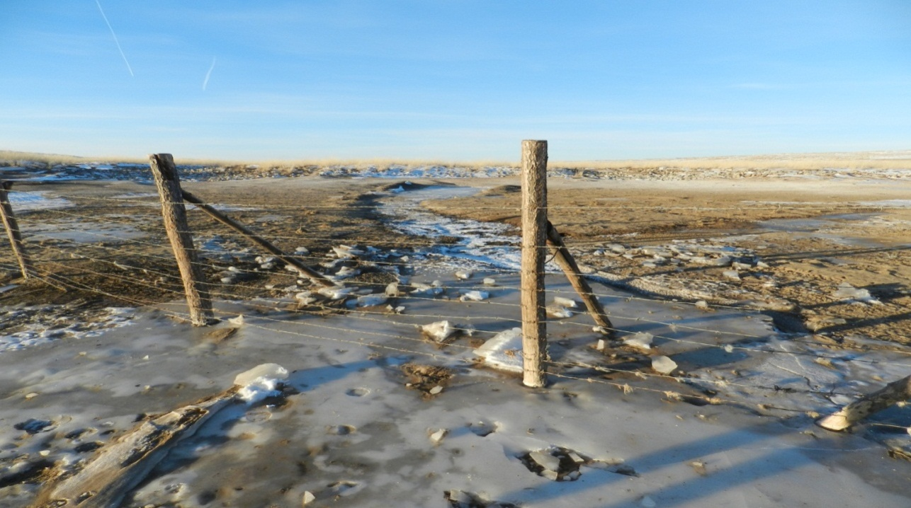

Picture 2: Tree Planting, in front of the local government building in Tuvshinshiree soum, Sukhbaatar Aimag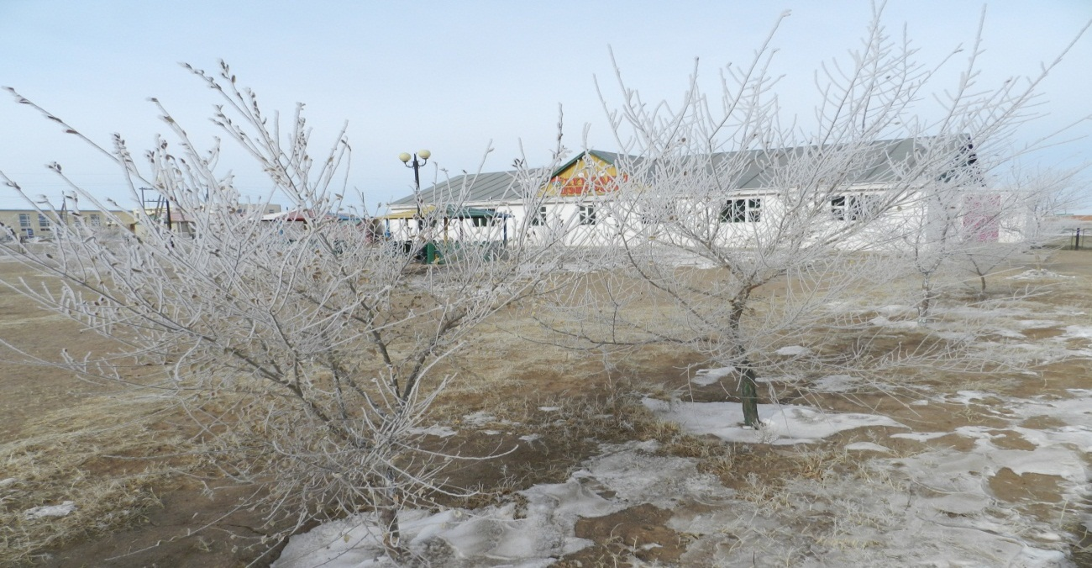
Picture 3: Esun Gal herder group, tree planting and green house area in Uulbayan soum, Sukhbaatar Aimag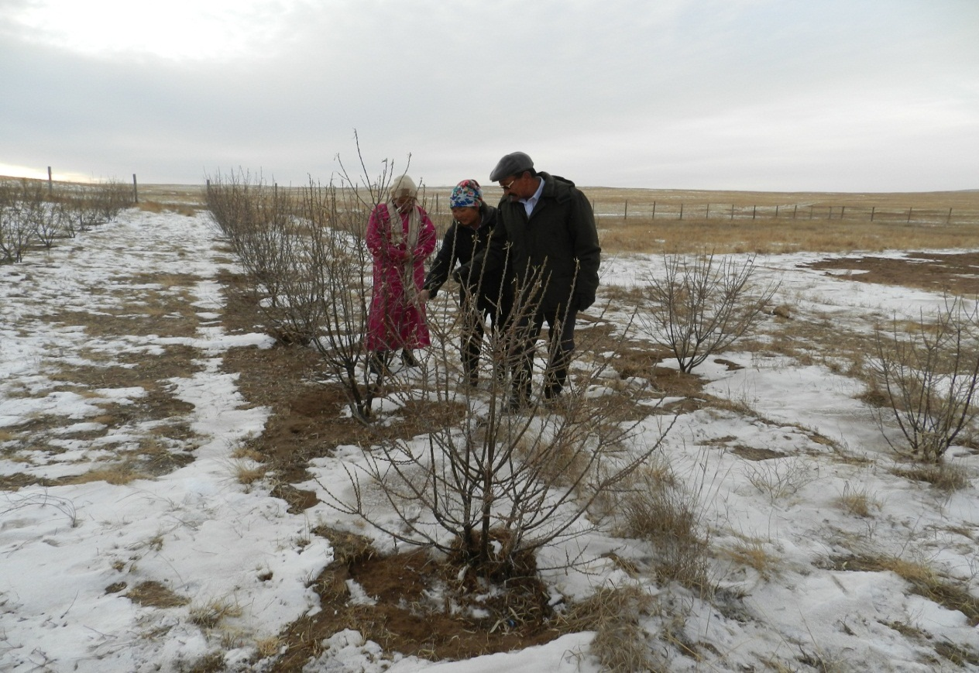

Picture 4: Underground Vefetable Storage of the Esun Gal herder group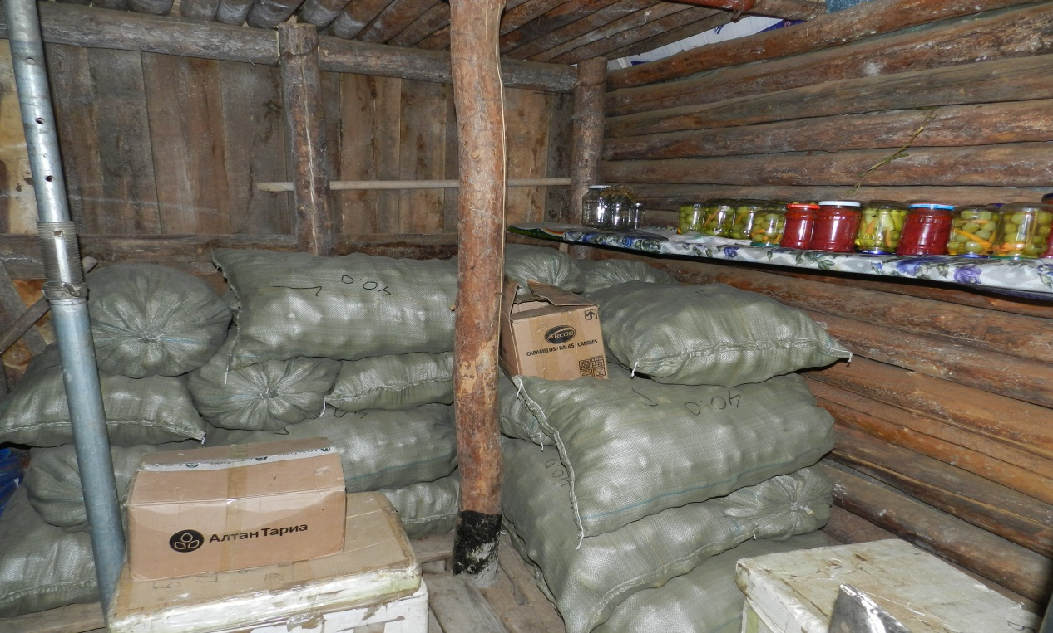

Picture 5: Workshop in Tuvshinshiree soum, Sukhbaatar Aimag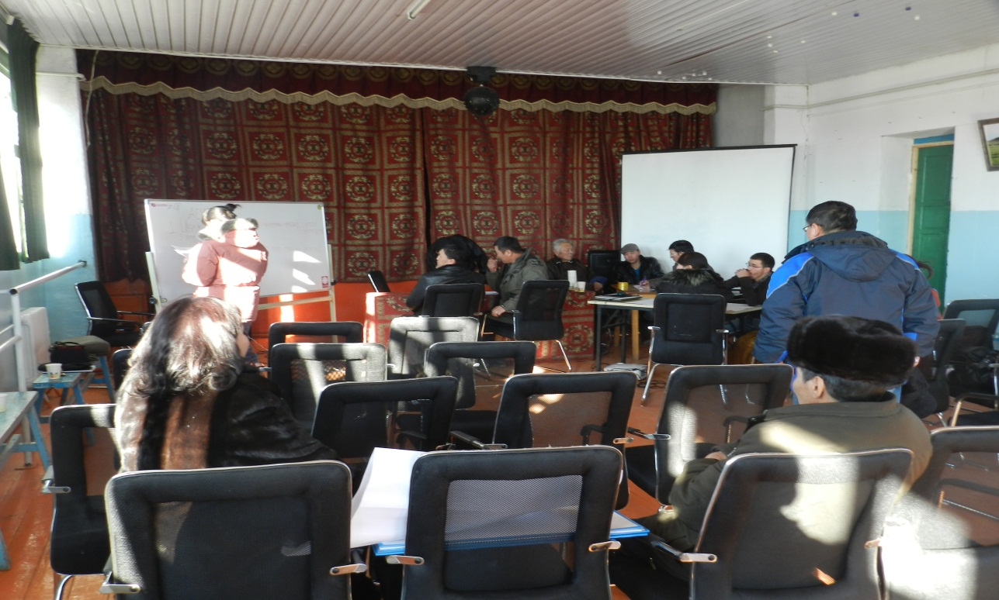

Picture 6: Research Center Accommodation building for researchers in Rashaant soum, Bulgan Aimag
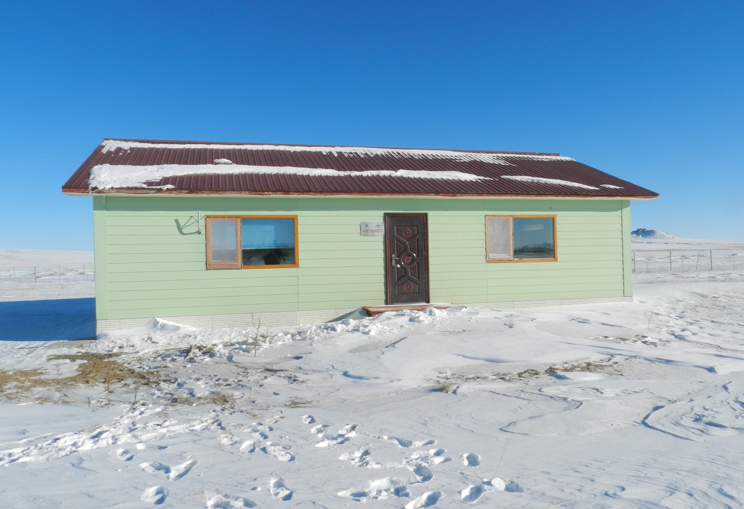
Picture 7: Research Center in Rashaant, Bulgan Aimag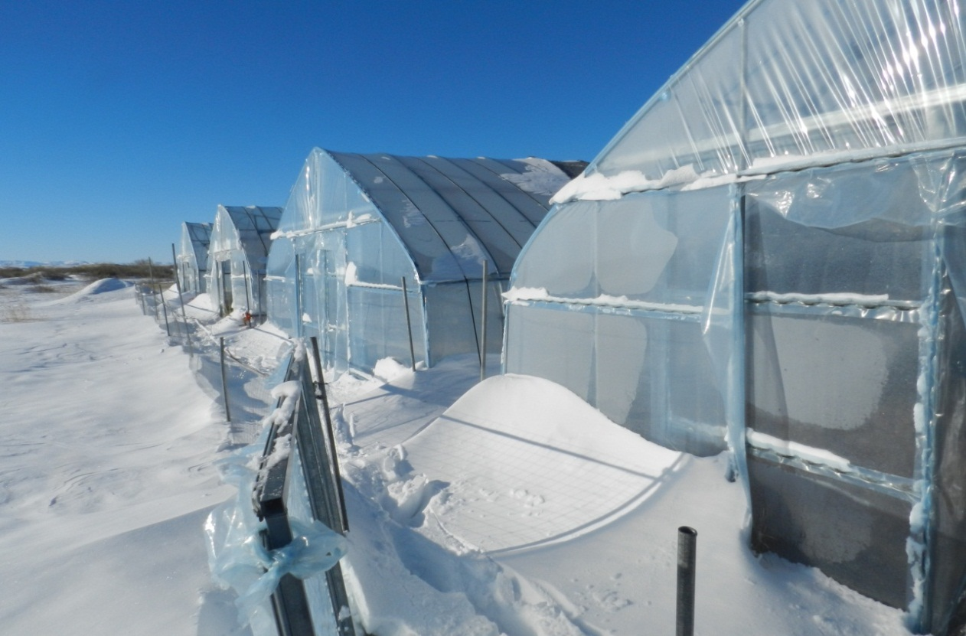

Picture 8: Inside the Greenhouse, Research Center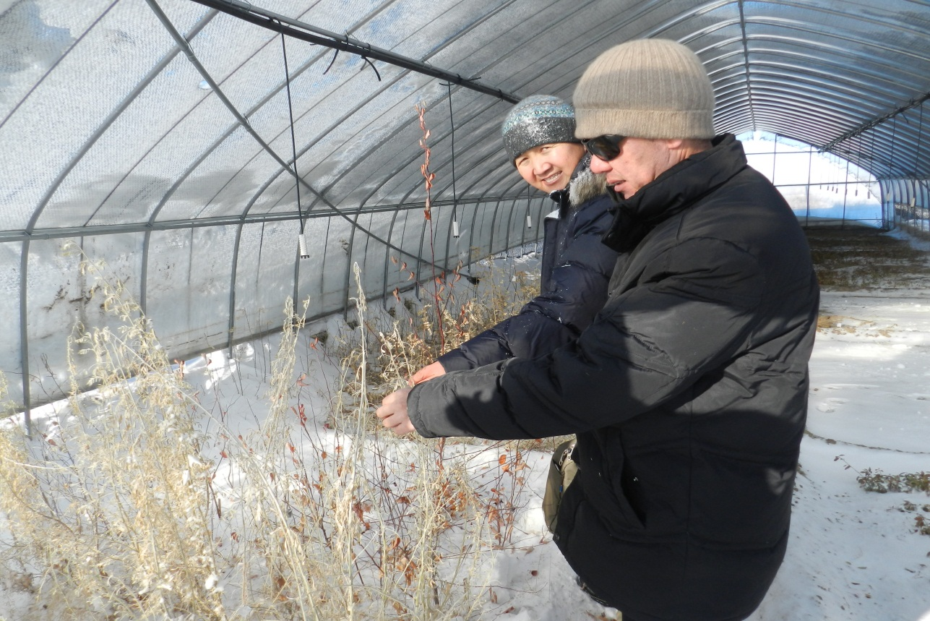

Picture 9: Hay fenced area, in Baruun Bayan Ulaan Soum, Uvurkhangai Aimag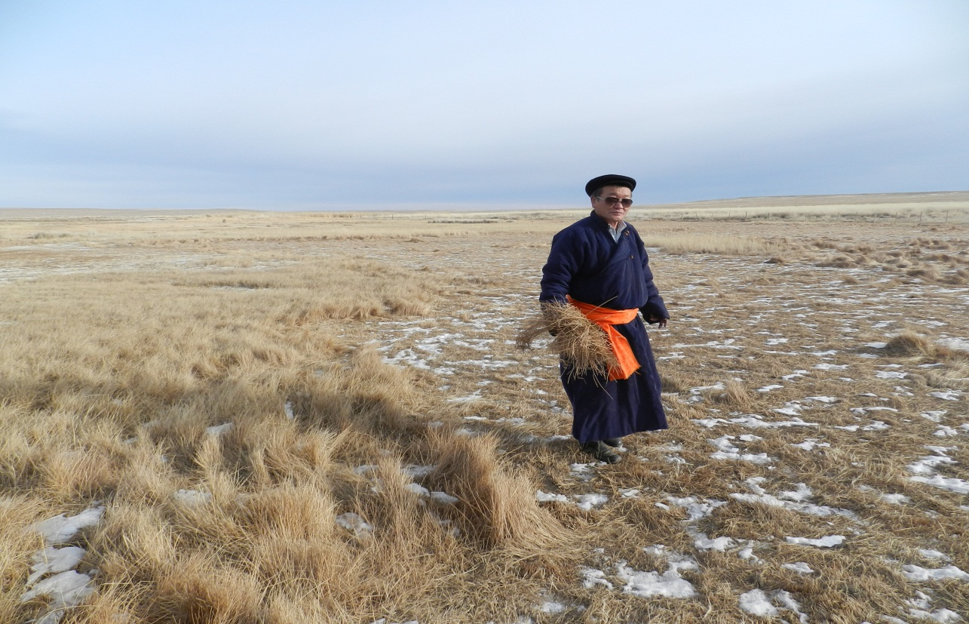

Picture 10: Saxual and planting area in Baruun Bayan Ulaan soum, Uvurkhangai Aimag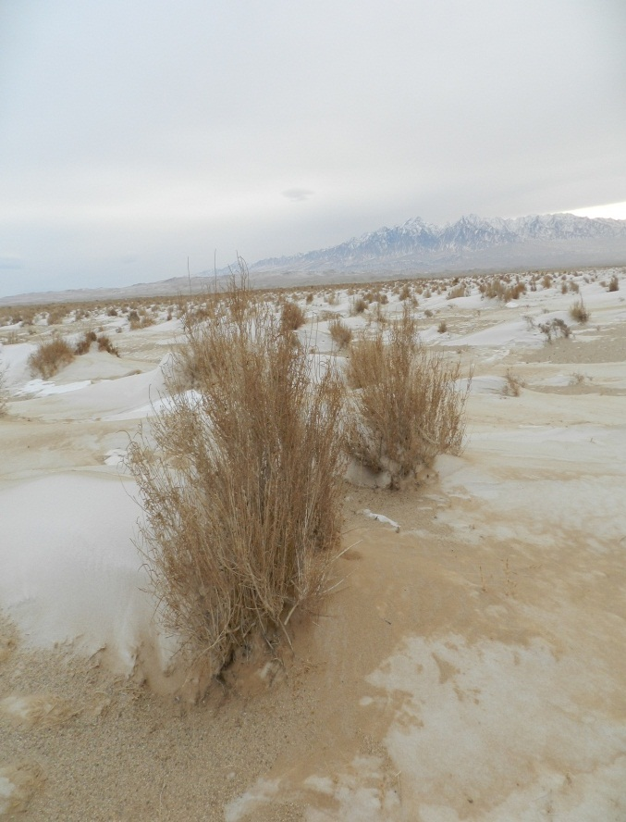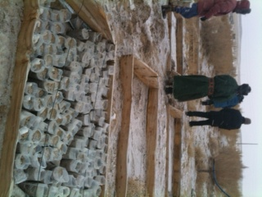

Picture 11: Taatsiin Tsagaan Nuur (Lake) in Baruun Bayan Ulaan soum, Uvurkhangai Aimag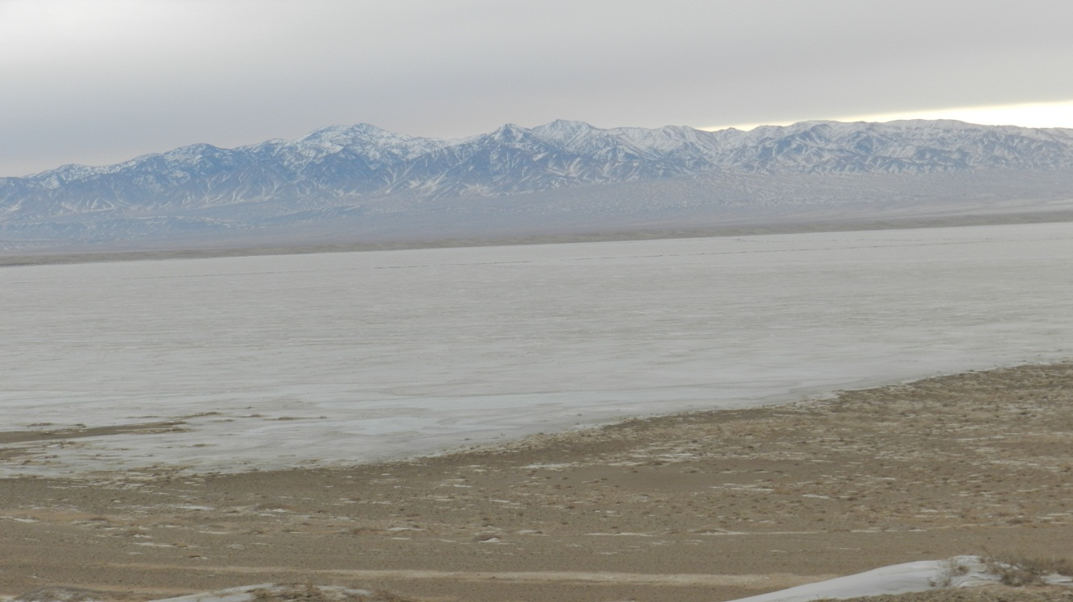

Picture 12: Project team, coordinator, leader of the Bayan Dukhum Uguuj herder Cooperative and the citizens representative, in front of the Herder Cooperatives Site in Uvurkhangai Aimag
