**TERMINAL EVALUATION**

**RUSSIAN FEDERATION**

**CONSERVATION OF WETLAND BIODIVERSITY IN THE LOWER VOLGA REGION**

**GEF ID: 1068 - UNDP PIMS: 1280**

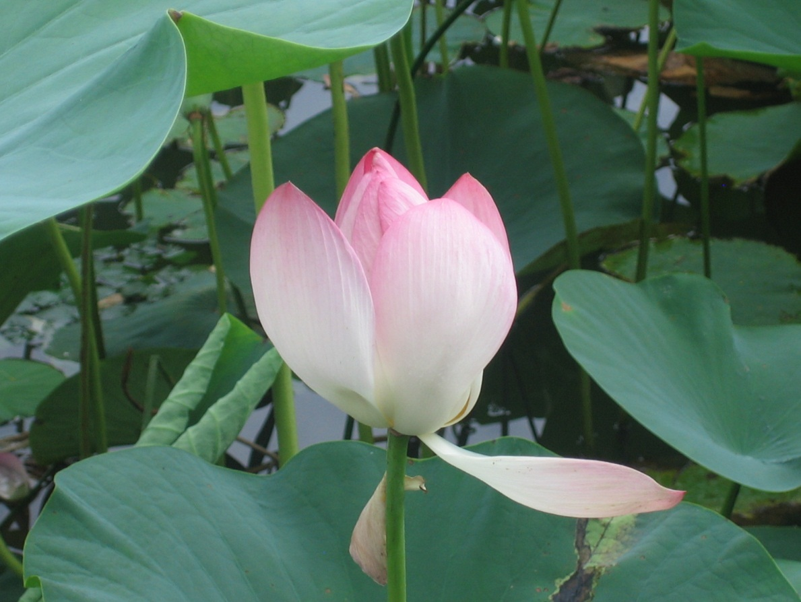

**Gonzalo Castro-de-la-Mata**

**International Consultant**

**November 8, 2012**

Table of Contents

ACRONYMS USED 4

EXECUTIVE SUMMARY 6

1. INTRODUCTION AND PROJECT CONTEXT 9

COUNTRY AND SECTOR BACKGROUND 9

PROJECT CONTEXT 9

PROJECT GOAL AND EXPECTED OUTCOMES 11

PROJECT SITES 13

PROJECT WORKING STRATEGY 14

PROJECT PARTNERS AND IMPLEMENTATION ARRANGEMENTS 14

DEPARTURES FROM THE ORIGINAL PROJECT DESIGN 15

2. OBJECTIVES AND METHODOLOGY OF THE FINAL EVALUATION 17

METHODOLOGY OF THE FINAL EVALUATION 18

3. ASSESSMENT OF PERFORMANCE 19

PROJECT FINANCES AT PROJECT APPROVAL 19

HISTORY OF THE PROJECT APPROVAL PROCESS 19

PROJECT DISBURSEMENTS 21

COFINANCING 22

PROJECT IMPLEMENTATION HISTORY 24

Project Inception and Early Implementation 24

Mid-Term Evaluation (MTE) 25

Project Implementation Since 2009 26

PROJECT PERFORMANCE SUMMARY 27

4. PROGRESS TOWARDS ACHIEVING OUTCOMES, GLOBAL ENVIRONMENTAL BENEFITS, AND THE PROJECT’s GOAL 28

Achievement of Outcomes 28

Achievement of Global Environmental Benefits 37

Achieving the Project Goal and Sustainability Issues: Towards Long-Term Impacts 38

5. CONCLUSIONS, LESSONS LEARNED, AND RECOMMENDATIONS 42

Conclusions 42

Lessons Learned 43

Recommendations 44

LIST OF ANNEXES 46

1. PROJECT RESULTS FRAMEWORK 47

a. Current Results Framework (From 2011 PIR) 47

b. Changes to Indicators in the Results Framework (From the PMU) 50

2. TERMS OF REFERENCE FOR THE TERMINAL EVALUATION 52

3. ADDITIONAL EVALUATION ISSUES ASSESSED BUT NOT INCLUDED IN THE MAIN REPORT NARRATIVE 56

4. PEOPLE AND INSTITUTIONS CONSULTED 57

5. DATES AND SCHEDULE OF FINAL EVALUATION 59

6. EVALUATION RATINGS 64

7. SCREENING CRITERIA FOR MICRO-CREDIT LOANS 65

8. DOCUMENTS REVIEWED 74

9. COMMENTS RECEIVED ON THE DRAFT REPORT 76

10. SIGNED ETHICS STATEMENT 78

# ACRONYMS USED

AO Astrakhan Oblast

AOA Astrakhan Oblast Administration

APR Annual Project Report

BAB Biodiversity Advisory Board

CAC Community Advisory Council

CAS Capacity Assessment Scorecards

CBD Convention on Biological Diversity

CCF Country Cooperation Framework

CDR Combined Delivery Report

CTA Chief Technical Adviser

CWA Core Wetland Area

DNPD Deputy National Project Director

EIA Environmental Impact Assessment

EIP Environment Investment Program

EPM Environment Program Manager

EPO Environment Program Officer

GDNREP General Directorate of Natural Resources and Environment Protection of MNR of Russia (in Astrakhan oblast, in Volgograd oblast, in Republic of Kalmykia)

GEF Global Environment Facility

GOR Government of Russian Federation

IUCN The World Conservation Union

LV Lower Volga

M&E Monitoring and Evaluation

METT Management Effectiveness Tracking Tool

MNR of Russia Ministry of Natural Resources of the Russian Federation

MTE Mid-Term Evaluation

NBSAP National Biodiversity Strategy and Action Plan

NEX Nationally Executed

NGO Non-Governmental Organization

NPC National Project Coordinator

NPD National Project Director

OP Operational Program

PA Protected Areas

PES Payments for Environmental Services

PIR Project Implementation Review

PM Project Manager

PMU Project Management Unit

PRODOC Project Document (UNDP)

PSC Project Steering Committee

RBIC Regional Biodiversity Information Center

RF Russian Federation

RK Republic of Kalmykia

RKA Republic of Kalmykia Administration

SBCUWR Strategy on Biodiversity Conservation and Use of Wetland Resources of Lower Volga

SGP Small Grants Program

SPNA Specially Protected Natural Areas

TA Technical Advisor

TCC Technical Coordination Councils for Environmental Protection established at the regional Management Directorates of the MNR of Russia

TPR Tripartite Review

UNDP United Nations Development Program

VO Volgograd Oblast

VOA Volgograd Oblast Administration

# EXECUTIVE SUMMARY

1. This document presents an independent and final evaluation of a project implemented by the Russian Federation to conserve the wetlands of the Lower Volga (LV) region (GEF Project 1068: Conservation of Wetland Biodiversity in the Lower Volga Region). The project was financed by the GEF as a Full Size Project, with UNDP acting as the Implementing Agency.
2. The evaluation was carried out by an international consultant (Dr. Gonzalo Castro de la Mata) with logistical support from UNDP and the project staff[1]. The evaluation was conducted during the month of August 2012, with a visit to Russia and the Lower Volga region between August 7th and 15th, 2012. It was conducted in a participatory manner through a combination of: (i) Site visits and interviews in the field with key stakeholders, and (ii) A review of documentation.
3. Goal and Objectives of the Project. The project Goal was to “ensure the conservation and sustainable use of biodiversity in the Lower Volga region.” The Immediate Objective was to “secure conservation of biodiversity in four Core Wetland Areas (CWA).The project envisioned five main outcomes:
4. Improved information on the LV and its biodiversity and improved information management and use in decision-making,
5. Strengthened institutional and regulatory capacity and multi-sectoral mechanisms for biodiversity conservation and use in the LV,
6. A strengthened LV System of Protected Areas,
7. Increased opportunities for the development of sustainable alternative livelihoods within CWAs and their vicinities, and
8. Increased awareness of and support for biodiversity conservation and sustainable development in the LV.
9. The Logical Framework (now Results Framework) was revised at project inception and after the Mid-Term Evaluation (MTE). The current Results Framework maintains the 5 original Outcomes, but the number of Outputs was changed to 15, and new indicators were agreed (Annex 1).
10. Project Implementation. The following are key observations regarding project implementation performance:

* The approval process was extremely slow. The first disbursement took place almost 8 years after its first informal pipeline entry. The project is scheduled to close in December 2012, which is 14 years after its pipeline entry.

* On the other hand, and once the project was approved by the GEF, implementation was relatively swift. The original project duration was envisioned to be 5 years, but in the end it took 6.5 years to implement it. This is not a major shortcoming both when compared with other GEF projects, as well as taking into account the challenging issues at stake.
* The Mid Term Evaluation (MTE) occurred at a critical time and the subsequent steps taken by UNDP to correct direction had fundamental and far-reaching influence over the project performance during subsequent years. The changes in the operational strategy implemented, chiefly among them the hiring of the current PM (Ms. Natalya Lopantseva), had wide-ranging implications.
* The years 2010 and 2011 saw the final consolidation of key project outputs, and the project entered into a phase in which it effectively achieved and in many cases exceeded its targets for outputs, outcomes, and its goal. This represents a remarkable success story and an example of a best practice in project turn-around.

1. Outcomes. Targets for most of the outcomes were achieved or exceeded. Although some of the indicator used both at the Outcome and Objective levels do not properly capture the higher-level accomplishments of the project, it is possible to construct a rationale to understand the project’s actual Impacts and sustainability prospects by going beyond the project’s indicators. The following unquestionable patterns emerge:

* Despite a “rocky” start, the project was able to disburse and implement activities closely following its pre-determined plan and for the most part within the GEF’s average “standards of service,”
* Most outcome indicators can be rated as satisfactory or highly satisfactory,
* The project established a solid foundation to introduce ecosystem-level management considerations at the LV at the level of key institutions, both public and private,
* Awareness regarding the relations between nature and water, and the consequent importance of the ecosystem services provided by wetlands, was substantially increased,
* A great number of tools including studies, guides, guidelines, and management recommendations were developed and adopted, including a Presidential decree recognizing the importance of water in the LV for biodiversity,
* Local capacity for understanding ecosystem-level issues was enhanced, and
* A shared vision regarding the ecosystem-level management needs of the LV has been achieved – this vision is shared across political divisions, a major accomplishment in itself.

1. Another major accomplishment of the project is the successful expansion and establishment of the PA network. Protected areas were strengthened and increased in area by more than 100%, thus establishing a “back bone” for the long term biodiversity conservation in the LV, and the total area under protection is expected to exceed the target and reach 748,640 ha.
2. On the basis of these observations, it is evident that the project’s achievement of its goal, to “ensure the conservation and sustainable use of biodiversity in the Lower Volga region” can be rated as Highly Satisfactory. Because these accomplishments transcend the project’s lifetime by influencing society over the long term, the project’s sustainability is also rated as Highly Satisfactory.
3. Summary Ratings:

|  |  |
| --- | --- |
| Element Evaluated | Rating |
|  |  |
| Project success overall | HS |
| Progress towards achieving its development objective | S |
| Progress in implementation | S |
| Sustainability | HS |

HS = Highly Satisfactory; S = Satisfactory; MS = Marginally Satisfactory; MU = Marginally Unsatisfactory; U = Unsatisfactory (U); HU = Highly Unsatisfactory

1. Lessons Learned. Looking ahead, it is important for future projects to learn from the successful experiences here, as well as to avoid pitfalls identified in this project. The following are the main lessons-learned:

* Proper staffing is essential to project success.
* Mid-Term Evaluations can be critical to place a project back on track.
* It is possible to turn a project around. The report highlights this experience as ***best practice.***
* Small Grants and Micro-Credit Facilities are complementary tools but are not interchangeable. The report highlights the micro-credit design as ***best practice.***
* Large and complex ecosystems require holistic approaches that go beyond the establishment and strengthening of PAs. Understanding ecosystem-wide dynamics and addressing roots causes, in this case water regimes, is vital.
* The proper bridging of science and policy can produce long-term fundamental changes in ecosystem management.

1. Recommendations. The project has successfully established the long-term foundation for a holistic management of the LV in which biodiversity and ecosystems are now recognized as legitimate water users. This is a major accomplishment and greatly enhances the long-term conservation prospects of these ecosystems. In order for the momentum gained not to be loss and for additional gains to be achieved, the following recommendations are provided:

* Engage the tourism industry to green its practices.
* Continue the long-term ecological monitoring programs.
* Consider introducing systems of payments for environmental services (PES).
* Engage the energy sector to develop biodiversity-friendly practices.
* Follow-up and measure the biodiversity impacts of the micro-credit facility.

# INTRODUCTION AND PROJECT CONTEXT

1. This document presents an independent and final evaluation (i.e., the Terminal Evaluation) of a project implemented by the Russian Federation to conserve the wetlands of the Lower Volga (LV) region (GEF Project 1068: Conservation of Wetland Biodiversity in the Lower Volga Region). The project was financed by the GEF as a Full Size Project, with UNDP acting as the Implementing Agency.

## COUNTRY AND SECTOR BACKGROUND

1. The Government of the Russian Federation is committed to a policy of conservation of biodiversity as an integral part of the country’s sustainable development agenda. The Russian Federation adopted its National Strategy on Biodiversity Conservation in 2002. The establishment and effective management of Russia’s protected area system is a key instrument in the country’s biodiversity strategy. The biodiversity strategy recognizes that the Lower Volga region is one of the country’s most important natural assets for the conservation of biodiversity of global and national importance and is in need of special conservation measures.
2. The Federal Government and the regional protection agencies of the Astrakhan Oblast, Volgograd Oblast and the Republic of Kalmykia manage the Specially Protected Natural Areas System (SPNA) in the Lower Volga. At project start, most of the protected areas in the Lower Volga region had a regional status, with the exception of the Astrakhan Biosphere Reserve, which was classified as a Federal level reserve (IUCN Category I). At that time, the network of protected areas (PA) in the Lower Volga consisted of:

* The Astrakhan Biosphere Reserve in Astrakhan oblast, IUCN Category I (98,000 ha including the buffer zone),
* The Regional Nature Park of the Republic of Kalmykia “Volga-Akhtuba Interfluve,” IUCN Category V (4,323 ha),
* The Regional Nature Park “Volga-Akhtuba floodplain” in Volgograd oblast, IUCN Category V (150,000 ha),
* The Regional Ilmenno–Bugrovoi Reserve in the western Ilmen-Steppe area in Astrakhan Oblast, IUCN Category IV (6,000 ha),
* Nine key ornithological sites of international importance in the European part of Russia; 5 in the Volgograd Oblast and 4 in the Astrakhan Oblast, and,
* Twenty-five regional nature monuments (in total exceeding 30,000 ha) and 3 regional hunting reserves (total area of 10,600 ha).

## PROJECT CONTEXT

1. The project is situated in the LV region in the southeastern part of the East European Plain (Figure 1). According to the original Project Document, the area is comprised of: (i) the entire Volga-Akhtuba floodplain area between the cities of Volgograd and Astrakhan, including the section within the Republic of Kalmykia; (ii) the Volga Delta (the largest delta in Europe and the largest delta bordering the Caspian Sea) including the shallow waters of the fore-delta; and (iii) the Ilmen-Steppe areas to the west of the Delta.
2. The rich biodiversity of the region is determined primarily by the dynamics of the water regime. The region and its biodiversity have been shaped by regular changes in the flow of the Volga River, characterized by large inter-seasonal and long-term variations. This variability in river discharge has also had a major effect on Caspian Sea levels, which is a closed basin with the Volga providing 80% of its annual inflow.
3. The location and area of wetland biotopes change continuously. Wetlands have appeared, disappeared or shifted spatially in response to changing environmental conditions, both in the Volga-Akhtuba floodplain and the coastal areas of the Caspian Sea. In turn, the changes in size and location of wetlands produce regular changes in population numbers of terrestrial and aquatic flora and fauna.
4. In the course of the 20th Century, the dynamics of the natural cycles were substantially altered as a result of human interventions. Following the construction of a series of reservoirs and irrigated agricultural fields, there was an increasing volume of water taken for industry and agriculture. Dikes protecting agricultural fields were not relocated and no agricultural fields were restored to wetlands. The total area of habitat important for wetland biodiversity has decreased significantly in the last decades. The impact of diminished habitat has been a significant decrease in the number of breeding water birds within colonies, and in the reduced rate of natural reproduction of fish and other aquatic animals.
5. The global importance of the LV wetlands (especially the Volga Delta) for biodiversity is widely recognized and considered to be one of the most important wetlands areas globally. It is also considered the best-preserved wetland habitat in Europe. At least 15 globally threatened bird species use the region, including the Red-breasted Goose (Rufibrenta ruficollis), Lesser White-fronted Goose (Anser erythropus), White-headed Duck (Oxyura leucocephala), Marbled Duck (Anas angustirostris), Ferruginous Duck (Aythya nyroca), Dalmatian Pelican (Pelecanus crispus), Siberian White Crane (Grus leucogeranus), Corn Crake (Crex crex), Lesser Kestrel (Falco naumanni), Spotted Eagle (Aquila clanga), Imperial Eagle (Aquila heliaca), Great Bustard (Otis tarda), Sociable Plover (Chettusia gregaria), Slender-billed Curlew (Numenius tenuirostris) and Aquatic Warbler (Acrocephalus paludicola). There are also species listed in the Russian Red Data Book, for instance, Spoonbill (Platalea leucorodia), Glossy Ibis (Plegadis falcinelbus), White-tailed Eagle (Haliaeetus albicilla), Pygmy Cormorant (Phalacrocorax pygmaeus) and Great Black-headed Gull (Larus ichtyaetus).
6. The Lower Volga wetlands occupy a strategic position within three important flyways for migratory water birds: the East African, the Mediterranean and the Central Asian-Indian flyways. It is also an area of natural reproduction of 6 Caspian sturgeon species, for of which: the Russian Sturgeon (Acipenser gueldenstaedti), the Beluga Sturgeon (Huso huso), the Stellate Sturgeon (Acipenser stellatus) and the Starlet (Acipenser ruthenus) are endangered and in the IUCN Red List. As a result of reservoir construction, the remaining natural spawning grounds of migratory sturgeon species are reduced from the previous 3,400 ha along the Volga course and its tributaries to 430 ha within the Volga-Akhtuba floodplain (the Volga and Akhtuba rivers) below the Volga hydropower station.
7. Four endemic plant species are found: Kossinski hornwort, Astrakhan campion, Tickseed, and Sphaeranthus volgensis. Seven Russian Red Data Book plant species occur in the area: Lotus Lily (Nelembo nucifera), Calltrop (Trapa natans), Egyptian pepperwort (Marsilea aegyptiaca), strigose pepperwort (Marsilea strigosa), Diandrochloa diarrhena, white water lily (Nymphaea candida), and Aldrovanda vesiculosa.
8. The project area lies within three political sub-divisions of the Russian Federation: Astrakhan Oblast (AO), constituting approximately 24,400km2 of the LV; Volgograd Oblast (VO), constituting approximately 1,560km2; and the Republic of Kalmykia (RK) with some 43km2 located in the LV.
9. According to the Project Document, most of the human population is concentrated in the city of Astrakhan (482,000 people), Volgograd (999,000 people) and Volzskyi (288,000 people). The percentage of rural population is approximately 25% in VO and 34% in AO, with the majority of them living in small villages. In contrast, the Republic of Kalmykia is mainly rural with an average population density of 4.2 people per km2, lower than the average for the region. During the 20th century the Volga River basin was a center of large-scale economic activities. Construction of hydropower plants and irrigation dams along the Volga River basin, including the enormous Volga–Kama cascade of reservoirs provided the foundations for industrial and agricultural development. The basin is Russia’s largest transport waterway, with a 70% share of total river transport in the Russian Federation.
10. The region is also essential for commercial freshwater fisheries. About 90% of harvested sturgeons come from the Lower Volga and the Northern Caspian. Although large areas of natural spawning grounds have been lost following the construction of the Volga-Kama cascades, spawning grounds of sturgeons and semi-migratory fish still exist in the Lower Volga region. Since the 1960s the natural reproduction of sturgeons and semi-migratory fish in the Lower Volga has been supported by artificial reproduction (hatcheries, fish breeding and growing farms, etc.). The region is also becoming increasingly important for the oil and gas industries.

## PROJECT GOAL AND EXPECTED OUTCOMES

1. The project Goal was to “ensure the conservation and sustainable use of biodiversity in the Lower Volga region.” The Immediate Objective was to “secure conservation of biodiversity in four Core Wetland Areas (CWA) through: (i) overall strengthening of the Lower Volga protected area system, (ii) introduction of supporting regulatory and policy environment and local participation, and (iii) demonstrating and introducing alternative income generating activities.” The area under protection would increase from 230,000 ha to 678,000 ha by the end of the project.
2. The project originally had five main outcomes:
3. Improved information on the LV and its biodiversity as well as improved information management and use in decision-making,
4. Strengthened institutional/regulatory capacity and multi-Sectoral mechanisms for biodiversity conservation and use in the LV,
5. A strengthened LV System of Protected Areas,
6. Increased opportunities for the development of sustainable alternative livelihoods within CWAs and their vicinities, and
7. Increased awareness of and support for biodiversity conservation and sustainable development in the LV.
8. Under Outcome 1, Improved Information on the LV and its Biodiversity and Improved Information Management and Use in Decision-Making, the following outputs were envisioned:

* Output 1.1. Monitoring and data needs of LV defined and agreed,
* Output 1.2. Directly relevant available information on LV is compiled, analyzed and key gaps are determined and filled, and
* Output 1.3. LV meta-database and mechanisms for access to and use of information are established and under implementation.

1. Under Outcome 2, Strengthened Institutional and Regulatory Capacity and Multi-Sectoral Mechanisms for Biodiversity Conservation and Use in the LV, the following outputs were envisioned:
   * Output 2.1 Formal coordination mechanisms among regional and local authorities for biodiversity conservation agreed and established,
   * Output 2.2. A regional strategy for biodiversity conservation defined and agreed among authorities,
   * Output 2.3. Changes in legislation and regulation undertaken for improving biodiversity conservation and enforcement mechanisms, and
   * Output 2.4. The operation of the Volgograd reservoirs adapted to biodiversity conservation needs in LV.
2. Under Outcome 3, A Strengthened LV System of Protected Areas, the following outputs were envisioned:

* Output 3.1 Establishment of four core wetland areas (Volga Delta; Ilmen; Central Volga Akhtuba Floodplain, and Upper Volga Akhtuba Floodplain,
* Output 3.2. Local advisory councils for each protected area established,
* Output 3.3 Management plans for CWAs defined and under implementation,
* Output 3.4. Financial sustainability of protected areas strengthened, and
* Output 3.5. Selected (degraded) habitats restored.

1. Under Outcome 4, Increased Opportunities for the Development of Sustainable Alternative Livelihoods Within CWAs and their Vicinities, the following outputs were envisioned:

* Output 4.1 Alternative livelihood options suitable to local conditions identified and selected in consultation with local communities, and
* Output 4.2. Technical and financial needs for the adoption of alternative livelihoods defined in consultation with local stakeholders and support provided.

1. Under Outcome 5, Increased Awareness and Support for Biodiversity Conservation and Sustainable Development in the LV, the following outputs were envisioned:

* Output 5.1. Regional Biodiversity Information Centers established within the General and regional Directorates of Natural Resources and Environmental Protection, and
* Output 5.2. Public awareness and training strategy targeted to different stakeholders groups developed and under implementation.

1. The original Logical Framework of the project therefore was ambitious, and included 5 Outcomes, 16 Outputs, 20 Indicators, and 51 proposed activities (GEF 2004).

## PROJECT SITES

1. The project targeted the entire watershed and floodplain of the Lower Volga River. In addition to the general area comprised of the Volga-Akhtuba floodplain area between the cities of Volgograd and Astrakhan, the Republic of Kalmykia, the Volga Delta and the Ilmen-Steppe, it specifically targeted four hypothetical CWAs that were to be defined during implementation: (i) CWA 1 (Volga Delta), CWA 2 (Ilmen Steppe Area), CWA 3 (Central Volga - Akhtuba Floodplain), and CWA 4 (Upper Volga – Akhtuba Floodplains). Figure 1 below shows the project area at the time of project approval and the proposed new ones (GEF 2005).

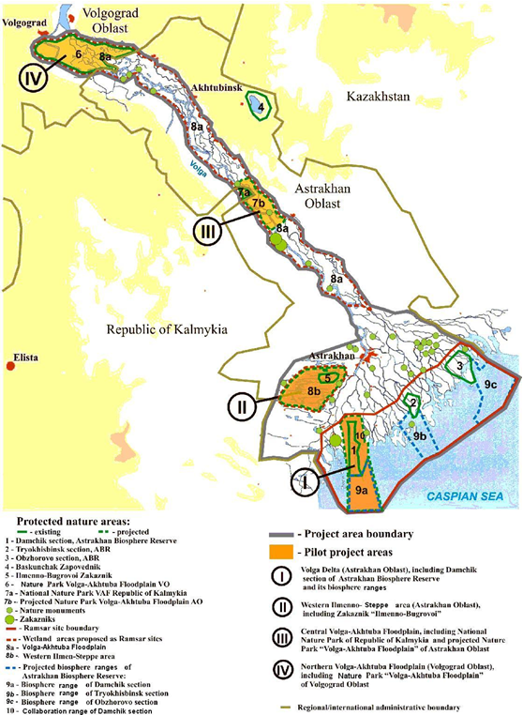

Figure - - Project Area and Sites as Presented in the Original Project Brief

## PROJECT WORKING STRATEGY

1. According to the Project Brief (GEF 2005), the project would utilize the establishment and strengthening of Core Wetland Areas (CWAs) as the heart of the project strategy: “In Russia, CWAs do not primarily focus on the conservation of nature by excluding human activities; on the contrary, wetland biodiversity conservation will be strongly interwoven with sustainable economic use.”
2. Besides formally establishing CWAs and creating favorable conditions for the long-term protection of biodiversity values, including assigning hotspots for biodiversity, the project planned to focus on local stakeholders to stimulate sustainable alternative livelihood activities in the CWAs through demonstration and technical support, awareness and training activities, and small grant facilities. In order to achieve successful implementation of project activities at the local level, it was necessary to provide support to targeted research, inventory and monitoring, integration of biodiversity aspects into the regional policy and legal framework, awareness raising and training, and information storage and sharing at the regional level.
3. There were several major challenges to the project that required sophisticated approaches to balance the various political and economic forces acting upon water management in the area: (i) the political divisions existing between the Oblasts and other administrative units; (ii) the root issue arising from conflicts among water users related to water management, and (iii) the lack of a unified “watershed vision” for the entire LV. Thus, it was clear that in addition to the measurable outcomes related to the consolidation and establishment of the CWAs, achieving the project Goal would depend upon effectively influencing the attitude and vision of all the major players in the entire LV watershed.

## PROJECT PARTNERS AND IMPLEMENTATION ARRANGEMENTS

1. Management arrangements reflected the provisions of standard rules and procedures of the UNDP National Execution Modality. Specifically:

* UNDP is the GEF Implementing Agency as nominated by the National Global Environment Facility Operational Focal Point,
* The Project’s Implementing Partner Agency is the Ministry for Nature Protection and Environment,
* Project Oversight is undertaken at the strategic level by an Inter-Institutional Project Steering Committee (PSC),
* Project Implementation is executed through a Project Management Unit (PMU).
* Day-to-day management is led by a Project Manager (PM).

1. Initially, the Ministry for Nature Protection and Environment nominated a local implementing agent in the region, based in Astrakhan, authorized to enter into contractual arrangements with individuals and sub-contractors on its behalf. The Astrakhan Regional Non-governmental Organization Supporting Environmental Protection (SOOS) followed UNDP NEX rules and procedures for selection and contracting and for making payments against all categories of the project budget, and in managing project funds, including budget planning, monitoring, revisions, disbursements, record keeping, reporting and auditing observing UNDP rules. It also acts in accordance with national financial regulations. In some cases, UNDP contracted project consultants directly and ensured direct payment accordingly.
2. The Project Document indicated that the PSC would meet at the start of the Project and regularly every six months thereafter. The PSC is chaired by the National Project Director (NPD). The Project Manager (PM) attends as an observer.
3. Overall guidance and coordination of the project implementation has been the responsibility of the National Project Director (NPD). The NPD is a State Employee designated by the National Executing Agency (Ministry of Natural Resources and Environment of Russia). It is an unpaid position covered by the Government in-kind contribution to the project. The NPD is accountable to the National Executing Agency and UNDP for the production of the project outputs, appropriate use of the project resources, and coordination of the UNDP project with other programs and projects implemented in the Russian Federation in the area of biodiversity protection and management. The NPD has been assisted throughout by a Deputy National Project Director (DNPD).
4. Day-to-day implementation is the responsibility of a Project Management Unit (PMU) located in two offices, one in Astrakhan and one in Volgograd, and comprising a full-time Project Manager (PM) and six full-time staff.
5. UNDP-GEF signed the Project Document with the Government of Russia on 17th November 2005. The first disbursements to the Project were made on 7th July 2006 and the Project was officially launched on 11th July 2006 at the start of the Inception Workshop.

## DEPARTURES FROM THE ORIGINAL PROJECT DESIGN

1. The Logical Framework of the project was revised at Project Inception. According to the Project Inception Report (UNDP 2007), the Logical Framework further defined the baselines and targets for the indicators, but maintained its 5 original Outcomes, 16 Outputs, 20 Indicators, and 51 Proposed Activities.
2. The Mid-Term Evaluation in early 2009 (MTE, UNDP 2009) recommended the Project to be re-launched at a full stakeholder workshop in order to refocus its aims and simplify its Logical Framework. Specifically, the MTE recommended that the project needed to be simplified and the log-frame clarified and re-examined including dropping some activities, removing a number of inconsistencies, and removing indicators and activities in places that were mismatched.
3. As a response to the MTE and as reported in the 2010 PIR (UNDP 2010), a number of individual indicators at the outcome level were re-examined and rectified, extraneous activities dropped, and inconsistencies were removed to improve the match between indicators and activities. The changes were subsequently approved by the PSC members, the UNDP CO and the RTA. The project Goal remained the same, but the objective changed to:

“To promote the conservation of globally important biodiversity and the “wise” use of land and water resources in the floodplain and delta, to allow for compensatory habitat development important for global biodiversity in a dynamic natural and human-induced environment.”

1. The Results Framework maintained the 5 original Outcomes, but the number of Outputs was changed to 15 (Annex 1, part a). The changes to the indicators in the Results Framework are presented in Annex 1, part b. In addition, the project closing date was extended from December 2010 to June 2012 (a total extension of 1.5 years). Subsequently, the project closing date was extended again to December 2012.

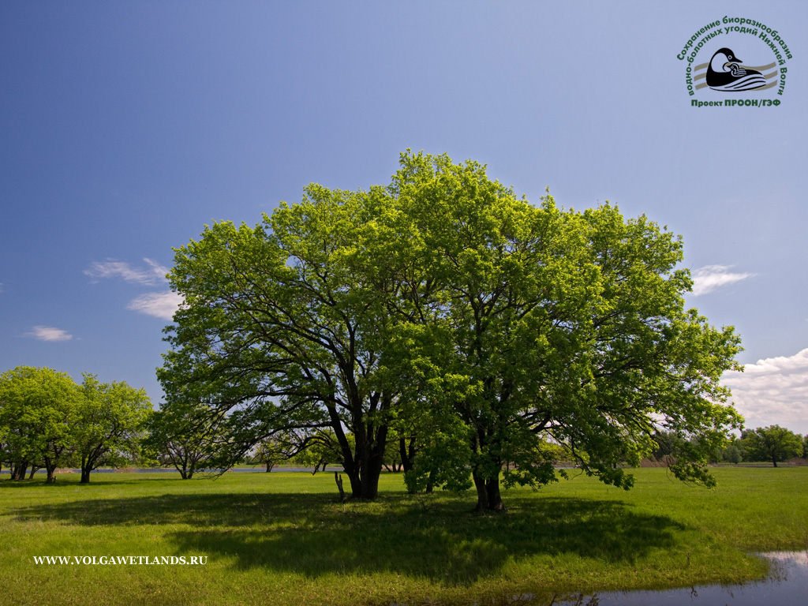

Figure - Healthy Oak Forest in the LV. Courtesy of the Project.

# OBJECTIVES AND METHODOLOGY OF THE FINAL EVALUATION

1. According to the Project Document, “an independent Final Evaluation will take place three months prior to the terminal tripartite review meeting, and will focus on the same issues as the mid-term evaluation. The final evaluation will also look at signs of potential impact and sustainability of results, including the contribution to capacity development and the achievement of global environmental goals. The Final Evaluation should also provide recommendations for follow-up activities. The organization, terms of reference and timing of the final evaluation will be decided after consultation between the parties to the project document.”
2. The statement above is in line with the objectives of the monitoring and evaluation guidelines of the Global Environment Facility (GEF):
3. To promote accountability for the achievement of GEF objectives through the assessment of results, effectiveness, processes, and performance of the partners involved in GEF activities. GEF results are monitored and evaluated for their contribution to global environmental benefits, and,
4. To promote learning, feedback, and knowledge sharing on results and lessons learned among the GEF and its partners, as a basis for decision-making on policies, strategies, program management, and projects, and to improve knowledge and performance.
5. In addition to providing an independent, in-depth review of implementation progress, this type of evaluation is responsive to the GEF Council’s decisions on transparency and better access to information during implementation and on completion of a project. Specifically, the Final Evaluation provides a comprehensive and systematic account of the performance of a completed project by assessing its project design, process of implementation, and results, vis-à-vis project objectives endorsed by the GEF including the agreed changes in the objectives during project implementation. Final evaluations have four complementary purposes:
6. To promote accountability and transparency, and to assess and disclose levels of project accomplishments,
7. To synthesize lessons that may help improve the selection, design and implementation of future GEF activities,
8. To provide feedback on issues that are recurrent across the portfolio and need attention, and on improvements regarding previously identified issues, and,
9. To contribute to the GEF Evaluation Office databases for aggregation, analysis and reporting on effectiveness of GEF operations in achieving global environmental benefits and on quality of monitoring and evaluation across the GEF system.

## METHODOLOGY OF THE FINAL EVALUATION

1. The evaluation was carried out by an international consultant (Dr. Gonzalo Castro de la Mata) with logistical support from UNDP and the project staff. The consultant was accompanied at all times by English-Russian translators (Messrs. Dmitry Zolotarev and Alexander Oshis). All logistical and organizational matters were handled impeccably by very proficient UNDP and Project Staff in Moscow and the Lower Volga[2].
2. The evaluation was conducted during the month of August 2012, with a visit to Russia and the Lower Volga Region between August 7th and 15th, 2012. It was conducted in a participatory manner through a combination of:
3. Site visits and interviews in the field with key stakeholders (Annexes 4 and 5), and,
4. A review of documentation (Annex 7).
5. In line with UNDP Evaluation Guidelines (UNDP 2002), this evaluation report is the key product of the evaluation process. Its purpose is to provide a transparent basis for accountability for results, for decision-making on policies and programs, for learning, for drawing lessons and for improvement.

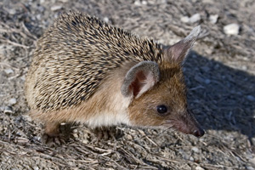

Figure - Eared Hedgehog

# ASSESSMENT OF PERFORMANCE

1. This section presents the key project identifiers, basic data on the project’s disbursements, a brief history of the approval process, and a condensed narrative of the project’s and implementation history and performance.
2. Table 1 below summarizes the key project identifiers.

Table 1 - Key Project Identifiers

|  |  |
| --- | --- |
| GEF ID | 1068 |
| UNDP PMIS ID | 1280 |
| GEF PHASE | GEF-3 |
| Project Type | Full Size Project |
| Focal Area | Biodiversity |
| Operational Program | OP 2 |
| GEF Strategic Priority in Biodiversity | BD-1 Catalysing Sustainability of Protected Areas |
| Current National Project Manager | Natalia Lopantseva |
| Current UNDP Project Manager | Irina Bredneva |
| Current UNDP Lead RTA | Maxim Vergeichik |

## PROJECT FINANCES AT PROJECT APPROVAL

1. Table 2 below shows the key project finances at the time of GEF CEO Approval. The total approved GEF grant including project preparation funds amounted to US$ 6.77M, while co-financing was expected at US$ 8.82M, for a total project cost of US$ 15.60M.

Table 2 - Key Project Finances at the time of GEF CEO Approval

|  |  |
| --- | --- |
| PDF-A Amount (Project Preparation) | 23,500 US$ |
| PDF-B Amount (Project Preparation) | 267,385 US$ |
| GEF Project Grant | 6,488,000 US$ |
| Total GEF Grant | 6,778,885 US$ |
| Co-financing Total | 8,824,000 US$ |
| Total Project Cost | 15,602,885 US$ |
| GEF Agency Fees (UNDP) | 382,000 US$ |

## HISTORY OF THE PROJECT APPROVAL PROCESS

1. The project first entered the GEF informal Pipeline on October 21, 1998 at the time of the Block-A approval for a Full-Size Project under the Focal Area of Biodiversity, Operational Program Number 2 (Freshwater and Marine Ecosystems). The project was retrofitted to contribute to the GEF-3 Strategic Priority Number 1 under Biodiversity: Strengthening Systems of Protected Areas at the time of Work Program Inclusion. Table 3 below shows the key project dates during the approval and implementation process.

Table 3 - Key Project Dates

|  |  |
| --- | --- |
| GEF Informal Pipeline Entry | October 21, 1998 |
| PDF-A Approval Date | October 21, 1998 |
| GEF Formal Pipeline Entry for Full-Size Project | October 23, 2000 |
| PDF-B Approval Date | June 26, 2001 |
| GEF Work Program Inclusion | May 21, 2004 |
| GEF CEO Endorsement Date | July 25, 2005 |
| PRODOC Signature Date | November 17, 2005 |
| Date of First Disbursement | July 7, 2006 |
| Planned project duration | 5 years |
| Original Planned Closing Date | December 31, 2010 |
| Actual Planned Closing Date | December 31, 2012 |

1. The Project was approved by the GEF CEO on July 25, 2005. The first disbursement took place on July 7, 2006, almost 8 years after its informal pipeline entry (PDF-A approval), but relatively swiftly after the signature of the PRODOC. The slight delays in initial disbursements were due to administrative constraints within the project National Executing Agency – the Ministry of Natural Resources of the Russian Federation (UNDP 2007).
2. The project is scheduled to close in December 2012, approximately 6.5 years after the first disbursement, 7.5 years after its approval by the GEF, and 14 years after its informal pipeline entry. The original project duration was envisioned to be 5 years, but in the end it took 6.5 years to implement. A timeline showing the project history and delays is shown in Figure 2 below. In relative terms, there is a large and protracted delay during project preparation, but actual project implementation from the time of GEF approval is relatively swift when compared with other GEF projects, despite the challenging issues at stake.

Figure – Graphic Timeline of Key Project Events

|  |  |  |  |  |  |  |  |  |  |  |  |  |  |  |  |
| --- | --- | --- | --- | --- | --- | --- | --- | --- | --- | --- | --- | --- | --- | --- | --- |
|  | **1998** | **1999** | **2000** | **2001** | **2002** | **2003** | **2004** | **2005** | **2006** | **2007** | **2008** | **2009** | **2010** | **2011** | **2012** |
| Pipeline Entry (Block-A) |  |  |  |  |  |  |  |  |  |  |  |  |  |  |  |
| PDF-B Approval |  |  |  |  |  |  |  |  |  |  |  |  |  |  |  |
| GEF Approval |  |  |  |  |  |  |  |  |  |  |  |  |  |  |  |
| GEF CEO Endorsement |  |  |  |  |  |  |  |  |  |  |  |  |  |  |  |
| First Disbursement |  |  |  |  |  |  |  |  |  |  |  |  |  |  |  |
| Expected Implementation |  |  |  |  |  |  |  |  |  |  |  |  |  |  |  |
| Actual Implementation |  |  |  |  |  |  |  |  |  |  |  |  |  |  |  |

## PROJECT DISBURSEMENTS

1. This section analyses project disbursements from data provided by UNDP in the form of Combined Delivery Report by Activity (CDR) for the years 2006 through 2012 (to date). Figure 3 below shows the project disbursements since the first disbursement in 2006, by funding source.

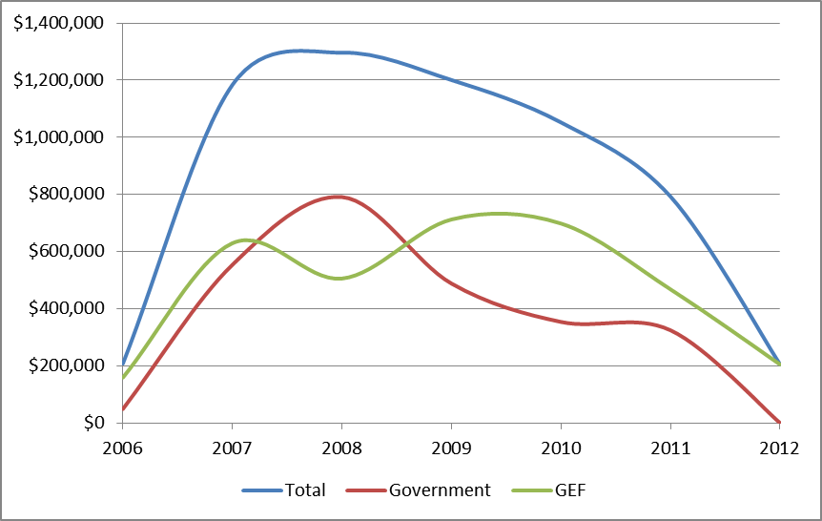

Figure - Annual Disbursements by Funding Source (US$)

1. Figure 3 reveals the following patterns:

* The overall disbursement pattern reflects a healthy project, in which total disbursements pick-up quickly in the first years, and remains relatively constant until the project ends.
* Disbursement by Government sources tends to be smoother than GEF disbursements. This probably reflects the “buffering” effect of the budgetary processes on the government side, in which planned budgetary resources are allocated ahead of time and disbursed primarily to cover recurring costs.
* On the GEF side on the other hand, and as we will see later, the disbursements are less smooth, with a dip in 2008, possibly reflecting the project operational challenges experienced in those years.

1. The disbursement profile in Figure 3 is not the typical profile of a GEF project characterized by slow start. This project seems to have been able to start quickly following the Prodoc signature (as mentioned earlier), and to disburse rapidly thereafter.
2. Figure 5 below shows the project disbursements by Project Outcome.

Figure - Annual Disbursements by Project Outcome (US$)

1. Figure 5 reveals the following patterns:

* Outcomes 1 (Improved Information Management), 3 (Strengthened System of PAs) and 5 (Increased Knowledge and Awareness), show a pattern of smooth disbursement, spread evenly throughout the project life.
* Outcome 2 (Strengthened Regulatory Capacity) on the other hand, reflects a pattern of accidental disbursement with exaggerated “ups and downs.” This probably reflects an inability of the project to maintain a cohesive vision regarding the implementation of this component.

## COFINANCING

1. Figure 6 below shows a summary of the co-financing figures by funding source, and compares expected co-financing at the time of Project Approval against actual co-financing achieved. Figures in blue highlight categories in which co-financing exceeded expected amounts; figures in red, on the other hand, reflect shortcomings.

Figure – Co-financing, Proposed vs. Actual (US$)



1. Several patterns emerge from Figure 7:
   * The total co-financing achieved exceeded the planned amount by almost US$700,000.
   * Most of this increase is due to Government sources (Federal and Regional), which exceeded their planned commitments by more than US$2M. This pattern was observed at all government levels, including the Federal government, the two Oblasts, and the Republic of Kalmykia.
   * Co-financing from other sources fell short of expectations by about US$1.3M; nevertheless, new sources of co-financing totaling above US$300,000 were successfully identified and added after the project started.

## PROJECT IMPLEMENTATION HISTORY

### Project Inception and Early Implementation

1. The first project activities included the recruitment of key staff among them the National Project Director (NPD) authorized in April 2006, and the National Project Manager (PM) in July 2006. The appointment of the PM required UNDP’s Russia Country Office to draft the Terms of Reference (TORs) and the organization of a competitive public tender procedure for its hiring. On July 1st 2006, Ms. Ludmila Kiseleva was appointed as the first PM. After the 1st Meeting of the Project Steering Committee (PSC) and the Inception Workshop (see above), the official launch of the project took place in Astrakhan on July 11 – 13th, 2006 (UNDP 2007). A detailed Project Implementation Plan and a Project Management Structure were discussed and agreed.
2. Project Implementation during the remaining of 2006 focused on hiring additional staff and building awareness about the project’s goals among key constituencies. Day-to-day implementation became the responsibility of the PMU divided among two offices: one in Astrakhan, and one in Volgograd.
3. The PM position was held by Ms. Kiseleva until September 2007, when she was sadly killed in a car accident. She was relatively swiftly replaced after a competitive process by Dr. Ekaterina Tkachenko, who took over in early 2008 and until mid-2009 when she was once again replaced. Thus, and since the first disbursement (July 2006) and until the Mid-Term Evaluation (MTE) took place in January 2009, the project lacked stable leadership, having two PMs each with less than 14 months in office.
4. It is important to note, however, that the early implementation of the project was challenging for reasons additional to the management changes described above. They go beyond operational issues and are rooted on the ultimate goals that the project was trying to achieve: First, the project attempted to tackle fundamental water resource management issues that in the past have been decided primarily on the basis of pure economic considerations with visible impacts upon society: agriculture, transport, and energy. Second, the project attempted to implement a watershed management vision throughout a large region comprising 3 geographic areas that differ in their administrative and socio-economic characteristics. Finally, the project’s vision in which ecological dimensions would be internalized and mainstreamed in order to achieve long term environmental sustainability was not readily shared or understood by all stakeholders.
5. In reality, these challenges are not unique or endemic to the Lower Volga region of Russia: they are germane to human societies worldwide. In this sense, it is important to point out that while the project was challenging, it was not necessarily complex in the sense of having been over-designed, or because it was trying to achieve “the impossible.”
6. It can be argued that the early implementation phase of the project can be considered as time lost due to the lack of management stability and the inability to deliver sharply focused outputs. On the other hand, it can also be argued that such a challenging project required a maturation phase in which the project’s vision and ideas are introduced to the key constituencies, and thus fundamental seeds of change, chiefly among these, awareness, were sowed. The actual magnitude of the impact of these early actions is difficult to determine but it was probably substantive.

### Mid-Term Evaluation (MTE)

1. The MTE took place in January 2009. It raised serious flags about the poor project performance to that date, and clearly pointed out the need to be more realistic about what the project could achieve (UNDP 2009). These concerns were also reflected in the relevant PIRs for 2007, 2008, and 2009, in which the project was rated by UNDP as Marginally Satisfactory due to the slow progress both towards delivering outputs and towards achieving its Development Objectives.
2. Therefore, 2009 becomes a turning point in the project implementation history. UNDP closely monitored the project daily activities in order to ensure a minimum level of disbursement delivery. According to the 2009 PIR (UNDP 2009): “Most of the recommendations focusing on the project implementation and management that required immediate action in the MTE have already been implemented. UNDP CO visited the project in June 2009 and participated in the project steering committee meeting and stakeholder consultations. The main objectives (…) were to refresh and reconfirm the project vision and plans with stakeholders, to fix the project management arrangements, and to plan for the implementation of most critical project's outcomes. The project receives strong political support at the local level, the project team has excellent working relations with the national executing agency, internal relationships and morale in the team improved noticeably, and local stakeholders are prepared to work constructively with the project. These factors speak of a potential for the project to get back on track over the next months with the support from its stakeholders.”
3. Several changes in the operational strategy were implemented, including:

* The release of the second PM and the hiring of the current PM (Ms. Natalya Lopantseva),
* Adjustments to the Results Framework (described above),
* Re-definition of project indicators,
* Project closing extension to June 2012, and
* Increased focus on activities with visible practical results in line with stakeholders’ needs and expectations.

1. Furthermore, the 2009 PIR states that “In the upcoming months, the project team shall concentrate on the following: The project team shall ensure that the project shifts its focus from purely theoretical work to more practical on-the-ground work that will result in visible outputs. This will help to retain and improve stakeholders buy-in. Some of the indicators were changed accordingly to enable the adequate assessment of the results achieved. These changes are reflected in the present PIR. Work on the hydrological aspects of wetland biodiversity conservation shall be accelerated. Establishment and expansion of PAs and capacity building to existing PAs is another important area. The team shall pay additional attention to activities aimed at increasing the financial sustainability of PAs, by means of awareness raising for government stakeholders, and supporting direct PA income generating activities, including, if necessary, legislative changes. The delays remain the serious concern and shall be addressed accordingly.”

### Project Implementation Since 2009

1. Since 2009, the project has experienced a remarkable turnaround that back then was inconceivable. Indeed, this is a remarkable story. The hiring of the new PM (Ms. Natalya Lopantseva) was no doubt the key development responsible for this turnaround. In addition, however, this report argues that many of the earlier project implementation activities served as building blocks for the awareness that resulted in the strong political support that the project enjoys today. Furthermore, the continuity of many of the staff that remained in the project provided a commitment that further strengthened the foundations of the project.
2. The 2010 PIR presents a changed perception of the project: ”UNDP CO visited the project in May 2010 to participate in the project steering committee meeting and stakeholder consultations. Project partners showed increased satisfaction and interest in project activities. This is the result of the project shifting from conceptual to a more practical on-the-ground work. And this is also a sign of an overall improvement of relation with the stakeholders. A visible progress was achieved in all of the project outcomes and the project is on track towards reaching its objective. In the next reporting period the project shall focus on completing all the challenging activities that have been initiated.”
3. The 2010 further states: “The rating of progress to DO has increased from "Marginally Satisfactory" in 2009 to "Satisfactory". (…) the newly appointed 3d PM established enabling working environment for the Project Management Team. A new, highly competent Task Manager on Biodiversity Conservation & PAs was hired. Contacts with stakeholders significantly improved, resulting in an increased mutual trust, especially with regional nature conservation authorities but notably also with the Lower Volga Basin Management Authority, focusing on improved regulation of dam water discharge to the LV. Good pace was gained in implementation of on-the-ground activities, (…). As a consequence, both Capacity Assessment Scores and METT scores maintained or increased their rise compared to the PIR 2009.”
4. The 2011 PIR consolidates the view that the project not only is back on track, but that it is making solid progress towards delivering its outputs and achieving its Development Objectives: “The 2010 “satisfactory” DO rating is maintained in this reporting period. Implementation and completion of on-the-ground activities continued at good pace: management plans for all established PAs in the project region are completed and endorsed; support is provided to various Departments (Awareness Raising , Ecotourism, Monitoring, Control) of 3 PAs in strengthening technical equipment resources, as well as to improve PA boundary demarcation and reconstruction & furnishing of one visitor center. The project documentation for the establishment of a new PA in the Volga-Akhtuba floodplain (Astrakhan Oblast) was completed, and is currently under review by the Ministry of Natural Resources and the Environment of the Russian Federation. The regional Nature Park “Volga-Akhtuba floodplain” (Volgograd Oblast) was formally internationally recognized as UNESCO Biosphere Reserve. (….). Overall, the present rating is considered valid as the PMT agrees on the ability of the project to reach most of its indicator targets in the logical framework by the end of the project.”
5. At the time of the Terminal evaluation visit, these views were widely shared by all interviewed, and the support for the project at all levels (public, private, NGOs) was palpable.

## PROJECT PERFORMANCE SUMMARY

1. This section[3] builds from the reinforcing observations provided by the analysis of key projects data and dates, project disbursement patterns, information provided annually in the PIRs, the MTE report, and the interviews during the field visit. The project performance in relation to implementation, disbursements, and ability to delivery outputs can be summarized as follows:
2. The approval process was extremely slow. The first disbursement took place on July 7, 2006, almost 8 years after its informal pipeline entry (PDF-A approval). The project is scheduled to close in December 2012, which is 14 years after this pipeline entry. It is legitimate to ask whether or not the challenges, premises, risks, and opportunities present at the time of project design are still present today, a full 14 years after the project was first formally conceived; thus, projects accomplishments may be strongly influenced by adaptive management than by design itself.
3. On the other hand, and once the project was approved by the GEF, implementation was relatively swift. The original project duration was envisioned to be 5 years, but in the end it took 6.5 years to implement it. This is not a major shortcoming both when compared with other GEF projects, as well as taking into account the challenging issues at stake.
4. The Mid Term Evaluation (MTE) occurred at a critical time and the subsequent steps taken by UNDP to correct direction had a fundamental and far-reaching influence over the project performance during subsequent years. Several changes in the operational strategy were implemented, including: the hiring of the current PM (Ms. Natalya Lopantseva), adjustments made to the Results Framework, re-definition of project indicators, project closing extension, and an increased focus on activities with visible practical results in line with stakeholders’ needs and expectations.
5. The years 2010 and 2011 saw the final consolidation of key project outputs, and the project entered into a phase in which it effectively achieved and in many cases exceeded its targets for outputs, outcomes, and its goal. The very strong and widespread support witnessed by the evaluator everywhere in the field, coupled with the objective measurement of the project’s results as described in the next section point to a remarkable success story and an example of a best practice in project turn-around.

# PROGRESS TOWARDS ACHIEVING OUTCOMES, GLOBAL ENVIRONMENTAL BENEFITS, AND THE PROJECT’s GOAL

1. The previous section discussed the progress made by the project under the following two dimensions: (i) Project performance as measured by implementation effectiveness and (ii) Progress towards delivering inputs and outputs (disbursements). With these results in mind, this section now analyzes three fundamental question of the Final Evaluation:
2. Has the project achieved its outcomes?
3. Has the project generated global environmental benefits?, and
4. Will results be sustainable beyond the project life?

## Achievement of Outcomes

1. This question is analyzed separately for each of the 5 Project Outcomes. Targets for each Outcome are ranked against achievement at the time of the Terminal Evaluation by following the color key in Table 4 below (refer to Annex 1 for the full Logical Framework):

Table 4 – Color-key to Rank the Level of Outcome Achievement

|  |  |  |
| --- | --- | --- |
| **Level of Achievement** | Color-Code | Rating[4] |
|  |  |  |
| Achieved |  | HS and S |
| In Progress |  | MS and MU |
| Little or no Progress so Far |  | U and HU |

HS = Highly Satisfactory; S = Satisfactory; MS = Marginally Satisfactory; MU = Marginally Unsatisfactory; U = Unsatisfactory (U); HU = Highly Unsatisfactory

1. The color-coded method[5] is used to facilitate the rapid review of the broad patterns emerging, but specific ratings are also provided.

***Outcome 1***. ***Improved Information on the LV and its Biodiversity as well as Improved Information Management and use in Decision-Making***

1. Table 5 below summarizes the progress made by the project at the time of the Final Evaluation towards achieving the targets under Outcome 1.

Table 5 - Level of Achievement for Outcome 1

|  |  |  |  |
| --- | --- | --- | --- |
| **Outcome 1** | **Indicator** | **Target** | **Achievement** |
| Improved Information on the LV and its Biodiversity as well as Improved Information Management and use in Decision-Making | Protocol on Information Exchange is elaborated and signed. Government and non-government stakeholders exchange information on their activities in the field of monitoring, data collection & analysis. | Monitoring protocol signed by at least 10 stakeholder organizations: Regional representative of federal level, PAs, regional level authorities. | **S** |
| Access to the web site and meta-database on LV wetland biodiversity secured for all stakeholders. | Web site exists, is accessible, regularly updated and institutionalized. | **HS** |
| Maximum acceptable stress load norms for recreation and agriculture are elaborated and formally endorsed. | Elaborated stress load norms are formally endorsed by relevant government authorities. | **HS** |

1. Targets for this Outcome were exceeded, with the exception of the first target (monitoring protocol developed and signed by at least 10 stakeholders), where although the protocol was developed, so far only 8 institutions have signed. The web portal and database on biodiversity is functioning. Finally, stress loads norms for agriculture and recreation have been developed, adopted for agriculture, and expected to be adopted for recreation at the time of project end.
2. These indicators, however, do not properly reflect the major project accomplishments to improve the information on the LV and to enhance its management. Major accomplishments not captured by these indicators include major hydrological studies linking habitat health and water regimes, substantive advancement in understanding of basic biology and management options for Oak Forests, several basic scientific studies supported on biodiversity distribution and abundance, etc.
3. Some of these accomplishments are fundamental. In particular, and as a result of direct project participation, some of the major stakeholders including officials at Russ-Hydro (in charge of managing water for electricity generation) have a new understanding about the values of water for nature and people. A formal decree recognizing these linkages in the LV within the “Federal Target Program for the Development of Water Economic Complex of the Russian Federation in 2012-2020” was signed by President Putin on April 19, 2012 (Government of Russia, 2012), and this milestone is widely acknowledged to be a result of the project.

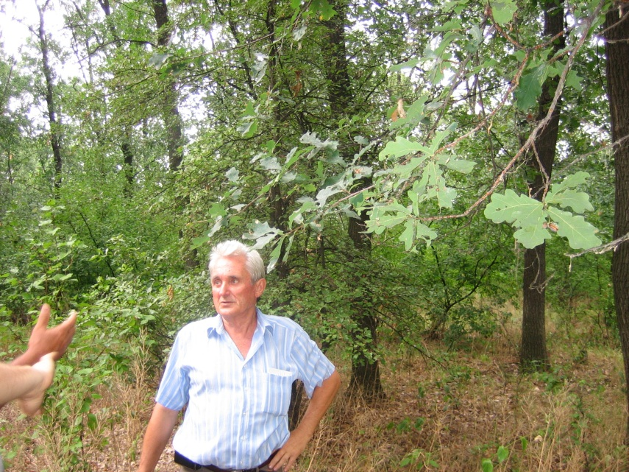

Figure - Dr. Victor Shulga, Recognized Oak Expert in Charge of Oak Studies

***Outcome 2***. ***Strengthened Institutional and Regulatory Capacity and Multi-Sectoral Mechanisms for Biodiversity Conservation and Use in the LV***

1. Table 6 below summarizes the progress made by the project at the time of the Final Evaluation towards achieving the targets under Outcome 2.

Table 6 - Level of Achievement for Outcome 2

|  |  |  |  |
| --- | --- | --- | --- |
| **Outcome 2** | **Indicator** | **Target** | **Achievement** |
| Strengthened Institutional and Regulatory Capacity and Multi-Sectoral Mechanisms for Biodiversity Conservation and Use in the LV. | PA Directorates formally participate in decision-taking on land use activities on their territories. | All PAs formally participate in decision-making | **HS** |
| PAs actively cooperate with tourist companies in developing ecotourism in the LV wetlands, in line with ecological tourism guidelines. | At least 10 tourist companies formally cooperate with PAs towards implementing ecological tourism in the LV wetlands. | **S** |
| Capacity Assessment scorecard. | Astrakhan Administrative Region: 70  Volgograd Administrative Region: 71  Republic of Kalmykia: 68 | **S** |

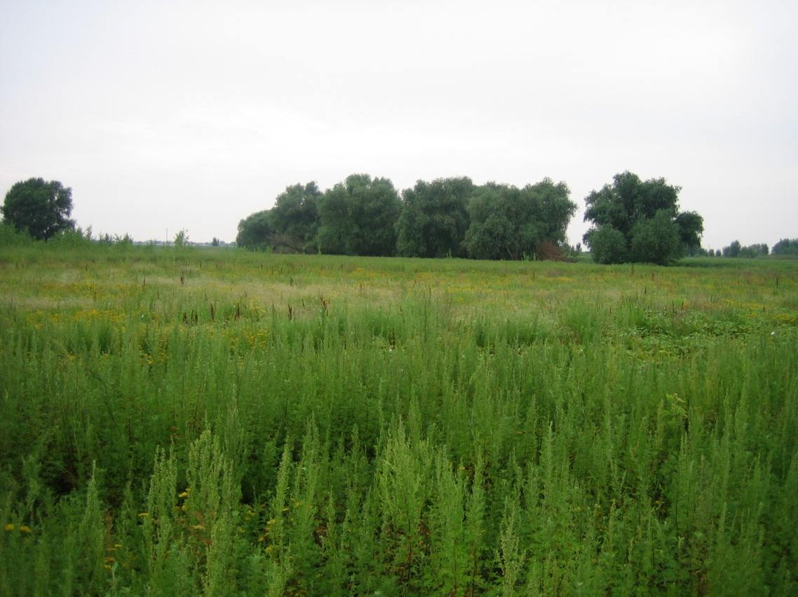

Figure - A view of the Nature Park of the Republic of Kalmykia

1. Targets under Outcome 2 were also largely exceeded. Both Oblasts and the Republic of Kalmykia now formally incorporate PA authorities to participate in decisions regarding land-use licensing procedures. The project also drafted an Ecotourism Development Plan for the LV, which was discussed with stakeholders and formally approved by the Astrakhan government and authorities. So far, 9 agreements with companies and institutions have been signed (out of a target of 10).
2. Institutional capacity has increased substantially from the baseline level as measured by the Capacity Assessment Scorecards (CAS), but they have not yet achieved their targets. Increases in scores represent between 65% and 76% of the targets. Given the steady rate of increase in the CAS, it is conceivable that the project may reach its targets at the time of project closure.
3. Once again as in the case of Outcome 1, the indicators and targets are modest and do not reflect the actual accomplishments of the project. It is clear that there is a strengthened capacity to better mainstream ecological considerations in the management of the LV at all levels.

***Outcome 3. A Strengthened LV System of Protected Areas***

1. Table 7 below summarizes the progress made by the project at the time of the Final Evaluation towards achieving the targets under Outcome 3.

Table 7 - Level of Achievement for Outcome 3

|  |  |  |  |
| --- | --- | --- | --- |
| **Outcome 3** | **Indicator** | **Target** | **Achievement** |
| A Strengthened LV System of Protected Areas | Management Effectiveness Tracking Tool (METT) scores Increased | -Astrakhanskiy Zapovednik: 69  -Ilmenno-Bugrovoy Reserve: 66  -Natural Park Volga-Akhtuba Floodplain: 66  -Nature Park of the Republic of Kalmykia: 56 | **S** |
| Non-budgetary revenues generated by PAs, in relation to government budget contributions for nature conservation activities | -Astrakhanskiy Zapovednik:  8,718,840 RuR  -Ilmenno – Bugrovoi Reserve:  423,832 RuR  -Natural Park Volga-Akhtuba floodplain (Volgograd oblast):  4,177,177 RuR  -Nature Park of the Republic of Kalmykia: 290,628 RuR | **MU** |
| Hectares of idle agricultural lands restored for use as spawning grounds | 4,000 ha | **HS** |

1. The Management Effectiveness Tracking Tool (METT) scores increased steadily in the four target PAs. The target was achieved at the Volga-Akhtuba Floodplain PA, but is still lags for the other 3 areas, and is currently at the 84% - 90% level. The momentum gained by the project makes it likely that these scores will continue to increase and reach their targets in the near future.
2. Regarding the increase in absolute levels of non-budget income generated by the PAs, the targets were not achieved. When compared with the baseline, these amounts exceeded the baseline in one case, remained at the baseline level in another, and dropped below the baseline in two cases.
3. The target for restoration of agricultural lands was exceeded by over 50%. This is a very successful indicator expected to continue growing in the future and thus providing seasonal fish spawning grounds, hay lands, pastures, as well as improved hydrological regimes.
4. The extension and creation of the new PAs (discussed below under the Goal) is not captured under this Outcome, even though it is clear that these deliveries are major contributors to the Outcome.

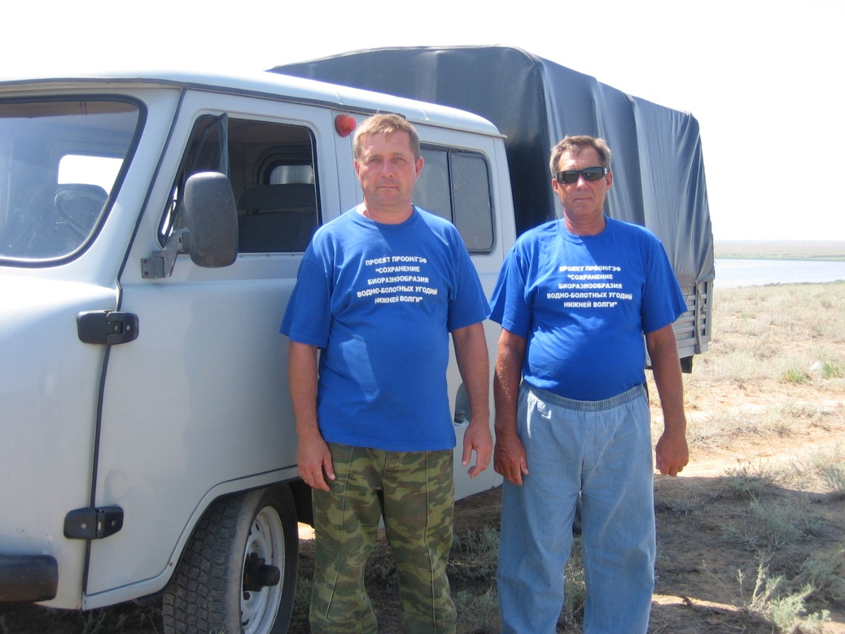

Figure – Messrs. Novichkov and Kotolevskiy, Ilmenno – Bugrovoi Reserve, Astrakhan

***Outcome 4. Increased Opportunities for the Development of Sustainable Alternative Livelihoods within CWAs and their Vicinities***

1. Table 8 below summarizes the progress made by the project at the time of the Final Evaluation towards achieving the targets under Outcome 4.

Table 8 - Level of Achievement for Outcome 4

|  |  |  |  |
| --- | --- | --- | --- |
| **Outcome 4** | **Indicator** | **Target** | **Achievement** |
| Increased Opportunities for the Development of Sustainable Alternative Livelihoods within CWAs and their Vicinities | Project-demonstrated examples of alternative livelihood options in key wetland areas. | 10 | **HS** |
| Micro-credit facility on wetland biodiversity-friendly alternative livelihoods. | At least 2 micro-credit facilities are established in the project region, revolving credit funds are timely returned by loaners. | **HS** |
| Initiatives supported by the Small-Grant Program demonstrate positive benefits for wetland biodiversity, albeit not necessarily being economically viable. | Project-supported small grant activities impact positively on wetland biodiversity | **HS** |

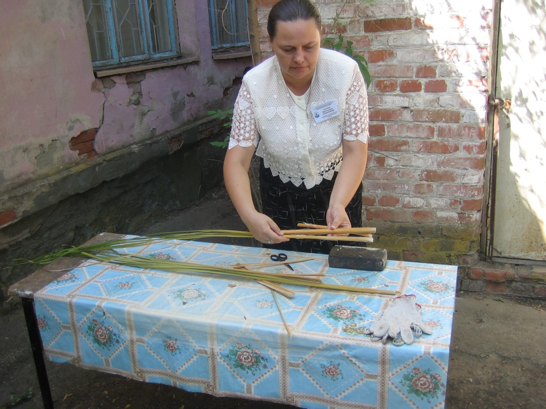

Figure - Demonstration of Handicraft Making at the Astrakhan Local Lore Museum

1. The project successfully issued 16 small grants to the projects specializing in various fields, from population's awareness rising to rural guest houses. The number of grants awarded (16) exceeded the target (10) by more than 50%. The consultant witnessed a very strong support expressed by the grantees, but this is not unusual since they are all receiving “free money.” Given the variety of grants awarded, however, it is difficult to properly measure the impact of such grants (it is noted that the indicator measures an output and not an outcome). If for example the purpose was to enhance awareness, then it is evident that these grants were successful. If on the other hand these grants were expected to establish replicable experiences of sustainable economic activities, then the impact is more doubtful.
2. It is unlikely, for example, that some of the local village houses can ever be sustainable. The logic of these efforts goes against the grain of the local economy. Indeed, the region of Astrakhan already attracts over 2 million visitors a year to commercial tourism facilities run by private enterprises who sell the local ecological attractions of the region to fishermen and hunters primarily coming from Moscow. The project made some efforts to green the existing industry, including elaborating guidance books, recreational load norms for wetlands, training and informational events aimed at ecotourism operators and local authorities, etc. There were meetings where the Project presented a plan of eco-tourism development for approval. An agreement was signed between the Project and the AO Government “On strategic collaboration in the sphere of eco-tourism development on the territory of the Astrakhan Oblast”. The inventory of the region’s recreational resources was held, methodological, information and recommendatory materials were elaborated and published, recreational load norms for the wetlands were developed, and training and awareness raising activities devoted to ecotourism were organized.
3. At the same time, the project could have been more aggressive in trying to “piggy-back” upon these successful private enterprises to introduce ecologically-friendly approaches such as “catch and release” fishing, photographic safaris, etc. In this case, the indicator is ranked as highly satisfactory (because it is tracking the output), but the impact and sustainability of some of these activities is dubious.[6]
4. The micro-credit facilities, on the other hand, operate within an existing micro-credit financial institution, building upon a mainstream sector while introducing ecological considerations as a screening tool to award GEF resources. This approach is much more likely to be sustainable because loans need to be repaid by the company or individual making use of the funds and thus all the energies of the recipients are aligned towards achieving the results. The author considers it important to highlight this experience, and even though it is too early to provide a final opinion regarding the sustainability of these efforts, the screening tool developed by the project to rank eligibility is reproduced in its entirety in Annex 7, given its importance to the GEF-wide family and because it can serve as an example to be replicated or improved elsewhere in the GEF portfolio. The design of the micro-credit facility is ranked as best practice, and it is recommended that an impact study should be performed to better understand the actual biodiversity benefits of these loans.
5. The experiences here suggest that small grants are an appropriate tool to support local awareness, especially when environmental education can be multiplied through local groups (whether school districts, local museums, etc.). On the other hand, small grants are clearly not a tool to be used to support profit-making enterprises. These supply-side approaches tend to subsidize unsustainable activities which in the end should be taken over by private enterprises operating in the standard risk-reward environments that underpin market economies. In these cases, micro-credit facilities should be the chosen tool.

***Outcome 5. Increased Awareness and Support for Biodiversity Conservation and Sustainable Development in the LV***

1. Table 9 below summarizes the progress made by the project at the time of the Final Evaluation towards achieving the targets under Outcome 5.

Table 9 - Level of Achievement for Outcome 5

|  |  |  |  |
| --- | --- | --- | --- |
| **Outcome 5** | **Indicator** | **Target** | **Achievement** |
| Increased Awareness and Support for Biodiversity Conservation and Sustainable Development in the LV | Level of awareness on biodiversity values and conservation efforts among the population of the LV. | 50% increase over the baseline value | **N/A** |
| School course on wetland biodiversity taught at schools in the Lower Volga. | 15 schools. | **HS** |
| Budget contributions to PAs for nature conservation activities by government authorities. | Increase 50% over the baseline:  Astrahanksi Zapovednik: US$540,000  Ilmenno – Bugrovoi Reserve: US$52,500  Natural Park Volga-Akhtuba Floodplain US$345,000  Natural Park Volga-Akhtuba Floodplain (Republic Kalmykia): US$36,000 | **HS** |

1. The measurement of the first indicator of this Outcome (level of awareness) is still in progress and thus no opinion can be provided. The project provided for the elaboration of a school course on wetland biodiversity on the lower Volga, and produced a high-quality teacher-textbook. Forty-two schools and 1,780 students participated, greatly exceeding the target of 15 schools. Finally, and regarding the budget allocation in 2012 compared with 2006, figures increased for all four PAs for nature conservation activities.

Figure - Project Poster at the Visitor Center in the Nature Park of the Republic of Kalmykia (RK)

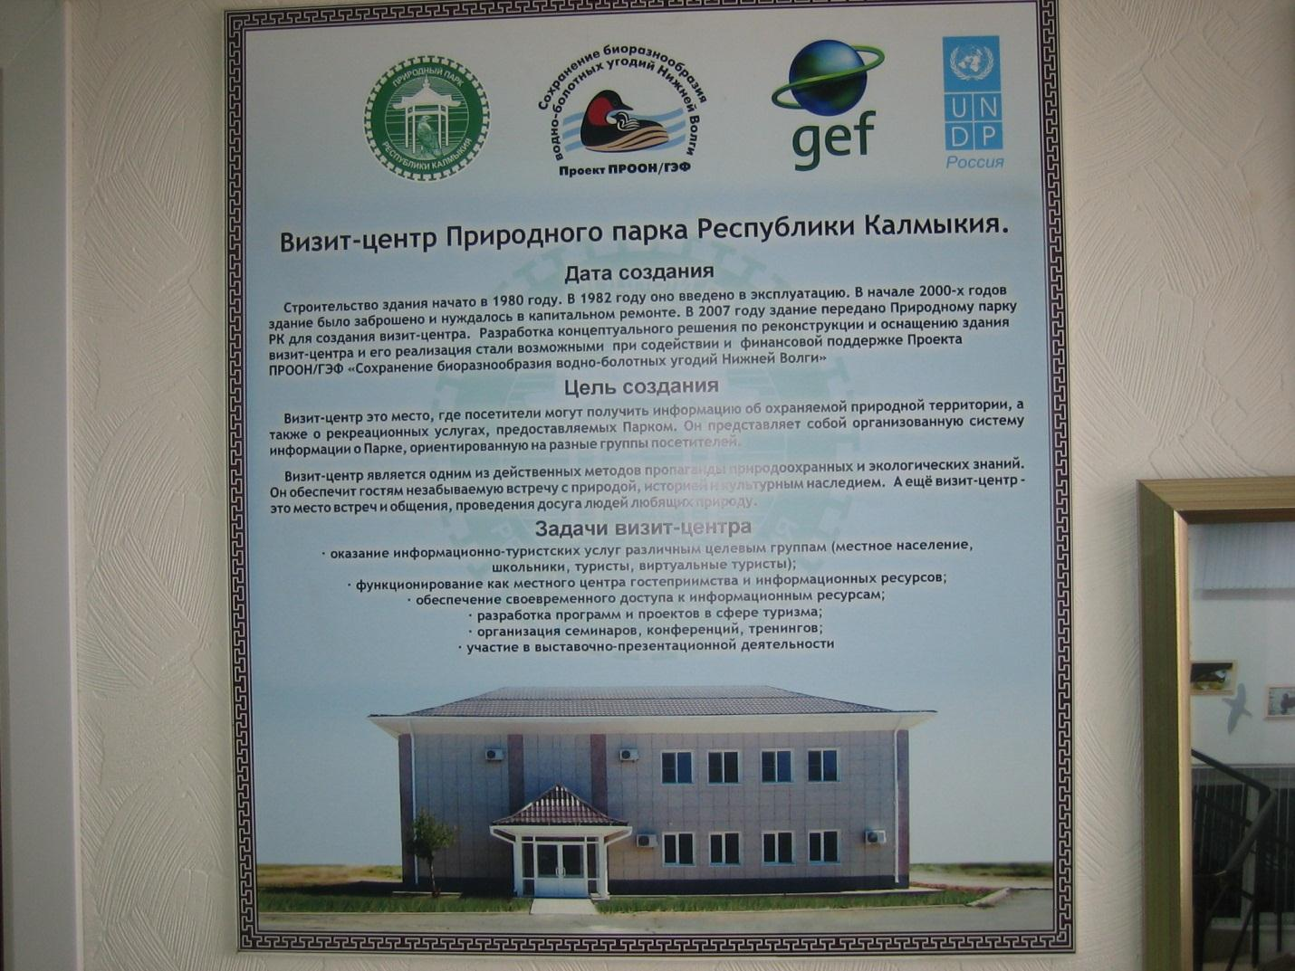

## Achievement of Global Environmental Benefits

1. Global environmental benefits under the GEF are tracked through indicators that are tailored-made for each of its Strategic Priorities under the Biodiversity Focal area. Under Strategic Priority 1 (Strengthening Networks of Protected Areas), the GEF utilizes a coverage indicator (number of hectares under protection), and a management quality indicator by using its “Management Effectiveness Tracking Tool” (METT). The underlying assumption to the use of these tools is that properly managed systems of protected areas with sufficient coverage effectively conserve biodiversity.
2. As mentioned above, the METTs were built-in as an indicator within Outcome 3. Scores increased steadily in the four target PAs: the target was achieved at the Volga-Akhtuba Floodplain PA, and although it has substantially increase in the other 3 areas, it has not yet reached the growth target and is currently at the 84% - 90% level of it.
3. It must be noted, however, that the project goes beyond the establishment and strengthening of PAs to deliver global biodiversity benefits in the LV. Given the key features of the watershed, maintaining global biodiversity values also requires the maintenance of ecological water flows and seasonal regimes over large scales. The project tackles this complex issue by introducing holistic water management in order to restore large-scale natural cycles of water regimes, which in turn produce the ecological succession that defines the ecology of these wetlands. This report therefore argues that the METTs are not sufficient to properly measure the global biodiversity benefits attained by this project, especially considering the scale in which the project operates. Measuring and tracing the METTs in isolation of the broader hydrological and ecological features provide a partial picture of both the challenges at stake, and the accomplishments of the project.

Figure – Observation Tower at the Nature Park “Volga-Akhtuba Floodplain”

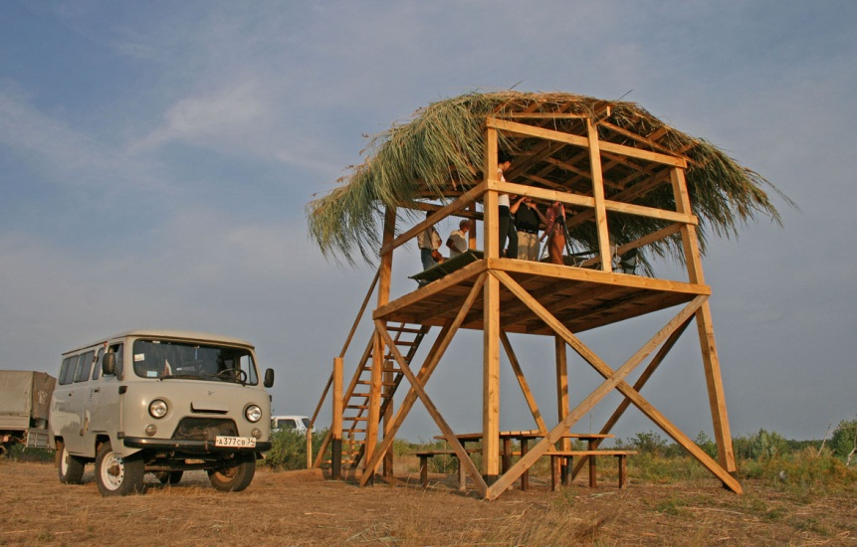

## Achieving the Project Goal and Sustainability Issues: Towards Long-Term Impacts

1. Finally, Table 11 below shows the level of progress toward achieving the targets of the Project’s Main Objective. The table utilizes the color-key described in table 4. The color-coded method is used to facilitate the rapid review of the broad patterns emerging, but specific ratings are also provided.

Table 11 – Level of Achievement for the Project Main Objective

|  |  |  |  |
| --- | --- | --- | --- |
| **Main Objective** | **Indicator** | **Target** | **Achievement** |
| To secure conservation and sustainable use of biodiversity in four key wetland areas of LV. | Population of key species in the CWAs (several) | Population numbers of the listed key species at least remain at their long-term average level (1997-2005 – baseline level) | **N/A** |
| Total area under protection (federal, regional and community levels) | 678,000 ha | **HS** |
| The number of bird colonies and their population numbers in the CWAs (several). | The number of colonies and the population numbers of the listed key species at least remain at their long-term average level (1997-2005 – baseline level) | **N/A** |
| The surface area covered by the Red data Book species - Lotus Lily (Nelumbo caspica) in the Volga Delta (indicator of ecosystem health) | Remain at least at its long-term average level | **HS** |
|  | The surface area covered with Oak (Quercus robur) in the Volga-Akhtuba floodplain (locally considered as key species because it is at the most southern boundary of its area) | No reduction in area compared to the baseline | **U** |

HS = Highly Satisfactory; S = Satisfactory; MS = Marginally Satisfactory; MU = Marginally Unsatisfactory; U = Unsatisfactory (U); HU = Highly Unsatisfactory

1. Two indicators at the Main Objective level have not yet been collected. Two additional indicators have been met or exceeded, and one has not reached its target. Of these, the most important one reflects a fundamental accomplishment of the project, which is enhancement of the system of PAs in the basin as a cornerstone of ecological sustainability.
2. At the outset, however, it is important to mention that in the author’s opinion these higher-level Impact indicators do not provide an accurate view of the project’s real impacts. Because the majority of these indicators reflect patterns of presence or abundance of selected species, and given that these species are subjected to natural patterns of variations whose cycles greatly exceed the life of the project, for the most part it is impossible to attribute results to the project interventions.
3. For example, the indicator measuring the surface area covered with Oak shows a net decrease from the baseline. An yet, based on the studies financed by the project, it is evident that the decreases observed are the product of changes in water regimes that go back decades and thus it would not be realistic to expect the project interventions to be reflected in the area covered by Oak forests in such a short time. The other side of this coin is that some of the changes in water management regimes introduced by the project are already having positive impacts upon the health of some Oak populations, even if the area covered by these populations cannot yet be objectively measured. Therefore, and despite that the project is clearly having a positive impact upon Oak populations, the indicator provides an “Unsatisfactory” result.
4. Fortunately, it is possible to construct a rationale to understand the project’s actual impacts and sustainability prospects by going beyond the project’s indicators. The following unquestionable patterns emerge:
   * Despite a “rocky” start, the project was able to disburse and implement activities closely following its pre-determined plan and for the most part within the GEF’s average “standards of service,”
   * Most outcome indicators can be rated as highly satisfactory (even if in some cases the indicators measure project outputs instead of outcomes),
   * The project established a solid foundation to introduce ecosystem-level management considerations at the LV at the level of key institutions, both public and private,
   * Awareness regarding the relations between nature and water, and the consequent importance of the ecosystem services provided by wetlands, was substantially increased,
   * A great number of tools including studies, guides, guidelines, and management recommendations were developed and adopted, including the Presidential decree recognizing the importance of water in the LV for biodiversity, and the joint decree of the Astrakhan Government and the Federal Ministry of Natural Resources which reinforces the expansion of the “Volga Delta” Ramsar site area and introduces the management arrangements to ensure the international wetland regime compliance,
   * Local capacity for understanding ecosystem-level issues was enhanced, and
   * A shared vision regarding the ecosystem-level management needs of the LV has been achieved – this vision is shared across political divisions, a major accomplishment in itself.
5. A major accomplishment of the project is the successful expansion and establishment of the PA network (Figure 14). Protected areas were strengthened and increased in area by more than 100%, thus establishing a “back bone” for the long term biodiversity conservation in the LV, and the total area under protection is expected to exceed the target and reach 748,640 ha. Here it can be seen that a “backbone” of PAs now protects a significant portion of the LV, thus constituting the foundation for effective ecosystem-level ecological management of the LV.

Figure - Ecosystem-level system of PAs

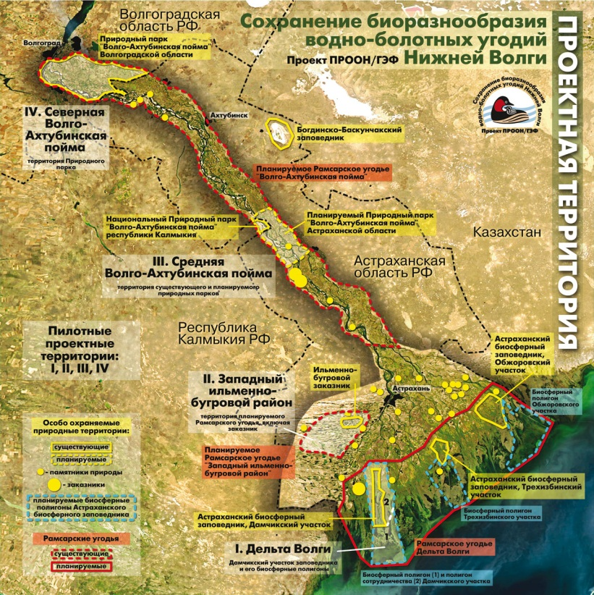

1. On the basis of these observations, it is evident that the project’s achievement of its goal, to “ensure the conservation and sustainable use of biodiversity in the Lower Volga region” can be rated as Highly Satisfactory. Because these accomplishments transcend the project’s lifetime by influencing society over the long term, the project’s sustainability is also rated as Highly Satisfactory. Table 12 below provides the summary ratings for the project.

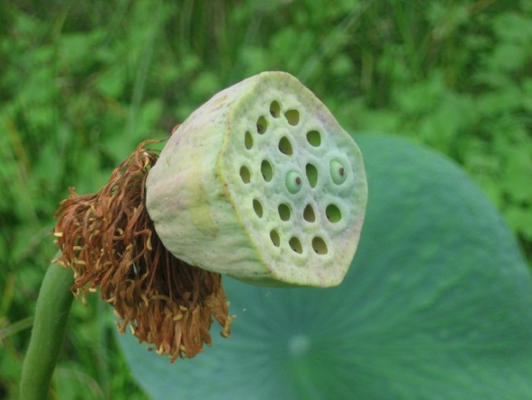

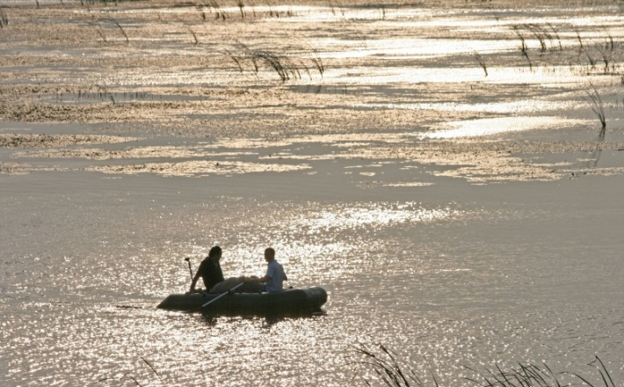

Table 1 - Summary Ratings

|  |  |
| --- | --- |
| **Element Evaluated** | **Rating** |
|  |  |
| Project success overall | HS |
| Progress towards achieving its development objective | S |
| Progress in implementation | S |
| Sustainability | HS |

HS = Highly Satisfactory; S = Satisfactory; MS = Marginally Satisfactory; MU = Marginally Unsatisfactory; U = Unsatisfactory (U); HU = Highly Unsatisfactory

# CONCLUSIONS, LESSONS LEARNED, AND RECOMMENDATIONS

1. This final section builds upon the findings delineated in the previous sections to arrive at high-level conclusions; it also looks forward by attempting to distill lessons learned and propose recommendations to guide future actions.

## Conclusions

1. The Conservation of Wetland Biodiversity in the Lower Volga Region project was characterized by a pattern of a very slow approval process but relatively swift implementation after GEF CEO Endorsement. Its early implementation phase was challenging and characterized by a lack of management stability. The project had two Project Managers in the first 3 years, each lasting less than 14 months.
2. The Mid-term evaluation (MTE) pointed to serious implementation shortcoming, which have also been identified by UNDP as reflected in the relevant PIRs in which the project was rated as Moderately Unsatisfactory. Swift changes were promoted by UNDP at mid-term, including the hiring of the third and current PM, a revision of the results framework, an extension of the project’s closing date, and a refocusing of the project on practical and visible on-the-ground activities in order to regain stakeholders trust.
3. Since mid-2009 the project changes course radically, and represents a remarkable example of a project turnaround. Scores in the PIR improve to Satisfactory, while project deliveries of outputs and outcomes accelerate and in most cases these deliveries exceed the project’s targets.
4. At the Outcome level, the project reached or exceeded most of its targets; nonetheless and as elaborated earlier, the indicators for outcomes do not properly capture the higher-level accomplishments of the project towards fulfilling its Goal. The same finding applies to the indicators of the Main Objective, where these higher-level Impact indicators do not provide an accurate view of the project’s real impacts. Because the majority of these indicators reflect patterns of presence or abundance of selected species, and given that these species are subjected to natural patterns of variations whose cycles greatly exceed the life of the project, for the most part it is impossible to attribute results to the project interventions.
5. Fortunately, it is possible to construct a rationale to understand the project’s actual Impacts and sustainability prospects by going beyond the project’s indicators. As mentioned earlier, the following unquestionable patterns emerge:

* Despite a “rocky” start, the project was able to disburse and implement activities closely following its pre-determined plan,
* Most outcome indicators can be rated as highly satisfactory (even if in some cases the indicators measure project outputs instead of outcomes),
* The project established a solid foundation to introduce ecosystem-level management considerations at the LV at the level of key institutions, both public and private,
* Awareness regarding the relations between nature and water, and the consequent importance of the ecosystem services provided by wetlands, was substantially increased,
* A great number of tools including studies, guides, guidelines, and management recommendations were developed and adopted, including the Presidential decree recognizing the importance of water in the LV for biodiversity,
* Protected areas were strengthened and increased in area by more than 100%, thus establishing a “back bone” for the long term biodiversity conservation in the LV
* Local capacity for understanding ecosystem-level issues was enhanced, and
* A shared vision regarding the ecosystem-level management needs of the LV has been achieved – this vision is shared across political divisions, a major accomplishment in itself.

1. On the basis of these observations, it is evident that the project’s achievement of its goal, to “ensure the conservation and sustainable use of biodiversity in the Lower Volga region” can be rated as Highly Satisfactory. Because these accomplishments transcend the project’s lifetime by influencing society over the long term, the project’s sustainability is also rated as Highly Satisfactory.

## Lessons Learned

1. Looking ahead, it is important for future projects to learn from the successful experiences here, as well as to avoid pitfalls identified in this project. The following are the main lessons-learned:
2. *Proper Staffing is Critical to Project Success. S*taffturnover at the level of the PM was high in the early stages of the project and had a negative impact upon implementation effectiveness. Once the third PM was chosen, however, the project was able to regain ground and to effectively deliver its outputs and outcomes. Strong managerial skills, excellent inter-personal qualities, ability to listen, and willingness to bring together a variety of stakeholders were some of the salient features that allowed the third PM to bring the project to a successful conclusion.
3. *Mid-Term Evaluations can be Critical to Place a Project Back on Track*. The MTE had a crucial impact and is acknowledged as a decisive influence to put the project back on track. Although most of the issues brought out by the MTE were already known by UNDP as reflected in the relevant PIRs, the MTE catalyzed change because the high visibility these formal evaluation tools play.
4. *It is Possible to Turn a Project Around*. This project represents a remarkable example of a project turnaround. The turnaround clearly represents a team effort in which all parts of the project played a role. For the purposes of this evaluation, it is important to highlight UNDP’s commitment and dedication to put it back on track. The experience surrounding the turnaround of the project is highlighted as best practice.
5. *Small Grants and Micro-Credit Facilities are Complementary Tools but are not Interchangeable*. The small grants facility had an excellent impact upon increasing awareness and enhancing the participation of key and diverse stakeholders, especially local Museums, education institutions, etc. Their impact upon promoting sustainable economic enterprises, on the other hand, is doubtful. The Micro-Credit Facility, on the other hand, was mainstreamed within an existing institution with wide reach and existing delivery capacity. Given that these micro loans need are repaid with little or no delinquency, it is unlikely that their use will be economically unsustainable. The design of this component is highlighted as best practice, although it is also recommended that its actual biodiversity impact should be measured on the ground (see below).
6. *Large and Complex Ecosystems require Holistic Approaches that go Beyond the Establishment and Strengthening of PAs*. PAs are the backbone of conservation, and in the case of the LV the project was able to consolidate an excellent set of PAs to serve as its long term foundation. At the same time, this complex ecosystem depends upon the maintenance of complex patterns of hydrological and ecological features that shape the dynamics of the ecosystem. The project successfully tackled hydrological issues and engaged the appropriate stakeholders beyond traditional biodiversity and environment agencies.
7. *The Proper Bridging of Science and Policy can Produce Long-Term Fundamental Changes*. The project was successful in bridging science and policy. The project engaged basic but fundamental studies on hydrology and ecology that served as the basis for strong policy recommendation to link water and biodiversity management. Such policy accomplishments would not have been possible without the proper rationale and justification provided by the strong supporting studies.

## Recommendations

1. The project has successfully established the long-term foundation for a holistic management of the LV in which biodiversity and ecosystems are now recognized as legitimate water users. This is a major accomplishment and greatly enhances the long-term conservation prospects of these ecosystems. In order for the momentum gained not to be loss and for additional gains to be achieved, the following recommendations are provided:
2. Engage the Tourism Industry to Green its Practices. The area receives large numbers of tourists who come to enjoy nature, although with primary interests around recreational fishing and hunting. The fact that these tourists visit well-established tourism facilities within all budget ranges (from very modest to high luxury) demonstrates that private entrepreneurs have been able to successfully establish and run these operations. Given the large number of tourists, estimated at upwards of 2 million per year in Astrakhan alone, there are enormous synergies through which the current practices can be “greened” progressively and making it clear that a strong link exists between the sustainability of the tourism industry and the health of these ecosystems.
3. Continue the Long-Term Ecological Monitoring Programs. The project has successfully developed and deployed biological and ecosystem-level monitoring protocols (i.e. Oak forests). Given the complexity of these ecosystems, the large natural variations in ecological cycles, and the strong dependence of various habitats and species upon water regimes, it is critical to continue monitoring key biological and ecosystem features to continue learning and adapting management regimes.
4. Consider Introducing Systems of Payments for Environmental Services (PES). The area is a fertile ground for the deployment of PES systems. Although the project has made enormous progress linking water, ecosystems, and biodiversity, with major consequences upon water use by other sectors, the proper long-term management of water requires efficient water allocation among sectors and users, and PES can be a very useful tool in many cases including compensating small farmers, charging tourism operators, fishermen compensations, etc.
5. Engage the Energy Sector to Develop Biodiversity-Friendly Practices. The project has already established strong working relationships with the energy sector, in particular with the hydropower sector (RusHydro), and with the Oil and Gas industries. The LV provides extraordinary opportunities to develop biodiversity-friendly practices with science as its foundation. The existing trust among key players represents a significant comparative advantage that usually does not exist in other settings. Some possible approaches include (i) introducing minimum impact practices upon habitats, (ii) eco-compensation schemes, and (iii) biodiversity offsets.
6. Follow-up the Biodiversity Impacts of the Micro-Credit Facility. It is important to understand the actual biodiversity impacts of the micro-credit facility; in this sense, it is erroneous to pretend that each and every loan will have a measurable impact upon biodiversity; instead, what needs to be learned is the extent to which “marginally-friendly” biodiversity productive practices can have strong cumulative impacts at the landscape level by removing threats in a sustainable manner.

# LIST OF ANNEXES

1. Logical Framework
2. Terms of Reference for the Terminal Evaluation
3. Additional Evaluation Issues Assessed but not Included in the Main Report Narrative
4. People and Institutions Consulted
5. Dates and Schedule of the Final Evaluation
6. Evaluation Ratings
7. Screening Criteria for Micro-Credit Loans
8. Documents Reviewed
9. Comments Received
10. Signed Ethics Statement

## PROJECT RESULTS FRAMEWORK

### Current Results Framework (From 2011 PIR)

|  |  |  |  |  |  |
| --- | --- | --- | --- | --- | --- |
| **Project Strategy** | **Objectively verifiable indicators** | | | | |
| **Goal** | **To promote conservation and sustainable use of biodiversity in the Lower Volga region.** | | | | |
| **Project purpose** | **Indicator**  **(what, where)** | **Baseline**  **(when: project start)** | **Target**  **(when: end-of-project)** | **Sources of verification**  **(how)** | **Risks and Assumptions** |
| **Objective** :  To secure conservation and sustainable use of biodiversity in four Core Wetland Areas of LV | 1 Population of key species in the CWAs:  Rare & endangered species:   * Dalmatian pelican *(Pelecanus crispus)* * White-tailed Eagle (*Haliaeetus albicilla*) * Osprey (*Pandion haliaetus*) * Goldeneye (*Bucephala clangula*)   Common but sensitive[7] species:   * Mute Swan (*Cygnus olor*) * Greylag Goose (*Anser Anser*) * Mallard (*Anas platyrhynchos*) * Red-crested Pochard (*Netta rufina*)   Mammal species:   * Wild Boar (*Sus scrofa*) * European Fox (*Vulpes vulpes*) * Brown Hare(*Lepus europaeus*) | Long-term average level:   * Dalmatian pelican: 100 * White tailed eagle: 175 * Osprey: 30 * Goldeneye: 30 * Mute Swan: 16,000 * Greylag Goose: 12,000 * Mallard: 30,000 * Red-crested Pochard: 11,000 * Wild Boar: 2,000 * European Fox: 7,000 * Brown Hare: 19,000 | Population numbers of the listed key species at least remain at their long-term average level (1997-2005 – baseline level)[8] | Species monitoring ground & aerial surveys. | In the long-run, the four established CWA plus the changes in water/land management, regulations and enforcement introduced by the project result in conservation and sustainable use of biodiversity in the whole LV.  Government legally recognizes the area as protected  The management and financing of PAs remains at least at the same level.  Extreme natural events (critical cold winters, low or high flooding, wind-induced surges) do not occur.  No significant changes or reorganisations in the state management structure for nature conservation occur |
| 2 Total area under protection (federal, regional and community levels) | 230,000 ha | 678,000 ha | Legal documents (for federal and regional)  Community agreements (for community managed protected areas) |
| 3 The number of bird colonies and their population numbers in the CWAs:   * Glossy Ibis *(Plegadis falcinellus*); * Pygmy Cormorant (*Phalacrocorax pygmaeus*); * Grey Heron (*Ardea cinera*); * Great White Egret (*Egretta alba*); * Night Heron(*Nycticorax nycticorax*) | Long-term average level:  Number of colonies: 27  Population numbers:   * Glossy Ibis: 2,200 * Pygmy Cormorant: 1,100 * Grey Heron: 3,400 * Great White Egret: 3,500 * Night Heron: 3,500 | The number of colonies and the population numbers of the listed key species at least remain at their long-term average level (1997-2005 – baseline level) | Species monitoring field & aerial surveys. |
| 4 The surface area covered by the Red data Book species - Lotus Lily (*Nelumbo caspica*) in the Volga Delta (indicator of ecosystem health) | Long-term average: 10,000 ha | Remain at least at its long-term average level | Field & aerial surveys. |
| 5 The surface area covered with Oak (*Quercus robur*) in the Volga-Akhtuba floodplain (locally considered as key species because it is at the most southern boundary of its area) | Long-term average: 2,000 ha | No reduction in area compared to the baseline | Field & aerial surveys |
| **Outcome 1**  Improved information on the LV and its biodiversity as well as improved information’s management and use in decision-making | 6 Protocol on Information Exchange is elaborated and signed. Government and non-government stakeholders exchange information on their activities in the field of monitoring, data collection & analysis | No protocol | Protocol on Information Exchange signed by at least 10 stakeholder organizations: regional representatives of federal government, PAs, regional authorities responsible for biodiversity conservation and natural resources use | Official signature documents of the Protocol | The main stakeholder groups willing to cooperate in data collection and exchange |
| 7 Access to the web site and database on LV wetland biodiversity secured for all stakeholders | No web site | Web site exists, is accessible, regularly updated and institutionalised | Formal accessible web site and included database |
| 8 Maximum acceptable stress load norms for recreation and agriculture are elaborated and formally endorsed. | No stress load norms | Elaborated stress load norms are formally endorsed by relevant government authorities | Official records of the relevant government authorities |
| **Outcome 2:** Strengthened institutional/regulatory capacity and multi-sectoral mechanisms for biodiversity conservation and use in LV | 9 PA Directorates formally participate in decision-taking on land use activities on their territories | One PA formally participates in land use decision-taking | All PAs formally participate in decision-taking | Official records | The regional authorities are not interested in involving the PAs in the agreement procedures on approving land use activities in the CWAs.  Tourism companies are not willing to participate or able to fulfil the criteria for certification. |
| 10 PAs actively cooperate with tourist companies in developing ecotourism in the LV wetlands, in line with ecological tourism guidelines | No cooperation between PAs and tourist companies | At least 10 tourist companies formally cooperate with PAs towards implementing ecological tourism in the LV wetlands | Cooperation agreements, examples |
| 11 Capacity Assessment scorecard | Baseline:  Astrakhan Administrative Region: 38  Volgograd Administrative Region: 45  Republic of Kalmykia: 30 | Target:  Astrakhan Administrative Region: 70  Volgograd Administrative Region: 71  Republic of Kalmykia: 68 | Official CA data sheet |
| **Outcome 3:**  The Lower Volga System of Protected Areas is strengthened | 12 Management Effectiveness Tracking Tool (METT) scores for four PAs:   * Astrakhanskiy Zapovednik * Ilmenno – Bugrovoi Reserve (Astrakhan Oblast) * Natural Park Volga-Akhtuba floodplain (Volgograd oblast) * Nature Park of the Republic of Kalmykia | Baseline values:  Astrakhanskiy Zapovednik: 54  Ilmenno – Bugrovoi Reserve: 34  Natural Park Volga-Akhtuba floodplain (Volgograd oblast): 43  Nature Park of the Republic of Kalmykia: 17 | Astrakhanskiy Zapovednik: 69  Ilmenno – Bugrovoi Reserve: 66  Natural Park Volga-Akhtuba floodplain (Volgograd oblast): 66  Nature Park of the Republic of Kalmykia: 56 | Mid-term and final METT analyses for PAs | Government authorities provide for adequate legal mechanisms allowing non-budgetary revenues to be earned by the PAs  Land users & managers can be convinced on land use changes providing benefits for nature and man  Land-owners are willing to cooperate in restoration activities. |
| 13 Non-budgetary revenues generated by PAs, in relation to government budget contributions for nature conservation activities | Baseline values:  Astrakhanskiy Zapovednik: 40%  Ilmenno – Bugrovoi Reserve (Astrakhan Oblast): 0%  Natural Park Volga-Akhtuba floodplain (Volgograd oblast): 30%  Nature Park of the Republic of Kalmykia: 0% | Target values  Astrakhanskiy Zapovednik: 60%  Ilmenno – Bugrovoi Reserve (Astrakhan Oblast): 30%  Natural Park Volga-Akhtuba floodplain (Volgograd oblast): 45%  Nature Park of the Republic of Kalmykia: 30% | Officially approved financial documents of the PAs |
| 14 Hectares of idle agricultural lands restored for use as spawning grounds | 0 ha | 4,000 ha | Surveys |
| **Outcome 4:** Opportunities for the development of sustainable alternative livelihoods are facilitated within CWAs and their vicinities | 15 Project-demonstrated examples of alternative livelihood options in CWAs | 0 | 10 | Project reports | Land users are willing to initiate perceived risky and new alternative livelihood activities  Government structures are willing to change the legal framework to stimulate alternative livelihood activities |
| 16 Micro-credit facility on wetland biodiversity-friendly alternative livelihoods | No micro-credit facility | At least 2 micro-credit facilities are established in the project region, revolving credit funds are timely returned by loaners | Reporting documents from the microcredit facilities |
| 17 Initiatives supported by the Small-Grant Programme demonstrate positive benefits for wetland biodiversity, albeit not necessarily being economically viable | No small grant programme | Project-supported small grant activities impact positively on wetland biodiversity | Small-Grant Programme reporting |
| **Outcome 5:**  Increased awareness of and support for biodiversity conservation and sustainable development in LV | 18 Level of awareness on biodiversity values & conservation efforts among the population of the LV | Baseline value: 30% | 50% | End-of-project survey data | Government authorities are willing to increase the budget financing of PAs for nature conservation activities |
| 19 School course on wetland biodiversity taught at schools in the Lower Volga | 0 schools | 15 schools | Independent survey |
| 20 Budget contributions to PAs for nature conservation activities by government authorities | Baseline = 2006  Astrakhanskiy Zapovednik: 360,000 US$  Ilmenno – Bugrovoi Reserve (Astrakhan Oblast): 35,000 US$  Natural Park Volga-Akhtuba floodplain (Volgograd Oblast): 230,000 US$  Natural Park Volga-Akhtuba floodplain (Republic Kalmykia): 24,000 US$ | Increase 50% over the baseline:  Astrakhanskiy Zapovednik: 540,000 US$  Ilmenno – Bugrovoi Reserve (Astrakhan Oblast): 52,500 US$  Natural Park Volga-Akhtuba floodplain (Volgograd oblast): 345,000 US$  Natural Park Volga-Akhtuba floodplain (Republic Kalmykia): 36,000 US$ | Officially approved financial documents of the PAs |

### Changes to Indicators in the Results Framework (From the PMU)

|  |  |  |  |  |
| --- | --- | --- | --- | --- |
|  | **OLD indicator** | **NEW (proposed) indicator** | **Baseline** | **Target** |
| **Outcome 1: Improved information on the LV and its biodiversity as well as improved information’s management and use in decision-making** | Government and non-government stakeholders officially having signed the Monitoring Protocol and participating in data collection and exchange | 6. Protocol on Information Exchange is elaborated and signed. Government and non-government stakeholders exchange information on their activities in the field of monitoring, data collection & analysis | No Protocol | Protocol on Information Exchange signed by at least 10 stakeholder organizations: Regional representative of federal government, PAs, regional authorities responsible for biodiversity conservation and natural resources use |
| Access to the web site and database on LV wetland biodiversity secured for all stakeholders | 7. Access to the web site and meta-database on LV wetland biodiversity secured for all stakeholders | No web site | Web site exists, is accessible, regularly updated and institutionalized |
| Impact assessment on biodiversity as part of the EIA procedure | 8. Maximum acceptable stress load norms for recreation and agriculture are elaborated and formally endorsed. | No stress load norms | Elaborated stress load norms are formally endorsed by relevant government authorities |
| **Outcome 2: Strengthened institutional / regulatory capacity and multi-sectoral mechanisms for biodiversity conservation and use in LV** | Inclusion of the PA Directorates in the official list of authorities to approve land use activities in the CWAs | 9. PA Directorates formally participate in decision-taking on land use activities on their territories | One PA formally participates in land use decision-taking | All PAs formally included in the official list. |
| Tourist companies actively cooperate in developing ecotourism in the LV wetlands and operate in line with the ecological tourism guidelines | 10. PAs actively cooperate with tourist companies in developing ecotourism in the LV wetlands, in line with ecological tourism guidelines | No cooperation between PAs and tourist companies | At least 10 tourist companies formally cooperate with PAs towards implementing ecological tourism in the LV wetlands. |
| **Outcome 3: The Lower Volga System of Protected Areas is strengthened** | Non-budgetary revenues generated by PAs, in relation to government budget contributions for nature conservation activities | 13. Non-budgetary revenues generated by PAs, in relation to government budget contributions for nature conservation activities | Тhe absolute level:  Astrakhanskiy Zapovednik:  3,875,040 RuR  Ilmenno – Bugrovoi Reserve:  0 RuR  Natural Park Volga-Akhtuba floodplain (Volgograd oblast):  1,856,790 RuR  Nature Park of the Republic of Kalmykia:  0 RuR. | Тhe absolute level:  Astrakhanskiy Zapovednik:  8,718,840 RuR  Ilmenno – Bugrovoi Reserve:  423,832 RuR  Natural Park Volga-Akhtuba floodplain (Volgograd oblast):  4,177,177 RuR  Nature Park of the Republic of Kalmykia:  290,628 RuR |
| **Outcome 4: Opportunities for the development of sustainable alternative livelihoods are facilitated in the LV wetlands** | Net income of enterprises & private land owners engaged in project-supported alternative livelihood activities | 16. Micro-credit facility on wetland biodiversity-friendly alternative livelihoods | No micro-credit facility | At least 2 micro-credit facilities are established in the project region, revolving credit funds are timely returned by loaners. |
| Legal mechanisms to stimulate the introduction/development of alternative livelihood activities | 17. Initiatives supported by the Small-Grant Programme demonstrate positive benefits for wetland biodiversity, albeit not necessarily being economically viable | No small grant programme | Project-supported small grant activities impact positively on wetland biodiversity. |

## TERMS OF REFERENCE FOR THE TERMINAL EVALUATION

Final Evaluation of the UNDP/GEF Project 00047701

“Conservation of wetland biodiversity in the Lower Volga”

I. INTRODUCTION

UNDP/GEF Monitoring and Evaluation (M&E) policy

The Monitoring and Evaluation (M&E) policy at the project level in UNDP/GEF has four objectives: i) to monitor and evaluate results and impacts; ii) to provide a basis for decision making on necessary amendments and improvements; iii) to promote accountability for resource use; and iii) to document, provide feedback on, and disseminate lessons learned. A mix of tools is used to ensure effective project M&E. These might be applied continuously throughout the lifetime of the project – e.g. periodic monitoring of indicators -, or as specific time-bound exercises such as mid-term reviews, audit reports and final evaluations.

In accordance with UNDP/GEF M&E policies and procedures, all regular and medium-sized projects supported by the GEF should undergo a final evaluation upon completion of implementation. Final evaluations are intended to assess the relevance, performance and success of the project. It looks at early signs of potential impact and sustainability of results, including the contribution to capacity development and the achievement of global environmental goals. It will also identify/document lessons learned and make recommendations that might improve design and implementation of other UNDP/GEF projects.

This evaluation is to be undertaken taking into consideration the GEF Monitoring and Evaluation policy (<http://gefeo.org/gefevaluation.aspx?id=140>) and the UNDP/GEF Monitoring and Evaluation Policy (<http://www.undp.org/gef/monitoring/index.html>).

Project objectives

The project development objective is to ensure the conservation and sustainable use of biodiversity in the Lower Volga (LV). To achieve this objective the project is to secure conservation and sustainable use of biodiversity in four Core Wetland Areas to be established by this project. The project has 5 main outcomes:

An improved information system for the LV and its biodiversity as well as improved information management and use in decision-making;

Strengthened institutional/ regulatory capacity and multi-sectoral mechanisms for biodiversity conservation and use in LV;

A strengthened system of protected areas in the Lower Volga;

Opportunities for the development of sustainable alternative livelihoods which are facilitated within CWAs and their surrounding landscapes; and

Increased awareness of and support for biodiversity conservation and sustainable development in LV.

Project location: Volgograd Oblast, Astrakhan Oblast, Republic of Kalmykia.

Project sites, or core wetland areas (CWAs):

Volga Delta: Damchik section of the Astrakhan Biosphere Reserve (IUCN Category # 1)in the Astrakhan Oblast and areas adjacent to it;

Ilmen-Steppe area: the Ilmenno-Bugrovoi game reserve (IUCN Category # 4) and adjacent areas;

Central Volga-Akhtuba floodplain: This CWA will cover the existing “National Nature Park of the Republic of Kalmykia “Volga-Akhtuba Interfluve” (IUCN Category #5) and Nature Park “Volga-Akhtuba Interfluve” of the Astrakhan Oblast which is being established under the UNDP/GEF project;

Upper Volga-Akhtuba floodplain: the Nature Park “Volga-Akhtuba Floodplain” of the Volgograd oblast (IUCN Category # 5).

The project is executed by the Ministry of Natural Resources and Environment of the Russian Federation (MNRE). The implementation of project activities are coordinated by the Project Implementation Team based in Volgograd, Astrakhan, and Elista. The overall management of the project is the responsibility of Project Manager, who is a full time employee of the project, stationed in Volgograd.

Project website: [www.volgawetlands.ru](http://www.volgawetlands.ru)

Mid-term evaluation of the project was completed in 2009. Mid-term evaluation report will be made available for the Evaluator selected for this assignment.

II. OBJECTIVES OF THE EVALUATION

This Final Evaluation is initiated by the UNDP Russia as the GEF Implemening Agency for this project and it aims to provide managers (at the Project Implementation Unit, UNDP Russia Country Office and UNDP/GEF levels) with a comprehensive overall assessment of the project and an opportunity to critically assess administrative and technical strategies, issues and constrains associated with large international and multi-partner initiatives. The evaluation will also collate and analyze lessons learn and best practices obtained during the period of the project implementation that can be further taken into consideration during development and implementation of other GEF projects in Russia and elsewhere in the world.

The purpose of the Evaluation is:

To assess overall performance against the Project objectives as set out in Project Document and other related documents (Inception report, METT, PIR, MTE – how recommendations of mid-term evaluation were implemented)

To assess the effectiveness and efficiency of the Project

To critically analyze the implementation and management arrangements of the Project

To assess the sustainability of the Project’s interventions.

To list and document initial lessons concerning Project design, implementation and management

To assess Project relevance to national priorities.

Project performance will be measured based on Project’s Logical Framework (see Annex III), which provides clear performance and impact indicators for project implementation along with their corresponding means of verification.

The Report of the Final Evaluation will be stand-alone document that substantiates its recommendations and conclusions.

III. EVALUATION

3.1. Products expected from the evaluation

The evaluation report outline should be structured along the following lines (see Annex I):

Executive summary

Introduction

The project(s) and its development context

Findings and Conclusions

Project formulation

Implementation

Project Finances

Results

5. Recommendations

Lessons learned

Annexes

The length of report normally should not exceed 50 pages in total. The draft report will be submitted to UNDP/GEF and the Ministry of Natural Resources and Environment no later than August 15, 2012. Based on the feedback received from stakeholders a final report will be prepared by September 15, 2012.

The report will be submitted electronically in English.

The report will be supplemented by a table on Cofinancing (Annex II) and Rate Tables (Annex IV).

3.2. Methodology for evaluation approach

The Final Evaluation will be done through a combination of processes including a desk study, selected site visits and interviews - involving all stakeholders (but not restricted to): MNRE, UNDP, Government officials on different levels, protected area management, Regional administrations and local municipalities, local NGOs, communities etc.

Evaluators should seek guidance for their work in the following materials:

GEF Monitoring and Evaluation policy (<http://gefeo.org/gefevaluation.aspx?id=140>)

UNDP/GEF Monitoring and Evaluation Policy (<http://www.undp.org/gef/monitoring/index.html>)

Measuring Results of the GEF Biodiversity Programme (<http://www.thegef.org/gef/node/2229>)

The methodology for the evaluation is envisaged to cover the following areas:

Desk study review of all relevant Project documentation

Consultations with Government, UNDP , Project implementation unit

Field site visit within project territories

Interviews with stakeholders

The evaluation must provide evidence-based information that is credible, reliable and useful.

In preparation for the evaluation mission, the project manager, with assistance from UNDP country office, will arrange for the completion of the Management Effectiveness Tracking Tool (METT). The tracking tool will be completed / endorsed by the  relevant implementing agency or a qualified national research /scientific institution, and not by the international consultant or UNDP staff. The tracking tool will be submitted to the international evaluation consultants, who will need to provide his/her comments on it. Upon incorporation of the comments from the international evaluation consultant  to the tracking tool, it will be finalized and attached as a mandatory annex to the final evaluation report.

Evaluators qualifications

The evaluation will be conducted by an International Consultant who should possess the following qualifications:

Expertise in areas of international projects’ monitoring and evaluation with the focus on biodiversity conservation, protected areas;

Knowledge/understanding of Russian conservation policies and legislation, institutional system, protected areas system, additional knowledge on NGO/indigenous community would be an asset.

A physical ability to travel to Russia (Lower-Volga region and Moscow) is needed

More specifically the candidate should demonstrate:

Recent experience with result-based management evaluation methodologies;

Experience applying participatory monitoring approaches;

Experience applying SMART indicators and reconstructing or validating baseline scenarios;

Recent knowledge of the GEF Monitoring and Evaluation Policy;

Recent knowledge of UNDP’s results-based evaluation policies and procedures

Competence in Adaptive Management, as applied to conservation or natural resource management projects;

Recognized expertise in the management and sustainable use of biodiversity;

Familiarity with protected area policies and management structures in Russia;

Demonstrable analytical skills;

Work experience in relevant areas for at least 10 years;

Experience with multilateral or bilateral supported conservation projects;

Project evaluation experiences within United Nations system will be considered an asset;

Excellent English communication skills.

IV. IMPLEMENTATION ARRANGEMENTS

Evaluation management arrangements

Role of Project Manager (located in Volgograd)

Coordination of evaluation activities and logistics in Lower-Volga region

Arrangement of field site visits

Organization of meetings with selected stakeholders

Compiling and providing to the evaluator necessary project reports and materials produced by the project

Role of UNDP

Coordination of evaluation activities in Moscow

Administrative and logistical support for the evaluator in Moscow

Tentative timeframe

Selection of evaluator early June 2012

Briefing for evaluator June 2012

Desk review June 2012

Debriefings in Moscow early July 2012

Trip to the field sites (including allocation for travel),   
interviews with local stakeholders, questionnaires July 2012

Validation of preliminary findings with stakeholders through   
circulation of initial reports for comments, meetings and other types of   
feedback mechanisms Early August 2012

Preparation and submission of preliminary report by 15 August 2012

Preparation and submission of final evaluation report by 15 September 2012

If any discrepancies have emerged between impressions and findings of the evaluation team and abovementioned stakeholders, these should be explained in an annex attached to the final report.

APPLICATION PROCESS:

Applicants are requested to send their applications by May 31, 2012 to Ms. Irina Bredneva, UNDP CO Russia, [irina.bredneva@undp.org](mailto:irina.bredneva@undp.org).

The application should contain:

Brief cover letter in English stating interest in and qualifications for the assignment;

P11 application form (to be downloaded here <http://www.unrussia.ru/en/vacancies.aspx>).

Technical proposal (methodology proposed for the evaluation)

Price offer indicating the total cost of the assignment (lump sum including e.g. consulting fees, per diem, travel costs, proposed number of working days etc.). Technical proposal and price offer shall be submitted as separate attachments.

Applicants will be selected on the basis of these criteria:

Technical criteria (70% in total)

Education and background, relevant practical experience, substantial knowledge and competencies

Proposed evaluation methodology

Financial criteria (30% in total)

Price offer from the candidate (lump sum)

V. TERMS OF REFERENCE ANNEXES (Not Copied Here)

Annex I: Outline of Final Evaluation Report

Annex II: Financial Planning Co-financing

Annex III: Logical Framework Matrix

Annex IV: Rating Tables

Annex IV: List of Documents to be reviewed by the evaluators

## ADDITIONAL EVALUATION ISSUES ASSESSED BUT NOT INCLUDED IN THE MAIN REPORT NARRATIVE

The Table below summarizes the main findings on issues required in the TORs but considered by the evaluator not essential elements of the main evaluation. These findings are presented here and not as part of the main report in order to preserve the flow of the main arguments in the report.

|  |  |
| --- | --- |
| **Evaluation Issue** | **Summary of Findings** |
|  |  |
| Use of log frame | Appropriate adjustment to the log frame in response to the Inception Workshop and the MTE. Nevertheless, and even after these adjustments, two problems with the log-frame were encountered: (i) some outcome indicators measured outputs, and (ii) most outcome indicators failed to capture the higher-level accomplishments of the project. |
| M&E | The M&E plan was adhered to carefully, and based on the log frame. UNDP produced relevant PIRs each year which provided a strong basis for monitoring and continuity. |
| Technology, use of | For the most part, not applicable. |
| Technical capacity | Extensive discussions in the sections on findings, lessons learned, recommendations, and through the use of the METTs. |
| Operational relations | No issues found. |
| Stakeholder participation | Present as an integral project feature. |
| Institutional Arrangements | Adequate, no issues found. |
| Generation & dissemination of information & lessons | Widely used as described in the report. |
| Linkages with other programs/projects | N/A. |
| Country Ownership | Strong as explained throughout. |
| Project Methodology | No issues found. |
| UNDP Contribution | No issues found except those mentioned in the report. |
| Risks Management | N/A. |
| Partnerships | Present throughout as discussed. |
| Replicability | Highly replicable within Russia and abroad. |
| Communications | Strong communication aspects found |

## PEOPLE AND INSTITUTIONS CONSULTED

|  |  |
| --- | --- |
| **NAME** | **POSITION AND INSTITUTION** |
|  | |
| Aigul Manshina | General Director of OOO “Strela” |
| Alexandra Loshkareva | ERM |
| Anatoliy Barabanov | Acting Director, All-Russia’s research institute of Agroforestry |
| Anna Lukonina | Director of the Botanic Garden of Volgograd State Social-Teachers’ Training University |
| Anna Lukyanova | Team Leader, Socio-Economic Component |
| Boris Mudankiev | Director of the RK Nature Park |
| Christina Scherbakova | Hostess of a Guest House in Astrakhan |
| Denis Solodovnikov | Assistant Professor of Chair of Nature Management, Geo-Information and Nano-Economic Technologies, Volzhskiy Humanitarian Institute |
| Dmiytiy Zolotarev | Assistant Professor of Chair of Nature Management, Geo-Information and Nano-Economic Technologies, Volzhskiy Humanitarian Institute |
| Ekaterina Maltseva | Assistant to the Project Manager |
| Elena Gugueva | Deputy Director, Nature Park “Volga-Akhtuba floodplain” |
| Galina Klinkova | Head of the UNESCO branch in Volgograd State Social-Teachers’ Training University |
| Igor Krasnov | Head, Service of Nature Management and Environment Protection of the Astrakhan oblast |
| Irina Bredneva | UNDP Program Associate |
| Larisa Vorobyeva | Head, Nature Department “Astrakhan state joint historic architectural museum-reserve” |
| Leonid Keyger | Head of Administration of the Municipal Entity “Yustinskiy district” |
| Lilya Zaolesskaya | Deputy Head, Service of Nature Management and Environment Protection of the Astrakhan oblast |
| Nadezhda Zhilkina | Deputy Minister of Sport and Tourism of the Astrakhan oblast |
| Name | Institution |
| Natalia Olofinskaya | UNDP Head of Environment Unit |
| Natalya Kizilova | Director, ARACC “Narodniy Credit |
| Natalya Krivykh | Deputy Head, Department for children’s Upbringing and Socializing |
| Natalya Lopantseva | Project Manager |
| Natalya Sakharova | Deputy Head, Lower Volga Basin Water Authority, Volgograd Oblast, Head, Department of Water Resources |
| Nikolay Nikidov | Head of the Municipal Entity “Tsagan-Aman settlement” |
| Oksana Klochkova | Communication Manager, Russia’s Research Institute of Agroforestry |
| Olga Gorelits | State Oceanographic Institute |
| Olga Yakutenko | Project Financial Specialist |
| Polina Vergun | Chair, Committee for environmental protection and nature management of the Volgograd Oblast |
| Ruslan Medzhidov | Project Coordinator in the Republic of Kalmykia |
| Sergey Bologov | Branch Director, Russia’s Research Institute of Agroforestry |
| Sergey Kanischev | Dean, Faculty of Natural and Humanitarian Sciences of Volzhskiy Humanitarian Institute |
| Sergey Stemasov | First Deputy Head of Municipal Entity “Ikryaninskiy district” |
| Sergey Yakovlev | Senior Ichthyologist, Federal State Institution “Nizhnevolzhrybvod,” Federal Fishery Agency, |
| Svetlana Dadonkina | Project Consultant on Ecological Awareness |
| Tatyana Chukralieva | organizer of excursions in the Museum “History of fishery in Ikryanoe settl |
| Tatyana Vasilchenko | Director, Museum |
| Valeriy Novichkov | State Inspector, IBR |
| Valery Orlov | National Project Director |
| Vasiliy Kotolevskiy | Driver |
| Victor Dronov | Senior Expert, Russia’s Research Institute of Agroforestry |
| Victor Shulga | Leading Specialist and Facilitator of the Inventory of Oak Forests |
| Vladimir Feldman | Head, Department of Licensing and Control, Ministry of Economic Development of the Astrakhan oblast |
| Vladimir Pischeleve | Deputy Project Director |
| Vyacheslav Poznyak | Director of the Nature Park “Volga-Akhtuba Floodplain |
| Yuriy Kaminov | Deputy Minister, Natural Resources and Environmental Protection of the Republic of Kalmykia |

## DATES AND SCHEDULE OF FINAL EVALUATION

The field visit took place during the month of August, 2012.

|  |  |  |  |
| --- | --- | --- | --- |
| **Date** | **Meeting Location and Objective** | | **Name and Title of People Met** |
|  | | | |
|  |  | |  |
| **August 6** | Depart Washington DC | |  |
| **August 7** | Arrival in Moscow | |  |
|  | Project Briefing | | Irina Bredneva (UNDP Program Associate) |
|  | Project Briefing | | Valery Orlov (National Project Director), Vladimir Pischeleve (Deputy Project Director), Irina Bredneva (UNDP Program Associate) |
|  | Project Indicators and Monitoring | | Alexandra Loshkareva (ERM) |
|  | Briefing | | Natalia Olofinskaya (UNDP Head of Environment Unit) |
| **Volgograd and Volgograd Oblast** | | | |
| **August 8** | Arrival in Volgograd, Hotel check-in | |  |
| **August 9** | Committee for environmental protection and nature management of the Volgograd oblast Interaction with the regional authorities. | | Polina Vergun, chairwoman of the Committee for environmental protection and nature management of the Volgograd oblast |
| All-Russia’s research institute of agroforestry, Russian Academy of Agriculture (VNIALMI)  Inventory of oak-forest, suggestions for improving the condition of oak forests and for their conservation. | | Anatoliy Barabanov, acting director of All-Russia’s research institute of agroforestry  Victor Shulga, leading specialist; facilitator of inventory of oak-forest, doctor of agricultural science.  Research-workers of the All-Russia’s research institute of agroforestry and other federal state institutions. |
| OOO “Coca-Cola HBC Eurasia”, branch in Volzhskiy.  Interaction with business structures, joint work on raising the awareness of the population, The Volga Day. | | Oksana Klochkova, public relations and communication manager |
| OAO “RusHydro” – “Volga Hydro-electro station”.  Interaction with the HES on improving the floodplain water supply to preserve biodiversity of the Lower Volga wetlands. | | Sergey Bologov, branch director  Victor Dronov, senior expert |
| Meeting with representatives of different structures at Volgograd social-teachers’ training university;  The Project’s interaction with federal structures of different departments;  The Project’s interaction with science structures | | Natalya Sakharova, deputy head of the Lower Volga basin water authority in the Volgograd Oblast, head of department of water resources,  Sergey Yakovlev, senior ichthyologist of Federal State Institution “Nizhnevolzhrybvod” of the Federal Fishery Agency,  Galina Klinkova, candidate of biological science, head of the UNESCO branch in Volgograd State Social-Teachers’ Training University; head of the work group on selecting areas to restore wetland biodiversity,  Anna Lukonina, director of the Botanic Garden of Volgograd State Social-Teachers’ Training University, work facilitator within the Project’s Small grant program. |
| **August 10** | The Project’s office | | Work with the Project team  Natalya Lopantseva, the Project manager  Anna Lukyanova, team leader, social-economic component  Ekaterina Maltseva, assistant of the Project manager |
| Nature Park “Volga-Akhtuba floodplain”  Meeting with the PA’s staff, representatives of higher educational institutions, research institutions:   * presentation of the Nature park Visit-Center, * Target financing of the PA; * Management plan and its implementation; * Work with tourists on the Protected area; * Restored area on the territory of Sotovo lake. | | Polina Vergun, chairwoman of the Committee for environmental protection and nature management of the Volgograd oblast.  Vyacheslav Poznyak, director of the Nature Park “Volga-Akhtuba floodplain”  Elena Gugueva, deputy director of the Nature Park “Volga-Akhtuba floodplain”  Galina Klinkova, head of the work group on selecting areas to restore wetland biodiversity, candidate of biological science.  Victor Shulga, leading specialist; facilitator of inventory of oak-forest, doctor of agricultural science  Sergey Kanischev, one of the contractors of the work “Elaboration of scientifically based recommendations of acceptable norms of load on nature complexes of the Lower Volga wetlands used in recreation”, dean of the Faculty of natural and humanitarian sciences of Volzhskiy Humanitarian Institute, candidate of geographical science  Denis Solodovnikov, one of the contractors of the work “Elaboration of scientifically based recommendations of acceptable norms of load on nature complexes of the Lower Volga wetlands used in recreation”, assistant professor of Chair of nature management, geo-information and nanoeconomic technologies of Volzhskiy Humanitarian Institute, candidate of geographical science.  Dmiytiy Zolotarev, one of the contractors of the work “Elaboration of scientifically based recommendations of acceptable norms of load on nature complexes of the Lower Volga wetlands used in recreation”, assistant professor of Chair of nature management, geo-information and nanoeconomic technologies of Volzhskiy Humanitarian Institute, candidate of geographical science. |
| **The Republic of Kalmykia** | | | |
| **August 11** | Transfer to Tsagan-Aman settl, Republic of Kalmykia | |  |
| The Nature Park of Republic of Kalmykia (RK)   * presentation of the Visit-Center of the RK Nature Park; * target financing of the PA; * Management plan and its implementation; * Work wit tourists on the Protected area; * Small Grant Program (restored meadow) | | Yuriy Kaminov, deputy minister of natural resources and environment protection of the Republic of Kalmykia.  Leonid Keyger, head of Administration of the Municipal Entity “Yustinskiy district.”  Nikolay Nikidov, head of the municipal entity “Tsagan-Aman settlement.”  Boris Mudankiev, director of the RK Nature park  Ruslan Medzhidov, the UNDP/GEF Project coordinator in the Republic of Kalmykia |
| Transfer to Astrakhan  Check-in at the hotel | |  |
| **Astrakhan and the Astrakhan oblast** | | | |
| **August 12** | | Ikryanoe settl., Independent municipal establishment  - Eco-business center (Small Grant Program), providing the locals (entrepreneurs) with consultation on development of alternative types of business.  - Management plan of the Protected area  Local Lore Museum (Small Grant Program)  Ilmenno-Bugrovoy Reserve (IBR):  - visiting the Ramsar land (strengthening the status of the PA, target financing, on-site marking borders of the Ramsar lands (name plates);  - showing the area on the Reserve territory for hydro regime restoration (joint work of the Ramsar Secretariat, Project and region)  Mumra settl.  - visiting the guest house in Mumra settl, Ikryaninskiy district (Small grant program, propaganda of ecotourism). | Aigul Manshina, General director of OOO “Strela”  Sergey Stemasov, first deputy head of Municipal Entity “Ikryaninskiy district”  Tatyana Vasilchenko, director of the Museum  Elena Selezneva, deputy director on museum projects  Tatyana Chukralieva, organizer of excursions in the Museum “History of fishery in Ikryanoe settl.”  Valeriy Novichkov, state inspector, IBR  Vasiliy Kotolevskiy, driver.  Christina Scherbakova, hostess of the guest house created within the frames of the Small Grant Program of the UNDP/GEF Project |
| Transfer to the hotel |  |
| **August 13** | | Ministry of education and science of the Astrakhan oblast  Joint work on raising awareness of the wetland biodiversity  Introduction of the school textook | Natalya Krivykh, deputy head of department for children’s upbringing and socializing, candidate of pedagogical science. |
| Ministry of sport and tourism of the Astrakhan oblast  Development of tourism in the Astrakhan oblast, joint initiatives on ecotourism development. | Nadezhda Zhilkina, deputy minister of sport and tourism of the Astrakhan oblast |
| Service of nature management and environment protection of the Astrakhan oblast  - Establishment of the Nature Park ‘Volga-Akhtuba interfluve”  - Joint initiatives, actions.  - Expanding of the Ramsar lands. | Igor Krasnov, head of the Service of nature management and environment protection of the Astrakhan oblast  Lilya Zaolesskaya, deputy head of the Service of nature management and environment protection of the Astrakhan oblast |
| Astrakhan regional agricultural consumers’ cooperative “Narodniy credit”  Selecting micro credit recipients in accordance with the elaborated criteria of environmental friendliness of the projects.  Work with agricultural manufacturers and controlling body (Ministry of Agriculture of the Astrakhan oblast) – providing microcredits.  Longtermness of the microcredit project. | Natalya Kizilova, director of ARACC “Narodniy credit”  Vladimir Feldman, head of department of licensing and control, Ministry of economic development of the Astrakhan oblast |
| Astrakhan state nature biosphere reserve (ASNBR), Local Lore Museum of the Astrakhan oblast  Meeting with the PA’s staff   * management plan * target financing of the Reserve for more successful work with locals, awareness raising. | Natalya Mekh, deputy director of ASNBR  Larisa Vorobyeva, head of the nature department “Astrakhan state joint historic architectural museum-resrve” |
| Office of the Project  Work with the Project Team in the office | Svetlana Dadonkina, the Project consultant on ecological awareness  Olga Yakutenko, financial specialist of the Project’s executive organization |
| **August 14** | | Transfer to Astrakhan airport | Flight to Moscow, Arrival in Moscow |
|  | | Hydrological Studies (UNDP Office, Moscow) | Olga Gorelits (State Oceanographic Institute) , Vladimir Pischeleve (Deputy Project Director) |
|  | | UNDP Debriefing (UNDP Office, Moscow) | Natalia Olofinskaya (UNDP Head of Environment Unit), Irina Bredneva (UNDP Program Associate) |
| **August 15** | | Depart from Moscow |  |

## EVALUATION RATINGS

|  |  |  |
| --- | --- | --- |
| **RATINGS** | **PROJECT PROGRESS TOWARDS MEETING ITS OUTCOMES AND OBJECTIVES** | **PROGRESS IN PROJECT IMPLEMENTATION** |
|  | This takes into account overall performance and the cumulative level of progress compared to the target level across all of the objective indicators. | This pertains to the project's success in implementing its activities according to the workplans, where elements such as execution of activities, effectiveness (including cost effectiveness) and delivery are taken into account. |
| Highly Satisfactory (HS) | Project is expected to achieve or exceed all its major global environmental objectives, and yield substantial global environmental benefits, without major shortcomings. The project can be presented as “good practice”. | Implementation of all components is in substantial compliance with the original/formally revised implementation plan for the project. The project can be presented as “good practice”. |
| Satisfactory (S) | Project is expected to achieve most of its major global environmental objectives, and yield satisfactory global environmental benefits, with only minor shortcomings. | Implementation of most components is in substantial compliance with the original/formally revised plan except for only a few that are subject to remedial action. |
| Marginally Satisfactory (MS) | Project is expected to achieve most of its major relevant objectives but with either significant shortcomings or modest overall relevance. Project is expected not to achieve some of its major global environmental objectives or yield some of the expected global environment benefits. | Implementation of some components is in substantial compliance with the original/formally revised plan with some components requiring remedial action. |
| Marginally Unsatisfactory (MU) | Project is expected to achieve its major global environmental objectives with major shortcomings or is expected to achieve only some of its major global environmental objectives. | Implementation of some components is not in substantial compliance with the original/formally revised plan with most components requiring remedial action. |
| Unsatisfactory (U) | Project is expected not to achieve most of its major global environment objectives or to yield any satisfactory global environmental benefits. | Implementation of most components is not in substantial compliance with the original/formally revised plan. |
| Highly Unsatisfactory (HU) | The project has failed to achieve, and is not expected to achieve, any of its major global environment objectives with no worthwhile benefits. | Implementation of none of the components is in substantial compliance with the original/formally revised plan. |

## SCREENING CRITERIA FOR MICRO-CREDIT LOANS

**REPORT**

**EXECUTION OF WORK ON ELABORATION OF CRITERIA OF**

**ENVIRONMENTAL FRIENDLY BUSINESS ACTIVITIES ON WETLAND AREAS**

**Contractor**

**V.B. Feldman**

**1.Introduction**

In accordance with the Terms of reference for the work on elaboration of the criteria of environmental friendliness of business activities on the wetland areas, aimed at implementation of the microcredit facility program for small and medium business within the social-economic component of the UNDP/GEF Project “Conservation of wetland biodiversity in the Lower Volga area”, the following activities were to be carried out:

* 1. Elaboration of and approving with the ordering party qualitative and quantitative criteria of environmental friendliness of business projects on wetland areas to be used at different stages of implementation of these projects (wetland area);
     + Stage of selecting projects to be implemented and financed,
     + Stage of midterm evaluation of the projects implemented and monitoring of preliminary results,
     + Stage of final evaluation of the projects and assessment of capability of experience distribution.
  2. Elaboration of proposals on using of the criteria in planning of financing activities and their assessment after the UNDP/GEF Project termination.

On that basis, we have elaborated a methodic to calculate the numerical rating of environmental friendliness of investment projects in monetary terms (rubles). The methodic makes it possible to compare directly and grade any investment projects to be carried out on the wetland area by the level of their environmental friendliness.

**2.Theoretical**

2.1. Object and goals of the expertise for environmental friendliness of projects

In international practice the need to assess environmental friendliness of projects and grading them by the level of their threat is widely acknowledged. All big financial organizations (European Bank for Reconstruction and Development, Moscow Bank for Reconstruction and Development, etc.) include criteria of environmental friendliness into the procedure of selecting among investment projects claiming for credits and loans. In most states there are regulatory documents on state environmental expertise of projects. Environmental and economic assessments of investment projects and economic activities of individuals in general are also carried out by non-government organizations, project institutions and private companies that provide services on elaborating sections of documentation on environment protection.

Environmental assessment of project is aimed at the following:

1. To guarantee that the person who takes the decision to financially support the project is informed on environmental implications of the project implementation and will take them into consideration while arriving at his decision.
2. To prevent form possible ecological risks that can hinder the project and lead to return of investment.
3. To enter all expenses and obligations with regard to economic efficiency of the project and point at those that contribute to resolving ecological problems.
4. To confirm economic efficiency of the investment projects with regard to improving the condition of environment and its components.

Society is greatly concerned about the environment condition still growing worse. In this regard, the liability of the investor, as well as of the party initiating the economic activity, for negative ecological effects and resulting from them social, economic and other consequences raises. Thus, before deciding to finance the project, the investor should be sure that ecological factor was taken into consideration in the project elaboration. However, the investor deals with preliminary forms of substantiation documentation: business-plan or technical and economic feasibility. Thus, the decision to finance the project is often taken by the investor long before the land plot is allocated and necessary project documentation and enabling papers are executed.

Expertise of environmental friendliness of substantiation documentation submitted for taking a financial decision helps eliminate uncertainties connected with ecological aspects of the project. The investor’s main concern while arranging an expertise is detecting problems connected with the state of the environment on the project implementation area and possible ecological risks; providing the investment programs with events aimed at prevention environment from damage or compensation for the damage. In accordance with the results of the expertise the investor may propose to update the project with regard to the environmental issues (list of environmental conditions of the project implementation). The investor controls the environmental conditions to be fulfilled by means of control over application of loan funds.

In-depth complex expertise of environmental friendliness of projects may appear laboursome and expensive. That’s why in some cases investors are confined to screening – short survey of the main ways of the project’s impact on the environment and to concerning necessary agreements. However, on the one hand, screening helps the investor reduce expenses, but on the other hand, it doesn’t save from ecological risks.

* 1. **Methodological approach to the assessment of environmental friendliness of projects.**

At present we can positively say that there are no unified methodic to assess environmental friendliness of projects and to range them by the level of the impact on environment. The reason of that is in the variety of investment projects themselves and apparent difficulties connected with assessment of their direct and indirect impact on environment. Among the existing approaches to defining economic value of nature resources and profit and helping to get a certain assessment, there are approaches based on market value, rent, cost approach, alternative cost, total economic value.

At the same time, these methods require analytical preliminary work for *each* project analyzed, which make them applicable only for certain large projects. That’s why, in practice methods of simplified screening of investment projects are used that have a limited system of unified indices in operation. The results of these methodics do not claim to be mathematically precise, but they help answer the important question: “Is this project implementation worth supporting”.

* 1. **Environmental screening and environmental assessment of investment projects.**

The procedures described herein after were elaborated and used by the specialists of the Russian Program of organizing investments to environmental improvement (RPOI) of the Center for preparation and implementation of international projects of technical assistance (CPIP).

Environmental screening (preliminary survey) is one of the elements of the process of taking decisions on the project at the stages of preparing the project proposal and selecting it by potential investors to include in their financing programs. At the stage of environmental screening the project is studied to see if it complies with environmental criteria, main requirements are specified as for the information contents being enough sufficient for the project preparation and assessment. The more detailed the information in each concept is, the faster the environmental screening will be carried out. At the same time, if the investor doesn’t have the data on this or that issue (qualitative and/or quantitative indicators of the environment condition or its separate components, detailed characteristics, etc.) at the stage of the project proposal preparation, this is not a drawback. Application with the project quotation can be submitted for the environmental screening.

Environmental screening procedure does not require to be attended by the investor.

Environmental screening includes the following operations:

* Classification of the project by the rate of its impact on the environment;
* Specifying the project compliance with environmental criteria;
* Defining the project’s priority;
* Working out a report.

1. **Practical.**
   1. Characteristics of projects and requirements for the methodic.

Practically all modern methods of analyzing ecological efficiency of investment projects are targeted at large- and medium-scale project which are characterized by the following:

* Design and estimate documentation or a business-plan being detailed enough;
* Sufficient time for decision taking;
* Sufficient financing that will reasonably cover timing and expenditures on environmental assessment specialists;
* In most cases, sufficient environmental impact, both positive and negative.

At the same time, the peculiarity of the projects financed by the Microcredit facility elaborated for small and medium business within the frames of the UNDP/GEF Project “Conservation of wetland biodiversity in the Lower Volga region” is characterized by the opposite indicators.

* Absence of project documentation and a low level of elaboration;
* The decision on the project start must be taken promptly (which is often connected with seasonal character of activity);
* Small amount of financing, where the expenditures on hiring qualified environmental assessment specialists will be absolutely unacceptable;
* Small environmental impact that is often limited to the territory of the settlement, or even to its part.

In this connection, it was decided to elaborate a simplified methodic which is characterized by the following:

* It would not require expensive researches from the applicant, neither would it require detailed information;
* It would allow to carry out environmental assessment of projects and range them in accordance with this indicator in real time mode;
* It would allow involve specialists with basic qualification and having basic knowledge in project analysis and environmental indicators;
* If needed, it would make it possible to involve external experts to resolve disputable issues, and their opinions would be considered in the general assessment.

According to this methodic, part of indicators can be defined by expert assessment method. To maximize the objectivity of calculation, the number of such indicators was reduced.

* 1. **Ways of environmental assessment of project.**
     1. **Assessment of negative impact of the project implementation**.

The assessment of negative impact of the project implementation on environment can be carried out in two ways:

1. According to the charge for negative impact on environment;
2. Using point rating system.

In this case, the first way should be considered the main. It is connected with the acting legislation of the Russian Federation:

1. Unified methodic of calculating the charge and order of paying charge for negative impact on environment by all agents of economic activity (Decree of the Government of the Russian Federation # 632 dated 28.08.1992 “ On confirming the order of specifying the charge and its maximum for environment pollution, waste disposal, and other types of harmful impact”).
2. The charge norms for discharging harmful substances into the air by station and mobile sources, polluting surface and ground waters, industrial and consumption residue disposal (Decree of the Government of the Russian Federation #344 dated 12.06.2003 as amended #410 dated 01.07.2005; #7 dated 08.01.2009).

Thus, any agent of economic activity on the territory of the Russian Federation, acting in accordance with the acting environment protection legislation is obliged to calculate and pay the charge for negative impact on the environment, the amount of this charge being directly proportional to the amount of the negative impact.

At the same time, at the stage of the project elaboration, certain indicators of its activity (including the amount of the charge for its negative impact on the environment) are, as a rule, unknown. In this regard, to assess environmental friendliness of such projects at the stage of their preliminary selection, the point rating methods evaluating separate indicators are more applicable.

* + 1. Assessment of positive impact at the stage of projects selection.

Positive environment impact from the project implementation is formed from separate activities considered in the following aspects:

1. Moving part of the economic activity beyond the borders of protected areas;
2. Implementing activities aimed at resource conservation and introduction of energy-efficient technologies.
3. Reducing unemployment rate by means of hiring individuals registered in job centers;
4. Arranging environment protection event and activities, including those being within the project’s primary activity (for instance, moving dead wood from forests that can be further used in crafts).

**3.3. Assessment of environmental friendliness of projects at the stage of their selection.**

* + 1. **Feasibility of this methodic.**

At the stage of selecting among projects it is reasonable to use the methodic of analyzing the project’s indicator and their rating points. It is connected with the fact that the project initiator is often unable to provide precise parameters of his future business to the expert (in most cases, design and project documentation as well as business plans are not elaborated for small business project, or elaborated in a primitive way).

* + 1. **Initial data and questionnaire.**

Assessment is carried out by means of filling in the project’s questionnaire and giving points in accordance with certain aspects.

Table 2. The project’s questionnaire.

|  |  |  |
| --- | --- | --- |
| **# ii** | **Questions** | **Points** |
|  | **Negative impacts** |  |
|  | Land-use management: |  |
|  | Is it intended to include additional land plots on wetland area into business (except for the lands of settlements) ?[9] |  |
|  | no | 0 |
|  | yes, in order to construct temporary facilities and similar constructions (including craftsmen workshops) | 1 |
|  | yes, for crop production | 2 |
|  | yes, to build recreation facilities of other object of tourist activity | 4 |
|  | yes, for livestock breeding | 7 |
|  | yes, for developing industry | 7 |
|  | Is it intended to have economic activity on the territory of protected areas? |  |
|  | no | 0 |
|  | yes | 10 |
|  | Water management: |  |
|  | Is water abstraction from natural water bodies planned? |  |
|  | no | 0 |
|  | yes, for domestic use | 3 |
|  | yes, for industrial purpose | 5 |
|  | Is waste water discharge to natural water bodies planned? |  |
|  | no | 0 |
|  | yes, utility fluids | 5 |
|  | yes, industrial wastes | 10 |
|  | Is it planned to have contracts for collecting sewage disposals and hard domestic wastes? |  |
|  | yes | 0 |
|  | no | 10 |
|  | Air pollution: |  |
|  | Is it planned to install boilers or other stationary pollution sources? |  |
|  | no | 0 |
|  | yes, of low capacity and for domestic purposes | 1 point for each source |
|  | да, большой мощности для промышленных целей  yes, of high capacity for industrial purpose | 3 point for each source |
|  | What fuel will be used in with this pollution sources? (Fill in if the previous answer is “yes”) |  |
|  | biogas | 0 |
|  | Natural gas | 1 point for each source |
|  | residual oil (mazut) or other heavy fluel (including biodiesel) | 3 point for each source |
|  | coal | 6 point for each source |
|  | Is it planned to use mobile sources of environment pollution? |  |
|  | no | 0 |
|  | yes, 1-5 items | 2 |
|  | yes, 1-10 items | 5 |
|  | yes, more than 10 items | 7 |
|  | Bioresources: |  |
|  | Is it planned to use bioresources on the territory of wetlands? |  |
|  | no | 0 |
|  | yes, collecting wild-growing berries, mushrooms, etc. | 2 |
|  | yes, organization of trophy hunting and fishing | 5 |
|  | yes, organization of industrial hunting/fishing | 10 |
|  | Is it planned to have a stock of bovine cattle, sheep, goats, camels, horses? |  |
|  | no | 0 |
|  | yes | 5 |
|  | General: |  |
|  | Was the amount of charges for negative impact on environment calculated? |  |
|  | yes | 0 |
|  | no | 5 |
|  | **Positive impact** |  |
|  | Is it planned by the project to reduce anthropogenic load on wetlands by means of moving a part of business beyond the borders of the area? |  |
|  | no | 0 |
|  | yes, a small part | 2 |
|  | yes, a sufficient part | 5 |
|  | Does the project plan to construct cleansing structures? |  |
|  | no | 0 |
|  | yes, for needs of the project | 2 |
|  | yes, for the project’s need and other economic entities | 5 |
|  | Are recultivation activities on wetlands planned by the project? |  |
|  | no | 0 |
|  | yes | One point for each ha, but not more than 10 points |
|  | Does the project plan to replace energy efficient technologies instead of the ones being used? |  |
|  | no | 0 |
|  | yes, on within the premises of the business | 2 |
|  | yes, on within the premises of the business and at other economic entities | 5 |
|  | Does the project plan to involve unemployed individuals registered in job centers to fill vacancies of the project? |  |
|  | no | 0 |
|  | Yes, up to 5 ppl. | 1 |
|  | Yes, more than 5 ppl. | 2 |
|  | Does the project plan activities on: |  |
|  | resource conservation, making new products with the use of residue | 5 |
|  | ecological awareness, upbringing, educating locals in ecological culture | 5 |
|  | fire fighting activities (haying, dead wood and grass collection, reed mowing, mineral strips, etc.) | One point for each 10 ha, but not more than 10 points |
|  | wetland biodiversity conservation, protection of flora and fauna | 5 |
|  | conservation and reproduction of vegetation, fighting desert advancing, restoration of degraded parts of wetlands | One point for each 10 ha, but not more than 10 points |
|  | Conservation of water bodies | 5 |
|  | Does the project plan to carry out other activities aimed at nature protection? |  |
|  | no | 0 |
|  | yes, locally (within the business premises) | 2 |
|  | yes, on a large scale (settlement, municipal district) | 5 |
|  | Does the project plan to continue work on positive impact on the wetland environment after grant financing is over? |  |
|  | no | 0 |
|  | yes, for a short period (1-5 years) | 2 |
|  | yes, for a long period ( more than 5 years) | 5 |

* + 1. **Order of assessment of environmental friendliness of investment project.**

The order of assessment of environmental friendliness of investment project is the following:

1. The expert questions the project’s initiator (or studies the documentation submitted) and marks his answers to the questionnaire items.
2. According to the answers the experts fills in the table with corresponding points. The points for negative impact of environment outside the project area are halved.
3. In case, certain indicators of the project’s negative impact change during its implementation, for point rating assessment the worst plan exponents of these indicators are used.
4. Points in part 1.”Negative impacts” and part 2 “Positive impacts” are summed up separately, and assessments of negative and positive impacts are formed separately.
5. Based on the project data the plan correlation of own assets of the project initiator and assets claimed for in Small Grant program is calculated: Kown = (own assets + assets of the project partners)/ the grant amount.
6. In case Kown  < 1, the sum of points in part 2 of the table is multiplied by Kown . It reflects the fact, that, provided the project having small financial assets, the possibility for its successful implementation (as well as implementation of environment protection activities) decreases.
7. The total sum of points in part 2, received from the previous calculation, is subtracted from the sum of points in part 1, which forms the total point assessment of the project environmental friendliness.
   * 1. Decision taking based on assessment.

According to the results of the assessment the projects is referred to one of the four groups divided by the principle of environmental friendliness.

Table 3. Defining the group of environment friendliness.

|  |  |  |
| --- | --- | --- |
| **# group** | **Point range** | **Conclusion** |
| 1 | <0 | The project is mostly directed at environment protection. The commercial part of the project must be thoroughly studied as well as the ground for the return of investments. At the same time, the project may be given a financial support provided the expert gives his positive conclusion. |
| 2 | 0~20 | The project does not very much affect the environment; positive assessment for the project is highly probable. The project can be accepted to be financed. |
| 3 | 20~40 | The project has quite a strong negative impact on environment, the initiator should think of changing the project’s parameters and find alternative technical or organizational decisions before the full package of documentation is submitted. The project can be accepted to be financed if the expert gives his positive conclusions, but the expert shall have to explain grounds for such assessment and why the project’s negative effects were not taken into consideration by him. |
| 4 | >40 | The project has a destructive impact on the environment. The initiator should refuse from its implementation or he should revise its contents. The project cannot be accepted for financing. |

If the initiator’s answer to the question 3.4.3.”Was the amount of charges for negative impact on environment calculated?” was negative, this project must be financed only if all necessary charges for negative impact on environment are calculated (even if the general decision on financing the project was positive). The amount of charges calculated must be written down in the project’s passport to be further used to carry out control over its implementation.

* 1. Assessment of the project environment friendliness during its implementation.
     1. Assessment directions.

The assessment of the project’s environment friendliness during its implementation is carried out in three directions.

1. Control over timely and full payment of charges for the negative impact on environment.
2. Control over the amount of charges for the negative impact on environment and over the fact that they will not be raised after the project reaches its plan results.
3. Calculation of the project’s environmental friendliness in point rating on a regular basis and comparing the results with the results of the project’s assessment on the stage of preliminary selection.

The data in ii.1 and 3 should be provided by the initiator every quarterly, in i.2 - annually.

* + 1. **Actions to be done after the assessment results.**

Ecologist-expert must inform the investor on the possible problems that might appear during the project implementation in the following cases:

1. if the payment for negative impact on environment is delayed for a quarter or a longer period, or if the delayed sum exceeds ¼ or more of the annual sum.
2. If the payment for NIE exceeds 25% of the plan indicator, except for the cases when such excess is caused by alterations in regulatory acts (in such cases the plan indicator must be reconsidered in accordance with the alterations).
3. If the assessment points of environment friendliness change sufficiently enough for shifting the project into the group divided by the principle of environmental friendliness with more negative indicators (the number of the group is raised).

By the results of the received information on the changes a decision may be taken as on termination of the project.

* + 1. Peculiarities of point assessment of the project’s environmental friendliness during its implementation.

Point assessment of the project’s environmental friendliness during its implementation is carried out by the general rules described in i.3.3, except for the following:

1. The questionnaire is filled in with factual data of the project’s implementation, except for the items describing the activities that have not been started yet in accordance with the plan of the project implementation. Thus, if the project plans to implement environment protection activities in IV quarter of the year, but the assessment is carried out in II quarter, the points for the positive impact from these activities are given in accordance with the plan indicators. Likewise, if the project plans to purchase a vehicle in III quarter of the year, and the assessment is carried out in II quarter, but the vehicle is not purchased yet, the points for the air pollution from mobile source are given according to the plan indicators.
2. If during the project implementation negative impact was reduced in comparison with the plan indicators, the points for negative impact are given according to the factual data. For example, according to the project plan 3 liquid fuel boilers were to be installed to heat the hot-houses, but only 2 gas boilers were actually installed and no other boilers are planned to be mounted, the points are given for the two gas boilers.
3. In case, certain indicators of the project’s negative impact change with the time, point assessment of these indicators is based on their maximum (worst) exponents (plan or factual).
4. Points for the positive impact of actually implemented activities are given full scale, and they are not multiplied by Kown , even if own assets of the project’s initiator are smaller than the grant sum. Points for the positive impact of the activities that have not yet been implemented are multiplied by Kown  in accordance with i.3.3.3.
5. In case the financing of the project form own assets is behind the project plan on the date of the assessment, Kown  is calculated as Kown  = (Own assets planned/ Grant sum)* (Own assets actually invested/ Own assets planned to be invested on the date of assessment).
6. In case the project’s initiator raises financing above the plan indicator by means of his own assets (during the whole period of the project implementation), Kown  is calculated all over again. If the sum actually invested by the project’s initiator exceeds the grant sum, Kown is not used in further calculations.
7. If the project activities have not been carried out by the assessment date (in accordance with the schedule), point for their positive impact are not given regardless of the fact that the initiator may plan to implement then later. Provided these activities are carried out in further periods, their positive impacts will be registered in compliance with i.1.
8. If the environment protection activities of the project have not been carried out in full scale, the points are given as multiplied by the per cent of activities implemented. For example, according to the project plan, six open lectures on sustainable development and environmentally responsible business were to be held in the first half year, but in fact, only three of them were arranged. Thus, by the results of the first half year, for the activities on “ecological education, development of ecological culture of the local population” not 5 point should be given but 5 * (3/6) = 5* 0,5 = 2,5.
   1. **Assessment of the project’s environmental friendliness by the implementation results.**

Assessment of the project’s environmental friendliness by the implementation results is carried out likewise with the assessment during the implementation but with the following differences:

1. The total actual sum of payments for negative impact on environment during the whole period of the project implementation is compared with the plan indicators. When the factual indicator exceeds the plan one by 25% or more, it proves the fact that the project’s environmental friendliness was much overestimated. If the factual indicators exceed the plan ones by more than 50%, this case must be thoroughly studied and the qualification and fairness of the project’s initiator may be placed in doubt.
2. Point assessment of the project’s environmental friendliness is carried out by the factual indicators. In case certain indicators changed with the time, the maximum exponent of the indicator is NOT used to assess environmental friendliness (unlike in selecting projects or their assessment during their implementation). For this purpose chronological average is used with rounding upward to a numeral having a physical meaning. For example, during two quarters of the project implementation two vehicles were used at the plant, during the next four quarters – 6 vehicles, and during the last two quarters – 4 vehicles. Thus, to calculate the total points according to i.3.3.3. “Is it planned to use mobile sources of environment pollution?”, the following estimated total of vehicles should be used: (2*2 + 4*6 + 4*2)/8 = 4,5 ≈ 5.
3. To calculate the positive impact of the implemented project Кown is not used.
4. In case the point assessment of environmental friendliness the implemented project appears to be high enough to shift the project into the group of a higher rate of environmental friendliness, it should be concluded that the project was not analyzed very thoroughly at the stage of the project selection. In case, the project assessment changed the group of the project to a group two rates higher (form the first to the third, or the second to the fourth), it is necessary to make organizational conclusions considering the experts making express-analysis.
5. The analysis of environment protection activities is performed separately pointing out the rate of their completion and reason of their falling behind the planned indicators. The conclusions in this part are made on an individual basis.
6. **Conclusion.**

According to the terms of reference, the methodic of point assessment of investment projects environmental friendliness was elaborated and tested in practice. This methodic helps range these projects by the level of damage caused to environment, considering positive environmental impact and key financial indicators.

Being tested on actual grant project applications of the UNDP/GEF microcredit program, this methodic showed the opportunity to quite accurately reveal potential environmental problems of the planned investment projects, and, at the same time, to reduce the risks of economic inefficiency of nature protection activities and risks of credit default.

The methodic guarantees that the person taking the decision to finance the project will be informed on the ecological consequences of its implementation and will be able to consider them when deciding to support the project financially or not.

This methodic can be used when taking decisions to finance any small projects, whose assessment depends, in large part, on nature protection aspect. However, it must be noted that the methodic doesn’t deal with studying commercial aspect of projects, and also aimed at reducing anthropological load on the Lower Volga wetlands. In this connection, it cannot be considered as universal and general.

## DOCUMENTS REVIEWED

Astrakhan Government. 2012. Official Booklet. Astrakhan for Tourists. Ministry of Sports and Tourism, Astrakhan.

Coca Cola Hellenic. 2012. Living Volga Project. Campaign Description. 15 Pp.

GEF. Several Dates. Tracking Tool for the Project. At Entry (2004), At Mid-Term (2008), at Closing (2012).

GEF. 2004. Conservation of Wetland Biodiversity in the Lower Volga Region. Project Brief. 86 Pp.

GEF. 2005. Conservation of Wetland Biodiversity in the Lower Volga Region. Full Size Project Document for CEO Endorsement. 171 Pp.

GEF. 2012. Project Database. <http://www.gefonline.org/projectDetailsSQL.cfm?projID=1246>

Government of Russia. 2012. Federal Target Program "Development of Water Economic Complex of the Russian Federation in 2012-2020.

Rus-Hydro. Hydro Plant Plan Description (In Russian). 2012.

Shulga, V.D., and A.I Gustova. Substantiation of Reception if Creation of Sustainable Forests. Unpublished Paper. 10 Pp.

UNDP. 2002. Evaluation Office. Guidelines for Outcome Evaluators: Monitoring and Evaluation Companion Series, #1.

UNDP. 2006 – 2012. Conservation of Wetland Biodiversity in the Lower Volga Region. Numerous calendars, booklets and pamphlets on the biodiversity of the region. In Russian.

UNDP. 2007. Conservation of Wetland Biodiversity in the Lower Volga Region. Project Inception Report. 95 Pp.

UNDP. 2007. UNDP GEF APR/PIR 2007 – Biodiversity (1 July 2006 to 30 June 2007).

UNDP. 2008. UNDP GEF APR/PIR 2008 – Biodiversity (1 July 2007 to 30 June 2008).

UNDP. 2009. UNDP GEF APR/PIR 2009 – Biodiversity (1 July 2008 to 30 June 2009).

UNDP. 2009. Conservation of Wetland Biodiversity in the Lower Volga Region. Mid-term Evaluation (MTE). Prepared by Phillip Edwards. 111 Pp.

UNDP. 2009. Conservation of Wetlands Biodiversity in the Lower Volga Region. PSC Meeting. Appendix 4. Adjustments to the Results Framework.

UNDP. 2010. UNDP GEF APR/PIR 2010 – Biodiversity (1 July 2009 to 30 June 2010).

UNDP. 2011. UNDP GEF APR/PIR 2011 – Biodiversity (1 July 2010 to 30 June 2011).

UNDP. 2012. UNDP GEF APR/PIR 2012 – Biodiversity (1 July 2011 to 30 June 2012).

## COMMENTS RECEIVED ON THE DRAFT REPORT

This section includes the comments received on the final draft, and explains the ways in which they were addressed.

1. Several editorial and factual corrections were received and accepted by the consultant.
2. As regards the text-book, it was a planned activity. And it was NOT implemented within the Small Grant Facility. The Small Grant facility covered the so-called information grant (a series of television programs). In this connection we suggest item 103 should be put as follows: "103.The Project successfully issued 16 small grants to the projects specializing in various fields, from population's awareness raising to rural guest houses:."

*Answer from Evaluator*: OK, adjustment made as suggested.

1. Comments to Paragraph 104.

A. After the midterm evaluation results were received, the Small Grant facility principles were updated and then aimed at supporting demonstration projects specializing in various fields. These projects not necessarily bring a permanent income but are being socially, informational and environmentally valuable. Financing of financially sustainable and cost-effective projects is carried out within the microcredit facility. The rural tourism project was assessed as environmentally positive according to the criteria of environmental friendliness.

B. It is difficult to resolve the issue during the project implementation period, but efforts were taken to achieve the aim not only by supporting certain projects financially, but also by working with tourist business and local authorities. Meetings with stakeholders were organized, including the administrative structures responsible for tourism development in AO. At these meetings the project presented the plan of ecotourism development in the region and the plan approved by the authorities. Agreement “On strategic cooperation in the sphere of ecotourism in AO” between the Project and the AO Government was signed.

C. The inventory of recreational resources of the region was taken. Different guidance books were elaborated and published (methodical guidelines, information booklets and recommendations), recreational load norms for wetlands were elaborated, trainings and informational events were arranged aimed at ecotourism, representatives of local authorities, tourist business and PAs participated in these activities.

Thus, within the frames of this project maximum information support was given to make tourist industry “green”, including providing tourist services in sport fishing “catch and release”. Using the experience of successful entrepreneurs the project tried to suggest environmentally-friendly approach to financing ecosystem services. We will surely involve Russian partners.

*Answer from Evaluator*: These statements do not alter the main perception that the rural houses may not be financially sustainable, but the text has been adjusted to emphasize the greening efforts.

1. Comments to Paragraph 104. “The Project tackled the complex ecotourism issues in the following manner. It has promoted an environmentally friendly approach based on the experience of successful entrepreneurs, arranged the meetings with stakeholders, including local authorities responsible for tourism development in the Astrakhan oblast. At these meetings the Project presented for approval The Plan of eco-tourism development in the region. The Agreement was signed between the Project and the AO Government “On strategic collaboration in the sphere of eco-tourism development on the territory of the Astrakhan oblast”. The inventory of the region’s recreational resources was held, methodical, information and recommendatory materials were elaborated and published, recreational load norms for the wetlands were developed, trainings and awareness raising activities devoted to ecotourism topic were organized. Representative of local authorities, tourist business and PAs took part in these activities. The indicators are considered to be highly effective (as they conform to the results). Considering the Agreement signed by the AO Government and the further work of the Project in the sphere of eco-tourism, there is no doubt about the positive impact and sustainability of the mentioned above activities.”

*Answer from Evaluator:* Adjustments have been made to the text to highlight the efforts. Given the importance of the comment to the project team, these comments are included here *ad verbatim*.

## SIGNED ETHICS STATEMENT

This Evaluation is guided by, and has applied, the following principles:

Independence. The Evaluator is independent and has not been engaged in the Project activities, nor was he responsible in the past for the design, implementation or supervision of the project.

Impartiality. The Evaluator endeavored to provide a comprehensive and balanced presentation of strengths and weaknesses of the project. The evaluation process has been impartial in all stages and taken into account all the views received from stakeholders.

Transparency. The Evaluator conveyed in as open a manner as possible the purpose of the evaluation, the criteria applied and the intended use of the findings. This evaluation report aims to provide transparent information on its sources, methodologies and approach.

Disclosure. This report serves as a mechanism through which the findings and lessons identified in the evaluation are disseminated to policymakers, operational staff, beneficiaries, the general public and other stakeholders.

Ethical. The Evaluator has respected the right of institutions and individuals to provide information in confidence and the sources of specific information and opinions in this report are not disclosed except where necessary and then only after confirmation with the consultee.

Competencies and Capacities. The credentials of the Evaluator in terms of his expertise, seniority and experience as required by the terms of reference are provided in an annex; and the methodology for the assessment of results and performance is described.

Credibility. This evaluation has been based on data and observations which are considered reliable and dependable with reference to the quality of instruments and procedures and analysis used to collect and interpret information.

Utility. The Evaluator strived to be as well-informed as possible and this ensuing report is considered as relevant, timely and as concise as possible. In an attempt to be of maximum benefit to stakeholders, the report presents in a complete and balanced way the evidence, findings and issues, conclusions and recommendations.

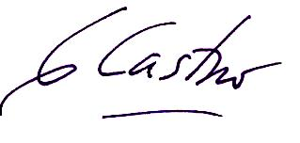

Signature: Date: September 15, 2012

1. The author expresses its sincere thanks to UNDP and the project staff at the PMU for their assistance and support during the course of this evaluation, in particular to Irina Bredneva, Natalia Olofinskaya, Natalya Lopantseva, Vladimir Pischeleve, Stanislav Shinkarenko, and my translators Dmitry Zolotarev and Alexander Oshis.
2. The author expresses its sincere thanks to UNDP and the project staff at the PMU for their assistance and support during the course of this evaluation, in particular to Irina Bredneva, Natalia Olofinskaya, Natalya Lopantseva, Vladimir Pischeleve, Stanislav Shinkarenko, and my translators Dmitry Zolotarev and Alexander Oshis.
3. Additional performance issues as required in the TORs but not essential to this evaluation are included in Annex 3.
4. Annex 6
5. ES LLC unpublished
6. See comments from received from the PMU on Annex 9.
7. *Sensitive* in this particular case would mean common species clearly and directly responsive to the habitat changes or other positive/negative environmental impact of human activities
8. The selection of bird species and their population numbers are based on their occurrence as **nesting** species in the region. Rare & endangered as well as common but sensitive **migratory** species are not selected as indicator due to the dependence of their population numbers on environmental and other factors in other regions.
9. hereinafter: When several variant are chosen, points are summed up.