**Business Case**

for the establishment of a Regional Field office in Wau

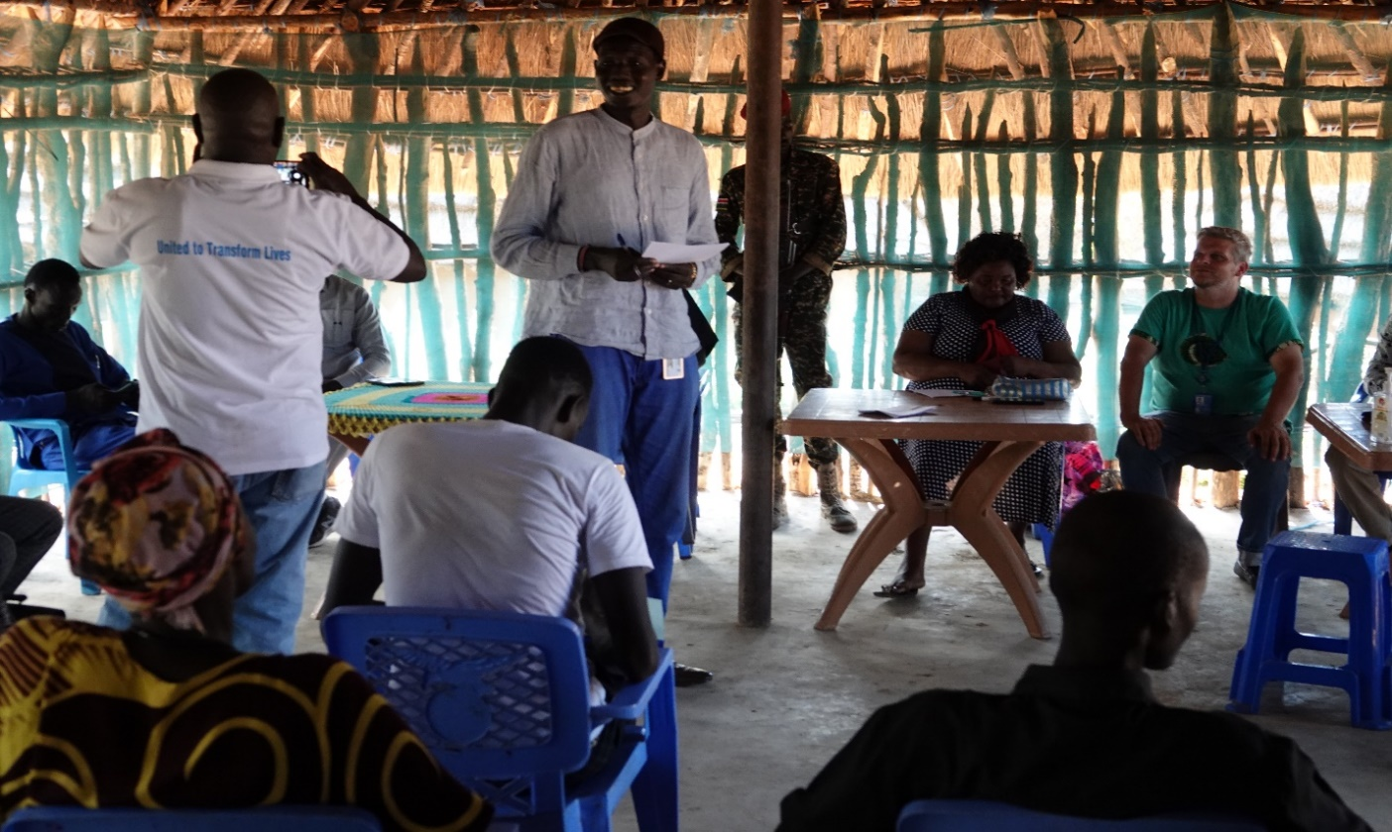

Figure : Peace Committee Training in Mayom, 28 June–07 July 2022, photo@UNDP

|  |  |
| --- | --- |
| Country Office: | UNDP South Sudan |
| Type: | Business Case for the establishment of a UNDP Regional Field office in Wau. |
| Locations: | Wau for Greater Bahr-el Ghazal |
| Duration: | 2023-2025 (aligned with the new CPD cycle) |
| Approved by: | Samuel Doe, UNDP Resident Representative,  UNDP South Sudan CO |
| Submission Date: |  |
| Regional Bureau: | The Regional Bureau for Africa [RBA] |

|  |  |
| --- | --- |
| Approval date: |  |
| Approved by: Samuel Doe, UNDP Resident Representative |  |

Contents

Executive Summary 4

1. Rationale and Strategic Vision 4

2. Vision for Wau Regional Field Office 6

3. Rationale and Criticality 6

4. Functions and Delegation 7

5. Structure 8

6. Oversight and management arrangements 14

7. Field Office budget including setup and recurrent costs 15

8. Viability 15

9. Risk Mitigation Strategy 17

10. Monitoring & Evaluation and Reporting 17

11. Communication 18

# Executive Summary

Immediately after South Sudan independence in 2011, UNDP had very strong field office presence throughout the country which enabled it to effectively implement its programmes and development mandate at state level. However, since independence South Sudan has suffered numerous disruptions which have undermined state building. Institutions are yet to be fully established; the social contract is not fully understood and embraced; and the State is yet to extend and exert its authority across the country. The two civil wars in 2013 and 2016 resulted in UNDP closing all the field offices and only operating from Juba the capital city, due to the deteriorating security situation in the country. South Sudan marked 10 years since independence in 2021 and the country has enjoyed relative stability since the signing of the Revitalized Agreement for the Resolution of Conflict in South Sudan (R-ARCSS) in September 2018, raising cautious optimism for durable peace and the return to sustainable development pathways. The country has also begun a process to develop its first Permanent Constitution that will define the social contract. The Constitution is to pave the way for the first democratic elections since independence in 2011. In order to increase its comparative advantage and delivery as a leading development agency UNDP needs to position itself with increased office presence across the country and in all the states.

Against this backdrop, UNDP Management has agreed an incremental approach to strengthening UNDP field presence and work towards establishing fully fledged field offices. The first phase of this strategy involved deploying Project Support Assistants in four offices (Yambio, Aweil, Torit and Bor ) who will be responsible for providing operational support to the project offices in these states.

The second phase is to further strengthen UNDP’s field presence and establish fully-fledged regional field office/sub-offices. South Sudan has three regions, namely: Greater Equatoria (composed of Eastern Equatoria, Central Equatoria and Western Equatoria states), Greater Upper Nile (composed of Upper Nile, Unity and Jonglei states as well as Greater Pibor Administrative Area and Ruweng Administrative Area) and Bahr el Ghazal (composed of Western Bhar el Ghazal, Northern Bahr-el Ghazal, Lakes and Warrap states as well as Abyei Administrative Area). So, UNDP proposes to strengthen offices in the regional capitals, that is, in **Wau** for Greater Bahr el Ghazal; in **Malakal** for Greater Upper Nile and in **Juba** for Greater Equatoria.

The UNDP senior management and team leads/their designate had a three-day mission to Wau, Western Bahr-el Gazel from 8th to 10th August 2022. The outcome of this assessment mission was for UNDP to move fast and establish a regional field office in Wau as presented in this business case. It is also anticipated that the regional office will also provide support to Aweil, Kuajok, and Abyei.

# Rationale and Strategic Vision

UNDP management has made a decision to step up its field presence, as the largest development partner, to support the Government’s policy shift from humanitarian ubiquity to expanding sustainable development activities across South Sudan. In addition to call for a stronger UNDP presence, the Government counterparts have requested UNDP to provide technical advisory support to the states and coordination of the implementation of the R-NDS at state level.

WBG has development needs in three clusters: Governance, Economic and Services. The government ministries in WBG state are also organized within these three clusters.

|  |  |
| --- | --- |
| Elements | Details |
| **Situation analysis:**  •Key development situation and challenges  •Recent and / or anticipated change  •New challenge and its scope  •Framework for planned response |  |
| **Description of UNDP in the area**  •Operational and programmatic set up in the area  •Past / current interventions and scope  •Key strengths and weaknesses (including relationship with counterparts / beneficiaries) | Due to the significant distance from Juba to Wau (600km) and the poor road infrastructure it is impossible to drive between the two locations especially during the rainy season. The only reliable means of travel from Juba to Wau is by air making it very expensive to provide operational and programme implementation support remotely. |
| **Suggested response**  •Operational and programmatic response and related requirements / value added  •Time frame  •Role of UNDP  •Means of funding / fund-raising and expected funding sources |  |
| **Key drivers** | Distinct needs of the Government of WBG as per assessment mission |

# Vision for Wau Regional Field Office

# Rationale and Criticality

Since its establishment in South Sudan, UNDP has been involved in delivering programmes that focus on humanitarian needs arising from a series of interconnected shocks including persistent communal violence, floods, droughts, and rapidly increasing climate stress. The new country programme(2023-2025) will focus on state building and nexus programming. It will adopt a bottom-up state building approach of laying foundations for cohesive community and social contracts, building and/ or strengthening local government and national institutions for service delivery, extending rule of law authority, and economic diversification and local economic development through small-scale technology and innovation that will increase climate-smart agricultural productivity, value addition, marketing, and financial inclusion.

UNDP will work with humanitarian, development, and peace/security actors for integrated and complementary programming that builds resilience and sustains peace, to transition the country out of humanitarian situations. The sub-national office at WAU will provide the necessary operational platform to reach the furthest behind and populations that are at risk of marginalization and violent extremism (particularly, in border and deprived rural areas). This sub-national presence has been commended by donors and partners and is considered as one of the key comparative advantages of UNDP CO South Sudan.

The analysis of UNDP South Sudan programme portfolio shows a strong investment at sub-national level. Indeed, during the current CPD cycle 2019-2022, out of UNDP’s total portfolio budget amounting to USD xx (including completed projects), USD xx (xx%) have been implemented. This clearly reconfirms the need for sub-national presence and outlets that would enable UNDP to engage effectively with communities in the design, delivery, and monitoring of is activities.

Moreover, the alignment to the country’s revised National Development Strategy (R-NDS 2021-2023) will require UNDP to maintain strong sub-national presence given the strong focus of the strategy on consolidate peace, reduce humanitarian footprint, and stabilize the economy.

# Functions and Delegation

Following a thorough review of programme and project needs and an analysis of the vision, UNDP is proposing the following primary functions for the sub-national presence in WAU for Greater Bahr-el Ghazal region:

* **Project Implementation Unit (PIU)**

The sub-national office in WAU will be responsible for provision of implementation, monitoring, and reporting services at the project level. In addition, programmatic coherence and coordination will be an important element of this function. This implies implementation oversight from a programmatic and operational perspective. Functions performed as part of PIU are limited to:

* Provision of technical implementation support
* Project transactions (HR, Procurement, Finance)
* Project activities implementation oversight and reporting
* Project-related liaison with project partners
* **Monitoring and Evaluation**

In support of CO efforts to enhance its monitoring and evaluation function, the sub-national office in WAU will be involved in regular collection and analysis of appropriate and credible data as well as will be responsible for capturing the collected data and evidence in relevant monitoring reports.

This function covers two levels of M&E: the first level focuses on results data and basic analysis required for monitoring and reporting on country programme results/impact; the second level relates to activities/outputs monitoring including monitoring of infrastructure interventions.

It is important to note that the monitoring field visits by the project staff from Juba should be minimized to the extent possible and should be limited to the visits requiring specific knowledge and expertise that the sub-national presence/outfits staff may not have.

The sub-national presence/outfits staff will be engaged in supporting decentralized and other types of evaluations as required by the projects and the CO.

* **Partnership, Advocacy and Innovation**

UNDP South Sudan will utilize its sub-national office to serve as a platform for partnership engagement and policy advocacy at local level and as a mechanism for innovative and participatory design and acceleration of its programming. While UNDP South Sudan has an AccLab, it will adopt approach/methodology for innovation in the delivery of this function.

The sub-national office will be in charge of liaison with counterparts in the field. This includes maintaining partnerships and communication channels with local authorities and non-state actors. The sub-national office will act as an interface of the projects in the targeted areas and will ensure smooth and effective engagement with the project beneficiaries.

The sub-national office will provide support to expand the CO’s advocacy, outreach, and visibility on key priority issues for UNDP South Sudan and UNDP corporately. The staff of sub-national office will work closely with programme and projects colleagues, including Communications unit, to gather information and data in support of key advocacy topics/subjects and will engage closely in dissemination activities.

Innovation will be one of the critical functions of the sub-national presence/outfits. This function will be built on AccLab methodology/approach which includes exploration, solution mapping and experimentation of local solutions. The sub-national presence/outfits will help UNDP CO South Sudan to generate new and innovative ideas using this methodology and will be used as regional “sense-making” antennas to frame a development space of new programming. This will enable the CO to form a community of expertise and practice and will allow the identification of locally sourced solutions and stimulate shared learning and insight.

# Structure

Enabling the UNDP presence in Greater Bahr-el Ghazal region to deliver on vision and programmatic approach requires the right set of capacities and delegated authorities on the ground. UNDP therefore has decided to establish an effective presence in the Greater Bahr-el Ghazal and consolidate its already on-going work, start implementing a wide range of projects immediately, set up an implementation and sub office structure that supports project implementation and showcase the experiences and successes. The model and functionality of the sub-national office will comprise of the following positions:

* Head of Field Office
* Program Officer, Access to Justice and Rule of Law
* Program Officer, Peace, and Community Cohesion
* Program Officer, Stabilization Recovery and Resilience
* Monitoring and Evaluation officer
* Communications officer
* Operational Analyst
* Support staff (driver, cleaner, security guard)

A key principle of the Sub-Office set-up at WAU is that the Head of Sub office represents UNDP in his/her region. S/he is responsible for overall project assurance and coherence with the UNDP strategic approach in the region and for overall delivery of projects. Therefore, program officers of each projects are directly supervised by the Head of Sub-Office (1st supervisor) on daily matters of the project and the implementation of activities in line with the project work plan of the geographic zone. The staff in sub-national office will depend on availability and need of projects being implemented in the targeted area and hence will be more elastic. The aim of this arrangement, which will require a high degree of collaboration, constant and open communication and feed-back as well as trust between UNDP CO Project Managers and Heads of Sub-Office, to shift resources and decision making as close as possible to the beneficiaries while ensuring overall programme coherence across UNDP South Sudan activities in the field.

Following is an overview of reporting lines:

* The *Head of the Sub-Office* works under direct authority and supervision of the Deputy Resident Representative -Programs in matrix Management (secondary reporting line) with the Deputy Resident Representative -Operations.
* The *Programme and operation team* of the Sub Office report in matrix to the Head of the Sub-Office (1st supervisor).
* *Programme Staff in Sub-Offices* report to the Programme Specialist and will liaise closely with respective programme units (PACC, A2J/RoL and STARR). *Operations Analyst in Sub-Offices* report to the *Head of the Sub-Office* and will liaise closely on technical matters with respective Head of Unit (Procurement, Finance, HR) in Juba.

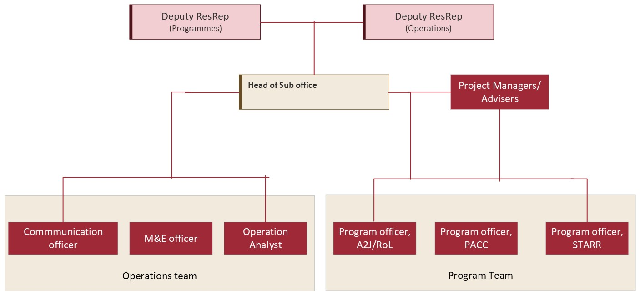 *The proposed structure of sub-national office is presented in the below chart*

Figure : Proposed UNDP Field office Structure at WAU

**b) Overview of roles and responsibilities for key business processes**

The following table describes different positions involved in programme and maps out their most important responsibilities. These can be modified on a case-by-case basis through detailed TOR in light of specific individual profiles.

|  |  |
| --- | --- |
| **Position/Description** | **Main Responsibilities** |
| **Head of Field Office**  The main representative of UNDP in the geographic zone, in charge of liaison with counterparts, support to inter-agency coordination in the sub-area, and functions and operations of the sub office. The Head of sub office is responsible for overall programme coordination at the SO level, supervises project management on the basis of Quarterly Work Plans approved by the Project Board, and ensures coordination across projects in the sub-area. | 1. Represents UNDP in the geographic zone. 2. Ensures overall coordination of projects and programes in her/his geographic zone. 3. Oversees and ensures project implementation on basis of Annual Work Plans and quarterly reviews. 4. Ensures efficiency in running the SO and coordination across projects in the geographic zone. 5. Coordinates and facilitates the regional collaborative planning process; and 6. Plays a leading role in the identification of new opportunities/partnerships for UNDP programming at SO level. |
| **Programme Officer - Access to Justice (A2J)**  The Programme officer has been delegated the responsibility for achievement of programme results in WAU. Within agreed parameters in the detailed work plan and under the day-to-day supervision of the Head of sub office, the programme officer is fully accountable for the achievement of programme outputs and is also responsible for the coordination of activities in and around WAU. | Under the supervision of the Head of Sub office, the Programme Officer for Access to Justice shall have the following responsibilities:   1. Support program development and implementation of access to justice and women participation in transitional justice processes; inter-governmental collaboration, planning, capacity building etc. 2. Support programme, implementation and monitoring of women, peace, and humanitarian fund in Wau. 3. Support organizational capacity development of partners (women’s organizations, CSOs, select government institutions) on access to justice, transitional justice and women, peace, and humanitarian action. 4. Support monitoring and tracking of trends and reports on access to justice, transitional justice and women, peace in humanitarian action. 5. Preparation of relevant documentation such as project summaries, briefing notes to support advocacy. 6. Support inter-agency coordination on access to justice and transitional justice. 7. Support to the UN Joint Programme on SGBV and women, peace and security network, UNDP Access to Justice, Security and Human Rights program. 8. Support advocacy, knowledge building and communication efforts on access to justice, transitional justice and women, peace, and humanitarian action. 9. Any other related tasks assigned to her/him by the supervisor or the Country Office Management. |
| **Programme Officer -PaCC**  The Programme officer has been delegated the responsibility for achievement of programme results in WAU. Within agreed parameters in the detailed work plan and under the day-to-day supervision of the Head of sub office, the programme officer is fully accountable for the achievement of programme outputs and is also responsible for the coordination of activities in and around WAU. | Under the supervision of the Head of Sub office, the Programme Officer for PaCC shall have the following responsibilities:   1. Maintain regular communication and coordination with relevant partners to ensure timely implementation of activities. 2. Facilitate and provide technical assistance for the implementation of peace and community cohesion related activities, enabling high quality delivery of outputs and activity results as per the PaCC project documents. 3. Strengthen synergies with/between PaCC activities and work of other UNDP projects/UN Agencies/other relevant partners to ensure the achievement of integrated results. 4. Support local partners in strengthening mechanisms for the coordination of local level peacebuilding activities and facilitate the coordination with relevant state level actors. 5. Promote community-led participatory conflict and context analyses to inform project programming. 6. Facilitate the strengthening of local peace structures, such as peace committees, to encourage joint and inclusive peacebuilding approaches at the local level. 7. Supervise and monitor the peace and community cohesion related work of CSOs identified by the project and facilitate and provide technical advice to ensure the achievement of quality results 8. Identify capacity needs of local peace partners/structures and support the design and implementation of capacity development initiatives. |
| **Programme Officer -STARR**  The Programme officer has been delegated the responsibility for achievement of programme results in WAU. Within agreed parameters in the detailed work plan and under the day-to-day supervision of the Head of sub office, the programme officer is fully accountable for the achievement of programme outputs and is also responsible for the coordination of activities in and around WAU. | Under the supervision of the Head of Sub office, the Programme Officer for STARR shall have the following responsibilities:   1. Coordinate the implementation of project activities and partners ensuring the achievement of project milestones as per the work plan and in the quality expected. 2. Foster and strengthen cooperation and coordination between the project's diverse stakeholders and beneficiaries to ensure successful project implementation. 3. Ensure accurate records of project outputs and impacts as well as regularly report on progress, best practices, lessons learned, success stories, beneficiaries' stories, and field observations 4. Coordinate and provide technical advice/guidance to project partners and implementers in areas concerning strategies, planning, management, implementation, and evaluation to ensure smooth progress and quality in implementation. 5. Contribute and advise on the development of vocational skills training frameworks and courses/training and business ideas with key stakeholders. 6. Ensure the operationalization and sustainability of the iHubs and the continued provision of career advice and placement services; |
| **M&E officer :**  The Monitoring and Reporting Analyst reports to the Head of Sub Office and is responsible for programme quality assurance, monitoring, and results reporting. He works in close collaboration with the Co South Sudan programme teams. | Under the supervision of the Head of Sub office, the M&E officer shall have the following responsibilities:   1. Setting up a monitoring and evaluation system that allows results tracking and helping determine impact, identify bottlenecks, delays, and other challenges, and advise on lines of action. 2. Building the monitoring and reporting capacity of implementing partners through training and providing technical support on the basic principle and practices of data collection and monitoring. 3. Lead in the collection and consolidation of baseline and end-line data to monitor change of beneficiary targeted and project progress and achievements. 4. Support the coordination of the implementation of the overall UNDP CO M&E framework. 5. Lead the donor reporting and corporate reporting process for the project, 6. Ensure that partners’ progress reports are in line with the project M&E framework. |
| **Communications Officer:**  The Communications officer reports to Head of Sub Office and work in coordination with the Monitoring and Reporting officer and is responsible for all internal and external communication, ensuring full visibility of UNDP activities in WAU vis-à-vis local, national, and international stakeholders. | Under the supervision of the Head of Sub office, the communication officer shall have the following responsibilities:   1. Prepare and conduct communications needs assessments for the Suboffice, including for projects, programmes, and corporate change initiatives. 2. Analyse requirements and synthesize proposals for elaboration of communications strategies, ensuring gender perspective. 3. Integrate communications, advocacy, and outreach strategies into proposals for project/programmes and other initiatives. 4. Develop, coordinate, implement and monitor the implementation of the South Sudan annual communications and advocacy strategies and plans. 5. Monitor and analyze print and social media and draft reports, and provide analysis to CO (when needed) 6. Coordinate UN system corporate and local campaigns and special events and ensure UNDP participation and visibility in Communications Group and ensuing joint communications activities. 7. Plan and propose communications strategies for the projects being implemented in WAU region 8. Identify and develop new communications partnerships and alliances to enhance visibility. 9. Liaise with advocacy partners and undertake outreach to civil society organizations, institutions, partners, and other groups to ensure that newsworthy information reaches the public and donors. |
| **Operations Analyst**  Under the guidance of the Head of Sub Office, the Operations Analyst acts as an advisor on all aspects of Field Office management and operations. This includes strategic financial and human resources management, efficient procurement and logistical services, ICT, and common services consistent with UNDP rules and regulations. The main role is to lead the operations, ensuring smooth functioning of the Field Office programs/ projects operations, consistent services delivery and constant evaluation and readjustment of the operations to take into account changes in the operating environment as and when needed. | The Operations Analyst leads and guides the Field Office Operations Team and fosters collaboration within the team, with programme staff and with other UN Agencies and a client-oriented approach. The Operations Analyst works in close collaboration with programme and project teams in the Field Office, operations staff in other UN Agencies, UNDP CO staff and Government officials to successfully deliver operations services.   1. Ensuring strategic direction of operations. 2. Financial resources management and supervision of the Finance team. 3. Human Resources Management and supervision of the HR team. 4. Efficient procurement and logistical services and supervision of the Procurement team. 5. Information and communication management and supervision of ICT team. 6. Common services organization and management, establishment of partnerships with other UN Agencies |

# Oversight and management arrangements

While the sub office in WAU will be managed by an experienced head of office with an adequate level of delegation, the provision of efficient support and oversight from the country office is necessary. To this end, the following arrangements will be put in place:

1. The overall oversight for Sub-Office rests with the RR. Nonetheless, for programmatic coherence and routine portfolio management, the entry point to the CO for the Field Team will the DRR – P&O. Aspects related to operations will be routed to the DRR-O. Therefore, the CO Senior Management structure will provide required oversight on field operations. The first point of call for Senior Management will be the Head of Project Office, who in turn will coordinate his/her Team to ensure compliance to CO, corporate SOPs and delivery of portfolio priorities and results.
2. The Head of Office will be the main representative of UNDP in the Wau for Greater Bahr-el Ghazal, in charge of liaison with counterparts, support to inter-agency coordination, functions and operations of the sub-office. As a Sub office, the Head is essentially responsible for overall portfolio management and coordination at that level, supervises his/her Team and is responsible for overall project management on the basis of Annual Work Plans, approved by the CO and ensures coordination across projects in the area.
3. Specific roles and responsibilities will include: representing UNDP in the WAU region; ensuring overall coordination of field portfolio and projects in her/his geographic zone; overseeing and ensuring project implementation on basis of Annual Work Plans and quarterly reviews; ensuring efficiency in running the sub-office and coordination across projects in the geographic zone; coordinating and facilitating the local collaborative planning process; and playing a leading role in the identification of new opportunities/partnerships for UNDP programming at local level.
4. The Sub-office will convene periodic UNDP review meetings with local partners (quarterly or at least one per annum). Where possible, UNDP CO designates should be invited to participate as relevant. The same applies with CO initiated review meetings, whereby field presence will be assured. Joint Monitoring Visits (preferably with participation of local partners and counterparts, as relevant) are encouraged at minimally on a quarterly basis, or more frequently if required. These should cover both programme and operations Teams within the HACT framework provisions.
5. The UNDP CO South Sudan in Juba will ensure effective follow-up of all action points agreed upon at Juba level, while the head of sub office is responsible for effective follow-up on action points at WAU.

# Field Office budget including setup and recurrent costs

1. Setup costs

|  |  |
| --- | --- |
| **One off set up costs** | US$ |
| Upgrading premises security and establishing MOSS compliance |  |
| Renovation of office |  |
| Communication infrastructure (V-sat and other) |  |
| Office equipment (computers, printers, furniture, etc) |  |
| Transportation (vehicles) |  |
| **Total** |  |

1. Recurrent monthly costs

|  |  |  |  |  |
| --- | --- | --- | --- | --- |
| **Recurring annual costs** | **2023** | **2024** | **2025** | **2026** |
| Staff costs |  |  |  |  |
| Travel costs |  |  |  |  |
| Annual operating costs (internet, fuel, electricity, communication, etc.) |  |  |  |  |
| Recurrent security costs (guards, radio-room, etc.) |  |  |  |  |
| Equipment maintenance costs |  |  |  |  |
| Rent for offices |  |  |  |  |
| Total |  |  |  |  |
|  |  |  |  |  |

# Viability

The viability of the sub-national office in WAU will be determined by the following criteria:

* Performance of sub-national office in delivering high-quality services to projects and the CO, measured through bi-annually assessment by the CO senior staff and beneficiary projects.
* Availability of the projects implemented in the targeted geographic areas sustaining a minimum of 30% of sub-national presence/outfits operating costs.
* Availability of the programme core resources to sustain the core team up to 70% without compromising programmatic priorities of the CO.
* Political and geographical importance.

The CO will perform an annual review of the above-mentioned criteria which will be used to determine sustainability and viability of the sub-national presence/outfits in a specific area.

For the sub-national presence to be deemed ‘**viable**’, their financial sustainability should be confirmed. This financial sustainability determination will be mainly focused/limited to invariable structure and general operating expenses, given that all the variable structure should be fully covered by respective projects (cost-sharing between projects is an option but should secure 100% of the post).

The source of funding for the “**invariable**” structure will be primarily secured from DPC. In the event, DPC collected pool proves to be insufficient, core resources will be utilized to cover the gap.

The following scenarios will be applied to determine financial sustainability/viability of the sub-national presence/outfits:

|  |  |  |  |  |
| --- | --- | --- | --- | --- |
| Indicators | Ratio of coverage of staffing costs of the invariable structure and GOE from direct project costs (DPC). | Ratio of coverage of staffing costs of the invariable structure and GOE from TRAC | Sustainability level (high, moderate, low) | Impact on viability |
| Scenario 1. | 100% | 0% | High | Very viable |
| Scenario 2. | 70% | 30% | Moderate | Viable |
| Scenario 3. | 50% | 50% | Low to moderate | Viable, requiring regular review and confirmation of incoming resources for the following year |
| Scenario 4. | Below 50% | Above 50% | Low | Not viable, requires action/decision within the next 12 months |

The sub-office will be established initially for a period of 36 months. Performance will be reviewed at the end of the first one year and at the end of the pilot or initial phase of 18 months. Potential extension or closure will be triggered by oversight reports [audit, evaluations, peer review mechanisms etc.]. Circumstance under which and how the local presence will be closed could include the following:

* Implementation of recovery, reconstruction and resilience programming is successfully completed as defined in the project documents.
* The recovery-development situation that led to the establishment of the presence phases out or end of programming cycle [2025, potentially if CP is extended]
* No more funding for the presence is available; and
* The security or crisis situation is deteriorating and seriously limits the effectiveness of the presence.
* Recommendation of oversight reports [e.g., audits, evaluations etc.].

UNDP will ensure the subsequent transfer of usable assets to local counterparts and partners as per its established assets management procedures.

# Risk Mitigation Strategy

|  |  |  |  |
| --- | --- | --- | --- |
| Risk | Impact | Probability | Mitigation measures |
| Funds collected through DPC are not sufficient to cover the “invariable” structure | Increased burden on core resources and diversion of funds from catalytic investments of the CO | High | Quarterly reviews of DPC collection |
| Core resources allocations are dramatically reduced in 2023-2025 and cannot be invested to cover gaps | CO is unable to sustain invariable structure | Medium | Review of criticality and viability of at-risk sub-national outfits |
| Change management results in loss of institutional memory, skills, and networks with local partners | Slowdown of programmatic delivery | Medium | Prioritization of current staff for new positions and special investments in building the capacity of new staff |
| Local communities and authorities may resist on closing of offices | Reputational damage for UNDP and potential political pressures put on CO management to reconsider decisions | Low | Strong communication and outreach strategy coupled with a faced approach for any potential closure |

# Monitoring & Evaluation and Reporting

In terms of monitoring and evaluation, the roles and responsibilities within the Sub-office is distributed as follows:

1. The monitoring of implementation progress, notably the appropriate implementation of activities in the region as defined in the annual work plan, is jointly performed by the Heads of Sub Office and the Programme teams.
2. Head of Sub-office in coordination with program officer and M&E officer is required to set up adequate management and monitoring systems for their portfolio. The M&E Specialists within Program unit in UNDP CO will assist in the provision of frameworks, templates, systems, etc.
3. Heads of Sub-Office is responsible for the monitoring of progress towards defined project outputs at the sub-regional level. Programme officers at Sub-Office will provide support to the Head of Sub-Office. In addition, M&E officer will assist Heads of Sub-Office in the collection of data for monitoring, both on output and outcome levels.
4. Periodic evaluation should take place at both programme and project level. The PMSU at CO is responsible for the development and implementation of a country programme evaluation plan. Project evaluation may be driven at sub-office level, depending on the nature and location of the project.

# Communication