|  |  |
| --- | --- |
|  |  |
|  |  |

|  |
| --- |
| **NCCSP – MONitoring & Evaluation GUIDELINE** |
| This document outlines key Monitoring and Evaluation (M&E) principles applied in the M&E framework of UNDP Afghanistan and in line with the World Bank M&E guidelines. It aims to provide all staff involved with practical guidance on the use of methods and tools to ensure mutual accountability and learning take place while PLACES’s results and best practices are captured and shared. |

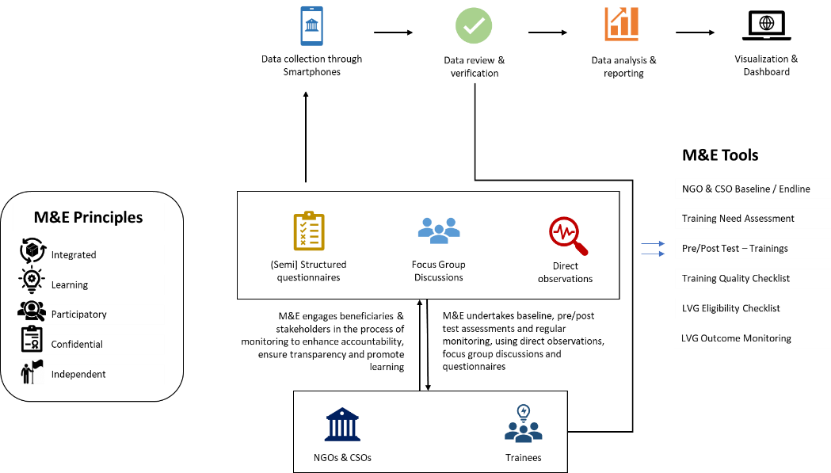

Table of Contents

1. Introduction and Objectives 3

1.1. Project Background 3

1.2. Theory of Change 4

1.3. Program Design 4

1.4. Monitoring & Evaluation 5

1.5. Overarching M&E Principles 5

1.5. Structure and Information Flow 6

2. Standard Operating Procedures for Monitoring, Analysis and Reporting on Program Activities 8

2.1. Management of the M&E System 8

2.2. Implementation and Results Monitoring and Reporting 9

2.2.1. SOPs for monitoring program objectives 11

3. Evaluation 15

4. Learning and Knowledge Development 17

4.1. Principles of learning 17

4.2. Adopted procedures 18

5. Monitoring on Cross cutting themes 18

5.1. Accountability to Affected Population 18

5.2. Gender 18

5.3. Human Right Based Approach 19

6. Ethical considerations 20

7. Annexes 21

7.1. Theory of Change diagram 21

7.2. Results Monitoring Matrix 23

7.3. Monitoring forms (add the link to the source) 23

7.4. M&E Task Tracker & Plan 23

7.5. M&E Master Sheet 23

7.6. Informed Consent form for project beneficiaries 23

7.7. Interview protocol and General Consent (text) 25

7.8. NCCSP Weekly M&E Plan 26

7.9. Use of KOBO for data collection 26

# Introduction and Objectives

This document outlines key standards and principles adopted and applied in the monitoring and evaluation (M&E) system of UNDP’s NGO/CSOs Capacity Support Project (hereafter referred as NCCSP project) in Afghanistan.

This M&E approach is guided by UNDP’s global indicators for capacity building support as well as the following UNDP Monitoring & Evaluation (M&E) tools and manuals, among others:

* UNDP’s [Evaluation Guidelines](http://web.undp.org/evaluation/guideline/documents/PDF/UNDP_Evaluation_Guidelines.pdf)
* UNDP’s [Evaluation Policy](http://web.undp.org/evaluation/policy.shtml)
* Handbook on [Monitoring for Results](C://Users/dell/Downloads/Documents/me-handbook.pdf)

This M&E approach aims to allow the project to:

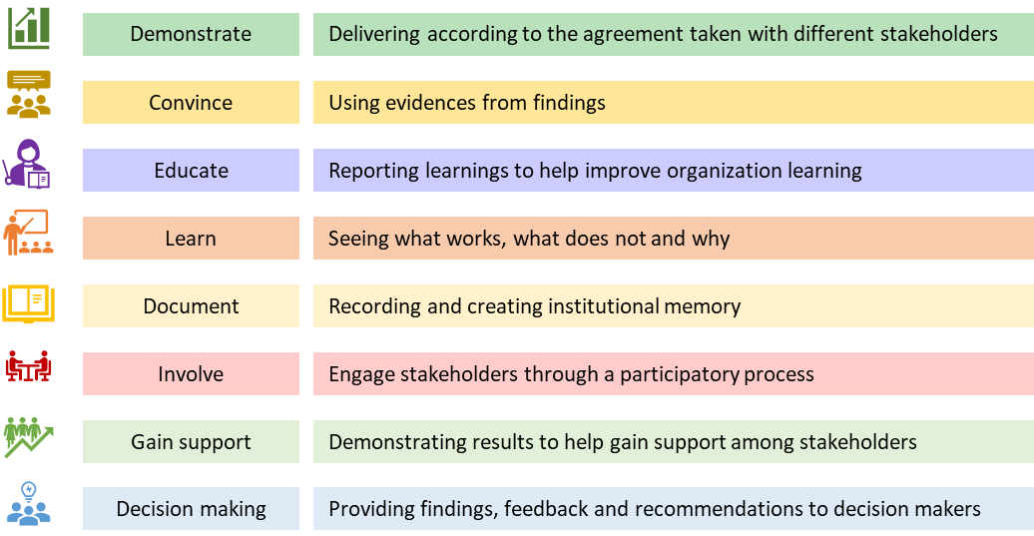

## Project Background

The Project Development Objective (PDO) of the NGO/CSO Capacity Support Project (NCCSP) is to enhance the capacities of selected registered national and local Non-Governmental Organizations (NGOs) and Civil Society Organizations (CSOs) to improve their performance and effectiveness. The NCCSP has been effective since 28 June 2022.

## Theory of Change

* If there is a tailored and updated understanding of the current operational and programmatic capacities of National NGOs and CSOs, including their challenges and aspirations, geographic presence, and outreach.
* If NGO/CSO capacities can be maintained and/or strengthened, including the coordination and collaboration, and operational space and advocacy.
* Then NGOs/CSOs will be able to continue delivering critically needed basic services to the most vulnerable in the communities.

The project contributes to UNDP Afghanistan’s priority focus to support basic human needs, complementing short-term humanitarian life-saving assistance with the safeguarding of livelihoods and the strengthening of community resilience under ABADEI, and under Outcomes 1, 2, and 3 of the UN Transitional Engagement Framework (TEF)24 in Afghanistan.

## Program Design

The proposed Objective of the Project is to enhance the capacities of selected registered national and local Non-Governmental Organizations (NGOs) and Civil Society Organizations (CSOs) to improve their performance and effectiveness.

The desired outcome is to build the capacities of select NGOs and CSOs, ultimately contributing to sustaining the provision of basic services and to providing life-saving support to the most vulnerable populations, in the short to medium term.

Output 1. NGO/CSO personnel capacity enhanced on core management functions and service delivery focused areas (including project management; fiduciary capacity; reporting on results; outreach and mobilization of women; and SEA/SH mitigation and response); (percent)

**Activity 1.1:** Map the current landscape of the Afghan civil society across all 34 provinces and keep track of the NGOs and CSOs that have remained active.

**Activity 1.2:**Finance an integrated approach combining direct training and hands-on support.

**Activity 1.3:** Promote the capacity of NGOs/CSOs on overall strategic and operational management, procurement, human resources, finance & admin management, gender sensitive programing, environmental & social safeguard norms, human-right based approach, do-no-harm etc.

Output 2. NGOs/CSOs benefitting from Project grant awards have enhanced their programs (including women outreach/mobilization and GBV mitigation and response mechanisms); (percent).

**Activity 2.1:** Provide Low -Value Grants37 to 200 NGOs/CSOs to support their capacity to deliver basic services, by helping them to reactivate their operations, retain key staff and solicit development solutions in support of the most vulnerable populations

**Activity 2.2:**Prioritize women-led organizations and local NGOs and CSOs that serve the most Vulnerable populations.

Output 3. NGOs/CSOs benefiting from improved coordination and access to better information and networking (percent).

**Activity 3.1:** Strengthen the dialogue and coordination structures of the NGO sector, with the aim to build coalitions.

**Activity 3.2:**create an avenue for dialogue and serve as a coordination structure for national and local NGOs, as well as for donors, for better integrating service delivery.

**Output 4.** Project Management and Implementation Support.

**Activity 4.1:** Finance costs related to the project management activities of UNDP.

## Monitoring & Evaluation

**Monitoring** can be defined as a continuing function that aims primarily to provide the management and main stakeholders of an ongoing intervention with early indications of progress, or lack thereof, in the achievement of results. An ongoing intervention might be a project, program, or other kind of support to an outcome.

**Evaluation** is a selective exercise that attempts to assess progress systematically and objectively towards and the achievement of an outcome. Evaluation is not a one-time event, but an exercise involving assessments of differing scope and depth carried out at several points in time in response to evolving needs for evaluative knowledge and learning during the effort to achieve an outcome.

## Overarching M&E Principles

UNDP is committed to deliver its intended outputs to target groups and participants at the right time and place with the right quality in an effective and efficient manner. To this end, M&E considers the following principles during regular monitoring of implementation and results, and during project evaluation.

* **Integrated:** Monitoring is an integral part of program implementation; thus, methodologies and tools are in place right at the start of activities and are used throughout implementation.
* **Related:** Monitoring is linked to the specific program objectives that were defined in the proposal and as stated in the section 1.3. in this document.
* **Learning:** M&E information should feed the program, UNDP management, the World Bank and stakeholders with learning and information for effective decision-making. M&E should play its vital in developing institutional knowledge.
* **Comparable:** Evaluation should follow a methodology that enables gathering information about program success following the OECD criteria (relevance, effectiveness, efficiency, impact, and sustainability) as stated in UNDP’s Evaluation Policy, to enable cross-comparison with similar projects in the field of reintegration.
* **Participatory:** M&E encourages participation by using a participatory approach to engage the key and local stakeholders, community-based organizations, community members and beneficiaries to ensure they contribute towards accountability and learning in the process of project implementation and M&E.
* **Confidential:** M&E should respect and protect the rights, welfare, and confidentiality of all those involved at any stage of program implementation.
* **Independent:** M&E is independent, meaning that the project team cannot influence the M&E to compromise on any finding that is to be reported to the management.

# 1.5. Structure and Information Flow

UNDP follows a multi-dimensional M&E process, where activities are monitored for progress and impact by the following internal and external stakeholders:

1. NGOs/CSOs and their employees, communities directly engage in project monitoring through the participatory M&E*.*
2. MgtWell (joint ventured with PAC India) serves as the Service Provider (SP) who delivers the services (e.g., mapping, support on the selection of NGOs/CSOs, cooperations, grant distributions) to the target beneficiaries under the direct supervision and leadership of NCCSP management.
3. Technical Program Staff, including Capacity Support Specialist, SES & GRM Specialist directly leading the implementation of the program activities engage in monitoring through progress tracking and quality assurance.
4. Third-party Monitoring Agent (TPMA) undertake physical monitoring of the activities and results on the ground and reports to UNDP and World Bank.
5. Regional M&E Officers engage in monitoring through verifying progress reported by the implementing partner and TPMA, quality assurance and monitoring of activity impact as well as lessons learnt.
6. Program Management Team engage in monitoring through oversight of program activities and selective verification of project activities and impact where necessary.
7. Donor & External Evaluators engage in project monitoring through the TPMA quarterly or on an ad hoc basis.

Figure 1. Levels of Program Monitoring and Evaluation

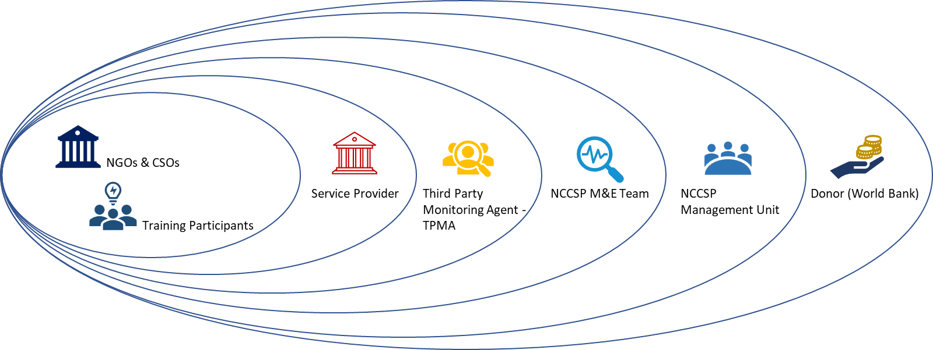

#### Key Internal Roles

The M&E is comprised of one M&E Specialist based in Kabul and eight Regional M&E Officers based in the provinces covering eight administrative zones that includes all the provinces (please refer to the below diagram). M&E Team will be undertaking monitoring and verification role on behalf of UNDP on the ground to ensure smooth delivery of the project and capture the wider changes (positive or negative). M&E Officers will report to the M&E Specialist on regular basis as envisaged in the Result Monitoring Framework (RMF) under the direct supervision of the project manager.

|  |  |
| --- | --- |
| **Role** | **Role Description** |
| Project Management Team | Oversees the implementation of program activities. Based in Kabul |
| Program Specialist | Leads the implementation of the selected program activity across the eight regions |
| M&E Officers | Conducts M&E of program activities in their respective provinces. Based in the provinces. |
| Cleans the data prior to sharing with the data analyst (the role is filled by the regional M&E Officers) |
| M&E Specialist | Oversees the work of MEAL PA in the provinces, in coordination with the designated MEAL PA. |
| Analyses the data as provided by the MEAL National and International FP and produces actionable reports for the project management team (the role is filled by M&E Specialist) |
| Investigation team | In cases of handling beneficiary’s complaint if it comes through M&E rather than the GRM, a team consisting of GRM, M&E and Capacity Building Specialist is appointed to lead an investigation. |
| Third Party Monitoring Agent (TPMA) | Undertake the role as envisaged in the TPMA guideline and agreed between UNDP and World Bank |

# Standard Operating Procedures for Monitoring, Analysis and Reporting on Program Activities

This section outlines standard operating procedures (SOPs) for monitoring of the key components of the project.

## 2.1. Management of the M&E System

A robust M&E system requires sound management to ensure its effectiveness as an early warning tool and a continuous source of learning for the program staff. To achieve this objective, the following procedures should be followed:

1. M&E Team operates independently and follows instructions from the M&E Specialist and Program manager directly.

*Workplans*

1. All M&E Officers complete a monitoring visits weekly plan using (Annex 7.4 – Task tracker)by each Thursday. Upon approval by the M&E Specialist, share the complete workplan with the Program management team on the same day COB.
2. M&E Officers share their monitoring visits plans with the M&E Specialist. M&E Officers are not required to get approval from other staff internally for their visits to ensure maximum independence of the monitoring activities. This doesn’t wave the internal procedure for field visits as advised by the UNDP Amin and Security teams.

*Oversight of the M&E process*

1. M&E Officers maintain an online master sheet (annex 7.5; NGO/CSO & Trainee’s Tracker) for each program component outlining progress of implementation of all projects, including any delays or challenges encountered. The sheet is shared every first day of each week with M&E Specialist, Program Specialist and Project Management.
2. M&E Specialist inputs the details of the latest monitoring visit to selected program activities into the M&E Management Sheet (Annex 7.5– NCCSP Tracker). Details should include date of visit, who undertook the visit, summary of observations and number of M&E visits conducted to the activity site. This aims to ensure that all activities are being monitored regularly and that monitoring efforts are spread evenly across the program.
3. The process for handling issues identified in the field is described in the Management Sheet (Annex 7.5 – NCSSP Tracker).
4. The process of handling complaints is described in the GRM Manual.

## 2.2. Implementation and Results Monitoring and Reporting

UNDP monitors program activities at two levels: 1) from input to output (implementation monitoring) and 2) from output to outcome (results monitoring). These monitoring results feed into evaluating program impact at a higher, strategic level.

The NCCSP program indicators are aligned with the SDG and UNDAF key result areas. Table 2 outlines key program indicators; those on which reporting is required to the donor and those on which reporting can help understanding the situation of program beneficiaries, to inform the decision-making of the program and UNDP management.

Table 2. Program level indicators.

|  |  |  |  |
| --- | --- | --- | --- |
| **Implementation and Results Indicators** | | | |
| **Output and Activity Results** | **Output Indicators** | **Targets** | **Indicator type** |
| Objective: Enhancing capacities, sustaining operations, and strengthening cooperation of select NGOs and CSOs | NGO/CSO personnel capacity enhanced in core management and service delivery focused areas (percent) (Percentage) | 50.00 | PDO indicators |
| Share of NGOs/CSOs trained in GBV prevention and response and demonstrating proper protocols in-place to support survivors of GBV (percent) (Percentage) | 100.00 | PDO indicators |
| NGOs/CSOs benefiting from improved coordination and access to better information and networking (percent) (Percentage) | 70.00 | PDO indicators |
| Output 1 (Atlas Output 00132321): Mapping & Capacity Strengthening of Select NGOs and CSOs | Select NGOs/CSOs received a minimum of six training packages offered under the Project. (Number) | 400.00 | Immediate Result Indicators |
| NGOs/CSOs that underwent the Project trainings report improved staff performance in training areas. (Percentage) | 60.00 | Immediate Result Indicators |
| NGO/CSO personnel trained under the Project reporting satisfaction with the capacity building activities. (Percentage, Custom) (Percentage) | 70.00 | Immediate Result Indicators |
| NGO/CSO personnel trained under the Project reporting satisfaction with the capacity building activities, of which female (Percentage) | 70.00 | Immediate Result Indicators |
| Output 2 (Atlas Output 00132322): Operational Support LVGs to Select NGOs/CSOs | Select NGOs/CSOs provided with operational support sub-grants under this Project. (Number) | 200.00 | Immediate Result Indicators |
| Operational support sub-grants benefitted women-led NGOs/ CSOs or delivered activities benefitting primarily women and girls. (Percentage) | 30.00 | Immediate Result Indicators |
| NGOs/CSOs that received Sub-grants have continued to be functional in areas of public outreach/community mobilization and/or service delivery for the full duration of the project (Number) | 100.00 | Immediate Result Indicators |
| Output 3 (Atlas Output 00132323): Development and Coordination of NGO platform | The NGO platform(s) was established and/or an existing platform was enhanced for national and local NGOs in Afghanistan to represent members of all relevant stakeholders. (Yes/No) | Yes | Immediate Result Indicators |
| Output 4: Project Management and Implementation Support | Grievances addressed within the time specified in the Project Operations Manual. (Percentage) | 80.00 | Immediate Result Indicators |
| Significant representation and inclusion of women among the non-support staff related to this Project under UNDP and its contracted implementation support partners. (Percentage) | 30.00 | Immediate Result Indicators |

*Source: PAD*

The below section outlines standard operating procedures (SOPs) for monitoring, analysis, and reporting of program achievements. All data are collected using Kobo toolkit and stored in line with the UNDP’s data protection principles in the SharePoint/Excel database or in Kobo database.

All forms referenced in the below sections contain questions developed to measure progress towards achievement as well as the quality of activities and beneficiaries’ satisfaction rates in relation to the agreed Indicators as well as Program-specific Indicators. The correlation between specific indicators and questions is presented in the ***Questions and Indicators Master Sheet*** (Annex 7.2; Result Monitoring Framework)***.*** This tool also aims to guide data analysis during the reporting stage.

### 2.2.1. SOPs for monitoring program objectives

In compliance with the principles mentioned earlier, the M&E team will undertake monitoring of the project activities and measurement of the project results.

M&E activities are embedded into the Project weekly workplan 2023, indicating the monitoring activities timeline throughout the year 2023. Please refer to the annex 7.8.

#### Step 1: Project baseline

On the result matrix as agreed between the donor and UNDP, the indicators 2, 3 and 5 under the output 2 will require a baseline assessment to determine the current situation prior of provision of capacity support and low value grants. At the meantime, the indicator 2 of output 1 and indicator 2 of output 3 require a baseline assessment prior of commencement of project activities. The following table determines the tool and timeline of the project baseline for the mentioned indicators:

Table 3. List of baseline / end-line tools for the program components

|  |  |  |  |  |  |
| --- | --- | --- | --- | --- | --- |
| **Output** | **Indicator** | **Target** | **Baseline/End-line tool** | **Frequency** | **Sampling method** |
| 1.1. | NGOs/CSOs that underwent the Project training report improved staff performance in training areas. (Percentage) | 60% | Pre/Post-test | Once, right before the start of the training, with the selected training participants | Stratified random sampling and simple random sampling with 10% of the training participants. |
| 1.2. | NGOs/CSOS reporting improvement from low to medium in operational and programmatic capacities due to LVGs (i.e., FM, RM, geographical outreach/expansion, staff retention, new program activities etc.) | 70% | NGO/CSO capacity assessment – baseline | Once the NGO/CSO is selected by the selection committee to receive the low value grant, a baseline assessment will be conducted to identify their current capacity on FM, RM, outreach, staff retention and activities. | The baseline and end-line survey will happen will all the NGO/CSOs who received LVG and capacity support. |
| NGO/CSO personnel capacity enhanced in core management and service delivery  focused areas (percent) (Text)" | 50% | Pre/Post-test | Once, right before the start of the training, with the selected training participants | Stratified random sampling and simple random sampling with 10% of the training participants. |
| 1.3. | NGOs/CSOs benefiting from improved coordination and access to better information and networking (percent) | 100% | NGO/CSO Networking/Coordination – baseline | Once the NGO/CSO is selected by the selection committee to receive the low value grant, a baseline assessment will be conducted to identify their current capacity on networking and communication with/through the available coordination platforms at the provincial and national level | The baseline and end-line survey will happen will all the NGO/CSOs who benefits from the enhancement of the coordination platforms at the provincial and national levels. |

#### Step 2: Project progress monitoring

**Output 1:** Monitoring of the training delivery, quality, and results:

1. M&E undertakes regular monitoring of the capacity enhancement sessions that are designed and conducted for the NGO/CSO’s staff at the provincial level.
2. A checklist (Tool #3) will be used for monitoring the quantity of the training material, conduciveness of the environment, quality of the training content and participation of women.
3. M&E team fills the checklist by directly visiting and observing the training location and training participants.
4. A reasonable proportion of the survey will happen through direct observation and the rest will be done remotely by engaging the training participants and local stakeholders.
5. Respondent’s view of the quality, effectiveness, relevancy, satisfaction, and content will be done as post-test or end-line at the end of the trainings. This will be done on a random basis with one third of the training participants through directly or remotely (Tool #3: Pre/Post Test).
6. The training pre and post test surveys will be revised and further updated once the training content is developed for each topic as indicated in the PAD.
7. In case of online training the online link to the forms (deployed in Kobo) will be sent to the participants via email in advance of the training with a description on when and how the pre-test and post-test survey forms to be filled.
8. The analysis of the data coming through the mentioned tools will inform management on the training effectiveness, relevance, and quality.

**Output 2**: M&E team will undertake monitoring of the grant distribution on regular basis as indicated in RMF, to verify and ensure the amount of grant, transparency in the process and relevance of the grant to the needs of the respective NGO/CSO. This survey will be done with all those NGO/CSOs that they benefit from the LVG of the NCCSP project. One-third of the surveys will be done in-person whilst the remaining will be done remotely through phone calls.

1. A checklist (Tool #5) containing the eligibility criteria, processes as envisaged in the policies and the NGO/CSO plan for using the grant will be used for each NGO/CSO once.
2. A questionnaire (Tool #4) will be used to monitor the relevance, use and results of the grants on NGO/CSOs capacity, performance, and resilience. This survey will be done once with each NGO/CSO that they receive the grant. The timeline will be three months after receiving the grant.
3. Verify the number of female staff hired/embedded in the NGO/CSOs management and operations for short and long term and are being equally paid as their male counterparts in the NGO/CSO.
4. Monitor women’s participation in the NGO/CSOs activities on the ground to ensure women are benefiting [in]directly from the grants provided to the NGO/CSOs.

**Output 3**: The output three focusses on enhancement of the available provincial and national level coordination platforms for NGO/CSOs. M&E team will undertake monthly review of the platforms including coordination meetings and reporting structures and the challenges associated with the provincial and national coordination platforms.

1. A baseline assessment (Tool #1 for individual assistance and Tool #4 for NGO/CSO) will be done at the beginning with each NGO/CSO to assess the current situation including the functions of the coordination platforms, frequency & effectiveness of the coordination meetings and the challenge and bottlenecks.
2. A monitoring form (Tool #4) will be used to continuously monitor the condition of the coordination platforms at the provincial level and effectiveness of the support being provided the NCCSP project.
3. Monitor participation of women-led NGO/CSOs in the provincial and national level coordination platforms, report the successes and challenges to the NCCSP project manager and donor based on the collected evidence.

Table 4. Survey tools, frequency, and sample size

|  |  |  |  |  |
| --- | --- | --- | --- | --- |
| **Monitoring Activity** | **Monitoring tool** | **Method** | **Frequency** | **Sample size** |
| Component 1 | | | | |
| Baseline survey of training participants | Tool 1: Individual Baseline | Through Kobo | Once with each training participant | 30% of the training participants - in person |
| Monitoring of training quality | Tool 3: Training Quality Checklist | Through Kobo | Once at the start of each training | All training session will be monitored. 50% through direct visits and 50% phone calls with the training participants |
| Training pre-test survey | Tool 2a: Training Pre-Text | Through Kobo | Once at the start of each training session | All training session will be covered through the Service Provider. M&E Officers will undertake for 30% of the sessions |
| Training post-test survey | Tool 2b: Training Post-Test | Through Kobo | Once at the end of each training session | All training session will be covered through the Service Provider. M&E Officers will undertake for 30% of the sessions |
| Component 2 | | | | |
| Verification of the selected NGO/CSO | Tool 5: Eligibility checklist | Through Kobo | Once with each NGO/CSO | All the selected NGO/CSOs will be covered |
| Baseline survey of NGOs/ CSOs | Tool 1: Baseline of NGO/CSO | Through Kobo | Once the NGO/CSO is selected | All the selected NGOs/CSOs will be covered |
| Monitoring of grant utilization | Tool 4b: Grant utilization survey | Through Kobo | Twice with each NGO/CSO | All the selected NGOs/CSOs will be covered |
| Component 3 | | | | |
| Monitoring of the NGO/CSO coordination mechanism | Tool 4: Coordination platform | Through Kobo | Two times with each NGO/CSO | 30% of the NGOs/CSOs will be covered through stratified random sampling |
| Monitoring of the women-led NGO/CSO coordination mechanism | Tool 4: Coordination platform with the women-led NGO/CSO | Through Kobo | Two times with each NGO/CSO | All the women-led NGOs/CSOs will be covered. |

#### Step 3: Data analysis and reporting

1. M&E Officers share the data of the surveys they undertake (e.g., baseline, monitoring, endline) on daily basis since the data collection is being done through Kobo that directly sends the data to the server upon the survey is finished.
2. M&E Officers shares cleaned data obtained during baseline and endline assessments via the online excel sheets or SharePoint for further process of review and analysis.
3. M&E Specialist analyses data against the findings obtained during baseline and endline assessment, and presents the data in an aggregated form to illustrate the impact of the project on the target population, including:
   1. Change in perceptions, capacity, and engagement of beneficiaries.
   2. % Of returnees who report satisfaction with assistance received
   3. And in line with the indicators outlined in the RMF.
4. M&E Specialist analyses the monitoring data of the project output 1 to 3 against the findings obtained during monitoring and direct observation and presents the data in an aggregated form to illustrate the impact of the project on the target population comparing with the baseline to see the level of changes attributed by the NCCSP project.
5. M&E Specialist generates monthly reports and shares with the project management and with the donor where necessary after having the confirmation of NCCSP project manager.
6. All reports will have at least one human-interest story or success story from each region with photos and quotes.

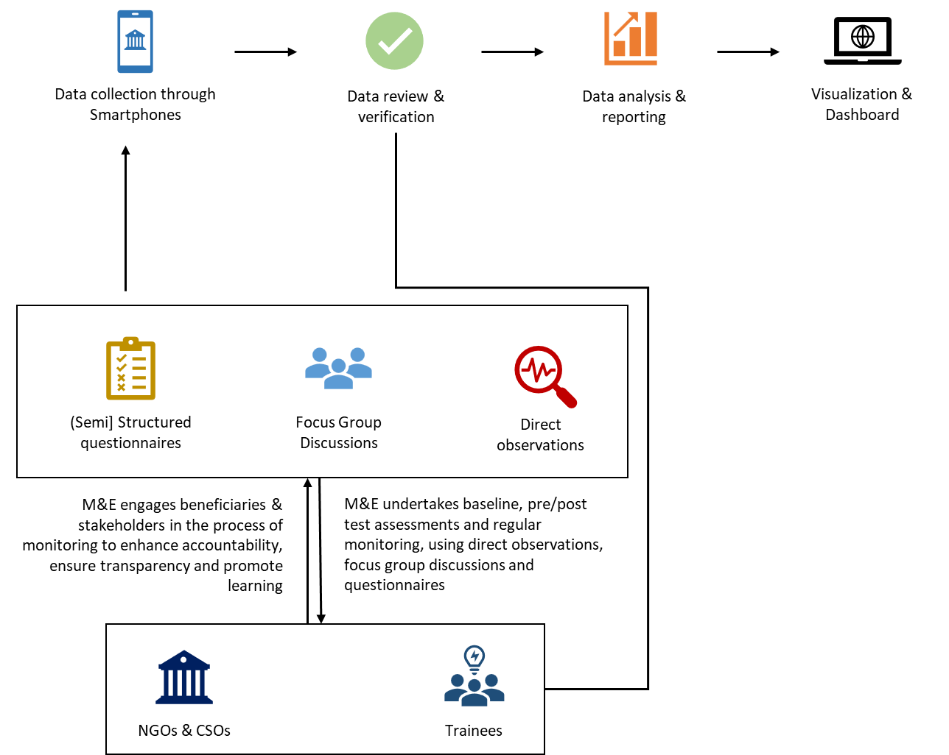

# Evaluation

The mid-term and final evaluations will assess the NCCSP project progress against the Project Document, targets stipulated in the Results Framework and the achieved results from 1 July 2022 to 31 June 2024 and propose recommendation which will inform and help improving the implementation of the project and designing any future interventions. The mid-term and final evaluations will be based on a desk review of project related documents and in-depth interviews and surveys as outlined in the methodology section. The evaluations will intend to document achievements, good practices, success cases, lessons learned and experiences. Based on the achievements to the date, the mid-term evaluation will provide forward looking programmatic recommendations for the project’s remaining life, using the OECD/DAC evaluation criteria on (a) relevance; (b) effectiveness; (c) efficiency; (d) sustainability; (e) impact; and (f) coherence. It will also focus importantly on the cross-cutting issues such as gender equality, human right based approach and do-no-harm.

The evaluation will cover the following cross-cutting themes: (a) Rights-Based Approach (RBA); (b) protection mainstreaming; (c) disability inclusion; (d) gender mainstreaming; (e) environmental sensitivity and sustainability; and (f) accountability to affected populations (AAP). All the above-mentioned themes have an equal priority to the UNDP that should be considered in this evaluation and the data collection process should be able to address these cross-cutting themes equally and effectively.

To foster program quality improvement and support learning, UNDP regularly conducts evaluations and studies as an integral part of its projects and programs. In this view, NCCSP **mid-term** and **final** evaluations will follow the below steps:

# Learning and Knowledge Development

Learning in the context of NCCSP, refers to processes and procedures that continuously record, transfer, and imply technical knowledge and expertise within and between the organization and external partners. In a formal and structured way, NCCSP aims to make explicit use of best practices, with the intention to facilitate an overall enabling environment through which institutional knowledge and organizational learning can be created and enriched over time. In a more formal, structured manner, NCCSP project organizes or formulates regular ‘lessons learned’ through publishing and disseminating insights during events and in written documents. In consultation with the other UDNP programs and donor, NCCSP project utilizes the lessons learned of other similar projects/programs and adopts best practices for the design, planning, implementation, and monitoring. On the other hand, NCCSP project continues to contribute and enrich UNDP’s and key stakeholder’s institutional knowledge through progressive tracking and recording the lesson’s learned and best practices.

## Principles of learning

NCCSP adopts the following principles whilst tracking and recording lessons learned and best practices:

**Shared vision:** project team members understand to continue contributing to the achievement of the project objectives through effective planning and implementation of the project activities.

**Individual learning:** learning starts with each individual employee in the process of accomplishing his/her duties. NCCSP staff members record their learning and share with the team through structured ways of recording lessons learned.

**Team learning:** keeping the fact in mind that the NCCSP program enjoys having a team of competent staff, they work together and support each other in the process of project implementation and monitoring. Dialogue and discussions happen in between, contribute to mutual learning.

**Learning for improvement:** Lessons-learned and best practices contribute to the program management to make effective decisions onward to strengthen the process of NCCSP project activities.

## Adopted procedures

Learning in organization happens continuously. Our intention is to establish a platform through which knowledge can be created, retained, and transferred in the NCCSP project and within the organization. To this end, M&E team track and records learning at two levels (field and program). Project team who works on the field, records their learning (what went well and what went wrong) and best practices (if backed by solid evidence) continuously and hold half day workshop on quarterly basis to record their lessons learned (Tool 06 – lessons learned record sheet).

**Step 1:** every individual team member records their evolving insights and lessons learned.

**Step 2:** M&E Officers supports the project team and prepare for quarterly workshop.

**Step 3:** team discusses their lessons learned in the workshop and put their lessons learned together.

**Step 4:** M&E Officers combine the lessons learned and share it with the M&E Specialist and project manager for review and record.

M&E Specialist, with the support of the project manager organizes an annual lessons-learned workshop to discuss the lessons learned and best practices with key stakeholders and colleagues from other UNDP units. The M&E Specialist documents the lessons learned and best practices and shares it internally and externally, in coordination with the project manager and reporting/communication staff.

# Monitoring on Cross cutting themes

# 



## Accountability to Affected Population

Accountability to affected people (AAP) is widely used in the humanitarian community to refer to the commitments and mechanisms that humanitarian agencies have put in place to ensure that communities are meaningfully and continuously involved in decisions that directly impact their lives.  
  
NCCSP M&E team considering the Grievance Redressing Mechanism (GRM) that is put in place by the project team and serving through AWAZ, will continue to ensure the responsible use of power (resource, decision making) combined with effective and quality project delivery on the ground so that [in]direct beneficiaries, local stakeholders and communities gain a sense of ownership of the project and hold the NCCSP team responsible for the project delivery with the right quality.

Question pertinent to accountability, equal use of resources, women participation and decision making will be embedded into the monitoring forms to help beneficiaries and local stakeholders raise their views and concerns comfortably.

## Gender

NCCSP follows a gender-sensitive approach by integrating perspectives and considerations on gender, beyond ensuring mere participation of female participants including women-led organizations and female employees. NCCSP carefully considers on how each activity can best engage different genders and how (differently) the project impacts men and women, boys, and girls.

NCCSP adopts a gender-sensitive M&E approach to analyze gender differences and underlying causes, discuss the findings amongst stakeholders and take appropriate action for women's empowerment by:

* Detecting negative impact on women, for example, increased workload, incidents of violence or other forms of backlash and discriminatory attitudes toward women and girls.
* Addresses the constraints of women and men appropriately, thereby improving project performance and outcomes.
* Assessing whether both men and women are satisfied with the project activities to ensure that their (different) needs are considered.
* Ensuring that the project does not overlook gender differences in vulnerability, which could result in severe impacts on women.
* Identifying opportunities to empower women, disabled and other socially marginalized minorities.

Indicators are disaggregated by sex and the project team implements project activities in a way to increase the participation of women to contribute towards the betterment of their conditions. M&E thus puts more attention in place to track the progress through gender-sensitive data acquisition tools. Female data collectors approach female beneficiaries for data collection.

**Consent**: M&E team seeks respondent’s consent at the beginning of each interview for every make and female respondent. M&E team member clearly describes the purpose of this interview/event. If a respondent refuses to answer to the questions, it will be respected, and another related female will be approached.

**Confidentiality**: M&E team ensures every male and female respondent to keep his/her response (views, feedback, or complaint) confidential and do not share his/her credentials and responses with others.

**Photo/Video consent**: M&E team does not take a photo or record a video without prior consent or agreement of a respondent especially when the respondent is female. M&E team explicitly explains the reason for taking a photo or recording a video and explains where the photo and video will be used, and the risk associated with the use of photos and videos and ensures that video material is not used beyond the audience agreed with the respondent.

**Group discussions**: M&E team holds the focus groups discussions separately for each gender category. Men and women will be approached in separate groups unless the participants, community or organization recommends and arranges the event.

## Human Right Based Approach

As envisaged in the NCSSP project document, the key human rights-based principles including participation, non-discrimination, dignity, equality, transparency, and accountability will be promoted by the project. M&E team ensure to take into count the key principle to support participation of women, men, PSN and marginalized group into the project activities. Questions associated with these principles will be embedded into the M&E data collection tools to monitor the condition and inform management for improvement.

M&E team will ensure that the role of CSOs and NGOs as independent entities acting in the interest of the communities, including marginalized and excluded groups and individuals, and in providing critical basic services is recognized and promoted by the NCCSP support. M&E team will ensure that communities and beneficiaries can access the rights guaranteed to them in the International Covenant on Civil and Political Rights (CCPR) and the International Covenant on Economic, Social and Cultural Rights (CESCR), Universal Declaration of Human Rights (UDHR) and the Convention on the Elimination of All Forms of Discrimination against Women (CEDAW).

# Ethical considerations

UNDP is committed to deliver its intended outputs to the target communities and beneficiaries at the right time and place in an effective and efficient manner. To this end, M&E considers the following principles during regular monitoring of implementation and results and during evaluation of the project.

When planning, designing, implementing, managing, and reporting on activities, M&E team will ensure that their actions are informed by ethical guidelines, particularly those outlined in the UNDP Monitoring & Evaluation Policy; OECD Data Protection Principles[1]; and UNEG[2] Ethical Guidelines for Evaluation that includes utility, credibility, independence, impartiality, ethics, transparency, human rights, and gender equality.

* **Personal data** in any form or medium, relates to an individual who can be identified, directly or indirectly, by means reasonably likely to be used, including where an individual can be identified by linking the data to other information reasonably available and can also be referenced as personal information or personally identifiable information. The owner (an individual) can make his/her personal data private by restricting access to it or can make it public. Sharing personal data of the beneficiaries publicly can pose risks to those individuals represented in the data.
* **Sensitive data** is considered as any data related to (i) racial or ethnic origin, (ii) political opinions, (iii) trade union association, (iv) religious beliefs or other beliefs of a similar nature, (v) physical or mental health or condition (or any genetic data), (vi) sexual orientation and other related activities, (vii) the commission or alleged commission of any offence, (viii) any information regarding judicial proceedings, (ix) any financial data, (x) children and (xi) an individual(s) or group(s) of individuals that face any risks of harm (e.g. physical, emotional, economic).
* **Informed consent** means that as many details about the purpose of data use (e.g., any risks, harms, and potential positive and negative impacts) is included in the notice when the consent is sought for data collection (e.g., an individual interview or focus group discussion). It is important to consider assessing the proportionality of risks, harms, and benefits of data use when consent is obtained.
* **Anonymized data** means that identifiable information of an individual is processed using all reasonable means to convert personal data into anonymous data, such as that it cannot be traced back or linked to an individual(s) or group(s) of individuals. There are many different methods that could be used to de-identify data. Examples include data aggregation, masking, pseudonymization and k-anonymity.

# Annexes



## Theory of Change diagram

Adopted from PAD.

|  |  |  |
| --- | --- | --- |
| |  |  | | --- | --- | | **Long-term Outcome**  **Outcome**  **Outputs**  **Activities**  **Short-term Outcomes**  Extended operational ability of targeted national and local NGOs/CSOs to implement on the ground  Subgrants delivered to select NGOs/CSOs, with special focus on those working with the most vulnerable communities and women led CSOs  **Component 2**  Operational Support Subgrants to Select NGOs/CSOs  NGO platform (at national and provincial levels) active and functional  NGO platform (vision; operating procedures) designed in consultation with key stakeholders  Improved coordination structure and increased service delivery effectiveness of the NGO sector  *[via networking; peer-to-peer learning; technical support]*  Select NGOs/CSOs trained (in project management; fiduciary; reporting; etc.)  Needs assessment conducted; capacity strengthening plan established; and training modules tailored  Strengthened capacity of select NGOs/CSOs to implement local service delivery & community mobilization  Enhanced knowledge of the current civil society landscape, including capacity gaps of the NGO/CSO sector  Database and taxonomy of active registered national and local NGOs and CSOs  Enhanced performance of select NGOs and CSOs for service delivery and implementation on the ground  Improved access to life-saving support for the most vulnerable populations in the short to medium term  **Component 3**  Development and Coordination of NGO platform  **Component 1**  Mapping and Capacity Strengthening  of Select  NGOs and CSOs   |  | | --- | |  |     **Assumptions:**   * The identification of NGOs and CSOs will not be curtailed by the Interim Taliban Administration (ITA) * Independence and operations of NGOs/CSOs are maintained * Security conditions in project areas allow for continued operations * Implementing partners will have safe and unhindered access to direct and indirect beneficiaries | |

## Results Monitoring Matrix



## Monitoring forms (add the link to the source)

* 1. Tool 1: Baseline/End-line Individual Assistance Form (Structured Questionnaire)
  2. Tool 2: Pre/Post-test (structured questionnaire for trainings)
  3. Tool 3: Training checklist (structured form for direct observation and training quality)
  4. Tool 4: Grant-Use Monitoring Form

## M&E Task Tracker & Plan



## M&E Master Sheet



## Informed Consent form for project beneficiaries

|  |  |  |  |
| --- | --- | --- | --- |
| **PURPOSES**  **Specified and defined prior to data collection** | **DESCRIPTION** | **CONSENT** | |
| **To be filled in by data controllers/interviewers** | **YES** | **NO** |
| 1. **Original specified purpose** | ***The personal data will be used by UNDP and its service provider or implementing partner where relevant, in order to identify the beneficiary and provide the required services as indicated in the NCCSP project document and agreed with the World Bank.*** |  |  |
| 1. **Continuum of assistance** | ***Personal indefinable information and information associated with the use of NCCSP support services will be regularly collected and used by the UNDP and its implementing partner*** |  |  |
| 1. **Additional research purpose** | ***Beneficiary information as indicated above will be used for research purposes by UNDP.*** |  |  |
| 1. **Additional foreseeable purposes** | ***Beneficiary information including personal data, photos, and videos will be used for success cases in reporting purposes by UNDP*** |  |  |

**General Consent Form**

I, [], hereby authorize the United Nations Development Program (hereinafter, “UNDP”) and any authorized person or entity acting on behalf of UNDP to collect, use, disclose and dispose my personal data and, where applicable, the personal data of my dependents [] for the following purposes:

I agree that my personal data may be disclosed to the following third parties for the above purpose(s):

|  |  |  |  |
| --- | --- | --- | --- |
|  | **NAME OF THIRD PARTY** | **CONSENT** | |
| **To be filled in by data controllers/interviewers** | **YES** | **NO** |
| 1. **Authorized UNDP staff** | ***Authorized UNDP staff*** |  |  |
| 1. **Authorized third parties** | ***TBD*** |  |  |

**Data subject’s declaration of informed consent:**

**1**. I have been informed about the specified and additional purpose(s) for which my personal data will be collected, used, disclosed, and otherwise processed as described above.

2. I understand that I may make requests concerning my personal data including access, modification and deletion, by contacting UNDP.

3.. I understand that withdrawal of my consent may result in UNDP being unable to provide me with a service for my benefit.

4. I declare that the information I have provided is true and correct to the best of my knowledge.

5. I hereby release, discharge, and agree to hold harmless UNDP, its officers, employees and agents from any liability or damage caused, directly or indirectly, to me, my family or relatives in connection with this authorization by virtue of the use or disclosure of my personal data for the specified purpose(s) as described above.

6. I understand the contents of this informed consent form after:

(a) Having read the above clauses: YES/NO

(b) The above clauses have been translated or read to me: YES/NO

7. I voluntarily make this declaration and freely consent to the collection and processing of my personal data by UNDP.

Signed at (place)*………………………………………* on (date)*…………………………………………….*

*……………………………… …………………………...................*

Interpreter’s signature Data subject’s signature or mark

## Interview protocol and General Consent (text)

This Annex outlines the protocol that UNDP and its third-party staff should follow when interviewing beneficiaries. It applies to all data collection tools used by the program.

**Interview Protocol**

All interviews should be conducted in a private space where beneficiaries may feel comfortable to reflect on their experience and to answer any potentially sensitive questions. They should never be forced to answer any question and have the right to interrupt the interview at any time.

1. Prior to meeting the beneficiary to be interviewed, the UNDP and its third-party staff is expected to fill out the **Profile** section of each survey. The information should then be verified by the interviewer with the beneficiary, and any outstanding question(s) from this section answered.
2. The interviewer is required to obtain the consent of the beneficiary being interviewed. If consent is obtained, the interviewer may proceed to the **Questionnaire** section.
3. For all questions, the interviewer should read the **questions,** and where prompted, to read the **response options** out loud.
4. The interviewer should observe the following **instructions** for each question:
   1. **“Select one response option”** indicates that the question can only have **one** response.
   2. **“Select all applicable response options”** indicates that the question can have **multiple** responses.
   3. **“Prompt, if needed”** indicates that the interviewer should read the response options, if needed, and allow the respondent to select the most appropriate option or multiple options (if multiple responses can be selected).
   4. **“Do not prompt”** indicates that the interviewer should not read the list of possible response options to the respondent. Instead, the interviewer should listen to the respondent’s free response, and select the response option(s) closest to their own words.
   5. Record the responses and any notes.
5. If selected answers refer to follow-up questions, the interviewer proceeds to the follow-up question (marked by question number in brackets).

4. Tick answer(s) (For this question, select the one response option that reflects the returnee’s answer)

1. Read question

|  |  |  |
| --- | --- | --- |
| No. | Question | Response Options |
| 1. | How satisfied are you with your current situation? (Overall situation, self-assessed by respondent)  Select one response option  Do not prompt | Very satisfied  Satisfied  OK  Dissatisfied à please explain  Very Dissatisfied à please explain  I don't wish to answer |

3. **listen to the respondent**

2. Follow instructions (For this particular question, do not read answers out loud)

**Interview Template**

**Introduction (to be read out by the interviewer to the beneficiary before commencing the survey):**

*As you may know, under the program entitled “NGO & CSO Capacity Support Project”, UNDP has/is currently providing assistance in form of capacity building trainings and low value grants to people like you. As a beneficiary, we would like to ask you a couple of questions about the assistance provided. Please know that your responses will give us a better idea of your experience with our organization and our partners with regards to the assistance received. Your responses are important and will help us all improve our work in the future.*

*The survey should take about [INSERT TIME] minutes to complete. Your participation is voluntary, and responses will be kept confidential. This is not a test, there are no right or wrong answers. You have the option to stop or not respond to any questions that you choose at any point during the survey. Your participation or nonparticipation will not affect the provision of future assistance to you. If I have your permission, can we proceed?*

**Note for Interviewer:** If the survey is conducted over the phone or if previous M&E surveys were previously conducted with the respondent who has signed/verbally consented, it is sufficient that verbal consent be obtained using the above script.

Beneficiaries should never be forced to answer any question and have the right to interrupt the interview at any time. In such case, their answers should be discarded entirely.

## NCCSP Weekly M&E Plan



## Use of KOBO for data collection

Kobo a nonprofit organization maintains the Kobo Toolbox as a free resource for social impact organizations allowing a wide range of practitioners to administer their research and data collections freely with higher data security in contrast with the other online free tools. Kobo supports collection of up to 10,000 submissions per month and store up to 5GB in media attachments. We therefore decided to use KOBO that allows us to collection the data online/offline from the field either though our computer browser or through smartphones.

The account created in Kobo for the NCCSP can be reached [here](https://kf.kobotoolbox.org/#/forms). Data collection forms are created in Kobo and are make accessible through online links for instance the [training quality checklist](https://ee.kobotoolbox.org/x/2uLJ3nnf). All the data will be collected through Kobo and extracted through excel forms for further processing and analysis.

We will keep a record/backup of the data from the KOBO to protect data from potential harms and technical glitches that may occur at some point. The data from the Kobo database will directly be linked to the online Excel sheets and a dashboard to demonstrate the results based on the pre-defined indicators. The online excel sheets will be protected and the cells that are not necessary to be used by the users will be locked. The open cells which require data entry and edit, will be validated based on the nature of the data-field to avoid entry of outlier information and protect from unnecessary attempts.

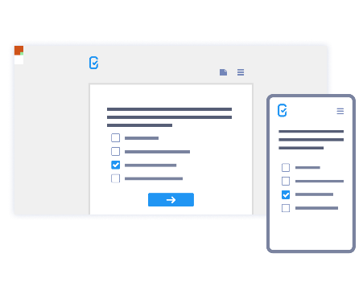KOBO supports two ways of data collection, a) online through browser of the computer and b) offline through the KOBO-Collect App available for Android & IOS for free. The tools will be designed in the KOBO and will be deployed for a test first, once we ensured that it works well, and questionnaire does not need any further change we will proceed with it.

To configure the devices for the Kobo-collect app, we need to download the app freely available for Android and IOS. Then we need to open the app and go the settings where the URL (kc.kobotoolbox.org) and the add the username and password. For the purpose of data security, username and password will not be inserted in this document but will be provided upon request.

1. [OECD Guidelines on the Protection of Privacy and Transborder Flows of Personal Data | OECD iLibrary (oecd-ilibrary.org)](https://www.oecd-ilibrary.org/science-and-technology/oecd-guidelines-on-the-protection-of-privacy-and-transborder-flows-of-personal-data_9789264196391-en)
2. [UNEG Norms & Standards for Evaluation_English-2017.pdf (iom.int)](https://evaluation.iom.int/sites/g/files/tmzbdl151/files/documents/UNEG%20Norms%20%26%20Standards%20for%20Evaluation_English-2017.pdf)