

**Joint Devolution Programme Document**

**COVER PAGE**

|  |  |
| --- | --- |
| **Joint Programme title:** | **Joint Devolution Support Programme** |
| Outcomes(s): <*verbatim from CF*> | By 2026, all people in Kenya at risk of being left behind - particularly all women and girls, all youth, and children, all in the ASAL counties and all in the informal urban settlements – inhabit an inclusive, enabling, socially cohesive and peaceful environment, while enjoying human rights, trust institutions and participate in transformative governance systems that are gender-responsive, just and rule of law  compliant. |
| Duration: | 4 Years |
| Anticipated start and end dates: | Start: 1 Jan 2025 |
|  | UNDP  UNICEF, UN WOMEN |
| *Lead PUNO:* |
| *PUNOs:* |
| Fund management modality: (Parallel; Consolidated; Pass-through) |  |

|  |  |
| --- | --- |
| **Total estimated budget:**5 |  |
| Out of which: |  |
| » Funded |  |
| » Un-funded |  |
| **Source of funds:** |  |
| » Government1 |  |
| » UNICEF |  |
| » UN WOMEN |  |
| » UNDP |  |
| » |  |
| » Donor 1. |  |
| » Donor 2. |  |
| » Donor 3. |  |
| » |  |

## Declaration of commitment and signatures



1 Government resources will not pass through the MPTF but will be used to pay for interventions directly implemented by the government. There is from commitment from the government and the funding from the government will contribute to the objectives of this programme.

By signing this Joint Programme (JP) document, all signatories commit to work together in a spirit of partnership to achieve the results identiﬁed in the **results framework, work plan and budget**.

|  |  |
| --- | --- |
| **Co-Chairs of Steering Committee** | |
|  | **United Nations Country Team** |
| *Theresa Mbaika*  *Principal Secretary*  *State department devolution,*  *Office of the Deputy President* | *Anthony Ngororano, Resident Representative UNDP, Kenya*  *Signature:*  *Date:* |
| *Signature:* |
| *Date:* |
| **UN Organizations** | |
|  |  |
| *Shaheen Nilofer* | *Anna Mutavati* |
| *Representative* | *Representative* |
|  | *Signature:* |
| *Signature* |  |
|  | *UN WOMEN, Kenya* |
| *UNICEF, Kenya* |  |
| *Date* | *Date* |
| *:* |  |
| **Non-UN Partner** *(as applicable)* | |
| *Name of Representative Signature Name of Organization*  *Date* | *Name of Representative Signature Name of Organization*  *Date* |

# Executive Summary

Devolution is a central pillar of Kenya’s governance under the Constitution of Kenya 2010 and its performance has informed this proposed joint devolution programme (JDP). The JDP is also informed by the achievements – and challenges - of previous devolution support programmes implemented by UN agencies including the most recent joint programme implemented by UNDP, UNICEF, UN WOMEN and UNCDF that came to an end 30 September 2023. The proposal is also informed by analyses such as: *Making Devolution Work for Service Delivery in Kenya* (2022), *Devolution with Disruption. Pathways to a successful new Kenya* (2012); Kenya’s Vision 2030, MTP IV priorities on governance, public administration and social sectors and contribute to the Bottom-Up Economic Transformation Agenda (BETA) priorities on health and digital and creative economy and the UN Common Country Assessment (2021). The program will contribute to the United Nations Sustainable Development Country Framework (2022-2026) outcome, Strategic Result Area 1: People and Peace, Outcome 1.1 *By 2026, all people in Kenya at risk of being left behind - particularly all women and girls, all youth and children, all in the ASAL counties and all in the informal urban settlements – inhabit an inclusive, enabling, socially cohesive and peaceful environment, while enjoying human rights, trust institutions and participate in transformative governance systems that are gender-responsive, just and rule of law compliant.*

The JDP is a strategic partnership of UN agencies working together with the Government of Kenya (GoK) to support decentralized service delivery, gender equality, systems for public participation and sustainable development for Kenya and Kenyans. The programme has been developed through a consultative and participatory process involving government entities, civil society, non-government organizations, the private sector, representation of the 4 LNOB groups (all women & girls, all youth & children, all in the ASAL counties & all in the informal urban settlements). Consultations have been held with key stakeholders from government, county government representatives, CSOs, youth, PWDs, private sector and donors including the 5 days retreat in Mombasa in 2023. The Principal Secretary for the State Department of Devolution (SDD), UNDP Deputy Representative , technical teams from UNDP, UNICEF, UN Women and UN RCO participated in the retreat.  The GoK stakeholders in the retreat included SDD, National Treasury and Economic Planning, Monitoring and Evaluation Department (MED),  Office of the Controller of Budget (OCoB), Office of the Auditor General (OAG), Commission on Revenue Allocation (CRA), National Youth Council (NYC), State Department of Gender, Council of Governors (CoG), Intergovernmental Relations Technical Committee (IGRTC), Kenya National Bureau of Statistics (KNBS), Parliamentary Budget Office (PBO), Society for Clerks at the Table (SOCATT), Kenya School of Government (KSG), Senate, Office of the Prime Cabinet Secretary . CSOs included were International Budget Partnership (IBP), Transparency International Kenya (TI-K), Federation of Women Lawyers Kenya (FIDA-Kenya), Inter-Religious Council of Kenya (IRCK) and Africa Voices. Development partners that participated included Sweden and FCDO.

The UN technical team has since then carried out additional consultations with county governments in Kilifi, Mombasa and Kwale counties. In Kilifi, consultations covered both county assembly and county executive. In Mombasa, discussions were held with CSOs including the youth, women, PWDs, community groups in urban areas and private sector.  In Kwale, the consultations were with the county executive and CSO/community representatives including people with disability, women business groups, youth groups and youth business groups, and community representatives on the County Budget and Economic Forum (CBEF).

Some of the recommendations from the consultations include, the programme needs to ensure the budget targets the marginalized wards in the counties, to concentrate JDP in marginalized Wards in the select counties, and to consider a strong element on economic empowerment of women, youth and PWDs and a stronger focus on applying technology in county assemblies and in public participation.

The design of the programme recognizes the substantive gains of devolution during the last decade including poverty reduction, improvement in service delivery, enhanced civic engagement in resource allocation and increased own source revenue albeit still far below targets. The design also recognizes the challenges in quality of public participation, lack of institutionalized social accountability mechanisms, enhanced civic engagement recognizing the importance of inclusion of marginalized groups (children, women, youth, PWDs and those living in ASALs and urban informal settlements), gender equality, regional disparities, lack of transparency, budget literacy and oversight and scrutiny of the county executives. The programme is addressing those challenges, in a catalytic manner working with a limited number of counties, whilst the government through intergovernmental mechanisms and national institutions will be able to scale up best practices and successes and amplify to other counties. The JDP is organized in three strategic outputs that are interdependent on each other to achieve the objectives of the programme:

1. Inclusive Public Participation and Civic Engagement including social accountability and oversight services.
2. County planning (CIDP/ADP) budget frameworks, execution, SDG localization and intergovernmental relations; and
3. Application of evidence based; data driven knowledge management to influence policy in devolved service delivery.

The value preposition of the JDP is strengthening devolved participatory governance, empowering communities, and promoting sustainable development in line with SDGs 5, 10, 11, 16 and 17. The JDP will add value to Kenya's development by consolidating previous gains while addressing emerging needs on devolution focusing on county governments performance in the areas mentioned above. The Programme Management Unit (PMU) will be placed at State Department for Devolution to ensure that results are captured with the responsible department and contributes to policy dialogues/development on devolution. The programme will also engage government partners such as the National Treasury and Planning, State Department for Gender, Kenya School of Government, and other stakeholders such as universities, civil society organizations (CSOs) and the private sector. The JP is designed to allow the participating UN organizations UNDP, UNICEF, and UN WOMEN, to utilize their comparative advantages, experience of working on devolution, field presence and cross-sectoral expertise to support programme implementation. ANNEX B provides a short overview of the participating agencies ongoing projects that relates to the proposed JDP.

The programme will start with a 6-month inception phase with comprehensive baseline assessments for each participating county where all aspects of county governance, administration, performance and service delivery in devolved sectors will be assessed. The assessments will inform the finalization of the full programme document.

# Situation Analysis

#### 2.1 Background

At independence 1963, Kenya had a decentralized system of governance, fondly referred to as *majimbo*. Local authorities were comparatively powerful and well-functioning institutions, appropriately funded to deliver a wide range of services to its citizens. However, over the decades that followed, starting in 1965 with the abolition of the *majimbo* (‘federal’) system, the country became, under the influence of the Kenyan African National Union (KANU), the political party in power till 2002, more and more centralized and its leadership increasingly authoritarian and notoriously corrupt. In the 1980s and 1990s, service delivery gradually became more politicized and dysfunctional; it was criticized for being unresponsiveness to citizen needs, lacking in accountability and highly accommodative of corruption. Towards the end of the 1990s this culminated in an economic and political crisis, associated with over-centralization; non-participation of the citizenry in the affairs of the state; and marginalization of large parts of the country, especially the arid and semi-arid (ASAL) areas. The marginalization grew broader and at the turn of the century, and as a flipside of rampant corruption, levels of service delivery at the local level were dismal across the country.

In fact, at the time, small projects funded by the often despised Constituency Development Fund (CDF) were the first signs of a public sector to reach communities to serve the *wanainchi*. Even if the development impact of the CDF projects may in cases have been questionable (it was a drop in the ocean), it was a major step in a longer-term process. At the time, local authorities, who had been left with limited functions and even fewer financial resources, were very much perceived as part of the dysfunctional system and worse often considered as prime examples of a defunct government. Public expenditure was characterized by a lack of response to local development concerns and relative levels of poverty across the county whilst public spending was guided by incremental budgeting. As a result, Kenya continued to show huge and increasing inequalities and poverty differentials across regions. The regions that were politically well connected benefitted disproportionately from public expenditure, with significant allocations, e.g., on major roads, as compared to other regions that did not enjoy similar status. Similarly, Okello (2015) concludes that the picture of Kenya developmental journey is not accidental, but a direct product of its political and development paradigm-shift adopted since independence. In fact, Kenya’s inequality is traceable in its history, political and social organization since independence, and heavily influenced by the period prior to it.2

In the end of the 1990s the Government of Kenya, still under the guidance of the then President, Daniel Arap

Moi, initiated consultations aiming at a revision of the Constitution. Notably during the consultations for the IMF promoted Poverty Reduction Strategy Programme (PRSP) citizens across the country came out to express themselves openly and very critically on the lack of public services and the oppressive regime that was in place, particularly pointing at the centralized Provincial Administration, that ran all the way from the president’s office down to the village chiefs.

2 Okello D. (2015) *Devolution and Kenya's Socio-Economic Development*: A Political Economy Inquiry and Emerging Case Law in Judiciary Training Institute and Katiba Institute (2015)

The public demand for change climaxed in the National Rainbow Coalition (NARC) Government being elected in December 2002, with Mwai Kibaki as the new president. NARC’s campaign was based on three main campaign pledges: (i) zero tolerance for corruption, (ii) introduction of free education, and (iii) completion of the constitutional review process within the first 100 days (about 3 and a half months) in the office. The attempt to finalize the constitutional review failed and so did a second attempt in 2005. After the 2007 elections, a committee to revise the 2005 draft was established, this time the process was successful and led to the 2010 constitution. The devolved government system took effect in March 2013, after the first elections under the new Constitution. In the end, the long journey for constitutional provisions around devolution succeeded because it was seen as the antidote to fundamentally alter resource allocation, address regional disparities and improve service delivery.

On the economic front, Kenya’s economic growth was strong in the decade preceding COVID-19, and rebounded quickly from the sharp contraction it suffered in 2020 due to the pandemic. The economy saw an impressive, sustained increase before the pandemic averaging 5 percent real gross domestic product (GDP) growth per year, followed by a significant 0.3 percent contraction in 2020 primarily because of Covid-19. However, the economy rebounded strongly in 2021, recording a real GDP growth of 7.5% in 2021 and 5.8% in 2022 returning to its pre-pandemic average growth3. Important to note that, alongside this growth, the fiscal deficit and debt-to-GDP ratio have increased significantly to about 68%, and the growth momentum has been slowed down by several bottlenecks including drought, inflation, pending bills, high debt services among others. Devolution has taken place in this sustained economic growth and poverty reduction. Since the introduction of county governments in 2013, county spending has increased from Ksh. 242.5 billion in FY2014/15 to Ksh. 497.5 billion in FY 2022/23 with an average year on year growth of 11 percent over the last 10 years of devolution4—a significant increase that has contributed to enhanced service delivery levels and investment. However, the share of counties overall spending has declined from a high of 15% in FY17/18 to 12 % in FY22/23 due to significant increases in debt servicing and growth in national government recurrent and development expenditure.

#### Devolution and county governance under the 2010 Constitution

The model of sub national governance Kenya adopted is grounded in its history and the politics around it. An effective implementation is therefore premised on a proper understanding of Kenya’s history. At the same time, the governance model is inspired by general principles of democratic and accountable county governments that are fully responsible for the mandates (tasks) assigned to them in the Constitution (Schedule 4). In simple terms, the 2010 Constitution was trying to achieve two main things: (i) a more equitable allocation of public resources across the country and (ii) decision making on spending of those resources to be transferred to lower levels of government, in line with the subsidiarity principle. The 2010 Constitution thus created a devolved governance

32023, Budget Policy Statement

4Controller of Budget Annual Budget implementation review reports

system with two levels of government: the national government with three arms, the national executive, parliament, and the judiciary; and 47 county governments, each having two arms: a county executive and a county assembly. For the executive, a distinction thereby needs to be made between those in political accountable leadership positions (the governor and the members of the executive committee) and the administration to ensure that the work is done, and services delivered).5

The objective of devolution, as amplified under article 174 of the Constitution, is to spread power, resources, and representation to the sub-national level.6 As such, the constitution allocates power and functions to each level of government with the national government being responsible for policy development whereas most of the service delivery responsibilities are assigned to county governments. Details of functional assignment to each level of government are provided under the fourth Schedule of the Constitution. Article 6 defines the relationship between the two levels of government as being *distinct and interdependent*, meaning that the two levels of government are constitutionally required to conduct their mutual relations based on consultations and co-operation. This is aimed at counteracting the tension that may naturally arise between the two levels of government, and which becomes known notably with regards to the sharing of national revenues as well as the shared functions, such as energy regulation; but also, primary education – which remained, contrary to usual practice around the world, a central government function.

To enable the county governments, that came into effect in March 2013, to discharge their functions properly, and whilst following the universal principle that “funding should follow functions”, article 203(2) of the Constitution provides for fiscal transfers from the national government to the county governments at a minimum level of at least 15 per cent of the national revenue on aggregate based on the most recent audited account. In addition, article 204 establishes an Equalization Fund, to the tune of 0.5% of the national government revenue to “provide basic services including water, roads, health facilities and electricity to marginalized areas to the extent necessary to bring the quality of those services in those areas to a level generally that is at par with the rest of the country.” Given the relatively small size of the equalization fund, and the political hurdles of allocating those resources, the equalization fund is largely symbolic, and as far as financial resources for counties are concerned, the focus of attention has been on revenue raised nationally that is shared both vertically (between the two levels of government) and horizontally (across the 47 county governments).

Bitter fights over the vertical and horizontal allocations of national resources have shown the importance of solid provisions for intergovernmental relations. At the national level, the Senate, which comprises of representatives (senators) drawn from each of the 47 counties, has the constitutional role of ensuring that the interests of the county governments are protected. Under the Intergovernmental Relations Act (2012), the Summit is established as the apex body for intergovernmental relations and brings together the President and all the 47 County Governors, whilst the Council of Governors (CoG), serves as a forum for consultation amongst the county governments. The Commission for Revenue Allocation (CRA), established under the Constitution, makes recommendations concerning the basis for the equitable sharing of revenue raised by the nationally between

5 When in this ProDoc the term ‘County Government’ is used, it refers to the agglomerate of both the county legislative -i.e. the assembly, which is -in principle- the supreme governance body of the county, as a representative of its people -, and the executive, being the Governor, members of the County Executive Committee (CEC) and staff of the county departments.

6 [County Functions/Services | AHADI toolkit (devolution.go.ke)](https://countytoolkit.devolution.go.ke/county-functions)

the national and county governments, and among the county governments. The office of the Controller of Budget (OCoB) has the constitutional mandate of authorizing the release of public funds to both the national and county governments.

Lastly, the Intergovernmental Relations Technical Committee (IGRTC) serves as technical intermediary between both levels of government, tasked to ‘facilitate effective and harmonious devolved governance through the promotion of consultation and cooperation´. The IGRTC also serves as secretariat for the Summit and took over the remaining residual tasks of the Transitional Authority that stood dissolved upon conclusion of its mandate in 2015. With the 2010 Constitution coming into force, not only did the national – local government relations fundamentally change, but at the same time, also the geographical boundaries of the new devolved entities, the counties, were drawn afresh as these 47 new counties overnight replaced around 275 districts (the lowest level where national government offices and staff were present) and some 175 local authorities. The introduction of the present model of devolution in Kenya can therefore easily be described as a double big bang, that completely restructured the organization of public service delivery in the country. That government services withstood, whilst replacing the centralized system and the defunct and ineffective local government system, is a commendable achievement.

Furthermore, numerous studies indicate that there have been clear improvements in service delivery levels with the onset of the devolved system of governance (e.g., with regards to accessibility of health services, with county hospitals providing services that were previously only available in the 8 provincial hospitals). The persistent, and in a way natural, tensions between the two levels of government apart, devolution has worked beyond expectations with no major disruptions in service delivery and the County governments have become important institutions and main providers of basic services in the country.7 Equally important is the fact that Kenyans, without exception, are positive on the system of devolved governments now in place, and they do see it as a huge turning point in the country’s history. Decentralization is not only about a more equitable sharing of power and resources but equally about people being able to influence the development of the area they live in.

#### Development challenges of relevance for the proposed JDP

The 2010 Constitution laid out a solid foundation for sharing of responsibilities and resources between the national and county governments. But the success is mixed and there are still several remaining challenges in getting the devolved system of governance to deliver equitable services to all citizens, particularly marginalized groups. Regional and economic disparities are still significant, lack of (disaggregated) data, transparency and accountability and oversight mechanisms are other weak areas. Devolution in Kenya has brought both opportunities and challenges, including conflicts over boundaries and local tensions. Public participation and inclusion are key to making devolved governance responsive at the county level, to ensuring effectiveness, transparency, and accountability of institutions, achieving the SDGs for all in Kenya and reaching the furthest behind first. Implementation of devolution continues to face problems in inter-governmental relations and coordination, and counties have limited capacity for inclusive planning and budgeting, M&E, and PFM in general. Continued support to devolution should focus on strengthening capacity for planning and budgeting, equitable

7 See e.g., Devolution without disruption: pathways to a successful new Kenya. Washington, D.C.: World Bank Group (2012)

Making Devolution Work for Service Delivery in Kenya. Muwonge, Abdu, Timothy Stephen Williamson, Christine Owuor, and Muratha Kinuthia. (2022). Washington, DC: World Bank

service delivery, strengthening PFM institutions and systems and developing the capacity of citizens to demand transparency, accountability, and improved services while at the same time strengthening the oversight institutions.

#### Funds for devolved functions retained in line ministry budgets.

There is little if any disagreement regarding the *de jure* assigned responsibilities to the counties, which adhere to the subsidiarity principle. However, there is contention that the national government is still holding on to funds and by extension functions that are constitutionally devolved to the counties.8 lBP Kenya estimated a few years ago (brief No.30), and that the situation is not expected to have changed, that some KES 65 billion is still encapsulated in line ministry budgets for functions that are devolved. Implementation and review reports from the Office of Controller of Budget show that, even though health is the most devolved function, the national government, through the Ministry of Health, continues to retain substantial funds based on the number of parastatals, such as KEMSA, that it runs; and through conditional grants such as for leasing of medical equipment which can be interpreted as usurping power of counties. Other examples are found in water supply arrangements guided by the Water Act 2016 that has institutional arrangement favoring centralization of what otherwise are devolved functions. A study conducted by the Intergovernmental Relations Technical Committee (IGRTC)9 confirmed that the national government is still undertaking functions which, constitutionally, are assigned to the counties, through its Ministries, Departments, and Agencies (MDAs).

#### Public participation and civic engagement – the need for an integrated and institutionalized approach to improve the quality of public participation.

Reconnecting people with the State was one of the underlying motivations for the new Constitution and the provisions for devolution. It is constitutionally mandated that governments at both levels must consult the people regarding public sector matters. The County Government Act demands that county governments put in place mechanisms for public participation at the sub-county, ward, and village levels. In general, counties that have a name for performing well (e.g., Makueni, Vihiga amongst others) do have such mechanisms in place. As evidenced by the Annual capacity performance assessment (ACPA) led by the Ministry of Devolution (now State department for devolution) county governments have made progress in public participation and civic engagement e.g. has the establishment of county civic education units gone from 63% in FY2016/17 to 94% in FY 2018/19.10 Despite the progress, the inclusive quality, effectiveness of participation is still a challenge and insufficiently focused on service delivery performance. Citizen’s lack of simplified information and necessary data to hold county governments to account makes it difficult for them to understand how they can hold county governments to account for delivery of quality services. One of the important mandates of IGRTC to foster effective and harmonious devolved governance through the promotion of consultation and cooperation - indicates a correlation between performance and an open atmosphere of dialogue which not only is the case in Kenya but also well established in countries with strong local democracy systems. To strengthen the inclusion of marginalized groups and their access to public services it will be important to continue pushing for the establishments of village administrations across all counties as stipulated by the County government Act 2012 That would help identify and communicate the needs and priorities of marginalized groups from each village and

8 See Making Devolution Work for Service Delivery in Kenya p xii.

9 Report by the Intergovernmental Relations Technical Committee on Emerging Issues on Transfer of Functions to National and County Governments (2017)

10See Making Devolution Work for Service Delivery in Kenya p 119.

amplify their voice to the county governments, provide the foundation for an integrated approach to participation and accountability, feedback mechanism, and ultimately help ensure equitable access to public services.11

#### Oversight role of the assemblies to mature – citizens to demand for social accountability.

The Kenyan model of devolution is called ‘strong mayoral’ or a ‘presidential system’ as the directly elected governor has a mandate from the people and can therefore be tempted to bypass the assembly, which is, or should be according to good democratic practice, the supreme governance body of the County government. Furthermore, there seems to be a correlation between perceived county performance and the way a governor connects with the county MCAs. The dualistic relationship between the executive and the assembly is not always well understood, as there are also examples that either of the parties is misusing its powers, as some county assemblies are too keen to acquire executive powers. It trickles down to issues of civic education; but as the numbers are big (all adult citizens; 1,450 MCAs many of whom only sit for one term), training alone cannot be the solution, there is need to think through strategic interventions, clarifying the roles of all parties.

Because of the ‘presidential system’ the role of the assembly, as an oversight organ, has gotten too little attention, as much as the County Assembly Forum (CAF) is making good efforts to change that. The Members of the County Assembly (MCAs) have a significant role to play, not the least because they are the link between people in the wards and the county government, and their role is bigger than only influencing small infrastructure projects to their wards. In the last elections (August 2022), 90% of the MCAs lost their seat, which may be good for democracy although it may also be a sign that something went wrong in the communication or messaging between the MCAs and their electorates.

#### Weak links between policy statements e.g., County Integrated Development plans (CIDPs) and annual plans and budgets.

Devolution has established accountability mechanisms that have enabled citizens and responsible institutions to exercise some degree of oversight on service delivery performance, but accountability and access to data and necessary information remains a challenge. Although county governments to some extents have been able to coordinate and facilitate citizen participation in county-level planning processes, participation has been of poor quality, low representation of marginalized groups, and the budget transparency improving at a slower pace recording only a 2% improvement from a county transparency index of 35% in 2021 to 41% in 2022. Service delivery reports, particularly the performance contracting evaluation, have minimal focus on inclusion. Moreover, sex-disaggregated data to inform the design of policies, and resource allocation to enhance equity is a challenge, including systems to track the resources, and the impacts of policies for effective and efficient service delivery. Civil society organizations continue to play a critical role in advancing representation of marginalized groups, citizens voice and promoting transparency and accountability, but the nature and extent of participation contemplated by the Constitution has not been achieved in either level of government. Technological uptake and private sector engagement also remains low. Despite the existence of guidelines for the preparation of the five-year County Integrated Development Plans (CIDPs), the plans often lack clear timelines and costings for priority projects to fed into the Annual Development Plans (ADPs) and consequently into budgets. Equally, where

11 Ibid. p 128

county level strategic plans or sector strategies are prepared, there often remains a mismatch between the plans and strategies and the approved expenditure proposal.12 It shows that the link between broader policy statements on the one hand and plans and budgets on the other, remains weak. There is scope for county governments to invest in a process of service delivery planning, whereby specified service delivery targets, activities and outputs are linked to resource allocations and the units or persons responsible. Such a process would facilitate an oversight role of the County Assembly on service delivery.

#### Women are underrepresented in leadership positions.

The August 2022 election witnessed a positive shift in political participation and representation of women. Female candidates made up an estimated 11% of the total number of candidates gazetted by the Independent Electoral and Boundaries Commission (IEBC). The 2022 election also recorded an increment in the number of women vying for elective positions, which resulted in an increased number of women successfully elected. After the 2022 elections there are 7 female governors (up from 6 to 15%), 3 senators, 29 elected national assembly members, 47 County Woman Member of the National Assembly (Woman Rep) and 115 members of the county assembly.13 Even though the number of female governors is higher than before, the number of female speakers (1 out of 47) and elected female MCAs (115 out of 1450) remains below par. The number of female speakers dropped from 6 in the previous period, to 1 this current mandate, reportedly because women consider the working environment as speaker unsafe because of pressure and harassment from the MCAs. The capacity of women’s participation in political leadership and decision making needs to be strengthened.

#### Use of service delivery data for resource allocation and oversight to improve.

As part of its core construct, devolution serves the purpose of ensuring that the citizenry benefits from efficient, effective, reliable and quality public goods and services by taking governance and resources closer to the people as informed by the subsidiarity principle. As much as there are intangible benefits of devolution (like sense of identity, belonging and being able to participate in local decisions) in the end, the success of devolution will be measured against improved service delivery. Service delivery performance data should be center stage in conversations between people, with their MCAs and between MCAs and the executive. Use of data will help align policies with plans and budgets. Although there are counties that effectively make use of data in decision making (thereby also making discussions on resource allocation less political and subjective), in most cases the use of data remains sub-optional.

Notably for example, the population of Kenya is largely youthful with children comprising 46 percent. Kenya’s 2019 census indicated that 75% of the population are aged below 35 years, reflecting a youthful population needed for social economic development. Further breakdown of the population indicates that 50.31% of the population are women and girls, and 46% are children (boys and girls). Additionally, 21 counties mainly in the ASAL region have over 50% of their population made up of children and 29% are youth. These counties have

12 The issue is raised in the County Public Expenditure and Financial Accountability (PEFA) reports produced by KIPPRA (2018)

13 <https://africa.unwomen.org/sites/default/files/2023-01/Women%27s%20Performance%20in%20the%202022%20Election->

[%20Final%20F%202%20pagers.pdf](https://africa.unwomen.org/sites/default/files/2023-01/Women%27s%20Performance%20in%20the%202022%20Election-%20Final%20F%202%20pagers.pdf)

experienced food security and climate change challenges. These have been compounded by national inequality, poverty, and social (inter-community) conflicts. Poverty remains high with one in three Kenyans monetarily poor. Child multidimensional poverty is about 47.7 percent implying that half of all children in Kenyan (10.9 million) are multidimensionally poor, lacking access to basic services. Multidimensional poverty is higher among girls and women compared to boys and men. More than 65% of women are multidimensional poor compared to 56% of the men. Further, 81% of adult women are deprived of access to the labor market, compared to 67%of adult men. leading to gender inequality gap. Among the youth, 46% percent of young women are deprived of economic activity compared to 34% of young men. They are also more likely to experience a larger number of deprivations than adult men. The challenge of lack of basic services has been exacerbated by inadequate use of data-driven, evidence-based decision-making by the government. On the contrary, county government resource allocation is largely skewed towards capital projects. There is a need to address the challenge of weak data management systems at county levels necessary for analysis to provide evidence to support the government in decision-making.

#### Public financial management (PFM) transparency, limited absorption by counties, value for money, anti-corruption, and sub-optimal performance of own source revenue

Public financial management systems are in place, but they are multiple and do not necessarily speak to each other and their use is yet to maximize efficiency and accountability. Systems like Standard Chart of Accounts (SCOA), Integrated Financial Management System (IFMIS), Controller of Budget Information Management System (COBMIS), Electronic Project Management Information System have been built to ensure standardized and real time prudent management of public resources both at national and county level. The systems still require further strengthening to achieve their full intended purpose, including increased budget credibility, reduced corruption, enhanced accountability and transparency for improved service delivery and quality of life.

Sound and transparent Public Financial Management remains a critical issue for both national and county governments. Evidence of mismanagement of funds, unlawful transactions and other governance related issues are common in both the reports of the OCoB and the Auditor General (AG). One issue flagged every year in the two reports is the fiduciary risks regarding spending locally generated funds without authority, which is a violation of PFMA regulations. At the same time, on a positive note and as reported by the Auditor General’s, there are also counties (e.g., Makueni and Nyandarua) that are awarded a ‘clean bill of health’ with the others having adverse audit queries relating to lack of supporting documents for expenditure, unlawful procurement processes, pending bills among other. The positive examples show that it is possible to have clean accounts and it should be seen as an incentive for all counties to reach that stage.

Absorption by counties, especially of the development budget remains low. Notably, frameworks for county-level allocation and use of their financial resources are in place but performance in planning and budgeting has been suboptimal and undermined the quality and sustainability of services. Plans and budgets do not focus sufficiently on service delivery. Budgets also tend to use input-linked results indicators rather than service delivery outputs or outcomes. This makes it difficult to link spending to services. Further, budget execution rates are volatile and very low for development budgets averaging around 60% per year for all counties, meaning there is a 40% window that would be injected in the much-needed development. One aspect of county expenditure management that compromises service delivery is the limited extent to which sector departments and service

delivery facilities receive their operating budget allocations. In some counties, for example, where county treasuries are centralized, service delivery units do not receive a reliable flow of funds, which constrains their operations. There is also a mismatch between the underlying drivers of poverty, planning, and the allocation of budgets.

A recurrent topic in the periodic reports made by the Office of Controller of Budget (OCoB) is the delays in disbursement of funds to counties, which has an adverse effect on service delivery. The genesis of these delays starts with the back and forth on the Division of Revenue Bill (DoRB), between the CRA and the National Treasury and subsequently between both the National Assembly and the Senate, with the result of County governments having to wait for the approval of the DORB and the County Allocation Revenue Act (CARA) before being able to finalize their annual budgets. Reports from the OCoB reveal that there are no disbursements in the first two months of the first quarter; but also, that during the rest of the year, the disbursement schedule as attached to the County Revenue Allocation Act (prepared after the DoRB) is often not respected. The result is that counties have insufficient time to spend the resources as part of their annual budgets, in which the anticipated amounts (transfers) were included. Some counties are reported to have substantial balances in their accounts. Another source of delays is attributable to the County Governments themselves, based on capacity gaps that lead to late submission of budgets to the county assembly and absence of timely reporting on the part of the counties which lead to delays in approval of withdrawals and release of funds by the OCoB.

Finally, some counties have lower capacity for implementation, which may be county government internal issues (e.g. weak procurement and contract management capacities) but can also be related to the county circumstances (e.g. limited presence of qualified contractors, conflicts, insecurity leading to difficulties to attract qualified staff, etc.). The counties that benefited from the constitution by getting a larger part of the resources (the ‘former’ ASAL counties) are those with lower implementation capacities, in part because of the external circumstances in those counties (remoteness, insecurity, low population density etc.).

Own source revenue remains suboptimal. The Comprehensive Own Source Revenue (OSR) potential and Tax Gap Study, recently published by the Commission of Revenue Allocation (CRA), most counties collect OSR far below their potential. In theory, local taxes reinforce the social contract between the local government and the citizens, which often leads to the conclusion that more attention should be paid to local revenue collection. There is, however, also another side to OSR which is that some counties, notably the ASAL counties, have a very low OSR potential and that even when they double or triple their OSR, it remains a fraction of what they receive from central government as equitable share through the CRA formula. Another aspect is that the collection of local revenues usually provides ample opportunities for corruption notably by collection of monies that never reach the county government account, and which is likely one of the explanations of low collection rates in the first place.14 Hence, as much as OSR is important, careful thought needs to be given to how to approach it, as the attention to service delivery should remain a top priority.

#### Intergovernmental relations

14 In 2011, Transparency International commissioned a study commissioned titled *Devolution in Kenya - Linking Discretion with Accountability and Integrity Analysis of the situation for the existing Local Authorities and recommendations for the future County* which illustrated cases of corruption with local revenues.

The framework for intergovernmental consultation, cooperation and coordination has been established-the summit at the apex, followed by the Intergovernmental Budget and Economic Forum, supported by a range of sectoral and cross-cutting intergovernmental forums. This framework is intended to ensure that the national government and counties work together to resolve the many issues that cannot be addressed unilaterally. However, intergovernmental coordination, collaboration, and cooperation have not worked as effectively as needed for several reasons: National MDAs have not found it easy to see or communicate with their subnational counterparts as governmental peers; intergovernmental competition over fiscal resources and frameworks and mechanisms not being operationalized because of a lack of resources and organizational inputs. This has led to duplication in the use of resources and convoluted accountability. Coordination would lead to a scale up of programmes and enhance the reach of the limited resources.

Against this backdrop the proposed programme focuses on enhanced county governance, empowered citizens that can influence service delivery by meaningful public participation in planning and implementation processes using data and evidence to inform decisions.

# Rationale, Theory of Change and Results

* 1. **Rationale**

47 county governments, the County Government Act (No 17 of 2012; revised 2013) provides under Part VI on decentralized units, that county governments shall decentralize further to urban areas and cities, sub countries and villages, and that the county assembly shall pass legislation to that end. Under part VIII of the same act, titled public participation, it is prescribed that the county government shall ‘establish modalities and platforms for public participation’ (Art 91 of the County Government Act), including citizen fora at decentralized units, such as the wards. Counties have made different arrangements, in response to this legal requirement. For the ward level, considered the most viable sub-county for both further decentralization and public participation, some counties have established a single ward development committee dealing with most issues; other counties have established a range of committees, to facilitate citizen engagement. In some counties, these committees are vibrant and part of the county governance system; in others, they are less active and used to tick a box when needed. Most counties have instituted ward grants, typically to a tune of KES 20-30 million per year for wards to select the development projects they want. These ward grants are a response to MCAs asking for funds and visible infrastructure to impress their electorate. Other county executives, however (including Kwale) have categorically refuted to establish such a mechanism arguing that they distribute the total development budget fairly across the wards (and that such a system is more efficient than dividing the development budget in small ward level envelopes; to which economists would agree but which is thought to go against political incentives).

With some exceptions public participation (and public meetings) are a rubber stamp to tick the box. Citizens often complain that what they find back in the county plans and budgets is not what they had discussed in the wards, suggesting that the concerned MCA had intervened at higher levels in the chain, closer to the final decision. And, as much as there are good exceptions, most committees could be more inclusive, and more gender balanced. Overall, there is scope to increase the relative number of female MCAs. The Kenya county governance model is, as mentioned above, a presidential or strong mayoral system, with a directly elected executive governor, accountable to the citizens. Under such a system, the power of the assembly is relatively

weaker (as compared to an arrangement where the elected assembly appoints the chief executive). Neither of these arrangements is superior or inferior but it has a bearing on power relations, whilst, as the body of elected peoples’ representatives, the assembly should be seen as the highest governance body, illustrated by the fact that in the County Government Act the assembly is described (Part III) prior to the executive (in Part IV). As described in the Constitution (Art 185), and based on the principle of separation of powers, the main roles of the legislative are (i) to approve the annual plan and budget (the ‘budget law’) and (ii) to exercise oversight, on behalf of the population they represent.

However, in the past 10 years, the focus has been on the executive, notably the governors, which is reflected by the prominent position of the Council of Governors (CoG), whilst the County Assembly Forum (CAF), representing the county assemblies at national level, is less well known. Currently, the county executive has the upper hand, and in practice the assemblies and the MCAs have tendency to try re-balance the power relation by assuming executive roles, i.e., by not discussing plans and budgets on the aggregate and in the line of set policies, but on details of resource allocation, thus being able to show what they secured for their ward. The separation of powers is a fine line, the position of which crystallizes itself in practice, but MCAs have pushed the line too far. The latter cannot be changed exogenously, as it must be configured by the parties themselves, whereby civic education also has a role to play, as MCAs should be judged on their oversight role in the context of county development (and not on what they brought to their constituency). An acrimonious relationship between executive and legislative are detrimental to the functioning of the county government.

Allocation of public resources is a political process, and subjective priorities and preferences play a role. However, enhanced use of data contributes to evidence-based decision making and a more effective and efficient allocation of resources whilst it facilitates discussion and reaching an agreement. Some counties have established GIS labs, and are using various data, e.g., population, location of health centers, to facilitate discussions on new development initiatives. Data makes decision-making more objective, rational and reduces the potential of uniformed political debates. Data constitutes an objective basis for investment decisions and can foster more harmonious relationships between the state and the people. The relationship between citizens and the executive is characterized by public participation, whilst their relationship with the elected representatives is based on social accountability; In turn, the relation between legislative and executive is defined as oversight (see Textbox 1). All three relationships must work properly for citizens to receive quality services they would prioritize. The sub optimal functioning of the relationships is part of the remaining governance gaps as identified in the previous section above.

**Textbox 1: Functional relations**

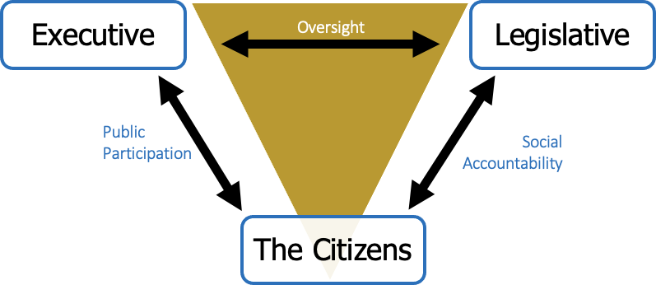

# Theory of Change

The theory of change outlines the pathway required to achieve the expected results, including major assumptions, risks, and risk mitigation measures.

**If** County public participation structures are strengthened, accountability mechanisms improved, and citizens can meaningfully engage in governance planning and monitoring processes.

**And If** Counties have Inclusive County Planning and Budgeting processes that promote equitable allocation of resources; execution processes and systems that ensure transparent and efficient service delivery; and strengthened oversight mechanisms.

**And If** Counties apply evidence based, and data driven knowledge management to influence inclusive policy dialogue and formulation in devolved service delivery.

**THEN** All people in Kenya at risk of being left behind – particularly women & girls, youth, and children, in the ASAL counties and informal urban settlements – can participate in transformative governance systems that are gender-responsive, just and rule of law compliant, and enjoy equitable, efficient, and accountable service delivery.

**Figure 1: Theory of Change**

**IF**

County public participation structures are strengthened; accountability mechanisms improved, and citizens meaningfully engage in governance planning and monitoring processes.



**AND IF**

Counties have Inclusive County Planning and Budgeting processes that promote equitable allocation of resources; execution processes and systems that ensure transparent and efficient service delivery; and strengthened oversight mechanisms.

**THEN**

All people in Kenya at risk of being left behind

- particularly women & girls, youth, and children, in the ASAL counties and informal urban settlements - can participate in transformative governance systems that are gender-responsive, just and rule of law compliant, and enjoy equitable, efficient, and accountable service delivery.



**AND IF**

Counties applies evidence based, and data driven knowledge management to influence inclusive policy dialogue and formulation in devolved service delivery.

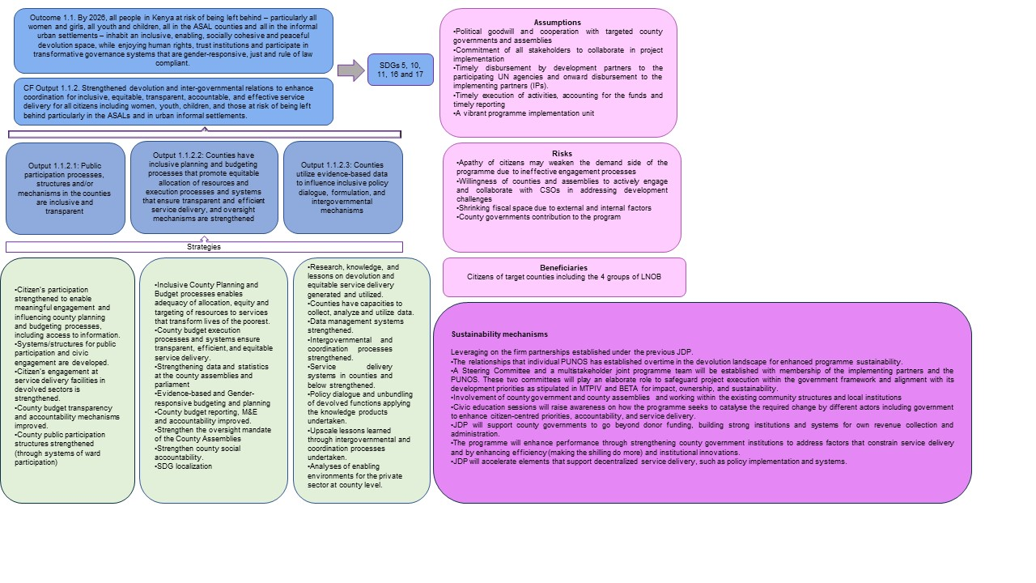

# Outcome and outputs

The overall objective with the joint programme is to empower citizens, providing structures for public participation, (budget) transparency and social accountability mechanisms. The Joint program will achieve its goals through the following outcome, CF output and project outputs:

**Outcome 1.1:** By 2026, all people in Kenya at risk of being left behind - particularly all women and girls, all youth, and children, all in the ASAL counties and all in the informal urban settlements – inhabit an inclusive, enabling, socially cohesive and peaceful environment, while enjoying human rights, trust institutions and participate in transformative governance systems that are gender-responsive, just and rule of law compliant.

**CF Output 1.1.2:** Strengthened devolution and inter-governmental relations to enhance coordination for inclusive, equitable, transparent, accountable, and effective service delivery for all citizens including women, youth, children, and those at risk of being left behind particularly in the ASALs and in urban informal settlements.

#### Project outputs with underlying strategies

**Output 1.1.2.1: Public participation processes, structures and/or mechanisms in the counties are inclusive and transparent.**

* Citizen’s participation strengthened to enable meaningful engagement and influencing county planning and budgeting processes, including access to information.
* Systems/structures for public participation and civic engagement in developed.
* Citizen’s engagement at service delivery facilities in devolved sectors is strengthened.
* County budget transparency and accountability mechanisms improved.
* County public participation structures strengthened (through systems of ward participation)

#### Output 1.1.2.2: Counties have planning and budgeting processes that promote equitable allocation of resources and execution processes and systems that ensure transparent and efficient service delivery, and oversight mechanisms are strengthened.

* Inclusive County Planning and Budget processes enables adequacy of allocation, equity and targeting of resources to services that transform lives of the poorest.
* County budget execution processes and systems ensure transparent, efficient, and equitable service delivery.
* Strengthening data and statistics at the county assemblies and parliament
* Evidence-based and Gender-responsive budgeting and planning
* County budget reporting, M&E and accountability improved.
* Strengthen the oversight mandate of the County Assemblies
* Strengthen county social accountability.
* SDG localization

#### Output 1.1.2.3: Counties utilize evidence-based data to influence inclusive policy dialogue, formulation, and intergovernmental mechanisms.

* Research, knowledge, and lessons on devolution and equitable service delivery generated and utilized.
* Counties have capacities to collect, analyze and utilize data.
* Data management systems strengthened.
* Intergovernmental and coordination processes strengthened.
* Service delivery systems in counties and below strengthened.
* Policy dialogue and unbundling of devolved functions applying the knowledge products undertaken.
* Upscale lessons learned through intergovernmental and coordination processes undertaken.
* Analyses of enabling environments for private sector investments at county level.

# Lessons learned from previous implementation.

The evaluations of the previous JDP outline several recommendations and lessons learned that have informed the design of this JDP. Firstly, working with national level institutions as implementing partners positively influenced the results and was needed at the time the previous program was launched but, as both the mid-and end term evaluation pointed out, a successor programme should focus more directly on supporting county governments to improve governance structures and deliver devolved functions with high quality.

The role of the UN being a convenor/connector of dialogue between government and citizens is an important factor to success and should continue to be supported. Unfortunately, the previous program was disjointed in the implementation of activities among the agencies. The value anticipated by agencies working together in a joint program was compromised as the comparative advantage of the agencies coming together was not well tapped. Joint work planning, monitoring, stronger presence on the ground and coherence of project activities in the next phase would address this challenge. The fact that the three agencies has several complementary projects/programmes relevant for the proposed programme ongoing at national and county level reinforce the added value of working together. Annex XX provides a short overview of relevant projects implemented by the agencies.

The JDP midterm evaluation highlighted the challenge of thinly spread resources for the lead agency in project implementation and programme management costs. To address this lesson, a solution will be implemented by separating the overall programme management budget from UNDP’s programme budget. This strategic adjustment aims to ensure more focused allocation of resources and effective utilization in both project implementation and overall programme management. The MTE further recommended that the new JDP should focus on fewer counties for better impact to avoid spreading too thin, hence the programme suggests focusing on fewer counties, going down from 14 to proposed 8 for the new JP.

Active participation in the devolution donor working group and devolution technical working group from the previous programme was weak. Those working groups provide an important forum to demonstrate results, engage in discussions on devolution and learn from what other agencies are doing. Going forward, the new JP will use these forums much more effectively and through its strategic outcome 3 provide analytics of interest not only directly for the programme but also for other actors in the devolution space. Hence, the engagement will be strengthened to enhance coordination and collaboration for greater results for the people of Kenya. The new JP will also actively engage in putting the experiences of devolution in Kenya in international forums. The JP will also organize bi-annual Local Governance Forums to highlight Kenya’s experiences and invite international actors that can provide useful insight in taking devolution further.

Equally the MTE recommended more coherence in the design of the program. Finally, the MTE strongly recommended that the program should develop analyses and knowledge products based on its work that also would inform and support the government in taking devolution further.

The end term evaluation recommended a stronger focus on evidence-based reporting and improving knowledge management in a successor programme. This JP has a dedicated output focusing on knowledge management.

and analyses that will support counties developing or revising subnational policies. Analyses, better use of data and development of knowledge products will support both county and national government in strengthening devolution further. The end term evaluation also recommended stronger emphasis on “developing, using, and repeating processes and practices that support coherence and more effective and efficient implementation within and across counties”. The new program has identified challenges that all participating counties face, hence the same set of activities will be implemented in the selected programme counties. This approach will also provide stronger evidence of what’s working and what’s not.

Finally, the proposed JP has put much more effort into being a joint design, not only the sum of what three UN agencies implement what they are mandated to. To ensure that the sum of the three participating agencies is greater than three, efforts on designing the activities in a way that the strength of each agency is accounted for in the design was another recommendation from the end term evaluation.

# Implementation approaches and ownership.

Implementation of the joint programme will start with a 6 months inception phase where county governance and service delivery assessments plus recruitment of key programme staff will take place. The inception phase will help the UN team, the county governments and other stakeholder to better understand the programme and the situation in the targeted counties and informing the implementation of the suggested outcomes and outputs in the programme. The assessment will also feed into deeper analyses that will support stakeholders in policy development and/or policy reviews to strengthen the system of devolved governance and service delivery. The inception phase will also be used to develop a joint programme spirit ensuring that everyone is familiar with the programme objectives and the role of each partner.

When fully up and running the programme will continue making analyses and engage in policy dialogues to further improve local governance and devolved service delivery e.g. organize bi-annual governance forums bringing together national and international expertise on decentralization to share experiences and get input from other experiences implementing decentralization. The programme will put significant efforts in developing knowledge products that will be useful for different stakeholders and help guide further steps in devolution in Kenya.

**County selection and geographical focus of the JDP.**

The mid-term evaluation recommended that a new programme should reduce the number of counties supported and avoiding spreading resources to thin. The proposed target counties for this programme have been identified against inequality and deprivation criteria: Monetary poverty, multidimensional poverty, gender gaps, youth multidimensional poverty, children multidimensional poverty, marginalized areas, ASAL and county capacity. Using these criteria the 47 counties were ranked as shown in Table 1 below.

Additionally, when the criteria were subjected to regional distribution 8 counties is recommended (see map next page): Kwale, Wajir, Samburu, Homabay, West Pokot, Kitui, Embu and Naruk. Out of these suggested counties, three are led by a female governor, four was part of the previous joint devolution programme and four are new counties.

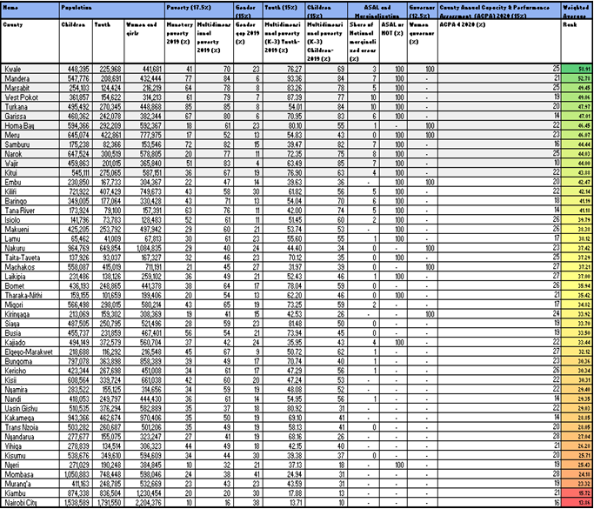**Table1: County level data**

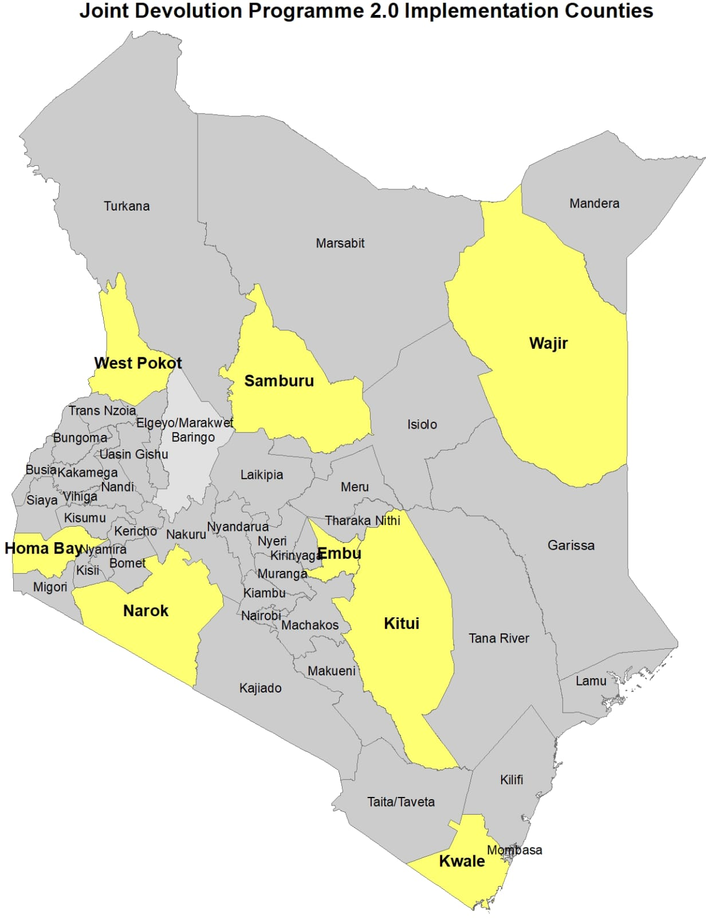

# Critical cross-cutting concerns – gender, youth, children and disaster risk reduction and resilience

To ensure effectiveness the joint programme has taken into consideration the following critical cross-cutting issues:

Gender has been integrated as a major element to facilitate achieving of the SDGs with a focus of leaving no woman nor girls behind. Under the guidance of UN WOMEN, the JDP will ensure gender priorities are well mainstreamed and articulated in all activities supported by the programme. Youth and children’s issues under the purview of county governments will also be mainstreamed in the JDP activities. Responding to leave no youth nor children behind, UNDP, UN WOMEN and UNICEF will respectively mainstream activities responding to the needs of youth and children within the devolution context especially in planning, budgeting, service execution, empowerment, and inclusion. The JDP will also be intentional in reaching ASAL areas through county targeting and people living in informal urban settlements through the CSOs. Indicators aligned to the cross-cutting issues will be incorporated in the results measurement framework to enhance specificity in reporting. Further, implementation of the JP will be anchored on the rights-based approach and in line with the Universal Declaration of Human Rights to ensure adherence to human rights principles and prioritize the protection and promotion of human rights, including economic, social, and cultural rights. This will also include alignment with the UN Convention on the Rights of Persons with Disabilities (UNCRPD) which sets out minimum standards for the rights of people with disabilities and the United Nations Convention of Children.

**Table 2: Other devolution support programmes**

|  |  |  |
| --- | --- | --- |
| Project Thematic Focus Key Partners | | |
| Supporting Kenya’s Devolution **(SKeD)** 10 M EUR | * Support improvement of county systems to deliver devolved services, * Support improvement of counties’ capacity to mobilize Own Source Revenue; and * Support actions to address marginalization to   reduce regional disparities in development and access to basic services. | The European Union and its implementing partner GIZ |
| Kenya Devolution Programme (ACT) | Responding to ineffective intergovernmental relations; ineffective county planning, public finance management and staff performance; inadequate engagement between county governments and citizens in service delivery; limited integration of evidence, digital technology and learning as enablers of public service delivery and reform. | UK Foreign Commonwealth Development Office |

|  |  |  |
| --- | --- | --- |
| Kenya Devolution Support program II  **(FY2024-2028) 150 MUSD** | KDSP II covers all 47 counties and selected number of national institutions and is anchored in the State department for Devolution. The program focuses on:  KRA 1: Sustainable Financing and Expenditure management for devolved service delivery (enhancement of own source revenue collection (including through automation) timely transfers to service delivery units, implementation of time-bound county pending bill action plans, automation of payrolls and associated capacity development of relevant institutions.  KRA 2: intergovernmental coordination, institutional performance, and human resource management for service delivery; and  KRA 3; Oversight, participation, and accountability for  service delivery. | World Bank |
| Financing Locally Led Climate Action (FLLoCA) Program US$150 IDA credit US$21.4 million Grant  from a Multi-Donor Trust Fund with resources from the Government of Denmark (US$9.8 million grant equivalent) the Government of Sweden (US$11.6 million grant equivalent), and US$80 million from the GoK. FLLoCA also receives funds from the Government of Netherlands and a soft loan, complementary funding of 31 million EUR from KWf. | FLLoCA aims to strengthen national and notably county government capacities to cope with the climate shocks and hazards and to enhance resilience at the community level through implementation of climate change adaptation actions that are identified and prioritized through participatory and inclusive ward level consultative processes.  The FLLoCA program development objective is to deliver locally led climate resilience actions and strengthen county and national governments capacity to manage climate risks. The program focuses on capitalizing the County Climate Change Funds; building county level capacity for planning, budgeting, monitoring, reporting and implementation of local climate actions, in partnership with communities; and strengthening of national and county levels institutional capacity for coordination, monitoring, verification and reporting on climate action, notably climate change adaptation. In partnership with local communities at ward levels and with support from the National Government, the County Governments are  the program's main implementing partners. | World Bank  The JP will leverage the FLoCCA program's attention on citizens' engagement in selection of climate action investments in the wards opening for social accountability mechanisms and a systematic approach to public participation across counties. |

# Sustainability plan and exit strategy.

The programme will be working with county governments, community leaders, and local institutions to strengthen their capacity in demanding transparency, accountability and meaningful participation in service delivery, local decision making and suggest social accountability and monitoring mechanisms in implementation of infrastructure projects. Civic education sessions will raise awareness on how the programme seeks to catalyze the required change by different actors including government to enhance citizen-centered priorities, accountability, and service delivery.

Further, the joint programme will support county governments in developing strong institutions and systems for own revenue collection and administrations.

The programme will enhance county performance through strengthening county institutions to address factors that constrain service delivery and by enhancing efficiency and institutional innovations. In addition, the JP will accelerate elements that support devolution, such as implementation of policies, legislations, and capacities, which in return keep interventions initiated by the programme remaining after the exit.

The programme will build on partnerships established during the previous JDP, with participating county governments, national government, civil society, and other stakeholders. The programme management structure includes a project steering committee that draws membership from the county and national government, Council of Governors (CoG) UN, donors, and non-state actors.

# Steering and Management Arrangements

The programme will be operationalized through a multistakeholder approach which will include a Steering Committee and a JP technical team. The programme management unit will be posted in State Department Devolution. Teams composed of various project partners will be established to ensure successful and smooth implementation, through guidance of the Project Steering Committee.

**The Steering Committee:**

The JP Steering Committee (SC) as per the terms of reference (Annex C1) is accountable for effective management of the JP and the achievement of JP results. It will provide strategic oversight and guidance for the JP team from launch to closure, including adjustments to envisioned results and strategy, progress review and learning, and evaluation. Composition of the SC will include:

**Table 3. Co-Chairs**:

|  |  |
| --- | --- |
| **Category** | **Institution and Designation** |
| Government of Kenya | Principal secretary, State department devolution |
| United Nations | Resident Representative, UNDP Kenya |

**Table 4. Membership of the Steering Committee:**

|  |  |
| --- | --- |
| **Participating UN Organizations** | |
| 1. | Representative, UNICEF Kenya Country Office |
| 2. | Country Representative, UN WOMEN Kenya Country Office |
| **Donors** | |
| 3. | Funding partners of the programme |
| **Government of Kenya Ministries, Agencies and Departments** | |
| 4. | County government representatives |
| 5. | Council of Governors |
| 6. | State Department for Gender |
| 7. | The National Treasury and State Department for Economic Planning |
| 8. | Intergovernmental Relations Technical Committee (IGRTC) |
| 9. | Kenya School of Government (KSG) |
| 10. | Society of Clerks at the Table (SOCCATT) |
| 11. | The National Treasury and State Department for Economic Planning |
| 12. | County Assemblies Forum |
| 13. |  |
| **Civil Society Organizations** | |
| 15. | LNOB groups |
| 16. | Local Public Sector Alliance (LPSA) |
| 17. | Academic institutions |
| 18. | Local government associations |

**Programme Management**

Secretariat functions to the JP will be provided by a Programme management unit at State Department Devolution. UNDP will take the lead in the recruitment of staff in collaboration with UNICEF and UN WOMEN. The management unit will ensure jointness, shared information and complementarity in project implementation among the UN organizations. The PMU will have the following staff: Programme Manager; Monitoring & Evaluation function (with M&E, learning, statistics, and reporting capabilities); a Communications function (also covering knowledge management); and a Programme/finance assistant. The budget for the management unit will be drawn from the consolidated joint programme resources and included in the joint programme Integrated Results and Resources Framework.

The management unit and overall program implementation will be guided by senior governance advisors (UNDP and UN WOMEN) and a senior social policy advisor (UNICEF). Each participating county will have a dedicated UN volunteer posted in the county, supporting implementation of the programme.

The programme management unit shall be responsible for:

* Prepare a consolidated Annual workplan (AWP) with joint activities and present the same to the JP Team for validation and to the steering committee for approval.
* Monitor budget compliance by PUNOs and financial reporting.
* Development of data collection tools for all indicators and ensure real time reporting on the indicators
* through ICT based tools.
* Prepare results-based reports and facilitate approval by JP SC as needed.
* Responsible for M&E (quarterly, semi-annual, and annual indicator based and narrative reporting)
* Develop and implement a communication strategy for enhanced programme visibility to stakeholders and the wider programme audience.
* Supervision of county level staff
* Monitor joint programme risks by continuously scanning the joint programme operating environment and update the join programme risk profile.
* Organizing of, including preparation of relevant documentation for, the annual programme steering committee meetings in conjunction with lead agency.
* Convening monthly JP technical meetings attended by the PMU, senior advisors, and the JP team to review progress and address any implementation issues.

## Figure 3: JP Management Arrangements

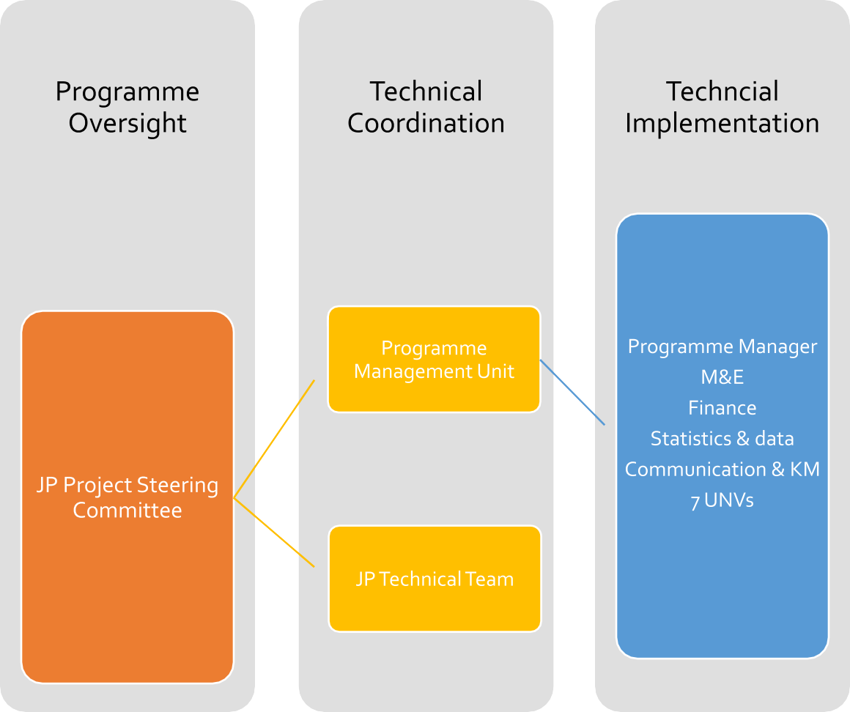

**Fund Management Modality**

This JP will adopt both the Parallel and the Pass-through Fund Management Modality (FMM). The Parallel modality will enable each PUNO to manage its own activities within the JP work plan and budget, whether from core/regular or other resources. The Pass-through Fund Management Modality will be applied for funds accessed from the multi partner trust funds (MPTFs) coordinated by the UN Resident Coordinator (UNRC) and any other donor who may fund the JP directly. The funding requirement for this JP is indicated in the budget presented in the results framework. The PUNOs plan to develop a resource mobilization strategy to fill the funding gap.

# Monitoring, Evaluation, Learning and Communication

**9.1 Monitoring, Learning and Reporting**: JDP will track progress through indicators and develop data collection tools to enable real time reporting. Further, since this JP has a strong component on capacity strengthening for county executive and county legislature, the need to develop training evaluation tools for capacity development interventions as they are executed and for follow-up on how the skills acquired are being applied using tested capacity development monitoring tools will be critical. This will also be complimented through tracer studies enabled by a comprehensive database for programme beneficiaries. A strong capability that will be needed under the programme M&E is knowledge development and management where data and qualitative information being generated from project activities will be packaged into high quality products. The monitoring function will also need a strong statistics capability to collect, process and collate data for the indicators and ultimately inform evidence-based, results-based reports. Monitoring will also generate lessons emanating from implementation while at the same time contribute to tracking of risks and assumptions.

The collation of monitoring information will be continuous and will be consolidated to generate quarterly, semi-annual, and annual reports as required by the donors and the PUNOs. The Annual report will be validated by the JP team, senior management of each participating UN organization and approved by the JP SC. The JP reports will provide an update on project progress against indicators and targets, lessons, good practices, challenges that need to be addressed and the financial report. All programme reports will be results and evidence-based, with compelling narratives. Annual and semi-annual reports will form the basis for guidance and decision-making by the JP SC. In addition, the programme will undertake at least two progress reviews meetings annually.

**9.2 Communication**: A strong communication strategy will be established to disseminate the results-based reports and knowledge management products generated by the monitoring and learning function, to stakeholders and a wide range of audience to ensure visibility of the PUNOs, donors and implementing partners. The programme communication function will work directly with PUNOs’, donors’ and implementing partners’ communication focal points to facilitate a seamless and joint approach in communicating the JDP’s activities and results.

To enhance JP visibility and create immediate awareness on the JP, the programme and programme staff will be launched in the target counties.

## 9.3 Evaluation

Midterm and final evaluations will be undertaken to establish whether the expected results have been achieved. The evaluation findings will also be used for learning by the PUNOs and partners, for decision-making to enhance accountability and credibility for results. The joint evaluations under JDP will be conducted according to guidelines from the United Nations Evaluation Group (UNEG) and OECD/DAC evaluation criteria. The evaluations will examine the relevance of the JDP strategy and results, the effectiveness and efficiency of implementation by PUNOs and other JDP partners, the sustainability of results and their contribution to CF’s Outcome 1.1, country priorities, and related SDG targets. In addition, the joint evaluations for the JDP will gauge the extent to which the guiding principles, especially LNOB, human rights and GEWE considerations were incorporated in the design and implementation. The evaluations will be commissioned by the JP SC and prepared by the JP team, serving as the management group, and facilitated by the programme management unit.

# Annex A. Terms of reference

## C1. Joint Programme Steering Committee

## Purpose:

The **JP Steering Committee (SC)** will be accountable for effective management of the JP and the achievement of JP results. It will provide strategic oversight and guidance for the JP team from launch to closure, including adjustments to JP results and strategy, progress reports and learning, and evaluation (*as required*).

#### Co-chairs:

The SC will be co-chaired by representatives of the Government and the UNCT. *Normally* the UN co-chair is the chair of the relevant CF Results Group and JWP from which the JP is derived. The UN co-chair represents and acts on behalf of the UNCT. Secretariat functions will be provided by the lead PUNO.When funding for the JP is from a global fund (e.g. Joint SDG Fund; Peacebuilding Fund; Spotlight Initiative) that *requires* a coordination role for the UNRC, the UNRC will co- chair the JP steering committee. In all other situations, UNRC involvement will be **optional** depending on the specifics of the JP.

#### Members:

Members will include relevant Government Ministries, Departments and Agencies; Heads of all PUNOs; representative of CSOs; representatives of employers’ organizations and trade unions.

#### Frequency of meetings:

Normally the Joint Programme SC will meet at least annually for the annual progress review.

#### Tasks:

1. Review and endorse the JP document, including the integrated results framework, work plan and budget.
2. Review, as needed, the JP resource mobilization needs and recommend and support opportunities to address funding gaps.
3. Review and endorse the annual results-based report to identify achievements, constraints, and opportunities, and to recommend measures to adapt and strengthen JP strategy and results for greater relevance and effectiveness.
4. During the annual progress review: (1) Review progress information, lessons and good practices, including any adjustments made by JP team, (2) Compare actual progress against expected JP results, (3) Consider the *contribution* of JP results to Cooperation Framework outcome(s), country priorities, and related SDG targets; and (4) Review the sustainability plan and exit strategy and make adjustments (as needed).
5. Review and approve any *substantive changes* that affect expected JP results and the theory of change, involve a no-cost extension, or that **exceed 25%** of the annual budget.
6. Review and endorse the rolling JP workplan and budget for the next year.
7. Share updates and reports with relevant stakeholders.
8. Scan the programme environment for changes and monitor assumptions and risks.
9. Facilitate the resolution of any external challenges that the JP team may face during the JP cycle.
10. If an evaluation is required, assume the role of, or appoint, an Evaluation Steering Group to:

» Appoint an Evaluation Manager.

» Approve the Terms of Reference for the [joint evaluation](http://www.uneval.org/document/detail/1620)

» Commission and receive the inception, progress and final reports of the joint evaluation.

» Develop and adopt a dispute resolution mechanism for the evaluation process; and

» Review and endorse the proposed management response to the findings and recommendations from the joint evaluation.

### C2. Joint Programme Team

### **Purpose:**

### The JP team will **manage the results** for the duration of the programme. This will be done in accordance with the JP results framework, work plan and budget. The team will comprise of responsible technical officers from Government Ministries, Departments and Agencies; all PUNOs (UNDP, UNICEF and UN WOMEN) representative of CSOs; representatives of Council of governors; and representative of LNOB groups. Coordination and programmatic leadership will be provided by the lead PUNO. The team will sequence planned activities, monitor implementation and the achievement of results, lessons learned and make adjustments for greater effectiveness together with government, implementing partners and non-UN partners. The JP team will practice a set of teamwork skills: participation, effective listening, collaboration, flexibility, and the ability to revise and refine. The JP team will be accountable to, and has a dual reporting role to, the JP Steering Committee (SC) and to their respective PUNOs and relevant government agency.

### **Coordination and Programmatic leadership:**

### Normally, the lead PUNO will provide coordination and programmatic leadership during implementation supported by the PMU.

### **Coordination: This will involve** (1) Organizing and supporting meetings of the JP SC; (2) Coordinating advocacy initiatives with donors and external stakeholders, and (3) Facilitate audit and evaluation (*as required*).

### **Programmatic leadership**: This involves supporting the JP team to manage for results. The lead PUNO will ensure programmatic coherence and quality in accordance with the JP results framework, work plan and budget and in adherence to quality standards by: (1) Organizing and chairing JP team meetings in collaboration with the co-chairing government agency; (2) Update the JP results framework, work plan and budget; (3) Lead joint monitoring and learning efforts, including joint field missions, (4) Facilitate programmatic learning and adjustments, (5) Consolidate the annual results-based report, based upon inputs from other PUNOs and partners; and (6) Report to JP SC meetings.

### **Role of the UNRCO**:

### When requested by all PUNOs, the pooled fund mechanism, or by individual donors the UNRCO may support the JP team for coordination purposes. When the UNRCO provides coordination support, the lead PUNO continues to provide programmatic leadership.

### **Members:**

### The team will comprise of responsible technical officers from Government Ministries, Departments and Agencies; all PUNOs; representative of CSOs; representatives of employers’ organizations and trade unions; and representative of LNOB groups.

### **Frequency of meetings:**

### The JP team will be meeting at least monthly.

### **Tasks of the JP Team**

### Sequence and monitor implementation of planned development activities for maximum synergy and coherence

### Track the JP budget and expenditures to ensure delivery of planned activities.

### Monitor the achievement of JP results and track indicators to ensure a contribution to Cooperation Framework outcome(s), country priorities, and related SDG targets.

### Scan the programme environment for changes and monitor assumptions and risks.

### Adjust JP activities, budgets, results and strategies to maintain relevance and effectiveness.

### Update the JP results framework, work plan and budget to reflect changes and ensure relevant information is updated in UN-INFO

### Identify lessons and undertake policy dialogue and advocacy with partners to identify opportunities to scale-up JP results and strategies.

### Review: Prepare and support the annual progress review

### Report: Prepare the annual results-based report

### Support the work of the JP SC and respond to information requests in a timely manner

### Support resource mobilization efforts of the UNRC, UNCT and SC

### Liaise with the [Operations Management Team](https://unsdg.un.org/resources/operations-management-team-country-level-terms-reference-template) to utilize available [common business services](https://unsdg.un.org/resources/bos-high-impact-services-resource-links)

### Liaise with the [UN Communication Group](https://unsdg.un.org/sites/default/files/uncg-country-tors.pdf) to develop joint communications products about the JP

### Share information about the JP amongst the team and with all partners in a timely manner.

**ANNEX B: Participating UN agencies work related to the JDP**

**UNDPs** civil society facility Amkeni Wakenya supports enhanced democracy and human right through technical assistance to civil society organizations. The project is in its third phace and its activities are aligned with the UNDP Global Strategic Plan 2022-2025, the Kenya Vision 2030 and MTP IV. The project supports enhanced public participation, and focusing on people-centered devolution, partnering with the Council of Governors and other key actors to improve governance and service delivery at the county level. The project budget is **6 378 846 MUSD** and covers the period 1 Jan 2023 to 31 Dec 2027.

Deepening Democracy is a project seeking to undertake strategic interventions aimed at deepening gains to transform democratic governance in Kenya. Project interventions, are undertaken in a phased approach focusing on good governance, electoral assistance, capacity development, and strengthening the capacity of governance institutions to enhance public accountability, gender equality, social inclusion, institutional coordination and stakeholder engagement through the following outputs: (1) Enhanced institutional capacity for inclusion, transparency, and accountability; (3) Strategic engagement on legal and institutional frameworks and stakeholder coordination for democratic consolidation; (4) Increased civic and media engagement and participation in governance processes for accountable service delivery (6) Enhanced capacity on security, risk management, and coordination; (7) Strengthened civic engagement women and youth participation in conflict prevention and peacebuilding; (8) Effective and efficient management, partnership formation, monitoring and evaluation of the project. The project is funded through a basketfund which includes the EU, Germany, Italy, Irish Aid and UNDP core resources. The total budget is **8,115,498 MUSD.**

**UNWOMEN** implement various projects on women’s participation in decision making, ending violence against women and girls, women economic empowerment, and on women peace and security in counties and at national level. Some of the key interventions in the counties includes:

 i) Capacity development for state and non-state actors on gender mainstreaming and inclusion in governance processes, strengthening the capacity of women in political leadership and decision-making including reducing negative social norms that exclude women from advancing in leadership spaces. The target counties include Kajiado, Wajir, Kisii, Kericho, Bungoma, Vihiga, Embu, Homa bay, Machakos, Nakuru, Kwale, Kirinyaga, and Meru.

ii) Supporting normative reporting processes at national and county level- SDG/VNR, Beijing, CEDAW, Maputol protocol and reviewing the ten county data sheets, including development of 37 County Gender Data Sheets, and the operationalization of value chain related to SDG indicator sets in all sectors, ministries, departments agencies, and local governments.

Iii) Supporting interventions on adolescent Youth & PLWDs/HIV/AIDS, and social transformation and behavioral change targeting youth, PWDs, faith-based leaders, council of elders and men engage groups on their role in prevention of VAWG in Nairobi, Homabay, and Kajiado.

iv) Supporting grassroots mediation networks in Lamu, Isiolo and Wajir to conduct community dialogues to effectively address and de-escalate tensions within the respective regions, including the localization of the Women's Peace and Security agenda at nationally and the county level.

iv) Supporting women’s economic empowerment through climate-smart agriculture in Kitui, Laikipia and West Pokot, fostering women’s resilience to climate change, strengthening their capacity to produce food within a changing climate, providing policy guidelines, and influencing the county plans and strategies to ensure they are gender-responsive and climate-smart.

The budget for implementing the above work is **USD 3M**.

**UNICEF** has an ongoing program with CoG with a budget of **142 934 USD** supporting policy development and capacity development in the area of budget transparency, public finance and data systems and citizens budgets in select counties. The program also provides technical assistance to CoG in the above mentioned areas.

UNICEF:s program on enhanced public financial management with International Budget Partnership (1/7-21 to 30/6-23, extended to 31/12-24) had a budget of **165 330 USD** targeting the 14 JDP counties plus a national level budget index. The program was funded, amongst other sources, from the previous JDP. The program focus on enhancing national and county level public financial management, budget transparency, citizens engagement and social accountability.