**Re-entry Action Plan (REAP)**

The CaB-LCT Projects adopts the Re-entry Action Planning process to ensure that key learning/insights gained by the training participants are significantly applied to their respective organizations. The REAP Activity is a proactive process that facilitates discussions and agreements between the training participants and training sponsor/provider on the strategies to be implemented following the training program.

A face-to-face REAP Workshop will be conducted to further enhance its contents.

The REAP will be evaluated based on the following:

1. Comprehensive assessment of the current situation
2. Clear identification of development objectives and success indicators
3. Realistic milestones in relation to competencies and other resources

| **PROFILE** |  | Comments |
| --- | --- | --- |
| **Name/s of Training Participants Involved in REAP Preparation** | 1. EnP. Ervie Rodriguez, MBA (CPDO)  2. EnP. Vergel Maaghop (CPDO)  3. Gary Abadines (CPDO)  4. Kathleen Ayuban (CENRO)  5. Atty. Gilbert Recosana, (CTMEU)  6. Marjorie Abella (SP)  7. Engr. Angel Amarante (CEO)  8. Michael Joseph Garcia (CPDO)  9. Joshua dela Cruz (CPDO)  10. PEMS Gene Eugenio (CTMEU)  11. Jesus I. Ibasco (CTMEU)  12. Engr. Boris Valeroso (CEO)  13. Engr. Mark Paulo Alcala (LCT-UNDP)  14. Engr. Peter Paul Ambas (CEO) |  |
| **Name of Organization** | **Local Government Unit (LGU) - City of Santa Rosa** |  |
| 1. **RELEVANCE OF THE REAP** |  |  |
| REAP Title | **Facilitating Implementation of  Low Carbon Transport Strategies:**  **FACING CHALLENGES AND OPPORTUNITIES** |  |
| Problem/  Opportunity | **PROBLEMS / CHALLENGES:**  **FLOODING:**  15 out of 18 barangays are flash flood prone areas.   * **Waterways are too narrow and shallow** * **Continuous development of upland areas that causes increased water run-off due to the use of non-permeable construction materials** * **Existing creeks and water tributaries no longer exist due to continuous development** * **Conversion of Agricultural lands into Commercial, Industrial and Residential use** * **Detention pond issues** * **Build-up of ISFs and building developments along the waterways**   **Flooding implication for low carbon transportation**   * **Infrastructure damage ( bike lanes, pedestrian pathways, charging station for EVs)** * **Disruption of power grid** * **Interruption on public transit** * **Less feasible alternative routes** * **Resilient low carbon planning**   **TRAFFIC CONGESTION:**  Traffic congestion at selected areas of the following:   * Manila South Road (National Road) * Santa Rosa - Tagaytay Road (National Road) * J.P. Rizal Blvd. (Provincial Road) * F. Gomez Street (Provincial Road) * Tatlong Hari Street (Provincial Road) * Balibago Complex Areas (City Road) * Few of the constituents (commuters and drivers) are inclined to engage in active transport regulations (all modes of transportation). * Traffic codes / regulations are neglected and violated. * Needs more signages, speed limits, among others. * Significant portion of walkways, pathways, and sidewalk bricks and pavements are removed / displaced. * Unregulated increase in the number of e-vehicles for private use. * Increase in GHG emissions and air quality deterioration due to increase in volume of vehicles. * Traffic congestion and limited centralized transport terminals. * Identified PUV pit stops for boarding and alighting of the commuting public. Public passengers are being boarded and alighted anywhere along the road contributing to road congestion. No designated proper facilities for boarding and alighting. * Streets and sidewalks are not yet fully connected which will make it easier for pedestrians to get to their destinations. * Lack of Parking Space * Holistic Expansion of public transportation (coordination with neighboring LGUs/ communities) * Promotion of Carpooling/ ride sharing services (private) to reduce overall carbon footprint * Encouragement of Active transport * Establishment of telecommuting and flexible working hours to spread out demand for transportation during peak hours. * Smart traffic management system to optimize traffic flow.   **AIR POLLUTION**  - Increase in GHG emissions and air quality deterioration due to increase in volume of vehicles   * Road vehicles as the major contributors of air pollutants     Figure 4.1 shows the share of each source to the total emissions. The bulk of the CO2, NMVOC, NO2, and PM10 emissions can be attributed to mobile sources. SOx emissions come chiefly from point sources while PM2.5, N2O, CH4 and BC emissions come from area sources.      **IV. Challenge - no dedicated Office to address the specific low carbon transport**   * LCT Technical Working Group (TWG) made a proposal for the creation of the **City Transportation Management Office** (**CTMO**) that can directly monitor, evaluate and develop plans mainstreaming LCT * Lack of centralized data and data management system used for data gathering (Knowledge Management Information System) * Challenge in coordinating or the Lack of Harmonization of Plans with neighboring Cities / Municipalities / Province / Region   **OPPORTUNITIES:**  **URBAN & FIRST CLASS CITY**  Revenue comes from the following sectors:   * **COMMERCIAL Areas:** SM City Mall, Robinson Mall, Complex Balibago Commercial Areas, Solenad 1-2-3 @ Nuvali Area, Vista Mall, Walter Mart Mall, Central Mall, City Business Districts, among others * **INDUSTRIAL Areas:** LTI Laguna Technopark Association Area, Meridian Industrial Complex Area, Daystar Industrial Park, Toyota Motors Philippines Corporation, Coca Cola Beverage Philippines Inc. - Sta. Rosa Plant, among others * **TOURISM Areas:** Enchanted Kingdom (EK), Nuvali Area, Santa Elena Golf and Country Club, The Country Club, Cuartel de Santo Domingo, Heritage Square, among others * **RESIDENTIAL Areas:** * Almost 200 Subdivisions (more new high class subdivision at west area) * Organized HOAs to support LCT * New Condominiums (SMDC, Greenfield, among others) * **Existing Cooperatives who are interested to Invest in LCT** * **Private Companies interested in the current Vehicle Modernization Program and the Electric Vehicle Industry Development Act (EVIDA) Law** | It's great that your REAP has identified flooding as a problem and the locations within the city that are prone to flooding. However, it would be even better to explicitly connect flooding with low carbon transport solutions. By doing so, we can address the root causes of flooding, which are often linked to carbon emissions, and work towards more comprehensive and sustainable solutions   * Less green due to developments * Increased pollution * Water / Solid Waste * Low mobility during floods, while there is continuous emission   While it's important to recognize the advantages of being an urban and first-class city, there are additional opportunities that can be considered to advance low carbon transport solutions.  For instance:   1. The city could explore partnerships with neighboring cities or regions to share knowledge and resources, leverage economies of scale, and coordinate efforts to promote sustainable transport options. 2. Additionally, the city could consider engaging with the private sector to leverage their expertise and resources to accelerate the transition towards low carbon transport solutions.   By taking a more comprehensive and collaborative approach, the city can tap into a wider range of resources and expertise, and build stronger networks and partnerships that can support its sustainability goals. It's important for the city to look beyond its urban and first-class status and to explore additional opportunities that can help advance its low carbon transport plan. |
| Description of Agency/LGU and its relation to REAP | **LGU - City of Santa Rosa**  **MANDATE**   * + - 1. CLUP with ZONING ORDINANCE       2. CDP       3. LDIP       4. AIP       5. ELA   DoTr/ DOST - bike lane project, railway projects  DPWH - strategic expansion of national roads  Transport Operators - Shift to EVs  General Public - engagement to active commuting  Private Institutions - higher parking fees and limited availability to discourage car usage and construction of EV charging stations and parking  Academic Institutions - promoting awareness campaigns about the environmental and health impacts of traffic congestion | To ensure the success of the  **Re-Entry Action Plan** (**REAP**) on Low Carbon Transport, it is important to identify and engage with all relevant stakeholders. These stakeholders can include but are not limited to, other adjacent LGUs, provincial government, LTFRB, transport operators, businesses, civil society organizations, academic institutions, and community members. Each stakeholder group brings unique perspectives, expertise, and resources that are critical to advancing sustainable transport solution  Therefore, it is essential to identify the role of each identified stakeholder in implementing the **REAP**. By understanding their mandate and role, you can build a comprehensive and sustainable low carbon transport system that benefits the entire community. |
| 1. **ACTION PLAN** |  |  |
| REAP Objectives | * To gradually shift Traditional Mode of Transport to Public Utility Vehicle Modernization Program (PUVMP) compliant vehicles * Establish a dedicated body that will develop and monitor LCT Action Plans * To increase the number of persons who use active transport mobility | In the re-entry action plan on low carbon transport, it is important to ensure that the plan's objectives are SMART - Specific, Measurable, Attainable, Resource-oriented, and Time-bound. By following the SMART framework, we can set clear and achievable goals that can guide and measure progress towards sustainable transport solutions. Please see a sample action plan below for your reference. |
| Activities and outputs  (Timeline: 6 months up to 2 years) | *What are the specific outputs expected from the implementation of the REAP* *based on the objectives with timelines*  **1. Conduct of LPTRP Study (Conduct Tricycle and PUV Study and come up with a plan to phase out legacy vehicles, 2-stroke engine motorcycles), rationalizing route plans for tricycles. Formulate Route Map Database.**   * **Completed Survey before the end of 2024** * **Centralized Transport System Database** * **Approved study by LTFRB & Approved Resolution by SP by the end of 2026**   **2. Capacity Building with LTFRB, DOTr, UNDP, & NCTS to finalize the LPTRP together with the Proposed Green Routes**   * **SP Approved Green Routes**   **3. Social Marketing with Stakeholders to discuss & cascade the benefits of the shift to PUVMP**   * **Stakeholders Acceptance**   **4. Create Livelihood program for potentially displaced drivers**   * **Increased number of skilled workers coming from the transportation sector**   **5. Revise E.O. on the functions of the LCT TWG**   * **Approved E.O. on LCT-TWG Functions**   **6. Identify Two Focal Persons to alternatively attend LCT TWG Meetings & Activities permanently**   * **Focal Persons identified per office**   **7. Active transport infrastructure improvement and expansion**   * **Established transport infrastructures (in budget spent)**   **8. Social Marketing Campaign on the promotion of walking and cycling**   * **Increased number of citizens engaged in walking & cycling**   **9. Identify road for possible conversion to flexible one-way street; to improve the current Class 3 Bicycle Lane to Class 1 or 2**   * **Approved Traffic Code**   **10. Identification of Pilot Barangays for Open Street Implementation**   * **Approved Barangay Proposal** |  |
| Required Resources | *Budgetary requirements and identified source of funds*  **Subject for Loan**  **General Fund** |  |
| Direct Beneficiaries | *Who is the main user and/or beneficiary of the REAP?*  *User could be within your workplace, work unit or community; and beneficiaries may be within and/or beyond your work unit.*  *Who will directly benefit from the implementation of your REAP? How many target beneficiaries does your REAP have? How will your REAP help your target beneficiaries?*   * Children and Pregnant Women - reduced risk of potential hazards * PWDs and Elderlies- accessibility and usability of public roads and sidewalks * Commuters - ease of transport and alternative mode * Private and Public Institutions - lessen delays due to traffic congestion   **(Residential, Commercial, Industrial, Tourism and Institutional Area)** |  |
| Women, Children, and other vulnerable sector | * Promotes active transport that is particularly beneficial for vulnerable groups with limited financial resources. * Efficient public transportation systems can reduce travel times. This can mean more time for work, education, and family activities. * Reduced traffic congestion reduces stress on vulnerable road users like pedestrians and cyclists. * Community connectivity is important to vulnerable groups who rely on local services and support networks. This will empower women enabling them to participate to the workforce, access education, and engage in community activities easily |  |
| Development Impact (Theory of Change) | *What is the ultimate, strategic impact that the REAP wants to achieve?*  **The Ordinance reflects the**  **City of Santa Rosa’s Vision to be**  ***"A Resilient, Safe and Secured,***  ***Transport-Friendly and Green City with Healthy, Productive, Connected, and***  ***Empowered Citizenry served by an Efficient, Transparent, Inclusive, and Participatory Government”*** |  |
| 1. **SUSTAINABILITY OF THE ORGANISATIONAL OUTCOME OF THE REAP** | |  |
| **Organizational outcome** | *How will the REAP enable the LGU to implement LCT/integrate low carbon transportation in their existing and future plans?*  Incorporate all future plans to the City Comprehensive Development Plan (CDP), Local Development Investment Plan (LDIP) and Comprehensive Land Use and Development Plan (CLUDP)  Providing Guidelines on Designing infrastructure projects aligned with LCT.  Design considerations on LCT infrastructures to be resilient on flooding |  |
| **Sustainability** | *What is your strategy to ensure that the gains of the REAP will be institutionalized and sustained beyond the REAP completion?*  City Comprehensive Development Plan (CDP), Local Development Investment Plan (LDIP) and Comprehensive Land Use and Development Plan (CLUDP) must be adopted by Sangguniang Panlungsod and Sangguniang Panlalawigan  Formulation of master plan consisting of programs aligned with LCT |  |
| **Risks** | *Identify the risks that might have an impact on the success of the Action Plan and how you plan to manage these to ensure success.*  The willingness to engage in the Government’s Mobility Modernization Program by stakeholders from the Private and Public Sector. Coordination with concerned agencies on the implementation of LCT programs. Submission of timeline to ensure that the concerned agencies will comply with the series of sub programs under REAP. |  |
| 1. **EFFECTIVENESS AND EFFICIENCY OF THE REAP PROJECT** | |  |
| Alignment of competencies | *Description of the required competencies/human resource needed to implement the REAP*  The **Re-Entry Action Plan** (**REAP**) brought about the need for a **City Transportation Management and Development Office** (**CTMDO**).  The **Low Carbon Transport** (**LCT**) **Technical Working Group** (**TWG**) may propose the creation of the **City Transportation Management and Development Office** (**CTMDO**) that can directly tackle issues on active mobility, road congestion, energy efficiency, climate change mitigation, and air quality management in the transportation sector.  The **CTMDO** can also address and resolve problems and issues through consultation and coordination with private and public stakeholders, adjacent LGUs and concerned NGAs.  The **CTMDO** can address traffic impact assessments and can formulate through legislation and implement measures to alleviate relevant active transportation and mobility issues. |  |
| Measurability | *What will serve as evidence of success of the REAP?*  *Cite what will show that the targets of your REAP are being realized.*  *This can be in terms of quantity, quality, and time? This may include % of usage of specific outputs, system or process, policy.*  *This can also include change in behavior of users or customers; improvements in the workplace’s/ community’s processes (and when possible, change in customers’ condition; Increase in revenue, etc.)*  Improved work life balance  Reduced travel time  Presence of PUVMP compliant vehicles  Increase in Active transportation activities like walking and cycling  Cleaner atmosphere  Less congested roads |  |

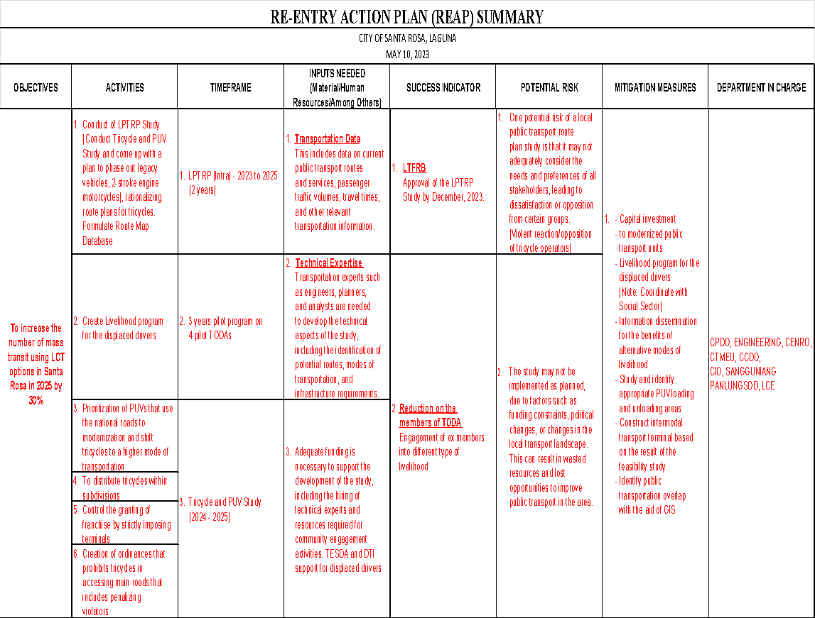

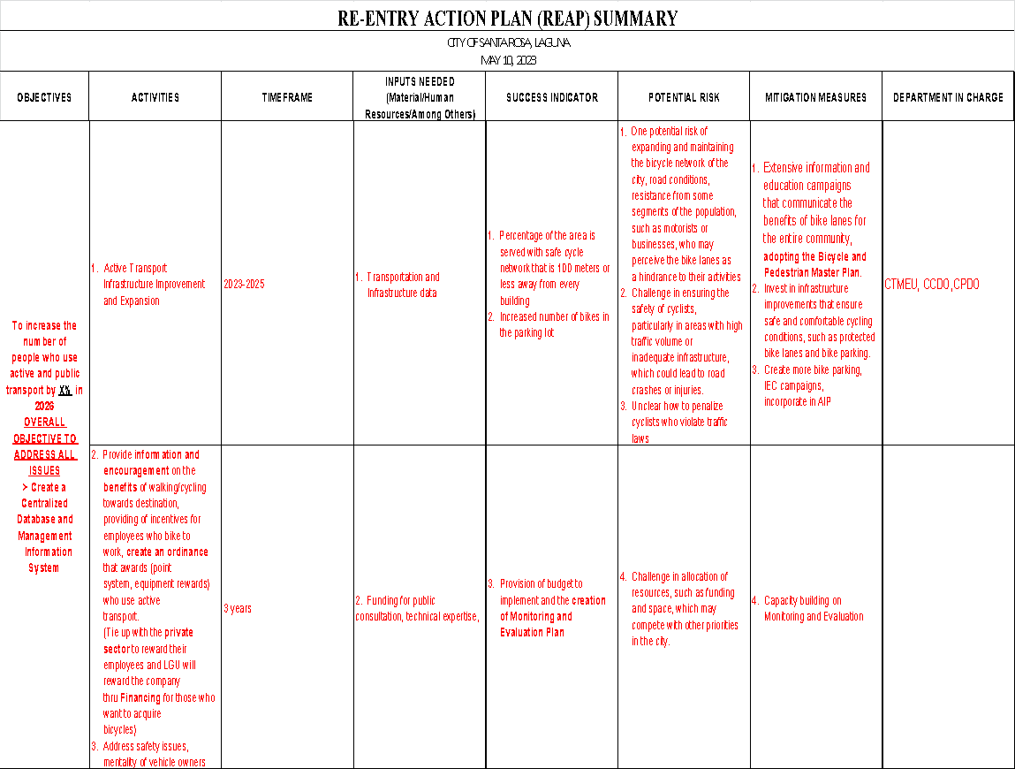

Prepared By:

* + - 1. EnP. Ervie Rodriguez, MBA (CPDO)
      2. EnP. Vergel Maaghop (CPDO)
      3. Gary Abadines (CPDO)
      4. Michael Joseph Garcia (CPDO)
      5. Joshua dela Cruz (CPDO)
      6. Engr. Maria Amor A. Salandanan, EnP (CENRO)
      7. Kathleen Ayuban (CENRO)
      8. PEMS Gene Eugenio (CTMEU)
      9. Atty. Gilbert Recosana, (CTMEU)
      10. Jesus I. Ibasco (CTMEU)
      11. Engr. Angel Amarante (CEO)
      12. Engr. Boris Valeroso (CEO)
      13. Marjorie Abella (SP)
      14. Engr. Mark Paulo Alcala (LCT-UNDP)
      15. Engr. Peter Paul Ambas (CEO)