UNITED NATIONS DEVELOPMENT PROGRAMME  BACK TO OFFICE REPORT  Date: 4-8 November 2024 | 
Name:  Pavel Faus, Project Specialist, UNDP IRH  Kateřina Linhartová, Project Associate, UNDP IRH | Patrycja Matusiak, Polish Partnership, UNDP IRH  Barbora Žáčková, Development Counsellor, Czech Embassy Chisinau
Purpose/Objectives of the assignment:

- Monitor ongoing and completed Challenge Fund (CF) projects (4 projects 2023, 1 project 2021).
- Conduct post-implementation monitoring of two 2022 Challenge Fund projects.
- Engage with UNDP CO management on existing and future cooperation
- Meet with the Czech Ambassador and Development Cooperation focal point at the Czech Embassy to explore synergies with Czech ODA.
- Attend the 3 project final events/press conferences
- Support visibility of Czech-UNDP Partnership activities in Moldova

Since 2018, 21 CF projects have been implemented in Moldova through the Czech-UNDP Partnership's Challenge Fund, with five projects currently ongoing. This partnership has provided $813,453 in funding, while innovators contributed $486,159, including in-kind co-financing. Out of the 21 innovations tested, 12 have been adopted locally, and six have successfully scaled up. In the week of November 4, 2023, final events for the Arnika 2023, BigTerra 2023, and Herman 2021 projects took place.

General Observations:

CO: Meeting of the Partnership’s team (Pavel Faus, Kateřina Linhartová) + Czech Embassy rep. Barbora Žáčková with UNDP CO management (DRR Seher Ariner and Dorin Toma), the meeting:
- Agreed to continue the cooperation with Moldovan partners and Czech and Polish stakeholders
- Commended existing results, scale-ups and visibility generated by the Partnership(s)
- Presented CO’s thematic work and priorities, ahead of future calls for applications and joint work
- Presented Czech Partnership’s Expertise on Demand offer and discussed need to identify needs for EU expertise
- Agreed to share details on CO’s EU Facility instrument and general EU-expertise needs
- Cooperation on Challenge Fund projects evaluation and implementation by the CO
- Further discussion on possible cost-recovery of CF projects support by the CO

Final Events: All 3 completed 2023 CF projects in Moldova achieved positive results and measurable impact, with clear outcomes. Projects’ final events were attended by UNDP and Czech Embassy representatives, highlighting the Partnerships added value. In particular
- the project on Protected Landscapes and Rangers (Arnika) is successfully applied and the final press conference was attended by UNDP’s RR Daniela Gasparikova and Czech Ambassador Jaromír Plíšek.
- the project Re:Wine (BigTerra) succeeded in stablishing a business model for support of regenerative viticulture with sustainability demonstrated by interest of wine producers, currently 3 wineries joined, multiple else in negotiations incl. main actors in the field. The final event was virtually attended by UNDP COs Serghei Botezatu and H.E. J. Plíšek.
- the project of traffic panels (Herman Electronics) was handed over and presented to UNDP’s Czech Partnership Team, with H.E. J. Plíšek attending.

Monitoring: Main outcomes from monitoring of 4 CF projects are: RNA genomic project (Academy of Sciences + MD Institute of Genetics) represents a great example of know-how transfer that is applied, with lasting impact beyond the project, as partners are planning to jointly apply for HORIZON projects. Good visibility with potential for further coverage. Monitoring of scaled-up Seed Libraries (Semínkovna) project is an example of a community based and driven project with clear results supporting food security, resilience at local level. Currently 21 locations across Moldova are active. Visibility requirements met. Monitoring of Beekeeping innovations (APIS) with final users indicates the technology is effective but financially challenging for most small-scale individual beekeepers, while large producers need multiple innovative beehives. Visibility of this project is also unsatisfactory. The Rainwater as alternative source of water (Caritas) project was discussed with implementer’s local team, agreed to extend the project until mid-2025 and aim for final public event in April/May 2025.

Visibility: blogs and social media content produced by CO’s comms for Arnika (4 pieces) and Re:Wine (4 pieces), content shared by the Czech MFA and Embassy, agreed further coverage of the Arnika-rangers project (video) and Academy of Sciences project (article, video) in upcoming months. Arnika-rangers video in production already. CO’s tweet on Re:Wine project shared by the Administrator.

Engagement and partnerships:
Meeting with local partners to evaluate results of CF projects
- ACSA management (Re:Wine)
- Biotica management (Rangers)
- Institute of Genetics, Physiology, and Plant Protection of the Moldova State University management (RNA Czech Academy of Sciences)
- Caritas CZ office in Moldova
- Chisinau Municipality and Public Transport company representatives

Meeting with Czech Ambassador to Moldova, H.E. Jaromír Plíšek, and Czech Embassy’s development counsellor Barbora Žáčková
Audio-visual resources:

UNDP social media coverage
Arnika Project
- Moldova strengthens its local volunteers’ rangers network and protected area management, with Czech and UNDP support | United Nations Development Programme
- (3) UNDP Moldova na platformě X: „🐾🌱Moldova strengthens its local volunteers’ rangers network and protected area management, with Czech and UNDP support. https://t.co/0emhg2hV0q https://t.co/WCXTv3Edzr“ / X
- UNDP Moldova - Cine poate deveni inspector voluntar de... | Facebook
- (5) Post | Feed | LinkedIn

Re:Wine project
- Moldovan wine-makers have access to a regenerative viticulture platform, created with UNDP-Czech support | United Nations Development Programme
- (3) UNDP Moldova na platformě X: „🇲🇩 winemakers use now Re-Wine, a regenerative🍇viticulture platform, enabling real-time monitoring of agricultural practices. Developed with UNDP & @czechaid support, the platform boosts data quality, soil health & climate resilience. https://t.co/DOE57Nlujz https://t.co/9jkuLsDMfT“ / X
- UNDP Moldova - 🍇Vinificatorii din Republica Moldova pot... | Facebook
- (5) Post | Feed | LinkedIn

(planned) Video for Arnika Project: in production tbc Dec 2024

Innovator’s coverage
Moldova's nature is guarded by selfless volunteer rangers. International cooperation helps, but protection from the authorities is still in making

Czech Embassy social media coverage (to be added)
Additional observations and follow up actions:  - Follow up action for Academy of Science project: possible article and video to be produced with UNDP CO during 2025  - Follow up for Rangers Arnika project: video production started  - APIS Bee-project beneficiary to provide feedback on Thermosolar Hive benefits and usability in one-year’s time  - Joint meeting of Partnerships Team (Berna) and UNDP CO (Seher) on EU-related agenda and opportunities for cooperation |  | Distribution List:  Partnerships Team  COST

Annex1

Czech-UNDP Partnership for SDGs
Monitoring of Challenge Fund projects in MD (CO overview)

11.11.2024
Pavel Faus, Kateřina Linhartová

- Semínkovna + Gradina Moldovei (2022)
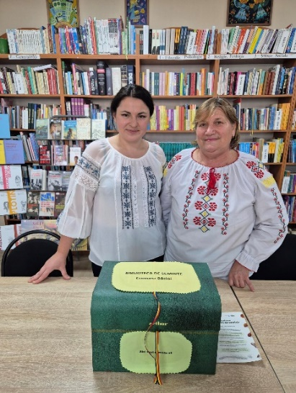
- Community-based seed libraries for exchange of locally produced seeds available at 21 sites across Moldova.
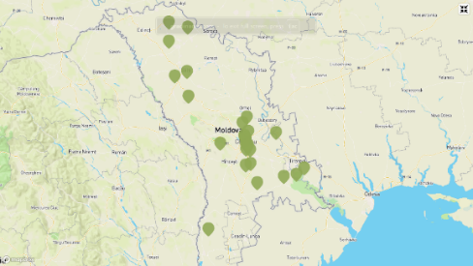
- Continuous growth of locations from 5 to 21, community based and driven project with clear results supporting food security, resilience at local level.
- Project encourages sustainable and localized production of food, seed libraries distribute locally grown seeds that are resilient in Moldova’s conditions.
- UNDP Article: Seed libraries were created as a first in Moldova, thanks to transfer Czech know-how | United Nations Development Programme

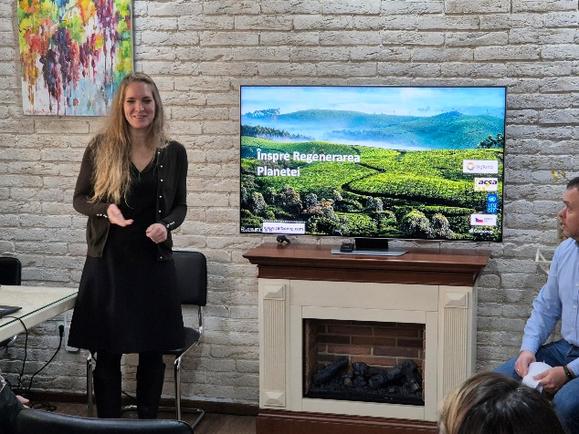
- Big-Terra + ACSA: project Re:Wine, regenerative wine-making + carbon trading (2023)
- Established business models are promising in terms of sustainability as demonstrated by interest of wine producers.
- Documented interest from wine producers (3 wineries joined, multiple else in negotiations incl. main actors in the field)
- Well organized final event and visibility, attended by the CO representative online and Ambassador
- UNDP Article: Moldovan wine-makers have access to a regenerative viticulture platform, created with UNDP-Czech support | United Nations Development Programme,

- Arnika + Biotica: support of protected landscapes project (2023)
- Project focusing on strengthening local volunteers’ rangers network and protected area management in Orhei, Lower Nistru and Codrii.
- Results include 30 rangers who received equipment and training on best practices; each protected area (PA) received a boat and a drone, 3x drones 3 boats in total.
- Study trip to Czech Republic, Advocacy for NATURA 2000 network and support of voluntary ranger’s efforts to join the EU association of rangers and actively participate (successful in 2023)
- Final Press Conference attended by UNDP RR and Czech Ambassador. Solid visibility materials and articles produced by the implementer.
- UNDP Coverage: Moldova strengthens its local volunteers’ rangers network and protected area management, with Czech and UNDP support | United Nations Development Programme

- EIB Academy of Sciences + the Institute of Genetics, Physiology, and Plant Protection of the Moldova State University (2023)
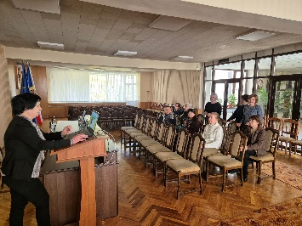
- Example of knowhow and knowledge transfer from CZ to Moldova under the Challenge Fund, women-led team of scientists from Moldova learned innovative RNA genomic selection practices.
- Primary focus of this knowledge transfer was on phytoplasma - a plant pathogen responsible for the degradation of vegetable produce quality and yield loss.
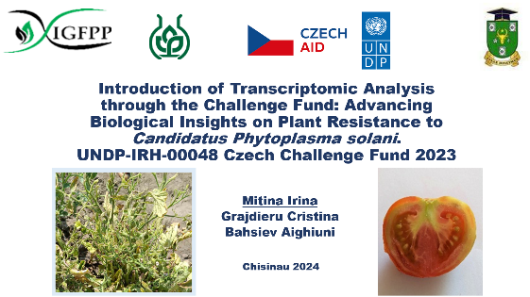
- Czech and Moldovan scientists collaborated on analyzing 12 samples of tomato RNA by high-throughput sequencing, each sample having at least 40 million paired-end reads, working both in Moldova and during scientists’ study trip to the Czech Republic to gain first-hand experience and get familiar with the method.
- Partnership continues beyond the project, looking at applying for HORIZON projects and other activities jointly.
- Results presented at a scientific conference.
- Possible further coverage – video in collaboration with UNDP CO – coordinating for 2025 with Laura

- Caritas project in Bilicenii Vechi Village (2023)
- Delayed due to procurement issues on Caritas side and construction permit delays in the village. Agreed with Caritas to extend the contract until Mid-2025 with planned final event and public opening in April 2025.
- UNDP and Embassy will be invited.

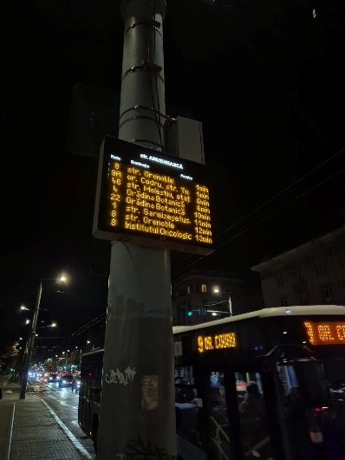
- Herman + Regia transport company: traffic panels at 4 locations in Chisinau (2021)
- Straight-forward project delayed by slow integration of GPS tracking systems of buses into the traffic panel software.
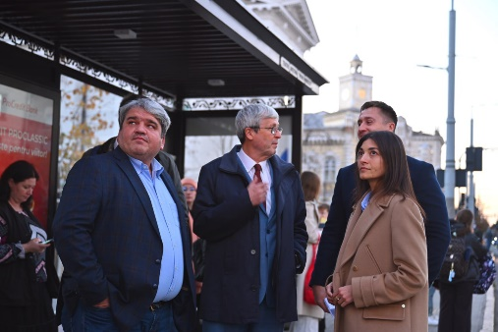
- System in operation at 4 locations in central Chisinau, Piața Marii Adunări Naționale, Teatrul Mihai Eminescu, Str. Armenească, Teatrul Național de Operă și Balet Maria Bieșu
- Final handover attended by the Ambassador with local press coverage.
- All panels with UNDP and Czech-Aid logo. Good visibility.

- Apis beekeeping project with National Association of Beekeepers of the Republic of Moldova (2022)
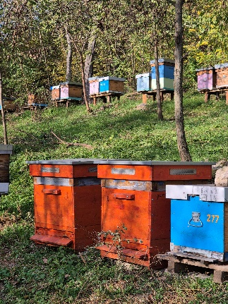
- Innovative thermos-solar beehives delivered to local beekeeping associations and beekeepers.
- Innovative solution helps killing the Varroa mite without the use of pesticides, by thermo-regulation in the beehive. Pilot testing in Moldova saw 14 hives distributed to beekeeper associations and individual beekeepers for promotion of the ecological method.
- Feedback from users indicates the technology is effective but financially challenging for most small-scale individual beekeepers, while large producers need multiple innovative beehives. Agreed with one producer to provide detailed data on use and benefits of the hive next season.
- Poor visibility, no donor/UNDP information on hives.
- Article: Czech companies are inspiring their Moldovan partners to make use of innovations | United Nations Development Programme

Annex2

Concept Note
Czech-UNDP Partnership for SDGs – Monitoring Mission to Moldova
Location: Chisinau and other regions in Moldova
Date: November 4 – 8, 2024
Mission Participants: Pavel Faus
Last update 6.11.2024

Mission Objectives:
- Monitor ongoing 2023 Challenge Fund projects (four projects, see items 1-4,7 below).
- Conduct post-implementation monitoring of two 2022 Challenge Fund projects (see items 5-7 below).
- Engage with UNDP CO management and thematic teams (in coordination with the DRR) to discuss future cooperation under the Challenge Fund and Expertise on Demand instruments. This includes identifying synergies with ongoing UNDP CO priorities. A joint meeting with the Czech Embassy is also anticipated (TBC).
- Meet with the Czech Ambassador and Development Cooperation focal point at the Czech Embassy to explore synergies with Czech ODA.
- Attend the Arnika project’s final event and press conference alongside representatives from UNDP CO and the Czech Embassy.

Planned agenda:
Arrival to Chisinau on Sunday/Monday morning, depending on most suitable options.
M0 4.11. | Chisinau | - fixed (09:00) Meeting with Arnika project implementation team and local partners + Czech Embassy counterparts, w/Embassy  - fixed (13:00) Big Terra local partner meeting (at ACSA, Mun. Chișinău, str. Petru Movila 23/8), w/Embassy
TU 5.11. | Chisinau | - 11:00 fixed Attending the final event of Arnika project in Chisinau w/Embassy + HE  - (afterwards) Czech Partnership Meeting with the Czech Embassy representatives  - 14:30 fixed Monitoring of EIB project at the State University of Moldova UNDP arranges, w/Embassy PoC:lidia_tumanova@yahoo.com  Dr. Irina Mitina, senior scientist, irina_mitina@hotmail.com)
WE 6.11. | Chisinau | - 09:00-12:00 fixed Final event/Monitoring of Big-Terra project: engagement with local partners UNDP arranges (at ACSA, Mun. Chișinău, str. Petru Movila 23/8)  - Flexible monitoring: APIS/Seminkovna/Caritas (We or Friday)  - Fixed 14:00 Post-monitoring of Semínkovna project in Chisinau: engagement with local partners (translation needed, PoC: Doina Levitchi, tel: 0 (69) 839222 location: Bacioi, Chisinau)
TH 7.11. | Chisinau | - fixed 14:00 UNDP CO management meeting (UN House / 31 August 1989 St 131)  - (4PM) Final Event of Herman Systems CF project: (PoC: Michal Neumann +420 607 234 402)
FR  8.11. | Chisinau | - fixed APIS monitoring 09:00 @Danceni, 10:00/10:30  10:00 Caritas (R.Williams St 10, MD-2028, Chișinău, Mihai Nani)  12:00 APIS monitoring (@Danceni, by car with the embassy)
Departure on Thursday evening or Friday morning, depending on suitable options.

Details of projects to be monitored:
1. Caritas (w/ Bilicenii Vechi municipality): Rainwater collection system for a kindergarten. Goal/Status: delayed, work in the community has not started yet. Meet with Caritas and agree on way forward for project completion.
2. Big Terra (Chișinău): Re.Wine – Using regenerative agriculture and climate data to support wine producers. Status: Nearly completed, final event and support of project’s visibility. Discuss local partner's plans for future.
3. EIB (Chișinău): Molecular genetics project with the State University of Moldova to improve tomato resilience. Status: Nearly completed, goal: meet local partners and to learn about applicability, scalability and plans for future.
4. Arnika (Protected Landscape Areas - CHKO): Working with Biotica. Support for managing protected areas, equipping local rangers in 3 NPs and support for adopting EU standards. Goal/Status: Nearly completed, verify equipment delivery and workshop progress. Meet local partners and government agencies. Assess potential for scale up. Support visibility.
5. Semínkovna: Successful 2022 project of seed libraries with existing scale-up from 5 to 20 locations. Status/Goal: Completed in 2023. Meet with partners, verify active locations, and support project’s visibility.
6. Apis: 2022 project working with local women-beekeepers. Thermo-solar beehives to combat the Varroa virus. Status/Goal: Completed in 2023, verify delivery and project logic. Visit 1-2 locations, assess effectiveness and market potential, and review visibility and potential for grassroot scale-up.
7. Herman: Delayed 2022 project. Public transport information panels at 3 locations in Chisinau for REGIA Bus company. Status/Goal: Monitoring of project delivery on-site in Chisinau + final milestone verification. Presentation/opening with attendance of Chisinau Regia Representatives and Czech Embassy (tbc)

Expected outcomes:
- Successful monitoring of seven Challenge Fund projects, including five ongoing projects (expected completion by 2024) and two completed projects from 2022.
- Briefings for UNDP CO management on the Czech-UNDP Partnership’s activities, and presentation of upcoming opportunities (e.g., Challenge Fund Call for Applications, Expertise on Demand).
- Joint discussion on cooperation between UNDP CO, CUP and the Czech Embassy, with a focus on aligning Czech ODA with the work of the Czech-UNDP Partnership.
- Presentation of the Czech-UNDP Partnership to the Czech Ambassador.
- Promotion of the Challenge Fund and Czech Partnership among local stakeholders.
- Collection and dissemination of visibility materials through CUP and Moldova CO channels. Lessons learned to be recorded for knowledge management purposes.

