Village Studies Battambang, Pailing and Banteay-Meanchay: Summary Findings:

1.0 Battambang Naom Chhay Ruom, Chief MAPU,MAPU Comments (19th October):

Noted that National level gives guidance on identifying the target communes to be de-mined. In these target communes we have certain criteria such as:
- Villages subject to serious threat – big numbers of BLS – the suspect land area is big (and close to residential areas)
- The number of victims – there are more mines and ERW. The highest risk to the people in the villages and communes.

NB it should be noted that in practice, in all three provinces the MAPU’s stated that these two criteria – presence of threat areas and its proximity to the residential areas, and the number of victims, was the key criteria for prioritisation.

Stated that the other two criteria is the focus on development and the poverty level when we decide to prioritise.

District: Lay Chantourn, Banan Deputy District Chief, 19th October 2015

Noted that following the peace and integration of the Khmer Rouge (in 1997/8), the district saw accidents rise as people started to reclaim farmland that was known to be hazardous. In some areas people have and are building houses on hazardous areas. He cited cited Bor Knol village in Chay Meanchay but this was not impression given from Village Leader on 20th October, also cited Snoueng and Takreum communes. Other areas included:

- Chay Meanchay Commune: Kompong Kuol, Bor Knols Village
- Kanteau Moi Commune: Thmei Village
- Snoueng Commune: Boung Krousal village, Boung Prey village and Bon Chay
- Takreum Commune: O’ Taneng area, O’slap ban village

NB This is a key finding of the evaluation – that farmers have and continue to occupy and farm hazardous areas. They either simply start using it themselves, clear the mines themselves, or employ others to do so. Their choices in this regard relates to the differing level of risk associated with the mines that are known to be in the ground. Refer to Table 1 ‘Risks Associated with different landmines threats’ in the main report. This reflects the fact that the demand for mine action has far outstripped the ability of the formal sector to supply it.

He commented that tourism sites are not being prioritised, such as the Angkorean temple on Phnom Banan, the famous Phnom Sampao which overshadows Route 57 (containing a temple and a killing field site), and the areas around the reservoir in Komping Pouy, although both are being promoted as tourist destinations.

NB These areas are without current / recent accidents, but this ignores the potential of the areas, and the economic significance of an accident in these areas, especially one involving a tourist. There is a more general point here about the reliability and comprehensiveness of the accident data as new villages are not being recorded, and these – this research has shown - are likely to be some of the most vulnerable.

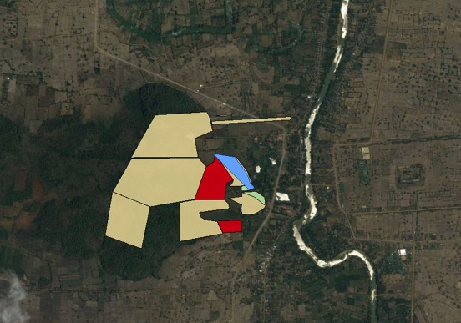
Phnom Banan: A1 minefields in red, not only dense but containing high-risk mines such as the PMN
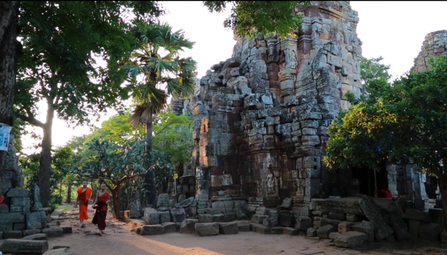
Wat Banan: already popular with tourists

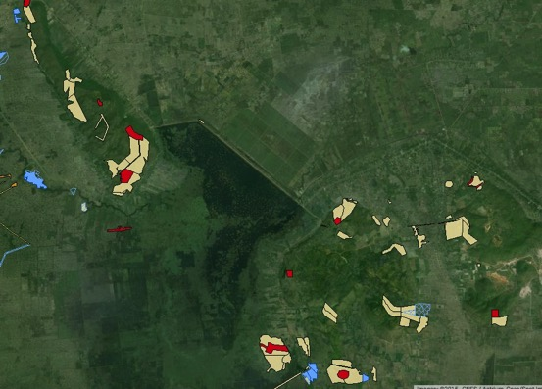
Komping Pouy Reservoir: again multiple A1 minefields in close proximity to villages and Battambang town, and an area that is being promoted for international tourism.

How does presence of mines slow development and affect livelihoods?
It is the fact that mines are a barrier to social and economic development. Mines also scare the tourists. 15 years ago they were a barrier to development, but now we have cleared many of the mined areas, and improved some parts, but not yet completed. This needs to be continued in order to bring the best for the area. Therefore highly relevant at sub-national level.

Are there less accidents than before? Yes. He thanks UNDP and operators for stabilising Banan in terms of safety from mine accidents. But in 2013-14 there was an accident in area where we did not expect it:
- Komping Pouy in the mountain area adjacent to the reservoir – a bamboo shoot digger 2013, named Sal Srey Nith. 19 years old female. Village: Daneng, Takreum commune. Amputee one leg. Recorded by CMVIS (CBMRR activist – network focal point) – but was reported to MAPU. Paul commented: This is evidence point and should be survey on this area.
- The same happened in Chay Meanchay, 2010 – ATM accident – iron buffalo with a trailor.

Both areas were NOT in BLS data.
An operator did respond to the incident but actually just checked a small area around the incident cite (CMAC it turned out according to later information and it was alleged that they did not create a new BLS polygon).

NB reveals that there are substantial gaps in the BLS, even after the recent land reclamation survey and that accidents are not comprehensively or systematically being captured and recorded as ‘evidence points’ that should automatically generate a new polygon.

After the accident, Theam Chantho the local CBMRR activist requested clearance in that area – ‘but the operator said its difficult because rocky and lots of forests …..Poor people collect bamboo shoots from that area where they are at risk of accident

NB Paul Comment 20th October: so still the poor are particularly vulnerable to the mine threat, and they are going to hazardous areas – the more remote areas, the harder to access for the operators. This is the same with areas south of the river in Andao Hep commune, Rattanak Mondul (people encroaching on mine risk land, but no records of accidents and no access to these remote areas). Additional Comment after field work: this pattern of the poor, landless supplementing their income, or sometimes being wholly dependent on foraging for timber, non-timber forest products (NTFP).

Conversely, it has been suggested that whilst high-risk areas such as those around Komping Pouy are not being added to the Data Base, in other areas huge areas are being added with limited evidence that creates misleading sectoral information, and this warrants further investigation and review. For example:
- Odar Meanchay. BS/CMAA/04690, classed as B1-3, on basis of suspect bombing after the Thai conflict. This contains 16,849,658 m2 (nearly 17km², but some operators question the justification.
- Military housing area in Odar Meanchay BS/CMAA/04478 added ½ million sq metres of B2. It was claimed this was cleared taking 4-5 months and finding no mines

CMAC’s CBMRR activists do not seem to be well networked and collaborating with other mine action agencies, which in effect reflects a lack of co-ordination at the provincial level.
- What type of sectoral working groups exist locally?
- Could the MAPUs take on more of a coordination role at provincial level.

Is she as CBMRR involved in annual planning cycle? Yes. Role? On behalf of the network of FPs. May take the role to provide input, identifying the areas in the district where there are mines. Many of them women? CBMRR – have in communes and villages. 60% are men, 40% women – but only in the target communities.

Reports that CMAC has not been doing MRE due to lack of funds since 2012.

DDL noted that: Chay Meanchay is an area that has been used as a battlefield, and if we look at the soil – its very favourable for agricultural activities (big potential). Half lowland, and half plateau. If there is no mines this would contribute greatly to rural development. We are talking here about the potential of the area – lost to mines – is this being captured in the planning process? Cf. the old sugar refinery in Bor Knols, good land. This area has great potential i.e. corn plantation etc But is this potential captured in the planning process?

Commune Case Study: Chay Meanchay
CMAA planning data for 2015 lists Chay Meanchay as 2nd most affected commune in Battambang, with CMVIS recording 14 mines, 4 ERW casualties in the last 5 years. However, it should be noted that these figures have been skewed by a tragic ATM accident in 2010 which accounts for all but one of these mine casualties.

The intention of the evaluator was to undertake a commune wide study in Chay Meanchay, and therefore two villages were selected for Focus Group Discussions that took place on 20th October (Chaeng and Bor Knols villages, both of which had received clearance under CfR II). These complemented in-depth semi-structured interviews with the Banan Deputy District Leader and the Chay Meanchay Commune leader held on 19th October. In every other field location visited only the District level officials and MAPUs were interviewed, together with village leaders of the villages in which FGDs were conducted.

The evaluator had first hand experience of this area in 1992 (when he assessed the health centre in Chaeng village), and later in 1994 when Mines Advisory Group started to do demining in the village centre area, and also worked to demine a secondary access road from Chaeng to Sdao town, in Rattanak Mondul on the main road, then Route 10, now Route 57. Chay Meanchay, and adjacent Andao Hep Commune to the west in Rattanak Mondul district were very much front line communes in the civil war following the withdrawal of Vietnamese forces in 1989, resulting in a surge of Khmer Rouge forces into southern and western Battambang. By 1991/2, the western half of Rattanak Mondul district (Treng and Ploumeas communes), and all land beyond was either considered a ‘militarised zone’ by the State of Cambodia (SoC) authorities, or directly administered by the Khmer Rouge, from their regional capital in Pailin. The front line was the river for some of this time, and in May 1992 the commune was very sparsely populated, with the army having a major camp in what is now the Pagoda, and the Sihanouk era health centre served as a stronghold position, overlooking the river. During this time the SoC army would lay mines at night around their positions, and also on Route 10 (in Sneoung commune Banan), and bring them in again the following morning. The evaluator visited the health centre in May 1992, and observed PMN2 mines lying in the bottom of the concrete irrigation ditch that runs in front of the old health centre. In May 1994, the Khmer Rouge surged forward up Route 10 and captured ground up to the outskirts of Battambang (Phnom Sampao in Banan). When they were pushed out in June 1994, not only was there a legacy of new ERW (UXO), but also they laid some nuisance mines, including anti-tank mines. This accounts for an accident reported in Bor Knols village during the course of the FGD.

Much of the demining done in the area is now not recorded on IMSMA, as is the case with much of the mine action work done in the early / mid 1990s, due to lack of GPS records etc. CfR II has cleared a number of sites in and around Chaeng and Bor Knols village, with a great deal of work having been done south of the river in recent years.,

Chim Veng, Commune Chief, Chay Meanchay and Village Chief of Chaeng Village.

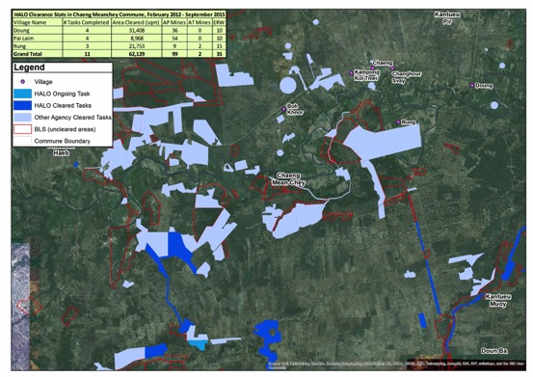

- Noted there were lots of mines laid in the past people herding cattle would lose livestock to mines – one of the ways people learned where the hazardous areas were
- The people feel more safe now after lots of demining from CMAC
- We also could not do agriculture because of the mines, confirms the results of the FGD in Chaeng that there is at least 30 ha south of the river which is still not being used because of mines
- Reduction in accidents he feels is because people have enough safe land and less necessity to take risks
- If cleared this 30 ha.s in Chaeng, people can grow crops, and its connected to a canal, so it would be very good. Now can not get full access to canal because of the mines. There have been many accidents accessing the canal. (There were also concerns expressed by the deputy village leader in Chaeng and others in the FGD about possible mines / ERW in a small irrigation ditch which runs past the old, Sihanouk-era health centre near to the river see below).
- Noted the Commune Action Plan (and associated Commune Investment Plan) has shifted from economic to social development priorities, under instruction and guidance from the Ministry of Planning.
- In terms of the MAPU planning process it was revealed that the Commune Chief is not directly involved and it was mostly the Village Chief who liases with the MAPUs and the Operators in the annual planning process. The Village leader from Dom gave a spontaneous, and apparently genuine, answer stating that the village leaders would think of people who have specific needs, for example if one villager only has contaminated land. He discussed what appeared to be good criteria. Mentioned a 14 has site cleared in his village, but with a total area of 20 has, meaning 6 ha.s remaining that will benefit 5/6 households, and this has been prioritised for clearance next year.

NB This was a pattern revealed elsewhere. Talk of ‘community participation’ in the MAPU led planning process appears to be overstated, and in reality this comes down to a dialogue between the Village Chiefs, who to some extent are locally accountable within their villages, MAPUs and Operators, especially with regards to actual selection of BLS polygons in their village area to be cleared that year. Their authority is generally accepted without question by the villagers, and most felt that decisions and site selection with regards to clearance had been fair. During the FGDs it was hard to solicit opinions from the villagers without the Village Leader , or his deputy, taking a dominant role. The team resorted to having one on one interviews with the village leader during the start of the FGD to establish a pattern of free participation from the villagers. But once the Village Leader returned to the group, he then dominated the dialogue, although with contributions from one or two more confident villagers, who obviously felt it was ‘safe’ to speak. Generally though, by the end of the village mapping process, sketching out the main features of the village, cleared areas, accidents and remaining hazardous areas, the process of participation had widened, and a wider group of villagers had successfully inputed to the process. However, the practical difficulties in obtaining ‘community participation’ in the evaluation FGD process, and its apparent strangeness (that all would be consulted and their opinion considered of equal importance to the village leader) suggests that the described village meetings detailed in the 9 point planning process are unlikely to take place as envisaged (although more research on this point would be useful). Again the dominant criteria seemed to be number of BLS polygons in or near the village, and their proximity to the residential area, rather than any form of social dimension, although in a few cases the village leaders stated that rich land owners might be excluded in favour of poorer members of the community. The FGDs seemed to confirm they had been consulted about the task selection, but it is suspected that this consultation is really more a case of being informed of which polygons in the village will be cleared in the upcoming demining season (and people did seem to be well informed of areas that were on the plan for the coming year).

In terms of gender dimensions, we really worked hard to try and ensure that we collected data in a gender disaggregated way, and even had the CMAA Gender Focal Point (Souvannary) and one of her key colleagues involved in Gender mainstreaming in the CMAA on the team. But the notion broke down because the MAPUs did not invite enough people to form two groups in many cases, and I followed Souvannary's lead and we did mixed groups i.e. one mixed group in each location. There were issues not just of gender in participation but also, as noted above, in terms as well of ensuring that those invited felt they could speak, as all were deferential to the village leader. In many cases we extracted the VL from the group, and I interviewed him on one side to

Overall though the women did contribute, and were involved in giving individual feedback, especially through the 'write down three key impacts of mines on the community; three key impacts of mine action' exercise which was conducted towards the end of the FGDs in each village. To some extent participation, regardless of gender, depended on individuals - Ieng Sopheng, an active member of the Duon Nuoy FGD in Svay Chek for example was a forceful and confident woman who had a lot to say in the group. On one occasion when we did manage to get a separate women's group working - in Veal Cheang, Ou Andong Commune - they were obviously not comfortable with the idea, as it appeared to challenge the VL's authority / knowledge perhaps - and the map they produced was far less detailed. The CMAA colleague (who is a gender FP) seemed to say that they felt they did not know as much as the men about mines.

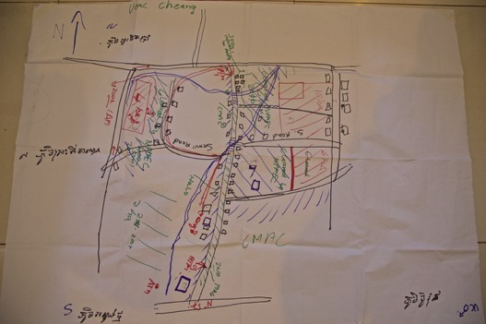
Veal Cheang Village Map: Male Group

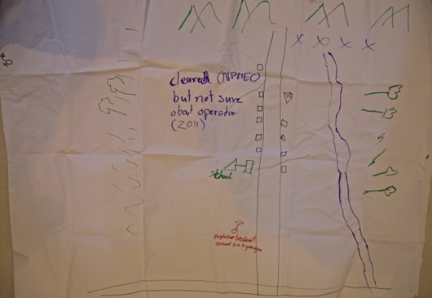
Veal Cheang Village Map: Female Group (orientation upside down cf. male map, but presented this was in order to make text legible).

Overall then in terms of participation in the evaluation, the women hung back, the MAPUs seemed to have very low awareness of gender issues and the importance of the basics of gathering gender disaggregated data. But my impression was that the dominant thing was not about gender, but about power in the communities and the CPP village chief expects - and the people expect - to take a lead.

Recommendation: more needs to be done to ensure and monitoring the level of community participation in the planning and prioritization process, and also for the impact study planned for the start of MfHD, and this needs to happen in a gender disaggregated processes.

Village: Chaeng, Chay Meanchay

CMVIS data reveals a total of 8 ERW casualties and 11 mine victims, nearby Rung had 4 victims of an ERW incident in 2012.

As noted below, Mr Preung Yern, the Deputy Village Leader is still farming risky land to the south of the river. Last year he says he ploughed up 3 PMN 2s (which are usually fully functional), in the course of the eight planting seasons he has used the land he claimed to have turned up more than 50 PMN2s. The ongoing evidence of mines would mean that this land can not be considered as ‘reclaimed’ and therefore fit for ‘release’ under C3, according to national standards.

People in the village reported that they were still opening new land, clearing and burning the forests, but admitting that the risks are unknown. They stated ‘We can’t wait for clearance’. In this commune these practices carry a higher level of risk, given the widespread presence of PMN2 mines that retain a high level of functionality.

NB It should be noted that in many areas communities reported through the FGDs that they were clearing forests and opening new lands, often resorting to burning the land as a means of threat reduction. In most other areas, this involved reclaiming land that is believed to be contaminated with low-risk mines (such as T-69s), with low levels of functionality. Chay Meanchay is therefore interesting that such practices are occurring in the context of high-risk threat contamination.

This said the FGDs revealed there are two plots, one reported as 20 ha.s and one of 30 ha.s not being used still south of the river, and described as ‘heavily contaminated’. The community risk assessment that this land is not worth using is due both to type of mine present (assessed as including PMN and PMN2s) – and the fact that they said they ‘have alternatives’. These areas represent an economic loss in the extremely fertile commune, but the locally formulated risk and return equation indicates that the risks of opening this land are unacceptable. It is suggested that this is EXACTLY the type of task that should be an immediate priority for CfR II. The fact that this land with huge agricultural potential is not being used is revealed in the following maps – one showing the BLS polygons (BS/CMAA/30348 - A4 and BS/CMAA/30336 - A4), and one with them removed. The unused land is clearly demarcated, and within the southern polygon it is obvious that some area is under cultivation, suggesting that the area could be reduced either through technical survey (C2) or land release (C3).

Recommendation: the impact survey proposed for the start of the MfHD project in 2016 should seek to capture detailed and nuanced insights into communities such as this, revealing not just the physical presence of polygons, but also the types of items (by differing levels of risk related to functionality) but also the impact these have on the community. This should seek to capture the economic potential of the area (not just agricultural, but also tourism etc); levels of risk taking still on-going as well as any other particular blockages to economic development, especially ones which have a climate change impact, for example with regards to blockages that affect water management and irrigation.

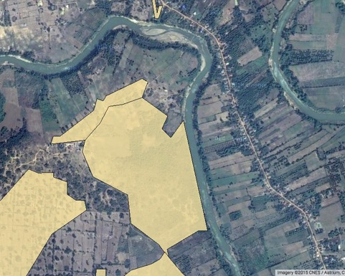
BS/CMAA/30348 - A4 and BS/CMAA/30336 - A4
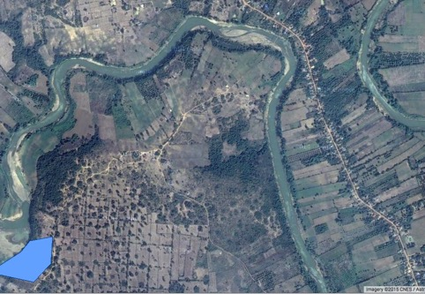
Same area without the poygon overlays showing unused and used area within the polygons

In 2010, there was also an ATM accident involving power plough and trailer, around 12 km from the village, on a well used road, but one which people knew was still risky. The FGD reported that ATMs were used extensively on old roads, and scattered up to 500 metres from the route of the old roads. They reported that they use active risk mitigation by avoiding the old roads, but admitted there was still a risk.

The FGD also revealed that villagers were generally better off, but many faced difficulties due to frequent droughts and water shortages, with there not being enough water for planting and transplanting of rice crops. There is an issue both of a general shortage of water, but also severe and damaging storms. The FGD and deputy VL referred to an irrigation ditch that runs north from the river, in front of the old health centre and was surveyed by CMAC in August 2015.

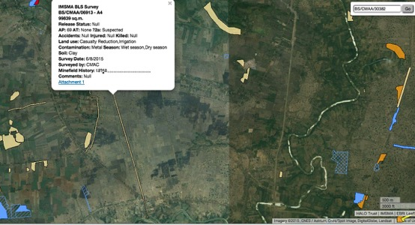
Irrigation ditch referred to in FGDs
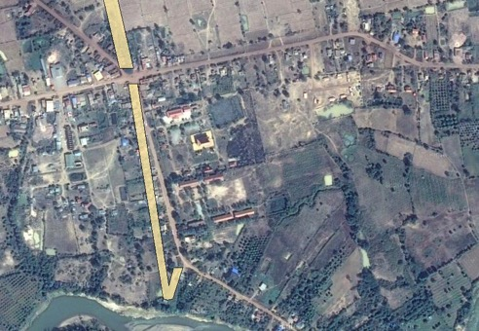

The ditch has become overgrown by the DVL reported that he was concerned to clear it as children had reported seeing mines or ERW in the ditch. This is the same ditch that the evaluator observed several PMN2s in during a visit in 1992. On request from the evaluator, MAG kindly deployed a community liaison team, and reported ‘the CLT team have been and conducted NTS.
· The area was cleared by MAG (3756m²) in 1993 only and no mines were found.
· Mapping is inaccurate from 1993 as no GPS/ArcGIS etc.
· Fully cleared, subsequent BLS also indicates no threat.
· Nearest BLS polygon approx. 450m away.
· Only items found have been empty 12.7mm casings.
· This is deemed end state land and any activity would contravene CMAS directives on mine action in end state land’.

The email concludes that no further action should be taken, although this negates the fact that this perceived threat is causing a potentially substantial economic blockage and therefore whilst – arguably – the technical assessment that no further action be taken might be the correct assessment (although one seemingly at odds with CMAC’s assessment), this ignores the risk assessment and concerns of the villagers. These villagers are not, as discussed elsewhere averse to taking risks with mines, and therefore if they are not using a community resource like this it would suggest a fairly well grounded fear.

Observation: tasks such as the irrigation ditch in Chaeng would not generate much in terms of m² outputs, nor if the MAG assessment is correct, would they generate much in terms of items destroyed. However, the impact of assuring villagers it is safe to clean and use the ditch could be extremely high, especially in the context of climate change and water shortage.

Recommendation: MfHD needs to undertake comprehensive impact studies that generate qualitative understandings of the mine and ERW situation and its socio-economic context, and impact on both development and livelihoods, as well as human security and well being, reflected in risk taking practices. Impact should consider the potential of the area, as well as the current situation. These qualitative understandings need to be translated into quantitative scores that will enable prioritization to be done on a rational basis, rooted in evidence. Operators then need to be incentivized and contracted in terms of delivering impact, assessed through measuring outcomes in the performance monitoring system, not merely measuring outputs.

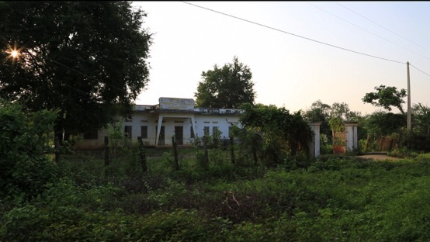
Sihanouk Era Health Centre and former SoC army position formerly protected by PMN2s in the early 1990s. The irrigation ditch runs in front of the old health centre.
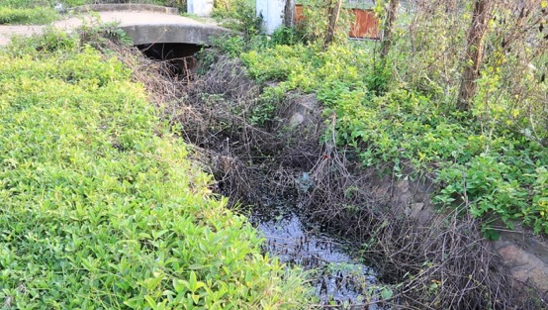
Close up of the irrigation ditch: clogged with weeds and not used because of fears of landmines and ERW, despite concerns over climate change and a need for irrigation.

Reviewing the land release data for Chaeng village reveals some potential issues with prioritisation, or recording of information, or both. Sites cleared under CfR II in 2012 and 2013 appear to be located in excess of 6kms to the south of the river, south of Rung village, and it seems strange to allocate these tasks to Chaeng. Many of the sites cleared under CfR II 2012-14 were located in the area shown on the map below.
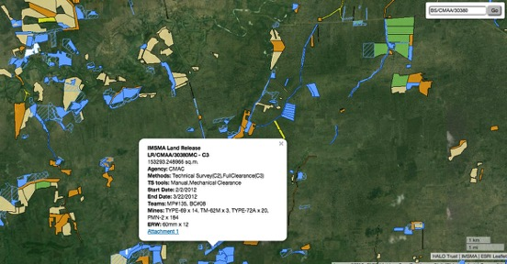
In 2014, CMAC on CfR II also worked in this area, for example releasing task number INV/BS/CMAA/30416 which yielded no mines, but released 181,810m2, taking a total of 33 operational days.

The prioritisation of such tasks seem hard to understand in light of the clearly stated MAPU criteria of number of polygons and proximity to the village. In the case of Chaeng village, these would obviously point to BS/CMAA/30348 - A4 and BS/CMAA/30336 - A4, located on the village map below as the two red crossed Has, containing 20 and 30 has respectively. This is CLEARLY a community priority since it was highlighted in the Chaeng village FGD, as well as by the commune leader during his interview on 19th October, and yet these areas were not prioritised for release at any stage during CfR II. Equally, Preung Yem the deputy village leader of Chaeng reported that he has been forced to open up hazardous land, south of the river (believed to be BS/CMAA/06780 - A4, BS/CMAA/06782 - A4, BS/CMAA/06779 - A4) – shown as the HA marked 50 x 2000 on the village map. This land he says he has ploughed up PMN2’s eight seasons after starting to cultivate the land. The prioritisation process seems odd, as it might be expected that if elites in the village (or at commune level) were to have undue influence over the prioritisation process with the MAPUs, then one might expect to see Preung Yem’s land being cleared (which actually would not be a conflict of interest since it meets the criteria in some ways – the fact that he has ploughed it more than 3 years though would suggest that it could in principle be released, although only if there is no evidence of mines, which in this case there has been).

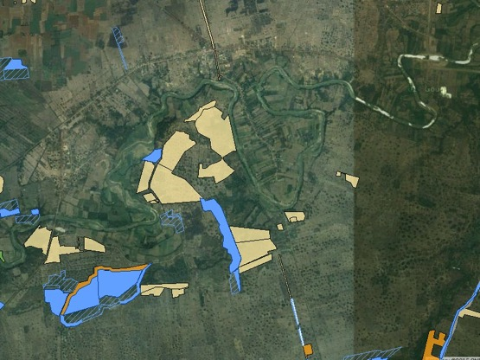
Priority areas in close proximity to Chaeng and Ruong villages. The blue polygon, BS/CMAA/30339 - A4, was released under CfR II in 2014, releasing 205121 sq.m. during the course of which 25 APMs were cleared, including 22 PMN2s which are high-risk theats.

Video Interview Transcript with PREUNG YERN, Deputy Village Chief, Chaeng Village, Chay Meanchay Commune, Banan District, Battambang

On the canal:
“People rely on this canal for water to irrigate their rice field when they face drought. This is a major issue we often experience here. The pump is at the station over there. Children often play in this canal and find bullets – such the 12 mm ones – and further up a B-40 rocket was found. This canal is 4 kilometer long.”

On claiming the (hazardous) land south of the river and ongoing risks:

When we started farming here, we began from that strip of land over there where there were no landmines. Then we reached a minefield, and before CMAC arrived just removed the landmines by ourselves. I would cut the wire or simply just burn the mines. Sometimes we asked the military to remove the landmines. Often we would just use our bare hands to move the landmines that we unearthed when ploughing, and put them aside.

Some people did have accidents from doing that.

Many people, including me, have lived here for many years, but initially we did not own any land. After the integration, people needed land and all they could find was land that was formerly battlefield. This area where we are standing right now is a battlefield.

Why did you claim land that you knew was risky?

“It was a long story. If we did not go out to claim the land, somebody else would. If we did not go and put our claim on it, you would have nothing, and we did not have money to buy land from anyone. We had to risk/exchange/trade our lives for it. I have 20 hectares. This year I hired a tractor to plow the land and two landmines were unearthed along with a rocket round.”

On impact of clearance: “First, we are now able to live with a complete sense of peace, without any fear like before. We no longer have to fear when we work on the land. Secondly, we can possess land where we can really have ownership on and to farm. Thirdly, I would be very happy to see any road or water canal development coming through this area in the future. Lastly, I have a request for the mine clearers to keep searching for landmines that are still remaining in my village. We would like to see all the leftover landmines removed, and that would tremendously help boost the confidence of the people living in this area.”

NB this interview – as highlighted in yellow – provides fascinating insight into the process of claiming land after the ‘integration’ of Khmer Rouge forces in 1998. Not only were local people driven by poverty to take risks with mines by bringing hazardous areas into cultivation, but there was also pressure to establish a claim to land in their localities ‘or others would take it’. Its not clear if this refers to others in the village, or outsiders. So the process of claiming and clearing the land, much of which has been undertaken by the informal private mine action sector, as confirmed in the 2005 study, is not something limited to the idea of ‘new settler villages on the frontier’, but also settled and established communities such as these which were ‘on the frontier’ in terms of being on former frontline / battlefield areas that had been military zones during the civil war. Inevitably then these areas had a large legacy of landmines and ERW.

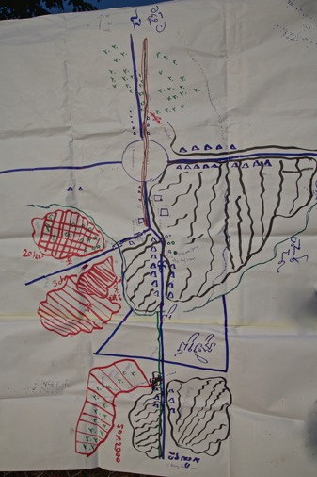
Community mapping from FGD clearly shows same priority areas, as well as highlighting the irrigation ditch.

Additional notes from FGD and interview with Deputy Village Leader:

- Villagers and animals had incidents with mines, so local people learned where were the hazardous areas, particularly during the late 1990s when people returned to the village. The timing is significant suggesting that until there was a credible peace, the village was only inhabited by the very poor (as per comment immediately below), and that much of the land south of the river remained off possibly off limits for security reasons. During this period people would explore areas and would find out there were hazards from seeing UXO and other ERW, or would see mines exposed by the rain.
- During an interview with a mine survivor in the village it was revealed that the ‘rich people’ only return to Chaeng after the final peace with the Khmer Rouge in 1997/8 when they deemed the overall security had improved sufficiently. As revealed in the FGD in Bor Knols village, these richer land owners would not directly farm hazardous land themselves but would either hire labourers to work the land, or deminers, or both. Sometimes they would ‘donate’ hazardous land to the poor, a practice which was referred to as giving ‘Som’ land in Bor Knols.
- Today the villagers don’t see as many mines, and incidents have become very rare. They mark mined areas with informal markings.
- Mines do still have an impact, there are still areas where people don’t know if there are mines or not, and there is residual risk i.e. where people are burning the forest to open new land. If people find mines they either ‘burn them or give them to CMAC’. They noted that ‘some mines can be moved’, but others need to be detonated in situ.

N.B. Villagers are handling and moving mines in Chay Meanchay, and this was a finding from all the communities visited during the field work. The people do have a clear sense of which mines are
- There has been village demining, including by the deputy village leader on his land south of the river. He noted that people started to farm in what was perceived as safe land, but there was not enough, so by 2000 people started to open up the more risky land. They would go and ‘observe the land’, and if they can see no evidence of mines then, in the absence of formal assistance from agencies like CMAC, they would start to remove the mines.

NB in every community visited the pressure on the land has significantly exceeded the ‘supply’ of demining services. People are generally entering known risk areas – either with a view to cultivating it or foraging for income supplements – with the exception of high-risk mine threats areas in some locations, but here only when they have sufficient alternative livelihood choices (as is the situation now in Chay Meanchay). In the ‘settler’ communities in the new villages, the growing communities typically have survived the riskiest periods when they have established a localised sense of the SHAs, cleared some areas, and started to build homes and establish farming land, well in advance of support from the formal mine action sector. This was particularly obvious when visiting Veal Cheang village, Ou Andong Commune, Pailin where the village had been cleared and settled in 2000, but formal mine action reportedly only arrived in 2010.

- There were several accidents during this period of reclaiming the land, particularly of livestock. They estimated that around 20 head of cattle were lost and 5-6 people injured.
- They reported that there had been meetings ‘at the district office’ to decided which land got cleared, including under CfR II, and that choices were made with reference to a map showing contaminated areas.
- They stated that there is no discrimination as to who benefits, and land has been given to the handicap, and cleared for both rich and poor. The DVL said the precise selection of area is based on the assessment of the mine threat, accessibility – so areas on and next to the roads. The focus appeared to be on community safety (which MIGHT account for why the high risk threats in the 30 ha plot of land have not been cleared, since the area is currently not being used and therefore the risks are negligible).
- The suspect areas to the west of the river (BS/CMAA/30348 - A4 and BS/CMAA/30336 - A4) are still not in the plan, but were sites of several accidents to cattle and people in the 1990s.
- Reported that Japanese funding had paid for a new road, which was finished in 2015 and involved demining, and was part of the CIP.
- They reported that after clearance there have been a lot of changes in the village. Before there was a lot of risk taking, but now they can work freely. There was a risk of death every time they dug the land in order to plant rice. They were using hazardous areas for farming before clearance. Mines were exposed when people were ploughing, and if the people saw the mines they would remove them. They were scared for their cows, and had ‘no choice’ but to deal with the threats. It seems that the priority was given to minefields due to proximity to residential areas and the village centred (but this is not the case with the CfR II minefields as argued above, based on information from the DB). Economic outcomes from clearance depend largely on the family. For some their situation has improved, others still have to send their children to Thailand. Some people’s land is too small and they can’t profit from clearance.
- They reported no land conflict after clearance. If land was given to people after clearance they would then get ownership of that land. During the Hand Over ceremony, all land cleared would be released to the owners.

NB This was a common finding in all the villages surveyed, namely there were no reports of land conflict after clearance. The only disputes were between neighbours over boundaries. In some villages people complained about the thoroughness of clearance i.e. in Kvav Lech, Svay Chek Commune a woman complained that her land had been ‘skipped over’ (perhaps a reference to land release), and in Ou Trav Chur, Serei Maen Cheay, Sampov Lun a part of the minefield was not cleared as CMAC believed it was the same beneficiary who had had land cleared earlier – therefore either refusing it on the grounds they mistakenly thought they were clearing the land twice, or refusing to clear on the basis of the same individual receiving an infair amount of clearance (if the former then it shows a lack of technical competence, and if the latter it illustrates undue operator influence on what is actually cleared).

District: Banan, Commune: Chay Meanchay
Village: Bor Knols
CMVIS data shows a total of 35 ERW and 29 Mine Casualties, but none in the last 5 years

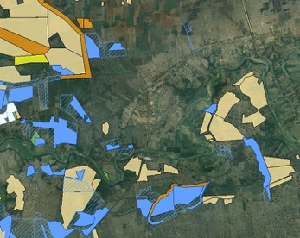
IMSMA data reveals presence of substantial hazardous areas to the north west of the village on the north bank of the river, as well as south of the river. A great deal of mine action work has taken place in Bor Knols, which is appropriate given the high number of casualties recorded in the area.
The FGD revealed the case of
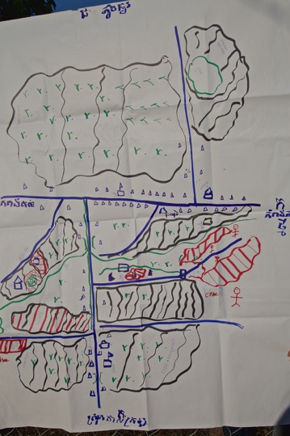

Village map from the FGD revealed three mine areas south of the river that have been sites of accidents, and remain community concerns. They are also close to the village centre, and yet more work has been done on sites further south and to the west of the village on the north bank of the river.

Video interview transcript with HUON CHOEM, 65, village chief, Bor Knol village. Location outside disused 1960s office of a sugar plantation to the south west of the village.

“This building used to be an office of a sugar plantation in the 1960s. But now can see bullet holes left over from the conflict. We suspect that there are still landmines littered in this area, which used to be an army camp for both the Khmer Rouge and government. Both sides laid mines. When one side was pushed, they laid mines before they left, and the same happened when the other side was pushed out by the enemy. This used to be a battlefield and a minefield. In 2002, mine clearance started for, first, the building of a pagoda. There were more than 100 deminers working to clear landmines along the main road and around the mountain. Only the mountain over there that hasn’t been swept clear of landmines yet. In the past, there were quite a few landmine incidents, but now people feel more confident and safe here after the clearance. Since then there has never been any incident although from time to time ERW would have been spotted here and there.”

On impact of clearance: “In the past everybody was living with fear, but once landmines were cleared the residents were able to expand their land using this kind of heavy machine. They feel more confident about safety. Family income and living conditions are improving, and there’s no doubt about that. Some people have more land than the other, but that’s normal. There are also new settlers who bought land to set up housing and do farming. This area is clear of landmines although some small ammunition could be spotted here and there occasionally. In the past, incidents happened to both humans and animals. Over there, two cows had their legs blown off by landmines. To the left, a soldier was killed in a landmine explosion and another lost his hand in an explosion of an improvised landmine planted by the Khmer Rouge soldiers before they retreated. The government soldiers tried to remove that landmine but ended up setting off the explosion instead.”

Additional notes from FGD and interview with Village Leader:

- He first settled in the village in 1981 and stayed throughout the conflict
- There were mines throughout the village as people left during the height of the conflict as it was a frontline area, and soldiers placed mines everywhere. Many left 1991-93, but came back after the election in 1993.
- They initially spotted the mined areas by observing evidence of battlefields, and then recording where the cattle had accidents.
- Mine clearance started in the area in 1995-6 with CMAC. MAG cleared along the roads, and some paddy fields.
- There were surprise attacks as late as 95-6 and the Khmer Rouge laid nuisance ATMs and Type 69 mines
- Phnom Bor Knols was a new village established in 1968, with a sugar refinery. After the 1993 election 10 families moved back and settled along the river. There were mines there and they felt afraid. The access to the river had some safe paths but the KR had set some booby traps.
- The village now is not 100% clear of mines, and they do find UXO. There remain suspected areas where the land is not used.
- He reported no mined areas on the north bank of the river in the immediate vicinity of the village, but there are 20-25 hectares unusued on the south bank of the river. A plantation was released in 2014-15 and there are some beneficiaries in the village. Some of the beneficiaries are richer people from Banan who set up a rice mill here. These are people who left during the war. He also said that some of them only arrived to buy land in 1990-1.

NB it was noted in Rattanak Mondul the next day that in Andao Hep commune, which lies adjacent to Chay Meanchay to the west, and also spans the Sang Khe River and was the former frontline, a similar pattern was observed. Namely during the period of insecurity and conflict, the rich had naturally relocated to safer areas. Their land was squatted on by poorer people, often from the west of Battambang. Thus one of the mine survivors featured in the evaluator’s book ‘War of the Mines’, Ches Sary, the wife of a soldier, injured in 1992, had long since left Andao Hep in 2008 when the evaluator attempted to find her again. Beyond that even the name of her village did not exist – Along Pouk is no longer a village in the commune ‘because it’s the name of a village from Samlout’. Given that at the time in the early 1990s the entire government controlled population of Treng and Ploumeas communes were living in Boeung Ampil IDP camp in the north east of Rattanak Mondul district, and retained their village and commune structures within the confines of the camp, it is likely then that a village like Anlong Pouk was actually a displaced Samlout village, relocated to live in abandoned lands of Andao Hep commune. Certainly, a drive through the commune revealed that it was relatively rich and it seems unlikely that the ‘poorest of the poor’ who appeared to be its inhabitants in 1992-3, have accumulated such wealth through development alone, although that said some ‘new village’ communities appear to have accumulated substantial wealth in 15-20 years since settling communities in the west of Battambang or in Pailin, as revealed elsewhere in this report.

- In the 1960s there had been a lot of commercial agriculture in the area – pineapples, sugar, some oranges by the river (which CM is famous for).
- Before clearance people were farming hazardous areas and having accidents
- Others saw mines and abandoned their lands
- When they could not farm their own land, some people hired other land to farm, and some collected rattan and cut wood.
- In the last five years people have had more land to use, they are selling in the markets, growing crops, planting fruit trees, cassava and vegetables. These changes are because of clearance.

Notes from FGD in Bor Knols.

- They noted that Phnom Brak (BS/CMAA/30312) (one of the last remaining SHAs near the village south of the main road), is still suspect. There is a former KR stockpile near here (Phnom Brak is shown as a red area north of the river – shown in green - in the Village Map on the left hand side of the map), this was reported to CMAC in 2012 but no action has been taken yet.

N.B. This might be another example, as revealed in Ou Trav Chou Village, Serai Meanchay Commune, Sampong Lun, of where the FGDs and village mapping exercise reveals known hazardous areas which do not appear on the IMSMA data, showing the value of on-going survey and participative techniques.

- They reported that some used hazardous areas before clearance, and others did not. They reported that some former soldiers did demining on their own. One former soldier, an amputee in the group reported that he had cleared his own land. He also reported that there had been an ATM incident on the road infront of his house in 1994 (nuisance mining during the temporary KR take over of the area in May 1994). He detected and cleared mines under and around his house.
- One widow said that she was offered to use a land for farming and she didn't know that the land was contaminated by mines. She just realized that when she found mines during ploughed that land. This land was referred to as ‘Som land’ – a form of gift offered free of charge. But when the land was cleared the landowner took the land back, and started to farm it. She now works as a day labourer.

NB there are many reports of villagers hiring suspect land to others to farm, or as in this case ‘donating it’ to the poor to use until it is cleared.
- There is a proportion of the village without land who continue to forage in the forests to supplement their livelihood from rattan, wood cutting, gathering NTFPs etc.
- Before clearance they said that ‘most of the land’ was not being used. They reported being wealthier due to there being more land to farm.

NB however, it is likely that when referring to clearance they conflate the clearance done by the formal sector (CMAC etc) with clearance done by the informal sector (as per findings from the 2005 report into the informal sector).

- They also reported that there had been no land conflicts since clearance.
- As in the Chaeng DVL interview (above) they confirmed that they had occupied hazardous land before clearance, and once cleared it was released to those who had occupied it. People had ‘grabbed’ the land before clearance (but were largely not using it – as in Chaeng).
- They are not resorting to going to hazardous areas (foraging) as much, as they have enough land now, and if people see landmines they are reporting to the Village Chief – there have been 3-4 reports in 2015, the last as recently as May.
- They noted that many young people – ‘the strong ones’ – go to Thailand (something like + 200 at the present time), and come home only for Pchum Benn and Khmer New year. They are being forced overseas and to the factories (special economic zones around Route 4 etc) because of lack of employment opportunities

District: Rattanak Mondul, Commune: Treng, Village: Kilo
CMVIS data shows a total of 22 ERW and 43 Mine Casualties in Treng Village, but none in the last 5 years. Treng appeared not to be listed as a priority commune in the current CMAA 2015 planning guidelines, perhaps reflecting a lack of accidents in the area, consistent with the village’s self assessment that they were to some extent impact free.
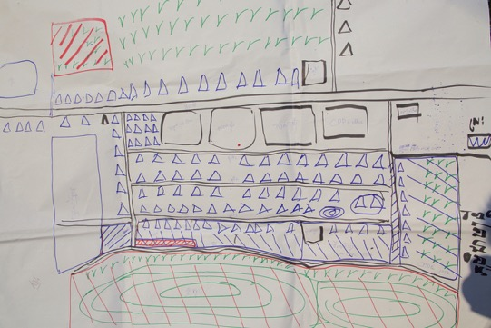
Village Map from FGD Kilo, Treng
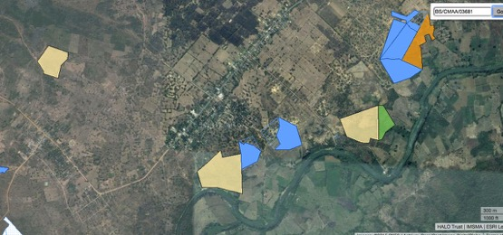
IMSMA Records – a great deal more clearance, both formal and informal has occurred in the area than is recorded on the system. The evaluator did research for his book in 1992-93 in what was then known as Kilo 38 – some few kilometres back up what is now Route 57 than the current location of Kilo, and both sides of the road were heavily mined and there were multiple demining accidents involving ‘village de-miners’ in the area in 1993. The two blue areas were cleared under CfR II, and the Has identified in the FGD can be identified adjacent to one of these in the centre of the shot, as well as the one in the top left.

- The FGD reported that the HA in the top left of the map they are not using at all, but the other HA (centre adjacent to river) they access to dig bamboo and cut wood. They reported that they do ‘fear’ the area, but the poor and unemployed do still go. Later in the discussions it was revealed that this area has been subjected to substantial informal demining, often driven by scrap metal collection, and the villagers report that the number of remaining mines is considered very low. This is state land and they said ‘the Government allows them to go because of the risk’ – implying perhaps that the land is redundant because of the mine risk, and therefore – a bit like the Som land mentioned in Bor Knols that for the poor suspect land is a resource, which may be taken away once clearance has occurred.
- They do farm in the suspect area right up to the bottom of the mountain, and have been doing so since 1998. They moved back to this location in 1998 (when the peace was confirmed).
- It was clear that the village was essentially ‘impact free’ – there are still mines and UXO in the area but people’s lives are not really impacted by them.
- The FGD participants said they were not invited to the prioritisation meetings – but only the ‘beneficiaries’ were. The sites were chosen based on the observation of the village chief reporting to the commune chief. They do organise a village meeting to discuss before their report goes up to the commune chief.
- CMAC cleared residential land in the village, but only limited farming land (this reflects findings of the 2005 report on Informal Demining. Most of the participants had cleared land for residential purposes, but only a few had cleared agricultural land. They claimed the land, and took risks cultivating it. Some reported this land was on the other side of the river, and other land is at the base of the mountain. Again they reported ploughing the land and mines coming out..

NB reviewing the IMSMA and Google Earth data there appear to be some areas which are rough land and some areas of forest (from whenever the Google Earth images were taken). It is suspected that there might be more hazardous areas south of the river than are recorded in IMSMA

NB this implies that the decision on which plots would be cleared had already been taken, perhaps in discussion between the MAPU and Village Leader and the beneficiaries and participants were merely informed of the decision.

- Less than 50% of the people in the village have enough land and are still taking risks with mines. Now there is no more forest to claim and clear. The people have to seek alternatives – working in factories, agricultural labour or migration to Thailand. 50% take risks going into contaminated areas to collect bamboo, mushrooms and seasonally available vegetables. But there are no accidents now. 20 years ago there were a lot of accidents. Some areas have been cleared by the people, some by scrap collectors with metal detectors – their motive is scrap and reclaiming the explosives which are being sold to use in quarrying. They have made it safer (reduced the threat).
- They said there are not many mines in the area of the village. They don’t see many mines, and now safety is much better. Some is due to the work of CMAC and some due to the work of the private deminers.
- There has been no land conflict, just disputes between neighbours on the borders of the land.

Sochenda Khun who facilitated the FGD notes:

‘People in Kilo village said that most contaminated areas in their village were nearby the river and on the mountain. They used to request for clearance those areas many times because some villagers had the land over there and some poor people overrun into the mountain for cutting wood and digging the bamboo, but this was rejected by operators since there were the difficult ground condition and hard to access’.
NB There were several examples of operators rejecting tasks due to operational constraints around access and safety. These decisions do not appear to be reviewed.

Additional notes from Sum Ke, Deputy Chief of Kilo Village, Treng

- There were big problem with mines when he first came back, and we hired people to plough the land (this is likely to have involved some informal demining too). Sometimes the cattle kicked or tripped over the mines, sometimes rain washed the soil away and the mines emerged.
- World Vision FFW often involved integrated mine action (funding for MAG) – they would check the ground before asking us to work on it.

Mines still a problem in Kilo?
- It is now better than before because 90% safer than before, we hardly ever hear about mine accidents. Advise the children who graze the cattle warning them not to touch or play with those mines.

Areas where there are still mines in the area?
- There maybe some suspected areas (see below) – maybe only UXO. There is not a significant problem.
- Last mine accident in the community?

2013 was the last accident – a tractor ploughing the fields hit an ATM. After one was exploded and then saw another on the track. Ploughing. Before it used to be ploughed by power plough, but not heavy enough to explode the ATM. It had already been ploughed 3 years before, using power plough.

About 10 km from here. Tasanh, small road going to the north – laterite road to the area about 7 km. In Treng commune Tasanh village, but ownership is the people from here. People who die are the people from this village – 1 person. Poor – working as tractor driver – hired labour.

- When did they start to clear these hazardous areas in and around the village?

In 1997 people came to settle and the population increased and then demining organisations came – CMAC. They demined along the road, and did ‘quick demining’, mainly to allow the people to build the houses, and then the people started to clear the forest and saw mines and requested clearance. They started to farm before it was cleared. In areas where saw clusters of mines – informed the commune leader.

If see mines on part of the land – feel safe in some areas, and continue to work on those areas. Some places – CMAC can’t clear the mines, just marked but not clear.

Are there still areas like this? Other areas such as Chamnopeak & Boueng Koki. Once CMAC asked him to take them there – very muddy could not get access there – last year 2015. That area was marked. Put on GPS as well. Land was proposed for demining and they came to check that area. But still some people claim and move onto that land – if they do not see any mines so continued. That land is subject to be cleared. Since 2000. Any accidents? No accidents.

There were accidents with people demining – at that time CMAC not operated to clear – and people encroached the land. 1998. Because those people were poor and no choice but to go into the forest to cut the wood or gather things. Still living in the village. Some work on their farms now. Did they come here as landless and then take risks and get to keep the land?

Some people who cleared and claimed the land and grew crops, and after clearance by CMAC the land was given back to the previous owner, and the original owner paid them off. Some did however keep the land.

N.B. This is a similar pattern to that observed in Chay Meanchay in as much as the rich left the insecure area, and did not return until after clearance, although there were no reports of people loosing access to the land post-clearance.

Why? Old owners – dead? In this area people still practice – shifting agriculture in Sihanouk – farm for 3-4 years – clear forest – practice do that until 1978, big encroachment people took land. Until 1979 practiced doing that – no clear ownership, people go into the forest – mainly forest. This is for paddy land

- When did the village become impact free?

About 10 years ago. Even though there are still accidents.

- How did mines impact them 1998 – 2005?

It was very risky, afraid of the mines, live in fear, challenge for us – when we do anything fear. At that time people encroached areas to cut bamboo to take risks – we were dangerous but because of poverty no choice.

Now people are richer – most of them livelihood has improved, and some still face challenges but most of them better than before. Some go to work in factories and make more income, some to Thailand to work there.

How much of improvement in livelihood is because they can farm? This year was destructive year – suffer from drought crops were devastated – at beginning of the year we lost things – can’t get yield or harvest – corn, and beans all destroyed because of the weather – no rain, and drought, but at the end of the season some rain and cassava started to grow and corn grows well.

Village: Ou Chorm Kraom, Commune Kampong Lapov, District: Samlout
CMVIS data shows a total of 0 ERW and 11 Mine Casualties. The Kampong Lapov commune is joint 12th in the 2015 CMAA planning guidelines, with 1 mine accident recorded in the last 5 years.

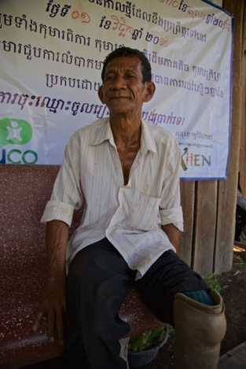

Ung Savann, Village Chief, 61, widower, 4 children

FGD:
- The area is part of a former military base with old military roads. The task cleared in 2011 is a former Khmer Rouge military base with a tank park close by.
- They stated they paid for part of the area to be cleared (both private deminers and CMAC)
- They knew that some places were a battlefield, and they could see the former KR base from the road. This area was contested between the KR and Vietnamese. They said ‘the soldiers knew where they had put the mines’.

NB it seems likely that ex-soldiers have been ‘invited’ to return to certain locations where they were stationed and fought, and therefore have local knowledge.
- Were they using suspect areas or not? People were very clear of where the ATMs were placed, on the old roads, and these would be mixed with APMs. We used to cultivate adjacent to the roads. We did find mines when ploughing including PMN2s
- They still fear mines today and would not consider themselves impact free.

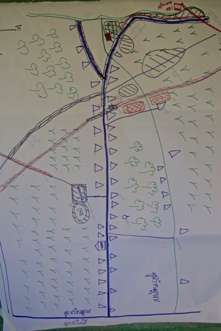
Village Map from FGD: Shows the main cleared area as the black polygon with diagonal shading over the old tank track, but other areas cleared by CMAC – according to the villagers are not recorded. Equally the two hazardous areas shown as red boxes below the uncleared tank road are not recorded on the web version of IMSMA

The villagers also show clearance of the road running parallel to the hazardous old route as having been cleared, which is also not recorded.

Villagers claimed that the small section of black polygon crossing the new road adjacent to the two red SHAs identified had been cleared by CMAC privately, for which some de-miners had been paid.

There is a high degree of accuracy between the village map and some of the data recorded on the web version of IMSMA which could lead to additional credibility being accorded to the villager’s claims.

Sochenda Khun who facilitated the FGD notes:

A villager in Ou Chorm Kraom told a sad story about a poor man who was a part-time labourer. There was some mined land and the owner rented a tractor to plough their land. Then the tractor owner hired that poor man to do that job. Unfortunately, he got injured during his work. This showed that mostly impact from mine action always affected to the poor people.

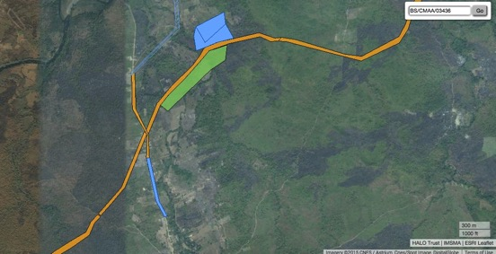
Official Records accessed 11th November (http://gis.halocambodia.org/viewer/imsma.html)
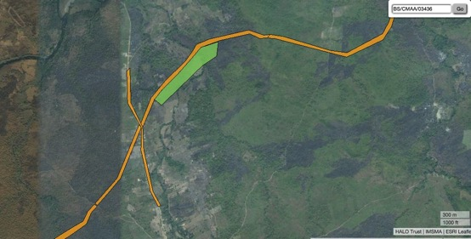
Official records without the cleared area indicated – note that the road in the centre of the image running top to bottom still appears as hazardous even though it has been cleared, as indicated above.

Interview with Village Chief Ung Savann:

Used to live here – but mostly from Takeo / Kampot. People came to settle here in 1998.

We used to live here during Khmer Rouge time – moved people to come here. After the war they come back again. There was a problem with the mines but only in some specific areas. Now most of them been cleared. We knew where the mines were because we were soldiers and we used to make war. Used to be the area where battles between KR and others, and we know there used to be mines. The tank route – we knew there were AT mines on that route.

Many accidents in the area? Areas where we suspected there were mines we tried to ban people from going there. Those areas have been cleared by CMAC – some part by CMAC, and commune councillors hired people to continue to clear the mines and they found another 2 ATMs in 2011. The rest was all cleared by CMAC cleared about 600 metres, and then they had other project and moved from the area. So we had to hire people. Built the road on the cleared route – commune fund paid for this (CIP?). Now its easy to communicate and trading – transport the maize and cassava to market.

CMAC cleared agricultural land – only a few points they have not yet cleared. There are a few hectares remaining areas that have not yet been cleared. Think there are PMN 2s, and drum (?), bullets – and some ATMs on the old road. Yes. They have a plan already and have not yet started the activity yet.

There are no accidents happening to people in the village, but there was an accident and 2 people from Tasanh had an accident on an ATM – when one was killed and one injured – on the old ATM route. On area that not yet been cleared. Everything is in the plan – but not yet responded to it. Very long Kampong Lapov to Samroung – Kok Kohlor district, Battambang. A company who came to plant Cassava – they constructed the road and they may pay for the road to be clear the land – the road has been cleared by the Chinese company that has the concession – Stung Doike village.

The old road no one dares to go on the old road because normally people don’t use the old road because know its often mined. There is another small path that local people use, and have a very full knowledge of the old AT mines – instead they use

When did demining start in this village / commune?

Demining started here? Can’t remember – implementation 2011 / 12 and 13.

Before - did they do village demining? Dare not to do that (NB but seem to have hired people and beneficiaries interviewed below stated they cleared the land in hazardous areas and found mines.)

What was impact on the people when the mines were here?

People lived as usual – we knew there were mines there but we did not go there. So people had enough land?

This year some people who had plantation tried to hire CMAC to clear the land for plantation – wanted to pay them, CMAC came with the car – and came to discuss. Tried to call them to come back – CMAC wanted to make the contract?

NB Seems to be some evidence that CMAC staff are taking payment for private clearance, and have done so already in this village.

When the owner of the land called – they came here – but they had already cleared the land – cut the vegetation. Later he wanted that they sign an agreement to ensure there would be no more.

After clearance – what is impact?

Now we have the road, the people can cultivate the farmland – before they could not get into the land to grow crops. Did they have land they could use before? They cultivated other land – people just cleared the land, if they found mines – plough and find 2 ATMs – If they found mines they did not use. If they didn’t find mines – they used it.

They do know (believed they knew) where the mines were before they started to use….. People perceive there would be no more mines because cars and tractor used that area – and then they had an accident. They assumed there would be no more, but when ploughing they found 2 more and then CMAC found more ATMs – in the field. 2011/2.

After clearance people got more land – yes. And we stop fearing.

Video Interview with two beneficiaries: Transcipts in Ou Chorm Kraom, Kampong Lapov, Samlot
Name: Keo Reth & Mrs Paen Ran, Beneficiaries

Man: “I have two hectares of land that have been cleared by CMAC. When I started cultivating the land before it was cleared, I came across landmines as I was trying to cut the bushes.”

Woman: “I too used to find landmines as I was clearing the bushes before CMAC got to sweep it. When we came across them simply collected them to put in one place, burned them and we ran away. My land is on the hill. We normally used hoe to work up the soil. Blow by blow, sometimes the soil was turned up with a landmine in it. We would just put them in one place and burned them. There are still landmines out there.”

Man: “In my case, my son dug and dug with the hoe, and there were two anti-tank mines resting on top of each other, so we managed to remove them and set them on fire later.”

Woman: “Of course I was quite scared but I had to take my chances.”

Man: “I first began working on a small piece of land before CMAC came, and when they came to sweep it, they found seven landmines.”

Woman: “Me too, I began cultivating the land before CMAC came to clear it. But only a section of the hill has been cleared of landmines.”

Man: “On my land, CMAC found 7 anti-tank mines and several smaller ones.”

Woman: “On my land, they quite a few small landmines but I don’t know how many.”

N.B. Provides evidence that people are working contaminated land and it does contain mines

On clearance certificates:

Man: “No, I did not receive any certificate from them. They left as soon as they finished.”

Woman: “No.”

On mines still left in the woman’s land:
“No, I have not extended the use of the rest of the land. I don’t have money to invest in it, and plus I am old and alone.”

How they feel about the impact of the clearance?
Man: “I am so happy after CMAC cleared my land of landmines. Because of that I have been able to expand my farm and to improve the life of my family.”

Woman: “I am very happy since a section of my land has been cleared of landmines, but I still have concern for the other parts in the hill that have not been cleared yet. My life has improved a lot compared to before. We are able to grow more crops without fear like in the past.”

Man: “There used to be an old road cutting through here, and there were two anti-tank mines one on top the other. And further up is my farmland where CMAC found seven anti-tank mines. My son had also found one, so that would make it eight altogether. There used to be a Khmer Rouge army camp by the stream, like half-way to Battambang. Up this way people are using the land although it is suspected of having landmines in it. They are growing rice on it.”

Ou Trav Chur Village , Serei Maen Cheay Commune, Sampov Lun District
CMVIS data shows 0 ERW and 10 Mine Casualties. The commune is 5th in the CMAA 2015 planning guidelines with 12 mine casualties.

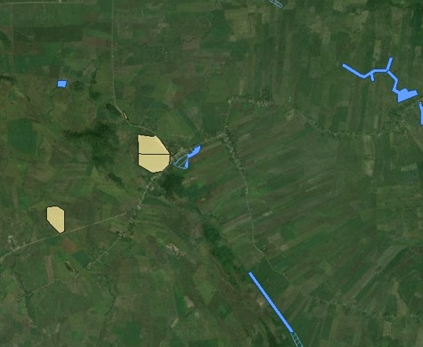
IMSMA data shows the same SHA by the cross roads, on the hill as shown on the village map – square red polygon with cross hatching.

The small cleared area top left, is also shown in the village map below (represented by a black polygon with shading).

The cleared area (blue) opposite the large SHA is also shown accurately on the village map but many other significant SHAs perceived by the villagers are NOT captured on IMSMA or have not been updated

The hills running adjacent to the road cleared visible with trees on the google earth image are also believed to be hazardous areas according to the villagers but are also not captured on IMSMA

According to the village map there has again been more clearance done that is not captured on IMSMA
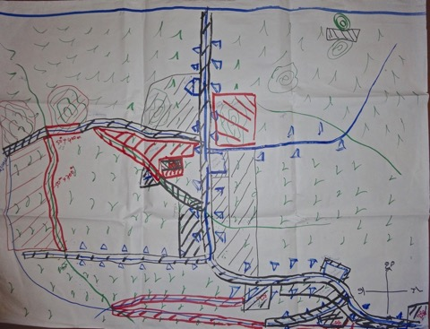
FGD Village map

Video Interview Transcripts
Location: Ou Trav Chur, Srei Mean Chey, Sampov Loun
Name: Tuern Seng (Beneficiary, BS/CMAA/40309)

“My land is just beyond this bush line, and I am grown cassava on it. From the beginning I knew the land had mines in it, but I did not grow anything on it until after CMAC swept it clear of landmines, just about three years ago. After the clearance we feel so happy, my children walk on the farm without fear like before anymore. Every year I benefit from the harvest of crops that we grow on our land. I would like to thank CMAC for their work and the countries that gave money to clear landmines in my village. I am very glad and thankful of their help. It is very important as it allows people to improve their livelihoods, to walk on the land without fear anymore. Things are definitely better in a sense that people are able to expand farmland to earn a living on.”

Name: TEM SAMORN, 65, village chief

“The hills behind me is still suspected of having landmines, and they have not been cleared yet. This used to be frontline as well as military camps used by different factions. The land behind my back here has been cleared following our request. The wider area around is designated for building a school.”

On impact of clearance: “As a result we were able to build a school for children to get education without any fear of danger. In addition to that we had a road built for the villagers to travel on with a lot of ease than before. However, there are still more areas that need clearance. This include old roads where are notorious of having anti-tank mines, and that is where incidents often tend to happen.”

Name: Cheng Nget

Man describing how he stepped on a landmine but it didn’t go off…

“I was walking up the hill on a small foot path, then I suddenly stepped on a landmine. I heard a sound under my foot but then I pressed it harder on the object. My wife started crying as soon she heard the sound. Until that point I had been walking through the jungle on the hill for three years looking for honey, but I never had that experience at all. But that day I just accidently stepped on it, but luckily it did not go off. Later I found two landmines and stashed them aside, but they disappeared, I don’t know what happened to them. I never occurred to me that there would be any danger. I just followed where the bees led me to and I did not pay much attention to what may be lying under the ground. There used to be 6-7 mortar rounds on one side of the hill but that they have been removed already. Yesterday, I was in the forest collecting honey as I always do. I cannot say for other people but for me I know what I do, I know my way.”

NB Another man took his children to the area and moved 15 mines to a stash in a tree

Sochenda Khun who facilitated the FGD notes:

There were several mine contamination areas in Ou Trav Chou which were used for trunks to access (old roads) and some were mountain areas. Nowadays those areas were used as farming land and belong to some villagers. The group discussion told that there were several of the anti-vehicle mine accidents occurred and the latest one was in 2014. People expressed that they used those lands for farming by manual methods and they didn't dare to apply any heavy tractors or machines on those areas so that their productivities from farming were still limited or just enough for normal living life. Surprisingly, the facilitators met and talked with a guy who was a former Khmer Rouge soldier. He used to overrun with his son to the mountain that was the highest contamination areas as it was the former military base of Vietnamese soldiers, luckily there wasn't any accident happened to him and his son. The villagers also told us that he was in drunk condition at that time. Another case was about a man who overrun to that same mountain for finding bee and honey. He stepped on mine and it was exploded but he just got very slightly injured. However, these cases should be concerning.

FGD and Village Leader Interview:

- 76 families settled the area in 1996 from Pailin
- Knew the mined areas fought here – old Vietnamese base
- Formal clearance only started in 2001
- Used suspect land before clearance – but used it differently – cultivating with hoes
- After clearance can use tractors and power ploughs
- Have been two ATM accidents and one accident with an APM last year when a man went to collect honey on the mountain and he lost a leg (this makes Cheng Nget’s story even more incredible). The villagers explained he was a newcomer and didn’t know the area. Other people go to the mountain ‘but only around the base’.
- Access big issue before clearance as the former routes (old routes) have been mined
- Some areas appear not to be on BLS
- Poor still engaging in risky activities – entering suspect areas – such as the story of Cheng Nget, collecting honey on the mined mountain that over-looks the school
- Confusion over one beneficiary’s name means area skipped over (Tuern’s name appearing on the clearance request apparently caused CMAC to reject this part of the task, believing it was duplication – this is why the blue line of clearance on the old route stops – middle centre bottom of the IMSMA screen shot - where it does – but the locals believe this to still be mined).
- They noted that prioritisation was ‘according to the village development plan’. There were handover ceremonies and the beneficiary was given a sketch map of the cleared area.

Interview with TEM SAMORN, 65, village chief

When came here in 1996 – did you know there were mines here? There had been a former military based of Vietnamese in the school. Many mines, both APMs and ATMs, and also other ERW.

How did they know which areas had mines? The KR explained – after the Vietnamese troops defeated – KR came to control the areas and explained where the mines were. Also along the routes.

Did people have safe area to make the house and farms?

When we came to settle down KR explained – that 500 metres from base – there are no mines except along the route – off the route forests they can clear and make homes and fields. Yes there were some accidents – and people became PWD – can’t remember, but some were injured and some killed.

When did the clearance start here?

From 2001 – CMAC – how many years working here? First project 2001 – 02. Prepared the village demining action plan and linked it to the investment plan.

Which areas did they prioritise first?

At first we de-mined for development – roads and the sides of the road and the school and pagoda. Then we cleared the residential land and then the agricultural land. First this area around the old base – was top priority and big risk to the people. Next close to the residential areas where people would go back and forth, as well as commuting to the areas, for example the need to collect firewood

We prepared the plan – there have been many areas cleared, but still some remaining such as old road, possible ATMs around the base of the hill and on top of the mountains – on the slope and not many people go there and so it will not be a priority.

Also there is one area where we have not yet cleared - 5 HH’s land – can’t clear due to 10 Type 69.

One guy has two plots of land – Mr Tuern Seng – CMAC think its overlap or a duplication – one has been cleared, but one not, and they skipped it, but he’s actually got two plots.

When did they reject his land being cleared? 2014.

Is there encroachment on suspect land? Outside / Borders of the village?

No don’t have such things in our village. (although the DDL said this was one area where this was happening).

Yes in the fields – there used to be an old crossing in that area – and mostly the accidents were due to ATMs. When we ploughed by tractors and heavy track ran on it there would be an accident. There were two accidents on around 2004-5 and one in 2015. The 2015 one was in February or March. A truck was transporting things.

Were people using the land (suspect APMs) before it was cleared?
This area has been cleared of APM already except for some areas near the mountain.

Is the village impact free now?
I can not assume that – because the people who are poor – sometimes they encroach the land up to the mountain – collecting vines and fire woods where sometimes. It is very close to the village – and they don’t settle that area. When they need the firewood and vines they will go there – therefore there is still risk and impact from mines.

How has clearance improved life in the village?
The benefit the people get – they do not have accidents – before they hesitated to plough and now they make more yields from the crops – as a result of clearance. For commuting they are not afraid of travelling – and no fears of risk by travelling.

Is this because they have more land or they cultivate the soil differently?
Before they had about 5 ri of land and they used hoes to dig they make the hole to plant. After clearance able to plough which increased the land and the commodoties. Were using the land that was suspect, but using it carefully.

Crops?
Corn, soya beans, sesame, cassava. They also grow mangos and fruit. More crops than before.

Last 15 years have people got richer? Yes richer than before, life has improved, and people have good houses and using new materials tractors and motorbikes. People are happy with the changes.

How much of change is due to landmine clearance?
10% of the area is still contaminated 90% of the land free of mines. The only source of income is from agriculture in this village.

Fence the mines?

The thing is some household had land that is free – ok for them some family has mines – so effects limited numbers, but for this affected who got clearance how much of a difference has it made?

Some people – most of them have improved their lives – before no proper houses and livelihood improved and some others still have problems, and some become poor. They have the land but don’t have the resources to use their land and they become poor. The poor have land – but lack resources to invest in the land.

But why? Personal factors – some better at farming than others – saving etc???

Thmei means ‘new’ village – literally, possibly on suspect land? Thmei village is in the CfR II work plan for 2015, and also for 2016
Community Based Mine Risk Reduction focal point
Presumably the concern here is that it makes it hard to achieve the m2. This is clearly a high-threat and high-impact area that is not being prioritised.
NTFP includes mushrooms, rattan, honey, hunting for animals etc
Email to David Horrocks, 11th November 2015 from NGUON Monoketya, Deputy Director, Socio-Economic Planing and Database Management Department (SEPD), Cambodian Mine Action and Victim Assistance Authority (CMAA)
The transcript of his interview from the video reveals that this incident involved a tractor that he had hired to plough his land.
11 people were killed and 1 injured when a power plough and trailer went over an ATM in Kampong Kol Thmei, in November 2010.
Email to Paul Davies, 30th October 2015
This testimony is available on video, and accessible at (You Tube reference)
Preung Yem is ploughing the land using a power plough, and therefore there is not much of an economic case to clear the land, but there would seem to be a safety issue.
The name of the village was changed to Boeng Trakuon village, based on the Ministry of Interior Cambodian National Gazetteer.
Email to David Horrocks, 11th November 2015 from NGUON Monoketya, Deputy Director, Socio-Economic Planing and Database Management Department (SEPD), Cambodian Mine Action and Victim Assistance Authority (CMAA)
This is usually an indicator of high-risk mines, such as PMN and PMN2 – there are many suspected PMN2 fields in neighbouring Chaeng, and its likely that these are present in Bor Knols. The immediate village area should be a very high priority, and not sites further south as have been prioritized.
‘Informal Village Demining in Cambodia: An Operational Study’ (2005)
Email to David Horrocks, 11th November 2015 from NGUON Monoketya, Deputy Director, Socio-Economic Planing and Database Management Department (SEPD), Cambodian Mine Action and Victim Assistance Authority (CMAA). NB this reflects the very high impact of mines in the area in the 1990s and perhaps into the 2000s.
Email to David Horrocks, 11th November 2015 from NGUON Monoketya, Deputy Director, Socio-Economic Planing and Database Management Department (SEPD), Cambodian Mine Action and Victim Assistance Authority (CMAA)
Email to David Horrocks, 11th November 2015 from NGUON Monoketya, Deputy Director, Socio-Economic Planing and Database Management Department (SEPD), Cambodian Mine Action and Victim Assistance Authority (CMAA)

