Village Studies Pailin: Summary Findings:

1.0 Pailin: Chhim Sambath Chief MAPU Comments (26th October):

NB Seemed a very committed and honest official, well aligned. Some MAPUs reported issues of lack of budget and transport constraints as limitations on their work. Others reported that they did not enjoy the work, and were qualified for other things (lawyer in one case), and had merely been assigned to the MAPU function and they wished to leave.

- Noted that few tasks done by the 5 operators in Pailin were outside the MAPU approved plan (cited 2 only this year and this was to respond to a request for construction of government buildings).
- Noted that HALO Trust sometimes asks for an extension of the BLS based on evidence from the ground. This type of ‘mindfulness’ should be more common and rewarded.
- Noted there are sometimes problems with a lack of participation from community and government officials (provincial, district and commune level0, such as:
  - Limited knowledge of the mine problem by the village leaders who have a crucial role in the planning process – reflects a need to ensure real participation on a gender disaggregated basis
  - Meeting venues being too far for the commune and village leaders to travel (lack of financial support to attend the meeting)
  - And yet the Pailin Government and Sala Krau District officials we met were highly informed about and motivated about the mine issue (see transcripts below). Their comments indicated that mine action is an extremely relevant and important issue in Pailin.
  - But, at the provincial level – participation remains limited – it is not seen as being relevant to their departments.

- Noted that all operators including NPMEC are reporting all tasks to him locally. But information not coming back to CMAA centrally, or up through the chain from MAPU in the regions to the CMAA centrally.
- There are challenges of access to some priority areas, especially in the wet season, compounded by the MAPU’s lack of transport, making it hard especially to transport materials to the meeting sites
- There is also a problem with the limited supply of mine action, as people start to cultivate contaminated areas. Villagers have limited land, land limited by mines and ERW. Our capacity “doesn’t respond to their needs in time”. There are many cases of people trying to reclaim hazardous areas because of poor livelihoods, and we ‘advise villagers to report to us, and then we can consider these areas and incorporate in the plan – because the proposals for clearance is based on consultation with the village authority and sometimes they don’t have full knowledge (of the mines problem), and that is one reason we may not capture all of the SHAs’.
NB Again the lack of community participation in the planning process is a concern of the MAPU and directly leads to a limitation on the amount and accuracy of knowledge on contaminated areas, reflected in the BLS polygon information. More participation as per the letter of the planning process would assist in this issue.
- He has also resorted to send HALO to do NTS in the priority areas before the planning process (and then sending information on existing BLS records to the community before planning meetings) – but HALO do not have the budget to do this kind of on-going survey.
NB Demonstrates the need for on-going survey
- Therefore every year working on 20% of sites outside of the current BLS polygons. Report to national CMAA and ‘request the operators to do survey in those areas’.
- There are accidents outside the BLS polygons. Says they follow up and send an operator to generate a new BLS polygon.
NB this should be an SOP. What does CMAS say?

- Casualty rate? This year in comparison to 5 years ago the prevalence has dramatically dropped down – before 2005 - 2010 in some years the accidents were around 100 people/year (500 in total) meaning that before 2010 the rate is very high. 2010-15 it’s dropped to around 90. 2014 22. 2015 – only 7. Prevalence down.

- Surprising given that people are still taking risks? Because of the incidents has gone down – before lot of mines along the roads and areas where people made houses – we found mines under the houses that people had constructed - currently mines only in crop plantations and on the bottom of the mountains – and those areas not frequently accessed by the people meaning that people can. Yes people know where there are areas, and they don’t have to interact so much. So mines before were on the roads and in the residential areas – now in agricultural areas and the moutains

- Other factors – new people – migrants – don’t have knowledge about mined areas. Didn’t know – and hire land and cultivate. People’s knowledge is very high here now. Every day when they see mines in daily activities. These people are vulnerable. Pailin is one of the province potential where 85% of the people’s livelihood is from agricultural activity. The people from other provinces come here and hire the land to cultivate the crops and Pailin does not have many workers, and Cassava and other crops become a good selling – good market for them. This makes people from other provinces to come here to do agricultural work or to labour in the farms. The accidents is due to entering to the forest to get NTFP. Mushrooms – those people have to collect those. Mostly migrants taking these risks.

LO LUE, Deputy Governor of Pailin city, District of Working Group (Mines) – part of the PMAC 26th October 2015

“Landmines are the biggest problem facing the people in Pailin. They represent the biggest concern that they have to live with and think about every day and each time they go about their business. Initially they had little information about the danger or did not quite understand when they were told about it. One danger was in collecting UXOs to sell for scraps. Another was in tempering with those devices. Danger also exists in farming. People cultivated the land with little idea that it might be littered with landmines. And the fear caused by landmine danger has forced many people to resettle in other areas. Another challenge in addressing landmine danger is when deminers began marking areas for clearance or warding about mine risk, some villagers did not understand that and removed the markers, causing the loss of data need for mine clearance operation. Or sometimes they just removed landmine warning signs to use for other purposes, which was another factor contributing to landmine casualties.”

Impact on development?

“Landmines have serious impact on development in Pailin. The biggest concern we have are the landmines we still have in certain areas where development projects are to be implemented. Landmine danger slows down development. That is why eradicating landmines is the top priority in this region for development to advance further.”

How important mine clearance has been?

“Mine clearance plays an important role in reducing poverty of the people in Pailin. Landmines are the biggest fear the people face everyday when they go out to cultivate their land. When they get injured, they lose their ability to earn income. Mine clearance is also important in helping reduce migration, because when people face danger in their farm, they would certainly abandon it and move away to another place. Therefore, getting rid of landmines is going to remain the top priority for us in Pailin in the long future to come.”

“On behalf of the people and the authority in Pailin, we would like to request UNDP continue providing support to mine clearance in Pailin. The reason is that there are still many minefields left uncleared in Pailin, and as a result of that fear of landmines remains high among the local population. That is why we strongly urge UNDP to continue providing financial support for mine clearance in our province.”

NGEL SOKONG, Deputy District Chief, Sala Krao district, Pailin, 27th October 2015

“On the impact of landmines, there are three things I want to talk about. First, it is the damage mines have done to the bodies of the people. Second, it is the financial pressure they have created for the families. Third, it is the loss of time that the people needed for earning income to support their families. Landmine-related injuries present a major challenge facing each family in trying to build their future. It is very hard for them to earn a living on their own after they were injured by landmines.”

“Regarding the areas that were suspected of having landmines and where financial support was mobilized to clear them, what I can tell you is that, as soon as they were declared clear of danger, those pieces of land ended up in the hands of the villagers who are using them for farming or building houses on. I can assure you about that, as far as Sala Krao district is concerned. No official in the district authority is trying to take advantage of that for their own benefits. The people in our district are the ones who are the direct beneficiaries of the cleared land.”

“Between 1998 and 2000, Pailin had just about 1,000 families. By that time the areas along the border were notoriously dangerous due to the landmines and explosive remnants of war that were left over by the fighting, and those areas had not received any mine clearance teams to sweep the land. As a result, landmine-related casualties were extremely high between 2001 and 2008. After the integration we had new settlers coming from other provinces to grab land for their ownership or to make a living by logging trees to sell for money. They had little idea that the areas used to be battlefields and are littered with landmines. They took their own risks and ended up having their legs and hands blown off or even loss of life to landmine accidents. As for the original settlers, they took precaution, but no matter how cautious they were accidents did occur to them too. Facing shortages in their daily life, they had to sell labors by working for others on the land that was infected by mines. Some people, because of need for money, tempered with unexploded ordnance to sell for scrap and hurt themselves in the process. Others got into accidents when they trying to use UXO to catch fish. These are the real experiences that I have encountered with through the years.”

“But accidents have now been reduced almost 100 percent thanks to the persistent campaigns done by the local authority and mine clearance agencies to raise awareness about dangers of mines and ERWs among the local population. Last year we had the lowest rate of casualties from mine and ERW accidents. Currently, the Sre Anteak area remains the only one that needs further notice and attention since it used to be a frontline that saw heavy fighting during the conflict.”

“Last but not least, I would like to thank the donors very much for the assistance to mine clearance until now and for the support that may be forthcoming in the future.”

Village Studies:

1. Bor Huy Khmer Cheung, Sangkhat Bor Yakha, Pailin Municipal Area, Pailin 26th October
CMVIS data reveals a total of 6 ERW and 12 mines casualties in the village, the Sangkat is ranked 5th in the last 5 years with 1 mine, 6 ERW casualties in the CMAA 2015 planning guidelines. The mine accident may be the accident at the Pagoda identified in the FGD.

NB the village was established in an area with a lot of mines, but the residential site was chosen because it had been the location of a Thai gem mining operation during the 1992-3 period when the area was under Khmer Rouge control, so the villagers believed it was mine free to build their houses. Similar patterns were observed in Banteay-Meanchay where villages, such as Prasant Tbaeng, were constructed by former fighters on the site of old military bases – inside the perimeter where it was known there were no mines

Transcripts from Video Interviews:

Name: MOEUN SAKEN, 40, Bor Huy Khmer Chheug Village, Sangkat Ba Yakha, Pailin, Beneficiary.

“I knew that our land had landmines because I saw one of them, and then we reported about that to CMAC. As soon as we found the landmine, we did not dare farm on it. We left it aside and move on to another piece of land that we thought did not have landmines. We just cultivated where there were no landmines.”

How did mines impact her life?

“It was scary until they came in to clear the landmines. Sometimes we had to take the matter into our own hands; when we saw a landmine we would pile dead wood on it, set them on fire and run away before it exploded. That served also as a warning sign for other people not to enter the land.
Impact of clearance:

“I am very happy after the land was cleared of mines. We can have more hope for a better living condition for our family. We initially had two hectares but now we have three hectares after they cleared landmines. I am thankful for the assistance to mine clearance. I am just happy – extremely happy.”

Name: CHHOEUNG CHHEAN, 64, Bor Huy Khmer Chheug Village, Sangkat Ba Yakha, Pailin (Landmine survivor)

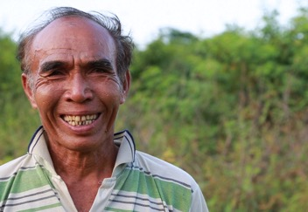

“I am a farmer and I grow cassava. I became an amputee after having a landmine incident in 2005. It happened to me when I was clearing the land to grow corn. I was aware the land was a dangerous area. The mines were laid by many people, and they were Khmer Rouge mines. I planted some by myself. We had them in maybe 50 to 60 army backpacks. But perhaps later others came with another 100 backpacks full of landmines to plant in the area that we were not aware about.”

Why did you encroach the land?

“We were simply poor and if we did not make effort to take the risk, what would be the solution to feed the children? After I had the accident it became quite difficult to move around to manage the plantation. My children had to quit school to help me out. But later deminers moved in to clear the land and thanks to that we were not so afraid like before and able to improve our livelihood. An aid organization in Battambang gave me this prosthetic leg, and I also received help from trauma care organization. If possible I would like to have a latrine set to improve our sanitation because we are too poor to afford it.”

Impact of clearance?

“The clearance has allowed me to improve farming to earn income for the family. It is not a whole lot but just enough for us to get by. Now I have nine hectares in total. Three hectares were the extra that I got after mine clearance. It has been not a good year for cassava – a lot of it died because of disease and lack of water.”

“I am very thankful for the soldiers who came to clear my land.”

FGD:

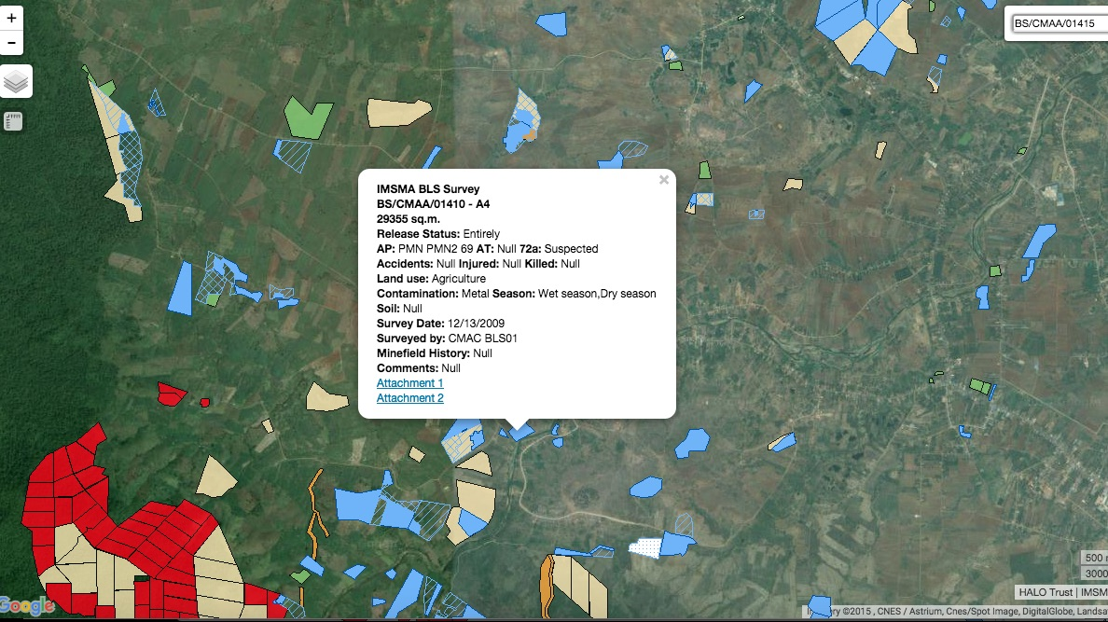

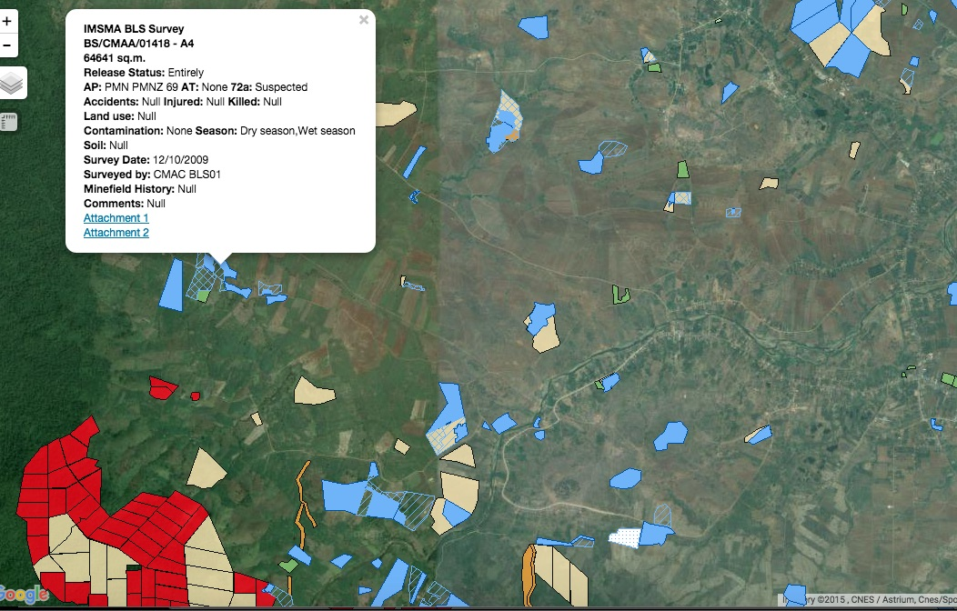

IMSMA screen shots showing two of the sites cleared by CfR II, NPMEC: 01418 is located adjacent to CHHOEUNG CHHEAN’s land, and clearance records show 335 Type 72a, 3 T 72b and 22 T 69 were cleared from this area which is consistent with Chhean’s testimony with reference to the large numbers of mines deployed in this area.

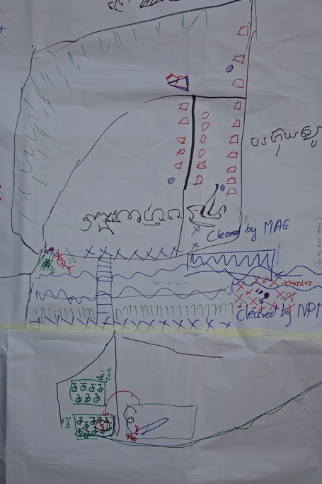
Village Map produced during the FGD. The cleared sites south of the river in the bottom of the map show BS/CMAA/01418, and include the site of Chhean’s 2005 accident. These areas were heavily mined.

- All were beneficiaries of CfR II
- MAG clearance site LR/CMAA/01396 was sold to a private water treatment plant after clearance after having been cleared for agriculture.
- The areas cleared to the west of the village (shown at the bottom of the village map above) were forest before clearance and were not used, and local people only used to access these areas using perceived safe paths.
- In 2010 there was an accident near the Pagoda – shown on the east bank of the river, north of the bridge on the community map – this was reported as a demining accident involving CMAC.
- There have been accidents with people in the village: they cited Chhean’s accident in 2005 in the SHA now cleared by NPMEC under CfR II in 2013. Another was injured in the forests cutting wood.
- Clearance has focused on specific areas close to the river, and paths and has not gone into the deeper areas of land / forest.
- There was a history of clearing the forests and land to grow crops, including on hazardous areas, as per Chhean’s story above.

Additional Interview with Sok Sann, Village Chief, Bor Huy Khmer Chueng, Sangkat Bor Ya Kha, Pailin Town

Noted the village was settled in 1998 after integration of the Khmer Rouge. Again these were mostly former Khmer Rouge soldiers who settled their families in an area they knew and had fought in.

‘Big problem with mines in the area?

‘In 1998, very many mines. We don’t know exactly where the mines – we knew some specific areas where we planted mines’.

- Reported mines being exposed as a result of the flooding in 2013:

‘Have reported SHAs to the CMAC mine action network. It was about 2 years ago (2013) they came to check, there was a flood and then when the water went away, I saw APM T - 69 – reported to the CBMRR – they came and destroyed it. They came and surveyed the area. Conclude that maybe it was washed away by the floods upstream? Next to the bank of the river. In his experience it was planted there – and soil eroded.’ (rather than mines floating or moving).
- Are people worried about mine in this village?
In my village 90% of the people are not concerned any more about mine risks – even though we have some SHAs. Because their land and agriculture land is now safe. Last year there was an accident – to one of our villagers He climbed up the mountain to collect fruit, and they stepped on the mines and lost one of his leg was amputated – did he know it was risky? His friend knew it was risky area – they said knew it was mined – but they got lost and stepped on the mine. Those people they normally observe the track that wild pigs use, then they feel it is safe. Yes they are poor – and at that time good price for Som fruit – can sell around 15 – 20 US$ 1 kg. Have land? Have small land or do not have land to farm – just got married – and after getting married have to separate from the parents. Set up own house. Guy injured was in 2015 – 28/9 years old. Just got married and his wife just delivered a baby. And he was poor and no money to support the family. Sometimes has to go to hospital for medical check up – now visiting grandma. Now live with his parents for support. His wife and baby – move in with his mother.
  - NB this is in the mountain that appears as a mass of red A1 minefields to the west of the village,
- Did they farm the land that was suspect prior to clearance?
Yes before we did use the suspect land – we encroached the land and cleared the forest and sometimes we found mines and ERW – and we leave that land. First CMAC and MAG came – we asked them to clear. Everyone encroached the land – when found the mines – moved to lower risk land – can’t expand much land. When they saw the mine – reported to MAG and CMAC, by NPMEC cleared.
- How did they know they were in a mined aread?
From his land saw the fragments and indicators – of mine explosion - on the ground. Burning the forests – and the mines emerge. Mines emerge.
2. Sre Antak Village, Salar Krau Commune, Salar Krau District. 27th October 2015
Salar Krau commune is listed as first in the 2015 planning guidelines, with CMVIS recording 9 mines victims and 14 ERW casualties recorded in the last 5 years. The CMVIS data seems to suggest that a total of only 2 ERW casualties have occurred in the village itself.

NB It should be noted that Sre Antak was highlighted in the interview with the Deputy District Leader as a priority village. In this light it is even more curious that the commune chief prioritised a ‘community forest’ in 2012 with CfR II funding, over other higher priority minefields (according to the villagers interviewed in the FGD, and according to CMAA planning guidance – proximity to village centre, history of accidents, technical threat etc) actually in the village. Clearance of polygons in and around the village centre produced good results in terms of numbers and was highly relevant in terms of type of mines cleared, including PMNs.

Both Sre Antak and Veal Cheang visited on the same day are very much ‘new villages, opened up by settlers driven by land hunger in the recent past (15 years). The latter does not appear on the official CMVIS records as it is reportedly ‘too new’ even though it has been settled since 2000.

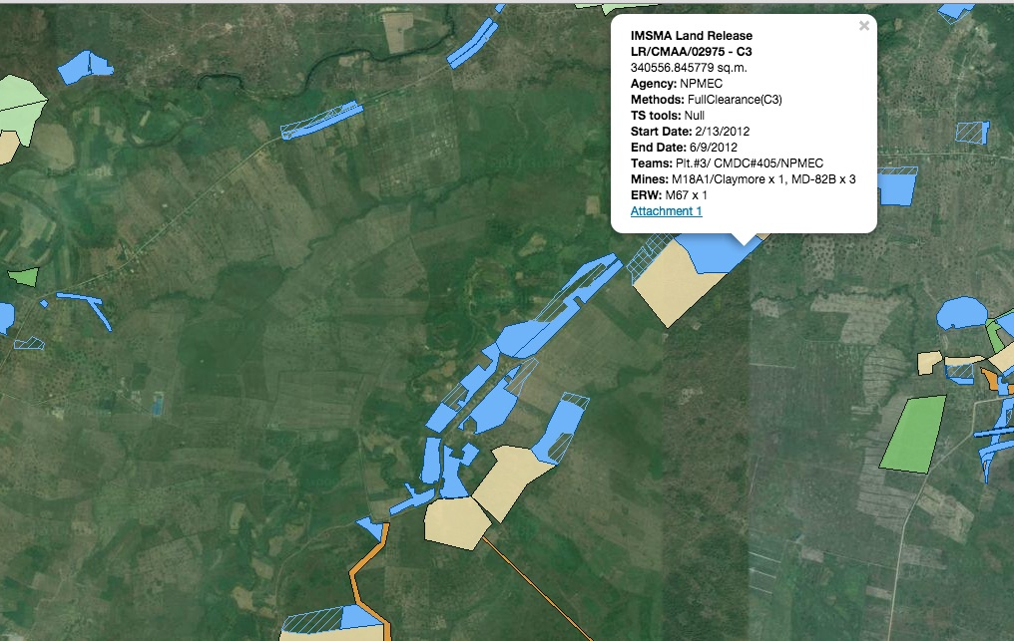

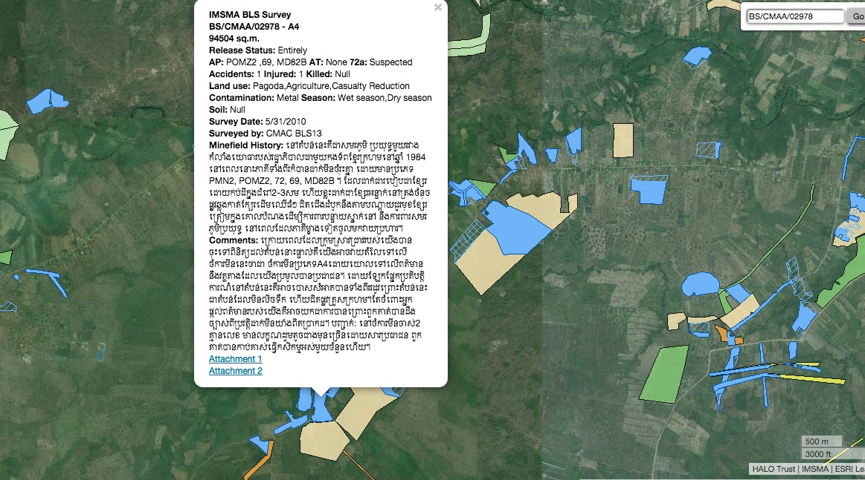
The LR code of the community forest site, 02975, reveals that one NPMEC team worked on this site that does not appear to have been prioritised by the villagers for 96 days only finding 4 mines (3 MD82B, and 1 M18A1), releasing 340,562 m2 through full clearance. The beneficiary information states 180 families (and this perhaps might have been thought of as a justification for the selection of the site). This warrants further investigation as to the actual land use as the current PCM reports are too aggregated to provide detailed information on a site by site basis. However, the records maintained by UNDP state that 115 operational days were spent on the site, and that there were only 15 beneficiary families
In contrast, site 02978, cleared in 2013 by the same NPMEC team also with CfR II funding, released 94,504 m2, in 48 days clearing 37 APMs, including 8 PMN2 and 14 PMNs which are high risk mines. Questions are thus raised as to why more land on task 02975 was not released through technical survey, as the contamination was clearly lighter, and clearance rates were far higher than on 02978 which is clearly a higher priority site. It is close to the centre of the village, surrounding a community asset, the temple, with a history of accidents and near miss incidents, and has high-risk mines such as the PMN and PMN2. Other sites cleared near the centre of the village have produced similar results, and other high-impact CHAs are still present in the village more than three years after what appears to be a far lower priority site – the community forest – was cleared, which in the UNDP’s summary data for the project is recorded as being released ‘for agriculture’. The village map below shows the cleared areas and the remaining hazardous areas without precision, but the relative locations do still accord with the IMSMA records above.
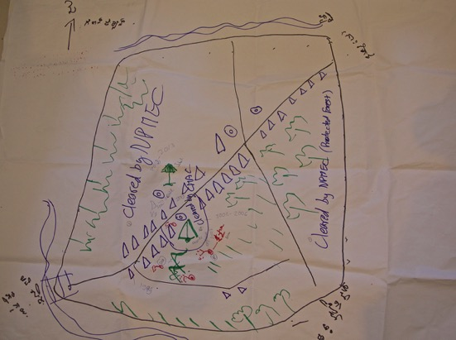

Video Interview Transcript with CfR II beneficiary:
This interview reveals the profile of many of the people in the new village – settlers, mostly from nearby Bovel district in Battambang who lacking land, moved into the area 15 plus years ago, to set up new communities with the hope of securing land, as discussed in the deputy district leader’s interview above.
Name: CHHAI DAM, 40, Sre Anteak village, Sala Krao

“I came from Bavel district where I did not have any land. When I first arrived the land was not cleared of landmines yet, and that done only much later. In order to support my family, I had to sell my labor for other people by working on their farm. At the beginning we just built a small house but after they cleared the landmines, I was able to build a bigger house with larger zinc roof.”

Impact of mine clearance:

“Just like other people I am so pleased with the mine clearance. It makes my mind more at peace, we don’t have to be afraid when we walk or work on the land as in the past anymore. I wish the people who have given money for demining all the best and to achieve whatever they wish for.”

He came in 2001 because he had a relative who settled in the area, and he had no land in Bovel. He built a new house on the cleared land, as before he had only had a small shack.

FGD discussion:
- Two operators have cleared in the village – CMAC and NPMEC
- The community forest is a total of 60 has and roughly half was cleared in 2012 as noted above (this is seen as a secondary priority by the people in the village). NB the remaining SHAs should be resurveyed.
- They came to the area first in 1999. There were mines around the residential areas, including the Pagoda – this area was cleared in part in 2005-06.
- They initially had even to build homes in risky areas. They would mark the risky areas, and inform the village chief. They would call CMAC to come and respond.
- In the area around the Pagoda, some former soldiers did informal demining in 2002. There had been two accidents, one involving a cow that lost a leg and in another incident a tractor detonated a mine.
- They knew there were mines in the area by seeing evidence of ERW.
- People do farm in the ‘community forest’.
- They report that people are already farming the areas around the cleared ‘community forest’ site, suggesting much land here could be released by land reclamation. It’s the poor who have no farming land who are using this area.
- The participants said they would prefer the SHAs in the middle of the village, BS/CMAA/02963 and BS/CMAA/03009 which are in the plan for 2016 according to the VL and MAPU to be cleared first though, before these remaining forest areas (BS/CMAA/02976 & 02974)
- One participant had an accident with a power plough in the SHAs near the Pagoda. Some of his land is still in the SHA and he says he does not use it for fear of mines – about 1 ha ‘by the stream’ – believed to be in BS/CMAA/02963, meaning a loss of roughly US$ 1000 per year to him. He has a total of 5 ha.s

- Veal Cheang, Ou Andong Commune, Sala Krau District, 27th October 2015
Salar Krau commune is listed as first in CMVIS with 9 mines victims and 14 ERW casualties recorded in the last 5 years. There are no CMVIS records for this village as it is listed as being too new.
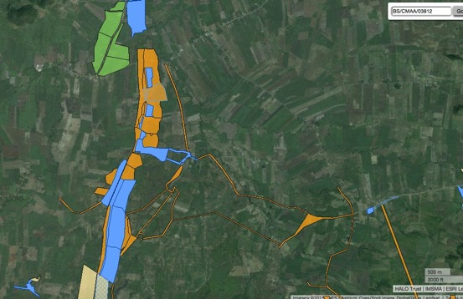From IMSMA: some of the areas cleared in the middle of 2015, are still not shown as released, such as 03820 at the time of writing, 12th November 2015. Suspected old routes contaminated with ATMs are clearly visible, and are also referred to in the community mapping produced by the FGD below. NB some sites cleared yielded low mines, perhaps indicating the efforts of local demining, whereas others still had significant numbers of mines, including high risk PMN and PMN2 mines.
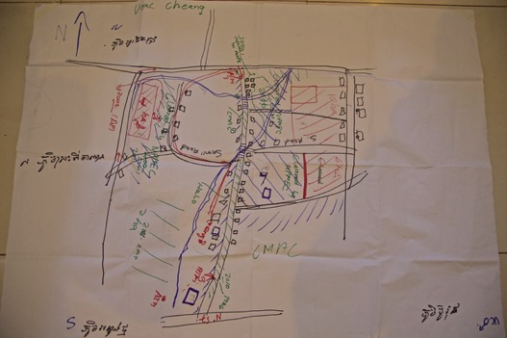

Video Interviews Transcripts:

Name: CHENG TO, 55, village chief, Veal Chheng village, Ou Andong commune

“I have been living in this village since 2000 along with other settlers. We came here because of the available land, although we knew there were mines here. There are no mines in the forested area in that direction, but over there it used to be a battle zone fought between the government and Khmer Rouge troops. There mines literally everywhere – particularly in those little mounds/termite hills. In each mound there were probably a basketful of landmines. They were not really buried but were left exposed on the surface. I used to be a government soldier, and when I first arrived – at that point there was no mine clearance work here – I went around to collect those landmines and put them on fire to prevent dangers especially to children. In 2002, CMAC and MAG contacted me and told to stop burning the landmines, and I did. People had little idea about the danger that they often tempered with ERW and sold them for scraps. But they stopped doing that after receiving warning about the danger from CMAC. Not longer after CMAC began surveying suspected minefields. In 2010, mine clearance was conducted by MAG, CMAC and Halo to allow for the road construction. In 2011, a military demining unit came to clear several pieces of land of housing and agriculture. More were done later by CMAC, MAG and Halo. But despite the efforts, there are still three big minefields in my village that have not been swept clear yet. I have learned that they will be proposed in the mine clearance work plan in 2016.”

Impact of clearance:

“First, I would like to extend by gratitude to the donors for their assistance to mine clearance. Before the clearance teams arrived, the people here were living with a long of fear and limited ability to exploit their land because the risks were too big. We were confined to farming using basic tools like hoes. But after the clearance was done the people have been very pleased with the ability to increase their livelihood activities that have improved their lives significantly. In the past virtually no development organization wanted to step foot in our area (due to fear landmine danger). The money lending people (microfinance people) never came, but after the clearance was done we now have the presence of seven money-lending groups, and also came other development groups to set up their presence here. Because the road is safe to travel they came to aid our village by digging wells, ponds, etc. We had the red cross representatives coming to assist the people who fell victims of storm or fire. In the past no one dared to come to our aid even if they wanted to because they were scared of landmines.

There has been significant improvement also economically as a result of mine clearance. Previously, people dared to build small houses, but in the years we have had mine clearance, many people have replaced their small houses with bigger ones. My house is an example. The people are very pleased with the current situation. They can build bigger house because they can feel more confident about the safety now compared to before.”

On using hoes:

“In the beginning we did use the hoes a lot as a farming tool to scrape the surface of vegetation away. In this kind of practice people did not come across a lot of landmines, but when we started plowing (using machinery) that was when we discovered a lot of them in the ground. When that happened, it deterred the tractors owners from sending their machinery to plow the land, and as a result people had to resort using chemical herbicide to kill the vegetation before planting their crops. Then mine clearing teams moved in, and after the clearance, people were able to expand their farm up to 10 hectares each.”

Name: SORN SIM, 46, 8 children, Veal Chheng village, Ou Andong commune

“I have been living in Veal Chaeng village since 2000. I followed my relatives and friends to live here because of the land. We face a lot of difficulties in the beginning because of the landmines, especially each time we went out to work to make a living. In 2011 mine clearance came in to clear land in the village. I feel quite happy because of the clearance. It makes it safer to walk around in the area. I have a small farmland but it has been cleared of landmines yet.”

FGD:
- The village was settled in 2000 and the people came from different places. ‘People’ told them to come, and they did because they did not have land in their original home provinces. Some now have 5 ha.s, others smaller bits of land, others more.
- Some people came later as they knew those who were already settled. They knew there were landmines when they cleared the forests.
- The operators – MAG, CMAC, HALO all arrived in 2010 – there was a need to construct the road, and so CMAC cleared that.
N.B. so this village is a classic example of both mine action and then development following the establishment of a village in a high risk hazardous area, where for 10 years the people dealt with the mine threat themselves.
- They reported 2 incidents – one mine accident in 2002 (APM) and an incident in the same year with 3 people being injured in a UXO accident.
NB so real evidence that CMVIS is under-recording the problem, especially in these high risk communities where there are new villages.
- The mine victim was cutting reeds in an area where they knew it was hazardous, and is still an SHA. Some people spotted mines and ERW along the roads – there were often trenches and other relics of battle visible, which served as an indicator of mines.
- There is also a risk with ATM threats. They found ATMs in 1 pit, and in two more places, double stacked ATMs. During the construction of the roads more ATMs were found. They reported an ATM accident, in 2010/11 off the road in the south of the village (shown in the middle bottom of the village map above). Again CMVIS has no record of these casualties. This was an incident when ploughing
- They note there has been no re-clearance of areas they have cleared themselves – since its assumed those areas are safe.
- There is clearance from other operators and donors than UNDP in these areas.
- Who is involved in prioritisation? The village chief said he was ‘informed’ of areas that had been surveyed as SHAs. During planning and prioritisation were the villagers involved? The Village Chief and his deputy were involved, and they initially proposed areas along the roads. Some of the residential areas they are now living in have been cleared – some had already constructed houses in the mined areas, and others owned land in these areas and waited for the clearance before constructing.
- There are three big SHAs they identified in the FGD that still need clearance. These are in the plan for 2016. NB Seems an example of highly relevant prioritisation.

Email to David Horrocks, 11th November 2015 from NGUON Monoketya, Deputy Director, Socio-Economic Planing and Database Management Department (SEPD), Cambodian Mine Action and Victim Assistance Authority (CMAA)
The name of the village was changed to Boeng Trakuon village, based on the Ministry of Interior Cambodian National Gazetteer.

