Village Studies Banteay-Meanchay: Summary Findings:

- Banteay-Meanchay: Leng Ranin, Chief MAPU Comments (28th October):

How much of a problem still?

- Mines causing problems to land use, and for people going to the forests to collect wires, weapons and NTFP collection, people collecting firewood at risk. People’s livelihood in rural areas often means they have to go into the forests where they are at risk of the mine accident.

- To date – encroachment still continues – motive is to grow rice or other crops.

- We also have problems with company land that is not cleared by the project, and the people sometimes get into company land – because our principle is that company land not to be cleared. People are taking risks in areas that are not eligible for clearance. Also land speculators buy the land – and people who live nearby encroach and take risks – NTFP – no subject to be cleared.

Should these areas be cleared??? If accident hot spots?

- We have discussed this issue several time and the answer is no – can not use the UNDP assistance budget to demine those people’s land. Tong Try UNDP says no.

N.B. there is an issue where humanitarian criteria and land ownership criteria might be seen to conflict

Accident Rates?

- Accident rates have come down – this year only 6 cases. 1 dead and 5 injured. 2014 – 21 people.

APMs ? ATMs ? ERW balance??

- This year 2 cases of ATMs. Other 4 are APM.

- 4 cattle – incidents – being recorded. Yes we are recording. CMVIS – recording in the forms. Important evidence point

- If accident outside BLS polygons? After accident – HALO always goes and clears the mines around the area – only if happens to human not to cattle? Make new polygon if outside BLS. They will make a new polygon. When accident to people HT would come in willing, if with accident ignore – the areas where cases of accidents to animals – HT ignore – soldiers in border area restrict access.

NB there seems to be an issue here around handling information and responses to areas where cattle have accidents.

High number of casualties from ATM – skews priority?

- The prioritisation of the MF analysed at national level, based on poverty of people and the number of accidents – many factors. The number of incidents have been reduced and now we tend to base it on the number of people – people continue to encroach the land but the accident rates are very low now.

Why?

- Because those areas maybe free of mines, because our BLS is considered suspected area – only – some people hire private de-miners to clear the mines for them, because we use C1. In B-M land encroachment is about 30,000 ha.s.

- In the Border areas? The Govt deploys soldiers, and this area not subject to be cleared – don’t allow demining agencies to clear near K5.

NB This is not for security reasons and more likely to be for commercial reasons – as per the site witnessed with HT on 31st October. BS/CMAA.20106 – red area A1 ploughed for Cassava Tamang – military police suspend HT MF don’t want to give to the people – using tractor team and private detector operators – recently ploughed around the trees.

So land still on BLS in addition to C1 recently

So the level of land encroachment is much higher than BTB. Why?

- Need for land. Because they live on the border because they don’t have land to farm and they have been relying on selling their labour alone. BTB its only 9 has. One reason is hire individual de-miner to check and clear before they clear the forest.

- Dynamic and changing problem – interacting with the land and environment.

Encroachment? Organised – involving ex-soldier families?

- We have some cases like this – only at the border – settling families of soldiers – wife comes with husband – and clear land at the base to grow food. Within that area – K5 – military or police.

MAPU work and organisation:

- MAPU based in Sisophon, in this structure we have the PMAC Chair, and they work with the district chairman of the mine action committees, and also Commune and Village members involved.

Mine Action Committees?

- Provincial PMAC have the role to manage the mine action in the province and this activity is executed by PMAC. Members of PMAC include Governor as the Chair and provincial department members and operators and the CMAA and district (target) representatives.

- Have another structure District Working Group on mine action. In target districts the commune and village involved in planning. At district level have a WG. WG? For the mine sector – this committee is only supporting mine action activities. Planning or conflicts on clearance land will get resolved in the DWG - conflict over cleared land? We have very few cases of this – conflicts on the borders of the land.

Any challenges to MAPU work? Reporting from operators?

- The challenge is the means of transport. We have requested CMAA for vehicles to be used in the field. Also for communications means with the operators. Need transport to be able to get out.

- Operators – no problems. Good sharing of information and co-ordination.

- Results in BM until end of July. Have not entered data from the operators. No

PMAC and provincial government? Engaged – relevant?

- Yes they see mine action as relevant and is an area of concern for them

Impact of clearance

- Over the last 5 years? We have seen reduction of accident, and more land so they can cultivate and grow crops as well as building the houses after the land has been cleared.

- People coming from other provinces – yes migrants (but before) – land hungry? New people – came a long time ago. Now there is no more land – and its been divided already. Last were 4-5 years ago. Before there is land, and they may request from the village chief.

N.B. this is clearly not true compared with what was seen on 31st October, new village Reak Smei Thma Romeal Banteay Chhmar Commune, (BS/CMAA/20185)

2.0 Suth Ngoy, Deputy District Leader Svay Chek, 29th October:

Over the last 10 years – there have been cases of accidents where many people died and some disabled. Amputations and accident in Bung Snao Village, Slao Kram area – where people driving the plough with trailer on ATM.

Every year accidents happen. Last year accident to a man digging on his farm, hit bomb and died. So mines has made people have accidents, and people who had one suffer and die and disabled.

Impact on people?

Some of the land encroached by people – clear the forests and clear the land because they are poor – onto the contaminated area and they clear the forests to cultivate crops like paddy and cassava that makes them vulnerable. Some people get into the forest to collect Yams or to collect NFTP.

Local people or migrants?

People from Svay Chek district. How many have to take risks like this? 15% are vulnerable like this – collecting firewood and other non-timber forest products

Remaining 85% enough land to make a living?

No – some people have to migrate to Thailand to work there. Currently in Svay Chek – many move to Thailand – 5000 young. Good labour force. Young males etc.

Reasons?

One reason – poverty, as most people don’t posses the land. How many do have enough land? 20% have enough land. Because SC is one of the poorest districts in the province.

There is farmland here that people are not using because scared of the mines. Yes in Boeng Snau village, Salal Krau commune – people came to settle in the contaminated area – after survey – we found there were mines and CMAC started to clear mines in residential area – people settled here as no other residential land. There was an accident two people ploughing with a tractor had an accident while they were.

Chosing the individual beneficiary? In regard to selection of the contaminated land to be cleared – first priority is areas where dense mines – priority one. Second, is the other area.

So a threat based prioritisation, rather than looking at poverty of people to benefit? Yes.

SC before the war – people always live along the roads. They reside on the road and after the integration people started to move to the border as no land in the town, and those areas where they resided near the border was the land that was contaminated with mines.

Migrants?

Have some people from other provinces - new villages forming comprised of migrants from other places and provinces – very poor people from different provinces – and some from BM. The rich people would not go and live in the hazardous areas.

Clearance and infrastructure development – what’s its importance?

Mine clearance is very important and as reflected in the 5 year district action plan, and the CIPs. Mine action is considered a priority and every year during the integration workshop HT and CMAC awarded with contracts to clear the mines in this area. MC was prioritised in 4 commune – Sala Krau, SC, Treas, Phkorm. The 4 communes were targeted as priority for MC. Ever integration workshop the 4 communes were selected. In the distict

Criteria for selection? The four communes used to be battlefield – very tough battlefields, and in the military base they planted the mines and most of the forest planted.

Siam Kram (number 2 commune in terms of CMVIS accidents) – across province????

What has change in last 5-10 years in SC and why?

People’s livelihood changed dramatically because people can cultivate cleared land, in part because the Cassava produces a good yield – 1ha of cassava can make a good living from that. They are also free from the mine risk.

3.0 Village Studies:

1. Don Nuoy Village, Treas Commune 29th October
CMVIS data reveals a total of 3 ERW and 27 mines casualties in the village, although Treas commune ranked Joint 10th in CMVIS in the last 5 years in Banteay-Meanchay with no information on the numbers of casualties.

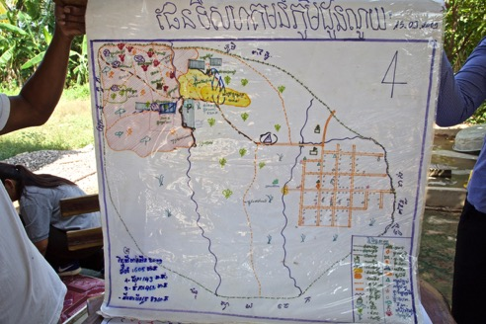

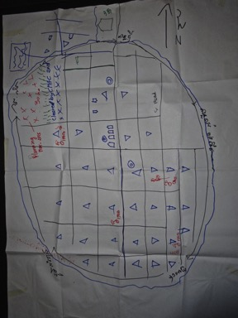
Village Map produced during FGD. Shows essentially the same information as the Village Leader’s existing map (above). Namely the only hazardous areas now in the area are farming areas to the north west of the village. The existence of the map shows that mines are a highly relevant issue for people in Don Nuoy.

It has proven difficult to locate the site of the village, relative to some of the areas cleared under CfR, and these seem to be some distance from any settlements. This is also an issue noted with regards to Khvav Lech village, also in Svay Chek district.

Most of the accidents reported in the FGD in the village area as such seem to be from the 1980s.

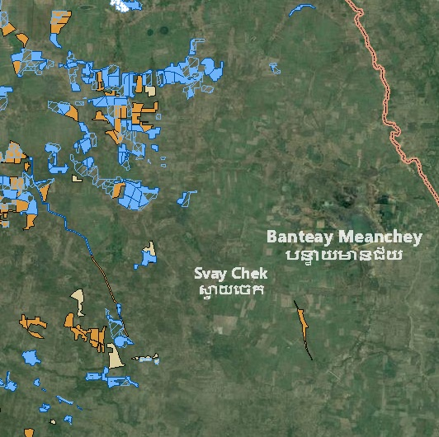
Screen shot shows BLS polygons about 8 km north north west of Don Nuoy village which lies below Svay of Svay Chek and to the right of the horizontal light yellow polygon at the bottom of the image below the yellow route running north north west to south south east. Don Nuoy by CMAA’s own prioritisation guidance is now far less impacted than other communities in Banteay-Meanchay and yet has received numerous tasks under CfR II, especially in 2014.

FGD Discussion:

- Some of the people left during the war in the 1980s and early 1990s, but many stayed throughout, living in trenches and enduring the hardships.
- Village Chief Hom Thanh (57) stayed in the village throughout the war, and the worst periods were 1985 – 1990.
- Different factions were laying mines during the war – KR, KPNLF and SoC. They would fight, win ground, lay mines, then loose, others would occupy and lay more mines.
- Many people moved out to Sisophon during the war (30%) but many stayed in the village. Some went across the border to Thailand – to site 2, Khao-I-Dang etc. People who stayed relied on eating Prahok, collecting yams and eating roots.
- They knew which areas were mined because they had stayed in the village through the war. There were however many accidents, and some were killed and some were disabled. Many accidents occurred when people were collecting Yams, and NTFPs.
- In the paddy fields next to the village there are no mines, but the areas that need clearing are further away. It seems likely that the village has had extensive mine action over many years, and that this would have started with the residential areas in the centre of the village:
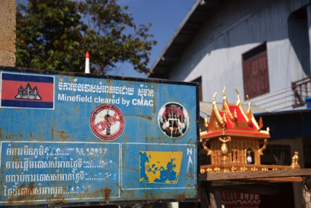
Minefield sign in the centre of the village, outside the village leader’s house seems to indicate the village residential areas were previously cleared by CMAC
- They have been ploughing contaminated land – ‘during the first ploughing we used to find mines and would put it on the side’ When we see mines we report them to CMAC. We farm lands with mines because we have ‘no other job and no other land’. If we find mines we used to move them to ‘stores’ – cache areas.
- The remaining contaminated areas – which they estimated at some 30 has – were put into the plan during discussion in March 2015, for clearance in 2016.
- There was some discussion about a private company ‘reducing the area’ – perhaps using the area, and some ‘individual soldiers’ still using the land – and some areas have been removed from the plan because of these reasons.
- It was later confirmed that clearance started in this area in 1993.
- Prioritisation and Planning: how involved were the villagers. They said that the villagers ‘can not decide’ and CMAC had decided already which areas to clear, and had studied it and then came and talked to the village leader and the owners of that land. CMAC does the same every year – studying, surveying and then talking to the people.
- Order of clearance? First they clear the road to gain access to the minefields. How do they select what gets done each year? Its based on the needs of the people for growing crops (poverty reduction) and also risk reduction – to achieve an accident free environment.
- Is the decision with the Village Leader? No, everything is with the MAPU – they talk to the people and the CBMRR (CMAC) focal point – they use this network to identify the risky areas. Is it a fair seletion? Yes its OK.
- Are the impact-free or are they still taking risks? Now they are less concerned and people have land to cultivate
- Has there been conflict about land? No.
- How much of the hazardous land cleared was NOT being used before clearance? They suggested that some 90% was NOT being used before clearance. Clearance has made a big difference and people are happy. The reason people didn’t try and claim the land before clearance was that they were scared of accidents.

NB this maybe because they had already cleared through informal means enough land to subsist. The additional land has produced economic and security benefits, but they were not prepared to demine this through informal methods as the return perhaps was not worth it. The number of recorded accidents in the village suggests there has been significant pressure on the land, and risk taking in the past

- Changes in the last 5 – 10 years? People are now living better than before – many have motorbikes, some can buy tractors and cars. Before there was no land to cultivate, but now people can save money. Before people were scared to get a loan. But now they are prepared to take on a loan, all because they have more land. Many people are growing Cassava. Some people are now borrowing money to clear land to grow Cassava.

NB this suggests that there maybe hazardous area being brought under production for Cassava – as ‘under’ or non-utilised land is likely to be that way for a reason, and usually this reason is mines or ERW.

- There are 9 PWD in the village. It’s a big village with 650 HH spreading over 2km2. 90% of the people are now financially OK, with only 10% poor and vulnerable. 90% are now OK because they have safe land. Those who are poor are those without safe land cleared already.

- People are now very happy that the threat has gone. They are happy because they are able to cultivate.

- The main concerns now are to do with the road access not being so good, especially the further west. The main road to Svay Chek and Sisophon was finished in 2014 – before it took 4 hours on a moto to get to Sisophon, now it takes 30 minutes. This has had a big influence on the economy – as before they had to spend a lot on transport and wasted a lot of time travelling. Now they can save money.

Video Interview Transcript with Villager:

IN SOKPHENG, 38, trader, Treas Commune, Svay Chek District, Banteay-Meanchay

“I am In Sokpheng. I was born in Duon Nuoy. I am a grocery seller in this village. Before we had mine clearance, life was hard for everyone. First of all, it affects the farmers by depriving them land to grow crops. When farmer cannot grow crops they don’t have money to buy things, that is also bad for me as a trader.”

“Before the clearance, people did not have much land to cultivate, plus they did not have other job to substitute farming. As a result, many people had to migrate to work in Thailand. But since more land has been cleared, people don’t feel compelled to resort to migration and prefer to stay to do farming in the village. They are able to increase their crops and earn more money to buy other stuff they need.”

“I still have some concern about landmines but not as big as before. In the past fear of landmine was part of our everyday life. It really made me feel stagnated not knowing what to do or where to go. Fear of danger was the biggest thing in our life.”

“Now I am so pleased to see that our people are able to cultivate the land, and their living standards have greatly improved. They have been able to earn more from their farming, and when they have more money, traders like me are happier – happier than before.”

“I have an 8-year-old son. I am happy for my son’s future too. Even if he ends up being a farmer in the future, I won’t have to worry about him getting hurt at all.”

“My last word is that I would like to see mine clearers come in and work on the remaining land that is still littered with mines. Once the village is fully free of landmines, the people will be able to increase their farming land and get prosperous in the future.”

2. Khvav Lech, Svay Chek Commune
CMVIS data reveals a total of 5 ERW and 57 mines casualties in the village, Svay Chek Commune ranked 7th in CMVIS in the last 5 years in Banteay-Meanchay with 4 mine casualties.
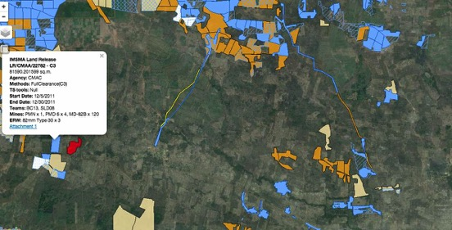
Minefields recorded by UNDP as having been cleared under CfR II, seem to lie to the north of the village (Village lies beneath the blue line, representing a cleared road, and to the right of the red SHA). The clear polygon in the top of the map, in the north west of Banteay Meanchay usually represents the location of a former military base – in this case as it is several kilometres from the border, it is likely to be a Vietnamese base. Many of the tasks attributed to Khvav Lech under CfR II appear to be on the south west edge of this former base, but other cleared areas in this area are attributed to Samraong village, also for Svay Chek Commune. Interestingly both 23782 and the red SHA (A1) are recorded in UNDP records as having been cleared in 2011, but 22783 is still shown as uncleared. Many recent tasks attributed to Khvav Lech have actually been in Techar Phnom Chaa 317 which is a military area and described as social concession land for former soldiers who are now PWDs.

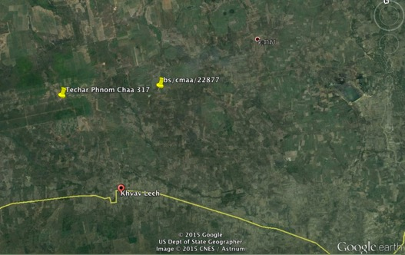
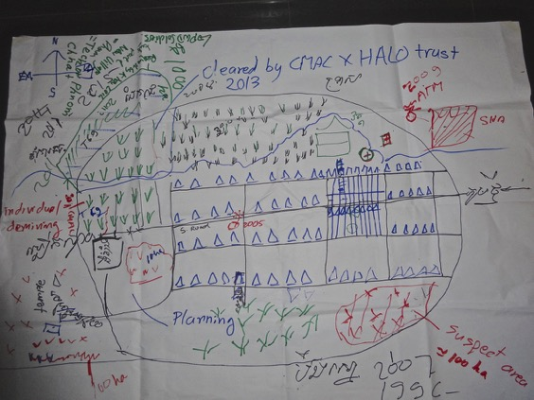

FGD Discussion:

- SHA bottom right – 100 ha – suspected: go to the area and they can see the mines and ERW. There are some people cultivating (poor). Plough with tractor. ATM – one ATM accident.
- T69 turning up – when ploughing. But been using it since 1996. Still finding? Some parts have people doing the cultivating., other areas they are scared and don’t use. NB this area is probably the SHA shown on the BLS polygons. NB why is this area not being prioritised for clearance when areas several kilometres to the north are being cleared under CFR II and attributed to this village? Accident with cattle 5 (2007) ATM. After accident happened - stopped using it. Now CHA. Did use some part of it 1996 – 2007

- Bottom left have the temple and 100 ha also – around the temple. Bert Ampil. Around still contaminated – high threat – some people still use the land. Owners of the land.

- SHA middle left, and green paddy cleared by individual demining as indicated on the map. It was cleared by villagers themselves, hire ex-soldiers in 2011 to demine. Had they been using that land before paid people to demine it? Had been using it – were afraid – become more afraid. Why? Because more contaminated? Because they spotted mines and afraid there would be an accident – decided to hire deminer – did they find many mines – many T 69s/ ATM. Still finding the mines – depends on situation – not sure if working or not. NB this may explain why the A1 (Red) Minefield shown on the IMSMA map as still not cleared, but cleared in 2011 did not yield many mines. It MAY be the same area. Or the area maybe not shown as cleared before the BLS survey reached the village.

- CMAC / HALO area top of the village map. 200 ha – have beneficiaries – woman beneficiary - were using the area. Finding mines and ERW. Ploughing with tractors. Started to use – ploughing for two years and then it was cleared.

  - cf Land Reclamation. Serious concerns – ask HALO…..

- Resettled here when? In 1996 they built houses in residential areas. Some people had stayed through the war, others displaced to Sisophon and border. Were they worried about mines in the residential area, they said not so concerne, but there has been no clearance. But when digging they are very careful. NB this maybe because the residential area was a former military camp, as in the case of Prasant Tbang. It is 12 km to the Thai border.

- SHA Top right -2009 – ATM accident . Lob Sam Ol had his near miss accident here. They had started to use the land since 1997, and in 2009 had an accident with an ATM on the access road. NB again this SHA is much closer to the village centre than many that are being cleared under CfR II, under the name of this village.

- This village area was a military base: a Vietnamese base, but also had KR, KPNLF, Issarak! Many generations of soldiers active in the area.

- Reported clearance started in 2002: but just started to clear around the roads and the residential areas, not part of the current recorded BLS, or CfR. Then in 2014 CMAC followed up and doing clearances in the fields, around Pagoda. Don’t have enough land so request to district to do the other clearance.

- Boundary changes mean that some of their villages is no longer their village – and high mines task from 2011 (A1) – is in new village – immediately to the west.

- SHAs….in the plan for the future? Some parts are in the plan – but there are areas of the disabled village adjacent that are still being cleared. This is Techar Phnom Chaa 317 which has been massively prioritised, and has relatively low results in terms of mines, whilst possibly higher priority minefields in Khvav Lech are not being cleared.

- NPMEC active in the area too. Doing some survey and clearance. 2009? Shown on BLS? In area left of the map adjacent to the PWD (Techar Phnom Chaa 317) area.

Were they consulted about which task should be done first? Community involvement in prioritisation”

- Village leader and MAPU involved – village and the beneficiary involved in discussions – but after selection. How are the beneficiaries selected? Have priorities / guidelines.

- Based on needs of the people! Also we need to look at whether can access.

How does MAPU know which people have the need?

- There is a process of prioritising and put numbers and those who get the most scores.

Meet with the villagers or just the village leader?

- Meet with the villagers and the chief (but only after selection). There are also the site investigations.

- Another guy – VC (poss) stated that in consultation with the Villagers they come up with proposal for inclusion in the commune plan – then the MAPU come and do the site investigation.

- District Integration Meeting – fits the tasks with the operators.

- They described a ‘New village’ – Teckar Phnom Chha 317 – used to be centre for PWD development – social concession land – given to PWD – integrated into this village. CMAC still there (and has been for several years).

Has the process of prioritisation been fair?

- No – my land has not been cleared yet. One woman – cleared along the road, it seems like they jumped over my land. Is it SHA? Yes were mines, and saw ATM – like body of the mine. When my husband saw the ATM – stop farming that land. Some part not cultivated. About 1 ha. Still working on the land – but hired someone to clear it 2011. Part of the land that they hired people to work on.

How has life changed in the village the last 5 years?

- Better, but most of them in debt – but borrow money to buy tractors and power plough…. Before we did not have this type of thing, but we had no debt – but now have debt. Alceda – make the loans.

Sources of credit include Village Bank, Vision Fund, Alceda.

- VF is the best. The criteria is not so complicated. So easy to get the loan. Interest rate – VF 2.7% per month?, AMK 2.7% Village Bank 2.75%.

Clearance made things better?

- Yes it has made things better we can rely on the paddy that we harvest – don’t need to buy rice. This year have to buy rice because of the weather – no rain, limited drinking water – and limited irrigation water. Have to drink water from the wells – keep it in concrete jar.

NB so again questions about prioritisation and planning. Lack of consultation and also outstanding CHAs close to the village centre which SHOULD be tasked and not being whist much clearance devoted to Techar Phnom Chaa and sites well to the north of the village is a cause for concern. These are attributed still to Khvav Lech (i.e. BS/CMAA/23392) but are not part of the village and this is inaccurate record keeping, and possibly disingenuous.

Name: LOB SAM OL, doctor

“I drove a power plough over an anti-tank mine, but apparently one wheel tilted and missed the detonator. I was on the way to plough the field when I hit it. But at first I didn’t realize it, and when I looked the wheel had already hit the mine but on its side, not the detonator in the middle.”

“When I was a soldier, I was stationed to guard a national road that was used by government soldiers to transport logistics to the frontline. I spotted a landmine and it went off when I tried to remove it. I lost some fingers and my left eye.”

How things were before the clearance?

“In this village, the people, knowing the land is littered with mines, had to take risk by clearing the land for use to sustain themselves and their families. They just had to work on any land they could their claim on way before CMAC and Halo teams arrived to conduct the clearance.”

Impact of clearance?

“The living conditions of the villagers have changed for the better after their land was cleared of mine. The most important thing is it removed the fear they used to live with for a long time.”

Name: LOEK SUONG, 55, female – farmer.

“I have six children, four boys and two girls. I do farming for a living. Before our land was swept clear of mines, fear was on the top of my head everyday, fear of getting into landmine accident. Now I am so glad that we do not have to live in this fear anymore after mines were removed from our land.”

“I had three hectares of land that were cleared of mines. I have been growing rice on them ever since to increase the yield, and that has substantially improved the living conditions of my family. Annually, we produce enough rice to eat and can still set aside some to sell for money. It is a lot better than before.”

“The people in the village are enjoying the benefit from mine clearance. They are very pleased with that. However, a section of the land to the west of our village has yet to be demined, and I have a small piece of land there too. I do not dare to cultivate it yet and have to wait until it is cleared of landmines first.”

Any words to UNDP/donors:

“I would be very grateful if they can help clear my remaining land in the west of the village so that I can start working on it.”

3. Yung Yoeung, DDL, Thmar Pouk District, 30th Oct 2015

Impact of mines?

Our district one of the district that is contaminated full of mines and ERW. The impact of the mines over several years includes difficulties faced by the people – some people become victimised because of mines, risk and UXO. We always have accident every year in 2015 3-4 cases – people, tractors and power trailer. Any development can not be achieved easily since we face the problem of mines, in particular the border with Thailand – a long and chronic battlefield in the civil war – people are concerned and at risk for their lives. Since the people do not have choices people take risks, people are either successful or fail.

These are the sorts of problems.

Accident rates have fallen in the last 5 years?

Indeed, over the last 5 years – 2011 – 2015 accidents of mines, even though happening the rate has come down gradually.

Why?

One factor is clearance which covers suspected areas, and second people better understand the mine risks and ERWs.

People taking risks – encroaching contaminated land & going to the forests etc.

People are doing this - in Thmar Pouk. % of people taking risks? We have done assessments in this area – people – some of them encroach the land and SHAs, but most people around 10% who encroach – get into the forests – and collect NFTPs – the other 90% have their own occupation and cultivate cleared land, but there are a small group of people who are cultivating

Migration – people from outside?

Yes. In 2008 there was encroachment from all different provinces (Kompong Cham, BTB, BM, SR, Prey Veng) – they came to encroach the land for example, in Thmar Roumeal village – area was suspected – and until now the Govt has resolved the problem – the village is normalised and we are working to clear the mines

Why come? In 2008 there was a lot of land, and also the area under protection – I don’t know how they got information about available land – but they started to invite neighbours and friends to clear the forests and settle.

Clearance Impact?

Operators here – HT and CMAC – HT implementing for a long time and good results and land released and given to people so they can expand their agricultural activities – they clear land every year and they have done continuously for 20 years – it is very good and has been very good – many areas saved for the people to cultivate their lands – people can get access by roads – even though the road not complete rehab but mines have been cleared – ensuring good and safe communication by the people – detected APMs and ATMs

Yes – we have cleared the road – the main road – first time was in 1992. I was in Svay Chek and later we constructed the road and had to cleared the road again – three clearances along the national road SC – TP – NPMEC / RCAF Engineers – tasked by the Gov’t to rehab the road and bridges. Funding for the new road – Sisophon north, ADB 29km, and rest covered by Korean funds – 113 KM. Sisophon and Korean funds TP – Samroang. Svey Chek – Chamroang Chamcar.

End of 2015. ADB completed and the area to be funded by Korean funds putting the foundation Samroang Chamcar – Odong Meanchay.

Impact on the people?

I strongly believe that our people after clearance people have more opportunities for livelihood activity, can again cultivate land safely and good roads and safe roads and able to expand livelihood activity and be free from mine risk. Livelihood improved – every house has moto and power plough. This is the contribution from mine clearance because people can use the land more efficiently than before.

The area heavily contaminated is now available to work as rice fields.

Migration Impact?

It is true that after people can extend agricultural land they are able to stay and work on the farm in TP the important crop is Cassava – after harvesting Paddy – work on Cassava and they have to work on that – no free time – previously used that time to work in Thailand or in the factories.

Thanks to all national and international institutions for providing funds and mine clearance making the people safer and able to cultivate land and increase livelihood activities, especially livelihood – would like to appeal to all donors – for CMAC and HT to continue to clear the mines. We have seen huge areas being cleared and there are some areas that we believe there are some mines – this used to be the area that was battlefields – and start and final end of the war – Mines and ERW are scattered in the area – and on behalf of people in TP request donors to continue to clear the mines until we are free from mine accidents.

3.Ta Mang Village, Kouk Romiet Commune, Thmar Pouk District
CMVIS data reveals a total of 5 ERW and 12 mines casualties in the village, Kouk Romiet Commune ranked 3rd in CMVIS in the last 5 years in Banteay-Meanchay with 9 mine and 5 ERW casualties.

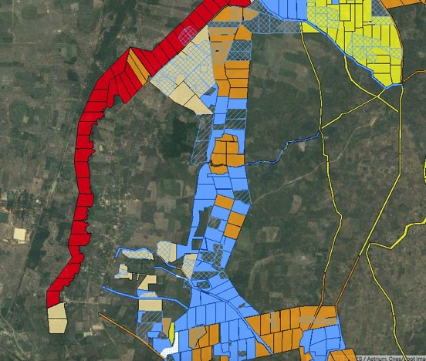
Screen shot of Ta Mang shows that it - like Prasant Tbaeng to the immediate north, sits within a former military base bounded by suspect areas. Much of the CfR II funded activity involved clearing ATM A3 MFs to the east of the village, shown here in blue.

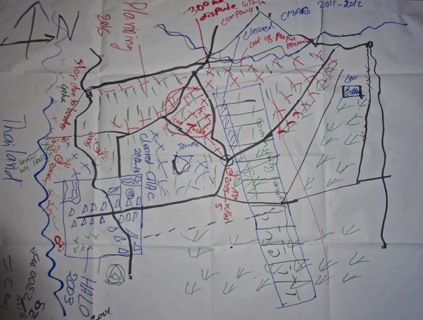FGD Village map of Ta Mang shows the village in the blue box adjacent to the Thai border and various areas to the east of the village that have been cleared. It shows the site of various accidents with APMs and ATMs, as well as some disputed land to the north of the village. Part of this may include BS/CMAA/20106 which although still designated as A1 minefield, had recently been ploughed when the consultant drove along the border military road on 31st October 2015. HALO Trust had been told to suspend clearance on this polygon by the Cambodian military. It is suspected the area was cleared by a private contractor – perhaps associated with the tractor team that had ploughed the land.

FGD discussion:

From the mapping:

- Conflict with land in top half of the map between local people and a company. This was in the plan for clearance and taken out of the MAPU plan. Company came in 2008 – created a land conflict.

- What is company doing? Leang Bou Construction Company – from PP – take the land to make something – not sure. 1783 ha plot.

- Did they want to buy the land – not come to buy coming to take the land. Bring machinery to bulldoze – but it’s the land of the people – what are the local leaders doing about it? – organise demonstration against the company.

Legal situation?

- Letter that nullifies the company’s licence from Min of Environment – the area is a special protection area. Company got a licence from Min of Environment – people settled in the area – and organised protest. Hun Sen letter of 16 Oct 2014 nullified the licence and give some of the land back to the people.

- Cut the concession by 215 ha. Agricultural land. To be used for Ag use.

- In the whole area – people living here ‘landscape protected area of Banteay-Chmar temple’ – ensure sustainable use. So this part under Min of Environment – the local people do not have title. They moved from the areas of the temple to get land. Had land there but some problem?

- They have some kind of soft title. Hun Sen sent students to demarcate areas in Cambodia because of land conflict. Felt he can’t trust Min of Land management – nationwide mission of students. Letter confirming occupancy – but not really title.

Have they been using the areas under dispute?

- 50 hh – using the area. Including families from other villages. Some people using the land already and they have hired deminers.

- They built village in 1996. And start using the land – in 2005 – hired deminers to clear the land – started to use it. Now on the plan. They found ATM, APM, ERW. T69,

NB This is why so many areas cleared under CfR II have been in use before, and why in some locations mines per area cleared are low – because they have already been ‘threat reduced’ by local / informal deminers.

Every year finding mines?

- Not every year – but when ploughing they find. Always using tractors. No accidents.

- Clearance by both CMAC and HALO.

- CMAC has been clearing Ag land and around the temples.

Many accidents?

- In 2005 5 people killed on ag land an ATM accident in the middle of the village. Power trailer transporting wood to construct a house. The road using several times – why the accident occurred that time. Even though go by sometimes step on some times not. Dry season.

- People killed 3 from here and Banteay-Chhmar 2. 2 people husband and wife from BC. People being transported – ask for a lift.

Why accidents on the border – K5?
People collect bamboo shoots in exchange for rice. On the K5. These people are poor and have no land. Now, 45% have no land and are poor. 45% poor – only residential land – to support life go to Thailand, some open forests to get land, others NFTPs – spiders, black or ground spiders, ground lizards wild yams, bamboo shoots.

Clearance started in the village in 2001. HALO – started. 5 years with out clearance in hazardous area. Did not have enough land to live – when build houses – found mines.
Prioritisation of areas to clear?
- Residential areas first. HALO find mines within the village? ERWs – cluster munition only (NB consistent with this being a base area with mines around it).
Choice of sites under CfR II:
- Same as last village – consultation with the MAPU and VL. Area selected first – then beneficiary comes for meeting. More based on technical threat.
Handover ceremony?
- Briefing on what has been done – yes have hand over ceremony and know where has been done.

Were there any areas that were cleared they were NOT using before clearance

- Central area – north east of village was being used before clearance for agriculture – but some areas they did not use. About 20 ha.s – only 2 ha cultivate – says MAPU.

- Community forest not being used at all before, but people have cleared the trees and growing crops.

- Some areas being used, some not. Depending on perception of the level of risk.

So clearance has given people access to more land and that has made people richer?

Yes and we are now better.

How many accidents in the village?

- 13 accidents in total both ATM and APM. Population now: 186 HH. 755 people

Is village impact free?

Main threat areas – are in the K5 and people are afraid of the risks – they encroach the area – but only some specific areas. People are still living fear from mines. So not impact free. Areas cleared – no fear and not seen any mines.

What has changed in the village last 5- 10 years?

Better livelihood. Before we had only the push cart, now we have power ploughs. How much of change because of more land because of clearance? The main reason for change is due to land clearance and more land to cultivate.

Yes they are at risk – seem to have knowledge – specific areas where dare not to enter. Some areas believe to be safe, and others seen as very risky. Area along border – and to east of village some forest areas where can still.

Border K5 has 18 MF – 40 has. Border has soldiers – HALO Trust ‘Y area’ – conflict with Thai soldiers. Buffer zone.

Transcript of NUN CHHOEUN, 52, interview on video:

“I got injured when I was working on my farmland. My hoe hit a landmine when I was digging the soil with it. I knew the land had mines but I had to take my chances because we did not have any means to rely on.”

“I have just about two rai of land for rice farming, and I have been working on it for 6-7 years now. When I was injured I was taken to a hospital. It cost about 20,000 to 30,000 baht to treat my injury. After I was released from the hospital and came back home, I did not receive any aid. But they gave me a water jar. I have a prosthetic leg but I don’t wear it often because it hurts. I received it from an aid organization. This year I had the latest prosthetic leg made for me. All I want it is for my other land to swept clear of landmines so that I can start growing cassava on it. All I can rely on these days is the two rai of land for growing rice. And I will be very grateful if someone can do that for me. The other land – I had worked on it before I had the accident, but I had to stop encroaching further after that.”

Other assistance you need?

“I will be very grateful for any assistance anyone can give me, but if they don’t give, I am not going beg either.”

4. Prasat Tbaeng, Banteay Chhmar Commune, Thmar Pouk District
CMVIS data reveals a total of 5 ERW and 30 mines casualties in the village, and Banteay Chhmar Commune ranked 1st in CMVIS in the last 5 years in Banteay-Meanchay with 15 mines and 1 ERW casualties. NB According to the village chief, the village has suffered a large proportion of these recent accidents, with the village chief confirming that during the 2011-2015 period there were 11 accidents (12 injured, 9 killed). This would suggest, according to formal CMAA planning guidance, that a higher proportion of CfR II clearance assets should have been deployed to Prasat Tbaeng than were allocated, and certainly that this area should have received more attention than Teckar Phnom Cha 317 in Svay Chek which appears to have consumed a disproportionate amount of mine action resources under CfR II.

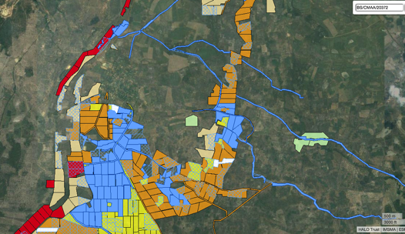
Screen grab from IMSMA shows village area, like Ta Mang, just inside Cambodia and adjacent to the K5, and the former UNBRO Camp Site 2, and sited on the location of a former KPNLF base which was essentially mine free although with some legacy of other ERW inside the location.
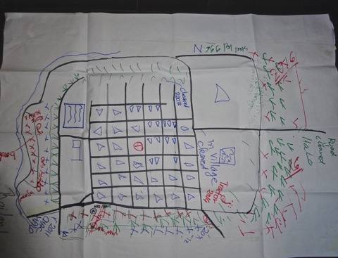
Village map from FGD shows sites of recent accidents, including one in the K5 and one tractor accident with an ATM in 2014 which resulted in the traumatic amputation of all the driver’s limbs. Prasant Tbaeng has received a lot of clearance of A3 minefields under CfR II, for example in 2011.
FGD Discussion:
- They referred to the buffer zone on the border that ‘can’t be entered by soldiers on both side of the border’. They also referred to one HT de-miner killed in 2015, one injured clearing the K5, but information received the following day seemed to suggest it was a villager from Prasant Tbang who had an accident in the K5 (December 2014).

NB information received the following day from Cambodian troops stationed on the border crossing revealed that on 27 September 2015, a Thai border policeman, who was collecting mushrooms had accident and lost both legs close to stream, PMN. This was round the same area as Prasant Tbang resident had accident (earlier Dec 2014 - cleared HT 100 mines – close to the stream - dead). Both bled out. The Thai – military reported waited for TMAC to clear a safe lane into him, as they were scared of the mines. He bled for 2 hours. His wife rushed in and came to cry on his corpse. TMAC later found a mine in her footstep that she had stood on. It didn’t explode.

PMN, ATM T58, LTM

- Have detailed maps from HT (2007) before BLS – lots of areas cleared. Now newly captured on BLS.

- Came to settle here in 1996. People from everywhere – different provinces, some from Site 2.

How did they know where the mines were when they first came here.

- They learned from where the accidents happened and there were soldiers who told them.

Given the land or encroaching / claiming hazardous areas?

- The military commander distributed the land to the people who came here. Settlement – learned from the soldiers that there is land available.

- Sihanouk time villages here? – don’t know. Information lost – but there was a very old road, believing some people lived here but moved out during the KR war (1970s). There are some older people who came back – this area also known as ‘the camp’ (as an ex KPNLF base)

These villagers knew people in the area. When they first came to live here only a few soldiers who were based in the area. There is a old road. The few soldiers told the people to be vigilant, and there are mines in the area. Saw axes and hoes in this area – when they constructed the road they found only UXO and ERW. This area was the camp for the soldiers. NB It later emerged it was a former KPNLF base, and therefore few if any mines laid on the inside of the perimeter.

So did they have safe land to farm when they first came here?

- When first came – in the area where they cleared the forests – for agricultural land they had accidents.

(Women not engaged any more – think its something the men know better – plenty of opportunities to participate).

Several cases of accidents clearing forests for fields.

So when did formal clearance start?

- Not sure?
- 2002 – 03 - for agricultural land.
CfR 2011 / 12 mostly – large numbers of BLS – but very low mines? Why?
The area along the border = dense minefield (K5) but behind the border suspected areas– not many mines. If found ATM – but not many – and usually along the road.
Stated that CfR in 2011 – found 18 ATMs (but no APMs). Correct.
People had already cultivated the land before the operators came to clear the mines. They ploughed with power plough, and then the ATM come out.
How many years under cultivation?
Contradictory statements ‘No we only used after clearance – only small areas were cultivated before’. Mines that were found in the fields or on roads / tracks. Some planted on roads or next
2011 tasks likely to have been picked to achieve large area. Large loop – used both and small detectors. So problem is not comparing apples with apples – clearance, cancellatiom release. Low price means tasks will be selected that can generate area, rather than maximising impact.
2014 – Tractor Accident – ploughing. ATM exploded. Tractor totally destroyed – driver severely injured hands and legs. Sent to Thailand. Can cross. Not from the village - - charge ploughing serve.
When problem make a call and ambulance from Thailand can come and pick them up.
So are they still farming risky areas? Yes.
Some people cultivate the land after self clearance, some cleared by private people –clearing service. No private clearance – on the east side of the village
Places where farming now where they feel it is still risky?
There are areas where people cultivate in a risky area?

Yes. Many families –here 510 HH – many cultivate on risky areas. Areas to the South East and East are in plan for 2016.

90% of people are able to cultivate on the land and make a living – those who go to Thailand, when free from here – make some extra cash. Large % of these are farming risky areas.

Recent Accidents?

One in CfR II cleared area 2011-12 – in 2005 – children played with UXO – killed 4. Paddy fields.

Suspect areas running adjacent to the village??? – all gone – nearest cleared and farthest still suspect.

People entering high-risk areas – K5?

Some are cultivating land in high-risk areas including the K5. In that area – some areas cleared and safe – but some areas where suspect.

NTFPs collection – in K5 – yes some people.

Impact free?

People still feel concerned and still at risk – request de-miners to clear his land.

Prioritisation fair? People involved in decision making?

It is fair. Yes the people involved in decision making for priorisation – no land conflict. Some have - some not.

Changes in the village the last 5 – 10 years?

Life has got better. But now they are in debt. Like the village this morning

How much of it getting better is to do with landmine clearance?

60% better overall

20% out of the 60% due to clearance.

40% of the 60% to do with??? (being prepared to) Cultivate on the risky area.

Email to David Horrocks, 11th November 2015 from NGUON Monoketya, Deputy Director, Socio-Economic Planing and Database Management Department (SEPD), Cambodian Mine Action and Victim Assistance Authority (CMAA)
Email to David Horrocks, 11th November 2015 from NGUON Monoketya, Deputy Director, Socio-Economic Planing and Database Management Department (SEPD), Cambodian Mine Action and Victim Assistance Authority (CMAA). This is the most impacted village of all 12 historically.
Email to David Horrocks, 11th November 2015 from NGUON Monoketya, Deputy Director, Socio-Economic Planing and Database Management Department (SEPD), Cambodian Mine Action and Victim Assistance Authority (CMAA)
Email to David Horrocks, 11th November 2015 from NGUON Monoketya, Deputy Director, Socio-Economic Planing and Database Management Department (SEPD), Cambodian Mine Action and Victim Assistance Authority (CMAA)
Email from Bunthy Chea, UNDP to Paul Davies, Friday 13th November 2015

