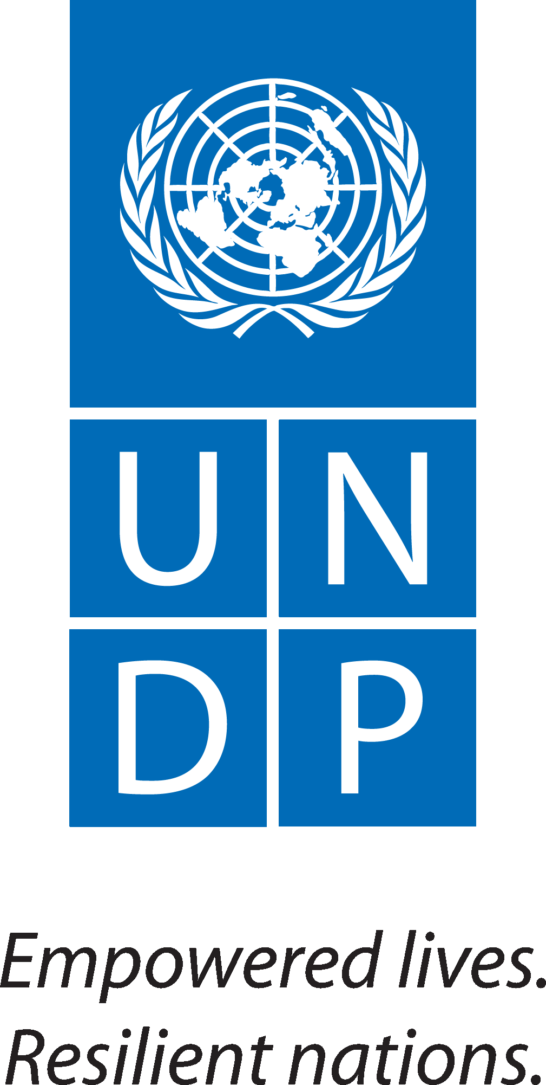
UNDP/GEF Mid-term Evaluation
Management Response and Tracking Template

[Mid-term Evaluation] Date: 12 August 2016

Prepared by: Jonas Heita Position: National Project Manager PASS Project Unit/Bureau: Windhoek/NIPA/MET/
Cleared by: Izumi Morota Position: UNDP DRR Unit/Bureau: Namibia/RBA
Input into and update in ERC: Martha Naanda Position: UNDP Programme Specialist. / M&E Focal Point Unit/Bureau: Namibia/RBA

Project Title: Strengthening the Capacity of the Protected Area System to Address New Management Challenges (PASS Namibia) –
Project No. 00089324 Project PIMS #: 4623
Evaluation Completion Date: 19 October 2016

Key Issues and Recommendations | Management Response* |  |  |  | Tracking**
 | Response | Key Actions | Timeframe | Responsible Unit(s) | Status*** | Comments
Key Issue 1: Incomplete log frame  Recommendation 1:  As part of the Project Document, the log frame was incomplete by the Mid-term Review (MTR). It was therefore recommended that the log frame should be updated. | The PMU agrees with the comment  - The missing baseline information has been obtained (baseline data, mid-term, and end-term targets, financial sustainable score card, and capacity development score card).  - The log frame (Strategic Results Framework) has been updated in consultation with the UNDP-CO and the UNDP Regional Service Centre (RSC) | - Obtain final approval of the log frame (SRF) from The RSC | January 2017 | PMU | Partially completed
Issue 2: Project components  Recommendation 1:  The contents of the three (3) project components remain valid and should not be subject to major modifications and should be considered to align the end of the project to the project objectives | The PMU does not understand this recommendation. | - Seek clarity from the reviewer | January 2017 | PMU | Pending
Recommendation 2:  The implementation of Component 3 depends on the approval of the Fire Management Strategy (FMS) without which, there is no framework for project intervention. MET should therefore speed up this process. | The PMU agrees with this comment. However, the FMS was finally approved by November 2016. | - Final layout and printing design  - Printing and distribution | January 2017 | PMU | Partially completed
Issue 3: Approval of project outputs  Recommendation:  Other outputs that await approval should be dealt with, with urgency. | This recommendation is general and there is a need to specify the outstanding outputs. | - The Reviewer should specify “other outputs” for traceability and common understanding | January 2017 | PMU | Pending
Issue 4: Work plan and budget  Recommendation 1:  Work plans and budget for the remaining project time should be reviewed and updated with appropriate details, including the milestones for close monitoring progress. | The PMU agrees with this recommendation. | - Milestones to be reviewed in accordance with the remaining budget and time frame | January 2017 | PMU | Partially completed
Recommendation 2:  The budgeting needs to be strictly focused on the project operations and budget lines, and the application of the most realistic quotations and quality assurance should continue. | The PMU agrees with this recommendation. | - Ensure that the project operations are aligned with project activities (budget lines)  - Apply best value for money and quality assurance | 2017 - 2018 | PMU | Partially completed
Issue 5: Awareness materials  Recommendation 1:  Efforts should be made to review and assess the effectiveness of awareness materials (media, flyers, stickers, billboards) and analyse their importance and impact in relation to the wildlife and ecosystem conservation. | The PMU agrees with the recommendation | - Devise a strategy to assess the effectiveness of the awareness materials produced and/or distributed this far. | March 2017 | PMU | Pending
Recommendation 2:  More awareness programmes on TVs and radios must be performed. | The PMU agrees with the recommendation | - Continue with the National Anti-poaching awareness billboards  - Develop radio clips | Ongoing | PMU | Partially completed
Issue 6: Visibility of GEF/UNDP on the PASS deliverables  Recommendation 1:  Additional visibility of GEF/UNDP on the PASS deliverables could play an important role in soliciting more support from these and other agencies | The PMU agrees with the recommendation | - Improve project visibility in accordance with project activities | 2017 | PMU | Partially completed
Issue 7: Inauguration of the Law Enforcement (LE) Training Centre  Recommendation 1:  The inauguration of the LE Training Centre should be fast tracked so that the LE training activities can start without further delays. | Recommendation endorsed | - Ensure that the LE Training Centre is fully furnished.  - Secure a date for the inauguration. | March 2017 | PMU/MET | Pending
Issue 8: Enactment of pending environmental bills and strategies  Recommendation:  During the remaining time of the project, efforts should be made to ensure that necessary enactment of pending environmental bills and strategies take place. | The PMU disagrees with the recommendation. The enactment of the bills and approval of strategies are not direct outputs of the project and progression thereof, is not the project’s responsibility. The project only provides technical and logistical support in accordance with MET’s work plan. | None
Issue 9: Project extension  Recommendation:  The project duration should be extended until the 30th of June 2018 | Recommendation endorsed | Project to apply for a no-cost extension in consultation with the UNDP Country Office. | June 2017 | PMU | Pending
Issue 10: Publication of project articles  Recommendation:  The project should aim to publish high quality articles to share project results and experience with a larger audience in journals and UNDP / GEF website and technical reports | Recommendation endorsed | Produce articles presenting the project results and circulate to larger audience via, journals, UNDP / GEF websites and technical reports. | Quarterly (March, June, September and December, 2017 | PMU | Pending
Issue 11: End of project seminar/conference  Recommendation:  The project should organise an international end-of-project technical seminar or conference at which results and achievements will be presented. | Recommendation endorsed | - Organize an anti-poaching conference to review effectiveness of anti-poaching strategies. Invite other countries affected by poaching from SADC and East Africa to partacke and share experiences.  - Organize technical seminar to review project interventions at project closure. | April 2017  March 2018 | PMU & MET | Pending
Issue 12: Project Sustainability  Recommendation 1:  The project should consider developing post-project activities to ensure sustainability of results at the national and regional level. | Recommendation endorsed | Develop Project Sustainability Plan | December 2017 | PMU | Pending
Recommendation 2:  In order to ensure the sustainability of the project, co-finances from all contributors need to be accounted for. | Recommendation endorsed | Capture co-finance inputs (monetary or non-monetary – Time, Effort, Intellectual Property etc) | June 2017 | PMU | Pending
Issue 13: End of project / project closure  It is strongly recommended that, the end of the PASS Project should coincide with the beginning of a new follow up project, which will benefit from its activities and also introduce a broader scope addressing other PAS issues, additional target species and additional target countries (neighbors) to nurture regional cooperation and technological transfer | The project concurs and strongly support this recommendation | None

* Unit(s) assigned to be responsible for the preparation of a management response will fill the columns under the management response section.
** Unit(s) assigned to be responsible for the preparation of a management response will be updating the implementation status. Unit assigned with an oversight function monitors and verifies the implementation status.
*** Status of Implementation: Completed, Partially Completed, Pending.

