Improving the coverage and management effectiveness of PAs
in the Central Tian Shan Mountains

Kyrgyzstan

GEF Agency: United Nations Development Programme
Executing Partner: State Agency for Environment Protection and Forestry (SAEPF)
GEF Biodiversity Focal Area; GEF Project ID: 4844
UNDP PIMS: 4934; UNDP Atlas Project ID: 00072819

Terminal Evaluation Report
May 31, 2017

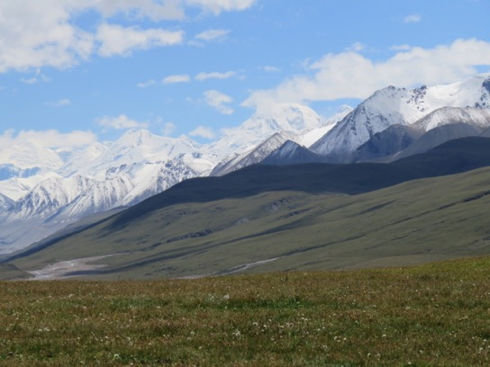 | 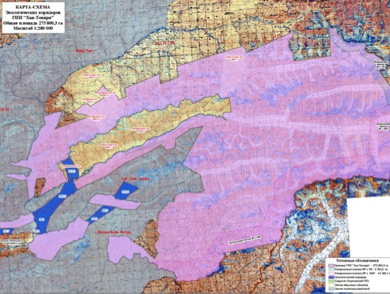
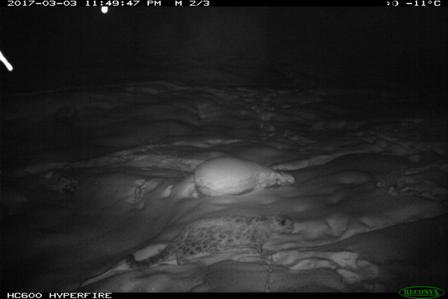 | 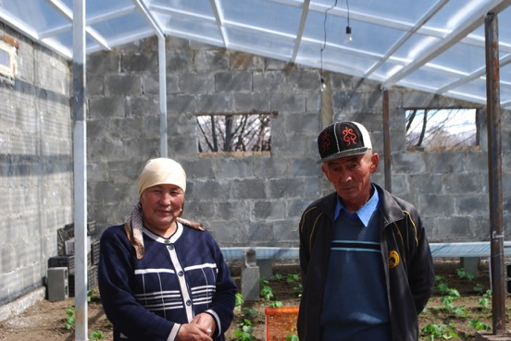

Images clockwise from top left: Khan Tengri National Park territory and buffer zone (Khan Tengri National Park Administration); Map of Khan Tengri National Park boundaries (source: draft management plan); Participants in the micro-grants program (Josh Brann); snow leopard in Khan Tengri National Park territory as camera trapped in March 2017 (Khan Tengri National Park Administration).

Josh Brann, International Consultant, Brann.Evaluation@gmail.com

Contents
I. Executive Summary 5
II. Central Tian Shan Project Terminal Evaluation Approach 13
A. Terminal Evaluation Purpose, Objectives and Scope 13
B. Principles for Design and Execution of the Evaluation 15
C. Evaluation Approach and Data Collection Methods 15
D. Limitations to the Evaluation 16
III. Project Overview 16
A. Kyrgyzstan Central Tian Shan Project Development Context 16
B. Central Tian Shan Project Concept Background 19
C. Problems the Central Tian Shan Project Seeks to Address 19
D. Central Tian Shan Project Description and Strategy 20
E. Implementation Approach and Key Stakeholders 22
i. Implementation Arrangements 22
ii. Key Stakeholders 23
F. Key Milestone Dates 24
IV. Relevance 26
A. Relevance of the Central Tian Shan Project Objective 26
i. Relevance to National and Local Policies and Strategic Priorities 26
ii. Relevance to GEF Strategic Objectives 27
iii. Relevance to Multilateral Environmental Agreements 28
B. Relevance of the Project Approach: Project Strategy and Design 29
V. Project Management and Cost-effectiveness (Efficiency) 30
A. Implementation, Including UNDP Oversight 30
B. Execution, Including Country Ownership 30
i. Project Management 30
ii. Country Ownership 31
C. Partnership Approach and Stakeholder Participation 31
D. Risk Assessment and Monitoring 32
E. Flexibility and Adaptive Management 32
F. Financial Planning by Component and Delivery 33
G. Planned and Actual Co-financing 35
H. Monitoring and Evaluation 37
i. M&E Design 37
ii. M&E Implementation 38
VI. Effectiveness and Results: Progress Toward the Objective and Outcomes 38
A. Outcome 1: Threatened species representation is improved by increasing coverage and management effectiveness of PAs in Central Tian Shan 39
B. Outcome 2: Habitat connectivity, sustainability, and effectiveness of PAs in Central Tian Shan are enhanced by regulating land use in buffer zones, wildlife corridors and other intervening landscapes 47
C. Impacts and Global Environmental Benefits 51
VII. Key GEF Performance Parameters 52
A. Sustainability 53
i. Financial Risks 53
ii. Socio-political Risks 53
iii. Institutional and Governance Risks 54
iv. Environmental Risks 54
B. Catalytic Role: Replication and Up-scaling 54
VIII. Main Lessons Learned and Recommendations 55
A. Lessons from the Experience of the Central Tian Shan Project 55
B. Recommendations for Consolidating Results and Supporting Sustainability of the Central Tian Shan Project 56
IX. Annexes 58
A. Annex 1: Terms of Reference 59
B. Annex 2: GEF Operational Principles 68
C. Annex 3: Kyrgyzstan Central Tian Shan Project Terminal Evaluation Matrix 69
D. Annex 4: Interview Guide 73
E. Annex 5: Rating Scales 78
F. Annex 6: Central Tian Shan Terminal Evaluation Mission Itinerary 79
G. Annex 7: Documents Reviewed 83
H. Annex 8: Kyrgyzstan Central Tian Shan Project Stakeholders 85
I. Annex 9: Kyrgyzstan Central Tian Shan Project Financial Tables 87
J. Annex 10: Central Tian Shan Project Results Framework Assessed Level of Indicator Target Achievement 90
K. Annex 11: Summary List of Micro-Capital Grants Projects 100
L. Annex 12: Kyrgyzstan Central Tian Shan Project Mainstreaming of UNDP Programme Principles 107

Acronyms

APR Annual Project Report
CBD Convention on Biological Diversity
CPAP Country Program Action Plan
CPD Country Programme Document
EIA Environmental Impact Assessment
FSP Full-size project
GDP Gross Domestic Product
GEF Global Environment Facility
Ha hectares
KM Kilometers
M&E Monitoring and Evaluation
NGO Non-governmental Organization
PIMS Project Information Management System
PIR Project Implementation Report
PMU Project Management Unit
PPG Project Preparation Grant
PSC Project Steering Committee
TOR Terms of Reference
UNDAF United Nations Development Assistance Framework
UNDP United Nations Development Programme
USD United States dollars
WB World Bank

Executive Summary
Table 1 Project Summary Data
Project Title: | Improving the coverage and management effectiveness of PAs in the Central Tian Shan Mountains
GEF Project ID: |  | 4844 |  | at endorsement (Million US$) | at completion (Million US$)
UNDP Project ID: |  | 4934 | GEF financing: | $950,000 | $950,000
Country: |  | Kyrgyzstan | IA/EA own: | $1,600,000 | $1,200,000
Region: |  | Europe & CIS | Government: | $2,866,666 | $3,045,666
Focal Area: |  | Biodiversity | Other: | $500,000 | $122,000
FA Objectives, (OP/SP): |  | GEF-5: BD-1: Improve Sustainability of Protected Area Systems; Outcome 1.1 Improved management effectiveness of existing and new protected areas; Output 1: New protected areas (number) and coverage (hectares) of unprotected ecosystems; Output 2: New protected areas (number) and coverage (hectares) of unprotected threatened species (number). | Total co-financing: | $4,966,666 | $4,367,666
Executing Entity: |  | State Agency for Environment Protection and Forestry | Total Project Cost: | $5,916,666 | $5,317,666
Other Partners involved: |  | National Academy of Sciences, Ak-su District, Jety-Oguz District, Issyk-Kul Province, multiple local-level administrations and their respective pasture management committees (Teploklyuchenka; Otrodnoe; Kerege-Tash; Bory-Bash; Ak-Bulan; Oktyabr; Chelpek; Enilchik), Issyk-Kul Biosphere Reserve, Sarychat-Eertash Reserve Administration, Karakol State Forestry Enterprise, Panthera, Fauna and Flora International, NABU, WWF, SLT, multiple private sector hunting companies | ProDoc Signature (date project began): |  | May 27, 2013
 |  |  | Operational Closing Date: |  | June 17, 2017

PROJECT DESCRIPTION AND OVERVIEW
- The Kyrgyzstan Central Tian Shan project is a GEF-funded medium-sized project working to improve the conservation of biodiversity across the wider Central Tian Shan landscape. The project officially commenced on June 17, 2013, implementation began on October 24, 2013 with the inception workshop, and is planned for completion June 17, 2017. The project is within the biodiversity focal area of the GEF portfolio. The project has GEF funding of $0.95 million USD, and planned co-financing of $4.97 million USD, for a total project cost of $5.92 million. The project is executed under UNDP’s Direct Implementation (DIM) modality, with the State Agency for Environment Protection and Forestry (SAEPF) as the main executing partner. UNDP is the implementing agency supporting execution and implementation, and is responsible for oversight of delivery of agreed outputs as per agreed project work plans, financial management, and for ensuring cost-effectiveness. At policy and strategic level the Project Board (PB) guides the project.
- The long-term goal towards which the project will contribute is “To conserve the globally significant biodiversity of Central Tian Shan.” The project objective is “to enhance the sustainability of protected areas in globally important ecosystems of Central Tian Shan by expanding their coverage and management effectiveness, better integrating them with land use in the wider landscape through an emphasis on well-managed buffer zones and wildlife corridors, and supporting biodiversity-compatible livelihoods in PAs.” The project is structured in two outcomes, consisting of ten outputs:
- Outcome 1: Threatened species representation is improved by increasing coverage and management effectiveness of PAs in Central Tian Shan
- Outcome 2: Habitat connectivity, sustainability, and effectiveness of PAs in Central Tian Shan are enhanced by regulating land use in buffer zones, wildlife corridors and other intervening landscapes
- The overall geographic focus of the project was the Central Tian Shan landscape, which covers approximately 1.32 million hectares in east-southeastern Kyrgyzstan. The key planned result of the project was the establishment of a new protected area, the planned Khan Tengri National Park (IUCN Category II). The project also planned to work on strengthening the management and conservation of Sarychat-Eertash State Reserve (IUCN Category I). The entire Central Tian Shan landscape falls within the Issyk-Kul Biosphere Reserve (IUCN Category VI), which encompasses all of Kyrgyzstan’s Issyk-Kul Province.
- According to GEF and UNDP evaluation policies, terminal evaluations are required practice for GEF funded medium-size projects (MSPs), and the terminal evaluation was a planned activity of the monitoring and evaluation (M&E) plan of the Central Tian Shan project. As per the evaluation Terms of Reference (TORs) the terminal evaluation reviews the actual performance and progress toward results of the project against the planned project activities and outputs, based on the standard evaluation criteria: relevance, efficiency, effectiveness, results and sustainability. The evaluation assesses progress toward project results based on the expected objective and outcomes, as well as any unanticipated results. The evaluation identifies relevant lessons for other similar projects in the future, and provides recommendations as necessary and appropriate. The evaluation methodology was based on a participatory mixed-methods approach, which included three main elements: a) a desk review of project documentation and other relevant documents; b) interviews with key project participants and stakeholders; c) field visits to a selection of project activity sites in Kyrgyzstan. The evaluation is based on evaluative evidence from the project development phase through April 2017, when the terminal evaluation data collection phase was completed. The desk review was begun in March 2017, and the evaluation mission was carried out from April 2nd – April 11th, 2017.

FINDINGS AND CONCLUSIONS ON THE MAIN EVALUATION CRITERIA
- With respect to relevance, the project is considered relevant / highly satisfactory. The project objective addressed a priority issue for biodiversity conservation in Kyrgyzstan. The project is fully in-line with Croatia’s national policies and legislation related to biodiversity conservation and the protected area system, including supporting strategic objective 3.1 of the National Biodiversity Strategy and Action Plan. The project also supports local priorities and strategies, as indicated by the strong local stakeholder support for the project. The project is aligned with the GEF biodiversity focal area strategic priorities on expanding the coverage of protected areas, and strengthening management effectiveness of protected areas. Further, the project clearly supports implementation of relevant multilateral environmental agreements, including Kyrgyzstan’s commitments under the Convention on Biological Diversity (CBD), Convention on Migratory Species (CMS), and Convention on the International Trade in Endangered Species (CITES).
- Project efficiency is rated highly satisfactory. The scale of the project results is above and beyond the corresponding project budget, relative to other GEF projects, as the project results are comparable to many full-sized projects. The project will be completed on time, with no required “no-cost” extension; full financial delivery is expected by the planned project completion date. Project management costs are approximately at the expected limits, at 10.3% of total costs. The documented project co-financing was slightly less than planned (87.9% of planned, or approximately $600,000 USD less than planned) as of March 31, 2017, but it is clear that there is additional co-financing contributions that have not yet been fully documented – for example, the cash and in-kind co-financing contributed by grantees of the micro-grant program.
- The PMU is highly professional and has demonstrated excellent planning, reporting, financial management, and has provided various technical inputs on financial and other aspects. Financial management procedures are in-line with norms for international development projects, and conform to UNDP and Kyrgyzstan policies and procedures. The project team and UNDP have also demonstrated strong adaptive management, including modifying the project approach, as necessary, following the mid-term review. The project has effective stakeholder engagement through various partnership approaches, with highlights including the strong engagement of various levels of government, from SAEPF (national level), Issyk-kul oblast (regional level), Ak-su and Jety-Oguz rayons (district level), and multiple aiyl okmotus (local level). The project also utilized a good communication strategy, and carried out appropriate risk management.
- The Central Tian Shan project has achieved the project objective and the two planned outcomes. The project effectiveness is rated satisfactory while project results / achievement of overall outcomes is rated highly satisfactory. The project met (or is likely to meet), or exceeded, 10 of 10 results indicator targets. Key results achieved with project support include:
- The national approval of the Khan Tengri National Park, with an area of 275,800.3 ha (nearly 50% larger than the originally planned target), which increased the national protected area coverage by 1.38%, to a national total of 7.38%.
- A METT score for Khan Tengri National Park of 57 (significantly exceeding the target of 28), and a METT score for Sarychat-Eertash of 76 (just passing the target of 75);
- Additional agreements in place related to Khan Tengri National Park external buffer zones, corridors, and hunting concession “quiet zones” covering a further 364,230.9 ha (against an original target of 200,000 ha), for total coverage of improved biodiversity management in the Central Tian Shan ecosystem of 789,149.1 ha, or approximately 60% of Kyrgyzstan’s entire Central Tian Shan landscape;
- Successful implementation of the micro-grant program: 16 projects funded with $139,000; an expected 92 jobs created; 287 direct beneficiaries (with 55% women) and >27,500 indirect beneficiaries (of which at least 28% women). The program has an estimated return-on-investment of ~1.2 years, which is quite positive;
- Improved monitoring and enforcement of wildlife poaching, including increased detection and prosecution (including prosecution of 100% of 26 cases since the 2016 PIR);
- Support for the development of multiple national-level laws and by-laws that have been adopted, including: Regulation on PA establishment, change of category, approval of borders and liquidation in the Kyrgyz Republic (approved by Government of the Kyrgyz Republic Decree from July 30th, 2015 #541); Regulation on land use of the State Nature Parks (approved by Government of the Kyrgyz Republic Decree on October 5th, 2015 #677); Regulation on Red Data Book of the Kyrgyz Republic (approved by Government of the Kyrgyz Republic Decree from April 11th, 2016 #189). The amendment to the national law on PAs on establishing ecological corridors has passed the first reading in the Kyrgyz Republic Parliament.
- Site-based impact-level results, including reduced illegal hunting in the target area, and the expansion of the range of wildlife into corridors and other areas previously avoided (anecdotally indicated);
- Overall, the project has contributed to a number of significant results that affect the national level, and which are likely to have highly catalytic effects, such as the national legislation adopted, and successful demonstration of activities such as freelance wildlife inspectors, and improved reporting on wildlife crime.
- While the project was ultimately highly successful, there are some caveats and minor considerations related to the results. Although the size of the Khan Tengri National Park is much larger than originally planned, some areas identified as key habitats for snow leopards and their prey species were not included within the boundaries of the national park, and much of the park area does not represent important biodiversity habitat, as it consists of high elevation rocks and ice. The key habitat area that was excluded consists primarily of approximately 25,097 ha on the north bank of the Enilchik River (for which the Otradnoe A/O has usufruct rights), which forms an enclave within the boundaries of the national park. In addition, some key habitat area on the south bank of the Saryjaz River was also not included due to mining claims in this area. Therefore is a consideration of “quantity vs. quality” with respect to the area of the new national park. From the point of view of the terminal evaluation this is not a critical issue, as the area of the national park does still include a large amount of key habitat area, and there are not critical threats to the key habitat area outside the PA. Another minor issue was that establishing the national park took longer than originally planned (due to the extended negotiations with the Otradnoe A/O), and so it was only possible to implement the micro-grants program within the last nine months of the project, which has left insufficient time to fully monitor and document the actual results from the micro-grant program.
- The risks to sustainability of the project results are limited, and overall sustainability is considered likely. Few project results require additional financial resources in order for the benefits to be sustained, apart from ongoing management of the Khan Tengri National Park, and SAEPF has planned budget allocations over the coming years for the park’s management. For example, legislation has been approved and stakeholder agreements are in place to continue support for the project results. The micro-grants program itself may not be fully sustained in its current form, but it was never intended to be. It was designed as a one-time program to provide support for the local communities that allocated their land-use rights on territory included within the boundaries of the national park. The fact that the micro-grant program will be continued and supported further by the GEF Small Grants Program in Kyrgyzstan is an additional achievement. Furthermore, SAEPF and UNDP are currently initiating a new protected areas project that will focus on the West Tian Shan region, but which will also continue national-level efforts related to protected area management, sustainable forest management, biodiversity corridors, and wildlife law enforcement.
- Institutional and governance issues related to sustainability are not significant; SAEPF is a highly committed partner with no immediate critical institutional risks. Provincial and district level administrations are also highly supportive of maintaining and continuing the project results. Socio-economic risks to sustainability are also limited. Local communities are by and large supportive of the newly established national park, and are supportive of the management regimes that have been agreed for the buffer zones and corridors. However it will be critical that the Khan Tengri National Park administration is proactive, open, transparent, and flexible in all aspects of PA management related to local communities as management arrangements are fully implemented. One of the key recommendations of this evaluation is that a local stakeholder management council for the Khan Tengri National Park should be established, as a mechanism for community-level input to management activities of the National Park. Environmental risks to sustainability are also not critical. There are some long-term concerns that need to be monitored, but these are not expected to affect the project results in any major way. These issues include: a.) The future impacts of climate change (which may be significant in high mountain ecosystems); b) The potential for mining exploration in some areas near the park buffer zones; c.) The sustainability of grazing regimes in the national park buffer zones; and d.) Any future expansion of trophy hunting activities on community lands bordering Khan Tengri National Park.
- Gender mainstreaming has been appropriately addressed through the project, although the project design did not include gender-disaggregated indicators. However, the project has collected some gender disaggregated results data, such as the breakdown of men and women involved in the micro-grant program; it is estimated that the micro-grant program has involved more than 50% women.
RECOMMENDATIONS
- The recommendations of the terminal evaluation are listed below, with the primary target audience for each recommendation following in brackets.
- Key Recommendation 1: A local community management council should be established for Khan Tengri National Park, as a mechanism for local communities to provide input to management activities of the National park. Such a body need not have binding authority over management of the National Park, but there needs to be a formal mechanism consisting of various stakeholder representatives, that meets regularly (i.e. quarterly) to review and provide input on management issues related to the National Park. This body should be instituted and facilitated by the Khan Tengri National Park administration, with support from Ak-su rayon. [SAEPF]
- Key Recommendation 2: SAEPF should collaborate with the Ministry of Agriculture and Kyrgyzgyprozem to support the Khan Tengri National Park administration to develop sustainable grazing plans for grazing lands within the PA buffer zones, in collaboration with local Pasture Management Committees using the PA buffer zones. [SAEPF]
- Key Recommendation 3: UNDP should determine how to best develop and leverage micro-grant / micro-finance activities within its overall portfolio for the long-term – within Kyrgyzstan, as well as globally. Many projects utilize micro-grant activities, but these are always one-time stand-alone outputs that are not then well integrated into a larger strategy or designed to be sustainable. There is significant potential to scale-up and replicate the good practice models of these micro-grant activities, but this should be done as part of a larger, broader UNDP micro-grant or micro-finance program, as it is not realistic to expect this from individual projects that apply these mechanisms. Such an approach could potentially be developed within the UNDP-GEF Small Grants Program, but such an approach would need significant planning and consultation, especially if it were implemented at the global level. [UNDP]
- Key Recommendation 4: The overall project exit strategy appears to be adequate, but the project must ensure that all key individual lower-level results have clear hand-off and continuation agreements in place. For example, the excellent initiative on wildlife crime reporting between the courts and the regional wildlife inspectors division should be continued. The project team and UNDP should also provide a short summary document to SAEPF highlighting the key practices and results that should be scaled-up to the national level (e.g. freelance inspectors; wildlife crime reporting; PA corridor agreements; biodiversity monitoring; cooperation with private hunting companies and establishment of “quiet zones” in hunting concessions; etc.). [Project Team and UNDP]
- Key Recommendation 5: The project should work with Ak-su rayon and Khan Tengri National Park to produce a signed agreement that both of these bodies will continue to work with Otradnoe A/O on the consideration of inclusion of the Otradnoe community lands within the National Park territory. A focal point for this issue should be designated within both the Ak-su rayon administration and the Khan Tengri National Park administration. [Project Team]
- Key Recommendation 6: As soon as it is feasible, UNDP should facilitate an information exchange meeting and process between the project team of the Central Tian Shan project and the project team of the new West Tian Shan project. During this process the planned activities for the West Tian Shan project should be jointly reviewed, and the Central Tian Shan project team should provide input to ensure that the West Tian Shan project activities are designed and planned taking into consideration all of the good practices and replicable models from the Central Tian Shan project. [UNDP]
- Key Recommendation 7: Even though the project is ending, UNDP should track the results of the micro-grant program to the extent feasible, in collaboration with the participating A/O administrations. In particular, the effectiveness of the grants for women participants compared to men participants should be analyzed in order to identify lessons and good practices for future similar programs. [UNDP]

CENTRAL TIAN SHAN PROJECT TERMINAL EVALUATION SUMMARY RATINGS TABLE
Evaluation Ratings:
1. Monitoring and Evaluation | Rating | 2. Implementation & Execution | Rating
M&E Design at Entry | MS | Quality of UNDP Implementation | S
M&E Plan Implementation | S | Quality of Execution - Executing Agency | S
Overall Quality of M&E | S | Overall Quality of Implementation / Execution | S
3. Assessment of Outcomes | Rating | 4. Sustainability | Rating
Relevance | R / HS | Financial Resources | L
Effectiveness | S | Socio-political | L
Efficiency | HS | Institutional Framework and Governance | L
Overall Project Outcome Rating | HS | Environmental | L
5. Impact | Rating | Overall Likelihood of Sustainability | L
Environmental Status Improvement | M
Environmental Stress Reduction | S
Progress Toward Stress/Status Change | S | Overall Project Results | HS

Standard UNDP-GEF Ratings Scale
Rating Criteria | Rating Scale
Relevance | - Relevant (R)  - Not-relevant (NR)
Effectiveness, Efficiency, Results, GEF principles, other lower-level ratings criteria, etc. | - Highly satisfactory (HS): There were no shortcomings in the achievement of objectives in terms of effectiveness or efficiency  - Satisfactory (S): There were minor shortcomings in the achievement of objectives in terms of effectiveness or efficiency  - Moderately satisfactory (MS): There were moderate shortcomings in the achievement of objectives in terms of effectiveness or efficiency  - Moderately unsatisfactory (MU): There were significant shortcomings in the achievement of objectives in terms of effectiveness or efficiency  - Unsatisfactory (U): There were major shortcomings in the achievement of objectives in terms of effectiveness or efficiency  - Highly unsatisfactory (HU): There were severe shortcomings in the achievement of objectives in terms of effectiveness or efficiency
Sustainability | - Likely (L): Negligible risks to sustainability, with key outcomes expected to continue into the foreseeable future  - Moderately Likely (ML): Moderate risks, but expectations that at least some outcomes will be sustained  - Moderately Unlikely (MU): Substantial risk that key outcomes will not carry on after project closure, although some outputs and activities should carry on  - Unlikely (U): Severe risk that project outcomes as well as key outputs will not be sustained
Impact | - Significant (S): The project contributed to impact level results (changes in ecosystem status, etc.) at the scale of global benefits (e.g. ecosystem wide, significant species populations, etc.)  - Minimal (M): The project contributed to impact level results at the site-level or other sub-global benefit scale  - Negligible (N): Impact level results have not (yet) been catalyzed as a result of project efforts
Other | - Not applicable (N/A)  - Unable to assess (U/A)  - Not specified (N/S)

Central Tian Shan Project Terminal Evaluation Approach
- The terminal evaluation is initiated by UNDP, which is the GEF Agency for the project, in line with the monitoring and evaluation plan of the project. The evaluation was carried out as a collaborative and participatory exercise, and identifies key lessons and any relevant recommendations necessary to ensure the achievement and sustainability of project results.

Terminal Evaluation Purpose, Objectives and Scope
- The purpose of the evaluation is to provide an independent external view of the progress of the project at its approximate completion, and to provide feedback and recommendations to UNDP and project stakeholders that can help strengthen the project and ensure its success following completion.
- The objective of the terminal evaluation is to:
- Identify potential project design issues;
- Assess progress toward achievement of expected project results;
- Identify and document lessons that can both improve the sustainability of benefits from this project and aid in the overall enhancement of UNDP and GEF programming in the region; and
- Make recommendations regarding specific actions that should be taken to enhance the results of the project.
- The scope of the evaluation is as outlined in the Terms of Reference for the evaluation (Annex 1), and covers the following aspects, integrating the GEF’s Operational Principles (Annex 2), as appropriate:
- Project design, development (including decision-making and gender mainstreaming), risk assessment / management, and preparation
- Country ownership and drivenness
- Project timing and milestones
- Implementation and execution arrangements, including GEF Agency oversight
- Stakeholder participation and public awareness
- Communications
- Partnership approach
- Work planning, financial management/planning, co-financing
- Flexibility and adaptive management
- Progress toward results outcomes and impacts
- Gender integration and mainstreaming in implementation
- Sustainability
- Catalytic role: Replication and up-scaling
- Monitoring and evaluation (project and results levels) compliance with UNDP and GEF minimum standards, including SMART criteria for indicators
- Lessons learned
- Impact and Global Environmental Benefits
- In addition, the UNDP requires that all evaluations assess the mainstreaming of UNDP programming principles, which include:
- UN Development Assistance Framework (UNDAF)/Country Program Action Plan (CPAP) / Country Programme Document (CPD) Linkages
- Poverty-Environment Nexus / Sustainable Livelihoods
- Disaster Risk Reduction / Climate Change Mitigation / Climate Change Adaptation
- Crisis Prevention and Recovery
- Gender Equality / Mainstreaming
- Capacity Development
- Rights-based Approach
- Evaluative evidence will be assessed against the main UNDP and GEF evaluation criteria, as identified and defined in Table 2 below:
Table 2. GEF and UNDP Main Evaluation Criteria for GEF Projects
Relevance
- The extent to which the activity is suited to local and national development priorities and organizational policies, including changes over time.
- The extent to which the project is in line with the GEF Operational Programs or strategic priorities under which the project was funded.
- Note: Retrospectively, the question of relevance often becomes a question as to whether the objectives of an intervention or its design are still appropriate given changed circumstances.
Effectiveness
- The extent to which an objective has been achieved or how likely it will be achieved.
Efficiency
- The extent to which results have been delivered with the least costly resources possible; also called cost-effectiveness or efficacy.
Results
- The positive and negative, foreseen and unforeseen changes to and effects produced by a development intervention.
- In GEF terms, results include direct project outputs, short to medium-term outcomes, and longer-term impact including global environmental benefits, replication effects and other local effects.
Sustainability
- The likely ability of an intervention to continue to deliver benefits for an extended period of time after completion: financial risks, socio-political risks, institutional framework and governance risks, environmental risks
- Projects need to be environmentally, as well as financially and socially sustainable.

Principles for Design and Execution of the Evaluation
- The evaluation was conducted in accordance with the GEF M&E Policy, which includes the following principles for evaluation: Credibility, Utility, Impartiality, Transparency, Disclosure, and Participation. The evaluation was also conducted in line with United Nations Evaluation Group norms and standards.

Evaluation Approach and Data Collection Methods
- The TE evaluation matrix, describing the indicators and standards applied with respect to the evaluation criteria, is attached as Annex 3 to this report. The interview guide used to provide a framework for qualitative data collection is included as Annex 4 to this evaluation report. The standard UNDP-GEF rating tables and rating scale applied is included as Annex 5 to this report. The evaluation commenced March 28th, 2017 with the signing of the evaluation contract, and the evaluation field mission was carried out from April 3rd – 11th, 2017. The evaluation field visit itinerary is included as Annex 6 to this report.
- The evaluation was carried out in accordance with the guidance outlined in the UNDP Handbook on Planning, Monitoring and Evaluating for Development Results, and in accordance with the evaluation guidance as outlined in the GEF M&E Policy.
- The collection of evaluative evidence was based on three primary data collection methodologies:
- Desk review of relevant documentation (list of documents reviewed included as Annex 7 to this report).
- Semi-structured interviews with relevant stakeholders at local, regional, and national
- Field visit to projects sites
- As such, the terminal evaluation process involved four main steps, some of which overlapped temporally:
- Desk review of project documentation, and logistical preparation and coordination with the project team for the field visit
- In-country field visit, including to Ak-su district (project target region), and qualitative interviews with key stakeholders at the national and local levels
- Analysis of data, follow-up to address any data gaps, and drafting of the evaluation report, then circulation to evaluation participants for additional feedback and input
- Finalization of the evaluation report and follow-up with the project team and stakeholders
- Individuals targeted for interviews were intended to represent the main project stakeholders, partners and beneficiaries, and those most knowledgeable about various aspects of the project. The evaluation also sought to include a representative sample covering all different types of stakeholders, including national and local government, civil society, local communities, and the private sector.

Limitations to the Evaluation
- All evaluations face limitations in terms of the time and resources available to adequately collect and analyze evaluative evidence. For the Central Tian Shan project terminal evaluation, the evaluator was not able to visit the actual project field site (Khan Tengri National Park) due to the remoteness of the site and its inaccessibility at the time of year of the evaluation mission. However, relevant stakeholders connected with the management of the national park were interviewed. Also, as is understandable, some project documents were available only in Russian or Kyrgyz language, although the project team and UNDP worked to ensure that language was not a barrier to the collection or analysis of evaluative evidence. Interpretation was also provided as necessary during the evaluation mission. In addition, all key documents were available in English. Altogether the evaluation challenges were not significant, and the evaluation is believed to represent a fair and accurate assessment of the project.

Project Overview

Kyrgyzstan Central Tian Shan Project Development Context
- This section contains a brief description of the project development context, i.e. the basic info on Kyrgyzstan’s protected areas system, and the socio-economic, legal and institutional context. It draws mainly from the project document, which contains more extensive and detailed information.
- Kyrgyzstan is a landlocked country situated in the center of Eurasia and spanning an area of 199,951 square kilometers. It declared its independence from the former USSR in 1991. Ethnic Kyrgyz make up the majority (73%) of the country's 6.02 million people (2016 estimate), followed by significant minorities of Uzbeks (14.6%) and Russians (6.0%). The country has low relative levels of wealth, with a per capital GDP at PPP of approximately $3,400, which ranks 145th in the world. Kyrgyzstan’s Human Development Index is a medium level at 0.655, which ranks 120th globally. Approximately 1/3rd of the population lives below the poverty line. In 2002, agriculture accounted for 35.6% of GDP and about half of employment. Remittances of around 800,000 Kyrgyz migrants working in Russia represent 40% of Kyrgyzstan's GDP.
- Kyrgyzstan has borders with Kazakhstan to the north, China to the east and southeast, Tajikistan to the southwest and Uzbekistan to the west. Altitudes range from 132 to 7,439 meters above sea level (see Figure 1), with the Tian Shan Mountains (merging into the Pamir-Alay in the south-west) covering 90% of the country’s area. The Tian Shan’s highest peaks are in the Central Tian Shan, at the border with Kazakhstan and China. The highest peak is Pobeda (7,439m), which is also the highest point in the country. The second highest peak, Khan Tengri (6,995m), is located just to the north. In terms of administrative boundaries, the Central Tian Shan falls within the Issyk-Kul province. The Tian Shan Mountains in Kyrgyzstan are generally described in several segments as follows: Northern Tian Shan (Chui valley and Kungei Alatoo), Central Tian Shan (the south of Issyk Kul province), Inner Tian Shan (Naryn province), and West and South-west Tian Shan (Osh and Jalal Abad provinces).
Figure 1 Topography of Kyrgyzstan
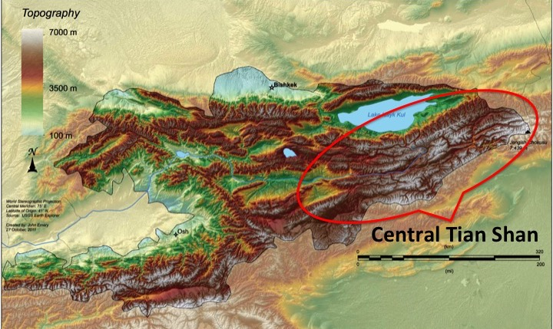
- Kyrgyzstan acts as a natural barrier between flora and fauna of Kazakhstan, Uzbekistan, and China, which are different biogeographic provinces. On the other hand, the Tian Shan and Alay ranges act as a bridge connecting fauna and flora of the Himalayas and Hindu Kush across Pamir with biota of Siberia, and across Dzungar Ala-Tau and Altay with biota of Mongolia. These two factors result in an extreme and unique combination of different fauna and flora elements, and underpin the significance of the biodiversity of Kyrgyzstan and the need for its conservation in the regional context. The country exhibits a rich diversity of natural resources – species, ecosystems, and landforms. Covering only 0.13% of the globe’s surface, Kyrgyzstan is home to about 1% of all known species.
- The Central Tian Shan belongs to the Global 200 Ecoregions list, and has a number of Important Bird Areas (IBAs). Forests cover just 5.62% of the country, with most of it in the Tian Shan Mountains. The relict Shrenk’s spruce forests (Picea schrenkiana) are endemic and have global significance. Central Tian Shan’s mountain forest catchments provide water resources for almost one third of the country and millions of hectares in neighboring countries and it is sometimes referred to as a natural water tower for Central Asia. The Tian Shan Mountains provide ideal habitat for the endangered snow leopard (Uncia uncia). Snow leopards are usually found between 3,000 and 5,400 meters above sea level where the environment is harsh and forbidding, the climate is cold and dry, and the mountain slopes sparsely vegetated with grasses and small shrubs, providing good cover and clear views to help them sneak up on their prey. The area is also home to ungulates that are the prey of the snow leopard such as the argali (Ovis ammon; IUCN status: near threatened), ibex (Capra ibex), and Tian Shan maral (Cervus elaphus). In terms of avifauna, Central Tian Shan is home to the ibisbill (Ibidorhyncha struthersii; noted as a rare species whose situation is extremely dangerous in the 4th National Report to the CBD), saker falcon (Falco cherrug; IUCN status: vulnerable), Himalayan griffon (Gyps himalayensis), Eurasian griffon (Gyps fulvus; listed as near threatened in national Red Book), cinereous vulture (Aegypius monachus; IUCN status: near threatened), golden eagle (Aquila сhrysaetos; listed as near threatened in national Red Book), great spotted woodpecker (Dendrocopos major; listed as near threatened in national Red Book), demoiselle crane (Anthropoides virgo; listed as near threatened in national Red Book), steppe eagle (Aquila nipalensis; listed as near threatened in national Red Book), imperial eagle (Aquila heliaca; IUCN status: vulnerable; CITES Appendix I) and short-toed eagle (Circaetus gallicus; listed as vulnerable in national Red Book).
Figure 2 Kyrgyzstan National Protected Area System as of 2015
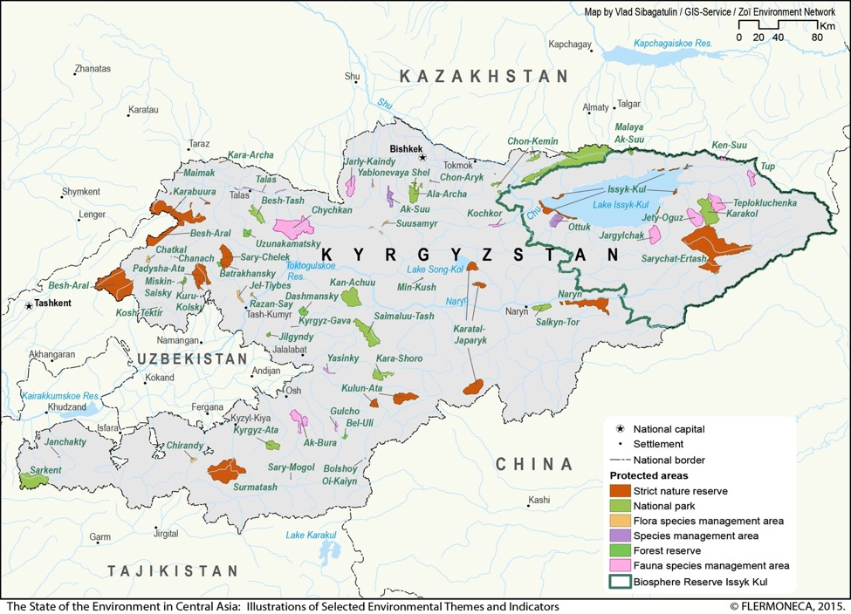

- The system of Specially Protected Nature Areas (SPNA) consists of 89 PAs covering an estimated 7.6% of the country, all of which are under the direct or indirect responsibility of the State Agency for Environment Protection and Forestry; 11 state nature reserves and 12 state nature parks are under the management of SAEPF. Conservation of biodiversity and ecosystems through extension of SPNA up to 7% of the national territory was one of the strategic targets of Kyrgyzstan in transiting to sustainable development set up by the government of the Kyrgyz Republic. A map of the main protected areas of Kyrgyzstan is shown in Figure 2 above. Three state nature parks - Alatai, Kan-Achuu and Khan Tengri were established in 2015-2016 and are not included in the map.

Central Tian Shan Project Concept Background
- As stated in the Prodoc, “The creation of a system of PAs for the whole country has acquired importance since 2007, when the WWF-developed Econet scheme was approved at the national level by the State Agency on Environmental Protection and Forestry (SAEPF)…as a basis for development of the PA network (i.e., the core of Econet) and a system of sustainable land and resource use (i.e., ecological networks, ecological corridors and buffer zones).” Further, as stated in the mid-term review, “The project primarily grew out of WWF’s Econet programme. In the resulting analysis, the Central Tian Shan emerges as an area of important ecological connectivity – most specifically as habitat for snow leopards. As a result of the analysis, a new protected area of 187,000ha – the Khan Tengri National Park – [was] proposed.” The idea to establish the Khan Tengri National Park also dovetailed nicely with the President of Kyrgyzstan’s strong support for the Global Snow Leopard and Ecosystem Conservation Program (GSLEP), as well as the country’s need to increase its PA coverage to meet the international target of 10% of national PA coverage. As part of Kyrgyzstan’s national snow leopard and ecosystem conservation program the Central Tian Shan was identified as one of two national priority landscapes for snow leopard conservation.

Problems the Central Tian Shan Project Seeks to Address
- The project document identifies the following threats to the high mountain ecosystem of the Central Tian Shan and associated biodiversity:
- Unsustainable cutting of forests;
- Extensive and uncontrolled agro-pastoral use, including increasing livestock numbers leading to degradation of mountain grasslands and conflict and competition with wild ungulates;
- Legal hunting and illegal (poaching) hunting
- Mining
- Two key barriers to effectively addressing these issues are described. First, there was inadequate coverage of key Central Tian Shan habitats by protected areas. According to the Prodoc, the previously existing PA in the region (Sarychat-Eertash reserve) covered less than 20% of snow leopard habitat in the region. Second, considering that species such as the snow leopard have home ranges much larger than protected areas can encompass, there also needs to be appropriate land-use management and planning in the wider landscape to implement biodiversity-compatible land-use practices.

Central Tian Shan Project Description and Strategy
- As stated in the Project Document, the long-term goal towards which the project will contribute is “To conserve the globally significant biodiversity of Central Tian Shan.” The project objective is “to enhance the sustainability of protected areas in globally important ecosystems of Central Tian Shan by expanding their coverage and management effectiveness, better integrating them with land use in the wider landscape through an emphasis on well-managed buffer zones and wildlife corridors, and supporting biodiversity-compatible livelihoods in PAs.” The project is structured in two outcomes, consisting of ten outputs:
- Outcome 1: Threatened species representation is improved by increasing coverage and management effectiveness of PAs in Central Tian Shan
  - Output 1.1. Establishment of a new protected area in Khan Tengri region
  - Output 1.2. Patrolling, enforcement, and surveillance systems strengthened
  - Output 1.3. Vocational training for PA staff to ensure that they can effectively fulfill management objectives
  - Output 1.4. METT introduced as a widespread tool for gauging the effectiveness of PAs
- Outcome 2: Habitat connectivity, sustainability, and effectiveness of PAs in Central Tian Shan are enhanced by regulating land use in buffer zones, wildlife corridors and other intervening landscapes
  - Output 2.1. Amendments to the Law on Protected Areas that define procedures for the establishment, operation, and enforcement of PA buffer zones and wildlife corridors
  - Output 2.2. Identification and designation of buffer zones for the new PA at Khan Tengri and wildlife corridors between Khan Tengri and Sarychat-Ertash NR
  - Output 2.3. Conservation management objectives of the PAs, buffer zones, and corridors aligned with territorial land use plans of five adjoining rural districts
  - Output 2.4. Agreements with local land users on modified patterns of resource use, and a system is in place for enforcement of new regulations
  - Output 2.5. Alternative livelihoods program for local communities designed and launched
  - Output 2.6. Training workshops for local authorities from other districts spanning the Tian Shan Mountains on how to account for biodiversity conservation considerations in territorial planning and on enforcement of regulations, using the experience of the Khan Tengri and Sarychat-Ertash PAs
- The overall geographic focus of the project was the Central Tian Shan landscape, which covers approximately 1.32 million hectares in east-southeastern Kyrgyzstan. The key planned result of the project was the establishment of a new protected area, the planned Khan Tengri National Park (IUCN Category II). The project also planned to work on strengthening the management and conservation of Sarychat-Eertash State Reserve (IUCN Category I). The entire Central Tian Shan landscape falls within the Issyk-Kul Biosphere Reserve (IUCN Category VI), which encompasses all of Kyrgyzstan’s Issyk-Kul Province. The targeted landscape region and two key targeted protected areas are indicated in Figure 3 below. The specific results expected from the project are highlighted in the project results framework, included as Annex 10 to this evaluation report (with an assessment of achievement of planned results targets).
- The total GEF financing for the project is $950,000 USD, funded from the GEF biodiversity focal area. Total co-financing was planned as $4.97 million USD.
Figure 3 Central Tian Shan Landscape Including Sarychat-Eertash Reserve and Originally Planned Khan Tengri National Park Boundaries
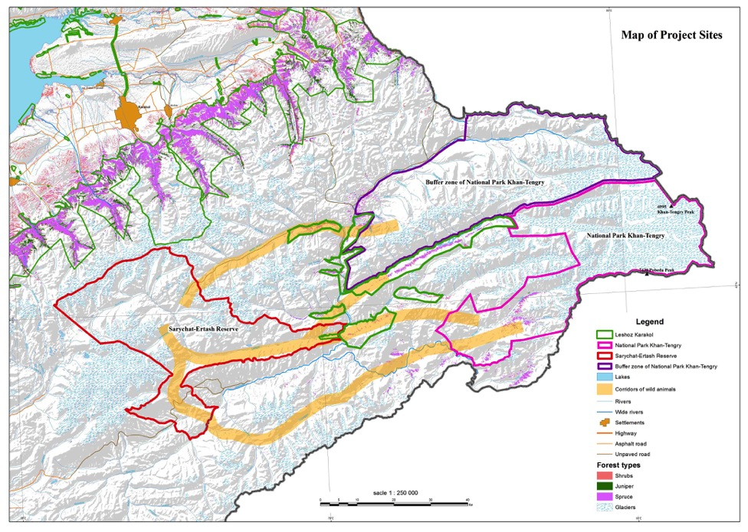

Implementation Approach and Key Stakeholders

Implementation Arrangements
- The implementation structure of the project is indicated in Figure 4, below. According to the Direct Implementation (DIM) Authorization for Kyrgyzstan Country Programme 2012-2016 by Kori Udovički, Regional Director, 11 January 2012, the project is executed by UNDP. The Kyrgyzstan State Agency for Environmental Protection and Forestry (SAEPF) is the national executing partner.
- Working in close cooperation with SAEPF, the UNDP Kyrgyzstan Country Office in Bishkek monitors the project implementation, reviewing its progress and ensuring the proper use of UNDP/GEF funds. The project is supported by the UNDP-GEF regional office in Istanbul. UNDP provides implementation support services to the project, including procurement, contracting of service providers, human resources management and financial services, in accordance with the relevant UNDP rules and procedures and Results-Based Management (RBM) guidelines.
- A Project Board (PB) was constituted as the executive decision making body for the project. The Project Board had 13 representatives, including senior representatives from the key national stakeholder institutions and partners, including: Director of SAEPF (Chair of the Board); Deputy Resident Representative of UNDP (Vice-Chair of the board); Deputy Director of SAEPF; General Director of the Issyk-Kul Biosphere Reserve, first deputy of the Plenipotentiary representative of the Government of the Kyrgyz Republic in Issyk-Kul Oblast, first deputy of the head of Ak-Suu district, Environment Program Leader of UNDP, Director of the Biology and Soil Institute of the National Academy of Sciences, head of the Enilchek self government body, national coordinator of WWF, Director of NABU in Kyrgyzstan, “Biom” NGO. The Director of the SAEPF is designated the as the chair of the Project Board, providing the strategic oversight and guidance to project implementation. The specific person serving as the Project Board chair was changed in May 2016 due to the change of the government following parliamentary elections in October 2015. The PB has met annually (three meetings prior to the terminal evaluation), approving the project Annual Work Plans (AWPs), discussing and deciding on the strategic issues, and providing overall guidance and oversight of the project. Meetings were held November 12, 2014; December 18, 2015; and December 28, 2016.
- The day-to-day administration of the project is carried out by the Project Coordinator with support from a Project Assistant; both are based in Karakol, in Ak-Su District, Issyk-Kul Province, which is approximately 5-6 hours drive from Bishkek. The Project Coordinator receives support from the UNDP project implementation unit (PIU), based in Bishkek. The team shares UNDP administrative and financial support services with other UNDP projects. The Project Coordinator is accountable to UNDP and SAEPF for the quality, timeliness and effectiveness of the activities carried out, as well as for the use of funds. The Project Coordinator prepares Annual Work Plans and submits them to the Project Board for approval, and ensures that the project produces the results specified in the project document, to the required standard of quality and within the specified constraints of time and cost. The Project Coordinator has been technically supported by contracted national service providers in completing various project activities. All recruitments and procurements are implemented by the Project Coordinator, in close consultation with the UNDP, in line with the UNDP and national rules and procedures.
Figure 4 Central Tian Shan Project Implementation Structure
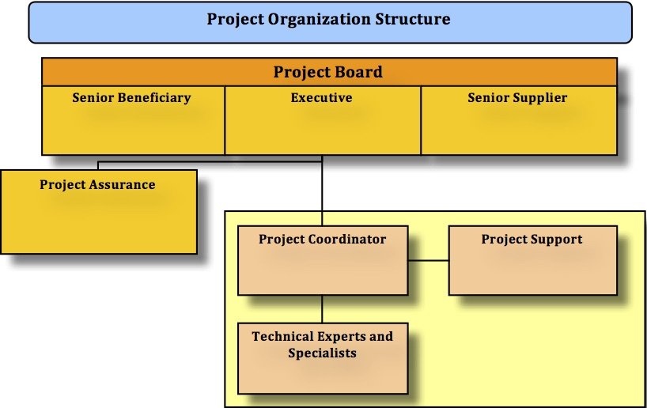

Key Stakeholders
- The project includes relevant stakeholders at the national and local levels. The full list of stakeholders identified in the project document is included as Annex 8 to this evaluation report. Stakeholders include government authorities at local, regional, and national levels, numerous civil society stakeholders, local land users and other private sector actors, as well as academic and research institutes. The most critical stakeholders can be considered as those represented on the Project Board, as indicated in Section III.E.i above. The key stakeholders in the project are the institutions with the top authority, mandate and responsibilities in management and governance of protected areas, wildlife management, and pasture management. In addition to these, a number of other stakeholders have been occasionally involved in the implementation of the project, including various other on-going projects (including FFI and WWF ongoing activities in Sarychat-Eertash, and the NABU North Tian Shan project) and their implementers, other sectoral Ministries and state institutions.

Key Milestone Dates
- Table 3 below indicates the key project milestone dates. The project concept began in 2011 (the GEF review notes that the GEF Focal Point approval letter is dated December 5, 2011), with the PIF subsequently submitted to the GEF in early 2012; the exact date of initial PIF submission was not available, but the initial GEF review of the PIF was March 13, 2012, indicating that the initial PIF was likely submitted in late February or early March 2012. After a revised PIF submission the project received PIF approval March 27, 2012, and PPG approval shortly after in April 2012. The next GEF review for CEO Approval initially came March 14, 2013. Therefore the 12-month period from April 2012 to March 2013 was the Prodoc development timeframe. The project received final GEF approval (only “CEO Approval” was required as the project was an MSP) on March 22, 2013. GEF Agency approval was May 27, 2013 with the UNDP Prodoc signature, and the project officially came to life June 17, 2013.
- During the first few months the project team was recruited, and the project coordinator was in place October 16, 2013. The project inception workshop was held October 24, 2013, timed to take place the day after the first Global Snow Leopard Summit, held in Bishkek. Holding the inception workshop at this time helped give the project a high profile at the national level, but also seems to have resulted in a less “operational” inception workshop, without significant discussion on potential project revisions, revisions to the logframe, budget, etc. (no such modifications are documented in the project inception report).
- The project mid-term review was held in November 2015, which was 29 months after the project officially started (60% into the official implementation period), but approximately 24 months after the project inception workshop. The terminal evaluation was held in April 2017, which was within 3 months of project completion, as per UNDP requirements. The project will finish, as scheduled, on June 17, 2017.
Table 3 Central Tian Shan Project Key Milestone Dates
Milestone | Expected Date [A] | Actual Date [B] | Months (Total)
1. First GEF Review (no initial PIF submission date available) | N/A | March 13, 2012
2. Revised Project Information Form (PIF) Submission | N/A | March 26, 2012 | 0.5 (0.5)
3. PIF Approval | N/S | March 27, 2012 | 0.0 (0.5)
4. Project Preparation Grant (PPG) Approval | N/S | April 17, 2012 | 0.5 (1)
5. GEF First Review of Prodoc (no initial Prodoc submission / CEO Approval Request date available) | March 27, 2013 | March 14, 2013 | 11 (12)
6. GEF Review of Revised Prodoc | March 27, 2013 | March 22, 2013 | 0 (12)
7. CEO Approval | March 27, 2013 | March 22, 2013 | 0 (12)
8. UNDP-Country Prodoc Signature | N/S | May 27, 2013 | 2 (14)
9. Project implementation start | N/S | June 17, 2013 | 1 (15)
10. Project Team In Place | N/S | October 16, 2013 | 4 (19)
11. Inception Workshop | N/S | October 24, 2013 | 0 (19)
12. Mid-term Evaluation | July 2015 | November 2015 | 24 (43)
13. Terminal Evaluation | April 2017 | April 2017 | 17 (60)
14. Project Operational Completion | June 17, 2017 | June 17, 2017 (current planned) | 3 (63)
15. Project Financial Closing | December 31, 2017 | N/A | 6 (69)

EVALUATION FINDINGS AND CONCLUSIONS

Relevance

Relevance of the Central Tian Shan Project Objective
- The Central Tian Shan Project is considered relevant (or “highly satisfactory” in terms of the relevance criteria), as the project directly addresses multiple national biodiversity conservation priorities in Kyrgyzstan. The project is in line with numerous national policies and laws, and is relevant to local resource user needs and priorities as well. The project is in-line with the agreed UNDP priorities for Kyrgyzstan, and is in-line with the GEF strategic priorities for the biodiversity focal area. Further, the project clearly supports relevant multilateral environmental agreements, including the CBD, the Convention on Migratory Species (CMS), and the Convention on Illegal Trade of Endangered Species (CITES).

Relevance to National and Local Policies and Strategic Priorities
- The project is directly contributing to implementation of a number of strategic objectives and associated action plans of Kyrgyzstan’s National Biodiversity Strategy and Action Plan (2014), which is a key strategic document for biodiversity conservation in Kyrgyzstan. The most recently revised NBSAP, covering the period 2014-2024, identifies a suite of activities to improve the management effectiveness of SPNAs, restore degraded mountain pastures and forests and enhance the sustainability of pasture and forest management use in high altitude mountain ecosystems. The Central Tian Shan project has specifically contributed to all four of Kyrgyzstan’s NBSAP Strategic Targets:
- Strategic Target 1: Integrate biodiversity conservation issue in the activities of state bodies and public organizations, as the basis of the human being and sustainable economic development of the Kyrgyz Republic;
- Strategic Target 2: Reduce the impact on biodiversity and promote its sustainable use;
- Strategic Target 3: Improve the protection and monitoring of ecosystems and species diversity; and
- Strategic Target 4: Improve the social importance of biodiversity and ecosystem services, increase the benefits of sustainable ecosystem services and traditional technologies.
- The project also is closely aligned with Kyrgyzstan’s strong national commitment to the conservation of the snow leopard. Kyrgyzstan is one of the leading range states in terms of its support for the Global Snow Leopard and Ecosystem Protection Program (GSLEP): Kyrgyzstan hosted the first global snow leopard summit in October 2013 (which also coincided with the inception workshop for this Central Tian Shan project), hosts the GSLEP secretariat, and will host the 2nd global snow leopard summit in August 2017. Within GSLEP, each range state has committed to securing two snow leopard habitat landscapes; for Kyrgyzstan the Central Tian Shan is one of two national priority snow leopard landscapes. Therefore the objective of the Central Tian Shan project of establishing Khan Tengri National Park and securing the wider landscape is highly relevant to and supportive of Kyrgyzstan’s support for global snow leopard conservation efforts.
- In addition, as the project is contributing to improvement of management effectiveness of protected areas in the Central Tian Shan, it is also indirectly contributing to improved management of Kyrgyzstan’s entire system of protected areas. After being piloted and demonstrated in the Central Tian Shan, planning and management best practices, standards, and procedures will be more easily transferred to and replicated in the rest of the network.
- The project also supports the implementation of multiple national laws and policies related to protected areas and environmental conservation. These include the Law on Environmental Protection (1999), Law on Wildlife (1999), Law on the Protection and Use of Flora (2001), Law on Special Protected Nature Areas (2011), Law on Hunting (2014), Law on Pastures (2009), and Law on Mountainous Territories (2002).
- The project also clearly has high local-level relevance. This is strongly indicated by the support and engagement received by the project from multiple different local stakeholders – at the district and village level. The project objective was directly supported by the Issyk-kul Province administration, the Ak-su and Jety-Oguz district administrations, and officially by all but one of the villages whose lands were involved in the establishment of the Khan Tengri National Park. Even in Otrodnoe village, which did not officially support the project with the allocation of its lands for the establishment of the national park, there was a great deal of support amongst residents, as expressed by representatives of the village administration during the terminal evaluation mission. The micro-grant program was another means by which the project supported local sustainable development and nature conservation priorities. The micro-grant program was well received, and support from the program was in high demand amongst local residents.

Relevance to GEF Strategic Objectives
- The GEF has limited financial resources so it has identified a set of strategic priorities and objectives designed to support the GEF's catalytic role and leverage resources for maximum impact. Thus, GEF supported projects should be, amongst all, relevant to the GEF's strategic priorities and objectives. The project was approved and is being implemented under the strategic priorities for GEF-5 (July 2010 – June 2014). Under the GEF-5 biodiversity strategic objectives, the project’s objective is directly in line with and supportive of Objective 1: “Improve the Sustainability of Protected Area Systems,” and contributes to Outcome 1.1: “Improved management effectiveness of existing and new protected areas.” Although the project was formally classified only under the “BD-1” GEF-5 strategic objective, the project also did support the BD-2 objective of mainstreaming biodiversity, as it supported the improvement of biodiversity conservation and management in a wider landscape beyond protected area boundaries. In particular this included improved biodiversity management and conservation in forestry areas, pasturelands, and hunting concessions. Altogether, including PA buffer zones and corridors, the project improved biodiversity management in 364,230.9 ha outside the boundaries of protected areas across the wider Central Tian Shan landscape. Therefore the project contributed to the BD-2 outcomes and indicators for GEF-5, as indicated in Table 4 below. The project results framework incorporated indicators that directly feed into the GEF-5 biodiversity results framework, including the METT score for the two PAs targeted (Khan Tengri and Sarychat-Eertash), and the coverage area of the PAs and coverage area of the wider production landscape area beyond the PAs.
Table 4 GEF-5 Strategic Objectives Supported by the Central Tian Shan Project
Objective 1: Improve the Sustainability of Protected Area Systems | Outcome 1.1: Improved management effectiveness of existing and new protected areas | Indicator 1.1: Protected area management effectiveness score as recorded by Management Effectiveness Tracking Tool | Output 1. New protected areas (number) and coverage (hectares) of unprotected ecosystems
 |  | Outcome Target: Eighty percent of projects meet or exceed their protected area management effectiveness targets covering 170 million hectares of existing or new protected areas | Output 2. New Protected areas (number) and coverage (hectares) of unprotected threatened species
Objective 2: Mainstream biodiversity conservation and sustainable use into production landscapes, seascapes and sectors | Outcome 2.1 Increase in sustainably managed landscapes and seascapes that integrate biodiversity conservation | Indicator 2.1: Landscapes and seascapes certified by international or national recognized environmental standards that incorporate biodiversity considerations measured in hectares and recorded by GEF tracking tool | Output 2. National and sub-national land-use plans (number) that incorporate biodiversity and ecosystem services valuation
 |  | Outcome Target: Sustainable use and management of biodiversity in 60 million hectares of production landscapes and seascapes

Relevance to Multilateral Environmental Agreements
- The CBD is a key multilateral environmental agreement for which the GEF is the financial mechanism. Kyrgyzstan is a party to the CBD, having ratified the agreement on August 6th, 1996, and becoming a party on November 4th, 1996. The Central Tian Shan project supports the CBD’s protected areas program of work, and meets CBD objectives by supporting the Convention's Articles 6 (General Measures for Conservation and Sustainable Use), 7 (Identification and Monitoring), 8 (In-situ Conservation), 10 (Sustainable Use of Components of Biological Diversity), 11 (Incentive Measures), 12 (Research and Training), 13 (Education and Awareness), 14 (Impact Assessment and Minimizing Adverse Impacts) and 17 (Exchange of Information). The project also supports the CBD’s Aichi targets for 2020, including:
- Target 1: By 2020, at the latest, people are aware of the values of biodiversity and the steps they can take to conserve and use it sustainably.
- Target 2: By 2020, at the latest, biodiversity values have been integrated into national and local development and poverty reduction strategies and planning processes and are being incorporated into national accounting, as appropriate, and reporting systems.
- Target 5: By 2020, the rate of loss of all natural habitats, including forests, is at least halved and where feasible brought close to zero, and degradation and fragmentation is significantly reduced.
- Target 11: By 2020, at least 17 per cent of terrestrial and inland water, and 10 per cent of coastal and marine areas, especially areas of particular importance for biodiversity and ecosystem services, are conserved through effectively and equitably managed, ecologically representative and well connected systems of protected areas and other effective area-based conservation measures, and integrated into the wider landscapes and seascapes.
- Target 12: By 2020 the extinction of known threatened species has been prevented and their conservation status, particularly of those most in decline, has been improved and sustained.
- Target 14: By 2020, ecosystems that provide essential services, including services related to water, and contribute to health, livelihoods and well-being, are restored and safeguarded, taking into account the needs of women, indigenous and local communities, and the poor and vulnerable.
- Target 17: By 2015 each Party has developed, adopted as a policy instrument, and has commenced implementing an effective, participatory and updated national biodiversity strategy and action plan.
- Target 19: By 2020, knowledge, the science base and technologies relating to biodiversity, its values, functioning, status and trends, and the consequences of its loss, are improved, widely shared and transferred, and applied.
- The Central Tian Shan project also supports the Convention on Migratory Species, as Khan Tengri National Park sits on Kyrgyzstan’s borders with Kazakhstan and China, and multiple species in the area make transboundary use of the regional ecosystem. Kyrgyzstan ratified this convention during implementation of the Central Tian Shan project, on May 1, 2014. In a similar manner the project supports the CITES Convention, as the project worked to address and control wildlife crime, including trade in endangered species – particularly in relation to the snow leopard. Kyrgyzstan is a party to CITES, having acceded to the convention on June 4, 2007.

Relevance of the Project Approach: Project Strategy and Design
- There are not critical issues in relation to the relevance of the project design. The project’s approach is considered sound, and was developed based on the political and institutional context of Kyrgyzstan in relation to PAs at that time. One strategic question is whether it would have been better for the project design to have planned to carry out the micro-grants program early in the project period, before the Khan Tengri National Park was gazetted. This would have been one way of building trust and positive relations with local communities while simultaneously seeking their support for establishment of the national park. As it was, only one community did not decide to support the project, but gaining and continuously retaining the support of the remainder of the communities was a long and difficult process and could easily have failed. On the other hand, if the project had undertaken the micro-grants program before the national park was established it would have forsaken some of the incentive for local communities to contribute their lands to the establishment of the national park. The optimum approach may be where fewer than half of the micro-grants are disbursed prior to the decision by local communities whether or not to support the PA, and then after the decision the remaining majority of the micro-grant funds could be disbursed to communities that supported the national park. However it is not clear that this strategic approach would be operationally feasible, as the micro-grant program requires a complex set of procedures and oversight mechanisms agreed in advance with village administrations.
- The only other consideration in terms of the project’s strategy is that the project did not significantly incorporate climate change-responsive approaches or activities. However, given the size and scope of the project in relation to the budget, it is hard to imagine how any incremental additions to the project workplans (such as climate-related research, or climate data analysis to forecast potential climate change impacts in the Central Tian Shan) would have been feasible.

Project Management and Cost-effectiveness (Efficiency)
- Overall, project efficiency is rated highly satisfactory. The results are impressive relative to the GEF grant allocation amount. The project’s adaptive management and stakeholder engagement approach are highlights. Project management costs are expected to be approximately 10% of GEF funding, in line with original budgeting. Financial management procedures are in-line with international norms, and conform with UNDP and Government of Kyrgyzstan policies and procedures. Project expected co-financing is on-track with 87.9% of co-financing contributed as of the terminal evaluation, and actual co-financing is projected to exceed the planned co-financing by the end of the project, once all sources of co-financing have been fully accounted. The PMU is highly professional and has demonstrated excellent planning, reporting, and financial management.

Implementation, Including UNDP Oversight
- UNDP is the responsible GEF Agency for the project, and carries general backstopping and oversight responsibilities. UNDP’s has fully and adequately supported the project during implementation, with no notable issues. UNDP implementation is considered satisfactory. UNDP has supported project implementation effectively, and provided special attention and support as necessary. For example, the UNDP Kyrgyzstan Country Office senior staff (Resident Representative, Deputy Resident Representative, and others) have written multiple letters to key stakeholders to address issues (e.g. the Otrodnoe lands) during project implementation, as necessary.

Execution, Including Country Ownership

Project Management
- As indicated in Section III.E above, the responsible national executing partner is the SAEPF. The project is implemented under the “direct implementation” modality, and the PMU is based in the UNDP Project Management Unit office with staff with UNDP contracts and UNDP email addresses. The project manager and project assistant are based in the city of Karakol, in Issyk-kul province, which is the nearest major city to the project area (the actual targeted project area is quite remote). Therefore project execution can also be considered “project management”, and relates directly to the work of the PMU, in combination with the financial management and administrative aspects handled by UNDP. Project execution is considered satisfactory. The Central Tian Shan project is characterized by highly professional and efficient project management, excellent financial planning, strong adaptive management, comprehensive reporting, and excellent engagement of stakeholders.

Country Ownership
- Country ownership of the project has been manifested throughout its preparation and implementation. First, as reflected in the previously cited national strategic objectives and priorities, the project is clearly addressing issues that are recognized among the key issues and top priorities the Government of Kyrgyzstan. Second, the project has been developed and implemented in close cooperation and full appreciation of the needs and priorities expressed by SAEPF. Local stakeholders and communities have participated in the project in a supportive way, and have expressed continued support for the sustainability of project results.

Partnership Approach and Stakeholder Participation
- The project has very strong partnership approach and stakeholder participation. The project has worked collaboratively and cooperatively with the full range of stakeholders, as testified during qualitative data collection during the terminal evaluation field mission. As previously indicated, the full list of relevant project stakeholders is included as Annex 8 to this evaluation report. In particular, the strong partnership of trust and mutual support between UNDP and SAEPF has been critical to achieving many of the key results from this project, as many of the outputs required political and technical support from SAEPF. The project team had strong and consistent outreach to local stakeholders throughout the project to build support for the establishment of Khan Tengri National Park.
- This strong stakeholder engagement approach is testified to through many facets of the project; for example, at least four roundtable meetings were held in 2016 in Ak-su district regarding the micro-grants program, with a total of 140 participants. Also, notably, with the project's support the Advisory Board under Khan Tengri National Park was established. A wide range of stakeholders both at national and local levels were informed about the PA Board establishment, as this is the first public board ever created in the PA sector of the Kyrgyz Republic. More than 70 representatives from 20 stakeholder groups with wide-ranging interests approved the Advisory Board regulation, and elected 11 members to the Advisory Board at the round table on June 17, 2016. It was anecdotally related that a local stakeholder representative joked that they could recite from heart the project coordinator’s standard speech about the project and PA.
- The Otrodnoe issue also can be considered as a positive indicator of stakeholder engagement, and conforms to UNDP social and environmental safeguards risk management. Globally PAs have a long negative history associated with displacement of local populations, and loss of local access rights; the Central Tian Shan project’s respect for the wishes of one community is a positive step in the other direction. One representative of another A/O even stated that the project should not have bothered consulting the communities, since the land in question is all government land anyway, and if the government wants to take it from the communities for other purposes then they can do so, while having extensive community consultation on the issue presents the opportunity for problems to arise. The issue with Otrodnoe is also a testament to the political structure and democracy in Kyrgyzstan; there are not many countries in the world where one small community can successfully stand-up against presidential priorities. Nonetheless, given the apparent strong support within the community for the national park, it is unfortunate that Otrodnoe has not yet given formal consent for the community lands to be included in the national park, and there are some possible negative ecological implications associated with this situation, but these issues are not considered to be so critical as to undermine the project objective.
- Another strong element of partnership was the project’s interaction with the private sector trophy hunting companies that have hunting concessions in areas surrounding Sarychat-Eertash and Khan Tengri PAs. The project worked with the hunting companies to support implementation of the hunting law, which requires setting aside 10% of hunting concessions annually as “quiet areas” as a wildlife management measure. Multiple agreements were signed to confirm the agreed management approaches to hunting concession territories.

Risk Assessment and Monitoring
- Within the Central Tian Shan project document Annex 1 (pp. 32-3 of the project document) includes the project risk analysis. This analysis is well developed, with 10 risks identified, and mitigation measures for each risk discussed in detail. Risks were monitoring during project implementation quarterly through UNDP’s Atlas risk log, and annually through the PIR. The main critical risk was the issue of Otrodnoe lands being contributed or not to the territory of the national park prior to its establishment, and this risk was appropriately addressed via the MTR, the Project Board, and project adaptive management measures.

Flexibility and Adaptive Management
- Flexibility is one of the GEF’s ten operational principles, and all projects must be implemented in a flexible manner to maximize efficiency and effectiveness, and to ensure results-based, rather than output-based approach. Thus, during project implementation adaptive management must be employed to adjust to changing circumstances.
- On the whole the project was implemented in a fully adaptive manner, following a results-based approach. Minor to moderate budget revisions were made throughout the implementation period, in accordance with UNDP and GEF procedures, requirements and guidelines. The project team made numerous adjustments throughout implementation to respond to particular circumstances or contexts. For example, in the early stages of implementing the micro-grants program there was an idea to implement the program as a micro-finance program rather than a micro-grant program, to use a modality that would be designed for longer-term sustainability. However, the financial terms necessary to meet the conditions of potential micro-finance partner organizations and banks were not conducive to the project’s goal of strongly supporting sustainable livelihoods, so the project ultimately decided to proceed with the micro-grant modality for this part of the project.
- However, the most significant adaptive management decision came following the mid-term review, at the Project Board meeting in December 2015. At this point the final proposal for the establishment of the Khan Tengri National Park had not been submitted to the government as the Otrodnoe A/O had not agreed to forego their usufruct rights on a key 25,000 hectares of land that was proposed to be included within the national park boundaries. The mid-term review had recommended that Khan Tengri National Park not be established without first exhausting all possible options with Otrodnoe A/O. However, the project had only 18 months remaining, and if any additional time passed before the PA was established there was a risk of the other participating A/Os withdrawing their support for the PA. Therefore the Project Board deemed it appropriate to proceed with establishing the Khan Tengri National Park, despite the lack of participation by Otrodnoe A/O.
- In retrospect it seems this was an appropriate decision. The MTR had also recommended that if the national park was not established by September 2016 then the project should be immediately closed. Therefore, the Project Board’s approach can be seen as a decision to move ahead with the best available approach for establishing the PA, rather than the perfect approach of having the Otrodnoe lands included. The issue of the Otrodnoe lands is further discussed in later Section VI on effectiveness and results.

Financial Planning by Component and Delivery
- The breakdown of project GEF financing is indicated in Table 5 below. Additional details on project finances are included in tables in Annex 9. The total project budget is $950,000 USD, not including the PPG amount. Of this, $350,000 (or 36.8% of the total) was planned for Component 1, and $505,000 (53.2%) was planned for Component 2. The planned project management budget equates to 10.0% of the total GEF resources. The M&E budget indicated in the M&E plan in the project document was $74,000, or 7.8% of the total budget. However, the budget for various M&E activities are drawn from multiple project budget lines, and do not have their own separate budget line; the M&E items with dedicated budget appear to have been budgeted for approximately $50,000 (80% of which for international consultants for the mid-term review and terminal evaluation).
- Figure 5 below shows the breakdown of planned and actual spending by components. As of March 31, 2017, the project had disbursed $849,533, or 89.4% of the project budget. Figure 6 shows the project planned, revised, and actual budget expenditure by year.
Table 5 Project Planned vs. Actual Financing, Through March 31, 2017 ($ USD)
 | GEF amount planned | Share of total GEF amount | GEF amount actual | % of GEF amount actual | % of original planned
Component 1 | 350,000 | 36.8% | 329,657 | 38.8% | 94.2%
Component 2 | 505,000 | 53.2% | 432,694 | 50.9% | 85.7%
Monitoring and Evaluation* | 74,000 | 7.8% | N/A |  | N/A
Project Coordination and Management | 95,000 | 10.0% | 87,182 | 10.3% | 91.8%
Total‡ | 950,000 | 100.0% | $849,533 | 100.0% | 89.4%
Sources: Project Document for planned amount; data provided by PMU for actual GEF amounts.
*The project document includes a detailed M&E budget. However, the total M&E budget includes activities that would be funded from the project management budget line (such as annual reporting) or other sources (such as UNDP oversight). As such, the funds for M&E activities were drawn from across project budget lines.

Figure 5 Central Tian Shan Project Actual Spending By Component ($ USD)

Figure 6 Central Tian Shan Project Planned, Revised, and Actual Spending by Year ($ USD)

- When reviewing different aspects of the project financial management and delivery it is important to keep in mind that the project was planned for 48 months, which in the project document was foreseen as four consecutive calendar years. However, since the project began official implementation in June 2013, it is in fact spanning five calendar years. Therefore, for example, financial delivery for the first calendar year (ending December 31, 2013) is significantly less than was planned in the project document.
- Figure 7 below shows the rate of project financial delivery vs the originally planned budget (in the Prodoc) and vs the annually revised budget.
Figure 7 Central Tian Shan Project Financial Delivery vs Approved Annual Budget

- The project financial delivery was below expectations for each year until 2016. From 2013 to 2015 annual financial delivery averaged less than 50% of the planned amount. In 2015 the project reached a significant slowdown (only 12.7% financial delivery of the planned budget for the year), which was directly related to the status of approval of the Khan Tengri National Park. Once the park was approved in early 2016, the project could again proceed and activities (and corresponding expenditures) significantly ramped up.
- The project management costs are another positive indicator of project efficiency and strong project financial management. The planned management costs were 10% of the total GEF funding (at the stated GEF threshold), and actual management costs as of March 31, 2017 were only 10.3% of the total project expenditure, which is fully reasonably close to the originally planned share. The actual exact share of project management costs cannot be assessed until after project completion.
- The project has not yet had an audit, although an annual audit is indicated in the project M&E plan, and is budgeted in the project document ATLAS budget (see budget note 23 under the “Total Budget and Workplan”, starting p. 23 of the Prodoc). The project document also states that auditing will be done in accordance with UNDP requirements and procedures, so it is possible that there has not been a requirement to have an external audit conducted as yet. Although there is strong faith in UNDP financial management processes, and no indication that there are any shortcomings in project financial management, it is considered good practice for projects to ensure that at least one external audit is conducted prior to the final project evaluation.

Planned and Actual Co-financing
- The expected project co-financing was $4,966,666, with a majority ($2.87 million USD) as in-kind and cash co-financing from the national government, primarily SAEPF as the main partner institution. This is an expected co-financing ration of 5.2 : 1. Table 6 below shows planned and actual co-financing. According to data provided by the project team, the project had received a total of approximately $4.37 million USD in co-financing as of March 31, 2017. This is 87.9% of the expected co-financing. The breakdown of co-financing is not tracked by project outcome because it is not managed by the project, and much of the co-financing has gone to support all aspects of the project.
- It appears that some sources of likely co-financing have not yet been fully accounted, and therefore it is likely that the actual co-financing received is likely closer to the original amount planned than currently indicated. For example, there is no co-financing indicated in relation to the cash and in-kind contributions made by the micro-grant participants, which has been significant in terms of land, infrastructure (i.e. buildings), their own labor, and additional materials not covered by the micro-grant they received. The micro-grant proposals anticipated co-financing totaling 5.89 million Kyrgyz som (approximately $87,000 USD), and anecdotally the actual contributions have been even more significant.
- Furthermore, there has been no accounting of the contribution of the usufruct rights foregone by the six communities that contributed land under their control to the territory of Khan Tengri National Park. Even though this land is (and was) technically state owned, the communities had fully legally recognized and guaranteed use, access, and lease rights to this land – as clearly demonstrated by the case of Otrodnoe A/O, which has not foregone these rights. According to national policies in Kyrgyzstan, these communities would theoretically be eligible to be compensated millions of dollars for this land, considering the amount of land given. Even if it would never be realistic for these communities to expect legal compensation in this amount, their potential foregone revenue in from livestock grazing or leasing grazing access to other parties is not insignificant.
Table 6 Planned and Actual Co-financing Received, as of March 31, 2017 (USD)
Sources of Co-finance | Name of Co-financer | Type of Co-financing |  | Amount Pledged | Actual 2013-2017 | % of Expected Amount
GEF Partner Agency | UNDP | In kind | Staff time, conference hall, vehicle | 1,600,000 | 1,200,000 | 75
National Government | SAEPF | In kind | Land, transport, staff time, equipment, office, conference hall | 800,000 | 800,000 | 100
National Government | SAEPF | Cash |  | 800,000 | 794,000 | 99.25
National Government | Republican Nature Protection and Forestry Development Fund | In kind |  | 916,666 | 916,666 | 100
National Government | General Directorate of the Issyk-Kul Biosphere Reserve | In kind | Conference hall, staff time, equipment | 350,000 | 350,000 | 100
National Government | National center for Mountain Regions Development | In kind | Staff time, equipment | 0 | 50,000
Local government | Issyk-Kul oblast administration | In kind | Conference hall, staff time | 0 | 30,000
Local government | Ak-Suu rayon administration | In kind | Conference hall, staff time, vehicle | 0 | 100,000
CSO | WWF | Training |  | 250,000 | 10,000 | 4
Donor | USAID | Training |  | 250,000 | 0
CSO | Fauna & Flora International (FFI) | In kind and cash | Equipment, staff time | 0 | 70,000
CSO | The Snow Leopard Trust (SLT) | In kind and cash | Staff time | 0 | 25,000
CSO | NABU | In kind and cash | Staff time, training | 0 | 11,000
National government | National Academy of Science | In kind | Equipment, staff time | 0 | 5,000
CSO | Private hunting companies | In kind | Equipment, horses, accommodation, staff time | 0 | 6,000
Total |  |  |  | 4,966,666 | 4,367,666 | 87.93
Sources: Planned from Project Document. Actual total co-financing received as per data received from PMU.

Monitoring and Evaluation
- The Central Tian Shan project M&E design generally meets UNDP and GEF minimum standards, but had some minor shortcomings and is considered moderately satisfactory. M&E implementation is considered satisfactory, and therefore overall M&E is considered satisfactory.

M&E Design
- The Central Tian Shan project M&E plan is outlined in the project document under the section titled “Monitoring Framework and Evaluation (beginning p. 27). The project document describes each of the planned M&E activities, including roles, responsibilities, and timeframe. The identified M&E activities include inception workshop and report, annual progress reporting (APR/PIR), Project Board meetings, project tracking of logframe indicators at objective and outcome levels, the independent mid-term and terminal evaluations, project terminal report, audit, and monitoring visits from UNDP. The M&E plan includes a specific section on “Learning and Knowledge Sharing”; in addition, it was expected lessons would be captured in the various M&E activities and reports, since, for example, they are automatically included in the annual MIR, and MTR and TE. The M&E plan is summarized in a table showing responsible parties, budget, and timeframe for each of the M&E activities, with the total expected budget of $74,000. This is adequate for a project of this size and scope, representing approximately 7.8% of the GEF allocation; however the plan does not indicate if the M&E costs are to be fully covered by GEF resources, or would be also partially funded by project partners such as SAEPF or other partners. The project’s activity-based budget does not have a specific M&E budget line; the resources for M&E activities is to be drawn from various project components, such as project management. The budget notes from the project document Total Budget and Workplan (p. 23 of the project document) indicate that the costs of international consultants for the mid-term review and terminal evaluation will be covered under Component 2 of the project. The project M&E plan is appropriately designed and well-articulated, and conforms to GEF and UNDP M&E minimum standards.
- The project results framework is a critical component of the project’s overall M&E framework. The Central Tian Shan project results framework indicators and targets do not fully meet SMART criteria. The baseline and target values for a couple of indicators are not fully sourced or justified. For example, the baseline values for the indicator on reducing in poaching and illegal logging state a baseline of 50 violations of illegal logging, and 70 poaching violations; however, relevant stakeholders later disputed these figures during project implementation. In addition, the project includes a baseline value of “only 30% of trophy hunting is legal because hunters are uncontrolled and unmonitored” which was not verified at the time of project approval. Another baseline value of “only 10% of incidents of illegal hunting successfully prosecuted” was also not sufficiently verified. A proposal for a revised results framework was included in the mid-term review, and was, for the most part, adopted by the Project Board following the mid-term review.

M&E Implementation
- The project M&E activities were generally implemented as foreseen. The PMU provides detailed reports at required reporting intervals (i.e. PIR), UNDP oversight has been appropriate, and the mid-term evaluation was commissioned according to schedule. Project Board meetings have been held annually, with three meetings held (November 12, 2014; December 18, 2015; December 28, 2016), not including the inception workshop (October 24, 2013).
- One minor issue is that the project has not had an audit, although the project document M&E plan indicates that audits would be conducted annually. The lack of audit is not necessarily due to inattention, as audits are not required for every individual project according to UNDP procedures, as many UNDP offices undergo an overall office audit. However, conducting at least one audit of a project’s financial management procedures and figures is considered good practice; a large majority of audits conducted on UNDP-GEF projects have returned some minor issues for correction and some useful recommendations for improving financial management procedures.

Effectiveness and Results: Progress Toward the Objective and Outcomes
- The Central Tian Shan project has achieved the project objective and the two planned outcomes. The project effectiveness is rated satisfactory while project results / achievement of overall outcomes is rated highly satisfactory. The project met (or is likely to meet), or exceeded, 10 of 10 results indicator targets. Key results achieved include:
- The national approval of the Khan Tengri National Park, with an area of 275,800.3 ha (nearly 50% larger than the originally planned target), which increased the national protected area coverage by 1.38%, to a national total of 7.38%.
- A METT score for Khan Tengri National Park of 53, significantly exceeding the target of 28, and a METT score for Sarychat-Eertash reserve of 76 (just passing the target of 75);
- Additional agreements in place with land users related to Khan Tengri National Park external buffer zones, corridors, and hunting concession “quiet zones” covering a further 364,230.9 ha (against an original target of 200,000 ha), for total coverage of improved biodiversity management in the Central Tian Shan ecosystem of 789,149.1 ha, or approximately 60% of Kyrgyzstan’s entire Central Tian Shan landscape;
- Successful implementation of the micro-grant program: 16 projects funded with $139,000; an expected 92 jobs created; approximately 287 direct beneficiaries (with 55% women) and ~27,500 indirect beneficiaries (at least 28% women). The program has an estimated return-on-investment of ~1.2 years, which is quite positive;
- Improved monitoring and enforcement of wildlife poaching, including increased detection and prosecution (including prosecution of 100% of 26 cases since the 2016 PIR);
- Support for the development of multiple national-level laws and by-laws that have been adopted, including: Regulation on PA establishment, change of category, approval of borders and liquidation in the Kyrgyz Republic (approved by Government of the Kyrgyz Republic Decree from July 30th, 2015 #541); Regulation on land use of the State Nature Parks (approved by Government of the Kyrgyz Republic Decree on October 5th, 2015 #677); Regulation on Red Data Book of the Kyrgyz Republic (approved by Government of the Kyrgyz Republic Decree from April 11th, 2016 #189). The amendment to the national law on PAs on establishing ecological corridors has passed the first reading in the Kyrgyz Republic Parliament.
- Site-based impact-level results, including reduced illegal hunting in the target area, and the expansion of the range of wildlife into corridors and other areas previously avoided (anecdotally indicated);
- The project objective level results indicators are summarized in Table 7 below.
Table 7 Central Tian Shan Project Objective Level Indicators
Indicator | Baseline | Target | Status
Territorial coverage of SPNAs in Central Tian Shan Mountains which provide habitat for the endangered snow leopard | 149,117.9 ha (Existing Sarychat Ertash reserve area) | Up to 336,119.9 ha by project end | Achieved / exceeded
Area of snow leopard habitat that is effectively protected in the Central Tian Shan Mountains | Low numbers of snow leopard (unable to quantify) | By project end, target area offers permanent habitat for 5 females with cubs | Achieved

- Considering the scope of the Central Tian Shan project it is beyond the capacity of this evaluation report to mention all project activities and outputs, and only the key results are discussed under each of the components below.

Outcome 1: Threatened species representation is improved by increasing coverage and management effectiveness of PAs in Central Tian Shan
- The first component of the project is focused on improve the coverage and effectiveness of the PA system in Central Tian Shan landscape so that better protection can be provided to threatened species (e.g. snow leopard) and relict, endemic Shrenk’s spruce forests. The total GEF funding planned for the component was $350,000 USD, which is 36.8% of the total GEF funding for the project; the actual expenditure as of March 31, 2017 was $329,657. The activities foreseen under this component are organized around the four key outputs:
- Output 1.1. Establishment of a new protected area in Khan Tengri region
- Output 1.2. Patrolling, enforcement, and surveillance systems strengthened
- Output 1.3. Vocational training for PA staff to ensure that they can effectively fulfil management objectives
- Output 1.4. METT introduced as a widespread tool for gauging the effectiveness of PAs
- Key results indicators for Outcome 1 are summarized in Table 7 below.
Table 8 Outcome 1 Indicators and Targets
Indicator | Baseline | Target | Status
Enhanced management effectiveness of target PAs (as measured by METT) | Sarychat Ertash: 54% Khan Tengri: 3% | Sarychat Ertash: 75% by project end Khan Tengri: 28% by project end | Achieved / exceeded
Reduction in poaching and illegal logging at target PAs (annual) per unit of patrolling effort, compared with year of initial patrolling | Illegal logging violations: 50 Poaching violations: 70 Total violations: 120 | Reduction by 30% | Achieved / exceeded

- The first, and most significant, planned result of the project was the establishment of a new protected area in the Central Tian Shan, to be known as Khan Tengri National Park (since it includes Khan Tengri Peak, the 2nd highest mountain in Kyrgyzstan, which also serves at the trilateral border point with Kazakhstan and China). The area targeted for protected area establishment is a highly remote region in eastern Kyrgyzstan, with no permanent population, and only a few dirt roads. There is only one permanent settlement anywhere in the vicinity of the proposed protected are – the aiyl okmotu of Enilchik. Geographically the area is mainly formed by the river valleys of the Enilchik and Saryjaz rivers cascading down from the glaciers and snowfields on the western flank of Khan Tengri peak.
- The entire region of the proposed PA is formally “owned” by the national government, under various land-use tenure regimes. While this entire area is essentially uninhabited, it has multiple types of land-use rights covering its territory. During the 1990s when Kyrgyzstan shifted away from the Soviet land tenure system, it allocated land-use rights to individual communities. In the territory for the proposed Khan Tengri National Park the land-use rights were held by seven aiyl okmotus. Apart from the aiyl okmotu of Enilchik, these aiyl okmotus are actually located far from the Khan Tengri area – approximately five hours by car to the northwest, within the Issyk-kul lake basin (where the majority of the population in Ak-su district is located). In some cases the communities did not regularly access or use in any way the land under their purview; in some cases this territory was used as summer pasture for livestock from these communities. While the land is owned by the national government, the communities have usufruct rights beyond grazing as well – for example communities can “allow” hunting or mining in their territory.
- In addition to community lands, the Khan Tengri area also includes land managed by “leskhozes” (state forestry management units). There is also areas that have been allocated as hunting concessions to private hunting companies (in the business of international trophy hunting). In the Khan Tengri area there are four hunting concessions, allocated to the following companies: Central Asian Safari Club, Tour Khan Tengri, Issyk-kul Intour, Ashuu-Tor. The most relevant of these in relation to the establishment of the national park is Tour Khan Tengri, which had hunting concession rights to approximately 63,000 hectares on the ridge to the south of the Enilchik river in the western half of the proposed PA territory.
- Understanding this context is important for understanding the process for establishing the national park. Although the proposed PA area was already “owned” by the national government, the project was obligated to work with the communities and other entities that held land-use rights in this area. Therefore the project undertook an extensive consultative process with the seven aiyl okmotus involved.
- Ultimately, as of late 2015, with only approximately 18 months of project implementation left, six of the seven aiyl okmotus had agreed to contribute a portion of their territory to the PA, with Otrodnoe aiyl okmotu withstanding. The reasons for Otrodnoe’s reticence cannot be easily identified. Among all of the aiyl okmotus involved, Otrodnoe was being asked to contribute the largest amount of territory – the average contribution from the other six aiyl okmotus was approximately 6,000 hectares, while Otrodnoe was being asked to renounce rights to approximately 25,000 hectares; thus the size of the area may have played a role. However, this area has limited potential for grazing, and was not being actively used by Otrodnoe residents. The project conducted an opinion survey of Otrodnoe residents, and found that of the 1,383 households surveyed, 75% were in favor of establishment of the national park, 17% were against, and 8% abstained. However, the community’s formal consent (which required full consensus) was withheld by one to three of the community council members. There was anecdotal information that at least one of these deputies wanted the community to retain rights to the area for potential long-term mining development to have greater income potential from the territory. In reality the prospect of mining in the area appears to be limited, considering the lack of other mining activity in the region. There was also anecdotal information that an agreement had been reached with one of the hunting companies to allow hunting on the community lands under a lease agreement that would provide financial benefits for the community; it is unknown if such an agreement has been made.
The project staff conducted a lot of awareness raising work with the local population, and we organized meetings in every village of the municipality. In general people supported the project because they understood the importance of the project objective. Awareness raising work was started in our municipality first. We think it was a great project, it created such an important national park and we don’t regret that [thousands] of hectares of our lands were transferred to the national park.
– Local government stakeholder
Figure 8 Area of the new Khan Tengri National Park (in pink)
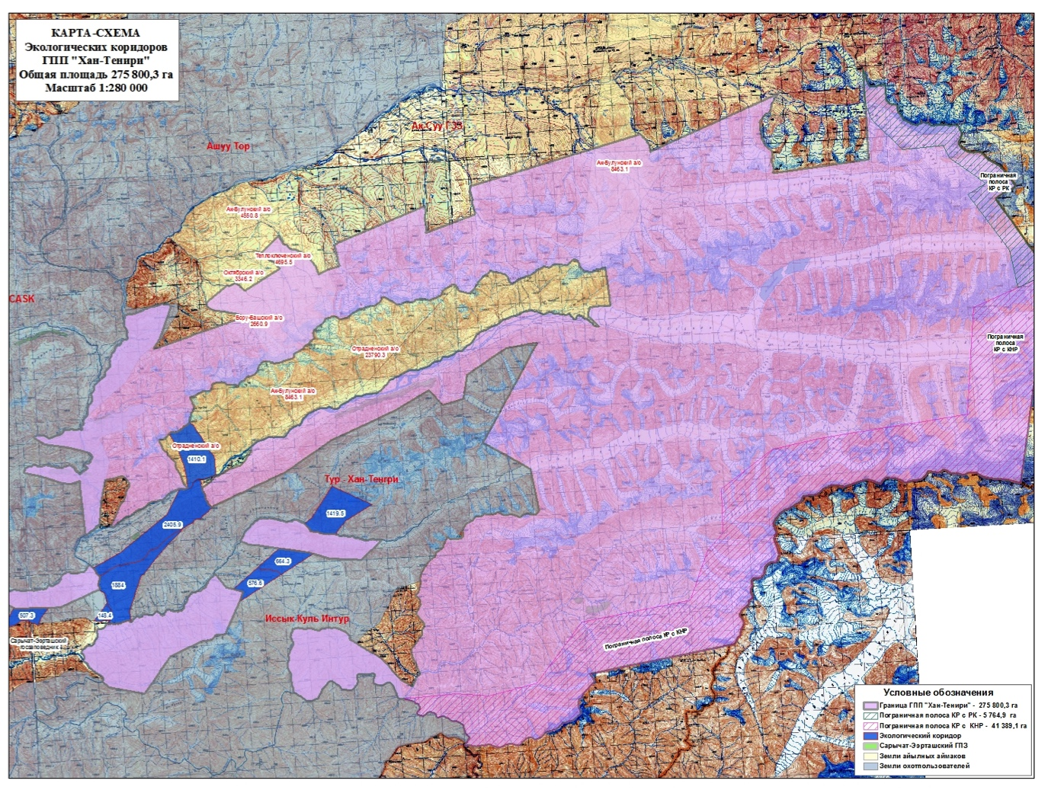
- While the project continued dialogue with Otrodnoe aiyl okmotu, the support from the other six aiyl okmotus fluctuated, and at various times there was a risk of losing support from the communities that had already agreed to support establishment of the park. In late 2015 the project mid-term review was held. The recommendations of the mid-term review along with the overall situation of the project, which was clearly becoming urgent, necessitated a decision from the Project Board at its December 2015 meeting on how to proceed: whether to postpone establishment of the national park further to continue dialogue with Otrodnoe and risk losing establishment of the PA altogether, or to proceed with establishment of the national park with boundaries excluding the Otrodnoe lands.
- The mid-term review had proposed continuing the dialogue up until September 2016, at which point the project should be closed if the national park had not been established. However, at its December 18, 2015 meeting the Project Board voted to proceed with establishment of the national park excluding the Otrodnoe lands. The necessary procedures were initiated within the government, and on February 12, 2016 the national park was formally established. The area of the national park is shown in Figure 8 above. The territorial contributions to the final area is shown in Table 9 below.
Table 9 Entities Contributing Territory to Establishment of Khan Tengri National Park
Entity | Area Contributed (ha)
Ak-Bulan aiyl okmotu | 6,532.6
Boru-Bash aiyl okmotu | 2,068.5
Chelpek aiyl okmotu | 4,646.6
Kerege-Tash aiyl okmotu | 15,440.3
Oktyabr aiyl okmotu | 1,785.0
Otrodnoe aiyl okmotu | 0
Teplklyuchenka aiyl okmotu | 9,835.3
Ak-su District | 205,117.9
Karakol Forestry | 30,374.1
Total | 275,800.3

- One interesting and innovative approach used to secure the support from the communities in question is an agreement between the national park and the communities that if the national park leases any of the former community lands for grazing (livestock grazing is allowed in the lower-protection zones of the national park), then this revenue will be transferred to the communities whose original lands are allocated under the lease. The actual implementation of this agreement seems unlikely (it seems unlikely that the national park would bother with leases that it won’t benefit from financially), but it is a safety mechanism to assure the communities involved that they aren’t foregoing potential income by contributing their lands for establishment of the national park.
- Dialogue with Otrodnoe representatives has continued even following the establishment of the national park. This included the participation of the head of Otrodnoe village in a study tour the project conducted for local stakeholders in 2016 to two protected areas in Kyrgyzstan. The village head expressed his personal support for Khan Tengri National Park, but he was evidently not able to secure full agreement from all village deputies. Until the last two months of the project the project reserved approximately $15,000 to micro-grants in Otrodnoe village if the community decided to contribute the 25,000 hectares in question to the national park. UNDP also sent numerous formal letters to Otrodnoe requesting their reconsideration of the issue. According to Otrodnoe representatives met during the terminal evaluation, the issue has been discussed further by the community, but without reaching consensus on the issue. Kyrgyzstan held local elections in late 2016, and there was some prospect that the Otrodnoe deputy(ies) opposed to contributing the lands to the national park would not be re-elected, but this did not occur.
Figure 9 Key biodiversity areas excluded from or partially covered by Khan Tengri NP
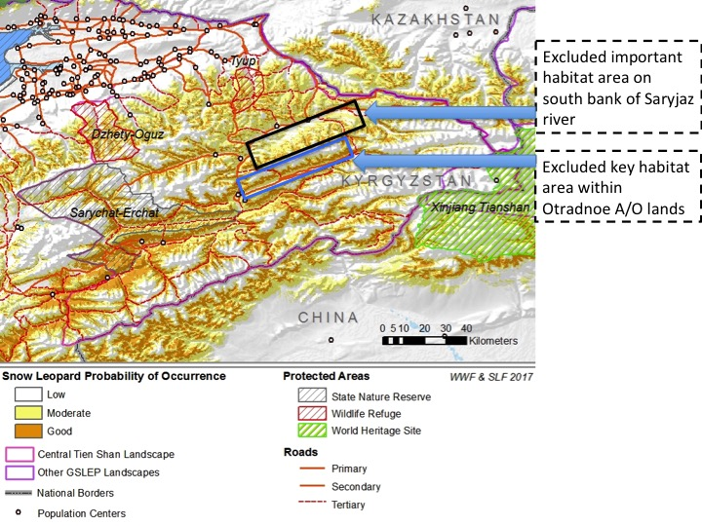
Source: Map from Snow Leopard Trust / GSLEP.
- While the project was ultimately successful in establishing the national park, there are some caveats and minor qualifications to this result. Although the size of the Khan Tengri National Park is much larger than originally planned, some areas identified as key habitats for snow leopards and their prey species were not included within the boundaries of the national park. Also, much of the park area does not represent important biodiversity habitat, as it consists of high elevation rocks and ice. The key habitat area that was excluded consists primarily of approximately 25,097 ha on the north bank of the Enilchik River (for which the Otradnoe A/O has usufruct rights), which forms an enclave within the boundaries of the national park. Figure 9 above highlights the key habitat area that is part of the Otradnoe lands and which was not included into the official boundaries of the national park. In addition, some key habitat area on the south bank of the Saryjaz River was also not included due to mining claims in this area. Therefore there is a consideration of “quantity vs. quality” with respect to the area of the new national park. From the point of view of the terminal evaluation this is not a critical issue, as the area of the national park does still include a large amount of key habitat area, and there are not critical threats to the key habitat area outside the PA.
- As previously discussed in Section V.C of this report, on Stakeholder Engagement, although the lack of formal consent from Otrodnoe for the community lands to be included in Khan Tengri National Park has some possible negative ecological implications, this issue can also be seen as a testament to the project’s rights-based approach, and to the quality of democracy in Kyrgyzstan. Globally, there is a long negative history of protected areas leading to displacement of local communities, and the loss of local access and use rights. The fact that Otrodnoe’s wishes have been respected provides a positive mark for the reputation of protected areas within Kyrgyzstan and globally, even though this is against the project’s immediate goals.
Figure 10 Clockwise from top left: Khan Tengri National Park Headquarters Renovation, Equipment Purchased by the Project, Equipment Storage, Headquarters Opening Ceremonies
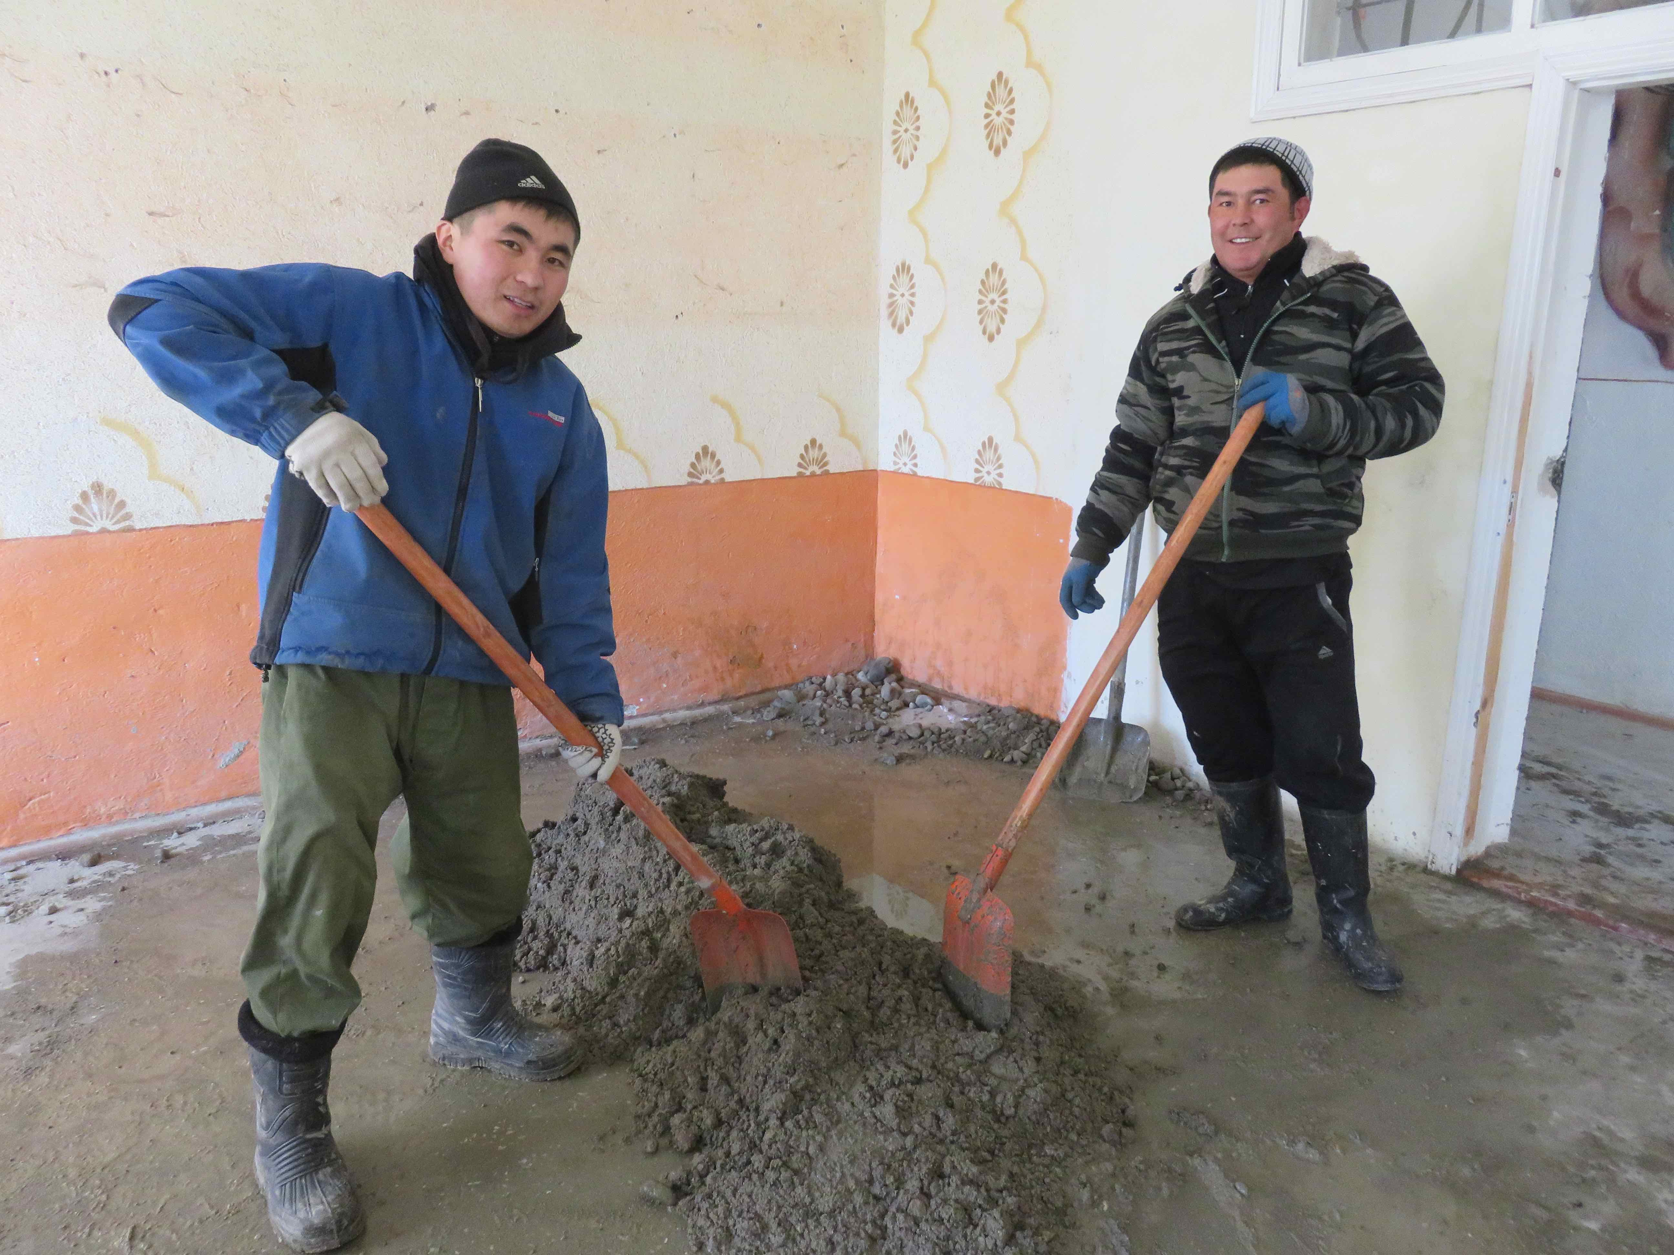 | 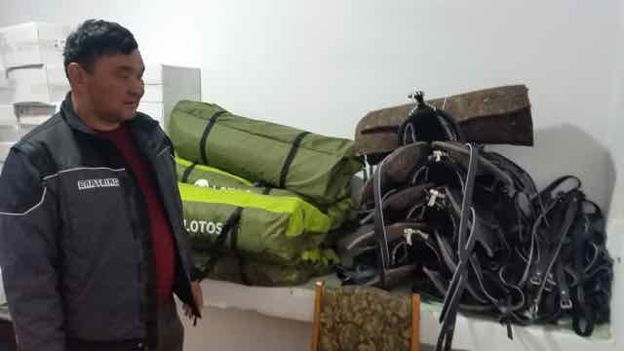
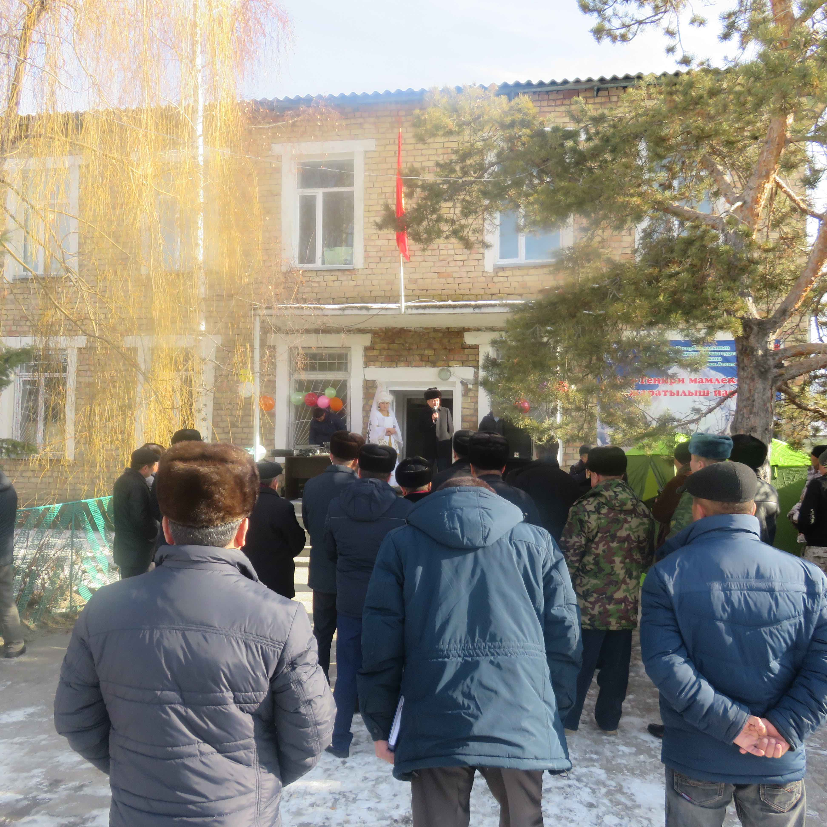 | 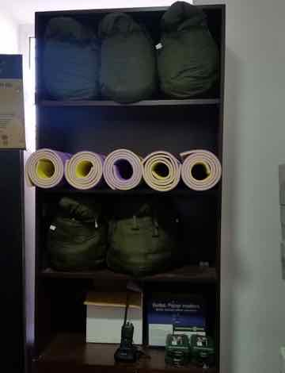

- Following establishment of the national park the project continued work to operationalize the PA, including equipping the staff with office equipment, books, uniforms, field equipment (tents, etc.), GPS units, a camera, binoculars, saddles, etc. (see Figure 10) One of the more interesting and challenging financial management activities of the project was the process of procuring 19 horses for the national park; the Kyrgyzstan UNDP procurement office had never dealt with the procurement of horses before. The Khan Tengri National Park staff used their own labor to renovate an abandoned building in approximately 1.5 months for park administration offices, with significant financial support from the project for renovation materials and tools (also see Figure 10). The project also allocated money for the construction of four ranger stations in the national park territory, which were being completed during the final few months of the project. The direct of the national park is a former head of Ak-su district, and the national park staff were comprised from the Karakol forestry unit, the nearby Karakol National Park, and the local branch of the hunting inspectorate. Many of the staff members employed by the park are originally from Enilchik village, the closest community to the national park territory.
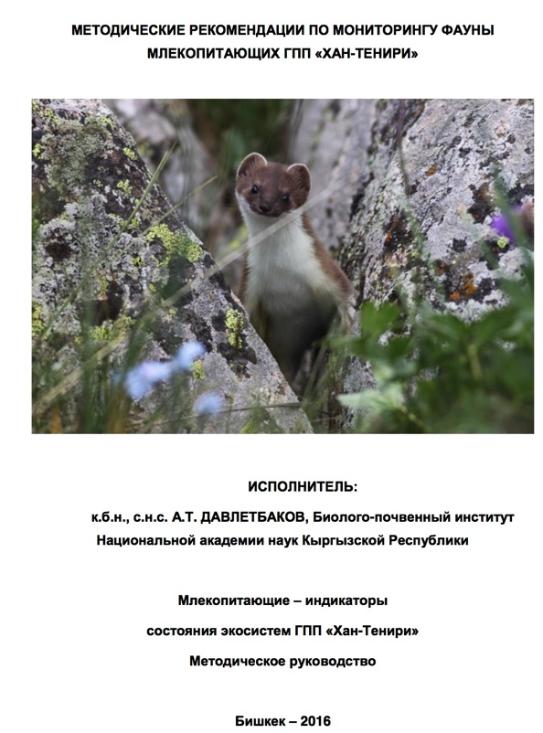
- With the project’s support, the management plan for Khan Tengri National Park was approved via order from SAEPF on May 26, 2017. The national park includes four zones: A. Limited economic activity zone (i.e. “internal buffer zone”) (50,209.3 ha - 18%); B. Tourism zone (11,117 ha – 4%); C. “Core” (zapovednik) zone (201,729 ha – 73%); D. Ecological stabilization zone (degraded land to be restored) (12,743 ha – 5%). A qualitative survey in Khan Tengri National Park was completed for the identification of zoning, demarcation of the zones, description of biodiversity values and environmental status, distribution and status of the most important and sensitive species, establishment of permanent monitoring plots, and GIS mapping. 20 permanent biodiversity monitoring plots were established. Monitoring plans were developed for flora and fauna in relation to the monitoring plots, and a program on long-term biodiversity monitoring was developed by researchers from the National Science Academy in close cooperation with Khan Tengri Park staff (see Figure 11). A management Advisory Body was also established in June 2016, with membership from local communities, the private sector, and local government stakeholders.
Figure 11 Recommendations for Monitoring Mammals in Khan Tengri National Park
- Under Output 1.2 the project achieved a number of important results. One important activity was that the project supported implementation of a provision of the 2014 hunting law that allowed for “freelance” wildlife inspectors, which essentially allows private citizens to act as game wardens to support enforcement of hunting laws and regulations. The motivation for private citizen participation is that freelance inspectors receive 30% of all financial penalties paid by the violators that they help catch. After an initial training program, once the freelance inspectors are provided ID cards by the hunting inspectorate. The project helped organize and train nine freelance inspectors in the two target districts. In close cooperation with the Department on Rational Use of the Natural Resources rangers and freelance inspectors, the project developed a patrol schedule and a reporting form. The reporting data includes number of violations, details about violations, penalties for violations, and the number of patrolling inspectors (rangers). GPS details have been introduced for patrolling.
- With the project’s support, and some accompanying factors, it appears that poaching has decreased, and prosecution of wildlife crime has increased. Information regarding wildlife law violation prosecution is included in the summary of results in the Strategic Results Framework, in Annex 10 of this report. In addition, some basic data was available for the terminal evaluation to assess the project’s contribution to reducing poaching in the region. According to the official statistics available for 2015 and 2016, in the two districts of Issyk-kul Province where the project was active – Ak-su district and Jety-Oguz district – the number of violations declined by 55% and 35% respectively, compared to a 5% decline for the rest of Issyk-kul province during the same period (see Table 11). This timeframe coincides with the implementation of the 2014 national hunting law as a whole, which significantly increased penalties for poachers. A one-year comparison is hardly enough data to draw concrete conclusions, but the difference in the decline between the project areas relative to the rest of Issyk-kul Province is so striking that it does make a case that the project likely made a real contribution to reducing poaching in the project area.
The monitoring visits and anti-poaching activities are very effective because teams go out to the field, and then local communities talk among themselves saying there are these visits, and saying if you get caught you will be in trouble.
– National Institutional Stakeholder
Table 11 Poaching Violations in Project Area Compared to Surrounding Area
Administrative Area | 2015 | 2016 | % Decline
Issyk-kul province excluding Ak-su and Jety-Oguz districts | 19 | 18 | 5%
Jety-Oguz district | 37 | 24 | 35%
Ak-su district | 22 | 10 | 55%

- The mid-term review recommended that the project introduce the “SMART” methodology for wildlife monitoring and patrolling. The project team discussed the feasibility of this with SAEPF, but determined that there wouldn’t be sufficient resources to introduce and sustain this approach other than within Khan Tengri National Park, so this idea was dropped.
- Some of the training done in relation to supporting the freelance inspectors also falls under the Output 1.3 of the project, on capacity development. This is further linked with Output 1.4. A training of the use of METT as a tool for monitoring the management effectiveness of protected areas was carried out in June 2014, and the METT was applied to both the Sarychat-Eertash zapovednik and Khan Tengri National Park (the METT score for these PAs is one of the project results indicators), as well 17 other protected areas within the country.

Outcome 2: Habitat connectivity, sustainability, and effectiveness of PAs in Central Tian Shan are enhanced by regulating land use in buffer zones, wildlife corridors and other intervening landscapes
- The second outcome of the project targets the second barrier to realizing a strategic, landscape-based approach to protected area expansion and management in the Central Tian Shan landscape – namely the lack of continuity and congruence between conservation actions within the confines of a PA and activities occurring adjacent to PAs. It aimed to increase the sustainability of PAs by enhancing the conservation-friendliness of intervening landscape areas. The total GEF funding for Outcome 2 was originally planned at $505,000 USD, which is 53.2% of the total GEF funding for the project; actual expenditure as of March 31, 2017 was $432,694. The activities foreseen under this component are organized around six key outputs:
- Output 2.1. Amendments to the Law on Protected Areas that define procedures for the establishment, operation, and enforcement of PA buffer zones and wildlife corridors
- Output 2.2. Identification and designation of buffer zones for the new PA at Khan Tengri and wildlife corridors between Khan Tengri and Sarychat-Ertash NR
- Output 2.3. Conservation management objectives of the PAs, buffer zones, and corridors aligned with territorial land use plans of five adjoining rural districts
- Output 2.4 Agreements with local land users on modified patterns of resource use, and a system is in place for enforcement of new regulations
- Output 2.5 Alternative livelihoods program for local communities designed and launched
- Output 2.6: Training workshops for local authorities from other districts spanning the Tian Shan Mountains on how to account for biodiversity conservation considerations in territorial planning and on enforcement of regulations, using the experience of the Khan Tengri and Sarychat-Ertash PAs
- Key results indicators for Outcome 2 are summarized in Table 12 below.
Table 12 Outcome 2 Indicators and Targets
Indicator | Baseline | Target | Status
Law on SPNAs provides clear guidance on establishment, management, and responsible party for PA buffer zones and wildlife corridors | Current law is unclear | Legislation improved through amendments by project end | Achieved / achievement likely
The area of the ecologically important areas surrounding protected areas and corridors within which natural resource management agreements (with stakeholders) are developed and implemented | 0 ha | 200 000 ha | Achieved / exceeded
Better management of hunting in buffers and corridors as reflected in percent of trophy hunting that is controlled and monitored | Only 30% of trophy hunting is legal because hunters are uncontrolled and unmonitored | 90% of trophy hunting is legally licensed | Achieved / not applicable
Prosecution of illegal hunting in ecologically important areas surrounding protected areas and corridors | Only 10% of incidents of illegal hunting successfully prosecuted | At least 50% of incidents of illegal hunting successfully prosecuted from Year 4 onwards | Achieved / exceeded
Increase in share of incomes of local communities from biodiversity-compatible alternative livelihood activities | More than 60% of income comes from hunting | By project end, at least 60 % of income comes from sustainable livelihoods promoted by the project | Not applicable
Reduced hunting among people using grazing pastures within the protected area once it has been established | 500 persons hunting in the area | 150 (reduced by 1/3) persons hunting by project end | Achieved / exceeded

- Under Output 2.1 the project supported three laws related to PAs that were approved by decree of the Government of the Kyrgyz Republic: The Regulation on Protected Area establishment, change of category, approval of borders and liquidation in the Kyrgyz Republic (Decree on 30 July, 2015; #541); Regulation on land use of the State Nature Parks (approved by Government of the Kyrgyz Republic Decree from 5 October, 2015; #677); Regulation on Red Data Book of the Kyrgyz Republic (approved by Government of the Kyrgyz Republic Decree from 11 April, 2016 #189). The project also proposed an amendment to national law on PAs regarding the establishment of ecological corridors, which is in final stages of approval; this law could not be start the process for approval without the previous amendment to the protected areas law, which was necessary to identify the category of “corridors” as a type of protected area in Kyrgyzstan. The project also analyzed legislation from other sectors (i.e. agriculture, etc.) and made recommendations to SAEPF about revisions and amendments to support integrated land-use planning and management.
- Outputs 2.2, 2.3, and 2.4 all relate to the project’s work to develop land-use planning mechanisms for the landscape beyond the boundaries of Khan Tengri National Park. As previously mentioned, the project was highly effective in this overall result, establishing biodiversity sensitive land-use regimes in 364,230.9 hectares (compared to an original target of 200,000 hectares). Combined with the protected areas in the Central Tian Shan region, this equates to a total of 789,149.1 ha, or approximately 60% of Kyrgyzstan’s entire Central Tian Shan landscape, including much of the best snow leopard habitat. This is a significant contribution toward Kyrgyzstan’s commitment to secure its two priority snow leopard landscapes by 2020, as part of the Global Snow Leopard and Ecosystem Conservation Program (GSLEP). There is currently a national activity to develop a landscape-level management plan to fully secure Kyrgyzstan’s Central Tian Shan landscape, and this will build and draw on the results and efforts of the project.
[With respect to snow leopard conservation] One of the things we’ve realized is that the overemphasis on PAs is actually damaging, because much of the strategy for PAs is curbing and stopping human use completely, but research is showing that there are ways that you can manage the pressures in the wider landscape.
- Civil Society Stakeholder
- The project applied three types of land-use management approaches to secure key habitat areas beyond the borders of the protected areas: 1. Designated ecological corridors (9,074.6 ha); 2. “Quiet zones” of hunting areas (~75,970 ha); and 3. PA external buffer zones (272.586.6 ha). The ecological corridors have not yet been secured at the national level since the national legislation recognizing this land-use category has not yet been fully approved, but the project established the corridors under agreements with Ak-su district. The eight individual corridors are shown in blue in the previous Figure 8. The corridors do not make up a large area, but they are critical for wildlife as they allow connections between parts of Khan Tengri National Park. In addition they create a direct connection between Khan Tengri National Park and Sarychat-Eertash zapovednik. The “quiet zones” of hunting areas is another provision of the 2014 hunting law, which the project helped implement in the area around these two PAs. The law specifies that 10% of hunting concession territory should be set aside as off-limits for hunting each year. The project worked with the hunting companies to identify key habitat areas that should be included in the quiet zone, such as important calving areas, and key migration routes. For the PA buffer zones the project worked with the aiyl okmotus and Khan Tengri National Park to established signed agreements for the land-use regimes of the aiyl okmotu lands bordering the national park. Another important result was a Memorandum of Understating that was signed between the Department on Rational Use of Nature Resources (i.e. “Hunting Department”), Department on Pastures, and Department on Tourism regarding the integration of biodiversity in relevant policy and developments plans and collaboration in policy implementation.
- Output 2.5 related to the alternative livelihood micro-grant program. A summary of the micro-capital grants is included as Annex 11 of this report, and some examples visited during the terminal evaluation mission are shown in Figure 12 below. As previously indicated, this activity was highly successful: The project invested $139,000 in 16 sustainable livelihood micro-grant projects in seven A/Os, creating 92 jobs. These projects have 287 direct beneficiaries, of which 157 (55%) are women. These projects also have more than 27,500 indirect beneficiaries, of which at least 28% are women.
- One issue with this output was that establishing the national park took longer than originally planned (due to the extended negotiations with the Otradnoe A/O), and so it was only possible to implement the micro-grants program within the last nine months of the project, which has left insufficient time to fully monitor and document the actual results from the micro-grant program. This evaluation recommends that UNDP continue to track the results of the micro-grant program, even though the project is ending, in collaboration with the participating A/O administrations. In particular, the effectiveness of the grants accessed by women participants should be analyzed in relation to the grants accessed by men participants, in order to identify good practices and lessons for other potential similar activities in the future.
- One notable development related to the micro-grants program was that it apparently incentivized other local communities to want to support the national park as well. Kara-Jal aiyl okmotu was not directly targeted by the project but did have some land near the proposed national park. After hearing about the micro-grants program Kara-Jal wanted to contribute 3,242 ha of their 8,390 ha to the territory of the national park; however the national park had already been established, and it wasn’t feasible to amend the boundaries for this small of a territorial addition. The Kara-Jal land was included in the national park buffer zone.
Figure 12 Examples of Sustainable Livelihoods Micro-grant Projects, clockwise from top left: Organic bakery equipment, greenhouse using biogas, dairy processing, another greenhouse
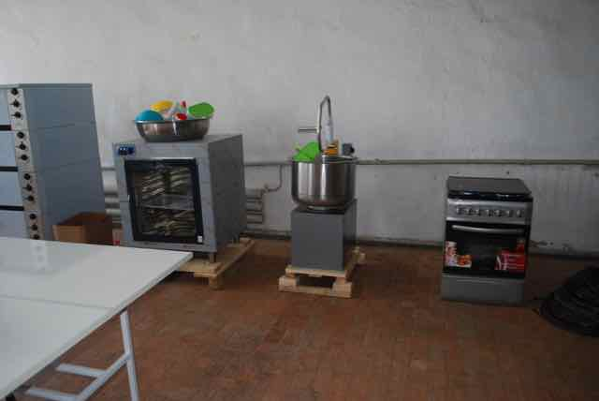 | 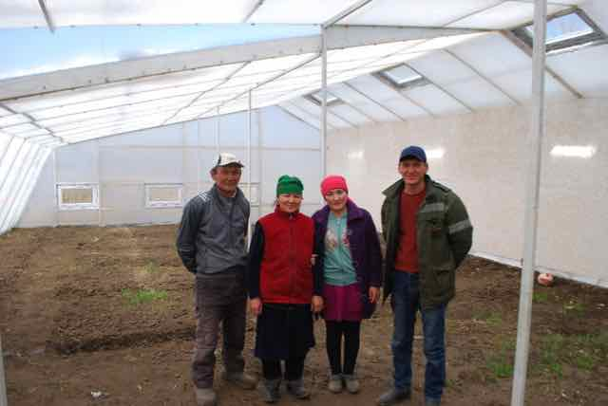
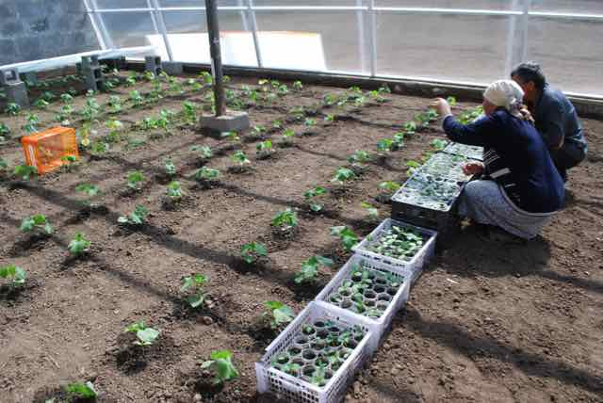 | 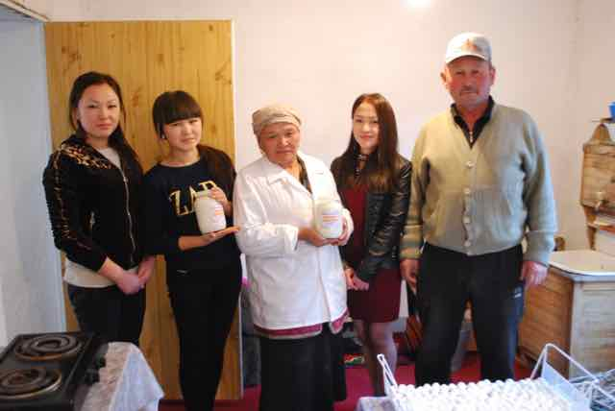

Impacts and Global Environmental Benefits
- For the GEF biodiversity focal area project impacts are defined as documented changes in environmental status of species, ecosystems or genetic biodiversity resources. Global Environmental Benefits have not been explicitly defined, but are generally considered to involve sustained impact level results of a certain scale or significance. The project document identifies the specific Global Environmental Benefits that the Central Tian Shan Project is expected to contribute to (p. 16 of the Prodoc). The Central Tian Shan project results framework does include some impact level indicators, particularly related to a reduction in the threats from poaching. An indicator related to snow leopard populations is also included.
It’s too early to say that there is an increase in the population of Marco Polo sheep, but there are pre-requisites for the increase in their population, because we noticed changes in their behavior, they are calmer.
- National Institutional Stakeholder
- The project has contributed to some site-based impact-level results, including reduced illegal hunting in the target area, and the expansion of the range of wildlife into corridors and other areas previously avoided (anecdotally indicated). The project has arguably contributed to a decline in poaching in the target region, although a more systematic study over a longer period of time would be required to determine this for certain. According to government statistics, the number of poaching incidents recorded declined in Ak-su district by 55% and in Jety-Oguz district by 35% from 2015 to 2016, while there was only a 5% decline on average in the other three districts of Issky-kul province. In addition, the project catalyzed improved reporting on wildlife crime prosecution, which seems to have contributed to improved prosecution – therefore likely a decrease in additional poaching.
- Although it is probably too early to be able to detect measurable changes in wildlife populations as a result of project activities, the terminal evaluation analyzed official national wildlife census data for Issyk-kul province relative to the rest of the country. However, the data presented too inconsistent of a picture to be able to draw any conclusions. For example, the number of brown bear in Issyk-kul province jumped from 43 individuals to 116 individuals from 2013-2014, while remaining relatively constant for the rest of the country. The total figures for snow leopard do show an 18% increase from 2013-2016 in Issyk-kul compared to a 5% increase for the rest of the country – but it is well-known that snow leopards are very poorly monitored, and these figures can only be considered a very rough estimate. The trend in the ibex population in Issyk-kul has roughly mirrored the rest of the country.
In one of the forestry entities that was included in the national park there was almost no wildlife just a few years ago. During this one year of the existence of the national park, illegal hunting and poaching was stopped in this territory. In this one year, 27 head of wild goats and sheep migrated to that area.
- Protected area representative
- The project has been one important factor that should lead to impact level results in the future. The project coincided with the start of the 2014 hunting law, which significantly improved the situation for wildlife management in Kyrgyzstan. The law reduced the number of hunting concessions in the country (a shift from “quantity to quality”), and adjusted the permissible harvest figures for key game species, which also happen to be important prey species for the snow leopard. The law allows only 1% of the population of mountain sheep to be hunted annually, and 4% of ibex; the national allowed take of ibex previously was 15% of the population.
- Impact ratings for the project are given as follows:
- Environmental status improvement is assessed as minimal;
- Environmental stress reduction is assessed as significant; and
- Progress toward stress/status change is assessed as significant.

Key GEF Performance Parameters
- Sustainability is one of the five main evaluation criteria, as well as being considered one of the GEF operational principles. Other GEF operational principles not otherwise addressed are discussed below, including the project’s catalytic role and stakeholder participation.
- UNDP-GEF project evaluations are also required to discuss the mainstreaming of UNDP program principles. This is covered in Annex 12 of this evaluation report.

Sustainability
- While a sustainability rating is provided here as required, sustainability is a temporal and dynamic state that is influenced by a broad range of constantly shifting factors. It should be kept in mind that the important aspect of sustainability of GEF projects is the sustainability of results, not necessarily the sustainability of activities that produced results. In the context of GEF projects there is no clearly defined timeframe for which results should be sustained, although it is implied that they should be sustained indefinitely. When evaluating sustainability, the greater the time horizon, the lower the degree of certainty possible.
- Based on GEF evaluation policies and procedures, the overall rating for sustainability cannot be higher than the lowest rating for any of the individual components. Therefore the overall sustainability rating for the Central Tian Shan project is likely.

Financial Risks
- While financial resources are always an important consideration, in the case of the Central Tian Shan project, financial risks to sustainability of project results are considered low, and sustainability in this regard is considered likely. The main consideration with respect to financial sustainability is the extent to which the management of Khan Tengri National Park will be funded in the coming years; the SAEPF has committed the budget amount allocated for Khan Tengri National Park for 2017 of 51,413 USD; the SAEPF approves its budget annually. The project also hired a consultant to develop a sustainable finance plan for Khan Tengri Park, which included calculating funding needs and possibilities for Khan Tengri Park for the coming 3 -5 years. Khan Tengri National Park will also be getting support from the national environmental fund for items such as vehicles, and other important management inputs.
- Few project results require additional financial resources in order for the benefits to be sustained. For example, legislation has been approved and stakeholder agreements are in place to continue support for the project results. The micro-grants program itself may not be fully sustained in its current form, but it was never intended to be. It was designed as a one-time program to provide support for the local communities that allocated their land-use rights on territory included within the boundaries of the national park. The fact that the micro-grant program will be continued and supported further by the GEF Small Grants Program in Kyrgyzstan is an additional achievement. Furthermore, SAEPF and UNDP are currently initiating a new protected areas project that will focus on the West Tian Shan region, but which will also continue national-level efforts related to protected area management, sustainable forest management, biodiversity corridors, and wildlife law enforcement.

Socio-political Risks
- Socio-economic risks to sustainability are also limited, and sustainability in this regard is considered likely. Local communities are by and large supportive of the newly established national park, and are supportive of the management regimes that have been agreed for the buffer zones and corridors. However it will be critical that the Khan Tengri National Park administration is proactive, open, transparent, and flexible in all aspects of PA management related to local communities as management arrangements are fully implemented. One of the key recommendations of this evaluation is that a local stakeholder management council for the Khan Tengri National Park should be established, as a mechanism for community-level input to management activities of the National Park.

Institutional and Governance Risks
- Institutional and governance issues related to sustainability are not significant, thus sustainability in this regard is considered likely. SAEPF is a highly committed partner with no immediate critical institutional risks (i.e. such as facing large-scale restructuring, or massive institutional turmoil). Issyk-kul provincial administration, and Ak-su and Jety-Oguz district level administrations are also highly supportive of maintaining and continuing the project results.

Environmental Risks
- Environmental risks to sustainability are also not critical, and this aspect of sustainability is considered likely. There are some long-term environmental concerns that need to be monitored, but these are not expected to affect the project results in any major way in the near to mid-term future. These issues include: a.) The future impacts of climate change (which may be significant in high mountain ecosystems); b) The potential for mining exploration in some areas near the park buffer zones; c.) The sustainability of grazing regimes in the national park buffer zones; and d.) Any future expansion of trophy hunting activities on community lands bordering Khan Tengri National Park.

Catalytic Role: Replication and Up-scaling
- As highlighted in Section VI on effectiveness and results, there are many aspects of the project that may or have already influenced the national level in Kyrgyzstan, including the project’s contribution to the development, approval and implementation of multiple pieces of national level legislation. Perhaps most significantly is the project’s work to codify the possibility for biodiversity conservation corridors outside of protected areas within the national protected areas legislation.
- Many of the project activities and outputs may also be replicated and scaled-up. These include the following:
- The project’s work to support implementation of the “freelance wildlife ranger” portion of the national hunting law;
- The project’s work on other aspects of wildlife law enforcement, including the model established for reporting on the actual enforcement of laws based on the conviction rate;
- The agreements put in place with local communities for PA buffer zone lands to support sustainable grazing approaches;
- The cooperation with private sector trophy hunting enterprises to implement revisions to the national hunting law, and other elements such as the 10% of hunting concessions being designated as “quiet zones”.
- Many of the project’s good practices and lessons will be incorporated in a new GEF-funded project (an additional collaboration between UNDP and the SAEPF) that will be working in the Western Tian Shan. The Western Tian Shan project will also carry further many of the project’s national-level efforts, such as those related to legislation revisions, wildlife law enforcement, and snow leopard monitoring and conservation.

Main Lessons Learned and Recommendations

Lessons from the Experience of the Central Tian Shan Project
- The terminal evaluation has identified the below notable lessons from the experience of the Central Tian Shan project. These lessons should be aggregated by UNDP and the Government of Kyrgyzstan for application to other similar future initiatives.
- Lesson: The “perfect” can be the enemy of the “good”. The project considered halting approval of the proposed Khan Tengri National Park until all relevant local administrations had agreed to allocate their territory for the national park. However, delaying the process further could have risked the entire result, as the support of all other relevant stakeholders was dynamic. Ultimately the Project Board decided to proceed, leaving some key territory of one local administration out of the boundaries of the proposed national park. In practical terms, this is likely to have relatively little effect on the status of biodiversity – although the excluded land represents some critical habitat for snow leopards and their prey, this land is not currently actively used for grazing or any other economic activity. If the land were leased to a trophy hunting company it would have some negative impact, but the activities would still be subject to the national wildlife management regime, which is designed to be biologically sustainable. If the project had not proceeded, all of the major achievements of the project would likely have been lost, or greatly diminished; the establishment of the largest protected area in the country is a highly significant achievement for the conservation of biodiversity, even if the official boundaries of the national park are not ideal.
- Lesson: Conservative planning with respect to project timeframes can deliver a payoff. Implementing a $0.95 million USD project over four years has some risks with respect to cost-effectiveness (i.e. the longer the project period, the higher the percentage of management, administration and overhead costs). However, allowing for this time period meant that the project could encounter some delays, yet still finish according to the originally planned schedule, rather than requiring a no-cost extension as most GEF projects do. In addition, the project was able to deliver the planned key results while keeping management costs within the required limits – likely thanks to good planning done early on that foresaw a 48-month implementation period.
- Lesson: Often times the missing element for success is just a line of communication between relevant parties. The project helped facilitate a mechanism whereby the courts report to the hunting authorities confirmation of convicted cases for wildlife crimes in Issyk-kul province. This has allowed the hunting authorities to actually track this information in detail, which was not previously happening.
- Lesson: The influence of democracy in Kyrgyzstan should not be taken for granted. Although the issue with Otrodnoe village was overall not positive for the project objective, it is impressive that a single local administration can have such a large effect on an issue that is a priority of the president of the country. Although it was not in alignment with the wishes of many powerful stakeholders, the position of Otrodnoe village has been respected.
- Lesson: When seeking the approval of local stakeholders regarding conservation issues, it may be more effective to present incentives early on in the process to build trust and relationships prior to asking for something in return. In the case of the Central Tian Shan project, the micro-grants program was not planned for implementation until after the establishment of the Khan Tengri National Park; however, the establishment of the park was dependent on the agreement of all relevant local administrations. The approach in any such situation needs to be carefully analyzed in order to determine whether it is best to provide positive incentives before a decision is requested, or to withhold incentives until consent is given.
- Lesson: A well-developed communications strategy can pay significant dividends. The communications plans and efforts of the project have been given little recognition in the internal project documents, but the project actually had a well-developed and timely approach to communications – at least relative to many GEF projects. It is not possible to prove, but it is highly likely that this strong communications approach contributed to the project’s success in significant ways. Communications activities are key to building partnerships and engaging stakeholders.

Recommendations for Consolidating Results and Supporting Sustainability of the Central Tian Shan Project
- The recommendations of the terminal evaluation are listed below, with the primary target audience for each recommendation following in brackets.
- Key Recommendation 1: A local community management council should be established for Khan Tengri National Park, as a mechanism for local communities to provide input to management activities of the National park. Such a body need not have binding authority over management of the National Park, but there needs to be a formal mechanism consisting of various stakeholder representatives, that meets regularly (i.e. quarterly) to review and provide input on management issues related to the National Park. This body should be instituted and facilitated by the Khan Tengri National Park administration, with support from Ak-su rayon. [SAEPF]
- Key Recommendation 2: SAEPF should collaborate with the Ministry of Agriculture and Kyrgyzgyprozem to support the Khan Tengri National Park administration to develop sustainable grazing plans for grazing lands within the PA buffer zones, in collaboration with local Pasture Management Committees using the PA buffer zones. [SAEPF]
- Key Recommendation 3: UNDP should determine how to best develop and leverage micro-grant / micro-finance activities within its overall portfolio for the long-term – within Kyrgyzstan, as well as globally. Many projects utilize micro-grant activities, but these are always one-time stand-alone outputs that are not then well integrated into a larger strategy or designed to be sustainable. There is significant potential to scale-up and replicate the good practice models of these micro-grant activities, but this should be done as part of a larger, broader UNDP micro-grant or micro-finance program, as it is not realistic to expect this from individual projects that apply these mechanisms. Such an approach could potentially be developed within the UNDP-GEF Small Grants Program, but such an approach would need significant planning and consultation, especially if it were implemented at the global level. [UNDP]
- Key Recommendation 4: The overall project exit strategy appears to be adequate, but the project must ensure that all key individual lower-level results have clear hand-off and continuation agreements in place. For example, the excellent initiative on wildlife crime reporting between the courts and the regional wildlife inspectors division should be continued. The project team and UNDP should also provide a short summary document to SAEPF highlighting the key practices and results that should be scaled-up to the national level (e.g. freelance inspectors; wildlife crime reporting; PA corridor agreements; biodiversity monitoring; cooperation with private hunting companies and establishment of “quiet zones” in hunting concessions; etc.). [Project Team and UNDP]
- Key Recommendation 5: The project should work with Ak-su rayon and Khan Tengri National Park to produce a signed agreement that both of these bodies will continue to work with Otradnoe A/O on the consideration of inclusion of the Otradnoe community lands within the National Park territory. A focal point for this issue should be designated within both the Ak-su rayon administration and the Khan Tengri National Park administration. [Project Team]
- Key Recommendation 6: As soon as it is feasible, UNDP should facilitate an information exchange meeting and process between the project team of the Central Tian Shan project and the project team of the new West Tian Shan project. During this process the planned activities for the West Tian Shan project should be jointly reviewed, and the Central Tian Shan project team should provide input to ensure that the West Tian Shan project activities are designed and planned taking into consideration all of the good practices and replicable models from the Central Tian Shan project. [UNDP]
- Key Recommendation 7: Even though the project is ending, UNDP should track the results of the micro-grant program to the extent feasible, in collaboration with the participating A/O administrations. In particular, the effectiveness of the grants for women participants compared to men participants should be analyzed in order to identify lessons and good practices for future similar programs. [UNDP]
- Recommendation 8: UNDP should in all future projects in Kyrgyzstan ensure that UNDP and GEF gender mainstreaming strategies and action plans are fully integrated throughout the project cycle. This includes, most critically, the project design phase. At this stage project-related decision-making mechanisms should be designed to ensure gender-mainstreaming perspectives are adequately represented. This should include either a large share of female representation, or in cases where this is not feasible due to the unavailability of technically qualified persons, then a special gender mainstreaming representative should be included among the decision-making body participants. [UNDP]

Annexes
Annex 1: Terms of Reference
Annex 2: GEF Operational Principles
Annex 3: Kyrgyzstan Central Tian Shan Project Terminal Evaluation Matrix
Annex 4: Interview Guide
Annex 5: Rating Scales
Annex 6: Central Tian Shan Terminal Evaluation Mission Itinerary
Annex 7: Documents Reviewed
Annex 8: Kyrgyzstan Central Tian Shan Project Stakeholders
Annex 9: Kyrgyzstan Central Tian Shan Project Financial Tables
Annex 10: Central Tian Shan Project Results Framework Assessed Level of Indicator Target Achievement
Annex 11: Summary List of Micro-Capital Grants Projects
Annex 12: Kyrgyzstan Central Tian Shan Project Mainstreaming of UNDP Programme Principles

Annex 1: Terms of Reference

Terms of Reference
for TERMINAL Evaluation:

Project Title: “Improving the Coverage and Management Effectiveness of Protected Areas in the Central Tian Shan Mountains”

Functional Title: International Consultant for Terminal Evaluation

Duration: Estimated 20 working days during March-April 2017, including field mission to Kyrgyzstan: Bishkek and Karakol.

Terms of Payment: Lump sum payable upon satisfactory completion and approval by UNDP of all deliverables, including the Evaluation Report

Duty station: Home based with a week mission to Bishkek (7 calendar days)

Terminal Evaluation Terms of Reference

INTRODUCTION
In accordance with UNDP and GEF M&E policies and procedures, all full and medium-sized UNDP support GEF financed projects are required to undergo a terminal evaluation upon completion of implementation. These terms of reference (TOR) sets out the expectations for a Terminal Evaluation (TE) of Improving the Coverage and Management Effectiveness of PAs in the Central Tian Shan Mountains (PIMS#4934).
The essentials of the project to be evaluated are as follows:

Project Summary Table
Project Title: | “Improving the Coverage and Management Effectiveness of Protected Areas in the Central Tian Shan Mountains”
GEF Project ID:  UNDP GEF Project ID (PIMS): |  | #4844  #4934 |  | at endorsement (Million US$) | at completion (Million US$)
Atlas award ID:  Atlas project ID: |  | 00085844  00072819 | GEF financing: | 0.950 | 0.950
Country: |  | Kyrgyzstan | IA/EA own: | 1.6 | 1.2
Region: |  | Central Asia | Government: | 2.866 | 2.86
Focal Area: |  | Biodiversity | Other: | 0.5 | 0.32
FA Objectives, (OP/SP): |  |  | Total co-financing: | 4.966 | 4.38
Executing Agency: |  | UNDP | Total Project Cost: | 5.916 | 5.33
Other Partners involved: |  | The State Agency on Environment Protection and Forestry of the Government of the Kyrgyz Republic, Ak-Suu Raion State Administration, target local self governments in the Ak-Suu, Issyk-Kul region, National Science Academy | ProDoc Signature (date project began): |  | 27 May 2013
 |  |  | (Operational) Closing Date: | Proposed:  17 June 2013 | Actual:  17 June 2017

Objective and Scope
The TE will be conducted according to the guidance, rules and procedures established by UNDP and GEF as reflected in the UNDP Evaluation Guidance for GEF Financed Projects, in the GEF Monitoring and Evaluation policy: http://www.thegef.org/gef/sites/thegef.org/files/documents/ME_Policy_2010.pdf and guidelines for conducting evaluations: www.thegef.org/gef/node/1905; as well as the UNDP Monitoring and Evaluation Policy: http://web.undp.org/evaluation/policy.htm.
The objectives of the evaluation are to assess the achievement of project results, and to draw lessons that can both improve the sustainability of benefits from this project, and aid in the overall enhancement of UNDP programming.
The Project aims at conservation of globally significant biodiversity in Central Tian-Shan mountain ecosystems through strengthening the protected area (PAs) systems by expanding PAs from 149,119.9 ha (existing Sarychat Ertash reserve) to Up to 336,119.9 ha by end of the Project (EOP) in order to effectively protect snow leopard habitat in the Central Tian Shan Mountains. The Project covers two outcomes: (1) threatened species representation is improved by increasing coverage and management effectiveness of protected areas (PAs) in Central Tian Shan; (2) habitat connectivity, sustainability, and effectiveness of PAs in Central Tian Shan are enhanced by regulating land use in buffer zones, wildlife corridors and other intervening landscapes.

Outcome 1:
Revised Indicators and Targets for Project End Date (2015):
- Enhanced management effectiveness of target PAs (as measured by METT) for the Sarychat-Eertash Reserve – 75%, the State Nature Park “Khan-Teniri” – 28%;
- Reduction in poaching and illegal logging at target PAs (annual) per unit of patrolling effort, compared with year of initial patrolling: reduction by 30%; Illegal logging violations: 33; poaching violations: 47; total violations: 80.

Outcome 2:
Revised Indicators and Targets for Project End Date (2015):
- Law on SPNAs provides clear guidance on establishment, management, and responsible party for ecologically important surrounding areas and wildlife corridors;
- The area of the ecologically important areas surrounding protected areas and corridors 200,000ha within which natural resource management agreements (with stakeholders) are developed and implemented;
- At least 50% of incidents of illegal hunting successfully prosecuted in Sarychat-Eertash Reserve, Khan-Teniri Park, the ecologically important areas surrounding protected areas, corridors;
- Increase in share of incomes of local communities from biodiversity-compatible alternative livelihood activities at least 60% of income comes from sustainable livelihoods promoted by the project;
- Reduced hunting among people using grazing pastures within the KTNP once it has been established.
The Project has primary results summarized below:
- The State Natural Park "Khan Teniri" was established with total area of 275,800.3 ha (Decree of Government of the Kyrgyz Republic dated from February 12, 2016 62), thereby the protected areas in Central Tien Shan has been expanded from existing 149,117.9 ha. to 424,918.20 ha. PA boundaries demarcated. Qualitative survey in Khan-Teniri Park has been accomplished: zoning, demarcation of the zones, description of biodiversity values and environmental state, distribution, ecological and environmental state for the most important and sensitive species, establishing permanent monitoring plots, mapping through the GIS.
- Management Plan of the Khan-Teniri is being developed.
- 20 permanent monitoring plots were established for biodiversity monitoring
- Passports for each plot, programme for long-term biodiversity monitoring have been developed.
- The Khan-Teniri rangers and research staff were trained in conducting biodiversity monitoring.
- Rangers guidebook has been developed and distributed to PAs rangers.
- Khan-Teniri Park staff provided with office equipment, uniforms, cameras, GPS navigators and other equipment for efficiency of their work in nature conservation and wildlife observation.
- Construction of four ranger houses in the "Khan-Teniri" Park is in the process.
- Management effectiveness (using METT) of the target PAs were assessed: Sarychat-Eertash – 71 and Khan-Teniri – 53 score.
- No illegal poaching and logging detected in the target protected areas for the last year (2016).
- The Department on Natural Resources Conservation rangers’ and freelance inspectors regularly patrol the surrounding territories and ecological corridors.
- Project supported the following legislations development:
  - The Regulation on PA establishment, change of category, approval of borders and liquidation in the Kyrgyz Republic (approved by Government of the Kyrgyz Republic Decree from 30 July, 2015 #541);
  - Regulation on land use of the State Nature Parks (approved by Government of the Kyrgyz Republic Decree from 5 October, 2015 #677);
  - Regulation on Red Data Book of the Kyrgyz Republic (approved by Government of the Kyrgyz Republic Decree from 11 April, 2016 #189);
  - The Project provided technical support for development of a programme and action plans on transition to sustainable development of the ecological and economic system of Issyk-Kul for 2015-2017, which was later integrated to the Sustainable Development Strategy of the Issyk-Kul region for 2015-2017 and its Action Plan for the implementation of the Sustainable Development Strategy of the Issyk-Kul region for 2015-2017, approved by order of the Plenipotentiary Representative of the Government of the Kyrgyz Republic in Issyk-Kul region dated February 9, 2015 #21 «On approval of the Strategy for Sustainable Development of the Issyk-Kul region for the years of 2015- 2017.
- The ecological corridors was established in 9061,1 map of the site was approved by stakeholders.
- Decree of the Ak-Suu raion (local government) on the ecological corridors issued on December 9, 2016, #171.
- The Advisory Board under Khan-Teniri Park was established. It involves relevant government agencies, local communities, and other stakeholders, including the business sector. The regulations for the Advisory Board was approved by the local communities and decision makers in June 2016.
- Multilateral agreements on collaboration among stakeholders and mainstreaming biodiversity in their developments plans (e.g., herding committees, private hunting companies, tour operators, self-local governance, Khan-Teniri State Nature Park) were signed.
- Memorandum of Understating has been signed among Department on Rational Use of Nature Resources, Department on Pasture and Department on Tourism for integration of the biodiversity in relevant policy and developments plans and collaboration in policy implementation.
- The Project organized study tours for local decision makers, local communities and PAs staff to Chon-Kemin, Salkyn-Tor State Nature Parks to share experiences on PA management and local communities involvement in PA management.
- The Project organized capacity building trainings to PAs staff and local decision makers on systemic thinking for the ecological perspective participatory problem-solving and decision-making processes.

Evaluation approach and method
An overall approach and method for conducting project terminal evaluations of UNDP supported GEF financed projects have been developed over time. The evaluator is expected to frame the evaluation effort using the criteria of relevance, effectiveness, efficiency, sustainability, and impact, as defined and explained in the UNDP Guidance for Conducting Terminal Evaluations of UNDP-supported, GEF-financed Projects. A set of questions covering each of these criteria have been drafted and are included with this TOR. The evaluator is expected to amend, complete and submit this matrix as part of an evaluation inception report, and shall include it as an annex to the final report.
The evaluation must provide evidence‐based information that is credible, reliable and useful. The evaluator is expected to follow a participatory and consultative approach ensuring close engagement with government counterparts, in particular the GEF operational focal point, UNDP Country Office, project team, UNDP GEF Technical Adviser based in the region and key stakeholders. Interviews will be held with the following organizations and individuals at a minimum:
Key stakeholders:
- State Agency on Environment Protection and Forestry;
- Division on Biodiversity Conservation and Protected Areas;
- Department on Forest and Hunting Resources Inventory;
- Department on Protection and Use of Natural Resources;
- Biology and Soil Institute of the National Academy of Science;
- Plenipotentiary Representative of the Government of the Kyrgyz Republic in the Issyk-Kul region;
- Ak-Suu Rayon State Administration;
- The Khan-Teniri State Nature Park;
- Sarychat-Eertash Reserve;
- UNDP “Environment for Sustainable Development” Programme.

Other stakeholders:
- Target local self-governments;
- Agencies working in the field of land management;
- NGOs.

The evaluator will review all relevant sources of information, such as the project document, project reports – including Annual APR/PIR, project budget revisions, midterm review, progress reports, GEF focal area tracking tools, project files, national strategic and legal documents, and any other materials that the evaluator considers useful for this evidence-based assessment. A list of documents that the project team will provide to the evaluator for review is included in Annex B of this Terms of Reference.

Evaluation Criteria & Ratings
An assessment of project performance will be carried out, based against expectations set out in the Project Logical Framework/Results Framework (see Annex A), which provides performance and impact indicators for project implementation along with their corresponding means of verification. The evaluation will at a minimum cover the criteria of: relevance, effectiveness, efficiency, sustainability and impact. Ratings must be provided on the following performance criteria. The completed table must be included in the evaluation executive summary. The obligatory rating scales are included in Annex D.

Evaluation Ratings:
1. Monitoring and Evaluation | rating | 2. IA& EA Execution | rating
M&E design at entry |  | Quality of UNDP Implementation
M&E Plan Implementation |  | Quality of Execution - Executing Agency
Overall quality of M&E |  | Overall quality of Implementation / Execution
3. Assessment of Outcomes | rating | 4. Sustainability | rating
Relevance |  | Financial resources:
Effectiveness |  | Socio-political:
Efficiency |  | Institutional framework and governance:
Overall Project Outcome Rating |  | Environmental :
 |  | Overall likelihood of sustainability:

Project finance / cofinance
The Evaluation will assess the key financial aspects of the project, including the extent of co-financing planned and realized. Project cost and funding data will be required, including annual expenditures. Variances between planned and actual expenditures will need to be assessed and explained. Results from recent financial audits, as available, should be taken into consideration. The evaluator(s) will receive assistance from the Country Office (CO) and Project Team to obtain financial data in order to complete the co-financing table below, which will be included in the terminal evaluation report.
Co-financing  (type/source) | UNDP own financing (mill. US$) |  | Government  (mill. US$) |  | Partner Agency  (mill. US$) |  | Total  (mill. US$)
 | Planned | Actual | Planned | Actual | Planned | Actual | Planned | Actual
Grants |  |  |  |  |  |  | 0.950 | 0.950
Loans/Concessions
- In-kind support | 1.6 | 1.2 | 2.866 | 2.86 | 0.5 | 0.32 | 4.966 | 4.38
- Other
Totals |  |  |  |  |  |  | 5.916 | 5.33

Mainstreaming
UNDP supported GEF financed projects are key components in UNDP country programming, as well as regional and global programmes. The evaluation will assess the extent to which the project was successfully mainstreamed with other UNDP priorities, including poverty alleviation, improved governance, the prevention and recovery from natural disasters, and gender.

Impact
The evaluators will assess the extent to which the project is achieving impacts or progressing towards the achievement of impacts. Key findings that should be brought out in the evaluations include whether the project has demonstrated: a) verifiable improvements in ecological status, b) verifiable reductions in stress on ecological systems, and/or c) demonstrated progress towards these impact achievements.

Conclusions, recommendations & lessons
The evaluation report must include a chapter providing a set of conclusions, recommendations and lessons.

Implementation arrangements
The principal responsibility for managing this evaluation resides with the UNDP CO in Kyrgyzstan. The UNDP CO will contract the evaluators and ensure the timely provision of per diems and travel arrangements within the country for the evaluation team. The Project Team will be responsible for liaising with the Evaluators team to set up stakeholder interviews, arrange field visits, coordinate with the Government etc.

Evaluation timeframe
The total duration of the evaluation will be 20 days according to the following indicative plan:
Activity | Timing (indicative) | Completion Date (indicative)
Preparation (desk review) | 3 days (March, 2017) | March, 2017
Evaluation Mission (in-country field visits, interviews and presentation of preliminary findings) | 7 days (March, 2017) | March, 2017
Draft Evaluation Report | 6 days (March, 2017) | April, 2017
Final Report | 4 days (March, 2017) | April, 2017

Evaluation deliverables
The evaluation team is expected to deliver the following:
Deliverable | Content | Timing | Responsibilities
Inception Report | Evaluator provides clarifications on timing and method | No later than 1 week before the evaluation mission. | Evaluator submits to UNDP CO and Project
Presentation | Initial Findings | Last day of the field mission (Friday) | Project Team, UNDP CO and key stakeholders, members of Project Board
Draft Final Report | Draft evaluation report, (per annexed template) with annexes | Within a week time after the field mission | Project team, CO, reviewed by RTA, GEF OFP
Final Report* | Final report addressing and integrating feedback and comments | Within a week time after receiving comments on the draft | Sent to CO for uploading to UNDP ERC.
*When submitting the final evaluation report, the evaluator is required also to provide an 'audit trail', detailing how all received comments have (and have not) been addressed in the final evaluation report.

Team Composition
The evaluation team will be composed of 1 international consultant. The international Consultant has responsibility over submission of a final report. The evaluator selected should not have participated in the project preparation and/or implementation and should not have conflict of interest with project related activities. The project will provide an interpreter to accompany the international consultant during the mission to Kyrgyzstan.
The International Consultant must present the following qualifications:
- A Master’s degree in environmental or biological sciences;
- At least ten years of working experience in the area of biodiversity conservation or natural resources management;
- At least two experience experiences working with the GEF or GEF-evaluations;
- Experience in working in Central Asian or CIS countries will be an asset;
- Fluency in English. Knowledge of Russian is an asset.

Evaluator Ethics
Evaluation consultants will be held to the highest ethical standards and are required to sign a Code of Conduct (Annex E) upon acceptance of the assignment. UNDP evaluations are conducted in accordance with the principles outlined in the UNEG 'Ethical Guidelines for Evaluations.

Annex 2: GEF Operational Principles
http://www.gefweb.org/public/opstrat/ch1.htm

TEN OPERATIONAL PRINCIPLES FOR DEVELOPMENT
AND IMPLEMENTATION OF THE GEF'S WORK PROGRAM

1. For purposes of the financial mechanisms for the implementation of the Convention on Biological Diversity and the United Nations Framework Convention on Climate Change, the GEF will function under the guidance of, and be accountable to, the Conference of the Parties (COPs). For purposes of financing activities in the focal area of ozone layer depletion, GEF operational policies will be consistent with those of the Montreal Protocol on Substances that Deplete the Ozone Layer and its amendments.

2. The GEF will provide new, and additional, grant and concessional funding to meet the agreed incremental costs of measures to achieve agreed global environmental benefits.

3. The GEF will ensure the cost-effectiveness of its activities to maximize global environmental benefits.

4. The GEF will fund projects that are country-driven and based on national priorities designed to support sustainable development, as identified within the context of national programs.

5. The GEF will maintain sufficient flexibility to respond to changing circumstances, including evolving guidance of the Conference of the Parties and experience gained from monitoring and evaluation activities.

6. GEF projects will provide for full disclosure of all non-confidential information.

7. GEF projects will provide for consultation with, and participation as appropriate of, the beneficiaries and affected groups of people.

8. GEF projects will conform to the eligibility requirements set forth in paragraph 9 of the GEF Instrument.

9. In seeking to maximize global environmental benefits, the GEF will emphasize its catalytic role and leverage additional financing from other sources.

10. The GEF will ensure that its programs and projects are monitored and evaluated on a regular basis.

Annex 3: Kyrgyzstan Central Tian Shan Project Terminal Evaluation Matrix
Evaluation Questions |  | Indicators | Sources | Data Collection Method
Evaluation Criteria: Relevance
- Does the project’s objective align with the priorities of the local government and local communities? | - Level of coherence between project objective and stated priorities of local stakeholders |  | - Local stakeholders  - Document review of local development strategies, environmental policies, etc. | - Local level field visit interviews  - Desk review
- Does the project’s objective fit within the national environment and development priorities? | - Level of coherence between project objective and national policy priorities and strategies, as stated in official documents |  | - National policy documents, such as National Biodiversity Strategy and Action Plan, National Capacity Self-Assessment, etc. | - Desk review  - National level interviews
- Did the project concept originate from local or national stakeholders, and/or were relevant stakeholders sufficiently involved in project development? | - Level of involvement of local and national stakeholders in project origination and development (number of meetings held, project development processes incorporating stakeholder input, etc.) |  | - Project staff  - Local and national stakeholders  - Project documents | - Field visit interviews  - Desk review
- Does the project objective fit GEF strategic priorities? | - Level of coherence between project objective and GEF strategic priorities (including alignment of relevant focal area indicators) |  | - GEF strategic priority documents for period when project was approved  - Current GEF strategic priority documents | - Desk review
- Was the project linked with and in-line with UNDP priorities and strategies for the country? | - Level of coherence between project objective and design with UNDAF, CPAP, CPD |  | - UNDP strategic priority documents | - Desk review
- Does the project’s objective support implementation of the Convention on Biological Diversity? Other relevant MEAs? | - Linkages between project objective and elements of the CBD, such as key articles and programs of work |  | - CBD website  - National Biodiversity Strategy and Action Plan | - Desk review
Evaluation Criteria: Efficiency
- Is the project cost-effective? | - Quality and adequacy of financial management procedures (in line with UNDP, UNOPS, and national policies, legislation, and procedures)  - Financial delivery rate vs. expected rate  - Management costs as a percentage of total costs |  | - Project documents  - Project staff | - Desk review  - Interviews with project staff
- Are expenditures in line with international standards and norms? | - Cost of project inputs and outputs relative to norms and standards for donor projects in the country or region |  | - Project documents  - Project staff | - Desk review  - Interviews with project staff
- Is the project implementation approach efficient for delivering the planned project results? | - Adequacy of implementation structure and mechanisms for coordination and communication  - Planned and actual level of human resources available  - Extent and quality of engagement with relevant partners / partnerships  - Quality and adequacy of project monitoring mechanisms (oversight bodies’ input, quality and timeliness of reporting, etc.) |  | - Project documents  - National and local stakeholders  - Project staff | - Desk review  - Interviews with project staff  - Interviews with national and local stakeholders
- Is the project implementation delayed? If so, has that affected cost-effectiveness? | - Project milestones in time  - Planned results affected by delays  - Required project adaptive management measures related to delays |  | - Project documents  - Project staff | - Desk review  - Interviews with project staff
- What is the contribution of cash and in-kind co-financing to project implementation? | - Level of cash and in-kind co-financing relative to expected level |  | - Project documents  - Project staff | - Desk review  - Interviews with project staff
- To what extent is the project leveraging additional resources? | - Amount of resources leveraged relative to project budget |  | - Project documents  - Project staff | - Desk review  - Interviews with project staff
Evaluation Criteria: Effectiveness
- Are the project objectives likely to be met? To what extent are they likely to be met? | - Level of progress toward project indicator targets relative to expected level at current point of implementation |  | - Project documents  - Project staff  - Project stakeholders | - Field visit interviews  - Desk review
- What are the key factors contributing to project success or underachievement? | - Level of documentation of and preparation for project risks, assumptions and impact drivers |  | - Project documents  - Project staff  - Project stakeholders | - Field visit interviews  - Desk review
- What are the key risks and barriers that remain to achieve the project objective and generate Global Environmental Benefits? | - Presence, assessment of, and preparation for expected risks, assumptions and impact drivers |  | - Project documents  - Project staff  - Project stakeholders | - Field visit interviews  - Desk review
- Are the key assumptions and impact drivers relevant to the achievement of Global Environmental Benefits likely to be met? | - Actions undertaken to address key assumptions and target impact drivers |  | - Project documents  - Project staff  - Project stakeholders | - Field visit interviews  - Desk review
Evaluation Criteria: Results
- Have the planned outputs been produced? Have they contributed to the project outcomes and objectives? | - Level of project implementation progress relative to expected level at current stage of implementation  - Existence of logical linkages between project outputs and outcomes/impacts |  | - Project documents  - Project staff  - Project stakeholders | - Field visit interviews  - Desk review
- Are the anticipated outcomes likely to be achieved? Are the outcomes likely to contribute to the achievement of the project objective? | - Existence of logical linkages between project outcomes and impacts |  | - Project documents  - Project staff  - Project stakeholders | - Field visit interviews  - Desk review
- Are impact level results likely to be achieved? Are the likely to be at the scale sufficient to be considered Global Environmental Benefits? | - Environmental indicators  - Level of progress through the project’s Theory of Change |  | - Project documents  - Project staff  - Project stakeholders | - Field visit interviews  - Desk review
Evaluation Criteria: Sustainability
- To what extent are project results likely to be dependent on continued financial support? What is the likelihood that any required financial resources will be available to sustain the project results once the GEF assistance ends? | - Financial requirements for maintenance of project benefits  - Level of expected financial resources available to support maintenance of project benefits  - Potential for additional financial resources to support maintenance of project benefits |  | - Project documents  - Project staff  - Project stakeholders | - Field visit interviews  - Desk review
- Do relevant stakeholders have or are likely to achieve an adequate level of “ownership” of results, to have the interest in ensuring that project benefits are maintained? | - Level of initiative and engagement of relevant stakeholders in project activities and results |  | - Project documents  - Project staff  - Project stakeholders | - Field visit interviews  - Desk review
- Do relevant stakeholders have the necessary technical capacity to ensure that project benefits are maintained? | - Level of technical capacity of relevant stakeholders relative to level required to sustain project benefits |  | - Project documents  - Project staff  - Project stakeholders | - Field visit interviews  - Desk review
- To what extent are the project results dependent on socio-political factors? | - Existence of socio-political risks to project benefits |  | - Project documents  - Project staff  - Project stakeholders | - Field visit interviews  - Desk review
- To what extent are the project results dependent on issues relating to institutional frameworks and governance? | - Existence of institutional and governance risks to project benefits |  | - Project documents  - Project staff  - Project stakeholders | - Field visit interviews  - Desk review
- Are there any environmental risks that can undermine the future flow of project impacts and Global Environmental Benefits? | - Existence of environmental risks to project benefits |  | - Project documents  - Project staff  - Project stakeholders | - Field visit interviews  - Desk review
Cross-cutting and UNDP Mainstreaming Issues
- Did the project take incorporate gender mainstreaming or equality, as relevant? | - Level of appropriate engagement and attention to gender-relevant aspects of the project |  | - Project documents  - Project staff  - Project stakeholders | - Field visit interviews  - Desk review

Annex 4: Interview Guide
Overview: The questions under each topic area are intended to assist in focusing discussion to ensure consistent topic coverage and to structure data collection, and are not intended as verbatim questions to be posed to interviewees. When using the interview guide, the interviewer should be sure to target questions at a level appropriate to the interviewee. The interview guide is one of multiple tools for gathering evaluative evidence, to complement evidence collected through document reviews and other data collection methods; in other words, the interview guide does not cover all evaluative questions relevant to the evaluation.

Key
Bold = GEF Evaluation Criteria
Italic = GEF Operational Principles

- PLANNING / PRE-IMPLEMENTATION
- Relevance
  - Did the project’s objectives fit within the priorities of the local government and local communities?
  - Did the project’s objectives fit within national priorities?
  - Did the project’s objectives fit GEF strategic priorities?
  - Did the project’s objectives support implementation of the relevant multi-lateral environmental agreement?
- Incremental cost
- Did the project create environmental benefits that would not have otherwise taken place?
- Does the project area represent an example of a globally significant environmental resource?
- Country-drivenness / Participation
- How did the project concept originate?
- How did the project stakeholders contribute to the project development?
- Do local and national government stakeholders support the objectives of the project?
- Do the local communities support the objectives of the project?
- Are the project objectives in conflict with any national level policies?
- Monitoring and Evaluation Plan / Design (M&E)
- Were monitoring and reporting roles clearly defined?
- Was there either an environmental or socio-economic baseline of data collected before the project began?

- MANAGEMENT / OVERSIGHT
- Project management
- What were the implementation arrangements?
- Was the management effective?
- Were workplans prepared as required to achieve the anticipated outputs on the required timeframes?
- Did the project develop and leverage the necessary and appropriate partnerships with direct and tangential stakeholders?
- Were there any particular challenges with the management process?
- If there was a steering or oversight body, did it meet as planned and provide the anticipated input and support to project management?
- Were risks adequately assessed during implementation?
- Did assumptions made during project design hold true?
- Were assessed risks adequately dealt with?
- Was the level of communication and support from the implementing agency adequate and appropriate?
- Flexibility
- Did the project have to undertake any adaptive management measures based on feedback received from the M&E process?
- Were there other ways in which the project demonstrated flexibility?
- Were there any challenges faced in this area?
- Efficiency (cost-effectiveness)
- Was the project cost-effective?
- Were expenditures in line with international standards and norms?
- Was the project implementation delayed?
- If so, did that affect cost-effectiveness?
- What was the contribution of cash and in-kind co-financing to project implementation?
- To what extent did the project leverage additional resources?
- Financial Management
- Was the project financing (from the GEF and other partners) at the level foreseen in the project document?
- Where there any problems with disbursements between implementing and executing agencies?
- Were financial audits conducted with the regularity and rigor required by the implementing agency?
- Was financial reporting regularly completed at the required standards and level of detail?
- Did the project face any particular financial challenges such as unforeseen tax liabilities, management costs, or currency devaluation?
- Co-financing (catalytic role)
- Was the in-kind co-financing received at the level anticipated in the project document?
- Was the cash co-financing received at the level anticipated in the project document?
- Did the project receive any additional unanticipated cash support after approval?
- Did the project receive any additional unanticipated in-kind support after approval?
- Monitoring and Evaluation (M&E)
- Project implementation M&E
- Was the M&E plan adequate and implemented sufficiently to allow the project to recognize and address challenges?
- Were any unplanned M&E measures undertaken to meet unforeseen shortcomings?
- Was there a mid-term evaluation?
- How were project reporting and monitoring tools used to support adaptive management?
- Environmental and socio-economic monitoring
- Did the project implement a monitoring system, or leverage a system already in place, for environmental monitoring?
- What are the environmental or socio-economic monitoring mechanisms?
- Have any community-based monitoring mechanisms been used?
- Is there a long-term M&E component to track environmental changes?
- If so, what provisions have been made to ensure this is carried out?
- Full disclosure
- Did the project meet this requirement?
- Did the project face any challenges in this area?

- ACTIVITIES / IMPLEMENTATION
- Effectiveness
- How have the stated project objectives been met?
- To what extent have the project objectives been met?
- What were the key factors that contributed to project success or underachievement?
- Can positive key factors be replicated in other situations, and could negative key factors have been anticipated?
- Stakeholder involvement and public awareness (participation)
- What were the achievements in this area?
- What were the challenges in this area?
- How did stakeholder involvement and public awareness contribute to the achievement of project objectives?

- RESULTS
- Outputs
- Did the project achieve the planned outputs?
- Did the outputs contribute to the project outcomes and objectives?
- Outcomes
- Were the anticipated outcomes achieved?
- Were the outcomes relevant to the planned project impacts?
- Impacts
- Was there a logical flow of inputs and activities to outputs, from outputs to outcomes, and then to impacts?
- Did the project achieve its anticipated/planned impacts?
- Why or why not?
- If impacts were achieved, were they at a scale sufficient to be considered Global Environmental Benefits?
- If impacts or Global Environmental Benefits have not yet been achieved, are the conditions (enabling environment) in place so that they are likely to eventually be achieved?
- Replication strategy, and documented replication or scaling-up (catalytic role)
- Did the project have a replication plan?
- Was the replication plan “passive” or “active”?
- Is there evidence that replication or scaling-up occurred within the country?
- Did replication or scaling-up occur in other countries?

- LESSONS LEARNED
  - What were the key lessons learned in each project stage?
  - In retrospect, would the project participants have done anything differently?

- SUSTAINABILITY
- Financial
- To what extent are the project results dependent on continued financial support?
- What is the likelihood that any required financial resources will be available to sustain the project results once the GEF assistance ends?
- Was the project successful in identifying and leveraging co-financing?
- What are the key financial risks to sustainability?
- Socio-Political
- To what extent are the project results dependent on socio-political factors?
- What is the likelihood that the level of stakeholder ownership will allow for the project results to be sustained?
- Is there sufficient public/stakeholder awareness in support of the long-term objectives of the project?
- What are the key socio-political risks to sustainability?
- Institutions and Governance
- To what extent are the project results dependent on issues relating to institutional frameworks and governance?
- What is the likelihood that institutional and technical achievements, legal frameworks, policies and governance structures and processes will allow for the project results to be sustained?
- Are the required systems for accountability and transparency and the required technical know-how in place?
- What are the key institutional and governance risks to sustainability?
- Ecological
- Are there any environmental risks that can undermine the future flow of project impacts and Global Environmental Benefits?

Annex 5: Rating Scales
Progress towards results: use the following rating scale
Highly Satisfactory (HS) | Project is expected to achieve or exceed all its major global environmental objectives, and yield substantial global environmental benefits, without major shortcomings. The project can be presented as “good practice”.
Satisfactory (S) | Project is expected to achieve most of its major global environmental objectives, and yield satisfactory global environmental benefits, with only minor shortcomings.
Moderately Satisfactory (S) | Project is expected to achieve most of its major relevant objectives but with either significant shortcomings or modest overall relevance. Project is expected not to achieve some of its major global environmental objectives or yield some of the expected global environment benefits.
Moderately Unsatisfactory (MU) | Project is expected to achieve its major global environmental objectives with major shortcomings or is expected to achieve only some of its major global environmental objectives.
Unsatisfactory (U) | Project is expected not to achieve most of its major global environment objectives or to yield any satisfactory global environmental benefits.
Highly Unsatisfactory (HU) | The project has failed to achieve, and is not expected to achieve, any of its major global environment objectives with no worthwhile benefits.
Adaptive management AND Management Arrangements: use the following rating scale
Highly Satisfactory (HS) |  | The project has no shortcomings and can be presented as “good practice”.
Satisfactory (S) |  | The project has minor shortcomings.
Moderately Satisfactory (S) |  | The project has moderate shortcomings.
Moderately Unsatisfactory (MU) |  | The project has significant shortcomings.
Unsatisfactory (U) |  | The project has major shortcomings.
Highly Unsatisfactory (HU) |  | The project has severe shortcomings.
Sustainability: use the following rating scale
Likely (L) |  | There are no or negligible risks that affect this dimension of sustainability/linkages
Moderately Likely (ML) |  | There are moderate risks that affect this dimension of sustainability/linkages
Moderately Unlikely (MU) |  | There are significant risks that affect this dimension of sustainability/linkages
Unlikely (U) |  | There are severe risks that affect this dimension of sustainability

Annex 6: Central Tian Shan Terminal Evaluation Mission Itinerary
Mission Agenda of Mr. Josh Brann Terminal Evaluator of the Project
in Bishkek, Karakol and Ak-Suu rayon of Issyk-Kul oblast in Kyrgyzstan, for the period from 04-10 April 2017

UNDP/GEF Project “Improving the Coverage and Management Effectiveness of Protected Areas in the Central Tian Shan Mountains”

Date | Time | Activity | Venue
04.04.2016 | 12.15 | Arrival of the International Consultant (Vehicle from the Hotel)
Day 1, 04.04.207, Tuesday, Driver Sansyzbai Aliev (Niva Shevrolet 01KG 0093)
 | 12.15-13.30 | Meeting with Project staff, for discussion of general project management issues and work schedule for the week.  Mr. Kumar Kylychev, Sustainable Development Dimension Chief  Ms. Nazgul Turdumatova, Project Coordinator | Urmat Ordo Hotel, Isanov str 85
 | 13.50-15.15 | Department of Conservation and Rational Use of Natural Resources:  Mr. Almaz Musaev, Director of Department Conservation and Use of Natural Resources  Ms. Nadezhda Emelianova, Head of Unit for Monitoring and coordination use of the animal world  Mr. Talantbek Turdumatov, Head of Unit for protection of animal resources reproduction | 87, Isanov street room 209 and 217, Bishkek | 0550661158  Nadezhda Emelianova
 | 15.30 – 16.00 | Meeting with UN Department of Safety and Security | UNDP CO  160 Chui avenue, Bishkek
 | 16.00- 16.45 | Meeting with UNDP Senior management. Participants:  Dr. Erkinbek Kasybekov, Assistant Resident Representative  Ms. Aidai Arstanbekova, M&E Officer  Ms. Aidai Ashiralieva, Programme Associate  Mr. Kumar Kylychev, Dimension Chief | UNDP CO  160 Chui avenue, Bishkek
 | 17.00-18.00 | Meeting with Researchers of the National Academy of Science:  Mr. Askar Davletbakov (ph - 0550965108)  Mr. Georgi Lazkov (ph - 0551641457)  Mr. Dmitry Milko (ph - 0552015065) | National Academy of Science, Room 202, 265 Chui avenue
Day 2, 05.04.2017, Wednesday Drivers:
 | 09.00-10.30 | Meeting with the State Agency on Environment Protection and Forestry:  Mr. Abdykalyk Rustamov, Director of the State Agency on Environment Protection and Forestry (SAEPF), GEF Operational Focal Point;  Mr. Nurlan Jumaev, Deputy director of the SAEPF  Ms. Baglan Salykmambetova, Head International Department of the SAEPF | Office of State Agency on Environment Protection and Forestry, 228, Toktogul street
 | 11.00-12.30 | Meeting with Mr. Yash Veer Bhatnagar, Central Tian Shan Natinoal Priority Landscape Management Plan Coordinator for Global Snow Leopard Ecosystem Protection (GSLEP) | Café-bar Sierra (Manas-Kievskaia) | Ph - 0706170465
 | 12.30-13.30 | Lunch
 | 13.30-14.15 | Mr. Eldiar Sheripov, Director of the Department on Forest Ecosystem  Mr. Bakyt Yrasaliev, Deputy Head of Forestry Ecosystems Development and Specially Protected Natural Reservations Department  Mr. Ruslan Akulov, Head of the Division on Protected Areas | Office of the Department on Forest Ecosystem  3b, Lev Tolstoy street,  0312 547842, 0771 406795 (Ruslan Akulov);  0771780121 (Azamat Konkuev)
 | 14.15-15.00 | Mr. Azamat Konkuev, Chief specialist of the State Institute on Forest Resources Inventory, author of the Khan-Teniri Park land and forest inventory | Office of the Department on Forest Ecosystem  3b, Lev Tolstoy street
 | 15.20-16.20 | Ms. Usupova Elmira, Head of Division for administarative support of environmental protection measures  Ms. Zhanyl Tilenchieva, head of the funding division | Office of Fund 142, Gorkiy street/Fatianova  Room 426, 4 floor, 549493, 0553 946797 (Zhanyl Tilenchieva)
 | 16.20-17.00 | Mr. Chyngyz Kochorov, GSLEP Secretariat, Fundraising Specialist | Office Office of GSLEP  142, Gorkiy street/Fatianova  Room 401, 4 floor  Tel. +996 312 56 41 95 mob: (996-550) 51-88-15 e-mail: chyngyz@globalsnowleopard.org
 | 17.30-17.45 | Phone call with Mr. Alymzhan Bektemirov Project Coordinator of the project "Biodiversity Conservation in the transboundary region of the Northern Tien Shan" | By phone:  0770 707031
Day 3, 06.04.2017, Thursday, driver
 | 8.00 | Departure to Karakol
 | 12.00-13.00 | Meeting with Ms. Anipa Kenenbaeva, Department Head, Department of Science, Ecological Monitoring, and Bioresources, Issyk-kul Biosphere Reserve | Balykchy, Shosseinaya 3 | 0777 701515, 0708521515
 | 16.00 | Arrival to Karakol
 | 16.00-17.00 | Mr. Bekturov Zhanybek, head of the Enilchek Local Self Government Body, Representative from Communities around proposed PA (freelance inspector), 0772676023  Mr. Ruslan Mamyrkanov, Enilchek village council, Representative from Communities around proposed PA, freelance inspector of antipoaching team, staff of Khan Tengri National Park. | Taygaytay, Tynystanova 29a
 | 17.45-19.00 | Khan Tengri National Park Administration. Meeting participants:  Mr. Kubanychbek Bekboev, Director of the State Nature Park “Khan-Teniri”  Mr. Joomart Osmon uulu, Deputy Director of the State Nature Park “Khan Tengri”  Mr. Hasenov Azamat, engineer for forestry security and protection | Office of the Khan-Teniri Park, Karakol, Karasaev 1B
Day 4, 07.04.2017, Friday, Driver Sansyzbai Aliev (Niva Shevrolet 01KG 0093)
 | 09.00-11.00 | Ak-su District Administration:  Mr. Elchibek Djantaev, Deputy Head (Acting Head) Ak-Suu district state administration;  Mr. Kydyrbaev Erkin 0773042301, Head of Otradnoe LSGB administration;  Mr. Abay Zakiryaev, Councilor of Otradnoe LSGB  Mr. Ernis Bakeshov, Deputy of Teplokluchenka LSGB council | Office of Ak-Suu district state administration | Djantaev - 0394891423, exceptional case 0773648974
 | 11.30-13.00 | Meeting with Mr. Zhumashev Zhyrgalbek, head of the Kerege-Tash LSGB  Visit to microcapital grant project “Bakery shop” Sary-Kamysh | Office of the Kerege-Tash LSGB, Sary-Kamysh village, Shakir-Ata 19 | 0779639046, 0705639046
 | 13.00-14.00 | Lunch
 | 16.00 – 17.00 | Mr. Asakeev Ishemkul, Deputy Director of the Sarychat-Eertash Reserve | Taygaytay, Tynystanova 29a | 0555046970
 | 17:30-18:30 | Visit to microcapital grant project “Dairy processing facility”  Ms. Chynybaeva Gulsara, grante | Chelpek village
Day 5, 08.04.2017, Saturday
 | 10.00-11.30 | Visit to microcapital grant projects «Starting poultry farm and greenhouse»  Mr. Bayaliev Tolondu, grantee  Mr. Jenish Bayaliev, co-grantee (son)  Ms. Ainur Kadyrova, co-grantee (wife)  Ms. Bermet Jumagul kyzy, co-grantee (daughter-in-law) | Ak-Bulun, Torgoeva str. 11
 | 11.00-12.30 | Visit to microcapital grant projects «Starting greenhouse»  Mr. Bekbolsun Kydykov, head of household  Ms. Shahtygul Kasenova, co-grantee | Zhyndan villige
 | 12.30-13.30 | Lunch
 | 13.30-19.00 | Meeting with Project staff | Project office
Day 6, 09.04.2017, Sunday, Driver Sansyzbai Aliev
 | 08.00-15.00 | Travel to Bishkek
Day 7, 10.04.2017, Monday, Driver Sansyzbai Aliev
 | 09.30-11.00 | Wrap-up meeting for UNDP CO. Participants:  Dr. Erkinbek Kasybekov, Assistant Resident Representative  Ms. Umutai Dauletova, Gender Mainstreaming Specialist  Mr. Kumar Kylychev, Dimension chief  Ms. Nazgul Turdumatova, Project Coordinator  Ms. Aselia Sagynbaeva, Project Assistant | UNDP CO  160 Chui avenue
 | 12.30 | Departure of the International Consultant

Annex 7: Documents Reviewed
Project-related Documents
- PIF
- PPG
- UNDP Project Document
- UNDP Environmental and Social Screening results
- Project Inception Report
- All Project Implementation Reports (PIRs)
- Project progress reports and work plans presented to Project Board
- Finalized GEF focal area Tracking Tools at CEO endorsement and mid-term
- Oversight mission reports
- All monitoring reports prepared by the project
- Financial and Administration guidelines used by Project Team
- Project operational guidelines, manuals and systems
- UNDP project office programme document(s)
- Minutes of the Board Meetings and other meetings
- Project site location maps
- Project document, including associated signature letters, co-financing letters, and other supporting accompanying documentation
- Project Events List
- Project Budget Revisions
- List of Contracts and Procurement Items
- Co-financing summary table
- Project financial data provided by the project management unit
- Project annual workplans

A number of additional project outputs and documents that were also only available in Russian or Kyrgyz were also briefly reviewed with minor translation support.

Non-Project Documents
- 5th National Report to the Convention on Biological Diversity
- Kyrgyzstan National Biodiversity Strategy and Action Plan, version 3 (2014)
- United Nations Development Assistance Framework for Kyrgyzstan 2012-2016
- UNDP Country Programme Document 2012-2016
- UNDP Country Programme Action Plan 2012-2016
- Global Snow Leopard Ecosystem and Protection Programme (GSLEP), 2013
- Kyrgyzstan National Snow Leopard Ecosystem and Protection Programme (NSLEP), 2013
- FLERMONECA, 2015. The Current Situation of Wildlife Management in Central Asian Countries.

Annex 8: Kyrgyzstan Central Tian Shan Project Stakeholders
Table 13 Kyrgyzstan Central Tian Shan Project Stakeholders
Stakeholder | Role
Government agencies
State Agency on Environment Protection and Forestry (SAEPF) | Main implementation partner assuring improvement of national policy and legislation on biodiversity conservation; organization of new PA; as well as managerial and financial sustainability of the national PA system; all PAs are accountable to SAEPF. Relevant departments include: Department on Forest ecosystem and Protected Areas, Department on Hunting and Forest Resources Inventory, Department on Protection and Use of Natural Resources
General Directorate of Biosphere Reserve Issyk Kul | The entire Issyk Kul province forms part of the Biosphere Reserve Issyk Kul, and the planed PA Khan Tengri is located in this area. Therefore, the project will build close collaboration with the administration of the Biosphere Reserve on all activities related to establishing and monitoring of PAs in the region
State Registration Service of the Kyrgyz Republic (SRS) | SRS will coordinate and control the registration of land property rights in the vicinity of the project site. Within its mandate, it is responsible for the following: 1) regulating of land relations (state registration deed, land cadaster) in the new PA , corridors and buffer zone; and 2) topography survey and mapping of the PA to prepare state registration deed for land users
State Agency on Regional Development, Investments, and Construction | Integration of biodiversity conservation and sustainable land management issues into local development plans and their further implementation
Province and District administrations | Issky-kul Oblast, and Ak-Su and Jety-Oguz Rayon administrations. Support to the establishment of the new PA and integration of biodiversity conservation into corresponding development strategies and plans. Support for community outreach to support establishment of Khan Tengri National Park.
Local communities
Local Self Governance Bodies | Teploklyuchenka; Otrodnoe; Kerege-Tash; Bory-Bash; Ak-Bulan; Oktyabr; Chelpek; Enilchik.  These bodies are responsible for the elaboration and implementation of local communities’ development strategies including local environment issues. They will be among the main project implementing partners at the local level in buffer zones and corridors in the vicinity of PAs
Associations of Pasture and Water Users | They are the users of ecosystem services regulating access of local communities to natural resources and sustainable use of biodiversity and they will provide inputs to the development of the landscape level management plan for Tian Shan that defines buffer zones and conservation-friendly uses in sensitive areas, as well as play a role in the development and implementation of alternative sustainable livelihoods.
Communities of the PA buffer zones | Active users of ecosystem services and to be involved in PA management and sustainable use practices to be promoted by the project.
Non-government organizations
Biom, Ecological Movement Aleine | These organizations have been involved in the development of approaches to sustainable use of biodiversity for local development and the establishment of private bio reserves. They will play an important role in the implementation of the concept of public participation in biodiversity conservation.
World Wildlife Fund | Provides various types of support to Sarychat-Eertash reserve.
NABU | Works on snow leopard conservation in North Tian Shan; source of information sharing and cross-support.
Flora and Fauna International | Provides various types of support to Sarychat-Eertash reserve. Works with local communities around Sarychat-Eertash Reserve
Snow Leopard Trust | Provides various types of support for snow leopard conservation in Kyrgyzstan, including oversight support of the GSLEP and Kyrgyzstan’s NSLEP.
Panthera | Provides snow leopard monitoring support to Sarychat-Eertash reserve.
Association of Forest and Land Users of Kyrgyzstan | Integration of sustainable natural resource management to local development plans, improvement of the legal framework for biodiversity conservation, environmental education in schools, and replication of best practices in biodiversity conservation, awareness raising and community mobilization for biodiversity conservation in PA buffer zones and corridors.
Research expertise
Two institutes of the National Science Academy of the Kyrgyz Republic: Biology and Soils Institute; Forest Research Institute | Based on their experience and expertise, these institutes will play a role in elaboration of the scientific grounds for biodiversity monitoring, improving participation in biodiversity inventory, development of biodiversity sustainable use norms, identification of the areas under strong pressure, PA management effectiveness assessment.
Private sector
Hunting tour operators | They are active users of the fauna and are to be involved in the development and implementation of sustainable hunting practices, conservation-friendly alternative income-generating opportunities promoted by the project, and will provide inputs and perspectives on local community user rights in developing amendments to the PA law on defining buffer zones and permitted uses.
Tour operators | They are stakeholders and they are secondary nature resources users, they should agree their activities their schedule with other nature resource users such as hunting operators not to disturb during the hunting periods
Kyrgyz community based tourism association (KCBTA) | To be involved in training of local communities to develop ecological tourism facilities and infrastructure as well as marketing of such community-based tours.
Source: original from Prodoc, updated for terminal evaluation.

Annex 9: Kyrgyzstan Central Tian Shan Project Financial Tables
ORIGINAL BUDGET (Prodoc ATLAS) | 2013 | 2014 | 2015 | 2016 | 2017 | Total
Component 1 | $91,700 | $129,000 | $94,300 | $35,000 | $- | $350,000
Component 2 | $124,490 | $159,190 | $124,370 | $96,950 | $- | $505,000
Project Management | $23,560 | $22,480 | $26,480 | $22,480 | $- | $95,000
Total | $239,750 | $310,670 | $245,150 | $154,430 | $- | $950,000
ACTUAL EXPENDITURE (Excel sheet) | 2013 | 2014 | 2015 | 2016 | 2017 | Total
Component 1 | $37,295 | $112,046 | $51,021 | $116,410 | $12,884 | $329,657
Component 2 | $5,954 | $61,574 | $63,148 | $181,792 | $120,225 | $432,694
Project Management | $7,476 | $31,309 | $20,805 | $24,320 | $3,271 | $87,182
Total | $50,725 | $204,929 | $134,975 | $322,522 | $136,380 | $849,533
Actual Delivery vs Original PRODOC Budget | 2013 | 2014 | 2015 | 2016 | 2017 | Total
Component 1 | 40.67% | 86.86% | 54.11% | 332.60% | N/A | 94.19%
Component 2 | 4.78% | 38.68% | 50.77% | 187.51% | N/A | 85.68%
Project Management | 31.73% | 139.27% | 78.57% | 108.19% | N/A | 91.77%
Total | 21.16% | 65.96% | 55.06% | 208.85% | N/A | 89.42%
Revision 1 Original Revised Budget (Excel sheet) | 2013 | 2014 | 2015 | 2016 | 2017 | Total
Component 1 | $37,210 | $163,500 | $125,394 | $34,600 | N/A | $360,704
Component 2 | $6,621 | $139,028 | $248,325 | $100,510 | N/A | $494,484
Project Management | $8,889 | $31,456 | $28,698 | $25,768 | N/A | $94,811
Total | $52,721 | $333,984 | $402,417 | $160,878 | N/A | $950,000
Actual Delivery vs Original Revised Budget (Excel) | 2013 | 2014 | 2015 | 2016 | 2017 | Total
Component 1 | 100.23% | 68.53% | 40.69% | 336.45% | N/A | 40.69%
Component 2 | 89.91% | 44.29% | 25.43% | 180.87% | N/A | 25.43%
Project Management | 84.11% | 99.53% | 72.50% | 94.38% | N/A | 72.50%
Total | 96.21% | 61.36% | 33.54% | 200.48% | N/A | 33.54%
Approved 2016 Budget | 2013 | 2014 | 2015 | 2016 | 2017 | Total
Component 1 |  |  |  | $145,500
Component 2 |  |  |  | $227,600
Project Management |  |  |  | $23,976
Total |  |  |  | $397,076
ACTUAL DELIVERY VS 2016 APPROVED | 2013 | 2014 | 2015 | 2016 | 2017 | Total
Component 1 |  |  |  | 80.01%
Component 2 |  |  |  | 79.87%
Project Management |  |  |  | 101.44%
Total |  |  |  | 81.22%
Revised 2016 Budget | 2013 | 2014 | 2015 | 2016 | 2017 | Total
Component 1 |  |  |  | $128,700
Component 2 |  |  |  | $197,115
Project Management |  |  |  | $21,185
Total |  |  |  | $347,000
ACTUAL DELIVERY VS 2016 REVISED | 2013 | 2014 | 2015 | 2016 | 2017 | Total
Component 1 |  |  |  | 90.45%
Component 2 |  |  |  | 92.23%
Project Management |  |  |  | 114.80%
Total |  |  |  | 92.95%
Approved 2017 Budget | 2013 | 2014 | 2015 | 2016 | 2017 | Total
Component 1 |  |  |  |  | $30,845
Component 2 |  |  |  |  | $100,800
Project Management |  |  |  |  | $9,288
Total |  |  |  |  | $140,933
ACTUAL DELIVERY VS 2017 APPROVED | 2013 | 2014 | 2015 | 2016 | 2017 | Total
Component 1 |  |  |  |  | 41.77%
Component 2 |  |  |  |  | 119.27%
Project Management |  |  |  |  | 35.22%
Total |  |  |  |  | 96.77%
Revised 2017 Budget | 2013 | 2014 | 2015 | 2016 | 2017 | Total
Component 1 |  |  |  |  | $53,650
Component 2 |  |  |  |  | $146,684
Project Management |  |  |  |  | $12,036
Total |  |  |  |  | $212,370
ACTUAL DELIVERY VS 2017 REVISED | 2013 | 2014 | 2015 | 2016 | 2017 | Total
Component 1 |  |  |  |  | 24.01%
Component 2 |  |  |  |  | 81.96%
Project Management |  |  |  |  | 27.18%
Total |  |  |  |  | 64.22%
Annual Total Financial Delivery Rate | 2013 | 2014 | 2015 | 2016 | 2017 | Total
vs Original | 21.16% | 65.96% | 55.06% | 208.85% | #DIV/0! | 89.42%
vs Revised | 70.74% | 33.55% | 12.68% | 92.95% | 64.22% | 89.42%

Annex 10: Central Tian Shan Project Results Framework Assessed Level of Indicator Target Achievement
Results Framework Assessment Key
Green = Achievement Likely / Achieved / Exceeded | Yellow = Achievement Uncertain | Red = Achievement Unlikely | Gray = Not applicable

Objective/Outcome | Description | Description of Indicator | Baseline Level | Target Level at end of project | Level at 30 June 2016 | Terminal Evaluation Assessment
Objective | To improve the coverage and effectiveness of protected areas in the Central Tian Shan Mountains so as to expand threatened species representation in the national system | Territorial coverage of SPNAs in Central Tian Shan Mountains which provide habitat for the endangered snow leopard | 149,117.9 ha (Existing Sarychat Ertash reserve area) | Up to 336,119.9 ha by project end | Target achieved. The State Natural Park "Khan Teniri" was established with total area of 275,800.3 ha (Decree of Government of the Kyrgyz Republic dated from February 12, 2016 62), thereby the protected areas in Central Tien Shan has been expanded from existing 149,117.9 ha. to 424,918.20 ha. Official demarcation of PA boundaries is in progress. Qualitative survey in Khan-Teniri Park has been accomplished: zoning, demarcation of the zones, description of biodiversity values and environmental state, distribution, ecological and environmental state for the most important and sensitive species, establishing permanent monitoring plots, mapping through the GIS. Management Plan of the Khan-Teniri is being developed. | Achieved/exceeded. Concur with self-assessment. Achieved 47% beyond target level. A key habitat area of more than 25,000 ha (state land for which usufruct and resource rights are held by the Otrodnoe Local Self Government Body) was not included in the boundaries of the national park, but this is partially compensated by the increased size of the area. The national park boundaries were established including 64,963.3 ha of land encompassed from existing hunting concessions in the area. In total, six Local Self Government Bodies voluntarily gave-up their usufruct and resources rights for 30,635 ha of land, on the condition that they will still have grazing rights on those lands within the boundaries of the national park which are zoned for minimal economic activity. The Khan Tengri National Park is the largest protected area in the country by a significant margin, and its establishment increased the national territory coverage of protected areas by 1.38%, to a total of 7.39%. The national park administration has been established. There is more work to be done for the national park management regime to be fully implemented (as outlined in the management plan), but the park is already at a reasonably good level of management effectiveness as indicated by the METT score, considering that it was only established in February 2016. The establishment of the park, combined with the agreements on corridors and buffer zones make a significant contribution to the conservation of the Central Tian Shan landscape.
 |  | Area of snow leopard habitat that is effectively protected in the Central Tian Shan Mountains | Low numbers of snow leopard (unable to quantify) | By project end, target area offers permanent habitat for 5 females with cubs | With the Project support, the National Science Academy researchers established in the "Khan-Teniri" Park 20 permanent monitoring plots for the snow leopard and its ecosystem, and birds. Out of 20: - 6 monitoring plots for large mammals; - 8 monitoring plots for flora; - 6 monitoring plots for birds. Passports for each plot, programme for long-term biodiversity monitoring are being developed. The Khan-Teniri rangers and research staff were trained in conducting biodiversity monitoring. Rangers guidebook has been developed and distributed to PAs rangers. The Project purchased and provided Khan-Teniri Park staff with office equipment, uniforms, cameras, GPS navigators and other equipment for efficiency of their work in nature conservation and wildlife observation. Construction of four ranger houses in the "Khan-Teniri" Park is in the process. | Achieved. Concur with self-assessment. This indicator was formally changed by the Project Board on the recommendation of the MTR. The MTR proposed to eliminate this indicator because the first indicator addresses area, and the METT score was already included. The indicator itself here is changed as per the MTR, but there was no new baseline or target value established.
Outcome 1 | Threatened species representation is improved by increasing coverage and management effectiveness of PAs in Central Tian Shan | Enhanced management effectiveness of target PAs (as measured by METT) | Sarychat Ertash: 54% Khan Tengri: 3% | Sarychat Ertash: 75% by project end Khan Tengri: 28% by project end | Not measured for the reporting period. Will be measured by end of this year. The Government Decree on establishing Khan-Teniri NP was issued on 12 February, 2016. The appointment of the Khan-Teniri NP Director, according to internal procedures of the State Agency on Environment Protection and Forestry took certain time. The Director of the Khan-Teniri NP was officially introduced at the end of the March 2016. Appointment of the other Khan-Teniri NP staff completed at the mid of May, 2016. The Project has not enough time for full and effective Project implementation and assess its results in the reporting period. | Achieved/exceeded. Concur with self-assessment. METT assessments were conducted in November 2016 by an independent 3rd party (NGO NABU) in cooperation with PA authorities. The METT score for Khan Tengri NP was 53 (significantly exceeding the target) and Sarychat-Eertash was 76 (just exceeding the target). The initial weakness for Sarychat-Eertash related to a low level of communication and interaction with local communities, and some management decision-making processes. After a preliminary METT assessment the project worked with the Sarychat-Eertash PA administration to strengthen these areas, and purchased some equipment. The project conducted the follow-up METT assessment for Sarychat-Eertash at the end of May 2017.
 |  | Reduction in poaching and illegal logging at target PAs (annual) per unit of patrolling effort, compared with year of initial patrolling | Illegal logging violations: 50 Poaching violations: 70 Total violations: 120 | Reduction by 30% | During the reporting period no illegal poaching and logging detected in the target protected areas. The Project--in close cooperation with the Department on Rational Use of the Natural Resources rangers and freelance inspectors--developed the raids itinerary and a reporting form. The reporting data includes number of violations, details about violations, penalties for violations, number of patrolling inspectors (rangers) suitable for analysis the data. GPS details has been introduced for patrolling. | Achieved/exceeded. Concur with self-assessment. No illegal hunting or logging detected in both targeted protected areas. There have been some cases around the protected areas.
Outcome 2 | Habitat connectivity, sustainability and effectiveness of PAs in Central Tian Shan are enhanced by regulating land use in buffer zones, wildlife corridors and other intervening landscapes | Law on SPNAs provides clear guidance on establishment, management, and responsible party for PA buffer zones and wildlife corridors | Current law is unclear | Legislation improved through amendments by project end | Project supported the following legislations development: The Regulation on PA establishment, change of category, approval of borders and liquidation in the Kyrgyz Republic (approved by Government of the Kyrgyz Republic Decree from 30 July, 2015 #541). Regulation on land use of the State Nature Parks (approved by Government of the Kyrgyz Republic Decree from 5 October, 2015 #677). Regulation on Red Data Book of the Kyrgyz Republic (approved by Government of the Kyrgyz Republic Decree from 11 April, 2016 #189). The amendments to national law on PAs on establishing ecological corridors has been passed first reading in the Kyrgyz Republic Parliament. The Regulation on establishing ecological corridors in the Kyrgyz Republic could not be approved without conception in the National Law on PAs. | Achievement likely. Concur with self-assessment. The one remaining item, the proposed by-law on corridors, is likely to be approved before the end of the project.
 |  | The area of the ecologically important areas surrounding protected areas and corridors within which natural resource management agreements (with stakeholders) are developed and implemented | 0 ha | 200 000 ha | Target partly achieved. Policies and legislations from various national sectors (such as agriculture, environment, and tourism) that positively support the integration of ecosystem based approaches for management and adaptation into development planning and legislative frameworks at the local and national levels were analyzed. Suggestions to environmental and land policy and legislations applying cross-sectoral (agriculture, hinting, tourism), area-based management tools, including ecosystem planning approaches, in order to effectively reduce local stressors from multiple sources and mitigate their impacts to vulnerable species and closely associated ecosystems were developed and submitted to SAEPF. Main landowners and land users (mining, hunting companies, tour operators etc.) located in surrounding PA and within the ecological corridors were identified. Several meetings and round tables on discussion the sectoral, intersectoral collaboration, economic incentives and the provision of alternative livelihoods essential for reducing natural resources degradation have been conducted at local and national levels. Agreements among interested parties on collaboration in sustainable natural resources use and biodiversity conservation has been drafted, and is going to be signed by stakeholders. The Supervisory Board for the Khan-Teniri Park was established as an advisory and supporting decision making body. Regulation on the Board was approved by local decision makers. The Project organized study tours for local decision makers, local communities and PAs staff to Chon-Kemin, Salkyn-Tor State Nature Parks to share experiences on PA management and local communities involvement in PA management. The Project organized capacity building trainings to PAs staff and local decision makers on systemic thinking for the ecological perspective participatory problem-solving and decision-making processes. | Achieved/exceeded. Approximately 263,633.3 ha total (buffer zone + corridors + hunting concession “quiet zones”). The total area of Khan Tengri NP buffer zone is assessed as 226,888.2 ha. The project also catalyzed agreements between PA authorities and private sector hunting companies to affirm implementation of national law stating that 10% of hunting concession territory should be designated as “quiet zones” with no hunting; these areas have been established in the parts of the hunting concessions that border the national park, and total 27,729 ha across the four hunting concessions that border Khan Tengri National Park and Sarychat-Eertash reserve. The project has established corridors based on district-level proclamation, which are expected to be given national-level status once the national by-law on corridors is adopted. The corridor areas cover 9,016.1 ha, and directly link Khan Tengri NP with Sarychat-Eertash reserve – creating an overall total connected Central Tian Shan landscape area with improved management for conservation of biodiversity of at least 663,088 ha. This does not include bordering hunting concessions, which have reasonably adequate biological management of game species, based on national legislation.
 |  | Better management of hunting in buffers and corridors as reflected in percent of trophy hunting that is controlled and monitored | Only 30% of trophy hunting is legal because hunters are uncontrolled and unmonitored | 90% of trophy hunting is legally licensed | The project no longer reports against this indicator. This indicator deleted as per the MTR recommendation. | Achieved / Not applicable. Based on the new hunting law adopted in 2014, all trophy hunting is regulated effectively. National targets for the “take” of ibex and argali are established (maximum 1% of argali population, maximum 4% of ibex population), and hunting tags for the individual number of animals to be harvested in each hunting concession are allocated based on the annual national game counts. The annual national game counts are conducted per individual hunting concession area, and are undertaken by independent 3rd party auditors (i.e. not by the trophy hunting companies themselves). Representatives of the SAEPF (local rangers) accompany all trophy hunts, verifying the location and legality of all hunts.
 |  | Prosecution of illegal hunting in ecologically important areas surrounding protected areas and corridors | Only 10% of incidents of illegal hunting successfully prosecuted | At least 50% of incidents of illegal hunting successfully prosecuted from Year 4 onwards | Target achieved. According to data from the Department on Rational Use of the Natural Resources during the reporting period 12 violations of environmental legislation including incidents of illegal hunting were detected in the project site (Ak-Suu region) of total penalty value of 12,800 USD. Ten (10) out of 12 offenders paid assigned penalties without any disputes and a penalty fee was less than 300 USD in each case. Two (2) remaining cases with a penalty fee above 300 USD were submitted to the court and the court made decision on submitted cases Considering the above, the target achieved for 100%. The State Agency on Environment Protection and Forestry has an agreement with the Border Guards Agency on collaboration in nature conservation activities, which contributes to fighting against illegal hunting. The freelance inspectors are being actively involved in nature conservation (raids) and awareness rasing activities. Two of them are working for the new established "Khan-Teniri" Park. | Achieved / exceeded. Concur with self-assessment. The project has organized data collection with the local branch of the environmental inspectorate and the courts to validate this. Since the figures reported in the 2016 PIR, there have been 26 cases in total, 13 of which were submitted to the courts, and all 13 were prosecuted. (Cases are submitted to the court for violations in which the fine is greater than 20,000 soms (~$300 USD), or for cases with lower penalty amounts for which violators initially refuse to pay. For the remaining 13 cases, the amount of the fine was less than 20,000 soms, and the violators paid at that time to the court.
 |  | Increase in share of incomes of local communities from biodiversity-compatible alternative livelihood activities | More than 60% of income comes from hunting | By project end, at least 60 % of income comes from sustainable livelihoods promoted by the project | No quantitative indicator is available at the moment. The Project organized a round table for the local communities member to share experiences of the UNDP rules on microcapital granting. A modality of the microcapital granting has been developed. | Not applicable. This indicator is no longer relevant based on the actual implementation of the micro-grants program. At the time the project was designed this indicator was targeted at only Enilchik Local Self Government Body, with a population of a few hundred people. In implementing the micro-grants program the project targeted all of the LSGBs that contributed land to the territory of Khan Tengri National Park; these LSGs have a total population of approximately 43,000 people. Therefore it is clear that the project’s micro-grants program will not be generating 60% of income for the targeted population. Nevertheless, other possible indicators that can be used to assess the success of the micro-capital grants program imply the positive results of the program, although the full results cannot be fully assessed as of the terminal evaluation; because of the late start of the program most of the micro-grant projects are still in the start-up phase and not fully operational. However, the project successfully approved 16 micro-grant projects with total funding of $139,000 USD. The micro-grant projects approved are projected to create 92 jobs (more than 50% women), have approximately 500 direct beneficiaries (more than 50% women), and have approximately 10,000 indirect beneficiaries. Assuming an approximate average monthly salary of $200 USD for the region, with 92 jobs created, this equates to a Return on Investment period of only 1.2 years, which is very positive.
 |  | Reduced hunting among people using grazing pastures within the protected area once it has been established | 500 persons hunting in the area | 150 (reduced by 1/3) persons hunting by project end | No hunting among people using grazing pastures within the KTNP has been recorded. | Achieved / exceeded. Concur with self-assessment. No hunting allowed in the boundaries of the national park.

Annex 11: Summary List of Micro-Capital Grants Projects
No. | Project Name | Name of project / location of implementation | A/O | Terms of implementation | Responsible for implementation | Direct beneficiaries in the gender perspective | Indirect beneficiaries in a gender perspective | Information about beneficiaries | Total amount of funds (in soms) | Amount requested from UNDP | Own contribution | Other sources | Total amount of funds (in USD) | Amount requested from UNDP | Own contribution | Other sources
1 | Establishment of a shop for processing and producing environmentally friendly agricultural products and creating additional jobs. | Shop for processing and production of environmentally friendly products and their implementation Kerege-Tash a / a village Kayirma-Aryk | Kerege-Tash | 5 months (extended for another two months) | Jaamat "Kol-Tor Tushum" The head of the Zhamat Karymbaeva A.S. | 8 people, of which 4 women | 1417 people, of which 815 women | Local residents and residents of other neighboring AO. | 816,000 | 653,000 | 163,000 | 0 | $12,728 | $10,186 | $2,542 | $-
2 | Providing residents of aiyl aimak with inexpensive and quality bakery products and creating new jobs. | Kerege-Tash a / a village Kerege-Tash "Organization of a confectionery shop" | Kerege-Tash | 5 months | Jaamat, Kobogonova Gulzada, head of the jaamata | 10 people, of which 5 women | 3560 people, of which 1835 women, 1735 men and 818 children | Local residents, schoolchildren | 689,927 | 546,927 | 143,000 | 0 | $10,762 | $8,531 | $2,231 | $-
3 | Development of ethnographic and ecological tourism, biodiversity conservation. | Teplokluchensky a / a village "Ethno town organization on the territory of the Khan Teniri GPP | Teplokluchensky | 5 months | Jaamat "Adam Eco" Bakeshov Ernest, the head of the jaamata | Direct - 30 of them 13 women | Indirect 100 people and out of them 65 women | Local residents, tourists and tour operators | 868,000 | 600,000 | 268,000 | 0 | $13,539 | $9,359 | $4,180 | $-
4 | Ecological education and education of people through the creation of Eco Tourism Company. Creating a guesthouse. | Teplokluchensky a / a Protection of the environment and ecology with the development of tourism | Teplokluchensky | 5 months | NGO "Bekem Yntymak Zhashtar Uyumu", Supatayev Salamat, leader of the initiative group | Direct - 50 of them, 25 women | Indirect - 550, from the bottom of 250 women | Tourists all over the world and residents of Issyk-Kul Oblast | 838,223 | 633,396 | 204,827 | 0 | $13,075 | $9,880 | $3,195 | $-
5 | Rational use of natural resources, use of the potential of forest fund lands and obtaining an environmentally friendly, exotic product | Teplokluchensky a / a, Processing of fruits and berries | Teplokluchensky | 5 months | Jaamat "Tokoy Too Ak-Suu" Rysmendeeva Ainagul, the leader of the jamat | Direct-16 of them 4 women | 14 people, of which 10 are women | Indirect: 20 (children from house of orphans-invalids will be given for free) | 804,000 | 349,000 | 455,000 | 0 | $12,541 | $5,444 | $7,097 | $-
6 | The development of ecological and ethnotourism on the territory of the State Khan-Tengri Natural Park, in particular on the Saray-Kol site, will be created a yurta ethno town. | Enilchek a / a Development of ecological and ethno tourism in the syrt zone in the Saray-Kol area | Enilchek | 5 months | Elikbaeva Shailoobubu, leader of the initiative group | Direct-30 of them 15 women | Indirect 200 people and out of them 110 women | Local residents and tourists | 1,076,150 | 676,150 | 400,000 | 0 | $16,786 | $10,547 | $6,239 | $-
7 | Expansion of the volume of production of the existing workshop in the ailm aimlak Enilchek | Enilchek a / a, Organization of wool felt and felt workshop. | Enilchek | 5 months | Jaamat "Enilchek Nur", Asangaliyev Suyunbek, head of the jaamata | Direct - 30 of them 20 women | Indirect 220 people and of them 120 women | Local residents and tourists | 489,340 | 419,340 | 70,000 | 0 | $7,633 | $6,541 | $1,092 | $-
8 | The development of ecotourism in the Kaindy site | Enilchek a / a, Development of ecotourism on the site of Qaeda (BP Khan-Teniri " | Enilchek | 5 months | The leader of the Zhamat Asanbaev Ulan | Direct – 12 people, of which 5 women | Indirect 33 people, of which 18 women | Residents of the district and tourists | 845,350 | 685,350 | 160,000 | 0 | $13,186 | $10,690 | $2,496 | $-
9 | Change the existing situation and meet the demand of villagers in the services of the sewing workshop. | Oktyabrsky a / a, Organization of the sewing workshop | Oktyabr | 5 months | Jaamat "Perizat", Mamatalieva Kyyal, the leader of the jaamata | Direct-20 people, 20 of them women | Indirect 500 people out of them 300, women, 100 children | Local residents of the district | 415,000 | 323,000 | 92,000 | 0 | $6,473 | $5,038 | $1,435 | $-
10 | Supporting the development of income-generating activities in the field of early vegetable production, providing services to meet the demand of the population in early vegetables, containing useful vitamins, the extension of the experience of growing citrus fruits and vegetables in the greenhouse | Oktyabrsky a / a, p. October, Organization of a greenhouse | Oktyabr | 5 months | Jaamat "Maman", Shebeken Arstanbek, Project Manager | Direct-20 people, including 10 women | Indirect 500 people out of them 400 women | Local residents and residents of the city of Karakol | 683,000 | 26000 | 657,000 | 664,960 | $10,654 | $406 | $10,248 | $10,372
11 | Support the development of income-generating activities in the cultivation of cucumbers, tomatoes, strawberries and other early vegetables, | Ak-Bulunsky a / a. from. Toktogul, Organization of a greenhouse | Ak-Bulun | 5 months | Jaamat "Sadyk-Ata". Kydykov Bekbosun, Project Manager | Direct - 7 of them 4 women | Indirect 5039 people and of them 1199 children | Local residents of the JSC and Ak-Suu district | 783,270 | 627,420 | 155,850 |  | $12,218 | $9,787 | $2,431 | $-
12 | The organization of a poultry farm, the production of meat and eggs, as well as the production of vegetables. Providing the local population with cheap eggs and vegetables, it will also help kindergartens and schoolchildren | Ak-Bulunsky a / a, p. Ak Bulun | Ak-Bulun | 5 months | Jaamat "Turgon onuguu jiamata" Bayaliev Tolondu, project manager | Direct: 7, of which, 4 women | Indirect: 5039 people and of them 1199 children | Local residents of the AO and the district | 1,168,750 | 679,650 | 489,100 |  | $18,230 | $10,601 | $7,629 | $-
13 | Preservation of ecology and biodiversity, ensuring environmental cleanliness, presenting the way of life, culture and traditions of the Kyrgyz people, national dishes and drinks, and providing material assistance to low-income families | Ak-Bulunsky a / a, the implementation of the project proposal tract Turgen | Ak-Bulun | 5 months | Zhamat Khan-Too. Dabaev Aybek, Project Manager | Direct – 7 people, of which 3 women | Indirect - 1500 out of them 830 women |  | 2063570 | 685,000 | 1378070 | 0 | $32,188 | $10,685 | $21,495 | $-
14 | Creating conditions for tourists and increasing the flow of tourists, creating additional jobs for members of jaamats and improving the life of the population. On the Kyzyl-Toka site, a yurt town will be organized where tourists will be received, horse routes, national games, national dishes will be organized for them, all conditions for recreation for holidaymakers will be created | Boru-Bashsky, a / a section of the Kyzyl-Tokoya GP Khan-Teniri, the Kyrgyz Aiyli Project | Boru-Bash | 5 months | Jaamat "Ayanbek", Baratov Ayanbek, Project Manager | Direct – 7 people, of which 2 women | Indirect 230 out of them 120 women | Locals and tourists from all over the world | 841,000 | 670,000 | 171,000 | 0 | $13,118 | $10,451 | $2,667 | $-
15 | Expansion of the existing shop for processing milk, production of kefir, cottage cheese, sour cream, kurut and other dairy products. In aiyl aimak, almost 80% of the population uses dairy products. Especially in the summer time there is more milk in the village, the price is cheaper, so jaamat intends to expand the milk processing workshop at home and provide the local population with quality dairy products. | Chelpeksky a / a, p. Burma-Suu, Strengthening of the Milk Processing Shop at home | Chelpek | 5 months | Project Manager Chynybaeva Gulsara | Direct – 8 people, of which 6 women | Indirect - 300 people, of which 230 women | Local residents of AO and residents of the city of Karakol | 780,100 | 650,100 | 130,000 | 0 | $12,168 | $10,140 | $2,028 | $-
16 | Expansion of the processing shop in Chelpek village. Processing of agricultural products such as: apricots, apples, currants, raspberries, apricots, plums | Chelpeksky a / a, p. Chelpek | Chelpek | 5 months | Jaamat Ringo, Dabaeva Rysboldu, Project Manager | Direct - 25 people, of which 17 women | Indirect 35 people and out of them 30 women | Local residents and residents of the city of Karakol | 982,500 | 687000 | 286,800 | 0 | $15,325 | $10,716 | $4,474 | $-
 |  |  |  |  |  |  |  |  | 14,144,180 | 8,911,333 | 5,223,647 | 664,960 | $220,623 | $139,000 | $81,479 | $10,372

Annex 12: Kyrgyzstan Central Tian Shan Project Mainstreaming of UNDP Programme Principles
Programming Principle | Project Principle Mainstreaming Approach
UNDAF / CPAP / CPD | The project supports the following UNDAF Outcome: “UNDAF Outcome(s): By 2016 sustainable management of energy, environment and natural resources practices are operationalized”.  The project supports the following Country Program Outcome: Outcome 6 -- “integrate principles of environmental sustainability and ecosystem approach into national, sectoral and local development plans involving governmental agencies, private sector, NGOs/ CBOs, and farmers with special attention to sustainable financing tools and mechanisms that can increase government spending for biodiversity conservation, as well as to pilot models for land use planning and management and landscape conservation”.
Poverty-Environment Nexus / Sustainable Livelihoods | The project provided an excellent linkage and demonstration of the poverty-environment nexus and sustainable livelihoods through the micro-grant program. This program directly linked environmental benefits with sustainable livelihoods, and the project worked to ensure that communities in the area of the protected areas can develop sustainable livelihoods, rather than facing increased poverty pressure due to degraded land resources.
Disaster Risk Reduction, Climate Change Mitigation / Adaptation | This was not a focus of the project, but climate issues were mentioned in some aspects of the project. This is an area where the project could have been strengthened, although the project budget was already highly leveraged to generate the project results.
Crisis Prevention and Recovery | Not applicable.
Gender Equality / Mainstreaming | The project did take gender-mainstreaming aspects into account in some respects, although this could have been further developed. As mentioned in the recommendations, gender mainstreaming aspects should be well developed in the project development phase, and then a gender mainstreaming action plan for project implementation should be produced by the project team at the start of implementation.
Capacity Development | The project contributed to capacity development in many ways, as a variety of project activities included training. In particular, the project contributed to increased national capacity on wildlife law enforcement and prosecution, and protected area management.
Rights | The project was implemented in a fully rights-based approach, as testified by the situation with Otrodnoe A/O, and this community’s unwillingness to renounce their usufruct rights to key habitat areas that were intended to be included in the territory of the Khan Tengri National Park. While this presented some challenges for the project in achieving its anticipated results, it does reflect a full respect for community-based resource-use rights.

See http://www.thegef.org/gef/Evaluation%20Policy%202010.
See http://www.uneval.org/normsandstandards/index.jsp?doc_cat_source_id=4.
See http://www.undp.org/evaluation/handbook.
Kyrgyz Republic Biodiversity Strategy and Action Plan, Ministry of Environmental Protection, Bishkek, November 1998
The country is divided into 7 provinces (Batken, Chui, Jalal-Abad, Naryn, Osh, Talas, and Issyk Kul) and 2 independent cities/ shaars (Bishkek, Osh).
Source: Wikipedia.
Shukurov E.D., Balbakova F.N. SPNAs of Kyrgyzstan and conservation of biodiversity of Tien Shan-Alai mountain construction. // Materials of ecological conferences and workshops. Bishkek, 2002. p. 43-41.
Note: The WWF Central Asia Econet project was a GEF-funded medium-sized project (GEF ID #1694), with UNEP as the GEF Agency, implemented from 2003-2006.
Note: “Buffer zones” externally adjacent to the boundaries of protected areas are not formally recognized or established under Kyrgyzstan’s protected areas law. The only legally recognized option for modifying land-use in areas surrounding PAs to have considerations for biodiversity conservation is to make specific agreements with the land holders, and those with usufruct rights. The term “buffer zones” is used in this report in relation to this project in the sense of the generally internationally recognized concept of PA buffer zones, and not in reference to a specific legal mechanism that is recognized in Kyrgyz national legislation.
Source: Project Document.
Mr. Mr. Sabir Atadjanov was PD for the project beginning in late-2013 until May 2016; Mr. Abdykalyk Rustamov is the current Director of SAEPF and PD.
Source: Project Document.
Sources: 1.A. Not applicable; 1.B. GEF Review Sheet; 2.A. Not specified; 2.B. PIF; 3.A. Not specified; 3.B. GEF online PMIS; 4.A. Not specified; 4.B. GEF online PMIS; 5.A. Within 12 month of PIF approval, as per GEF requirements; 5.B. GEF Review Sheet; 6.A. Within 12 months of PIF approval, as per GEF requirements; 6.B. GEF Review Sheet; 7.A. Within 12 months of PIF approval, as per GEF requirements; 7.B. GEF Review Sheet; 8.A. Not specified; 8.B. Signed/scanned project document; 9.A. Not specified; 9.B. Project inception report; 10.A. Within six months of Prodoc signature; 10.B. Mid-term Review; 11.A. N/S; 11.B. Project inception report; 12.A. 24 months after project official start; 12.B. Date of mid-term review mission; 13.A. Within 3 months of project completion, as per UNDP requirements; 13.B. Date of terminal evaluation mission; 14.A. 48 months after project initiation; 14.B. Foreseen project completion date; 15.A. As per UNDP procedures; 15.B. Not applicable.
For the focal area strategic priorities for GEF-5, see GEF Council document GEF/R.5/31, “GEF-5 Programming Document,” May 3, 2010.
Exact amount in USD depends on the exchange rate applied, depending on exactly when the co-financing is accounted during the project implementation period.
Note: Although Enilchik is the closest community to the national park territory, it does not have any significant land-use rights to land in that area; this is partly due to Enilchik’s origin as a relatively new community established during Soviet times to support a mining scheme in the region that never came to fruition.
Note: Annexes to the ToRs have been left out of this evaluation report for space and clarity considerations. The annexes to the ToRs are as follows: A. Project Logical Framework; B. List of Documents to be Reviewed by the Evaluators; C. Terminal Evaluative Matrix Template; D. Rating Scales; E. Evaluation Consultant Code of Conduct and Agreement Form; F. Evaluation Report Outline; G. Evaluation Report Clearance Form.
For additional information on methods, see the Handbook on Planning, Monitoring and Evaluating for Development Results, Chapter 7, pg. 163
A useful tool for gauging progress to impact is the Review of Outcomes to Impacts (ROtI) method developed by the GEF Evaluation Office: ROTI Handbook 2009.
Two additional national PAs (Alatai National Park and Kan-Achuu National Park) were also established during the project lifetime in the West Tian Shan ecoregion, covering a total area of 87,323 ha, further increasing the national PA coverage to 7.822%.

