Evaluation Office of UN Environment

|  |  |
| --- | --- |
| Final | Terminal Evaluation of the UN Environment - UNDP Project: “Adapting water resource management in the Comoros to expected climate change” |

Filter Tank, Pomoni-Lingoni water supply scheme

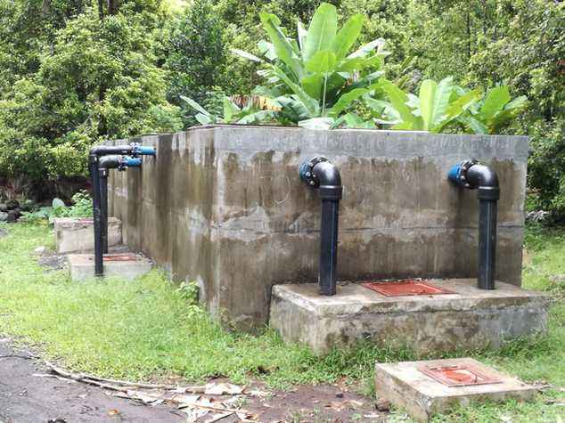

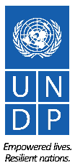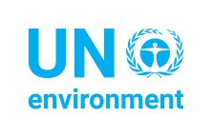



June 2017

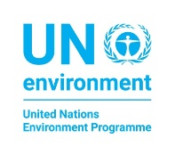

**Evaluation Office of UN Environment**

**Photos Credits:**

All photos, including front cover: Thorbjorn Waagstein

@UN Environment/ Thorbjorn Waagstein, UN Environment Evaluation Mission 2017

This report has been prepared by an independent consultant evaluator and is a product of the Evaluation Office of UN Environment. The findings and conclusions expressed herein do not necessarily reflect the views of Member States or the UN Environment Senior Management.

For further information on this report, please contact:

Evaluation Office of UN Environment  
P. O. Box 30552-00100 GPO  
Nairobi Kenya  
Tel: (254-20) 762 3389  
Email: [chief.eou@unep.org](mailto:eou@unep.org#_blank)

“Adapting water resource management in the Comoros to expected climate change”

UNEP PIMS: 4188

03/17

All rights reserved.

© 2017 Evaluation Office of UN Environment

ACKNOWLEDGEMENTS

This Terminal Evaluation was prepared for the Evaluation Office of UN Environment by Thorbjorn Waagstein, Economist, PhD, as the Lead Consultant. The report benefits from a peer review conducted within the Evaluation Office of UN Environment.

The Evaluation Office of UN Environment would like to thank the UNDP Country Office in Comoros, and in particular the project manager responsible at UNDP, Karim Ahmed Ali, the former Project Coordinator Charaf-Eddine Msaîdié and the officer responsible for the Island Technical Unit in Mohéli, Abdou Soimadou Ali, for their contribution and collaboration throughout the Evaluation process.

The consultant Thorbjorn Waagstein, partner in the Danish consultant company PEMconsult, is an experienced evaluator who has evaluated projects within different sectors in Latin America, Africa and Asia.

ABOUT THE EVALUATION

**Joint Evaluation:** No

**Report Language(s):** English

**Evaluation Type:** Terminal Project Evaluations

**Brief Description:** This report is a terminal evaluation of a UN Environment - UNDP - GEF project implemented between 2011 and 2016. The overarching goal of the project was defined in the project document as to adapt water resource management to climate change in the Comoros. The project’s global environmental objective was defined in the project document as “*to reduce the risk of climate change on lives and livelihoods from impacts on water resources in the Comoros”*. The main intended outcomes were the strengthening of institutions at national, regional and community level, the improvement of water supply and water quality for selected pilot communities to combat impacts of climate change, and increased awareness of adaptation good practice. The evaluation sought to assess project performance (in terms of relevance, effectiveness and efficiency), and determine outcomes and impacts (actual and potential) stemming from the project, including their sustainability. The evaluation has two primary purposes: (i) to provide evidence of results to meet accountability requirements, and (ii) to promote learning, feedback, and knowledge sharing through results and lessons learned among UN Environment, UNDP, the GEF and the executing partners in Comoros.

**Key words:** Climate Change Adaptation, Comoros, Water Supply, Water Resource Management, Sustainable Agriculture, Water and Soil Conservation, Reforestation, Terminal Evaluation, GEF, GEF Project;

Project identification table

|  |  |  |  |
| --- | --- | --- | --- |
| UNEP PIMS ID: | 4188 | IMIS number: |  |
| Sub-programme: | Climate Change | Expected Accomplishment(s): |  |
| UNEP approval date: | 21 December 2010 | PoW Output(s): |  |
| GEF project ID: | 3857 | Project Type: | FSP |
| GEF OP #: |  | Focal Area(s): | Climate Change Adaptation |
| GEF approval date: | 18 August 2010 | GEF Strategic Priority/Objective: | Climate Change - LDCF |
| Planned Start Date: | November 2010 | Actual start date: | February 2011 |
| Planned completion date: | November 2014 | Actual completion date: | Not completed yet |
| Planned project budget at approval: | US$ 13,056,318 | Total expenditures reported as of end 2016: | UNEP: US$ 895,661  UNDP: US$ 2,614,364 |
| GEF Allocation: | US$ 1,020,000 for UNEP, US$ 2,720,000 for UNDP | GEF grant expenditures reported as of [date]: | 2,700,000 |
| PPG GEF cost: | US$ 30,000 for UNEP | PPG co-financing: | US$100,000 |
| Expected FSP co-financing: | US$ 9,316,318 | Secured FSP co-financing: | 100% (according to UNDP) |
| First Disbursement: | 23 May 2012 (UNEP part) | Date of financial closure: | Not closed yet |
| No. of revisions: | 2 | Date of last revision: | 28 July 2015 |
| Date of last Steering Committee meeting: | June 2015 | Date of financial closure: | March 2017 |
| Mid-term evaluation (actual planned date): | November 2013 | Mid-term evaluation (actual date): | July 2014 |
| Future phases/related projects | UNEP/GEF (USD 5,140,000) for ”*Building Climate Resilience through Rehabilitated Watersheds, Forests and Adaptive Livelihoods*”.  UNDP/GEF (USD 8,932,421) for “*Comoros: Strengthening Comoros Resilience Against Climate Change and Variability Related Disaster*”. | | |

Map Comoros, Administrative Divisions

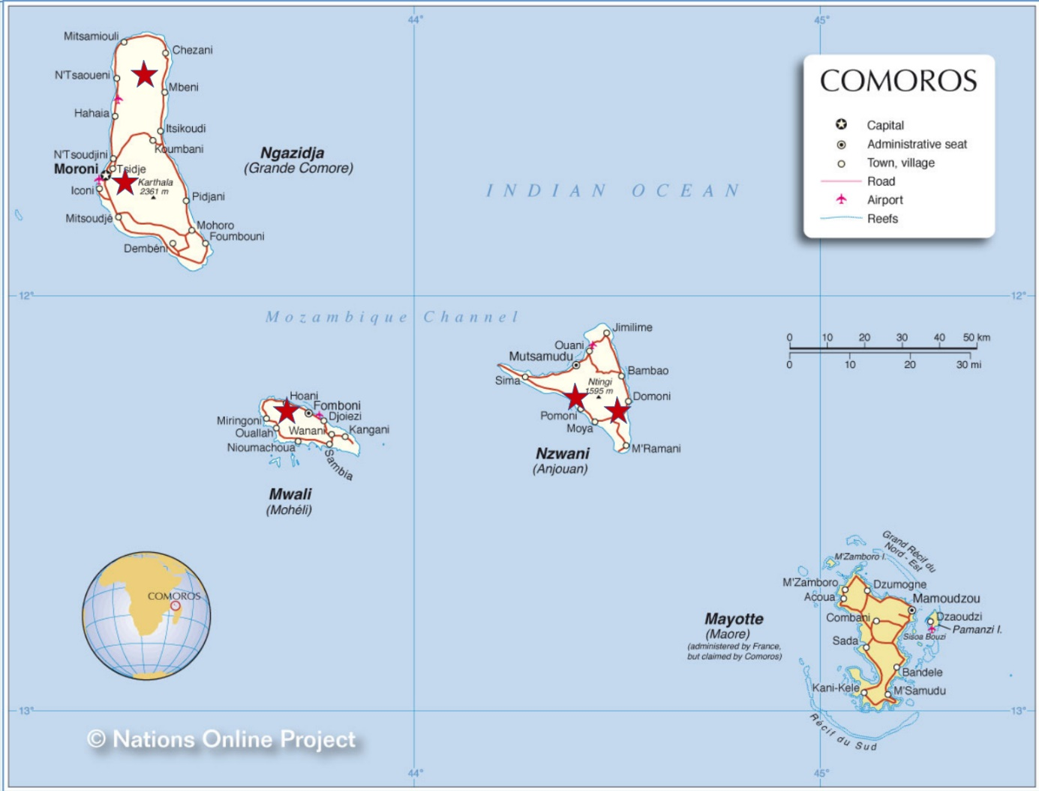Note: The red stars indicate the 5 pilot project locations

TABLE OF CONTENTS

Executive summary xi

1. Introduction 1

2. Evaluation methods 1

3. The Project 3

3.1 Context 3

3.2 Objectives and components 4

3.3 Target areas/groups 6

3.4 Implementation arrangements 7

3.5 Changes in design during implementation 8

3.6 Project financing 9

3.7 Project partners 10

3.8 Reconstructed Theory of Change of the project 11

4. Evaluation Findings 14

4.1 Strategic relevance 14

4.2 Achievement of outputs 15

4.2.1 The activities carried out 15

4.2.2 Achievement of outputs related to Outcome 1 16

4.2.3 Achievement of outputs related to Outcome 2 18

4.2.4 Achievement of outputs related to Outcome 3 21

4.3 Effectiveness: Attainment of project objectives and results 22

4.3.1 Attainment of Outcome 1. 22

4.3.2 Attainment of Outcome 2. 23

4.3.3 Attainment of Outcome 3. 24

4.3.4 Attainment of project goal and planned objectives 25

4.3.5 Likelihood of impact based on reconstructed ToC and using RoTI 26

4.4 Sustainability and replication 27

4.5 Efficiency 30

4.6 Factors affecting performance 31

4.6.1 Preparation and readiness 31

4.6.2 Project implementation and management 31

4.6.3 Stakeholder participation, cooperation and partnerships 32

4.6.4 Communication and public awareness 32

4.6.5 Country ownership and drivenness 32

4.6.6 Financial planning and management 33

4.6.7 UNEP/UNDP Supervision, guidance and technical backstopping 33

4.6.8 Monitoring and Evaluation 34

4.6.9 External factors 34

5. Conclusions and Recommendations 34

5.1 Conclusions 34

5.2 Lessons Learnt 40

5.3 Recommendations 41

Annex A. Response to stakeholder comments 44

Annex B. Evaluation ToR 45

Annex C. Evaluation Programme and People met 51

Annex D. Bibliography 55

Annex E. Planned and carried out activities 59

Annex F Indicators, targets and achievements 64

Annex G. Debriefing presentation 68

Annex H. Budget and actual expenditures 76

Annex I. Pictures from field visits 80

Annex J. Stakeholder analysis 86

Annex K. Assessment of the overall quality of project design 90

ACRONYMS

|  |  |
| --- | --- |
| ACCE | Climate Change Adaptation for Water Resource Management (“*Projet d’adaptation de la gestion des ressources en eau aux changements climatiques*”) (The project under evaluation) |
| AfDB | African Development Bank |
| AFD | French Development Cooperation (*“Agence Française de Développement”)* |
| ANACM | National Agency of Civil Aviation and Meteorology *(“Agence Nationale de l’Aviation Civile et de la Météorologie”)* |
| ASECNA | Agency for Air-traffic Security in Africa and Madagascar (“*Agence pour la Sécurité de la Navigation Aérienne en Afrique et à Madagascar*”) |
| CDRE | Regional Centre for Economic Development (“*Centre Régional de Développement Économique”)* |
| CNDRS | National Centre for Scientific Documentation and Research (“*Centre national de documentation et de recherche scientifique* ”) |
| CTA | Chief Technical Advisor |
| DGEME | General Directorate for Energy, Mines and Water *(“Direction Générale de l'Énergie, des Mines et de l’Eau”)* |
| DGEF | General Directorate for Environment and Forests *(“Direction Générale de l’Environnement et des Forêts”)* |
| DREF | Regional Directorate for Environment and Forests *(“Direction Régionale de l’Environnement et des Forêts”)* |
| FNAC | Fédération nationale des agriculteurs communautaires |
| GDP | Gross Domestic Product |
| GEF | Global Environment Facility |
| GoC | Government of Comoros |
| HDPE | High Density Polyethylene |
| IMF | International Monetary Fund (GEF) |
| INRAPE | National Institute for Research in Agriculture, Fishery and the Environment  (”*Institut National de la Recherche pour l'Agriculture, la Pêche et l'Environnement”*) |
| IWRM | Integrated Water Resource Management (Acronym in French: GIRE) |
| LDCF | Least Developed Countries Fund |
| M&E | Monitoring and Evaluation |
| Ma-Mwe | Autonomous Agency for Water and Energy Distribution |
| MAPEEIA | Ministry for Agriculture, Production, Environment, Energy and Handicraft (“*Ministère de la Production, de l'Environnement, de l'Énergie, de l'Industrie et de l'Artisanat*”) |
| MDG | Millennium Development Goals (UN) |
| NAPA | National Adaptation Programme of Action |
| PAEPA | Programme for Water Supply and Sanitation “*Projet d'alimentation en eau potable et d'assainissement*” (AfDB) |
| PAGEC | Project for support to Community Management for Water at the islands for Anjouan and Mohéli (“*Projet d’Appui à la Gestion Communautaire de l’eau sur les Iles d’Anjouan et de Mohéli”)* |
| PIR | Project Implementation Report |
| PNDHD | National Programme for Sustainable Human Development  *(”Programme national de Développement Humaine Durable”*) (IFAD) |
| RESEAU | Strengthening of water services in Anjouan and Mohéli (*Renforcement des Services de l’EAU sur les Iles d’Anjouan et de Mohéli*) |
| ROtI | Review of Outcomes to Impact |
| RUTI | Responsible for the Island Technical Unit (“*Responsables des Unités Techniques Insulaires”*) (UNDP) |
| SCAD | Comoros Poverty Reduction and Growth Strategy (“*Stratégie de croissance accélérée et de développement durable“*) |
| SDG | Sustainable Development Goals (UN) |
| SIDS | Small Island Development State |
| ToC | Theory of Change |
| ToR | Terms of Reference |
| UCEA | Union of Water Committees of Anjouan *(“Union des Comités de l’Eau d’Anjouan“)* |
| UCEM | Union of Water Committees of Mohéli *(“Union des Comités de l’Eau de Mohéli“)* |
| UNDAF | United Nations Development Assistance Framework |
| UNDP | United Nations Development Programme |
| UNDP-BCPR | UNDP - Bureau for Crisis Prevention and Recovery |
| UNEP | United Nations Environment Programme |
| UNV | UN Volunteer (*“Volontaire des Nations Unies“ – VNU in French*) |
| VRA | Vulnerability Reduction Assessment |
| WRM | Water Resource Management |

# Executive summary

A. Introduction

1. The Global Environmental Fund (GEF) funded project *“Adapting water resource management in the Comoros to expected climate change”* (ACCE*)[1],* jointly implemented by United Nations’ Development Programme (UNDP) and UN Environment (UNEP), was designed to address climate change induced challenges in the Comoros. Project implementation started in February 2011 and was originally scheduled to finish at the end of 2014, but the duration was extended until the end of 2016. The GEF funding was USD 3,740,000 (UNEP: USD 1,020,000 and UNDP: USD 2,720,000) and UNDP-TRAC provided USD 200,000. Furthermore, there has been a co-financing of Euro 150,000 from the Flemish Government (2013-14), which was not planned originally.
2. This report presents a Terminal Evaluation which was conducted after the operational completion of the project. The evaluation was carried out by a single consultant. Field work was carried out in the Comoros from 20 February to 11 March 2017.
3. The overarching goal of the project was defined in the project document as “*to reduce the risk of climate change on lives and livelihoods from impacts on water resources in the Comoros*”. The project’s global objective was defined as to reduce the risk of climate change on lives and livelihoods from impacts on water resources in Comoros. To achieve this, the following outcomes were planned: (a) Institutions at a national (i.e. the Autonomous Agency for Water and Energy Distribution (Ma-Mwe) and the National Agency of Civil Aviation and Meteorology (ANACM)) and community (i.e. the Unions of Water Committees in Anjouan and Mohéli - UCEA and UCEM) level strengthened to integrate climate change information into water resources management, (b) Water supply and water quality improved for five selected pilot communities to combat impacts of climate change[2], (c) Awareness and knowledge of adaptation good practice increased for continued process of policy review and development.

B. Findings

1. *Strategic Relevance.* The project is aligned to the Initial National Communication (2002) and the National Adaptation Programme of Action (NAPA) (2006), which listed the water sector as being the second most vulnerable sector to climate change (after agriculture), and it is consistent with the United Nations Development Assistance Framework (UNDAF), the UN Environment medium term strategy, the UNDP Strategic Plan, the GEF Least Developed Countries Fund (LDCF) eligibility criteria and the UN Millennium Development Goals. It also takes into account human rights concerns as the pilot projects are addressing water stressed rural communities, including the construction of public stand-posts for people who cannot afford a household connection. However, several activities under Outcomes 1 and 3, which were related more directly to climate change, were eliminated for various reasons, and the project has thus put less emphasis on climate change than originally planned, being redirected more towards a more traditional water supply project. The project strategic relevance is thus rated as *moderately* s*atisfactory*.
2. *Achievement of outputs*. Concerning the outputs under Outcome 1 (Capacity building), the two first outputs related to the availability of climate data and the capacity to use them *have been achieved*. There is clearly more climate information available, it is collected and recorded and ANACM has more capacity to use the data for modelling and forecasting. The hydrological modelling *was not achieved* as data was deemed to be insufficient for modelling. The outputs related to improving the policy framework and developing a capacity strengthening plan within this area have been *partially achieved* due to another project (PAEPA)[3]. As the new Water Act has not been approved, it was not deemed relevant to strengthen capacity within this area, so this output has *not been achieved*. The outputs related to Outcome 2 (putting into place five pilot water supply schemes) have been *partially achieved only*, due to budget constraints, as the costs were underestimated in the project document. The outputs related to Outcome 3 (project communication and finding and disseminating the lessons learnt), have been *partially achieved* concerning the first part (communication) and *not achieved* concerning the second part (dissemination of lessons learnt). All in all, the evaluation rating of outputs is *moderately satisfactory*.
3. *Effectiveness - Attainment of Objectives and Planned Results.* Regarding the *first outcome*, which aimed at strengthening the capacity of the different institutions to integrate climate change information into water resources management, the attainment is mixed. On one hand, there is clear progress in ANACM (collection of data, modelling and analysis), and there is a more widespread awareness in the institutions about the need to improve the management and integration of data related to climate in general and climate change in particular. There is furthermore a nascent interest in Integrated Water Resource Management (IWRM). The more tangible effect expected regarding an improved policy framework for water resource management, which takes into account climate change, has not happened. Even so, with a proposal for a new Water Act elaborated (supported by PAEPA), there is some progress regarding the policy framework. However, there is still a long way to go.
4. The planned *second outcome* was improved water supply and water quality for the five pilot communities to combat the impacts of climate change. The evaluator assessment is that: (a) The quantity of water has increased, but due to the old distribution network, this is not fully noticeable to the users, (b) The quality has probably improved at the two sites where slow filters have been installed, but water quality measurement has not been carried out, so this is not documented, (c) Access has only improved where increased water pressure has returned water to sectors connected, but where the water did not reach because of too low pressure in system. Access is still a major problem in Moroni, Hoani-Mbatsé and probably Lingoni-Pomoni.
5. The *third outcome* was that awareness and knowledge of adaptation good practice for continued process of policy review and development has increased. As no measurement has been made, neither for the baseline, nor for the end-of-project situation, this outcome impact is difficult to assess. With these caveats, the evaluator assessment is that there is an increasing awareness of the impact of climate change, as this was mentioned by many of the interlocutors. This is no doubt an effect of the many campaigns and projects related to climate change, including the present project. Regarding the communication part, if a distinction is made between (a) general communication products on climate change and the project, and (b) technical documents on the lessons learnt for knowledge networks, the evaluator assessment is that the general communication (a) has probably been covered quite well, but more specific technical information on lessons learnt (b) has not been covered at all.
6. The overall evaluation rating of the attainment of the outcomes is *moderately unsatisfactory*.
7. The indicator for the *project objective* was the vulnerability to climate change of the pilot project communities. The baseline study carried out Vulnerability Reduction Assessment (VRA) workshops in the villages and they were rated around 4 with an end-of-project target of 2. As the VRAs have not been repeated end-of-project it is difficult to assess this indicator. The evaluator assessment is that the vulnerability has been reduced, as water supply has increased considerably in the pilot communities thus mitigating the impact of future reductions in rainfall. However, taking into account the limitations of the water supply schemes installed, a rating of 2 appears too optimistic.
8. Independently of the (probable) failure to achieve the indicator target, *it is considered moderately likely* that the project objective and goal will be achieved, but it will take time. There are considerable barriers, but also a noticeable political will to progress and a process is in motion. There are several on-going efforts with external support to put in place Integrated Water Resource Management (IWRM) (among these the SIDS-IWRM project and the newly approved UN Environment GEF financed Watershed Management project).
9. The *sustainability* is assessed to be the main weakness of the project. The institutional strengthening of ANACM is considered sustainable, but the process to improve the policy framework will no doubt still need substantial external support to keep moving. However, the main sustainability challenges are related to the pilot projects.
10. As it is now, the water division of Ma-Mwe (Moroni water supply) *is not sustainable,* as non-accounted for water may be as high as 80% and the capacity for operation and maintenance (operation and management) is low. There is no quick fix for the lack of sustainability of Ma-Mwe. The water system was privatised a decade ago but the privatisation was not successful, and it was subsequently taken back by the Government. The bad state of the distribution network is one of the main problems, but also the lack of a proper company structure. An obvious first step is to separate the Ma-Mwe water division out as an independent company, be that public or private. But for the company to be viable, considerable investment is needed, among others for network rehabilitation (substituting the old asbestos-cement pipes with High Density Polyethylene (HDPE) pipes), increased reservoir capacity, construction of new wells and installation of meters. A completely new commercial department would have to be set up to secure metering and invoicing.
11. The four community water supply projects also have serious challenges regarding sustainability, and it can safely be stated that if something substantial is not done to secure operation and maintenance, *they are not sustainable*. There is an urgent need to put systems for operation and management and cost recovery in place. If that is not done, the water schemes will soon start to degrade, a process that is already visible. It should be added that the reforestation activities on communal lands are clearly *not sustainable* either*,* and the drip-irrigation introduced for water conservation is *not working*. All in all, the probability that sustainability is achieved is rated as *unlikely.*
12. As the sustainability clearly is a major challenge, it is assessed premature to consider *replication* of the pilot projects, even if it is assessed that there are some interesting experiences that might be worth replicating.
13. It should furthermore be mentioned that the lack of a proper Monitoring and Evaluation (M&E) system implies that hard data are difficult to get (e.g. people effectively served by the water supply schemes, production of water, service hours etc.). This includes the Moroni pilot project with Ma-Mwe.
14. Due to the lack of detailed financial information, it is difficult to make a well-founded assessment of the *cost-efficiency*. With this caveat in mind, it is the evaluator’s impression that much has been done with relatively limited inputs, and the quality of the works is generally acceptable to good. So the rating for efficiency is *satisfactory.*
15. All in all, the project is rated as *moderately* *unsatisfactory.*

D. Lessons learnt

1. The participatory process to select the communities and the involvement of the communities from the very beginning of the project planning is considered to be a crucial factor that has increased the community ownership. It is a relatively simple element to include in project planning, but is often omitted for time reasons or other inconveniences. This is a positive lesson learnt, widely applicable elsewhere.
2. The introduction of slow filters in the community water supply schemes is an interesting innovation to improve water quality, often ignored in community projects. Potentially there is a lesson learnt which can be used for upscaling. However, for that to be the case, the experience needs first to be properly documented. In particular, it has to be documented whether the water quality has actually improved, and whether the required operation and management is suitable for community schemes.
3. When a water supply scheme is planned, the issue of operation and management should be included from the very project design. Failure to do so, as is the case for the present project, puts the future sustainability of the investment at risk. Furthermore, it is important that the project scope include the whole system, including the distribution network and the meters, which has not been the case for the present project. If the project does not include these elements, it is very difficult to put into place a sustainable management of the scheme. This is not a new lesson learnt, as this is well-known from many other similar projects, but it has once again been confirmed by the present project.
4. The water supply scheme adopted in the pilot projects are well beyond a size that can be managed informally by a Community Water Committee. The operation and management has to be formalised and paid for, independently of the organisational setup chosen (community operated or outsourced to a private operator). Again, this is not a new lesson learnt, as this is well-known from many other similar projects, but is has once again been confirmed by the present project.
5. The main weakness of the pilot project in Moroni is the lack of a proper, dedicated operation and maintenance structure and a system for cost recovery. This obviously puts the investment made at risk. The general lesson learnt is that support to a city water supply system should include as a clear condition that proper operation and management is put in place and that there is a system for tariff collection that permits to cover at least the operation and maintenance costs. If there is a need to subsidise the operation and maintenance costs, it has to be clearly defined how and by whom. Again, this is not a new lesson learnt, as this is well-known from many other similar projects, but is has once again been confirmed by the present project.
6. When planning the reforestation in the present project, proper attention was not paid to an analysis of why the land had been deforested. The consequence is that most of the reforestation made on communal land has been lost. The general lesson learnt is that a thorough analysis should be made during project planning of the factors that have lead to deforestation in the first place, and that these factors should be addressed as part of the project. If they are not, the reforestation is likely to be unsuccessful.
7. The present project promoting climate change adaptation has included activities in a variety of fields, covering a variety of issues that are important for climate change adaptation. However, the result has been that the investments have been spread out thinly, there has been a considerable management burden and the impacts are difficult to discern. The lesson learnt is that when planning a climate change adaptation project, it is important to avoid attempting to do everything, as the risk is that the investments are spread out too thinly, that it will be difficult to manage and that the impact in each area will be small. It is therefore important to maintain a focus for the project and only include project issues outside the focus area of the project, when these are absolutely necessary for success, and it is unlikely that they will be covered by other actors.

E. Recommendations

1. As it has been mentioned, the pilot projects are incomplete, particularly by not including the improvement of the distribution network and the metering. This implies that it is not possible to reap the full benefit of the investments made. The corollary is that there can be considerable benefits from a relatively limited additional investment. Furthermore, it is very difficult to put into place a sustainable management of the water supply schemes when these are not functioning properly at the outset, so this additional investment can increase the probability of success in putting into place a sustainable management of the schemes. It is therefore **recommended** to the Ministry of Production and its partners, particularly UNDP and UN Environment, to urgently search for additional funds to complement the investments made in the five pilot projects. It is further recommended that these additional funds be conditioned on the putting into place of a formalised management of the community pilot schemes. In the case of Moroni, the condition for the provision of additional funds should be that a process of creating an autonomous water company has at least started. Furthermore, as the arguments for and against privatisation of the water supplies in the Comoros, combined with several unsuccessful experiences with privatisation, appear to have complicated the search for sustainable solutions for the operation and management, it is **recommended not** to link the setting up of formal structures for the management of the water supply schemes with the question of ownership, as this may derail the process. There are many successful examples of both publicly and privately owned water supply companies in other parts of Africa, so the question of ownership is not at the core of the issue.
2. The experience with the slow filters in the community water supply schemes should be documented so decisions can be taken on whether to replicate them in other projects. It is **recommended** to UN Environment and UNDP to make sure this happens.
3. The evaluator considers that setting up a policy and institutional framework for IWRM is a necessary step towards adapting the management of water resources in the Comoros to climate change. It is therefore **recommended** to the Government of Comoros, UNDP and UN Environment to include IWRM in future projects in the country. Experience from other African countries shows that this will be a long process, so it is important not to set up too ambitious short term goals. Putting into place IWRM requires a long haul.
4. Taking into account the various observations made in the present report, it is **recommended** that UNDP and UNEP revise the newly approved GEF projects to make sure that: (a) they have conducted proper feasibility studies, when relevant, (b) a gender analysis has been conducted and is reflected in the implementation strategy, (c) adequate formal monitoring systems are set up, and (d) when relevant, VRAs are repeated at the end of the project to document the changes that have been achieved.

# Introduction

1. The Global Environmental Fund (GEF) funded project *“Adapting water resource management in the Comoros to expected climate change”* (ACCE*)[4],* jointly implemented by United Nations’ Development Programme (UNDP) and UN Environment (UNEP), was designed to address climate change induced challenges in the Comoros. Project implementation started in February 2011 and was originally scheduled to finish at the end of 2014, but the duration has been extended to the end of 2016. The GEF funding was USD 3,740,000 (UNEP: USD 1,020,000 and UNDP: USD 2,720,000) and UNDP-TRAC provided USD 200,000. Furthermore, there has been a co-financing of Euro 150,000 from the Flemish Government (2013-14), which was not planned originally.
2. In line with the UNEP and UNDP Evaluation Policies, the present terminal evaluation is undertaken at completion of the project to assess project performance (in terms of relevance, effectiveness and efficiency), and determine outcomes and impacts (actual and potential) stemming from the project, including their sustainability. The evaluation had two primary purposes: (i) to provide evidence of results to meet accountability requirements, and (ii) to promote operational improvement, learning and knowledge sharing through results and lessons learned among UNEP, UNDP and the GEF. Therefore, the evaluation has identified lessons of operational relevance for future project formulation and implementation.

# Evaluation methods

1. According to the evaluation Terms of Reference (ToR), the evaluation should focus on four key questions, based on the project’s intended outcomes:
   1. Has climate change information been integrated into the water resources management systems of Comoros as a result of the project? Was the project effective in enhancing institutional capacity at the national and community level to facilitate the process?
   2. To what extent has water supply and water quality improved in the pilot communities as a result of the project? To what extent has this helped the communities to adapt to the adverse effects of climate change? Is there evidence of the approach being replicated elsewhere in the Comoros?
   3. Has the awareness and knowledge of adaptation good practices increased as a result of the project? Has the increased awareness and knowledge resulted in review and development of adaptation policies?
   4. Overall, has the project contributed towards reducing negative impacts of climate change on water resources in Comoros? Was the project successful in setting in motion a process that will ultimately contribute towards reduced risks of climate change induced problems on the lives and livelihoods of people in terms of water resources?

These questions have guided the evaluation.

1. The evaluation comprised three main phases: 1) inception and document review, as documented in the inception report, 2) field mission to Comoros including stakeholder interviews and project site visits, and 3) analysis and reporting. The evaluation was carried out by a single consultant.
2. During the inception and document review phase the evaluator had only access to part of the project documentation (project document, progress reports from UN Environment and UNDP, and some of the studies carried out, e.g. the baseline study). The evaluator consulted further more general documentation on the Comoros, the expected impact from future climate change, the documentation from related projects and the strategy documents from GEF, UNDP and UN Environment.[5] These documents were reviewed, a revised Theory of Change (ToC) was proposed, the main evaluation questions were defined and a detailed programme for the field visit was proposed. The draft inception report was discussed with the UN Environment Evaluation Office over Skype and meetings were held with the UN Environment task manager in Copenhagen and the UNEP Evaluation Office in Nairobi.
3. The second phase was the field work, which was carried out in the Comoros from 20 February to 11 March 2017. During the field work in Comoros, the main activities were (i) interviews with former key project staff from UNDP/UNEP (principally the former project manager, the UN Volunteer Engineer who formerly worked at the project, the UNDP project responsible and the technical officer (RUTI) responsible at Mohéli), (ii) the key Ministries and institutions involved at central (Union) level (including the Meteorological Services (ANACM) and the Water and Electricity Company (Ma-Mwe)), and (iii) field visits to the pilot projects (5 in all).*[6]* As planned, the main thrust was put on the field visits, as the pilot projects in budgetary terms constituted the main component. During the field visits, all the constructed or rehabilitated infrastructures were visited and key stakeholders interviewed. It turned out not to be possible to carry out the planned Focus Group meetings as these had not been convened. Instead, community leaders and water committee members and some randomly chosen beneficiaries were interviewed to the greatest extent possible.
4. A final workshop was carried out, organised by UNDP, where the main findings were presented.[7] However, the participation in the workshop was very limited (UNDP, ANACM and Ma-Mwe). The feed-back was therefore also limited.
5. It is a general limitation for terminal evaluations that the key project team is not in place any more, and that focus generally has shifted towards presently on-going activities. Apart from this general limitation, there were several inconveniences that complicated the field visits to Anjouan and Mohéli. As the Government of Comoros (GoC) had cancelled the operating license for one of the two inter-island airlines, it turned out to be impossible to carry out the planned programme, so eventually the evaluation programme had to be adjusted to the availability of flights. The flight schedules were irregular and this was further complicated by the nearby cyclone in Madagascar (Enowa), which lead to several cancellations. As a consequence, quite a lot of time was lost waiting at the airports at Anjouan and Mohéli and the final workshop had to be postponed to Saturday 11 March. The visit to Anjouan was not prepared as expected as the local UNDP officer was occupied with other tasks, so when the evaluator arrived the programme was improvised, and was only possible due to support from the General Secretary of the Commissariat for Production (this support is sincerely acknowledged). However, as the evaluator was not accompanied by persons knowing the details of the project, and as the visits were not announced on beforehand, and hence it was not possible to interview members of the Water Management Committees at one of the pilot sites (Pomoni-Lingoni), the field visit was less productive than expected. At Mohéli on the contrary, the visit was very well prepared and the evaluator succeeded in interviewing all the relevant stakeholders.
6. It should be mentioned that project evaluations always face the question of *attribution*, particularly at outcome and objective level. For the outcomes and objectives, the evaluation has to assess as a first step the present situation and the probability of the outcomes and objectives being attained in the future, independently of the attribution of the project evaluated. Outcomes and objectives may be attained – or not attained – for many reasons beyond the project. What finally has to be evaluated is whether the project has *contributed* to this, and of course whether the contribution is substantial or marginal. Therefore, even if the evaluation is that a given outcome has a reasonable chance of being attained in the future, this does not necessarily mean that the project is successful, as it may have failed, but other stakeholders may be responsible for it being achieved anyway – and vice versa. There is often a desire by project funders to be able to define exactly their own share of a given achievement, however, particularly when projects are small and there are many actors intervening, this will more often than not be a futile exercise.
7. It should furthermore be mentioned that the lack of a proper Monitoring and Evaluation (M&E) system implies that hard data are difficult to get at (e.g. people effectively served by the water supply schemes, production of water, service hours etc.). This includes the Moroni pilot project with Ma-Mwe. It should also be mentioned that it has not been possible for the evaluator to get detailed financial information comparing the original budget with the actual expenditures for each activity.

# The Project

## Context

1. Comoros is a Small Island Developing State predicted to be adversely affected by climate change (climate change) and climate variability. The climate of Comoros is strongly influenced by large ocean-atmosphere interactions, such as trade winds, El Niño and monsoons. However, the negative effects of climate change might result in changes in rainfall levels and patterns, increased temperatures, sea level rise with subsequent salinization and increased frequency of climatic hazards. These effects will reduce the availability of water in general and negatively affect the quality of water through dilution of contaminants, such as pollutants, salts and sediment. Therefore, climate change is likely to have negative impact on water supply and water quality in Comoros. These adverse effects are superimposed on existing human practices such as high rates of deforestation, as well as inadequate water resources management including inadequate water supply infrastructure, insufficient water treatment and water quality monitoring. Combined, these factors threaten water and food security, economic growth and ultimately people’s livelihoods. The risks related to water security are well acknowledged in Comoros; they have been identified by the Comoros Poverty Reduction and Growth Strategy (SCAD II) as among the most critical problems facing the Comoros, and the NAPA (2006) process listed water sector as being the second most vulnerable sector to climate change (next to agriculture).
2. No significant changes in the political context have occurred since the project was formulated. The Comoros has been through long periods of political instability since independence in 1975, but there has been relative stability since 2009[8], the elections in mid-2016 took place in relative calm and the power was handed over to the new President without major upheavals.
3. According to the World Bank, the economic situation has deteriorated the last couple of years as growth has slowed and the economy remains undiversified (with a heavy dependence on family remittances from abroad and on production and export of vanilla, ginger and ylong-ylong). While the economy had showed signs of recovery achieving an eight-year high in terms of economic growth at 3.5% in 2013, conditions since then have deteriorated with growth slowing from 2.1% in 2014 to 1% in 2015 and 2016 (against a population growth of around 2.4%). Severe shortages in electricity supply have presented a drag on all sectors of the economy. Slowing growth has been accompanied by a rapid depreciation of the Comorian franc by approximately 24% since June 2014, placing a strain on the import capacity of this highly import-dependent economy, and increasing pressure on domestic prices. For these reasons, the fiscal situation is very fragile and the country is thus very dependent on access to foreign aid.
4. Of relevance for the present project is that UNDP is implementing another project with GEF funding (USD 8,990,890) called “Enhancing Adaptive Capacity and Resilience to Climate Change in the Agriculture Sector in Comoros”, [abbreviated](https://www.thegef.org/project/building-climate-resilience-through-rehabilitated-watersheds-forests-and-adaptive) to CRCCA[9]. This project has been implemented in close coordination with the present project and has complemented activities for which funding was insufficient. Other important complementary projects are the AfDB PAEPA[10] project and the EU-AFD Water and Sanitation project for Domoni[11]. An on-going regional Small Island Development State (SIDS) pilot project promoting IWRM (GIRE in French) is also relevant, particularly as it is expected to be scaled up in the future.
5. Of relevance for the continuation of some of the initiatives financed by the project, it should be mentioned that UNEP has received GEF approval for funding (USD 5,140,000) for a project called: ”Building [Climate Resilience through Rehabilitated Watersheds, Forests and Adaptive Livelihoods](https://www.thegef.org/project/building-climate-resilience-through-rehabilitated-watersheds-forests-and-adaptive)”, and UNDP has received GEF approval for funding (USD 8,932,421) for a project called: “Comoros: Strengthening Comoros Resilience Against Climate Change and Variability Related Disaster”.[12] Furthermore, UNDP is preparing a project for the Green Climate Fund, which (if approved) will make it possible to complement crucial missing elements of the pilot projects (see further below).

## Objectives and components

1. The overarching goal of the project was defined in the project document as “*to adapt water resource management to climate change in the Comoros*”. The project’s global objective was defined in the project document as to: “*reduce the risk of climate change on lives and livelihoods from impacts on water resources in Comoros*”. To achieve this, the following outcomes were planned:
   1. Institutions at a national (i.e. Ma-Mwe and ANACM) and community (i.e. the Unions of Water Committees at Anjouan and Mohéli - UCEA and UCEM) level strengthened to integrate climate change information into water resources management.
   2. Water supply and water quality improved for selected pilot communities to combat impacts of climate change.
   3. Awareness and knowledge of adaptation good practice increased for continued process of policy review and development.
2. The project logic was therefore that by increasing the availability of information regarding the effects of climate change, enhancing the capacity to use this information and the revision of the policy framework for specifically the water sector, the Government of Comoros would have increased its capacity to take the necessary measures to adapt to climate change. The interventions implemented at the pilot sites would, according to the project document, “*test the extent to which: i) delivery to safe water for household use; ii) access to water for irrigation purposes; iii) income streams; and iv) livelihoods can be protected and improved under changing climatic conditions, and based on this a plan for upscaling was to be elaborated. Finally, support for learning and dissemination of the experiences should facilitate the further process of adapting to climate change.”*
3. The main planned outputs and activities are indicated in the table below:

Table 1. Planned outputs and activities

| Outcome | Outputs | Main activities |
| --- | --- | --- |
| Outcome 1. Institutions at a national (i.e. Ma-Mwe and ANACM) and community (i.e. UCEA and UCEM) level strengthened to integrate climate change information into water resource management. | Output 1.1. Information on climate change risks to water availability in Comoros improved. | Asses capacity of ANACM  Provide adequate equipment  Develop systems for collecting data  Support for analysing of data and modelling  Training of staff from, among others, ANACM, Ma-Mwe, UCEM and UCEA |
| Output 1.2. Capacity to assess and monitor changes in water supply and quality (given climate change projections) developed. |
| Output 1.3. Preparation and provision of improved climate information for water resource management policies and spending plans. |
| Output 1.4. Integration of improved climate information with water resource management policies and spending plans, and other relevant policies. | Revise and analyse policy documents (including the Water Act)  Develop proposals  Establish a cross-ministerial body for coordination of climate change adaptation  Develop capacity for policy development |
| Output 1.5. Capacity development plan for policy review and design among decision-makers developed based on best known scientific and technical evidence-base. |
| Output 1.6. Capacity development plan for policy review and design among decision-makers implemented. |
| Outcome 2: Water supply and water quality for selected pilot communities to combat impacts of climate change improved. | Output 2.1. Technologies to improve water access and quality that mitigate climate change risks piloted, e.g. soil conservation measures, water harvesting, remedial work on existing boreholes. | Rehabilitation of water schemes at five pilot project sites  Training of water management committees in operation and management  Awareness raising in communities  Training of farmers in sustainable agriculture  Reforestation  Train Ma-Mwe staff in operation and management and cost recovery  Develop a replication plan |
| Output 2.2. Community members trained to manage adaptive water interventions sustainably. |
| Outcome 3: Awareness and knowledge of adaptation good practice for continued process of policy review and development increased. | Output 3.1. Knowledge products developed on lessons learned for policy makers, communities and donors throughout the project. | Compile the results and lessons learned under Outcome 1 and 2  Develop awareness and training materials  Establish parliamentarian working groups and brief them  One national and three island-level workshops for dissemination  Community workshops to disseminate lessons learnt  Newsletters, newspaper articles, booklets and pamphlets  Collate and submit all technical documents and establish project web-site |
| Output 3.2. Learning disseminated through platform for national learning and sustainability. |
| Output 3.3 Disseminate Comorian experience in knowledge networks related to water and climate change, including ALM, GAN and IW Learn. |

## Target areas/groups

1. The project has the following principal target stakeholders:
   1. At central (Union) level: The General Directorate of Water and Forests (DGEF) (where the Project Unit is located), The General Directorate of Energy and Water (DGEME) (both originally under the same Ministry, MAPEIAA, but since mid 2016 under two different ministries), and the meteorological services (ANACM). Originally also the parliamentary politicians would be targeted, but these activities were transferred to another project (PAEPA).
   2. At Island Level: The Water and Electricity Company (Ma-Mwqe) at Grande Comore, the Union of Water Committees at Anjouan (UCEA) and Mohéli (UCEM), and the Island Directorates for the Environment at Anjouan and Mohéli.
   3. At community level: the Village Water Committees and Inter-village Water Committees and the Municipalities.
2. Important stakeholders are also several similar projects, among these the UNDP CRCCA[13] project, the AfDB PAEPA[14] project, the EU-AFD Water and Sanitation project for Domoni[15], the IFAD project PNDHD[16] and others. There is a table with a stakeholder analysis in Annex J.
3. Some additional stakeholders were mentioned in the project document. The *University of Comoros* has been participating in the Project Board, but has not been actively involved. It is not clear for the evaluator what the involvement has been of the *Farmers Union* (FNAC), the *National Institute for Research in Agriculture, Fishery and the Environment* (INRAPE), or the *National Center for Scientific Documentation and Research* (CNRDS), also mentioned in the project document, as the meetings set up with these did not materialise. It is understood that their involvement has been very limited. Taking into account the focus of the project on climate change adaptation in the water sector, with a heavy emphasis on water for human consumption, it is considered that the stakeholder involvement has been satisfactory.
4. Regarding the coordination, the main water sector institutions were represented on the Project Board (see below). There have been quite extensive consultations with the stakeholders during project preparation and the minutes from the different events were included as an annex to the project document. Regarding the broader sector coordination, there is as part of the monitoring framework for the Poverty Reduction Strategy (SCAD) a Water and Sanitation Sector Working Group, chaired by the General Planning Commissariat, which is in charge of the coordination between the GoC and the donors, presently with AFD as lead donor.

## Implementation arrangements

1. The Project Board (Steering Committee – “*Comité de Pilotage*”) included as mentioned a broader range of stakeholders, including stakeholders not directly targeted by the project activities such as the University of Comoros. The Chief Technical Adviser (CTA) and technical project staff have also participated in the project board meetings, and in some of these there has also been representatives from other similar projects (as CRCCA and PNDHD).
2. The project board has met a little less than once a year, in all 4 times over five years. First meeting was in February 2012, the second in September 2012, the third in April 2013 and the fourth (and last) was in December 2015. At the project board meetings reports on project progress were presented, the annual work plans for 2012, 2013 and 2016 were presented and general issues of concern were discussed. The role of the project board has been more ceremonial than envisaged in the project document, where 2 meetings per year were stipulated. The work plans and budgets for 2014 and 2015 seem not to have been approved by the project board. It is understood that the technical committees at national and island level have never been functional. In the documentation received by the evaluator there are no minutes from these meetings.
3. The project implementation set-up is shown in the below figure (taken from the project document):

Figure 1. Organisational structure

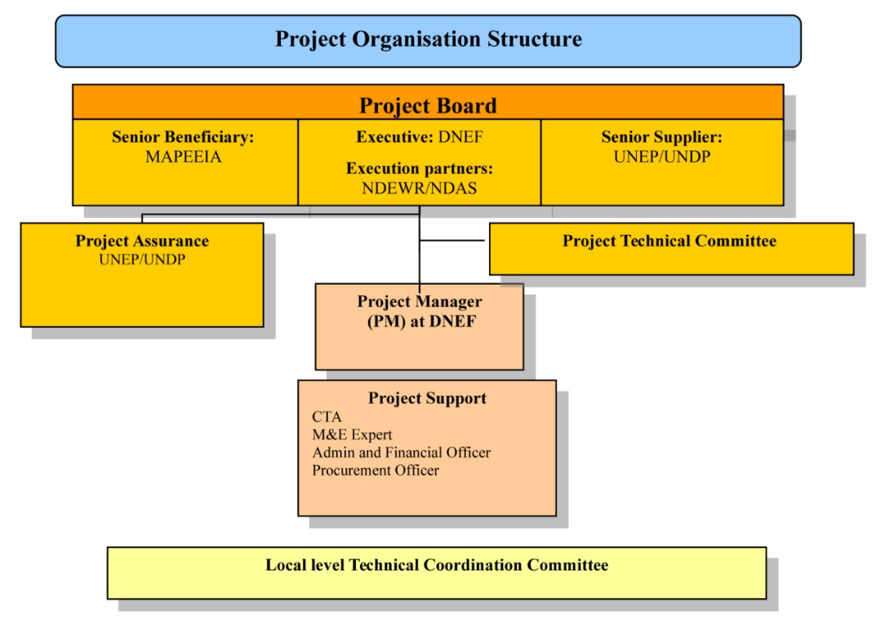

1. The day-to-day operations were handled by a Project Coordinator located at DGEF and supported by an accountant and some support staff. The technical part was supported by the CTA, UN Volunteers (called VNU after their French acronym) and short term consultants. At each island, there was a responsible technician (called RUTI), financed and shared by the present (and other) UNDP-UNEP projects. It is evident that even if the project has been carried out under the National Execution modality, the UNDP country office has had a pro-active role in project implementation.

Figure 2. Management setup

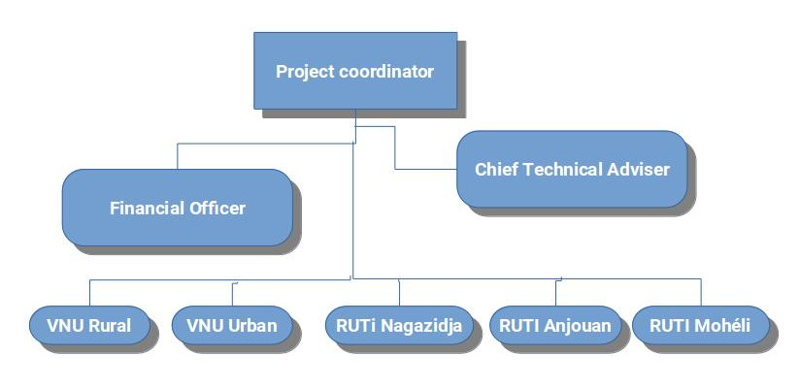

1. Project supervision has been divided between UNEP and UNDP, according to the division of the outputs between UNEP and UNDP across the outcomes. The UNEP supervision was handled by a Task Manager located at the UNEP-DTU Centre in Copenhagen, and the UNDP supervision was carried out by the local UNDP office at Moroni with backstopping from the UNDP Regional Office at Addis Ababa. This division of the supervision has of course not made is easier for UNDP and UNEP, as each of them have struggled to keep themselves updated on the progress on the outputs, which were the responsibility of the other part.
2. It was stated in the project document that *“M&E will be undertaken by the Project Support Staff and the UNDP Country Office with support from UNDP/UNEP. UNDP will be the lead on all M&E with input provided by UNEP to ensure that there is one harmonized M&E report.”* The Mid Term Review pointed out that the M&E needed to be strengthened, but this has not happened. There was a budget for M&E (Annex 7 to the project document), which also included funding for the Mid Term Review and the Final Evaluation. An M&E Expert was planned as part of the technical team, but it is understood that this post was eliminated.

## Changes in design during implementation

1. The basic design of the project with three outcomes has not been changed. However, it turned out after making the feasibility studies for the Pilot Projects under Outcome 2 (UNDP part) that the cost of these had been severely underestimated during project design. At the same time, several activities planned under Outcome 1 (UNEP part) were not feasible. Among these was the hydrological modelling, as there was not sufficient data for this, the need for weather stations was reduced and the planned hydrological measuring equipment was not acquired. As a consequence, a budget revision was carried out in 2013, where several activities planned under the UNEP part for Outcome 1 were scaled down or eliminated, and UNEP took on some of the soft costs of Outcome 2 (among others the payment for international consultants and co-financing of the RUTIs), which made it possible to allocate more UNDP funding for the Pilot Projects (Outcome 2). At the same time the project period was extended with one year to end 2015 within the existing budget (“no-cost” extension).
2. Even with this reallocation, the funding was still insufficient for the five pilot projects. It was then discussed whether one or two pilot projects should be eliminated, or whether all five projects should be maintained, but scaled down. As the communities had been part of the participative planning process, it was not considered a good idea to completely eliminate a pilot project, so the second option was chosen. However, this decision has had consequences for the effectiveness and sustainability of the projects, as it will be discussed below, as the projects generally are incomplete.
3. After the Mid Term Review a new revision was made, where some activities under Outcome 1 were changed (and some eventually - for different reasons - not carried out). At the moment of the Mid Term Review, it looked as if the project could still be finalised within the existing time-frame, which turned out to be too optimistic. The project was thus in practice extended to end 2016. It was mainly the Pilot Projects that were implemented in 2015-2016 as most of the other activities had been finalized (or decisions had been taken not to carry them out).
4. One of the five pilot projects was changed, so instead of the Djandro Plateau (Mohéli), the nearby communities of Hoani and Mbatsé were included (2 communities instead of 5). This could be done without creating major problems as the Djandro Plateau was taken over by a project financed by AFD.

## Project financing

1. The evaluator has received summary information on the budgets and actual expenditures from the UNDP country office in Moroni. Below is a summary table – there are more details in Annex H. Detailed information that would permit to compare the budget with the actual expenditure for each planned activity was not made available.[17]

TOTAL BUDGET AND ACTUAL EXPENDITURES (USD)

Table 2. Original budget and actual expenditure

| Outcome / Component | Original budget | Actual expenditure |
| --- | --- | --- |
| Outcome 1: Institutions at a national (i.e. Ma-Mwe and ANACM) and community (i.e. UCEA and UCEM) level strengthened to integrate climate change information into water resources management. | 1,018,000 | 847,164 |
| Outcome 2: Water supply and water quality for selected pilot communities to combat impacts of climate change improved. | 2,144,000 | 2,869,068 |
| Outcome 3: Awareness and knowledge of adaptation good practice for continued process of policy review and development increased. | 178,000 | 276,633 |
| Project Management | 500,000 | 346,340 |
| Monitoring and Evaluation | 100,000 | 66,481 |
| Outcome / Component | 3,940,999 | 4.405.685 |

1. The project document expected co-financing from several sources, basically other similar projects and contributions from partner institutions. This co-financing only means that the projects are expected to contribute to the same objectives and outcomes, not that ACCE would receive funding from these, expect for the UNDP-TRAC funds.

Table 3. Co-financing

| Name of Co-financier (source) | Type | BUDGET (USD) |
| --- | --- | --- |
| UNDP-TRAC | Grant | 200,000 |
| BAD | Parallel | 6,398,106 |
| AFD | Parallel | 1,020,000 |
| ANACM | Parallel | 23,515 |
| Ma-Mwe | Parallel | 568,147 |
| UNDP-BCPR | Parallel | 918,550 |
| UNDP | In-kind | 148,000 |
| Comoros Government | In-kind | 40,000 |
| Total co-financing: |  | 9,316,318 |

1. According to the UNDP Country Office, these projects have been carried out as expected. The UNDP-TRAC funding has materialised, and the same has the ANACM and Ma-Mwe contributions. [18]

## Project partners

1. As mentioned above, the project has been implemented under the national execution modality. The main partner and organisation responsible for the project implementation was the Ministry of Agriculture, Production, Environment, Energy, Industry and Handicraft (MAPEEIA).[19] There were some initial discussions on whether the project should be placed under the DGEME or the DGEF. The project management unit ended up being located at the DGEF.[20]
2. The main partners being involved in the implementation were, apart from DGEF (WRM) and DGEME (Water Sector Policy), ANACM (climate data collection, analysis and modelling), Ma-Mwe (Moroni Pilot Project), UCEM and UCEA (support to the setting up of Water Management Committees at the four community pilot schemes). At community level the partners have been the Water Management Committees and to some extent the municipalities. Neither the Regional Directorates for the Environment (decentralised authority at Island level), nor the Commissariats for Production (deconcentrated authorities at Island level) have been directly involved in the implementation, as this has been managed directly by the Project Coordinator at DGEF (DGEF was contract holder for the construction of the pilot projects). These main partners have at the same time received technical assistance and training, strengthening their capacity. There is a more detailed stakeholder analysis in Annex J.

## Reconstructed Theory of Change of the project

1. The project document did not make use of Theory of Change but it had a table with the outcomes and indicators. The outputs and activities were detailed in the text. The underlying logic was coherent: The project was intervening at three levels:
   1. Strengthening the relevant sector institutions so they would have better data relevant for climate change available and would be able to interpret them and use them for disaster prevention, for planning for climate change adaptation and for sector policy formulation,
   2. Piloting water supply schemes at community level that are more resistant to climate change (droughts, extreme weather events, saltwater intrusion) and protect the water sources (reforestation and more sustainable agricultural practices).
   3. Information and lessons learnt, particularly from the pilot projects, on adaptation and how to remove barriers to adaptation should be collected and disseminated.
2. The logic was then that based on these three outcomes, contributions would have been made to the objective: “*to reduce the risk of climate change on lives and livelihoods from impacts on water resources in the Comoros”*. One of the pathways described is that the GoC decides to upscale the experiences from the project.
3. However, how to come from the outcomes to the goal is not clear. Below is a reconstructed ToC based on the project document logical framework, where intermediate states have been included[21]. At Union level, it is supposed that the strengthening of the institutions related to climate change monitoring and data processing, will lead to the following *intermediate states*:
   1. The institutions, among these ANACM and Ma-Mwe, have put in place a self-sustaining system with the capacity to predict the future impact of climate change on water resources,
   2. A satisfactory policy framework for Integrated Water Resource Management (IWRM) is put in place, and
   3. The improved policy framework for IWRM is implemented and enforced
4. Experience from other countries shows that it is a long process to put into place a political and institutional framework for IWRM, and when that has been done, to actually succeed in the implementation and the enforcement. Among the barriers are normally:
   1. Resistance to IWRM measures from vested interests.
   2. Lack of understanding in the communities of the need for IWRM measures to secure the water resources for the common good. This is a barrier that the project has possibilities to influence (hence a driver).
   3. Difficulties in the enforcement because of lack of political backing when negotiation and consensus seeking turns out to be insufficient to solve conflicts over the water resources. This is often when political will to implement IWRM falters (hence an assumption).
5. Regarding the pilot activities at community level, the envisaged intermediate stage is: Best practices from the pilot projects and other experiences are integrated into the GoC’s developments plan for the water sector and used for scaling up.
6. A driver for this to happen is that a solution is found for sustainable operation and maintenance, which makes them candidates for replication (together with other experiences with community water schemes), and an assumption is that the GoC is able to find the resources internally and/or externally for this upscaling.

Figure 3. Reconstructed Theory of Change

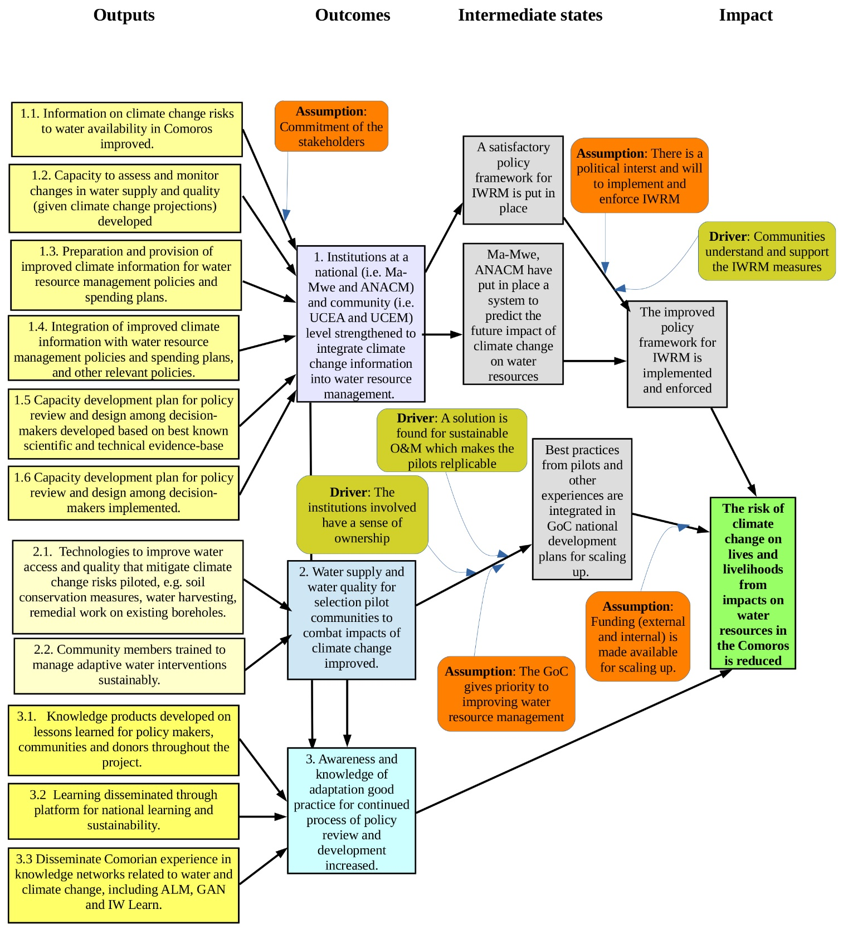Note: The yellow boxes indicate the outputs as stated in the project document, while the blue boxes indicate the outcomes as stated in the project document. The grey boxes indicate the proposed intermediate states, the olive boxes indicate the proposed drivers and the orange boxes the proposed assumptions, as identified in the reconstructed ToC.

1. This reconstructed TOC was presented to the stakeholders that participated in the debriefing, but there were no detailed comments to it.

# Evaluation Findings

## Strategic relevance

1. The Project is contributing to the 2008-2012 United Nations Development Assistance Framework (UNDAF), Outcome 4: "*By 2012, the integrity of the ecosystems is preserved and the eco-services they provide are for the benefit of the population, and the vulnerability to natural and climatic hazards is significantly reduced*"[22].[23] The project is also aligned to the UN Environment Medium-term Strategy 2010–2013 (even if it is not mentioned in the project document), where Climate Change is one of the six cross-cutting thematic priorities[24], and to the UNDP 2008-2011 Strategic Plan, which has environment and sustainable development, including adaptation to climate change, as one of its strategic pillars[25]. It is also aligned to the Initial National Communication (2002) and the National Adaptation Programme of Action (NAPA) (2006), which listed the water sector as being the second most vulnerable sector to climate change (after agriculture).
2. The project conforms in principle to the GEF Least Developed Countries Fund (LDCF) eligibility criteria, namely: i) undertaking a country driven and participatory approach; ii) implementing the NAPA priorities; iii) supporting a “learning-by-doing” approach; iv) undertaking a multi-disciplinary approach; v) promoting gender equality; and vi) undertaking a complementary approach. It also takes into account the human rights as the pilot projects are addressing water stressed rural communities and the construction of public stand-posts, which gives access to water for the people who can not afford a household connection. The weakest point here is the promotion of gender equality, an issue which is not explicitly addressed, despite that it is well known that gender issues are very important in water projects at community level. It is stated in the project document that the project has been designed to meet overall GEF requirements in terms of implementation and design, e.g. sustainability, replicability, M&E and stakeholder involvement. As it will be discussed below, this is the case for stakeholder involvement, but regarding sustainability, replicability and M&E, this may have been the intention, but is has not been fully achieved.
3. The project document is from before the Sustainable Development Goals (SDG), so reference is made to the Millennium Development Goals (MDG). The project document states that the resultant improved access to drinking water will be a key element for the improvement of the nutritional status of the Comorian community, therefore attaining better health outcomes and positively affecting MDGs 4 and 6 and 7. It is considered that this is a too broad statement and that the most clear contribution of the project is to Target 7C of MDG 7 (“*halve by 2015, the proportion of the population without sustainable access to safe drinking water and basic sanitation*”) and Target 7A (“*To integrate the principles of sustainable development into every nation’s policies and programmes, and also reverse the depletion of environmental resources”*).
4. With the emphasis in the project on capacity building, the project is also aligned to the Bali Strategy[26]. However, it should be noted that eventually not all the planned capacity building activities were carried out (which is considered justified – see below).
5. *In conclusion,* the project is well aligned, both to the UN and to the national priorities. However, as mentioned above, several activities under Outcome 1 and 3, related more directly to climate change, were eliminated for various reasons, and the project has thus put less emphasis on climate change than originally planned, being redirected more towards a more traditional water supply project. The project strategic relevance is thus rated as *Moderately* *Satisfactory*.

## Achievement of outputs

### The activities carried out

1. To secure the planned 11 outputs (6 outputs for Outcome 1 and 3 outputs for each of Outcome 2 and 3), 52 activities were planned (20 for each of Outcome 1 and 2, and 12 for Outcome 3). Not all activities were eventually carried out, either because they were being done by another project, or they were considered infeasible, or because they were considered to be less relevant due to the circumstances – and in some cases because of budget constraints. In Annex E there is comparison of planned activities and activities eventually carried out.[27] There is of course a direct relationship between the realization of activities and the outputs – if some of the activities are not carried out, the outputs can not be expected to be fully achieved (unless they *have* been carried out, but just with financing from other sources).
2. The activities fall principally in two main groups: (i) strengthening of national institutions in the area of Water Resource Management (WRM) and climate change, and (ii) the five pilot projects aimed at putting into place sustainable and climate change resistant Water Supply Schemes and improving water and soil conservation. The third group of activities is derived from the two first (collecting and disseminating information on the project and climate change, and supporting advocacy in the area of WRM and climate change).
3. In general terms, there were most changes in the planned activities for the first outcome (outputs 1.1 to 1.6), while several activities for the third Outcome (outputs 3.1 to 3.3) were not carried out. For Outcome 2 (outputs 2.1 to 2.3), activities were carried out on all five planned project sites, but the scope was reduced due to budget constraints. All these changes of course affected the achievement of the outputs.

### Achievement of outputs related to Outcome 1

1. Output 1.1. “Information on climate change risks to water availability in Comoros improved”, and Output 1.2 “Capacity to assess and monitor changes in water supply and quality (given climate change projections) developed”.
2. The main partner institution for these two outputs is the National Agency for Civil Aviation and Meteorology, ANACM. The project has financed the installation of 5 small automatic meteorological stations (2 in Anjouan, 2 in Grande Comore and 1 in Mohéli). All five stations are operational (since 2012) and according to ANACM they have had few problems during operation and they have never lost data. They are connected to ANACM by mobile phone. Two staff members have been trained by the provider at their factory in France. The data collected is used in the climate models for forecasting. They have technical support from ASECNA.[28]
3. Before the installation of these 5 stations, the only meteorological data available was from 2 airports and the forecasting was made by international agencies (the evaluator saw 4 of the 5 stations during the field visits). ANACM has since received 4 more weather stations financed by the CRCCA project.

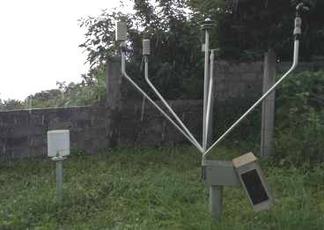

The weather station at Bandasamlini

1. The data and the climate modelling have permitted ANACM to produce its own weather forecasts, which are recorded for Television at the studio installed at ANACM.

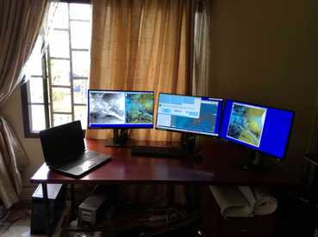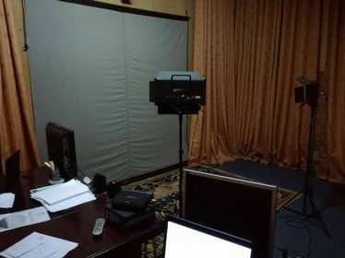

*Climate modelling workstation at ANACM (not financed by the project)*

*Studio for recording weather forecasts, ANACM*

1. ANACM staff has together with staff from other institutions received training in climate modelling (15 persons for 1 week). One staff from ANACM has been trainee in Niger for two months in the use of the modelling software and one staff from ANACM has been on a one week training in France.
2. The ex-project-coordinator has provided the following information on the training carried out:

Table 5. Training workshops Outcome 1.

| Training workshops | Participants |
| --- | --- |
| Training of staff from Ma-Mwe, UCEA, UCEM, DGEF, DGEME and ANACM on the integration of climate data and the risk management approach in the water sector (UNEP funds). | 33 participants of which 8 women |
| Training of staff from ANACM and DGEF on the collection and analysis of climate data and the downscaling of climate models (UNEP funds) | 18 participants of which 5 women |

1. It was planned also to introduce hydrological modelling. However, it turned out that the hydrological data available were not sufficient for this modelling. Training was carried out, but concrete modelling was not done. The planned installation of hydrological measuring equipment was not done. Several of the activities related to the first output were gathered after the Mid Term Review in a new activity 1.1.4 “*State of the Art study on water and climate in Comoros, including analysis of sectorial policies that hinder or facilitate resilience and, links between tides and salinity, an analysis of costs and benefits of adaptation, and the recommendation of adaptation indicators*”.[29] This study – in the latest planning scheduled for last quarter of 2016 - was *not* carried out. The justification for this study is not clear, and hence the consequence of not carrying it out does not appear to be of major importance.
2. *In conclusion*, as there is no clear target for these outputs (“increased”, but with how much?), it can safely be stated that t*he two outputs have been achieved*. There is clearly more climate information available, it is collected and recorded and ANACM has more capacity to use the data for modelling and forecasting.
3. The data could be used better, however. The information is published in a monthly bulletin, but the evaluator considers that the data ought to be available at an ANACM website. Furthermore, as stated by ANACM, the database it very extensive and could be brought to much more use than it is presently.
4. Output 1.3. “Preparation and provision of improved climate information for water resource management policies and spending plans”.
5. This output was to be based on the hydrological modelling of water resources, which turned out not to be feasible due to insufficient data. It should have been done in close cooperation with the AFD project and the SIDS IWRM project. *This output has not been achieved.*
6. Output 1.4. “Integration of improved climate information with water resource management policies and spending plans, and other relevant policies.”
7. The activities under this output were primarily an analysis of the institutional and policy framework for the water sector, make proposals for a revised Water Act (“*Code de l’Eau*”), develop proposals for tariff policy and analyse the consequences for other sector policies (Agriculture, Environment, Economic Growth). As these activities were taken up by the AfDB financed PAEPA project, they have *not been carried out* by the ACCE. The PAEPA project has only been partly successful in achieving this output: the sector analysis has been carried out and a proposal for a revised Water Act has been developed. The proposal has not passed parliament and is still under consideration – an often heard comment is that the proposal is too generic and not sufficiently adapted to the concrete Comorian environment. The output has thus been *partly achieved***,** but due to another project.
8. Output 1.5. “Capacity development plan for policy review and design among decision-makers developed based on best known scientific and technical evidence-base.”
9. The elaboration of a capacity development plan was taken out after the Mid Term Review as this was being done by the PAEPA project. The planned training was not carried out either, according to the former project coordinator because the new Water Act had not been approved. The output has thus been *partly achieved***,** but due to another project.
10. Output 1.6. “Capacity development plan for policy review and design among decision-makers implemented.”
11. The activities included the establishment of a cross-ministerial body for government coordination on adaptation policy and training activities. These have not been done, according to the former project coordinator because the new Water Act had not been approved. Hence, *the output has not been achieved***.**

### Achievement of outputs related to Outcome 2

1. Output 2.1. “Technologies to improve water access and quality that mitigate climate change risks piloted, e.g. soil conservation measures, water harvesting, remedial work on existing boreholes.”
2. As mentioned, the five planned pilot projects have been implemented, but with a general reduction in scope due to budget constraints, and one of the sites was changed (the five Djandro Plateau communities were substituted with the neighbouring communities Hoani and Mbatsé).
3. The main scope of the projects was eventually the following:
4. *The Moroni project with Ma-Mwe.* The improvement of the network was limited to the 7 km Transmission Main from TP5 to the main reservoir (RB2000), partial rehabilitation of the borehole TP5, installation of 5 valves for air exhaust, 1 interconnection and 1 evacuation valve. The borehole UNO4 is presently under rehabilitation with other funding.
5. *The Bandasamlini Project, Grande Comore (Njazidja).* The project scope was changed to mainly cover construction of impluviums, reforestation and training in soil and water conservation. The planned reservoirs are under construction with funds from the CRCCA project.
6. *The Nioumakélé project, Anjouan (Nzwani).* The rehabilitation of the network was limited to the construction of a new water intake and a partial rehabilitation of the transmission main.
7. *The Lingoni-Pomoni project, Anjouan.* The rehabilitation of the network was limited to the rehabilitation of the intake, construction of a new transmission main and the construction of a slow filter was added. Only one of the reservoirs was constructed (Pomoni), the other reservoir (Lingoni) was rehabilitated. 57 public stand-posts installed.
8. *The Mbatsé-Hoani Project, Mohéli.* As the site was changed, the scope was also different from the planned. The project consisted in the rehabilitation of the water intake, a new transmission main, a slow filter and one reservoir. Installation of 35 public stand-posts and rehabilitation of 20 more.
9. In conclusion, *the output has been partly achieved*(partly only due to budget constraints).

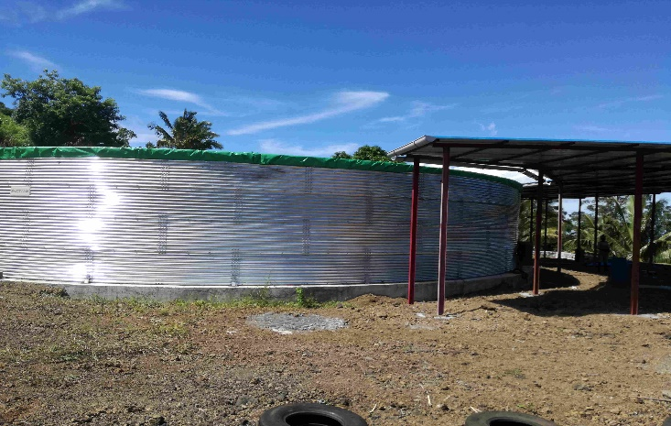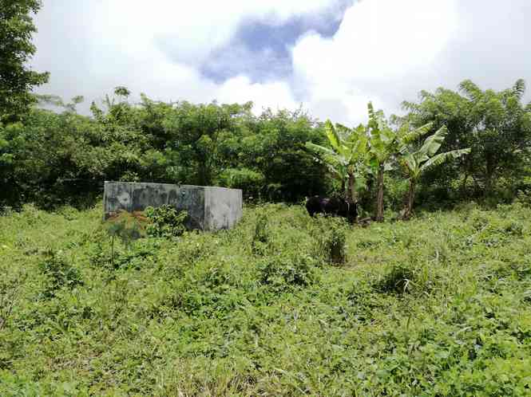

Impluvium, Bandasamlini Water harvesting Reservoir, Bandas. (CRclimate changeA financed)

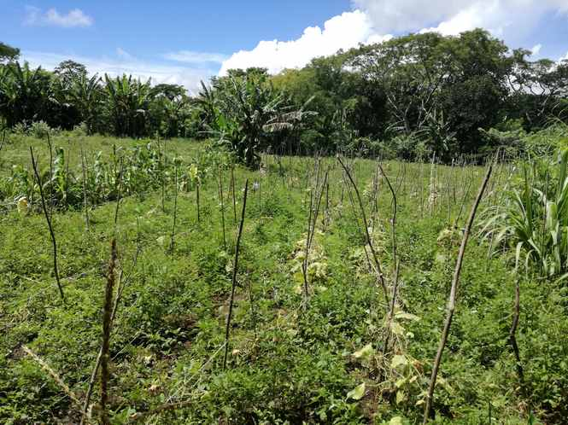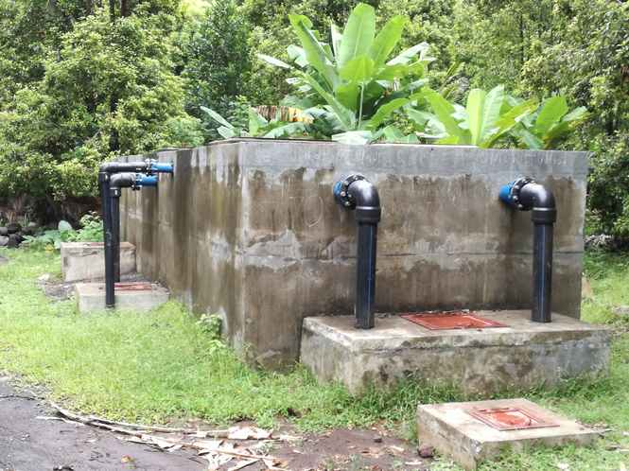

Contour planting, Bandasamlini Slow filter, Lingoni-Pomoni scheme

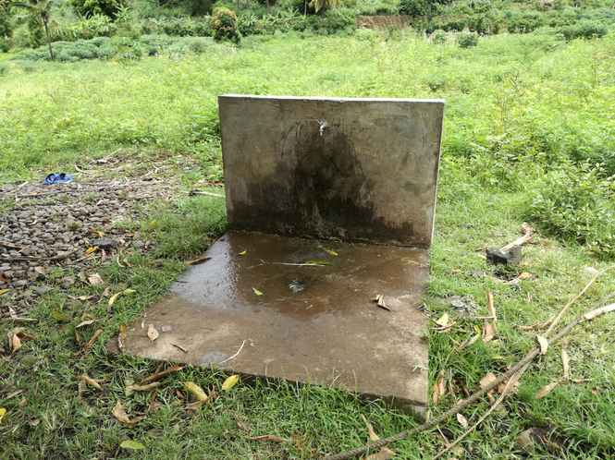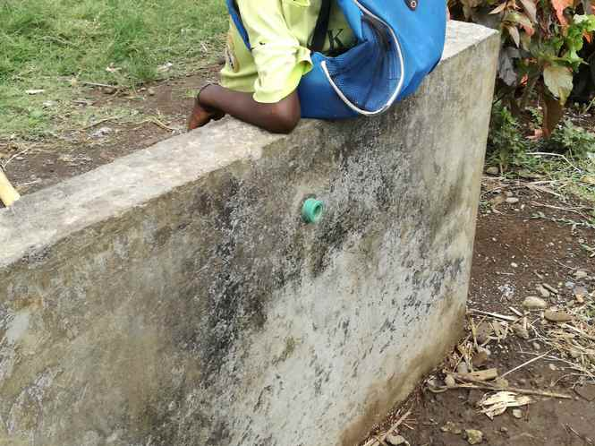

Public stand-post, Pomoni Broken school stand-post, Pomoni

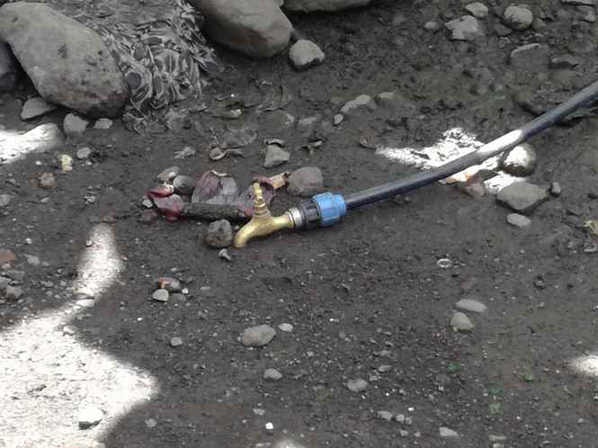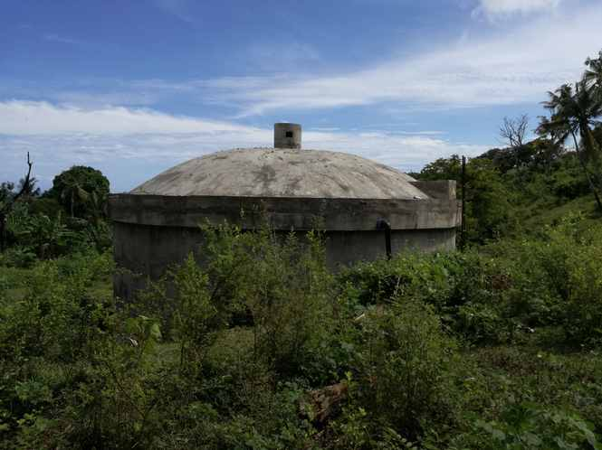

Household yard connection, Pomoni Water reservoir, Hoani

1. Output 2.2. “Community members trained to manage adaptive water interventions sustainably.”
2. Training has been carried out of members of the water committees (“*Comités de gestion de l’eau*“) in four of the pilot projects (i.e. excluding Moroni). Slow filters for water treatment have been constructed at two sites (Lingoni-Pomoni and Hoani-Mbatsé) as the lack of water treatment in the community water schemes is an obvious challenge. The Ma-Mwe staff has been trained in soldering of HDPE pipes.
3. The ex-project-coordinator has provided the following information on the training carried out for community members:

Table 6. Workshops Outcome 2

| Training workshops | Participants |
| --- | --- |
| Training on Community Management of water supply | 28 members of the Lingoni-Pomoni, water committees, of which 8 women (Anjouan)  20 members of the Mbatsé-Hoani water committees, of which 8 women (Mohéli) |
| Training on maintenance and repair of rural water supply networks | 15 members of the Lingoni-Pomoni and Nioumakelé water committees (Anjouan)  10 members of the Hoani-Mbatsé water committees (Mohéli) |
| Training on sustainable and resilient agricultural land management | 125 farmers in 8 groups |
| Training of farmer-promoters on installation and maintenance of drip-irrigation kits | 26 farmers in Bandasamlini, 17 in Lingoni –Pomoni (Anjouan) and 9 in Mohéli |

1. As the output has been formulated more as an activity than as an output, it can be said that *the output has been achieved*. However, sustainability remains a distant goal still, as discussed below in the section on sustainability.
2. Output 2.3. “Degraded agricultural and forested lands in pilot sites are the object of sustainable land use plans and vegetative cover increases”
3. A participative species selection for reforestation was carried out, land use plans were elaborated and training in agro-sylvo-pastoral systems was carried out. Participatory reforestation was carried out within communities in the framework of the national campaign "1 Comorian, 1 tree". Data on number of trees planted are hard to get at. However, as much of the planting has been done on communal lands, and the survival rate on these communal lands according to information from some of the participants is extremely low, it is dubious whether there has been a measurable increase in the vegetative cover. We shall discuss this further under the sustainability section below. *The output has thus been partly achieved*.

### Achievement of outputs related to Outcome 3

1. Output 3.1. “Knowledge products developed on lessons learned for policy makers, communities and donors throughout the project.”
2. The planned activities were the compilation of project results and identification of potential barriers to their replication, and the launching and disseminating of knowledge products and communications products.
3. Apart from the printing of some pamphlets and the production of caps and t-shirts, *this output has not been achieved*.
4. Output 3.2. “Learning disseminated through platform for national learning and sustainability”
5. The activities carried out were related to the project inception: an inception workshop, community workshops on the project and publicizing information on the project in newsletters, newspaper articles and other local media. The potentially more transcendental activities as creating a parliamentary working group and the organisation of national and island workshops disseminating the results and lessons learnt from the project have not been carried out. Hence, the *output has been partially achieved.*
6. Output 3.3. “Disseminate Comorian experience in knowledge networks related to water and climate change, including ALM, GAN and IW Learn.”
7. This has not been done; hence *the output has not been achieved.*
8. **Concluding on the achievement of outputs**, it is evident that many outputs have not been achieved or have only been partially achieved. There are several reasons for this, as mentioned above. It obviously does not make sense to insist on an output that another project is already working on delivering (e.g. the policy framework and the elaboration of an institutional strengthening plan being done by the PAEPA project). However, there are also some more project design related constraints. It is e.g. not clear, how it should be possible to derive the lessons learnt from the project and disseminate these in community workshops and on knowledge platforms within the stipulated project period, unless the implementation plan had allowed for a significant period after the implementation of the last proper project activities to carry out these (in practical terms) post-project activities. The main reason the pilot project outputs under Outcome 2 have only been partially achieved is again down to a design issue, as the original budgeting for these projects was way below what was needed. On the other hand, it is the impression than when prioritising the outputs, the pilot projects were considered imperative as there was much pressure from the communities and the Government to show concrete results, leading to lower priority being given to the more climate change specific outputs under component 1 and 3. For these reasons it is assessed that the achievement of the outputs is *moderately satisfactory* (and not unsatisfactory).

## Effectiveness: Attainment of project objectives and results

1. A baseline study was carried out during the inception phase (in 2011), which revised the indicators for the objective and the outcomes and proposed some changes to these, and established baseline values. A total of 9 outcome indicators were originally included in the project document. After the baseline study, several of these indicators were changed and once again after the Mid Term Review. In the end, two of the indicators were dropped as not measurable (indicators for typhoid cases and for increased agricultural production), and 7 indicators remained.
2. Several of these indicators have not been measured and the assessment of the indicators made by UNEP and UNDP respectively is not identical. In Annex F there is a table with the (revised) indicators, baseline values, end-project targets, assessment made by UNEP and UNDP and comments by the evaluator. In the present section we will only give an overall summary assessment of the outcomes. For details, please see Annex F.

### Attainment of Outcome 1.

1. **Outcome 1:** *Institutions at a national (i.e. Ma-Mwe and ANACM) and community (i.e. UCEA and UCEM) level strengthened to integrate climate change information into water resource management.*
2. One indicator for Outcome 1 is: “*Number of policy documents at the Union decisional level, the island decisional level and the community/local level revised or elaborated to include regulations and provisions that promote gender equitable adaptation in the water sector.”* It has an end-project target of:
   1. The Water Act is revised and includes regulations and provisions that promote gender-equitable adaptation.
   2. One water programme with priority actions by 2030 is elaborated by the end of the project.
   3. Water Acts at the local level in the pilot sites in Moheli and Anjouan are revised to include regulations and provisions that promote gender-equitable adaptation
3. The following has been achieved:
   1. The Water Act has been revised, but financed by the PAEPA project. The quality is questionable and there is still a long way to approval and implementation.[30]
   2. Not achieved.
   3. There are no local Water Acts, but the project has elaborated standard statutes and regulations for water management committees which can be used locally. No specifics regarding women or gender are mentioned in these standard regulations (e.g. composition of the boards).
4. The second indicator for Outcome 1 is: *“The number of policy-makers and planners at the Union and island levels using adjusted processes and methods (e.g. collecting water data and climate data, modelling climate trends and monitoring water quality and supply) to develop gender-equitable water management policies that integrate climate change projections”.*
5. The end-project target is: “*By the end of the project, at least the following numbers of planners are using adjusted processes and methods, in terms of collecting water and climate data, modelling climate trends and monitoring water quality and supply, to develop water management policies that integrate climate change projections: 7 policy makers and planners at Union level, 5 in MaMwe; 10 in ANACM; 3 in the Directorate of Environment in Mohéli; 5 in the Directorate of Environment in Anjouan; 2 in UCEM and 7 in UCEA.”*
6. UNDP reports that “*12 planners use methods adjusted to take climate change into consideration in order to develop water management policies”.* It is not clear what exactly UNDP is basing the assessment upon. The evaluator has not been able to make a firm assessment on this from the interviews.
7. The **evaluator assessment** regarding the first outcome is that there is clear progress in ANACM (collection of data, modelling and analysis), and that there is a more widespread awareness in the institutions (DGEME and DGEF) about the need to improve the management and integration of data related to climate in general and climate change in particular. There is furthermore a nascent interest in integrated water resource management, and there is an on-going political process to bring forward a new Water Act, which is expected to include a more consistent regulatory framework for water resource management. However, there is still a long way to go before an appropriate policy and institutional framework for climate change adaptation is in place. This should not be a surprise as this type of political processes tends to be slow.

### Attainment of Outcome 2.

1. **Outcome 2:** *Water supply and water quality for selected pilot communities to combat impacts of climate change improved.*
2. The first indicator for Outcome 2 is: “*Overall perception of the population per pilot site on: i) the daily quantity of water accessible for domestic uses ii) the facility of access to this water and iii) the quality of the water used (as per WHO standards) on a rating of 1-4*”[31]
3. The end-project target is: Raise the rating to 2 for all three criteria across all project sites. The UNDP assessment is that this target has basically been achieved.[32]
4. As mentioned, the Vulnerability Reduction Assessment workshops carried out in the communities during the baseline study have not been repeated end-project (the UNDP ratings is a desk assessment). The evaluator has only been able to talk to members of some of the water committees. It is debateable whether the change of this indicator made after the Mid Term Review to cover *perceptions* instead of more tangible data on water quantity, water quality and continuity of service was a good idea. These more tangible data could have been collected with a relatively simple monitoring system, but as this was not done, it is not possible to make a precise assessment.
5. **The evaluator assessment is that:**
   1. *The quantity* of water has increased, but due to the old distribution network, this is not fully noticeable to the users,
   2. *The quality* has probably improved at the two sites where slow filters have been installed, but water quality measurement has not been carried out so this can not be documented.
   3. *Access* has only improved where increased water pressure has returned water to sectors connected, but where the water did not reach, and in some cases where new areas have been covered with public stand-posts. Access is still a major problem in Moroni, Hoani-Mbatsé and probably Lingoni-Pomoni. The UNDP rating as 2 (users report that they are satisfied) therefore appears too optimistic.
6. The second indicator for Outcome 2 is: “Number of surviving trees in reforested areas”, with an end-project target of “*80% survival rate which gives 144,000 living trees by the end of the project*”. The UNEP assessment is that the tree planting directly attributed to the LDCF project is around 140 ha (140,000 trees), with a reported 'good' survival rate.
7. **The evaluator assessment** is that the survival rate of the reforested communal areas is very low, in some cases zero. The survival rate at private farms is much higher, particularly for the fruit trees (up to 80% in Bandasamlini). A more detailed assessment is not possible due to lack of monitoring data.
8. **The overall evaluator assessment** of the attainment of outcome 2 is that the pilot projects have contributed to improve the water supply in the communities (and Moroni), but as mentioned not to the degree expected due to the limited character for the interventions. The promotion of water and soil conservation in agriculture has no doubt had some positive effects. It is difficult to assess the degree of impact, as there is no monitoring data on e.g. how many farmers have actually put into practice more sustainable farming methods. As this is a relatively small add-on component, the impact is probably not very significant[33]. Changing agricultural practices among small farmers is a long progress, which is often started working with selected farmer-promoters (as it has been done in the project) and then the successful experiences are promoted among other members of the communities.

### Attainment of Outcome 3.

1. **Outcome 3**: *Awareness and knowledge of adaptation good practice for continued process of policy review and development increased*.
2. The first indicator for Outcome 3 is: “*Percentage of men and women (public and decision makers) aware of climate change vulnerability and adaptation responses*”. The end-project target is: “*By the end of the project, at least 30% of the population within pilot site communities are aware of climate change impacts and adaptation options. Mid-way through the project, at least 10% of the population within pilot site communities are aware of climate change impacts and adaptation options based on their involvement with pilot site interventions.”* The UNDP assessment is that 40% of the population within pilot sits and 70% of decision-makers have better knowledge on climate change impacts and adaptation options.
3. As no measurement has been made, neither for the baseline, nor for the end-project situation, it is difficult to assess. It is not clear how the 10% baseline value was arrived at, neither how UNDP makes its assessment of the 40%. With these caveats, **the evaluator assessment is** that there is an increasing awareness of the impact of climate change, as this was mentioned by many of the interlocutors. This is no doubt an effect of the many campaigns and projects related to climate change, including the present project. A more precise attribution is not possible.
4. The second indicator for Outcome 3 is: “*Number of newspaper articles, booklets and pamphlets highlighting lessons learned during the project and # of technical documents on lessons learned submitted to knowledge networks*”. The end-project target is that *“The project lessons are distributed in hard copy (e.g. pamphlets, briefing notes, newsletters, booklets etc), electronically (e.g. via the project website), via radio broadcast and via one national and three island-level workshops. Mid-way through the project, a project website is operational and is regularly updated with project information.*
5. The UNEP-UNDP assessment is that this is work in progress as a number of communication products have been produced.
6. The evaluator has seen a few communication products but has not received a complete list of what has been produced. The web-site was reportedly working for two years. If a distinction is made between (a) general communication products on climate change and the project, and (b) technical documents for knowledge networks, **the evaluator assessment is** that the general communication (a) has probably been covered quite well, but more specific technical information on the project and the lessons learnt (b) has *not been covered at all*.
7. **The overall evaluator assessment** of the attainment of outcome 3 is that there has been an increase in awareness, attributable to many different programmes, of which the present project is one. However, it is difficult to quantify. The contribution of the project to learning is minimal, but this could still be done (see the recommendations below). As a consequence, **the overall evaluator rating of the attainment of outcomes** is *moderately unsuccessful*.

### Attainment of project goal and planned objectives

1. The overarching *goal* of the project was “*to adapt water resource management to climate change in the Comoros*.” *The project objective wa*s that “*The risk of climate change on lives and livelihoods from impacts on water resources in Comoros has been reduced”.* The indicator was: “*The percentage change in vulnerability of men and women living in the pilot sites to climate change risks on availability of clean water.*” The baseline study carried out vulnerability reduction assessment workshops in the villages.[34] The end-project target is that the vulnerability is reduced to 2 at all 5 project sites[35]. The UNDP assessment is that this target has been achieved.
2. The vulnerability reduction assessment workshops have as mentioned not been repeated end-project and the evaluator has only been able to talk to randomly selected community members. **The evaluator assessment** is that the vulnerability has been reduced, but taking into account the limitations of the water supply schemes installed, a rating of 2 appears too optimistic.

### Likelihood of impact based on reconstructed ToC and using RoTI

1. As mentioned, the objective is: “The *risk of climate change on lives and livelihoods from impacts on water resources in the Comoros has been reduced*”.
2. As mentioned in section 3.8 on the reconstructed ToC, to reach this desired situation the *following intermediate states* could be envisaged:
   1. The institutions, among these ANACM and Ma-Mwe, have put in place a self-sustaining system with the capacity to predict the future impact of climate change on water resources,
   2. A satisfactory policy framework for IWRM is put in place, and
   3. The improved policy framework for IWRM is implemented and enforced
   4. Best practices from the pilot projects and other experiences are integrated into the GoC’s developments plan for the water sector and used for scaling up.
3. The likelihood for a) to happen is considered high for ANACM which has already reached a good capacity, but low for Ma-Mwe. b) is in process, and is also likely to take place, but it will probably take several years, so it is considered moderately likely. c) obviously depends on b), and experience from other countries in Africa and elsewhere shows that this is a rather long process, so again it is *moderately likely*. Another thing is “*attribution*”. Regarding a), the attribution by ACCE is considered to be substantial, while for b), the attribution from other projects is considered to be more important.
4. Regarding the assumptions identified in the reconstructed ToC:
   1. *There is a political interest and will to implement and enforce IWRM*. This interest and will is considered to be weak for the moment, but as the issue of water becomes increasingly serious due to climate change and increased population pressure, the assumption is in the medium to long term considered to be likely to hold.
   2. *The Government gives priority to improving the water resource management*. Following the above reasoning, as the political will increases with time, this assumption is also considered to be likely to hold in the medium to long term.
   3. *Funding is made available for scaling up*. The likelihood of this assumption to hold is difficult to assess as it depends on the financial capacity of the Government and the willingness of the development partners to contribute. It is considered *moderately likely* to hold.
5. *Barriers* are as mentioned likely to be: a) Resistance to IWRM measures from vested interests, (b) lack of understanding in the communities of the need for IWRM measures to secure the water resources for the common good, and (c) difficulties in the enforcement because of lack of political backing when negotiation and consensus seeking turns out to be insufficient to solve conflicts over the water. This is often when political will to implement IWRM falters.
6. For the upscaling to happen (intermediate stage d) above), a driver is that a solution is found to the challenge of sustainable operation and management of the water supply schemes. As it will be discussed in the next section, this continues to be a serious challenge and should be prioritised by the water sector stakeholders.
7. In conclusion, *it is considered moderately likely* that the objective will be achieved, but it will take time. There are considerable barriers, but also a noticeable political will to progress. There are several on-going efforts with external support to put in place IWRM (among these the SIDS-IWRM project and the newly approved UNEP GEF financed Watershed Management project). The challenge related to sustainable operation and management is recognised, even if the resistance to payment for water - and in particular a tariff which secures cost recovery - is still considerable, among both the population and several influential politicians.

## Sustainability and replication

1. *The strengthening of ANACM appears to be sustainable*. The institution has a considerable technical staff with a relatively low turnover. The change of Government in mid 2016 led to changes to the top management, but not to changes in the technical staff. The institution has continuous technical support from ASECNA and the World Meteorological Organisation. The provider of the weather stations has a representative in the country. As ANACM is an autonomous institution that also covers civil aviation, it has a fairly stable economy.
2. The - admittedly limited - efforts done by the project to *improve the policy framework* and institutional set-up (given that the planned activities were taken over by PAEPA), including the drive towards IWRM, have contributed to setting in motion a process, but it *cannot be considered sustainable*, unless further support is given. Luckily, several donors seem to be willing to do this. The Water and Sanitation Sector Working Group mentioned above has the water policy high on the agenda. Furthermore, several new projects to support IWRM are upcoming.
3. The main institutional anchoring of the project in Anjouan and Mohéli is in *the unions of water committees (UCEA and UCEM)*. These organisations have been created with support from earlier projects by the French Development Agency (AFD). They are supposed to be maintained financially by contributions from the members (the water committees), but in reality *they depend crucially on external support*. There are several ideas on how to make them viable in the future, among these as service providers and providers of spares to the water committees, but it is likely that they will in the medium term continue to be almost completely dependent on external support. An AFD representative explained to the evaluator that it is planned to continue cooperation within the water sector in the future and that this support will include continued technical and financial support to UCEA and UCEM. So at least in the medium term, the unions should be able to continue operating.
4. *The water division of Ma-Mwe* has a quite capable technical staff and was itself in charge of laying the Transmission Main financed by the project. However, the organisation is predominantly an electricity provider, and water supply is clearly a second priority (there is presently no wastewater services). The payment for water is extremely low – a rough calculation made by Ma-Mwe in 2012 showed that only around 20% of the water produced was actually invoiced. The rest was either physical losses (leakages in the network) or commercial losses (water delivered was not metered and invoiced). *This is clearly unsustainable***.** There is no quick fix for the lack of sustainability of Ma-Mwe. A privatisation was tried a decade ago but was not successful, and the company was taken back by the Government. The bad state of the distribution network is one of the main problems, but also the lack of a proper company structure. The Ma-Mwe water director wants his division separated out as an independent company, be that public or private. But for the company to be viable, heavy investments are needed, among others for network rehabilitation (substituting the old asbestos-cement pipes with HDPE pipes), increased reservoir capacity, construction of new wells and installation of meters. A completely new commercial department would have to be set up to secure metering and invoicing. How likely this is to happen is difficult to say. The director of DGEME expressed that she is aware of the need for a complete overhaul of Ma-Mwe, so the political will may be there. Regarding financing, UNDP is - as mentioned - about to present a new project to the Global Green Fund, which includes follow-up on the pilot projects, including considerable funding for Ma-Mwe. If this financing is achieved, the future may look brighter, on the condition that profound changes are made at Ma-Mwe – in fact a complete organisational overhaul.
5. The four *community water supply projects* also have serious challenges regarding sustainability, and it can safely be stated that if substantial action is not taken to secure operation and maintenance, they *are not sustainable*. There is an urgent need to put into place systems for operation and management and cost recovery. If that is not done, the water schemes will soon start to degrade, a process that is already visible. The challenge for the community pilot schemes is aggravated by the fact that the water supply schemes are incomplete, as they do not include rehabilitation of the distribution network or the installation of meters. An interlocutor told the evaluator that he considered that the Pomoni-Lingoni water supply system was “unmanageable” (“*ingérable*”) due to the fact that investment had not been made to improve the distribution system. The evaluator agrees with this assessment.
6. In general, these community water supply schemes are too big for informal community management, where the operation and management is based on voluntary work. There is an urgent need to set up a formal structure for operation and management and financial management and to pay for the operation and management services (independently of the institutional set-up, i.e. whether the community takes on the responsibility for operation and management and hires the necessary staff or contracts the operation and management out to private operators). It is worth mentioning that this problem is general for the Comoros, as most water supply schemes lack sustainable management. There are few cases of successful management. One case mentioned is Sima town (Anjouan) (around 11,000 inhabitants, not visited), where the water supply is managed by a private company. However, at the same time the evaluator was told that the water tariff is 1,000 KMF (around 2 Euro) per m3, which does not sound as a realistic model to replicate.[36] UNDP informs that in the project presented to the Global Green Fund, extra funding for the four community water supply schemes is included. It is vital when trying to put into place a sustainable management system that it starts out with a reasonably well functioning scheme, including distribution and metering.[37]
7. The *reforestation* on communal lands is clearly *not sustainable*. When asking to see the reforested areas at Bandasamlini the evaluator was told by the farmer-promoters working with the project that there was really nothing to see, as survival was close to zero. At Hoani-Mbatsé the evaluator saw some areas on the river banks that had surviving trees, but the general conclusion is that reforestation on communal lands at present is very unlikely to become sustainable. One of the challenges is the lack of clear property rights. Lands that are denominated communal tend to have somebody considering himself the owner. So in cases where the perceived owner does not agree, he will simply cut down the trees planted (the evaluator was shown two cases where this had happened). Generally, when planning reforestation, it should be analysed why the area has been deforested in the first place. If the factors causing the deforestation are still present (use for agricultural activities, use for grassing, agricultural fires etc.), there is no reason to believe that the reforestation will be successful.
8. *Drip-irrigation* has been introduced as a water conservation measure, e.g. in Bandasimlini. According to the farmer-promoters the drip-irrigation kits worked well the first year, but not afterwards. They claimed that the reason was the quality of the drip-irrigation kits, but it is difficult to say. It might also be because of the lack of experience with drip-irrigation farming and hence that care is not taken to protect the pipes. The challenge was recognized by the CRCCA project team (which continues the activities started by the AcCCE), and they told the evaluator they were now piloting alternatives.

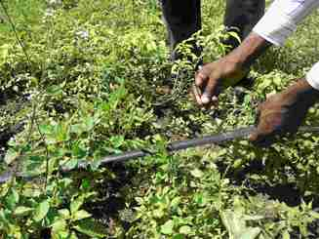 Broken (and abandoned) drip-irrigation pipes, Bandasamlini

1. Based on the above the following *overall assessments* can be made of the different sustainability categories mentioned in the terms of reference:
   1. *Socio-Political sustainability*. As mentioned, the political will to take action on climate change in the water sector is rather incipient presently, except for simply investing in supplying more water. A political process favouring improved water resource management has been set in motion. However, if there is no further external support, it will be very slow. Socially, there is increasing awareness of climate change and the need to adapt, but in very general terms. As further external support is likely to materialise, it is considered likely that the process will achieve socio-political sustainability,
   2. *Sustainability of the institutional framework*. The present institutional framework is not conducive for an improved water resource management to adapt to climate change. A clear policy and regulatory framework for water resource management is not in place yet, and in the case of Ma-Mwe a restructuring is necessary. The project has, as mentioned above, contributed to a process that may result in an improved institutional framework, but again further external support is needed. As this support is likely to materialize, it is considered moderately likely that an improved institutional framework may be put in place in the medium term.
   3. *Technical and financial sustainability.* The weak point is as mentioned related to the technical and financial sustainability of the water supply schemes constructed with support from the project, and the improved agricultural practices promoted. These are considered financially and technically *unsustainable*.
   4. *Environmental sustainability.* The activities supported by the project are generally environmentally sound: constructing more robust water supply infrastructures able to withstand harsher climatic conditions, reducing water losses and improving water and soil conservation in agriculture. The main negative environmental effect is – as is normally the case for water supply schemes – that the increased availability of water will produce more wastewater, particularly in the case of Moroni. For that reason, further projects to improve water supply in urban areas should be accompanied by investments to mitigate this negative environmental effect. The environmental sustainability is hence considered *moderately likely*.
2. As the sustainability clearly is a major challenge, it is assessed to be premature to consider *replication* of the pilot projects. There are good experiences that might be replicated, among which should be mentioned: the participative approach from the very start of the project planning, the use of local contractors in Mohéli and the introduction of slow filters to improve water quality. For the latter, it would be a good idea to check the water quality to assess the working of the filters. It should also be remembered that if the filters are not backwashed regularly, they may actually block the water supply, so good operation and management is absolutely crucial. All in all, the evaluation rating for replicability is considered to be *unsatisfactory*.

## Efficiency

1. Regarding the *timeliness* of the project interventions, the project has experienced delays, particularly in the implementation of the pilot projects. There are many reasons for these delays, but in the case of the pilot projects the need to carry out proper feasibility studies was an important factor. The Moroni project was thus not finished until mid 2016. Regarding the training activities, the process of hiring external consultants turned out to be very slow. So regarding the timeliness, the efficiency was rated as *unsatisfactory*.
2. Due to the lack of detailed financial information, it is difficult to make a well-founded assessment of *the cost-efficiency*. With this caveat in mind, it is the evaluator’s impression that much has been done with relatively limited inputs.
3. This is for example the case for the project with Ma-Mwe to improve the water supply in Moroni. Ma-Mwe had a considerable stock of HDPE pipes (that it had received earlier as a donation from the Chinese Government, independently of the present project), they contracted out the excavations but laid the pipes with their own staff (after training in HDPE soldering provided by the project). The supervision was provided by the UN volunteers. As the water supply in Moroni did not improve noticeably in many parts of Moroni after the new transmission line went on stream in mid 2016, some critics claim it is due to leakages in the new transmission main due to bad quality of the work laying the pipes. However, Ma-Mwe insists that when they measure what goes in at the well and what arrives to the reservoir RB2000, the loss is actually only around 5%.[38] Obviously, the limited impact of the project is due to its partial character – the transmission main has improved but all the other imperfections in the system are still there, particularly the leaking distribution network and the instability of the electricity supply for the pumps (which limits production).
4. In general, the works inspected by the evaluator give the impression of being of acceptable, and in many cases quite good, quality[39]. The water committees were generally expressing satisfaction with the works carried out, even if some details were criticised. Often the main critique was related to the limited scope of the work, e.g. in Hoani-Mbatsé where the fact that the distribution network in general was not improved means that several sectors are not connected to the system, and they are of course not happy.
5. The use of local contractors is commendable, as is the case of the contractor SOGEM at Mohéli. There are big advantages using local contractors and normally it is less costly. The main risk is the quality, but in this case it does not seem to be a problem as the quality appears to be relatively good.
6. The use of UN volunteers appears as a case of relatively cost-efficient provision of technical assistance. The assistance was highly appreciated by the partner institutions.

## Factors affecting performance

### Preparation and readiness

1. The project planning has been participatory from the very beginning, including the selection of the sites for the pilot projects, where priority was given to the poorest and most water stressed communities.[40]
2. As has been mentioned during the sections above, the project document is in places not quite realistic regarding the extent, the sequencing and the timing of the outputs, underestimating the time needed for political processes. This is for example the case regarding several follow-up activities, which in practice needed the new Water Act to be approved before it was relevant to carry them out, and regarding the time needed from the end of the implementation of the activities to the documentation and dissemination of the lessons learnt foreseen in outcome 3. This has obviously affected the achievement of these specific outputs.

### Project implementation and management

1. The project steering has not been functioning as it was planned. The Project Board has taken a more ceremonial character than it was envisaged in the project document. Only 4 meetings have been held in five years, whereas the plan was 2 annual meetings. Furthermore the annual work plans and budgets should be approved by the PB, which is only the case for 3 of them. The technical committees were never made operational.
2. There are quite a lot of projects related to climate change in the water sector in the Comoros. It is the impression that there has during implementation been a good coordination between the projects searching for complementarity, which has been very helpful, not least because of the budget constraints for ACCE. This is particularly the case for the AfDB funded PAEPA project, the UNDP-GEF CRCCA project and the AFD projects. A good example of coordination with the latter is the swap made of communities in Mohéli with AFD (Djandro plateau communities exchanged with Hoani-Mbatsé).
3. The fact that UNDP has had technical units at each island (RUTI), co-financed by different projects, including the ACCE, has been helpful for implementation, taking into account the difficult transport between the islands.

### Stakeholder participation, cooperation and partnerships

1. As mentioned above, the project preparation process has been participative from the beginning, starting with the planning of the pilot projects. This has continued during project implementation with the setting up of local Project Steering Committees with the inclusion of the communities. This participative process means that there is an active participation by the target groups, which is very important for the future. The degree of participation was appreciated by the evaluator during the visit to Hoani-Mbatsé in discussions with the Mayor and the Water Committees regarding the future management of the water supply scheme. What may have been lacking is a better integration of the schools.

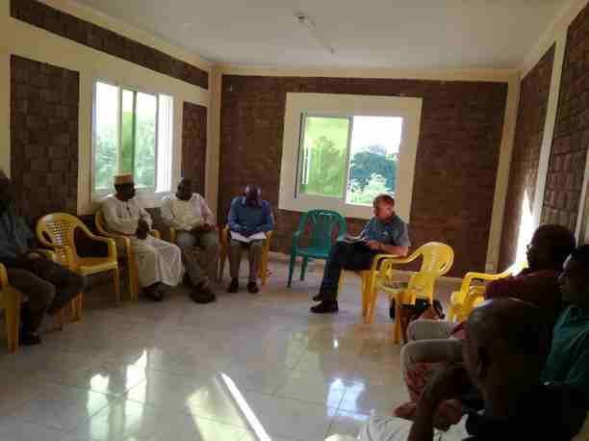Discussion on the future management of the Hoani-Mbatsé scheme at the Mayor’s office.

1. In the case of the main national partner institutions (ANACM and Ma-Mwe), it appears that the support received from the project has been discussed thoroughly with these on beforehand and basically corresponds to what they needed (within the financial limits of the project)

### Communication and public awareness

1. Communication and public awareness activities were foreseen under outcome 3 and are reported to have been carried out, including pamphlets, newspaper articles and local radio programmes (the evaluator has no seen the products). Regarding the pilot projects, particularly the Moroni project, it is the impression than the information on the project may have been too optimistic taking into account the partial character of the project, which has contributed to the frustration and criticism arising from the lack of improvement in the water supply perceived by many people in the city[41].

### Country ownership and drivenness

1. The project has been carried out using the national execution modality so the project unit was located in DGEF, and the project manager was the director of DGEF. It is the evaluator’s impression that there has been a quite high sense of ownership by the DGEF and the Ministry, which also has been reflected in the high priority given to the concrete water supply activities.
2. The UNDP country office took on a quite active role during project implementation, which on one hand has probably helped implementation, but on the other hand has made the division of roles less clear. The evaluator has e.g. been informed that the contracting of external consultants under the UNDP activities were carried out directly by UNDP using UNDP procedures, which turned out to be a quite lengthy process.

### Financial planning and management

1. All the UNEP funding and part of the UNDP funding were managed directly by the project unit in DGEF. This appears to have been functioning adequately. However, the financial reporting has not followed the original project budget, which was following the logic of activities, outputs and outcomes. Instead, the detailed reporting is on type of expenses (staff, travel, external consultants, payment to contractors etc.). This must have been a major drawback, not only for the progress reporting but also for the financial planning and management.
2. The extension of the project was given as “no-cost extension” so the extension of the project with two years would be expected to increase the relative weight of the administrative costs. However, referring to the budget and actual expenditures in section 3.6, the actual administration cost are *lower* than budgeted. One reason could be that several administration costs have been reduced (e.g. the non-hiring of communication and M&E staff). This is not easy to determine from the accounts.
3. Except for one case, the external auditors do not have comments to the project accounts. The case commented upon by the auditors was a payment made by the CRCCA “borrowing” funds from the ACCE project. This is of course not permitted, and the funds have been transferred back from the CRCCA to the ACCE project.
4. As it can be seen from the presentation of the budgets in section 3.6, the project was cofinanced by other projects, but in the sense that these projects aim at some of the same outputs and outcomes as the present one. In some cases these alternative sources of financing have taken over a specific output, which have therefore not been done by the present project. And in other cases these projects have taken over from the present one, as it is e.g. the case of the UNDP managed CRCCA project (construction of reservoirs in Bandasamlini and in general training of farmers in sustainable farming). This close cooperation between the projects has generally been positive, e.g. when the CRCCA project (which continues to 2018) has been able to follow up on activities of the ACCE project in the area of sustainable agriculture, as the ACCE sustainable agriculture component was very limited. A draw back is that it obviously makes attribution more difficult to assess.

### UNEP/UNDP Supervision, guidance and technical backstopping

1. The project implementation was complicated by the fact that the outputs were divided between UNEP and UNDP across the outcomes. This implied in practical terms double reporting to UNEP and UNDP, even if the main donor for both was the same (GEF).
2. The UNEP supervision has been relatively hands-off with only a few visits to the project. Combined with the lack of a proper M&E system it is obvious that it has been difficult for the UNEP task manager to keep himself updated on the project, and this is also reflected in the reporting (the PIRs), which is detailed and follows the project document closely, but in places is inaccurate. This is compounded by a lack of timely responsiveness by the project unit to UNEP questions.
3. The UNDP has had a much closer supervision from its Country Office in Moroni. However, the progress reports (PIRs) are imprecise and difficult to follow. The reporting follows the standard UNDP format, but it is simply not possible to compare the activities planned in the project documents, including the changes made after the Mid Term Review, with the activities actually carried out. Combined with the lack of detailed financial reporting, this can not have been conducive for the supervision.

### Monitoring and Evaluation

1. Concerning the Mid Term Review, one of the main issues being analysed was how to adapt the pilot projects to the lack of funds due to the underestimation of the costs. The Mid Term Evaluation made a long list of recommendations, but most of them quite general and not very operational. Changes were suggested for some of the indicators, which were actually made afterwards, but even so several indicators were not easy to follow.[42]
2. As mentioned, a proper formal monitoring system was not set up, despite a recommendation in this sense from the Mid Term Review, so there was no system in place to systematically track the achievements of the targets. VRAs were conducted in the pilot communities, but final VRAs to establish the end-of-project situation were not carried out. None of the persons interviewed had any idea about the *GEF tracking tool*, so it must be supposed it has not been used.
3. The lack of a proper monitoring system has made project steering and reporting more complicated than necessary. Relatively simple monitoring tools could have been installed, registering regularly e.g. the water production and the level of service in each community, the number of farmers that are actively participating in training on sustainable agriculture and putting into practice some of the new techniques, the number of farmers receiving subsidised inputs (e.g. drip-irrigation kits, seeds, technical assistance), etc.

### External factors

1. There is in general a difficult environment in the Comoros when it comes to promoting sustainable management of water supply schemes, as there is a generalised lack of understanding of the need to pay for the water. There are even some political leaders who have been campaigning against the payment for water. However, if the positive discussion with the Hoani-Mbatsé water committees on the need for metering and payment can be taken as a signal, this may be improving.
2. The population pressure leading to the use of lands on steep slopes for agriculture leads to continued deforestation and will make it more difficult to conserve soil and water and thus adapt to climate change. The ACCE project, as well as e.g. the CRCCA project, has been promoting contour planting with trees and other perennials to diminish the erosion, which is commendable, but these areas are in reality not apt for agriculture.
3. The lack of clarity regarding property rights to communal lands has significantly hampered the promotion of reforestation on communal lands.
4. There is in fact no system for water quality control in place in the Comoros, which means that there is little awareness of the problems with water quality, and little incentive to improve the quality.

# Conclusions and Recommendations

## Conclusions

1. The Union of Comoros has considerable challenges related to water supply. Even if these challenges are not directly related to climate change, but are rather a result of population pressure, lack of maintenance of existing infrastructure, deforestation and expansion of agriculture to steep sloping lands that are not apt for agriculture, they are expected to be further aggravated by future climate change. The project is thus addressing a highly relevantchallenge for the Comoros, and is considered to be well aligned, both to the UN and to the national priorities. However, for different reasons the activities related more directly to climate change adaptation have been reduced and it is clear the pilot water supply schemes have been given priority, thus redirecting the project towards a more traditional water supply project. The relevance is therefore rated as *Moderately Satisfactory.*
2. *The achievement of outputs*presents a mixed picture. Concerning the first outcome (Institutional strengthening to cope with climate change), the main achievements is the strengthening of the collection, storing and analysis of meteorological data (ANACM), while several outputs have not been delivered, either because they were covered by other projects (e.g. improving the policy framework for the sector), were not feasible (e.g. hydrological modelling) or considered not relevant (e.g. training of decision makers, taking into account that the new Water Act has not been approved).
3. Concerning the outputs related to the second outcome (the five pilot projects), all projects have been constructed and are operational, but the scope has had to be reduced due to funding constraints as the cost had been underestimated during project preparation. The overall assessment is that the project has delivered within the financial limitations, but that the incomplete nature of the projects represents a major risk related to the sustainability.
4. Concerning the outputs related to the third outcome (analysing and publicising the results of the project), little has been achieved (mainly initial workshops and some promotional products). However, this is not assessed to be a major drawback, as it is considered that the expectations regarding this outcome were too high in the project design. It is not likely that a 4-year rather limited project (less than 4 million USD) will result in radically new knowledge being produced that can be included in a scaling up at Union level. The project has some interesting innovations, as e.g. the introduction of slow filters to improve water quality, but the functioning of these filters has not been sufficiently analysed yet (e.g. water quality measurements to check whether the quality has actually improved and possible operation and management challenges) for it to be prudent to do scaling up. Overall, the achievement of the outputs is rated as *moderately satisfactory*.
5. *The achievement of the Outcomes* also presents a somewhat mixed picture. There is clearly some progress related to Outcome 1, particularly in the field of the collection and use of meteorological data. There has also been some progress in improving the policy framework as the debate on a new Water Act has started, but there is still a long way to go. The introduction of the concept of IWRM, crucial for improving the water resource management, is still very incipient. It is considered that the achievements are acceptable for a relatively short project, taking into account that these political processes normally take quite a long time, and that it is likely progress will continue after the project (helped along by several new externally financed projects).
6. *Outcome 2* (the pilot projects) is not fully achieved, as the projects due to budget constraints are incomplete. This means that even if the water production has increased, the full benefit is not derived from the projects as reflected in service level and access. This is also the case for the Moroni project. As the projects have been reduced because of an underestimation of the costs, an important weak point not addressed by the projects is the distribution network, so water leakage is a major problem affecting the service. For the community water supply schemes, what the water committees do is to close the water main in the evening so the reservoir can be filled during the night (as leakage during the night is prevented) and hence there is at least water in the early morning hours. Evidently, this is not an optimal solution.
7. *Outcome 3* (awareness raising regarding climate change and dissemination of project results) is difficult to assess, as awareness is not easily measured. Even so, the evaluator’s assessment is that it is partly achieved as awareness on climate change seems to be rising (due to many factors of which the project is only one). The other part of the outcome (dissemination of lessons learnt from the project) has not been achieved. It should be taken into account that as the pilot projects were among the latest activities to be carried out in 2015-2016, it is difficult to identify the lessons learnt immediately after the constructions have finished. This is thus a difficulty inherent in the design of the project. Overall the achievement of the outcomes is rated as *Moderately Satisfactory.*
8. The main weakness of the project is related to the **operation and management,** and hence the *sustainability* of the pilot project infrastructures. This is assessed to be a very serious issue, because if it is not addressed, the infrastructures constructed or rehabilitated will start deteriorating again very soon – in fact the deterioration is already visible in places. So basically, the investment is at risk of being lost. It should be added that this problem is general for most projects within the water sector in the Comoros, so it is neither new, nor surprising.
9. To address the issue of sustainable operation and management of the water supply schemes, it is necessary to put into place more formal management structures. The community schemes are too big for the operation and management to be based on voluntary work by a Water Committee. More formal structures have to be set up, where the operation and management is taken care of by paid staff, be that own staff or contracting the management out to a private operator. The challenge related to operation and management is compounded by the fact that the pilot schemes have weaknesses, which have not been addressed by the project, particularly rehabilitation of the distribution network and installation of meters. Before this is done, it will be difficult to establish sustainable management structures for the schemes. These same problems are present for the Moroni project, but at a bigger scale. Sustainable operation is difficult to visualise without further investments to improve the system, combined with an overhaul of the electricity and water company, Ma-Mwe, separating the water division out in an independent company.
10. The probability of eventually achieving the objective (increased capacity for the Comoros to adapt to climate change) is considered *moderately likely* (but far from assured), as processes have been set in motion that are likely to continue, supported by both internal and external actors, including newly approved projects by UNEP and UNDP.
11. The probability that sustainable management of the water supply infrastructures is put in place depends crucially on whether it turns out to be possible to find additional funding to complement the investments made. UNDP is presently applying for funds from the Global Green Fund for this purpose. If this funding is approved, and if they are conditioned on improvements in the management of the water schemes, including in Moroni, the probability that the projects become sustainable will increase. The overall rating of the probability of achieving sustainability is therefore *Unlikely*.
12. When taking an overall look at the project design, it appears that the project intended to do many things in different areas with a quite limited budget and management setup: Institutional development at national, island and community level, development of the policy framework for the sector, advocacy for inclusion of climate change into the sector policy, improvement of potable and agricultural water supply in Moroni and selected communities, promotion of protection of water sources and promotion of water and soil conservation in agriculture. The risk with this approach is that the investments are spread out too thinly. And this seems effectively to have been the case for the ACCE project, an issue that became more evident as the costs of the water supply infrastructures were heavily underestimated and the project therefore experienced severe budget constraints.
13. Returning to the key questions from the ToR (mentioned above under Chapter 2 on the evaluation methodology), the following conclusions can be drawn based on the above conclusions:
    1. *Has climate change information been integrated into the water resources management systems of Comoros as a result of the project? Was the project effective in enhancing institutional capacity at the national and community level to facilitate the process?* The answer to the first question is no, and to the second question yes. As mentioned, a process to put into place an improved water resource management integrating climate change information has been started as a result of the activities of several actors, including the present project. The main contribution made by the present project is no doubt the improved availability of climate data and the enhanced capacity to analyse these data.
    2. *To what extent has water supply and water quality improved in the pilot communities as a result of the project? To what extent has this helped the communities to adapt to the adverse effects of climate change? Is there evidence of the approach being replicated elsewhere in the Comoros?* The water supply has increased in the pilot communities by increasing the water intake, increasing the reservoir capacity and to some extent reducing the water loss. The quality has probably increased in two of the pilot schemes. To *what extent* this has happened is difficult to answer due to the lack of monitoring data. These changes, combined with some progress in soil and water conservation, will help the communities to adapt to adverse effects of climate change, expected to result in less availability of water. There is no evidence of replication. As mentioned, the evaluator finds this would also be premature to expect. It may be possible (and commendable) to replicate some of the experiences (see further below).
    3. *Has the awareness and knowledge of adaptation good practices increased as a result of the project? Has the increased awareness and knowledge resulted in review and development of adaptation policies?* The answer to the first question is probably yes, due to several actions in the field, including the present project (no precise measurement has been made). The answer to the second question is no, not yet.
    4. *Overall, has the project contributed towards reducing negative impacts of climate change on water resources in Comoros? Was the project successful in setting in motion a process that will ultimately contribute towards reduced risks of climate change induced problems on the lives and livelihoods of people in terms of water resources?* The answer to the first questions is yes. The second question is not adequately formulated. Yes, a process has been set in motion, but this can not be attributed to the present project alone.

Table 7. Summary assessment

| Criterion | Summary Assessment | Consultant’s Rating[43] | UNEP- EO rating |
| --- | --- | --- | --- |
| A. Strategic relevance | The Comoros have serious problems with water supply, which are expected to be exacerbated by climate change in the coming years. The project is considered to be highly relevant and well aligned, both to the UN and to the national priorities. However, there has been a change in focus, directing it more towards a conventional water supply project. | MS | MS |
| B. Achievement of outputs | The achievement of outputs presents a mixed picture, as several outputs have not been achieved, and others have been reduced as the costs have been underestimated in the project document. | MS | MU |
| C. Effectiveness: Attainment of project objectives and results |  |  |  |
| 1. Achievement of direct outcomes | As several outputs have not been achieved or only partly achieved, this has an effect on the outcomes. This is particularly serious for the pilot projects as they – due to budget constraints - only partly address the challenges in the communities and hence the full benefit of the investments is not achieved. | MS | MU |
| 2. Likelihood of impact | As processes have been set in motion in the area of climate change, water resource management and improvement of the policy framework for the sector, and as several internal and external actors are supporting these processes, it is considered moderately likely that the intended increased capacity for adaptation will be achieved, even if it will take time. | ML | MU |
| 3. Achievement of project goal and planned objectives | ML | MU |
| D. Sustainability and replication |  | UL | UL |
| 1. Financial | The pilot projects are presently not sustainable technically and financially. This is also the case for the Moroni project. The likelihood that this will improve depends on further efforts for funding the sector and for changing the management setup. | UL | UL |
| 2. Socio-political | The political will to take action on climate change in the water sector is rather incipient presently. A political process favouring improved water resource management has been set in motion, however, if there is no further external support, it will be very slow. Socially, there is increasing awareness of climate change and the need to adapt, but in very general terms. As further external support is likely to materialise, it is considered likely the process will achieve socio-political sustainability. | L | L |
| 3. Institutional framework | As mentioned above, a process has been set in motion to improve the institutional framework for the sector. Where this will lead is of course difficult to say, but it is assessed as likely. | L | L |
| 4. Environmental | The activities undertaken are generally environmentally positive (water and soil conservation, reduction of leakages, improved framework for IWRM etc.). The main negative impact will probably come from increased wastewater in Moroni. | L | L |
| 5. Catalytic role and replication | The project is considered to have played a positive role with good coordination with the different actors, both internal and external. The question of replication is considered premature. | MS | U |
| E. Efficiency | The project has generally achieved the outputs with limited funds, so it is considered relatively cost-effective. | S | MU |
| F. Factors affecting project performance |  |  |  |
| 1. Preparation and readiness | The project preparation is generally considered to be satisfactory. The main weakness is that the question of sustainability has not been sufficiently addressed during preparation. The cost estimates have turned out not to be realistic, which has affected the project. The planned time schedules have in places been unrealistic. | MS | MS |
| 2. Project implementation and management | The project management set-up has generally been working satisfactorily. It has been supported by the presence of UN Volunteers to give technical support, particularly to the implementation of the pilot projects. The presence of technical units (RUTI) on each island has also been helpful. | S | S |
| 3. Stakeholders participation and public awareness | The pilot projects have had a good stakeholder involvement from the very beginning (site selection) and with local project committees during implementation, which is considered a major strength. At island level, the involvement of local authorities has been less satisfactory. | S | S |
| 4. Country ownership and driven-ness | The modality has been National Execution and DGEF has taken an active role in project management. The main sector institutions have been represented in the project board, but the board has not been meeting as planned and the technical committees have not been functional. | MS | MS |
| 5. Financial planning and management | The financial planning has been complicated by the fact that the different outputs have been financed by UNDP and UNEP across outcomes. Furthermore, the financial reporting has not been helpful for an overview of the financial situation during implementation, which is an essential planning tool. | MU | MU |
| 6. UNEP and UNDP supervision and backstopping | The UNEP supervision has not been very close and this is reflected in not very precise reporting. The UNDP has followed the project more closely through its Country Office, but the reporting is not very informative. | MS | MS |
| 7. Monitoring and evaluation |  | U | U |
| a. M&E Design | A quite good baseline study was carried out during inception, which is commendable. However, several of the outcome indicators defined turned out to not be easy to measure and hence were dropped. No output indicators were defined. | U | U |
| b. Budgeting and funding for M&E activities | Even though funding was provided for in the budget, these funds were not used as planned. | MU | MU |
| c. M&E Plan Implementation | The M&E has not been working well, and this is reflected in the rather imprecise reporting | U | U |
| Overall project rating |  | MU | MU |

## Lessons Learnt

1. The project carried out a participatory process to select the communities and the involvement of the communities from the very beginning of the project planning. It is considered that this has been a crucial factor for increasing the community ownership, which appears to be relatively high for at least some of the pilot projects. This is potentially a good point of departure for setting up a sustainable management of the schemes (which for other reasons have not happened). It is a relatively simple element to include in project planning, but is often omitted for time reasons or other inconveniences. This is a positive lesson learnt, widely applicable elsewhere.
2. Water quality is a major concern in the Comoros as Anjouan and Mohéli are dependent on surface water for the water supply systems. The introduction of slow filters in two of the community water supply schemes is an interesting innovation to improve water quality, often ignored in community projects. **Potentially** there is a lesson learnt which can be used for upscaling. However, for that to be the case, the experience needs first to be properly documented. In particular, it has to be documented whether the water quality has actually improved, and whether the required operation and management is suitable for community schemes.
3. When planning the pilot water supply schemes, little attention was paid to the issue of the operation and management of the water supply schemes, except for supporting the setting up of water management committees and providing these with some training. This has proved to be insufficient. Another challenge has been that the projects, due to budget constraints, have only addressed some of the deficiencies in the existing systems, while others have not been addressed. This is in particular the case for the existing distribution networks, which have not been rehabilitated, implying that there continues to be substantial water losses in the systems. Furthermore, no meters have been installed. This has made the water supply schemes difficult to manage, and when the schemes are not working properly, people are less willing to pay for the service. The lesson learnt is that when a water supply scheme is planned, the issue of operation and management should be included from the very project design. Failure to do so puts the future sustainability of the investment at risk. Furthermore, it is important that the project scope include the whole system, including the distribution network and the meters. If the project does not include these elements, it is very difficult to put into place a sustainable management of the scheme. This is not a new lesson learnt, as this is well-known from many other similar projects, but it has once again been confirmed by the present project.
4. The community water supply schemes constructed by the project are rather big. They are managed by water management committees, and the task of operating the schemes clearly surpass what can be expected from this type of management, so the infrastructures are not properly operated and maintained. The lesson learnt is that water supply schemes over a certain size can not be managed informally by a community water committee. The operation and management has to be formalised and paid for, independently of the organisational setup chosen (community operated or outsourced to a private operator). Again, this is not a new lesson learnt, as this is well-known from many other similar projects, but is has once again been confirmed by the present project.
5. The pilot project in Moroni is support to a rather big city water supply system. However, as the management of the system is the responsibility of an institution (Ma-Mwe) dedicated mainly to the provision of energy, the management of the water supply is not prioritised and the funds for maintaining the system are way below what is needed. Furthermore, the cost recovery is extremely low. This was known when the project was planned, but even so the question of operation and management was not addressed as part of the project, except for some training in the issue of cost recovery. The sustainability of the Moroni water system is therefore very low. The lesson learnt is that support to city water supply systems should include as a clear condition that the management of the system is separated out in an autonomous water company, public or private, and that tariffs should make it possible to cover at least operation and management. If the tariffs are insufficient to cover operation and management, then is should be clearly defined how and by whom it will be subsidized, and the likelihood for this to happen should be assessed. Again, this is not a new lesson learnt, as this is well-known from many other similar projects, but it has been confirmed by the present project.
6. The project has supported reforestation on communal lands but the survival of the trees is very low. The reason for the areas being deforested in the first place have not been analysed during the project planning, so this is not surprising. It is understood, that there are many reasons for the deforestation, including pressure from agriculture, lack of clarity on the ownership for these communal lands, agricultural fires etc. The lesson learnt is that when reforestation is planned, the causes of deforestation should be analysed thoroughly. If the factors causing the deforestation are not addressed, the reforestation is likely to be unsuccessful.
7. The present project promoting climate change adaptation has included activities in a variety of fields: Institutional development at national, island and community level, development of the policy framework for the sector, advocacy for inclusion of climate change into the sector policy, improvement of potable and agricultural water supply in selected communities, promotion of protection of water sources and promotion of water and soil conservation in agriculture. All these issues are important for climate change adaptation, however, the result is that the investments have been spread out thinly, the management burden has been heavy and the impacts are difficult to discern. The lesson learnt is that when planning a climate change adaptation project, it is important to avoid attempting to do everything, as the risk is that the investments will be spread out too thinly, that it will be difficult to manage and that the impact in each area will be small. It is therefore important to maintain a focus for the project and only include in the project issues outside the focus area of the project, when these are absolutely necessary for success, and it is unlikely that they will be covered by other actors.

## Recommendations

1. As it has been mentioned, the pilot projects are incomplete, particularly by not including the improvement of the distribution network and the metering. This implies that it is not possible to reap the full benefit of the investments made. The corollary is that there can be considerable benefits from a relatively limited additional investment. Furthermore, it is very difficult to put into place a sustainable management of the water schemes when these are not functioning properly, so this additional investment can increase the probability of success in putting into place a sustainable management of the schemes. It is therefore **recommended** to the Ministry of Production and its partners, particularly UNDP and UNEP, to urgently search for additional funds to complement the investments made in the five pilot projects. It is further recommended that these additional funds be conditioned on the putting into place of a formalised management of the community pilot schemes[44]. In the case of Moroni, the condition for the provision of additional funds should be that a process of creating an autonomous water company has at least started. Furthermore, as the arguments for and against privatisation of the water supplies in the Comoros, combined with several unsuccessful experiences with privatisations, appear to have complicated the search for sustainable solutions for the operation and management, it is **recommended not** to link the setting up of formal structures for the management of the water supply schemes with the question of ownership, as this may derail the process. There are many successful examples of both publicly and privately owned water supply companies in other parts of Africa, so the question of ownership is not at the core of the issue.
2. Water quality is a major concern in the Comoros as Anjouan and Mohéli are dependent on surface water for the water supply systems. The introduction of slow filters in two of the community water supply schemes is an interesting innovation to improve water quality, often ignored in community projects. The experience with the slow filters in the community water supply schemes should be documented so decisions can be taken on whether to replicate them in other projects. It is **recommended** to UNEP and UNDP to make sure this happens. If this is not possible using remaining project funds, alternative funding should be found.
3. The present project has as one of its stated goals to improve the water resource management and to include into it the expected climate change impact. This goal is considered to be highly relevant, but it is touched upon only lightly in the present project. The evaluator considers that setting up a policy and institutional framework for integrated water resource management (IWRM) is a necessary step towards adapting the management of water resources in the Comoros to climate change. It is therefore **recommended** to the GoC, UNDP and UN Environment to include IWRM in future projects in the country. Experience from other African countries shows that this will be a long process, so it is important not to set up too ambitious short term goals. Putting into place IWRM requires a long haul.
4. The project evaluated has few considerations regarding gender. This is surprising as it is well-known that a right approach to gender is essential for community water supply projects. As very little information is available on gender, it is not possible to say to which degree this lack of gender analysis and strategy has affected performance. However, it is **recommended** that future UNEP and UNDP projects within the community water sector in Comoros include gender analyses and based on this identifies possible gender differentiated implementation strategies, including the two new GEF funded projects.
5. Taking into account the various observations made in the present report, it is **recommended** that UNDP and UNEP revise the newly approved GEF projects to make sure that: (a) they have conducted proper feasibility studies, when relevant, (b) a gender analysis has been conducted and is reflected in the implementation strategy, (c) adequate formal monitoring systems are set up, and (d) when relevant, VRAs are repeated at the end of the project to document the changes that have been achieved.

Annexes

# Annex A. Response to stakeholder comments

To be filled in before the final version.

**To the comments received on (*date*) from the Terminal Evaluation of (*project name*) (UNDP/UNEP Project ID-*PIMS #)***

*The following comments were provided in track changes to the draft Terminal Evaluation report; they are referenced by institution (“Author” column) and track change comment number (“#” column):*

|  |  |  |  |  |
| --- | --- | --- | --- | --- |
| Author | # | Para No./ comment location | Comment/Feedback on the draft TE report | TE consultant  response and actions taken |
|  |  |  |  |  |
|  |  |  |  |  |
|  |  |  |  |  |
|  |  |  |  |  |
|  |  |  |  |  |
|  |  |  |  |  |
|  |  |  |  |  |
|  |  |  |  |  |
|  |  |  |  |  |
|  |  |  |  |  |

# Annex B. Evaluation ToR

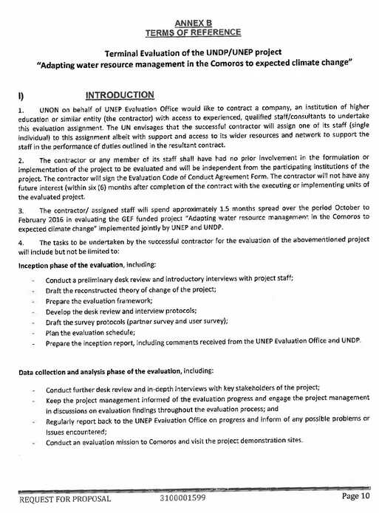

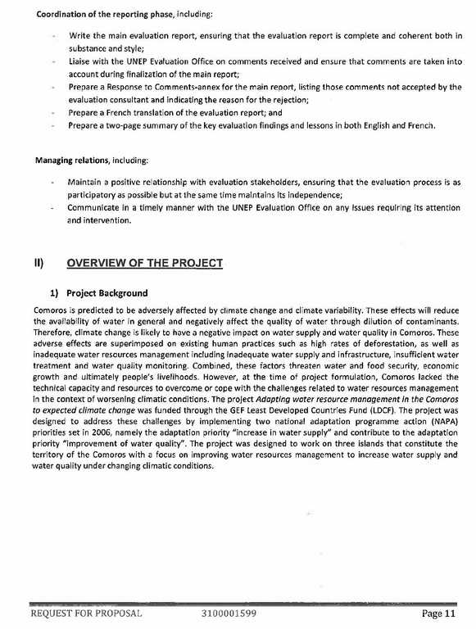

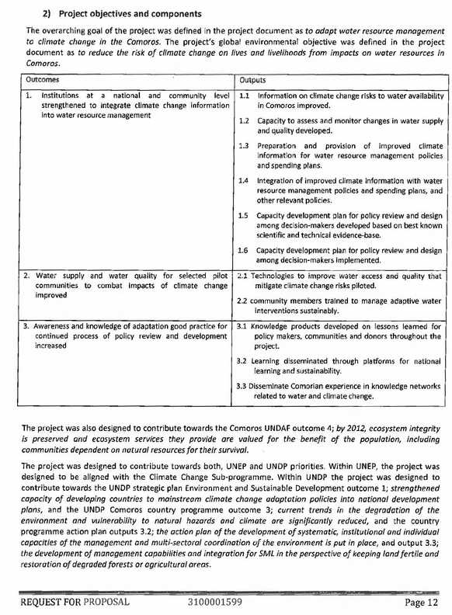

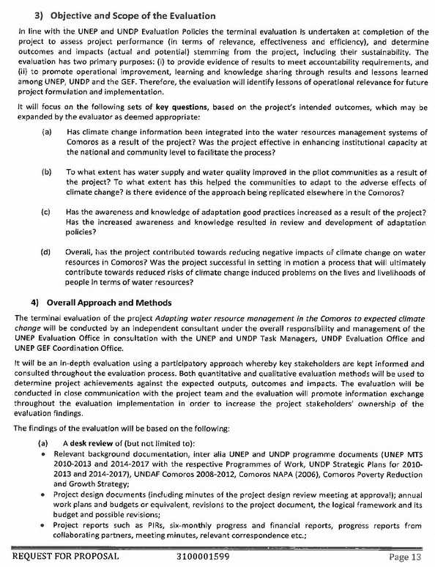

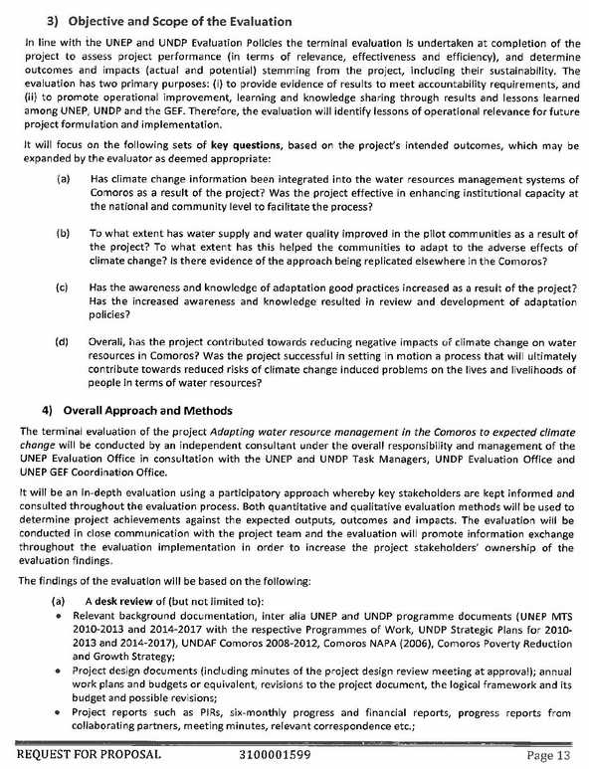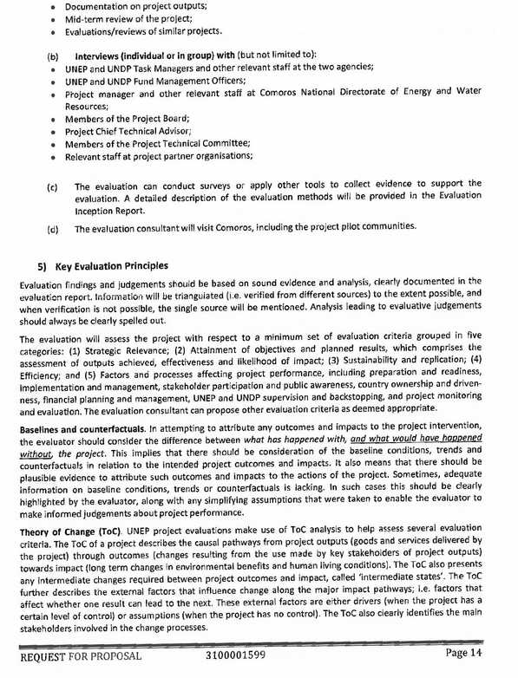

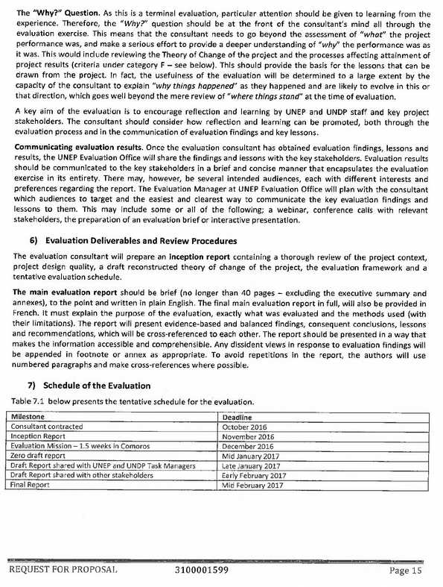

# Annex C. Evaluation Programme and People met

Programme

| Date |  | Activity |
| --- | --- | --- |
| Monday, February 20 | Morning | Meeting in Copenhagen with UNEP task manager Lars Christiansen |
| Friday, February 24 | Morning | Meeting in Nairobi with UNEP Evaluation Unit, Tiina Piiroinen and Shakira Adil Khawaja |
| Saturday, February 25 | Afternoon | Evaluator arrives to Moroni |
| Monday, February 27 | Morning | Initial meeting with National Directorate for Environment and Forests (DGEF) |
| Afternoon | Initial meeting with UNDP National Office |
| Reading of new documentation received |
| Tuesday, February 28 | Morning | Meeting with ANACM |
| Afternoon | Meeting with Director, Ma-Mwe  Visit to University of Comores, Water laboratory  Buying of flight tickets for visit to Anjouan and Mohéli |
| Wednesday – March 1 | Morning | Meeting with Director, DGEME |
| Morning-Afternoon | Field visit to Moroni Pilot Project |
| Thursday, March 2 | Whole day | Field visit to Bandasamlini |
| Friday, March 3 | Morning | Meeting with AFD |
| Afternoon | Meeting with GIRE project, Dr. Oledi |
| Saturday, March 4 | Morning | Meeting with CRclimate changeA Project |
| Sunday, March 5 |  | Start preparation of debriefing |
| Monday 6 March | Morning | Flight to Matsamudu, Anjouan  Meeting with the Union of Water Committees (UCEA) |
| Afternoon | Meeting with Directorate for the Environment (decentralised authority)  Meeting with Commisariat (de concentrated authority) |
| Tuesday 7 March | Whole day | Field visit to the two pilot projects (Pomoni-Lingoni and Niumakele) |
| Wednesday 8 March | Morning | Flight to Mohéli (arriving around midday as the flight was several hours delayed due to rains from Cyclone Enowa) |
|  | Afternoon | Meeting with stakeholders at CDRE, Fomboni  Travel to Hoani. Meeting with Municipal Council at Hoani-Mbatsé and representatives from the Water Committees. |
| Thursday 9 March | Morning | Visit to pilot project Hoani-Mbatsé |
| Afternoon | Preparation of debriefing presentation |
| Friday 10 March | Morning | Flight back to Moroni. Heavy delay due to the disruptions in flights the days before. |
| Afternoon | Finalisation, debriefing presentation |
| Saturday 11 August | Morning | Debriefing at PNUD Country Office |
| Afternoon | Evaluator departs for Nairobi |

People Met

| Name | Position | Contact |
| --- | --- | --- |
| UNEP | |  |
| Lars Christiansen | Task Manager, Copenhagen | [lachr@dtu.dk](mailto:lachr@dtu.dk)  +45 4533 5272 |
| Tiina Piiroinen | Evaluation Officer, UNEP Nairobi | Tiina.Piiroinen@unep.org  +254 20 76 4181 |
| Shakira Adil Khawaja | Fund Management Officer , UNEP Nairobi | Shakira.khawaja@unep.org |
| Mela Shah | Senior Programme Management Assistant, UNEP Nairobi | [Mela.Shah@unep.org](mailto:Mela.Shah@unep.org)  254-20-7623740 |
| UNDP | |  |
| Karim Ali Ahmed | Project Officer, PNUD Country Office | [karim.a.ahmed@undp.org](mailto:karim.a.ahmed@undp.org) |
| Omar Houmadi | Comptable, PNUD, Moroni | [omar.houmadi@undp.org](mailto:omar.houmadi@undp.org)  +269 33 463 12 |
| Seybou Mossi | Hydraulic Engineer, VNU | [Mossi.seybou@undp.org](mailto:Mossi.seybou@undp.org)  +269 359 79 96 |
| Saïd Hamada Mdziani | RUTI de Ngazidja (Gran Comore) | [Saidhamada.mdziani@undp.org](mailto:Saidhamada.mdziani@undp.org)  +269 332 14 06 |
| Abdou Soimadou Ali | RUTI ACCE/CRCCA | [Abdou.soimadou@undp.org](mailto:Abdou.soimadou@undp.org)  +269 332 09 31 |
| AFD |  |  |
| Bicarima Ali | Project Officer | [alib@afd.fr](mailto:alib@afd.fr)  +2693311330 |
| DGEF | |  |
| Youssouf Elamine Mbechezi | General Director | [Elamine_youusouf@yahoo.fr](mailto:Elamine_youusouf@yahoo.fr)  3219486 |
| Ismael ? | Director, CRCCA Project |  |
| Charaf-Eddine Msaidié | Project Coordinator, ACCE, now Expert in Biodiversity, RNAP | charafeddine2008@gmail.com  +269 332 08 49 |
| **Advisors** | | |
| Joana Talafre (by Skype) | Chief Technical Advisor | [joana.talafre@okapiconsulting.ca](mailto:joana.talafre@okapiconsulting.ca) +1(514) 465.8446 |
| Ministry of Production | | |
| Issimaila Mohamed | National Director, CRCCA project and Deputy Director for DNSAE | issimaila2002@yahoo.fr  +269 333 11 02 |
| ANACM | | |
| Farid | Responsible for Meteorological Services |  |
| Mohamed Hamid | Technical Director |  |
| Ma-Mwe | | |
| Abderemane | Director for Water | +269 3238962 |
| University of Comores | |  |
| Dr. Achmet | Dean, Faculty of Technical Sciences | achmetsm@yahoo.fr |
| General Directorate for Energy and Mines | | |
| Mme Chadhuiliati | General Director |  |
| CEFADER | | |
| Dr. Ouledi | Administrative and financial responsible, GIRE project | +269 3332757 |
| Anjouan, Environmental Directorate | | |
| Mouhoudhoir Boura | Director | moudhoir3@yahoo.fr  +269 320 31 80 |
| Fairouze Toybou | Director for Water | [Fairouze.toybou@yahoo.fr](mailto:Fairouze.toybou@yahoo.fr)  +269 324 52 01 |
| Anjouan, Commissariat for Production | | |
| Nassouri Toilibou | General Secretary | +269 336 07 74 |
| UCEA (Union of Water Committees, Anjouan) | | |
| Farid Anasse | Coordinator | [Farid.anasse.fah@gmail.com](mailto:Farid.anasse.fah@gmail.com)  +269 332 70 68 |
| Omar Houmadi | President | +269 338 38 31 |
| Pomoni-Lingoni Pilot Project | | |
| Arfashad Mohamoud | Member of Project Steering Committee, Pomoni |  |
| ? | Wife of President for the Pomoni Water Committee, Shirach Salin. |  |
| Nioumakele Pilot Project | | |
| Faisau Suf | President of the Water Committee, Shaucini Village |  |
| Stakeholder Meeting at CRDE, Fomboni (Mohéli) | | |
| Loutoufi madi | Director CRDE fomboni | Loutma2010@yahoo.fr  +269 332 04 62 |
| Ahamada Madi Ahamada | Head of services, CRDE | [Ahamada-madi@yahoo.fr](mailto:Ahamada-madi@yahoo.fr)  +268 349 46 97 |
| Bendjadide Ali Tamou | Technician, CRDE | Back-home@ymail.fr |
| Abdou Soimadou | Member of UCEM | [Ucem.moheli@yahoo.fr](mailto:Ucem.moheli@yahoo.fr)  3494692 |
| Toiouildine Mouandhui | Former responsible for water supply management at UCEM | [mouandhuitoiouilou@yahoo.fr](mailto:mouandhuitoiouilou@yahoo.fr)  3354352 |
| Lailina Daniel | Regional Directorate for Environment and Forests (DREF) | Dalayass98@yaho.fr |
| Mohamed Mhidhine Tsira | Mohéli National Marine Park | Tsira.hidhin@gmail.com |
| Toihiri Mohamed | Director, FADESIM | cdfadesim@yahoo.fr |
| Mohamed Abdou | Administrative and financial responsible, SOGEM | +269 343 96 66 |
| Soidi Ahmed | Member of SOGEM | +269 349 70 85 |
| Anrifatte Mohadji Charif | General Director, SOGEM | +269 357 25 26 |
| Chamsidine Abdallah | Director, Commissariat, Production |  |
| Said Abdouroihmane Ahmed | Former director for the DREF. Now president of Water User Committee, Djoiezi | +269 332 49 85 |
| Malida Abdelkader Ahamada | Member, CRDE | +269 321 04 09 |
| Ousmane Soiyifiliamane | Member, CRDE | +269 338 79 28 |
| Meeting at the Mayors Office, Hoani-Mbatsé | | |
| Hazalis Dokara | Mayor, Hoani-Mbatse | +269 339 00 60 |
| Chamsidine Abdallah | Member of the Municipal Council | +269 337 01 80 |
| Bacrar ali | Notable |  |
| Ali hamidoun | Member Water Management Committee | +269 334 02 86 |
| Ahmed omar avilaza | Member Water Management Committee | +269 353 86 06 |
| Mikidache ahamada | Member Water Management Committee | +269 327 15 20 |
| Loutfi madi ahamada | Member Water Management Committee | +269 332 04 62 |
| Enrabi abassi abdallah | Member Water Management Committee | +269 321 00 08 |
| Ankibou hamissi | Member Water Management Committee | +269 337 58 67 |
| Madi hamada | Member Water Management Committee | +269 339 30 30 |
| Field visit, Hoani-Mbatsé | | |
| The field visit to the Water Supply Scheme was accompanied by the PNUD RUTI, members of the Water Management Committees and an Engineer from SOGEM (company that constructed the system). For names, see above. | | |
| “Sandy” (nickname) | Farmer and promoter for sustainable agricultural practices |  |

# Annex D. Bibliography

Project Documentation

1. Project Identification Form (PIF), GEF/UNDP, December 2008
2. Project Identification Form (PIF), GEF/UNEP, December 2008
3. *“Adapting water resource management in the Comoros to expected climate change”,* UNDP Project Document, November 2010
4. *“Adapting water resource management in the Comoros to expected climate change”,* UNEP Project Document, November 2010
5. Mid Term Review. *“Adapting water resource management in the Comoros to expected climate change”,* September 2014
6. PPG Document. UNDP. 2009
7. UNDP Project Budget Revision, *“Adapting water resource management in the Comoros to expected climate change: 2010-2014”,* Proposal for additional funding: Euros 150,000, 2013-2014
8. UNEP : Budget Revision 1 (28 January 2013) and 2 (30 September 2013)
9. UNEP-GEF ; PIR 2015 and 2016
10. UNDP-GEF : PIR 2014-2016
11. Minutes from Board Meetings (4)
12. Reports for various field visits.

Studies and other project documents

1. “Developing Baseline Information and Indicators: Adapting Water Resource Management in the Comoros to Increase Capacity to Cope with Climate Change”,Groupe-conseil Baastel, March 2011
2. « Étude d’Aproject document sur la pose d’une conduite principale et une conduite secondaire pour l’adduction en eau potable de Moroni et ses environs », BICHE-TUNISIE, novembre 2012
3. « Étude d’impact environnemental et social sommaire », BICHE-TUNISIE, novembre 2012
4. «Études Aproject document pour l’aménagement et la réhabilitation d’infrastructures de stockage d’eau à des fins agricoles et domestiques sur des bassins versants des zones de Nioumakelé‐bas et Lingoni‐pomoni (Anjouan) », Bureau d'Études X2Z
5. «Études Aproject document et DAO pour la réhabilitation et la construction d’infrastructure es de stockage d’eau à des fins agricoles dans la zone de Bandassamlini, Sangani et Hamalengo », Bureau d'Études X2Z
6. « Études Aproject document et DAO pour la mise en place d’un système d’adduction d’eau à des fins domestiques et agricoles pour les communautés de Mbatsé et Hoani (MOHELI) », Bureau d'Études X2Z
7. Ma-Mwe : Table with statistics on daily water production from boreholes TP5 and ONU 4, January and February 2017
8. Ma-Mwe : « Rapport d'activité sur l'état d’avancement des essais d'étanchéité et d’alimentation en eau potable de la capital via le nouveau réseau. Période d’essai : juin- Sept. 2016. »
9. Ma-Mwe : « Rapport d'activité sur l'état d’avancement des essais d'étanchéité et d’alimentation en eau potable de la capital via le nouveau réseau. Période d’essai : 8 aout – 10 septembre 2016. »
10. Ma-Mwe :« Situation de l’accès à l’eau potable de Moroni et ses environs », 27 janvier 2017
11. ACCE : « Rapport de synthèse sur l'évaluation des besoins en renforcement des capacités relatifs aux parties prenantes en charge de la gestion de l’eau », juin 2013
12. ACCE: « Rapport final de validation des espèces resilientes – Mohéli », aout 2013
13. ACCE: «Rapport de la situation de référence du site d’intervention du projet ACCE de Bandassamlini – Sangani – Diboini a la Grande Comore », septembre 2013
14. ACCE : «Compte Rendu. Atelier insulaire de validation du rapport d'évaluation des besoins en renforcement des capacités des parties prenantes de la gestion des ressources en eau Fomboni - Mohéli », le 14 mai 2013
15. ACCE : «Étude sur la situation de référence de M’batsé et de Hoani », juillet 2013.
16. UNDP : « INFORAPIDE : Journée de reboisement à Bandassamlini – Sangani, le 17 février 2013 »
17. ACCE : « Modèle de règlement intérieur du CGE », 2013
18. ACCE : « Modèle de statuts du CGE », 2013
19. ACCE : « Rapport de synthèse sur l'évaluation des besoins en renforcement des capacités relatifs aux parties prenantes en charge de la gestion de l’eau, mars 2013
20. ACCE :« Rapport de formation des paysans formateurs à l’installation et l’entretien des kitsgoutte à goutte », janvier 2014
21. ACCE: »Rapport de l’Atelier de pérennisation des actions de reboisement,

UNEP / UNDP documents:

1. “Plan cadre des Nations Unies pour l’aide au développement (PNUAD / UNDAF) (2015-2019)”
2. “Système des Nations Unies en Union des Comores: Plan cadre des Nations Unies pour l'aide au développement (UNDAF), 2008-2012”
3. United Nations Environment Programme: “*Medium-term Strategy 2010–2013*”
4. United Nations Environment Programme: “*Medium-term Strategy 2014–2017*”
5. UNDP: *“Strategic plan, 2008-2011*”, 2008
6. Accelerating global progress on human development *
7. UNEP, Bali Strategic Plan for Technology Support and Capacity-building, 2004
8. UNEP: Evaluation Policy, 2009
9. UNDP: A Guide to the Vulnerability Reduction Assessment, 2008
10. UNDP: Handbook on Planning, Monitoring and Evaluating for Development Results, 2009
11. UNDP: Addendum June 2011. Updated guidance on Evaluation in the Handbook on Planning, Monitoring and Evaluating for Development Results (2009)

GEF Documents

1. GEF Evaluation Office: “*The RotI Handbook*”, 2009
2. GEF: “*Monitoring Guidelines of Capacity Development in GEF Operations”*
3. GEF/IEO: “*Monitoring & Evaluation in the GEF”*
4. GEF/IEO: “*The GEF M&E Policy and Terminal Evaluations Guidelines”*, 2015
5. GEF: « *La Politique en matière de suivi et d’évaluation du FEM »*, 2010

Government of the Union of the Comoros

1. « Stratégie de croissance accélérée et de développement durable. 2015-2019. »
2. « Contributions Prévues Déterminées au niveau National de l’Union des Comores », septembre 2015
3. « Communication Nationale Initiale sur les Changements Climatiques », décembre 2002
4. « Programme d’Action National d’Adaptation aux changements climatiques (PANA) », mars 2006
5. « Énonce de la politique forestière de l’Union des Comores », mai 2010
6. DGEME-PAEPA-Hydro Plante: «  Élaboration du cadre institutionnel, organisationnel et financier du secteur d’AEPA », Juin 2013

Other documents used

1. Groupe de la Banque Africaine de Développement, Union des Comores, “*Document de stratégie pays 2016-2020”*
2. African development Bank: “*Country Strategy Paper* *2011-2015*”, November 2011
3. FMI: “*Consultations de 2014 au titre de l’article iv – rapport des services du fmi, annexe d’information, analyse de viabilité de la dette*”, Janvier 2015
4. Nodalis Conseil: “*Diagnostic de la gestion de l’eau en milieu urbain aux Comores : Fomboni Et Mutsamudu”*, Novembre 2013
5. AFD : « Évaluation du Document Cadre de Partenariat « France-Union des Comores » (2006-2010) Rapport final – Vol 2A : Analyses sectorielles, septembre 2012
6. “*Approvisionnement en eau potable de l’agglomération de Domoni et ses alentours”* – N° FED/2012/024-239
7. Enhancing adaptive capacity for increased reliance to climate change in the agriculture sector in the Union of the Comoros (CRclimate changeA), Project Document
8. “*Glossary of Key Terms in Evaluation and Results Based Management*”, OECD-DAC
9. World Bank: “*Country Partnership Strategy for the Union of Comoros for the Period FY14–FY17”*, 2014
10. Union Européenne : “*Document de stratégie pays et programme indicatif national pour la période 2008-2013”*, 2007
11. PNUD/COSEP: “Étude de vulnérabilité aux aléas climatiques et géologique en Union des Comores”, 2011
12. UNEP-UNDP : “Environmental Emergencies Comoros. Report of Scoping Mission”. June 2013
13. UNIDSR : Review of Comoros. UNISDR Working Papers on Public Investment Planning and Financing Strategy for Disaster Risk Reduction

# Annex E. Planned and carried out activities

In the table below the evaluator has tried to compare the planned activities with the activities actually carried out. It is not an easy task as the reports are not very specific about the activities carried out. The table has been compiled based on the PIR and information from the former project coordinator.

| Outcome | Outputs | Activities | Progress |
| --- | --- | --- | --- |
| **Outcome 1.** Institutions at a national (i.e. Ma-Mwe and ANACM) and community (i.e. UCEA and UCEM) level strengthened to integrate climate change information into water resource management. | Output 1.1. Information on climate change risks to water availability in Comoros improved. | 1.1.1a definition and adoption of the water and climate monitoring parameters | **Completed** in 2012 (UNEP PIR) |
| 1.1.1b. Identification, in collaboration with ANACM of the equipment needs and sites for monitoring stations | **Completed** in 2012 (UNEP PIR) |
| 1.1.2 Acquisition and installation of hydrometerological and agrometeorological stations | **Completed** in 2015 (UNEP PIR) |
| 1.1.3 conversion of existing available data on microfile to a usable format | **Completed** in 2014 (UNEP PIR) |
| 1.1.4 State of the Art study on water and climate in Comoros, including analysis of sectorial policies that hinder or facilitate resilience and, links between tides and salinity, an analysis of costs and benefits of adaptation, and the recommendation of adaptation indicators | Planned for 2016 4Q. **Has not been carried out.** |
| 1.1.5 Develop data collection, conservation and analysis systems in each island | Taken over by other project? |
| 1.1.6 Acquire and analyze data from the tide gauges in Ngazidja to determine links between salinity and tides as well as to measure sea level (reformulated activity as tidal gauge is already available in Comoros) | After the MTR this was to be included in 1.1.4 |
| Output 1.2. Capacity to assess and monitor changes in water supply and quality (given climate change projections) developed. | 1.2.1 stakeholder analysis and assessment of needs towards the development of a capacity building plan to strengthen monitoring and assessment capacity for availability and water quality. | **Completed** in 2014 (UNEP PIR) |
| 1.2.2 Training of ANACM staff on climate data collection and analysis and on climate model downscaling | **Completed** in 2015 (UNEP PIR) |
| 1.2.3 Training of MAMWE staff on integration of climate data and on water related climate risk management | **Completed** in 2015 (UNEP PIR) |
| 1.2.4. Training of UCEA and UCEM staff on the operation and management of hydraulic infrastructures | **Completed in 2015** (UNEP PIR) |
| Output 1.3. Preparation and provision of improved climate information for water resource management policies and spending plans. | 1.3.1 Acquisition and installation of hydrological monitoring equipment including training. | The equipment has reportedly been procured and installed, and final calibration is still needed. Training and final calibration is planned for second half of 2016. **Not clear if this has been done.** |
| Output 1.4. Integration of improved climate information with water resource management policies and spending plans, and other relevant policies. | 1.4.1 Analysis of sectoral policies that facilitate or hinder community resilience | After the MTR this was to be included in 1.1.4. **Not done.** |
| 1.4.2. Develop policy notes showing impacts, costs, benefits of resilience in the three islands | After the MTR this was to be included in 1.1.4. **Not done.** |
| 1.4.3 Revise the water Code and regulations | Has been transferred to the AfDB financed PAEPA project |
| 1.4.4 Develop recommendation on the changes to national budget or water prices and tariffs, including on cost recovery | Has been transferred to the AfDB financed PAEPA project |
| 1.4.5. Review and revise development legislation and policy, the environmental action plan and the poverty reduction strategy | Has been transferred to the AfDB financed PAEPA project |
| 1.4.5b. Training on the recovery of costs related to hydrological infrastructure | **Not done.** |
| Output 1.5. Capacity development plan for policy review and design among decision-makers developed based on best known scientific and technical evidence-base. | 1.5.1 Develop a capacity development plan for policy revision and planning related to adaptation (following 1.2.2) | The activity was removed from the project after the MTR, following the realization that a capacity development plan had been developed by another project. |
| 1.5.2 Train planners and decision-makers on revisions and proposed changes to existing legislation and regulations | Planned for Q4 of 2016. **Not done,** as the Water Code has not been approved. |
| Output 1.6. Capacity development plan for policy review and design among decision-makers implemented. | 1.6.1. Establish an intergovernmental and interministerial process for revising policies related to water | **Not done,** as the Water Code has not been approved. |
| **Outcome 2:** Water supply and water quality for selected pilot communities to combat impacts of climate change improved. | Output 2.1. Technologies to improve water access and quality that mitigate climate change risks piloted, e.g. soil conservation measures, water harvesting, remedial work on existing boreholes. | 2.1.1 Feasibility study for the rehabilitation of Moroni's main water line and system | Completed in 2013 |
| 2.1.2 Environmental and Social Impact Assessment for construction and rehabilitation works on three islands | Completed in 2013 |
| 2.1.3 Feasibility study for the reservoirs and harvesting structures in Anjouan | Completed in 2013 |
| 2.1.4. Feasibility study on the implementation of a water piping network for drinking and agricultural purposes in Moheli | Completed in 2013 |
| 2.1.5 Feasibility and ESIA for the rehabilitation and construction of water conservation structures for agriculture in Bandassamlini Sangani and Hamalengo (Grance Comore) | Completed in 2013 |
| 2.1.6 Conduct rehabilitation works for the Moroni water network | **Partially done** only due to budget constraints. |
| 2.1.6b Conduct rehabilitation works for Bandassamlini and surroundings | **Partially done** only due to budget constraints. |
| 2.1.7 Conduct rehabilitation and piping works in Anjouan | **Partially done** only due to budget constraints. |
| 2.1.8 Conduct water mobilization and conservation works in Moheli | Done, shared with the CRCCA project. |
| 2.1.9. Work supervision and develop a replication plan | Work has been supervised. **Replication plan not elaborated.** |
| 2.1.10 Develop indicators and targets to measure adaptation in the water sector | **Not done.** |
| Output 2.2. Community members trained to manage adaptive water interventions sustainably. | 2.2.1 Establish and train a water management committee in Ngazidja under supervision of MAMWE | Not clear whether that has been done. |
| 2.2.1b Assess previous experience on water treatment and propose adapted and replicable technologies for water quality control and treatment | Not clear whether that has been done. |
| 2.2.2 Train MAMWE technical staff in charge of operations and maintenance (chlorination, pump maintenance, leak detection) | The Ma-Mwe director reported that the staff has been trained in soldering of HDPE pipes. |
| 2.2.3 Capacity development for local water stakeholders towards a sustainable management of rehabilitated water structures | Done. |
| 2.2.4 Introduce technologies for water potabilization and treatments at local level, including ecological sanitation systems (Mbatse, Hoani and Lingoni-Pomoni) | Slow filters have been installed in both sites. |
| 2.3. Degraded agricultural and forested lands in pilot sites are the object of sustainable land use plans and vegetative cover increases (UNEP) | 2.3.1a finalize the state of reference on agricultural planning and perform participatory species selection for reforestation works (formerly part of 2.1.5) | Reportedly completed in 2014. Report not received. |
| 2.3.2 Elaborate a land use plan in each site | Completed in 2014. |
| 2.3.3. Train and support communities during reforestation using an agro-sylvo-pastoral approach that promotes resilience | Completed in 2014 |
| 2.3.4 Participatory reforestation within communities in the framework of the national campaign ""1 Comorian, 1 tree" | Completed in 2014 |
| 2.3.5 Training and support to producers towards the sustainable and resilient land use for agriculture (Bandassamlini and Nioumakele) | Completed with Flemish Funds in 2016. |
| **Outcome 3:** Awareness and knowledge of adaptation good practice for continued process of policy review and development increased. | Output 3.1. Knowledge products developed on lessons learned for policy makers, communities and donors throughout the project. | 3.1.1 compile project results and identify potential barriers to their replication | Planned for Q4 of 2016 at project closure. **Not done.** |
| 3.1.2 Launch and disseminate knowledge products and communications products | Some communication products have been produced (caps, t-shirts, pamphlets). |
| Output 3.2. Learning disseminated through platform for national learning and sustainability. | 3.2.1 Create a parliamentary working group and organize seminars on risks posed by climate change | **Not done,** as the Water Code has not been approved. |
| 3.2.2 organize national workshop and 3 islands workshops for the dissemination of project lessons and results | **Not done**. |
| 3.2.2a Inception workshop | Completed in 2012 |
| 3.2.3 Organize community workshops on the project | Done |
| 3.2.4 Publish workshop reports and distribute documents | Done |
| 3.2.5 Publish a monthly newsletter, newspaper articles, pamphlets and other documents on the project | Some materials produced. Copies not received. |
| 3.2.6 intervene through local media (radio, TV) | Done |
| Output 3.3 Disseminate Comorian experience in knowledge networks related to water and climate change, including ALM, GAN and IW Learn. | 3.3.1 Create, validate and launch project website | Website was launched and functioned for 2 years (2013-2014). |
| 3.3.2 compile information and technical documents and submit them to various networks | **Not done** |
| 3.3.4 develop a document summarizing project lessons for publication in an academic journal and presentation at an international conference | **Not done** |

# Annex F Indicators, targets and achievements

|  | Indicator | Baseline | Target | Assessment UNDP/UNEP PIR | Assessment evaluator |
| --- | --- | --- | --- | --- | --- |
| **Objective** | 1. The percentage change in vulnerability of men and women living in the pilot sites to climate change risks on availability of clean water. | Moroni: rating of 4 (on a scale of 1-5): quite vulnerable; Plateau Djandro in Moheli: rating of 4 on average for four villages; Lingoni-Pomoni in Anjouan: rating of 4: quite vulnerable; High Nioumakele in Anjouan: rating of 4: quite vulnerable; Bandamsamlini: rating of 3: moderately vulnerable. | Rating to be improved to 2: Not very vulnerable | **UNDP:** Rating of 2 achieved for all 5 sites  **UNEP:** Not measured | The baseline study VRAs have not been repeated end-project (the UNDP ratings is a desk assessment). The evaluator has only been able to talk to randomly selected community members.  **The evaluator assessment** is that the vulnerability has been reduced, but taking into account the limitations of the water supply schemes installed, a rating of 2 appears somewhat optimistic. |
| **Outcome 1** | 2. Number of policy documents at the Union decisional level, the island decisional level and the community/local level revised or elaborated to include regulations and provisions that promote gender equitable adaptation in the water sector. | Water Act for the Union of Comoros does not have any regulations for application. There is one environmental law and environment strategy, but lack of regulation for adaptation. The Comoros agricultural strategy dates back from 1994 and has not been implemented. Water management is only considered from the point of view of intensification, not rainfall scarcity or intensification of rainfall. | a. The Water Act is revised and includes regulations and provisions that promote gender-equitable adaptation.  b. One water programme with priority actions by 2030 is elaborated by the end of the project.  c. Water Acts at the local level in the pilot sites in Moheli and Anjouan are revised to include regulations and provisions that promote gender-equitable adaptation | **UNDP**: Since the revision of the water code was done by another project financed by the AfDB, this project contributed only for the inclusion of the climate change dimension in the document. Another revision that will take into account the Gender dimension needs to be done.  **UNEP:** No formal measurement of outcome indicator yet | a. The Water Act has been revised (PAEPA project). The quality is questionable and there is still a long way to approval.  b. Not achieved  c. There are no local Water Acts, but the project has elaborated standard regulations for water management committees which can be used locally.  **The evaluator assessment** is that some progress has been made regarding the policy framework, but that there is still a long way to go. |
| 3. The number of policy-makers and planners at the Union and island levels using adjusted processes and methods (eg collecting water data and climate data, modelling climate trends and monitoring water quality and supply) to develop gender-equitable water management policies that integrate climate change projections. | Policy makers and planners at the Union and Island levels do not currently integrate knowledge of climate change into policies related to water and agriculture and they lack capacities to collect water data, to model climate change and to monitor water quality and supply. At the Union level there are a total of 20 policy makers and planners. | By the end of the project, at least the following numbers of planners are using adjusted processes and methods, in terms of collecting water and climate data, modeling climate trends and monitoring water quality and supply, to develop water management policies that integrate climate change projections:  7 policy makers and planners at Union level, 5 in MaMwe; 10 in ANACM; 3 in the Directorate of Environment in Moheli; 5 in the Directorate of Environment in Anjouan; 2 in UCEM and 7 in UCEA, | **UNDP:** 12 planners use methods adjusted to take climate change into consideration in order to develop water management policies  **UNEP:** No measurement yet. | It is not clear what exactly UNDP is basing the assessment on. The evaluator has not been able to establish a clear assessment on this from the interviews.  The **tentative evaluator assessment** is that there is clear progress in ANACM (collection of data, modelling and analysis), and that there is a more widespread awareness in the institutions (DGEME and DGEF) about the need to improve in the management and integration of data related to climate in general and climate change in particular. There is furthermore a nascent interest in IWRM. |
| **Outcome 2** | 4. Overall perception of the population per pilot site on: i) the daily quantity of water accessible for domestic uses ii)the facility of access to this water and iii)the quality of the water used (as per WHO standards) on a rating of 1-4 ( 1 = very satisfied, 2= satisfied, 3 = unsatisfied, 4 = very unsatisfied). | Moroni: Quantity = 3, Access = 3, Quality = 3; Djandro: Quantity = 4, access = 4, Quality = 4; High Nioumakele in Anjouan: Quantity = 3, Accesss = 2, Quality = 3; Lingoni=Pomoni in Anjouan: Quantity = 2, Access = 4, Quality = 3. | Raise the rating to 2 for all three criteria across all project sites. | **UNDP:** Moroni: Quantity = 2, Access = 2, Quality = 2;  Mbatse-Hoani: Quantity = 2, access =2, Quality = 2;  High Nioumakele: Quantity = 3, Accesss = 2, Quality = 2;  Lingoni=Pomoni: Quantity = 1, Access = 2, Quality = 2  **UNEP:** No rating | As mentioned, the baseline study VRAs have not been repeated end-project (the UNDP ratings is a desk assessment). The evaluator has only been able to talk to members of the water committees.  **The evaluator assessment** is that (a) the quantity of water has increased, but due to the old distribution network, this is not fully noticeable to the users, (b) the quality has probably improved at the two sites where slow filters have been installed, but that quality measurement has not been carried out. (c) Access has only improved where increased water pressure has returned water to sectors connected, but where the water did not reach before. Access is still a major problem in Moroni, Hoani-Mbatsé and probably Lingoni-Pomoni. The UNDP rating therefore appears rather optimistic. |
| 5. Number of surviving trees in reforested areas. | The GDT project has planted 10000 fruit and forest trees in Lingoni-Pomoni. None in Bandasamlini. There are no protection measures for forests currently. | 2 sites of 95ha each to be reforested (Bandasamlini & Lingoni-Pomoni). At 1000 trees/ha = 180,000 trees. Target is an 80% survival rate which gives 144,000 living trees by the end of the project. | **UNEP:** Reforestation campaigns during end 2015 and 2016 have achieved a total planting of an additional 67,152 trees (67 ha), with a reported 'good' survival rate. The total tree planting directly attributed to the LDCF project is thus around 140 ha | **The evaluator assessment** is that the survival rate of the reforested communal areas is very low, in some cases 0. The survival rate at private farms is much higher, particularly for the fruit trees (up to 80% in Bandasamlini). A more complete assessment is not possible due to lack of monitoring data. |
| **Outcome 3** | 6. Percentage of men and women (public and decision makers) aware of climate change vulnerability and adaptation responses. | Currently knowledge on specific climate change risks and adaptation options is low among the public and decision-makers. It is estimated that 10% of decision makers and less than 5% of the population in the pilot sites know much about climate change and adaptation. | By the end of the project, at least 30% of the population within pilot site communities are aware of climate change impacts and adaptation options.  Mid-way through the project, at least 10% of the population within pilot site communities are aware of climate change impacts and adaptation options based on their involvement with pilot site interventions. | **UNDP:** 40% of the population within pilot sits and 70% of decision-makers have better knowledge on climate change impacts and adaptation options.  **UNEP:** Progress on awareness has not yet been measured,. | As no measurement has been made, neither for the baseline, nor for the end-project situation, it is difficult to assess. It is not clear what the 10% baseline value is arrived at, neither how UNDP makes its assessment of the 40%.  With these caveats, t**he evaluator assessment** is that there is an increasing awareness of the impact of climate change, as this was mentioned by many of the interlocutors. This is no doubt an effect of this and many other campaigns and projects related to climate change. |
| 7. Number of newspaper articles, booklets and pamphlets highlighting lessons learned during the project and # of technical documents on lessons learned submitted to knowledge networks. | Except for the National Communications and the NAPA there are currently no available documents and reports about good practices on climate changeA and water in Comoros. | By the end of the project, project lessons are distributed in hard copy (e.g. pamphlets, briefing notes, newsletters, booklets etc), electronically (e.g. via the project website), via radio broadcast and via one national and three island-level workshops.  Mid-way through the project, a project website is operational and is regularly updated with project information. | **UNDP:** This work is in progress, a number of communications products have been produced.  **UNEP:** A number of communication products have been produced in the reporting period. | The evaluator has seen a few communication products but has not received a list of what has been produced. If a distinction is made between (a) general communication products on climate change and the project, and (b) technical documents for knowledge networks, t**he evaluator assessment** is that the general communication (a) has probably been covered quite well, but more specific technical information (b) has not been covered at all. |

# Annex G. Debriefing presentation

Below is a handout of the presentation made by the consultant at the UNDP Office in Moroni on Saturday 11 March 2017, before the consultant left the Comores.[45]

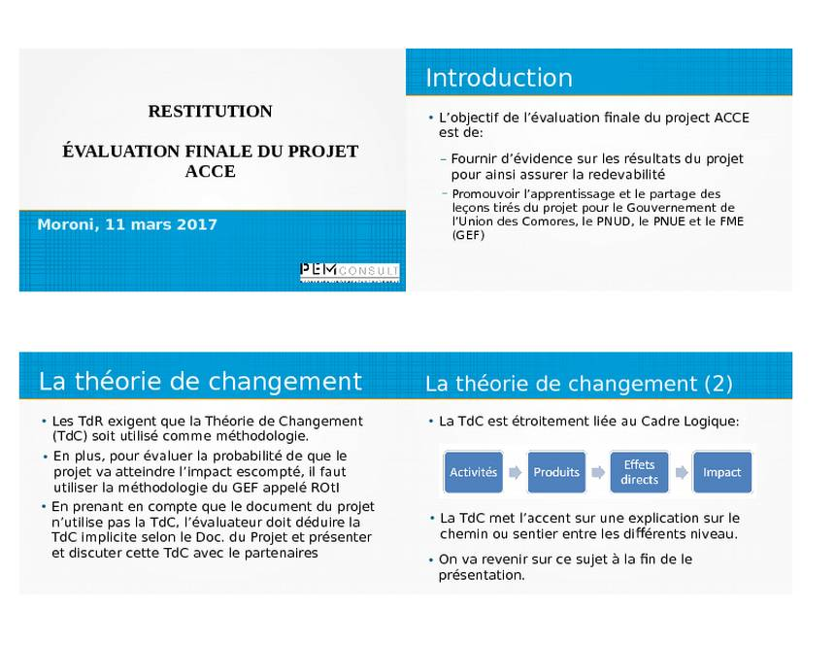

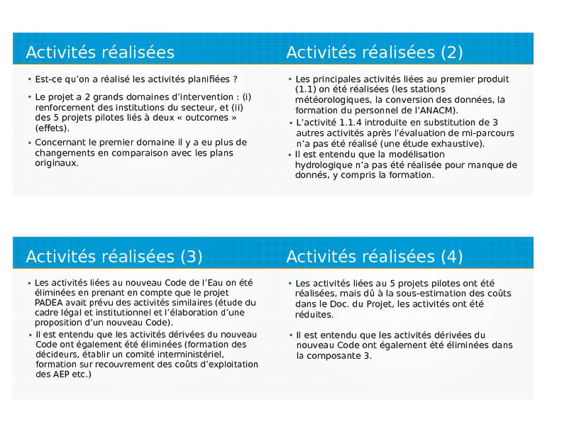

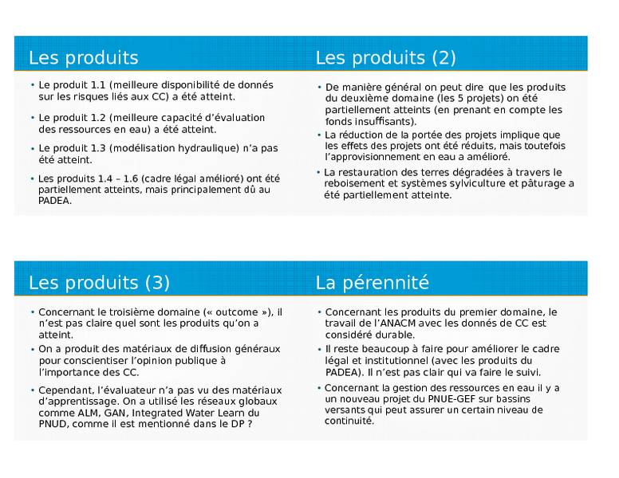

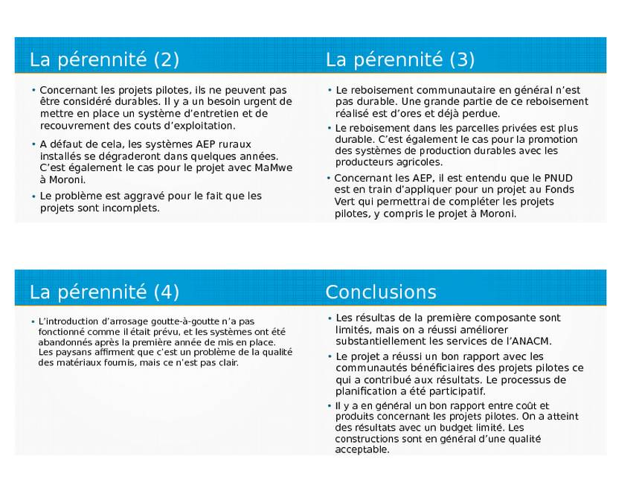

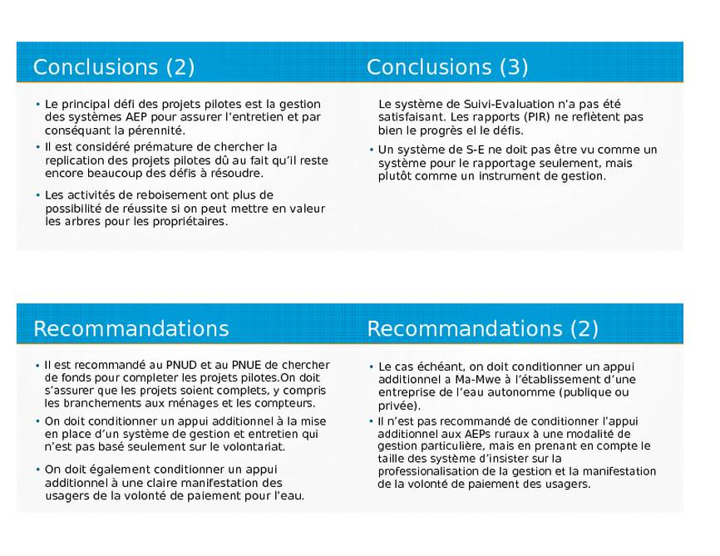

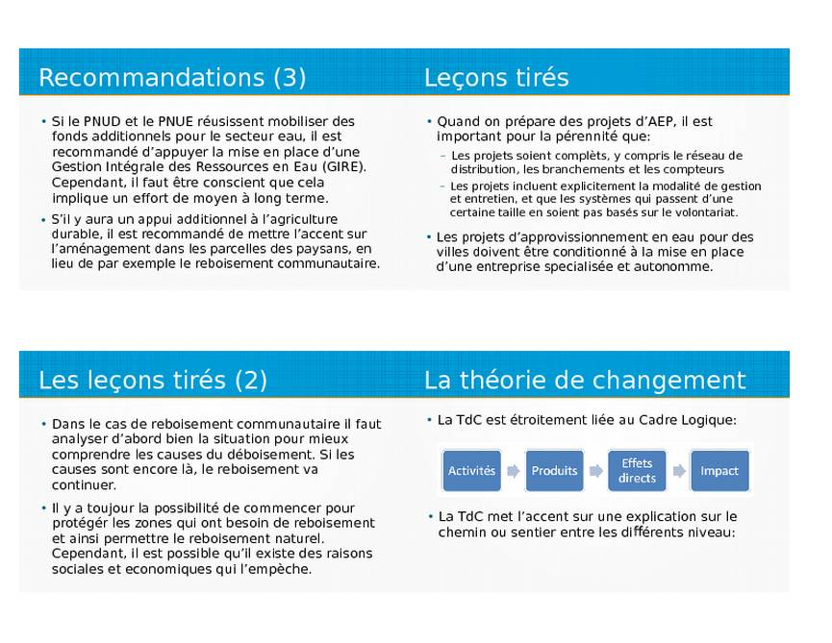

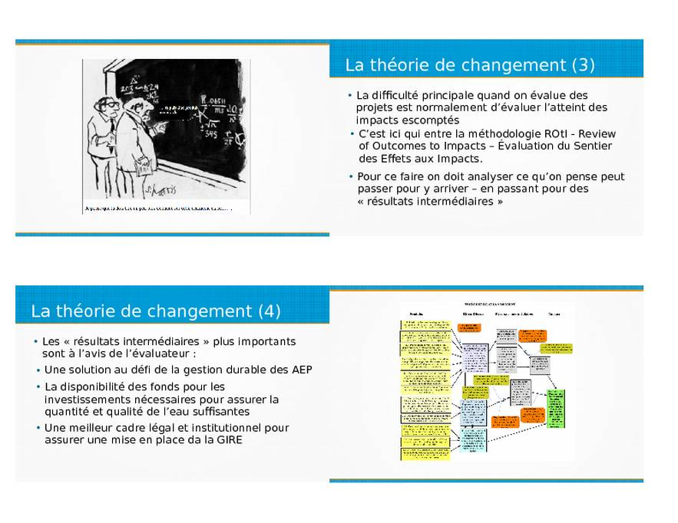

# Annex H. Budget and actual expenditures

The evaluator has received the following table from the UNDP office in Moroni regarding budget and actual expenditures.



Based on this and the budgets indicated in the project document, the following tables have been computed:

BUDGET UNDP (From Project Document) AND ACTUAL EXPENDITURES (USD)

| Outcome / Component | Source | Budget | Rev. Budget | Actual expenditure | Diff. With original budget |
| --- | --- | --- | --- | --- | --- |
| Outcome 1: Institutions at a national (i.e. Ma-Mwe and ANACM) and community (i.e. UCEA and UCEM) level strengthened to integrate climate change information into water resources management. | GEF | 288,000 | 220,738 | 339,437 | 51,437 |
| UNDP co-financing | 0 | 37,573 | 37,573 | 37,573 |
| Flemmish Government | 0 | 123,696 | 123,696 | 123,696 |
| Total Outcome 1 |  | 288,000 | 382,006 | 500,705 | 212,705 |
| Outcome 2: Water supply and water quality for selected pilot communities to combat impacts of climate change improved. | GEF | 2,078,000 | 2,036,844 | 1,886,789 | -191,211 |
| UNDP co-financing | 0 | 501,477 | 501,477 | 501,477 |
| Flemmish Government | 0 | 68,208 | 66,658 | 66,658 |
| Total Outcome 2 |  | 2,078,000 | 2,606,530 | 2,454,925 | 376,925 |
| Outcome 3: Awareness and knowledge of adaptation good practice for continued process of policy review and development increased. | GEF | 74,000 | 80,509 | 127,059 | 53,059 |
| UNDP co-financing | 0 | 22,515 | 22,515 | 22,515 |
| Total Outcome 3 |  | 74,000 | 103,024 | 149,574 | 75,574 |
| Project Management | GEF | 210,000 | 298,152 | 282,958 | 72,958 |
| UNDP co-financing | 200,000 | 55,382 | 55,382 | -144,618 |
| Total project management |  | 410,000 | 353,534 | 338,340 | -71,660 |
| Monitoring and Evaluation | GEF | 70,000 | 63,756 | 63,756 | -6,244 |
| UNDP co-financing | 0 | 2,724 | 2,724 | 2,724 |
| Total Monitoring and Evaluation |  | 70,000 | 66,481 | 66,481 | -3,519 |
| *Sub-total (GEF)* |  | *2,720,000* | *2,700,000* | *2,700,000* | -20,000 |
| *Sub-Total TRAC and other UNDP co-financing* |  | *200,000* | *619,671* | *619,671* | 419,671 |
| *Sub-total (Flemmish Government)* |  | *0* | *191,904* | *190,354* | 190,354 |
| TOTAL |  | 2,920,000 | 3,511,575 | 3,510,025 | 590,025 |

BUDGET UNEP (From Project Document) AND ACTUAL EXPENDITURES (USD)

| Outcome / Component |  | Budget | Rev. Budget | Actual | Diff. With original budget |
| --- | --- | --- | --- | --- | --- |
| Outcome 1: Institutions at a national (i.e. Ma-Mwe and ANACM) and community (i.e. UCEA and UCEM) level strengthened to integrate climate change information into water resources management. | GEF | 730,000 | 486,088 | 346,458 | -383,542 |
| Outcome 2: Water supply and water quality for selected pilot communities to combat impacts of climate change improved. | GEF | 66,000 | 394,388 | 414,143 | 348,143 |
| Outcome 3: Awareness and knowledge of adaptation good practice for continued process of policy review and development increased. | GEF | 104,000 | 99,059 | 127,059 | 23,059 |
| Project Management | GEF | 90,000 | 9,965 | 8,000 | -82,000 |
| Monitoring and Evaluation | GEF | 30,000 | 30,500 | 0 | -30,000 |
| TOTAL |  | 1,020,000 | 1,019,999 | 895,661 | -124,340 |

TOTAL BUDGET AND ACTUAL EXPENDITURES (USD)

|  |  |  |
| --- | --- | --- |
| Outcome / Component | Original budget | ACTUAL |
| Outcome 1: Institutions at a national (i.e. Ma-Mwe and ANACM) and community (i.e. UCEA and UCEM) level strengthened to integrate climate change information into water resources management. | 1,018,000 | 847,164 |
| Outcome 2: Water supply and water quality for selected pilot communities to combat impacts of climate change improved. | 2,144,000 | 2,869,068 |
| Outcome 3: Awareness and knowledge of adaptation good practice for continued process of policy review and development increased. | 178,000 | 276,633 |
| Project Management | 500,000 | 346,340 |
| Monitoring and Evaluation | 100,000 | 66,481 |
|  | 3,940,999 | 4.405.685 |

**Co-financing**

|  |  |  |  |  |  |  |  |  |  |
| --- | --- | --- | --- | --- | --- | --- | --- | --- | --- |
| **Co-financing (Type/Source)** | **UNEP own  Financing (US$1,000)** | | **Government**  **(US$1,000)** | | **Other\***  **(US$1,000)** | | **Total  (US$1,000)** | | **Total**  **Disbursed (US$1,000)** |
| **Planned** | **Actual** | **Planned** | **Actual** | **Planned** | **Actual** | **Planned** | **Actual** |  |
| * Grants |  |  |  |  |  |  |  |  |  |
| * Loans |  |  |  |  |  |  |  |  |  |
| * Credits |  |  |  |  |  |  |  |  |  |
| * Equity investments |  |  |  |  |  |  |  |  |  |
| * In-kind support |  |  |  |  |  |  |  |  |  |
| * Other (*)   -  - |  |  |  |  |  |  |  |  |  |
| **Totals** |  |  |  |  |  |  |  |  |  |

* This refers to contributions mobilized for the project from other multilateral agencies, bilateral development cooperation agencies, NGOs, the private sector and beneficiaries.

|  |  |  |  |  |
| --- | --- | --- | --- | --- |
| **Financial management components** | | | **Rating** | **Evidence** |
| Attention paid to compliance with procurement rules and regulations | | |  |  |
| Contact/communication between the PM & FMO | | |  |  |
| PM & FMO knowledge of the project financials | | | S |  |
| FMO responsiveness to financial requests | | |  |  |
| PM & FMO responsiveness to addressing and resolving financial issues | | |  |  |
|  | Were the following documents provided to the evaluator: | |  |  |
|  | A. | An up to date co-financing table |  | No |
|  | B. | A summary report on the projects financial management and expenditures during the life of the project - to date |  | Yes |
|  | C. | A summary of financial revisions made to the project and their purpose |  | Yes |
|  | D. | Copies of any completed audits |  | No |
| Availability of project financial reports and audits | | |  |  |
| Timeliness of project financial reports and audits | | |  |  |
| Quality of project financial reports and audits | | |  |  |
| FMO knowledge of partner financial requirements and procedures | | |  |  |
| **Overall rating** | | |  |  |

# Annex I. Pictures from field visits

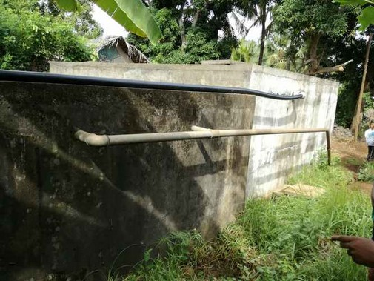

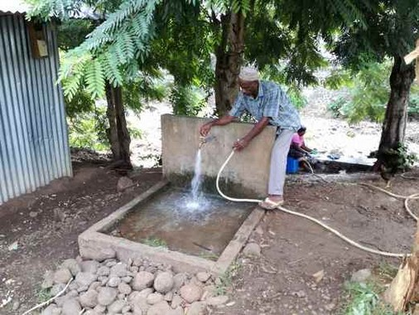Lingoni-Mbatsé water supply scheme. New (right) and old (left) water reservoir. As the new reservoir has few connections, it overflows into the old reservoir (black, upper pipeline) making more water available for the existing distribution system.

New public stand-post, Mbatsé

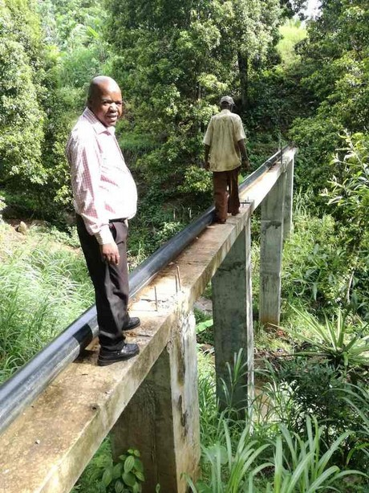River crossing for the partially rehabilitated transmission main, Nieumakélé

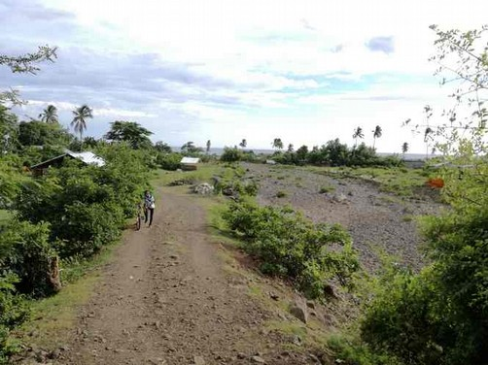Fomboni-Mbatsé. Reforestated river bank with little left.

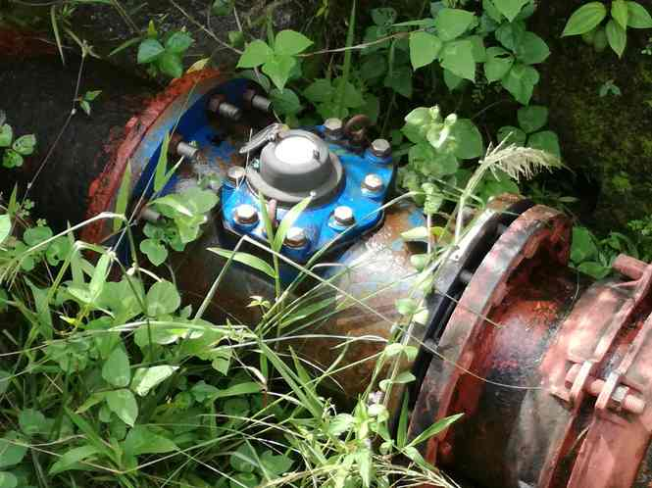Macro-meter, Moroni water scheme

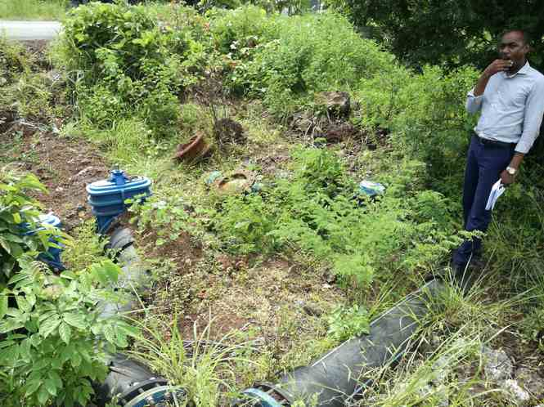Airing valve, Moroni water supply project.

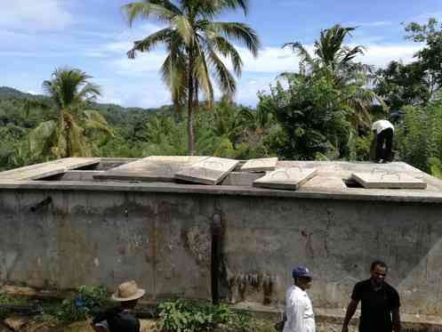Slow Filter, Lingoni-Hoani water supply scheme. The covers turned out to be too heavy to manage. The plan is to substitute them with lighter covers.

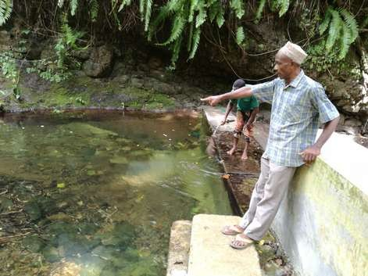

Rehabilitated intake, Lingoni-Hoani water supply scheme

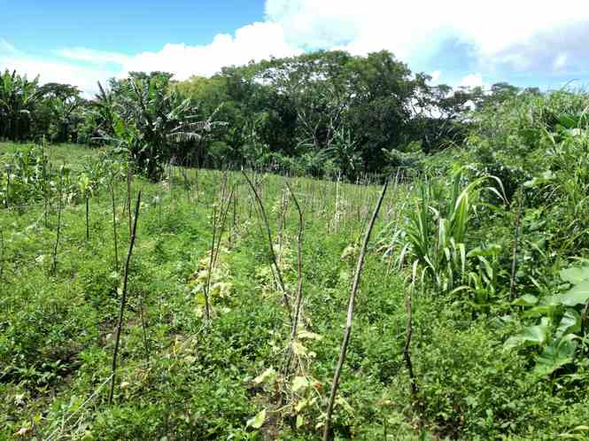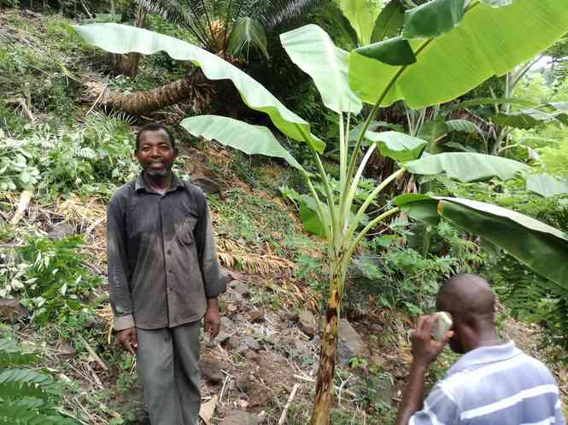Contour farming on steep slopes, Lingoni. Farmer-Promoter “Sandi”.

Contour farming, Bandasamlini

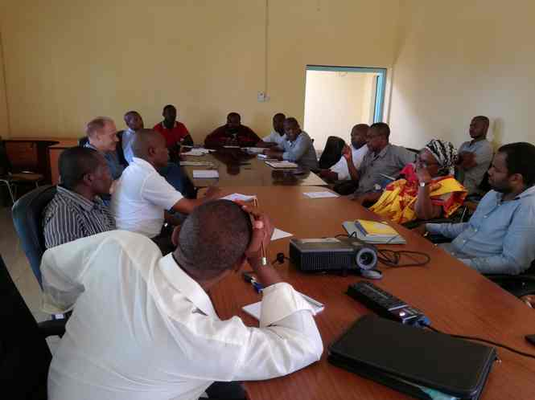

Stakeholder meeting at Fomboni, CRDE

# Annex J. Stakeholder analysis

This stakeholder analysis is limited mainly to the institutions that the evaluator has had the opportunity to meet. Other institutions mentioned in the project document are the National Farmers Association (FNAC) and the National Institute of Research in Agriculture and Fisheries (INRAPE). In the case of FNAC, it turned out to be impossible to set up a meeting. Anyway, they are only related to the sustainable agriculture part of the project, which is a minor component. In the case of INRAPE, a meeting was set up, but the director was occupied, and after waiting for an hour, the evaluator decided to cancel the meeting.

| Stakeholder | Responsibility/Role | Mandate | Interest | Influence | Rating explanation | Capacity and Constraints |
| --- | --- | --- | --- | --- | --- | --- |
| Union Level | | | | | | |
| DGEME | After the shift in Government in mid 2016, the Directorate is now under the Vice-Presidency/ Ministry for Production.  DGEME is responsible for the development of policy and regulation for the sector.  It is also responsible for the elaboration of investment plans and for the coordination of the different actors intervening in the sector and for securing the quality of the interventions.  It is in principle project owner (“maître d’ouvrage“) for projects within the sector. | High | Medium | High | The Directorate has direct access to the Vice-President/Minister for the sector and hence to the Presidency.  The proposal for new Water Act is presently in the Ministry where is is under revision.  It is the impression that water is not the top priority as the problems in the electricity sector are seen as more pressing. | The Directorate has very limited human resources  It has a limited budget and is dependent on projects being implemented through the Ministry |
| DGEF | The responsibility of the Directorate for the Environment and Forest is to:  Protect the environment and control pollution  Regulate and require Environmental Impact Assessment Studies  Monitor the environment  Specifically for the water sector, promote the rational use of water, define quality parameters and permits for discharge of wastewater | High | High | Low | Even if the Directorate has the formal mandate to regulate the environmental sector and hence a strong mandate within climate change adaptation, it has limited leverage. | The Directorate has few own resources and is very dependent on projects being carried out through the Directorate |
| ANACM | ANACM is responsible for carrying out the public policy in the area of Civil Aviation and Meteorology.  Because of its role in the gathering and analysis of meteorological data, it has become a key agency when it comes to data collection and analysis related to disaster prevention and the adaptation to the future impact of climate change and. | High | High | High | ANACM has a clear mandate within data collection and climate change | The meteorological division has competent and stable technical staff  As ANACM it has income from its aviation activities, it has a relatively stable economy  The meteorological division has technical support from both ASECNA and the World Meteorological Organisation. |
| Ma-Mwe | Ma-Mwe has a double subordination: technically under the Ministry of Energy and financially under the Ministry of Finance.  It has the responsibility of production and distribution of energy and water at national level. In reality it provides energy and water in Grande Comore only, and energy in Mohéli. | High | Medium | High | The institution has a very extensive mandate within water in the case of Grand Comore, so it is in principle a powerful stakeholder.  However, the energy part of its mandate is given priority and that is also where the main income is generated. | The water division has a relatively good technical capacity.  Very limited financial resources.  The activities of energy and water are not separated and its accounts are not public.  It only recovers around 60% of the costs within energy and 15-20% within water  Its board has never been functional |
| Ministry of Public Health | The Ministry is in charge of policy formulation within hygiene and sanitation.  The Directorate for Sanitary Education and Social-Sanitary Action has a department for water that is in charge of the control of water quality. | High | Low | Low | The Ministry has the mandate but not the resources to control the water quality. There is therefore in practical terms no control of public water quality, except when there are epidemics. | The Ministry does not have the funding to fulfil its mandate and does not even have a water laboratory. |
| University of Comores | The University, created in 2003, has a faculty for science and technique and a Faculty of Medicine and Public Health. It has a water laboratory in Moroni (in La Corniche). | Low | High | Medium | The main interest of the University is in water quality, which they consider is not given the priority needed (generally next to no treatment, no chlorination, no water quality control) | Qualified technical staff and a well equipped water laboratory  Strong interest in the issue of water quality. |
| Island level | | | | | | |
| Regional Directorates for the Environment | This is a decentralised authority, which depends on the (elected) Governor (after the federalisation of in 2009).  The precise mandate within climate change and water supply is not clear | Medium | High | Medium | Formally, climate change and water provision is within their mandate, It is not well defined but seems to be a more overall level (plans and policies)  It does not seem that they generally are involved directly in externally financed projects, which constitute an important source of finance. | Very limited staff and financial capacity |
| Island Commissariats for Production | This is a deconcentrated authority, which depends on the line ministries.  The commissariat has different directorates (Agriculture, Environment, Water and Energy, Fishery etc.), which have a double subordination under the line Ministry and the Governor,  The precise mandate within climate change and water supply is not clear | Medium | High | Medium | Formally, climate change and water provision is within their mandate. Their precise role is not well defined.  It does not seem that they generally are involved directly in externally financed projects, which constitute an important source of finance. | The Commissariats have a quite extensive staff in the different directorates. However, within water it is very limited. |
| UCEA-UCEM | The Unions of Water Committees have formally received a mandate as delegated Project Owners for water projects (*maitres d’ouvrage déléguées*), and particularly AFD is cooperating with these to carry out projects within the water sector.  They are furthermore formally responsible for the management of community water supply schemes. | High | High | High | Even if the mandate is partly overlapping with other institutions, they are in practice involved in many community water projects, particularly responsible for setting up and training the Water Committees | The Unions have competent staff within water supply and water supply management.  Their main weakness is their dependence on externally financed projects for their operation.  This implies that they are in practice only supervising water supply schemes within the framework of externally financed projects. |
| Community level | | | | | | |
| The Municipalities | The municipalities are responsibility for the local water supply, sanitation and the environment, so formally they have an important mandate within climate change and water supply. | High | High | Medium | The municipalities have a quite extensive mandate, and water is of high priority in the communities. However, as a new institution their influence is still limited. | As the municipalities were created recently with the law on decentralisation from 2011, they are still a very incipient institution with little capacity and very limited financial resources.  Even so, depending on the mayor, they can have a quite influential role e.g. in organising the operational model for the water supply system. |
| Water Management Committees | The water management committees (“*Comités de Gestion de l’eau*”) are responsible for the management of water supply schemes at community level – delegated from the Unions of Water Committees). | High | High | High | They are in practice in charge of the water supply schemes. So the schemes depend crucially on the functioning of these committees. Where they work, the system is maintained to some extent. Where they are not, the schemes are deteriorating. | In general they have serious problems operating the systems, and in particular to collect payments from the users.  This is partly due to their limited capacity and partly due to a culture of no-payment for waterl. |

# Annex K. Assessment of the overall quality of project design

|  |  |  |  |  |  |  |  |  |
| --- | --- | --- | --- | --- | --- | --- | --- | --- |
| **A.** | **Project Context and Complexity** | | | | | **YES/NO** | **Comments/Implications for the evaluation design**  **(e.g. questions, TOC assumptions and drivers, methods and approaches, key respondents etc)** | **Section Rating[46]: 5** |
| 1 | Does the project face an unusually challenging operational environment that islikely to negatively affect project performance? | | i)Ongoing/high likelihood of conflict? | | | No | The Comoros has been prone to conflicts and coups since independence, but it has been quite stable since 2008 with peaceful handing over of power after the elections, including the latest on in 2016. | |
| ii)Ongoing/high likelihood of natural disaster? | | | Yes | The Comoros are very vulnerable to climatic events, particularly flooding due to heavy rainfalls. The 2012 floods damaged roads and social infrastructure, including water supply. Around 10% of the population was affected. The 2014 Cyclon Hellen had some impact in Comoros but caused far more damage in Madagascar and Mozambique. | |
| iii)Ongoing/high likelihood of change in national government? | | | Yes | There was a change in Government in 2016 and as the winning candidate’s lead was very narrow in the second round, it led to widespread protests, particularly in Anjouan. However, the impact on the project implementation was limited as most activities had been completed. | |
| **B.** | **Project Preparation** | | | | | **YES/NO** | **Comments/Implications for the evaluation design**  **(e.g. questions, TOC assumptions and drivers, methods and approaches, key respondents etc)** | **Section Rating: 4** |
| 2 | Does the project document entail a clear and adequate problem analysis? | | | | | Yes | The vulnerable ecology compounded by rapid population growth and inadequate agricultural practices are described, and the additional challenges presented by CC are analysed with data on rainfall (longer dry seasons) and temperature rise. | |
| 3 | Does the project document entail a clear and adequate situation analysis? | | | | | Yes | There is a quite thorough description of the context (economy, politics, geography and climate change challenges) and the policy response to CC (the NAPA process). The barriers to solutions are identified as limited knowledge and expertise, inadequate policy framework and financial constraints. The main weakness is an insufficient discussion of possible conflicting interests between stakeholders and the difficulties related to enforcement. | |
| 4 | Does the project document include a clear and adequate stakeholder analysis? | | | | | No | According to the UNEP PD, the five pilot sites were identified through an intensive consultative process held at the national, island, and community levels. During the Inception Workshop (held on 24 September 2009 in Moroni) with all stakeholders (national level), teams of stakeholders from different sectors (including stakeholders from different islands) identified the regions most vulnerable to climate change impacts. Scoring Workshops were held on each island. The public institutions involved are described and their technical limitations are emphasised. The responsible institutions and the partners for each of the project outputs are listed in a table, and there is in Annex 17 a Stakeholder Involvement Plan. There is, however, not a description of the roles and interests of the different stakeholders. | |
| 5 | *If yes to Q4:* Does the project document provide a description of stakeholder consultation during project design process? *(If yes, were any key groups overlooked: government, private sector, civil society and those who will potentially be negatively affected)* | | | | | Yes | As mentioned above, an inception workshop was held with the main stakeholders, including scoring workshops as each Island. During project preparation validation workshops were held. The minutes from the validation workshops are included as Annex 18 in the PD. | |
| 6 | Does the project document identify concerns with respect to human rights, including in relation to sustainable development? | | | | i)Sustainable development in terms of integrated approach to human/natural systems | No | The term “human rights” is not used in the PD. However, it is mentioned that the project will assist in the realization of the goals set out in the Poverty Reduction and Growth Strategy (PRGS, 2009), with has sustainable development, including protection of the environment, as the major focus of the strategy with increasing water supply, improving soil productivity and integrated coastal management being three of the seven priority programmes. | |
| ii)Gender | Yes | It is mentioned that “efforts to promote gender equity will also be integrated in all aspects of the project’s activities”, but there is no description of how this will be done. Gender is part of some of the indicators. | |
| iii)Indigenous peoples | N/A |  | |
| **C** | **Strategic Relevance** | | | | | **YES/NO** | **Comments/Implications for the evaluation design**  **(e.g. questions, TOC assumptions and drivers, methods and approaches, key respondents etc)** | **Section Rating: 4** |
| 7 | Is the project document clear in terms of its relevance to: | | | i) UNEP MTS, PoW and Sub-programme | | No | The PD makes reference to UNDAF, Outcome 4, namely: “By 2012, ecosystem integrity is preserved and ecosystem services they provide are valued for the benefit of the population, including communities dependent on natural resources for their survival”. No mention is made of the UNEP Medium-term Strategy 2010–2013. | |
| ii) Regional, Sub-regional and National environmental issues and needs? | | Yes | The PD makes reference to the INC (2002) and the NAPA (2006), which listed the water sector as being the second most vulnerable sector to CC. | |
| iii) The relevant GEF focal areas, strategic priorities and operational programme(s)? (if appropriate) | | Yes | It is stated in the PD that the project conforms to the LDCF’s eligibility criteria, namely: i) undertaking a country driven and participatory approach; ii) implementing the NAPA priorities; iii) supporting a “learning-by-doing” approach; iv) undertaking a multi-disciplinary approach; v) promoting gender equality; and vi) undertaking a complementary approach. Furthermore, it is stated that the project has been designed to meet overall GEF requirements in terms of implementation and design, e.g. sustainability, replicability, M&E and stakeholder involvement. | |
| iv) Key SDG[47] goals and targets | | Yes | The PD is from before the SDG so reference is made to the MDG. The PD states that the resultant improved access to drinking water will be a key element for the improvement of nutritional status of the Comorian community, therefore attaining better health outcomes and positively affecting MDGs 4 and 6 and 7. It is considered that the most clearly relevant contribution is to Target 7C of MDG 7 (“halve by 2015, the proportion of the population without sustainable access to safe drinking water and basic sanitation”) and Target 7A (“To integrate the principles of sustainable development into every nation’s policies and programmes, and also reverse the depletion of environmental resources”). | |
|  | Does the project address key cross cutting issues? | | | * South-South Cooperation *(where appropriate)* | | No | Not mentioned in the PD nor implicitly included. | |
| * Bali Strategic Plan | | No | The Bali Strategic Plan is not explicitly mentioned. However, with the emphasis on national Capacity Building in the project, it is clearly in line with the Bali Strategy. | |
| **D** | **Intended Results and Causality** | | | | | **YES/NO** | **Comments/Implications for the evaluation design**  **(e.g. questions, TOC assumptions and drivers, methods and approaches, key respondents etc)** | **Section Rating: 5** |
| 9 | Is there a clearly presented Theory of Change? | | | | | No | The PD is based on a normal Logical Framework with no explicit mention of a Theory of Change | |
| 10 | Are the causal pathways from project outputs (goods and services) through outcomes (changes in stakeholder behaviour) towards impacts (long term, collective change of state) clearly and convincingly described in either the logframe or the TOC? | | | | | No | The casual pathway from outputs to outcomes is relatively clearly and convincingly described. However, the description of the pathway from the outcomes towards impacts (“The project objective is to reduce the risk of climate change on lives and livelihoods from impacts on water resources in Comoros”) is sketchy. To achieve the long-term impact, institutions responsible for the water sector (strengthened through outcome 1) should have improved the regulatory framework, awareness should have increased (outcome 3) and an improved framework for enforcement should come into place. Furthermore, the pilot projects (Outcome 3) should be sustainable (O&M, fee collection) for them to be candidates for replication and financial sources for increasing investment in the sector should have been identified. | |
| 11 | Are impact drivers and assumptions clearly described for each key causal pathway? | | | | | No | The assumptions are very rudimentary (Sustained commitment of key stakeholders, that pilot sites have been well chosen and that CC concerns are not overshadowed by emergencies). | |
| 12 | Are the roles of key actors and stakeholders clearly described for each key causal pathway? | | | | | Yes | Lead institutions are identified for the different outputs. | |
| 13 | Are the outcomes realistic with respect to the timeframe and scale of the intervention? | | | | | Yes | The project turned out to be somewhat underfunded, but as other projects are partially overlapping, it has been possible to achieve most of the outputs by joining efforts. | |
| **E** | **Logical Framework and Monitoring** | | | | | **YES/NO** | **Comments/Implications for the evaluation design**  **(e.g. questions, TOC assumptions and drivers, methods and approaches, key respondents etc)** | **Section Rating: 4** |
| 14 | Does the logical framework | i)Capture the key elements of the Theory of Change/ intervention logic for the project? | | | | Yes | The logframe captures quite well the pathway from outputs to outcomes. | |
| ii)Have ‘SMART’ indicators for outputs? | | | | No | There are no indicators for the outputs. | |
| ii)Have ‘SMART’ indicators for outcomes? | | | | Yes | The Outcome indicators were refined during a baseline study carried out in the beginning of 2011. There was a minor revision of some of the indicators after the MTR in 2014 to make them more “Smart”. | |
| 15 | Is there baseline information in relation to key performance indicators? | | | | | Yes | The 2011 baseline study defines the baseline values for 9 outcome indicators. | |
| 16 | Has the desired level of achievement (targets) been specified for indicators of outputs and outcomes? | | | | | Yes | The 2011 baseline study includes target values for the outcomes. The outputs are defined in the PD. | |
| 17 | Are the milestones in the monitoring plan appropriate and sufficient to track progress and foster management towards outputs and outcomes? | | | | | No | The 2011 baseline study only includes end-project values for the outcomes. | |
| 18 | Have responsibilities for monitoring activities been made clear? | | | | | No | It is stated in the PD that “M&E will be undertaken by the Project Support Staff (PSS) and the UNDP Country Office (UNDP CO) with support from UNDP/UNEP. UNDP will be the lead on all M&E with input provided by UNEP to ensure that there is one harmonized M&E report. The MTR pointed out that the M&E needed to be strengthened as an M&E staff post had been eliminated. | |
| 19 | Has a budget been allocated for monitoring project progress? | | | | | No | There is a budget for M&E (Annex 7 to the PD), which includes funding for the MTR and the Final Evaluation. An M&E Expert is mentioned as part of the technical team, but it is understood from the MTR that this post has been eliminated. The M&E expert is not part of the procurement plan in Annex 14 to the PD. | |
| 20 | Is the workplan clear, adequate and realistic? *(eg. Adequate time between capacity building and take up etc)* | | | | | No | There is a timetable for implementation in the PD (Annex 5) detailing outputs and activities. There was some delays in the first two years which could be taken to mean that the implementation plan was not wholly realistic. One of the reasons for delay of the pilot projects was that it was decided to make a proper feasibility study, not foreseen in the original implementation plan (Even if it is mentioned in Annex 16 that *“A financial and technical feasibility study followed by a detailed design phase will be carried out for the design of the water works.”* | |
| **F** | **Governance and Supervision Arrangements** | | | | | **YES/NO** | **Comments/Implications for the evaluation design**  **(e.g. questions, TOC assumptions and drivers, methods and approaches, key respondents etc)** | **Section Rating: 5** |
| 21 | Is the project governance and supervision model comprehensive, clear and appropriate? *(Steering Committee, partner consultations etc. )* | | | | | Yes | There is a clear governance set-up under a national execution modality. The Project Board (Steering Committee) is reported to have functioned adequately. However, it is understood the Technical Committee has not been functioning regularly. | |
| 22 | Are roles and responsibilities within UNEP clearly defined? | | | | | Yes | The supervision has been carried out by a Task Manager at the UNEP Copenhagen office. | |
| **G** | **Partnerships** | | | | | **YES/NO** | **Comments/Implications for the evaluation design**  **(e.g. questions, TOC assumptions and drivers, methods and approaches, key respondents etc)** | **Section Rating: 5** |
| 23 | Have the capacities of partners been adequately assessed? | | | | | No | There is a description of each partner institution, but not a detailed description of its capacities and needs. | |
| 24 | Are the roles and responsibilities of external partners properly specified and appropriate to their capacities? | | | | | Yes | The roles look well defined and seems to be in correspondence to the capacities. | |
| **H** | **Learning, Communication and Outreach** | | | | | **YES/NO** | **Comments/Implications for the evaluation design**  **(e.g. questions, TOC assumptions and drivers, methods and approaches, key respondents etc)** | **Section Rating: 5** |
| 25 | Does the project have a clear and adequate knowledge management approach? | | | | | Yes | There is a component (Outcome 3) which is dedicated to knowledge management and dissemination. | |
| 26 | Has the project identified appropriate methods for communication with key stakeholders during the project life? If yes, do the plans build on an analysis of existing communication channels and networks used by key stakeholders? | | | | | Yes | The Project Board is quite comprehensive and includes all key stakeholders, which should ensure a relatively high level of communication. | |
| 27 | Are plans in place for dissemination of results and lesson sharing at the end of the project? *If yes, do they build on an analysis of existing communication channels and networks?* | | | | | Yes | Se line 25. | |
| **I** | **Financial Planning / Budgeting** | | | | | **YES/NO** | **Comments/Implications for the evaluation design**  **(e.g. questions, TOC assumptions and drivers, methods and approaches, key respondents etc)** | **Section Rating: 4** |
| 28 | Are there any obvious deficiencies in the budgets / financial planning at design stage? *(coherence of the budget, do figures add up etc.)* | | | | | Yes | According to the MTR, several budgetlines were underfunded, particularly for Outcome 2 (The Pilot Projects), as the Feasibility Studies had not been carried out yet. It is understood that it was possible to cover these gaps relying on other projects (parallel co-funding). | |
| 29 | Is the resource mobilization strategy reasonable/realistic? *(If it is over-ambitious it may undermine the delivery of the project outcomes or if under-ambitious may lead to repeated no cost extensions)* | | | | | Yes | The main funding is parallel co-funding via other projects. Evaluator has not received information on whether this cofunding has actually materialised. | |
| **J** | **Efficiency** | | | | | **YES/NO** | **Comments/Implications for the evaluation design**  **(e.g. questions, TOC assumptions and drivers, methods and approaches, key respondents etc)** | **Section Rating: 5** |
| 30 | Has the project been appropriately designed/adapted in relation to the duration and/or levels of secured funding? | | | | | No | As mentioned, the project has been extended for almost two years. It is understood that most of the activities have actually been carried out with much less delay, as the main delay has been related to the pilot projects. | |
| 31 | Does the project design make use of / build upon pre-existing institutions, agreements and partnerships, data sources, synergies and complementarities with other initiatives, programmes and projects etc. to increase project efficiency? | | | | | Yes | The project uses the existing national institutions and has been coordinated closely with other similar projects, thus securing complementarities. It was e.g. planned in the PD to use HDPE pipes and a trench excavator donated by China for the main transmission line in Moroni. | |
| 32 | Does the project document refer to any value for money strategies (ie increasing economy, efficiency and/or cost-effectiveness)? | | | | | No | No specific Value for Money considerations are mentioned in the PD. However, the cost per beneficiary does not look excessive. | |
| 33 | Has the project been extended beyond its original end date? *(If yes, explore the reasons for delays and no-cost extensions during the evaluation)* | | | | | Yes | Yes, almost two years. The main reason is delays in the implementation of the pilot projects (Outcome 2). | |
| **K** | **Risk identification and Social Safeguards** | | | | | **YES/NO** | **Comments/Implications for the evaluation design**  **(e.g. questions, TOC assumptions and drivers, methods and approaches, key respondents etc)** | **Section Rating: 4** |
| 34 | Are risks appropriately identified in both the ToC/logic framework and the risk table? *(If no, include key assumptions in reconstructed TOC)* | | | | | No | There is a risk matrix in section 3.5 in the PD that is generally adequate. However, the risk of not being able to achieve cost-recovery in the pilot projects seems to be underestimated, both regarding probability and impact. This can have serious implications for the replicability. | |
| 35 | Are potentially negative environmental, economic and social impacts of the project identified and is the mitigation strategy adequate*? (consider unintended impacts)* | | | | | Yes | The risk of a negative social impact from raising the water tariffs is mentioned, but at the same time it is foreseen to provide poor families with subsidized water from standposts. | |
| 36 | Does the project have adequate mechanisms to reduce its negative environmental foot-print? *(including in relation to project management)* | | | | | Yes | It is mainly an environmental project which should improve the environment (reforestation, reduction of water losses). | |
| **L** | **Sustainability / Replication and Catalytic Effects** | | | | | **YES/NO** | **Comments/Implications for the evaluation design**  **(e.g. questions, TOC assumptions and drivers, methods and approaches, key respondents etc)** | **Section Rating: 4** |
| 37 | Was there a credible sustainability strategy at design stage? | | | | | No | The project has a strong element of capacity building at Union level, Island level and community level, which aims at creating sustainability. However, even if the question of lack of cost recovery in the water supply systems is mentioned, and the project document stresses the low level of O&M before project intervention, it is not clear how this challenge of operational and financial sustainability will be approached, apart from more general capacity building. | |
| 38 | Does the project design include an appropriate exit strategy? | | | | | Yes | The project has a strong emphasis on capacity building, which does not imply permanent support to the institutions from the project. | |
| 39 | Does the project design present strategies to promote/support scaling up, replication and/or catalytic action? | | | | | Yes | The aim of Component (Outcome) 2 is to pilot water supply schemes, including protection of the catchment area, which can be replicated. A strategy for scaling up is one of the project outputs, but it is not clear to the evaluator whether this strategy has been elaborated. | |
| 40 | Did the design address any/all of the following: socio-political, financial, institutional and environmental sustainability issues? | | | | | No | As mentioned, most of the emphasis has been on institutional capacity building, aiming for sustainability by overcoming the lack of properly trained staff. At community level the project implies awareness raising and training of local actors. However, it is not clear from the PD how the financial sustainability of the water supply will be approached. | |
| **M** | **Identified Project Design Weaknesses/Gaps** | | | | | **YES/NO** | **Comments/Implications for the evaluation design**  **(e.g. questions, TOC assumptions and drivers, methods and approaches, key respondents etc)** | **Section Rating: 5** |
| 41 | Were there any major issues not flagged by PRC? | | | | | No | The evaluator has not got the minutes from the PRC approval, but from the first presentation to the Project Approval Group (PAG). Among the issues were: (i) strengthening the reference to NAPA, ii) make sure outputs are quantifiable to the extent possible, and (iii) underlining the role of UNDP, some existing regional projects, NAPA experience and other work with UNDP. | |
| 42 | What were the main issues raised by PRC that were not addressed? | | | | | No | The issues mentioned above were addressed in the PD. | |

1. Acronym derived from the French project title: “Projet d’adaptation de la gestion des ressources en eau aux changements climatiques”
2. Moroni, Bandasamlini, Lingoni-Pomoni, Hoani-Mbatsé, Nieumakélé
3. AfDB financed project : “*Projet d'alimentation en eau potable et d'assainissement*”
4. Acronym derived from the French project title: “*Projet d’adaptation de la gestion des ressources en eau aux changements climatiques*”
5. See Annex D for a list of references
6. See Annex C for the itinerary and the people met.
7. See Annex H for the presentation made at the workshop.
8. According to the 2009 revised constitution, the Comoros is now a Union (Federation) of three Autonomous Islands: Ngazidja (Grande Comore), Nzwani (Anjouan) and Mwali (Mohéli), each with their own autonomous government.
9. Enhancing adaptive capacity for increased reliance to climate change in the agriculture sector in the Union of the Comoros
10. “*Programme d’Alimentation en Eau Potable et d’Assainissement*”
11. “*Approvisionnement en eau potable de l’agglomération de Domoni et ses alentours”*
12. https://www.thegef.org/projects?f[]=field_country:44
13. Enhancing adaptive capacity for increased reliance to climate change in the agriculture sector in the Union of the Comoros
14. “*Programme d’Alimentation en Eau Potable et d’Assainissement*”
15. “*Approvisionnement en eau potable de l’agglomération de Domoni et ses alentours*”
16. “*National Programme for Sustainable Human Development*”
17. The evaluator has asked UNDP Comoros for this information, but what is presented here is what has been made available.
18. The evaluator asked the UNDP office for documentation from these projects but was told that they don’t have these documents, which sounds plausible.
19. “*Ministère de la Production, de l'Environnement, de l'Énergie, de l'Industrie et de l'Artisanat*”
20. After the election of a new Government in mid 2016 the Ministry has been split up, but during the project it was one single Ministry.
21. There is as mentioned no ToC in the project document. The intermediate stages are proposed by the evaluator based on an interpretation of the inherent logic in the project document. The revised ToC has been presented at the final workshop but no comments were received.
22. Système des Nations Unies en Union des Comores : “*Plan cadre des Nations Unies pour l’aide au développement (UNDAF) (2008-2012)*”. Page 38.
23. In the UNDAF 2015-2019, the project contributes to Outcome 2: *“Strengthening of the access to basic social services and of household resilience”*, under which water and sanitation is a component.
24. In particular the expected accomplishment (a) (*That adaptation planning, financing and cost-effective preventative actions are increasingly incorporated into national development processes that are supported by scientific information, integrated climate impact assessments and local climate data)*; and (e) “*That country policymakers and negotiators, civil society and the private sector have access to relevant climate change science and information for decision-making.”*
25. “*The strategy of UNDP focuses on supporting countries in (a) assessing vulnerability in key sectors; (b) integrating climate change risk considerations into national development plans and policies; and (c) gaining access to new funding sources to support innovative adaptation initiatives” (UNDP: “Strategic plan, 2008-2011”, 2008).*
26. Governing Council of the United Nations Environment Programme: “*Bali Strategic Plan for Technology Support and Capacity-building”*, 2005
27. It should be mentioned that it has not been easy to establish exactly which activities have actually been carried out – completely or partially – due to various factors: (I) the reporting is not very precise, (ii) it has not been possible to get detailed financial information related to each activity, and (iii) the Project Unit was not in place any more at the time of the evaluation. The table in Annex E therefore constitutes the evaluator’s best understanding of what has been done – and not done.
28. “Agence pour la Sécurité de la Navigation Aérienne en Afrique et à Madagascar”
29. The original formulation was: “1.1.4. Analyse available meteorological data (including data converted in Activity 1.1.3, river flow data and rainfall data) to validate the hydrological models computed in Activity 1.2.1.“ It was joined with the original activities 1.1.6 (“Installation of tide gauge”), 1.5.1 (“Develop a capacity development plan for policy review and design among stakeholders.”) and 2.1.9 (“Develop indicators and targets to measure adaptation in the water sector”).
30. There is for example no mention of gender issues in the proposal.
31. 1 = very satisfied, 2= satisfied, 3 = unsatisfied, 4 = very unsatisfied.
32. For details, including the baseline values, cfr. Annex F.
33. Which is also the reason why the very ambitious indicator related to increased agricultural production was taken out.
34. They were conducted based on a composite of 4 indicator questions: (i) Vulnerability of livelihood/welfare to existing climate change and/or climate variability; (ii) Vulnerability of livelihood/welfare to developing climate change risks; (iii) Magnitude of barriers to adaptation (institutional, policy, technological, financial, etc); and (iv) Ability and willingness of the community to sustain the project intervention.
35. A vulnerability score on a scale of 1 to 5. (1: Not vulnerable; 2: Not very vulnerable; 3: Moderately vulnerable; 4: Quite vulnerable; 5: Highly vulnerable.)
36. Experience from other countries in Africa known to the evaluator (e.g. Burkina Faso and Uganda) is that when the tariff for community water is too high, it tends to start a vicious circle of falling consumption, increasing prices and lack of profitability, as people revert to insecure water sources.
37. An earlier World Bank Water Supply project in Mutsamudu and Fomboni, where the posterior operation of the schemes was contracted out to private operators, turned out unsatisfactory due to several factors, among these a low service level because of the state of the network, which created conflicts between the stakeholders. See the study: *Nodalis: “Diagnostic de la gestion de l’eau en milieu urbain aux Comores. Fomboni et Mutsamudu”,* 2013
38. This sounds plausible, but as the statistics provided by Ma-Mwe for January-February only refer to production (what goes in) the evaluator can not corroborate this.
39. The evaluator has a lot of experience with water supply systems, but is an economist, **not** an engineer.
40. The pilot communities were selected at multi-stakeholder scoring workshops on each Island, using 11 criteria, among which are vulnerability to climate change, poverty level, rainfall, level of land degradation, incidence of water born diseases, feasibility of interventions and local implementation capacity. The minutes from the scoring workshops are included as annex to the project document.
41. See discussion under section 4.5 “Efficiency”
42. Please see section 4.3 above.
43. Highly Satisfactory (HS); Satisfactory (S); Moderately Satisfactory (MS); Moderately Unsatisfactory (MU); Unsatisfactory (U); Highly Unsatisfactory (HU). Sustainability is rated from Highly Likely (HL), Likely (L), Moderately Likely (ML), Moderately Unlikely (MU), Unlikely (UL), Highly Unlikely (HU).
44. At the discussions the evaluator participated in with the Hoani-Mbatsé water committees and the mayor, the water committees raised it as a concern that this may be the case and hence that they needed urgently to do something about it.
45. It should be mentioned that the presentation erroneously refers to the PAEPA project as PADEA. Is should thus read PAEPA.
46. Rating system for quality of project design and revision. A number rating 1-6 is used for each section: Highly Satisfactory = 6, Satisfactory = 5, Moderately Satisfactory = 4, Moderately Unsatisfactory = 3, Unsatisfactory = 2, Highly Unsatisfactory = 1. The overall quality of the evaluation report is calculated by taking a weighted mean score of all rated quality criteria, see below. (For Project Context and Complexity, replace ‘un/satisfactory’ with ‘un/likely’)
47. Depending on the date of project approval and type of intervention the MDGs (2015)or Aichi Biodiversity Targets (2020) may stand as alternatives to the SDGs (2030).