EVALUATION OF THE UNDCS FOR TURKEY (2011-2015) – FINAL REPORT

(FINAL DRAFT)

Prepared by UDA Consulting May 2016
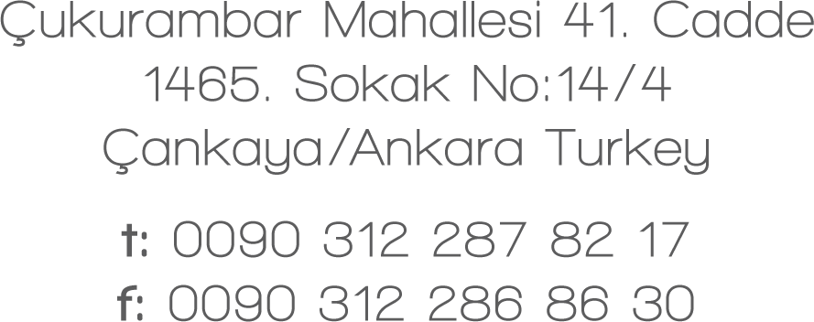

Contents
Executive Summary 3
1.Background 7
2.Evaluation Questions 8
3.Evaluation Methodology 11
4.Challenges Faced 13
5.Findings 15
Relevance 15
Effectiveness 20
Efficiency 29
Sustainability 30
Design and Focus 32
UN Coordination 33
Use of the UN’s Five Programming Principles 36
6.Conclusion 38
7. Recommendations 40
ANNEX 1: List of Documents Reviewed 41
ANNEX 2: List of In-Depth Interviewees 42
ANNEX 3: List of Non-UN Organizations which Responded to the On-Line Survey 43
ANNEX 4: On-Line Survey Questions 44
ANNEX 5: Some Activities of the UN Agencies in Response to the Syria Crisis 58

Executive Summary
A final evaluation of the UNDCS implemented in Turkey between 2011 and 2015 was carried out by independent consultants during the period from December 2015 to April 2016. This report sets out the procedures followed, the findings, and the conclusions and recommendations of the evaluators.
The purpose of the evaluation was not only to support greater accountability but also to inform future practice – and specifically the implementation of the following cycle of cooperation between Turkey and the UN, covering the years 2016-2020. With this in mind, the evaluators set out (i) to assess the contribution made by the UN System within the framework of the UNDCS to national development results, (ii) to identify the factors that have positively or negatively affected the contribution of the UN Country Team (UNCT), (iii) to extrapolate lessons learned, and (Iv) to provide actionable recommendations for improving the UNCT contribution and for coordination and monitoring mechanisms.
The evaluation was based on a review of relevant documents and information and data gathered through in-depth interviews and on-line surveys.
In-depth interviews were conducted with the UN Resident Coordinator, heads of UN agencies active in Turkey and some other key UN staff in Ankara. All of the UN interviewees shared their views, comments and suggestions honestly and openly. Indeed, all UN staff were very cooperative and supportive throughout the evaluation process.
In-depth interviews were also conducted at the Ministry of Foreign Affairs and the Ministry of Livestock, Food and Agriculture. Both ministries were helpful. However, it was not possible to arrange interviews with other Government institutions, including the Ministry of Development, which is the UN’s coordinating partner for the UNDCS on the Government side.
The two on-line surveys were carried out in order to reach a wider range of relevant individuals and organizations, and thus to obtain more views about the UNDCS implementation and its outcomes. The evaluation team prepared separate on-line surveys for Government institutions and civil society organizations (CSOs) on the one hand and for staff of the UN agencies on the other. Responses were received from 11 representatives of CSOs and from 31 UN staff members with experience of inter-agency collaboration.
As per the Terms of Reference, the review of documents, in-depth interviews and on-line surveys were based on a set of evaluation questions which encompassed the relevance, effectiveness, efficiency, sustainability and design and focus of the UNDCS, its coordination and its use of the UN’s five programming principles – namely, the Human Rights-Based Approach, Gender Equality, Environmental Sustainability, Results-Based Management and Capacity Development.
The UNDCS was found to have been relevant. Its priority areas and outcomes were in line with the priorities of Turkey as expressed in National Development Plans. It also contributed positively to Turkey’s ability to fulfil its international and regional commitments. However, the evaluators questioned why the UNDCS was not amended during the Mid-Term Review of 2013 to encompass the new situation arising as a result of the impact of the Syria crisis on Turkey, which emerged as a major issue for the country, and in practice absorbed much of the energies of several agencies.
With respect to the effectiveness of the UNDCS, it was found that the targets set for 12 (57 percent) of the 21 indicators were achieved. This relatively modest rate of achievement was related partly to technical issues: some targets may have been set unrealistically high, and some of the indicators were not fully measurable, pointing to incomplete implementation of the UN programming principle of Results-Based Management (see below).
The perceptions of participants in the on-line survey concerning the progress made by the UNDCS were more positive. This was true both for UN agency staff members and for representatives of civil society organizations. However, the perceptions of these two groups diverged noticeably in some respects. In particular, while the UN staff members were positive about the level of the contribution made by the UNDCS towards the implementation of human rights legislation, equal access to justice and the empowerment of vulnerable individuals and groups to participate equally in and influence decision-making processes, the perceptions of the civil society organizations were negative. The civil society respondents nevertheless commended the contribution of the UNDCS in the area of gender equality.
In terms of efficiency, the UNDCS was found to have helped to reduce the transaction burden and to simplify communications in relations between the UN and the Government. However, there still appears to be room for improvement in this respect. Almost all of the heads of UN agencies interviewed acknowledged this point. Meanwhile, most of the UN staff who participated in the on-line survey did not believe that the UNDCS helped to avoid duplications, or that it simplified the communication between the UN and civil society organizations.
The close correlation between national priorities and goals and those of the UNDCS, coupled with the implementation of the programming principle of capacity development (see below), provide a sound guarantee of the sustainability of the UNDCS and its achievements. At the same time, however, it was observed that the UNDCS 2011-2015 faced a number of challenges not only due to cyclical factors such as electoral timetables and turnover of personnel, but also due to geo-political circumstances, and more recently internal political tensions and a volatile security situation in some parts of the country. Similar issues may have to be faced during the implementation of the UNDCS for 2016-2020. Consideration will need to be given to the future of the UN’s substantial response to the impact of the Syria crisis in Turkey.
In its design and focus, the UNDCS was in general coherent and realistic in the sense that it was designed in line with national priorities, commitments and time frames. The country programmes and action plans, programmes, projects and strategies of the UN agencies generally followed on coherently. However, the focus of the UNDCS became less fully aligned with country priorities and commitments as the impact of the Syria crisis grew. The UN agencies rightly became closely engaged in matters related to the refugee situation, but this was not reflected in the UNDCS.
It was observed that the UNDCS contributed positively to establishing better coordination among the UN agencies, including through the Working Groups and Thematic Groups, in line with the substantial efforts made in this direction. However, some problems persist regarding the duplication of activities, divergent procedures, and lack of clarity of roles and responsibilities among the agencies.
All of the UN’s five programming principles were strongly in evidence both in the design and in the implementation of the UNDCS. However, some of the indicators used in the UNDCS for 2011-2015 could have been defined in a manner more compliant with the principles of Result Based Management. This is a technical issue, and it could have been avoided if there had been in-house monitoring and evaluation expertise within the UNCT.
In the light of these findings, the evaluators have set out their conclusions and proposed a set of recommendations. The following are among the points that have been highlighted:
Monitoring and Evaluation: The monitoring and evaluation capacity of the UN in Ankara should be enhanced. This will also ensure that Results-Based Management principles are fully implemented, and in particular that the indicators to be used for the UNDCS for 2016-2020 are defined in such a way as to be more compliant with the principles of Results-Based Management (RBM). At the same time, the individual UN agencies should allocate enough financial resources in support of efficient monitoring of their own programmes, projects and activities at both agency and UNCT levels. It is recommended that the mid-term review of the UNDCS 2016-2020 should be initiated at the end of 2017, so that timely measures can be taken, depending on needs arising and the latest socio-economic and geo-political developments.
Coordination: The efforts that have been made to increase coordination among the UN agencies, including through the Working Groups and the Thematic Groups, need to be pursued further. The senior management of the UN agencies should take steps to further clarify the roles and responsibilities among the UN agencies. It is recommended that areas of duplication among the UN agencies should be identified and eliminated during the next UNDCS cycle.
Sustainability and flexibility: While UN agencies will continue to operate in Turkey in the near future, and even increase their operations in view of the Syria crisis, circumstances may change in the medium term. With respect to the Syria crisis, UN agencies could usefully develop action plans for various possible scenarios while collectively strengthening the disaster-preparedness and contingency planning of the UN Country Team. More generally, close attention may need to be paid to exit/sustainability strategies under the UNDCS for 2016-2020.
Civil society: There is a need for greater efforts to improve coordination and communication with civil society organizations (CSOs). The UN has a critical part to play in enhancing the role of CSOs in Turkey. Regular meetings with CSOs would increase their sense of belonging.
Gender: Since all of the civil society organizations which contributed to the evaluation process highlighted the positive contribution of the UNDCS with respect to gender issues, it is recommended that the UN should continue to develop and reinforce its strategies and activities in this area.
While implementing the recommendations of this evaluation, it is important that the UN in Turkey should continue to perform successfully with respect to: the relevance of its programming to national goals and Turkey’s international commitments; its focus on results - and on ensuring the sustainability of its efforts through Capacity Development; its concern to implement the Human Rights-Based Approach and Environmental Sustainability, and its commitment to Gender Equality, an area in which the UN system has a strong profile in Turkey.
Finally, the evaluation team would like to express its deep appreciation of the close cooperation and support which it received from the UN Country Team, UN staff, the Ministry of Foreign Affairs, the Ministry of Livestock, Food and Agriculture, and all the civil society organizations that participated in the evaluation.

Background
The United Nations Development Cooperation Strategy (UNDCS) under evaluation is the third generation Common Country Programme Document produced by the United Nations System in Turkey covering the period 2011-2015.
The UNDCS for 2011-2015 established three strategic areas of cooperation between the UN system and the Turkish Government for the five-year programme period: (I) Democratic and Environmental Governance, (II) Disparity Reduction, Social Inclusion and Basic Public Services, and (III) Poverty and Employment). A Mid-Term Review of the UNDCS for 2011-2015 was implemented in 2013.
The Government of Turkey and the UN System in Turkey recently began to implement a new UNDCS covering the years 2016-2020, which follows on from the UNDCS under evaluation. This final evaluation therefore aims not only to support greater accountability towards agreed national objectives and priorities in Turkey but also to inform the implementation of the new Strategy through an analysis of challenges encountered and lessons learned in the preceding cycle.
The specific objectives of the evaluation were:
- to assess the contribution made by the UN System within the framework of the UNDCS to national development results, basing all judgements on evidence in line with the evaluation criteria;
- to identify the factors that have affected the contribution of the UN Country Team (UNCT), seeking to explain the level of performance by identifying the relevant enabling factors and bottlenecks, and to extrapolate lessons learned based on the aforementioned matters;
- to provide actionable recommendations for improving the UNCT contribution, and for coordination and monitoring mechanisms, notably with a view to informing the implementation of the new cycle of cooperation between Turkey and the UN. These recommendations should be logically linked to the conclusions and draw upon lessons learned identified through the evaluation.
Figure 1: Specific Objectives of the Evaluation

2. Evaluation Questions
The evaluation questions were identified as follows in accordance with the standard international criteria for development evaluation, as reflected in United Nations Evaluation Group (UNEG) standards.
Assessing the relevance of the UNDCS in relation to the issues it was designed to address and to their underlying causes:
- To what extent have the UNDCS outcomes addressed key development issues and national priorities in Turkey, and their underlying cause and challenges, and what are the gaps that should (have) receive(d) further attention?
- To what extent has the UNDCS been relevant to Turkey's international and regional commitments, including human rights instruments and the recommendations of Human Rights mechanisms (Universal Periodic Review, treaty bodies, special procedures), to sustainable development, and to the needs of women and men, girls and boys in Turkey?
- To what extent was the UNDCS Results Matrix flexible and relevant to respond to new issues and their causes as well as challenges that arose during the UNDCS cycle, including humanitarian situations?
Assessing the effectiveness, to the extent possible, of the UNCT's contribution to the outcomes defined in the UNDCS:
- What progress has been made towards the realization of the UNDCS outcomes in terms of the stated indicators in the UNDCS framework?
- What were the main factors that promoted or hindered the effectiveness of the UNDCS?
- Have there been any unintended results, and if so, have they affected national development positively or negatively, and to what extent have they been foreseen and managed?
Assessing the efficiency of the UNDCS as a mechanism to minimize the transaction costs (funds, expertise, time, administrative costs, etc.) of UN support for the Government of Turkey and for the UN agencies:
- To what extent and in what way has the UNDCS contributed to a reduction of transaction costs (financial to the extent possible) for the government and for each of the UN agencies? In what ways could transaction costs be further reduced through harmonization and simplification?
Assessing the sustainability of UNDCS implementation:
- To what extent can one say that the benefits of the implementation of the UNDCS have continued, or are likely to continue, after it is completed?
- Have complementarities, collaboration and/or synergies fostered by the UNDCS contributed to greater sustainability of the results of donor intervention in Turkey?
Assessing the design and focus of the UNDCS:
- To what extent is the current design of the UNDCS coherent and focused? Are expected outcomes realistic given the UNDCS timeframe, the resources available and the planned country programmes, projects and programme strategies?
Assessing UN Coordination:
- To what extent did the UNDCS create actual synergies among agencies (and among and between country programmes etc.) and involve concerted efforts to optimise results and avoid duplication (including the current coordination mechanisms such as Thematic Groups and Working Groups)?
- Is the distribution of roles and responsibilities among the different UN agencies well defined and facilitated in the achievements of results, and have these arrangements largely been respected in the course of implementation?
Assessing the use of the UN's Five Programming Principles:
- To what extent have the programming principles (the Human Rights-Based Approach, Gender Equality, Environmental Sustainability, Results-Based Management, and Capacity Development) been considered and mainstreamed in the UNDCS chain of results? More specifically:
      - To what extent did the UNDCS make use of Gender Mainstreaming and the Human Rights Based Approach, and promote human rights and gender equality standards and principles (participation, non-discrimination, accountability, etc.), in order to achieve its goals?
      - To what extent did the UNDCS strengthen capacities for data collection and analysis to ensure the availability of data disaggregated on the basis of race, color, sex, geographical location, etc., and did those subject to discrimination and disadvantage benefit from priority attention?
      - Did the UNDCS effectively use the principles of environmental sustainability to strengthen its contribution to national development results?
      - Did the UNDCS make adequate use of Results-Based Management to ensure a logical chain of results, and to what extent is the current monitoring system of the UNDCS adequate to track the results achieved and ready for use in the next cycle?
      - Did the UNDCS adequately invest in, and focus on, national capacity development? To what extent and in what ways did the UNDCS contribute to developing the capacity of Government institutions and civil society institutions?
      - Did any shortcomings arise due to failure to take the five programming principles into account during the implementation of the UNDCS?

Evaluation Methodology
The methodology to be employed during the course of the evaluation was developed at the inception phase in line with the Terms of Reference. The evaluation was conducted in such a way as to obtain answers for the pre-determined evaluation questions in line with an evaluation matrix which provided the main analytical framework against which data was gathered and analysed. The outcomes and outputs included in the UNDCS Results Framework were also examined within this framework.
The evaluation adopted a mixed-method approach comprising qualitative and quantitative elements in order to maximize validity and reliability.
Desk review: A desk review was conducted of a wide range of documents including:
- the UNDCS itself, the UNDCS Mid-Term Review report, and the country programmes, country programme action plans, annual reports and/or evaluations of individual UN agencies, together with progress or final reports on their programmes or projects;
- national development plans and strategy documents, national statistical yearbooks, national human rights reports, the annual report of the Ombudsman Institution and other relevant documents of national institutions and bodies, and
- relevant international conventions to which Turkey is a party, the corresponding Concluding Observations of the UN treaty bodies, UN Human Rights Council reports, EU progress reports and Millennium Development Goals reports.
All in all, the evaluation team was able to review a significant volume of documents relevant to most of the evaluation questions at this phase of the evaluation. A list of documents reviewed is annexed to this report (Annex 1).
In-depth Interviews: During the evaluation process, a number of in-depth, face-to-face interviews were conducted with senior staff of the UN Country Team, Government institutions and a civil society organization. These interviews provided key qualitative inputs for the evaluation.
Interviews were conducted with the majority of the heads of UN agencies based in Ankara as well as other key staff members. During these interviews, the heads of agencies provided their overall views on the expected outcomes of the UNDCS, the challenges encountered during its implementation, lessons learned and any and all other related issues. All the UN heads of office and UN staff members were extremely informative and cooperative.
Several in-depth interviews were envisaged with relevant Government organizations that cooperate closely with the UN. In this context, the evaluation team met with the Department of Multilateral Economic Affairs of the Ministry of Foreign Affairs responsible for relations with international organizations. However, the officials interviewed were recently appointed, so it was possible to obtain the Ministry’s perspective on the implementation of the UNDCS only to a certain extent. Another in-depth interview was conducted at the Ministry of Food, Agriculture and Livestock.
The full list of interviewees with whom in-depth interviews were conducted is annexed to this report (Annex 2).
On-line surveys: Separate on-line surveys were prepared for Government institutions and civil society organizations on the one hand and for members of staff of the UN agencies on the other. The questionnaires developed for this purpose are annexed to this report (Annex 4).
The purpose of the on-line surveys was to reach a wider range of relevant individuals and organizations, and thus to obtain more views about the UNDCS implementation and its outcomes. In the event, a total of 11 representatives of non-UN organizations and 31 persons from the UN agencies based in Ankara completed and returned the survey forms.
The on-line survey for UN staff was conducted among staff members who have taken part in the work of the inter-agency Thematic Groups and Working Groups. These are the staff members who represent their agencies in joint efforts on behalf of the UN Country Team.
Respondents to the on-line surveys were asked to give their opinions on the outcomes and indicators of the UNDCS, the work of the Thematic Groups and Working Groups, and the coordination and communication between UN and non-UN organizations. The respondents were also asked for their overall comments and suggestions with respect to the UNDCS for 2011-2015.
A list of the civil society organizations that responded to the survey is annexed to this report (Annex 3).

Challenges Faced
A number of challenges were faced in obtaining qualitative and quantitative data for the evaluation.
A number of government institutions could not be reached. In spite of the repeated efforts of the evaluation team and the Office of the Resident Coordinator, it proved impossible to arrange a meeting at the Ministry of Development (MoD), which was a key stakeholder of the UNDCS for 2011-2015 in its capacity of coordinating agency on the Government side. The evaluation team also sent several reminders to the MoD concerning the on-line survey, but was unable to secure its participation. Similar difficulties were encountered in efforts to reach line ministries and other government institutions.
There has been a high circulation of staff in Government institutions in recent years. The vast majority of high-level administrators and staff involved in cooperation with the UN were appointed only recently. Indeed, the persons interviewed both at the Ministry of Foreign Affairs and at the Ministry of Food, Agriculture and Livestock were appointed recently, and were not well informed about the UNDCS for 2011-2015.
The response to the on-line surveys was lower than anticipated, even though the Monitoring for Strategic Results Inter-agency Working Group and the evaluation team each sent out several reminders both to UN staff and to non-UN institutions and organizations. In the case of the on-line survey for Government institutions and civil society organizations (CSOs), a total of 65 invitations were sent out. The 11 respondents represented only 17 percent of the invitees. The respondents were from CSOs, rather than Government institutions. As for the UN staff, only 31 out of the 138 individuals contacted (about 23 percent) responded to the on-line survey.
Table 1: Distribution of UN Staff who Responded to the On-Line Survey
 | No. of responses | Group size | Response rate (%)
Thematic Group participants:
Gender | 14 | 24 | 58
Youth | 12 | 20 | 60
Human Rights | 10 | 27 | 37
Working Group participants:
HIV/AIDS | 3 | 13 | 23
Monitoring for Strategic Results | 10 | 21 | 48
Regional Development | 8 | 17 | 47
Office Management Team | 7 | 17 | 41
Communications | 10 | 20 | 50
GEF-6/Environment | 3 | n/a
Syria Response Group | 16 | 16 | 100
HACT* Task Force | 10 | 10 | 100
* Harmonized Approach to Cash Transfers
While the level of response for the on-line survey was lower than hoped for, the information gathered through the survey was nevertheless very enlightening. The on-line survey tool made it possible to reach a total of 31 additional persons within the UN country team and 11 different civil society organizations, and to obtain their views about the UNDCS for 2011-2015. The on-line surveys were not mentioned either in the Terms of Reference for the evaluation or in the consultant’s technical offer; they were conducted in line with a suggestion made by the evaluation team during the inception phase of the evaluation. It would not have been possible to interview so many people using the face-to-face interview technique alone. The on-line survey also provided data suitable for quantitative analysis - albeit with limited representativeness in view of the low response rate.

Findings

Relevance
- To what extent have the UNDCS outcomes addressed key development issues and national priorities in Turkey, and their underlying cause and challenges, and what are the gaps that should (have) receive(d) further attention?
One of the basic principles set by Turkey’s Ninth National Development Plan was that “transparency, accountability, participation, efficiency and citizen satisfaction” should be the main criteria in the provision of public services. The Plan also aimed to strengthen human development and social solidarity through policy reviews, especially in the fields of education, employment, poverty, health and social security. The main purpose of policies in these fields is defined as follows: to raise the quality of life and welfare of society by ensuring that all segments of the population benefit sufficiently from basic public services and a multi-dimensional social protection network. The UNCDS for 2011-2015 relates closely to these goals. Although the Tenth National Development Plan, covering the years 2014-2018, was drawn up after the UNDCS for 2011-2015 was signed, the priorities of the UNDCS can be said to be in accordance with the objectives and targets of the Tenth National Development Plan as well.
The support of the UNDCS for strengthened accountability, transparency and participation in public sector institutions is relevant to national commitments contained in both the ninth and tenth National Development Plans, as well as in the strategic plans that are prepared and implemented by all public administrations to ensure participation and accountability. National commitments have also been made to the introduction and the use of information and communication technologies in the provision of public services, including e-government, wıth a view to delivering flexible, hıgh quality, effective, fast and inter-operable services as a practice of good governance. These commitments are closely compatible with the UNDCS perspectives of ensuring citizens’ access to information and providing transparency and participation in public sector institutions.
The Ninth National Development Plan had a specific emphasis on increasing the quality and effectiveness of the judicial system. It sought to strengthen legal and institutional arrangements so as to ensure the rapid, fair, reliable and proper operation of the judicial process in the framework of supremacy of law and rule of law. It also aimed to make arrangements to protect the rights of those unjustly treated and provide them with sufficient legal assistance. The UNDCS is relevant to these national commitments since it targets improved access to justice through increased efficiency of judicial systems that ensure equality and are non-discriminatory. The UNDCS goes further than the Plan by emphasizing the protection of the social, economic, cultural, civil and political rights of all, especially women, children and members of disadvantaged communities as an additional criterion in assuring improved access to justice.
The Plan has a specific focus on increasing the quality of education while ensuring its inclusiveness. The UNDCS is relevant to these national priorities in its support for the measures that need to be taken to reduce gender and geographical discrepancies in completion of quality primary and secondary education, as well as to ensure equitable access to quality basic services for rural communities.
When it comes to health services, the Plan aims at improving access to health services by meeting needs for infrastructure and health personnel and ensuring that they are evenly distributed around the country. The UNDCS is in line with this national goal, displaying a shared concern to improve equitable access to health care.
While the UNDCS addresses almost all development issues and national priorities for equitable access to basic services by all, it does not make any reference to the capacity development needs of the institutions responsible for the provision of basic services. There is no defined target or indicator related to capacity development, including the development of human resources and infrastructure, even though this is crucial for improving the quality of basic services. However, capacity building has been observed to be one of the core principles of most of the UN agencies active in Turkey, and is clearly highlighted in their country programmes.
Overall, the UNDCS proves to have made a good analysis of key development challenges and issues in Turkey, and to have succeeded in establishing appropriate linkages with national commitments. It provides a broader perspective than the Plan in that it approaches the national objectives with a clear human rights lens, incorporating the human rights-based approach and thus achieving alignment with Turkey’s international human rights commitments.
The following figure summarises the common objectives of the UNDCS and the ninth and tenth National Development Plans.
Figure 2: Main objectives of the National Development Plans of Turkey and the UNDCS
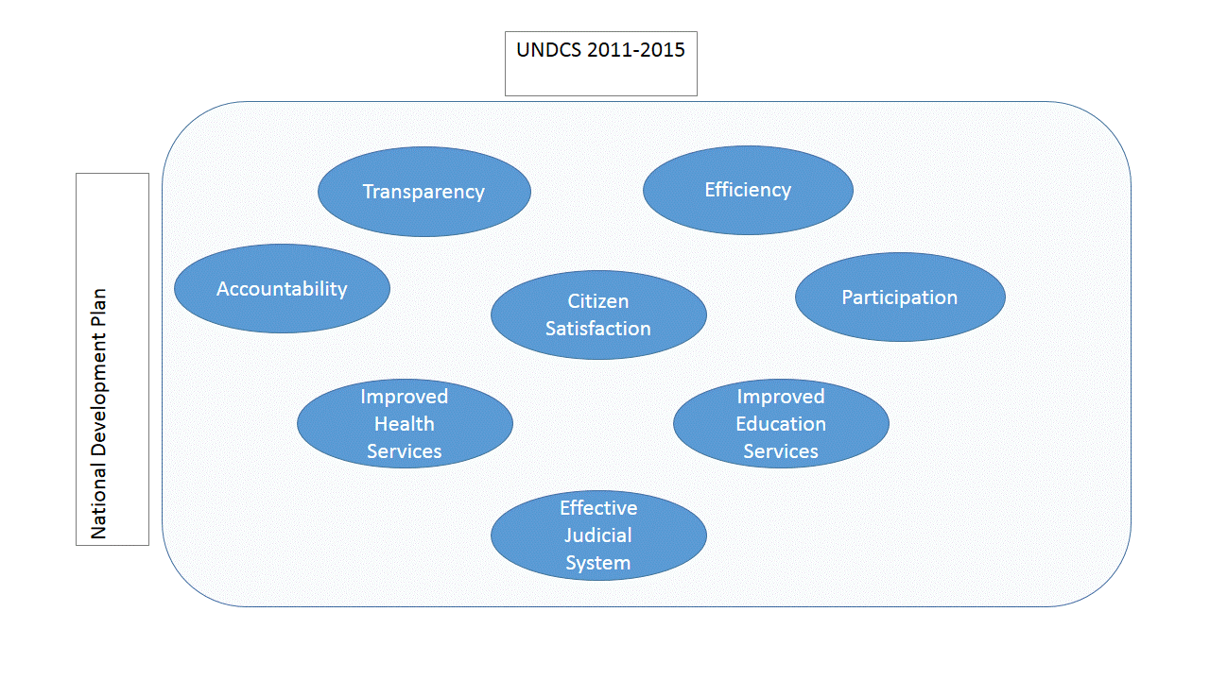
- To what extent has the UNDCS been relevant to Turkey’s international and regional commitments, including human rights instruments and the recommendations of Human Rights mechanisms (Universal Periodic Review, treaty bodies, special procedures), to sustainable development, and to the needs of women and men, girls and boys in Turkey?
The UNDCS targets enhanced democratic governance and rule of law by addressing strengthened governance, improved access to justice for all and improved mechanisms for monitoring and implementation of human rights legislation, as well as greater compliance with international instruments. These issues are also at the heart of the concerns of all human rights bodies and procedures including treaty-based and charter-based bodies, the Universal Periodic Review (UPR) and the Office of the High Commissioner for Human Rights. The UNDCS is also highly relevant to the European Union’s vision of democracy and human rights.
The UNDCS seeks to ensure the full and active participation of every citizen in public decision making as well as to promote enhanced opportunities for participation for members of poor or socially disadvantaged groups in decision making processes at all levels. This is central to all human rights instruments and the recommendations of human rights mechanisms. For the EU, this is a matter of social inclusion, regarded as a process of ensuring that vulnerable groups and persons enjoy greater participation in the taking of decisions which affect their lives, thereby ensuring that they are able to access their fundamental rights. With its emphasis on empowering individuals and vulnerable groups to participate equally in and influence decision-making processes at all levels, the UNDCS is relevant to Turkey’s international and regional commitments.
Turkey became a party to the United Nations Framework Convention on Climate Change (UNFCCC) on May 24th, 2004. The UNDCS is relevant to the UNFCCC in the sense that it aims to ensure sustainable development resilient to climate change and to promote a low-carbon economy through enhanced environmental policy design and implementation capacity, thereby mitigating the impact of climate change on the economy, environment and society - especially vulnerable groups and communities - and on human health. The support which the UNDCS extends to the national efforts required to sustain biodiversity, ecosystem goods and services, and natural resources, to reduce the impact of climate change on the water and agriculture sectors including forestry, animal husbandry and fisheries, and to preserve the natural and cultural heritage, also render it compatible with many other international obligations of Turkey such as the Bern Convention on the Conservation of European Wildlife and Natural Habitats, the United Nations Convention on Biological Diversity, the Paris Convention for the Prevention of Marine Pollution from Land-Based Sources, the Barcelona Convention for the Protection of the Marine Environment and the Coastal Region of the Mediterranean, and the UNESCO World Heritage Convention.
The UNDCS places high priority on the elimination of discrimination against women in line with the recommendations of the Committee on the Elimination of Discrimination against Women (CEDAW). Under its second priority area (Disparity reduction, social inclusion and basic public services), the UNDCS includes a specific outcome about the equal participation of women in all fields of public, private and civil society. In this respect, the UNDCS also closely parallels Turkey’s ninth and tenth development plans.
The UNDCS is relevant to the visions of the OECD (EFA: Education for All), UNESCO and the EU in the field of equitable access to education and employment for all, adopting a rights-based approach and upholding the principles of non-discrimination and inclusiveness in education and the labour markets.
With respect to health, the emphasis of the UNDCS on strengthening equitable access to knowledge, information, employment and quality basic services is in line with the policies of the EU, ILO and WHO.
The UNDCS target of strengthening equitable access to knowledge, information and basic services (education, health, nutrition, water and sanitation, and human rights) is also well aligned with the Convention on the Rights of the Child (CRC).
Last but not least, the UNDCS is relevant to the Millennium Development Goals (MDGs), as it allows the UN system in Turkey to respond collectively to higher level national priorities and needs while achieving the MDGs.
- To what extent was the UNDCS Results Matrix flexible and relevant to respond to new issues and their causes as well as challenges that arose during the UNDCS cycle, including humanitarian situations?
A number of new circumstances, issues and challenges arose during the course of the period of implementation of the UNDCS, as attested to by the Mid-Term Review (MTR) of 2013, the UNDCS Annual Review of 2014, and the developments that took place in 2015. One new development relevant to the strengthening of accountability, transparency and participation in public sector institutions was the “New Positive Agenda” launched by the EU and Turkey in May 2012 with a view to reinvigorating their mutual relations. The positive agenda endorsed by the EU member states and Turkey was not intended to replace the accession negotiations between Turkey and the EU but to complement them and to strengthen the reform process in Turkey. Important areas covered by the positive agenda included legislative alignment, political reforms and increased participation in people-to-people programmes, all of which are relevant to the strengthening of accountability, transparency and participation in public sector institutions. These are all areas verifiable by the indicators included in the UNDCS Results Matrix, such as the number of recommendations made by international human rights instruments acted upon, or the number of national norms and items of legislation aligned with international standards. In this sense, the Results Matrix can be considered sufficiently flexible and relevant to respond to new issues related to accountability, transparency and participation in public sector institutions.
A very different case of changing circumstances and challenges was the impact of the Syria crisis, which began in 2011, and resulted in a constant and increasing influx of refugees into Turkey, substantially transforming the humanitarian and development context in the country. According to Turkey’s Directorate General of Migration Management, 2.75 million Syrians are now living in Turkey. Of these, about 10 percent are living in temporary accommodation centres (camps), while the rest are living in host communities in almost all provinces of Turkey. In some cities, like Kilis, the refugee population has come to exceed the local population of Turkish citizens. In addition to the Syrians, Turkey is receiving significant flows of refugees from Afghanistan and Iraq. The Government of Turkey has committed to do its best for all the refugees in Turkey, and has allocated significant resources to support them.
UN agencies in Turkey have been assisting the Government in its actions in support of the refugee population. To illustrate the variety and extensiveness of these programmes, a list of some of the activities which the UN agencies in Turkey have reported carrying out in response to the Syria crisis is annexed to this report (Annex 5).
Overall, the response of the UN agencies to the impact of the Syria crisis was of vital importance, as indicated – inter alia - in the UNDCS Annual Reports and the letters of the Resident Coordinator. It would not, of course, be reasonable to expect the UNDCS Matrix drawn up before the crisis broke out to be flexible enough to respond to this major humanitarian situation. Nevertheless, there was an opportunity during the Mid-Term Review (MTR) conducted in 2013 to add one or more relevant outcome(s) and/or indicator(s) to the UNDCS results matrix. In the view of the evaluation team, it would have been very appropriate for relevant outcomes and corresponding indicators to have been included in the UNDCS as a result of the MTR. Although the UN agencies responded to the Syria crisis in many ways, in practice, the failure to revise the UNDCS Results Matrix constitutes an omission. It must be added that the results matrix for the UNDCS for 2016-2020 does indeed include outcomes related to the ongoing response and resilience agenda for the Syria crisis.

Effectiveness
- What progress has been made towards the realization of the UNDCS outcomes in terms of the stated indicators in the UNDCS framework?

Statistical findings on the achievement of results: Table 2 provides the latest available data for the 21 UNDCS indicators in comparison with the original targets. It can be seen that the target was achieved in 12 cases (57 percent of the number of indicators).
There are several possible reasons for the deviations from the targets which are not directly related to the effectiveness of the implementation of the UNDCS. First of all, some of the targets seem not very realistic. For example, the UNDCS targeted a decrease of 5 percent in greenhouse gas emissions, but in practice an increase of about 28 percent was recorded. Another target aimed to provide jobs for 500,000 new persons by 2015. However, the baseline figure was 118,278 in 2011. This means that an increase of 328 percent was anticipated over a period of four years. This may not have been realistic. Achieving such a major improvement would have required a very sharp increase in GDP and other economic indicators between 2011 and 2015. A third example of an unrealistic target was the goal of a 100 percent increase in the national budget allocations for research and development. Even though there was, in fact, a significant increase (34 percent), the target was not met. A larger increase in the amounts allocated by the Government for research and development would have been desirable, but it may have been over-optimistic to aim to bring this about within four years.
Secondly, some of the indicators were not sufficiently measurable. The indicators for democratic governance, in particular, were not measurable. It would have been possible to identify alternative indicators, which could have been both qualitative and measurable.
In addition to the above, the definitions of some of the indicators (See Table 2) were unclear. There were also cases where the use of different sources of verification for the same indicator resulted in divergent findings. This raises the problem of reliability of sources as well as casting doubt on whether the target was reached or not.
Overall, the indicators used in the UNDCS for 2011-2015 could have been defined in a manner more compliant with the principles of Results-Based Management. This is a technical issue, and could have been avoided if there had been in-house monitoring and evaluation expertise within the UNCT. More generally, it is essential to ensure that sufficient resources are set aside for the monitoring of programmes, projects and activities at both agency and UNCT levels.
Table 2 (a): UNDCS Indicators Statistics – Priority Area 1: Democratic and Environmental Governance
Outcomes | Indicators | Baseline | Target 2015 | End-line | Comments | Sources
1- Enabled Enviroment for Inclusive and Democratic Governance, the Rule of Law and Access to Justice for all including further compliance with international commitments and human rights norms and standards | # of recommendations by the International human rights instruments met | UPR 2010 | 1/5 of the recommendations | Approx. 1/3 | Target reached (but indicator not easy to measure) | UPR 2015_Turkey's National Report, EU Progress Report 2014, UNDCS MTR 2013, UNDCS Annual report 2014
 | # of cases resolved through mediation processes | N/A | 2,500 | 5,042 (2013) | Target reached | http://www.adb.adalet.gov.tr/Sayfalar/istatistikler/uygulamalar/adb_uygylamalari/images/index.html
 | # of national norms and legislations aligned with international standards | 11 pending | 10 | Numerous but not countable | Not easy to measure | UPR 2015_Turkey's National Report, EU Progress Report 2014, UNDCS MTR 2013, UNDCS Annual report 2014
2- Empowered individuals and vulnerable groups participate equally in and influence decision-making processes at all levels. | # of city councils with participants of women, youth and population groups that need special attention/protection | 40 | 81 | 60 (2014) | Target not reached | UNDCS Annual Review 2014, p. 15
 | # of local action plans prepared by local administrations in cooperation with the city councils | 6 UNJP programme cities | 12 | 12 | Target reached | UNJP WFC Evaluation Report
 | Share of women represented in political decision-making at local and national levels | Seats in Parliament: 9.11%; Mayors: 2% | Parliament: 15% , Mayors: 10% | Parliament: 17.8%  Mayors: 4.9% | Target partially reached | TURKSTAT, Number of representatives and representation rate in the Assembly by the election year and sex, 1935-2015/Supreme Election Board
3. Strengthened policy formulations and implementation capacity for the protection of the environment and cultural heritage in line with sustainable development principles, taking into consideration climate change, including disaster management, with a special focus on gender perspective | Land area under protection | 37,000 ha | 50,000 ha | 70,000 (2015) | Target reached | UNDCS Annual Report 2014, p.19/Ministry of Forest and Water Affairs Statistics: http://www.milliparklar.gov.tr/Anasayfa/istatistik.aspx?sflang=tr
 | Level of GHG emissions | 366.5 mt | 350 mt | 459.1 mt (2013) | Target not reached | TURKSTAT, http://www.tuik.gov.tr/PreHaberBultenleri.do?id=18744
 | Systems for disaster risk reduction in place | N/A | Disaster risk reduction action plan in place | AFAD has a national risk reduction plan | Target reached (but indicator is not measurable) | AFAD (Prime Ministry Disaster and Emergency Management Authority), Tenth National Development Plan for 2014-2018

Table 2 (b): UNDCS Indicators Statistics – Priority Area 2: Reducing Disparities, Social Inclusion and Basic Social Services
Outcomes | Indicators | Baseline | Target 2015 | End-line | Comments | Sources
4- Increased provisions of inclusive and responsive public as well as community-based services to strengthen equitable access to knowledge, information and quality basic services | Employment rate | Worst five provinces: 24.16%  Best five provinces: %59.64 | 45% / 65% | 28.36% / 53.84% | Target not reached | TURKSTAT, Information Society Statistics, 2004-2015
 | # of people with access to e-services | 34% internet access | 60% | 69.5% (2015) | Target reached | TURKSTAT
5- Equal participation of women ensured in all fields of public sector, private sector and çivil society with strengthened institutional mechanisms to empower women’s status | Level of women's labour force participation | 27.4% | 40% | 32.3% (September 2015) | Target not reached | TURKSTAT, Labour force status by educational attainment, September 2014-2015
 | Share of women in senior positions in private and public sector | 7% | 16% | Public: 9.4% , Private: 25% | Target partially reached | www.kadininstatusu.gov.tr
 | Amount of funds allocated to institutional mechanisms to empower women's status at national and local levels | US$3,135,000 | US$4,000,000 | KSGM budget: 8.181.000 TL (for 2015) | Target reached (but indicator is not easy to measure) | http://www.resmigazete.gov.tr/main.aspx?home=http://www.resmigazete.gov.tr/eskiler/2014/12/20141226m1.htm&main=http://www.resmigazete.gov.tr/eskiler/2014/12/20141226m1.htm

Table 2 (c): UNDCS Indicators Statistics – Priority Area 3: Poverty and Employment
Outcomes | Indicators | Baseline | Target 2015 | End-line | Comments | Sources
6- Enhanced poverty alleviation through the implementation of more effective income inequality reduction policies and programmes | Poverty ratios | Food poverty: 0.54%  Food+non-food poverty: 17.1% | Food poverty: 0.01%  Food+non-food poverty: 13% | Food poverty: 0.03 % , Food+non-food poverty: N/A | Target not reached | TURKSTAT
 | Share of poorest quintile in national consumption | 9.10% | 12% | 38.20% | Target reached | TURKSTAT
7- Increased opportunities for employment and decent work for all through the implementation of equity-enhancing policies, strategies and programmes that promote economic growth, based on competitiveness, increased productivity and corporate social responsiblity. | Unemployment rate | Total 14%  Male 13.9%  Female 14.3 % Youth: 25.3% Rural: 8.9%, Urban: 16.6% | Total: 12%  Male: 11.7%  Female: 12.5% | Total: 9.9%  Male: 9%  Female: 11.9% | Target reached | TURKSTAT
 | # of people placed in a job as a result of active labour policies | 118,278 | 500,000 | 310,000 in 2014.  239,000 (2015 - first 9 months) | Target not reached | TURKSTAT
 | # of industrial clusters | 0 | 10 |  | Indicator is not available  Not easy to measure)
 | Labour productivity rate | US$21 | US$30 |  | Indicator is not available
 | Govermental and private expenditures on research and development | 0.73% of GDP | 1.5% of GDP | 1% of GDP | Target not reached | TURKSTAT

Findings of the on-line survey on the achievement of results: In addition to the comparison of end-lines with targets given in Table 2, the evaluation team recorded the perceptions of UN staff members and civil society organizations about the effectiveness of the indicators through the on-line surveys.
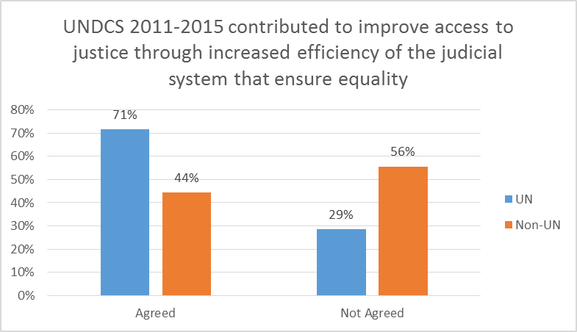
Figure 3: Perceptions of achievement of targets under Priority Area 1 Outcome 1 (justice)
The representatives of non-UN organizations interviewed were less positive than the UN staff members about the achievement of targets in the area of equal access to justice.
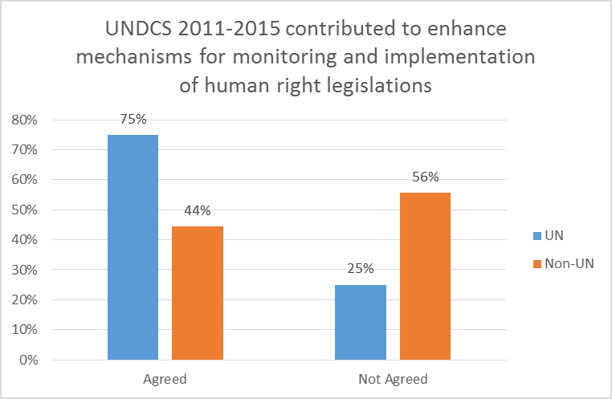
Figure 4: Perceptions of achievement of targets under Priority Area 1 Outcome 1 (human rights)
Similarly, while the UN staff members were positive about the progress made towards enhanced mechanisms for monitoring and implementation of human rights legislation – a target that was difficult to measure through the UNDCS indicators (See Table 2) - non-UN organizations were less convinced.
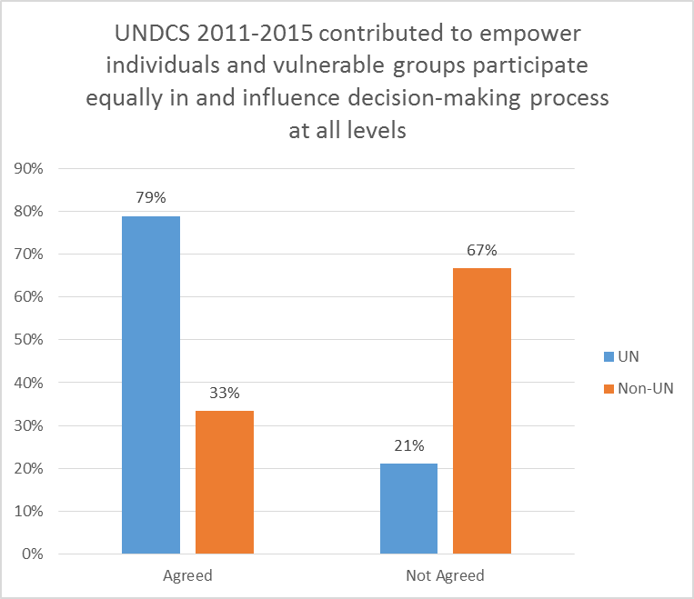
Figure 5: Perceptions of achievement of targets under Priority Area 1 Outcome 2 (empowerment)
With respect to the empowerment of vulnerable individuals and groups, two-thirds of the representatives of civil society organizations who responded to the on-line survey felt that the UNDCS had not achieved its target. This was in line with the statistical findings, since only one of the three indicators used by the UNDCS to measure success in this area was fully achieved. However, the vast majority of the UN staff respondents seemed to believe that the targets were achieved.
Figure 6: Perceptions of achievement of targets under Priority Area 2 Outcome 2 (women
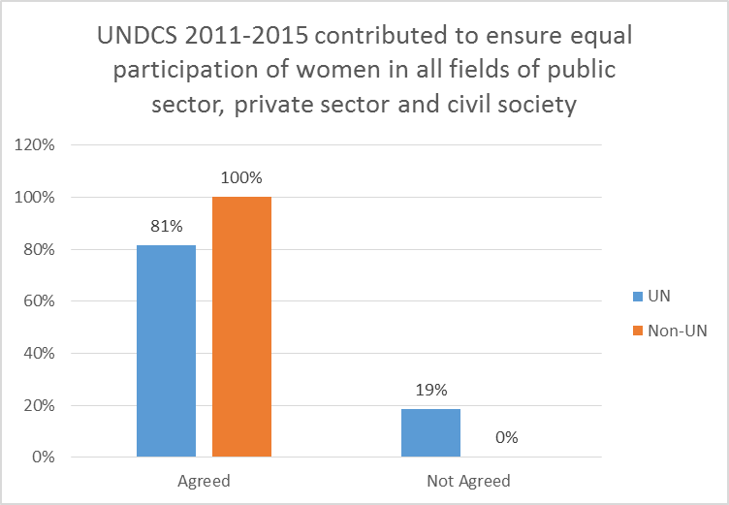
The vast majority of the on-line survey respondents - UN staff members and representatives of civil society organizations alike - believed that the UNDCS contributed to strengthening institutional mechanisms to empower women and strengthen their participation. Yet among the three statistical indicators used by the UNDCS to measure progress in this area, the target was reached in only one case.
Figure 7: Perceptions of overall achievement of targets under the UNDCS
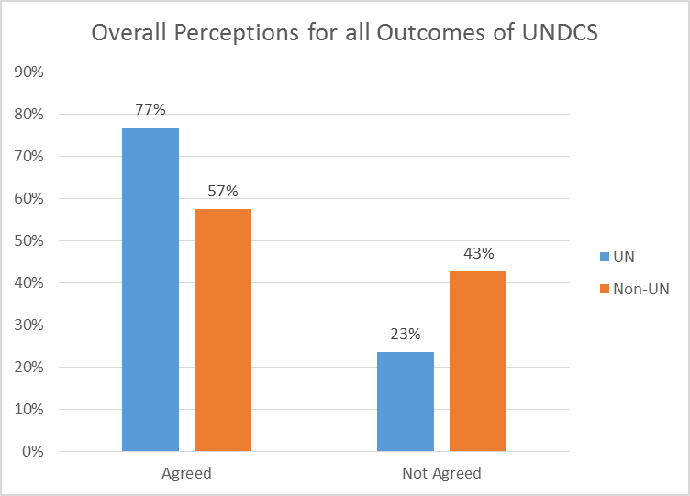
Overall, both UN staff and non-UN organizations were positive about the contribution made by the UNDCS towards progress in its three priority areas in Turkey between 2011 and 2015. However, among those who responded to the survey, the civil society organizations were noticeably less positive than the staff of the UN agencies themselves.
Attention may also be drawn to the fact that, in some areas, a significant proportion of the UN staff members responding to the survey stated that they had no knowledge of the progress made under the UNDCS, or would rather not comment. This is understandable for staff members not working in the thematic area referred to in the question. However, there were also cases where UN staff did not report any opinion even though they were members of the Working Groups or Thematic Groups related to the UNDC priority areas/outcomes referred to in the question.
- What were the main factors that promoted or hindered the effectiveness of the UNDCS?
A number of factors had a negative impact on the effectiveness of the UNDCS. The three most important of these, as listed by the UN staff surveyed, were the various elections held in 2014 and 2015, funding issues, and high staff turnover in Government departments. Representatives of civil society organizations who responded to the on-line survey agreed about these three points. Political violence was also seen as a negative factor, particularly in 2015. Hundreds of casualties were reported in south-eastern provinces in 2015, including both civilians and non-civilians, and residents of conflict-ridden urban districts had to flee their homes for security-related reasons. The violence spilled over into western provinces in the form of terrorist attacks. Civilians were also targeted by the Islamic State of Iraq and Syria (ISIS), which claimed responsibility for deadly suicide bombings in Diyarbakır, Şanlıurfa and Ankara. The violent conflicts and increasing political tension experienced in 2015 distracted attention from the implementation of the UNDCS in 2015 and hindered is effectiveness.
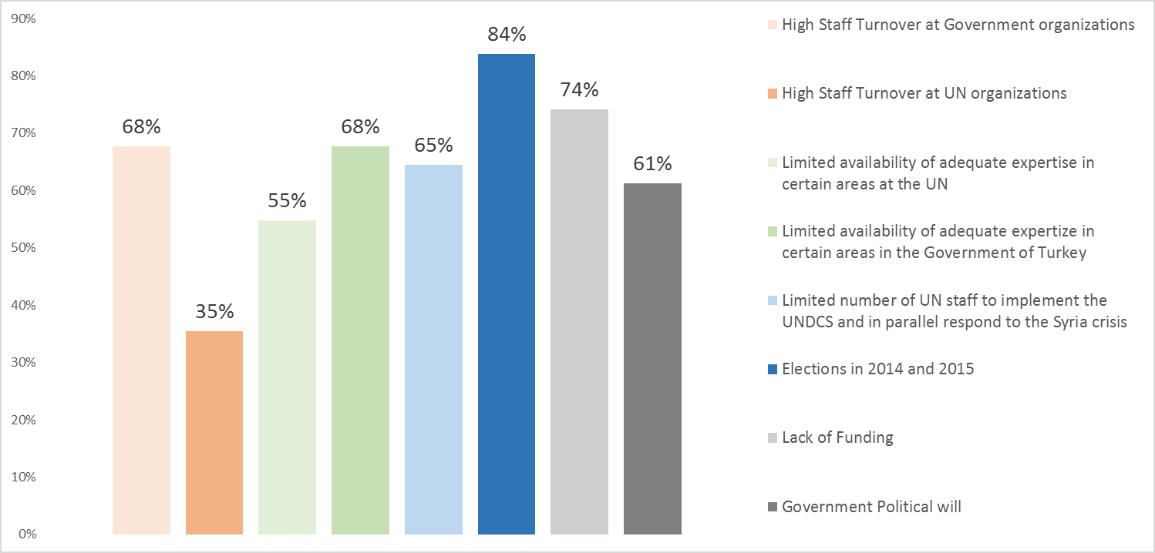
Figure 8: To what extent have the below challenges had an impact on the implementation of the UNDCS (according to UN staff)?

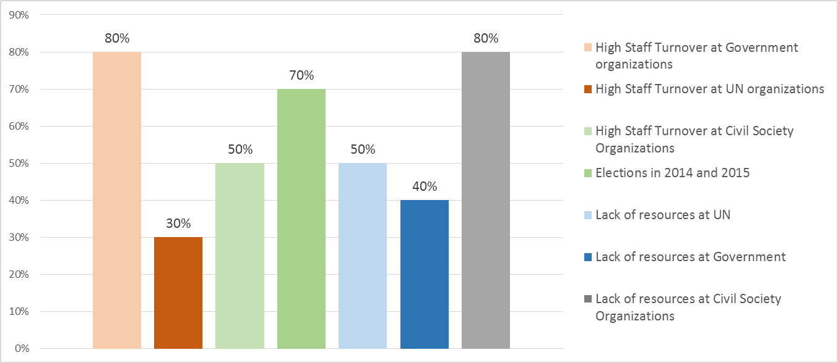
Figure 9: To what extent have the below challenges had an impact on the implementation of the UNDCS (according to non-UN organizations)?

At the same time, there were several factors which positively influenced the effectiveness of the UNDCS. These can be listed as:
- the strong coordination between the UN and Government institutions/civil society organizations, as reported during the in-depth interviews and through the on-line survey;
- the positive contribution made by the Thematic Groups and Working Groups to simplifying the communication among UN organizations,
- the positive impact of both the Thematic Groups and the Working Groups on the establishment of linkages between the programmes/projects being implemented by the various UN agencies.
- Have there been any unintended results, and if so, have they affected national development positively or negatively, and to what extent have they been foreseen and managed?
One field of cooperation which generated examples of unintended results was the Local Equality Action Plans (LEAPs). There were positive unplanned results in terms of the introduction of gender-responsive budgeting in pilot cities and the replication of local equality mechanisms in non-pilot cities. The introduction of gender-responsive budgeting can be considered a contribution to national development through increased awareness of the importance of the linkage between women’s specific needs and relevant budget allocations. Similarly, the dissemination of local equality mechanisms enabling and encouraging women’s participation in local decision making processes is a positive step which supports national objectives concerning enhanced women’s participation in politics. While these positive developments were initially unforeseen, the process was managed smoothly. There were also negative unintended effects of the cooperation around LEAPs. These were related to men’s discriminatory attitudes and obstacles to women’s participation. This situation underlines the complexity of undertaking gender equality and women’s empowerment initiatives in the local context and the importance of engaging men in gender equality initiatives.

Efficiency
- To what extent and in what ways has the UNDCS contributed to a reduction of transaction costs (financial to the extent possible) for the government and for each of the UN agencies? In what ways could the transaction costs be further reduced through harmonization and simplification?

It was not possible to identify any means to measure objectively, on the basis of solid evidence, documentation or analysis (including triangulation), whether the UNDCS contributed to a reduction in transaction costs. Consequently, the only sources of information for assessing efficiency gains were the UN officials and staff members and representatives of non-UN organizations who were interviewed in depth or who responded to the on-line surveys.
Among the UN staff members who responded to the on-line survey, about 48 percent believed that the UNDCS helped to reduce the burden of transactions between the UN and Government organizations. At the same time, however, almost 60 percent of them agreed that the UNDCS helped to simplify the communication between the Government and UN agencies. These responses can be taken to indicate that the UNDCS helped to coordinate the communication between the UN and the Government in some ways but that there is still room for improvement in this respect. Indeed, almost all of the heads of UN agencies interviewed were of the same opinion, in parallel with the results of the on-line survey of staff members.
With respect to duplication among UN organizations, only 40 percent of the UN staff who participated in the on-line survey agreed that the UNDCS helped to avoid duplications, while 60 percent disagreed. UN staff members were also far from positive about the contribution made by the UNDCS to simplifying the communication between the UN and civil society organizations. This issue was discussed during the in-depth interviews with the heads of the UN agencies. Most of them stated that more effort would be made to improve these communications during the implementation of the UNDCS for 2016-2020.
Figure 10: Communication between UN and Government organizations and within the UN Country Team
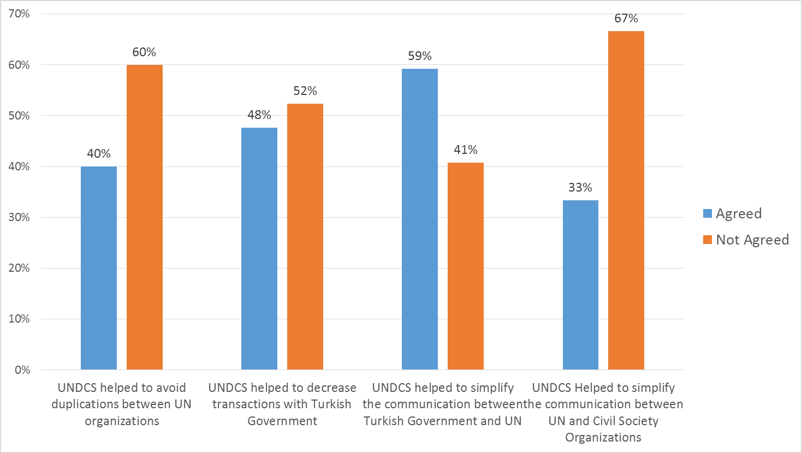

Sustainability
- To what extent can one say that the benefits of the implementation of the UNDCS have continued, or are likely to continue, after it is completed?
The main guarantee of the sustainability of the contribution of each UNDCS to Turkey’s development lies in the close relationship between the goals of the UNDCS and those of the National Development Plans. In this sense, the topics covered in the UNDCS are part of a continuous and sustainable process for the Government. From this, it is possible to surmise that Government institutions and society in Turkey will continue to benefit from the contribution of the UNDCS after it is completed. The representatives of Government institutions and civil society organizations who were interviewed for the evaluation also spoke of the important role of the UN in assisting the Government to fulfil its international commitments. The national capacity developed as a result of the UNDCS (See below) also contributes to the sustainability of the UNDCS outcomes.
Aside from the above, most of the heads of UN agencies active in Turkey who were interviewed described plans to extend and expand their work in the country in view of the continuing impact of the Syria crisis. There is, in fact, little doubt that the Government needs the assistance of the international community in this area, given the size and complexity of the challenges it faces and their international dimensions. It is thus clear that the UN will continue its activities in Turkey in the near future with a particular focus on matters related to the refugee situation. In future, however, the contribution of the UNDCS vis-a-vis the situation arising from the Syria crisis may not be sustainable at current or envisaged levels. In any case, the forms of cooperation between the UN and Turkey may need to change. Accordingly, increased attention may need to be placed on sustainability and possible exit strategies under the UNDCS for 2016-2020.

Design and Focus
- To what extent is the current design of the UNDCS coherent and focused? Are expected outcomes realistic given the UNDCS timeframe, the resources available and the planned country programmes, projects and programme strategies?
The UNDCS for 2011-2015 was in general coherent and realistic in the sense that it was designed in line with national priorities, commitments and time frames. The results matrix was consistent with national goals as identified by the ninth and tenth National Development Plans. The country programmes and action plans, programmes, projects and strategies of the UN agencies followed on coherently from the matrix.
However, as noted above in the discussion of the effectiveness of the UNDCS, a number of inconsistencies occurred when setting indicators and targets for the UNDCS outcomes. In some cases, this resulted in the adoption of targets that were arguably unrealistic; in others, the indicators used for measuring the progress of the UNDCS could have been defined more carefully so as to enhance measurability and conform more closely to Results-Based Management principles.
The focus of the UNDCS became less clearly aligned with country priorities and commitments as the impact of the Syria crisis grew. Although the UN agencies carried out a large volume of work related to the refugee situation, especially after 2013, no outcome(s) or indicator(s) were included in the UNDCS results matrix in order to reflect this. It would have been possible to include one or more relevant outcomes and indicators through the Mid-Term Review (MTR) in 2013, but this path was not taken.

UN Coordination
- To what extent did the UNDCS create actual synergies among agencies (and among and between country programmes etc.) and involve concerted efforts to optimise results and avoid duplication (including the current coordination mechanisms such as Thematic Groups and Working Groups)?
The implementation of a UN Joint Programme developed in 2008-2009 under the MDG Achievement Fund continued until 2012. In parallel with this, coordination meetings between the Resident Coordinator and the Joint Programme managers continued with a view to maximizing synergies and establishing linkages between the JPs as well as learning from each other and sharing best practices. The UNCT contributed to advocacy activities/initiatives by making joint public appearances, delivering joint presentations and so on. Meanwhile, the Knowledge Management System facilitated the sharing of information, knowledge and best practices among the UN agencies.
The UNCT developed two joint programmes in 2012. In addition to this, five UNDCS Theme Groups were formed, each under the leadership of one or more agencies (UNDP, UNFPA, UNICEF and FAO). The UNDCS Theme Groups prepared reports in cooperation with Government partners and held meetings at the strategic level.
The UNCT was supportive in sharing the cost of the Resident Coordinator’s Office. The UN agencies, UNFPA, FAO, UNICEF and UNDP actively contributed to the UNCT work plan. Furthermore, a Syria Response Group was created in 2013 at Representative level, in addition to the UN Task Force on Syria. UNDCS annual reports were developed through cooperation and coordination among the relevant UN agencies. In addition to the five existing UNDCS Thematic Groups, a Working Group on Human Rights was established in 2013.
UN Women chairs the UN Country Team Gender Thematic Group and provides a Gender Specialist to the Resident Coordinator’s office, with a view to ensuring that the UN system is gender-responsive and relevant, and that it promotes policies, programmes and operations that protect human rights and promote equitable development for women, men, girls and boys. The UN Gender Thematic Group ensures gender mainstreaming in the planning and implementation of the UNDCS, and supports UN agencies in promoting coordinated UN joint programming that advances gender equality and the empowerment of women.
The interviews with the heads of the UN agencies and the Resident Coordinator clearly indicated that the UNCT sees a lot of advantages in implementing joint programmes. According to the senior UN staff interviewed for this evaluation, the UNCT has been making considerable efforts to increase the efficiency and effectiveness of the UNDCS Thematic Groups and Working Groups.
The findings of the on-line survey confirm that other UN staff members are also positive about the contribution made by the Thematic Groups and Working Groups to improving the communication among UN agencies and between UN agencies and the Government.
Figure 11: Opinions of UN Staff about Thematic Groups
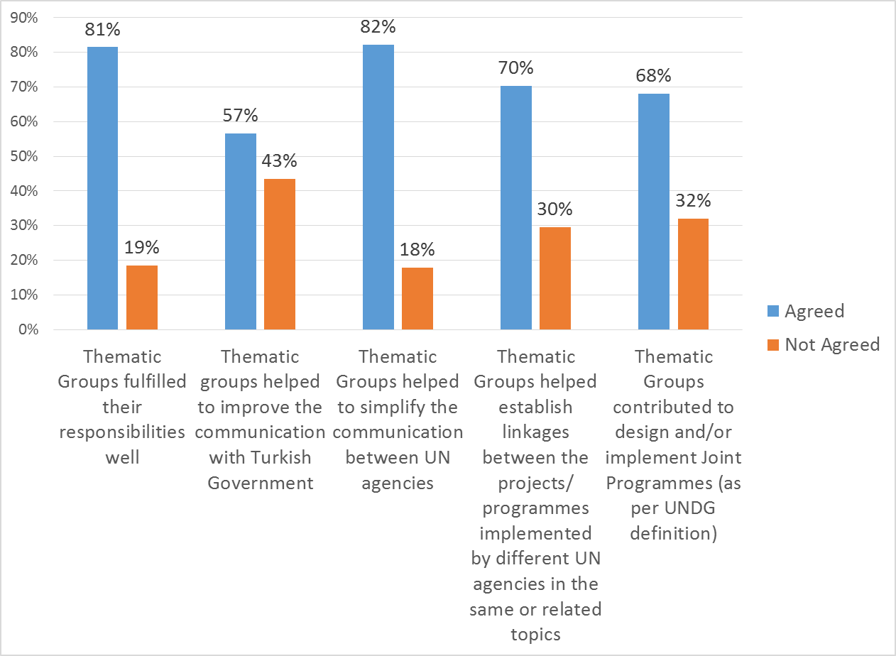
Although the UN Country Team displays motivation to work within the “One UN” framework and avoid duplications, and has exerted some efforts along these lines, significant challenges persist. Each UN agency has its own individual rules, reporting lines, funding and priorities. This sometimes makes it difficult to align the activities/aims/objectives/outcomes of a given UN agency with the UNDCS. This point was highlighted by heads of UN agencies during the in-depth interviews conducted for the evaluation.

Figure 12: Opinions of UN staff about Working Groups
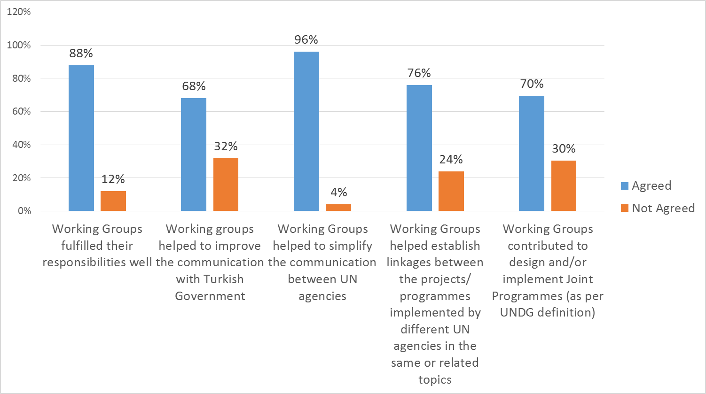

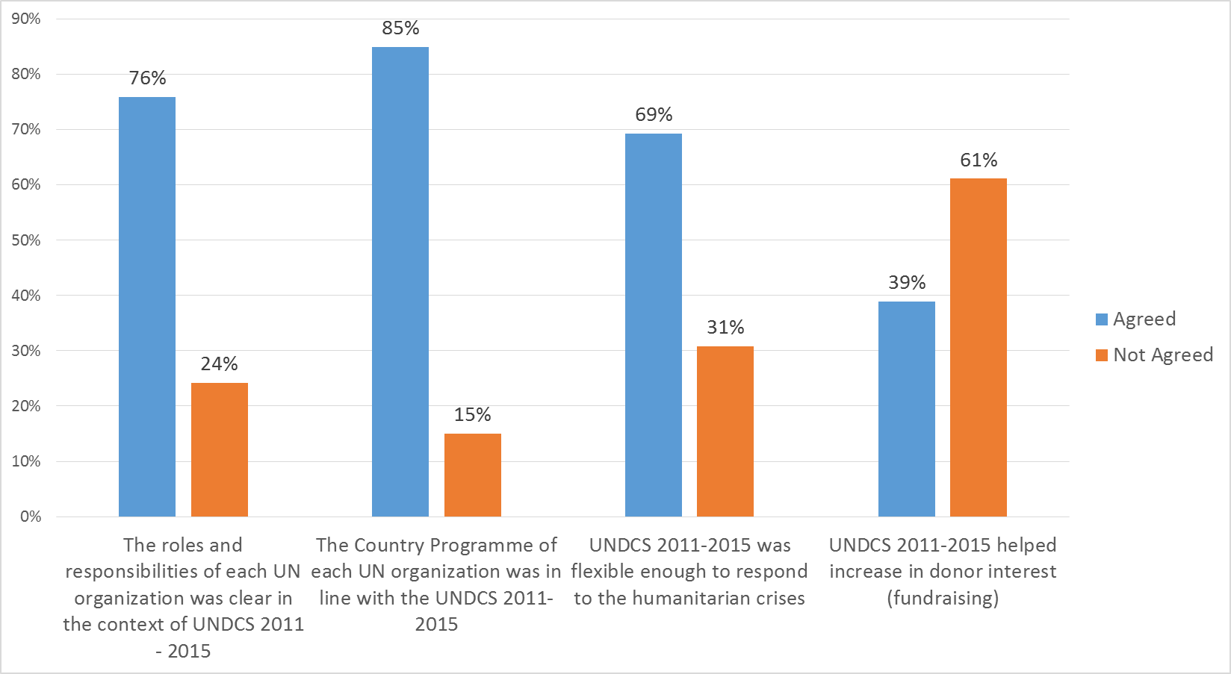
Figure 13: Opinions of UN staff about the UNDCS
- Is the distribution of roles and responsibilities among different UN agencies well defined and facilitated in the achievements of results, and have these arrangements largely been respected in the course of implementation?
Of the UN staff who responded to the on-line survey, 76 percent agreed that the roles and responsibilities of the UN agencies are clear in the context of the UNDCS. However, 24 percent of the respondents disagreed. Some of the heads of agencies also pointed out that the roles and responsibilities of the UN agencies overlap with each other in some respects.
As many as 85 percent of the UN staff responding to the survey agreed that the country programme of each UN agency was in-line with the UNDCS. The heads of the UN agencies also stressed this during the in-depth interviews. The UNDCS annual report for 2014 and the Resident Coordinator Annual Reports (RCAR) also highlight the strong linkage between the country programmes and the UNDCS.

Use of the UN’s Five Programming Principles
- To what extent have the programming principles (the Human Rights-Based Approach, Gender Equality, Environmental Sustainability, Results-Based Management, Capacity Development) been considered and mainstreamed in the UNDCS chain of results?
To achieve its goal, the UNDCS makes use of Gender Mainstreaming and the Human Rights Based Approach (HRBA) and promotes human rights and gender equality standards and principles in all outcomes and outcome indicators. Thus, Outcome 1 concentrates on human rights norms and standards (especially accountability) to provide an enabling environment for inclusive and democratic governance, the rule of law and access to justice for all. Outcome 2 focuses on the empowerment and equal participation of individuals and vulnerable groups in decision making processes at all levels. This is in line with the HRBA principles of non-discrimination and participation. It also draws special attention to women’s participation in local and national decision making mechanisms as addressed specifically by the indicators. Outcome 3 takes into account gender equality when promoting strengthened policy formulation and implementation capacity for the protection of the environment and cultural heritage. Outcome 4 adopts an intrinsic HRBA approach by addressing the inclusiveness and responsiveness of service provision as well as promoting equity in access to knowledge, information and quality basic services. Outcome 5 directly addresses gender equality. The outcome and indicators rest firmly on the assertion that women and men are equal beneficiaries of human rights and that they should enjoy the right to participate in political, economic and social life equally. Outcome 6, addressing enhanced poverty alleviation with a strong equity focus, is fully in line with human rights and gender equality standards and principles. Similarly, Outcome 7 takes a very solid equity approach to increasing opportunities and decent employment for all. The emphasis on decent work rests on the HRBA, and the emphasis placed on gender equality is clear from the chosen indicators.
The UNDCS has a strong potential to contribute to the development of capacities for data collection and analysis to ensure the availability of disaggregated data. A number of the indicators are formulated in precisely this manner. For instance, the third indicator under Outcome 2, the first and second indicators under Outcome 5 and the first indicator under Outcome 7 refer to the collection of gender-disaggregated data, while the first, second and third indicators under Outcome 2, the first indicator under Outcome 4 and the first indicator under Outcome 7 encourage the collection of data disaggregated by geographical location. A partnership was developed with the Economic Policy Research Foundation of Turkey (TEPAV) in order to deliver a training seminar and to develop a guidebook for local authorities for their data collection and gender impact assessment processes. Some Regional Development Agencies (e.g. Ahiler, Serhat and İpekyolu) have included gender-sensitive data collection and gender impact assessments in their regional development plans as areas for future work.
The UNDCS makes use of environmental sustainability principles to strengthen its contribution to national development results. This can be observed in almost all the outcomes of the UNDCS. Thus Outcome 1 refers to “greater compliance with international instruments, norms and legislation with a focus on the environment” (pp.7-8); Outcome 3 speaks of “strengthened policy formulation and implementation capacity for the protection of the environment and cultural heritage in line with sustainable development principles, taking into consideration climate change, including disaster management” (p.8); Outcome 4 addresses “impacts to and vulnerabilities of the basic services due to changing climatic conditions” (p.9); Outcome 5 draws attention to the “different roles, responsibilities and capacities of men and women in use of natural resources, as well as capacity to respond to natural disasters caused by climate change”; Outcome 6 notes that “the livelihood assets of people living on the marginal eco-systems are under enormous stress owing to vagaries of climate” (p.10), and Outcome 7 targets “increases in employment opportunities including opportunities for green jobs” (p.10).
The UNDCS was originally based on Results-Based Management (RBM). This means that outputs, outcomes and higher level goals or impact are formulated in a logical chain, and a management strategy is presented by which all actors contributing directly or indirectly to achieving the national goals ensure that their processes, products and services contribute to the achievement of the desired objectives. However, as noted earlier, some individual targets and indicators in the UNDCS were not fully RBM-compliant.
The UNDCS has contributed to national capacity development of Government institutions and civil society organizations through various programmes and workshops and through resource mobilisation. For example, the UNDP developed tailor-made capacity building programmes and conducted them with the civilian authorities responsible for the oversight of the internal security forces, while the IOM conducted capacity-building workshops with barristers in order to enhance legal aid/legal assistance mechanisms for migrants in line with the new legal framework. Some capacity building efforts have also taken place targeting the newly-elected members of the Equality Commissions established in Municipal Assemblies in all United Nations Joint Programme (UNJP) cities and in the Provincial Assemblies of the three UNJP cities which have not been granted Metropolitan status.

Conclusions
Overall, there is sufficient evidence to substantiate the conclusion that the focus and design of the UNDCS for 2011-2015 were in line with the national development priorities of the Government of Turkey. It can also be stated with confidence that the UNDCS helped all the UN agencies based in Turkey to act in a more coordinated manner. Although a number of challenges were faced during the course of the implementation of the UNDCS 2011-2015, it is very encouraging to note that the Resident Coordinator and the heads of all the UN agencies are aware of the actions which need to be taken to avoid a repetition of these issues during the implementation of the next UNDCS cycle in 2016-2020.
The Syria crisis began very soon after the UNDCS took effect in 2011. Several UN agencies provided support and assistance within the boundaries of the funding available to them. However, the Mid-Term Review of the UNDCS conducted in 2013 did not define any outcome or indicator for the humanitarian response. The reason for this was not clear to the evaluation team. It has, however, been noted that the UNDCS for 2016-2020 includes outcomes and indicators related to the situation arising from the Syria crisis.
With respect to the effectiveness of the UNDCS, although both UN staff and non-UN organizations were generally positive about the progress made against the expected outcomes, a comparative analysis of end-lines against targets (Table 2) shows that the targets were met for only 12 of the 21 indicators.
A number of shortcomings detracted from the effectiveness of the UNDCS. Firstly, there were some difficulties in setting the indicators and targets, as Results-Based Management (RBM) guidelines were not closely followed. Other factors included the high staff turnover at Government organizations, limited expertise on certain topics within the Government, the busy election period in 2014 and 2015, lack of Government political will, insufficiencies of funding, and more general limitations on human and financial resources.
Several good examples may be cited of the positive contribution of the UNDCS to Turkey’s ability to fulfil its international and regional commitments. The UNDCS has also contributed positively to the development of sustainable capacity, both within the Government and in civil society organizations, in all three of the strategic areas of the UNDCS and all seven of its results areas. However, there is still an outstanding need to support civil society organizations (CSOs) if they are to increase their roles and responsibilities in decision-making processes related to strategic topics in Turkey. To this end, CSOs would like to be more closely involved in the work of the UN Thematic Groups and Working Groups. Finally, it was reported that CSOs would like to receive more financial and technical support from the UN, depending on the availability of resources.
The UNDCS had a positive impact on coordination and communication. About 60 percent of the UN staff who participated in the on-line survey agreed that the UNDCS had helped to simplify the communications between the Government and UN agencies. This can be taken as an indicator that while the UNDCS helped to coordinate the communication between the UN and the Government, there is still room for improvement. Indeed, the vast majority of the heads of UN agencies interviewed were of the same opinion, in parallel with the results of the on-line survey.
The level of coordination among UN agencies is the key factor for the successful implementation of the UNDCS. The Thematic Groups and Working Groups are established for this purpose. However, while the Thematic Groups and Working Groups duly helped to simplify the communications between UN agencies, UN staff who contributed to the on-line survey did not feel that they contributed to a reduction in duplications among UN organizations. The heads of the UN agencies also highlighted the existence of such duplications during the interviews conducted with them. Similarly, UN staff were not positive about the contribution of the UNDCS in facilitating communication between the UN and CSOs. While it is important to note that Turkey was not a pioneer Delivering as One (DaO) country in terms of UN system programming, among the Standard Operating Procedures for DaO, the UN Country Team in Turkey has adopted three out of six components – namely: “one leader”, “one programme” (for UNDCS 2016-2020) and “communicating as one”.
One of the most important lessons learned from the UNDCS for 2011-2016 concerns the need to increase the monitoring and evaluation capacity of the UN in Ankara. Actions are already being planned to increase this capacity, as indicated by the UN Resident Coordinator (RC). In addition, RC office staff have noted that there are plans to restructure the Thematic Groups and Working Groups so that they can play a more effective role in monitoring the results of the UNDCS.
The UNDCS plays an important role in ensuring that UN programmes are developed and implemented in line with the priorities of Turkey. The role of the UN is particularly vital in the context of the response to the situation created by the Syria crisis, which is expected to continue to require attention for some years to come. It is therefore very likely that the UN will continue its activities in Turkey in the near future. Indeed, the UNDCS for 2016-2020 has already been approved by the Government of Turkey.

7. Recommendations
In light of the above, the following recommendations are made:
Monitoring and Evaluation: The monitoring and evaluation capacity of the UN in Ankara should be enhanced. This will also ensure that Results-Based Management principles are fully implemented, and in particular that the indicators to be used for the UNDCS for 2016-2020 are defined in such a way as to be more compliant with the principles of Results-Based Management (RBM). At the same time, the individual UN agencies should allocate enough financial resources in support of efficient monitoring of their own programmes, projects and activities at both agency and UNCT levels. It is recommended that the mid-term review of the UNDCS 2016-2020 should be initiated at the end of 2017, so that timely measures can be taken, depending on needs arising and the latest socio-economic and geo-political developments.
Coordination: The efforts that have been made to increase coordination among the UN agencies, including through the Working Groups and the Thematic Groups, need to be pursued further. The senior management of the UN agencies should take steps to further clarify the roles and responsibilities among the UN agencies. It is recommended that areas of duplication among the UN agencies should be identified and eliminated during the next UNDCS cycle.
Sustainability and flexibility: While UN agencies will continue to operate in Turkey in the near future, and even increase their operations in view of the Syria crisis, circumstances may change in the medium term. With respect to the Syria crisis, UN agencies could usefully develop action plans for various possible scenarios while collectively strengthening the disaster-preparedness and contingency planning of the UN Country Team. More generally, close attention may need to be paid to exit/sustainability strategies under the UNDCS for 2016-2020.
Civil society: There is a need for greater efforts to improve coordination and communication with civil society organizations (CSOs). The UN has a critical part to play in enhancing the role of CSOs in Turkey. Regular meetings with CSOs would increase their sense of belonging.
Gender: Since all of the civil society organizations which contributed to the evaluation process highlighted the positive contribution of the UNDCS with respect to gender issues, it is recommended that the UN should continue to develop and reinforce its strategies and activities in this area.

ANNEX 1: List of Documents Reviewed
Document Source | Document Name
Resident Coordinator’s Office | UNDCS 2011 - 2015
 | UNDCS Mid-Term Review 2013
 | Country Analytical Validation Report
 | UNDCS M+E Summary Learning Note
 | UNDCS Annual Report 2014
 | UNDCS 2016 – 2020
 | Resident Coordinator Annual Reports 2011-2014
FAO | Annual Reports for 2011, 2012, 2013 and 2014
 | FAO Country Programme Framework 2012-2015
 | Turkey Country Programme Framework 2016-2020 (draft)
ILO | Country Programme Report
UNDP | Annual Business Plan for 2014 and 2015
 | Country Programme Action Plan 2011
 | Country Programme Document 2011-2015
 | Integrated Work Plan Monitoring for 2010, 2011, 2012 and 2013
 | Quality Assurance Scores - ROAR 2011
 | Turkey ROAR 2012, 2013 and 2014
 | Strategic Notes for 2011, 2012, 2013 and 2014
UNFPA | Country Office Annual Reports for 2011, 2012, 2013 and 2014
 | Country Programme Action Plan Results and Resources Framework
 | Country Programme Action Plan Planning and Tracking Tools
 | Country Programme Action Plan 2011-2015
 | UN Joint Programme on Women Friendly Cities
 | Country Programme Evaluation
 | UNFPA Strategic Plans
UNWOMEN | Annual Reports 2010-11, 2011-12, 2012-13, 2013-14, 2014-15
 | Progress of the World’s Women 2015-2016: Transforming Economies, Realizing Rights
 | Pathway to Gender Equality
UNICEF | Country Programme Action Plan 2011-2015
 | Annual Report 2014
 | Strategic Plan 2014-2017
 | Justice for Children Report
 | Evaluation of UNICEF’s response to the Turkey Refugee Crisis
 | Situation Analysis of Children in Turkey, 2014
 | UN Convention on the Rights of the Child
WHO | Biennial Collaborative Agreement
EU | 2014 Progress Report
 | Turkey in Europe: The imperative for Change
 | EU and Turkey – EU electronic Library
MDG | Turkey Final Evaluation
CEDAW | Convention on the Elimination of all Forms of Discrimination against Women
Ombudsman | Annual Reports 2013 and 2014
Ministry of Development | Annual Development Plans
 | Economic and Social Indicators
UN General Assembly | Human Rights Council, working group report 21st session
Turkstat | Official Statistics

ANNEX 2: List of In-Depth Interviewees
Face to face (in-depth) interviewees:
Adem Arkadaş, International Children’s Centre
Ahmet Parla, UN Information Centre.
Halide Çaylan, Head of the Office of the Resident Coordinator
Kamal Malhotra, Resident Coordinator & UNDP Resident Representative
Karl Kulessa, UNFPA Representative & Zeynep Başarankut, UNFPA Assistant Representative
Lado Gvilava, IOM Chief of Mission
Mustafa Osman Turan, Ministry of Foreign Affairs
Pavel Ursu, WHO Representative
Philippe Duamelle, UNICEF Representative
Volkan Güngören, Ministry of Food, Agriculture and Livestock
Zeliha Ünaldi, Gender Specialist, RC Office

ANNEX 3: List of Non-UN Organizations which Responded to the On-Line Survey:

Doğa Koruma Merkezi Vakfı (DKM) – Nature Conservation Centre Foundation
Günder – Günder solar energy association
Hak-İş Konfederasyonu – Hak-İş trade union confederation
Kırmızı Şemsiye Dernegi – Red Umbrella Association
Sabancı Üniversitesi – Sabancı University
Türkiye Baralor Birligi – Union of Turkish Bar Associations
Türkiye Ekonomi Politikaları Araştırma Vakfı (TEPAV) –Economic Policy Research Foundation of Turkey
Türkiye İşçi Sendikaları Konfederasyonu (Türk-İş) – Confederation of Turkish Trade Unions
Türkiye Kadın Dernekleri Federasyonu (TKDF)- Turkey Federation of Women’s Associations
World Wildlife Fund Turkey
(One other organization responded anonymously.)

ANNEX 4: On-Line Survey Questions

SURVEY FOR UN AGENCIES

Name of the Organization:
Please indicate the UNDCS 2011-2015 work area you were primarily involved in (name of the thematic groups or working groups and etc.)
Working group (list the names of the working groups):
Thematic group (list the names of the working groups):

Date: /……/…….. (Day/month/year)

Q1 - What do you think about the below arguments about the UNDCS 2011-2015 Results Framework?
 | Fully Agreed | Agreed | Not Agreed | Not Agreed At All | Don’t Know / No Comment
Outcomes/outputs were realistic within the UNDCS 2011-2015 time frame
Indicators were representative of the outcomes/outputs
Indicators for outcomes/outputs were measurable

Q2 - What do you think about the below arguments about UNDCS 2011 – 2015?
 | Fully agreed | Agreed | Not Agreed | Not Agreed At All | Don’t Know / No Comment
UNDCS 2011-2015 contributed to improve access to justice through increased efficiency of the judicial system that ensure equality
UNDCS 2011-2015 contributed to enhance mechanisms for monitoring and implementation of human rights legislation
UNDCS 2011-2015 contributed to empower individuals and vulnerable groups to participate equally in and influence decision-making processes at all levels
UNDCS 2011-2015 contributed to Turkey’s ability to sustain its biodiversity and conserve its natural resources and ensure climate resilience
UNDCS 2011-2015 contributed to promote energy efficiency and low carbon economy
UNDCS 2011-2015 contributed to Turkey’s ability to preserve its natural and cultural heritage
UNDCS 2011-2015 contributed to enhance the quality of community based services (education, health, nutrition, water and sanitation and human safety)
UNDCS 2011-2015 contributed to ensure equal participation of women in all fields of public sector, private sector and civil society
UNDCS 2011-2015 contributed to empower women
UNDCS 2011-2015 contributed to Turkey’s ability of improving policies and strategies to enhance income distribution, human development and accelerating the fight against poverty
UNDCS 2011-2015 contributed to Turkey’s ability to enhance policies/strategies to reduce unemployment

Q3 - What do you think about the below arguments?
 | Fully Agreed | Agreed | Not Agreed | Not Agreed At All | Don’t Know / No Comment
UNDCS helped to avoid duplications between UN organizations
UNDCS helped to decrease transactions with the Turkish Government
UNDCS helped to simplify the communication between the Turkish Government and UN
UNDCS helped to simplify the communication between UN and Civil Society Organizations

Q4 - How would you score the level of overall coordination during the implementation of UNDCS 2011-2015?
 | Very Good | Good | Bad | Very Bad | Don’t Know / No Comment
Coordination between UN organizations
Coordination between Government organizations
Coordination between UN and Government organizations
Coordination between UN and Civil Society Organizations

Q5 - What do you think about the below arguments about UN’s Five Programming Principles related with UNDCS 2011- 2015?
 | Fully Agreed | Agreed | Not Agreed | Not Agreed At All | Don’t Know / No Comment
UNDCS 2011-2015 helped to enhance the capacity of civil society
UNDCS 2011-2015 contributed to promote human rights
UNDCS 2011-2015 contributed to promote gender equality
UNDCS 2011-2015 contributed to enhance the capacity on data collection and analysis at relevant national organizations
The monitoring system of UNDCS put in place after the MTR was adequate

Q6 – What do you think about the Thematic Groups (Gender, Youth, Human Rights) of the UN in Turkey?
 | Fully agreed | Agreed | Not Agreed | Not Agreed At All | Don’t Know / No Comment
Thematic Groups fulfilled their responsibilities well
Thematic groups helped to improve the communication with the Turkish Government
Thematic Groups helped to simplify the communication between UN agencies
Thematic Groups helped establish linkages between the projects/ programmes implemented by different UN agencies in the same or related topics
Thematic Groups contributed to design and/or implement joint programmes (as per UNDG definition)

Q7 – What do you think about the UNDCS Working Groups (HIV/AIDS, Monitoring for Strategic Results, Regional Development, Office Management Team, and Communications)?
 | Fully agreed | Agreed | Not Agreed | Not Agreed At All | Don’t Know / No Comment
Working Groups fulfilled their responsibilities well
Working groups helped to improve the communication with the Turkish Government
Working Groups helped to simplify the communication between UN agencies
Working Groups helped establish linkages between the projects/ programmes implemented by different UN agencies in the same or related topics
Working Groups contributed to design and/or implement Joint Programmes (as per UNDG definition)

Q8 - What do you think about the below arguments about UNDCS 2011 – 2015?
 | Fully agreed | Agreed | Not Agreed | Not Agreed At All | Don’t Know / No Comment
The roles and responsibilities of each UN organization were clear in the context of UNDCS 2011 - 2015
The Country Programme of each UN organization was in line with the UNDCS 2011-2015
UNDCS 2011-2015 was flexible enough to respond to the humanitarian crises
UNDCS 2011-2015 helped increase in donor interest (fundraising)

Q9 - To what extent have the below challenges had an impact on the implementation of the UNDCS?
 | Had No impact | Positive impact | Negative Impact | No Comment
High staff turnover at Government organizations
High staff turnover at UN organizations
Limited availability of adequate expertise in certain areas at the UN
Limited availability of adequate expertise in certain areas in the Government of Turkey
Limited number of UN staff to implement the UNDCS and in parallel respond to the Syria crisis
Elections in 2014 and 2015
Lack of funding
Government political will
Other, please state: ________________

Q10 – What would be your overall comments about UNDCS 2011 – 2015?
……………………………………………………… (TEXT – up to 2500 characters)

Q11 – What would be your main suggestions for UNDCS 2016 – 2020?
……………………………………………………… (TEXT – up to 2500 characters)

SURVEY FOR RELEVANT GOVERNMENT INSTITUTIONS AND CIVIL SOCIETY ORGANIZATIONS

Name of the Organization: ……………………………………
Role / position in the organization: …………………………
Please type your role/involvement/relation in/with UNDCS 2011 – 2015 process/activities:
……………………………………………………………………………………………………

Date: /……/…….. (Day/month/year)

Q1 - How would you score the level of coordination between organizations during the implementation of UNDCS 2011-2015?
 | Very Good | Good | Bad | Very Bad | Don’t Know/No Comment
Coordination between UN organizations
Coordination between Government organizations
Coordination between UN and Government organizations
Coordination between UN and Civil Society Organizations
Coordination between Government and Civil Society Organizations

Q2 - To what extent have the below challenges had an impact on the implementation of the UNDCS?
 | Had no impact | Positive impact | Negative Impact | Don’t know /No Comment
High staff turnover at Government organizations
High staff turnover at UN organizations
High staff turnover at Civil Society Organizations
Elections in 2014 and 2015
Lack of resources at UN
Lack of resources at Government
Lack of resources at Civil Society Organizations
Other, please state: ___________________

Q3 - What do you think about the below arguments?
 | Fully Agreed | Agreed | Not Agreed | Not Agreed at all | Don’t Know
UNDCS 2011-2015 helped to avoid or decrease unnecessary transactions between UN and Turkish Government
UNDCS 2011-2015 helped to simplify the communication between Turkish Government and UN
UNDCS 2011-2016 was in line with the national development plans of Turkey
UNDCS 2011-2015 helped to enhance the capacity at Civil Society Organizations

Q4 - What do you think about the below arguments about UNDCS 2011 – 2015?
 | Fully agreed | Agreed | Not Agreed | Not Agreed At All | Don’t Know / No Comment
UNDCS 2011-2015 was flexible enough to respond to the humanitarian crises
UNDCS 2011-2015 helped increase in donor interest (fundraising)
UNDCS 2011-2015 contributed to improve access to justice through increased efficiency of the judicial system that ensure equality
UNDCS 2011-2015 contributed to enhance mechanisms for monitoring and implementation of human rights legislation
UNDCS 2011-2015 contributed to empower individuals and vulnerable groups to participate equally in and influence decision-making processes at all levels
UNDCS 2011-2015 contributed to Turkey’s ability to sustain its biodiversity and conserve its natural resources and ensure climate resilience
UNDCS 2011-2015 contributed to promote energy efficiency and low carbon economy
UNDCS 2011-2015 contributed to Turkey’s ability to preserve its natural and cultural heritage
UNDCS 2011-2015 contributed to enhance the quality of community based services (education, health, nutrition, water and sanitation and human safety)
UNDCS 2011-2015 contributed to ensure equal participation of women in all fields of public sector, private sector and civil society
UNDCS 2011-2015 contributed to empower women
UNDCS 2011-2015 contributed to Turkey’s ability of improving policies and strategies to enhance income distribution, human development and accelerating the fight against poverty
UNDCS 2011-2015 contributed to Turkey’s ability to enhance policies/strategies to reduce unemployment

Q5 – What would be your overall comments about UNDCS 2011 – 2015?
……………………………………………………… (TEXT – up to 2500 characters)

Q6 – What would be your main suggestions for UNDCS 2016 – 2020?
……………………………………………………… (TEXT – up to 2500 characters)

ANNEX 5: Some Activities of the UN Agencies in Response to the Syria Crisis
- A Syria Response Group at representative level was formed in April 2013. In addition to this, the UN Task Force on Syria continues to enhance the collaboration at a technical level.
- UN Turkey responded to the polio virus in Syria in 2013. WHO and UNICEF organized a vaccination initiative (SIA) for children under 5 in Turkey to confine the possible spread of the polio virus.
- UNDP and UNFPA have become partners in the Regional Response Plan-6 for Syria which was launched in Ankara in December 2013. The UN in Turkey hosted several high level visits from heads of UN agencies during the year.
- UNICEF initiated a programme on “inclusion of Syrian Children in Host Communities through Child Right Committees” in July 2014.
- UNICEF provided input to the EU progress report, and supported the Implementation of the Monitoring and Reporting Mechanism on grave violations of children’s rights in situations of armed conflict vis-à-vis Syria.
- The UNCT including UNICEF coordinated with UN agencies in other countries under the UN Syria crisis response plans. UNICEF supported a high-level Ministry of Family and Social Policies study visit to Jordan regarding unaccompanied minors, contributing to the development of a new child rights-compliant system to be piloted in Adana, Turkey, in 2015.
- UNICEF Country Office continues to advocate for the creation of a specialized Juvenile Justice entity (including for Syrian children) within the Ministry of Justice to ensure better insight and collaboration between various stakeholders.
- UNICEF has continued to promote policies and programmes that ensure the meaningful participation of youth (including Syrian youth) through policy advice, technical assistance, enabling knowledge exchange and demonstrating how young people can be engaged. A sixth International Youth Leadership Academy (IYLA) summer school was held in September 2014 on the theme of Peace and Youth with 30 young people from across the CEE-CIS and Middle East and North Africa (MENA) regions including young Syrian people living in host communities in Turkey.
- Under the Academy, another four-day interactive training workshop was conducted in December in Gaziantep with Syrian young people on Peace and Communications in 2014.
- The number of Syrian adolescent volunteers empowered by youth workers to organize activities for/with children reached 590 at the end of 2014. The number of children that benefited from child friendly spaces in camps for Syrians was 41,036 in 2014.
- Capacities of the Ministry of Health, local service providers and medical NGOs on SRH and GBV response during emergencies have been strengthened via two regional (ECHO) Minimum Initial Service Package (MISP) Trainings in Hatay and Adana (64 health officials were trained). In addition, the capacity of Syrian NGO members (who are Syrian doctors, nurses, pharmacists, and dentists) on SRH and GBV response during emergencies has been strengthened via two MISP Trainings in Şanlıurfa and Gaziantep (42 Syrian service providers were trained) in 2014.
- Capacities of Syrian service providers on clinical management of rape were strengthened through a workshop in Şanlıurfa (23 Syrian service providers were trained by international trainers). Grants were provided to three NGOs – International Middle East Peace Research Center (IMPR), Syrian American Medical Society (SAMS) and Syrian Support Group (SSG) – and to Harran University for service provision on GBV and RH in 2014.
- UNDP started the first host community response to the Syria crisis in 2014, with a specific focus on emergency and municipal services. An MoU was signed with the Ministry of Health (MoH). Based on this, reproductive health kits and family planning commodities were procured as requested by MoH according to the needs of Syrian population in 10 provinces. 44,000 family hygiene kits were procured and 10,000 were distributed in Syria reaching 50,000 beneficiaries. 23,650 female dignity kits were procured as well as reproductive health kits (for a population of 100,000) and distributed via cross border operations. Finally, 3,850 units of soap and 1,100 of detergent were procured for three camps (Nizip1-2, and Karkam).
- UNICEF co-coordinated the education working group chaired by the Ministry of National Education; UNICEF’s added value in education for Syrian children is based on 60 years of collaboration in education in Turkey and its track record of the last two years reaching 70,000 children in camps and 93,000 children in host communities with the provision of education and supplies.

Ninth National Development Plan 2007-2013, p.13
Ninth National Development Plan 2007-2013, p.111
Ninth and Tenth National Development Plans
UNDCS 2011-2015, p.7
UNDCS 2011-2015, p.9
UNDCS Priority Area 1: Democratic and Environmental Governance (Outcome 1)
UNDCS Priority Area 1: Democratic ad Environmental Governance (Outcome 1 and Outcome 2 ) UNDCS Priority Area2: Reducing Disparities, Social Inclusion and Basic Social Services (Outcome 1 and Outcome 2)
The General Principles of EU Administrative Procedural Law, European Parliament, 2015)
European Convention on Human Rights and EU Strategic Framework and Action Plan on Human Rights and Democracy
Ninth National Development Plan, 2007-2013
UNDCS Priority Area 2 (Outcome 2)
CEDAW Committee Concluding Observations 2010, Draft/11.08.2014
Result 5: Equal participation of women ensured in all fields of public sector, private sector and civil society with strengthened institutional mechanisms to empower women’s status.
UNDCS Priority Area 2 (Outcome 1 and Outcome 2).
Education 2030, Incheon Declaration and Framework for Action: Towards Inclusive and Equitable Quality Education and Lifelong Learning for All.
Strategic Framework for European Cooperation in Education and Training (ET 2020)
UNDCS Priority Area 2 (Outcome 1)
EU documents at EU Portal: http://ec.europa.eu/policies/
Decent Work and the 2030 Agenda for Sustainable Development.
WHO Strategy for European Region: Health 2020
UNDCS Priority Area 2 (Outcome 1)
UNDCS Annual Report 2014
UNDCS MTR 2013, p.8
Almost equal to the population of Macedonia.
www.goc.gov.tr and www.afad.gov.tr
UNJP WFC Evaluation, p.34
RCAR 2011
RCAR 2011
RCAR 2013
http://eca.unwomen.org/en/where-we-are/turkey/un-system-coordination
UNDCS Annual Report 2014
UNDCS Annual Report 2014.
UNDCS Annual Report 2014
RCAR-2013 letter, RC Office
RCAR-2013 letter, RC Office
UNDCS Annual Report 2014
UNDCS Annual Report 2014
UNDCS Annual Report 2014
UNDCS Annual Report 2014
UNDCS Annual Report 2014
UNDCS Annual Report 2014
UNDCS Annual Report 2014
UNDCS Annual Report 2014
UNDCS Annual Report 2014
UNDCS Annual Report 2014

