Final Evaluation Report
“E-Government Promotion for Improved Public Service Delivery” project
Technical Annex
Evaluation object: | Joint project between the Ministry for Development of IT and Communications of the Republic of Uzbekistan and UNDP ‘E-Government Promotion for Improved Public Service Delivery’
Project number: | 00088586
Project approved budget: | 1,000,000 USD including:  - 500,000 USD – UNDP (regular)  - 500,000 USD – Government of the Republic of Uzbekistan (State Committee for Communication, Informatization, and Telecommunication Technologies; Ministry of IT & Communications)
Project start date: | 10 July 2014
Project end date: | 31 July 2017
Project implementing partner: | Ministry for Development of Information Technologies and Communications of the Republic of Uzbekistan
Organization commissioning the evaluation: | UNDP Country Office in Uzbekistan, Good Governance Unit
Report date: | 18 May 2017
Report version: | Final draft
Location: | Minsk, Belarus; Tashkent, Uzbekistan
Evaluation period: | 2014-2017
Evaluator: | Dr. Yuri Misnikov (ITMO University, St. Petersburg, Russia)

Table of Contents

Table of Contents 2
List of acronyms 3
PART 4. Technical Annex 4
Annex 1. Detailed evaluation results and supporting evidence 4
Period 1: Progress made towards implementing AWP 2014/2015 4
Period 2: Progress made towards implementing AWP 2016/2017 7
Annex 2. Schedule of meetings 12
Annex 3. List of institutions visited and persons met/interviewed 13
Annex 4. List of questions asked. 14
Annex 5. Summary record of the interviews 15
UNDP CO, 27.3.2017, 10:00 15
Ministry of IT & Communications – MITC (MININFOCOM) www.mitc.uz, 27.3.2017, 15:00 16
Computerization and Information Technologies Developing Centre – UZINFOCOM, www.uzinfocom.uz, 28.03.2017, 14:00 20
Chamber of Commerce and Industry of Uzbekistan (CCI), 28.03.2017, 16:00 22
Ministry of Health, 29.03.2017, 15:00 23
State Tax Committee, 29.03.2017, 10:00 25
Joint project between the Cabinet of Ministers and UNDP “LGSP-2”, 29.03.2017, 17:00 26
INHA University, 30.3.2016, 10:00 27
Tashkent State Law University, 30.3.2017, 14:00 27
ICT News Magazine, 30.3.2017, 16:00 28
IT Association, 31.03.2017, 11:00 29
UNICON.UZ, 31.3.2017, 15:00 30
Annex 6. Proposed design of a strategic policy document Digital Uzbekistan 2025 31
Annex 7. Proposed targets for Phase II. 32
Annex 8. Recommended content of a national interoperability strategy 35
Annex 9. Recommended configuration of e-government institutional ecosystem 37
Annex 10. Recommended structure of a e-service maturity benchmarking system (platform) 40
Annex 11. Selected screenshots of selected project publications 42
Annex 12. List of documents consulted. 48
Annex 13. Evaluation Terms of Reference 52
Annex 14. Evaluator’s biodata 58

List of acronyms
ADB | Asian Development Bank
APR | Annual Progress Report
AWP | Annual Work Plan
CDR | Combined Delivery Report
CO | Country Office
BFU | Business Forum Uzbekistan
BPR | Business Process Reengineering
CIO | Chief Information Officer
EGDC | e-Government Development Centre
GIZ | German Agency for International Cooperation
ICT | Information and Communication Technology
LGSP | Local Governance Support Programme
MITC | Ministry for Development of Information Technologies and& Communications
M&E | Monitoring and Evaluation
NPС | National Project Coordinator
OECD | Organization for Economic Cooperation and Development
PD | Project Document
SDC | Swiss Agency for Development and Cooperation
SDG | Sustainable Development Goals
UNDAF | United Nations Development Assistance Framework
UNDP | United Nations Development Programme
UNDESA | United Nations Department of Economic and Social Affairs
WB | World Bank

PART 4. Technical Annex

Annex 1. Detailed evaluation results and supporting evidence

Period 1: Progress made towards implementing AWP 2014/2015

Activity Result 1: Online public services delivery enhanced (front-office)

Annual output targets | Status | Supporting evidence
1.1. Roadmap, Action plan on Call Center and draft outreach Plan for my.gov.uz is submitted to CCITT for consideration. | Achieved | - Participation in the 4 meetings of inter-agency working group on the sub-index “electronic services” and open data.  - Contributions made to:  - Cabinet of Ministers Resolution №120 of 13.05.2015 “On the measures to further improve procedures for public service delivery and interagency information sharing”;  - Cabinet of Ministers Resolution №232 of 7.08.2015 “On the Open Data Portal”;  - Law on Electronic Government signed by the President on December 9, 2015.  - Prepared:  - Conceptual overview of the national and international experience in developing public services  - Concept of Open Government Data for Uzbekistan 2016-2020  - Analytical report on the role of Open Data for e-gov development  - Proposals expressed by business community regarding e-services development  - Organized:  - Training on OGD and openness to 70 government institutions (including with participation of UNDESA experts in February-March 2015 and in November 2015, recommendations made for 12 ministries and agencies)  - First ever hackathon on OGD (September 2015)  - International Roundtable and seminars with the participants from Georgia and Latvia  - Study visits to Korea, Georgia, Turkey for the MTIC and EGDC staff  - Training workshop for regional authorities on OGD and government-citizen communication held in Djizak (June 2015)  - Public awareness raising through 10 cases of infographics, 6 articles, 3 blogs, 2 video clips, 6 radio and 4 television features.
1.2. International expertise, including through partnership with UNDESA, is provided to the draft normative legal acts on e-government and open data. | Achieved

Activity Result 2: e-Government interoperability improved and effective business process reengineering (BPR) mechanisms applied (back-office)

Annual output targets | Status | Supporting evidence
2.1. At least 2 research papers on interoperability and BPR are prepared and widely disseminated based on pilot application of BPR methodology in selected government organizations. | Achieved | - Contributions made to:  - Cabinet of Ministers Resolution №120 “On further improvement of the procedures for public service provision and informational interoperability among government agencies”  - Prepared:  - Conceptual overview of the national and international experience in developing public services  - Report on the results of the reengineering of three public services for people with disabilities (Ministry of Labor and Social Protection)  - Methodological guidance on BPR for government agencies  - Analytical report on building effective interoperability system  - Inventory and formation of the public e-services registry (307 services published on the portal)  - New edition of the Methodology to assess the use of ICT in government institutions at central and local levels.  - Reengineering plan for 16 public services provided via the Single Window Centers.  - To-be models for public services: placing commercial ads and issuing permission to sell alcohol.  - Organized:  - Round table on raising the online maturity of e-services (November 2015)  - Round table on the current state and prospects of e-services development (December 2015)
2.2. The definition of public services, guidelines for classification and inventory of public services are submitted to Government for streamlining public services in 8 ministries and agencies as well as for legislative review and drafting. | Achieved
2.3 The Guidelines for classification and inventory of public services is prepared and publicly discussed based on common definition of public services. | Achieved
2.4 Concept of Business Process Management System is prepared and widely discussed | Achieved

Activity Result 3: e-Government institutional development enhanced through capacity building of “e-Government development center”

Annual output targets | Status | Supporting evidence
3.1. Communication strategy for e-governance is developed and disseminated. | Achieved | - Prepared:  - New edition of the Methodology to assess the use of ICT in government institutions at central and local levels.  - Communications strategy to promote e-government in Uzbekistan for 2016-2020.  - Media communication plan to raise awareness of e-government services among citizens and entrepreneurs for 2016  - Organized:  - International Roundtable and seminars with the participants from Georgia and Latvia  - Study visits to Korea, Georgia, Turkey for the MTIC and EGDC staff  - Procurement via 2 tenders of hardware equipment for the EGDC
3.2. Current M&E system on e-government is revised and widely discussed. | Achieved
3.3. Revised M&E system is applied online to benchmark progress of the ICT implementation in government organizations. | Achieved

Period 2: Progress made towards implementing AWP 2016/2017

Activity result 1 – Online public service delivery enhanced (front-office)

Annual output targets | Status | Supporting evidence
2016  1.1. At least 2 transactional online services are available via my.gov.uz and/or other channels.  1.2. Draft normative acts on implementing the law on e-governance and a roadmap on developing e-services are submitted to MITC. | Achieved | - Two public services – on income tax return (proactive e-service – maturity stage 4) and property registration (transactional e-service – stage 3)– redesigned from scratch with their “To-Be” models submitted to the government; new regulation proposed to implement the above services; the back-end infrastructure for property registration service is expected to be finalized by 1 July 2017; the tax service is planned for launching later in 2017 as the special regulatory framework has been passed by the government.  - The project has assisted in drafting regulatory acts to elaborate and implement the Law "On electronic government", which came into force in June 2016. A number of governmental decision have been adopted – on measures to implement the law on e-government and the methodology to assess the quality of online services; specifically, the national legal and regulatory framework now includes such terms as “transactional service”, “e-participation”, “openness framework”.  - A roadmap to optimize and digitalize five most popular public services prepared, namely: enrolment in (i) kindergarten, (ii) primary school, (iii) university, (iv) motor vehicle registration, (v) paying traffic ticket penalties/fines (items iii and iv to be filly reengineered and integrated with the new version of the national e-gov portal - my.gov.uz in 2017).  - Contributions made to drafting:  - Cabinet of Ministers Resolution #188 “On further measures to implement the Law on E-Government of the Republic of Uzbekistan” adopted on June 3, 2016;  - Cabinet of Ministers Resolution #353 “On methodology to evaluate the quality of electronic public services delivery” adopted on October 20, 2016;  - The Cabinet of Ministers Resolution #262 “On measures to create e-government interagency data network” adopted on August 12, 2016;  - Methodology for evaluating transparency of government agencies (adopted on January 6, 2016);  - Regulation on ensuring transparency of government agencies (published on August 9, 2016).  - Draft Cabinet of Ministers Resolution on single registry of references and classifiers used in e-governance.  - Draft law on administrative procedures.  - Strategy for Developing Electronic Public Services in 2017-2020.  Organized  - Technovation program in Uzbekistan to train girls on STEM, entrepreneurship and mobile development for new e-services.
2017  1.1. Roadmap on streamlining and digitalizing at least 3 public services is submitted to MITC.  1.2. Draft normative acts on implementing the law on e-governance are submitted to MITC. | Achieved

Activity Result 2: e-Government interoperability improved and effective business process reengineering (BPR) mechanisms applied (back-office)

Annual output targets | Status | Supporting indicators/evidence
2016  2.1. Normative legal act (or government’s technical standard) is drafted to institutionalize BPR in modernization of public services delivery.  2.2. Policy brief on administrative procedures and BPR prepared and disseminated. | Achieved | - Assistance to MITC provided in drafting the Cabinet of Minister Resolution #184 “On the enhancement of the electronic public services procedures” adopted on June 2, 2016 (improving the quality of public services delivery and institutionalizing BPR concept in Uzbekistan; obliges all public agencies to carry out BPR activities prior to implementing online services in order to simplify redundant administrative procedures, unify documents, reduce time and costs, delegate decision-making powers related to service provision).  - A first ever policy brief “Conceptual aspects of developing public services institute in Uzbekistan” prepared and disseminated among line ministries to embed BPR into administrative procedures in public service organizations and in Uzbekistan.  - Draft Cabinet of Ministers Resolution on single registry of references and classifiers used in e-governance.  - Organized  - visit of the UK GDS experts to conduct workshop on digital transformation (March 2017);  - study and business trip for MITC to Belarus to attend TIBO ICT week and sign MOUs with Belarus counterparts on learn technoparks and other cooperation areas (April 2017);  - workshop for EGDC staff on the use of the BPMS system procured by the project (April 2017).  - Continued participation in the interagency working group on e-services sub-index, to ensure interoperability of new SIS/databases, improve e-services for citizens  - Contributions made to drafting:  - Cabinet of Ministers Resolution #188 “On further measures to implement the Law on E-Government of the Republic of Uzbekistan” adopted on June 3, 2016;  - Cabinet of Ministers Resolution #353 “On methodology to evaluate the quality of electronic public services delivery” adopted on October 20, 2016;  - Cabinet of Ministers Resolutions on the single registry of references and classifiers used in e-governance and on interagency data network, as well as the law on administrative procedures.  - The Cabinet of Ministers Resolution #262 “On measures to create e-government interagency data network” adopted on August 12, 2016;  - Methodology for evaluating transparency of government agencies (adopted on January 6, 2016);  - Regulation on ensuring transparency of government agencies (published on August 9, 2016).  - Draft law on administrative procedures.  - Strategy for Developing Electronic Public Services in 2017-2020.  - Proposals made for  - the second phase of the projects  - reducing the excessive number of confirmation papers citizens must submit to receive a service  - developing a unified model of Call centers and the virtual reception area  - creating an e-petition site  - creating a data portal of the State Statistics Committee for SDG monitoring
2017  2.1. Review of international best practices on BPR is prepared and submitted to MITC  2.2. Business process management System (BPMS) is piloted in e-Government Development Centre. | Achieved

Activity Result 3: e-Government institutional development enhanced through capacity building of “e-Government development center”

Annual output targets | Status | Supporting indicators/evidence
2016  3.1. The national review of e-Government development in Uzbekistan is prepared and widely disseminated.  3.2. Donor Coordination Council is established and functioning to mobilize stakeholder resources in promoting e-governance in Uzbekistan. | Achieved | - The 1st national review of e-government development 2016 was prepared and submitted to EGDC. Dissemination activities completed in 2017  - Additionally, the Project has developed and widely disseminated Guidelines in support of implementing e-Government Law and promoting the use of ICTs in administration developed and disseminated among government agencies at central and local levels.  - Donor Coordination Council (DCC) established and five meetings held on 20 and 29 January, 16 March, 7 April 20 December 2016 (included UNESCO, WB, ADB, LG CNS Uzbekistan, KOICA, NIPA and GIZ) (in cooperation with LGSP-2 project).  - Proposals made for  - for the second phase of the projects  - reducing the excessive number of confirmation papers citizens must submit to receive a service  - developing a unified model of Call centrers and the virtual reception area  - creating an e-petition site  - creating a data portal of the State Statistics Committee  - Winners of the Open Data Challenge 2016 hackathon supported  - Organized  - visit of the UK GDS experts to conduct workshop on digital transformation (March 2017);  - study and business trip for MITC to Belarus to attend TIBO ICT week and sign MOUs with Belarus counterparts on learn technoparks and other cooperation areas (April 2017);  - workshop for EGDC staff on the use of the BPMS system procured by the project (April 2017).
2017  3.1. The capacity of MITC, EDC and other key government agencies on e-services, interoperability, administrative reform is enhanced.  3.2. Donor Coordination Council is functioning to mobilize stakeholder resources in promoting e-governance in Uzbekistan. | Achieved

Annex 2. Schedule of meetings
Arrival: 26 March at 02:45 from Moscow by flight SU-1870, accommodation in hotel
Departure: 2 April 2017 at 04:45 by flight SU-1871 to Moscow.
 | 27 Mar | 28 Mar | 29 Mar | 30 Mar | 31 Mar
 | Monday | Tuesday | Wednesday | Thursday | Friday
10:00 | UNDP CO | E-Government Development Center | State Tax Committee | INHA University in Tashkent | E-Government Development Center
11:00 |  |  |  |  | IT Association
12:00 | EGOV Project
14:00 |  | UZINFOCOM |  | Tashkent State Law University
15:00 | MININFOCOM |  | Ministry of Health |  | UNICON
16:00 |  | Chamber of Commerce/UNDP (BFU-3 Project) |  | ICT News magazine
17:00 |  |  | LGSP-2 Project |  | UNDP CO de-briefing

Annex 3. List of institutions visited and persons met/interviewed

UNDP CO & E-GOV PROJECT www.uz.undp.org
- Mr. Azizkhon BAKHADIROV, Programme Analyst on Rule of Law, Good Governance Unit
- Mr. Bunyod AVLIYOKULOV, e-Gov Project Manager
MINISTRY OF IT & COMMUNICATIONS – MININFOCOM www.mitc.uz
- Mr. Farkhod IBRAGIMOV, Head of Division, Business process reengineering in the public sector
- Mr. Anvar MANSUROV, Leading specialist, Department for developing e-Government information systems
E-GOVERNMENT DEVELOPMENT CENTRE (EGDC) www.egovernment.uz
- Mr. Sherzod KHABIBULLAYEV, Director
- Mr. Shukhrat KAYUMOV, First Deputy Director
- Mr. Murod RASULOV, Deputy Director
COMPUTERIZATION AND INFORMATION TECHNOLOGIES DEVELOPING CENTRE – UZINFOCOM www.uzinfocom.uz,
- Mr. Khusan ISAEV, Director
CHAMBER OF COMMERCE AND INDUSTRY OF UZBEKISTAN (CCI), www.chamber.uz
- Mr. Alisher SHAIKHOV, Chairman, CCI
- Mr. Bahodir BEKOV, Manager, UNDP project “Business Forum of Uzbekistan. Phase 3”
MINISTRY OF HEALTH, www.minzdrav.uz
- Mr. Rinat GAFAROV, Deputy Director for Technical Affairs
- Mr. Djovdat ABDULLAEV, Head of Information and Analytics Department
STATE TAX COMMITTEE, www.soliq.uz
- Mr. Almaz RASULOV, Head of Unit on Taxation of Individuals
- Ms. Elena KOKAREVA, Lead Specialist of MININFOCOM
Joint project between the Cabinet of Ministers and UNDP “LGSP-2”, www.lgsp.uz
- Mr. Dilshod ISROILOV, Project Manager, Local Governance Support Programme/Phase 2
INHA UNIVERSITY, www.inha.uz
- Mr. Sarvar BABAKHODJAEV, Rector
- Technovation mentors/coordinators: Saida YUSUPOVA, Elena SELEZNEVA (coordinators), Elvira KUDAKAEVA, Rano SOBIROVA (mentors), Khilola UMAROVA (mentor/coordinator)
- Open Data Challenge Hackathon participants: Otabek Davronbekov, Khusan Jusufkhojaev, Siyavushkhon Kholmatov
TASHKENT STATE LAW UNIVERSITY
- Mr. Dilshodjon UMAROV, Vice Rector
- Mr. Oybek YAKUBOV, Head of International Affairs Unit
- Administrative Law Scholarship Program Winners: Akmal ABDUSATTAROV, Yokutkhon YUSUPOVA
ICT NEWS MAGAZINE
- Mr. Shukhrat SATTAROV, Editor-in-Chief
IT ASSOCIATION
- Mr. Ilkhom ABDULLAEV, Chairman; Chairman, Committee on Information and Communication Technologies, Legislative Chamber of the Oliy Majlis (Parliament)
UNICON.UZ
- Mr. Muzaffar DJALALOV, Deputy Director
- Ms. Laviza ISKHAKOVA, Senior Research Assistant

Annex 4. List of questions asked.

- Do you believe that the project has been able to support the government in its effort to enhance the delivery of online public services at the front-office side? If so, please justify by providing supporting evidence, examples, comments. If not, please explain what failed.
- Do you believe that the project has been able to support the government in its effort to (a) improve the interoperability of e-Government services at the back-office side and (b) how effective was the related business process reengineering mechanisms applied to improve interoperability? If so, please justify by providing supporting evidence, examples, comments. If not, please explain what failed.
- Do you believe that the project has been able to support the government in its effort to enhance the development of e-Government institutional capacities by establishing the “e-Government Development Center”? If so, please justify by providing supporting evidence, examples, comments. If not, please explain what failed.
- How would you assess the quality of project management and UNDP’s overall support by choosing between ‘Excellent’, ‘Good’, ‘Acceptable’, ‘Unsatisfactory’?
- Please share your main lesson(s) you have learned by participating in this project?
- Please tell whether the project should continue with UNDP support? If so, please share what should be its main focus/priorities for the next three to five years?

Annex 5. Summary record of the interviews

UNDP CO, 27.3.2017, 10:00
Answers to the briefing questions
During the briefing at the UNDP CO, it was specifically asked to address the following issues, namely:
- To which extent the project through its focus on Business Process Reengineering (BPR) has supported the creation of an enabling ecosystem that cuts across other government agencies and sectors (i.e. beyond the EGDC and other agencies directly supported by the project – e.g. State Tax Committee, Ministry of Health and Social Protection)?
- While it is believed that the support provided to the Inter-Agency Commission on the UN e-Gov Survey ranking progress was effective, as evidenced by the advances in the ranking, whether or not further support is still needed? Even though Uzbekistan has already moved ahead the planned ranking positions, there is a problem of supplying the inaccurate data to the ITU about the state of the telecom infrastructure and the actual Internet use. Such inaccuracy undermines the overall e-Gov index ranking.
While the answers to these questions can be found in different parts of this report, the evaluation agrees in general that the focus on BPR has significantly helped working with other parts of the government (not counting the EGDC and other MITC subordinate bodies) and laying the foundation for the interoperable ecosystem. However, the latter still needs to be created using a whole-of-government approach and adding other important components to the already available and well-advanced BPR process. At the same time, the interviews revealed difficulties working with other agencies and sectors that are not always ready to develop e-gov services according to the same rules. The creation of such an ecosystem was not the project goal per se (and it would simply be impossible to create it over such a short period of time). To make a full benefit from the BPR approach, it should be properly institutionalized and supported by other critical processes; for example, having a full-fledged interoperability framework (or a number of such frameworks) to address the all plethora of issues that need to be implemented to make interoperability work as an e-gov ecosystem. How to do it is well-described and known. One of the first steps in this direction should be the establishment of the Council of the Chief Information (or Technical, as appropriate) Officers (CIO). These are usually heads of ICT departments/Information Centers within ministries and agencies. They need to be involved in developing common interoperability frameworks and guidelines to be followed by other agencies. Once such a CIO Council has been established and operationalized, there will be a possibility to make the BPR process sustainable and irreversible and eventually create an enabling national e-government ecosystem. Without such institutionalization, the ecosystem would remain incomplete.
The answer to the question regarding the necessity to further support the Inter-Agency Commission on the UN e-Gov Survey ranking progress is ‘Yes’. First of all, such support has indeed been very effective (thanks to the advice provided by the UNDESA staff). At the next stage, it is not advised to involve UNDESA to the same degree assuming that there is already local knowledge available what to focus on in order to improve the ranking positions. The task will be rather how to maintain the achieved level and move further. That will require expanding e-services of the transactional nature, publishing more open data and expanding e-participation initiatives (and institutionalizing them, as there is no national e-participation portal available, although the project is helping with the e-petition portal as a stand-alone initiative). Another side of the continued progress will be to ensure that the accurate data are supplied to the ITU as far as the ICT/telecom infrastructure is concerned (at the moment, the level of such accuracy is not sufficient). UNDP is certainly well-positioned to support the above Commission in working with the ITU in a similar manner it’s been working with UNDESA and it is recommended to support UNICON in this at the practical level (as it seems that it will host the respective working group).

Ministry of IT & Communications – MITC (MININFOCOM) www.mitc.uz, 27.3.2017, 15:00
Main points raised/discussed:
- The initial 1st phase of e-gov development included the reform of the legal and regulatory environment to make the impact of the launched BPR. That was preceded by analytical work with the help of UNDP.
- The Government Regulation No 184 of 2.6.2016 on the measures to improve the provision of public e-services was key to start implementing the e-Government Law and make BPR working. UNDP has helped invent a new innovative formula BPR + New Regulation = New Interactive e-Service
- UNDP’s input to reforming the income tax service and making it fully automated and proactive (to be launched by the State Tax Committee later in 2017 following the government’s approval) was critical.
- UNDP has also been instrumental and helpful in procuring experts, providing advice, undertaking useful study tours; for example, UNDP has assisted in building the vision for the planned TechnoPark, in creating the inter-agency working group on e-Gov Index by involving UNDESA experts – this work has especially been successful as Uzbekistan during 2014-2016 moved in the overall UN e-Gov survey from the 100th position up to the 80th and from the 71st place in e-Participation Index up to the 47th. That made Uzbekistan one of the most progressing countries.
- UNDP’s advisory services were most helpful in Open Data (by the UNDP IRH, Russian and UK experts engaged by UNDP) and showing the advantages of the agile approach in building flexible information systems.
- The country could have done better unless inaccuracies in ICT/telecom-related data (the Ministry has set up a special working group to address that issue). Same applies to the human capital index where the education-related data also suffer from inaccuracies.
- The 2nd e-gov phase will be based on the roadmap until 2021 with 50 interactive e-services available – business registration is already possible with just 3-4 clicks, income tax will be realized soon, the next generation of the national e-Services Portal will be launched in April 2017. At this phase, the hardware issues will be less important than the software to make public services electronic (the government is building the e-gov infrastructure) and hire companies that can do it. That would mean both expansion in the availability of more interactive e-services, on the one hand, and the creation of full-fledged state information systems (SIS) in specific thematic domains, on the other hand. The government would like to widen partnership with UNDP, given a very successful track record during phase 1, and produce more tangible results in building such SISs from scratch in behalf of the government (funding is available from the ICT Development Fund proceeds). Such request comes at a time as the Ministry does not have sufficient capacity to build such systems on its own as yet and external support is needed.
- The EGDC needs further support in equipping with best knowledge but also in undertaking more effective public relations campaigns to inform what it is doing and how it is working.
- Legal education. Another direction is to improve the Lex.uz portal containing official legal and regulatory acts. A need exists to develop a vocabulary to explain complex terms in simpler language and provide interactive advice to wider non-specialist audience.
- The EGDC will undertake a client satisfaction survey among citizens and entrepreneurs, including via the Single Window Centers in the regions.
- The work is ongoing to streamline the licensing procedures for entrepreneurs - as many as 196 licenses have been simplified or removed altogether following a rigorous review of related business processes and regulation and the proposed implementation roadmap. This work will be continued resulting in adopting a government decree on each service to enforce its implementation. It is important that UNDP continues participating in this work.
Observations:
- The leaps forward in the UN rankings requires maintaining efforts to keep the country advancing.
- The government sees in UNDP a trusted partner. This is a game-changer in the existing pattern of the partnership when UNDP provides know-how and advice while the Government builds e-gov systems and services. The government intention is well-understood as it knows how to expand and move faster, thanks to the methodological foundation, laid down by UNDP, but does not have enough capacities to so. This is also a good opportunity to mobilize cost-sharing resources as it is clear that UNDP will no longer have sufficient finances from the core. The successful experience of UNDP in Azerbaijan might be useful in this regard.
- UNDP should help the working group (and UNICON) to ensure that more accurate data are collected on ICT/telecommunications infrastructure. That would help eliminate factors that deteriorate the ranking position.
- Explore with the government possible thematic areas where UNDP could feel comfortable in building a SIS and discuss implementation arrangements that would not put UNDP in a disadvantaged position (e.g. in procurement, which is often problematic). Develop a viable risk management and contingency plan in case of uncertainties. This opportunity should not be missed to participate directly in reforming the public sector driven by wide-ranging digital transformations.
- UNDP can consider hiring experts to develop a comprehensive Public Awareness, Communication and Information Dissemination Strategy (Plan) for the Centre which would go beyond public relations but tell the story, engage the reader. That activity should be linked with the creation of the e-Gov Demonstration Facility (see more below) that would demonstrate how e-gov solutions work in real life.

e-Government Development Centre (EGDC) www.egovernment.uz, 28.03.2017, 10.00; 31.03.2017, 10:00
Main points raised/discussed:
- Effective cooperation with the project that has supported the Centre by breaking new ground and providing valuable knowledge services. A lot has been done thanks to the project which provided a non-stop support to the Centre.
- The Centre was created with the mission to advance the e-gov agenda by implementing the e-Government Law (signed on 9 December 2015 and entered into force on 10 June 2016) and the earlier Government Decree #1989 of 27.06.2013 on further development of the national information and communication system of Uzbekistan. The Centre supports the work of the Republican Commission established to coordinate the implementation of the Comprehensive programme of the development of the national information and communication system for 2013-2020.
- The Centre has an implementation roadmap and was given in possession six state registers (state information systems). The project was involved from the very outset when the work to operationalize the Centre had just started. The first task was to start the open dialogue with other ministries and sectors to explain what is e-government and not to be confused with IT. Then the work commenced on the analytical side. UNDP’s input was critical at all stages, including in existing portals (on e-services and Open Data). Such a dialogue started with business community as well, including via surveys.
- Work started on Open Data. The notion of Open Data was completely new. As a result of the activities undertaken by the project – e.g. conducting a first workshop in 2015 to discuss strategy, creating the Open Data Portal and organizing two hackathons – there is now a good understanding of benefits of data disclosure.
- Openness requires proactive public relations and communication campaigns. Public briefings and press-clubs as a form of openness have become mandatory for all government agencies in their relations with the public.
Uzbekistan significantly progressed in the UN eGov Survey 2016 – a clear indication of the progress made, with the UNDP’s role being critical. If the start of the project there were 200 services available on the Single portal of interactive state services (my.gov.uz, created in 2013) offered 200 services (20,136 applications were received, of which 89% came from citizens and 11% from businesses, at the project end, the portal added 100 services more and processed over I million requests from citizens (43%) and businesses (57%). While only 12 services offer a possibility to make payments online (traffic tickets, obtaining digital signature, taxes, railroad and air tickets, kindergarten, communicable utilities/services), it cannot be done at the moment directly from the portal (a need to use various internet-baking schemes which does not allow to reach a full electronic handling of the case). Yet, the work is underway to undertake payments via the portal with the launch of its next version in 2017.
- The EGDC has started cooperation with another UNDP project LGSP-2 to address e-Gov issues at the regional level as well.
- Preparatory work has started for e-Voting, with the first step being the creation of an automated list of voters.
- The time has come to update the Government’s Decree # 1989 to reflect upon the progress already made and align better with the country’s new 5-year strategic plan which includes the use of ICT across the board.
- In April 2017, a new edition of the e-services portal will be launched to signify further progress.
- Work is underway to develop an e-State vision that would also cover other power branches (e.g. parliament, judiciary). There are problems as in many public authorities the old thinking still prevails, functions are duplicated. To ensure consistency and synchronization, all agency plans in IT/e-Gov development are consulted with and approved by the Centre.
- The national ICT Development Fund (based on the proceeds of the Universal Service Fund) is the main source of funding from the government side. The strategic task for the year 2018 will be to fully digitize 30 public services at the transactional level of service maturity (stage 3 according to the UN model of online presence) based on the new interoperability system. The ultimate objective is to have 50 of such services online.
/UNDP has expanded the donor assistance base in e-Gov by establishing a Donor Council; e.g. the ADB will focus on services for businesses; the WB will work with the Ministry of Health on a $360m project.
- New direction – closer work with the regions by holding quarterly meetings with them; once a year – a meeting with heads of the Single Window Centres; the task is to consolidate their work and services.
- There are 12 complex state information systems. Business registration information system is a good example; IS in education is a priority (planned cost is 1.8 billion sum)
- More should be done in educating citizens on the ground.
- There is a need for managing and exchanging e-Gov knowledge. 70k of civil servants underwent ECDL training (thanks to the IT Association) – this was a positive experience.
- The IT Association (created in 2006) helps to improve legal and regulatory environment but should be engaged at the earlier stages of new law development; when UNDP helps to prepare a new law/regulation, it is a better quality and raises fewer questions; UNDP should continue its assistance in improving legal environment in e-gov.
- In addition to providing analytical and methodological support, UNDP also could be involved in more tangible projects in other areas – it is about e-State, not just about e-government in a narrower sense; e.g. in creating a new e-voting system in the Parliament.
- In 2015, the EGDC started assessing the use of ICT in government agencies and the quality of e-services.
- The BPR methodology needs to be a regularly updated living document.

Observations:
- The role of UNDP has been highly positive and critically important; it is unlikely that without the project support to the EGDC, the progress made in moving public services online would have been possible.
- Adding 100 new e-services over three years (from 200 in 2014 to 300 in 2017), the increased volume of the processed requests from 20 thousand to 1 million and the rapid growth of e-services for businesses represent the evidence of the significant e-government progress. Such a progress resulted in the country’s moving 20 positions up in the UN e-Gov Index (24 positions were gained in the e-Participation Index. That surpasses by far the ranking targets set in the UNDAF. Yet the challenge is to prove that this progress has not been accidental and maintain it at least at the similar level in the next 2018 Survey (drop in the region of 1-3 places would be within the margin of statistical error, whilst the drop exciding 5 places would be a serious concern about the sustainability of the progress recorded in the 2016 Survey). The portal contains two dozen thematic areas for the above 300 services plus a separate module for electronic payments.
- More to be done in informing the public to explain and facilitate uptake of new e-services.
- Continued support to the Centre will be indispensable for ensuring the sustainability of the progress made by the Centre as the government key e-gov actor. To this end, consider establishing under the Centre’s aegis a public service Council of Chief Information Officers (CIOs) for coherent policies and synchronized implementation actions.
- The next phase should focus exclusively on fully interactive services to make them available online. While UNDP has already strengthened the Centre’s capacity in BPR, there many challenges exist and will exist in other organizations that are less advanced. UNDP should help making the BPR practice sustainable across the board in the design of other services.
- One of the possible directions of such support should be establishing a strong link with the overall e-government architecture that is being built now and ensure that the architecture is based on the ‘whole-of-government’ and ‘once-only’ principles. That will require to devise new interoperability frameworks and a range of respective strategies for back-office digitalization depending on the sector-specific conditions. UNDP can share best practices in this field help devise both the frameworks and strategies.
- UNDP should strengthen the effort to engage with other donors and partners to make the Centre a well-networked institution.
- The Centre should participate directly in any activities that aim at reforming the public sector and services to ensure that the role of ICT and digital transformation is properly addressed and prevent the automation of bad public administration practices.
- Design and create a knowledge management system in e-governance with the aim to nurture inter-agency exchange of best practices and expand skills
- Create an e-Gov Demonstration and Public Awareness Facility/Platform to inform the public (could be run/operated by a third-party, e.g. INHA University) and demonstrate how e-gov solutions work in practice. New e-services are coming. Such a platform should also include a co-creation section to engage citizens and young developers in designing new e-services.

Computerization and Information Technologies Developing Centre – UZINFOCOM, www.uzinfocom.uz, 28.03.2017, 14:00
Main points raised/discussed:
- Fully satisfied with the cooperation with UNDP on a broad range of issues, especially in the field of e-Gov index and the methodology on the evaluation of openness in the work of government agencies.
- The Centre develops software products for e-services according to the given (by the EGDC) specifications and does not know whether the proposed model of the service is optimal. UNDP also provides such analytical support (via the EGDC) but also could do it directly, as the EGDC (due to its still limited capacity) is not in a position to work with all the sectoral ministries and organizations.
- Works closely with the EGDC which commissions the work – based on the established procedures/guidelines – to be done and provides necessary methodological support.
- Involved in the work aimed at raising the UN e-Gov index and ranking.
- Responsible for maintaining the e-Services Portal https://my.gov.uz; while at the moment it provides 300 public e-services of mostly informational nature, in the near future there will be only interactive services linked up to the online payment system when the portal will notify end-users in advance about scheduled payments and offer to make such transactions.
- The single identification system has been created via login and password.
- Created the technical platform of the Open Data Portal https://data.gov.uz/ru. Runs the dedicated blog and undertakes PR campaigns, however more information dissemination needs to be done in social networks as well. The EGDC determines data sets to be published while the agencies themselves publish them using the common interface for entering machine-readable data (on SCV and PDF formats).
- The Centre’s staff needs more training, participation in study tours, to be briefed on technological innovations.
- The future plans include further development of the Open Data portal by expanding its functionalities.
Observations:
- The Centre is a highly competent institution doing professional job in the field of e-services and Open Data. Appreciates partnership with UNDP which provides value-added analytical advice directly and indirectly (via the EGDC). However, no data sets have been published using the linked open data technologies, e.g. RDF (Resource Description Framework) Data Cube for modeling data as an information cube – the W3 Consortium standard for modelling data.
- While UZINFOCOM has developed and maintained the Open Data Portal, it’s been possible thanks to UNDP support. At the moment UZINFOCOM is a developer, not a policy agency while such a complex issue as open data is a policy issue in the first place.
- There is also a concern that there are two portals dealing with the issue of openness – one is on openness as such (a portal at the IT Association/Public Council on Governance Openness) and another on Open Data. That might confuse the public. In addition, there is no government agency in charge (while at the moment it is OK, in future the lack of political support may be detrimental).
- Discuss with the government about the institutionalization (in the mid-term) of the entire e-participation/e-democracy agenda and consider whether UNICON could take charge of these issues (while UZINFOCOM will continue maintaining the portal) if it is going to become an e-gov think-tank type of the institution responsible for policy issues as well (see more in other sections).
- Discuss with MININFOCOM a strategy of the better use and re-use of open data as a means of establishing a data-driven decision support system (DSS). That could be implemented as a comprehensive platform of Linked Statistical Open Data dedicated to a certain thematic area – e.g. in the field of labour market, training and retraining including social protection. The platform would be able to generate a specified range of composite indicators constructed from and built on open data to demonstrate in real time - and upon demand – various trends and illustrate via visualization tools situation analysis in certain areas. That work should involve professional statisticians who know how to build indicators and how to read them (with the development of relevant government APIs). Policy makers and other actors would have access to such indicators. The availability of such a system would help strengthen Uzbekistan’s positions in the UN e-Gov index as well.
- The Centre staff should not be seen as a mere software development entity that does programming according to the given specification. Having highly professional and qualified staff, it should be also involved in designing such specifications to be able to discuss the planned software products at early stages and offer best technological solutions. That will allow not only to deliver products of higher quality but also cut the time needed to programme them.
- In expanding the work on Open Data, more attention should be given to relevant technologies that link data, especially statistical data so they could be re-used for justifying better decisions, particularly in social development.
- The Centre should practice as much as possible the agile approach towards programmming so as to consult the end-user starting from the product’s first prototype and continue doing that until the product is ready for use.

Chamber of Commerce and Industry of Uzbekistan (CCI), 28.03.2017, 16:00
Main points raised/discussed:
- A long-lasting partnership with UNDP in implementing a Business Forum project to provide better services for businesses. Cooperation with UNDP is good. The two projects have managed to outline the common agenda and work together for better results.
- Important that UNDP helps donors coordinate their activities among them, as often such cooperation is minimal. UNDP is more flexible compared with other donors (e.g. WB, ADB) to adjust quickly when the needs change.
- UNDP is committed to the end-user focused approach which was demonstrated in reforming the tax return services, which previously more served the needs of the tax administration rather than those of the clients.
- The BPR activities – based on the methodology developed by UNDP – have appeared to be highly impactful. Specifying key workflows and business processes helped radically improve business services by making the regulatory environment simpler. It’s resulted in removing many absolute licenses (17) and permissions (as many as 60). Government agencies would not be able to do this work on their own without UNDP’s help. That should be continued and more agency staff trained on BPR. One of the major outcomes of BPR was the development of common for all government agencies business identifiers and classifiers. Such methodological guidance helped create new classification standards which is expected to be approved by the government. 16 business services have been defined based on the common approach. Yet not all agencies are ready to use common solutions.
- Very successful has been cooperation with the notary agencies for business registration which is the most fundamental business service and key to the development of other services. Now this process is fully automated and instant thanks to the interoperability solutions based on the “once-only” principle. Starting from 1 April, individual entrepreneurs that register business without forming a legal entity are no longer required to submit paper permissions – it is 100% digitized. Only 6 documents are needed to establish business as a legal entity. The Chamber has developed a guide How to establish a new business.
- Business services are hosted on a technical platform of the Chamber. There is a need to increase uptake of available services. New mobile solutions can help increase new service end-users.
- The analytical supported provided by UNDP should continue as not all government agencies can cope with the new services alone.
- Not all services could be fully automated. Other channels are important, such as Call Centers – each agency should have one. There is a need to develop a national concept of Call Centers using the same approach.
- A lot has been done to improve the quality of public services provided via the Single Window (under Justice Ministry) which hold weekly meetings with entrepreneurs. Now they serve entrepreneurs only but in future will start serving citizens as well.
- It is important that the private business start providing their services, as the Chamber does, not only the government. Public-private partnerships are the solution. Draft law on PPP is being considered by the government and discussed in Telegram.
- The Open Data portal is an important step forward. Business is interested to get more information and data from the government. More data will be needed, especially of statistical nature so as to analyze trends more accurately for decision-making. The future work to be based on the common data classification system and include data on licenses, insurance, audit. More data are needed to build new viable business models.
- The Chamber is working on procurement automation and is creating a joint with India training center on project management. New competences are needed.
- The emergence of new technologies changes behavior as end-users less frequently visit official sites and prefer social networking sites instead. The Telegram messenger application is especially popular in Uzbekistan which is also used for debates and discussions. The government should take the changing technological preferences into account (e.g., Ministry of Labor is active on social media but this is not typical among government agencies).
- All entrepreneurs should have their virtual personal cabinet where all their data and transactions will be accumulated and all changes will be automatically updated for the entrepreneur to view them instantly.
- Cloud solutions should be used more (administered by the EGDC). The work is underway on the single register of public services. The BPR is well established now but needs further support to advance more services.
Observations:
- Good example of two UNDP projects cooperating together, with the e-Gov one providing advice on BPR which has resulted in the creation of an interactive and friendly project on business registration.
- Continue applying the BPR-based approach to other e-services for businesses.

Ministry of Health, 29.03.2017, 15:00
Main points raised/discussed:
- UNDP worked with the Ministry of Labour and Social Protection (and other government agencies) on studying a possibility for an e-service aimed creating an online renting system of the orthopedic support products for people with disorders of the skeletal system and associated muscles/joints. The social protection function was later transferred to the Ministry of Health which is now in a complex process of absorbing this function. Those who worked with UNDP on developing the above e-services did not join the Health Ministry and were not available for interview.
- The Labour Ministry transferred four ISs, however technically these databases were not compatible with the Ministry of Health technical standards and subsequently were reworked to fit the latter and also be integrated with one another. That is, the UNDP’s input was not lost but further expanded.
- The new state programme for social protection has been developed and submitted for government approval following a thorough review of the social protection functions and activities. Technical specifications have been developed for creating an interactive Social Protection IS to provide all services via the single window.
- Once the new programme has been approved (expected to happen in 2017), it will then become clear its funding and a tender will be announced to develop a new comprehensive IS with relevant e-services. The legal and regulatory basis has already been updated (Law on Interactive Social Protection and the government regulation of 28 December 2016 #2705 on the development of the interactive database).
- At the moment, the Ministry is not prepared to discuss possible areas for cooperation, although UNDP is highly respected and closely associated with ICTs. It was thanks to UNDP’s promotional efforts that the issue of Open Data (the presentation took place in the Ministry of Health too along with other public institutions) has become a reality (Open Data were considered ‘fantastic’ when first heard about at the presentation).
- The Ministry has developed an eHealth concept and working with the WB and ADB to automate the patient records, create digital infrastructure, develop telemedicine and train staff.
Observations:
- UNDP is considered a valuable partner. The transfer of the social protection function to the Ministry of Health from the Labour Ministry has complicated the cooperation, yet UNDP’s contribution was not in vein.
- The Ministry might be ready to cooperate with UNDP once the new state programme on social protection is approved to see what UNDP can do. There is a strong impression that with the transfer of the social protection function, the Ministry’s capacities may not be sufficient to cope with the newly added challenges.
- eHealth area is covered by the WB and ADB, however, UNDP still may have suitable entry points for targeted intervention.
- Explore and discuss with the Ministry possible entry points for UNDP’s involvement in assisting in the implementation of the social protection programme as far as the creation of the new IS and related e-services are concerned. Ideally, UNDP could take over the tender process and subsequent implementation of the interactive social protection IS by applying the agile project management approach on behalf of the Health Ministry (under the cost-sharing arrangements).
- Find out more what the WB and ADP assistance programmes in eHealth specifically focus on. Consider offering BPR services when and if it comes to developing and designing eHealth services for citizens (engaging citizens in service design and co-creation).

State Tax Committee, 29.03.2017, 10:00
Main points raised/discussed:
- There has been close cooperation with UNDP for studying business processes for a pro-active e-service to pay income tax (individual persons). It will be a fully automated, a three-click transactional and pro-active service promising many benefits for end-users (the service will pull the relevant information from other registers/databases).
- New government regulation for the new e-service was approved by MINNFOCOM and is expecting its enactment by the government decision in 2017, so as to launch the e-service in the second half of the year (technically all has already been done).
- The new e-service will notify tax payers in advance – before 1 April – the already calculated amount to pay; end-users will have to agree or disagree with the proposed amount; in case of the agreement, the tax will be instantly paid online (the payment period will last until 1 June).
- Other forms of taxes are considered for full automation as well, e.g. for renting apartments (via notaries that are connected with the respective Ministry of Justice database about rental deals). The Ministry of Justice will develop its own system by the end of 2017 and connect to the tax database.
- There are other 30 services available on the Committee’s web site (not all of them are transactional). It is planned that more interoperability solutions will be realized to connect to other databases hosted by other agencies (Road Traffic Police, vehicle registration, licensing, local taxes). The main problem is the lack of readiness of other government agencies to open up their registries and automate them using modern technologies.
Observations:
- The old – current – tax e-service was poorly designed and unfriendly which resulted the decline of the people actually using it. The new service should be fully credited to UNDP.
- The implementation of this new proactive service will be a major breakthrough in public service provision on a national scale setting up a good example for other ministries to follow.
- This case of the fully automated interactive service also demonstrates the lack of effective interoperable solutions, when each act of data exchange is an ad hoc event – there is still no clarity on how this system should look like and how to implement it using the whole-of-government approach.
- UNDP has developed an excellent analytical report describing how this new e-service was designed and developed. It clearly demonstrates that the very content of the service is changing with the new delivery model. It is also a good case of presenting the important lessons learned to further publicize the project impacts as widely as possible to tell that e-services become a principal driver of the broader reform of the entire public service system (to be considered in the PAR effort).
- UNDP should provide assistance in monitoring the uptake of the new service by applying best practices for conducting user satisfaction surveys (Moldova’s experience in conducting such surveys can be a good case to look at for replication). Then UNDP should formulate the lessons learned and publicize them widely across government agencies and the public at large (e.g. via cooperation with ICT News Magazine).
- UNDP should continue assisting in automating public services that present a clear public value for their end-users – that are friendly and useful. In addition to updating the successful BPR methodology, UNDP should work with the government in developing a methodology that ensures not only the effectiveness and efficiency of internal business processes but also the generation of new public values – a value-based approach to public service provision via ICTs. The process of end-user engagement in service design as early as feasible should constitute the core of the public value methodology in e-governance.
- UNDP can further assist the government in developing such interoperability frameworks that ensure the protection of personal data and privacy when information and data re exchanged between disparate registries and databases. The new national interoperability framework should be closely linked with the broader e-government architecture that is being developed (includes new data processing centre with possible cloud-based solutions for other agencies to use).

Joint project between the Cabinet of Ministers and UNDP “LGSP-2”, 29.03.2017, 17:00
Main points raised/discussed:
- There has been close and mutually fruitful cooperation between the e-Gov Project and LGSP-2.
- The Single Window Centers are under the Justice Ministry and provide 16 services to entrepreneurs.
- The programme is closely linked with the ongoing PAR (as part of the five strategic priorities for the next five years), including the reform of civil service and the changing approaches to regional development.
- Cooperation in Open Data has especially been successful, with the focus of training administration staff in the regions and the synchronization of their regional portals with the national portal (once data have been entered onto the regional portal they automatically appear on the national one as well).
- Successful cooperation in organizing the open data hackathon in 2015 (resulted in the development of a prototype for the mobile app called FixIt to report on local problems).
- The programme is going to benefit from the British financing. Good prospects exist to mobilize further finding (e.g. from the EU).
Observations:
- Excellent cooperation between the two projects. Once the LGSP expands its regional coverage, there will be more opportunities for e-gov interventions depending on the next phases of both projects.
- Keep informing each other to synergies as much as possible for mutual benefit.

INHA University, 30.3.2016, 10:00
Main points raised/discussed:
- The University is new, with the first graduates (bachelor degree) planned for 2018 (700 students overall taught in computer engineering and related curricula). Master’s curricula will be implemented afterwards. Hosts a number of Centres, such as on distant education, innovation, cooperation with IT industry (has a venture company registered in California).
- Employs lecturers from South Korea; engages with kids aged 9-10 to reveal and support early interest in mathematics.
- Encourages and supports best students with various incentives, including by providing free education for 10 best students; 60-70% of the third-year students are already employed.
- Cooperation with UNDP has been successful – in jointly implementing the Open Data Challenge (hackathon) and Technovation initiatives. One of the hackathon’s winner was a prototype (hardware device) to analyze air pollution – it is being now finalized at the request of the Ministry of the Environmental Protection.
- The Technovation programme, technovation.uz (part of the larger international project), is aimed at educating young women in IT: university’s students serve as mentors (organized in partnership with the Tashkent city administration, the Women’s Committee and the youth organization Kamolot).
- The meeting with the Technovation mentors/coordinator and Open Data Challenge Hackathon winners provided first-hand evidence of the impacts of these initiative already produced (although the Technovation initiative was still ongoing when the interview took place).
- Open Data Challenge Hackathon was hosted by the University for 2 days and produced a number of viable prototypes with clear public value, such as MyWay app, which will be officially supported; the application pulls open data from various sources and informs drivers about traffic jams, availability of petrol at gas stations, allows making emergency calls, etc.
Observations:
- Very good examples of partnerships to reach out to other important actors and stakeholders outside the government. Such partnerships are indispensable for promoting e-gov agenda for greater and broader societal impacts.
- Consider designing a partnership-based programme of public education on the use of digital technology, computer/internet security, including on e-services, at the grass-root level aiming at each region. The INHA University could help develop relevant training materials – handbooks aimed at different age groups, especially children in rural areas, also in the form of games (the expertise is already available). That initiative should be coordinated with the proposed e-Gov Demonstration Facility. The Estonian Look@World project http://www.vaatamaailma.ee/en/lookworld can be a good practice to follow.
- Consider engaging the INHA University in making the SDGs easy to understand and measure (also, in the form of gamification, as part or independently of the official portal measuring success in accomplishing SDGs).

Tashkent State Law University, 30.3.2017, 14:00
Main points raised/discussed:
- The University is the only higher educational institution in Uzbekistan that teaches on all aspects of law in Uzbek, Russian and English languages (five BA courses and ten MA courses including in e-gov; has also a doctoral programme). Consults the Parliament and the Supreme Court, reviews the proposed law bills. Has a strong research agenda as well.
- From December 2015 through March 2016, UNDP and the University cooperated in setting up a scholarship programme for BA, MA and doctoral studies (over 100 applicants registered) to facilitate research in the areas of administrative law and public administration.
- 13 experts reviewed the submitted research proposal and selected three: one in BA studies (female student) and two in doctoral.
- It’s been very fruitful cooperation with UNDP, which demonstrated highly responsible attitude and was very active. As many as 40 MA students were attached to the EGDC to cover all legal/regulatory aspects of e-Gov development.
- One of the results of the scholarship programme was a proposal to establish stand-alone teaching discipline on e-governance.
- There is a need to continue such cooperation to cover other scholarly areas including civic rights, e-business.
Observations:
- The scholarship case clearly demonstrates that the e-Gov promotion agenda needs to include academia as well to widen the stakeholder base and address the emerging issues. This is critical for effective knowledge management and dissemination plan.
- It is advised to focus more strongly on advancing, on the one hand, the new emerging areas (such as data-driven economy including new business models, law and digital technology, regulation of e-participation/e-democracy) and, on the other hand, to reflect on those practical aspects of e-gov development that UNDP addresses in its cooperation programme (e.g. learning lessons, studying leadership aspects, transferring and codifying best practices, e-gov at the regional/local level) with the government.
- New digital economy and society will require new laws. Cooperation at the crossroads of law and technology research agenda will need to have an applied character by addressing the current and future challenges of e-government development by engaging with law practitioners in the government and lawmakers in the Parliament.

ICT News Magazine, 30.3.2017, 16:00
Main points raised/discussed:
- The team of the ICT News Magazine has been completely renewed. The previous team which worked with UNDP was no longer available for interview. The new head of ICT News knows UNDP well (having worked in the past with JICA and IREX).
- The important factor is that the magazine is read in the government.
- UNDP is known for producing quality documents and the overall transparency in their preparation. Can do what others cannot.
- However, often the produced documents are complex for understanding by the ordinary reader. There is a need to simplify the contents of such documents for easer understanding. The ICT News could help in more effective communication and information dissemination. There must be a greater clarity with regard to who is the intended audience of the prepared materials.
- While the materials prepared by UNDP are typically interesting they announce a forthcoming event/activity but there is no follow up afterwards to tell what has been done in practice. Also, there is a need to explain the background history of the reported activity in order to place it in concrete context.
- The magazine is a host of the CIO Club comprising government officials and IT experts as a venue for mutual consultation, especially with business.
Observations:
- UNDP can cooperate with the magazine in spreading its message and be part of its broader Public Awareness, Communication and Information Dissemination Strategy/Plan in e-Gov. The magazine can help formulate such a plan.
- Not clear what is the objective of the CIO Club. Usually, the CIO Councils are established to ensure greater effectiveness of inter-agency cooperation (each ministry/body is represented by ICT manager) and managed by the government body responsible for implementing the national e-Gov strategy/Action Plan.
- Consider development of a stand-alone Public Awareness, Communication and Information Dissemination Plan – with the ICT News support – to accompany UNDP’s activities in e-Gov and help develop similar plan/strategy for the EGDC to better inform the public and end-users (see references to the e-Gov Demonstration Facility).
- Consider establishing national CIO Council as a consultative and operational body directly involved in implementing the e-Gov agenda. The EGDC should chair and manage it. The CIO Club can also be invited as far as cooperation with the private ICT industry is concerned.
- Regularly write articles for publishing in ICT News (ideally in each issue). Diversify the format of reported activities by using the form of shorter news pieces and also larger analytical articles.

IT Association, 31.03.2017, 11:00
Main points raised/discussed:
- The main theme of cooperation was the development of the monitoring system designed to monitor the degree of openness in the work of government institutions (the LGSP-2 project helped to organize awareness raising trainings on openness in the regions).
- The e-gov project developed a concept of the portal of the Public Council on Government Openness, prepared methodology on evaluating openness and regulation to ensure openness of government agencies.
- The system is based on the Openness Law of 2013; it was piloted in Samarkand and Bukhara as a law experiment in 2013 (lasted for 10 months) and on the Government Decree #320 of 6.11.2015 to implement the law and to establish the Public Council on Government Openness; as a result, the time within which public authorities should respond to citizens’ queries was reduced from the standard 30 days to 15 days and 7 days on the case of queries coming from the media.
- Three is no single body assigned in the government that is responsible for implementing the Openness agenda but job descriptions of government executives includes relevant responsibilities.
- The Government decision #320 (of 2015) established a Public Council to promote the openness agenda in government by including deputy-ministers, in addition to representatives of the non-governmental sector and IT specialists.
- The Public Council was charged with the task to create a methodology for the Openness Index. UNDP project helped to create the relevant methodology and Openness Regulation.
- The Index is applied to rate 47 organizations (all ministries, regional authorities) as of 1 January 2017. The results of the monitoring will be published in April on the web site ochiqlik.uz and will be updated twice a year.
Observations:
- There is no government body in charge of openness and citizen participation. This is a major drawback in advancing e-participation agenda in Uzbekistan despite the progress made in the e-Participation index. However, maintaining its positions in the 50 best performing countries – that should be the aim for the Survey 2018 and move to the group of 30 for the Survey 2020 – will require much stronger efforts to institutionalize e-Participation as a national e-gov priority.
- Cooperation with UNDP has been successful resulting in the forthcoming launch of the portal of the Public Council on Government Openness.
- Openness is an important direction for UNDP to stay involved and improve the portal further. It is recommended to consider linking the openness performance with SDG agenda, as the notion of openness and participation will be critical to achieve many SDGs. UNDP may also wish to strengthen the participation part as well.
- Discuss with MININFOCOM how to handle the growing domain (including institutionalization) of openness in government, open data and e-participation; it is suggested to consolidate these issues into a separate thematic area of e-gov (e.g. Open and Participatory e-Governance or e-Democracy) and assign an institution in charge – UNICON might be considered for the role of “operator/host” under the overall direction of the Public Council on Openness in close cooperation with the EGDC as the main government agency in charge of e-gov.
- The next steps should include discussion with the government the formulation of a national e-Participation concept followed by the elaboration of the e-Participation strategy and a respective e-Consultation portal (that might be part of the current Openness Portal). E-Petition site will also be needed but the role of e-petitions differs from e-consultations and these two e-participation facilities should be kept separate (at least in the short term to avoid confusion). The e-petitioning site might be better attached to the Parliament.

UNICON.UZ, 31.3.2017, 15:00
Main points raised/discussed:
- Created in 1992, now is under functional transformation to meet current challenges better by repositioning itself as a research, analytical think-tank institution, with a special department (Centre) responsible for e-government issues by monitoring and analyzing the use of ICT in governance.
- Participated in the elaboration of the law on e-Government.
- Last year, the Government took a decision to create an interagency data exchange network as a system of network and information security; it will be coupled with the expanded national geographic information system with special focus on property objects and Open Data for better situational analysis and decision-making.
- In 2016, the Government decided to develop a new decision control system to raise the level of transparency and enforcement discipline – UNICON is responsible for the development process and is cooperating with the private sector to build the system. First pilots to start in April.
- UNICON has signed a Memorandum of Cooperation with the INHA University on research and development.
- Work is ongoing on e-Khokimiyat to evaluate the performance of khokimiyats by citizens.
- A new unit has been created to continue improving the country’s position in the UN e-Gov survey. The main task will be to build analytical capacity to improve the accuracy of the data – linked to the ICT-related part of the e-Gov index – to be passed on to the ITU. UNDP can help in providing methodological support and in collecting best practices from other countries.
- Open Data portal – it is planned to collect and release data from the cadaster of telecom property/objects.
- Developer of information system standards and the national GIS.
Observations:
- UNICON is reforming itself to find place in the new e-gov ecosystem. There is indeed a need for an institution that would serve as an analytical think-tank. If that is the case, UNDP might help it to reform itself by building its adequate analytical capacities (but that should be based on the strong commitment on both the government to create such an institution and on the readiness of the organization to reform itself).
- Open Data are released but not used to take decisions.
- Consider role of UNICON as an operator/host of e-participation activities (see above), in cooperation with the Public Council on Governance Openness.
- In the short term, support the working group on collecting more accurate data on the ICT/Telecom infrastructure and further inclusion into the UN e-Gov Index. UNDP might wish to contact the ITU and request help if needed. Data is usually collected during May-June; i.e. the next UN e-Gov Survey 2018 will contain data for 2017, which makes the matter urgent.
- In the medium term, UNDP can discuss support in building UNICON’s capacities to develop relevant e-gov standards, if such a task would be assigned (sharing responsibilities with the government agency in charge of standardization).
- In the longer term, UNDP could assist UNICON in sharing best practices how to become a well-managed, KPI-based organization in the fast changing e-gov setting (e.g. by developing a Strategic Management and Performance Plan).

Annex 6. Proposed design of a strategic policy document Digital Uzbekistan 2025
As the digital transformation expands and accelerates bringing about new multiple social, economic and organizational challenges in the years ahead, the country will need a vision and understanding how to respond to such challenges strategically beyond e-government (aimed in the first place at public service digitalization). One of such challenges takes a form of the growing complexity of state and non-state information systems built based on using the latest generation of digital technologies (e.g. block-chain, Internet of Things, Bog Data technologies). The objective of the proposed new policy vision document entitled, for example, Digital Uzbekistan 2025 is to address in a comprehensive and integrated manner all the key aspects of the state, society and economy in the context of the Programme of further development of the information and communication system of Uzbekistan for 2021-2025 («Программы дальнейшего развития национальной информационно-коммуникационной системы Республики Узбекистан на 2021-2025 годы»). Chart below graphically presents the four main transformation domains that this policy could include.
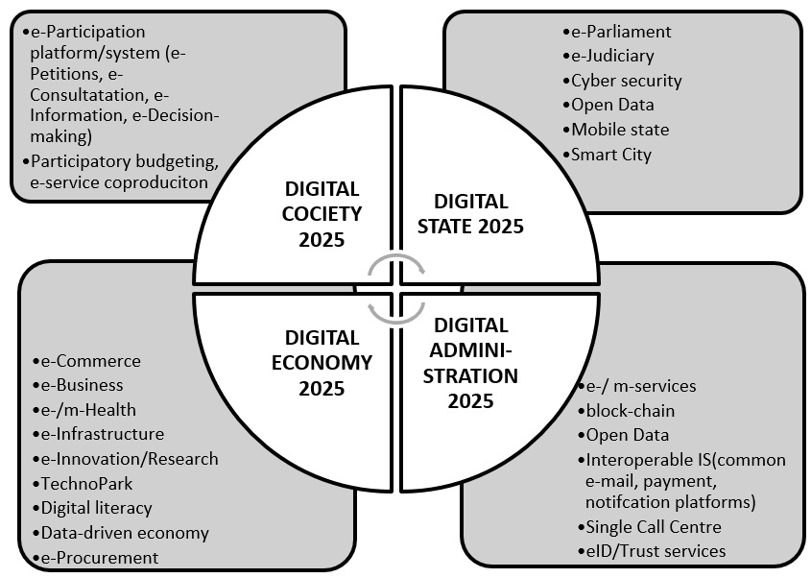

Annex 7. Proposed targets for Phase II.

Expected output 1: Enhanced governance and efficient, convenient, more responsive citizen-oriented public services delivery through advancement of e-Government in Uzbekistan
Activity Result 1 (extended from Phase I): Interoperable online public services delivery enhanced (front-office)
Recommended baseline indicators | Recommended output targets 2020
- 300 number of online services on the Portal;  - 1,150,740 number of requests processed;  - most of the services available on the portal provide one or two-way informational services at Stage 1  - minority of the services available on the portal provide two-way interactive services at Stage 3 (downloadable forms)  - 2 transactional services in tax administration and business registration at Stage 3 (full electronic case handling) available on the portal  - 1 targeted service in tax administration at Stage 4 (automatic, no need for request needed) available on the portal  - 0.6884: value of the UN Survey online service index  - Lack of the effective and accurate e-service monitoring and benchmarking system  - Availability of the monitoring systems tracking the progress of ICT use and openness in the public sector  - Lack of mobile services | - over 10 million requests processed;  - 90% of one/two-way informational services at Stage 1  - at least 75% of two-way interactive services at Stage 3 (downloadable forms)  - at least 50% of transactional services at Stage 3 (full electronic case handling)  - at least 35% of targeted services at Stage 4 (automatic, no need for request needed)  - at least 0.75 is the value of the UN Survey 2020 online service index  - Availability of the national e-service maturity benchmarking system  - Availability of mobile services and mobile identification of end-users

Activity Result 2 (extended from Phase I): e-Government interoperability improved and effective business process reengineering (BPR) mechanisms applied (back-office) – UNDP, government funded.
Recommended baseline indicators | Recommended output targets 2020
- Lack of e-government interoperability policies based on the once-only principle  - Lack of the CIO Council  - Lack of the common e-government architecture based on the whole-of-government principles  - Lack of the common data centre and cloud services  - BPR methodology applied in less than 50% of government and state agencies  - Lack of interoperable electronic identification and trust services | - A module-based national interoperability framework addressing the key aspects of interoperability developed and approved  - CIO Council established and operationalized  - Data Centre built and cloud services provided for government and state agencies  - BPR methodology applied in at least 50% of government and state agencies  - Legal and regulatory frameworks prepared and applied to establish a common for all government and state agencies system of electronic identification of end-users  - Trust services introduced to raise the quality and security in e-service provision

Activity Result 3 (modified from Phase I): e-Government institutional and policy ecosystem enhanced through capacity and competence building of e-Government development center, UNICON, State Statistics Committee, Ministry of Labour, Parliament and other government and state institutions at central and regional level – UNDP, donor and government funded.
Recommended baseline indicators | Recommended output targets 2020
- Lack of strategic management plans available for EGDC and UNICON  - Lack of tailor-made training and competency development programmes for the staff of EGDC, UNICON, State Statistics Committee, Parliament  - Insufficient accuracy of ICT/ telecom data  - Lack of training and forward-looking competency development programmes for central and regional government/state institutions  - Lack of institutionalized mechanisms of knowledge and best practice exchange across the government/state  - Low level of awareness of the general public in the regions about e-services  - Lack of large-scale partnership-based initiatives to educate population in e-service provision and digital literacy  - Low level of ICT use on the work of the Parliament and the lack informalization strategy  - Lack of the comprehensive longer-term strategy of digital transformation of the government, state and economy | - Availability of the Strategic Management Plan for EGDC and UNICON  - More accurate data sent to the ITU for the UN e-Government Survey 2020  - Availability of tailor-made training programmes on (i) interoperability and common e-government architecture including electronic identification and trust services, (ii) Open Data, (iii) e-Participation, (iv) e-Parliament, (v) public service benchmarking for the staff of EGDC, UNICON, UZINFOCOM, State Statistics Committee, Ministry of Labour, the members of the CIO Council  - Availability of general-purpose training programmes on best international practices in e-government, Open Data and e-participation for civil servants, specialists and decision-makers of all government/state agencies  - At 90% of the staff of the computer centres at central (members of the CIO Council) and regional level trained on best national and international practices in e-government, Open Data and e-participation  - At least 70% civil servants and specialists at central level and 50% at regional level trained on best national and international practices in e-government, Open Data and e-participation  - e-Government Demonstration and Knowledge Exchange Facility established and operationalized (operated by UNICON in cooperation with EGDC, ICT News Magazine, INHA and Tashkent State Law universities)  - A broad-based public-private partnership (under the leadership of IT Association and INHA University) established and the roadmap prepared to train 10% of the population living in rural areas and small towns on e-services and digital literacy in general; target regions identified, training modules developed to train trainers-of-trainers  - Availability of the e-Parliament strategy  - First phase of the e-Parliament strategy implemented  - Availability of the training programmes for the Parliament on the digital transformation of its operations  - At least 3 training sessions including 1 study tours organized for the Parliament staff  - Availability of Uzbekistan 2025 vision prepared and publicly discussed

Activity Result 4 (new for Phase II): Benefits of open-data driven decision-support system identified and exploited in the field of employment and social protection (linked to SDG agenda) – UNDP, donor and government funded.
Recommended baseline indicators | Recommended output targets 2020
- Lack of effective use and re-use of Open Data for decision-making purposes  - Lack of understanding of the benefits of Linked Open Statistical Data by civil servants and decision-makers  - Lack of competences and leadership at the State Statistics Committee in exploiting Open Statistical data  - Lack of specialized data-driven platforms as decision-support systems  - Lack of training and competency development programmes on Linked Open Data for civil servants, specialists and software developers  - Incomplete legal and regulatory environment for advanced use of Open Data in the public sector | - Availability of tailor-made training programmes on Linked Open Data (LOD) technologies  - Availability of tailor-made training programmes on data-driven decision-support systems  - At least 6 tailor-made training sessions, including 2 study tours, organized for EGDC, UZINFCOM, UNICON, State Statistics Committee, Ministry of Labour and the members of the CIO Council on data-driven decision-support systems EGDC with participation of international trainers  - Proposals made to improve the enabling regulation of Open data use and re-use (e.g. in the form of Green/White policy papers/briefs and common guidelines for data-set publishing)  - Availability of the concept and design of a data-based labour market monitoring and decision-support platform  - A beta version of the labour market monitoring and decision-support platform is available for internal testing

Activity Result 5 (new for Phase II): The empowering potential of citizen engagement online demonstrated and strengthened through the creation of a e-participation platform for public consultation and e-petitioning for more democratic decision and policy making – UNDP, donor, government funded.
Recommended baseline indicators | Recommended output targets 2020
- Lack of the institutionalized mechanisms and platforms for engaging citizens in governance  - Lack of legal certainty regarding citizen engagement in policy and decision making  - Lack of the legally functioning e-participation and e-petition platforms  - Lack of tailor-made training and competency development programmes on the use of e-participation tools for decision-making | - Availability of the official national e-participation concept/strategy  - A beta version of the e-participation platform for public consultation with citizens at all governance levels is available for testing  - Availability of the e-Petitioning platform integrated with the e-Participation portal  - Availability of tailor-made training programmes on best practices in e-participation  - At least 6 tailor-made training sessions, including 2 study tours, organized for the staff of for the staff of EGDC, UNICON, UZINFOCOM and other government/state agencies

It is advised to undertake an independent evaluation of Phase II in 2019.

Annex 8. Recommended content of a national interoperability strategy

The national e-government interoperability strategy should cover the of the entire State Information System supplemented by the common for all government agencies interoperability solutions (interoperability modules) for web, security, software, etc. As a framework strategy, it should be both an inter-organizational agreement and instrument to achieve the government-wide interoperability. As an instrument, it will include a collection of requirements, standards and instructions, handling the interoperability of information systems and services of the public sector to ensure that e-government solutions and services are mutually interoperable. It will also serve as a common guideline for preparing public sector IT legal acts, designing IT solutions and organizing IT related public procurement. The implementation of such a strategy will create conditions for citizens and businesses to communicate with the state via digital services without knowing anything about the hierarchic structure of the public sector or the division of roles in it. It will also bring more transparency into information related political decisions of the information system.

The national e-government interoperability strategy should be developed by the CIO Council that needs to be established prior to strategy development. The composition of the Council should be tailored to local conditions. The best international practice has proven that such a Council is the major enforcement mechanism of interoperability policies. Its membership base should include all the key actors who will translate e-government policies into the real-life practice of individual ministries, sectors, government agencies. It is advised that the CIO Council includes not only CIOs per se (that is, heads of computer centers) but the equivalent positions of Chief Executive Officers (CEOs), Chief Financial Officers (CFOs), Chief Information Security Officers (CISOs), Chief Technical Officers (CTOs), private sector managers and project leaders who offer development and administrative services to the public sector.

As far as the backend G2G e-government services are concerned (not to be confused with front-end G2C e-services for end-users which are the result of the interoperable G2G solutions and services), the national interoperability strategy (framework) should include (but not to be limited to): (a) the common service model, (b) interoperability architecture of services, (c) the concept of the interoperable service per se, (d) requirements for services, (d) service levels, (e) catalogue of services. The already gained experience in BPR should substantially facilitate the formulation of a common interoperability strategy and then implement it. Without the CIO Council and such a strategy, the further progress in developing transactional public e-services of high maturity level will be undermined (the lack of those already slows down the progress that otherwise would have been possible).

The proposed interoperability strategy (framework) should:
- be based on the following interoperability principles:
- Subsidiarity and proportionality
- User-centricity
- Inclusion and accessibility
- Security and privacy
- Multilingualism
- Administrative simplification
- Transparency
- Preservation of information
- Openness
- Reusability
- Technology neutrality and adaptability
- Effectiveness and efficiency

- include the following interoperability dimensions:
- Political context of the interoperability framework of the state information system
- Political context of public sector information systems
- Legal interoperability
- General legal acts regulating the state information system
- Coordination of legal acts from IT aspect
- Organizational interoperability
- Organizations
- Responsibility
- Cooperation and division of labour
- Coordination
- Strategic planning
- Council of Computer Science
- Coordination of information systems of local governments
- Semantic interoperability
- Technical interoperability

- include the use of Open standards addressing:
- Software and open specifications
- Joint infrastructure services
- Support systems
- Joint supporting infrastructure

- include the management arrangements for:
- the interoperability of the entire state information system
- the interoperability among public sector institutions

- include the role of websites in the state information system addressing:
- Website obligation
- Website as a registry
- Websites and service room
- Service levels
- Name domains

- contain the following aspects of semantic interoperability:
- Agreed addresses (UR-s)
- Clear uniform resource locators (URL)
- Taxonomy
- Language-technological support and search
- Annotation

- contain references to the following Web engine related issues:
- IPv6
- Default ports
- Reduction of the number of file formats
- Office software formats
- UTF-8
- XML
- RDF and RSS
- HTML and XHTML
- RDFa in XHTML
- CSS
- WAI WCAG
- XForms

- include the following requirements for website content:
- Usability
- Availability
- Security
- Archiving of a website
- (Self)assessment of the interoperability of websites

Annex 9. Recommended configuration of e-government institutional ecosystem

The successful experience of building capacities of the EGDC should be extended to strengthen capabilities of other institutions. It is proposed that, in addition to the EGDC, UNDP should start building capacities of UNICON to help it change its mission and become an analytical clearing house for e-government. Another critical agency in light of the expanding Open Data activities is the State Statistics Committee which needs to be empowered to reuse open statistical data for providing new tools for more informed and grounded decision making (by creating data-driven decision-support system in the field of social development).

One option is to continue focusing on capacity and competency building (as the reviewed project has done) by providing intellectual support of catalytic nature in the already established fields (such as BPR, Open Data, UN rankings), on the one hand, and by expanding them to break new ground in new e-gov domains (e-participation, mobile services, information systems), on the other hand. The other option is to combine the provision of such knowledge services with implementation of projects on behalf of the government to set up and operationalize comprehensive information systems in those areas which the government is not able to cover due to the limited capacity. In the current circumstances the second option looks more preferable as it promises greater impacts, provided that the funding is available and that possible risks for UNDP to directly implement large-scale information systems and related e-services are minimized. In other words, the main challenge is how to support the government operate on a new technological and organizational level across all branches and sectors of the government and state at large.

In this context, for UNDP to formulate its priorities for the next phase of e-government assistance it is essential to understand the broader formation of the emerging institutional ecosystem of the expanding e-government developments for the next 5-7 years and strategically support such ecosystem. As argued above, the current e-gov ecosystem (as emerged around the BPR) is incomplete. Graphically, it can be depicted as illustrated below.

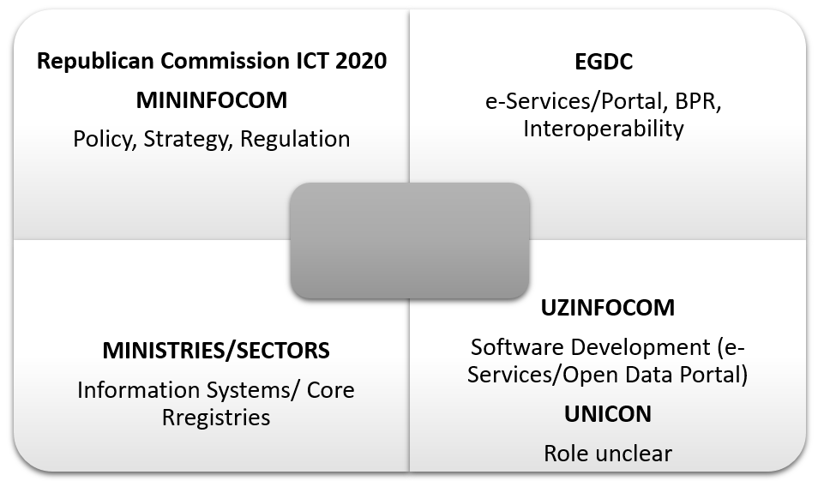

An example of a desired (ideal To-Be) e-gov ecosystem could look like this (does not mean to be comprehensive)
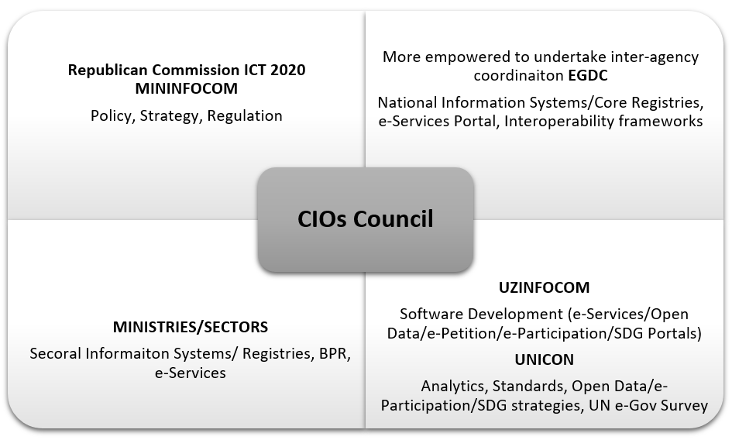

The ideal institutional e-government ecosystem would include (a) the more empowered EGDC to enforce proper inter-agency coordination across sectors and to focus on the creation of the national state information systems and core registries (and Data Centre/Cloud services) needed for proper interoperability, e-service delivery via the Portal, (b) the functioning CIO Council as an internal participatory coordination mechanism to facilitate the application of the common BPR and interoperability strategy within the ministries/sectors the CIOs represent, (c) UZINFOCOM would continue its role as a software developer, (d) UNICON acquiring new functions and powers as a main e-gov think tank responsible for e-gov analytics, Open Data and e-Participation strategies, competency development, standards (together with EGDC), liaising with ITU and UNDESA on e-Gov Survey and also SDG monitoring (optional), (e) ministries focusing on BPR within their sectors and respective e-services and gradually transfer their sectoral IS/hardware registries to the new Data Centre(s) and the EGDC as their possible operator.

UNDP is advised to engage in deeper cooperation with the government to implement on its behalf more complex information systems, preferably in those sectors where the existing capacity is low and when such systems could significantly contribute to the growth of proactive e-services with an added value for citizens and businesses (typically social and environmental development, civic engagement and participation). For example, UNDP could discuss a possibility to develop a comprehensive e-Participation system of public consultation and participatory decision-making, including a national e-Participation portal (includes e-Petitions). Or it could be a data-driven comprehensive IS to connect into one whole the fields of social petition, labour market and vocational training. At the same time, UNDP should discuss clear terms and conditions of such deeper cooperation to divide functional responsibilities and minimize possible risks that may arise, for example, during procurement of equipment and software development services.

The new e-gov ecosystem should also include the topics of Open Data and e-Participation in a more streamlined way. At the moment, there are no dedicated government agency in charge of these issues neither from the policy, not from the practice perspectives. It might be reasonable to consider that UNICON could take up this role and responsibility (but its capacity needs to be substantially enhanced).

The second direction includes supporting other government agencies whose services are vital for citizens yet their capacity to undertake BPR remains low. These are mainly services in the field of social development (employment, social protection, environmental management, community development) closely linked with the SDG context. UNDP should help the government assess the potential of ICTs and e-government services to accomplish the national SDG agenda and focus on those sectors and services that will be vital for implementing SDG. UNDP has an excellent example in this field, namely: digitalizing services aimed at improving quality of life of people with physical disabilities. This kind of assistance directly contributes to the accomplishment of Target 3.8 ‘Achieve universal health coverage, including financial risk protection, access to quality essential health-care services and access to safe, effective, quality and affordable essential medicines and vaccines for all’ (Goal 1 ‘End poverty in all its forms everywhere). UNDP should discuss with the Ministry of Labour and Social Protection opportunities to continue working in this direction and also addressing other pertinent issues (such as creating various databanks and solutions to assist in eHealth planning, human resources needs assessment, medicine procurement, infrastructure construction. There must be a through inventory of SGDs undertaken to disclose and assess the potential of e-government solutions for accomplishing the goals in the context of Uzbekistan.

Annex 10. Recommended structure of a e-service maturity benchmarking system (platform)

The project’s success poses a range of new challenges. One of them is how to measure the progress made towards creating a new institutional ecosystem? It is suggested that for the next phase the project the strategy of measuring the baseline indicators be amended. For one, it is not recommended to apply the baseline indicators measuring the volume of services with a payment functionality as the key indication of service transactional maturity. Payments could be made directly from the portal when this function is the part of the e-government architecture. On the other hand, making payment-related services could be done via e-banking systems linked with the portal (as in Estonia). This is a matter of the portal architecture. However, more important is the creation of a clearer and more holistic system that measures other transactional and interactive aspects of service provision.

At the moment, the emphasis is placed on two types of the service features. One feature is interactivity which essentially means that the service is predominantly of informational interaction between citizens and authorities (this mainly the maturity Stage 2 ‘Enhanced information services’ according to the UN Survey classification when government websites deliver enhanced one-way or simple two-way e-communication between government and citizen, such as downloadable forms for government services and applications; the sites have audio and video capabilities and are multi-lingual, among others; Stage 1 ‘Emerging information services’ mean one-way interaction via information provision and links to other ministries, departments and other branches of government that provide information). The other main feature is a transactional mode meaning that end-users have a possibility to make the service-related payments (e.g. taxes, fines, etc.). However, according to the UN definition the Transactional services (maturity Stage 3) are not only interactive but transactional capable of processing non-financial transactions, e.g. e-voting, uploading the downloaded forms, filing taxes online, applying for and receiving certificates, licenses and permits. The most advanced ‘Connected service’ at Stage 4 are proactive by targeting citizens through their life-cycle events including certain groups of citizens with tailor-made services to meet their special needs. Citizens are not any longer requested to provide information, for there are interoperability solutions in place cutting across the departments and ministries in a seamless manner. That stage also includes e-participation component when the Government creates an environment that empowers citizens to be more involved with government activities so as to have a voice in decision-making. In other words, the functioning interoperability system is a prerequisite for moving e-services to this proactive stage.

It should be noted that the UN Surveys until the year 2016 measured not services per se according to their maturity stage but the entire government web sites (therefore some advanced countries (such as Japan in the Survey 2014) do not have 100% at Stage 1 (‘Emerging presence’). In other words, interactive transactional services go well beyond financial transactions alone. For example, according to the UN Survey 2014, 41% of all online services were ‘Enhanced information services’ (Stage 2) and 23% were categorized as transactional services of Stage 3 and further 24% belonged to Stage 3 of ‘Connected service’. It was not possible to verify that indeed 1 of 4 services as of 2013 were the Connected ones (the Survey 2016 did not reveal the break-down of online services by stages). The main task is to create a monitoring system of service maturity by stages and set the respective baseline indicators to measure progress at each stage. It is recommended not to set hard targets for ranking positions due to their volatility and contingency. The recommended service maturity targets are presented below (based on the analysis of other countries’ performance in this regard).

Maturity level | Year
 | UN Survey 2012 | UN Survey 2014 | UN Survey 2016 | UN Survey 2018 (minimal) | UN Survey 2020 (minimal)
Online service index value | 0.4967 | 0.4488 | 0.6884 | 0.7000 | 0.7500
Stage 1 (one/two-way informational) | 100% | 88% | n/a | 85% | 90%
Stage 2 (two-way interactive – downloadable forms) | 62% | 41% | n/a | 50% | 75%
Stage 3 (transactional - full electronic case handling) | 21% | 23% | n/a | 35% | 50%
Stage 4 (targeted, automatic, no need for request) | 39% | 24% | n/a | 30% | 35%
% Average for stages 1-4 | 43% | 42% | n/a | 50% | 60%

The main task is to enter by 2020 the group of countries with the high level of service maturity, i.e. the online presence index is at least 0.7500. This is an achievable task given the progress already made. However, one of the main requirements to make the progress sustainable is to build a fully operational interoperability system as part of the new e-government architecture based on the whole-of-government and once-only principles (includes the development of a new data centre and related cloud services for all government agencies), as well as the introduction of mobile services including electronic identification/authentication via mobile devises. If, for example, there are 350 services available on the portal, by 2020 at least 50% of them should be fully handled electronically at stage 3 without a need to visit offices or use paper – that should be the main target (not necessarily directly payable from the portal). The target for the automated, connected services at stage 4 could be softer covering around one-third of all services. These targets are still quite demanding which will require to speed up digitalization process and wider application of BPR. To make that happen, the establishment of the CIO Council will be indispensable. According to the 2014 UN e-Government Survey, in 2014 there were as many as 82 countries that have the CIO Council operational. Uzbekistan should not stay away from that global trend.

Annex 11. Selected screenshots of selected project publications

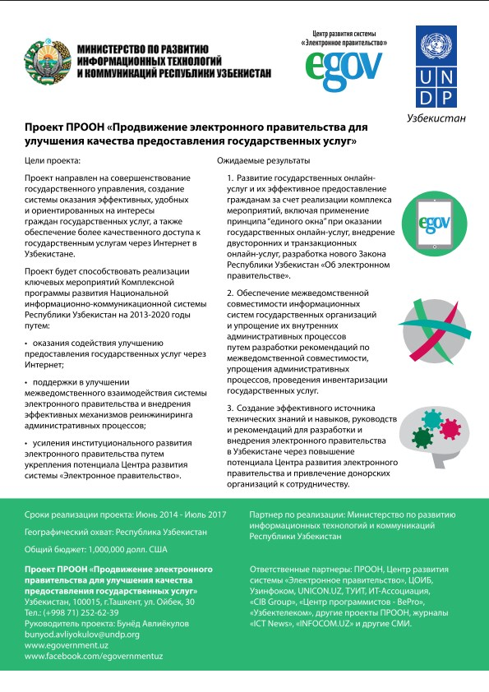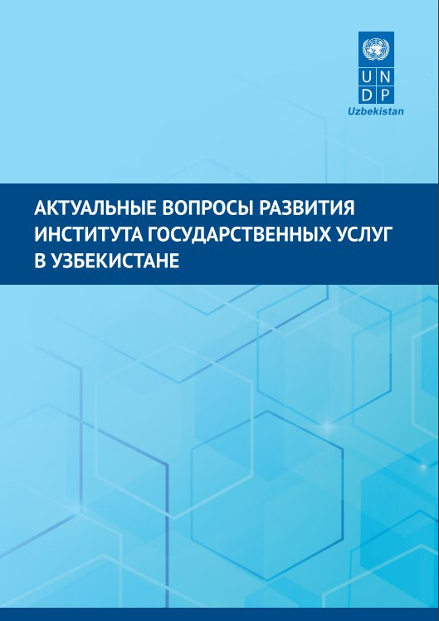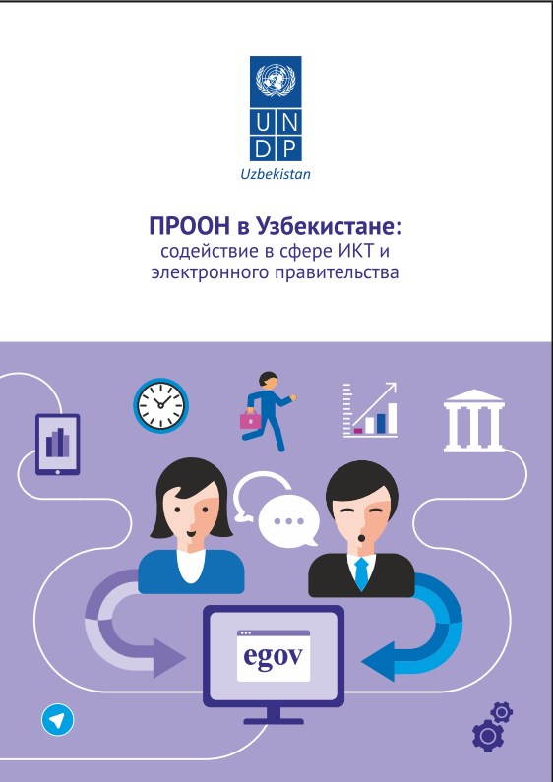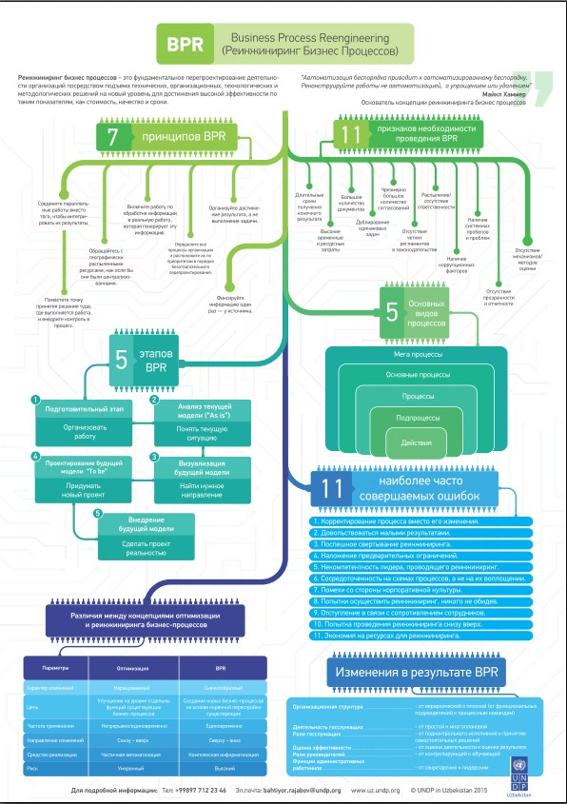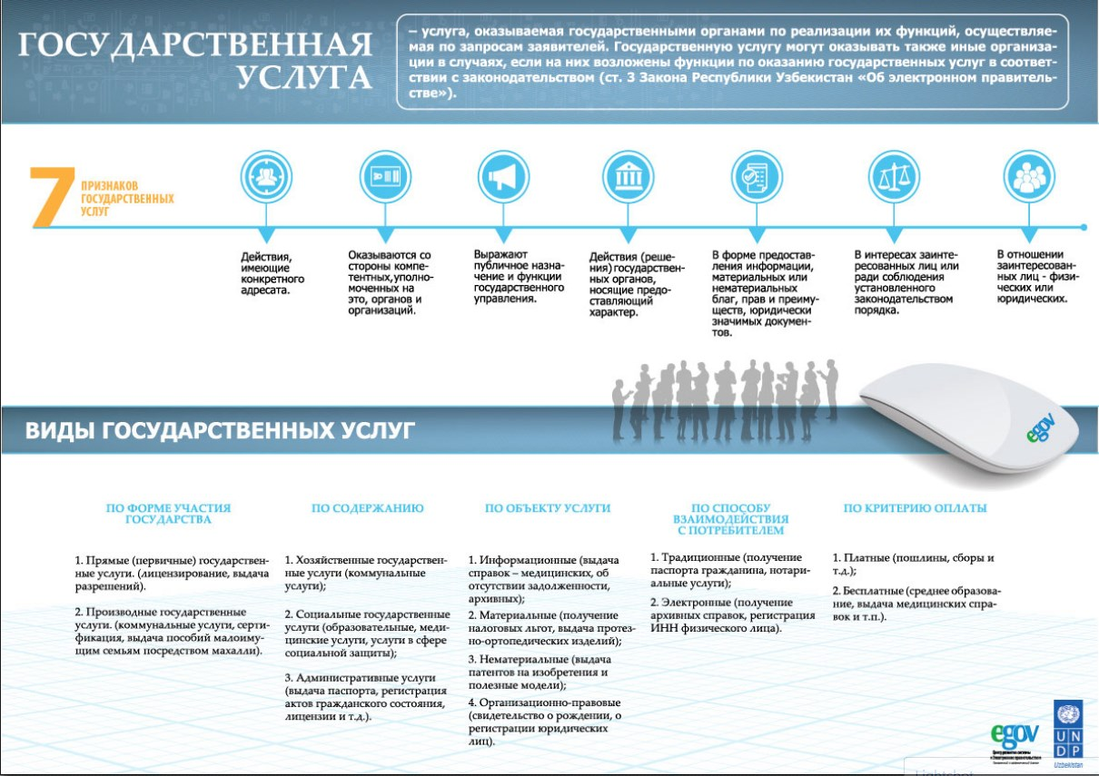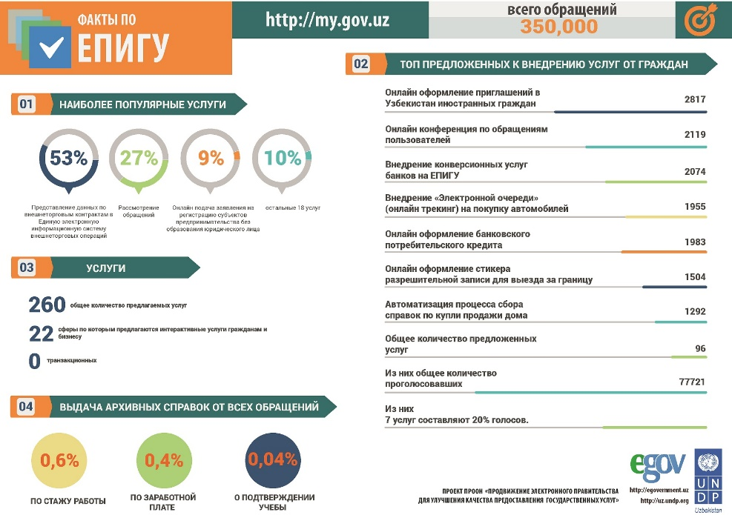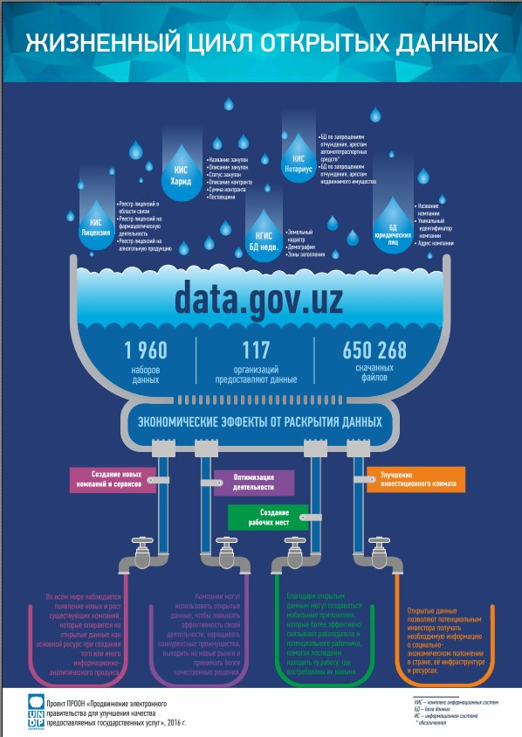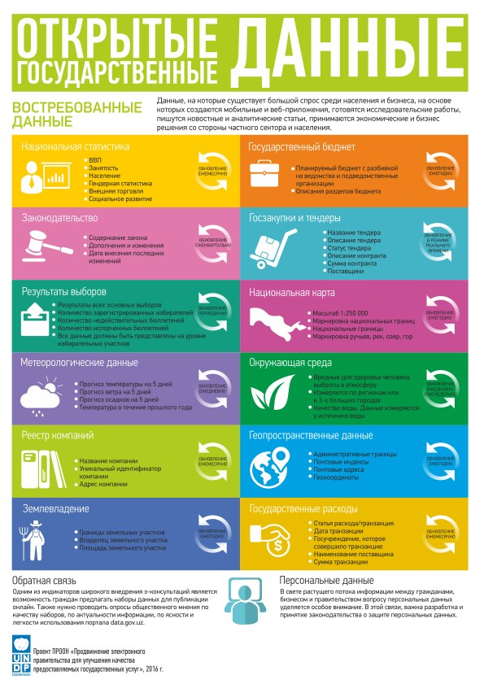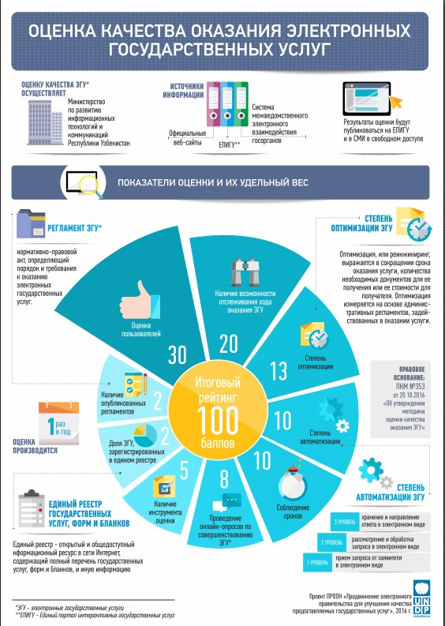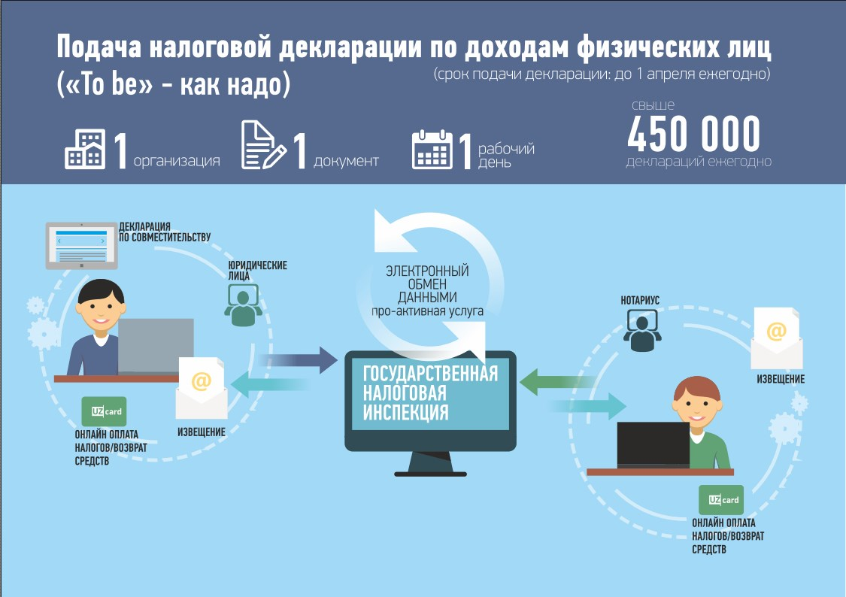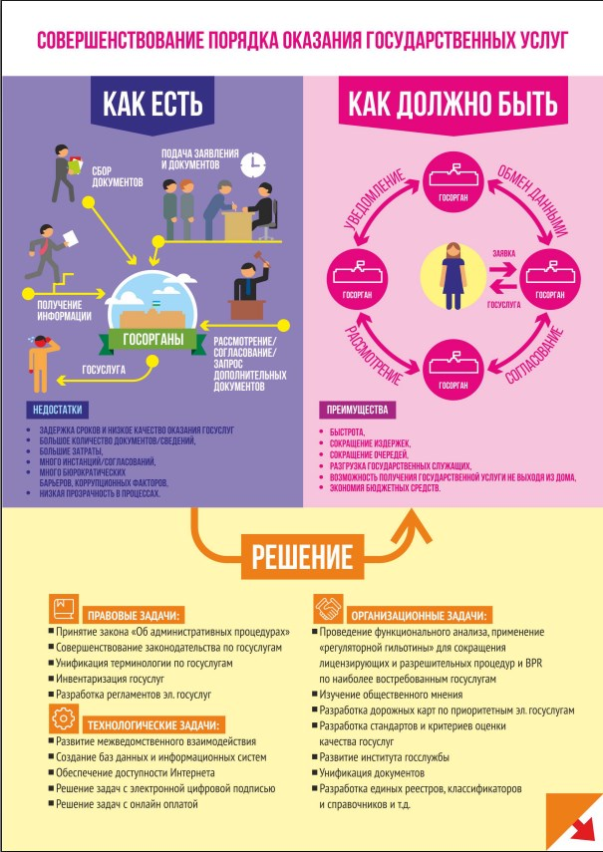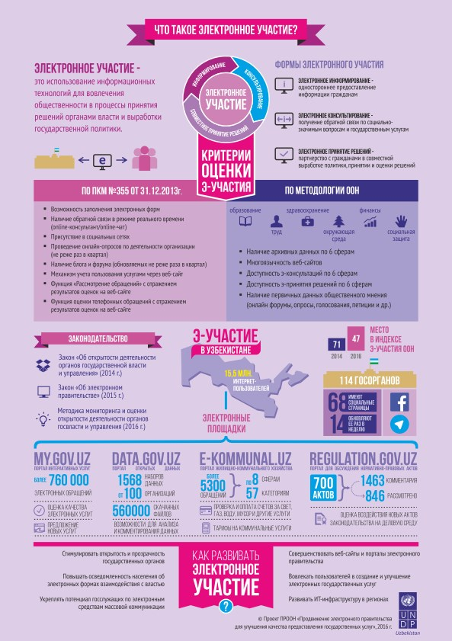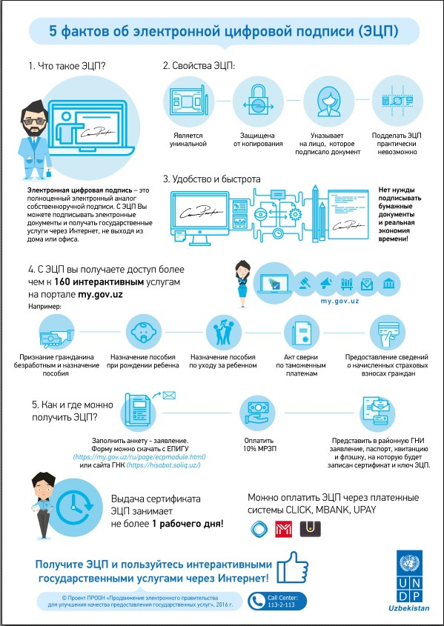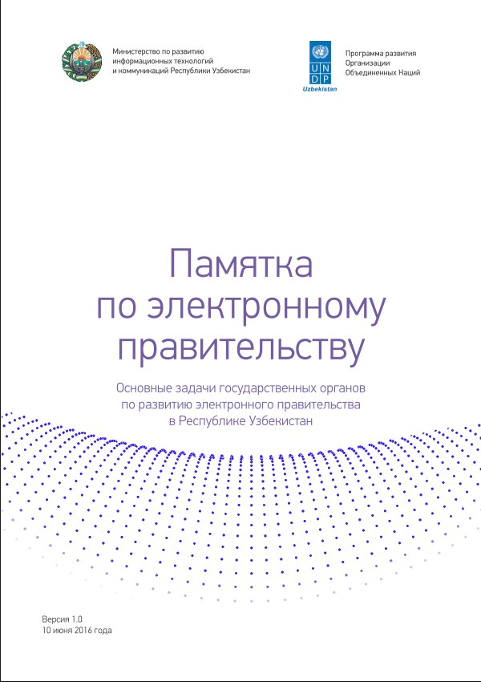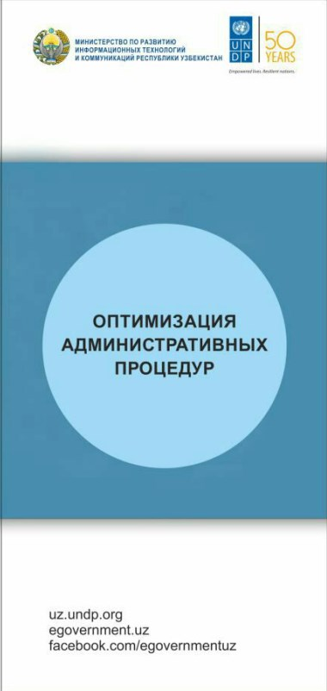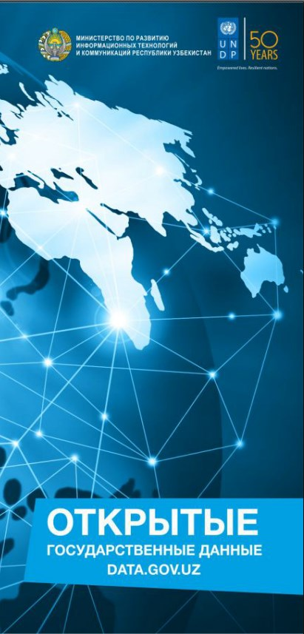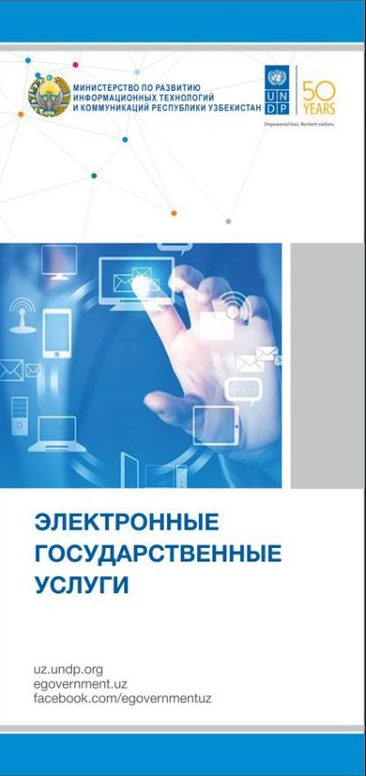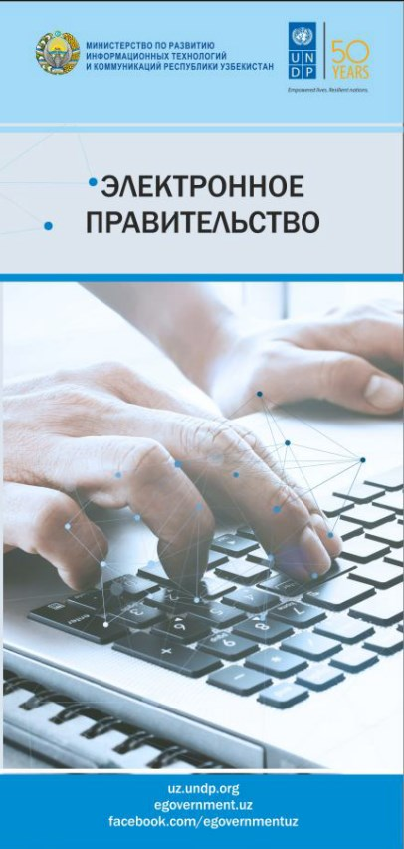

Annex 12. List of documents consulted.
Laws and regulations
- ПОСТАНОВЛЕНИЕ ПРЕЗИДЕНТА РЕСПУБЛИКИ УЗБЕКИСТАН О МЕРАХ ПО ДАЛЬНЕЙШЕМУ РАЗВИТИЮ НАЦИОНАЛЬНОЙ ИНФОРМАЦИОННО-КОММУНИКАЦИОННОЙ СИСТЕМЫ РЕСПУБЛИКИ УЗБЕКИСТАН. №ПП-1889, 27 июня 2013 года.
- ОСТАНОВЛЕНИЕ КАБИНЕТА МИНИСТРОВ РЕСПУБЛИКИ УЗБЕКИСТАН ОБ УТВЕРЖДЕНИИ МЕТОДИКИ ОЦЕНКИ КАЧЕСТВА ОКАЗАНИЯ ЭЛЕКТРОННЫХ ГОСУДАРСТВЕННЫХ УСЛУГ, № 353, Собрание законодательства Республики Узбекистан, 2016 г., № 42, ст. 491 (МЕТОДИКА оценки качества оказания электронных государственных услуг органов государственного и хозяйственного управления, органов государственной власти на местах и иных организаций)
- ПОСТАНОВЛЕНИЕ КАБИНЕТА МИНИСТРОВ РЕСПУБЛИКИ УЗБЕКИСТАН О ДАЛЬНЕЙШИХ МЕРАХ ПО РЕАЛИЗАЦИИ ЗАКОНА РЕСПУБЛИКИ УЗБЕКИСТАН «ОБ ЭЛЕКТРОННОМ ПРАВИТЕЛЬСТВЕ», № 188, 32.06.2016, Собрание законодательства Республики Узбекистан, 2016 г., № 23, ст. 269 (ПОЛОЖЕНИЕ о порядке оказания электронных государственных услуг через Единый портал интерактивных государственных услуг и официальные веб-сайты государственных органов).
- ПОСТАНОВЛЕНИЕ КАБИНЕТА МИНИСТРОВ РЕСПУБЛИКИ УЗБЕКИСТАН О МЕРАХ ПО ОРГАНИЗАЦИИ ДЕЯТЕЛЬНОСТИ ЦЕНТРА РАЗВИТИЯ СИСТЕМЫ «ЭЛЕКТРОННОЕ ПРАВИТЕЛЬСТВО» И ЦЕНТРА ОБЕСПЕЧЕНИЯ ИНФОРМАЦИОННОЙ БЕЗОПАСНОСТИ ПРИ ГОСУДАРСТВЕННОМ КОМИТЕТЕ СВЯЗИ, ИНФОРМАТИЗАЦИИ И ТЕЛЕКОММУНИКАЦИОННЫХ ТЕХНОЛОГИЙ РЕСПУБЛИКИ УЗБЕКИСТАН, Собрание законодательства Республики Узбекистан, 2013 г., № 38, ст. 492.
- ПОСТАНОВЛЕНИЕ КАБИНЕТА МИНИСТРОВ РЕСПУБЛИКИ УЗБЕКИСТАН О МЕРАХ ПО СОВЕРШЕНСТВОВАНИЮ ПОРЯДКА ОКАЗАНИЯ ЭЛЕКТРОННЫХ ГОСУДАРСТВЕННЫХ УСЛУГ, № 184, 02.06.2016, Собрание законодательства Республики Узбекистан, 2016 г., № 23, ст. 265 (ПОЛОЖЕНИЕ о реализации мероприятий по совершенствованию порядка оказания электронных государственных услуг)
- ПОСТАНОВЛЕНИЕ КАБИНЕТА МИНИСТРОВ РЕСПУБЛИКИ УЗБЕКИСТАН О МЕРАХ ПО СОВЕРШЕНСТВОВАНИЮ ПОРЯДКА НОТАРИАЛЬНОГО УДОСТОВЕРЕНИЯ СДЕЛОК С ПРИМЕНЕНИЕМ МЕЖВЕДОМСТВЕННОГО ЭЛЕКТРОННОГО ВЗАИМОДЕЙСТВИЯ, № 106, 27.02.2017, Собрание законодательства Республики Узбекистан, 2017 г., № 9, ст. 131 (ПОЛОЖЕНИЕ о порядке нотариального удостоверения сделок купли-продажи, мены и дарения недвижимого имущества с применением межведомственного электронного взаимодействия)

Project management
- UNDP Country Programme Action Plan (CPAP) 2010-2015.
- Country programme document for Uzbekistan (2016-2020) of 20 May 2015.
- UNDP country programme document Uzbekistan (2010-2015) of 9 July 2009.
- UNITED NATIONS DEVELOPMENT ASSISTANCE FRAMEWORK FOR THE REPUBLIC OF UZBEKISTAN. United Nations in Uzbekistan, Government of the Republic of Uzbekistan, 2016–2020.
- Annual Work Plans for 2014, 2015, 2016, 2017
- Progress report for 2016.
- MINUTES of the First Project Board Meeting of UNDP project “E-Government Promotion for Improved Public Service Delivery”. Date and time: December 15th, 2015, 15:00 to 16:30.
- MINUTES of the Project Board Meeting Minutes of UNDP project “E-Government Promotion for Improved Public Service Delivery”. Date and time: December 9th, 2016, 15:00 to 17:00.
- Combined Delivery Reports for 2014, 2015, 2016.
- Основные направления деятельности проекта «э-Правительство для улучшения качества оказания государственных услуг» в 2015 году (PowerPoint Presentation).
- Проект «Продвижение ЭП для улучшения качества предоставления государственных услуг». Итоги 2016 г. и планы на 2017 г. Бунёд Авлиёкулов, руководитель проекта, 9 декабря 2016 г. (PowerPoint Presentation).
- Проект «Продвижение ЭП для улучшения качества предоставления государственных услуг». Итоги 2015 г. и планы на 2016 г. Бунёд Авлиёкулов, руководитель проекта, 15 декабря 2015 г. (PowerPoint Presentation).
- Информация об освоении средств софинансирования проекта ПРООН по ЭП.
- Handbook on Planning, Monitoring and Evaluating for Results, 2009.
- UNDP Updated Guidance on Evaluation in the Handbook on Planning, Monitoring and Evaluating for Results.
- Development Results (2009), Addendum June 2011.
- The evaluation policy of UNDP, 15 November 2010.
- UNEG Quality Checklist for Evaluation Reports, 2010.
- UNEG Code of Conduct for Evaluation in the UN System, March 2008.
Project products, analytics, methodology
- Отчет по итогам конкурса MIT.UZ Open Data Challenge 2016.
- Об итогах хакатона по открытым данным.
- Памятка по электронному правительству. Основные задачи государственных органов по развитию электронного правительства в Республике Узбекистан, 10 июня 2016 года.
- О деятельности проекта ПРООН по ЭП в области PR.
- Концепция официального веб-сайта Общественного совета по открытости.
- Резюме отчета по результатам BPR услуг Минтруда Республики Узбекистан.
- Аналитический обзор по совершенствованию наиболее востребованных государственных услуг в Республике Узбекистан.
- Методика оценки качества оказания электронных государственных услуг
- Методика мониторинга и оценки открытости деятельности органов государственной власти и управления. Утверждено Решением Общественного совета по координации и мониторингу деятельности по обеспечению открытости деятельности органов государственной власти и управления от 6 декабря 2016 года.
- Аналитическая справка по государственной услуге «Предоставление налоговых деклараций физическими лицами».
- Обеспечение открытости деятельности органов государственной власти и управления (Сборник нормативно-правовых актов).
- Положение о проведении о проведении конкурса Technovation Challenge в городе Ташкенте, 2017 год.
- ПОЛОЖЕНИЕ О ПРОВЕДЕНИИ СТИПЕНДИАЛЬНОЙ ПРОГРАММЫ ПРООН ПО АДМИНИСТРАТИВНОМУ ПРАВУ И ГОСУДАРСТВЕННОМУ УПРАВЛЕНИЮ ДЛЯ БАКАЛАВРОВ, МАГИСТРАНТОВ, НЕЗАВИСИМЫХ ИССЛЕДОВАТЕЛЕЙ И ДОКТОРАНТОВ ТАШКЕНТСКОГО ГОСУДАРСТВЕННОГО ЮРИДИЧЕСКОГО УНИВЕРСИТЕТА.
Project information dissemination
- План подготовки статей по актуальным вопросам продвижения ЭП/внедрения ИКТ в госуправление в 2017 году.
- Темы презентаций от ПРООН на ИКТ Неделе 2015.
- Предложения ПРООН по проведению Недели ИКТ 2016.

Annex 13. Evaluation Terms of Reference

UNITED NATIONS DEVELOPMENT PROGRAMME
JOB DESCRIPTION

I. Position Information
Position Title:  Type:  Project Title/Department:  Location:  Expected places of travel:  Duration of the service:  Reports To: | International Consultant for Final Evaluation of EGOV project  IC contract; independent evaluation of the UNDP project  E-Government Promotion for Improved Public Service Delivery  Home-based  Tashkent, Uzbekistan (April 3-7, 2017)  30 days during March/April 2017, part-time  Head of Good Governance Unit, UNDP Uzbekistan CO

II. Background
Existing public services delivery system in Uzbekistan is characterized by low level of transparency, high degree of corruption practices, lack of clear and customer-oriented information sharing and feedback mechanisms, limited focus on vulnerable groups. Uzbek Government has been putting an effort to improve public service delivery by advancing e-government and benchmarking the progress against United Nations’ E-Government Development Index. According to the recent estimates, Uzbekistan’s ranking has risen from 100 in 2014 to 80 in 2016. In 2017, the Government of Uzbekistan intends to intensify its efforts and puts even more ambitious target of reaching top 50 countries. Government of Uzbekistan realizes that in order to achieve the goal it needs to redesign business processes in back offices of government entities offering G2B and G2C services, establish customer-oriented front offices and engage public in service design.

E-Government Promotion for Improved Public Service Delivery (E-Gov) is a UNDP Project implemented jointly with the Ministry of development of information technologies and communications of the Republic of Uzbekistan (MITC). It aims at enhancing governance and achieving efficient, convenient, more responsive citizen-oriented public services delivery to provide better access to online public services. The Project contributes to implementation of key activities of e-Government Master Plan for 2013-2020 through: (1) assistance in enhancing government online services delivery (2) support in improving e-Government interoperability and applying effective business process reengineering (BPR) mechanisms (3) enhancing e-Government institutional development via capacity building of e-Government development center.

The first component – Enhancing online public service delivery (front-office) – aims at assisting the Government in accelerating further development of online public service delivery and achieving efficient, faster, convenient, more responsive, and citizen-oriented services through implementation of complex activities including: supporting the application of “single window” principle within online public service delivery, assisting in the introduction of two-way & transactional online services, conducting awareness raising & outreach activities on promotion of online public services, providing support in drafting a new law of Uzbekistan “On e-Government”;

As part of its second component – improving e-Government interoperability and applying effective business process reengineering (BPR) mechanisms (back-office) – the Project supports Government’s efforts in ensuring interoperability of existing & future information systems of state organizations, and simplification of internal business processes through formulation of recommendations on proper application of interoperability specifications & policies, participation in redesign of business processes, and provision of support in the inventory of public services, and assistance in the implementation of interoperability framework that takes into account legal, organizational and technical levels.
The third component of the project focuses on enhancing e-Government institutional development through capacity building of “e-Government development center” (EGDC). The Project assists the Government in building an effective source of technical expertise and skills, advice and guidance for development and deployment of e-Government in Uzbekistan through assistance in organizational capacity building of the e-Government development center.

Since its launch in 2014, the project has developed a number of initiatives successfully implemented in the fields of e-governance, open data, e-participation and other areas of good governance. This year the project is approaching its completion, which is July 2017.
The details of the project activities are available at http://www.uz.undp.org/content/uzbekistan/en/home/operations/projects/democratic_governance/e-government-promotion-for--improved-public-service-delivery-.html, in Facebook https://www.facebook.com/groups/data.uz/, and other online resources (http://www.mitc.uz, http://www.egovernment.uz/, etc.).

III. Objectives of the Evaluation / Evaluation requirements and methodology
This Final Evaluation is initiated by the UNDP Uzbekistan and aims to assess the relevance, performance, management arrangements and success of the project and provide recommendations for possible follow-up. Based on internal assessment and continuous positive feedback of the stakeholders and project beneficiaries, it is envisaged that UNDP Uzbekistan remains committed in continuing its efforts in this field. Therefore, it is anticipated that the outcomes of the evaluation will be a clear source for future planning and prioritization of UNDP Uzbekistan activities in the field of E-Governance and Public Administration Reform. It should provide the basis for learning and accountability for managers and stakeholders. The evaluation will have to provide to UNDP complete and convincing evidence to support its findings/ratings. Particular emphasis should be put on the project results, the lessons learned from the project and recommendations for the follow-up activities.
This evaluation is to be undertaken in line with the evaluation policy of UNDP (http://www.undp.org/content/undp/en/home/operations/accountability/evaluation/evaluation_policyofundp) and the UNDP Handbook on Monitoring and Evaluating for Results (http://web.undp.org/evaluation/handbook/index.html).

The assignment will take place within March/April 2017. It will involve deskwork and meetings with national partners and stakeholders, including project beneficiaries. The international consultant will work in close collaboration with UNDP Uzbekistan CO and relevant stakeholders.
EVALUATION OBJECTIVES:
The evaluation is intended to provide a comprehensive overall assessment of the project and to provide recommendations for exit strategy and/or follow-up activities.
The purpose of the Final Evaluation is:
- To assess overall performance against the Project objective and outcomes as set out in Project Document.
- To assess the effectiveness and efficiency of the Project.
- To analyze critically the implementation and management arrangements of the Project.
- To assess the sustainability of the project’s interventions.
- To list and document lessons concerning Project design, implementation and management.
- To assess Project relevance to national priorities.
- To assess changes in the baseline situation and provide guidance for the future activities in the area of promoting E-Governance.

Project performance will be measured based on Project’s Results and Resources Framework, which provides clear indicators for project implementation. The Report of the Final Evaluation will be stand-alone document that substantiates its recommendations and conclusions.

EVALUATION:
Under the direct supervision of the Head of Good Governance Unit and in close cooperation with EGOV Project Manager, the International Consultant for Evaluation of EGOV project will be responsible for the completion of the following tasks and duties:

Project concept and design: The evaluator will assess the project concept and design. He/she should review and provide an evaluation of the project strategy, planned outputs, activities and inputs, implementation modality, clarity and effectiveness of management arrangements and cost-effectiveness of approaches taken in relation to the overall project objectives. The evaluator will assess the achievement of results and targets against the project work plans.

Implementation: The evaluation will assess the implementation of the project in terms of quality and timeliness of inputs, efficiency and effectiveness of activities carried out. Effectiveness of management, the quality and timeliness of monitoring and backstopping by all parties to the project should also be evaluated. In particular, the evaluation is to assess the Project team’s use of adaptive management in project implementation.

Project outputs, outcomes: The evaluation will assess the outputs in relation to the CP outcomes, achieved by the project as well as the likely sustainability of project results. This should encompass an assessment of the achievement of the immediate objectives and the contribution to attaining the overall objective of the project. The evaluation should also assess the extent to which the implementation of the project has been inclusive of relevant stakeholders and to which it has been able to create collaboration between different partners. The evaluation will also examine if the project has had significant unexpected effects, whether of beneficial or detrimental character.

The Final Evaluation will also cover the following aspects:

Results and effectiveness:
Changes in development conditions. Address the following questions, with a focus on the perception of change among stakeholders:
- What are main outputs and outcomes of the project?
- What are the impacts of the project? Do they have equal value for women and men beneficiaries?
- Has project contributed to establishment of efficient national institutional frameworks for promotion of online public services, open data, BPR, e-participation and other elements of e-government?
- Has the UNDP partnership strategy been appropriate and effective?
- Has awareness on online public services, open data, BPR, e-participation and e-government in general and among stakeholders been increased?
- Has attention of stakeholders to online public services, open data, BPR, e-participation and other e-government issues increased and has it been reflected in concrete actions?
- Has capacity of state bodies been increased?
- Has implementation of online public services, open data, BPR, e-participation and other e-government initiatives improved?
Measurement of change: Progress towards results should be based on a comparison of indicators before and after the project intervention.

Project strategy: How and why outputs contribute to the achievement of the expected results. Examine their relevance and whether they provide the most effective route towards results.

Sustainability: Extent to which the benefits of the project will continue, within or outside the project domain, after it has come to an end. Relevant factors include for example: development of a sustainability strategy, establishment of financial and economic instruments and mechanisms, mainstreaming project objectives into the local economy, etc.

Project’s Adaptive Management Framework:
Monitoring Systems
  - Assess the monitoring tools currently being used:
  - Do they provide the necessary information?
    - Do they involve key partners?
    - Are they efficient?
    - Do they encourage disaggregation of data (by sex, region, age, education)?
    - Are additional tools required?

Risk Management
- Validate whether the risks identified in the project document and the ATLAS Risk Management module are the most important and whether the risk ratings applied are appropriate. Describe any additional risks identified and suggest risk ratings and possible risk management strategies to be adopted for the future activities.

Work Planning
- Assess the use of the logical framework as a management tool during implementation and changes made to it;
- Assess the use of routinely updated workplans;
- Are work planning processes result-based? If not, suggest ways to re-orientate work planning.
- Assess financial management of the project, with specific reference to the cost-effectiveness of interventions.

Reporting
- Assess whether UNDP reporting requirements were met.
- Assess whether disaggregated data is being used.

Underlying Factors
- Assess the underlying factors beyond the project’s immediate control that influence outcomes and results. Consider the appropriateness and effectiveness of the project’s management strategies for these factors.
- Assess the effect of any incorrect assumptions made by the project.

UNDP Contribution
- Assess whether UNDP’s outputs and interventions can be credibly linked to achievement of the outcome, including the outputs, programmes, projects and soft and hard assistance that contributed to the outcome;
- Assess the role of UNDP against the requirements set out in the UNDP Handbook on Monitoring and Evaluating for Results;
- Assess implementation of the new UNDP requirements outlined in the UNDP User Guide, especially the Project Assurance role;
- Assess the UNDP contribution to the project “soft” assistance (policy advice & dialogue, advocacy, coordination).

Partnership Strategy
- Assess how partners are involved in the project’s adaptive management framework: (i) Involving partners and stakeholders in the selection of indicators and other measures of performance; (ii) Using already existing data and statistics; and (iii) Analyzing progress towards results and determining project strategies.
- Identify opportunities for stronger substantive partnerships in the future.
- Assess how local stakeholders participate in project management and decision-making. Include analysis of strengths and weaknesses of the approach adopted by the project and suggestions for improvement.
- Assessment of collaboration between governments, intergovernmental and non-governmental organizations.
- Assessment of collaboration between implementation units of other related projects.
- Assessment of local partnerships.
- Transfer of capacity to the national institutions.

Project Finance:
- Assess the cost-effectiveness of the project interventions.

Formulation of a new results framework for future partnership

The purpose of the formulation of the new results framework for future partnership is to identify the potential entry points for development intervention in the areas of e-governance, public administration reforms, enhancement of e-participation and government’s capacity building. The documents to be prepared by international consultant during formulation of the new results framework for future partnership should comply with UNDP standards on results-based management, and templates for project document. UNDP Good Governance Unit will provide these necessary templates to the international consultant.

Under the direct supervision of the Head of Good Governance Unit and in close cooperation with Programme Analyst on Rule of Law, the Inernational Consultant for evaluation of the Project and the formulation of the new results framework for future partnership will be responsible for the completion of the following tasks and duties:
- Analyze major lessons learned from Project`s previous activities and conduct country context analysis in order to determine background of problems showing the need/demand for the new results framework for future partnership;
- Prepare project proposal, project justification, identifying the main implementing partner, key stakeholders and beneficiaries, overall goals and specific objectives, a list of main activities, duration, and outputs, potential risks and estimated budget;
- Draft the Results and Resource Framework (RRF) for the proposal on the new results framework for future partnership. The template for RRF will be provided by UNDP Good Governance Unit;
- Advise to UNDP senior management on organization structure for the possible new project, including description of roles and responsibilities of project team members;
- Propose monitoring and evaluation mechanism as well as quality management for activity results during the new project implementation.

EVALUATION METHODOLOGY:
The Final Evaluation will be done through a combination of techniques, including
- Desk review of all relevant documentation (project outputs and other materials);
- Consultations with stakeholders (partners and beneficiaries) and UNDP staff;
- Validation exercise with UNDP CO and national partners of Project.

Evaluation should involve the wider possible range of stakeholders.

IV. Deliverables and timeframe
The duration of the assignment is up to 30 working days, including writing of the final evaluation report in the period of March/April 2017. The final timeframe will be agreed upon in the beginning of consultancy assignment. All deliverables should be submitted to UNDP by the International Consultant in English.
# | Deliverables | Deadlines
1 | Monitoring and Evalution work plan and report outline, including plan of meetings with stakeholders | March 29, 2017
2 | Draft Evaluation report, including Annex on analysis of validation results for preliminary findings with stakeholders | April 21, 2017
3 | Final evaluation report | April 30, 2017
Tentative timeframe |  |  |  | Working days
 | Desk review based on of briefings with the project team and GGU. |  |  | 5 days
 | Interviews with local stakeholders, questionnaires, focus groups |  |  | 5 days
 | Validation of preliminary findings with stakeholders through circulation of initial reports for comments |  |  | 8 days
 | Preparation of draft evaluation report and incorporation of comments |  |  | 7 days
 | Submission of final evaluation report |  |  | 5 days

V. Payment Conditions
This is a lump sum that should include costs of consultancy required to produce the above deliverables. Payment will be released in three following installments:
- Upon submission and acceptance by Programme Unit of UNDP of the deliverable 1 - 25% of the lump sum
- Upon submission and acceptance by Programme Unit of UNDP of the deliverable 2 - 30% of the lump sum
- Upon submission acceptance by Programme Unit of UNDP of the deliverable 3 - 45% of the lump sum.

VI. Recruitment Qualifications
Education: | - Master Degree in e-governance, communications, media, law, public administration, public policy, humanitarian and social sciences and other areas relevant for the assignment is required
Experience: | - At least 5 years of practical experience in any of the following areas is required: institutional organization and public sector in complex environments, strategic processes planning, e-governance, project management, monitoring and evaluation of development projects in governance sector;  - Out of 5 yeas, at least 1 year of experience with results-based management evaluation methodologies, participatory monitoring approaches and applying SMART indicators is required;  - Previous experience with public administration reform, e-government, ICT reform, related project design and implementation, preferably in CIS region is an asset;  - Awareness of gender issues (preferably in the CIS region) and knowledge of gender mainstreaming techniques is an asset;  - Project evaluation experiences within UN system will be considered an asset.
Language Requirements: | - Fluency in English is required; knowledge of Russian is an asset but not a requirement
Others: | - Strong communication skills, client-orientation, ability to work in a team;  - Initiative, analytical judgment, ability to work under pressure, ethics and honesty;  - Understanding of human rights, gender and cultural dimensions.  - Advanced ability to use IT equipment and software.

V. Signatures - Post Description Certification
Incumbent (if applicable)
Name Signature Date
Chief Division/Section:
Mr. Azizkhon Bakhadirov / a.i. Head of Good Governance Unit Signature Date

Annex 14. Evaluator’s biodata

Yuri MISNIKOV (PhD in Digital Media and Communications, University of Leeds, UK)
Consultancy/research area: e-Governance/ICT Scholar and Consultant
Citizenship: Republic of Belarus
Education
- 2007-2011: Doctoral studies at the University of Leeds, Institute of Communications Studies, UK (Degree of Doctor of Philosophy (PhD) in new media and communications).
- 1986-1987: Post-graduate studies at the Moscow State University, Economics Faculty, Centre for Population Studies (Diploma in Demography).
- 1975-1981: Graduate studies at the Belarusian State University, Faculty of Geography, Minsk (Diploma in Human Geography).
Professional background
Sept 2014 – present: Senior Researcher (part-time), Centre for e-Government Technologies, ITMO University, St. Petersburg, Russia. 2012-2014: Independent ICT/e-governance scholar/expert. 2001-2007: ICT/e-Governance Regional Policy Advisor for Europe and the Commonwealth of the Independent States (CIS), UNDP Regional Centre in Bratislava, Slovakia. 1999-2001: UNDP Deputy Resident Representative in Kyrgyzstan. 1993-1999: National Professional Officer, Assistant Resident Representative, Officer-in-Charge of the UN/UNDP Office in Belarus. 1981-1993: Researcher at the Belarusian Institute of Urban Development and Regional Planning.
As UNDP Regional e-Governance Advisor at the Bratislava Regional Centre, Yuri assisted in the formulation of national and regional e-strategies, initiated and managed multi-country projects including the establishment of the Estonian e-Governance Academy in Tallinn and the formulation of the Electronic South-Eastern Europe Agenda (eSEE). Organised two regional e-Governance Practice meetings in 2004 (Ukraine) and 2006 (Estonia); took part and spoke at numerous national, regional and global events including the World Summit on the Information Society in Geneva (2003) and Tunis (2005). Was responsible for preparing several UNDP publications on knowledge and best practice transfer in Information Society/e-Governance. Has an excellent knowledge of the post-communist transition context. Acquired vast knowledge as a reviewer of EU’s R&D/S&T ICT projects under the 6th and 7th Framework Programmes. Authors and reviews academic papers.
Fluent in: Russian and Belarusian (native tongues), English, Polish
Contacts:
E-mail: yuri.misnikov@gmail.com
LinkedIn: http://uk.linkedin.com/pub/yuri-misnikov/7/31a/17b

«О мерах по совершенствованию порядка оказания электронных государственных услуг»
Закон Республики Узбекистан «Об электронном правительстве» of 9.12.2015.
In Russian: «О мерах по дальнейшему развитию Национальной информационно-коммуникационной системы Республики Узбекистан».
In Russian: «Республиканская Комиссия по координации реализации Комплексной программы развития развитию Национальной информационно-коммуникационной системы Республики Узбекистан на 2013-2020гг.»
Experience of Moldova could be taken as a case of good practice.
Data centrers are being constructed for cloud-based services for all government agencies.
In Russian: Методика мониторинга и оценки открытости деятельности органов государственной власти и управления (approved by the Public Council on coordination and monitoring of activities aimed at openness within the government of 6 December 2016).
Over 2,000 data sets published, 700,000 downloads, 100 contributing organizations.
See more here https://www.w3.org/TR/vocab-data-cube/.
There is a well-written summary of the more detailed report on the results of BPR process designed for the Labour Ministry (Резюме Отчета по результатам BPR услуг Минтруда Республики Узбекистан»)
In Russian: Аналитическая справка по государственной услуге «Предоставление налоговых деклараций физическими лицами».
In Russian: «Об открытости деятельности органов государственной власти и управления»
Here and below based on the Estonian Interoperability Framework.
Despite the UNDESA abandoning its four-stage service presence model, there is a need to have a national model which, for example, could be a combination of the UN and European Union’s approaches (a five-stage service maturity model); other metrics can be added too to align with the new UNDESA approach.
Does not include the stage-based maturity model.

