**Evaluation Report**

###### Strengthening the Capacity of the Cairo Center for Conflict Resolution and Peacekeeping in Africa Project

**1. Background Information on the Project and Purpose of Evaluation**

Africa has been plagued with violent conflicts since the last century, with wide-ranging and disastrous humanitarian, socio-economic, political and security ramifications for its countries and societies. African people have borne the brunt of these conflicts, with millions killed, injured or displaced, as a result. Africa has also suffered from the spread of terrorism and violent extremism.

The Cairo Center for Conflict Resolution and Peacekeeping in Africa (CCCPA) was established in 1994 under the auspices of the Egyptian Ministry of Foreign Affairs to support peace efforts with the aim of providing "African solutions to African problems." CCCPA is an African Union center of excellence in training, capacity building and research in the fields of conflict resolution, crisis management, peacekeeping, peacebuilding, border management, and preventing radicalization and extremism leading to terrorism. The Center pursues its mandate primarily by supporting African local, national, regional, and continental actors in their efforts to achieve peace, security and prosperity in Africa.

Collaboration between CCCPA and the United Nations Development Programme (UNDP), with the support of the Government of Japan (donor), began in 2008.

* The first phase of collaboration, which extended from 2008 to June 2014, aimed to support CCCPA by strengthening its institutional capacity to enable it to become a regional and international center of excellence in peacekeeping, peacebuilding and conflict resolution training. The project was designed to address the following:
* Formulation, implementation as well as monitoring and evaluation (M&E) of CCCPA’s capacity development
* Integrated training for peacekeeping missions in Africa as a new approach to capacity building for peacekeeping
* Gender mainstreaming in peacekeeping operations in Africa
* Strengthening CCCPA communications, outreach and knowledge management
* Promoting South-South cooperation for peacekeeping and conflict resolution in Africa
* The second phase of the CCCPA-UNDP cooperation entitled “Enhancing the capacity of local actors in efforts to improve Peace and Stability in North Africa, the Sahel and Great Lakes” was signed in May 2014 and aimed to achieve the following outputs:
* Improved knowledge in border management in North Africa and the Sahel
* Greater understanding of and improved skills in peacekeeping and peacebuilding issues in North Africa, the Sahel and the Great Lakes Region
  + Improved knowledge and skills in conflict resolution and crisis management in North Africa, the Sahel and the Great Lakes Region

This phase was extended in2015, 2016 and, most recently, in 2017 to expand the coverage of CCCPA’s work to include all of Africa, with additional focus on the following:

* Enhanced African capacities to combat terrorism and extremist ideologies leading to it
* Improved African capacities in conflict resolution, peacekeeping and peacebuilding
* Enhanced African capacities in border and crisis management[including international/regional management of trans-boundary natural resources and supporting the Tokyo International Conference on African Development (TICAD) process]

**2. Purpose of the Evaluation**

**This independent project evaluation took place during the implementation of the project and takes stock of the entire project. It** assesses the project’s effectiveness and efficiency in achieving the intended objectives and meeting the planned results. It also evaluates the project’s relevance, impact and sustainability, including views of the technical and managerial aspects. Moreover, the evaluation identifies factors that have facilitated and/or impeded the achievement of the objectives. It concludes with recommendations and lessons learned for the project partners for future phases of the project.

**3. Evaluation Scope and Objectives**

The scope and objectives of this evaluation include the following:

* Assess the status of the project’s results and how they are being achieved, with an assessment of the UNDP’s contribution/approach
* Assess the outcomes achieved in relation to the stated objectives (capacity building, institutional strengthening, gender mainstreaming, South-South cooperation; etc.) and their development across the project’s phases
* Identify factors that have facilitated and/or impeded the achievement of the objectives
* Assess the project’s relevance, efficiency, effectiveness, and sustainability
* Provide implementation recommendations for the next stages/phases of the project and to identify key lessons emerging from past and current activities

The evaluation timeframe is that of the entire project duration (from 2008 to-date).

**4. Evaluation Criteria**

The project was evaluated against the following criteria:

* ***Relevance***: Assessing the degree to which the project was, and remains, relevant in the context in which it was implemented.
* ***Efficiency/management***: Assessing the outputs realized in relation to the inputs provided, including whether or not the management structures were appropriate.
* ***Effectiveness*:** Assessing the extent to which the project objectives were achieved. Using evaluative evidence, the evaluation analyses the contributing factors, unintended outcomes (positive or negative, direct or indirect).
* ***Impact and sustainability***: Assessing the lasting change brought about by the project.
* ***Gender and social inclusion sensitivity***: Assessing the project’s sensitivity to gender and social inclusion.

**5. Methodology**

For the purpose of conducting this evaluation, a variety of tools (stated below) were used to obtain accurate and up-to-date information.

* **Documentation review:** A thorough review and analysis of major documents was conducted during the evaluation period (Annex 1). This included a review of the project documents for the three phases, quarterly progress reports, annual project reports, project implementation reports, project technical reports, M&E reports, and meeting minutes of the Project Board and International Advisory Board (Annex 1). A thorough review of CCCPA’s website and monthly newsletter was also conducted, in addition to a review of media coverage of CCCPA’s trainings and activities.
* **Interviews:** Following briefings by the UNDP, a total of 28interviews were conducted with CCCPA team members (director, project manager and project staff) and representatives of the Embassy of Japan (ambassador and military attaché), UNDP, national project partners and beneficiaries (including the ministries of foreign affairs, defense, interior and justice).
* **Attendance of project activities:** A direct evaluation was conducted by attending some of the project activities, including, most notably, the African Union (AU) High Level Retreat for Special Envoys and Mediators in Africa(the AU’s most important annual event in the field of peace and security), organized by CCCPA in November 2016. This provided for first-hand appreciation of CCCPA’s substantial and logistical capacities.
* **Focus groups and questionnaires**: Three focus group discussions were organized with relevant stakeholders on the sidelines of CCCPA activities. Two questionnaires were also prepared and filled out by participants of CCCPA trainings.

Based on the above inputs, a rigorous analysis was conducted to assess the relevance, efficiency, effectiveness, impact and sustainability of the project.

**6. Analysis and Findings**

**First: Relevance**

To judge the relevance of the project in the context in which it was (and is being) implemented, the evaluation assessed the extent to which the project is suited to the priorities of the recipient country (Egypt), the implementing partners (CCCPA and UNDP), the donor (the Government of Japan) and target beneficiaries.

Based on the above, the project was (and continues to be)extremely relevant in the context in which it was (and is being) implemented. It was found to be perfectly in line with the priorities and policies of the governments of Egypt and Japan, to have contributed to the attainment of CCCPA’s and UNDP’s visions, and to be extremely relevant to the needs/expectations of target beneficiaries.

Nationally, the project is grounded in a number of top Egyptian foreign policy priorities (which in turn ensured full national ownership, including policy-level guidance and oversight). In particular, the project proved to be extremely relevant in the context of fostering and diversifying relations with African countries, restoring Egyptian leadership in African institutions, and advancing “African solutions to African problems”.

The activities and outputs proved to be highly relevant to the pursuit of the above objectives. In addition to enhancing Egyptian-African cooperation, by means of training and capacity building approaches, the project also enhanced Egypt’s position in African institutions, especially the AU. One of CCCPA’s most notable achievements--facilitated by the project--was securing the return of the AU High-Level Retreat for Peace Envoys and Mediators in Africa to Egypt in 2016--making it the first time since the suspension of Egypt’s membership in the AU in 2013 (which lasted for a year), and the fourth time for CCCPA to host the AU’s most important event on peace and security.

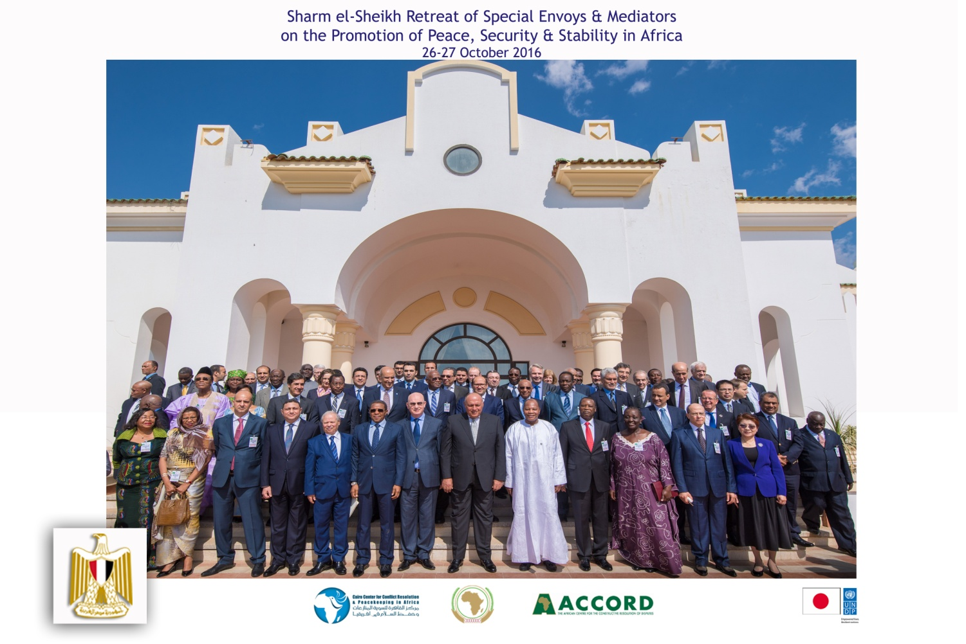

Figure 1: *7th Annual Retreat of Special Envoys and Mediators on the Promotion of Peace, Security and Stability held on 26 and 27 October 2016 in Sharm El Sheikh, Egypt*

The project also served Egypt’s longstanding interest in elevating its contribution to United Nations (UN) peacekeeping both quantitatively and qualitatively. After a period of stagnating contributions to UN peacekeeping, Egypt is now back in the list of the top five police-contributing countries and top ten troop-contributing countries. This happened at a time when peacekeeping continues to be the most important tool available for the international community for achieving and sustaining peace and security, and when the demand for qualified and well-trained peacekeepers continues to surge, reaching records high. In this regard, the project facilitated the training of thousands of Egyptian and African peacekeepers, who were later deployed (or already deployed) to UN/AU peacekeeping missions.

The evaluation also found that the expansion of the project’s outcomes and activities during the second phase [from only covering conflict resolution and peacekeeping areas to include topics such as combating human trafficking and smuggling of migrants, and prevention of radicalization and extremism leading to terrorism (PRELT)] has contributed significantly to enhancing the relevance of the project in the context in which it was (and is being) implemented. This expansion was also in line with the importance attached to both topics in Egypt’s (and Japan’s) foreign and international cooperation policies.

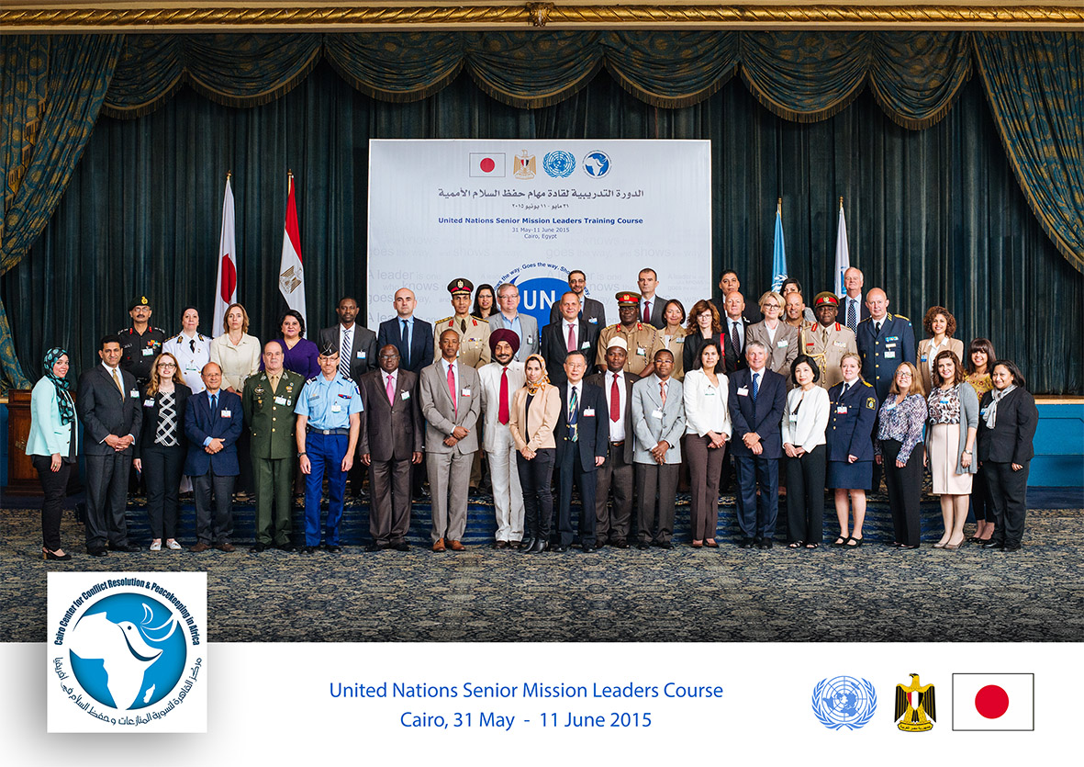

Figure 2: *Participants of the 21st Session of the UN Senior Mission Leaders Course held from 31May-11 June 2015 in Cairo, Egypt*

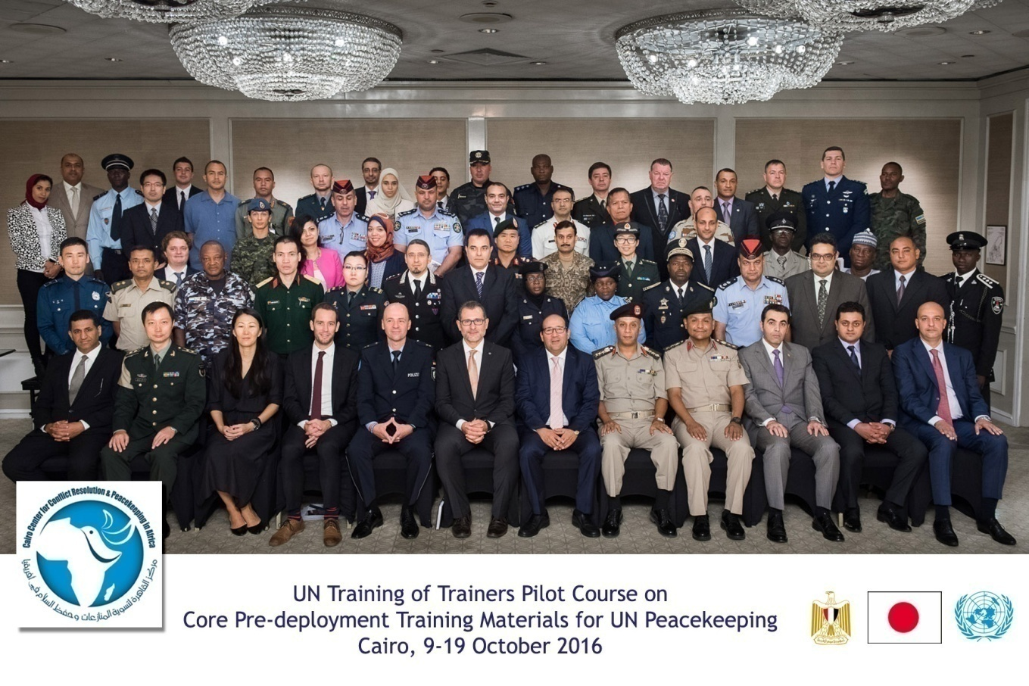

Figure 3: *Participants of the UN Global Training of Trainers (ToT)Course on Core Pre-deployment Training Materials held from 9-19 October 2016 in Cairo, Egypt*

The project also helped consolidate Egypt’s longstanding position as a “pillar of multilateralism”, which gained additional impetus during the last two phases of the project with Egypt’s (and Japan’s) candidacy--and then membership--of the UN Security Council. During that period, the project supported the organization of major regional events, as part of the regional consultations of the strategic reviews of UN peacekeeping operations and peacebuilding architecture and the global debates that ensued.

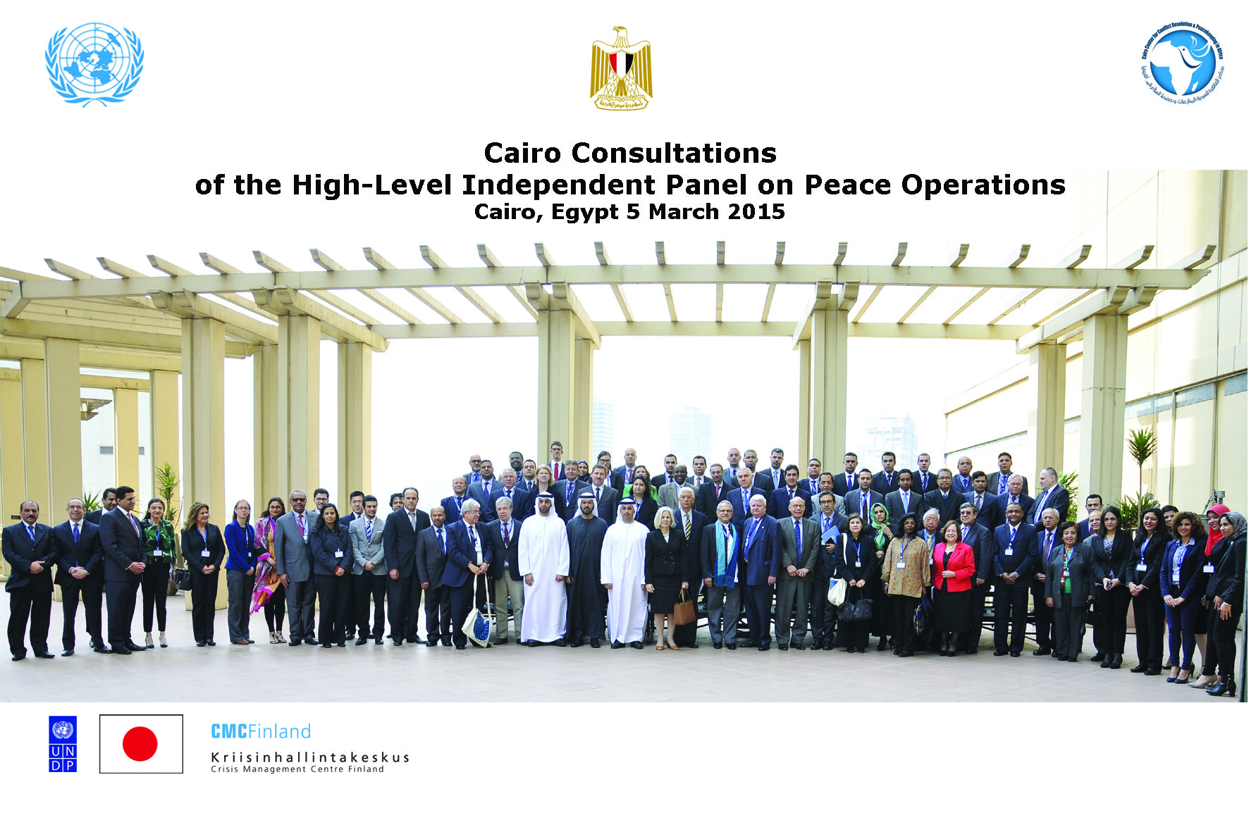

Figure 4: *Participants of the Middle East and North Africa Consultations of the High-level Independent Panel on Peace Operations held on 5 March 2015 in Cairo, Egypt*

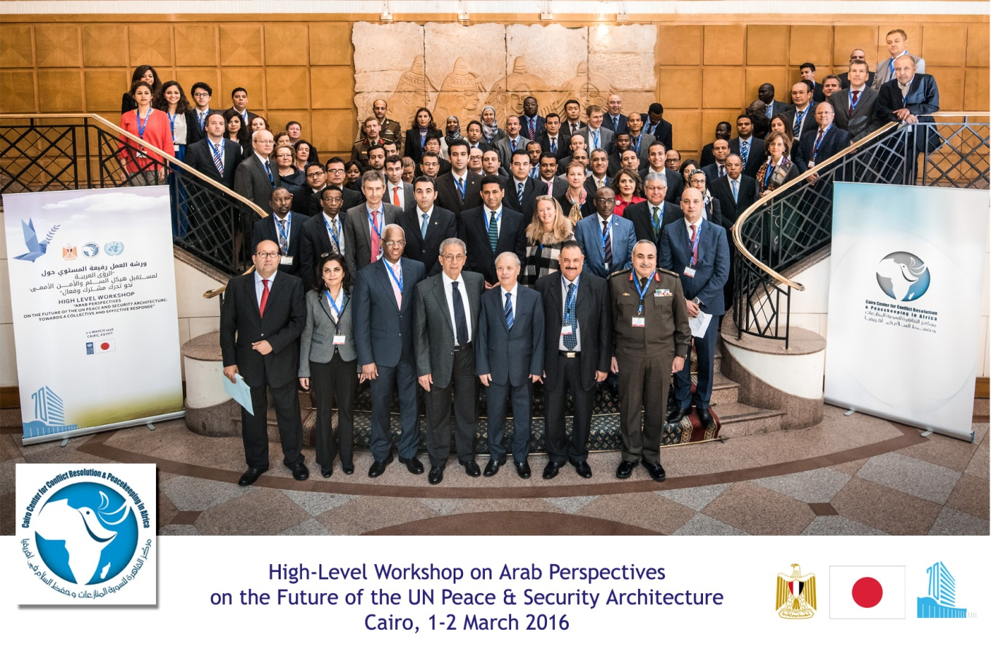

Figure 5: *Participants of the High-Level Workshop on “Arab Perspectives on the Future of the UN Peace & Security Architecture held on 1 and 2 March 2016 in Cairo, Egypt*

The project was also found to contribute to the attainment of the objectives of Japan’s foreign policy and official development assistance, in particular contributing to the “peace and development of the international community”. The project’s outcomes and activities contributed to meeting the benchmarks set by the Yokohama Action Plan (2013-2017) in key areas, including supporting the African Peace and Security Architecture and enhancing the capacities of regional economic communities and mechanisms in Africa. According to the Japanese ambassador in Cairo, “*the number of peacekeepers trained by CCCPA alone exceeded the total targeted number of trainees according to the Yokohama Action Plan*”.

The project also supported preparations for the TICAD VI Summit, held in Nairobi, Kenya on 27 and 28 August 2016. For this purpose, and during the period 2016-2017, CCCPA organized two workshops in Cairo and Addis Ababa. The events provided opportunities for multiple stakeholders, including the AU, the governments of Egypt and Japan, and TICAD partners (UN, UNDP, World Bank and AU), to explore synergies between the African Peace and Security Architecture and the TICAD process, including the Yokohama Action Plan and the Nairobi Declaration.

The project was also found to be relevant to the attainment of the UNDP’s mandate; including the achievement of the 2030 Sustainable Development Agenda, in particular Sustainable Development Goal (SDG) 16 (peace, justice and strong institutions), SDG 5 (gender equality) and SDG 17 (partnerships).

As for AFRICA,the project was able to meet the demands of the African countries ,as far as the improved knowledge in border management in North Africa and the Sahel , greater understanding of and skills in peacekeeping and peace building issues in North Africa , the Sahel and the Great Lakes . The project was , also able to provide for better knowledge and skills in conflict resolution and crisis management in these regions . It was also relevant to other crisis and issues such as : migration , human trafficking and trade in small arms .

The project has also showed remarkable efficiency in the inclusion of mainstreaming gender and empowering women in Peace and Security and increasing the role of women in peace building and preventing extremism in the African countries.

Last, but not least, trainees and participants of the project’s activities expressed a high degree of satisfaction with the quality of the events they attended. The project’s M&E reports show that participants particularly valued CCCPA’s good organization and logistics during activities, the high quality of course material provided, and the fact that useful concept notes were sent before the courses. They also highly appreciated the opportunity to network and share experiences with other participants.

While government officials continue to constitute the bulk of beneficiaries of CCCPA’s trainings, the PRELT program extended the project’s reach to local communities. The unique approach adopted by the program (rules and ethics of war and peace in Islamic Sharia), was found not only to be a groundbreaking effort, but also extremely relevant to the needs of community leaders and influencers. In the words of a high-ranking Somali official, CCCPA trainings have “*changed the thinking capacity of the Mogadishu Municipal staff on security and radicalization ideologies. They have shared the knowledge and experiences they have learned with the communities at large in Mogadishu City, as well as with the Municipal staff. The training outcome has made a real difference in our understanding of radicalization and extremism*”.

**Second: Efficiency/Management**

The project’s efficiency was assessed by relating outputs to inputs and examining the appropriateness of management structures.

The project was found to be cost-efficient. Consecutive external audits have also showed that the project has abided by UNDP’s financial and administrative rules and regulations. Early planning and competitive agreements with major local suppliers has helped to significantly drive down the costs of major items. In addition, and equally important, the remarkable improvement in CCCPA’s institutional capacity–especially during the period from 2014 to date–have also helped reduce costs.

A clear indicator of the enhanced institutional capacity is the sharp increase in the number of trainings conducted and events (conferences, workshops, roundtables, etc.) organized annually, as well as the dramatic surge in the number of trainees, as illustrated in the graphs below.

**Graph A – Number of Trainings (January2008-December2016)**

**Graph B- Number of Trainees (January2008-December2016)**

As a result of the improved efficiency and management, the number of trainings and trainees have, on many occasions, surpassed those targeted in the project’s document. Tables (1), (2), and (3) below compare the project’s stated targets with actual deliverables for the period 2014-2017.

**Table (1)**

**Enhancing the Capacity of Local Actors in Efforts to Improve Peace and Stability in**

**North Africa, the Sahel and Great Lakes (1 March 2014–31 October 2015)**

|  |  |  |  |  |
| --- | --- | --- | --- | --- |
| **Output** | **Number of Trainings/Workshops** | | **Number of Trainees** | |
| **Target** | **Actual** | **Target** | **Actual** |
| Output (1) Improved knowledge in border management in North Africa and the Sahel | 12 | 13 | 275 | 236 |
| Output (2) Greater understanding ofand improved skills in peacekeeping and peacebuilding issues in North Africa, the Sahel and Great Lakes Region | 12 | 13 | 200 | 1,385 |
| Output (3) Improved knowledge and skills in conflict resolution and crisis management in North Africa, the Sahel and Great Lakes Region | 12 | 14 | 300 | 330 |

**Table (2)**

**Consolidating Peace, Security and Stability in Africa (1 April 2015–30 October 2016)**

|  |  |  |  |  |
| --- | --- | --- | --- | --- |
| **Output** | **Number of Trainings/Workshops** | | **Number of Trainees** | |
| **Target** | **Actual** | **Target** | **Actual** |
| Output (1) Enhanced African capacities PRELT | 6 | 6 | 100 | 102 |
| Output (2) Improved African capacities in conflict resolution, peacekeeping and peace-building | 6 | 13 | 100 | 4,306 |
| Output (3) Enhanced African capacities in border and crisis management ( including international/regional management of trans-boundary natural resources) | 5 | 7 | 117 | 125 |

**Table (3)**

**Consolidating Peace, Security and Stability in Africa 2 (1 April 2016–31 March 2017)[1]**

|  |  |  |  |  |
| --- | --- | --- | --- | --- |
| **Output** | **Number of Trainings/Workshops** | | **Number of Trainees** | |
| **Target** | **Actual** | **Target** | **Actual** |
| Output (1) Enhancing African capacities in dealing with cross-border challenges: terrorism and extremism leading to it, organized crimes and illegal migration/ human trafficking | 5 | 2 | 42 | 100 |
| Output (2) Enhancing African capacities in peacekeeping and peacebuilding | 8 | 9 | 120 | 2,677 |
| Output (3) Enhancing African capacities in conflict resolution and crisis management | 4 | 2 | 80 | 40 |
| Output (4): Support of TICAD activities | 2 | 1 |  | 28 |

Another aspect of the project’s efficiency that has been examined is whether or not the project’s activities were implemented on time. This issue was closely examined as CCCPA had requested an extension of the project in two consecutive fiscal years (2014-2015 and 2015-2016).In 2014-2015, the request was justified based on the savings from the exchange rate variation and to allow for the hosting of the UN Senior Mission Leaders training course in May-June 2015 and the CCCPA International Advisory Board Meeting in August 2015.In 2016, the extension request was based on the challenges of obtaining timely clearance from relevant authorities; a necessity for the implementation of the PRELT program.

It should be noted, however, that no such extension has been requested for the current phase of the project (2017). According to the Director of CCCPA, the 2017 project will finish on time and planning for the implementation of the 2017-2018 phase is in its final stages; another indication of the improved efficiency of the project.

To appreciate the extent of the project’s enhanced performance highlighted above, a thorough analysis of the appropriateness of CCCPA’s institutional structure was conducted, with a particular emphasis on organizational changes introduced during the period 2014-2017. These changes (highlighted below)have also helped overcome most of the challenges identified in the previous project review [Project Evaluation and Macroeconomic Analysis (PEMA) Report], thus easing in the process of transition into a results-based management approach.

* **The establishment of a Knowledge Creation and Management Department:** The period 2014-2017 saw the establishment of several knowledge creation and management structures:
  + **The establishment of five thematic departments**: Peacekeeping; Peacemaking and Peacebuilding; Transnational Threats; PRELT; and Women, Peace and Security.
  + **The establishment of CCCPA’s research unit**: This unit serves as the Center’s intellectual hub--conducting needs assessments, developing and updating training manuals and materials, as well as concept notes and reports for the Center’s conferences, workshops and roundtables.

As a result of these developments, CCCPA was able to accomplish the following:

* + Develop its own training manuals, toolkits, handbooks, exercises, etc.
  + Publish the first ever research paper on Egypt’s Contribution to peacekeeping, covering both doctrinal and policy aspects
  + Produce research outputs, some of which were turned into UN documents, while others were published by leading global research centers, namely
    - *General Assembly, Sixty-ninth session, Agenda Item 29*: Report of the Peacebuilding Commission (A/69/654-S/2014/882)
    - *African Regional Consultation on the UN General Assembly Debate on UN, Peace and Security* (4 March 2016, Addis Ababa) co-authored with NUPI, ACCORD and Training for Peace
    - *Setting the Stage for the UNGeneral Assembly’s High-Level Thematic Debate on UN, Peace and Security: Reflections and Key Messages from Regional Meetings*
* **Capacity building of CCCPA staff and ToT:** During the period 2014-2017, CCCPA invested heavily in enhancing the capacity of staff through trainings and mentorship programs. CCCPA also started populating its roster of national, regional and international experts, trainers and facilitators. The project also facilitated commissioning part-time consultants, who, among other things, have assisted in enhancing the Center’s capacity. As a result of these developments, most CCCPA trainings are currently implemented by its staff and experts on its roster. It is noteworthy in this regard, that a member of CCCPA’s staff has been asked to join a UN mobile training unit conducting pre-deployment trainings in Africa; a clear indication of CCCPA’s enhanced capacity.
* **The establishment of a fully-functional M&E unit:** CCCPA has enhanced its M&E system since 2014. M&E is carried out at three levels:
  + The first level of evaluation (reaction/satisfaction) is primarily measured at the end of each training through a questionnaire.
  + Level two of the evaluation (learning/knowledge gained) is measured through pre and post-training questionnaires. Both levels are further evaluated through focus groups conducted at the end of each training.
  + Level three of the evaluation (behavior) is measured through field visits at the end of the project year. This level assesses long-term takeaways from the training courses and their impact on trainees (i.e. how the training has changed the way they implement their jobs). Outcomes of the evaluation feed back into updating training curricula and materials, as well as improving the organizational and logistical aspects of the trainings.
* **The establishment of fully-operational, functional departments:** These departments include logistics, financial/administrative, M&E, outreach and communication, etc.).
* **The establishment of an International Advisory Board:** This advisory board consists of eminent global personalities and leading experts in the field of peace, security and development. Itis responsible for providing strategic counsel on global and regional opportunities and challenges to peace, security and stability. It also supports CCCPA’s global outreach efforts. A list of the board members is included in Annex 1.

**UNDP Contribution**

UNDP has contributed to mobilizing resources for the project since 2008. It has enhanced CCCPA’s capacity by conducting trainings on communication and M&E. UNDP has also supported CCCPA to mainstream gender in its activities in line with UN Security Council, as well as conduct gender disaggregated reporting This is in addition to contributing to enhancing the visibility of the project, CCCPA, and the donor and assisting in the production of a promotional video show casing the Center’s accomplishments.

UNDP also assumes the role of project assurance and supports the Project Board by carrying out objective and independent project oversight and monitoring functions; and by ensuring that implementation is done in accordance with the UNDP National Implementation (NIM) guidelines and that UNDP rules and regulations for recruitment and procurement is followed for all project activities. This role therefore ensures that project results are achieved as planned in a timely and efficient manner.

**Third: Effectiveness**

The project’s effectiveness was evaluated by assessing the extent to which it has achieved its objectives, with a particular focus on the objective of establishing CCCPA as a Center of Excellence. Based on this assessment, the project was found to be highly efficient.

At its start, the project focused on “strengthening the institutional capacity of CCCPA” to become a center of excellence, and in the words of CCCPA’s stated vision at the time “a world class training and research facility on peacekeeping, peacebuilding, conflict resolution and crisis management, with a particular focus on the challenges to peace and security in Africa”. However, and based on previous evaluations of the project, covering the period 2008-2013, these ambitious goals were only partially achieved. According to the mid-term evaluation of the project, conducted by the Center for Project Evaluation and Macroeconomic Analysis of the Egyptian Ministry of International Cooperation, the project was only viewed as efficient in “assisting CCCPA in enhancing its capacity”, while “failing to provide it with an M&E mechanism”.

For the period 2014-2017, however, the project has not only contributed to building the institutional capacity of CCCPA, but has also played a crucial role in elevating its international standing. Today, CCCPA is not only an African Union center of excellence in training and capacity building and the only civilian training center on issues of peace and security in the Arab world, but it has also become a leading contributor to global debates on the future of peacekeeping and peacebuilding, as illustrated from the high-level events organized by the Center.

Specifically, and in collaboration with the UN Peacebuilding Support Office and the Peacebuilding Commission, CCCPA organized the first High-Level Workshop on Regional Aspects of Peacebuilding in 2014. The workshop was part of the strategic review of the UN peacebuilding architecture. The workshop was identified in the Report of the Peacebuilding Commission on its eighth session as an opportunity for the Commission to engage in a dialogue with representatives of African Governments, including countries on the Commission’s agenda and representatives of the AU, the regional economic commissions and research institutes, as well as the World Bank, the African Development Bank and key partner countries. In 2015, CCCPA hosted the Middle East and North Africa Consultations of the High-Level Independent Panel on Peacekeeping Operations (HIPPO). The event not only provided an opportunity for Arab countries to contribute to this important global debate, but also to include many of their recommendations in the final HIPPO report.

As a follow up to these two events, and in preparation for the High-Level Debate on the “Future of UN, Peace and Security”, organized by the President of the General Assembly, CCCPA organized two regional meetings in 2016: a High-Level Arab workshop in Cairo and an African consultation in Addis Ababa. Consequently, CCCPA was selected as one of only three global centers that briefed the High-Level event in New York (May 2016) on the outcomes of the regional consultations[2]. CCCPA also co-organized a ministerial breakfast, in collaboration with the Egyptian permanent mission in New York on the “Continuum of UN Peace Interventions”. The event was a highlight of Egypt’s presidency of the Security Council in May 2016, chaired by the Egyptian Foreign Minister.

During the same period, CCCPA saw a dramatic surge in its regional and international status. In 2015, CCCPA assumed the presidency of the African Peace Support Trainers Association and is currently a member of its management committee. In 2016, CCCPA joined the Executive Committee of the International Association of Peacekeeping Training Centres (IAPTC). Also in 2016, CCCPA assumed the co-chairmanship of the Integrated Disarmament, Demobilization and Reintegration Group. In January 2017, CCCPA assumed the role of Secretariat of the IAPTC for a five-year period (2017-2022), becoming the third center globally--and the first African and Arab center--to assume this role. Related to the above, preparations are underway for hosting the 23rd Annual Conference of the IAPTC, the biggest and most prestigious annual event bringing together peacekeeping training centers from around the world.

The project was also found to have achieved another of its major objectives; namely streamlining gender in peacekeeping and peacebuilding. Despite not being funded as a project outcome during the period 2014-2017, CCCPA delivered 12 foundational courses and 3 ToT courses in cooperation with the Crisis Management Center of Finland (CMC), the League of Arab States, and the Arab Women Organization. CCCPA trainings are based on a training manual and toolkit, developed and regularly updated by CCCPA--in cooperation with partners.

Moreover, and in pursuit of its mandate of training African peacekeepers, CCCPA’s core pre-deployment trainings integrate an intensive module on Gender in Peacekeeping, with a special focus on preventing sexual exploitation and abuse. Since January 2016, CCCPA has conducted 10 courses, training 2,995 Egyptian peacekeepers in total. As a result of all these activities, CCCPA has established a network of experts and practitioners with enhanced knowledge and skills relating to the women, peace and security agenda. In addition, CCCPA has adopted a gender-sensitive approach in all its programs and activities, beyond peacekeeping and peacebuilding, such as human trafficking, smuggling of migrants and PRELT. (CCCPA’s efforts in gender mainstreaming and social inclusion will be addressed in more detail later.)

**Fourth: Impact and Sustainability**

Impact and sustainability were evaluated by assessing the lasting change brought about by the project.

The following positive changes--intended and unintended--were achieved as a result of the project:

* Enhanced African capacities in areas of peacemaking, peacekeeping, crisis management and combating human trafficking.
* Improved resilience of targeted local African communities in PRELT.
* Support of Egypt’s leading role in multilateral organizations, including, most notably, supporting Egypt’s bid for the membership of the UN Security Council, and its subsequent membership of the UN Security Council and the African Union Peace and Security Council.
* Providing valuable opportunities for African and Arab opinions to be considered on critical issues relating to the future of the UN peace and security architecture.
* Enhanced communication between African counterparts working in areas of peace and security, as a result of the networking opportunities created by the project’s activities.

To assess the sustainability of these positive impacts beyond Japanese funding, the question was analyzed in the context of the potential sustainability of CCCPA’s position as a Center of Excellence. In this regard, the evaluation examined the extent to which CCCPA’s managerial and operational improvements have been institutionalized. In particular, the evaluation identified which of the existing structures and functions have the potential of ensuring the sustainability of the project’s benefits. A key finding of the evaluation is that sustainability of the project’s results has improved significantly during the period 2014-2017 as a result of the following:

* The commitment of the Egyptian Ministry of Foreign Affairs and national authorities to the sustainability of the project’s impact and results. According to multiple high-level officials, CCCPA is currently regarded as an important tool of Egyptian foreign policy.
* The establishment of an in-house knowledge creation and management structure, which has moved CCCPA a long way on the road to full institutional ownership of the entire process of development and delivery of trainings.
* The establishment of the International Advisory Board, which provides strategic counsel and additional high-level visibility.
* The establishment of an M&E Unit; thus ensuring quality control and improvement.

Another important aspect to assess the sustainability of project impact, the evaluation also assessed CCCPA’s resource mobilization, partnerships and outreach strategies. While the project continued to be the largest source of funding for CCCPA activities, CCCPA’s consecutive managements have proven capable of mobilizing additional resources of significance.

As an African Union Center of Excellence for the North African Regional Capability (NARC), CCCPA had signed an agreement with the AU to provide capacity building and training activities for the military, police and civilian components of the NARC. CCCPA successfully implemented 11 trainings during the project period (March 2013 to December 2015). The project was funded by the European Union.

Other projects were implemented during the evaluation period, including (i) a multi-year project on “Streamlining Gender in Peacekeeping and Peacebuilding”, implemented in cooperation with the Crisis Management Center of Finland, funded by the Government of Finland; and (ii) two training/research projects with the Ford Foundation. Also during the evaluation period, CCCPA leveraged additional resources for the implementation of major events and trainings, in cooperation with other partners, including most notably the Egyptian Fund for Technical Cooperation with Africa, the Egyptian Agency for Partnership for Development, the UN (Department for Peacekeeping Operations/Integrated Training Service Department, Office for Military Affairs, Peacebuilding Support Office, Peacebuilding Commission, President of the General Assembly, Office of Rule of Law and Security Institutions, etc.)and its agencies (UNDP, UN Women, UN Refugee Agency, United Nations Institute for Training and Research, International Organization for Migration, etc.), the AU, the League of Arab States, the Arab Women Organization, Zentrum für Internationale Friedenseinsätze (ZIF) and International Institute of Humanitarian Law (IIHL).

### In addition to the above, CCCPA has signed a memorandum of understanding with the following organizations: ZIF, IIHL, CMC, United States Institute of Peace (USIP), Assistant Secretary for Preparedness and Response (ASPR), the Sudanese Council for Voluntary Associations, the North Sudan Disarmament, Demobilization, and Reintegration Commission, African Centre for the Constructive Resolution of Disputes(ACCORD), Moroccan Center for Strategic Studies, AGWAD Center for Reconciliation (Sudan), [Ecole de maintien de la paix Alioune Blondin Beye](https://www.google.com.bh/url?sa=t&rct=j&q=&esrc=s&source=web&cd=5&cad=rja&uact=8&sqi=2&ved=0ahUKEwiY8Y_9vvPSAhUBnxQKHTf2B34QFgg-MAQ&url=http%3A%2F%2Freffop.francophonie.org%2Fstructures-de-formation%2Fecole-de-maintien-de-la-paix-alioune-blondin-beye-emp&usg=AFQjCNHI-NgcuV_hXwY2_I0Vj7-X0tXy5w&sig2=rwwfuL_2MqQLeKoikUKENg&bvm=bv.150729734,d.d24) de Bamako (EMP Bamako), African Civilian Stand By Roster for Humanitarian and Peace Building Missions (AFDEM),Geneva Centre for Security Policy (GCSP), Institute of Security Studies (ISS), Scuola Superiore Sant’Anna, Peace Operations Training Institute (POTI), Norwegian Institute of International Affairs (NUPI), Kofi Annan International Peacekeeping and Training Centre (KAIPTC), International Peace Support Training Centre (IPSTC), Libyan National Reconciliation Commission, and Sudan’s Humanitarian Aid.

Another significant, positive change witnessed during the period 2014-2017 is the remarkable improvement in the visibility of CCCPA, the project and its staff, partners (UNDP and Japan), not only as a result of the project’s activities, but also as a direct outcome of CCCPA’s marketing and communication strategy.

In addition to the high-level events and trainings conducted during the implementation of the project and the research produced, CCCPA has successfully relied on social media outlets to improve its visibility. This included launching a new and improved website, a Facebook page, a Twitter account, and a monthly newsletter featuring the Center’s recent and future activities. New promotional materials, including brochures and fact sheets have also been produced. CCCPA has also expanded its outreach to media outlets, both Egyptian and African, including TV channels (a piece on “Women, Peace and Security: The Role of Institutions at Times of Peace and of War in the Arab Region” aired on the BBC Arabic Service), newspapers, and magazines (an article including CCCPA’s PRELT program was published in the US News & World Report). In all such activities, the Center and the project made the visibility of the Government of Japan and the UNDP a priority.

Despite these many advantages and strengths, two interrelated issues have the potential to affect the future sustainability of the project’s impact: namely the autonomy of CCCPA and the financial/administrative implications for CCCPA’s future legal status on the funding of its activities.

Contrary to many similar organizations around the world, CCCPA is--and is expected to continue to being--a government agency. This immediately limits the pool of resources available for funding its activities, as compared to think tanks and training and research centers not associated with governments. To be competitive in raising the necessary resources to fund its expanding activities, CCCPA needs to establish a new legal status, with the maximum possible statutory flexibility, while maintaining policy-level, administrative and financial supervision of relevant national authorities.

While consecutive managements of CCCPA have exerted considerable effort towards establishing the Center as an autonomous entity affiliated with the Egyptian Ministry of Foreign Affairs, including possibly through a presidential decree, these efforts have gained new momentum with CCCPA’s current management, but have yet to yield the desired results.

Another major vulnerability for the sustainability of impact is that with the exception of CCCPA management (a serving diplomat), the hiring of all CCCPA is project-based. This means that CCCPA runs the serious risk of losing part or all of its investment in building its staff capacity. To overcome this problem, the Government of Egypt and some suggested stakeholders, should complement their in-kind contribution to the Center, with annual financial resources to cover the cost of essential staff and overheads.

The Egyptian government and suggested stakeholders should also consider appointing more diplomats and other government officials in top and middle management. This will further improve the Center’s capacity, while ensuring policy-level guidance and oversight.

**Fifth: Gender and Social Inclusion**

The project was found to be highly sensitive to gender and social inclusion. Today, 48% of CCCPA’s staff are women. Moreover, 28% of CCCPA trainees are women (excluding trainees in pre-deployment trainings who are primarily Egyptian military males). While on the face of it, this seems to be a low percentage, it was found to be comparable with--if not exceeding--the global ratios of about 23-24% in similar training organizations.

The project was also found to be in line with SDG5 of promoting gender equality and empowering women. In addition, the project’s (and other CCCPA) activities were found to advance the implementation of the women, peace and security agenda (UN Security Council Resolution1325 and subsequent resolutions), while paying due attention to the particularities of the Arab and African regions.

Based on interviews with national, regional and international stakeholders, CCCPA was found to have actually established itself as a pioneer in streamlining gender in peacemaking, peacekeeping and peacebuilding, with a particular focus on the MENA region. It is worth noting in this regard, that the Arab Women Commission, during its last meeting (held in Manama, Bahrain), directed its Secretariat to work closely with CCCPA on building Arab capacities in the field of women, peace and security.

Consistent with the above, the Director of the Women and Children Department in the League of Arab States expressed her satisfaction with the level of cooperation with CCCPA on women, peace and security issues, including in the implementation of the Arab Regional Strategy and Plan of Action on Women, Peace and Security adopted by Member States in 2015. In the same vein, the Regional Director of UN Women expressed his appreciation for the high degree of professionalism of CCCPA management and staff, as demonstrated in the implementation of joint projects.

**7. Main Challenges and Recommendations**

**Implementation Challenges**

With regards to challenges facing the implementation of the project, the following were identified by CCCPA management, staff and stakeholders:

* **Lack of long-term financing arrangements:** Long-term financing would support the upscaling of CCCPA’s activities in niche areas in which it has already established for itself beyond peacekeeping, including mediation; PRELT; combating human trafficking and smuggling of migrants; and women, peace and security. The success of such efforts is essential for the long-term financial sustainability of the Center.
* **Short-term funding cycle**: While highly appreciative of the continued support of the Government of Japan since 2008, CCCPA management and national stakeholders highlighted the short span of the funding cycle during the second phase of the project (one year) as an obstacle to long-term planning. CCCPA management expressed interest in exploring additional sources of funding from Japan with longer funding cycles (2-3 years minimum).
* **Challenges to M&E:** CCCPA staff reported some difficulties encountered in reaching out to a sizable portion of CCCPA’s alumni, most notably military and police participants, due to their deployment to peacekeeping missions or the standard restrictions imposed by their organizations. However, the M&E unit--with the help of Egyptian embassies/missions abroad--has managed to overcome this challenge, mainly through conducting field visits and meeting with officials in their home countries.
* **Operational challenges:** CCCPA management and staff highlighted that operational challenges reported in the earlier evaluation (the 2014 PEMA evaluation), as a result of the fast-moving political situation in Egypt during the period 2011-2013, are no longer a concern. During 2013, CCCPA’s contingency plans, which included moving events outside Tahrir Square and having closer coordination with relevant Egyptian authorities, helped to deliver the project’s expected outputs. As such, no interruptions or cancellations of scheduled events, out of security concerns, were reported for the period 2014-2017.

**Recommendations for CCCPA**

* Establish the following departments, and employ highly qualified personnel:
  + - Fundraising
    - Communication and Outreach
    - Human Resources
* Improve the Center’s pedagogical capacities
* Move to the implementation of advanced training courses and ToT programs

**Recommendations for the Government of Egypt**

* Establish the Center’s autonomy, as an entity of the Ministry of Foreign Affairs, with flexible statutory authority that would enhance the Center’s ability for financial management and sustainability
* Provide larger premises for CCCPA to accommodate the rapid growth in staff numbers

**Recommendations for the donor community and UNDP**

* Provide the necessary resources to upscale CCCPA’s activities, including in the areas of mediation; combating human trafficking and smuggling of migrants; PRELT; and women, peace and security
* Support CCCPA’s move to a larger premises, with state-of-the-art training equipment

**Annex 1 – International Advisory Board Members**

|  |  |  |
| --- | --- | --- |
|  | **Board Member (Name & Title)** | **Country** |
|  | **H.E. Amre Moussa – Chairman of the Board**  *Former Secretary General of the League of Arab States* | Egypt |
|  | **H.E. Kenneth Kuanda**  *Former President of Zambia* | Zambia |
|  | **H.E. José Ramos-Horta**  *Former President of Timor Leste& Chairman of the High Level Independent Panel for the Review of Peacekeeping Operations* | Timor Leste |
|  | **H.E. Joaquim Chissano**  *Former President of Mozambique* | Mozambique |
|  | **H.E. Dileita Mohamed Dileita**  *Former Prime Minister of Djibouti* | Djibouti |
|  | **H.E. Edem Kodjo**  *Former Prime Minister of Togo*  *Former Secretary-General of the Organization of African Unity* | Togo |
|  | **H.E. Dr. Salim Ahmed Salim**  *Former Secretary-General of the Organization of African Unity* | Tanzania |
|  | **H.E. Lakhdar Brahimi**  *Former Minister of Foreign Affairs* | Algeria |
|  | **H.E. Minister Moushira Khattab**  *Former Minister of Family & Population* | Egypt |
|  | **H.E. Mary Chinery-Hesse**  *Former Deputy-Director General of the International Labor Organization* | Ghana |
|  | **H.E. Dr. Sukehiro Hasegawa**  *Former SpecialRepresentative of the Secretary-General to Timor Leste* | Japan |
|  | **H.E. Ambassador. Hesham Badr**  *Assistant Minister of Foreign Affairs for Multilateral & International Security Affairs* | Egypt |

**Annex 2 – List of Documents Reviewed**

1. Concept Note for Egypt Peacekeeping Center - 2007
2. Terms of reference for assessment missions - 2008
3. Report of Assessment Mission to UNDP on CCCPA by ICT4 Peace Foundation and the Geneva Centre for Security Policy
4. PEMA report 2014
5. Quarterly and final UNDP reports for the years 2014/2015/2016
6. Brief papers issued by CCCPA

**Annex 3 – Events Attended During Evaluation Period**

1. Training on combating human trafficking and smuggling of migrants, Cairo, 6-10 November 2016.
2. AU High-Level Retreat for Peace Envoys and Mediators in Africa, Sharm El Sheikh, 26-27 October 2016.
3. The UN Global ToT Course on Core Pre-Deployment Training Materials, Cairo, 9-19 October 2016.
4. Training on mainstreaming gender in peacekeeping and peacebuilduing, Cairo, 19-22 November 2016.

**Interviews Conducted During the Evaluation Period**

|  |  |
| --- | --- |
|  | **(Name & Title)** |
|  | **Group Interview -** *UN ToT course participants* |
|  | **Ambassador Magued ABDEL AZIZ -** *Under Secretary General & Special Adviser on Africa* |
|  | **Ambassador Magued ABD-EL FATTAH -** *Ministry of Foreign Affairs - Egypt* |
|  | **Ambassdor Amgad ABDEL GHAFOUR -** *Assistant Foreign Minister for African Organizations - Ministry of Foreign Affairs, Egypt* |
|  | **Ambassador Osama ABDEL KHALEK -** *Deputy Assistant Foreign Minister for Cabinet Affairs -Ministry of Foreign Affairs, Egypt* |
|  | **Minister Plenipotentiary Amr AL JOWAILY -** *Director of UN Affairs -Ministry of Foreign Affairs, Egypt* |
|  | **Ms. Naglaa ARAFA -** *Governance Team Leader and Assistant to the Resident Representative UNDP-Egypt* |
|  | **Ambassador Hecham BADR -** *Assistant Foreign Minister for Multilateral Affairs - Ministry of Foreign Affairs, Egypt* |
|  | **Mr. Rafael BARRIERI -** *Mentor at UN ToT course* |
|  | **Mr. El-Mostafa BENLAMLIH -** *Acting Permanent Representative- UNDP- Egypt* |
|  | **Counselor Hatem ELATAWY -** *Project Manager of the ‘Sustaining Peace and Stability in Africa Project’ implemented by CCCPA* |
|  | **Mr. Karim EL KHASHAB -** *Ministry of Foreign Affairs, Egypt* |
|  | **Ms. Nadine EL KORAYEIM -** *Researcher on Cross-border Challenges and M&E Assistant-CCCPA* |
|  | **Lt. Colonel Mohamed EL MOBAIDY -** *Jordan* |
|  | **Ambassador Mohamed GHONEIM -** *Deputy Assistant Foreign Minister for Immigration and Refugees and Combat Against Human Trafficking – Ministry of Foreign Affairs, Egypt* |
|  | **Mr. Vasu GOUNDEN** *- Director of Accord – South Africa* |
|  | **Ambassador Mohamed IDRISS -** *Assistant Foreign Minister for African Affairs – Ministry of Foreign Affairs, Egypt* |
|  | **Ambassador Takeheiro KAGAWA -** *Embassy of Japan in Egypt* |
|  | **Ms. Iman KEIRA -** *Program Coordinator and Head of M&E Unit-CCCPA* |
|  | **Brig. Gen. Ehab KHEDR** *- Military Advisor -CCCPA* |
|  | **Dr. Inas MEKKAWI -** *Director of Women, Family and Child Department - League of Arab States* |
|  | **Mr. Mohamed NACIRI-***Regional Director-UN Women* |
|  | **Ambassador Mahmoud NAEL -** *Deputy Assistant Foreign Minister for African Organizations - Ministry of Foreign Affairs, Egypt* |
|  | **Mr. Stephan SHWARZ -** *Mentor at UN ToT course* |
|  | **Ms. Mahitab SAAD** *- Training Officer- CCCPA* |
|  | **Ms. May SALEM -** *Program Associate for Cross-border Challenges- CCCPA* |
|  | **Ambassador Soad SHALABY -** *Former Director of CCCPA, 2008-2011* |
|  | **Colonel Nozomu SHIMIZU -** *Defense Attaché - Embassy of Japan in Egypt* |
|  | **Counselor Ashraf SWELAM -***Director of CCCPA* |

**Annex 4- List of Acronyms and Abbreviations**

|  |  |
| --- | --- |
| **ACCORD** | African Centre for the Constructive Resolution of Disputes |
| **AU** | African Union |
| **CCCPA** | Cairo Center for Conflict Resolution and Peacekeeping in Africa |
| **CMC** | Crisis Management Centre Finland |
| **HIPPO** | High-Level Independent Panel on Peacekeeping Operations |
| **IAPTC** | International Association of Peacekeeping Training Centers |
| **IIHL** | International Institute of Humanitarian Law |
| **M&E** | Monitoring and Evaluation |
| **MENA** | Middle East and North Africa |
| **NARC** | North African Regional Capability |
| **PEMA** | Project Evaluation and Macroeconomic Analysis |
| **PRELT** | Preventing Radicalization and Extremism Leading to Terrorism |
| **SDG** | Sustainable Development Goal |
| **TICAD** | Tokyo International Conference on African Development |
| **ToT** | Training of Trainers |
| **UN** | United Nations |
| **UNDP** | United Nations Development Programme |
| **ZIF** | Zentrum für Internationale Friedenseinsätze |

1. Figures include statistics from 1 April 2016 to 31 December 2016
2. Other notable international events organized by CCCPA during the period 2014-2017 include the 7thAfrican Union High-Level Retreat for Peace Envoys and Mediators in Africa (also hosted at the Center, a high-level roundtable with the President of the General Assembly on the “UN at Crossroads”, and hosting the Assistant Secretary-General for Rule of Law and Security Institutions for an discussion about “Strategic Turns in Peacekeeping Operations.”