**Project N °: 00073902**  
  
  
**Title of the project:**  
Financial Sustainability of  
National System of Protected Areas (SNAP), Ecuador  
  
  
**ANNEXES OF THE FINAL EVALUATION**  
  
  
**March 2017**

Consulting Team:  
Marlon Flores  
Jorge Leiva

Content  
  
Annex 1. Terms of Reference…………………………………………………………….. 3  
Annex 2. Itinerary of the Final Evaluation Mission……………………………... 4  
Annex 3. List of persons interviewed…………………………………………………. 5  
Annex 4. Sample attendance lists at the EF mission……………………………..7  
Annex 5. Revised documents…………………………………………………………….. 9  
Annex 6. Matrix of evaluation questions…………………………………………... 14  
Annex 8. Project staff table 2011-2016, and at the end………………………23  
Annex 9. List of projects financed by the MFC …………………………………...25  
Annex 10. Sample of PSF Products and Profile ………………………………….26  
Annex 11. Method to estimate the cost reduction in MFC…………………. 27  
Annex 12. Responses to Comments on the Draft Report…………………….29

### Annex 1. Terms of Reference

(Separate Document)

### Annex 2. Itinerary of the Final Evaluation Mission

### 

### Annex 3. List of persons interviewed

| *N°* | *Nom* | *Surname* | *Title* | *Organization* | | *Email* | *date* |
| --- | --- | --- | --- | --- | --- | --- | --- |
| 1 | Flavio | Celín | PSF Advisor | Consultor Independiente | [flaviocelin@gmail.com](mailto:flaviocelin@gmail.com) | | 14-10-2016 |
| 2 | Diego | Cushquicullma | RPFCU Administrator | Reserva de Producción de Fauna Chimborazo | [diego.cushquicullma@ambiente.gob.ec](mailto:diego.cushquicullma@ambiente.gob.ec) | | 15-10-2016 |
| 3 | Poirl | Castedo | Natural heritage | MAE-Chimborazo | [alberto.castedo@ambiente.gob.ec](mailto:alberto.castedo@ambiente.gob.ec) | | 15-10-2016 |
| 4 | Mónica | Murillo | Financial Administrative Unit | DPACH | monica.murillo@ambiente.gob.ec | | 15-10-2016 |
| 5 | Marcelo | Pino |  | Dirección MAE Chimborazo | [marcelo.pino@ambiente.gob.ec](mailto:marcelo.pino@ambiente.gob.ec) | | 15-10-2016 |
| 6 | Mario | Cuup | Forestry Technician | DPACH | mario.cuup@ambiente.gob.ec | | 15-10-2016 |
| 7 | Juan | Zoala | Coordinador of the Project | GAD Provincial de El Oro | jualtogg@hotmail.com | | 17-10-2016 |
| 8 | Wilson | Romero | Profesor UTMACH | UTMACH | [wromero@utmachala.edu.ec](mailto:wromero@utmachala.edu.ec) | | 17-10-2016 |
| 9 | Rodrigo | Gastibon | President | ASOGROTEM La Tembladera | [comuna.sanjacinto@hotmail.com](mailto:comuna.sanjacinto@hotmail.com) | | 17-10-2016 |
| 10 | Nayla | Quintana | Administor | ASOGROTEM La Tembladera | nayla.asogrotem@gmail.com | | 17-10-2016 |
| 11 | René | Bochiqui | Secretary | ASOGROTEM La Tembladera | [rebochiqui@gmail.com](mailto:rebochiqui@gmail.com) | | 17-10-2016 |
| 12 | Héctor | Ramirez | Tourism Management | ASOGROTEM La Tembladera | olcidosf.s@hotmail.com | | 17-10-2016 |
| 13 | Jayser | Ruiz | President | GAD PR Bellavista | [jayser_ruiz84@hotmail.com](mailto:jayser_ruiz84@hotmail.com) | | 17-10-2016 |
| 14 | Marcelo | Ramírez | Ex President | Red de Bosques | [sabiaesperanza@hotmail.com](mailto:sabiaesperanza@hotmail.com) | | 18-10-2016 |
| 15 | Jorge | Hidalgo | Coordinador | CNBRPE | [Jhidalgo.hidalgo71@gmail.com](mailto:Jhidalgo.hidalgo71@gmail.com) | | 19-10-2016 |
| 16 | Andrés | Aguirre | Presidente | CNBRPE | [redbosques@hotmail.com](mailto:redbosques@hotmail.com) | | 19-10-2016 |
| 17 | Rodrigo | Araneda | Secretary | CNBRPE | [rodrigoaraneda@gmail.com](mailto:rodrigoaraneda@gmail.com) | | 19-10-2016 |
| 18 | Manuel |  | Secretary | San Pablo |  | |  |
| 19 | Francisco | Núñez | Administrador PNC | Parque Nac. Cotopaxi | [gregorio.nunez@ambiente.gob.ec](mailto:gregorio.nunez@ambiente.gob.ec) | | 20-10-2016 |
| 20 | Martha | Vega | Craftsman | APIDT | 0997127676 | |  |
| 21 | Hilda | Vega | Craftsman | APIDT | 0998290233 | |  |
| 22 | Pedro | Vega | Craftsman | APIDT | 0987324131 | |  |
| 23 | Blanca | Quindigalle | Craftsman | APIDT | 0989787665 | |  |
| 24 | Lorena |  | Craftsman | APIDT | 0983496759 | |  |
| 25 | María | Ibaquiche | Craftsman | APIDT | 0990020326 | |  |
| 26 | EDER | Armijos | Environmental technician | SGA GADPEO |  | |  |
| 27 | David | Zaldumbide | PSF Technician | MAE | david.zaldumbide@ambiente.gob.ec | | 13-10-2016 |
| 28 | Giovanna | Robayo | AP Tourism Technique | MAE | giovanna.robayo@ambiente.gob.ec | | 13-10-2016 |
| 29 | Zornitza | Aguilar | PSF Project Coordinator | MAE | zornitza.aguilar@ambiente.gob.ec | | 13-10-2016 |
| 30 | Juan Carlos | Andrade | Responsible Result 1 PSF | MAE | Juan.andrade@ambiente.gob.ec | | 14-10-2016 |
| 31 | Paola | Guijarro | Responsible PSF | MAE | jenny.guijarro@ambiente.gob.ec | | 14-10-2016 |
| 32 | Johanna | Veloz | UN-PSF Volunteer | MAE | johanna.veloz@ambiente.gob.ec | | 14-10-2016 |
| 33 | Juan Carlos | Rivera | PSF Technician | MAE | juan.rivera@ambiente.gob.ec | | 14-10-2016 |
| 34 | Mariela | Garrido | PSF Monitoring and Monitoring Technician | MAE | mariela.garrido@ambiente.gob.ec | | 14-10-2016 |
| 35 | Marcela | Torres | UAP Coordinator | MAE | marcela.torres@ambiente.gob.ec | | 14-10-2016 |
| 36 | Verónica | Lasade | DNB lawyer | MAE | veronica.lasade@ambiente.gob.ec | | 14-10-2016 |
| 37 | Nelly | Paspool | FAP-DNB technique | MAE | nelly.paspool@ambiente.gob.ec | | 14-10-2016 |
| 38 | Joci | Oni | Planner | MAE | joci.oni@ambiente.gob.ec | | 14-10-2016 |
| 39 | Leonidas | Corbo | Assistant | MAE | henry.corbo@ambiente.gob.ec | | 15-10-2016 |
| 40 | Paul | Castedo | Technician | MAE |  | | 15-10-2016 |
| 41 | Cesm | Chimborazo | Park ranger | MAE | cesm.chimborazo@ambiente.gob.ec | | 15-10-2016 |
| 42 | Pedro | Vaca | SPA-4 | MAE-RPFCH | pedro.vaca@ambiente.gob.ec | | 15-10-2016 |
| 43 | Antonio | Morales |  | ESPOCH |  | | 15-10-2016 |
| 44 | Naomí | Niebel | Agronomist |  |  | | 15-10-2016 |
| 45 | Noé | Rodríguez | teacher | ESPOCH |  | | 15-10-2016 |
| 46 | Maritza | Vaca | teacher | ESPOCH |  | | 15-10-2016 |
| 47 | Manuel | Guolone | Case Condes |  |  | | 15-10-2016 |
| 48 | Myriam | Poray | RPFCH Specialist | MAE-RPFCH |  | | 15-10-2016 |
| 49 | Olmedo | Coyombe | Project Coordinator | CORDTUCH | corporacion@cordtuch.org.ec | | 15-10-2016 |
| 50 | Mario | Levi | Forestry Technician | MAE-DEPACH |  | | 15-10-2016 |
| 51 | Miguel | Marijón |  |  |  | | 17-10-2016 |
| 52 | Jorge | Hidalgo | CICOP Project Coordinator | CNBRPE |  | | 17-10-2016 |
| 53 | Germán | Collaguaso | Project Coordinator | Yunguilla |  | | 17-10-2016 |
| 54 | Byron | Amaya | UAP Specialist | MAE-DNB | byron.amaya@ambiente.gob.ec | | 17-10-2016 |
| 55 | Sebastián | Sierra | UAP Specialist | MAE-DNB | marcelo.sierra@ambiente.gob.ec | | 17-10-2016 |
| 56 | Juan | Rivera | PSF Technician | MAE | juan.rivera@ambiente.gob.ec | | 17-10-2016 |
| 57 | Luis | Suarez | Director | CI-Ecuador | lsuarez@conservation.org | | 09-12-2016 |

### Annex 4. Sample FE attendance lists

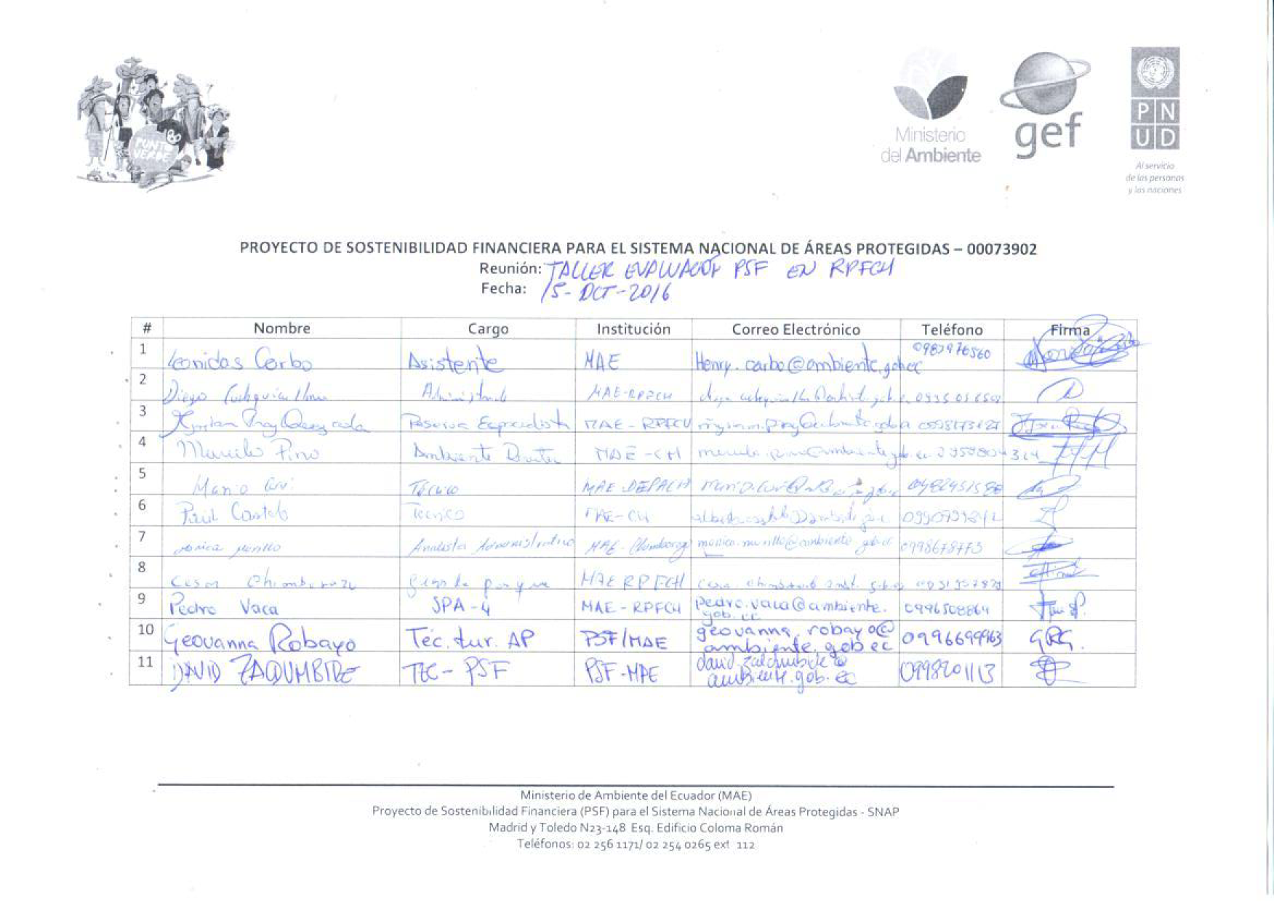

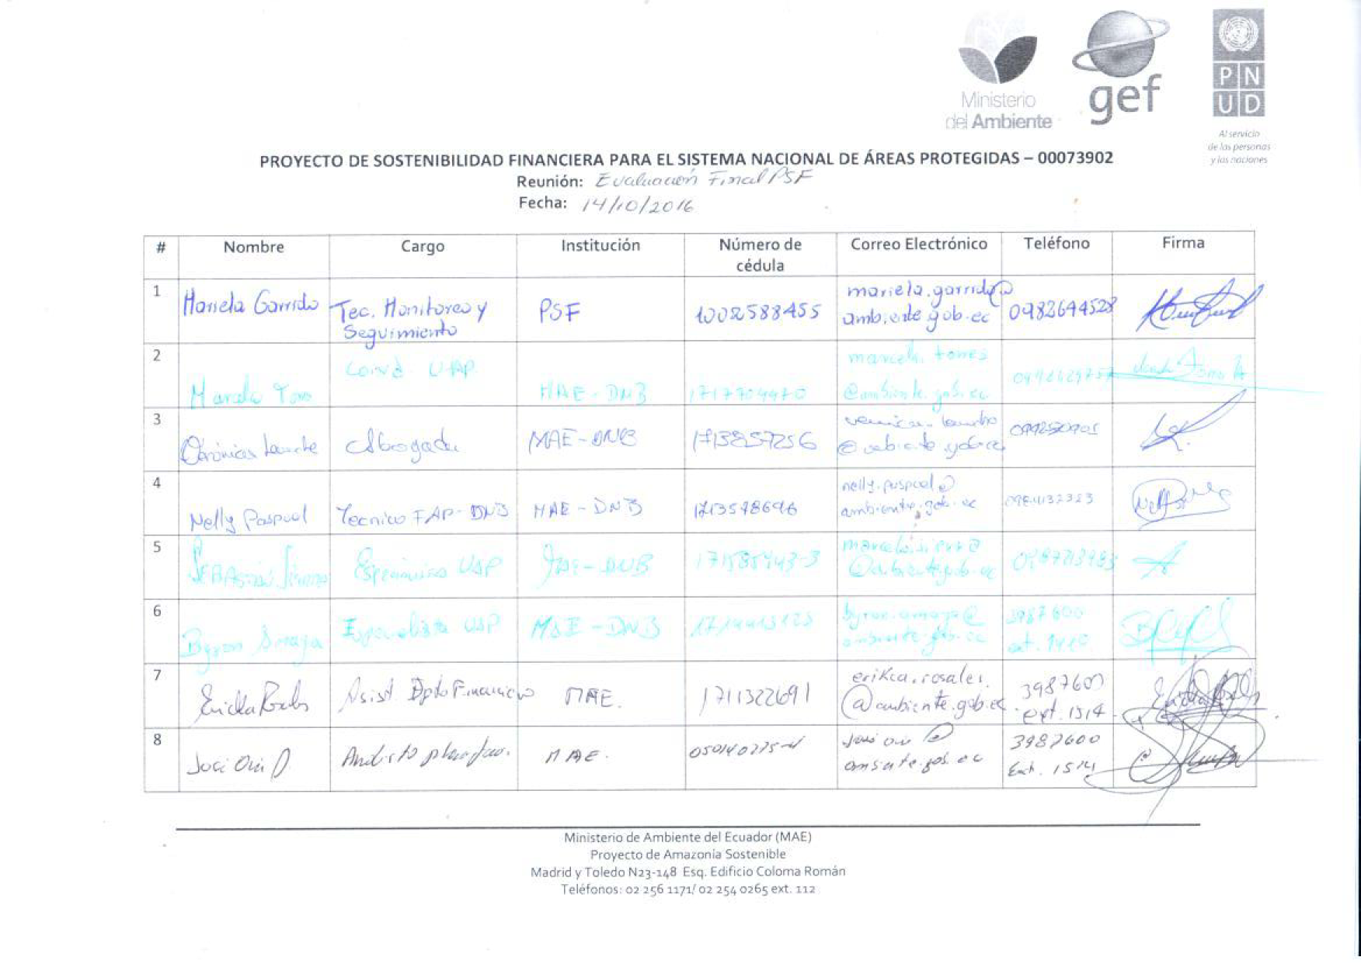

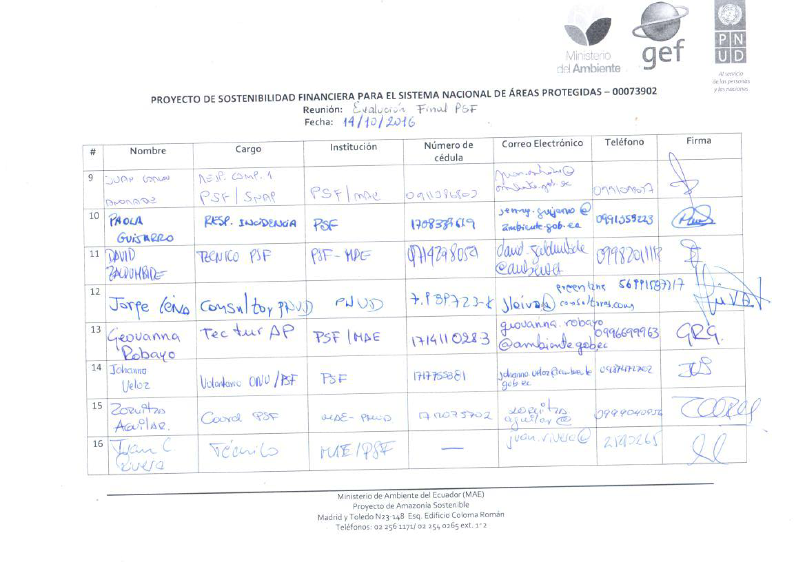

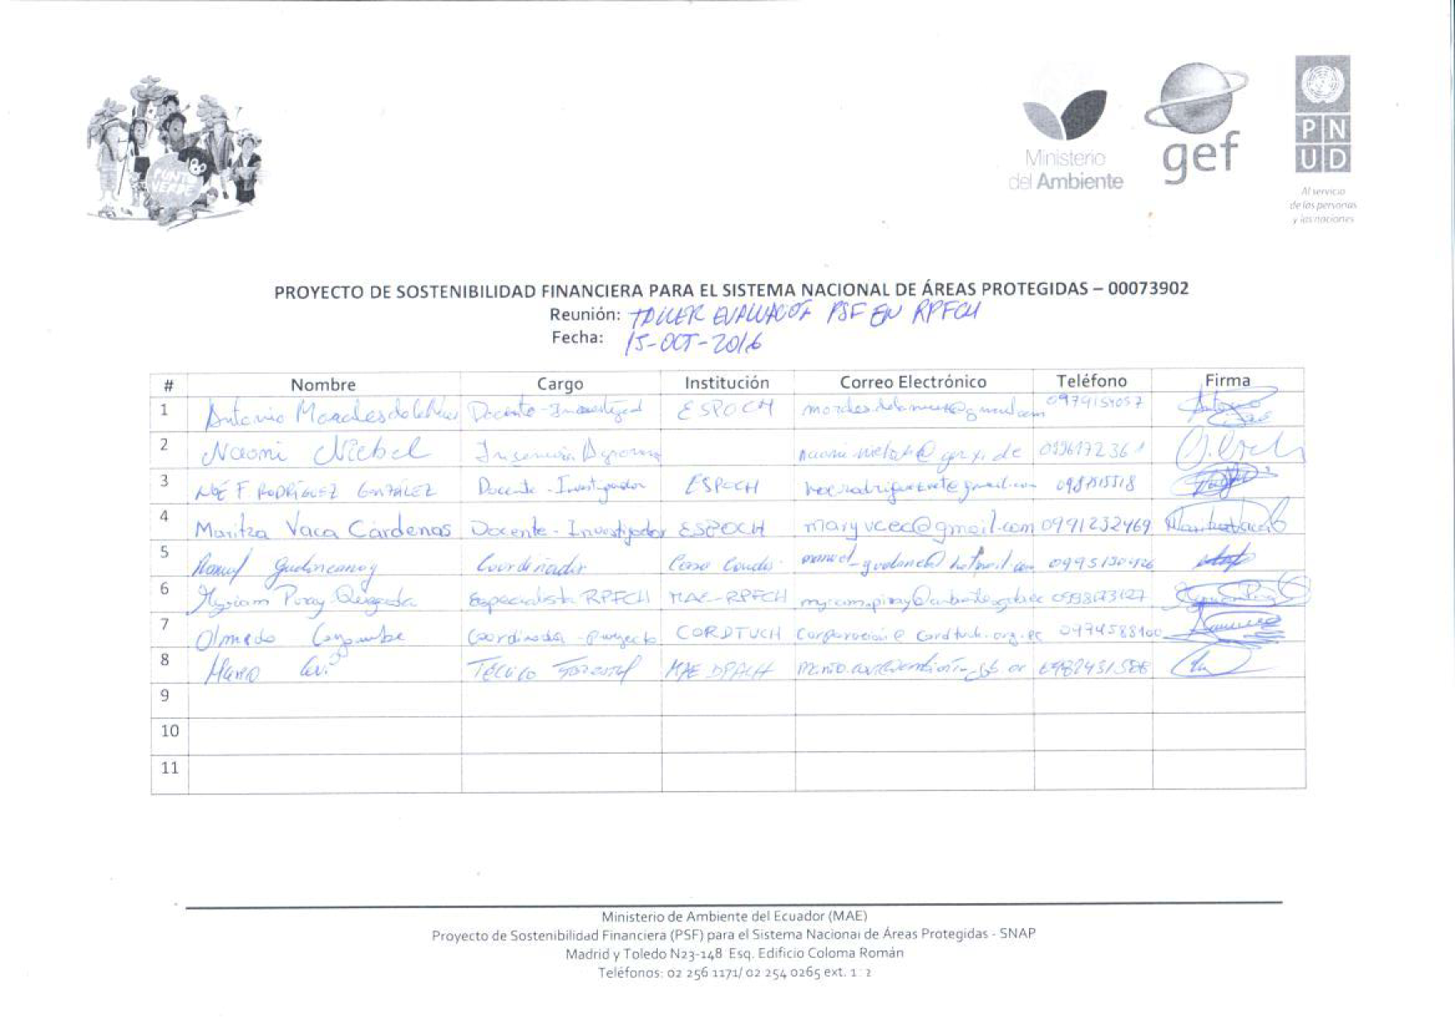

### Annex 5. Revised Documents

| Nº | Name of the document |
| --- | --- |
| 1 | 11.10.2016 CNBRPE.pdf |
| 2 | 13-10-2016 Registration Support EF PSF.pdf |
| 3 | 14-10-2016 Registration Support EF PSF.pdf |
| 4 | 15-10-2016 Registration Support EF PSF.pdf |
| 5 | 17-10-2016 EF PSF Support Record.pdf |
| 6 | 1-Incentives-environmental1.pdf |
| 7 | 20160922 Consolidated Matrix.xlsx |
| 8 | 4142-Biodiversity-2016 PIR Report.docx |
| 9 | AA 03052016.pdf |
| 10 | AA 08082014.pdf |
| 11 | AA rate 07102015.doc |
| 12 | AA rate 09122015.doc |
| 13 | AA rate 17092015.doc |
| 14 | AA rate 18092015.doc |
| 15 | AA rate 18092015_FINAL.doc |
| 16 | AA rate 18112015-cinthy.doc |
| 17 | AA rate 22102015.doc |
| 18 | AA rate 22102015.pdf |
| 19 | AA rate 24082015FINAL.doc |
| 20 | AA Rate 24082015FINAL.pdf |
| 21 | AA rate 29102015.doc |
| 22 | AA rate 29102015.pdf |
| 23 | Acta 06032014.pdf |
| 24 | Acta agreements 14012014.docx |
| 25 | Agreements Presentation Presentation Evaluation Fees Product 2.docx |
| 26 | Agreements Presentation Presentation Evaluation Fees Product 2.pdf |
| 27 | Minutes Agreement Meeting 06032014.docx |
| 28 | Agreement Agreements Meeting 24032014_Editado.pdf |
| 29 | Minutes of the meeting 29102014.docx |
| 30 | Minutes of the meeting 29102014.pdf |
| 31 | ACCUMULATED_GASTS GEF AND UNDP September 2016.xlsx |
| 32 | Adjustment to PRODOC 2014.pdf |
| 33 | AM 025.pdf |
| 34 | AM 04042016.docx |
| 35 | Annex 10_Actas Advisory Committee CI-TNC-FAN-CNBRPE-PNUD.pdf |
| 36 | Annex 12_Matrix Criteria Selection MFC.xls |
| 37 | Annex 16_Convention Cooperacio Klein Tours.docx |
| 38 | Annex 17_Coaching matrix articulation project.pdf |
| 39 | Annex 18_Comments Financial Report CNBRPE.xlsx |
| 40 | Annex 20_Actas discussions with CNBRPE.pdf |
| 41 | Annex 21_POP of CNBRPE security items.xlsx |
| 42 | Annex 22_Communications from the CNBRPE to PSF.docx |
| 43 | Annex 23_ Acta definitive agreements CNBRPE.pdf |
| 44 | Annex 25_AM National Incentives Program.docx |
| 45 | Annex 27_Accepts of substantial termination CICOP.pdf |
| 46 | Annex 3_PRODOC.pdf |
| 47 | Annex 4_Ppt RSC - Sociobosque - private sector.pptx |
| 48 | Annex 5_Acta Agreements CDN 22.01.2016.pdf |
| 49 | Annex 9_ Methodology Evaluation Contracts.pdf |
| 50 | Annex prodoc 2013.pdf |
| 51 | Annex_14 Cost Benefit Analysis MFC.xlsx |
| 52 | AR 05042016.pdf |
| 53 | Protected Areas of Ecuador.pdf |
| 54 | Help Proposed report Patents 01 03 16_GRG.docx |
| 55 | Bulletin summary projects MFC.pdf |
| 56 | Financial gap AP pilots PSF - PANE.xls |
| 57 | Demand Calculation.xlsx |
| 58 | CALCULATION PATENTS TOUR OPERATION TERRESTRE.xlsx |
| 59 | CALCULATION RATES MAE2016-1.xls |
| 60 | CALCULATION RATES PERMANENT AND TEMPORARY USE.xls |
| 61 | RSC Catalog.pdf |
| 62 | CDR 2011.pdf |
| 63 | CDR 2012.pdf |
| 64 | CDR 2013.pdf |
| 65 | CDR 2014.pdf |
| 66 | CDR 2015.pdf |
| 67 | CDR April-June 2016 2T by fund.pdf |
| 68 | CDR Jan-March2016 1T by fund.pdf |
| 69 | ESF Documentation System - SNAP.docx |
| 70 | Encounter.docx |
| 71 | BETWEEN FORESTS AND TEMBLADERA.pptx |
| 72 | Kitchen equipment.xlsx |
| 73 | SNAP Financial Sustainability Strategy.pdf |
| 74 | Strategy Output.doc |
| 75 | Study of Needs-SNAP-ART-FINAL-To-Web.pdf |
| 76 | Evaluation_Cafetería El Morro_REMACOPSE_revision_ABC.docx |
| 77 | Evaluation_Cafetería El Morro_REMACOPSE_revision_ABC.pdf |
| 78 | Standard Recipe Format FIN.xlsx |
| 79 | PSF Expenses.pptx |
| 80 | Buying Guide Equipment.docx |
| 81 | GuideEEM.pdf |
| 82 | Guide-Methodology-Evaluation-of-EffectivenessManagementPatrimonyAreas-PG.pdf |
| 83 | Santay Report 09072014.doc |
| 84 | Technical Report Santay Zz.docx |
| 85 | Guidelines for the elaboration of financial sustainability plans.pdf |
| 86 | Social_list_VESNAP.xlsx |
| 87 | MAE-SPN-2016-0152.pdf |
| 88 | MANUAL MAINTENANCE PANE.pdf |
| 89 | MATRIX RESTAURANTS ECU.xlsx |
| 90 | MATRIX INTERNATIONAL RESTAURANTS.xlsx |
| 91 | Output matrix PSF.xlsx |
| 92 | Mechanisms PSF_SGMC.pdf |
| 93 | Mechanisms PSF_SGMC.pptx |
| 94 | Technical Report RATES.doc |
| 95 | MENU.docx |
| 96 | METT CNBRPE.xlsx |
| 97 | METT PANE.xlsx |
| 98 | METT_La Tembladera.xlsx |
| 99 | MFC.pdf |
| 100 | Observations PSF_Modelo Standard.docx |
| 101 | Actual weather Santay 22062016.pdf |
| 102 | ORGANIZATION MAE.png |
| 103 | PIR 2016 FINAL.xlsx |
| 104 | PIR 2016 FINAL.xlsx |
| 105 | BUSINESS PLAN CHALLUA MIKUNA ok.pdf |
| 106 | POA 2012 PSF.xlsx |
| 107 | POA 2013 PSF.xlsx |
| 108 | POA 2014 PSF.xlsx |
| 109 | POA 2015 PSF.xls |
| 110 | POA 2016 PSF.xls |
| 111 | POA plurianual.doc |
| 112 | PPT Mintur 110416.pdf |
| 113 | PPT Mintur 110416.pptx |
| 114 | PPT Mintur 290416_Version 2.pdf |
| 115 | PPT Mintur 290416_Version 2.pptx |
| 116 | PPT_PSF_10052016.pptx |
| 117 | BUDGET FOOD AND BEVERAGES.xls |
| 118 | Spanish ProDoc signed 00073902.pdf |
| 119 | Spanish ProDoc signed 00073902.pdf |
| 120 | Prodoc-color-AV.pdf |
| 121 | PRODUCT 1 SOCIALIZATION 300616.pdf |
| 122 | PRODUCT 2 Technical Document.doc |
| 123 | PRODUCT 2 Technical Document.pdf |
| 124 | PRODUCT 2_Tarifas PANE260116.pdf |
| 125 | PRODUCT 3 RATE INGRESO_080916.pdf |
| 126 | Model_model.pdf |
| 127 | PROJECTION RATES 161115.pptx |
| 128 | PSF Summary Zz2.pdf |
| 129 | R1 legal framework.pdf |
| 130 | R2 Capacities.pdf |
| 131 | R3 Rating.pdf |
| 132 | R4 Pricing Models.pdf |
| 133 | RA 01032016.pdf |
| 134 | Registration 03052016.pdf |
| 135 | Registration 05042016.pdf |
| 136 | Registration 06032014.pdf |
| 137 | Registration 08082014.pdf |
| 138 | Record 1503204.pdf |
| 139 | Registration 18112015.pdf |
| 140 | Registration 18122013.pdf |
| 141 | Registration 24032014.pdf |
| 142 | Record_22102015.pdf |
| 143 | Registration_24082015.pdf |
| 144 | Record_29102014.pdf |
| 145 | Registration07102015.pdf |
| 146 | Record17092015.pdf |
| 147 | Record29102015.pdf |
| 148 | Summary Contracts and Agreements ANR Isla Santay Final.xlsx |
| 149 | Executive Summary Santay.doc |
| 150 | EXECUTIVE SUMMARY VALUATION.pdf |
| 151 | Summary PSF Mechanisms 12052016.pptx |
| 152 | Summary PSF Mechanisms 17062016.pptx |
| 153 | Summary Socialization 4 to 11 April 2016.docx |
| 154 | RMT Management Plan PSF.xlsx |
| 155 | RMT PSF.pdf |
| 156 | Scan Asociacion Artesanal Malecon de Salinas.pdf |
| 157 | Scan concession Bicycle rental in REMACOPSE.pdf |
| 158 | Scan cafeteria concession in the area mirador el morro.pdf |
| 159 | Scan cafeteria concession in the Chocolatera of REMACOPSE.pdf |
| 160 | 11.10.2016 CNBRPE.pdf |
| 161 | 13-10-2016 Registration Support EF PSF.pdf |
| 162 | 14-10-2016 Registration Support EF PSF.pdf |
| 163 | 15-10-2016 Registration Support EF PSF.pdf |
| 164 | 17-10-2016 EF PSF Support Record.pdf |
| 165 | 1-Incentives-environmental1.pdf |
| 166 | 20160922 Consolidated Matrix.xlsx |
| 167 | 4142-Biodiversity-2016 PIR Report.docx |
| 168 | AA 03052016.pdf |
| 169 | AA 08082014.pdf |
| 170 | AA rate 07102015.doc |
| 171 | AA rate 09122015.doc |
| 172 | AA rate 17092015.doc |
| 173 | AA rate 18092015.doc |

### Annex 6. Matrix of evaluation questions

| Evaluation criterias | Evaluation Questions | Indicadors/standars of success | Source of data | Method and instruments of recollection of data |
| --- | --- | --- | --- | --- |

|  |  |  |  |  |
| --- | --- | --- | --- | --- |
| Relevance: (i) The measurement to which an activity is aligned with local and national development priorities and organizational policies, including modifications over time; (Ii) The measurement to which the project is aligned with the GEF operational programs or with the strategic priorities on which the project was funded. Note: In retrospect, the issue of relevance often becomes a question about whether the objectives of an intervention or its design are relevant datas changes in circumstances. | | | | |
| GEF Priorities | How does the project contribute to ensuring sustainable finance for PAs? | I) incorporation of financial mechanisms for PAs; Ii) incorporation into the design project of considerations of sustainable use of DB in economic activities. | (I) GEF operational programs; (Ii) GEF strategic objectives; (Iii) Prodoc; Iv) project progress reports; V) reports MINTUR, MAE | I) documentary review; Ii) interviews |
|  | How does the project contribute to the diversification of income to ensure the management of the PAs meet their objectives? | (I) incorporation into the project of financial sustainable sources over time. | (I) Prodoc; (Ii) national and local regulations; Iii) project reports; (Iv) studies; V) reports MINTUR, MAE; Vi) Acts of directive committee. | I) documentary review; Ii) interviews |
|  | The project is aligned with GEF priorities regarding the implementation of protected areas the sustainable exploitation of its biodiversity? | I) development of a sustainable exploitation model of DB in the project. | (I) GEF operational programs; (Ii) GEF strategic objectives; (Iii) Prodoc; Iv) work in progress reports; V) reports MINTUR, MAE. | I) documentary review; Ii) interviews |
|  | Does the project support the efforts made by other international conventions and agreements on DB? | I) project coordination with other ongoing activities related to DB protection | I) co-financing reports; Ii) acts of directive committee; Iii) project reports; Iv) GEF focal point reports | I) documentary review; Ii) interviews |
|  | How does the project support to increase the portrayal of the terrestrial AP system? | I) Activities with the forest network; Ii) increase of income and organization of the network to manage PPPs so that they fulfill their objectives. | I) co-financing reports; Ii) Acts of directive committee ; Iii) project reports; Iv) forest network reports. | I) documentary review; Ii) interviews |
| BD Focal Area | Does the project support the biodiversity focal area and strategic priorities? | I) N ° consultations and meetings held with Ecuador's GEF focal point; Ii) incorporation of GEF priorities into government policies, plans and programs as a result of the project .. | I) co-financing reports; (Ii) Acts of executive group; Iii) project reports; Iv) GEF focal point reports+ | I) documentary review; Ii) interviews |
| UNDP Priorities | To what extent does the project align with institutional reform priorities and MAE capacity building to plan, sustainably use and conserve DB? | I) development of a sustainable exploitation model of DB in the project; (Ii) gender considerations and minority groups incorporated into the design and implementation of the project; Iii) use of planning methodologies and techniques in AP; Iv) development of financial mechanisms and income diversification in PA. | (I) UNDF; (Ii) CP; (Iii) PIR / APT; (Iv) Prodoc; V) project reports | I) documentary review; Ii) interviews |
|  | Is the project within the priorities and program lines of the CP of UNDP and UNDAF? | (I) incorporation of UNDAF and CP priorities into project design and implementation | (I) UNDAF; (Ii) CP; (Iii) PIR / APT; (Iv) Prodoc; V) project reports | I) documentary review; Ii) interviews |
|  | Is the project aligned with UNDP gender equity criteria? | I) gender considerations and minority groups incorporated into the design and implementation of the project | (I) UNDAF; (Ii) CP; (Iii) PIR / APT; (Iv) Prodoc; V) project reports | I) documentary review; Ii) interviews |
|  | How does the project support Ecuador's environmental and development priorities? To what extent has the project responded to changing national and partner priorities on financial and sustainable use of biodiversity? | I) inclusion of government priorities contained in plans and programs, within the design and execution of the project; Ii) New regulations and improvements of the current ones as a consequence of the execution of the project; Iii) number of new jobs thanks to the project. | (I) Prodoc; (Ii) national and local government plans; (Iii) national and local policies; (Iv) national and local plans for actors | I) documentary review; Ii) interviews |
|
|  | Is the project within government programs in terms of financing and use of the biodiversity of the national and local environmental authority? | I) N ° project activities supporting municipalities and provincial environmental authorities; Ii) improvement of the local and national DB status | (I) Prodoc; (Ii) national and local government plans; (Iii) national and local policies; (Iv) national and local plans for actors | I) documentary review; Ii) interviews |
|  | Is the project within the priorities of the Ministry of Tourism? | I) N ° project activities that improve SNAP visits; Ii) Number of tourism operators with sustainable practices; Iii) New tourism guides and regulations | I) MINTUR development plans; (Ii) prodoc; Iii) MINTUR regulations and activities; Iv) budgets MINTUR; V) project reports; (Vi) MINTUR reports. | I) documentary review; Ii) interviews |
| Local Actors | Is the project within the plans, programs and policies of the municipalities involved? | I) Number of consultations and coordination during design and execution of the project; Ii) Number of new employment or poverty reduction. | I) municipal development plans; (Ii) prodoc; Iii) municipal regulations and activities; (Iv) municipal budgets; V) project reports; Vi) municipal reports. | I) documentary review; Ii) interviews |
|  | Does the project respond to the needs and priorities of beneficiary organizations? | I) Number of consultations and coordination during design and execution of the project; Ii) Number of new employment or poverty reduction of communities in PA; Iii) business plans and forest network financing. | I) development plans for local actors; (Ii) prodoc; V) project reports; (Vi) reports and meetings | I) documentary review; Ii) interviews |
| Suitability | Are there logical links between the problem to be solved, the expected results of the project and the project design (in terms of national capacity, project components, choice of partners, structure, implementation mechanisms, scope, budget, resource use, etc.)? | I) n relevant actors and capacities identified during project design and execution; (Ii) project budget appropriate to the activities; (Iii) adequate cause-effect logic; Iv) degree of focus on results and not on activities; V) N ° results and activities appropriate to the project budget. | (I) Prodoc; Ii) minutes of the steering committee; Iii) project reports; Iv) planning activities; V) changes introduced project; (Vi) Annual budgets; PIR / APR; Vii) reports other agencies | I) documentary review; Ii) interviews |
|  | Are the main risks considered? | I) Degree of cause-effect analysis; Ii) adequate identification of actors; (Iii) adequate interpretation of context data; Iv) Number of key stakeholder consultations during project design and execution. | (I) Prodoc; (Ii) MTR; (Iii) Annual planning; (Iv) executive group minutes; Vi) implementation partner reports; PIR / APT | I) documentary review; Ii) interviews |
|
| Effectiveness: To what extent has the initiative achieved the outputs, results and objectives of the project? What internal and external factors explain the results achieved or the lack of results? | | | | |
| Objectives, results and products | Has the project been effective in achieving the expected results? | I) New and adjusted normative number; (Ii) adjusted baseline BD; Iii) BD model designed and working; (Iv) Design and operation of financial mechanisms for PA; V) Number of actors applying business model and new planning tools. | I) Tracking tools; (Ii) project reports; PIR / APR; Iii) sectoral regulations related to DB; Iv) budgets and annual plans institutions involved; V) execution partner reports; (Vi) existing and proposed funding mechanisms. | I) documentary review; Ii) interviews |
|  | Did the project reach or contribute to any unforeseen or unwanted results? | I) N. results not foreseen in the project design. | I) Tracking tools; (Ii) project reports; PIR / APR; Iii) sectorial regulations related to DB; Iv) budgets and annual plans institutions involved; V) execution partner reports | I) documentary review; Ii) interviews |
| Needs of the Beneficiaries (gender and DH) | To what extent has the project responded to national environmental realities (institutional and policy frameworks) and population (inequalities or inequities)? | N ° project activities framed within government programs, plans and policies; Ii) Improvement in DB; (Iii) No. of minorities and gender equity participating in program activities; Iv) Number of expected results implemented. | (I) project reports; (Iii) national and local policies and programs; Iv) executive group minutes; (V) PIR / APR; (Vi) MTR | I) documentary review; Ii) interviews |
| Risks and Assumptions | What external factors have influenced (enhancing or blocking) the scope of the results? How were they managed? | I) N ° consultations and meetings with key stakeholders during project design and execution; Ii) quality analysis identification of actors; Iii) quality contextual analysis (economic, social, needs, etc); Iv) quality cause-effect analysis. | I) prodoc; (Ii) project reports; (Iii) MTR; (Iv) RIP / APR; V) implementation partner reports; (Vi) Acts of executive group meetings | I) documentary review; Ii) interviews |
| Strategy | What has been the quality of the strategies developed, including targeting? Were these suitable? | (I) achievement of project objectives; Ii) Degree appropriation actors; Iii) Degree of inclusion of BD theme in institutions and groups participating in the project. | I) prodoc; (Ii) project reports; (Iii) MTR; (Iv) RIP / APR; V) implementation partner reports; (Vi) Acts of executive group meetings | I) documentary review; Ii) interviews |
| AI, EA (focus on results, risks, response | Was the support for the project provided by UNDP effective? | I) N ° Meeting coordination; Ii) contributions in support of project design and implementation; Iii) Use of "UNDP corporate brand" as conflict facilitator; Iv) quality monitoring and technical advice provided to the project. | I) prodoc; (Ii) project reports; (Iii) MTR; (Iv) RIP / APR; V) implementation partner reports; (Vi) Acts of executive group meetings | I) documentary review; Ii) interviews |
|  | What has been the execution quality by the Implementing Partner? | I) degree of progress activities and achievement of results; Ii) degree efficiency and effectiveness use of project budget; Iii) degree of performance with co-financing; Iv) capacity to involve actors; V) capacity to incorporate cross-cutting BD themes in tourism and productive activities in PA; Vi) degree of improvement in BD status in the intervention areas. | I) prodoc; (Ii) project reports; (Iii) MTR; (Iv) RIP / APR; V) implementation partner reports; (Vi)Acts of the executive group meetings | I) documentary review; Ii) interviews |
| Alliances / links | What has been the level of participation of stakeholders, beneficiaries and partners in the implementation of the project? Were their roles clear? | I) N ° coordination of relevant actors; Ii) N ° meetings and type of decisions taken by the executive group of the project; Iii) roles and responsibilities given to each participant. | I) prodoc; (Ii) project reports; (Iii) MTR; (Iv) RIP / APR; V) implementation partner reports; (Vi) Acts of executive group meetings | I) documentary review; Ii) interviews |
| What alliances / links were relevant to achieving results? |
| GBR / Monitoring (plan, financing, mechanisms, adaptive management) | To what extent did the logical framework, work plans, monitoring and evaluation plan guide results-based project management and support decision-making? Did these tools adapted to provide the necessary flexibility to achieve results? | I) degree of compliance of POA and annual budgets; Ii) Use logical framework for M & E; Iii) M & E system; Iv) adaptive management quality; V) use of tracking tools to verify improvements in BD. | I) prodoc; (Ii) project reports; (Iii) MTR; (Iv) RIP / APR; V) implementation partner reports; (Vi) Acts of executive group meetings; Vii) POAs and annual budgets; viii) Use of tracking tools. | I) documentary review; Ii) interviews |
| Integration | To what extent has the project generated indirect or direct benefits in support of poverty alleviation and governance? | I) Number of employment opportunities created; Ii) business model implemented; (Iv) established local community participation mechanisms. | I) prodoc; (Ii) project reports; (Iii) MTR; (Iv) RIP / APR; V) implementation partner reports; (Vi) Acts of executive group meetings; Vii) POAs and annual budgets; viii) Use of tracking tools. | I) documentary review; Ii) interviews |
| Efficiency: Was the project implemented efficiently according to the international and national standards? | | | | |
| Financiamiento/cofinanciamiento | Did co-financing happen as planned? And if not, how was it complemented? | I) degree of performance with co-financing; Ii) N ° activities carried out with the co-financing. | I) prodoc; (Ii) project reports; (Iii) MTR; (Iv) RIP / APR; V) implementation partner reports; (Vi) Acts of executive group meetings; (Vii) annual POAs and budgets; Viii) Use of tracking tools. | I) documentary review; Ii) interviews |
| Cost / effectiveness factors | To what extent has the implemented strategy maximized the resources available for achieving results? | 1. I) N ° non-redundant activities; (Ii) N ° planned and completed activities; Iii) N ° activities contributing to the results; Iv) activities carried out according to planning; % Of staff resources. | I) prodoc; (Ii) project reports; (Iii) MTR; (Iv) RIP / APR; V) implementation partner reports; (Vi) executive group meetings minutes; Vii) POAs and annual budgets; viii) Use of tracking tools. | I) documentary review; Ii) interviews |
| Implementation IA, EA (timely support) | Was the project support provided by UNDP efficiently? | I) Number of technical consultancies carried out; Number of tenders according to planning; N. facilitation activities. | **\**I) prodoc; (Ii) project reports; (Iii) MTR; (Iv) RIP / APR; V) implementation partner reports; (Vi) executive group meetings minutes; Vii) POAs and annual budgets; viii) Use of tracking tools. | I) documentary review; Ii) interviews |
| Sustainability: Are there any financial, institutional, socio-economic or environmental risks for the sustainability of the project's results and effects, in the long term? | | | | |
| Estrategia | What actions were put in place for the sustainability of the results? How has the project used the dialogue with key partners to influence the national agenda and policies | I) exit strategy; Ii) existence of new regulations tourism sectors, economic activities in AP; (Iii) financial mechanisms and sustainable business models for tourism and economic activities within PAs (SNAP, APP, APC); Iv) income from new economic activities in the PAs. | I) exit strategy; (Ii) replication plan; (Iii) Prodoc; (Iv) project reports; PIR / APR; V) reports implementing partners; (Vi) co-financing reports. | I) documentary review; Ii) interviews |
| What are the key challenges and risks to the sustainability of the results of project initiatives that need to be addressed directly and rapidly? |
| Is the exit strategy explicit? What measures have been introduced to contribute to the sustainability of the efforts made by the project? |
| Institucional | Is there evidence that project partners will pursue the activities beyond the fulfillment of the project? | I) budgets in municipalities, GAD, parish authorities, ministries include resources for BD protection activities in AP; (Ii) resources available to control new regulations; Iii) economic activities in AP include sustainable procedures in their businesses. | I) prodoc; (Ii) project reports; (Iii) MTR; (Iv) RIP / APR; V) implementation partner reports; (Vi) executive group meetings minutes; Vii) POAs and annual budgets, viii) budgets in MAE, MINTUR, Municipalities and local actors. | I) documentary review; Ii) interviews |
| Have the organizations and their internal systems and procedures positively assimilated the results of the efforts made during the project execution time? |
| Is the current capacity suitable to ensure the sustainability of the results achieved? |
| Social, economic and political environment | Were laws, policies and frameworks addressed during the project in order to focus on the sustainability of key reforms and initiatives? | I) N ° regulations introduced by the project; (Ii) No checks carried out by national and local authorities; Number of zoning and financing | **i**  I) development plans for local actors; (Ii) prodoc; (Iii) Community partnership activities and plans; (Iv) forest network budgets; V) project reports; Vi) reports and meetings; Vii) tourism sector regulations and productive activities in AP; (Viii) Co-financing reports | I) documentary review; Ii) interviews |
|  | What is the degree of political commitment to continue working on the results of the project? | (I) Inclusion of BD protection activities in programs, policies of national and local governments; Ii) budgets for BD protection activities in MAE, municipalities and GAD; (Iii) PA management plans incorporating diversified sources of income; Iv) forest network business plans. | I) development plans for local actors; (Ii) prodoc; (Iii) Community partnership activities and plans; (Iv) forest network budgets; V) project reports; Vi) reports and meetings; Vii) tourism sector regulations and productive activities in AP; (Viii) Co-financing reports | I) documentary review; Ii) interviews |
| Are there suitable incentives to ensure the livelihood of the economic and environmental benefits achieved during the project? |
| Catalytic Role: To what extent has the project proved to have a catalytic role in the country or other geographical areas? | | | | |
| Scalability and replicability | How can experience and good practices influence biodiversity conservation and use of strategies? | I) replication plan; Ii) systematization of project experience; Iii) Number of replication activities in other locations. | I) Exit strategy; (Ii) replication plan; (Iii) Prodoc; (Iv) project reports; PIR / APR; V) reports implementing partners; (Vi) co-financing reports; Vii) plans and programs MAE, MINTUR, GAD. | I) documentary review; Ii) interviews |
| Were the capacities of individuals and institutions developed to expand project achievements in the country? |
| How can the country from the success stories of the project, improve the possibility of impact on ongoing and future initiatives? |
| Impact: To what extent has the project achieved impacts or has advanced to achieving the expected impacts and impacts? Have you had unexpected or unwanted effects? | | | | |
| Contribution to the effect | To what extent has the project contributed to the impact of UNDP CPAP: 1.1.1 Collective initiative on positive synergies between the fight against poverty and gender-specific environmental planning; 2.1.1 Number of legal and institutional instruments that support the National Environmental Authority to fulfill its monitoring functions; 3.1.1 Number of financial mechanisms for sustainability designed and implemented in agreement with the actors, men and women alike; 3.2.1 Number of community-based projects on biodiversity management with a gender and intercultural approach implemented; 4.1.1 Number of adaptation policies, strategies, plans and programs within national and local development plans. | (I) introduction of BD protection in national and local budgets; (Ii) financial mechanisms to secure PA income; Iii) models of sustainable management of DB working; Iv) new DB protection regulations; V) improvement in the income of the PA communities | I) tracking tools; (Ii) UNDAF, CP; (Iii) prodoc; Iv) project reports; (V) PIR / APR; Vi) reporting institutions and stakeholders; (Vii) MTR; (Viii) plans and programs related to PA funding and income generation for PA communities; Ix) MINTUR plans, policies and programs. | I) documentary review; Ii) interviews |
| Impacts | **¿**  How does the project contribute to the expected impact on the global environment? | I) results of tracking tools for BD; Ii) BD status; Iii) planning of BD protection activities; (Iv) increased income and diversification for PAs; V) new incorporated PAs that improve and protect the portrayal of these areas. | I) tracking tools; (Ii) UNDAF, CP; (Iii) prodoc; Iv) project reports; (V) PIR / APR; Vi) reporting institutions and stakeholders; (Vii) MTR; (Viii) plans and programs related to income generation for PAs; (ix) plans, policies and programs MINTUR, MAE; X) declaration of new public, private and community PAs. | I) documentary review; Ii) interviews |

### Annex 8. Project staff table 2011-2016, and at the end

### 

|  |  |
| --- | --- |
|  | Staff at the end of the Project |
| 1 | Zornitza Aguilar , **Project Coordinator**  zornitza.aguilar@ambiente.gob.ec |
| 2 | Juan Carlos Rivera, **Specialist in Business Plans**  **juan.rivera@ambiente.gob.ec** |
| 3 | Mariela Garrido, **Specialist in Monitoring and Monitoring** **mariela.garrido@ambiente.gob.ec** |
| 4 | Paola Guijarro, **Responsible for Advocacy, Advocacy and Visibility** **jenny.guijarro@ambiente.gob.ec** |
| 5 | Geovanna Robayo, **Specialist in Tourism of Protected Areas** **geovanna.robayo@ambiente.gob.ec** |
| 6 | Nelly Valles, **Assistant UNDP Procedures**  **nelly.valles@ambiente.gob.ec** |
| 7 | Leonardo Porras , Technical Director Wetland La Tembladera |
| 8 | David Zaldumbide, **Technician in Models of Economic and Financial Management**  **david.zaldumbide@ambiente.gob.ec** |
| 9 | Juan Carlos Andrade, **Responsible for Component 1**  **juan.andrade@ambiente.gob.ec** |

**Annex 9. List of projects financed by the CFM**

|  |  |  |  |
| --- | --- | --- | --- |
|  | MFC benefits and costs per project (in USD) | | |
| Nº | **Project MFC** | **Benefits** | **Costs** |
| 1 | **AGRODUP** | 228.019,00 | 69.065,68 |
| 2 | **ARO** | 144.810,50 | 68.804,74 |
| 3 | **Artelangosta** | 136.878,00 | 59.065,68 |
| 4 | **ASOGROTEM** | 147.040,00 | 68.465,68 |
| 5 | **Caimito** | 77.509,00 | 68.327,68 |
| 6 | **Cerro Seco** | 77.905,00 | 66.177,42 |
| 7 | **Challwa Mikuna** | 115.370,00 | 68.804,74 |
| 8 | **CNBRPE** | 184.111,40 | 165.179,68 |
| 9 | **CORDTUCH** | 100.838,50 | 69.020,68 |
| 10 | **CORTUS** | 91.691,00 | 69.029,68 |
| 11 | **ESPOCH** | 141.812,00 | 68.638,68 |
| 12 | **Flor Andina** | 82.566,49 | 39.065,68 |
| 13 | **HEIFER** | 193.507,24 | 69.065,68 |
| 14 | **Kawsak Sacha** | 78.936,00 | 68.965,68 |
| 15 | **Kawsay - COINOA** | 839.679,70 | 69.065,68 |
| 16 | **Paquiestancia** | 119.468,69 | 49.065,68 |
| 17 | **Quilotoa** | 84.850,00 | 69.065,68 |
| 18 | **San Gregorio** | 100.366,00 | 69.065,68 |
| 19 | **Tamboloma** | 378.224,89 | 68.465,68 |
| 20 | **Yunguilla** | 67.182,00 | 61.065,68 |
|  | **Total** | **3.390.765,41** | **1.403.471,41** |

**Annex 10. Sample of PSF products and profile**

|  |  |  |  |  |  |
| --- | --- | --- | --- | --- | --- |
|  | PSF Products 2010-2016 | AP management | Material to show AP as a good investment | Improving AP's financial management capacity | Tool to mobilize resources or cost savings |
| 1 | Elaboration of law for PAs and new regulatory law for the inclusion of SNAP subsystems |  |  |  |  |
| 2 | Development of policy recommendations and guidelines |  |  |  |  |
| 3 | Elaboration of an expanded technical selection matrix to incorporate new APs |  |  |  |  |
| 4 | Training of institutions is in the new national system of environmental management |  |  |  |  |
| 5 | Technical assistance and workshops to promote SNAP's financial management capacities |  |  |  |  |
| 6 | Strengthening of the CNBRPE to financing mechanisms through the partner program Bosque (support to the understanding of program requirements). |  |  |  |  |
| 7 | Strengthening CNBRPE's access to financing mechanisms through the Socio Bosque Program (support for understanding the program's requirements). |  |  |  |  |
| 8 | Exploration of financing mechanisms with low revolving fund Result N4 |  |  |  |  |
| 9 | Elaboration of criteria to access the revolving fund; |  |  |  |  |
| 10 | Review of the SNAP strategic plan (2007-2016) to incorporate private APs, NAPs and community APs; |  |  |  |  |
| 11 | Update on SNAP financial gaps; |  |  |  |  |
| 12 | Definition of methodology to determine the basic funds required for the new SNAP; |  |  |  |  |
| 13 | Definition of conservation costs in scenarios of climate change and addressing the consequences of climate change; |  |  |  |  |
| 14 | Elaboration of methodology to determine financing in 3 different scenarios and will be applied to all PAs, be they public, private and community. |  |  |  |  |
| 15 | Revenue projection for the entire SNAP, based on the experiences of the 9 pilot areas and the yasuri initiative |  |  |  |  |
| 16 | Elaboration of a business plan for the short, medium and long term of the updated strategic plan for pilot AP. |  |  |  |  |
| 17 | Preparation and implementation of Management and Business plans for the pilot areas; |  |  |  |  |
| 18 | Development of a planning system, M&E of management plan by results, compatible with the one used by the government; |  |  |  |  |
| 19 | Implementation of a training program for financial planning and administration and M&E; |  |  |  |  |
| 20 | Elaboration of technical manuals and use guides, according to the experiences of the pilot areas; |  |  |  |  |
| 21 | Evaluation of the biomass stock, focusing on the economic value of the carbon stocks contained in the NAPs of the PANE (41 AP), to apply REDD + |  |  |  |  |
| 22 | TSA Studies: Tourism and Hydro-energy |  |  |  |  |
| 23 | Company Communication is based on the economic and social value of SNAP / TSA Studies |  |  |  |  |
| 24 | Development of negotiation capacity of financing with different partners, oriented to the MAE, DNBD, local parks |  |  |  |  |
| 25 | Implementation of Net Income Models; |  |  |  |  |
| 26 | Development of Model management for private areas |  |  |  |  |
| 27 | Development of model management for community protected areas |  |  |  |  |
| 28 | SNAP Financial Sustainability Strategy |  |  |  |  |

**Annex 11. Method to estimate the cost reduction in CFF (Compensatory Financing Facility)**

The cost-benefit model, developed by the PSF and its impact levels (included in the Charts below) used to estimate the cost reduction of PA management, is not considered the most appropriate. Cost Benefit (CB) analysis is not the most appropriate tool for this effect.

To define cost savings, it’s necessary to know (have a baseline) the cost of operating each management program of each of the pilot APs where CFMs exist. In addition, to know the level of direct positive impact of the activities supported by MFC projects to one of the conservation strategies of a PA. For example, reducing the level of threats (illegal hunting) that leads to reduce the number of patrols).

From the analyzed documents, it can be seen that the PA budgets are not individualized, nor are they developed on the basis of actual costs by result and linked to specific conservation programs. Indeed, the analyzes of financial gaps are not based on detailed cost analyzes by program and by PA. The gap analyzes create estimations at the SNAP (PANE) level. Without actual cost data from conservation programs at the AP level and the impact of certain CFMs, it is not possible at this time to determine cost savings in a relatively acceptable way.

**Analysis Cost Benefit**

**Parameters**

**AM = AP budget savings**  
 Administration and planning  
 Control and surveillance of Wildlife  
 Biodiversity management and ecosystem restoration  
 Public use and tourism  
 Communication, environmental education  
**RP = Reduction in pressures to RRNN  
BE = Economic Benefits for the communities involved  
AI = Intersectional Associations  
RC = Reduction of conflict**  
**In front of: Investment non-reimbursable resources for each project + the operational cost of the MFC.  
   
AVERAGE OF THE RELATION COST BENEFIT = 2.47**

### Impacts

### linkage

3. Reducing the pressure of ecosystems where the initiatives are implemented

USD 559,188 for the administration and planning program

USD 326,536 for the control and surveillance program

USD 542,867 for the communication program environmental education and participation

USD 404,016 for the public use and tourism program

USD 1558,159 for the biodiversity management program

Estimate the cost at USD 654,334

Reduce conflict and increase the connection with AP

Estimate the cost at USD 226,410

1. Management support and reduction in the cost of managing the PA  
   Total = USD 2,847,899

2. Direct economic benefit of organizations and families involved in the execution of projects

### Annex 12. Responses to Comments on the Draft Report

The first version of the report received 392 comments and 900 editorial corrections, the latest being accepted almost in their entirety, since they helped to improve the accuracy and scope of the text involved. The matrix with the comments made and the answers of the evaluators for each of them, is available if required, since it was not included in the report because it is very extensive (123 pages).

With reference to the comments, the evaluators tried to cover most of these, which can be classified in the following 4 topics:  
  
1. Methodology;

2. Indicators;

3. Conceptual;

4. Miscellaneous (they are comments that try to complete the paragraph involved and that go beyond what was intended to be shown in the report).

**The comments under the 1st and 2nd classification** were mostly welcomed. The evaluators reviewed the UNDP methodology and evaluation report and made the necessary adjustments to the final version, eliminating redundant paragraphs as well as incorporating comments and relocating paragraphs that were in wrong sections.

In reference to the indicators, the main difference is that the evaluators found that the indicators based on the UNDP financial framework were not adequate to reflect the achievement of the project objectives in terms of the advance of financial sustainability. This conclusion was reached because the PAs had not been able to diversify their financial sources, focusing only on the State and some international financial initiatives. Additionally, it was found that most of the pilot areas had no business plans, but rather procedures to elaborate budget.

The other aspect was that the communities revenues that support the management of PAs dropped their revenues after PSF interventions, a situation that would also affect the financial stability of these communities and, therefore, their support to the management of PAs and the adoption of best practices. The PFS considers that achieving the indicators was sufficient to declare the success of the project and its financial sustainability.

**For the comments related to the 4th Category,**

They tried to incorporate the best quality as much as possible and left out from what did not directly contribute to the texts mentioned.  
  
**The comments under the 3rd category** were not welcomed in its entirety. as they revealed a conceptual difference noted between the evaluators and the PSF team, so these differences were shown in the final report of the evaluation, demonstrated the difference in criteria between The evaluators and the PSF.

Indeed, in the texts referring to the low participation of relevant actors (MINTUR, CI, etc.), for example, the PSF confirms that there are minutes of meetings, which would demonstrate the participation of the actors. After reviewing the documentation and the interviews with the key stakeholders, the evaluators endorse that setting up meetings to inform and socialize the project activities is not synonymous with the participation, since the key actors or strategic partners do not participate in the genesis of the activities, their rationality and way of achieving their objectives.

Another aspect related to participation was the observation of the evaluators about the lack of peer reviews of the studies carried out by the PSF. While the PSF reported that there were records in which the final reports were subject to stakeholder review, the evaluators consider that this was not sufficient to ensure the quality of the studies and that the peers were also have to participate in the development of The TDR, the selection of the consultants and the revision of the partial data of the progress of the consultancies. The evaluators consider that, in this way, key information and quality products can be obtained that respond to the needs of the sectors on which it is intended to intervene and that, finally, the loyalty and appropriation of these can be achieved Studies for later application.

With regards to the problems found with the NBPE, the PSF argues that this situation is given too much importance, compared to the remaining project activities. The evaluators consider that it should not be forgotten that the RNBPE is a strategic partner and co-executor of the PSF, being also the individual entity that received the majority of resources from the PSF (about USD 300 thousand), so that its participation was relevant in the context of PSF implementation. On the other hand, the evaluators found that the correspondent works for CICOP were not functional and, therefore, became a serious threat to the future sustainability and efficiency of that investment. The PSF indicated that the works were received as per UNDP norms and national standards, so the subject would be worked out according to these specific standards.

Another of the divergences shown with PSF team is that the evaluators did not find a direct relationship between the different products obtained and the main objective of the project financial sustainability. The most clear example of this dichotomy can be found with CFMs, where the projects are primarily community-based, without a clear component of generating financial mechanisms for PA management.