TERMINAL EVALUATION: ENHANCING ADAPTIVE CAPACITY AND RESILIENCE TO CLIMATE CHANGE IN THE AGRICULTURAL SECTOR IN MALI

MISSION REPORT
10-19 October 2016

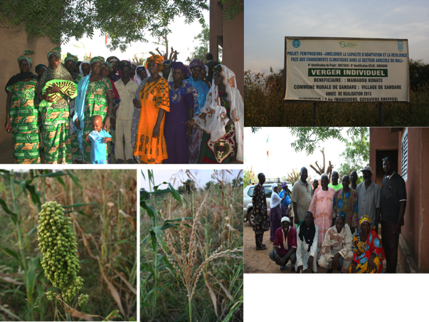

Prepared by:

Jessy Appavoo from SouthSouthNorth
&
Djibril Doucouré from AE2C

November 2016

Table of Acronyms

ACDI | Canadian International Development Agency
AEDD | Environmental and Sustainable Development Agency
CbA | Community-based Adaptation
CCC | Communal Advisory Committee
DNA | National Directorate of Agriculture
EbA | Ecosystem-based Adaptation
ENI-ABT | Ecole Nationale d'Ingénieurs Abderhame Baba Touré
GCAM | Meteorological Assistance Group
GLAM | Multidisciplinary Group for Meteorological Assistance
GEF | Global Environment Facility
IER | Research Institute
IPCC | International Panel for Climate Change
JICA | Japan International Cooperation Agency
LDCF | Least Developed Countries Fund
LDCs | Least Developed Countries
M&E | Monitoring & Evaluation
NAPA | National Adaptation Programme of Action
PDSEC | Economic, Social and Cultural Development Plan (PDSEC)
TE | Terminal Evaluation
UNDP | United National Development Programme
WFP | World Food Programme

Please note that the acronyms listed in italics in the table above and throughout this report highlight the acronyms as they would be used in French.

Table of Contents
Table of Acronyms i
1. Introduction 1
1.1. Introduction to the Evaluation Team 1
1.2. Objective of the Mission Report 2
2. Mission Programme 2
3. Stakeholder Consultations 3
4. Meeting Notes 4
4.1. Meeting with Dr Abdoulaye Bayoko, UNDP 4
4.1.1. History of the project 4
4.1.2. From NAPA to project concept 4
4.1.3. Preliminary results 4
4.2. Meeting with Mrs Niambélé, Project Coordinator 5
4.2.1. Institutional arrangements for the implementation phase 5
4.2.2. Background information 5
4.2.3. Implementation of the project 6
4.3. Meeting with Mr Birama Diarra, Mali-Météo and Project Board Member 8
4.3.1. Technical expertise and experience to address climate change 8
4.3.2. Mali-Météo’s involvement in the project formulation and implementation 8
4.3.3. Selection of project intervention sites 9
4.3.4. Observed climatic trends 9
4.3.5. Mali-Météo’s involvement in developing project outputs 9
4.3.6. Challenges faced in the implementation of the project 9
4.3.7. General remarks 10
4.4. Meeting with Mr Sibiry Bengaly, Project M&E Staff 10
4.4.1. Baseline information 10
4.4.2. Ongoing M&E 10
4.4.3. Results Framework 11
4.5. Focus Group in Massantola 11
4.5.1. Project results from the CCC’s point of view 12
4.5.2. Results and impacts from the beneficiaries’ point of view 12
4.5.3. Capacity-building among beneficiaries 13
4.5.4. Sustainability of the interventions 13
4.6. Focus Group in Sandaré 13
4.6.1. Results and impacts from the beneficiaries’ point of view 13
4.6.2. Results and impacts from the CCC’ point of view 14
4.6.3. Replicating the benefits of the project 14
4.6.4. Capacity-building 14
4.6.5. Challenges faced 15
4.6.6. General remarks 15
4.7. Focus Group with CCC in Cinzana 15
4.7.1. Background information on Cinzana’s CCC 15
4.7.2. CCC’s role and responsibilities 15
4.7.3. Results and impacts of the project 16
4.7.4. Sustainability of interventions 17
4.7.5. Objective of the GCAM 17
4.7.6. Interventions yet to be implemented 17
4.8. Focus Group with beneficiaries in Cinzana 18
4.8.1. Results and impacts from the beneficiaries’ point of view 18
4.8.2. Capacity-building 18
4.8.3. Challenges faced 19
4.8.4. General remarks 19
4.9. Meeting with Project Team 19
5. Project summary 25
5.1. Formulation of the project 25
5.2. Implementation of the project 25
5.3. M&E 26
Preliminary recommendations 26
Annex A: Attendance Registers 27
Annex B: Interventions Financed by LDCF and ACDI 34
Annex C: Photographs of Stakeholder Consultations and Field Visits 38
C.1. Massantola – 13 October 2016 38
C.2. Sandaré– 15 October 2016 39
C.3. Cinzana – 17 October 2016 41

1. Introduction

The project entitled “Enhancing Adaptive Capacity and Resilience to Climate Change in the Agricultural Sector in Mali” started in 2010 and is currently ongoing. The project close-out is expected to take place in December 2016. The project is financed by the Least Developed Countries Fund (LDCF) fund through the Global Environment Facility (GEF). The designated implementing and executing authorities are the United National Development Programme (UNDP) and the National Directorate of Agriculture (DNA).

The project was initially approved for a total of four years – i.e. from 2010 to 2014. The GEF has granted the project a two-year extension at no extra cost. The project is in the last implementation quarter and as part of the contractual obligations to the donor, an independent Terminal Evaluation (TE) of the project needs to be undertaken. The purpose of this TE is to assess: i) the project strategy; ii) the progress towards results; iii) the on-the-ground implementation of the project; and iv) the sustainability of the interventions implemented to achieve the overall objective of the project.

As part of this TE, a mission was undertaken to Mali to collect the necessary information for the criteria mentioned above. The 10-day mission started on Monday 10 October and ended on 19 October 2016. The first part of the mission consisted of the several meetings with key stakeholders who were involved in the formulation and the implementation of the project, including the Project Management Unit at the DNA. The second part consisted of ground-truthing of the information collected from the stakeholders consulted as well as the quality of the interventions financed by the LDCF. During the second part of the mission, the Evaluation Team engaged with the beneficiaries in three out of the six communes selected for the project. The project was implemented in the following communes:

Region | Circle | Commune
Kayes | Nioro | Sandaré
Koulikoro | Kolokani | Massantola
Ségou | Ségou | Cinzana
Sikasso | Koutiala | M’Pessoba
Mopti | Douentza | Mondoro
Gao | Bourem | Taboye

The first three sites in the table were visited during the field mission. A detailed mission programme is included in Section 2.

1.1. Introduction to the Evaluation Team

The Evaluation Team comprised an International Consultant, Jessy Appavoo from SouthSouthNorth, and a National Consultant, Djibril Doucoure from AE2C. The consultants were recruited individually and worked together during the in-country mission and thereafter for the compilation of the evaluation report.

Jessy Appavoo is a social scientist with a focus on food security, and climate change. She has previously worked in the environmental management field and has co-lead several GEF-funded climate change adaptation projects in Africa. Jessy has previously worked on a TE for the Adaptation Fund in Senegal. She is familiar with the requirements of the Global Environment Facility (GEF) as she has previously led and co-led several GEF projects focusing on Ecosystem-based Adaptation (EbA) and Community-based Adaptation (CbA) in Africa. Having developed several logframes and results framework for UNDP and UNEP, she has an extensive knowledge of SMART (Specific, Measurable, Attainable, Relevant, Time-bound) indicators.

Djibril Doucouré graduated in Management at Faculté des Sciences Juridiques et Economiques and has a DESS (Specialized Advanced Studies Degree) in Decentralization and Local Development Engineering. He is a monitoring and evaluation specialist with extensive experience in developing and management of development projects. He was previously the Director of Development Department and Project Monitoring and Evaluation Officer for United States African Development Foundation (USADF) in Mali. He was also the Director of Mission for the establishment of the Informal Sector Support Programme on behalf of the Ministry of SMEs / SMIs in Guinea, Director of Mission for Evaluation and Investigation of the Program Cash For Work ECHO / CARE in Ségou and Mopti. He leads the mission of Monitoring and Evaluation of the External MINUSMA Peace Building Fund Program in the regions of Gao and Timbuktu.

1.2. Objective of the Mission Report

This report provides a breakdown of the activities undertaken during the mission to inform the evaluation of the project, the stakeholders consulted as well as the information collected in-country. The main points discussed with the different stakeholders – either in meetings or in a focus group setting – are included in Section 4 of this report.

2. Mission Programme

Mission programme for Jessy Appavoo and Djibril Doucouré, 10 -19 October 2016

Monday 10 octobre 2016
14h00 | Arrival of International Consultant in Bamako
16h30 - 17h30 | Meeting with Djibril Doucouré, National Consultant
Mardi 11 octobre 2016
10h00-11h00 | Meeting with Dr Abdoulaye Bayoko, UNDP
14h00-17h00 | Meeting with Mrs Niambélé, Project Coordinator
Mercredi 12 octobre 2016
08h45-10h00 | Meeting with Mr Birama Diarra, Mali-Météo Agency
10h30-14h00 | Meeting with Mr Sibiry Bengaly, Project M&E staff
14h15-15h00 | Field mission preparation at the UNDP Office
15h00-16h00 | Meeting with Djibril Doucouré, National Consultant
Thursday 13 October 2016
08h00-17h00 | Travel from Bamako to Massantola
14h00-17h30 | Focus group meeting with beneficiaries and members of the CCC
17h30-19h00 | Visit of on-the-ground activities in Massantola
Friday 14 October 2016
08h00-13h00 | Travel from Kolokani to Sandaré
13h00-16h00 | Focus group meeting with beneficiary groups (women’s associations and cooperatives) and CCC
16h00-18h00 | Visit of on-the-ground activities in Sandaré
Saturday 15 October 2016
08h00-17h00 | Travel from Sandaré to Bamako
Dimanche 16 octobre 2016
8h00-17h00 | Bamako
Monday 17 October 2016
06h00-10h00 | Travel from Bamako to Ségou
10h00-12h00 | Focus Group Meeting with CCC in Cinzana
12h00-14h00 | Focus Group Meeting with beneficiaries in Cinzana
14h00-19h00 | Travel from Ségou to Bamako
Tuesday 18 October 2016
08h30-14h30 | Meeting with the Project Team
Wednesday 19 October 2016
08h30 | End of mission: travel back to Cape Town

3. Stakeholder Consultations

During the course of the 10-day mission, the following stakeholders were consulted:

Date of consultation | Name | Organisation | Role
11-Oct-16 | Dr Abdoulaye Bayoko | UNDP | Programme Technical Advisor
11-Oct-16 | Mrs Niambélé | DNA | Coordinatrice du projet
12-Oct-16 | Mr Birama Diarra | Mali-Météo | Project Board Member
13-Oct-16 | Mons Sibyli Bengaly | DNA | M&E staff member
14-Oct-16 | See Annex A | Jekabaara Cooperative of Massantola | Beneficiaries
14-Oct-16 | See Annex A | Kotognontala Cooperative of Massantola | Beneficiaries
14-Oct-16 | See Annex A | CCC Massantola | L’organe d’execution du projet au niveau de la commune
15-Oct-16 | See Annex A | Jama Jigui Cooperative of Sandaré | Beneficiaries
15-Oct-16 | See Annex A | Dugu Jigui Cooperative of Samantara | Beneficiaries
15-Oct-16 | See Annex A | Nyetaa Cooperative of Diallara | Beneficiaries
15-Oct-16 | See Annex A | Jekafo Cooperative of Assa Tièmala | Beneficiaries
15-Oct-16 | See Annex A | Kotognontala Cooperative of Monzombougou | Beneficiaries
15-Oct-16 | See Annex A | CCC Sandaré | Local implementing team
17-Oct-16 | See Annex A | CCC de Cinzana | Beneficiaries
17-Oct-16 | See Annex A | Benkadji Cooperative of Cinzana Gare | Beneficiaries
17-Oct-16 | See Annex A | Benkadji Association in Dona | Beneficiaries
17-Oct-16 | See Annex A | Kondia Women’s Group | Beneficiaries

4. Meeting Notes

4.1. Meeting with Dr Abdoulaye Bayoko, UNDP

Meeting with Dr Abdoulaye Bayoko, UNDP Proogramme Technical Advisor
Date: 11 October 2016
Time: 10h00
Location: UNDP Office
Present: Dr Bayoko, Jessy Appavoo and Djibril Doucouré

4.1.1. History of the project
Dr Bayoko provided a detailed history of the formulation of the project. The following was discussed on the history of and the rationale for the LDCF-financed project:
- This project is the very first to be formulated and implemented within the field of climate change adaptation in agricultural sector in Mali.
- The concept of the project was identified in the National Adaptation Programme of Action (NAPA). The NAPA was intended by the as a platform for Least Developed Countries (LDCs) to adapt to the effects of climate change.
- The Government of Mali received $10 million from the GEF to identify the main climate change adaptation priorities and develop project ideas to decrease the vulnerability of local communities and economic sectors to the negative effects of climate change.
- To develop the NAPA, several layers of stakeholder participation were undertaken. Each stakeholder group raised their own concerns and the common theme was the increasing scarcity of water resources.
- The beneficiary sites for the LDCF-financed project was determined based on a vulnerability assessment undertaken under another donor-funded project in Mali as well as the vulnerability classification of communes included in the programme “l’Initiative 166 Communes.” This programme was developed by the Government of Mali to address the increasing threat of food insecurity in the country.
- It emerged from the NAPA that water cannot be a limiting factor for the local communities to practice income-generating agricultural activities and during the dry season.

4.1.2. From NAPA to project concept
As a result of what emerged from NAPA, the following considerations informed the design of the project:
- Water retention and collection technologies and techniques need to be prioritised.
- Bearing the negative effects of climate change, diesel-powered engines should not be used for water pumping; instead there is a need for solar-powered systems.
- During the identification of well points, the future effects of climate change need to be considered on the potential future levels of groundwater and stream flows. In addition, the predicted changes in the spatio-temporal distribution patterns need to be considered. This is to ensure that the sources of water provided by the project are resilient to the predicted effects of climate change.
- The activities were identified in a participative manner with the local community members and key stakeholders from local government structures and rural development representatives.
- There was also a need to develop technological packages for local communities. These packages consist of resilient seed varieties – especially those low in water consumption – and technical agronomical guidelines. The premise for using the resilient seed varieties is to maximise yield while reducing water consumption. These technological packages were developed by the Research Institute (EIR).
- At the outset of the formulation of the LDCF-financed project, it was agreed that technical extension advisors would reach out to local communities to raise awareness about the technological packages for maximum coverage and support.

4.1.3. Preliminary results
According to Dr Bayoko, thus far, the following has been noted:
- There has been a high adoption rate of the new technologies and techniques in the beneficiary sites. The reason being that the new technologies and techniques were demonstrated through a pilot farmer in each of the beneficiary commune. The use of a pilot farmer led to traction in each of the beneficiary communes as members of the local communities start noticing the difference in yield on the pilot plots.
- Technical advice was provided during the whole cycle to beneficiaries of resilient seed varieties.
- The replication of results was undertaken through the sharing of experience by the pilot farmer and the project’s technical advisors.
- Low-cost rain gauges were provided to the beneficiary communities to record rainfall data. Two people from each commune were trained to read and record rainfall data. Thanks to the use of rain gauges, precise localised data became available. As per the amount of rainfall collected, local communities would then be advised by the Agricultural Extension Officers as to which seed varieties to plant and when. There is a feedback mechanism to provide the rainfall data back to Mali-Météo.

4.2. Meeting with Mrs Niambélé, Project Coordinator

Meeting with Mrs Niambélé, Project Coordinator from the DNA
Date: 11 October 2016
Time: 14h00
Location: DNA Office
Present: Mrs Niambélé, Jessy Appavoo and Djibril Doucouré

A lengthy discussion was held with Mrs Niambélé to understand the implementation of the LDCF-financed project activities. We discussed the following points in terms of the background of the implementation of the project:

4.2.1. Institutional arrangements for the implementation phase
- There are three staff members from the DNA who currently work on the project. They are Mrs Niambélé herself as the project coordinator, Mr Sibiry Bengaly as the designated M&E staff member and a project assistant.
- CCCs have been instrumental in coordinating and implementing project activities on the ground. They usually consist of 10-12 members from different line ministries at the local level and are chaired by the mayor in each beneficiary commune.

4.2.2. Background information
- In 2013, the Canadian International Development Agency (ACDI) expressed interest in supporting the ongoing LDCF-financed project by providing additional financial resources to finance best-practices and successful interventions emerging from the LDCF-financed project. The funds provided by ACDI were used in four of the beneficiary sites of the LDCF-financed project, excluding Taboye and Mondoro. ACDI provided $2,145,000, which almost equates to the financial resources provided by the LDCF for the implementation of the project – i.e. $2,340,000. For instance, ACDI funded the feasibility study and the construction of a micro dam in Massantola. The idea was to upscale the positive results from the pilot interventions under the LDCF-financed project to an increased number of beneficiaries among the six interventions sites. See Annex B for a list of interventions financed by ACDI in the intervention sites.
- Mrs Niambélé explained that there has been considerable delay in the implementation of the project, which has led to a two-year extension from March 2014 to December 2016. The delay is largely attributed to political instability in the northern part of the country, which started in 2012. As two of the project intervention sites are located within the politically unstable zone of the country, the project as a whole was delayed. Activities of the project had already started in the communes of Taboye and Mondoro when the politically unstable situation erupted. Consequently, for a while, the project experienced some unintended delays whereby little progress was being made on the ground.
- The six intervention sites were carefully selected as they represent the different agro-ecological zones of Mali. In so doing, it is ensured that the results of the project are disseminated to cover the entire country for maximum benefits in the long term. Six sites representing different agro-ecological zones were selected also partly to compare the results of the LDCF-financed interventions among the different agro-ecological zones.

4.2.3. Implementation of the project
Mrs Niambélé provided a breakdown of the different components of the project.
Component 1 consisted of the following:
- The activities of this component relate largely to raising awareness on the effects of climate change. As such, impact studies were undertaken to deepen the understanding of the potential socio-economic effects of climate change on the selected beneficiary communes. By understanding the likely effects on the economy, climate change adaptation become more pertinent on the local context.
- The climate-proofing tool developed by the Environmental and Sustainable Development Agency (AEDD) and financed by GIZ was applied to identify appropriate adaptation measures for each commune based on their level of vulnerability to climate change.
- On average, 12 adaptation measures were identified in each commune. Then they proceeded to a prioritisation exercise. As on average, approximately 80% of the population’s livelihoods depend on agriculture, the adaptation measures relating to the agricultural sector were prioritised.
- Under this component, it was intended for the Economic, Social and Cultural Development Plan (PDSEC) to be revised to incorporate the prioritised adaptation interventions and also to commit a share of the local budget for the implementation of such interventions.
- Awareness-raising activities at different levels of governance – national, regional and local – to inform decision-makers, technical advisors in line ministries, and NGOs on reducing vulnerability of local communities’ livelihoods to the effects of climate change.
- Regional workshops with a diverse set of stakeholders including research institutions and technical agricultural institutions on the potential effects of climate change in the agricultural sector. Through these regional workshops, awareness-raising activities were undertaken with approximately 500 people. Awareness-raising also pertained to the use of agro-meteorological services to increase the resilience of the agricultural sector.

Component 2 of the LDCF-financed project pertained largely to the on-the-ground interventions to decrease the vulnerability of the agricultural sector to the effects of climate change thereby decreasing the risks of food insecurity among local communities in the selected beneficiary communities. To do so, the following was undertaken:
- Adaptation interventions to climate change among vulnerable communities were prioritised.
- The seed varieties distributed and adopted by the project beneficiaries were recommended by the IER while the DNA is responsible for the dissemination of the techniques to be applied to these seed varieties.
- The demonstration plots established in each beneficiary communes showcase the benefits of the resilient seed varieties supported under this project.
- As the pilot farmer in each beneficiary commune benefits from several seed varieties under the project, a share of the yield of rain-fed crops is forfeited to the local authorities through the CCC for dissemination to other beneficiaries in the commune. This is to contribute to a stock of seeds to be disseminated to other farmers in the following agricultural season.
- Based on the seed varieties promoted and supported under the LDCF-financed project, new seed for rain-fed crops will have to be procured every three years.
- The technical agronomical guidelines are adapted to each commune based on the pre-existing climatic conditions. The guidelines contain information on the seed varieties to be planted (when and how) which corresponds to the band of rainfall recorded in the commune. This is considered to be empowering as it allows farmers to make informed decisions based on meteorological information and technical advice received under this project.
- The Meteorological Assistance Group (GCAM) relays the rainfall data to the local radio station, which diffuses the information. The cost of the information dissemination through the local radio is financed by the LDCF project through a contract and a yearly subscription fee.
- The Agricultural Extension Officers provide technical support telephonically to cover the maximum number of people within their designated communes. They are also present at markets to relay information to farmers.
- The Agricultural Extension Officers – financed by the Government – are overworked. For instance the local Agricultural Extension Officer in Cinzana has to cover 72 villages. As a result of this, some of the needs of the extension officers were covered under the LDCF-financed project. As these extension officers are overworked, it is imperative that the local communities seek ongoing technical advice either through strategic partnerships or by organising themselves into groups and financially contributing to access such services. In some instances, the Agricultural Extension Officers were assisted by the extension officers for livestock and water specific to the needs of the commune.
- The establishment of the CCCs ensure that the technical knowledge acquired through the LDCF-financed project and the structure put in place to further the agenda of climate change adaptation remains within the selected communes even after the completion of the project.
- The LDCF-financed project has been instrumental to revive cooperatives in certain communes, which has led to increased social cohesion.
- The activity pertaining to micro-insurance to be implemented and financed by OXFAM through an ongoing project was not realised. This is because the OXFAM team was not responsive to the many requests of the project management team. This activity was subsequently removed from the project.
- Under this component, many women have been trained on the use of organic manure and composting techniques. In addition, awareness-raising was undertaken among women on income-generating activities to supplement household income and be less dependent on agriculture. LDCF resources supported market gardening activities among women’s groups.
- ACDI has supported several activities pertaining financing strategies for the diversification of livelihoods with a particular focus on women and youth groups.
- The LDCF-financed project has established management groups to monitor and manage stocks in cereal seed banks. The banks were financed by ACDI. The mayors of the communes lead the management groups.

The activities of Component 3 have not yet been implemented to date. Component 3 relates to the compilation and dissemination of lessons learnt from the LDCF-financed project to capitalize the results realized thus far. Workshops on the results of and lessons learnt from Components 1 and 2 are planned.

According to Mrs Niambélé, several challenges were faced during the implementation of the project. While some of the challenges are common with donor-funded projects, there are some that could have been avoided. The challenges faced by the project management team are:
- The late establishment of the coordination unit and the approval of documents has delayed the beginning of the project from March to September 2010.
- The Project Board was established towards the end of 2011.
- Several of the studies that were undertaken by local and/or international consultants were delayed.
- Mali-Météo and consultants contracted for this project were overworked at a certain point in the implementation of the project. This meant that it was difficult to get their input and technical advice for the realisation of certain activities.
- The major challenge remains institutional, more specifically to the release of funds from UNDP. In several instances, a delay of two months was noted between the request and the release of funds. It seems that the chain of command is too long and required too many people to intervene, which slows down the process of disbursement. In some instances, the project team was requested to submit the same documents several times as they were lost in the system. To facilitate the disbursement process, the finance department at UNDP needs to work closely with the Finance Assistant on this project.
- The unstable political situation in Mali has significantly on the progress on the implementation of the project interventions in Mopti and Gao.

4.3. Meeting with Mr Birama Diarra, Mali-Météo and Project Board Member

Meeting with Mr Birama Diarra, Mali-Météo
Date: 12 October 2016
Time: 08h45
Location: Mali-Météo Agency
Present: Mr Birama Diarra, Jessy Appavoo and Djibril Doucouré

Mr Birama Diarra is the Director of the meteorological and climatological services at Mali-Météo. He is a member of the Project Board. He provided detailed information on the meteorological aspect of the LDCF-financed project. The following points were discussed:

4.3.1. Technical expertise and experience to address climate change
- Mali-Météo has extensive experience in providing technical assistance for addressing climate change. This started in the 1970s when Mali-Météo expanded its services to provide technical assistance in the rural parts of the country, which experienced a severe drought. Since then, the agency has extensively promoted the adoption of climate information and services to combat climate change, in particular droughts. In the 1980s, their expertise was sought to promote the use of climate information and services in Mali to decrease food insecurity. As a result of increased awareness of climate change on a global scale in the 1990s, Mali-Météo was involved in developing the adaptation and mitigation fields. However, in the 1990s, climate change adaptation was not known as such, but rather as the need to address the impacts of droughts.
- As the agency developed such technical expertise and experience in the field of climate change, Mali-Météo became the focal point for climate change in the 1990s. It has been the focal point until 2011 when this role was transferred to the AEDD.
- Mali-Météo is the focal point for the International Panel for Climate Change (IPCC). The transfer of capacities from Mali-Météo is ensured by both agencies working closely together.
- Mali-Météo has contributed to the development of the NAPA and many climate change-related policies and strategies at the national level. 19 project concepts were identified in the NAPA, including the concept for the LDCF-financed project. However, as a result of budget restrictions – $300,000 – these ideas could not be further explored in the NAPA document.

4.3.2. Mali-Météo’s involvement in the project formulation and implementation
- Mali-Météo was involved in: i) developing the technical aspect of adaptation to climate change of the LDCF-financed project; ii) capacity-building of key stakeholders to understand and address the effects of climate change and the linkage with the status of food security; iii) provide the relevant outputs to inform the decision-making process with regard to climate change; and iv) formulation of interventions.
- The agency provided agro-meteorological services required by the project.
- One of Mali-Météo’s core functions in the implementation of the project was the capacity building of members of local communities for reading and recording rainfall data. The agency contributed to identifying and procuring a low-technology rain gauge (see picture below) for each village within the six selected communes. They also trained two farmers in each village to read and record the rainfall data, which is then communicated to the agency. This intervention was very well received in the different communities and contributes towards creating trends in localised rainfall data.
- As it was recommended in the ProDoc that low-technology rain gauges to be used, Mali-Météo approached a Swiss company to create such instruments. Mali-Météo was involved in the product development and the company has since established a factory in the country for the manufacturing of rain gauges for West Africa. The low-technology rain gauges cost approximately 3000 CFA ($ 6) compared to the imported ones that cost approximately 150,000 CFA ($ 300).
- Mali-Météo has undertaken quality assurance of a sample of the rain gauges produced locally. In addition, the rain gauges used meet the national quality standards.

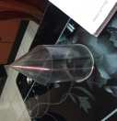

4.3.3. Selection of project intervention sites
- A total of six interventions sites were selected in the ProDoc. Out of those sites, three are considered to be highly vulnerable to food insecurity. These three intervention sites were identified in the 166 Communes Initiative. Three intervention sites – not identified in the 166 Communes Initiative, were also selected, as they experience food insecurity.
- The areas vulnerable to food insecurity as identified in the 166 Communes Initiative are Massantola, Mondoro and Taboye.

4.3.4. Observed climatic trends
- The prevailing climatic trend in Mali is decreased rainfall as a result of climate change. The total amount of rainfall received annually has decreased by 20% since 1970s.
- Based on patterns observed to date, a notable decrease in rainfall is recorded every decade.
- The isohyets have shifted by at least 5 km since the 1970s.
- In addition to decreasing rainfall, an increase of approximately 0.7°C has been recorded since the 1970s. A 2°C increase is forecasted by 2050.

4.3.5. Mali-Météo’s involvement in developing project outputs
- Developing sowing schedules for varieties
- Developing rainfall forecasts, which are supplemented by the rainfall data, collected on the ground.
- There has been a 20-30% increase in yields for several crops in some intervention areas as a result of the use of climate information and services.

4.3.6. Challenges faced in the implementation of the project
Being a member of the Project Board, Mr Diarra acknowledges that the project team has faced several challenges during the implementation phase. These are:
- Limited financial resources have been allocated to the implementation of this project. This is partly because the project was approved during a time whereby the benefits of climate change adaptation were not as widely recognised as they are today. As a result of the budget, the coverage of the interventions were limited.
- One of the major challenges relate to the disbursement of funds by the UNDP, especially at the outset of the project.
- The onset of the conflict in the north has significantly delayed the project. Consequently, the project interventions sites in the north, Taboye and Mondoro, have only benefitted from a few project interventions.
- Some of the technical aspects of the project could have been improved, especially those relating to capacity building of key stakeholders.

4.3.7. General remarks
- The market gardening intervention implemented by the LDCF-financed project has been a success, especially in terms of raising the status of food security. The government is looking into upscaling and replicating this particular intervention.
- Several local associations – especially women’s groups – and cooperatives have benefitted from the project interventions. The rationale behind was to ensure the sustainability aspect of the project so that local groups are empowered and their capacities to adapt to climate change strengthened.
- The involvement of local government structures ensures that there is enhanced awareness on the effects of climate change and the perpetuation of the activities implemented thus far.

4.4. Meeting with Mr Sibiry Bengaly, Project M&E Staff

Meeting with Mr Sibiry Bengaly, Project M&E staff
Date: 12 October 2016
Time: 11h00
Location: DNA Office
Present: Mr Sibiry Bengaly, Jessy Appavoo and Djibril Doucouré

Mr Sibiry Bengaly is one of the core members of the project management unit. He is responsible for the M&E of all interventions implemented under the LDCF-financed project. A lengthy discussion was held with him to understand the M&E mechanism implemented throughout the project.

4.4.1. Baseline information
- At the outset of the project (2010), the baseline situation in the six communes was established. The baseline situation was established through questionnaires developed by Mr Bengaly. These questionnaires were sent to the local agricultural extension officers in each commune to be filled out and sent back to the project management unit.
- The questionnaires largely related to the yield of different crops (seed variety) within the particular areas and data pertaining to animal rearing and forestry. The baseline was established based on the seed varieties used and the corresponding yields recorded for the 2009-2010 agricultural season. In addition to crop yields, information was gathered on animal rearing in the intervention sites.
- In addition to the local agricultural extension officer, other members of the CCC contributed to the information requested in the questionnaire.
- The Mid-Term Report highlighted that a one year average of crop yield does not provide robust information to establish the baseline situation.
- Information pertains only to component 2. Capacities were not measured. A thorough baseline assessment should have been undertaken.
- Baseline situations were established for the communes of Mondoro and Taboye. However, as a result of ongoing conflict in the north, virtually no M&E has been undertaken within these intervention sites.
- Thereafter, Mr Bengaly, consolidated the information obtained from the questionnaires in a report. However, the methodology for data collection for establishing the baseline situation is not included in the report.
- It was pointed out no verification of the information provided in the questionnaires was undertaken by the project management unit. The reason being that Mr Bengaly has extensive experience in the agricultural field and as such could judge the appropriateness of the information provided for each commune.

4.4.2. Ongoing M&E
- To track the performance of the interventions financed by the LDCF project, demonstration plots were established in each beneficiary commune. The demonstration plots for resilient seed varieties for cereals are 0.5-1.0 hectares in size.
- To monitor the performance of the seed varieties (for cereals) distributed under the LDCF-financed project, information was regularly collected from the demonstration plots using demonstration plots monitoring form. The beneficiaries of the demonstration plots complete forms – developed by Mr Bengaly – on a regular basis to track the performance of the seed varieties promoted under the project. In these forms, information on the yield, pests as well as the average yield for non-resilient seed varieties recorded in the area.
- Control plots have not been used under this project to track the performance of the climate-resilient seed varieties used. The yield from the demonstration plot is compared to the average yield for non-resilient seed varieties in the area.
- 187 villages across the six selected communes have received rain gauges. Two members of each village were trained to read and record rainfall data. The average rainfall recorded – at the beginning and at the end of the agricultural season – is then compared to the forecasts provided by Mali-Météo.
- Local agricultural extension officers are responsible for collecting data on the performance of the crops promoted under the LDCF-financed project relating to market gardening. He follows a set of guiding questions with the beneficiaries of the demonstration market gardens to complete the monitoring form. These forms monitor the performance of crops within the demonstration market gardens through the use of the techniques on which they have received training. These techniques include the use of organic manure as opposed to chemical fertilisers and compost for improved yields. The monitoring forms also track the quantity of the crops produced that is consumed by the beneficiary, the amount sold and the corresponding financial revenues.

4.4.3. Results Framework
- It was highlighted that the Results Framework has not been modified and has remained as is in the ProDoc.
- The indicators used in the framework are way too vague and do not meet the SMART – Specific, Measurable, Attainable, Realistic and Time-bound – criteria developed by the GEF. As a result, the Results Framework should have been revised at the outset of the project as part of the M&E exercise.
- The results are also poor formulated in the Result Framework thereby making it difficult to measure and even attain. The results should have been formulated in terms of the outputs of the project and/or prevailing conditions that can be assessed or measured (either qualitative or quantitative).
- The means of verification of the results – as stated in the Results Framework – are vague and do not point to specific documents that should have been compiled during the course of the project.
- It was highlighted that there was no M&E plan developed at the outset of the project. Should this have been developed, it would have been clear that the Results Framework should have been revised.
- The revision of the PDSEC has been used as an indicator. However, it is not recommended to use politically-bound indicators as these are too dependent on the political will and is beyond the control of the project management team.
- At Project Board meetings, the prevailing results of the project were not discussed in terms of the Results Framework, but rather per activity.
- The MTR did not highlight that a revision of the Results Framework was needed. The recommendations of the MTR related largely to the fine-tuning of the M&E mechanism. No course correction activities were recommended in the MTR.

4.5. Focus Group in Massantola

Focus group with CCC and beneficiaries’ groups in Massantola
Date: 13 October 2016
Time: 14h45
Location: Massantola
Present: Mrs Niambélé, Mr Sibiry Bengaly, Jessy Appavoo, Djibril Doucouré, and 26 participants (of which 16 were women)

We were welcomed by the mayor of the commune of Massantola. He is also the president of the CCC. Present were several members of the CCC – including the local agricultural extension officer - and representatives of two beneficiaries’ associations and two women’s groups. Women from all 45 villages are involved in these groups and partake in market gardening activities, cereal farming and microfinance. The presidents of the women’s associations were present at the focus group meeting.

4.5.1. Project results from the CCC’s point of view
After welcoming the participants as well as the evaluation team, the mayor provided a brief explanation of the purpose of the evaluation and the focus group meeting. Thereafter, the following points were discussed:
- All of the activities to be implemented in the commune of the Massantola were validated by the CCC.
- Approximately 25 activities were planned for the commune of Massantola and 20 activities have been implemented to date.
- 45 villages in the commune have benefitted either directly or indirectly from the LDCF-financed project, although not in an equal manner.
- All villages in the commune have benefitted from capacity building in terms of the use of climate-resilient seed varieties and techniques to be adopted for market gardening.
- A well has been rehabilitated and equipped with a solar-powered pump in the village of Sirakoroba. The water pumped is used for local consumption as well as for animals.
- A market garden has been delineated with fencing and established for a woman’s group in Manta. The market garden is equipped with a large well and a solar-water pump.
- Overall, the mayor, as the president of the CCC is satisfied with the results of the project.
- Many women have been trained on the use of the climate-resilient seeds (for cereals) and different techniques for increased production of crops in market gardens – particularly black-eyed peas and peanuts. These women now grow potatoes, tomatoes, and lettuce among many other crops.
- Three women’s associations in the commune have been equipped with tools such as ploughs, oxen, wheelbarrows, shovels, and picks.

4.5.2. Results and impacts from the beneficiaries’ point of view
- The women were very satisfied with the support they received, especially in the form of tools, from the project. As Mali is predominantly a patriarchal society, this translated to men having priority over the use of tools for agricultural activities. Therefore before the project’s support, the women beneficiaries had to wait for tools to be available – after being used by the men – for them to be able to proceed with agricultural activities. Since they have received tools funded by the LDCF project, they have managed to use their tools when intended, i.e. in keeping with the sowing and harvesting schedules.
- They have been able to grow enough onions and potatoes to be self-sufficient. However, the tomato plants have failed because of insects.
- They have observed a noticeable increase in their living conditions as a result of increased food production and consequently increased food availability. The vegetables, beans, peanuts, and fresh produce from the market gardens have supplemented their diets. As a result, they are more food secure than they were at the before the implementation of the project. In addition, they have more disposable income as they buy less and less fresh produce from the market.
- As the women’s groups own respective demonstration market gardens collectively, they all partake in the resulting benefits. To date, the revenue generated from the sale of the surplus of produce – grown in the demonstration market gardens – is approximately 200,000 CFA. Usually, any extra money generated is used to buy more seeds, however, this year they have managed to each access a portion of the revenue for to procure agricultural input for market gardening and small-scale commercial activities.
- One of the women’s associations has benefitted from the seeds for beans for a total of 2 hectares and they have also received seeds for sesame.
- The president of one of the women’s associations mentioned that the members have been involved in the LDCF-financed project for the last 3-4 years. Their experience has been different to other projects implemented in the past. This is because the management and implementation teams have delivered on their promises.
- As a result of the training they have received on the use of organic manure and compost, sowing guidelines/schedules as well as the use of climate information, women have benefitted significantly in terms of increased yield, less time spent in the field, increased disposable income and increase availability of food for domestic consumption.

4.5.3. Capacity-building among beneficiaries
- It was mentioned that one of the impacts of the project – which will extend well beyond its lifespan – is the capacity-building within the local community for the use of climate information in agricultural practices. The beneficiaries rely strongly on the localised quantity of rainfall recorded over certain periods of time to make an informed decision about which crops to plant and when to do so. They beneficiaries are grateful for being empowered to make informed decisions that will impact their livelihoods.
- Thanks to the project, the beneficiaries are now aware of the impacts of climate change and the need for adaptation interventions to be implemented in order to become food secure.
- As a result of the training they have received under the LDCF-financed project, the beneficiaries have come to realise that adaptation correlates with the intensification of agricultural activities as opposed to expansion.

4.5.4. Sustainability of the interventions
- A participant highlighted that she is worried about the imminent project closure. However, thanks to the mechanism put in place under the project – whereby a share of the harvest is stocked for seedlings – they will still have access to seeds for the coming years. To access new seeds, those that need to be replaced on a 3-year basis, the women’s association will approach the local agricultural extension officer who is also a member of the CCC. He holds the institutional memory and will facilitate the procurement of climate-resilient seeds.
- The CCC is committed to fulfilling their role beyond the project’s lifespan as they have recognise the benefits that have been derived thus far. There is a heightened sense of local ownership over the interventions financed by the LDCF.

4.6. Focus Group in Sandaré

Focus group with CCC and beneficiaries’ groups in Sandaré
Date: 14 October 2016
Time: 14h00
Location: Municipality Office
Present: Mrs Niambélé, Mr Sibiry Bengaly, Jessy Appavoo, Djibril Doucouré, and 26 participants (of which 11 were women)

The local community members present at the meeting represented the commune of Sandaré and in particular the villages of Samantara and Sandaré. There are 20 members in the CCC, and not all of them were present at the focus group meeting.

4.6.1. Results and impacts from the beneficiaries’ point of view
- Some of the women associations have managed to generate 750,000 CFA from the one-hectare demonstration plot established under the project. They were able to buy a plot of land thanks to the additional revenue.
- The beneficiaries have been practising market gardening for many years, but without implementing the appropriate techniques. They practised market gardening under water constraints and therefore they had to break rocks to reach the underground water supply (which was increasingly going deeper from the surface). Thanks to the construction of water basins in the demonstration plots, they now have easy access to water for irrigation purposes.
- Thanks to the LDCF-financed project, they have been able to increase their production of cereals.
 | Millet (kg/ha) | Sorghum (kg/ha)
Before LDCF-financed project | 500 | 300
Since implementation of LDCF-financed project | 800 | 800

- Some women managed to harvest 200 kg of maize on a quarter of a hectare plot, which is located on abandoned land because of the poor quality soils.
- The commune of Sandaré has experienced favourable rain over the 2015/2016 agricultural season which has contributed to good yields. However, the local community does not associate the increased yield to the favourable rains alone, but also to the interventions of the project. For example, the beneficiaries have realised that the soil retains humidity as a result of the use of compost even during dry spells. This has contributed to increased yields.
- Food consumption patterns are slowly shifting as a result of the LDCF-financed project. For instance, it was highlighted that potatoes – a tuber that was not previously consumed widely- is now consumed in almost every home in the village of Sandaré.
- One of the notable changes recorded in the food consumption pattern is that people can now afford to snack in between meals, while previously this was not common occurrence. For instance, some members of the local communities have a small salad between breakfast and lunch.
- Food is now available during dry spells and during winter.
- There has been an improvement in the health of children since the inception of the LDCF-financed project and this is largely attributed to increased food availability.

4.6.2. Results and impacts from the CCC’ point of view
- There is a stark difference from the baseline situation to the conditions prevailing now.
- The beneficiaries have received training on techniques, which are easy to replicate and disseminate to a wider audience.
- The pilot farmers and beneficiaries of demonstration plots have been carefully selected by the CCC to maximise the chances of success of the project.
- Radio broadcasts were held on Sundays from 18h00-19h00 to raise awareness on the effects of climate change, the need to create groups and associations as opposed to working independently as well as the amount of rainfall recorded in specific areas and the corresponding seed varieties to use. The broadcasts were held by the local agricultural extension officer, who is a member of the CCC.
- The PDSEC was revised in 2012 under the LDCF-financed project.
- There has been no financial commitment made in the PDSEC to carry on with the activities of the CCC after the end of the project. However, the deputy mayor has confirmed that the commune will finance the work and the meetings of the CCC.

4.6.3. Replicating the benefits of the project
- The mode of implementation of the project has been such as a different group of people benefits from the climate-resilient cereal seeds every year to ensure a wide coverage of beneficiaries. In addition, the system implemented by the CCC is that a portion of the harvest of cereals goes through the CCC to be redistributed to other beneficiaries for seed production.
- To reach a maximum number of beneficiaries, a field in the local community has been dedicated to the production of climate-resilient sorghum seed.
- As a result of the project, disparate agricultural groups have had to join forces and work together; this has led to increased social cohesion among members of the commune of Sandaré.

4.6.4. Capacity-building
- As a result of the training they have received under the LDCF-financed project, the beneficiaries grow produce including inter alia lettuce, tomatoes and shallots.
- Several beneficiary groups have received training on the production and use of manure to increase production – as opposed to the use of chemical fertilisers. Thanks to the training received, some of the women’s associations have harvested 900 kg of maize on one hectare.
- The local community is grateful for the increased capacity to use climate and weather information to make informed decisions. The local community has benefitted significantly from the training received by two pilot farmers on the reading and recording of rainfall in localised areas.
- The increase in yield is largely attributed to varieties of seeds that adapted to the local climatic conditions, in particular to the rainfall. In addition, the beneficiaries have been trained on several techniques such as Zai, compost production and the use of manure which have all contributed to increase in yields recorded in the areas covered by the LDCF-financed project.
- The training received by the beneficiaries were two-fold; firstly they were trained by the local agent in a classroom setting and secondly practical training was held in the field to apply the techniques discussed. The beneficiaries are confident that they can train other members of the local communities in Sandaré on these techniques.

4.6.5. Challenges faced
- The biggest challenge faced by some of the beneficiaries is that they struggled to organise themselves into groups – e.g. associations or cooperatives – at the outset of the project. There were many disparate small women’s groups, which were working independently of each other. They have since managed to group themselves together to form the “Dougoudjigui Cooperative” which means “hope for the village”.

4.6.6. General remarks
- The synergy between the LDCF- and ACDI-financed interventions has made a real impact on the local communities in the commune of Sandaré. ACDI financed a multi-purpose platform to generate solar-powered electricity, which is used by several communities for productive uses. One of the women’s groups pays a nominal fee to access the electricity to make ice cream and to produce dried goods – such as dried herbs.

4.7. Focus Group with CCC in Cinzana

Focus group with CCC in Cinzana
Date: 16 October 2016
Time: 10h00
Location: Municipality Office
Present: Mrs Niambélé, Mr Sibiry Bengaly, Jessy Appavoo, Djibril Doucouré, six members of the CCC

We had a separate meeting with some of the members of CCC before meeting the beneficiaries. Six members of the CCC were present. Unfortunately, the mayor was not present, but the deputy mayor – who has been involved in the implementation of the project – was present.

4.7.1. Background information on Cinzana’s CCC
- The CCC comprises the technical services, members of local communities in the commune and elected members of the council.
- The CCC meets every three months whereby they discuss the strategy for accessing climate-resilient seeds and redistributing seeds from the previous agricultural season and the challenges faced since the previous meeting. The request for climate-resilient seeds is channelled via the CCC and then communicated to the project team.

4.7.2. CCC’s role and responsibilities
- The CCC has coordinated the procurement and use of climate-resilient seeds for crops including inter alia millet, sorghum and peanuts. They have also coordinated interventions to counteract deforestation in the commune, the use of improved cookstoves, and the dissemination of market gardening practices to increase food production in the village of Cinzana.
- The CCC contributed to the sectoral impact study financed under the LDCF project. The different aspects included in the impact study are: i) droughts; ii) deforestation; iii) soil degradation as a limiting factor to food production; iv) poverty; v) social cohesion; vi) public health; vii) rural to urban migration; vii) erratic rainfall; and ix) gender sensitivity.
- The structure of the CCC – i.e. regrouping different technical services – has been previously used in other projects such as the project to combat desertification funded by the Japan International Cooperation Agency (JICA).
- The CCC emphasised awareness-raising in the commune on climate change, the associated impacts and the need to address the impacts thereof.
- There are several past and ongoing initiatives in the commune of Ségou to address erosion and deforestation. Through an ongoing World Food Programme initiative in the commune, a union consisting of cooperatives covering 26 villages has been established.
- The CCC disseminated the directives received from the AEDD to the local communities. The CCC played a documentary produced by the AEDD – after translating to the local language – on climate change for the local communities.
- The seasonal forecasting is communicated to the CCC. Thereafter the local extension officers were responsible for disseminating the information to the local communities.
- The local agricultural extension officer who is also the focal point for climate change in the commune of Cinzana is responsible for collating the information received from the farmers who have been trained to read and record rainfall data.
- The CCC was consulted during the assessment of the PDSEC and it was collectively agreed that there are sufficient climate change considerations in the document. There was therefore no need to revise the PDSEC. The PDSEC already includes adaptation measures such as the use of climate-resilient seeds and reforestation.

4.7.3. Results and impacts of the project
- Based on the feedback received from the pilot farmers, the CCC confirmed that there has been an increase in yield from 0,9 tonnes to 1,2 tonnes for sorghum in demonstration plots. This is not only attributed to climate-resilient seeds but also to the use of climate information to determine the appropriate seed varieties based on the rainfall recorded in the area. The technical guidelines have been useful to determine the recommended seed varieties in relation to the amount of rainfall recorded in the area.
- Agricultural kits consisting of ploughing equipment, tools as well as cattle for ploughing have been distributed to several women’s organisations.
- 110 demonstration plots have been established in Cinzana for the 2015-2016 agricultural season.
- In Cinzana, there are 72 villages, out of which 75% have benefitted from the new techniques and technologies. To be more specific, these villages have largely benefitted in terms of climate-resilient seeds financed by the LDCF.
- As a result of the climate-resilient seeds financed by the LDCF, ladyfingers are now widely consumed all year round. This has led to a positive change in prevailing dietary patterns and an increase in food security. There is an increasing awareness among members of the CCC that in order to be food secure, nutritious foods need to be consumed in the right amounts.
- The CCC confirmed that local communities are increasingly becoming aware that as a result of climate change, they can no longer rely solely on traditional forecasting methods to determine the beginning, duration and intensity of the rainy season. Now, they increasingly rely on scientific information on the beginning, end, duration and intensity of the upcoming rainy season and plan accordingly.
- There has been an increase in social cohesion as women’s and youth groups as well as the council collaborated on several brainstorming sessions and workshops held under the LDCF-financed project. These groups are aware of the impacts of climate change on their lives.
- One rain gauge has been installed in each of the 72 villages in Cinzana.
- An increase in the food security status among the beneficiary group has been experienced. This increase is not only due to increased food availability but also as a result of the quality of food produced and the diversity in the new diets.
- There has been an increased in yield with a decrease in costs – in terms of chemical fertilisers – and labour required.
- There has been an increase in household disposable income as less money is spent on chemical fertilisers and an increase in yield has been observed.
- There has been an increase in the quality of the land thanks to the use of organic manure and compost.
- There has been a notable increase in the health status of the local communities, which is linked to increased food security.

4.7.4. Sustainability of interventions
- To date, there is no clear strategy developed or implemented to access technical climate information such as seasonal forecasts, once the project ends. The CCC is confident that they will still manage to access such technical information even though they have no established relationship with Mali-Météo. The CCC believed that as the technical extension officers are government employees, they are in a position to access such information. The CCC is confident on the fact that there will be a demand for scientific climate information from the beneficiary communities after the project closes and as such they will also see to it that forecasts are available. It will be a tandem effort between the CCC and the local beneficiary communities.
- Realising the benefits of climate information services, there has been mobilisation of people and resources in local beneficiary communities so that they can access more rain gauges. The increased in awareness on the challenges posed by climate change has enabled the local communities to join forces to address the effects thereof on their livelihoods.
- The commune has commitments towards addressing climate change; the commune has funded plants for all 72 villages and the municipality buys climate-resilient seed varieties that are then distributed to the local communities. In addition, realising that farmers faced several challenged in stocking the harvest, the municipality purchased warehouse space for the safe stocking of harvest.
- The commune is committed to making amendments to the budget in the PDSEC so that more funds can be allocated to addressing climate change in the future.

4.7.5. Objective of the GCAM
- The GCAM was created to ensure the sustainability of the interventions relating to climate information. As envisaged in the ProDoc, the GCAM is meant to consist of several members of the local community who are responsible for the dissemination of climate information.
- The GCAM has not been working efficiently. This is largely attributed to the fact that there are no financial resources made available to them – for transport purposes for meetings every 10 days and for communication costs. The project team decided from the outset of the project that no funds would be allocated to the GCAM because once the project closed, the structure would most likely fall apart. It was therefore expected that communities would finance their meetings and communications costs and by the time the project closed, there would be a long-term strategy in place.
- It was suggested by the project team that the commune could potentially fund the activities of the GCAM. The CCC highlighted that it would be difficult for them to absorb such costs in their already restrained budget. The CCC mentioned that perhaps they could consider looking into covering the costs of the CCC twice a year but not on a 10-day basis. However, if this is done on a bi-annual basis, local communities will miss important climate information.

4.7.6. Interventions yet to be implemented
- The market gardening activities are being developed and the implementation has not yet started in the commune of Cinzana.
- It is envisaged that micro-credit activities will support artisanal activities and small-scale commercial activities in the commune. Consultations have been held with a micro-credit company but no agreement has been reached to date. The alternative income-generating activities to be financed by micro-credit are envisaged to provide alternative livelihoods that are not entirely dependent on natural systems.

4.8. Focus Group with beneficiaries in Cinzana

Focus group with beneficiaries in Cinzana
Date: 16 October 2016
Time: 12h00
Location: Municipality Office
Present: Mrs Niambélé, Mr Sibiry Bengaly, Jessy Appavoo, Djibril Doucouré, 10 beneficiaries (women) and 5 members of the CCC

The objective of this meeting with the beneficiaries was to understand the LDCF-financed project from their point of view. Throughout the discussion, some members of the CCC interjected as required, but the focus remained on the beneficiaries. The beneficiaries were represented by three associations, namely Benkadji from Cinzana-Gare and Dona as well as the Women’s Group of Kondia.

4.8.1. Results and impacts from the beneficiaries’ point of view
- The beneficiaries highlighted that agriculture is the main source of livelihoods.
- The women’s organisations have been provided with tools for market gardening. They currently grow onions, tomatoes, shallots and cucumbers in the market gardens. Before they were equipped with tools, women would only be allowed to use existing tools and equipment after men have used them. This means that often the women would fall behind on the agricultural calendar, which meant that they could not optimise the chances of success of their crops.
- The technical guidelines provide clear information on the seed varieties to plant based on the amount of rainfall received.
- They were used to seed varieties that with long cycles, but since the project has been rolled out in Cinzana, they have access to seeds with relatively shorter cycles.
- There is an increased availability of food – for example black-eyed peas – that has led to an increase in nutrition. They also have access to fresh produce from the market gardens all year round.
- They spend less money on buying food, which means that they have more disposable income for productive uses. Before the establishment of the market gardens, they would have to go to weekly markets to purchase fresh produce. Therefore they had to budget for transport costs to and from the market as well as the purchase of the produce.
- Their diet base has expanded as new food item has been introduced to them and has been made readily available in the market gardens and/or demonstration plots.
- Moringa is used as windbreaks to shield small crops from the wind. The plant is also used for consumption; it is especially used as a supplement in kids’ diets. Moringa is proving relatively useful to combat malnutrition in Cinzana.
- There has been awareness-raising undertaken under the LDCF-financed project to promote women having more access to land to conduct income-generating activities. For instance, one of the women’s groups managed to lease degraded land for market gardening activities. They rehabilitated the land using the techniques on which they received training and established a demonstration plot. After having had a good yield, the owner decided he wanted the land back and women beneficiaries were not allowed to carry on with their activities. They approached the CCC and the mayor had to intervene so that they could carry on with their activities.

4.8.2. Capacity-building
- They have been trained on the use of certain types of climate-resilient seeds.
- Women of all three associations have received training on the use of microdoses of fertilisers.
- They have received training on the preparation of the soil in demonstration plots – for example, they use organic manure in such a way as to prevent the germination of weeds and they apply moisture-retaining techniques by covering the topsoil with fodder to prevent moisture loss.
- The beneficiaries are confident that they can disseminate the techniques learned to other members of their respective communities. They are already imparting some of the knowledge acquired to their immediate family as they train them so that they can also participate in agricultural activities.

4.8.3. Challenges faced
- They have received climate-resilient cereal seeds and black-eyed peas. The cereals have flourished this season while the black-eyed peas are not. They have not been able to harvest any peas so far. The local agricultural extension officer then highlighted that the type of black-eyed peas that was distributed is a fodder crop and not for consumption. However, the beneficiaries were not aware that this particular variety was to be used as fodder crop and not for consumption. The beneficiaries stated that this was not communicated to them prior to planting and that there was no training received on this particular variety of black-eyed peas that they received. This points out to a lack of communication from the local agricultural extension officer. It seems that the modus operandi of the local agricultural extension officer is that he communicates the information to one person per village and expects that person to disseminate the information. This modus operandi is used despite the fact that the women’s organisations have been targeted as beneficiaries and they should have received the training and/or information generated through the LDCF-financed project.
- The tomato plant has failed this season because they did not understand the technical guidelines for this particular crop.

4.8.4. General remarks
- When asked to describe the effects of climate change on their lives and livelihoods, the beneficiaries could not explain the changes in weather patterns and the effects thereof. They did not qualify these changes in terms of changes in yield or other income-generating activities. This shows that there has been a breakdown in communication when technical information was provided to them during training sessions.

4.9. Meeting with Project Team

Meeting with the Project Team
Date: 18 October 2016
Time: 08h30
Location: DNA Office, Bamako
Present: Mrs Niambélé, Mr Sibiry Bengaly, Mrs Diallo, Jessy Appavoo, Djibril Doucouré

The objective of the meeting was to discuss the progress of the activities in light of the stakeholder consultations undertaken in the project sites and the quality of the interventions implemented. We therefore discussed each activity individually to understand the progress of the activities.

Activity number | Name of activity | Progress of activity
1.1.1 | A detailed analysis of the projected impact of climate change on the food production sector is conducted un the targeted municipalities (under available scenario). | Assessments have been undertaken in all of the targeted communes and individual reports compiled. The assessment was undertaken in terms of the potential impacts of climate change on every economic sector in each of the communes. The focus was largely focused the short-term impacts of climate change.
1.1.2 | A detailed analysis of the cost of the forecasted impact of climate change on food production and other vulnerable income production activities (under available scenario) is conducted in the targeted municipalities and specific impacts on men and women groups are analyzed. | Although this activity is aligned with Act 1.1.1, they were undertaken separately and by different consultants. This activity was undertaken for all of the targeted communes. Under this activity, the financial costs associated with the impacts of climate change were elaborated. In so doing, the interventions were prioritized to address the impacts with the most financial repercussions. The findings of the study were presented at a validation workshop including the technical M&E team.
1.1.3 | Based on the analysis undertaken under activities 1.1.1 and 1.1.2, relevant adaptation measures are identified in a participatory manner in order to prevent and manage the adverse impacts of climate change on food production within each of the targeted municipalities. | This activity was undertaken by the AEDD and was coupled with Act 1.1.2. The ‘climate-proofing’ tool developed by the AEDD was applied for this activity to identify adaptation interventions. Thereafter, succinct directives were formulated and disseminated to the four communes. On average, 12 adaptation interventions were identified. This activity was not undertaken in Taboye and Mondoro as a result of the outbreak of conflict in the North.  The identification of the adaptation interventions was undertaken by the AEDD using the ‘climate-proofing’ tool and was presented to the local communities in each commune. In a 3-day workshop, the adaptation interventions were discussed and prioritized in collaboration with the local communities. On average, five adaptation interventions were selected for implementation.
1.1.4 | Anticipated costs and benefits of each measure are assessed based on state-of-the-art methods and wide stakeholder consultations and the most cost-effective and gender balanced measures are identified. | Under this activity, a cost-benefit analysis was undertaken for each of the five adaptation interventions prioritized by the local communities in each commune. This activity was undertaken by a multi-disciplinary team consisiting of academic staff from the National School for Engineers (ENI-ABT), Mali-Météo, and several line ministries.
1.2.1 | Current PDSEC of targeted municipalities are analyzed to assess the baseline level of climate change adaptation considerations. | Four PDSEC – except for Taboye and Mondoro – were evaluated. This evaluation was undertaken in collaboration with the AEDD. Out of the four PDSEC assessed, three of them were revised – i.e. Masantola, Sandaré and M’Pesoba. The PDSEC in Cinzana was not revised as it contained sufficient climate change considerations. The revisions were made in terms of the technical information pertaining to climate change contained therein, and not budgetary information.
1.2.2 | On the basis of the findings from Output 1.1, short guidelines are elaborated and disseminated to municipal decision-makers in order to facilitate the integration of adaptation considerations within PDSECs in targeted municipalities. | This activity was coupled with Act 1.1.3.
1.2.3. | Based on lessons learned from pilot initiatives (implemented under Outcome 2.2), climate change risk management is incorporated into PDSEC of targeted municipalities. | See activity 1.2.1.
1.2.4 | Awareness-raising activities are undertaken with representatives of the other local levels of administration (circles and regions) in order to promote the integration of adaptation considerations at those levels and enable an overall coherent approach to adaptation at the various administration levels. | A total of eight workshops were held to raise awareness of climate change and the need for adaptation interventions to be implemented. For four of the intervention sites – excluding Taboye and Mondoro – a workshop was held at the regional and communal levels. There was an emphasis on raising awareness within research institutions. The AEDD led this intervention and on average 25 people attended each workshop.
1.2.5 | On the basis of the findings from Output 1.1 and in partnership with local decision makers, the population of the targeted municipalities (farmers, breeders etc.) are informed of the projected impacts of climate change on local food production and economic activities. | This activity was coupled with Act 1.2.4 to disseminate the relevant information to key stakeholders. These include mayors, representatives of council, and NGOs.
1.3.1 | Budget of PDSEC is analyzed with a view to identifying potential resources for the mainstreaming of climate change adaptation. | The budget was analysed, however this did not lead to any concrete outputs.
1.3.2 | Financing strategies are elaborated within the targeted municipalities in order to ensure adequate financing of the needed adaptation measures within targeted municipalities after project closure. | This activity was coupled with Act 1.3.1. It was highlighted that the budget at the commune level is limited, with little scope to absorb the formulation and implementation of adaptation interventions. All budgetary reference to addressing climate change was linked to specific partners working in the commune. Local authorities do not have the financial capacity to support adaptation interventions. However, the micro-finance activity supported by this project is meant to bridge this gap and provide a strategy for financing adaptation interventions.
1.4.1 | On the basis of the findings from Output 1.1, short guidelines targeting local technical structures supporting rural development are elaborated (one for each agro-ecological zones). | Succinct directives were compiled and distributed and targeted different groups of people. The directives were disseminated in four of the targeted communes – except Taboye and Mondoro. However, these directives were not specific to each commune as similar adaptation interventions were identified in each of the agro-ecological zones.
1.4.2 | Awareness-raising and training activities targeting local technical structures supporting rural development are conducted to disseminate the guidelines; | The succinct directives elaborated in Act 1.4.1 were disseminated. It was highlighted that no training was provided to the local structures.
1.4.3 | Awareness-raising activities are undertaken within some of the main research and teaching institutes of the country. | Awareness-raising was undertaken on the need to include climate change in curriculums. The main research institutions, particularly those focused on agriculture, were invited. A total of 500 people attended the workshop.  This activity was undertaken by a multi-disciplinary team consisting of academic staff from ENI-ABT, Mali-Météo, and several line ministries.
1.5.1 | National level agriculture- (including livestock and fisheries) and food security-related laws, policies, plans and programmes are analyzed in order to evaluate the potential for integration of adaptation considerations. | The key policy documents were analysed, however no revisions were made as this is beyond the scope of the project. The AEDD was responsible for this activity, which was subcontracted to a consultant. The Evaluation Team recommended that the Project Team makes this report available to the national directorate so that the necessary revisions can be made to the policy documents in the future (should they feel the need to) and also to prevent duplication of work by another project.
1.5.2 | In partnerships with stakeholders involved with this topic and on the basis of the findings from project Outputs 1.1-1.4 and from project component 2, a strategy for the integration of project findings regarding climate change adaptation consideration within national agriculture - and food security-related laws, policies, plans (including national agriculture campaign plans) and programmes is formulated and implemented. | See Act 1.5.1 above.
2.1.1 | Stakeholders of the targeted municipalities (producers, extension agents, decision makers, etc.) are informed of the potential positive impacts of taking into account agro-meteorological information while taking decision related to agricultural activities. | This activity was undertaken in partnership with Mali-Météo, NGOs, local communities and technical line ministries. The agency conducted stakeholder consultations to determine the need for agro-meteorological needs in each commune.
2.1.2 | Producers and extension agents within the targeted municipalities are equipped with basic materials, trained in data collecting methods and in the practical use of agro-meteorological information. | The project funded a low-technology rain gauge in each village of the targeted communes. A total of 187 rain gauges were distributed in the first round. In the second round, 100 rain gauges were distributed to replace the damaged ones and/or additional ones to supplement the rainfall data collected.  In each village, two members of the local community were selected for training on how to read and record rainfall data. These local community members were also trained on keeping records of yield so that the Project Team can determine whether a relationship exists between the amount of rainfall received and the yield.  This activity led to establishment of the GCAM in each commune.
2.1.3. | Local multidisciplinary group for meteorological assistance (GLAM) are created or strengthened in each pilot municipality. | The GLAM was not realized, but instead GCAMs were established. The difference lies in the fact that the GLAM is at the level of the circle while the GCAM is at the communal level.  The GCAMs are not entirely operational - see Section 4.7.5 of this report.
2.1.4 | Based on the lessons learned under Output 2.2 in the targeted municipalities, the most cost-effective resilient cultural practices and technologies (traditional or innovative) are disseminated through national the agro–meteorological services system and the GTPA. | The GTPA was an already existing structure before the LDCF-financed project. The purpose of this activity was to ensure that information is relayed from the GCAM to the GTPA, however this activity has not been realized.
2.2.1 | Based on the results of the participatory scientific cost assessment conducted under Activity 1.1 of the project, resilient agro-pastoral practices and technologies to be demonstrated in each municipality are selected with the relevant local stakeholders. | A scientific evaluation of the five adaptation interventions prioritized by the local communities was undertaken.
2.2.2 | Implementation approach (in each municipality) for the demonstration activities is developed; | The same approach was used in all four communes – i.e., the mayor was approached to recommend pilot farmers for the demonstration activities.
2.2.3 | In close partnership with the local communities, the selected demonstration resilient agro-pastoral practices and technologies projects will be implemented over the last 3 years of the project. | This activity was coupled with Act 2.2.2.
2.3.1 | Awareness-raising activities regarding the importance of resilient alternative income-generating activities in the communities of the targeted sites are carried out; | This activity has started, but not yet completed in the targeted communes –except Mondoro. A study was undertaken on identification and evaluation of alternative income-generating activities. Some of the alternative income-generating activities identified in this study have been financed by ACDI and not the LDCF. However, the study did not consider the costs of implementation of the alternative income-generating economic activities.  The type of alternative income-generating economic activities identified in the report include inter alia: market gardening, small-scale commercial activities, artisanal activities such as dyeing of fabric, soap making and sewing.
2.3.2 | Socio-economic assessments of current income-generating activities are carried out for the pilot municipalities; | See Act 2.3.1.
2.3.3 | Alternative resilient income-generating activities are identified and prioritized in partnership with local communities (through local workshops and seminars). | See Act 2.3.1.
2.3.4 | A small revolving fund that will micro-finance resilient income- generating activities is set with the support of local microfinance institutions up in each of the targeted municipalities. | This activity has not yet been implemented to date. Consultation workshops at the communal level have been undertaken to date in M’Pessoba, Massantola, Cinzana and Sandaré.  There is a need to involve different government structures and key stakeholders in developing this activity.
2.3.5 | An eligibility screening tool is developed for assessing fund requests and ensuring that only additional needs due to projected climate changes are funded. | See Act 2.3.4.
2.3.6 | With the support from the revolving fund managed by pilot municipalities’ administrations, demonstrations of the alternative resilient livelihoods are conducted within the targeted municipalities. | See Act 2.3.4.
2.4 | Micro-insurance schemes that will reduce the vulnerability of producers to cc will be developed and tested in the Malian cotton production zone and the pilot municipalities. (This output will be financed and implemented by the Planet Guarantee harvest micro insurance project and OXFAM adaptation project in the Malian cotton production zone) | This activity was meant to be developed and implemented by OXFAM. However, there has been no communication from the OXFAM Project Team despite numerous attempts. This activity has therefore been discarded. There were no budgetary provisions for this activity under the LDCF-financed project.
3.1.1 | A system for gathering and capturing lessons learned is designed (this is closely linked to the project’s monitoring and evaluation system). | None of the activities pertaining to Component 3 has been implemented to date. The Evaluation Team highlighted that the interventions of this component needs to start as soon as possible, given that the project is meant to end in December. In addition, the LDCF-financed project was a pilot project and the dissemination of lessons learnt is crucial to inform other projects on implementing adaptation interventions in the agricultural sector. To ensure a lasting effect of the project, it is important that the activities of this component are well thought through and that a Communications Specialist be consulted. Without the input of a Communications Specialist, the lessons learnt may not be communicated in most effective and poignant way.
3.1.2 | Prepare tools for capturing and communicating project achievements/challenges (e.g. reports, DVD, films, documentaries, community radio shows, brochures).
3.2.1 | Highly vulnerable municipalities of the country with whom the captured lessons will be shared are identified.
3.2.2 | Based on the results from Outcomes 1and 2, adaptation training packages for rural stakeholders in the vulnerable municipalities are developed for 3 agro-ecological zones of the country.
3.2.3 | Press releases, workshops and round tables, etc., are prepared/organized to share lessons with selected highly vulnerable municipalities of the country.
3.2.4 | Some study tours for vulnerable municipality representatives and farmers to the pilot municipalities are arranged.
3.3.1 | National and international stakeholders with whom the captured lessons will be shared are identified.
3.3.2 | Relevant stakeholders’ forums and websites to which the project should contribute are identified.
3.3.3 | Events are organized at the national level in order to share the lessons learned with stakeholders concerned with resilient cultural practices and communities vulnerable to food security issues. This would include the preparation of press releases (national radio stations, climate change and environment journalist network (ANEJ).
3.3.4 | Lessons learned through the project are integrated within the Malian government 166 Communes Initiative and within future national agriculture campaign plans.
3.3.5 | Regular contributions to the UN’s Adaptation Learning Mechanism (ALM) are made as well as to other national and international websites and forums dealing with adaptation to climate change.

5. Project summary

The Evaluation Team requested that the Project Team provide insights on the formulation and the implementation of the LDCF-financed project as well as the on-the-ground technical capacity for the implementing the project.

5.1. Formulation of the project

- It was highlighted by the Project Coordinator that the project was developed with little collaboration with the DNA, even though its focus was on adaptation to climate change in the agricultural sector. The formulation of the ProDoc was written in close association with Mali-Météo and not the DNA, which has led to some technical challenges in the implementation phase.
- There were substantial delays relating to the validation of documents from the UNDP, which has led to the DNA being able to peruse the ProDoc for a very short time for any amendments to be made. As a result of the limited time given to the DNA officials, some of the gaps in the ProDoc could not be addressed.

5.2. Implementation of the project

- The support received from the UNDP has been insufficient in the implementation of this project, given that it was a pilot project.
- The challenges relating to the late disbursement of funds has delayed many of the activities of the project. This challenge could have been resolved internally at the UNDP (see Section 4.2.3).
- The DNA had little influence on the on-the-ground implementation team (in communes and villages), which became problematic during the implementation of the activities. The DNA should have had more influence on the selection of the on-the-ground implementation team. In addition, some of the team members were not full-time employees and could not be fully dedicated to the project.
- The management arrangements as mentioned in the ProDoc bypassed the regional and communal government structures. This has led to the regional and communal government structures to be disinterested in the project and they have provided little support towards its implementation.
- According to the ProDoc, the M&E staff member was meant to be employed on a part-time basis. However, the Project Coordinator had to lobby for a dedicate M&E staff member on the team.
- Many of the local actors did not have the technical capacity required for the implementation of the adaptation interventions on the ground.

5.3. M&E

- The Evaluation Team reiterated that the M&E of the project could have been bolstered to ensure effective monitoring on the ground.
- Following the MTR, a consultant was recruited for the compilation of an M&E manual, and not a plan specific to the LDCF-financed project. This manual was compiled without any field visits and was based solely on the information gathered from technical forms sent to the different beneficiary communities.
- If not at the outset of the project, the Results Framework should have been revised following the MTR. However, this was not recommended in the MTR.

Preliminary recommendations

There were two sets of recommendations presented by the Evaluation Team. The first pertains to the recommendations to be implemented to ensure the successful completion of the project:
- The interventions of Component 3 need to be implemented as soon as possible in order to ensure that a qualified Communication Specialist is contracted and has sufficient time to develop the interventions to communicate the lessons learnt to key stakeholders. The Terms of Reference (ToRs) and the call for proposal need to be prioritised at this stage.
- The project team needs to strive to complete the project by December this year as the project has already been extended by two years.
- It would be useful and would leave a lasting effect if the GCAMs are revived before the end of the project. This would ensure that the climate information aspect of the project does not fall apart after its completion.
- A set of well thought through ToRs need to be compiled for the micro-credit activity. The Project Team should require the expertise of reputable consultants in the field to develop detailed ToRs for this specific intervention.

The second set of recommendations pertained to lessons learnt to inform future projects:
- In terms of the Results Framework, the M&E aspects need to be well thought through. If this has not been undertaken at the ProDoc level, the Project Team needs to revise and justify these revisions with the UNDP. The indicators used need to be specific to each target which in turn need to be aligned with the SMART guidelines developed by the GEF. If the targets are vague and not attainable within the lifetime of the project, the evaluation of the project will consequently reflect poor performance. An analysis of the Results Framework needs to be undertaken at the outset of the project as a priority.
- The concept of CCC as used in this project is highly recommended as it supports capacity-building among local structures, promotes ownership of the project and ensures sustainability after the project lifespan.
- It is notable of the Project Team to have sourced co-financing to fund additional activities in the interventions sites.
- Even when using a CCC approach in the implementation of a project, there needs to be an M&E mechanism in place to ensure that the information is filtered to the beneficiaries. The Project Team remains accountable for the implementation of each intervention.
- The translation and dissemination costs should not be a limiting factor in providing supporting documentation to the beneficiary communities in addition to verbal communication. This could prevent misinterpretation of information and maladaptation practices.

Annex A: Attendance Registers

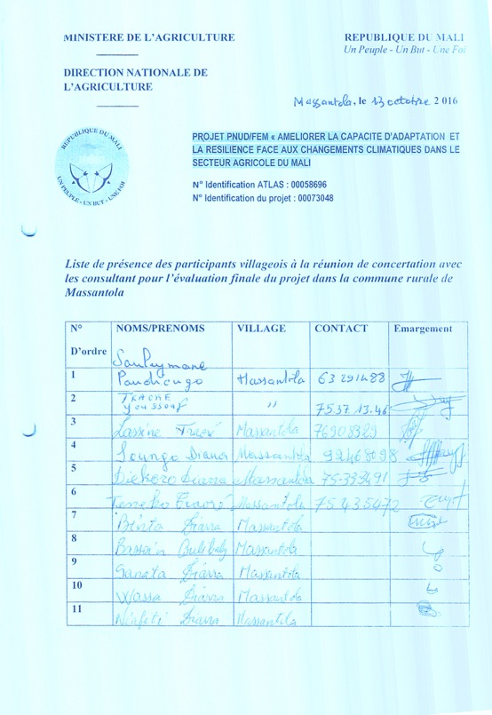

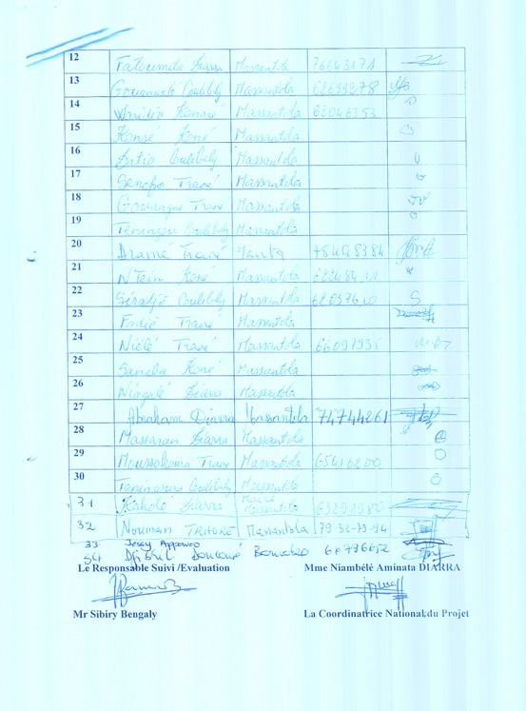

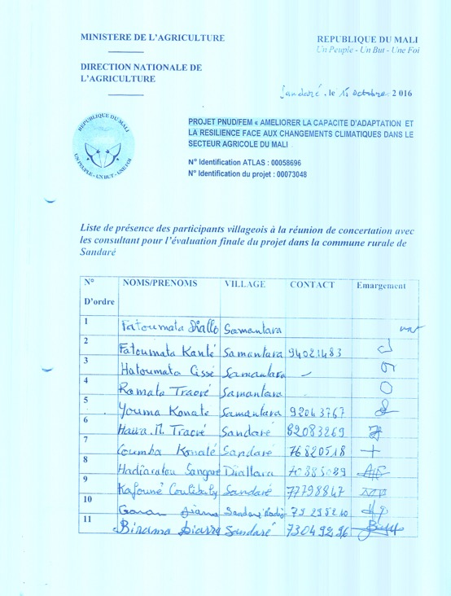

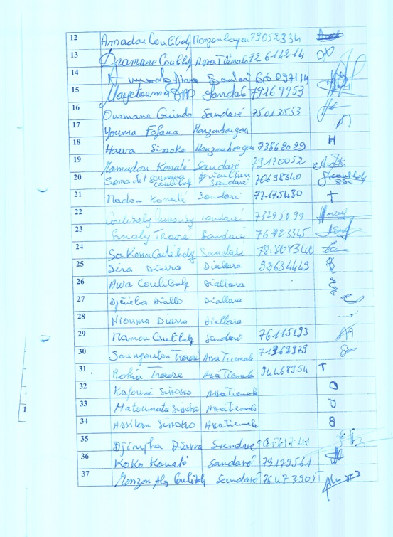

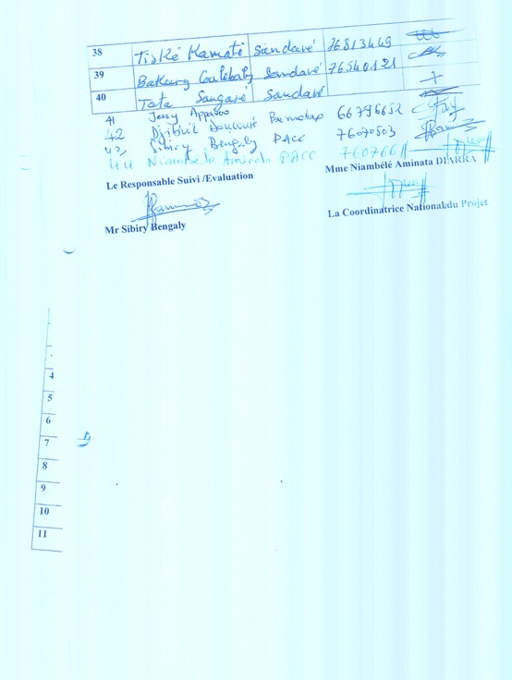

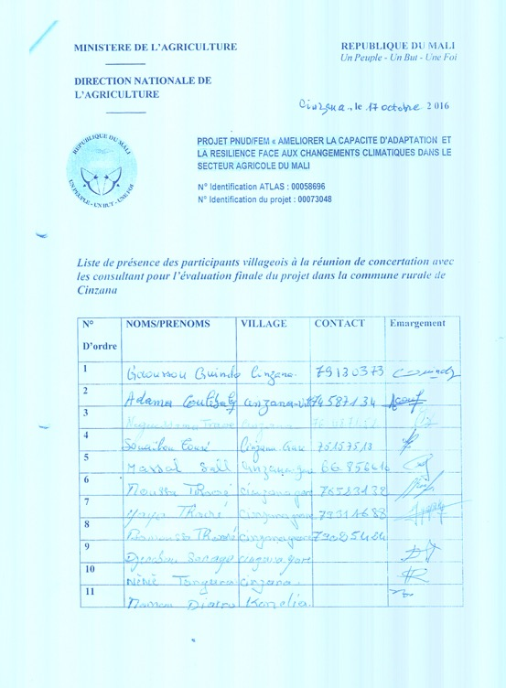

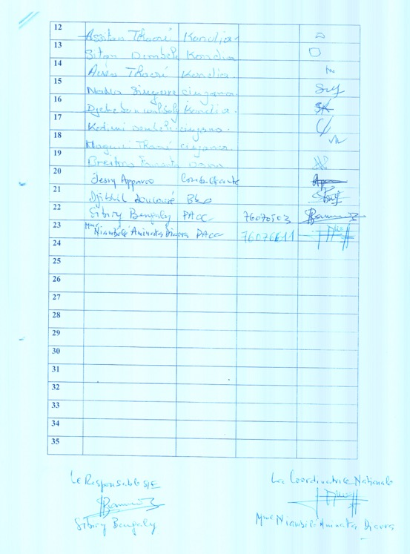

Annex B: Interventions Financed by LDCF and ACDI

Please note that all interventions highlighted in green and orange were financed by the LDCF and ACDI respectively.

Commune | Village | Name of intervention | Year | Beneficiaries | Notes
Sandaré | Sandaré | Orchard | 2012 | Ousmane Guindo | 0,5 ha area (Eucalyptus) fenced off
 |  | Orchard | 2013 | Mamadou Konaté | 1 ha area fenced off
 |  | Grove | 2014 | Youth Association of Sandaré | 0,5 ha area (Eucalyptus)
 |  | Market garden with large well | 2014 | Djama Djigui Women’s Cooperative | 1 ha fenced off (land plot bought by beneficiaries themselves thanks to additional revenue)
 |  | Agricultural tools (oxen, donkeys, ploughs, wheelbarrows etc) | 2013 | Djama Djigui Women’s Cooperative
 | Diabé | Grove | 2014 |  | 1 ha fenced area
 |  | Agricultural tools (oxen, donkeys, ploughs, wheelbarrows etc) | 2013 | Benkadji Women’s Cooperative
 | AllahinaBankass | Grove | 2014 | Youth Association | 0,5 ha fenced area
 | Sérédji | Grove | 2015 | Youth Association | 0,25 ha fenced area (Acacia sénégal and prosopis)
 | Koronga | Orchard | 2014 | Mamoutou Coulibaly | 0,25 ha fenced off (mango and lemon trees)
 | Wassamangatéré | Orchard | 2014 | Kardigué Coulibaly | 0,5 ha fenced area (Mango trees)
 | Diallara | Market garden | 2013 | nié ta Women’s Cooperative | 1 ha fenced area
 |  | Agricultural tools (oxen, donkeys, ploughs, wheelbarrows etc) | 2013 | nié ta Women’s Cooperative | -
 | Samantara | Solar-powered multi-functional platform | 2015 | Dougou Djigui Women’s Cooperative | Mill, husker and battery charger
 |  | Market garden with solar-powered well | 2015 | Dougou Djigui Women’s Cooperative | 1 ha fenced area
 |  | Agricultural tools (oxen, donkeys, ploughs, wheelbarrows etc) | 2014 | Dougou Djigui Women’s Cooperative
 | Assa Tiémala | Agricultural tools (oxen, donkeys, ploughs, wheelbarrows etc) | 2014 | Die Kafo Women’s Association
 | Monzombougou | Agricultural tools (oxen, donkeys, ploughs, wheelbarrows etc) | 2014 | koto Gnon gon talla Women’s Cooperative
 |  | Orchard | 2014 | Amadou Coulibaly | 0,5 ha area fenced off  (jujube and baobab)
Massantola | M’Pesseribougou | Agro-forestry demonstration plot | 2012-2013 | Mamadou Diarra | 0,5 ha area fenced off  (Acacia sénégal and eucalyptus)
 | Sabougou | Agro-forestry demonstration plot | 2013 | Diaraba Coulibaly | 0,5 ha area fenced off  (eucalyptus)
 | Somambougou | Agro-forestry demonstration plot | 2014 |  | 0,5 ha area fenced off  (eucalyptus)
 | Siratoma | Agro-forestry demonstration plot | 2014 | Diossama Traoré | 0,5 ha area fenced off  (eucalyptus)
 | Manta | Agro-forestry demonstration plot | 2015 | Dramé Traoré | 0,5 ha area fenced off  (eucalyptus)
 |  | Market garden with solar-powered well and water tank | 2015 | Women’s Association | 1 ha area fenced off
 | Sirakoroba | Communal well and water tank | 2015 | Population
 |  | Agro-forestry demonstration plot | 2015 | TénékoTraoré | 0,5 ha area fenced off  (eucalyptus)
 | Dotiambougou | Grove | 2014 | Youth Association | 1 ha area fenced off  (eucalyptus)
 | Nerekoroko | Grove | 2014 |  | 1 ha area fenced off  (eucalyptus)
 | Massantola | Market garden with solar-powered well | 2015 | Women’s Association | 2 ha fenced area for market garden
 |  | Orchard | 2015 | Kaholé Diarra | 1 ha area fenced off (mango and jujube trees)
 |  | Dam | 2015 | Villagers | Sufficient to irrigate 22 ha
 |  | Agricultural tools (oxen, donkeys, ploughs, wheelbarrows etc) | 2014 | Kotognôgôntala Women’s Association
 |  | Agricultural tools (oxen, donkeys, ploughs, wheelbarrows etc) | 2014 | Djèkabara Women’s Association
 | Fonflebougou | Solar-powered multi-functional platform | 2015 | Women’s Association | Mill, husker and battery charger
Cinzana | Nabougou | Acacia Sénégal Plantation | 2012 & 2013 | Youth Association | 3 ha area fenced off (Acacia sénégal)
 | Cinzana-village | Acacia Sénégal Plantation | 2012 & 2013 | Youth Association | 5 ha area fenced off (Acacia sénégal)
 | N’Gakoro | Acacia Sénégal Plantation | 2012 | Fousseyni | 1 ha area fenced off (eucalyptus)
 | Tongo | Solar-powered multi-functional platform | 2014 | Women’s Association | Mill, husker and battery charger
 | Fambougou | Water tank in proximity to a well | 2014 | Population | Village water system
 | Dona | Market garden with solar-powered pump | 2015 | Women’s Association | 1 ha area fenced off for market garden
 |  | Agricultural tools (oxen, donkeys, ploughs, wheelbarrows etc) | 2014 | Women’s Association
 | Kondogola | Agricultural tools (oxen, donkeys, ploughs, wheelbarrows etc) | 2014 | Women’s Association
 | Cinzana-Gare | Agricultural tools (oxen, donkeys, ploughs, wheelbarrows etc) | 2014 | Women’s Association
 |  | Plantation | 2015 | Sinaly Touré | 1 ha area fenced off (eucalyptus)
 |  | Orchard | 2015 | Bamoussa Traoré | Mango and Jujube trees
 | Zambougou-Were | Plantation | 2015 | Salif Traoré | 1 ha area fenced off (eucalyptus)
 | Moussa-were | Plantation | 2014 | Fousseyni Daou | 1 ha area fenced off (eucalyptus)
 | Zambougou | Plantation | 2014 |  | 1 ha area fenced off (eucalyptus)
 |  | Plantation | 2015 | Békaye Coulibaly | 1 ha area fenced off (eucalyptus)
 | Kondia | Plantation | 2015 | Tahirou Tangara | 1 ha area fenced off (eucalyptus)
M’Pessoba | Dentiola I | Plantation for villagers | 2013 | Communal | 1 ha area fenced off (Teak and Karite)
 | Bana | Plantation for villagers | 2013 | Communal | 1 ha area fenced off (Teak and caïlcédrat)
 |  | Water tank connected to an existing well | 2014 | Communal
 | Kintieri | Plantation for villagers | 2013 | Communal | 1 ha area fenced off (cailcédrat)
 | Sobala | Plantation for villagers | 2013 | Communal | 1 ha area fenced off (eucalyptus)
 | Zandiéla | Grove | 2014 | Communal | 1 ha area fenced off (Mélina)
 | M’Pessoba | Plantation | 2015 | Birama Coulibaly | 1 ha area fenced off (Mélina)
 |  | Plantation | 2014 | Fousseyni Coulibaly | 1 ha area fenced off (teak)
 |  | Orchard | 2015 | Kalifa Coulibaly | 1 ha area fenced off (Orange trees)
 |  | Agricultural tools (oxen, donkeys, ploughs, wheelbarrows etc) | 2014 | Pewo Women’s Association
 | Dazana | Agricultural tools (oxen, donkeys, ploughs, wheelbarrows etc) | 2014 | gnèsigui ton Women’s Association
 | Gouantiesso | Dam | 2015 | Village | Will enable the irrigation of an area of upto 430 ha upon completion
 |  | Caïlcédrat plantation | 2015 | Adama Dembélé | 1 ha area fenced off (caïlcédrat)
 | Dozola | Market garden with solar-powered pump and water tower | 2015 | Women’s Association | 1 ha area fenced off for market gardening
 | Dentiola I Sobala | Gliricidia plantation | 2015 | Communal plantation | 1 ha area fenced off (fodder)
 |  | Solar-powered multi-functional platform | 2015 | Women’s Association | Mill, husker and battery charger
 | Nankorola | Orange orchard | 2015 | SouleymaneCoulibaly | 1 ha area fenced off
 | Mina | Plantation | 2015 | AbdoulayeDembélé | 1 ha area fenced off (Mélina)
 | Kemessorola | Plantation | 2015 | YoussoufCoulibaly | 1 ha area fenced off (Mélina)
Mondoro | Tiguila | Agro-forestry | 2014 | Mamoutou Ongoïba | 0,5 ha area fenced off (baobab/eucalyptus)
 | Banai | Agro-forestry | 2014 | Amadine Ongoïba | 0,5 ha area fenced off (baobab/eucalyptus)
 | Mondoro | Agro-forestry | 2015 | Yacouba Boura Ongoïba | 0,5 ha area fenced off (baobab)
 | Djoulouna | Agro-forestry | 2015 | Bourama El Hadji Ongoïba | 0,5 ha area fenced off (eucalyptus)
Taboye | Dengha | Market garden | 2015 | Women’s Association | 0,75 ha
 | Ouani | Market garden | 2015 | Women’s Association | 0,30 ha
 | Bia | Market garden | 2015 | Women’s Association | 0,30 ha
 | Tondibi | Market garden | 2015 | Women’s Association | 1 ha

Annex C: Photographs of Stakeholder Consultations and Field Visits

C.1. Massantola – 13 October 2016

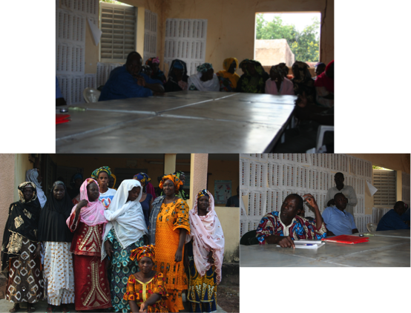

C.2. Sandaré– 15 October 2016

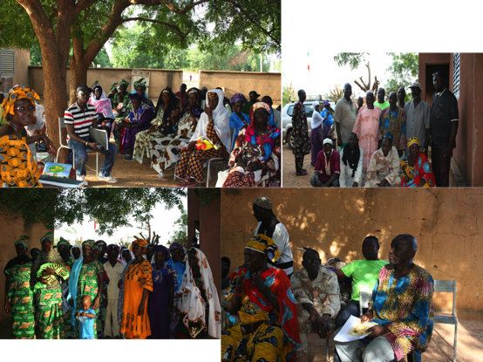

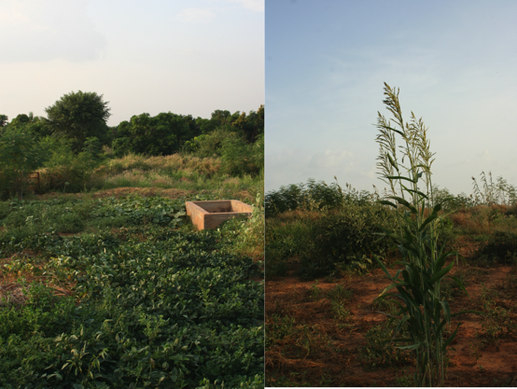

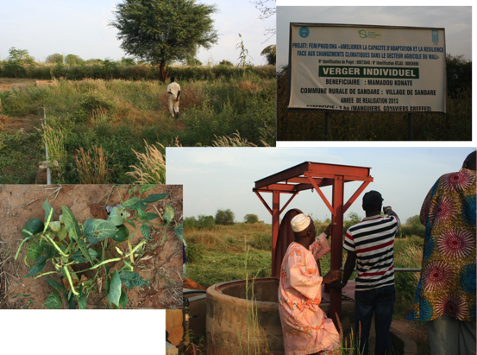

C.3. Cinzana – 17 October 2016

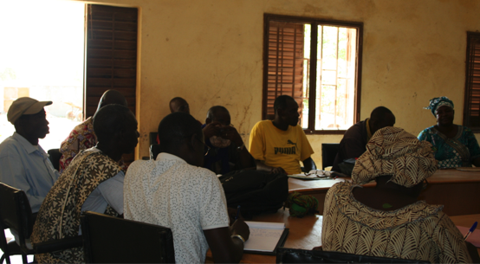

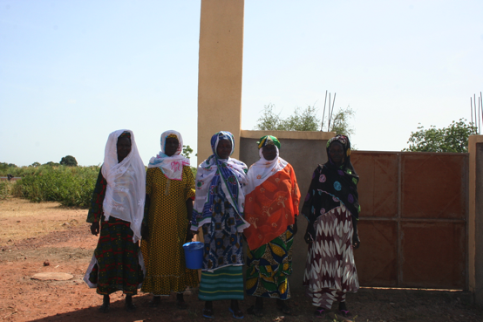

It was planned that the evaluation team would go to Samantara to visit the interventions implemented on the ground. However, we could not proceed to the village as the road became unusable following heavy rains the night before.
A visit of the on-the-ground interventions was planned for Cinzana. However, it was cancelled because of the sudden death of a member of the local community. The members of the local authority of the commune therefore advised the evaluation team not to go to Cinzana.
A presentation of the preliminary results was planned for the afternoon. However, it was cancelled following the unavailability of the UNDP team. The National Consultant presented the preliminary findings to the UNDP team on 02 November 2016. The International Consultant joined the presentation via skype.
In these schedules, seed varieties for various crops are recommended to be planted at a certain time of the year based on the amount of rainfall received.

