TERMINAL EVALUATION: ENHANCING ADAPTIVE CAPACITY AND RESILIENCE TO CLIMATE CHANGE IN THE AGRICULTURAL SECTOR IN MALI

LIST OF PERSONS INTERVIEWED

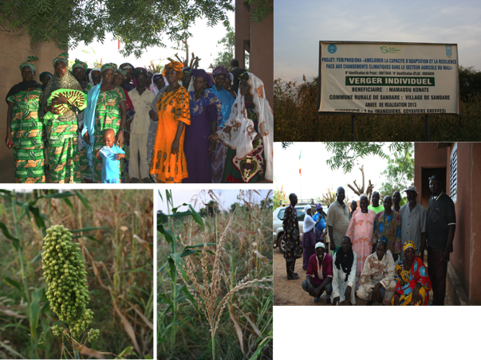

Prepared by:

Jessy Appavoo from SouthSouthNorth
&
Djibril Doucouré from AE2C

November 2016

Date of consultation | Name | Organisation | Role
11-Oct-16 | Dr Abdoulaye Bayoko | UNDP | Project Technical Advisor
11-Oct-16 | Mrs Niambele | DNA | Project Coordinator
12-Oct-16 | Mr Birama Diarra | Mali-Météo | Project Board Member
13-Oct-16 | Mr Sibyli Bengali | DNA | Project M&E staff
14-Oct-16 | See attendance register | Women’s associations (Massantola) | Beneficiaries
14-Oct-16 | See attendance register in the Mission Report attached as Annex A. | Women’s associations  (Massantola) | Beneficiaries
14-Oct-16 | See attendance register in the Mission Report attached as Annex A. | CCC | Project coordinators at the local level and beneficiaries
15-Oct-16 | See attendance register in the Mission Report attached as Annex A. | Women’s associations (Sandaré) | Beneficiaries
15-Oct-16 | See attendance register in the Mission Report attached as Annex A. | Women’s associations  (Sandaré) | Beneficiaries
15-Oct-16 | See attendance register in the Mission Report attached as Annex A. | CCC | Project coordinators at the local level and beneficiaries
17-Oct-16 | See attendance register in the Mission Report attached as Annex A. | CCC (Cinzana) | Beneficiaries
17-Oct-16 | See attendance register in the Mission Report attached as Annex A. | Women’s associations  (Cinzana) | Beneficiaries
17-Oct-16 | See attendance register in the Mission Report attached as Annex A. | CCC | Project coordinators at the local level and beneficiaries

The following beneficiary groups were present at the focus group meetings in each of the sites visited. The following groups are women’s associations or cooperatives.

Table 9: Beneficiary groups consulted
Commune | Name of association or cooperative
Massantola | Jekabaara Cooperative of Massantola  Kotognontala Cooperative of Massantola
Sandaré | Jama Jigui Cooperative of Sandaré  Dugu Jigui Cooperative of Samantara  Nyetaa Cooperative of Diallara  Jekafo Cooperative of Assa Tièmala  Kotognontala Cooperative of Monzombougou
Cinzana | Benkadji Cooperative of Cinzana Gare  Benkadji Cooperative of Dona  Women’s Group of Kondia

