TERMINAL EVALUATION: ENHANCING ADAPTIVE CAPACITY AND RESILIENCE TO CLIMATE CHANGE IN THE AGRICULTURAL SECTOR IN MALI

QUESTIONAIRE USED
10-19 October 2016

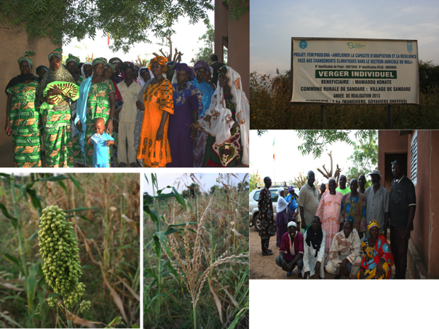

Prepared by:

Jessy Appavoo from SouthSouthNorth
&
Djibril Doucouré from AE2C

November 2016

Relevance
To what extent the interventions of the project were aligned with the development and planning policies of Government of Mali.
What was the importance of the project and the interventions implemented to the various groups of beneficiaries?
Did the interventions of the project address the needs and interests of the beneficiaries?
To what extent did the interventions of the project address a core problem identified by the beneficiaries?
Effectiveness
To what extent were the objectives of the project realized?
What proportion of the initial target group of beneficiaries was reached during the implementation of the project?
To what extent were the originally defined objectives of the project realistic?
What factors/determinants were crucial for the realization or failure to achieve project objectives?
What were the strengths and weaknesses of the project?
Efficiency
Were the objectives of the project realized in a cost-efficient manner?
To what extent were the human and financial resources used economically to achieve the objectives of the project?
Were there any means of optimizing the human and financial resources used in the project?
Did the PMU provide the services required for the successful implementation of the project?
Were the capacities created within state and non-state actors throughout the lifespan of the project used efficiently?
Did the PMU support the timely implementation of interventions? If so, how did they support this aspect of project management?
Were there any delays in implementing interventions as a result of poor project management?
If there were any delays in the implementation of the project, what was the likely cause of such delay?
Were the interventions of the project implemented according to the original workplan?
Impact
What has happened within the target locations and groups of beneficiaries since the onset of the project?
What real difference have the interventions of the project made to the beneficiaries?
How many people has the project impacted?
Have the interventions of the project contributed to the achievement of regional and national objectives in Mali?
To what extent have the interventions been altered/modified to achieve the objectives following the undertaking of the midterm review?
What are the key parameters/determining factors that have influenced the achievement of the objectives?
Have the interventions of the programmes decreased the vulnerability of the beneficiaries to the effects of climate change?
Sustainability
Are the positive results achieved thus far sustainable?
To what extent will the interventions implemented to date be expected to continue following the termination of the project? Which interventions are likely to be implemented following the termination of the project? If such is the case, who are the actors responsible for their implementation and how much insight/training have they received through this project?
To what extent will the effects be expected to continue following the termination of the project?
To what extent can the beneficiaries sustain the effects of the project without human and financial support from the PMT in the long term?
Have the beneficiaries been equipped to adapt sufficiently following the termination of the project?
Which factors are likely to undermine the sustainability of the results achieved to date?
Was there an exit strategy implemented? If so, did the exit strategy make provisions to further the benefits?
To what extent will the capacities created throughout the design and implementation of this project be used to further Mali’s commitment to mitigate and adapt to the effects of climate change and to address poverty.
Coordination
Was there a lack of coordination amongst the PMU, between the PMU and the executing team and the beneficiaries?
What factors (internal or external) were specifically responsible for the coordination of the project?
Participation
What was the level of ownership of the project among the beneficiaries and the implementing team?
What was the level of participation of the different stakeholder groups through the project design and implementation phase?
Who were the champions among each stakeholder group?
What methods were employed to promote the participation of various stakeholder groups in the design and implementation of the project?

The discussions held based on the above questions formed the basis of this evaluation in conjunction with the information collected during the desk review and the site visits.

