Enhanced Rural Resilience in Yemen (ERRY) Joint Programme: Mid-Term Review (MTR) Report
March 2016 - June 2017

Prepared jointly with

- August 2017

Acknowledgements

The ACAS and Afcar teams would like to thank the many people who contributed and participated in the ERRY JP Mid-Term Review (MTR). Abderrahim El Moulat, Monitoring & Evaluation and Reporting Officer and Ahmed Ahmed, Joint Programme Manager of the ERRY Programme gave generously of their time and were always on hand to facilitate meetings, provide guidance and forward documents.

The technical staff and management of Participating UN Organisations (PUNOs) as well as staff from Implementing Partners (IPs) provided insights and overview, highlighting the challenges, vision and scope of the ERRY programme. In the field, local authorities, community leaders and members shared information, wisdom and critique to inform the MTR, which benefits from their collective input.

This report was commissioned by the ERRY Joint Programme Unit (JPU) and supported by the European Union, which provides the financial support to ERRY. EU staff in Brussels and their representative in Sana’a are thanked for their broader perspective and constructive criticism.

The findings and conclusions expressed in the report are entirely those of the authors and should not be attributed in any manner to ERRY, PUNOs, IPs or affiliated organisations.

Drafted by:
Adnan Qatinah, Amin Saeed, Philip Visser, Sharaf Alkibsi and Sharon Low

Abbreviation

ACAS Asia Conflict and Security
CDC Community Development Council
CfW Cash for Work
ERRY Enhanced Rural Resilience in Yemen
EU European Union
FAO Food and Agriculture Organization
FFS Farmer Field School
FGD Focus Group Discussion
IDP Internally Displaced Persons
ILO International Labour Organisation
IP Implementing Partners
IM Insider Mediators
JCU Joint Coordination Unit
M&E Monitoring & Evaluation
MSC Most Significant Change
MTR Mid Term Review
NA Not Applicable
OECD-DAC Organisation for Economic Co-operation & Development- Development Assistance Committee
PUNO Participating United Nations Organisations
RACI Responsible, Accountable, Consulted, Informed
SWOT Strength, Weakness, Opportunities, Threat
TOC Theory of Change
TOR Terms of Reference
TOT Training of Trainers
UNDP United Nations Development Programme
VAPG Village Agricultural Producers' Groups
VC Value Chain
VCC Village Community Council
WFP World Food Programme
WUA Water User Association

Table of Contents

Acknowledgements 2
Abbreviation 3
Executive Summary 5
1. Introduction 10
1.1 ERRY Operating Context 10
1.2 About Enhanced Rural Resilience in Yemen (ERRY) 12
1.3 Purposes and Objectives of MTR 18
2. Findings 24
2.1 ERRY Indicative Results 24
2.2 Lessons Learned 42
3. Recommendations 47
3.1 ERRY JPU 47
3.2 Economic Empowerment Component 49
3.3 Solar Energy and Social Cohesion Components 50
3.4 Strengthening Local Authorities and Private Sector Component 51
3.5 Scaling up and Expanding ERRY 51
Annex 1. ERRY Terms of Reference 55
Annex 2. Data Collection Team 62
Annex 3. ERRY Logframe 63

Executive Summary

This Mid-Term Review (MTR) gauges the progress of the Enhanced Rural Resilience in Yemen (ERRY) Joint-programme towards its intended outcomes: 1) strengthening community economic resilience and social cohesion and 2) supporting local institutions to maintain and deliver basic services. It also provides lessons learned from the first 12 months of implementation and technical advice to tailor the project to better suit the evolving context. This report is intended to serve as one input into a broader reflection process on the project’s progress by providing evidence-based findings and recommendations and informing donor and UN decision-making on project extension and scale-up.

Methodology: The methodology for this MTR included: 1) a desk review of documents provided by ERRY management; 2) in-depth consultations with ERRY staff, Participating United Nations Organisations (PUNO) management and technical staff, and Implementing Partner (IP) staff; 3) field data collection by teams covering all four governorates and nine out of 18 districts, including key informant interviews with 105 community leaders and local authorities and focus groups with 410 beneficiaries; 4) an online survey completed by nine IPs; and 5) debriefing workshops to test and validate preliminary findings.

Limitations: Key limitations for the review process included restricted geographical access due to security concerns, small scale of field data sampling which were not representative of the interventions by the PNUOs, UN time pressures, and no entry into Yemen for international team members. The international consultants therefore engaged with some PUNOs and IPs via phone and videoconference. To supplement these consultations, Asia Conflict and Security (ACAS) Consulting formed a partnership with Afcar Consulting (based in Sana’a) to collect comprehensive field data. This combined the access and local knowledge of a national field team with the objectivity and comparative knowledge of an international team. In addition, ACAS appointed a local focal point to provide independent observations and perspective of the field data and collection process.

Report structure: The Introduction provides background information about the ERRY project, clarifies its purpose and objectives, and describes its operating context. It also further elaborates the methodological approach taken by the review team and explains the tools used to gather information and draw conclusions. The Findings section describes the indicative results of each component of the programme and how these results contributed to the stated outcomes and outputs. A summary is provided of the overall result for each outcome and output to show the collective achievement of ERRY as a whole. Lastly, the Recommendations section extrapolates lessons learned from the first 12 months of implementation, and offers actionable recommendations to strengthen ERRY’s design and implementation modalities for the remainder of the current project cycle, as well as for a possible extension or scale-up.

Key Findings

Overall assessment: By and large, target communities responded positively to all components of ERRY. Most activities contributed towards resilience and economic self-reliance. Questionnaire responses rate the programme’s overall impact as ‘Very Good’. Still, IP capacities need reinforcement and synergies must be strengthened between PUNOs and IPs. An in-depth review of project design and implementation mechanisms is warranted.

Output 1.1 / Community Livelihoods and Productive Assets: The creation and reactivation of Village Cooperative Councils (VCCs) was considered by most respondents as a very important community structure for decision making, resilience planning and coordinating the programme’s interventions at the community level. Cash for Work activities, when used to build community assets, were particularly well regarded by respondents. The process of selecting the beneficiaries could, however, be better communicated to the entire community. Cash for Work is a short-term intervention, and close monitoring of the benefits on livelihoods and income should be captured, along with an exit strategy so that the benefits can be sustained and further enhanced. Cash for Work activities linked to youth entrepreneurial development is a more complex endeavour and requires a more patient and supportive process. These activities are vulnerable to criticism when the process of selecting beneficiaries is not sufficiently open to the whole community. The agricultural value chain market development holds significant advantages. Through this activity, Small- and Medium-Enterprise (SME) systems and institutions are targeted that can drive competitiveness and job creation. For instance, through support for smallholder producers, market opportunities – specifically milk and dairy products – can be identified and developed. This added significant cash to needy households. Grouping farmers achieved economy of scale and stronger negotiation power.

Output 1.2 / Solar energy: Results for provision of solar energy were mixed, with those interviewed expressing dissatisfaction over the small number of solar lanterns provided for household lighting. Although additional solar lanterns will be provided for households in the coming quarters, funding does not allow for sufficient provision of solar lanterns to meet the high needs. The selection and prioritization of the beneficiary households should be carefully managed with the full engagement of the communities and local authorities. The solar component can also strengthen gender responsiveness, especially for households. In addition, many expressed appreciation when public services and assets (like clinics) were enhanced with solar panels.

Output 1.3 / Social cohesion: As a standalone component, social cohesion activities received some criticism; its activities delivery could be improved. The conflict scans conducted in communities provided a unique window into local conflict dynamics, historical tensions, and prospects for conflict resolution. Actual efforts to resolve the identified conflicts will take place in the coming quarters, but the social cohesion component should ideally provide a basis to guide and prioritize the project implementation through a more comprehensive localized conflict analysis, drawing on the resources of the wider ERRY project.

Output 2.1 / Institutional capacity building: Thus far, this component was able to achieve good progress on strengthening local structures, mechanisms, and related capacities with the long-term aim for communities and local authorities to be able to coordinate, plan, implement, and monitor the relevant project interventions and deliver services. In the coming quarters, this component will focus on the implementation of the identified priority interventions in the communities and districts, with close oversight and technical backstopping from IPs. The PNUOs should ensure that the VCCs and local authorities are closely engaged in the implementation and monitoring, and where capacities exist, in the implementation of interventions under ERRY. However, given the weak, if not non-existent, current capacities of the local structures and communities, PNUOs should ensure that the local structures have the minimum required capacities before engaging in transfer and oversight of financial resources.

Output 2.2 / Private sector engagement: Assessments and plans are in place and await implementation during the next implementation period.

Lessons Learned

Relevance: The MTR concludes that the ERRY joint-programme design, substantive components, and desired outcomes remain highly relevant to the current Yemeni context. The deteriorating conditions make the pursuit of resilience, economic self-reliance, strengthening local structures and mechanisms for community engagement, and social cohesion even more important than when the programme was originally designed. That said, the coherence of the different components could be strengthened, along with conceptual and practical synergies among PUNOs and IPs.

Effectiveness: There is a need for more streamlined communication and coordination with local decision-making structures. This will involve building working relationships with different layers of local government. Also, two-way accountability between PUNOs and communities must be strengthened, and this could take the form of a direct feedback mechanism from communities to PUNOs.

Efficiency: It is advisable to regularly review project efficiency to ensure the programme’s targets are realistic and its outputs efficiently delivered. This report provides ‘burn rates’ as an indicator for PUNOs to reflect on their current implementation modalities and cost efficiency.

Impact: While it is likely that ERRY has contributed to resilience in each target governorate, it is too early to attribute this trend to ERRY, given factors elaborated in this report. Moreover, it is assumed that programmatic impact will be enhanced with increased geographical convergence of the various components. Currently, the level of convergence is low and could be made more effective. ERRY partnering agencies should also consider documenting their collective impacts to strengthen the rationale for collaboration. Lastly, it is advisable to mainstream gender sensitivity across ERRY programming, which would enhance the positive impacts for women and men.

Sustainability: While it is too early to draw conclusions about the programme’s sustainability, working more closely with local governments and local decision-making structures – in addition to IPs – and ensuring appropriate exit strategies for the short-term Cash for Work interventions could augment prospects for sustainability.

Recommendations

Recommendations are offered to strengthen the current functioning and implementation of ERRY.

ERRY Joint Coordination Unit: It is recommended to conduct a stakeholder analysis to systematically outline the layers of decision-making within ERRY (internal and external), with view to improving accountability and coherence. Joint assessments and monitoring visits among PUNOs and IPs, as well as more regular communication between PUNOs and local authorities, are also advisable.

Economic Empowerment and Solar Energy Components: There are opportunities for increased synergies between the economic empowerment and the solar energy components. Solar energy is central to both households and community assets (such as clinics). It is recommended to enhance linking solar energy support to other components, including the provision of solar energy to productive assets such as water pumps for farmers as well as for enhancing the functioning and delivery of key social services (schools, health facilities and local district offices).

Social Cohesion Component: A clear link exists between localised conflicts and breakdown of social cohesion. Local conflicts almost always involve competition over scarce resources. Building social cohesion, therefore, entails inclusive dialogue to equitably share resources and build community assets. It is recommended to mainstream the social cohesion component across the different ERRY interventions for conflict sensitivity and to apply the conflict lens in the prioritization of the interventions, including in the recovery and resilience plans. This would substantially contribute to resolving local conflicts.

Strengthening Local Authorities and Private Sector Component: The component seeking to strengthen local authorities’ ability to deliver services faces a dilemma. Engaging local government as an implementation partner would be optimal. However, several factors are presently discouraging this approach. Nevertheless, it is recommended that local authorities be engaged more directly and substantially by both PUNOs and IPs in the course of implementation. At this stage, PNUOs should ensure that the local structures have the minimum required capacities before engaging in transfer and oversight of financial resources.

Scale-Up and Expansion of ERRY: ERRY was designed based on a clear rationale, and the scale-up should also be based on a clear rationale and integrate the recommendations of the present MTR as well as other lessons learned during this first implementation period. This will give confidence to the range of stakeholders invested in ERRY and will contribute to financial prudence, transparency and programmatic coherence. It is hoped that the analysis, lessons and critique provided by this MTR will offer a reflective argument for the continuation of ERRY beyond the current three-year funding cycle.

Introduction

ERRY Operating Context
Yemen is in political transition. Long gone are the heady days of the 2011 uprising, when Yemeni youth, inspired by the Arab Spring events in the wider Middle East, took to the streets, expressing their frustrations with the political status quo. The inclusive national dialogue that followed brought Yemeni political and civil society leadership into conversation to search for a new way forward. The process concluded in January 2014 and offered a new beginning for a country which most often is referred to as the poorest in the Middle East. Soon, however, the promise petered out as political brinkmanship became the default political impulse. Before long the lines of division were drawn in the sand. The stage was set for the war that is pushing Yemen to the brink of disaster, creating a humanitarian crisis amidst the stress of violent political transition. The internationally recognized government re-established themselves in Aden but the security environment remains difficult for both government and international agencies. With a reported minimum number of 8,053 civilians killed and over 45,000 injured, the inclination is to reduce the assessment of the damage to Yemen to a number or as only a humanitarian crisis.

Village-level conflict analysis highlights that in many cases the national conflict impacts on local dynamics, sometimes directly but most often indirectly. One of the most direct expressions of the national conflict is the establishment of two layers of local governance. The first performs the role of providing local services - health, water, sanitation and education. The second is an expression of the political imperative to oversee the influx of resources, aid and community support that flows into governorates and districts. ERRY should build relationships with both levels.

The Yemen economy has continued to decline since the war started. This holds several consequences for Yemen and its population. Relevant for ERRY is how a declining economy impacts people and their ability to stay resilient and self-reliant. In general, it is making people poorer. Communities now live much closer to the edge of survival, having depleted much of their resources and savings. Social and family networks equally are exhausted. At a broader level it is important to note that the Social Welfare Fund, which provides financial assistance to poor households, stopped functioning in early 2016, affecting nearly eight million people. Only 13 percent of households had access to international remittances in March 2016, and a September 2016 report indicated the remittances were obstructed by delays, lack of currency, closed offices, and banks unwilling to use the official exchange rate. Limited cash liquidity also impacts consumer prices and trading which impacts the ability of ordinary people to purchase basic commodities. At a social level, the impact of poverty and declining self-reliance filters down to relationships and old conflicts and fault lines take on new dimensions.

Several sectors important for ERRY livelihood support components have been impacted by the conflict: high input prices, water and fuel shortages. It has severely disrupted the agricultural and fishing sectors, which employed over 50 percent of Yemen’s workforce. Cultivated area and production decreased by 38 percent in 2016, and livestock production decreased by 35 percent compared to pre-crisis levels. Fishing in coastal areas (Hajjah, southern Taiz and Al Hodaidah) has stopped due to access and security issues, as well as the blockage of land, air and marine ports for fish exports. Insecurity and poor access to agricultural inputs limits farmers' access to their lands and ability to produce. The poultry sector is on the brink of disintegration, which will affect many farmers, as the sector previously saw high investment. Additionally, a desert locust infestation identified in 2016 has continued into 2017. Scientists fear that interventions to control the locusts might kill bees, which are vital to the economy.

Most of the 333 districts in Yemen are still accessible to humanitarian actors. An estimated 62 percent of the country's districts - mainly in the eastern and central regions - are either fully accessible or are subject to relatively few security constraints. Taiz, Marib and Sa'ada governorates have the greatest number of districts that are extremely difficult to access. Airstrikes have damaged much of the infrastructure and most recently, the roads and bridges around the port of al Hodeidah were targeted. This infrastructure is vital for the movement of humanitarian and commercial supplies into the country. Insecurity on connecting roads from al Hodaidah continues to pose a threat to humanitarian staff, making access to populations in these areas difficult. Aden airport is open but with restricted access. Around 24.3 million people lack access to electricity through the public grid . Power cuts are frequent across the country; major cities, Sanaa, Taiz, Aden, and al Hodeidah do not have electricity supplied by municipalities.

Perhaps the single-most important driver of local conflict is water. Village level conflict analysis repeatedly identifies that at community level, water-related disputes are by far the most common. The devastating cholera outbreak highlights the need for clean and accessible water supplies. Since the start of the current outbreak, the National Water Resources Authority (NWRA) has closed more than 40 water stations in the hardest hit areas. They will remain closed until they comply with national standards. A rapid assessment of household water storage tanks was conducted in hotspot locations in Ibb and Sana'a. Most of the tanks tested were contaminated. The lack of good quality, reliable drinking water sources is forcing people to seek alternative unsafe options such as unregulated private sellers and unprotected wells. Hajjah has suffered chronic water shortages, causing additional health problems such as skin infections and diarrhea. Investment in water infrastructure and in community capacities to manage their water resources is an essential component considered in the ERRY design.

The ERRY project is focused on making a difference at the local level. The national context impacts and shapes local dynamics and deepens the quest for livelihoods of already stretched communities and households. Working with communities carries political and security risks and ERRY must operate with a deep understanding of both local and national conflict dynamics to optimise impact and minimise risks.

About Enhanced Rural Resilience in Yemen (ERRY)
The Enhanced Rural Resilience in Yemen (ERRY) is a three-year programme funded by the European Union (EU) and implemented by Participating United Nations’ Organisations (PUNO) and their respective Implementing Partners (IP). A number of IPs also signed agreements with local Civil Society Organisations (CSOs) to provide easier access and delivery to some of the select villages.

The overall objective of the programme is to enhance the resilience and economic self-reliance of crisis-affected rural communities and strengthen social cohesion through support to livelihoods stabilisation and recovery, strengthening local governance capacities and improving access to sustainable energy. This objective will be achieved through the collective impact in combining the select components of ERRY and drawing on the complementarity of the participating agencies’ comparative advantages. This assumes synergy and conceptual coherence between the different components, wherein each component on its own contributes towards the stated outcomes. A detailed ERRY Logical Framework is provided in Annex 3.

    - Programme Design

Outcome 1: Communities are better able to manage local risks and shocks for increased economic self-reliance and enhanced social cohesion

Output 1.1: Community livelihoods and productive assets are improved to strengthen resilience and economic self-reliance

A number of activities were designed to achieve Output 1.1:
- Strengthen community-based governance structures such as Community Development Committees (CDCs) and Village Community Councils (VCCs) as a basis for community-driven empowerment and decision-making. VCCs mobilize community members to develop integrated community resilience plans that will be supported by UNDP through Community Compacts.

- Enhance resilience through assets accumulation. Under this activity, food insecure households will have access to cash. At the same time, households will be engaged in productive activities oriented to create or restore productive community assets as well as assets that enhance communities’ resilience in the face of shocks such as drought, floods and conflict.

- Support sustainable livelihoods and income-generation with the provision of seed capital to establish micro and small social businesses using small grants schemes. The “3x6 approach” is implemented to promote youth and women employment and is adapted to ensure inclusion, ownership and impact:

Figure 1: 3x6 approach

Greater integration with business networks, markets, financial access, as well as business development services is pursued through strategic partnerships with business associations, local authorities, financial providers, as well as Business Support Centers where applicable.

- Skills developed of women and men in agricultural value chains (FAO)
A review and study of the key value chains in the crop, livestock and fishery sectors was conducted to identify livelihoods opportunities. Priority crops / livestock Value Chains for food security and income opportunities for rural smallholders were identified and supported in the targeted districts. The major criteria for selection were: good priorities for cash income and food security, good market growth opportunities, good potential for smallholder farmers to participate in that growth, and existing technical challenges that can be addressed.

Output 1.2- Communities benefit from solar energy for sustainable livelihoods opportunities

Activities under Output 1.2 included:
- Expansion of solar energy applications to strengthen rural energy resilience, capacity building and recovery.

- Provision of solar energy to secure the electricity needs for the delivery of essential public services for vulnerable rural communities focusing on community infrastructure (e.g. refrigeration to store vaccines and medicines; solar water pumps for communal areas, street lights for greater communal security, etc.).

- The application of solar energy alternatives by implementing pilot interventions focused on productive assets such as integrated solar water pumping, in collaboration with local cooperatives and concerned institutions, was demonstrated across the targeted governorates.

- Marketing of micro-business development for solar energy, including a rapid assessment on the solar market potential to support business development in the solar energy sector, with a special focus on micro businesses. This activity also supported the development of a solar market mix (i.e. product/equipment, price, promotion and distribution) to encourage private sector engagement and support energy service demands through provision of solar energy.

Output 1.3: Informal networks promote social cohesion through community dialogue and delivery of services

Activities under Output 1.3 include:
- Strengthening existing or new Water User Associations (WUAs), including women members, to promote better water management and reduce local conflicts. This component focuses on the start-up phase of WUAs and on incentives that drive the establishment and operation of WUAs.

- Insider Mediators (IM) are local community actors possessing high levels of legitimacy and trust with the parties involved in specific conflict(s) and thus the unique ability to directly or indirectly influence conflict parties’ behavior and thinking. UNDP will expand the cadre of IM it works with, ensuring at least 30 percent of IMs are women, and train them on conflict-resolution mechanisms.

- Capacity development for IMs includes knowledge and skill development such as conflict analysis, mediation and negotiation skills, leadership and gender sensitivity. In addition, they are expected to promote social cohesion and capacity development which incorporates understanding of conflict and tensions related to identity, interethnic relations, inter-and intra-religious relations, gender-based violence, and the role of traditional mechanisms in conflict prevention.

Outcome 2: Institutions are responsive, accountable and effective to deliver services, build the social contract and meet community identified needs

Output 2.1: Functions, financing and capacity of local authorities enabled to deliver improved basic services and respond to public priorities

Activities for Output 2.1. include:
- Capacity development of local authorities so that they can take the lead in humanitarian and recovery planning, monitoring and coordination. Some local authorities are still collecting taxes and fees which are used to implement government projects. In facilitating local authorities’ service delivery, a core team/crisis management team, which consists of representatives of main service delivery departments, will be reactivated and supported.

Output 2.2: Increased capacity of local actors and strengthened partnership of private sector to enhance economic recovery.

Activities for Output 2.2 include:
- In parallel with the value chain analysis conducted by FAO in the agricultural sector, ILO implemented a rapid Participatory Value Chain Analysis for non-agricultural sectors with high potential for job creation. Emphasis was on the identification of bottlenecks for job creation that will be later tackled with direct interventions, either through training services under this component, or through other components tackling advocacy, coordination and governance at governorate/local levels.

- In addition, capacity building is provided to training providers on: (a) competency-based approach to training; (b) pedagogical skills for instructors; and (c) testing and certification methods. Emphasis is put on workplace-based learning. The project supports the “upgrading of informal apprenticeships”, i.e. concurrently improving the training provision, the workplace environment and the productivity of small businesses - linked with training providers. Capacity building for Business Development Services (BDS) is also provided. ILO is linking with WFP for the development of post-Cash for Work services. This support will be provided for the design and piloting of graduation packages.

- The private sector remains a key and overlooked partner in the promotion of resilience through employment and economic revitalisation. UNDP has mapped active and credible economic entities and their networks in targeted governorates contributing to stakeholders and community profiles. UNDP builds the capacities of existing business associations and key economic institutions using the UNDP capacity assessment tool, with a focus on rural areas, to encourage private-sector led employment creation and identification of new opportunities.

Table 1: Summary of ERRY Results Framework
Outcomes | Outputs
Communities are better able to manage local risks and shocks for increased economic self-reliance and enhanced social cohesion. | Community livelihoods and productive assets are improved to strengthen resilience and economic self-reliance
 | Communities benefit from solar energy for sustainable livelihoods opportunities
 | Informal networks promote social cohesion through community dialogue and delivery of services
Institutions are responsive, accountable and effective to deliver services, build the social contract and meet community identified needs. | Functions, financing and capacity of local authorities enabled to deliver improved basic services and respond to public priorities
 | Increased capacity of local actors and strengthened partnership of private sector to enhance economic recovery

    - Targeted Areas

The ERRY Programme is being implemented in 17 districts within four governorates - Hajjah, Hodeidah in the North and Lahj and Abyan in the South. The target group is the most vulnerable (women, youth, Internally Displaced Population, Marginalized People), using inclusive, participatory and conflict-sensitive tools to mobilize and get them involved in the proposed activities.

Table 2: PUNO and their interventions by districts
 | ILO | FAO | UNDP | WFP
Abyan (11 districts)
Kenfar | X | X | X | X
Loudar |  |  | X
Zenjibar | X | X
Mawdhiah |  |  | X | X
Lahj (15 districts)
Tuban | X | X | X | X
Habeel Jabr |  | X | X
Al-Houtah | X
Halmein |  |  |  | X
Hajjah (31 districts)
Abs | X | X | X
Caidanah |  |  | X
Bani Qais Al-Tour |  | X | X | X
Aslam | X |  | X | X
Al-Hodeidah (26 districts)
Al-Zuhrah | X | X | X
Bait Al-Faqeh |  |  | X | X
Bajel | X | X | X
Zabeed |  |  | X | X
Al Marawaah |  | X

Purpose and Objectives of Mid Term Review
This MTR was commissioned by the ERRY JCU to identify what is working well, and what can be done better to provide a rationale and evidence-based recommendations to scale-up the programme and increase its coverage. The objectives of this MTR as stated in the TOR are:
- Assess ongoing relevance of the ERRY joint programme in the current political and economic contexts;
- Review how ERRY is being implemented, identify the main implementation challenges, and how the programme delivery can be more effective, including in coordination and management;
- Assess the programme’s performance halfway into implementation, focusing on actual progress and results achieved that are contributing towards community resilience, social cohesion, access to solar energy, self-reliance and livelihoods;
- Derive lessons from the midway intervention and formulate recommendations to improve the programme’s delivery and performance; and
- Provide objective evidence and justifications for supporting the scale-up of the programme to include more beneficiaries and cover more geographic areas.

    - MTR Strategy and Design
The design and implementation of the ERRY joint programme focuses on the synergies and strength of the PUNOs and the IPs, as well as with a broader set of social, economic, policy and cultural contextual factors that influence both intermediate outcomes and long-term impacts.

This MTR focused on two aspects of the programme— (1) those related to the programme design, and (2) those pertaining to the implementation of its activities. These decisions in turn influence two sets of results: (1) the reach of the programme (coverage), and (2) specific early outcomes which the ERRY joint programme aims to achieve, particularly with respect to access to livelihoods opportunities and broader investments in community resilience and social cohesion.

Figure 2: Evaluating decisions and results

Design

Implementation

Programme reach (coverage)

Programme outcomes
Decision-sets
Evaluable results

The overall review utilizes the OECD-DAC criteria to assess the extent to which the project interventions were:
- Effective and efficient in reaching these goals,
- Relevant and appropriate to deliver these results to project stakeholders; and
- Have the potential to be sustainable.

The MTR, as stated in its ToR, is intended to provide evidence to address the following evaluation questions:

Review criteria | Questions
Relevance | - To what extent is the ERRY programme still relevant to the initial identified needs and Yemen context?  - To what extent is the ERRY programme approach contributing to address the resilience and livelihoods’ needs of the targeted beneficiaries  - Is there a rationale and/or evidence for expanding the programme’s coverage and number of beneficiaries?
Effectiveness | - Is the ERRY programme on the right track to achieve its intended outputs and targets during the covered period?  - What were the main factors that influenced the achievement of the programme’s objectives and outputs?  - Has the ERRY programme reached its target beneficiaries, especially the more vulnerable groups (women, IDPs, marginalized groups)?  - Were the internal and external coordination and communication mechanisms effective in sharing information and creating synergies among the programme’s direct stakeholders?  - Based on the progress so far and the ground situations, what are the recommended changes to the implementation approaches, strategies and the management processes to enhance the programme’s effectiveness?
Efficiency | - Were the programme’s resources efficiently utilized? Are there more efficient ways of delivering the same or better results with the available inputs?  - How efficient were the management and accountability structures of the project? (Programme cycle, staffing, M&E processes, selection of implementing partners)  - What are the strengths, weaknesses, opportunities and threats of the project’s implementation processes?
Impact and Sustainability | - To what extent are programme’s intended impacts on the communities’ resilience and livelihood starting to emerge? Can the gains made under the programme be sustained?

ACAS-Afcar understands that this review will partly inform the scaling up strategy for ERRY. The MTR will concentrate on answering questions related to design, implementation and results. It also endeavors to provide preliminary answers to the questions related to the longer-term outcomes, which will be more fully addressed with the end-line analysis. The MTR will not document the full range and depth of the programme’s resulting outcomes and impacts, but rather assess leading indicators (most notably livelihoods, self-help, social cohesion and community resilience) and their implications for potential impact.

    - Methodology

ACAS and Afcar teams proposed a design using a variety of methods:
- A comprehensive desk review of programme records, national and international documents as provided by the ERRY JPU. An Inception Report was drafted, which provided a detailed timeline and approach for the MTR. The Inception Report was discussed and agreed to by the ERRY JPU;
- Discussions with regional staff based in Amman, Jordan: Edward Christow and Marta Vallejo Mestres. This provided background and helped to gain understanding of the original thinking behind ERRY and how different UN agencies came together to submit a joint proposal.
- Video-conferencing with the ERRY teams in Sana’a and Aden and the international team in Amman, Jordan over nine days, including: ERRY JCU (n=4), PUNOs (n=18), Heads of UN Agencies (n=4), IPs (n=10), as well as EU representatives in Brussels and Sana’a (n=2). These participatory discussions were very helpful to gain better insight in the thinking of each of the major stakeholders through an exchange with the ACAS team.
- Field data collection conducted by Afcar team in nine out of 17 districts in the four governorates:
- Semi-structured interviews with a total of 105 local authorities and community leaders.
- Focus group discussions (n=41) with 410 beneficiaries (41.2% females, 58.8% males).
- Informal conversations and participant observation.
- Online survey completed by nine IPs. A set of survey questions was posted on the online tool Survey Monkey and completed by all the IPs. This was particularly helpful to get a deeper understanding of their partnering arrangements, villages they are active in and their analysis of the programme’s results to-date.
- Debriefing sessions with field associates (Amin Saeed, Adnan Qatinah, Sharaf Alkibsi) to discuss preliminary findings, and to deliberate on inconsistencies, ambiguities and dilemmas during field data collection.
- Preliminary findings discussions with PUNO technical staff, Afcar consultants and ERRY JCU.
- Final report drafting process and discussions to ensure the report reflects the field data collection and its findings.

Table 3: Summary of semi-structured interview respondents
Govern-orate | Districts | PUNOs | IP | Local autho-rities | VCC | CD consu-ltants | Entrep specia-lists | Mediation trainers | Public service/Solar systems | VAPG/FFS Trainer | Total
Sana'a |  | 4 | 3 |  |  |  |  |  |  |  | 7
Hajjah | Hajjah City |  | 3 | 3 |  |  |  |  |  |  | 6
 | Bani Qais |  | 1 | 2 | 1 |  |  |  |  | 2 | 6
 | Aslam |  |  | 2 |  | 1 | 3 |  | 2 |  | 8
Hodeidah | Hodeidah City |  | 3 | 4 |  |  |  |  |  |  | 7
 | Bajil |  | 2 | 3 |  |  | 3 |  | 2 | 2 | 12
 | Zabeed |  | 1 | 2 |  |  |  | 3 |  |  | 6
 | Al-Marawaah |  | 1 | 2 |  |  |  |  |  | 2 | 5
Lahj | Al-Hawtta City |  | 2 | 1 |  |  |  |  |  |  | 3
 | Tuban |  | 1 | 3 | 1 | 3 | 3 | 3 | 2 |  | 16
 | Habil Jabr |  |  | 2 | 2 | 3 |  | 2 |  |  | 9
Abyan | Zenjibar |  | 2 | 1 |  |  |  |  |  |  | 3
 | Kenfar |  |  | 2 |  | 3 | 3 |  | 2 |  | 10
 | Moudyah |  |  | 2 | 3 |  |  | 2 |  |  | 7
Total |  | 4 | 19 | 29 | 7 | 10 | 12 | 10 | 8 | 6 | 105

Table 4: FGDs by district and theme
Governorate | Districts | Community benefiting from solar energy | Youth benefiting from entrepreneur-ship support | IMs and communities work with | Community benefiting from community assets & CfW | Community benefiting from value chain support | Total
Hajjah | Bani Qais |  |  |  | 2 | 2 | 4
 | Aslam | 2 | 2 |  | 2 |  | 6
Hodeidah | Bajil | 2 | 2 |  |  | 2 | 6
 | Zabeed |  |  | 2 | 2 | 2 | 6
 | Al-Marawaah |  |  |  |  | 2 | 2
Lahj | Tuban | 1 |  | 1 | 2 | 2 | 6
 | Habil Jabr |  |  | 2 |  |  | 2
Abyan | Kenfar | 1 | 2 |  | 2 |  | 5
 | Moudyah |  |  | 2 | 2 |  | 4
Total |  | 6 (n=) | 6 | 7 | 12 | 10 | 41 (n=)

Figure 3: Number of FGD respondents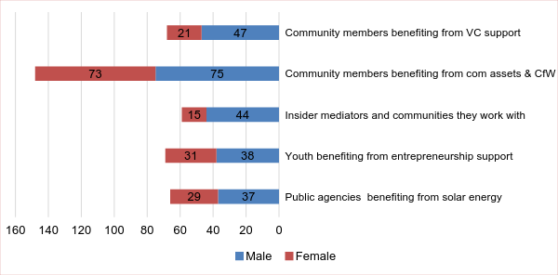

Data collection was conducted between 15-21 July 2017. A team of 18 field researchers worked under two field supervisors. The selection of districts was based on: (i) equal North/South Governorates and Districts, (ii) presence of thematic focus, (iii) PUNOs intervention in the Districts, (iv) balance of representation of each thematic focus for this review, and (v) Districts where sufficient substantive work was done.

This report serves to complement the progress reports prepared by ERRY JCU. It triangulated and elaborated ground-level information and insights provided by ERRY staff for the scaling up phase. It is not meant to be representative of the interventions and/or their results but a snapshot of the processes which are put in place to ensure assistance is provided.

    - Limitations

The MTR was conducted under significant time pressure due to tight deadlines for submission. This was further complicated when the international consultants could not obtain visas to enter Yemen. This meant that the national consultants who conducted the field data collection and the international consultants were not able to have direct face-to-face discussions to discuss the design of the field component and the findings. The lack of direct access necessitated extended and regular communication via teleconference with ERRY management, PUNOs, IPs and Afcar field team. The ERRY management facilitated all the meetings which was helpful. ACAS appointed a focal person in Sana’a to act on their behalf and to provide an independent viewpoint and perspective on field data gathering and field observations.

Access and travel in Yemen is risky and takes considerable planning and costs. Afcar Consulting was contracted to gather field data and was similarly confronted with limitations of access. To overcome this, they made use of a network of locally based researchers and facilitators. As such, most likely only the “best case scenario” was presented as a cross-sectional finding and the findings should not be considered as representative across the entire programme. It needs to be taken as an exploratory non-systematic assessment of the programme's early results and outcomes for further discussions to strengthen ERRY’s delivery.

The MTR shares a built-in bias with all data collection processes, that is (i) Hawthorne effect, wherein respondents modify their comments or behaviour when they know they are being observed; (ii) interviewer bias, when knowledge and experiences of an interviewer influence the responses; and (iii) social desirability bias, when respondents tell interviewers what they think they want to hear. Two factors specific to the MTR heightened this bias effect. The first was limited access due to insecurity and cumbersome procedures for travel outside the main centres. The second was the relatively small sample size. The findings therefore cannot be representative of the entire range of beneficiaries or the full scope of the ERRY programme.

To minimise bias, MTR team met and discussed with senior staff in Amman, Jordan who were part of ERRY design to check up on assumptions and to limit these from influencing data collection or interpretation. Additionally, all findings were triangulated based on (1) routine data available, (2) consolidation of ground-level understanding from stakeholders, and (3) broader thematic knowledge.

Findings

ERRY Indicative Results
Findings regarding ERRY indicative results are given below in relation to outcomes and organized by specific outputs. Based on discussions with ERRY Joint Coordination Unit team, results are not disaggregated for any agencies or intervention sites due to the non-representativeness of the sampling. However, where relevant, salient findings are reported from the analysis of disaggregated data.

    - Achievements and Major Outputs

As part of the ERRY joint programme, communities were targeted for participatory planning and prioritization across the four Governorates. Solar energy was introduced, with additional linkages sought through enterprise recovery to reach markets. Local governance was enhanced through capacity building of Governorates and local district authorities servicing the entire local population. To reduce tensions and improve social cohesion for resilience-building, insider mediators (IMs) were trained and supported, with strengthening informal networks like water user associations for economic revitalization and basic services to be delivered.

Table 5: Summary of Communities, Direct and Indirect Beneficiaries (March 2016-June 2017)
 | Resilience Plans (participatory planning) | Agricultural and non-agricultural Livelihoods | Solar energy | Conflict prevention and resolution | Local governance (local authorities) | Workforce and business association support
UNDP | 181 VCCs activated, 160 resilience plans developed and 249 community self-help initiatives implemented | 749 individuals established social businesses. Total of 11,893 indirect beneficiaries (cash for work and social businesses) | 40 communities: 800 households, 20 health centres, 20 schools, 2 market places and 2 productive associations | 42 trainers provided training to 228 IMs.  4 district conflict scans conducted, with community dialogue initiated in 4 governorates | 4 Governorate Offices.  8 local district authorities | Capacity assessments completed for 2 business associations.
FAO |  | 9,350 farmers benefited from agriculture value chain development and provision of inputs |  | 30 water user associations activated
ILO |  |  |  |  |  | 27 business startup trainers trained;  220 people received business startup training; Assessment on informal apprenticeship progressing
WFP |  | 16,065 households participated in cash for work; 62 community assets built or rehabilitated
Source: ERRY Year 1 Annual Report pp 9-11

In addition to the direct and indirect beneficiaries, ERRY has also impact on the lives of local populations through the effect of community level engagement and local authorities/association support activities, which is not captured in the above-table. ERRY interventions are also expected to produce collective impacts on the entire communities and populations, combining through the different components in contributing to community resilience building.

    - Outcome 1: Communities are better able to manage local risks and shocks for increased economic self-reliance and enhanced social cohesion

Output 1.1 Community livelihoods and productive assets are improved to strengthen resilience and economic self-reliance

Table 6: Perception of community members towards ERRY and its intervention’s assumptions
 | ERRY improved community livelihoods | ERRY improved productive assets | Improved community livelihoods strengthen resilience and economic self-reliance | Improved productive assets strengthen resilience and economic self-reliance | Improved community livelihoods and productive assets strengthen community social cohesion
Cash for Work (n=148) | 5.0 | 4.9 | 4.8 | 4.8 | 4.7
Entrepreneurship development (n=69) | 4.8 | 4.5 | 5.0 | 4.7 | --
Value chain development (n=68) | 4.7 | 3.7 | 4.7 | 3.3 | 4.7
Average scores | 4.8 | 4.4 | 4.8 | 4.3 | 4.7
Question: On a scale of 1 to 5, as a group, indicate if you agree to the statement which will be read out to you. (1) Totally disagree; (3) Unsure; (5) Totally agree
- Cash for Work and Community Assets Rehabilitation
Villages of Shorokh and Damanah, Zabeed district, Hodeidah.

Four young men, Hasan, Salem, Ali and Khalil, received cash for paving roads between Shurookh and Damanah. Besides acquiring new skills, they also got to know their neighbors better during the process of working together. They were also perceived to be more creditable by the local shop owner. They reported to have stronger confidence to jointly deal with the upcoming raining season.

With the cash:
- Hasan made a ceiling for his rooms
- Salem and Ali each bought a solar light system
- Khalil bought 2 goats

At the same time, getting to know each other contributed to stronger cohesion among the community as they could attend weddings and funerals:

“Getting to know one another between the team members and improving their livelihoods. Some of their family members can stop running away from not being able to repay debts. Merchants also used to refuse to provide loan as they do not have an income, but now they are willing to consider providing them with credit.”

“The cost of transportation used to be high due to inadequacy of the road. After rehabilitating the road, any kind of car can reach easily the village so that transportation is cheaper. The community realized the importance of cooperation to facilitate projects that serve the whole community.”

- Selection of participants to Cash for Work activities was done based on selection criteria set between the village council leadership and the implementing partners (IPs). Work included rehabilitation of roads, agricultural lands and water wells, as well as removal of garbage and trees from public areas.

- Besides receiving cash, indirect benefits reported were: (i) community members acquired knowledge and skills which made them more employable; (ii) cash was invested as capital for livelihood opportunities, for example purchase of motorbikes, livestock, starting grocery stores among others; (iii) better opportunities to get loans; (iv) improved relations (social capital) within and between communities and civic-mindedness; as well as functional public goods (and services) which led to cost-savings in other aspects of life.

- The key difference between the WFP and UNDP approaches for Cash for Work are:

WFP | UNDP
Obtain list of beneficiaries’ names from IPs and disburse cash through post office. Less efficient and more delays. | Sends cash to IPs to disburse through Alamal Microfinance Bank (NGO owned by SFD) and Alkuraimi MF (private bank). More efficient and prompt payment.
Worked with either VCCs or created Community Councils to decide on asset rehabilitation. Key objective was community development and social cohesion. | CfW was a prelude to the provision of entrepreneurship training and grants for youth. Skills and business development training is provided, and payments are done bi-weekly. Key objective is alternative livelihood options. Challenge is that some participants felt that CfW had not added any community development value as it focused on small scale community assets due to the limited duration of the CfW (1 month), or more ‘soft’ community initiatives (i.e. street cleaning , etc.)
Community may work on asset rehabilitation for up to 12 months. Grant is provided for procurement of materials like cement, sand, etc. | Youth will work on assets rehabilitation for up to 30 days. Only basic tools were provided.
 | There is a strong effort to tailor the CfW interventions to promote the engagement of more women. At present, around 30% of CfW beneficiaries are women.

- Communities raised a few aspects which could be better managed for Cash for Work to contribute towards community resilience and self-reliance: (i) better quality tools, as the ones distributed were inferior; (ii) more prompt transfer of cash, as it could take up to several months before communities received it; (iii) provide information, skills or knowledge to enhance improved livelihoods, food security and self-reliance besides cash; and (iv) provide basic welfare like food and water during course of work, as well as first aid and medical care. The above-mentioned suggestions varied between communities, leadership management style as well as differences in IPs’ approaches, but it does offer a sense of the community’s expectations.
- Five out of 12 focus groups, including six out of 18 local authorities and six out of seven VCC leaders interviewed reported that women were either not effectively mobilized or underrepresented in the CfW component, due to the nature of the selected community projects, which labour intensive. Also noteworthy is that all local authorities and VCC leaders interviewed were male.

- 3x6 approach and Youth Entrepreneurship Development
Key achievements
So far, 1,664 CfW beneficiaries, about 30 percent of whom are women, participated in life-skills and business trainings including financial literacy training. All CfW beneficiaries opened a bank (savings) account and each saved around US$180 by the end of the CfW period. Through the CfW initiatives, the project has explored collaborative actions with local authorities and other agencies working in Yemen to realign the CfW activities to address the cholera outbreak in Yemen.

A total of 749 beneficiaries (around 30 percent women) who submitted viable business plans have been supported with business grants and advisory services and successfully established their individual and joint microbusinesses.

Approximately 10 percent of the beneficiaries who did not graduate to the second stage of entrepreneurship support managed to set up their microbusinesses building on their savings generated during the CfW initiatives.

After two months:
- 98 percent of startups in Hajja and Hodeidah are still functioning
- 87 percent of startups in Abyan are still functioning
- 100 percent of women-owned businesses are still functioning. For the first time in their rural areas, some women established pioneer businesses such as: women’s café, wedding events organization and a photography studio catering to women allowing them privacy. Assessment showed that these women were managing their businesses by themselves.
- In Abyan, selection of participants was based on an application process. Youth were expected to submit a form (business proposal) and attend an interview to qualify. In Hajja and Hodeidah, business consultants reviewed all business proposals and made the selection based on agreed criteria.

- All groups interviewed mentioned that they had to participate in Cash for Work, including cleaning of health facilities, schools or other community assets, for about a month before they were given training and grants to start their own business. It is worth mentioning that the participants on the entrepreneurship track are required to save about 40 percent to 60 percent of wages earned under CfW as base capital required for the business set up. This was intended to strengthen the ownership of the capital and of the business.

- One group reflected that there were an “insufficient number of grants” given out compared to the number of people who received training. This may be the sentiment among participants who were unsuccessful in getting onto the entrepreneurship track or in receiving additional grants. The approach under the 3x6 is to select 50 percent of CfW beneficiaries to engage in the entrepreneurship track.

“Women have only few options when it comes to education and most women work with their families in agriculture, cattle breeding or sit idle at home. So, they considered this project an opportunity to get out of this limited space and embark on new horizons. However, targeting of women was low and [not many women] were grant recipients. It should be noted that each project should cover an appropriate number of beneficiaries and yield a significant impact!”

- On average, about 30 percent of participants in the entrepreneurship track development are women. However, as the selection is done from the pool of Cash for Work beneficiaries, the pool of women is smaller as there is a perception that CfW activities in general (including community assets rehabilitation) are not suitable for them. There were suggestions from FGDs to create less physical activities and replace them with more ‘soft’ community initiatives such as community outreach and social mobilization as activities for girls and women instead.

- Three out of five focus group participants reflected that many were unaware of what the activity entailed at the time of registration. They were only asked if they were “interested in getting a job” and they responded positively. Some women were signed up by their community leaders without knowing what the activity was. It took them some time before they figured out what the job entailed. Eventually, all of them were appreciative of the opportunity. One group suggested having an orientation session during time of registration, as well as stronger publicity support vis-a-vis the communities to enhance visibility for businesses supported by ERRY.

- Entrepreneurship specialists proposed continuous follow-up and support for youth creating small businesses. Suggested formats included creating a platform for communication, such as an alumni association or assemblies so that they will continue to share experiences, collaborate and build future partnerships.

- Agriculture Value Chain Development
Key achievements

Increasing framers’ capacities for food production and income:
- Improved milk quality (discarded milk by dairy factory has been reduced by 15 percent), increased milk price (from 185 YER to 210 YER), increased milk production delivered to dairy factory (from 25 000 liters to 30 000 litres /day), increased number of dairy producers by 10 percent.
- Higher growth rate, with shortening fattening cycle of sheep and goats, increased milk production from half to one litre / day / cow (five to 10 percent increase) improved animal health.
- Germination rate and vegetative appearance are much better with vigorous growth as compared to fields planted using their traditional seeds. Farmers are expecting high production and productivity of food grain that would improve their food security.

Improving rural women’s economic empowerment in terms of food security, employment and income generation. Women represent 30 percent of project beneficiaries who:
- Generate household cash income through sales of dairy products and animals.
- Produce traditional Yemeni dairy products (milk, Zabadi-Yoghurt, Hakin-Laben, Butter, Samneh-Ghee), which are good sources of protein and micronutrients.
- Significantly increased demand for improved quality dairy products.

- The entry points of ERRY agricultural value chain market development are at two levels: 1) Small Medium Enterprises (SME), which address systems and institutions that can drive competitiveness and job creation, and 2) support to smallholder producers in identifying market opportunities – in this case milk and dairy products. It was also noted that FAO provides all who are engaged in the related value chain with clear targeting criteria.

- At the SME level, FAO targets farmers with sufficient capacity to be supported in setting up small enterprises with specialised training and equipment. Some support was also given to them to negotiate collectively with input suppliers. There were reported requests for support to procure heavy-duty equipment like refrigeration, solar power and tractors among others:

“Participants in dairy product processing are those who possess cows. Many of them owned cows before the interventions. The interventions helped them build, leverage and expand capital as a result of having healthier cows, and thus more revenue because the cow is producing more. The one who acted like a leader seemed to be a wholesaler who buys from those who have one or two cows, and he takes the logistics to deliver to the factories. The people who had more cows were more excited about the support as they received more tanks and bricks.”

- At the same time, FAO distributed small dairy equipment to 650 smallholder beneficiaries, including 200 women headed-households, creating 25 groups. Women were trained to improve milk quality standards and apply proper techniques of traditional dairy production while introducing new techniques to ensure healthier and safer dairy products. Dairy products are a very important source of income for most families.

- FAO also took an additional step to group farmers into Village Agricultural Producers’ Groups (VAPG) to help them achieve economies of scale in their production, and strengthen their powers of negotiation on agricultural product prices. These groups are playing key roles as focal points supporting project teams to implement projects, supervise farmers, and manage logistics (extension, farm inputs, and veterinary services).

- To ensure sustainability, Extension Supervisory Committees (ESCs) were formed, comprising five to six people in each targeted district, who were identified among MOAI extension staff at district Office levels, and trained and assigned as TOT to give training to farmers and to VAPGs.

- Village Cooperative Councils (VCCs)

- Informal community-based governance structures are not new to Yemen. Community Development Committees (CDCs) have been supported by UNDP in Abyan, Ibb and Sa’ada Governorates before. VCCs have similar functions as CDCs, and had been established as part of a community-based governance structure in Yemen. They have been reactivated or additionally established under ERRY in the locations where the project is present.

- In some districts, WFP is working with a separate ‘community mechanism’, Community Committees, which are not VCCs. This is because ERRY activities started before VCCs were established/strengthened in some communities, and a community engagement mechanism was required to implement the Cash for Work activities. IPs working on the strengthening of VCCs said that this community structure was seldom or never used by other agencies.

- The VCCs should have the required capacities to plan and manage the grants for community initiatives. Therefore, the continuous capacity support to VCCs is strongly needed to build local/community mechanisms for implementation of community initiatives, including eventually the autonomous management and oversight of the small grants.
Output 1.2 Communities benefit from solar energy for sustainable livelihoods opportunities

Table 7: Perception of community members (n=66) towards solar energy and intervention assumptions
ERRY provided solar energy systems for the community | Solar energy systems contributed towards livelihoods opportunities | Schools or health facilities which have solar energy systems improved their services
5.0 | 3.5 | 4.3
Question: On a scale of 1 - 5, as a group, indicate if you agree with the statement
which will be read out to you. (1) Totally disagree; (3) Unsure; (5) Totally agree
Examples of tangible benefits to the community of access to solar energy

Health Centre in Aflah Aldowlwahi, Aslam in Hajjah: Specialises in providing vaccinations to women and infants in 12 nearby villages. The health centre was almost non-functioning due to a lack of cold-chain facilities for the vaccines. Since the installation of a solar energy system, the health workers can organize vaccination campaigns for the communities. The positive impact was dual – work for health workers, and health for the community.

School at market area, Middle Aslam, Aslam in Hajjah: uses solar energy to power the school which also hosts a lot of IDP children. Solar power has enabled the functioning of fans, water pumps and a school radio programme. School attendance has increased, along with the students’ awareness and knowledge of renewable energy and its benefits.

- Criteria for selection of household beneficiaries for the solar energy component was unclear among the community members interviewed despite the guidelines provided by UNDP and IPs. It was perceived to be “a matter of luck”, “top-down” and “intrusive” as families were only informed of the distribution of the solar panels after the IPs went into their homes, took pictures and verified their information. One focus group specifically pointed out that only four out of 110 beneficiaries of solar energy systems were households led by women. It was also reported that “small” quantity, “insufficient” voltage and “poor” quality solar energy panels were distributed.

“We have been trained on how to use the solar system and how to maintain it. It can handle only 3 lamps. The generated energy does not meet all household wants. We also noticed it was low quality, batteries were bad quality, some were received non-functioning, and some had some malfunction as they were used.”

- Several focus groups mentioned the “downgrade of solar systems from 100 watts to 30 watts”. This was inconsistent with the technical reports by the programme’s staff of which “it has always been planned for 30 watts solar systems”. It was highlighted that the provision of solar energy for households was specifically for lighting purposes. The extra energy needs may not be provided for given the limited resources. Additionally, each household may have more than one family, as such, it is noteworthy that “sufficient provision” is subjective.

“We got power, we can now charge our cellphones free instead of paying 50 Yemeni Rial per charge at the main city. Also, we can have light at night, our kids can study at night. We can listen to the radio and know the news, its good entertainment.”

- While there were no direct reports on solar energy contributing towards household livelihood opportunities during the period of covered by the MTR, solar equipment to enhance productive assets (i.e. water pumps for farmers) will be provided in the upcoming quarters. There were reports on enhancement of other aspects of ‘livelihoods’ including improved education, improved communication (charging of phone batteries), and protection/security (as the solar lanterns are portable). Additionally, a significant portion of solar equipment goes into enhancing social services (education, health, etc.), which in turn strengthens livelihoods for communities. Many women expressed a preference to install solar energy for water pumps for their crops or to receive gas instead, if the purpose was to improve their livelihood options.

- There were also observations suggesting distrust towards IPs and local authorities:

“Local communities and decision makers interact with the UN as unit, not as partners. We have noticed this clearly in the local communities. We do not trust IPs, the reason is that these IPs gave everything to the local authorities, and therefore, local authorities became the trustees for execution. Since local communities are not satisfied with the local authorities, local communities lost trust of the executing partners.”

- Women would rather have gas cylinders for cooking so that they avoid going to fetch wood. However, it was noted that gas cylinders are also in limited supply, especially in rural areas, and require maintenance/regular refills.

“Women didn't perceive themselves to be the beneficiaries of the solar systems. Gas cylinders may be better option for women who wanted to have a break from walking 3 km to get the wood to cook household food.”

Output 1.3 Informal networks promote social cohesion through community dialogue and delivery of services

Table 8: Perception of community members (n=68) towards informal groups and its assumptions
ERRY formed informal networks (like WUA and VAPG) | WUA promote social cohesion through delivery of services | VAPG promote social cohesion through delivery of services
2.8 | 1.3 | 3.2
Question: On a scale of 1 to 5, as a group, indicate if you agree to the statement which will be read out to you. (1) Totally disagree; (3) Unsure; (5) Totally agree.

- This component received mixed feedback in terms of its results. While there was expression of appreciation towards the training and awareness raising elements, there was also general dissatisfaction towards IPs’ approach and project delivery, specifically in the North:

“No support received except training. It helped us acquire new knowledge and concepts related to dispute-resolution. Not enough…. we see nothing on the ground that would be of benefit to the people. It would have been better for them to call their project an awareness rather than mediator program to solve problems.”

- This reflection is also shared by several mediation trainers:

“I was a trainer in the project for four days and I trained 20 of the mediators. After that we were neglected and weren’t included in any activities in the project other than providing voluntary consultations for mediators.”

“Yes, the management and design of the project are good but the way it’s implemented is insufficient. What was surprising about the project is not having a plan in place. Also, there wasn’t a tangible harmony between project management and no clear tasks for members.”
Case Study: Fatima, award winning mediator helping to solve disputes in Abyan Governorate
In March 2017, Fatima was awarded the Women’s International Day Prize, bestowed by the Youth Leadership Development Foundation and sponsored by UN Women, in recognition of her efforts on dispute resolution and contribution to maintaining social peace in Lawdar District, Abyan Governorate. She was one of the trainees who completed the Dialogue Design and Facilitation, and Conflict Transformation for Insider Mediators training developed that targeted 56 insider mediators in Abyan, and implemented by the Search for Common Ground (SFCC), an implementing partner of UNDP under the Enhanced Rural Resilience in Yemen (ERRY) Programme. Fatima has expressed her happiness because of the recognition that she has received on Women’s International Day.
Fatima is not only a skilled insider mediator, but also a civil society activist, as the Head of a local NGO, Women Development Association in Abyan. With her frequent interaction with other civil society actors, she witnessed the internal disputes over financial issues of a local NGO which led to the suspension of activities. Despite various efforts, the dispute remained unsolved for six months. To put her mediation and facilitation skills acquired from the training into practice, Fatima initiated informal dialogue sessions with parties of dispute, including members of the administrative body and General Assembly members of that NGO. Her voluntary initiative, impartiality and professionalism were recognised by both parties and the local authority.

- While there were extensive efforts invested by UNDP and IPs to guide the selection of IMs, the community perceived that the mediators “raised underlying conflicts with the intention to resolve them, however nothing was done so far”. This could be due to the fact that the actual community dialogues and small-scale initiatives aimed at resolving the identified conflicts are yet to be implemented in the coming quarter.

“In fact, it was surprising that there was full resentment, whether [from] local authorities, local mediators or mediation trainers, in terms of the absence of a clear vision in the organization's plan, the level of coordination and the confusion.”

- The MTR team is cautious to take the above interpretations at face value for several reasons:
- WFP, through IP Islamic Relief for CfW, and UNDP, through IP Search for Common Ground for social cohesion, were present in the same districts;
- Comparing the outputs of CfW and social cohesion could lead to unfair comparisons. In one focus group, this apparently gave rise to tensions as social cohesion benefits are less tangible;
- The lesson learnt here is that community should be cautious not to compare the results of two very different activities but considered the complementary benefits within the same community. Specifically, as the social cohesion-related activities had started later, and take more time to implement than CfW.

- In Lahj and Hajja governorates, most if not all IMs are also VCC members. Together, they formed four community committees to conduct conflict scans and track needs in the targeted districts. In Al Hodeida and Abyan, the IPs worked with the selected and trained IMs to conduct the conflict scans. Next, they identified local conflicts and expanded community dialogues with conflicts validation meetings. This was followed by community dialogues before providing small grants to fund the community conflict resolutions.

- In Northern and Southern regions, it was reported that the social cohesion component should also consider addressing other aspects of ERRY project, i.e. livelihoods. Table 7 shows that informal groups like Water User Associations (WUA) and Village Agricultural Producers' Groups (VAPG) were not perceived to have the intended effect of advancing social cohesion. This might be because ERRY support for these informal groups is still in its initial stages. There is a need to bring WUAs and VAPGs to make up part of the IM groups – for those who are qualified. At the moment, FAO only re-activated current WUAs and created new WUAs. FAO and UNDP highlighted their plan to support WUAs with solar energy systems in ERRY Year 2.

    - Outcome 2: Institutions are responsive, accountable and effective to deliver services, build the social contract and meet community identified needs
Output 2.1 Functions, financing and capacity of local authorities enabled to deliver improved basic services and respond to public priorities

Table 9: Perception of community members (n=68) towards local authorities and its intervention’s assumptions
Local authorities are responsive to public priorities | Local capacity of local actors is increased
2.3 | 3.7
Question: On a scale of 1 to 5, as a group, indicate if you agree to the statement which will be read out to you. (1) Totally disagree; (3) Unsure; (5) Totally agree

- This output concentrates heavily on capacity assessment, building and training of the local authorities and strengthening the relevant mechanisms and structures to support their capacities to eventually plan and deliver services, including the implementation of projects. At this stage, the local authorities are not directly incorporated as part of ERRY programme implementation process as their capacities are weak. The focus under ERRY Year 1 was to develop the community resilience plans which feed into the district recovery plans. At the same time, capacity building and support of the District Teams’ (DT) core team, which include NGOs and private sector, was provided to strengthen the related structures/mechanisms. The DTs are part of District Management Teams (DMT), which also benefit from capacity building, and are representative of the Executive Office (line ministries) and local administration departments, including the Participatory, Information and Financial Departments, directly under the District Manager. DMTs are mandated to manage the work of the districts, as well as the current humanitarian response and delivery of services. DTs/DMTs will lead the development of the recovery plans, their monitoring and their implementation follow-up.

- Transparency and open flow of communication is essential to retain government goodwill. In several cases this was raised as an issue as some authorities felt that they were inadequately involved in the programme process. PUNOs and IPs are unable to initiate any projects without prior coordination and approval of project implementation from the local decision-making structures. However, it is also acknowledged that this is not easy to balance - in the North, duplication of local governance and an oversight Executive Unit complicates building relationships of trust.

- Local decision-making structures like VCCs are not being used by all IPs for implementation, as their capacities are still being strengthened. Although the role of VCCs as part of the community governance structure is increasingly enhanced, efforts are still required to ensure that they are recognized by UN agencies, the communities and the local authorities as key players in important decisions for their communities.

- All local authorities interviewed (n=18) reflected that they were engaged in the process of ERRY but would like to be even more involved. Initially, there were complaints from a governorate office in the South that some agencies were not sharing their work plans and district selections. This has improved significantly, with agencies sharing information with the governorate office and engaging closely on key aspects. The challenge has been that PUNOs are not working in all districts together, and it becomes difficult to gather/consolidate information at local/district level.

Output 2.2 Increased capacity of local actors and strengthened partnership of private sector to enhance economic recovery

Table 10: Perception of community members (n=69) towards private sector and local business and its assumptions
 | Private sector partnerships are strengthened | Local business actors enhanced economic recovery | Private sector enhanced economic recovery
Entrepreneurship participants | 4.3 | 4.0 | 4.7
Value chain participants | 2.0 | -- | --
Question: On a scale of 1 to 5, as a group, indicate if you agree to the statement which will be read out to you. (1) Totally disagree; (3) Unsure; (5) Totally agree

- It is still too early to review the progress of this output. However, it was noted that there was a capacity assessment done and capacity building plan developed for the Chamber of Commerce in Hodeidah and Yemeni Business Club in Aden. The assessments pointed to a significant gap in terms of the required capacities/structures/mechanisms. This requires significant investment. The follow up will be to implement some of the recommendations in the capacity building plans so that the local Chambers of Commerce and business networks can be strengthened to at least engage in the current crisis response and related recovery planning at the district level.

    - Summary Assessment of ERRY Outcomes
Outcome 1: Communities are better able to manage local risks and shocks for increased economic self-reliance and enhanced social cohesion
Output 1.1  Community livelihoods and productive assets are improved to strengthen resilience and economic self-reliance | These activities, when used to build community assets, were particularly well regarded by respondents. Cash for Work activities linked to youth entrepreneurial development is a more complex endeavour and requires a more patient and supportive process. Also, activities are vulnerable to criticism where the process of selecting beneficiaries is not sufficiently open to the whole community. The agriculture value-chain was assessed as an important contribution to livelihood and food security of the farmers’ communities. VCCs are a valuable tool for mobilizing communities and coordinating the programme’s interventions at the community level.
Output 1.2  Communities benefit from solar energy for sustainable livelihoods opportunities | When public services and assets (like health centers) were enhanced with solar panels/energy, appreciation was high.
Output 1.3  Informal networks promote social cohesion through community dialogue and delivery of services | As a standalone component, social cohesion activities received a fair share of criticism and could be better implemented. The conflict scans have provided a unique window into local conflict dynamics, historical tensions, and prospects for conflict resolution. What remains absent is actual efforts to resolve the conflicts drawing on the resources of the wider ERRY project.
Outcome 2: Institutions are responsive, accountable and effective to deliver services, build the social contract and meet community identified needs
Output 2.1  Functions, financing and capacity of local authorities enabled to deliver improved basic services and respond to public priorities | The challenge of making local authorities an implementing partner is acknowledged. It should be considered when the local authorities have enough capacity to participate more directly in ERRY service delivery.
Output 2.2  Increased capacity of local actors and strengthened partnership of private sector to enhance economic recovery | Assessments and plans are in place and await implementation.

Lessons Learnt
It is important to flag 10 areas that the MTR prioritized to serve as lessons learnt and opportunities to consider for ERRY scale-up design. These lessons refer specifically to design and implementation.

    - Relevance

Using context to determine the relevance of programme design: The ERRY districts selection criteria use humanitarian, economic and development criteria related to livelihood opportunities, food insecurity and poverty. Little attention is given to local political tensions, divisions and fault lines. War was mentioned to provide a rationale for increased programme activity to address needs and not as a factor that shapes local relationships or increases local tensions and competition. ERRY appears to miss an opportunity to enhance project design and targeting using local contextual dynamics. While different social protection modalities (community-driven development, job creation, cash transfers, conditional grants) could improve social cohesion, limited awareness and knowledge of conflict dynamics may impact relevance negatively, and has risks for sustainability.

Conceptual synergies between different components strengthen relevance of collaboration: With multiple layers of implementation, conceptual clarity and coherence is challenging. Cross-cutting linkages are not fully articulated and exchange between components are limited, which affects how different components could build on one another. For example, the conflict scans show that almost all community conflicts were driven by a lack (or mismanagement) of resources much more than local power dynamics. This infers that building of community resilience requires investment both in social protection modalities like cash transfers, livelihood opportunities, constructing/rehabilitating community assets, facilitated through inclusive dialogue processes, VCC resilience planning and district recovery plans among others. Strengthening synergies between the different components of ERRY requires close coordination and collaboration among PUNOs. It starts with the planning phase and continues to the implementation of the activities. Joint field visits will also strengthen common understanding among the IPs.

ERRY connects humanitarian and development interventions through early recovery and resilience building: Many IDPs, civilians in conflict-intense areas, and other vulnerable people need humanitarian relief. However, the clear majority of the population have been affected by the collapse of the economy and public services, fuel and power shortages, infrastructure damage, medical and psychosocial conditions and deterioration of security. Yemenis need to build resilience in the context of the prolonged complex crisis, restore their livelihoods and communities, rehabilitate damaged infrastructure, invest in education, access energy, goods and quality public services, and to continue to plan their futures. Introducing development-focused thinking in the humanitarian response will help build resilience across Yemen. It buttresses the overall impact and cost-effectiveness of the international response and facilitates sustainable development pathways.

    - Effectiveness

Streamline communication and coordination with local decision-making structures: The terms North and South of Yemen infer political and geographical divides. Political realities, governance, the security situation, economic opportunities and humanitarian needs are different in the respective areas. It is noteworthy that in the north (Hajjah and Al Hodeida), two local authorities are present: a) the local council and Governor are responsible for issues of governance and service delivery, while b) the Executive Unit is concerned with access and control over resources and organisations active in the area. ERRY needs to operate with political acumen, build relations with both structures and remain aware of the interests of the different entities to ensure continued goodwill and permission to implement project activities. Involving government authorities in the projects, transparency and open flow of communication should be standard practice.

Programme’s visibility and communication: As part of its external communication, ERRY regularly produces case studies, brochures, success stories and posters published on its joint website to communicate its objectives and achievements. Social media (Twitter, Facebook) has also been used to increase the visibility of the programme. In all implementation in the field, signs and banners were used to publicize the EU and its contribution. ERRY also produced photos and videos and used quarterly consultations with the stakeholders to communicate on the project’s approach and results. Visibility and communication activities are key for sharing the programme’s approach and ambitions and garnering further support for its smooth implementation.

Strengthen two-way accountability between PUNOs and the communities: WFP reported to have initiated a beneficiary feedback mechanism, increasing transparency, relevance and effectiveness of their work with communities. However, there seems to be still an apparent lack of real-time monitoring in place. On one hand, there were several requests from PUNO members for this MTR to review detailed programming aspects such as “were the inputs provided sufficient?”; “was the length of training/mentorship enough?”; and on the other hand, the findings from several focus group discussions also revealed a certain level of frustrations, for example: distrust towards IPs or local authorities; long lag time between activities or transfer of payment; uncertainty around what the project was about, among others. This suggests that PUNOs will need to provide more proactive and hands-on support when working with IPs. An anonymous feedback mechanism direct to PUNOs or the programme’s JCU may allow more responsive interventions and adaptation on a real-time basis.
    - Efficiency

Regularly review project efficiency to adjust targets and assess resource allocation: During the first year, some outputs were achieved with less resources allocated. Comparing output achieved against burn rate for Year 1, we noted that Output 1.3 Informal networks promote social cohesion through community dialogue and delivery of services was achieved despite only 44 percent burn rate, that is, only 44 percent of the budget was spent to achieve 125 percent of outputs targeted. Similar trends were observed for Outputs 1.1 and 1.2. From a resource management perspective, a closer look at the funds allocation and activities could reveal opportunities for reallocation of funds to optimise the financial resources at ERRY’s disposal.

Figure 4: Year 1 Output-based efficiency
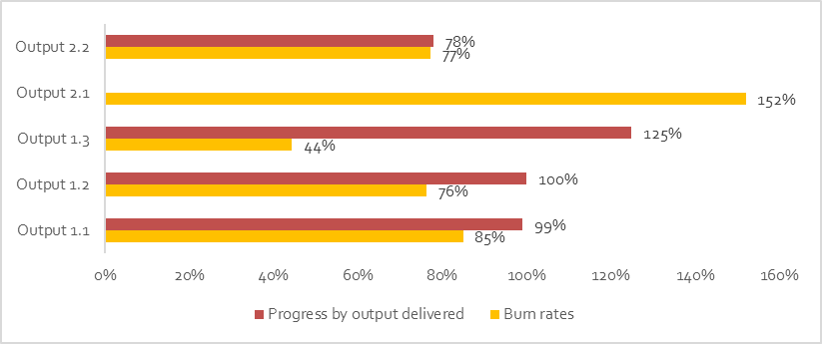
Burn-rate: Expense/Budget (Source: ERRY Joint Unit Finance)
Progress by output delivered (Source: ERRY Year 1 Annual report pp 9-11)

Risk management for sub-contracting: Layers of subcontracting implementation is expensive and at a certain point it might be costly beyond what makes monetary sense. FAO and ILO implement directly, whereas UNDP and WFP subcontract to IPs at 43.4 percent and 81.9 percent of their respective budgets. This MTR did not further review the budget of IPs to understand the proportion of overhead vs operations. It is recommended for PUNOs to have a closer purview of the background and capacities of their direct IPs and their respective local partners to ensure “do no harm” practices are adopted. Based on an initial survey, of the nine IPs, three of them signed service agreements with eight other local agencies to either implement some parts of ERRY components, or implement the full ERRY component in different communities.

Revise the programme’s targets: Some of the programme’s outputs, as indicated in the figure above, achieved more than their targets for the covered period (e.g. more VCCs were established, more assets rehabilitated, more insider mediators trained or Cash for Work beneficiaries than the annual targets). This is mainly due to the fact that the programme’s targets were not properly estimated at the design stage of the programme. After this midterm review, the output targets should be revised to ensure ERRY attains its full efficiency and sets realistic targets.

Table 11: ERRY Year 1 Expense Summary
 | UNDP+JCU | WFP | FAO | ILO
Fixed costs/Overhead | 36.73% | 1.74% | 15.68% | 54.92%
Staff and other personnel costs | 25.40% | 1.74% | 15.68% | 54.40%
Equipment, Vehicles and Furniture including Depreciation | 11.33% | 0.00% | 0.00% | 0.53%
Variable costs/Operation | 63.28% | 98.26% | 84.32% | 45.08%
Transfers and Grants to Counterparts | 43.40% | 81.86% | 0.00% | 0.00%
Supplies, Commodities, Materials | 0.05% | 9.08% | 52.65% | 5.85%
Contractual Services | 8.13% | 0.71% | 13.19% | 24.93%
Travel | 2.31% | 0.07% | 3.92% | 5.42%
Operating and Other Direct Costs | 5.58% | 0.00% | 6.72% | 2.49%
Indirect Support Costs (7%) | 3.81% | 6.54% | 7.84% | 6.39%
Fixed vs Variable | 1:4 | 1:5 | 1:5 | 1:1

Document benefits of ERRY collaboration and integration: At this point of the review, ERRY integration is mainly sharing agencies’ technical competencies and logistical coordination with little geographical integration. For example, synergies within the solar component providing services to dairy groups of FAO agriculture and UNDP livelihoods components; ILO skill and entrepreneurship training provided to all ERRY livelihoods interventions. There is also joint action planning at the field level. On the other hand, there were unaccounted benefits and cost savings relating to the joint programming which were not documented – for example shared office space in the regions, joint assessments and evaluations, among others. It was apparent from the discussions that PUNOs are exploring more synergies to enhance the effectiveness and efficiency of ERRY. As such, documenting these synergies would contribute towards expanding and deepening the thought processes and promote conceptual and practical coherence.

    - Impact and Sustainability

Programme impact must be considered against operating context and geographical convergence. While it is likely that ERRY has contributed in some ways to resilience in each targeted community, it is not possible at this time to attribute this trend to ERRY, given the following factors:

- Short implementing timeframe – 12 months
- Emergencies like cholera and food insecurity
- PUNOs operationally covering only 13-19 percent of districts of the Northern region (Hajjah - 4/31 districts and Al-Hodeidah – 5/26 districts) and 27-36 percent of districts of the Southern region (Abyan – 4/11 districts and Lahj – 4/15 districts).
- The level of convergence also varies:
  - Five districts with only one PUNO presence
  - Six districts with presence of two PUNOs
  - Five districts with presence of three PUNOs
  - Two districts with presence of all PUNOs
  - It was unclear if they work in the same sub-district and/or village levels as there was no documentation on this level of disaggregation.

Mainstreaming gender-sensitive programming: Many focus groups and project leaders reflected that it was difficult to include women in the project due to socio-cultural constraints, especially for labor-intensive Cash for Work. Firstly, women’s leadership and public participation is lacking. This is partially cultural, in that there is a struggle to promote women’s involvement. Secondly, some of the activities adopted by ERRY were perceived to be “inappropriate” for women and girls. As such, some female participants for the entrepreneurship components and local governance withdrew or abstained from participating. This should not be read as an implementation failure under ERRY. Rather, this finding underpins the complexity of the operating environment related to enhancing the engagement of women.

Work with local decision-making structures in contributing towards ERRY outcomes: The current implementation modality of ERRY is delivery through IPs. The political situation and capacity levels makes it difficult to implement through local authorities. Adjusting service delivery to enhance the engagement of local authorities in some components may promote direct interest of communities in a structure that makes important decisions.

Recommendations
The broad outlines of the ERRY design and rationale were formulated in late 2015. The shifting context in Yemen underscores the need for a reflective review of the current programming. The broad fault lines of the conflict are well described in many UN and ERRY documents, and select aspects are highlighted in the context description above. Equally well documented is the deteriorating humanitarian context of millions in dire need of assistance. The recent and ongoing cholera outbreak adds urgency for a matching medical response but does not change the fundamentals of the bigger picture. Yemen is a society in crisis with consequent impacts on the lives of millions of people. Therefore, it is pertinent to extrapolate, with the war dragging into its third year, that more of the same is needed to keep pace with the ever-increasing crisis. However, for purposes of improvement and with aspirations to meaningfully impact individuals and communities’ livelihoods, resilience and social cohesion, a more nuanced understanding is required and should be reflected in the ERRY revised design and implementation.

The Recommendations in this report focus on: (1) coordination and communication mechanisms by the ERRY Joint Unit; (2) improving economic empowerment component; (3) improving solar energy and social cohesion components; (4) building a more responsive local decision-making structure and private sector; (5) suggestions for scaling-up or expanding ERRY beyond the current three-year funding cycle. The recommendations relate to the Lessons Learned described above.

ERRY JPU

- Stakeholder Analysis - This is partially done through the Annual Review and all the different coordination mechanisms in place. However, it is recommended to dedicate additional time to conduct stakeholders’ analyses including PUNOs, IPs, local governance and community decision making structures. This is particularly important to understand local linkages and relationships which impacts the ability of local networks to sustain project interventions beyond ERRY.

- Programme Coherence and Delivery - This recommendation has two parts:
  - Conceptual: It is essential that all the organisational entities involved in implementing different ERRY components understand the ERRY design and how the different parts of ERRY fit together to individually and collectively build towards the desired outcomes. It is recommended that a Theory of Change be developed that articulates how the ERRY intervention will lead to change and how the different components are part of it. This will require using humanitarian and conflict lenses, as both are required to achieve the outcomes. Systematic documentation of the benefits of ERRY collaboration and integration will support a learning agenda and enable different components to understand how they relate and contribute to make results and impacts more sustainable.

  - Practical: ERRY management should map out who is implementing the project on the ground, as several IPs are delivering ERRY services through local civil society structures. Joint planning to advance implementation synergies at both practical and conceptual levels is also recommended.

- Joint Assessments and Monitoring Visits - Joint assessments and monitoring visits (instead of agency-specific) to governorates and districts are recommended to strengthen the exchange of information, sharing of progress and joint learning. This will promote both formal and informal connections between different ERRY components and with the local authorities.

- Relationship and Communication with Local Actors - It is essential that ERRY is perceived positively by both communities and local authorities. This involves regular and open communication with the concerned local actors. Such communication should be through one channel, with the JCU taking a lead at the national and sub-national levels. To strengthen the two-way accountability between PUNOs and local authorities and communities, it is recommended to set up an anonymous feedback mechanism at the joint programme level. WFP reports that it has its own feedback/hotline system with a dedicated team to receive the feedback from the stakeholders, using a variety of mediums. JCU should review the system and determine if it can be used for the whole of ERRY.

- Project Efficiency - Financial efficiency should be used as a window into broader programmatic implementation. This takes on heightened importance where IPs are not the direct implementers, but have arrangements with local structures to deliver services. It is recommended to review the background and implementing modalities of the IPs and their subcontracted partners to ensure conflict sensitive implementation and consistent quality and alignment with ERRY programmatic goals. Regular review of project efficiency may also enable reallocation of resources, while ensuring sound financial management. The programme’s targets should also be revised to ensure the project is realistically attaining its full delivery potential.

- Gender-Specific Programming - The MTR acknowledges the efforts by ERRY to increase women’s participation in decision making structures and as beneficiaries of various interventions. However, a systematic approach is recommended by first conducting or strengthening gender-specific assessments to identify or adapt programming and activities to encourage more women to participate and benefit from ERRY interventions. For example, by designing women-sensitive Cash for Work activities, engaging more women in solar micro-enterprises, increasing the proportion of women in home-based small businesses, increasing women’s participation in VCCs and as Insider Mediators, and creating women’s economic empowerment small projects such as dairy product processing and marketing. More specifically, ERRY should develop a Gender Strategy outlining its gender equality ambitions, specific activities and targets.

- Synergies – Optimising synergies should be key to the ERRY approach. For example, producing energy is a key factor in economic self-reliance and income-generating activities and synergies between the two should be strengthened. Conceptually, it is important to reinforce the Theory of Change and how the two components are mutually reinforcing. It is also recommended to identify other existing areas of synergy and strengthen them.

- Visibility and Communication – ERRY should enhance its visibility by using more innovative tools to communicate to its external audiences such as social media, videos and newsletters. ERRY should also advocate for a resilience-based approach in the Yemeni humanitarian context, linking resilience with humanitarian work.

Economic Empowerment Component

- Cash for Work Interventions - The strength of Cash for Work is that it can be applied to households, but the physical infrastructure improvements benefit the whole community. Cash for Work initiatives can be strengthened by developing activities that encourage more women to participate. Many of the local conflicts that lead to breakdown in social cohesion can be addressed through Cash for Work projects. Closer collaboration between these activities and ERRY’s social cohesion component is encouraged. Linkages should also be made between Cash for Work activities and community resilience plans: interventions should be designed in a way to improve livelihoods, increase income and reduce food insecurity.

- Community Resilience Planning - The key to strengthening resilience is to attend to both economic/infrastructure and social needs. Community cohesion and building strong local inclusive networks are as important as attending to increased productivity, additional cash, or new roads or water wells. This could be achieved through strengthening VCCs’ capacities to plan, mobilize resources and implement self-help initiatives. Close attention to and alignment between ERRY interventions and what communities have done for themselves, in terms of developing their own resilience plans, will go a long way towards increasing local ownership of ERRY interventions and ensuring their sustainability.

- Agricultural Value Chain Development - The current methodology as developed by FAO works very well, and other PUNOs can learn from it. This component should focus on contribution to food security and livelihoods for small-holders and farming communities. As an additional area of intervention and support, fisheries can be investigated. Many people in some of the districts relied on fisheries as a means of income and livelihoods.

- Collaboration with Humanitarian Interventions and Other Programmes - All PUNOs have other programmes and projects beyond ERRY. Collaboration between ERRY’s Cash for Work activities and other similar interventions throughout the country would offer scope for complementary approaches. More urgently, ERRY should explore and collaborate with agencies implementing cholera interventions on strengthening of assets or resources related to water sources and hygiene. ERRY should work more closely with the Yemen Cholera Response Task Force and WFP/UNICEF to explore ways ERRY can contribute to cholera prevention, such as through enhanced provision of solar energy to health facilities to improve health services and solar water pumps to improve access to potable water. ERRY could also integrate awareness creation sessions on cholera prevention in all its training activities (e.g. business training, farmers’ field schools, Cash for Work, women’s groups, schools, etc.)

More generally, ERRY should coordinate with humanitarian interventions through the existing coordination and joint planning mechanisms such as Food Security Cluster Coordination and Early Recovery Cluster Coordination, where ERRY is already a member with other humanitarian aid organizations. The cluster coordination would give an opportunity for ERRY to link with other humanitarian interventions for joint planning and increased harmonization. At a lower level, ERRY should actively coordinate with other humanitarian interventions at the Governorate level where similar clusters exist. This will improve humanitarian and resilience-building synergies, avoid duplication and optimize targeting.

Solar Energy and Social Cohesion Components

- Implementing Partner Capacity – It is recommended to build up IPs’ core competencies, including how best to structure and assume their role in their community, and how to engage with local authorities. IPs should be supported to undertake brief, cost-effective feedback mechanisms to ascertain community perceptions of their organisation’s work.

- Solar energy - IPs capacities should be strengthened to more effectively communicate and engage communities and local authorities on the selection, distribution, management and maintenance processes of solar powered energy sources. Consider also providing solar pumps and solar cookers.

- Social Cohesion – It is recommended to align the social aspects of dialogue with the substantive components of livelihoods, including Cash for Work, solar, and the planning processes at community and district level. This will promote resolving local conflicts through inputs and resources that can be provided by ERRY. Dedicate space, time, and other resources to encourage IPs to learn from each other’s experience.

Strengthening Local Authorities and Private Sector Component

- Strengthen Local Authorities - Local government is the provider of social services and yet does not have the means or capacities to do so. The challenge faced by ERRY is to strengthen local authorities’ capacities to deliver services at a point when local authorities are weakened by several factors, including a lack of salaries and resources. Despite the mentioned obstacles, the MTR recommends that ERRY should strengthen engagement with local authorities in the next phase, provided a substantial improvement in their capacity. Already delivered under ERRY I, the capacity building component will be complemented with an injection of cash to ensure interest of communities in a structure that makes important decisions.

- Communication - ERRY JCU should take a stronger lead role to streamline ERRY communication and coordination with local decision-making structures instead of relying on individual PUNOs and IPs to act by themselves. A system is needed to ensure communication is channeled through one point. An option would be to nominate one PUNO lead for each governorate on behalf of the consortium.

- Reframing Outcome 2 - The current framing holds the promise that local authorities will have the capacity and means to provide service delivery at least at a minimum level. However, the inputs required might be beyond such an expectation. It should, therefore, be considered to reframe the outcome to reflect on what is a more likely outcome given the level and nature of inputs and the time remaining in the project.

Scaling up and Expanding ERRY

There is every reason to put forward a persuasive argument that ERRY should be scaled up and expanded, based on the obvious increased needs, food insecurity and vulnerability of many millions due to protracted crisis and existing deep-rooted poverty.

ERRY was designed based on a clear rationale and the scale up will also be based on a clear rationale. This will give confidence to the range of stakeholders invested in ERRY and will contribute to financial prudence, transparency and programmatic coherence. It is hoped that the analysis, lessons and critique provided by this MTR will offer a reflective argument for the continuation of ERRY beyond the current thee-year funding cycle. The broad rationale for scaling up ERRY, as emerging from the review, rests upon six pillars:

- The ongoing conflict is making more people more vulnerable as it erodes livelihoods and means of self-reliance.

- The importance of strengthening resilience is both practical and strategic. At a practical level, the addition of small resource inputs means many households and communities can build their own resilience and rely less on already overloaded humanitarian interventions. Resilience can complement the humanitarian interventions by protecting livelihood assets and creating livelihood opportunities for crisis affected households that are not targeted by the relief aid. At a strategic level, resilience helps to make communities less vulnerable to political manipulation. Moreover, resilience and social cohesion interventions build foundations for post-conflict recovery and a return to the development path.

- With no political solution on the table, the need to retain and build community social cohesion is more crucial than ever. The broader political fracturing can easily replicate itself in relations between and within communities. From a conflict resolution perspective, addressing social cohesion before it frays completely is an important preventative measure.

- Strengthening the capacity of local government to be an actor in the provision of services, even at a minimum level, is essential. Support for government at the local level will help to maintain a crucial institutional capacity for service delivery which is needed to stabilize relations between communities and government and will be needed at such time when the war ends and rebuilding and post-conflict development becomes possible.

- The ERRY intervention will complement the humanitarian relief interventions by protecting livelihood assets and creating livelihood opportunities for crisis affected households that are not targeted by relief aid. By providing opportunities for sustainable livelihoods, it can help to reduce the protracted humanitarian situation. At a strategic level, resilience helps to make communities less vulnerable to political crisis. Moreover, resilience interventions build a foundation for the post conflict recovery and return to the path of sustainable development. The ERRY joint programme model, which links resilience with humanitarian interventions, is an innovative approach in crisis-affected contexts that should be further expanded and consolidated for potential replication to similar contexts in Yemen or elsewhere.

- Resilience-based interventions address immediate and underlying causes of vulnerability and food insecurity. Thus, they require medium to long-term implementation periods, investments and adequate resources for sustainable impacts and results. Therefore, the current programme should be extended and expanded beyond the current three-year implementation and funding period.

    - Specific Scaling up Suggestions
- Geographical Areas - It is recommended that ERRY continue working in the same four Governorates for the following reasons:
  - Needs: While the needs may be equally pressing in many other governorates, it is important, for reasons of impact and sustainability, to retain the current geographical focus. All four covered governorates are among the seven governorates out of the 22 classified as IPC Phase 4 (emergency) in terms of food insecurity. In addition, most districts in the four governorates also fall in IPC Phase 4. Currently, ERRY is only targeting 63,000 indirect beneficiaries, which represent a very small fraction (2 percent) of the target district population experiencing food insecurity crisis or emergency. Expansion to include other districts in the same governorates, and/or new communities in the same districts, or new beneficiaries in the same communities should be considered if there is agreement between PUNOs where to concentrate their collective efforts. In fact, ERRY is currently targeting only 18 districts out of the 83 districts of the four governorates. One of the critiques offered in this MTR is that much of ERRY’s good work gets dissipated, as not enough components are concentrated in one locality. Given the humanitarian needs and priorities in these four governorates, most ongoing humanitarian interventions operate there, offering ERRY opportunities to complement humanitarian interventions with its resilience-building focused approach.

  - Operations: ERRY has established good working relationships with the local authorities, communities, IPs, security apparatus in the four covered governorates. This will be an added-value and gained economies when ERRY expands its activities to districts in the same governorates. Expanding the project to other new governorates will require building the same relationships in the new governorates with related requirements in time and resources.

  - Access and Security: The four active ERRY governorates are relatively accessible in terms of infrastructure, and security conditions are relatively better for its activities compared to other governorates with similar needs such as Taiz or Sa’ada.

- Programming Components - The current set of programmatic components is well received by most of the communities and has the potential for longer-term impact. Adjustments and refinement can be made as suggested in the Lessons Learnt and Recommendation sections. The range of Livelihood options can be revised or/and expanded. Fisheries in select localities may offer an additional source of income. The component on social cohesion should be mainstreamed to inform the planning, coordination and prioritization of the interventions under ERRY.

- Implementing Partners (IPs) - The ability of local government to deliver even a minimum of services can be strengthened with the long-term vision to work with them as Implementing Partners when they eventually have adequate necessary capacities. This no doubt carries additional risk and perhaps a measure of efficiency must be traded in the process. It also may require additional inputs in the form of training and accountability measures. On the plus side, it should promote cooperation and possibly facilitate access and build a broader base of goodwill.

- Community-led Interventions - Functioning VCCs provide access and sustainability of interventions as they are a locally trusted structure that helps to make decisions and promote ownership. Cases where VCCs drafted Resilience Plans should be used by the various programme’s components as they provide a common framework for all to work from. It is thus advisable to work with communities with an active and legitimate VCC, or establish through ERRY credible local VCC structures.

Annex 1. ERRY Terms of Reference
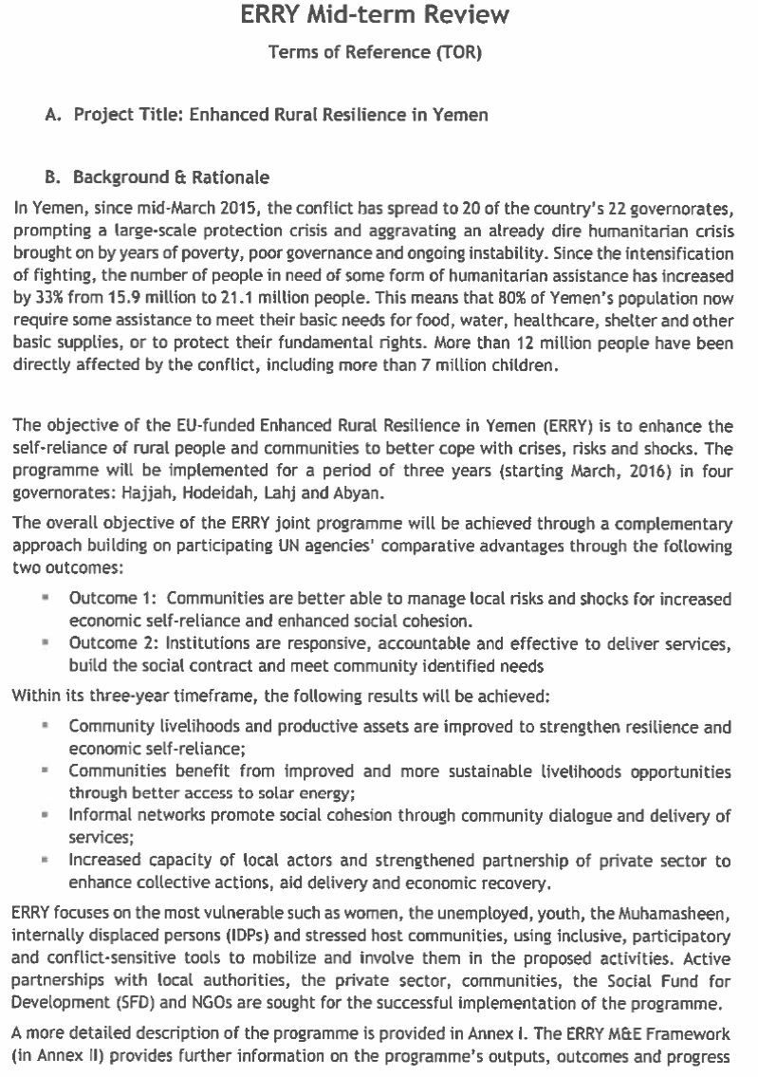
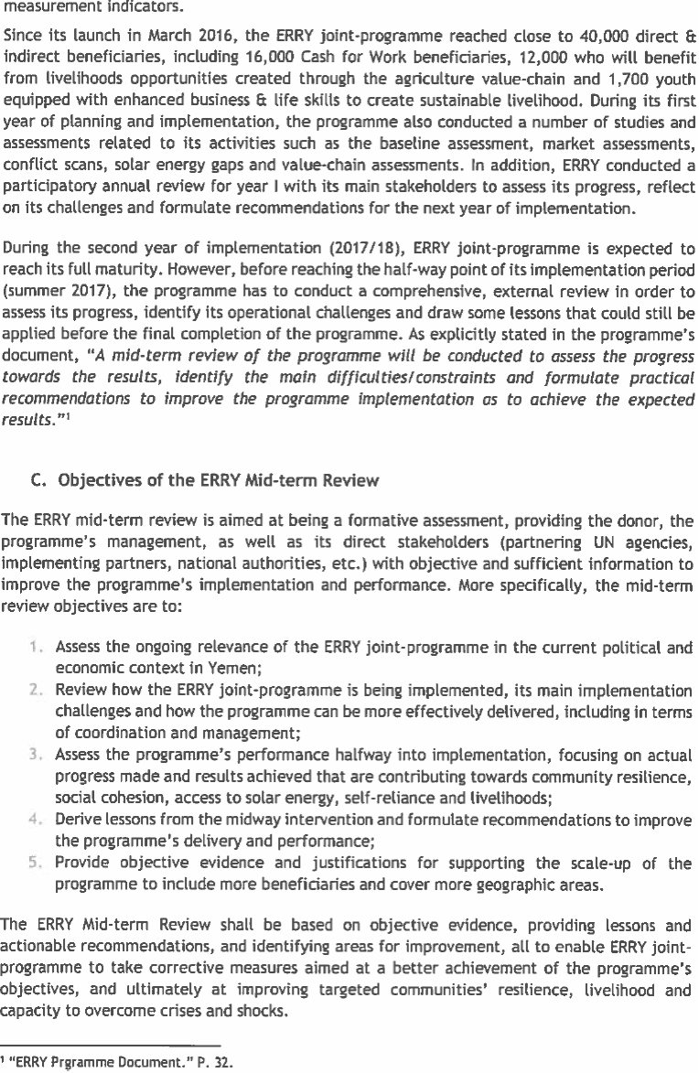
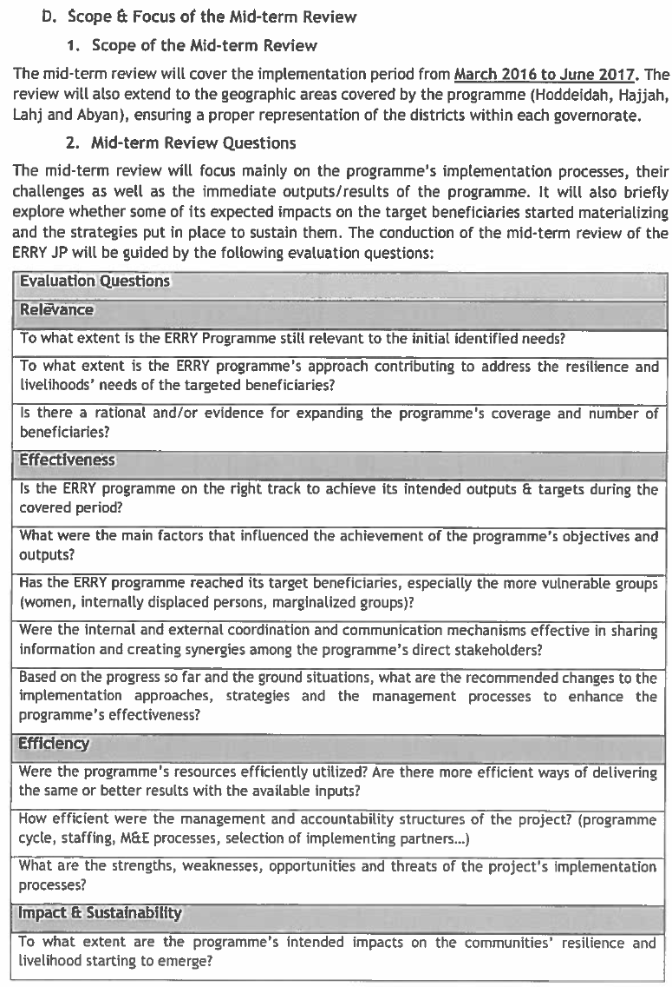
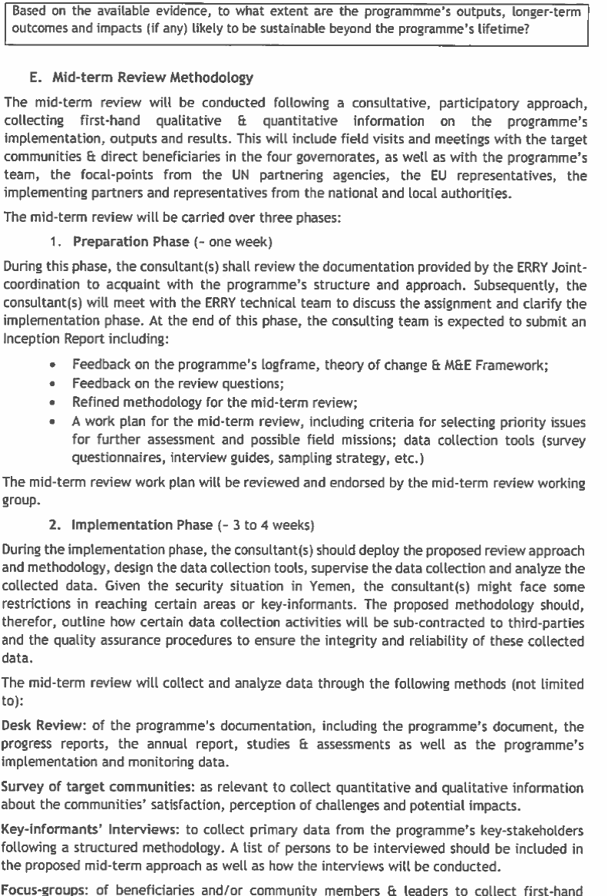
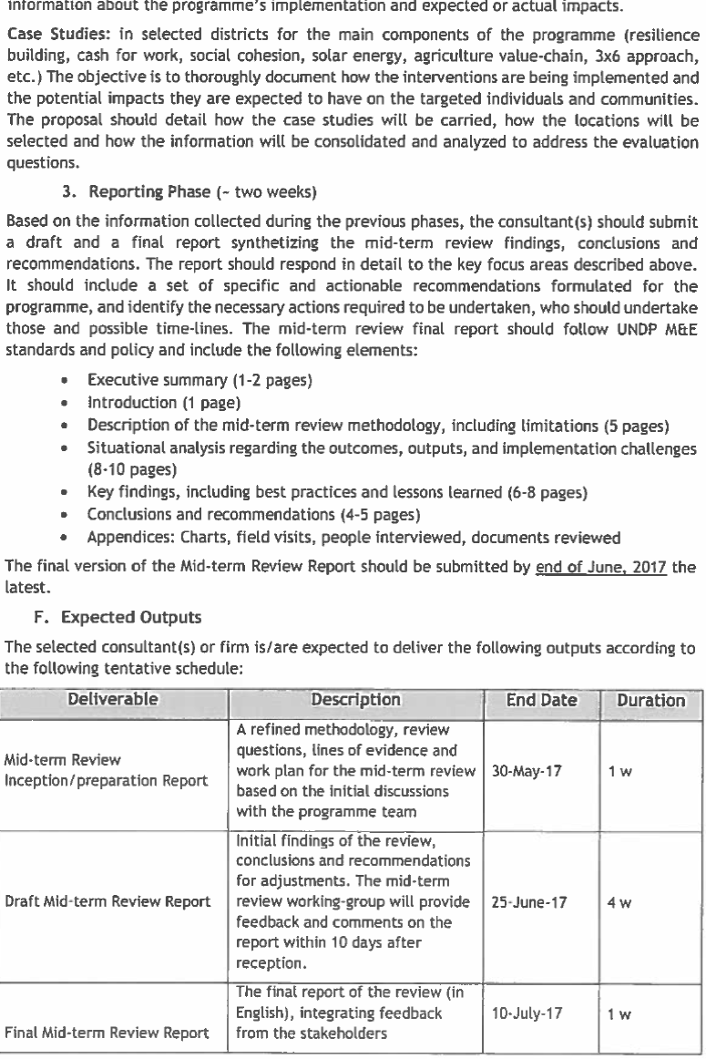
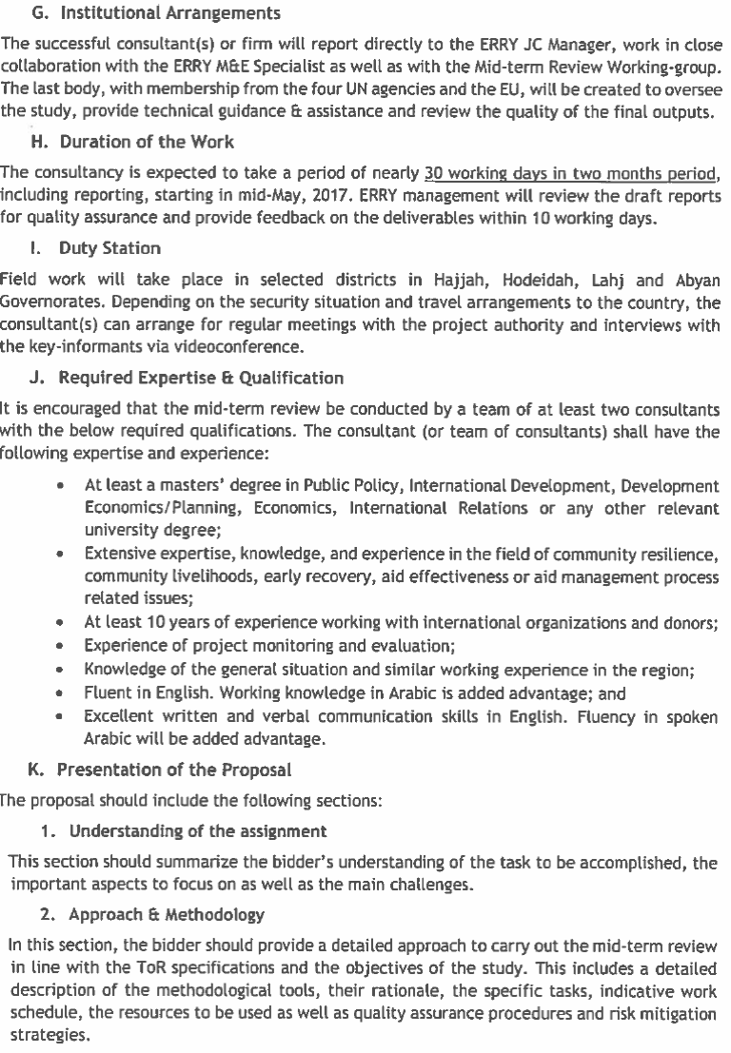
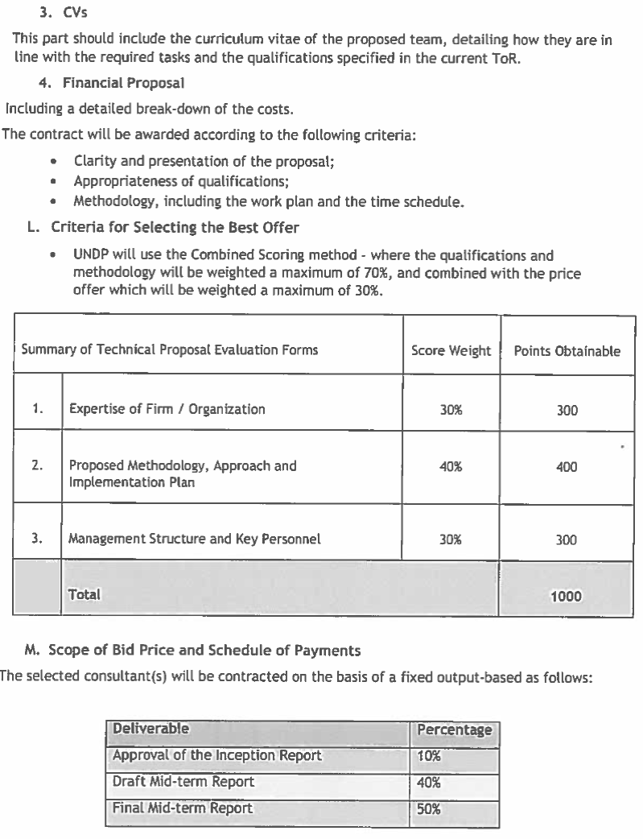

Annex 2. Data Collection Team

The team will be comprised of the following members:
- Mr. Adnan Qatinah, Team Leader
- Mr. Amin Saeed, ACAS Focal Point
- Two (2) senior key experts/Area Leads – (i) Dr. Sharaf Al-Kibsi for Hajjah and Hodeidah Governorates; and (ii) Mr. Waleed Al-Hamry for Lahj and Abyan Governorates
- 16 researchers/facilitators with equal representation of both gender to be divided into 8 districts,
- Mr. Waleed Ahmed, Administrative Assistant
- Mr. Nasser Al-Showafy, Translator;
- Local coordinators, recruited from target districts to facilitate and coordinate meetings with the targeted key informants and participants from various stakeholders.

ACAS Quality Assurance and Project Management

Southern Area Lead 2

Abyan
Team 3 + Team 4

Lahj
Team 1 + Team 2

Northern Area Lead 1

Hodeidah
Team 3 + Team 4

Hajjah
Team 1 + Team 2

Sharon Low
Livelihoods and Resilience Lead

Philip Visser
Social Cohesion and Conflict Lead

Amin Saeed
ACAS Focal Point
Adnan Qatinah
Afcar Focal Point

Annex 3. ERRY Logframe
Outcome 1: Communities are better able to manage local risks and shocks for increased economic self-reliance and enhanced social cohesion
Intended Outputs | Key Performance Indicators for 2018 | Indicative Activities | Inputs
Output 1: Community livelihoods and productive assets are improved to strengthen resilience and economic self-reliance  Baseline  - No community resilience plans exist  - Emergency employment options to stabilize rural livelihoods are limited  - Limited entrepreneurial pathways available in rural (remote) areas for affected/vulnerable groups  - Technical and operational capacities of communities to engage in viable value chain opportunities are inadequate and there is no institutionalization of farmer field school schemes  Means of Verification  - Report from implementing partner, third party monitoring report  - Report from implementing partner, third party monitoring report  - Report from implementing partner, third party monitoring report  - Report from technical assistance, third party monitoring report | - 100 community resilience plans are developed  - At least 14,000 vulnerable and food insecure individuals indirectly benefiting from emergency income generating revenues that provides immediate income  - At least 21,000 men and women indirectly benefiting from improved skills to establish community-oriented social businesses for self-reliance  - 28,000 men and women indirectly benefiting from technical and economic capacities built on agriculture value chains. | 1.1 Inclusive community-based governance system is strengthened to develop community resilience plan and identify community prioritized actions  1.1.1 Establish and operationalize CDCs through training and technical support  1.1.2 Develop community resilience plans and community initiatives  1.1.3 Provide block grant based on community compact | Budget estimate:  USD 1,330,000.00
 |  | 1.2 Livelihoods opportunities are provided through stabilized cash and vouchers for work, focusing on community asset rehabilitation  1.2.1 Validate target community criteria in coordination with target districts representative bodies, including district councils  1.2.2 Carry out screening and validating projects through environmental protection criteria  1.2.3 Prepare micro-project implementation plans including bill of quantities for the various assets identified, procurement plans for the required materials as well as labor allocation for the various micro-projects  1.2.4 Selection of beneficiaries and monitoring implementation of physical activities, ensuring quality standards of work/assets are met | Budget estimate:  USD 7,140,400.78
 |  | 1.3. Income-generating revenues are created through enterprise recovery (such as within the framework of 3x6 approach) targeting communities affected by the crisis  1.3.1 Conduct market assessment in targeted governorates to identify viable social businesses matching demand  1.3.2 Select beneficiaries according to the vulnerability criteria agreed on with national counterparts / local communities and provide them with seed capital through community-based cash-for-work  1.3.3 Develop capacities of beneficiaries in life and business development skills, and coach them to develop their own social business plan in line with market assessment  1.3.4 Complement beneficiaries seed capital with micro grants to enable the creation of social businesses  1.3.5 Oversee establishment of business venturing as per respective business plans, with a focus on collective endeavors, supporting linkages to markets/community service centers for the established businesses | Budget estimate:  USD 4,294,920.00
 |  | 1.4. Skills developed of women and men in agricultural value chains  1.4.1 Identification of key agricultural value chain opportunities through market assessment and participatory community validation  1.4.2 Provision of inputs to farmers for the realisation of value chain  1.4.3 Establishment of Farmer Field Schools (FFS) in targeted locations  1.4.4 Technical training of selected farmers on skills required for value chain development  1.4.5 Institutionalisation of the FFS approach | Budget estimate:  USD 5,169,442.00
Output 2: Communities benefit from solar energy for sustainable livelihoods opportunities  Baseline  - No programme framework to promote solar energy resilience building in Yemen is in place  - TBD in targeted locations  - Limited applications of solar energy for productive uses (TBD in targeted areas)  - No solar energy market mix in place for promotion of solar energy solutions  Means of Verification  - National programme framework  - Project periodical report  - Project periodical report  - Project periodical report | - Seven solar energy resilience building programming initiatives formulated and implemented  - At least 100 rural communities will improve their access to solar energy  - Introduction of solar energy applications to improve performance of 12 economically productivity assets  - Solar energy market mix conducted and networking developed among solar dealers | 2.1. Expansion of solar energy applications programmed and operationalized to strengthen rural energy resilience, capacity building and recovery  2.1.1 Map rural energy insecurity gaps in the targeted governorates  2.1.2 Develop and implement awareness raising programme and campaign focusing on decision makers, and public at the local level  2.1.3 Share best practices and experiences for scale-up and replication and encourage south-south cooperation on rural energy resilience building and business development  2.1.4 Develop solar programme framework defining immediate, medium and long-term actions for resilience building | Budget estimate:  USD 812,100.00
 |  | 2.2. Decentralized solar energy services installed in public service centers to reinforce livelihood resilience of vulnerable rural communities  2.2.1 Analyze and define the short-term, medium term and long term solar energy priorities with stakeholders for feasibility of communal solar energy (i.e. for public centers including health clinics, and schools)  2.2.2 Design a phased out road map for technical installation of feasible communal solar energy services (i.e. solar lanterns, solar powered street lights, solar water pumps for communal places) to improve access to basic social services  2.2.3 Deliver and install the community solar energy systems  2.2.4 Train local cooperatives on installation and maintenance of the community solar energy systems | Budget estimate:  USD 1,955,363.00
 |  | 2.3. Solar energy introduced to support enhancement of rural community energy resilience  2.3.1 Determine through a prioritization process the critical immediate and future energy needs for improving the performance of the productive assets in rural communities  2.3.2 Identify the demonstration sites and define roles and responsibilities of stakeholders involved, particularly local institutions including cooperatives  2.3.3 Design and install pilot solar energy systems applications for economic and productive assets such as rural power generation for electrification/micro businesses and integrated solar water pumping to demonstrate economically optimal and sustainable water use  2.3.4 Develop and implement capacity building programme for installation, maintenance and linkage with micro-businesses on solar energy initiative | Budget estimate:  USD 1,291,007.50
 |  | 2.4. Marketing of micro-business development for solar energy supported  2.4.1 Assess solar market potential to support business development in the solar energy sector, with special focus on micro businesses  2.4.2 Develop a strategic solar market mix programme (product/equipment, price, promotion and distribution) to encourage private sector engagement and support energy service demands through provision of solar energy  2.4.3 Support building partnership and networking between national solar dealers, local private sector and key stakeholders within the four targeted governorates  2.4.4 Support community resilience and solar business development through technical assistance and solar business development | Budget estimate:  USD 135,000.00
Output 3: Informal networks promote social cohesion through community dialogue and delivery of services  Baseline  - Water User Associations (WUA) are either non-existent or are not fully operational in the targeted governorates  - 34 community-based dialogue mechanisms were established in Abyan but not in other governorates  - No significant evidence of efforts to build consensus, dialogue or resolve disputes peacefully (based on a qualitative scoring and means of verification)  Means of Verification  - Project periodical report  - Report from implementing partner, third-party monitoring report  - Report from implementing partners, focused group meeting with target community members | - 30 communities where WUA developed a mechanism to facilitate dialogues for water resource management, agriculture production systems, and crop production systems  - 60 community-based dialogue facilitated by insider mediators  - Significant evidence of efforts to build consensus, dialogue or resolve disputes peacefully (based on a qualitative scoring and means of verification) | 3.1. Water User Association (WUA) established  3.1.1 In partnership with CDCs, identify and build a relationship of trust with existing or create new WUA  3.1.2 Increase production and profitability through changes in crop production systems and improve on processing and marketing at the benefit of farmers.  3.1.3 Promote discussion on the potential for water marketing and valuation, including the possibility to consider a financial contribution from the urban population and the private sector as the investments made by farmers will secure their drinking water supply in future. | Budget estimate:  USD 306,558.00
 |  | 3.2 Insider Mediators are better able to prevent and resolve community level conflicts (including areas such as exclusion and natural resources based conflicts)  3.2.1 Community level conflict and situation analysis conducted  3.2.2 Capacity development through mentoring and targeted trainings of insider mediators  3.2.3 Innovative approaches of Insider Mediators supported with small grants based on work plans | Budget estimate:  USD 1,083,200.00
Outcome 2: Institutions are responsive, accountable and effective to deliver services, build the social contract and meet community identified needs
Output 1: Functions, financing and capacity of local authorities enabled to deliver improved basic services and respond to public priorities  Baseline  - No capacity of local authorities for planning, budgeting, and monitoring basic services delivery  - No framework of private sector and citizen engagement in target governorates  Means of Verification  - Local authorities’ development report, recovery plan  - Project periodic report/ completion report | - From no capacity of local authorities for planning, budgeting and monitoring basic services delivery to very partial capacity observed in four governorates (based on a qualitative scoring and means of verification)  - Institutional framework for engaging private sector and citizens in local recovery/ resilience plan will be developed and launched in four governorates | 1.1 Local authorities are better able to plan, monitor, and coordinate aid and recovery  1.1.1 Conduct public service damage assessment by citizen and develop citizen monitoring system  1.1.2 (Re)activate DMT and restore minimum public service delivery  1.1.3 Develop a district recovery plan with monitoring framework  1.1.4 Establish coordination mechanism at the governorate level  1.1.5 Provide technical advice to the UNDP project team and local authorities | Budget estimate:  USD 1,388,115.20
Output 2: Increased capacity of local actors and strengthened partnership of private sector to enhance economic recovery  Baseline  - Business development services and informal apprenticeship schemes have a limited outreach to the rural areas (TBD in the targeted areas)  - Dependency on short term employment schemes is high with limited graduation strategies  - Business associations/economic institutions have a limited technical and operational engagement in enterprise recovery  Means of Verification  - Project periodic report  - Project completion report/ evaluation  - Project periodic report | - 1,400 community members indirectly benefit from informal upgrading apprenticeship schemes and business development services  - 40% more likely not to apply for Cash for Work with SFD again in the following year  - At least two business association/ economic institutions with governorate coverage have their capacity needs assessed and addressed for greater enterprise recovery engagement | 2.1 Strengthen capacity of local training providers to deliver market relevant skills and entrepreneurial training  2.1.1 Conduct participatory value chain analysis and skills needs assessments of non-agricultural sectors, with high potential for job creation  2.1.2 Strengthen the capacity of local training and BDS service providers and employers to implement on-the-job training and entrepreneurship/enterprise development interventions in partnership with SMEPS  2.1.3 Design and implement private sector led apprenticeship schemes and business development services including coaching and financial literacy assistance for targeted youth (including upgrading of informal apprenticeship in informal economy)  2.1.4 Develop, test, and institutionalize post Cash for Work services pilot. | Budget estimate:  USD 1,075,419.00
 |  | 2.2. Strengthen partnership with the private sector to accelerate early recovery and employment  2.2.1 Map active and credible economic entities with networks in targeted governorates  2.2.2 Build capacities of business associations and economic institutions to encourage private sector-led employment creation | Budget estimate: USD 200,000.00
  - Technical and management agency resources adequate to implement activities and reach results are in place/available

FAO Budget estimate: USD 2,362,500 (+GMS: 558,508.08)
ILO Budget estimate: USD 1,325,811 (+GMS: 168,086.10)
UNDP Budget estimate: USD 2,347,521.36 (+GMS: 1,187,764.77)
WFP Budget estimate: USD 698,099.29 (+GMS: 548,695.00)
  - Joint (inter-agency) programme coordination unit is operationalized for effective administration, coordination, monitoring and evaluation of results
Convening Agency (UNDP) Budget estimate: USD 2,513,354.78 (additional USD 140,186.92 to FAO for the North sub-national coordination)

The rate at which a new company is spending its venture capital to finance overhead before generating positive cash flow from operations; it is a measure of negative cash flow. Source: Investopedia, accessed 2 September 2017: http://www.investopedia.com/terms/b/burnrate.asp#ixzz4rWCiu100
OCHA 2017. Available at: http://reliefweb.int/sites/reliefweb.int/files/resources/2017_PMR_YEMEN_final_EN.pdf
UNICEF, 23 February 2016, Humanitarian Situation Report. Available at: http://reliefweb.int/sites/reliefweb.int/files/resources/UNICEF%20Yemen%20Humanitarian%20Situation%20Report%2C%2010%20-%2023%20Feb%202016.pdf
UNDP,28 March 2016, Yemen Resilience Monitor: Communities coping with Conflict. Available at: http://reliefweb.int/report/yemen/yemen-resilience-monitor-communities-coping-conflict-28-march-2016
FAO, July 2017, Situation Report, Available at: http://reliefweb.int/sites/reliefweb.int/files/resources/FAOYemen_sitrep_July2017.pdf
ibid
USAID, 1 July 2016, Complex Emergency, Available at: http://reliefweb.int/sites/reliefweb.int/files/resources/07.01.16%20-%20USG%20Yemen%20Complex%20Emergency%20Fact%20Sheet%20%2312.pdf
ibid
OCHA, 16 June 2017, Humanitarian access snapshot. Available at: http://reliefweb.int/sites/reliefweb.int/files/resources/1_5.pdf
Reliefweb, 31 January 2017, Humanitarian Coordinator in Yemen, Jamie McGoldrick, Statement on the Situation in the Dhubab and Al Mokha Areas http://reliefweb.int/report/yemen/humanitarian-coordinator-yemen-jamie-mcgoldrick-statement-situation-dhubab-and-al-mokha
Reliefweb, 31 October 2016, Yemen Humanitarian Response Situation Report. Available at: http://reliefweb.int/report/yemen/yemen-humanitarian-response-situation-report-october-2016
Health and WASH Cluster, 25 May 2017, YEMEN: Acute watery diarrhea/ cholera outbreak Situation Report #3. http://reliefweb.int/sites/reliefweb.int/files/resources/Situation%20report%20Cholera%20in%20Yemen%2C%2025%20May%202017-2.pdf
UN Human Rights Council, 16 June 2017, World community must solve Yemen water crisis to halt spiralling cholera outbreak – UN experts. http://reliefweb.int/report/yemen/world-community-must-solve-yemen-water-crisis-halt-spiralling-cholera-outbreak-un
ECHO, 6 July 2017, Yemen: Combatting Severe Malnutrition with Clean Water http://reliefweb.int/report/yemen/yemen-combatting-severe-malnutrition-clean-water
United Nations Development Programme, World Food Programme, International Labour Organisation and Food Agricultural Organisation
(i) For All Foundation, (ii) Search for Common Ground, (iii) Social Fund for Development, (iv) Partners Yemen, (v) Sustainable Development Foundation, (vi) Vision Hope, (vii) Islamic Relief Yemen, and (viii) CARE
Community Compacts will include a block grant for one year (calculated on the basis of the community size and particular vulnerability criteria) and a programme of training, technical assistance and awareness-raising support to be provided by UNDP through IP. It will also detail expected community contributions to realizing the integrated community plan. If other agencies are supporting the plan, they will also be signatory to the Community Compact.
Feedback from WFP team: “The rationale behind the 2 month delay of cash distribution to the participants was of twofold: i) the CFW activities started in Oct 2016 which coincided with the transfer of the Central Bank of Yemen from Sana’a to Aden (in September 2016). This move disrupted the financial sector and created cash liquidity problems at financial institutions. In addition, WFP contracted financial service provider, the Yemen Post Office, failed to provide the Performance Bond/Bank Guarantee which was assessed as a risk by WFP treasury, therefore small tranches of funds were transferred to Post Office during initial months which delayed cash transfer and created a backlog.”
Reports from PUNO highlighted an average of 20-30% target beneficiaries engaged in CfW are women.
This reflects a selection bias and is not necessarily true for the project
FAO commented that this quote should be placed in perspective and that the conclusion is premature. The entry point of ERRY value chain market development is at the Small Medium Enterprise (SME) level which address systems and institutions that can drive competitiveness and job creation. At a later stage, more could be done to focus on the smallholder producers.
The criteria used to define vulnerability are: (1) household income, (2) expenditure, (3) energy poverty, and (4) families with children in schools with no electricity.
UNDP clarified that the procurement of the solar equipment was done through the UNDP Global LTA with pre-selected firms at HQ. The selection was done through a rigorous process, and according to the procurement rules and procedures with the quality assurance done. Proper feedback is provided in case of any malfunctioning or dissatisfaction with the equipment which is reflected in the procurement and LTA.
The socio-economic assessment carried out to identify priority sectors for solar equipment support also provided recommendations on the specifications for solar lanterns for households, which were used for the procurement. The specification for household lanterns was upgraded to 30 watts panel from the initial 10 Watts based on the assessment to accommodate (3 LED bulbs or more, 3w), a socket to charge cellphones (2 port or more of USB charge mobile), radio or TV. The home solar system should be multipurpose (lighting two rooms, charging a cell phone), portable, easy to use, safe and secure as well as long battery lifecycle”.
Assets related to social capital (social relations, relationship within the community etc.), physical (well-being including security, shelter, etc.), natural (natural/environmental assets), financial capital (income, access to finance etc.).
It was noted that the distribution of solar energy for water pumps was delayed until early 2017. A thorough preparatory phase is required which includes environmental assessment on the impact of installing a water pump, attaching solar systems for water pumps, supply and irrigation to replace the diesel pumps. They were also provided to organized groups (farmers’ group/cooperatives owning the water wells) as it requires some basic knowledge to maintain and manage the system and to ensure these are accessible by its members.
Typically, it is IPs that deal with communities, not UN Agencies.
Clarification from ERRY management - IPs are responsible for installation and selection. Local authorities might be involved in the selection process, but certainly not in the execution.
It is worth noting that the delivery and equipment of the solar equipment for service delivery (i.e. health facilities) are done through the Ministry of Health under the National Vaccination Programme. However, the distribution of the solar equipment for household use are done directly by the IPs.
This might be out of scope for ERRY. However, it reflects a perspective and therefore it is retained as a point for learning.
IMs are nominated based on: (i) acceptance by community; (ii) prior experience in mediation; (iii) leadership experiences, e.g., they are part of informal local/community or tribal mediation mechanisms. The nomination process is done through participation of local councils, NGOs, well-known figures in the area, and IPs. The Sheikhs and community members are also engaged.
Executive Unit approval is pertinent as they have the power to block implementation and access
All IPs under the ERRY programme are required to have a thorough capacity assessment with a proven track record to adequately manage, implement and report on the progress and results of specific interventions, with a suitable financial accountability mechanism, oversight and governance structure. Local authorities and community structures such as VCCs are currently not capacitated to be full-fledged IPs for ERRY programme components.
Districts will be selected on the basis of a combination of criteria that will include: (a) Access and availability of IPs; (b) Poverty and unemployment rates; (c) Levels of food insecurity; (d) Absence of Qat production in the respective districts/communities (if possible); (e) Potential to open new land of agriculture and link to sustainable access for water; and (f) Limited or no humanitarian assistance provided so far.
IPC Report, March 2017.

