**TERMINAL EVALUATION**

**ICAO/UNDP-GEF Project: "Transforming the Global Aviation Sector: Emissions Reductions from International Aviation"**

GEF Project ID: 5450

UNDP PIMS ID: 5254

Atlas Project ID: 91318

Award ID: 82348

**FINAL REPORT**

**Submitted by**

**Jesse Uzzell**

**November 5, 2018**

ACKNOWLEDGEMENTS

Recognition is due to the many people who dedicated their time to meet with the evaluators and share their experiences and knowledge about the project. The mission was hosted by the ICAO in Montreal, Canada who attended the needs of the Evaluator with openness, diligence and efficiency. Special thanks to Ms. Althea Roper of the Jamaican Civil Aviation Authority and Mr. Junior Levene, Energy Management Coordinator at NMIA, for hosting the meetings at Norman Manley International Airport in Jamaica and showcasing the Solar-to-Gate project.

TABLE OF CONTENTS

1. Introduction 9

1.1. Purpose of the TE and objectives 9

1.2. Scope and methodology 9

1.3. Structure of the TE report 11

2. Project Description and Development Context 12

2.1. Development context 12

2.2. Project description and problems that the project sought to address 12

2.3. Project Objective and Outcomes 14

2.4. Project implementation arrangements 19

2.5. Project timing and milestones 21

3. Findings 23

3.1. Project Design and Formulation 23

3.2. The Project Results Framework (PRF) 23

3.3. Project Implementation & Management Arrangements 26

3.4. Adaptive Management 29

3.5. Monitoring and Evaluation: design at entry and implementation 29

3.6. Partnership Arrangements 30

3.7. UNDP and Executing Agency Partner implementation and coordination 30

3.8. Finance and co-finance 31

3.9. Management of the Project Funds 33

3.10. Project Results 34

3.11. Outcome 1: More developing States and SIDS identify low emissions measures. 34

3.12. Outcome 2: Instruments are available to support the development of a legal and regulatory environment that facilitates the financing of feasible low emissions aviation measures in States. 36

3.13. Outcome 3: The cost and resources expended by developing States and SIDS to have access to updated technical information on low emission mitigation measures is greatly minimized. 39

3.14. Component 4: The feasibility of implementing low emissions aviation measures is demonstrated through the pilot project and the lessons learnt are made available to facilitate the replication in developing States and SIDS. 44

3.15. Project Objective 52

3.16. Project Relevance 56

3.17. Effectiveness and Efficiency 56

3.18. Sustainability 57

3.1. Financial risks to sustainability 58

3.2. Socio-economic risks to sustainability 58

3.3. Institutional framework and governance risks to sustainability 59

3.4. Environmental risks to sustainability 59

3.5. Catalytic Role and Impact 59

4. Conclusions, Recommendations and Lessons Learned 62

4.1. Conclusions and Evaluation Ratings Summary 62

4.2. Final Recommendations and Lessons 65

Annexes 67

Annex 1: Evaluation Terms of Reference 69

Annex 2: Evaluation Protocol 70

Annex 3: Co-financing 101

Annex 4: TE Meetings and Itinerary 103

Annex 5: List of Project Documents Reviewed during the TE 105

Annex 6: Programs for the Capacity Building Seminar in Jamaica and Fiji 106

Annex 7: Proposed Construction Schedule for the Jamaican Pilot Project 115

Annex 8: Proposed Action Plan for Upgrading of the Knowledge Sharing Platform 117

Acronyms and Abbreviations

ANSP Air Navigation Service Provider

APU Auxiliary Power Unit

ASBU Aviation System Block Upgrade

ATM Air Transport Management

CAEP Committee on Aviation Environmental Protection

CCM Climate Change Mitigation

CDM Clean Development Mechanism

CNS Communication, Navigation and Surveillance

COP Conference of the Parties to the UNFCCC

EF Emission Factor

ER Emission Reductions

FESG Forecasting and Economic Analysis Support Group

GEF Global Environment Facility

GHG Greenhouse Gas

GPU Ground Power Unit

GSE Ground Support Equipment

ICAO International Civil Aviation Organization

LDCs Least Developed Countries

LTO Landing and Take-off Cycle

MBM Market-based Measure

M&E Monitoring & Evaluation

PMU Project Management Unit

PV Photovoltaic

RES Renewable Energy Sources

RPK Revenue Passenger Kilometres

RTA Regional Technical Advisor

RTK Revenue Tonne Kilometers

SBI Subsidiary Body for Implementation

SBSTA Subsidiary Body for Scientific and Technological Advice

SIDS Small Islands Developing States

ULD Unit Load Device

UNDP United Nations Development Programme

UNFCCC United Nations Framework Convention on Climate Change

USD United State Dollar

Executive Summary

Project information table

|  |  |  |  |  |
| --- | --- | --- | --- | --- |
| **Project title:** | Transforming the Global Aviation Sector: Emissions Reductions from International Aviation | | | |
| UNDP Project ID (PIMS #) | 5254 | PIF Approval Date: | | 2- Aug-2013 |
| GEF Project ID (PMIS #) | 5450 | CEO Endorsement Date: | | 14-Nov-2014 |
| ATLAS Business Unit, Award # Proj. ID: | 91318, 82348 | Project Document (ProDoc) Signature Date (date project began): | | 1-June-2015 |
| Country: | Global | Date project manager hired: | | 9-November-2015 |
| Region: | SIDS | Inception Workshop date: | | 26-March-2016 |
| Focal Area: | Climate Change | Terminal Evaluation completion date: | | 23-July-2018 |
| GEF Focal Area Strategic Objective: | Energy, Infrastructure, Transport and Technology | Planned project closing date: | | 31-Dec-2017 |
| Trust Fund [indicate GEF TF, LDCF, SCCF, NPIF]: | TF | If revised, proposed op. closing date: | | 23-July-2018 |
| Executing Agency / Implementing Partner | United Nations Development Programme / International Civil Aviation Organization | | | |
| Other execution partners: |  | | | |
| **Project Financing** | at CEO endorsement (US$) | | at Terminal Evaluation (US$)* | |
| [1] GEF financing: | 1,950,000 | | 1,950,000 | |
| [2] UNDP contribution: | 300,000 | | 300,000 | |
| [3] Government: | 3,000,000 | | 3,000,000 | |
| [4] Other partners: | 9,750,000 | | 9,750,000 | |
| [5] Total co-financing [2+3+4] | 13,050,000 | | 13,050,000 | |
| PROJECT TOTAL COSTS [1+5] | 15,000,000 | | 15,000,000 | |

Project description

The objective of the project is to support capacity building in developing States for implementing technical and operational measures for reducing CO2 emissions from international aviation.

Achieving a sector wide transformation toward a low carbon aviation industry requires concerted action at the global and national levels. While technical innovation is clearly necessary for improved efficiency, a global transformation to a low emissions aviation industry that fully accounts for developing States must also include technical support, strengthening of national capacities, and the creation of a policy and market environment that rewards investment in low emission technologies. The UNDP/ICAO partnership, supported with GEF resources, will establish a framework that allows the international aviation sector in developing States and SIDS to fully engage in low emissions aviation and fulfil their GHG emissions reduction potential. This will be accomplished through the implementation of four project components, designed to stimulate the implementation of low emission aviation measures in developing States and SIDS.

TE Ratings & Achievement Summary Table

Project evaluation results are summarized in the rating Table A below.

**Table A: Summary of the Project Ratings from the Terminal Evaluation.**

|  |  |  |
| --- | --- | --- |
| **Rating Project Performance** | | |
| **Criteria** | **Comments** |  |
| **Monitoring and Evaluation:** Highly Satisfactory (HS), Satisfactory (S) Moderately Satisfactory (MS), Moderately Unsatisfactory  (MU), Unsatisfactory (U), Highly Unsatisfactory (HU) | | |
| Overall quality of M&E | (rate 6 pt. scale) | MS |
| M&E design at project start up | (rate 6 pt. scale) | MU |
| M&E Plan Implementation | (rate 6 pt. scale) | MS |
| **IA & EA Execution:** Highly Satisfactory (HS), Satisfactory (S) Moderately Satisfactory (MS), Moderately Unsatisfactory (MU),  Unsatisfactory (U), Highly Unsatisfactory (HU) | | |
| Overall Quality of Project Implementation/Execution | (rate 6 pt. scale) | MS |
| Implementing Agency Execution | (rate 6 pt. scale) | MS |
| Executing Agency Execution | (rate 6 pt. scale) | S |
| **Outcomes** Highly Satisfactory (HS), Satisfactory (S) Moderately Satisfactory (MS), Moderately Unsatisfactory (MU), Unsatisfactory  (U), Highly Unsatisfactory (HU) | | |
| Overall Quality of Project Outcomes | (rate 6 pt. scale) | S |
| Relevance: relevant (R) or not relevant (NR) | (rate 2pt. scale) | R |
| Effectiveness | (rate 6 pt. scale) | MS |
| Efficiency | (rate 6 pt. scale) | S |
| **Sustainability:** Likely (L); Moderately Likely (ML); Moderately Unlikely (MU); Unlikely (U). | | |
| Overall likelihood of risks to Sustainability: | (rate 4pt. scale) | ML |
| Financial resources | (rate 4pt. scale) | ML |
| Socio-economic | (rate 4pt. scale) | L |
| Institutional framework and governance | (rate 4pt. scale) | L |
| Environmental | (rate 4pt. scale) | L |
| **Impact:** Significant (S), Minimal (M), Negligible (N) | | |
| Environmental Status Improvement | (rate 3 pt. scale) | S |
| Environmental Stress Reduction | (rate 3 pt. scale) | M |
| Progress towards stress/status change | (rate 3 pt. scale) | S |
| **Catalytic Role:** Significant (S), Minimal (M), Negligible (N) | | |
| Knowledge Transfer | (rate 3 pt. scale) | S |
| Expansion of Demonstration Projects | (rate 3 pt. scale) | S |
| Capacity Building and Training | (rate 3 pt. scale) | S |
| Scaling Up | (rate 3 pt. scale) | S |
| **Overall Project results** | (rate 6 pt. scale) | S |

Summary of Conclusions and Recommendations

**Overall the project is rated as Satisfactory.** The project design had many different activity types, and in a perfect scenario each activity type would have had its own monitoring, reporting, verification (MRV) protocol that also established key risks to be monitored. The ProDoc PRF was not detailed enough to have provided all the necessary indicators and MRV that the project needed.The project was successful in combining knowledge tools showing best practice examples of sustainable aviation practices, including two pilot projects that demonstrate grant financing and private sector financing for the renewable energy (solar PV) component. The project provides good examples of

* Adaptive management for Component 4: a re-allocation of the project funding to finance 2 separate pilot projects at NMIA and SIA.
* Well-structured and precise Terms of Reference for the pilot projects at the NMIA airport facility and for Outcome 1. This allowed the selection of the main contractors (Solera and McKinsey) to proceed smoothly and for the deliverables to be easily checked and approved by all stakeholders during the implementation.
* Creatively going beyond the original mandate, as demonstrated by the MAC Curve Tool development for Outcome 1.
* Early engagement of the relevant local stakeholders, as shown by the early outreach efforts to secure the pilot project support and approvals by the Jamaican authorities.
* An interdisciplinary team of professionals tasked with delivering the project results. Without a doubt the critical factor for the success of this project were some of the skilled and dedicated individuals at ICAO. While only working on this project on a part-time basis they managed to complete the deliverables on budget and almost on time, and with a general high level of excellence. This is a great example of leveraging co-financing resources from within the host organization that would not normally be available if the team was only funded from the project budget.

Table of Recommendations

|  |  |
| --- | --- |
| 1 | Always include an active UNDP RTA on UNDP/GEF projects as a mentor and coach for the project throughout its lifetime, in particular for multi-agency projects such as this one, and have them thoroughly review the PRF at inception. They should also provide detailed guidance on monitoring and reporting standards with specific examples for the project. |
| 2 | Always perform some type of independent mid-Term Review for short-term projects, even if it is only focused on monitoring and reporting issues as this is the source of the most common pitfalls in GEF projects. |
| 3 | Always have a full-time project manager throughout the lifetime of the GEF project. It is a risky strategy to outsource so much of the project effort without a full-time management of the outcomes. |
| 4 | A risk management seminar demonstrating available tools and methods for the project staff should become standard practice at the project inception, with the result that the main project risks are identified during the seminar and better monitored during project implementation. |
| 5 | There should be a central UNDP standard and standard software package for “online knowledge bases” and online “technical support platforms” as these are called for in almost every UNDP/GEF project. |
| 6 | It is recommended to develop future guidance to assist solar-to-gate project developers and proponents on how to best account for CO2 savings resulting from both domestic and international flights operating from electrified gates. Such guidance should account for the future policy frameworks which may impact the GHG accounting. |
| 7 | All UNDP/GEF projects should always try to highlight the business case for environmental improvement measures, not just the environmental or policy case, as that will provide a better foundation for future replication of the innovation/measure. |

1. Introduction
   1. Purpose of the TE and objectives

The TE is expected to measure the effectiveness and efficiency of project activities in relation to its stated objectives and to capture lessons learned from the project activities. The TE report should provide advice on:

* To promote accountability and transparency, and to assess and disclose the extent of project accomplishments.
* To synthesize lessons that can help to improve the selection, design and implementation of future GEF financed UNDP activities.
* To provide feedback on issues that are recurrent across the UNDP portfolio and need attention, and on improvements regarding previously identified issues.
* To contribute to the overall assessment of results in achieving GEF strategic objectives aimed at global environmental benefit.
* How the adaptive management and monitoring functioned during the project?
* Whether the project objectives were achieved?
* What were the project’s impacts?
* How sustainable are the project results?

The evaluation is to be undertaken in line with the evaluation policy of UNDP, and the UNDP/GEF evaluation guidance.

* 1. Scope and methodology

In accordance with the Terms of Reference, its scope includes:

* Project strategy (including project design and its results framework).
* Project progress towards results, including assessment of project performance, based against expectations set out in the indicators of the Project Results Framework (PRF), and identifying remaining barriers and project's strengths.
* Project implementation and adaptive management, including management arrangements, work planning, project extension, finance and co-finance, monitoring and evaluation systems, stakeholder engagement, reporting, and communications.
* Sustainability of the project results and adequacy of risk management; assessment of financial, socio-economic, institutional and environmental risks to sustainability.
* Conclusions and recommendations.

This evaluation covers the project's activities since the PIF approval date and in more detail since the official Inception Workshop of the Project on January 26, 2016 until July 23, 2018. The evaluation has to be undertaken in line with the evaluation policy of UNDP, considering the UNDP/GEF Terminal Evaluation guidance. The findings of the evaluation are structured around the major performance criteria considered for the Terminal Evaluation.

In accordance with the Evaluation Consultant Code of Conduct and the evaluators' experience, several methodological principles are applied, such as (i) triangulation and validation of information: different sources were systematically searched for contrasting and validating the information received; (ii) anonymity and confidentiality of individual informants, (iii) integrity, disclosing the full set of relevant information, and (iv) sensitiveness in the relations with stakeholders.

The TE tasks have been organized around the TE mission, defining 3 key stages: pre-mission, mission, and post-mission. The core evaluation tasks conducted at each stage are listed in Table 1.

**Table 1: Main activities during the TE**

|  |  |  |
| --- | --- | --- |
| Pre-mission tasks | Mission Tasks | Post-mission Tasks |
| Desk review of project docs  Prep meetings to discuss project | Interviews with project stakeholders at ICAO HQ  Site visit to project activity in Jamaica | Phone interviews and e-mails  Assessment of additional reports  TE Report Write-up |

Pre-mission tasks. These activities serve to get a first overview of the project contents and operations and to identify the various professionals involved in its development. This is based on desk review of the project documents and phone calls with the key project staff. The main outcomes of this stage are the preparation of the evaluation matrix, the questionnaires for the interviews and the mission plan, including the identification of local stakeholders to interview, the site visit plans, etc.

Mission tasks. Mission tasks started with a kick-off meeting with project officers and ended with a wrap-up meeting with them, presenting the results of the mission and discussing the path until TE completion. The main objective of the mission was to complete the factual information and resolve any questions that could not be answered during the site visits.

Post-mission tasks. Post mission actions are directed towards the completion and submission of the final TE report. It is usually necessary to complete the information gaps identified at the previous stages, and to review some additional documents and undertake additional phone interviews.

The evaluation methodology primarily three instruments with a view to facilitating an understanding of the views and contributions of the different stakeholders involved in the project, the framework conditions for their activities and the relationships with other actors. Typically, the quantitative information is presented in prepared reports, and the while interviews largely gather qualitative information and anecdotal evidence to support the claims made by the project stakeholders in the project documentation.

***Evaluation Matrix:*** The evaluation matrix (Annex 2) follows the UNDP/GEF evaluation guidance and includes the main evaluation questions, based on the PRF. It provides the overall guidance for the process, and serves as a basis for the preparation of the interview guides and the documentation review.

***Documentation Review****:* The documents reviewed by the evaluator are listed in Annex 5.

***Face-to-face semi-structured interviews:*** These interviews were conducted during the missions to Montreal and Kingston and included the main project's stakeholders, the persons involved in the project's implementation and management and the local technical experts. The interview list is in Annex 4.

***Site Visit to See Demonstration Activities:*** Along with meeting key stakeholders in Montreal the Evaluator also traveled to the Norman Manley International Airport in Kingston, Jamaica to see the pilot Solar-to-Gate project.

***Phone interviews***. Phone interviews were held with international consultants and with those stakeholders who were unable to meet the Evaluators during the field mission. Although keeping the same semi-structured approach of the face-to-face interviews, the questions were generally more specific, due to the time constraints associated with a phone interview.

* 1. Structure of the TE report

This report follows the structure established in Annex F of Terminal Evaluation Terms of Reference, with an

* Executive Summary,
* Project description and background context.
* Evaluation Findings
* Conclusions and recommendations.

The annexes gather together the relevant background information for this report: ToR, List of Project Activities, mission itinerary, list of persons interviewed, list of documents reviewed, and co-financing table, etc.

1. Project Description and Development Context
   1. Development context

An important aspect of the aviation industry is ground operations at airports. It is evident that the expected growth in the aviation industry will lead to higher demand for airport services. Although airport operations account for a small part of the total aviation emissions, airports themselves are very important, as they are the gateways to communities, cities and countries. Undertaking emission reduction measures at airports can provide opportunities that can help towards the sustainability of the sector as a whole.

It is important to note that in many small States (particularly Small Island Developing States (SIDS) and least developed countries (LDCs)) the local airports almost solely service international operations, as domestic operations are either non-existent or a very small fraction of the overall airport operations. At the same time, the airports are large with sufficiently long runways to allow for the landing and take-off of large aircraft that are used for international and/or intercontinental flights, and large terminals catering to an international clientele.

ICAO has an ongoing program that develops polices, Standards and Recommended Practices (SARPs) and provides technical guidance to its Member States to reduce CO2 emissions from international civil aviation. Furthermore, ICAO has developed, in collaboration with an ad-hoc group of experts from the CAEP composed of States and stakeholders, ICAO Doc 9988, Guidance on the Development of States’ Action Plans on Emission Reduction, which serves to guide States, step-by step, through the process of preparing and submitting an action plan for emission reductions from international aviation.

Several ICAO States provided information regarding their emissions levels as well as their plans to implement actions to reduce these emissions. From an analysis of the reported information, the categories “Aircraft technology”, “Alternative fuels” and “Improved air traffic management and infrastructure use” are those most commonly identified in the submitted action plans.

ICAO forecasts a significant growth in air traffic on a global scale for the coming decades. A large part of this growth is expected to happen in developing States and SIDS, some of which are already emerging as key players in the international transportation of passengers and goods.

* 1. Project description and problems that the project sought to address

The commitment of ICAO Member States and of the aviation industry to implement a strategy for environmentally sustainable growth forms a strong basis for the GEF project. Furthermore, the roadmap established by ICAO is a solid foundation for action. However, to date there are noticeable differences in the level of engagement among ICAO Member States. The submission status of action plans mirrors these differences, as a large majority of those were submitted from developed States and some large developing States. There is a risk that, without additional support and encouragement, this gap could widen and developing States will fall significantly behind in the development and implementation of low emission programmes for international aviation. As a global sector in which the majority of growth is expected to occur in developing States, it is essential for all States to fully engage in reducing GHG emissions in order to meet ICAO’s global aspirational goals.

The ICAO-UNDP-GEF project is designed to support ICAO Member States in engaging further in low emissions aviation planning and implementation. Several developing States require financial and technical support to implement the measures outlined in their action plans. The incremental adoption of technical guidance and activities faces constraints of financial feasibility, since many measures bring about CO2 reductions at costs of capital that could be used elsewhere in the business cycle with better returns. This is of concern, especially to developing States that are already constrained due to lack of access to capital and/or high borrowing costs. Financing from GEF and co-financing from other entities will reduce this constraint by reducing the cost of adopting new technologies by developing States that otherwise could not have been implemented. Likewise, there are significant technical and capacity constraints in developing States that prevent the adoption of aviation regulations and procedures that can significantly reduce CO2 emissions.

The principal added value of this project is that it will allow for the enhanced involvement of developing States in reducing emissions from international aviation. By providing strengthened technical assistance, guidance and capacity building to developing States, the project will ensure that such States are able not only to develop high quality action plans, but to make informed choices in selecting and implementing appropriate mitigation measures to reduce GHG emissions from international aviation. Through the demonstration of feasible low emission measures, the project will encourage technology transfer and knowledge sharing, leading to a more rapid adoption of state-of-the-art technology. The project is timely, as ensuring more active engagement by developing States and SIDS at this time will allow them to build in low emission measures into their long term planning and investment strategies, as they prepare to experience high growth rates in the sector.

Achieving a sector wide transformation toward a low carbon aviation industry requires concerted action at the global and national levels. While technical innovation is clearly necessary for improved efficiency, a global transformation to a low emissions aviation industry that fully accounts for developing States must also include technical support, strengthening of national capacities, and the creation of a policy and market environment that rewards investment in low emission technologies. The UNDP/ICAO partnership, supported with GEF resources, will establish a framework that allows the international aviation sector in developing States and SIDS to fully engage in low emissions aviation and fulfil their GHG emissions reduction potential. This will be accomplished through the implementation of four project components, designed to stimulate the implementation of low emission aviation measures in developing States and SIDS. This framework is shown in Figure 1.

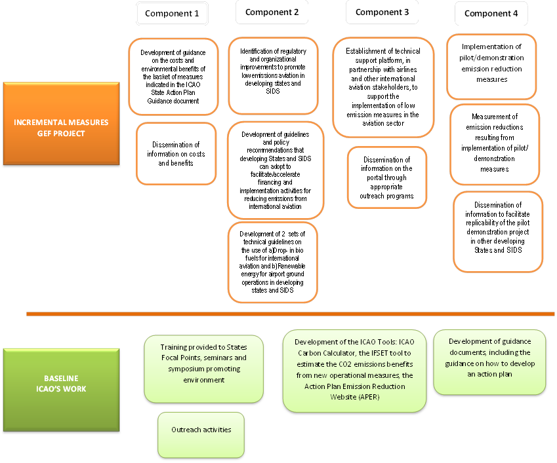

Figure 1: Baseline activities and incremental measures under the four components of this project. Source: *UNDP ProDoc*

In relation to this project, ICAO proposed additional activities that do not form part of the current work programme of the Organization. The focus of these activities will be assisting developing States and SIDS. The aim of these activities is two-fold:

* To foster nationally-appropriate actions on international aviation in developing States and SIDS where no such action would have been taken; and
* To accelerate the rate of implementation by assisting States to overcome barriers through the implementation of specific mitigation actions.
  1. Project Objective and Outcomes

The primary Objective of the project is to support capacity building in developing States for implementing technical and operational measures for reducing CO2 emissions from international aviation. This will be accomplished through the four Outcomes or project components implemented in parallel:

1. Identification of low emissions aviation measures in developing States and SIDS;
2. Supporting developing States and SIDS to strengthen their national capacities and improve their national processes and mechanisms for the reduction of aviation emissions;
3. Establishment of a technical support platform for the implementation of low emissions measures;
4. Demonstration of low emissions aviation measures in developing States and SIDS.

Each component includes specific outcomes and outputs which are interrelated and support each other and are shown in Figure 2.

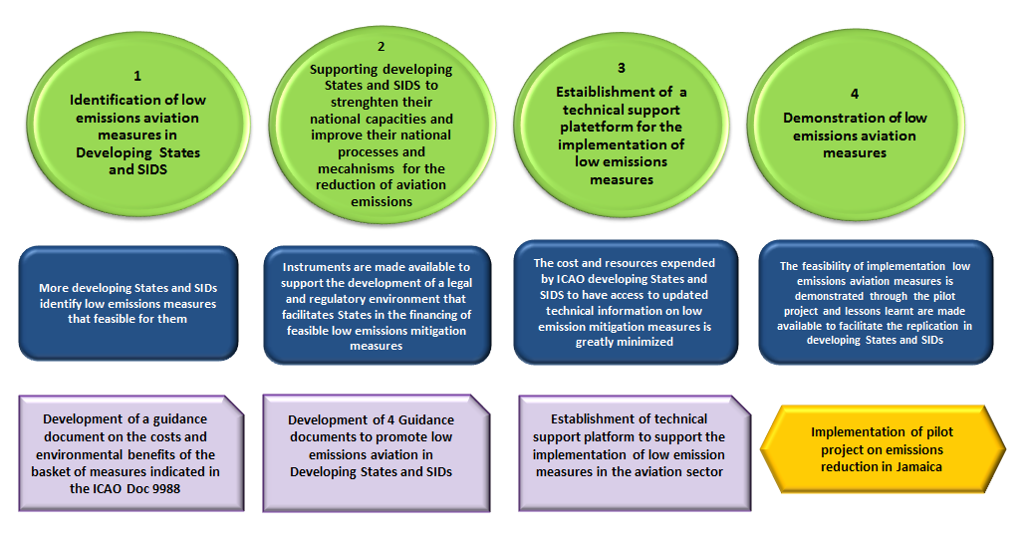

Figure 2: The four project Outcomes and main deliverables. Source: *ICAO*

***Component 1: Identification of low emissions aviation measures in developing States and SIDS***

**Outcome 1: More Developing States and SIDS identify low emissions measures that are feasible for them**

Through this component, ICAO will provide technical support and guidance to developing States and SIDS in order to enable them to identify feasible low emissions measures and report them to ICAO through the State action plan process. The proposed outputs (1.1 and 1.2) are additional to the mandated and planned ICAO activities described earlier (e.g., outreach activities relating to the dissemination of State action plan guidance contained in Doc 9988). One of the main difficulties of developing States and SIDS is the lack of information and guidance on the costs and environmental benefits associated with the basket of measures contained in ICAO Doc 9988, Guidance on the Development of States’ Action Plans on Emission Reduction.

This guidance on costs and environmental benefits will address this difficulty by allowing/facilitating developing States and SIDS to make informed decisions regarding implementing mitigation actions that are most feasible in light of their national circumstances. This component is also expected to result in an increase in the number of action plans submitted to ICAO. Furthermore, it is expected that the information submitted will be more complete and comparable across States enabling ICAO to improve its assessment of the progress towards meeting the overall aspirational goals, as stated in Resolution A38-18.

*Output 1.1: Development of guidance on the costs and environmental benefits of the basket of measures indicated in ICAO Doc 9988.*

ICAO will conduct a detailed assessment of the costs and environmental benefits associated with implementing various feasible measures in developing States and SIDS, including renewable energy projects. The assessment will take into consideration the most recent and up-to-date studies and reports on economic costs, financial implications and benefits of aviation measures published by, inter alia, relevant national authorities, regional and international organizations, industry associations, academia, and non-governmental organizations. The results of the assessment will be presented in a report including guidance for developing States and SIDS on how to identify and implement measures that are appropriate to their national circumstances.

*Output 1.2: Dissemination of the information on costs and benefits*

Following the completion of the assessment study under Output 1.1, ICAO will disseminate the results to ICAO Member States. Two workshops will be organized in the context of this project, specifically targeted to SIDS . During the workshops, ICAO will inform national experts of the results of the assessment, in particular the costs and benefits of different mitigation actions, and assist them to use this information to select amongst different mitigation options. ICAO Member States in other regions will engage with the project during other regularly scheduled ICAO events, which are co-financed by ICAO.

***Component 2: Supporting developing States and SIDS to strengthen their national capacities and to improve their national processes and mechanisms for the reduction of aviation emissions***

**Outcome 2: Instruments are available to support the development of a legal and regulatory environment that facilitates the financing of feasible low emissions aviation measures in States**

Through this component, ICAO will develop guidance and recommendations that are essential to stimulate the willingness and financing for implementing low emissions reduction measures. Such guidance and recommendations are not currently available for ICAO developing States and SIDS and it is expected that they will support the strengthening of national capacities leading to incremental actions that will bring about reductions in emissions from international aviation.

*Output 2.1: Identification of regulatory and organizational improvements to promote low emissions aviation in developing States and SIDS*

ICAO will develop guidance for developing States and SIDS on how to identify nationally appropriate improvements in regulations and organizational structures to help them implement low emissions strategies and measures in the aviation sector. This will include guidance on how to:

1. Draft recommended national legislation and/or develop specific legal instruments (e.g. laws, memoranda of understanding, etc).
2. Establish national teams that would identify appropriate mitigation measures and oversee the process for their implementation.

*Output 2.2: Development of guidelines and policy recommendations that developing States and SIDS can adopt to facilitate/accelerate financing and implementation activities for reducing emissions from international aviation*

Building upon CAEP support documents, ICAO will develop guidelines and policy recommendations specifically targeted to developing States and SIDS, particularly:

1. Guidelines on how to secure financing from various available sources (public, development finance institutions (DFI) and private) best suited for developing States and SIDS including self-financing of projects wherever feasible.
2. Guidelines on self-financing strategies that can be used by various stakeholders in developing States and SIDS in implementing emissions reduction projects.
3. Guidelines and policy recommendations in the area of renewable energy projects, including best practices on how to deal with public utilities and private renewable energy providers (e.g. feed-in tariffs, power purchase agreements, land lease agreements, and ownership models for environmental projects in airports).

*Output 2.3: Development of two technical guidelines on the use of: a) Drop-in bio fuels for international aviation; and b) Renewable energy for airport ground operations in developing States and SIDS.*

Over the last years, there has been growing interest in the use of renewable energy for aviation, especially because of its significant emissions reduction potential. The efforts of ICAO States have focused on two key areas: drop-in biofuels and use of renewable energy (RE) at airports. Within the aviation community, however, there is a lack of guidance on the use of RE for the sector. Therefore, ICAO will develop two technical guidance documents, providing appropriate assessments and guidelines to developing States and SIDS, in relation to:

1. The incorporation of drop-in biofuels for international aviation
2. The feasibility of using RE at airports

The guidance on drop-in biofuels will build on the outcome of the GEF targeted project “Global Assessments and Guidelines for Sustainable Liquid Biofuel Production in Developing Countries”, but will focus on the specific circumstances of the international aviation taking into consideration particular challenges and opportunities. For the latter, ICAO will use relevant up-to-date information on the utilization of RE, including (but not limited to) the IPCC Special Report on Renewable Energy Sources and Climate Change Mitigation, as well as the IPCC Fifth Assessment Report.

***Component 3: Establishment of a technical support platform for the implementation of low emissions measures***

**Outcome 3: The cost and resources expended by ICAO developing States and SIDS to have access to updated technical information on low emission mitigation measures is greatly minimized**

Under this Component, ICAO will support developing States and SIDS in their implementation of low emissions measures through the establishment of an integrated environmental portal to share relevant information from a range of stakeholders. The integrated portal will also facilitate ICAO’s provision of assistance leading to an accelerated implementation of environmental ICAO standards, practices, guidelines and recommendations.

*Output 3.1: Establishment of a technical support platform, in partnership with airlines and other international aviation stakeholders, to support the implementation of low emission measures in the aviation sector.*

The technical platform will bring together all technical information essential to implement emissions reduction measures such as standards, tools, guidance documents, guidelines, information on indicative costs, benefits, training material, in a SharePoint-like portal accessible from anywhere by States. The information will be public domain and will be collected from different sources including: ICAO, national governments, academia, vendors, business associations, etc. The availability of such a platform will also significantly reduce the time spent, costs and other overheads of developing States to collate information, leading to incremental implementation of emissions reduction measures.

*Output 3.2: Dissemination of information on the portal through appropriate outreach programs.*

During the two workshops that will be organized in the context of this project , ICAO will provide hands-on training and support to SIDS on the use of the portal and other tools. In addition, ICAO will use the portal to communicate with, and provide further ad-hoc assistance to, developing States and SIDS in the implementation of measures identified in their action plans. These outreach activities are expected to enhance the implementation of mitigation activities in developing States and SIDS. ICAO Member States in other regions will be provided with information from this project during other regularly scheduled ICAO events. The two workshops will disseminate information from outputs 1.2, 3.2 and 4.3 and will be organized in regions with SIDS.

***Component 4: Demonstration of low emissions aviation measures***

**Outcome 4: The feasibility of implementing low emissions aviation measures is demonstrated through the pilot project and lessons learnt are made available to facilitate replication in developing States.**

As stated in the ProDoc, ICAO has identified the installation of photovoltaic (PV) panels at the international airport of Jamaica as an ideal candidate for the pilot project. During the project implementation, the lessons learnt from the pilot project for each milestone phase will be closely monitored and well documented. These phases will cover activities pre- and post- implementation, as well as the measures adopted to quantify the emissions reduction benefits. The documentation of the lessons learnt from the pilot project will be the basis for outreach and communicating the project to other developing States and SIDS.

*Output 4.1: Implementation of pilot/demonstration emission reduction measures*

A promising mitigation activity that involves the reduction of international aviation fuel is limiting the use of on-board APUs. APUs are used to provide electricity to, and run the air conditioning of an aircraft after it has landed or while it is readied for take-off. According to industry data, APUs consume anything from 40 gallons of jet fuel per hour to more than twice this amount depending on the size and operating conditions of an APU. It is clear therefore that there is a significant potential to reduce CO2 emissions by eliminating the use of APU while an aircraft is on the ground.

An alternative to APUs is the use of ground support equipment, such as GPUs, which can provide the required electricity to an aircraft while running on liquid fossil fuels (e.g., diesel oil) or grid electricity. The proposed pilot project involves the installation of PV panels to produce electricity that will be used to run GPUs replacing APUs for international flights.

The benefits of replacing grid electricity at airports are associated with reducing international aviation fuel consumption for APUs and improving airport operations. For this project, it is expected that the airport electrical system will be powered by both solar power and grid power. All the solar power will be fed into the airport’s electrical system. To avoid complexities associated with feeding the solar power into the national grid (e.g. negotiating a power purchase agreement), it is proposed that the solar power produced will be consumed on site. When the PV array is producing less than the airport needs, the utility will compensate. With a large enough solar panel system, the amount of energy produced by the solar panel system per year could offset the amount of energy used from the grid. The diagram below illustrates this option. In the unmitigated case, the airport produces its own electricity or purchases electricity from the national grid, the majority of which comes from the combustion of fossil fuels.

*Output 4.2: Measurement of emission reductions from aviation resulting from implementation of pilot/demonstration measures.*

As part of the preparatory phase for the pilot project, information will be collected on the usage of APUs, by specific aircraft type and the related consumption of aviation fuel while aircrafts are on the ground. This information will be used to estimate the potential reduction of aviation fuel as result of the pilot project. As part of the implementation of the pilot project, a meter will be installed to measure the amount of electricity produced by the PV panels.

It will be assumed that the amount of electricity produced by the PV panels will replace an equivalent amount of grid electricity. Additional information will be collected on the electricity generation system in Jamaica (e.g. amount of electricity produced, technology used, mitigation measures (if any), fuels used and their characteristics, distribution losses, etc.). Based on this information, an average grid EF (EFGrid) will be developed that represents the average amount of CO2 released per kWh produced by the grid. The quantity of CO2 avoided because of the pilot project will be calculated by combining the PV electricity production and the EF through the following equation:

*Emissions avoided = kWh of PV electricity provided to airport building • EFGrid*

*Output 4.3: Dissemination of information to facilitate replicability of the pilot project in other developing States and SIDS.*

In the context of the workshops to be organized under this project, ICAO will communicate the lessons learnt from the pilot project implementation during its different phases and will develop a roster of States where the pilot project can be scaled up in the future. The outreach of ICAO, in collaboration with other stakeholders, will assist developing States and SIDS to better understand the technical and financial feasibility of replicating similar projects, leading to further incremental emissions reductions. States in other regions will engage in this project during other regularly scheduled ICAO events co-financed by ICAO.

* 1. Project implementation arrangements

As established in the ProDoc, UNDP is acting as the implementing agency for this project and ICAO as implementing partner, according to UNDP's Agency Implementation Modality (AIM). The default mode of implementation for UNDP is the National Implementation Modality (NIM) whereby a Government entity (typically a Ministry) together with a local UNDP office implement the GEF project. UNDP has done several AIM projects before with e.g. UN Food and Agriculture Organization (FAO) and World Bank but this was the first project in the aviation sector and with ICAO.

It was expected that this project would complement another project, the ICAO-EU Assistance Project: Capacity Building for Co2 Mitigation from International Aviation, which started about the same time as this GEF project but had a larger budget (6.5 million Euros) and a ran for 5 years and is located in the same Environmental Protection Department at ICAO. This project is classed as a “Medium-sized” project by the GEF but has a short time-frame of 3 years compared to the more usual 4-5 years for implementation. In addition, due to the shorter project lifetime there is not an independent mid-term evaluation of the project, which is standard practice from most UNDP/GEF projects.

A Project Steering Committee (PSC) is responsible for making management decisions. The Director of the Air Transport Bureau (D/ATB), the Deputy Director, Environment (DD/ENV), the Chief, Finance (C/FIN), and the Director of the Technical Cooperation Bureau (D/TCB) will compose this Committee, with the participation of UNDP as an observer.



Figure 3: The project management structure*. Source: ProDoc*

At the inception workshop for the project the roles of UNDP and ICAO in regards to project implementation were clarified:

*ICAO/ENV will:*

*• Prepare and coordinate the project*

*• Participate in Inception Workshop*

*• Facilitate, support Project Board meetings per ProDoc and as agreed with UNDP RTA*

*• Provide project assurance role per ProDoc*

*• Ensure completion of timesheets as required*

*• Issue Annual Work Plan (AWP)*

*• Monitor implementation of AWP and timetable*

*• Conduct budget revisions, verify expenditures, advance funds, issue combined delivery reports, and ensure no over-expenditure of budget*

*• Ensure necessary audits*

*• UNDP monitoring requirements*

*• Submit/contribute to annual PIR*

*• Final budget revision and financial closure*

*• Final reports as required by donor and/or UNDP-GEF*

*UNDP will:*

*• Participate in Inception Workshop*

*• Support in sourcing of potentially suitable candidates*

*• Provide advisory services as required*

*• Review AWP*

*• Return unspent funds to donor*

*• Monitor projects to ensure activities funded by donor comply with agreements and project document*

*• Oversight and monitoring to ensure financial transparency and clear reporting to the donor*

*• Advisory services as required*

*• Assess project for quality assurance*

*• Arrange and oversee Terminal Evaluation*

*• Project visits*

*UNDP-GEF is on the board represented by Ms. Adriana Dinu, Executive Coordinator, UNDP – Global Environment Finance, who can delegate her board duties to Mr. Alers. ICAO is represented by Mr. Boubacar Djibo, Director, Air Transport Bureau (ATB). Beneficiary representatives will include counterparts from Jamaica Civil Aviation Authority and other relevant developing States and Small Island Developing States (SIDS). Project Assurance is done by Mr. Page with support of Ms. Hernandez. Ms. Hupe, Project Manager, with project support from Ms. Hornek, reports to the project board. Project Board is established according to diagram on page 41 of the Project Document [*Figure 3*]. It will meet once a year to review annual progress and agree on the annual work plan. The first Project Board meeting is tentatively scheduled for the last quarter of 2016 in Montreal or New-York, as logistically both locations are convenient for both organizations. If need arises ad hoc project board meeting can be convened. It is possible to invite other people to the project boards meeting.*

* 1. Project timing and milestones

The ProDoc does not include a table of milestones. However, the project timing and some milestones can be deducted from some deadlines established in the PRF for some indicators. They are summarized in the table below. The first digit in the milestone numbering refers to the project component associated to the milestone. As can be seen, due to the relatively short project lifespan the main deliverables are all planned for completion in Year 3 (2018).

Table 2: List of Main Project Milestones

|  |  |  |
| --- | --- | --- |
| # | Milestone | Year for completion |
| 1.1 | Guidelines on cost and environmental benefits of the basket of measures developed by project. | 3 |
| 1.2 | Number of developing States and SIDS with clearly identified feasible measures for implementation. | 3 |
| 2.1 | Guidelines for low emission aviation policy and regulation in developing States and SIDS. | 3 |
| 2.2 | Guidelines for developing States and SIDS regarding drop-in biofuels and renewable energy for airport operations. | 3 |
| 3.1 | Technical Support Platform | 3 |
| 3.2 | Outreach Activities | 3 |
| 4.1 | Capacity Building for SIDS | 3 |
| 1.3 | Demonstration project: Solar-to-Gate at NMIA | 3 |

1. Findings
   1. Project Design and Formulation

Overall, the project design is adequate as it is based on a review of the institutional, political and the technical context. The ProDoc identified opportunities available for action at two levels, at the international level using ICAO as the platform for a top-down initiatives related to education, and bottom-up approaches at the local/national level through the pilot projects in Jamaica and the capacity building workshops for the stakeholders in the SIDs.

The components of the project were well conceived and based on measures that were identified and supported by ICAO to move the aviation industry to a more sustainable path and reduce GHG emissions in the sector. As SIDs are isolated and rely more on air transportation for their economies, particularly for tourism, focusing the project on SIDs was a smart strategy. By using ICAO as the implementing partner the project also leveraged ICAO’s networks with the SIDs and developing States which provides a much larger impact with the funding and project staffing available. As mentioned previously, the project was also designed to complement the ICAO-EU project and there are synergies and overlaps that contributed to both projects meeting their goals, e.g. SAF feasibility studies, future implementation of the MAC curve tool, solar-to-gate projects, etc.

From the technical side, the project design provides a clear framework for the incremental measures and how these relate to the current (baseline) activities at ICAO as shown in Figure 1. The project design is also very prescriptive in how to move forward with pilot activities and even includes a letter of support from the Government of Jamaica which provides access to land (land grant) for a future project.

Overall it can be said that the Project Design, as detailed in the ProDoc, was well thought out and structured, and this is evidenced by the PMUs ability to implement the project activities on time and on budget with only modest challenges which are typical of most projects.

* 1. The Project Results Framework (PRF)

The PRF in the project document is specific in terms of the expected actions of the project. These actions are generally included within the PRF under the category of "indicators", with a target that refers to the actual implementation of each particular action. The PRF is shown in Annex 2 as part of the Evaluation Protocol. Most of the indicators are SMART (Specific, Measurable, Achievable, Relevant, Time-bound) with two exceptions:

* Objective 1.3 Target: Indirect Emissions: Additional 1,000,000 tons of CO2 reduced in developing countries and SIDS over 20 year
* Outcome 2.1 Target: Policies and regulations guidelines are adopted and enforced to stimulate low emission aviation investments in developing States and SIDS.

Little guidance was provided in the ProDoc or during the Project Inception on how to further substantiate the indirect emissions (Objective 1.3 Target) during the project implementation. The ProDoc develops certain assumptions in section 2.5.2 during an estimate of the potential indirect emission reductions. Ideally some type of survey might have been undertaken by the project and/or a study of e.g. country submissions to ICAO, UNFCCC, etc. to collect the information and data to revise this estimate with verifiable/updated assumptions. In this regard the indicator fails the measurable requirement.

Outcome 2.1 is not seen as being achievable by ICAO as policy adoption and enforcement is not something ICAO can directly facilitate.

It was mentioned at the inception workshop by the UNDP RTA that they PRF could be revised within certain limits, but this was never acted upon by the PMU during the project lifetime. During the TE it was pointed out by the Evaluator that these two indicators were not appropriate, or were difficult to monitor/measure, and that these should have been updated.

Table 3: Project Risk Matrix from the ProDoc (Impact/Probability scale is 1 to 5 with 5 being highest).

| **#** | **Description** | **Date Identified** | **Type** | **Impact &**  **Probability** | **Countermeasures / Mngt response** | **Owner** |
| --- | --- | --- | --- | --- | --- | --- |
| 1 | Developing States do not prioritize emission reductions from international aviation. | PIF | Governance | I = 4  P = 2 | The project is embedded in a framework of multiple stakeholder discussions on emission reductions facilitated by ICAO, which has made significant progress in engaging all ICAO States.  The development of State Action Plans demonstrates a willingness to identify actions to reduce emissions according to national circumstances.  The possibility of engaging GEF and additional support for the implementation of such measures provides a greater incentive for developing States to join this effort. | PMU |
| 2 | The aviation industry does not embrace the measures needed to achieve significant emission reductions from the sector. | PIF | Governance | I = 4  P = 1 | The commitments and voluntary targets established by the industry are a strong indicator that there is willingness to engage in low emissions aviation.  A key aspect is to ensure concerted action across the industry, so that the potential financial impact is not imbalanced across regions, thus affecting the competitiveness of the industry.  ICAO is at the forefront of this concerted action and has a successful track record of engaging the industry, which provides reassurance on the continued commitment of all associated stakeholders. | PMU |
| 3 | Global economic conditions do not allow developing States and/or the aviation industry to invest in low emissions aviation. | PIF | Development | I = 4  P = 2 | International aviation is a highly competitive industry, which is particularly vulnerable to the state of the global economy. As such, the commitment to additional investment fluctuates according to global economic conditions.  The project seeks to minimize this risk by creating medium and long term market and regulatory conditions that establish a stable framework for investment in low emissions measures, regardless of global economic fluctuations.  Furthermore, State action plans will identify the most cost effective measures for implementation, thus creating a potential for increased competitiveness and costs savings through emission reductions. | PMU |
| 4 | The Government of Jamaica withdraws its support to the project. | PPG | Governance | I = 2  P = 1 | The Government of Jamaica has agreed at the highest level to participate in the project. Letters of intent and support have been received by the Government of Jamaica and by CASSOS.  However, should the Government of Jamaica decide not to participate, ICAO has already identified other SIDS that fulfil the criteria established for this project and who have expressed interest in participating in the project. | PMU |
| 5 | It is difficult to verify the GHG emission reductions delivered by the project. | PPG | Development | I = 3  P = 3 | The focus of this project is to assist ICAO Member States to reduce emissions from international aviation. Given the global scope, the verification of results is a key parameter not only of the demonstration component (Component 4) but of the whole project.  To verify emissions reductions from the demonstration component, an appropriate methodology will be used including continuous monitoring of electricity production from the PV panels.  For the other project components, information will be collected from States’ action plans and will be reviewed against relevant information from industry associations.  Throughout the duration of the project, ICAO will draw on technical knowledge and expertise to implement a robust monitoring and verification system, in collaboration with national and international experts. | PMU |
| 6 | The unit cost of the PV panels would be too high for use in this project. | PPG | Development | I = 4  P = 1 | The unit cost of PV panels has decreased over the last few years. However, this issue was raised during PPG and it was decided to increase the budget for Component 4 to ensure that there are enough financial resources available for the installation of PV panels. | PMU |
| 8 | Adverse social impacts (such as labour loss) would affect the introduction of renewable energy in international aviation. | PPG | Sustainability | P = 1  I = 2 | Replacing fossil fuels with RE may have impacts on labour demand, especially for oil production and processing.  The introduction of innovative technologies, however, presents new opportunities for employment, as well as improving local environmental conditions by reducing local pollution and noise. | PMU |
| 9 | Exchange rate risk. | PPG | Financial | P = 2  I = 3 | The exchange rate between the US dollar and the Jamaican dollar may increase and/or fluctuate, potentially leading to a reduced value of GEF resources.  This external risk has affected the performance of other GEF Projects in developing countries.  Careful financial planning should help anticipate such a situation. | PMU |

A review of the project risk matrix shown in Table 3 shows that many major risks where properly identified during the project screening and development phases. The PMU did not follow-up adequately regarding Risk 5 (GHG ER verification) and there is little evidence that a systematic effort was put in place in regards to collecting information to justify the indirect emissions reductions from the project activities. However, the monitoring system put in place for the real-time monitoring of the electricity production from the solar to gate project (and thus the direct ER’s) is state-of-the-art and allows remote monitoring from ICAO headquarters.

In hindsight, the risk matrix mainly focused on macro factors and missed institutional risks related to differences in e.g. procurement procedures between UNDP and ICAO that went unnoticed until they ultimately created some unexpected delays for the project. Otherwise generally speaking the risk matrix is logical and robust.

These issues related to the PRF and monitoring are described in more detail in the next sections. In general it is the Evaluator’s opinion that the original PRF was not as well designed as the project itself and would be rated as “Moderately Unsatisfactory” if such a rating was done as part of the TE. However, it is the responsibility of the PMU to notice and rectify this as much as possible during the project implementation.

* 1. Project Implementation & Management Arrangements

The project was implemented within the Environmental Department of ICAO. The key project staff and stakeholders are listed below.

Table 4: List of the key project staff and stakeholders involved in the GEF project.

|  |  |  |  |
| --- | --- | --- | --- |
|  | First name | Last Name | Title |
| **ICAO** |  |  |  |
| Environment | Jane | Hupe | DEPUTY DIRECTOR, ENVIRONMENT, ATB/ENV |
| Neil | Dickson | CHIEF, ENVIRONMENTAL STANDARDS SECTION, ATB/ENV/ES |
| Adilia | Hornek | PROJECT MANAGER, ICAO-UNDP-GEF ASSISTANCE PROJECT, ATB/ENV |
| Stephen | Barrett | TECHNICAL CONSULTANT, ICAO-UNDP GEF ASSISTANCE PROJECT, ATB/ENV |
| Chrystelle | Damar | ASSOCIATE ENVIRONMENT OFFICER, ATB/ENV |
| Blandine | Ferrier | ASSOCIATE REGIONAL OFFICER, OSG/EUR-NAT |
| Eduardo | Caldera | PROGRAMME COORDINATOR, ICAO-EU ASSISTANCE PROJECT, ATB/ENV |
| Harkamal | Gahunia | TECHNICAL ASSOCIATE, ATB/ENV |
| Jasna | Sepetavec | PROGRAMME/ADMINISTRATIVE ASSISTANT, ATB/ENV/CC |
| Luis | Horta | UNDP-GEF Project Policy Consultant – Alternative Fuels |
| Andreas | Hardeman | Platform Content Management Consultant |
| Finance | Lynette | Lim | ACTING CHIEF, FINANCE BRANCH, OSG/FIN |
| Procurement/ Technical Cooperation Bureau (TCB) | Marie-Ange | Nyssen | HEAD, PROCUREMENT UNIT, TCB/PRO/PRU |
| **JAMAICA** |  |  |  |
| Jamaica Civil Aviation Authority (JCAA) | Althea | Roper | Manager, Aviation Statistics Airfares and Rates, Economic Regulation Department, Jamaica Civil Aviation Authority |
| NMIA Airports Ltd (NMIAL) -subsidiary of Airports Authority of Jamaica (AAJ) | Junior | Levene | Energy Management Coordinator  NMIA Airports Limited  Palisadoes, Jamaica |
| **UNDP** |  |  |  |
| Global Environmental Finance Unit | Marcel | Alers | Head of Energy UNDP - Global Environmental Finance Unit Bureau for Policy and Programme Support United Nations Development Programme |
| Global Environmental Finance Unit | Melissa | Hernandez | Programme Associate - EITT UNDP – Global Environmental Finance Unit  Bureau for Policy and Programme Support |

The quality of the project implementation varied by the activity and outcome. In most cases the activities were implemented extremely well by the PMU and this are discussed in more detail in the next sections. Overall the project implementation can be considered moderately satisfactory due to issues with Outcome 3 and the general lack of monitoring and reporting particularly during the latter stages of the project. If inadequate monitoring and reporting is the symptom, then the root causes could be due to the following facts:

* There were no dedicated full-time staff in the PMU at ICAO. The PM was originally hired to only work 2 days a week which was increased to 3 days a week in 2018. The rest of the staff at ICAO worked extra on the project in addition to their normal duties in the Environmental Department.
* The original UNDP Regional Technical Advisor, Mr. Oliver Page, left UNDP and the project shortly after the Inception Meeting in 2016 and was not replaced by UNDP. This resulted in a “coaching gap” insofar as GEF/UNDP M&E procedures were concerned as this was ICAO first GEF project.
* Only one official Project Steering Committee meeting was held by the project in March 2018, in Kingston, Jamaica. As the PSC does have a clear oversight role for the project it should have convened in at least once in 2017.
* The project never had any type of independent Mid-term Evaluation which might have caught some of the PRF and M&E issues earlier.

It is very unusual to not have any full-time dedicated staff for a GEF project. During the interviews this was consistently raised as one of the challenges this project faced, and the decision to hire a part-time PM might have seemed like a good idea at the time of the project formulation. The rationale for this was that the bulk of the work would be done by sub-contractors (consultants) and that the PM role was more about oversight and management of the deliverables, which would not justify a full-time position at ICAO.

Even though a suitable candidate was found for the PM role and one of the reasons she applied was that it was part-time, it was by all accounts a situation where she often worked on the project outside of the 2 days a week and often from home. This is also evidenced by the increase in man-days for the PM from 2 days a week to 3 days a week in 2018.

Normally having a project with so many moving parts without any dedicated full-time staff would be a recipe for disaster. It is a testament to the professionalism and conscientiousness of the project team at ICAO that the project performed as well as it did in delivering so many results, considering that the list of staff in Table 3 (except the PM) all had other full-time duties within the Environmental Department. Some interviewees also attributed the success to the strong team feeling within the department, the strong leadership from the Department Deputy Director, and the PM’s personality and ability to get others to “buy-in” to the project. As one staff member described it, “You took pride in working on the project, and wanted to be a part of it because it had very positive and tangible results (the pilot solar-to-gate project) compared to the typical development of reports or guidance documents etc. So, it was an exciting project for the department and you wanted to be part of that team.”

It should also be pointed out that the primary contractors/consultants for the project were mostly highly experienced professionals who delivered good results for the project within the budget limitations. The feedback from the ICAO staff was overwhelmingly positive in this regard, though there were typical issues related to revisions, reference to ToRs, etc. before the tasks could be considered completed. That is a positive consequence of the review and oversight role of the PMU and is normal for any project.

One surprising issue that was raised during the staff interviews, and also in the official project documents (PIR, PSC minutes, etc.), was the difficulty the PMU faced with aligning the procurement procedures between UNDP and ICAO. This was mentioned by everyone as a major challenge the project faced during implementation and it caused major delays. Essentially the problem boils down to two institutions with very well-developed guidelines and procedures having a policy conflict that created a deadlock: UNDP could not disburse funds until an assignment was completed, and ICAO could not issue a tender for an assignment without the necessary funds being in the ICAO accounts to back the tender. This procurement issue effectively froze the project progress in 2016 until the right people of the appropriate high-level in the two bureaucracies took the decisions to use common sense to break through the resulting deadlock and granted an exception to the procedures.

* 1. Adaptive Management

Adaptive management in the UNDP/GEF context has a very specific meaning and it is worthwhile repeating it here. Adaptive management is defined as the project’s ability to adapt to changes to the project design (project objective, outcomes, or outputs) during implementation resulting from: (a) original objectives that were not sufficiently articulated; (b) exogenous conditions that changed, due to which a change in objectives was needed; (c) the project’s restructuring because the original objectives were overambitious; or (d) the project’s restructuring because of a lack of progress.

The project experienced 2 major cases where adaptive management led to changes in the project design (Components and Activities) but not in the overall Objective of the project:

1. Improvement of the concept for Outcome 1 to develop an online MAC Curve tool
2. Modifications of Outcome 4 activities and redesign of the solar PV size and expansion to two project sites at NMIA *and* SIA.

This adaptive management resulted in an improvements for both Outcomes within the original budget as discussed in greater detail in the next sections.

* 1. Monitoring and Evaluation: design at entry and implementation

As discussed earlier the monitoring indicators in the ProDoc, particularly for Objective 1 and Outcome 2, did not provide a good relationship between the project’s environmental impact and progress with the project’s activities. Prime examples are

* *Objective 1.3 Target: Indirect Emissions: Additional 1,000,000 tons of CO2 reduced in developing countries and SIDS over 20 year*
* *Outcome 2.1 Target: Policies and regulations guidelines are adopted and enforced to stimulate low emission aviation investments in developing States and SIDS.*

Within the ProDoc the onus of the M&E design is placed on the future PMU and the project participants. In Annex 5 Monitoring Framework and Evaluation it clearly states:

*The Inception Workshop should address a number of key issues including:*

1. *Assist all partners to fully understand and take ownership of the project. Detail the roles, support services and complementary responsibilities of UNDP GEF staff vis à vis the project team. Discuss the roles, functions, and responsibilities within the project's decision-making structures, including reporting and communication lines, and conflict resolution mechanisms. The Terms of Reference for project staff will be discussed again, as needed.*
2. *Based on the project results framework and the relevant GEF Tracking Tool if appropriate, finalize the first annual work plan. Review and agree on the indicators, targets and their means of verification, and recheck assumptions and risks.*
3. *Provide a detailed overview of reporting, monitoring and evaluation requirements. The M&E work plan and budget should be agreed and scheduled.*

So in the view of the Evaluator this is a correct process to finalize the M&E requirements for the project upon inception but even so the initial M&E framework could have been better conceived in regards to thinking about *how would* the indicators be measured. Therefore at project start up the M&E Formulation is rated as ***Moderately Unsatisfactorily.***

As mentioned previously, during the Inception Workshop minutes it states that the PRF and M&E plan was reviewed. However, no changes were made. Afterwards, with the exception of the Annual PIR no evidence of quarterly or periodic monitoring and reporting of the project results have been presented during the TE. In addition, some of the stipulated data/information collection to estimate the targets in the PRF was collected near the end of the project not during the project implementation. Due to the short lifetime of the project only 2 PIR’s were conducted in 2016 and 2017.

Most of the project results and deliverables took place after the 2017 PIR and therefore the 2016 and 2017 PIR had limited reporting insofar as real results of the project, but the PIRs did accurately reflect the progress and follow-up actions of the project implementation at those stages. If a PIR had been done in 2018 more emphasis might have been made by the PMU to update the target estimates in the PRF before the TE, and possibly the two problematic indicators/targets mentioned above might have been improved.

The M&E Plan Implementation is rated as ***Moderately Satisfactory*** because some of the fundamental issues with the M&E Indicators were never fixed and this ultimately caused problems for the PMU to quantify the environmental impact project the generated. The Overall Quality of the M&E is rated as ***Moderately Satisfactory***.

* 1. Partnership Arrangements

The engagement of key stakeholders was primarily done through participation as full members or observers at the PSC and regular communication by email and phone calls during the implementation of the projects in Jamaica. The primary partners in the project besides UNDP were

* Key government stakeholders from the Jamaican federal government, and from the local administrations in the pilot cities of Kingston and Montego Bay.
* Technical experts and contractors in the USA, Canada, and Jamaica
* A few private stakeholders involved with the airports.

There are few records of project meetings outside of the 1 PSC meeting in 2018 and the annual PIR. The project produced excellent minutes from the mission to Jamaica that took place in early 2016. The level of engagement was with partners was generally appropriate though the project might have benefited from a more active Steering Committee that met more often in 2017 or more regular input from a UNDP RTA.

* 1. UNDP and Executing Agency Partner implementation and coordination

Generally speaking the performance of the Executing Agency (ICAO) and PMU was very strong, even during the difficult situations that arose in project from time to time. Because of this fact, and the positive reputation the project management team enjoyed among the stakeholders for timely responses and feedback, provides a strong case for rating the Implementation of the Executing Agency (ICAO) as *Satisfactory****.*** This rating is also supported by the realistic project reporting in the PIRs and other minutes, and management of the project risks such that the main deliverables were successfully implemented.

It is important to emphasize that this was ICAO’s first UNDP/GEF project and as such there was a learning curve for all involved, particularly in relation to the UNDP/GEF procedures related to monitoring and reporting on progress. The team at ICAO that was tasked with implementing the project were experienced professionals but some of the onus for coaching them regarding the correct way to do certain activities was on UNDP. Initially the UNDP RTA was active in the project but after he left in 2017 there was not a replacement from UNDP who became involved in the project on a regular basis. Some UNDP staff were active on the financial and ATLAS reporting but this evaluator believes that certain mistakes might have been avoided if an active UNDP RTA had been part of the project to the end. To put this another way, the quality of the risk management might have been improved if additional guidance from an experienced RTA had been available. For example, the PMU’s preparation for the TE was lacking and there should have been more assistance/coaching from UNDP on how to prepare the documentation and evidence for the TE. Another example would be little review by UNDP of Component 3 for quality and completeness even though budget reappropriations were done and approved by UNDP.

The TE guidelines specify that if there were some short comings that the rating should be *Moderately Satisfactory,*and as explained above there was some lack of oversight which created short-comings in the project implementation and terminal preparations, particularly in regards to the lack of a dedicated UNDP RTA and a lack of regular PSC meetings. Therefore the Implementing Agency’s (UNDP) rating is Moderately Satisfactory.

While the overall coordination between the two agencies seemed to be strong, some things could have been done better and the situation with the procurement procedures caused real delays in the project implementation. Overall the Partner implementation and coordination is rated as ***Moderately Satisfactory***.

* 1. Finance and co-finance

The project finances were reviewed during the TE and the information made available to the evaluator only covers the period through June 30, 2018, as ICAO has, per agreement, until December 31, 2018 to finalize the project payments and disbursements. Table 5 and Figure 4 show the budget disbursements during the project life. The project activities effectively started in 2016 and with the extension ended in July 31, 2018. This shift in start date and also the shift of the payments for the deliverables in Components 1 and 4 to 2018 explains the large difference between the ProDoc budget and the real disbursements by the project.

|  |  |  |
| --- | --- | --- |
| **YEAR** | **PRODOC BUDGET** | **Disbursements until**  **June 30, 2018** |
| 2015 | 261,063 | 12,623 |
| 2016 | 461,996 | 113,118 |
| 2017 | 1,226,941 | 306,975 |
| thru June 2018 |  | 914,239 |
| thru Dec 2018 |  | budgeted: 603,045 |
| **TOTAL** | **1,950,000** | **1,950,000** |

Table 5: Budget distribution by year

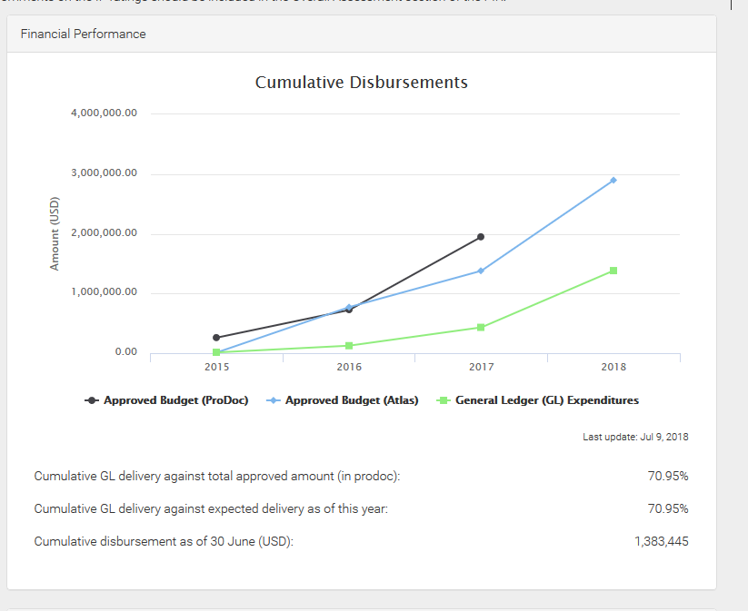

**Figure 4: Budget distribution during project life-time.**

The blue line in Figure 4 has a larger amount than the project budget. According to UNDP staff, the “… blue line indicates the yearly budget entered into Atlas, which is not limited to the total grant amount. That line is more informative, the black and green are showing the real spending against the grant amount.”. The distribution of resources among the four components of the project is presented in Table 6 and Table 7. The largest shift between components was from Component 3 and Component 4 to Component 1 which had to do with increasing the budget for the work that McKinsey did for Component 1.

Table 6: Budget distribution among components

|  |  |  |  |
| --- | --- | --- | --- |
|  | Through 2018 Project Budget (USD) | ProDoc Budget (USD) | Difference (USD) |
| Component 1 | 350,042 | 300,042 | +50,000 |
| Component 2 | 244,843 | 244,843 | 0 |
| Component 3 | 145,290 | 155,290 | -10,000 |
| Component 4 | 1,081,850 | 1,121,850 | -40,000 |
| Project Management | 127,975 | 127,975 | 0 |

Table 7: Budget distribution along main ATLAS items through June 30, 2018

|  |  |  |
| --- | --- | --- |
| **ATLAS ID** | **Item** | **Amount** |
| 71205 | International Consultants | 125,342.84 |
| 71305 | Local Consultants | 70,504.32 |
| 71605 | Travel | 91,759.91 |
| 72105 | Contractual Services Companies | 1,001,088.48 |
| 74205 | Audio visual & print production costs | 23,377.15 |
| 75705 | Trainings | 34,882.59 |
|  | **Total** | **1,346,955.29** |

Within the components the largest budget change occurred within Component 3. The cost of the SIDS seminars was under-budgeted and approx. $40,000 was transferred from the development budget of the Knowledge Platform to travel costs and other costs associated with the 2 SIDS seminars. These budget changes were approved by UNDP in consultation with ICAO.

Table 8: Realization of co-financing for the project

|  |  |  |
| --- | --- | --- |
| **CO-FINANCER** | **PRODOC (USD)** | **2018 Co-finance (USD)** |
| CAEP and Member States | 3,000,000 | 3,000,000 |
| ICAO Budget | 1,500,000 | 1,500,000 |
| Multilateral agency (EU) | 8,250,000 | 8,250,000 |
| UNDP | 300,000 | 300,000 |
| **TOTAL** | **15,000,000** | **15,000,000** |

The planned project co-financing was confirmed by the PMU and evidence was provided during the TE. The bulk of the co-financing was provided by the ICAO-EU project that collaborated actively with this one.

* 1. Management of the Project Funds

The PMU did a professional job preparing project budgets and the UNDP and ICAO finance staff have experience managing many projects so it was little surprise that the project accounts were managed quite well. The system and UNDP procedures include strong financial controls on how the project funding should be dispersed and reallocated. As shown in Figure 4 the project stayed under-budget for most of its time and there could be some funding left over by the end of the project that needs to be returned to the GEF, however it is currently budgeted for expenditures through December 2018. There were no reported irregularities regarding the project accounts.

* 1. Project Results

Each Component/Outcome and the main Objective are discussed in detail in the following sections and the justification for each rating is provided. Overall the project is rated as **Satisfactory** in accordance with the UNDP/GEF definition that “the level of outcomes achieved more or less as expected and/or there were moderate short comings” in the project. These outcomes and any shortcomings are discussed in more detail in the following sections.

* 1. Outcome 1: More developing States and SIDS identify low emissions measures.

Table 17 below shows the PRF indicators agreed for the project for Outcome 1. The last column shows the status at project end. Component 1 had 2 major main activities in mind to development guidance on different measures to reduce emissions and to disseminate the results. The project team took this task to an entirely higher level by deciding to develop an online platform that estimates for users the Marginal Abatement Cost curves (MAC) for different reduction options and even a basket of reduction options. The team hired McKinsey, famous for developing MAC curves for GHG reduction actions globally, and had them apply their expertise to the aviation sector. The result is a comprehensive and unique analysis of the economic costs and environmental benefits of a basket of 20 distinct measures:

|  |  |
| --- | --- |
| *Measure 1 – Purchase new aircraft* | *Measure 11 – Improve taxiing* |
| *Measure 2 – Improve fuel efficiency through development or modification* | *Measure 12 – Minimise weight* |
| *Measure 3 – Replace engines* | *Measure 13 – Minimise flaps (takeoff and landing)* |
| *Measure 4 – Develop of Sustainable Aviation Alternative Fuels (SAAF)* | *Measure 14 – Minimise reverser use* |
| *Measure 5 – Improve pre-departure planning (DMAN) and arrival planning (AMAN)* | *Measure 15 – Reduce speed* |
| *Measure 6 – Improve collaborative decision-making (A-CDM)* | *Measure 16 – Optimise aircraft maintenance (engine washing and zonal drying)* |
| *Measure 7 – Improve air traffic management in non-radar airspace* | *Measure 17 – Select aircraft best suited to the mission* |
| *Measure 8 – Improve fuel efficiency of departure and approach procedures* | *Measure 18 – Install fixed electrical ground power and preconditioned air to enable auxiliary power unit switch-off* |
| *Measure 9 – Introduce continuous climb and descent procedures* | *Measure 19 – Use cleaner alternative sources of power generation (for fixed electrical GPU and PCA)* |
| *Measure 10 – Improve aircraft guidance on apron* | *Measure 20 – Construct taxiways and speed exits* |

The online MAC tool and an accompanying report *Aviation Carbon Emission Reduction Measures* discusses the benefits of each measure and the costs, eventually arriving at overall CO2 abatement costs for the measures:

*The average cost per tonne (t) numbers are based on the total carbon savings (most frequently driven by fuel savings) and the total net cost of achieving those carbon savings. The net cost takes into account the financial benefit of fuel savings as well as other relevant savings such as reduced maintenance cost, and subtracts those from the costs associated with implementation (capital expenditure and operations)... If the savings are high enough or the cost low enough, the net cost ends up being negative.*

These negative cost measures are often called the “low hanging fruit” because they pay for themselves over a period of time. An example of the MAC study outcome for Measure 2: Improve Fuel Efficiency through Development or Modification is shown in Table 16: Improve fuel efficiency through development or modification: implementation cost per tonne CO2.

Table 9: Improve fuel efficiency through development or modification: implementation cost per tonne CO2

| **Category** | **Subcategory** | **Aircraft size* & Age** | **USD/t CO2** |
| --- | --- | --- | --- |
| Wing tip devices | Blended winglets/sharklets | NB ≤15 years | 55 |
| NB > 15 years | 255 |
| WB ≤15 years | -145 |
| WB >15 years | 20 |
| Split winglets with scimitar tips | NB ≤15 years | -85 |
| NB >15 years | 40 |
| Coatings | * Drag reduction coatings * Turbulent flow drag coatings (riblets) * Aircraft graphic films | TP | -160 |
| NB | -135 |
| WB | -175 |
| Lighting/wireless | High-power LEDs for cabin lighting | TP | -10 |
| NB | -15 |
| WB | -25 |
| Wireless/optical connections for IFE | TP | 15 |
| NB | -105 |
| WB | -155 |
| Engine upgrades |  | TP | 140 |
| NB | 670 |
| WB | 105 |

**\*Please Note: NB = Narrow Body, WB = Wide Body, TP = Turbo-prop / regional jet aircraft**

In the above example the costs vary strongly depending on the age of the aircraft; the newer the plane the longer the pay-back period to recoup the initial investment. The study itself is a unique resource for policy-makers and industry managers and is one of the few public examples of estimating MAC curves for an industry sector that this Evaluator is aware of. Outcome 1.1 deserves a *Highly Satisfactory* rating for taking the task in the ProDoc and improving on the initial design and concept.

The online tool is not available to the public on the ICAO website at the time writing. The Evaluator was shown a beta version during the visit to ICAO HQ. The tool allows the user to develop different baskets of measures for an airport/region and to analyze the possible long-term costs and benefits. It is planned to be released as part of the ICAO-European Union Project that has another two years remaining. Because the PMU has not presented statistics for the target indicator and the online platform is not implemented by end of the project, a rating of *Moderately Satisfactory* is given to Outcome 1.2. The Overall rating for Outcome 1 is **Highly Satisfactory.**

Table 10: PRF Indicators for Outcome 1: More developing States and SIDS identify low emissions measures.

| **Description of Indicator** | **Baseline Level** | **Target level at end of project** | **Status at Project End** | **Rating** |
| --- | --- | --- | --- | --- |
| 1. Level of understanding of costs and benefits of aviation mitigation measures in developing States and SIDS. | Limited qualitative and quantitative knowledge of costs and benefits of aviation mitigation measures in the context of developing States and SIDS. | Costs and benefits of low emissions aviation are clearly quantifiable and understandable in developing States and SIDS due to assessment tools developed by the project. | The target value is **Over** **Achieved**  MAC curve study and online tool is an impressive result with wide potential for application for planning by policy-makers and industry management. | Highly Satisfactory |
| 2. Number of developing States and SIDS with clearly identified feasible measures for implementation. | One third of developing States and SIDS have identified nationally-feasible measures. | At least 10 additional developing States and SIDS have identified country specific mitigation measures. | The target value **Achieved**  The online MAC curve platform is not currently operating; however, as part of the longer running ICAO-European Union Project, the platform will be made operational and they results will be disseminated in the future as part of that project. | Satisfactory |
| The Project Outcome 1 is rated as: **Highly Satisfactory** | | | |  |

* 1. Outcome 2­­­: Instruments are available to support the development of a legal and regulatory environment that facilitates the financing of feasible low emissions aviation measures in States.

The primary deliverables for Outcome 2 were 4 reports developed by two experts contracted to the project. These reports were developed in collaboration with the project team and consist of the following:

1. *Regulatory and Organizational Framework to Address Aviation Emissions*
2. *Renewable Energy for Aviation: Practical Applications to Achieve Carbon Reductions and Cost Savings*
3. *Sustainable Aviation Fuels Guide*
4. *Financing Aviation Emission Reductions*

The primary audience for these reports are policy-makers and managers in Government Agencies and as such the reports are meant to be more of a first induction to the topics whereby the interested party may seek out more specific knowledge elsewhere. All the reports strike a good balance between teaching the basic knowledge and giving practical examples of cases in the aviation sector around the world. It is fair to say that the reports are useful and of high quality. The *Sustainable Aviation Fuels Guide* is a particularly useful reference which presents the different SAF options, processes and feedstocks in a nicely organized fashion for the reader (Figure 5 gives an example).

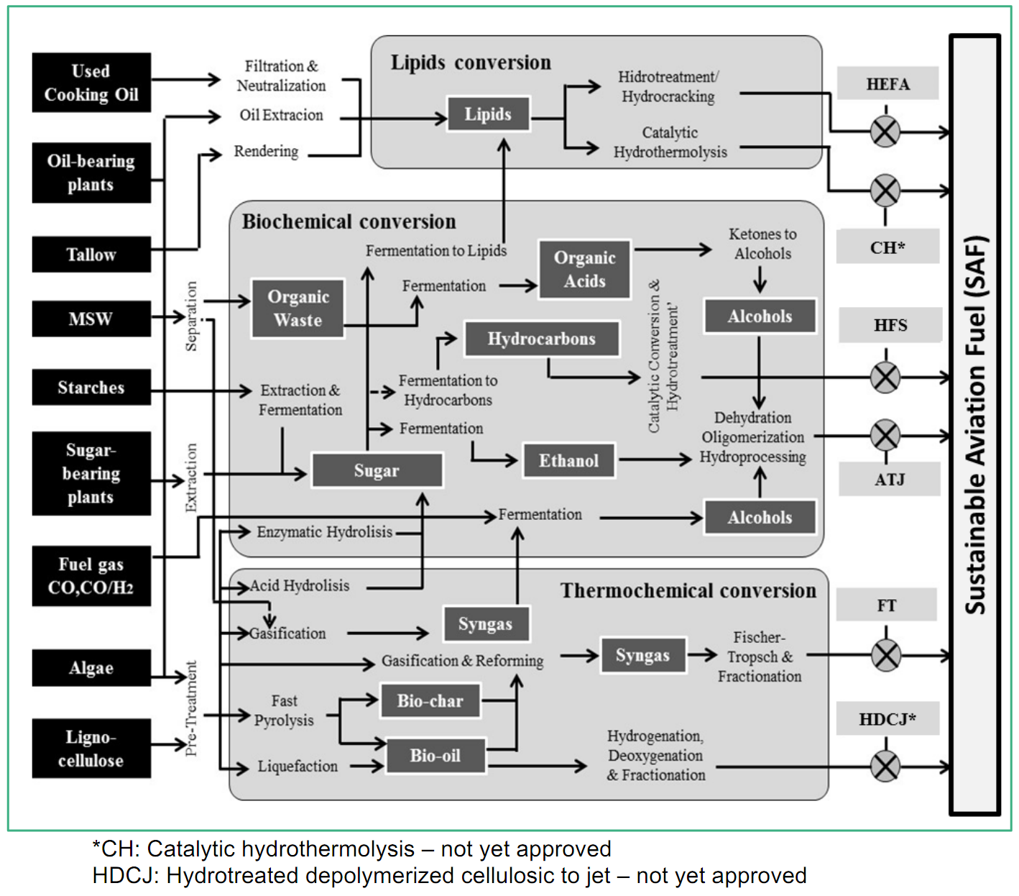

Figure 5: Processing routes for Sustainable Aviation Fuels (SAF). Copied from the *Sustainable Aviation Fuels Guide.*

The *Financing Aviation Emission Reductions* report was also well put together and follows a pedagogic path in its approach to taking the reader from basic project finance concepts to an overview of multi-lateral and bi-lateral financing initiatives.

The main critique of the reports, and the improvement that this Evaluator would propose, would be to provide a stronger emphasis on how to build “the business case” for e.g. renewable energy projects. All of the different elements are touched upon but none of the case studies delve into the economics of the projects and how they were funded. It would be useful to show examples that could discuss (even theoretically) important financial metrics such as pay-back period, internal rate of return (IRR), net present value (NPV), and return on investment (ROI). In addition, including a basic Project Idea Note (PIN) template[1] (or something similar) that is used by several multi-lateral banks would highlight the main items that investors or financing agencies want to analyse. The ProDoc actually provides an example on page 21 of framing the basic business case for a solar panel project at airports. The *Financing Aviation Emission Reductions* and/or the *Renewable Energy for Aviation* reports would have benefited from such a section, or project case study examples, on how to prepare the business case for investors, banks, and other stakeholders.

Regarding Outcome 2.1, the target indicator was not correctly developed in the ProDoc and this was never addressed during the project implementation. It was pointed out to the project team during the Evaluator’s visit to ICAO that the target requires that “Policies and regulations guidelines are *adopted and enforced*…” – however it was clear to all present that adoption and enforcement should never have been the original target as ICAO must respect the sovereignty of its Member States. It can produce recommendations and guidelines but the Secretariat cannot actively lobby for adoption in any country. It is clear to the Evaluator that this target is not applicable and should be changed to the “Development of policy and regulation guidance to stimulate low emission aviation investments in developing States and SIDS.” On this basis the rating for Outcome 2.1 is *Satisfactory* as shown in Table 18.

Overall Component 2 is evaluated as being ***Satisfactory***.

Table 11: PRF Indicators for Outcome 2: Instruments are available to support the development of a legal and regulatory environment that facilitates the financing of feasible low emissions aviation measures in States.

| **Description of Indicator** | **Baseline Level** | **Target level at end of project** | **Status at Project End** | **Rating** |
| --- | --- | --- | --- | --- |
| 1. Level of implementation of low emission aviation policy and regulation in developing States and SIDS. | Low level of policies and regulations in place for the implementation of low emission aviation policy and regulation in developing States and SIDS. | Policies and regulations guidelines are adopted and enforced to stimulate low emission aviation investments in developing States and SIDS. | The target value: **Not Applicable**  This targets for this indicator are poorly selected. ICAO cannot influence any adoption of national policies other than to produce guidance. Likewise, enforcement measures are entirely up to the governments. The target should be changed to “Development of policy and regulation guidance to stimulate low emission aviation investments in developing States and SIDS.” | Satisfactory |
| 2. Level of technical knowledge in developing States and SIDS regarding drop-in biofuels and renewable energy for airport operations. | Limited technical knowledge in developing States and SIDS regarding drop-in biofuels and renewable energy for airport ground operations. | Technical knowledge on drop in biofuels and renewable energy projects in airports increased due to technical guidance developed by the project. | The target value: **Fully Achieved**  The reports provide a good knowledge foundation for the readers and information on how to apply the drop-in biofuels and renewable energy to airport operations. | Satisfactory |
| The Project Outcome 2 is rated as: **Satisfactory** | | | |  |

* 1. Outcome 3: The cost and resources expended by developing States and SIDS to have access to updated technical information on low emission mitigation measures is greatly minimized.

Outcome 3 is described in ambitious terms in the ProDoc and never uses the term website or webpage but rather “technical platform” and “portal”. It is worth repeating the description here:

*The technical platform will bring together all technical information essential to implement emissions reduction measures such as standards, tools, guidance documents, guidelines, information on indicative costs, benefits, training material, in a SharePoint-like portal accessible from anywhere by States. The information will be public domain and will be collected from different sources including: ICAO, national governments, academia, vendors, business associations, etc. The availability of such a platform will also significantly reduce the time spent, costs and other overheads of developing States to collate information, leading to incremental implementation of emissions reduction measures.*

In the last PIR from 2017 the primary description of the platform is that it will be part of the larger ICAO website and that it would be ready by the end of 2017:

*Development of the platform is implemented in close cooperation with Business Technology and Services Section (BTS) of ICAO. The platform will be ready by the end of 2017 to serve as a stage for dissemination of the guidance documents developed within the project, as well as technical materials developed by other environmental aviation organizations to support environmental protection in aviation. The technical platform will also showcase in detail the best practices of the pilot project in Jamaica to encourage its replicability in other SIDs.*

*The advantage of the integrated environmental portal is that it will share a wide-range of information on low emission mitigation measures (e.g. tools, standards, guidance document, guidelines, recommendations) from various sources, including ICAO, national governments, academia, business association and private sector. Brought together on one single technical platform, more complete and comparable information will be easily accessible to relevant aviation stakeholders, including aviation authorities, airports, aviation industry, civil society of Member States, particularly developing States and SIDS.*

It makes perfect sense to integrate the project’s “Technical Support Platform” into the larger ICAO Environmental Protection mission webpages to allow it to compliment the already existing suite of tools that are available on the ICAO website. The advantage of this approach is that there should be a longer-term management of the platform by dedicated ICAO Business Technology and Services Section and Environmental Department staff once the UNDP/GEF project finishes.

However, an initial review of the ICAO website during the TE found some issues and short-comings in the first iteration of the “integrated environmental portal”. These ranged from easy-to -fix issues to such as the KSP being difficult to locate and access to issues regarding the KSP search results. After consultation with ICAO staff it was agreed that an Action Plan for upgrading the KSP would be developed before the TE was finished. This Action Plan is presented in Annex 8.

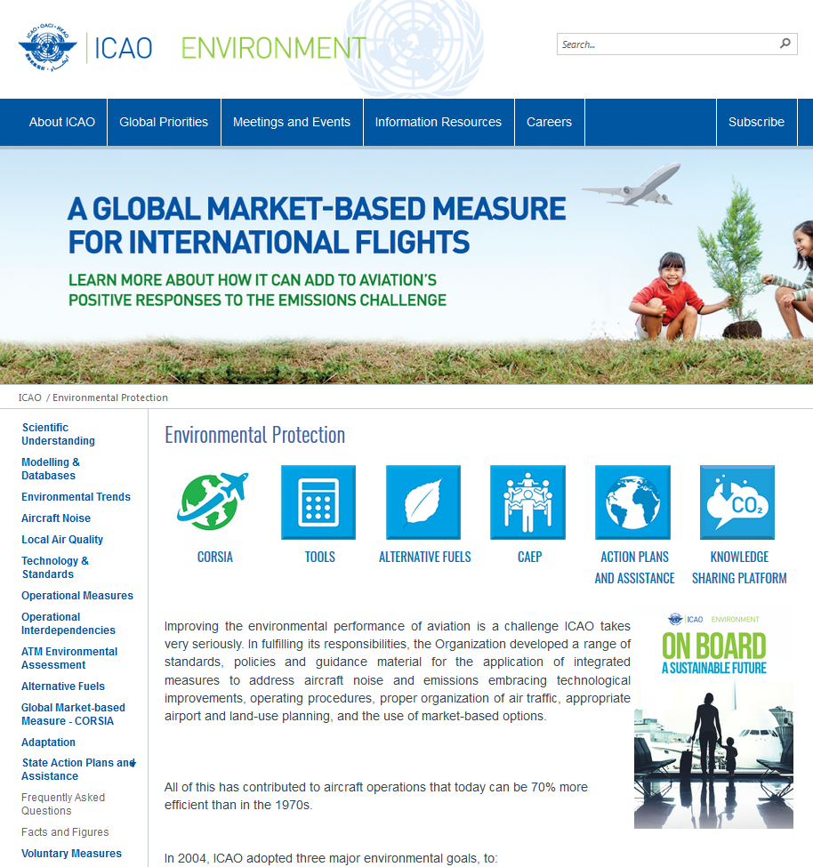

Figure 6: The Main ICAO Environmental Protection website page. Main link to the KSP on the top right and easy to locate.

The KSP is described in detail as shown in Figure 9. Note that the organization is based on seven (7) categories and five (5) formats as described below. As part of the TE the KSP was reviewed by running searches and reviewing the outcomes.

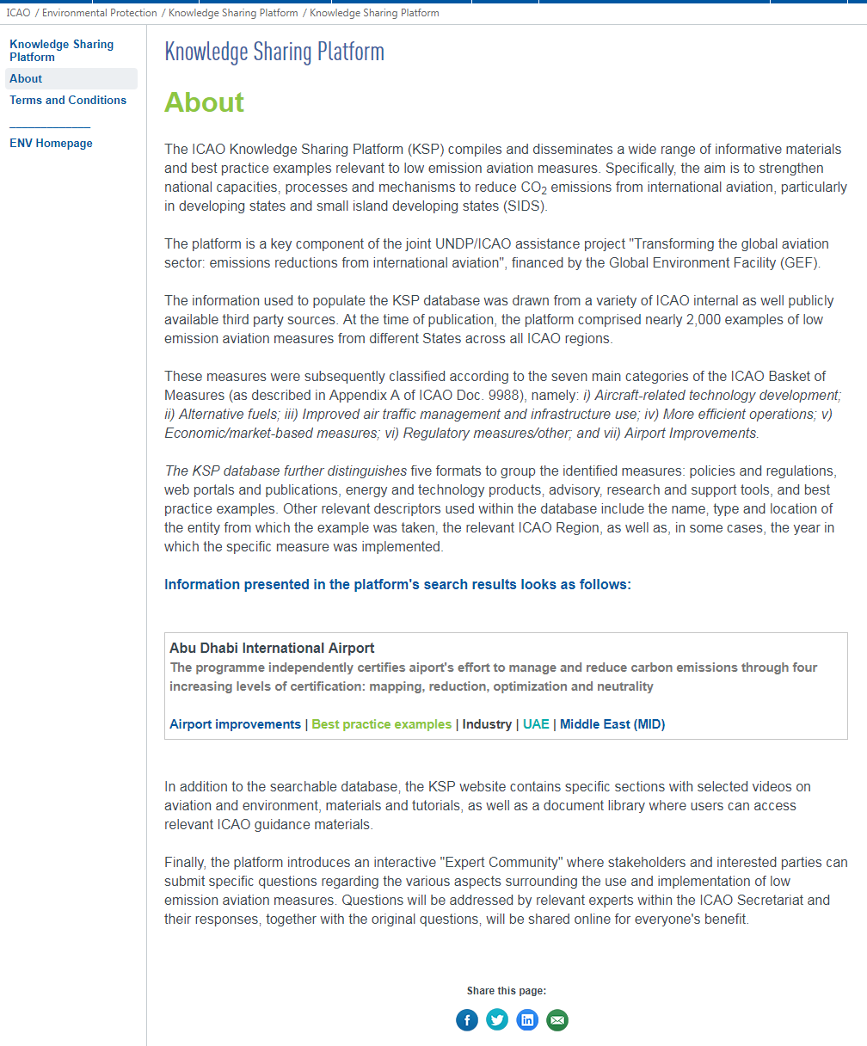

Figure 7: Description of the Knowledge Sharing Platform under “About”.

The system maintains a hyperlink to an external website that is connected to each search result in the database. In the earlier days of the internet it was common practice for most websites to have a “Useful Links” section. The KSP is essentially a database of “Useful Links” cross-catalogued by category/subject, format, year, keyword and region. The platform description cites over “2,000 examples of low emission measures” (i.e. currently 1805 database entries) but upon initial review many of the entries were repetitious in that they provide the user the same hyperlink for many entries, or in some cases the hyper-link was not useful or was incorrect.

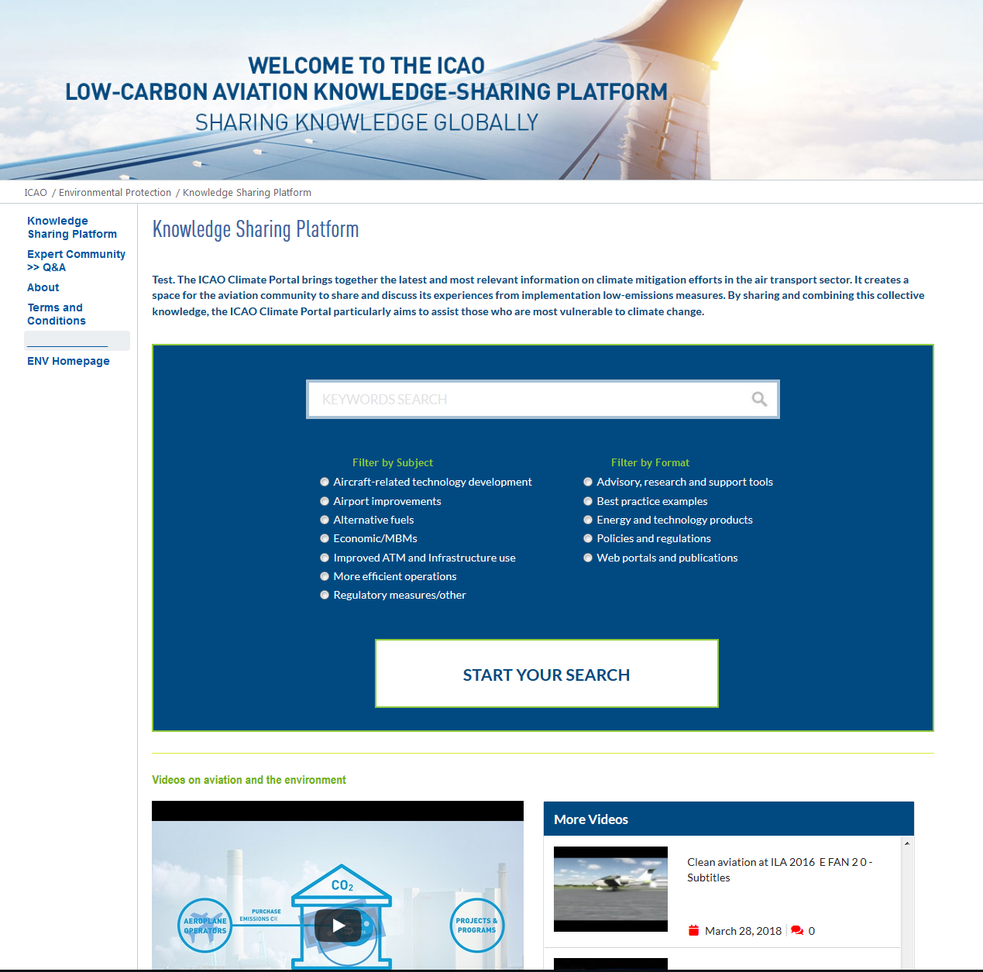

Figure 8: Main page to the Knowledge Sharing Platform.

This was not a good result and prompted the discussion about future maintenance needs of the KSP. Since little content is saved locally in the KSP the success or failure of the KSP information depends on the external links being maintained by other parties (and the Boeing database) and presumably upon a regular updating of the hyperlinks maintained in the KSP database. It should also be noted that this concern about the challenge for ICAO of maintaining the KSP was raised by the UNDP Representative during the PSC meeting in March, 2018.

As part of the Action Plan for improvement ICAO has updated the KSP and implemented an internal process for updates and quality control of the KSP information. In addition the Questions and Answers section is moderated and easier to access. The updated version is an improvement and further development will provide a resource for the target audience, namely air transport managers and administrators in SIDS and LDCs.

There are a total of eight (8) videos collected on the KSP landing page/platform. ICAO plans to add a greater amount of videos in the future and some that more focused on the project results in Jamaica.

ICAO has not provided statistics on the KSP usage at this time as called for in the PRF target indicator 3.3. The “Ask our Expert Community” section is currently not being actively used but this was partially due to some of aforementioned access issues.

Table 12: PRF Indicators for Outcome 3: The cost and resources expended by developing States and SIDS to have access to updated technical information on low emission mitigation measures is greatly minimized.

| **Description of Indicator** | **Baseline Level** | **Target level at end of project** | **Status at Project End** | **Rating** |
| --- | --- | --- | --- | --- |
| 1. Level of technical support provided by ICAO to developing States and SIDS. | Limited technical support targeted to developing States and SIDS provided by baseline programme | Technical support platform established support developing countries and SIDS. | The target value: **Achieved**  The platform is established but was buried in the ICAO website. The KSP is now easily accessible and should be used more in the future. | Moderately Satisfactory |
| 2. Level of technical information for low emissions aviation provided by key stakeholders in the technical platform. | Technical information provided in a dispersed, ad hoc manner by individual stakeholders. | Technical support platform provides information in a coordinated and organized manner , incorporating information from airlines, airport managers, air transport authorities, manufacturers, and other key aviation stakeholders. | The target value: **Partially Achieved**  As discussed, the KSP platform suffered from design weaknesses and its dependency on the hyperlinks in the database being correct, updated, and pointing to meaningful information for the user.  A longer-term plan is now in place by ICAO for the maintenance and updating of the content. There are still limitations regarding whether the community of users should be able to submit new additions/entries and content to the database and KSP platform that they feel would be useful to the community. | Moderately Satisfactory |
| 3. Number of users in developing States and SIDS. | Technical support platform not developed. | Developing States and SIDS use the platform on a regular basis to access relevant technical information, as measured by database usage statistics. | The target value: **Partially Achieved**  It is not evident that the “Technical Support Platform” is being used on a regular basis. ICAO could not provide statistics on usage at this time. | Moderately Unsatisfactory |
| The Project Outcome 3 is rated as: **Moderately Satisfactory** | | | |  |

Component 3 is also focused on capacity building and replication of the pilot project in Component 4, and the project main webpage clearly provides the materials and presentations from the two capacity building seminars on “Low Emissions and Aviation Measures” in Jamaica and Fiji which were organized as part of Component 3 during April and May, 2018. Those workshops were well attended with almost 50 participants from government and other aviation stakeholders at each seminar. The program for both workshops is attached in Annex 6 and the presentations available on the website are interesting and of good quality.

Lastly, there is currently little information in the Project webpage or KSP on the Pilot Solar-to-Gate Project in Jamaica when one chooses that link: Only two short paragraphs and a map of Jamaica. It does not appear to have been updated since the start of the project.

Due to the issues discussed above, Component 3.1 and 3.2 are rated as Moderately Satisfactory. Component 3.3 are rated as Moderately Unsatisfactory. The overall rating for Component 3 is **Moderately Satisfactory**.

* 1. Component 4: The feasibility of implementing low emissions aviation measures is demonstrated through the pilot project and the lessons learnt are made available to facilitate the replication in developing States and SIDS.

The Government of Jamaica supported the project at the ProDoc stage in 2014 as evidenced by the Endorsement letter. When the project started one of the first priorities of the ICAO staff was to re-engage the Jamaican Government and Agencies in the project and the ICAO Project Manager and Environmental Department Head made a mission in late September, 2016 to Kingston and Montego Bay to discuss a solar PV project at one of the airports.

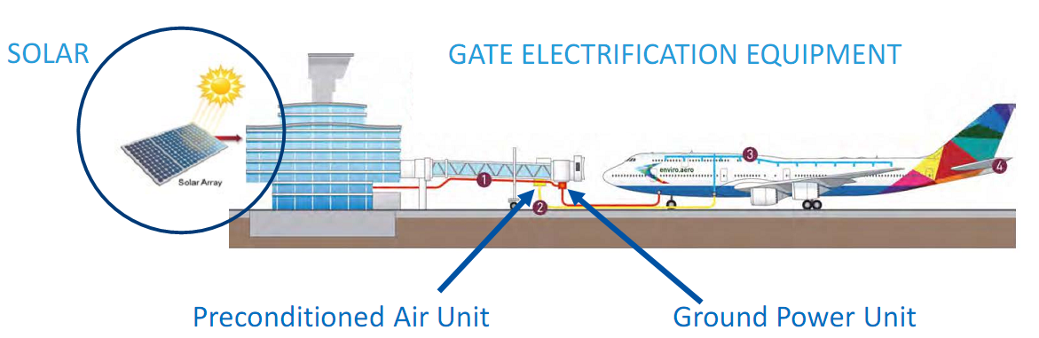

Figure 9: Solar-to-Gate project concept. *Source: ICAO.*

After some analysis and discussions over the following year it was decided that the Norman Manley International Airport (NMIA) in Kingston, which is publicly owned, would be the recipient of the pilot solar-to-gate project. One of the early changes in the project design was the reduction of the size of the solar PV system from 398KW to 100KW to accommodate the new PV location in the parking lot. The original planned location was rejected due to glare concerns once a new air traffic control tower was erected. Another deviation from the original planning and budget relates to the gate electrification equipment. It was assumed in the ProDoc stage that the PCA and GPU would be at the airport gate and that the project budget would only be used for the PV equipment and installation.

Subsequently, in a good example of adaptive management the PMU broadened the scope and ambitions of Component 4 by shifting budget resources and also engaging the private airport in Montego Bay, Sangster International Airport. Due to the smaller than planned PV installation at NMIA the project had enough resources to purchase one set of PCAs and GPUs at both airports to electrify Gate #1 (NMIA) and Gate #(SIA). Gate electrification and air conditioning/air handling is necessary for the aircraft to not run its own APU at the gate or utilize a mobile GPU using diesel, thus potentially lowering CO2 emissions.

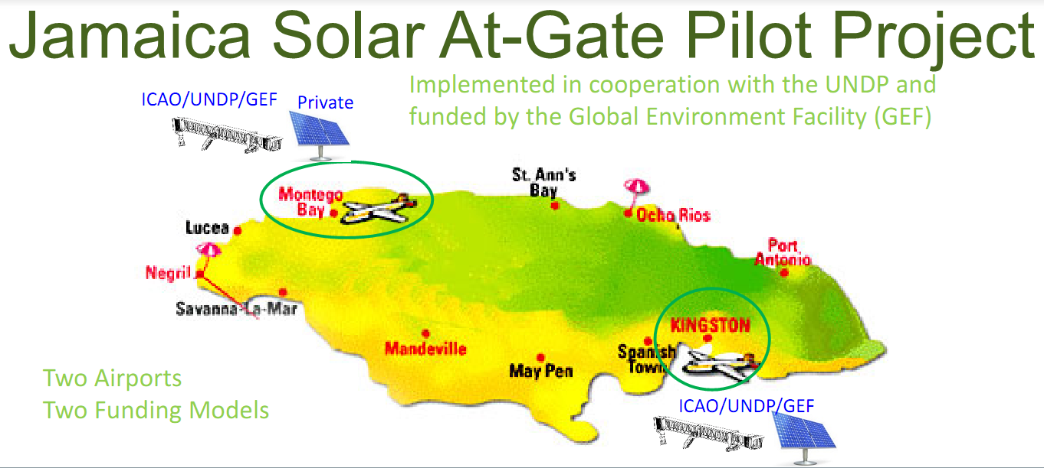

Figure 10: Overview of the two locations and funding components from the project. *Source: ICAO.*

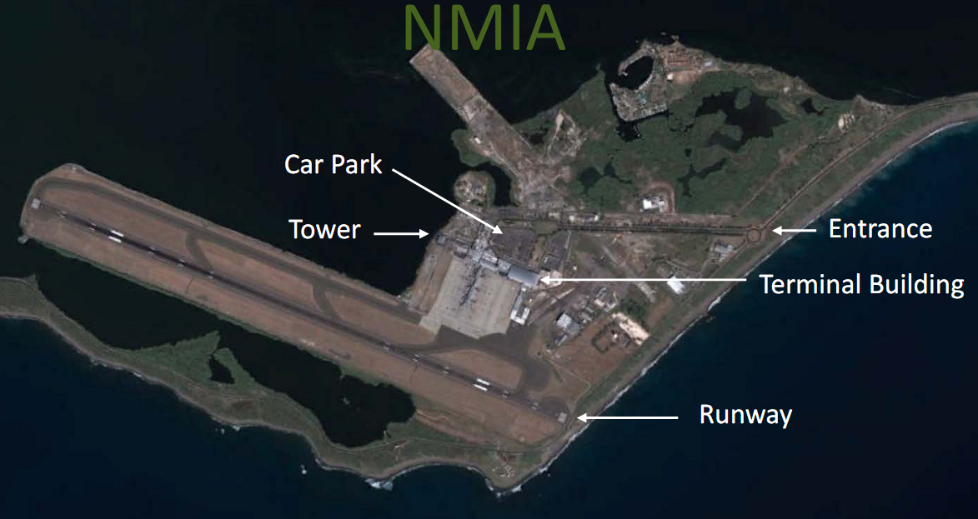

Figure 11: A satellite view of NMIA showing the main facilities. *Source: ICAO.*

Currently there are 9 gates operating at NMIA while SIA has 19 gates and is the larger airport of the two. At the time of the TE the SIA management were still in initial discussions with potential PV solar suppliers and investors and plan to have a tender this year (2018) for the installation of a 1 to 2MW PV system at the airport. Such a system could allow SIA to electrify several gates and/or save on the cost of electricity if it is implemented.

Figure 14 and Figure 16 show the NMIA airport near Kingston and the locations of the solar-to-gate project developed by the project. The Evaluator visited NMIA and met with Ms. Althea Roper of the Jamaican Civil Aviation Authority and Mr. Junior Levene, Energy Management Coordinator at NMIA. The tour of the airport and project sites confirms the operational capability of the pilot solar-to-gate project. However, at the time of the TE the gate was not in use by the airlines because the NMIA management was in the process of negotiating the new tariffs for gates, including Gate 1 with the project PCA and GPU. It was not known at the time if the airlines would pay more or less for using Gate 1 compared to the other gates.

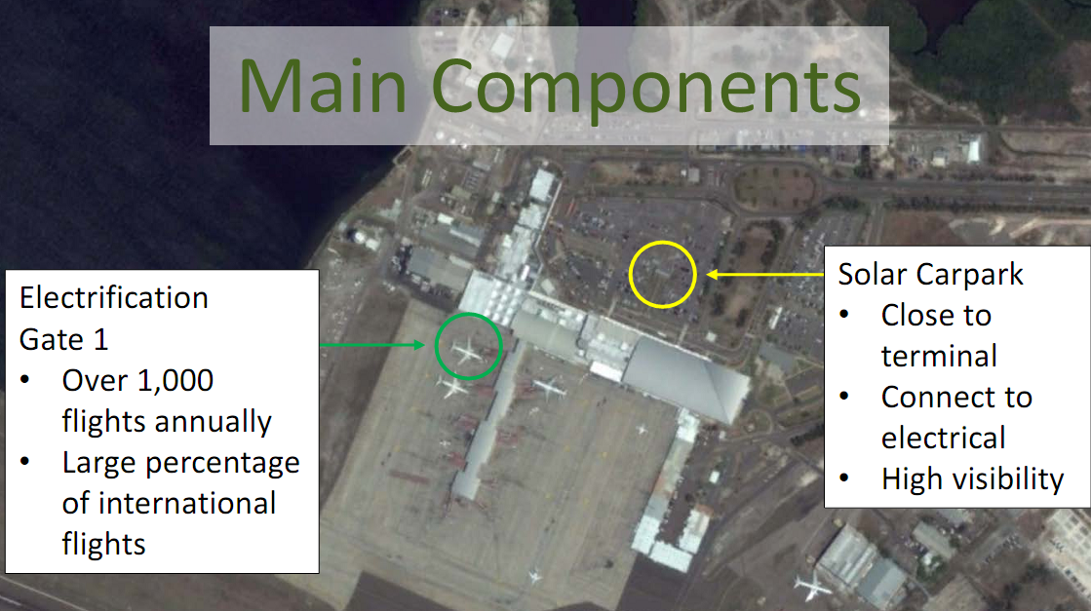

Figure 12: A satellite view of NMIA showing the location of the solar-to-gate components. *Source: ICAO.*

The ICAO PMU developed the Terms of Reference (ToR) for the Solar-to-Gate project and ran a competitive tender in 2016. Eight proposals were received, four met the ToR, and two were short-listed for serious consideration. The winner of the tender was Solera[2] together with its local partner Powergen Ltd. Annex 7 provides an overview of the many steps and parallel tasks that the contractors accomplished during the construction phase of the project.

Solera and Powergen Ltd had to overcome some initial work challenges related to the increased security measures and protocols at an international airport. According to project personnel the security protocols caused delays in the construction but overall the teams were praised for their professionalism and ability to overcome obstacles that arose during the construction of the solar-to-gate project. For example, any changes in construction plans need to be approved by the Airport Safety team first. Mr. Levene was given credit for many times helping to solve local issues at the airport that would have caused longer delays. Overall the project was only a few months behind schedule, in large part due to customs delays, and was commissioned on April 23rd, 2018. Solera should also be given credit for upgrading the solar PV mounts when it was discovered that the original mounts that were purchased did not withstand Category 5 hurricane impacts on other solar PV locations in the Caribbean during 2017’s devastating Hurricane Season.

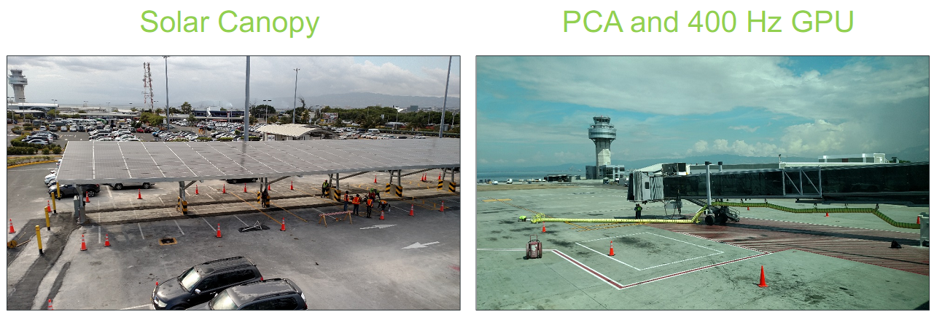

Figure 13: Photos of the 100KW Solar PV array under construction and Gate 1 with the PCA and GPU*.* Note the air traffic control tower behind the solar array in the upper left of the photo. *Source: ICAO*

The Solar-to-Gate system is well designed and constructed. Some design limitations relate to the positioning and angle of the solar canopy. Normally solar arrays are often positioned to face South or oriented along the East-West direction to capture maximum sunlight. Due to glare issues this solar array is oriented along the North-South direction and angled slightly to the East in order to not cause glare on the main air traffic control tower. This placement reduces the daily power output but was a necessary compromise.

The system does not include batteries for energy storage and the electricity from the PV panels is connected to the main terminal power supply, not directly to Gate 1. This a better solution as it allows the continuous use of the solar PV array. According to the staff it generates approximately 425KWh electricity per day which should more than meet the future needs of Gate 1.

The project has also erected signs at the parking lot (Figure 17) so people can read more about the project and realize they are parked under a solar array; not everyone realizes it when they park their car under the “roof”. In the main terminal there is also display in which has more real-time information about the project and local weather conditions (Figure 18).

Even though Gate 1 was not currently accepting flights, the solar PV array was still producing electricity for the airport which would offset electricity consumption from the grid, resulting in CO2 emission savings. In regards to Outcome 4.2, electricity monitoring data at NMIA has been reported by the project from May until mid-September, 2018. Currently 57,771 kwh of electricity has been generated by the solar at gate project. This results in an estimated CO2 savings of 51.44 tCO2 which is lower than the target indicator of 3000 tCO2 by project end. The monthly theoretical production would be around 15,000 kwh of electricity and the reported amount is in that range. In the 2017 PIR it was stated that the project estimated the savings to be 1455 tCO2 by project end. The same PIR states that the NMIA project in Kingston should reduce 1000 tons of CO2 per year. However, this number is too large and appears to be from revised ProDoc estimates. There was not clarity during the TE on how that estimate in the PIR was chosen, as estimates provided by Dr. Dickson during the TE for the annual CO2 savings from NMIA are more accurate at 176 tCO2 per year.

The CO2 estimates from this project also leads to interesting methodological discussion for this and future solar-to-gate projects on how to account for and monetize CO2 reductions. At NMIA the flights for the project’s electrified gate will be international. The approved UN CDM methodology AMS-IM: *“Small-scale Methodology: Solar power for domestic aircraft at-gate operations”* is very specific that it is only applicable to domestic flights, *not international flights.* Therefore, future solar-to-gate projects at airports which handle international air traffic will need guidance on how to properly account for the domestic and international flights in order to avoid double-counting if any solar-to-gate electrified gates service both types of flights.

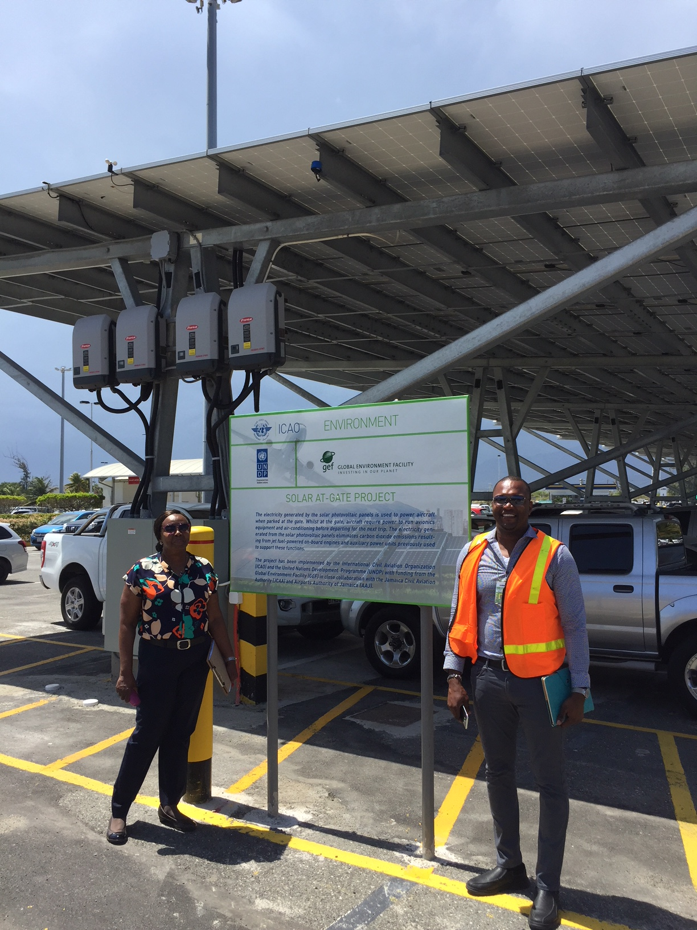

Figure 14: Ms. Althea Roper and Mr. Junior Levene next to 100KW Solar PV array the public parking lot. Note the sign clearly alerting the public of the solar-at-gate project.

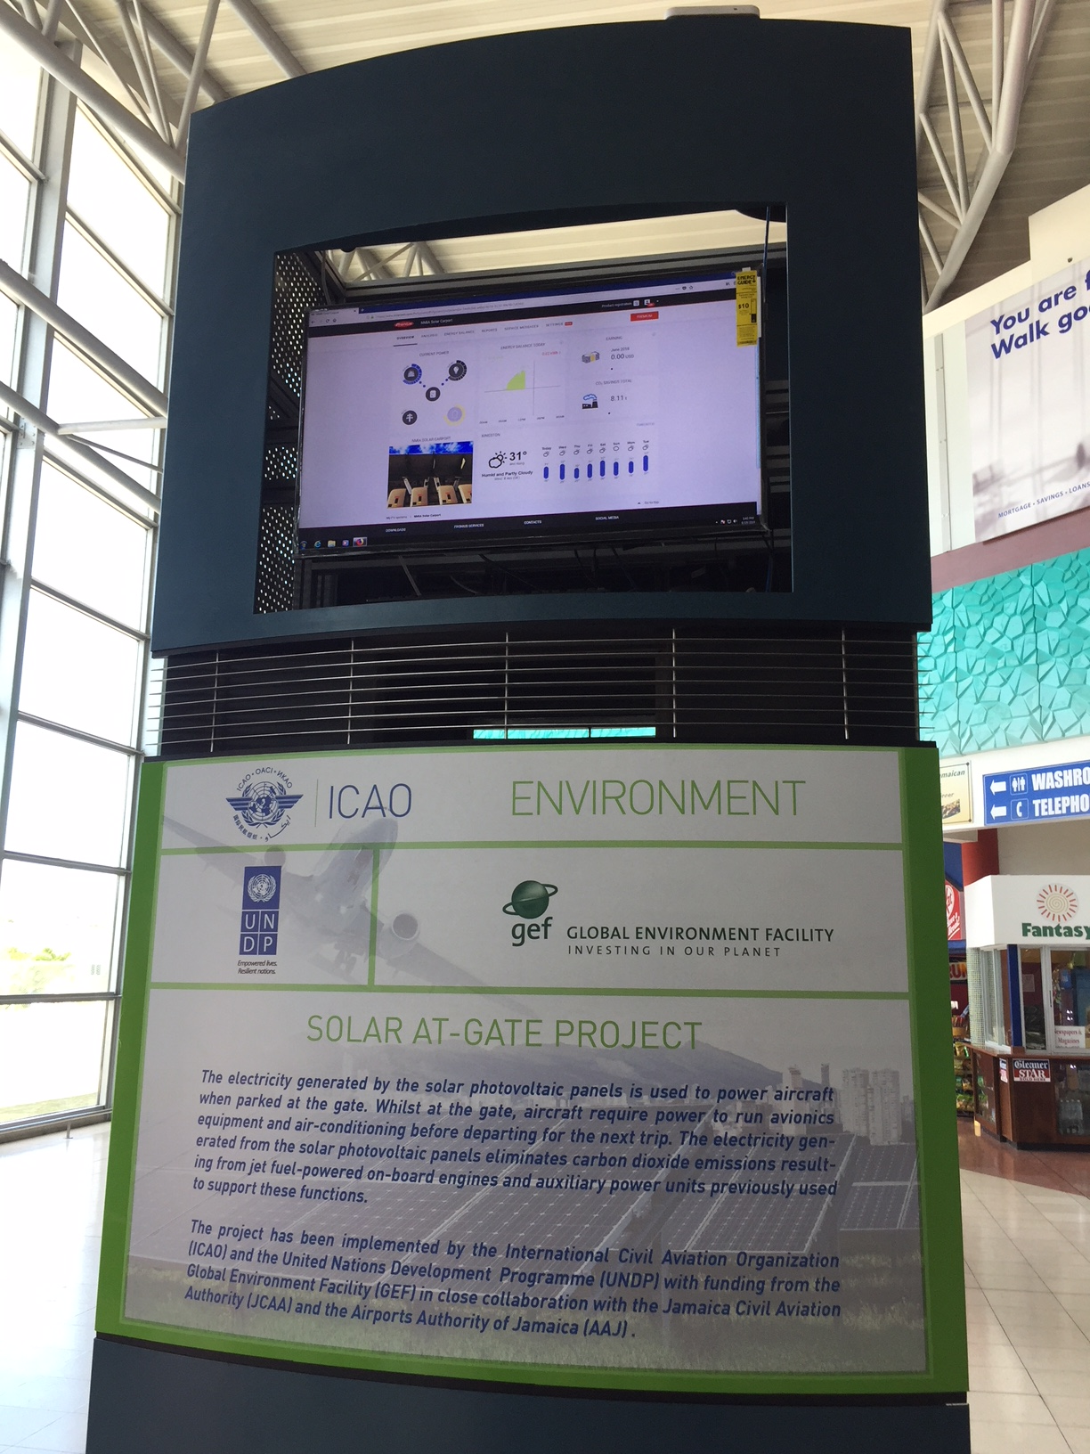

Figure 15: Inside the NMIA main terminal is this display which also shows the PV solar array’s electricity production.

Most of the awareness raising activities related to Outcome 4.3 were discussed in more detail in the previous section, however, it should be noted that the project team had additional training for airport staff in Jamaica as part of the pilot project. Table 20 shows the PRF indicators for Outcome 4 along with the status at project end.

Table 13: PRF Indicators for Outcome 4: The feasibility of implementing low emissions aviation measures is demonstrated through the pilot project and the lessons learnt are made available to facilitate the replication in developing States and SIDS.

| **Description of Indicator** | **Baseline Level** | **Target level at end of project** | **Status at Project End** |  |
| --- | --- | --- | --- | --- |
| 1. Level of experience of aviation sector in implementation of low emissions projects aviation in SIDS | No low emission international aviation project in a SIDS. | Low emission pilot project is fully implemented and operational in a SIDS. | The target value: **Fully Achieved**  1 Solar-to-Gate Project has been fully implemented at NMIA, and the project has been a catalyst for the development of a larger Solar-to-Gate project at SIA in Montego Bay. | Highly Satisfactory |
| 2. Direct emission reductions resulting from demonstration project. | No pilot project in place | At least 3,000 tons of CO2 reduced by the demonstration project at end of GEF project (leading to 17,500 tons of CO2 over investment lifetime) | The target value:  **Under-achieved**  The project is commissioned but Gate 1 has not been receiving aircraft as the new fee structure is under negotiation with the airlines. From May 2018 (start of operation) to September 18, 2018, 57,771 kwh of electricity has been produced by the solar panels, resulting in an estimated CO2 savings of 51.44 tCO2. | Moderately Satisfactory |
| 3. Level of awareness of low emission aviation project feasibility in developing States and SIDS. | Limited knowledge on the feasibility of low emissions aviation projects in developing States and SIDS context. | Increased confidence/ knowledge in feasibility of low emissions aviation projects in developing States and SIDS as a result of dissemination of pilot project results. | The target value: **Achieved**  The PMU has done a good job of advertising the solar-to-gate project concepts and results through various mediums and forums and will continue to do so in partnership with other ICAO activities such as the EU funded “Capacity Building for CO2 Mitigation from International Aviation”. However as mentioned previously the pilot project information on the Knowledge Platform/project website needs to be updated. | Satisfactory |
| The Project Outcome 4 is rated as **Satisfactory** | | | |  |

Outcome 4.1 is deservedly rated as *Highly Satisfactory*. Outcome 4.2 suffered from some delays and thus is rated as *Moderately Satisfactory*. The awareness raising activities linked to the Outcome 4.3 are deemed to be in line with what was planned for the project and the result is rated as *Satisfactory*. The overall rating for Outcome 4 is ***Satisfactory***.

* 1. Project Objective

The Project Objective is the penultimate target of the GEF project: To support capacity building in developing States for implementing technical and operational measures for reducing CO2 emissions from international aviation; as measured by the project indicators. Table 1Table 21 lists the three indicators for the Project Objective that the Project should have monitored and reported during its lifetime. The Evaluator has listed the PRF target values and the reported values achieved by the project.

Table 14: PRF Indicators for the Project Objective: To support capacity building in developing States for implementing technical and operational measures for reducing CO2 emissions from international aviation.

| **Description of Indicator** | **Baseline Level** | **Target level at end of project** | **Status at Project End & Comments** | **Rating** |
| --- | --- | --- | --- | --- |
| 1. Level of capacity of developing States and SIDS for implementing measures that reduce emissions from international aviation. | Few SIDS’ national experts have information and access to tools to enable them to take decisions on implementation of actions to reduce CO2 emissions from international aviation. | At least 70% of SIDS with international aviation activity have been informed and provided access to outputs developed in the context of this project. | The target has been **Achieved** through two information workshops organized by the project in 2018 in Jamaica and Fiji as well as the additional ICAO meetings:   * the ICAO “Green Airport Seminar” on 29 and 30 November 2017; * the ICAO Regional Seminars on States’ Action Plans and CORSIA from March 21 – April 18, 2018; * the meeting of the ICAO North American, Central American and Caribbean (NACC) Directors of Civil Aviation on September 19-21, 2017; and * the meeting of ICAO Asia and Pacific (APAC) Directors of Civil Aviation on August 7-11, 2017. | Satisfactory |
| 2. Demonstration of low emissions international aviation measures in the context of developing States and SIDS. | Very few emission reduction projects in developing States/SIDS are directly related to reducing emissions from international aviation. | One pilot project is in place by the end of the project, and serves as a model for replication. | The target value is **Over Achieved**  ICAO selected two airports in Jamaica - Norman Manley International Airport (NMIA) in Kingston and Donald Sangster International Airport (SIA) in Montego Bay – to serve as pilot project sites for demonstrating “Solar-to-Gate” technology in order to reduce international aviation emissions reductions.  Currently the NMIA project has completed commissioning and the SIA project is awaiting the final component, which is the solar panel financing and installation. | Highly Satisfactory |
| 3. Amount of CO2 emissions reduction facilitated by the investments of the Project from the four components. | Baseline emission reduction trends in international aviation as projected by ICAO , with limited participation of developing countries and SIDS. Numerical value to be defined in first year of project implementation. | Direct: 17,500 tons of CO2 over the 25 year timeline of the pilot investments made during the project implementation.  Indirect: Additional 1,000,000 tons of CO2 reduced in developing countries and SIDS over 20 years | The achieved values are **Partially Achieved**  The Direct Emission Reductions are lower than initially planned for the Kingston (NMIA) project because the solar panel capacity is 100KW instead of the 398KW stated in the ProDoc. However, the Direct Emission Reductions could also include the partially implemented solar-to-gate project at Montego Bay (SIA) which is planned to have an installed solar capacity of 1 to 2MW, depending on the availability of space. Currently the project can verify of 51.44 tCO2.  If both projects are fully implemented then the Direct Emissions Reductions will be overachieved. Currently the Kingston (NMIA) pilot project is estimated to reduce approx. 4,400 t CO2 during its lifetime.  The evidence for Indirect Emissions reductions is currently only circumstantial evidence related to the submission of State Action Plans. Likewise, the ProDoc assumptions and ER target is speculative and the project did not collect or utilize any statistics to validate the assumptions. These issues are discussed in more detail below. | Moderately Satisfactory |
| The Project Objective is rated as **Satisfactory** | | | |  |

The Project exceeded the key Objective targets in relation to capacity building and the implementation of pilot solar-to-gate demonstration projects. In particular, the project managed to catalyze the development of two solar-to-gate projects in Jamaica, going beyond its original mandate and deservedly should receive a *Highly Satisfactory* rating for Objective Indicator 2.

Despite these successes the project had some difficulties in justifying its key objectives of CO2 emission reductions at the time of the TE. In regards to the Direct Emission Reductions the issue relates to the key ProDoc assumption that the project would not have to fund the gate electrification equipment, and would therefore have a larger budget for the solar PV panels at the NMIA. This turned out to be an invalid assumption and the gate electrification equipment was also financed by the project at both NMIA and SIA. Due to budget and space restrictions at NMIA (the airport is located on a thin peninsula) the solar PV capacity was reduced to 100KW installed, which was about a quarter of the planned capacity in the ProDoc (398KW). Consequently, the Direct Emission Reductions that are estimated to occur from NMIA over its lifetime of 25 years are reduced from 17,500 tons of CO2 to 4,400 tons of CO2, which is significantly below the target value. Currently the project has reduced of 51.44 tCO2 through September 18, 2018.

On the other hand, the project also partially financed another solar-to-gate project at SIA in Montego Bay as there was some financing left over from the NMIA project. The SIA project has not constructed the solar PV panels yet as they are in the process of accepting proposals from potential turn-key suppliers who will also provide the financing solution for the solar PV arrays. The ambition is to have a much larger PV installation at SIA somewhere in the range of 1MW to 2MW. This would more than make up for the shortfall in ERs from the NMIA project, and it is highly likely that the solar PV installation will move ahead as the electricity price in Jamaica is more than high enough (above USD 0.25/KWh) to support the investment. Based on discussions with the SIA stakeholders, this Evaluator is of the opinion that the project will move forward and install the solar PV system in due time. Therefore, the project could receive a satisfactory rating for the Direct Emissions as opposed to a lower rating if only the ERs from NMIA are used.

In regards to the Indirect Emission Reductions, the methodologies used in the ProDoc are considered to be reasonable though the choice of the target of 1 million tons of CO2 reduced is an arbitrary round number derived from the potential consequences of implementing the project Components 1 through 4. The problem is that ProDoc specifically calls for the monitoring of certain indicators. The author even highlights the risk of “the GHG emissions reductions delivered being difficult to verify” in the risk matrix on page 29 of the ProDoc:

*The focus of this project is to assist ICAO Member States to reduce emissions from international aviation. Given the global scope, the verification of results is a key parameter not only of the demonstration component (Component 4) but of the whole project.*

*To verify emissions reductions from the demonstration component, an appropriate methodology will be used including continuous monitoring of electricity production from the PV panels.*

*For the other project components, information will be collected from States’ action plans and will be reviewed against relevant information from industry associations.*

*Throughout the duration of the project, ICAO will draw on technical knowledge and expertise to implement a robust monitoring and verification system, in collaboration with national and international experts.*

The source of verification is stated to be the project monitoring reports, but beyond the PIR such reports were not developed by the PMU. The ProDoc itself gives very little guidance on what data to collect to estimate the Indirect Emissions except for the above comparison of State Action Plans and “relevant information” from industry associations.

The end result is that the only basis for justifying the Indirect Emissions is the statistic that 20 out of the 107 ICAO Member States have indicated plans in their voluntary Action Plans to implement solar energy projects at airports in the future (approximately 19% of the submitted State Action Plans). This is a laudable number but it is very unclear as to how much installed PV capacity this could result in, and it says nothing about the other actions that could be attributed to low-emission aviation measures (Components 1 through 3). In that regard the PMU can only offer the same analysis that is done in the ProDoc without justifying the analysis with any new data derived from, e.g. a stakeholder survey or industry statistics developed during the project. This is a lost opportunity and makes the Indirect Emissions estimation impractical to verify. The indirect ER numbers proposed by the project are not unreasonable, but the causal link needs to be better supported. For example, some low-emission aviation measures could just as easily happen due to macro-economic factors such as higher aviation fuel prices and have little to do with the project efforts.

This is not the first, nor the last, GEF project to have difficulties justifying the Indirect Emission reductions. In the Evaluator’s experience the GEF project approval process provides a perverse incentive to over-estimate the indirect emission reductions while often providing insufficient monitoring guidance in the ProDoc. The ProDoc should have given better guidance regarding which indicators to monitor during the project implementation for the indirect emissions: They do not meet the guidelines for SMART[3] indicators. Nevertheless, one of the lessons learned is that better guidance regarding M&R activities should have been given by UNDP staff to the ICAO staff, who had never managed a GEF project before. This oversight could have been caused by the UNDP RTA leaving the project at an early stage without a replacement, as the technical advisor role was then internalized in ICAO. Another factor was the lack of any kind of mid-term review, as it would have caught this monitoring issue and prescribed corrective actions.

In conclusion, due to the aforementioned monitoring issues, Objective 3 should be rated as *Moderately Satisfactory.* Some CO2 reduction results were achieved, but they are difficult to quantify and verify at this time.

Overall, the project Objective meets the criteria to be rated as **Satisfactory** in the opinion of this Evaluator.

* 1. Project Relevance

Project Relevance is defined by the GEF as “The extent to which the objectives of a development intervention are consistent with beneficiaries’ requirements, country needs, global priorities and partners’ and donors’ policies.”. This project is ***Very Relevant*** to the future needs of SIDs in particular as well as developing States. It is also very relevant to the ongoing work at the international level in ICAO in regards to CORSIA and the introduction of SAFs and other measures to reduce GHG emissions in the aviation sector.

* 1. Effectiveness and Efficiency

UNDP TE Guidelines define effectiveness as the “extent to which the development intervention’s objectives were achieved, or are expected to be achieved.” The GEF TE Guidelines define efficiency as “the extent to which the project’s actual outcomes commensurate with the expected outcomes”. The UNDP guidelines also alludes to ranking the outcomes and objectives according to importance, but provides no guidance or methodology for a weighting of the importance of the outcomes. Therefore, this TE is applying the definitions above to mean that *Effectiveness relates to how many and what kind of the targets in the PRF did the project achieve at project end?*

|  |  |  |  |  |  |  |
| --- | --- | --- | --- | --- | --- | --- |
|  | HS | S MS | MS MU | U HU | |  |
| **PRF Indicator** | **Over-Achieved** | **Achieved** | **Partially Achieved** | **Not Achieved** | **Unknown** | **Total Targets** |
| ***Objective 1*** | 1 | 1 | 1 |  |  | **3** |
| ***Outcome 1*** | 1 | 1 |  |  |  | **2** |
| ***Outcome 2*** |  | 2 | 1 |  |  | **3** |
| ***Outcome 3*** |  | 1 | 2 |  |  | **3** |
| ***Outcome 4*** | 1 | 1 | 1 |  |  | **3** |
| **Total** | **3** | **6** | **5** | **0** | **0** | **14** |

Table 15: List of Project Achievements in relation to Project Results Framework Targets at Project Ending. The colored bars show the general relation between the achievement and rating of the indicator.[4]

Effectiveness in the UNDP/GEF context also relates to risk management. In regards to risk management, the project did not carry out a formal risk management procedure though risks to implementation were discussed by the project team during the Annual Review process. By not using a systematic approach to risk management and incorporating it into the overall project monitoring and reporting, some issues that might have been caught earlier were not. However, the project risk matrix in the ProDoc is marginally adequate as it primarily focuses on macro issues that the project has little control over with the exception of the GHG emission reductions and support from the Jamaican Government. If systematic project risk management is the real goal then better tools needed to be developed at the start of the project and followed-up in a more regular manner than once a year. Given the high level of successful implementation by the project it can be argued that most of the project risks were managed by the project team due to professional effort when a potential problem or risk was identified. One example was the shifting of resources once it was found that the gates at NMIA were not electrified (something that was not picked up in the original risk matrix).

The project achieved 9 of its 14 targets while 5 were partially achieved. Almost 65% of the targets were fully achieved by project end which is a moderately successful result and therefore the project’s effectiveness is rated as ***Moderately Satisfactory***.

In regards to efficiency, the questions relate to

* Was the project implemented efficiently, in-line with international and national norms and standards?
* Was the project support provided in an efficient way?
* How efficient are the partnerships and arrangements for the project?
* Did the project efficiently utilize local capacity in implementation?
* What is the abatement cost for the long-term GHG reductions?

It can be said that this project has a global scope compared to the traditional UNDP project which is typically managed by a country office and is state-wide or regional in scale. In this regard ICAO was an ideal implementation partner and had the capacity to efficiently implement the project activities on a global scale, including the network of offices and contacts in the SIDS and developing States.

The PMU had a very active partnership with the Jamaican Civil Aviation Authority (JCAA), the Jamaican Ministry of Transport and Mining, and the administrations at NMIA and SIA. In regards to the pilot project in Jamaica and the 2 regional workshops, the PMU engaged locals at all levels during their implementation.

The efficiency of the project is rated as **Satisfactory**.

* 1. Sustainability

As highlighted in the ProDoc, the project’s sustainability relies in the successful implementation of all four project Outcomes:

1. *The project aims to assist States to contribute to the sustainable development of international aviation. It promotes the strengthening of national capacities through the provision of appropriate material and guidance to developing States and SIDS in order to facilitate the implementation of cost effective mitigation measures that can generate a positive cash flow during their lifecycle.*
2. *The Outcomes of Components 1 to 3 promote a better understanding among developing States and SIDS of the feasibility of these measures, as well as their environmental and financial benefits. They also enhance awareness among States on the various financing mechanisms that are available to implement these measures, without the need for additional grant support.*
3. *Furthermore, the lessons learnt from the implementation of the pilot project (Component 4, including installation of PV panels at an airport), along with the associated guidelines and policy recommendations, have the potential to become a model for many developing States and SIDS*.

The importance of establishing the economic incentives for future measures and the financing mechanisms for them is the main message for the future sustainability of these mitigation measures in the aviation sector. The main carriers of sustainability for the project can be summarized as:

* + *Educational* (Outcomes 1 – 3) – The establishment of the Knowledge Base and online tools such as the Marginal Abatement Cost Curve model, as well as the guidance documents.
  + *Legislative (Outcomes 2 & 3)* – the project introduced legislative case studies and examples of legislative measures in the Knowledge Base.
  + *Demonstration Projects (Outcome 4)* – The pilot solar-to-gate projects in Jamaica.

The educational and capacity building elements of this project varied in quality from the development of the unique MAC Curve Tool (Outcome 1) and the solid Guidance Reports (Component 2), to the marginally implemented Knowledge Base (Outcome 3). The pilot projects in Outcome 4 were particularly well done along with the 2 capacity building workshops for SIDS. However, for the vast majority of the stakeholders working in the aviation sector in SIDS and developing States, the first and most important tool for them after the project finishes would be to access and utilize the Knowledge Base (Outcome 3). Few of them may have the opportunity to tour Jamaica and see the pilot projects at NMIA and SIA, but all of them will have internet access and can learn about these projects and other ways to implement sustainable actions in the aviation sector via a properly developed and maintained ICAO Knowledge Base. A living Knowledge Base of environmental actions for the aviation sector, with an active “community of practice”, could be the real long-term legacy of this project. This knowledge base should highlight the lessons learned from the pilot projects as well as capture *new lessons learned* from new initiatives.

Unfortunately, Component 3 has some implementation issues as reported in the previous section and until these are resolved the long-term Sustainability of the project results are rated as *Moderately Likely (ML)*.

* 1. Financial risks to sustainability

The main financial risks relate to Outcomes 3 and 4. There is the risk that appropriate financing for the SIA solar PV installation will not be found and that the project only supports an electrified bridge system at SIA. Another long-term risk is in relation to resources within ICAO dedicated to maintaining the Knowledge Base once the project ends. Generally speaking these risks are viewed as being low to moderate.

* 1. Socio-economic risks to sustainability

The socio-economic risks to sustainability relate to macro-economic issues in the aviation and renewable energy sector. Currently there is little public opposition within the aviation sector against moving toward a more fuel efficient and sustainable path to reduce GHG emissions. ICAO, its member states and aviation stakeholders have developed a basket of measures to reduce emissions including technology and standards, sustainable alternative fuels, operational improvements and CORSIA. Aviation fuel prices are also increasing with the higher price of oil (around $70 a barrel) which gives more incentives to reduce consumption while also making SAFs more price competitive. In regards to SIDS in particular, electricity prices are typically much higher than in other countries as all the fuel needs to be imported, while prices for solar PV is continually declining due to strong competition. Today there are only regulatory, policy, and finance barriers to greater use of solar PV in SIDS and at SIDS airports where a huge fixed cost is energy. The general economics of solar PV make total sense if one can arrange the financing, and if policy makers support the opening up of often monopolistic energy markets in SIDS. Therefore socio-economic risks to the project long-term goals are low and the socio-economic sustainability is *Likely*.

* 1. Institutional framework and governance risks to sustainability

The major institutional and governance frameworks at the international level are already in place: The UN Paris Agreement, CORSIA, ICAO Resolutions A39-2: *Consolidated statement of continuing ICAO policies and practices related to environmental protection – Climate change* that established global aspirational climate goals for the sector*, and* A39-3*: Consolidated statement of continuing ICAO policies and practices related to environmental protection – Global Market-based Measure (MBM) scheme that establishes the basis for CORSIA.* . CORSIA will start its pilot phase from 2021 through 2023 for States that have volunteered to participate in the scheme and the first phase will apply from 2024 through 2026.

As these agreements primarily rely on voluntary commitments by the member states, on an individual state level there are always risks that a new government might change direction away from taking action against climate change. However, in the target groups: SIDS and developing States, the impacts of climate change are already being felt and long-term many of these countries are the most vulnerable to climate change. It is unlikely that they will ignore these global frameworks and rather more likely that they will continue to implement measures at the national level in line with these initiatives. Therefore, the long-term institutional and governance sustainability is *Likely*.

* 1. Environmental risks to sustainability

No local environmental risks have been identified during the project implementation or TE that would affect the project long-term sustainability. The only possible risks relate to catastrophic events such as hurricanes and the related flooding. The solar PV system at NMIA has been designed to withstand a Category 5 hurricane event. The environmental sustainability of the project is *Likely*.

* 1. Catalytic Role and Impact

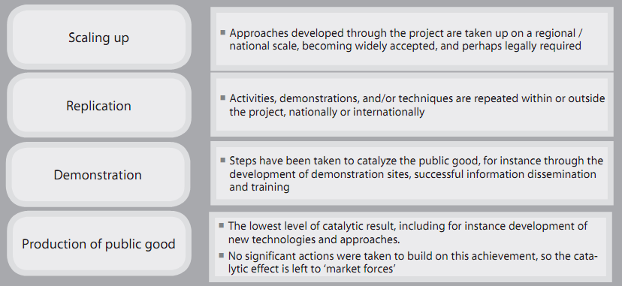

Figure 16: Explanation of the different catalytic roles to be evaluated. *Source: UNDP/GEF TE Guidelines.*

Figure 16 explains the different types of catalytic role the project is evaluated against. The primary catalytic role of this project is through the demonstration projects in Jamaica and a capturing of the lessons learned from these projects for dissemination to a wider audience in the SIDs and developing States. The project also supported parallel activities (and vice versa) within the EU sponsored project “Capacity Building for CO2 Mitigation from International Aviation” which also plans to implement two solar-to-gate projects in Cameroon and Kenya; and has produced feasibility case studies for SAFs in the Dominican Republic and Trinidad and Tobago, including requests for funding. The synergies between these two projects are high by design and even the same consultant who developed the reports in Outcome 2 is working with the ICAO-EU project. With the exception of the ICAO-EU funded projects, it is not known if there are any more planned solar-to-gate projects in the SIDS or developing States, but a foundation for knowledge transfer and replication was laid by the project and the online knowledge base of reports and the TSP. The business case for solar projects in SIDS is typically strong due to the high electricity prices and the low cost of solar per installed KWh. However, sometimes other institutional or market barriers need to be overcome, and one of the goals of this project was provide knowledge on how to overcome such barriers. It is now up to people in the member states to use this knowledge and apply it for future legislation and projects.

Future environmental initiatives after the project, whether public or private, should be able to obtain valuable information about solar-to-gate opportunities along with other CO2 mitigation measures which should assist them in developing the feasibility study and value case for potential projects in the aviation sector. The project ratings for Catalytic Role are given in Table 16 and are satisfactory for the four indicators. The project carried out specific training and certification for the workers at NMIA as well as the two well attended workshops in Jamaica and Fiji as discussed for Outcome 3.

Table 16: Rankings of the Catalytic Role of the Project

|  |  |  |
| --- | --- | --- |
| **Catalytic Role:** Significant (S), Minimal (M), Negligible (N) | | |
| Knowledge Transfer | (rate 3 pt. scale) | S |
| Expansion of Demonstration Projects | (rate 3 pt. scale) | S |
| Capacity Building and Training | (rate 3 pt. scale) | S |
| Scaling Up | (rate 3 pt. scale) | S |

In regards to the environmental impact of the project, with the exception of the renewable energy component, it is difficult to establish itat this time. The clean energy component is small (currently 100KWel installed capacity) and overall one can infer that the project will have a positive qualitative impact but quantification is impossible without a long-term study of the replication impact and additional renewable energy capacity that is commissioned.

While not a stated priority of the project, gender equality is a key policy being pursued by all the organizations involved in the project, and the gender impact of the project was significant as women played key roles throughout the project. The Director, Environment in ICAO is female as well as the ICAO-UNDP-GEF Project Manager and many of the staff participating in the project. As shown in Table 4, 10 out of the 15 key staff and stakeholders involved in the project are women. The project also had to follow ICAO policies for gender equality.[5]

During the project outreach and seminars in Fiji and Jamaica, an effort was made by the project to have a strong gender balance in a sector that is typically overly represented by men:

* Jamaica: 25 Male and 22 Female participants (including interpreters and ICAO staff)
* Fiji: 33 Male and 17 Female participants (including ICAO staff and Media)

Overall, it can be stated that the gender equality and empowerment of women is seen as being very strong for this project.

With the introduction of 17 Sustainable Development Goals (SDG) by the UN it is now interesting to see which SDG indicators this project impacts. While an analysis was not done by the PMU, in this evaluator’s opinion the project directly or indirectly impacts 11 of the 17 SDGs:

   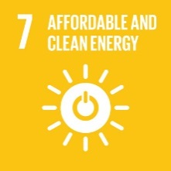  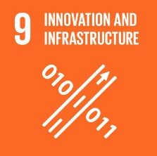

 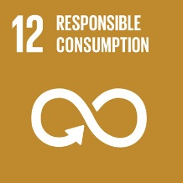   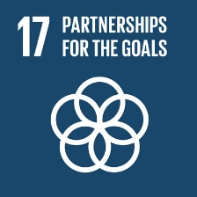

1. Conclusions, Recommendations and Lessons Learned
   1. Conclusions and Evaluation Ratings Summary

The summary of ratings for the Project and its components is listed in Table A and Table 22. The project team produced some excellent results and the PMU at ICAO should be commended for accomplishing so much in such a short time. The Evaluator does not have statistics available but anecdotal evidence suggests that few GEF projects accomplish as much without more time or extensions. The major deliverables for Outcomes 1, 2, and 4 were produced in a timely and highly professional manner. This success is a reflection of the professional and motivated team at ICAO but also the highly competent consultants and contractors that were hired and managed by them. The team produced very well thought out ToRs for the sub-contractors which paid dividends when the draft deliverables needed improvements or the pilot project construction ran into any issues.

There are many positive lessons learned from this project and these will be discussed in more detail in the next section. As is the case with these evaluations, negative issues or non-conformities require more discussion, but it should be kept in mind that the overall performance of this project is quite good.

During the terminal evaluation it became obvious that the project suffered from a few key issues that started with the project design of the M&E and propagated through the project implementation:

* Some of the original M&E and PRF indicator targets were inappropriate or needed better formulation, as discussed in previous sections.
* A systematic monitoring and reporting, including risk management tools, was not implemented by the PMU. Little emphasis was placed on collecting the data needed to justify the project results according to the PRF indicators.
* The lack of an active UNDP Regional Technical Advisor, after the originally assigned RTA left UNDP after project inception, likely left the project without experienced guidance in regards to GEF M&E requirements and tools, which was only realized by the end of the project. For example, the inappropriate PRF indicators should have been modified and there exist procedures for doing so.
* The lack of dedicated full-time staff in the PMU likely created a situation whereby hard deliverables (and “putting out any fires” related to these) were always the priority in the PMU; leaving a lack of capacity or prioritization to properly implement the required GEF monitoring and reporting. In this context, the institutional and procedural problems related to procurement between ICAO and UNDP became a major distraction during a crucial time for the PMU, and likely diverted attention and man-hours from the more mundane tasks of monitoring and reporting.

The primary impact from the poor monitoring performance relates to the estimation of GHG emission reductions attributable to the project now and in the future. In response to these initial findings the PMU arranged to produce the updated direct and indirect GHG ER estimate; however, due to capacity issues this has not been accomplished by the end of the TE.

The other issue that weighed on the performance of the project was Outcome 3, specifically the implementation of the online Technical Support Platform (TSP). There exists a wealth of information on developing digital knowledge bases and different models as the basis for the construction of these. Despite the large budget initially appropriated for this Outcome, little fundamental research appears to have been done by the PMU on knowledge management models and tools when preparing the design for the TSP. One commonly employed scientific model which demonstrates the hierarchy of learning and knowledge management is called DIKW: Data, Information, Knowledge, and Wisdom”.

The basic premise of this model is that basic data needs to be collected and managed/processed in a way to turn that into information for the user that is vetted and explained by experts, leading to a transfer of knowledge, not just basic information. This theoretical basis of DIKW is illustrated in Figures 18 through 20.



Figure 17: DIKW hierarchy. *Source: Unknown*

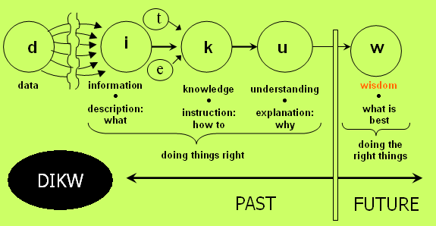

Figure 18: DIKW process to generate knowledge and wisdom for the user. *Source: Adapted from Russell Ackoff*

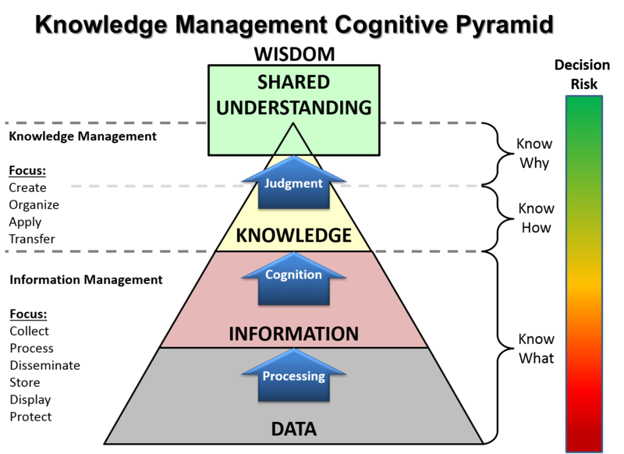

Figure 19: DIKW Adaptation in use within the US ArmyKnowledge Management Community of Practice. *Source: U.S. Army*

The other related concept that needs to be emphasized more in Outcome 3 is the creation of an online and living “community of practice” for environmental measures in aviation as part of the TSP. A great example of an online tool that covers both of these concepts is a “Wiki”[6], with Wikipedia being the most known and successful example. Many smaller and focused wikis exist around the internet and within organizations. While the Evaluator is not suggesting that ICAO create a wiki, the point is that more resources and effort should have been put into creating and maintaining the TSP, which would allow it to meet the original objective of being a “Sharepoint”-like[7] collection of information, instead of the current collection of useful hyperlinks (that has maintenance issues as discussed previously). With the large amount of “knowledge base” software available for purchase[8] its surprising that the project team chose to develop a custom solution with limited features and support.

The project’s real legacy and sustainability lies with the education material and the demonstration activities in Jamaica developed by the project, tied to an online knowledge sharing platform that creates a community of practice. As a response to the initial findings from the TE, the ICAO project team has decided to develop and implement an “Action Plan” for the upgrading and maintenance of the Outcome 3 technical support platform and knowledge base. This action plan is shown in Annex 8.

The GEF project ratings are not an average but rather focused on whether there were short-comings and if so, were the short-comings minor, moderate, or severe. This creates a rating scheme whereby many positive outcomes can seem outweighed by some key short-comings. The project’s overall rating is ***Satisfactory***, even though two components merited a Highly Satisfactory rating.

As the key stakeholder of the project, ICAO’s Environmental Department will continue to be the care-taker of the project outcomes so that its impact will live on even after this project ends.

* 1. Final Recommendations and Lessons

Though it is often stated, it needs to be repeated here: Project reporting is not the same thing as project monitoring. The project produced most of the necessary reports to UNDP management but often the indicators and components are described as “on track” or “satisfactory” in the PIRs, etc. This refers more to the project activity implementation and does not necessarily reflect monitored impacts that relate back to the project Objective. The impression is that the PMU focused on implementing the activity and then assessing the impact only at the end, which is a natural tendency, but not ideal if the project data was not collected sufficiently during the activity.

The project design had many different activity types, and in a perfect scenario each activity type would have had its own monitoring, reporting, verification (MRV) protocol that also established key risks to be monitored. This would represent a heavy load on the project initially but would have paid dividends toward the end. Such a task should have been given greater emphasis in the ProDoc and in the initial project planning to provide a proper platform for project evaluation. The ProDoc PRF is not detailed enough to have provided all the necessary indicators and MRV that the project needed. This is common for most UNDP/GEF projects but sometimes this is recognized and further developed early in the project.

Otherwise, most of the main lessons bear repeating in this report to reach a wider audience. In regards to what the project did well, the project was successful in combining knowledge tools showing best practice examples of sustainable aviation practices, including two pilot projects that demonstrate grant financing and private sector financing for the renewable energy (solar PV) component. The project did so by providing good examples of

* Adaptive management for Component 4: a re-allocation of the project funding to finance 2 separate pilot projects at NMIA and SIA.
* Well-structured and precise Terms of Reference for the pilot projects at the NMIA airport facility and for Outcome 1. This allowed the selection of the main contractor (Solera and McKinsey) to proceed smoothly and for the deliverables to be easily checked and approved by all stakeholders during the implementation.
* Creatively going beyond the original mandate, as demonstrated by the MAC Curve Tool development for Outcome 1.
* Early engagement of the relevant local stakeholders, as shown by the early outreach efforts to secure the pilot project support and approvals by the Jamaican authorities.
* An interdisciplinary team of professionals tasked with delivering the project results. Without a doubt a critical factor for the success of this project were some of the skilled and dedicated individuals at ICAO. While only working on this project on a part-time basis they managed to complete the deliverables on budget and almost on time, and with a general high level of excellence. This is a great example of leveraging co-financing resources from within the host organization that would not normally be available if the team was only funded from the project budget.

Some of the other lessons learned and recommendations for future projects should be

* Always include an active UNDP RTA on UNDP/GEF projects as a mentor and coach for the project throughout its lifetime, in particular for multi-agency projects such as this one, and have them thoroughly review the PRF at inception. They should also provide detailed guidance on monitoring and reporting standards with specific examples for the project.
* Always do some type of independent mid-Term Review for short-term projects, even if it is only focused on monitoring and reporting issues as this is the source of the most common pitfalls in GEF projects.
* Always have a full-time project manager throughout the lifetime of the GEF project. It is a risky strategy to outsource so much of the project effort without a full-time management of the outcomes.
* A risk management seminar demonstrating available tools and methods for the project staff should become standard practice at the project inception, with the result that the main project risks are identified during the seminar and better monitored during project implementation.
* There should be a central UNDP standard and standard software package for “online knowledge bases” and online “technical support platforms” as these are called for in almost every UNDP/GEF project.
* It is recommended to develop future guidance to assist solar-to-gate project developers and proponents on how to best account for CO2 savings resulting from both domestic and international flights operating from electrified gates. Such guidance should account for the future policy frameworks which may impact the GHG accounting.
* All UNDP/GEF projects should always try to highlight the business case for environmental improvement measures, not just the environmental or policy case, as that will provide a better foundation for future replication of the innovation/measure.

Annexes

Annex 1. Terms of Reference

Annex 2: Evaluation Matrix

Annex 3: Project Co-financing

Annex 4: TE Mission Itinerary

Annex 5: List of documents reviewed

Annex 6: Programs for the Capacity Building Seminar in Jamaica and Fiji

Annex 7: Proposed Construction Schedule for the Jamaican Pilot Project

Annex 8: Proposed Action Plan for Upgrading of the Knowledge Sharing Platform

Annex 9: Audit Trail (included in separate file)

## Annex 1: Evaluation Terms of Reference

## Annex 2: Evaluation Protocol

|  |  |  |  |  |  |  |  |  |  |  |
| --- | --- | --- | --- | --- | --- | --- | --- | --- | --- | --- |
| **Objective or Outcome** | **Description** | | | | | | |  |  |  |
| **Objective:** | **To support capacity building in developing States for implementing technical and operational measures for reducing CO2 emissions from international aviation.** | | | | | | |  |  |  |
|  | **Description of Indicator** | **Baseline Level** | | **Target level at end of project** | | **Level at 30 June 2016** | **Cumulative progress since project start** | **2018 End of Project Status** | **Terminal**  **Evaluation**  **Comments** | **Rating** |
|  | Level of capacity of developing States and SIDS for implementing measures that reduce emissions from international aviation. | Few SIDS’ national experts have information and access to tools to enable them to take decisions on implementation of actions to reduce CO2 emissions from international aviation. | | At least 70% of SIDS with international aviation activity have been informed and provided access to outputs developed in the context of this project. | | During Sixth Meeting of the North American, Central American and Caribbean Directors of Civil Aviation in Nassau, Bahamas (10-12 May 2016) 40% of SIDS in the Caribbean region have been informed through the project on the importance of promoting the use of sustainable sources of energy, transfer of technology and innovation. States received further information on the pilot project in Jamaica and possibilities of its replication throughout region recognizing the value of already established framework, effective partnership among ICAO, Civil Aviation Authorities, UNDP and GEF.    States were assured that they will have access to the different outputs developed in the context of the project such as guidance documents and cost-benefits analysis, which will result in reduced costs, less time-investment relying on best practices and lessons learned from the Jamaican pilot project.    The project communications strategy includes the production of several outreach materials with the results of the studies (available at the end of 2016), including also a web platform, which will serve as engaging tools to disseminate further the guidance documents and lessons learned under the project to all SIDs.    These outreach materials will be also complemented by the capacity building workshops to be organized within the project (output 1.2, .3.2 and 4.3) specifically targeted to SIDs as well as at regular scheduled ICAO events to ensure global outreach and reach the target of 70% SIDs by 2017. | Several SIDS were represented at key international events such as the ICAO Alternative Fuels Seminar in Montreal in February 2017, ICAO Regional Seminar on States' Action Plans and Carbon offsetting and Reduction Scheme for International Aviation (CORSIA) in Rio de Janeiro in March 2017 and Jakarta in April 2017. They have been trained on environmental protection and aviation and were informed of the outputs of the project, namely:  - the assessment of the costs and environmental benefits associated with the implementation of the aviation low emissions measures;  - the four guidance documents on regulatory and organizational measures to promote low emissions aviation, the financing mechanisms to support implementation of aviation emissions reduction activities; the promotion of use of alternative jet fuels; and the use of renewable energy at the airports;  - the technical platform for the implementation of low emissions measures; and  - the solar-to-gate pilot project in Jamaica,  as well as their potential benefits from their implementation in SIDs.  These outputs support ICAO’s capacity building programme and action by Member States to reduce CO2 emissions from international civil aviation. It enables them to identify feasible emissions reduction measures and to communicate to ICAO their plans for the implementation through the Action Plan process. The solar-to-gate pilot project in Jamaica has been promoted as an example that could be easily replicated by other SIDs to contribute to their efforts in reducing the impact of aviation on climate change.  Several outreach events will be planned during several scheduled ICAO events, once all outputs are finalized, including:  - two information dissemination workshops (one in the Caribbean region and one in Asia Pacific Region) will be organized within framework of the project;  - the ICAO “Green Airport Seminar” on 29 and 30 November 2017;  - the ICAO Regional Seminars on States’ Action Plans and CORSIA;  - the meeting of the ICAO North American, Central American and Caribbean (NACC) Directors of Civil Aviation; and  - the meeting of ICAO Asia and Pacific (APAC) Directors of Civil Aviation.    These venues will serve as platform to further inform SIDS on the developed tools by the project that will be now available to the States to assist them in the implementation of aviation emissions reduction activities. |  |  |  |
|  | 2. Demonstration of low emissions international aviation measures in the context of developing States and SIDS. | Very few emission reduction projects in developing States/SIDS are directly related to reducing emissions from international aviation. | | One pilot project is in place by the end of the project, and serves as a model for replication. | | ICAO has selected two airports in Jamaica - Norman Manley International Airport (NMIA) in Kingston and Donald Sangster International Airport (SIA) in Montego Bay – to serve as pilot project sites for demonstrating international aviation emissions reductions. After a thorough assessment of the available options and consultations with Jamaican authorities and leading experts in the field of renewable energy and aviation, it was decided to implement a "Solar-to-Gate" project which will replace carbon intensive electricity from aircraft gate activity with carbon-free renewable energy. The project design is consistent with the recently approved Clean Development Mechanism AMS-I.M., “Solar Power for Domestic Aircraft At-Gate Operations.” The procurement process is underway and commissioning of the solar system and newly retrofitted electric gates is scheduled for spring 2017. | A procurement process was undertaken from August 2016 to July 2017. It included an international tender and a Consortium consisting of Solera Sustainable Energies Company Ltd. and PowerGen Ltd. was selected for the provision of Solar Photovoltaic System and Gate Electrification Equipment associated equipment and services for the Jamaica Civil Aviation Authority (JCAA). The pilot project identified for implementation is the replacement of existing fossil fuel powered gate equipment by new electric units powered by a solar photovoltaic facility. It will consist in the implementation of solar projects in two airports, as follows:  - replacing the diesel fueled Auxiliary Power Units (APU) and Ground Power Units (GPU) with equipment powered by green energy at Norman Manley International Airport in Kingston;  - and gate electrification equipment and capacity building of the airport staff to attract funding sources to provide solar equipment at Sangster International Airport in Montego Bay  When the project is completed, the process, lessons learnt and on-going data collection will be disseminated to all 191 ICAO Member States aiming at promoting its replication in other States, in particular SIDs and developing States. |  |  |  |
|  | 3. Amount of CO2 emissions reduction facilitated by the investments of the Project from the four components. | Baseline emission reduction trends in international aviation as projected by ICAO , with limited participation of developing countries and SIDS. Numerical value to be defined in first year of project implementation. | | Direct: 17,500 tons of CO2 over the 25 year timeline of the pilot investments made during the project implementation.  Indirect: Additional 1,000,000 tons of CO2 reduced in developing countries and SIDS over 20 years | | This Solar-to-Gate project will be the first known instance where solar electricity will be used directly for aircraft electrical functions, including cabin air conditioning, currently powered by diesel and jet fuel when the aircraft is parked at the gate. In order to design the project to prove direct consumption of solar electricity by the aircraft, additional equipment, specifically a Pre-Conditioned Air Unit and a 400 Hz Ground Power Unit, is necessary. This change in the project design results in a modified project life cycle (25 year basis) CO2 reduction estimate of 10,788 tons which is below the estimate developed in the project conceptualization phase. Two other unique aspects of the project will also be demonstrated. At SIA, the solar panel component will be installed on a cost recovery basis, thus stimulating partnership between public and private sector. In addition, because the project will be implemented on a per gate basis, it can be easily repeated at additional gates using the design and cost information collected from the demonstration sites.  The project offers a direct approach for reducing aircraft carbon emissions to off-set forecasted air travel growth, and associated economic and social benefits across the globe. Indirect emissions reductions estimate will be identified once it is known how many airports will be implementing similar projects. | The Jamaica Pilot Project proposes to implement the CDM Small-scale Methodology, “Solar power for domestic aircraft at-gate operations” at Kingston and Montego Bay Airports. The objective of the project is to eliminate existing aircraft emissions associated with the auxiliary power unit (APU) and replace it with solar power thereby eliminating previous emissions including those associated with carbon dioxide (CO2). Based on the information on the number and type of aircraft, their connection times, existing CO2 emissions from APUs from aircraft at each airport, approx. 1,000 ton is the amount of CO2 emissions that will be avoided per year. It is important to note that the Pilot Project is fully funding all equipment associated with the Kingston Project and, upon completion, all emissions 714,686 (kg) will be fully decarbonized.  For the Montego Bay Project, the project is funding the gate electrification components and is working with the airport operators to consider alternative business options to have the solar component funded by a private partner. As a result, emissions from the APU will be electrified and transferred from the airport to the regional source of electricity such as a coal-fired power plant. Therefore, the carbon emission reductions of 383,020 (kg) for Montego Bay airport will be fully achieved once the second phase of the project is completed by the private partner. Furthermore, a series of qualitative research initiatives will be implemented that could help collect data regarding the benefits of the project, including:  • distribution of four guidance document among State Action Plan Focal Points accompanied by the questionnaire requesting feedback on the utility and readership, as well as the application of the information received from the guidance documents,  • session on cost benefit study with general information about the research and side-event/workshop for focal points on the use of the tool, as well as Technical platform kick-off event during a Seminar on Green Airports (27 November 2017 - 1 December 2017)  • two workshops planned within the framework of the project to disseminate information about the deliverables of the project among Member States. |  |  |  |
| **The progress of the objective can be described as:** | | **On track** | | | | | |  |  |  |
| **Outcome 1:** | **More developing States and SIDS identify low emissions measures.** | | | | | | |  |  |  |
|  | **Description of Indicator** | **Baseline Level** | | **Target level at end of project** | | **Level at 30 June 2016** | **Cumulative progress since project start** | **2018 End of Project Status** | **Terminal**  **Evaluation**  **Comments** | **Rating** |
|  | 1. Level of understanding of costs and benefits of aviation mitigation measures in developing States and SIDS. | Limited qualitative and quantitative knowledge of costs and benefits of aviation mitigation measures in the context of developing States and SIDS. | | Costs and benefits of low emissions aviation are clearly quantifiable and understandable in developing States and SIDS due to assessment tools developed by the project. | | A procurement process was initiated to identify a suitable supplier to develop a Guidance Document (output 1.1.) on the costs of environmental benefits of the basket of measures indicated in ICAO Doc 9988.    As a result of the procurement process, a leading consulting firm that has unique experience of developing CO2 abatement curves and analyzing the cost/benefit of carbon reduction measures in more than 25 countries and various sectors was selected. The study will be completed by the end of 2016 and disseminated as of 2017 through outreach material and capacity building workshops.    In addition, as a result of a joint partnership with the current ICAO-European Union Project, the results of this study will be turned into an online interface, that will facilitate access and manipulation of the data by the States, thus enhancing the impact and outreach of this guidance document for the States to identify those mitigation measures with the highest impact. | A procurement process was conducted and McKinsey & Company, Inc., Italy was selected to conduct a comprehensive assessment to develop a Guidance Document (output 1.1.) on the economic costs and environmental benefits of the basket of measures. The study will be completed by the end of third quarter of 2017 and disseminated as of 2017 through outreach material and capacity building workshops and general ICAO events. Based on the results of the measure-level analysis, recommendations will be made for measures to be implemented by developing States and SIDS in the Asia-Pacific and the Caribbean regions selected for this study (approx. 25 states). |  |  |  |
|  | 2. Number of developing States and SIDS with clearly identified feasible measures for implementation. | One third of developing States and SIDS have identified nationally-feasible measures. | | At least 10 additional developing States and SIDS have identified country specific mitigation measures. | | Once cost-benefit analysis of each potential CO2 reduction measure is done, online platform, one-on-one consultations with the States, coaching session and informational materials will enhance capacities of more States to identify nationally appropriate relevant low emission measures by end 2017.    The project will also work jointly with the Caribbean Aviation Safety and Security Oversight System (CASSOS) and other regional organizations related with aviation to identify measures that are applicable to a group of States and promote their implementation within a regional approach as applicable. | As a result of a joint partnership with the current ICAO-European Union Project, the results of the study on the costs of environmental benefits of the basket of measures will be turned into an online interface, that will allow the States to manipulate data and use the results of the study when selecting their mitigation measures in their new or updated State Action Plans. The online tool will optimize the cost-benefit analysis for the selection of mitigation measures by the focal points in their Action Plans.  This study will substantially support the decision-making process of developing States and SIDS for the selection of mitigation measures to be implemented to reduce CO2 emissions from international aviation. It will provide the necessary elements to the States to assess costs and potential environmental benefits of the mitigation measures that are cost effective and consistent with their national circumstances. |  |  |  |
| **The progress of the objective can be described as:** | | **On track** | | | | | |  |  |  |
| **Outcome 2:** | **Instruments are available to support the development of a legal and regulatory environment that facilitates the financing of feasible low emissions aviation measures in States.** | | | | | | |  |  |  |
|  | **Description of Indicator** | **Baseline Level** | | **Target level at end of project** | | **Level at 30 June 2016** | **Cumulative progress since project start** | **2018 End of Project Status** | **Terminal**  **Evaluation**  **Comments** | **Rating** |
|  | 1. Level of implementation of low emission aviation policy and regulation in developing States and SIDS. | Low level of policies regulations in place for the implementation of low emission aviation policy and regulation in developing States and SIDS. | | Policies and regulations guidelines are adopted and enforced to stimulate low emission aviation investments in developing States and SIDS. | | Terms of Reference with the scope of a Guidance Document on Renewable Energy and Financing were developed in early 2016. Subsequently, a recruitment process took place and an expert was recruited in May 2016.    Renewable Energy guidance document: a first draft is expected by 15 November 2016 and the final document is to be available by 2 January 2017. The Financing policy paper will be available on 14 April 2017.    Following the submission of these studies, an outreach strategy will be put in place to disseminate the results amongst all SID's by end 2017. | Three Guidance Documents on:  - Financing of the Renewable Energy Projects;  - Regulatory and Organizational Changes to Facilitate Aviation Emission Reduction Projects; and  - Airports Renewable Energy Projects  have been drafted and are currently being finalized to become publications that are both in hard copy and electronic format. These documents will be distributed among all 191 ICAO Member States, and tailor-made Seminars are planned in the first Quarter of 2018 for SIDS in the Caribbean and Asia-Pacific regions to present and disseminate their content. Subsequently, States with the help of the information received from the guidance materials will be able to identify additional mitigation measures and inform ICAO through developing a State Action Plan or updating an existing one. |  |  |  |
|  | 2. Level of technical knowledge in developing States and SIDS regarding drop-in biofuels and renewable energy for airport operations. | Limited technical knowledge in developing States and SIDS regarding drop-in biofuels and renewable energy for airport ground operations. | | Technical knowledge on drop in biofuels and renewable energy projects in airports increased due to technical guidance developed by the project. | | Terms of Reference with the scope of a Guidance Document on Alternative Fuels were developed in early 2016. Subsequently, a recruitment process took place and an expert was recruited in May 2016.    The Guidance document is to be available by 31 August 2016.    Following the submission of the study, an outreach strategy will be put in place to disseminate the results amongst all SID's by end 2017. | A Guidance Document on Alternative Fuels has been drafted and will be finalized for publication on 30 August 2017, both in hard copy and electronic format for distribution among all 191 ICAO Member States. Subsequently, with the help of the information received from the guidance materials, States will be able to identify additional mitigation measures and inform ICAO through developing a State Action Plan or updating an existing one. |  |  |  |
| **The progress of the objective can be described as:** | | **On track** | | | | | |  |  |  |
| **Outcome 3:** | **The cost and resources expended by developing States and SIDS to have access to updated technical information on low emission mitigation measures is greatly minimized.** | | | | | | |  |  |  |
|  | **Description of Indicator** | **Baseline Level** | | **Target level at end of project** | | **Level at 30 June 2016** | **Cumulative progress since project start** | **2018 End of Project Status** | **Terminal**  **Evaluation**  **Comments** | **Rating** |
|  | 1. Level of technical support provided by ICAO to developing States and SIDS. | Limited technical support targeted to developing States and SIDS provided by baseline programme | | Technical support platform established support developing countries and SIDS. | | An initial market research of potential service providers to develop content and provide IT support for the technical support platform was conducted. Terms of Reference and scope are being prepared and will be ready for tender in Q4 2016.    The platform should be ready by Q2 2017 to serve as a stage for dissemination of the guidance documents developed within the project to support environmental protection in aviation and also to showcase the best practices of the pilot project in Jamaica to encourage its replicability in other SIDs | Platform Content management Consultant and Web Designer are under recruitment to perform activities related to the development of the technical platform. Development of the platform is implemented in close cooperation with Business Technology and Services Section (BTS) of ICAO. The platform will be ready by the end of 2017 to serve as a stage for dissemination of the guidance documents developed within the project, as well as technical materials developed by other environmental aviation organizations to support environmental protection in aviation. The technical platform will also showcase in details the best practices of the pilot project in Jamaica to encourage its replicability in other SIDs. |  |  |  |
|  | 2. Level of technical information for low emissions aviation provided by key stakeholders in the technical platform. | Technical information provided in a dispersed, ad hoc manner by individual stakeholders. | | Technical support platform provides information in a coordinated and organized manner , incorporating information from airlines, airport managers, air transport authorities, manufacturers, and other key aviation stakeholders. | | Discussion on various potential online tools, including e-newsletter, online training courses, educational videos and other, have taken place with potential service providers and ICAO’s IT department. | The advantage of the integrated environmental portal is that it will share a wide-range of information on low emission mitigation measures (e.g. tools, standards, guidance document, guidelines, recommendations) from various sources, including ICAO, national governments, academia, business association and private sector. Brought together on one single technical platform, more complete and comparable information will be easily accessible to relevant aviation stakeholders, including aviation authorities, airports, aviation industry, civil society of Member States, particularly developing States and SIDS.  Once available, this platform will become a recommended reference for States when developing their national strategies to address environmental protection within the aviation sector and to prepare their States’ Action Plans. |  |  |  |
|  | 3. Number of users in developing States and SIDS. | Technical support platform not developed. | | Developing States and SIDS use the platform on a regular basis to access relevant technical information, as measured by database usage statistics. | | Developing States and SIDS will use the platform once it is in place in Q2 2017.    The platform will provide SIDs and other States updated and useful information based on the results of the guidance documents developed within the project, which will support the development of national strategies to address environmental protection in aviation and will also offer two examples of practical projects under two different business models to reduce emissions at airports through the use of renewable energy that can be replicated in any other SID (Jamaica pilot project). | Focal Points will receive training in the 4th Quarter of 2017 on the effective use of the technical platform, as well as information on the use of the platform to support States in their submission of the first State Action Plan or updating an existing one. |  |  |  |
| **The progress of the objective can be described as:** | | **On track** | | | | | |  |  |  |
| **Outcome 4:** | **The feasibility of implementing low emissions aviation measures is demonstrated through the pilot project and the lessons learnt are made available to facilitate the replication in developing States and SIDS.** | | | | | | |  |  |  |
|  | **Description of Indicator** | **Baseline Level** | | **Target level at end of project** | | **Level at 30 June 2016** | **Cumulative progress since project start** | **2018 End of Project Status** | **Terminal**  **Evaluation**  **Comments** | **Rating** |
|  | 1. Level of experience of aviation sector in implementation of low emissions projects aviation in SIDS | No low emission international aviation project in a SIDS. | | Low emission pilot project is fully implemented and operational in a SIDS. | | An on-site mission to Jamaica to oversee the potential construction sites and discuss with government authorities and relevant stakeholders was conducted by ICAO officials in March 2016.    Technical Specifications for the equipment and installation services have been drafted and approved by the Jamaican Authorities. Preparations for the site survey and lead Technical Meetings with potential bidders at Norman Manley International Airport, Kingston and Sangster International Airport, Montego Bay are underway. Bidders meeting is scheduled at the end of August in Jamaica.    The solar power system and gate electrification pilot project will be delivered by spring 2017. | Evaluation process to select a supplier for the provision of Solar Photovoltaic System and Gate Electrification equipment for two airports in Jamaica has been concluded and Solera Sustainable Energies & PowerGen Limited have been selected as the contractors for this project. Once the contract negotiation process is completed, the selected supplier with provide detailed technical design of the project together with the implementation schedule for ICAO’s approval, in consultation with the end-users. The completion of the installation of the procured equipment is envisioned for the fourth quarter 2017. |  |  |  |
|  | 2. Direct emission reductions resulting from demonstration project. | No pilot project in place | | At least 3,000 tons of CO2 reduced by the demonstration project at end of GEF project (leading to 17,500 tons of CO2 over investment lifetime) | | It is estimated that 1,455 tons of CO2 will be reduced as a result of the project activities by the end of the project. | The Jamaica Pilot Project applies CDM Small-scale Methodology, “Solar power for domestic aircraft at-gate operations” at Kingston and Montego Bay Airports. The objective of the project is to eliminate existing aircraft emissions associated with the auxiliary power unit (APU) and replace it with solar power thereby eliminating previous emissions including those associated with carbon dioxide (CO2). Based on the information on the number and type of aircraft, their connection times, existing CO2 emissions from APUs from aircraft at each airport, approx. 1,000 ton is the amount of CO2 emissions that will be avoided per year. It is important to note that the Pilot Project is fully funding all equipment associated with the Kingston Project and, upon completion, all emissions 714,686 (kg) will be fully decarbonized. For the Montego Bay Project, the project is funding the gate electrification components and is working with the airport operators to consider alternative business options to have the solar component funded by a private partner. As a result, emissions from the APU will be electrified and transferred from the airport to the regional source of electricity such as a coal-fired power plant. Therefore, the carbon emission reductions of 383,020 (kg) for Montego Bay airport will be fully achieved once the second phase of the project is completed by the private partner. |  |  |  |
|  | 3. Level of awareness of low emission aviation project feasibility in developing States and SIDS. | Limited knowledge on the feasibility of low emissions aviation projects in developing States and SIDS context. | Increased confidence/ knowledge in feasibility of low emissions aviation projects in developing States and SIDS as a result of dissemination of pilot project results. | A series of capacity building activities, including training for airport staff during the pilot project site visits are included in the workplan and will be completed by spring 2017 at the delivery date of the solar project.    The project will strengthen national capacities in Jamaica with the provision of training and information on the use of renewable energy at the airports and carbon emission reduction opportunities, as well as potential benefits of solar to the airport. It will also provide with information on the available opportunities to work with private and public partners to enhance the pilot projects and to develop other solar projects in the future. | Sharing developed guidance material and lessons learned from the Pilot project implementation with the Member States through regular ICAO events and two information dissemination workshops (one in the Caribbean region and one in Asia Pacific Region), as well as providing Member States with access to the integrated technical platform resources will:  - lead to an accelerated implementation of emission reduction measures;  - reduce the cost and resources expended by the States to have access to the technical information;  - increase the number of State Action Plans submitted to ICAO; and  - increase the number of ICAO Member States implementing similar renewable energy initiatives due to the easy replicability of the Jamaica pilot project model. |  |  |  | | |
| **The progress of the objective can be described as:** | | **On track** | | | | | |  |  |  |

## Annex 3: Co-financing

|  |  |  |
| --- | --- | --- |
| **CO-FINANCER** | **PRODOC (USD)** | **2018 Co-finance (USD)** |
| CAEP and Member States | 3,000,000 | 3,000,000 |
| ICAO Budget | 1,500,000 | 1,500,000 |
| Multilateral agency (EU) | 8,250,000 | 8,250,000 |
| UNDP | 300,000 | 300,000 |
| **TOTAL** | **15,000,000** | **15,000,000** |

## Annex 4: TE Meetings and Itinerary

|  |  |
| --- | --- |
| **ICAO HQ - Day 1 - Wednesday, 30 May 2018** | |
| **09:00 – 09:30** | **Arrival of Mr. Jesse Uzzell (ICAO/UNDP-GEF Technical Evaluator)** |
| **09:30 – 10:45** | **Overview Meeting of what will be the role of the Technical Evaluator**   * Introduction to the ICAO/UNDP-GEF Team at HQ * Interview/ Meeting schedules discussion * Inception Report and Final Report Deliverables/timeline to be discussed |
| **10:45 – 12:45** | **Meeting with Adilia Hornek, Project Manager for ICAO/UNDP-GEF Project** |
| **12:45 – 13:45** | **Lunch** |
| **13:45 – 15:00** | **Meeting with Dr. Neil Dickson, Chief, Environmental Standards** |
| **15:00 – 16:00** | **Meeting with Dr. Neil Dickson, Chief, Environmental Standards and Mr. Mathias Grossmann on McKinsey** |
| **16:00 – 17:00** | **Meeting with Ms. Harkamal Gahunia, Technical Associate, and Ms. Jasna Sepetavec, Programme/Administrative Assistant** |
| **ICAO HQ - Day 2 - Thursday, 31 May 2018** | |
| **09:00 – 09:15** | **Recap of Day 1** |
| **09:30 – 10:30** | **Meeting with Ms. Jane Hupe, Deputy Director, ENV** |
| **10:45 – 11:15** | **Meeting with Ms. Lynette Lim, Acting Chief, Finance Branch** |
| **11:30 – 12:00** | **Meeting with Ms. Marie-Ange Nyssen, Head, Procurement Unit, TCB/PRO/PRU** |
| **12:30 – 14:00** | **Lunch Farewell Adilia** |
| **14:00 – 15:00** | **Meeting with Eduardo Caldera, Programme Coordinator, ICAO-EU Assistance Project** |

**15:00 – 16:00 Meeting with Chrystelle Damar, Associate Environment Officer**

**16:00 – 17:00 Meeting with Ms. Adilia Hornek, Project Manager for ICAO/UNDP-GEF Project**

|  |  |  |  |
| --- | --- | --- | --- |
| |  | | --- | | **Kingston, Jamaica NMIA Day 1 - Tuesday, 19 June 2018** | | | |
| **09:31** | **Arrival of Mr. Jesse Uzzell (ICAO/UNDP-GEF Technical Evaluator) with Jet Blue Flight**  Ms. Althea Roper will welcome you upon arrival | |
| **10:00 – 11:00** | **Meeting with Ms. Althea Roper**  Manager, Aviation Statistics Airfares and Rates, Economic Regulation Department | |
| **11:15 – 12:15** | **Meeting with Mr. Junior Levene**  Energy Management Coordinator, Norman Manley International Airport |  |
| **12:15 – 13:15** | **Lunch** |  |
| **13:15 – 14:45** | **Site Visit of the solar facility and gate equipment**  With Mr. Junior Levene and Ms. Althea Roper | |
| **15:00 – 15:30** | **Meeting with Mr. Bruno Pouezat,**  UN Resident Coordinator/UNDP Resident Representative  Jamaica, Bahamas, Bermuda, Turks & Caicos and Cayman Islands | |
| **16:35** | **Jet Blue Flight arriving at Fort Lauderdale Airport at 19:27** | |

## Annex 5: List of Project Documents Reviewed during the TE

1. 2016 – 2018 Minutes from Steering Committee Meetings
2. 2013 GEF Project Review
3. 2015 -2018 UNDP Atlas Project Disbursement Review Tables
4. 2016 Project Implementation Review
5. 2016 Terms of Reference for Policy Consultants
6. 2017 Project Implementation Review
7. 2016 – 2018 Annual Work Plans
8. Terms of Reference for Contractor Selection
9. 2016 – 2018 Budget Revisions
10. 2016 Contract between ICAO & Solera & Powergen
11. 2017 Project Extension Request
12. 2017 Jamaica Project Schedule and Workplans
13. 2016 1st ICAO Mission Report from Jamaica
14. 2016 2nd ICAO Mission Report from Jamaica
15. 2018 Pilot Project Schedule
16. Project Risk Management Memo (Undated)
17. 2017 Website Development ToRs
18. 2015 Project ProDoc
19. 2017 Technical Specifications for PROCUREMENT OF EQUIPMENT AND INSTALLATION SERVICES FOR SOLAR PHOTOVOLTAIC SYSTEM
20. Project Deliverable: Report on Renewable Energy for Aviation
21. Project Deliverable: Report on Financing Aviation Emission Reductions
22. Project Deliverable: Report on Regulatory and Organizational Framework to Address Aviation Emissions
23. Project Deliverable: Report on Sustainable Fuels Aviation Guide
24. Draft Final Project Report

## Annex 6: Programs for the Capacity Building Seminar in Jamaica and Fiji

**ICAO “CAPACITY BUILDING SEMINAR ON LOW EMISSIONS AVIATION MEASURES**

**24 -26 April 2018**

**NORMAN MANLEY INTERNATIONAL AIRPORT (NMIA), KINGSTON, JAMAICA PRELIMINARY PROGRAMME**

|  |  |
| --- | --- |
| **DAY 1 – 24 April 2018** | |
| **REGISTRATION: Please see General Information Document** | |
| 15:00 – 15:40 | **Welcome and introduction**    Moderator: Mr. Rohan Campbell, Deputy Director General Regulatory Affairs, Jamaica Civil Aviation Authority (JCAA)     * Representative of the Minister of Transport and Mining, Jamaica      * Ms. Jane Hupe, Deputy Director, Environment, International Civil Aviation Organization      * Mr. Marcel Alers, Global Head Energy, Infrastructure, Transport and Technology, United Nations Development Programme |
| 15:40 – 16:15 | **The solar-at-gate pilot projects: project inception, management and lessons learnt**    Moderator: Ms. Adilia Hornek, Project Manager, Consultant, ICAO     * Ms. Althea Roper, Manager, Aviation Statistics Airfares and Rates, Jamaican Civil Aviation Authority * Mr. Junior Levene, Energy Management Coordinator, Airports Authority of Jamaica * Mr. Stephen Barrett, Technical Advisor, Consultant, ICAO * Mr. Norman Davis, Managing Director, PowerGen Limited |
| 16:15 – 17:30 | **Ribbon Cutting / Ownership Transfer followed by a Guided Tour of Facilities** |
| 18:00 | **Cocktail Reception** |

|  |  |
| --- | --- |
| **DAY 2 – 25 April 2018** | |
| 09:00-10:30 | **States’ strategy to deal with international aviation emissions: ICAO State Action Plans**    In 2010, ICAO launched the States’ Action Plan initiative. As of February 2018, 106 States representing more than 90.1 per cent of global revenue tonne kilometers (RTK) have voluntarily developed and submitted their Action Plans to ICAO, thus outlining their strategy to deal with international aviation emissions. The States Action Plans enable States and their stakeholders to articulate in a quantified manner the range of low emissions aviation measures that they intend to implement. After providing an overview of the State Action Plan initiative, this session will explain how the ICAO-UNDP-GEF capacity-building and assistance project fits into the ICAO State Action Plan initiative.    Moderator: Ms. Adilia Hornek, Project Manager, Consultant, ICAO     * Ms. Jane Hupe, Deputy Director Environment, ICAO * Dr. Neil Dickson, Chief Environmental Standards, ICAO * Mr. Luis Raúl Sánchez Vargas, Regional Officer, Aeronautical Meteorology and Environment, ICAO |
| 10.30 – 11:00 | Coffee Break |
| 11:00 – 12:30 | **Implementation of low emissions measures: renewable energy at airports**    The objective of this session will be to build upon the experience gained with the implementation of the solar at-gate pilot project in Norman Manley International Airport, Jamaica and provide the audience with the most relevant information to be able to replicate such projects.    Moderator: Ms. Adilia Hornek, Project Manager, Consultant, ICAO     * Dr. Neil Dickson, Chief Environmental Standards, ICAO * Mr. Stephen Barrett, Technical Advisor, Consultant, ICAO on the ICAOUNDP-GEF Guidance Document R*enewable Energy for Aviation:*   *Practical Applications to Achieve Carbon Reductions and Cost Savings*   * Dr. David Renné, President, International Solar Energy Society * Mr. Shane Munroe, Chief Technical Officer of Sangster International Airport |
| 12:30 – 14:00 | Lunch break |
| 14:00 – 15:00 | **Session continued**    Renewable energy can be deployed by Member States and aviation stakeholders to reduce CO2 emissions from international aviation activities. ICAO has produced guidance to help States assess renewable energy opportunities and select the |

|  |  |
| --- | --- |
|  | solutions that best meet their operational needs. This session will explore existing renewable energy technologies and their use, issues to consider in project conceptualization, the fundamental steps for planning and developing a renewable energy project, and a summary of several project examples from existing airports in the region.    Moderator: Ms. Adilia Hornek, Project Manager, Consultant, ICAO     * Mr. Stanley Smith, Chief Executive Officer, Antigua and Barbuda Airport Authority * Mr. Stephen Barrett, Technical Advisor, Consultant, ICAO * Ms. Areefa Khan-Labban, Health Safety and Environment Specialist, Trinidad and Tobago Civil Aviation Authority     **Question and Answers Session** |
| 15:00 – 15:30 | Coffee Break |
| 15:30-17:00 | **Implementation of low emissions measures: sustainable aviation fuels**    Sustainable aviation fuels are an essential component of ICAO’s basket of measures to reach the international aviation global aspirational goal of carbon neutral growth from 2020. More than 100,000 flights have already been operated using a portion of alternative aviation fuels, thus demonstrating the technical feasibility of such fuels and their associated environmental benefits. This breakthrough is supported, and even driven by States worldwide. Thus, this session will give access to first-hand information on how to set-up a sustainable aviation fuels supply chain.     * Moderator: Ms. Jane Hupe, Deputy Director Environment, ICAO      * Dr. Neil Dickson, Chief Environmental Standards, ICAO, on the ICAOUNDP-GEF Guidance Document *Sustainable Aviation Fuels Guide*. * Mr. Juan Veras, DGCA Dominican Republic * Ms. Ofelia Barcena, Assistant Director, IATA     **Questions and Answers Session** |
| 17:00-17:30 | Closing Remarks of Day 2 |
| **DAY 3 - 26 April 2018** | |
| 09:00-10:30 | **Supporting SIDS and their aviation stakeholders in selecting measures for the State Action Plan on CO2 Emissions Reduction Activities from International Aviation - Launch of the MAC curve Tool.**    All ICAO Member States want to act on the environment. ICAO’s role is to carry out activities in support of States’ commitment to environmental protection. The ICAO-UNDP-GEF project has enabled the development of a unique guidance document which will support States and their aviation stakeholders in quantifying |

|  |  |
| --- | --- |
|  | the costs and environmental benefits of 20 selected mitigation measures. Such guidance is expected to greatly facilitate the submission of quantified States’ Action Plans, and the implemented of the measures selected in the plans. This session will include a tutorial on ICAO MAC Curve Tool (2018). Calculating Marginal Abatement Costs of Mitigation Measures and Corresponding Emissions Reductions.    Leader: Dr. Neil Dickson, Chief Environmental Standards, ICAO |
| 10:30-11:00 | Coffee break |
| 11:00 – 12:00 | **Regulatory and Organizational Changes**    The question of governance is at the core of States’ efficient decision-making. With the objective of sound aviation environmental management in mind, this session will detail possible recommendations for States to integrate in their governance structure.    Moderator: Ms. Jane Hupe, Deputy Director Environment, ICAO     * Mr. Stephen Barrett, ICAO-UNDP-GEF Guidance Document*Regulatory and Organizational Framework to Address Aviation Emissions* * Mr. Ricardo Case, Director, Engineering Services,   Jamaica Public Service   * Mr. Eduardo Caldera Petit, ICAO-European Union Programme   Coordinator |
| 12:00 – 13:30 | Lunch break  **Demonstration of the Low-Carbon Aviation Knowledge-Sharing Platform** |
| 13:30 – 15:00 | **Financing Low Emissions Aviation Measures**    Amongst the challenges faced by States and stakeholders in implementing identified low emissions aviation measures, financing often comes on the top of the list. This session will raise awareness on the various financing mechanisms available to implement aviation measures with a positive impact on the environment, and will demonstrate that the modernization of facilities and economic development should be an integral part of the business case for renewable energy projects.    Moderator: Dr. Neil Dickson, Chief Environmental Standards, ICAO     * Mr. Stephen Barrett, Technical Advisor, Consultant, ICAO on the ICAOUNDP-GEF Guidance Document *Financing Aviation Emissions*   *Reductions*   * Mr. Kingsley Thomas, Senior Advisor, Caribbean Basin Sustainable Energy Fund (CABEF) * Mr. Leonard Allen, President, Solera Renewable Energies     **Questions and Answers Session** |
|  |  |
| 15:00-15:30 | Coffee break |
| 15:30-16:30 | **Renewable Energy in the Caribbean: current initiatives and possible synergies**    This session will explore how to create synergies with on-going regional projects and identify possible cooperation opportunities to further advance clean energy use in the region, in line with SDG 7.    Moderator: Dr. Neil Dickson, Chief Environmental Standards, ICAO     * Mr. Donneil Cain, Senior Project Manager, Caribbean Community Climate Change Centre * Ms. Rachel Paulk, Deputy Chief of Party, US AID Caribbean Clean Energy Programme     **Questions and Answers Session** |
| 16:30 – 17:00 | **Conclusions from the Seminar and next steps**  Mr. Rohan Campbell, Deputy Director General Regulatory Affairs, JCAA  Mr. Marcel Alers Global Head Energy, Infrastructure, Transport and Technology,  United Nations Development Programme  Ms. Jane Hupe, Deputy Director Environment, ICAO |
| 17:00 End of Seminar | |

**ICAO “CAPACITY BUILDING SEMINAR ON LOW EMISSIONS AVIATION MEASURES**

**23 -24 May 2018 NADI, FIJI**

**PROGRAMME**

|  |  |
| --- | --- |
|  | **DAY 1 – 23 May 2018** |
| 08:00-09:00 | **Registration** |
| 09:00-9:30 | **Welcome and Introduction**     * Mr. Sharvada Sharma, Solicitor General and Permanent Secretary for Civil Aviation, Government of Fiji      * Ms. Jane Hupe, Deputy Director, Environment, ICAO |
| 09:30-10:45 | **ICAO State Action Plans**    In 2010, ICAO launched the States’ Action Plan initiative. As of May 2018, 107  States representing more than 91.8 per cent of global revenue tonne kilometres (RTK) have voluntarily developed and submitted their Action Plans to ICAO, thus outlining their strategy to deal with international aviation emissions. The States Action Plans enable States and their stakeholders to articulate in a quantified manner the range of low emissions aviation measures that they intend to implement. After providing an overview of the State Action Plan initiative, this session will explain how the ICAO-UNDP-GEF capacity-building and assistance project fits into the ICAO State Action Plan initiative.    Moderator: Mr. Eduardo Caldera Petit, Programme Coordinator, ICAO     * Ms. Jane Hupe, Deputy Director Environment, ICAO * Ms. Chrystelle Damar, Associate Environment Officer, ICAO * Dr. Stelios Pesmajoglou, Environment Officer, ICAO     **Special Presentation by Ms. Theresa Levestam, Controller Ground Safety, Civil Aviation Authority of Fiji** |
| 10.45 – 11:15 | Coffee Break |
| 11:15 – 12:45 | **Implementation of low emissions measures: renewable energy at airports**    The objective of this session will be to build upon the experience gained with the implementation of the solar at-gate pilot project in Norman Manley International Airport, Jamaica and provide the audience with the most relevant information to be able to replicate such projects. |

|  |  |
| --- | --- |
|  | Moderator: Mr. Eduardo Caldera Petit, Programme Coordinator, ICAO     * Ms. Chrystelle Damar, Associate Environment Officer, ICAO on the ICAO-UNDP-GEF Guidance Document R*enewable Energy for Aviation:*   *Practical Applications to Achieve Carbon Reductions and Cost Savings*   * Dr. Stelios Pesmajoglou, Environment Officer, ICAO * Ms. Althea Roper, Manager, Aviation Statistics Airfares and Rates, Jamaican Civil Aviation Authority |
| 12:45 – 14:00 | Lunch break |
| 14:00 – 15:00 | **Session continued**    Renewable energy can be deployed by Member States and aviation stakeholders to reduce CO2 emissions from international aviation activities. ICAO has produced guidance to help States assess renewable energy opportunities and select the solutions that best meet their operational needs. This session will explore existing renewable energy technologies and their use, issues to consider in project conceptualization, the fundamental steps for planning and developing a renewable energy project, and a summary of several project examples from existing airports in the region.    Moderator: Ms. Chrystelle Damar, Associate Environment Officer, ICAO     * Mr. Peceli Nakavulevu, Private Sector Expert of the Pacific Centre for Renewable Energy and Energy Efficiency * Mr. Ken Lau, Senior Manager Technical Affairs, Airports Council International (ACI Asia-Pacific) * Mr. Eduardo Caldera Petit, Programme Coordinator, ICAO     **Question and Answers Session** |
| 15:00 – 15:30 | Coffee Break |
| 15:30-17:00 | **Implementation of low emissions measures: sustainable aviation fuels**    Sustainable aviation els are an essential component of ICAO’s basket of measures to reach the international aviation global aspirational goal of carbon neutral growth from 2020. More than 100,000 flights have already been operated using a portion of alternative aviation fuels, thus demonstrating the technical feasibility of such fuels and their associated environmental benefits. This breakthrough is supported, and even driven by States worldwide. Thus, this session will give access to first-hand information on how to set-up a sustainable aviation fuels supply chain.     * Moderator: Ms. Jane Hupe, Deputy Director Environment, ICAO      * Dr. Neil Dickson, Chief Environmental Standards, ICAO, on the ICAO- |

|  |  |
| --- | --- |
|  | UNDP-GEF Guidance Document *Sustainable Aviation Fuels Guide*.   * Ms. Angela Foster-Rice, Managing Director, Environmental Affairs and Sustainability, United Airlines * Mr. Eduardo Caldera Petit, Programme Coordinator, ICAO     **Questions and Answers Session** |
| 17:00-17:30 | Closing Remarks of Day 1 |
| 18:00 | Cocktail reception |
| **DAY 2 - 24 May 2018** | |
| 09:00-10:30 | **Supporting SIDS and their aviation stakeholders in selecting measures for the State Action Plan on CO2 Emissions Reduction Activities from International Aviation- Launch of the MAC Curve Tool.**    All ICAO Member States want to act on the environment. ICAO’s role is to carry out activities in support of States ‘commitment to environmental protection. The ICAO-UNDP-GEF project has enabled the development of a unique guidance document which will support States and their aviation stakeholders in quantifying the costs and environmental benefits of 20 selected mitigation measures. Such guidance is expected to greatly facilitate the submission of quantified States’ Action Plans, and the implemented of the measures selected in the plans. This session will include a tutorial on ICAO MAC Curve Tool (2018). Calculating Marginal Abatement Costs of Mitigation Measures and Corresponding Emissions Reductions.    Leader: Dr. Neil Dickson, Chief Environmental Standards, ICAO |
| 10:30-11:00 | Coffee break |
| 11:00 – 12:00 | **Regulatory and Organizational Changes**    The question of governance is at the core of States’ efficient decision-making. With the objective of sound aviation environmental management in mind, this session will detail possible recommendations for States to integrate in their governance structure.    Moderator: Dr. Neil Dickson, Chief Environmental Standards, ICAO     * Ms. Chrystelle Damar, Associate Environment Officer, ICAO, on the ICAO-UNDP-GEF Guidance Document*Regulatory and Organizational Framework to Address Aviation Emissions* * Mr. Espen Ronneberg, Climate Change Adviser, Secretariat of the Pacific Regional Environment Programme * Mr. Eduardo Caldera Petit, Programme Coordinator, ICAO     **Questions and Answers Session** |
| 12:00 – 13:30 | Lunch break  **Demonstration of the Low-Carbon Aviation Knowledge-Sharing Platform** |
|  |  |
| 13:30 – 15:00 | **Financing Low Emissions Aviation Measures**    Amongst the challenges faced by States and stakeholders in implementing identified low emissions aviation measures, financing often comes on the top of the list. This session will raise awareness on the various financing mechanisms available to implement aviation measures with a positive impact on the environment, and will demonstrate that the modernization of facilities and economic development should be an integral part of the business case for renewable energy projects.    Moderator: Ms. Chrystelle Damar, Associate Environment Officer, ICAO     * Mr. Joshua Wycliffe, Permanent Secretary for Local Government, Housing and Environment, Government of Fiji * Dr. Neil Dickson, Chief Environmental Standards, ICAO, on the ICAOUNDP-GEF Guidance Document *Financing Aviation Emissions*   *Reductions*   * Mr. Lachlan Phillips, Director International Standards, Department of Infrastructure and Regional Development, Government of Australia     **Questions and Answers Session** |
| 15:00-15:30 | Coffee break |
| 15:30-16:30 | **Renewable Energy in the Pacific: current initiatives and possible synergies**    This session will explore how to create synergies with on-going regional projects and identify possible cooperation opportunities to further advance clean energy use in the region, in line with SDG 7.    Moderator: Ms. Jane Hupe, Deputy Director Environment, ICAO     * Mr. François Martel, Secretary General, Pacific Island Development Forum * Mr. Wairarapa Young, Project Implementation Officer, Pacific Power Association (on Global Solar Atlas)     **Questions and Answers Session** |
| 16:30 – 17:00 | **Conclusions from the Seminar and next steps**  **Fiji Civil Aviation Authority**  **Ms. Jane Hupe, Deputy Director Environment, ICAO** |
| 17:00 End of Seminar | |

## Annex 7: Proposed Construction Schedule for the Jamaican Pilot Project



## Annex 8: Proposed Action Plan for Upgrading of the Knowledge Sharing Platform

**KSP Database**

Since Friday, 20 July 2018, all of the links included in the KSP database have been checked for functionality and accuracy. Throughout the process, any broken links were replaced with functional ones. Wherever practical, links that previously directed the user to a company or organization’s homepage have been redirected to a page more specific to the mitigation measure described on the KSP site. Additionally, many of the mitigation measure descriptions have been updated to provide more detail. Finally, a few entries were added in an effort to ensure consistency, while several entries were deleted to minimize redundancy. All updates were made in Excel, and then uploaded to the ICAO website using Sharepoint.

**Ask the expert community**

The log-in prompt to access the “Ask the expert community” page has been removed. Once we receive a sufficient number of questions we can begin displaying the questions and responses on a new Questions and Answers page, which will have a link directly under the “Submit your question” button, as well as in the list of site links along the left of the page:

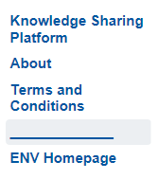

The Questions and Answers page will include an introductory paragraph:

This page allows stakeholders and interested parties to submit specific questions regarding the various aspects of the use and implementation of low emission aviation measures. These questions are then addressed by relevant experts within the ICAO Secretariat and shared below for everyone’s benefit.

After coordination within ICAO, we have agreed that the format of the Questions and Answers content will be in a table format. In order to improve the functionality of this table, it will include a search function.

**Future updates**

Future updates to the KSP can be made directly to the Sharepoint database on the webpage. Following the completion of any updates to the database, an Excel version of the database will be downloaded from Sharepoint, to ensure that the ICAO Environment office always has an offline master copy of the information. In order to ensure that this webpage stays up to date with the latest information, a function will be added to the job post of any future UNDP Project consultants working with the ICAO Environment office. In the meantime, an ICAO Environment officer will maintain the page.

Questions submitted to the “Ask the expert community” page are received in the ICAO Environment Outlook mailbox, with one designated ICAO Environment officer in copy. All questions received have the subject line “ENV Knowledge Sharing Platform - Question to Expert Community”. It will be the responsibility of the ICAO Environment officer to ensure that the question is received and answered by the appropriate member of the ICAO Environment team. This officer will then post the response on the webpage and inform the sender that the response to their question has been posted.

1. https://wbcarbonfinance.org/Router.cfm?Page=SubmitProj&ItemID=24683
2. www.soleraenergies.com
3. SMART: Specific, Measurable, Achievable, Relevant, and Time-bound
4. The ratings are more of a gradient and the rating system allows some subjectivity for the Evaluator to take into account the circumstances and context of the target and component that is being rated.
5. https://www.icao.int/annual-report-2017/Pages/global-priorities-all-strategic-objectives-hr-development-gender-equality.aspx
6. A wiki is a website on which users collaboratively modify content and structure directly from the web browser. There are tens of thousands of other wikis in use, both public and private, including wikis functioning as knowledge management resources, notetaking tools, community websites, and intranets. Wiki is a Hawaiin word meaning “quick”.
7. https://www.helpscout.net/helpu/knowledge-base-examples/
8. https://www.g2crowd.com/categories/knowledge-management