

Final Report -

Final Evaluation of “Development of the North West Coast and Mine Action Project”

Egypt

May 2018 – December 2018

Framework Contract EuropeAid/132633/C/SER/Multi

Lot No 12: Humanitarian Aid, Crisis Management   
& Post-Crisis assistance

Letter of Contract No: 2018/395872

Prepared by: Particip GmbH

Ulrich TIETZE

Submitted in October, 2018

|  |
| --- |
| *This report was prepared with the financial assistance of the European Commission. The views  expressed in this report are those of the consultants and do not necessarily reflect those of the European Commission*  *completeParticip Consortium comprising:* Particip GmbH(lead) and AOAV, Cardno, Cideal, Coventry University, Dara, Deutsche Welle, ECDPM, Epes Mandala, Femconsult, ICMPD, Niras, WYG |

**Table of Contents**

List of Figures iv

List of Tables iv

List of Acronyms and Abbreviations v

Executive Summary vi

1 Introduction 11

1.1 Background and Context 11

1.2 Purpose and Scope of the Evaluation 13

1.3 Evaluation Methodology 13

2 Evaluation Findings 16

2.1 Design 16

2.2 Intervention Logic 16

2.3 Relevance 18

2.4 Effectiveness 21

2.5 Efficiency 23

2.6 Impact 26

2.7 Sustainability 28

2.8 Gender 30

2.9 Lessons Learned 30

3 Conclusions and Recommendations 31

3.1 Conclusions 31

3.2 Recommendations 33

Annexes 35

Annex 1: Terms of Reference 35

Annex 2: Evaluator and Company 52

Annex 3: Evaluation tools: questionnaires and interview guides 53

Annex 4: Evaluation Matrix 57

Annex 5: Intervention Logic 60

Annex 6: Map of Egypt and Project Area 61

Annex 7: List of Persons Contacted during the Evaluation 62

Annex 8: Literature and Documents Consulted 63

Annex 9: Detailed Work Plan 64

Annex 10: Demining Maps 65

Annex 11: Organizational Chart and Networking Diagram 67

List of Figures

Figure 1: Map of the Project Area with District Boundaries 18

Figure 2: Mine Survivors and Location of Accident per District 20

Figure 3: Mine survivors from the Database in Income Generating Activities 23

Figure 4: Number of Yearly Mine/UXO Accidents 28

Figure 5: Reconstructed Intervention Logic 60

Figure 6: Population Density Map of Egypt with Project Area 61

Figure 7: Demining map: Dabaa Nuclear Power Plant Site 65

Figure 8: Demining Map: Agricultural Land in Alamein 66

Figure 9: Exec Sec, Organisational Chart 67

Figure 10: Exec Sec, Cooperation and Networking 67

List of Tables

Table 1: Budget and Estimated Expenditures 24

List of Acronyms and Abbreviations

|  |  |
| --- | --- |
| CSO | Civil Society Organization |
| ERW | Explosive Remnants of War |
| EU | European Union |
| EUDEL | EU Delegation |
| Exec Sec | Executive Secretariat for Demining |
| ENCMSD | Egyptian National Center for Mine Action and Sustainable Development |
| ENP | EU Neighborhood Policy |
| FGD | Focus Group Discussion |
| GICHD | Geneva International Center for Humanitarian Demining |
| GMS | General Management Support |
| IL | Intervention Logic |
| IMAS | International Mine Action Standards |
| IMSMA | Information Management System for Mine Action |
| KII | Key Informants Interviews |
| MinAgr | Ministry of Agriculture and Land Reclamation |
| MinIIC | Ministry of Investment and International Cooperation |
| MinDev | Ministry of Local Development |
| MinDef | Ministry of Defense |
| MinWI | Ministry of Water Resources and Irrigation |
| MinEl | Ministry of Electricity |
| MinHous | Ministry of Housing |
| MDG | Millennium Development Goal |
| MinSocS | Ministry of Social Solidarity |
| MRE | Mine Risk Education |
| NWC | North West Coast |
| NTS | Non-Technical Survey |
| QA | Quality assurance |
| QC | Quality Control |
| QM | Quality management |
| ROM | Results Oriented Monitoring |
| TS | Technical Survey |
| ToR | Terms of Reference |
| ToT | Training of Trainers |
| UNDAF | United Nations Development Assistance Framework |
| UNDP | United Nations Development Programme |
| UXO | Unexploded Ordnances |
| WWII | World War two |

Executive Summary

#### Background

The major source of contamination from explosive remnants of war in Egypt can be traced back more than 70 years to World War II. Explosive remnants of the World War II contaminated an estimated 2,680 square kilometers of land in the North West Coast and has claimed 8,313 casualties (697 killed and 7.616 injured), of which 5,015 were civilians. This contamination is said to contribute to the fragile socio-economic structure of the North West Coast and its inland desert.

In an effort to support the affected Matrouh Governorate to overcome this major developmental challenge, the project aimed to:

* 1. strengthen the national capacities of stakeholders to address Mine Action in Egypt through the provision of relevant tools and mechanisms;
  2. reintegrate mine victims into society by minimizing their physical impairment and increasing their economic stability;
  3. develop Mine Risk Education (MRE) and advocacy activities; and support the continuation of mine clearance operations in line with the National Development Plan of the North West Coast.

It addressed the negative humanitarian and socio-economic impact of widespread ERW contamination, with the overall objective “to improve the efficiency and effectiveness of the overall Mine Action Programme in Egypt”.

The project started October 2014 and ended April 2018. This Final Independent Evaluation is an end of project evaluation and was planned in the project design phase. The evaluation was conducted by a single independent evaluator carried out within 30 days during the period May - October, 2018.

#### Purpose, scope and methodology of the evaluation

The scope of the evaluation covered the entire duration of the Mine Action Project. Geographically, it focused on the North West Coast of Egypt, the region of implementation of the action, and the city of Cairo, where the UNDP and the Executive Secretariat for Demining (Exec Sec) are based.

The evaluation followed the Organization for Economic Co-operation and Development - Development Assistance Committee (OECD – DAC) criteria: relevance, efficiency, effectiveness, impact and sustainability, as well as gender. The Terms of Reference set out a list of questions to be answered by the evaluation.

A detailed work plan was elaborated as well as tools and methodologies. Together with thorough stakeholder identification a set of questionnaires corresponding to the target groups was developed.

A 15 day field visit was undertaken in four areas (El Negila, Marsa Matrouh, Dabaa and Alamein) where project activities had been implemented. During that time 28 interviews were performed (13f, 15m); 12 with direct beneficiaries and 16 with local staff or local institutions. Additionally interviews were also conducted with members of the Exec Sec project team and UNDP in Cairo. These interviews followed an interview guide developed at inception stage. Two focus group meetings were held with female Survivors of Mine Accidents and 12 members of local NGOs all beneficiaries of program activities.

A major constraint affecting the evaluation was that information gathering of demining was made difficult by security restrictions by the Military. The evaluator attempted to mitigate this lack of specific information by detailed questions during a discussion of mine clearance operations. This might have had a negative impact on the validity of the data used to evaluate the implementation and effectiveness of demining aspects of the project.

#### Key Evaluation findings

Design

The project was based on the hypotheses that, apart from humanitarian aims, the rationale behind support to Mine Action in Egypt lies in the challenge it poses to the development of affected communities. As a result of the intervention the project aimed to develop and modernize national structures to minimize the impediments to development and the security risk posed by landmines and ERW. The project expected to strengthen the national capacities of stakeholders in Mine Action in Egypt through providing the relevant tools and methods for Mine Action.

On the basis of interviews with the project team and all stakeholders as well as informants, and feedback provided by participants in training sessions, the evaluator has concluded that the rational on which the project was designed was sound, and captured key challenges posed by mines and ERW problems in the North West Coast.

Intervention Logic

The intervention was based on three strategies: Demining, Victim Assistance and Mine Risk Education; with detailed planning of various activities to ensure the desired outputs. Cross-sectional activities were used to strengthen the information data base, the Executive Secretariat and a gender sensitive strategy was designed to empower women in their project role.

The project document did not contain a logical framework. The Results and Resources framework was appropriate, in the sense that the flow from program objectives to outputs and activities were rational and in line with the intervention logic. The proposed risk mitigation approaches were appropriate and realistic.

A more impact-oriented logical framework in place of the current Results and Resources framework would have better reflected the long term perspective of the project’s achievements.

Relevance

The project was relevant in that it addressed clear needs, consistent with priorities set with the National Development Plan of the North West Coast. It supported the efforts of Egypt to develop living conditions and infrastructure to enhance the North West Coast’s economic potential.

The projects demining activities were relevant in particular to the urban and country development of the New City Alamein. The clearance for these investment projects had little relevance to the livelihoods of rural population, specifically in those areas with a high accident rate in the past.

Mine actions seems still very relevant to the development issue. Humanitarian problem has progressively declined in the last decade, together with the number of incidents

The project contributed favorably to the health situation in the Matrouh Governorate. It has drastically improved access to a prosthetic service of the mine survivors, who before had to travel to Alexandria or Cairo to be treated. The project had relevance to mine survivors in both the needs of their health and economic situation. The project was also relevant promoting gender equality and empowering women.

The project was very important in that it raised the public awareness about the risk of mines or UXO related accidents. Repeated harmful ERW explosions in the past years required an extensive campaign with the aim increasing mine risk awareness and safe behavior.

The project was also compatible with the EU Neighborhood Policy (ENP) on economic development for stabilization, the EU country strategy in Egypt, the United Nations Development Assistance Framework (UNDAF) for Egypt and with other EU policies and Member State Actions.

Effectiveness

Generally the project appeared to be effective in that most of the planned activities were implemented, results achieved and outcomes largely met.

The cooperation of the EUDEL with the UNDP Country office provided valuable input into the project. Effective, mutual support helped to overcome critical situations during the project’s duration. The role of the Executive Secretariat in promoting certain priorities for areas to be cleared of mines and UXO to the National Committee was not as robust as it should have been the case.

The project has proved to be effective in terms of mobilizing development and specific infrastructural investments (city of Alamein), not very much in terms of benefitting rural and Bedouin communities in the targeted areas. The project’s gender approach has proved to be very effective in mobilizing women empowerment in Bedouin communities.

The method of manual ERW removal used by the Egyptian Army appears to be effective eliminating the risk of mine accidents given the geographical conditions and the risk level in the contaminated areas (a verification was not possible for the mission). Maps and other data of the cleared area are only available as very general data and not sufficient for IMSMA or to draw any conclusions about the operations.

The establishment of a center for artificial limbs was a highly effective measure to restore maximum physical functional ability to mine survivors with lower limb amputations. The empowering of local NGOs to assist the mine survivors to have better access to the center was also very effective. The project changed successfully the economic situation of some mine survivors. Livestock was provided to a selected numbers of mine survivors (215 out of 740), which was an effective measure, but many beneficiaries are still without support.

The design of target group oriented education methods, the high quality of the MRE material for children and the focusing on women as trainers assured real access to high risk groups like children in general and young boys especially. The installation of the “180” telephone number by the MRE team under which civilians report findings of mines or UXO to the police before exploding, has proved very effective.

Efficiency

The project represented good value for money, and obviously benefited from UNDP's institutional expertise, its access to outside experts/trainers, and its experience of other similar projects. In terms of project management/institutional arrangements for planning and supporting the delivery of activities, the project performed well. The distribution of costs was in line with the project objectives and its logical framework.

The evaluation showed that the project enjoyed a high level of collaboration with other stakeholders during the implementation phase. The managerial capacity of the Exec Sec was not as strong as needed; this was in part due to repeated changes in its directorate and consequently resulted in delays in project implementation.

The efficiency of demining by the Egyptian army is impressive in terms of reaction time and speed of operation. This prompt efficient action is more a question of available funds and good negotiation skills of their clients, often commercial petrol companies, and not as a response to a pressing humanitarian or development needs of the local authorities.

The establishment of the Artificial Limb Center was done in an economically resourceful manner. The involvement of local personnel and the inexpensive support by experienced prosthetic technicians from the military El Agouza Rehabilitation Center in Cairo has proved to be very efficient. The quality of the produced and fitted artificial limbs is high. The income generating strategy for mine survivors produced positive results. Many of the interviewed mine survivors reported an increase in household income 6 months after the start of the measure.

The involvement of religious entities and mosques in the MRE was an innovative and very efficient measure in influencing and teaching the male population. The quality of the MRE Training was high, so was the MRE material used in the educational sessions for the trainers and for the final beneficiaries. Especially the MRE methods and the material for children was very well developed and adapted to children’s perceptions and experience.

Impact

The evaluation found positive effects in terms of use of cleared land for the important urbanization project of New City Alamein. The improved economic development through demining of the urbanization area is without doubt a positive outcome although this was not the primary intention of the project. The demining supported by the EU has not yet produced a visible or positive impact for the specific target group of mine survivors or the rural Bedouin community in general.

The outcome of the project’s demining component is after all an effective and nationally owned Mine Action program, but it is mainly owned by the Egyptian Military which finally decides on priorities of the areas to be cleared.

The outcomes from the new established Artificial Limb Center were inspiring and very evident. The project has achieved the wider outcome in that target communities have better access to basic services and a slightly higher income.

The project has achieved the wider outcome of an increased public awareness and safer behavior in high risk groups. The number of mine or UXO accidents is going down, which is undoubtedly a result of the project’s MRE activities.

Sustainability

The outcome of the project’s demining component is sustainable in the sense that, with help of the project, the Army Corps of Engineers is well organized, trained and well equipped, and is able to continue with demining operations. The present system of demining has little positive impact on the local rural population and therefore sustainability is questionable.

The Executive Secretariat lacks detailed information about the demined terrain, the clearance procedure and the found items. Without this information it will also be difficult for the future Egyptian National Center for Mine Action and Sustainable Development (ENCMSD) to build sufficient experience to plan and sustain a program for demining in Egypt.

The future of the Artificial Limbs Center is currently uncertain. A decision on what options would be the best to sustain the production of artificial limb is pending. The remaining income generating activities for registered mine survivors are currently funded through other donors. Supporting new victims will be manageable as numbers are expected to be low.

There is the clear expectation of nearly all interviewed beneficiaries, local authorities and project officials that Mine Risk Education should continue. The project has achieved a common understanding that Mine Risk Education is the key to preventing future accidents. Existing strong collaboration with state school might lead in the future to the integration of MRE in the official school syllabus.

The main sustainability’s issue of the project is related to the continuity of the Executive Secretariat itself and the strengthening of its role with the creation of the Mine Action Center in Egypt. This center should coordinate all mine actions activities in the country with information systems and decision’s capacity

Gender

The evaluation showed that the results of the rapid mini gender analysis had an impact on the project design and implementation. The project has a clear gender strategy and benefitted from UNDP’s expertise on this. In all positions, including the technical staff of the Artificial Limb Center, women are equally represented. Gender issues were irrelevant to priority setting of the clearance operation, but this is also true of other societal groups and not specifically women.

Lessons Learned

The project design and intervention logic should clearly state the group of direct beneficiaries for each and every output.

The relationship between the UNDP project management and the Egyptian implementing partners was very good. An important factor was the high level of the international expertise of UNDP in administrative and financial management.

Training, capacity interventions and support services to beneficiaries, however successful initially, need to be formalized and integrated into an institutional framework of activities.

#### Main conclusions

The project was highly relevant in that it was based on a sound analysis of the situation of the Mines and UXO problematic in Egypt’s North West Coast, and addressed needs that were in line with the country’s development plan for the region.

The project favored demining for infrastructural development and not humanitarian demining. This is a reasonable undertaking as such and it proved successful in the current context. It allowed the safe expansion of the New City Alamein construction site with surrounding agricultural areas for the future supply of the New City. It also helped preparing safe ground for the future Nuclear Power Plant at the North West Coast and it enabled Petrol Companies to safely explore possible natural oil and gas reserves in the western desert. The project did not put any emphasis on ERW clearance for humanitarian reasons. The districts west of Marsa Matrouh, where most accidents happened in the past were not included in the demining activities.

The manual demining method of the Egyptian army seems to be appropriate for ERW contaminated areas of the North West Coast (although the mission was not able to verify the presented performance).

The IMSMA database focuses on mine victims and has some MRE data. The stored records of the demining project do not contain sufficiently detailed data to be a workable mine clearance data base.

The lack of transparent and updated information systems containing specific number and location of found mines and UXO in a cleared minefield as well as the missing location and characteristic of ERW incidents and accidents is a major constraint to sustain the relevance of mine issue in Egypt and more specifically in the North West Coast.

The fully functional Artificial Limb Center in Marsa Matrouh is the highlight of the project. It has improved considerably the access to a prosthetic health service of the mine survivors and has extremely committed and well trained staff. It also respected in all aspects a holistic gender approach.

Income generating activities for mine survivors started late but nevertheless they are successful. It is expected that funds from other donors will fill the gap, left by the project.

The project has achieved a common understanding that Mine Risk Education/awareness is the key to preventing future accidents. There is an increased public awareness and safer behavior in high risk groups. There is the clear expectation of nearly all interviewed beneficiaries, local authorities and project officials that Mine Risk Education will continue.

#### Main recommendations

Information should be collected at community level identifying its land clearance needs with the active participation of all groups; ensuring women have a voice and using rapid rural appraisal techniques.

The Executive Secretariat should commission a Non-Technical Survey of the areas in question with involvement of civil society to identify suspected hazardous areas and its priorities for clearance.

The Executive Secretariat should present detailed demining proposals to the National Committee with clear targets in terms of size, benefitting population, expected outcomes and long term impact.

The inter-ministerial National Demining Committee should meet regularly to discuss and decide on the acceptability of these proposals.

The Executive Secretary should develop together with local authorities a long term plan for locally based and locally financed Mine Risk Education.

# Introduction

## Background and Context

The major source of contamination from explosive remnants of war in Egypt can be traced back more than 70 years to World War II. Prior to the launching of the first phase of this project (2007) explosive remnants of the World War II contaminated an estimated 2,680 square kilometers of land in the North West Coast and has claimed 8,313 casualties (697 killed and 7.616 injured), of which 5,015 were civilians[1]. This contamination is said to contribute to the fragile socio-economic structure of the North West Coast and its inland desert.

In an effort to support the affected Matrouh Governorate to overcome this major developmental challenge, especially since it is disadvantaged as being one of the poorest 10 governorates in Egypt, the project aimed to:

* 1. strengthen the national capacities of stakeholders to address Mine Action in Egypt through the provision of relevant tools and mechanisms;
  2. reintegrate mine victims into society by minimizing their physical impairment and increasing their economic stability;
  3. develop Mine Risk Education (MRE) and advocacy activities; and support the continuation of mine clearance operations in line with the National Development Plan of the North West Coast.

In 2001, as part of the overall North West Coast development plan, a National Demining Committee was established. The committee was comprised of 20 ministries, concerned governorates, and NGOs and headed by the Minister of International Cooperation.

Egypt's Mine Action program has been developed since 2007 and includes the basic structure and institutions to control, coordinate and implement Mine Action activities. The program has currently a three-tier structure that includes:

* The National committee for the Supervision of Mine Clearance and the Development of the North West Coast.
* The Executive Secretariat for Mine Clearance and the Development of the North West Coast (NWC) at the Ministry of International Cooperation ("Executive Secretariat")
* The Corps of Military Engineers that has the overall responsibility to undertake demining operations in Egypt.

A number of individual strategy plans for Mine Action program components: advocacy and communication, resource mobilization, victims' assistance and Mine Risk Education had already been formulated by the project, A draft national strategic plan for Mine Action in Egypt, pulling together these individual components and adding a clearance plan, was discussed in 2012, and was an activity for Phase II.

A Financing Agreement for a Joint EU Rural development Programme was signed by three "beneficiary" Ministries: Ministry of Agriculture and Land Reclamation (MinAgr) ("Lead Beneficiary"), Ministry of Water Resources and Irrigation (MinWI) and Ministry of Local Development (MinDev), with the Ministry of Investment and International Cooperation (MinIIC) being the National Coordinator.

The Programme had 2 components:

1. The Rural Development Component, implemented by the Italian Cooperation, via a EU Delegation (EUDEL) agreement and
2. The Mine Action Component, the "Development of the North West Coast and Mine action project ", was implemented by UNDP, via a Contribution Agreement (EU contribution: EUR 4.7 m, duration 3 years starting in October 2014).

The action to be evaluated, the Mine Action Component, was the second phase of the wider Mine Action Programme initiated in 2007 with the participation of several donors and EU Member States. The project, which had a duration of 3 years (with an extension of 6 months, in effect running till 30 April 2018), addressed the negative humanitarian and socio-economic impact of widespread contamination, actual and perceived, caused by land mines and Unexploded Ordinances (UXO) and the overall objective of the project was “to improve the efficiency and effectiveness of the overall Mine Action Programme in Egypt.”

The intended outputs of the project were:

1. Strengthened national capacities of relevant stakeholders to manage Mine Action in Egypt, for mine clearance operations in the North West Coast region and for accelerated mine clearance operations
   1. Strengthening of the information base to support decision making and development of strategies to address the challenge of Mine Action (technical and non-technical surveys, improved geographic information system, formal clearance prioritization system).
   2. Development of national capacities in the field of Mine Action (finalization of a gender sensitive Mine Action Strategy, exchange programs and workshops with other countries).
   3. Strengthened national capacities in mine clearance operations (development of Egyptian Mine Clearance Standard Operating Procedures, technical training for demining teams, a Clearance Quality Management Unit performing in line with international best practices).
   4. Deminers better equipped to conduct mine clearance operations
   5. Enhancement of the Executive Secretariat
2. Reintegration of Mine Victims, with a special emphasis on women, into society and enabling them to contribute to the development of the North West Coast Area.
   1. Creation of a medical facility to provide mine victims with access to treatment minimizing physical impairment from injury, restoring maximum physical functional ability (including provision of appropriate assistive devices), and psychological support.
   2. Strengthening and empowering NGOs and Mine Victims through income-generating activities and capacity building.
3. Development and expansion of the Mine Risk Education (MRE) Programme and advocacy activities.
   1. Needs assessment for Mine Risk Education, providing a baseline for MRE intervention design and subsequent Knowledge, Attitude and Practices (KAP) evaluations of MRE effectiveness.
   2. Training of rural leaders on MRE.
   3. Advocacy initiatives intended at creating greater public awareness about the landmine situation, Mine Action activities, direct and indirect impact of antipersonnel landmine contamination.

There was a strong focus on gender considerations. This was felt to be of paramount importance for the design and implementation of the project.

The project involved work with key Egyptian institutions involved in Mine Action and in the Development of the North West Coast, including the Ministry of Housing (MinHous), the Ministry of Agriculture and Land Reclamation (MinAgr), the Ministry of Electricity (MinEl), the Ministry of Social Solidarity (MinSocS), the Matrouh Governorate and its Parliament Representatives, the Matrouh Mayors and Sheiks’ council. Local NGOs and activity related service providers were also involved. (For a Cooperation and Networking Diagram see Annex 11)

A wide range of activities was implemented as part of the project, based on annual progress reports. They included the procurement of demining equipment, clearance of Explosive Remnants of War (ERW) in contaminated areas, medical and economic support was given to mine survivors, and training courses and campaigns to enhance Mine Risk Education, capacity building for officials and partner organizations, support to inter-agency cooperation; as well as activities involving civil society and independent experts.

This Final Independent Evaluation initiated by EUDEL Cairo is an end of project evaluation as per the project document, and was planned in the project design phase. The evaluation was conducted by a single independent evaluator hired for this purpose and the evaluation was carried out within 30 days during the period May- October, 2018.The evaluation covered the entire period of the Mine Action Project.

## Purpose and Scope of the Evaluation

According to the Terms of Reference (ToR), the evaluation seeks to provide an overall independent assessment of the past performance of the project and key lessons and recommendations in order to improve current (if relevant) and future actions. The scope of the evaluation covered the entire duration of the Mine Action Project. Geographically, it focused on the North West Coast of Egypt, the region of implementation of the action, and the city of Cairo, where the UNDP and the Executive Secretariat for Demining (Exec Sec) are based.

In essence, the evaluation addressed three aspects:

1. Project: the activities, outcomes and impact of the project, assessed in accordance with the standard evaluation criteria set out in the ToR.
2. Lessons learned and good practice: assessment to identify patterns as to the most effective and innovative project approaches.
3. Future action: the first two elements of the evaluation provided information to propose future approaches that may be integrated in future support to Mine Action efforts in Egypt.

The main users of this evaluation will be the EU, the executing agency UNDP and the national stakeholders involved in the Action namely the Exec Sec, the MinIIC and the Governorate of Matrouh.

## Evaluation Methodology

The evaluation followed the Organization for Economic Co-operation and Development - Development Assistance Committee (OECD – DAC) criteria: relevance, efficiency, effectiveness, impact and sustainability, as well as gender. The data analysis included secondary data assessed as part of the desk review as well as primary data collected during the field missions in form of semi-structured interviews and focus group discussions. Triangulation of sources, methods and theories ensured an objective and thorough analysis of all collected data, which formed the basis for formulating findings and drawing conclusions. Recommendations and lessons learned as well as best practices were derived from these analyses.

The ToR (Annex 1) set out a detailed list of questions to be answered by the evaluation. A methodology was developed in order for these questions to be addressed in detail.

The narrative and analytical description of this report are derived from primary and secondary data. The following methodology was adopted in line with the provisions of the ToR and upon approval by the EUDEL through the Inception Report.

### Inception Phase

Consultation with the EUDEL task manager and UNDP program manager in Cairo preceded the field activities in order to understand ‘on the ground reality’, perceptions of the program team, and EUDEL’s preferred or suggested approach. A detailed evaluation plan was presented in the Inception Report with evaluation questions, guided by the EU evaluation standards and methodological approach. An Inception Report outlining research methodologies, and a coordination and synchronization process was submitted to the EUDEL during this phase.

### Desk Analysis

This involved studying all documentation received from the project team; compiling past reports and other relevant documents from both primary and secondary sources. This was completed by Skype interviews with stakeholders not based in Egypt, such as the Geneva International Center for Humanitarian Demining (GICHD).

Following the desk review, the consultant prepared different formats and materials on planning and conducting this study to gather the information related to each of the criteria, i.e., relevance, efficiency, effectiveness, impact, sustainability and gender. These included:

a) a detailed work plan,

b) tools and methodologies,

c) a set of questionnaires corresponding to each target groups: Focus Group Discussion (FGD), Key Informants Interviews (KII), consultations, and

d) stakeholder identification: civil society organizations (CSOs); local government; policy holders, Corps of Military Engineers etc.

### Field Phase and Data Collection

This phase began with a meeting in Cairo for the implementation of the data collection process, first with the EU program manager, and subsequently joined by the UNDP program manager and the Directors and key staff of the Exec Sec of the MinIIC. The Inception Report submitted to the EU also contained proposed methods for data collection. Based on these consultations, a shared approach was arrived at regarding data collection, including finalizing the evaluation questionnaire, stakeholder list and selection of field visit sites. (The evaluation questions and interview guides are available in Annex 3).

A 15 day field visit was undertaken in four areas (El Negila, Marsa Matrouh, Dabaa and Alamein) where project activities had been implemented. During that time the evaluator saw 27 stakeholders and met a total of 87 persons (44f, 43m). There were 28 interviews (13f, 15m); 12 with direct beneficiaries and 16 with local staff or local institutions. Interviews were also conducted with members of the Exec Sec project team in Cairo and members of the UNDP Regional Office in Cairo. The breakdown of people interviewed by gender and institution is given in Annex 7.

Semi-structured interviews with a range of stakeholders, including beneficiaries of program activities involved discussing history and current context of the project, on the basis of the evaluation matrix. Also taken into account was each stakeholder’s particular area of work, level of knowledge or experience of the project, and other specificities. These interviews followed an interview guide developed at inception stage. The evaluator also made sure that interviewees were given opportunities to raise issues of their own choice. Furthermore interviewees were also given time to address future needs, identify good practice that they would like to see reproduced, and raise any concerns. Similar guiding questions to those from the interviews were also used with all who benefitted from the program’s activities

Focus group meetings were held with 16 female Survivors of Mine Accidents or relatives of victims of ERW explosions, and 12 members of local NGOs all beneficiaries of program activities using similar guiding questions as in the interviews.

### Data Analysis and Aggregation

Based on field findings and information gathered from primary or secondary sources, qualitative and quantitative data were compiled. This was followed by analyses of the assessment of progress, achievement and recommendations. Given that the evaluation is qualitative in nature, predominantly focusing on the stakeholders’ perceptions, the consultant used the Analyst Triangulation method, i.e., using multiple observations and analyses derived from the identified categories of the responses of stakeholders.

This provided a check on selective perception and illuminated blind spots in the interpretive analysis. The goal was to understand the multiple ways of qualitative interpretation of data, whilst also being aware of convergence and divergence in the perceptions of the stakeholders.

### Reporting

The reporting phase was undertaken with a view to finalizing the evaluation report. The consultant undertook consolidation of data obtained towards the preparation of the final report using a set of formats reflecting each of the key results area. The Tools and Methodologies used for data collection leading to the preparation of the evaluation report are contained in Annex 3.

### Limitations and Constraints on the Evaluation

As anticipated in the inception report, a major constraint affecting the evaluation was that of access to the project area for demining. That was made difficult by security restrictions imposed by the Military. Methods and tools for demining as well as clearance achievement were explained in a PowerPoint presentation. Unfortunately the evaluator did not have access to this data. A visit to real live demining operations was not allowed and the full mine clearance operation reports were classified. Mine clearance methods were demonstrated with mock mines in an artificial mine field. It was not possible to meet or interview deminers. The evaluator attempted to mitigate this lack of specific information by detailed questions during a discussion of mine clearance operations thus gleaning a little more data on the Army’s demining activities and operating techniques. This restriction prevented the evaluator from obtaining evidence to verify the received information on demining operations on the ground. One feels that this might have had a negative impact on the validity of the data used to evaluate the implementation and effectiveness of demining aspects of the project[2].

# Evaluation Findings

## Design

The project was based on the hypotheses that, notwithstanding the humanitarian imperative, the rationale behind support to Mine Action in Egypt lies in the challenge it poses to the development of affected communities. The very fear of mines and ERW is an impediment to population growth in wide areas and restricts the free movement of persons and goods. Their presence also deprives people of basic services; restricts the use of natural resources; and severely undermine the achievement of the Millennium Development Goals. As a result of the intervention the project aimed to develop and modernize national structures to minimize the impediments to development and the security risk posed by landmines and ERW.

The project aimed to strengthen the national capacities of stakeholders in Mine Action in Egypt through providing the relevant tools and methods to:

1. Strengthened national capacities for mine clearance and accelerating operations in the North West Coast.
2. Reintegration of Mine Victims, with a special emphasis on women, thus contributing to the development of the North West Coast Area.
3. Development and expansion of the Mine Risk Education and advocacy activities to increase awareness and safe behavior in an ERW contaminated environment.

The design also took into consideration key recommendations from the 2009 UNMAT report and recommendations from the 2012 consultancy report which addressed mainly questions of an institutional framework, capacity development, the priority setting for beneficiary groups and mine clearance activities.

On the basis of interviews with the project team and all stakeholders as well as informants, and feedback provided by participants in training sessions, the evaluator has concluded that the rational on which the project was designed was sound, and captured key challenges posed by mines and ERW problems in the North West Coast.

## Intervention Logic

The Project Document assumed that Landmines and ERW are believed to have a significant negative impact on Egypt, particular as a restriction on socio-economic development, especially in the North West Coast. Egyptian civilians were said to use mine and unexploded ordnance (UXO) contaminated areas for cultivation, grazing, housing and infrastructure projects.

An analysis of the project document and interviews with stakeholders demonstrate that the project’s planned outcomes and outputs were consistent with Egypt’s national strategies to develop the Northwest Coast and to reduce the negative impact of Landmines and ERW.

The intervention of the Mine Action project was based on three strategies: Demining, Victim Assistance and Mine Risk Education; with detailed planning of various activities to ensure the desired outputs. Cross-sectional activities were used to strengthen the information data base, the Executive Secretariat and a gender sensitive strategy was designed to empower women in their project role.

Despite the sound design and a well elaborated intervention logic, the project did not clearly indicate expected outcomes vis-à-vis the type of intervention and the expected number of direct and indirect beneficiaries. For output 2: Reintegration of Mine Victims, the target group consists of those mine survivors in the data base; however for output 3: Development and expansion of the MRE program, similar information is missing. The project reached in fact only a selection of people directly and indirectly impacted by ERW contamination. The project would have had a greater impact if an attempt had been made to reach the rural population in remote area using public awareness campaigns and educational gatherings.

For output 3: “Strengthening national capacities of relevant stakeholders to manage Mine Action”. The direct beneficiaries of this were mainly those officials and staff involved in the demining activities. . A number of training courses were provided to a number of project staff who are involved in other relevant activities.

But, as effective demining was one of the key activities to achieve this output, information would be necessary, how many people directly benefits from the clearance activities and where this removal of ERW takes place.

The project document did not contain a logical framework. The Results and Resources framework was appropriate, in the sense that the flow from program objectives to outputs and activities were rational and in line with the intervention logic. The proposed risk mitigation approaches were appropriate and realistic, and reflected UNDP’s in-depth knowledge and understanding of the work in Egypt and of the Egyptian partner organizations.

Nevertheless the Results and Resources framework of the project lacked a set of defined outcomes and impacts, which would illustrate the desired situation in the North West Coast after the successful completion of the Mine Action. In the Reconstructed Intervention Logic, prepared for the Inception Report, some possible outcomes were suggested:

1. Land is productively used and leads to improved livelihood
2. The target communities have increased access to basic services and income
3. Public awareness on the risk of ERW and safe behavior has increased

As long term impact, - not necessarily solely the result of the Mine Action project, - it was proposed:

1. An effective sustainable and nationally owned Mine Action program
2. Increased security and stability and better development opportunities
3. Fewer mine incidents, and fewer victims.

(see Annex 5: Intervention Logic)

A more impact-oriented logical framework in place of the current Results and Resources framework, which emphasizes specific results, would have better reflected the long term perspective of the project’s achievements.

The intended outputs of the project (summarized above in the Background and Context chapter of this report) were in line with UNDP’s general format and were logically interconnected. However, the outputs did not always indicate to where the achieved results would lead.

Some of the indicators and targets were not accurate enough or proved ineffective for measuring the achievement of the results:

* The formulation of Output 1: “Strengthened national capacities for mine clearance operations and accelerated operations in the North West Coast.”
  + This does not clearly state how the strengthening of the national Mine Action capacity will impact positively in the future.
* The same is true for Output 3: ”Development and expansion of the Mine Risk Education Programme, and advocacy activities”.
  + This leaves the final state after a successful implementation of the MRE program unclear and does not specify any desired outcome.

Indicators and targets for some output were not sufficiently precise or in some cases unrealistic.

* Output 1: The target was: “174.440acres (705,9sqkm) cleared of landmines and UXO”
  + This needs a better explanation about the clearing method. The expected area to be cleared was so large that international experience shows that this clearance would require huge financial resources and manpower. The budgeted funds for this output of approx.: €3.460.000 would not be sufficient. (A more detailed discussion on this issue can be found in the chapter Efficiency)
* Output 2: The target was: “All mine victims, in the database, engaged in income generation activities”
  + This is an idealistic target. There should be indication of the number of mine survivors who would benefit from income generation activities after the project has finished, it is not possible to achieve this target with a limited budget.
* Output 3: The Indicator was: “Number of new mine incidents”
  + This indicator is apparently wrong formulated; it means obviously the number of accidents. The distinction between incidents and accidents is important. Incidents include also all findings of ERW without having caused any form of accident. While the expected target of less than 3 new mine accidents annually would be a realistic figure, the expected number of incidents would be much higher than 3 per year. The target value is also very narrow; accident numbers in a one digit range would be statistically equally significant. A target indicating: “The number of accidents is below 10 per year and with continue decrease in the future” would be more appropriate. A more pertinent indicator for the success of MRE activities would also be the number of reported incidents and the subsequently removed items.

## Relevance

|  |
| --- |
| **Evaluation questions**  Can the evaluation confirm the relevance of the intervention with a view to address the mine problem in the North West Coast of Egypt and did the intervention contribute favorably on the health situation and the economic development in the North West Coast of Egypt? |
| Were the project actions coherent with the EU strategy in Egypt and with other EU policies and Member State Actions? |

The relevance of the project was assessed through a review of the extent to which the objectives of a project are consistent with the needs of the Egyptian Government and how the intervention was designed and implemented to align and contribute addressing the ERW problem in line with the country’s plan of action.

The project was relevant in that it addressed clearly expressed needs, consistent with priorities set at national level with the National Development Plan of the North West Coast. It supported the national efforts of Egypt to develop living conditions and infrastructure to enhance the North West Coast’s economic potential.

The project has shown its relevance in terms of investment and development issues. Humanitarian demining seems not to be a relevant problem in those parts of the North West Coast in which demining has taken place.

Figure 1: Map of the Project Area with District Boundaries

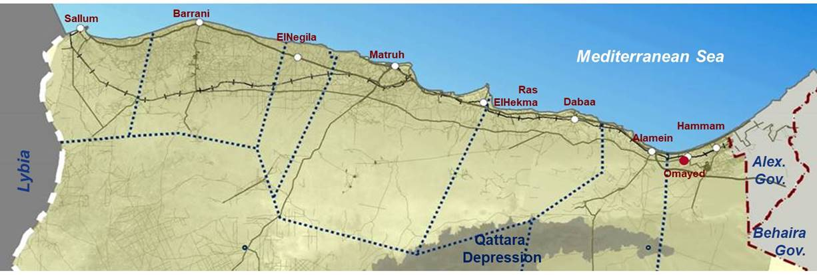

Source: Exec Sec

#### Relevance to the Health Situation

The project did definitely contribute favorably to the mine survivors’ health situation in the Matrouh Governorate. The fully functional Artificial Limb Center has already fitted 74 mine survivors with new limbs and helped another 97 with maintenance of the existing prosthesis. It has drastically improved the access to a prosthetic service of the mine survivors, who before had to travel to Alexandria or Cairo to be treated.

It is to be regretted that mine accident survivors with injuries others than lower limb amputations had to be referred to other centers. This referral system needs to be formalized as it is at present rather ad hoc.

The project was highly relevant in relation to directly assisting the achievement of the Millennium Development Goal (MDG), No. 4: *Reducing child mortality rates*. By adopted safe behavior through its child-based MRE training and child oriented MRE campaigns, by the removal of ERW before they can be detonated by curious children; and via improving access to first aid and medical care for survivors of mine accidents.

The Artificial Limb Center is accomplishing a very important role for mine victims from past accidents, but the number of injured people attended is meanwhile relatively small.

#### Relevance to the Economic Development

The project’s demining activities were relevant in particular to the urban and the country’s development of the New City Alamein. The project strongly supported the national plan to create infrastructural and economic conditions in new cities in desert areas to attract people from the Nile-valley and the Delta to enable their permanent residence in the North West Coast[3].

The project has been a timely intervention from the perspective of the Government of Egypt given its high relevance to the economic development of the Alamein and Hammam area in the North West Coast.

#### Coherence with EU Strategy to Egypt

The project was also relevant in strengthening the international cooperation between Egypt, the United Nations and the European Union. The project emphasized that the EU is a reliable cooperation partner and also accepts its responsibility for the historical legacy of mines and UXO laid in the WWII by providing assistance to remove the hazard. The joint EU and UN high profile commemoration of the 75th anniversary of the battle of Alamein together with the President of the Republic of Egyptian government on the 21st of October 2017 highlighted this commitment. There were also representatives from of the UK, Spain, New Zealand, Estonia, Greece, Cyprus, Croatia, and Estonia at this ceremony[4].

The project was also compatible with the EU Neighborhood Policy (ENP) on economic development for stabilization, the EU country strategy in Egypt, the United Nations Development Assistance Framework (UNDAF) for Egypt and with other EU policies and Member State Actions e.g. the Action Plan for International Cooperation of the Federal Republic of Germany. Commitment of Member States is clearly shown in their willingness to help Egypt with the remnants of WWII so that those living in rural areas improve their living standards.

### Relevance at Project Output Levels

Each of the project’s three outputs was pertinent to the needs of identified stakeholders in terms of Mine Action capacity building and fulfillment of its commitments. This finding emerges from the above overview of the project design and from interviews with stakeholders and beneficiaries, who unanimously viewed the project as responding to key needs and improving the efficiency and effectiveness of the overall Mine Action program in Egypt.

#### Capacity for Mine Clearance Operations

Strengthening the national capacity for Mine Action was essential for the need to have safe land for urban and infrastructural investment in the Alamein district; however output 1 was of less direct relevance to the aim of the project, due to the formulation of the output:

Referring to the project document, strengthening of the demining sector should also result in clearance activities to create secure conditions for agriculture or other land use for the directly affected Bedouin population. They make their living mainly by herding sheep in desert areas some of which are contaminated by mines and UXO. As the records of the past show, most of the accidents have happened in the rural areas of Barrani, Salloum and El Negila. (see Figure 1 for the districts and Figure 2 for accident statistic). In these western districts no mine clearance was done, neither for humanitarian purposes or to prepare safe agricultural land. In Dabaa, although the accident rate was fairly high, the clearance of the area for the future Nuclear Power Plant was focused on the potential production of electric energy and had little relevance to the livelihoods of rural population[5].

Figure 2: Mine Survivors and Location of Accident per District

Source: Exec Sec

The project was only indirectly relevant to the equally mentioned MDG No. 7: *Ensuring environmental sustainability*. The removal of landmine and UXO contamination may ultimately contribute to prevent 'overload' on other, uncontaminated agricultural and grazing areas; there is also the possibility of an adverse effect, as the use of mechanical demining techniques affects the thin fertile layer of the fragile desert vegetation.

#### Reintegration of Mine Victims

The project had relevance to mine survivors in both it met the needs of their health and economic situation. Mine victims receive a small pension from the Egyptian Government in the range of 30% to 60% of the official minimum salary; most lived mainly from support by other family members. Improving their financial independence through income generating activities was highly appropriate.

The project was also relevant to MDG No. 3: *Promoting gender equality and empowering women*. This was achieved by making sure that female beneficiaries are heard during community Mine Action data gathering. In the income generating planning process for mine survivors the project also had a strong gender oriented approach.

#### Development and Expansion of Mine Risk Education

The project was highly appropriate in that it raised the public awareness about the risk of mines or UXO related accidents. There had been in the past years repeated harmful ERW explosions triggered by intentional moving of or tampering with the explosive devices. This clearly demonstrated the need for a MRE and awareness campaign to ensure that there was the appropriate knowledge of the risk of ERW posed and safe behavior in an affected environment.

## Effectiveness

|  |
| --- |
| **Evaluation questions**  To what extent did the project achieve its planned objective and outcomes? |

Generally the project appeared to be effective in that most of the planned activities were implemented, results achieved and outcomes largely met. It certainly also helped enhance institutional capacities, through training and Training of Trainers (ToT). The Civil Society Organization side of the project also appeared to perform effectively. In terms of project management/institutional arrangements, the project did well with UNDP as the project holder and, on occasion, as the booster of the project:

The cooperation of the EUDEL with the UNDP Country office provided valuable input into the project. Effective, mutual support helped to overcome critical situations during the project’s duration.

The management for the implementation of demining could have act stronger and focused more with a clear and pro-active mandate in being the Executive Secretariat of the National Committee. Its role in promoting certain priorities for areas to be cleared of mines and UXO to the National Committee was not as robust as it should have been the case[6].

The overachieving of the target of output 1 by 137% (1.674sqkm cleared instead of 705,9sqkm) was an indication that the project had not put in place an appropriate planning and monitoring for the clearance activities. Although this achievement is a remarkable result, it shows that neither the MinIIC with its Exec Sec as the national implementing agency nor the Governorate of Matrouh nor UNDP as the project holder were involved in an in depth planning process for the removal of ERW in the North West Coast.

### Effectiveness at Project Output Levels

#### Capacity for Mine Clearance Operations

Notwithstanding the question of who does the planning and who decides on priorities, the project was decidedly effective in achieving output 1. By using demining equipment purchased with funds from the project the Corps of Military Engineers of the Egyptian army were able to remove mines and other ERW from more than 1.674sqkm: 1) 152sqkm of terrain of the New City of Alamein, 2) 46sqkm of the area reserved for the envisaged Nuclear Power Plant in Dabaa, 3) 164sqkm of agricultural land in the area near to the New City of Alamein, and 4) 1.312sqkm of terrain to enable petroleum explorations near Barrani.

The method of manual ERW removal used by the Egyptian Army appears to be effective eliminating the risk of mine accidents[7]. Although international studies found typical manual clearance rates of 50 – 100sqm/day/deminer[8], the Egyptian average of 625sqm/day/deminer appears to be realistic given the geographical conditions and the risk level in the contaminated areas: These being a flat terrain and a stony desert area with little vegetation. Furthermore the ERW contamination consist mainly of Anti-Tank mines with high metal content or full metal shells, which are known to be easy to detect. The local risk level is rather low with an average accident rate of 8 per year in an area of more than 2.000sqkm and the army has not report post-clearance accidents since the project started in 2009. The purchased demining equipment, detectors and demining machines were appropriate and used in an effective manner. Some sophisticated and highly expensive dual sensor detectors with Ground-Penetrating-Radar were used adequately in difficult terrain such as soil with high-metal content. The demining machines were used to prepare breaching lanes during the technical survey and occasionally for quality control. The external QA/QC team of the Exec Sec, which supervises the army’s clearance operations, performs according international standards.

* The target for output 1: *174.440acres (705,9sqkm) cleared*, was fully achieved

Despite this impressive clearance result the effective achievement of sub-output 1.1 “Strengthening of the information base” was in fact limited. The ultimate version of the Information Management System for Mine Action (IMSMA) was installed and the IT officer trained, but the database consist predominantly of mine victim data and records about MRE activities. The clearance of more than 1.600sqkm is recorded as only four demining projects in IMSMA with merely the data of the outer perimeter, the complete area cleared and the total number of ERW found. Maps of the cleared area are available but only as large scale image data[9]. This is unsuitable for IMSMA or drawing any conclusions about the operations. (see 2 examples of demining maps in Annex 10)

#### Reintegration of Mine Victims

**Physical rehabilitation:** The establishment of a center for artificial limbs was a highly effective measure to restore maximum physical functional ability to mine survivors with lower limb amputations. The center has recently started fitting above knee prosthesis, but is still in the experimental phase.

The empowering of local NGOs to assist the mine survivors to have better access to the center was also very effective.

* The target for this output: *Establishment of fully staffed and equipped medical facility catering to victims of mine accidents* was completely achieved.

**Economic rehabilitation:** The project was effective to the economic situation of only some of mine survivors.Interviews with project team members and NGOs made it clear that the output of economic reintegration of mine survivors was formulated in an over-ambitious manner with the target of having all mine victims engaged in income generating activities. This made the effective delivery difficult in the context of the project. The stated Indicator of: “Number of men and women beneficiaries receiving loans”; was also not suitable as the granting of loans were no longer seen by the EU as an appropriate measure and replaced with providing the beneficiaries with livestock.

Income generating activities started late, 215 of 740 of mine survivors were provided with livestock and this has proved effective. But many of the target beneficiaries (525) are still without support.

* The target for this output 2: *All mine victims, in the database, engaged in income generating activities,* was only achieved to 29%.

Figure 3: Mine survivors from the Database in Income Generating Activities

Source: Exec Sec

#### Development and Expansion of Mine Risk Education

Needs assessment and baseline evaluation increased the effectiveness of the MRE activities.

The design of target group oriented education methods, the high quality of the MRE material for children and the focusing on women as trainers assured real access to high risk groups like children in general and young boys especially.

The approach to women empowerment and the involvement of religious leaders for awareness-building was innovative within the Egyptian context and proved very successful.

The installation of the “180” telephone number by the MRE team under which civilians report findings of mines or UXO to the police before exploding, has proved very effective. It is one of the great achievements of the MRE campaigns that it has created a bond of trust between the Bedouin population and the local authorities. A part of the local population was and still is involved in the scrap metal business selling the metal shells and even its explosive content. Somebody who reported an ERW finding was running the risk of being suspected of illegal trade in explosive devices although the motive was to prevent harm to the family or the community. This former attitude of the police and also military appears to have changed and experience of swift reaction in removing the items has consolidated the people’s trust.

The exact number of ERW incidents is not known, the records are kept by the local police. What is missing is a thorough follow-up of all ERW incidents and accidents to get more details about the location of the site and finally feed the IMSMA database with geo-referenced records.

After having not a single accident in 2016, four accidents happened in 2017. Up to September 2018 two accidents were reported. As explained above the value of 4 accidents per year in 2017 can be regarded as an indicator of successful achievement of output 3, even if the exact target for the output 2: *Less than 3 new mine incidents annually,* has not been reachedfully.

## Efficiency

|  |
| --- |
| **Evaluation questions**  Have the project's funds been used appropriately, in an efficient manner? |
| To what extent have all planned outputs been delivered in a logical sequence and with high quality? |

The project represented good value for money, and obviously benefited from UNDP's institutional expertise, its access to outside experts/trainers, and its experience of other similar projects. In terms of project management/institutional arrangements for planning and supporting the delivery of activities, the project performed well.

The distribution of costs was in line with the project objectives and its logical framework but the budget lines were not well balanced between the first component: Strengthening the capacities for mine clearance and the components of Reintegration for mine survivors and Development and expansion of MRE.

Table 1: Budget and Estimated Expenditures

|  |  |  |  |
| --- | --- | --- | --- |
| **Output** | **Budget €** | **% of total** | **Utilization** |
| 1. Strengthened capacities for mine clearance | 3,460,097 | 73,5% | 99.6% |
| 2. Reintegration of mine survivors | 635,412 | 13,5% | 94.6% |
| 3. Development and expansion of MRE | 301,687 | 6,4% | 93.3% |
| GMS | 307.804 | 6,5% | 98.4% |
| **Total** | **4.705.000** | **100%** | **98.5%** |

Source: UNDP

The evaluation showed that the project enjoyed a high level of collaboration with other stakeholder stakeholders during the implementation phase. Sometimes decision processes in the MinIIC were slow and issues needed to be constantly raised to move things forward. In many cases this was only possible due to a strong and fruitful collaboration between UNDP and the Exec Sec. In terms of project management / institutional arrangements for delivery of activities, the project also performed well, although some activities were only achieved well towards the end of the project. Much of the credit for finding solutions to problems is due to the high level commitment and dedication of the project management by UNDP which was in most of these cases the driving force behind the project. It was clear that the Exec Sec team on an individual level had good organizational skills and flexibility, as well as an understanding of the substantial issues related to Mine Action.

The managerial capacity of the Exec Sec was not as strong as needed and resulted in delays in project implementation of some activities (i.e. Income generating). After the unfortunate death of the charismatic first Director in 2015, the position remained vacant for nearly two years. It was filled with the army liaison person, who also was the projects’ responsible for demining, as the acting head and later as a director. During the same period the female administrative head of the Exec Sec was promoted to a directorial position. Thus the Exec Sec had two directors, and although both positions were named “Director”, it was clear that the female director was regarded as less influential. Her role presented her with difficulties when it came to negotiating with male counterparts especially those in the army. (see organizational chart in Annex 11)

Partnership and collaboration with the NGOs was a positive and a successful dimension of this project. Notwithstanding the meager financial assistance provided to the four NGOs, they unequivocally mentioned the catalytic role of the project in their training and empowerment. The project supported them enabling them to stay in the field and to continue their work in the identification of mine survivors, and contributing to the rehabilitation of victims. (see cooperation and networking diagram in Annex 11)

### Efficiency at Project Output Levels

#### Capacity for Mine Clearance Operations

The reported removal of Landmines and UXO from 1.674sqkm of land by the Army Corps of Engineers was highly cost efficient. The EU contributed to the purchase of demining equipment and the development of capacity with €3.460.000. The Egyptian bodies who requested demining (MinHous, MinAgr, MinEl and the Petrol sector) covered the running costs of the operations. The MinDef funded the salary costs of that of approx. 300 deminers for the 42 months of the project period. The Egyptian army also contributed with existing equipment.

The quality of demining seems to be high; the external QA/QC team reported only 9 minor non-conformities in two of the four demining projects (the Nuclear Power plant site in Dabaa and the agriculture terrain in Alamein.)

The efficiency of demining by the Egyptian army is impressive in terms of reaction time and speed of operation. This prompt efficient action is more a question of available funds and good negotiation skills of their clients, often commercial petrol companies, and not as a response to a pressing humanitarian or development needs of the local authorities[10]. The decision of the Egyptian government to only allow the national army to do demining is comprehensible in the security context of the region. The Army Corps of Engineers seem to be a well-trained and -equipped unit, but the current institutional and management arrangement is not the solution to both the humanitarian ERW problem and returning safe land to communities. The Egyptian Military is in fact the sole arbitrators of when and where demining operations will take place. Unfortunately the Exec Sec does not play as active a role in proposals that will predominantly benefit the rural population to allow agricultural and animal husbandry activities.

The introduction of “180” as a dedicated telephone number to report findings of ERW by civilians has proved a real success. Interviewed beneficiaries and the Army Corps of Engineers confirmed that these items were removed by an Army team within 48 hours. This prompt action is a very efficient way of reducing the risk of future ERW related accident.

Unfortunately these findings are not recorded in the IMSMA database, although Spot-Clearance data can be recorded in IMSMA. Even if the military is reluctant to hand over clearance data, a local field officer from the project should record the coordinates of the findings from a nearby safe point; thus gradually building up geo-referenced information of ERW findings.

#### Reintegration of Mine Victims

**Physical rehabilitation:** The establishment of the Artificial Limb Center was done in an economically resourceful manner. The involvement of local personnel and the inexpensive support by experienced prosthetic technicians from the military El Agouza Rehabilitation Center in Cairo has proved to be very efficient. The center is a spacious construction, appropriately equipped and with well-trained technical staff. The quality of the produced and fitted artificial limbs is high; the center is using on occasion superior Otto-Bock-components imported from Germany, which might not be in the future the most cost-effective approach. All mine survivors interviewed were very satisfied with their new limbs. Some of the older victims already had prosthesis from the El Agouza center and reported that the quality of those provided by the Matrouh Center is absolutely comparable.

**Economic rehabilitation:** The leading idea of an Agro-Industrial center which should employ mine survivors was not regarded feasible within the project’s duration; the handover of livestock to mine survivors or their relatives was then implemented as a substitute income generating measure. The implementation of these activities was delayed because of logistical difficulties, until the end of the 6 months extension period of the project. The available funds were not sufficient to help all mine survivors so exclusion criteria was adopted to better serve those most in need which made the use of funds for the economic rehabilitation less effective.

The quality of the income generating strategy produced positive results. Many of the interviewed mine survivors reported 6 months after the start of the measure an increase in household income.

**Strengthening of local NGOs:** The involvement of local NGOs was fruitful; NGOs were also instrumental in collecting and recording high quality reliable mine survivor data.

#### Development and Expansion of Mine Risk Education

**Expansion of MRE:** 22 Training of Trainer sessions with 768 (562m, 206f) participants have been held and more than 92.000 persons have been reached by MRE campaigns. The involvement of religious entities and mosques in the MRE was an innovative and very efficient measure in influencing and teaching the male population which cannot easily be reached through formal educational channels.

**Development of MRE:** Local NGOs have done sterling work in mine awareness and advocacy activities. Most of their work isdone by volunteers. This is surely a cost-efficient but not necessarily the most effective way of tackling these activities as the management of voluntary work can be problematic.

The quality of the MRE training was high, so was the MRE material used in the educational sessions for the trainers and for the final beneficiaries. Especially the MRE methods and the material for children was very well developed and adapted to children’s perceptions and experience.

## Impact

|  |
| --- |
| **Evaluation questions**  What are the main impacts/effects of the project in the field?  Are they consistent with was foreseen at the beginning of the project? |
| At the desegregated level of each component, which are the main results and which of them can be especially highlighted?  Have they been consistent with the objectives of the project? (With an especial emphasis on the demining component) |

It is too early to assess the final impact of this project given the recent cessation of project activities. Impacts are beyond the immediate outputs and relate to wider long term outcomes. They depend greatly on how the National Government and the involved Ministries make use of the cleared land, the installed medical facility and how the affected population’s security situation and everyday living conditions improve.

#### Capacity for Mine Clearance Operations

The evaluation found positive outcomes in terms of use of cleared land for the important urbanization project of New City Alamein. The evaluator also met farmers who recently migrated from the Nile-delta to formerly ERW suspected areas in the Alamein desert and immediately started agricultural activities after the clearance finished. The Government additionally finished the El Hammam channel, making now the irrigation of the cleared land possible.

All this happened in the Alamein zone, the upcoming “hot spot” for urban and economic development, which is of high interest to big investors, the owner of large areas of desert terrain and the constructor of some of the biggest hotels and housing projects in New City Alamein. Those who are investors and have a stake in future development have obviously also influenced the agricultural areas to be demined. E.g. the demining map of the agricultural land in Alamein shows the projected location of two large poultry farms, reflecting vested interests in the area chosen for demining (see Annex 10). The improved economic development through demining of the urbanization area is without doubt a positive outcome although this was not the primary intention of the project.

It is to be hoped that the local rural population, which had suffered most from mines and UXO impact in the past, will benefit in the long run from new jobs and small business opportunities in the new city. Interviewees expressed their concerns that they might lose their traditionally grazing and agricultural rights when the land is given to the new legal owners.

The demining supported by the EU has not yet produced a visible or positive impact for the specific target group of mine survivors or the rural Bedouin community in general[11].

The outcome of the project’s demining component is after all an effective and nationally owned Mine Action program.

#### Reintegration of Mine Victims

The project has achieved the wider outcome that target communities have better access to basic services and a slightly higher income.

The evaluation found enhancement of CSO Mine Action capacity and a stronger commitment by the local authorities to better the living conditions of mine survivors and to find solution to ERW problems. The evaluation also found much improvement in terms of staff skills and competences. This could mainly be observed in the Victim Assistance and MRE component.

The outcomes from the new established Artificial Limb Center were inspiring and very evident. Not only is it a reference point for mine survivors in need of a new limb, it is also a role model for a locally managed, high quality and a gender balanced production facility with an approach to include mine survivors in all levels of the enterprise. The impact of this center could go beyond its present role; especially if it manages a more diverse production facility after the actual mine survivors are mostly assisted.

The income generating activities have not yet produced a sufficiently satisfying impact for the reintegration of mine survivors: the number of people benefitting from this component is very small.

The final activities were implemented late, many of the mine survivors entered into the income generating program only in April 2018, the last month of the project. Still at the time of evaluation most of the interviewed mine survivors reported a positive impact of the project activities on their everyday life. Some beneficiaries had already successfully increased business opportunities and are generating income through livestock production. They were able to sell some livestock and improve the size of their herds and with the profit had money left over for day to day expenses. Some are still struggling to generate an adequate income, others are not yet included in this program. Consequently there is still much room for improvement.

#### Development and Expansion of Mine Risk Education

The project has achieved the wider outcome of an increased public awareness and safer behavior in high risk groups. The impact is also visible: The number of mine or UXO accidents is going down, which is undoubtedly a result of the project’s MRE activities. There was no ERW clearance done in the high risk area, which would explain the reduction of accidents. The impact of having fewer victims can be observed over time after the phase I of the project started in 2007. The yearly variation of the current accident rate has no statistical significance. It is important is that the figures remained low and are declining steadily. This is an excellent result of the project.

Figure 4: Number of Yearly Mine/UXO Accidents

Source: UNDP/Exec Sec reports

## Sustainability

|  |
| --- |
| **Evaluation questions**  To what extent are the project results (impact if any, and outcomes) likely to continue after the project ends? |
| In particular what are the main results in terms of institutional strengthening and capacity building? In case some constraints still prevail, how could they be circumvented? |

The evaluation assessed whether the outputs of the project are likely to continue after its termination, institutionally, financially and in relation to partnerships and cooperation.

As in the case of impact, there are elements of sustainability that can be identified. They include the adoption of policies and practice consistent with international Mine Action guidelines, the acquisition of new skills by government and military officials, and the reinforcement of the key civil society platform on Mine Action.

In relation to financial sustainability, it is clear that for a critical mass of educators, and trainees to be developed and retrained, a project of this size can only set the initial stage. While it is scaling up; replication and continuation of some of the key activities need to be supported by renewed funding. Despite some agreements with certain Ministries, school and health authorities, most officials and all beneficiaries admitted that they are counting on a follow-up project to continue the activities of the Executive Secretariat.

Strong political will and further convincing results need to be demonstrated by the Exec Sec to the national decision makers in order to assure they allocate the needed funds to invest in and maintain Mine Action activities.

### Sustainability at Project Output Levels

#### Capacity for Mine Clearance Operations

The outcome of the project’s demining component is sustainable in the sense that, with help of the project, the Army Corps of Engineers is well organized, trained and well equipped. There is no doubt that this corps is more than able to continue with demining operations.

Priority setting for demining activities is the preserve of the army, sustainability of mine clearance operations is guaranteed as long as the clients (Ministries, investors, petrol companies) have an interest in demining and funds are available. The rationale behind the EU support to Mine Action in Egypt was to remove ERW contamination to assist economic development within affected communities. The present priorization system of demining has little positive impact on the local rural population and therefore sustainability is questionable.

The MinIIC announced in January 2017 the launch of the Egyptian National Center for Mine Action and Sustainable Development (ENCMSD)[12], which would be the sole authorized nation-wide representative for the Egyptian side concerning coordination of demining in areas containing ERW and that the Ministry of Defense would undertake the actual clearance and inspection tasks of landmines and explosives. While this would be a decisive step for the sustainability of the Mine Action program, the center has not yet been established and there is no sign from the MinIIC that this will happen soon.

Currently planning, operating, monitoring and reporting of demining seem to be completely in the hands of the Egyptian Military. The Executive Secretariat lacks detailed information about the demined terrain, the clearance procedure and the found items. Without this information it will also be difficult for the ENCMSD to build necessary experience to plan and sustain a program for demining in Egypt.

#### Reintegration of Mine Victims

The future of the Artificial Limbs Center is currently uncertain, at time of the evaluation the contracts of all staff were about to expire within a month time. The MinIIC stated it has secured funds for another 6 months. A study about different options for the future of the Artificial Limbs Center involving other Ministries or entities (Health, Social Solidarity, Governorate of Matrouh or the private sector) was done by an external consultant and was handed over to the MinIIC some months ago. A decision on what options would be the best to sustain the production of artificial limb is pending.

Within the next year, all mine survivors with lower limb and most likely also those with above knee amputations will have been assisted; the center needs a long term plan about what to do with the facilities and with the staff after no more artificial limbs are needed for the present mine survivors. The installation could be used for manufacturing other kind of products, more commercially oriented and no longer related to Mine Victims.

Training and empowering of NGOs in the later part of the project has enabled four NGOs to elaborate their own projects to assist mine survivors. This is offers an opportunity to engage the civil society sector more actively in possible continuation of the Victim Assistance part of the project,

The remaining income generating activities for registered mine survivors are currently funded through other donors. The Exec Sec is confident that they will be able to support all victims in the database until April 2019 when current funds end. Supporting new victims will be manageable as numbers are expected to be low.

#### Development and Expansion of Mine Risk Education

Like all projects that put a strong emphasis on training, the first and most essential element of sustainability of the MRE component is that acquired skills and expertise remain with those who participated in training, and as a result enhance the capacity of the institutions to which the participants belong. Representatives of beneficiary NGOs have also acknowledged to the evaluator the obvious benefits of training to their staff and institutions.

There is the clear expectation of nearly all interviewed beneficiaries, local authorities and project officials that Mine Risk Education should continue. The project has achieved a common understanding that Mine Risk Education is the key to preventing future accidents. Existing strong collaboration with state school might lead in the future to the integration of MRE in the official school syllabus.

## Gender

|  |
| --- |
| **Evaluation questions**  To what extent were gender considerations mainstreamed in the design and implementation of the project |

The design took an approach to support mainstream gender considerations in the project by commissioning a rapid mini gender analysis and to get a firsthand impression of the effectiveness of the equity and mainstreaming measures implemented on the ground. The evaluation showed that the results of this analysis had an impact on the project design and implementation.

The project had a clear gender strategy and benefitted from UNDP’s expertise on this. In all positions, including the technical staff of the Artificial Limb Center, women are equally represented. The project also capitalized on the key role Bedouin women play in education of children.

Women have no share in the demining component; this is understandable as demining operations are the preserve of the Military.

Gender issues were irrelevant to priority setting of the clearance operation, but this is also true of other societal groups and not specifically women.

## Lessons Learned

|  |
| --- |
| **Evaluation questions**  Which are the main lessons learnt of the project? |
| Would it possible to identify best practices valuable from communication and dissemination? |
| To what extent added the EU funded project benefits to what would have resulted from Member States' interventions only? |

A number of lessons could be learnt from the implementation of this project over the last three years:

The project design and intervention logic should clearly state the group of direct beneficiaries for each and every output.

Misconceptions in priority settings in terms of target group and target area as with the selection of the areas for demining should be avoided.

One of the key lessons that could be learnt from this project is the importance of a good relationship between the UNDP project management and the Egyptian implementing partners. One important factor underpinning this excellent relationship was the high level of the international expertise of UNDP in administrative and financial management.

Another lesson is that training, capacity interventions and support services to beneficiaries, however successful initially, need to be formalized and integrated into an institutional framework of activities. This approach would ensure that the mine survivor support and Mine Risk Education to be sustainable in the long run.

# Conclusions and Recommendations

## 3.1 Conclusions

The project was highly relevant in that it was based on a sound analysis of the situation of the Mines and UXO, which is problematic on Egypt’s North West Coast, and addressed needs that were clearly in line with the country’s development plan for the region. The approach was appropriate as it addressed identified needs. The approach based on three outputs was sound, with focus on demining; Victim Assistance; and Mine Risk Education. The project should be considered value for money.

However, some of the outputs lacked a clear vision of the desired outcomes leading to a project design that was oriented to the achievement of results which did not completely comply with the original concept.

#### Capacity for Mine Clearance Operations

The project favored demining for infrastructural development and not humanitarian demining. Demining for development is a reasonable undertaking as such and it proved successful in the current context. It allowed the safe expansion of the New City Alamein construction site with surrounding agricultural areas for the future food supply of the New City. It also helped preparing safe ground for the planned Nuclear Power Plant at the North West Coast and it enabled Petrol Companies to safely explore possible natural oil and gas reserves in the Western Desert. The project did not put any emphasis on ERW clearance for humanitarian reasons although the high number of mine and UXO accidents in the North West Coast has been one of the key arguments for justifying the Egyptian Mine Action efforts. The districts west of Marsa Matrouh, where most accidents happened in the past were not included in the demining activities. The demining for investment and development had all taken place in the Alamein area with much lower incidence of mine accidents.

The Executive Secretariat acts well as UNDP’s implementer of the Victim Assistance and MRE component of the project with highly committed staff and good managerial capabilities. The Exec Sec’s part is rather weak when it comes to the demining component. The Exec Sec and apparently also the Ministry of Cooperation does not play a significant role in priority setting of areas to be cleared. It also has limited possibilities to supervise the clearance procedure of the Egyptian Military and to guarantee the quality of the product.

The Exec Sec does not receive enough detailed information from the Military about the nature of the ERW contamination after the clearance procedure and is therefore not in a position to build up a workable mine clearance data base. The Egyptian Information Management System for Mine Action (IMSMA) focuses too much on mine victims and on MRE data, and is not the core planning and management tool for all demining operations it should be.

According to observed demonstrations, the manual demining method of the Egyptian Army appears to be appropriate for the existing ERW contaminated and risk level (although the mission was not able to verify the presented performance in situ). Manual and mechanical demining methods seem to be applied well; an internal QA procedure is in place. The Exec Sec does external QA but with a very small team which does not seem to be able to overall verify the quality of the demining in the entire huge cleared area.

The Egyptian Army does the planning and execution of clearance with minimal reporting to the Executive Secretariat, which basically receives the information where the demining will take place and a final declaration stating that the area is cleared and how many items have been found. For the Exec Sec and even more so for a future Egyptian National Center for Mine Action it would be ideal if they would deliver input on the areas to be demined and receive detailed clearance reports to draw their own conclusions for further actions. This conundrum can only be resolved by the Egyptian authorities themselves.

#### Reintegration of Mine Victims

The fully functional Artificial Limb Center in Marsa Matrouh is the highlight of the project. It has improved considerably the access to a prosthetic health service of the mine survivors and has extremely committed and well trained staff. It also included in aspects of its work a holistic gender approach.

The present lack of commitment by the Egyptian Government to the center throws a shadow over its future. Its continuing successful work is in doubt due to an unclear funding situation leaving staff and patients in limbo. The sustainability of the Artificial Limb Center in Marsa Matrouh is not yet guaranteed, this should be of major concern of the Exec Sec and the Ministry of Cooperation. The center has sufficient human and technical capacities to also assist other people with disabilities not only Mine Survivors. With additional training and some new equipment the facilities could moreover be used to produce orthotics for patients with walking impairments after injuries or limb malposition.

Income generating activities for mine survivors were severely under budgeted, they started late and covered only less than a third of the registered mine survivors, but nevertheless they were successful. Livestock distribution turned out to be a suitable and locally very appropriated approach to generate income for mine survivor’s families. The budget restrictions forced the project to concentrate these measures on households most in needs, i.e. elderly mine survivors or households lead by the widow of the victim who sometimes had difficulties to increase their net income substantially. Households led by younger male mine survivors seem to be better able to start a productive business with the livestock received.

#### Development and Expansion of Mine Risk Education

The project has achieved a common understanding that Mine Risk Education is the key to preventing future accidents. A significant reduction of mine or UXO accidents in the North West Coast during the past years demonstrates the positive impact of the MRE activities. There is an increased public awareness and apparently safer behavior in high risk groups. The male Bedouin population, who was involved in scrap metal collection and moved or tampered with ammunition shells, is now more reluctant going back to this business. Young boys constitute still a high risk group for suffering mine or UXO accidents. The evaluator met a 12 year old boy who just had lost his right hand after tampering with an UXO in a remote desert area. In this respect some MRE educators express the need for more activities in rural areas and found there was too much focus on the urban population.

In terms of sustainability of MRE activities there is the clear expectation of nearly all interviewed beneficiaries, local authorities and project officials that Mine Risk Education will continue.

## 3.2 Recommendations

#### The strengthening of the Executive Secretariat for the Demining and Development of the North West Coast represented a significant step forward in addressing the mine and explosive remnants of war (ERW) issue in Egypt and in addressing the economic marginalization of the North West Coast region. The work of the Secretariat was guided by the larger development plan for the North West Coast. The plan represents an ambitious scheme of macro and micro development objectives and projects for the region. One of the key challenges emphasized in this context was that most of these projects will require demining support before any development activity can be safely undertaken. In this respect the project has achieved impressive results. More than 1.600 sqkm of formerly ERW contaminated land are meanwhile accessible for infrastructural and agricultural development and natural resources exploration. The beginning of long-term influence of this measure is already visible; large investments have been made for the New City Alamein, the first phase of its construction is underway, some farmers have started cultivating the cleared land supporting the food supply of Alamein.

#### Capacity for Mine Clearance Operations

While much progress has been made, the evaluator identified the need for additional consolidation of the relationship between the Egyptian Army and the Executive Secretariat so an acceptable level of transparency could be achieved. Instead of merely facilitating the purchase of equipment for demining and some random QA and QC, the Exec Sec should be much more involved in the prioritization of the areas to be cleared and not leave the decision only to the Egyptian Army, who does clearance predominantly where and when funds are available. The Executive Secretariat should present detailed demining proposals to the National Committee with clear targets in terms of size, benefitting population, expected outcomes and long term impact; and the inter-ministerial National Demining Committee should meet regularly to discuss and decide on the acceptability of these proposals.

Whereas the current demining activities focus on large investment oriented development areas there is a need if a future project is to achieve excellence that there is better communication between the Exec Sec and the local communities that clearance better reflect the needs of the rural population. Information should be collected at community level identifying its land clearance needs with the active participation of all groups and members of the community, ensuring women have a voice and using rapid rural appraisal techniques. This information should be channeled via the appropriate mechanisms of the Governorates to both the Exec Sec and those responsible for demining so this clearance is in the interests of the local population.

The Executive Secretariat should commission a Non-Technical Survey of the areas in question with involvement of civil society to identify suspected hazardous areas and its priorities for clearance. The Army Corps of Engineers might consider establishing a community liaison structure.

Donor contributions should focus on enabling this communication between the Exec Sec and the local communities to ascertain priority areas for humanitarian demining. Donors might consider covering operating cost for the demining of a limited number of identified and well-defined suspected hazardous areas with a recognized humanitarian impact. The number of mine or UXO accidents in the North West Coast is low and suspected hazardous areas of priority are most likely few and concentrated to the districts west of Marsa Matrouh. The Egyptian army is sufficiently equipped and trained to accomplish this task with its own means, there seems to be no need to improve its equipment with donor funds. The operating costs of investment-oriented projects should continue to be financed by client funds.

The Executive Secretariat should demand more detailed information about the already cleared land and the explosive items found to gain technical experience for planning further actions. Upgrading of skills in recognition, mapping and recording of ERW incidents should be a priority so that there is full compliance with international standards and IMSMA requirements and that the data can be used effectively. The Exec Sec and even more a future Egyptian National Center for Mine Action should use IMSMA as their key planning and prioritizing tool to deliver convincing input to the National Committee on the areas to be demined.

#### Reintegration of Mine Victims

As the Artificial Limb Center is the key achievement for an effective and efficient physical rehabilitation of mine survivors, the Egyptian Government should as soon as possible decide on the future of this center. The project had commissioned a study on imminent development and needed changes in the institutional and managerial structure of the Artificial Limb Center containing five elaborated proposals on how to continue. A final decision on one of the proposals is of highest priority.

The Artificial Limb Center should by mid-2019 develop a strategy for a long term usage of the facilities. The majority of the mine survivors will be fitted by then and plans need to be at hand what to do with the facilities in the long run. The center should pro-actively explore possibilities to expand the production after 2019 to orthotics and/or to the manufacture of commercial products that could be manufactured by current employees using the existing tools and machines. Donors should consider supporting the center as long as mine survivors or other persons with physical impairments are assisted.

To enhance the effectiveness of the income generating activities knowledge and skills exchange between experienced and less capable beneficiaries should be organized. Donors should consider its support.

#### Development and Expansion of Mine Risk Education

There are no doubts that some areas of the North West Coast will also in the future continue to be sparsely contaminated with ERW. There will remain a certain threat to the rural Bedouin population especially for those male adults who continue to look for scrap metal and for young boys who tend to underestimate the danger and try to move the items or tamper with it. This constitutes a need for a long-term institutionally based Mine Risk Education in the North West Coast.

The Executive Secretary should develop together with local authorities a plan for locally based and financed sustainable Mine Risk Education. Existing strong collaboration with state schools should be used to integrate MRE in the official school syllabus.

The Executive Secretary should consider funding a member of one of the existing NGOs whose role is to support and offer ongoing training to those involved in MRE. The training should involve prioritizing where MRE is needed and evaluation of effectiveness.

Donors should consider funding the establishing of this institutional MRE structure.

Annexes

## Annex 1: Terms of Reference

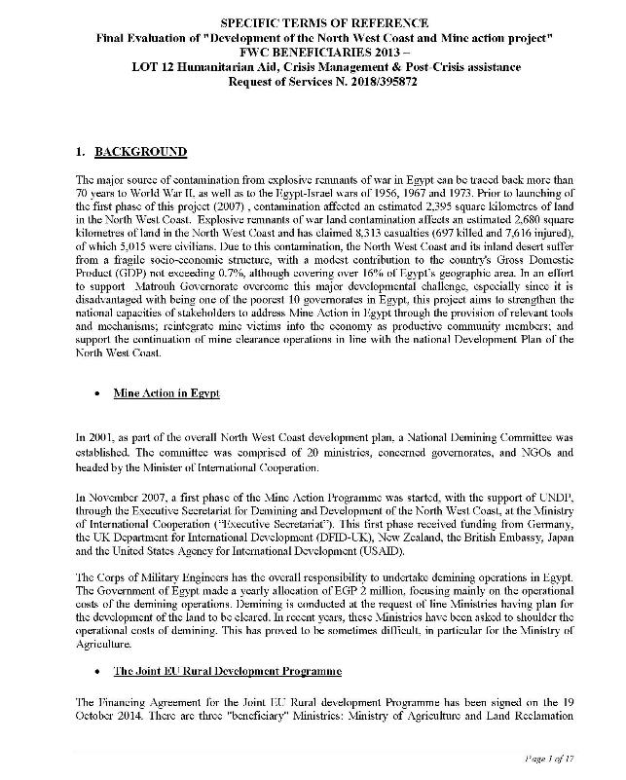

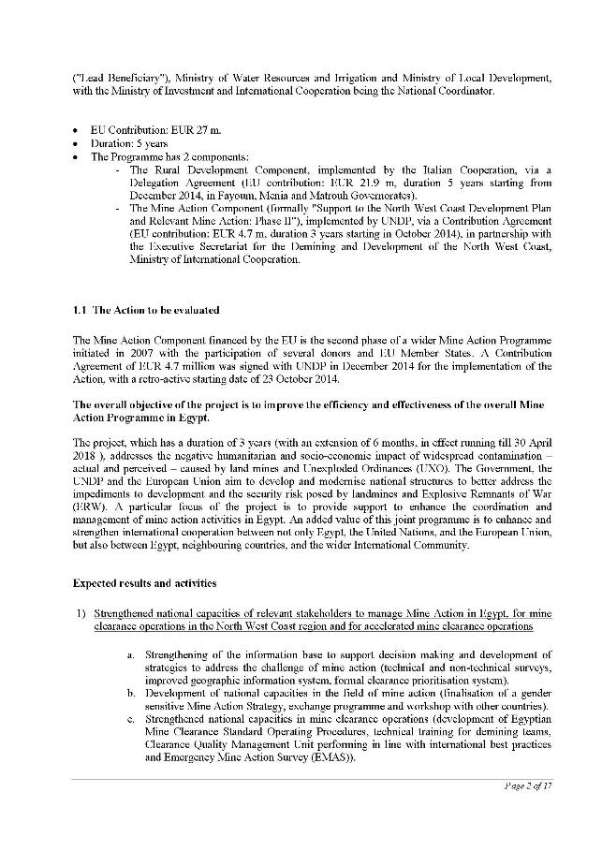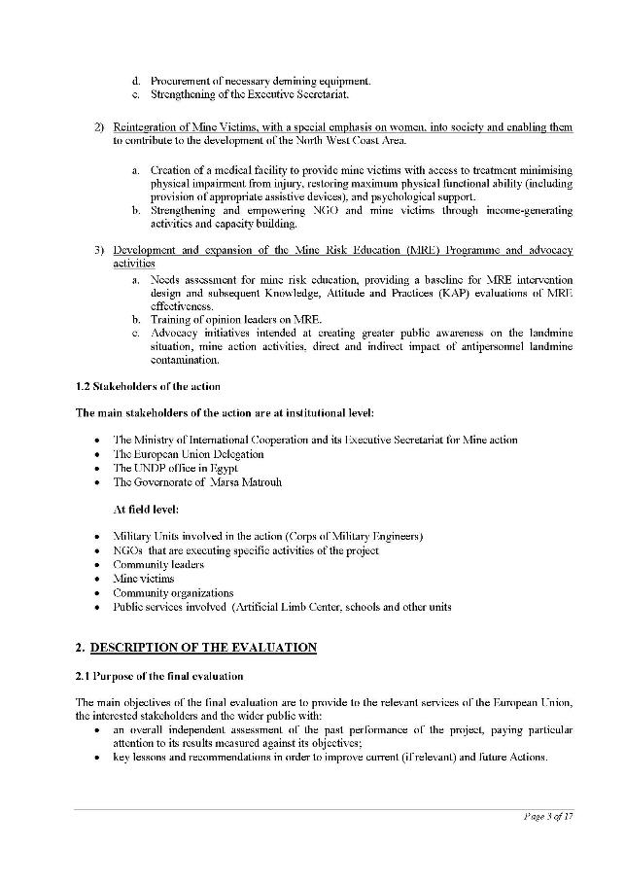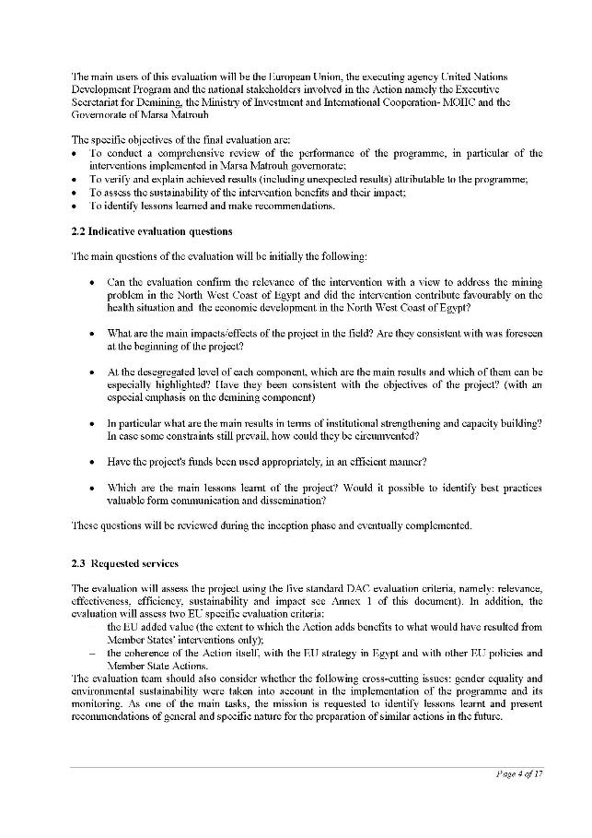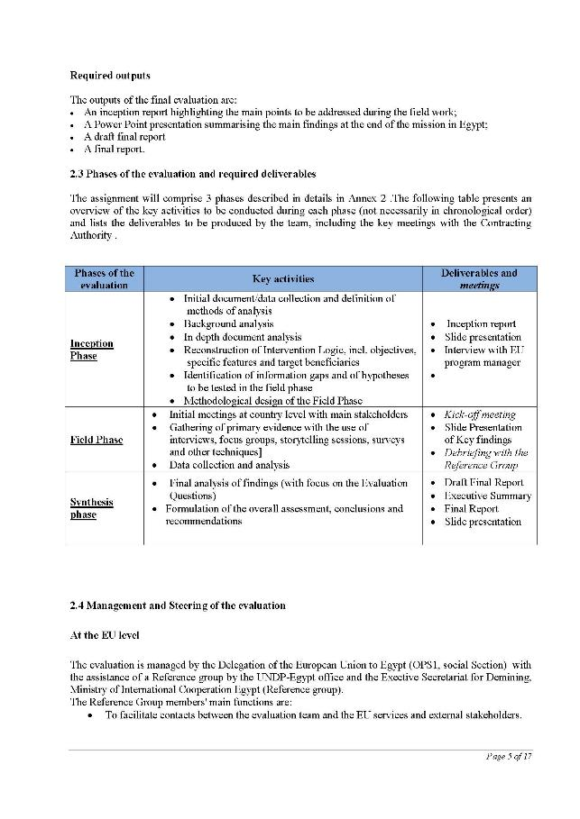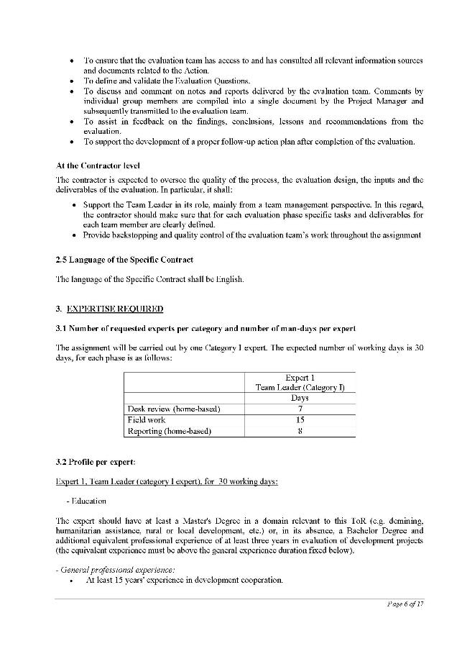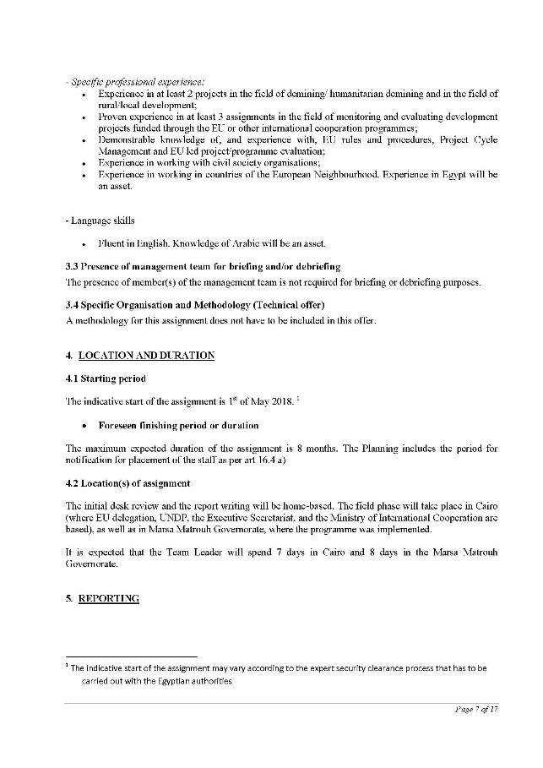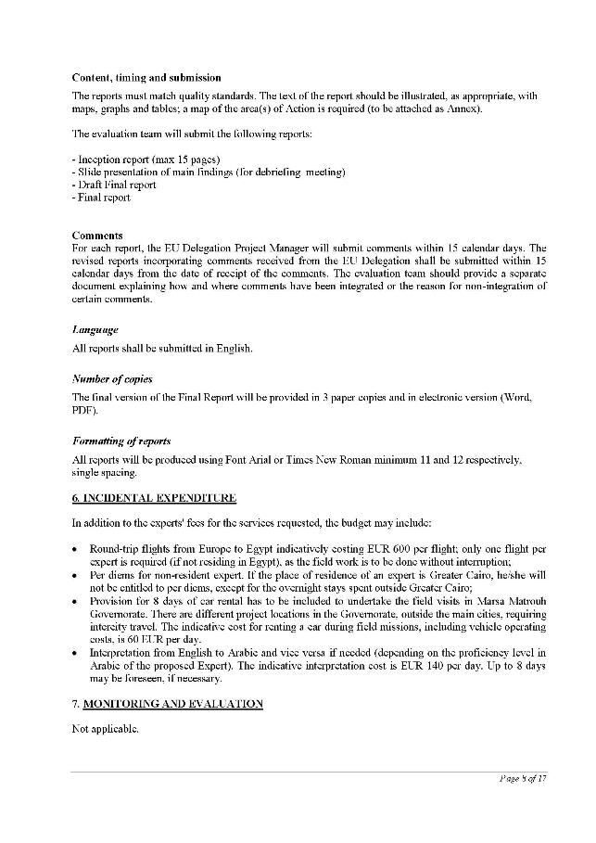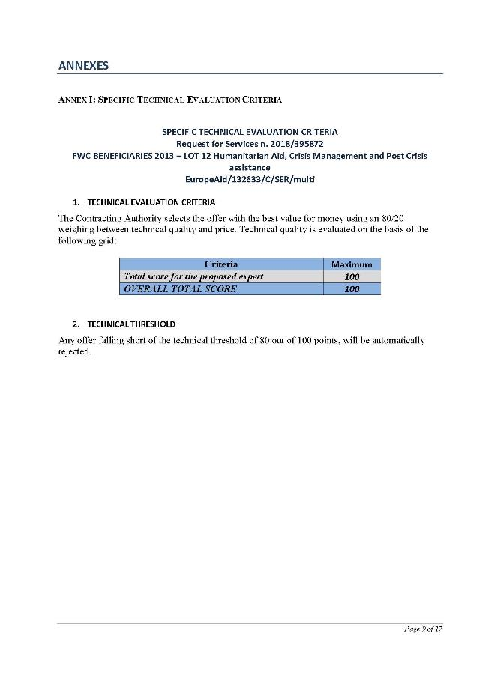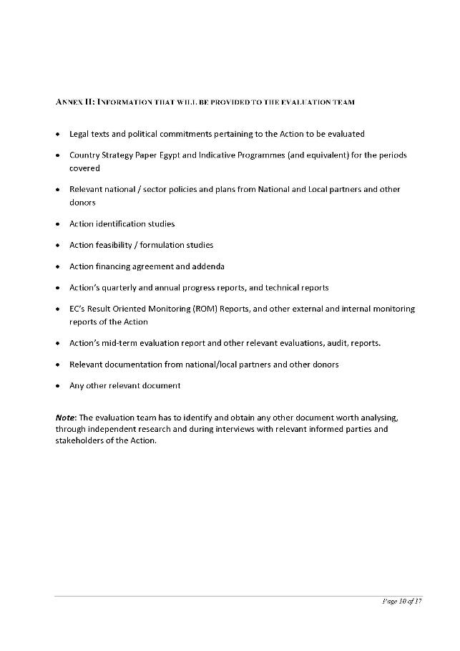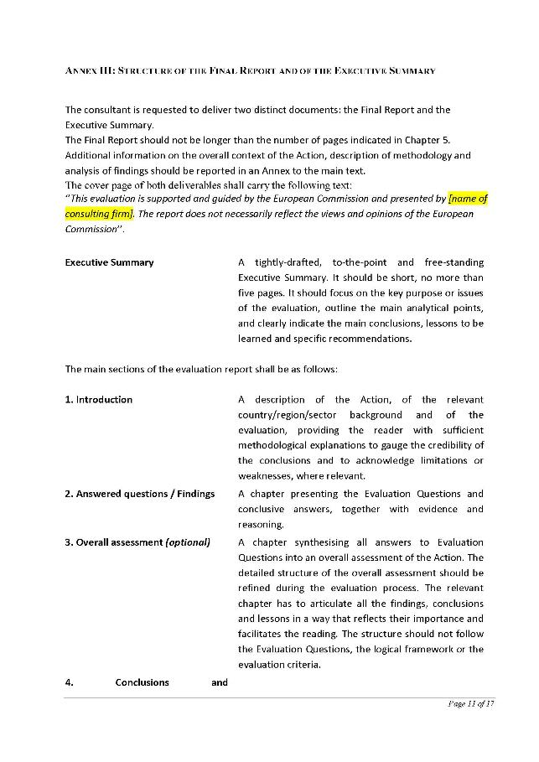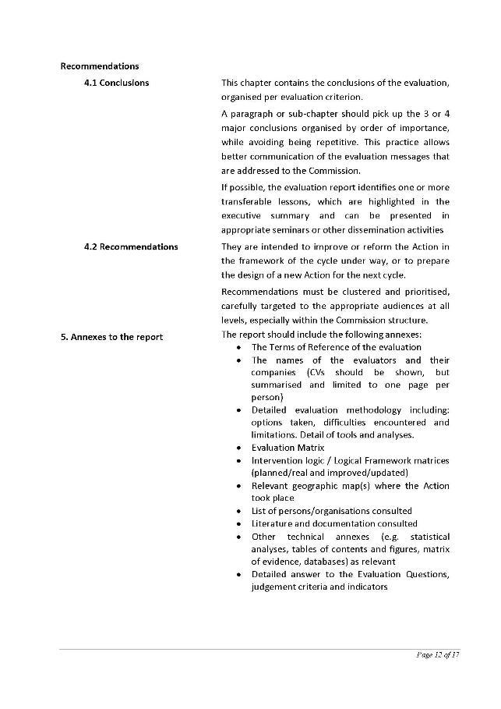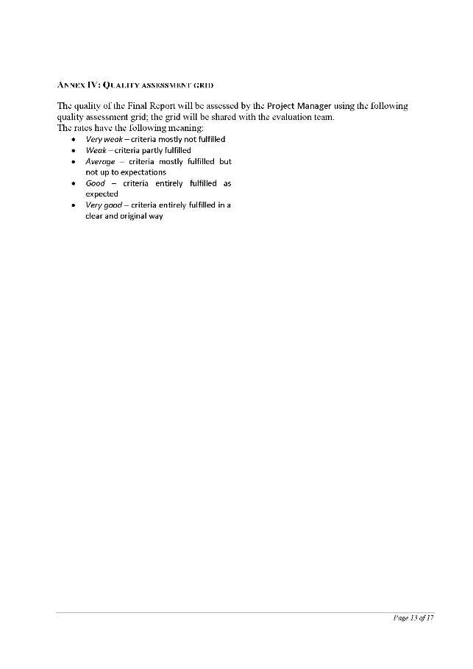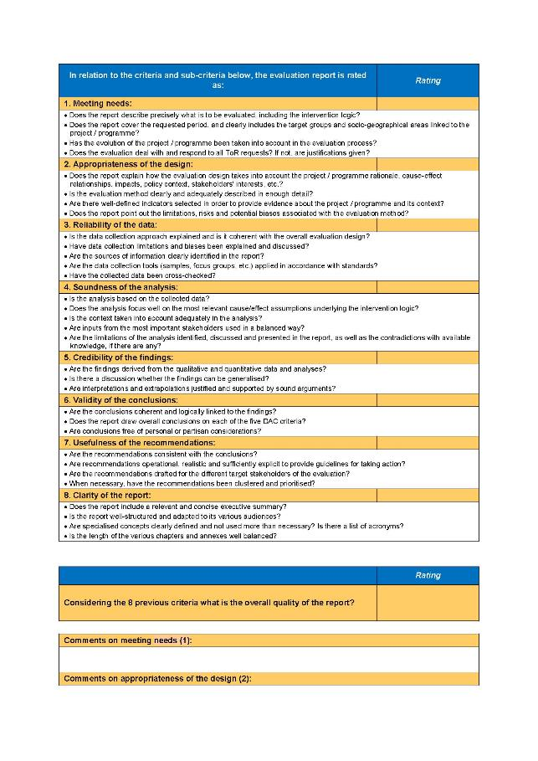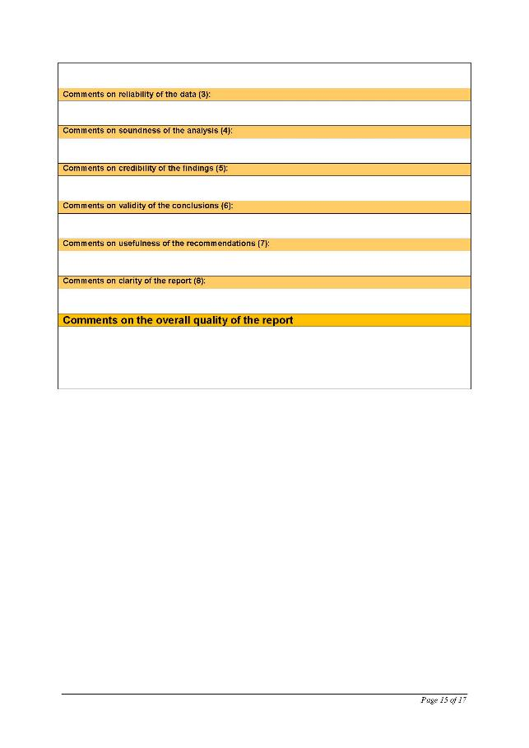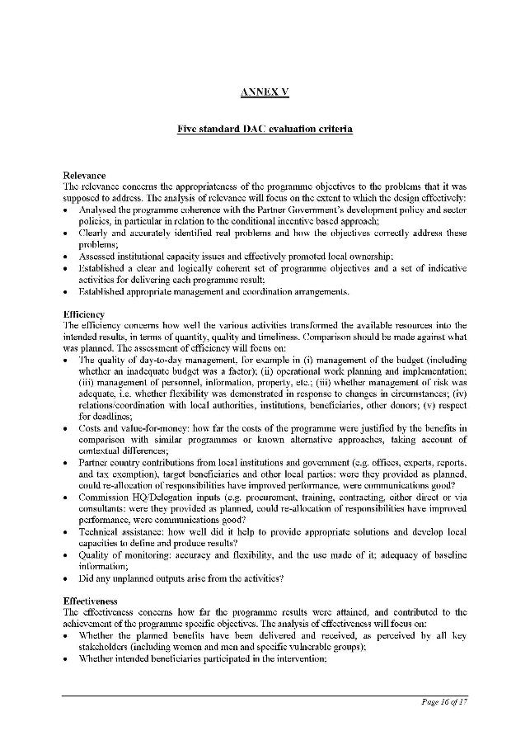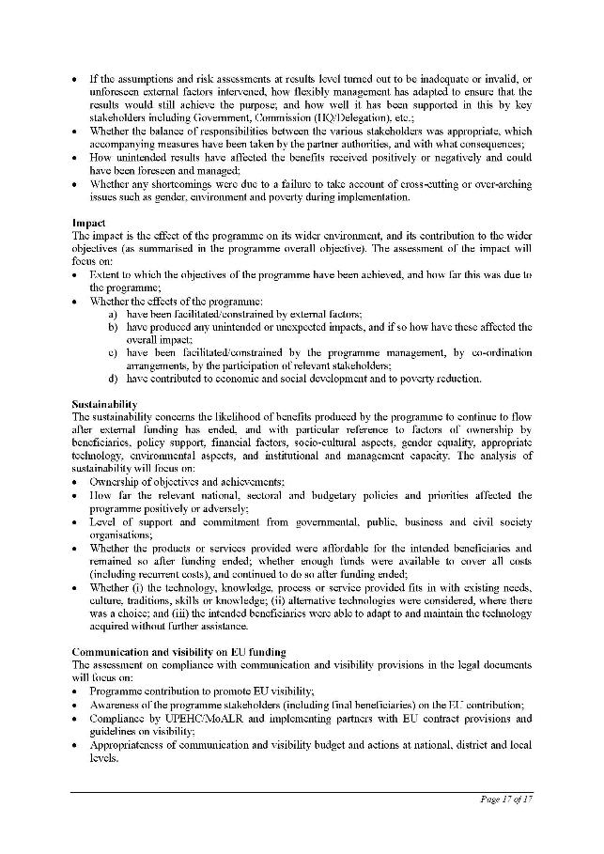

## Annex 2: Evaluator and Company

**Role in the project: Team Leader**

**Category: Mine Action Expert**

**Staff of: Particip GmbH**

1. **Family name: TIETZE**
2. **First names: Ulrich, Werner**
3. **Date of birth:** 22th August 1948
4. **Passport holder:** Germany
5. **Civil status:** married
6. **Permanent residence** Selkestrasse 28, D-12051 Berlin, Germany, [utietze@lycos.com](mailto:utietze@lycos.com),
7. **Education:**

|  |  |
| --- | --- |
| **Institution (date from – date to)** | **Degree(s) or Diploma(s) obtained:** |
| Free University, Berlin / Germany, 1971 to 1975 | Diploma Physicist, Specialization in Biomedical Engineering. |
| Rheinische Friedrich Wilhelms University Bonn / Germany, 1968 to 1971 | Baccalaureate in Physics, Mathematics and Chemistry |

1. **Language skills:** indicate competence on a scale of 1 to 5 (1: excellent; 5: basic)

|  |  |  |  |
| --- | --- | --- | --- |
| **Language** | **Reading** | **Speaking** | **Writing** |
| German | Mother tongue |  |  |
| **English** | **1** | **1** | **1** |
| Spanish | 1 | 1 | 1 |
| Portuguese | 1 | 2 | 2 |
| French | 4 | 5 | 5 |
| **Arabic** | **5** | **5** | **5** |

1. **Membership of professional bodies:** n/a
2. **Other skills:** Experienced in evaluation and review techniques (**theory of change**, critical path method, **Project Cycle Management,** Log Frame, Capacity Works).

* Professional experience in socio-economic and **impact studies** and statistical analysis.
* Experienced in specialized database and GIS software (**IMSMA**, ArcView, ExpertGPS).

1. **Present position:** Independent Consultant **with focus on Mine Action,** post-crisis assistance and **rural development**.
2. **Years with the present employer:** 9 years as independent consultant
3. **Key qualifications:** (relevant to the assignment):

Mr. Ulrich Tietze has 20 years of professional experience in **management and/or evaluation** of **demining, humanitarian aid** and **development** p**rojects** incountries of the **Middle East,** Asia, Latin America, and Africa.

* **Experience in projects in the field of demining/ humanitarian demining and in the field of rural/local development**:
* Manager of a **Battle Area Clearance** and **humanitarian demining** program In Libya.
* Director of a **Mine Victim rehabilitation center** in Angola.
* Coordinator of the **Landmine Impact Survey** as a base **of rural development i**n Angola**.**
* **Assignments in the field of monitoring and evaluating development projects funded through the EU or other international cooperation programs:**
* **Evaluating** the capacities and competence of the **EU and US (PM/WRA)** supported **Quality Management system** of the national humanitarian **demining** program in Colombia;
* **Evaluating** the **US (PM/WRA)** funded **Mine Risk Education** program and identifying specific high risk groups to more effective implementation of PM/WRA inputs in Laos;
* **Knowledge of, and experience with, EU rules and procedures, Project Cycle Management and EU led project/program evaluation**
* Monitoring in **Egypt** and South Sudan.
* **Experience in working in countries of the European Neighborhood.**
* UNDP Chief Technical Advisor in **Egypt** to thenational authorities on developing a Mine Action strategy as an integral part of Egypt’s North West Coast development program.
* Program Manager in **Libya** of a Danish Church Aid demining program.

## Annex 3: Evaluation tools: questionnaires and interview guides

Questionnaire for Institutions

|  |  |  |  |  |  |
| --- | --- | --- | --- | --- | --- |
| **Name:** |  | | **Sex:** | |  |
| **Position:** |  | | | | |
| **Duty station/District:** |  | **Date:** | |  | |

|  |  |
| --- | --- |
| **Guiding questions:** | **Your answer:** |
| 1. **Brief Analysis of the context from your point of view:** |  |
| * 1. What is the reason why the project started now, so many years after World War II? |  |
| * 1. Is this present situation in the North West Coast consistent with the objectives of the project? |  |
| * 1. Have there been changes in the context that would now merit reflection on your actions? |  |
| 1. **Current situation:** |  |
| * 1. Is there a difference between planning and realization? |  |
| * 1. With what organization is the project cooperating? |  |
| 1. **Organizational structure and how the project management works:** |  |
| * 1. What is the organizational and operational structure at project local level? * Organogram |  |
| * 1. How are cooperation/collaboration/ partnership with other organizations, networks, and or municipal and departmental/national administrations? * Venn diagram |  |
| * 1. How are decisions taken within the institution? |  |
| * 1. How the team is composed, how is the team stability/turn-over? |  |
| * 1. How is the cooperation with UNDP and the EU? |  |
| 1. **Relevance:** |  |
| * 1. To what extend did beneficiaries participate in the designing and/or adjustment of the project and in the decision making during its implementation? |  |
| * 1. Is the contribution of the project relevant and appropriated to the local and regional context? |  |
| * 1. To what extent **women** have participated in the project and what contributions have been made in their local contexts? |  |
| 1. **Efficiency:** |  |
| * 1. Were the implemented practices cost efficient in terms of cost vs. benefits? * Is there transparency of the project costs locally? |  |
| * 1. Have alternative approaches been discussed and if, with what results? * In mine clearance? * In health services for mine survivors? * In income generating activities? * In MRE methods? |  |
| 1. **Impact:** |  |
| * 1. Have significant changes been generated (intended and unintended)?   For team and separately for beneficiaries (differentiated by **gender**)   * In the person? * In the family? * In the community? |  |
| * 1. Have negative changes been brought about, directly or indirectly by the project? * I.e. against their costumes? Do no harm! |  |
| * 1. Had the project an Economic impact (livelihood and income): * Which livelihood interventions are most successful, which failed? * What were the reasons for success and failure? |  |
| * 1. What impact could be obtained in regard to the empowerment of the community, groups or individuals? * Impact in regards to the relation between the **genders**, * Impact in regard to rights of people with disabilities. |  |
| 1. **Sustainability:** |  |
| * 1. To what extent is it likely that the project benefits will persist once the project is completed? |  |
| * 1. What were the main factors that influenced the achievement or non-achievement of the project's sustainability? |  |
| * 1. Sustainability focus:      + *Land*: Is the demined land in use?      + *Health*: Have all mine survivors access to the medical facility?      + *Income:* Are all mine survivors benefitting from income generating activities? |  |
| 1. **Recommendations:** |  |
| * 1. What recommendations can be made in regards of the components of the project?      + In mine clearance?      + In health services for mine survivors?      + In income generating activities?      + In MRE methods? |  |

Beneficiaries’ Questionnaire

|  |  |  |  |
| --- | --- | --- | --- |
| **Name:** |  | **Sex:** |  |
| **Profession/Occupation:** |  | | |
| **Duty station/Village::** |  | **Date:** |  |

**Note: Questions shaded in gray are especially for women!**

|  |  |
| --- | --- |
| **Guiding questions:** | **Your answer:** |
| 1. **Brief Analysis of the context from your point of view:** |  |
| * 1. How was your live before the project started? |  |
| * 1. What happened to you after the mine accident? |  |
| * 1. Had anything occurred during the project, which was not foreseen and needed reaction? |  |
| * 1. What has the project achieved and what has still to be done? |  |
| 1. **Current situation:** |  |
| * 1. Was there a difference between the initial plan and what has finally been done in the project? |  |
| * 1. Is there a cooperating with other organization or governmental institutions? |  |
| 1. **Organizational structure and how the project management works:** |  |
| * 1. Were you always aware who was the responsible for the project in your community? |  |
| * 1. Do you think there was a good cooperation with other organizations and with the municipal administration? |  |
| * 1. Have you heard about UNDP and the EU? |  |
| 1. **Relevance:** |  |
| * 1. When did you first heard about the project? Where you asked your opinion during the project? |  |
| * 1. What do you think was the best the project did for you and the community? |  |
| * 1. Were women of your community involved in the project? |  |
| 1. **Efficiency:** |  |
| * 1. Do you know how much money was spent for: * The medical facility? * The income generating activities * Do you think these moneys were well spent? |  |
| * 1. Did you or your community have other ideas what could be done more? |  |
| 1. **Impact:** |  |
| * 1. What had changed in your everyday life? For yourself? For your family? For your community? |  |
| * 1. Did the project cause something, which you don´t like? |  |
| * 1. *Economic impact (livelihood and income):* Do you now have now a higher income? How do you think you could earn more? |  |
| * 1. *Social impact:*  Were there any social/power problems? Do you feel stronger now in the community? Do you have now some personal money? |  |
| 1. **Sustainability:** |  |
| * 1. What do you think will happen after UNDP and the Exec Sec will leave the village? * Are there some other activities from the Government? |  |
| * 1. What makes you confident that things will go well? * What worries you most? |  |
| * 1. *Sustainability focus*: * *Land*: Are you using now land which was blocked due to mines? * *Health*: Do you - as mine survivor or her/his family - have access to the medical facility? * *Income*: Are you - as mine survivor or her/his family - benefitting from income generating activities? |  |

## Annex 4: Evaluation Matrix

|  |  |  |  |  |  |
| --- | --- | --- | --- | --- | --- |
| **Evaluation criteria** | **Evaluation Question** | **Indicator(s), data** | **Collection method(s)** | **Data source** | **Sampling** |
| Relevance | Can the evaluation confirm the relevance of the intervention with a view to address the mine problem in the North West Coast of Egypt and did the intervention contribute favorably on the health situation and the economic development in the North West Coast of Egypt?? | UNDP baseline data from project documentation at the beginning of Phase II that determines needs and expectations.    Interview responses to questions on relevance. | Desk Review  Face-to-face interviews  Focus group discussions | Desk review documentation including minutes from Board meetings and Project Initiation documentation.    Interviews with beneficiaries , key EU, UNDP and relevant ministries personnel and Exec Sec staff  Focus group with beneficiaries | Purposeful |
| Were the project actions coherent with the EU strategy in Egypt and with other EU policies and Member State Actions? | Egypt and the EU documents, European Neighborhood Policy (ENP)  Interview responses to questions on relevance. | Desk Review  Face-to-face interviews | Desk review documentation    Interviews with key EU and relevant ministries personnel | Purposeful |
| Effectiveness | To what extent did the project achieve its planned objective and outcomes? | Project documentation including annual reports.  Interview responses to questions on effectiveness. | Desk Review  Face-to-face interviews | Desk review documentation    Interviews with key UNDP personnel and Exec Sec staff | Purposeful |
| Efficiency | Have the project's funds been used appropriately, in an efficient manner?  To what extent have all planned outputs been delivered in a logical sequence and with high quality? | Project documentation including annual financial reports.  Interview responses to questions on efficiency. | Desk Review  Face-to-face interviews | Desk review documentation    Interviews with key UNDP personnel, Army Corps of Engineers and Exec Sec staff | Purposeful |
| Impact | What are the main impacts/effects of the project in the field?  Are they consistent with was foreseen at the beginning of the project? | Project documentation including annual reports.  Interview responses to questions on impact. | Desk Review  Face-to-face interviews  Focus group discussions | Desk review documentation    Interviews with beneficiaries, key UNDP personnel and Exec Sec staff  Focus group with beneficiaries | Purposeful |
| At the desegregated level of each component, which are the main results and which of them can be especially highlighted?  Have they been consistent with the objectives of the project? (With an especial emphasis on the demining component) | Project documentation including annual reports.  Interview responses to questions on impact. | Desk Review  Face-to-face interviews  Focus group discussions | Desk review documentation    Interviews with key EU, UNDP and relevant ministries personnel and Exec Sec staff  Focus group with beneficiaries | Purposeful |
| Sustainability | To what extent are the project results (impact if any, and outcomes) likely to continue after the project ends? | Project documentation including annual reports.  Interview responses to questions on impact. | Desk Review  Face-to-face interviews | Desk review documentation    Interviews with key EU, UNDP and relevant ministries personnel and Exec Sec staff | Purposeful |
| In particular what are the main results in terms of institutional strengthening and capacity building? In case some constraints still prevail, how could they be circumvented? | Project documentation including annual reports.  Interview responses to questions on impact. | Desk Review  Face-to-face interviews | Desk review documentation    Interviews with key EU and UNDP personnel, Army Corps of Engineers and Exec Sec staff | Purposeful |
| Gender | To what extent were gender considerations mainstreamed in the design and implementation of the project | Project documentation including annual reports.  Interview responses to questions on Gender. | Desk Review  Face-to-face interviews  Focus group discussions | Desk review documentation    Interviews with beneficiaries, key UNDP personnel and Exec Sec staff  Focus group with beneficiaries | Purposeful |
| Lessons learned and best practices | Which are the main lessons learnt of the project? | Project documentation including annual reports.  Interview responses to lessons learnt. | Desk Review  Face-to-face interviews | Desk review documentation    Interviews with key EU and UNDP personnel and Exec Sec staff | Purposeful |
| Would it possible to identify best practices valuable form communication and dissemination? | Project documentation including annual reports.  Interview responses to lessons learnt. | Desk Review  Face-to-face interviews | Desk review documentation    Interviews with key UNDP personnel and Exec Sec staff | Purposeful |
| To what extent added the EU funded project benefits to what would have resulted from Member States' interventions only? | Project documentation including annual reports.  Interview responses to lessons learnt. | Desk Review  Face-to-face interviews | Desk review documentation    Interviews with key EU, UNDP and relevant ministries personnel and Exec Sec staff | Purposeful |

## Annex 5: Intervention Logic

Figure 5: Reconstructed Intervention Logic



## Annex 6: Map of Egypt and Project Area

Figure 6: Population Density Map of Egypt with Project Area

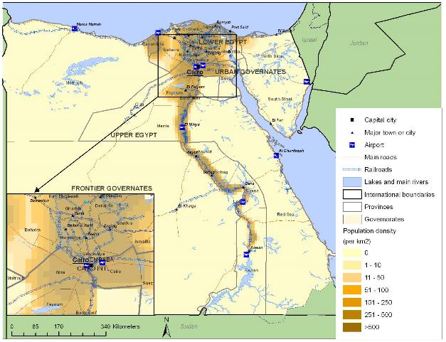

## Annex 7: List of Persons Contacted during the Evaluation

|  |  |  |  |  |
| --- | --- | --- | --- | --- |
| **No of Interviewees** | **Organization** | **Sex disaggregated data** | | **Location** |
|  |  | **Male** | **Female** |  |
| 1 | GICHD, Geneva International Center for Humanitarian Demining | - | 1 | Geneva, Switzerland |
| 3 | The European Union Delegation Cairo | 2 | 1 | Cairo, Egypt |
| 2 | The UNDP office in Egypt | - | 2 | Cairo, Egypt |
| 7 | Executive Secretariat for Mine action | 4 | 3 | Cairo, Egypt |
| 3 | Ministry of International Cooperation | 3 | - | Cairo, Egypt |
| 2 | The Governorate of Marsa Matrouh (City Council El Negila) | 2 | - | El Negila, Egypt |
| 4 | mine survivors delegation, City Council El Negila | 4 | - | El Negila, Egypt |
| 6 | Interviews with 4 mine survivors and 2 veterinaries in the livestock program | 3 | 3 | El Negila, Egypt |
| 3 | MRE consultants | 1 | 2 | Marsa Matrouh, Egypt |
| 3 | Artificial Limb Center staff | 2 | 1 | Marsa Matrouh, Egypt |
| 2 | MRE Trainer and trainees | - | 2 | Marsa Matrouh, Egypt |
| 16 | Focus group with female mine survivors / relatives | - | 16 | Marsa Matrouh, Egypt |
| 10 | NGOs that are executing specific activities | 8 | 2 | Marsa Matrouh, Egypt |
| 3 | Army Corps of Engineers | - | 3 | Alamein, Egypt |
| 3 | MRE School Session and Ambulance | 2 | 1 | Alamein, Egypt |
| 2 | Exec Sec QA/QC team | 2 | - | Alamein, Egypt |
| 3 | New City Alamein project management | 3 | - | Alamein, Egypt |
| 2 | The Governorate of Marsa Matrouh (City Council Dabaa) | 2 | - | Dabaa, Egypt |
| 9 | Interviews with 7 mine survivors and meet 2 veterinaries in the livestock program | 3 | 6 | Dabaa, Egypt |
| **84** |  | **41** | **43** |  |

## Annex 8: Literature and Documents Consulted

|  |  |  |  |  |
| --- | --- | --- | --- | --- |
| **Document – name** | **Reviewed (y/n)** | **Utility (1=very useful; 5=not useful)** | | **Comments** |
| **Country Strategy Paper Egypt and Indicative Programmes (and equivalent) for the periods covered** | | | | |
| UNDAF Egypt 2013-2017.pdf | yes | 4 | | Relation to the project in very general terms |
| UNDP Egypt One-Pager FEB2016- Updated.pdf | yes | 3 | | Compressed version of the project document |
| European Union Joint Rural Development Programme <http://www.eu-jrdp.org/> | yes | 3 | | Rural Development Component of the Joint Programme |
| EU Egypt Country Strategy paper 2007-2013 | yes | 3 | |  |
| EU and Egypt Partnership Priorities 2017-2020 | yes | 4 | | EU – Egypt cooperation , ENP |
| **Action financing agreement and addenda** | | | | |
| Full agreement.pdf | yes | 1 | | Project document |
| Addendum 1.PDF | yes | 1 | | Mine Action Project EU Work Plan July 2017 - April 2018 |
| Explanatory Note.PDF | yes | 1 | | No cost extension April 2018 |
| special conditions.pdf | yes | 4 | | Signature page |
| ANNEX III Mine Action EU Budget for Action USD Euros Final.xls | yes | 1 | | Full Budget |
| **Action’s quarterly and annual progress reports, and technical reports** | | | | |
| 2015Mine Action Phase II -Annual Progress Report .Revised.docx | yes | 1 | |  |
| 2015Mine Action II. Annual Financial Report Revised.xlsx | yes | 1 | |  |
| Mine Action II. Annual Financial Report 2017.Updated.31Oct2017.xlsx | yes | 1 | | Last financial report  31 October 201 |
| 16-12-15 report draft.pdf | yes | 2 | | Draft version |
| Annual Work plan EU 2016.pdf | yes | 3 | |  |
| Mine Action Phase II -Annual Progress Report (Jan-Oct 2017)+ FK Amendments[1].docx | yes | 1 | |  |
| Annual Work plan EU 2017.Updated.docx | yes | 3 | |  |
| **EC’s Result Oriented Monitoring (ROM) Reports, and other external and internal monitoring reports of the Action** | | | | |
| ROM Report | yes | 1 | | ROM Report act as mid-term revue |
| ROM presentation 090117.pptx | yes | 4 | | Presentation of the project for ROM mission |
| **Relevant documentation from national/local partners and other donors** | | | | |
| UNMAT inter-agency assessment in 2009 | yes | | 1 | Mentioned in the project document |
| Report On Findings from a Gender Assessment Mission | yes | 1 | | Gender strategy for the project |
| A Study of Manual Mine Clearance — 2. The Management of Manual Mine Clearance Programmes, GICHD, Geneva, August 2005. | yes | 1 | | Manual Mine Clearance methodologies |

## Annex 9: Detailed Work Plan

|  |  |  |  |
| --- | --- | --- | --- |
| **Phases of the evaluation** | **Output – Reports** | **Dates** | **Deliverables and *meetings*** |
| **Inception Phase** | Initial document/data collection and definition of methods of analysis | 1 to 15 June 2018 | * Inception report * Slide presentation * Interview with EU program manager |
| Background analysis |
| In depth document analysis |
| Reconstruction of Intervention Logic, incl. objectives, specific features and target beneficiaries |
| Identification of information gaps and of hypotheses to be tested in the field phase |
| Methodological design of the Field Phase |
| **Field Phase** | Initial meetings at country level with main stakeholders in Cairo | 16 to 17 Sept 2018 | * *Kick-off meeting* * Slide Presentation of Key findings * *Debriefing with the Reference Group* |
| Gathering of primary evidence with the use of interviews, focus groups, storytelling sessions, surveys and other techniques in Matrouh Province | 18 – 28 Sept 2018 |
| Data collection and analysis in Cairo | 29 Sept – 4 Oct 2018 |
| **Synthesis phase** | Final analysis of findings (with focus on the Evaluation Questions) | 8 Oct – 12 Oct 2018 | * Draft Final Report * Executive Summary |
| Formulation of the overall assessment, conclusions and recommendations | 15 Oct – 19 Oct 2018 |
| **Report** | Delivery Final Report | 26 Oct 2018 | * Final Report * Slide presentation |

## Annex 10: Demining Maps

Figure 7: Demining map: Dabaa Nuclear Power Plant Site

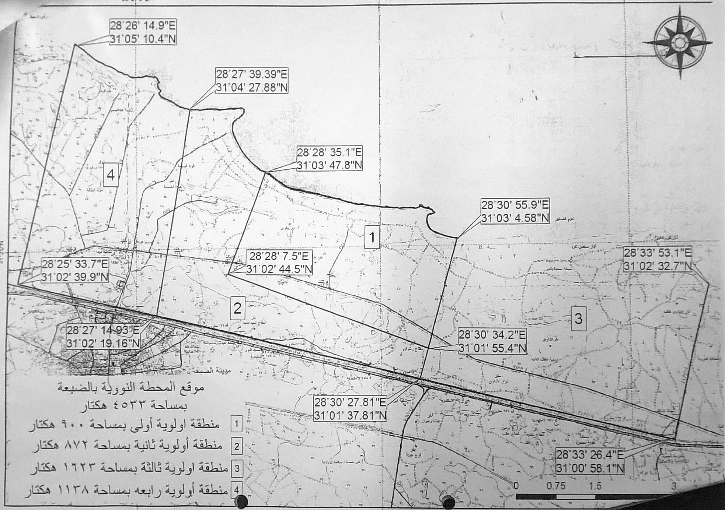

Source: Exec Sec, Cairo

**Translated Legend:**

Dabaa Nuclear Plant Site

With an area of 4.533 hectares

1. First priority area of 900 hectares
2. Second priority area of 278 hectares
3. Third priority area of 1.623 hectares
4. Fourth priority area of 1.138 hectares

Figure 8: Demining Map: Agricultural Land in Alamein

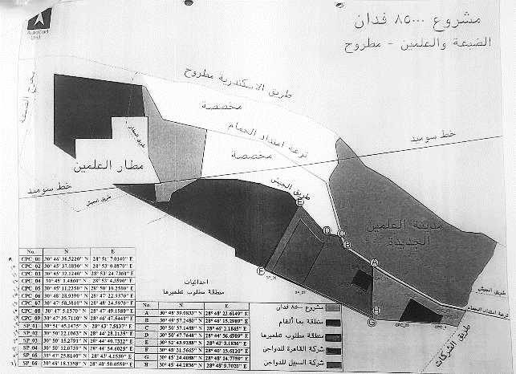

Source: Exec Sec, Cairo

**Translated legend:**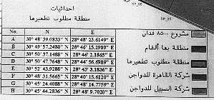

*Coordinates*

*Area to be cleared*

8,500 acres project land (34,4sqkm)

Area with mines

Area required to be relieved

Al Qa’ra Poultry Company

Al Avenue Poultry Company

## Annex 11: Organizational Chart and Networking Diagram

Figure 9: Exec Sec, Organizational Chart

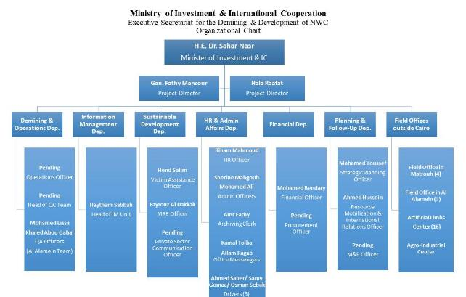

Figure 10: Exec Sec, Cooperation and Networking

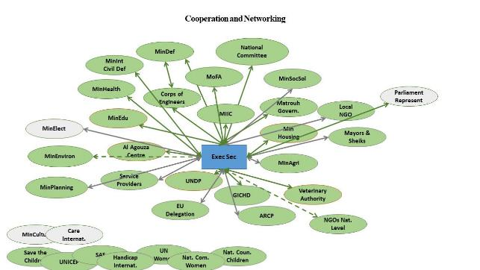

1. Management response: Non-Technical /Technical surveys were conducted by the Corps of Military Engineers in 2016 to assess and evaluate the area and extent of land contamination in the NWC region. These surveys concluded that the area of contaminated land in the NWC has reached 5,100 sqkm.
2. Management response: Meeting with the Army Officers at Al-Alamein field battalion shows that there were less restriction on sharing information than before. All questions raised by the evaluator were answered by the responsible Military Officers. Inspection by the evaluator in the demining demo area was prohibited for safety reasons. All detailed information about mine clearance operations in currently being recorded in IMSMA.
3. Management response: According to the NWC Development Plan, The clearance of New Alamein Land was necessary for the acceleration of the establishment of the new city of Alamein. Besides, other projects in the area of the old city of Alamein, such as agriculture projects as well as the nuclear plant in Dabaa will contribute to the improvement of the livelihoods of the overall NWC population.
4. <http://mineaction.eg/news-events/> (October 2017)
5. Management response: As reported the first phase of the new city of Alamein for example, will include a residential, medical, commercial, business, industrial, educational and touristic projects and services, such as: museums, a renewable energy station, historical places, hotels, conference centers, libraries, mosques, churches, schools, and universities. It will help to create more than 279,375 job opportunities.
6. Management response: The Executive Secretariat already submitted a proposal to the National Committee for conducting clearance operations in the contaminated lands which are closer to the high density populated areas. Also, the MIIC shared a proposal for funding a third phase of the project with the EU.
7. To evaluate the effectiveness of the ERW removal it has to be noted that the mission was not able to judge the actual performance as verification proved impossible.
8. A Study of Manual Mine Clearance — 2. The Management of Manual Mine Clearance Programmes, GICHD, Geneva, August 2005.
9. Management response: A new digitalized map has been installed to be the background for IMSMA. Recording of the other data of the cleared land is currently in progress.
10. Management response: Demining is being carried out as per the prioritisation plan. Funding the clearance operations is being financed by the Ministry of Defence this includes the salaries of 300 deminers and the unit running costs. Other contributions are made available from other Ministries. The Ministry of Defence is the state apparatus that responsible for mine clearance operations in Egypt (by force of law).
11. Management response: It is too early to assess the final impact of the project, impact is beyond the end of the project phase.
12. [http://www.miic.gov.eg/English/MediaCentre/News/Pages/Launch-of-the-The-Egyptia.aspx](http://www.miic.gov.eg/English/MediaCenter/News/Pages/Launch-of-the-The-Egyptia.aspx)

    (checked 15/10/18)