Midterm Review Report

|  |  |
| --- | --- |
| **Project Title:** | China’s Sustainable Bio-Energy Development Demonstration Project in Guangxi |
| **UNDAF Outcome(s):** | Government and other stakeholders ensure environmental sustainability, address climate change, and promote a green, low carbon economy |
| **Expected CP Outcome(s):**  *(Those linked to the project and extracted from the CP)* | Local carbon and other environmentally sustainable strategies and technologies are adapted widely to meet China’s commitments and compliance with Multilateral Environmental Agreements |
| **Expected Output(s):***(Those that will result from the project)* | A replicable model of sustainable biomass sourcing for bio-energy development in Guangxi and in China is established and benefit smallholder farmers and rural communities |
| **Implementing Partner** | China International Center for Economic and Technical Exchanges (CICETE) |
| **Cooperating Partner** | Guangxi Provincial Department of Commerce  Chongzuo Municipal Government |

**Brief Description**

This project aims to establish a replicable model of sustainable biomass sourcing for bio-energy development in Guangxi and eventually across China. The goal is to assist China in achieving its sustainable energy development strategy, in order to mitigate the adverse impacts of climate change and meet the target of increasing the share Renewable Energy in the energy consumption by 2015 set in the 12th five-year (2011-2015) plan. In developing the biomass material production and supply system, the project will benefit local farmers and rural communities engaged in sugarcane, cassava and energy grass production and other stakeholders, such as forest farms and other processing enterprises of timber and cash crops.

The total duration of this MTR was conducted for 3 *weeks* starting 5*th Sept 2018.* The MTR timeframe is as follows:

* *5th Sept 2018: Received documents* *( Kaidi Quarterly Progress Reports Workplan_2015-2018(1) and Kaidi Quarterly Progress Reports Workplan_2015-2018(2)*
* *13th to 16th Oct 2018:* Analysis of documents *(quarterly progress report and annual report, Project Document both in English and Chinese version)*
* *16th to 17th Oct 2018:* Document review and preparing MTR Inception Report
* *19th Oct 2018: MTR Inception Meeting in Beijing with participants from UNDP, CICETE, Provincial Program Management office and UNV from Chouzuo Program Office*
* *23rd to 30th Oct. 2018: MTR Field Mission*: stakeholder meetings, interviews, field visits

*7th Dec 2018:* Mission wrap-up meeting & presentation of initial findings of MTR mission

* *4th to 14th Dec 2018, 9 days:* Preparing draft report
* *21st to 22nd Dec 2018, 2 days:* Incorporating audit trail on draft report/Finalization of MTR report
* *23rd Dec 2018, 2 days:* Preparation & Issue of Management Response
* *28th Dec 2018:* Expected date of full MTR completion

**MTR team members**

Mr. Ling Lin, PhD. Independent Consultant

Mr. Nong En, Committee for Commerce and Port Management of Chongzuo City, Guangxi Zhuang Autonomous Region，

Ms. Qin Liling，Committee for Commerce and Port Management of Chongzuo City, Guangxi Zhuang Autonomous Region

Ms. Peng Pei，Project Assistant (UNV), United Nations Development Programme in China

**Acknowledgements**

This mid-term review is supported and assisted by the project partners, with active participation in the discussion of the question interviewed, contributing valuable information and recommendations, in particular, the member agencies of the project leading group and the staff of the PMO in Chongzo provided professional and efficient support for the smooth conduct of this MTR. Thank you all here!

TABLE OF CONTENTS

1. Executive Summary 1

• Project Information Table 1

• Project Description (brief) 1

• Project Progress Summary 1

• MTR Ratings & Achievement Summary Table 2

• Concise summary of conclusions 5

• Recommendation Summary Table 6

2. Introduction 9

• Purpose of the MTR and objectives 9

• Structure of the MTR report 10

3. Project Description and Background Context (3-5 pages) 11

• Development context: environmental, socio-economic, institutional, and policy factors relevant to the project objective and scope 11

• Problems that the project sought to address: threats and barriers targeted 11

• Project Description and Strategy: objective, outcomes and expected results, description of field sites 12

• Project Implementation Arrangements: short description of the Project Board, key implementing partner arrangements, etc. 12

• Project timing and milestones 15

• Main stakeholders: summary list 19

4. Findings 20

4.1 Project Strategy 20

• Project Design 20

4.2 Progress Towards Results 21

• Progress towards outcomes analysis 21

4.3 Project Implementation and Adaptive Management 22

• Management Arrangements 22

• Work planning 24

• Project-level monitoring and evaluation systems 27

• Stakeholder engagement 27

• Reporting 29

• Communications 29

4.4 Sustainability 30

• Financial risks to sustainability 30

• Socio-economic to sustainability 30

• Institutional framework and governance risks to sustainability 30

• Environmental risks to sustainability 31

5. Conclusions and Recommendations (4-6 pages) 32

5.1 Conclusions 32

• Comprehensive and balanced statements 32

5.2 Recommendations 33

6. Annexes 34

Annex 1: MTR ToR 34

UNDP Midterm Review Terms of Reference 34

Annex 2: MTR evaluative matrix (evaluation criteria with key questions, indicators, sources of data, and methodology) 43

Annex 3: Example Questionnaire or Interview Guide used for data collection 44

Annex 4: Ratings Scales 48

Annex 5: MTR field mission itinerary 49

Annex 6: List of persons interviewed 50

Annex 7: List of documents reviewed 51

Annex 8: Signed UNEG Code of Conduct form 52

Annex 9: Signed MTR final report clearance form 53

# 1. Executive Summary

### • Project Information Table

|  |  |
| --- | --- |
| **Project Title:** | China’s Sustainable Bio-Energy Development Demonstration Project in Guangxi |
| **UNDAF Outcome(s):** | Government and other stakeholders ensure environmental sustainability, address climate change, and promote a green, low carbon economy |
| **Expected CP Outcome(s):**  *(Those linked to the project and extracted from the CP)* | Local carbon and other environmentally sustainable strategies and technologies are adapted widely to meet China’s commitments and compliance with Multilateral Environmental Agreements |
| **Expected Output(s):**  *(Those that will result from the project)* | A replicable model of sustainable biomass sourcing for bio-energy development in Guangxi and in China is established and benefit smallholder farmers and rural communities |
| **Implementing Partner** | China International Center for Economic and Technical Exchanges (CICETE) |
| **Cooperating Partner** | Guangxi Provincial Department of Commerce  Chongzuo Municipal Government |

### • Project Description (brief)

This project aims to establish a replicable model of sustainable biomass sourcing for bio-energy development in Guangxi and eventually across China. The goal is to assist China in achieving its sustainable energy development strategy, in order to mitigate the adverse impacts of climate change and meet the target of increasing the share Renewable Energy in the energy consumption by 2015 set in the 12th five-year (2011-2015) plan. In developing the biomass material production and supply system, the project will benefit local farmers and rural communities engaged in sugarcane, cassava and energy grass production and other stakeholders, such as forest farms and other processing enterprises of timber and cash crops

### • Project Progress Summary

According to the Project Document, this project is planned to be carried out in two stages with a 5-year period for implementation cycle. It was started in January of 2015 and is expected to be completed by the end of 2019.

There are 19 outputs set up in the ProDoc with logical supporting indicators and activities in the results and resources framework table. After reviewing all documents in PMO and field visits in Chongzuo with their workplan tracking system, it was shown that relevant actions have been taken for most of the outputs according to the workplan till present, however, still some activities were behind the schedule due to the delay in disbursement of funds, which may lead to the fact that some field operations could not catch the agricultural seasonal cycle. So far, most planned activities toward the specific output have no significant modification during implementation and most of them are on track until October 2018. But two outputs have been changed to original ProDoc , i.e. output 1.3 has been cancelled and the definition/scope of output 4.2 has been revised, as agreed and signed by all necessary parties on the PSC meeting on 12th Oct. 2016. More field information was requested for conducting the output 1.3 (Completion of Design and Plan for Sustainable Industry Chain of Using agro/forestry Biomass Resources in key pilot areas). The scope of output 4.2 has been revised from “feasibility study on developing and demonstrating raw juice cooling and storage facilities by using exhaust heat from sugar plants as cooling energy source” in the original ProDoc to “To establish Guangxi biomass energy collection and storage mechanism and compile Research Report of Establishment on Guangxi Biomass Energy Collection and Storage Mechanism” in their current workplan.

The overall budget for the project is 5.8 million USD and the overall spending is nearly 2.5 million USD by the end of October 2018, the overall spending ratio is about 43%. In regards to the stage I of the project, it was budgeted 2.332 million USD, the spending ratio is about 107%.

### • MTR Ratings & Achievement Summary Table

**Indicator Assessment Key**

|  |  |  |
| --- | --- | --- |
| Green= Achieved | Yellow= On target to be achieved | Red= Not on target to be achieved |

|  |  |  |
| --- | --- | --- |
| **Ratings for Progress Towards Results:** (one rating for each outcome and for the objective) | | |
| 6 | Highly Satisfactory (HS) | The objective/outcome is expected to achieve or exceed all its end-of-project targets, without major shortcomings. The progress towards the objective/outcome can be presented as “good practice”. |
| 5 | Satisfactory (S) | The objective/outcome is expected to achieve most of its end-of-project targets, with only minor shortcomings. |
| 4 | Moderately Satisfactory (MS) | The objective/outcome is expected to achieve most of its end-of-project targets but with significant shortcomings. |
| 3 | Moderately Unsatisfactory (HU) | The objective/outcome is expected to achieve its end-of-project targets with major shortcomings. |
| 2 | Unsatisfactory (U) | The objective/outcome is expected not to achieve most of its end-of-project targets. |
| 1 | Highly Unsatisfactory (HU) | The objective/outcome has failed to achieve its midterm targets, and is not expected to achieve any of its end-of-project targets. |

|  |  |  |  |
| --- | --- | --- | --- |
| **MTR Rating & Achievment Sumary Table** | | | |
| **Output** | **Midterm Level & Assessment** | **Achievement Rating** | **Justification for Rating** |
| Pre-conditional Feasibility Study | On target to be achieved | MS | The study was conducted by an expert group. There is a PPT report for the feasibility study, but no further analysis on final results framework with detailed indicators and activities as required in this study. Especially, there is no report on Pilot areas selection and boundaries definition. This output was just partially done. |
| **Stage-I (Early of 2015—end of 2016)** | | | |
| **Component 1: Development of comprehensive development plan for promoting modern environment-friendly agriculture, forestry and animal husbandry and biomass energy industry on basis of inventory on the agricultural and forestry resources and their current use in Chongzuo** | | | |
| Output 1.1: Compilation of Chongzuo’s Comprehensive Plan for Promoting Modern and Environment-Friendly Agriculture, Forestry, Husbandry Development (2015-2025) | Achieved | HS | Completed in high quality. The plan has addressed issues identified by the project. |
| Output 1.2: Compilation of Comprehensive Development Plan for Non-Grain Biomass Energy Industry of Chongzuo, Guangxi (2015-2025) | Achieved | HS | The plan has addressed issues identified by the project. |
| Output 1.3 Completion of Design and Plan for Sustainable Industry Chain of Using agro/forestry Biomass Resources in key pilot areas | On target to be achieved | NOT  APPLICABLE | This output has been suspended or cancelled due to lack of information about selection of “key pilot areas". So, no rating is in here by MTR team. Would suggest to keep this output and to achieve it later. |
| **Component 2: Empowerment of local farmers and enhanced productivity through institutional arrangements and technical training** | | | |
| Output 2.1: Establishment of Modern Agricultural Training Centre for providing technical training to farmers on Sugarcane production | On target to be achieved | S | Partial indicators can be found in progress reports. Need link it with a comprehensive model in selected key pilot area |
| Output 2.2: Support to establish Farmers’ Field School to provide technical trainings to farmers on high-yield crop farming, production management and pest management, etc. | On target to be achieved | S | Some information collection has been finished and trainings have been provided to farmers. But further understandings about Farmers' school with approaches listed in the ProDoc original version are needed. FFS should be used as approach for engagement of the communities in key pilot areas. |
| **Component 3: Development/improvement mechanized operations in sugarcane planting and harvesting for supporting the implementation of “Double-High” Sugarcane Farming Upgrading Strategy in Chongzuo** | | | |
| Output 3.1 Standardization of sugarcane mechanized operation | On target to be achieved | MS | In the preparation stage with key stakeholders. The standardization should be developed according to deferent models. |
| Output 3.2 Promotion of mechanized farming operation services | Achieved | HS | 25 agriculture machines and equipment were delivered to 17 cooperatives. |
|
| Output 3.3 feasibility study on combining harvesting and juicing operations | On target to be achieved | S | The study tour was conducted in Japan, Australia. Valuable information and ideas were obtained for this project. On site feasibility study is planned to be done in the coming years. |
| **Stage-I Total** |  |  |  |
| **Stage-II (2017-2019)** | |  |  |
| **Component 4: Feasibility studies and demonstration of innovative, energy-efficient and environment-friendly technologies in the traditional sugar refining process.** | | | |
| Output 4.1 Partnership formulated and feasibility study completed for upgrading existing off-grid CHP plants within sugar mills | Achieved | HS | The study has been completed. Potential partners have been identified to be work with. |
| Output 4.2 feasibility study on developing and demonstrating raw juice cooling and storage facilities by using exhaust heat from sugar plants as cooling energy source | NOT  APPLICABLE | NOT  APPLICABLE | The definition/scope has been changed as bellow, no rating here |
| Output 4.2 To establish Guangxi biomass energy collection and storage mechanism and compile Research Report of Establishment on Guangxi Biomass Energy Collection and Storage Mechanism | On target to be achieved | S | This is a replacement of the original output 4.2. There is a decision made by the project leading group considering that Kaidi's new power plant is not be established on schedule. |
| Output 4.3 Demonstration of environment-friendly recycling technologies in the sugar milling process | On target to be achieved | MS | The feasibility report has been completed. How to link with the comprehensive models should be discussed later |
| **Component 5: Creation of sustainable biomass sourcing models, including eucalyptus energy forests, energy grasses and cassava plantations, in addition to biomass from sugar industry** | | | |
| Output 5.1 Pilot and establish eucalyptus demonstration plantations as sustainable forest biomass sources | Achieved | S | Three plantation pilots of 34 ha have been established, but a final survival check after 3 years is demanded by the end of the project. |
| Output 5.2 Pilot energy grass-planting models by use of marginal lands | Achieved | S | Three pilots have been established. A 28 ha grass planting pilot has been visited during this MTR mission. |
| Output 5.3 Pilot high-yield cassava farming | On target to be achieved | NOT  APPLICABLE | The activity has been cancelled. Due to not much cassava farming in the project area currently. No rating here. |
| **Stage-II Total** |  |  |  |
| **Component 6: Project management (from Stage-I through to Phase 2)** | | | |
| Output 6.1 Project Management | Achieved | HS | The management team is working well, especially the field office in Chongzuo, roles and responsibilities are clearly defined among the team with 4 staff on board. The internal M&E was done well through \quarterly report and annual report tracking, they are taking annual workplan in timely manner and saved as M&E tool. |
| Output6.2 Advocacy and Communications | Achieved | S | A lot of project communication and advocacy works have been delivered, such as development brochures, project short video story and plan discussed for footages collection for producing a documentary film to tell the successful stories of the project.  An overall communication strategy in writing format is not in place yet, and everyone involved in managing of the project should be considered. Advocacy efforts have been reached one of great achievements through organizing of China-ASEAN Biomass Energy forum. |
| Output 6.3 M&E including mid-term and final evaluations | Achieved | S | M&E has been well planned in the workplan includes internal tracking, mid-term and final evaluation. |
| Output 6.4 UNV support | Achieved | HS | Three UNV have been participated in this project and done a great job. |
| Output 6.5 Auditing | Achieved | S | Annual regular auditing has been conducted once by an independent auditing agency and no significant risk has been reported. Final auditing has been planned to be conducted at the final stage of the project. |

### • Concise summary of conclusions

In general, the progress is on track and this project is implemented towards the objectives setup in the original ProDoc in English version, though some outputs are partially achieved, but their practices, techniques and approaches being promoted and tested still need time to be fully accomplished and to be able to package into an exact models for demonstration and communicating. So, the time left for the project cycle, is very important to make valuable outcomes from this project that could be able to contribute to raising China’s bioenergy consumption ratio in near future. According to MTR process, in terms of project implementation itself, evidences from the project are showing that there is no reason or significant risks which may break the implementation of this project. There is a backup strategy being discussed among the implementation body of the project to deal with Kaidi’s funding delay issue.

### • Recommendation Summary Table

|  |  |
| --- | --- |
| Recommendation Summary Table | |
| Output | Recommendations |
| Pre-conditional Feasibility Study | A community development expert has been invited to work with PMO going through key pilot area selection process. Based on the pilot area selection, the management team could review and revise the framework of resources table. The key is to define what is biomass energy development model and it should be demonstrated in an integrated "full industry Chain" in selected areas in typical geographic locations. The review of logical framework should be conducted thus to avoid misleading information. The Chinese translation for the original English ProDoc should be done completely. |
| **Stage-I (Early of 2015—end of 2016)** |  |
| **Component 1: Development of comprehensive development plan for promoting modern environment-friendly agriculture, forestry and animal husbandry and biomass energy industry on basis of inventory on the agricultural and forestry resources and their current use in Chongzuo** | |
| Output 1.1: Compilation of Chongzuo’s Comprehensive Plan for Promoting Modern and Environment-Friendly Agriculture, Forestry, Husbandry Development (2015-2025) | During interview with local stakeholders, they showed great interests in reports and information from analysis. Report should be delivered to stakeholders. |
| Output 1.2: Compilation of Comprehensive Development Plan for Non-Grain Biomass Energy Industry of Chongzuo, Guangxi (2015-2025) | The plan could be an information base for selecting key pilot areas. |
| Output 1.3 Completion of Design and Plan for Sustainable Industry Chain of Using agro/forestry Biomass Resources in key pilot areas | The industry Chain in key pilot areas may be formulated as different models:  energy company + community;  energy company + corporations + community;  bioenergy consumption for community + individuals sugar cane grower.  Demonstration of those models in key pilot areas is a core value of this project |
| **Component 2: Empowerment of local farmers and enhanced productivity through institutional arrangements and technical training** | |
| Output 2.1: Establishment of Modern Agricultural Training Centre for providing technical training to farmers on Sugarcane production | The centre should provide trainings to farmers in the key pilot areas. |
| Output 2.2: Support to establish Farmers’ Field School to provide technical trainings to farmers on high-yield crop farming, production management and pest management, etc. | FFS should be setup for the community learning process in selected pilot areas, the approach should be done as below:  • FFS is field based and should be working during full cropping seasons. • The primary learning material at a FFS should be the sugarcane/cassava/energy grass/energy forest management. • The FFS meeting place should be close to the learning plots. • FFS educational methods should be experiential, participatory, and learner-concerned. • Each FFS meeting should include at least three activities: the agro-ecosystem analysis, a “special topic”, and a group dynamics activity. • In every FFS, participants should conduct a study comparing new with traditional plots. • A FFS often includes several additional field studies depending on local situations. •The number of participants should be controlled between 25 and 30 in a FFS. Participants learn together in small groups of five to maximize participation. • All FFSs should design a Field Day, in which farmers make presentations about the results of their studies. • A pre- and post-test is conducted as part of Field School for diagnostic purposes and for determining follow-up activities. • The facilitators of FFS’s undergo intensive season-long residential training to prepare them for organizing and conducting Field Schools. • Preparation meetings precede an FFS to determine needs, recruit participants, and develop a learning contract. • Final meetings of the FFS often include planning for follow-up activities. |
| **Component 3: Development/improvement mechanized operations in sugarcane planting and harvesting for supporting the implementation of “Double-High” Sugarcane Farming Upgrading Strategy in Chongzuo** | |
| Output 3.1 Standardization of sugarcane mechanized operation | The standardizations may be developed for sugarcane mechanized operations in different geographic locations and it should cover both small scale and large scale operations for typical areas |
| Output 3.2 Promotion of mechanized farming operation services | Review current partners who are doing farming operation services and then make plan for further promotion activities. |
| Output 3.3 feasibility study on combining harvesting and juicing operations | PMO may need a detailed report on explaining the current technique issues. |
| Stage-I Total |  |
| **Stage-II (2017-2019)** |  |
| **Component 4: Feasibility studies and demonstration of innovative, energy-efficient and environment-friendly technologies in the traditional sugar refining process.** | |
| Output 4.1 Partnership formulated and feasibility study completed for upgrading existing off-grid CHP plants within sugar mills | It is recommended that the national grid operators, sugarcane mills and NDRC authority can discuss CHP issues through a workshop organized by PMO. |
| Output 4.2 Feasibility study on developing and demonstrating raw juice cooling and storage facilities by using exhaust heat from sugar plants as cooling energy source | It has been changed as below. The project leading group was made this changes considering that Kaidi's new company is not being established as planned. |
| Output 4.2 To establish Guangxi biomass energy collection and storage mechanism and compile Research Report of Establishment on Guangxi Biomass Energy Collection and Storage Mechanism | The research could be adjusted for other options if pilot areas is selected. No comment. |
| Output 4.3 Demonstration of environment-friendly recycling technologies in the sugar milling process | Demonstration in the company at certain selected pilot areas is highly suggested. |
| **Component 5: Creation of sustainable biomass sourcing models, including eucalyptus energy forests, energy grasses and cassava plantations, in addition to biomass from sugar industry** | |
| Output 5.1 Pilot and establish eucalyptus demonstration plantations as sustainable forest biomass sources | This pilot plantation is also suggested to be established in the Key selected pilot areas. The biomass energy forest sustainable management guideline should be one of output based on actual practices. Final check should be done by the end of the project. |
| Output 5.2 Pilot energy grass-planting models by use of marginal lands | This Pilot is also suggested to be established in key pilot areas. The sustainable management guideline for grass planting should be one of output based on actual practices in pilot areas. Final check should be carried out by the end of the project. |
| Output 5.3 Pilot high-yield cassava farming | This pilot has been stopped after a consultation with staff from agriculture department. |
| Stage-II Total |  |
| **Component 6: Project management (from Stage-I through to Phase 2)** | |
| Output 6.1 Project Management | Review the results framework with some necessary outputs, indicators and activities since situation and assumption changed dramatically in last few years and should get an official approve from UNDP, CICETE and Provincial MPO. The PMO should start to develop a phase out plan for this project to make sure knowledge gained from this project can be transferred to stakeholder and partners in developing biomass energy. |
| Output6.2 Advocacy and Communications | The team need to formulate an overall communication and advocacy strategy plan for this demonstration project. |
| Output 6.3 M&E including mid-term and final evaluations | Review and refine the M&E plan after the result framework is reviewed. The final evaluation should base on the revised results framework. |
| Output 6.4 UNV support | UNV's support is still needed. It would be better to organise trainings on TOC for UNV and local staff. |
| Output 6.5 Auditing | PMO already has a plan. |
|

# 2. Introduction

This is the UNDP Mid-term Review (MTR) of the project titled China’s Sustainable Bio-Energy Development Demonstration Project in Guangxi implemented through the China International Centre for Economic and Technical Exchanges (CICETE), which has been undertaking from 2015 to December 2019. According the ProDoc, the project started in January, 2015 and is in its third year of implementation. This MTR is conducted according to the workplan.

### • Purpose of the MTR and objectives

* assess progress towards the achievement of the project objectives and outcomes
* assess early signs of project success or failure with the goal of identifying the necessary changes to be made in order to set the project on-track to achieve its intended results
* review the project’s strategy, its risks to sustainability, making recommendations for continuing or discontinuing the Project.

• Scope & Methodology: principles of design and execution of the MTR, MTR approach and data collection methods, limitations to the MTR

As agreed in the inception meeting of MTR, participatory approach is principally used to facilitate discussions with key bodies involved in the implementation. This is also an evidence-based review process.

Based on the original ProDoc English version, all outputs and activities listed in the results and resources of framework table in the document have been reviewed. Key stakeholders in project sites have been interviewed and field operations been visited. Data is mainly collected from PMO’s workplan and the reporting tracking system, reports generated from the project. Semi-structure interviews are used to collect information from stakeholders.

Methods being used during this MTR as following

* Document analysis
* Semi-structure Interview with key persons from related organizations
* Semi-structure Interview with stakeholders
* Focus Group discussions on topics with members from the leading groups
* Field visit to benefited or targeted corporations and farmers from communities

|  |  |
| --- | --- |
| 图片包含 人员, 室内, 就坐, 地板  自动生成的说明 | 图片包含 餐桌, 人员, 就坐, 室内  自动生成的说明 |
| 图片包含 墙壁, 室内, 人员, 计算机  自动生成的说明 | 图片包含 建筑物, 人员, 户外  自动生成的说明 |
| 图片包含 人员, 室内, 墙壁, 群组  自动生成的说明 | 图片包含 天空, 人员, 户外, 地面  自动生成的说明 |

### • Structure of the MTR report

The MTR report starts with the description of the project, including the size, the context and patterns of biomass energy development and biomass utilisation in Guangxi, the barriers and core challenges for developing biomass in Chongzuo city, and a brief of project progress. Then a detailed introduction about key findings of this review will be introduced. After the presentation of the evidence analysis, insights and recommendations for further delivery of the project will be discussed.

# 3. Project Description and Background Context

The overall China-UNDP project goal is to assist China in mitigating climate change by meeting the target as per the 12th FYP of increasing the share of renewable energy in the energy mix by 2015. This project aims to set up a scalable sustainable biomass sourcing for biomass model energy development in China. Based on UNDP-China ongoing sustainable sugarcane farming projects in Guangxi, the project strategy thus focuses on i) farmers’ capacity building in ensuring high-yield biomass production at local levels; ii) innovative technologies on improving the energy efficiency of sugar cane planting and processing industry; iii) movements on extending the variety of raw biomass materials sources; iv) project framework designed under the scheme of Sustainable Energy for All (SE4ALL).

### • Problems that the project sought to address: threats and barriers targeted

There is a lack of sustainable biomass sourcing mechanism for bio-energy development. The problem can be attributed to many factors. One is the competition for biomass materials between industries, such as paper and timber processing industries, in Guangxi. Further, planting biomass feedstock plants will compete with other agricultural products, since growing economic crops such as vegetables and fruit may bring more profits than growing grain crops. Sustainable biomass sourcing models hence need to be created. Other prominent factors include: sustainable and stable raw material sources and supply channel, two important factors proven worldwide for the renewable energy development. However, there exist several barriers to these two factors’ realization in Guangxi.

* Development plan for Chongzuo’s modern eco agriculture, forestry and husbandry needs to be adapted to Guangxi’s modern industrial development plan
* Small Landholding vs. Farmers’ Cooperatives
* low-skilled farmers vs. Empowerment through Vocational Training Farmer and Field Schools
* Sugarcane Harvesting and Transportation Cost Barriers
* Low Efficiency in Sugarcane Processing and Bagasse Utilization Barriers

### • Project Description and Strategy: objective, outcomes and expected results, description of field sites

The project was planned to be implemented in a five-year period (from 2015 to 2019) and will achieve the following overall objective: Through piloting a sustainable bio-energy development model, the project will assist China to implement its sustainable energy development strategy, particularly in achieving the goal of increasing share of renewable energy in the national energy consumption by 2020 which will mitigate the climate change.

The project objective agreed among UNDP, and local government in Guangxi is: to establish a replicable sustainable bio-energy development in China and to benefit small farmers and rural communities through engaging them in biomass production and supply.

In view of the complexity and comprehensiveness, the project will be implemented in a phased approach to achieve the project objectives. Specific objectives of the first phase are to conduct scientific planning, selecting pilots for demonstration, development of mechanized operation in sugarcane farming operations in order to support Chongzuo sugar industry to achieve "Double-High" upgrading strategy. Specific objectives of the second phase are to set up sustainable biomass sourcing models involving farming, forestry and sugar industry sector, along with establishment of energy crops, forests and other energy demonstration bases.

### • Project Implementation Arrangements: short description of the Project Board, key implementing partner arrangements, etc.

To achieve above mentioned project objectives the following five technical components are recommended, in addition to one component for communication/advocacy and project management:

**In Stage-I (2015 – 2016):**

1) Development of Chongzuo’s comprehensive development plan for developing modern environment-friendly agriculture, forestry, animal husbandry, and biomass energy industry on basis of inventories on available/potential agricultural and forestry biomass resources;

2) Establishment/optimization of the operation of farmer’s cooperatives and provide capacity development to sugarcane farmers in Chongzuo through setting up modern agricultural training system and Farmers’ Field School (FFS);

3) Development/improvement mechanized operations in sugarcane planting and harvesting for supporting the implementation of “Double-High” Sugarcane Farming Upgrading Strategy in Chongzuo;

**In Stage-II (2017 – 2019):**

4) Feasibility studies and demonstration of innovative, energy-efficient and environment-friendly technologies in the traditional sugar refining process.

5) Creation of sustainable biomass sourcing models in Chongzuo, including biomass from sugar industry, eucalyptus energy forests, energy grasses and cassava plantations;

Project Management board describing

**PMOs at Provincial and Prefectural levels**

**Project Steering Committee**

**UNDP**

**CICETE(IP), GUANGXI DOFCOM(CP)**

**Key Stakeholders in Gungxi (CHONGZUO GOVT. BOC, etc ) and DONOR**

**Project Assurance**

(M&E)

**Project Support (Expert Teams, UNV, etc )**

**Project Organization Structure**

**TEAM A**

**TEAM C**

**TEAM B**

The Project is nationally executed, and CICETE acts as the Implementing Partner in line with the NEX modality. A National Project Management Office is established in CICETE and taking responsible for overall implementation and coordination.

UNDP China will be responsible for: (i) providing the third-party cost sharing for the project; (ii) overseeing financial expenditures against the approved project budgets; (iii) appointing independent financial auditors and identifying evaluators jointly with MOFCOM/CICETE; and (iv) ensuring that all activities including procurement and financial services are carried out in strict compliance with agreed regulations.

A National Project Steering Committee (NPSC) is established, composed of the senior management from CICETE, UNDP China, Guangxi Department of Commerce, and the people’s government of Chongzuo. The NPSC is in charge of reviewing and approving annual work plans and key achievements, coordination among the parties, and dissemination of the project achievements among the governmental agencies. NPSC meeting is convened at least once in a year to review and approve the AWP and provide timely guidance to the implementation of the project. In line with the NEX manual and the actual needs of the project, NPSC can authorize the PMO to draft and amend Project Management Regulations and approve the draft/amendments to serve as basis for project implementation and auditing.

Guangxi Department of Commerce (DOFCOM) is Project Cooperating Partner. For managing the overall implementation of the project in Guangxi, a Provincial Project Management Office (PPMO) is set up in the DOFCOM, with the senior management of the Department of Commerce as National Project Director (NPD) , who is assisted by PMO Director and PMO for coordination with CICETE and Chongzuo, managing, instructing and supervising the city-level PMO.

A city-level Leading Group (LG) is set up in Chongzuo in order to guide the execution of the project and coordination among agencies in Chongzuo. The LG is chaired by senior management of Chongzuo Government, and composed of representatives from the key bureaus and departments related to commerce, planning, financing, sugar industry, forestry, agriculture, environment and natural resources, and etc.

Under the leadership of provincial PMO and the LG, a Chongzuo PMO is set up in the Bureau of Commerce（BOC) in Chongzuo, chaired by PMO Director recommended by BOC and appointed by DOFCOM and Chongzuo Government, who is taking responsibilities of managing day-to-day operation, including: (i) preparation/updates of project work and budget plans, record keeping, accounting and quarterly and annual progress reporting; (ii) drafting of terms of reference, technical specifications and other documents as necessary; (iii) identification, proposal of project consultants to be approved by the NPD; (iv) Prepare documentation for equipment procurement based on the AWP through tendering; (v) organization of duty travels, seminars, public outreach activities and other project events; (vi) maintaining working contacts with project partners at the local level; and (VII) managing the project staff and the UNV recruited specifically for the project.

### • Project timing and milestones

Project timing:

|  |  |  |  |  |
| --- | --- | --- | --- | --- |
| Workplan:2015-2020 | | | | |
| Project: 89703 China's Sustainable Bio-Energy Development of Demonstration Project in Guangxi | | | | |
| Outputs | Progress | | | |
| 2015 | 2016 | 2017 | 2018 |
| I. Comprehensive research and specified studies | | | | |
| 1.1Compilation of Chongzuo's Comprehensive Plan for Promoting Modern and Environment-Friendly Agriculture, Forestry, Husbandry Development(2015-2025) |  | Field Research and resources inventory in Chongzuo | study completed |  |
| 1.2 Compilation of Comprehensive Development Plan for Non-Grain Biomass Energy Industry of Chongzuo, Guangxi (2015-2025) |  | Field Research and resources inventory in Chongzuo | study completed |  |
| 1.3 Feasibility study on combining harvesting and juicing operations |  |  | Inception workshop, compilation, review of the study |  |
| 1.4 Partnership formulated and feasibility study completed for upgrading existing off-grid CHP plants within sugar mills |  |  | Compilation of *Development of Biomass Thermoelectricity with Wastes from Sugar Milling Process* |  |
| 1.5 Demonstration of environment-friendly recycling technologies in the sugar milling process |  |  | Compilation of *Research Report on Recycling Waste Water from Sugar Milling Process for Sugarcane Irrigation, Research Report on Producing Organic Fertilizers with Wastes from Sugar Milling Process, Research Report on Generating Electricity with Biogas Produced by Ethanol Waste Water* |  |
| II、Multiple utilisation of Biomass resource | | | | |
| 2.1 Formulation of sustainable biomass sourcing models, including eucalyptus energy forests, energy grasses and cassava plantations to achieve development and utilisation of biomass energy in sugar mills | | | | |
| 2.1.1 Establishment of energy forests and energy grasses farming demonstration bases |  |  | Designation of bidding company; used synthetic scoring method, 3 demonstration bases for energy forests, 3 for energy grasses, and 1 for sapling fostering were selected |  |
| 2.1.2 Pilot energy grasses-planting models by using marginal lands |  |  |  |
| 2.2Empowerment of local farmers and enhanced productivity for assisting the industrial upgrading | | | | |
| 2.2.1. Establishment of Modern Agricultural Training Centre in Chongzuo | 16 batches of capacity development workshops on mechanical ploughing and planting integrated operations at the “High Yield and High Sugar Content” (H-H) Sugarcane Planting Base for 1766 local farmers | |  | Capacity development workshops on mechanical ploughing and planting integrated operations at the “High Yield and High Sugar Content” (H-H) in progress |
| 2.2.2 Facilitate the establishment of Farmers' Field School to provide technical trainings to farmers | 1.14 batches of modern agricultural techniques trainings, with admissions totalled 178 2.2 batches of technical trainings on unpolluted breeding for 349 people. | | 1.5 batches of capacity development workshop for 300 people； 2.7 batches of workshops on livestock technology for 512 participants | Workshops on livestock technology in progress |
| 2.3 Promotion of the mechanised operation | | | | |
| 2.3.1 Standardisation of sugarcane mechanised operation | National Sugarcane Production Mechanisation Promotion Event |  |  | 2 batches of capacity building workshops on agricultural machinery for 177 local people. |
| 2.3.2 Promotion of mechanised operation services |  |  | procured and distributed 25 agricultural machineries, including 17 sugarcane leaf balers, 4 lawn mowers and 4 tractors. |  |
| III、Partnership establishment, Publicity and Communications | | | | |
| 3.1 Strategy, Cooperation and Adaptive Management | Project Inception workshop | 1 PSC meeting organised | 1.Site visits organised 2.7 management meetings at different level organised | 6 relevant management meetings organised |
| 3.2 Communications |  |  | 1.Promoting the United Nations Sustainable Development Goals: China-ASEAN Biomass Energy Forum for Sustainable Development was successfully held in Nanning 2. Starting the minutes video clip production 3.Starting the production of documentary for the project | Australia and Japan visit for advanced experience in biomass development and sugar industry. |

Project Milestones till the March 2018

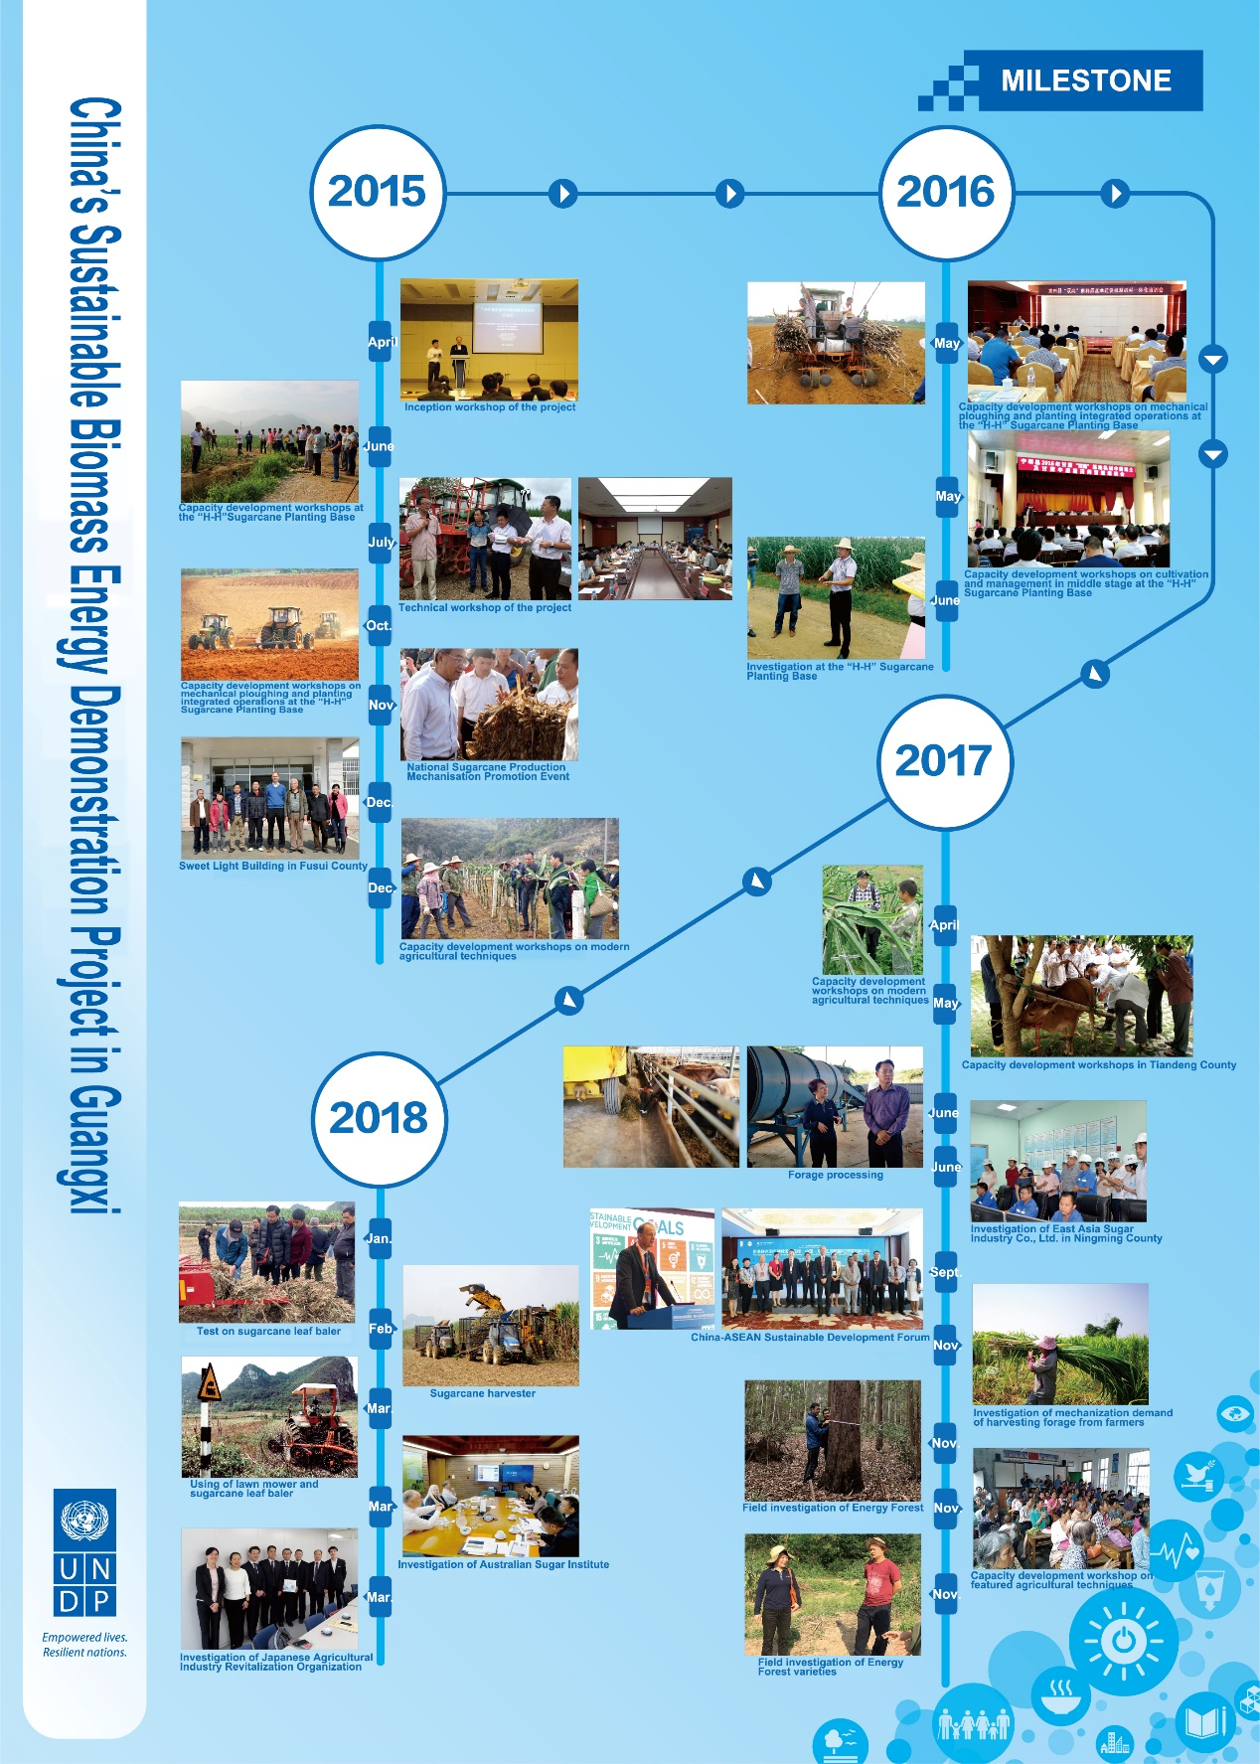

Project Sites locations:

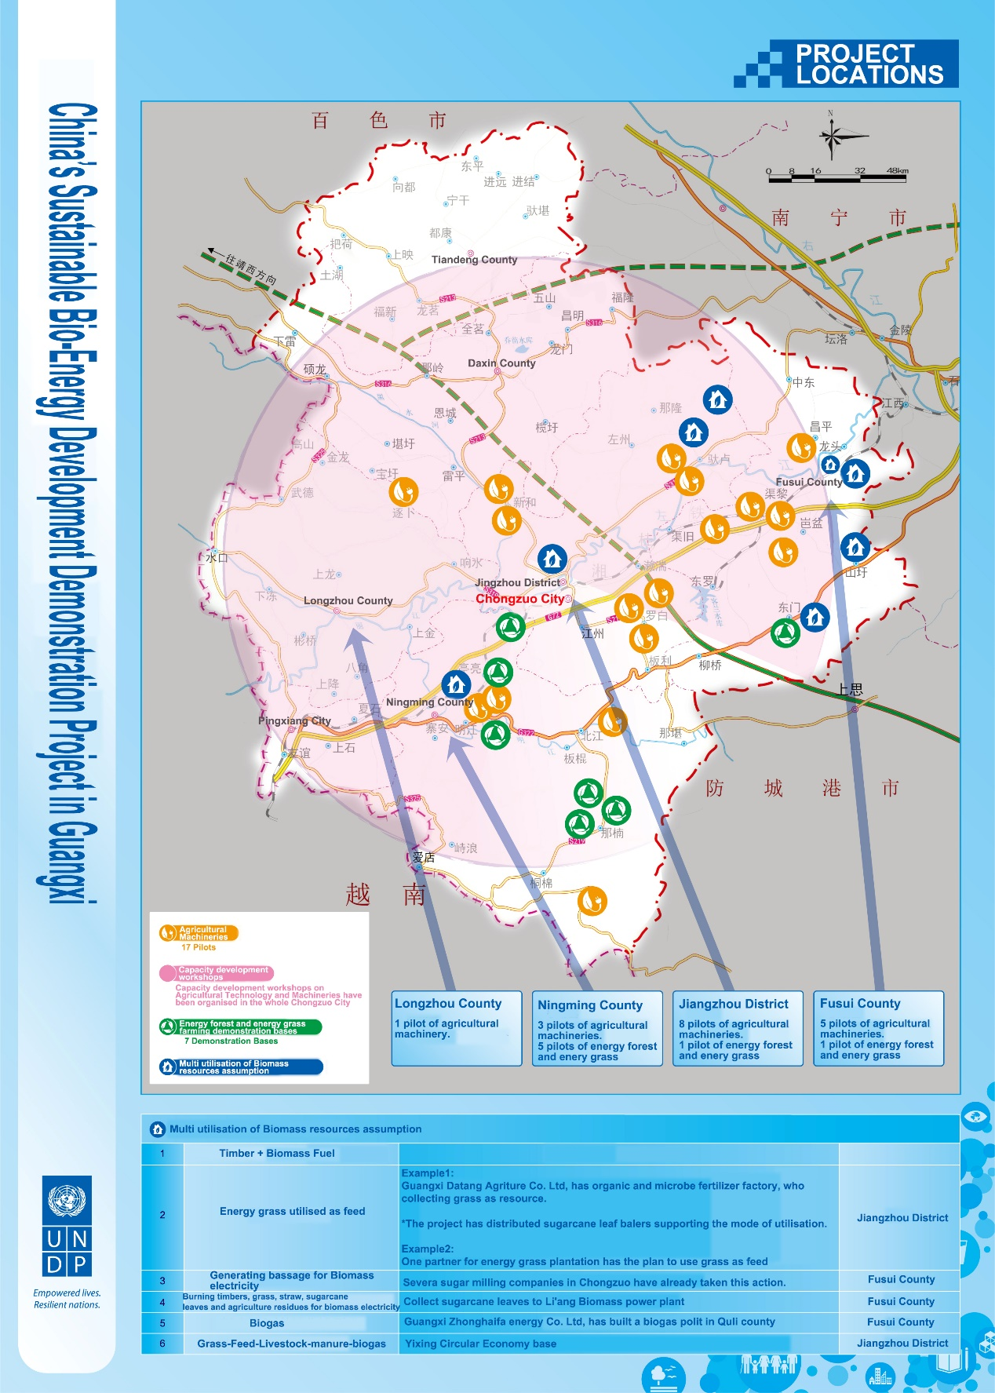

### • Main stakeholders: summary list

Main stakeholders being engaged by the PMO are list as below:

* Sugar Cane Growers Cooperatives
* Sugar Cane Farming Enterprises
* Sugar-producing companies
* Agricultural Machinery Service Cooperatives
* Biomass Power Plants
* Energy Forest/Grass Grower Cooperatives
* Local authorities (Municipal and County level)
* Service Companies (For Vietnamese Labours)
* Guangxi Development and Reform Commission
* Chongzuo Municipal Bureau of Environmental Protection
* Frontiers people
* Migrant Labours (Vietnamese)
* Sugar Cane Growers Individuals
* China Southern Power Grid
* Sugar Industry Development Office

# 4. Findings

## 4.1 Project Strategy

### • Project Design

The original Programme Document (ProDoc) in English, has illustrated clearly biomass development approaches with its’ issues/challenges, objectives and outcomes in a logical way which is appropriate for the situation right now. Activities designed for addressing issues are reasonable in order to achieve outputs respectively.

In the pre-conditional feasibility study, according to the document written by an expert group, it seems that they did not go through a “pilot area” selection process and define the scope and the boundary of the pilot area. This is a key element for further analysis of outputs to be achieved and activities to be taken to address specific issues.

• Results Framework

The results framework has been well formulated with appropriate indicators proving outputs to be achieved, but some outputs still need more analysis to be defined clearly. For example, the output 1.3 should be defined with boundary and scope through a pilot area selection process in the stage of pre-conditional feasibility study. Without the complete selection process, the PMO decided to pause(cancel) this output by misunderstanding of the pilot area.

There is an information gap between the original English version of ProDoc and Chinese version ProDoc and workplan being used now in terms of definition of “Famers’ Field School” (FFS) and its steps to be taken through. This information could not be found in Chinese version of ProDoc neither the workplan. It may mislead PMO team on FFS and caused that the FFS hasn’t been used as a community engagement approach for mobilizing community participation in the full industry chain for biomass energy development in selected pilot areas.

## 4.2 Progress Towards Results

### • Progress towards outcomes analysis

Table. MTR Ratings & Achievement Summary Table for (*China’s Sustainable Bio-Energy Development Demonstration Project in Guangxi*)

|  |  |  |
| --- | --- | --- |
| **Measure** | **MTR Rating** | **Achievement Description** |
| **Project Strategy** | N/A |  |
| **Progress Towards Results** | Objective Achievement Rating: (rate 6 pt. scale) **MS** | Biomass energy development aspects with technique modules, resource using and approaches are well planned, information base for further pilot areas selection to demonstrate Sustainable Industry Chain of Using agro/forestry Biomass Resources is provided. |
| Outcome 1 Achievement Rating: (rate 6 pt. scale) **MS** | Two of three outputs in this outcome have been correctly delivered, analysis has been done on biomass energy development situation, technique modules and existing problems in Chongzuo. While suspended with consent from all parties and with the correct procedure, it is highly recommended that the PMOs could reconsider integrating output 1.3 to the project framework as it would be helpful to serve as a platform to demonstrate integrated solution of biomass energy, community participation in the process, and land use planning and market connection, etc. |
| Outcome 2 Achievement Rating: (rate 6 pt. scale) **MS** | Completed as planned. |
| Outcome 3 Achievement Rating: (rate 6 pt. scale) **MS** | The standardization development is being discussed and planned, but need to do it after each exact module and geographic location has been defined. |
| Outcome 4 Achievement Rating: (rate 6 pt. scale) **MS** | Output 4.2 has been replaced with a new outcome expected with definition and scope, but indicators and activities should be carefully revised, renewed and re-identified. |
| Outcome 5 Achievement Rating: (rate 6 pt. scale) **MS** | Trees and grass planting are properly completed in the place, but the linkage between the plantation and the integrated biomass energy industry chain should be clarified. |
| Outcome 6 Achievement Rating: (rate 6 pt. scale) **HS** | The operation and performance of management teams are of satisfactory, in particular the team in Chongzuo is highly efficient given the resources obtained and achievements so far. |
| Etc. |  |
| **Project Implementation & Adaptive Management** | (rate 6 pt. scale) Management Arrangements, **HS** | The management team is running smoothly and making great progress. |
| Finance **S** | Specific financial management guideline is well established and followed by staff. |
| project-level monitory and evaluation  **S** | Tracking system is in operation, and data collection for each indicator of the outputs is being correctly managed. |
| work planning, **HS** | Budgeting and planning process through work planning is excellent. |
| Reporting **HS** | Quarterly report and annual report are well managed |
| Communication **MS** | Efforts have been made in many aspects. Overall communication strategy should be documented. |
| **Sustainability** | Overall **ML** |  |
| Financial risks **ML** | One of partners’ (Kaidi) funding is behind the schedule |
| Socio-economic risks  **ML** | Rural community should be emphasized as a key stakeholder to be closely engaged. |
| Environmental risks **ML** | Plantation activities need follow environmental management Guideline given by expert. |
| Institutional Framework and Governance risks, **L** | Capacity, knowledge gained by PMO staff and partners from this project will continuing contribute to biomass-energy projects in Chongzuo and other places. To accomplish this project for reach final goal, the team with supporting system is capable |

• Remaining barriers to achieving the project objective

There are not much remaining big barriers to achieving the project objective so far, but allocating appropriate funds is demanded for pushing forward the project towards the end of the project cycle as planned, therefore the final “models” with innovations could be built for duplicating in other areas.

## 4.3 Project Implementation and Adaptive Management

### • Management Arrangements

The project Management Office (PMO) in Chongzuo has two fulltime staff, and at least one UNV each year based in the office for assisting in many ways. A leader from Chongzuo Municipal Commission of Commerce and Port Administration is taking leadership role in managing the PMO regularly.

The role and responsibility for each staff has been defined clearly and reporting line is well defined and obtained too.

Please see the position and job description as the chart below.

**China's Sustainable Bio-Energy Development of Demonstration Project in Guangxi**

**Office organisation and job description of Chongzuo PMO**

|  |  |  |
| --- | --- | --- |
| **No.** | **Post** | **Job description and duties** |
| 1 | Director of the PMO | Maintain the overall operation of the PMO at project level, responsible for project coordination, project management, and guiding project implementation.  1. Responsible for the implementation of the project, report to the national management office.  2. Appoint the project manager.  3. Review and approve the budget and final balance, work plans and related reports of the project office at project level |
| 2 | Deputy director of the PMO | Assist the director in carrying out and managing the daily operation of the project, report to the director of the project office.  1. Management coordination;  2. Publicity and communication;  3. Participate in the project-related meetings on behalf of the project team;  4. Responsible for the human resource management;  5. Responsible for arranging the financial management;  6. Review the final balance, work plans and related reports of the project office. |
| 3 | Project Officer of the PMO | Under the supervision of the director and deputy director of the PMO, responsible for the daily operation of the project, and report to the director of the PMO.  1. Write and update the project work plan and activity budget management on time.  2. Responsible for the specific implementation and supervision of project activities.  3. Responsible for the preparation and consultation with all partners.  4. Responsible for the budget application.  5. In the case of implementation or subcontracting by external project cooperation agencies, ensure that these institutions arrange and implement project inputs in accordance with cooperation subcontracts, and responsible for an overall supervision and coordination of the work.  6. Prepare project quarterly and annual reports. Assist in independent review and evaluation of the project as needed.  7. Supervise the work of other staff, domestic and international experts  8. Report the progress of the project to the director of the PMO.  9. Write the final project report. |
| 4 | Accounting of the PMO | Fully responsible for the management of the daily expenses of the PMO. Responsible for the accounting of accounting documents, file management; prepare financial statement; review the daily financial management of the office at the project, ensure the effective use of funds, and ensure that the financial operations of project are regular and correct; responsible for asset management, internal audit supervision and special audits of the project office. |
| 5 | Staff | Assist project officers in their work; report to the director of the PMO. |
| 6 | Staff (full-time) | Assist project officers in their work; report to the director of the PMO.  1.Coordination with UNDP, CICETE, PPMO, local authorities, experts and other staff members.  2. File management, including the development of the project budget, project summary, project reports, summary of activities, etc.  3. Deliver project activities: make plans for activities, organise meeting, visits and capacity development workshops.  4. Chinese-English translation for documents including materials and speeches of various conferences, and necessary interpretation in work meetings and site visits.  5.Supervise and monitor the activities of partners at the project level.  6. Prepare project quarterly and annual reports. Assist in independent review and evaluation of the project as needed.  7. Logistics supports for the project office.  8.Ad-hoc works as requested. |

### • Work planning

Based on the results and resources framework in the ProDoc, the team created a workplan to guide management of all activities. The workplan have been updated regularly and adapted as needed when new decisions made by authorities from key partners, like UNDP, CICETE and Provincial PMO. Please see the workplan being used as below.

|  |  |  |  |  |
| --- | --- | --- | --- | --- |
| Workplan:2015-2020 | | | | |
| Project: 89703 China's Sustainable Bio-Energy Development of Demonstration Project in Guangxi | | | | |
| Outputs | Progress | | | |
| 2015 | 2016 | 2017 | 2018 |
| I. Comprehensive research and specified studies | | | | |
| 1.1Compilation of Chongzuo's Comprehensive Plan for Promoting Modern and Environment-Friendly Agriculture, Forestry, Husbandry Development(2015-2025) |  | Field Research and resources inventory in Chongzuo | study completed |  |
| 1.2 Compilation of Comprehensive Development Plan for Non-Grain Biomass Energy Industry of Chongzuo, Guangxi (2015-2025) |  | Field Research and resources inventory in Chongzuo | study completed |  |
| 1.3 Feasibility study on combining harvesting and juicing operations |  |  | Inception workshop, compilation, review of the study |  |
| 1.4 Partnership formulated and feasibility study completed for upgrading existing off-grid CHP plants within sugar mills |  |  | Compilation of *Development of Biomass Thermoelectricity with Wastes from Sugar Milling Process* |  |
| 1.5 Demonstration of environment-friendly recycling technologies in the sugar milling process |  |  | Compilation of *Research Report on Recycling Waste Water from Sugar Milling Process for Sugarcane Irrigation, Research Report on Producing Organic Fertilizers with Wastes from Sugar Milling Process, Research Report on Generating Electricity with Biogas Produced by Ethanol Waste Water* |  |
| II、Multiple utilisation of Biomass resource | | | | |
| 2.1 Formulation of sustainable biomass sourcing models, including eucalyptus energy forests, energy grasses and cassava plantations to achieve development and utilisation of biomass energy in sugar mills | | | | |
| 2.1.1 Establishment of energy forests and energy grasses farming demonstration bases |  |  | Designation of bidding company; used synthetic scoring method, 3 demonstration bases for energy forests, 3 for energy grasses, and 1 for sapling fostering were selected |  |
| 2.1.2 Pilot energy grasses-planting models by using marginal lands |  |  |  |
| 2.2Empowerment of local farmers and enhanced productivity for assisting the industrial upgrading | | | | |
| 2.2.1. Establishment of Modern Agricultural Training Centre in Chongzuo | 16 batches of capacity development workshops on mechanical ploughing and planting integrated operations at the “High Yield and High Sugar Content” (H-H) Sugarcane Planting Base for 1766 local farmers | |  | Capacity development workshops on mechanical ploughing and planting integrated operations at the “High Yield and High Sugar Content” (H-H) in progress |
| 2.2.2 Facilitate the establishment of Farmers' Field School to provide technical trainings to farmers | 1.14 batches of modern agricultural techniques trainings, with admissions totalled 178 2.2 batches of technical trainings on unpolluted breeding for 349 people. | | 1.5 batches of capacity development workshop for 300 people； 2.7 batches of workshops on livestock technology for 512 participants | Workshops on livestock technology in progress |
| 2.3 Promotion of the mechanised operation | | | | |
| 2.3.1 Standardisation of sugarcane mechanised operation | National Sugarcane Production Mechanisation Promotion Event |  |  | 2 batches of capacity building workshops on agricultural machinery for 177 local people. |
| 2.3.2 Promotion of mechanised operation services |  |  | procured and distributed 25 agricultural machineries, including 17 sugarcane leaf balers, 4 lawn mowers and 4 tractors. |  |
| III、Partnership establishment, Publicity and Communications | | | | |
| 3.1 Strategy, Cooperation and Adaptive Management | Project Inception workshop | 1 PSC meeting organised | 1.Site visits organised 2.7 management meetings at different level organised | 6 relevant management meetings organised |
| 3.2 Communications |  |  | 1.Promoting the United Nations Sustainable Development Goals: China-ASEAN Biomass Energy Forum for Sustainable Development was successfully held in Nanning 2. Starting the minutes video clip production 3.Starting the production of documentary for the project | Australia and Japan visit for advanced experience in biomass development and sugar industry. |

There were some information gaps between original English version ProDoc with Chinese version ProDoc and current workplan, that may cause misunderstanding in some output’s definition, scope and approach to be reached. For example, Farmers’ Field School (FFS), definition of FFS and steps recommended in the ProDoc of original English version, are not found both in Chinese version ProDoc and existing workplan being used.

• Finance and co-finance

The budgeting of the project is going well, all Procurements of the project were made strictly following the government procurement regulation.

From the project budget table, no cash is directly allocated in the budgeting table as co-financing from government side, but there are actual contributions from local government agencies that have been made to the project through coordination by the advising committee. Synergies between the project activities with similar activities conducted by each agency in Chongzuo were happened so that have more people benefited in last two years.

Synergy project with government effort to local community is a big potential in Chongzuo in coming years. The group review workshop with participants from advising committee conducted during MTR shows that member agencies are still very interesting in looking for outputs from this project and willing to contribute or synergy available resources in their plan into this project to enlarge beneficiary groups.

While the contribution was not signed and committed right at the beginning of launching the project, the PMO could potentially keep a record of the gov resource mobilised for reporting and storytelling, if this is agreed by the gov, since UNDP PMOs are not entitled to monitor gov spending

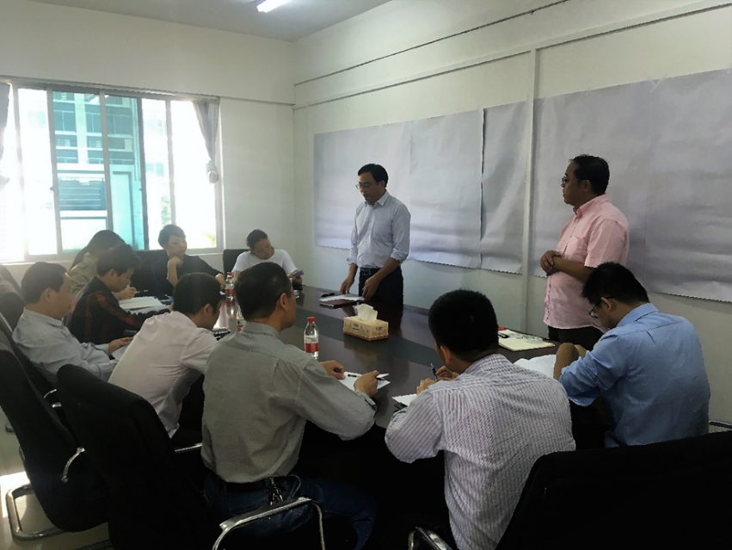

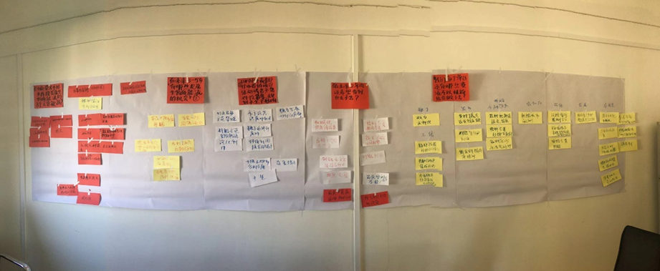

### • Project-level monitoring and evaluation systems

The team has an internal M&E for the project management, together with the workplan tracking system, all indicators have been monitored in regular base and outputs have been evaluated in timely manner. Documents filing system was well managed by the team and easy to be tracked for all records.

### • Stakeholder engagement

Multi-stakeholder involvement is one of the characteristics of this innovation type of project. The management team has defined most of key stakeholders to be engaged with along the project cycle. With great efforts made by the advising committee of PMO, the team had effective communication and cooperation with each stakeholder to gain their support in many aspects and making synergy of their resources for benefit more widely. Regarding to pilot area establishment, since the output 1.3 has been suspended, tangible communities have not been determined yet, and strategies for engagement of local communities haven’t been developed in the beginning stage.

Please see the picture for stakeholder mapping done with the PMO team during MTR field mission in Chongzuo. The individual sugar cane growers in the community are able to have strong power and resources to influence biomass collection but have low interests in the project. A prepared community assessment should be conducted and the project team should engage them into biomass energy “full industry chain”, thus the pilot could be demonstrated in a meaningful way.

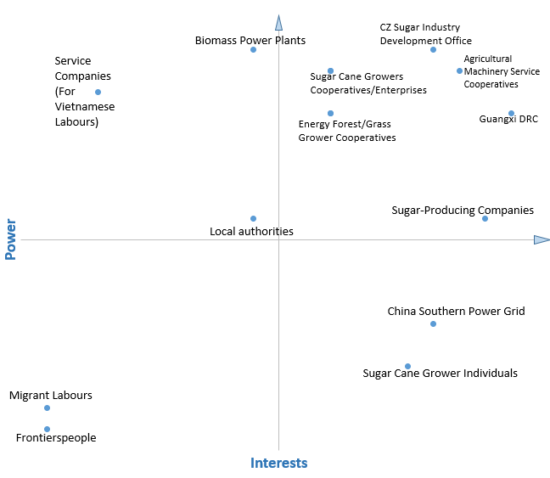

### • Reporting

Reporting line is clearly defined at each level and decision procedures are performed at all levels. Given the existing management structure, there is no significant barrier to manage this project towards its’ objectives, except that the information flow may take longer time within the structure.

The team in Chongzuo PMO prepares quarterly report and annual report on schedule. The reports cover all information needed for the project management and tracks performance of individual activities in effective way.

### • Communications

A lot of activities have been done for project communication and advocacy, such as development brochures, project short video story and a plan for video footages collection discussed for producing a documentary film to tell the successful stories of the project.

An overall communication strategy in writing format is not in place yet but activities have been done by PMOs at all level for general communication and advocacy in last two years

Advocacy efforts have been reached one of great achievements through organizing of China-ASEAN Biomass Energy forum.

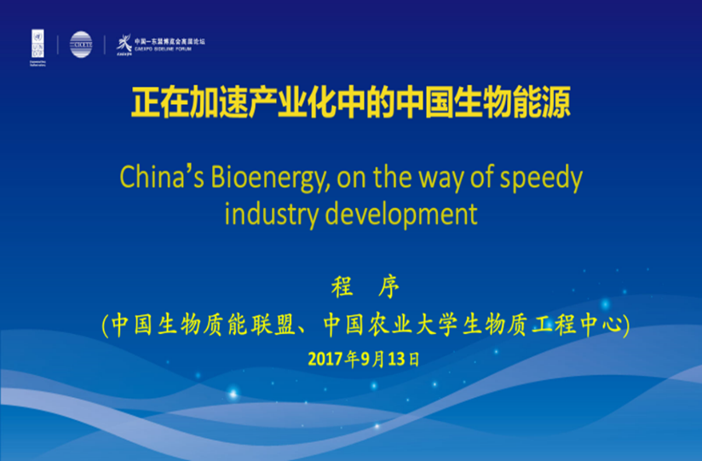

## 4.4 Sustainability

### • Financial risks to sustainability

Kaidis’ funding is not available to be transferred on schedule due to company’s internal financial crisis, it could be a big risk for reaching project objective within the project lifecycle. The current balance of PMO could no longer maintain the office operation after the February of 2019. In addition, further payments are uncertain to be made for 12 ongoing contracts, which could be another risk for this project if no backup plan prepared for this situation.

### • Socio-economic to sustainability

More communities and beneficiaries need to be covered as key stakeholders for “full industry chain” establishment, including those benefited from previous implemented activities.

### • Institutional framework and governance risks to sustainability

The management structure is meeting the management requirement at this moment. But the team does not start to develop a face out strategy to ensure that all outcomes from this project can be fully functioning through post management period.

A working team was formulated by staff from UNDP, CICETE and PMO at provincial and municipal in the beginning of the project, coordination meetings were organized regularly and as needed, which ensures communications among the team in an effective way up now.

There is a project management guideline developed for all staff, it covers financial and budget management, contract, office and human resource management.

Please see the first page of the guideline as below:



(*N.B. Management regulation used in the PMO is in Chinese Version and no translation exists*)

### • Environmental risks to sustainability

Lack of developed community level land use plan, large scale environment impacts on land use from the project cannot be found or evaluated during this MTR. The plantations being established by corporations need to follow the guidance of environment management recommendations developed by the forestry expert in Chongzuo. The fir plantation is being well managed, and the survival rate is around 85%.

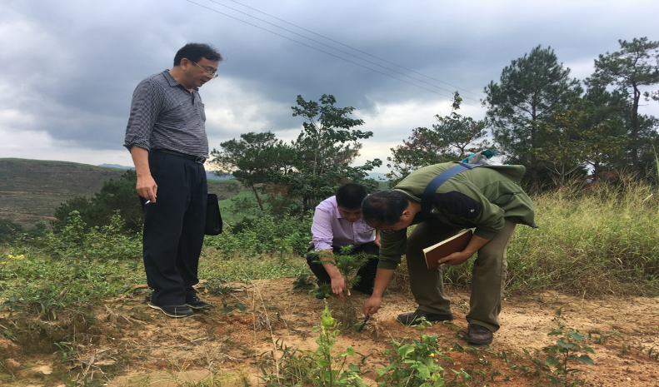

# 5. Conclusions and Recommendations

## 5.1 Conclusions

### • Comprehensive and balanced statements

In the preparation stage of this project, biomass energy development issues have been fully analysed, and the advantages and opportunities for the development of biomass in Chongzuo have been identified. The concept and objectives set up for this project show that multi stakeholder need to be engaged with innovative approach. Among its’ framework, issues to be addressed with strategies has been clearly linked with each other in a logical manner. Outputs formulated with supporting indicators and activities are well defined, it provides a practical guidance to implementation body for effectively delivery activities.

For the implementation, all activities with their progress being made are almost following the RRF. Each activity carried out with defined indicators has been tracked by the PMO regularly. In all 19 outputs, more than half of them are smoothly progressing until now.

UNDP, CICETE and PPMO are cooperating very well and the communication is running effectively ensuring the project’s implementation as planned

One of project donor, Kaidi group was shown their high ownership about the project and very appreciated the achievements.

PMO in Chongzuo has accomplished all activities as planned. Budgeting, contracts, office space and people management are carried out in an effective way and all files and documents are well saved in a safety way at the project level.

Most key stakeholders have been identified and collaborative partnership has been built correctly for this project. No significant crisis can be found in regards to the stakeholder engagement so far.

PMO in Chonzuo has done a lot of communication and extension works with local partners. Publics, local government agencies, companies, corporations and farmers shared their understanding about biomass energy development issues and ideas. Some of them have already participated in the project activities. Advocating effort has parallelly made at provincial and national level for more significant impacts. The project concept and practices have been comprehensively discussed and promoted through the ASEAN international forum on Biomass Energy Development.

All research reports, plans, feasibility studies, training materials, videos have been orderly managed by PMO and saved as a knowledge base for partners and public. Some details of those products have been taken by local government agencies for helping their planning and decision making, and local corporates and companies are also very keen to learn data and information from those products.

## 5.2 Recommendations

There are three major recommendations for further consideration: (for more details, please see recommendations table)

* The project objective agreed among UNDP, and local government in Guangxi is: to establish a replicable sustainable bio-energy development in China and to benefit small farmers and rural communities through engaging them in biomass production and supply. To achieve the objective above with a tangible and replicable demonstrations on the ground as a model for showing the biomass energy development in a full industry chain, a full journey from community land use practices to the biomass energy generation should be taken through with the best practices, innovations and empowerment of small farmer and community, thus, the PMO is highly recommended to go through a key pilot area and communities selection process with consideration of packaging implemented activities into a comprehensive model in few selected key pilot areas in Chongzuo.
* From operational point of view, after key pilot areas selection process conducted, the results and resources framework should be revised, which includes definition and scope for outputs changed accordingly. The leading group of the project should make an official approval and announcement of the revised RRF to PMO after this MTR and it should be the RRF for the final evaluation.
* To achieve the final objective set up for this project, an overall communication strategy would be suggested to be formulated to ensure that impacts can be reached out at the level as expected.

# 6. Annexes

### Annex 1: MTR ToR

## UNDP Midterm Review Terms of Reference

1. **INTRODUCTION**

This is the Terms of Reference (ToR) for the UNDP Mid-term Review (MTR) of the project titled *China’s Sustainable Bio-Energy Development Demonstration Project in Guangxi* implemented through the *China International Center for Economic and Technical Exchanges (CICETE)*, which has been undertaking since *2015 to December 2019*. According the ProDoc, the project starts on *January, 2015* and is in its *third* year of implementation. This ToR sets out the expectations for this MTR.

**2. PROJECT BACKGROUND INFORMATION**

The project was designed with the following Goal, Objective, and Outcomes:

*Project Goal: The overall China-UNDP project goal is to assist China in mitigating climate change by meeting the target as per the 12th FYP of increasing the share of renewable energy in the energy mix by 2015.*

*Project Objective:　The project will achieve the following overall objective: Through piloting a sustainable bio-energy development model, the project will assist China to implement its sustainable energy development strategy, particularly in achieving the goal of increasing share of renewable energy in the national energy consumption by 2020 which will mitigate the climate change.*

*Project Outcomes: 1) Inventory the agricultural and forestry resources and use in Chongzuo and compile Chongzuo’s Comprehensive Plan for Modern Ecological Agriculture, Forestry and Husbandry and Biomass Energy Development; 2) Establish farmer’s cooperatives and Farmers’ Field School (FFS) and enhance farmer’s production capacity through technical training; 3) Study the feasibility of innovative sugarcane harvest model and combined sugarcane harvest-juicing model; 4) Establish and pilot the biomass sourcing models, i.e. eucalyptus energy forest base, energy grasses and cassava plantations to extend the raw biomass materials sources; 5) Develop and demonstrate innovative, low-energy consumption and environment-friendly sugar refine technologies and integrated bagasse utilization technologies; and 6) Project management, monitoring and evaluation.*

*However, in terms of the timeframe, the actual implementation of the Project has differed from what was designed in the ProDco, in which in the first stage at the beginning of 2015 to the end of 2016, the project activities focus on sugarcane and related industrial upgrading, including support for the government to carry out scientific biomass planning, capacity building and training exchange system, and promote mechanization and large-scale sugar cane, etc. The second stage, at the end of 2016 to 2019, according to the stages of implementation and the findings of the first phase of the project, a joint forestry sector and sugar industry and expand the supply of biomass feedstock to establish biomass resource collection models and explore biomass power generation feasibility. Communication, as well as project management, monitoring and evaluation will be across the two phases.*

**3. OBJECTIVES OF THE MTR**

The MTR will assess progress towards the achievement of the project objectives and outcomes as specified in the Project Document (ProDoc), and assess early signs of project success or failure with the goal of identifying the necessary changes to be made in order to set the project on-track to achieve its intended results. The MTR will also review the project’s strategy, its risks to sustainability, making recommendations for continuing or discontinuing the Project.

**4. MTR APPROACH & METHODOLOGY**

The MTR must provide evidence based information that is credible, reliable and useful. The MTR team will review all relevant sources of information including documents prepared during the preparation phase (i.e. Project concept note, UNDP Environmental & Social Safeguard Policy, the ProDoc, project reports including Annual Project Review, project budget revisions, lesson learned reports, national strategic and legal documents, and any other materials that the team considers useful for this evidence-based review).

The MTR team is expected to follow a collaborative and participatory approach[1] ensuring close engagement with the Project Team, government counterparts, the UNDP Country Office(s), and other key stakeholders.

Engagement of stakeholders is vital to a successful MTR.[2] Stakeholder involvement should include interviews with stakeholders who have project responsibilities; executing agencies, senior officials and task team component leaders, key experts and consultants in the subject area, Project Steering Committee, project stakeholders, academia, local government and CSOs, etc. Additionally, the MTR team is expected to conduct field missions to *Nanning and Chongzuo Guangxi*.

The final MTR report should describe the full MTR approach taken and the rationale for the approach making explicit the underlying assumptions, challenges, strengths and weaknesses about the methods and approach of the review.

**5. DETAILED SCOPE OF THE MTR**

The MTR team will assess the following four categories of project progress.

**i. Project Strategy**

Project design:

* Review the problem addressed by the project and the underlying assumptions. Review the effect of any incorrect assumptions or changes to the context to achieving the project results as outlined in the Project Document.。
* Review the relevance of the project strategy and assess whether it provides the most effective route towards expected/intended results. Were lessons from other relevant projects properly incorporated into the project design?
* Review how the project addresses country priorities. Review country ownership. Was the project concept in line with the national sector development priorities and plans of the country (or of participating countries in the case of multi-country projects)?
* Review decision-making processes: were perspectives of those who would be affected by project decisions, those who could affect the outcomes, and those who could contribute information or other resources to the process, taken into account during project design processes?
* Review the extent to which relevant gender issues were raised in the project design.
* If there are major areas of concern, recommend areas for improvement.

Results Framework:

* Undertake a critical analysis of the project’s indicators and targets, assess how “SMART” the midterm and end-of-project targets are (Specific, Measurable, Attainable, Relevant, Time-bound), and suggest specific amendments/revisions to the targets and indicators as necessary.
* Are the project’s objectives and outcomes or components clear, practical, and feasible within its time frame?
* Examine if progress so far has led to, or could in the future catalyse beneficial development effects (i.e. income generation, gender equality and women’s empowerment, improved governance etc...) that should be included in the project results framework and monitored on an annual basis.
* Ensure broader development and gender aspects of the project are being monitored effectively. Develop and recommend SMART ‘development’ indicators, including sex-disaggregated indicators and indicators that capture development benefits.

**ii. Progress Towards Results**

Progress Towards Outcomes Analysis:

* Review the indicators against progress made towards the end-of-project targets using the Progress Towards Results Matrix; colour code progress in a “traffic light system” based on the level of progress achieved; assign a rating on progress for each outcome; make recommendations from the areas marked as “Not on target to be achieved” (red).

Table. Progress towards Results Matrix (Achievement of outcomes against End-of-project Targets)

|  |  |  |  |  |  |  |  |
| --- | --- | --- | --- | --- | --- | --- | --- |
| **Project Strategy** | **Indicator[3]** | **Baseline Level[4]** | **Midterm Target[5]** | **End-of-project Target** | **Midterm Level & Assessment[6]** | **Achievement Rating[7]** | **Justification for Rating** |
| **Objective:** | Indicator (if applicable): |  |  |  |  |  |  |
| **Outcome 1:** | Indicator 1: |  |  |  |  |  |  |
| Indicator 2: |  |  |  |  |
| **Outcome 2:** | Indicator 3: |  |  |  |  |  |  |
| Indicator 4: |  |  |  |  |
| Etc. |  |  |  |  |
| **Etc.** |  |  |  |  |  |  |  |

**Indicator Assessment Key**

|  |  |  |
| --- | --- | --- |
| Green= Achieved | Yellow= On target to be achieved | Red= Not on target to be achieved |

In addition to the progress towards outcomes analysis:

* Identify remaining barriers to achieving the project objective in the remainder of the project.
* By reviewing the aspects of the project that have already been successful, identify ways in which the project can further expand these benefits.

**iii. Project Implementation and Adaptive Management**

Management Arrangements:

* Review overall effectiveness of project management as outlined in the Project Document. Have changes been made and are they effective? Are responsibilities and reporting lines clear? Is decision-making transparent and undertaken in a timely manner? Recommend areas for improvement.
* Review the quality of execution of the Implementing Partner(s) and recommend areas for improvement.
* Review the quality of support provided by the all partner agencies, including UNDP, and recommend areas for improvement.

Work Planning:

* Review any delays in project start-up and implementation, identify the causes and examine if they have been resolved.
* Are work-planning processes results-based? If not, suggest ways to re-orientate work planning to focus on results?
* Examine the use of the project’s results framework as a management tool and review any changes made to it since project start.

Finance:

* Consider the financial management of the project, with specific reference to the cost-effectiveness of interventions.
* Review the changes to fund allocations as a result of budget revisions and assess the appropriateness and relevance of such revisions.
* Does the project have the appropriate financial controls, including reporting and planning, that allow management to make informed decisions regarding the budget and allow for timely flow of funds?

Project-level Monitoring and Evaluation Systems:

* Review the monitoring tools currently being used: Do they provide the necessary information? Do they involve key partners? Are they aligned or mainstreamed with national systems? Do they use existing information? Are they efficient? Are they cost-effective? Are additional tools required? How could they be made more participatory and inclusive?
* Examine the financial management of the project monitoring and evaluation budget. Are sufficient resources being allocated to monitoring and evaluation? Are these resources being allocated effectively?

Stakeholder Engagement:

* Project management: Has the project developed and leveraged the necessary and appropriate partnerships with direct and tangential stakeholders?
* Participation and country-driven processes: Do local and national government stakeholders support the objectives of the project? Do they continue to have an active role in project decision-making that supports efficient and effective project implementation?
* Participation and public awareness: To what extent has stakeholder involvement and public awareness contributed to the progress towards achievement of project objectives?

Reporting:

* Assess how adaptive management changes have been reported by the project management and shared with the Project Steering Committee.
* Assess how well the Project Team and partners undertake and fulfil UNDP reporting requirements
* Assess how lessons derived from the adaptive management process have been documented, shared with key partners and internalized by partners.

Communications:

* Review internal project communication with stakeholders: Is communication regular and effective? Are there key stakeholders left out of communication? Are there feedback mechanisms when communication is received? Does this communication with stakeholders contribute to their awareness of project outcomes and activities and investment in the sustainability of project results?
* Review external project communication: Are proper means of communication established or being established to express the project progress and intended impact to the public (is there a web presence, for example? Or did the project implement appropriate outreach and public awareness campaigns?)
* For reporting purposes, write one half-page paragraph that summarizes the project’s progress towards results in terms of contribution to sustainable development benefits.

**iv. Sustainability**

* Validate whether the risks identified in the Project Document, Annual Project Review and the ATLAS Risk Management Module are the most important and whether the risk ratings applied are appropriate and up to date. If not, explain why.
* In addition, assess the following risks to sustainability:

Financial risks to sustainability:

* What is the likelihood of financial and economic resources not being available once the UNDP assistance ends (consider potential resources can be from multiple sources, such as the public and private sectors, income generating activities, and other funding that will be adequate financial resources for sustaining project’s outcomes)?

Socio-economic risks to sustainability:

* Are there any social or political risks that may jeopardize sustainability of project outcomes? What is the risk that the level of stakeholder ownership (including ownership by governments and other key stakeholders) will be insufficient to allow for the project outcomes/benefits to be sustained? Do the various key stakeholders see that it is in their interest that the project benefits continue to flow? Is there sufficient public stakeholder awareness in support of the long term objectives of the project? Are lessons learned being documented by the Project Team on a continual basis and shared transferred to appropriate parties who could learn from the project and potentially replicate and/or scale it in the future?

Institutional Framework and Governance risks to sustainability:

* Do the legal frameworks, policies, governance structures and processes pose risks that may jeopardize sustenance of project benefits? While assessing this parameter, also consider if the required systems mechanisms for accountability, transparency, and technical knowledge transfer are in place.

Environmental risks to sustainability:

* Are there any environmental risks that may jeopardize sustenance of project outcomes?

**Conclusions & Recommendations**

The MTR team will include a section of the report setting out the MTR’s evidence-based conclusions, in light of the findings.[8]

Recommendations should be succinct suggestions for critical intervention that are specific, measurable, achievable, and relevant. A recommendation table should be put in the report’s executive summary.

The MTR team should make no more than 15 recommendations total.

**Ratings**

The MTR team will include its ratings of the project’s results and brief descriptions of the associated achievements in a *MTR Ratings & Achievement Summary Table* in the Executive Summary of the MTR report. See Annex E for ratings scales. No rating on Project Strategy and no overall project rating is required.

Table. MTR Ratings & Achievement Summary Table for (*China’s Sustainable Bio-Energy Development Demonstration Project in Guangxi*)

|  |  |  |
| --- | --- | --- |
| **Measure** | **MTR Rating** | **Achievement Description** |
| **Project Strategy** | N/A |  |
| **Progress Towards Results** | Objective Achievement Rating: (rate 6 pt. scale) |  |
| Outcome 1 Achievement Rating: (rate 6 pt. scale) |  |
| Outcome 2 Achievement Rating: (rate 6 pt. scale) |  |
| Outcome 3 Achievement Rating: (rate 6 pt. scale) |  |
| Etc. |  |
| **Project Implementation & Adaptive Management** | (rate 6 pt. scale) |  |
| **Sustainability** | (rate 4 pt. scale) |  |

1. **TIMEFRAME**

The total duration of the MTR will be approximately 9 *weeks* starting 20*th Jan 2018,* and shall not exceed five months from when the consultant(s) are hired. The tentative MTR timeframe is as follows:

* *20th Jan 2018 :* Application closes
* *23rd Jan 2018:* Selection of MTR Team
* *24th Jan 2018:* Prep the MTR Team (handover of project documents)
* *26th to 29th Jan 2018, 4 days:* Document review and preparing MTR Inception Report
* *2nd to 3rd Feb 2018, 2 days:* Finalization andValidation of MTR Inception Report- latest start of MTR mission
* *4th to 14th Feb 2018, 11 days:* MTR mission: stakeholder meetings, interviews, field visits

*20th Feb 2018:* Mission wrap-up meeting & presentation of initial findings- earliest end of MTR mission

* *20th to 28th Feb 2018, 9 days:* Preparing draft report
* *1st to 2nd Mar 2018, 2 days:* Incorporating audit trail on draft report/Finalization of MTR report
* *12th to 13th Mar 2018, 2 days:* Preparation & Issue of Management Response
* *22nd Mar 2018:* (optional)Concluding Stakeholder Workshop (not mandatory for MTR team)
* *23rd Mar 2018:* Expected date of full MTR completion

The date start of contract is 20*th Jan 2018*.

Options for site visits should be provided in the Inception Report.

1. **MIDTERM REVIEW DELIVERABLES**

|  |  |  |  |  |
| --- | --- | --- | --- | --- |
| **#** | **Deliverable** | **Description** | **Timing** | **Responsibilities** |
| **1** | **MTR Inception Report** | MTR team clarifies objectives and methods of Midterm Review | Within the first 5 working days of the MTR mission | MTR team submits to the Commissioning Unit and project management |
| **2** | **Presentation** | Initial Findings | End of MTR mission | MTR Team presents to project management and the Commissioning Unit |
| **3** | **Draft Final Report** | Full report (using guidelines on content outlined in Annex B) with annexes | Within 3 weeks of the MTR mission | Sent to the Commissioning Unit, reviewed by RTA, Project Coordinating Unit |
| **4** | **Final Report\*** | Revised report with audit trail detailing how all received comments have (and have not) been addressed in the final MTR report | Within 1 week of receiving UNDP comments on draft | Sent to the Commissioning Unit |

*The final MTR report must be in English. If applicable, the Commissioning Unit may choose to arrange for a translation of the report into a language more widely shared by national stakeholders.

### Annex 2: Questions formulated for the interview to each stakeholder groups

Outlines of Semi-structure interview to stakeholder groups

一、糖办：

1、 制糖业的现状？

2、 制糖业发展的优势是啥？

3、 发展有哪些机会？

4、 制糖业面临的挑战是啥？

5、 你了解我们的项目吗？

6、 你希望这个项目在那些方面能对你有帮助？

7、 你能以那种形式参与到项目中来？

8、 你有啥问题要问我们吗？

二、劳务公司：

1、 外籍劳工的引入现状？

2、 外籍劳工引入的趋势是啥？

3、 崇左引进外籍劳工的主要目的是啥？

4、 优势与机会

5、 面临的制约因素和挑战是啥？

6、 如何应对

7、 我们这个项目能在哪些方面能帮助到你？

8、 对参与这个项目你有啥建议？

9、 关于这个项目你有啥问题？

三、生物质发电厂：

1、 啥时建的厂，规模产出概况

2、 你认为你们厂的生物质发电的前景如何？

3、 你们厂3-5年内面临的挑战是啥？

4、 有应对策略和机会吗?

5、 发电厂给当地带来的主要贡献是啥？

6、 我们这个项目对你们的帮助有哪些？

7、 你们是如何参与这个项目的？参加过培训吗？有个农民田间学校你参加过吗？

8、 参与这个项目还有啥建议

9、 对这个项目还有问题要问我们吗？

四、农机公司：

1、 农机公司发展的概况？

2、 3-5年内发展的目标是啥？

3、 员工主要来自那里？

4、 面临的挑战是啥？

5、 有啥对策和机会？

6、 如何参与我们这个项目的？有个农民田间学校你参加过吗？

7、 取得的效果是啥？

8、 对这个项目有啥改进意见？和期望？

9、 关于这个项目有其它问题要问吗？

五、甘蔗种植合作社：

1、 合作社有多少社员？管理机制概况？社员获得利益情况？

2、 种植规模有多大？

3、 劳力使用情况

4、 使用哪些农机具？啥时后开始使用的？

5、 合作社3-5年内，面临啥问题与挑战？

6、 有啥机会和策略？

7、 如何参与这个项目的？参加过培训吗？有个农民田间学校你参加过吗？

8、 如果继续参与项目，有啥建议和期望？

9、 你有啥问题要问吗？

六、甘蔗种植企业：

1、 那年办的厂？规模多大

2、 土地是如何解决的？租赁、流转、入股？

3、 劳力如何解决的？主要是男劳力还是女劳力？外劳使用管理？

4、 目前工厂3-5年的发展目标是啥？

5、 目前面临的挑战是啥？

6、 有策略和机会吗？

7、 你们企业参加了哪些项目活动？有些啥产出？

8、 对今后的项目有啥建议和期望。

9、 有啥问题需要问吗？

七、制糖企业：

1、 企业基本概况

2、 生产能力及目标

3、 员工来源

4、 原料来源和数量

5、 未来3-5年的发展目标

6、 存在的主要挑战是啥

7、 有啥策略和机会

8、 您知道生物质能源项目吗？

9、 你参加过哪些项目活动？为啥？

10、 参加这个项目的感受是啥？

11、 如果要继续参加这个项目有啥建议和期望？

12、 有个研究报告你看到没？

13、 热电联共技术有啥看法？

14、 能在你的厂开展吗？为啥？

15、 你有啥问题要问我们吗？

八、林业企业（大户）

1、有多少林木面积？主要是啥树种？经营目标是啥

2、劳力来源？

3、土地性质？

4、目前搞好森林经营面临啥挑战？

5、有机会和策略吗?

6、了解生物质发电的情况吗？

7、知道咱们这个项目吗？

8、参与过哪些活动？

9、如果有，对你们的影响是啥？

10、如果继续这个项目你有啥建议和期望？

11、项目上的研究报告和规划你看到了吗？

12、还有啥问题要问我们吗？

### Annex 3: Records for a Facilitated group discussion with participants from agencies of the leading group

|  |  |  |  |
| --- | --- | --- | --- |
| **项目名称** | 广西生物质能可持续发展示范项目 | **会议名称** | 2018年项目中期评估研讨会 |
| **会议时间** | 2018年10月29日10:00-12:00 | **会议地点** | 崇左市商务与口岸管理委员会五楼小会议室 |
| **与会单位** | 广西生物质能可持续发展示范项目市级项目办、自治区项目办、崇左市发改委、崇左市工信委、崇左市糖业办、崇左市林业局、崇左市农业局、崇左市农机局、崇左市环保局、龙州县政府 | | |
| **会议议题：**2018年项目中期评估崇左市级成员单位研讨会，项目活动梳理及下一步安排讨论。 | | | |
| **一、会议基本情况：**  市级项目办对项目进展进行简要汇报，并对各成员单位的协助支持表示感谢。联合国开发计划署驻华代表处专家顾问凌林博士对此次参与式独立中期评估工作进行介绍，并同各成员单位与会人员重点对项目工作开展进行梳理，重点讨论项目与崇左市总体的协同发展、生物质及生物质能发展的主要机遇与挑战、项目的重要产出及初步影响、以及进一步推进项目的具体设想。加强成员单位之间的沟通与合作。  **二、会议讨论议题：**  **一）、目前崇左市的可持续地发展生物质能源的主要挑战？**   * **原料方面**：   **生物质原料保障。**当地已有几家生物质的电厂，也有树皮、木屑、蔗渣（供糖厂生物质电厂发电），但未来会有更多的生物质电厂，如何保障可持续的原料供应？  **生物质原料收集模式和链条缺失。**  **生物质原料收集成本过高。**机械化缺失是收集成本高的一个重要因素。  **生物质原料破碎压缩成型。**如何使田间地头的生物质能够成形为高密度的燃料，方便运输及利用？   * **技术方面**：   **机械化水平有待提高。**  **生物质综合利用率、循环利用率低。**目前大量生物质原料直接搁置在田间地头不进行处理。如何使得使用效率最大化？如何开发生物质及生物质能源的循环利用？  **生物质能源技术的便捷性、创新性。**生物质能源技术利用的便捷性。生物质高附加值产品生产技术及利用途径。   * **民众适应性：**   **农民素质有及生物质能利用能力待提高。**  **技术操作培训不够。**特别是操作生物质技术能力有待提高。   * **政策挑战：**   **生物质发展的政策基础。**政策对于生物质及生物质能源产业的持续支持。  **碳交易补偿机制的完善。**碳交易市场上减排后的溢价补偿应该通过转移支付的方式到贫困县等相应地区。  小结：根据以上所说的挑战，项目实际做出了相关工作，特别是在机械化的提高、原料的供应，如能源林草示范点的开发、生物质饲料化应用、树皮林业三剩物等能源化的利用，等等方面做出了相关尝试；也给农民提供了相关培训，做出了小型农机在当地的使用尝试，并在自治区层面上做了一些政策倡导的工作。项目和崇左所面临的挑战还是高度契合的。  **二）、在未来的3到5年，有那些发展生物质能源的机会？例如：政策、大型企业的入驻、土地流转上可能为生物质发展带来的促进等。**   * **政策机遇**   **国家发改委对生物质发电的电价补贴（0.75元/度）。**在实地对电厂的补贴中也了解到电厂确实有相关补贴，但目前补贴到位太晚，对小型生物质发电厂造成很大压力。  **生态文明建设理念**。在习总书记生态文明建设的理念带动下，高耗能的产业会被淘汰，生物质能源的发展会迎来新的机遇。  **振兴乡村计划帮助农村发展。**做农民的工作，使农民致富，未来的新能源利用需要在农村这一块铺开。   * **原料上的机遇。**   **崇左的“双高“基地建设**是一个重点。至2020年，崇左市范围内要完成210万亩，目前已有建设195万亩。且全市在推进**“糖料蔗保护区建设”**，也是国家下达的保障政策，保面积保产量。  **崇左的农业产业化+工业转型升级**可以说是崇左最大的发展机遇。制糖企业的后期利用及技术改造升级，让生物质利用成为可能，这是在崇左形成的天然叠加。再者，产业化水平高则甘蔗尾叶收集的水平也相应提高。  **三）、广西生物质能可持续发展示范项目的哪些活动或产出已对政策、规划产生影响？**   * **走在“十三五”规划前的禁烧秸秆示范。**   项目于“十三五”之前启动，走在“十三五”之前。国民经济与社会发展第十三个五年计划明确不能焚烧秸秆，项目以减少秸秆焚烧、降低碳排量的设计提前介入“十三五”，提前示范秸秆禁烧行动。   * **推动生物质综合利用产业，进行村级生物质利用示范。**   按设计，项目预计在完结时对生物质综合利用业态起到推进作用，特别是从生物质发电、生物质饲料化利用并通过“过腹还田”的方式形成沼气等链条、村级生物质气化利用（发改委项目）来进行生物质综合利用。   * **在崇左市范围内达成关于甘蔗尾叶利用的广泛共识。** * **延长糖业产业链，从甘蔗种植到尾叶利用。** * **通过项目设计将环保理念及技术引入乡村。**   甘蔗尾叶从纯粹焚烧到综合利用，粉碎还田、生物质能源化利用、饲料化利用。   * **区域层面上对产业政策制定的影响。**   在糖业的发展、后续产物、糖厂自动化升级、糖价调节机制、乙醇价格调节等产业支持政策及激励措施上有带动和引领作用。对新能源发展政策、新能源技术发展支持导向会有一定的影响。   * **对“十四五”规划产生可能影响。**   **农林废弃物利用产业结构和资金支持力度。**最大的影响可能是在乡村振兴的框架下，从技术和资金上为在农业废弃物利用的突破取得支持和关注。  **四）、未来两年希望看到项目的哪些具体产出？**   * **解决生物质原料的收集，提高机械化程度，降低成本。**希望通过项目的个别机械化示范点，看到成本确实下降的案例。 * **秸秆分类收集综合分类利用。**个别省市其实也有了相关的示范。秸秆在田间直接按后端利用产业需求分类，如适合焚烧发电的秸秆、适合作为固体燃料的秸秆、生物质肥料等分别分类。 * **引导原料生产上要推进良种、提高产量提高纤维素**，由此推动蔗渣生物质利用。 * **生物质技术综合利用技术突破**：   **成型原料的村级利用。**生物质原料体量大、成本高，技术突破形成成型原料，降低运输成本，实现村级利用。  **制糖企业等生物质的综合利用。**协助推动大型生物质利用厂的技术突破进一步利用尾叶秸秆。**热电联产技术升级**。   * **发动基层农村群众。**适时建立农**民田间学校**，依托专业组织找到适用于实地的**技术**，在基层自发互助进行技术学习，并提升**综合利用意识和能力**。   **五）、从部门角度而言，项目可以结合哪些资源或从哪些方面继续推进？**   * **市糖办**：“双高”基地建设、甘蔗良种化。 * **市农业局：乡村振兴建设**，高效农业生态发展，在农产品产量提高的基础上提高生物质能源原料数量，合理利用生物质。**微生物的利用**，如微生物秸秆腐熟剂、利用微生物进行垃圾无害化处理等。已有**农业技术培训资源**，但缺少农业尾端利用和农作物全方位综合利用的培训。 * **市林业局（农村能源办）：农村新型能源推广**，特别是沼气的综合利用、**秸秆的综合分类**处理、**农村的污染废水废气废渣治理**有赖于结合生物质能发展协同处理。 * **市农机局：**对**熟练机手的相关培训**确保机械化程度的提高。 * **市环保局：污染源控制**、**环保督查**的责任分工与分解，加强重点监测和相关历史数据分析。**村级垃圾分类**的落实。 * **市发改委：**自治区层面上对乡村振兴有一个**项目库**，对县级相关上报项目有一定资金支持。 * **龙州县：农业产业化**的不断提高，目前龙州县正在进行土地流转和标准化建设。**工业技术的改良**将支撑生物质的利用，包括生物质电厂离网发电的技术、**生态乡村建设**中垃圾分类也将需要垃圾发电技术。积极**借鉴先进模式和经验**。龙州县目前在打造**坚果加工**行业，希望利用加工过程中废弃的壳进行能源化利用。**牛羊养殖及畜牧业**目前也是全市在重点推动的产业，也是生物质利用的连接点。作为边境县，希望通过项目同时进行**跨境培训**或建立培训中心，输出当地先进理念进行**河道管理（河长制）**，垃圾处理。 * **市工信委：**生物质利用在工业方面全产业链全部利用的模式。**锅炉改造**计划，对提效锅炉改造给予阶段性补助。**工业绿色发展**、**工业绿色体系、工业绿色集成**，特别是节能环保产业的推动、清洁生产、循环经济利三大块，支持相关项目。例如东亚糖业的绿色集成发展。   **三、结论：**  一）、项目吻合当地大发展方向。且抓住了相关发展机会，并结合当地政府各部门的需求和资源进行利用。  二）、项目在政策层面、操作层面及业态层面上已产生了一定影响。  三）、尽管项目本身面临相关调整，但对未来的发展方向已有一些想法，可以就个别重点进行调整并推动项目的进一步实施。  四）、在提升农民技术和意识方面，项目可以充分运用农民田间学校（FFS）工具，传递技术资金和市场，充分做农民的工作，做农村的工作。  参会人员（后附签到表）：  UNDP中期评审专家：凌林  崇左市发展和改革委员会：马日龙  崇左市工业和信息化委员会：郑智嵘  崇左市糖业发展办公室：梁子洪  崇左市林业局：黄肖梅  崇左市农业局：黄艳红  崇左市农机局：黄勇  崇左市环保局：陈东  龙州县人民政府：仲国桃（市级项目办副主任）  广西生物质能可持续发展示范项目崇左自治区级项目办：赵呈亮  广西生物质能可持续发展示范项目崇左市级项目办：农恩、覃丽玲、彭佩 | | | |

### Annex 4:Example Questionnaire or Interview Guide used for data collection

Semi-structure interview to sugarcane grower in the community

Date: 26th October, 2018

Location：18th Floor, Xinhao Chengshi Huayuan, Ningming County, Chongzuo

Participants：

ZHU Guangming, Sugar cane grower in Ningming County

LING Ling，MTR Consultant of UNDP China

NONG En，Project officer in Chongzuo PMO

QIN Liling，Project assistant in Chongzuo PMO

PENG Pei，UNV

Q1: Would you please introduce your family？

A: I’m 58-year-old, my wife is at the same age. We have a son (32-year-old) and a daughter (24-year-old). Our son is married and has a daughter (7-year-old). We are living in the same house. The daughter is also married and living in the neighbour village with her husband, a boy and a girl. My wife and I are main labours in our family. We have 10 mu tenure for agricultural products, don’t feed any livestock, we plant some vegetable only for our family and we don’t participate in other business.

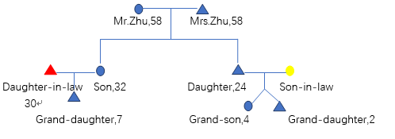 （*Family tree of ZHU：circle represents male member，triangle represents female members*）

Q2: What about your tenure?

A: We have 10 mu for the whole family growing sugar cane, but 1 of it is idle land. We also have 0.2-0.3 mu for vegetable planting. The local sugar milling companies encourage us to plant sugar cane. We start sugarcane growing from the 80s. In that period, we planted 5 mu of rice at the same time. From the 2005, we gave up rice growing and only plant sugarcane. My wife and me are the labours responsible for the producing, we plant as much as possible. The volume of production can reach 5t/mu。Sometimes we would ask our neighbours for help if needed. We used to work as au pair in village, but the rule changed. Besides, the sugar milling company uses quota to control the sugar cane trade and harvest arrangements. So we begin to ask labours from other villages to harvest.

Q3: What is the peak time for your farming activities every year?

A：From March to July, we are extremely busy in this period every year. Sugar cane should be planted immediately after harvesting. According to the soil condition, ploughing should be carried out every 2-3 years. It takes about 6 months (50%) to conduct field management in a year. Harvesting and planting would be completed every February-April, management is carried out from February to July, and the harvest season starts from December.

Q4：Are responsibilities different between your wife and you in terms of agricultural activities?

A：We generally do the same work; no clear difference exist, except that the spraying of herbicides and others which requires carrying a 30-40 kg bucket would mainly be my duty.

（N.B.：Mr. Zhu mentioned that his wife is not in a good condition at present, and stopped agricultural activities after the interview.）

Q5：Source of drinking water？

A：Mountain spring water. But tap water is provided and drinking water master system and plan exist in Ningming County.

Q6：what kind of fertilizer do you use？

A: I used to buy fertilizer from the market. But now the sugar milling factory also supplies fertilizer. 90% of farmers use fertilizer from sugar company. They give the fertilizer to the farmers at the beginning of sugar cane developing cycle, and the fertilizer is deducted from the payment of sugar cane harvested later. The fertilizer of the sugar factory is better, and it is also very popular among farmers.

Q7：How do you harvest sugar cane? And transport it to the milling factory?

A：The plots in this village are relatively small thus the sugar cane planted can only be harvested by hand. We use agricultural tractors for transportation. Though theoretically, the cost for transportation is 1/RMB/ton/km, but since it is too close to the sugar factory, the driver who pulls the sugar cane will ask the farmer for 50 yuan/car.

Q8：Is there a crop rotation? Is it possible for sugarcane fields to return to paddy fields?

A：Rotation will be carried out according to the land conditions, and we would prefer the corn as the rotation crop in general. If the price of sugar changes or other factors such as closure of the sugar milling factory show up, it is feasible to return the sugar cane field to the paddy field. But if it is not incidence, we will continue growing sugar cane.

Q9：Would growing sugar cane affect the land fertility?

A：Generally speaking yes. The continuous cultivation of sugar cane in the land would continue no longer than 5-6 years, and the fertility will reach its limit. But at present, the fertilizers given by the sugar mills are mainly based on filter ash and fat carbon fertilizers. They are bio-fertilizers and are relatively friendly to the land.

Q10：How do you deal with the leaf? Do you collect the leaves? Is it considered to be used for biomass power generation?

A：The individuals growing sugar cane will start to peel the sugar cane in July, on the one hand, sugar cane is easy to have a higher output, and on the other, the sugar cane with less leaves is not easy to fall down. This kind of management is labour-intensive for one reason. Besides, the leaves of this part are not easy to collect. Therefore, they are usually placed on the ground. Another part of residues can be used is the top part leaf of sugar cane. After harvesting sugar cane, this part is cut off directly, and some cattle farmers will collect it, but the growers usually have no interest to collect them.

Note: This is only the case for manual cultivation. Individuals are not willing to use huge agricultural machines, considering the loss and compaction for the land.

Q11：What do you think about the agricultural mechanisation in Ningming County?

A：In Ningming, about 60% of the land are small plots controlled by individuals and are not centralised. Sugar factories tried to put together large enough swaths of land. The negotiation was difficult, land transfer, land boundaries, etc. are very sensitive issues. However, I do think that it is a trend to put plots together for a huge swath in the future. Young generations are not farming, the future of the agriculture relies on machines.

### Annex 5: Ratings Scales



### Annex 6: MTR field mission itinerary

*19th Oct. 2018*: MTR Inception Meeting

*23rd Oct. 2018*: MTR First Field Mission Meeting

*24th Oct. 2018*: Stakeholders meetings and interviews I

*11:00-12:00* Interview with Mr.Liang, officer of the Sugar Industry Development Office of Chongzuo.

*15:30-17:00* Interview with Mr.Huang, officer of the Human and Resources and Social Security Bureau of Chongzuo.

*25th Oct. 2018*: Field visits and Stakeholders interviews II

*09:00-12:00* Field visit to Guangxi Funan East Asia Sugar Co.,Ltd and Guangxi Funan Bio-Energy Co.,Ltd in Fusui County of Chongzuo City.

*13:30-15:30* Field visit to Zhenfeng Agricultural Machinery Service Co.,Ltd in Fusui County of Chongzuo City.

*16:00-17:30* Field visit to Leida Modern Agricultural Cooperative in Fusui County of Chongzuo City.

*26th Oct. 2018*: Field visits and Stakeholders interviews III

*08:30-10:30* Interview with the manager of Fenghuaxingnong bio-agriculture Co.,Ltd in Ningming County of Chongzuo City.

*11:00-13:30* Interview with the member of Dong’anxinyao cooperative and the sugarcane grower individual in Ningming County of Chongzuo City.

*15:00-17:30* Field visit to one Energy Forest planting demonstration of the project in Ningming County of Chongzuo City.

*27th Oct.-28th Oct. 2018*: Interviews with the PMO staffs and document review.

*29th Oct. 2018:* Group Discussion with implementation partners.

### Annex 7: List of persons interviewed

List of persons interviewed

(In alphabetical order)

DING Lei, Manager, Leida Agricultural Machinery Cooperative of Fusui County

FANG Qun, Manager, Jiefeng Agriculture Co., Ltd.

HUANG Peng, Section Chief of cross border migrant labour management centre, Chongzuo Municipal Centre of Human Resources and Social Security

HUANG Xianxian, Senior Technologist, Guangxi Funan Bioenergy Co., Ltd.

LI Jianhua, Manager, Ning Ming Feng Hua Xing Nong Ecological Agriculture Co., Ltd.

LI Yi, Member, Dong’an Xin Yao Planting Cooperative of Ningming County

LIANG Zihong, Section Chief of technology and production section, Chongzuo Municipal Sugar Industry Development Office

LU Yong, Manager, Zhenfeng Agricultural Machinery Co., Ltd.

MA Junyong, Manager, Zhenfeng Agricultural Machinery Co., Ltd.

NONG Xiongfei, Senior Technologist, Jiefeng Agriculture Co., Ltd.

WEI Yangcai, Chief of operation section, Guangxi Funan Bioenergy Co., Ltd.

XIONG Xiongyi, Deputy Manager, Guangxi Funan Bioenergy Co., Ltd.

ZHU Guangming, Sugarcane Grower, famer in Ningming County

### Annex 8: List of documents reviewed

1. Project Document “China’s Sustainable Bio-Energy Development of Demonstration Project in Guangxi” (English version+Chinese version)

2. Workplan for 2015-2019

3. Two Year Workplan for 2017-2018

4. Two Year Workplan for 2018-2019

5. Quarterly Project Progress Report of the Third Quarter 2015 (English Version+Chinese version)

6. Annual Project Progress Report of 2015 (English Version+Chinese version)

7. Quarterly Project Progress Report of the Q1-Q3 2016 (English Version+Chinese version)

8. Annual Project Progress Report of 2016 (English Version+Chinese version)

9. Quarterly Project Progress Report of the Q1-Q3 2017 (English Version+Chinese version)

10. Annual Project Progress Report of 2017(English Version+Chinese version)

11. Quarterly Project Progress Report of the Q1-Q3 2018 (English Version+Chinese version)

12. Chongzuo’s Comprehensive Plan for Promoting Agriculture, Forestry, Husbandry Development (2015-2025)

13. Comprehensive Report on Agriculture, Forestry, Husbandry Resource in Chongzuo

14. Comprehensive Development Plan for Non-Grain Biomass Energy Industry of Chongzuo, Guangxi (2015-2025)

15. Back to Office Report-Japan, Austrilia

16. Feasibility Study of the Upgrading Existing Off-Grid CHP Plants Within Sugar Mills

17. Feasibility Study on Combining Harvesting and Juicing Operations

18. Study on Recycling of Treated Sewage for Sugarcane Irrigation

19. Study on Production and Refining of Biogas from Sewage Treatment for Production of Compressed Natural Gas (CNG)

20. Study on Production of Organic Fertilizers with Wastes from the Sugar Milling Process

21. Brochures of China-ASEAN Sustainable Development Forum

22. Presentations documents used in China-ASEAN Sustainable Development Forum

23. Script and filmscript drafted for the documentary and video clip

24. All subcontracts signed

25. All documents of each capacity building workshop (including brochures, manuals, photos, presentation signatures, invoices, etc.)

26. All Meeting Minutes

27. Payment Requests Documents

28. Internal Management Regulation Documents of the Project Management Office

29. Field visits reports

30. Recommendations for tree species selection to the plantations in the project of biomass energy sustainable development demonstration in Guangxi.

### Annex 8: Signed UNEG Code of Conduct form

### Annex 9: Signed MTR final report clearance form

1. For ideas on innovative and participatory Monitoring and Evaluation strategies and techniques, see [UNDP Discussion Paper: Innovations in Monitoring & Evaluating Results](http://www.undp.org/content/undp/en/home/librarypage/capacity-building/discussion-paper--innovations-in-monitoring---evaluating-results/), 05 Nov 2013.
2. For more stakeholder engagement in the M&E process, see the [UNDP Handbook on Planning, Monitoring and Evaluating for Development Results](http://www.undg.org/docs/11653/UNDP-PME-Handbook-(2009).pdf), Chapter 3, pg. 93.
3. Populate with data from the and scorecards
4. Populate with data from the Project Document
5. If available
6. Colour code this column only
7. Use the 6 point Progress Towards Results Rating Scale: HS, S, MS, MU, U, HU
8. Alternatively, MTR conclusions may be integrated into the body of the report.