ANNEX 7.7: TERMS OF REFERENCE FOR TERMINAL EVALUATION

INTRODUCTION
In accordance with UNDP and GEF M&E policies and procedures, all full and medium-sized UNDP support GEF financed projects are required to undergo a terminal evaluation upon completion of implementation. These terms of reference (TOR) sets out the expectations for a Terminal Evaluation (TE) of the Global Maritime Energy Efficiency Partnerships (GloMEEP) Project: PIMS 5201 (Official Project Title: Transforming the Global Maritime Transport Industry towards a low Carbon Future through Improved Energy Efficiency (GloMEEP)).
The essentials of the project to be evaluated are as follows:

PROJECT SUMMARY TABLE
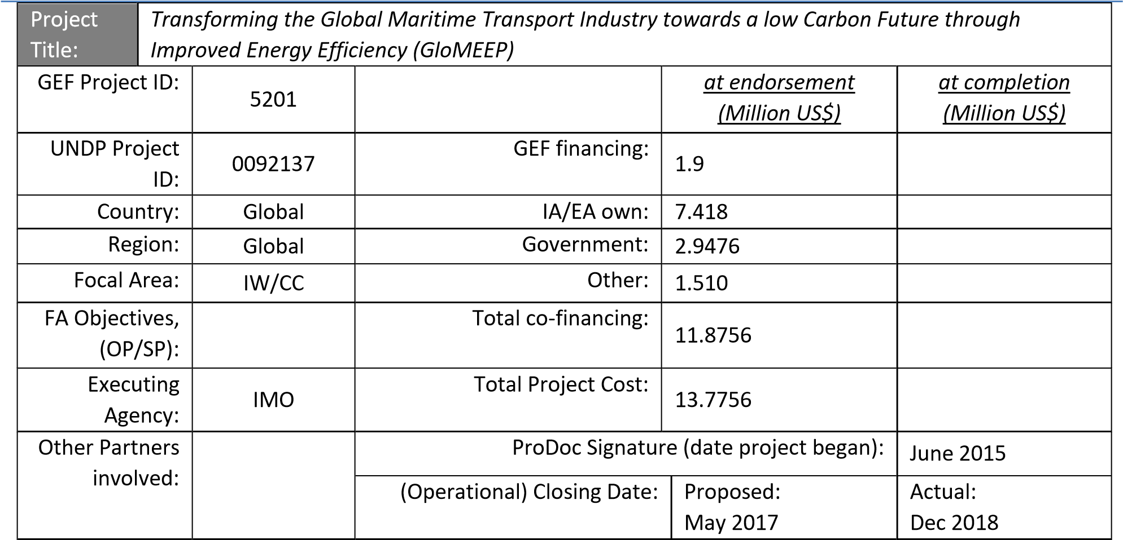

OBJECTIVE AND SCOPE

The project was designed to build capacity in developing countries for implementing the technical and operational measures for energy efficient shipping and to catalyze overall reductions in GHG emissions from global shipping.
The specific objectives of the project include the creation of a strong partnership and coordinated actions between 10 developing countries and, at each country level, systematically pursue:
- Legal, policy and institutional improvements via country assessment, policy development and future planning and road mapping.
- Building capacity (human and institutional) in area of shipping GHG reduction.
- Create the foundation for public-private partnership for future energy efficient technology assessment and deployment.
- Accelerate and assure effective implementation of IMO’s technical and operational energy efficiency measures, particularly in the developing countries where shipping is increasingly concentrated
The ultimate objective of GloMEEP is to assist developing states to implement sustainable methods and create an enabling national environment for reduction of shipping energy use and promotion of low carbon maritime sector in order to minimize the adverse impacts of shipping emissions on climate change, ocean acidification and local air quality.
The TE will be conducted according to the guidance, rules and procedures established by UNDP and GEF as reflected in the UNDP Evaluation Guidance for GEF Financed Projects.
The objectives of the evaluation are to assess the achievement of project results, and to draw lessons that can both improve the sustainability of benefits from this project, and aid in the overall enhancement of UNDP programming.

EVALUATION APPROACH AND METHOD

(Annex C
An overall approach and method for conducting project terminal evaluations of UNDP supported GEF financed projects has developed over time. The evaluator is expected to frame the evaluation effort using the criteria of relevance, effectiveness, efficiency, sustainability, and impact, as defined and explained in the UNDP Guidance for Conducting Terminal Evaluations of UNDP-supported, GEF-financed Projects. A set of questions covering each of these criteria has been drafted and are included with this TOR ) The evaluator is expected to amend, complete and submit this matrix as part of an evaluation inception report, and shall include it as an annex to the final report.
The evaluation must provide evidence‐based information that is credible, reliable and useful. The evaluator is expected to follow a participatory and consultative approach ensuring close engagement with government counterparts, in particular the key stakeholders. The evaluator is expected to conduct a field mission to London. Interviews will be held with the following organizations and individuals at a minimum: GloMEEP PCU, IMO officers, UNDP officers, Strategic Partners, National Focal Points and Coordinators, and members of the Global Industry Alliance.
The evaluator will review all relevant sources of information, such as the project document, project reports – including Annual APR/PIR, project budget revisions, midterm review, progress reports, GEF focal area tracking tools, project files, national strategic and legal documents, and any other materials that the evaluator considers useful for this evidence-based assessment. A list of documents that the project team will provide to the evaluator for review is included in Annex B of this Terms of Reference.

EVALUATION CRITERIA & RATINGS

(see | Annex A
An assessment of project performance will be carried out, based against expectations set out in the Project Logical Framework/Results Framework ), which provides performance and impact indicators for project implementation along with their corresponding means of verification. The evaluation will at a minimum cover the criteria of: relevance, effectiveness, efficiency, sustainability and impact. Ratings must be provided on the following performance criteria. The completed table must be included in the evaluation executive summary. The obligatory rating scales are included in Annex D.

Evaluation Ratings:
1. Monitoring and Evaluation | rating | 2. IA& EA Execution | rating
M&E design at entry |  | Quality of UNDP Implementation
M&E Plan Implementation |  | Quality of Execution - Executing Agency
Overall quality of M&E |  | Overall quality of Implementation / Execution
3. Assessment of Outcomes | rating | 4. Sustainability | rating
Relevance |  | Financial resources:
Effectiveness |  | Socio-political:
Efficiency |  | Institutional framework and governance:
Overall Project Outcome Rating |  | Environmental :
 |  | Overall likelihood of sustainability:

PROJECT FINANCE / COFINANCE

The Evaluation will assess the key financial aspects of the project, including the extent of co-financing planned and realized. Project cost and funding data will be required, including annual expenditures. Variances between planned and actual expenditures will need to be assessed and explained. Results from recent financial audits, as available, should be taken into consideration. The evaluator(s) will receive assistance from the Project Team to obtain financial data in order to complete the co-financing table below, which will be included in the terminal evaluation report.
Co-financing  (type/source) | UNDP own financing  (mill. US$) |  | Government  (mill. US$) |  | Partner Agency  (mill. US$) |  | Total  (mill. US$)
 | Planned | Actual | Planned | Actual | Planned | Actual | Actual | Actual
Grants
Loans/Concessions
• In-kind support
• Other
Totals

MAINSTREAMING

UNDP supported GEF financed projects are key components in UNDP country programming, as well as regional and global programmes. The evaluation will assess the extent to which the project was successfully mainstreamed with other UNDP priorities, including poverty alleviation, improved governance, the prevention and recovery from natural disasters, and gender.

IMPACT

The evaluators will assess the extent to which the project is achieving impacts or progressing towards the achievement of impacts. Key findings that should be brought out in the evaluations include whether the project has demonstrated: a) verifiable improvements in ecological status, b) verifiable reductions in stress on ecological systems, and/or c) demonstrated progress towards these impact achievements.

CONCLUSIONS, RECOMMENDATIONS & LESSONS

The evaluation report must include a chapter providing a set of conclusions, recommendations and lessons.
Conclusions should build on findings and be based in evidence. Recommendations should be prioritized, specific, relevant, and targeted, with suggested implementers of the recommendations. Lessons should have wider applicability to other initiatives across the region, the area of intervention, and for the future.

IMPLEMENTATION ARRANGEMENTS

The principal responsibility for managing this evaluation resides with the Executing Agency (IMO). The EA will contract the evaluator. The Project Team will be responsible for liaising with the evaluator to set up stakeholder interviews, coordinate with the Government etc. It has been agreed that the evaluator will be responsible for making his own travel arrangements, which are included within the remuneration of this contract.

EVALUATION TIMEFRAME

The total duration of the evaluation will be 44 days according to the following plan:
Activity |  | Timing | Completion Date
Preparation | 22 days |  | 07/09/17
Evaluation Mission | 5 days |  | 15/09/17
Draft Evaluation Report | 10 days |  | 25/09/17
Final Report | 5 days |  | 30/09/17

EVALUATION DELIVERABLES

The evaluation team is expected to deliver the following:
Deliverable | Content | Timing | Responsibilities
Inception  Report | Evaluator provides  clarifications on timing and method | No later than 1 week before the mission to London. | Consultant submits to UNDP and  GloMEEP PCU
Presentation | Initial Findings | End of evaluation mission  (London) | To PCU and UNDP
Draft Final  Report | Full report, (per annexed template) with annexes | Within 3 weeks of the evaluation mission | Sent to IMO, PCU, UNDP GEF  Technical Adviser
Final Report* | Revised report | Within 1 week of receiving  UNDP comments on draft | Sent to IMO and UNDP for uploading to UNDP ERC
Presentation | Final presentation of full report and findings | 12th of November via videoconference | To final Global Project Task Force  Meeting (Ningbo, China)
*When submitting the final evaluation report, the evaluator is required also to provide an 'audit trail', detailing how all received comments have (and have not) been addressed in the final evaluation report.

EVALUATOR ETHICS

Evaluation consultants will be held to the highest ethical standards and are required to sign a Code of Conduct (Annex E) upon acceptance of the assignment. UNDP evaluations are conducted in accordance with the principles outlined in the UNEG 'Ethical Guidelines for Evaluations'

PAYMENT MODALITIES AND SPECIFICATIONS

Days | Milestone
10 | At contract signing
29 | Following submission and approval of the 1ST draft terminal evaluation report
5 | Following submission and approval (UNDP-CO and UNDP RTA) of the final terminal evaluation report

For additional information on methods, see the Handbook on Planning, Monitoring and Evaluating for Development Results, Chapter 7, pg. 163
A useful tool for gauging progress to impact is the Review of Outcomes to Impacts (ROTI) method developed by the GEF Evaluation Office: ROTI Handbook 2009

