Terminal Evaluation (TE) Report
UNDP-GEF China Anhui Wetlands Project
Strengthening the management effectiveness of the wetland protected area system in Anhui Province, China

November 2018

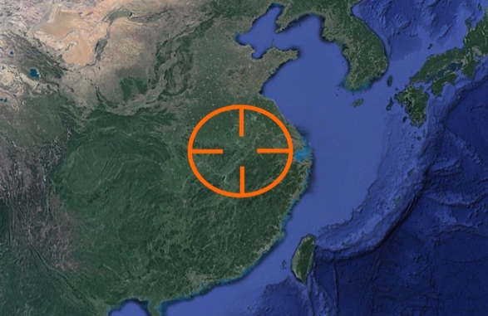 | 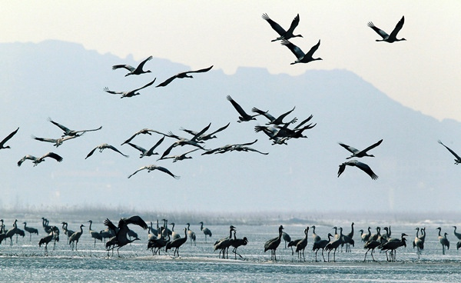
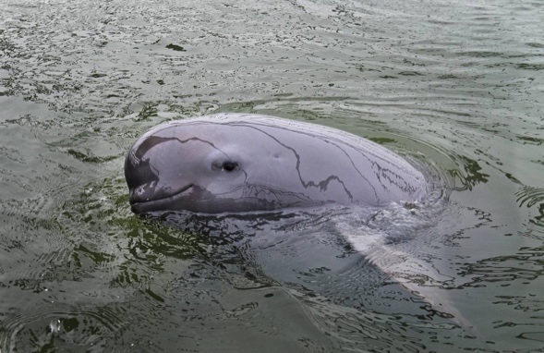 | 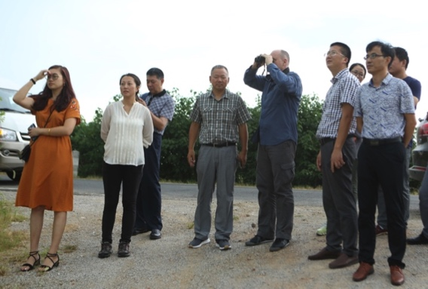

CBPF-MSL
China Biodiversity Partnership Framework - Mainstream of Life
Project 4 - Anhui Wetlands Project (GEF 4896 / UNDP PIMS 4868)

Prepared by:
Steve Raaymakers & Wang Yue
Co-evaluators - Terminal Evaluation Team
CBPF-MSL Projects 3 (Hainan) & 4 (Anhui)
OPENING PAGE
PROJECT SUMMARY TABLE:
Project Title: | UNDP-GEF CBPF-MSL Project 4: Strengthening the management effectiveness of the wetland protected area system in Anhui Province.
GEF Project ID: | 4896
UNDP Project ID: | 4868
Country: | People’s Republic of China (PRC)
Region: | Asia-Pacific (AP)
GEF-5 Focal Area: | Biodiversity (BD)
GEF-5 BD Objective: | BD-1: Improve Sustainability of Protected Area (PA) Systems.
GEF-5 BD Outcomes: | BD-1.1: Improved management effectiveness of existing and new PAs.
 | BD-1.2: Increased revenue for PA systems to meet total expenditures required for management.
Executing Agency: | Anhui Forestry Department (AFD)
Other Partners: | Shengjin Lake National Nature Reserve Management Authority
ProDoc Signature (Project Start): | 31 Dec. 2013
Operational Closing Date: | 30 Dec. 2018
Financial Closing Date: | 30 Jun. 2019
TE Timeframe: | 9 July to 31 December 2018 (as specified in TE contract)
TE Team: | Steve Raaymakers, steve@eco-strategic.com  Wang Yue, ywang0406@163.com

PROJECT BUDGET:
Source | At endorsement (US$) | At Terminal Evaluation  (August 2018) (US$)
GEF Financing: | 2,654,771 | 2,654,771
IA/EA own Financing: | 700,000 | ¹Not realized
Government Financing: | 17,447,255 | 48,375,000
Other Financing: | - | ²30,000,000
Total Co-financing: | 18,147,255 | 78,375,000
Total Project Cost: | 20,802,026 | 81,029,770
¹Refer section 3.2.2 for explanation
²Loan from Islamic Development Bank for work in Susong Huayang River and Lake Group Wetlands – one of the Project sites. See Table 4.
CONTENTS
ACKNOWLEDGEMENTS 5
EXECUTIVE SUMMARY 6
Brief Project Description 6
Evaluation Rating Table 8
Conclusions, Lessons & Recommendations 14
ACRONYMS 21
1. INTRODUCTION 22
1.1 TE Purpose 22
1.2 TE Scope & Methodology 22
1.3 Structure of the TE Report 23
2. PROJECT DESCRIPTION 24
2.1 Project Start & Duration 24
2.2 Problems that the Project Seeks to Address 26
2.3 Development Objectives 27
2.4 Baseline Indicators & Expected Results 28
2.5 Main Stakeholders 29
3. TERMINAL EVALUTION FINDINGS 32
3.1 Project Design 32
3.1.1 Analysis of the Strategic Results Framework 32
3.1.2 Assumptions and risks 37
3.1.3 Lessons from other relevant projects incorporated into project design 40
3.1.4 Planned stakeholder participation 40
3.1.5 Replication approach 40
3.1.6 UNDP comparative advantage 41
3.1.7 Linkages between project and other interventions within the sector 42
3.1.8 Management arrangements 42
3.2 Project Implementation 45
3.2.1 Adaptive management 45
3.2.2 Project finance & co-finance 47
3.2.3 Monitoring & evaluation: design at entry and implementation 51
3.2.4 UNDP implementation & partner execution 52
3.3 Project Results 54
3.3.1 Overall results (attainment of objectives) 54
3.3.2 Relevance 65
3.3.3 Effectiveness 65
3.3.4 Efficiency 66
3.3.5 Mainstreaming 66
3.3.6 Sustainability 70
3.3.6 Impact 71
Annex 1: Terminal Evaluation ToR 72
Annex 2: Terminal Evaluation Field Mission Itinerary 80
Annex 3: List of Persons Interviewed 83
Annex 4: List of Documents Reviewed 88
Annex 5: Evaluation Consultant Agreement Forms 92
ANNEX 6: Signed Report Clearance Form 94
Annexed in a separate file: Audit Trail 95

ACKNOWLEDGEMENTS

The TE consultants acknowledge the assistance of the following persons in undertaking the TE:

- Ms. Lisa Farroway, Regional Technical Adviser (RTA), Biodiversity, UNDP.

- Dr. Chaode Ma, Programme Director, Biodiversity & Ecosystems, UNDP China.

- Ms. Xinhua Zhao, Programme Associate, Energy & Environment, UNDP China.

- Ms. Cheng Zheng, Programme Assistant, Energy & Environment, UNDP China.

- Mr. Hui QIU, Deputy Director-General, Anhui Forestry Department

- Dr. Dayuan XUE, CTA/Professor, Minzu University of China

- Mr. Xiaochun ZHOU, Project Coordinator/Director, Anhui Wetland Conservation Center

- Mr. Wenlian WANG, Deputy Director, Chizhou Municipality Forestry Bureau

- Ms. Fei LENG, Project Manager, Anhui PMO

- Mr. Bulong ZAI, Interpreter

- All other key stakeholders including those who kindly and freely shared their views and perspectives about the project during TE interviews and discussions, as listed in Annex 3.

EXECUTIVE SUMMARY

Brief Project Description

- The UNDP-supported, GEF financed and Nationally-executed (NEX) project Strengthening the management effectiveness of the wetland protected area system in Anhui Province (Anhui Wetlands Project), is being carried out between 31 December 2013 and 30 December 2018 as Project No. 4 under the broader China Biodiversity Partnership Framework - Mainstream of Life (CBFF-MSL). The Project is implemented by the United Nations Development Programme (UNDP) Country Office (CO) - China, and executed by the Anhui Forestry Department (AFP) with support from the Anhui Finance Department (AFD), several municipal and local governments and the management staff of Shengjin Lake National Nature Reserve (NNR) and other wetland Nature Reserves and protected areas in the Province. The Project was implemented with a grant of US$2,654,771 from GEF (5th tranche), and co-financing commitments of $700K from UNDP and US$17,447,255 from Chinese government sources (at Terminal Evaluation actual co-financing from government sources was reported as being 2.7 x the original commitment, plus an additional $30 million loan from the Islamic Development Bank, bringing total co-financing to 4.3 x the original commitment).

- Anhui Province is located in the lower reaches of the Yangtze River catchment and hosts a variety of nationally and internationally important wetlands and associated biodiversity, including riverine wetlands, riverside lakes and marshlands. The wetlands of Anhui Province are part of the broader Central Yangtze River and Lakes Eco-region, which covers an area of 754,500 km², and which has been identified by the World Wide Fund for Nature (WWF) as a Global 200 Eco-region - making it one of the world's 200 most important biological regions. Globally important biodiversity values include wintering habitat for a range of migratory bird species, including the critically endangered Siberian Crane (Leucogeranus leucogeranus); and also key habitat for the critically endangered Yangtze River Finless Porpoise (Neophocaena asiaeorientalis), the critically endangered Yangtze River Alligator (Alligator sinensis) and the critically endangered Chinese Sturgeon (Acipenser sinensis).

- The Anhui wetlands also have enormous socioeconomic value and provide a wide range of ecosystem services to the 60 million people who live in the Province, including drinking water supply, irrigation for some of the most productive agricultural areas in China, flood control, fisheries production, pollution absorption and tourism and recreation.

- The lower reaches of the Yangtze River including Anhui Province form the world’s busiest inland shipping corridor, which combined with the effects of several major industrial cities and ongoing economic growth and development have been sources of significant environmental pressures and impacts.

- In order to address these impacts the goal of the UNDP-GEF Anhui Wetlands Project is to contribute to the conservation and sustainable use of globally significant biodiversity in Anhui Province. The project’s strategic objective is to strengthen the management effectiveness of the wetland protected area (WPA) system in Anhui, in response to existing and emerging threats to the globally significant biodiversity and essential ecosystem services. The site focus was initially on Shengjin Lake NNR, which provided a basis for developing meaningful interventions that were replicated elsewhere in the WPA system, including demonstration activities at Tongling River Porpoise NNR, Yangtze Alligator NNR, Anqing River Wetlands Provincial Nature Reserve (PNR), Shiju lake PNR and Susong Huayang River Lake PNR.

- In accordance with UNDP-GEF monitoring and evaluation (M&E) policies and procedures, all full and medium-sized UNDP supported, GEF financed projects are required to undergo a Terminal Evaluation (TE) upon completion of implementation. This report presents the TE for the Anhui Wetlands Project.

Evaluation Rating Table

Component | Rating | Reasons for rating
1. Monitoring & Evaluation
- M&E Design (at entry): | Highly Satisfactory | - The ProDoc and its Strategic Results Framework (SRF) included a comprehensive, well developed M&E design embracing both quantitative and qualitative indicators, including, but not limited to:  - Management Effectiveness Tracking Tool (METT).  - Ecosystem Health Index (EHI).  - Institutional Capacity Score Assessment (CSA).  - Knowledge, Attitude, Practice (KAP) assessment.  - Area coverage of Protected Areas (PAs) (with clear target).  - Financial sustainability of PA system (with clear target).  - Development of regulations, policies, management plans and guidelines (with clear target).  - Pre-project assessments of these indicators were conducted during project-design and included in the ProDoc, providing a very strong baseline against which to measure project progress through the periodic M&E activities.  - Overall, the TE consultants consider that the M&E design as contained in the ProDoc is a textbook example of how a proper M&E Plan should be formulated, and can be used as a model for other similar projects, subject to some minor improvements as outlined in section 3.1.1 of this report.
- M&E Plan Implementation: | Moderately Satisfactory to Satisfactory | - The Project Management Office (PMO) adhered to the M&E Plan including reporting indicators and targets against the baselines as contained in the ProDoc / SRF.  - The PMO complied very well with the quarterly, annual, mid-term and terminal reporting requirements of UNDP-GEF, and also developed a Self-Assessment report for the TE, which was innovative and extremely useful to the TE team  - The PMO monitored and reviewed progress of site activities and sub-projects.  - The Project undertook systematic training and capacity building of experts and Protected Area personnel in M&E methodologies, including METT and EHI.  - However, there were some deficiencies in implementation of the M&E Plan, including but not limited to:  - Reliance on ‘self-assessments’ of METT, EHI etc often by individuals rather than teams at PA level, although these were subsequently checked by team including expert and CTA. These evaluations would be stronger if initial assessment at PA level was also undertaken by a team.  - A natural tendency for self-assessments to score overly-positive in some cases without full justification / substantiation.  - Limited external review and cross-checking of the ‘self-assessed’ evaluations by independent experts, to check the validity and veracity of the evaluations.  - For the indicator of increase in new Protected Areas, it appears that new categories of Protected Area were added to the final assessment that were not included in the baseline assessment, thereby giving a false, positive assessment against the baseline (see Figures 5 & 6).  - Not identifying and reporting limitations in supporting data and thus weaknesses of METT, EHI etc.  - Not fully supporting the mainly subjective, qualitative EHI, METT and other self-assessments with more objective evaluation methods based on scientific data on quantitative parameters and indicators.
- Overall quality of M&E: | Satisfactory | - Combining a rating of Highly Satisfactory for M&E Design (at entry) with a rating of Moderately Satisfactory for M&E Plan Implementation gives an overall rating for quality of M&E of Satisfactory.  - The budget for M&E was 5% of the total budget, which is adequate to allow proper M&E without diverting disproportionate funding resources away from implementation of technical activities.
2. IA& EA Execution
- Quality of UNDP Implementation: | Satisfactory to Highly Satisfactory | - The UNDP Country Office (CO) was a highly active member of the Project Steering Committee (PSC) and was fully engaged and intimately involved in all aspects of the project from design and inception onwards, providing strong levels of support ranging from high-level strategic issues to detailed technical and administrative issues.  - All stakeholders consulted, including the PMO, Anhui Forestry Department (AFD) and other provincial agencies reported very high levels of satisfaction with the level of support provided by UNDP for project implementation.  - Feedback was that UNDP CO staff maintained an “open-door” policy whereby they could be approached for advice, assistance, guidance and support on any issue at any time.  - Feedback was that all requests to the UNDP Country Office were responded to very rapidly.  - Satisfaction was also expressed with the level and quality of support provided by both the UNDP Regional Technical Adviser (RTA) and the project Chief Technical Adviser (CTA).  - Satisfaction was also expressed with the various training provided by UNDP, including on project management.  - It was reported that the organizational arrangements made by the UNDP CO for the MTR were highly satisfactory.  - The experience of this TE team was that the organizational arrangements made by the UNDP CO for the TE were outstanding, with every detail being taken care of with efficiency and effectiveness.  - The TE team noted that the Project includes some activities that are highly relevant to the UNDP Social & Environment Standards (SES) and the ProDoc includes a social and environment screening. The TE is of the view that greater attention could have been paid to SES compliance in standard Project progress reports (QPR, APRs, PIRs etc) and greater attention should be paid to SES in future projects (refer Lesson 4 below for details).  - A significant issue identified by the TE is that the UNDP commitment of a “grant” (i.e. cash) of US$700K in co-financing has not been realized during the Project. It is recommended that greater attention should be paid to ensuring that co-financing commitments align with GEF definitions and criteria and are actually realized for future projects (refer section 3.2.2 for details).  - If not for these last two points this component would be rated as Highly Satisfactory.
- Quality of Execution - Executing Agency: | Satisfactory | - The AFD, as Executing Agency, is fully committed to the Project right up to the highest levels, and has provided strong and constant support to the PMO, has chaired and led the PSC, and has committed significant co-financing to the project, reportedly well in excess of commitments at project start (x2.7) (although the TE team is not able to verify the veracity of reported levels of con-financing from government agencies).  - Based on expenditure as a measure, the Project has achieved an execution rate of 81% to date – which is very high compared to similar projects.  - The PMO staff and especially the Project Manager exhibited extremely high levels of enthusiasm, commitment, work ethic and management capability, efficiency and effectiveness.  - Every single stakeholder that was consulted by the TE team expressed the highest levels of respect and appreciated for the efforts and effectiveness of the Project Manager and the PMO as a whole.  - The PMO has developed and followed clear and detailed workplans, and most project outputs and targets have been significantly achieved, and in many cases well exceeded, which is the most important indicator of the quality of execution.  - The results of M&E activities including the MTR have been effectively taken on by the PMO and project design and implementation have been effectively adapted as required.  - The PMO appears to have followed the provisions of GEF/UNDP Country Management Manual and the “Financial Management Measures for the Project for Strengthening the Management Effectiveness of the Wetland Protected Area System in Anhui Province with the GEF grant.”  - The PMO was extremely responsive to all requests from the TE team during the TE process, and exhibited a very high ability for adaptive management, accommodating last minute requests for schedule changes and other demands immediately, efficiently and effectively.  - While not having a scientific or technical background, the Project Manager exhibited a remarkable level of knowledge of ecological principles and best management practices relating wetland ecosystems.  - Effective use has been made of experts, and very high levels of respect and appreciation were also expressed for the CTA who had served the Project previously.  - Auditors’ reports indicate a higher level of internal control than is often the case for such projects.  - There are some areas where the quality of execution could be improved, and these are described below under 3 - Assessment of Outcomes – “Effectiveness” and also “Efficiency”.
- Overall quality of Implementation / Execution: | Satisfactory to Highly Satisfactory | - The Project was implemented in accordance with the “Standard Basic Assistance Agreement” and the “United Nations Development Assistance Framework for the PRC” (UNDAF 2016-2020) signed between UNDP and the Chinese Government.  - All the relevant stakeholders effectively participated in all aspects from the design to implementation of the project.  - The Project continuously applied adaptive management with approval of the Project Steering Committee, adjusting the budget according to the actual conditions, and reducing unnecessary material costs in order to enable more activities.  - Combining the IA and EA implementation ratings plus the fact that there is an extremely high level of coordination and cooperation between the IA and EA, but also considering the areas for improvement as identified by the TE, provides for an overall rating of Satisfactory to Highly Satisfactory for project implementation / execution.
3. Assessment of Outcomes
- Relevance: | Relevant | All project components, outcomes & outputs are assessed as being highly relevant to:  - GEF-5.  - United Nations Development Assistance Framework (UNDAF)(2016-2020).  - UNDP Country Programme Document (CPD) (2016-2020).  - Country and provincial biodiversity and wetlands conservation policies, programs, needs and priorities.
- Effectiveness: | Satisfactory | - Overall it appears that the Project has been highly effective in achieving, and in many cases exceeding, most of its objectives and targets as assessed by the indicators in the Project Strategic Results Framework, e.g.:  - Continuous improvement in METT, EHI etc.  - Reducing environmental pressures and stresses (e.g. removal of nets).  - High-level of mainstreaming.  - Legal and regulatory policy framework and system have been improved.  - Management capacity was highly enhanced on provincial, basin and reserve level.  - Publicity promotion and awareness improvement.  - The removal of 2,800 km of fish-traps and nets from Shengjin, Shijiu & Huayuang Lakes has perhaps been one of the most effective achievements of the project, in terms of real ecological benefits.  - Some targets are reported as significantly exceeded, e.g.  - Increase in Protected Areas (175K ha vs 80K ha target).  - Level of co-financing (4.3 x original commitment).  - However, as reported above, for the target of increase in new Protected Areas, it appears that new categories of Protected Area were added to the final assessment that were not included in the baseline assessment, thereby giving a false, positive assessment against the baseline (see Figures 5 & 6).  - Also, some activities appear to be of limited effectiveness (e.g. many of the research studies are poor quality and not applied to PA management / eco-agriculture project was too limited in scope and has largely failed, building of small-scale sewerage treatment demonstration facilities has not included provision for ongoing operation and maintenance).
- Efficiency: | Satisfactory | - Overall it appears that the Project has been reasonably efficient, including:  - Achieving non-trivial savings on many activities, allowing funds to be used for additional efforts.  - Reportedly leveraging significant additional co-financing (although the TE team is a not in a position to verify such reports).  - Co-opting all relevant government agencies into wetland conservation efforts through cross-sector and inter-department arrangements.  - Mainstreaming through adoption of Provincial Wetlands Regulation, Policies and Plans etc.  - However, some significant in-efficiencies are noted, e.g.:  - Poor quality of research reports and lack of application to PA management (due to using the ‘lowest price’ Municipal procurement policy).  - Highly focused delivery of education and awareness activities (lectures to individual classrooms which provide very small return for effort compared to “teach the teacher to teach” / making more strategic wetland input to Provincial education curriculum – which would have a much bigger multiplier effect).  - Lack of partnering with other major projects and programs (e.g. WWF’s $230 million Yangzte Eco-region Action Plan).  - Limited engagement with NGOs.  - Almost no engagement with private sector.
- Impact | Significant | - Too early to assess properly in terms of large-scale impact.  - At smaller scale, Project has had positive impact, as per effectiveness category above:  - Continuous improvement in METT, EHI etc.  - Reducing environmental pressures and stresses (e.g. removal of nets)  - High-level of mainstreaming.  - Increasing awareness of wetlands issues.
- Overall Project Outcome Rating: | Satisfactory | - Overall it appears that the Project has achieved and in many cases exceeded most of its objectives and targets as assessed by the indicators in the ProDoc / SRF.  - If were not for the various issues identified against the various categories above, the Project could theoretically have achieved at Overall Project Outcome rating of Highly Satisfactory. However, according to the UNDP-GEF Rating Scales, a Highly Satisfactory rating requires that there are no shortcomings at all, which is virtually impossible for any project. In the real world nothing can ever be 100% perfect, and there were some shortcomings identified for this project, as outlined above.  - Overall, the TE is if the view that ALL parties involved in the Project deserve the highest commendation, and that other GEF projects should look at this Project as a best-practice model, both in terms of its design and how it was implemented and executed, while also adopting the lessons relating to those few areas where there were some shortcomings (which are to be expected in any project).
4. Sustainability
- Financial resources: | Likely | - Reportedly there has been extremely large commitment of funds to wetlands conservation in Anhui Province by all levels of government, way in excess of original commitment in the ProDoc (at least 2.7x more).
- Socio-political: | Likely | - Very strong policy direction from Central Government.  - Reported significant increase in awareness of wetlands issues (although the TE team has concerns about the rigor, representativeness and reliability of the KAP analysis).
- Institutional framework & governance: | Likely | - Very strong policy direction from Central Government.  - Strong mainstreaming of wetlands protection into Provincial and local policies, laws, plans and procedures (e.g. new Regulation, River, Lake and Forest Chief system with wetlands-related performance indicators on individual positions).  - Development of Shengjin Lake NNR Integrated Basin-wide Management Plan.  - However, AFD stated that it does not intend to continue the PSC / similar coordination mechanism once the project ends, unless directed to continue the PSC or similar coordination mechanism by central Govt (or UNDP).
- Environmental: | Moderately Unlikely | - The main risk to sustainability is environmental:  - Pollution and water quality impacts from agriculture and continuing high-rates of urban and industrial development in surrounding catchments.  - Relatively small areas covered by the PAs, fragmentation and lack of habitat connectivity and ecological corridors linking PAs (see Figures 5 & 6).  - Climate change impacts.
- Overall likelihood of sustainability: | Likely | - The momentum generated by the project, the high-level of mainstreaming achieved, the increased level of awareness achieved and the ongoing government commitment to wetland conservation indicates a high likelihood of sustainability of the project results, provided that ongoing funding is assured.

Conclusions, Lessons & Recommendations

Conclusions

- Conclusion 1: Overall, to date, the Project has been extremely successful and effective in achieving, and in many cases exceeding, most of its objectives and targets as assessed by the indicators in the Project Strategic Results Framework. This high level of success appears to be due to a number of inter-supporting factors, including those outlined in conclusions 2 to 12 below.

- Overall, the TE is if the view that ALL parties involved in the Project deserve the highest commendation, and that other GEF projects should look at this Project as a best-practice model, both in terms of its design and how it was implemented and executed, while also adopting the lessons relating to those few areas where there were some shortcomings (which are to be expected in any project).

- Some examples of the major achievements of the Project include but are not limited to:

- Adoption of the Anhui Wetland Conservation Regulation by the 24th meeting of the Standing Committee of the 12th People’s Congress of Anhui Province in November 2015, which went into effect on 1 January 2016, followed by preparation of guidelines on the Interpretation of the Regulation.

- Approval of the Anhui Province Wetland Conservation Plan 2016-2030 by the provincial government in April 2017.

- Issuing of the 13th Five-Year Plan for Anhui Province Ecological Environmental Protection in July 2018.

- Release of the Anhui Province Red Lines for Ecological Protection in July 2017,

- Inclusion of wetland conservation rate in the green development indicator system for Anhui Province, and inclusion of wetland area, wetland conservation rate and wetland function change status in the assessment of forestry development in each city, including in the examination contents of party committees and governments at all levels through the policies of river chief / lake chief / forest chief (usually, the chief is the main leader of the party at each government level).

- Successful listing of the Shengjin Lake NNR as a Ramsar site in October 2015.

- Upgrading 17 WPAs from provincial to national level WPAs.

- Developing the Shengjin Lake NNR Management Plan as well as management plans for the other five reserves covered by the Project.

- Developing the Integrated Shengjin Lake Basin Management Plan, covering the broader catchment around the NNR.

- Reported continuous improvement in Management Effectiveness Tracking Tool (METT), Ecological Health Index (EHI) and Institutional Capacity Score Assessment (CSA) for all seven WPAs covered by the Project (although the TE has some comments on the rigor and reliability of these assessments – see section x).

- A reported 175K ha increase in WPA coverage (exceeding the project target of 80K ha by >2x) (although it appears that this has been achieved by adding new PA categories to the final assessment that were not included in the baseline assessment, thereby giving a false, positive assessment against the baseline) (see Figures 5 & 6).

- Conclusion 2: There has been very strong and constant support from the UNDP-CO, and a very high level of coordination and cooperation between UNDP as the Implementing Agency and the AFD as the Executing Agency.

- Conclusion 3: There has been very strong policy direction and resourcing from the highest levels of the Central Government, including directives on eco-civilization generally and national prioritization of wetlands conservation specifically, from recent Central Communist Party Congresses.

- Conclusion 4: There has been very strong commitment to the Project and to wetlands conservation generally from the highest levels of the Anhui Provincial Government, and especially the AFD, as manifested in the various wetlands mainstreaming initiatives implemented by the Provincial Government outlined above, supported by high levels of financial commitment (reportedly 2.7 x what was committed in the ProDoc).

- Conclusion 5: There has been and remains extremely high levels of enthusiasm, commitment, work ethic and management capability, efficiency and effectiveness at the PMO, and especially the Project Manager.

- Conclusion 6: The PMO has exhibited strong capacity for flexibility and adaptive management, including effectively learning lessons and taking on the recommendations of the Mid Term review (MTR).

- Conclusion 7: Strong cross-sector, inter-department coordination and cooperation mechanisms have been established, including through the Project Steering Committee (PSC) and similar committees at municipal and local government levels.

- Conclusion 8: There has been a major focus on building management and technical capacity amongst PA staff.

- Conclusion 9: There has been a major focus on undertaking large-scale, physical interventions to address some of the most serious environmental impacts in the WPA system in Anhui Province, resulting in significant ecological improvement. This has included removing illegal activities from within PA core areas, resettling communities that were located within PAs to other areas (with 1,300 people having reportedly been resettled), and reportedly removing 2,800 km of fish-traps and nets from Shengjin, Shijiu and Huayuang Lakes.(it should be noted that the TE team is not in a position to verify the veracity of these reported numbers) (it should also be noted that while resettlement was undertaken and financed by the Government, the Project was closely associated with resettlement activities in that they were undertaken at Project demonstration sites as part of the management plans for those sites as supported by the Project, the Project directly funded trials of eco-compensation payments to resettled people, and the Project also directly funded the removal of fish-traps and nets which directly resulted in the removal of long-standing livelihoods from the WPAs, directly creating a need for alternative sustainable livelihoods for the affected communities. Given these very close linkages between the Project and the Government resettlement actions at the Project demonstration sites, the TE considers that the UNDP Social and Environment Standards (SES) could have been more thoroughly addressed during implementation of these project activities - including those actions taken by Government but which are directly linked to the Project) (refer section 3.2.4).

- Conclusion 10: There has been some good work on ecological restoration of wetland habitats in some of the PAs, although the TE team is of the opinion that there is substantial scope to expand and replicate this work, and some of the restoration concepts and approaches are not always ecologically sound and could benefit from external scientific expert review and inputs.

- Conclusion 11: There has been a major focus on communication, publicity and education, including effective use of mass media, which appears to have had a positive impact in raising awareness of wetland issues from top government decision makers to the general public (although the TE does note some limitations on the efficiency of these efforts – as outlined below). There are also questions about the representativeness, rigour and reliability of the Knowledge, Attitude & Practice (KAP) survey, which reports an alleged 80% increase in awareness across the Province).

- Conclusion 12: Overall, the momentum generated by the project, the high-level of mainstreaming achieved, the increased level of awareness achieved and the apparent strong commitment by the Central, Provincial, Municipal and local governments to wetland conservation, indicates a high likelihood of sustainability of the project results, provided that ongoing funding is assured. The main risks to sustainability of wetland conservation in Anhui Province are broader environmental impacts in the catchments around the WPAs, especially pollution and water quality impacts from agriculture, and continuing high-rates of urban and industrial development in surrounding catchments. The potential for environmental water shortages in non-flood season, needing to be solved by dispatching reservoirs and sluices along rivers and lakes, might be another threat. The relatively small areas covered by the PAs, ecological fragmentation and lack of habitat connectivity and ecological corridors linking PAs, is also a significant threat to their long-term sustainability. This requires urgent adoption and implementation of coordinated, integrated catchment management across the whole Central Yangtze River and Lakes Eco-region, and ideally, significant expansion of the area of each PA, and the linking of PAs through ecological corridors.

Lessons & recommendations

Despite the very high success rate of the Project, as with any project there are always areas for improvement, as outlined in the following lessons and recommendations.

- Lesson 1: The Provincial Government has demonstrated an extremely high level of commitment to wetlands conservation, including adoption of the Regulation, five-year plan, ecological red line plan, NNR management plans and the Integrated Shengjin Lake Basin Management Plan, amongst others. However, a review of the brief English summary of these documents indicates that some of them might have a risk of lacking sufficient implementation capacity, and the concepts and approaches contained in these documents are not always based on the essential principles of ecological sustainability, ecosystem based management or best scientific knowledge and practice. Some of the plans appear to be ‘wish lists’ for further technical projects, and lack strategic vision and clear goals and objectives, with supporting programmatic frameworks to achieve these goals and objectives. In some cases the linkages between the various regulatory, planning and management documents are not totally clear, and there may be a certain lack of coordination and consistency, creating critical gaps and overlaps between the various documents.

Recommendation 1: It is recommended that the regulatory, planning and management documents could benefit from external scientific expert review and inputs, and a mechanism to ensure better coordination, consistency and linkages between them. As for the WPA issue, all the regulations and plans should be highly coordinated at provincial level in their initial stage of formulation, so as to ensure that an integrated and practical concept is involved.

- Lesson 2: In their M&E self-assessments the PMO has reported continuous improvement in the key indicators of METT, EHI and CSA for all seven WPAs covered by the Project. During the TE mission the TE team held a review session with the PMO and their relevant experts to assess the approach taken, and as a result the TE team is of the view that these scores are influenced by several limitations, including:
  - Reliance on ‘self-assessments’ by individuals rather than high-level or specialized teams such as research institute and universities to undertake evaluations.
  - In some cases an apparent poor understanding by the assessor regarding the underlying indicators in the METT, EHI or CSA, resulting in allocation of inaccurate or inappropriate scores.
  - A natural tendency for self-assessments to score overly positive in some cases without full justification / substantiation. There might be a heavy reliance instead of concrete investigation and verification during the self-assessing process.
  - Limited external review and crosschecking of the ‘self-assessed’ evaluations by independent experts, to check the validity and veracity of the evaluations.
  - Not identifying and reporting limitations in supporting data and thus weaknesses of evaluation findings.

While these limitations have undoubtedly resulted in some of scores allocated in the METT, EHI and CSA assessments being inaccurate or inappropriate, as a result of the review session the TE team is of the view that an overall trend of improvement in the METT, EHI and CSA scores is probably generally correct, although perhaps not at the rate of improvement reported in the self-assessments.

Recommendation 2: It is recommended that the rigor and reliability of the METT, EHI and CSA scoring could be improved by:
  - providing additional regular training of more people in the METT, EHI and CSA scoring methods,
  - using teams rather than individuals to undertake the assessments,
  - making greater use of external review and cross-checking of the ‘self-assessed’ evaluations by independent experts, to check the validity and veracity of the evaluations, and
  - Strengthening the process monitoring and tracking assessment, with supervising engineers hired if necessary.
  - Independent assessment teams or groups should be hired by Central Government or UNDP, without any present and latent relationship with PMO, and used throughout the whole process and over every significant procedure. And if they are from research institutes or colleges, they should have sufficient and specialized knowledge and corresponding qualifications.

- Lesson 3: As outlined above the Project reports that there has been a 175K ha increase in WPA coverage (exceeding the project target of 80K ha by >2x). However, it appears that this has been achieved by adding new PA categories to the final assessment that were not included in the baseline assessment, thereby giving a false, positive assessment against the target (see Figures 5 & 6).

Recommendation 3: It is recommended that exactly the same set of PA categories should be used in both the baseline and the final assessments.

- Lesson 4: The Project has directly supported a range of major activities which are highly relevant to the UNDP Social & Environment Standards (SES) – including the mass removal of fishing nets and traps from the wetlands – which directly results in fishing-families having to shift to other forms of livelihoods, piloting payments of eco-compensation to affected people, and the development of NNR management plans that include removing human uses and habitation from the NNRs, with a range of potentially significant social impacts. These large-scale activities supported by the Project can also have significant environmental implications if not planned and managed properly – being further relevant to UNDP SES.

- What was notable during the TE was that every different person from different government levels who provided information on resettlement arrangements, provided markedly different accounts of the resettlement packages and arrangements provided to resettled people.

- The ProDoc does contain a social and environment screening and annual PIRs do contain a standard section on Environmental & Social Grievances, however this is only completed if stakeholders actively submit a grievance (i.e. it has to be triggered by an affected stakeholder and is purely reactive). Affected stakeholders are highly unlikely to submit a grievance to UNDP if they are not aware that this mechanism is available (which appears to be the case with Anhui stakeholders consulted by the TE). In addition to the reactive grievance process, the SES requires a more pro-active approach including mitigation and management plans, informing stakeholders of access to information and reporting mechanisms, and active monitoring, reporting and compliance processes to ensure that SES is complied with. None of the quarterly reports address SES, and only the final, 2018 PIR (which was completed after the TE mission) contains a more complete section on SES (this is a result of changed UNDP guidelines which now require all PIRs to include an SES section from 2018). Given the nature of some of the Project activities the TE considers that SES should have been more formally and thoroughly addressed in all quarterly reports, APRs and PIRs.

Recommendation 4: It is recommended that greater attention should be paid to SES in future projects that support or are associated with large scale activities that have potential SES implications.

- Lesson 5: The TE team is of the opinion that there is substantial scope to expand and replicate wetland ecological restoration work that was developed and demonstrated during the Project. However, it appears that some of the restoration concepts and approaches applied may not have always been ecologically sound and could benefit from external scientific expert review and inputs.

Recommendation 5: It is recommended that the wetland ecological restoration concepts and approaches that were developed and demonstrated during the Project should be reviewed by external scientific experts to ensure that they are ecologically sound and comply with best practice, and that once this is established, efforts be made to substantially expand and replicate wetland ecological restoration throughout the Province.

- Lesson 6: The effectiveness of the Project has been limited by the fact that the PMO, being hosted by the Chizhou Municipal Forestry Department, applied the Municipal Government’s procurement policy when engaging consultants, experts and institutions to undertake technical studies and provide other services. Reportedly, this procurement policy has a strict requirement to select the lowest price bid, without consideration of the quality of the technical proposal or overall value for money. As a result, many of the scientific and technical reports developed for the project were reportedly of very low quality, and significant additional effort had to be expended by the PMO and other experts to improve their quality. The TE team does not understand why Provincial procurements procedures, of even UNDP procurement procedures, were not used. This is a provincial project across several sites, not a municipal project at one site only. As a result of using municipal procedures the quality of outputs was compromised.

Recommendation 6: It is recommended that for the remainder of the project, and for any future projects, a more comprehensive procurement procedure be used that assesses price along with the quality of the technical proposal and overall value for money. In consideration of the very low money limit in public bidding (e.g. in Chizhou the limit is no more than 50,000 yuan ($8,000) in 2015 and 100,000 yuan ($15,000) from 2016, the PMO should have been set up at provincial level and used provincial government or even UNDP procurement procedures.

- Lesson 7: As outlined above the Project has made significant effort on communication, publicity and education. However, the TE finds that the delivery of these activities has been highly focused on very small and restricted audiences, such as lectures by the Project Manager and project experts to individual classrooms or at specific training courses and awareness events, and a focus on a single so-called “wetlands school”. This highly focused approach achieves a very small return for effort and is not consistent with the global objectives of GEF, which is to support catalytic activities which generate much broader, strategic-level, multiplier benefits. It is also not efficient use of the valuable time of the Project Manager to be personally acting as an individual teacher. The Project Manager should focus on managing the project, and engage a larger number of teachers to spread the message. While not explicitly provided for in the project design, a more strategic approach with much broader impact across a much larger audience would be to use GEF funds to work with the Anhui Education Department (AED), to develop a wetlands component to the Province-wide education curriculum, together with wetlands textbooks and teaching materials. This would be followed with providing training to all relevant teachers in the Province on wetlands education (the “teach the teacher to teach” approach). This would have a much bigger multiplier effect, and achieve much greater returns and broader impact from the GEF investment.

Recommendation 7: It is recommended that if possible for the remainder of the project, and as part of post-project follow-up activities, the AFD could look at working with the AED start considering and planning a wetlands component to the Province-wide education curriculum, together with wetlands textbooks and teaching materials. This would be followed with providing training to all relevant teachers in the Province on wetlands education (the “teach the teacher to teach” approach). This would have a much bigger multiplier effect, and achieve much greater returns and broader impact from investment in wetlands education.

- Lesson 8: An important consideration in the evaluation of GEF projects is the degree to which the Project has effectively partnered with other relevant programs and projects in the subject area, and also with environmental NGOs and the private sector. Such partnering is a useful way to create synergistic benefits between projects, multiply positive impacts and even secure additional co-financing. As far as could be ascertained during the TE the Project has not partnered effectively with other relevant programs and projects in the Province (e.g. Islamic Development Bank project at Anqing worth US$30 million), has only partnered with limited NGOs (e.g. Green Anhui), and on a limited basis, has not partnered at all with the ‘true’ private sector. Private sector involvement is critical when the main threats to wetlands in the Province come from private sector industrial activities in the surrounding catchments.

Recommendation 8: It is recommended that if possible for the remainder of the project, and as part of follow-up activities, the PMO and AFD should build stronger partnerships for wetlands conservation with other relevant programs and projects in the subject area, with environmental NGOs and with the private sector.

- Lesson 9: The main risks to sustainability of wetland conservation in Anhui Province are broader environmental impacts in the catchments around the WPAs, especially pollution and water quality impacts from agriculture, water shortage risk in non-flood seasons, and continuing high-rates of urban and industrial development in surrounding catchments. The relatively small areas covered by the PAs, ecological fragmentation and lack of habitat connectivity and ecological corridors linking PAs, is also a significant threat to their long-term sustainability (see Figures 5 & 6).

Recommendation 9A: It is recommended that the Anhui and neighbouring Provincial Governments adopt and implement coordinated, integrated catchment management across the whole Central Yangtze River and Lakes Eco-region, and wherever possible significantly expand the area of individual WPAs in order to strengthen their long-term ecological viability, and seek to link WPAs through the establishment of ecological corridors.

Recommendation 9B: Water utilization of ecosystem especially in dry season should be ensured by a series of measures including connecting relative river channels and lakes, supplementing essential water flows into the wetlands, keeping suitable water levels in lakes and wetlands by dispatching reservoirs and controlling sluices along the rivers, and real-time monitoring water level and quality. (e.g. in Chizhou’s local water resources planning, there will an amount of no less than 80 m m³ ecosystem water use per year. But that needs to be monitored and implemented).

ACRONYMS

AED Anhui Education Department
AFD Anhui Education Department
APR Annual Project Report
AWP Annual Work Plan
CAP Conservation Action Planning
CBPF-ML China Biodiversity Partnership Framework - Mainstream of Life
CICETE China International Centre for Economic and Technical Exchanges
CCF Coca Cola Foundation
CO Country Office (of UNDP)
CNR County Nature Reserve
CSA Institutional Capacity Score Assessment
CTA Chief Technical Advisor
EA Executing Agency
EHI Ecosystem Health Index
GEF Global Environment Facility
IA Implementing Agency
KAP Knowledge, Attitude, Practice
MER Monitoring, Evaluation & Reporting
METT Management Effectiveness Tracking Tool
MoU Memorandum of Understanding
MTR Mid Term Review
NEX Nationally Executed
NGO Non-Governmental Organisation
NNR National Nature Reserve
NPD National Project Director
NWP National Wetland Park
PA Protected Area
PIMS Project Information Management System
PIR Project Implementation Review
PM Project Manager
PMO Project Management Office
PNR Provisional Nature Reserve
PRC People’s Republic of China
PWGP (Coca Cola) Partnership for Water Governance Programme
PWP Provincial Wetland Park
RTA Regional Technical Adviser (of UNDP)
SES (UNDP) Social and Environment Standards
SMART Specific, Measurable, Achievable, Relevant & Time-bound
SRF Strategic Results Framework
TE Terminal Evaluation
TOR Terms of Reference
UN United Nations
UNDP United Nations Development Programme
UNDAF United Nations Development Assistance Framework
USD United States Dollar
WP Wetland Park
WPA Wetland Protected Area
WWF World Wide Fund for Nature & Natural Resources

1. INTRODUCTION

1.1 TE Purpose

- The TE was undertaken in accordance with the Terms of Reference (ToR) contained in Annex 1, and in accordance with UNDP Guidance for Conducting Terminal Evaluations of UNDP-supported, GEF-financed Projects (the TE Guidelines).

- The purpose of the TE is to assess the achievement of project results, and draw lessons that can improve the sustainability of benefits from this project and aid in the overall enhancement of UNDP programming.

1.2 TE Scope & Methodology

- The TE was conducted using the criteria of relevance, effectiveness, efficiency, sustainability and impact, as defined and explained in the TE Guidelines. In accordance with the TE Guidelines the TE team has endeavoured to base its findings on evidence-based information that is credible, reliable and useful.

- The TE team undertook a mission to Beijing (UNDP-Country Office) and to Anhui Province between 22 July and 30 July 2018 in accordance with the itinerary contained in Annex 2 (see also Figure 2 below). The TE team followed a participatory and consultative approach ensuring close engagement with the UNDP-GEF Regional Technical Adviser (RTA), the UNDP-CO, the Project Management Office (PMO), Anhui Government counterparts and key stakeholders, as listed in Annex 3. The TE team reviewed a comprehensive set of documentation relating to the project as listed in Annex 4.

- Assessment of project performance was carried out based against expectations set out in the Project Strategic Results Framework (SRF), as contained in the ProDoc and revised by the Project during implementation (refer section 3.1.1), which provides Project objectives, targets and indicators with corresponding means of verification. Ratings were assigned for the prescribed Project elements of outcomes, relevance, effectiveness, efficiency, sustainability and impact, in accordance with the Rating Scales shown in Table 1, as specified in the TE Guidelines.

- The TE assessed the extent to which the project is achieving impacts or progressing towards the achievement of impacts, including whether the project has demonstrated verifiable improvements in ecological status, verifiable reductions in stress on ecological systems, and/or demonstrated progress towards these impact achievements.

- The TE assessed key financial aspects of the project, including the extent of co-financing planned and realized.

- Wherever possible, triangulation (use of multiple, cross-checked sources of information) was applied to verify and substantiate information reported and to help overcome bias that may arise from single sources of information. For example, if a stakeholder reported a certain view on an issue, views on the same issue were actively sought from other stakeholders during separate interviews, and the view was only reported as a TE finding if three or more stakeholders shared that view. When stakeholders reported views on matters that could be checked in documents – the relevant documents were subsequently checked (e.g. several stakeholders reported concerns about the quality of research reports commissioned by the Project – so the TE team reviewed a selection of the reports). Conversely, when a document reported certain findings, these were verified by discussing with stakeholders involved with production and/or review of the document (e.g. the TE team held an interactive review session with relevant project personnel and experts to systematically work through the Project’s methods and findings on key targets and indicators, including METT, EHI etc).

- It was not possible to apply triangulation for some Project parameters, due to lack of alternative data sources, for example finance and co-financing data, and reported increase in the area of Protected Areas – the reports provided by the Project on such data were accepted by the TE team at face value.

1.3 Structure of the TE Report

- This TE report is structured in accordance with Annex F of the ToR as contained in Annex 1 of this report, and as reflected in the Table of Contents of this report.

TABLE 1: Terminal Evaluation Rating Scales (from the UNDP-GEF TE Guidelines)
Ratings for Outcomes, Effectiveness, Efficiency, M&E, I&E Execution | Sustainability ratings: | Relevance ratings
6: Highly Satisfactory (HS): no shortcomings  5: Satisfactory (S): minor shortcomings  4: Moderately Satisfactory (MS)  3. Moderately Unsatisfactory (MU): significant shortcomings  2. Unsatisfactory (U): major problems  1. Highly Unsatisfactory (HU): severe problems | 4. Likely (L): negligible risks to sustainability | 2. Relevant (R)
 | 3. Moderately Likely (ML): moderate risks | 1. Not relevant (NR)
 | 2. Moderately Unlikely (MU): significant risks  1. Unlikely (U): severe risks | Impact Ratings:  3. Significant (S)  2. Minimal (M)  1. Negligible (N)
Additional ratings where relevant:
Not Applicable (N/A)
Unable to Assess (U/A

2. PROJECT DESCRIPTION

2.1 Project Start & Duration

- The UNDP-GEF Project Document (ProDoc) for the Nationally-Executed (NEX) project Strengthening the management effectiveness of the wetland protected area system in Anhui Province (Anhui Wetlands Project), was signed in December 2013 and physically commenced in May 2014, and will close operationally on 30 December 2018 and financially in June 2019. The Anhui Wetlands Project is Project No. 4 under the broader China Biodiversity Partnership Framework - Mainstream of Life (CBFF-MSL).

- The Project is implemented by the UNDP CO - China, and executed by the Anhui Forestry Department (AFP) with support from the Anhui Finance Department (AFD), several municipal and local governments and the management staff of Shengjin Lake National Nature Reserve (NNR) and other wetland Nature Reserves and protected areas in the Province.

- The Project is being implemented with a grant of US$2,654,771 from GEF (5th tranche), and co-financing commitments of $700K from UNDP and US$17,447,255 from Chinese government (at Terminal Evaluation actual co-financing from government sources was reported as being 2.7 x the original commitment, plus an additional $30 million loan from the Islamic Development Bank, bringing total co-financing to 4.3 x the original commitment).

- The project aims to strengthen the management effectiveness of wetland conservation systems in Anhui in response to existing and emerging threats to global significance biodiversity and essential ecosystem services.

- The site focus was initially on Shengjin Lake NNR, which provided a basis for developing meaningful interventions that were replicated elsewhere in the WPA system, including demonstration activities at six other Wetland Protected Areas (WPAs); Tongling River Porpoise NNR, Yangtze Alligator NNR, Anqing River Wetlands Provincial Nature Reserve (PNR), Shiju lake PNR and Susong Huayang River Lake Group PNR (Table 2 and Figure 2).

TABLE 2: The seven Wetland Nature Reserves along the Yangtze River in Anhui Province included in the Project
NNR = National Nature Reserve, PNR = Provincial Nature Reserve.
No. | Name of nature reserve | Area (Hectare) | Main habitat/ protected species | Year Established | Managing Agency
1 | Shengjin Lake NNR | 33,400 | Wetlands, hooded crane | 1986 | Chizhou Forestry Bureau
2 | Tongling Yangtze River Dolphin NNR | 31,518 | Yangtze finless porpoise | 2000 | Anhui Environment Protection Department
3 | Anhui Yangtze Alligator NNR | 18,565 | Yangtze River alligator | 1982 | Anhui Forestry Department
4 | Anqing Yangtze River Wetlands PNR | 50,332 | Wetlands, waterbirds | 2013 | Anqing Forestry Bureau
5 | Anhui Guichi Shibasuo PNR | 3,652 | Wetlands, cranes | 1998 | Guichi District Forestry Bureau of Chizhou City
6 | Anhui Dangtu Shijiu Lake PNR | 10,667 | Wetlands, waterbirds | 2001 | Dangtu County Agricultural Commission
7 | Susong Huayang River Lake Group PNR | 50,496 | Wetlands, waterbirds | 2013 | Susong Forestry Bureau
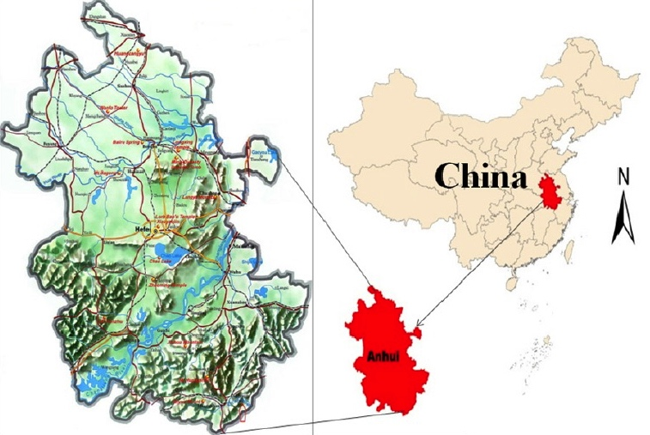

FIGURE 1: Location of Anhui Province in China. The Yangtze River can be clearly seen running through the bottom half of the province on the left-hand map. The WPAs are distributed along either side of the river, as shown on Figure 2 below

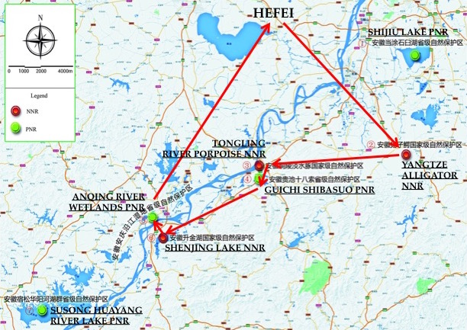

FIGURE 2: The seven WPA demonstration sites under the Project. The red arrows show the route taken by the TE team during the TE mission 23-30 July 2018, visiting five of the seven sites

2.2 Problems that the Project Seeks to Address

- Anhui Province is located in the lower reaches of the Yangtze River catchment (Figure 1) and hosts a variety of nationally and internationally important wetlands and associated biodiversity, including riverine wetlands, riverside lakes and marshlands. The wetlands of Anhui Province are part of the broader Central Yangtze River and Lakes Ecoregion, which covers an area of 754,500 km², and which has been identified by the World Wide Fund for Nature (WWF) as a Global 200 Ecoregion - making it one of the world's 200 most important biological regions.

- Globally important biodiversity values include wintering habitat for a range of migratory bird species, including the critically endangered Siberian Crane (Leucogeranus leucogeranus); and also key habitat for the critically endangered Yangtze River Finless Porpoise (Neophocaena asiaeorientalis), the critically endangered Yangtze River Alligator (Alligator sinensis) and the critically endangered Chinese Sturgeon (Acipenser sinensis).

- The Anhui wetlands also have enormous socioeconomic value and provide a wide range of ecosystem services to the 60 million people who live in the Province, including drinking water supply, irrigation for some of the most productive agricultural areas in China, flood control, fisheries production, pollution absorption and tourism and recreation.

- According to the ProDoc the wetland area in Anhui Province is 2.92 million hectares, accounting for 21.0% of the total land area of the province. There are total 16 wetland nature reserves in the province (3 at national level, 11 at provincial level, and 2 at municipal level). The total area of wetland conservation is 302,000 hectares, accounting for 49.1% of the province’s natural wetland area. Among them, the Shengjin Lake, Chaohu Lake, Shijiu Lake, Taiping Lake and Chinese Alligator Nature Reserve are the wetlands of national importance (Figure 2).

- The lower reaches of the Yangtze River including Anhui Province forms the world’s busiest inland shipping corridor, which combined with the effects of several major industrial cities and ongoing economic growth and development have been sources of significant environmental pressures and impacts.

- According to the ProDoc the problems that the Project seeks to address are the major threats to Anhui wetlands in general and Wetland Protected Areas (WPAs) in particular that are typical of threats to wetlands across China. Generally, these are primarily:

- Unsustainable use of wetlands mainly for fisheries production.

- Conversion of wetlands for other land uses, including aquaculture, agriculture and urban development.

- Pollution from aquaculture, agriculture, industry, urban growth, economic development and upstream land use.

- Poor hydrological management.

- Invasive alien species.

- Climate change.

- These threats are exacerbated by the lack of a coordinated, integrated, cross-sector and inter-government framework for sustainable management of wetlands based on an ecosystem approach, and an inability to effectively coordinate inter-sector interests in wetlands leading to conflicting sector objectives and conflict between conservation and exploitation of wetlands. An emerging threat is that of uncontrolled mass tourism in critical wetland areas.

- While the central and provincial governments have been making significant efforts to addressing these problems and threats success is hampered by three barriers identified in the ProDoc, which the Project is designed to assist in addressing:

- Barrier 1: Limited capacities for integrating wetlands issues into Provincial and sector policies and plans.

- Barrier 2: Limited knowledge and experience with integrated basin management of wetlands.

- Barrier 3: Limited tools and capacities for wetland PA site management.

2.3 Development Objectives

- In seeking to address the problems outlined in section 2.2 the Project is aligned with the following elements of the Biodiversity (BD) Focal Area of the 5th trance of GEF funding (GEF-5):

- BD Objective 1: Improve Sustainability of Protected Area (PA) Systems.

- BD Outcome 1.1: Improved management effectiveness of existing and new PAs.

- BD Outcome 1.2: Increased revenue for PA systems to meet total expenditures required for management.

- In order to address the GEF Objective and Outcomes, the UNDP-GEF Anhui Wetlands Project has the following Project Development Goal and Strategic Objective:

- Project Development Goal: To contribute to the conservation and sustainable use of globally significant biodiversity in Anhui Province.

- Strategic Objective: To strengthen the management effectiveness of the WPA system in Anhui, in response to existing and emerging threats to the globally significant biodiversity and essential ecosystem services.

- In order to achieve the Goal and Objective, the Project design in the ProDoc has three Components aligned with three matching Outcomes, with Outputs under each:

- Component (Outcome) 1: Enhanced provincial capacities for WPA system management:
  - Output 1.1: Strategies for incorporating wetland biodiversity conservation considerations into sector policies and guidelines for production sectors.
  - Output 1.2: Provincial regulatory frameworks for wetlands adopted ensuring protection of WPAs.
  - Output 1.3: Provincial level PA financing strategy with special focus on Shengjin Lake NNR improves financial sustainability.

- Component (Outcome) 2: Strengthened basin-level coordination and implementation of integrated management ensures sustainability of WPA system:
  - Output 2.1: New integrated Shengjin Lake basin plan that is accepted by sectors in place and replicated in at least two additional nature reserves.
  - Output 2.2: Cross-sector basin level coordination mechanism in place.
  - Output 2.3: Systems for knowledge management and exchange across WPAs in the Province (and with the MSL programme).

- Component (Outcome) 3: On-site threats to biodiversity at the Shengjin Lake NNR and adjacent WPAs are reduced:
  - Output 3.1: Shengjin Lake NR Management Plan is developed and approved by the AFD.
  - Output 3.2: Fishing quotas based on ecological carrying capacity are established and accepted by Fisheries sector.
  - Output 3.3: Capacity strengthening tools developed and operational for PA staff and local communities.

2.4 Baseline Indicators & Expected Results

- The ProDoc included a comprehensive, well developed and very clear and user-friendly Strategic Results Framework (SRF) embracing both quantitative and qualitative indicators (refer section 3.1.1 below for details), including, but not limited to:

- Management Effectiveness Tracking Tool (METT).
- Ecosystem Health Index (EHI).
- Institutional Capacity Score Assessment (CSA).
- Knowledge, Attitude, Practice (KAP) assessment.
- Area coverage of Protected Areas (PAs) (with clear target).
- Financial sustainability of PA system (with clear target).
- Development of regulations, policies, management plans and guidelines (with clear target).

- Pre-project assessments of these indicators were conducted during project-design and included in the ProDoc, providing a very strong baseline against which to measure project progress through the periodic monitoring and evaluation (M&E) activities.

- The ProDoc SRF also includes well-developed indicators and targets for the overall Strategic Objective and for each Outcome and Output, which together define the project’s expected results.

- During Project implementation the PMO and AFD did revise and slightly amend the SRF – and this is discussed in section 3.2.1 below.

- Overall, the TE consultants consider that the SRF and associated M&E design as contained in the ProDoc is a textbook example of how proper baseline indicators and expected results should be formulated, as part of the project SRF, and can be used as a model for other similar projects, subject to some minor improvements as outlined in section 3.1.1 below.

2.5 Main Stakeholders

- Significant attention has been paid to identifying key Project stakeholders, both during the initial project design as outlined in the ProDoc, and through continuous updating by the PMO during Project implementation. Table 3 lists key project stakeholders as identified by the PMO for the TE. In addition. Annex 3 to this report list key stakeholders that were interviewed during the TE mission. While the PMO and AFD have made significant effort to engage and coordinate with stakeholders during the Project, including through the inter-departmental, cross-sector PSC, a significant gap is limited engagement with environmental NGOs and private sector interests in the key stakeholder lists (note: while the Shengjin Lake Fishery Cooperative is listed as ‘private sector’, it is actually a State-organized cooperative).

TABLE 3: Key project stakeholders as identified by the PMO
Stakeholders | Roles and responsibilities
International and national level
UNDP | Supervises project execution and fund appropriation. Coordination and execution of GEF projects.
Ministry of Finance | Responsible for operation of focal points (OFP). Coordination and execution of GEF projects.
State Forestry Administration (including National Wetland conservation Center) | Responsible for forest land, most of China’s nature reserves, wildlife issues, wildlife trade (CITES), wetland conservation (Ramsar Convention), drafting departmental regulations, especially regulations with regard to wetlands.
Provincial level
The Government of Anhui Province | The project executing agency. Responsible for provincial management, development planning and execution and planning and financing of provincial reserve systems.
Department of Finance of Anhui Province | Responsible for ensuring availability, appropriation and financial supervision of the supporting funds.
Provincial and local government forestry departments (including Wildlife Conservation Bureau) | Responsible for the planning and management of provincial reserve systems and the protection of flora and fauna in the province. In addition, it is also responsible for wetland management. AFD is the main executing agency of the project.
Anhui Provincial Natural Resources Conservation and Management Station (including Anhui Wetland Conservation Center) | Responsible for the protection and management of wild and/or rare flora and fauna in the province, it may be a key executing agency for the implementation of the project under AFD.
The Standing Committee of the People’s Congress of Anhui Province | Responsible for the coordination of legislative and management functions in Anhui Province, including the regulations of Anhui Province on nature reserve management and wetland conservation.
Departments of water resources of the provincial and local government | Responsible for planning and controlling water resources planning and distribution. Key stakeholders in the efforts to ensure adequate water flow to the target wetlands.
Departments of water resources of the provincial and local government | Environmental issues, pollution control, coordination of CBPF execution and coordination in drafting of new laws. Must participate in amendments of any proposed regulations.
Yangtze River Fishery Resources Management Committee | Responsible for sustainable use of aquatic resources and the protection of rare freshwater animals and their habitats in the Yangtze River and its tributaries and lakes.
Local level
Chizhou Municipal Government | Controls the areas within and around the Shengjin Lake National Nature Reserve and its surrounding, and pays remunerations of the working staff. Chizhou City has established a cross-sector coordination committee for the planning and management of the Shengjin Lake National Nature Reserve.
(Provincial) Agriculture Department and local government | Responsible for agriculture and fishery. Responsible for key stakeholders in freshwater and saltwater fisheries in terms of sources of pollution from water and agricultural water consumption. Should make the biodiversity and the reserve conservation be mainstreamed in its plan and avoid wetland pollution. Can help monitor wetland biodiversity on agricultural land adjacent to nature reserves. Cooperation is needed in the aspect of harvesting control in a sustainable context.
Anhui Shengjin Lake National Nature Reserve Management Authority | Responsible for the planning and management of the Shengjin Lake National Nature Reserve. The main executor of wetland level project contents.
Chizhou Fishery Administrative Department | Responsible for the sustainable use of fishery resources, the protection of freshwater wildlife and their habitats, compliance execution and the supervision of fishery practices. Reserves the right to lease the Shengjin Lake and will be a key partner during the execution of the project.
Primary and secondary schools | Many primary and secondary schools (including teachers and students) in Hefei, Anqing, Xuancheng and Chizhou participated in the project activities. Conducted propaganda and education to the students on wetland conservation so that they can communicate to adults in a “small hands in big hands” manner.
Non-governmental organizations
WWF and other informal NGOs | Supports biodiversity conservation in the Yangtze River ecological regions. It has launched the Yangtze River Ecoregion Action Plan and has developed a strategy for the protection of the middle and lower reaches of the Yangtze River and the Yangtze River Estuary. Can be used for technical support, consulting, training and monitoring. Strong ability to implement grassroots actions together with local communities. Non-governmental organizations directly participated in the project’s publicity and training activities through the project media publicity campaigns and part of direct actions as well as participation in bidding.
Chinese Academy of Sciences, several professional and regional academic and research institutes and universities | Provide technical expertise, collaborators and consultants on hydrology, plants and animals.
Private sectors
Shengjin Lake Fishery Cooperative | This is a wild fishery cooperative that supports the project outcomes of sustainable fishery through direct equity participation. Discussions with the directors of the cooperatives show that they have a strong interest in rebuilding habitats for sustainable fishery.
Project cooperation enterprises | Provide technology or services to the project. They are the participants of the project and also one of the targets of the project.
Media
Anhui Daily, Chizhou Media | Carry out column wetland conservation publicity at the provincial level through Wetland Day and Love Bird Week, etc. The media coverage of PPG occurred in the Shengjin Lake National Nature Reserve, and the local media in Chizhou reported on the activities in the Chizhou river basin.
Individuals
Experts | International and domestic experts provided technical and intellectual support to the project.
Local community (county, district and village) | The main resource user. Local communities around the target nature reserves will be the participants in co-management activities and beneficiaries. They directly or indirectly participated in project activities.
Volunteers participating in nature conservation | Voluntarily carry out patrol, rescue, etc. through the project media publicity or partly through direct action.
Patrolmen | Directly participate in the daily patrol work of the nature reserves.

3. TERMINAL EVALUTION FINDINGS

3.1 Project Design

3.1.1 Analysis of the Strategic Results Framework

- The SRF at project design as contained in the ProDoc is reproduced in Table 4 below. The TE team assesses that the SRF was well developed, clearly structured and user-friendly. There are logically-structured, clearly set, achievable and measurable indicators, baselines and end of project targets set for the overall project Objective and for each project Outcome and Output, supported by identification of the sources of information for verification of indicators, as well listing risks and assumptions.

- The well-structured SRF is found to meet the essential requirement of being SMART (specific, measurable, achievable, relevant and time-bound). The baseline, targets, indicators, sources of information and risks and assumptions are highly specific and are organized to be relevant to each Project objective and outcome. The indicators are measurable and supported by clearly articulated sources of information. The targets are modest enough to be achievable but ambitious enough to have a meaningful, positive impact (although it is noted that significant challenges arose in achieving the main target relating to increase in protected areas). All targets are time-bound (by end of the Project).

- The TE team does make two points about the SRF as follows:

- For Outcomes and Outputs the indicators and targets are not clearly arranged against each Output, but grouped against the overall Outcome. While this is the standard template for UNDP-GEF projects, it is a little inconvenient when trying to assess each indicator and target against the different Outputs. In some cases the Outputs are in fact the end of project targets. The SRF could have been a little better organized had indicators and targets (with supporting baselines etc.) been structured against each Output specifically, rather than just grouped against the overall Outcome. This would require an amendment to the overall UNDP-GEF template for SRFs.

- The sources of information (for verification) for Outcomes include METT, EHI and CSA, which do suffer from some limitations as outlined in section 3.2.5 below.

- During Project implementation the PMO and AFD did revise and slightly amend the SRF – and this is discussed in section 3.2.1 below.

- Overall, the TE consultants consider that the SRF as contained in the ProDoc is a textbook example of how a proper SRF should be formulated, and can be used as a model for other similar projects, subject to some minor improvements outlined above.

TABLE 4: The Project Strategic Results Framework (SRF) at project design as contained in the ProDoc
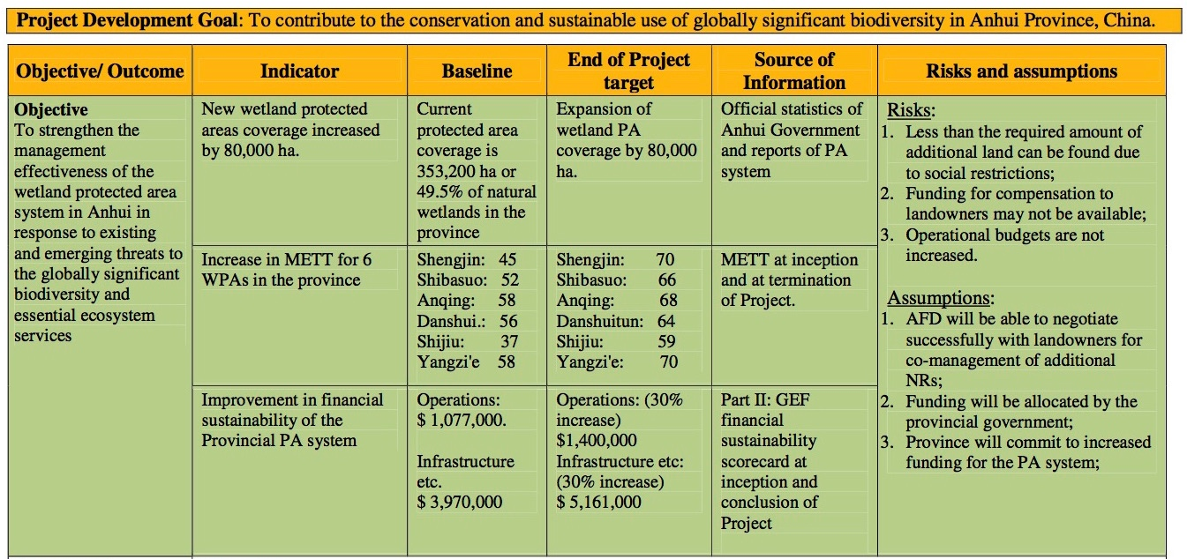

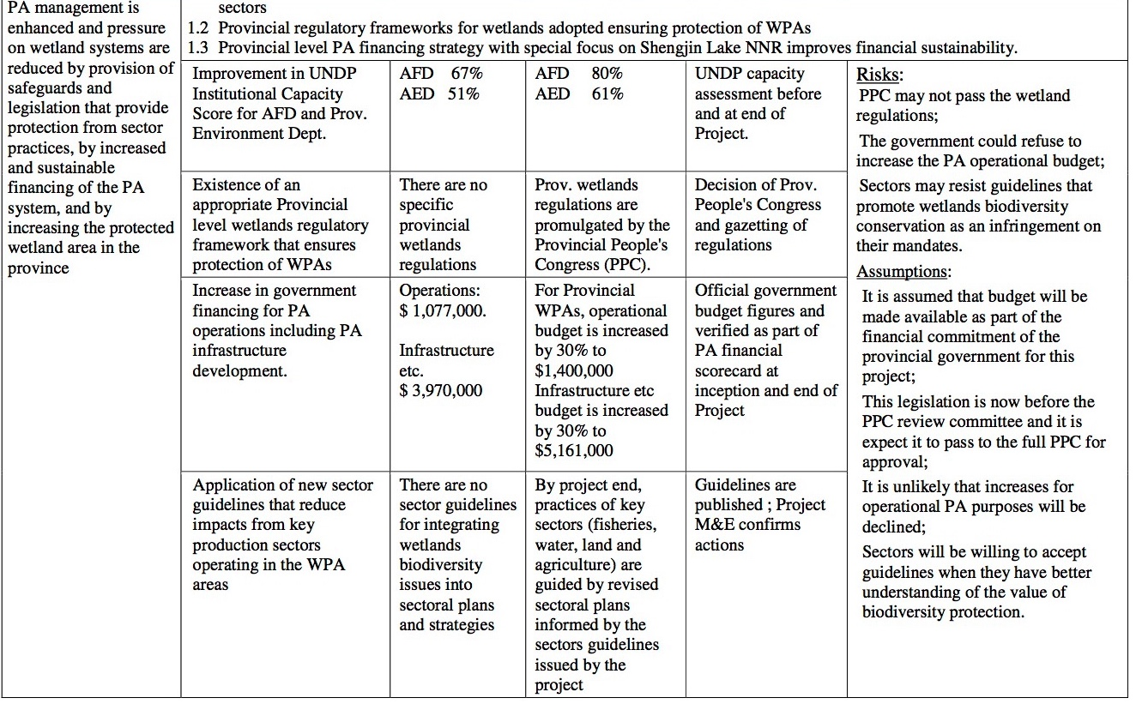
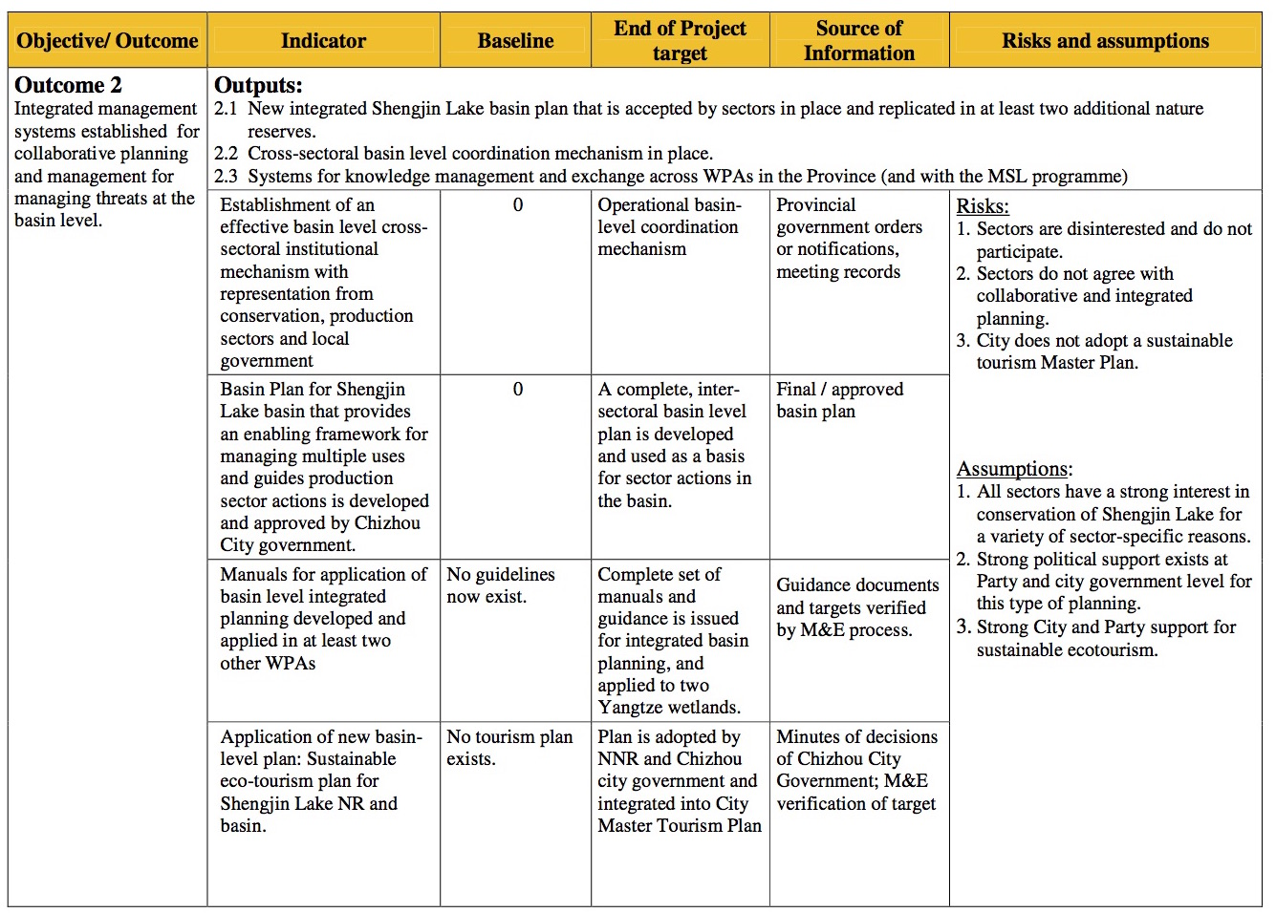

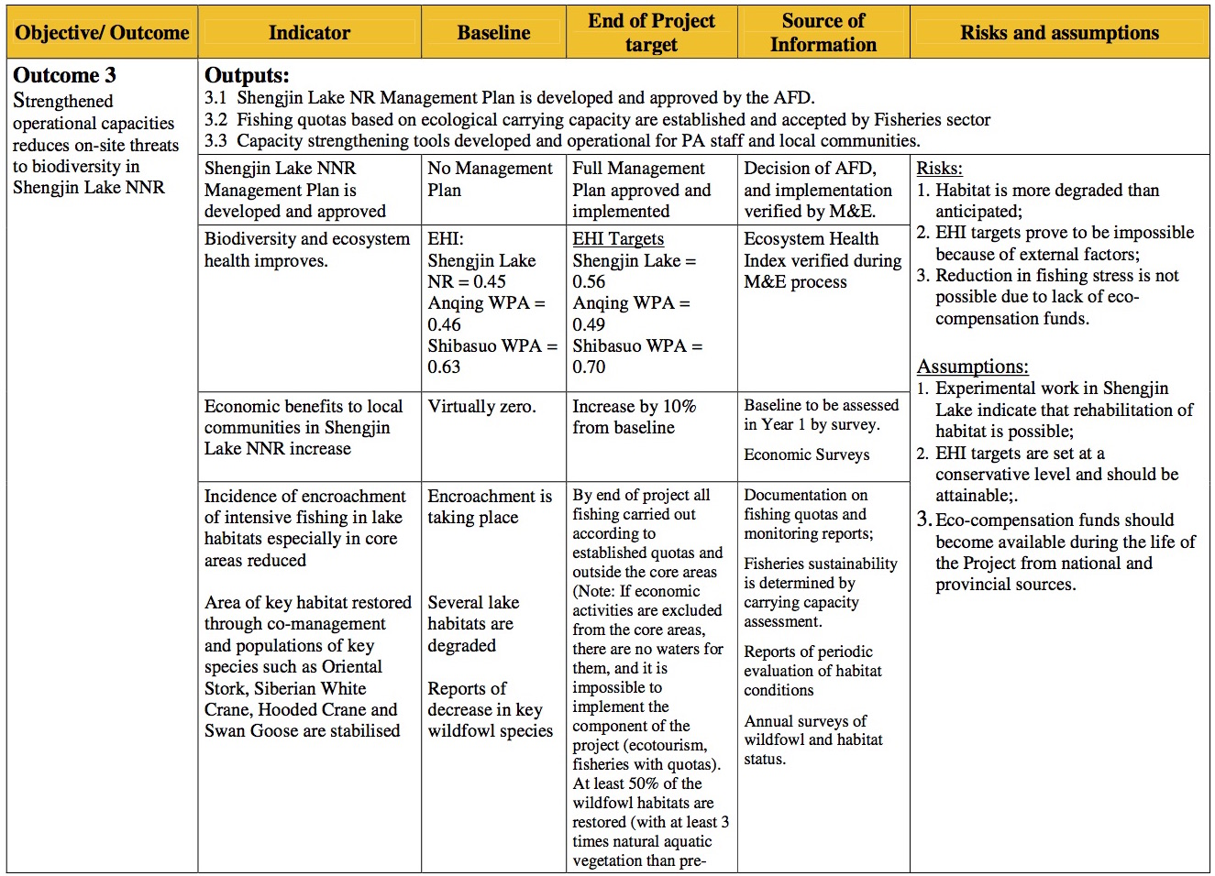

3.1.2 Assumptions and risks

- The SRF in Table 4 above contains very clear assumptions and risks aligned against the overall project Objective and against each Outcome. The assumptions and risks as applied to the project design appear to be appropriate, relevant, logical and practical.

- Table 5 below compares projects risks as assessed in 2013 before project inception (as identified in the ProDoc) against the TE team’s assessment during the TE period (July 2018). The TE team assesses that during Project implementation the PMO has managed project-level risks well, and that overall, risks relating to mainstreaming and inter-departmental coordination have decreased over time, especially due to a clearly increased commitment to and mainstreaming of wetlands issues in the Provincial Government, backed by very strong policy directives and funding support for wetland conservation and national “eco-civilization” goals from the Central Government. However, inter-sector coordination mechanisms are focused almost solely on government agencies, and private sector and civil-society sectors need to be integrated into these mechanisms, to reduce these risks further.

- The main remaining risks, including post-project, are beyond the direct control of the Project. These are external environmental impacts on WPAs from the broader catchments (pollution, hydrological flow etc), and the relatively small size of the WPAs and lack of ecological connectivity between WPAs, which threatens their ecological viability in the longer term. Another potential threat is water shortage for ecosystem demand in dry seasons. The TE team assesses these risks to be higher now that at project inception.

- Adoption of the Integrated Basin Management Plan for Shengjin Lake NNR is a positive step, but this needs to be implemented on-the-ground, and similar plans need to be developed for all of the other wetlands, within a larger integrated basin plan for the whole Yangtze River eco-region.

- The potential long-term effects of climate change could also be severe not only for the Anhui wetlands but the entire Yangtze River basin and all wetlands in China. Climate change has continued to accelerate since project inception and the TE team assesses these risks to be higher now that at project inception. More and more frequently extreme climate and resultant risks might bring into some irreparable damage to the quality of creature habitats and general biodiversity. In addition to the vital need for global action to address climate change, at the Provincial and local levels it is also vital to build the resilience of wetlands to climate change, by strengthening and protecting their ecological health through on-the ground action, as promoted by the Project.

TABLE 5: TE team’s assessment of changes in project risks (TE comments in blue)
Risk Identified | Category | Impact | Likelihood | Assessed in ProDoc | Assessed at TE | TE Comments
Mainstreaming WPAs into sector policies hindered by lack of incentives for other sectors, poor enforcement of agreed priorities and plans that may be incompatible with larger urban and industrial development programs. | Political | High | Moderately likely | Medium | Low to medium | There has been strong mainstreaming as evidenced by adoption of the Anhui Wetland Conservation Regulation, Wetland Conservation Plan 2016-2030 and many others.  While the Dept of Construction & Urban Planning was reportedly involved in the scope of the new Wetland Regulation, it was clear during the TE mission that larger urban and industrial development programs in the Province are currently not fully integrated into wetlands planning and remain a significant external threat to wetlands in Anhui.
Government sectors may not provide appropriate level representation or cooperation may not be forthcoming from sector representatives in provincial or municipal Coordination Committees | Political | Medium | Unlikely | Low | Low | It was clear to the TE that effective cross-sector / inter-departmental coordination mechanisms have been established including the PSC at Province level and at local government levels.  However, NGOs and private sector are more or less missing from these committees, and should be invited to join, including the long-term post-project inter-sector coordination mechanisms.
Water quality seriously deteriorates beyond the ecological threshold due to upstream activities including urban and rural development and dam operation. | Environmental | Medium | Moderately likely | Medium | Medium to high | The large-scale removal of fish traps and nets from the wetlands should assist water quality by facilitating water flow, however the TE has not seen any long-term water quality data to verify this.  Apart from three very small, village-scale sewerage treatment systems, it appears that the project has not supported any meaningful pollution reduction / water quality improvement actions.  While Central, Provincial and local governments are reportedly implementing a range of measures to address aquatic pollution and water quality, it is very clear from TE observations of the very high intensity of agriculture, industry, infrastructure and urban development in the surrounding catchments that water quality and pollution impacts from the surrounding catchments remain a high risk to the wetlands. This highlights the need to expand and accelerate pollution control measures.  Adoption of the Integrated Basin Plan for Shengjin Lake NNR is a positive step, but this needs to be implemented on-the ground, and similar plans need to be developed for all of the other wetlands, within a larger integrated basin plan for the whole Yangtze River eco-region.
Severity of climate change induced floods and drought may undermine conservation efforts promoted by the project through extreme changes in water level and lake bottom conditions. | Environmental | Medium | Moderately likely | Low | Medium to high | Failure in flood control might destroy existent WPA conservation facilities, and water shortage might result in low water level in rivers and lakes, bringing into irreparable damage into wetland habitats.  While modeling the exact effects is difficult, a review of the recent scientific literature indicates that climate change risks are increasing both globally and specifically in the Yangtze River wetlands eco-region.  This highlights the need to build climate change resilience through improved ecological health of the Yangtze River wetlands.
Local and provincial agencies do not take river basin planning and management seriously and local government refuses to decrease fishing pressure. | Strategic | Low | Unlikely | Low | Very Low | This risk has been almost removed completely through concerted action taken by AFD with support from the project, includjng large-scale removal of fish traps and nets and regulatory prohibition on fishing in the WPAs.

3.1.3 Lessons from other relevant projects incorporated into project design

- Compared with many other similar projects it appears that for this project, significant effort was made during the project design to incorporate lessons from previous and other relevant projects, which has been a significant positive factor in ensuring that the project design is sensible, logical and practical, and which has assisted greatly in the successful implementation of the Project.

- The project was designed following the experiences of several other GEF biodiversity projects in China – in Qinghai and Gansu and an earlier GEF wetlands program, as well as the recently closed large-scale EU funded EU-China Biodiversity Program (ECBP), which specifically assisted Anqing City in improved protection of Caizi Lake.

- Learning lessons from these earlier projects, the design departed from the earlier designs in that each of the provincial projects is a stand-alone full project managed by its own National Project Director (NPD) and PMO, largely funded from provincial sources and not dependent on fund transfers from a national coordinating project.

- The rationale was to give the local agencies a greater sense of ownership as well as to speed up planning, actions and payments locally. The design also tries to tackle wetland issues at provincial and landscape levels rather than being strictly focused on one demonstration site, and with a greater focus on mainstreaming wetland issues into all sectors.

3.1.4 Planned stakeholder participation

- The project design as outlined in the ProDoc includes both a comprehensive Stakeholder Analysis (in Part I of the ProDoc) and plans to develop a Stakeholder Involvement (Plan IV of the ProDoc), which was to be prepared upon project inception as an identified workplan activity.

- The TE team has not seen a copy of any specific Stakeholder Involvement Plan developed upon project inception and the PMO advises that none was developed, and stakeholder engagement was undertaken on a largely ad-hoc basis. However, it was clear to the TE team that effective cross-sector / inter-departmental coordination mechanisms have been established including the PSC at Province level and at local government levels, although NGOs and private sector are missing from these committees. Stakeholder engagement could have been even more effective had the PMO developed a structured, programmatic, properly designed Stakeholder Involvement Plan at the beginning of the Project, as required by the ProDoc.

3.1.5 Replication approach

- The project design as outlined in the ProDoc includes provisions for sustainability and replicability under Part II - Strategy, with the Project being designed to be replicable in three main areas:

- Planning: The Shengjin Lake NNR Management Plan developed under this Project will provide guidance on a methodology for implementing the State Council's 2010 'Announcement" on NR management. It is anticipated that this type of planning will become a model for replication in other NRs.

- Business Approach to Nature Reserve Management: This Project will pioneer best-practices in the development of business opportunities, such as Public-Private-Partnerships (PPPs) that will achieve both sustainability of the conservation activity, and generate revenues to supplement core government funding, and provides alternative livelihoods for local residents. The Project intends to show that wetland NRs can be successfully operated within a business model.

- Basin Management: Most wetland NRs are part of a river/lake basin system. Currently, WPAs are not managed within a holistic basin context. The Project will pioneer an integrated approach to basin management within which Shengjin Lake NNR resides. This approach will involve a multi-sector approach, and a methodology, to manage the threats arising from basin activities outside the nature reserve.

- The TE assesses that the Project made good very progress on replication under a) Planning, in that the Shengjin Lake NNR Management Plan was successfully developed and adopted, and has been sued as a model for the other six WPAs covered by the Project.

- The TE assesses that the Project has not made good progress on replication under b) Business Approaches, in that no such approaches, including PPPs, have been developed and applied at even one demonstration site, let alone replicated at additional WPAs. Opportunities for business approaches to WPA management are constrained by a regulatory prohibition on ecotourism operations in Nature Reserves, and the Draft Ecotourism Plan developed by the Project for Shengjin Lake NNR has not been adopted and implemented by the Provincial Government. A so-called “company” has been formed to undertake on-the ground management activities at Shengjin Lake NNR, reportedly employing ex-fishermen displaced by enforcing the ban on fishing in the NNR. However, this is simply a service company that is contracted and paid by the government to undertake work, it is not a PPP or a “business approach”. The funding still comes from government sources, not from revenue-generating business activities, and in effect the workers are employed by the government. There is still a long way to go on this component.

- The TE assesses that the Project has made some progress on establishing the basis for replication under c) Basin Management, in that the Shenjin Lake Integrated Basin Management Plan has been developed and adopted. However, this remains to be implemented, and to date there has been no replication of similar integrated basin-wide plans for the other WPAs. In order to be truly effective, because all of the catchments and basin are inter-connected through the Yangtze River, these also need to be coordinated under a broader integrated management plan for the whole Yangtze River eco-region basin.

3.1.6 UNDP comparative advantage

- The comparative advantage of UNDP as the GEF Implementing Agency for this Project is based on the long-standing physical presence of the UNDP-CO in Beijing, with a long history of UN support to the Government of China on sustainable development issues. The UNDP-CO has well established and effective working relationships with relevant Central and Provincial Government agencies, including in-depth understanding of Chinese Government laws, policies and procedures, as well as international experience with capacity development programs, and an ability to access international expertise on wetland and biodiversity conservation issues. The UNDP-CO is also effectively supported on GEF-BD projects through the UNDP-GEF Regional Technical Adviser (RTA) located in Bangkok, adding to the agency’s comparative advantage.

3.1.7 Linkages between project and other interventions within the sector

- An important element in the design of such projects is to seek effective links and cooperative partnerships with other relevant programs and projects in the subject area, including those undertaken by government, external donors, environmental NGOs and the private sector. Such partnering is a useful way to create synergistic benefits between projects, multiply positive impacts and even secure additional co-financing.

- Unfortunately it appears that the project design as outlined in the ProDoc did not contain any specific provisions relating to linkages and meaningful partnerships with other relevant programs and projects in the subject area. The Project has shared knowledge and experiences with the other five “sister” UNDP-GEF wetland projects undertaken in China under the China Biodiversity Partnership Framework - Mainstream of Life (CBPF-ML). While this sharing has been beneficial to all projects, they are all part of the same initiative, undertaken in different Provinces under similar designs, and does not generate the same synergistic, “on-ground” benefits as partnering with other relevant programs and projects within the Province itself.

- The Project did partner with work funded through a US$30 million loan from the Islamic Development Bank (IDB) for the construction of patrol roads, biodiversity monitoring centres and other facilities in the Susong Huayang River and Lake Group Wetlands PA (one of the Project demonstration sites) (refer also section 3.2.2).

- As far as could be ascertained during the TE the Project has not partnered at all with the ‘true’ private sector. Private sector involvement is critical when the main threats to wetlands in the Province come from private sector industrial and urbanization activities in the surrounding catchments.

- A potentially significant partner for the Anhui Wetlands Project is the WWF Yangtze River Ecoregion Action Plan, which is a strategy for the protection of the middle and lower reaches of the Yangtze River and the Yangtze River Estuary. The work of WWF in the region includes tools for WPA management, a Nature Schools Network and the Yangtze Basin Protected Area Network (YPAN), with over US$230 million in funding (including from private sector sources like Coca Cola and HSBC Bank).

- The TE understands that despite good personal connections with relevant WWF personnel, the Project has not cooperated on a substantive bases with these WWF initiatives, for example through actual partnering on the planning and implementation of joint activities. It is understood that the Project has paid WWF to provide technical support and training (i.e. engaged them as consultants) for specific tasks, however this is not real or effective “partnering” in the sense envisioned here. The existence of the well-funded WWF Yangtze River Ecoregion Action Plan presents a significant opportunity for the UNDP-GEF Anhui Wetlands project to achieve a significantly multiplied effect through the coordination of funding, resourcing and joint activities, however it seems that this opportunity may have been missed. The PMO states that it did try to engage with the WWF Yangtze River Ecoregion Action Plan but suggests that WWF did not see Anhui Province as a high priority, despite the fact that Anhui is located precisely in the lower reaches of the Yangzte, which is a target area for the WWF Action Plan.

3.1.8 Management arrangements

- The Project is implemented by the UNDP-CO and executed by the AFD with support from the Anhui Finance Department, several municipal and local governments and the management staff of Shengjin Lake National Nature Reserve (NNR) and other WPAs in the Province.

- The project is implemented nationwide in accordance with the Standard Basic Assistance Agreement and the Country Project Action Plan (CPAP) signed between UNDP and the Chinese Government.

- An indication of the project-specific management arrangements are shown in Figure 3, and include:

- National Project Director (NPD): Senior officials in AFD with overall responsibility for day-to-day oversight of project implementation and management.

- Anhui Wetland Conservation Center (WCC): Part of AFD - provides scientific and technical guidance and support for Project implementation.

- Project Management Office (PMO): Comprising a “Director”, who is the Deputy Director of the Chizou Forestry Bureau, plus the Project Manager and other staff and consultants, employed using Project funds or assigned from the Bureau, with day-to-day responsibility for managing technical implementation of the Project. The Project Manager and staff were initially housed at the field office of the Shengjin Lake NNR, however this proved to be logistically challenging and after the MTR, it was moved to the Chizhou Forestry Bureau in Chizhou city itself (maybe due to the management difficulties and low efficiency), which manages the Shengjin Lake NNR.

- Project Steering Committee (PSC): This was formed in 2014 to provide overall direction and guidance for the implementation of the project. It has representatives from 13 organizations, including UNDP, the Central Government Ministry of Finance and State Forestry Administration, AFD, Anhui Finance Department, the Provincial Development and Reform Commission, the Provincial Environmental Protection Department, the Provincial Agricultural Committee and the Provincial Water Resources Department. Missing from the PSC are NGO and private sector representatives, which is a limitation as achieving integrated, cross-sector wetlands management is one of the main objectives of the project. (Though NGO wasn’t involved into the PSC, however, representatives from NGO would be invited to attend annual PSC meeting, and to report both the progress of its participation into the project and the next phase plan. So Actually, NGO has actively involved into the project in this project.)

- Chizhou Shengjin Lake Basin Management Committee (SLBMC): This was established to coordinate cross-sector issues relating to the Shengjin Lake Basin and comprises 18 relevant departments from Chizhou Municipal Government to strengthen cooperation and coordination to improve the management effectiveness of the Shengjin Lake wetland protected areas. As with the broader PSC, NGO and private sector representatives are not on the SLMBC. Again this is a limitation as achieving integrated, cross-sector wetlands management is one of the main objectives of the project.

- Chief Technical Adviser (CTA): Provided on a part-time basis from the National MSL office to provide scientific and technical advice, advise PMO in developing annual work plans and making strategic decisions, assure the quality of outputs/outcomes of service contracts, review PIRs, QPRs and APRs, supervise the execution of service contracts and the Project’s overall implementation, and other support to the Project when necessary.

- There do not appear to be specific Project coordination arrangements for the other six WPAs covered by the project (Tongling River Porpoise NNR, Yangtze Alligator NNR, Anqing River Wetlands Provincial Nature Reserve (PNR), Shijiu lake PNR and Susong Huayang River Lake PNR) (Table 2 and Figure 2).

- The project account was opened under the account of the Anhui Shengjin Lake National Nature Reserve Management Authority, with the Chizhou Municipal Government Accounting Center administering the receipt and disbursement of Project funds in the Province.

- Overall the TE finds the project coordination arrangements to be unnecessarily and extremely complex and therefore not optimally efficient. There are too many “supervisory” positions and unclear lines of reporting and duplicated lines of reporting. Given that this is Provincial project with a significant focus on replicating project outcomes across seven wetlands throughout the Province, the TE does not understand why the PMO was established at the Chizhou Forestry Bureau and not at the AFD, which is the designated Executing Agency. Actually PMO at a Bureau level has very limited capacity to realize high-efficient coordination which is critically important to this project. The complex coordination arrangements appear to introduce too many layers of administration, which reportedly caused delays with decision making, hampering timely conduct of activities. This would have also increased transaction and administration costs. Generally in China, PMO of an international cooperation project should be set up at least on a provincial level, especially for the ecosystem-related types of project.

- For a relatively small project like this one (circa $2.6 million of GEF funds), a much simpler, flatter and direct coordination structure would be more appropriate with high effectiveness and efficiency.

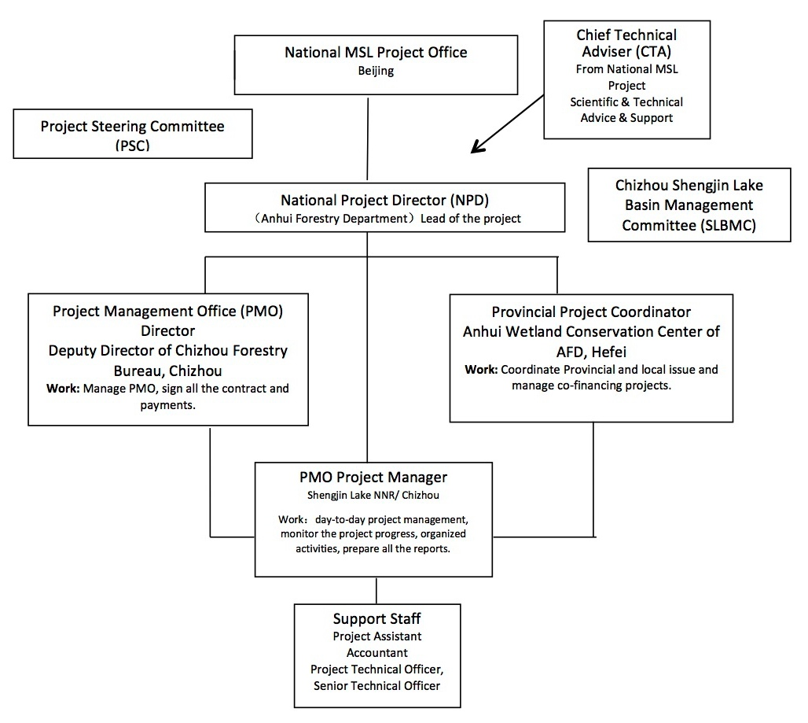
FIGURE 3: Indicative coordination arrangements for the UNDP-GEF Anhui Wetlands Project – which in the view of the TE are unnecessarily complex for a project of this scale and therefore not optimally efficient

3.2 Project Implementation

3.2.1 Adaptive management

- The PMO has exhibited strong capacity for flexibility and adaptive management, including effectively learning lessons and taking on the recommendations of the MTR by making adjustments to the Project from 2016 to 2018 as outlined in Table 6.

- However, some important items remain to be addressed, as highlighted in the “blue” TE comments in Table 6.

TABLE 6: Changes made to the Project in response to the MTR recommendations

Corrective actions for the design, implementation, monitoring and evaluation of the project
 | Recommendation: The PMO should be relocated to sit directly under the management authority of the Chizhou Municipal Forestry Bureau and needs to be in Chizhou City itself. The authority of signature for activities should also be appropriately placed under the director or vice director of the Chizhou City Forestry Bureau. | AFB, UNDP
Adjustment: The Anhui GEF Project Office has set up an office in Chizhou Forestry Bureau to strengthen communication with the Municipal Forestry Bureau, Chizhou Shengjin Lake Basin Management Committee and other reserves. The right to sign has also been adjusted accordingly.
TE Comment: Given 7 demo sites the PMO should have been housed in AFD, not a municipal govt / single WPA.
 | Recommendation: New project management regulations need to be drafted and appropriate budget re-allocations made to reflect the new management authority and the re-focusing of activities as proposed in this MTR. They will need to be approved by the PSC and UNDP. | Project coordinator, AFD, UNDP, PSC
 | Adjustment: Has reformulated the management regulation, adjusted the budget, and adjusted unnecessary material costs in order to unfold more activities. The management regulation was discussed during the meeting of the Steering Committee.
 | Recommendation: Two full-time technical officers need to be employed, one at provincial level under the AFB Wetlands Centre and the project coordinator, and one at Chizhou City under the PMO. The former is expected to engage in delivering Outcome 1 and 2 and in particular supporting the government ‘ownership’, uptake and approval of the Shengjin Hu Basin Management Plan. This officer should also be capable in providing technical oversight to the 15 or so sub-contractors and their plans and reports.  The latter is expected to engage in delivering tangible (visible) demonstrations for habitat restoration of wetland areas in and around Shengjin Hu. The PMO-based technical officer is also expected to act as the conduit between the sub-contractors’ Shengjin Hu Management Plan and the Shengjin Hu NNR authority in creating a viable plan for full funding submission with all project stakeholders in agreement. (Outcome 3). | AFB, UNDP
 | Adjustment: The project recruited 2 employees.
- . | Recommendation: The Shengjin Hu Basin Management Plan and the Shengjin Hu Management Plan run from 2014 to 2018, but are not expected to gain planning approval until 2017. The recommendation is that they are redrafted to run from 2017-2021 in order to provide a legacy and sustainable output from the project. | AFD
 | Adjustment: The time limit for the management plan/planning was adjusted to be 2018-2022 according to need.
 | Recommendation: The Chizhou Shengjin Hu Basin Management Committee was established in Chizhou City in May 2015. With 18 different government agencies involved in the basin management, the task to achieve agreement to implement such a basin plan is very large. Thus the project needs to allocate time and financial resources to this committee. This should include funds for meetings, trainings, and a study tour of an appropriate site and agency to deliver this can be identified. Again full ownership of this basin plan is important. | Project, Chizhou City Government
Adjustment: According to expert opinions, the project office provided many opportunities for learning and exchange for Chizhou Shengjin Lake Basin Management Committee (including inspection of wetlands in Taiwan and exchange on mainstreaming of biodiversity in Qinghai, etc.).
TE comments: It appears that the PMO has missed the point being made by the MTR – which is to provide support to the committee to “implement” the basin plan, not only to do “learning exchange”.
Also, the committee should include NGO & private sector.
 | T Recommedation: The Chizhou basin committee need to endorse their basin plan and submit to both county government and then provincial government (various, or directly to provincial government and funding departments – ADRCs) to approve. | Chizhou City Government
Adjustment: The basin management plan has been discussed at the meeting of the municipal government, and will be approved finally after revision and improvement.
TE comment: The PMO advises that the basin plan was approved by Chizhou Municipal Government in August 2018 immediately after TE mission.

Actions to follow up or reinforce initial benefits from the project
 | Recommendation: The project document target of 80,000 ha of new WPAs to be designated by December 2018 is not achievable. It needs to be changed to ’By December 2018, 80,000 ha of WPA submitted for approval, of which 60,000 ha to be designated’. Thus planning and submission of the remaining 48,000 ha within the project timeframe still needs to go ahead, even if higher level approval lags behind. This is because higher level approval is now being determined by the Anhui Wetland Conservation Master Plan (2016-2030) | AFB
Adjustment: This advice was consulted with RTA, but not adopted. The project has achieved the objective at present.
TE comment: the Project reports that there has been a 175K ha increase in WPA coverage (exceeding the project target of 80K ha by >2x). However, it appears that this has been achieved by adding new PA categories to the final assessment that were not included in the baseline assessment, thereby giving a false, positive assessment against the baseline (see Figures 5 & 6).
 | Recommendation: The designation of smaller local nature reserves or wetlands under county, district, even Administrative Village Committee management is a partial solution to the land conflicts. This needs further promotion as it is already in line with provincial policy. Areas less than 8 ha could be included if local WPA designation is accepted. AFB need to take a lead in creating the conditions to make this happen. | AFB
 | Adjustment: In addition to smaller local reserves, AED, the provincial Water Resources Department and other departments were included the conservation of water sources and conservation of newly built aquatic germplasm resources reserves in this scope.
 | Recommendation: The Shengjin Hu wetland restoration demonstrations need to be clearly conceptualized, be bold, and be visibly implemented and should also be one of the key tasks of the PMO level technical officer. They should include both technical and institutional (collaborative management) aspects. | Project
 | Adjustment: After the purse seines/fishing nets are demolished for restoration of the wetlands in Shengjin Lake, the natural restoration of the lake and wetland vegetation rehabilitation in some of the polders were carried out at the same time.
 | Recommendation: The training skills and capacity of An Qing Forestry Bureau (AQFB) need to be better utilized. This could be achieved through an external events contract and the hire of persons as individual experts. | Project, AQFB
 | Adjustment: A number of training and promotional activities have been carried out in Anqing
 | Recommendation: There is a need for more emphasis in working directly with local government stakeholders, namely those who have an impact on wetlands. This means working with government - water resource and environmental protection on specific issues. A number of 10-15 key issues should be selected across the seven WPAs and quarterly meetings agreed with these government offices. | Project Coordinator, AEPD, Agricultural Commission Dangtu County
 | Adjustment: Under the support of Chizhou Forestry Bureau and Chizhou Shengjin Lake Basin Management Committee, the project office and the cooperative partners have discussed the possibility of project implementation and future work with the water department, environmental protection department and the tourism commission, etc. for many times.
 | Recommendation: Shibasuo Wetland PA Management Plan should include a detailed chapter on integrated wetland basin management, including a mechanism for collaborative institutional authority and management decision-making. | Guichi Forestry Bureau
 | Adjustment: The contents have been added.
 | Recommendation: The PMO should be represented on the Chizhou Shengjin Hu Basin Committee, at least as a temporary member or observer. At present, the project is represented via the director of the Chizhou Forestry Bureau (CFB). | CFB, Chizhou City Government
 | Adjustment: The PMO was represented on the Chizhou Shengjin Hu Basin Committee.
Proposals for future directions underlining main objectives
 | Recommendation: Despite Shengjin Hu NNR being listed as a Ramsar site, it needs to adopt a more pro-active management approach for the benefit of biodiversity, in particular more submerged aquatic vegetation and a suitable water management regime aimed at seasonal variable water levels suitable for wetlands plants and animals/birds. At present it appears largely managed for water storage and compartmentalized for fishing value. | Shengjin Hu NNR Management Board
 | Adjustment: After communication with the water department of Chizhou City, this department agreed in principle to avoid the flooding period without affecting the life safety of the people, and regulate Huangpen Sluice according to the rational scientific plan and the biodiversity requirements. The mayor also made a request for connection of rivers at the meeting.

3.2.2 Project finance & co-finance

- It should be noted that the TE team are not accountants or financial auditors, and are not in a position to verify the financial management processes and nor the financial data that has been provided by the Project or by the AFD – all such data has simply been accepted at face value. It is understood that the Project finances are subject to “double audit” by UNDP and the Anhui Finance Department.

- It is understood that the Project is subject to the provisions of UNDP-GEF Country Management Manual and the Financial Management Measures for the Project for Strengthening the Management Effectiveness of the Wetland Protected Area System in Anhui Province with the GEF Grant, jointly issued by the Anhui Finance and Forestry Departments (note that the TE team has not reviewed this document).

- A five-year budget and work plan is included in the ProDoc at project inception. During the project implementation period, at the beginning of each year, the PMO developed a Two-Year Work Plan, which was jointly approved and signed by the country project director and the UNDP project leader before becoming effective. Quarterly work plans were also prepared, and the funds approved by UNDP transferred to the project account in the Anhui Finance Department. The PMO staff then submit applications for appropriation to the Anhui Finance Department, who transfer funds into the project account set up in Chizhou Municipal Accounting Center (in the view of the TE this system is too complex with too many steps, unnecessarily increasing administration workload, timelines and transaction costs. There should have been a single project account at Anhui Finance Department, which could disburse funds directly for project purposes without the extra step of the Chizhou account).

- At the end of each quarter, the project office submits a quarterly financial statements (FACE) to UNDP; and at the end of each fiscal year, there is an annual comprehensive executive report (CDR).

- Considering that most of the work of the project needs to be carried out locally, the project allocated more project funds to the Nature Reserves when preparing work plans. During the four and a half years of project implementation, reportedly 57.3% of the GEF funds were used at the local reserve level, 20.4% were used for provincial-level projects and project management funds were controlled at 4.7% so as to meet GEF requirements of <5% on project management.

- At the time of the TE, and with 6 months still to go until operational closure of the Project, reportedly US$ 2,159,535 of the project funds had been used, representing a total implementation rate of 81.3%, as shown in Table 7. This is considered a high project implementation rate compared to many similar projects. Table 8 shows budget and expenditures up to the TE.

- With regard to co-financing, the Project Identification Form (PIF) identifies a total commitment of US$ 18,147,255, comprising $17,447,255 from Government sources and a $700K grant (cash) commitment from UNDP.

- The PMO reports that at July 2018, actual co-financing from government sources had reached US$ 48,375,000, over 2.7 x the original commitment and 16 x the amount of the GEF grant (way in excess of GEF requirements). Most of the additional co-financing came from the Central Government Ministry of Finance to support the WPAs under new Central Government prioritization of wetlands and broader eco-civilization policy directions. Table 9 shows the reported co-financing sources.

- In addition, by cooperating with work funded through a loan from the Islamic Development Bank (IDB) the Project secured US$30 million in additional co-financing for Project-related activities, which was not predicted in the original project design. This funding was managed by the Anhui Reform and Development Commission and assisted the construction of patrol roads, biodiversity monitoring centres and other facilities in the Susong Huayang River and Lake Group Wetlands PA (one of the Project demonstration sites). The Project provided technical advice and support.

- Unfortunately, the commitment of a $700K “grant” (which means “cash” under GEF co-financing guidelines) from UNDP has not been realized. The UNDP-CO advised that these funds were to be sourced from the Coca-Cola Foundation (CCF) under the multi-year (2007-2018 to date) Coca Cola Partnership for Water Governance Programme (PWGP). The PWCP is a partnership between CCF, the China International Centre for Economic and Technical Exchanges (CICETE) and UNDP and is focused on supporting government efforts to improve water resources management and drinking water safety in rural parts of China (and not on wetland PA management). The TE has identified some issues with this allocation, as follows:

- Firstly, given that the funds were actually provided by the CCF and not UNDP, it was erroneous for UNDP to identify itself as the source of this potential co-financing on the PIF and subsequent project-related documents. The CCF should have been identified as the co-financing source. For UNDP to identify itself as the source of this co-financing is analogous to UNDP identifying itself as the source of the GEF grant - it is factually incorrect. To be listed as co-financing from UNDP, especially if it is identified as a “grant”, the funding would need to be genuinely sourced from UNDP’s own budget / funding sources, not from another donor.

- Secondly, throughout the Anhui GEF Project duration (2014-2018) the PWGP has not supported a single activity in Anhui Province. The PWGP has focused primarily on north-east China (e.g. Yellow River region) and some other Provinces, but not on Anhui, and has not focused on improving PA management. The GEF definition of “co-financing” is “financing that is additional to GEF project financing, and that supports the implementation of a GEF-financed project and the achievement of its objective(s).” The PWGP has done nothing at all to support implementation of the Anhui Wetlands Project, nor the achievement of its objectives – which are all focused on Anhui Province and on improving the wetland PA system. It therefore does not meet the GEF definition of co-financing with regard to the Anhui GEF Project.

- The $700K commitment of grant co-financing by UNDP has therefore not been realized during the Project. It is recommended that greater attention should be paid to ensuring that co-financing commitments in the PIF and ProDoc align with GEF definitions and criteria and are actually realized for future projects.

- Combining the final (to date) $48,375,000 of co-financing provided by government with the additional $30 million of co-financing from IDB for the Susong site, and subtracting the $700K UNDP commitment that has not been realized, gives a total co-financing figure of $78,375,000, or $60,227,745 more than the original commitment of $18,147,255. This represents a ratio of total co-financing ($78,375,000) to GEF financing ($2,654,771) of nearly 30 to 1, well in excess of the GEF-5 upper guideline of 6 to 1. This is a highly commendable achievement, and unprecedented in other similar GEF projects.

TABLE 7: The annual payment amount and implementation rate
 | 2013  USD | 2014  USD | 2015  USD | 2016  USD | 2017  USD | 2018  USD | 2019  USD | Total up to Terminal Evaluation  2013 - 2018  USD
Annual budget and actual expenditure
Annual budget | $0 | $228,380 | $700,076 | $685,964 | $633,454 | $652,372 | $122,955
Actual expenditure | $0 | $163,746 | $609,081 | $600,447 | $506,170 | $280,091.19 | $0 | $$2,159,535.17
Implementation rate |  | 72% | 87% | 88% | 80% | 43% |  | 81.3%

TABLE 8: Project budget and expenditures up to the TE
Outcome | 2013  USD | 2014  USD | 2015  USD | 2016  USD | 2017  USD | 2018  USD | 2019  USD | Total  USD
Indicative Breakdown of Project Budget in Project Document:
Outcome 1 |  | $71,800 | $209,400 | $128,800 | $62,900 | $69,271 |  | $542,171
Outcome 2 |  | $86,800 | $106,800 | $109,600 | $79,800 | $83,900 |  | $466,900
Outcome 3 |  | $134,500 | $403,000 | $367,700 | $326,900 | $288,100 |  | $1,520,200
Project Management |  | $29,500 | $26,500 | $22,500 | $22,000 | $25,000 |  | $125,500
Total | $0 | $322,600 | $745,700 | $628,600 | $491,600 | $466,271 | $0 | $2,654,771
Outcome | 2013  USD | 2014  USD | 2015  USD | 2016  USD | 2017  USD | 2018  USD | 2019  USD | Cumulative Totals at Terminal  2013 - 2018  USD
Annual Work Plan Budgets and Actual Expenditures Incurred through Terminal:
Outcome 1:
Annual Work Plan |  | $84,550 | $201,320 | $176,267 | $98,429 | $81,225 | $11,049
Disbursed |  | $53,351 | $203,868 | $139,691 | $52,986 | $40,209.3 | $0 | $490,10
Balance (AWP-Disbursed) | $0 | $31,199 | -$2,548 | $36,576 | $45,443 | $41,016 | $11,049
Outcome 2:
Annual Work Plan |  | $86,750 | $100,814 | $98,127 | $120,769 | $111,775 | $13,993
Disbursed |  | $62,835 | $78,707 | $109,738 | $89,853 | $64,080.31 | $0 | $405,212
Balance (AWP-Disbursed) | $0 | $23,915 | $22,107 | -$11,611 | $30,916 | $47,695 | $13,993
Outcome 3:
Annual Work Plan |  | $29,450 | $372,526 | $384,130 | $391,619 | $431,446 | $94,327
Disbursed |  | $28,628 | $299,491 | $314,868 | $351,439 | $162,713.26 | $0 | $1,157,141
Balance (AWP-Disbursed) | $0 | $822 | $73,035 | $69,262 | $40,180 | $268,733 | $94,327
Project Management:
Annual Work Plan |  | $27,630 | $25,416 | $27,440 | $22,637 | $27,926 | $3,586
Disbursed |  | $18,932 | $27,015 | $36,149 | $11,892 | $13,088 | $0 | $107,076
Balance (AWP-Disbursed) | $0 | $8,698 | -$1,599 | -$8,709 | $10,745 | $14,838 | $3,586
Grand Totals:
Annual Work Plan | $0 | $228,380 | $700,076 | $685,964 | $633,454 | $652,372 | $122,955
Total Disbursed | $0 | $163,746 | $609,081 | $600,447 | $506,170 | $280,091 | $0 | $2,159,535
Balance (AWP-Disbursed) | $0 | $64,634 | $90,995 | $85,517 | $127,284 | $372,281 | $122,955

TABLE 9: Reported co-financing from government sources for the Anhui Wetlands Project
Year | Name of supporting fund | Type of supporting fund | 2018 mid-year statistics (10⁴ Yuan) | USD (exchange rate 6.4)
2013 | Wetland conservation subsidy Fund from the central finance | Compensation for wetland conservation ecological benefit | 1,000 | 1,562,500
 | Supporting fund for GEF project from Provincial finance | Provincial finance | 140 | 218,750
2014 | Wetland conservation subsidy Fund from the central finance | Compensation for wetland conservation ecological benefit, subsidy for wetland conservation | 4,900 | 7,656,250
 | Wetland conservation subsidy fund from the provincial finance | Special fund for wetland conservation from the provincial finance | 160 | 250,000
2015 | Wetland conservation subsidy Fund from the central finance | Compensation for wetland conservation ecological benefit, government incentive fund, subsidy for wetland conservation | 4,500 | 7,031,250
 | Wetland conservation subsidy fund from the provincial finance | Special fund for wetland conservation from the provincial finance | 750 | 1,171,875
2016 | Wetland conservation subsidy Fund from the central finance | Compensation for wetland conservation ecological benefit, government incentive fund, subsidy for wetland conservation | 5,600 | 8,750,000
 | Wetland conservation subsidy fund from the provincial finance | Special fund for wetland conservation from the provincial finance | 1,500 | 2,343,750
2017 | Wetland conservation subsidy Fund from the central finance | Compensation for wetland conservation ecological benefit, government incentive fund, subsidy for wetland conservation | 5,100 | 7,968,750
 | Wetland conservation subsidy fund from the provincial finance | Special fund for wetland conservation from the provincial finance | 1,500 | 2,343,750
2018 | Wetland conservation subsidy Fund from the central finance | Compensation for wetland conservation ecological benefit, government incentive fund, subsidy for wetland conservation | 4,110 | 6,421,875
 | Wetland conservation subsidy fund from the provincial finance | Special fund for wetland conservation from the provincial finance | 1,700 | 2,656,250
Total |  |  | 30,960 | 48,375,000

3.2.3 Monitoring & evaluation: design at entry and implementation

- The ProDoc and SRF included a comprehensive, well developed M&E design embracing both quantitative and qualitative indicators, including, but not limited to:

- Management Effectiveness Tracking Tool (METT).
- Ecosystem Health Index (EHI).
- Institutional Capacity Score Assessment (CSA).
- Knowledge, Attitude, Practice (KAP) assessment.
- Area coverage of Protected Areas (PAs) (with clear target).
- Financial sustainability of PA system (with clear target).
- Development of regulations, policies, management plans and guidelines (with clear target).

- Pre-project assessments of these indicators were conducted during project-design and included in the ProDoc, providing a very strong baseline against which to measure project progress through the periodic M&E activities.

- Overall, the TE consultants consider that the M&E design as contained in the ProDoc is a textbook example of how a proper M&E Plan should be formulated, and can be used as a model for other similar projects, subject to some minor improvements as outlined in section 3.1.1 of this report.

- The PMO adhered to the M&E Plan including reporting indicators and targets against the baselines as contained in the ProDoc / SRF. The PMO complied very well with the quarterly, annual, mid-term and terminal reporting requirements of UNDP-GEF, and also developed a Self-Assessment report for the TE, which was innovative and extremely useful to the TE team.

- The PMO monitored and reviewed progress of site activities and sub-projects.

- The Project undertook systematic training and capacity building of experts and Protected Area personnel in M&E methodologies, including METT and EHI.

- However, there were some deficiencies in implementation of the M&E Plan, including but not limited to:

- Reliance on ‘self-assessments’ of METT, EHI etc by individuals rather than teams to undertake evaluations.

- A natural tendency for self-assessments to score overly-positive in some cases without full justification / substantiation.

- Limited external review and cross-checking of the ‘self-assessed’ evaluations by independent experts, to check the validity and veracity of the evaluations.

- For the indicators of new Protected Areas it appears that new categories of Protected Area added to the final assessment may not have been included in the baseline assessment, thereby possibly giving a false, positive assessment against the baseline (see Figures 5 & 6).

- Not identifying and reporting limitations in supporting data and thus weaknesses of METT, EHI etc findings.

3.2.4 UNDP implementation & partner execution

- The UNDP CO was a highly active member of the Project Steering Committee (PSC) and was fully engaged and intimately involved in all aspects of the project from design and inception onwards, providing strong levels of support ranging from high-level strategic issues to detailed technical and administrative issues.

- All stakeholders consulted, including the PMO, AFD and other provincial agencies reported very high levels of satisfaction with the level of support provided by UNDP for project implementation. Feedback was also that UNDP CO staff maintained an “open-door” policy whereby they could be approached for advice, assistance, guidance and support on any issue at any time. Feedback was that all requests to the UNDP Country Office were responded to very rapidly.

- Satisfaction was also expressed with the level and quality of support provided by both the UNDP RTA and the project Chief Technical Advisers (CTAs) who have served the Project.

- Satisfaction was also expressed with the various training provided by UNDP, including on project management.

- It was reported that the organizational arrangements made by the UNDP CO for the MTR were highly satisfactory. The experience of this TE team was that the organizational arrangements made by the UNDP CO for the TE were outstanding, with every detail being taken care of with efficiency and effectiveness.

- As reported above the TE assesses that UNDP-SES requirements could have been more rigorously applied, monitored and reported, and the $700K grant of co-financing committed by UNDP in the PIF was erroneously identified as UNDP co-financing and was not actually realized in relation to the Anhui GEF Wetlands Project.

- With regard to partner execution, the AFD, as Executing Agency, is fully committed to the Project right up to the highest levels, and has provided strong and constant support to the PMO, has chaired and led the PSC, and has committed significant co-financing to the project, reportedly well in excess of commitments at project start (x2.7) (although the TE team is not able to verify the veracity of reported levels of con-financing from government agencies).

- Based on expenditure as a measure, the Project has achieved an execution rate of 80% to date – which is very high compared to similar projects.

- The PMO staff and especially the Project Manager exhibited extremely high levels of enthusiasm, commitment, work ethic and management capability, efficiency and effectiveness. Every single stakeholder that was consulted by the TE team expressed the highest levels of respect and appreciated for the efforts and effectiveness of the Project Manager and the PMO as a whole.

- The PMO has developed and followed clear and detailed workplans, and most project outputs and targets have been significantly achieved, and in many cases well exceeded, which is the most important indicator of the quality of execution.

- The results of M&E activities including the MTR have been effectively taken on by the PMO and project design and implementation have been effectively adapted as required.

- The PMO was extremely responsive to all requests from the TE team during the TE process, and exhibited a very high ability for adaptive management, accommodating last minute requests for schedule changes and other demands immediately, efficiently and effectively.

- While not having a scientific or technical background, the Project Manager exhibited a remarkable level of knowledge of ecological principles and best management practices relating wetland ecosystems. Effective use has been made of experts, and very high levels of respect and appreciation were also expressed for the CTA who had served the Project previously.

- Auditors’ reports indicate a higher level of internal control than is often the case for such projects.
- There are some areas where the quality of execution could be improved, and these are described in section s3.3.3 and 3.3.4 below.

3.3 Project Results

3.3.1 Overall results (attainment of objectives)

- Overall, the Project has achieved or exceeded the objective and most of the outcomes and targets as assessed by the indicators in the Project SRF as shown in Table 10 (with some comments from the TE in “blue”).

TABLE 10: Overall Project results at July 2018 (TE period) (based in the Project SRF)
Description of Indicator | Baseline Level | End of project target level | Level at MTR | Cumulative progress since project start  (as reported by PMO) | TE Assessment
Overall Project Objective:
New wetland protected areas coverage increased by 80,000 ha. | Current protected area coverage is 353,200 ha or 49.5% of natural wetlands in the province. | Expansion of WPA coverage by 80,000 ha. | 15 pilot provincial-level wetland parks were established, and the wetland protected area increased further by 30,202 ha in 2014,  7 pilot National-level wetland parks were approved by SFA, 2 provincial wetland parks and 6 municipal wetland parks were established. The wetland protected area increased by 1,961ha in 2015.  To date, the project achieved 40% of the total target. | New wetland protected areas coverage increased by 175,347.02 ha since project start.  Previous data was only covered wetland parts from Anhui Forestry Department (AFD). As PSC members’ suggestion, the WPA data from Anhui Environmental Protection Department (AEPD) and other departments were counted in. Such as Protected water sources, Aquaculture germplasm resource reserves and Protected reservoirs, etc.  According to the data, from July 2017 to June 2018, the data of increased WPAs was 63,235.73 ha, which including 7,310.93 ha new pilot wetland parks and 55,924.8 ha new protected reservoirs. | As outlined in the TE report the issue of adding new types of PAs that were not included in the baseline needs to be addressed.
Increase in METT for 7 WPAs in the province. | Shengjin: 55 Shibasuo: 48 Anqing: 58 Danshui.: 56 Shijiu: 37 Yangzi'e 58 Huayang: 43.1 | Shengjin: 70 Shibasuo: 66 Anqing: 68 Danshuitun: 70 Shijiu: 59 Yangzi'e: 70 Huayang: 62 | Self-assessment by 7 WPAs staff:  Shengjin: 67.7  Shibasuo: 60  Anqing: 63.4  Danshuitun: 67  Shijiu: 51.1  Yangzi'e: 67  Huayang: 52 | The METT self-assessment provided by 7 WPAs staff in reporting period, and reviewed by monitoring expert:  Shengjin: 73.7  Shibasuo: 66.7  Anqing: 68.7  Danshuitun: 75  Shijiu: 68.8  Yangzi'e: 76.5  Huayang: 62.4  All the fishing nets of 7 NRs were removed, they got fully support from AFD and local government. Management plans for the NRs were developed. Some NRs recruited more staff, etc. | Achieved.  [note TE comments about the scoring in sections 3.2.5 and 3.3.3 above]
Improvement in financial sustainability of the Provincial PA system. | Operations:  $ 1,077,000.  Infrastructure etc.  $ 3,970,000 | Operations: (30% increase)  $1,400,000  Infrastructure etc: (30% increase)  $ 5,161,000 | Annual increment of Operations: (18% increase)  $1,270,860  Annual increment of Infrastructure etc: (16% increase)  $ 4,605,200 | Operation budget increased to $ 1,443,000 (34% increase)  Infrastructure budget increased to $ 5,240,000 (32% increase)  In addition, for the project fund, in 2018, the Wetland Conservation Special Fund from Anhui Financial Department is 2.65 million USD for wetland conservation, more than 2017.  About 7.97 million USD from central government in 2017. | Achieved.  [note that TE team is not in a position to verify the levels of financing reported]
Outcome 1: Provincial capacity for PA management is enhanced
Description of Indicator | Baseline Level | End of project target level | Level at 30 June 2017 | Cumulative progress since project start
1.1 (a) New WPA coverage increased by 80,000 ha; (b) 3 wetlands of provincial level identified to be promoted to national PAs; (c) Shengjin Lake Wetland identified to be listed as a Ramsar site and endorsed by SFA and Government of China. | (a) Current protected area coverage is 353,200 ha; (b) Anqing Riverine PNR and Huayanghe Lakes PNR intend to be upgraded as NNR; (c) no NNR listed as a Ramsar site in Anhui Province. | Expansion of WPA coverage by 80,000 ha; 3 provincial-level wetland upgraded to national PAs; Shengjin Lake NNR listed as a Ramsar site and endorsed by SFA and Government of China. | 15 pilot provincial-level wetland parks were established, and the wetland protected area increased further by 30,202 ha in 2014,  7 pilot National-level wetland parks were approved by SFA, 2 provincial wetland parks and 6 municipal wetland parks were established. The wetland protected area increased by 1,961.42 ha in 2015.  Shengjin Hu NNR had been listed as a Ramsar site. | (a) New wetland protected areas coverage increased by 175,347.02 ha since project start.  (b) 17 provincial wetland parks were upgraded into national since project start.  Meanwhile, PMO supported Wuchang Lake to upgrade to National Nature Reserve.  c) Achieved in Oct. 2015. | As outlined above there is the issue of adding new types of PAs that were not included in the baseline.
1.2: a) Mainstreaming of wetland biodiversity into sector policies to reduce the threats from sectors to wetlands; b) Improvement in Institutional Capacity Score for AFD (75%) and AED (74%). | a) Lack of mainstreaming of wetland biodiversity into sector policies; b) AFD (58%) and AED (58%). | Wetland biodiversity brought into sector policies;  AFD 75%, AED 74% | Third Provincial-level PSC meeting was held in June 2016. The Anhui Wetland Conservation Plan (2016~2030) was submitted to provincial government for approval.  Anhui Biological Resources Conservation and Utilization Plan (2011-2020) was developed by Anhui Environmental Protection Department  Institutional Capacity self-assessment:  AFD68%  AED67.5% | (a)  1. The fifth Provincial-level PSC meeting was held on April 11, 2018 in Susong county. 43 attendees from different sectors attended the meeting. Anhui Financial Department and other sector representatives expressed their strong support to wetland conservation.  “The Implementation Plan of Wetland Conservation and Restoration in Anhui Province” was published in September 2017, which was developed by AFD.  AEPD developed “The plan for National Biodiversity Priority Protected Area in Anhui province (2017 - 2030)”.  Starting from July 2017, the Rate of Protected Wetlands has been incorporated into Green Development Indicator System of Anhui Province, and the wetland area, wetland protection rate and the change of wetland function have been included in the evaluation of forestry development in all cities.  In September 2017, the provincial government issued the "The Implementation Plan of Ecological Red Line Demarcation and Protection in Anhui Province”, which was developed by AEPD. And was approved by the State Council.  In 2017, policies of river chief / lake chief / forest chief were implemented at a full scale among the whole Anhui province. Usually, the chief is the main leader of party and government.  AFD issued the "Anhui wetland directory management method". The second List Wetlands of Provincial Importance will be published soon.  (b)  Institutional Capacity self-assessment:  AFD 85%  AEPD 81% | Achieved.
1.3: Improve and issue the Regulations on Wetlands Protection of Anhui Province. | There are no specific provincial wetlands regulations. | Prov. wetlands regulations are promulgated by the Provincial People's Congress (PPC). | The Anhui Wetland Conservation Regulation was approved by the Standing Committee of the Anhui Provincial People’s Congress on November 19th, 2015 and was enacted from January 1st, 2016. | Achieved in Jan. 2016.  Anhui Wetland Conservation Regulation communication activities were launched during the World Wetland Day, Bird-loving week, Anhui Wetland Day, etc. | Achieved
1.4: (a) Increase in government financing for PA operations including PA infrastructure development; (b) develop other revenue sources and increase the part directly for wetland protection. | Operations:  $ 1,077,000.  Infrastructure etc.  $ 3,970,000 | For Provincial WPAs, operational budget is increased by 30% to $1,400,000.  Infrastructure etc budget is increased by 30% to $5,161,000 | Annual increment of Operations: (18% increase)  $1,270,860  Annual increment of Infrastructure etc: (16% increase)  $ 4,605,200 | (a) Achieved.  Data in reporting period:  Operation budget increased to $ 1,443,000 (34% increase)  Infrastructure budget increased to $ 5,240,000 (32% increase)  (b) Achieved.  In 2018, the Shengjin Lake ecological protection and development Co., Ltd. was established. The company is affiliated by Chizhou Forestry Bureau. It takes ecological benefits as the main consideration, meanwhile, taking account of social and economic benefits, and developing capital management in various ways, financing and project investment through various channels. | Achieved  [note that TE team is not in a position to verify the levels of financing reported]
Outcome 2：Intensify coordination at basin level, conduct integrated basin management, and ensure sustainability of WPA system
2.1: Increase in METT for 7 WPAs in the province. | Shengjin: 55  Shibasuo: 48  Anqing: 58  Danshui.: 56  Shijiu: 37  Yangzi'e 58  Huayang: 43.1 | Shengjin: 70  Shibasuo: 66  Anqing: 68  Danshuitun: 70  Shijiu: 59  Yangzi'e: 70  Huayang: 62 | Self-assessment by 7 WPAs staff with the METT evaluation forms before the MTR:  Shengjin: 67.7  Shibasuo: 60  Anqing: 63.4  Danshuitun: 67  Shijiu: 51.1  Yangzi'e: 67  Huayang: 52  All these 7 WPAs are developing management plans. WPAs undertook researches and investigations and the results were involved in the plan, and some other aspects improved the management effectiveness. | The METT self-assessment provided by 7 WPAs staff in reporting period, and reviewed by monitoring expert:  Shengjin: 73.7  Shibasuo: 66.7  Anqing: 68.7  Danshuitun: 75  Shijiu: 68.8  Yangzi'e: 76.5  Huayang: 62.4 | Achieved.  [note TE comments about the scoring in sections 3.2.5 and 3.3.3 above]
2.2: a) Basin Plan for Shengjin Lake basin is developed and approved by Chizhou City government and applied in at least two additional nature reserves; b) Sustainable eco-tourism plan for Shengjin Lake basin is developed. | a) No Basin Plan and tourism plan exist now; b) No eco-tourism plan for Shengjin Lake NR and basin exists now. | A completed and approved inter-sectoral basin plan developed and applied in NRs; Sustainable eco-tourism plan developed and implemented. | The Integrated Shengjin Hu Basin Management Plan first draft was delivered.  The Sustainable eco-tourism plan for Shengjin Hu basin was drawn up. | (a) On track.  The draft of The Integrated Shengjin Lake Basin Management Plan was delivered to Chizhou Shengjin Lake Basin Management Committee and received many comments. It passed the expert panel review on March 21, 2018, and was submitted to Chizhou Municipal government for approval. The meeting was hold on June 22. The government agreed to approve the plan with slight revisions..  (b) On track.  Shengjin Lake and Neighboring Area Eco-tourism Plan exposure draft was submitted to Chizhou Municipal government for approval. The meeting was hold on June 22. | Achieved.  [The PMO advises that the basin plan was approved by Chizhou Municipal Government in August 2018 immediately after the TE mission.]
2.3: Establishment of an effective basin level cross-sectoral institutional mechanism with representation from PA, local communities and local government. | No basin level cross-sectoral institutional mechanism now exist. | Operational basin-level coordination mechanism. | R A cross-sectoral Shengjin Hu Basin Management Committee in Chizhou City established in May 2015. | MTR suggestion about this indicator had followed. Budget was relocated and study tour for Chizhou Shengjin Hu Basin Committee members on wetland management in Taiwan and biodiversity mainstreaming in Qinghai were organized in 2017 and 2018. The PMO also represented in municipal meetings. | Achieved.
2.4: Systems for knowledge management and exchange developed. | No systems for knowledge management and exchange. | Knowledge management and exchange systems developed. | The Chinese website for Anhui wetlands was published in late September 2015. www.ahwetland.com  The hardware was procured and will have GIS and some other software to build the database. | The English version of www.ahwetland.com (originally Chinese only) was online but need more contents and updating.  The database and knowledge exchange system was constructed and uploading data.  The database for Shengjin Lake NNR and Chinese Alligator NNR were construction and testing. | Partially achieved.  [Database is not fully operational or particularly useful]
Outcome 3: The on-site threats to biodiversity in Shengjin Lake NNR and neighboring WPAs are reduced
3.1: Shengjin Lake NNR Management Plan is developed and approved | No Management Plan | Full Management Plan approved and implemented | Shengjin Hu NNR Management Plan first draft was delivered. | The report on Shengjin Lake NNR Management Plan passed the panel review on March 21, 2018. CTA, other wetland experts, representatives from Anhui Financial Department, DRC, AEPD, Agricultural Council and Water Resource Department joined the meeting.  Panel review meetings for six different nature reserves’ management plans were held from August 31 to September 3,2017.  Shengjin Lake NNR Management Plan was approved and some actions had been taken. During the management plan submission and approval period, almost all the fishing nets in Shengjin Lake had been removed, especially early 2018. | Achieved.
3.2: a) determine fishing quota of the lake based on its ecological capacity; Incidence of encroachment of intensive fishing in lake habitats especially in core areas reduced; b) improve biodiversity and ecosystem health of Shengjin Lake, Anqing Riverine Wetlands and Shibasuo. | a) No fishing quota based on ecological capacity calculation; Encroachment is taking place; b) EHI: Shengjin Lake 0.45, Anqing Riverine Wetlands 0.43, and Shibasuo 0.41. | Fishing quota determined; By end of project all fishing carried out according to established quotas and outside the core areas (Note: If economic activities are excluded from the core areas, there are no waters for them, and it is impossible to implement the component of the project (ecotourism, fisheries with quotas).; EHI Targets Shengjin Lake = 0.70 Anqing WPA = 0.61 Shibasuo WPA = 0.63 | Self-assessment by WPAs staff before MTR:  Shengjin Hu = 0.61 (PIR 0.52)  Anqing WPA = 0.513 ((0.48)  Shibasuo WPA = 0.51 ((0.47)  The score rose up due to the fish off for upper lake of Shengjin Hu WPA and co-management with local communities were undertaken in Shibasuo WPA. | (a) Achieved.  From 2018, Fishing is forbidden in the whole Shengjin Lake core area after the Central Government Environmental Inspection.  The study on “Sustainable Fishing Quota” passed the expert panel review on February 4, 2018. It provided some options and solutions under different scenarios.  (b) Achieved.  EHI self-assessment:  Shengjin Lake = 0.76  Anqing WPA = 0.61  Shibasuo WPA = 0.63  PMO organized training in late 2017. EHI is one of the tools to evaluate and compare NRs’ own situation to their past. The expert also helped to review the EHI. All the fishing nets of 7 NRs were removed, the environment improved. Management plans for the NRs were developed. | Achieved.
3.3: a) the professional skills of the staff have been improved; b) local communities can get benefit from PA community co-management. | a) Capacity building in the reserve needs to be done; b) there is almost no economic benefit for communities. | Conservation protection skills increased; benefit increased by 10% from METT baseline. | 10 training courses were organized throughout the year. More than 450 people times and more than 200 staff from wetland nature reserves (NRs) and wetland parks had been trained.  Two community co-management meetings with local stakeholders for Shengjin Hu NNR were held in 2015, various co-management activities were organized in neighbouring WPAs. | (a) Achieved  Training for NRs’ and Wetland Parks’ staff is sustained. Topic including, patrol, community co-management, bird/vegetation recognition, regulation communication, natural education, wildlife rescue, wetland restoration, etc.  Target audiences from just 7 project NR staff, extended to NRs and wetland parks for the whole province. To officials from different sectors, to university students, to students in primary school, to grass roots rangers, and also to local residents, etc.  The PMO organized 23 professional training for NRs’ and Wetland Parks’ staff and officials from different sectors since project start. Over  1020 people times (about 15% of women) attended training or exchange studies.  According to MTR’ suggestion and RTA’s suggestion in last PIR, PMO arranged more exchange training for NR staff and basin level officials in reporting period.  12 training sessions had been made during the reporting period, and more than 431 people times (about 13% of women) attended.  The surveys to evaluate the training effectiveness showed more than 90% staff feel the training is useful for their work and would like PMO to organize more training for them.  In Q3 of 2017, the PMO did a survey to local residents who’s living around Shengjin Lake NNR, which we did the same in 2015. Public awareness on wetland conservation raised from 40% to 80%.  (b) Achieved.  Shengjin Lake NNR and the Shengli village signed the community co-management agreement in June.  Communication activities were organized. Including, Huangmei Operas featuring wetland culture were presented to the local residents in villages in July 2017 and June 2018.  The agreement between Chinese Alligator NNR, an agriculture company and the local community were signed in 2014 to conduct ecological agriculture and benefitted the local residents.  The study on alternative livelihoods passed the expert panel review on February 4, 2018. Some of them were accepted by Shengjin Lake NNR. | Achieved  [Note: there are limitations on the capacity assessment and also the KAP – the reported progress is most likely not as significant as the PMO reports, but never-the-less, it is likely to still be positive]
3.4: Area of key habitat restored through co-management and populations of key species such as Oriental Stork, Siberian White Crane, Hooded Crane and Swan Goose are stabilised. | Several lake habitats are degraded.  Reports of decrease in key wildfowl species. | At least 50% of the wildfowl habitats are restored (with at least 3 times natural aquatic vegetation than pre-restoration).  Population of key species remaining stable | The total population of key species (winter birds) grew slightly in 2015 but isn’t up to 2012 yet. Habitats restoration and demonstration for Shengjin Hu NNR, Anqing NR and Chinese Alligator NNR will start from the third quarter of 2016. | The fishing nets in all the core areas have been removed for the Shengjin Lake, and over 50% of the wildfowl habitat has been restored.  The natural aquatic vegetation in the Dahu Lake area will be naturally restored.  The Shengjin Lake Reserve has carried out a vegetation restoration project in some of the diked areas where the water level can be regulated, in the hope of preserving the germplasm resources and playing a demonstration role.  All the fishing nets of NRs along Yangtze river in Anhui were removed. Including 646,000 meters of Shengjin Lake NNR, 855,000 meters of Susong PNR and 1,340,000 meters of Shijiu Lake PNR.  More than 2,100 Mu of aquatic vegetation in Shengjin Lake NNR were restored as demonstration and germplasm bank of aquatic vegetation. Most of the areas will be restored through natural restoration after Central Government Environmental Inspection.  Due to disturbance from removal of fishing nets from July 2017 to April 2018, the total population of migrant birds were reduced in the winter of 2017. The population of Oriental Stork, Siberian White Crane was stable in 2017, but the population of Swan Goose reduced. | On track.  [needs to be followed up and tracked.  Restoration methods should be subject to external, expert review to ensure that they are ecologically appropriate and comply with best practice]

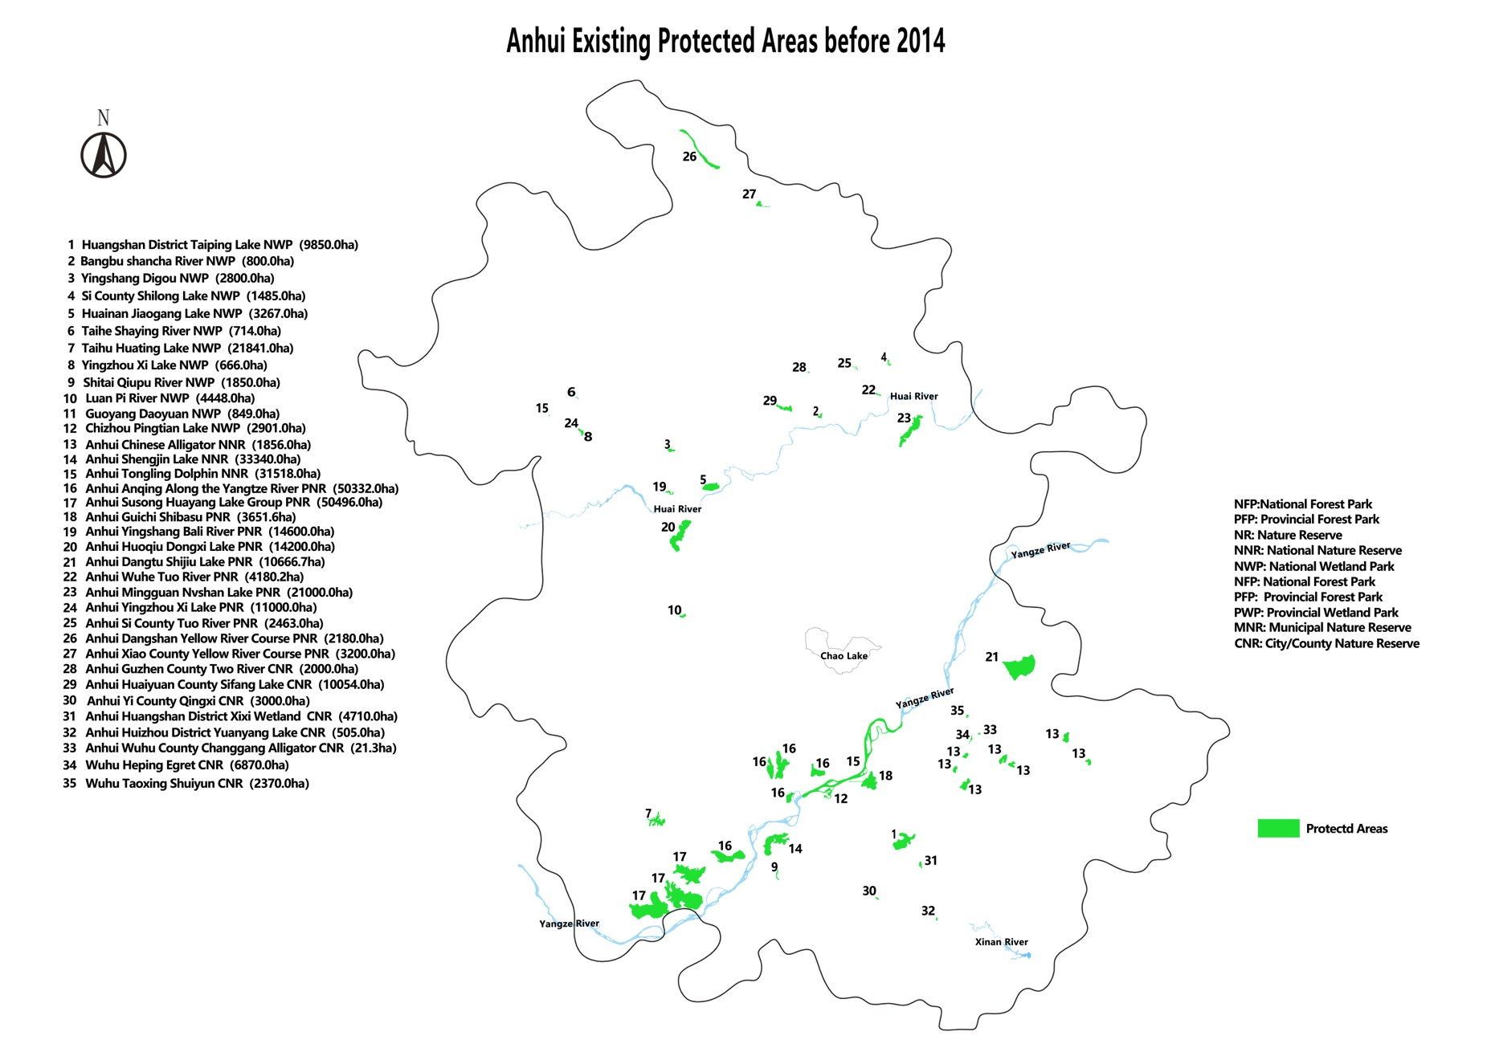
FIGURE 4: Existing PAs at Project inception, which provided the Project baseline (source: PMO).
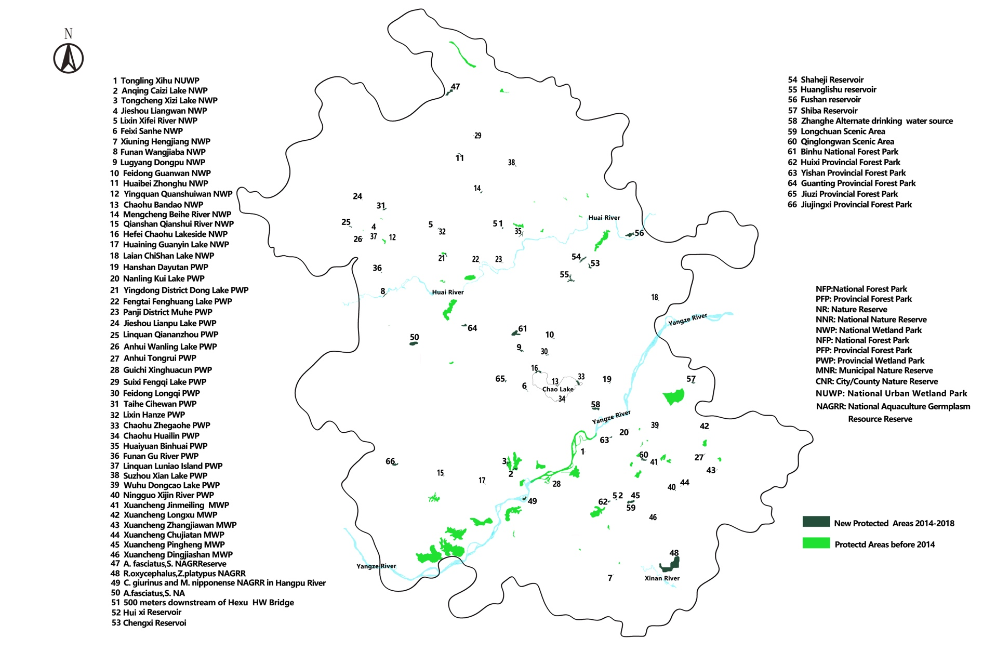
FIGURE 5: Existing PAs at Project inception (light green / not numbered) and new PA’s since project inception (dark green / numbered and listed)(source: PMO).
Note that new PAs include PA categories that were not included in the baseline in Figure 4 (e.g. Reservoirs, Scenic Reserves and Gemplasm Reserves).
Note also the extremely small size of most of the PAs and the lack of ecological connectivity between PAs, which limits their long-term ecological viability and sustainability.

3.3.2 Relevance

- All Project components, outcomes & outputs are assessed as being highly relevant to:
- GEF-5.
- United Nations Development Assistance Framework (UNDAF)(2016-20).
- UNDP Country Programme Document (CPD) (2016-20).
- Country and provincial biodiversity and wetlands conservation policies, programs, needs and priorities.

3.3.3 Effectiveness

- Overall it appears that the Project has been effective in achieving, and in many cases exceeding, the objective and most of the outcomes and targets as assessed by the indicators in the Project SRF, e.g.:

- Continuous improvement in METT, EHI etc.
- Reducing environmental pressures and stresses (e.g. removal of nets).
- High-level of mainstreaming.
- Legal and regulatory policy framework and system have been improved.
- Management capacity was highly enhanced on provincial, basin and reserve level.
- Publicity promotion and awareness improvement.
- The removal of 2,800 km of fish-traps and nets from Shengjin, Shijiu & Huayuang Lakes has perhaps been one of the most effective achievements of the project, in terms of real ecological benefits.

- Some targets are reported as significantly exceeded, e.g.

- Increase in Protected Areas (175K ha vs 80K ha target).
- Level of co-financing (2.7 x original commitment).

- However, some reported data need to be further verified (e.g. increase in PA area).

- During the TE mission the TE team held a review session with the PMO and their relevant experts to assess the approach taken to METT, EHI etc. While the limitations listed in section 3.2.5 have undoubtedly resulted in many of scores allocated in the METT, EHI and CSA assessments being inaccurate or inappropriate, as a result of the review session the TE team is of the view that an overall trend of improvement in the METT, EHI and CSA scores is probably generally correct, although perhaps not at the rate of improvement reported in the self-assessments.

- Also, some activities appear to be of limited effectiveness (e.g. many of the research studies are poor quality and not applied to PA management / eco-agriculture project was too limited in scope and has largely failed, building of small-scale sewerage treatment demonstration facilities has not included provision for ongoing operation and maintenance).

3.3.4 Efficiency

- Overall it appears that the Project has been reasonably efficient, including:

- Achieving non-trivial savings on many activities, allowing funds to be used for additional efforts.
- Reportedly leveraging significant additional co-financing (although the TE team is a not in a position to verify such reports).
- Co-opting all relevant government agencies into wetland conservation efforts through cross-sector- and inter-departmental arrangements.
- Mainstreaming through adoption of Provincial Wetlands Regulation, Policies and Plans etc.

- However, some significant in-efficiencies are noted, e.g.:

- Poor quality of several research reports and lack of application to PA management (due to using the ‘lowest price’ Municipal procurement policy).
- Highly focused delivery of education and awareness activities (lectures to individual classrooms which gives very small returns for effort compared to “teach the teacher to teach” / making more strategic wetland input to Provincial education curriculum – which would have a much bigger multiplier effect).
- Lack of partnering with other major projects and programs (e.g. WWF Yangtze program with $130 million funding).
- Limited engagement with NGOs.
- Almost no engagement with private sector.

3.3.5 Mainstreaming

- UNDP supported GEF financed projects are key components in UNDP country programming, as well as regional and global programmes. The TE therefore assesses the extent to which the Project was successfully mainstreamed with other UNDP priorities, including poverty alleviation, improved governance, the prevention and recovery from natural disasters and gender. Each of these is considered in as follows:

- Poverty alleviation: The Project is not explicitly designed to address poverty alleviation. The Project has supported the mass removal of livelihood activities from the Project WPA demonstration sites in Anhui Province (mainly fishing activities), which could actually contribute to increasing poverty if alternative sustainable livelihoods are not provided. However, the Project has also funded the trial of eco-compensation payments to relocated fishers and supported the establishment of a contracting company, which employs ex-fishers to undertake WPA management work for AFD.

- Improved governance: The Project has supported significant improvements in governance relating to WPAs including strong mainstreaming of wetlands protection into Provincial and local policies, laws, plans and procedures (e.g. new Regulation, River, Lake and Forest Chief system with wetlands-related performance indicators on individual positions), development of Shengjin Lake NNR Integrated Basin-wide Management Plan, and significantly improved inter-departmental and cross-sectoral communication and coordination arrangements.

- Natural disasters: The Project is not explicitly designed to address prevention and recovery from natural disasters, however by supporting improved management of wetlands the Project has supported improved resilience to natural disasters relating to floods and droughts, which can be significant in Anhui Province. The improved governance arrangements supported by the Project have also contributed to improved disaster prevention, preparedness and response, through significantly improved inter-departmental and cross-sectoral communication and coordination arrangements.

- Gender: While the ProDoc does not contain an explicit component on gender it does provide that gender balance should be emphasized as an integral aspect of all Project activities. The ProDoc also required that capacity development at the community level should be gender inclusive, especially in regards to livelihood training that may have a disproportionate impact on women. The Project progress reports (APRs, PIRs etc) explicitly include reporting on these gender aspects and indicate strong gender balance and even in-balance towards greater involvement of females than males in many Project activities. The TE mission observed good gender balance during all TE activities, with females playing leadership roles on many aspects.

- Overall, the TE assesses that the Project is well mainstreamed with other UNDP priorities. In addition, while not required by the TE ToR, an assessment of how the UN Sustainable Development Goals (SDGs) are relevant to and mainstreamed by the Project is presented below in Table 11. This finds that nearly all SDGs are relevant to highly relevant and have been effectively mainstreamed in the Project.

TABLE 11: Relevance of the UN Sustainable Development Goals (SDGs) to the Project
SDG |  | General relevance to UNDP-GEF Anhui Wetlands Project
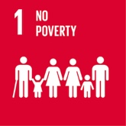 | 1. NO POVERTY | Partially relevant:  The Project is not explicitly designed to address poverty alleviation. The Project has supported the mass removal of livelihood activities from the Project WPA demonstration sites in Anhui Province (mainly fishing activities), which could actually contribute to increasing poverty if alternative sustainable livelihoods are not provided. However, the Project has also funded the trial of eco-compensation payments to relocated fishers and supported the establishment of a contracting company, which employs ex-fishers to undertake WPA management work for AFD.
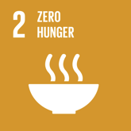 | 2. ZERO HUNGER | Partially relevant:  As per SDG 1.
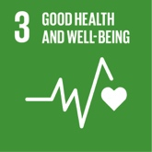 | 3. GOOD HEALTH & WELL BEING | Highly relevant:  Good health and wellbeing are dependent on many factors including clean, healthy environments and ecosystems, including wetland ecosystems.  Project efforts to improve the ecological health of wetlands will also promote good health and wellbeing of adjacent human populations.  The Project has reported continuous improvement in the Ecological Health Index (EHI) at all wetland demonstration sites.
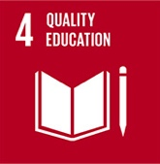 | 4. QUALITY EDUCATION | Highly relevant:  Effective protection and management of wetlands requires broad-base awareness and understanding amongst the general population about the importance and values of wetlands, which can only be achieved through education.  Healthy wetlands also present useful sites and resources for practical educational activities.  Achieving and maintaining healthy wetland ecosystems requires the application of knowledge-based management and scientific research and monitoring, which requires high-levels of education of wetlands management professionals.  The Project has expended significant effort on education and awareness activities however the TE assesses that these could have been much more effective and efficient, with greater return on effort and greater multiplier effect, had a more strategic, programmatic approach been taken. This could have included working through the Provincial education department to evolve a wetlands component to the Provincial curriculum, and training teachers in wetlands education rather than spending Project effort on direct lectures to individual classrooms.
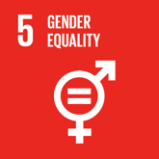 | 5. GENDER EQUALITY | Relevant:  Both men and women have key and equal parts to play in achieving and maintaining healthy wetlands.  While the ProDoc does not contain an explicit component on gender it does provide that gender balance should be emphasized as an integral aspect of all Project activities. The ProDoc also required that capacity development at the community level should be gender inclusive, especially in regards to livelihood training that may have a disproportionate impact on women.  The Project progress reports (APRs, PIRs etc) explicitly include reporting on these gender aspects and indicate strong gender balance and even in-balance towards greater involvement of females than males in many Project activities.  The TE mission observed good gender balance during all TE activities, with females playing leadership roles on many aspects.
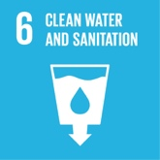 | 6. CLEAN WATER & SANITATION | Highly relevant:  Pollution from surrounding catchments including sewage and wastewater discharges are one of the more significant threats to healthy wetlands in Anhui province, and achieving good sanitation including proper sewage and wastewater treatment is fundamental to addressing this.  Wetlands can also play a vital in biological treatment of wastewater, and in maintaining the health of drinking water supply catchments.
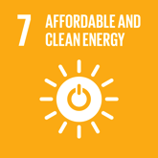 | 7. AFFORDABLE & CLEAN ENERGY | Not relevant.
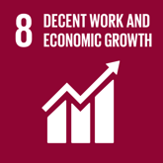 | 8. DECENT WORK & ECONOMIC GROWTH | Relevant  As per SDG 1.  Moving forward WPA’s also present opportunities for decent work and economic growth through the development if appropriately designed and managed, nature-based, low-impact eco-tourism, although this is currently prohibited in NNR’s under Chinese law.
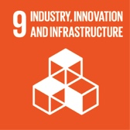 | 9. INDUSTRY, INNOVATION & INFRASTRUCTURE | Relevant  Innovation and infrastructure are important tools for restoring, maintaining and protecting the ecological health of wetlands.  However, careful assessment of potential impacts must be carried out to ensure that the application of innovation and infrastructure is ecologically appropriate and does not cause net negative impacts.
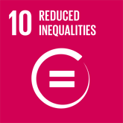 | 10. REDUCED INEQUALITIES | Relevant  As per SDGs 1 & 5.
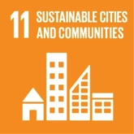 | 11. SUSTAINABLE CITIES & COMMUNITIES | Highly relevant  As per SDG 3.
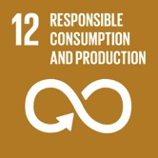 | 12. RESPONSIBLE CONSUMPTION & PRODUCTION | Relevant  As per SDG 6.
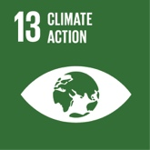 | 13. CLIMATE ACTION | Highly relevant  Climate change is one of the most significant environmental threats to the long-term sustainability of Anhui wetlands.  Achieving this SDG is fundamental to maintaining and protecting the ecological health of wetlands.
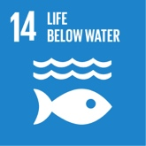 | 14. LIFE BELOW WATER | Highly relevant.  The wetlands of Anhui Province provide critical habitat for a wide range of aquatic life including but not limited to a range of migratory water-bird species, including the critically endangered Siberian Crane (Leucogeranus leucogeranus); and also the critically endangered Yangtze River Finless Porpoise (Neophocaena asiaeorientalis), the critically endangered Yangtze River Alligator (Alligator sinensis) and the critically endangered Chinese Sturgeon (Acipenser sinensis).
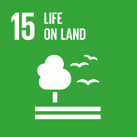 | 15. LIFE ON LAND | Highly relevant.  Terrestrial and wetland ecosystems are intimately connected; requiring a holistic, integrated catchment management approach to natural resource management, which recongnizes land-wetland connections and inter-dependence.
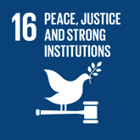 | 16. PEACE, JUSTICE & STRONG INSTITUTIONS | Highly relevant.  Achieving healthy wetlands requires strong legal, regulatory and administrative frameworks and systems.  The Project has made significant achievements on this SDG, including strong mainstreaming of wetlands protection into Provincial and local policies, laws, plans and procedures.
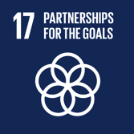 | 17. PARTNERSHIPS FOR THE GOALS | Highly relevant.  Healthy wetlands cannot be achieved and maintained without a broad range of partnerships across and between many scales, including multi-lateral organizations, between national governments, within national governments and with and between civil society and the private sector.  Building such partnerships has been a significant achievement of the Project, however significant further work is required in this area, including greater involvement of the private sector and NGOs, and effective partnerships with the broader Yangtze River eco-region catchment.

3.3.6 Sustainability

3.3.6.1 Financial sustainability

- Overall, the TE assesses that there are very strong prospects for financial sustainability of Project-related activities post-Project. Reportedly there has been extremely large commitment of funds to wetlands conservation in Anhui Province by all levels of government, way in excess of original commitment in the ProDoc (at least 2.7 x more). This is driven by increasing Central Government support for WPAs under new Central Government prioritization of wetlands and broader eco-civilization policy directions.

3.3.6.2 Socio-political sustainability

- Overall, the TE assesses that there are very strong prospects for socio-political sustainability of Project-related activities post-Project. Reportedly there has been a significant increase in awareness of wetlands issues throughout society and the political/ governance system in Anhui Province (although the TE team has concerns about the rigour, representativeness and reliability of the KAP analysis).

- The positive picture relating to financial sustainability is strongly correlated with socio-political sustainability.

3.3.6.3 Institutional & governance framework

- Overall, the TE assesses that there are very strong prospects for sustainability of wetlands-related institutional and governance frameworks post-Project. There has been strong mainstreaming of wetlands protection into Provincial and local policies, laws, plans and procedures (e.g. new Regulation, River, Lake and Forest Chief system with wetlands-related performance indicators on individual positions), and development of Shengjin Lake NNR Integrated Basin-wide Management Plan.

- The AFD stated that it does not intend to continue with the PSC once the project ends, but will continue with similar (and even expanded) coordination mechanisms especially if directed to by central Government (or UNDP).

- The positive picture relating to financial sustainability is strongly correlated with the sustainability of wetlands-related institutional and governance frameworks.

3.3.6.4 Environmental sustainability

- The TE assesses that the main risk to the sustainability of wetlands in Anhui Province is environmental, including:

- Pollution and water quality impacts from agriculture and continuing high-rates of urban and industrial development in surrounding catchments.

- Relatively small areas covered by the PAs, fragmentation and lack of habitat connectivity and ecological corridors linking PAs (see Figures 5 & 6).

- Climate change impacts. Failure in flood control might destroy existing WPA conservation facilities, and water shortage in dry season might result in low water level in rivers and lakes, and possibly cause irreparable damage to wetland habitats.

- While significant efforts are being made by all levels of Government to address these and other environmental threats to wetlands in Anhui Province, the shear scale of agriculture and urban and industrial development in surrounding catchments, relative to the very small size of the WPAs, and the global nature of climate change impacts, mean that these threats will most likely continue and possible increase in coming years. This serves to highlight the urgent need to continue with concerted efforts to maintain and further strengthen the ecological health and resilience of wetland habitats in Anhui Province.

3.3.6.5 Overall assessment of sustainability

- The momentum generated by the project, the high-level of mainstreaming achieved, the increased level of awareness achieved and the ongoing government commitment to wetland conservation indicates a high likelihood of sustainability of the Project results, provided that ongoing funding is assured.

3.3.6 Impact

- The TE assesses that it is too early to assess whether the Project will have large-scale, long-term impact. However, at a smaller scale, Project has had positive impact, as per section 3.3.3 above, including:

- Continuous improvement in METT, EHI etc.
- Reducing environmental pressures and stresses (e.g. removal of nets)
- High-level of mainstreaming.
- Increasing awareness of wetlands issues.

Annex 1: Terminal Evaluation ToR

(excluding Annexes)

Terminal evaluation terms of reference:

UNDP-GEF China hainan & anhui wetlands projects

INTRODUCTION
In accordance with UNDP and GEF M&E policies and procedures, all full and medium-sized UNDP support GEF financed projects are required to undergo a terminal evaluation upon completion of implementation. These terms of reference (TOR) sets out the expectations for a Terminal Evaluation (TE) of the two sister projects under the same CBPF-MSL (China Biodiversity Partnership Framework-Mainstream of Life) programme, they are: Project 3 (Hainan Project, PIMS 4597), Strengthening the Management Effectiveness of the Wetland Protected Area System in Hainan for Conservation of Globally Significant Biodiversity; Project 4 (Anhui Project, PIMS 4868), Strengthening the management effectiveness of the wetland protected area system in Anhui Province.
The essentials of the project to be evaluated are as follows:

Project Summary Table
Project 3:
Project Title: | Strengthening the Management Effectiveness of the Wetland Protected Area System in Hainan for Conservation of Globally Significant Biodiversity
GEF Project ID: |  | 84186 |  | at endorsement (US$) |  | at completion (US$)
UNDP Project ID: |  | 4597 | GEF financing: | 2,634,771
Country: |  | China | IA/EA own: | 700,000
Region: |  | AP | Government: | 17,300,000
Focal Area: |  | BD | Other:
FA Objectives, (OP/SP): |  |  | Total co-financing: | 18,000,000
Executing Agency: |  | Hainan Forestry Department (HFD) | Total Project Cost: | 20,634,771
Other Partners involved: |  | Dongzhaigang Nature Reserve | ProDoc Signature (date project began): |  |  | June 28, 2013
 |  |  | (Operational) Closing Date: |  | Proposed:  June 27, 2018 | Actual:

Project 4:
Project Title: | Strengthening the management effectiveness of the wetland protected area system in Anhui Province
GEF Project ID: |  | 85732 |  | at endorsement (US$) |  | at completion (US$)
UNDP Project ID: |  | 4868 | GEF financing: | 2,654,771
Country: |  | China | IA/EA own: | 700,000
Region: |  | AP | Government: | 17,447,255
Focal Area: |  | BD | Other:
FA Objectives, (OP/SP): |  |  | Total co-financing: | 18,147,255
Executing Agency: |  | Forestry Department of Anhui Province | Total Project Cost: | 20,802,026
Other Partners involved: |  |  | ProDoc Signature (date project began): |  |  | Dec. 31, 2013
 |  |  | (Operational) Closing Date: |  | Dec. 30, 2018 | Actual:

Objective and Scope
The project was designed to:
Project 3: The project goal is: to contribute to the conservation and sustainable use of globally significant biodiversity in Hainan Province, China. The project objective is: to strengthen the management effectiveness of the wetland protected area system in Hainan in response to existing and emerging threats to the globally significant biodiversity and essential ecosystem services. The focus of the project is to strengthen Hainan’s PA system to ensure the protection of a representative sample of its exceptionally rich and unique biodiversity and to more effectively manage the wetland PA subsystem.

Outcome 1: Improved protection and management of Hainan’s ecosystems through expansion, consolidation and sustainable financing of the provincial PA system
Outcome 2: Strengthened protection, participatory management and restoration of mangrove forests through the development of a Mangrove PA Network.
Outcome 3: Improved integration of wetland conservation into development and sectoral planning and practices through a strengthened PA System Management Framework including economic valuation of wetland ecosystem services.

Project 4: The project’s goal is: to contribute to the conservation and sustainable use of globally significant biodiversity in Anhui Province, China. The project strategic objective is to strengthen the management effectiveness of the wetland protected area system in Anhui in response to existing and emerging threats to the globally significant biodiversity and essential ecosystem services. The site focus is on Shengjin Lake NNR that will provide a basis for developing meaningful interventions that can be replicated elsewhere in the WPA system.
Outcome 1: Enhanced provincial capacities for WPA system management
Outcome 2: Strengthened basin-level coordination and implementation of integrated management ensures sustainability of WPA system
Outcome 3: On-site threats to biodiversity at the Shengjin Lake NNR and adjacent WPAs are reduced.
The TE will be conducted according to the guidance, rules and procedures established by UNDP and GEF as reflected in the UNDP Evaluation Guidance for GEF Financed Projects.
The objectives of the evaluation are to assess the achievement of project results, and to draw lessons that can both improve the sustainability of benefits from this project, and aid in the overall enhancement of UNDP programming.

Evaluation approach and method
An overall approach and method for conducting project terminal evaluations of UNDP supported GEF financed projects has developed over time. The evaluator is expected to frame the evaluation effort using the criteria of relevance, effectiveness, efficiency, sustainability, and impact, as defined and explained in the UNDP Guidance for Conducting Terminal Evaluations of UNDP-supported, GEF-financed Projects. A set of questions covering each of these criteria have been drafted and are included with this TOR (fill in Annex C) The evaluator is expected to amend, complete and submit this matrix as part of an evaluation inception report, and shall include it as an annex to the final report.

The evaluation must provide evidence‐based information that is credible, reliable and useful. The evaluator is expected to follow a participatory and consultative approach ensuring close engagement with government counterparts, in particular the GEF operational focal point, UNDP Country Office, project team, UNDP GEF Technical Adviser based in the region and key stakeholders. The evaluator is expected to conduct a field mission to China, including the following project sites including Hainan and Anhui Provinces. Interviews will be held with the following organizations and individuals at a minimum: (UNDP, SFA, Forestry Departments in Anhui and Hainan Provinces).
The evaluator will review all relevant sources of information, such as the project document, project reports – including Annual APR/PIR, project budget revisions, midterm review, progress reports, GEF focal area tracking tools, project files, national strategic and legal documents, and any other materials that the evaluator considers useful for this evidence-based assessment. A list of documents that the project team will provide to the evaluator for review is included in Annex B of this Terms of Reference.

Evaluation Criteria & Ratings
An assessment of project performance will be carried out, based against expectations set out in the Project Logical Framework/Results Framework (see Annex A), which provides performance and impact indicators for project implementation along with their corresponding means of verification. The evaluation will at a minimum cover the criteria of: relevance, effectiveness, efficiency, sustainability and impact. Ratings must be provided on the following performance criteria. The completed table must be included in the evaluation executive summary. The obligatory rating scales are included in Annex D.

Evaluation Ratings:
1. Monitoring and Evaluation | rating | 2. IA& EA Execution | rating
M&E design at entry |  | Quality of UNDP Implementation
M&E Plan Implementation |  | Quality of Execution - Executing Agency
Overall quality of M&E |  | Overall quality of Implementation / Execution
3. Assessment of Outcomes | rating | 4. Sustainability | rating
Relevance |  | Financial resources:
Effectiveness |  | Socio-political:
Efficiency |  | Institutional framework and governance:
Overall Project Outcome Rating |  | Environmental :
 |  | Overall likelihood of sustainability:

Project finance / cofinance
The Evaluation will assess the key financial aspects of the project, including the extent of co-financing planned and realized. Project cost and funding data will be required, including annual expenditures. Variances between planned and actual expenditures will need to be assessed and explained. Results from recent financial audits, as available, should be taken into consideration. The evaluator(s) will receive assistance from the Country Office (CO) and Project Team to obtain financial data in order to complete the co-financing table below, which will be included in the terminal evaluation report.
Co-financing  (type/source) | UNDP own financing (mill. US$) |  | Government  (mill. US$) |  | Partner Agency  (mill. US$) |  | Total  (mill. US$)
 | Planned | Actual | Planned | Actual | Planned | Actual | Actual | Actual
Grants
Loans/Concessions
- In-kind support
- Other
Totals

Mainstreaming
UNDP supported GEF financed projects are key components in UNDP country programming, as well as regional and global programmes. The evaluation will assess the extent to which the project was successfully mainstreamed with other UNDP priorities, including poverty alleviation, improved governance, the prevention and recovery from natural disasters, and gender.

Impact
The evaluators will assess the extent to which the project is achieving impacts or progressing towards the achievement of impacts. Key findings that should be brought out in the evaluations include whether the project has demonstrated: a) verifiable improvements in ecological status, b) verifiable reductions in stress on ecological systems, and/or c) demonstrated progress towards these impact achievements.

Conclusions, recommendations & lessons
The evaluation report must include a chapter providing a set of conclusions, recommendations and lessons.

Implementation arrangements
The principal responsibility for managing this evaluation resides with the UNDP CO in (include Country name).The UNDP CO will contract the evaluators and ensure the timely provision of per diems and travel arrangements within the country for the evaluation team. The Project Team will be responsible for liaising with the Evaluators team to set up stakeholder interviews, arrange field visits, coordinate with the Government etc.

Evaluation timeframe
The total duration of the evaluation will be 52 days according to the following plan:
Activity | Timing | Completion Date
Preparation | 6 days | July 15,
Evaluation Mission | 20 days | August 10
Draft Evaluation Report | 22 days | Sep. 5
Final Report | 4 days | Sep. 20

Evaluation deliverables
The evaluation team is expected to deliver the following:
Deliverable | Content | Timing | Responsibilities
Inception Report | Evaluator provides clarifications on timing and method | No later than 2 weeks before the evaluation mission. | Evaluator submits to UNDP CO
Presentation | Initial Findings | End of evaluation mission | To project management, UNDP CO
Draft Final Report | Full report, (per annexed template) with annexes | Within 3 weeks of the evaluation mission | Sent to CO, reviewed by RTA, PCU, GEF OFPs
Final Report* | Revised report | Within 1 week of receiving UNDP comments on draft | Sent to CO for uploading to UNDP ERC.
*When submitting the final evaluation report, the evaluator is required also to provide an 'audit trail', detailing how all received comments have (and have not) been addressed in the final evaluation report.

Team Composition
The evaluation team will be composed of 1 international and 1 national evaluators. The consultants shall have prior experience in evaluating similar projects. Experience with GEF financed projects is an advantage. The international evaluator will be designated as the team leader and will be responsible for finalizing the report. The evaluators selected should not have participated in the project preparation and/or implementation and should not have conflict of interest with project related activities.
The Team members must present the following qualifications:

Competencies
- Strategic technical and intellectual skills in the substantive area with global dynamic perspectives;
- Leadership, innovation, facilitation, advocacy and coordination skills;
- Ability to manage technical teams and engage in long term strategic partnership;
- Entrepreneurial abilities and ability to work in an independent manner;
- Ability to work effectively in a team, with good relationship management skills ;
- Strong managerial and coordination skills, including ability to coordinate the development of large, complex projects;
- Demonstrated ability to operate effectively in a highly complex organizational context;
- Ability to maintain high standards despite pressing deadlines;
- Excellent communication (both oral and written) and partnership building skills with multi-dimension partners and people, skill for conflict resolution and negotiation;
- Excellent writing skills, especially in the preparation of official documents and reports;
- Good knowledge of China’s environmental and socio-economic context.
Required Skills and Experience
Education
- An advanced degree in conservation, natural resources management, environmental science or related fields, preferably in PA conservation and management.
Experience
- Minimum 3 years of relevant professional experience including Project development, implementation and evaluation
- Knowledge of UNDP and GEF, such as GEF policy and practices, GEF project requirements;
- Previous experience with results‐based monitoring and evaluation methodologies;
- Technical knowledge in the targeted focal area(s) including biodiversity conservation, agriculture, natural resources co-management, integrated planning, etc.
- Expertise in economic and social development issues
- Good communications and writing skills in English
- Professional experiences in working in China and with Chinese counterparts would be an advantage.
- Working experiences in high altitude areas

Language
- Fluency in written and spoken English is required;
- Good knowledge of Chinese is an asset.
IT Skills:
- Good IT skills.

Evaluator Ethics
Evaluation consultants will be held to the highest ethical standards and are required to sign a Code of Conduct (Annex E) upon acceptance of the assignment. UNDP evaluations are conducted in accordance with the principles outlined in the UNEG 'Ethical Guidelines for Evaluations'

Payment modalities and specifications
(this payment schedule is indicative, to be filled in by the CO and UNDP GEF Technical Adviser based on their standard procurement procedures)
% | Milestone
10% | At contract signing
40% | Following submission and approval of the 1ST draft terminal evaluation report
50% | Following submission and approval (UNDP-CO and UNDP RTA) of the final terminal evaluation report

Application process
Applicants are requested to apply online (http://jobs.undp.org, etc.) by June 15, 2018. Individual consultants are invited to submit applications together with their CV for these positions. The application should contain a current and complete C.V. in English with indication of the e‐mail and phone contact. Shortlisted candidates will be requested to submit a price offer indicating the total cost of the assignment (including daily fee, per diem and travel costs).
UNDP applies a fair and transparent selection process that will take into account the competencies/skills of the applicants as well as their financial proposals. Qualified women and members of social minorities are encouraged to apply.

Annex 2: Terminal Evaluation Field Mission Itinerary

July 23-30 2018

Date | Time | Activities | Location | Host organization & personnel | Remarks
2018/7/23  Mon. | Afternoon | MU5170 1650-1905 BJ-Hefei Arrive Hefei | Hefei Airport | PMO | Airport pick-up
 | 19:00-21:00 | Check-in | Huangshan hotel | PMO
2018-7-24  Tue. | 08:00-12:00 | TE kick-off meeting:  1.Introduction of all participants  2.Display Project videos  3.Introduction to the project and overall progress (ppt）  4.Final confirmation to the TE field trip agenda  Meeting with PSC members  Service contractor, NGO representatives | Huangshan hotel | NPD, Manager of AFD  PMO  Representatives from Anhui Financial Department, DRC, AEPD and other PSC members.  Anhui University,  Anhui Daily  NGO representative | Group Meeting
 | 14:30-17:30 | Interview of Journalists, local NGO representatives and Senior Technical officer | Huangshan hotel | Journalists, local NGO representatives and Senior Technical officer | Individual interview (4)
2018-7-25  Wed. | 08:00-11:00 | Hefei-Xuncheng (3h) | / | Project Coordinator, CTA, PM | /
 | 11:00-12:00 | Field visit to Ecological agriculture site of Alligator NNR | Alligator NNR (Changqiao station) | NR staff, officials, representative from company, etc.  Project coordinator, CTA, PM | Field visit
 | 13:30-17:30 | Group meeting in Changqiao village and interview local residents. |  |  | Group Meeting
 | 18:30-20:00 | Changqiao-Tongling (1.5h) | / | / | /
 | 20:00 | Check-in in Tongling | Tongling Hotel | / | /
2018-7-26  Thu. | 8:00-10:00 | Visit Tongling Dolphin NNR authority | Dolphin NNR | NR Staff | Field visit and interview
 | 10:30-11:30 | Tongling-Shibasuo (1h) | / | / | /
 | 13:30-15:00 | Meeting with officials, staff from Shibasuo PNR, Ranger, local residents | Shibasuo PNR | Officials, ranger, residents, CTA, PM | Site visit and  Group Meeting
 | 15:00-16:30 | Interview with villages and ranger |  | Ranger, residents | Individual interview (3)
 | 17:00-17:30 | Shibasuo-Chizhou (0.5h) | / | / | /
 | 18:00-19:40 | Meeting with volunteers, Shibasuo PNR staff. | Dajiuhua Hotel | Volunteers, NR staff. CTA, PM | Group Meeting and Individual interview (3)
 | 20:00 | Check-in and dinner |  | / | /
2018-7-27  Fri. | 09:00-12:00 | Meeting with the officials from Shengjin Lake Basin Management Committee in Chizhou | Dajiuhua Hotel | Representatives from Committee, CTA, PM | Group Meeting
 | 13:00-14:30 | Chizhou-Shengjin Lake （1.5h） | / | / | /
 | 14:30-16:00 | Meeting with local residents, rangers, staff of Shengjin Lake NNR. | Shengli Lake NNR | Local residents, rangers, NR staff, CTA, PMO | Group Meeting
 | 16:00-19:00 | Visited Restoration site & the bridge &  Yanwo station |  |  | Field visit
 | 19:00-20:00 | Yanwo station – Chizhou （1h）  Then dinner | Dajiuhua Hotel | / | /
2018-7-28  Sat. | 08:00-12:30 | Project outcomes discussion and interview | Dajiuhua Hotel | CTA, PM | Group Mee
 | 13:40-14:40 | Chizhou-Anqing (1h) | / | / | /
 | 15:00-17:00 | Meeting with officials and PNR staff,  Local NGO | Anqing Forestry Bureau | Officials, NR staff, Representative from NGO, CTA, PM | Group Meeting and interview
 | 17:00-19:30 | Anqing-Hefei (2.5h) | / | / | /
 | 21:00 | Check-in | Huangshan hotel | / | /
2018-7-29  Sun. | 08:30-11:00 | Logframe, METT, EHI discussion | Huangshan hotel | CTA, M&E expert, PM | Group Meeting
 | 11:00-12:30 | Meet with NDP and PMO to give feedback |  | NPD, officials, CTA, M&E expert, Project coordinator, PMO | Group Meeting
 | 13:30-14:00 | Interview with contractor: film producer |  | CTA | Individual interview (1)
 | 14:00-18:00 | Logframe, METT, EHI discussion |  | M&E expert, PMO | Group Meeting
 | 18:00-19:00 | Interview with Service contractor: film producer |  | Film producer | Individual interview (1)
2018-7-30  Mon. | 08:00-10:00 | Other issue and report preparation | Huangshan Hotel | / | /
 | 10:00-11:00 | Hotel to Airport  HU7336 1215-1500 Hefei-Haikou. | / | PMO | Airport see-off

Annex 3: List of Persons Interviewed

*Individual interviews
Name | Gender | Position | Organization | Role in project | Contact Information
Hui QIU | Male | Deputy Director | Anhui Forestry Department | National Project Director (NPD)
Dayuan XUE | Male | Professor | Minzu University of China | Chief Technical Advisor (CTA)
Yongli WANG | Male | Deputy director general | Anhui Financial Department | Project Steering Committee (PSC)
Jian XU | Male | Deputy director general | Anhui Environmental Protection Department | Project Steering Committee (PSC)
Zuoyou ZHOU | Male | Engineer | Provincial Agriculture Committee | Project Steering Committee (PSC)
Xiaoming LI | Female | Engineer | Provincial Water Resources Department | Project Steering Committee (PSC)
Wei SHENG | Male | Deputy director general | Provincial Development and Reform Commission | Project Steering Committee (PSC)
Xiaochun ZHOU | Male | Director | Anhui Wetland Conservation Center | Project Steering Committee (PSC) | 562193925@qq.com
Song LIU | Male | Staff | Anhui Wetland Conservation Center | Executor
Ying ZHANG | Female | Staff | Anhui Wetland Conservation Center | Executor
Fei LENG | Female | Project Manager | Anhui GEF Project Office | Project Manager | 188228225@qq.com
Shengni TIAN* | Male | Associate Professor | Anhui Agricultural University | Senior Technical Officer | 624996071@qq.com
Lizhi ZhOU | Male | Professor | Anhui University | Project partner/ Third-party contractor | 908156872@qq.com
Zipeng WANG* | Male | Student | Anhui University | Executor
Kai WANG* | Female | Journalist | Anhui Daily | Communicator
Yuanyuan LIU | Female | Journalist | Anhui Business | Communicator
Lin LONG | Female | Journalist | China Green Times – Anhui | Communicator
Xiang ZHOU* | Male | Director | Green Anhui | NGO/ Third-party contractor
Jiming WANG* | Male | General Manager | Jinniu film company | Third-party contractor
Bulong ZAI | Male |  |  | Interpreter
Hongxing ZHU | Male | Deputy Director | Anhui Yangtze Alligator National Nature Reserve Administration Authority | Head of demonstration site
Xiaoyan MA | Female | Vice section director | Anhui Yangtze Alligator National Nature Reserve Administration Authority | Executor demonstration site | 41693586@qq.com
Guohong WANG | Male | Clerk | Jingxian County Protection Station, Anhui Yangtze Alligator National Nature Reserve Administration Authority | Executor of demonstration site
Kaiwen ZHENG | Male | Clerk | Jingxian County Protection Station, Anhui Yangtze Alligator National Nature Reserve Administration Authority | Executor of demonstration site | 543524457@ qq.com
Honglin DONG | Male | Township chief | Township government, Jing County | Executor
Wenjian ZHAO | Male | Secretary | Zhongqiao Village | Executor
Xinping WANG | Male | General Manager | Eco-agriculture Company | Executor of eo-agriculture project
Shangsen ZHAO | Male | Director | Tongling River Dolphin National Nature Reserve | Executor of demonstration site
Ran CHEN* | Male | Vice section director | Tongling River Dolphin National Nature Reserve | Executor of demonstration site | 552085992@qq.com
Bajin ZHANG* | Male | Ranger | Tongling River Dolphin National Nature Reserve | Executor
Kaizhi FANG | Male | Vice director | Anhui GEF Project Office /Guichi District Forestry Bureau | Executor
Dongsheng CHENG | Male | Station Head | Guichi Shibasu Nature Reserve Management Station | Manager of Nature Reserve | 651525896@qq.com
Yunfeng DU | Male | Vice secretary | Maotan Village, Dushang Street Office, Guichi District | Community co-manager of wetland reserve
Jun ZHOU* | Male | Principal | Guichi District Maotan Primary School/ Guichi Shibasu Wetland School | Head of Wetland School | 452979566@qq.com
Zhengrong DU* | Male | Patrolman | Shibasu protection station | Ranger | 15922394813
Xiaoming FANG* | Male | Director of Discipline | Guichi District Maotan Primary School/ Guichi Shibasu Wetland School | Executor
Shi WANG* | Male | Chairman | Chizhou Wild Bird Protection Association | Executor | 13905662869
Jingxiu WANG* | Female | Head of Development Department | Development Department of Chizhou Science and Technology Museum | Executor
Mingxiang ZHANG | Male | Professor | Beijing Forestry University | Project expert | zhangmingxiang@bjfu.edu.cn
Jiliang XU | Male | Professor | Beijing Forestry University | Project expert | xujiliang@bjfu.edu.cn
Yong YUAN | Male | Director | Management Office of Huangpeng Sluice, Chizhou Water Affairs Bureau | Member of Shengjin Lake Management Committee
Weiguo QIAN | Male | Deputy Director | Chizhou Public Security Bureau | Member of Shengjin Lake Management Committee
Bing HU | Male | Deputy County Director | Dongzhi County Government | Member of Shengjin Lake Management Committee
Rong WANG | Female | Section chief | Human Resources and Social Securety Bureau | Member of Shengjin Lake Management Committee
Yuyou ZHOU | Male |  | Chizhou Development and Reform Commission | The member of Shengjin Lake Management Committee
Wenheng WANG | Male |  | Chizhou Financial Bureau | Member of Shengjin Lake Management Committee
Xudong BAO | Male | Deputy Secretary-general | Chizhou Municipal Government | Member of Shengjin Lake Management Committee
Wenlian Wang | Male | Director | Shengjin Lake Nature Reserve Administration Authority | Director of Project Office
Wen HUANG | Male | Vice director | Chizhou Agricultural Committee | Member of Shengjin Lake Management Committee | 18956600226
Changqing CHENG | Male | Vice director | Chizhou Environmental Protection Bureau | Member of Shengjin Lake Management Committee
Zonghong WANG | Male | Director | Chizhou Forestry Bureau | Head of the Forestry Bureau | 13856615988
Hailong WU | Male | Professor | Anhui Normal University | Project expert – M&E | whlong@mail.ahnu.edu.cn
Fangwu ZHAO | Male | Staff | Shengjin Lake Nature Reserve Administration Authority | Project assistant of PMO & Executor of demonstration site | 18056620186
Lingzhi XU | Female | Project officer | Anhui GEF Project Office | Project Officer/ Technical Officer | 469175320@qq.com
Wenbin XU | Male | Vice director | Shengjin Lake Nature Reserve Administration Authority | Head of Nature Reserve | 13856668157
Yujian ZHAO | Male | Deputy general manager | Shengjin Lake Ecological Company | Executor | 13705666456
Tongjun LIU | Male |  | Law Enforcement Unit | Executor
Qingsong WU | Male |  | Law Enforcement Unit | Executor
Mingyong ZHANG | Male |  | Law Enforcement Unit | Executor
Yunwei SONG | Male | Staff | Shengjin Lake Nature Reserve Administration Authority | Executor of demonstration site | 14755521266
Kefei YANG | Male | Town mayor | Shengli Town, Dongzhi County | Executor | 18005662553
Daoping DUAN | Male | Patrolman | Shengjin Lake Nature Reserve Administration Authority | Ranger | 13637126802
Yongsheng HE | Male | Secretary | Shengli County Government | Executor
Zhongjian ZHANG | Male |  | Shengjin Lake Ecological Protection Development Co., Ltd | Executor
Julin ZHANG | Female |  | Kangqiao Village | Executor
Jing ZHANG | Male |  | Kangqiao Village | Executor
Jian FAN | Male | Project manager | Xizi Lake Ecotourism Co., Ltd. | Executor of demonstration site | 13956896779
Hong ZHANG | Male | Deputy director | Anqing provincial nature reserve for wetlands along Yangtze River | Executor of demonstration site | 05565025296
Jianhua MA | Male | Director | Anqing provincial nature reserve for wetlands along Yangtze River | Chief manager of Nature Reserve | 13865713250
Xudong HE | Male | Station Head | Yixiu District Forestry Bureau | Executor of demonstration site | 13966951355
Sanyi Wang | Male | Chairman | Caizi Lake Wetland Ecological Protection Association | NGO | 13349266778
Zhongdong ZHANG | Male |  | Tongcheng Forestry Bureau | Executor of demonstration site
Quansheng XIAO | Male | Station Chief | Wangjiang County Forestry Bureau | Executor demonstration site
Dapeng TAN | Male | Staff | Wangjiang County Forestry Bureau | Executor
Xin ZHANG | Male | Director | Susong County Forestry Bureau | Executor of demonstration site
Shenghua ZHANG | Male | Director | Susong PNR | Executor of demonstration site
Chun ZHANG | Male | Section Chief | AFD | Executor

Annex 4: List of Documents Reviewed
Documents Provided by UNDP and Anhui PMO:
- Project Document
- PIF
- Project Inception Report
- List and contact details of interviewees
- MTR report
- Table of project budgets and expenditures
- TYWP 2014-2015
- TYWP 2015-2016
- TYWP 2016-2017
- TYWP 2017-2018
- TYWP 2018-2019
- CDR 2014
- CDR 2014
- CDR 2015
- CDR 2017
- UNDP-GEF Anhui Project TE Itinerary-EN
- TE self-assessment report of GEF Anhui-draft
- The gap analysis of the vacancies and expansion needs of wetland protected areas in Anhui Province (In Chinese)
- Value Evaluation of Wetland Ecosystem Services in Anhui Province (In Chinese)
- Wetland Biodiversity Mainstreaming (In Chinese)
- The Measurement of Alternative Livelihood and Eco-Compensation (In Chinese)
- Assessment of crop loss caused by birds of Shengjin Lake (In Chinese)
- Analysis of the Shengjin Lake Ecological Fishery Carrying Capacity (In Chinese)
- The study on Wuchanghu water level control mechanism/management (In Chinese)
- Analysis on ecological impact of construction of different vegetation type on the survival of wild animals (In Chinese)
- Study on Shengjin Lake carbon inventory (In Chinese)
- Anqing Wetlands Provincial Nature Reserve Management Plan (In Chinese)
- Susong Huayang River Lake Group Provincial Nature Reserve Management Plan (In Chinese)
- Susong Huayang River Lake Group Provincial Nature Reserve Management Plan (In Chinese)
- Anhui Guichi Shibasuo Provincial Nature Reserve Management Plan (In Chinese)
- Anhui Dangtu Shijiu Lake Provincial Nature Reserve Management Plan (In Chinese)
- Anhui Shengjin Lake National Nature Reserve Management Plan (In Chinese)
- The Integrated Shengjin Lake Basin Management Plan (In Chinese)
- Shengjin Lake NNR and Neighboring Area Eco-tourism Plan (2018-2030) (In Chinese)
- Anhui Yangtze Alligator National Nature Reserve Management Plan (In Chinese)
- Anhui Tongling River Dolphin National Nature Reserve Management Plan (In Chinese)
- PIR 2015
- PIR 2016
- PIR 2017
- PIR 2018
- APR 2014
- APR 2015
- APR 2016
- APR 2017
- 2015 Q1 QPR
- 2015 Q2 QPR
- 2015 Q3 QPR
- 2016 Q1 QPR
- 2016 Q2 QPR
- 2016 Q3 QPR
- 2017 Q1 QPR
- 2017 Q2 QPR
- 2017 Q3 QPR
- 2018 Q1 QPR
- 2018 Q2 QPR
- 2018 GEF BD SO1 TT_METT_2011 version_BD1-Anhui-EN-final (Project GEF BD-1 Tracking Tool)
- PMO working system
- PMO working system – revision
- Shengjin Lake Basin Management Committee and Member Units’ responsibility
- Logical framework table
- Map of Anhui GEF Project Demonstration Sites
- Organigram of Anhui Project
- Other international cooperation projects in Anhui, ECBP brief introduction
- Newly increased wetland protection area
- Summary of “Anhui Wetland Conservation Regulation” and summary of “Interpretation of Anhui Wetland Conservation Regulation”
- Summary of “Planning of Anhui Province for Wetland Conservation 2016-2030” 7. Wetland Conservation Rate in Green Development Indicator System
- Summary of “The implementation Plan of Wetland Conservation and Restoration in Anhui Province”
- Summary of river chief lake chief forest chief policies
- Summary of “Administrative Measures for Anhui Shengjin Lake National Nature Reserve”
- Summary of “13th Five-Year Planning of Anhui Province for Ecological Environmental Protection”
- Summary of “Red Lines of Anhui Province for Ecological Protection”
- Table of information for co-financing
- Operating expenses 34% & Infrastructure expenses 32%
- Summary of the integrated Shengjin Lake Basin Management Plan
- Summary of “Shengjin Lake NNR and Neighboring Area Eco-tourism Plan”
- Summary of “Shengjin Lake NNR Management Plan”
- Chizhou City Shengjin Lake Management Committee and the Work Responsibilities
- Relevant Regulations on Fishing Prohibition in Protected Areas in the Yangtze River Basin
- Evidential Materials on Removed Fishing Nets
- Summary of EHI
- EHI_Shengjin Lake NNR_EN
- EHI Shibasuo PNR_EN
- EHI _Anqing PNR_EN
- Specific content for each training and elaborating the target audiences
- Awareness of wetlands was increased from 40% in 2015 to 80% in 2017
- Summary of METT
- METT Shengjin Lake NNR_EN
- METT Shibasuo PNR_EN
- METT Anqing PNR_EN
- METT Tongling Dolphin NNR_EN
- METT Shijiu Lake PNR_EN
- METT Yangtze Aligator NNR_EN
- METT Susong PNR_EN
- Anhui-GEF BD SO1 TT_METT_and FSC_BD1_21
- UNDP-GEF Anhui Project TE Itinerary-EN-Final
- Capacity score card_AEPD_EN
- Capacity score card_AFD_EN
- Updated Self-assessment report: TE self-assessment report of GEF Anhui-0813
- Anhui Wetland Conservation Regulation
- Service Contract lists
- Table of project budgets and expenditures
- Evaluation of the training effectiveness

Annex 5: Evaluation Consultant Agreement Forms

Annex 5A: TE Consultant Code of Conduct Agreement Form - Raaymakers

Evaluators:
- Must present information that is complete and fair in its assessment of strengths and weaknesses so that decisions or actions taken are well founded.
- Must disclose the full set of evaluation findings along with information on their limitations and have this accessible to all affected by the evaluation with expressed legal rights to receive results.
- Should protect the anonymity and confidentiality of individual informants. They should provide maximum notice, minimize demands on time, and respect people’s right not to engage. Evaluators must respect people’s right to provide information in confidence, and must ensure that sensitive information cannot be traced to its source. Evaluators are not expected to evaluate individuals, and must balance an evaluation of management functions with this general principle.
- Sometimes uncover evidence of wrongdoing while conducting evaluations. Such cases must be reported discreetly to the appropriate investigative body. Evaluators should consult with other relevant oversight entities when there is any doubt about if and how issues should be reported.
- Should be sensitive to beliefs, manners and customs and act with integrity and honesty in their relations with all stakeholders. In line with the UN Universal Declaration of Human Rights, evaluators must be sensitive to and address issues of discrimination and gender equality. They should avoid offending the dignity and self-respect of those persons with whom they come in contact in the course of the evaluation. Knowing that evaluation might negatively affect the interests of some stakeholders, evaluators should conduct the evaluation and communicate its purpose and results in a way that clearly respects the stakeholders’ dignity and self-worth.
- Are responsible for their performance and their product(s). They are responsible for the clear, accurate and fair written and/or oral presentation of study imitations, findings and recommendations.
- Should reflect sound accounting procedures and be prudent in using the resources of the evaluation.

Evaluation Consultant Agreement Form
Agreement to abide by the Code of Conduct for Evaluation in the UN System
Name of Consultant: Steve Raaymakers
Name of Consultancy Organization (where relevant): EcoStrategic Consultants
I confirm that I have received and understood and will abide by the United Nations Code of Conduct for Evaluation.
Signed at Cairns, Australia on 13 July 2018
Signature:

Annex 5B: TE Consultant Code of Conduct Agreement Form - Wang

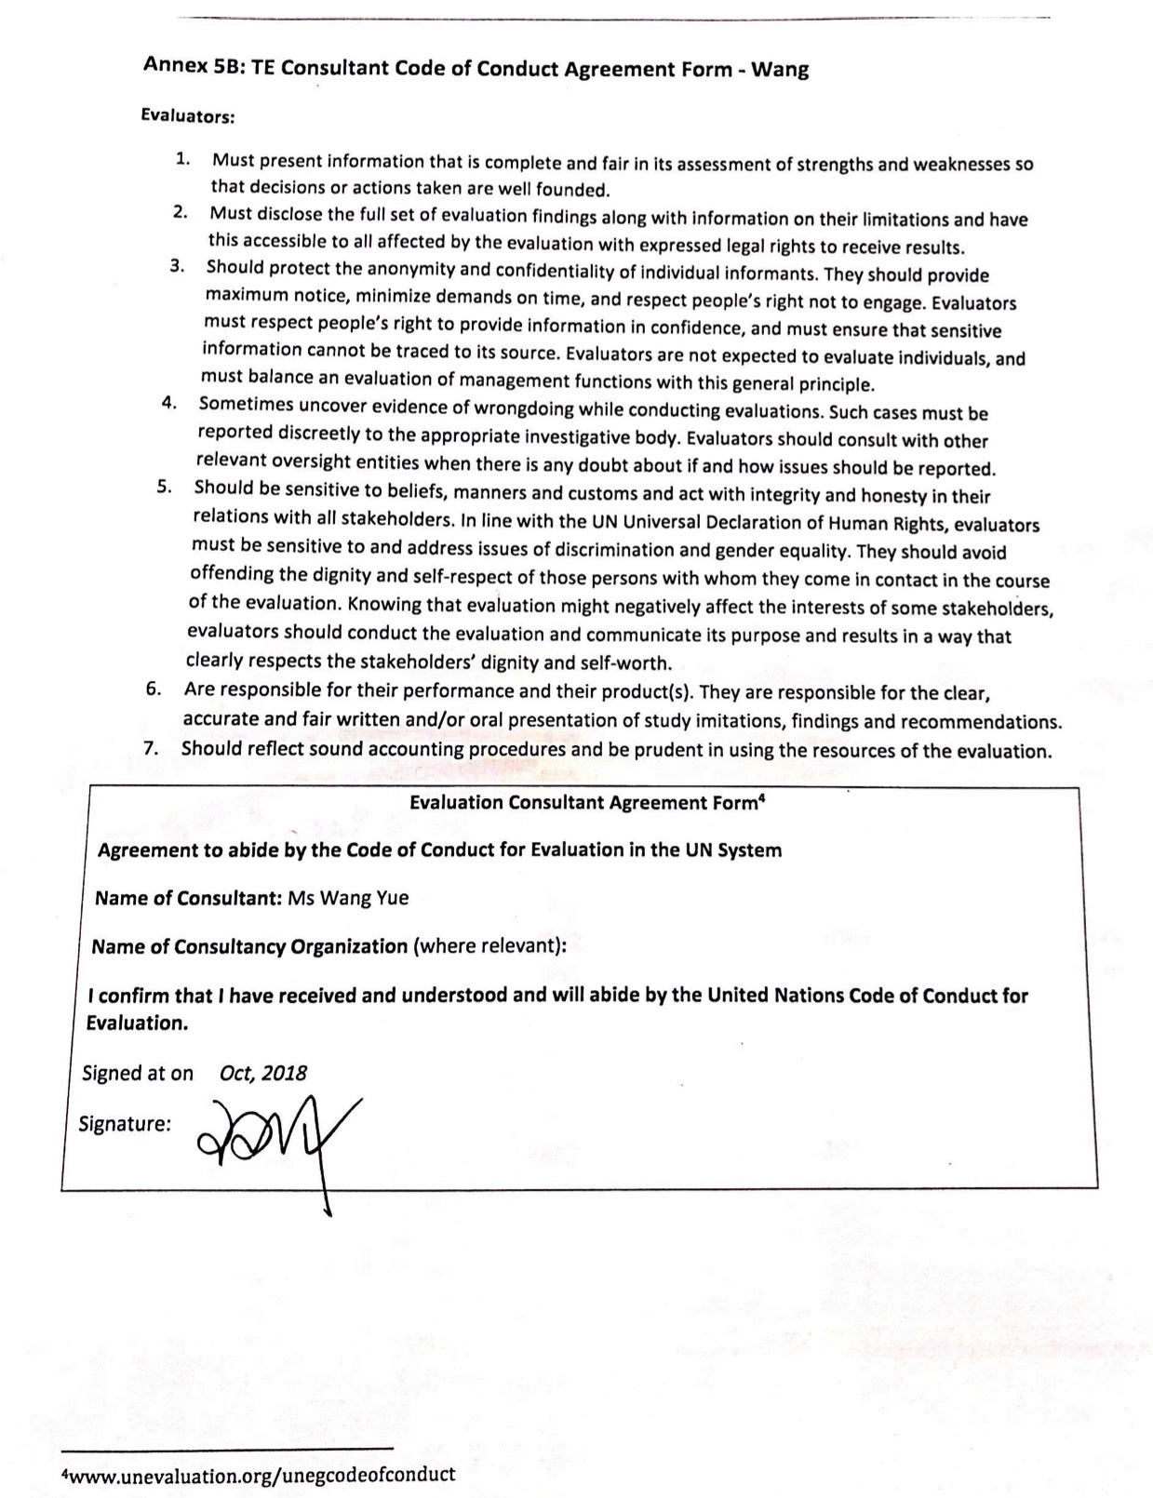

ANNEX 6: Signed Report Clearance Form
(to be completed by CO and UNDP GEF Technical Adviser based in the region and included in the final document)
Evaluation Report Reviewed and Cleared by

UNDP Country Office

Name: MA Chaode

Signature: Date: 30 Nov. 2018

UNDP GEF RTA
Name: Lisa Farroway
Signature: Date: 03 Dec. 2018

Annexed in a separate file: Audit Trail

For additional information on methods, see the Handbook on Planning, Monitoring and Evaluating for Development Results, Chapter 7, pg. 163
A useful tool for gauging progress to impact is the Review of Outcomes to Impacts (ROtI) method developed by the GEF Evaluation Office: ROTI Handbook 2009
www.unevaluation.org/unegcodeofconduct

