`

Terms of Reference (TOR)
Mobile Money for the Poor (MM4P)

Mid-Term Evaluation

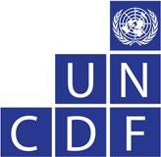

United Nations Capital Development

December, 2017

Mobile Money for the Poor (MM4P) ‐ Mid‐Term Evaluation [re-publishing]

Programme name: Mobile Money for the Poor (MM4P)
Countries: Benin, Lao PDR, Liberia, Malawi, Nepal*1, Senegal*, Uganda*, Zambia* Executing Agency: United Nations Capital Development Fund (UNCDF) Timeframe: 2014 ‐ 2019
Total estimated program budget: $36,000,000

Total cumulative programme disbursement (by Q1 2017): $20,717,661
Funding Agencies: UNCDF, Swedish International Development Cooperation Agency, Australian Department of Foreign Affairs and Trade, Bill and Melinda Gates Foundation and the MasterCard Foundation.
Previous evaluation: UNCDF conducted a joint internal Strategic Review of MM4P and the Better than Cash Alliance in 2014.

Background

o United Nations Capital Development Fund and its Inclusive Finance Practice Area

The United Nations Capital Development Fund (UNCDF) is the UN’s capital investment agency for the world’s 48 Least Developed Countries (LDCs). UNCDF uses its capital mandate to help LDCs pursue inclusive growth. UNCDF uses ‘smart’ Official Development Assistance (ODA) to unlock and leverage public and private domestic resources; it promotes financial inclusion, including through digital finance, as a key enabler of poverty reduction and inclusive growth; and it demonstrates how localizing finance outside the capital cities can accelerate growth in local economies, promote sustainable and climate resilient infrastructure development, and empower local communities. Using capital grants, loans, and credit enhancements, UNCDF tests financial models in inclusive finance and local development finance; ‘de‐risks’ the local investment space; and proves concept, paving the way for larger and more risk‐averse investors to come in and scale up.

Following UNCDF’s Strategic Framework 2014‐2017, UNCDF’s overall context is framed ‐ at the highest level ‐ by the challenges and trends faced by developing countries and by its geographic focus on the LDCs.

1 For the purposes of this evaluation, and in view of implementation progress to date, the evaluation team will be expected to assess progress of the whole programme using desk review techniques. To deepen evaluators ’ understanding of programme results, we are requesting that the ev aluation team conducts visits to the following four countries: Senegal, Uganda, Zambia and Nepal (denoted through a star in the text above).The country visits should last at least five days and be conducted by teams of two consultants, the lead member having at least 7 – 10 years of relevant experience in implementing inclusive finance programmes with a digital finance focus.

At a corporate level, key elements to be considered are the UNDP 2014 ‐ 2017 Strategic Plan and the lessons learnt during the UNCDF planning period 2010‐2013.

Bearing in mind the current trends in development finance and the structural challenges faced by the LDCs, UNCDF aims to realize the full potential of its capital mandate and flexible financial instruments to eradicate poverty, reduce inequalities and promote inclusive and sustainable growth.

UNCDF’s work is organized around a set of three broad development objectives, which UNCDF attempts to meet together with selected group of development partners from the public and private sectors both internationally and nationally, and first and foremost UNDP and the UN system.

The broad development objectives that UNCDF contributes to are:

- Increasing financing for basic services and sustainable and inclusive growth;
- Establishing financing mechanisms to increase resilience to economic and environmental shocks;
- Fostering policy environment conducive to sustainable financing for sustainable development.
UNCDF’s inclusive finance practice area (FIPA) contains a mixture of country, regional and global programmes. It supports 33 LDCs and is serving 8 million clients through the Financial Service Providers (FSPs) in which it invests. FIPA follows a sector‐based approach and, more recently, has been implementing its programmes through a series of thematic initiatives. These initiatives are designed to test promising models or solve specific problems across a range of countries to demonstrate a new approach or model. Global programmes often work in countries closely with country or regional country programmes, if present. A detailed explanation of FIPA’s approach can be found at: http://www.uncdf.org/financial‐inclusion

M o b i l e M o n e y fo r th e P o o r ( M M 4 P ) 10

The Mobile Money for the Poor programme (MM4P) was designed as a global programme to demonstrate how the correct mix of technical, financial, and policy support can assist in scaling up sustainable digital financial services (DFS) that reach the poor in very low‐income countries. The programme specifically targets low‐income, rural, and female end‐beneficiaries. MM4P is the largest of UNCDF’s initiatives in digital finance, covering eight countries and providing support to two others.

The programme is implemented in accordance with UNCDF’s Gender Equality and Empowerment of Women (GEEW) Strategy, which was adopted in 2012. Highlights include:
- For all relevant projects, targets are set in terms of reaching women
- MM4P requests gender disaggregated data from its partners, and works with partners to include gender as a standard monitoring indicator
- Market, customer and impact research is disaggregated by gender
- Research is conducted to better understand the behavior and challenges faced by women in terms of digital financial inclusion
- MM4P organizes events in which the potential and challenges of women are addressed

10 http://mm4p.uncdf.org/

  - The programme specifically targets the attendance of women for workshops, events and trainings

UNCDF launched MM4P in 2012 because it saw that DFS were not taking off in the Least Developed Countries (LDCs) which are, by definition, more challenging and less attractive to the private sector. UNCDF benefited from the experience of UNCDF’s regional Pacific Financial Inclusion Programme (PFIP) which was the first in UNCDF to support DFS. PFIP provided policy support to regulators and grant support to DFS providers and, in some cases, bulk users of DFS (e.g. government, microfinance institutions). UNCDF, Sida, and the Australian Department for Foreign Affairs and Trade (DFAT) provided initial funding of US$6.35 million to start testing this approach in four LDCs in Africa and Asia: Lao PDR, Liberia, Malawi and Nepal.

UNCDF took advantage of the first 2 ½ years of MM4P to test and adapt the programme. The result of the test period was to shift the programme from primarily a grant‐led programme with a policy component to a market development approach that builds the overall digital financial services ecosystem. However, MM4P retains a heavy emphasis on direct support – more technical than financial ‐ to DFS providers.

Given this new approach, the Bill & Melinda Gates Foundation (BMGF) chose UNCDF to implement MM4P in Uganda in early 2014, the MasterCard Foundation (MCF) agreed to support MM4P expansion into Benin, Senegal and Zambia in late 2014. USAID and the MetLife Foundation have also contributed support to Nepal since 2015. The new strategy and funding are reflected in the Programme Document of 2014. Funding sources and amounts per country vary greatly and consequently so does implementation; Benin, Senegal and Zambia are fully‐funded ecosystem development programmes by MCF while Uganda is a large programme skewed to digitizing payments as funded by BMGF. Nepal and the other countries have more limited interventions. Unfortunately, MM4P Liberia and Malawi are now nearly out of funds, which will result in UNCDF’s exit from these countries in 2017. In 2017, MM4P began providing technical oversight to UNCDF Sierra Leone which is focused on digitization of payments.

o Benefits of Digital Financial Services to Development and the Poor

There is increasing evidence regarding the positive role of DFS in driving financial inclusion in some markets in sub-Saharan Africa. An Innovation for Poverty Action study in Kenya showed that where DFS became more accessible, women were more likely to switch from farming to business occupations and to save more. Overall, an estimated 185,000 women changed occupations, and 194,000 households, primarily
2

female‐headed households, were lifted above the poverty line.
Other studies on the other hand point to

the need for increased evidence regarding the impacts of DFS at the client level.3

o The growth of digital finance in other UNCDF programmes supporting digital financial inclusion

DFS is increasingly a part of UNCDF’s financial inclusion agenda as UNCDF’s financial service provider partners and UNCDF’s funders see it as the most promising means to reach the poor with financial

2 http://www.poverty-action.org/study/long-term-effects-access-mobile-money-kenya

3 http://www.financedigitalafrica.org/wp-content/uploads/2017/11/FiDA-Snapshot-16-Digital-Finance-Impact- Evidence-Summary.pdf

services. FIPA has a number of programmes in its financial inclusion division that directly support digital finance projects as part of their portfolio. Digital is also beginning to play a role across UNCDF’s local development finance work. In some cases, such as Lao PDR, Nepal and Sierra Leone, MM4P’s team are implementing parts of other UNCDF programmes.

Two other programmes are primarily focused on DFS. As noted, PFIP is largely focused on DFS and was the initial inspiration for MM4P. The other is the Better than Cash Alliance[1] a global partnership of governments, companies, and international organizations that accelerates the transition from cash to digital payments in order to reduce poverty and drive inclusive growth, that is housed by UNCDF. The Alliance was launched in 2012 with an initial focus on global advocacy and research explaining the benefits of digitization of payments to stakeholders and members. In late 2014, UNCDF contracted a third‐party strategic review of the Alliance and MM4P to assess progress and determine whether they should work more closely together. While viewed as largely complementary, the reviewers believed the two programmes still needed to develop their core competencies before considering closer cooperation and recommended that the Alliance and MM4P should test cooperating closely in countries of shared interest. Per the recommendation, the two programmes have experimented with different types of collaboration in Senegal, Nepal and Malawi, which are both MM4P focus countries and Alliance members.

Over the period 2017 – 2018, the Alliance will undergo a series of external assessments to reflect on results to date and inform decisions around future directions. One option is for the Alliance to become an inclusive digital payments ecosystem‐building alliance, in which case a much closer working relationship between MM4P and the Alliance might be considered, even a merger.

MM4 P P r o g r a m m e O v e r v i e w

o Mission

MM4P’s mission is to contribute to poverty reduction by supporting low income and rural households in LDCs by increasing their financial security through appropriate, affordable and secure means to receive, manage and save money through digital financial services.

The purpose of MM4P is to demonstrate how the correct mix of technical, financial, and policy support, combined with research, can contribute to the development of sustainable DFS that reach the poor in more challenging markets, primarily in the LDCs.

MM4P’s goal is to build inclusive digital financial sectors whereby individuals and businesses, including women and rural customers, have access to and can effectively use a broad range of digital financial services that are provided responsibly, and at reasonable cost, by sustainable institutions in a well‐ regulated environment in the markets in which they operate.

[1] https://www.betterthancash.org/

Geographic focus

MM4P is a global program, and is currently active in eight LDCs (Benin, Laos, Nepal, Sierra Leone, Malawi, Senegal, Uganda and Zambia). In each of these countries, MM4P implements projects that aim to accelerate financial inclusion through digital financial services.

For the purposes of this evaluation, and in view of implementation progress to date, the main country focus will be Nepal, Senegal, Uganda, and Zambia. Evaluators will be invited to reflect on progress to date in other countries using desk review techniques.

MM4P DFS Market Development strategy [Theory of Change]

MM4P’s core strategy focuses on supporting shifts between stages of market development in digital financial services in partner countries. The development of the DFS market is not widely understood because there are few examples of success. However, looking at the more advanced countries and taking lessons learned from the development of the banking sector there, MM4P has characterized the evolution of the market into four stages: Inception, Start‐up, Expansion and Consolidation (see below). Simplified, a market is in Inception stage when there are only a few actors with limited outreach working without clear policies or supporting DFS infrastructure. Consolidation is when a market has a range of competitive actors and services that are clearly regulated and interconnected environment. MM4P has characterized the different stages of market development using eight indicators and set milestones for each of the stages. This framework allows MM4P to measure and monitor progress in the level of market development on an annual basis in each country (see Table 1 below). Globally, most markets are stuck in the Start‐up stage. Moving from Start‐up into a solid Expansion market stage is proving challenging in most markets. Expansion is the critical stage where several players are gaining scale, reaching sustainability and increasing investment. DFS markets seem to accelerate rapidly once a critical mass of the adult population is using the service, between 10 and 15 percent.

MM4P Work Streams and Programme Development Phases

MM4P structures its approach into six work streams that identify key elements of the DFS ecosystem, each roughly corresponding to specific stakeholder groups: providers of DFS (providers, infrastructure); users (retail customers, high‐volume users); distribution (i.e., agents); and policy & regulation. At the centre is what MM4P terms ‘ecosystem development,’ which encompasses the range of interdependent measures (education, consensus building, awareness raising, partnership building) that bring stakeholders together to build a sector that can reach the mass market. Each of the indicators in the market development measurement framework refers to one or multiple work streams. Figure 1 below describes each of the works streams, including examples of the type of activities that the programme implemented within each of the work streams.

Furthermore, the experience of MM4P has proven that long‐term results are generated when the programme takes the time to build relationships and get the buy‐in from stakeholders in the market, in part by supporting the improvement of partners’ existing operations. MM4P has identified three phases of country programme development, which also applies to one‐on‐one engagement with stakeholders:

Phase 1 ‐ Buy in: Build relationships with all stakeholders in the sector, mainly achieved through market

research involving key stakeholders and trainings, workshops and forums to build industry dialogue

Phase 2 ‐ Improve: Support key stakeholders in expanding and improving their current business and building credibility and trust at the partner level

Phase 3 ‐ Innovate: Based on credibility and trust built in the market, work with several stakeholders to design and launch innovative concepts and partnership models to further reach rural, female, and unbanked customers.

Table 1: MM4P Market Development Stages and Milestones

35

idation
Indicators Workstream Inception Star |  |  | t‐up Expansion Consol
Percentage of adult population with an active registered DFS account | Customers <1% of adult population using DFS 1‐5% |  | of adult population using DFS 5‐35% | of adult population using DFS >35% of | adult population using DFS
Number of active agents per 100,000 of adult population | Distribution 0 – 19 | active agents per 100,000 adults 20 – 59 | active agents per 100,000 adults 60 ‐ 139 active agents per 100,000 adults >140 act |  | ive agents per 100,000 adults
Number of providers offering DFS in the market on a sustainable basis | Providers No providers 1 ‐ 2 p |  | roviders 3 ‐ 5 providers >5 provi (lead providers expand and new providers (many pr enter) services) |  | ders  oviders and complementary
Providers attitudes and plans towards expanding and improving their DFS products and services to currently underserved population segments (for example female, rural, unbanked) | Providers Business case for DFS is unproven, few Provi providers committed to improve and expand and v their services to underserved population popu segments |  | ders are convinced of potential for DFS Provid alue proposition of underserved even) of lation segments contin  service | ers achieve sustainability (break‐ Providers achieve substantial profitability services and are committed to (above break‐even) and are committed to  ue to offer and expand their existing continue to offer and expand their existing s underserved population segments services to underserved population  segments
Types of products offered in the market | Providers and No ma High Volume  No hig | ss market products or services offered Basic  P2P,  h volume services offered. trans  Some domi P2G). | "first generation" products offered: Basic "first generation" products offered: A variety of advanced products offered: cash in/cash out, airtime top up, P2B P2P, cash in/cash out, airtime top up, P2B Basic "first generation" products offered: fers such as bill payments transfers such as bill payments P2P, cash in/cash out, airtime top up, P2B  transfers such as bill payments  high volume payment services, AND some "Second generation" products  nated by from many to one (i.e. P2B or offered: "Second generation" products widely  Savings, loans, insurance, merchant offered: Savings, loans, insurance, merchant payments payments  High volume payment services, mostly from High Volume payment services widely used many to one (P2G, P2B) and a few from one from many to one, one to many, many to  to many (G2P or B2P) many (B2B).
Type of institutional arrangements for High Volume payments | High Volume None | "Off‐net" transfers and some bilateral Multil agreements |  | ateral agreements Sector‐w | ideagreements
Types of partnerships formed for delivering DFS | Ecosystem No pa | rtnerships, fragmented ecosystem Ea rl y: Mi ddl e: Adva nce Providers are mostly working on their own, Partnerships for distribution through Intercon products and distribution are largely payment aggregations; widespread non‐ network exclusive. exclusivity of agents; distribution chains as product agents; bilateral transfers. models;  There are some bilateral partnerships in the  market such as for bill payments, off net Bank‐MNO partnerships provide wallet‐bank Partners transfers, account‐wallet linkages, and MNO‐ product linkages, e.g. credit, insurance. operate a Bank linkages for liquidity  There are several large payment aggregators Partners active in the market, and some merchant provider payment aggregators. banks & |  |  | d:  nection through shared agent (by law); multilateral transfers;  aggregators; DFS ‐ based business payments for services.  hips between providers to inter‐  ccounts and/or wallets.  hips between different types of  s to launch innovative services (e.g. MNOs, MNOs & MFIs, etc).
Types of regulation supporting DFS | Policy and No Gu  Regulation pilots excep | idelines. Regulatory approval for Basic granted based on no objections or and e tions. bank | Guidelines permitting agent banking Specia  ‐money. Regulation now permits to place s and non‐banks to offer DFS. includ  protec | lized regulations/guidelines for DFS in DFS fully on most key regulatory areas Systems ing: agents, KYC, e‐money, consumer payment tion consume | integrated into National Payments with guidelines on agents,  s, settlement, e‐money, KYC and r protection

Figure 1: MM4P work streams and activities

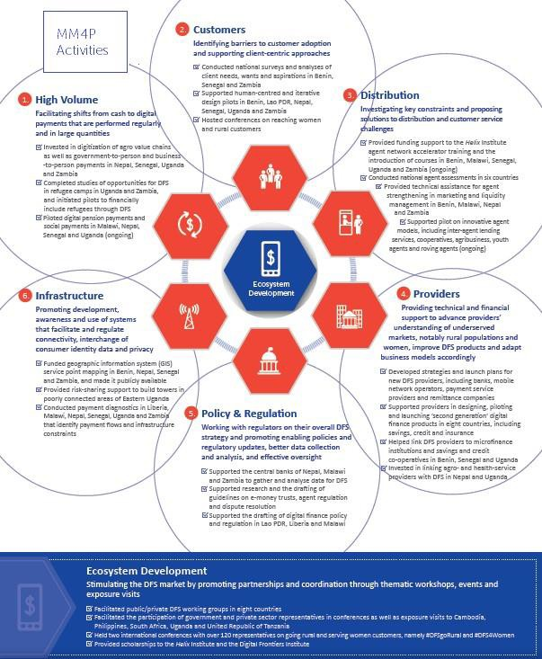

Programme Outcomes

The focus of the programme theory of change is to help stakeholders make shifts between the stages of DFS market development. MM4P measures its success by the extent to which the markets in which it works have reached the Expansion stage.

In some countries, UNCDF has additional outcomes that are linked to the source of funding. In Uganda, UNCDF has a separate RMF for the Gates Foundation. In Nepal, it has targets linked to its two main sources of funding, the UNNATI A2F programme and USAID Nepal.

Programme Implementation Status

The table below shows the status of the programme for each of the countries to be visited during this evaluation. The last two columns show the country’s market development stage at the launch of the programme and the current stage of development.

Table 4: Status by country

Country | Launch | Until | Programme Development Phase | Market Development Stage
 |  |  |  | Baseline | Current
Nepal | Dec-13 | Dec-17 | Improve | Inception | Start-Up
Senegal | Apr-15 | Dec-19 | Buy in/ Improve | Start-up | Early Expansion
Uganda | Oct-14 | Dec-17 | Innovate | Start-up | Expansion
Zambia | Feb-15 | Dec-19 | Improve/Innovate | Start-up | Early Expansion

Annex 2 provides more information on the activities implemented per country per work stream. More information on the programme can be found at http://mm4p.uncdf.org/

P u r p o s e , S c o p e an d O b j e c t i v es of th e E v a l u a t i o n

The evaluation is commissioned in accordance with UNCDF’s Evaluation Plan 2016‐2017 and its broader Evaluation Policy which sets out a number of guiding principles and key norms for evaluation in the organization following the standards of the United Nations Evaluation Group in which UNCDF is an active member.12

12 For more information, please see: http://web.undp.org/evaluation/policy.shtml

Amongst the norms that the Policy seeks to uphold, the most important are that the evaluation exercise be independent, credible and able to provide information that is useful and relevant to support evidence‐ based programme management and broader strategic decision making.

With this in mind, the evaluation has been designed with the following overall objectives:

- to allow UNCDF and funding partners to meet their accountability and learning objectives

- ensure that the evaluation can support ongoing attempts by the programme and its funders to capture good practice and lessons to date in a sector which is evolving fast and is increasingly relevant to meeting the objectives of the Sustainable Development Goals

- to guide and inform the remaining years of MM4P implementation as well as – if appropriate –
subsequent programming

- situate the programme in UNCDF’s larger Strategic Framework 2014‐2017 and discussions around
UNCDF’s New Strategic Framework 2018‐2021

The mid‐term evaluation is expected to assess both the results to date (direct and indirect, whether intended or not) from the first years of implementation as well as the likelihood of the programme meeting its end goals as set out in the programme document on the basis of current design, human resource structure, broad implementation strategy, etc.

It will seek to build – where appropriate – on the lessons learnt and recommendations generated from the internal strategic review conducted in the first half of 2015. It is expected that the evaluation will provide useful and actionable recommendations to increase the likelihood of success by the end of the programme in 2019.

The overall objective of the evaluation is to focus on the relevance and performance of the programme to date. Critical to this evaluation is the assessment of the relevance and effectiveness of the ecosystem approach in moving the market.

The specific objectives of the evaluation are:

  - To assist UNCDF and its partners to understand primarily the relevance, efficiency, effectiveness of MM4P results to date in the countries in which it intervenes – and as far as it is possible to ascertain at this point of programme implementation – the likely impact and sustainability of the MM4P programme going forward
  - To validate and/or refine the programme’s theory of change at this stage of implementation
  - Situate the programme in its broader environment, compared to similar programmes and other initiatives
  - Provide forward‐looking operational and strategic recommendations;

E v a l u a t i o n m e t h o d o l o g y an d p r o p o s a l

The evaluation should be transparent, inclusive, participatory and utilization‐focused. The overall

methodology is organized according to a theory of change approach, framed by the UN/ OECD DAC criteria and drawing upon mixed methods (quantitative and qualitative) data to capture MM4P’s contribution to
market development and systemic change to date in the various countries in which it is intervening. This approach follows initiatives such as the Donor Committee on Enterprise Development’s guidance on facilitating and measuring market development14 and is also in line with UNCDF’s own ‘innovation‐to‐ scale’ approach whereby UNCDF –supported interventions aim to start with piloting/innovation, move to consolidation in additional countries before being scaled up in markets and country policy systems more broadly.

To do this, the evaluation should follow a theory‐of‐change approach to assess M M 4 P ’ s progress against its expected end results, considering the influence of relevant contextual factors at the national and local levels that may have influenced the programme results. In doing so, the evaluation should use as far as possible contribution analysis as a frame for the evaluation with a view to capturing in the various countries in which MM4P is being implemented the programme’s contribution to broader system‐ and market‐level change alongside – where relevant ‐ the contribution of other actors or drivers of change.15

In line with UN evaluation practice, the scope of the evaluation should cover all five standard UN/OECD DAC evaluation criteria: relevance/ appropriateness of design, efficiency, effectiveness, and (likelihood of) impact and sustainability. In doing so, the focus of the evaluation goes beyond assessing whether UNCDF is currently ‘doing things right’ in programme execution and management, to a broader assessment of whether, given evidence available, MM4P ‐ as implemented by UNCDF together with key programme partners, and in comparison with similar approaches implemented by others ‐ looks to be the ‘right approach’ to achieving the higher‐level objectives agreed in the initial phase.

The evaluation design should respect the standards set out in the United Nations Evaluation Group (UNEG)
Handbook to Integrate Human Rights and Gender Equality in Evaluation

13 http://www.cgap.org/topics/facilitating-and-measuring-market-development
14 https://www.enterprise-development.org/implementing-psd/market-systems/
15 For more information, please see: http://www.betterevaluation.org/en/plan/approach/contribution_analysis.

16 These are included in the evaluation matrix below.

and UNEG’s Ethical Guidelines and Code of Conduct.17

The evaluation should draw upon mixed methods of quantitative and qualitative data using both existing secondary data sources and primary data to be collected during the evaluation, ensuring evidence‐based findings and recommendations.

Evaluation questions

In line with the typical approach to theory-based evaluation of complex interventions, the table below sets out a series of preliminary evaluation questions to be addressed in the evaluation. These questions relate to the objectives of the evaluation listed above and operationalize MM4P’s theory of change and its results framework into a set of measurable categories of evaluative analysis. A final evaluation matrix will be developed together with the MM4P Team in Brussels during the inception phase.

Evaluation criteria and main questions | Evaluation sub‐questions (including elements of analysis)
Question 1:  Relevance and quality of design  The appropriateness of the programme’s objectives to the real problems, needs and priorities of its key | 1.1 As currently designed, to what extent is the MM4P approach relevant to the programme countries and key stakeholders the programme supports?
 | 1.2How complementary is the MM4P approach to other initiatives aimed at supporting the development of digital financial service markets in the LDCs.
 | 1.3 To what extent is programme design sufficiently taking cross‐cutting issues such as gender and human rights and social and environmental performance into account?

17 UNEG Code of Conduct: http://www.unevaluation.org/document/detail/102; UNEG Guidance for Integrating Human Rights and Gender Equality in Evaluation http://www.unevaluation.org/document/detail/980

Question 2: Efficiency  Extent to which the programme has converted inputs and activities into results (outputs) and how well as this been managed/overseen? | 2.1 How well has the programme delivered its expected results to date?
 | 2.2 What is the quality of the programme management, including the appropriateness of the results measurement process to capturing the results of the programme, as well as the cost of MM4P compared to other initiatives in the area of DFS and to UNCDF’s broader portfolio?
 | 2.3.What is the contribution of MM4P’s knowledge management framework to the broader objectives of the programme and to broader communities of practice active in DFS promotion at the global level?
Question 3: Effectiveness Contribution of MM4P to organisational change by individual digital finance ecosystem participants | 3.1. To what extent is MM4P contributing to building capacity of various DFS ecosystem participants (DFS providers, regulators, users of DFS) in the various countries in which it is being implemented?  3.2 To what extent have MM4P’s ecosystem activities contributed to building awareness, interest and commitment of stakeholders in expanding DFS?
Question 4: Likely Impact | 4.1 What has been the overall contribution t o d a t e of MM4P’s direct financial and technical support to the development of strong digital finance systems in the programme countries?

(Likely) programme impact at both beneficiary and market/policy system levels
 | 4.2 What will be MM4P’s likely contribution to increasing access to digital financial services, in general and specifically for low‐income, rural, un‐ (and under‐)banked, and female clients and with what effects?
Question 5: Sustainability of programme results within the broader market/policy system environment | 5.1 To what extent are programme outcomes at the level i) of participants in the market for digital financial services, ii) policymakers and market regulators and iii) beneficiaries of digital financial services likely to continue over time?
 | 5.2 How sustainable are the changes in DFS market development that MM4P contributes to?

Data collection toolkit

For the purposes of this RFP, and on the basis of the questions included above and the information present elsewhere in this RFP and on the MM4P website, interested bidders are requested to propose a data collection toolkit explaining how they will make best use of existing secondary data and generate during

the evaluation additional primary data during the country visits which together will be able to answer the questions listed above.

For information, the key categories of secondary data that will be made available to the evaluators include:

  - Initial programme documents including programme document, donor agreements, reports from scoping missions
  - Mapping of external and/or UNCDF initiatives that are complementary or overlap with MM4P
  - Documents explaining MM4P internal management procedures and processes
  - Annual results reporting/donor reporting/minutes of Investment Committees approving MM4P activities/financial information
  - Key knowledge management products, including Knowledge Management Strategy, results of learing events and Digital Financial Services working groups
  - Annual Provider survey
  - Overview of broader ecosystem activities, including platforms for knowledge sharing

The combination of primary and secondary tools or separate ‘lines of evidence’ should number at least five and be designed with triangulation and complementary assessment of the sub-questions in the matrix in mind.

The content of these different lines of evidence should also be used to inform the writing of 10 – 15 page country reports which should summarise MM4P’s contribution to DFS market development in the countries visited paying careful attention to the role of policy and institutional context in driving or hindering programme results.

Both the results of the data collection toolkits and the country reports should then be used in a transparent manner to inform the writing of the final evaluation report as a way of demonstrating the findings of the evaluators to the evaluation questions and supporting the conclusions and recommendations that the team will make.

M a n a g e m e n t r o l e s an d r e s p o n s i b i l i t i e s :

To ensure independence and fulfilment of UN evaluation standards, the Evaluation Unit of UNCDF in New York is responsible for the management of this evaluation and will hire an independent firm to conduct the evaluation. The Evaluation Unit will work with the evaluators to ensure that the evaluation is conducted per UNEG Norms and Standards in Evaluation in the UN System, the UNEG Code of Conduct for Evaluation in the UN System and UNEG Guidance for Integrating Human Rights and Gender Equality in Evaluation. The Evaluation Unit will provide substantive support, including joining the evaluation team in selected field visits, and is responsible for the overall quality of the report.

The Programme (MM4P) will provide administrative and logistical support. Specifically, MM4P will provide a reference guide and access to all relevant documents; a list and contact information of key stakeholders; and assistance in scheduling meetings in each country. The team will be available for introductory and close out meetings in each country and shall make itself available to answer questionsand

provide documents. UNCDF may provide office space in each country for the team to work upon request. The evaluation team is expected to organize its own travel, visas, accommodation and local transport.

An Advisory Panel for the evaluation will be set up, composed of representatives of UNCDF’S Financial Inclusion Practice Area at Headquarters as well as from the direct funders of the evaluation. The role of the Advisory Committee is to support the Evaluation Unit in managing the evaluation by participating in the following:

‐ Reviewing the TOR
‐ Reviewing and commenting on the inception report
‐ Reviewing and commenting upon the draft report
‐ Being available for interviews with the evaluation team

The evaluation may also be supported by a Reference Group of interested UNCDF partners from international development agencies and UNCDF’s partner governments in the LDCs. The composition of this Group will be decided prior to the launch of the evaluation.

E v a l u a t i o n p r o c e s s

The evaluation process has 3 distinct phases:

Inception Phase and desk review

  - Methodological briefing between the evaluation team and the Evaluation Unit to ensure clear understanding of the evaluation methodology, approach and main deliverables as per TOR;
  - Inception meetings with Advisory Panel and key programme stakeholders to familiarize
the Evaluation Team with the programme objectives, results to date and expectations for this evaluation.
  - Stakeholder Mapping and stakeholder selection for data gathering.
  - Workshop in Brussels to finalize the evaluation approach with the programme team
  - Finalization of the evaluation methodology and tools, to include a sampling strategy for more in‐depth analysis of various aspects of the performance of the programme as well as a strategy for collecting, analysing and aggregating different sources of data into the final evaluation report.
  - Finalization of the schedule for country visits and stakeholder interviews

- In‐country phase: in‐depth data collection and research, including site visits and key informant interviews. De‐briefing sessions with key in‐country stakeholders may be organized to present emerging trends/ preliminary findings and to build ownership of the findings with programme counterparts. The Team Leader may be asked to debrief the Advisory Panel and Evaluation Unit at the end of the country visits. This with a view to provide a sense of the evaluation team’s preliminary findings ahead of the draft reporting phase.

As explained above, the evaluation team is expected to visit Senegal, Zambia, Uganda in Africa and Nepal in Asia.

- Post‐Mission Phase: analysis and synthesis stage, including a debrief with MM4P on initial findings and final questions, interpretation of findings and drafting of the evaluation report, HQ debrief of the final evaluation report.

A u d i e n c e an d t i m e l i n e

The primary audience for this evaluation is UNCDF, stakeholders in the countries in which UNCDF is implementing MM4P, as well as the funders and key partners of MM4P.

The evaluation is scheduled to be launched in Q1 2018 and finalized in Q2 2018, with the following proposed timeline:

‐ Inception phase18:January 2018
‐ In‐country phase19: F e b r u a r y – M a r c h 2 0 1 8
‐ Post‐Mission Phase: A p r i l – June 2018

Mai n d e l i v e r a b l e s

Once the evaluation has begun, the contractor will produce the following deliverables:

- An inception report presenting a fully developed evaluation matrix, methodology, data collection tool kit and a detailed work plan with timeline following a template to be provided by the Evaluation Unit.

- Draft and final reports presenting the evaluation findings and recommendations for the program as a whole (max. 35 – 45 pages) plus in annex short (15 – 20 page) synthesis reports of findings from each country visited (with francophone country deliverables in French) as well as an Executive Summary of maximum 5 pages summarising the main findings and recommendations in English and French.

- All completed tools and datasets making up the different lines of evidence should be made available to the Evaluation Unit in the form of a dedicated DropBox (including transcribed highlights from key interviews and focus group discussions, and details from quantitative a n d q u a l i t a t i v e analysis as relevant).

- Ahead of the final HQ presentation, and any other debriefings that are organised, provide a PowerPoint presentation that serves as a visual aid when presenting evaluation findings. The slides should contain brief sentences/bullet points that synthetically provide the core information of the evaluation report. The PowerPoint should be put together on the basis of a template provided and should follow the organization of the evaluation report.

The proposed timeframe and expected deliverables will be discussed with the evaluation team and refined during the inception phase. The final schedule of deliverables will be presented in the inception report. The Evaluation Unit reserves the right to request revisions to the evaluation deliverables until they meet the quality standards set by the UNCDF’s Evaluation Unit for evaluation reports (please see Annex 4

for more details).

C o m p o s i t i o n of E v a l u a t i o n T e a m

The evaluation team should present a combination of technical expertise in evaluation and experience in designing and managing interventions in the field of digital financial services. Experience in evaluating UN programmes, including UNCDF, is preferred but not mandatory.

The team should be familiar with approaches used to assess program contribution to market development/systemic changes with a focus on inclusion of the poor20 as well as theory‐based approaches to programme evaluation, using both quantitative and qualitative analysis of existing secondary data and primary data sources.

The team should also demonstrate the following experience and expertise:

  - Proven experience of designing and leading international development evaluations applying a variety of relevant evaluation designs of a range of different modalities in international developmentcooperation

  - Demonstrated experience in integrating gender equality and women’s empowerment in evaluation.
  - Evidence of formal evaluation and research training, including familiarity with OECD or UN norms and standards for development evaluation as well as the evaluation of market system approaches, such as that developed by CGAP.
  - Familiarity with evaluating market and system‐development approaches to poverty reduction
  - Experience in developing relevant program recommendations from evaluation insights. The team must also have experience in financial inclusion and specifically in digital financial services.
  - Expertise in designing and conducting evaluations in the field of financial inclusion in developing countries
  - Strong knowledge and experience of working to support the roll out of digital financial services, preferably in the context of the focus countries or at least South Asia and Africa
  - Familiarity with other development organization programmes which support digital financial services, such as CGAP, DFID, Omidyar Foundation, the Bill & Melinda Gates Foundation, the MasterCard Foundation or the International Finance Corporation.
  - Familiarity with UNCDF and its inclusive finance programmes is preferred.

20 For example, DFID’s work on making markets work for the poor or the DCED markets for the poor approach.

The evaluation team should also be gender‐balanced and include representatives who are familiar with one or more of the African and Asian countries in which the MM4P programme has been implemented. Teams are encouraged to include African or Asian nationals.

The team should also be able to work in French and in English in view of the countries to be visited. It is requested that the proposed evaluation team be made up of at least the following roles:
    - 1 Team Leader with evaluation/inclusive finance and ideally DFS experience

    - 1- 2 DFS experts with a minimum of at least 7 - 10 years relevant experience

    - At least 2 - 3 national/regional consultants with country ecosystem experience in DFS to participate in the country visits.

For the country visits, the evaluation team should be made up of at least two consultants, the senior consultant having at least seven – ten years of relevant experience to the programme being evaluated.

P r o p o s a l r e q u i r e m e n t s

- Methodology
- Detailed work plan with timeline of major activities
- Overview of past examples of conducted evaluations with comparable scope, including references
- Proposed team (with detailed CVs)

The technical proposal shall describe the methodology and approach to achieve the objectives of the study, including the team proposed. The technical proposal should not exceed 30 pages + annexes (for example CVs).

As part of the methodological proposal for the evaluation the following elements should be included:

  - An overview of the data collection toolkit to be used in answering the evaluation questions, including the qualitative and quantitative tools that will be used in assessing existing secondary data and generating new primary data. In proposing the evaluation methodology, bidders are requested to respect the various quality standards for UNCDF evaluation set out in Annex 4.
  - The proposal should highlight how the evaluation will disaggregate and present findings on women, rural, and un(der)‐banked population segments, as well as make use of a gender lens, particularly in regard to women’s economic empowerment.21

As part of the detailed work plan with timeline of major activities should include:

  - A detailed evaluation work plan showing the overall time commitment to the project, as well as specific activities and time allocated to each individual team member. Note that the evaluation team should have sufficient time to complete:

  - Review of all relevant programme documentation during the inception phase, including a briefing by the MM4P team on the programme during the inception phase to be conducted in Brussels, Belgium;
  - Country visits to the four countries mentioned above;
  - Write up of the evaluation report presenting the findings on the programme as a whole as well as the supplementary country reports.
The country visits should be a minimum 5 days per country.

The overall level of effort for the evaluation is estimated to be around one hundred and fifty person days.

Note that the team members conducting the country visits to Senegal must be fluent in French and have experience of providing consulting services in French‐speaking countries.

We take the opportunity here to remind potential bidders that in line with UN requirements for evaluation, the ability of the evaluation team to conduct an independent and impartial evaluation of the intervention being assessed is a pre-requisite. With this in mind, interested firms should ensure specifically that members of the evaluation team that are proposed have not had any previous experience of working with the MM4P programme. In cases where firms have worked previously for MM4P, firms should explain clearly how they intend to ensure that evaluation teams are able to work in an independent and impartial manner.

21 In addition to the UN Evaluation Group guidance on embedding gender equality and women’s empowerment into UN evaluations: http://www.unevaluation.org/document/download/2107, please see for information the latest report by the UN Secretary General’s High Level Panel on Women’s Economic Empowerment: Leave No One Behind – Take Action for Transformational Change on Women’s Economic Empowermenthttp://hlp-wee.unwomen.org/-
/media/hlp%20wee/attachments/reports-toolkits/hlp-wee-report-2017-03-taking-action-en.pdf?la=en

A n n e x 1: MM4 P R e s u l t s M e a s u r e m e n t F r a m e w o r k

The MM4P Results Measurement Framework (RMF) monitors activities and results on program, country, and project level. The elements included in the different levels of the framework are depicted in the figure below.

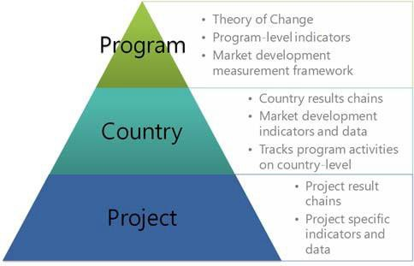

Figure 2 below shows the structure of the MM4P Theory of Change. Based on the theory of change, detailed results chains were developed for each country that show how activities are assumed to lead to stakeholder, customer and sector outcomes, and impact. Given the programme objective of shifting the DFS market along the path of development, the measurement of the progress of the market is a key element of the country results measurement frameworks. As discussed in Section 3.3, this entails country‐ level data collection and monitoring of the DFS market. In addition, the country RMFs track program activities on country level.

MM4P also closely measures and monitors the results of its projects. For all relevant projects, a results chain is developed, which visualizes the hypothesis of how activities will lead to outcomes and impact. Based on the results chain, project‐specific indicators are developed, which measure the progress and results of a project, and capture learnings. Where relevant and feasible, project indicators and definitions are aligned to the country‐level indicators (e.g. adoption and use of DFS, agent activity), to allow for aggregation and comparison.

Figure 2: Structure MM4P Theory of Change

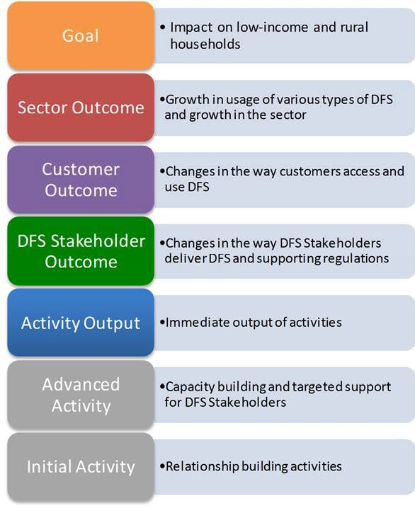

A n n e x 2: A c t i v i t i e s pe r c o u n t r y (formoreinformationpleasesee:http://mm4p.uncdf.org)

Benin

Market development:

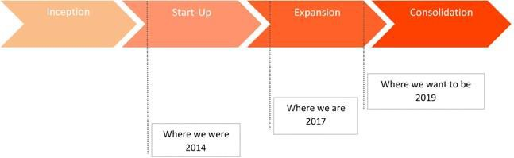

Activities per work stream:

Customers
- Technical assistance to MTN Benin to develop DFS for savings groups and payments, targeting Zémidjans, i.e. motor taxis (ongoing)
- Research on DFS customer adoption and usage (completed)
- Human Centric Design research with providers (completed)

Providers
- Technical Assistance to MFI Alidé and MTN Benin to develop a bank2wallet push‐pull service (ongoing)
- Feasibility assessments of specific DFS with providers (ongoing)
- Training workshop for banks on how to leverage DFS (completed)
- Market research, workshop, and individual institutional assessments of MFIs’ readiness to leverage DFS for growth (completed)

Distribution
- Technical assistance to Etisalat Moov to improve their agent network (ongoing)
- Financial Service Point mapping (ongoing)
- Strategic assessment of agent networks of providers (completed)
- Support DFS stakeholders to attend the Helix Agent Network Accelerator training (ongoing)

High volume
- Support participation of ministry representatives to peer learning exchange on government payment digitization in South Africa and Colombia (completed)
- Workshop to raise awareness and provide information on the Payment Flow Diagnostic (planned) and the opportunity to digitize government‐to‐person (G2P) payments (completed)

Ecosystem development
- Established and facilitates the DFS Working Group, which meets every quarter. Technical sub committees work on various recommendations. (ongoing)
- Support DFS stakeholders to participate in the Digital Frontiers Institute training (ongoing)
- Workshops for DFS stakeholders on various topics (e.g. partnerships between financial institutions and MNOs, MFIs

and DFS) (ongoing)
Nepal

Market development stages:

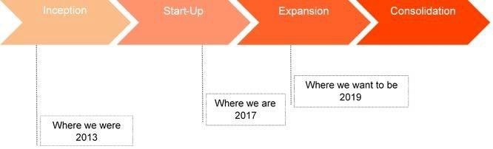

Activities per work stream:

Customers
- Support NRB in assessing demand for and use of DFS in rural areas (ongoing)
- Support Prabhu Limited in developing a mobile application to improve financial literacy (ongoing)

Providers
- Support IME to launch its mobile money services (ongoing)

Policy and Regulation
- Support NRB to develop a national payment system strategy (ongoing)
- Support NRB in developing a geo‐spatial data reporting and analytics system (ongoing)

Distribution
- Support DFS stakeholders to attend the Helix Agent Network Accelerator training (ongoing)
- Support to bank to review agent network strategy (ongoing)

High volume
- Support to the Department of Civil Registration to develop the strategy, pilot and follow up on the pilot and roll‐out of
G2P digitization strategy for social security payments

Ecosystem development
- Workshops for DFS stakeholders on various topics (e.g. G2P, retail payment system NRB, digitization of payments in agricultural value chains, MFIs and DFS) (ongoing)
- Activate NRB and payment service providers working group for regular dialogue / DFS Workling Group (ongoing)
- Supported participation from NRB and Ministry of Finance in a learning exchange to India for understanding creation of digital eco‐system (completed)

Senegal

Market development stages:

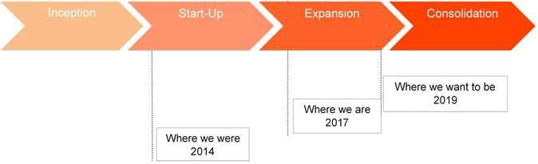

Activities per work stream:

Customers
- Research on DFS customer adoption and usage (completed)
- Human Centric Design research with providers (completed)

Providers
- Support CAURIE‐MF to digitize savings groups’ operations by enabling credit officers to collect savings and process loan repayments digitally (ongoing)
- Technical assistance to Orange Money for the establishment of Orange kiosks (ongoing)
- Feasibility studies with providers to assess specific DFS (ongoing)

Distribution
- Financial Service Point mapping (ongoing)
- Support DFS stakeholders to attend the Helix Agent Network Accelerator training (ongoing)
- Technical assistance to providers to strengthen their rural agent network (ongoing)
- Strategic assessment of agent networks of providers (completed)

High volume
- Conduct a payment flow diagnostics, implemented by the national statistics bureau ANSD and BTCA (ongoing)
- Technical Assistance to the digitization of pension payments (ongoing)
- Support the participation of ministry representatives to peer learning exchange on government payment digitization in South Africa and Colombia (completed)

Ecosystem development
- Established and facilitation of the DFS Working Group, which meets every quarter. Technical sub committees work on various recommendations (ongoing)
- Support DFS stakeholders to participate in the Digital Frontiers Institute training (ongoing)
- Workshops for DFS stakeholders on various topics (e.g. MFIs and DFS) (ongoing)

Uganda

Market development stages:

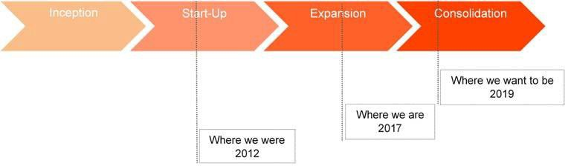

Activities per work stream:

Customers
- Customer research on multiple DFS as part of support to providers

Providers
- Technical assistance to MTN to develop, pilot and scale its savings and lending product MoKash (completed)

Policy and Regulation
- Study on interoperability and the role of PSPs, on behalf of Bank of Uganda (ongoing)
- Study on KYC Requirements for Digital Financial Services in Uganda (ongoing)
- Supported Bank of Uganda in developing data collection tools for FSPs (completed)
- Technical assistance to the Bank of Uganda to enable the regulatory environment in preparation for the National Financial Inclusion Strategy (completed)

Distribution
- Technical assistance to banks for the development and launch of their agency banking strategies (ongoing)
- Support DFS stakeholders to attend the Helix Agent Network Accelerator training (ongoing)
- Technical assistance to Living Goods (an NGO) and MTN to develop and pilot a roving agent model (ongoing)

High volume
- Technical assistance to providers and aggregators for the digitization of payments in agricultural value chains (ongoing)
- Technical assistance to providers and aggregators for the digitization of social cash transfers in Bidi Bidi refugee settlement (ongoing)

Ecosystem development
- Organize events for DFS stakeholders (e.g. DataHack4FI, open API workshop, fintech) (ongoing)

Zambia

Market development stages:

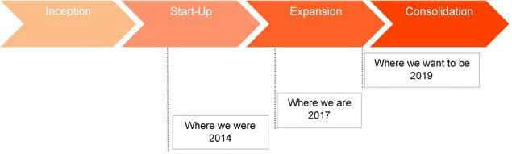

Customers
- Research on DFS customer adoption and usage (completed)
- Human Centric Design research with providers (completed)

Providers
- Technical assistance to Spagris Zambia to implement effective agent training and to develop a strategy (ongoing)
- Support to Zoona to develop and pilot its mobile money wallet Sunga (completed)

Policy and Regulation
- Provide support to the Bank of Zambia to improve collection and analysis of data on DFS (ongoing)
Distribution
- Financial Service Point mapping (ongoing)
- Support Airtel Money to test and scale innovative agent liquidity models (ongoing)
- Support FINCA Zambia to develop and test liquidity management solutions and financial services (credit and saving facilities) for mobile money agents (ongoing)
- Support DFS stakeholders to attend the Helix Agent Network Accelerator training (ongoing)
- Strategic assessment of agent networks of providers (completed)

High volume
- In partnership with UNHCR, support the digitization of social cash transfers in Meheba Refugee Settlement (ongoing)
- Technical assistance to MTN in developing and testing go‐to‐market solutions to expand outreach of its bulk payment service in peri‐urban and rural areas (ongoing)
- Conduct a Payment Flow Diagnostic for the Government of Zambia (completed)
- Supported the participation of ministry representatives to peer learning exchange on government payment digitization in South Africa and Colombia (completed)

Ecosystem development
- Established and facilitate DFS Working Group (ongoing)
- Organize workshops for DFS stakeholders on various topics (e.g. HCD, KYC) (ongoing)
- Support DFS stakeholders to participate in the Digital Frontiers Institute training (completed)

A n n e x 3: MM4 P co m m i s s i o n ed dat a

Source | Description | Year | Countries
Intermedia Customer Insights Survey | National representative demand sidedata on customer adoption andusage of DFS products (http://finclusion.org/) | 2015 | Benin, Senegal*
Agent Network Accelerator data | Supply side overview of the DFS landscape, identifying challenges and opportunities in expanding the agent network | 2016 | Benin Senegal Zambia
Financial service point mapping | Building publicly accessible geo‐spatial data bases on penetration and use of financial services (http://finclusionlab.org/) | 2015 ‐  ongoing | Benin Nepal Senegal Zambia
Annual Provider Survey | Annual survey conducted by MM4P with providers on their DFS operations | 2017 | Benin Senegal Zambia
Payment flow diagnostics | Data on the volume of cash and digital payment flows on a national level, segregated by business, personal and government | 2017 | Zambia
* Intermedia also conducts its survey in Uganda but this is not commissioned by MM4P. Finscope Survey data is available for Zambia (2015).

A n n e x 4: Q u a l i t y G r i d fo r U N C D F e v a l u a t i o n s

As per UNDP’s Policy, to which UNCDF is party, all external evaluations commissioned by UNCDF’s Evaluation Unit are subject to external quality control by UNDP’s Independent Evaluation Office. Bidders are requested to respect the elements of this quality assessment tool in coming up with their proposed approach for the evaluation.

TOR and Design (Weight 15%)
1. Do the Terms of Reference clearly outline the focus for the evaluation in a logical and realistic manner?
2. Do the Terms of Reference detail timescales and budgets for the evaluation?
3. Does the TOR clearly outline the evaluation's planned approach?
4. Is the proposed outline of the evaluation approach and methodology clearly detailed in the ToR?
5. Does the ToR request the evaluator to include gender and vulnerable group issues within the evaluation?
Report and Methodology (Weight 30%)
STRUCTURE
1. Is the evaluation report well‐balanced and structured?
2. Does the Evaluation report clearly address the objectives of the evaluation as outlined in the ToR?
METHODOLOGY
3. Is the evaluation's methodological approach clearly outlined?
4. Is the nature and extent of the project/ programmes stakeholders or partnerships and their role and involvement in the project/ programme explained adequately?
5. Does the Evaluation clearly assess the projects/ programmes level of RELEVANCE?
6. Does the Evaluation clearly assess the projects/ programmes level of EFFECTIVENESS?
7. Does the Evaluation clearly assess the projects/ programmes level of EFFICIENCY?
8. Does the Evaluation clearly assess the projects/ programmes level of SUSTAINABILITY?
DATA COLLECTION
9. Are data collection methods and analysis clearly outlined?
10. Is the data collection approach and analysis adequate for scope of the evaluation?

11. Are any changes to the evaluation approach or limitations in implementation during the evaluation mission clearly outlined and explained?
REPORT CONTENT
12. Does the evaluation draw linkages to the UNDP country programme strategy and/ or UNDAF?
13. Does the Evaluation draw linkages to related National government strategies and plans in the sector/ area of support?
14. Does the evaluation detail programme/ project funding and provide funding data?
15. Does the evaluation include an assessment of the projects M&E design, implementation and overall quality?
16. Are all indicators in the logical framework assessed individually, with final achievements noted?
Crosscutting (Weight 15%)
1. Are human rights, disabilities, minorities and vulnerable group issues addressed where relevant?
2. Does the report discuss poverty/ environment nexus or sustainable livelihoods issues, as relevant?
3 . Does the report discuss disaster risk reduction and climate change mitigation and adaptation issues where relevant?
4. Does the report discuss crisis prevention and recovery issues, as where relevant?
5. Are the principles and policy of gender equality and the empowerment of women (GEEW) integrated in the evaluation scope and indicators, as relevant?
6. Does the Evaluation's Criteria and Evaluation Questions specifically address how GEEW has been integrated into the design, planning, implementation of the intervention and the results achieved, as relevant?
7. Are gender‐responsive Evaluation methodology, Methods and tools, and Data Analysis Techniques selected?
8. Do the evaluation findings, conclusions and recommendation take gender equality and the empowerment of women (GEEW) aspects into consideration?
9. Does the evaluation draw linkages to the SDGs and relevant targets and indicators for the area being evaluated?
Evaluation Findings, Conclusions and Recommendations (Weight 40%)
FINDINGS AND CONCLUSIONS

1. Does the evaluation report contain a concise and logically articulated set of findings?
2. Does the evaluation report contain a concise and logically articulated set of conclusions?
3. Does the evaluation report contain a concise and logically articulated set of Lessons learned?
4. Do the findings and conclusions relate?
5. Are the findings and conclusions supported with data and interview sources?
6. Do the conclusions build on the findings of the evaluation?
7. Are risks discussed within the evaluation report?
RECOMMENDATIONS
8. Are the recommendations clear, concise, realistic and actionable?
9. Are recommendations linked to Country Office outcomes and strategies and actionable by the CO?

