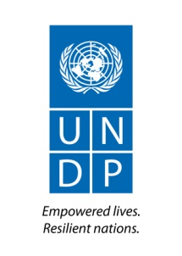
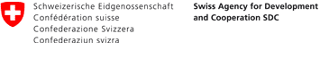

Project “Strengthening Representative Bodies
in Mongolia”

MID-TERM REVIEW
Final Report

December 2018

Project information

Project Title | “Strengthening Representative Bodies in Mongolia” project
Country | Mongolia
Implementing Partner: | Parliament Secretariat, Parliament of Mongolia, jointly with the UNDP and with support from the Swiss Agency for Development and Cooperation (SDC)
Project Start date | January 2017
Project End date | December 2020
Total resources | UNDP TRAC: $ 500,000  Donor SDC: $3,300,000  Total $3,800,000
Reporting Period | January 2017 to November 2018
Contributing Outcome (UNDAF/CPD): | By 2021, governing institutions are more responsive and accountable to citizens, while ensuring effective participation of young people and realisation of the rights of the poor and marginalised.
Brief Description | The promulgation of the new constitution in 1992 marks the beginning of the emergence of local self-governing bodies in Mongolia. Citizens Representatives Hurals (CRHs) have become a stable institution and played an important role in the consolidation of democracy. However, challenges remain in making them truly representative of local people, as a responsive and accountable institution. The legal framework established in the early transition period has not kept pace with the country’s social, economic and political transformations. Laws are approved without sufficient consultations with local authorities, thus making their implementation difficult at the local level. The organizational capacities of CRHs are constrained by limited resources available at their disposal, unclear mandates and lack of overall guidance. With significant turnover of the CRHs’ members, there is a continuous need to update the knowledge of their duties and responsibilities as elected representatives. At the same time, citizens’ ability to demand accountability from elected representatives is limited due to their low awareness about the functioning of local self-governing bodies, which make important decisions affecting their lives.  The Project’s aim is to address the above challenges by adopting a comprehensive three-pronged strategy for capacity development of local self-governing bodies, addressing simultaneously the interrelated levels of legal and institutional environment, the organisational capacity of CRHs including individual competencies as locally elected representatives. In addition, the Project will assist the Parliament of Mongolia in translating recent laws and policies into concrete actions aimed at creating opportunities for meaningful citizen participation in decision-making, mobilising support of CRHs in awareness raising and monitoring the implementation of recently approved laws. In turn, this would result in the increased effectiveness of laws by translating policy declarations to concrete impacts at the citizens’ level. The Project builds on the foundation laid by the “Support to Participatory Legislative Processes” and “Capacity Strengthening of Local Self-governing Bodies” projects, both implemented by the Parliament Secretariat with support from UNDP and SDC from 2013-2016.
Outputs | The project is articulated around four main “Outputs”:  - Improved legal framework for local self-governance.  - Citizens’ Representative Hurals have improved organizational capacity.  - National training program for local elected representatives is institutionalized.  - Improved capacity of the Parliament Secretariat to support representative bodies.
UNDP Contact Person | Daniela Gasparikova  Deputy Resident Representative  UNDP Mongolia  Email: daniela.gasparikova@undp.org  Tel: 976-317585 (1111)  Website: www.mn.undp.org  Facebook.com/undp.mongolia

Acknowledgements and disclaimer

The Mid-term review provided a ring side view of capacity development of local self-governing bodies in Mongolia. It was an engrossing experience.
I thank all project stakeholders who met with the MTR team for one on one discussions, group discussions, for sharing with us their thoughts and perspectives. In particular, I thank all the representatives from the Aimags, Soums, Districts that we met and the citizens who travelled (some long distances) to meet with us for a couple of hours. These were very valuable exchanges and informative.
We are particularly thankful to Mr. Tsolmon Tsedev, the National Project Director for making time for us in the midst of his heavy parliamentary schedule. Our special thanks to Mr. Byambasuren Urgamal, Deputy Chief of the Cabinet Secretariat for meeting with us.
The project team provided outstanding support; from taking care of logistics, to explaining different facets of the project, updating information, providing all possible documents available in English, and consistent back up for preparing this document. Barkhas Losolsuren, Zoljargal Gantumur and Camille Barras, a big thank you for the professional manner in which this was done. And also, to the other staff of the team who supported this entire effort. A very special word of thanks goes to our translator Batjargal Khishigsuren.
I thank my colleagues of the MTR team, Liliane Tarnutzer and Patrick Duong for the perceptive and simulating discussions that we had and for educating me in the process.
The content of this report is the sole responsibility of the consultant and can in no way be taken to reflect the views of the United Nations Development Programme, authorities in Mongolia, nor those of any other party. All efforts have been made to ensure that the information presented here is correct, and any factual error that may appear is unintended and is the sole responsibility of the consultant.

Dr. Cherian Joseph
New Delhi
17 December, 2018

Table of Contents
 | Title | Page
 | Project information | 2
 | Acknowledgements and disclaimer | 4
 | Table of contents | 5
 | List of abbreviations and acronyms | 7
 | Executive summary | 8
1 | The background: the country and the project | 15
1.1 | Country background | 15
1.2 | The past foundations | 17
1.2:1 | - Strengthening Representative Bodies in Mongolia (SRBM) | 17
1.2:2 | - SRBM objectives | 17
2 | MTR objectives | 18
3 | MTR methodology | 18
3.1 | Limitations of the MTR | 20
4 | The evaluation principles | 21
5 | Project findings | 21
5.1 | Output 1 Improved legal framework for local governance | 21
5.1:1 | - Progress results | 22
5.1:2 | - Challenges | 23
5.2 | Output 2 Citizens’ Representative Hurals have improved organizational capacity | 23
5.2:1 | - Progress results | 24
5.2:2 | - Challenges | 26
5.3 | Output 3 National training programme for local elected representatives is institutionalized | 27
5.3:1 | - Progress results | 28
5.3:2 | - Challenges | 30
5.4 | Output 4 Improved capacity of the Parliament Secretariat to support representative bodies | 30
5.4:1 | - Progress results | 31
5.4:2 | - Challenges | 32
6 | Critical cross cutting themes | 33
6.1 | The marginalised, rural poor, youth and women | 33
6.1 :1 | - Progress results | 33
6.1:2 | - Challenges | 34
6.2 | Project communication | 34
6.2:1 | - Progress results | 34
6.2:2 | - Challenges | 34
6.3 | Monitoring & Evaluation (M&E) | 34
6.3:1 | - Progress results | 34
6.3:2 | - Challenges | 34
7 | Conclusions | 35
7.1 | Some distinct features | 35
7.2 | Project relevance | 36
7.3 | Effectiveness | 37
7.4 | Sustainability | 38
8 | Recommendations | 39
8.1 | Citizen engagement | 39
8.2 | Strengthening training for hurals | 40
8.3 | Small grants scheme | 40
8.4 | Youth, vulnerable and marginalised | 41
8.5 | Institutionalisation of www.khural.mn | 41
8.6 | Project communication | 41
8.7 | Project management | 41
8.8 | The Parliament Secretariat | 42
Annexures
Annex 1 | Theory of change | 43
Annex 2 | Guiding questions | 44
Annex 3 | Documents accessed / List of persons interviewed / MTR Team | 47
Annex 4 | Responses from group exercises | 49
Annex 5A | Key results of CRH grant projects, 2017 | 53
Annex 5B | Citizens’ Representative Hurals and NGOs that received grants, 2018 | 56
Annex 6 | Women’s leadership in local government training report by MonFemNet | 59

List of abbreviations and acronyms

Abbreviations / Acronyms | Expanded form
AMLA | Association of Mongolian Local Authorities
CSLSB | Capacity Strengthening of Local Self-Governing Bodies project
CRH | Citizens’ Representative Khural
LATUG | Law on Administrative and Territorial Units and their Governance
LDF | Local Development Fund
MALA | Mongolian Association of Local Authorities
MOJHA | Ministry of Justice and Home Affairs
NAoG | National Academy of Management
NAMBS | National Association of Mongolian Baghs and Soums
NPD | National Project Director : Secretary General, Secretariat of the Great State Hural
PS | Parliament Secretariat
PIU | Project Implementation Unit
SDC | Swiss Agency for Development and Cooperation
SSCS | Standing Committee on State Structure of the Parliament of Mongolia
UNDP | United Nations Development Programme

Executive summary
Introduction
The Strengthening Representative Bodies in Mongolia (SRBM) project builds on the groundwork laid by the “Support to Participatory Legislative Processes” and “Capacity Strengthening of Local Self-governing Bodies” projects. The two projects were implemented by the Parliament Secretariat with support from UNDP and SDC from 2013-2016. The projects provided technical support for local khurals to improve their role as overseers of local authorities and public resource utilisation and assisted Parliament in improving legislative drafting processes through policy analysis and stakeholder dialogue and the increased access of citizens to their elected representatives.
The SRBM project has adopted a comprehensive three-pronged strategy; capacity development of local self-governing bodies- addressing simultaneously the interrelated levels of legal and institutional environment, and enhancing the organisational capacity of Hurals as well as the individual competencies of local elected representatives. These interventions are “intended to reinforce each other’s impacts and create synergies at the outcome level – ensure project contributions towards making governing institutions more responsive and accountable to citizens.” These were organized around the following four outputs:
1. Improved legal framework for local self-governance.
2. Citizens’ Representative Hurals have improved organisational capacity.
3. National training programme for local elected representatives is institutionalized.
4. Improved capacity of the Parliament Secretariat to support representative bodies.

MTR Objectives
The objectives of this Mid-term review (MTR) of the SRBM project was, “to assess the relevance, effectiveness, efficiency, and sustainability of the SRBM project in its first two years of implementation (2017-2018). A particular focus”, it emphasised “should be laid on the progress made towards the achievement of the project outcomes and towards institutionalization, while ensuring to encompass as well as considerations of relevance, validity, project management and implementation. Based on the findings of the assessment, the MTR is to establish practical recommendations on the adjustments of activities, outputs, approaches, structure and strategies to be undertaken for the remainder of the project duration until the end of 2020.”
“The MTR should draw on a balanced combination of assessment methodologies and data collection tools, including desk reviews, key informant interviews, focus group discussions and / or participatory workshops, direct observation (field visits), etc.”
The Consultant is expected to “adopt a collaborative and participatory approach thereby ensuring close engagement with all relevant stakeholders. Consultations and interviews conducted during the in-country mission should thus involve a sufficiently broad and representative range of stakeholders who have project responsibilities and / or benefit from the project.”
MTR methodology
This review was guided by multiple methodological approaches. The review was firmly committed to a collaborative and participatory approach. The review sought to provide adequate space for the project unit and the stakeholders to engage with the review team. It sought the active participation of the project team in providing of data, analysis of data, in seeking insights from their experience and to be present in discussions with Hural representatives and citizens. Desk study, interviews / meetings with stakeholders at their institutions, one on one interviews with senior officials in the government and other key informants, direct observation through two days of field visit, and extensive discussions with the project team and within the MTR team are what this review is based on.
The team visited aimags, soums, and district hurals. To facilitate active participation of stakeholders (citizens and elected representatives) and to enable them to express themselves freely, group work exercises were conducted at many meetings. These group exercises required dialogue between participants before they shared their understanding with the MTR team on the questions posed to them. The questions focussed on how hurals have changed and serve citizens better, whether elected representatives have acquired greater capacity post training, the capacities acquired through the training, etc. This process provided insights and more informed understanding.
The guiding questions prepared in advance of the mission provided the orientation for our interaction and reflection. The report reviews the project outputs through the lenses of relevance, effectiveness, and sustainability. In the review of sustainability, it primarily reflects on institutionalization as a measure that is particularly important for the future of the representative bodies.
Important findings and conclusions
The SRBM project embraces a wide span of work. It is based on a thoughtful collaboration with stakeholders in which the Parliament Secretariat is the co-architect to accomplish the project outputs. Certain distinct features define the working of the project.
Project outputs have their respective activity focus. But in the pursuit of an activity the project reaches out to varied stakeholders to build agreement on issues. This is evident in numerous instances, whether it pertains to the LATUG revision consultations which were held at different levels of administrative units, including bagh, soum and aimag, with participation of representatives of both local governments and local self-governing bodies or in preparing the handbook for CRHs to apply the Law on General Administrative Procedure (LGAP). This outreach to multiple but relevant stakeholders to build consensus is a distinct feature.
The continuous bringing together of different stakeholders to share, discuss and contribute to the decision making for recommendations, for finalizing procedures, etc., has contributed to responsible collaboration. This has taken time and effort but it contributes to transparency and facilitates long term commitment. It builds an enabling environment for meaningful participation by stakeholders, and sets a point of reference and exemplar for stakeholders in their practice. This ability of the project to facilitate collaborative working has been another distinct feature of its work.
In bringing stakeholders together for various activities, the project has promoted and supported partnership building. The task groups of hural secretaries, or the partnership between PS and SPS are examples of this. Some partnerships are manifest. However, there are valuable connects being formed at an informal level which hold the seeds for partnerships – as in the case of women representatives who have formed forums of their own. Similarly, the interaction opportunities organized for stakeholders are triggering connects which are contributing to working relationships. While some of these connections may happen at individual, and in some cases at organizational level, these are building a culture of engagement between stakeholders, independent of the project. This paves the way for partnerships.
The project activities require participation of many institutions and individuals holding different positions in organisations. The seriousness demonstrated in their participation underlines that stakeholders from varied backgrounds are willing to commit time for project activities, and that there is a latent but serious interest in wanting to be better equipped for local self-governing bodies. This is valuable capital for the project, but more valuable capital for decentralization and the continuing development of local bodies. It also reflects on the shepherding the project has done over the last two years, and having built well on the foundations laid by the earlier projects.

Project relevance
- The relevance of the project is anchored in the conditions that prevail. Reforms are still happening. It is work in progress. Political conditions are dynamic and democracy is at work. The contribution of the project is immensely appreciated.
- There is strong commitment expressed to the reform process, whether in working for and / or supporting activities for the LATUG revision to happen, the signing of the Memorandum of Understanding (MoU) by the National Academy of Governance (NAoG) to “institutionalize and maintain the national training programme for strengthening capacity of representatives of Citizens’ Representatives of Khurals”, the extending of technical support to over 360 sub-site administrators for the maintenance of www.khural.mn website by the Cabinet Secretariat, the seeking of further training for hural secretaries and presidium members, etc.
- All of these and many more underlines that both in sharing or adopting responsibilities to steer project activities and in seeking further defined capacity building, the key stakeholders perceive the relevance of the project to the future of decentralization and local governance reforms. It is not just spoken of but there are actions that back such statements. These actions are not being rushed. The political process is not being bypassed.
- The outputs of the projects are very much aligned to completing the unfinished reforms “which involves continuous efforts to enhance and implement the legal framework, while at the same time strengthening capacities of local authorities as well as citizens’ demand for accountability.”

Effectiveness
- Objectives across the outputs are being effectively achieved. The present position on LATUG revision is that the concept note prepared by the legal firm has been submitted to the Parliamentary Working Group on decentralization. This significant progress ensures that the Working Group has the necessary input for it to take it forward.
- Members of the Great State Hural and technical staffers from the Working Group for Constitutional revision, a key body for actualizing reforms, have been exposed to practices in Finland and Japan to update their knowledge of relevant features of other local governance systems. These would be considered as they work on the reform process.
- The large picture that emerges on hurals is that capacities of hurals are on an upward growth slope. For a nation with a history of centralized government, the range of inputs have led to a gradual but definite change in mind sets, from non-participatory decision making to participatory decision making. These are small steps in the right direction
- The organizational capacities of hurals have been significantly enhanced over the last two years. Model meeting procedures have been completed. The process of adopting the procedures is in progress.
- Small NGO grants have broadened the pool of experienced NGOs working with local self-governing bodies, providing capacity building to NGOs and hurals. National NGOs have become more acquainted with local level governance processes and challenges, while hurals have benefited from the expertise the NGOs bring.
- The objective of providing a handbook to CRHs to apply the Law on General Administrative Procedure (LGAP) has been achieved.
- The institutionalization of the website www.khural.mn with the Cabinet Secretariat of the Government of Mongolia was done in 2017.
- Output 3 has seen strong achievements. This includes the National training programme for local elected representatives being institutionalized at NAoG with the MoU signed between NAoG and UNDP.
- The network of trainers has been consolidated. It is still to reach the planned figure. The National Induction Training of elected representatives of all levels of hurals achieved over 90% participation. Attendance rates saw a clear improvement from earlier years.
- The leadership training was first provided to city, district and aimag representatives / presidium members. Subsequently the leadership training covered in 2018 soum presidiums around half the aimags and women’s leadership training has covered all hurals.
- Capacity development has been marked by the continuous effort to improve methodological inputs for trainers, continuing inputs on designs, and the updating of curricula. There is demand from different stakeholders for further capacity building. Using participatory and didactic methods has led to greater internalization.
- Capacities of the stakeholders have been developed in numerous ways through all these inputs. Capacity building has covered a wide gamut of interventions relevant to the varied stakeholders. This includes technical capacity building and individual orientation and competency development of the elected representatives as highlighted above. The evidence is that the relationship between law, the elected representative, the citizen and the government functionary is well recognized and understood better. Elected representatives are thus appropriately capacitated to support the reform process, in particular their role in making hurals become more responsive and accountable.
- The project management team (PIU) has done remarkable delivery with a very lean team who are involved with the project activities / outputs. Multiple directions of coordination, ranging from training management, support for legal drafting, to knowledge exchange and technical capacity building and coordinating with a variety of stakeholders has been managed competently. The effectiveness is reflected in the wide array of results.

Sustainability
- The project has all through focussed on sustainability. The project Sustainability Plan provides a guide map.
- In providing inputs for the revision of the LATUG law the project has focussed on facilitating dialogue and building agreement. As narrated in the findings above, it has reached a critical stage. If the efforts do not lead to a revised LATUG law or assuming that the Law does not happen in this present house, the technical support provided by SRBM could continue serving for passing the law post 2020 elections (if not passed before).
- Overall, the dialogue process of multiple consultations to build agreement, to firm up documents, to plan for dissemination etc., provides learning for all stakeholders on the importance of information sharing and how greater transparency and accountability are accomplished in action. The consultative process builds ownership and commonly acknowledged institutional reference for future action. This anchors sustainability.
- Hurals are more strongly anchored now. Model procedures for functioning and the handbook for CRHs to apply the Law on General Administrative Procedure (LGAP) are in place. These constitute substantive steps in the institutionalization process.

- Feedback indicates that hurals attend to citizens. Citizens are being consulted. This citizen engagement which is in early stages embeds sustainability in the social context. While hurals have addressed the marginalised and poor, this needs more attention.
- NAoG has formalized its role in revision of the induction training. A Local Governance Training Hub is proposed at NAoG to both anchor the work taken up so far for local government development and also to set up a data base containing hural decisions, good practices of hurals, information on elected representatives, etc. A part of the institution’s budget is committed for training of hural secretaries. These actions embed institutional sustainability.
- A first, but important step in financial sustainability for hural capacity building was accomplished by 10 aimags in bearing around 28% of the cost for leadership training for Presidium members.
The collaboration between the Mongolian Parliament and the SPS builds bridges for future independent contact and professional exchange.

The project’s contribution to the Intended Outcome as stated in the UNDAF/Country Programme that “by 2021, governing institutions are more responsive and accountable to citizens, while ensuring effective participation of young people and realization of the rights of the poor and marginalized”, is addressed. The project is significantly contributing to making governing institutions more responsive and accountable to citizens.

Main recommendations
Citizen engagement
- To better address citizen engagement, the project should aim for synergies with SDC governance projects which focus specifically on citizen engagement.
- Aimags, soums, districts, etc. need to explore what they can do to increase citizen awareness and participation. NGOs should be involved in these exercises.
Strengthening training for hurals
- Hurals need higher level skill input in budget review, the planning function, legislative oversight, etc. These can be addressed through thematic training programmes. Cost sharing possibilities need to be considered.
- Hural secretaries and presidium members who are at the core of hural functioning need to be focussed on more in the remaining years. Greater focus is required on their administrative work to develop greater effectiveness / efficiencies in the discharge of responsibilities to hurals and citizens.
- Given the importance of the bagh level as the lowest tier of governance, to ensure that citizens’ needs are reflected adequately in soum and aimag level planning, it is recommended that the aimag level takes on the responsibility to train the Chairs of bagh General Meetings.
- It is an opportune moment to discuss and develop criteria for cost sharing of training costs and to implement in practice. The working groups of aimag and districts hural secretaries can be tasked to discuss and work out steps to take this forward.

Small grants scheme
- Small grants have significantly contributed to hural capacity development and greater citizen engagement. Given the difficulties that some hurals have faced in the present round of small grant projects, it is recommended that hurals be twinned with appropriate NGOs or local resource person/s to support project implementation. Local resource persons would be better connected in the change process.
- The grants made available to NGOs by the small grant scheme need to be increased. It is recommended that the project makes available fewer grants, but larger amounts with multi-year applicability. This needs to be done with due care not to increase transactions costs. Such support over a longer period of time would increase citizen awareness.
Youth, vulnerable and marginalised
- The project’s aims with regard to improving inclusiveness should be clarified first before strategic entry points are identified. It is recommended to establish synergies with existing projects that target the poor and marginalized. It may provide a catalyst to greater participation by youth. The grant scheme might provide for opportunities to address issues of inclusion more prominently.
Institutionalisation of www.khural.mn
- The website needs further updating and technical support. The website is the most visible dimension of hural developments and actions and adds value to the effectiveness of project dissemination.
Project communication
- A comprehensive MIS on the number of participants who undergo training by level of hurals, by region, kind of programme, gender, age, etc. is required. This would provide a baseline for future. This can be incorporated with the Training hub proposed by NAoG.
- The project has achieved much in capacity building. A document that captures the journey of capacity building in strengthening representative bodies, in building individual and institutional capacities and its impact on the functioning of hurals, is necessary for institutional memory, for dissemination and for reflection.
- The PIU requires technical support for strengthening both M&E and communication.
Project management
- It is recommended that to further strengthen capacities in technical guidance and advocacy for local governance in the project, a senior professional be appointed as an Advisor / Consultant. The individual should have a strong background in local governance and be well acquainted with Mongolian law and practice. The individual should preferably be a Mongolian national. This is not suggested as a permanent advisor/ consultant, but to provide critical backstopping support when required.
- For strengthening ownership of the PS in activities that needs its attention, such activities may be included in the work plan of the Parliament with allotted responsibilities.
- The present UNV leaves early next year. The recruitment of the new UNV be initiated at the earliest.
- A local consultant be hired to reinforce the M&E and also support documentation. Short term consultancy may be considered.

The Parliament Secretariat
- The ownership of the PS in activities under its oversight needs to be more manifest to stakeholders. Greater visibility of its contribution and leadership to strengthening hurals as representative bodies would immensely serve sustainability and motivate greater participation of stakeholders.

1. The background: the country and the project
1.1 Country background
Mongolia is a unitary state with a central government and three tiers of sub-national governments. The territory of Mongolia comprises of 21 aimags and the capital city, with a total of 330 soums and 1612 baghs (rural) and 9 districts and 152 horoos (urban). According to the Constitution of Mongolia, the administrative and territorial units are organised on a combination of both self-governance and state administration. The Constitution defines self-governing bodies in aimags, the capital city, soum and districts as Citizens’ Representative Hurals (CRH) (referred hereafter as hurals) of their respective territories; in baghs and horoos as general meetings of citizens. Currently, there are over 8000 elected representatives in the aimag, capital city, soum and district CRHs.
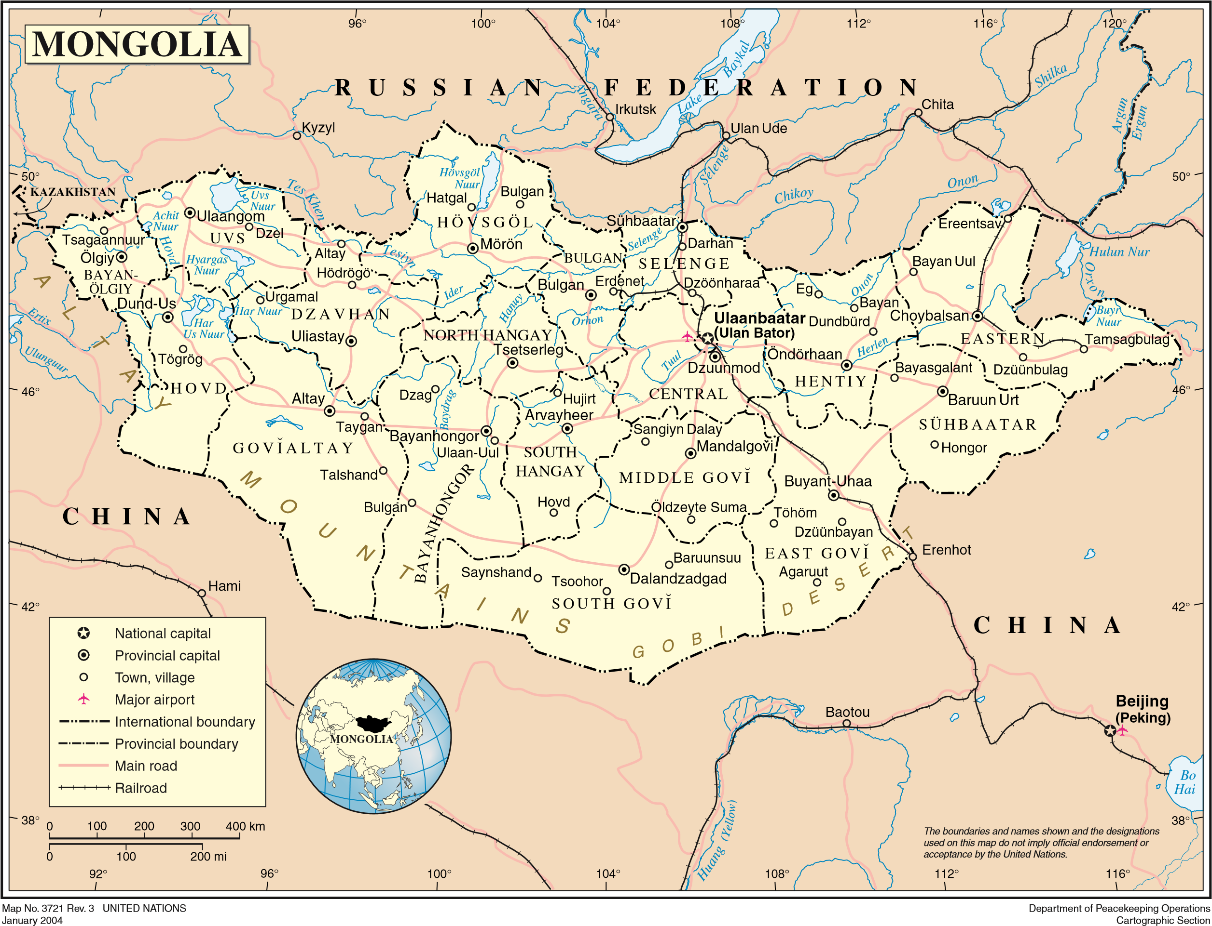 Figure 1
A landlocked country, between Russia to the north and China to the south, Mongolia is 1,564,116 square kilometres (603,909 sq mi) in size, the 18th-largest and the most sparsely populated unitary sovereign state in the world. It has a population of only 3,031,330 (as of July 1, 2016) and only 1,990,787 voters across the country (as of July 9, 2017) with an average voter turnout of 72.88%. The population density, as compiled from official sources indicates a population density in midyear as divided by land area in square kilometres as 1.9487 per sq. Km in 2016.
Mongolia has been a functioning dynamic democracy for the last 28 years. “Mongolia is widely viewed as a stable democracy and free country with a market based economy, in which human rights are well-respected, the media is free, and genuine political competition exists. The next test of Mongolia’s democracy is how well the country can transform the enormous development potential of its vast mineral wealth into inclusive and sustainable growth. At this crossroads of its development, Mongolia approved a new long-term development vision for the country – Sustainable Development Concept of Mongolia till 2030 – in February 2016, which is firmly anchored in the global 2030 Agenda for Sustainable Development. The vision’s declared objectives are to “increase economic growth, eradicate poverty and reduce inequality, increase educational attainment, improve life expectancy, preserve the ecological balance, improve the country’s business environment, and build a governance system that is professional, stable and participatory and free of corruption.”
“A key factor for success in this regard is the continued deepening of democracy and strengthening of key institutions to enable people’s voice to be taken into account in decision making and to ensure accountable government institutions delivering sustainable development and inclusive services. Rebuilding trust in political institutions and changing citizens’ view of their government in treating them fairly, being democratic and associated with economic success is of fundamental importance for governance in Mongolia today.”
“With this in mind, the UN System (including UNDP) in Mongolia defined one of the strategic priority outcomes for Mongolia as: “By 2021, governing institutions are more responsive and accountable to citizens, while ensuring effective participation of young people and realisation of the rights of the poor and marginalised”. SDC’s Country Strategy for Mongolia is “to contribute to equitable and sustainable social and economic development in Mongolia” by “fostering effective, efficient and fair local governments, satisfied citizens, and a genuinely representative and effective civil society”.
World Bank reports social indicators have improved. On the economic side, “after a sharp slowdown during 2014-16 driven by a fall in commodity prices and declining FDI, the Mongolian economy strongly recovered in 2017 and 2018H1. GDP growth rate increased from 1.2 percent in 2016 to 5.3 percent in 2017 and 6.3 percent the first half of 2018.” The same report also states that “growth outlook remains positive in 2018 and beyond, mainly supported by robust growth in private consumption and private investment in mining and manufacturing. Short and medium term risks to the outlook include political uncertainty, commodity shocks, border bottlenecks, and poor handling of money laundering issues.”
The report goes on to note “Improving household incomes in 2017-2018H1 and positive outlook augur well for poverty reduction after the 2016 increase.” The report also then underlines that “To ensure sustainable and inclusive growth and to reduce poverty, Mongolia will need to strengthen governance; build institutional capacity to manage public revenues efficiently; allocate its resources effectively among spending, investing, and saving; and ensure equal opportunities to all its citizens in urban and rural areas. It needs to do this in a manner which protects the environment and intergenerational equity.”
The case of the project for the deepening of democracy and strengthening representative bodies is clearly well founded.

1.2 The past foundations
Before expanding on the project design of SRBM it will be relevant to briefly touch upon the previous work in Mongolia of SDC and UNDP that laid the foundations for the present project.
1.2:1 Strengthening Representative Bodies in Mongolia (SRBM), builds on the groundwork laid by the “Support to Participatory Legislative Processes” and “Capacity Strengthening of Local Self-governing Bodies” projects, both implemented by the Parliament Secretariat with support from UNDP and SDC from 2013-2016. Parliament Secretariat was the implementing partner for both projects.
These efforts to strengthen democratic processes and bodies began in 2013 when SDC entered into a partnership with UNDP “on the Capacity Strengthening of Local Self-Governing Bodies (CSLSB) Project.” The project provided “technical support for local khurals to improve their role as overseers of local authorities and public resource utilisation”. The SDC and UNDP also backed the project on Support to Participatory Legislative Processes (SPLP) Project “to assist Parliament in improving legislative drafting processes through policy analysis and stakeholder dialogue and the increased access of citizens to their elected representatives. In 2015, the Law on Legislation was adopted with SPLP support, setting benchmarks in the drafting of legislation, legislative oversight and making public consultations on draft laws mandatory.” The passing of the Law on Legislation was a major mile stone in this collaboration with the Government of Mongolia.
In the CSLSB terminal report at the close of that project the author writes that, “The project interventions covered one term of local elected bodies (4 years). To build the capacity of elected bodies, to attract committed elected representatives and a cadre of competent staff who could effectively deliver good local public services, engage local people, that meet high standard of public service is a long-term endeavour. The next phase is justified on the ground for reinforcing successes achieved through the first phase, fully institutionalize the initiatives such as the national training programme and integrated website and assist in undertaking the required legal reforms in the area of local governance.”
1.2:2 SRBM objectives
SRBM building on past achievements focusses making “Mongolia’s sub-national local assemblies more responsive and accountable to citizens, ensuring youth participation and realising the rights of the poor and marginalised. A comprehensive capacity-development strategy will be implemented that addresses the legal and institutional environment, the organisational capacity of local councils and the competencies of locally elected politicians. Gender equality and pro-poor approaches are mainstreamed in the project’s design and in its results framework.”
The project hence adopted a “comprehensive three-pronged strategy for capacity development of local self-governing bodies, addressing simultaneously the interrelated levels of legal and institutional environment, the organisational capacity of hurals as well as the individual competencies of local elected representatives. In addition, the project will assist the Parliament of Mongolia in translating recent laws and policies into concrete actions aimed at creating opportunities for meaningful participation by citizens in decision-making, mobilising support of hurals in awareness raising, monitoring of implementation of recently approved laws, thus increase the effectiveness of these laws at the citizens’ level. These interventions should reinforce each other’s impacts and create synergies at the outcome level – ensure project contributions towards making governing institutions more responsive and accountable to citizens.” These translated into the following four outputs:
1. Improved legal framework for local self-governance.
2. Citizens’ Representative Hurals have improved organisational capacity.
3. National training programme for local elected representatives is institutionalized.
4. Improved capacity of the Parliament Secretariat to support representative bodies.

The Theory of Change captures this scenario and the progress from inputs to outputs, to outcome and impact comprehensively (see Annex 1).
2. MTR objectives
The objectives of this Mid-term review of the SRBM project as articulated in the Terms of Reference (ToR) of this consultant are, “to assess the relevance, effectiveness, efficiency, and sustainability of the SRBM project in its first two years of implementation (2017-2018). A particular focus should be laid on the progress made towards the achievement of the project outcomes and towards institutionalization, while ensuring to encompass as well as considerations of relevance, validity, project management and implementation. Based on the findings of the assessment, the MTR is to establish practical recommendations on the adjustments of activities, outputs, approaches, structure and strategies to be undertaken for the remainder of the project duration until the end of 2020.”
The TOR further states that “the MTR must provide evidence-based information that is credible, reliable and useful. The SRBM project is open to and interested in using a variety of evaluation methods that contribute evidence to the guiding questions listed below and allow for triangulation of findings.” Towards this end the guiding questions initially provided by the project team in the ToR were worked on by this Consultant, shared with MTR team members and rearticulated to provide a ready reference for steering discussions and interviews with stakeholders and beneficiaries (see Annex 2).
3. MTR methodology
The ToR stressed that “the MTR should draw on a balanced combination of assessment methodologies and data collection tools, including desk reviews, key informant interviews, focus group discussions and / or participatory workshops, direct observation (field visits), etc.”
The Consultant is expected to “adopt a collaborative and participatory approach thereby ensuring close engagement with all relevant stakeholders. Consultations and interviews conducted during the in-country mission should thus involve a sufficiently broad and representative range of stakeholders who have project responsibilities and / or benefit from the project.”
This review was guided by multiple methodological approaches. The review was firmly committed to a collaborative and participatory approach. The review sought to provide adequate space for the project unit and the stakeholders to have an active role in sharing with the review team. It sought the active participation of the project team in providing of data, analysis of data, drawing out insights from experience and to be present in discussions with Hural representatives and citizens. The MTR has drawn from document study, the many interviews / meetings with stakeholders at their institutions, one on one interviews with senior officials in the government, direct observation through two days of field visit, and expansive discussions with the project team and within the MTR team (see Annex 3 for list of documents and list of persons interviewed).
In our visits to aimags, soums, we organised group work exercises with stakeholders (citizens and elected representatives). Where there were large groups present, of more than 10, whether of citizens or of citizens and elected representatives and other stakeholders, we divided the large groups into smaller groups. The group would be briefly informed of the purpose of the review and the purpose of their participation. Then questions would be presented to be commonly discussed in each sub group. After they had spent sufficient time to discuss the issue between themselves, they would be asked to write the main points on flipcharts provided to them. This process generated dialogue between themselves before they shared their understanding. It provided a more informed response to the questions posed. The statements written in Mongolian would be quickly translated into English for the MTR team. These then provided a basis to ask further questions to the assembled group.
Usually there were three rounds of questions posed to the subgroups for them to share their thoughts. This manner of interaction triggered animated discussion and expression of views in the sub groups. Participants answered drawing from their experience. The plenary discussion that followed provided the platform for us to ask contextualised queries on what had been achieved, how it would be sustained, and how hural representatives contributed.
Where we met with smaller groups, the interaction would open with an introduction of the MTR team and the purpose of the meeting. This would be followed by the local authorities sharing about their work. The MTR team would then have a discussion with the group on the basis of questions discussed between us in advance and deriving from the guiding questions.
The MTR team (see Annex 3 for information on MTR Team) along with project team visited the following soums, aimags, district for interaction in the field with elected representatives, citizens, and officials at the respective levels. All interactions outside Ulaanbaatar took place in the aimags of Selenge and Tov.

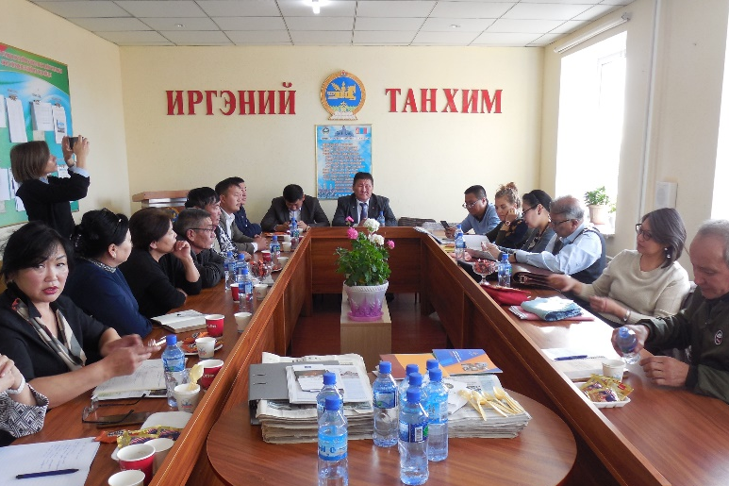
- At Javkhlant soum, Selenge aimag met with representatives from Javkhlant, Eroo and Shaamar soums (2-3 Reps and 2 bagh Chairs from each of the soums: total 12-15 participants). Group interaction.
- At Sukhbaatar (aimag center of Selenge) met with representatives from the aimag hural for group discussion.
- Subsequently met with citizens from the same aimag for a group discussion.
- At Bayanchandmani Soum, Tov aimag: met with citizens and conducted a group exercise.
At Javkhlant soum, Selenge Aimag
- Met with soum hurals, Bagh Chairs and grant recipients from Bayanchandmani, Bornuur, Jargalant, Altanbulag soums of Tov aimag: group discussion (close to 25 participants).
- At Khan-Uul district, UB City: Met with Chair of district hural, other elected representatives, and Secretary of the hural. Group discussion.

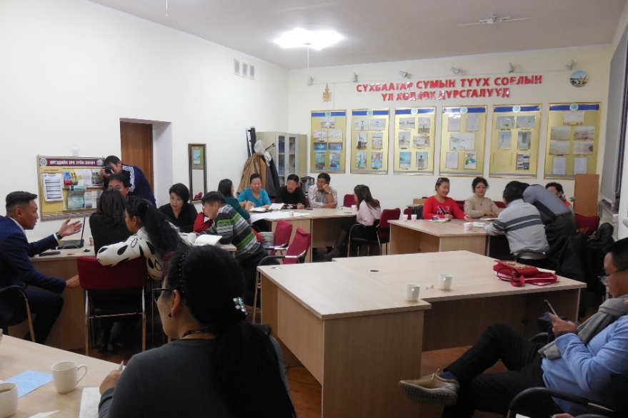
These meetings and discussions whether with officials, with elected representatives and citizens, or NGOs and consultants, did not just provide information about project progress, but more importantly they provided a vital sense of the working of democratic processes and the value attached to relevant and appropriate change to strengthen representative bodies. Those we met acknowledged the unique work of the project and recognised the definitive contribution in capacity building, in strengthening institutions, in supporting legal changes. There was positive recognition.
Group discussions underway with citizens from Selenge Aimag.

On the other hand, our interaction at grass root level with ordinary citizens revealed that they are perceptive of immediate local issues and effectively articulate their concerns. The groups we met consisted predominantly of those over 40/45 in age. And in all large groups there were equal if not more women. Youth participation was rare.

The translated charts of some of the group exercise discussions from aimags and soums reflect the ability of citizens to raise issues (see Annex 4).

3.1 Limitations of the MTR

This MTR report has some limitations.

The in-country mission was very short. The effective time available for meetings, interviews, field visits was effectively 4.5 days excluding the time for MTR team meetings and debriefing. This was tight.

It would have helped to meet some other actors particularly those who are members of the sub committees concerned with the LATUG law, officers from the Governor’s offices at aimags, and the Hural Secretariats. Even though secretaries of Selenge aimag Hural and Khan-Uul district hural were present in the respective group discussions, greater interaction with hural secretaries would have been useful.

We had limited interaction with NGOs, though the few we met were very valuable. And we did not get to meet with other development partners. The project team did their best to arrange for us appointments in the time available as effectively as possible.

Time permitting it would have also been useful to interact with territorially different aimags / soums from an entirely dissimilar region. But nevertheless, the in-country mission was fulfilling.

This report does not address financials. The MTR team had shared in the debriefing that “based on the documentation received an informed assessment on the projects financial sustainability nor cost effectiveness could be made”. A UNDP administered audit is conducted annually and internal audits are conducted twice a year by the Parliament Secretariat. These audits would provide sufficient information.

4. The evaluation principles
This report reviews the project through the lenses of relevance, effectiveness, and sustainability. In the review of sustainability, it primarily reflects on institutionalization as a measure that is particularly important for the future of the representative bodies. These terms are used as expressed in the OECD / DAC principles. The questions that have guided this review are presented below. These principles constantly steered and directed the thought frames, questions and analysis of the team.

Principles | Questions
Relevance | To what extent are the objectives of the program still valid? Are the activities and outputs of the program consistent with the overall goal and the attainment of its objectives?  Are the activities and outputs of the program consistent with  the intended impacts and effects?
Effectiveness | To what extent were the objectives achieved or are likely to be  achieved?  What were the major factors influencing the achievement or non-achievement of the objectives?
Sustainability | To what extent will the benefits of a program or project continue after donor funding ceases?  What are the major factors which influence the achievement or non-achievement of sustainability of the project?

5. Project findings
The following section provides a brief description of the key results under each of the outputs of the project. The key progress results are highlighted as these underpin the capacity development of local self-governing bodies, address the interrelated levels of their legal and institutional environment, and the organisational capacity development of hurals including individual capacity development of locally elected representatives. The key results reveal the multi-faceted spectrum of work and the range of stakeholders engaged with. It is against that background that perceived challenges are then articulated for each output.
5.1 Output 1. Improved legal framework for local governance

Interventions under this output will be centred around the LATUG revisions mainly. The project will provide the necessary technical support to the Standing Committee on State Structure and Sub-Standing Committee in developing a conceptual framework for the reform of local government system in Mongolia, reform options based on comparative analysis, consensus building on the conceptual framework through different means such as regional and national forums and online discussions.

Key interventions | Description
LATUG revision | Interventions under this output will be centred around the LATUG revisions mainly.
Issues based research | Build a knowledge base about the functioning of local governments, while providing substantive inputs into the constitutional debates and other legal reforms.
Create a space for dialogue | Create a space for representatives of local authorities for dialogue and debates with policy makers by organizing forums, TV and online discussions on topics of importance for local governments.

5.1:1 Progress results

LATUG revision

- The project has over the last two years made steady and valuable progress to this output. Numerous rounds of discussions were organised in 2017 with relevant experts. These discussions covered various aspects of local governance; the scope of LATUG and relations it regulates. Dialogue was arranged to “identify implementation challenges, and reflect suggestions for revised conceptual framework of the Law; these consultations were held at different levels of administrative units, including bagh, soum and aimag, with participation of representatives of both local governments and local self-governing bodies.” The contribution of these discussions was acknowledged by the Chairman of the Standing Committee on State Structure.

- A study supported by a team of local governance experts was commissioned in late 2017 for analysing the implementation of LATUG (Law on Administrative and Territorial Units and their Governance) and developing guiding principles for local governance legal revisions. The study is completed. The guiding principles developed in the study were presented to the Parliamentary Working Group on Decentralization earlier this year in June as well as to the Parliamentary Working Group for Constitutional revision consultations. This is a critical achievement.

- Following from this and as part of the planned activities a Legal Firm was hired to “(i) draft amendments of LATUG, (ii) prepare concept papers and draft amendments of related laws/ regulations, etc.”

- Currently, the Law firm has prepared the concept note for submission to the Parliamentary Sub Committee on decentralization.

- To further support this process, in March 2018, two separate parliamentary delegations comprising Members of Parliament and technical staffers serving in the Working Group for Constitutional revision consultations regarding State Structure travelled to Finland and Japan respectively, for a one week study visit. “The visits aimed to strengthen key decision makers’ knowledge of relevant features of foreign local governance systems in the view of the upcoming constitutional and policy reforms in Mongolia.”

Knowledge base
- “Municipal Law of Foreign Countries: Theory and Contemporary Practice” (2017) is being translated into Mongolian as part of the effort to build a knowledge base about the functioning of local governments and to provide a relevant reference.

5.1:2 Challenges
- In the Risk Log, “Lack of interest and political consensus on the revision of the LATUG”, is mentioned as a key risk. The risk management measures include, raising awareness about the need for reforms (through public debates, media advocacy, mobilize support from local governments through different fora). It also states that there should be “close engagement of UNDP and SDC senior management with Chairs of Standing Committees of the Parliament.”

This close engagement is necessary for building political consensus, an important condition for sustainability. The Board provides a platform for such engagement. However, to bring together the key policy makers who are not on the Board for building political consensus, the project can organize dialogue events where progress on this account is shared and actors encouraged to consider how they take it forward.

5.2. Output 2. Citizens’ Representative Hurals have improved organizational capacity

Interventions under this strategy will aim at improving the internal structures, policies and procedures, thus the effectiveness of hurals as an institution.

Key interventions | Description
Improved procedures of hurals | The functioning of the hural and its committees will be strengthened through streamlined procedures and application of newly developed template procedures based on best practices.
Improved quality of decisions by hurals | Develop a simplified manual or check list for resolutions to be passed by hurals. Practical guidance will be provided to hural secretariats through developing a manual of implementation of the LGAP.
Promotion of development of good practices related to hurals’ oversight and representation function | The project will make available 20 grants per year to hurals which will be provided on a competitive basis to oversee the executive’s performance in delivering government programmes aimed at poverty reduction to marginalised groups.
Institutionalisation of www.khural.mn | The project will continue to support further improvement and sustainability of the website by providing hural website managers with additional training; organizing moderated forums for hural representatives on selected topics; ensuring its sustainable continuation after 2020 through gradual handing over.
Performance management framework established | This new performance measurement framework aims to have a strong focus on supporting hurals to actively manage and improve their organisational performance.

5.2:1 Progress results

Output 2 addresses critical aspects of the functioning of hurals to strengthen them as representative bodies. The key progress is summed up below.

Strengthening hural capacities

- An achievement that has contributed significantly to strengthening hural capacities in the last two years is the completion of a model meeting procedure for hurals. It was developed in 2017 through multiple consultations held with a sample of soum, aimag, the capital city and Chingeltei district hurals, etc. A further survey was conducted in 120 soums, hurals of 13 aimags. Consequently, a total of 15 hural meeting procedures were reviewed, and a list of laws and Parliamentary resolutions being used in hural operations was prepared. The model meeting procedure was presented to hural secretaries earlier this year.

- In 2018 one of the six working groups formed from aimag and district CRH secretaries as task forces to cooperate on different project related responsibilities, customised through online consultations the standard meeting procedures and devised a plan to advocate the standard procedure for adoption by some aimag and soum hurals. Some soums committed to adopting the same.
- Subsequently in response to a letter sent in November 2018 to all aimag hurals, along with the improved procedure, requesting them to examine the possibility to have the procedure approved for both the aimag hurals and their soums, one aimag (Arkhangai) has adopted the procedure.
- The project formed six working groups of aimag and districts hural secretaries as task forces in early 2018 to take on responsibilities for:
- Mainstreaming of standard meeting procedures
- Support to hurals for updating www.khural.mn and finding solutions for funding for maintenance costs
- Establishment of training plans of soum hurals and funding for cost sharing
- Support to the development of a Performance Management Framework
- Support to application of Law on General Administrative Procedure
- Public awareness raising about hural functions

- A handbook for hurals to apply the Law on General Administrative Procedure (LGAP) was developed to assist hurals to fulfil their duties as stipulated in the LGAP. To prepare the handbook, a list of hural administrative acts registered with MOJHA was analysed, and consultations held across all levels of the local government structure. Court decisions related to hurals, Citizens’ General Meeting decisions were also analysed. Legal professionals from wider society, lecturers of administrative law, and lawyers in general were also invited to participate in consultations. The LGAP handbook also has been presented to hural secretaries.

Strengthening citizen engagement *
- From our group exercises during our field visits to aimags, soums, etc. we gathered that:
- Citizens acknowledge that hurals have shown greater responsiveness as demonstrated in:
- Public hearing being organized based on citizens’ requests;
    - Soum hural policy and decisions informed to citizens through representatives;
    - Hural representatives organize ‘Representatives listen to citizens’ campaign at their constituencies;
    - Hurals identify, analyse and prioritize issues brought up by citizens;
    - Bagh General meeting functions regularly and forwards citizens’ issues / proposals.
- Hurals have taken up specific activities including addressing livelihood needs of the community.
- Hural representatives acknowledge in turn that:
- Decisions are better informed by local / citizen requirements;
          - Community participation in the process of monitoring / oversight conducted by hurals increased at all hural levels particularly with regard to:
          - Budget;
          - Local Development Fund;
          - Soum Development Fund.
- On the other hand, the fact that citizens mentioned shortcomings also points to a strong ability by them to identify issues, and to raise them (see Annex 4 for details).

* (These are changes as compared to the earlier functioning of hurals prior to the training being imparted.)

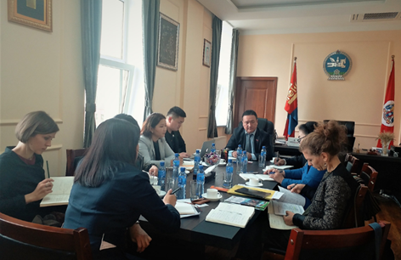 | 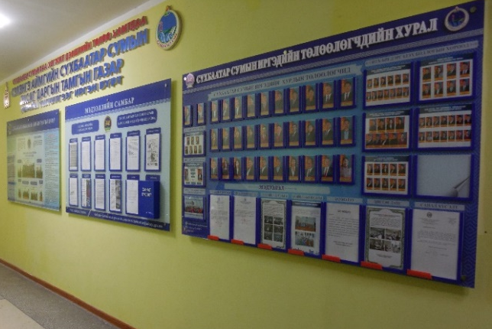
Meeting with Khan-Uul district hural | A corridor of information display at Sukhbaatar, aimag center of Selenge

Information dissemination
- At more than one venue (where we went) one was struck by the display of documents, photographs, graphs, etc, either in the corridors or in the meeting halls, of information related to the concerned soum, aimag, district, etc. At Khan-Uul district hural we were shown handouts prepared on some laws by the hural. The willingness to disseminate information, through such display practices promotes greater transparency and accountability in a small but significant way.

Small grant supported projects
- A key input in Output 2 has been the small grant support. The small grants are awarded to Hurals and NGOs to work on specific activities that contribute to development of institutional capacity in participation-based policy-making and monitoring of local services and improved decision-making and oversight capacity. In both 2017 and 2018 small grants have been awarded (see Annex 7 for details of Small grant awards). In 2017 the grant program resulted in the preparation of 16 procedural guidelines and four programs being developed by the Hurals. An end of grant workshop in 2017 resulted in a horizontal learning process between 2017 and former grantees. The interaction reinforced connections of hurals with non-profit organizations for capacity building purpose, and improved quality of several small grant proposals in 2018 (see Annex 5 for details on small grants).

Learning from the South - South experience
- In June 2018, a study visit in Poland was organised for nine aimag chairpersons. Another group of seven aimag hural chairpersons went to the Philippines under this South-South exchange. Both groups visited a number of local governance related institutions to learn from the local governance system and reflect on reform options in Mongolia.
An exchange of information between the two groups is now planned. Also representatives from this group of aimag hural chairpersons will inform the lawmakers and relevant stakeholders on their learnings from Poland and the Philippines local government system.

Website www.khural.mn
- Under the maintenance and content improvement of www.khural.mn, the website was institutionalized with the Cabinet Secretariat of the Government of Mongolia in 2017 and one of the working groups (referred to above) carried out a monitoring project for web pages administered by aimags and soums and drew conclusions for improvement in mid 2018. The IT department of the Cabinet Secretariat, under its mandate to provide professional and methodological support to hurals, has been extending technical support to over 360 sub-site administrators on a daily basis, taking initiatives to update the website, and thereby, contributing to its sustainability.

Performance management framework
- Consultants have been contracted for the Performance management framework.

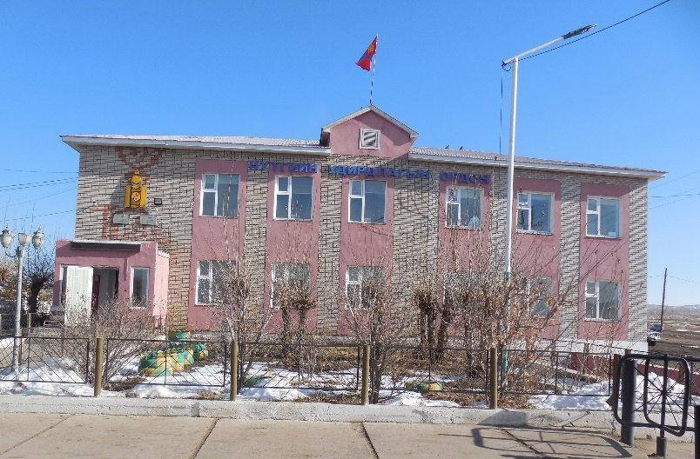
Bayanchandmani soum

5.2:2 Challenges
- In 2018 the small grants programme has seen a drop in the number of hural grantees working on the grant projects they took up. NGOs have on the other hand have been able keep the momentum. Discussions brought out that hurals have had difficulties pursuing these projects as there are no staff with them to conduct, organize and write up findings. This is a valuable intervention and requires to be strengthened. (Only the Chair and Secretary of hurals are employed staff of soum hural.)
- The law requires hurals to only meet twice in a year. Many hurals meet more often. Figures reported by hurals regarding the number of meetings held in 2017 ranged from 2 (minimum value) to 8 (maximum value), with an average of 3.33 for aimag hurals and 4.48 for soum hurals. Now that the participation of hural representatives in meetings, the orientation to local government are well addressed, greater focus can be placed on the core tasks in which they further strengthen hurals as representative bodies.
- Mainstreaming of the model meeting procedures by soums and aimags will need consistent support from the concerned working group and the Parliament Secretariat. The use of LGAP implementation guidelines also calls for consistent support from the legislative leaders.

5.3 Output 3. National training programme for local elected representatives is institutionalized

An elected representative is a position of responsibility. This is a challenging role with limited resources available to reach out their electorate and they have other duties besides being a representative. In order to be a competent elected representative and for carrying out such responsibilities, they need experience and skills. Elected representatives need to understand how local government works, how it relates to central authorities, local government’s legal rights and obligations and the opportunities and obstacles.

Key interventions | Description
Induction training for newly elected representatives | Induction training programme with a revised content will be offered to all elected representatives and chairs of bagh and horoo general public meetings in the first half of 2017.  Training programme will be continuously updated throughout the implementation of the project by the Academy of Management.
Leadership training programme | The content and methodology of the leadership training programme will be finalized during the current phase of the project. Leadership training will be offered to chairs and presidium members of hurals at all levels.
Women leadership training | A leadership programme for women in elected offices in order to motivate them to provide leadership in their communities and hurals, to stand for elections, seek common solutions to local problems and increase their ability to influence decision making process in hurals and eventually increase of number of women candidates and elected.
Thematic training modules made available | The project will expand the national training programme by developing additional short courses on topics that are identified by hurals as important and offered based on their demands, using different training methodologies such as video conferencing and online training.
Network of trainers expanded and maintained | The project will expand the number of trainers available per aimag, ensure that they continuously upgrade their technical knowledge and didactic skills.
Sustainability of the training programme | The Working Group, established by the Parliament Secretariat in 2016, will aim to develop options for institutionalization of the national training programme.
Increased citizens’ awareness about their elected representatives. | The project will support civic education activities aimed at increasing citizens’ awareness about the importance of elected representatives, functioning and performance of their representatives.

5.3:1 Progress results
Output 3 which focusses on “simultaneous improvement in and implementation of existing training modules and increased ownership of the national institutions complemented by commensurate budgets allocated to Hurals for training purpose” has made significant progress. The major aspects of progress in this output are briefly captured below.

Implementation of different trainings

- The project enabled the delivery of induction training to 7,377 hural representatives nationwide within the first six months after local elections to equip the newly elected officials with their key competences. UB city and aimags were covered in 2016 and soums and districts mostly in early 2017. Of the elected women, 89.7% attended this training.
- The National Induction Training for hural representatives was managed by the project in 2017 as also the revision its training curriculum. NAoG ran the Training of Trainers (ToT) for trainers and provided lecturers.
- A milestone was the nationwide training for bagh hural chairpersons together with soum hural secretaries who have to provide technical support to the former as provided in the law.
- Training was delivered to 180 presidium members (80%) of hurals of all 21 aimags of Mongolia in 2017. This included 89.4% of 38 women who are presidium members of aimag hurals.
- In 2018, 250 hural representatives from all districts and 1097 soum presidium representatives from ten aimags took part in a two day leadership training, with an attendance rate of around 90%. This was undertaken on a need basis by the concerned aimags on a cost sharing basis. It was organized to cater to the presidium members who are all elected representatives and manage work in between hural sessions.
- A Women’s Leadership Training (WLT) was organized for the 2,164 female CRH representatives across the country. This was done for the first time in Mongolia under the previous project phase (CSLSB). But in the present offer the WLT training curriculum was entirely revised. It was largely led by the NGO MomFemNet. The revision took into account lessons learned from the previous phase and recent legal changes. The new contents were upgraded with numerous real cases and examples. The WLT started in March 2018. It has now been conducted in all hurals: 21 aimags and their soums, and city and district hurals (see Annex 6 for a report on WLT).

Network of Trainers
- Another milestone in this journey were the efforts made to build the network of trainers and continuously contribute to the content and methodological development of trainers. A core of around 62 trainers are now available. They were selected during the Phase 1 of the project and are still on board. They supported the nationwide training for 7344 councillors and 1600 bagh hural chairpersons.
- They have undergone various trainings including participating with NAoG in refresher training of the Induction training.
- Another 30 trainers have undergone leadership ToT. The group includes those who were officially nominated by 21 aimag hurals in response to PIU call and includes NGOs. NGOs like MonFemNet have been actively involved. 48.4% of the trainers are women.
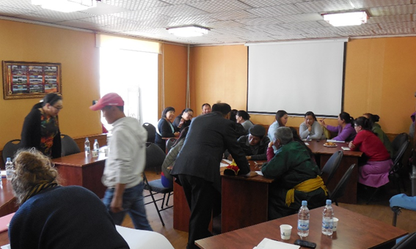

Group discussions with community at Bayanchandmani soum

Training materials
- The project developed a training programme and handbook for Chairs of bagh General meetings for the first time in the local government history of Mongolia. It covered 1,870 grassroots / community level officials. This included 97% of the 525 women who were elected as Chairs of bagh General Meeting. The training handbook for baghs contained a compilation of relevant legal provisions, templates commonly used for baghs, and other reference materials, such as pasture use agreement template. Neither such training nor training handbook for Chairs of bagh General Meetings had been provided before.
- Other materials prepared for training support include: leadership training handbook for trainers and participants, women leadership training handbook.
Institutionalization of the training programme
- In July 2017 an MoU was signed between the National Academy Of Governance (NAoG) and UNDP, “to institutionalize and maintain the national training programme for strengthening capacity of representatives of Citizens’ Representatives of Khurals” and outlined the activities which would be carried out during 2017, 2018, and 2019-2020. The MoU further articulated that the parties would conclude cost sharing agreements for this.
- This marked an important milestone in the collaboration between the Project and NAoG for the future conduct of induction training, the continuous revision of course content, the hand-over of the training curriculum by 2020, the preparation of trainers, etc.
- Further delivery of leadership training for soum presidium members was made possible owing to financial commitment (cost-sharing) by ten aimags. The aimags bore on an average 28% of the costs. This was a big step in introducing cost sharing in hural training. That 50% aimags took it up on a cost sharing basis also reflected that the 2017 training had been found useful.
Increased citizens’ awareness about their elected representatives
- Contracted consultant for initiating public campaign. Budgeted for 2019.

5.3:2 Challenges
- It is inevitable that there will be fluidity in the number and composition of the overall group of trainers. NAoG as well as the PIU shared that a core is gradually emerging. The following will pose challenges:
- The essential base number necessary for any particular training;
- Their distribution across the country to serve aimags and soums;
- Their availability at the time points required;
- Their payments beyond project funds from local government;
- Their continuing trainer development.
- While NAoG has clearly indicated it will be responsible for further development of induction training, and the training for Hural secretariat staff, who will attend to the others? Discussions are happening between NGOs, Associations of actors in this arena, and the PIU. This is a strategic need that affects the future course.
- Increasing citizens’ awareness calls for greater project effort including addressing the young and marginalized groups to make them aware of the functioning and performance of their representatives. The PIU needs support for this.

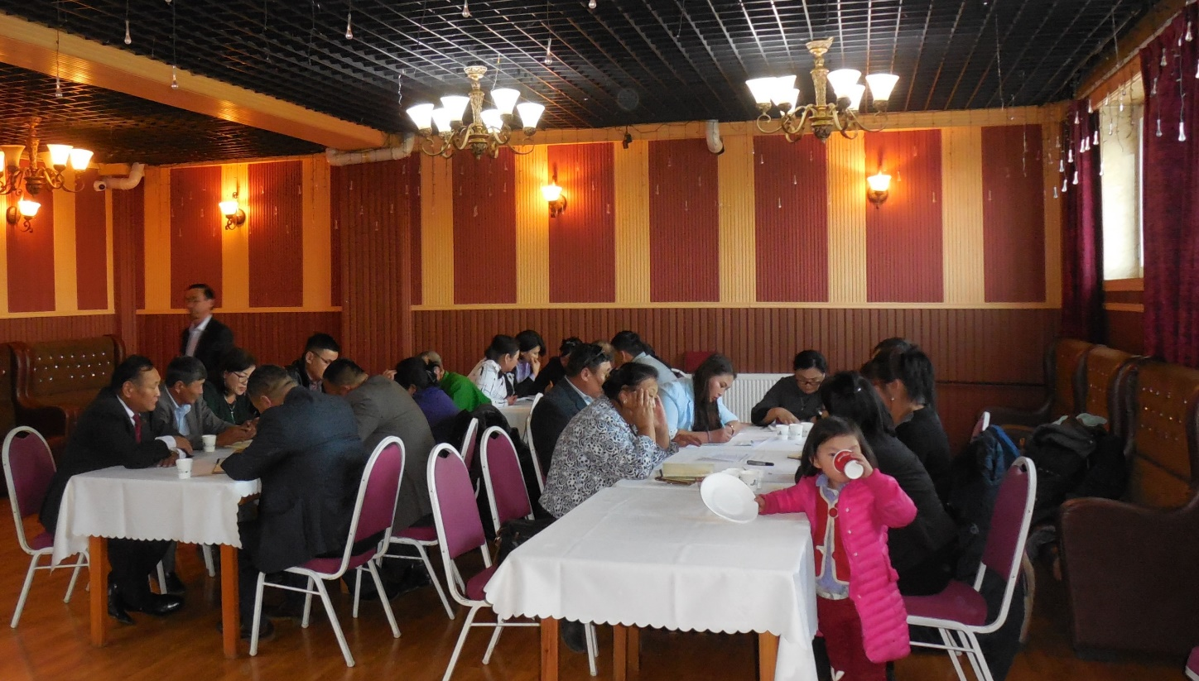
Participants preparing charts in groups. Soum hurals, bagh Chairs and grant recipients from Bayanchandmani, Bornuur, Jargalant, Altanbulag soums of Tov aimag

5.4 Output 4. Improved capacity of the Parliament Secretariat to support representative bodies

The Parliament Secretariat (PS) has been assigned with important new roles in the legislative process by the Law on Legislation. Project will provide capacity development support to the staff of the Parliament Secretariat for them to effectively undertake newly assigned roles by the Law on Legislation. This requires the Parliament Secretariat to develop new technical skills among its staff to review impacts and cost-benefit analysis by law initiators, and also conduct monitoring of the implementation of laws.

Key interventions | Description
Improved capacity for legal analyses | Provide capacity development support to the staff of the Parliament Secretariat for them to effectively undertake newly assigned roles by the Law on Legislation, namely, in acquiring techniques of legal analysis of draft laws.
Monitoring of implementation of laws | The project will support the Parliament Secretariat and the SCSS in conducting a regular monitoring of implementation of laws and developing such monitoring tools as demonstrated in the case of laws that are relevant to local governments and the state structure in general.
Improved research capacity | The project will use a combination of training and applied research on selected topics and allowing access of staff to international sources. Training modules will be developed and offered to staff covering topics of research methods, techniques of policy analysis and comparative legal studies.
Improved procedures for public consultations | The Parliament Secretariat will develop procedures and guidelines for local governments on how to conduct public consultations as implementation mechanisms of the newly approved laws (Legislation, General Administrative Procedures, Development Policy and planning. Jointly with local hurals, the Parliament Secretariat will conduct public awareness raising campaign about the legislative process in the parliament and new legal framework so that citizens are aware of their rights and more actively engaged in legislative and policy making processes.

Output 4 is central to enhancing technical capacities of the Parliament Secretariat in what is mentioned above and for anchoring future law-making pertaining to decentralization and local government.

5.4:1 Progress results

Improved capacity for legal analyses

- In 2017, a working proposal on details of legislative drafting was prepared by the Parliament Secretariat staff, based on the findings of the study visit to German Parliament (legal need assessment, ex-ante impact analysis, assessment of feasibility, coherence, acceptance and costs, effectiveness analysis).
- In 2017, the Parliament Secretariat also began work on drafting internal guidelines on legislative drafting with workflow and division of labour among departments and standing committees, with assistance from a project consultant.
- A major collaboration was initiated in late 2017 with the Swiss Parliamentary Services (SPS) on legislative drafting and evaluation of implementation of approved laws. This was specifically taken up on the request of the Parliament Secretariat. A working group was established at the Parliament Secretariat to work on selected projects of legislative drafting and evaluation.
- Dissemination workshops have been organized in the latter part of this year for staff of Parliament Secretariat (PS).
- Translation of parliamentary meeting procedures of seven foreign countries’ as a key resource is now available to the PS and researchers.
- A comprehensive training curriculum and handbook to serve as training policy for PS’ staff is about to be finalized with the project’s assistance. It provides parliamentary advisors with guidance regarding drafting of Constitutional amendments and public and civil laws and different aspects of legislative drafting (terminology, etc.)
Monitoring of implementation of laws
- As agreed in the work plan for cooperation for 2018 one specific evaluation was chosen that would be conducted by the PS and accompanied by the SPS in 2018. The Law chosen for this cooperation project was the Law on Land Allocation to Mongolian Citizens, which was extended in May 2018 for ten additional years and has important implications for local self-governing bodies.
- An evaluation design workshop took place in mid 2018 in Ulaanbaatar with a small group of participants from the PS and the SPS to develop an evaluation design. A second workshop was held in Fall (October) 2018 focusing on the next steps of the evaluation. The work continues.

Improved procedures for public consultations
- Project supported the first evaluation by the Parliament Secretariat in 2017 on Monitoring of the Law on Combating Alcoholism.
- Under the requirements of Mongolian Law with reference to public consultation on draft laws through public hearing, two public consultations were held.
An online conference was held in July 2017, including MPs, senior officials of aimag and the Capital government departments and local self-governing bodies on proposed amendments to the Constitution.
- A public hearing was organized by the Standing Committee on Petitions in December 2017 on monitoring the implementation status of the Resolution No.5 of 2016 on the enforcement of legal acts regarding rehabilitation of the degraded land due to mining activities and the compensation of damages.

Improved research capacity
- Consultancy on analysing and establishing recommendations for improving Parliament’s meeting procedure is completed.
- Policy research on the oversight function of the Parliament has started.
- Selection of a Consultant for translation of Standing Orders of several foreign countries, and translation of “Legislative Drafter’s Desk book: A Practical Guide” (Tobias A. Dorsey, 2006) is underway.

5.3:2 Challenges
The Secretary General of the Parliament Secretariat (the National Project Director) shoulders a major responsibility in the legislative structure of Mongolia. Given his own very crowded schedule and the numerous issues that engage his attention in the present circumstances in Parliament and the larger political context, the project has been privileged to have his time.
In output 4 there are challenges which follow from the very critical nature of activities selected.

- The work with the Parliament is very important and critically relevant towards building technical capacities. A plan for institutionalization of the transfer of learning to the PS would be beneficial for consolidation. A beginning has been made. This would promote sustainability and lead to greater effectiveness.
- Most activities in this output are shown as responsibilities of Parliament Secretariat in the Multi year work plan. But the implementation responsibility to a great extent comes to rest largely on the PIU. One possible resolution is that these activities are included in the work plan of the Parliament.
- Public hearings as a bottom up approach to citizen engagement requires greater stakeholder promotion and participation. An institution has been identified to provide methodological inputs and orientation. Public hearings empower citizens, but officials and elected representatives would feel challenged.
- At the time the project was formulated there was a separate Research Unit in the PS. This was later integrated with the Monitoring unit. The proposal that “training modules will be developed and offered to staff covering topics of research methods, techniques of policy analysis and comparative legal studies” has progressed but more could have been achieved if the responsibility for leading and overseeing research was organizationally settled.

6. Critical cross cutting themes

Underneath all the above outputs is the driving thought that “the indirect and ultimate target group of the project is the population in the constituencies of the local Hurals […] By focusing some of the project activities specifically on improving the interaction between local Hural representatives and people of marginalised or “voiceless” groups, like youth, women and urban and rural poor, the Project aims to make them more visible for local Hural representatives and to create an accountability link between the local Hural representatives and these marginalized groups in order to move their interests higher on the agenda of the local Hurals.”
Another cross cutting theme is of “external communication established to convey the project progress and (intended) results to the public” (from Consultant ToR).
Both these themes came up repeatedly in the discussions of the MTR team and were discussed with the PIU. They are reviewed below.
6.1 The marginalised, rural poor, youth and women

6.1 :1 Progress results

- Elected women representatives have been served well across hurals. All training interventions whether the Induction training, the Leadership training for women, the Bagh Chair training; women have participated actively. Moreover, many have been encouraged to join in as trainers. There is also evidence of women acquiring greater confidence, contributing to hural decision making, etc.
- The women leadership training delivered to women representatives across levels was critical in enabling networking, creating alliances between women across levels and even more importantly across party divides.
- A number of the small grants projects have involved women, youth and herders (39 small grants on pasture management in 2018).

6.1 :2 Challenges

- While women elected representatives have been well addressed, the poor and marginalized are not visible in the discourse and project activities. One heard of them in the interviews with the NGOs on small grant projects, but little elsewhere.
- An exploration of the political economy and its implications for the strengthening of representative bodies would enable the project to make better informed strategic choices. It would help make hural representatives more sensitive to how the poor and marginalized get bypassed in the democratic process, particularly where strong economic interests prevail which can blind side the marginalized.
- Youth as mentioned earlier in this report need to be actively engaged with. They constitute nearly a third of the population; this is a growing number. Youth as a constituency pose a challenge for the project.

6.2 Project communication

6.2:1 Progress results
- The project serves project stakeholders well. The website, documents in Mongolian from handbooks, manuals to training materials, designs, etc., are considerable and well brought out. The focus so far has been on basic documentation and internal communication.

6.2:2 Challenges
- The project has not produced analytical reports. Challenges must be highlighted. This would contribute to reflection on shortcomings, the possible solutions, the future needs and the strategic choices to be made for strengthening representative bodies. This is required both for the board and key actors.
- There is much that the project can share. There are projects in the region which would benefit immensely from the experience of the project, the best practices, change stories and project impact. The project must move to another level of communication both with stakeholders and in disseminating within Mongolia and outside.

6.3 Monitoring & Evaluation (M&E)

6.3:1 Progress results

- The project has followed through on training and hural capacity development well. A survey to capture changes in hural capacities is underway. As most are in Mongolian we have had access only to those currently available in English and a few were translated for us.

6.3:2 Challenges
- Innovative ways of tracking transfer of learning to action need to be developed.
- Changes that citizens experience as a consequence of improved hural functioning and particularly the marginalized and poor need to be made visible. Citizens will be one source of information but ground studies would reveal more firmly real changes.

7. Conclusions
The project document states that “the emergence of local self-governing bodies played an important role in the country’s transition to democracy in the last two decades. However, as in other countries, decentralization and local governance reforms is neither simple nor fast. The ‘unfinished reforms’ need to be completed which involves continuous efforts to enhance and implement the legal framework, while at the same time strengthening capacities of local authorities as well as citizens’ demand for accountability.”
To support the unfinished reforms, the project adopted “a comprehensive three-pronged strategy for capacity development of local self-governing bodies, addressing simultaneously the interrelated levels of legal and institutional environment, the organisational capacity of Hurals as well as the individual competencies of local elected representatives”. The four outputs follow from this strategy. The key progress results shared earlier in this report makes evident the substantive and focussed work done under each of the outputs.
The SRBM project embraces a wide span of work. It is based on a thoughtful collaboration with stakeholders, in which the Parliament Secretariat is the co-architect to accomplish the project outputs. The project has certain distinct features which are briefly covered here before addressing relevance, effectiveness and sustainability dimensions of the project.
7.1 Some distinct features
Outputs have their respective activity focus. But in the pursuit of an activity, the project always reaches out to varied stakeholders to build agreement. For instance, the LATUG revision consultations were held at different levels of administrative units, including bagh, soum and aimag, with participation of representatives of both local governments and local self-governing bodies. External experts were drawn into the assessment, and the guiding principles were presented to the Parliamentary Working Group on Decentralisation, as well as to the Parliamentary Working Group for Constitutional revision. This reaching out to multiple but relevant stakeholders to build consensus characterizes the project.
For the hural model meeting procedure, “multiple consultations were held with a sample of soums, aimags, the capital city, etc.” The continuous bringing together of different stakeholders to share, discuss and contribute to the decision making for recommendations, for finalizing procedures, etc., has contributed to responsible collaboration. This has taken time and effort but it contributes to transparency and facilitates long term commitment. It builds an enabling environment for meaningful participation by stakeholders, and sets a point of reference and exemplar for stakeholders in their practice. This ability of the project to facilitate collaborative working has been another distinct feature of most of its work. It is reflected in many contexts. Only a few examples have been highlighted.
In bringing stakeholders together for various activities, the project has promoted and supported partnership building. The task groups of hural secretaries, or the partnership between PS and SPS are examples of this. These partnerships are manifest. However there valuable connects being formed at an informal level which also hold the seeds for partnerships – as in the case of women representatives who have formed forums of their own (reported to us in interaction). Similarly, the interaction opportunities organized for stakeholders are triggering connects which are contributing to working relationships. NGOs we met shared that they had established connect with some hurals where they conducted training or supported the small grant scheme. At one of our field visit interactions, a group spoke of how the training they received encouraged them to visit other hurals for understanding their working. While these may happen at individual, and in some cases at organizational level, these are building a culture of engagement between stakeholders, independent of the project. This paves the way for partnerships.
The project activities have required participation of many institutions and individuals holding different positions in organisations. Their participation has been encouraging and positive. This is not just because the project has coordinated or managed well. There is an evident willingness to participate. This is exemplified in numerous ways. (This understanding is based on field interaction, the meetings and interviews, and the reports accessed.) When citizens waited for us at aimags / hurals for meetings with us though we were running late; when hural representatives spared time to meet with us or when functionaries (like hural Governors or other hural functionaries) continued to participate in discussion meetings despite other engagements, one sensed a seriousness about their participation. The data on the number of women and men who make time to attend leadership training with very high participation rates points to this. The interest demonstrated by hurals in wanting to undertake small grant schemes, the demands for further training for presidium members, for secretaries of hurals and for bagh chairpersons; all these underline that stakeholders from varied backgrounds are willing to commit time for project activities, and that there is a latent but serious interest in wanting to be better equipped for local self-governing bodies. This is valuable capital for the project, but more valuable capital for decentralization and the continuing development of local bodies. It is a consequence of the shepherding the project has done over the last two years, as well as having built well on the foundations laid by the earlier projects.

7.2 Project relevance
The relevance of the project is anchored in the conditions that prevail. Reforms are still happening. It is work in progress. Progress is happening, though not possibly with the speed that some may expect or desire. Political conditions are dynamic and democracy is at work. The contribution of the project is immensely appreciated.
- There is strong commitment expressed to the reform process, whether in working for and/ or supporting activities for the LATUG revision to happen, the signing of the MoU by NAoG to “Institutionalize and maintain the national training programme for strengthening capacity of representatives of Citizens’ Representatives of Khurals”, the extending of technical support to over 360 sub-site administrators for the maintenance of www.khural.mn website by the Cabinet Secretariat, the seeking of further training for hural secretaries and presidium members, etc. All of these and many more underlines that both in sharing or adopting responsibilities to steer project activities and in seeking further defined capacity building, the key stakeholders perceive the relevance of the project to the future of decentralization and local governance reforms. It is not just spoken of but there are actions that back such statements. These actions are not being rushed. The political process is not being bypassed. That is how it should be.
- The NPD in our interview shared that he looked forward to self sufficient soums and aimags and that this would make a big difference to national development. The relevance of the project finds reflection in this statement.
- The outputs of the projects are very much aligned to completing the unfinished reforms “which involves continuous efforts to enhance and implement the legal framework, while at the same time strengthening capacities of local authorities as well as citizens’ demand for accountability.” The project is focused on this.

7.3 Effectiveness
- Objectives across the outputs are being effectively achieved. In Output 1 the present position on LATUG revision is that the concept note prepared by the legal firm has been submitted to the Parliamentary Working Group on decentralization. This significant progress ensures that the Working Group has the necessary input for it to take it forward.
- The visit of MPs and technical staffers from the Working Group for Constitutional revision to Finland and Japan provides them knowledge of relevant features of foreign local governance systems to consider as they work on the reform process in Mongolia.
- The large picture that emerges on hurals is that capacities of hurals are on an upward growth slope. For a nation with a history of centralized government, the range of inputs have led to a gradual but definite change in mind sets, from non participatory decision making to participatory decision making. These are small steps in the right direction.
- Under Output 2 the organizational capacities of hurals have been significantly enhanced over the last two years. Model meeting procedures have been completed. The process of adopting the procedures is in progress. Some soums have committed while Arkhangai aimag has adopted it.
- Small grants to hurals and NGOs have broadened the pool of experienced NGOs working with local self-governing bodies, providing capacity building to NGOs and hurals. National NGOs have become more acquainted with local level governance processes and challenges, and collected real life cases, while hurals have benefited from the expertise the NGOs bring.
- The objective of providing a handbook to hurals to apply the Law on General Administrative Procedure (LGAP) has been achieved. This provides hurals a simplified manual or check list for resolutions to be passed by hurals and also assist in developing procedures for public consultations. The South-South exchange to enhance the knowledge of aimag chairpersons bolsters this further. Follow up for dissemination of the south- south learning to a wider audience is initiated.
- The institutionalization of the website www.khural.mn with the Cabinet Secretariat of the Government of Mongolia was done in 2017. This was a key objective under output 2.
- Output 3 has seen strong achievements. This includes the National training programme for local elected representatives being institutionalized at NAoG with the MoU signed between NAoG and UNDP.
- The network of trainers has been consolidated. It is still to reach the plan figure. The National Induction Training covered a total of 7,377 (91.1%) elected representatives of all levels of hurals fulfilling an important objective under this output. Attendance rates saw a clear improvement from earlier years. Leadership training covered in 2018 around half the aimags and women’s leadership training has covered all hurals.
- Capacity development has been marked by the continuous effort to improve methodological inputs for trainers, continuing inputs on designs, and the updating of curricula. There is demand from different stakeholders for further capacity building, which have been referred to earlier. The quality of recall by participants reflected well on the course content, the design of the programme, and the methodologies used. Using participatory and didactic methods has led to greater internalization. As one woman hural representative put it, “I learnt that it is within my mandate to understand / identify local problems, propose solutions, etc.” Another pointed to “learning of the working of decentralization.” Still another shared, that the training ‘helped them understand that problems (faced by them) are structural, not personal.”
- Using participatory and highly interactive training methodologies sensitizes participants more deeply to the difference between centralized, control oriented functioning of “local government” and grass root based, bottom up working of local government. The project has invested time and tremendous effort in this. This is an investment into the future of democratic functioning.
- Capacities of the stakeholders have been developed in numerous ways through all these inputs. Capacity building has covered a wide gamut of interventions relevant to the varied stakeholders. This includes technical capacity building and individual orientation and competency development of the elected representatives as highlighted above. The evidence is that the relationship between law, the elected representative, the citizen and the government functionary is well recognized and understood better. Elected representatives are thus appropriately capacitated to support the reform process, in particular their role in making hurals become more responsive and accountable.
- The project management team (PIU) has done remarkable delivery with a very lean team who are involved with the project activities / outputs. The project document mentions “’that the core team members of the project will be kept to a minimum: Project Manager, M&E Officer, Administrative and Financial Officer, International UNV and driver. Additional support officers will be hired on a short-term basis during peak periods in terms of workload such as organizing training workshop and big meetings, and national technical advisers will be hired for specific tasks with clear deliverables. This way, the project will ensure cost-efficiency as well as diversifying the expertise.”
- This team has delivered well. It has meant managing multiple directions of coordination: ranging from training management, support for legal drafting, to knowledge exchange and technical capacity building and coordinating with a variety of stakeholders. This has been managed competently. The effectiveness is reflected in the wide array of results.

7.4 Sustainability
- The project has all through focussed on sustainability. This is well articulated in the Sustainability Plan. A guiding axiom is that “The Project strongly focuses on stakeholder engagement with detailed joint planning of gradual handover of project activities to their identified owners […] The stakeholders and partner organizations who will take on a key role towards ensuring long-term project sustainability”.
- Supporting revision for the LATUG law has been a very important focus. As narrated above it has reached a critical stage. The final shape of the LATUG law will depend on the law makers. The project was committed to providing technical support for preparing the law. That has been done and continues to be done. If the efforts do not lead to a revised LATUG law or assuming that the Law does not happen in this present house the technical support provided by SRBM could continue serving for passing the law post 2020 elections (if not passed before).
- Overall, the dialogue process of multiple consultations to build agreement, to firm up documents, to plan for dissemination etc., provides learning for all stakeholders on the importance of information sharing and how greater transparency and accountability are accomplished in action. The experience inculcates practice and facilitates institutionalization.
- The consultative process builds ownership and commonly acknowledged institutional reference for future action. This anchors sustainability.
- The website is now under the supervision of the Cabinet Secretariat. This has been a key concern for the project. The institutionalization dimension is attended to. The financial and technical sustainability have still some ground to cover.
- Hurals are more strongly anchored now. Model procedures for functioning and the handbook for hurals to apply the Law on General Administrative Procedure (LGAP) are in place. These constitute substantive steps in the institutionalization process.
- The feedback indicates that hurals attend to citizens. Citizens are being consulted. This citizen engagement which is in early stages embeds sustainability in the social context. While hurals have addressed the marginalised and poor, this needs more attention.
- NAoG has formalized its role in revision of the induction training and has proposed a Local Governance Training Hub at NAoG to both anchor the work taken up so far for local government development and also to set up a data base containing Hural decisions, good practices of hurals, information on elected representatives, etc. NAoG also shared that a part of the institution’s budget is committed for training of hural Secretaries. These actions put in place institutional sustainability.
- A first but important step in financial sustainability for hural capacity building was accomplished by 10 aimags in bearing around 28% of the cost for leadership training for Presidium members. This needs to be pursued further as the economy improves and should be a priority for the project.
- The Cabinet Secretariat affirmed strong support for hural training and that NAoG as an institution under the Cabinet Secretariat would fully support the partnership to take forward the reach of training. Budgetary commitments should be encouraged.
- The collaboration between the Mongolian Parliament and the SPS builds bridges for future independent contact and professional exchange.
- Online public hearing may prove invaluable to active citizen participation in local government given the population characteristics of Mongolia. Technological advances need to be exploited for a more sustainable grounding of public hearing.

The project’s contribution to the Intended Outcome as stated in the UNDAF/Country Programme that “by 2021, governing institutions are more responsive and accountable to citizens, while ensuring effective participation of young people and realization of the rights of the poor and marginalized”, is addressed. The project is significantly contributing to making governing institutions more responsive and accountable to citizens. The recommendations below put forward thoughts to further strengthen “effective participation of young people and realization of the rights of the poor and marginalized.”

8. Recommendations
The recommendations below address all four outputs and the cross cutting themes. They have been grouped to provide clarity with regard to the focus of the recommendation.
8.1 Citizen engagement
- Public awareness raising is included in the multi year work plans in both output 1 and 4. In the latter it refers to raising awareness about legislative process and new laws. It is recommended that this is addressed with greater vigour with the Parliament Secretariat.
- To better address citizen engagement, the project should aim for synergies with SDC governance projects which focus specifically on citizen engagement.
- Aimags, soums, districts, etc. need to explore what they can do to increase citizen awareness and participation. Dialogue events to brainstorm on what needs to be done and what needs to be communicated can be a starting point for a few pilots or even for consideration for small grant projects. NGOs should be involved in these exercises.
8.2 Strengthening training for hurals
- Hurals need higher level skill input in budget review, the planning function, legislative oversight. etc. These can be addressed through thematic training programmes. NAoG is aware of this need. These need to be incorporated into future training revision. Cost sharing possibilities need to be worked on. It will enhance the effectiveness of hurals.
- Hural secretaries and presidium members who are at the core of hural functioning need to be focussed on more in the remaining years. Greater focus is required on their administrative work to develop greater effectiveness/ efficiencies in the discharge of responsibilities to hurals and citizens.
- The proposed continuation of induction and refresher training by NAoG would only encompass soum and aimag level, but not the bagh level. Given the importance of this lowest tier of governance to ensure that citizens’ needs are reflected adequately in soum and aimag level planning, it is recommended that the aimag level takes on the responsibility to train the Chairs of bagh General Meetings.
- As the economy is improving and as some regions / aimags are better placed financially, it is an opportune moment to discuss and develop criteria for cost sharing of training costs and to implement in practice. The Project has facilitated the establishment of working groups of aimag and districts hural secretaries, as task forces to support different project related responsibilities. The appropriate working group can be tasked to discuss and work out steps to implement it.
- It would not be appropriate at this point to do a country wide roll out of the Performance management framework for hurals as evidently proposed by the Consultants. The methodology and the content can be first piloted in a sample of aimags and soums, as already indicated in the project document and focus on indices that disclose member performance on fundamentals of their participation. The Consultants should have “consultations with the Central government, hurals, subject matter experts, and citizens and check against the existing reporting requirements”.
8.3 Small grants scheme
- Small grants have significantly contributed to Hural capacity development and greater citizen engagement. Given the difficulties that some hurals have faced in the present round of small grant projects, it is recommended that hurals be twinned with appropriate NGOs or local resource person/s to support project implementation. This would contribute to drawing on local resources and in connecting them even more in the change process.
- The grants made available to NGOs by the small grant scheme need to be increased. From discussion with NGOs it became evident that they had difficulties in completing commitments with the approved funds. It is recommended that the project makes available fewer grants, but larger amounts with multi-year applicability. This needs to be done without increasing transactions costs. This support to hurals “in order to increase pro-poor focus of its interventions, oversee the executive’s performance in delivering the services and implementation of government programmes aimed at poverty reduction” for women, young people, the poor and vulnerable groups would provide strategic direction. Such support over a longer period of time would increase citizen awareness.
- The criteria for hural / NGO selection must be reviewed to boost effectiveness, sustainability and relevance. Small grants must reinforce project priorities of increasing pro-poor focus of its interventions and developing public hearings initiated by hurals on general oversight.
8.4 Youth, vulnerable and marginalised
- The project’s aims with regards to improving inclusiveness should be clarified first before strategic entry points are identified. It is recommended to establish synergies with existing projects that target the poor and marginalized. This could e.g. be envisioned through the grant scheme under Output 2 or in the frame of the planned activities towards increasing citizens’ awareness about their elected representatives. It may provide a catalyst to greater participation by youth. The appropriate time is now. The grant scheme might provide for opportunities to address issues of inclusion more prominently.
8.5 Institutionalisation of www.khural.mn
- The website evidently needs further updating and technical support. The working group tasked with the working of the website can propose actions necessary to ensure that the website fulfils the invaluable dissemination need with enhanced technological competence and transparency. The website is the most visible dimension of hural developments and actions and adds value to the effectiveness of project dissemination.
8.6 Project communication
- It is recommended that a comprehensive MIS on the number of participants who have undergone training by level of hurals, by region, kind of programme, gender, age, etc. be prepared. This would also provide a baseline for future. The project has a number of reports, surveys etc. but not a comprehensive data picture across all participants. It can then be incorporated with the Training hub proposed by NAoG.
- The project has achieved much in capacity building. A document that captures the journey of capacity building in strengthening representative bodies, in building individual and institutional capacities and its impact on the functioning of hurals, is necessary for institutional memory, for dissemination and for reflection. Documentation must include stories of change at the individual and institutional levels backed by evidence of change at the behavioural, attitudinal, and functional levels. Evidence from the Performance management framework and hural survey would be relevant for this documentation.
- The PIU requires technical support for strengthening both M&E and communication.
8.7 Project management
- It is recommended that to further strengthen capacities in technical guidance and advocacy in local governance in the project, a senior professional be appointed as an Advisor / Consultant. The individual should have a strong background in local governance and be well acquainted with Mongolian law and practice. The individual should preferably be a Mongolian national. This not is suggested as a permanent advisor/ consultant, but to provide critical backstopping support when required.
- For strengthening ownership of the PS in activities that needs its attention, such activities may be included in the work plan of the Parliament with allotted responsibilities.
- The present UNV leaves early next year. It is strongly recommended that the process for recruitment of the new UNV be initiated at the earliest and that the individual be appointed a full month ahead of the departure of the present UNV. This would make for a better handing over and integration into the project.
- It is also recommended that a local consultant be hired to reinforce the M&E and also support documentation. This would depend on budget availability. Short term consultancy may be considered.
- Support staff should be recruited as per the project need.

8.8 The Parliament Secretariat
- The ownership of the PS in activities under its oversight needs to be more manifest to stakeholders. Greater visibility of its contribution and leadership to strengthening hurals as representative bodies would immensely serve sustainability and motivate greater participation of stakeholders.

The great value of this project rests in its perceptive and discerning inputs to strengthen local government. The support to buttress the legal framework, enhance capacities of the key institutions, build abilities of the elected and promote citizen participation, is an amazing encompass. That this is done in fullest partnership with the state, roots the effort in reality.
Such partnerships inevitably will have operational and ideational differences. What matters is that dialogue is always ongoing. The project has done this. That is to the credit of all the key actors.
The progress made would like look small steps today. But the groundwork done till now has long term “significance for equitable and sustainable social and economic and effective, efficient and fair local governments, satisfied citizens, and a genuinely representative and effective civil society”. The next two years must consolidate the gains and utilise the opportunities.

Annex 1
Annex 2

Guiding questions (as in the evaluation plan)
The guiding questions elaborated below incorporate the questions provided in the ToR by the project but have been regrouped to facilitate greater focus. Some dimensions have been added. Within each dimension questions have been kept short and simple wherever possible. It is recognised that with certain stakeholders time available to have an extensive discussion would be short. The MTR team would need hence in conjunction with the CO to determine in advance of such meetings, wherever possible, the questions that must be taken up. These questions would be appropriately addressed to different stakeholders / actors.
These guiding questions are not frozen. As always in a field situation contextual realities would generate new questions. The guiding questions however provide a strong direction to the review.

ORGANIZATIONAL / PROJECT ACCOMPLISHMENTS
Progress towards results
- What progress has been made towards achievement of the planned outputs and (short-term) outcomes of the project?
- What are the main factors (positive and negative, internal and external) that have affected achievement and / or non-achievement of the outputs and outcomes?
- Are there recurring road blocks / impediments that have slowed down progress? What are these?
- Are there any potential unintended outcomes?
- Have beneficiaries demonstrated clear evidence of greater engagement in the functioning of local self-governing bodies?
- Which best practices could be leveraged during the rest of the project?
- Are there any recommendations for improving the achievement of outcomes?
- How is leadership provided for the project?
Planned outcomes and time frame
- Is it feasible to deliver the planned outputs within the remaining period of the project implementation (2019-2020)?
- If not feasible, what are not feasible and why? What should be done?
- Are the project’s planned outcomes clear and achievable within this time frame?
- What should be done to increase ability to achieve them?
- What are main impediments to achievement of outputs and outcomes?

SUSTAINABILITY AND INSTITUTIONALIZATION
Elements of sustainability
- What progress has been made towards sustainability in general?
- What elements are contributing to creating sustainability?
- Financial sustainability: Are there evidences of increased commitment from government institutions to (co-)finance project activities? Have cost-efficiency strategies been put into place? What can the project do to secure financial commitment beyond the project duration?
- Institutional sustainability: What is the status on the gradual take-over of project components by national institutions? Have national institutions been identified for that purpose? Are there signs of ownership from stakeholders with regard to activities, processes, tools, etc.? Is there evidence of replication and up-scaling? If not, how can the project address these concerns?
- Technical sustainability: Were the appropriate national institutions chosen to partner for technical support? Were their competencies / capacities scrutinised before being chosen to partner?
- Social sustainability: To what extent do the implemented activities answer to needs of the different sub-groups of beneficiaries? Does the project engage grass root organizations or others who are championing governance participation?
- Is the project setup and organization supportive of the project’s sustainability goals
- What are the recommendations for ensuring sustainability of long term change and hence for the design of the exit phase of SRBM?
Relevance and validity
- Are there changes in the overall environment that are likely to affect the project?
- Are these changes conducive to strengthening local bodies and the decentralization process?
- Are the strategy and objectives of the program still relevant given the recent / planned changes in the legal environment?
- Are the activities and outputs of the project relevant to the attainment of outcomes and to the local capacity building needs?
- Are the theory of change and its underlying assumptions still valid?
- Which of the four thrust areas have delivered the most meaningfully and contributed to the reform process?
- What are the most powerful disincentives to promoting democratic processes and structures?

GENDER AND MARGINALIZED
- To what extent has the project succeeded in attracting politically marginalized groups, youth, women, urban and rural poor, and their greater participation in local bodies?
- How have their capacities been enhanced?
- Is this reflected in budget allocations and inputs?
- Are partner institutions committed to this?
- Have the traditionally excluded found space to participate and grow?
PROJECT MANAGEMENT, M&E, AND IMPLEMENTATION
- Given two years of experience is the project management and operations structure appropriate for accomplishing the project goals?
- How clear are the roles and responsibilities of project staff and partners?
- Is decision-making transparent and undertaken in a timely manner?
- Are effective processes in place for quality assurance, risk management, result-based work planning, reporting?
- Does the project enjoy the elbow space to respond to changes and needs quickly and effectively?
- What M&E tools have been used? Have the tools used provided sufficient and speedy analysis and insights?
- Have the outputs been delivered within intended deadlines?
- Is internal communication regular and effective? Have the resources (financial, human, time, etc.) of the project been efficiently used to achieve relevant outputs and outcomes (cost-effectiveness)?
- Does the project have the appropriate financial controls, including reporting and planning, that allow management to make informed decisions regarding the budget and allow for timely flow of funds? How appropriate were changes to fund allocations as a result of budget revisions, if relevant?
PARTNERSHIPS
- Has the project developed and leveraged the necessary and appropriate partnerships?
- Do local and national government stakeholders have an active role in project decision-making?
- What synergies and collaboration with other projects, among which are SDC projects, has been built so far? Are there opportunities to further develop these synergies?
- Has the project actively sought to engage with other projects / donors pursuing strengthening of local governance, (ongoing/future) development projects to harness learning, build collaboration and institutionalization?
- Have there been consultations / dialogue across project partners for building sharing learning, harnessing capacities and forging alliances?
- Are proper means of external communication established to convey the project progress and (intended) results to the public?
  - Are some key stakeholders left out of communication?
  - Does this communication with stakeholders contribute to their awareness of project results and to their investment in the sustainability of project results?
  - Are their examples of when stakeholders have been enthused by project communication; for eg. through public hearings?
  - Have partners taken communication to the wider community?
  - How often has the project reported to the wider network of “partners” on project progress and achievements?
- Have partners pushed the boundaries for strengthening democratic processes?
- What stakes do elected representatives have in this process?
CAPACITY BUILDING AND LEARNING
- What has been the reaction of traditional power elites to the capacity building undertaken?
- What is the evidence that capacity and knowledge generated by the project will be used beyond the project lifecycle?
- How have the earlier excluded been empowered?
- How does this capacity building mesh with the shifts in population from large areas of Mongolia to the capital?
- What lessons have become obvious about strengthening local bodies, increasing participation of citizens, empowering Hurals?
- Who is responsible for consolidating learning?
- How is the learning being embedded in the wider reality?
The verification and validation of the above would emerge from the content of the discussions and from the data generated by the tables. These would also be cross checked with data as presented in reports and through some write ups that are requested for.
Documents accessed / List of persons interviewed / MTR Team
Annex 3

Among the many documents accessed for this MTR, the following are some of the more important documents which provided a fundamental orientation and reference on the project:
- SRBM Project Document, the SRB Fact Sheet of SDC, and Project document on the Sustainability Plan
- Progress reports and Annual work plans for 2017 and 2018
- MOU’s signed for consultancies and institutional collaborations
- Small grant reports (in English)
- Reports in English of training conducted. These include monitoring surveys apart from presentation of designs and narrative reports from 2017 &2018.
- Short version of Minutes of Board meetings (English translation.)
- Chapter 8 of LATUG law assessment. (English translation.)
- MTR and Terminal reports of the evaluations of the CSLSB project
- Report of the Joint Monitoring by Great State Hural and UNDP on Monitoring of the Law on Combating Alcoholism
- The Role of The Constitution Of Mongolia In Consolidating Democracy: An Analysis; Commissioned by the Parliament of Mongolia and UNDP.
- Reports of the collaboration between the Swiss Parliamentary Services and the Secretariat of the State Great Khural
- Tables on the project outputs to indicate progress on key indicators filled by the project team.
The above documents apart there were numerous other documents made available by the project team. All of which may not be cited but were valuable. The documents reflect the vibrant texture of the work. And so much more is written in Mongolian which this author could not use.

List of persons interviewed / held discussions with

- Mr. Tsolmon Tsedev, Secretary General of the Secretariat of the State Great Hural, National Project Director of SRBM
- Mr. Byambasuren Urgamal, Deputy Chief of the Cabinet Secretariat, Government of Mongolia
- Mr. Togtokhsuren Dulamdorj, Member of Parliament (State Great Hural) and Chairman of the Standing Committee on State Structure
- Mr. E.Tuvshinjargal, Head of Legal Affairs Department, Secretariat of the State Great Hural
- Mr. B.Erdenebilegt, Head of Information, Monitoring and Evaluation Department, Secretariat of the State Great Hural
- Mr. G.Byambaa, Chairman, Ms. Narantuya, hural representative and Deputy Governor, Ms. Erdenechimeg, hural representative and Head of Policy Committee, Mr. E.Oyunbold, secretary, and secretariat officers, Selenge aimag hural
- Khural representatives from Javkhlant, Eroo and Shaamar soums, Selenge aimag
- Citizens from Selenge aimag
- Mr. Ts.Enkhbat, Chairman of aimag hural, secretariat officers, hural representatives of Bayanchandmani, Bornuur, Jargalant and Altanbulag soums, Tuv aimag
- Citizens of Bayanchandmani soum, Tuv aimag
- Mr. B.Tseren, Chairman, Mr. Batbileg, hural representative and former Chairman, further hural representatives, and Ms. J.Ichinnorov, secretary, Khan-Uul district hural
- Ms. D.Enkhjargal, Director, Ms D.Doljinsuren, Ms Lkhamsuren, MonFemNet (NGO working for women’s empowerment)
- Ms. Bayarsaikhan, Step Without Border, NGO
- Mr. J.Maizorig, Partner, Ms. O.Bolortsetseg, Senior Associate, MDS KhanLex LLP (law firm appointed to develop (i) draft amendments of LATUG, (ii) concept papers and draft amendments of related laws/ regulations)
- Mr. L.Luvsanjamts, Ms. T.Erdenebileg, consultants appointed to develop the performance management framework
- Senior faculty team of the National Academy of Governance including Prof. Baigal Dorj, Director of the Public Administration School, Prof. Byambayar, Dean of training department, Prof. A.Altanzul, Prof. Ts.Delgerjargal, Prof. Myagmarsuren and Prof. Otgontuya
- Ms. Beate Trankmann, UNDP Resident Representative
- Ms. Gabriella Spirli, Deputy Director of Cooperation, SDC
- Ms. Zolzaya Lkhagvasuren, Senior National Programme Officer, SDC
- Exhaustive discussions with the project team on at least three occasions, as well as during field visits: Ms. Barkhas Losolsuren, Program Analyst, Ms. Zoljargal Gantumur, National Project Coordinator SRBM, and Ms. Camille Barras, Knowledge Management Officer

The MTR Team
The team for the Mid – term review consisted of:
- Patrick Duong: Local Governance Expert, UNDP Regional Office, Bangkok
- Liliane Tarnutzer: Local Governance / Evaluation Expert, SDC Head Office, Bern
- Cherian Joseph: Institutional Development and Learning Consultant associated with LOGIN Asia; Delhi, India.

Patrick Duong was familiar with the project having being part of the team that had helped formulate the project proposal. He has also engaged with the Project team over the past two years and had met earlier a few of the key actors.
For both Liliane and Cherian, it was their first contact with the project. Cherian had met some of the project team members through training of LOGIN Asia in Ulaanbaatar. Both had no knowledge of the project from before.

Responses from group exercises
Annex 4
Tables below are based on the charts prepared by participants in Mongolian and subsequently translated.
2018.10.30, meeting with citizens from Selenge aimag
Questions | Group A | Group B | Group C
Q1  What services do CRHs provide? Are you satisfied | - Public hearing being organized since 2017 based on citizens’ requests  - Private and public organizations implementing ‘crime-free community’ campaign  - Hural representatives organize ‘Representatives listen to citizens’ campaign at their constituencies  - Within efforts to increase transparency, CRH communicates with citizens through Facebook and websites by posting reports, resolutions and decisions.  We are satisfied with these. | Strengths:  - pluralism and inclusive decision  - citizens’ regulations expressed through representatives  Weakness  - hural decisions poorly communicated to citizens | - Determined Sukhbaatar soum development fund policy  - Soum hural policy and decisions informed to citizens through representatives  - Poor citizens’ monitoring  Bagh general meeting:  - bagh GM is the smallest / primary local self-governing body, but functions poorly  - Lack of community engagement
Q2  How can CRHs serve you better? | - More close / active engagement of reps with constituency members  - Citizens’ voice / proposals to be delivered and resolved by higher level institutions  - bagh public meeting chair’s position to be full time  - To hold non performing representatives (who are not working with their constituency) accountable | - Elect representatives properly  - Improve reps’ performance, accountability and capacity to train them  - Improve participatory monitoring with citizens to scrutinize hural decisions | - Improve capacity of bagh GM.  - make Bagh GM chairs’ position permanent  - allocate budget  - Improve community engagement  - Start all issues from the smallest unit.
Q3  Do CRHs provide the opportunity to voice your concerns and how do your representatives take this forward? | Representatives do not work / engage with their constituency members | - Manifesto / Action Program implementation is good, but representatives’ engagement with citizens is insufficient  - Representatives’ community engagement is poor. | - Reps elected from 1st and 2nd baghs [baghs often have numbers instead of names] collect and forward citizens’ opinion/voice  - Soum reps do not get / have resources to solve social issues of citizens  - Reps use their own / private resources to address some issues

2018.10.31, meeting with citizens from Tuv aimag
Questions | Group 1 | Group 2 | Group 3
Q1  What services do CRHs provide? Are you satisfied | - Bagh GM, functions regularly and forward citizens’ issues / proposals  - Soum development fund allocations decided based on citizens’ proposals  - Active land allocation campaign to make citizens own land plots  - Regularly organize exhibition / fairs to promote / market SMEs | - Reps do not disseminate hural information to citizens much.  - Citizens want soum hural to be more open and transparent, but [this is not happening].  - Hural is not sufficiently monitoring governors’ office (implementation).  - Budget of programs/ project is not sufficient for citizens to access. | - Support household entrepreneurship activities  - Waste management of soum center, SME support  - Managing size of livestock.  - Repair road and bridges  To citizens  - Solving land allocation issues  - Set up fixed tariff for well water consumption  - Approve and monitor/ evaluate programs / projects  - SME development  - Mother and child health protection/ promotion  - Prevention of crime
Q2  How can CRHs serve you better? | - Soum hural associations and decisions should be disseminated to citizens and report implementation to citizens  - Improve soum hural representatives’ and presidium members’ responsibilities and competence  - To convene open town public meeting  - Improve attendance and participation of bagh public meeting | - Representatives should be proactive and committed.  - Before hural makes decisions, representatives should inform (about?) hural meeting agenda and let citizens’ inputs reflected in decisions  - Representatives should have certain fiscal (/financial?) powers  - Soum hural should be free of politics | - Representatives do not visit households, nor disseminate information or report to citizens  - Citizens themselves should be active and committed

2018.10.31, meetings with Hural representatives from Tuv aimag (soum)
Questions | Group 1 | Group 2 | Group 3
Q1  What are the 3 main things you have been working on / achieved as a CRH rep? [?] | - Hural decisions address better citizens’ interests and become more objective and effective  - There are positive impacts to representatives’ communications with citizens to disseminate hural decisions and to collect their concerns and suggestions to include / reflect in hural decisions through improved / active participation in hural sessions  - When reviewing implementation of hural decisions, hural committees and relevant departments of governor’s office evaluate them based on citizens’ feedbacks and requests | - Monitoring functions of all-level hural improved. Community engagement improved  - Budget  - LDF  - Soum Development Fund  - Functions of BPM improved  – Bagh development fund established  - Implementation of hural decisions improved, so has monitoring function. | - Soum representatives:  - Improved capacity  - Commitment, participation improved  - Information dissemination to citizens  - Bagh general meeting:  - Improved actual (now) practice to organize bagh GM  - Identify, analyze and prioritize challenges / concerns faced by citizens  - Plan and address them  - Citizens engagement and commitment improved  - Hural decisions become more objective / realistic
Q2  What capacities have been improved? | - To ensure compliance with legal frameworks (committees’ conclusions, to set up monitoring team from hural) to be a part of them.  - To monitor budget and budget expenditure  - To approve result of oversight activities and have it reflected in hural decision | - Reviewed laws related to budget  - Improvements as a result of information-sharing and communications  - Improvements as a result of attending capacity-building and leadership trainings organized by international project  - Receive information online | - Conducting review (monitoring) on policy implementation and draw conclusions  - Monitoring soum-level investments  - Expenditure and purposes of LDF and soum development fund disbursements  - Improved capacity as a result of attending training  (citizens <-> envoy)

KEY RESULTS OF CRH GRANT PROJECTS, 2017
Annex 5A
№ | Aimag, district, soum CRHs: Project title, main activities and results
REPRESENTATION FUNCTION AND ENGAGING CITIZENS
1 | Khentii aimag - Using deliberative polling in aimag CRH decision-making
 | Based on preliminary survey, a deliberative polling was organized on “Re-planning of soum cemetery”. During initial stage citizens supported more the option of establishing a new cremation place, but after the second round and with balanced information and cost estimations, they supported the repair and maintenance of the current cemetery.
2 | Khan-uul district - Eco-district with citizens’ engagement
 | A procedure for citizens to follow when they travel and camp in open nature was developed. In doing so, information was provided to citizens, and public hearing was organized in accordance with the Law on Public Hearing. Also “Procedure for environmental patrol wardens”, and “General procedure for Monitoring” were developed.
3 | Gobi-altai aimag, Esunbulag soum - Engaging young people in CRH decisions
 | Trainings were organized among young people on 4 laws and CRH activities and mandates. Open day “Policy decisions in our lives” was organized among young people, and a survey of 581 young people was conducted on participation of young people in CRH decisions. Proposals collected through survey were reflected in soum policy documents - “Youth development sub programme”, “Cooperation agreement with companies with mining exploration licenses” were developed.
4 | Umnugobi aimag, Nomgon soum - Citizens’ participation (young people) - public hearing
 | Training on how to conduct public hearing was organized, information on the new Law on Youth development, the aimag youth development programme, soum development fund, and youth participation was provided, and feedback and suggestions were obtained.
5 | Zavkhan aimag, Telmen soum - Reflecting the results of public consultations in CRH decisions
 | Survey among over 500 households on their satisfaction with LDF funded activities, and proposed activities for 2018, and service delivery of soum public agencies, including Soum governor’s office, school, kindergarten, health centre, cultural centre and veterinary services. Discussions on pasture degradation and management were conducted in 5 rural baghs, and agreed to use two measures; taking horses to otor (to places with better grass) and pasture rotation.
6 | Zavkhan aimag, Erdenekhairkhan soum - Engaging women in CRH policy making and decision making
 | In collaboration with Chairs of Bagh General Meetings and the women’s association, the CRH visited each household, conducted a survey. A forum “Women’s participation in local development” was organized with 192 women, CRH representatives, and Bagh governors. “Procedure for cooperation of soum CRH and women’s organization” was developed.
7 | Sukhbaatar aimag, Uulbayan soum - Empowering herders through Citizens’ hall and with CSOs
 | Herder groups were formed and training was organized for 80 people, 10 from each group, on activities of the Citizen Hall, ways for herder groups to participate, and their rights and duties established by different laws.
8 | Bayankhongor aimag, Buutsagaan soum - Strengthening oversight through stronger CRH
 | Monitoring over mining rehabilitation sites along Baidrag river was conducted in accordance with the terms of reference, and formal notices were issued based on the results of the monitoring. Internal monitoring over the use of LDF and Soum Development Funds has started. A penalty of MNT 4.5 million was issued for one mining company, and the activity of one company was halted. “Women’s development programme” was developed and “General procedure for monitoring and oversight” was drafted.
9 | Bayan-ulgii aimag, Buyant soum - Improving collaboration of CRH and citizens
 | Two language information boards are put at 4 baghs and soum CRH. Training on functions and responsibilities local self-governing bodies was organized among Kazakh and uriankhai citizens.
10 | Uvs aimag, Zuungobi soum - Oversight with citizens’ participation
 | A training on the Law on Public Hearing and the Procedure for Conducting Public Hearing was organized for CRH representatives, Governor’s office, heads of budgetary entities, and bagh governors. In collaboration with soum environmental officers, photo monitoring was conducted and concluded that 50% of the soum pasture land is normal, around 30% is fair, and around 20% of land is degraded. Wintering and spring places were marked on the soum map. “Soum pasture use procedure”, “Procedure for organizing public hearing” were developed and the public hearing was organized on these topics.
11 | Bulgan aimag, Buregkhangai soum - Managing soum pasture land with citizens’ participation
 | Information sessions on adequate pasture use were made for herders, and their feedback was obtained. Experience sharing visits were made to Tuv aimag, Undurshireet soum CRH, Pasture use association, and NGO working in this field. “Soum pasture management sub-programme” was drafted.
12 | Uvurkhangai aimag, Arvaikheer soum – Soum CRH and engaging young people
 | In collaboration with Citizenship Education Centre, a lecture on “Youth development and citizens’ participation” was organized for 157 young people. Mobile Citizens’ Hall worked in baghs, disseminating information about the current soum affairs, CRH decisions, and obtaining public feedback. An information session about local self-governance was organized for school children. An online meeting was conducted with chairs of citizens’ general meetings and governors. “Procedure for conducting online meeting”, “Youth sub-programme” were developed.
OVERSIGHT FUNCTION
 | Oversight - glass account, public services, and LDF
13 | Darkhan-Uul aimag – Monitoring the implementation of CRH decisions
 | A review of all CRH decisions since 1994 was done, and those of the last three CRH mandates were codified. A survey among 600 citizens was conducted on their understanding of CH decisions and the extend they see them relevant to their lives. “Procedures for monitoring the implementation of aimag CRH resolutions” was drafted, and an open discussion was conducted on the draft procedure to obtain citizens’ comments.
14 | Uvs aimag - Monitoring the quality of education, developing the right education policy
 | A discussion was organized on implementation of aimag CRH approved Educational Programme, and results based educational quality assessment. The baseline of students’ attainment (current level) was established with CRH representatives participating as independent monitors, and this proved useful for preventing from any disputes.
15 | Bayangol district - Strengthening the CRH Oversight committee, capacity building of its members
 | The CRH oversight committee was established by the district CRH resolution, and a training was organized for its members. ”Bylaw of the oversight committee” was developed and discussed by the CRH Presidium meeting. LDF 2018 training and discussion was organized, and the results of prioritization were submitted to the Governor’s office for inclusion in 2018 budget.
 | Oversight – environmental protection
16 | Dornogobi aimag, Airag soum - Citizens’ participation in the process of granting mineral resource licenses
 | Monitoring the activities of mining companies was done, in accordance with the decree of the Chair of CRH. “Procedure for conducting public hearing by the Airag soum government” was drafted, a related handbook was developed, and the procedure was adopted. Using this procedure, a training was conducted among citizens, and their feedback was obtained on the draft agreement with mining companies and artisanal mining entities. “Cooperation agreement with exploration companies”, “Cooperation agreement with artisanal mining entities” were drafted.
17 | Khentii aimag, Murun soum - Monitoring the implementation of environmental protection laws
 | A training on exercising CRH oversight function in the mining sector was conducted, with practice work on the mining and rehabilitation fields. Indicators for assessment card were developed and used in monitoring. A soum map that illustrates 13 exploration and 6 exploitation fields, 217 historic and cultural sites, wintering and spring places was developed, and placed in the Citizens’ Hall and bagh centres for public information. A sub-council of EITI was established. A “Procedure for monitoring the implementation of laws related to subsoil use and protection” was developed.
18 | Dundgobi aimag, Ulziit soum - Monitoring the implementation of environmental protection laws by mining entities
 | A training about extractive sector laws and regulations was conducted for CRH and Chairs of Bagh general meetings. Using a specially designed assessment card, a mining monitoring was done on the field. “Procedure for conducting CRH monitoring in activities of mining entities operating in the soum territory” was adopted. Notice for follow up measures was sent based on the results of the monitoring.

KEY RESULTS OF NGO GRANT PROJECTS, 2017

NGOs – project focus, main results | Partner CRHs
“Steps without border” – Strenghthening CRH committees, and applying public hearing for improving citizens’ participation | Dornogobi aimag, Khatanbuleg, Dalanjargalan soums
CRH committees attended a practical training to review and improve the 2017, 2018 soum main directions of social and economic development. 8 CRH committees of 2 soums developed their action plans, presented them to Governor’s Office, NGOs, heads of budgetary entities, and advisory groups. Information was provided on how to participate effectively in public hearing on extractive sector agreements, and methodology for reviewing the implementation of such agreements. In order to strengthen CRH committees, citizens with knowledge and expertise of different fields were mobilized in drafting CRH Committee procedure and the main directions of social and economic development. Furthermore, upon consultation with citizens, Advisory groups were established by the CRH resolution.
“New administrative initiative” – Organizing budgetary public hearing | Selenge aimag, Sukhbaatar soum
A training was conducted on the role of CRH in budget approval, on how to analyze the local budget and learn the constituency needs. A working group with 5 people was formally established and organized public hearing on 2018 soum budget. This was the first public hearing organized by CRH on budget review. The public hearing was attended by the heads of the Selenge aimag Audit Department, Finance and Treasury Department, and officers of Taxation Department. As an outcome of this project, aimag CRH invited representatives of civil society to its budget approval meeting for the first time in its history.

“Local governance, citizens’ monitoring” – Applying General Law on Administrative Procedure in CRH decision making | Tuv aimag, Zuunmod, Sergelen soums
A practical training on how to express one’s views and suggestions and how to rank the comments on draft decision by their importance. Especially, the training on General Law on Administrative Procedure provisions that are most applicable to citizens was well received. Citizens’ suggestions and comments were sought on the following issues; setting up fees for waste removal, and regulations on commerce and services and taxi services. The results of consultation with citizens were brought to the attention of decision makers. These cases provided important lessons learned on content and logistics of reflecting citizens’ feedback in CRH decision making.
“Enguinaran” – Improving internal organizational capacity of CRHs | Khuvsgul aimag, Murun, Alag-erdene soums
A methodology entitled “6 steps for effective oversight by the CRH Social Policy Committee” was developed in collaboration with the members of the respective Committees. This methodology can be used for other soum CRHs.

“Khuvsgul lakers” – CHR role and participation in resolving environmental issues | Tuv aimag, Zaamar soum, Khan-uul district
With participation of the CRH representatives belonging to the Environmental Committee, a consultation was organized on hural powers related to soum environmental challenges and possibilities of resolving contradiction between aimag and soum CRHs decisions concerning mineral licenses.
MALA – Capacity building of CRH Secretariat staff | Capital city, Chingeltei district
Based on the training needs assessment, 6 topics were selected for training of CRH Secretariat staff. The content for these topics were developed and respective trainings were organized for over 30 staff of 8 district CRHs of the capital city.

Annex 5B

Citizens’ Representative Hurals and NGOs that received grants
- Proposals from Citizens’ Representative Hurals
№ | Aimag and soum Citizens’ Representative Hurals | Proposal
1. | Bayan-Ulgii province | Building the capacity of Citizens’ representative Hurals’ public monitoring team that monitors and assesses implementation of Governor’s action plan and socio-economic development programs
2. | Bayankhongor province | Increasing youth participation in provincial citizens’ representative hural activities and decisions
3. | Dornogobi province | Good health policy and service is our future
4. | Dornod province | Local development – citizen with job and income
5. | Khovd province | Improving public monitoring from Citizens’ representative hural committees
6. | Bayankhongor province, Buutsagaan soum | Building the capacity of representatives of Citizens’ representative hural and head of bagh meetings
7. | Bayankhongor province, Bogd soum | Improving monitoring functions of Citizens’ representative hural
8. | Bayankhongor province, Gurvanbulag soum | Involving public in local procurement and supply monitoring and increasing their involvement in decision making
9. | Gobi-Altai province, Sharga soum | Monitoring of meeting – public audit
10. | Dornogobi province, Airag soum | Monitoring function of Citizens’ representative hural in implementation of Governor’s action plan and socio-economic development programs
11. | Dornogobi province, Sainshand soum | Business growth – poverty reduction
12. | Dornogobi province, Erdene soum | Improving public participation in environmental protection and air and soil pollution reduction in Ulaan-Uul bagh
13. | Dundgobi province, Adaatsag soum | Improving the operation of public monitoring voluntary committee of soum development fund spending
14. | Dundgobi province, Undurshil soum | Public participation – future development
15. | Uvurkhangai province, Kharkhorin soum | Developing administrative acts of planning with public participation
16. | Tuv province, Altanbulag | Improving public participation in monitoring of land policy and its decision making as well as developing and approving future activity plans and procedures
17. | Uvs province, Khovd soum | Implementing regular monitoring in public service
18. | Khovd province, Jargalant soum | Strengthening public monitoring from citizens’ representative hural committees
19. | Khuvsgul province, Tsagaan-Uul soum | Women’s initiatives at local level
20. | Khuvsgul province, Erdenebulgan soum | Women participation in local development
21. | Bulgan province, Teshig soum | Having public monitoring on implementation of pasture adequate use and protection law and developing and implementing pasture use procedure and plan
22. | Bulgan province, Khishig-Undur soum | Establishing pasture management plan with participation of herders and addressing challenges facing livestock industry
23. | Bulgan province, Khutag-Undur soum | Developing and maturing citizen based, responsible and capable citizens’ representative hural
24. | Dornogobi province, Urgun soum | Citizens and entities participation in reducing desertification
25. | Dornod province, Khulunbuir soum | Pasture is our future
26. | Dundgobi province, Khuld soum | Capacity building of soum and bagh pasture user groups
27. | Dundgobi province, Ulziit soum | Capable pasture – guarantee of livelihood
28. | Umnugobi province, Sevrei soum | Developing Sevrei soum pasture use regulation with involvement of herders and public
29. | Sukhbaatar province, Dariganga soum | Ensuring implementation of environmental protection laws and regulations in Dariganga nature reserve by monitoring soum environmental protection activities
30. | Tuv province | Developing a guideline and recommendation on setting livestock numbers that are suited for pasture capacity and getting it approved by soum citizens’ representative hural
31. | Tuv province, Bayantsagaan soum | Responsible herders – improved pasture
32. | Tuv province, Bayanchandmani soum | Help seeking pasture
33. | Tuv province, Zaamar soum | Rehabilitating degraded mine land with public participation and turning them to pasture
34. | Tuv province, Lun soum | Good pasture – herders’ participation
35. | Tuv province, Undurshireet soum | Maturing the pasture management
36. | Tuv province,Sumber soum | Pasture protection – nutritious food
37. | Khuvsgul province, Tumurbulag soum | Increasing herders’ participation at decision making level
38. | Khentii province, Bayan-Ovoo soum | Rich steppe –Precious livestock
39. | Khentii province, Batnorov soum | Public participation is the key

- Proposals from NGOs
№ | Name of NGO | Title of proposal
1. | Tungaamal Centre | Building the capacity of representatives of Citizens’ representative hural for policy implementation analysis and assessment
2. | Administarative new initiative | Improving local budget monitoring function of citizens’ representative hural with public participation
3. | Khuvgul dalain ezed movement | Making land issue process of Khuvsgul nature reserve open and transparent through public participation
4. | Darkhan-Uul branch of social improvement women movement | Learning about public hearing
5. | Steps without border | Building the capacity of citizens’ representative hural’s monitoring committees as part of their monitoring function and developing good practice, procedures and guidelines
6. | Urnukh Khugjil | Establishing sustainable mechanism for public particiaption in environmental protection activities

Annex 6
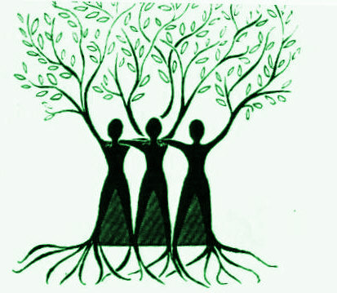
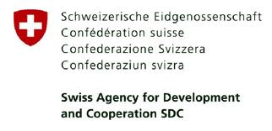
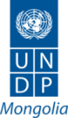
МОНФЕМНЕТ үндэсний сүлжээ
MONFEMNET National Network
Жендэрийн шударга ёсны төлөө! Towards Gender Justice!

“Women’s leadership in local government”
Training report
I. General information
When: 17-18 May, 2018
Where: Arkhangai province
Trainers from МОНФЕМНЕТ: D. Enkhjargal, A. Anudari, D. Doljinsuren
Local trainers: J. Ariunaa, doctor from Family Health Center, Arkhangai province
II. Training processes
Training background:
Good preparation prior to training in Arkhangai aimag has led to successful delivery of the trainings. Trainings took place at libraries in the aimag center so that the training rooms were bigger with good lighting, easier and comfortable for participants. However, there are too many participants from different soums in one classroom which made group works last longer and late for the schedule. Trainers opted for short group exercises to catch up delays and to complete all planned topics.
Aimag CRH issued a training procedural rule before the training program, included in participants’ folders, and informed the rule during the opening session which also helped to facilitate training efficiently.
Answers | 1 | 2 | 3 | 4 | 5
I learned a lot of things from the training |  |  | 3 | 4 | 59
Training content and approach were good. |  |  | 1 | 7 | 58
Training was relevant to women representatives. |  |  |  | 3 | 61

Suggestion to add into training contents:
There was no suggestion to add anything to training content like the previous trainings.

Suggestion related to training approaches:
The participants were highly satisfied with training content and methodology approaches, as seen from training wrap-up discussion and evaluation sheets. Moreover, participants shared their impressions and opinions regarding the training during the training and highlighted that training activities were useful and interesting. Some participants stated that they updated their previous knowledge and experiences, and provided structured knowledge of many things which they knew or heard previously in bits from there and here.
Training delivery:
- Opening: Training was held in two groups at two libraries in tandem. The opening session was attended by all participants in one classroom, and training started under the music and singing of the Mongolian anthem. Registration started at 8.30AM, but training started at 9.30AM as 80% of participants showed up at 9.00AM.
- Timeliness: Aimag CRH ensured good organization of the training by explaining high importance of the training so that the training was completed as planned schedule.
- Participation: participants were very active, and a key factor of having facilitated successful participatory trainings was practical exercises based on real life examples and challenges from their own communities which appealed participants’ interests and met their needs.
- Support from CRH: the quality of preparation and organization of the training by CRH were excellent. Each class has assistant tutor and the hural secretary also monitored attendance and participation during the training.
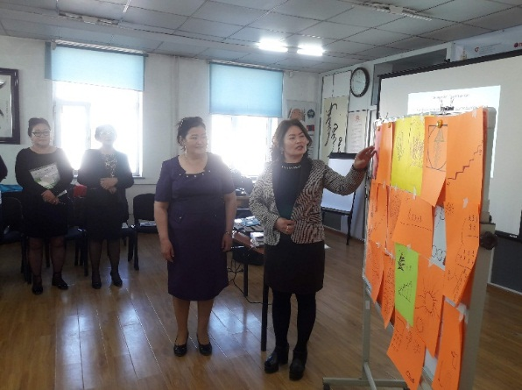
- Training venue: Trainings were organized at suitable classrooms which were convenient for both participants and trainers.
- Group works: Participants assigned in one classroom were from more than 3 soums. Due to a big class size, group works lasted longer than the planned schedule, and pushed the next topic sessions back and delayed. Nevertheless, participants were divided in to 4-6 groups by their soums, and tried to work faster and more active so that eventually the training contents were all delivered at the end of the training, as planned.

Looking at real life leadership examples of women representatives, they successfully implemented leadership projects and activities by choosing challenges faced by local citizens and making perseverant efforts to resolve them effectively. Woman representatives are good at observing and picking up urgent challenges faced by their constituents and themselves to resolve them, as a part of their responsibilities of being an elected representative. As one common observation from previous and this trainings appears that woman representatives want to resolve many challenging issues, but face many difficulties and eventually fail to make improvements because they lack of supports and networks and cannot join with other woman representatives based on their shared values. They grasped and about it during the training and understood the importance of collaboration on shared issues.

Questions | Yes | No
Have you ever initiated agenda to be deliberated at Hural meeting? | 28 | 42
Have you initiated inquiry of a certain issue to relevant authorities or official in order to resolve it? | 40 | 30
Have you as a team of woman representatives initiated and presented a certain issue to be deliberated by Hural? | 17 | 53

Experiences of realizing representatives’ role and responsibility:
Ch. Chuluuntsetseg, Elected representative of Tsenkher soum: She proposed installation of security cameras within the soum center during the CRH meeting in 2015; in particular at kindergartens, schools and hospital. It was a challenging issue for her soum and other khural members supported the idea. In accordance with the decision from the Hural, the soum governor was assigned the task so that soum hospital’s maternity ward, kindergarten and school were installed security cameras so that the activity was implemented successfully. As a result, safety of mothers at the maternity ward and of children at kindergarten were addressed and improved better. Previously, security issues were often problematic and criticized widely. Another initiative was to remove plastic bags from handling food products. Currently, there are 41 sales and service providers in Tsenkher soum. Under soum CRH decision and soum Governor;s directive, at 41 points the cotton shopping bags and sacks were sold in sufficient numbers based on tailor’s service capacity of the soum. Currently, people learned to prefer and use cotton shopping bags more than plastic bags.
Ch. Enkhjargal, elected representative of Tuvshruulekh soum: Woman representatives initiated “Waste management” program in our soum. We collected proposals from people during bagh public meeting and then submitted proposal to soum CRH which tasked soum Governor to implement “Waste management” program. As a result of Waste management program, soum has a community day to clean streets. A guard is appointed at the landfill to dispose waste properly. The soum center is becoming garbage-free. I also initiated activities to fix road and bridge. After heavy rain, the soum center roads become difficult to travel, and I lobbied Hural to assign the Governor take actions in such regards.
III. TRAINING OUTCOMES
Participants’ evaluation:
Participants highlighted the following things as highly important benefits of the training:
- “More challenges mean more work to do” and “changing a problem tree to a solution tree” were important concept and tool allowing to understand where to start to solve a particular issue.
- Interactive learning provides goop opportunities to share experiences and knowledge among woman representatives that they all have rich experiences to offer at the table.
- Training provided structured knowledge and information.
- Training created a starting point of collaboration for them.
Participants also appreciated training methods and approaches. For instance, representatives who are school teachers say they can use these methodologies in their school teaching jobs too. One of important benefits of the training was sharing and learning their experiences and narrative stories. One participant indicated that the training itself was very useful to her, along with experiences and knowledge of other participants amazed her, and made her feel disappointment as compared to her remote soum situations on one hand, and also on the other hand enthusiasm to make efforts to continue learning and improving herself.
The training also allowed a paradigm change in their old-style perspectives and understandings. Such kind of training is not only useful for woman representatives but also for other women of their local communities. Some participants expressed that they want to organize similar trainings to empower local women in their communities by using the training handbook. Some said that women’s collaboration and solidarity are important at all levels and all areas, and they should make initiatives to unify and mobilize local women.
Before training |  |  |  |  | After training
1 | 2 | 3 | 4 | Topics | 1 | 2 | 3 | 4
10 | 13 | 22 | 5 | Whom to represent? Social structure mapping |  | 1 | 6 | 50
12 | 18 | 18 | 3 | Shared leadership |  | 1 | 1 | 57
18 | 22 | 11 | 2 | Analyze challenges, identify potential solutions |  | 1 | 4 | 50
17 | 21 | 12 | 1 | Identify interests of audience + Analyze decision-makers’ position and power |  | 1 | 6 | 48
17 | 18 | 13 | 2 | Create and narrate Leadership stories |  | 1 | 3 | 48
15 | 19 | 14 | 2 | Apply news laws on community engagement |  | 1 | 3 | 52
17 | 15 | 18 | 1 | Strengthen influence circle |  | 1 | 2 | 59

Narrative story-telling:
I was nominated to the local hural during 2016 local election campaign from the bag named Khuur. Our soum has good natural settings with rivers and forests, but Khuur bag faces the worst shortage of water with only few wells and springs and no forests. At the upstream of springs, people cut trees a lot illegallso so that springs were drying up faster. I thought I should contribute to address this issue and help our bagh. When I met and talked with people around, I heard that people from Khashaat soum often fence their springs. Last winter I went to Khashaat soum and asked people there how they manage the work to fence springs. They responded that some fences were funded from their own and local resources, and other funded by UN Environment Protection Fund. I also heard that UN will fund three more fences in Khashaat soum so I asked if our soum can be included in those 3 fencing activities. I was told to submit my proposal which I complied immediately. Then, we received ready-made fence this spring. Without fencing springs tend to get contaminated by both animals and people. As springs dried up due to such unnecessary factors, herders water their livestock from the lake by traveling a long distance. After the ready fence arrived, it required to mobilize labor to install the fence, and thus I met herders who consume water from the target spring. There are over 20 households and over 10 thousand animals relying on that spring. When I told my issue, herders willingly helped to install the fence which does not require to dig holes and is suited to prevent unnecessary negative impacts to the spring (digging holes may dry up springs). Since the spring fenced up, its water outflow revived and increased, and herders are very happy and made initiative to fence and restore two more springs jointly with my support.
Challenges
Selected issues | Solutions
1. Dental problems prevalent among children aged 6-16 years old  2. Environmental and soil pollution  3. Pollution of Terkh White Lake  4. Civic education  5. Waste managewent  6. Animal health  7. Waste management and Environmental pollution  8. Water shortage  9. Pastureland degradation | 1. Establish dental service and hire a dentist  2. Develop “Healthy and clean environment’ program, and to be approved by CRH;  3. Improve waste management  4. Improve civic education through developing and implementing Civic education program  5. Increase budget  6. Improve quality of livestock  7. Include budget in the budget plan  8. Create wells, adopt regulations to manage them  9. “Quality over quantity” program to be developed and implemented.

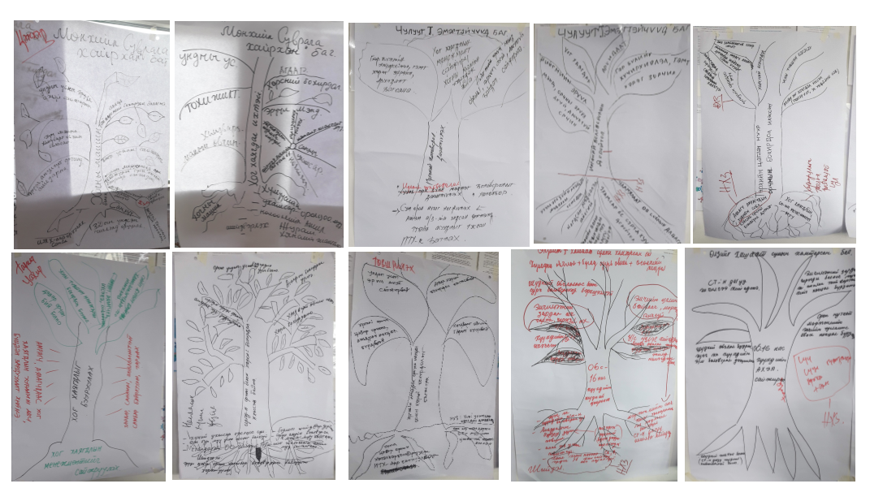
Cooperation plans
Woman representatives’ initiatives and potential joint cooperation activities:
- Organize women’s forum;
- Plant trees and create “Love grove”;
- Organize public hearing on pastureland management;
- Organize discussion themed “Family values”;
- Organize herders’ consultation meeting themed “Our pride”;
- Develop a project to create and eat local brand vegetables;
- Develop a plan to improve animal health;
- Mobilize “Save Tami River” movement;
- Organize charity campaign “One representative one person with disability”;
- Organize discussion on Promoting proper cyber culture;
- Monitor Food safety;
- Plan trees.

Participants’ testimonies:
- Representative from Erdenebulgan soum: I was runniing a small busines in Bayankhongor province before I moved to this soum in 2001. I stil run a small shop selling different products. In the last 4 years, I travel back and forth between Bayankhongor and Arkhangai aimags to survey basic needs of people on the market. I observed that decision-makers do not know about herders’ life. Only people visiting herder households around can now if they have enough food and other needs. Thus, I decided to be elected to the local hural to address herders’ social issues. There are many challenging issues to be resolved in such regards. For instance, health insurance. Herders do not know about the health insurance, nor about the list of discounted medicines. Thus, no can use this discounted offer. I told my constituents "If you paid your health insurance premiums, you should get your discounted medicines". I also raised this issue to soum governor. Now I plan to utilize newly-acquired knowledge from this training to help my fellow citizens.
- Currently, things are developing faster and all baghs have office premises. But some bagh governors and bagh pheldshers are not based at their baghs. At bagh public meetings people express their challenges quite often, but nothing changes. However, this training provided many tools and tactics for how just to resolve bagh level issues, but gave many ideas on how to address soum level challenges too. Our soum hural has 9 woman-representatives. When I come back to my soum, I will set up a women’s group and collaborate together regardless of age, as we share our ideas during the training.
- After having attended the training, I think of going to work with goals and ambitions. Previously, I never looked into my own self. I also want to work in teams.
- I learned a lot during the training. My participation and engagement was poor before the training, so now I want to work proactively.
- I realized that we have enormous resources. Due to lack of knowledge, we cannot better use our resources. Although my hural term remains short, I want to do many things.
- Yesterday evening after yesterday’s training, our soum woman-representatives talked about how we can cooperate together; in other words, shifting from Me to Us.
- Training was held high quality, beneficial and interesting. I learned a lot of things which I can use directly after I go back to my soum. First of all, I am planning to form a women’s group.
- I learned that problems should not be seen from legal perspectives. Also I am thinking to make efforts persistently until the end after picking up an issue..
- Training methodology and exercises are an effective conducive to its contents. I understand that I should activate women’s lobby groups.
- This training was delivered easy to understand based on real life examples. Everyone always has open opportunities before them. Importantly, we have to utilize them properly to address our challenges. Yesterday I thought a lot about the training after I got home. I am a member of Hural’s land management committee. There are actions I am thinking to include in our Committee’s work plan. And many more activities to implement jointly with other women representatives.
- This training was delivered easy to understand based on real life examples. Everyone always has open opportunities before them. Importantly, we have to utilize them properly to address our challenges. Yesterday I thought a lot about the training after I got home. I am a member of Hural’s land management committee. There are actions I am thinking to include in our Committee’s work plan. And many more activities to implement jointly with other women representatives.
- I understand well that leadership does not mean one person’s excellencies, but process of collaborative development involving everyone. I want to disseminate training knowledge to many people, and I am, as a school teacher, going to implement training tactics at my school. I am very satisfied with my participation in this training.
- We – 7 woman representatives in our hural – will form a women’s group. I understand that Leadership starts from one self, then mobilize others, create a team and make changes eventually..
- I am planning to implement at least one leadership activity in the remaining term of my representation, and discussing what to do with my colleagues.
- This 2-day provided comprehensive understanding about Who is a representative? and What a representative should do? In the next two years, I will work to represent my constituents in a real sense.
- I thought leadership is a work of special people. I plan to implement shared leadership, to contribute and participate in such leadership activities actively, and to expand my role and responsibilities as a representative.
- I learned a lot from the training. Our soum hural has 10 woman representatives and we are discussing to form a women’s group.

Difficulties faced during the training and solutions used for overcoming them
Due to local contexts and availability, each class size was too big consisting of more than 3 groups which led to pushing sessions back and late so that facilitators had to shorten their sessions, summarize and combine presentations in order to include all planned contents and activities during the training.

There was some technical problem with equipment, but hural staffs quickly fixed and allowed the training progressed smoothly.
Hural staff members already started to distribute training evaluation sheets during the tea break and some participants were filling evaluation sheets from the project team and co-implementing partner before the training ended, so facilitators stopped the incident immediately. But it was already late to collect sheets from some participants so that participants’ concentration was dispersed momentarily.
Further considerations:
Hural staff members should consult and get permission from facilitators beforehand, when they need to take any actions related with logistics and other issues. This consideration should be informed to assistant facilitators mobilized from Hural before training starts during orientation session.

IV. Post-training initiative
During the local election campaign in 2016, woman candidates running for the local hural have signed MoU, as participants shared during the training. The MoU aims to ensure that woman candidates shall follow high level ethics value during the election campaign so that they do not defame their competitors, but respect one another and uphold just and fair competition. Woman representatives who heard about it for the first time also very appreciated and made initiative to introduce the practice in their communities. It is considered a very important initiative to promote women’s participation and leadership perspectives.

Report prepared by: D. Doljinsuren
Date: June 15, 2018

SRBM, Project document.
www.un.org/Depts/Cartographic/map/profile/mongolia.pdf
IFES Election Guide | Country Profile: Mongolia {www.electionguide.org/countries/id/144/}.
SRBM, Project document, p 5.
https://www.worldbank.org/en/country/mongolia
SDC Fact Sheet on Strengthening of Representative Bodies in Mongolia (SRB), p. 3, 2017.
Project Terminal Report, “Capacity Strengthening of Local Self-Governing Bodies”, March 2017.
SDC Fact Sheet on Strengthening of Representative Bodies in Mongolia (SRB), p. 1, 2017.
SRBM, Project document, p 5.
ToR of the Consultant, September, 2018.
https://www.oecd.org/dac/environment-development/2669958.pdf
SRBM, Project document, p. 9
Refer project Annual reports 2017 and 2018. Mention came up in our meetings with concerned actors.
Learnt of this post our in country mission.
Annual report 2018.
SRBM, Project document, p. 6.
Reported by the PIU. Survey conducted among a small, random sample for soums; all aimags covered.
SRBM, Project document, p. 7.
From discussions with PIU.
Annual progress report, 2017, p 8.
As provided in the MOU between NAoG and UNDP.
Project document: Stakeholder engagement, p. 13.
Personal field notes from group discussions
SRBM Sustainability plan: 2017

