## ANNEX I: TERMS OF REFERENCE

|  |
| --- |
| Background |
| UNDP’s regional project on Arab Knowledge (AKP) is part of the UNDP Regional Programme for the Arab States. The first phase of the project was launched in 2007 through a partnership with Mohammed Bin Rashid Al Maktoum Knowledge Foundation (MBRF), which was followed by phase II in (2016-2020).  AKP aims to promote knowledge societies and policies as transformational means to achieve sustainable development. The project contributes to driving active conversation and raise awareness on the importance of knowledge and knowledge-based policies for sustainable development. Hence, it encourages using knowledge generation as advocacy tools, aiming to widely disseminate and embed in policy debates.  More specifically, AKP strives to achieve two key outputs:  i) Arab Knowledge Index (AKI) and Knowledge4all digital portal to provide easily accessible data on knowledge accumulation, production and consumption within a development framework;  ii) Participatory platforms to maximize outreach and dissemination of knowledge products developed, and building educational capacities (ministries, universities, regional research institutions, etc.) to improve the state of knowledge in Arab countries.  Over the course of phase II, AKP focused on designing, launching and enhancing new knowledge products, namely the Global Knowledge Index (GKI), Arab Knowledge Index (AKI) and digital portal [Knowledge4all], to provide easily accessible data on knowledge within a development framework. This includes measuring performance of countries in the Arab region on knowledge acquisition, dissemination and production.  Through its outputs and associated knowledge products and activities, the project has been visibly contributing to the objective of supporting and promoting “knowledge for human development” in the Arab region. The ultimate objective has been to support the region’s efforts towards establishing the aspired knowledge societies and economies. This is in line with the major objectives and expected outcomes of RBAS/Regional Programme Document (2018-2021) particularly in relation to accelerating structural transformation of productive capacities in a sustainable and inclusive manner (RPD outcome 1).  As the project has been extended to 2030, UNDP seeks the recruitment of an international consultant to conduct a mid-term project evaluation. |
| Duties and Responsibilities |
| **Objectives of the Evaluation**  The evaluation will be conducted by an independent consultant. It will assess the project’s progress (and challenges), taking the linkages to the broader initiative into consideration, at the outcome level, with measurement of the output level achievements and gaps and in particular, what changes were achieved as a result of the project towards fostering knowledge, and ultimately the promotion of knowledge societies and policies as transformational means to achieve sustainable development.  The purpose of the external evaluation is foremost to assess how the project impacted the progress towards the achievement of the objectives. Moreover, the contribution of the project in enabling a coherent development engagement and to identify the factors that have affected its implementation will be assessed.  The evaluation will consist of a desk review-based research, a mission to Amman and Dubai to meet with the project team and key stakeholders, and in-depth interviews with key stakeholders and beneficiaries. It will document results achieved, the challenges faced, and how those challenges were addressed.  The evaluation is expected to identify success stories, good practices, challenges, constraints, and lessons learned, as well as to provide recommendations on substantive and process issues to inform the future direction, implementation, and the next steps of the project for the upcoming phase 2020-2030.  The external evaluation will cover the period from January 2016 till August 2019. It will be based on the activities financed by the Mohammed Bin Rashid Al Maktoum Knowledge Foundation (MBRF).  The specific evaluation **objectives** are to:   1. Analyze the relevance of the project strategy and approaches; 2. Validate the project results in terms of achievements and/or weaknesses toward the targeted results; 3. Assess the potential for sustainability of the results and the feasibility of ongoing, nationally-led efforts and commitment to help promote knowledge societies and policies as transformational means to achieve sustainable development; 4. Document key lessons learned, good practices, success stories and challenges to inform future work of various stakeholders in addressing the area of fostering knowledge; and 5. Document and analyze possible weaknesses in order to improve next steps of project interventions in the mentioned area.   **SCOPE OF WORK**  In assessing the project, the evaluation will take into consideration the following criteria:  **Relevance and appropriateness**   1. Was the project relevant, appropriate and strategic to fostering knowledge for sustainable development goals and challenges? 2. Was the project relevant, appropriate and strategic to the mandate, strategy, functions, roles, and responsibility of the key actors? 3. Was the project relevant, appropriate and strategic to the UNDP development goals?   **Effectiveness and efficiency**   1. Were the actions to achieve the outputs and outcomes effective and efficient? 2. Were there any lessons learned, failures/lost opportunities? What might have been done better or differently? 3. How did the project deal with issues and risks? 4. Were the outputs achieved in a timely manner? 5. Were the resources utilized in the best way possible? 6. Were the resources (time, funding, human resources) sufficient?   **Impact and sustainability**   1. Will the outputs/outcomes lead to benefits beyond the life of the existing project? 2. Were the actions and result owned by the partners and stakeholders? 3. Was the capacity (individuals, institution, and system) built through the actions of the project? 4. What is the level of contribution of the project management arrangements to national ownership of the set objectives, result and outputs? 5. Were the modes of deliveries of the outputs appropriate to promote regional / national ownership and sustainability of the result achieved? 6. Did the project address cross-cutting issues include gender?   **Project design**   1. To what extent did the design of the project help in achieving its own goals? 2. Was the context, problem, needs and priorities well analyzed while designing the project? 3. Were there clear objectives and strategy? 4. Were there clear baseline indicators and/or benchmark for performance? 5. Was the process of project design sufficiently participatory? Was there any impact of the process? 6. Was there coherence and complementarity by the project to other entities in the field of fostering knowledge? 7. Was there coherence, coordination and complementarity by the project with other donor funded activities in the field of fostering knowledge?   **Project management**   1. Are the project management arrangements appropriate at the team level and project board level? 2. Was there appropriate visibility and acknowledgement of the project and donor? 3. The Final Evaluation should be aligned with the principles established in UNDP’s Evaluation Policy and the UN Evaluation Group’s [Norms and Standards for Evaluation](http://www.unevaluation.org/document/detail/1914).   **METHODOLOGY**  Based on the UNDP guidelines for evaluations, the evaluation will be inclusive and participatory, involving principal stakeholders into the analysis. During the evaluation, the consultant is expected to apply the following approaches for data collection and analysis.   1. **Desk review**of relevant documents, including progress reports and any records of the various opinion surveys conducted during the life of the project**.** 2. **One field visit** (including to Amman and Dubai) to meet with the project team and stakeholders in the field (3 working days) to conduct key informative interviews. 3. An **analytical report**, which should contain an executive summary (mandatory), be analytical in nature (both quantitative and qualitative), be structured around issues and related findings/lessons learned; and include conclusions and recommendations. 4. During the process, the consultant will report to the Director of the Regional Hub, who will provide overall guidance and ensure satisfactory completion of the deliverables. There will be close coordination with the Chief Technical Advisor (CTA) and project team who will assist in connecting the consultant with senior management, development partners, beneficiaries and key stakeholders. In addition, the CTA will provide key project documentation prior to fieldwork, and project staff will assist in developing a detailed programme to facilitate consultations as necessary.   **EXPECTED OUTPUTS AND DELIVERABLES**   1. The consultant is expected to deliver the following outputs: 2. Inception report on proposed evaluation methodology, work plan and proposed structure of the report; 3. A draft preliminary evaluation report, to be presented at a debriefing meeting with UNDP; 4. Final report including a 2-3 pages’ executive summary.   Please refer to “Annex 1: Proposed Evaluation Workplan” for a detailed view of the Deliverables/Outputs with the corresponding Activity, Estimated Duration, Due Dates, Review and Approvals Required.  S/he will work with the AKP Chief Technical Advisor based in Dubai under the supervision of the Regional Hub Director based in Amman, based on the workplan enclosed as Annex 1. |
| Competencies |
| Functional   * Good teamwork and interpersonal skills; * Flexibility and ability to handle multiple tasks and work under pressure;   Knowledge Management and Learning   * Ability to strongly promote and build knowledge products; * Seeks and applies knowledge, information and best practices from within and outside of UNDP; * Demonstrates strong oral and written communication skills;   Judgment/Decision-Making   * Mature judgment and initiative; |
| Required Skills and Experience |
| **QUALIFICATIONS OF THE SUCCESSFUL INDIVIDUAL CONTRACTOR**  I. Academic Qualifications:   * At least a master’s degree in social sciences, management or related discipline;   II. Years of experience:   * A minimum of 7 years of experience in implementation / evaluation of projects/programmes on democratic governance / fostering knowledge; preferably some experience of these in the Arab countries; * Experience in cooperation with multilateral agencies * Strong background experience including familiarity with UN systems, requirements, procedures, and rules & regulations; * Solid understanding of international knowledge standards and experiences in programming on related issues; * Proven work experience in use of participatory evaluation methods for identifying measurable target indicators and in particular for identifying outcome / impact – positive change of behavior, policy or law made; * Demonstrated ability to assess complex situations in order to succinctly and clearly distil critical issues. * Excellent analytical and report writing skills   IV. Language Requirements:   * Language proficiency in both English and Arabic, written and oral is required.   **INSTITUTIONAL ARRANGEMENT**   * The individual is required to exhibit his or her full-time commitment with UNDP-RBAS; * S/He shall perform tasks under the general guidance and the direct supervision of the Arab Knowledge Portal (AKP) project manager. The supervision of the (AKP) project manager will include approvals/acceptance of the outputs as identified in the previous section; * The individual is expected to liaise and collaborate in the course of performing the work with other consultants, suppliers and UN colleagues; * The individual is required to provide periodical progress reports on regular and needed basis throughout the assignment in order to monitor progress; * The individual is required to maintain close communication with UNDP-RBAS on regular and needed basis at any period throughout the assignment in order to monitor progress. In the event of any delay, S/he will inform UNDP promptly so that decisions and remedial action may be taken accordingly; * Should UNDP deem it necessary, it reserves the right to commission additional inputs, reviews or revisions, as needed to ensure the quality and relevance of the work.  1. **FINANCIAL PROPOSAL**   Interested candidates should provide lump sum fees for requested services with detailed breakdown. This amount must be “all-inclusive”. Please note that the terms “all-inclusive” implies that all costs (professional fees, travel costs, living allowances, communications, consumables, etc.) that could possibly be incurred are already factored into the final amounts submitted in the proposal. Also, please note that the contract price will be Deliverables/Outputs based - not fixed - subject to change in the cost components.  The contractor will be paid an all-inclusive Deliverables/Outputs based lump sum amounts over the assignment period, subject to the submission of Certification of Payment (CoP) duly certified and confirmation of satisfactory performance of achieved work (deliverables/outputs) in line with the schedule of payments table hereunder.   |  |  |  |  | | --- | --- | --- | --- | | **Milestone** | **Estimated due date** | **Expected number of working days for each deliverable** | **Payment** | | **Output:**   * 1. Evaluation inception report (including evaluation workplan and timeframe, and using the Sample evaluation matrix-Table A below) * 2. Draft evaluation report   Draft evaluation findings.  Documented records of interviews and observations with stakeholders.  Presentation of findings to key stakeholders  Draft report delivered to UNDP for consideration and comments   * 3. Final evaluation report   A report of maximum 25 pages in word document format with tables/graphs where appropriate will be submitted after the completion of the mission, incorporating comments made on the draft | 6 days from contract signature date      32 days from submitting the Evaluation inception report            7 days from submitting the Draft evaluation report | 6 days          10 days                    5 days | 100% of the contract value upon satisfactory completion of all Deliverables |     **RECOMMENDED PRESENTATION OF OFFER**  Interested individual consultants must submit the following documents/information to demonstrate their qualifications. Candidates that fail to submit the required information will not be considered.   1. Duly accomplished **Letter of Confirmation of Interest and Availability**using the template provided by UNDP; 2. **Personal CV**, indicating all past experience from similar projects, as well as the contact details (email and telephone number) of the Candidate and at least three (3) professional references; 3. **Brief description** of why the individual considers him/herself as the most suitable for the assignment, including references to how she/he will approach and complete the assignment. 4. **Submit technical proposal and methodology for this assignment**   **Interested candidates shall submit above documents to the Job Advertisement Website:**[**https://jobs.undp.org/cj_view_jobs.cfm**](https://jobs.undp.org/cj_view_jobs.cfm)  **as one document not later than 7th December, 2019**  **Interested candidates can find Procurement notice, letter of confirmation of interest and availability and P11**[**http://procurement-notices.undp.org/view_notice.cfm?notice_id=61703**](http://procurement-notices.undp.org/view_notice.cfm?notice_id=61703)  **Please do not submit financial proposal in this stage.  Financial proposal shall be requested from Candidates who are considered technically responsive**  **EVALUATION**  Individual consultants will be evaluated based on the following methodologies:  **Step I: Screening and desk review:**  Individual consultants will be evaluated based on the following methodology.  Applications will be first screened and only candidates meeting the following minimum requirements will progress to the pool for shortlisting:   * **Criteria A:**At least a master’s degree in social sciences, management or related discipline * **Criteria B:** A minimum of 7 years of experience in implementation / evaluation of projects/programmes on democratic governance / fostering knowledge; preferably some experience of these in the Arab countries; * **Criteria C:**Language proficiency in both English and Arabic written and oral is required.   Shortlisted Candidates will be then assessed and scored against the following evaluation criteria:  **Technical evaluation Criteria**max 100 points (Weighted 70):   * **Criteria A** At least a master’s degree in the social sciences, management or other relevant field of study (20 points); * **Criteria B:** A minimum of 7 years of experience in implementation / evaluation of projects/programmes on democratic governance, in particular knowledge; preferably some experience of these in the Arab countries (25 points); * **Criteria C:** Experience in cooperation with multilateral agencies would be a Strong background experience including familiarity with UN systems, requirements, procedures, and rules & regulations (10 points); * **Criteria D:**Excellent analytical and report writing skills; Knowledge of English and Arabic (5 points); * **Criteria E:** Quality of the proposed methodology and technical offer (40 points)   **Financial Criteria - 30% of total evaluation**  For those offers considered in the financial evaluation, the lowest price offer will receive 30 points. The other offers will receive points in relation to the lowest offer, based on the following formula: (PI / Pn) * 30 where Pn is the financial offer being evaluated and Pl is the lowest financial offer received.  **Step II: Final evaluation**  The final evaluation will combine the scores of the desk review and the financial proposal with the following weights assigned to each:  Individual consultants will be evaluated based on the **cumulative analysis** methodology (weighted scoring method), where the award of the contract will be made to the individual consultant whose offer has been evaluated and determined as:   * Responsive/compliant/acceptable; and * Having received the highest score out of a pre-determined set of technical and financial criteria specific to the solicitation.   Technical Criteria weight: [70%]  Financial Criteria weight:  [30%]  Only Individual Consultants obtaining a minimum of 49 points (70%) on the Technical evaluation would be considered for the Financial Evaluation.  Annexes   * Annex 1- Proposed Evaluation Workplan * Annex 2- Structure of Evaluation Report * Annex 3- Code of conduct |

## ANNEX II: EVALUATION MATRIX

|  |  |  |  |  |  |  |
| --- | --- | --- | --- | --- | --- | --- |
| **Relevant Criteria** | **Key Questions** | **Sub Criteria** | **Sub Questions** | **Sources of information** | **Stakeholders** | **Methods for Data Analysis** |
| **Relevance** | *The extent to which the Outcome activities are suited to the priorities and policies of the country at the time of formulation*  **Are we doing the right things?** | Alignment | * 1. Does the AKP’s structure and objectives address key issues, their underlying causes, and challenges identified in the region? Are they aligned with: regional/national priorities? SDGs? With UNDP’s development goals? | Country policies and strategies, references, UN reports, media | RBAS staff, AKP staff, Government institutions | Desk review, interviews |
| Design | * 1. Was the design of the AKP adequate to expected objectives, and flexible enough to adapt to potential changes?   2. To what extent did the AKP adopt gender-sensitive, human rights-based and conflict-sensitive approaches?   3. To what extent was the theory of change presented in the outcome model a relevant and appropriate vision on which to base the initiatives? | UN reports, project reports, portfolio analysis | RBAS staff, AKP staff | Desk review, interviews |
| **Effectiveness** | *The extent to which the Outcome activities attain their objectives*  **Are the things we are doing working?** | Credibility | 2.1. What are the main contributions to development for which the project is recognized in the region? | ROAR& project reports, Comparison of reports to work plans; evaluation reports | RBAS staff, AKP staff, beneficiaries, contractors | Desk review, interviews |
| Achievements | * 1. How has the AKP achieved expected outcomes? | ROAR, progress reports | RBAS staff, AKP staff, beneficiaries, partners | Desk review, interviews |
| Fallout effect | * 1. What are the unexpected outcomes or consequences they yielded? What are their implications? | Project reports, work plans, ROARs, project beneficiaries | RBAS staff, AKP staff, beneficiaries, partners | Desk review, interviews |
| Challenges | * 1. Which were the main weaknesses of the project? | Project reports, ROARs | RBAS staff, AKP staff, beneficiaries, partners | Desk review, interviews |
| Good practices | * 1. How effective have been practices and tools used in the AKP? (good practices, institutional strengthening, partnerships) | Project reports, ROARs | All stakeholders | Desk review, interviews |
| **Efficiency** | *Measurement of the outputs in relation to the inputs*  **Are we doing things right?** | Organizational Efficiency | 3.1 Was management adequate to the planning and execution requirements? (management arrangements, work planning, finance, value for money, timing and delays, project-level monitoring and evaluation systems, coordination, stakeholder engagement, reporting, communications)  3.2 To what extent have UNDP practices, policies, processes and decision-making capabilities affected the progress of the AKP?  3.3 To what extent were partnership modalities conducive to the delivery of AKP outputs?  3.4 To what extent did monitoring systems provide management with a stream of data that allowed it to learn and adjust implementation accordingly?  3.5 To what extent did UNDP promote gender equality, the empowerment of women, human rights and human development in the delivery of AKP outputs? | Evidence of fund disbursement being appropriate to maximize utility Evidence of decision making, adjustment and learning  Evidence of a performance management system having been established and utilized for decision-making  Evidence of coordination | RBAS staff, AKP staff | Desk review, interviews |
| **Impact** | *The benefits of the project related activities that are likely to continue after the project’s fund has been exhausted*  **Did the project induce direct and/or indirect changes and will they last?** | Institutional Impact | 4.1 Have efforts produced durable results in the national capacities in governments and civil society? | Evidence of improvements in performances and progress in related sectors/areas | Partners, RBAS and AKP staff | Desk review, interviews |
| **Sustainability** | Coordination | 5.1 To what extent did UNDP establish mechanisms to ensure the sustainability of the AKP outcomes?  5.2 To what extent do regional / national partners have the institutional capacities, including sustainability strategies, in place to sustain the outcome-level results?  5.3 Have complementarities, collaboration and/or synergies fostered by the AKP contributed to greater sustainability of results? | Evidence of results from cooperation at regional level  Cooperation between regional projects and COs  Reports, ROARs | Partners, RBAS and AKP staff | Desk review, interviews |
| Financial and policy sustainability | 5.4 Have any outcomes of the AKP been translated into budgeted state projects/policies? | Integration of project outcomes into national planning, budgeting and monitoring systems Financial flows within institutions to maintain outcomes | Project reports, ROARs, national/ regional reports | Desk review, interviews |
| Knowledge sustainability | 5.5 Are knowledge materials produced in the project being still used or disseminated? | Embedding of knowledge material into institutional practices, evidence of use | Project reports, ROARs, beneficiaries | Desk review, interviews |

## ANNEX III: LIST OF INDIVIDUALS OR GROUPS INTERVIEWED

*Key Informant Interviews in Numbers*

|  |  |
| --- | --- |
| **Number of Completed Interviews** | 17 out of 19 |
| **Number of Completed Focus Group Discussions** |  |
| **Number of Uncompleted Interviews** | 2 |
| **Number of Interview days** | 4 |
| **Gender Distribution** | F= 10 M=16 |
| **People with Disabilities** | 1 with disability, 1 working with people with disabilities (PWD) |
| **Shortest Interview** | 14 min |
| **Longest Interview** | 45 min |
| **Average Duration of Interview** | 28.17 min |

*Friday May 29th, 2020*

|  |  |  |  |
| --- | --- | --- | --- |
| **Key Informant** | **Function** | **Status of Interview** | **Duration of Interview** |
| Ms. Sara Ghraiz | Pharmacist, Jordan | Completed | 29 min |
| Ms. Manar El Mitri | University student, Egypt | Completed | 35 min |
| Ms. Futoon Obeidat | Freelancer, Jordan | Completed | 28 min |
| Ms. Shaymaa Al Bahrawi | PhD Candidate, Egypt | Completed | 25 min |
| Mr. Hisham Al Odat | Lawyer, Jordan | Completed | 20 min |

*Saturday May 30th, 2020*

|  |  |  |  |
| --- | --- | --- | --- |
| **Key Informant** | **Function** | **Status of Interview** | **Duration of Interview** |
| Mr. Hazem Ismail | Economic Researcher, Egypt | Completed | 45 min |
| Mr. Fathi Emad | President of Egypt Youth 2030, Egypt | Completed | 40 min |
| Mr. Raad Al Ghoneimi | Teacher and lab supervisor, Jordan | Completed | 25 min |

*Sunday May 31st, 2020*

|  |  |  |  |
| --- | --- | --- | --- |
| **Key Informant** | **Function** | **Status of Interview** | **Duration of Interview** |
| Mr. Saif Al Mansouri | Corporate Affairs Adviser to the CEO of Mohammed Bin Rashid Al Maktoum Knowledge Foundation (MBRF) and Focal Point with UNDP | Completed | 32 min |

*Tuesday June 2nd, 2020*

|  |  |  |  |
| --- | --- | --- | --- |
| **Key Informant** | **Function** | **Status of Interview** | **Duration of Interview** |
| Mr. Thabet Al Nabulsi | Adviser to Jordan’s former Minister of Youth, Jordan | Completed | 15 min |
| Dr. Hijazi Ibrahim | Regional Specialist for Basic Education, UNESCO Regional Bureau, Lebanon | Completed | 23 min |
| Dr. Ali Ibrahim | Associate Professor of Administrative and Policy Studies in Education at UAE University, UAE | Completed | 22 min |
| Dr. Najoua Fezza Ghriss | Professor of Education at Tunis University, Tunis | Completed | 30 min |
| Dr. Hasan Al Bilawi | Professor of Sociology of Education at Helwan University in Cairo, Egypt | Completed | 37 min |
| Mr. Jan Sturesson | International Strategy Consultant, Sweden | Completed | 20 min |
| Mr. Firas Al Shawabkah | Youth Consultant, Ministry of Youth, Jordan | Completed | 14 min |
| Mr. Khalid Wazani | Chairman of Jordan Investment Commission, Jordan | Completed | 22 min |
| Mr. Yasser Refaat | Adviser to the Minister of Higher Education, Egypt | Postponed |  |
| Dr. Yousef Saddik | Professor of Social Science at Mohammed V University, Morocco | No response after several attempts to reach out from RBAS and Evaluation Consultant |  |

*Monday June 15th, 2020*

|  |  |  |  |
| --- | --- | --- | --- |
| **Focus Group Discussion (FGD) participants** | **Function** | **Status of Interview** | **Duration of Interview** |
| Mr. Khaled Abdel Shafi | UNDP RBAS Regional Director | Completed | 50 min |
| Ms. Paola Pagliani | Regional Programme Coordinator |
| Mr. Abusabeeb Elsadig | Result and Resource Management Specialist |
| Ms. Maya Abi-Zeid | Reporting & Knowledge Management Specialist |
| Mr. Hany Torky | Chief Technical Advisor |
| Ms. Diana Assaf | Copywriter and Research Officer |
| Ms. Sirine Saghira | Web Editor |
| Ms. Stephanie Boustany | Research Associate |
| Mr. Anthony Fakhoury | Researcher |

## ANNEX IV: LIST OF SUPPORTING DOCUMENTS REVIEWED

|  |  |  |  |  |
| --- | --- | --- | --- | --- |
| **Document** | **Type** | **Year** | **No. of Documents** | **Link** |
| **Regional Programme Documents**Bottom of Form | Regional | 2014-2017  2018-2021 | 2 | <https://www.dropbox.com/home/Desk%20review/1.Regional%20Programme%20Documents> |
| **RP Mid-Term Review 2016** | Regional | 2016 | 1 | <https://www.dropbox.com/home/Desk%20review/2.%20RP%20Mid-Term%20Review%202016> |
| **Results-Oriented Annual Reports** | Regional | 2016-2019 | 4 | <https://www.dropbox.com/home/Desk%20review/3.Results-Oriented%20Monitoring%20Reports> |
| **Project Document** | Project Specific | 2016-2020 | 7 | <https://www.dropbox.com/home/Desk%20review/4.Project%20Document> |
| **Project Board** | Project Specific | 2016-2019 | 12 | <https://www.dropbox.com/home/Desk%20review/5.Project%20Board> |
| **Progress Reports** | Project Specific | 2016-2019 | 4 | <https://www.dropbox.com/home/Desk%20review/6.Progress%20Reports> |
| **Annual Workplans** | Project Specific | 2016-2019 | 4 | <https://www.dropbox.com/home/Desk%20review/7.Annual%20Workplans> |
| **Back-to-Office Reports** | Project Specific | 2016-2019 | 65 | <https://www.dropbox.com/home/Desk%20review/8.Back-to-Office%20Reports> |
| **Knowledge Products** | Project Specific | 2016-2019 | 36 | <https://www.dropbox.com/home/Desk%20review/9.Knowledge%20Products> |
| **Support to UNDP Country Offices** | Project Specific | 2016-2019 | 4 | <https://www.dropbox.com/home/Desk%20review/Support%20to%20UNDP%20Country%20Offices> |
| **Monitoring Framework** | Project Specific | 2016-2019 | 1 | <https://www.dropbox.com/home/Desk%20review> |
| **Brief Report on K4All Website Traffic** | Project Specific | 2019 | 1 | <https://www.dropbox.com/home/Desk%20review> |
| **Stakeholders List and Interview Schedule** | Reference | 2020 | 2 | <https://www.dropbox.com/home/Desk%20review/Stakeholders%20List%20and%20Interview%20Schedule> |
| **AKP Team Diagram** | Reference | 2020 | 1 | <https://www.dropbox.com/home/Desk%20review> |
| **MAIN AKP FOLDER:** [**https://www.dropbox.com/home/Desk%20review**](https://www.dropbox.com/home/Desk%20review) | | | | |

## ANNEX V: PROJECT RESULTS FRAMEWORK

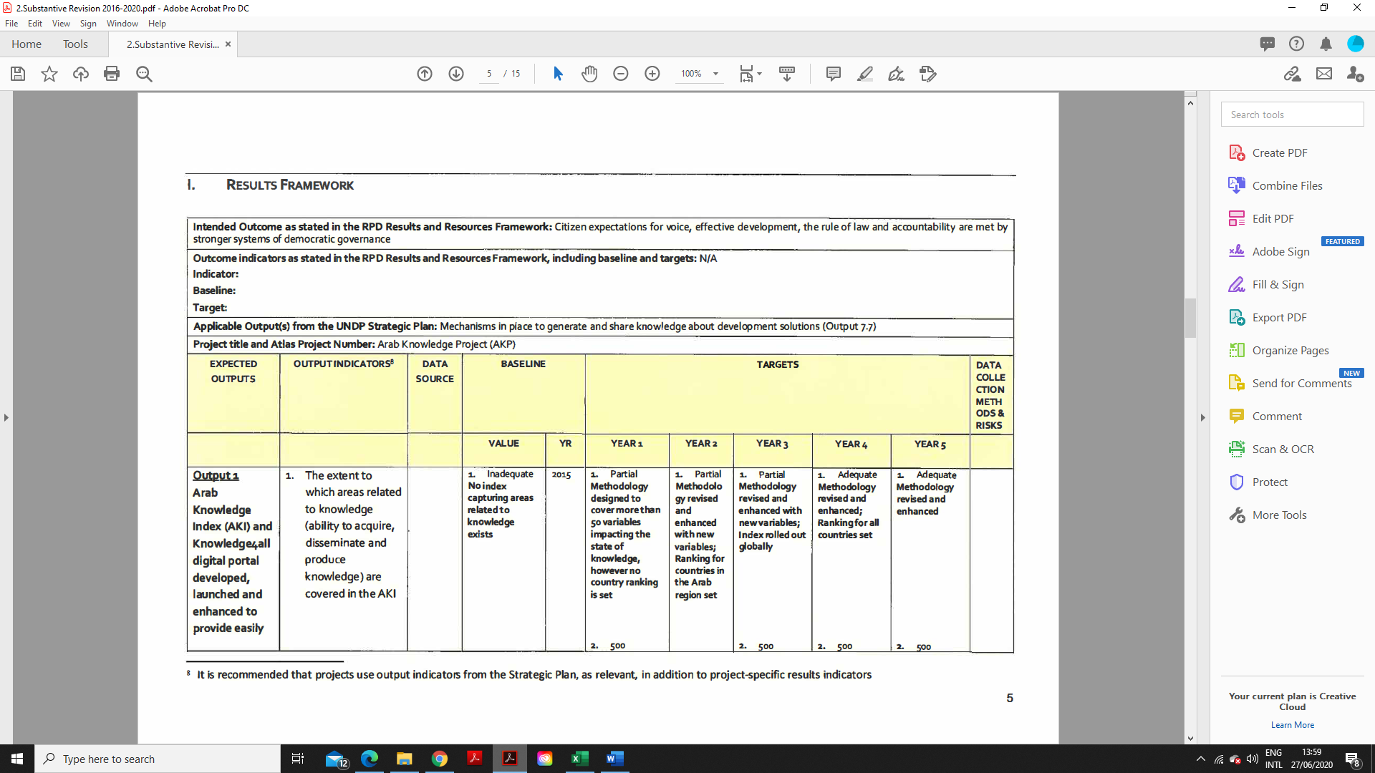

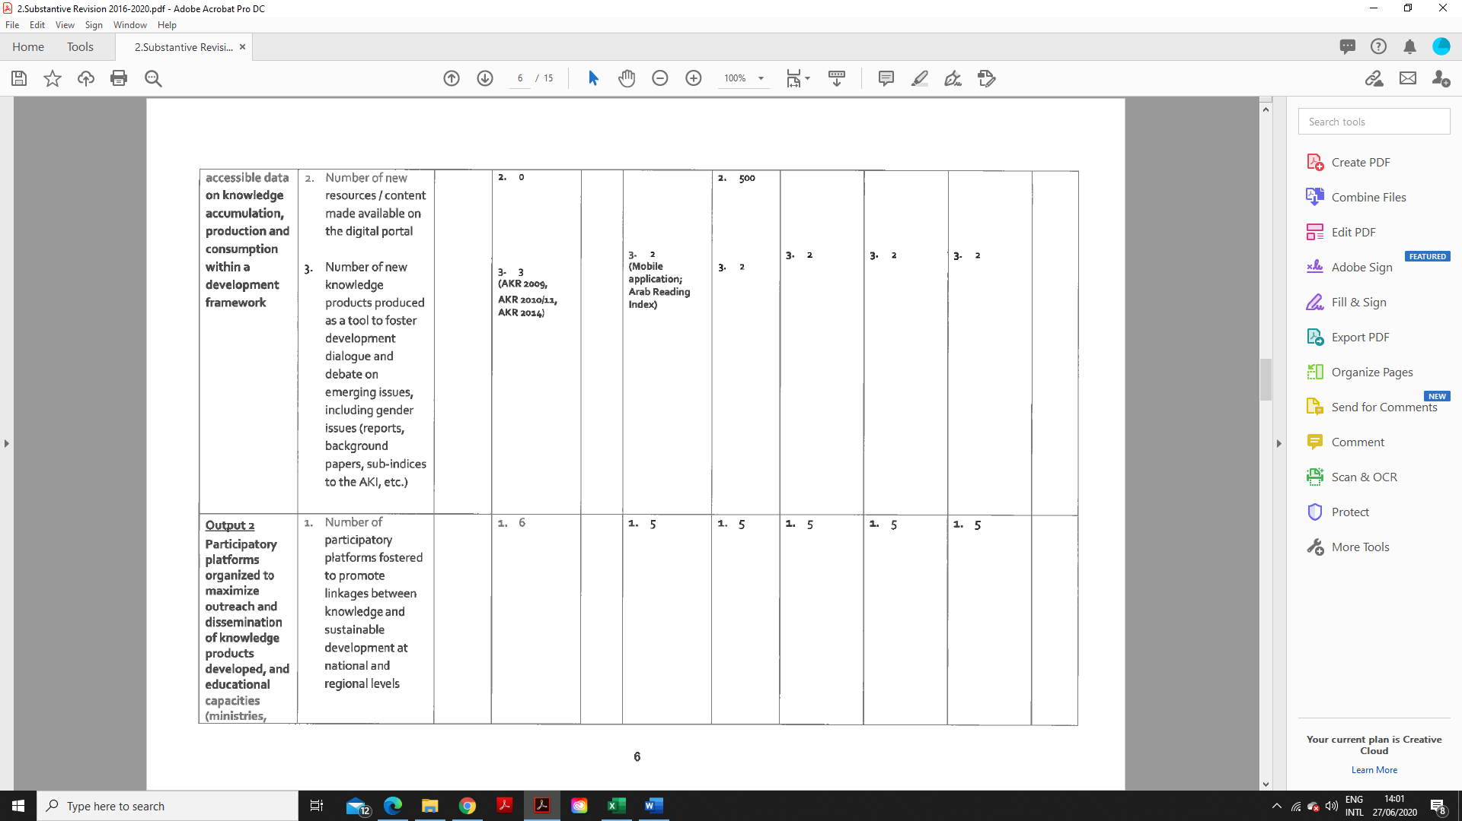

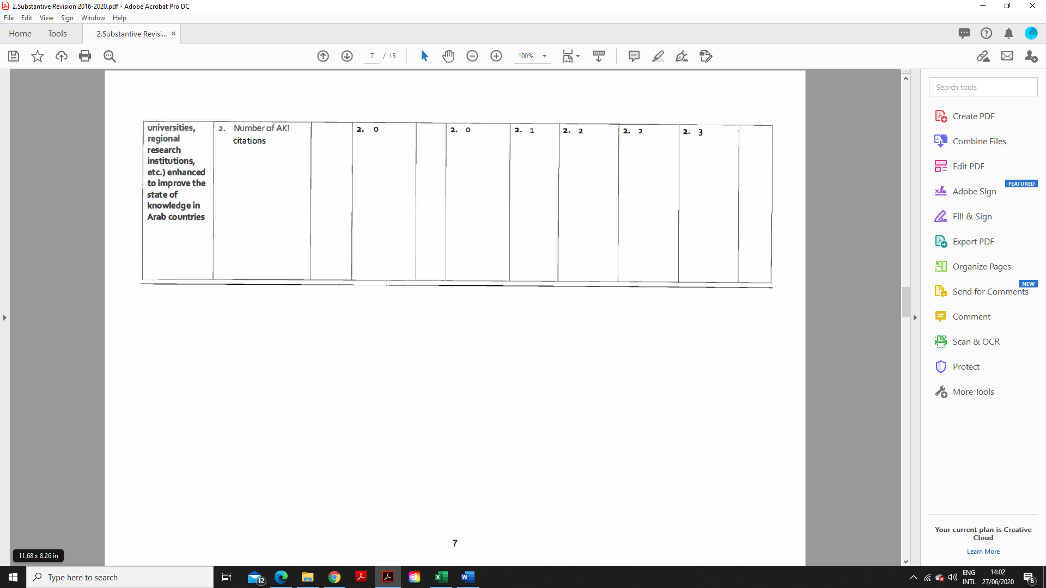

## ANNEX VI: SUMMARY TABLES OF PROGRESS TOWARDS OUTPUTS, TARGETS AND GOALS

**2016: Progress against each output**

|  |  |  |
| --- | --- | --- |
| **Project Output 1: Arab Knowledge Index (AKI) 2015 and Arab Knowledge Portal outreach strategy implemented** | | |
| **Output indicators** | **Targets** | **Progress against targets** |
| Level of awareness of AKI 2015 and Arab Knowledge Portal among beneficiaries and stakeholders | **Baseline:** Limited awareness (AKI 2015 and Arab Knowledge Portal launched in Q4 of 2015)  **Target:** Increased level of awareness among 150 research centres, 100 universities in the Arab region, and around 100 experts. | **Reporting period:**   * No progress.   **Cumulative total: (Achieved)**   * AKI 2015 reached 150 research centres and 100 universities in the Arab region, as well as 600 experts. |
| **Project Output 2: Arab Knowledge Index (AKI) 2016 developed, updated and launched** | | |
| **Output indicators** | **Targets** | **Progress against targets** |
| Number of themes covered in AKI 2016 | **Baseline:** 6 themes covered in AKI 2015  **Target:** 6 themes covered in AKI 2016 | **Reporting period:**   * No progress   **Cumulative total: (Achieved)**   * 6 themes covered in AKI 2016, in addition to a 7th relating to reading (ARI to be incorporated in AKI 2017) |
| Number of countries covered in AKI 2016 | **Baseline:** 22 countries covered in AKI 2015  **Target:** All countries of the world covered in AKI 2016 | **Reporting period:**   * No progress   **Cumulative total: (Not yet achieved)**   * 22 countries covered in AKI 2016 (AKP plans to expand the index to cover all countries of the world in 2017). |
| Number of experts attending the launch event in Dubai | **Baseline:** 7 Core Team members identified to attend the AKI 2015 launch  **Target:** 50 experts attending AKI 2016 launch | **Reporting period:**   * In addition to the core team members attending the third knowledge summit in December 2016, approximately 50 experts attended the event   **Cumulative total: (Achieved)**   * In addition to the core team members attending the third knowledge summit in December 2016, approximately 50 experts attended the event. |
| **Project Output 3: Arab Knowledge Portal enhanced and updated** | | |
| **Output indicators** | **Targets** | **Progress against targets** |
| Number of indicators covered in Data Visualization in the Arab Knowledge Portal in 2016 | 1,000 indicator themes covered in the portal in 2016 | **Reporting period:**   * 400 indicators relating to AKI’s indices, pillars and sub-pillars covered in the portal.   **Cumulative total:**   * 400 indicators relating to AKI’s indices, pillars and sub-pillars covered in the portal. |
| Number of countries covered in the Arab Knowledge portal in 2016 | All countries of the world covered in the portal in 2016 | **Reporting period:**   * No progress   **Cumulative total:**   * 22 countries covered in the portal |
| Number of publications covered in the Arab Knowledge portal in 2016 | 500 publications covered in the portal in 2016 | **Reporting period:**   * No progress   **Cumulative total:**   * Approximately 150 publications were covered in the portal in 2016. |
| Number of events covered in the Arab Knowledge Portal in 2016 | 250 events covered in the portal in 2016 | **Reporting period:**   * 23 events covered in the portal and 31 pieces of news (14 in Arabic and 17 in English).   **Cumulative total:**   * 34 events were covered in the portal (17 in Arabic and 17 in English) and 31 pieces of news (14 in Arabic and 17 in English). |

**2017: Progress against each output**

|  |  |  |
| --- | --- | --- |
| **Project Output 1: Arab Knowledge Index 2016 and Knowledge4All portal and mobile application outreach strategy implemented** | | |
| **Output indicators** | **Targets** | **Progress against targets** |
| 1. Number of participatory platforms fostered to promote Arab Knowledge Index 2016, Knowledge4All portal and mobile application | **Baseline:** 1 (Knowledge Summit 2016)  **AWP target:** 10 | **Reporting period**: 8   * 9th Emirates Airlines Festival of Literature in Dubai * K4D Global Partnership Conference in the United Nations Office at Geneva * Workshop at Alexandria University * 61st World Statistics Congress in Marrakesh * Interdisciplinary Social Sciences Conference in Hiroshima * UKFIET Education and Development Forum in Oxford * GITEX Technology Week 2017 in Dubai * Second International Conference “Towards Building Egyptian Knowledge and Innovation Society” in Cairo   **Cumulative total:** 8 |
| 2. Level of awareness of AKI 2016 and Knowledge4All portal and mobile application among beneficiaries and stakeholders | **Baseline:** 1,500 experts and academics (Knowledge Summit 2016)  **AWP target:** 2,500 experts and academics | **Reporting period**: 1,280 (experts and professionals in the areas of knowledge and development)  **Cumulative total:** 2,780 |
| **Project Output 2: Global Knowledge Index produced and launched, and Arab Knowledge Index 2017 and Knowledge4all portal and mobile application developed, launched and enhanced to provide easily accessible data on knowledge accumulation, production and transfer within a developmental framework** | | |
| **Output indicators** | **Targets** | **Progress against targets** |
| 1. The extent to which areas related to knowledge (ability to acquire, disseminate and produce knowledge) are covered in the Global Knowledge Index and AKI | **Baseline:** No global Knowledge Index and AKI Methodology revised and enhanced with new variables  **AWP target:** Global Knowledge Index and AKI 2017 produced | **Reporting period:** Fully-achieved   * Global Knowledge Index produced and launched covering 131 countries and 133 variables.   **Cumulative total**:   * Global Knowledge Index produced and launched covering 131 countries and 133 variables. |
| 2. Number of new resources/ content made available on the digital portal | **Baseline:** 500+ (including data variables)  **AWP target:** 1,000+ (covering various publications and events on knowledge-related topics) | **Reporting period:** 367  **Cumulative total:** 867 (490 knowledge indicators, in addition to 266 publications, 79 events and 32 newsletters) |
| 3. Number of experts involved in the preparation for the Arab Knowledge Index 2017 | **Baseline:** 0  **AWP target:** 20 | **Reporting period:** 20  **Cumulative total:** 20 |
| 4. Number of experts attending the launch event in Dubai | **Baseline:** 0  **AWP target:** 2,000 | **Reporting period:** 2,500  **Cumulative total:** 2,500 |

**2018: Progress against each output**

|  |  |  |
| --- | --- | --- |
| **Project Output 1: Global Knowledge Index 2017 and Knowledge4All portal and mobile application outreach strategy implemented.** | | |
| **Output indicators** | **Targets** | **Progress against targets** |
| 1. **Number of participatory platforms fostered to promote the Global Knowledge Index 2017, Knowledge4All portal and mobile application** 2. **Level of awareness of the GKI 2017 and Knowledge4All portal and mobile application among beneficiaries and stakeholders** | Baseline:   1. 1 (Knowledge Summit 2017) 2. Low level of awareness (2,500 experts and academics)   AWP target: 2,000   1. 13   High level of awareness (20,000+ experts and academics) | Reporting period: Full-achieved  Cumulative total: out of 13 (target) events, 15 were achieved.  Reporting period: 2,670  Cumulative total: 2,670 were reached; moderate level of awareness was achieved against the target. |
| **Project Output 2: Global Knowledge Index 2018 produced and launched, and Knowledge4all portal and mobile application updated and enhanced to provide easily accessible data on knowledge accumulation, production and transfer within a developmental framework.** | | |
| **Output indicators** | **Targets** | **Progress against targets** |
| 1. **The extent to which areas related to knowledge are covered in the Global Knowledge Index 2018** 2. **Number of countries covered in the GKI** 3. **Number of new resources/ content made available on the digital portal** | Baseline:   1. High - Wide coverage of knowledge-related areas in GKI 2017 (6 areas: pre-university education; technical vocational education and training; higher education; research, development and innovation; information and communications technology; and economy; in addition to the general enabling environment that covers further knowledge aspects such as health, environment, and institutional, gender and empowerment. 2. 131 3. 867 (490 knowledge indicators, in addition to 266 publications, 79 events and 32 newsletters)   AWP target: 2,000   1. Significant – Wider in-depth coverage of the knowledge-related areas in GKI 2018 through structure review and data update 2. 135 3. 1,500 | Reporting period: Fully-achieved   * Global Knowledge Index 2018 produced and launched covering 134 countries and 133 variables. * The GKI 2017 Analysis, under the title “Knowledge and Fourth Industrial Revolution,” was completed and released. * The Future of Knowledge: A Foresight Report was completed and launched, presenting a pilot study, covering 20 countries.   Cumulative total:   * Global Knowledge Index 2018 produced and launched covering 134 countries and 133 variables. * The GKI 2017 Analysis, under the title “Knowledge and Fourth Industrial Revolution,” was completed and released. * The Future of Knowledge: A Foresight Report was completed and launched, presenting a pilot study, covering 20 countries.   Reporting period:   * 381 (198 knowledge indicators, in addition to 108 publications, and 75 events) |

**2019: Progress against each output**

|  |  |  |
| --- | --- | --- |
| **Project** **Output 1: Global Knowledge Index 2018, Knowledge and the Fourth Industrial Revolution Report, Future of Knowledge Report, and Knowledge4All portal and mobile application outreach strategy implemented** | | |
| **Output indicators** | **Targets** | **Progress against targets** |
| 1. **Number of participatory platforms fostered to promote the Global Knowledge Index 2018, the Future of Knowledge Report, and Knowledge4All portal and mobile application** 2. **Level of awareness of the GKI 2018, the Future of Knowledge Report, and Knowledge4All portal and mobile application among beneficiaries and stakeholders** | Baseline:   1. 1 (Knowledge Summit 2018) 2. Low level of awareness (4,000 experts and academics)   AWP target:   1. 6 2. High level of awareness (20,000+ experts and academics) | Reporting period: Full-achieved  Cumulative total: out of 10 (target) events, 12 were achieved.  Reporting period: 6,000+  Cumulative total: 6000+ were reached; moderate level of awareness was achieved against the target.  In addition to 51,314 users on website during 2019 |
| **Project Output 2: Global Knowledge Index 2019 and Future of Knowledge Foresight Report 2019 produced and launched, and Knowledge4all portal and mobile application updated and enhanced to provide easily accessible data on knowledge accumulation, production, and transfer within a developmental framework** | | |
| **Output indicators** | **Targets** | **Progress against targets** |
| 1. **The extent to which areas related to knowledge are covered in the Global Knowledge Index 2019 and the Future of Knowledge Foresight Report 2019** 2. **Number of countries covered in the GKI and the Future of Knowledge** 3. **Number of new resources/content made available on the digital portal** | Baseline:   1. High - Wide coverage of knowledge-related areas in GKI 2018 (6 areas: pre-university education; technical and vocational education and training; higher education; research, development and innovation; information and communications technology; and economy; in addition to the general enabling environment that covers further knowledge aspects such as health, environment, and institutional, gender, and empowerment) and the Future of Knowledge 2018 (AI, cybersecurity, biotechnology, blockchain, and future skills). 2. 134 countries (GKI) and 20 countries (Future of Knowledge) 3. 381 (198 knowledge indicators, in addition to 108 publications, and 75 events)   AWP target:   1. Significant – Wider in-depth coverage of the knowledge-related areas in GKI 2019 through structure review and data update 2. 134 in GKI and 40 countries in Future of Knowledge 3. 1,500 | Reporting period: Fully-achieved   * Global Knowledge Index 2019 produced and launched covering 136 countries and 133 variables. * The Future of Knowledge: A Foresight Report 2019 was completed and launched, widening its coverage to 40 countries.   Cumulative total:   * Global Knowledge Index 2019 produced and launched covering 136 countries and 133 variables. * The Future of Knowledge: A Foresight Report 2019 was completed and launched, widening its coverage to 40 countries.   Reporting period:   * 382 (199 knowledge indicators, in addition to 108 publications, and 75 events)   Cumulative total:   * 382 (199 knowledge indicators, in addition to 108 publications, and 75 events)   Reporting period:   * 1,500+   Cumulative total:   * 1,500+ |

## ANNEX VII: CODE OF CONDUCT SIGNED BY EVALUATOR



**CODE OF CONDUCT FOR EVALUATION IN THE UNITED NATIONS SYSTEM**

1. The conduct of evaluators in the UN system should be beyond reproach at all times. Any deficiency in their professional conduct may undermine the integrity of the evaluation, and more broadly evaluation in the UN or the UN itself, and raise doubts about the quality and validity of their evaluation work.

2. The UNEG1 Code of Conduct applies to all evaluation staff and consultants in the UN system. The principles behind the Code of Conduct are fully consistent with the Standards of Conduct for the International Civil Service by which all UN staff are bound. UN staff are also subject to any UNEG member specific staff rules and procedures for the procurement of services.

3. The provisions of the UNEG Code of Conduct apply to all stages of the evaluation process from the conception to the completion of an evaluation and the release and use of the evaluation results.

4. To promote trust and confidence in evaluation in the UN, all UN staff engaged in evaluation and evaluation consultants working for the United Nations system are required to commit themselves in writing to the Code of Conduct for Evaluation2 (see Annexes 1 and 2), specifically to the following obligations:

**Independence**

5. Evaluators shall ensure that independence of judgement is maintained and that evaluation findings and recommendations are independently presented.

**Impartiality**

6. Evaluators shall operate in an impartial and unbiased manner and give a balanced presentation of strengths and weaknesses of the policy, program, project or organizational unit being evaluated.

1 UNEG is the United Nations Evaluation Group, a professional network that brings together the units responsible for evaluation in the UN system including the specialized agencies, funds, programmes and affiliated organizations. UNEG currently has 43 such members.

2 While the provisions of the Code of Conduct apply to all UN staff involved in evaluation, only UN staff who spend a substantial proportion of their time working on evaluation are expected to sign the Code of Conduct, including staff of evaluation, oversight or performance management units directly involved in the management or conduct of evaluations. All evaluation consultants are required to sign when first engaged by a UNEG member.





