 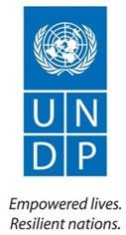

# Project Terminal Evaluation

**“CLIMATE PROOFING LOCAL DEVELOPMENT GAINS IN RURAL AND URBAN AREAS OF MACHINGA AND MANGOCHI DISTRICTS - MALAWI”**

UNDP PIMS 4508

GEF ID 4797

GEF focal area: Climate Change - Adaptation

Strategic Program of GEF 5:

CCA1 Reduce vulnerability to the adverse impacts of climate change, including variability, at local, national, regional and global level  
CCA2 Increase adaptive capacity to respond to the impacts of climate change, including variability, at local, national, regional and global level  
CCA3 Promote transfer and adoption of adaptation technology

Implementing Partner: Ministry of Natural Resources, Energy and Environment

Ministry of Local Government and Rural Development (Mangochi and Machinga District Councils)

Ministry of Finance, Economic Planning and Development

Region: Africa  
Country: MALAWI

Evaluation conducted by Cliff Mr.Bernard Nuwakora and Mr. Kamoto Judith (PhD)

from December, 2019 – January, 2020

Report submitted 3rd June 2020

# Acknowledgements

The report was the work of an International and Independent Consultants **(Cliff Bernard Nuwakora and Dr. Kamoto Judith - PhD)** contracted by UNDP-GEF Malawi. The Evaluation team would like to thank the Project team both at UNDP and Implementing Partners for their valuable contribution towards the completion of this assignment. This was particularly in respect to providing information and general guidance for the execution of the assignment.

All project stakeholders at various levels that directly and indirectly participated in various activities leading to the completion of this assignment and compilation of this report are cordially appreciated. Without their input, the completion of the assignment would not have been this smooth.

Acronyms and Abbreviations

ADCs Area Development Committees

CC Climate Change

CoBRA Community Based Resilience Analysis

CPP Climate Proofing Project

CRAF Climate Resilience Adaptation Fund

CREAM Clear, Realistic, Evaluability, Achievable and Measurable

CSO Civil Society Organisations

DECs District Executive Committees

DESC District Environment Sub committee

EU European Union

FGDs Focus Group Discussions

FIMA Financial Inclusion in Malawi

GEF Global Environmental Facility

GHG Green House Gas

HHA Household Approach

M&E Monitoring and Evaluation

MBS Malawi Bureau of Standards

MGDS Malawi Growth and Development Strategy

MTR Mid-term Review

NCCP National Climate Change Program

NCCSC National Climate Change Steering Committee

NEX National Implementation

NGOs Non-Governmental Organisations

NTFP Non-timber Forest Product

PESTEL Political, Economic, Social, Technological, Environmental & Legal

PIPs Project Implementing Partners

PIR Project Implementation Review

RNE Royal Norwegian Embassy

SDGs Sustainable Development Goals

SLM Sustainable Land Management

SMART Specific, Measurable, Achievable, Realistic & Time bound

SWOT Strengths, Weaknesses, Opportunities and Threats

TE Terminal Evaluation

UNDP United Nations Development Programme

UNFCCC UN Framework Convention on Climate Change

VDCs Village Development Committees

VSLA Village Savings and Loans Association

**Table of Contents**

Project Terminal Evaluation i

Acknowledgements ii

Executive Summary viii

1.0 Introduction 1

1.1 Purpose of the TE and Objectives 1

1.2 Scope & Methodology 1

1.3 Ethics 3

1.4 Limitations 4

1.5 Structure of the report 4

2.0 Project description and development context 5

2.1 Development Context 5

2.2 Project start and duration 7

2.3 Problems that the project sought to address 8

2.4 Immediate and development objectives of the project 10

2.5 Baseline Indicators established 11

2.6 Main stakeholders 12

2.7 Expected Results 13

3.0 Findings 15

3.1 Project Design / Formulation 15

3.1.1 Analysis of LFA/Results Framework (Project logic /strategy; Indicators) 15

3.1.2 Assumptions and Risks 18

3.1.3 Lessons from other relevant projects incorporated into project design 19

3.1.4 Planned stakeholder participation 19

3.1.5 Replication approach 21

3.1.6 UNDP comparative advantage 22

3.1.7 Linkages between project and other interventions within the sector 22

3.1.8 Gender responsiveness of project design 24

3.1.9 Social and Environmental safeguards 24

3.1.10 Management arrangements 24

3.2 Project Implementation and Adaptive Management 25

3.2.1 Adaptive management 26

3.2.2 Partnership arrangements 26

3.2.3 Project Finance: 27

3.3.4 Monitoring and evaluation: design at entry and implementation. 28

4.0 Project Results 29

4.1 Overall results (attainment of objectives) 30

4,2 Relevance 41

4.3 Effectiveness & Efficiency 42

4.4 Country ownership 45

4.5 Mainstreaming 46

4.6 Sustainability 48

4.7 Impact 58

5.0 Conclusions, Lessons and Recommendations 63

5.1 Conclusions 63

5.2 Lessons Learnt 64

5.3 Recommendations 65

6.0 Annexes 67

Annex 1: Template for Reporting Progress towards outcome Results 67

Annex 2Terminal Evaluation Terms of Reference 78

Annex 3: Evaluation Matrix 83

Annex 4: Data collection tools 86

Annex 5: Template for capturing project financial data 96

Annex 6: Template for Reporting Co-financing performance 97

Annex 7: List of consulted stakeholders 98

Annex 8: District Itinerary 99

Annex 9: List of Documents Reviewed 101

Annex 10: Evaluation Consultant Agreement Form 101

Annex 11: Signed UNEG Code of Conduct form For Consultants 103

**Figures**

Fig 1.1: Evaluation Scope 2

Fig 1.2: The overall analytical framework 3

Fig 2.1: Mult-level project expected results 14

Fig 3.1: Hierarchy of project results 16

Fig 3.2: Project Theory of Change 17

Fig 3.3: Distribution of the project budget by outcome. 27

Fig 3.4: Budget allocation across project years and performance analysis 28

Fig 4.1: Outcome 4 indicator performance assessment 38

Fig 4.2: Outcome level performance summary 44

**Tables**

Table 2.1: Key Institutions with climate change management mandate. 6

Table 2.2: project stakeholders 12

Table 4.1: Output level indicators, targets and achievements 31

Table 4.2: Indicator level achievement under outcome 2 33

Table 4.3: Achievement under outcome 3 35

Table 4.4: Performance assessment under outcome 4. 37

Table 4.5: Project performance under outcome 5 39

Table 4.6: Project performance at objective level 43

Table 4.7: Sustainability Matrix 50

# Executive Summary

The Government of Malawi with support from GEF and UNDP has since 2014 been implementing a five year project “Climate Proofing Local Development Gains in Rural and Urban Areas of Machinga and Mangochi Districts – Malawi”. Implemented through the Ministries of : i) Natural Resources, Energy and Environment; ii) Local Government and Rural Development (Mangochi and Machinga District Councils); and iii) Finance, Economic Planning and Development, the project was designed to respond to the inadequate mainstreaming of CC considerations in Malawi’s baseline programs. This had exposed development gains from over a hundred million USD investments in agricultural input subsidy, decentralization, irrigation expansion, and disaster risk reduction to climate change related risks; particularly, CC induced droughts, floods and post-harvest losses hence making the dependent livelihoods highly vulnerable.

Despite the wide recognition that healthy ecosystems provide cost effective means of adaptation to CC, the country’s natural ecosystems were prior to the CPP threatened by over-exploitation and inappropriate /weak management; and, the weak technical capacity, limited knowledge and inadequate financing which reduced the effectiveness of resource users and their government’s efforts of climate proofing the development programs, at the local, district and national levels.

It was against this background that the CPP was designed to achieve three objectives namely;

* Reduce vulnerability to the adverse impacts of climate change, including variability, at local, national, regional and global level
* Increasing Adaptive capacity to respond to the impacts of climate change, including variability, at local, national, regional and global level
* Adaptation Technology Transfer: Promote transfer and adoption of adaptation technology

The project was implemented under a co-financing arrangement with a total budget of USD 41,318,200 which was envisaged to be contributed by GEF (US$ 5,318,200), UNDP (US$ 2,000,000) and the Government of Malawi (US$ 34,000,000). Implemented over a five year period, the project prioritized support towards: i) Knoweldge generation to support the formulation comprehensive community based adaptation plans; ii) Adoption of ecological and physical infrastructure measures for water management to regulate baseflow and reduce risk of climate change driven floods while mitigating against droughts; iii) promotion of climate smart agriculture and safe post-harvest management technologies and practices with an intention of achieving enhanced production, reduction in grain loss hence increasing food security; and iv) Mainstreaming climate change considerations and financing into local development programs and a capacitated extension service and district councils to promote replication and sustainability of the CPP initiatives. The project summary is given in the table below.

**Project Summary Table**

**Methodology**

This Terminal evaluation was conducted in accordance with the UNDP guideline for conducting Terminal evaluation of GEF funded projects (UNDP, 2014) and the standard GEF rating scale were used as summarized below. A variety of evaluation approaches were used to gather information pertaining to all the evaluation variables. Data was collected through literature review, stakeholder’s consultations at sub national level. A total of 44 stakeholders were consulted. The collection and analysis of data was guided by the evaluation matrix, which was developed at the Inception phase. Results are presented following the evaluation themes criteria with their corresponding scores and ranks as in table below.

* Evaluation Rating Table

|  |  |  |  |  |
| --- | --- | --- | --- | --- |
| **Criteria** | **Rating of this project** | | | **Remarks** |
| **IA&EA Execution:** Highly Satisfactory (HS), Satisfactory (S), Moderately Satisfactory (MS), Moderately Unsatisfactory (MU), Unsatisfactory (U), Highly Unsatisfactory (HU) | | | | |
| Overall quality of project implementation/execution | 6 –Highly Satisfactory | The project concept was well thought through with interventions that well resonate the problem being addressed. Besides, the project was able to institute sound management and coordination arrangement. | | |
| Implementing Agency execution | 6 – Highly Satisfactory |
| Executing Agency execution | 6 – Highly Satisfactory |
| **Monitoring and Evaluation (M&E)**: Highly Satisfactory (HS), Satisfactory (S), Moderately Satisfactory (MS), Moderately unsatisfactory (MU), Unsatisfactory (U), Highly Unsatisfactory (HU) | | | | |
| Overall quality of M&E | 5 - Satisfactory | There was a specific M&E plan with clear responsibility centers, tools, clear deliverables. The evaluation established adequate adherence to the plan. | | |
| M&E design at project start up | 5 – Satisfactory | The presence of a results framework with fairly measurable indicators, baseline values and targets. | | |
| M&E plan implementation | 6 – Highly Satisfactory | The developed M&E plan was well adhered to throughout implementation. | | |
| **Relevance**: Relevant (R), Not Relevant (NR) | | | | |
| Overall relevance of the project | 2 – Relevant | Align well within the GEF, UNDP and National policy frameworks. Addressed issues that contribute to local, national and international development | | |
| GEF and UNDP strategic alignment | 2 – Relevant |
| National policy frameworks and ownership | 2 – Relevant |
| **Outcomes**: Highly Satisfactory (HS), Satisfactory (S), Moderately Satisfactory (MS), Moderately Unsatisfactory (MU), Unsatisfactory (U), Highly Unsatisfactory (HU) | | | | |
| Overall quality of project outcomes | 5 –Satisfactory | Outcome indicators well defined, measurable and achievable with fairly corresponding outputs. | | |
| Outcome 1 | 5 –Satisfactory | 2 out of 3 outcome indicator targets fully achieved with substantial progress on the 3rd. | | |
| Outcome 2 | 5 –Satisfactory | 2 out of 6 indicator targets achieved, other three partially achieved but no evidence on the progress of the other one. | | |
| Outcome 3 | 4-Moderately Satisfactory | None of the two indicator targets achieved but a partial achievement is observable. | | |
| Outcome 4 | 4-Satisfactory | 3 out of 4 indicator targets achieved and other one partially achieved. | | |
| **Effective and efficiency**: Highly Satisfactory (HS), Satisfactory (S), Moderately Satisfactory (MS), Moderately Unsatisfactory (MU), Unsatisfactory (U), Highly Unsatisfactory (HU) | | | | |
| Effectiveness | 5 – Satisfactory | | On the whole, 9 out of 20 outcome indicators were fully achieved while 10 partially achieved and only 1 not achieved at all. | |
| Efficiency | 5 – Satisfactory | | There was adequate framework for cost containment as expenditure was well aligned with results through the outcome-based budgeting. | |
| **Partnership**: Highly Satisfactory (HS), Satisfactory (S), Moderately Satisfactory (MS), Moderately Unsatisfactory (MU), Unsatisfactory (U), Highly Unsatisfactory (HU) | | | | |
| Overall partnerships built | 6-Highly Satisfactory | | This was due to high degree of forging partnerships with various formal and informal partners as well as those from upstream to downstream. Partnerships were wide and involved mix of private sector, governments as well as CSO/Non state actors and community beneficiaries | |
| Overall stakeholders participation | 6-Highly Satisfactory | | Avenues for effective stakeholder participation were available. | |
| **Relevance**: Relevant (R), Not Relevant (NR) | | | | |
| Overall relevance of the project | 2 – Relevant | | The project was very relevant given the importance of climate change resilience and adaptation to global and national development agenda. | |
| GEF and UNDP strategic alignment | 2 – Relevant | | The project is very relevant as addresses the concerns enshrined in the GEF and UNDP strategic documents and programmes | |
| National policy frameworks and ownership | 2 – Relevant | | The project is also indeed very fitting and relevant as it addressees the issues of climate change mainstreaming in the national development processes. | |
| **Sustainability:** Likely (L) Moderate Likely (ML), Moderately Unlikely (MU), Unlikely (U) | | | | |
| Overall likelihood of Sustainability | **Likely** | | The project has stimulated all the four pillar of sustainability; participation, ownership, contribution and capacity strengthening. | |
| Financial resources | ML – Moderately Likely | | The government which is supposed to provide financial resources to sustain the activities is still grappling with budget constraints | |
| Socio-economic aspects | ML – Moderately Likely | | These need continuous follow up and as the project is ending this will need proper consolidation and close monitoring and follow up. | |
| Environmental sustainability | Likely | | The project successfully supported regeneration of forests and coupled with the built capacity in mainstreaming environmental protection and climate change mitigation, the project gains are likely to go beyond the project lifespan. | |
| Institutional systems | L - Likely | | The project was anchored in government structures and systems in its implementation and management although with government staff look at project work as secondary after their primary responsibility. However this is likely to be sustainable as using government structures ensures continuity to some extent | |
| **Impact**: Significant (S), Minimal (M), Negligible (N) There are clear indicators that would lead to great impact over time through mentioned best practices | | | | |
| Environmental status improvement | S-Significant | | The project without doubt and short period was able to address environmental concerns and for instance deforestation and river bankst degradation | |
| Social-economic status improvement | S-Significant | | The project has had some good indicator on improvement of socio economic aspects such as climate smart agriculture, modern post-harvest handling. Creation of markets and development of products value chains for farmers | |
| **Overall Project Results** | **HS - Highly Satisfactory** | | **As a result of the project intervention’s ripple effects, the project is well positioned to holistically achieve its main goal.** | |

**Summary of findings.**

The project intervention logic was sound with appropriate linkages among all the project variables (problem being addressed, project objectives and outcomes, as well as outputs and specific activities). A detailed situational analysis conducted prior to project design, the participatory methodologies as well as UNDP comparative advantages were the key factors behind the enhanced project concept and design

The implementation arrangement accorded government agencies to effectively participate in the project hence strengthening country ownership and likelihood of sustainability.

The project was well aligned with both the global and national policy frameworks thereby providing good platform to building synergies and partnership.

The project has fairly achieved its purpose. And even those outcome targets that have not been achieved are likely to be achieved beyond the project lifespan.

The project succeeded in mobilizing implementation resources with 92.5% of the budgeted financial resources has been realised at the time of this evaluation. There has been an elaborate financial system with adequate controls to avoid leakages.

Although there was a fairly good M&E framework, the inability of some indicators to be measured compromise objective progress. Specification of the source of baseline data is critical for enable future verifications for purposes of progress tracking.

The project has meaningfully contributed to its objective as most of its outcome level targets have been achieved holistically or partially. Gender equality related results such as women economic empowerment through Income Generating Activities as well as gender trainings are highly commendable. For example joint decision making at household level coupled with joint resource ownership and control have all improved over the baseline situations.

The participatory approach that has underpinned project implementation is a strong pillar for sustainability as it usefully promotes ownership, contribution and capacity building. This implies that even the outcomes that may not be achieved within the project’s timeframe shall still be achieved with successful mainstreaming of the project in the national development agenda at different levels.

The project has been well aligned with the development aspirations of both the implementing agencies and beneficiary communities. This presents great potential for the sustainability of the benefits. Thus, the project was of great value to the ecosystems in the pilot districts and even beyond with its envisaged impacts transcending national and regional boundaries.

**Lessons Learnt**

1. Popular and effective participation of all stakeholders at various level is key to successful project implementation.
2. Mainstreaming of climate change resilience and adaptability may not be holistically achieved within a short time but the seeds sown live longer while generating the desired results. However, a conducive policy environment with continuous awareness creation about need for sustainable natural resources exploitation is necessary.
3. Working through partnerships with other government entities and harnessing local capacity is critical for project success as it stimulates ownership and facilitate resource mobilization as the case been under the co-funding arrangements of the project.
4. Achievement of sustainable results in climate change resilience and adaptation requires multiple approaches given the multi-dimensional nature of the threats. The project well analyzed the problem, which supported the design of a holistic and more appropriate approach to mainstreaming climate change.
5. A comprehensive exit strategy focused on institutional and financial mechanisms for sustainability is important right from the design stages of a project. This is because if the exit plan is developed at the design stage, it is well integrated in the general project implementation.
6. The use of risk register helps the project to keep afloat as it creates the potential of timely designing of mitigation measures.

**Recommendations**

A number of recommendations were made in line with the findings of the Terminal Review, the summary of which includes:

1. The project performance targets should have been gender disaggregated to ensure inclusiveness of the project benefits especially between men and women. The project benefits accruing to individuals especially in relation to numbers trained ought to have been disaggregated by gender.
2. The future design of the project should be more focused and develop strategic activities with clear targets and performance indicators which are “SMART” as well as avoiding over ambitious activities that cannot be realized within the project or program time frame. This would enhance the effectiveness and efficiency in terms of delivering on the required outcomes and the resultant impact.
3. Develop an M&E system and reporting for planning and building a knowledge management and database. This can be interlinked, integrated and interfaced with the existing government M&E system which not only enhances management but also enhances institutional memory through proper reporting, record keeping and archiving at all central and local government levels for streamlined integrated data base management as a pillar for effective Results-Based Monitoring & Evaluation/Management.
4. In future design to enhance Project visibility communication and multimedia strategy should be one of the core mainstreaming activities and clearly spelt out in the project document. Further still proper branding and labeling of project activities should be promoted.
5. It is crucial that in future, capacity needs assessments and gaps be undertaken before the start of the project and prior to selection and prioritization of key activities of implementation. The Capacity Needs Assessment across board would generate areas and gaps within their priority which would hence lead to the development of an informed criteria of community activity selection and prioritization this will address downstream capacity gaps in specific areas such as at the district in terms of financial management as well as at the community levels in terms of entrepreneurship skills, record keeping and reporting.
6. Progress reporting should adhere to the units of measure used at baseline. This is because in some indicators were formulated with percentage while tracking of progress is measured in absolute terms.

# 1.0 Introduction

The Government of Malawi with support from GEF and UNDP has since 2014 been implementing a five year project “Climate Proofing Local Development Gains in Rural and Urban Areas of Machinga and Mangochi Districts – Malawi”. Implemented through the Ministries of : i) Natural Resources, Energy and Environment; ii) Local Government and Rural Development (Mangochi and Machinga District Councils); and iii) Finance, Economic Planning and Development, the project was intended to achieve three objectives namely;

* Reduce vulnerability to the adverse impacts of climate change, including variability, at local, national, regional and global level
* Increasing Adaptive capacity to respond to the impacts of climate change, including variability, at local, national, regional and global level
* Adaptation Technology Transfer: Promote transfer and adoption of adaptation technology

The project is set to close and as per GEF and UNDP evaluation policy, a terminal evaluation was required and subsequently commissioned by the UNDP Malawi Country Office with the following purpose and objectives.

## 1.1 Purpose of the TE and Objectives

The purpose of the evaluation was to assess the extent to which the project results have been achieved, and to draw lessons that can both improve the sustainability of benefits from this project, and aid in the overall enhancement of UNDP programming. Thus, this was both a process and performance assessment of the project with particular focus on: Relevance, Effectiveness, Efficiency, Impact, Mainstreaming; and Sustainability. The evaluation sought to answer three universal evaluation questions namely; i) What did the project set out to achieve and how?; ii) To what extent has the project achieved its aspirations and why?; ii) What lessons and best practices can be drawn from the project implementation experience to inform future programming?. The purpose and objectives of the evaluation are further expounded under the evaluation scope and methodology in the next sub section.

## 1.2 Scope & Methodology

The evaluation scope covered both the process and results aspects of the project with the analysis centered on the project design, appropriateness of the implementation and management (technical & financial) arrangements, results in the light of the set targets and the lessons learnt. Principally, the central focus of the evaluation was to ascertain project performance along the stipulated evaluation criteria. The evaluation scope is summarised in figure 1.1 below;

## Fig 1.1: Evaluation Scope

* Relevance
* Institutional sustainability
* Process efficiency
* Effectiveness
* Implementation efficiency
* Results sustainability
* Project contribution
* What has/not worked well
* Lessons learnt
* Recommendations

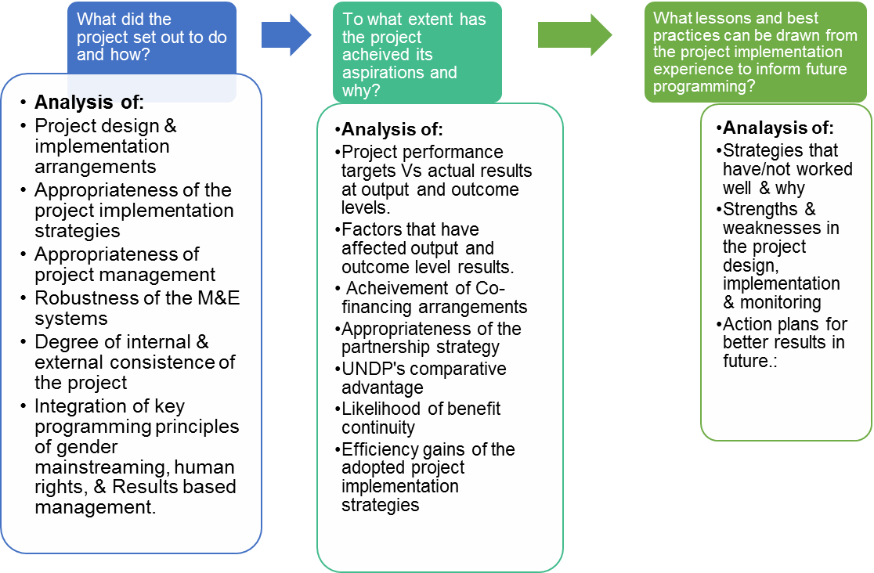

The evaluation adopted a mixed methods approach to capture, analysis and present evaluative evidence on all evaluation aspects presented in the evaluation scope in Fig 1.1 above. Using a highly participatory approach, the overall execution of this evaluation was aligned with UNDP-GEF Guidelines. Major evaluation participants included UNDP, relevant Ministries, Departments and Agencies (MDAs) of the Government of Malawi, Project Implementing Partners (PIPs) and project beneficiaries.

Evaluation utilized both primary and secondary data. Primary data was captured through qualitative techniques while quantitative data was extracted from secondary literature. Under qualitative approach, key informative FGDs were conducted using tailored key informant interview guides (annex 3). Review of literature on the other hand followed a three phase process namely; i) determining the required information, ii) securing the relevant documents; and iii) extracting summarized data for subsequent analysis.

Analysis of data adequately addressed the aspects of both a process and results evaluation. As such, a systems analysis model provided the overall analytical framework as summarised in Figure 1.2 below;

## Fig 1.2: The overall analytical framework

**Project performance in the light of evaluation criteria**

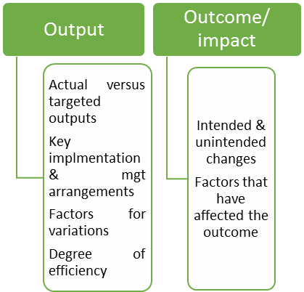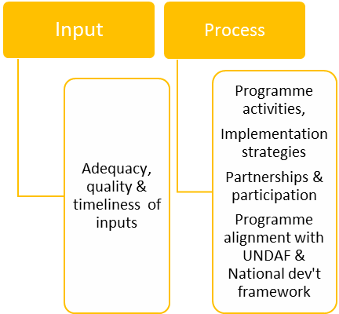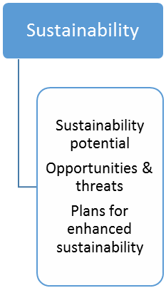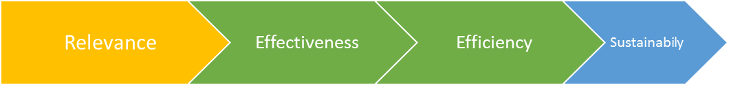

The analysis also integrated a number of analytical tools relevant to the contextual scope of the evaluation. They included;

* Gender analysis for example case studies of supported women groups were conducted.
* Human Rights Based approach to Development
* Policy And Regulatory Analysis,
* PESTEL(Political, Economic, Social, Technological And Legal) Analysis
* The SWOT (Strength, Weaknesses, Opportunities And Threats) Analysis
* Results Based and Management analysis
* Capacity Development
* Governance analysis with particular emphasis on aspects of accountability, transparency and participation in the environment and natural resources sector.

From the analysis, the evaluation articulates; i) the appropriateness of the project concept and design in addressing the identified problem and barriers; ii) appropriateness of the implementation strategies in supporting the realisation of the desired results; iii) progress towards results; iv) best practices and lessons learnt; v) recommendations.

## 1.3 Ethics

In the execution of this evaluation, the evaluators adhered to the UNEG Code of Conduct as per the attached signed copy of the same. The evaluators made it clear to all respondents that participation in the evaluation exercise was voluntary and that they were free to withdraw their participation at will. All the collected data was treated with utmost confidentiality in order to protect the personalities of the participants and besides, all participants consented. Therefore, whereas the opinions expressed in this report are those of the evaluators, they are based on concrete evaluative evidence deduced from credible sources.

## 1.4 Limitations

The quantitative data used in this report is extracted from the project reports especially the Annual PIRs. This implies that the quantitative results attained in the period beyond the scope of these reports may have not be comprehensively captured. Nevertheless, the evaluators compared the results with the most recently filled tracking tool and to this extent, inconsistences have been largely minimised.

Secondly, the evaluation was undertaken shortly after implementation had end and this time may not be sufficient for the fully fledge project impact to have been formed. Nevertheless, the evaluation captured higher level results that are projected to support the realisation of long term changes in the welfare indicators of the population.

## 1.5 Structure of the report

The structuring of the report adheres to the report template for terminal evaluations provided in the UNDP-GEF evaluation guidelines[1] with some minor modifications. The report is structured in four sections with section one presenting the general introduction with particular focus on; evaluation purpose, evaluation scope and methodology. Section two presents project description and development context with focus on; Project start and duration, Problems that the project sought to address, Immediate and development objectives of the project, Baseline Indicators established, Main stakeholders and Expected Results which lay a foundation for the presentation of the findings in section three. The presentation of findings focuses on; Project Design / Formulation, Project Implementation as well as Project results in respect to relevance, effectiveness, efficiency, impact and sustainability. This forms the basis of the conclusions, lessons learnt, best practices and recommendations that are presented in the last section. The report also provides a number of annexes which include; ToR, itinerary, list of documents reviewed, summary of field visits, list of persons interviewed, evaluation matrix, summary of results and ratings tables.

# 2.0 Project description and development context

Increased vulnerability to climate change and its resultant natural disasters continued to threaten the comprehensiveness and sustainability of development gains in Malawi prior to the project under evaluation[2]. Thus, the planned interventions under this project were designed to respond to specific problems in order to achieve the desired results as presented in this section.

## 2.1 Development Context

Malawi is a low income country whose economy is largely agro-based with small holder farmers mainly practicing rain-fed agriculture. With an estimated population of 17.2 million people and a population growth rate averaging at 3%[3] coupled with its total land area of 118,484 km2 (11.8 million ha), Malawi is one of the most densely populated countries. This exerts pressure on the country’s natural resources as they constitute the major source of the population’s livelihoods.

As a result of the population pressure on the land, land holdings have continued to shrink leading to dwindled agricultural harvests as well as environmental degradation arising from deforestation and soil fertility loss. This continues to reduce the benefits that the population derives from the environment (ecosystem services) as shown by reduced stream flows, decline or extinction of fish and other animals and limited sources of biomass energy[4].

Malawi ascribes to global and regional commitments such as the Sustainable Development Goals (SDGs), Agenda 2063, Istanbul Programme of Action, SADC Regional Indicative Strategic Development Plan, COMESA Treaty as well as International Conference on Population and Development (ICPD) Beyond 2014 among others. Commendable efforts to align the country’s national development framework with both global and regional commitments is evident through key national development instruments such as; Vision 2020, Malawi Poverty Reduction Strategy (MPRS) and Malawi Growth and Development Strategy (MGDS).

Through its global and regional commitments, Malawi highly prioritizes environment protection and climate change mitigation as key pathways for achieving sustainable development. As such, the country, with the support of development partners has developed progressive environmental management policies and strategies including the National Environmental Policy, National Climate Change Management Policy (June, 2016). This is anchored on the country’s Agriculture Sector Wide Approach (ASWAp) that priorities investments in three strategic areas: food security and risk management; commercial agriculture, agro-processing, and market development; and sustainable agricultural land and water management.

Therefore, climate change mitigation is well weaved in the national development framework as explicitly indicated in the various strategies and actions plans for example, the National Adaptation Programmes of Action (NAPA) formulated in 2006. In pursuance of the aspirations of the of the NAPA, the National Climate Change Steering Committee and its Technical Working Group were established to provide technical and strategic guidance on the mainstreaming of climate change mitigation in national development framework. The CCP was aligned with various policies including inter alia; Malawi Growth and Development Strategy (MGDS II 2012–2016); Food Security Policy, 2006; Agriculture Sector Gender, HIV and AIDS Strategy 2012-2017; Malawi Land Policy 2002; & Malawi Irrigation Policy and Development Strategy, 2000 among others.

In addition to the policy environment, Malawi has put in place a formidable decentralised institutional framework that oversees policy implementation, monitoring and reporting on environmental matters. It includes the line ministries, district councils as well as thematic structures such as National Climate Change Steering Committee and Technical Committee on Climate Change. Key institutions with the environmental protection and governance mandate are summarised in table 2.1 below.

## Table 2.1: Key Institutions with climate change management mandate.

|  |  |
| --- | --- |
| Institution/Department | Roles and responsibilities |
| Ministry of Finance and Economic Planning (MoFEP) | Plays the leading role in the implementation of the National Climate Change program and in mainstreaming attention to climate change in sectoral programs and government policies. Besides, it chairs the National Climate Change Steering Committee. |
| National Climate Change Steering Committee. | Composed of key stakeholders in the field of Climate Change, it provides a forum for effective policy dialogue on frameworks, priority setting, and ways and means of facilitating investment and transfer of technology on climate change initiatives in the country. |
| Technical Committee on Climate Change | The Technical Committee provides update and information related to national climate change programme and reports to the Steering Committee. Its work closely with the Government-Donor Technical Working Group and membership includes stakeholders from all sectors. |
| Ministry of Natural Resources, Energy and Mining (MoNREM) Has five key departments: Environmental Affairs Department (EAD), Department of Climate Change and Meteorological Services (DCCMS), Department of Forestry, Department of Energy Affairs and Department of Mining. | Its principle role is to coordinate management of natural resources, energy mining, environment and climate change management. Through the EAD, the ministry is responsible for preparing and implementing environmental policies and relevant legislations. Additionally, it is responsible for enforcing the regulations and providing guidance on environmental issues, including climate change.  Through the DCCMs, the ministry plays a leading role in providing data on climate change.  Although all the five departments play central roles in environmental management, it is the EAD and DCCMS that play a leading role in coordinating climate change issues in Malawi. |
| The Department of Forestry | Has primary authority and responsibility for the management of forest resources and is focused on the control of illegal production of charcoal, the protection of forest reserves, and promotion of reforestation. |
| Multiple departments | Other multiple departments in the government are involved with various aspects of agricultural development, including land resources, crop production, research, and extension. |
| District Councils | Through the office of the District Environmental Officer (DEO), the councils play a significant role of coordinating and overseeing environmental issues and the preparation of the district state of environment reports (SOERs). |
| Area Development Committees (ADC) | Headed by the Traditional Authorities, ADC’s mandate is to manage and govern the environment and natural resources under its jurisdiction. Its mandate lies in environmental action planning, implementation & reporting at area level |
| Village Development Committees (VCD) | Is responsible for all environmental management tasks in collaboration with the higher level structures. |

Despite the sustained investment in the environmental protection area, vulnerability to diverse climate change risks including Floods, hailstorms, heavy rainfall, increase in temperatures, erratic rains and droughts was reportedly high in the project target districts of Machinga and Mangochi (see problem analysis in sub section 2.3 below). All these continue to put both lives and livelihoods of the Malawian population at stake hence justifying continued investment in the sector in order to mitigate climate change effects.

## 2.2 Project start and duration

According to the project document, the project start date was July 2014 and slated to end in June 2019. Although both the CEO endorsement and PRODOC signature were secured in July, 2014, the project inception meeting was held nearly after ten months (April, 2015). Even after the inception meeting, project activity implementation could not commence until November, 2015[5]. Delays in the release of funds to the implementing partners was the overriding cause of delays in activity implementation. Protracted account opening processes at district level occasioned the delays. However, it is noted that even when bank accounts were opened in august, 2015, funds were actually received in mid-November, 2015[6]. This time was too late for most of the planned activities to be undertaken and were subsequently pushed to the 2016 work plan.

Therefore, as a result of the experienced delays during the initial phases of the project, the project completion date has been operationally extended to March 2020[7]. Following the delayed start of the project activity implementation, a few activities that formed the critical path of the project were prioritised and implemented in 2015 completely and/or partially. For example, out of the 60 planned activities only 6 and 19 constituting 10% and 31.7% were actually implemented completely and partially respectively. a total of 35 (58.3%) of the planned activities for 2015 were not undertaken at all[8]. However, since the full commencement of project activities, implementation momentum has been well maintained with annual reports indicating activity implementation success rate at 80% and above[9].

## 2.3 Problems that the project sought to address

The Climate Proofing Project was designed and implemented as a pilot project with an intention of guiding possible replication and scale up. This implies that although this pilot project was targeted at two districts of Machinga and Mangochi, the problem being addressed is of national character and significance. More specifically, the project set out to support the mainstreaming of climate change in national and subnational development in order to ensure enhanced and sustainable development gains.

The project concept and design was anchored on the realisation that inadequate mainstreaming of climate change considerations in the baseline projects in Malawi was exposing gains realised from various development projects to great climate change related risks such as droughts, floods as well as post-harvest losses.[10] The project design also took cognisance of the fact that whereas healthy eco-systems provide a cost effective pathway to effective CC adaptation, a number of factors compromised the degree to which such healthy eco-systems in Malawi could be achieved. Significantly, the country’s natural ecosystems continued to be threatened by: i) over-exploitation and inappropriate /weak management; ii) the weak technical capacity and limited knowledge on climate change adaptation; and iii) inadequate financing which reportedly reduced the effectiveness of resource users and their government’s efforts of climate proofing the development programs, at the local, district and national levels.

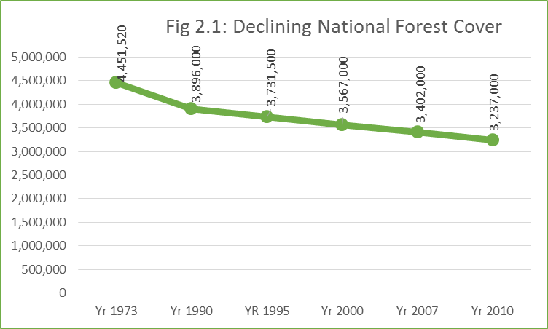As a result of the prevailing gaps in the eco-system management, national forest cover has reduced by 27.3% between 1973 and 2010. This has had detrimental consequences on the country’s climatic conditions over the years characterised by prolonged droughts, erratic rains as well as increase in temperature.

Although the effect of the changing climatic conditions have been felt across all sectors of the economy, agriculture, water resources, fisheries and infrastructure are the most affected. The above induced climate change disasters were putting both lives and livelihoods especially for the populations in the hotspot areas at stake.

The evaluation noted that efforts were made to clearly define the problem and its direct redress measures at the project concept, design and implementation. Indeed the articulation of the problem in the project document fairly depicts a causal-effect relationship which informs the project’s pathway/theory of change as summarised in figure 2.2 below;

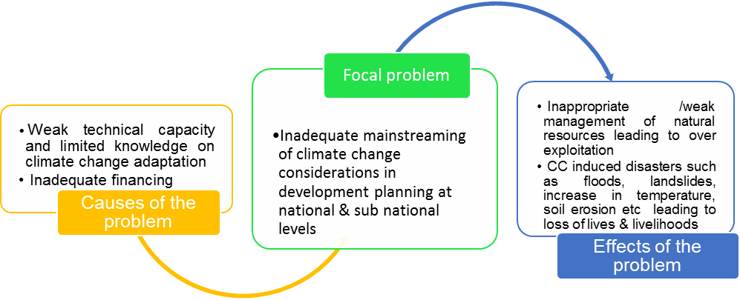

The terminal evaluation noted that objective and empirical problem analyses were conducted as reflected in the first and second National Communication to the United Nations Framework Convention on Climate Change (UNFCCC)[11], the National Adaptation Programme of Action and the National Climate Change Program (NCCP)[12] as well as the Malawi climate change vulnerability assessment (2013).

In addition to the empirical studies whose results were used to define the problem, participatory consultations and discussions were held with key stakeholders in the six identified pilot sites[13]. It is apparent that the Climate Proofing Project was designed to respond to the inhibiters to successful mainstreaming of climate change considerations in development planning as well as some of the immediate effects of the climate change induced disasters. Thus, the project focus was on addressing both the upstream and downstream bottlenecks for achieving healthy eco-systems that would support climate change adaption.

The evaluation however noted that although the problem identification processes were to some extent structured and systematic, the problem analysis was less comprehensive to vividly articulation both the causes and effects at various levels. For example, the project document under outcome 2 paragraph 142 identifies a number of challenges that impede implementation and out-scaling of technologies. They include; These include: i) inadequate operational resources (human, material and financial) to fully out-scale the success stories; ii) inadequate transport capacity reducing poor mobility and the timely reach of extension service; iii) inadequate integration of up-to-date climate change information in the extension package; iv) inadequate capacity building opportunities for staff; v) inadequate coordination, collaboration and networking amongst service providers; vi) weak linkages between research, extension and farmers, thereby weakening the support of current research to the farming communities. However, the deeply rooted causes of these challenges are not articulated. The dangers of this, is that, the project may only address the immediate causes of the problem hence leading to partial success in total eradication of the problem and its effects. This limitation notwithstanding, the project change strategy is fairly adequate as seen in its immediate and development objectives as well as the expected results as bench marked by the baseline indicators all discussed in the next sub sections.

## 2.4 Immediate and development objectives of the project

In the light of the problem analysis above, the project’s development objective was to “reduce vulnerability to climate change driven droughts, floods and post-harvest grain losses for rural and urban communities of Machinga and Mangochi Districts of Malawi through ecological, physical and policy measures”. The achievement of this objective was envisaged through five outcomes that were targeted to benefit over 0.5 million people. The core project outcomes are:

1. The impact of ecosystems degradation in aggravating vulnerability to climate change risks and reducing resilience of development gains understood and integrated into key decision-making processes at the local, sub-national and national levels
2. Skills and operational capacity enhanced in the District, EPA and TA level technical officers to support implementation, maintenance and monitoring of the activities under component 1 and to mainstream climate risks into all local development process (skills, legislation, information)
3. Public and domestic water harvesting, storage and distribution reduces climate change driven flooding and regulates availability of water throughout the year in flood & drought hotspots
4. Rehabilitation of badly degraded forests, protection of riverbanks, lake shores and urban infrastructure
5. Productivity of agriculture supported by adoption of climate smart systems and measures

The Terminal evaluation noted that the immediate objectives/outcomes logically flow from the development objective. In fact, it is apparent that the outcomes constitute the indicators of the development objectives and as such, the degree of alignment between the development and immediate objectives is satisfactorily good. However, the phrasing of outcomes 3-5 needed to be more results oriented by articulating the envisaged changes in the baseline indicators at the end of project implementation (see details in the analysis of the results framework). Nevertheless, a performance measurement plan was well integrated in the project design with both outcome indicators and targets whose achievement would be benchmarked by the baseline indicator values as further presented below.

## 2.5 Baseline Indicators established

During the project design, both outcome and output indicators were set and this informed the setting of the performance targets[14] (see summary of the project performance in annex 1. Baseline values for each outcome and output indicators were established mainly from two major data sources namely: i) the baseline survey that was done by Centre for Development Management (CDM) and ii) District Council records (2015). The Terminal evaluation noted that the baseline indicator values were most current and therefore good benchmarks for tracking project progress overtime.

However, a review of the project results matrix has established that two baseline values from two different sources of data (District Council records and the actual baseline study that was conducted) were used. It is further indicated that although time scope of the two datasets is not far apart (2015 & 2016), there are great variations in some baseline values for some indicators. For example, the Percentage decrease of households facing annual food deficit in Mangochi was put at 75% according to the District Council records (2015) but the 2016 project baseline study established at 67%[15]. This notwithstanding, it is not clear which of the two values should be based on in tracking progress. Furthermore, the evaluation team feels that it was not good use of project resources to commission a baseline study even on the indicators on which data was available from the district council records.

The above shortcomings notwithstanding, the established baseline values were constantly referred to during progress reporting as indicated in the PIRs. Thus, the investment committed towards establishing these baseline values was worthwhile in streamlining project progress tracking.

## 2.6 Main stakeholders

The involvement of stakeholders at all stages of programme/project development and implementation has continued to receive international recognition as a key driver for stakeholder ownership of the project. Thus, effective stakeholder involvement forms an integral part of the project sustainability efforts. Indeed, the evaluation noted that deliberate and satisfactory efforts to involve all relevant stakeholders I various processes of project design and implementation were undertaken. The project document clarifies the process of stakeholder involvement in the project and even their roles.[16] Key stakeholders mentioned in the project document and their specific roles that made them relevant in this project are presented in table 2.1 below.

## Table 2.2: project stakeholders

|  |  |
| --- | --- |
| Institution/Department | Roles and responsibilities |
| Ministry of Finance and Economic Planning (MoFEP) | Plays a leading role in the implementation of the National Climate Change program and in mainstreaming attention to climate change in sectoral programs and government policies. Besides, it chairs the National Climate Change Steering Committee. |
| National Climate Change Steering Committee. | Comprising of key stakeholders in the field of Climate Change, the committee provides a forum for effective policy dialogue on frameworks, priority setting, and ways and means of facilitating investment and transfer of technology on climate change initiatives in the country. |
| Technical Committee on Climate Change | The Technical Committee provides update and information related to national climate change programme and reports to the Steering Committee. They work closely with the Government-Donor Technical Working Group and membership includes stakeholders from all sectors. |
| Ministry of Natural Resources, Energy and Mining (MoNREM) Has five key departments: Environmental Affairs Department (EAD), Department of Climate Change and Meteorological Services (DCCMS), Department of Forestry, Department of Energy Affairs and Department of Mining. Of these EAD and DCCMS play a leading role in coordinating climate change issues in Malawi. | The Ministry’s primary role is to coordinate management of natural resources, energy mining, environment and climate change management.  The EAD is responsible for preparing and implementing environmental policies and relevant legislations. It is also responsible for enforcing the regulations and providing guidance on environmental issues, including climate change.  The DCCMs is charged with the leading role in providing data on climate change. The new Department chairs the National Climate Change Technical Committee, which is the secretariat of the National Climate Change Steering Committee - a new national coordination body that aims to assist the government to coordinate international aid assistance related to climate change.  The EAD, in collaboration with the DCCMS, is responsible for coordinating climate change issues in the country. Major policy thrusts include the coordination and proper management of the environment and the natural resource base in collaboration with line ministries and departments, the private sector, NGOs, select communities, and other relevant stakeholders at district, national, regional, and international levels. |
| The Department of Forestry | Has primary authority and responsibility for the management of forest resources and is focused on the control of illegal production of charcoal, the protection of forest reserves, and promotion of reforestation. There are currently very few champions in government to prioritize interventions that build resiliency of rural populations. |
| Multiple departments | Other multiple departments in the government are involved with various aspects of agricultural development, including land resources, crop production, research, and extension. |
| District Councils | Each of the 28 districts has a position for the Environmental Officer (EDO), many of them vacant. The EDO are responsible for coordinating and overseeing environmental issues and the preparation of the district state of environment reports (SOERs). |

It is apparent that the project design and implementation appropriately considered the importance of stakeholder involvement. As indicated in the project document, a stakeholder baseline analysis was conducted which guided the involvement of each stakeholder. Whilst a list of stakeholders was built during the project design process, the extent to which these stakeholders were actively involved forms a central piece of this evaluation as presented in sub section 3.1.4.

## 2.7 Expected Results

The CPP was designed to support the realisation of global and national level results enshrined in GEF strategic plan, UNDAF and CPD as reflected in the project results matrix and as further illustrated in figure 2.1 below.

## Fig 2.1: Mult-level project expected results

**GEF Strategic objectives:**

Objective 1: Reduce vulnerability to the adverse impacts of climate change, including variability, at local, national, regional and global level.

Objective 2: Increase adaptive capacity to respond to the impacts of climate change, including variability, at local, national, regional and global level.

Objective CCA -3 - Adaptation Technology Transfer: Promote transfer and adoption of adaptation technology

**CPD Outcomes**

3.1 Institutions strengthened to develop and improve policies, strategies and plans for climate change, environmental management, and disaster risk reduction.

3.2 Integrated info systems strengthened for decision-making on disaster risk reduction, climate change and environmental management

**CPP Outcomes**

1. The impact of ecosystems degradation in aggravating vulnerability to climate change risks and reducing resilience of development gains understood and integrated into key decision-making processes at the local, sub-national and national levels
2. Skills and operational capacity enhanced in the District, EPA and TA level technical officers to support implementation, maintenance and monitoring of the activities under component 1 and to mainstream climate risks into all local development process (skills, legislation, information)
3. Public and domestic water harvesting, storage and distribution reduces climate change driven flooding and regulates availability of water throughout the year in flood & drought hotspots
4. Rehabilitation of badly degraded forests, protection of riverbanks, lake shores and urban infrastructure
5. Productivity of agriculture supported by adoption of climate smart agriculture practices

**CPP Outcome indicators**

* 1. Number of comprehensive community based adaptation

plans integrating traditional and technical knowledge;

1.2 Community involvement in monitoring vulnerability

1.3 Quality knowledge products available, shared and being

used

2.1 Extension packages for key sectors updated with climate

risk management information

2.2 District level development plans and policies updated with

climate risk management provisions.

2.3 Diploma in Forestry include current climate change

content

2.4 Improvement in Capacity Index Score card

2.5 % increase in development funds of the districts

. 3.1 Number of physical infrastructures constructed to ensure sustainable water supplies and reduce disaster risks

3.2 Number of homes with water harvesting structures

4.1 Number of Village Forest Areas registered

4.2 Hectares of forests under improved management

4.3 Kilometers of river and lake shore under protection

4.4 Number of households using alternate and improved energy

5.1 No. of hectares on which climate smart farming is practiced

5.2 Percentage increase in productivity per acre or per unit of land

5.3 Area under climate smart small holder irrigation

5.4 Water use efficiency in small holder irrigation

5.5 % reduction in post-harvest losses for those engaging

**CPP Outputs**

1.1 Information provided on how the state of use and management options of critical resources/ecosystems/landscapes influence effectiveness of baseline programs

1.2 Comprehensive landscape adaptation plans formulated

1.3 Participatory Monitoring, Evaluation, Reflection and Learning (PMERL) formulated and information gathered used in adaptive management and shared widely

2.1 Operational capacity of the extension service boosted to enable communities to mainstream climate risk considerations in the implementation of baseline programs

2.2 Local and national development policies influenced by the project supported pilots to strengthen policies and policy enforcement for climate consideration.

2.3 Lessons generated at the project/district level fed into the national climate programme, SLM platform and other national planning debates

3.1 Construction of mini dams, water ponds, retention ridges, and water diversion structures

3.2 Construction of physical structures to support infrastructure and expansion of water harvesting from dwellings

4.1 Degraded watersheds (forest ecosystems) rehabilitated, river Banks and Lake shores protected from direct siltation

4.2 Provision of improved and sustainable supplies of energy, including adoption of sustainable charcoal

4.3 Diversification of household food basket and incomes via expansion of aquaculture and NTFP

5.1 Adoption of climate smart farming practices

5.2 Uptake of climate safe post-harvest management technologies and practices

# 3.0 Findings

The main objectives of the evaluation was to assess the achievement of project results, and to draw lessons that can both improve the sustainability of benefits from this project, and aid in the overall enhancement of UNDP programming. To satisfy this objective, three core components of the project namely: project design/formulation; project implementation and adaptive management; and project results were assessed as presented hereunder. The results of this assessment forms the basis of the conclusions and recommendations presented in section four of this report.

## 3.1 Project Design / Formulation

The quality of the project design/formulation in respect to the SMARTNESS of the results framework, timely detection of potential risks, project’s internal and external consistence, appropriate implementation arrangements as well as comparative advantage of the executing agency greatly influence project success. Thus, the ToR required an assessment and ranking of these aspects as presented here below.

## 3.1.1 Analysis of LFA/Results Framework (Project logic /strategy; Indicators)

Project strategy is sound as it depicts a logical flow of interventions and results. The TE found out that the design of the project results was in tandem with the higher level results enshrined in the GEF strategic plan as well as UNDAF and CPD (see fig 2.1). At project level, there is satisfactory linkage between the problem being addressed, the interventions and the envisaged results at output and outcome levels (see project Theory of Change in fig 3.2 below). Both output and outcome indicators were formulated in conformity with both SMART[17] and CREAM[18] criteria which gives credence to project performance measurement.

A total of 17 outcome level indicators with their respective baselines and performance targets were established for the five outcomes which were logically flowing from the objective indicators. The evaluation noted a logical flow from the project objective up to the activities as shown in fig 3.1 below.

## Fig 3.1: Hierarchy of project results

Project Objective

Objective Indicators & Targets

Project Outcomes

Project Outcome Indicators

Project Outputs

Project Activities

However, measurement objective indicator 2 ‘Percent change in soil erosion and siltation of water bodies’ was not possible. It was for this reason that even MTR recommended the changing of the indicator. Whereas management response shows that the indicator was accordingly changed, it however kept featuring in the post-MTR PIRs. The TE noted that what was instead changed was the reporting on the indicator with emphasis moved away from the changes in soil erosion and siltation to activity based indicators such number of trees planted. It was important for the indicator to be modified even with its target in tandem with the MTR recommendations. The continuous reflection of the old indicator and its corresponding targets but with a modified tracking and reporting created disharmony between the indicator and project reporting (see PIR 2019, Pg 5)

Furthermore, some project aspirations for replication were not appropriately accompanied by corresponding activities. Although the project envisaged the replication of the interventions in the pilot sites to other districts with similar problems through wide dissemination of lessons and knowledge products, no specific activities were carried out to that effect and besides, there was no specific indicator and even target against which progress would be benchmarked.

Other initial indicators especially ‘Improvement in Capacity Index Score card’ lacked clarity while others such as “% increase in development funds of the districts” lacked corresponding initiatives to support its realisation. Much as the MTR brought to light several gaps in the results framework and management was accordingly in agreed and pledged revision of the same, reporting on some indicators was not changed. For example, although it was realised that the baseline values on crop yields were not realistic and even the source not clearly ascertained, nothing was done to revise them. This has portrayed the project performance to be statistically below the set targets even when substantial contributions towards food security strengthening is evidently observable.

## Fig 3.2: Project Theory of Change

**Project Outcomes**

The impact of ecosystems degradation in aggravating vulnerability to climate change risks and reducing resilience of development gains understood and integrated into key decision-making processes at the local, sub-national and national levels.

Skills and operational capacity of District, EPA and TA level technical officers to support implementation, maintenance and monitoring of the activities under component 1 and to mainstream climate risks into all local development process (skills, legislation, information)

Public and domestic water harvesting, storage and distribution reduces climate change driven flooding and regulates availability of water throughout the year in flood & drought hotspots

Rehabilitation of badly degraded forests, protection of riverbanks, lake shores and urban infrastructure

Productivity of agriculture supported by adoption of climate smart agriculture practices

**Pressure on the natural resources**

**Limitations in institutional and individual capacities to plan for climate change.**

**Inadequate resources provided for CC mitigation**

Participatory Monitoring, Evaluation, Reflection and Learning (PMERL) formulated and information gathered used in adaptive management and shared widely

Operational capacity of the extension service boosted to enable communities to mainstream climate risk considerations in the implementation of baseline programs

**Poorly coordinated CC interventions at district level.**

Information provided on how the state of use and management options of critical resources/ ecosystems/ landscapes influence effectiveness of baseline programs.

Comprehensive landscape adaptation plans formulated using the information generated under output 1.1, complemented by community based resilience assessments

**Focal Problem: Inadequate mainstreaming of CC considerations in Malawi baseline programs**

**Intervention: Capacity development for CC mitigation & adaptation**

Local and national development policies influenced by the project supported pilots to strengthen policies and policy enforcement for climate consideration

Lessons generated at the project/district level fed into the national climate programme, SLM platform and other national planning debates, to lobby and influence the adoption of climate risk considerations as minimum criteria for accessing agricultural input subsidy benefits

Construction of mini dams, water ponds, retention ridges, and water diversion structures.

Construction of physical structures to support infrastructure and expansion of water harvesting from dwellings:

Degraded watersheds (forest ecosystems) rehabilitated, river Banks and Lake shores protected from direct siltation.

Establish two community-based Climate Smart Agriculture Centres

Development of skills and institutional arrangements for individual and/or communal climate safe post-harvest management practices and storage facilities disseminated

Adoption of climate smart farming practices including water use efficiency in small scale irrigation systems improved

Diversification of household food basket and incomes via expansion of aquaculture and NTFP reduce pressure on the forests, river and lake fisheries

Provision of improved and sustainable supplies of energy, including adoption of sustainable charcoal

Project Goal: The development and food security gains from the baseline programs are secured through community empowerment to integrate climate risk considerations in the development policies, plans, projects and actions.

**Main effect of the problem: Low production, high post harvest**

**losses, food insecurity & loss of development gains**

On the basis of the findings above, it suffices that the strategic results framework was logical and provided a solid base for measuring project performance with clear and measurable indicators. However, the MTR highlighted some gaps in the results framework particularly regarding the source of data to verify results which management accordingly rectified.[19] In the light of the strengths of the project’s log frame/results framework as presented above, a rating of **5/6 (Satisfactory)** is awarded.

## 3.1.2 Assumptions and Risks

The design and implementation of the Climate Proofing Project was based on 4 fundamental assumptions namely: i) the integration of climate change adaptation in development plans, programmes and land use practices makes economic sense and reduces the risks of climate-induced losses and damages over the long term; ii) a combination of ecological, physical and policy measures provide a more cost effective means of climate change adaptation; iii) successful mainstreaming of climate change mitigation and adaptation strategies in development planning enhances the gains from and sustainability of development interventions; iv) a mult-stakeholder collaboration provides a harmonised approach to project implementation and increases implementation effectiveness.

The evaluation found the project assumptions valid and that they were appropriately integrated in the project design hence forming an integral part of the project’s Theory of Change. As a result, the project endeavoured to make the conditions described in the assumptions available since they are the key drivers of project success. However, significant risks inherent in both the internal and external project environment were identified at the design stage of the project and a mitigation plan was equally constituted[20].

Key risks identified at the design stage were: i) resistance to the inter-departmental collaboration; ii) development planners prioritize speed over quality of infrastructure investments; iii) inadequate local systems, capacities and skills to maintain the infrastructure provided under the project; iv) political influence over the adoption of climate change adaptation strategies which inevitably causes delays; and v) high illiteracy levels in the community.

In the light of the risks above, the project put in place a mitigation plan that mainly comprised of: i) capacity development of counterpart departments; ii) development and application of operational manuals; iii) awareness creation about the importance of climate change adaptation; iv) training of management committees and farmers; and v) periodic project reviews. The project document contained a detailed risk analysis and mitigation measures (Pg 66) which the evaluation found to be comprehensive. Indeed, the devised mitigation measures were bent towards creating a conducive environment to facilitate the implementation of the project.

During risk analysis, systematic rating criteria was used and this helped in prioritization of the risks and their corresponding mitigation measures. As a result, the evaluation noted that project implementation was not grossly affected by any unanticipated risk. The risk mitigation measures were reasonably appropriate to secure successful project implementation.

## 3.1.3 Lessons from other relevant projects incorporated into project design

UNDP has implemented a series of projects in the environment, resource management, capacity development and up-stream policy support in developing countries and particularly in Africa. This experience contains valuable lessons that can significantly inform the design and implementation of related projects in many parts of world. More specifically, the evaluation established that at the time of designing the Climate Proofing Project in Malawi, UNDP was running a programme portfolio of 30 projects under 4 clusters; Environment/Climate Change/Disaster Risk Reduction, Growth and Millennium Development Goals, Capacity Development, and Governance[21].

Significant projects from which lessons to inform the design and implementation of the Climate Proofing Project include inter alia; i) supporting the government to mainstream climate change considerations into national development through the National Climate Change Programme; ii) the Africa Adaptation Programme; iii) the Poverty and Environment Initiative; iv) Financial Inclusion in Malawi (FIMA): 2007-2011) and v) Access to Justice Programme among others.

The experiences and lessons from the above and several other projects undertaken by UNDP were vital in guiding the designing and implementing both up and down-stream activities under this project. Through these projects, UNDP had established working relations with various agencies which made coordination and partnerships under this project much easier. Furthermore, the lessons and experiences from the past projects gave UNDP a comparative advantage in the implementation of this project as further discussed under sub section 3.1.6 below.

## 3.1.4 Planned stakeholder participation

Streamlined stakeholder participation in both the design and implementation of projects is of significant importance especially with regard to sustainability. The evaluation noted that the project at design stage developed an elaborate stakeholder participation plan with the Ministry of Local Government and Rural Development through the district councils of Mangochi and Machinga Districts leading the project execution. It is further noted that the composition of the councils with representation from various relevant ministries provided a platform through which these other ministries participated in the project.

National, district and community level stakeholders were effectively identified and appropriately engaged at various stages of project design and implementation. At community level, the project supported capacity development of village development committees in order to be able to meaningfully participate. Participation of community level stakeholders is also strongly seen during profiling of hotspot areas and generation of mitigation measures[22]. Direct involvement of various community based groups such as water user’s groups, honey cooperatives, seed multiplication groups and civil protection groups provide strong evidence of active stakeholder participation at grass root levels. The participation of district and national level stakeholders was secured through the various committees that were established to guide project implementation that included; National Steering Committee on Climate Change, National Climate Change Technical Committee, Project Coordinating Committee.

The participation of NGOs, private sector, academia and research institutions is articulated in the project document (see pg 91). Indeed, there was elaborate arrangement for their engagement. For instance, these stakeholders were made part of the various committees that were established to oversee and guide project implementation. The evaluation further established that the participation of the NGOs, CBOs and the private sector was maximised through the Community Resilience Adaptation Fund (CRAF) as well as the agricultural value chain processes. For instance, a total of 10 local NGOs and CBOs activity participated in implementing climate change adaptation initiates under the CRAF.[23] The project facilitated linkages between the farmers and the private sector organisations that are working in value chain development. Significant of these include inter alia; Malawi Honey Council, Export Trading Group; HMS Grains; Rab Processors; and Arkay Plastics among others.

The project connections with the NGO networks in the two districts was a strategic initiative that facilitated partnerships and information sharing. For example, the project partnered well with other projects and NGOs including inter alia; Catholic Development Commission (CADECOM), Malawi Lake Basin Program, The Millenium Challenge Account and COOPI International in Mangochi and World Vision International, Total Land Care, Shire River Basin Management Project and PERFOMA Project (Perfecting Ecosystems and Restoring Forests in Malawi) in Machinga.

Whereas the participation of NGOs and Private sector was ascertained, the evaluation did not capture sufficient evidence on the participation of the universities, research institutions and the professional bodies. For instance, the participation of academic institutions particularly Lilongwe University of Agriculture and Natural Resources (LUANAR) is only reported about in the 2018 PIR report. The decimal participation of the academia was equally raised at mid-term evaluation[24]. Which perhaps could have caused the improvements recorded in the same period. However, in 2019, the involvement of the academia is scantly reflected. This notwithstanding, the evaluation noted that the progress reporting templates provided adequate avenues for tracking and reporting about partnerships and were in position to providing guidance to effective stakeholder engagement.

## 3.1.5 Replication approach

Replicability and scalability of the project design arguments its internal and external coherence. This is often achieved when the problem being addressed has been well analysed and the project interventions well aligned with national development agenda. Review of the project document reveals that replicability of the project was thought through and well laid out strategies to support its realisation. Sharing of methodologies, lessons and results was an integrated strategy for enhanced replicability[25].

Given the fact that many parts of Malawi face climate change related disasters, the project approach has great potential for replication. The design of all project components; capacity development, awareness creation, policy support ably support replication. The evaluation further noted that lessons learnt and best practices were periodically documented as part of the project implementation reports and shared with various stakeholders[26].

Furthermore, the project management structures especially at community level are key in ensuring replication of the project approach through wide sharing of lessons learnt and best practices. It is apparent that the lessons from the project have informed the district development plans (2017-2021), thereby creating avenues for replication.

Furthermore, the evaluation established that, indirectly, part of the replication was embedded in the partnership arrangements. The CCP was part of the NGO Networks operating in the two targeted districts and this enabled the sharing of knowledge, lessons learnt and best practices that would enable replication. Additionally, a number of NGOs and CBOs received trainings under the project on climate change adaption. A combination of the capacity strengthening and CRAF enabled these NGOs and CBOs to replicate the project initiatives beyond the project catchment area. Reading from the 2018 PIR, the evaluation learnt that the project acted as a centre of excellence for testing and piloting various new technologies developed by the university. All these provide an avenue for successful replication.

## 3.1.6 UNDP comparative advantage

UNDP’s comparative advantage in implementing climate resilient interventions is outstanding premised on its vast track record and experience in environmental management cluster. It is noted that at the time of the project design, UNDP’s programme portfolio had 30 active projects under 4 clusters namely: Environment/Climate Change/Disaster Risk Reduction, Growth and Millennium Development Goals, Capacity Development, and Governance. Under these priority areas, UNDP provided both up stream policy support and down-stream programmatic support geared towards capacity and systems strengthening of national institutions for sustainable and inclusive service delivery.

Indeed, UNDP has a long-standing history of supporting climate change adaptation and disaster risk reduction in the world, Africa and Malawi. Significantly, at the time of CPP design, UNDP was already engaged in various related interventions including inter alia; supporting the government to mainstream climate change considerations into national development, Africa Adaptation Programme, Poverty and Environment Initiative, and Financial Inclusion in Malawi (FIMA): 2007-2011.

Furthermore, being a locally based UN agency with vast track record of coordinating mult-partner development initiatives, UNDP was best placed for this project too. Through various projects, UNDP had played coordination role which strengthened its capacity and expertise in leading mult-stakeholder interventions.

## 3.1.7 Linkages between project and other interventions within the sector

Project linkages with other projects within the sector is well articulated in the project document (see pgs 39-41). At the CPP design, all related projects were identified with a purpose of ascertaining their interventional and geographical scope to ensure that there is no duplication and wastage of resources. Furthermore, the assessment of related projects was intended to enable partnership and synergies in order to achieve enhance interventional impact.

At national level, the project also participated in the Adaptation Working Group Symposiums and South-South cooperation through community based adaptation conference hosted in Malawi in 2018. More specifically, the project supported EAD to organise the first ever symposium that was held at BICC in Lilongwe in 2018. This provided a platform for showcasing best practices and innovations in climate change adaption. This was indeed an instrumental opportunity for sharing adaptation knowledge which in turn creates more opportunities for replication.

Besides the national level participation, the CPP established and cherished partnerships with other like-mined projects and agencies. Projects with which the Climate Proofing project had more direct linkages with include: the 3 GEF financed projects in the Shire Basin namely; SLM project supported by UNDP; Climate Adaptation for rural Livelihoods and Agriculture supported by African Development Bank and the World Bank led project on natural resources management and climate change. Others were the GEF and World Bank financed Shire River Basin Management Program; enhancing community Resilience to Climate Variability and Change funded by DFID, Royal Norwegian Embassy (RNE) and Irish Aid and the EU funded Farm Income Diversification program.

The evaluation noted that although these programs had similar objectives, there was not geographical overlaps. For instance in the two districts of Machinga and Mangochi, there were no existing climate resilience program being implemented. There were deliberate efforts at the CPP design to avoid duplication that would lead to resource wastage. Furthermore, the management structure anchored on national institutions with the environmental management mandate facilitated CPP linkage with other projects thereby enabling information and experience sharing. For instance, the project management units of all projects in the environment cluster were represented in the Climate Change Technical Committee.

However, much as there were plans of routine production and dissemination of key knowledge products targeting stakeholders outside the project geographical area, the evaluation could not verify the dissemination of such products. As was also highlighted in the MTR report[27], the absence of a specific desk/person with sole responsibility of sharing these knowledge products beyond the project pilot areas in a way compromised effective linkages. Much as the contents of the knowledge products were shared through a number of platforms, this was less systematic as it lacked clear performance indicators that would guide progress tracking.

Nevertheless, the evaluation noted that production of knowledge products received appropriate attention during project implementation to facilitate sharing of lessons and best practices even beyond the CPP catchment areas. Knowledge products developed under the project include; Climate Smart Fish Farming Resource Book; Enterprise Development Manual; and Forestry Extension Kit Volume 2.

## 3.1.8 Gender responsiveness of project design

Gender mainstreaming in project design and implementation is a key consideration for GEF funded and UNDP implemented projects. A review of the project document indicates that indeed, gender was well considered during the design as reflected in both the implementation arrangement as well as the results framework. For instance, gender officers were identified as one of the key district personnel that was planned to play an active role in the implementation of the project. Furthermore, the analysis of the problem for which the problem was designed to address was informed by gender disaggregation of the problem impact on both women and men as well as other social groups. Despite its late implementation, a gender analysis study was conducted as well as gender training of the project beneficiaries and implementers.

The adoption of the Community Based Adaption approach provided a valid framework for integrating key aspects of inclusiveness in the project implementation. Despite some obstacles to effective gender mainstreaming presented by cultural and religious beliefs, the mainstreaming of gender in the CCP has yielded significant fruits including inter alia; empowerment of women groups, improved decision making at household level and improved gender relations among household approach (HHA) implementers. For instance, VSL groups were trained and have been empowered economically (see detailed gender analysis of the project under sub section 4.5).

## 3.1.9 Social and Environmental safeguards

The project document confirms that the project design and implementation based on careful consideration of the social and environmental safeguards. The contribution of the project towards environmental protection was part of the focal areas that was assessed during the project screening phase. All the potential effects of the CCP were explored prior to implementation and this enabled the integration of safeguards in the project implementation arrangement. For instance, the adoption of community based adaptation approach ensured adequate incorporation of both social and environmental concerns in the implementation of the project.

## 3.1.10 Management arrangements

The management of the project was anchored on the UNDP National Execution (NEX) modality following NEX guidelines and requirements that are set out in the UNDP Programming Manual. The overall management responsibility was entrusted to UNDP (Executing Agency) and the Ministry of Natural Resources Energy and Environment (implementing Partner) with the Director of Environmental Affairs as the technical head. Project management was well decentralized with national, district and village level structures.

At national level, National Climate Change Steering Committee (NCCSC) provided the overall policy guidance through the National Climate Change Technical Committee. However, the oversight role on the day to day project activities was executed by a Project Coordinating Committee that was chaired by the Director of Environmental Affairs, Ministry of Natural Resources, Energy and Mining. Comprising of UNDP and UNDP-GEF, Chair persons of the DECs of Machinga and Mangochi districts, the committee’s primary role was to ensure implementation effectiveness and efficiency in tandem with the project document as well as ensuring appropriate project linkage with national development aspirations enshrined in the National Climate Change Program.

At the district level, the District Commissioners were the accounting officers with the Environmental District Officers working as the technical Focal Points for the project. Project management further benefited from the existing structures such as District Environment Sub Committee (DESC). However, the day to day activity implementation was run by the District Project Coordinators assisted by a Finance and Administrative Assistants that were recruited for each district.

The management functions of each structure was clearly articulated in the project document (see pg 87) and evaluation participants expressed satisfaction with the manner in which each structure executed it designated management roles. There was satisfactory adherence to the management structure stipulated in the project document. Indeed, the management arrangements ably promoted country ownership of the project with potential for enhanced sustainability.

However, the reliance on the national structures and resources such as human resources had both advantages and disadvantages. The evaluation noted that the project significant delays in activity implementation as a result of staff capacity gaps. For instance, Procurement process and procedures under the District Councils were somewhat slow largely because of understaffing. The sole officer that was responsible for procurement had the responsibility to cater for the entire government sectors in the district[28].

It is apparent that project management arrangements were appropriate and provided sufficient guidance through project implementation. However, the evaluation noted that management core concern was on activity implementation in the pilot areas and with decimal attention paid to scaling up results beyond the project area through systematic and committed sharing of lessons and experience. The absence of a designated personnel in-charge of project communication was a lost opportunity for enhanced and systematic propagation of project methodologies beyond the project target areas.

## 3.2 Project Implementation and Adaptive Management

The degree of responsiveness of the project to its implementation landscape influences its success. As such, the project implementation team ought to remain sensitive to changes in the project’s implementation environment in order to adapt to the changing circumstances. This calls for flexible management structures, a vibrant M&E system and efficient partnership and coordination arrangements as further discussed hereunder;

## 3.2.1 Adaptive management

Project implementation has demonstrated commitment to adaptive management. A number changes in the project design were effected during implementation in tandem with the implementation landscape. For instance, the carrying forward of the planned project activities for the year 2015 into the work plan of 2016 upon delayed disbursement of project resources best evidences the vibrancy of adaptive management. Project management structures had periodic meetings in which emerging issues in the project’s implementation continuum were identified and discussed. It is also on record that upon the resignation of one of the district coordinators, the other coordinator took charge of the activities in the other district. Although according to the project staff, this to some extent compromised implementation efficiency, it provided a quick solution to the management vacuum that had been created by the coordinator’s resignation.

## 3.2.2 Partnership arrangements

The project implementation well thrived on partnerships with other players in the impact area. These included the local NGOs, private sector, local community management structures as well as the academia. For instance, the year 2017 saw vibrant partnerships especially when the project rolled out the Community Resilience Adaptation Fund (CRAF), where these local NGOs and the CBOs joined the efforts with the project in implementing climate change adaptation initiatives through small grants from the project.

The involvement of the private sector has also been evident more especially in honey value chain processes. The project supported honey producers were linked to the market through their cooperative. Key private sector actors that have participated in the project include inter alia; Export Trading Group, HMS Grains, Rab Processors, Arkay Plastics. These are value chain actors are working directly with the farmers in the supply of inputs and buying of agricultural commodities. The farmers have also been linked to commercial banks in the two districts for possible financing where they have a gap since the groups are registered as cooperatives and they can access loans.

As a result of project facilitated partnerships, more engagements have been propelled. For example according to project staff, some NGOs and CBOs that participated in the small grants are now able to develop their own concept papers for resource mobilization. It is apparent that the partnership arrangement adopted during project implementation provide opportunities for continuity of climate resilience and adaptation advocacy within the pilot districts and even beyond.

## 3.2.3 Project Finance:

The overall project cost was estimated at US$ 41,318,200 of which 5,318,200 and 2,000,000 was to be provided by GEF and UNDP respectively with the Government of Malawi providing 34,000,000 under the co-financing arrangements. The overall financial management was anchored on UNDP policies and procedures with FACE and HACT as the key financial management tools. In fact, the financial management with regard to roles, responsibilities and procedures were well articulated in the project document (see pg 89).

In conformity with the project audit clause, both internal (quarterly) and external audits have been performed and results used to inform decision-making. Despite the early challenges in financial management posed by delayed disbursement, there was demonstrated prudence in the management of project funds with adequate compliance with standard UNDP/GEF operating procedures. The project financial management system included appropriate controls that allowed the project management team to make informed choices regarding the budget at any time.

There has been adequate commitment to align project expenditure with the annual work plans and budgets, which has ensured that resources are spent towards realizing project outputs. The project budget was allocated to specific outcomes (i.e. Outcome-based budgeting) implying that project spending has been well aligned with the envisaged project results, which promotes value for money. Analysis of the budget allocation to different outcomes, it is established that outcomes 5 and 2 took the lion’s share of the budget with project management cost constituting 4.7% of the budget as shown in the figure below.

## Fig 3.3: Distribution of the project budget by outcome.

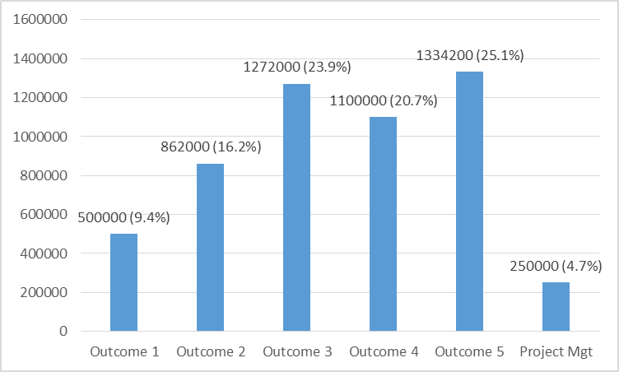The evaluation established that the use of outcome budgeting was a valid strategy of ensuring that expenditure is well aligned with the expected results which is an indicator of efficient projects. Furthermore, with project management costs at less than 5%, much of the project budget was actually spent to deliver results. The distribution of the project budget across the project implementation period with much of the budget being allocated to the first and 2nd years of the project indicates that project budgeting was commensurate with the level of activity as shown in fig 3.2 below.

## Fig 3.4: Budget allocation across project years and performance analysis

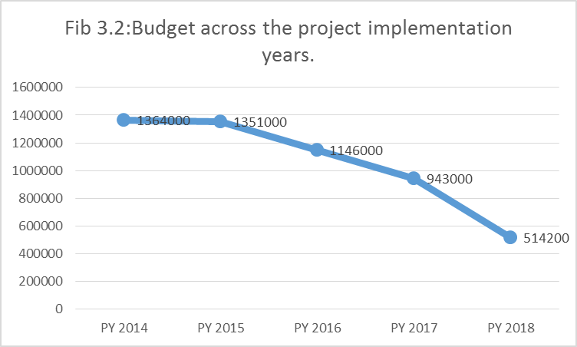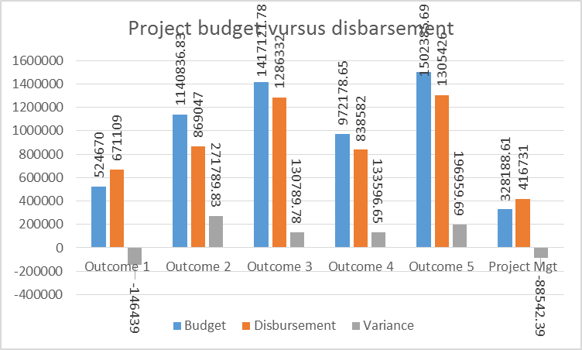

As regards project financing, the evaluation noted that great strides towards full realization of the project budget were made. In fact, the project had already received 91.5% of the planned total budget. However, data on the extent to which the pledges by different funders towards the project have been realised at terminal evaluation was scanty. As a result, the evaluation was not able to ascertain the contributions made by different funders as indicated in annex 6. The available data only indicates contributions as at the MTR. It is therefore necessary for the IP to fill in the co-financing table in annex 6 as at the TE.

Effective involvement of all the partners in project implementation has been a successful tool in mobilizing their contributions under the co-financing arrangement. Much as the total budget had not been realized in fully at the time of writing this report, the amounts so far committed have been significant. Project performance on financing is therefore rated at: **5/6 –Satisfactory**.

## 3.3.4 Monitoring and evaluation: design at entry and implementation.

The project Monitoring and Evaluation arrangements are well laid out in the project document (Pgs 91-94). Key M&E deliverables were specified and included; inception meeting, quarterly and annual reviews, periodic monitoring through site visits, mid-term and end of project evaluations. Also at entry point, a monitoring and evaluation work plan with clearly apportioned responsibilities and indicative budget was developed.

Indeed, the M&E plan was in tandem with the UNDP and GEF procedures. There was appropriate commitment to undertaking the planned M&E activities and production of the corresponding reports. The evaluation noted that with the exception of the 2015 PIR, other M&E deliverables were produced and appropriately shared to guide decision making.

At the design stage, a results framework was developed reasonably in conformity with the SMART criteria. Baseline conditions were coherently established and well-articulated in the results framework which formed the basis of indicator target setting and performance measurement. The evaluation noted that there were indeed adequate M&E tools provided to track all the performance and management indicators of the project.

Quarterly and annual M&E reporting was well adhered to and in conformity with the standard UNDP-GEF standards according to the provided templates. The M&E reports were discussed and were significantly instrumental in informing project related decision making. The periodic M&E reports were consistent with both the MTR and the TE findings. Despite the fairly elaborate M&E framework both at entry and during implementation, it was without gaps and they included the following;

Although there were plans of refining it during the inception report but never took place. This deprived the project of strengthening the project performance measurement variables in the framework. As such, the linkages among the project variables; objectives-outcomes, outputs and activities should have been much stronger (see analysis under relevance sub section).

The other gap noted in the M&E plan is the failure to indicate the source of baseline data to enable reviewers to verify the authenticity of such sources. Inappropriate baseline data poses serious challenges of realistic target setting as well as performance measurement. This has been particularly true on outcome 5 indicator 2. The gaps in the M&E plan notwithstanding, the evaluation is confident to report of the existence of commitment among the project staff to adhere to the plan. This was also made possible by the M&E tools that were developed for the project. In the light of the strengths and weaknesses discussed here above, a score of **5/6 (satisfactory) is awarded.**

# 4.0 Project Results

Assessment of the project results formed the central part of this evaluation and was intended to inform the drawing of lessons that can both improve the sustainability of benefits from this project, and aid in the overall enhancement of UNDP programming. Premised on the OECD/DAC evaluation criteria, assessment of results focussed on the overall attainment of the project objectives, relevance, effectiveness and efficiency of the project interventions and implementation strategies with regard to country ownership, mainstreaming, sustainability and impact as seen hereunder.

## 4.1 Overall results (attainment of objectives)

The goal of the Climate Proofing Project was to secure the development and food security gains from the baseline programs by empowering communities to integrate climate risk considerations in the development policies, plans, projects and actions. This was envisaged to be achieved through provision of knowledge, tools, capacities and methodologies for the adoption of an ecosystems and community based approach to adaptation. In the light of the project objective, five outcomes were set with their corresponding indicators and targets with clear baseline values to benchmark progress along the implementation continuum as presented hereunder.

**Outcome 1: The impact of ecosystems degradation in aggravating vulnerability to climate change risks and reducing resilience of development gains understood and integrated into key decision-making processes at the local, sub-national and national levels**

Information on the climate risks that were reducing the effectiveness of the baseline programs prior to CPP was grossly inadequate. For instance, the nature of the ecosystem goods and services delivered by the key natural, agro-ecological and hydrological systems, their vulnerabilities to climate change and the impacts of the management practices on ecosystems qualities, vulnerabilities and resilience are often unknown, or only partially known[29]. This situation could not favor integration of climate change concerns into key decision-making processes.

In response to the baseline situation, the Climate Proofing Project prioritized 3 outputs namely; i) provision of Information on how the state of use and management options of critical resources/ecosystems/landscapes influence effectiveness of baseline programs in the hotspots of Mangochi and Machinga; ii) formulation of comprehensive landscape adaptation plans; and iii) support Participatory Monitoring, Evaluation, Reflection and Learning (PMERL) and wide sharing of information gathered and its subsequent utilization in adaptive management. The achievement of these outputs was planned to be tracked through a number of indicators as summarized in table 4.1 below.

## Table 4.1: Output level indicators, targets and achievements

|  |  |  |  |
| --- | --- | --- | --- |
| **Outputs/Indicators** | **Baseline** | **Target** | **Achievement** |
| Outcome 1: The impact of ecosystems degradation in aggravating vulnerability to climate change risks and reducing resilience of development gains understood and integrated into key decision-making processes at the local, sub-national and national levels | | | |
| Number of comprehensive community based adaptation and technical knowledge; plans integrating traditional and technical knowledge; | None | 6 (one per hotspot) | Six (one for each hotspot) landscape plans have been formulated. The plans have also informed the integration of community-based adaptation in the 5 years District Development Plans (DDPs) for 2017-2022 in Mangochi and Machinga Districts. |
| Community involvement in monitoring vulnerability | No formal systematic means of involving community in monitoring vulnerability | Set of indicators for monitoring community vulnerability agreed and being actively used | * 66 community structures with 15 committee members each were revamped and strengthened. * The committees were training in participatory M&E and were thus able to conduct monthly and quarterly monitoring and report to the district council. * 75 community volunteers who were trained by the project in safer housing and construction standards with an aim of promoting construction of strong infrastructure that is resistant to natural disasters. |
| Quality knowledge products available, shared and being used | No publications on ecosystems, their values and contribution to reducing CC risks | At least 6 knowledge products acceptable for international publishing standards and information evidently being used in training, | * 3 manuals: the climate smart fisheries manual, the forestry management manual and the irrigation water management handbook have been produced. * The manuals are also translated into vernacular to enhance understanding of the CCA concepts by the local communities. * Other information products such as leaflets, documentaries and articles on climate change adaptation have also been developed * Some of the documentaries have been shared to media houses (print, radio and TV stations). |

From the table above, it is apparent that the project’s performance at output level was impressive with all indicator targets having been met. However, the analysis of the extent to which the above project interventions have contributed to the percentage decrease in population believed to be highly vulnerable in Mponda, Chimwala, Namkumba, Mlomba, Nyambi & Chikweo hotspots is critical to ascertain the project’s outcome level achievement.

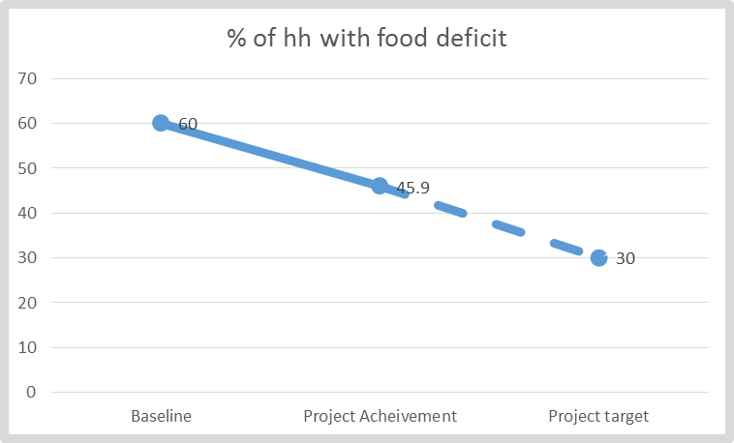Guided by the baseline situation (over 60% of 91,670 households face food deficits), the project target was to reduce the population facing food insecurity by 50%. A review of the 2019 PIR indicates that food security has been improved in 12845 households of 55002 (60% of 91670) that experienced food deficits prior to the project. This implies that the project has been able to cause a 23.4% decrease in the households that faced food deficits at the project’s baseline as seen in figure 3.1 above.

The evaluation learnt that the project supported interventions such as Climate Smart Agriculture technologies that have been extended to 7410 households, Non-timber forest based enterprises that have directly benefited 1,350 households, and Irrigation farming and seed multiplication (on-farm businesses) in which 1866 households have benefited are responsible for the observed results. Although the exact project target of 50% reduction in the households facing food deficit has not been achieved (largely due to poor yields occasioned by army warm and drought), the project investments are highly potential to support continuous productivity improvement. This is envisaged to continuously contribute towards the achievement of the project target since the output level indicator targets have been achieved. It is on this ground the project performance on this outcome is scored **5/6 (Satisfactory).**

**Outcome 2: Skills and operational capacity enhanced in the District, EPA and TA level technical officers to support implementation, maintenance and monitoring of the activities under component 1 and to mainstream climate risks into all local development process (skills, legislation, information).**

Malawi had prior to the Climate Proofing Project made great strides in instituting a vibrant environmental governance structure both at national and sub national levels in the National Envronmental Policy 2017 and other regulatory frameworks. However, inadequate resources (material, human and financial) constrained the functionality of the sub national envrionmental goverance structures. For instance, baseline findings revealed that the District Environmental Sub Committee had not been able to discharge its functions effectively in any of the pilot districts due to non-availability of funds[30]. Additionally, the integration of climate change consideration in the decentralised service delivery planning and implementation was equally constrained hence making baseline projects vulnerable to climate change risks.

In response to the baseline situation summarised above but detailed in the project document, the Climate Proofing Project set out to deliver three core outputs under this outcome and they are: i) Operational capacity of the extension service boosted to enable communities to mainstream climate risk considerations in the implementation of baseline programs; ii) Local and national development policies influenced by the project supported pilots to strengthen policies and policy enforcement for climate consideration; iii) Lessons generated at the project/district level fed into the national climate programme, SLM platform and other national planning debates, to lobby and influence the adoption of climate risk considerations as a criteria for accessing Farm Input Subsidy.

The successful delivery of the above project outputs constituted the project’s pathway to achieving the outcome as measured through the set outcome indicators presented in table 3.2 below;

## Table 4.2: Indicator level achievement under outcome 2

|  |  |  |  |  |
| --- | --- | --- | --- | --- |
| **Outcome** | **Indicators** | **Baseline** | **Target** | **End line achievement** |
| **Skills and operational capacity enhanced in the District, EPA and TA level technical officers to support implementation, maintenance and monitoring of the activities under component 1 and to mainstream climate risks into all local development process (skills, legislation, information)** | Extension packages for key sectors updated with climate risk management information | Current extension packages for key sectors do not contain climate risk management information | Extension packages for key sectors updated with climate change information and current CC management tools and techniques | A total of 4 key extension packages have been updated; They are: Forestry Management & Climate Smart Fisheries handbooks as well as the water management  Enterprise Development training manuals. |
| District level development plans and policies updated with climate risk management provisions. | Limited content, none fully updated with current CC management/risks issues | 4 District level programs, development plans and/or policies updated with climate risk management provisions | Project successfully supported;   * Formulation and updating of 5 planning instruments. * the operationalization of District Development Plans (DDPs) * development of District State of Environment and Outlook Report (DESOER) in the two districts * Formulation of National environment and climate change and communication strategy. |
| Diploma in Forestry include current climate change content | Outdated curriculum at the College of Forestry, no students receiving training on updated curriculum | New curriculum for Diploma on forestry and 200 forestry diploma graduates (50:50 on gender) | With the advice from MACOF, focus was changed from curriculum development to supporting internship. As such, 18 students (12 males & 6 Females) been supported under internship. |
| Improvement in Capacity Index Score card | On average 50% of positions vacant across local to district levels in both districts; only 25% of current staff have some level of training on CC | Vacant positions less than 40%,  100% of staff in positions have training on CC | Climate change trainings delivered to 24 (18 & 6 males & females respectively) to the members of the Gender Technical working Group and 90 (59 & 31 males & females respectively) frontline staff. |
| % increase in development funds of the districts | Less than 2% of district funds being allocated to CC related initiatives | At least 3% | No specific achievement on the indicator is noted since no effort was devoted to it after MTR recommendation that the indicator be removed. However, the project support to development planning has potential to indirectly contribute to the achievement of the indicator. |

From the presentation of outcome indicator achievement above, it is apparent that 3 of the 5 set indicators were not satisfactorily achieved as the results to a larger extent deviate from the set indicators and their corresponding targets. This is largely due to the poor alignment between the outcome indicators and the outputs delivered. Under conventional project planning, the outputs to be delivered are directly derived from the outcome indicators which was not the case under this project. For example, indicators 3, 4 & 5 do not systematically rhyme with the delivered outputs under this outcome. For this reason, performance under this outcome is rated (**3/6 Moderately unsatisfactory**).

**Outcome 3: Public and domestic water harvesting, storage and distribution reduces climate change driven flooding and regulates availability of water throughout the year in flood & drought hotspots**

With the increasing warming trend recorded over the years, Malawian future weather had changed much with even expectations of exacerbating climate variability that prevailed prior to the CPP. As a result, more intense cycles of floods and droughts, unpredictable rains was affecting over 90% of rural dwellers who depend on rain fed small scale farming. Furthermore, the changing whether also affected infrastructure and dwellings, particularly in poor neighbourhoods in the urban areas.

Subsequent to the situation that prevailed, the Climate Proofing Project prioritized two outputs under this outcome namely; i) Construction of mini dams, water ponds, retention ridges, and water diversion structures; ii) construction of physical structures to support infrastructure and expansion of water harvesting from dwellings. Project achievements under this outcome is presented in table 2.3 below;

## Table 4.3: Achievement under outcome 3

|  |  |  |  |  |
| --- | --- | --- | --- | --- |
| **Outcome** | **Indicators** | **Baseline** | **Target** | **End line Results** |
| **Public and domestic water harvesting, storage and distribution reduces climate change driven flooding and regulates availability of water throughout the year in flood & drought hotspots** | Number of physical infrastructures constructed to ensure sustainable water supplies and reduce disaster risks | About 2 mini dams, several check dams | At least 10 mini dams and over 100 check dams, nullahs, and other structures | * 1 mini dam constructed in Mangochi (Stambuli Dam), * 2 weirs that collect water for irrigation , * 1800 check dams and swalleys, nullas and infiltration pits have been constructed. * 19 fish ponds have been constructed (7 in Mangochi and twelve in Machinga, with two more fish ponds in progress in Machinga). |
| Number of homes with water harvesting structures | Less than 10% of 91,760 households harvest water from rooftops | Over 35% of 91,760 households harvesting water from rooftops | * Additional 0.25% of the 91760 have been enabled to harvest water. * A total of 75 above ground water tanks have been mounted |

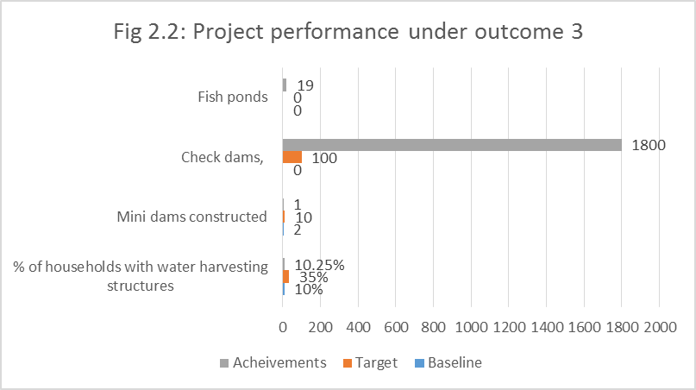Analysis of the endline results in the light of the set targets indicated decimal performance as none of the targets had been met by the time of this evaluation. For this reason, performance is rated as **moderately successful.**

According to the project staff, underperformance was attributed to the over ambition in the target setting. However, having known the high set targets and the available resources, the project team should have considered the revision of these targets in the results framework. This would have inclined the assessment to be done in the light of the revised targets. However, much as the indicator targets have not been met, it is noteworthy that the delivered outputs have been highly impactful especially with regard to improving food security and domestic water availability.

**Outcome 4: Rehabilitation of badly degraded forests, protection of riverbanks, lake shores and urban infrastructure**

The districts of Machinga and mangochi are endowed with vast natural resources including vast forest cover and water bodies that play a critical role in climate modification in the area. For instance, the two districts have an estimated 654478 ha of forest cover. Whilst Mangochi district was engaged in the implementation of Phase II of the Improved Forest Management for Sustainable Livelihoods Programme (IFMSLP) and the Lake Chilwa Basin Climate Change Adaptation Programme (LCBCCAP), these initiatives were not covering the selected hotspots. As a result of the gaps in the forest management practices in the two pilot districts, rampant deforestation and degradation as a result of human activity threatened the sustainability of these forests[31].

It was against this background that the Climate Proofing Project set out to put in place measures to secure the baseline investments from climate related risks. These included rehabilitation of badly degraded forests, protection of riverbanks, lake shores and urban infrastructure. It was envisaged that these interventions would improve land cover, infiltration and base flow; increasing the ability of the landscape to regulate water flow during droughts and floods, offering ecological protection from climate change induced droughts and floods.

Subsequently, the project prioritized three outputs namely; i) Degraded watersheds (forest ecosystems) rehabilitated, river Banks and Lake shores protected from direct siltation; ii) Provision of improved and sustainable supplies of energy, including adoption of sustainable charcoal; iii) Diversification of household food basket and incomes via expansion of aquaculture and NTFP to reduce pressure on the forests, river and lake fisheries.

The extent to which the delivered project outputs supported the realisation of the envisaged outcome was at the core of this evaluation. Performance assessment under this outcome is anchored on the set outcome indicators as presented in table 2.4 below.

## Table 4.4: Performance assessment under outcome 4.

|  |  |  |  |  |
| --- | --- | --- | --- | --- |
| **Outcome** | **Indicators** | **Baseline** | **Target** | **End line results** |
| **Rehabilitation of badly degraded forests, protection of riverbanks, lake shores and urban infrastructure** | Number of Village Forest Areas registered | 7 | 20 | The project has supported the establishment of 24 Local Forest Organisation but only 15 ( 9 and 6) are registered in Machinga and Magochi respectively. |
| Hectares of forests under improved management | 410 ha under community forest | At least 1,500 ha under community forest | A total area of 2,269.75 hectares of land under improved forest management. |
| Kilometers of river and lake shore under protection | 5km of lake shore and about 7km of river banks under protection | At least 100 km of lake shore and 100 km of river banks under protection from direct siltation | 217km of river banks (54km for Mangochi and 163.9km for Machinga) have been planted with fast growing exotic trees, indigenous tree species and bamboos in both districts. |
| Number of households using alternate and improved energy | Less than 5% of 91,760 households currently use any form of energy efficient technologies | At least 35% of 91,760 households adopt high energy efficient technologies and methods | 21.3% of the 91760 are have adopted high energy efficient technologies & methods; |

As presented in the table above, it is apparent that the project surpassed its targets on two indicators while on the other two, project performance fell short of the set targets. However, on all the indicators, the project made significant contribution in the light of the baseline indicator values as presented in figure 2.3 below.

## Fig 4.1: Outcome 4 indicator performance assessment

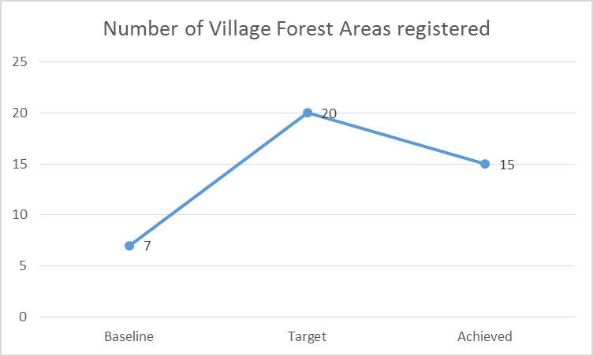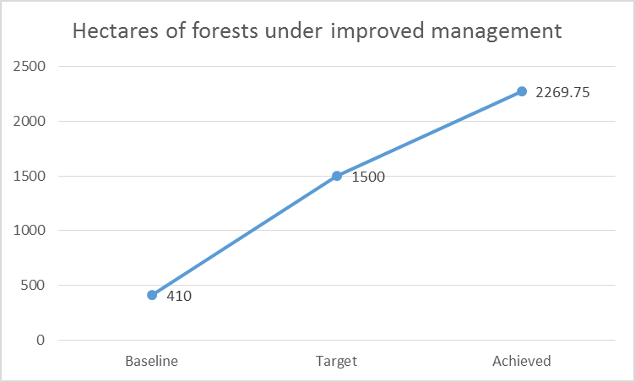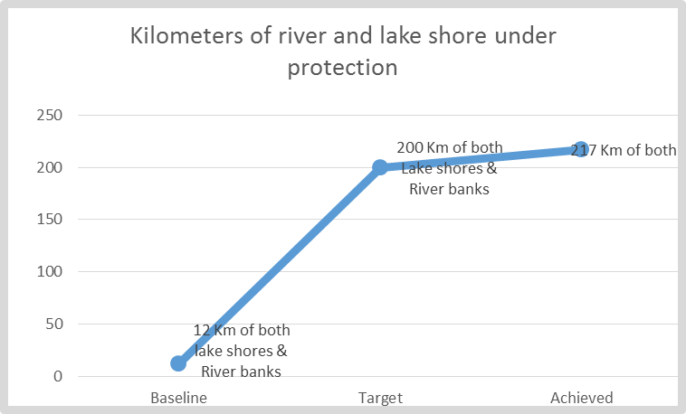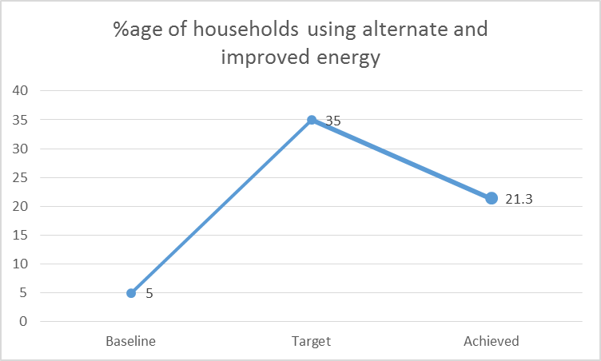

Although some indicator targets have not been achieved, the evaluation noted that the delivered outputs have great potential of generating ripple effect that will continuously support the realisation of the outcome overtime. For instance, the evaluation noted that the achievements registered throughdiversification of household food basket and incomes via expansion of aquaculture and NTFP as well as adoption of efficient energy stoves have great potential of reducing pressure on the forests, river and lake fisheries. For this reason, project performance under this outcome is rated **satisfactory**; the short falls in the indicator targets notwithstanding.

**Outcome 5: Productivity of agriculture supported by adoption of climate smart systems and measures**

Agriculture remains a key driver for Malawi’s economic growth and development as a major source of food and employment especially in the rural areas. As such, considerable investment has been made in the sector over the years aiming at strengthening both productivity and profitability. Significant of such investments has been the in-put subsidy program. However, the country’s vulnerability to climate change risks greatly affected the performance of the agricultural sector. For instance, soil erosion was prior to the Climate Proofing Project a major threat to agricultural productivity and profitability hence compromising the gains of the baseline programs such as the Farm in-put subsidy program.

In the light of the baseline situation, the Climate Proofing Project set out to facilitate the adoption of climate smart measures to reverse the simplification of the agriculture system that had systematically weakened its ability to secure food supplies for a majority of the families. These measures were also envisaged to enhance water use efficiency under irrigation, thereby increasing the effectiveness of the agriculture input subsidy and the national irrigation scheme. Three outputs were accordingly delivered to support the realisation of the outcome as measured by the set indicators in table 2.5 below.

## Table 4.5: Project performance under outcome 5

|  |  |  |  |  |
| --- | --- | --- | --- | --- |
| **Outcome** | **Indicators** | **Baseline** | **Target** | **End line Results** |
| **Productivity of agriculture supported by adoption of climate smart systems and measures** | No. of hectares on which climate smart farming is practiced | Area under agroforestry: 144.6 ha | More than 5000 ha | A total of 7935Ha are under climate smart agriculture in both Mangochi and Machinga putting project performance under this indicator at 158.7% |
| Farmers practicing CSA 2073 (2.3%) | 40% of 91760 Households practice CSA | 38,808 H/H practice CSA in both districts. In addition to those who were practicing CSA prior to the project, the total number of H/Hs practicing CSA stands at representing 44.6%. |
| Percentage increase in productivity per acre or per unit of land | |  |  |  | | --- | --- | --- | | Crop | District [32]  (tons/ha) | District[33] | | Maize | 1.9 | 1.55 | | Sorghum | 0.95 | 66 | | rice | 1.839 | 0.889 | | Cowpeas | - | 0.333 | | Cassava | 19,527 | 15,107 | | Soya beans | 63 | 59 | | Over 40% increase over baseline yields for key crops | |  |  | | --- | --- | | Average Yield | % increase | | 1.030 | -45.8% | | 1.030 | 8.2 | | 1.188 | -35.5 | | 435 | -104.4 | | 15887 | -18.6 | |  | 9.5 | |
| Area under climate smart small holder irrigation | Before the project less than 100 hectares despite potential | At least 1000 hectares under climate smart small holder irrigation | 182Ha under Climate Smart Smallholder Irrigation representing 18.2% of the set target. |
| Water use efficiency in small holder irrigation | On average water use efficiency lower than 25% | On average water use efficiency increase to >50% in small holder irrigation | Water use efficiency estimated at 50% due to the effectiveness of the project supported technologies. |
| % reduction in post-harvest losses for those engaging | On average approximately 35% of grains, fruits, vegetables, fish was being lost to poor post-harvest practices before the project. | Less than 10% post-harvest loss of grains, fruits, vegetables, fish being lost to poor post-harvest practices | Estimated to have reduced to between 25-30% largely due to the project supported post-harvest handling technologies. |

Statistically, the project appears to have performed poorly on the yield enhancement indicator as the end-line results sharply fall short of the even the baseline values. However, discussion with a variety of stakeholders that participated in this evaluation, it was revealed that the yields in the pilot districts have significantly increased. From the review of the project document, it is noted that the source of baseline data was not provided and this constrained the evaluator’s efforts to verify the source. In the light of the statistical analysis in the table vis-a-vis stakeholder responses on the project contribution towards improved crop yields, it is possible that the source of the baseline data was erroneous hence compromising objective assessment of the project performance on this indicator. Nevertheless, it is reported in PIR that yields in the hot spot have been relatively higher than those recorded outside. It is therefore apparent that the contribution of the project towards enhanced yields through climate start agricultural interventions can never be under estimated.

The climate smart agricultural practices that have been introduced under the project have great ripple effect with potential of scaling up production and reducing post-harvest losses even beyond the project timeframe and geographical area.

Assessment of the outcome indicator achievement revealed that targets on the two indicators were fully achieved while good progress was also recorded on the other two indicators. It is only on one indicator where statistical presentation of the results portray the project to have under-performed. However, given the feedback provided by the stakeholders on the project interventions under the indicator, great achievements are emphasized. It would have been more prudent if the source of the baseline data was verified. This notwithstanding, the evaluation noted that the project investment under outcome five was appropriate and relevant and therefore able to support the realisation of those indicators where decimal results have been registered statistically. For this reason, project performance under this outcome is rated as **satisfactory.**

## 4,2 Relevance

The project logic was sound and comprehensive based on well-articulated problem analysis. Thus, the problems the project set out to address were correctly identified and justified. Adequate efforts were undertaken at the design stage to establish baseline values against which performance targets were set.

The project importance and linkages to the international and national development ambitions as enshrined in SDGs, UNDAF, CPD and Malawi Growth and Development Strategies as well as other national policies are evident. Project linkage with particularly national policy framework was given adequate consideration at the design stage. A number of policies to which the project is aligned were exhaustively identified and specific linkages drawn out (see pg 37-39). As such, the importance of the project in supporting national development aspirations was adequately articulated.

Globally, the Climate Proofing Project is directly aligned with Sustainable Goal 13 “Take urgent action to combat climate change and its impacts” and several others indirectly such as goal 1 on poverty reduction; 2- hunger; 7-Affordable and clean energy; 14-life under water; and 15-life on land. By implication, the problem the project set out to address was of global concern which makes the project benefits transcend territorial boundaries.

Efforts were equally made to align the project with both UNDP and GEF strategic directions. More specifically, the project was aligned with GEF 5 strategic areas as well as CPD outcomes here below;

* Mainstreamed adaptation in broader development frameworks in targeted vulnerable areas
* Reduced vulnerability to climate change in development sectors
* Increased knowledge and understanding of climate variability and change-induced threats at country level and in targeted vulnerable areas
* Strengthened adaptive capacity to reduce risks to climate-induced economic losses
* Successful demonstration, deployment, and transfer of relevant adaptation technology in targeted areas.

CPD outcomes to which the project is aligned

* Outcome 3.1: Institutions strengthened to develop and improve policies, strategies and plans for climate change, environmental management, and disaster risk reduction.
* Outcome 3.2: Integrated info systems strengthened for decision-making on disaster risk reduction, climate change and environmental management

Internally, project interventions were logically flowing well linked with the desired results right from the objectives up to the specific activities. The multi stakeholder implementation arrangement that was adopted was sufficient and well thought through to support realisation of the results. However, the evaluation noted a few cases where project outcome indicators were not perfectly corresponding with the outputs and instances where output indicators were not comprehensively addressed by the project activities at lower levels (See analysis under outcome 2 above). The observed gaps in the project logical flow notwithstanding, the project’s external and internal consistence was adequate and hence relevant. It is on this ground that a rank of **5/6 (satisfactory)** is awarded.

## 4.3 Effectiveness & Efficiency

Analysis of project effectiveness explores the extent to which the project outcomes and objectives have been achieved. The project objective was to support the use of ecological, physical and policy measures to reduce vulnerability to climate change driven droughts, floods and post-harvest grain losses for rural and urban communities of Machinga and Mangochi Districts of Malawi [reaching over 0.5 million people. Achievement of this objective was planned to be measured through three core indicators as summarised in table 4.6 below.

## Table 4.6: Project performance at objective level

|  |  |  |  |  |
| --- | --- | --- | --- | --- |
| **Objective** | **Indicators** | **Baseline** | **Target** | **End line Result** |
| **Using ecological, physical and policy measures to reduce vulnerability to climate change driven droughts, floods and post-harvest grain losses for rural and urban communities of Machinga and Mangochi Districts of Malawi [reaching over 0.5 million people.** | Improvement in food security for households participating | Over 60% of 91,670 households face food deficits – don’t produce enough to last till the next harvest | At least 50% decline in number of households facing annual food deficits (less than 30% still face food deficits) | Project has supported improvement of food security status of 12,845 Households (H/Hs). This represents 23.3% of 55056 H/H or 60% of 91760 who were facing food deficits prior to the project. |
| Percent change in soil erosion and siltation of water bodies | Soil erosion estimated at 20 tons/ha/year and 8 EPAs report “severe” rates of erosion | 40% reduction in soils going into the water bodies; 50% in EPAs reporting severe rates of erosion | Although the MTR recommended for the removal of this indicator due to its inability to measure, the project interventions have been significant in controlling soil erosion. Key interventions to consider are: i) improved forest management; ii) tree planting along river banks equivalent of 217km in both districts. These interventions have a significant impact on siltation. |
| Availability of skills and resources necessary to continue adaptation after conclusion of project (indicator for sustainability) | Average scores for communities and institutions on UNDP capacity scorecard is <20% and >40% respectively | UNDP capacity scorecard for communities and technical teams increase to 50% and 75% respectively | The project has supported capacity development in identify, prioritize, implement, monitor and evaluate adaptation strategies and measures. A total of 15,875 people trained over the project duration. They include, farmers ,District Environmental Sub Committee (DESC) ,District Civil Protection Committees (DCPCs), Village Natural Resource Management Committees (VNRMCs), Area Development Committees (ADCs), Lead Farmers (LFs), Beach Village Committees (BVCs) ,and Village Civil Protection Committees (VCPCs). |

Although the indicator targets have not be statistically achieved, the evaluator is confident to state that this project is highly impactful even the degree of ripple effect associated with the interventions. For instance, much as 42211 out of 91760 are still facing food insecurity, the climate smart interventions coupled with improved post-harvest handling practices that have been supported by the project are well placed to support further reduction of the number of food insecure households. Furthermore, the river bank management interventions that have been supported coupled with capacity development of key natural resource management structures remain critical in controlling siltation. On the basis of both the observed and project results of the Climate Proofing Project, a rank of **5/6 (satisfactory)** is awarded.

Project performance at outcome level was equally good as evidenced by the percentage of outcome indicator targets that have been fully or partially achieved as summarised in figure 2.4 below.

## Fig 4.2: Outcome level performance summary

Out of 20 outcome level indicator targets, the evaluation established that 9 or 45% were fully achieved and/or surpassed while 10 or 50% were partially achieved. Only one indicator was not achieved at all and no explicit intervention to achieve it has been noticed by this evaluation. It is however important to note that although some outcome indicator targets were partially achieved, the project deliverables are highly impactful and therefore able to facilitate the achievement of enhanced results beyond the project implementation period through ripple effects. It is on this ground that the overall project performance at outcome level is rated as **satisfactory with a score of 5/6.**

As regards efficiency, the TE established that the project resources were efficiently utilized with 95.3% of the project budget having been spent on core activity implementation. Management cost was only 4.7% which is an indicator of an efficient project. Project implementation was mainstreamed in the existing management structures at district and community levels which had enormous efficiency management gains. As presented in the project finance section, the adoption of outcome and output based budgeting and expenditure coupled with robust financial management procedures instituted by UNDP helped to ensure adequate alignment between project expenditure and activity implementation.

## 4.4 Country ownership

The Government of Malawi is committed to achieving Sustainable Development Goals (SDGs) and this puts, sustainable use of natural resources at the forefront in the country’s achievement of the aspirations under its national and global development frameworks. The Climate Proofing project therefore addresses key issues that that strengthen the country’s ability to achieve its national development priorities as enshrined in the MGDSIII and several other policy frameworks related to climate change resilience and adaptation. In particular, the project addresses the linked problems of deforestation and degradation, poverty alleviation and social development through integration of climate change resilience in development planning. This is tandem with the national priorities as reflected in numerous sectoral policies, strategies and action plans. All these are key factors that underpin country ownership of the project as further evidenced by the following.

The Government’s willingness to contribute about 82.3% of the total required resources under project co-financing arrangement is a good indicator that the government played an active role. Furthermore, the integration of project implementation in the National Implementation Modality also well evidences country ownership of the project. As such, the involvement of government officials in the entire project implementation processes has been evidently indicating ownership. The role played by several government structures both at national and sub national levels well evidences the country ownership of the project hence increasing the likelihood of sustainability.

All the government stakeholders that participated in this evaluation expressed willingness to continue playing an active role in maintaining and protecting the benefits of the project. Although no commitment on the side of government to provide a budgetary allocation for the implementation of some of the uncompleted project activities has been ascertained, the capacity that has been developed under the project shall continue pushing climate change resilience and adaption on national planning and development agenda.

Capacity strengthening for climate change mainstreaming in development planning was the key intervention under this project on which significant results have been registered (as discussed under effectiveness section). Thus, the project has successfully created awareness about the need to mainstream climate change and has subsequently built capacity for its realisation. These constitute key pillars upon which climate change resilience and adaption shall continually feature the development planning of Malawi as a whole and particularly the pilot districts.

## 4.5 Mainstreaming

The UNDP and GEF require that projects approved from 2014 have a gender analysis and those from 2018 have a gender analysis and action plan. It was reported by the project implementation Unit (Environmental Affairs Department) that a gender analysis was not taken at the onset of the project until the midterm review when this gap was highlighted. From 2017 the CCP undertook gender training for project participants, implementers and stakeholder and a gender analysis followed in the final year of the project. It is evident at the TE that the Climate proofing project activities were implemented with a gender lens in the districts of Mangochi and Machinga especially in the 6 hotspots. The implementation of most of the activities took a household approach to extension, which allows all members of the household to participate in planning and implementation of activities that can improve livelihoods of all household members (men, women and youth). This approach proved to have improved the power relations and decision making among all gender categories in the household. The household approach promoted participation of all gender categories into the project and promoted gender equality among the project beneficiaries. There is evidence that women are championing some climate adaptation initiatives by heading groups and taking part in key decision making e.g. the Chairperson of Issa Mponda irrigation scheme and of fish farming group in Mangochi, mong others[34].

This is despite that there are challenges to mainstreaming gender in Mangochi and Machinga districts because of cultural and religious underpinnings. In addition to the fact that the gender gap was filled in the middle of implementing the project. There is room for scaling up gender related interventions in the communities within and outside the hotspots as the household approach being followed is part of the agriculture extension methodology in the country.

The achievements that have been realized include empowerment of women groups, improved decision making at household level and improved gender relations among household approach (HHA) implementers. For instance, VSL groups were trained and have been empowered economically (see table 3.1)

From the proceeds, members have been economically empowered especially women who have managed to purchase farm inputs (fertilizers and seed), iron roofs for their houses, built houses, bought livestock (pigs, goats, chickens) and are paying school fees for their children. The women no longer ask for money from their husbands for upkeep or home use but have opened up small scale businesses which allow them to get profits and utilize the funds at household level.

In addition, 10 Agricultural Extension Development Officers (AEDOs) were trained on Household Approach in Mangochi (2017), the frontline workers trained 60 local facilitators. The 60 local facilitators have reached out to 240 households which are now practicing household approach in Chilipa, Mthiramanja, Nankumba, Mbwadzulu and Nasenga EPAs.

Mtemankhokwe VSL Group in Issa Mponda Village, TA Mponda in Mangochi District comprises of 28 members (5 males and 23 females) was trained in 2017 and currently has accumulated savings worth MK1, 650,000.

Titukule VSL Group in Manjawira Village, TA Mponda in Mangochi District has a membership of 37 (5 males and 32 females) was trained in 2017 and so far has accumulated MK2, 340,000.

Panthunzi VSL Group from Saidi Matola Village, TA Nankumba in Mangochi District is comprised of 28 members (7 males and 21 females) was trained in 2017 and has accumulated MK1, 870,000.

Tiyanjane VSL Group from Saidi Matola, TA Nankumba in Mangochi District is comprised of 25 members (6 males, 19 females) was trained in 2018 and has accumulated MK870, 860.

Likonde VSL Group in Katema Village, TA Mponda in Mangochi District comprises 20 members (3 males, 17 females) and has managed to accumulate MK 564, 000.

Due to the visions made by the households under HHA, some households already reached some milestones e.g in TA Nankumba in Mangochi, Mr Useni Shaibu, of Nkupa Village, bought a bicycle; Blessings Chitani of Zimbayuda Village bought a Solar Panel and inverter; Mr Piasi of Zimbayuda Village bought a solar water pump which he uses at the Irrigation scheme (Chiwole); Mr Ismael Mdala of Selemani Village, bought a goat, solar panel; and Christina Likongwe of Nkupa Village is paying her daughter’s school fees.

Michael Bango from Kalipande Village, GVH Matenje in TA Chilipa in Mangochi used to hussle with his tomato vending where he used to borrow a bicycle to ferry tomatoes to Ntcheu but never enjoyed the proceeds from his business. For three years, he had nothing to show for his business until in 2017 when he was introduced to HHA by Climate Proofing Project, after attending the training on HHA, him and his family managed to produce their household vision which helped them to start making decisions together. Currently (after one year), Michael knows how to spend according to his household vision and he has managed to accumulate a number of assets which include the following; finished roofing his house with corrugated iron sheets, he bought four goats, 15 chickens, 1 cow and a bicycle which the family uses. He no longer borrows a bicycle and one of the milestones by 2020 is that he should own a motorcycle (and he has already started saving for it).

A gender analysis was also conducted on households that are implementing household approach (HHA) with the aim of comparing the 2019 situation with that of 2017. The findings indicate an increase of 32.7% from 2017. This is a result of the trainings that took place in June 2017 where decision making for both men and women was at 30.8%. But at the end of the CCP, 63.5% of the households are able to make decisions together. Controlling of assets has also increased from 32% in 2017 to 59%. This shows that HHA is really a good tool in showing results for gender. However, these results are only limited to those trained in HHA and only explains what happens in the households that are implementing HHA which is still far from the total number of beneficiaries in the project hotspots. There is solace in the fact that the HHA is an extension approach being spearheaded by the Department of Agriculture Extension Services and the District council has embraced it and has vowed to upscale its implementation through other projects at the council level.

It can therefore be concluded that the advancement of gender equality and women empowerment have put the disadvantaged groups, being women and girls at the centre of programming in the two districts. For example, the project has witnessed 69% of women participating in the income enhancement activities supported by the project, such as honey production, irrigation farming and village savings and loans association. This has reduced the financial pressure that women suffer in caring for their households. This has improved families' nutrition and even reduced the pressure on natural resources because in the past women were mostly reverting to the forests to collect firewood for sale, which in turn promoted deforestation. However, with the interventions of the project, they are ably getting income and being empowered to make choices on their own. However, this shows that men’s participation is below 40% which is also very low. The low participation of men is due to the fishing industry where most men prefer going to the lake for fishing than remaining in the communities.

## 4.6 Sustainability

The CCP activities and interventions were implemented to meet the objectives of the project, which were centered on how communities can reduce their vulnerability to the effects of climate change and secure development and food security gains. At the expiry of the project the achievements need to be sustained to continue contributing towards the CCP objective. Recognizing this fact, the councils of the two districts have developed an exit strategy and sustainability plan in order to create a greater potential for sustained impact of the activities and interventions in the six hotspots where the project was piloted. The process of developing the plan was consultative and involved the participation of both district and all relevant community level governance structures. This in itself was implemented with a sustainability lens in mind. In the plan, the councils have defined how to promote and measure the sustainability of the interventions by the communities and other stakeholders. Main focus has been on capacity building of local governance structures, strengthening linkages and sustaining their motivation to ensure continuity of interventions beyond project life. Special attention has been given to the project’s identified “6 best practices” that require continued support for possible up-scaling and replication. These include

* Solar powered irrigation (promotion and installation of solar powered equipment in irrigation schemes vs. fuel powered irrigation)
* Rain water harvesting technologies (Construction of Dams, Use of concrete check dams as Soil and water conservation measures)
* Natural Regeneration
* Utilization of Non Timber Forest Products (NTFP) and value addition (fish farming and Bee keeping)
* Community adaptation plans using CoBRA
* Renewable energy sources (Installation of Biogas facilities in public institutions

It is important to note that all activities of the project were centered on achieving synergies advocated for in Climate Smart Agriculture thus increasing productivity, climate change adaptation and mitigation measures. The attainment of such synergies by the communities was the primary criteria for the selection of interventions deemed as best practices. Therefore, best practices in this context are those that have proved to increase productivity and income while increasing the communities’ ability to adapt to climate change and at the same time mitigating the causes of the same and building the communities’ resilience.

The existing policy and institutional framework is adequate to ensure sustainability of the project benefits. The country formulated a National Environmental Policy in 2017 that provides the overall policy guidance for climate change mitigation. At the institutional level, several decentralised environmental management strictures are evident. They include inter alia, National Climate Change Steering Committee, Technical Committee on Climate Change, the Ministries of Finance and Economic Planning & Natural Resources, Energy and Mining with their respective departments. At the district level, the District Councils and particularly the district Environmental Sub Committee provide strategic leadership in environmental management which role is undertaken by Development Committees at lower level.

The CPP made strategic investments that enhances sustainability of its benefits. They are: revamping and strengthening of 66 community structures, training of 75 community volunteers as was support provided towards production of manuals[35] as presented in the effectiveness analysis section above. The existing policy and institutional framework coupled with the project specific sustainability enhancement interventions in the matrix below make it more likely for the benefits of the project to be sustained beyond the project period. However the limited funding of the established structures remains an uphill threat to full scale sustainability.

## Table 4.7: Sustainability Matrix

| BEST PRACTICE[36] | KEY ACHIEVEMENTS/IMPACTS[37] | | | GAPS[38] | SUSTAINABILITY STRATEGIES AND ACTIONS | COSTS(MK) |
| --- | --- | --- | --- | --- | --- | --- |
| Ecosystem health | Food Security | Socio-economic |
| Solar powered irrigation (promotion and installation of solar powered equipment in irrigation scheme vs. fuel powered irrigation) | * Environmentally friendly i.e. no carbon emissions as compared to fuel powered systems. | * It has highly contributed to increased yields compared to baseline e.g. the project has exceeded expectation by directly improving food security status of 12,845 HH. This represents a total of 77% decline in number of households (less than 23% =16500HH that still faced food deficits at the beginning of the project). At present, 38888 HH under the project are pursuing diversified climate-resilient livelihood options. * Increased capacity to withstand shocks of climate change | * Because production is done 3 times per season, farmers are able to obtain higher incomes through sales of produce e.g. Namosi Scheme in Machinga used to harvest 5700kgs of Maize at an area of 5 has but after the introduction of the project, they are able to produce 72,000kgs on 24 ha. * The money saved from buying fuel for fuel powered irrigation pumps is used on other household needs * Members in these schemes have formed VSL groups which help them to improve their saving culture * Labour costs on irrigating crops have been minimized because the practice is labour saving. | * There is no routine maintenance of irrigation schemes due to inadequate capacity of the scheme members * There are no land agreements between the communities and the schemes * WUAs are not in place. i.e. only WUGs are available * There is no linkage of the farmers to reliable markets * There are very few solar powered irrigation schemes in the districts (2 in Machinga and 3 in Mangochi) | Promote adoption & functionality of sustainable solar powered irrigation system by conducting the following activities:   * facilitate routine maintenance of irrigation schemes * establish community irrigation scheme maintenance fund * facilitate signing of Community land agreements * facilitate formulation and registration of WUAs * Link farmers to reliable markets * Upscale/establish new solar powered irrigation schemes in the two districts (Machinga 3, Mangochi 2) | 394,000,000  (US$540,000) |
|  |  |  |  |  |  |  |
| Rain water harvesting technologies (Construction of Dams, Use of concrete check dams as Soil and water conservation measures) | * It has facilitated water availability and controlled soil erosion thereby promoting residual moisture during dry spells whilst at the same time contributing to the ecosystem health * Check dams have contributed to ecosystem/environmental health by using environmentally friendly construction materials as compared to those that use poles and bamboos * Controlled flood downstream. The farmers in TA Mponda did not register any floods in 2018/2019 * Enough water is available throughout the year and accessible for farmers downstream due to Stambuli Dam in Mangochi | It has contributed much to increased yields by increasing moisture retention and minimizing loss of soil fertility |  | * There are no operation and maintenance funds for the dam * Catchment conservation is limitedly done around the dam * Lack of catchment management committees * Only one dams have been constructed hence the need to upscale | Promote the adoption of RWH technologies and flood control measures by doing the following:   * Facilitate the establishment of operation and maintenance fund * Facilitate catchment conservation of the Dam * Establish /revamp catchment management committees * Train catchment management committees in catchment management, conservation * Facilitate establishment of nurseries and woodlots for agroforestry seedlings * Facilitate and support the construction of SWC structures in catchment areas | 350,000,000  (US$480,000) |
|  |  |  |  |  |  |  |
| Natural regeneration | Increased forest cover due to rehabilitated woodlands through natural regeneration (1789Ha rehabilitated). | Reduced incidences of soil erosion contributing to improved soil fertility which leads to increased production of food. | Conducive environment for the production of NTFP which will lead to increased income levels amongst beneficiaries. (honey and local mushroom production) | * Low scale of implementation. * Limited number of registered LFOs. * Limited of enforcement of by-laws. * Lack of participatory forest management plans for some Village Forest Areas. | Increase forest cover through the following activities:   * Scaling up implementation of natural regeneration. * Register the remaining LFOs. * Enforcement of forest by-laws. * Develop forest management plans. | 70,000,000  (US$ 95,890) |
| Utilization of Non Timber Forest Products (NTFP) and value addition (fish farming and Bee keeping) | -Reduced pressure on the natural resources due to the presence of alternative income sources away from charcoal production and capture fisheries. | Increased income to buy diversified food items and in acquisition of farm inputs leading to increase in food production. | A total of (USD 34,482) 25 million Kwacha (10,000kgs) has been realized from honey sales in Machinga with members having increased their resilience to shocks.  Total membership stands at 574 (428F & 146M). | * The honey is not certified by Malawi Bureau of Standards despite enjoying market share. * No processing units as required by Malawi Bureau of Standards. * Lack of clear business plans for the groups. * Implementation done at a low scale. * Low income due to the increased number of beneficiaries against the income realized i.e. 25 Million against 574 beneficiaries resulting in K14500 per person per year | Promote enterprise development through the following activities:   * Capacity building initiatives in quality control (MS19 & MS21) * Registration with MBS on certification programme. * Construction of a processing house (Mini-factory) * Procurement of processing machine. (Candle making machine, honey processing machine) * Training of groups in marketing, business planning & business mgt. * Upscale the production of honey. | 60,000,000  (US$82,191) |
| Improved food and nutrition security since fish is a source of protein. | Increased income among the members i.e. 4,070Kgs was harvested and with  MK8, 140,000.00 realized leading to reduced poverty levels.  Total beneficiaries are 295 (180F & 115M) | * Low income due to the increased number of beneficiaries against the income realized. * (MK8,140,000.00 against 295 members MK27,593/farmer for a period of 3 years) * Over reliance on the project to support them with fingerlings and feed * Lack of marketing skills), Lack of business plans | Upscale integrated fish farming practices through the following activities:   * Establish new and strengthen existing fish farming groups * Train fish farmers to produce own quality fingerlings and feed * Train fish farming groups in marketing and business management * Disseminate Climate Smart Fish Farming manual (practices) |
| Community adaptation plans using CoBRA. | * Identified the key characteristics of ecosystems and prioritize local interventions to address issues in 6 hotspot and 4 control areas. * Increased knowledge and skills on adaptation through narrowing the capacity gap towards ecosystem Management * Established an integrated Community Based Adaptations Planning Frameworks that effectively promote local resilience building and vulnerability reduction in 6 hotspot areas | Identified the key food security bottlenecks and prioritized local interventions to address issues in 6 hotspot and 4 control areas. | Identified the key household income characteristics and prioritized local interventions to address issues in 6 hotspot and 4 control areas. | * Inadequate human & financial capacity to translate resilience concepts identified under CoBRA into practice. * Low coverage as it was done in targeted hotspots only. | Mainstream CoBRA in all development planning processes through the following activities:   * Disseminate CoBRA training manual to all existing platforms at all levels (district and national). * Roll out CoBRA to the remaining traditional authorities through existing platforms (decentralized structures). * Build capacity on CoBRA to all existing platforms at all levels (Local, district and national). * Advocate the incorporation of CoBRA into the decentralized planning systems. | 55,000,000  (US$ 76,000) |
|  |  |  |  |  |  |  |
| Renewable energy (Biogas installation in Public institutions) | * Reduces deforestation through provision of alternative energy source to fuel wood * Contributed to reduction in carbon emissions through capturing and utilization of methane for energy production * Enhanced proper organic waste (solid & liquid) management * Replication of two more biogas plants in Dedza and Ntcheu with support from GIZ and UP respectively. | It has provided bio-fertilizer which increased production at Mangochi prison. The Prison harvests maize crop 3 times per year to a total yield of 2025 kilograms from a 1 acre piece of land. Vegetables are also grown on the plot that adds nutritional security for the inmates. | * Ensured savings on cost for fuel wood i.e. the cost for Mangochi Prison reduced from MK8, 640,000 per year to MK 2, 879, 999 per year. In Machinga DHO it has a potential of saving about MK 2, 000, 000.00 of fuel wood * It has contributed to reduction of electricity costs incurred by public institutions i.e. Prison and hospital * Created employment and business opportunity to local people and companies | * Inadequate capacity of the staff in operation and maintenance of the plant * Misconception of communities towards the raw materials used as feedstock for bio-digesters. * High initial costs. | Upscale the adoption of alternative energy technologies through the following activities:   * Strengthen the Capacity of Staff in operation and maintenance to ensure sustainability of the intervention * Enhance mind set change through public awareness Campaign. * Lobby for subsidizing the costs of materials and facilitate up scaling to institutions such as schools, hospitals and prisons. | 557,000,000  (US$763,000) |

The fact that councils have been in the fore front developing sustainability plans it means that the project’s aim of making a shift in thinking within national government entities, district administrations and local authorities in integration of climate change adaptation with development planning in the long term has been attained. The district councils vowed to continue with project activities by engaging CSO, NGOs and other stakeholders working in the district to take up and up scale the activities.

The sustainability plan for the best practices has included the cost of maintaining the adaptive activities carried out under the project and this is one step towards dealing with the risk of financial sustainability because the cost can be built into the council annual budget and stakeholders wishing to help in maintaining the adaptive activities have cost information at hand.

In addition, for instance, the soil and rain water harvesting technologies (dams) have been planted with multi-purpose trees and shrubs by the communities benefiting from the dam to minimize soil erosion and to regulate / sustain the water flows. This therefore means that the watersheds and the catchment areas of these dams are protected from soil erosion. Further, the maintenance and operation of these dams and water channels and the care of the dams is the responsibility of area development committees (ADCs), and village development committees (VDCs), who have outlined locally agreed measures to maintain the dams. As the adaptive actions undertaken under the project, e.g. dams, solar powered irrigation and water management structures are directly benefitting individual farmers by creating positive impact in their incomes (see 3.3.7) this has motivated the farmer groups to make the required investment in maintaining such activities. Furthermore, since all the agriculture development works are implemented through some of the Ministry of Agriculture, Irrigation and Water Development departments, sustainability will be ensured through continuously following up the activities through regular extension services of the government departments at district council level.

The CCP project took an approach of involving multiple agencies from national to the local level in implementation of adaptive actions, as such built capacities for institutional and governance sustainability. For example, the CCP project worked with Civil Society Organisations and NGOs; the private sector, UN Volunteers and other GEF small grants programmes in the two districts. This therefore means that throughout the project implementation period, the project built partnerships with multiple agencies working in the impact area. This was more pronounced in the year 2017 when the project rolled out the Community Resilience Adaptation Fund (CRAF), where local NGOs and community based organizations (CBOs) joined efforts with the project in implementing climate change adaptation initiatives through small grants from the project. This was part of the Exit Strategy arrangements under the project. To date, a total of 5 NGOs and 5 CBOs are participating under CRAF but also through the training they got from the project, the local NGOs and the CBOs are able to develop concept papers and source their own funds from other donors to support climate change adaptation.

The project also worked with local community members through their local governance structures at community level, such as the ADC, and VDCs in strengthening their capacity to understand and implement climate change adaptation and mitigation initiatives, but also improving their capacity in coordination, monitoring and reporting of activities. The project took into consideration local and indigenous knowledge from community partners and participants on what worked in the past and devised ways on how to improve on them. For example, the use of Tephrosia vogelli solution in treating fall army worms in maize fields. This practice ensured food security in the face of climate triggered pest infestation.

The project also collaborated with the private sector by providing farmers with linkages to markets, a space dominated by private actors. This was through various interventions of economic value that the project introduced such as local seed production, honey production and irrigation farming. To this effect, the farmers were organized into cooperatives, that dully registered. At present the honey producing farmers have been linked to the Malawi Honey Council which is supporting the farmers in value chains and value addition to make the product internationally recognized. The farmers have also been linked to private sector value chain actors namely Export Trading Group, HMS Grains, Rab Processors and Arkay Plastics. These value chain actors are working directly with the farmers in the supply of inputs and buying of agricultural commodities. The farmers have also been linked to commercial banks in the two districts for possible financing where they have a gap since the groups are registered as cooperatives and they can access loans. The private sector has also benefited from the project in the two districts because most of the inputs procured during implementation of the project activities were procured right in the two districts. The private sector has also benefited from the increased supply of their raw materials following the increased production levels registered under the project. These linkages ensure sustainability of adaptive actions.

The CCP project also collaborated with the GEF Small Grants Programme and the Malawi Environmental Endowment Trust to learn best practices in disbursing and managing grants. This helped the project to ably manage the Community Resilience Adaptation Fund (CRAF), a window within the project that supports local NGOs and community based organizations (CBOs) within the impact areas through very small grants in order to build local capacity in climate change adaptation. The knowledge gained through this collaboration is key to sustainable adaptation actions.

In addition to NGOs and CBO and the private sector, the CCP project collaborated with the academia such as the Lilongwe University of Agriculture and Natural Resources (LUANAR), in particular, to learn and replicate innovations in post-harvest crop losses, irrigation, integrated pest management and soil and water management technologies. With this, the project was able to establish climate change adaptation learning centers (centres of excellence) such as Namosi in TA Mlomba and Ulongwe in TA Nyambi in Machinga District, Issa Mponda in TA Mponda, Nsenjere in TA Chimwala. These are loci for best practices where neighboring communities visit to learn about climate change adaptation technologies. Such centres will sustain adaptation actions and are avenues for up scaling activities.

Sustainability elements and plans of some of the interventions (e.g. dams and oil processing plant) are necessary as they have implications on sustainability of investments done by the project. These interventions were established towards the end of the project which has led to late realization of benefits, although it was encouraging to note that the communities were convinced of future benefits. It is therefore recommended that large scale infrastructural projects have to be initiated during the earlier stages of the project for communities to enjoy the benefits within the project period. It is therefore concluded that the interventions have been implemented with built in mechanisms for sustainability and are able to meet food security, ecological and socio economic needs of the communities in the impact areas.

## 4.7 Impact

1. **Renewable Energy Technologies**

Climate Proofing Project has piloted the use of renewable energy technologies (solar and bio-gas) in institutions and communities that has helped to reduce pressure on forests, has potential to reduce GHG emissions and increase food production. However, factors such as; high initial capital costs, choice of demonstration sites and inadequate sensitization has affected adoption. There also challenges with feedstock for the digester. Therefore, there is a need for deliberate efforts by the government and other stakeholders to upscale these technologies in all public institutions and encourage private sector to follow suit. There is further need to strengthen awareness campaigns in urban areas to accelerate adoption of these technologies. There is need to engage with local refuse collectors in Machinga to provide food refuse to the hospital as feedstock. In addition to biogas, solar energy for lighting was provided for lighting (4088). This has been demonstrated in public institutions namely Malundani Community Day Secondary School (CDSS), Chikweo CDSS, Chikweo Primary School and Malundani primary school in Machinga. Apart from the fact that it has demonstrated the use of alternative clean energy, this will go a long way in improving the pass rate of learners in schools as they will study during the night. This will increase literacy levels in the two districts of Mangochi and Machinga.

Mangochi prison and Machinga district hospital have been supported with biogas digesters which aid in daily cooking. The installation of a biogas digester at Mangochi prison support 300 inmates. The waste from the digester is used to fertilize a garden which gives 3 crops a year, the prison is able to save cost of woodfuel, food and avoid forest degradation due to woodfuel reliance. Machinga District Hospital digester supporst over 350 in patients.

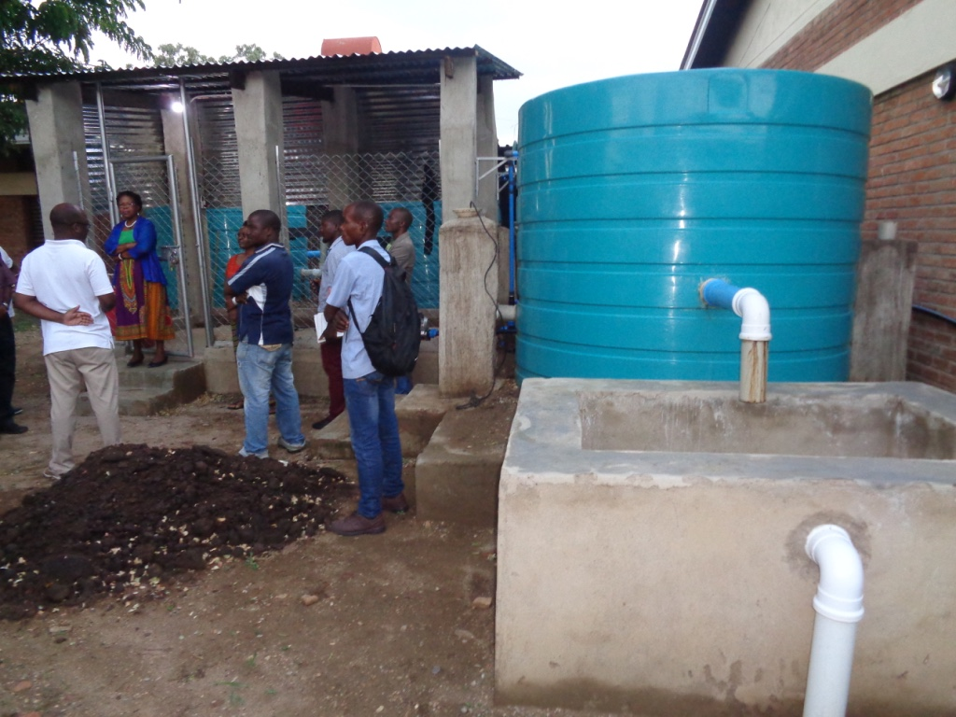

Insert pictures

1. **Honey Production**

Under the project, production of honey has proven to have high potential to replace charcoal production as an alternative income source. Beekeeping groups were mobilized to form Cooperative societies. A total of 3 Cooperatives were established in Machinga (Naminyanga in Mlomba, Ngusi in Chikweo and Nyambi in Nyambi). The total membership for the groups is 249 (187 female and 62 male). This has reduced the vulnerability of women to shocks as most of the groups are dominated by women. A total of (USD 34,482) 25 million Kwacha has been realized from the honey sales (10,000kgs) in Machinga with members having increased their resilience to shocks. In Mangochi beekeeping was introduced towards end of project and communities are yet to benefit but are optimistic because of what Machinga communities have achieved. The chairperson of Chipojola Bee keeping Cooperative narrated that he has been able to buy a motorbike from the sales of honey and other members were able to buy fertilizers, chickens for rearing and goats. The chairperson and some members of the group have attended look and learn visits to other honey production sites including attending a conference in the capital city Lilongwe to display and showcase their honey. In the chairperson words *“I have come to the meeting with that motorbike which I bought with funds from the sales of honey”.* There is tremendous evidence that honey sales have changed lives of Chipojola villagers. However, the communities bemoaned about limited linkages to markets and slow process to Malawi Bureau of Standards (MBS) certification. To ensure that bee keeping is a viable enterprise, there is need to consider issues of inputs against number of beneficiaries, certification of honey produced by the (MBS) and market linkages.

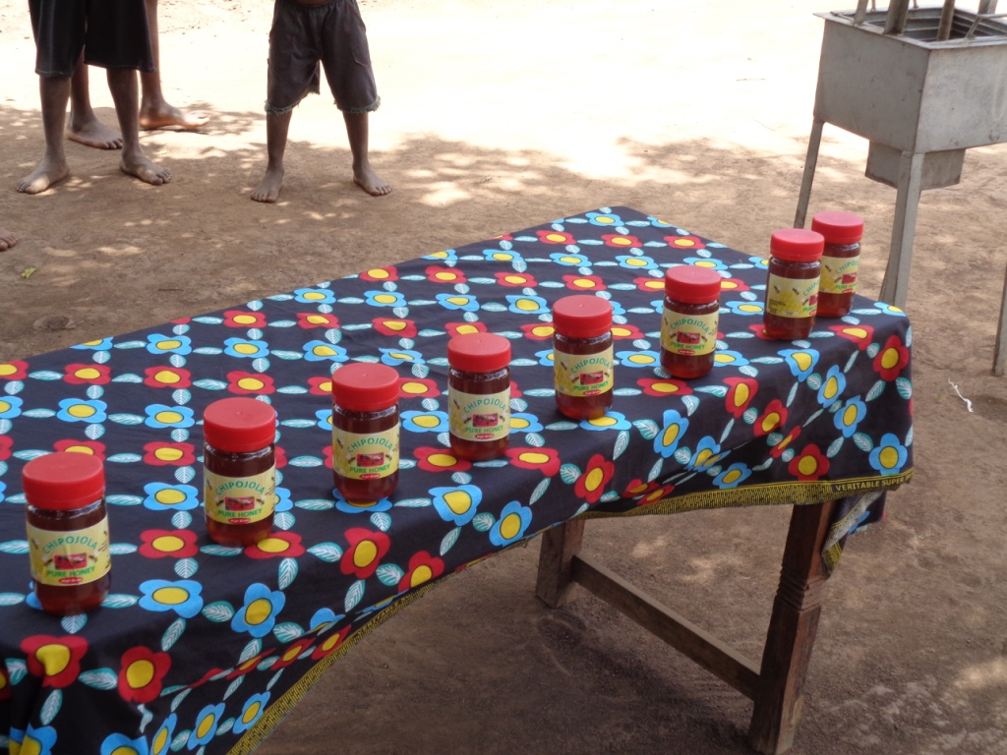

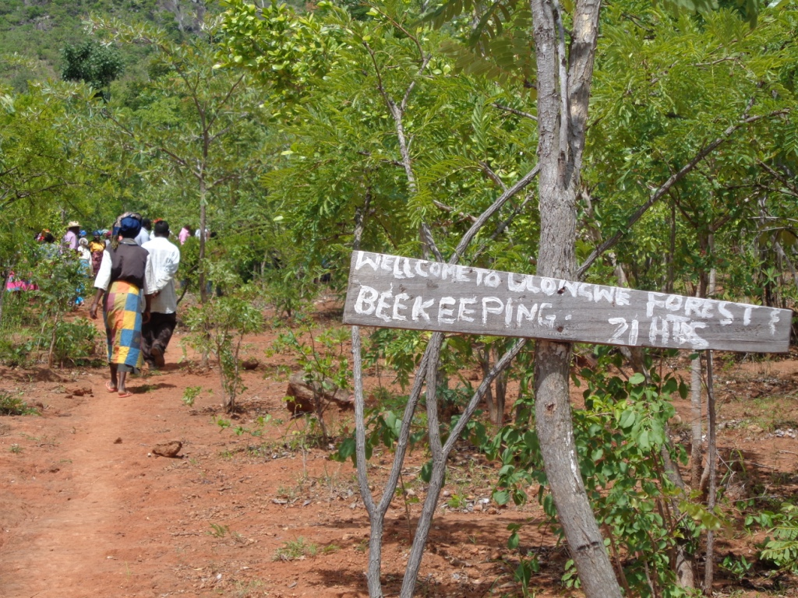

1. **Fish Farming Technologies**

Promotion of climate smart fish farming technologies have enhanced resilience of farmers against climate related shocks through increased food and nutrition security and income. 19 fish ponds have been constructed under CPP (7 in Mangochi and twelve in Machinga). In 2016, CPP reached out to the community at Mkawa Village after the villagers expressed the need through their VDC. The chairperson of the group Chimwemwe Nkosi, narrated that their interest came after listening from the radio about fish farming *“We heard of fish farming enterprise on the radio and realized that we had resources for the initiative, an ideal land that holds water and a river that never runs dry from where we could divert water. We thus thought of venturing into the business”*. Through the project, a Fish Farming Group was established. Through professional guidance from Fisheries Department, the members manually constructed a Climate Smart Fish Pond as one of the Best Practices promoted under the project. The pond was stocked with fingerings sourced from the National Aqua-Culture Center in Domasi. The committee was further assisted with initial fish feed sourced from MALDECO Fisheries.

The Committee at Mkawa was trained to locally produce fish feed using locally available materials. In addition, the group has been trained in Integrated Livestock-Fish Culture System. In terms of fish species, the chairperson informed the TE team that “There was only one type of fish, Makumba (Oreochromisshiranus), in the pond and that they chose it because it has high fertility rate and requires less feed unlike other fish species like Chambo (Tilapia) fish that survives well in sandy environment and mlamba (Clariasgariepinus) which needs more feed.” Fish farming is transforming lives of the group members by improving income security of the group members. Earnings realized from fish harvests are revolved into VSL where members borrow more and make it grow through interest attached to it. The evaluation team was informed by Mrs Nkosi that *“the first time the group harvested fish they realized approximately MK100, 000.00 and the second time they realized twice as much, the money realized had been invested in VSL where they (group-members and none-members) borrow money and repay a loan with an interest rate attached’*.

The fish Pond, plays a significant role to the Mkawa community for food and economic benefits. Besides, it has also solved the problem of scarcity of fish in the community which was putting the people at nutritional risk as fish is the cheapest source of protein. “We used to struggle to source fresh fish and mostly we could access spoilage fish, but with the availability of this pond, people are accessing fresh quality fish in the vicinity,” one member of the pond said.

The members are also investing the money grossed via VSL in diverse things like buying livestock and buying fertilizer to supplement organic manure for crop production.

One member said *“I invested the money by buying fertilizer and two goats that have reproduced such that I now have four in total”.* Another has also invested the money in livestock - bought a goat that bred 1 offspring such that he now has two goats. These goats are very important because they provide manure used as pond fertilizer thereby boosting the growth of planktons that the fish feed on.

The money is circulating within the community improving the economic status of the community members. This in turn is ensuring forest regeneration as they are not burning charcoal to source the income which was a common trend in the past. Through CPP, Mkawa village has excelled in alleviating economic hardships and responded well to the adverse impacts of climate change. Asked why the water in the pond was dark, Mrs Nkosi said *“this is to trick the animal that eats the fish in the pond, we drop animal dung so that algae grows and the dark green water you see is because of the algae but this protects the fish”.* In terms of fish feed the group members indicated that they produce own feed from soybeans which comes from own farming activities.

In Machinga a community group is also undertaking fish farming and employs the same management tactics as those of Mangochi Mkawa village. However, to scare predators of fish they have constructed a goat housing on the corner of the pond, so that the goat droppings act as feed but also promotes algae growth. The communities of Machinga have benefitted immensely from fish farming and are able to pay school fees, buy livestock among many benefits.



The Government of Malawi recognizes the significant impact climate change is posing to various sectors, including Fisheries. Aquaculture has especially been affected by reduced precipitation, flooding, increasing water temperatures among others. Department of Fisheries has reviewed the Fisheries and Aquaculture Policy to mainstream emerging issues that includes climate change. The production of Climate Smart Fish Farming Resource Book is a direct response to this policy direction.

The Climate Smart Fish Farming Resource Book presents a unique intervention for promoting climate smart fish farming in Malawi in general, but specifically in Machinga and Mangochi where it is being piloted.

1. **Irrigation Infrastructure**

Under the pilot project, dams have proven to be effective in regulating water flow which has resulted into reduced incidences of floods downstream and ensured water availability for multipurpose use. Nonetheless, it is important to thoroughly look into matters of land tenure, compensations and design issues during feasibility studies for large scale interventions such as construction of dams and irrigation schemes, the reason being that in the project impact area village heads had to give up land for community irrigation schemes. However, irrigation infrastructure has done wonders for farming communities in Mangochi and Machinga districts. CP introduced a most convenient and environment-friendly method of irrigation: solar pump irrigation, in Issa Mponda village having seen the commitment of the six pioneers of irrigation in the farming community that used fuel pump irrigation system. With the installation of the solar pump the number of farmers joining the Issa Mponda scheme kept increasing.

The community is fully owning and managing the pump and according to Ms. Gladys Muchiteni and Mr. Chawanda Ofesi Phiri, the pump has brought with it salvation to the people of Issa Mponda*.“Food security has now been restored in our village as we now grow crops three times a year instead of just once as is the case with rain-fed agriculture,” explains Muchiteni. She further added that, she has built a 2 bedrooms house in Mangochi town for rent to ensure reliable income source and has also just bought 10,000 bricks at K11.00 each with which she intend to build another house.” Phiri concurs with Muchiteni saying with the solar pump, they are now able to produce more than enough for consumption such that they are able to sell the surplus harvest and pay the school fees for their children.*

*“I have so far bought five goats but I am now remaining with 2 goats as I sold some during lean periods and other people have built good houses with the money we get from the sales of the surplus harvest,”* explains Phiri.

Mwasulama pointed out that the scheme is impacting on the lives of many people in the village. *“We had been dwelling in grass-thatched houses for a long time. I’m happy to say that we have now built a new house with iron sheets and we’re planning to decorate it after the next harvest.*”

The People from Issa Mponda Village, with the help of the district offices of lands, forestry and agriculture are doing all they can to save Mtemankhokwe River which is the water source for their irrigation. They are employing good agriculture practices and they are also planting trees along the river banks. From a village without hope back in 2005, Issa Mponda is now a village envied by surrounding villages and those who pass by.

1. **Forest Natural Regeneration**

More forests have been regenerated naturally with less effort and costs in management as compared to most means of tree propagation. This has accelerated increase in forest cover which has contributed positively towards rehabilitation of degraded forests in the project hotspot areas. Sustainable management of these resources is dependent on production of Participatory Forest Management Plans (PFMPs) and registration of Local Forest Organizations. These empower rural communities to effectively manage and take ownership of their forest resources. The project exceeded its target with a total area of 2,269.75 hectares of land under improved forest management. Cumulative Hectare (Ha) under planted trees stands at 391.44 and cumulative Ha under natural regeneration is at 577.87. 217km of river banks (54km for Mangochi and 163.9km for Machinga) have been planted with fast growing exotic trees, indigenous tree species and bamboos. Most of the rivers with their river banks protected are those where the project is extracting water for irrigation (e.g. Naminyanga, Mpira, Mtemankhokwe, Kabudira and Nansenga rivers).

Most of the trees planted along the rivers will show impact in the reduction in siltation in the long term. This is because most of the trees have not grown to the level that can significantly reduce siltation.

# 5.0 Conclusions, Lessons and Recommendations

## 5.1 Conclusions

The project intervention logic was sound with appropriate linkages among all the project variables (problem being addressed, project objectives and outcomes, as well as outputs and specific activities). A detailed situational analysis conducted prior to project design, the participatory methodologies as well as UNDP comparative advantages were the key factors behind the enhanced project concept and design

The implementation arrangement accorded government agencies an avenue to effectively participate in the project hence strengthening country ownership and likelihood of sustainability.

The project was well aligned with both the global and national policy frameworks thereby providing good platform to building synergies and partnership.

The project has fairly achieved its purpose. And even those outcome targets that have not been achieved are likely to be achieved beyond the project lifespan.

The project succeeded in mobilizing implementation resources with 92.5% of the budgeted financial resources has been realised at the time of this evaluation. There has been an elaborate financial system with adequate controls to avoid leakages. The results (Outcome and output) based budgeting and expenditure was key in keeping the project resources and activity implementation in satisfactory consistence hence promoting project efficiency. It was praiseworthy that only 4.7% of the project budget was spent on management.

Although there was a fairly good M&E framework, the inability of some indicators to be measured compromised objective progress assessment. Specification of the source of baseline data is critical for enable future verifications for purposes of progress tracking.

At implementation level, gender considerations was adequately incorporated in the project activities implementation. However, the lack of engendered indicators and targets constrains the assessment of the degree of success. Nevertheless, all project interventions have had significant impact on both women and men.

The project has meaningfully contributed to its objective as most of its outcome level targets have been achieved holistically or partially achieved.

The participatory approach that has underpinned project implementation is a strong pillar for sustainability as it usefully promotes ownership, contribution and capacity building. This implies that even the outcomes that may not be achieved within the project’s timeframe shall still be achieved with successful mainstreaming of the project in the national development agenda at different levels.

The project has been well aligned with the development aspirations of both the implementing agencies and beneficiary communities. This presents great potential for the sustainability of the benefits. Thus, the project was of great value to the ecosystems in the pilot districts and even beyond with its envisaged impacts transcending national and regional boundaries.

The project made considerable contribution towards gender equality especially through gender focussed trainings that were supported by the project. In effect, improvement in joint decision making at household level as well as joint ownership and control over resources between women and men had improved from 32.7% to 63.5% and 32% to 59% respectively over the project period.

Furthermore, women VSLA were supported and coupled with the investment in irrigation farming, household food production level has reportedly improved. It is apparent that CCP project has positively impacted women empowerment by strengthening their capacities to meet both their practical and strategic gender needs. However, for sustained results more engagements and advocacy for women empower remain necessary within the project target area and even beyond.

## 5.2 Lessons Learnt

1. Popular and effective participation of all stakeholders at various level is key to successful project implementation.
2. Mainstreaming of climate change resilience and adaptability may not be holistically achieved within a short time but the seeds sown live longer while generating the desired results. However, a conducive policy environment with continuous awareness creation about need for sustainable natural resources exploitation is necessary.
3. Working through partnerships with other government entities and harnessing local capacity is critical for project success as it stimulates ownership and facilitate resource mobilization as the case been under the co-funding arrangements of the project.
4. Achievement of sustainable results in climate change resilience and adaptation requires multiple approaches given the multi-dimensional nature of the threats. The project well analyzed the problem, which supported the design of a holistic and more appropriate approach to mainstreaming climate change.
5. A comprehensive exit strategy focused on institutional and financial mechanisms for sustainability is important right from the design stages of a project. This is because if the exit plan is developed at the design stage, it is well integrated in the general project implementation.
6. The use of risk register helps the project to keep afloat as it creates the potential of timely designing of mitigation measures.

## 5.3 Recommendations

* 1. Corrective actions for the design, implementation, monitoring and evaluation of the project

|  |  |  |
| --- | --- | --- |
| Recommendation | Basis | Responsible party |
| In future projects, the source of baseline values should be indicated to allow verification and realistic target setting. In the event that secondary data is insufficient to generate adequate baseline values, a baseline survey should be among the prioritized activities. | The baseline data on food security was remained higher despite the reported project contribution. This portrays the project as if it has had decimal impact. | UNDP and IPs. |
| At the design level, it is important to ensure that lower level results the project activities are derived from the output indicators and outputs from the outcome indicators while outcomes are derived from the objective/goal indicators. This is necessary to achieve enhanced internal consistence of the project. | There was noted inconsistence in the results framework with higher level results indicators not rhyming well with lower level interventions. | UNDP and IPs. |
| It is also important that both the mid-term and end-line targets be set to allow strategic focus on their achievement. This is because, the mid-term result targets for CPP were not set and this compromises objective mid-line performance measurement. | Mid-line performance targets were not set and this compromises objective progress assessment. | UNDP |
| Project benefits accruing to individuals should be engendered at both the indicator and target levels. For example, if it say training, the number of women and men to be targeted should be clearly indicated. | Much as the project paid attention to gender considerations, the lack of engendered indicators and targets compromised assessment of extent of success. | UNDP |
| Progress reporting should adhere to the units of measure used at baseline. | This is because in some indicators were formulated with percentage while tracking of progress is measured in absolute terms. | UNDP & IPs |

* 1. **Actions to follow up or reinforce initial benefits from the project**

|  |  |  |
| --- | --- | --- |
| Recommendations | Basis of recommendation | Responsible Party |
| It is therefore necessary to consider replication of the best practices beyond the pilot project area. Moreover, this was a pilot project. This is because Climate change resilience and adaptation requires continuous and systematic effort. | Whereas the project has made some impact, much is still desired especially beyond the geographical reach of the current project. | Gov’t of Malawi, UNDP & Local NGOs as well as CBOs |
| It is important that the un delivered outputs be incorporated in the successor projects in order to support the holistic achievement of the envisaged results. | The project had envisaged to construct 10 dams but instead was able to construct only one. | UNDP and Gov’t of Malawi |
| Integration of climate change in other district development plans should be facilitated. This can be achieved through sufficient capacity development using the CPP best practices. | This was a pilot project whose lessons and experiences was intended to guide continuous work towards effective adaptation. | Government of Malawi |
| The Government of Malawi with support from development partners should conduct a mult-sectoral capacity assessment for climate change resilience and adaptation to guide the formulation of a capacity development strategy. | Capacity development for CC adaptation and resilience is still projectised yet the need for national capacity development is apparent | Gov’t of Malawi & Development Partners. |
| Integration of Climate Change reliance and adaption into training curriculum of academic institutions. This is potentially important for scaling up adoption and replication of climate change adaptation and resilience strategies developed under this project. | This constitutes part of the project outputs that were not delivered yet important. It is education that bridges the gap between the present and future generations. | Gov’t of Malawi. |

* 1. **Proposals for future directions underlining main objectives**

|  |  |  |
| --- | --- | --- |
| Recommendation | Basis of the recommendation. | Responsible party |
| Support for enhanced climate change resilience and adaptation is still necessary. This calls for continuous support to the government of Malawi to scale up initiatives for climate change mainstreaming. Basket funding approach hinged of the national climate change adaptation work plan should be explored. | Explicit efforts towards climate change adaptation are based on projects. This inhibits uniformity of practices country-wide as these projects do not cover the entire country at one go. | Development Partners. |

# 6.0 Annexes

## Annex 1: Template for Reporting Progress towards outcome Results

| **Green: Holistically** Achieved | | | | **Yellow:** Partially achieved | | **Red:** Not achieved |
| --- | --- | --- | --- | --- | --- | --- |
| Extracted from project document (IP indicates if there have been approved changes) | | | | | | IP to fill out this column with text on achievement and colour code [TE will reassess colour code during review] | | | TE team | TE team fills out ... |
| Objective / Outcome | | Indicator | Baseline | Targets  End of Project | | Results at TE | | | Achievement Rating | Justification for Rating |
| Objective: Using ecological, physical and policy measures to reduce vulnerability to climate change driven droughts, floods and post-harvest grain losses for rural and urban communities of Machinga and Mangochi Districts of Malawi [reaching over 0.5 million people | | Improvement in food security for households participating | Over 60% of 91,670 households face food deficits – don’t produce enough to last till the next harvest | At least 50% decline in number of households facing annual food deficits (less than 30% still face food deficits) | | The project has exceeded expectation by directly improving food security status of 12,845 Households (H/Hs).This represents a total of 77% decline in number of households (less than 23% =16,500H/Hs that still faced food deficits at the beginning of the project). At present, 38,888 H/Hs under the project are pursuing diversified climate-resilient livelihood options. | | | 5/6 Satisfactory | 60% of 91,670 is 55,056. Since food security was improved in 12,845 of 55,056 that were food insecure prior to the project, the percentage decline is 23.3% |
| Percent change in soil erosion and siltation of water bodies | Soil erosion estimated at 20 tons/ha/year and 8 EPAs report “severe” rates of erosion | 40% reduction in soils going into the water bodies; 50% in EPAs reporting severe rates of erosion | | The Mid Term Review (MTR) recommended that this indicator should be revised to evaluate the "area of land under ground cover" rather than the "percentage of erosion" which is difficult to measure. The districts do not have the capacity to measure the reduction in siltation as it is only done by Department of Land Resource at national level.  The project exceeded its target with a total area of 2,269.75 hectares of land under improved forest management. Cumulative Hectare (Ha) under planted trees stands at 391.44 and cumulative Ha under natural regeneration is at 577.87. | | | 5/6 Satisfactory | Much as the indicator was not easy to measure and hence the MTR recommendation for its changing, the project implemented activities are able to support the realisation of the desired results. |
| Availability of skills and resources necessary to continue adaptation after conclusion of project (indicator for sustainability) | Average scores for communities and institutions on UNDP capacity scorecard is <20% and >40% respectively | UNDP capacity scorecard for communities and technical teams increase to 50% and 75% respectively | | A total of 15,875 people trained over the duration of the project to identify, prioritize, implement, monitor and evaluate adaptation strategies and measures. The achievement includes farmers ,District Environmental Sub Committee (DESC) ,District Civil Protection Committees (DCPCs), Village Natural Resource Management Committees (VNRMCs), Area Development Committees (ADCs), Lead Farmers (LFs), Beach Village Committees (BVCs) ,and Village Civil Protection Committees (VCPCs) trainings. | | | 5/6 Satisfactory | The conducted trainings have benefited various climate change resilience & adaptation structures at district and community level. This favours continuous propagation of knowledge. |
| Outcome 1: The impact of ecosystems degradation in aggravating vulnerability to climate change risks and reducing resilience of development gains understood and integrated into key decision-making processes at the local, sub-national and national levels | | Number of comprehensive community based adaptation plans integrating traditional and technical knowledge; | None | 6, one per hotspot | | In total, the project has completed 6 community adaptation action plans (one per hotspot) which went to inform the themes under the Community Resilient Adaptation Fund (CRAF) designed to support 6 Non-Governmental Organizations (NGOs) and 5 Community Based Organizations (CBOs) to implement a cost-sharing scheme to incentivise a widespread adoption of climate smart interventions. The Local NGOs and CBOs implemented some strategic evidence-based instruments. | | | 6/6  Highly satisfactory | The end-line target has holistically been achieved. |
| Community involvement in monitoring vulnerability | No formal systematic means of involving community in monitoring vulnerability | Set of indicators for monitoring community vulnerability agreed and being actively used | | The project revamped and strengthened 66 community structures, with 15 committee members each. These include the area development committees, the village development committees, local forestry organizations and the village action committees. These committees were trained in participatory project monitoring. The committees monitor progress of the project on monthly and quarterly basis and report to the full council at district level. | | | 5/6 Satisfactory | Community capacity has been strengthened in monitoring vulnerability. However, the lack of a quantitative indicator to benchmark progress constrained actual measurement of performance.  The project achieved 66.7% of the set target. |
| Quality knowledge products available, shared and being used | No publications on ecosystems, their values and contribution to reducing CC risks | At least 6 knowledge products acceptable for international publishing standards and information evidently being used in training, planning & implementation of project program | | Four knowledge products have been produced under the project (Climate Smart Fisheries Manual, Forestry Management Manual, Irrigation and Water Management Handbook, and an Enterprise Development Training Manual)  The project has also developed information products such as leaflets, documentaries and articles on climate change adaptation. So far six developed and some of the documentaries have been shared to media houses (print, radio and TV stations). | | | 5/6 Satisfactory |
| Outcome 2: Skills and operational capacity enhanced in the District, EPA and TA level technical officers to support implementation, maintenance and monitoring of the activities under component 1 and to mainstream climate risks into all local development process (skills, legislation, information) | | Extension packages for key sectors updated with climate risk management information | Current extension packages for key sectors do not contain climate risk management information | Extension packages for key sectors updated with climate change information and current CC management tools and techniques | | During the entire project implementation period a total of 4 key extension packages were updated. These include Forestry Management Handbook; Climate Smart Fisheries Handbook to incorporate climate risk management information, water management manual, and Enterprise Development training manual. In addition Project staff were also trained on the four manual | | | 6/6 Satisfactory | The project achieved 100% of the set target. |
| District level development plans and policies updated with climate risk management provisions. | Limited content, none fully updated with current CC management/risks issues | 4 District level programs, development plans and/or policies updated with climate risk management provisions | | Supported the development and updating of District Planning Instruments i.e. the district development plans (DDP) for the two target districts, the District State of the Environment Outlook Report (DESOER) for Machinga and District Socio-Economic Profile for Mangochi. The project input was to mainstream climate change in the planning frameworks and guides.  In Addition the project also supported development of National level strategy namely National environment and climate change and communication strategy. | | | 6/6 Highly Satisfactory | The project achieved 100% of the set targets. |
| Diploma in Forestry include current climate change content | Outdated curriculum at the College of Forestry, no students receiving training on updated curriculum | New curriculum for Diploma on forestry and 200 forestry diploma graduates (50:50 on gender) | | The project has supported 18 (12M, 6F) students under internship. These were graduate students from major universities and colleges in the country. Under internship programme. They were attached to Forestry, Agriculture, Land resource, Energy, Environment as well as finance and admiration.  This has helped the students to acquire knowledge and skills to build adaptive capacity of communities in climate change issues. | | | 2/6 Moderately unsatisfactory | The project has grossly underperformed on the set targets. Besides, the implemented activities were not aligned with the indicator. |
| Improvement in Capacity Index Score card | On average 50% of positions vacant across local to district levels in both districts; only 25% of current staff have some level of training on CC | Vacant positions less than 40%, 100% of staff in positions have training on CC | | 44(34M, 8F) DESC members, 24 (18M, 6F) Gender technical working group members and 90 (59M, 31F) frontline staff were trained in climate change related subjects. The trainings included Community Based Resilience Analysis (COBRA), gender mainstreaming and project sustainability | | | 5/6  Satisfactory | Much as the output delivery is substantial, the unit of measure (absolute figures) used in reporting is different from the unit of measure (%) used in the indicator. This compromises objective assessment of indicator performance  Capacity for climate change mainstreaming has been created. This may influence increased budgetary allocations for climate change resilience & adaptation. |
| % increase in development funds of the districts | Less than 2% of district funds being allocated to CC related initiatives | At least 3% | | The independent MTR recommended that this indicator be removed because it may not be achieved within the project period. However, project's support towards development of District Planning Frameworks helps ensure that investments in climate change related interventions are now more appealing. | | | 2/6 Moderately Unsatisfactory |
| Outcome 3: Public and domestic water harvesting, storage and distribution reduces climate change driven flooding and regulates availability of water throughout the year in flood & drought hotspots | | Number of physical infrastructures constructed to ensure sustainable water supplies and reduce disaster risks | About 2 mini dams, several check dams (to be confirmed during inception) | At least 10 mini dams and over 100 check dams, nullahs, and other structures | | For the entire project period:  1 mini dam constructed in Mangochi (Stambuli Dam),  2 weirs that collect water for irrigation ,  1800 check dams and swalleys, nullas and infiltration pits have been constructed.  19 fish ponds have been constructed (7 in Mangochi and twelve in Machinga, with two more fish ponds in progress in Machinga).    There has been an over achievement in construction of check dams and related structures because topography needed more structures also due to continued degradation in the hotspots .  Only one mini dam was constructed because the target was overambitious and costly. | | | 5/6 Satisfactory | It is only the dam construction indicator that has not been achieved. On other indicators, the project registered above 100% success. |
| Number of homes with water harvesting structures | Less than 10% of 91,760 households harvest water from rooftops | Over 35% of 91,760 households harvesting water from rooftops | | bout 0.25% of the targeted households have been reached with the technology  The project has covered 225 households who are benefiting from the above ground water tanks mounted to harvest rain water.  A total of 75 above ground water tanks have been mounted during the project implementation period  The mounted structures cover approximately .75 Ha of back yard gardens that planted with indigenous vegetables a few other exotic vegetables like lettuce and Chinese cabbage.  The backyard gardens have gone a long way enhancing food and nutrition security as well as offering alternative sources of revenue for the targeted communities. | | | 4/6 | Statistically, the indicator performance is way below the set target. However, best practices have been demonstrated and this favours replication. |
| Outcome 4: Rehabilitation of badly degraded forests, protection of riverbanks, lake shores and urban infrastructure | | Number of Village Forest Areas registered | 7 | 20 | | The project has registered 15 Local Forest Organizations (LFOs) so far nine (9) of them are registered in Machinga District and 6 for Mangochi. These are Lukongolo, Nkadyomboka, Ulongwe, Maisi, Mbalwe, Maonga, Nguse, Chipojola and Gracium in Machinga while in Mangochi Issa Mponda, Msauka, Simika, Mtanga, Chimatiro, Mkali, Nsinje, Tung’ande, Mkuchira, Mchesera, Maganga, Masakasa, Mwaye, Chasika, Makokola, Saidi Matola, Namakoma, Chilawi, Mbapi and Mkope have been established and trained. Out of these established and trained Village Natural Resource Management Committees (VNRMCs) only 20 are registered and the remaining 14 will be registered before the remaining period of project implementation. This means that once registered the project will exceed the target of 20 LFOs to be registered. The remaining LFOs will be registered this year (2019).  This has improved the governance aspect in the management of natural resources. | | | 5/6 Satisfactory | The project has achieved 75% of the set target but with potential to exceed the target once the pending organisations get registered. |
| Hectares of forests under improved management | 410 ha under community forest | At least 1,500 ha under community forest | | The project exceeded its target with a total area of 2,269.75 hectares of land under improved forest management.  Cumulative for Ha under planted trees stands at 391.44 and cumulative Ha under natural regeneration is at 577.87  217 Km/Ha under river line    489 Ha under Agro-forestry  203 Ha under swales. | | | 6/6 Highly Satisfactory | The project has exceeded its set target by 51.3% |
| Kilometers of river and lake shore under protection | 5km of lake shore and about 7km of river banks under protection | At least 100 km of lake shore and 100 km of river banks under protection from direct siltation. | | 217km of river banks (54km for Mangochi and 163.9km for Machinga) have been planted with fast growing exotic trees, indigenous tree species and bamboos in both districts. Most of the rivers with their river banks protected are those which the project is tapping water for irrigation such as Naminyanga, Mpira, Mtemankhokwe, Kabudira and Nansenga rivers; just to mention a few.  In conclusion the project has exceeded the set target of 100Km to be protected and this has led to reduced rate of siltation in the protected rivers.  The district however does not have the capacity to measure the reduction in siltation as it is only done by Department of Land Resource at national level.  Most of the trees planted along the rivers will also show impact in the reduction in siltation especially in long term. This is so because most of the trees have not grown to the level that can reduce siltation. | | | 6/6 Highly Satisfactory | The project exceeded its set target by 117%. |
| Number of households using alternate and improved energy | Less than 5% of 91,760 households currently use any form of energy efficient technologies | At least 35% of 91,760 households adopt high energy efficient technologies and methods | | The project has directly reached to 14,938H/Hs out of the total target of 32,116 H/Hs (35% of 91,760) representing 46.5 % who have been directly supported with anticipated ripple effect spanning out over 90% of total target who are adopting use of energy efficient technologies that include;  -Energy efficient stoves and production of briquettes (10,598).  The project has also reached 128 HH (79 female and 49) in Mangochi while 124HH (72 female and 52 male through solar powered irrigation schemes against the use of diesel powered water pumps.  5 VNRMCs are producing energy cooking stoves and membership stands at 92 (71 Females and 21 Males) in Mangochi while in Machinga a total of 6 groups were formed with membership of 186 (157 females and 29 Males)  - use of solar energy for lighting (4088). This has been demonstrated in public institutions namely Malundani Community Day Secondary School (CDSS), Chikweo CDSS, Chikweo Primary School and Malundani primary school in Machinga. Apart from the fact that it has demonstrated the use of alternative clean energy, this will go a long way in improving the pass rate of learners in schools as they will study during the night. This will increase literacy levels in the two districts of Mangochi and Machinga.  -demonstration of biogas in public institutions such as prisons and hospitals eg, 300 inmates at Mangochi prison are being supported by the biogas digester in their daily cooking, while installation of a biogas digester at Machinga District Hospital is under way and is expected to support over 350 in patients. | | | 6/6 Highly Satisfactory | Project has exceeded its target by 11.5% |
| Outcome 5: Productivity of agriculture supported by adoption of climate smart systems and measures | | No. of hectares on which climate smart farming is practiced | In Mangochi 144.6 ha under agroforestry; only 529 farmers adopting climate smart measures – making 0.13% of population.  In Machinga 161.5 ha under conservation Agriculture and 1,544 smallholder farmers participating | Over 40% of 91,670 households engaging in some form of climate smart farming system or practices; area under agroforestry in particular increase to over 5,000 ha; area under CA increase to more than 5,000ha | | To date the project has reached out to a total of 38,808 H/H out of the total target of 36,668H/H representing 106% direct achievement. This is as a result of demonstrations and capacity building initiatives in Climate Smart Agriculture (CSA) principles promoted by the project.  With a ripple effect set at 40%, the total number of HH adopting Climate Smart Farming practices is expected to increase even further.  With the additional 1246Ha, the total area under CSA in the impact sites to date is 7935Ha (4858Ha in Mangochi and 3077Ha in Machinga).  7935Ha is a consolidated figure for all CSA technologies which include Conservation Agriculture, Agroforestry, pit planting, making of swales, use of early maturing and high yielding varieties and drought tolerant crop varieties. | | | 6/6 Highly Satisfactory | The project exceeded its target. Besides, the interventions have significant ripple effects through replication.  Although the project performance is seemingly below the baseline values, there is evidence of improved yields compared to the previous season. |
| Percentage increase in productivity per acre or per unit of land | Baselines for all crops in figure 7: Machinga - maize – 1.9tons/h, sorgum – 95 tons/ha, soyabeans 63tons/ha  in Machinga  Mangochi – maize – 1.55, sorgum 66, soyabean 59tons/ha | Over 40% increase over baseline yields for key crops | | There is a significant increase in yield of maize, sorghum and soy bean both districts compared to last year. The 2018/19 3rd round production report for Machinga indicates a13% increase (909kgs/ha to 1030kgs/ha) while Mangochi registered a 22% increase (759kgs/ha to 1030kgs/ha).  Increase in yield has also been registered for Rice over last year with 32% (900kgs/ha to 1188kgs/ha) in Machinga and 29% (490kgs/ha to 633kgs/ha) in Mangochi.  Cowpeas has increased in yield over last year, Machinga has increased with 13% (386kgs/ha to 435kgs/ha) while Mangochi has increased by 14 %( 381kgs/ha to 435kgs/ha).  For Cassava there is an increase of 6% and 5% in yield thus from 14433kgs/ha to 15322kgs/ha and from 15610kgs/ha to 16452kgs/ha in Machinga and Mangochi respectively.  For sorghum, there an 8% and 15% increase in yield for Machinga and Mangochi respectively.  Soybean has also increased in yield over last year. Machinga has increased with 10% while Mangochi registered 9% increase.  This overall increase in yield over last year can be attributed to favorable weather and availability of seeds. In the project hotspots however where yields are relatively higher with 20% it is attributed to the project interventions through climate smart agriculture practices  NB: If compared to the figures cited on the baseline, to date figures are lower. This is because the figures in the base year are so exorbitant (even beyond those stipulated as potential yield in the Guide to Agricultural Production) such that the project implementers question their source as such it is hard to use them as benchmarks. | | | 5/6 Satisfactory |
| Area under climate smart small holder irrigation | Currently less than 100 hectares despite potential | At least 1000 hectares under climate smart small holder irrigation | | An additional 2Ha land has been developed as a permanent scheme in Mangochi. This has resulted to a cumulative 182Ha land to be under Climate Smart Smallholder Irrigation.  Of this area, 103 Ha is under Solar and gravity fed system which is permanent while 79Ha is under treadle pumps which the project supplied in the impact sites.  These 182Ha are covered in a total of 11 schemes that have been developed and rehabilitated.  It has to be noted that there was no additional development of new area under irrigation in this final year due to funding limitations rather there was just completion of works that had already started.  There is however potential and will for scaling out and rolling out of solar powered irrigation system in the whole district given financial support. This is it was identified as one of the best practices of the project during the Project sustainability survey. | | | 6/6 Highly  Satisfactory | A total of 7935Ha are under climate smart agriculture in both Mangochi and Machinga putting project performance under this indicator at 158.7% |
| Water use efficiency in small holder irrigation | On average water use efficiency lower than 25% | On average water use efficiency increase to >50% in small holder irrigation | | To date, water use efficiency/irrigation efficiency has increased to about 50% in all irrigation schemes. This is because the project continued facilitating and advocating for the formation of Water Users Groups (WUG) in all irrigation schemes which have helped to improve water scheduling, distribution and management and also the maintenance of canals and conveyance pipes and weirs. These structures helped reduce seepage  Though a proper assessment has not been done on water use efficiency, the technologies promoted by the project have proved to be best practices towards improving water use efficiency.  To achieve high scores on water use efficiency however, drip irrigation would be an ideal pathway but was not done due to financial limitations. | | | 5/6 Satisfactory | Water use efficiency estimated at 50% due to the effectiveness of the project supported technologies. |
| % reduction in post-harvest losses for those engaging | On average approximately 35% of grains, fruits, vegetables, fish are currently being lost to poor post-harvest practices | Less than 10% post-harvest loss of grains, fruits, vegetables, fish being lost to poor post-harvest practices | | Estimated to have reduced to between 25-30% largely due to the project supported post-harvest handling technologies. | | | 4/6 Moderately satisfactory | The promoted post-harvest handling technology is able to facilitate the achievement of more results through scalability and replication. |

## Annex 2Terminal Evaluation Terms of Reference

INTRODUCTION

The Global Environment Fund-financed project on Climate Proofing Local Development Gains in Rural and Urban Areas of Machinga and Mangochi Districts in Malawi was designed to reduce vulnerability to climate change driven droughts, floods and post-harvest grain losses for rural and urban communities in targeted areas. The project aimed to secure development and food security gains by empowering communities to integrate climate risk considerations in development policies, plans, projects and actions by providing knowledge, tools, capacities and methodologies for the adoption of an ecosystems and community-based approach to climate change adaptation, targeting over 458,371 people in 91,674 households. The 5-year project started in July 2014 and ends in June 2019.

In accordance with UNDP and GEF M&E policies and procedures, all full and medium-sized UNDP support GEF financed projects are required to undergo a terminal evaluation upon completion of implementation. These terms of reference (TOR) sets out the expectations for a Terminal Evaluation (TE) of the *Climate Proofing Local Development Gains in Rural and Urban Areas of Machinga and Mangochi Districts* (PIMS #4508).

The project is implemented by the Government of Malawi, through the Ministry of Natural Resources Energy and Mining with support from Global Environment Facility (GEF) and United Nations Development Programme (UNDP). The project started July 2014 and is in its final year of implementation.

The essentials of the project to be evaluated are as follows:

Project Summary Table

|  |  |  |  |  |  |  |
| --- | --- | --- | --- | --- | --- | --- |
| Project Title: |  | | | | | |
| GEF Project ID: | | PIMS#4508 |  | *at endorsement (Million US$)* | | *at completion (Million US$)* |
| UNDP Project ID: | | 00090060 | GEF financing: | $5,318,200 | | $5,318,200 |
| Country: | | Malawi | IA/EA own: |  | |  |
| Region: | | Africa | Government: | $34,000,000 in kind | | $34,000,000 in kind |
| Focal Area: | | Climate Change | Other: | UNDP $2,000,000 | | UNDP $2,300,000 |
| FA Objectives, (OP/SP): | | •Objective CCA-1: Reduce vulnerability to the adverse impacts of climate change, including variability, at local, national, regional and global level  •Objective CCA-2 - Increasing Adaptive capacity to respond to the impacts of climate change, including variability, at local, national, regional and global level  •Objective CCA -3 - Adaptation Technology Transfer: Promote transfer and adoption of adaptation technology | Total co-financing: | $41,318,200 | | $41,618,200 |
| Executing Agency: | | UNDP/Ministry of Natural Resources, Energy and Environment | Total Project Cost: | $41,318,200 | | $41,618,200 |
| Other Partners involved: | | MOEPD, MOAFS, MOLHUD, MOLGRD, DICE, LUANAR, University of Malawi, Mangochi and Machinga District Councils. | ProDoc Signature(date project start): | | | July 2014 |
| (Operational) Closing Date: | | Proposed:  March 2020 | Actual:  June 2019 |

Objective and Scope

The project was designed to:

Secure the development and food security gains from the baseline programs by empowering communities to integrate climate risk considerations in the development policies, plans, projects and actions. The project’s outcomes are as follows:

i. Outcome 1: The impact of ecosystems degradation in aggravating vulnerability to climate change risks and reducing resilience of development gains understood and integrated into key decision-making processes at the local, sub-national and national levels.

ii. Outcome 2: Skills and operational capacity of District, EPA and TA level technical officers to support implementation, maintenance and monitoring of the activities under component 1 and to mainstream climate risks into all local development process (skills, legislation, information)

iii. Outcome 3: Public and domestic water harvesting, storage and distribution reduces climate change driven flooding and regulates availability of water throughout the year in flood & drought hotspots

iv. Outcome 4: Rehabilitation of badly degraded forests, protection of riverbanks, lake shores and urban infrastructure

v. Outcome 5: Productivity of agriculture supported by adoption of climate smart agriculture practices

The Scope of the Terminal Evaluation:

The TE will be conducted according to the guidance, rules and procedures established by UNDP and GEF as reflected in the UNDP Evaluation Guidance for GEF Financed Projects.

The objectives of the evaluation are to assess the achievement of project results, and to draw lessons that can both improve the sustainability of benefits from this project, and aid in the overall enhancement of UNDP programming.

Evaluation approach and method

An overall approach and method[39] for conducting project terminal evaluations of UNDP supported GEF financed projects has developed over time. The evaluator is expected to frame the evaluation effort using the criteria of **relevance, effectiveness, efficiency, sustainability, and impact,** as defined and explained in the UNDP Guidance for Conducting Terminal Evaluations of UNDP-supported, GEF-financed Projects. A set of questions covering each of these criteria have been drafted and are included with this TOR (*Annex C*) The evaluator is expected to amend, complete and submit this matrix as part of an evaluation inception report, and shall include it as an annex to the final report.

The evaluation must provide evidence‐based information that is credible, reliable and useful. The evaluator is expected to follow a participatory and consultative approach ensuring close engagement with government counterparts, in particular the GEF operational focal point, UNDP Country Office, project team, UNDP GEF Technical Adviser based in the region and key stakeholders. The evaluator is expected to conduct a field mission to Mangochi and Machinga district councils, including the project 6 hotspot sites in the 2 districts. Interviews will be held with stakeholders including organizations and individuals.

The evaluator will review all relevant sources of information, such as the project document, project reports – including Annual APR/PIR, Community Based Adaptation (CBA) interventions reports, project budget revisions, midterm review, quarterly progress reports, GEF focal area tracking tools, project files, national strategic and legal documents, technical studies and any other materials that the evaluator considers useful for this evidence-based assessment. A list of documents that the project team will provide to the evaluator for review is included in Annex B of this Terms of Reference.

Evaluation Criteria & Ratings

An assessment of project performance will be carried out, based against expectations set out in the Project Logical Framework/Results Framework (see  Annex A), which provides performance and impact indicators for project implementation along with their corresponding means of verification. The evaluation will at a minimum cover the criteria of: **relevance, effectiveness, efficiency, sustainability and impact.** Ratings must be provided on the following performance criteria. The completed table must be included in the evaluation executive summary. The obligatory rating scales are included in  Annex D.

|  |  |  |  |
| --- | --- | --- | --- |
| **Evaluation Ratings:** | | | |
| **1. Monitoring and Evaluation** | ***rating*** | **2. IA& EA Execution** | ***rating*** |
| M&E design at entry |  | Quality of UNDP Implementation |  |
| M&E Plan Implementation |  | Quality of Execution - Executing Agency |  |
| Overall quality of M&E |  | Overall quality of Implementation / Execution |  |
| **3. Assessment of Outcomes** | **rating** | **4. Sustainability** | **rating** |
| Relevance |  | Financial resources: |  |
| Effectiveness |  | Socio-political: |  |
| Efficiency |  | Institutional framework and governance: |  |
| Overall Project Outcome Rating |  | Environmental : |  |
|  |  | Overall likelihood of sustainability: |  |

Project finance / cofinance

The Evaluation will assess the key financial aspects of the project, including the extent of co-financing planned and realized. Project cost and funding data will be required, including annual expenditures. Variances between planned and actual expenditures will need to be assessed and explained. Results from recent financial audits, as available, should be taken into consideration. The evaluator(s) will receive assistance from the Country Office (CO) and Project Team to obtain financial data in order to complete the co-financing table below, which will be included in the terminal evaluation report.

|  |  |  |  |  |  |  |  |  |
| --- | --- | --- | --- | --- | --- | --- | --- | --- |
| Co-financing  (type/source) | UNDP own financing (mill. US$) | | Government  (mill. US$) | | Partner Agency  (mill. US$) | | Total  (mill. US$) | |
| Planned | Actual | Planned | Actual | Planned | Actual | Actual | Actual |
| Grants |  |  |  |  |  |  |  |  |
| Loans/Concessions |  |  |  |  |  |  |  |  |
| In-kind support |  |  |  |  |  |  |  |  |
| * Other |  |  |  |  |  |  |  |  |
| Totals |  |  |  |  |  |  |  |  |

Mainstreaming

UNDP supported GEF financed projects are key components in UNDP country programming, as well as regional and global programmes. The evaluation will assess the extent to which the project was successfully mainstreamed with other UNDP priorities, including poverty alleviation, improved governance, the prevention and recovery from natural disasters, and gender. In addition, the evaluation will be included in the country office evaluation plan.

Impact

The evaluators will assess the extent to which the project is achieving impacts or progressing towards the achievement of impacts. Key findings that should be brought out in the evaluations include whether the project has demonstrated: a) verifiable improvements in ecological status, b) verifiable reductions in stress on ecological systems, and/or c) demonstrated progress towards these impact achievements.[40]

Conclusions, recommendations & lessons

The evaluation report must include a chapter providing a set of **conclusions**, **recommendations** and **lessons**.

Implementation arrangements

The principal responsibility for managing this evaluation resides with the UNDP CO in Malawi. The UNDP CO will contract the evaluators -International Consultant and ensure the timely provision of per diems and travel arrangements within the country for the evaluator. The Project Team will be responsible for liaising with the evaluator to set up stakeholder interviews, arrange field visits, coordinate with the Government etc.

Evaluation timeframe

The total duration of the assignment for International Consultant will be 16 days according to the following plan:

|  |  |  |
| --- | --- | --- |
| **Activity** | Timing | Completion Date |
| **Starting Date** |  | 2nd September 2019 |
| **Preparation** | 2 days | 6th September 2019 |
| **Evaluation Mission** | 10 days | 20th September 2019 |
| **Draft Evaluation Report** | 2 days | 4th October 2019 |
| **Final Report** | 2 days | 11th October 2019 |

Evaluation deliverables

The International Consultant is expected to deliver the following:

|  |  |  |  |
| --- | --- | --- | --- |
| Deliverable | Content | Timing | Responsibilities |
| **Inception Report** | International Consultant provides clarifications on timing and method, consolidates and finalizes | No later than 2 weeks before the evaluation mission. | International Consultant submits Inception Report to UNDP CO |
| **Presentation** | Initial Findings from the field evaluation mission | End of evaluation mission | International Consultant submits to project management, UNDP CO |
| **Draft Final Report** | Consolidates and finalizes Draft Final Report in full report (per annexed template) with annexes | Within 3 weeks of the evaluation mission | International Consultant sends to CO, reviewed by RTA, PCU, GEF OFPs |
| **Final Report\*** | Consolidation and finalization of revised report | Within 1 week of receiving UNDP comments on draft | International Consultant sends to CO for uploading to UNDP ERC. |

*When submitting the final evaluation report, the evaluator is required also to provide an 'audit trail', detailing how all received comments have (and have not) been addressed in the final evaluation report.

## Annex 3: Evaluation Matrix

| **Evaluative Criteria Questions** | | **Indicators** | **Sources** | **Methodology** |
| --- | --- | --- | --- | --- |
| Relevance: How does the project relate to the main objectives of the GEF focal area, and to the environment and development priorities at the local, regional and national levels? | | | | |
|  | * In which areas are project objectives consistent with the main objectives of the GEF focal area as well as the district, national and regional development priorities? | * Specific reference made to the GEF focal areas objectives. * Degree of alignment between the project interventions & results with the regional, national & district priorities. * Specific strategies employed to achieve project’s external consistence. | * GEF strategic plan * National development documents (NDP, Vision 2020, National Climate Change Policy, 2012, Malawi’s Growth and Development Strategy II * District development plans * Project document * Key informants | * Desk review * Key informant interviews * Group discussions. |
|  | * What has been/is the effect of the project’s degree of external consistence on its implementation & sustainability | * Specific ways in which project alignment with global, regional, national & district priorities has facilitated and/or inhibited its success | * Project performance reports such as PIR & MTR * Key informants | * Desk review * Key informant interviews * Group discussions. |
|  | * What lessons can be drawn from the project experience as regards relevance enhancement? | * What has/not worked well in promoting project external consistence | * Project Implementation reports * Key informants | * Desk review * Key informant interviews * Group discussions. |
| Effectiveness: To what extent have the expected outcomes and objectives of the project been achieved? | | | | |
|  | * What specific changes have taken place in the outcome indicators recorded at baseline?. | * The difference between the current and the baseline outcome indicator values * Extent of project attribution. | * Project results framework * Project reports * Key informants | * Desk review * Key informant interviews * Group discussions. |
|  | * To what extent have the project’s outcome targets been achieved? | * Intended results achieved * Unintended results achieved * Potential of the outcome results in supporting the achievement of the goal. | * Project results framework * Project reports * Key informants | * Desk review * Key informant interviews * Group discussions. |
|  | * What factors have facilitated and/or inhibited the extent of project success? | * Facilitators & barriers to project success * Key lessons learnt | * Project results framework * Project reports * Key informants | * Desk review * Key informant interviews * Group discussions. |
| Efficiency: Was the project implemented efficiently, in-line with international and national norms and standards? | | | | |
|  | * To what extent did the project implementation adhere to the international & national standards | * Level of adherence to financial management policies & manuals of UNDP, GEF & IPs * Facilitators & inhibitors to good adherence to the norms & standards * Effect of the observed level of adherence on the overall project implementation. * Best practices & Key lessons to learn | * Key policies & management manual relevant to the project * PIR * Key informants | * Desk review * Key informant interviews * Group discussions. |
|  | * How economical has the project utilized the available resources (equipment, financial & human resources) | * Specific evidence for economical use of resources * Effect on overall project success * Best practices & Key lessons to learn | * PIR * Project financial reports (audits etc) * Key informants | * Desk review * Key informant interviews * Group discussions. |
|  | * To what extent was the project implemented within the constraints of time and budget? | * Percentage of project activity implementation * Ability of the project to realize its budget * Degree of variation between the project budget and expenditure. | * PIR * Project financial reports (audits etc) * Key informants | * Desk review * Key informant interviews * Group discussions. |
| Sustainability: To what extent are there financial, institutional, social-economic, and/or environmental risks to sustaining long-term project results? | | | | |
|  | * What specific opportunities and threats underlie the sustainability of the project? | * Policy, institutional & regulatory framework that favour project sustainability * Potential threats to enhanced sustainability * Political will to uphold project results * Available capacity to sustain the results | * Sustainability plan/ exit strategy * Key policies & regulations * Institutional framework * Key informants | * Desk review * Key informant interviews * Group discussions. |
|  | * How best can the sustainability of the project be ensured | * Action plans for enhanced project sustainability | * Other successful projects with relatively similar implementation context * Key informants | * Benchmarking through desk review * Key informant interviews * Group discussions. |
| **Impact: Are there indications that the project has contributed to, or enabled progress toward, reduced environmental stress and/or improved ecological status?** | | | | |
|  | * What specific contribution has the project made towards improving the ecological status? | * Changes in the baseline indicators * Project attribution | * Project document * Project reports (PIR) * Other relevant study reports * Key informants | * Desk review * Key informant interviews * Group discussions. |
|  | * What areas require more support in order to achieve the desired ecological status? | * What remains un done * Existing threats to eco-system * Other national environmental priorities in need of further support | * Environment related reports * National development documents * Vulnerability assessment reports * Key informants. | * Desk review * Key informant interviews * Group discussions. |

## Annex 4: Data collection tools

**UNDP MALAWI COUNTRY OFFICE**

**CLIMATE PROOFING LOCAL DEVELOPMENT GAINS IN RURAL AND URBAN AREAS OF MACHINGA AND MANGOCHI DISTRICTS - MALAWI**

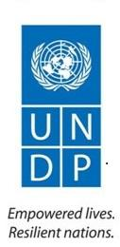

**Project Implementation Unit**

Project Name:………………………………………………………………………

Stakeholder Category…………………………………………………………………

Name of Institution…………………………………………………………………

Position of the respondent in the Institution……………………………………………

Institution’s general Mandate……………………………………………………………

Specific role/benefit of the institution in/from the project…………………………

Interview Date…………………………………………….

Interview start time ………………………End Time…………………………………

Interview No …………………………………….

Interview conducted at ………………………………………………………………

Respondent’s Contact info: email…………………………………Tel: ………………

Interview Conducted By:………………………………………………………

**Introduction**

* Self-introduction
* Background of the project being evaluation
* Purpose of engagement/interview and how long it is expected to last
* How the respondent was select
* Obtain consent

**Project Strategy: Project design**

* Problem identification and analysis processes undertaken to inform project design
* Appropriateness of the project interventions in addressing the identified problem
* Weakness and gaps of the project interventions in addressing the identified problem
* The relevance of the project assumptions
* Effects of incorrect assumptions on the appropriateness of the project interventions
* Specific lessons from relevant projects that were incorporated during the design and implementation of the project
* Degree of alignment between the project and country priorities
* Strategies employed to achieve enhanced alignment between the project and country priorities
* Degree of inclusiveness in the project decision making; Stakeholders included/excluded in decision making processes
* Employed strategies to promote inclusiveness in project decision making
* Specific gender concerns being addressed by the project
* Personal comment on the extent of gender mainstreaming in the project
* Specific improvements required in the project design and implementation arrangements

**Results Framework/Logframe**

* Comment on the SMARTness of the project indicators & targets both at mid and endline.
* Challenges encountered in indicator measurement
* Specific modification(s) required in the project objectives, outcomes or components if any
* Comment on the extent to which progress so far has led to, or could in the future catalyse beneficial development effects (i.e. income generation, gender equality and women’s empowerment, improved governance etc...)
* Necessary modifications in the Results framework to incorporate the development effects of the project above.

**Progress Towards Results**

* Intended results achieved so far
* Possible Unintended results so far/envisaged
* Recommended strategies to curb the negative unintended results
* Variation between the midline targets and actual results to date
* Facilitators and inhibitors for performance.

**Project Implementation and Adaptive Management**

* Overall effectiveness of project management as outlined in the Project Document.
* Changes made in the project management arrangements in the course of project implementation
* Gaps in the project management in respect to;

1. Clarity of the responsibilities
2. Reporting
3. Transparent decision making

* Recommended improvements in project management arrangements
* Institutional/capacity Strengths, weaknesses and gaps of implementing partners and its influence of the quality of project execution.
* Suggested recommendations for institutional/capacity strengthening
* Strengths, weaknesses and gaps in the support provided by the GEF Partner Agency (UNDP)
* Areas for improvement in the support provided by the GEF Partner Agency (UNDP)
* Causes of delays (if any) in the project start-up and implementation
* Recommended redress measures
* Mainstreaming of RBM in the work planning; Successes, gaps and recommendations
* Evidence for the use of the result framework as a management tool
* Changes made in the results framework since inception; causes and effects
* More changes required in the results framework (if any)

**Finance and co-finance:**

* Project financial management arrangements
* Comment on the cost effectiveness of the project interventions
* Appropriateness and relevance of the changes effected in fund allocations
* Achievements, opportunities and challenges of the co-financing arrangements
* Suggested recommendations for improvement

**Project-level Monitoring and Evaluation Systems:**

* Comprehensiveness of the monitoring tools being used
* Gaps and weaknesses in the monitoring tools being used.
* Proportion of the budget allocated to monitoring
* Financial related challenges facing the Monitoring Unit & their effect on the execution of the M&E function.
* Basis of monitoring & Evaluation budget

**Stakeholder Engagement:**

* Stakeholder engagement strategies
* Specific gains emanating from stakeholder engagements
* Barriers and/or facilitators for effective stakeholder engagements and involvement
* Specific role being played by government stakeholders in project implementation & management
* Strategies employed to promote participation and country-driven processes.
* Facilitators/inhibitors for enhanced participation of gov’t stakeholders.

**Reporting**

* Processes for reporting and sharing changes in project management
* Level of inclusiveness and transparency of such processes
* Specific GEF reporting requirements to be complied with
* Level of compliance with the requirements
* Facilitators and inhibitors for reporting compliance
* Mechanisms for integrating lessons learnt in the management framework of the project
* Facilitators/barriers to effective integration of lessons learnt

**Communications:**

* Frequency and communication mode with both internal and external stakeholders
* Effect of the communication strategy on the overall project success
* Barriers to effective communication with stakeholders

**Sustainability**

* Risk analysis methodology that was applied
* The basis of the risk rating
* Stakeholder perceptions on the identified risks
* Possible effect of the risks on the project in the event of their occurrence
* Potential sources of resources to sustain the project beyond GEF funding
* Ability and willingness of different stakeholders to mobilize/contribute financial resources for the sustenance of the project beyond GEF funding
* Opportunities and challenges to financial sustainability of the project beyond GEF funding
* Level of stakeholder ownership of the project
* Stakeholder willingness to contribute resources towards sustenance of the project
* Extent of stakeholder participation in the project implementation
* Strategies employed to promote stakeholder ownership of the project
* Favourable/unfavourable laws, policies and governance structures for enhanced sustenance of the project.
* Accountability, transparency and technical knowledge transfer requirements
* Availability of the above requirements
* Environment concerns underlying project design and implementation
* Perceptions of key stakeholders on the effects of the project on the environment

**UNDP MALAWI COUNTRY OFFICE**

**CLIMATE PROOFING LOCAL DEVELOPMENT GAINS IN RURAL AND URBAN AREAS OF MACHINGA AND MANGOCHI DISTRICTS - MALAWI**



**Implementing Partners (National Level)**

Project Name:………………………………………………………………………

Stakeholder Category…………………………………………………………………

Name of Institution…………………………………………………………………

Position of the respondent in the Institution……………………………………………

Institution’s general Mandate……………………………………………………………

Specific role/benefit of the institution in/from the project…………………………

Interview Date…………………………………………….

Interview start time ………………………End Time…………………………………

Interview No …………………………………….

Interview conducted at ………………………………………………………………

Respondent’s Contact info: email…………………………………Tel: ………………

Interview Conducted By:………………………………………………………

**Introduction**

* Self-introduction
* Background of the project being evaluation
* Purpose of engagement/interview and how long it is expected to last
* How the respondent was select
* Obtain consent

**Project Strategy: Project design**

* Appropriateness of the project in addressing the identified problem
* Key weakness and gaps of the project interventions in addressing the identified problem
* Relevance of the project interventions to the country priorities?
* Inclusiveness of the decision making processes
* Integration of gender in project design and implementation
* Specific improvements required in the project design and implementation arrangements

**Progress Towards Results**

* Project results achieved
* Possibility of the project achieving full results at full time
* Factors affecting the achievement of results
* Action plans for enhanced results.

**Project Implementation and Adaptive Management**

* Challenges in the overall project management arrangements and how have they affected the results?
* Institutional Capacity gaps that have affected or likely to affect project performance at various levels of implementation
* Institutional capacity strengthening proposals
* Required improvements in project management arrangements for the success of the project

**Sustainability**

* Sustainability potential of the project
* Opportunities and threats to project sustainability
* Proposals for enhanced sustainability.

**Thank you for cooperation**

**UNDP MALAWI COUNTRY OFFICE**

**CLIMATE PROOFING LOCAL DEVELOPMENT GAINS IN RURAL AND URBAN AREAS OF MACHINGA AND MANGOCHI DISTRICTS - MALAWI**



**Implementing Partners at districts**

Project Name:………………………………………………………………………

Stakeholder Category…………………………………………………………………

Name of Institution…………………………………………………………………

Position of the respondent in the Institution……………………………………………

Institution’s general Mandate……………………………………………………………

Specific role/benefit of the institution in/from the project…………………………

Respondent’s Contact info: email…………………………………………………Tel: …………………………………

Interview Conducted By:…………………………………………………………

**Introduction**

* Self-introduction
* Background of the project being evaluation
* Purpose of engagement/interview and how long it is expected to last
* How the respondent was select
* Obtain consent

**Project Strategy: Project design**

What role did you/ your organisation play during Problem identification and analysis processes that informed the project design?

……………………………………………………………………………………………………………………………………………………………………………………………………………………………………

How appropriate have you found the project interventions in addressing the identified problem?

……………………………………………………………………………………………………………………………………………………………………………………………………………………………………

What are the key weakness and gaps of the project interventions in addressing the identified problem?

……………………………………………………………………………………………………………………………………………………………………………………………………………………………………

To what extent do you find the project assumptions appropriate and relevant?

……………………………………………………………………………………………………………………………………………………………………………………………………………………………………

With specific example, how have you found the project interventions aligned with country priorities?

……………………………………………………………………………………………………………………………………………………………………………………………………………………………………

What strategies were employed to achieve enhanced alignment between the project and country priorities?

……………………………………………………………………………………………………………………………………………………………………………………………………………………………………

As a key stakeholder, in which ways have you/your organisation been included in the decision-making processes regarding the project.

……………………………………………………………………………………………………………………………………………………………………………………………………………………………………

In your opinion, are all stakeholders involved in the decision-making processes regarding the project? Justify your answer.

……………………………………………………………………………………………………………………………………………………………………………………………………………………………………

In your opinion, how has gender been integrated in the implementation of the project? Is there adequate gender mainstreaming framework in the project? What gaps are evident and how they can be addressed?

……………………………………………………………………………………………………………………………………………………………………………………………………………………………………

What specific improvements required in the project design and implementation arrangements?

……………………………………………………………………………………………………………………………………………………………………………………………………………………………………

**Progress Towards Results**

In accordance with the project results matrix, what intended results have been achieved?

……………………………………………………………………………………………………………………………………………………………………………………………………………………………………

What unintended results have been achieved as well or envisaged?

……………………………………………………………………………………………………………………………………………………………………………………………………………………………………

What strategies would you suggest to curb the negative unintended results?

……………………………………………………………………………………………………………………………………………………………………………………………………………………………………

What do you consider as facilitators and/or inhibitors for project performance.

……………………………………………………………………………………………………………………………………………………………………………………………………………………………………

**Project Implementation and Adaptive Management**

What challenges have you noted in the overall project management arrangements and how have they affected the results?

……………………………………………………………………………………………………………………………………………………………………………………………………………………………………

What changes have been made in the project management arrangements in the course of project implementation?

……………………………………………………………………………………………………………………………………………………………………………………………………………………………………

In order for you/your office to deliver well on its project implementation requirements, what capacity gaps do you have and how can they be addressed?

……………………………………………………………………………………………………………………………………………………………………………………………………………………………………

What improvements in project management arrangements do you consider necessary for the success of the project?

…………………………………………………………………………………………………………………

**Finance and co-finance:**

What critical gaps are notable in the project’s financial management?

……………………………………………………………………………………………………………………………………………………………………………………………………………………………………

What improvements are needed in the project’s financial management?

……………………………………………………………………………………………………………………………………………………………………………………………………………………………………

**Sustainability**

With specific examples, to what extent are the results of this project sustainable?

……………………………………………………………………………………………………………………………………………………………………………………………………………………………………

What are the key sustainability opportunities and threats the project faces?

……………………………………………………………………………………………………………………………………………………………………………………………………………………………………

How can the project sustainability be strengthened?

……………………………………………………………………………………………………………………………………………………………………………………………………………………………………

**Thank you for cooperation**

## Annex 5: Template for capturing project financial data

Note: cells highlighted in yellow to be filled by IP



## Annex 6: Template for Reporting Co-financing performance

**Instructions for IP: Please fill in the cells highlighted in yellow, providing itemized details of co-financing realized at TE stage**.



## Annex 7: List of consulted stakeholders

|  |  |  |  |
| --- | --- | --- | --- |
| **NO.** | | **NAME** | **POSITION** |
| 1 | | Zainabu Jonathan | Vice secretary |
| 2 | | Bwanali Mwamudu | Chairperson |
| 3 | | Emma Chawanda | Member |
| 4 | | Chrissy Wojesi | Member |
| 5 | | Milire Amadu | Member |
| 6 | | Kwilama Edward | Member |
| 7 | | Asiyatu Raphael | Member |
| 8 | | Amina White | Member |
| 9 | | Alesi Mtila | Member |
| 10 | | Elida Minga | Member |
| 11 | | Hawa Yasini | Member |
| 12 | | Asiyatu Afati | Member |
| 13 | | Patuma Saidi | Member |
| 14 | | Agness Alabu | Member |
| 15 | | Ainesi Issa | Member |
| 16 | Clencens Mwasulama | | Chair lady |
| 17 | Louis Maseko | | Secretary |
| 18 | Bakali Meya | | Vice chairperson |
| 19 | Vincent Mwasulama | | Member |
| 20 | Saidi Aubi | | Member |
| 21 | Issa Yasini | | Member |
| 22 | Mussa Kasiyamo | | Member |
| 23 | Sauzande Saizi | | Member |
| 24 | Amina Ulanda | | Member |
| 25 | Kwilama Edward | | Member |
| 26 | Emma Chawanda | | Member |
| 27 | Asiyatu Raphael | | Member |
| 28 | Amina White | | Member |
| 29 | Emma Chawanda | | Member |
| 30 | Musa Mbwana | | Member |
| 31 | Alesi Mtila | | Member |
| 32 | Elida Minga | | Member |
| 33 | Adija Dili | | Member |
| 34 | Asiyatu Afati | | Member |
| 35 | Patuma Saidi | | Member |
| 36 | Ainesi Issa | | Member |
| 37 | Nkosi | | Chairlady |
| 38 | Idi Mangochi | | Member |
| 39 | Seven Alifi | | Vice Chairperson |
| 40 | Zainabu Gaesi | | Member |
| 41 | Jumani Sumani | | Member |
| 42 | Sadi Sumani | | Chairperson |
| 43 | Frank Kachingwe | | Secretary |
| 44 | Juma Kagwa | | Treasurer |

## Annex 8: District Itinerary

DISTRICT LEVEL ITINERARY

TERMINAL EVALUATION: CLIMATE PROOFING LOCAL DEVELOPMENT GAINS PROJECT

17TH -19TH DECEMBER 2019

1. **Mangochi District:**

|  |  |  |  |  |
| --- | --- | --- | --- | --- |
| Day | Time | Site / Location | Activity / Intervention | Responsibility |
| **Tuesday**  17th Dec | 9:00 –11:30hrs | Mpale Cultural Village | * Meeting with Heads of Departments and Implementing Sectors | * Project Manager |
| **Tuesday**  17th Dec | 13:00 – 13:30hrs | Mangochi Prison | * Biogas Facility & Bio fertilizer | * Environ. District Officer |
| **Tuesday**  17th Dec | 14:00-15:30hrs | Issa Mponda Irrigation Scheme | * Solar Power Irrigation * Riverbank Protection | * District Irrigation Officer * Forestry |
| **Tuesday**  17th Dec | 15:30-16:30hrs | GVH Issa Mponda | * Afforestation * Soil & Water Conservation | * District Forestry Officer * Land Resources |
| **Wednesday**  18th Dec | 9:00-9:30hrs | VH Kanzimbile | * Stambuli Multi-Purpose Dam | * District Water Services Officer |
| **Wednesday**  18th Dec | 9:45-10:15hrs | Katema | * Mkawa Fishpond * Village Savings Loans Scheme | * District Fisheries Officer * District Community Dev. Officer |
| **Wednesday**  18th Dec | 10:30-11:15hrs | Likonde | * Oil Processing Factory | * District Trade Officer |
| **Wednesday**  18th Dec | 12:30hrs | Depart for Machinga | | |

**Machinga District:**

|  |  |  |  |  |
| --- | --- | --- | --- | --- |
| Day | Time | Site / Location | Activity / Intervention | Responsibility |
| **Wednesday**  18th Dec | 13:00 – 15:30hrs | Mandevu Farm | * Meeting with Heads of Departments and Implementing Sectors | * Project Manager CPP |
| **Wednesday**  18th Dec | 16:0:0–17:000hrs | Machinga District Hospital | * Biogas Facility | * Environ District Officer |
| **Thursday**  19th Dec | 9:00-10:00hrs | Namosi Scheme | * Gravity Rice Scheme * Integrated Agriculture Aquaculture | * District Irrigation * District Fisheries Officer |
| **Thursday**  19th Dec | 10:30-11:00hrs | Chipojola | * Beekeeping | * Trade / Forestry Officer |
| **Thursday**  19th Dec | 1300 -15:30hrs | Nyambi | * Ulongwe Solar Scheme * Natural Re- generation * Soil & Water Conservation | * District Irrigation * District Forestry Officer * Agriculture |

## Annex 9: List of Documents Reviewed

* Guidance for conducting Terminal Evaluations of UNDP-supported, GEF-financed projects (2012)
* Project Document

World Bank (2018): Systematic Country Diagnostic: Breaking the cycle of low growth and slow poverty reduction.

Malawi Growth and Development Strategy (MGDSIII, 2017-2022).

* Annual report 2015.
* Annual reports (2016-2019).
* National Communication of the Republic of Malawi under the Conference of the Parties (COP) of the United Nations Framework Convention on Climate Change (UNFCCC).
* Ministry of Natural Resources, Energy and Environment: : National Adaptation Programmes of Action (2006 & 2011)
* CPP Updated Results Matrix.
* Management Response to MTR findings.
* Hotspot identification report
* PIR 2019
* Mid-term Report
* Best Practices Sustainability plan (dated October, 2019)

## Annex 10: Evaluation Consultant Agreement Form

Agreement to abide by the Code of Conduct for Evaluation in the UN System:

Name of Consultant: _____Cliff Bernard Nawukora ________****

**I confirm that I have received and understood and will abide by the United Nations Code of Conduct for Evaluation.**

Signed at 3rd June 2020Signature: ___****

**I also approve this TE report**

Signed at *____ _ ---* Signature:

Agreement to abide by the Code of Conduct for Evaluation in the UN System:

Name of Consultant: _____Dr. Judith Kamoto (PhD) 

Name of Consultancy Organization (where relevant): __N/A_________________________________

**I confirm that I have received and understood and will abide by the United Nations Code of Conduct for Evaluation.**

Signed at 3rd June 2020 *--* Signature: ___

**I also approve this MTR report**

Signed at *____ ---* Signature:

## Annex 10: Signed UNEG Code of Conduct form For Consultants

**Evaluators/Consultants:**

1. Must present information that is complete and fair in its assessment of strengths and weaknesses so that decisions or actions taken are well founded.
2. Must disclose the full set of evaluation findings along with information on their limitations and have this accessible to all affected by the evaluation with expressed legal rights to receive results.
3. Should protect the anonymity and confidentiality of individual informants. They should provide maximum notice, minimize demands on time, and respect people’s right not to engage. Evaluators must respect people’s right to provide information in confidence, and must ensure that sensitive information cannot be traced to its source. Evaluators are not expected to evaluate individuals, and must balance an evaluation of management functions with this general principle.
4. Sometimes uncover evidence of wrongdoing while conducting evaluations. Such cases must be reported discreetly to the appropriate investigative body. Evaluators should consult with other relevant oversight entities when there is any doubt about if and how issues should be reported.
5. Should be sensitive to beliefs, manners and customs and act with integrity and honesty in their relations with all stakeholders. In line with the UN Universal Declaration of Human Rights, evaluators must be sensitive to and address issues of discrimination and gender equality. They should avoid offending the dignity and self-respect of those persons with whom they come in contact in the course of the evaluation. Knowing that evaluation might negatively affect the interests of some stakeholders, evaluators should conduct the evaluation and communicate its purpose and results in a way that clearly respects the stakeholders’ dignity and self-worth.
6. Are responsible for their performance and their product(s). They are responsible for the clear, accurate and fair written and/or oral presentation of study limitations, findings and recommendations.
7. Should reflect sound accounting procedures and be prudent in using the resources of the evaluation.

**Consultant Agreement Form**

Agreement to abide by the Code of Conduct for Evaluation in the UN System:

Name of Consultant: **CLIFF BERNARD NUWAKORA**

**INTERNATIONAL CONSULTANT**

**I confirm that I have received and understood and will abide by the United Nations Code of Conduct for Evaluation.**

Signed at Kampala 3rd June 2020

Signature: 

1. Guidance for conducting Terminal Evaluations of UNDP-supported, GEF-financed projects (2012)
2. Project Document
3. World Bank (2018): Systematic Country Diagnostic: Breaking the cycle of low growth and slow poverty reduction.
4. Malawi Growth and Development Strategy (MGDSIII, 2017-2022).
5. Annual report 2015.
6. Ibid
7. ToR
8. Op cit
9. Annual reports (2016-2019).
10. Project Document
11. National Communication of the Republic of Malawi under the Conference of the Parties (COP) of the United Nations Framework Convention on Climate Change (UNFCCC).
12. Ministry of Natural Resources, Energy and Environment: : National Adaptation Programmes of Action (2006 & 2011)
13. Project document.
14. CPP Updated Results Matrix.
15. Updated Results Matrix.
16. Project Document Pg 35
17. Specific, Measurable, Achievable, Realistic and Time bound.
18. Clear, Realistic, Evaluability, Adequate & Measurable.
19. Management Response to MTR findings.
20. Project Document Pgs 64-65.
21. Project Document (Pg 43).
22. Hotspot identification report
23. PIR 2019 (Pgs 49-50)
24. Mid-term Report (Pg 67).
25. Project Document (Pg 70)
26. Best Practices Sustainability plan (dated October, 2019)
27. MTR Report (Pg 69)
28. Project Annual Report, 2015 (Pg 15).
29. Project Document (Pg 44)
30. Project Document (Pg 48)
31. Project Document (Pg 55)
32. Machinga
33. Mangochi
34. PIR (2019).
35. Three manuals: Climate Smart Fisheries, Forestry Management & Irrigation water Management as well as the National Environmental & Climate Change & Communication strategy were produced.
36. Refer to section 3.3.6 for working definition
37. High level positive changes on ecosystem health, food security and socioeconomic status of the communities as a result of the project interventions
38. Issues that affected the implementation of the project activities and may hinder sustainability.
39. For additional information on methods, see the [Handbook on Planning, Monitoring and Evaluating for Development Results](http://www.undp.org/evaluation/handbook), Chapter 7, pg. 163
40. A useful tool for gauging progress to impact is the Review of Outcomes to Impacts (ROtI) method developed by the GEF Evaluation Office:  [ROTI Handbook 2009](http://www.thegef.org/gef/sites/thegef.org/files/documents/M2_ROtI%20Handbook.pdf)