Bhutan Sustainable Low-emission Urban Transport Systems

Mid-Term Review Report

December 2, 2020

Final

Bhutan Sustainable Low-emission Urban Transport Systems - Information

|  |  |  |
| --- | --- | --- |
|  | **Official Project Title:** | Bhutan Sustainable Low-emission Urban Transport Systems |
|  | **Country:** | Bhutan |
|  | **UNDP PIMS** | 5563 |
|  | **GEF Project ID:** | 9367 |
|  | **GEF Operational Focal Area:** | CCM (Climate Change Mitigation) |
|  | **GEF Agency:** | United Nations Development Program [UNDP] |
|  | **Executing Partner:** | Ministry of Information and Communications |
|  | **Project Time frame:** | September 2018 - September 2021 |
|  | **Mid-Term Review Timeline:** | July – November 2020 |
|  | **Prepared by:** | Ameya Udgaonkar – International consultant from PwCPL, India  Chhimi Dorji – National Consultant from Bhutan |

Acronyms

APA Annual Performance Agreements

ASEAN Association of Southeast Asian Nations

AWP Annual Work Plan

BDBL Bhutan Development Bank Ltd.

BIL Bhutan Insurance Ltd.

BIT Business Income Tax

BNBL Bhutan National Bank Ltd.

BOB Bank of Bhutan

BPC Bhutan Power Corporation Limited

BTC Bhutan Trade Classification

BTFEC Bhutan Trust Fund for Environmental Conservation

CC Climate Change

CCM Climate Change Mitigation

CCM TT Climate Change Mitigation Tracking Tool

CCTV Closed-circuit television camera

CDR Combined Delivery Report

CEO Chief Executive Officer

COVID-19 Coronavirus Disease of 2019

CPD Country Programme Document

CSO Civil Society Organization

DHPS Department of Hydropower and Power Systems (MOEA)

DPNB Druk PNB Bank Ltd.

DRE Department of Renewable Energy (DRE)

DTE Department of Technical Education (DTE)

EoI Expression of Interest

EV Electric Vehicle

EVSE Electric Vehicle Supply Equipment

GEF Global Environment Facility

GHG Greenhouse Gases

FGD Focus Group Discussion

FYP Five Year Plan

GEF Global Environment Facility

GHG Green House Gas

GNHC Gross National Happiness Commission

IPs Implementation Partners

ICE Internal Combustion Engine

KI Key Informants

LDCF Least Developed Countries Fund

LEV Low Emission Vehicle

M&E Monitoring and Evaluation

MOIC Ministry of Information and Communications

MOWHS Ministry of Works and Human Settlement (RGoB)

MTR Mid-Term-Review

NDC Nationally Determined Contribution

NEX National Execution

Nu Bhutanese Ngultrum

O&M Operation and Maintenance

PB Project Board

PHEV Plug-In Hybrid Electric Vehicles

PIF Project Information Form

PMU Project Management Unit

PMO Prime Minister’s Office

PwCPL PricewaterhouseCoopers Private Limited

QPR Quarterly Progress Report

RGoB Royal Government of Bhutan

RICB Royal Insurance Corporation of Bhutan

RMA Royal Monetary Authority of Bhutan

RSTA Road Safety and Transport Authority

SESP Social and Environmental Screening Procedure

SDG Sustainable Development Goals

TAC Technical Advisory Committee

TOP Taxi Operating Permit

TOR Terms of Reference

TWG Technical Working Group

UL Unrealized Loss

UNDAF United Nations Development Assistance Framework

UNDP United Nations Development Programme

USD United States Dollar

Acknowledgement

The Mid Term Review Report for Bhutan Sustainable Low-emission Urban Transport Systems was prepared by Mr. Ameya Udgaonkar – International consultant from PwCPL, India and Chhimi Dorji – National Consultant for UNDP Bhutan. The report has been prepared based on review of project documents, analysis of data, and information collected during consultations with relevant stakeholders.

We are very grateful to GEF and UNDP Bhutan for funding the project and trusting us with the MTR. We acknowledge the guidance support, feedback and coordination by Resident Representative Ms. Azusa Kubota, Mr. Chimi Rinzin, Mr. Nawaraj Chhetri, and Mr. Ugyen Dorji of UNDP Bhutan office. We would like to thank Ms. Usha Rao, Regional Technical Advisor and her colleagues at Bangkok Regional Hub of UNDP for their technical review and guidance of the MTR.

We sincerely thank Mr. Phuntsho Tobgay, Secretary, Ministry of Information and Communications, Royal Government of Bhutan, chairperson of the Project Board, for encouraging, providing feedback and leading us to complete the study successfully. We also express gratitude to Mr. Norbu Wangchuk, Director, Department of Technical Education, Ministry of Labour and Human Resources and team for the time and advice on the project.

The support and cooperation from the EV PMU is highly appreciated and we would like to thank Mr. Phub Gyeltshen, and Ms. Kezang Choden for the exceptional cooperation.

All other interviewees were also highly receptive and helpful in their views, ideas and perspectives on EVs. We would like to thank all of the following: BDBL CEO Mr. Phub Dorji and team, BOB Directors Mr. Tshering Tenzin and Mr. Prem Moktan along with team; Mr. Wangchuk of MOLHR; Mr Phuntsho Dhendup, Oftg. Director, DoS, MOIC and team; Mr. Rinzin Chophel, Chairman and team from Taxi Association of Bhutan; Ms. Dechen Zam and Mr. Tshewang Jamtsho of GNHC; Ms. Tashi Choden, DHPS, MoEA; Ms. Dechen P Yangki, DRE, MoEA; Ms. Ugyen Lham, RSTA; Mr. Ghana Shyam Tamang, DCSD, BPC; Ms. Tenzin Wangmo, Chief of CCD and board member of project board, NECS.

We would also like to thank and express our gratitude to the RSTA Engineers Mr Phuntsho Wangdi and Ms. Tenzin Wangmo for their relentless support, responses and company during site visits to conduct field assessment and consultations at Paro and Wangduephodrang. We also thank the RSTA In-charge, Municipal Engineers, Thromde Thuemis, and Taxi Tshogpas for organizing and joining us for the consultations in Paro and Wangdue Phodrang.

We are also grateful to the representatives of all the car dealers of Bhutan who made time to attend our consultation, numerous taxi drivers across Paro and Thimphu for their survey responses, and lastly, but not the least, the EV taxi drivers and owners of EV private cars for your candid and valuable insights to the EV sector of Bhutan.

Table of Contents

1. Executive Summary 8

2. Introduction 13

2.1. Purpose of the Review 13

2.1.1. Audience for the review 13

2.1.2. Scope & Methodology 13

2.2. Structure of the MTR report 9

2.2.1. Ethics 9

2.2.2. Audit Trail 9

2.2.3. Limitations 9

2.2.4. Rating Scales 9

3. Project Description 12

3.1. Development Context 12

3.2. Problems that the Project Sought to Address 12

3.3. Project Description and Strategy 12

3.4. Implementation Arrangements 13

3.5. Project Timing and Milestones 13

3.6. Stakeholders 13

4. Findings 15

4.1. Project Strategy 15

4.1.1. Project Design 15

4.1.2. Results Framework/Logframe 16

4.1.3. Gender Mainstreaming and Social Inclusion Analysis 20

4.2. Progress Towards Results 21

4.2.1. Progress towards outcomes analysis 21

4.2.2. Remaining barriers to achieving the project objective 30

4.3. Project Implementation and Adaptive Management 31

4.3.1. Management Arrangements 31

4.3.2. Work planning 32

4.3.3. Finance and co-finance 33

4.3.4. Project-level monitoring and evaluation systems & Reporting 34

4.3.5. Stakeholder engagement 35

4.3.6. Communications 35

4.4. Sustainability 35

4.4.1. Financial risks to sustainability 35

4.4.2. Socio-economic risk to sustainability 36

4.4.3. Institutional framework and governance risks to sustainability 36

4.4.4. Environmental risks to sustainability 37

5. Conclusions and Recommendations 38

5.1. Conclusions 38

5.2. Recommendations 38

Appendix A. - Appendices 42

A.1. MTR ToR (excluding ToR annexes) 42

A.2. MTR Evaluation Matrix 50

A.3. Example Questionnaire or Interview Guide used for data collection 52

A.4. MTR Mission Itinerary 53

A.5. List of Persons Interviewed & Minutes of Meeting 53

A.6. Field Mission Photographs 74

A.7. List of Documents Reviewed 76

A.8. Signed UNEG Code of Conduct for Evaluators/MTR Consultants 77

A.9. Final MTR Report Clearance Form 79

A.10. Budget Re-appropriation possibility 80

Project Information Table

|  |  |  |  |  |
| --- | --- | --- | --- | --- |
| **Project Title** | Bhutan Sustainable Low-emission Urban Transport Systems | | | |
| UNDP Project ID (PIMS #): | 5563 | PIF Approval Date: | | 23rd May 2017 |
| GEF Project ID (PMIS #): | 9367 | CEO Endorsement Date: | | 23rd July 2018 |
| ATLAS Business Unit, Award #, Project ID: | 00094488  00098606 | Project Document (ProDoc) Signature Date (date project began): | | 28th September 2018 |
| Country: | Bhutan | Date project manager hired: | | October 2018 |
| Region: | South Asia | Inception Workshop date: | | 30th October 2018 |
| Focal Area: | Climate Change Mitigation | Midterm Review completion date: | | September 15, 2020 |
| GEF Focal Area Strategic Objective: | Sustainable Transport | Planned closing date: | | September 2021 |
| Trust Fund: | NA | If revised, proposed op. closing date: | | NA |
| Executing Agency/ Implementing Partner: | Ministry of Information and Communications (MoIC) | | | |
| Other execution partners: | NA | | | |
| **Project Financing** | *at CEO endorsement (US$)* | | *at Midterm Review (US$)* | |
| [1] GEF financing: | 2,639,726 | | 1,422,716.85 | |
| [2] UNDP  contribution: | N.A | | 13399 | |
| [3] Government: | 10,318,000 | | 283,285 | |
| [4] Other partners: |  | | 2,649,475.00 | |
| [5] Total co-  financing [2 + 3 +  4]: | 10,318,000 | | 2,946,159.15 | |
| PROJECT TOTAL COSTS [1 + 5] | 12,957,726 | | 4,368,876.00 | |

# Executive Summary

The Bhutan Sustainable Low-emission Urban transport Systems (UNDP-GEF) project has an objective to facilitate low-carbon transition in the Bhutan’s urban transport sector by promoting wider uptake of low emission vehicles (LEVs), in particular electric vehicles (EVs), as the preferred fuel source for transport in Bhutan. The project has three main components, 1. Policy support for low-emission transport; 2. Awareness and capacity development; and, 3. Investment in low-emission transport systems and support services.

Ministry of Information and Communications (MoIC) is the implementing partner (IP). UNDP is the primary provider of oversight services, guidance, and backstopping and also provides technical inputs. There is a full-time project management unit (PMU) for the project staffed with Project Manager, Project Support Officer and a Project Administrator. The project is implemented for a period of 3 years starting from September 2019 and is 12 months away from completion. The total project cost is USD 12,957,726; the GEF financing is USD 2,639,726 and the Government support is USD 10,318,000.

**Relevance:** The GHG emissions from the transport sector are projected to 660,000 tCO2 in 2030[1]. Electric Vehicles are high priority for RGoB. Besides that, safe, reliable, comfortable and environmentally friendly transportation system are enshrined in Bhutan’s Vision 2020, a 20-year strategy for national development. The Bhutan Sustainable Low-emission Urban transport Systems project is aligned with RGoB’s efforts to reduce fossil fuel imports and GHG emissions from transport sector. The project ensures relevance by introducing EVs in Bhutan’s taxi segment which is expected to then penetrate other segments as well. Additionally, the project also strives to support low emission transport policies and capacity development of various stakeholders.

**Progress:** The project has undertaken significant activities resulting in a favorable environment for electric vehicles in Bhutan. The project is on course for many of its indicators related to policy and regulatory support. Limited progress is seen with activities related to awareness and capacity development and deployment of EVs. One of the reasons for delay is attributed to the COVID 19 pandemic, but these can be easily overcome by implementing the recommendations provided in this MTR. By mid-term 100 EV taxis were targeted to be deployed and even though 128 taxis have already been sanctioned by the project, the pandemic has delayed the delivery and hence deployment of the EVs. Few trainings and awareness activities were undertaken by the project, but additional efforts are required with respect to awareness and knowledge transfer on EVs, specifically on training of taxi drivers on technical, safety and financial aspects of EVs and training of public transport policy makers & transport staff/officials. The project should closely monitor the progress in the next six months as well as the COVID 19 situation and based on the position in March 2021 an extension of 12 or 18 months beyond the current end date of September 2021 can be considered. If the project is able to achieve most of its targets it will be a pioneer project likely to shape the LEV journey in Bhutan.

**Expenditure:** At the time of MTR the budget of USD 1,422,716 out of the USD 2,639,725 GEF contribution (~54%) has been spent. Additionally, USD 2,718,475 has been spent which includes USD 2,946,159 from the Government out of the USD 10,318,000 allotted for the project and 2,435,190 from project partners.

**Notable Achievements:** There are a number of achievements for the project. A few notable achievements are: 1) RMA, the central bank, approved 70% loan ratio for procurement of EVs from FIs from September 2019 in while it is only 30% for ICE vehicles and loan tenure increased from 5 years to 7 years; 2) A number of awareness and training workshops have been conducted for the benefit of the taxi drivers and government officials due to which there is knowledge of EV in the Bhutanese society; 3) The project has sanctioned/disbursed EV subsidy for 128 beneficiaries for 122 male drivers and 6 female drivers; 4) 65 more applicants have been shortlisted to receive subsidy under the project.

**Challenges:** The project faces a few challenges given the current situation of COVID-19 pandemic and evolving landscape of EV technology.

* There has been a significant delay in the delivery of the electric vehicles due the ongoing COVID-19 Pandemic. As a result, only 2 EVs have out of the 128 sanctioned have been deployed. It is expected that the remaining EVs should be delivered by end of December 2020.
* The project has undertaken quite a few awareness and capacity building activities which includes awareness workshops for stakeholder’s study visits to Korea, India etc. However, a sustainable approach is lacking to ensure capacity building of the stakeholders i.e. for the taxi drivers and government officials. The project is in the process of developing a curriculum in collaboration with Ministry of Labour and Human Resources however, the challenge is compounded by the pandemic and the training program activities have been deferred.
* The project has successfully created a Project Board and Technical Working Group for the project oversight. However, there is currently no systematic coordination for the broader theme of sustainable mobility to ensure collaboration between government, donor agencies, development partners and other stakeholders.
* There are concerns amongst the banking community with respect to the ability of taxi drivers to pay back the loan. One of the reasons is the adverse impact of the pandemic on the tourism industry and its direct correlation with the taxi business.
* The project has lost considerable amount of time due to the COVID-19 pandemic and the project is only 12 months away from its end date. This has left the project with very little time to complete all the planned activities under the project.
* The PMU currently has one Project Manager, Project Support Officer and a Project Administrator. Though the PMU is doing excellent work, human capacity augmentation is necessary to complete the project in a timely manner.
* Under the current practice no financial commitment is sought from the shortlisted taxi drivers for booking the EV. This could escalate in a situation where the taxi drivers withdraw their commitment after the EVs are delivered under the project.

**Ratings:** The project has the potential to make a major impact in Bhutan’s sustainable transport ecosystem and achieve highly satisfactory ratings across all components if the MTR recommendations can be adopted and implemented. In sum, despite the challenges mostly from the COVID-19 pandemic can be overcome to achieve the objectives of the project. The specific ratings are: Project objective - Moderately Satisfactory; Component 1 – Satisfactory; Component 2 – Moderately Satisfactory; and Component 3 - Satisfactory. The indicators which are a cause of concern are: Number of public transport policy makers and transport staff and officials trained; Share of taxi drivers willing to switch to EV; Number of taxi drivers benefitting from training and information about technical, safety and financial aspects of LEV ownership; and Number of new EV purchases enabled by the project. From a sustainability point of view MTR team does not see any major sustainability risks to the project and has been rated Moderately Likely (ML) which is moderate risks, but expectations that at least some outcomes will be sustained due to the progress towards results on outcomes at the Midterm Review

**Recommendations:** A summary of recommendations for the project are:

|  |  |
| --- | --- |
| R1 | **Identify the training need of transport policy maker and transport staff/officials, create a well-defined training programme for officials and identify the officials to be trained.**  *Justification:* The project has to train 100 (50 female) officials from the transport sector. The activities to meet this indicator have been ad hoc in nature. For example, International EV Technology conference & ASEAN EV summit 2019, Study visit to Delhi, India for carry out comparative rates assessment for EV charging stations.  The current strategy for training which relays on study tours and conferences/expos is non-sustainable as the knowledge gained through these activities is either lost or compartmentalized. Additionally, moving forward, study tours and/or expos visits may not be possible due to travel restrictions as a result of COVID 19 pandemic.  A more sustainable approach would be to develop a training programme/curriculum covering different aspects of EV ecosystem relevant to transport staff/officials and train officials similar to the one being developed for taxi drivers with support from MoLHR. The project can also identify relevant webinars on low emission transport offered by different multilateral agencies and leading universities around the word and explore participation of officials and policy makers. Responsible Party: PMU and MoIC |
| R2 | **Create a coordination committee for sustainable urban mobility constituting of representatives from key government agencies and donor agencies active in Bhutan.**  *Justification:* In outcome 2 the first indicator is coordination mechanism between government and donor agencies. The indicator is very specific and clear and has been included in an effort to institutionalize low emission transport in Bhutan. However, no such effort has been made under the project. The current project activities have been limited to creating PB, TWG and coordination with taxi drivers and car dealers. The activities have been very restrictive and limited to the project.  In an effort to create a mechanism which is sustainable and effective well beyond the project timelines the project needs to create systematic collaboration between government and activate donor agencies in Bhutan.  The PMU with support from UNDP & MoIC should develop a strategy to create such a mechanism. The strategy could be as simple as defining a mission and vision statement for this committee and identifying representatives of the relevant government agencies and donor agencies operating in the low emission transport space and bringing them together on one platform. This committee can then meet regularly to identify the gap, overlaps and issues in the sector and work in collaboration to resolve them.  This type of mechanism will also help in streamlining the efforts of different entities, create a symbiotic relationship between agencies and help avoid duplication of efforts and redundancy.  Responsible Party: PMU and MOIC. |
| R3 | **Ensure the perception survey conducted towards the end of the project records the willingness of taxi drivers to switch to EV cars.**  *Justification:* The measure of the achievement of the indicator under component 2, “Share of taxi drivers willing to switch to EV” will be done through a perception survey towards the end of the project.  The first perception survey was conducted at the beginning of the project and the survey covered entire demographic of Bhutan.  It is understood that in the second perception survey taxi drivers will be covered but the project should ensure that a separate section is dedicated to taxi drivers in the perception survey which will help in easily measuring the end of project indicator value.  The project can also carry out regular assessment for this indicator at end of each training session organized for the taxi drivers. This information can be used as complimentary to the perception survey.  Responsible Party: PMU and UNDP |
| R4 | **Strategize and include innovation in training and information on technical, safety and financial aspects of LEV for taxi drivers.**  *Justification:* Under the component 2 the indicator target is 200 taxi drivers (all women drivers - 35 women) at midterm and 1000 taxi drivers (35 women) at end of the project) Though the project has taken considerable efforts the project has not been able to achieve significant numbers with respect to training taxi drivers.  So far, the trainings have been restricted to advocacy workshops and study tours.  The project is currently developing curriculum for training taxi drivers with support from MoLHR. However, due to the COVID 19 pandemic there have been some delays as well as lack of clarity on how to take up these trainings.  The MTR team did not get a chance to review the work in progress/draft curriculum developed but assumes it includes important technical, safety and financial aspects of EVs. For example, the dos & don’ts in case of a fire in an electric vehicle are completely different from a conventional ICE vehicle. The precautions necessary for a long battery (major cost component of EV) life is vital from a taxi drivers’ perspective as the EV is his main source of income.  The project should create a specific plan and schedule for training of remaining taxi drivers. The project is also advised to explore avenues for conducting online training session and encourage participation of taxi drivers in webinars as classroom trainings, study tours may not be possible due to the ongoing COVID-19 pandemic. This approach would be more sustainable and could be extended to other EV owners as and when required.  Additionally, the project can also involve automobile workshop owners/ mechanics and energy sector adequately for workshops, trainings and discussions on the project.  Responsible Party: PMU |
| R5 | **Reconnecting with FIs/banks, bankers, insurance companies and taxi association to ensure their participation in the project.**  *Justification:* The Royal Monetary Authority of Bhutan (RMA) RMA during its 151st Board meeting held on 17th September 2019 accorded up to 70% loan approved for the purchase of EV. The loan tenure for EV has been increased from 5 years to 7 years. These have been some positive financial arrangements for EVs.  Even though these financial policies and regulations are in place there might be issues with their compliance as these are only the ceilings applicable for loan approvals by FIs.  During the stakeholder consultations with the taxi association it was pointed out that they are not happy with the current electric vehicle loan policies of banks. The banks seem to have various requirements and criteria for EVs and not following as per RMA directives- in terms of repayment period (not 7 years, but 5 years), amount calculation (only 70% after reduction of subsidy amount, not on total cost of car), and requirement of collateral etc.  Similarly, during the interview with FIs the banks expressed their concerns with respect to taxi driver’s ability to pay back the loan and hence have put in place extra collaterals for EVs. The FIs expressed the need for a sit down with the project and taxi association to bring more clarity to the issue. They also gave good inputs which could be adopted to resolve the current situation.  Cars are expected to arrive soon in Bhutan. Therefore, it is highly recommended for the PMU to coordinate a meeting between the RMA, banks, insurance companies and Taxi Association. The key issues to be highlighted during the meeting are;   1. PMU to present the benefits and risks of EV taxis to stakeholders formally with proper figures and examples of pay-back, benefit to country etc., 2. Propose various mechanisms to reduce the risk of EV taxi loans such as insurance schemes, group loans or government support, 3. Discuss on the issues of insurance claim clarity with the insurance companies, and 4. Come up with a mutually beneficial and amicable loan plan for EV taxi drivers with 1-2 of the banks without further delay.   Responsible Party: PMU and MOIC |
| R6 | **The project is advised to apply for an extension.**  *Justification:*The project end date is September 2021; the project is left with only 12 months. Due to the COVID-19 pandemic considerable time has been lost and since the pandemic situation is evolving there is little clarity on when the situation will return to normal. The project is adapting to the situation however there have been delays in majority of the activities. The pandemic has not only resulted in delays in the project activities but also in the way people and business operate now.  With respect to the project activities the pandemic has impacted the delivery of the EVs which has resulted in only 2 EVs plying on the roads instead of 100; and delays in training and awareness activities; a total of 5 indicators have been impacted. The project is recommended to apply for an extension. The project can assess the situation around March 2021 and based on the progress can decide if a 12 month or an 18-month extension is necessary. The project should apply for extension 6 months prior to close of the project which is on or before March 2021.  Responsible Party: UNDP |
| R7 | **Enhance the capacity of the Project Management Unit (PMU)**  *Justification:*The PMU has been very proactive in implementation of the project. However, the MTR team recognizes the current limited human capital in the PMU especially the technical knowledge required for training and capacity building of the stakeholders.  The capacity limitation was also highlighted by Secretary MoIC during the MTR mission.  Hence it is advisable to recruit a communication expert/s to support the PMU in preparation of training/advocacy materials and conduct trainings/ awareness etc. The technical person can be hired by UNDP for this project or an expert from RSTA can be taken on secondment for the period of the project.  Responsible Party: UNDP |
| R8 | **Ensure commitment from taxi drivers and prepare a backup plan to ensure deployment of EVs.**  *Justification:*Under the current practice, selected taxi drivers can book and secure the EVs without any financial commitment. The MTR team is of the view that this could transpire into a situation where the EVs are delivered and the taxi drivers may refuse to receive the vehicles later. To mitigate this risk going forward a small down payment (5%-10%) should be made by the taxi drivers.  Additionally, due to the COVID-19 pandemic and related issues, the taxi business, like many other businesses (tourism), does not look promising for a considerable period in the near future. Subsequently there is a huge risk that there may not be adequate EV taxi applicants seeking project support. Therefore, the PMU and PB will have to be vigilant and may have to carry out necessary strategic alignment to the project activities. One of the possible solutions is providing subsidy to private cars for personal use or utility services, on-line shops, but reducing subsidy amount (~10%). With this, more EV cars could be purchased that may eventually lead to equivalent GHG reduction.  Responsible Party: PMU |
| R9 | **Other critical recommendations based on stakeholder consultations**   1. In August 2020, the PMU had just moved from MOIC to PMO. In the immediate term, this is an excellent move and would give the project much attention and drive. Nevertheless, for the long term, the EV and LEV transport sector should have a focal office and dedicated officers. For this an institutional review of MOIC or RSTA is required and an office for low emission/ alternative fuels transport highly recommended to be set up immediately. 2. A feasibility study to explore possibility of manufacturing EV components using local resources to make Bhutan a player in the EV industry could be commissioned as part of the project. 3. Look into possibility for more enhanced trainings and TOT programs for TTIs with possibility of procuring a training EV model- either a real demo or an old EV car or 3D training kit for EVs to start working on the training programs 4. The budget savings in some activities, could be re-allocated for procurement of 2-3 EVs or rental of 2-3 existing EV taxis through the project for PMU, MOIC, RSTA or DTE/MOLHR for advocacy, demonstration and training purpose. The activities that has some savings are: Activity 1.1.3; Activity 1.3.2; Activity 1.3.3; Activity 2.3.1; Activity 3.1.2; and, Project Assistant based in MOIC that adds to around US$87,000. 5. Review the need to have charging station at both Tachhogang and chumzom which are less than 10km apart and maybe explore setting up one at Menchhuna/ Lumitsawa on the way to Wangdue from Thimphu, 6. Bilateral discussion with insurance companies on EV Car Accident recovery and also on business loan for EV taxis besides Accident insurance. 7. Study on TOP system for Taxis and viability of ensuring all new Taxis to be EVs henceforth 8. Initiate a feasibility study of coming up with a scrapping policy for old polluting cars to ensure a level playing field for EVs. 9. Study and propose taxation policy for PHEVs and HEVs depending on their performance to promote LEVs in addition to EVs.   Responsible Party: PMU and MOIC |

# Introduction

## Purpose of the Review

The Bhutan Sustainable Low-emission Urban transport Systems MTR has three main objectives:

* Accounting of progress made by the Bhutan Sustainable Low-emission Urban transport Systems project and spending of funds allocated to the project;
* Recommendations/Course correction (if required) for adjustments to project design, implementation strategy, project activities etc. to ensure achievement of project outcomes;
* To lay a strong foundation for terminal evaluation as well as upcoming or other UNDP-GEF programmes.

This independent review was conducted between July – August 2020 by a team of international and national consultant.

### Audience for the review

There are three key audiences for this review: 1) the main stakeholders of the project: The Royal Government of Bhutan, UNDP, and GEF; 2) stakeholders of project implementation which includes the PMU and MOIC, and 3) other organizations engaged or interested in low emissions transport sector in Bhutan.

### Scope & Methodology

The field work for the review was undertaken over a period of two-weeks from August 1 – 11, 2020 to assess progress of the project operations. The methodology was based on mix of techniques and involved the use of commonly applied evaluation tools such as document review, interviews, site visits, questionnaire, information triangulation, analysis and synthesis. Triangulation of data was done by collecting project related documents from the PMU and UNDP and confirming the data credibility through interviews and FGDs.

A participatory approach was also taken for the collection of data, formulation of recommendations and identification of lessons learned. It included bilateral meetings, focus group discussions, telephonic interview, online surveys and online video conferences.

The review began with an online meeting which was attended by the consultants, UNDP and PMU officials on July 29, 2020. A detailed itinerary for the evaluation was then drawn up and contacts from all stakeholders were listed. The methodology broadly constituted the following steps:

The MTR was carried out by an international consultant; Ameya Udgaonkar from PwCPL, India and a national consultant; Mr. Chhimi Dorji. The following activities were completed as a part of the MTR:

1. A desk review and selection of suitable methodology.
2. A review of project documents and information material shared by the PMU and UNDP.
3. Submission and approval of the MTR Inception Report which outlined all the evaluation methodology, documents to review, questions, tentative dates and stakeholder lists.
4. Field visits to project locations and discussion meetings with all relevant stakeholders from August 1 -11, 2020 for KI interviews lead by the national consultant.
5. Online consultations and video conference with PMU, UNDP, Car dealers and telephonic interviews jointly by international and national consultant.

A detailed mission schedule and list of stakeholders consulted for the MTR are in appendix A.5 & A.6

The MTR team employed gender responsive evaluation by using an inclusive and participatory methodology. The MTR team ensured that women were appropriately represented in all the consultations i.e. female taxi drivers, female officials and staff. The details of women participants are appended to each consultation attached in the attendance sheets. The MTR did not desegregate groups of women based on their power relation or between men and women, but efforts were made to include as many female representative as possible during the consultations. There were more than 16 female stakeholders from total of 40 participants consulted in total during the MTR. Structure of the MTR report

The report is divided into four major sections. Section one summarizes the project with respect to the intended audience, major findings, scoping and methodology. In the second section, the project is compared with the contextual settings and discusses the problems that the project sets out to address, the strategy adopted, operationalization arrangements and key milestones and stakeholders that the project has worked with to engage with.

In the third section, key findings from the project are summarized and presented under four major metrics; project strategy, progress towards results, project implementation and adaptive management and sustainability. The final section presents a conclusion and summary of the key recommendations.

A detailed annexure with minutes of the various meetings and online discussions or interviews are also included.

### Ethics

The evaluation was conducted in most independent and confidential manner as per the guidelines for evaluators and manual for Mid-Term evaluation. Stakeholders and survey respondents were clearly explained about the evaluation, their consent sought and their confidentially assured. The UNEG Code of Conduct form that was signed was used for the MTR.

### Audit Trail

All comments and suggestions to the report and findings are documented through an “audit trail” which is annex separate from the main report. All comments and feedback are either corrected or clarified as specified in the audit trail.

### Limitations

The review was carried out over the period of July – September 2020 including preparatory activities, field mission, desk reviews and completion of the report. These were also carried as per the guidelines outlined in the Terms of Reference and also the recent UN guidelines and safety protocols for evaluation under COVID-19 measures.

There were no limitations with respect to language for review of written documentation. Interviews were held in Dzongkha and English and all project documentation is prepared in English. Interviews were conducted with the key stakeholders during the mission in Thimphu, Paro and Wangdue Phodrang Districts. The evaluator feels that the information obtained during the desk review and MTR mission phases of the review is sufficiently representative.

Due to COVID-19 pandemic, there had been limited interactions with stakeholders. Some of the interviews were carried out using telephone and online survey. Besides that, the international consultant could not visit Bhutan for the evaluation due to which some issues may have been missed.

### Rating Scales

The prescribed ratings from ToR were used for evaluating the findings.

Table 1: Scores and Scales used for Rating

|  |  |  |
| --- | --- | --- |
| **Ratings for Progress Towards Results:** (one rating for each outcome and for the objective) | | |
| 6 | Highly Satisfactory (HS) | The objective/outcome is expected to achieve or exceed all its end-of- project targets, without major shortcomings. The progress towards the objective/outcome can be presented as “good practice”. |
| 5 | Satisfactory (S) | The objective/outcome is expected to achieve most of its end-of- project targets, with only minor shortcomings. |
| 4 | Moderately Satisfactory (MS) | The objective/outcome is expected to achieve most of its end-of- project targets but with significant shortcomings. |
| 3 | Moderately Unsatisfactory (MU) | The objective/outcome is expected to achieve its end-of-project targets with major shortcomings. |
| 2 | Unsatisfactory (U) | The objective/outcome is expected not to achieve most of its end-of- project targets. |
| 1 | Highly Unsatisfactory (HU) | The objective/outcome has failed to achieve its midterm targets, and is not expected to achieve any of its end-of-project targets. |
| **Ratings for Project Implementation & Adaptive Management:** (one overall rating) | | |
| 6 | Highly Satisfactory (HS) | Implementation of all seven components – management arrangements, work planning, finance and co-finance, project-level monitoring and evaluation systems, stakeholder engagement, reporting, and communications – is leading to efficient and effective project implementation and adaptive management. The project can be presented as “good practice”. |
| 5 | Satisfactory (S) | Implementation of most of the seven components is leading to efficient and effective project implementation and adaptive management except for only few that are subject to remedial action. |
| 4 | Moderately Satisfactory (MS) | Implementation of some of the seven components is leading to efficient and effective project implementation and adaptive management, with some components requiring remedial action. |
| 3 | Moderately Unsatisfactory (MU) | Implementation of some of the seven components is not leading to efficient and effective project implementation and adaptive, with most components requiring remedial action. |
| 2 | Unsatisfactory (U) | Implementation of most of the seven components is not leading to efficient and effective project implementation and adaptive management. |
| 1 | Highly Unsatisfactory (HU) | Implementation of none of the seven components is leading to efficient and effective project implementation and adaptive management. |
|  | | |

|  |  |  |
| --- | --- | --- |
| 4 | Likely (L) | Negligible risks to sustainability, with key outcomes on track to be achieved by the project’s closure and expected to continue into the foreseeable future |
| 3 | Moderately Likely (ML) | Moderate risks, but expectations that at least some outcomes will be sustained due to the progress towards results on outcomes at the Midterm Review |
| 2 | Moderately Unlikely (MU) | Significant risk that key outcomes will not carry on after project closure, although some outputs and activities should carry on |
| 1 | Unlikely (U) | Severe risks that project outcomes as well as key outputs will not be sustained |

**Ratings for Sustainability:** (one overall rating)

# Project Description

## Development Context

Bhutan is experiencing unprecedented growth in car ownership in recent years leading to rapid increase in transport sector greenhouse gas (GHG) emissions. The emissions are projected to reach 660,000 tCO2 in 2030[2]. The RGoB aspires to reduce its GHG emissions through uptake of Low Emission Vehicles (LEVs), as a more sustainable alternative and preferred choice for urban mobility in Bhutan. In particular, electric vehicles (EVs) are the highest priority of the RGoB with an ambitious aspirational target to introduce 1,000 electric vehicles per year resulting in number of EVs to be about 6,000 in 2020[3].

The need for a safe, reliable, comfortable and environmentally friendly transportation system are enshrined in Bhutan’s Vision 2020, a 20-year strategy for national development. It is also listed in all major national documents such as the Nationally Determined Contribution (NDC) submitted in 2015, the 12th FYP of the government of Bhutan and Draft National Transport Policy 2017 among others.

The project forms an integral part of the broader RGoB’s efforts to reduce fossil fuel imports and reduce the GHG emissions from the transport sector in Bhutan by shifting to alternative low or zero-carbon vehicles. The project targets Bhutan’s taxi sector as the entry point for EVs and envisions to be the driving force for EV market transformation in Bhutan.

The target segment has a high potential for GHG emission reduction merely due to the high kilometer run. The project estimated that the taxis emit GHG 3 times higher and forms a strong justification from an environmental point of view.

Additionally, a faster return on investment is expected due to the high kilometer run of taxis and consequently higher-level cost savings from replacement of fossil fuel. Further, the visibility offered by EV taxis will help generate awareness about EVs and help bring social and cultural change amongst the citizens of Bhutan.

From a gender perspective, it has been observed that women in Bhutan are dependent on public transport such as taxis in their travel patterns. The project also ensures that women taxi drivers are encouraged and given preference for the subsidy offered under the project.

## Problems that the Project Sought to Address

The project seeks to introduce sustainable and inclusive transport that is safe, reliable, accessible and affordable while contributing to Bhutan’s goal of remaining carbon neutral.

Based on the analysis carried out in the sector, the main barriers to introducing LEVs in the transport sector are high up-front costs, lack of technical skills, limited awareness, understanding and ambiguity of policies and regulations on EVs.

## Project Description and Strategy

The project consists of a three-pronged approach to solve the barriers listed above through three components dealing with 1) policy de-risking and creating an enabling environment for EVs, 2) awareness raising and capacity building and, 3) investment support.

The first component addresses policy barriers by supporting the development and implementation of enabling policy and regulatory framework for LEVs. The second focuses on barriers related to awareness and technical capacities of the various market stakeholders. The third component envisages the design and implementation of the financial support mechanism to address affordability barriers, as well as investment in the EVSE.

The strategic objective of the project is to facilitate the initial stage of low-carbon transition in Bhutan's urban transport sector by promoting wider uptake of LEVs, in particular, the EVs since this is one of the priority interventions as per the Low Emission Development Strategy.

The ambition and the expected scale of market transformation is to ensure that, by the end of the project, the share of EVs in the taxi fleet in the country will increase substantially from 1.6% up to 6.5% or in absolute numbers from 99 up to 399 vehicles.

## Implementation Arrangements

**Implementation modality**: The project is implemented for a period of 3 years starting from September 2018. It is nationally executed in accordance with the National Execution (NEX) Manual agreed between the UNDP and the Royal Government of Bhutan (RGoB). The Implementing Agency for the Project is the Ministry of Information and Communications (MoIC), which has the governmental mandate to promote low emissions and efficient transportation system in Bhutan.

There is a full-time Project Management Unit (PMU) for the project. The PMU is responsible for overall coordination, implementation and delivery of project outputs in a timely and effective manner. The PMU comprises of a Project Manager for operational direction, implementation and management of the project; Project Support Officer and Project Administrator for project administration and day-to-day support to project management. The PMU operated from MoIC however, from August 2020, the project management along with its mandates has been transferred to the Office of the Prime Minister of Bhutan (PMO). But the Project Administrator is not there with the PMU anymore.

The project is supported by a Project Board for guidance and a Technical Advisory Committee (TAC). The TAC, is a multi-disciplinary team of technical people from various government agencies and corporations, to provide technical advice and support to the project. Such a group was deemed necessary given the technical complexity of the project and the requirement of involvement from various stakeholders.

## Project Timing and Milestones

PIF Submission: 16th May 2016

PIF Approval: 23rd May 2017

Prodoc Signing: 28th September 2018

Project Implementation Start: 30th October 2019

Mid Term Review: August 2020

Terminal Evaluation:

Closing Date (Original): September 2021

The Project document was signed on September 28, 2018 with an estimated start date of March 2019. But the project could start implementation only from September 2019.

## Stakeholders

There are several groups of stakeholders involved in the project planning and implementation, along with beneficiaries. These are listed in the table below.

Table 2: Stakeholder roles and responsibilities

|  |  |  |
| --- | --- | --- |
| Stakeholder | Role | Deliverable |
| Ministry of Information and Communications – MOIC, PMU | Lead responsible agency and PMU | All project activities |
| Gross National Happiness Commission Secretariat | Overall delivery and monitoring of GEF/LDCF financing and project implementation. | Cross-sector |
| Taxi Association | Key stakeholder agency of the main beneficiary group | Outputs 1.1, 1.2, 2.1, |
| Road Safety and Transport Authority | Technical support and policy guidance | Outputs 1.1, 1.2, 1.3, 2.3 |
| Ministry of Labour and Human Resources | Support for capacity building for EV sector | Outputs 1.4, 2.2 |
| Royal Monetary Authority of Bhutan and other Financial Institutes | Main parties to support, implement and provide loans for project beneficiaries. | Output 3.1, 3.2 |
| Local Governments | Support in providing land, parking and concessions and services for EVSE. | Output 1.1, 3.3 |
| Car Dealers | Key partner to supply EV, EVSE and related services for the project and the long term | Output 1.4, 3.1 |
| EV Taxi Drivers | Ownership, Management and Feedback for interventions as ultimate beneficiaries | All |

UNDP Bhutan office offers crosscutting support across all work streams and outcomes as identified in the project besides overall supervision of the project activities.

# Findings

## Project Strategy

The overall objective of this project is to “facilitate low-carbon transition in Bhutan's urban transport sector by promoting wider uptake of low emission vehicles (LEVs), in particular electric vehicles (EVs), as the preferred fuel source for transport in Bhutan”. The main strategy of the project is to implement the project under three specific areas of intervention so that the goal of urban low emission transport is initiated in a wholesome manner. The project has been strategically designed to look at all financial, technical and policy matters hindering green transport sector. Largely, the strategy and approach of the project are comprehensive and well planned. There is however room for better coordination, institutionalization of the initiative and capacity building which are explained under following broad headings on strategy, progress, implementation and sustainability.

### Project Design

The project design was well thought through and is inclusive of almost all relevant stakeholders either directly in the project document or involvement by the PMU as part of activities. The knowledge and experience of similar projects in the past by World Bank and bilateral funds have been used in the project design and planning. The project is also well aligned with national priorities and 12FYP requirements of the government. The project design recognizes key challenges and barriers in the current ecosystem and aims to address them. Additionally, the design is forward looking and strives to address the challenges that may arise in the future. For example, the design recognizes that increase in EV stock will create safe EV battery disposal a challenge and hence the project design includes a component that looks at e-waste disposal and management regulation.

The project design focuses on EV taxis only, while it is hard to say whether the project could have included additional segments to avoid some of the issues the project is facing due to COVID-19 pandemic, which of-course were unforeseen. The importance of being more adaptive and flexible is worth considering for future projects.

As indicated above, the project has ensured the involvement of most stakeholders, the only agency that has not been involved as intensely in the current project is the energy sector (Department of Renewable Energy, Hydropower and Power Systems including Department of Trade) to work on fuel import, electricity supply, pricing and trade balance assessments. The said stakeholder highlighted the increase in EV stock and deployment of charging infrastructure will have a direct impact on the electricity consumption, distribution network systems, electricity tariff and electricity usage pattern. Overall, the project receives full marks for being holistic, relevant and in line with the national priorities. The project strives to reduce GHG emissions from urban transport (taxis) by facilitating LEV’s through policy introduction, awareness & capacity building and financial support. These are based on realistic assumptions like necessary support from RGoB and relevant departments/FIs, policy and regulatory acceptance and implementation and financial incentives attractive enough for taxi drivers to switch to EVs.

Bhutan’s increasing urban population has resulted in increase in demand for urban transport subsequently leading to increase in private motor transport. This has resulted in traffic congestion, air pollution, road safety issues, social exclusion, and negative impact on health amongst other things in urban cities like the capital Thimphu. Thus, the project is pertinent as it strives to introduce sustainable transport in these areas.

The project was developed through a consultative process. The project strategy was developed in collaboration with inputs from various relevant government agencies, international experts etc. Initially it was contemplated to include E-buses but based on the inputs received, the project was restricted to taxis for larger impacts.

The project strategy is in-line with national priorities and RGoB’s “Avoid-Shift-Improve“ policy framework focusing on the “Improve” pillar which advocates, “reduction of negative impacts of motorized transport, increasing efficiency and reducing fuel consumption or the introduction of alternative fuels”.

The project aligns with Bhutan’s Visions 2020, National Transport Policy 2017 which aims to promote safe, reliable, affordable and environmentally friendly public transport system. Further, the project also contributes to Bhutan’s commitment to remain carbon neutral and the Nationally Determined Contribution (NDC) commitment of 2015.

From a gender mainstreaming perspective, the project has taken excellent consideration of gender mainstreaming in the project design, implementation and roll out. Special considerations during the selection of project beneficiary were provided to female drivers with 18 points extra. Besides that, the EVs chosen are also of comfortable and long range to make them female friendly.

### Results Framework/Logframe

A critical analysis of the projects result framework is presented. The assessment is done to evaluate how SMART (Specific, Measurable, Achievable, Relevant, Time-bound) the indicators and targets are and suggestions on revision is given wherever necessary. With respect to the time-bound criterion, all targets are assumed compliant, as they are set as end-of-project performance metrics.

Project Objective:

There are three indicators at the project level as indicated below:

Table 3: SMART analysis of project objective

| **Indicator** | **Baseline Level** | **Midterm Target** | **End-of-project Target** | **MTR SMART Analysis** | | | | |
| --- | --- | --- | --- | --- | --- | --- | --- | --- |
| **S** | **M** | **A** | **R** | **T** |
| **Project Objective: To facilitate the initial stage of low-carbon transition in the Bhutan’s urban transport systems as the preferred choice of mobility in Bhutan** | | | | | | | | |
| Lifetime direct GHG emissions avoided as a result of project-facilitated increase in LEVs | N/a | 1,145 tCO2/year or  14,330 tCO2/ lifetime | 3,440 tCO2/year or  43,000 tCO2/ lifetime | Y | Y | Y | Y | Y |
| Number of users of low emission vehicles (including female) |  | 100,000 passengers per year for 100 EV taxis, including at least 50% (50,000) female | 300,000 passengers per year for 300 EV taxis, including at least 50% (150,000) female | Y | Y | Y | Y | Y |
| Volume of investment mobilized and leveraged by the project for low-emission vehicles, of which:  - public (mln US$)  - private (mln US$)  [UNDP Strategic Plan 2018-2023, Output 2.5.1] “Amount of resources brokered by UNDP for investment in renewable energy and zero-carbon development” |  | Private: 2,180,000$ (80% of 100 EVs)  Public: 2,700,000 $: (cca Nu.180.00 million - value of tax incentives/import duty exemption for 100 EVs + at least 11 charging stations) | Private: 6,545,000$ (80% of 300 EVs)  Public: 10,318,000$: (Nu.540.00 million - value of tax incentives/import duty exemption for 300 EVs + 45 charging stations) | Y | Y | Y | Y | Y |
| SMART: Specific, Measurable, Achievable, Relevant, Time-Bound  Green: SMART criteria compliant (Y); Yellow: questionably compliant with SMART criteria (?); Red: not compliant with SMART criteria (N) | | | | | | | | |

The first objective indicator is the lifetime direct GHG emissions avoided as a result of project-facilitated increase in LEVs. The second indicator is related to number of passengers serviced including number of women passengers by the EVs deployed by the project per annum and the third indicator is the public and private investment mobilized by virtue of this project. All the three indicators are specific, measurable, relevant. There has been delay in deployment of EVs under the project. At mid-term 100 EVs were expected to be deployed. So far only two EVs are plying on the roads. This delay is attributed to COVID-19 pandemic which has impacted the EV supply chain globally. However, the project has already sanctioned 126 EVs all of which are expected to arrive in Bhutan by December 2020. Additionally, the retirement age for taxi has been increased from 9 years to 12 years which will ensure achievement of the objective indicators.

Outcome 1: By the end of the project period, required policy and regulatory environments are in place to support the promotion of low emissions transport systems

The outcome 1 is for establishing policy and regulatory environment to promote low emission transport system in Bhutan. Four indicators have been assigned to assess the achievement of this outcome as described below:

Table 4: SMART analysis of Outcome 1

| **Indicator** | **Baseline Level** | **Midterm Target** | **End-of-project Target** | **MTR SMART Analysis** | | | | |
| --- | --- | --- | --- | --- | --- | --- | --- | --- |
| **S** | **M** | **A** | **R** | **T** |
| **Outcome 1: By the end of the project period required policy and regulatory environments are in place to support the promotion of low emissions transport systems** | | | | | | | | |
| Status of national targets for introduction of LEV | There is no officially approved target for EVs in Bhutan | National target for LEV proposed and adopted, including appropriate technical and financial justification | National target for LEV adopted | Y | Y | Y | Y | Y |
| Status of regulations enabling and incentivizing investment in LEV and support infrastructure | Package of fiscal incentive in place providing for exemption from VAT tax and import duties | At least 3 additional EV enabling regulations proposed | At least 3 additional EV enabling regulations proposed and adopted | Y | Y | Y | Y | Y |
| Status of regulations addressing e-waste disposal and management issues | No regulations | Regulations addressing e-waste disposal developed and proposed for adoption | Regulations addressing e-waste disposal adopted and piloted | Y | Y | ? | Y | Y |
| Number of public transport policy makers and transport staff and officials trained (including female) | N/a | 100 (50 female) | 100 (50 female) | ? | Y | Y | ? | Y |
| SMART: Specific, Measurable, Achievable, Relevant, Time-Bound  Green: SMART criteria compliant (Y); Yellow: questionably compliant with SMART criteria (?); Red: not compliant with SMART criteria (N) | | | | | | | | |

The end of project target for the 1st and 2nd indicator under component/outcome 1 is proposing and adopting of national target for LEV and additional EV enabling financial regulations respectively showcasing higher level ownership of the activities. The 3rd indicator talks about development, adoption and piloting of regulations on e-waste disposal. The end of project target indicator has a piloting element which is overly ambitious obligation considering the short project period of three years whereas the battery and electronic components life is more that five years which raises questions on the achievability of the indicator. For example, the e-waste disposal regulation may introduce Extended Producer Responsibility (EPR) which makes manufacturers responsible for safe collection and disposal however, it may not be possible for the project to ensure that it is piloted within the project time frame.

The 4th indicator is capacity building of policy makers, transport staff and officials. The end of project target indicates gender which is a positive attribute. However, the indicator could have been more specific on the type of training to be rendered. Additionally, the training of 100(50 females) officials is more of an output under this component, it would have been worthwhile to formulate a performance metric to assess the results of the capacity building exercise.

Outcome 2: By the end of the project period institutions and consumers are fully aware and knowledgeable on the EVs

Under Outcome 2 institutional and consumer awareness and capacity building is targeted. The achievement of this component/outcome is based on three indicators as detailed below.

Table 5: SMART analysis of outcome 2

| **Indicator** | **Baseline Level** | **Midterm Target** | **End-of-project Target** | **MTR SMART Analysis** | | | | |
| --- | --- | --- | --- | --- | --- | --- | --- | --- |
| **S** | **M** | **A** | **R** | **T** |
| **Outcome 2: By the end of the project period institutions and consumers are fully aware and knowledgeable on the EVs** | | | | | | | | |
| Status of coordination mechanism among public and donor agencies involved in low emissions transport | No coordination mechanism in place | Coordination mechanism in place | Coordination mechanism in place | ? | Y | Y | ? | Y |
| Share of taxi drivers willing to switch to EV | At least 25% of taxi drivers are willing to switch to EV car | At least 50% of taxi drivers are willing to switch to EV car | At least 75% of taxi drivers are willing to switch to EV car | Y | Y | ? | Y | Y |
| Number of taxi drivers (including female) benefitting from training and information about technical, safety and financial aspects of LEV ownership | N/a | 200 (and all current women drivers - 35 female) | 1,000 (and all current women drivers - 35 female) | Y | Y | Y | ? | Y |
| SMART: Specific, Measurable, Achievable, Relevant, Time-Bound  Green: SMART criteria compliant (Y); Yellow: questionably compliant with SMART criteria (?); Red: not compliant with SMART criteria (N) | | | | | | | | |

The 1st indicator is for creating a coordination mechanism between public and donor agencies and the end of project target is formation of a coordination mechanism. Putting in place a coordination mechanism again is more of an output. The end of project target indicator is not specific nor is the intended benefit/use of the coordination mechanism. It would have been better to establish an end of project target which could measure how the coordination mechanism is contributing towards institutional capacity enhancement. For example, a specific indicator would have been a coordination committee for LEV transport consisting of 3 ministries/department and 3 multilateral/bilateral agencies and end of project target of 3 committee meeting.

The 2nd indicator is for increasing the willingness of the taxi drivers to switch to EVs. There were 4,518 taxis operating in Bhutan as of June 2018[4]. The end of project target indicator is very ambitious targeting taxi drivers (75% willing to switch) across Bhutan considering the project financial support was initially restricted to only taxi drivers in Thimphu region. which has now been changed to the entire country and training efforts restricted to 1000 drivers. This raises the questions on the achievability of the end of the project target.

The 3rd indicator is specific and talks about training and information about technical, safety and financial aspects of LEV ownership. However, the end of project target indicator is just the number of taxi drivers which again is an output instead of a measurable metric contributing towards the component/outcome. A more prudent approach would have been combining the 2nd and 3rd indicator where training and capacity building exercise could have been extended to 1000 taxi drivers and the target indicator would have been 75% of the taxi drivers participating in these training willing to switch to EVs.

Outcome 3: By the end of the project period necessary financial support / incentive mechanisms are in place to increase investment in low emission transport systems and support services

The outcome 3 is with respect to operationalizing of financial mechanism for benefit of LEVs. The component has 3 indicators listed below:

Table 6: SMART analysis of outcome 3

| **Indicator** | **Baseline Level** | **Midterm Target** | **End-of-project Target** | **MTR SMART Analysis** | | | | |
| --- | --- | --- | --- | --- | --- | --- | --- | --- |
| **S** | **M** | **A** | **R** | **T** |
| **Outcome 3: By the end of the project period necessary financial support/incentive mechanisms are in place to increase investment in low emission transport systems and support services** | | | | | | | | |
| Number of new EV purchases enabled by the project  [12th FYP] Number of electric vehicles registered  [CPD draft 2.3.3] Zero or low emissions vehicles uptake | N/a | 100 | 300 | ? | Y | Y | ? | Y |
| Status of the financial support mechanism to promote LEV investment | N/a | Financial support mechanism piloted with GEF support | Financial support mechanism is operational on sustainable basis with the level of investment support reflecting changes in market development (gradual decrease) | Y | Y | Y | Y | Y |
| Leveraged investment in EV and support infrastructure enabled | N/a | Private: 2,180,000$ (80% of 100 EVs)  Public: 2,700,000 $: (cca Nu.180.00 million - value of tax incentives/import duty exemption for 100 EVs + at least 11 charging stations) | Private: 6,545,000$ (80% of 300 EVs)  Public: 10,300,000$: (Nu.540.00 million - value of tax incentives/import duty exemption for 300 EVs + 45 charging stations) | Y | Y | Y | Y | Y |
| SMART: Specific, Measurable, Achievable, Relevant, Time-Bound  Green: SMART criteria compliant (Y); Yellow: questionably compliant with SMART criteria (?); Red: not compliant with SMART criteria (N) | | | | | | | | |

The 1st indicator is related to number of EV purchases enabled by the project. The end of project target of 300 EVs is again an output and more relevant target would have been the impact of the deployment of the 300 EVs in terms of economic gain for the taxi drivers or GHG emission reduction similar to indicated in the project objective.

### Gender Mainstreaming and Social Inclusion Analysis

The UNDP social and environmental screening process (SESP) was carried out as part of the project preparation phase, and the results annexed to the project document. The SESP concluded that the project is rated as moderate risk, based on (1) The improper management and disposal of EV batteries could harm community health, through exposure to toxic and other chemicals, (2) Inappropriate location of charging stations without due environmental consideration could lead to adverse impacts to habitats; and (3) Limited women drivers and lack of equitable opportunities for women in transport sector could mean that the project reproduces those discriminations, were characterized as MODERATE: risk to gender equality and women’s empowerment; risk to environmental sustainability, risks to community health, safety and working conditions; risks to pollution prevention and resource efficiency.

The SESP describes what management measures are expected to be taken in response to the identified risks. With regard to the improper management and disposal of EV batteries, the project is working with an international consultant to develop regulations for e-waste disposal which will be adopted and piloted. The report prepared on the E-waste disposal and management has been shared to the relevant stakeholders and the comments are being incorporated. Additionally, inappropriate location of EV charging stations also poses an adverse environmental impact. The project undertakes due environmental and social assessment for proposed charging stations.

A gender analysis and action plan are in place to address the gender inequality and women’s empowerment which specifies priority to female taxi drivers to avail subsidy for purchase of EV taxis; training and capacity building and creation of intelligent transport system to enhance safety of women.

The project results framework is gender specific. It targets 50 female policy makers and transport staff for training and capacity building, there is also a provision for training all current women drivers on technical, financial and safety aspects of LEV ownership.

## Progress Towards Results

### Progress towards outcomes analysis

|  |  |
| --- | --- |
| Project Objective: To facilitate the initial stage of low-carbon transition in the Bhutan’s urban transport systems as the preferred choice of mobility in Bhutan | |
| Progress towards achieving the project objective is rated as: | Moderately Satisfactory (MS) |

Table 7: Progress towards results, project objective

| **Indicator** | **Baseline Level** | **Level in 1st PIR (self- reported) – July 2020** | **Midterm Target** | **End-of-project Target** | **Midterm Level & Assessment** |
| --- | --- | --- | --- | --- | --- |
| Lifetime direct GHG emissions avoided as a result of project-facilitated increase in LEVs | N/a | **5.1437 tCO2e** | 1,145 tCO2/year or  14,330 tCO2/ lifetime | 3,440 tCO2/year or  43,000 tCO2/ lifetime | Not on Target |
| Number of users of low emission vehicles (including female) |  | **2180 passengers (700) female passengers** | 100,000 passengers per year for 100 EV taxis, including at least 50% (50,000) female | 300,000 passengers per year for 300 EV taxis, including at least 50% (150,000) female | Not on Target |
| Volume of investment mobilized and leveraged by the project for low-emission vehicles, of which:  - public (mln US$)  - private (mln US$)  [UNDP Strategic Plan 2018-2023, Output 2.5.1] “Amount of resources brokered by UNDP for investment in renewable energy and zero-carbon development” |  | **Private: 2,791,244.83 $**  **Public: 880,711.43 $: This is inclusive of the co-financing from Bhutan Trust Fund for Environmental Conservation for the installation of charging stations and the UNIDO project for E-buses.** | Private: 2,180,000$ (80% of 100 EVs)  Public: 2,700,000 $: (cca Nu.180.00 million - value of tax incentives/import duty exemption for 100 EVs + at least 11 charging stations) | Private: 6,545,000$ (80% of 300 EVs)  Public: 10,318,000$: (Nu.540.00 million - value of tax incentives/import duty exemption for 300 EVs + 45 charging stations) | On target |

100 EVs were expected to be plying on the road by midterm resulting in avoided emissions of 1,145 tCO2/year and providing service to about 100,000 passengers per year, including at least 50% (50,000) female. Currently there are only 2 EVs operating contributing to only 5.144 tCO2e direct GHG emissions avoided and number of passengers catered is only 2,880 out of which ~700 were women. So far, the investment mobilized from private that is the taxi beneficiaries is USD 2,791,244.83. The public fund mobilized is USD 880,711.43. The investment mobilized is significant due to the fact that the project has been able to book/sanction 128 EVs.

The midterm achievement levels are significantly lower. This is attributed to the COVID 19 pandemic which has impacted the global EV supply chain and has delayed the delivery of the EVs. At midterm, the assessment is not on target to be achieved.

There are a few positives working in the favor of the project.

* The project was able to book/sanction 126 EVs, though the delivery of vehicles is an issue. Additional, 65 applicants have been shortlisted.
* The retirement age/useful life of taxis have been changed from 9 years to 12 years will help in achieving the end of project target of 43,000 tCO2/lifetime if the project is able to ensure 300 EVs on road by end of the project.

The MTR team would like to make following recommendations. The project should assess the progress around March 2021 and in case the number of EVs on road is still significantly low take following actions:

1. Apply for a 12-month extension to GEF. This extension will help compensate the time lost due to the COVID-19 pandemic. The pandemic situation is evolving and in case the disruptions due to the pandemic spill over to the last quarter of FY21 then the project can think of a full 18-month extension.
2. In case the project finds diminishing participation from the taxi drivers then the project should extend the subsidy to EV buyers from other sectors such as private car owner, utility services, on-line business suppliers etc whose demand are increasing under COVID-19 impact. The subsidy can be 10% for private buyers.

Component 1: Policy support for low-emission transport

|  |  |
| --- | --- |
| Outcome 1: By the end of the project period required policy and regulatory environments are in place to support the promotion of low emissions transport systems | |
| Progress towards achieving the outcome 1 is rated as: | Satisfactory (S) |

Table 8: Progress towards results, outcome 1

| **Indicator** | **Baseline Level** | **Level in 1st PIR (self- reported) – July 2020** | **Midterm Target** | **End-of-project Target** | **Midterm Level & Assessment** |
| --- | --- | --- | --- | --- | --- |
| Status of national targets for introduction of LEV | There is no officially approved target for EVs in Bhutan | **The cabinet issued executive directives for the procurement of EVs to replace all government pool vehicles/fleet with on February 2020 vide letter no.C3/49/2020/458.**  **Zero% sales tax for Electric Vehicle Charging Station under the Bhutan Trade Classification (BTC) code 8504.40.00** [**https://www.mof.gov.bt/wp-content/uploads/2015/07/BTCT2017.pdf**](https://www.mof.gov.bt/wp-content/uploads/2015/07/BTCT2017.pdf)  **Preparation of Road Map for EV adoption for Bhutan in line with the existing policies** | National target for LEV proposed and adopted, including appropriate technical and financial justification | National target for LEV adopted | On target |
| Status of regulations enabling and incentivizing investment in LEV and support infrastructure | Package of fiscal incentive in place providing for exemption from VAT tax and import duties | **RMA accorded the approval for 70% loan for the procurement of EVs from the financial institutions as of September 23, 2019**  **Loan tenure for EV increased from 5 to 7 years.** | At least 3 additional EV enabling regulations proposed | At least 3 additional EV enabling regulations proposed and adopted | On target |
| Status of regulations addressing e-waste disposal and management issues | No regulations | **The project has engaged an international consultant to review the policy guidelines and regulations for disposal and recycling of EV batteries**  **A mission was conducted in November 2019**  **A second mission was due but deferred because of the COVID-19 pandemic.**  **The consultant is working remotely and connected with the project team through online platform.**  **The report prepared on the E-waste disposal and management has been shared to the relevant stakeholders and the comments are incorporated.** | Regulations addressing e-waste disposal developed and proposed for adoption | Regulations addressing e-waste disposal adopted and piloted | On target |
| Number of public transport policy makers and transport staff and officials trained (including female) | N/a | **6 (0)**  **Trained three Motor Vehicle Inspectors and three Technical Training Institute instructors on “EV repair training” at Delhi** | 100 (50 female) | 100 (50 female) | Not on Target |

There has been considerable progress under component 1 which focuses on the policy support for low emission transport. There are some delays and deacceleration of activities due to the ongoing COVID-19 pandemic. However, the project is navigating the current issues to complete the activities on time for example the consultant developing the guidelines and regulations for e-waste disposal is virtually connected with the team. A major concern is with respect to training and capacity building activities.

Status of national targets for introduction of LEV

The roadmap for EV adoption for Bhutan has been developed and currently under review. It is expected that the roadmap for EV adoption will provide recommendations for adoption of national LEV targets. The project implementing partner MOIC is actively pursuing policy reforms; The cabinet has issued an executive directives for the procurement of EVs to replace all government pool vehicles/fleet similarly there is no sales tax for Electric Vehicle Charging Station under the Bhutan Trade Classification (BTC) code.

Status of regulations enabling and incentivizing investment in LEV and support infrastructure

Two fiscal regulations are already in place. The Royal Monetary Authority (RMA) of Bhutan accorded the approval for 70% loan ratio from 30% for the procurement of EVs from the financial institutions as of September 23, 2019. The loan tenure for EV was increased from 5 to 7 years. Additionally, distinctive green number plates for EVs has been launched for enabling and creating awareness amongst citizens. During the interview with taxi association it was pointed out that the banks have various requirements and criteria for EVs and not following the RMA directives in terms of repayment period (not 7 years, but 5 years), amount calculation (only 70% after reduction of subsidy amount, not on total cost of car), requirement of collateral etc. Thus, it would be worthwhile for the project to look into this issue to realize the full potential of the regulations put in place.

Status of regulations addressing e-waste disposal and management issues

The MTR team met with different stakeholder and the few concerns raised with respect to e-waste disposal are:

* MoIC Secretary raised his concern about the management of EV batteries at the end of their life and also mentioned that it is not included in the E-waste management strategy that has been developed by the ministry.
* GNHC official stated that the study done on EV battery waste through the project would need proper vetting and feasibility analysis before being finalized.
* In the interview with EV dealers a non-EV dealer raised question about the disposal of EV batteries and mentioned that the project has to come up with methods of reusing and disposal of batteries in an environment friendly ways before it is late.

An international consultant been engaged to review the policy guidelines and regulations for disposal and recycling of EV batteries. The first mission was conducted in November 2019, the second mission was planned but has been deferred due to COVID-19 pandemic travel restrictions. The consultant is connected with the project team virtually and though there is a delay the work is still on going.

As per the PMU the study on EV battery reuse, recycle and waste management is done by the project. Trainings on safe handling of batteries in case of accidents and safe disposal of battery waste are also planned. However, a recycling plant for batteries is not feasible in Bhutan. Therefore, the PMU is coming up with the modality to work with an entity to dispose of/ return battery waste properly either to a car manufacturer or e-waste handling company. Further, SOP will be developed for disposal and management of EV battery waste through the project.

A point of concern is the end of project target which includes piloting of the e-waste disposal regulation. It is important to note that the project ends on September 2021 (3 years) with an option to extend for additional 12/18 months however, the life of an EV battery (taxi) is more than 5 years and hence the verification of successfully piloting would be tricky.

Number of public transport policy makers and transport staff and officials trained (including female)

The progress with respect to training and capacity building of policy and transport staff and official has been very limited. So far 33 (6 females) stakeholders including 3 motor vehicle inspectors and 3 instructors from training institute have been trained. These trainings have not been specific and relied on study and/or expo visits to Indian, Thailand etc. The project does not have a concrete strategy for these trainings. The ad hoc nature of trainings can be attributed to the indicator not being specific. A similar training activity is also planned for taxi drivers in which the project is in the process of developing a curriculum in collaboration with the Ministry of Labour and Human Resources (MoLHR). Comparable initiative can also be planned for the officials.

It is important to note that the EV ecosystem involves a wide range of stakeholders i.e. different ministries, departments, banking sector etc. and EV being a comparatively new area suffers from lack of knowledge and awareness which has also been acknowledged by various stakeholders during the MTR mission. Hence, it would be advisable for UNDP along with MoIC to step in and support the PMU and devise a strategy to take up this activity. Study visits and participation in expo’s may no longer be possible due to the COVID 19 pandemic hence, the strategy could include identifying various webinars and encouraging identified officials and policy makers to participate in these online webinars. Additionally, similar to the curriculum being developed for taxi drivers with support from MoLHR a curriculum can be devised for the government officials and policy makers.

Other possible strategies are also to have a master trainer with background in IT Engineering/ Computer applications and virtual /online trainings with Technical institutes outside Bhutan. For this, perhaps the identified individual may also be sent for a long-term training (Masters/ MSc) on EV through the project.

Component 2: Awareness and Capacity Development

|  |  |
| --- | --- |
| Outcome 2: By the end of the project period institutions and consumers are fully aware and knowledgeable on the EVs | |
| Progress towards achieving the outcome 2 is rated as: | Moderately Satisfactory (MS) |

Table 9: Progress towards results, component 2

| **Indicator** | **Baseline Level** | **Level in 1st PIR (self- reported) – July 2020** | **Midterm Target** | **End-of-project Target** | **Midterm Level & Assessment** |
| --- | --- | --- | --- | --- | --- |
| Status of coordination mechanism among public and donor agencies involved in low emissions transport | No coordination mechanism in place | **Instituted project board to steer the implementation of the project with the involvement of relevant stakeholders.**  **Established close coordination with the taxi association of Bhutan**  **Coordination mechanisms are in place with the EV car dealers.**  **Also, with the recent Government’s directive for the transfer of the EV project to the Prime Minister’s Office, it is expected to assist in the smooth facilitation of the project activities and enhance the execution of green urban mobility.** | Coordination mechanism in place | Coordination mechanism in place | On target |
| Share of taxi drivers willing to switch to EV | At least 25% of taxi drivers are willing to switch to EV car | **A perception survey conducted by the project indicated that 38.14% respondents considered buying EVs** | At least 50% of taxi drivers are willing to switch to EV car | At least 75% of taxi drivers are willing to switch to EV car |  |
| Number of taxi drivers (including female) benefitting from training and information about technical, safety and financial aspects of LEV ownership | N/a | **Study visit to Korea which consisted of 3 taxi drivers (1 female)** | 200 (and all current women drivers - 35 female) | 1,000 (and all current women drivers - 35 female) | Not on Target |

Status of coordination mechanism among public and donor agencies involved in low emissions transport

A few important coordination mechanisms put in place by the project are the Project Board (PB) and Technical Working Group (TWG). These have been created for providing project guidance. The PB is chaired by Secretary MoIC and the members are from UNDP, GNHC, NEC, MoF, MoLHR etc. The project board meeting has been conducted 4 times since the inception of the project, the last board meeting was virtual. However, as per the indicator’s requirement and to ensure sustainability beyond project period there is a need to institutionalize some mechanism for coordination between government and other stakeholders mainly active donor agencies in Bhutan.

In a recent development the project has been moved to the PMO from MoIC. The implication of this move will give the project more visibility and exposure. The other fall out of this is MoIC is not sure of its role in the project which was indicated during the interview with MoIC. The project in collaboration with UNDP and MoIC with buy-in from PMO should use this opportunity to create coordination committee for Urban Mobility or EVs with dedicated representatives from relevant Government and donor agencies. The other option will be to set up the LEV division/ section at RTSA/ MOIC for institutional memory, responsibility and sustainability.

Share of taxi drivers willing to switch to EV

A perception survey was carried out at the beginning of the project which highlighted barriers to EV adoption in Bhutan like financial, knowledge, range, charge time etc. It also talks about demographically targeted awareness activities. The project has undertaken different advocacy activities which include advocacy videos which have been aired on national television, workshops and distribution of brochures, pamphlets and merchandise (mugs, t-shirts). The awareness activities have been hampered by the ongoing COVID-19 pandemic.

The second perception survey is planned at end of the project. The baseline status was 25% taxi drivers were willing to switch to EVs. As the perception survey is scheduled towards the end of the project the mid-term levels are unknown. Additionally, there is risk of not knowing the status of the indicator till the very end of the project. Due to the above reasons the indicator assessment has been left unmarked.

Number of taxi drivers (including female) benefitting from training and information about technical, safety and financial aspects of LEV ownership

The project has undertaken quite a few activities which include advocacy workshops and study tours. The study tour to Korea consisted of 3 taxi drivers (1 female). The advocacy workshop consisted of 744 participants out of which 60 were taxi drivers. The project is in process of developing training curriculum in collaboration with Ministry of Labour and Human Resources. However, this has been delayed and the issue is now compounded due to COVID-19 pandemic as classroom training is no longer possible in the near future. Currently there is no strategy to ensure training of the remaining taxi drivers. Once the curriculum is finalized the project with support from UNDP should develop a strategy for undertaking training activities. The project should look into virtual training/workshop possibilities as well as relevant webinars.

Component 3: Investment Supported for Low Emission Transport Systems and other Services

|  |  |
| --- | --- |
| Outcome 3: By the end of the project period necessary financial support/incentive mechanisms are in place to increase investment in low emission transport systems and support services | |
| Progress towards achieving the outcome 3 is rated as: | Satisfactory (S) |

Table 10: Progress towards results, component 3

| **Indicator** | **Baseline Level** | **Level in 1st PIR (self- reported) – July 2020** | **Midterm Target** | **End-of-project Target** | **Midterm Level & Assessment** |
| --- | --- | --- | --- | --- | --- |
| Number of new EV purchases enabled by the project  [12th FYP] Number of electric vehicles registered  [CPD draft 2.3.3] Zero or low emissions vehicles uptake | N/a | **2 (Subsidy has been disbursed to 128 individuals)** | 100 | 300 | Not on Target |
| Status of the financial support mechanism to promote LEV investment | N/a | **The financial mechanism with GEF support is piloted** | Financial support mechanism piloted with GEF support | Financial support mechanism is operational on sustainable basis with the level of investment support reflecting changes in market development (gradual decrease) | On target |
| Leveraged investment in EV and support infrastructure enabled | N/a | **The total mobilized fund from Private: Nu.195,387,138 (USD 2,791,244.83)**  **Mobilized fund from public: Nu. 109,781,664 (USD 1,568,309.46)** | Private: 2,180,000$ (80% of 100 EVs)  Public: 2,700,000 $: (cca Nu.180.00 million - value of tax incentives/import duty exemption for 100 EVs + at least 11 charging stations) | Private: 6,545,000$ (80% of 300 EVs)  Public: 10,300,000$: (Nu.540.00 million - value of tax incentives/import duty exemption for 300 EVs + 45 charging stations) | On target |

There has been notable progress under this component, including sanction of subsidy to 128taxi drivers, financial support mechanism in place, and mobilization of private and public funds for EVs. There are some limitations which the project faces due to the COVID-19 pandemic.

Number of new EV purchases enabled by the project

The project has executed many activities like finalizing EV & EVSE specifications, advocacy program, study tours and multiple EoIs to participate in the subsidy program. Only 2 EVs subsidized by the project are plying on the roads. Additional 126 EVs have been booked but the delivery has been delayed due to the COVID-19 pandemic. The project has also selected 65 new applicants eligible for subsidy. The remaining EVs are expected to be delivered by December 2020.

The COVID-19 pandemic has impacted the automotive supply chain including electric vehicles globally. China accounts for a large portion of automotive parts manufacturing. Major global auto part makers have factories located in the Hubei province. Owing to the closure of the factories of these companies, there has reportedly been a delay in the production and delivery of vehicles. The impact of Covid-19 could make consumers more risk-averse to new technologies and higher-priced vehicles, such as EVs. The downward trend in fuel prices would negatively affect the cost-benefit of EVs in the medium term. Adverse impact of supply chain disruptions is also more likely on EVs than the internal combustion engine (ICE) vehicles mainly because the supply chain for EVs is still in the process of getting established, vis-a-vis a long-established supply chain for ICE vehicles.

Since the lockdowns have been lifted from most of the countries worldwide, experts suggest there would be a V-shape recovery for EV market.

The project is advised to review the progress around March 2021 and if required seek a time extension to compensate for the delays due to the COVID -19 pandemic. The extension can be for 12 months or 18 months based on the situation in March 2021 which is 6 months before the end of project. Additionally, incase uptake of EVs by taxi drivers is found to be limited the project can extend the subsidy to private buyers due to the propensity of change in consumer behaviors post Covid-19, people would be more inclined towards buying personal vehicles for personal use, utilist services or online shops. Public transport would take a hit in the short term, due to the perceived lack of safety, cleanliness and hygiene.

Status of the financial support mechanism to promote LEV investment

The project has made efforts which led RMA to increase of loan ratio from 30% to 50% for purchase of EVs which was subsequently increased to 70% in Sept 2019. Additionally, the loan tenure has been increased from 5 to 7 years. Already 128 taxi drivers have received subsidy under the project. 2 EVs are already operating and the taxi drivers have already taken support of the financial mechanism established by the project. It is safe to say that at midterm the financial support mechanism has been piloted with GEF support.

There are a few concerns which were identified during the MTR mission. During the meeting with FIs they raised concerns with respect to the payback capacity of the taxi drivers. As per their data the highest Non-Performing Loans (NPL) are from the transport sector. They also raised concerns on the screening process for taxi drivers adopted by the project, the economic viability of EVs and the current status of tourism due to COVID-19.

During the meeting with the taxi association, they expressed their unhappiness with the current electric vehicle loan policies of the banks. Banks seem to have various requirements and criteria for EVs and are not following RMA directives in terms of repayment period (not 7 years, but 5 years), amount calculation (only 70% after reduction of subsidy amount, not on total cost of car), requirement of collateral etc.

In light of the above the project should initiate a joint meeting with FIs/banks, taxi association/taxi drivers and insurance company to resolve the concerns of the stakeholders. Both the FIs and taxi association are very keen to participate in the program to address the issues amicably.

Leveraged investment in EV and support infrastructure enabled

The project has undertaken multiple activities under this component and has notable achievements. Land user certificate was obtained for Paro, Wangdue, Punakha and Haa Dzongkhags. Civil works for the installation of charging infrastructure is complete, but the installation is pending. Disbursed subsidy to 128 taxi beneficiaries. The cost of the cars accounted to USD 3,278,842.89. Net payable amount by the taxi drivers inclusive of the loan is USD 2,791,244.8 and the total subsidy disbursed is USD 687,598.05. Private fund mobilized: USD 2,791,244.83, Public fund mobilized: USD 1,568,309.46

### Remaining barriers to achieving the project objective

Table 11: Barriers to achieving project objectives and impacts

|  |  |  |
| --- | --- | --- |
| **Deliverables** | **Barriers** | **Risks to Program Impact** |
|
| Output 1.1. Regulations developed and promoted to enable operations of EVs and EVSE | * Delay in consultant reports cascading into extended timelines * Lack of technical capacity and inability to approve standards and guidelines | * delay and time extension * draft reports not finalized |
| Output 1.2. Mid- term and long-term target for National EV and EVSE developed | * Delay in consultant reports leading to uncompleted roadmaps | * Delay |
| Output 1.3. Policy guidelines and regulations developed to address e-waste disposal and management | * Delay in consultant reports * Inability to finalize the document * Lack of technical capacity at MOIC to take up the e-waste management | * Delay * Can undermine the risk of e-waste |
| Output 1.4 Technical capacity of the relevant agencies and public bodies are enhanced on various aspects of EVs and EVSE | * Delay in implementing trainings | * Not much skills gained for O&M of EVs * Negative publicity if there are any issues with first few without trainings. |
| Output 2.1 Awareness campaign supported | * Delay in conducting awareness programs | * Lack of awareness on EV and limited EV users |
| Output 2.2: Information Guide developed, and technical training implemented on EVs | * Delay in implementation * Mismatch of training and requirement | * Delay * Negative publicity of the project due to breakdowns |
| Output 2.3 Effective and functional Coordination mechanism established to promote EVs | * Inability to coordinate all meetings | * Lack of support and cooperation |
| Output 3.1 Financial support mechanism for EVs established and operational | * Delay in procurement and roll out of cars on the street * Ambiguity wrt car specifications * Limited study on subsidy/ discount system * Limited EV taxi applicants | * Delay in project target * Bad reputation on the EV sector * Lack of applicants for EV discount program * Failure to achieve project target of 300 EV taxis |
| Output 3.2 Financial regulations are revised to enable implementation of EV Discount Program  and its sustainability | * Non provision of loans by banks as desired | * Taxi drivers are not able to procure and repay back loans |
| Output 3.3: Charging infrastructure expanded through demonstrated viable business model to ensure sustainability | * Delay in study and installation of EVSEs * Unclear modality of O&M system | * Limited opportunity to rectify issues. * Unsustainable EVSE system |

## Project Implementation and Adaptive Management

The current management arrangement of PMU consists of Mr. Phub Gyeltshen, Project Manager and Ms. Kezang Choden, Project Support Officer. The PMU was initially based with MoIC but later shifted under the Prime Minister’s Office (PMO). This was an innovative approach that the project took to generate distinct results. The PMU can implement directives/ plans directly to push the project ideas and activities further. In additional, from UNDP there is Mr. Nawaraj Chhetri, Programme Analyst; Mr. Chimi Rinzin, Team Leader and Mr. Ugyen Dorji, RBM Specialist who are based out in UNDP CO with support from the Reginal Technical Advisor and team at Bangkok Regional Hub.

We interviewed key stakeholders of the project and held consultations with the Project Management Unit to understand the implementation and adaptive management mechanisms in the project. Most of the stakeholders expressed satisfaction on the existing project management functions and mechanisms. However, during the MTR team’s meeting with MoIC the Secretary MoIC highlighted to issues with the current management arrangement which is, limited HR capacity of the PMU; and the lack of clarity of the roles and responsibilities of MoIC & PSC board after the shift of the PMU from MoIC to PMO.

**Transparency and Consultative approaches in decision making are widely appreciated by stakeholders.**

The overall rating for project implementation and adaptive management is Satisfactory (S).

### Management Arrangements

#### Project Board (PB)

Project Board (PB) was established to provide high-level guidance and oversight to the project. The PB is chaired by the Secretary of the MOIC and made up of senior representatives from all key national agencies, UNDP and other key partner agencies. The PB is responsible for high-level management decisions and policy guidance required for implementation of the project, including recommendations and approval of project plans, budget and revisions. The PB decisions are made in accordance to standards that ensure efficiency, cost- effectiveness, transparency, effective institutional coordination, and harmony with overall development policies and priorities of the Royal Government of Bhutan, UNDP and their development partners.

The PB is constituted and meets regularly. Meeting minutes for all the five meetings made available to the evaluation team suggest that the PB has been effectively providing important directional oversight to the project. In addition to the directional comments, PB has also been extremely successful in advising the team on important policy and technical implementation aspects such as procurement and prioritization of interventions keeping project cost considerations and objectives in view. Even during the COVID-19 situation, one PB meeting was held virtually which is exemplary both in the use of technology and seriousness of the project team.

#### Technical Working Group

At the operational level, the Technical Working Group (TWG) offer implementation and monitoring support. The TWG comprises of a multi-disciplinary team of technical experts from various government agencies and implementing partners, to provide technical advice and support to the project ensuring technical guidance for civil construction works, site selection, adoption of EV specifications and selection of project beneficiaries.

TAG meetings were convened till date for numerous works such as site selection, technical specification adaptation and selection of dealers. Records of the meetings and field visits indicate rich technical deliberations that are aimed at improving and exploring technical options for optimizing the impact of investments made under the program. The documents also suggest strong coordination between line departments and possible capacity enhancements via participation in collective thinking and technical deliberation processes. The meeting and field reports are detailed and record discussions exhaustively.

#### UNDP

As the GEF implementing agency, UNDP has offered substantive support services to the project, including administrative issues, financial reporting, procurement support, and technical advisory delivered through UNDP Bhutan CO, the regional technical advisor based in the Asia-Pacific Hub in Bangkok and New York. Progress reports have been comprehensive and timely produced. One project implementation review (PIR) has been submitted which gives insights into program implementation and strategic management.

UNDP together with MoIC has established the Project Board (PB) for providing guidance to the project. UNDP provides active support for M&E activities. The M&E activity support extended by UNDP are inception workshop, quarterly and annual reporting activities, PIR, gender action plan, addressing any social and environmental issues (none yet), MTR, TE. UNDP team also conducts onsite field visits to ensure that project activities are implemented according to plans and evaluate effectiveness.

#### Stakeholder Partners

This includes a host of government agencies such as the National Environmental Commission Secretariat, the Gross National Happiness Commission, Road Safety and Transport Authority, Taxi Association, Vehicle Dealers, and Ministry of Labour and Human Resources.

These stakeholders’ partners are part of the project’s Technical Working Group and hold regular meetings to review the project issues and initiate requisite corrective actions.

Bilateral discussions with the stakeholders highlighted good relation the PMU has with the key stakeholders and that there is good buy in from these stakeholders.

There is a strong focus on results-based planning and activity scheduling across outputs in the project. Quarterly review and reporting formats incorporate and reflect upon the progress achieved against targets from the Results Framework. Our Key Informant Interviews and Focus Group Discussions (FGDs) with project stakeholders suggest clear understanding of the project objectives, activities and interest in the project. Beneficiaries suggested that there was a high level of awareness on the objectives and outcome of the project.

#### Project Management Unit (PMU)

The PMU was hosted by the Planning and Policy Division of MOIC until July 2020. Since, Aug 1, 2020 the PMU has been shifted to the Prime Ministers’ Office of Bhutan along with budget, manpower and mandate. The PMU is responsible for overall coordination of the project with various agencies for the delivery of project outputs in a timely and effective manner. It also facilitates project-related planning activities such as preparation of annual work plans and is responsible for overall project monitoring and reporting. Mr. Phub Gyeltshen is the Project Manager and Ms. Kezang Choden the Project Support Officer. The list of project management meetings that were convened by the PMU supporting implementation.

* First project board meeting, January 2019, MoIC
* Second project board meeting, May 2019, MoIC
* Third project board meeting, October 2019, MoIC
* Fourth project board meeting, March 2020, Virtual

MoIC with support from UNDP has constituted the Project Board (PB) which is chaired by the Secretary MoIC. Additionally, MoIC has created the Technical Working Group (TWG) for implementation and monitoring support. The MTR team found that there is a requirement of capacity augmentation of the PMU.

### Work planning

The important milestones in the project timeline are presented below. The PIF submission was done in May 2016 almost 4 years ago. There was a year’s gap between prodoc submission and approval and additional one year’s gap between prodoc approval and project start date which is September 2018. However, the projects relevance has not diminished due to this delay.

It has been 2 years since the project launch with one year to ago. Since, the launch of the project it has made significant progress to achieve the said indicators. The project is currently finalizing the “Roadmap for EV adoption for Bhutan”, “Regulations for E-waste disposal”. There has been a delay in these activities however they will be completed before end of the project.

There has been a significant delay with respect to the number of EV purchases enabled by the project. This delay can be attributed to the current COVID-19 pandemic. Even though the project enabled the purchase of 128 EVs only 2 EVs have been delivered and currently plying on the road. The remaining are still being shipped.

The project has undertaken different capacity building and awareness activities. However, not much progress has been made with respect to the corresponding indicators. The MTR has indicated more sustainable approaches in section 4.1.2. In the current COVID-19 pandemic situation which may even last till March 2021 the project may not be able to undertake any additional capacity building and awareness activities. Under these circumstances the project may think of reallocating the budget allocated for these activities.

### Finance and co-finance

According to available expenditure reports provided by the project, at total of USD **1,422,716.85** out of USD 2,639,726 in GEF funds (about 53%) had been spent. Co-financing expenditure of USD 2,946,159 has been reported. The government co-financing expenditure amount is US 283,285 out of USD 10,318,000 (2.7%) allotted for the project.

Table 12 Expenditures 2018-2020 Based on UNDP CDRs (in USD)

|  |  |  |  |  |  |  |  |
| --- | --- | --- | --- | --- | --- | --- | --- |
| **S/No** | **Component** | **2018** | **2019** | **2020** | **Total Spent** | **Total Allocated** | **% Spent** |
| 1 | Policy | 0 | 70820 | 4669.45 | **75,489.45** | 90000 | 83% |
| 2 | Awareness & Capacity Building | 3122.69 | 54353.36 | 5030.74 | **62,506.79** | 110000 | 56% |
| 3 | Investment Support | 2079 | 872275.05 | 274149.09 | **1,148,503.14** | 2314025 | 49% |
| 4 | PMU | 7447.73 | 57510.56 | -2532.75 | **62,425.54** | 125701 | 49% |
| 5 |  | 0 | 46343.69 | 0 | 46343.69 | 0 | --- |
|  | Net UL* | 71.39 | 26428.21 | 948.64 | **27,448.24** | 0 | --- |
|  | **Total** | **12,720.81** | **1127730.87** | **282265.17** | **1,422,716.85** | 2,639,726 | 53% |

*Net Unrealized Loss = Unrealized Loss – Unrealized Gain

#### Project Co-financing

Table 13 Details on project co-financing

|  |  |  |  |  |
| --- | --- | --- | --- | --- |
| **Source of Co-financing** | **Name of Co-financier** | **Type of Financing** | **Investment Mobilization** | **Amount ($)** |
| UNDP | UNDP | Grant | Investment mobilized | 13,399 |
| Civil Society Organization | Bhutan Trust Fund For Environmental Consservation (BTFEC) | Grant | Investment mobilized | 214,285 |
| Private Sector | Financial institutes ( BOBL, BNBL, RICBL, BIL, T Bank, DPNB) | Equity Investment | Recurrent expenditures | 2,435,190.01 |
| Recipient Country Government | Royal Government of Bhutan (Installation of CCTV for the 15 Charging Stations) | Grant | Investment mobilized | 42,857.14 |
| Recipient Country Government | Royal Government of Bhutan (Acquisition of land for the installation of charging stations | Gant | Investment mobilized | 150,000 |
| Recipient Country Government | Royal Government of Bhutan (Office rental and operational cost for running office) | Grant | Investment mobilized | 30,000 |
| Recipient Country Government | Royal Government of Bhutan (Cost of Technical Working Groups) | Grant | Investment mobilized | 10,000 |
| Recipient Country Government | Royal Government of Bhutan (Electricity Consumption and maintenance cost) | Grant | Investment mobilized | 428 |
| Recipient Country Government | Royal Government of Bhutan (Pay and allowances for the staff) | Grant | Investment mobilized | 50,000 |
| **Total Co-Financing** | | | | **2,946,159** |

#### Asset Management & Financial Audits:

The project has a Project asset register for equipment and tools procured for the project. CDR reports for 2018,2019 & 2020 were provided. Up until the MTR, no financial audits were undertaken since there weren’t much disbursement until recently. Like any other nationally implemented project, the project is subjected to RGOB’s auditing by the Royal Audit Authority of Bhutan both for financial and procurement adherence. According to the PMU, the RAA’s audit for the project is planned for March 2021 along with auditing for the MOIC.

Review of the project budget items, and allocation was done. One of the key missing items in the budget allocation for the project was missing demonstration/ training EV vehicle for the project as a whole. In 2019, the PMU had been able to seek support from another UN project and BTFEC through which a Hyundai Kona EV had been procured for the project. UNDP provided USD 13399 for procurement of EV car for demonstration purpose. It was established during the MTR visit that having the EV as a demonstration with the PMU of the EV project was of tremendous benefit to create visibility of the project, help erase myths and misunderstandings about EVs, showcase the EV technology and assist in training everyone from drivers, to passengers, to engineers to decision makers.

In this regard, it is proposed that the project could further procure 2-3 EVs and provide it to the PMU, MOIC, RSTA or DTE/MOLHR for advocacy, demonstration and training purpose. Alternatively, the project may also hire 2-3 EV taxis in the market and use them for demonstration purpose which will be cheaper and also support the EV taxi drivers during the on-going COVID-19 related market limitation. Based on discussion with the PMU, there are some budget savings in some activities, which could be re-allocated for procurement/hire of 2-3 EVs through the project. The activities that have savings are: Activity 1.1.3; Activity 1.3.2; Activity 1.3.3; Activity 2.3.1; Activity 3.1.2; and, Project Assistant based in MOIC that adds to around US$87,000. The details are in the Appendix 10.:

### Project-level monitoring and evaluation systems & Reporting

With respect to the M&E system the MTR team found that significant measures have been put in place if not all. The project document has a specific budget for M&E activities. The estimated cost for implementation of the M&E plan, as recorded in the project document, is USD 55,500, which is about 2% of the GEF grant.

The MTR team was provided with updated UNDP Social and Environmental Screening Procedure and plans, Implementation and Monitoring Stage Quality Assurance Report, PIR. The CCM TT at mid-term is updated.

Apart from the above, the project has constituted a Project Board and a Technical Committee. Additionally, the project implementation partner MoIC has their own M&E system and this project is part of it. The indicators from this project have been aligned to government indicators such as government’s financial year planning and annual performance agreements (APA). The APA system is an agreement between the MOIC and the Prime Minister’s Office and there are periodic reviews and evaluation which is systematic. This is aimed to ensure project progress and performance

In response to the COVID-19 pandemic, they have started doing cluster level meetings where each cluster presents their progress and at program level, a monthly meeting is scheduled.

The project maintains necessary reporting documents. The MTR team was given access to the PIR, AWPs, CDRs, QPRs, minutes of the project board meetings, updated SESP, quality assurance report, mission reports, workshop reports and other project documents. The AWPs are specifically prepared and endorsed by the Project Board to ensure that project is progressing well in the right direction and pace.

This MTR and the TE which will be undertaken at end of the project is also part of their M&E and reporting system.

The M&E system in place is sufficient and requirement of additional monitoring mechanism is not advised.

### Stakeholder engagement

There is a strong stakeholder engagement observed in the project, PMU and UNDP has followed a collaborative approach. The stakeholders include a host of government agencies such as the National Environment Commission Secretariat, the Gross National Happiness Commission, Road Safety and Transport Authority, and Ministry of Labour and Human Resources. The main stakeholders from the beneficiary group are Taxi Association, Vehicle Dealers, Taxi Drivers, and Financial Institutions.

Bilateral discussions with the stakeholders highlighted good relation the PMU has with the key stakeholders and that there is good buy-in from these stakeholders.

The project can take additional efforts to bring in Department of Renewable Energy as a regular stakeholder. Further, supplementary efforts can be made with the financial institutions to bolster their confidence in EVs and ability of taxi drivers to be able to pay back the loan. This can be achieved by having bankers’ workshop and regular interactions with them.

Insurance companies have also not been involved in the project planning and discussions. While they are not critical, it was discovered during the assessment that they have a role in making the project viable and more lucrative for EV drivers. Firstly, EV drivers are not comfortable with the insurance policy of EVs as they have the same policy for EVs as for ICE cars, wherein only 50% of cost of battery will be covered. But for an EV a major chunk of the cost is their battery. On the other hand, claims for metal parts and engine are 90% of collateral. This factor can discourage customers to buy as it is a higher risk for EV owners. The second issue is on the possibility of purchasing business insurance on the EV loan together with the current system of getting only accident insurance. It may be calculated only on the 70% loan component from the bank and not the other 30%. Thus, further discussion between the PMU and insurance companies is deemed necessary to understand and explore the possibility. This was also something the banks wanted to be clarified for EVs.

### Communications

As indicated above the project has high level of stakeholder engagement which was observed during the MTR team’s consultations with them and is also obvious from the project buy-in. The project has undertaken various awareness and capacity building activities like awareness videos, brochures, pamphlets and merchandise. In addition, the project has also carried out stakeholder workshops, awareness workshops and training workshops.

However, the project might have to rethink its communication strategy in light of the COVID-19 pandemic. A robust digital communication strategy might be more effective to reach a larger audience in the current situation as roadshows and in person workshops may no longer be possible. Based on consultation with stakeholders and assessment by the MTR team few innovative ideas are; making short videos on EVs and sharing on mobile apps such as Telegram/ WhatsApp/ Wechat, training of trainer of taxi drivers with demonstration cars to teach about EV benefits; awareness and advocacy by 1-2 individuals with an EV car in taxi parking instead of mass gatherings on posters/ power point; and, meetings and discussions to be held in the evenings instead of day-time.

## Sustainability

The overall rating from the sustainability point of view is Moderately Likely (ML). The MTR team doesn’t see major risk to the sustainability to the project results. The project is very much in line with draft National Transport Policy which is encouraging low emissions transport. Any issues with respect to sustainability have been highlighted throughout the report with possible ways to address them.

### Financial risks to sustainability

The financial risk to sustainability is medium. So far, the taxi drivers have been able to book EVs without paying any deposit. The PMU selects the eligible taxi drivers based on the eligibility criteria developed by the project and books the EVs for them by transferring the 20% subsidy amount to the vehicle dealership.

Though the beneficiary selection criteria are strong there is a high likelihood of taxi drivers backing out from their contract without any implications and creating a situation where the PMU is left with EVs bookings and no takers for the vehicle. PMU does have a legal agreement executed with taxi drivers, but it may just land up in a legal battle if at all they withdraw their candidature on arrival of cars. There is slight possibility, as there is unforeseen delay and increase in car cost due to dollar exchange rate unfavorably. Unfortunately, due to the COVID-19 pandemic the vehicle delivery has been delayed hence there is no way of validating or refuting the above assessment.

Further, from the interviews with financial institutions it was observed that the banks are more and more skeptical of loan disbursement for EV taxis as they feel that the current circumstances are not ideal for the tourism industry, which may have a direct impact on the income of the taxi drivers and their capacity to repay the loan.

EV dealers are supportive of selling both EVs and non-EVs equally. However, it was mentioned that any further support from the government in terms of waivers of Business Income Tax (BIT) for sale of EVs would encourage more EV uptake.

Another issue was on the differentiation of taxation on full EVs, Mild Hybrids, Full Hybrids and Plug-In Hybrid Electric Vehicles (PHEV). They have different performance and emission reduction potential. The project may take up the issue with RGOB and look into the issue so that financial benefit of the EVs and LEVs are clarified which may encourage more buyers.

The maintenance of existing EV charging stations are questionable since current EV drivers mentioned that some of them are not working and not user friendly with proper manuals/ logbooks. The new study on operation and maintenance of EVSEs should keep this in mind. The need of a quick charging station at Tachhogang in Paro, which is only about 10km from existing Chunzom charging station was also pointed out. MTR team also believes that either of the station could be shifted to Menchuna/Lumitsawa on the highway between Thimphu and Wangdue.

The energy sector representatives felt that energy tariff and subsidy for the future needs to be studied and prepared for in advance to shift from complete free scheme to gradual cost-sharing mechanism.

### Socio-economic risk to sustainability

The socio-economic risk to sustainability is medium merely due to the fact that there are only 2 EVs plying on the roads currently which the project has supported. It is understood that this scenario has been created due to the COVID-19 pandemic and which is beyond the control of the project.

The project expects to roll out the remaining 126 EVs subsidized under the project, the vehicles are expected to be delivered in December. Additionally, 65 new applicants have been selected to receive subsidy under the project.

As per the SESP, the project has identified discrimination against women as a risk due to limited women drivers and lack of equitable opportunities for women in transport sector. The project is addressing this through a gender action plan. Additionally, the project gives preference to women drivers in the selection criteria for taxi drivers approved to receive subsidy under the program.

One of the main assumptions of the project was the Taxi Operating Permit (TOP) in which no new taxi permits will be given in Thimphu region and all replacement taxis could be encouraged to buy EVs. The main benefit to the TOP system was that the number of taxis in the market would be capped. However, in 2018 the TOP system was removed by the government due to request from taxi drivers who wanted to buy taxis and thought it was not fair to them. Currently, there is ever increasing purchase of taxis in the market. This has been further aggravated due to COVID-19 pandemic, as many people from the tourism sector are now buying new taxis and joining the taxi fleet increasing competition in taxi business. The tourism sector is completely shut down and there is no tourist business for taxi sector which used to get around 100,000 passengers in a year, and; local taxi ridership has been extremely low in the last few months due to the pandemic and lockdown due to which taxi drivers are not able to earn enough. In light of this, it may be worth to study if all new taxis henceforth should be EV or to reintroduce the TOP system.

Similarly, the lifespan of taxi was also increased from 9 to 12 years in 2018- 2019 which means that there will be no taxis retiring from the market in the next 1-2 years. There is also no scrapping policy in Bhutan on old cars, which may lead to huge congestion and pollution in future. A need to study the lifespan of cars and scrapping policy is also necessary to ensure that EVs have a fair playing field.

### Institutional framework and governance risks to sustainability

The institutional framework and governance risk to sustainability is low. The project has established a project board and a technical working group which meets regularly to discuss the project progress and to provide necessary guidance. The project also has well established linkages with all the relevant stakeholders of the project. Additionally, the project may look into creating a coordination committee for urban mobility/EVs to ensure an active institutional mechanism even after completion of this project.

The chairmanship of the project board may also need to be reviewed by the UNDP, PMO and MOIC to ensure that there is proper guidance and oversight of the project. With the transfer of PMU from MOIC to PMO, the administrative and financial reporting line of the PMU is with the Cabinet Secretariat.

The other suggestion from MTR on the institutional framework is to set up a LEV section/division at RSTA/ MOIC. This will ensure that the EV project has a home after the project tenure, while also incorporating the office’s manpower, budget and responsibility into the main RGOB system of planning, financing and monitoring.

### Environmental risks to sustainability

The environmental risk to sustainability is medium. With respect to EVs, proper disposal or reuse strategy for the electric batteries in the EVs after their useful life is an important aspect. The project is already in the process of developing regulations for e-waste disposal wherein a draft report has already been prepared and circulated for stakeholder consultation. It is expected that regulations regarding e-waste disposal will be in place before end of the project (or before the batteries from the EVs procured under this project reach their end of useful life).

As per the SESP the project also plans to develop a pilot Programme for collection, safe disposal/waste management and recycling of batteries as well as stakeholder plan and training programme for sustainable management of EVs.

Additionally, inappropriate location of EV charging stations also poses an adverse environmental impact. The project undertakes due environmental and social assessment for proposed charging station.

Bhutan could also explore to play as a specialized producer rather than becoming a consumer alone in the global EV movement. More research and development of local skills, resources and technology could be explored to make Bhutan a player in the EV industry. Perhaps a small fund from the project could be allocated to study on how Bhutan could play a role in this global movement to shift from a mere consumer to a supplier/ producer of certain specialized EV component or service.

# Conclusions and Recommendations

## Conclusions

The Bhutan Sustainable Low Emission Urban Transport System Project is a very important project not only from MoIC-UNDP-GEF perspective but also from an overall sustainable urban transport perspective for Bhutan. This can be considered as one of the pioneer projects which is likely to shape the LEV journey for Bhutan. The project design has rightly taken into account policy/regulatory, awareness and financial subsidy aspects. The project design receives high marks for being innovative, relevant and aligned to national priorities.

The project has an effective implementation and management arrangement. The project has constituted Project Board and Technical Working Group for project guidance and decision making. There is active participation from UNDP and PMU.

The project has ensured active stakeholder participation and the project is well received by the stakeholders as found during the MTR mission/stakeholder consultations. The project has been able to spend 53% of the GEF funds and USD 2,932,760 as co-financing.

The project has an effective M&E and reporting system and most of the required M&E documents are in place. Even in the COVID-19 pandemic situation the project has been able to continuously monitor the project progress. The MTR team does not see major sustainability risks to the project and has been rated Moderately Likely (ML).

Having said that there is room for improvement. There is a need to strengthen the PMU. Though the PMU has a capable project manager and staff, additional human capacity for technical training, awareness and publicity will help the implementation and management of the project.

The COVID-19 pandemic has delayed implementation of few activities in the project. The project can employ alternate strategies to ensure timely completion of project targets. Working remotely is the new normal hence the project can employ enhanced online communication to work with stakeholder and consultants to complete pending activities like “Roadmap for EV adoption for Bhutan”, “Regulations for e-waste disposal”.

Awareness and capacity building activities have been significantly lagging and need course correction and/or change in the strategy. This may also be enhanced by having a technical person on team or having a LEV office at RSTA/ MOIC in the immediate future.

## Recommendations

Our key recommendations from the findings presented in the section above are:

|  |  |
| --- | --- |
|  |  |
| R1 | **Identify the training need of transport policy maker and transport staff/officials, create a well-defined training programme for officials and identify the officials to be trained.**  *Justification:* The project has to train 100 (50 female) officials from the transport sector. The activities for this indicator have been ad hoc in nature. For example, International EV Technology conference & ASEAN EV summit 2019, Study visit to Delhi, India to carry out comparative rates assessment for EV charging stations.  The current strategy for training which relays on study tours and conferences/expos is non-sustainable as the knowledge gained through these activities is either lost or compartmentalized. Additionally, moving forward study tours and/or expos visits may not be possible due to travel restrictions as a result of COVID 19 pandemic.  A more sustainable approach would be to develop a training programme/curriculum covering different aspects of EV ecosystem relevant to transport staff/officials and train officials similar to the one being developed for taxi drivers with support from MoLHR. The project can also identify relevant webinars on low emission transport offered by different multilateral agencies and leading universities around the word and ensure participation of officials and policy makers. Responsible Party: PM and MoIC |
| R2 | **Create a coordination committee for sustainable urban mobility constituting of representatives from key government agencies and donor agencies active in Bhutan.**  *Justification:* In outcome 2 the first indicator is coordination mechanism between government and donor agencies. The indicator is very specific and clear and has been included in an effort to institutionalize low emission transport in Bhutan. However, no such effort has been made under the project. The current project activities have been limited to creating PB, TWG and coordination with taxi drivers and car dealers. The activities have been very restrictive and limited to the project.  In an effort to create a mechanism which is sustainable and effective well beyond the project timelines the project needs to create systematic collaboration between government and activate donor agencies in Bhutan.  The PMU with support from UNDP & MoIC should develop a strategy to create such a mechanism. The strategy could be as simple as defining a mission and vision statement for this committee and identifying representatives of the relevant government agencies and donor agencies/development partners operating in the low emission transport space and bringing them together on one platform. This committee can then meet regularly to identify the gap, overlaps and issues in the sector and work in collaboration to resolve them.  This type of mechanism will also help in streamlining the efforts of different entities, create a symbiotic relationship between agencies and help avoid duplication of efforts and redundancy.  Responsible Party: PMU and MOIC |
| R3 | **Ensure the perception survey conducted towards the end of the project records the willingness of taxi drivers to switch to EV cars.**  *Justification:* The measure of the achievement of the indicator under component 2, “Share of taxi drivers willing to switch to EV” will be done through a perception survey towards the end of the project.  The first perception survey was conducted at the beginning of the project and the survey covered entire demographic of Bhutan.  It is understood that in the second perception survey taxi drivers will be covered but the project can ensure that a separate chapter is dedicated to taxi drivers in the perception survey which will help in easily measuring the end of project indicator value.  The project can also carry out regular assessment for this indicator at the end of each training session organized for the taxi drivers. This information can be used as complimentary to the perception survey.  Responsible Party: PMU and UNDP |
| R4 | **Strategize and include innovation in training and information on technical, safety and financial aspects of LEV for taxi drivers.**  *Justification:* Under the component 2 the indicator target is 200 taxi drivers (all women drivers - 35 women) at midterm and 1000 taxi drivers (35 women) at end of the project) Though the project has taken considerable efforts, it has not been able to achieve significant numbers with respect to training taxi drivers.  So far, the trainings have been restricted to advocacy workshops and study tour to South Korea.  The project is currently developing curriculum for training taxi drivers with support from MoLHR. However, due to the COVID 19 pandemic there have been some delays as well as lack of clarity on how to take up these trainings.  The MTR team did not get a chance to review the work in progress/draft curriculum developed but assumes it includes important technical, safety and financial aspects of EVs. For example, the dos & don’ts in case of a fire in an electric vehicle are completely different from a conventional ICE vehicle. The precautions necessary for a long battery (major cost component of EV) life is vital from a taxi drivers’ perspective as the EV is his main source of income.  The project should create a specific plan and schedule for training of remaining taxi drivers. The project is also advised to explore avenues for conducting online training session and encourage participation of taxi drivers in webinars as classroom trainings, study tours may not be possible due to the ongoing COVID-19 pandemic. This approach would be more sustainable and could be extended to other EV owners as and when required.  Additionally, the project can also involve automobile workshop owners/ mechanics and energy sector adequately for workshops, trainings and discussions on the project.  Responsible Party: PMU |
| R5 | **Reconnecting with FIs/banks, bankers, insurance companies and taxi association to ensure their participation in the project.**  *Justification:* The Royal Monetary Authority of Bhutan (RMA) during its 151st Board meeting held on 17th September 2019 accorded up to 70% loan approved for the purchase of EV. The loan tenure for EV has been increased from 5 years to 7 years. These have been some positive financial arrangements for EVs.  Even though these financial policies and regulations are in place there might be issues with their compliance.  During the stakeholder consultations with the taxi association it was pointed out that they are not happy with the current electric vehicle loan policies of banks. The banks seem to have various requirements and criteria for EVs and not following as per RMA directives- in terms of repayment period (not 7 years, but 5 years), amount calculation (only 70% after reduction of subsidy amount, not on total cost of car), and requirement of collateral etc.  Similarly, during the interview with FIs the banks expressed their concerns with respect to taxi driver’s inability to pay back the loan and hence have put in place extra risk reduction measures such as requiring collaterals for EVs. The FIs expressed the need for a sit down with the project and taxi association to bring more clarity to the issue. They also gave good inputs which could be adopted to resolve the current situation.  Cars are expected to arrive soon in Bhutan. Therefore, it is highly recommended for the PMU to coordinate a meeting between the RMA, banks, insurance companies and Taxi Association. The key issues to be highlighted during the meeting are;   1. PMU to present the benefits and risks of EV taxis to stakeholders formally with proper figures and examples of pay-back, benefit to country etc., 2. Propose various mechanisms to reduce the risk of EV taxi loans such as insurance schemes, group loans or government support, 3. Discuss on the issues of insurance claim clarity with the insurance companies, and 4. Come up with a mutually beneficial and amicable loan plan for EV taxi drivers with 1-2 of the banks without further delay.   Responsible Party: PMU and MOIC |
| R6 | **The project is advised to apply for an extension.**  *Justification:*The project end date is September 2021; the project is left with only 12 months. Due to the COVID-19 pandemic considerable time has been lost and since the pandemic situation is evolving there is little clarity on when the situation will return to normal. The project is adapting to the situation however there have been delays in majority of the activities. The pandemic has not only resulted in delays in the project activities but also in the way people and business operate now.  With respect to the project activities the pandemic has impacted the delivery of the EVs which has resulted in only 2 EVs plying on the roads instead of 100; and delays in training and awareness activities; a total of 5 indicators have been impacted. The project is recommended to apply for an extension. The project can assess the situation around March 2021 and based on the progress can decide if a 12 month or an 18-month extension is necessary. The project should apply for extension 6 months prior to close of the project which is on or before March 2021.  Responsible Party: UNDP |
| R7 | **Enhance the capacity of the Project Management Unit (PMU)**  *Justification:*The PMU has been very proactive in implementation of the project. However, the MTR team recognizes the current limited human capital in the PMU especially the technical knowledge required for training and capacity building of the stakeholders.  The capacity limitation was also highlighted by Secretary MoIC during the MTR mission.  Hence it is advisable to recruit a technical person/s to support the PMU in preparation of training/advocacy materials and conduct trainings/ awareness etc. The technical person can be hired by UNDP for this project or an expert from RSTA can be taken on secondment for the period of the project.  Responsible Party: UNDP |
| R8 | **Ensure commitment from taxi drivers and prepare a backup plan to ensure deployment of EVs.**  *Justification:*Under the current practice the selected taxi drivers can book and secure the EVs without any financial commitment. The MTR team is of the view that this could transpire into a situation where the EVs are delivered and the taxi drivers may refuse to receive the vehicles later. To mitigate this risk going forward a small down payment (5%-10%) should be made by the taxi drivers.  Additionally, due to the COVID-19 pandemic and related issues, the taxi business, like many other businesses (tourism), does not look promising for a considerable period in the near future. Subsequently there is a huge risk that there may not be adequate EV taxi applicants seeking project support. Therefore, the PMU and PB will have to be vigilant and may have carry out necessary strategic alignment to the project activities. One of the possible solutions is providing subsidy to private cars for personal use or utility services, on-line shops, but reducing subsidy the amount (10%). With this, more EV cars could be purchased that may eventually lead to equivalent GHG reduction.  Responsible Party: PMU |
| R9 | **Other critical recommendations based on stakeholder consultations**   1. In August 2020, the PMU had just moved from MOIC to PMO. In the immediate term, this is an excellent move and would give the project much attention and drive. Nevertheless, for the long term, the EV and LEV transport sector should have a focal office and dedicated officers. For this an institutional review of MOIC or RSTA is required and an office for low emission/ alternative fuels transport highly recommended to be set up immediately. 2. A feasibility study to explore possibility of manufacturing EV components using local resources to make Bhutan a player in the EV industry could be commissioned as part of the project. 3. Look into possibility for more enhanced trainings and TOT programs for TTIs with possibility of procuring a training EV model- either a real demo or 3D training kit or an old EV car for EVs to start working on the training programs 4. The budget savings in some activities, could be re-allocated for procurement of 2-3 EVs or rental of 2-3 existing EV taxis through the project for PMU, MOIC, RSTA or DTE/MOLHR for advocacy, demonstration and training purpose. The activities that has some savings are: Activity 1.1.3; Activity 1.3.2; Activity 1.3.3; Activity 2.3.1; Activity 3.1.2; and, Project Assistant based in MOIC that adds to around US$87,000. 5. Review the need to have charging station at both Tachhogang and chumzom which are less than 10km apart and maybe explore setting up one at Menchhuna/ Lumitsawa on the way to Wangdue from Thimphu, 6. Bilateral discussion with insurance companies on EV Car Accident recovery and also on business loan for EV taxis besides Accident insurance. 7. Study on TOP system for Taxis and viability of ensuring all new Taxis to be EVs henceforth 8. Initiate a feasibility study of coming up with a scrapping policy for old polluting cars to ensure a level playing field for EVs. 9. Study and propose taxation policy for PHEVs and HEVs depending on their performance to promote LEVs in addition to EVs.   Responsible Party: PMU and MOIC |

1. Appendices
   1. MTR ToR (excluding ToR annexes)

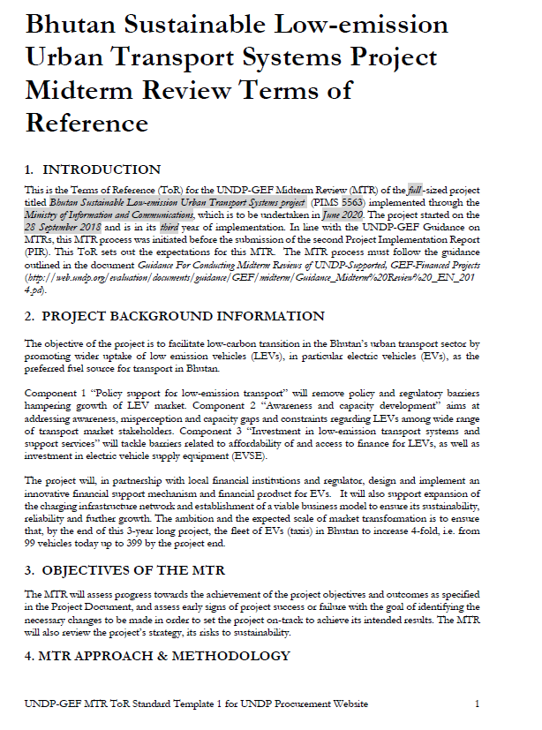

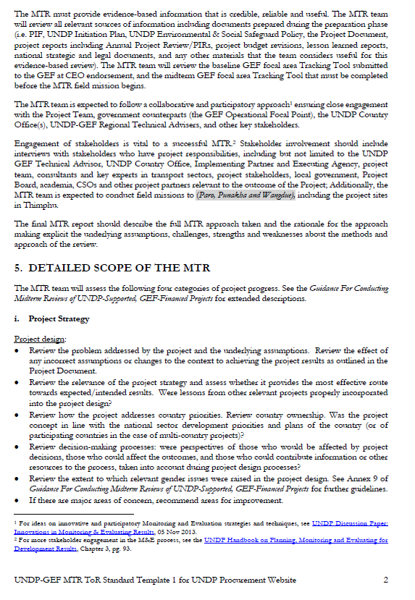

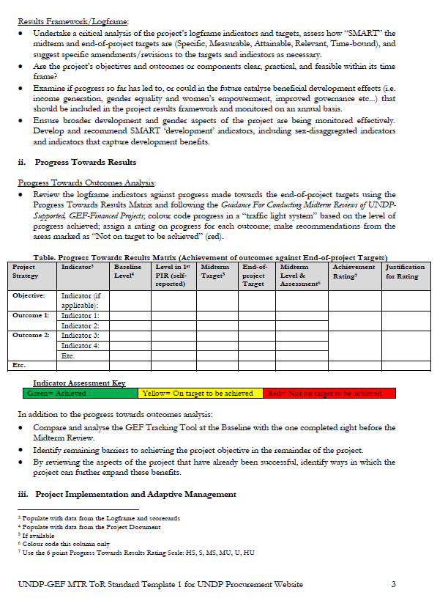

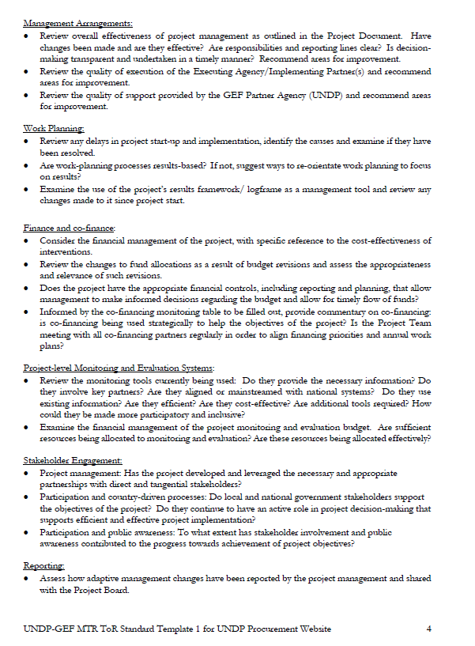

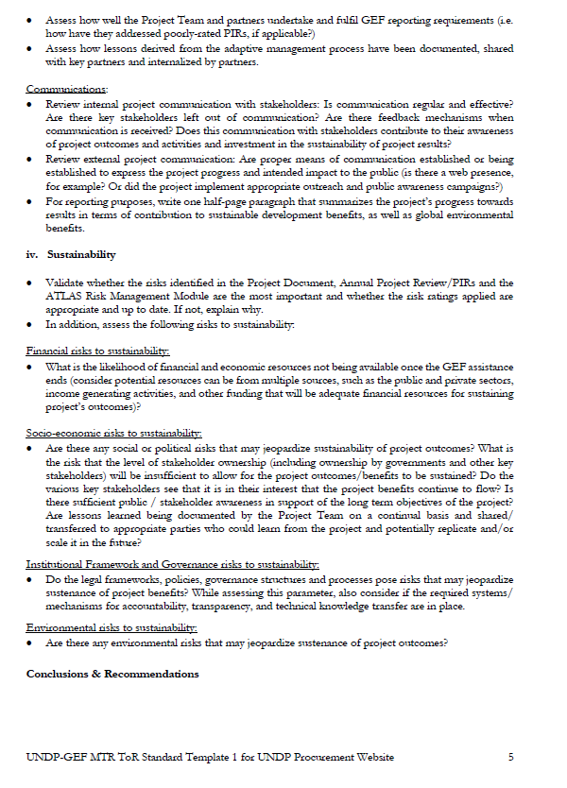

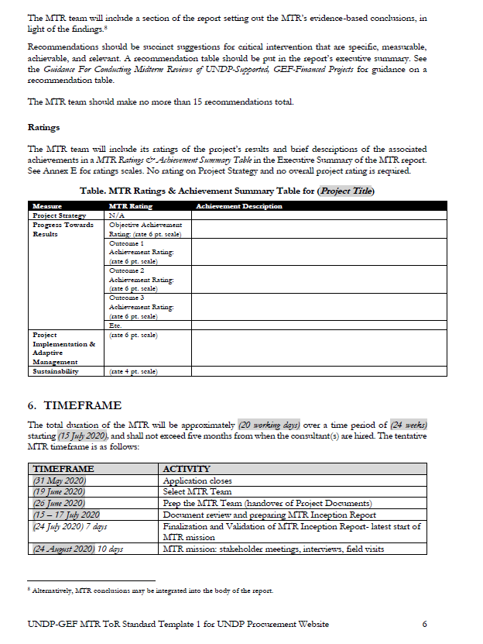

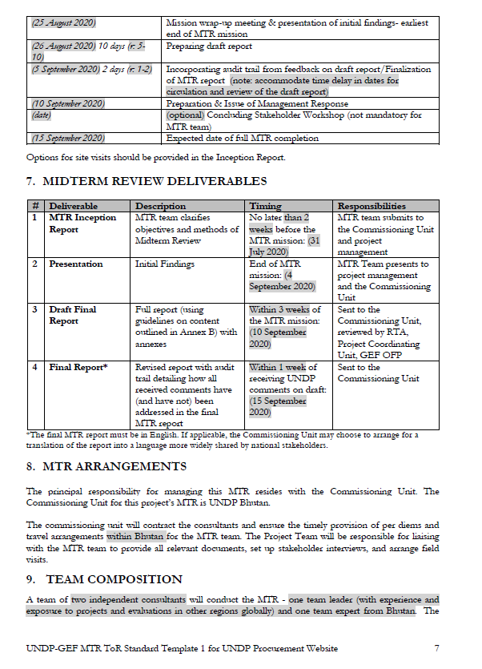

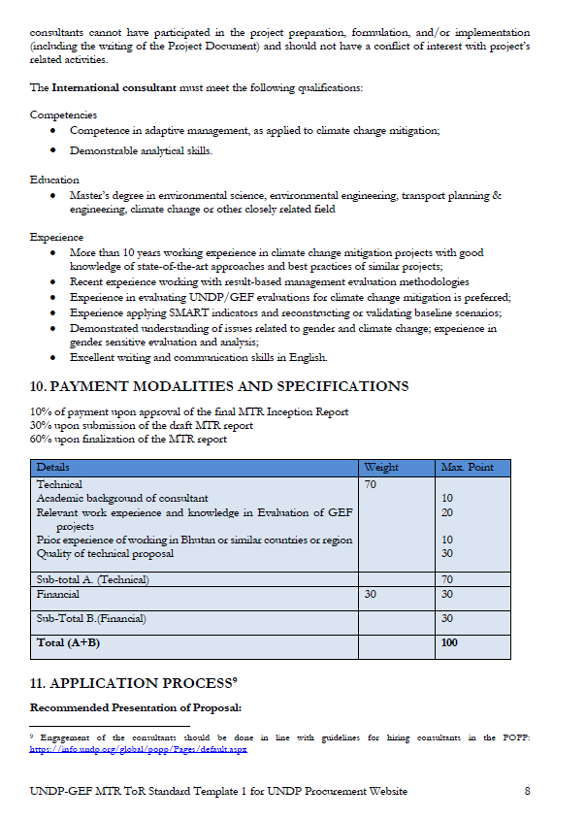

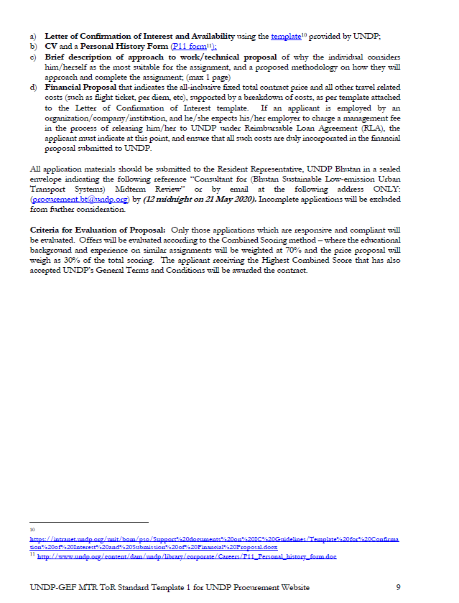

* 1. MTR Evaluation Matrix

|  |  |  |  |
| --- | --- | --- | --- |
| **Evaluative Questions** | **Indicators** | **Sources** | **Methodology** |
| Project Strategy: To what extent is the project strategy relevant to country priorities, country ownership, and the best route towards expected results? | | | |
| Does the project fit in with country priorities, such as transport policy, vehicle emission roadmap, energy priorities? | National priorities | National policy documents; stakeholders working for national and state institutions | Review of official documents; stakeholder in-depth consultations |
| Is there a real need for the project on Low emission urban transport? | Traffic and emission situation, policy and regulatory status, affordability of LEVs | Project documents, Study reports,  Stakeholders | Document review,  In-depth stakeholder consultations; |
| Given that globally cost of EVs has dropped significantly has that changed the relevance of the project as compared to when it was designed and/or launched? | Information EV market in the country | EV stakeholder’s car dealers, FIs | In-depth stakeholder consultations |
| Is the project innovative and/or filling a niche that is not already filled? is the project just duplicating other efforts, or is it indeed addressing an unmet need? | LEV initiatives in the country by other schemes, and other donor projects | Documents,  stakeholders | In-depth stakeholder consultations, document review |
| Assuming there is an unmet need, does the project design combining demonstration, awareness, support for policy, and financing aspects provide the best route to meet these needs? | Information on the policy/regulatory and financing status | Stakeholders, ProDoc | In-depth stakeholder consultations, document review |
| Progress Towards Results: To what extent have the expected outcomes and objectives of the project been achieved thus far? | | | |
| Has the project deployed LEVs that will result in acceptance and market transformation? | Number EVs on road; percent subsidy disbursed; contributions of beneficiaries; | Project reports; project management team; beneficiaries; FIs | Document review, stakeholder consultations, site visits |
| Has the project resulted in policy changes or at least draft policies that will influence the growth in LEV deployment? | Policies or draft policies national level; | Draft policy documents, Stakeholders | Online search; Document review; stakeholder consultations |
| Has the project made progress in supporting new financing mechanisms? | Evidence of MoIC allocation to the programs; evidence of bank loan programs supporting EV loans; evidence of taxi drivers’ participation in the scheme | Project documents, RMA decisions in board meetings; bank stakeholder input; other stakeholder input | Document review; stakeholder consultations |
| Project Implementation and Adaptive Management: Has the project been implemented efficiently, cost-effectively, and been able to adapt to any changing conditions thus far? To what extent are project-level monitoring and evaluation systems, reporting, and project communications supporting the project’s implementation? | | | |
| Considering the timeline left in the project, has sufficient progress been made towards results? | Evidence of actual EVs deployed; status of policy support; evidence of activities for capacity building and awareness; | Project reports; stakeholders involved in the project; | Document review; stakeholder consultations |
| What have been the challenges/ barriers to achieving results? How have these problems been addressed? | Problems in implementation have been addressed promptly and issues have been resolved in timely fashion | PIRs; UNDP; MoIC; other stakeholders | Document review; stakeholder consultation |
| Was monitoring carried out as planned? | M&E and reporting activities | PIRs; project monitoring plan; quality assurance report; SESP; project timeline; stakeholders | Document review; stakeholder consultation |
| What has been UNDP’s role in the project? | UNDP actively involved in monitoring project and solving any problems that are occurring | PIRs; MoIC; PMU; UNDP | Stakeholder consultation; document review |
| Sustainability: To what extent are there financial, institutional, socio-economic, and/or environmental risks to sustaining long-term project results? | | | |
| Are the EVs deployed through the project going to be sustainable? | Status of EV deployment; income generated by beneficiaries; operating issues with the EVs | Beneficiaries of EVs; project reports; stakeholders | Stakeholder consultation; document review |
| Are the EVs deployed likely to be replicated with a possibility of market transformation? | % subsidy; % contributed by beneficiaries; assessment of whether persons are willing to buy EVs without subsidy | Beneficiaries; project reports; | Stakeholder consultation; document review |
| What kind of policy changes will support sustainability? | Status of policies; Information on the policy can support the long-term market transformation | Policy documents; Experts; stakeholders | Stakeholder consultation; document review |
| Is the government likely to institutional LEV for urban transport? | existing policy or draft policy; actions taken by the government departments; coordination mechanism | Policy documents or draft policy documents; decisions of board meetings, stakeholders | Document review; stakeholder consultations |

* 1. Example Questionnaire or Interview Guide used for data collection

1. In what ways were stakeholders involved in the design of the project? Please describe how they were involved.
2. What were the design considerations for the project? Are they appropriate?
3. Can you think of any ideas to improving the project design considerations and activities?
4. Is the project concept in line with the national sector development priorities and plans of the country? Please explain which national priorities and plans – 12FYP.
5. How relevant are project activities in meeting the intended outcomes of the project? Please elaborate.
6. To what extent has the project achieved the outcomes or will be likely to achieve them?
7. Can you please explain the project activities which have contributed to strengthening the social and environmental sustainability?
8. What are the major gaps influencing the achievement or non-achievement of the outcomes so far? What can be done?
9. How has project stakeholder’s cooperation effected the achievement of results and outcomes?
10. What were some social considerations by the project to make it inclusive? Where they effective. Please explain.
11. Have any issues emerged during the implementation of the project? If so, what were the gaps influencing the effective implementation of the project activities?
12. If you have answered Yes to the above question, how what are your plans to tackle the issues?
13. How did the project consider gender issues in the project design and implementation? Were they effective? Please explain.
14. Which specific project activities have contributed to gender equality and women empowerment?
15. How can the project increase involvement of women in the project and its benefit?
16. Can please help us understand the how the direct and indirect avoided GHG emissions were calculated.
17. Has the CCM TT been updated with mid-term results?
18. According to you, which project activities have helped in mainstreaming environmental sustainability?
19. What is the projects’ plan in terms of future uptake of low emission vehicles?
20. What were the innovative approaches that the project used to generate distinct results?
21. What type of internal monitoring systems does the project have to ensure timely accomplishment and quality of project activities?
22. Is the project on track of completion? Do you foresee any deviation in terms of cost or time or deliverables?
23. What were some challenges due to COVID-19 on the project? How would you minimize such impacts on the project in future? Both in terms of project management and LEV.
    1. MTR Mission Itinerary

The mission in Bhutan was led by National Consultant and joined by the International Consultant where feasible and necessary. The consultation also included travel to the neighboring districts of Paro and Wangdue. The field mission and consultation record of the MTR which is shown in the following table. The list of participants and minutes from the meetings are in the next section.

Table 14: Field Mission Plan

|  |  |  |  |  |  |
| --- | --- | --- | --- | --- | --- |
| Day | Date | Morning | | Afternoon | |
|  |  |  | |  | |
|  | 29/7/2020 | PMU* | | | |
|  | 30/7/2020 | MOIC | MOLHR |  |  |
|  | 31/7/2020 |  | Taxi Association | Station Operators | GNHC |
|  | 3/8/2020 | RSTA | Taxi Drivers |  |  |
|  | 4/8/2020 | Car Dealers* | | Energy Sector* | |
|  | 5/8/2020 | BOB | Kuenphen Motors | NECS |  |
|  | 6/8/2020 | Paro site visit | | | |
|  | 7/8/2020 | Wangdue/Punakha site visit | | | |
|  | 10/8/2020 | BDBL |  |  |  |
|  | 11/8/2020 |  |  | UNDP* |  |

* Ameya/ International Consultant joined via online video conference

* 1. List of Persons Interviewed & Minutes of Meeting

Survey questionnaires were designed to assess the Midterm Review (MTR) of the full -sized project titled Bhutan Sustainable Low-emission Urban Transport Systems project for all key stakeholders. Focus Group Discussions (FGD) and bilateral meetings were held with all stakeholders to evaluate the targets against each outcome/output of the Project and their achievements until the MTR of the project. The details of the meeting and its minutes are in the following section;

FGD with PMU

The FGD with the Project Management Unit (PMU) was held on 29th July 2020 at Ludrong hotel meeting hall. The meeting started at 10:35 am and ended at 5 pm. The minutes of the FGD are as follows;

* The PMU mentioned that the Gross National Happiness Commission (GNHC) led the formulation of the project based on previous EV project. They consider that all relevant stakeholders seem to have been consulted in project design but unfortunately, the concerned stakeholders did not have much competency and contribution to the project design and planning since the project is somewhat new to them. The consultant and one/two technical person were leading the discussion during the initial phase of the project.
* Procurement or demonstration on use of EVs by leaders, policy makers and even for the PMU to set examples to the public was not considered during the design of the project. It was also stated that the project should have studied the limitation on competency of project during design of the project instead of directly procuring and rolling out the project. They think that laying the foundation of the project such as policy and clear directives for electric vehicles, trainings and setting up of the system at first would have helped in implementing the project activities smoothly and also achieve the project outcome more effectively.
* The taxi drivers, who are the primary beneficiaries of the project, were hard to gather and convince the objective and benefits of the project. This was mainly due to the misconception among people due to earlier EVs imported in the country, some of which did not have good range or performance and also due to the high cost of electric cars. However, the PMU adopted various measures to bring almost all taxi drivers on board during the consultative meetings. Several strategies such as requesting Honorable Minister MOIC for the meetings, seeking help from traffic personnel were used.
* It was observed by PMU that EV dealers, who only deal with EVs in the country are highly interested in the project whereas the dealers who deal in all kinds of vehicles (both EV and non EV) are not too keen to promote the EV market due to its high buying cost compared to conventional cars and less post service business owing to EVs’ general low maintenance requirement.
  + On the suggestions for further uptake of EVs and incentivize the dealers to sell EVs, it may be possible for the government to waive off income tax/ BST on the sale of EVs by dealers. As of now, they do not have much incentive to sale EVs.
* The project is line with the national sector development priorities and plans of the country. Some of them are Bhutan’s Vision 2020, National Transport Policy 2017, Nationally Determined Contribution (NDC), 12th FYP and to SDG 1 on poverty, SDG 13 on climate action and SDG 15 on life on land.
* The PMU is working towards the project outcome now, many activities of the project are on track and additional activities are also initiated but due to the Covid-19 pandemic, there is a delay in delivery of EV from suppliers, otherwise the EVs from the project would be already on road.
* It is felt by the PMU that people who drive EV are considered to have eco-friendly pride and were also considered better off economically. The green number plates for EV also shows great visibility and maybe able to enter during pedestrian day or environment day in restricted areas.
* The international airport at Paro is also planning to open E-cab desk to promote use of EVs.
* There is direct support to the 300 EVs that will be purchased by the project. Beyond that to make it inclusive the subsidy is limited now to make it beneficial for all others. Policy interventions such as providing loan increase, free charging facility, and green registration for EVs are being promoted.
* It has been found that many EV owners do not own homes of their own therefore; overnight charging stations at different suburbs are required exclusively for EVs. Further, future buildings would require EV charging provision in the basement.
* There are 6 female beneficiaries out of 120 EVs from the project currently. Further the project is giving 18 points extra for female applicants for subsidy from the project during the selection process. EVs seem to be female oriented/ friendly with auto gear, low maintenance and smooth driving. Overall, there is no hindrance/bias for any gender in Bhutan regarding this context. CCTVs will be installed at charging stations for safety concerns of female drivers since that is the place where people mostly gather.
* The study on EV battery reuse, recycle and waste management is done by the project. Trainings on safe handling of batteries in case of accidents and safe disposal of battery waste are also planned.
* Planning to open a recycling plant for batteries is not feasible in Bhutan. Therefore, the PMU is coming up with the modality to work with an entity to dispose of/ return battery waste properly either to a car manufacturer or e-waste handling company. Further, SOP will be developed for disposal and management of EV battery waste through the project.
* The shifting of PMU from MOIC to PMO was an innovative approach that the project took to generate distinct results. The PMU can implement directives/ plans directly to push the project ideas and activities further. PMU/PMO is looking forward in setting up a division on promotion of LEVs and demonstrates examples to the other government agencies and general public.
* The project is on track but due to the delay in delivery of EV owing to the current situation, the project needs time extension depending on external factors such as restrictions in Country of Origin and others. All meetings, workshops, trainings, advocacy, awareness, roadshow has been deferred due to the Covid-19 pandemic.
* There is need for budget reallocation among the project activities. The PMU is of the opinion that some activities’ budget maybe cut down and increased for other. Specifically, the budget on awareness program on EV should be increased and the budget allocated for some of the activities of project (such as for consultancy services and coordination etc.) could be decreased since it is hardly used as of now. A good way to create more awareness of the project and EV technology is having few demonstration cars by the PMU and other prominent individuals in the country. This will help in creating visibility of the project and also generating more interest to go for EVs.
* The PMU also shared the latest expenditure statement of the project for use by the consultants. The consultants agreed to further review the project expenditure and come out with recommendations.
* The PMU was requested to provide details on cars sold in the market by the dealers beyond the project.

**Number of Attendees**

|  |  |  |  |  |
| --- | --- | --- | --- | --- |
| S/no | Name | Designation/Office | Gender | Phone/Remarks |
|  | Phub Gyeltshen | Project Manager, PMU | Male | 17997393 |
|  | Kezang Choden | Project Support Officer, PMU | Female | 17306177 |
|  | Ameya Udgaonkar | International Consultant | Male | Online |
|  | Chhimi Dorji | National Consultant | Male | 17556306 |
|  | Karma Yangzom Dorji | National Consultant | Female | 17448854 |

FGD with MoLHR

The FGD with the Department of Vocational Education and Training under Ministry of Labor and Human Resources (MoLHR) was held on 30th July 2020 at their office. The meeting started at 2:00 pm and ended at 3:00 pm. The minutes of the FGD are as follows;

* The Department of Vocational Education and Training (TVET) had been involved in the project with a representative as member in the technical committee/ task force team. The project has also trained 3 trainers from the institutes on EV repair and maintenance. Further, incorporation of EV maintenance and operation modules are planned to be incorporated in the curriculum of the trainings at their institutes.
* The TVET department and the project are also planning to provider refresher courses to taxi drivers with EV O&M skills.
* The TVET office confirmed their interest towards the project and its activities. They mentioned that the project goes in-line with their TVET greening program. This program aims to provide green skills and contribute to green economy of the country. The ministry faces challenges in providing trainings of variety and quality as of now.
* As of now, the main limitation with the TVET program in the country is lack of physical demonstration and experiment vehicles for hands-on training at the institutes. They stated that it would be best if the project could provide electric cars for practical learning for their institutes. If not possible, then the next option would be to procure latest digital technologies and 3D images with EV training Kits, they believe that this will help their trainees learn and implement their learning effectively. This would also supplement the efforts from the vendors on training technicians in the market on EV technology.
* The ratio of male and female undergoing automobile training at their institutes comprises of 65% male and 35% female now. Their target is to increase the female participants by 5% by the end of 12 FYP. They believe that more female would turn up to take the EV training course as it does not require significant physical labor. An example was also cited about the institutes on electrical engineering where the female enrollment is higher due to ease of working and female friendliness. EV courses would also be similar in nature and female friendly.
* The office mentioned that the ratio of male and female participants is often driven by the nature of the work. They are planning to design their training system equitable to both gender and differently abled people.
* The office questioned on the life span of the 300 EV taxies which will be on road by the end of project. The importance of having proper spares and services on the EVs is thus crucial and the TVET sector could thus play a major role in ensure sustainability of the benefits. Skilling of necessary manpower in the EV technology is seen as major risk that needs to be tackled.
* The office said that the main component of an EV is their battery hence, adequate numbers of trainees/technicians should be trained in maintenance and safe handling of the batteries.
* Overall, the TVET sector is very much in support of the project and its objectives. It is also in-line with the sector’s initiative in terms of equitable and balance socio-economic development through productive workforce / employment through low carbon development and climate resilient society. The training and involvement of TVET in the EV sector would also further support the sector’s interest to provide green skills and green growth.

**Number of Attendees**

|  |  |  |  |  |
| --- | --- | --- | --- | --- |
| S/no | Name | Designation/Office | Gender | Phone/Remarks |
| 1 | Norbu Wangchuk | Director, DTE | Male | - |
| 2 | Wangchuk | Program Analyst, DTE | Male | 17609015 |
| 3 | Phub Gyeltshen | Project Manager, PMU | Male | 17997393 |
| 4 | Kezang Choden | Project Support Officer, PMU | Female | 17306177 |
| 5 | Chhimi Dorji | National Consultant | Male | 17556306 |
| 6 | Karma Yangzom Dorji | National Consultant | Female | 17448854 |

FGD with MoIC

The FGD with the Ministry of Information and Communication (MoIC) was held on 30th July 2020 at their office. The meeting started at 3:12 pm and ended at 4:45 pm. The minutes from the FGD are as follows;

* Dasho Secretary raised his concern about the management of EV batteries at the end of their life and also mentioned that it is not included in the E-waste management strategy that has been developed by the ministry.
* The Research and Development (R&D) in transport sector including the EV is important but it is missing for now with any relevant agencies. The significance of investing adequately in R&D was emphasized.
* Dasho stated that the number of charging stations that will be installed by the project will be too less to fulfill the complete outcome of the project and would need further analysis and careful consideration.
* Fifteen EV charging machines have arrived in the country but due to the Covid-19 pandemic, the delivery of transformers has been delayed.
* There is no problem in release of budge from the donor agency, but it was stated that the total amount of budget allocated for the project is too ambitious to fulfill the outcome of the project. The incentive/subsidiary while buying EVs ($5500/car) were also said to be not attractive to encourage buyers. Dasho is of the opinion that to achieve the complete outcome of the project, more investment, training, awareness and better and continued subsidy should be given for potential car owners or replacement. As of now the regulations and subsidies are not attractive compared to EV subsidies in other countries.
* After the PMU moved under the PMO from MoIC, the roles and responsibility of the Ministry, PSC board to the project is not clear.
* Dasho Secretary also mentioned that EV requires some inclusion in the National Transport Policy since it is not there as of the current draft. Further discussion with RSTA was recommended.
* The Secretary of MoIC also suggested that Bhutan could contribute as a specialized producer rather than becoming a consumer alone in the global EV movement. In particular, Dasho suggested that perhaps the use of locally available Graphite could be explored to be used in EV batteries. It was mentioned that a typical EV battery requires some 40 kg of graphite. In addition to that, more research and development of local skills, resources and technology could be explored to make Bhutan a player in the EV industry. Perhaps a small fund from the project could be allocated to study on how Bhutan could play a role in this global movement to shift from a mere consumer to a supplier/ producer of certain specialized EV component or service.
* There is a capacity issue in Bhutan on EV as of now; even the PMU is led by only two staff who are self-trained. The MOIC/ related agencies do not have any expertise on EV technology. The consultant informed Dasho about previous EV/Energy projects in the energy sector. Involvement of the Department of Renewable Energy, DRE under MoEA with the EV project would be good which was recommended to be explored.
* Dasho Secretary stated that gender is not a cultural issue in Bhutan but still the project is giving 18 extra points to female applicants on the project beneficiary selection to encourage them.
* He also mentioned that there is a need to have Department of Transport separately and not under RSTA so that the department can look after all transport issues holistically. This would also help promote alternative transportation modes such as EVs, hybrids, trains/railways and even water transport.

**Number of Attendees**

|  |  |  |  |  |
| --- | --- | --- | --- | --- |
| S/no | Name | Designation/Office | Gender | Phone/Remarks |
| 1 | Phuntsho Tobgay | Secretary, MoIC | Male | 17613828 |
| 2 | Ugyen Norbu | Officiating DG, RSTA | Male | 77364637 |
| 3 | Kezang Choden | PSO, PMU | Female | 17306177 |
| 4 | Chhimi Dorji | National Consultant | Male | 17556306 |
| 5 | Karma Yangzom Dorji | National Consultant | Female | 17448854 |

FGD with taxi association

The FGD with taxi association was held on 31st July 2020 at their office. The meeting started at 11:00 pm and the minutes of the FGD are as follows;

* The taxi tshogpa/association (TA) is recently approved as a registered CSO. They represented as members of Task Force Committee on selection of cars and also involved during the site selection of EV charging stations.
* The members of taxi association, consisting of all taxi drivers across the country have attended the sensitization and awareness campaign of EVs. They said that it has been an eye-opening experience for them. They have also participated in the project activities such as trainings on 1-2 days induction course on EV operation and maintenance. One female and 2 males participated in the exhibition on EVs in Bangkok sponsored by the project. Another group has attended training in Thailand on EV technology.
* The taxi association has helped taxi drivers know about the EV cars and convince them to go for EV, but not mentioning any specific brand. Three taxi drivers have sold their conventional taxi cars and are now waiting for replacement EV taxis.
* Members of TA are satisfied with it since the EV fulfilling project technical specifications has high clearance. Required modifications were also suggested and incorporated.
* They said that it will be difficult for them to pitch in more than Nu.300, 000 from their side now. They believe that in future people will be able to afford once the technology is proven and spares/services are readily available. For now, subsidy from project side has to help bring down the upfront cost as drivers are mostly from lower income section of the society.
* They are not happy with the current electric vehicle loan policies by our banks. They need support from the PMU to settle down with banks on the EV car loan. Banks seems to have various requirements and criteria for EVs and not following as per RMA directives- in terms of repayment period (not 7 years, but 5 years), amount calculation (only 70% after reduction of subsidy amount, not on total cost of car), requirement of collateral etc.
* If any bank considers giving lower interest, coordinated approach, clarity and better deals on EV taxi loans, then the association would go for a MOU with the concerned bank which then help them reach out to more taxi drivers. Thus, a joint meeting between RMA/BOB/BDBL/PMU is requested from TA.
* The taxi association members think that taxi drivers will not be interested to purchase EVs in future without the 20% subsidy from the project as it will be too expensive.
* The EV taxis can charge freely from the quick charging stations in the country now and it will be free for the project duration of 3 years. They said that it is acceptable to pay the charging fees after the project duration.
* The average electricity bill for charging their EV taxi is Nu. 900/month from home which is equal to 1-2 days of fuel expense. They feel that the electric cost for charging their EV is very reasonable; therefore, home charging would be preferred by most drivers. However, quick chargers would be necessary for back up in emergency.
* They mentioned that an EV car dealer is interested to support in installation of EV charging stations for free in 2-3 eastern districts of Bhutan which are not covered by the project.
* They said that workshops are not included in the current project activity. They need advocacy on EV and should be advised for EV spares & services. It was also suggested that the project should start working with local automobile workshop owners and train/ educate them.
* Taxi association stated that TA is interested to take care of the EVSE system in all 20 districts of the country and may support better O&M with CCTVs. This may need to be included as a possible solution for the road map on EVSE.
* It was informed that spare parts and services for EVs should be available for upto 70% of the parts/ population of the car since taxis cannot afford to stay off-road. They mentioned that all EV spare parts and services are expensive as of now; therefore, project should ensure that these costs are brought down before the project end through various ways.
* COVID-19 situation has delayed in supply of EV taxis which has been ordered before 5-6months. This has put off the livelihood of some drivers since they sold their old EVs.
* The taxi association can provide advanced refresher course on EV driving to promote the EV market. The association would need demonstration cars or use their cars later once they arrive. The proposed Samthang training center by the project for 3-4 days also sounds adequate for the time being. The association now has technically competent trainer.
* They said that the advocacy on EVs should be spread to all 20 districts of the country.
* As an innovative approach, the association should sign MOU with ABTO so that EV can be used as luxury car and be able to cater to foreign tourists. It would be nice if EVs could participate in government tenders as high-end cars (higher standard).
* There are 6 females who applied for EVs through the project, they got 18-point bonus during the selection which was a good idea to increase the number of women involved in the project. The CCTVs which will be installed at EV charging stations will also make it safer for female taxi drivers.
* The possibility of having camera inside the EV taxis would also make it safer for female drivers.
* The taxi association has strong interest on replacing all taxi with EV taxi in future but the subsidiary from the project/government should continue beyond 300 EVs.

**Number of Attendees**

|  |  |  |  |  |  |
| --- | --- | --- | --- | --- | --- |
| S/no | Name | Gender | Designation/Office | Gender | Phone/Remarks |
| 1 | Rinzin chophel | Male | Chairman, BTA | Male | 17907990 |
| 2 | Dorji Wangchuk | Male | Tshokpa, BTA | Male | 17600014 |
| 3 | Tshering Wangmo | Female | Tshokpa, BTA | Female | 17613741 |
| 4 | Phub Gyeltshen | Male | Project Manager, PMU | Male | 17997393 |
| 5 | Kezang Choden | Female | Project Support Officer, PMU | Female | 17306177 |
| 6 | Chhimi Dorji | Male | National Consultant | Male | 17556306 |

FGD with EV Charging Station Operators

The FGD with the Road Safety and Transport Authority (RSTA) was held on 31st July 2020 at their office. The meeting started at 2:30 pm and the minutes of the FGD are as follows;

* There are four EV charging stations in the western region of the country taken care by the DoS, MoIC. In total, there are 5 EV charging stations in the country. There is one EV charging station located at the Paro International Airport that is being taken care by DOAT.
* The operation and maintenance of the existing EV charging stations that are under MoIC are outsourced to the contractors at Nu.15,000 per month for one charging station.
* The monthly electricity bill for 4 EV charging stations ranges from Nu.7,000 to Nu.15,000 and it is being paid by the RGoB.
* The staffs from DoS, MoIC randomly visit the EV charging stations to monitor the system. The department under MoIC who looks after the EV charging stations mentioned that whenever there are problems with the EV charging stations, they immediately receive complaints from the EV drivers through phone call.
* The technicians submit monthly report consisting of detail use and users of EV charging station to the office.
* Fifteen charging stations purchased by the project has already arrived in the country but due to the delay in delivery of transformers, installation of EV charging stations are delayed.
* The office is planning to initiate POP swipe card services to the users of EV charging stations. They also have ideas to develop an app/software funded by the flagship program to check the availability of the charging station.
* There are no other issues and challenges in operating and maintaining the EV charging station except with manhandling of the EV charging machine. This is due to the lack of knowledge/advocacy about the safe handling/use of EV charging machines and also due to frustration of the EV drivers during the electricity black outs. The office mentioned that this problem can be avoided by installing CCTVs at every EV charging station and also by giving training on safe use of EV charging stations.
* The office cited that the project has missed the trainings on use of charging stations that could be provided as part of project activities to the beneficiaries during the design of the project.
* They also mentioned that installing EV charging station at the car parking of all ten ministries could be made mandatory to promote EV car users.
* A member from the office said that the model car that is with PMU now has given them many new learning and experiences. Considering the benefits of EV to environment, less maintenance and no use/expenditure on fossil fuels, he is interested to purchase electric car for his personal use.
* The office mentioned that 15 new additional EV charging stations to their existing charging stations will be sufficient for 399 EVs but it will be inadequate to fulfill the entire outcome of the project.

**Number of Attendees;**

|  |  |  |  |  |
| --- | --- | --- | --- | --- |
| S/no | Name | Designation/Office | Gender | Phone/Remarks |
| 1 | Phuntsho Dendup | Offg. Director, DoS, MoIC | Male | 77478900 |
| 2 | Sonam Dorji | Procurement Officer | Male | 17776617 |
| 3 | Phub Gyeltshen | Project Manager, PMU | Male | 17997393 |
| 4 | Kezang Choden | PSO, PMU | Female | 17306177 |
| 5 | Chhimi Dorji | National Consultant | Male | 17556306 |
| 6 | Karma Yangzom Dorji | National Consultant | Female | 17448854 |

FGD with GNHC

The FGD with the Gross National Happiness Commission (GNHC) was held on 31st July 2020 at the GNHC meeting room. The meeting started at 3:30 pm and ended at 5:00 pm. The minutes of the FGD are as follows;

* The Gross National Happiness Commission (GNHC) considers that the project is going well and is in right direction but there is a delay in delivery of EVs due to the prevailing Covid-19 situation.
* GNHC also clarified that the project was designed properly with proper consultation and involvement of all relevant sector including the private sector.
* The officials believe that main challenges to the project are; the misconception on EVs as short range, low clearance, the high upfront cost, and issues with current EV charging stations.
* Since the EVs purchased through the project has not arrived in the country, the GNHC officials cannot say much about the project during the MTR.
* The lack of capacity in terms of resources and skilled EV technicians and know-how of EV technology in the whole country is another major challenges/issues stated in implementation of the project.
* An official mentioned that this EV project is unique in nature compared to other project since this project has to deal with different types of stakeholders starting from taxi drivers, financial institutes and other government and private agencies.
* The GNHC believes that the project is in line with 12 FYP, NDC of Bhutan and also contributes to some SDGs.
* An official stated that the study done on EV battery waste through the project would need proper vetting and feasibility analysis before being finalized.
* The officials raised concerns about the threat/competition with EV taxies when the electric buses by Thimphu Thromdes starts running on the road.
* The provision of subsidiary to taxi and private drivers who wants to go for EV but are not included in the project should be stated clearly from now.
* There should be strategies and plans in place to make this EV project run on long term. After the end of project duration, there should be a right home for the project who shall be held responsible to carry the EV initiatives forward.
* The PMU should conduct a basic training to mechanics/technicians and EV car dealers before the EV purchased through the project arrives in the country. This will help EV dealers and mechanics to be confident and inspect EVs after they arrive to Bhutan.
* The GNHC officials stated that PMU should also accelerate the installation of EV charging stations and have it ready before 300 EVs arrive in the country.
* There are also government M&E systems for the project, where the annual work plans and budget are reviewed by the GNHC. It is included in the annual performance agreement (APA) of MOIC. However, henceforth this will be included in the responsibility of the Cabinet Secretariat by GNHC as the PMU is there. The tracking will also be done by GNHC.
* A concern was also raised on the quality assurance testing of the cars delivered through the project. The possible need of testing before being shipped may need to be explored to minimize the risk.

**Number of attendees**

|  |  |  |  |  |
| --- | --- | --- | --- | --- |
| S/no | Name | Designation/Office | Gender | Phone/Remarks |
| 1 | Dechen Zam | Program Coordinator, DCD, GNHC | Female | 17894499 |
| 2 | Tshewang Jamtsho | PMCD, GNHC | Male | 17769809 |
| 3 | Kezang Choden | Project Support Officer, PMU | Female | 17306177 |
| 4 | Chhimi Dorji | National Consultant | Male | 17556306 |
| 5 | Karma Yangzom Dorji | National Consultant | Female | 17448854 |

FGD minutes with RSTA

The FGD with the Road Safety and Transport Authority (RSTA) was held on 3rd August 2020 at their board meeting hall. The meeting started at 10:10 am and the minutes of the FGD are as follows;

* The project is taken over by Ministry of Information and Communications (MoIC) from (Gross National Happiness Commission) GNHC. Road Safety and Transport Authority (RSTA) has taken the initiative to survey by going around few districts of the country for installation of EV charging stations in terms of numbers and location. After the PMU has moved to PMO from MoIC, RSTA has only provided with the details of taxies in the country.
* The RSTA officials believe that if infrastructure such as EV charging station comes in all districts of the country, low emission vehicles (LEVs) can be promoted. With this the trade deficit in the country can be reduced along with benefiting the environment.
* The officials mentioned that promotion LEV is also a mandate of RSTA.
* The Transport Development Division (TDD) handles the overall policy of RSTA and the Transport Management Division (TMD) looks after the bus services in the country.
* An official from RSTA stated that the continuity of the project and activities might be a problem after the project duration ends. For example, the 20% subsidiary is only for 300 EV taxies during the time of the project, how about if some other taxi drivers and private owners come forward to buy later? They stated that subsidy to EV should continue in future since the cost of the EV are quite expensive compared to conventional cars.
* The officials mentioned that since the vehicle registration and licensing is done by the RSTA, people think that they are responsible for everything related to transport services but they are not the sole agency who can decide on the issue and impose the policies.
* An official from RSTA said that the main challenges and issue currently with the promotion of EV are high cost of EVs and lack of adequate EV charging stations in the country.
* RSTA can help in creating awareness about the benefits of EV and LEVs to the public.
* There is a gap in policy because the roads outside the city are built by DOR, but the design and related safety issues are looked after by RSTA. These kinds of gaps affect the implementation of the project activities.
* The noise and air policy standards are made by NECS and imposed on RSTA to implement. Since RSTA lack capacity and capability, to implement the policies are prodigious challenge.
* RSTA is the right agency in the country to lead an exemplary action on promoting LEV but the office does not own a single EV. They also lack fund, trainings and capacity in case of EVs.
* The officials said that they do testing and fitness of EV vehicles now but due to lack of trainings on how to do so, they face challenges even to find out the chassis number of electric cars that comes from various companies.
* An official from RSTA stated that people in general usually consider the high upfront cost of the EV, the environmental benefits and others come next. Even the 20% subsidiary to buy EV through the project is less.
* RSTA has no authority to reduce or forgo the registration fees of EV, this directives have to come from Ministry of Finance.
* It was discussed during the FGD that a person should be provided with incentives if he surrenders his old car and have plans to replace it by an EV.
* From January 2021, RSTA will start complying with Euro 6 standards.

**Number of Attendees**

|  |  |  |  |  |
| --- | --- | --- | --- | --- |
| S/no | Name | Designation/Office | Gender | Phone/Remarks |
| 1 | Tenzin Wangmo | Electrical Engineer, RSTA | Female | 17816575 |
| 2 | Phuntsho Wangdi | AE, RSTA | Male | 17741357 |
| 3 | Ugyen Lhamo | RLO, RSTA | Female | 17624533 |
| 4 | Phub Gyeltshen | Project Manager, PMU | Male | 17997393 |
| 5 | Kezang Choden | Project Support Officer, PMU | Female | 17306177 |
| 6 | Chhimi Dorji | National Consultant | Male | 17556306 |
| 7 | Karma Yangzom Dorji | National Consultant | Female | 17448854 |

FGD with car dealers

The FGD with car dealers in Thimphu was held on 4th August 2020 at Ludrong hotel conference hall. The meeting started at 10:50 am and ended at 1:00 pm. The minutes of the discussion are as follows;

* Eleven car dealers were represented in the FGD, these includes both EV and non EV dealers. Some car dealers were involved in the project right from the first meeting when the PMU was with MoIC. All non EV car dealers said that they are interested to supply EV to the market in future.
* One of the car dealer (STCBL) has even plans to install EV charging stations at their fuel stations and are keeping provision of charging points.
* The four car dealers who came forward qualified their EV specifications according to the standards set up by the project. However, the time duration for the contract comes to an end by August 2020 and different car dealers can quote again with different types of EVs from September 2020.
* The main component of EV is their battery and public trust issue lies there especially in terms of lack of service/trained technicians for maintenance, re-use and disposal of batteries.
* The car dealers mentioned that there is a need to train buyers on the operation and maintenance of EVs along with battery care and management. Some dealers provide 30-45 minutes of car operation and maintenance to each buyer, but some does not do any training on EV use or management.
* An EV car dealer mentioned that there is so much of compromise made in terms of quality of EV for cost. The on-board charging port of EV should be good especially for EV taxies. Therefore, proper quality assurance needs to be carried out to ensure that the cars purchased through the project are of good quality and durable.
* On the question of the technical specifications, it was proposed by dealers that it may be left for the drivers to choose the brand and car as they wish. Although they admitted being involved since the beginning, they are now realizing that perhaps it is too expensive for most people. It was clarified by the PMU that a minimum range of 200km on one charge was required by taxi drivers themselves. The project cannot afford to lower this and jeopardize the EV sector and project’s name. However, if there are only minor deviations, dealers were reminded to submit in the new expression of interest.
* A car dealer raised question on the disposal of battery of EVs and its future. Nissan dealer mentioned that their principal company is planning to take back the battery from their customers.
* One participant believes that a major chunk of the cost of EV is their battery, but the insurance company gives only 50% of claims during time of accidents for battery, glass and rubber items. On the other hand, claims for metal parts and engine are 90% of collateral. This factor can discourage customers to buy EVs and not correct since the battery in EV is equivalent to a car engine for ICE. A discussion with the insurance company is thus necessary by the PMU and car dealers.
* A non-EV dealer raised question about the disposal of EV batteries and mentioned that the project has to come up with methods of reusing and disposal of batteries in an environment friendly ways.
* Almost all car dealers raised issues with the specifications of EV set by the project because the EVs with these conditions cost huge amount. They mentioned that the major issue with promotion of EV is their cost so they would like to have different brand and types of EVs and leave it on the customers to choose or else they are concerned that just one or two brands of EV might dominate the market.
* Nissan confirmed that they have spares available in stock along with trained technicians. The turnaround time for Nissan Leaf maintenance is one day.
* Hyundai also mentioned that they have an existing workshop and basic maintenance could be provided, but specialized technicians and adequate stocks are not there.
* Few car dealers mentioned that with varieties in brand and types of EV, they might require different charging machines, and this would be another challenge since the machines the project will install can only charge two types of EVs.
* Some participants stated that application of same tax bracket/conditions on all hybrid cars is not fair and it has to be differentiated according to their types and guarantee on CO2 emission. This is particularly true considering all hybrids in one tax category.
* For instance, in Bhutan, all hybrid cars are subjected to same tax depending on their engine size. However, it was clarified that there are 3 different types of hybrids.

1. Mild hybrids; better than ICE cars, has a small battery that can store energy, but the primary propulsion is petrol, and the battery only helps during certain times to reduce fuel. It cannot be charged from electricity. E.g., [Honda Insight](http://www.autotrader.ca/research/honda/insight/2012/), [Honda CR-Z](http://www.autotrader.ca/research/honda/cr-z/2016/)
2. Full hybrids (HEV); the vehicle uses propulsion of both the petrol engine and battery. The battery is charged when the petrol engine is running. The battery then runs the car until it gets exhausted. It cannot be charged from electricity. E.g., Toyota Prius, Kia Optima Hybrid, Ford Fusion Hybrid, Kia Niro, Hyundai Ioniq HEV,
3. Plug-In Hybrid Electric Vehicle (PHEV); PHEV works like a regular hybrid and EV combined. It can be charged from electricity like an EV and ran on petrol like a hybrid. For short range, the car run on batteries, while for long drive it runs on petrol and recharges the battery performing like a hybrid. E.g., Chevrolet Volt, Hyundai Ioniq PHEV, Toyota Prius Prime, Chrysler Pacifica PHEV, BMW i8, Ford C-Max Energi, Mitsubishi Outlander PHEV.

<https://www.autotrader.ca/newsfeatures/20180410/types-of-electric-vehicles-explained/>

* + It was shared that this tax regime is not appropriate and there should be different tax slabs for these three types of hybrids. Since this is also leading to low emissions, the PMU was requested to take this tax differentiation issue with the government. The suggestion was to use CO2 emission/ km drive of the car during the official launch as indicator for green taxation and not the engine capacity alone.
* All car dealers mentioned that there is misconception among people with EV since it is a new technology otherwise, they are not biased when promoting EV and conventional cars.
* The car dealers mentioned that they can further decrease the price of EV if the government could make consideration on BIT related to sales of EV and waive off taxation on spare parts of EVs.
* Few of them also said that the government could train engineers and technicians specifically on EV in preparation of EVs entering the country.
* An EV dealer talked about the need of charging station/EV charging power point at the Phuentsholing Customs office area, where they unload the EVs. It can even be an AC port provision as car batteries get completely drained during shipping and needs some power to reach to showrooms or DC charging stations.
* Dealers also mentioned that government asked EV owners to change license plate, but no benefit or priority was provided.
* All car dealers are looking forward to joining an EV/ low emission vehicle expo/ display if organized by the PMU. It will give good visibility to the EV and low emission vehicle sector and initiatives.

**Number of attendees**

|  |  |  |  |  |
| --- | --- | --- | --- | --- |
| S/no | Name | Designation/Office | Gender | Phone/Remarks |
| 1 | Ugyen Dorji | RM. Singye Agency | Male | 17608507 |
| 2 | Bishnu Gurung | Zimdra | Male | 17600217 |
| 3 | Saroj Kr. Rai | Shingkhar Pvt. Ltd (KiaBhutan) | Male | 17728029 |
| 4 | Sanitri Gurung | Dha Chzen Motors | Female | 77351623 |
| 5 | Kinley Bidha | HOD, Toyota | Female | 17755447 |
| 6 | Kelzang Lhaden | Thunder Motors | Female | 77101857 |
| 7 | Dawa Lham | Karjung Motors | Female | 17111887 |
| 8 | Kezang Choden | PSC | Female | 17306177 |
| 9 | Pema Lodey | Sr. GM, BHM | Male | 77100290 |
| 10 | Ugyen Dorji | Warranty Admin, BHM | Male | 77222100 |
| 11 | Kinley Tshering | Dha Chzen Motors, Marketing Officer | Male | 17757407 |
| 12 | Rajan Gurung | Ford, TMPL | Male | 77465902 |
| 13 | Jigme Tenzin | TMPL | Male | 17591500 |
| 14 | Singhey Gyamtsho | Dha Chzen Motors | Male | 17113511 |
| 15 | Phub Gyeltshen | Project Manager, PMU | Male | 17997393 |
| 16 | Kezang Choden | Project Support Officer, PMU | Female | 17306177 |
| 17 | Chhimi Dorji | National Consultant | Male | 17556306 |
| 18 | Karma Yangzom Dorji | National Consultant | Female | 17448854 |

FGD with energy sectors

The FGD with the energy sectors in the country was held on 4th August 2020 at Ludrong hotel meeting hall. The meeting started at 2:30 pm and ended at 4:30 pm. The minutes of the FGD are as follows;

* The Department of Renewable Energy (DRE) was involved in the confirmation of technical specifications of the project.
* If the project need subsidiary in terms of electricity for EV charging stations and major investment on transmission network, the Department of Hydropower Systems (DHPS) is the relevant authority. Until now, they have not received any request/proposal regarding this matter from any project.
* Bhutan Power Cooperation (BPC) was involved from the initial stage of the project. They have carried out the feasibility study on the potential sites for charging stations with their cost estimation. Anything related to transformers and transmissions are looked after by BPC.
* An official from DHPS stated that domestic need for electricity should be met during the lean season, if required they even import electricity to fulfill the need.
* Participants mentioned that the electricity bill from EV charging are paid by the government for now but in future, it should be borne by individual EV owners; therefore, a policy/guideline should be in place now to have a smooth transition later.
* With the increasing numbers of EVs and promotion of LEVs in the country, an official from BPC mentioned the need for electricity demand forecast study so that relevant agencies can prepare accordingly. The current cost of generation and supply of electricity is around Nu 5/kWh while it is sold to the customers for Nu 1-3 /kWh and the difference borne by the government.
* The DRE seems to be very much interested to be involved in the project as it promotes clean energy. The participants said that the project needs a proper home, a right agency or a separate department to carry out the implementation of the project activities efficiently.
* They also stated that mechanical engineers and technicians specially trained on EVs should be there in the country since there is absence of these currently.
* The official from DRE said that they are planning to pilot a renewable energy (RE) solar powered EV charging station. It may also be possible to pilot such Solar powered charging stations in off-grid locations.
* A participant raise issue on the calculation of CO2 reduction since the project is providing EV taxis to the existing conventional taxi drivers and only new cars are added in the market without scarping / retiring the old cars from the road. How is this being calculated in the project?
* They said that there should be a detailed plan regarding the sustainability of existing EV infrastructure and network of EV charging stations across the country after the project comes to an end.
* As per the Energy Efficiency and Conservation Policy, which is approved by the cabinet, EV promotion is part of MOIC’s mandate.
* It was also proposed to incorporate EV parking and EV charging in urban plans and building design guidelines.
* It was also mentioned that a study could be commissioned to study the possibility and details of a national electric highway (e-highway) connecting the entire country. The study could be for the whole country with a blueprint/ roadmap of what is needed where and when, along with load forecasts and payment mechanism. The implementation of the e-highway maybe then be done in phases as per the blueprint/ strategy. It may also contain the economic aspects of gradually levying electrical charges on the EV charging and removal of other subsidies.

**Number of attendees**

|  |  |  |  |  |
| --- | --- | --- | --- | --- |
| S/no | Name | Designation/Office | Gender | Phone/Remarks |
| 1 | Tashi Choden | DEE/DHPS, MoEA | Female | 17647484 |
| 2 | Dechen P Yangki | Dy.EE/DRE, MoEA | Female | 17488600 |
| 3 | Ghana Shyam Tamang | Sr. Manager/ DCSD, BPC | Male | 17639585 |
| 4 | Kezang Choden | Project Support Officer, PMU | Female | 17306177 |
| 5 | Chhimi Dorji | National Consultant | Male | 17556306 |
| 6 | Karma Yangzom Dorji | National Consultant | Female | 17448854 |

FGD with Bank of Bhutan

The FGD with the Bank of Bhutan (BoB) was held on 5th August 2020 at their board meeting hall. The meeting started at 10:30 am and ended at 12:30 pm. The minutes of the discussions are as follows;

* The FGD participants are well aware of the EV project. They said that they have taken the initiative for green financing from the year 2015 through GCF accreditation process and since then, they have changed lots of internal rules, regulations and policies.
* The BoB has created Green Banking Division solely to support green financing.
* BOB has received directives from RMA to give 70% loan to the customers availing for EVs, but they said that the loan record of transport sector has highest Non-Performing Loans (NPL). Therefore, they need to study the risk factors and also find ways to mitigate risks so that they can make it a win-win situation for both bank and the customers.
* They raised concerns about the competition in market for the EV taxi drivers since Thimphu Thromde is also coming up with electric buses and their infrastructures, decrease in ridership due to CVOID-19 and dramatic reduction in regional tourists.
* They have asked if the project has studied economic and financial viability of project so that it can be used as baseline by the financial institutes.
* BoB has asked the PMU to share the economic analysis carried out by the project so that they can get an overall view, study risk factors and look at ways to mitigate them.
* Few participants were concerned if the project has done proper screening process to the taxi drivers who are availing EV through the project. Thimphu already has the highest concentration of taxis in Bhutan.
* To cope up with the bad record of loans in the transport sector portfolio, they have started taking extra collateral while giving loans to purchase cars in addition to the vehicle itself. There a several options to do away with that requirement of additional collateral for EVs;
  + If the insurance company can provide business insurance on the loan along with the EVs in addition to the current system of providing only accident insurance. It may be calculated only on the 70% loan component from the bank and not the other 30%.
  + If Taxi drivers could form groups through the Taxi Association and take loans for EVs as groups- Group Lending Schemes for EVs.
  + Committed support from government agencies including RSTA and Traffic police to trace drivers and cars without delay.
  + Regular monitoring and reporting by the PMU or its successor office working on the EV sector to ensure that project beneficiaries are paying their loan EMI on time.
  + Explore for options to install GPS on cars for easy tracing.
  + It was also mentioned that there is a need to build proper connection or sign MoUs between banks and other relevant stakeholders such as Taxi Association and PMU so that they can easily trace driver/vehicle who has defaulted their vehicle loan. They think that chances of lapses in paying monthly EMI regarding EV would be high since banks give 70% loan and they just have to show 10% equity with 20% subsidy.
* The officials from BoB said that they would like to have meeting with insurance company coordinated by the PMU regarding the aforementioned matter. BOB will also appoint a focal person dedicated for EV loans and issues.
* BoB is interested to provide green financing for EVs and also supports the project since it is for the national cause but they said that they have do a detail scrutiny and a proper study on related risks and its mitigation and make an informed decision.

**Number of attendees**

|  |  |  |  |  |
| --- | --- | --- | --- | --- |
| S/no | Name | Designation/Office | Gender | Phone/Remarks |
| 1 | Tshering Tenzin | Director, BoB | Male | 17244004 |
| 2 | Prem Moktan | Credit Director, BoB | Male | 17635048 |
| 3 | Kencho Pemo | BoB | Female | 17113755 |
| 4 | Tashi Tenzin | BoB | Male | 17581850 (tashitenzin@bob.bt) |
| 5 | Phub Gyeltshen | Project Manager, PMU | Male | 17997393 |
| 6 | Kezang Choden | Project Support Officer, PMU | Female | 17306177 |
| 7 | Chhimi Dorji | National Consultant | Male | 17556306 |
| 8 | Karma Yangzom Dorji | National Consultant | Female | 17448854 |

Bilateral meeting with Kuenphen Motors

The bilateral meeting with Kuenphen Motors happened on 5th August 2020. The meeting started at 1 pm and minutes of the meeting are as follows;

* Kuenphen motor has ordered 125 EV taxies, 5 of the buyers are female and rest are male. Among them 1-2 drivers are upgrading their EV taxi whereas all others will own EV for the first time.
* This car dealer has explored the EV market and tried to establish partnership with a bank and insurance company using his own strategies to reduce the burden on the EV car buyers.
* He visited China twice spending about Nu. 1 million from his pocket. However, the prevailing covid-19 pandemic has caused delay in delivery of EVs. He believes that 43 EVs will be arrived in country by September, 2020 and the rest are expected to be delivered by October, 2020.
* He mentioned that the main issue lies in converting the left-hand driving EVs to right hand driving as required in Bhutan. The left-hand driving EVs are said to be readily available in market in China.
* Each car will be certified in terms of quality assurance and a test drive will also be carried out.
* MOU between the car dealer and the manufacturer is being amended for future use. The car dealer mentioned that the global EV origin hub is from China and it would be convenient if government could indicate interest to have EV fleet in the country.
* One million worth of necessary EV spare parts has been ordered and will be arriving in the country soon. The company already has a demo EV drive car for marketing and promotion purposes. To provide the services related to EVs, the company has 2 mechanics graduated from TTI who will be specifically trained on the maintenance of EVs. They were planning to send for training to Hongkong but due to the covid-19 pandemic across the globe, training has been postponed. The cost of the training will be shared between the dealer and the manufacturer.
* The dealer has plans to mobilize all 125 EVs by December 2020 and he will also be targeting for private buyers.
* He also stated that if RSTA has different set of registration fees and AR fees for EVs, it would be encouraging both for the car dealers and the buyers. If Thromde considers provision of designated EV parking spaces in core areas and also let EVs on road on pedestrian day, then this would be another inspiration for people to go for EV.
* The dealer said that there is a need to have more EV charging stations/points at the port of entry. He also suggested that there should be toilet/restroom facility and fast food restaurants near the charging stations.

**Number of attendees**

|  |  |  |  |  |
| --- | --- | --- | --- | --- |
| S/no | Name | Designation/Office | Gender | Phone/Remarks |
| 1 | Thukten | Proprietor and CEO, Kuenphuen Motors | Male | - |
| 2 | Kezang Choden | Project Support Officer, PMU | Female | 17306177 |
| 3 | Phub Gyeltshen | Project Manager, PMU | Male | 17997393 |
| 4 | Chhimi Dorji | National Consultant | Male | 17556306 |

Bilateral meeting with NECS

The bilateral meeting with Climate Change Division under National Environment Commission Secretariat was held on 5th August 2020 at their office. The meeting started at 3:00 pm and the minutes of the meeting are as follows;

* The Chief of CCD, NECS is a member of PSC of the project. The current Chief of CCD was not involved in the design of the project.
* Since NECS is the overall coordinator of waste in the country, the issue on battery waste from EVs was raised during the meetings. NECS urged the project not to treat the battery waste in isolation but to align with the mandates of rules and regulations of waste of NECS.
* She mentioned that since the ongoing EV project is like a pilot project to the country, there will be lots of lesson learning from it.
* She said that the lack of EV charging stations in the country may discourage people to go for EV.
* Taxation according to different types of hybrid vehicles was encouraged since the emission level from them will be different.
* Air quality standards are setup by NECS and implemented by RSTA, CCD believes that as an institution, there isn’t much hindrances but RSTA lack capacity in terms of resources and trained technicians.
* She mentioned that there is a need to scale up such project to national level by creating separate department for transport sector.
* She questioned on the basis of awarding 20% subsidiary ceiling upto USD 5,500 to the EV taxi drivers through the project. She said that if that is to meet the target of the project, what if 300 taxi drivers do not show up to buy EV taxi through the project? Did the project consider providing more subsidiary and reducing EVs from 300 numbers? Since this is the stage where we are promoting EVs, more than 20% subsidiary should be provided now, the EV market will pick up on its own later in future.
* She said that with the covid-19 situation currently, the USD rates has gone up drastically, therefore, the subsidiary should not be restricted upto USD 5,500. On one hand we are looking to promote the EV and on the other hand there are lots of obligations imposed, these has to be balance.
* There are adequate policies and strategies in place for transport sectors from NECS, the relevant agencies just have to be ready to buy in.

**Number of attendees**

|  |  |  |  |  |
| --- | --- | --- | --- | --- |
| S/no | Name | Designation/Office | Gender | Phone/Remarks |
| 1 | Tenzin Wangmo | Chief, CCD, NECS | Female | - |
| 2 | Kezang Choden | Project Support Officer, PMU | Female | 17306177 |
| 3 | Chhimi Dorji | National Consultant | Male | 17556306 |
| 4 | Karma Yangzom Dorji | National Consultant | Female | 17448854 |

FGD at field visit in Paro

The FGD was held on 6th August 2020 at Paro Municipal Office. The meeting started at 10:00 am and ended at 1:00 pm. The minutes of the discussions are as follows;

* The Local Government at Paro was involved during the site selection for EV charging stations. A full survey was carried out, potential sites were identified and then priority sites were selected.
* The taxi drivers said that driving taxi is an interim job for some, due to the covid-19 pandemic, many tourist guides and drivers started driving taxi now.
* The drivers said that initial upfront cost of EV is the main challenge, followed by high repayment of monthly EMI to the banks. The numbers of taxis increasing on the road imposing high market competition is another challenge for them. With the increase in number of taxis, insufficient parking spaces are other issues.
* The drivers believe that this challenge can be overruled if relevant authorities can stop/ban the import of conventional taxies henceforth and only allow EV taxis.
* They believe that awareness program on EV should also be aired on national television through videos and conduct one to one awareness program to taxi drivers in their parking lot.
* The taxi drivers feel that there is a need to provide free designated parking spaces for EV taxis in the prime areas.
* When the project duration comes to an end, the drivers said that they will have no problem paying for the use of quick EV charging stations since the cost is minimal.
* The risk of quick charging stations to be mostly occupied leading to congestion if many private EVs come on the road was also raised.
* The participants mentioned that many taxi drivers have various misconceptions on EV regarding its range, battery life and maintenance.
* The municipal office clarified that they would be able to work with local taxi association to provide designated EV taxi parking spaces, but they may not be in the prime central locations. It would also need formal discussions, but definitely possible.
* It may also be possible for the local Thromdes to provide a parking fee waiver for EVs, but the instruction should come from the central government and applied uniformly across all districts.
* Conventional taxis in Bhutan are required to be of Red or White color only. However, there is an exception for EV taxis as they are not readily available or customized. Perhaps the PMU could use this as a strategy to make it attractive for drivers who prefer unique colors.
* It was also stated that the quality assurance of EV taxis are critical and use of third-party inspection/ verification maybe used to ensure quality on dispatch from port of shipping.

**Number of Attendees**

|  |  |  |  |  |
| --- | --- | --- | --- | --- |
| S/no | Name | Designation/Office | Gender | Phone/Remarks |
| 1 | Sonam Dorji | Taxi Tshogpa | Male | 17620416 |
| 2 | Namgay Wangchuk | Taxi Tshogpa | Male | 17620128 |
| 3 | Dorji Wangdi | Survey Engineer, Paro | Male | 17618125 |
| 4 | Norbu Tshering | AE, Municipal Paro | Male | 17695332 |
| 5 | Phuntsho Wangdi | AE, RSTA | Male | 17741357 |
| 6 | Tenzin Wangmo | EE, RSTA | Female | 17816575 |
| 7 | Phub Gyeltshen | Project Manager, PMU | Male | 17997393 |
| 8 | Kezang Choden | Project Support Officer, PMU | Female | 17306177 |
| 9 | Chhimi Dorji | National Consultant | Male | 17556306 |

FGD at field visit in Wangdue

The FGD was held on 7th August 2020 at the RSTA conference hall. The meeting started at 11:00 am and ended at 1:00 pm. The minutes of the discussions are as follows;

* The Thromde Thuemi and municipal engineers of Wangdue Phodrang were involved during the site selection for EV changing station.
* The municipal office has not received any executive order from the PMO regarding the purchase of electric cars for all government pool vehicles henceforth.
* There are 260 taxi drivers in Wangdue,
* None of the meeting attendees had attended any awareness and sensitization program on EV but their friends who attended briefed them about the awareness program.
* Taxi drivers think that the strategy to give awareness to them should be changed. They suggested that awareness program should be conducted in the evening or at night for an hour, give practical demonstration and provide test drives for drivers especially on rough and steep roads.
* The main challenge for taxi drivers to purchase EV is its cost and battery life. They also believe that EVs cannot travel on rough roads, gives short range, carry heavy load and climb uphill.
* The life of taxi has been increased to 12 years from 9 years now. Thus, it is possible that not many people are interested to replace their taxis.
* Taxi drivers are concerned about the increasing numbers of taxies coming on the road since this would impose intense market competition. They said that EV taxi drivers cannot come down on the taxi fare because there is a territorial guarding and also certain norms among themselves.
* The participants stated that the project could also focus on private cars and give them the same subsidiary facility in addition to taxis for the project to achieve its targets.
* Participants also mentioned that the delay in arrival of taxis is making many drivers unresponsive, as they do not want to wait for delivery of cars. Once the EVs are on the road, many people could get interested and the requirements may rise.
* They mentioned that there is no separate car parking for EVs both in existing and new town extension plan. They feel that separate parking provision for EV should be incorporated in planning of LAPs.
* The officials from the municipal office said that requirement to provision AC charging plug points for EV in new house constructions should be incorporated in Bhutan Building Regulations. This should be communicated to Department of Engineering Services, MOWHS.
* All the participants believe that the spare parts and services for EVs should be readily available.
* There should also be quick charging stations between the Thimphu-Wangdue highway.

**Number of Attendees**

|  |  |  |  |  |
| --- | --- | --- | --- | --- |
| S/no | Name | Designation/Office | Gender | Phone/Remarks |
| 1 | Cheten Norbu | Sr. MVI | Male | 17642290 |
| 2 | Tenzin Wangmo | EE | Female | 17816575 |
| 3 | Kuenga Dorji | Tshogpa | Male | 77379102 |
| 4 | Choki Wangchuk | Urban Planner | Male | 17331550 |
| 5 | Choida | RSTA | Male | 17637331 |
| 6 | Phuntsho Wangdi | RSTA | Male | 17741357 |
| 7 | Ugyen Chedup | Taxi Driver | Male | 17627339 |
| 8 | Chado Dema | Taxi Driver | Female | 17910019 |
| 9 | Tshering Tashi | Taxi Driver | Male | 17364758 |
| 10 | Phub Gyeltshen | Project Manager, PMU | Male | 17997393 |
| 11 | Kezang Choden | Project Support Officer, PMU | Female | 17306177 |
| 12 | Chhimi Dorji | National Consultant | Male | 17556306 |
| 13 | Cheten Norbu | Sr. Motor Vehicle Inspector | Male | 17642290 |

Bilateral meeting with EV taxi drivers

The bilateral meeting with EV taxi drivers happened on 8th August 2020. The minutes of the meeting are as follows;

* The cost of car is Nu. 2.4 million, 70% is loan from bank (BNBL) for 5 years, EMI is Nu. 35,000.
* The EV taxi drivers mostly uses the quick DC charging stations and the electricity bills of those charging stations are borne by the government. They charge from their home sometimes and they pay electricity bill ranging from Nu. 1,500 to Nu.2, 000, this includes electricity used for domestic use at home too.
* The taxi drivers are happy with the overall performance of their EV and happy with their decision to drive EV taxis. One of them has even upgraded his EV taxi to Hyundai Ionic from Nissan Leaf due to its better range. He said that it gives a range of 350-370 kms on one full charge.
* The EV drivers said that usually they cover a range of 300kms per day but due to the prevailing COVID-19 pandemic, they can only cover about 150kms per day.
* They said that there is a need to have quick EV charging stations and even few AC chargers on the way to Phuentsholing and also at Phuentsholing.
* They said that they would like to focus more on Indian tourist; therefore, they would like to have quick charging stations at all tourist spots/districts.
* They are aware about the locations of upcoming EV charging stations; however, they feel that charging stations at some points are not necessary. Specifically, an EV taxi driver mentioned that if there is an EV charging station at Chunzom, installation of charging station at Tachog Lhakhang, which is just few kms away, is not necessary.
* They believe that there is strong support from the government on EVs as they are provided with 70% loan and 20% subsidy from the project. Otherwise, it would not have been possible for them to go for EV taxis.
* They said that passengers also prefer EV taxi over other taxis and they also have pride in driving an EV as it is luxurious and clean for the environment.
* EV taxi drivers are concerned about the availability of spares parts and services on time as taxis cannot afford to stay off-road. They are also concerned about the re-sale value of the car, cost of battery after the warranty period and battery waste management.
* The EV taxi drivers are worried about the ridership since many new taxis (conventional) are coming on the road now creating stiff market competition. The risk is more for EV taxis since they have to pay higher monthly EMI repayment to the bank irrespective of ridership while the conventional taxis have lower EMI and fuel expense is low when the business is scarce.

**Number of Attendees**

|  |  |  |  |  |
| --- | --- | --- | --- | --- |
| S/no | Name | Designation/Office | Gender | Phone/Remarks |
| 1 | Dorji Wangchuk | EV taxi driver | Male | 17612041 |
| 2 | Ugyen Penjor | EV taxi driver | Male | 17311562 |
| 3 | Chhimi Dorji | National Consultant | Male | 17556306 |

Bilateral meeting (Wangdue)

The bilateral meeting happened on 7th August 2020 at Wangdue. The meeting started at 2:00 pm and ended at 3:00 pm. The minutes of the meeting are as follows;

* The participant from RSTA went to New Delhi, India and attended a 21 days training on EV Design and Manufacture. It was focused on technical aspects of EV design, battery, manufacture, operation and maintenance. It was attended by total of 6 participants from RSTA and Technical Training Institutes supported by the current project.
* The certificate course was very useful to the participants and they have been able to learn about the EV technology and maintenance which was new for all of them.
* The participant is now capable of giving 2-3 hours of basic training on EV to his colleagues; however, to do an in-depth training, they would need an EV expert.
* The trainee had no contact or exposure to any EV car dealer or car in Bhutan before the training. It would be better to get hands on experience before and after they attend any training on EV in future. Besides that, trainees may also forget their newly acquired skills.
* Since the battery and EV technology keeps on improving, they believe that it is necessary to update their knowledge periodically.
* The trainee also mentioned that they are involved and are aware of the other aspects of the EV project, but would like to be involved, contribute and support to EV sector in Bhutan. They are also willing to be trainer for future EV programs in Bhutan. Trainees from the training institutes will develop modules for teaching about EVs at their institutes.
* The trainee also believes that EV maintenance would be highly suitable for female auto-electricians and
* It was clarified that many Bhutanese do not prefer India for training, but for this group, they were interested in the technology and science behind EV. As one of the first group of Bhutanese technicians trained on EVs he believes that it is a privilege and opens up the opportunity for him to contribute to the EV sector of Bhutan.
* He is of the opinion that EVs will be good for Bhutan and highly beneficial. The only group that may loose from this transition would be automobile workshops as their business may go down due to lower maintenance and spares for EVs.

FGD with BDBL

The FGD with Bhutan Development Bank ltd (BDBL) was held on 10th August 2020 at their board meeting hall. The meeting started at 10:00 am and the minutes of the discussions are as follow;

* The FGD participants are well aware about the on-going EV project. They already work with one of the EV car dealer.
* The bank has received directives from RMA to provide 70% loan, 7 years tenure to customers availing EV loan.
* The bank has received 7-10 applicants who came forward to avail EV taxi loan and the bank has done the first round of assessment.
* It was mentioned that if the bank gives 70% loan, 20% subsidy from the project, the equity is only 10% of the cost of car by the EV taxi drivers. With cars costing around Nu. 2.0 million, the loan amount is high due to which they are concerned if the drivers can pay the monthly EMI of around from 25,000 - 35,000.
* Few participants said that to continuously let the EV taxis move on the road, there should be spare parts and services readily available. Taxis cannot afford to stay off road or else they will have difficulty in paying the monthly EMIs to the bank.
* BDBL would like to support the project but they are worried about the viability of the project and also its continuity after the project duration. As the funds with their bank are public fund, it is necessary to properly assess the risk factors. It will be easy in giving EV loans if the government can come forward as sovereign guarantor.
* The bank shall also study the practicality of the project by talking to existing EV taxi drivers.
* It was clarified that BDBL does not seek additional collateral for transport loans unlike some other banks. Even if required, BDBL does accept rural land and properties as collateral.
* It was proposed that the project could explore getting insurance on the EV taxi loans. If the insurance company comes on board with certain insurance schemes for loan protection of EVs, the risk factors can be shared between institutes.
* If other banks do not give loans to this EV project owing to risk involved but BDBL is mandated to so due to social and environmental considerations, then the government is requested to shift all its account to BDBL to make the bank viable.
* It was also suggested that building an app to book taxis with voice messaging facility would be convenient for both drivers and passengers.
* The officials said that the project or the government should maintain record of the EV taxis coming in the country and conventional taxis going off road and make certain rules on it.
* In future, BDBL has plans to create separate division for green financing. They have policies at place concerning Environmental and Social Safeguards and Gender currently. BDBL is also at an advanced stage to get accredited by GCF.
* A concern was also raised on the current EVs and the technology. It was suggested that the battery technology and EVs might get more advanced and cost competitive in the near future, so waiting for few years may also be viable since the project already seems to be delayed.
* Staggering the purchase and roll out of EV taxis was also recommended to study the market properly and tweak any issues or challenges in the system. After the first batch, the project may assess how it performs on road along with their monthly EMI repayment. Thereafter the next lot may then be processed based on the feedback and experience.
* The team was also informed that some 100,000 customers in the form of regional tourists are not there in the market anymore whereas the numbers of taxis are same or increasing. Thus, bringing in new EV taxis in the market is making it more competitive and unviable for all. This is a big risk factor for the bank and the project on investing in new EV taxis for the next 1-2 years.
* BDBL also supports the idea of having a tripartite agreement between the PMU, Bank and Taxi Association along with supporting group loans for EV taxis.

**Number of Attendees**

|  |  |  |  |  |
| --- | --- | --- | --- | --- |
| S/no | Name | Designation/Office | Gender | Phone/Remarks |
| 1 | Pema Choden | DGM, Credit, BDBL | Female | 17629446 |
| 2 | Sonam Peldon | AGM, Credit, BDBL | Female | 17742282 |
| 3 | Sonam Letho | TMB, BDBL | Male | 77117667 |
| 4 | Pema Wangdi | GM, CPRD, BDBL | Male | 17623841 |
| 5 | Nidup Tshering | GM, Finance, BDBL | Male | 17647910 |
| 6 | Phub Dorji | CEO, BDBL | Male | 17810340 |
| 7 | Phub Gyeltshen | Project Manager, PMU | Male | 17997393 |
| 8 | Kezang Choden | Project Support Officer, PMU | Female | 17306177 |
| 9 | Chhimi Dorji | National Consultant | Male | 17556306 |
| 10 | Karma Yangzom Dorji | National Consultant | Female | 17448854 |

FGD with UNDP

The FGD with UNDP was held on 11th August 2020 via zoom (video conference). The meeting started at 2:30 and ended at 4:30 pm. The minutes of the discussions are as follows;

* The design of the project was comprehensive based on previous experiences and all relevant stakeholders were involved from the very beginning including the power sector (BPC).
* Initially, the government wanted to pilot E-buses but based on various discussions and consultations it was decided to focus on taxis.
* The officials from UNDP stated that the EV project was proposed to be with GNHC initially, but due to more relevance, it was handed over to MoIC later.
* They believe that the EV road map which is being developed should take care of issues for 20-30 years ahead and from a holistic sustainability point of view. They have looked into both private- public aspects in the operation and management of the EV sector.
* The main outcome of the project is to reduce the GHG emission which will happen with the increase in number of EV ridership but currently, there aren’t many people driving EV and the numbers of conventional taxis are increasing on road every day. With the life of taxis being increased from 9 years to 12 years, the aim to reduce the number of conventional taxis appears challenging.
* UNDP has a strong internal M&E system. Weekly cluster updates, Quarterly FACE report reviews, annual work plan reviews, PIR and board meetings have been consistently carried out within the project by the project officers. Besides that, UNDP level Implementation and Monitoring Stage Quality Assurance Assessment had been carried out which had rated the project as highly Satisfactory.
* Additionally, even in the COVID-19 situation, the project was able to conduct regular M&E meetings and PSC/ board meeting.
* There is delay in the delivery of EVs purchased through the project due to the prevailing Covid-19 pandemic; this has caused the main challenge because without the practical demonstration, it is hard to prove that EVs are a better and reliable mode of transportation.
* The project manager highlighted some concerns regarding reservations of financial institutions (FIs) with respect to loans for EVs. The FIs believe that COVID-19 has impacted the tourism industry in Bhutan and consequently also the shared mobility business.
* They mentioned that the lack of technical capacity regarding LEVs and EVs in Bhutan is another issue. They have used the consultants /technical experts hired for working on technical aspects of the project to help provide awareness and encouragement on EV.
* On the subsidiary limit of US$ 5500/car irrespective of their total cost, it was explained that the initial consideration was for a total car cost of Nu. 1.8 m and 20% of that with an exchange rate of US$ 1- Nu 70. Since the US$ rate has now changed, and the car costs have increased the figures are now skewed. The MTR team had been asked to review the subsidy separately and provide feedback.
* Gender has been a key consideration for the project. Few of the considerations made by the project are; there is 18 points bonus in the selection of EV taxi applicants for female drivers; installation of CCTVs at all QCS; long-range of EV so that potential female drivers are not stranded on the roads; gender-neutral policies on all aspects of the project including training and awareness programs. Besides the above, it is also envisaged that more female drivers could make a living driving EV taxis and the female taxi riders will also get more comfortable, safe, and reliable rides.
* The possibility of working with local Taxi App developers and using other smart technologies such as car cameras and mobile Apps were also discussed. The project could explore these applications to make the EV taxi sector attractive.
* Since monthly EMI loan repayment to the banks are huge, they said there should be some consideration from the financial institutes (as already requested by the central bank) and if car dealers can accept their payment on installment basis then this can reduce the burden on the EV buyers. They believe that the financial mechanism has to be properly studied and the PMU could initiate works on that.
* The MTR team mentioned of the main challenge for the project being able to roll out all 300 EV taxis within the project time as there are couple of issues; the lifespan of conventional Taxis is increased from 9 to 12 years which means that many drivers will not be selling their old taxis soon; the Taxi Operating Permit (TOP) system which puts a cap on taxis in the country is withdrawn; due to COVID-19 pandemic, many people from the tourism sector are now buying new taxis and joining the taxi fleet increasing competition in taxi business; the tourism sector is completely shut down and there is no tourist business for taxi sector which used to get around 100,000 passengers in a year, and; local taxi ridership has been extremely low in the last few months due to the pandemic and taxi drivers are not able to earn enough.
* The team agreed that these are all valid concerns for the project. However, it is hoped that it is not as bad as imagined and that the issues shall be sorted out once the first lot of taxis arrive in September. The project can then do a situational assessment and thereafter make appropriate strategic changes. Possible strategies may include promotion of EVs for the private sector, increase subsidy for EV taxis, working with insurance companies to reduce risks for taxis drivers, and also project time extension as the main cause is due to the pandemic which is a force majeure.
* The MTR team was also requested to review the current project situation and advise on the need of time extension.
* MTR is requested to indicate the delay, but the actual request for time extension shall be submitted later, but before 6 months of the planned end date of the project.
* The MTR team was also requested to highlight the positive accomplishments of the project as there are quite a few of them. The MTR team fully acknowledged that there are abundant positive results of the project such as the central bank changing its regulation for EV loans; green license plate for EVs; enhanced awareness of EV; more private people buying EVs without any subsidy; availability of EV technicians and chargers; government ordering all government fleet to be EVs; government quota holders being given Nu 100,000 extra if they buy EVs and there is a desire wave for EV already created in the market.

**Number of Attendees**

|  |  |  |  |  |
| --- | --- | --- | --- | --- |
| S/no | Name | Designation/Office | Gender | Email |
| 1 | Nawaraj Chhetri | UNDP | Male | nawaraj.chhetri@undp.org |
| 2 | Ameya Subodh Udgaonkar (IN) | International Consultant | Male | ameya.subodh.udgaonkar@pwc.com |
| 3 | Chimi Rinzin | UNDP | Male | chimi.rinzin@undp.org |
| 4 | Ugyen Dorji | UNDP | Male | ugyen.dorji@undp.org |
| 5 | Phub Gyeltshen | Project Manager, PMU | Male | pgyeltshen@cabinet.gov.bt |
| 6 | Chhimi Dorji | National Consultant | Male | chimi6@gmail.com |

Survey of old EV Users

All the people who participated in the survey for the midterm review of “Bhutan Sustainable Low-emission Urban Transport Systems Project” are residents of Thimphu. There are equal numbers of male and female participants in the survey and are all educated. It has been just 1 year since some of them owned an electric car whereas for most it has been around 5-6 years.

A company owns one EV, while three are owned by families as their second cars. All of them own Nissan Leaf EV of 2014 and 2015 model. The cost of the car ranged from Nu. 900,000 (demo) to 1,450,000 (new). Most of them have availed loan while buying their electric car. The kilometer reading on their car ranges from 45,000 to 90,000. Some of the EV owner just covers a range of 25kms daily while others cover around 80-100kms. They pay an average of Nu.300 as electric bill every month.

All the private EV owners charge their car from their home as most are not satisfied with the current EV Quick charging stations in our country in terms of quality, quantity, and time consumed to charge their vehicle. To a large extent they are fine with the home charging system and time.

Figure 1 shows that 3 of 4 respondents are very happy with their EV car, while one is Happy. This shows an excellent feedback from the EV community.

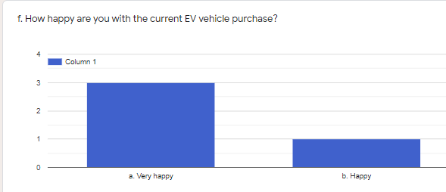

Figure 1 Satisfaction with EV purchase by EV owners

All EV owners who participated in the survey are well aware of the benefits of low emission vehicle (LEV) such as an EV. They stated that there is need for quick charging stations mainly on the Thimphu-Punakha and Phuentsholing highways and across the whole country if possible.

They said that charging stations should be maintained periodically, and they will not mind paying some fee to the charging station operator/caretaker to do regular cleanups and maintenance. They complained that quick charging stations at Chunzom was broken and not fixed for a long time and the one at Paro town is always found locked.

They suggested that notification/ information should be shared if any station is out of service or under maintenance either through a mobile App or even through a WhatsApp group for EVs in the country.

Short videos or training or manual on how to use the quick charger should also be provided to public. It was mentioned that some Charging stations do not have any instruction on how to use them, while some has a short poster.

The respondents think that there is lack of adequate policy and regulatory framework for electric vehicles in our country. To encourage more people to go for EVs, they believe that both DC fast charger and AC charger should be there at all potential sites; banks should have separate schemes and policies for customers availing EV loan, give more awareness programs on EV. Free parking facility for EVs would encourage people to use electric cars.

EV owners also mentioned that there is no benefit or differentiation to them after changing their vehicle number plates to green at an additional cost.

Some owners are also concerned about the cost of spare parts and services should they need them in future. As of now, they have not carried out any maintenance of repairs on the cars for 4-5 years.

* 1. Field Mission Photographs

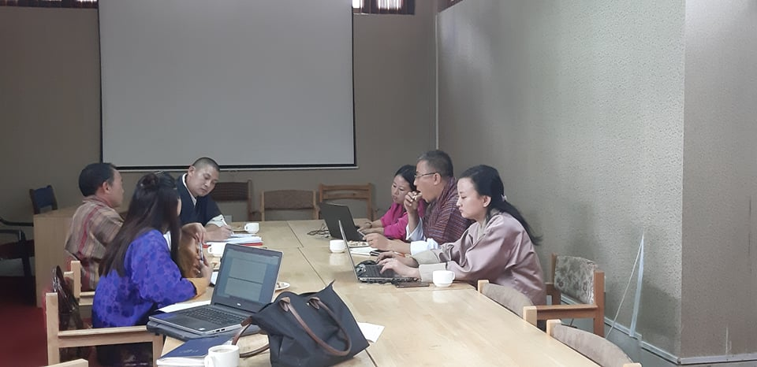

Figure 1: Focus Group Discussion with RSTA officials

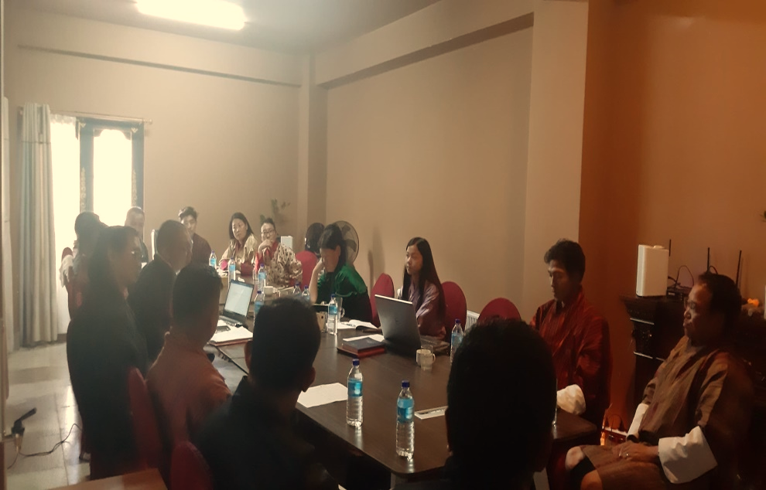

Figure 2: The National Consultant in discussion with car dealers

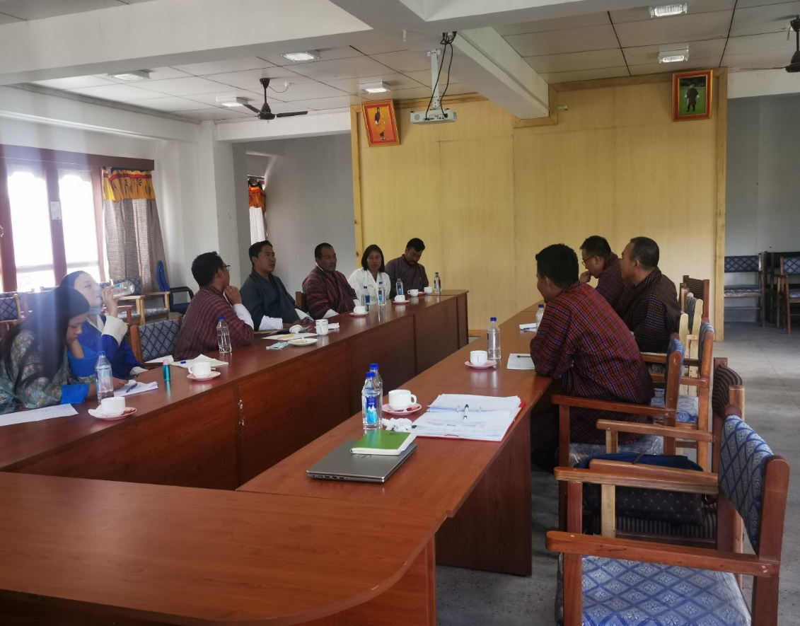

Figure 3: FGD in Wangdue with local government, taxi tshogpas and RSTA officials

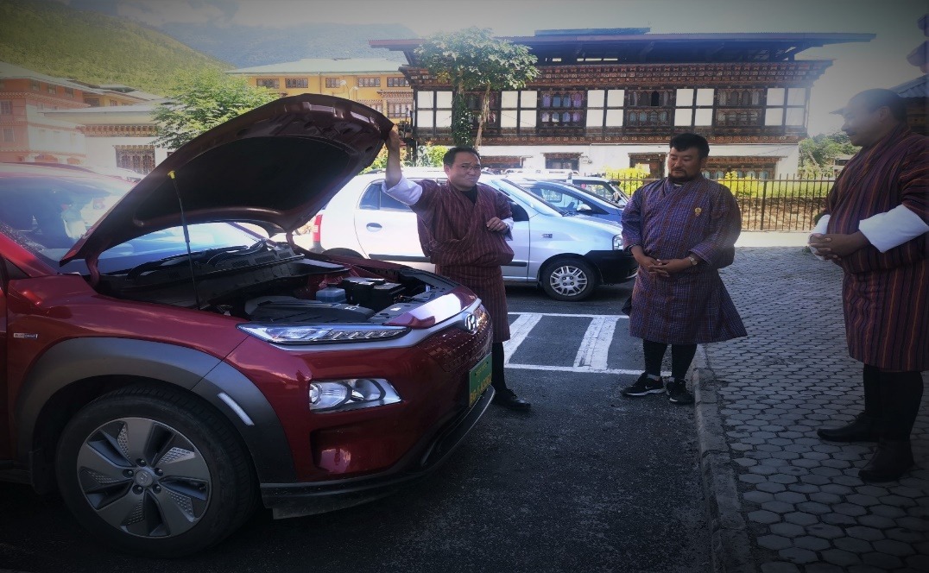

Figure 4: PM of EV Project training taxi drivers in Bajo with the Hyundai Kona EV

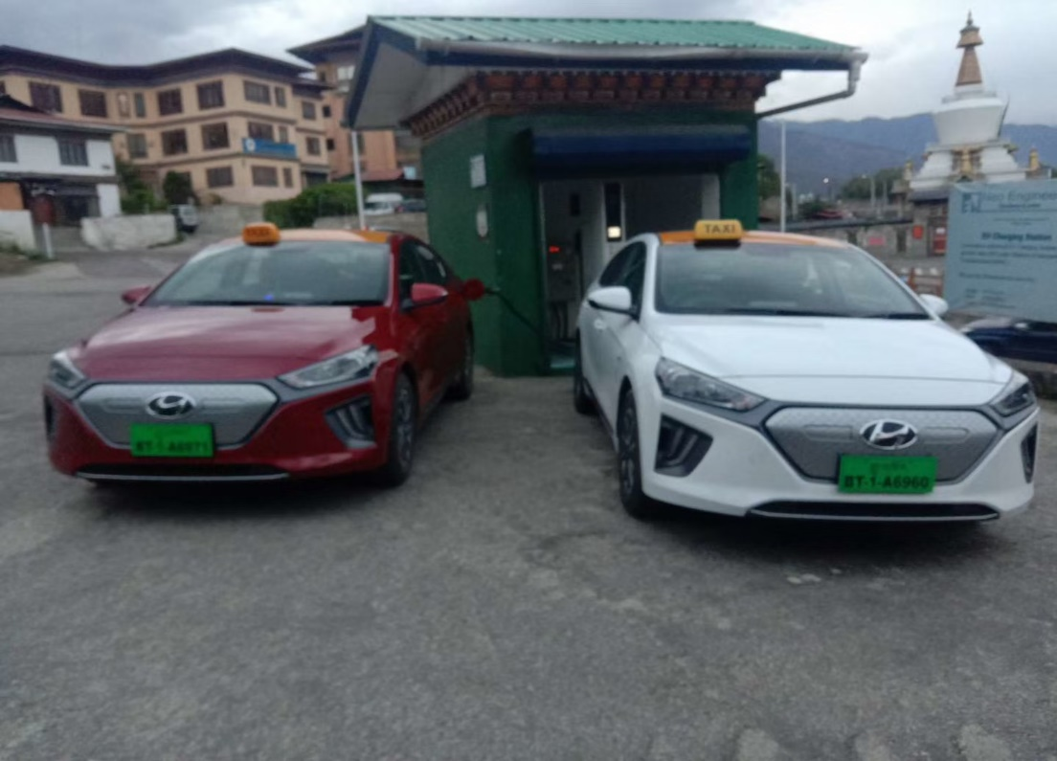

Figure 5: Hyundai Ionic EV Taxis in Thimphu ( picture Dorji Wangchuk)

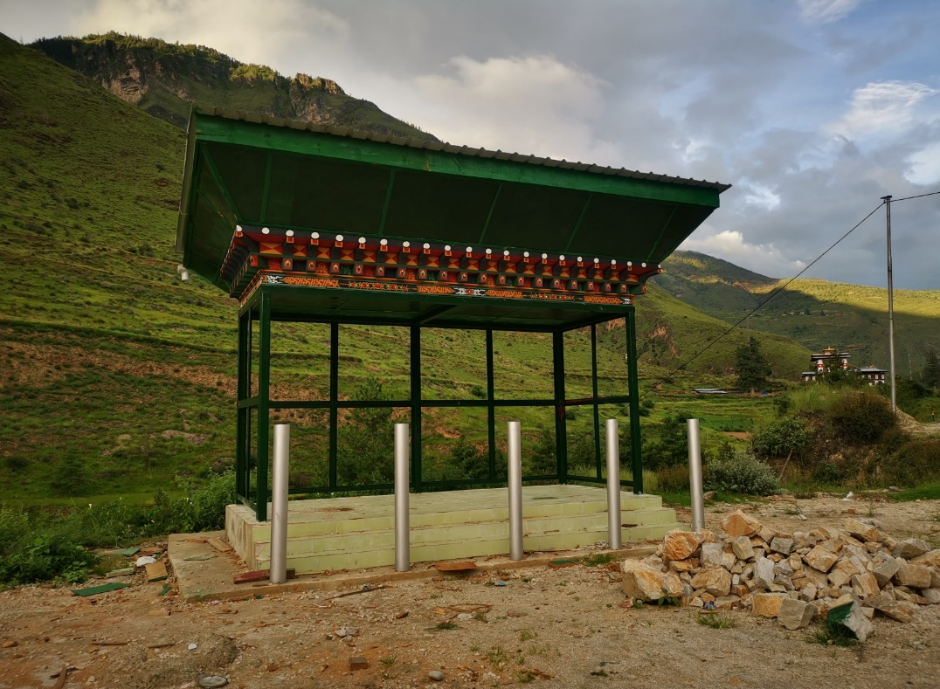

Figure 6: Quick Charging Station Site at Paro Tachhogang

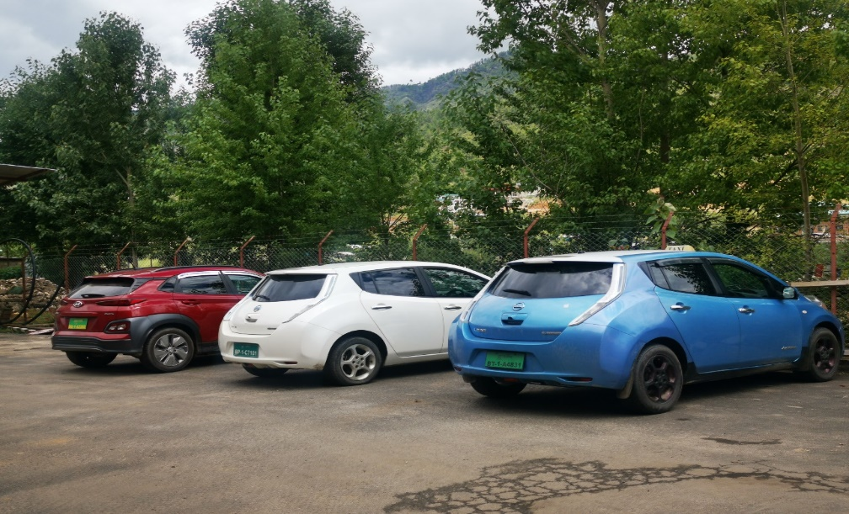

Figure 7: EVs in Bhutan

* 1. List of Documents Reviewed
  + Project Identification Form
  + UNDP Initiation Plan
  + UNDP Project Document
  + UNDP Environmental and Social Screening results
  + Project Inception Report
  + Project Implementation Reports
  + Quarterly Progress Reports
  + Audit reports
  + GEF CCM TT
  + Combined Delivery Report
  + Field Mission Report
  + Project Board Minutes of Meeting
  + Workshop Reports
  + EV Specifications
  + Implementation and Monitoring Stage Quality Assurance Report
  + World Bank EV Report
  + Manual for Calculating GHG Benefits of GEF Projects
  + Manual for Calculating GHG Benefits of Global Environment Facility Transportation Projects
  + Financial and Administration guidelines used by Project Team
  1. Signed UNEG Code of Conduct for Evaluators/MTR Consultants

Evaluators/Consultants:

1. Must present information that is complete and fair in its assessment of strengths and weaknesses so that decisions or actions taken are well founded.

2. Must disclose the full set of evaluation findings along with information on their limitations and have this accessible to all affected by the evaluation with expressed legal rights to receive results.

3. Should protect the anonymity and confidentiality of individual informants. They should provide maximum notice, minimize demands on time, and respect people’s right not to engage. Evaluators must respect people’s right to provide information in confidence and must ensure that sensitive information cannot be traced to its source. Evaluators are not expected to evaluate individuals and must balance an evaluation of management functions with this general principle.

4. Sometimes uncover evidence of wrongdoing while conducting evaluations. Such cases must be reported discreetly to the appropriate investigative body. Evaluators should consult with other relevant oversight entities when there is any doubt about if and how issues should be reported.

5. Should be sensitive to beliefs, manners and customs and act with integrity and honesty in their relations with all stakeholders. In line with the UN Universal Declaration of Human Rights, evaluators must be sensitive to and address issues of discrimination and gender equality. They should avoid offending the dignity and self-respect of those persons with whom they come in contact in the course of the evaluation. Knowing that evaluation might negatively affect the interests of some stakeholders, evaluators should conduct the evaluation and communicate its purpose and results in a way that clearly respects the stakeholders’ dignity and self-worth.

6. Are responsible for their performance and their product(s). They are responsible for the clear, accurate and fair written and/or oral presentation of study limitations, findings and recommendations.

7. Should reflect sound accounting procedures and be prudent in using the resources of the evaluation.

MTR Consultant Agreement Form

Agreement to abide by the Code of Conduct for Evaluation in the UN System:

Name of Consultant: Ameya Udgaonkar

Name of Consultancy Organization (where relevant): PricewaterhouseCoopers Pvt. Ltd.

I confirm that I have received and understood and will abide by the United Nations Code of Conduct for Evaluation.

Signed at New Delhi (Place) on 13/11/20 (Date)

Signature: 

MTR Consultant Agreement Form

Agreement to abide by the Code of Conduct for Evaluation in the UN System:

Name of Consultant: ___Chhimi Dorji

Name of Consultancy Organization (where relevant): ChhimiD Consulting

I confirm that I have received and understood and will abide by the United Nations Code of Conduct for Evaluation.

Signed at Thimphu, Bhutan (Place) on ________13/11/2020________ (Date)



Signature: ___________________________________

* 1. Final MTR Report Clearance Form

Midterm Review Report Reviewed and Cleared By:

Commissioning Unit

Name: _____________________________________________

Signature: _____________________________ Date: __________________

UNDP-GEF Regional Technical Advisor

Name: _____________________________________________

Signature: _____________________________ Date: ___________________

* 1. Budget Re-appropriation possibility



1. Bhutan Vehicle Emission Reduction Road Map and Strategy, 2017–2025, ADB BRIEFs, ADB, July 2019
2. Bhutan Vehicle Emission Reduction Road Map and Strategy, 2017–2025, ADB BRIEFs, ADB, July 2019
3. The Bhutan Electric Vehicle Initiative, Scenarios, Implications, and Economic Impact, WBG, 2016
4. https://www.pressreader.com/bhutan/bhutan-times/20190331/281522227448773