Terminal Evaluation (TE)
INCEPTION REPORT

September 2020

Implementing a “Ridge to Reef” approach to protect biodiversity & ecosystem functions in Nauru

(R2R Nauru Project)
GEF Project ID 5381 / UNDP PIMS 5218

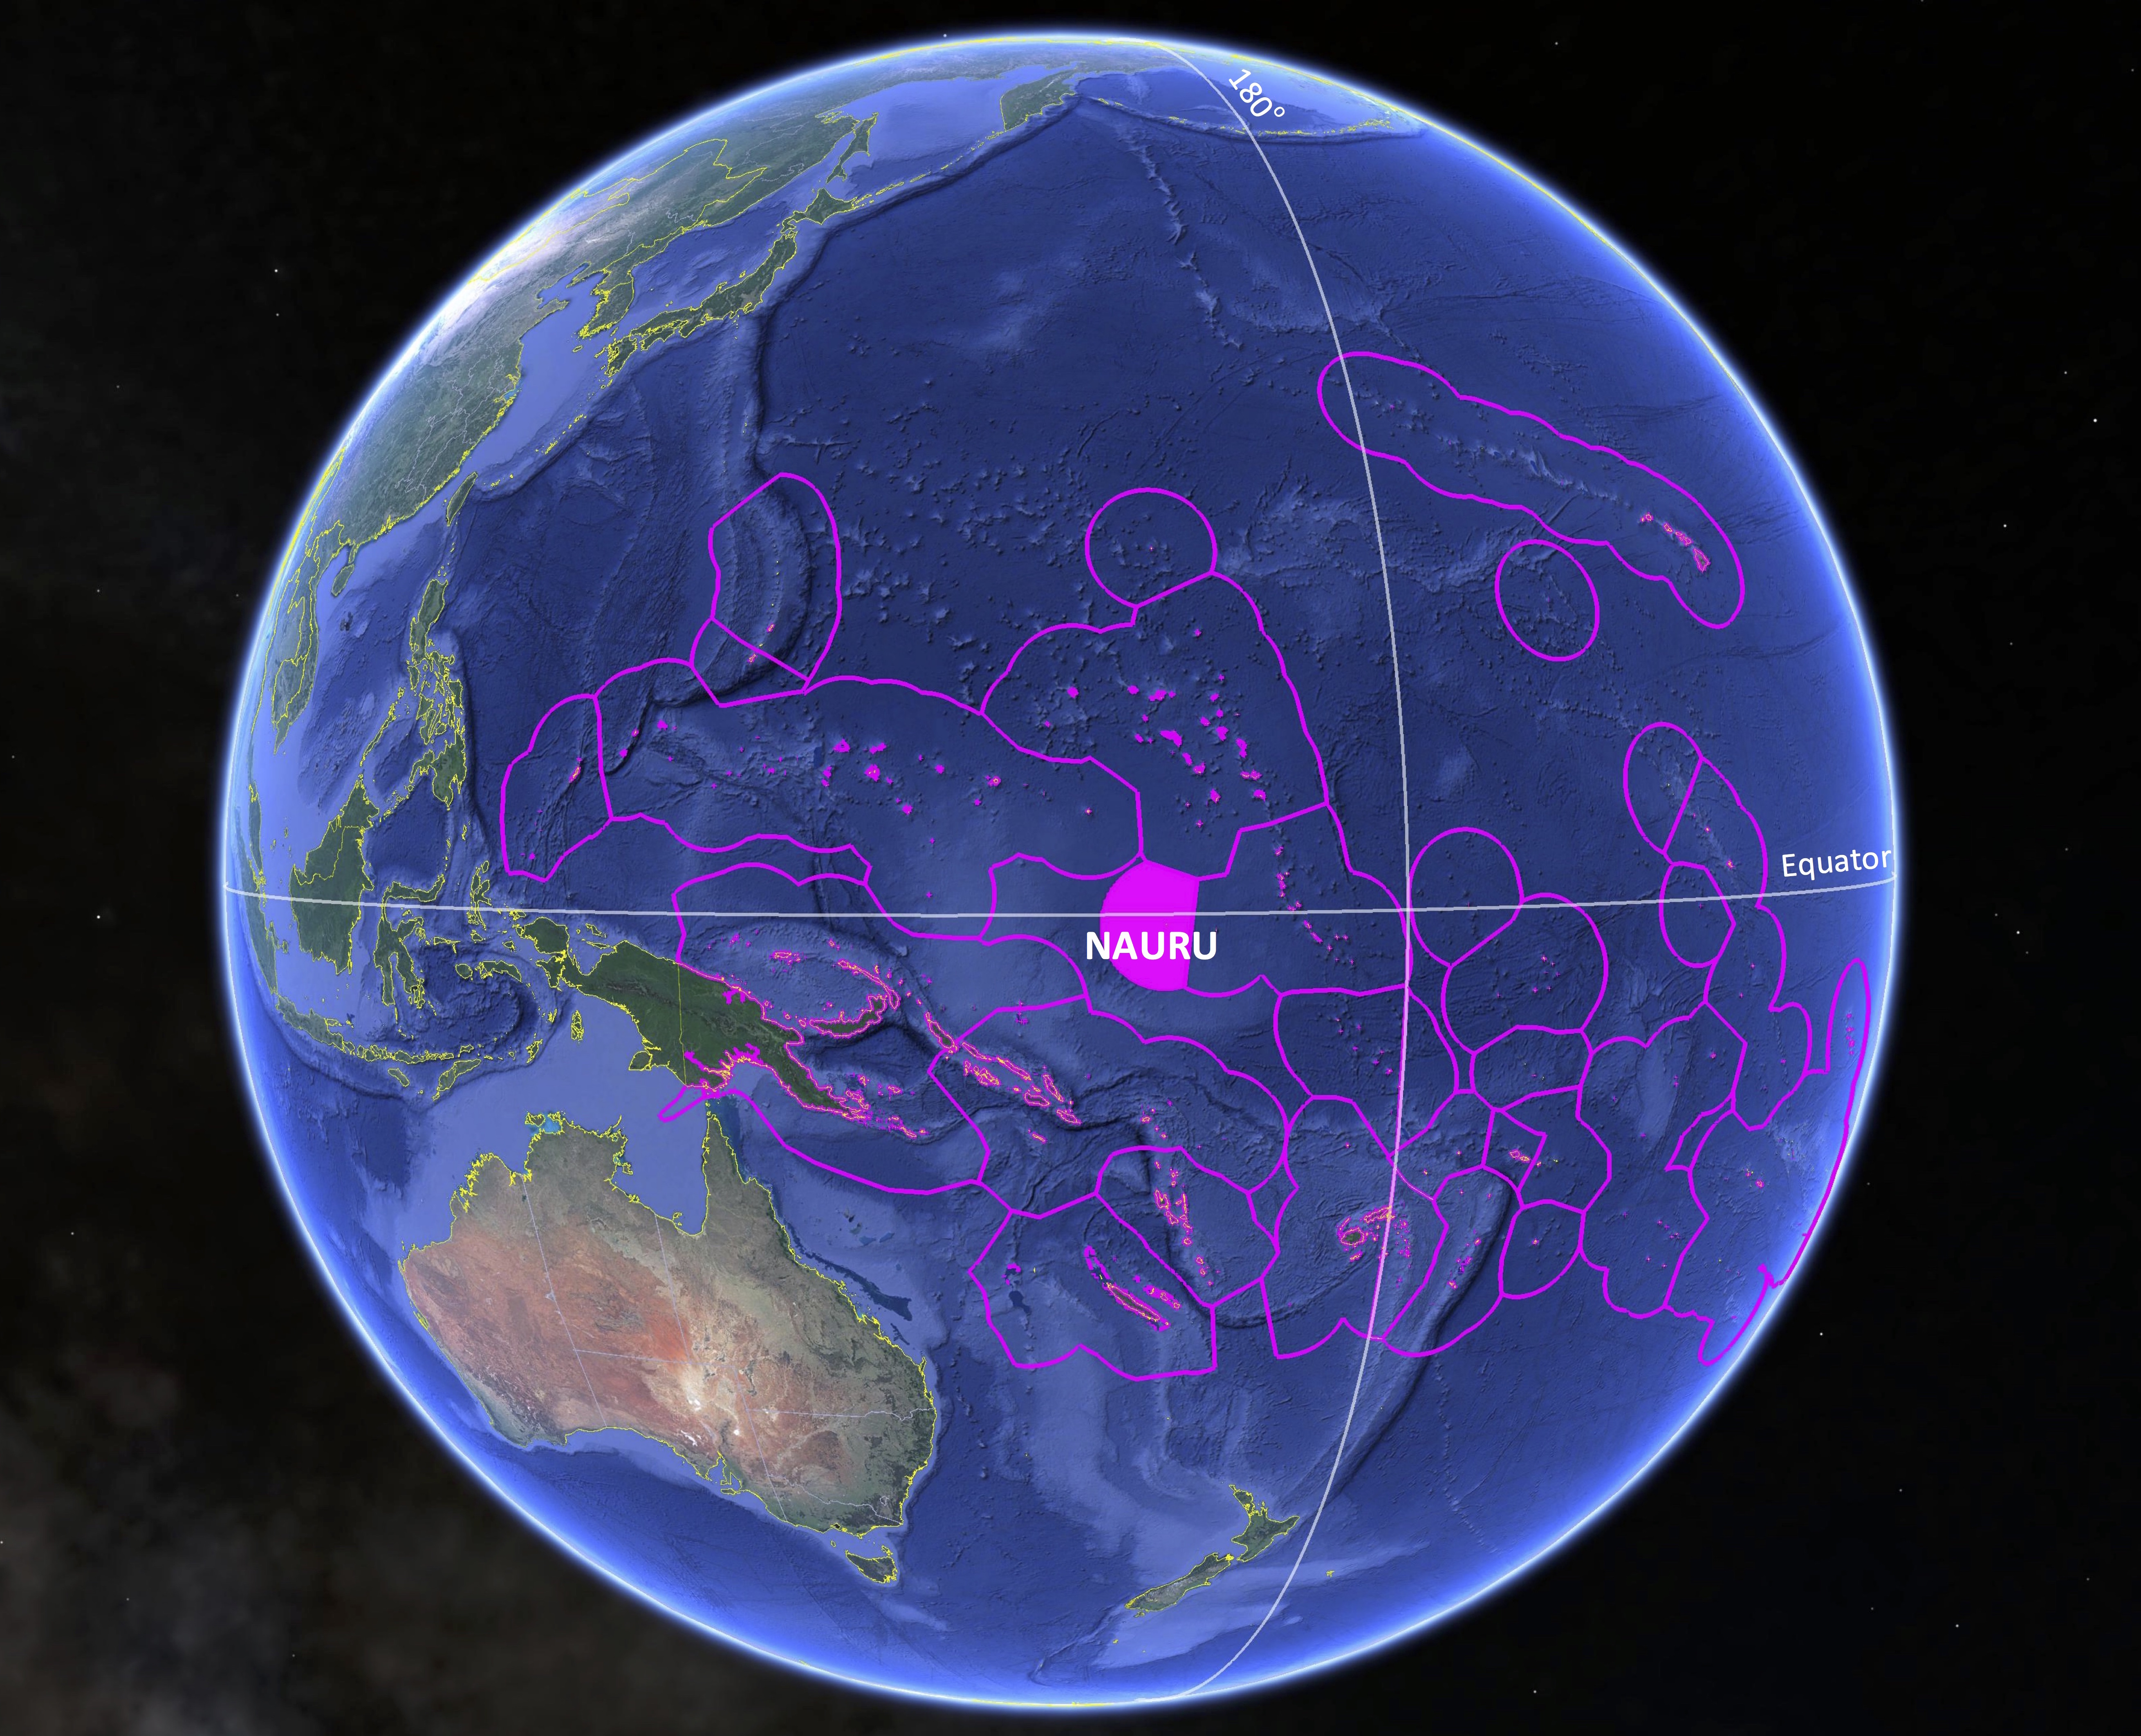 | 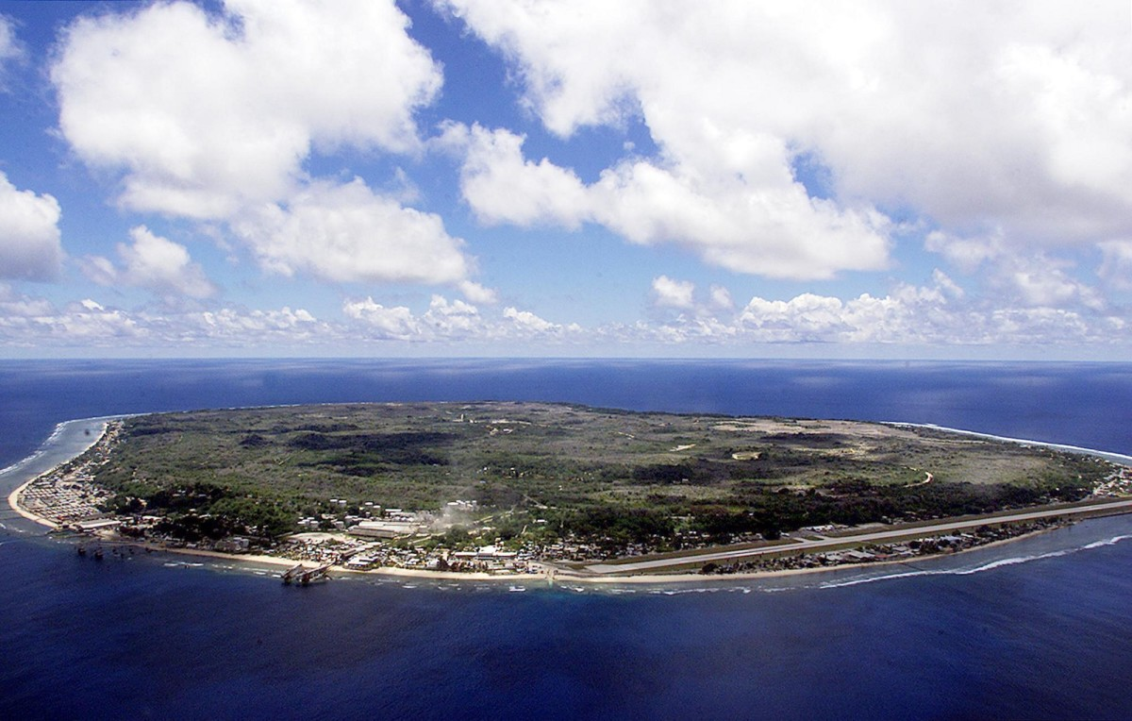

Prepared by:
Steve Raaymakers
EcoStrategic Consultants
Terminal Evaluation Consultant

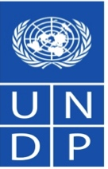

PROJECT DATA:

Project Title: | Implementing a “Ridge to Reef” approach to protect biodiversity & ecosystem functions in Nauru (R2R Nauru Project)
Parent Program: | Pacific Islands Ridge to Reef National Priorities - Integrated Water, Land, Forest & Coastal Management to Preserve Ecosystem Services, Store Carbon, Improve Climate Resilience and Sustain Livelihoods (Pacific R2R Program).
GEF Agency: | United Nations Development Programme (UNDP)
GEF Project ID: | 5381
UNDP ID No.s: | Project ID: 00092583. Atlas Award ID: 00084678. PIMS No.: 5218
Country: | Republic of Nauru
Region: | Asia Pacific
GEF Cycle & Trust Fund: | GEF 5 – GEF Trust Fund (GTF)
GEF Focal Area: | Multi-Focal Area: Biodiversity (BD), Land Degradation (LD) and International Waters (IW).
GEF Focal Area Objectives:  (Climate Change Adaptation - CCA) | - BD-1: Improve Sustainability of Protected Area Systems.  - BD-2 Mainstream Biodiversity Conservation and Sustainable Use into Production Landscapes, Seascapes and Sectors.  - LD-3: Integrated Landscapes: Reduce pressures on natural resources from competing land uses in the wider landscape).  - IW-3: Support Foundational Capacity Building, Portfolio Learning and Targeted Research Needs for Ecosystem-Based, Joint Management of Transboundary Water Systems.
UNDAF Outcome:  (UNDAF Pacific Sub-region 2013-17) | - Outcome Area 1: Environmental management, climate change and disaster risk management.
Executing Entity: | Government of Nauru (GoN)  - Environment Division, Department of Commerce, Industry & Environment (DCIE).
Other Partners: | GoN  - Nauru Fisheries & Marine Resources Authority (NFMRA).  - Department of Agriculture.
Pilot Sites (N to S - see Figure 1): | 5 Districts: Anabar, Ijuw, Anibare, Buada, Meneng.
Financing: | At endorsement (US$) | At completion (US$)
GEF financing (BD): | 1,789,829 | TBA (to be assessed during the TE)
GEF financing (LD): | 699,429
GEF financing (IW): | 155,100
GEF financing (Total): | 2,644,358
UNDP: | 40,000 | TBA
GoN - DCIE: | 6,253,000 | TBA
GoN - NFMRA: | 2,114,000 | TBA
Total co-financing: | 8,407,000 | TBA
Total Project Cost: | 11,051,358 | TBA
Planned project duration: | 48 months (4 years). Two extensions granted.
Planned Start (ProDoc Signature): | March-April 2015.
Actual Start (Inception Workshop): | February 2016.
Mid Term Review (MTR) Date: | Jul-Oct 2018.
Terminal Evaluation (TE) Date: | Sept-Oct 2020.
Operational Closing Date: | Original planned: April 2019. First Extension: 30 June 2020. Second Extension: 28 February 2021.
TABLE OF CONTENTS

1. INTRODUCTION 4
1.1 Project background 4
1.2 Objectives of the Terminal Evaluation 5
1.3 Risks & assumptions 6
2. METHODOLOGY 7
2.1 Guidelines 7
2.2 TE Scope & approach 7
2.3 Support from National Consultant 7
2.4 Data analysis & triangulation 8
2.5 TE ratings 9
2.6 TE report structure & content 10
2.7 Ethics 10
3. TE DELIVERABLES & WORKPLAN 10
ANNEX 1: Key Stakeholders 11
ANNEX 2: R2R Nauru – Terminal Evaluation Questions (EQs) 14
ANNEX 3: List of documents and reports 15
ANNEX 4: Progress Report Template (from ProDoc PRF) 16
ANNEX 5: TE Report Structure 22
ANNEX 6: TE Consultant Code of Conduct Agreement Form 24
ANNEX 7: TE Terms of Reference 25

1. INTRODUCTION

1.1 Project background

- The R2R Nauru Project is part of the broader Pacific Regional Program on “Pacific Islands Ridge-to-Reef National Priorities – Integrated Water, Land, and Coastal Management to Preserve Biodiversity, Ecosystem Services, Store Carbon, Improve Climate Resilience and Sustain Livelihoods (Pacific R2R Program)”. This program is designed to build stronger linkages between sustainable development and management of freshwater ecosystems (e.g. ground water systems for Nauru) and coastal/marine areas and promotes the implementation of holistic, integrated management of natural resources.

- The R2R Nauru Project is a GEF Full-Size four-year Project (original time-frame April 2015 to April 2019) approved with a total budget of USD$11,051,358.00 comprising a GEF grant of USD$2,644,358, a UNDP grant of $40,000, and in-kind support from the Government of Nauru (GoN) to a total of USD$8, 367, 000.00. The GEF funding component is derived from three focal areas as follows:

- Biodiversity (BD -2): US$1,789,829.
- Land Degradation (LD-3): US$699,429.
- International Waters (IW-3): US$155,100.

- The project is intended to improve the poor performance of Nauru in implementing the Millennium Development Goals (MDGs) 7a and 7b on environmental sustainability and is also linked to implementing Sustainable Development Goals (SDGs) 13 (Climate Action), 14 (Life Under Water) and 15 (Life on Land).

- The project was designed to develop, establish and implement a government and community partnership approach to increase knowledge for better management of natural resources and ecosystem services for the entire Island of Nauru, through demonstrating innovative integrated land, water, biodiversity, coastal and marine management approaches thereby protecting and increasing livelihoods opportunities, food security, and enhancing climate resilience, at five initial Pilot Sites (Districts) of Anabar, Ijuw, Anibare, Buada and Meneng (Figure 1).

- These goals will be achieved by building Nauru’s capacity to implement a comprehensive cross sectorial regime for sustainable land, freshwater water, solid waste, coastal and marine area management and ensuring the initiatives are mainstreamed and established into all levels of decision making including government policy, laws and regulations and community plans.

- The goals of the Project were to be achieved through four project components that are directly interconnected at national and site-based community (district) levels, as follows:

- Component 1 - Conservation of marine biodiversity: Improved management effectiveness of new marine conservation areas.

- Component 2 - Sustainable land and water management: Integrated landscape management practices adopted by local communities living within the ‘bottom-side’ and applicable ‘ridge’, and ‘topside’ areas not covered by mining.

- Component 3 - Governance and institutions: Biodiversity conservation and Sustainable Land Management (SLM) mainstreamed in policy and regulatory frameworks.

- Component 4 - Knowledge Management: Improving data and information systems on biodiversity conservation and land, coastal and marine management best practices for relevant government agencies and communities.

- The Project is being implemented by GoN through the UNDP National Implementation Modality (NIM), with a Project Management Unit (PMU) engaged by UNDP and based within the Environment Division of the Nauru Department of Commerce, Industry & Environment (DCIE). For various reasons which will be assessed in the TE report, here have been significant delays in implementation of the Project with the initial target end date of April 2019 being first extended to June 2020 and now to end of December 2020 for operational closure and end of January 2021 for financial closure, with all activities to be completed by end of February.

- In accordance with UNDP-GEF monitoring and evaluation requirements the Project was subject to a Mid-Term Review (MTR) during July-October 2018 and now as the Project draws to an end, a Terminal Evaluation (TE), which is the subject of this Inception Report.

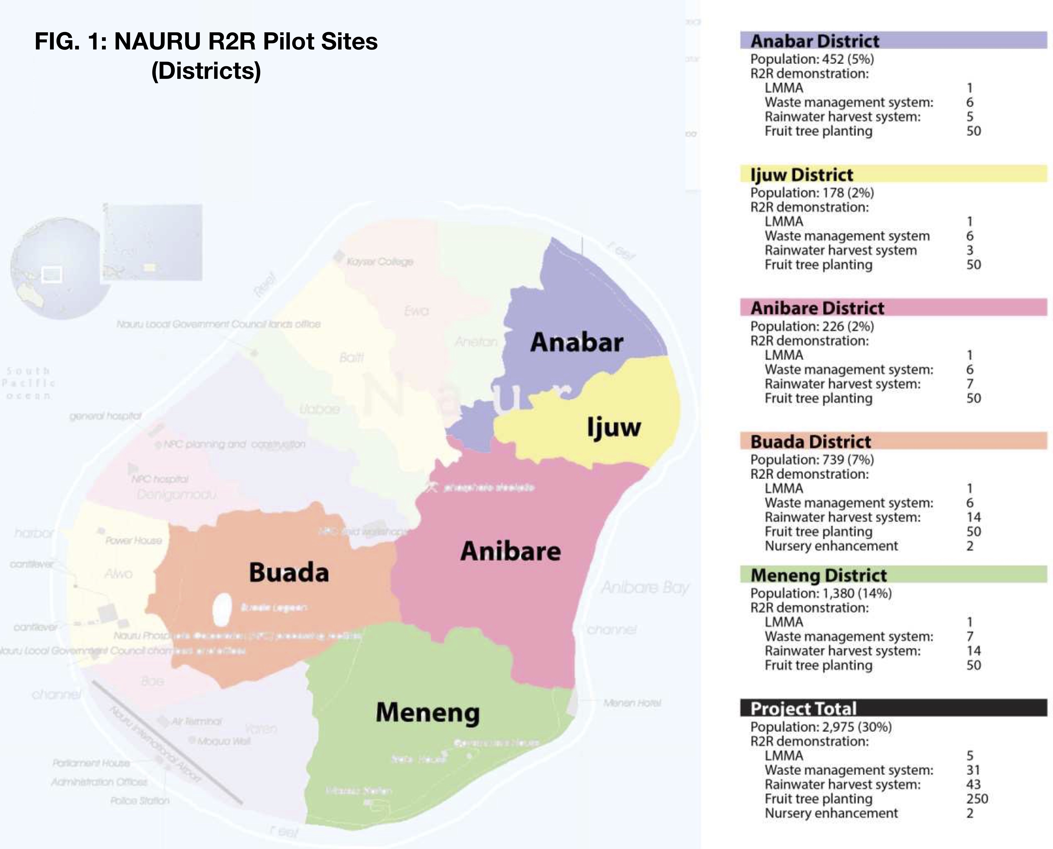

1.2 Objectives of the Terminal Evaluation

- In accordance with the “Guidance for Conducting Terminal Evaluations of UNDP-Supported, GEF-Financed Projects 2020” (the UNDP-GEF TE Guidelines 2020) the overall objectives of the TE are to:

- Assess the achievement of project results against what was expected to be achieved.

- Draw lessons that can:
- improve the sustainability of benefits from this project; and
- aid in the overall enhancement of UNDP programming.

- Further to this, the objectives of the evaluation will be to:

- Assess the achievement of project results supported by evidence (i.e. progress of project’s outcome targets).

- Assess the contribution and alignment of the project to relevant national development plan or environmental policies.

- Assess the contribution of the project results towards the relevant outcome and output of the Sub Regional Programme Document (SRPD) & United Nation Pacific Strategy (UNPS/UNDAF).

- Assess any cross cutting and gender issues examination on the use of funds and value for money.

- The TE report will promote accountability and will assess how cross cutting issues (including gender equality, right based approach, capacity development, poverty-environment nexus, crisis prevention and recovery, disaster risk reduction, climate change mitigation and adaptation as relevant) have been addressed by the project.

1.3 Risks & assumptions

- The TE will be carried out over the period of late September through November 2020, and shall be completed by 30 December 2020; including preparatory activities, desk review, consultation with stakeholders and completion of the TE report. The following risks and assumptions are highlighted for the evaluation, noting that the exclusion of an evaluation mission to Nauru by the TE Consultant (TEC) requires all consultations to be undertaken remotely:

- Essential data from UNDP, PMU, DCIE and partners: The TEC is dependent on and assumes that all essential documents, data and information will be provided by the relevant parties in a timely manner.

- Stakeholder consultations: The TEC is totally dependent on UNDP, PMU and DCIE to complete the stakeholder tables in Annex 1, with email contacts for each stakeholder, and provide these to the TEC by Monday 28 September, so that the TEC can begin to reach out to stakeholders or set up consultations calls with each. The TEC assumes that stakeholders will make themselves available for consultation.

- Timely review of Draft Report: It is assumed that UNDP and GoN will review the TEC’s Draft Evaluation Report (DER) and provide review comments in a timely manner, to allow completion of the Final Evaluation Report (FER) within the TE timeline. Any delays in the provision of review comments by UNDP and/or GoN will require the submission date for the FER to be pushed back pro-rata.

- Language: It is assumed that all consultations can be undertaken in English.

2. METHODOLOGY

2.1 Guidelines

- The overall approach and methodology of the TE will follow the UNDP-GEF TE Guidelines, 2020.

- The TE will also comply with:
- The United Nations Evaluation Group (UNEG) Ethical Guidelines for Evaluators, 2008.
- The United Nations Universal Declaration of Human Rights, in particular being sensitive to and addressing issues of discrimination and gender equality.

(see also section 2 .5 below).

2.2 TE Scope & approach

- The TE will assess the project against the criteria of relevance, effectiveness, efficiency, sustainability, and impact, as defined and explained in the UNDP-GEF TE Guidelines, 2012.

- A set of Evaluation Questions (EQs) are included in Annex 2 and these will be emailed out to all stakeholders with an invitation to complete and send back to the TEC by Friday 9 October. In order to encourage frank and free feedback, questionnaire respondents will NOT be required to identify themselves in the questionnaire, and all responses will be treated as anonymous and fully confidential.

- The TE will evaluate implementation of the Project, and will NOT evaluate individuals.

- The TE will provide evidence‐based information that is credible, reliable and useful.

- The TE will review all relevant sources of information, including the Project Document, project reports – including Annual Project Reviews (APRs) and Project Implementation Reviews (PIRs), project budget revisions, MTR Report, the GEF focal area tracking tools, project files, national strategic and legal documents, and any other materials that the TEC considers useful for this evidence-based assessment. A list of example documents is contained in Annex 3, and additional documents may be requested by the TREC as the evaluation proceeds.

- The TE will assess the key financial aspects of the project, including the extent of co-financing planned and realized. Project cost and funding data will be required, including annual expenditures. Variances between planned and actual expenditures will need to be assessed and explained. Results from recent financial audits, as available, should be taken into consideration.

2.3 Support from National Consultant

- At the time of preparation of this Inception Report a National Consultant (NC) had not yet been recruited and there were still doubts if this would go ahead, due to new UNDP requirements for all consultants to have health insurance, and the lack of availability of such insurance in Nauru – so it may transpire that there will be no NC for this evaluation. If an NC is engaged then in accordance with their ToR they will assist the TEC to set up consultation meetings with stakeholders, chase-up questionnaire responses, collect in-country information, undertake field visits for validation purposes and related in-country tasks.

2.4 Data analysis & triangulation

- The TE will assess how cross cutting issues (including gender equality, right based approach, capacity development, poverty-environment nexus, crisis prevention and recovery, disaster risk reduction, climate change mitigation and adaptation as relevant) have been addressed by the project. Data will be collected across a diverse range of indicators, as far as is available from the project, and analysis will integrate gender considerations, and assess whether data provided by the project is disaggregated by sex and other relevant categories.

- Wherever possible, data triangulation (use of multiple, cross-checked sources of information) will be applied to verify and substantiate information reported and to help overcome bias that may arise from single sources of information. For example, if a stakeholder reports a certain view on an issue, the evaluation team will actively seek views on the same issue from other stakeholders during separate interviews, and the view will only be reported as an evaluation finding if three or more stakeholders share that view.

- When stakeholders report views on matters that can be checked in documents – the relevant documents will be checked. Conversely, when a document reports certain findings, these will be verified by discussing with stakeholders involved with production and/or review of the document.

- When it is not possible to apply triangulation for some Project parameters, due to lack of alternative data sources, for example finance and co-financing data, the reports provided by UNDP on such data, will be accepted at face value.

- NOTE: The TEC will require assistance from UNDP, PMU and DCIE to obtain financial data in order to complete the co-financing table below (Table 1), which will be included in the TE report. In addition the separate UNDP-GEF Co-financing Template provided separately will need to compledted.

TABLE 1: Co-financing Table
Co-financing  (type/source) | UNDP own financing  (mill. US$) |  | Government  (mill. US$) |  | Partner Agency  (mill. US$) |  | Total  (mill. US$)
 | Planned | Actual | Planned | Actual | Planned | Actual | Planned | Actual
Grants:
Loans/Concessions:
In-kind support:
Other:
Totals:

- NOTE: The TEC will also require assistance from UNDP, PMU and DCIE to complete the current and project status of each project component as per the template in Annex 4., by Friday 2 October.

- Once the Draft Evaluation Report is ready, just prior to submitting the report the TEC will present the major findings “live” to UNDP, PMU and DCIE via a PowerPoint presentation on Zoom. This will allow interactive discussion and questions and clarifications to be asked of the TEC, before the Draft Evaluation Report is reviewed by UNDP, PMU and DCIE.

- The Final TE Report will be accompanied by a separate Audit Trail showing how each review comment has been addressed.

2.5 TE ratings

- The TEC will include ratings of the project’s results and brief descriptions of the associated achievements in a TE Ratings & Achievement Summary Table in the Executive Summary of the TE report, as shown in Table 2 and based on the rating scales shown in Table 3.

TABLE 2: UNDP-GEF Evaluation Ratings Framework
Evaluation Ratings:
1. Monitoring and Evaluation | Rating | 2. IA& EA Execution | Rating
M&E design at entry: |  | Quality of UNDP Implementation:
M&E Plan implementation: |  | Quality of Execution - Executing Agency:
Overall quality of M&E: |  | Overall quality of Implementation / Execution:
3. Assessment of Outcomes | Rating | 4. Sustainability | Rating
Relevance: |  | Financial resources:
Effectiveness: |  | Socio-political:
Efficiency: |  | Institutional framework and governance:
Overall Project Outcome Rating: |  | Environmental:
 |  | Overall likelihood of sustainability:

TABLE 3: UNDP-GEF Evaluation Rating Scales
Rating scales:
Ratings for Outcomes, Effectiveness, Efficiency, M&E, I&E Execution | Sustainability Ratings: | Relevance Ratings:
6: Highly Satisfactory (HS): No shortcomings.  5: Satisfactory (S): minor shortcomings.  4: Moderately Satisfactory (MS).  3. Moderately Unsatisfactory (MU): Significant shortcomings.  2. Unsatisfactory (U): Major problems.  1. Highly Unsatisfactory (HU): Severe problems. | 4. Likely (L): Negligible risks. | 2. Relevant (R).
 | 3. Moderately Likely (ML): Moderate risks. | 1. Not relevant (NR).
 | 2. Moderately Unlikely (MU): significant risks.  1. Unlikely (U): Severe risks. | Impact Ratings:  3. Significant (S).  2. Minimal (M).  1. Negligible (N).
Additional ratings where relevant:
Not Applicable (N/A). Unable to Assess (U/A).

2.6 TE report structure & content

- The TE Report will be structured in accordance with Annex 5 below, as required by the TE ToR.

2.7 Ethics

- As outlined in section 2.1 above the evaluation will be conducted in accordance with the UNEG Ethical Guidelines for Evaluators, and the TEC has signed the Evaluation Consultant Code of Conduct (Annex 6). In particular, the TEC will ensure the anonymity and confidentiality of individuals who will be interviewed. In respect to the UN Declaration of Human Rights, results will be presented in a manner that clearly respects stakeholders’ dignity and self-worth.

3. TE DELIVERABLES & WORKPLAN

- The total duration of the TE will be 30 working days starting Monday 11 September 2020, and shall not exceed 30 December 2020. The TE activities, tasks and completion dates, supported by the NC where relevant, are shown in Table 4 (Note: As outlined above there may be no NC for this evaluation).

TABLE 4: TE activities, tasks and target completion dates (red text = target date for UNDP/PMU/DCIE)
Activity /Task | Target Date (2019)
1. TEC Prepares Draft Inception Report: | Mon 21 Sept
2. Hold Inception Zoom Meeting: | Thurs 24 Sept
3. TEC Submits Final Inception Report | Fri 25 Sept
4. UNDP/PMU/DCIE provide completed Stakeholder Tables (Annex 1) to TEC: | Mon 28 Sept
5. TEC sends out Questionnaire (Annex 2) to all stakeholders: | Fri 25 Sept
6. Stakeholders return completed Questionnaires to TEC for analysis (NC to chase up): | Fri 8 Oct
7. UNDP/PMU/DCIE provide completed Progress Table (Annex 4) to TEC: | Fri 2 Oct
8. UNDP/PMU/DCIE provide completed GEF Tracking Tools (BD, LD & IW) to TEC: | Fri 8 Oct
9. TEC completes detailed desk-review of all relevant documents: | Fri 2 Oct
10. TEC with NC support completes stakeholder consultations (remote): | Fri 16 Oct
11. TEC with NC support prepares and submits Draft Evaluation Report (DER): | Fri 30 Oct
12. TEC with NC support presents DER to UNDP/PMU/DCIE via PowerPoint on Zoom: | Fri 30 Oct
13. UNDP/PMU/GoN/stakeholder review DER: | Fri 6 Nov
14. TEC with NC support submits Final Evaluation Report (FER) incorporating review comments, and with separate Audit Trail:* | Sun 15 Nov*
*NOTE: Subject to timely review and provision of comments on the DER by UNDP/PMU/GoN/stakeholders. Any delays with review will push back final submission date pro-rata.

ANNEX 1: Key Stakeholders

UNDP/PMU/DCIE please complete and email to TEC by by Monday 28 September

UNDP [pls include relevant RTA, Fiji Regional staff, country staff]
Name | Position | Role in Project | Email
Jose Padilla | RTA UNDP | Regional Technical Advisor | jose.padilla@undp.org
Winifereti Nainoca | RSD Deputy Team Leader | Oversight Management | winifereti.nainoca@undp.org
Loraini Sivo | RSD Programme Analyst | Project Manager | loraini.sivo@undp.org
Josua Turaganivalu | RSD Programme Associate | Project Support Staff | josua.turaganivalu@undp.org

Project Management Unit (PMU) [Pls include previous staff that have moved on, and their current email]
Name | Position | Role in Project | Email
[add columns as required]

GoN [pls include all relevant staff form DCIE, DoA, NFMRA, any other departments]
Name | Organization | Position | Role in Project | Email
[add columns as required]

Pilot Site - Anabar [pls include all relevant key stakeholders from this community]
Name | Organization | Position | Role in Project | Email
[add columns as required]

Pilot Site – Ijuw [pls include all relevant key stakeholders from this community]
Name | Organization | Position | Role in Project | Email
[add columns as required]

Pilot Site – Anibare [pls include all relevant key stakeholders from this community]
Name | Organization | Position | Role in Project | Email
[add columns as required]

Pilot Site – Buada [pls include all relevant key stakeholders from this community]
Name | Organization | Position | Role in Project | Email
[add columns as required]

Pilot Site – Meneng [pls include all relevant key stakeholders from this community]
Name | Organization | Position | Role in Project | Email
[add columns as required]

Other Stakeholders [pls include all relevant key stakeholders not included above]
Name | Organization | Position | Role in Project | Email
[add columns as required]

ANNEX 2: R2R Nauru – Terminal Evaluation Questions (EQs)

(Note: These are simplified, summary questions to be sent out to Stakeholders. The full set of Evaluation Questions contained in the ToR and specified in the UNDP-GEF TE Guidelines 2020 will be addressed by the TEC in the TE Report, using all data sources)

Please note: Respondents are NOT required to identify themselves on the questionnaire, and all responses will be treated as anonymous and fully confidential.

1. Relevance: How does the project relate to environmental and development priorities at the local, national and Pacific regional levels?

2. Effectiveness: To what extent have the expected outcomes and objectives of the project been achieved?

3. Efficiency: Was the project implemented efficiently? What was done well and what could have been done more efficiently, and how?

4. Sustainability: Do you think that the project outcomes will be continued and sustained after the Project has closed? What are main barriers to continuity and sustainability that need to be overcome? (e.g. financial, institutional, technical capacity, community ownership, etc):

5. Impact: Has the project helped to reduce environmental stress and/or improved ecological status?

6. Project Implementation: Please share your views about the effectiveness of project implementation. What was done well and what could have been done better, and how?

7. Communication & Consultation: In your view how effective was the project at communication and consultation with key stakeholders? What was done well and what could have been done better, and how?

8. Main Project Strengths: In your view what are the main strengths of the project?

9. Main Project Weaknesses: In your view what are the main weaknesses of the project?

10. Other Points / Recommendations: Please feel free to make any additional points and recommendations about the project:

Pls email your response to the Terminal Evaluation Consultant by Friday 8 October 2020.
steve@eco-strategic.com

ANNEX 3: List of documents and reports

These are example documents, and additional documents may be requested by the TREC as the evaluation proceeds.

GEF Documents:
- GEF focal area strategic Programme Objectives
- GEF Project Identification Form (PIF), Project Document and Log Frame Analysis (LFA)
- GEF Tracking Tools (BD, LD & IW).

UNDP Documents:
- UN Development Assistance Framework (UNDAF)
- Country Programme Document (CPD)
- Country Programme Action Plan (CPAP)

Project Documents:
- Project Document (ProDoc)
- Project Inception Report
- Implementing/executing partner arrangements
- List and contact details for project staff, key project stakeholders, including Project Boards, and other partners to be consulted
- Midterm Evaluation (MTE) and other relevant evaluations and assessments
- Annual Project Implementation Reports (PIR)
- Annual Progress Reports (APRs)
- Quarterly Progress Reports (QPR)
- Project budget, broken out by outcomes and outputs
- Financial Data including Combined Delivery Reports (CDR)
- Comprehensive report of subcontracts and consultancies.
- Technical reports and similar outputs produced by the Project.
- Sample of project communications materials, i.e. press releases, brochures, documentaries, etc.

ANNEX 4: Progress Report Template (from ProDoc PRF)

Component 1: Conservation of marine biodiversity
UNDP/PMU/DCIE please complete columns 5 and 6 and submit to TEC by Friday 2 October.
Please complete columns 5 and 6 using exactly the status of the Targets in column 4, not other criteria or long narrative.
1. Objectives and Outcomes | 2. Indicator | 3. Baseline | 4. Targets  End of Project | 5. Target Status at end Sept 2020 | 6. Likely Target Status at end Feb 2021 (Project End)
OBJECTIVE: To preserve biodiversity, ecosystem services, improve climate resilence and sustain livelihoods inNauru using a ridge to reef approach. | Status of integrated land, water and coastal management in Nauru | Sectoral approach with minimal efforts towards coastal biodiversity conservation | LMMA implementation and integrated land-use management planning and implementation:
OUTCOME 1.1  Improved management effectiveness of new marine conservation areas. | Area of coastal and marine water under active management as a Locally Managed Marine Area | Zero= LMMA will be introduced through this project | 33% of coastline of Nauru (approximately 10 km) incorporated into LMMA with implementation of management plans in 4 Districts (Anabar, Anibare, Ijuw and Meneng):
Output 1.1.1  A network of locally managed marine areas (community based (CB) or locally managed marine areas (LMMAs) established through community actions and supporting enabling government actions | Agreement between Government and DCC on LMMA establishment management | Zero | 4 agreements with 4 coastal districts:
 | Ecosystem health survey identifying priority sites for protection and management | Limited information exists | Important marine biodiversity protected through zoning plans:
Output 1.1.2  LMMAs strengthened through development and implementation of management plans (following participatory approaches and Integrated Coastal Management to address threats, including climate change impacts; guidelines for utilizations of MMAs including closed seasons and closed areas agreed on and implemented) | Development of island level (national) based / CCA / LMMA Plan | Zero national plan developed | National LMMA plan prepared and adopted:
 | Implementation of District level LMMA action Plans | Zero LMMA actionplans | 4 Management Plans developed and implemented for each selected Districts:

Component 2: Sustainable land and water management
UNDP/PMU/DCIE please complete columns 5 and 6 and submit to TEC by Friday 2 October.
Please complete columns 5 and 6 using exactly the status of the Targets in column 4, not other criteria or long narrative.
1. Objectives and Outcomes | 2. Indicator | 3. Baseline | 4. Targets  End of Project | 5. Target Status at end Sept 2020 | 6. Likely Target Status at end Feb 2021 (Project End)
OUTCOME 2.1  Integrated landscape management practices adopted by local communities living within the ‘bottom-side’, and applicable ‘ridge’, and ‘topside’ areas not covered by mining. | Land-use management plans being actively implemented in all 5 districts | Currently zero. | 5 district land-use management plans being actively implemented:
Output 2.1.1  Biophysical, demographic and socioeconomic assessments conducted and reviewed in the project districts, focusing on the bottom-side and applicable ‘ridge’ areas and topside not covered by mining. | 2.1.1.1 Baselines for land-use plan and terrestrial environmental management established. | Rudimentary land-use maps with limited district focus terrestrial | National assessment completed with detailed 5 district terrestrial profiles:
Output 2.1.2  Integrated agriculture land-use plan developed for the bottom-side and applicable ‘ridge’ and topside areas that are not covered by mining through review of the draft land-use plan and patterns of land ownership for the project districts/sites. | 2.1.2.1 Integrated land-use plan | Land-use plan (1994). | Island-wide integrated agriculture land-use plans developed with special focus on priority districts:
Output 2.1.3  Soil and water conservation measures implemented, including through rehabilitation of degraded land in ‘ridge’ and topside areas using economic species such as fruit trees and increase of communal water storage facilities in the five water-stressed project districts to support home gardens and household water supply. | 2.1.3.1 Number of households growing fruit-trees to contribute to soil conservation measures | Less than 5% in each of the 5 districts growing fruit trees (tbc during land-use planning) | 20% of households in each of the 5 districts:
 | 2.1.3.2 Water storage enhanced in selected communities | Approximately 195 water harvesting / storage facilities (with 3,000m³ capacity) in place | 43 additional water harvesting / storage facilities established:
Output 2.1.4  Drought- and salt-tolerant food crops tested and practices disseminated to districts (communities and households) building on initiatives of bilateral and multilateral organizations. | 2.1.4.1 Number of participating households using new crop varieties in all 5 districts | Zero households using “ New” drought and salt-tolerant crops not currently available | 20% of households in each of the 5 districts:
Output 2.1.5  Innovative measures implemented (e.g. composting toilets) to reduce pollution loads by at least 10% on LMMAs to improve ecosystem health and sustain ecosystem services. This is based on successes of pilot demonstrations of the IWRM project and as a way of implementing the national IWRM plan. | 2.1.5.1 Number of waste water treatment systems (compositing toilets) for reducing pollution established. | 6 composting toilets operational in 5 districts | 28 new composting toilets operational in 5 districts:

Component 3: Governance and institutions
UNDP/PMU/DCIE please complete columns 5 and 6 and submit to TEC by Friday 2 October.
Please complete columns 5 and 6 using exactly the status of the Targets in column 4, not other criteria or long narrative.
1. Objectives and Outcomes | 2. Indicator | 3. Baseline | 4. Targets  End of Project | 5. Target Status at end Sept 2020 | 6. Likely Target Status at end Feb 2021 (Project End)
OUTCOME 3.1  Biodiversity conservation and SLM mainstreamed in policy and regulatory frameworks. | Same as Output 3.1.1
Output 3.1.1  Relevant policies developed for key sectors such as environment, waste management, natural resource management, coastal fisheries, and agricultural land-use” developed. | 3.1.1.1. Number of policies developed for key sectors incorporating R2R considerations. | Various old and draft plans exist, but need urgent re-validation and revision to support JNAP and NBSAP implementation | 4 sectoral plans / strategies developed  e.g. Waste Management; Integrated Agriculture Land Use; NBSAP implementation; Environmental & Social Safeguards Policy & Guidelines:
Output 3.1.2  Capacity strengthening of national agencies associated with new policies and framework process development and formulation, including drafting of legislation, monitoring and evaluation (impacts, water quality, etc.), project implementation/ management and oversight, GIS, land-use planning; participation in relevant trainings organized through the regional R2R project. | 3.1.2.1 Number of trained government personnel on integrated R2R approaches (gender disaggregated data) | Limited –  Zero  Training on GIS, project implementation / management and oversight in 2007 and 2008) and on Vulnerable & Adaptation assessment for JNAP. | 45 staff from across ministries and fisheries authority: | .
Output 3.1.3  Community leaders in 5 districts capacitated towards biodiversity conservation, sustainable land management and climate change adaptation through appropriate trainings and other capacity building activities focusing on: project management, land-use planning, waste management, and marine management. | 3.1.3.1. Number of district leaders trained on applying and enforcing skills in integrated R2R approaches with due consideration for gender distribution | Zero | 15 community leaders (DCC, Women Reps and NGO reps) all 5 districts for each district):
 | 3.1.3.2. Proportion of population (households) adopting specific actions to enhance R2R management in districts | ~20% of households (All community members exposed to community outreach in Past) | Up to 80% of households adopting specific actions:
Component 4: Knowledge management
UNDP/PMU/DCIE please complete columns 5 and 6 and submit to TEC by Friday 2 October.
Please complete columns 5 and 6 using exactly the status of the Targets in column 4, not other criteria or long narrative.
1. Objectives and Outcomes | 2. Indicator | 3. Baseline | 4. Targets  End of Project | 5. Target Status at end Sept 2020 | 6. Likely Target Status at end Feb 2021 (Project End)
OUTCOME 4.1  Improved data and information systems on biodiversity and land management best practices. | Same as 4.1.1.1 and 4.1.2.1
Output 4.1.1  Integrate data and information on biodiversity and sustainable land management and relevant sectors on the Environment; provide inputs to the regional R2R program on monitoring and progress reporting on the Pacific R2R program | 4.1.1.1. Number of databases developed for DCIE. | Zero (one database was developed for climate change, however this needs to be expanded and integrated) | 1 (integrated database):
 | 4.1.1.2. Number of training courses conducted on database setup & maintenance. | Zero | 4 (1 per year):
Output 4.1.2  Knowledge products (videos, photo stories, flyers, brochures) on all thematic areas and best practices developed and disseminated through various media (print and broadcast). | 4.1.2.1. Number of community members receiving information on R2R management and taking action to enhance environment | Zero community households | 500 households :

ANNEX 5: TE Report Structure

i. | Opening page:  Title of UNDP supported GEF financed project  UNDP and GEF project ID#s.  Evaluation time frame and date of evaluation report  Region and countries included in the project  GEF Operational Program/Strategic Program  Implementing Partner and other project partners  Evaluation team members  Acknowledgements
ii. | Executive Summary  Project Summary Table  Project Description (brief)  Evaluation Rating Table  Summary of conclusions, recommendations and lessons
iii. | Acronyms and Abbreviations  (See: UNDP Editorial Manual)
1. | Introduction  Purpose of the evaluation  Scope & Methodology  Structure of the evaluation report
2. | Project description and development context  Project start and duration  Problems that the project sought to address  Immediate and development objectives of the project  Baseline Indicators established  Main stakeholders  Expected Results
3. | Findings  (In addition to a descriptive assessment, all criteria marked with (*) must be rated)
3.1 | Project Design / Formulation  Analysis of LFA/Results Framework (Project logic /strategy; Indicators)  Assumptions and Risks  Lessons from other relevant projects (e.g., same focal area) incorporated into project design  Planned stakeholder participation  Replication approach  UNDP comparative advantage  Linkages between project and other interventions within the sector  Management arrangements
3.2 | Project Implementation  Adaptive management (changes to the project design and project outputs during implementation)  Partnership arrangements (with relevant stakeholders involved in the country/region)  Feedback from M&E activities used for adaptive management  Project Finance:  Monitoring and evaluation: design at entry and implementation (*)  UNDP and Implementing Partner implementation / execution (*) coordination, and operational issues
3.3 | Project Results  Overall results (attainment of objectives) (*)  Relevance(*)  Effectiveness & Efficiency (*)  Country ownership  Mainstreaming  Sustainability (*)  Impact
4. | Conclusions, Recommendations & Lessons  Corrective actions for the design, implementation, monitoring and evaluation of the project  Actions to follow up or reinforce initial benefits from the project  Proposals for future directions underlining main objectives  Best and worst practices in addressing issues relating to relevance, performance and success
5. | Annexes  ToR  Itinerary  List of persons interviewed  Summary of field visits  List of documents reviewed  Evaluation Question Matrix  Questionnaire used and summary of results  Evaluation Consultant Agreement Form

ANNEX 6: TE Consultant Code of Conduct Agreement Form

Evaluators:
- Must present information that is complete and fair in its assessment of strengths and weaknesses so that decisions or actions taken are well founded.
- Must disclose the full set of evaluation findings along with information on their limitations and have this accessible to all affected by the evaluation with expressed legal rights to receive results.
- Should protect the anonymity and confidentiality of individual informants. They should provide maximum notice, minimize demands on time, and respect people’s right not to engage. Evaluators must respect people’s right to provide information in confidence, and must ensure that sensitive information cannot be traced to its source. Evaluators are not expected to evaluate individuals, and must balance an evaluation of management functions with this general principle.
- Sometimes uncover evidence of wrongdoing while conducting evaluations. Such cases must be reported discreetly to the appropriate investigative body. Evaluators should consult with other relevant oversight entities when there is any doubt about if and how issues should be reported.
- Should be sensitive to beliefs, manners and customs and act with integrity and honesty in their relations with all stakeholders. In line with the UN Universal Declaration of Human Rights, evaluators must be sensitive to and address issues of discrimination and gender equality. They should avoid offending the dignity and self-respect of those persons with whom they come in contact in the course of the evaluation. Knowing that evaluation might negatively affect the interests of some stakeholders, evaluators should conduct the evaluation and communicate its purpose and results in a way that clearly respects the stakeholders’ dignity and self-worth.
- Are responsible for their performance and their product(s). They are responsible for the clear, accurate and fair written and/or oral presentation of study imitations, findings and recommendations.
- Should reflect sound accounting procedures and be prudent in using the resources of the evaluation.
Evaluation Consultant Agreement Form
Agreement to abide by the Code of Conduct for Evaluation in the UN System
Name of Consultant: Steve Raaymakers
Name of Consultancy Organization (where relevant): EcoStrategic Consultants
I confirm that I have received and understood and will abide by the United Nations Code of Conduct for Evaluation.
Signed at Cairns, Australia on 21 September 2020
Signature:

ANNEX 7: TE Terms of Reference

[Pls refer separate document – not included here to keep size of this document reasonable]

Plans for management of waste from piggery and poultry included in this plan
Using a six-point rating scale: 6: Highly Satisfactory, 5: Satisfactory, 4: Marginally Satisfactory, 3: Marginally Unsatisfactory, 2: Unsatisfactory and 1: Highly Unsatisfactory, see section 3.5, page 37 for ratings explanations.
www.unevaluation.org/unegcodeofconduct

