Annex 9: RPD-MTR: Outcome 1 Mapping of RPD Activities by Scale and Impact
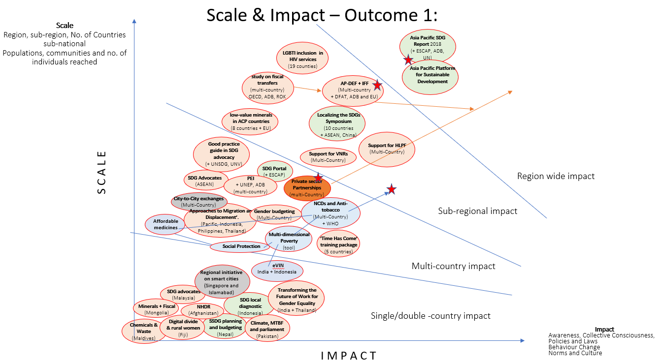

Annex 10: RPD MTR - Outcome 2 & 3 Mapping of RPD Activities by Scale and Impact
