|  |
| --- |
| ***CATALYZING IMPLEMENTATION OF THE STRATEGIC ACTION PROGRAM FOR THE SUSTAINABLE MANAGEMENT OF SHARED LIVING MARINE RESOURCES IN THE CARIBBEAN AND NORTH BRAZIL SHELF LARGE MARINE ECOSYSTEMS***  ***CLME+***  **GEF/UNDP/UNOPS** |

## **TERMINAL EVALUATION**

Table of Contents

Part 1: Executive Summary 4

Part 2: Introduction 9

2.1 Evaluation purpose and scope 9

2.2 Methodology 9

2.3 Evaluation questions 10

2.4 Ethics 10

2.5 Limitations 10

Part 3: Project Description 11

3.1 Context and problems that the project sought to address 11

3.2 Business as Usual Scenario and associated baseline projects 14

3.3 The alternative scenario: immediate and development objectives of the project 16

3.4 Project Components and expected results 17

3.5 The project’s Theory of Change 21

3.6 Total resources that have been identified for the project 23

3.7 Key stakeholders and main partners 24

3.8 Execution and management arrangements 26

Part 4: Findings 28

4.1 Project Design 28

4.1.1 The Results Framework 29

4.1.2 Assumptions and Risks 31

4.1.3 Key stakeholders and partners involved in the project 32

4.1.4 Gender Responsiveness of project design 32

4.2 Project Implementation 33

4.2.1 Adaptive management 33

4.2.2 Actual stakeholder participation and partnership arrangements 34

4.2.3 Project Finance and Co-finance 36

4.2.4 Monitoring & Evaluation: design at entry, implementation, and overall assessment 38

4.2.5 Implementing Agency (UNDP), Executing Agency (UNOPS): overall assessment of implementation/oversight and execution. 39

4.2.6 Risk Management 41

4.2.7 Social and Environmental Standards 41

4.3 Project Results and Impacts 41

4.3.1 Progress Towards Objective and Expected Outcomes 41

4.3.2 Relevance 48

4.3.3 Effectiveness 48

4.3.4 Efficiency 49

4.3.5 Overall Project Outcome 49

4.3.6 Sustainability 49

Part 5: Main Findings, Conclusions, Recommendations, Lessons Learned 50

5.1 Main Findings 50

5.2 Conclusions 51

5.3 Lessons Learned and Recommendations 52

**Tables**

Table 1. CLME+ States, Territories, Associated States, Departments, Outermost Regions and Islands with a Special Status

Table 2. CLME+ States and Territories and CARICOM, SICA, OECS and ACS memberships

Table 3 – Outcomes formulation Table 4 – Theory of Change

Table 5 – Project Stakeholders

Table 6 – Project Executing Partners

Table 7: Results Framework elements

Table 8: MTR key recommendations

Table 9: Co-financing

Table 10. Confirmed Sources of Co-Financing at TE Stage

**Figures**

Figure 1: Institutional arrangements

Fig.2 – CLME+ Intervention logic Figure 3: The roles of country representatives

Figures 4 and 5: Expenditure evolution over total budget, and Cumulative expenditures 2015 - 2021

Figure 6: Financial Implementation Progress of the three main executing partners

**Acronyms**

CANARI Caribbean Natural Resource Institute

CARICOM Caribbean Community and Common Market

CBD Convention on Biological Diversity

CCAD* Central American Commission for Environment and Development

CEP Caribbean Environment Programme (UNEP)

CERMES Centre for Resource Management and Environmental Studies

CFMC Caribbean Fisheries Management Council

CLME Caribbean Large Marine Ecosystem

CLME+ Caribbean and North Brazil Shelf Large Marine Ecosystems (CLME Project)

COP Conference of Parties

CRFM Caribbean Regional Fisheries Mechanism

CSAP Civil Society Action Program

CSO Civil Society Organization

DSS Decision Support system

EA Executing Agency

EAF Ecosystem Approach to Fisheries

EBM Ecosystem-based Management

FAO Food and Agricultural Organization

FAO- WECAFC Food and Agricultural Organization of the United Nations - Western Central Atlantic

Fisheries Commission

FFO Fisher Folk Organizations

GCFI Gulf and Caribbean Fisheries Institute

GEB Global Environmental Benefits

GEF Global Environment Facility

GEAF Governance Effectiveness Assessment Framework

GPA Global Program of Action for the Protection of the Marine Environment from Land Based Activities

IGO Inter-Governmental Organization

IOC Intergovernmental Oceanographic Commission of UNESCO

IOCARIBE IOC UNESCO Sub-commission for the Caribbean Sea and Adjacent Regions

IUU Illegal, Unreported and Unregulated fishing

IW International Waters

IWC International Waters Conference

IW-LEARN International Waters Learning Exchange and Resource Network

LBS Protocol concerning Pollution from Land-Based Sources and Activities (Cartagena Convention)

LME Large Marine Ecosystem

LMR Living Marine Resources (CLME Project)

M&E Monitoring and Evaluation

MOU Memorandum of Understanding

MPA Marine Protected Area

MTE Mid-Term Evaluation (CLME Project)

NAP National Action Plan

NBSAP National Biodiversity Strategies and Action Plans

NBSLME North Brazil Shelf Large Marine Ecosystem

NGO Non-Governmental Organization

NOAA National Oceanic and Atmospheric Administration

OECS Organization of Eastern Caribbean States

OSPESCA* Organization of the Central American Fisheries and Aquaculture Sector

PCU Project Coordinating Unit

PEG Project Executive Group (CLME Project)

PIR Project Implementation Review (UNDP)

PPG Project Preparation Grant

PSAP Private Sector Action Program (CLME Project)

PSC Project Steering Committee (CLME Project)

RFB Regional Fisheries Body

RFMO Regional Fisheries Management Organization

RGB Regional Governance Body

RGF Regional Governance Framework (CLME Project)

SAP Strategic Action Program (CLME Project)

SCM Steering Committee Meetings (CLME Project)

SGI Small Grant Initiatives (CLME Project)

SGP Small Grants Program (GEF)

SICA* Central American Integration System

SIDS Small Island Developing States

sLMR shared Living Marine Resources (CLME Project)

SPAW Specially Protected Areas and Wildlife Protocol (Cartagena Convention)

STAC Scientific Technical Advisory Committee

STAP Scientific and Technical Advisory Panel

TDA Transboundary Diagnostic Analysis (CLME Project)

TE Terminal Evaluation (UNDP/GEF projects; CLME Project)

TORs Terms of Reference

UNDP United Nations Development Program

UNEP United Nations Environment Program

UNESCO United Nations Educational, Scientific and Cultural Organization

UNOPS United Nations Office for Project Services

USA United States of America

USD United States Dollars

UWI University of the West Indies

# **Part 1: Executive Summary**

The Caribbean and North Brazil Shelf Large Marine Ecosystems (jointly referred to as “the CLME+ region region”) are two of the world’s 66 Large Marine Ecosystems. Together, they cover a total marine area of ± 4.4 million km2. This vast marine space is a major contributor to regional socio-economic development and is key to many globally important ecological processes. The CLME+ is bordered by over 35 States and Territories and is therefore considered one of the most geopolitically diverse and complex marine regions in the world. These culturally diverse countries and territories range from among the largest (e.g. Brazil, USA) to among the smallest (e.g. Barbados, St. Kitts and Nevis) and from the most developed to the least developed in the world. The geopolitical fragmentation of the CLME+ region is indicative of the highly transboundary nature of both the marine resources as well as of the problems affecting these resources. At the same time this level of fragmentation is indicative of the crucial importance of enhancing the cooperation among CLME+ region countries and stakeholders in order to ensure sustainable societal benefits, both at the regional, national and local levels.

Fisheries and tourism are two key economic drivers in the region that are highly dependent on the health of these marine ecosystems. Over the past decades, pollution, habitat degradation and unsustainable fishing practices have increasingly impacted ecosystem health in the CLME+ region. In 2014, as the result of a GEF IW foundational project (CLME), the countries bordering the region endorsed a 10-year Strategic Action Program (SAP) which provided Governments and the relevant Inter-Governmental Organizations (IGOs) with a roadmap to reverse degradation of the marine environment and to secure its important resource base. By October 2017, the SAP had been endorsed at the political level by 35 Ministers representing 25 countries and 6 overseas territories from the region.

The aim of the project object of the present Terminal Evaluation was to support the implementation of the following SAP actions addressing the five key issues of transboundary concern which are putting at risk the sustainability of the shared living marine resources of the CLME+ region identified by the diagnostic assessments:

(i) The highly fragmented governance frameworks of the marine environment in general and of fisheries in particular, distributed across a number of sub-regional entities responding to different governing bodies and with different country representatives (SAP Strategies 1-3).

(ii) The limited human/financial resources and capacity to implement/enforce governance frameworks, compounded by inadequate access to data and information, public awareness and participation, and consideration of the value of ecosystem goods and services.

(iii) Lack of experience in the implementation of the Ecosystem-Based Management approach for key ecosystems and associated fisheries in the CLME+ region.

(iv) The lack of financial resources for governmental action, recognized as an important root cause of the region’s limitations in terms of the scale at which actions to address environmental degradation and to support the development of a blue economy can currently be implemented.

(v) The insufficient communication, co-ordination and information exchange among primary CLME+ region SAP stakeholders and among the myriad of existing and planned projects, activities and initiatives in the region, constituting an important barrier to fully capture the societal and environmental benefits expected from the project and other investments.

|  |  |  |  |
| --- | --- | --- | --- |
| Project Details |  | Project Milestones |  |
| Project Title | Catalyzing Implementation of the Strategic Action Program for the Sustainable Management of Shared Living Marine Resources in the Caribbean and North Brazil Shelf Large Marine Ecosystems | PIF Approval Date: | November 7th , 2013 |
| UNDP Project ID (PIMS #): | 5247 | CEO Endorsement Date: | March 4th, 2015 |
| GEF Project ID: | 5542 | ProDoc Signature Date: | April 22nd, 2015 (as per PIMS+ register) |
| UNDP Atlas Business Unit, Award ID, Project ID: | Award ID: 00085866 | Date Project Manager hired: | May 1st, 2015 |
| Country/Countries: | Antigua and Barbuda, Bahamas, Barbados, Belize, Brazil, Colombia, Costa Rica, Dominica, Dominican Republic, Guatemala, Grenada, Guyana, Haiti, Honduras, Jamaica, Mexico, Nicaragua, Panama, St. Kitts and Nevis, St. Lucia, St. Vincent and the Grenadines, Suriname, and Trinidad and Tobago  Non GEF eligible country: USA | Inception Workshop Date: | 24-26 January, 2016 |
| Region: | LAC | Mid-Term Review Completion Date: | October 30th, 2018 |
| Focal Area: | International Waters | Terminal Evaluation Completion date: | March 30th, 2021 |
| GEF Strategic Priorities/Objectives: | IW 2 (GEF 5) | Planned Operational Closure Date: | October 31st, 2021 |
| Trust Fund: | GEF TF | | |
| Implementing Partner (GEF Executing Entity): | UNOPS | | |
| NGOs/CBOs involvement: | through consultations | | |
| Private sector involvement: | through consultations | | |

|  |  |  |
| --- | --- | --- |
| Financial Information | | |
| PDF/PPG | at approval (US$M) | at PPG completion (US$M) |
| GEF PPG grants for project preparation | 300,000 | 450,000 |
| Co-financing for project preparation |  |  |
| Project | at CEO Endorsement (US$M) | at TE (US$M) |
| [1] UNDP contribution: | 2.619.579 | 0 |
| [2] Government: | 98,117,248 | 105,496,481 |
| [3] Other multi-/bi-laterals: | 33,416,695 | 32,548,506 |
| [4] Private Sector: | NA |  |
| [5] NGOs: | NA |  |
| [6] Total co-financing [1 + 2 + 3 + 4 + 5]: | 134,153,695 | 138.044,987 |
| [7] Total GEF funding: | 12,500,000 | 12,500,000 |
| [8] Total Project Funding [6 + 7] | 146,653,695 | 150,544,987 |

**Project Information Table**

|  |  |
| --- | --- |
|  | |
| 1. Monitoring & Evaluation (M&E) | Rating |
| M&E design at entry | HS |
| M&E Plan Implementation | HS |
| Overall Quality of M&E | HS |
| 2. Implementing Agency (IA) Implementation & Executing Agency (EA) Execution | Rating |
| Quality of UNDP Implementation/Oversight | S |
| Quality of Implementing Partner Execution | S |
| Overall quality of Implementation/Execution | S |
| 3. Assessment of Outcomes | Rating |
| Relevance | HS |
| Effectiveness | S |
| Efficiency | MS |
| Overall Project Outcome Rating | S |
| 4. Sustainability | Rating |
| Financial sustainability | ML |
| Socio-political sustainability | L |
| Institutional framework and governance sustainability | L |
| Environmental sustainability | HL |
| Overall Likelihood of Sustainability | ML |

**Evaluation Ratings Table**

|  |  |
| --- | --- |
| Ratings for Outcomes, Effectiveness, Efficiency,  M&E, Implementation/Oversight, Execution, Relevance | Sustainability ratings: |
| 6 = Highly Satisfactory (HS): exceeds expectations and/or no shortcomings  5 = Satisfactory (S): meets expectations and/or no or minor shortcomings  4 = Moderately Satisfactory (MS): more or less meets expectations and/or some shortcomings  3 = Moderately Unsatisfactory (MU): somewhat below expectations and/or significant shortcomings  2 = Unsatisfactory (U): substantially below expectations and/or major shortcomings  1 = Highly Unsatisfactory (HU): severe shortcomings  Unable to Assess (U/A): available information does not allow an assessment | 4 = Likely (L): negligible risks to sustainability  3 = Moderately Likely (ML): moderate risks to sustainability  2 = Moderately Unlikely (MU): significant risks to sustainability  1 = Unlikely (U): severe risks to sustainability  Unable to Assess (U/A): Unable to assess the expected incidence and magnitude of risks to sustainability |

|  |
| --- |
|  |
| TE Recommendations |
| * Entrusting regional IGOs and CSOs with the formulation of many of the plans, strategies, policy reforms and governance mechanisms and tools called for in the SAP, and delegating their approval/adoption to their governance bodies and processes, was a strategic design choice of the CLME+ project, coherent with the approach taken in the foundational CLME project. The role of countries’ governments should not however be underestimated, particularly in IW projects aiming at determining policy, institutional, legislative reforms and investments at the country and regional levels, such as the CLME+ project. In order to facilitate country ownership, and the internalization of project outputs, future efforts should consider expanding the direct role of countries in project execution, and putting in place effective communication mechanisms with and within countries, streamlined and implemented according to ad hoc protocols. |
| * Aligning marine and coastal environmental protection policies (coastal zone management, land-based sources of pollution, biodiversity, etc.) and sustainable approaches to wild capture fisheries is a key aspect of the blue economy and an innovative contribution of the CLME+ project that should be broadly replicated. Similarly, intersectoral consultation/coordination at country level is of paramount importance to forge and consolidate regional policies aimed at enhancing the sustainability of shared fisheries and other marine resources. |
| * In addition to, and alongside the highly commendable efforts to introduce ecosystem-based management of fisheries, strengthen RFMOs, fight against IUU fishing, and support more biodiversity friendly fishing practices, which characterize the CLME+ project, as well as the whole IW fisheries portfolio, the transition from wild capture fisheries, to “fish farming” and the creation of alternative livelihoods for fisherfolks have not received noticeable attention. Overall, production from the world's wild fisheries has levelled out and may be starting to decline, as a contrast to farmed fisheries and mariculture that are growing in importance, and are technological in nature, revolving around developments in aquaculture. The promotion of sustainable aquaculture – in many instances the only long-term solution – should be a relevant part of future efforts in the region. The rights of artisanal coastal fisherfolks communities, whose role in providing food security to coastal populations, as noted by an interviewee, has been made even more precious by the global economic crisis caused by the Covid 19 pandemic, need to be protected. This notwithstanding, there are cases where the priority of preserving living marine resources for future generations should prevail, and require the reduction or even the ban of wild capture fishing. Hence the imperative of promoting alternative livelihoods for affected fishing communities, a field that has received minor attention in the CLME+ project, limited to a small but notable pilot on sea moss farming in St Kitts and Nevis. |
| * As recommended by the TE of the foundational CLME project, broadening the partnership to include multilateral development banks (CAF, CDB, IDB, The World Bank) and other potential multilateral and bilateral donors, could be beneficial for fostering as well as coordinating SAP implementation in the long term. Systematic dialogue with these critical potential partners has not however happened in the CLME+ project. The CLME+ TE reiterates the recommendation to seek the involvement of development banks and major donors in future initiatives. |

# **Part 2: Introduction**

## **2.1 Evaluation purpose and scope**

The TE has been conducted according to the guidance, rules and procedures established by UNDP and GEF as reflected in the UNDP Evaluation Guidance for GEF Financed Projects. The author of this Terminal Evaluation is Dr. Andrea Merla, who also authored the Mid Term Review.

The objectives of the evaluation are to assess the achievement of project results, and to draw lessons that can both improve the sustainability of benefits from this and similar projects, and aid in the overall enhancement of UNDP programming.

## **2.2 Methodology**

The evaluation effort is framed using the criteria of *relevance, effectiveness, efficiency, sustainability, and impact,*as defined and explained in the UNDP Guidance for Conducting Terminal Evaluations of UNDP-supported, GEF-financed Projects. The evaluation strives to provide evidence‐based information that is credible, reliable and useful, obtained through a participatory and consultative approach ensuring close engagement with government counterparts, in particular the GEF operational focal point, UNDP Country Office, project team, UNDP GEF Technical Adviser based in the region and key stakeholders. The evaluator was expected to conduct a field mission to the region that had to be cancelled due to the Covid pandemic. Interviews were held with the following organizations and individuals:

* Representatives of Intergovernmental Organizations, CSOs and other entities part of the PEG
* Selected project National Focal Points
* PCU staff
* UNDP GEF Regional Technical Advisor
* UNDP Head, Water & Ocean Governance Program
* Executing Agency representative

The evaluator has reviewed all relevant sources of information, such as the project document, project M&E reports – including Annual APR/PIR, project budget revisions, mid-term review, progress reports, GEF focal area tracking tools, project files, national strategic and legal documents, documents produced by the project and other materials that the evaluator considered useful for this evidence-based evaluation. An assessment of project performance has been carried out, based against expectations set out in the Project Results Framework, which provides performance and impact indicators for project implementation along with their corresponding means of verification. The Evaluation has assessed the key financial aspects of the project, including the extent of co-financing planned and realized. Variances between planned and actual expenditures were also assessed. The evaluator has received valuable assistance from and the Project Team to obtain financial data in order to complete the co-financing tables, and other information relating to project outputs and performance.

## **2.3 Evaluation questions**

| **Evaluative Criteria Questions** |
| --- |
| Relevance: How does the project relate to the main objectives of the GEF focal area, and to the environment and development priorities at the local, regional and national levels? |
| Effectiveness: To what extent have the expected outcomes and objectives of the project been achieved? |
| Efficiency: Was the project implemented efficiently, in-line with international and national norms and standards? |
| Sustainability: To what extent are there financial, institutional, social-economic, and/or environmental risks to sustaining long-term project results? |
| Impact: Are there indications that the project has contributed to, or enabled progress toward, reduced environmental stress and/or improved ecological status |

## **2.4 Ethics**

The evaluation has been conducted in accordance with the principles outlined in the United Nations Evaluation Group (UNEG) ‘Ethical Guidelines for Evaluations’.

## **2.5 Limitations**

## 

The evaluation period coincided with the onset and progressive spreading of the Covid 19 pandemic, which prevented the evaluator to visit project sites, and have face to face interviews. The evaluator wishes to recognize the support received from the PCU staff, the UNDP CO in Panama and UNOPS headquarters that allowed to minimize the impacts of this constraint, and is grateful to all the interviewees that found the time to interact with him during this difficult time.

# **Part 3: Project Description**

## **3.1 Context and problems that the project sought to address**

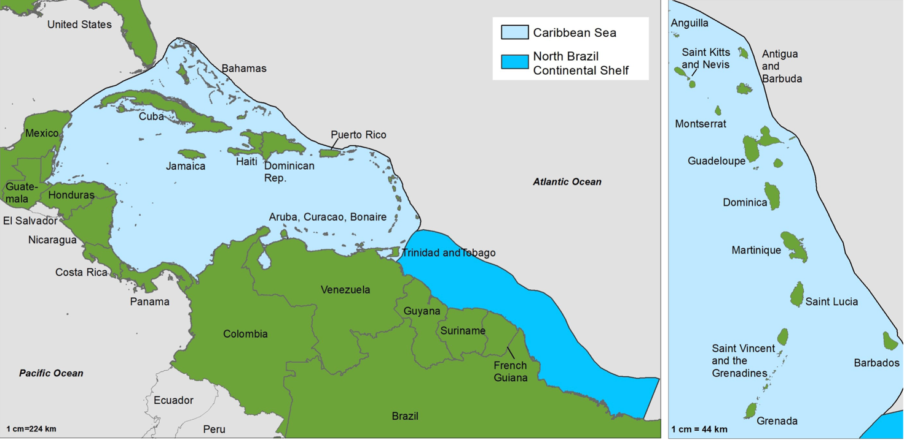

Jointly, the *Caribbean and North Brazil Shelf Large Marine Ecosystems* (further referred to in this document as *CLME+*) constitute one of the geopolitically most diverse and complex sets of LMEs in the world. Twenty-six independent States and more than fifteen dependent/associated territories border or are located within this marine area covering approximately 4.4 million km2. The marine environment of the CLME+ represents a largely shared resource and constitutes a fundamental and integral part of the economic, cultural and spiritual reality of the region and its peoples. The associated marine ecosystems deliver important goods to human society - including through fisheries and tourism - and provide equally important services including climate services (e.g. through “blue forests”) and coastal defenses (e.g. by coral reefs). At the same time, these ecosystems are the support base for the CLME+’s globally unique marine biodiversity. Tourism and fisheries are both of high social and economic importance in the region, but are heavily dependent on the health of the CLME+’s marine ecosystems and their associated *shared Living Marine Resources* (sLMR).

**Table 1. CLME+ States, Territories, Associated States, Departments, Outermost Regions and Islands with a Special Status**

|  |  |  |
| --- | --- | --- |
| Independent Continental States | Independent Island States | Overseas dependent territories, associated states, outermost regions, departments and island with a special  status |
| Belize  Brazil Colombia Costa Rica Guatemala Guyana  Honduras Panama Mexico Nicaragua Suriname  Venezuela  United States of America | Antigua & Barbuda  Bahamas, Barbados  Cuba  Dominica  Dominican Republic  Grenada  Haiti  Jamaica  St. Kitts & Nevis  Saint Lucia  St. Vincent & the Grenadines  Trinidad & Tobago | Anguilla (*United Kingdom*) Aruba, Curaçao, St. Maarten  British Virgin Islands (*United Kingdom*)  Cayman Islands (*United Kingdom*) French Guiana  (*France*) Guadeloupe  (*France*) Montserrat  (*United Kingdom*) Martinique  (*France*)  Puerto Rico  (*United States of America*)  Bonaire, St. Eustatius, Saba\St. Barthelemy (*France*)  St. Martin (*France*)  Turks and Caicos (*United Kingdom*)  U.S. Virgin Islands (*United States of America*) |

The capacity of the marine ecosystems to provide the goods and services that are so critical to the region’s livelihoods, sustained socio- economic development and well-being, has become however increasingly impacted by a multitude of human activities, consumption patterns and management decisions, with possible further aggravating effects to be expected from climate change and sea-level rise. *Transboundary Diagnostic Analyses* (TDAs) conducted under the foundational “*CLME Project”* (UNDP/GEF, 2009-2013) identified three inter-linked, key environmental problems with severe socio-economic impacts across the CLME+ region and beyond: (i) *unsustainable fisheries* resulting in over-exploited and collapsing fish stocks; (ii) *habitat degradation* and (iii) *pollution*. Technical studies on sLMR governance conducted under the CLME Project have shown that management of marine ecosystems and their associated resources in the CLME+ has traditionally been conducted in a highly fragmented manner, with individual habitats or fish stocks assessed and managed separately, and with little consideration to preserving the overall ecosystem health. The impacts of these problems are evidenced by, for example, the reduction of total fishery catch by CLME countries within FAO Area 31 (“Western Central Atlantic”) from approximately 1.79 million tons in the late 1990s to about 1.25 million tons in 2010, and by estimated annual losses in tourism revenue due to coral reef degradation ranging from 100 – 300 million USD between 2000 and 2015. Such impacts have a clear negative effect on overall socio-economic development, food security and public health, and thus on the social and political stability in the region, as well as on overall global biodiversity. Reduced resilience of the socio-ecological system as a consequence of the former can further exacerbate the impacts from climate change, leading to a potentially profound environmental -economic crisis in the CLME+ region by mid-century, if not earlier. Causal Chain Analyses conducted under the CLME Project for the key environmental problems described above allowed the identification of the following seven cross-cutting root causes: (i) weak governance; (ii) limited human and financial resources; (iii) inadequate (access to) data and information/knowledge; (iv) inadequate public awareness and involvement; (v) inadequate consideration of the value of ecosystem goods and services; (vi) population and cultural pressures; and (vii) trade and external dependency. Dealing with these root causes to resolve the *CLME+*’s key environmental problems has been a core consideration in the development and region-wide political endorsement in 2013 of a 10-year “*Strategic Action Program for the Sustainable Management of the shared Living Marine Resources of the Caribbean and North Brazil Shelf LMEs”* (further referred to in short as “*the CLME+ SAP*”). The full implementation of the SAP will require substantial expansion and enhancement of the gradually emerging, but still insufficient levels of coordination and collaboration among CLME+ countries and organizations with a stake in the marine environment.

The broad political endorsement in 2013 of the 10-year CLME+ SAP provides the region with an important reference framework for coordinated action aimed at achieving sustainability in wild capture fisheries through the adoption and implementation of the ecosystem approach (EBM/EAF) within a context of improved overall environmental security*. With the limitations of human and financial resources in the region being recognized as important root causes, the absence of transitory incremental funding necessary to kick-start SAP implementation by consolidating transboundary cooperation mechanisms and strengthening capacities would constitute a substantial barrier to catalyzing change in the region, and thus to achieving the CLME+ SAP’s expected objectives, outcomes and outputs. The removal of this barrier represents the raison d’etre of the project under evaluation.*

## **3.2 Business as Usual Scenario and associated baseline projects**

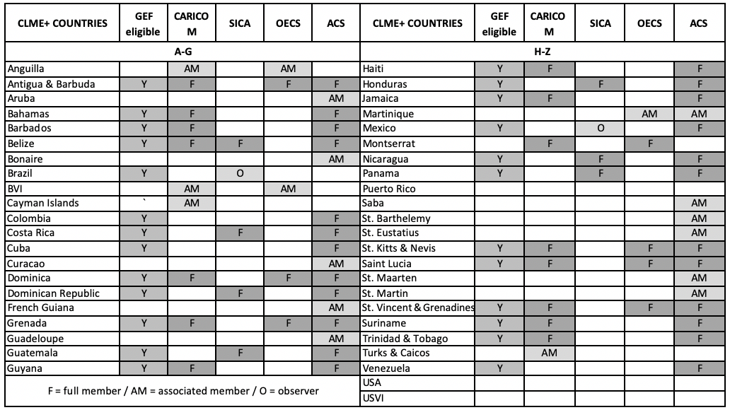

**Table 2. CLME+ States and Territories and CARICOM, SICA, OECS and ACS memberships**

In many parts of the CLME+ region, considerable albeit fragmented efforts have already been made to deal with the region’s environmental problems:

1. Sub-Regional Fisheries Bodies have been established, including the *Organization of the Fisheries and Aquaculture Sector of the Central American Isthmus* (SICA-OSPESCA; 1995), the *Caribbean Regional Fisheries Mechanism* (CARICOM-CRFM; 2002) and the *Western Central Atlantic Fisheries Commission* of FAO (FAO-WECAFC; 1973).
2. The entry into force in 1983 of the *Convention for the Protection and Development of the Marine Environment in the wider Caribbean Region* (“*Cartagena Convention*”), which constitutes a comprehensive agreement that provides a legal framework for cooperative regional and national actions, supported by three Protocols.
3. The agreement on other, sub-regional cooperative efforts: the *Campeche Declaration of 2008 on the Mesoamerican Strategy for Environmental Sustainability*, the signing of the *2012 Memorandum of Understanding between the CRFM and OSPESCA*, and the development and adoption (2013) by the Organization of Eastern Caribbean States (OECS) of the *OECS’s Oceans Governance Policy*, which is mutually supportive and complementary with the CLME+ SAP, and represents the first transboundary ocean policy agreement in the region.

These existing and emerging governance arrangements[1] in the CLME+ region are complemented by numerous programs, projects and initiatives dealing with sLMR and supportive of/compatible with the overall SAP objectives, both at the local, national and sub-regional levels:

1. GEF IW projects within the region and globally that will interact with the CLME+ project: Gulf of Mexico LME, CROP, CReW+, IWEco, TWAP and IW:LEARN; Amazon, Sixaola and Artibonito river basins; ;
2. GEF BD efforts geared towards the strengthening, expansion and/or sustainable financing of Marine and Coastal Protected Areas and for developing and/or updating NBSAPs;
3. GEF projects assisting fisheries (Sustainable Management of Bycatch in Latin America and Caribbean Trawl Fisheries, Climate Change Adaptation in the Eastern Caribbean Fisheries Sector and Introduction of Billfish Management in the Western Central Atlantic Region);
4. Projects and initiatives involving other partners including: TNC (The Caribbean Challenge Initiative), GIZ (Improving the Management of Coastal Resources and the Conservation of the Marine Biodiversity in the Caribbean Region), IDB Multilateral Investment Fund for adaptation of Caribbean coastal communities, CANARI/EuropeAid (Strengthening Caribbean Fisherfolk to Participate in Governance), DFID/CCCCC (Caribbean Regional Resilience Development Implementation Plan, IODE (ODINCARSA, SPINCAM, CMA).
5. additional relevant activities and initiatives involving the main project partners and other donors.

A number of these activities are well aligned with, and are essential for the achievement of the overall objectives of the CLME+ SAP. However, many have been, or are being developed and implemented in a fragmented “ad hoc” manner, increasing the risk of gaps or overlaps in coverage of key issues, isolation/non-replication of efforts, and of competition amongst organizations and countries/stakeholders for limited donor funds. In light of this and despite the many efforts over the past decades, many of the region’s marine resources continue to be threatened and/or in decline. The rising threats posed by climate variability and change further make the systematic mainstreaming of climate change adaptation considerations increasingly urgent. Under business as usual overall environmental degradation would continue; critical straddling fish stocks - economically and socially very important to the region - would not become sufficiently restored, and sustainable stock management at Maximum Sustainable Yield (MSY) across relevant geographic ranges would not be achieved; the areas/extension of protected key habitats and ecosystems would be insufficient to optimize the delivery of goods and services from sLMR in a sustainable and climate-resilient way. Increased unemployment and poverty, impacts on human health and well-being, forced migration, and a rise in illegal activities are only some of the associated socio-economic impacts to be expected as *a consequence of the fact that adequate overarching governance arrangements and strategic frameworks for coordinated action have not been established.*

## **3.3 The alternative scenario: immediate and development objectives of the project**

Three considerations are at the basis of the project “*Catalyzing Implementation of the Strategic Action Program for the Sustainable Management of shared Living Marine Resources in the Caribbean and North Brazil Shelf Large Marine Ecosystems (CLME+ Project)*”:

1. the CLME+ SAP recognizes the need to implement the /ecosystem-based management/ecosystem approach to fisheries. (EBM/EAF), to address the root causes of fisheries loss, habitat degradation and pollution and to mainstream climate change considerations across all actions, as essential for ensuring the sustainable provision of goods and services from shared living marine resources in the CLME+;
2. Increasing awareness indeed exists within the region that steps must be taken towards the implementation of an integrative and well-coordinated, ecosystem-based governance model for the adaptive management of marine resources across the CLME+ region;
3. Ultimately, such an integrated regional governance framework should involve all sectors with a stake in the marine environment (e.g. fisheries, tourism, shipping, oil and gas, etc.). However, the complexity of the region and the existing constraints in terms of financial, technical, human and organizational capacity make it necessary for a progressive, step-wise approach.

The strategies and timeline of the CLME+ SAP provide a roadmap that will help the countries of the region in their efforts to gradually expand capacities and knowledge, and strengthen the frameworks and arrangements for region-wide cooperation, coordination and decision-making. Efforts under the CLME+ SAP implementation project primarily contribute to creating the enabling conditions for improved and sustainable sLMR governance and management in the CLME+ region. At the same time, it is expected that gradual expansion of both the scale of the actions and of the scope of the framework (e.g. by more fully integrating other productive sectors such as shipping and oil/gas) will occur as additional awareness is being built and stakeholders – including the private sector and international or regional development banks - become increasingly involved.

In the CLME+ region, as described above, considerable resources have already been invested in a number of regional and sub-regional organizations. For this reason, the objective of the project is to strengthen organizations that already successfully exercise leadership within their existing geographical or thematic areas of responsibility. The project foresees moreover that these organizations take over key responsibilities in the execution (and/or coordination) of key actions under the different SAP Strategies. Enhanced coordination and collaboration among organizations, arrangements, programs, projects and initiatives constitutes an important cross-cutting criterion used throughout the development of the CLME+ SAP.

The CLME+ project is consistent with and supportive of the six strategies of the CLME+ SAP. At the overarching, LME level, the 3 mains strategies are: (S1) Enhance the regional governance arrangements for the protection of the marine environment; (S2) Enhance the regional governance arrangements for sustainable fisheries; and (S3) Establish and operationalize a regional policy coordination mechanism for ocean governance with an initial focus on shared living marine resources.To facilitate EBM/EAF in the CLME+’s three marine ecosystem types that support the region’s most important fisheries and biodiversity, and building upon existing baseline activities, the project aim is to promote the implementation of 3 additional SAP strategies: (S4) Enhance the governance arrangements for ecosystem- based management of reefs and associated ecosystems (e.g. seagrass beds, mangroves, reef slopes and coastal lagoons); (S5) Enhance the governance arrangements for implementing an ecosystem approach for pelagic fisheries; and, (S6) Implementing EBM/EAF of the Guianas-Brazil continental shelf with special reference to the shrimp and groundfish fisheries.

The SAP recognizes that bringing about structural change - while essential for achieving large scale impacts - may only result in effective, region-wide improvement of environmental and socio-economic conditions in the CLME+ in the medium- and long term. Therefore, the CLME Project’s actions for structural changes in institutional, policy and legal frameworks (*Component 1*), and for increased human and institutional capacity and technical/scientific knowledge (*Component 2*) have been combined with progressive implementation of “stress reduction” measures, innovative demonstrations, and initiatives geared towards the up-scaling of early results (*Component 3*). In addition to this, the project includes the analysis of high-priority investment needs to catalyze full-scale implementation of the CLME SAP (*Component 4*), and the monitoring and assessment frameworks and knowledge management and exchange mechanisms to foster synergies among projects and initiatives in the CLME+ region (*Component 5)*.

## **3.4 Project Components and expected results**

***Project Objective:*** Facilitating Ecosystem Based Management/Ecosystem Approach to Fisheries in the CLME+ for the sustainable and climate resilient provision of goods and services from shared living marine resources, in line with the endorsed CLME+ SAP

***Component 1****: Consolidating the institutional, policy and legal frameworks for sustainable and climate-resilient shared living marine resources governance in the CLME+ region.*

##### *Expected Outcome: Integrative governance arrangements for sustainable fisheries and for the protection of the marine environment, in line with the endorsed CLME+ SAP.*

Output 1.1: Decisions on coordination & cooperation arrangements and institutional mandates in line with CLME Strategies 1 (environment), 2 (fisheries) and 3 (cross sectoral policy coordination).

This includes important project achievements:

* Enhanced governance arrangements for the protection of the marine environment to be achieved through a formal agreement between Brazil and the Cartagena Convention Secretariat (UNEP CEP);
* A decision on a modality for the coordinated implementation of actions under the SPAW and LBS Protocols under the Cartagena Convention;
* A decision among CLME+ partners on the interim mechanism for the coordination of actions towards sustainable fisheries (to be led by FAO-WECAFC, including in the first instance CRFM and OSPESCA (and possibly OECS) and covering the full CLME+ region;
* A formal multi-country decision on a robust, region-wide and long-term governance arrangement (or arrangements) for sustainable fisheries management in the CLME+ region;
* A decision, among the CLME+ SAP endorsing parties and stakeholders, on a mechanism to support coordinated implementation of the SAP;
* Consensus among the CLME+-participating countries on a permanent, inclusive and sustainably financed policy coordination mechanism for sustainable and climate-resilient sLMR governance in the CLME+ region.

Output 1.2: National Inter-sectoral coordination mechanisms in place (including science-policy interfaces, as feasible).

This output focuses on fostering improved consultation and coordination processes between different sectors and stakeholders at the national level, and on their linkage with the regional processes and arrangements.

Output 1.3: Regional policies, declarations and/or regulations, and associated national-level legislation and/or plans, appropriate to enable effective EBM/EAF in the CLME*+.*

This implies a revision of those regional policies/regulations and associated national legislations that at present do not support or are incompatible with the EBM/EAF approach, including the adoption and integration within these policies and legal frameworks of important paradigms such as the *“precautionary approach”*, and the “*adaptive management”* and “*polluter pays”* principles.

Output 1.4: Data management, access and exchange arrangements to support adaptive management and the implementation of the CLME + Project and SAP*.*

This includes the agreement among countries on Memoranda of Understanding (MoUs) and Protocols to facilitate access to, and exchange of key data, information and indicator sets will be critical for the overall Monitoring & Evaluation (M&E) of CLME+ Project and CLME+ SAP implementation.

Output 1.5: Sustainable financing mechanism(s)/plan(s) to ensure short, medium and long- term operations of the enhanced arrangements for sLMR governance in the CLME+ region.

This output aims at ensuring Long-term sustainability of the different governance arrangements established and consolidated through Project COMPONENTS 1, 2 and 3, as a response to the needs to sustainably finance and operate the different key elements of the CLME+ Regional Governance Framework (RGF).

***Component 2:*** *Enhancing the capacity of key institutions and stakeholders to effectively implement knowledge-based EBM/EAF for sustainable shared living marine resources use in the CLME+*

##### *Expected Outcome: Enhanced institutional and stakeholder capacity for sustainable and climate-resilient sLMR management at regional, sub-regional, national and local levels (with special attention to regional and sub-regional organizations with key roles in SAP implementation).*

Outputs of this Component are aimed at improving the institutions’ and stakeholder’s ability to implement or support EBM/EAF in the CLME+ region. They include: the collaborative development and delivery of action plans to deal with issues of cross-cutting, region-wide importance such as: Illegal, Unreported and Unregulated (IUU) fishing, habitat degradation and pollution (Output 2.1); the collaborative development of a Civil Society and Private Sector Action Program (C- SAP and P-SAP; Output 2.2); the promotion of a Small Grants coordination mechanism to support the implementation of priority actions identified in the C-SAP; the identification of good practices in the field of data and information management, and best available (innovative) tools and technologies –tailored to the capacity and needs of the region and its stakeholders (Output 2.3); enhancement of awareness, empowerment of stakeholders and better coordination and collaboration, through an over-arching CLME+ Communication and Dissemination Strategy (Output 2.4); Training on matters of cross-cutting importance for the CLME+ SAP identified and incorporated in Training Plan (Output 2.5); Targeted research strategies to support knowledge-based implementation of the EAF/EBM approach (Output 2.6).

***Component 3****: Implementing EBM/EAF in the CLME+ region*

##### *Expected Outcome: Progressive reduction of environmental stresses (with particular attention to socially just solutions and the enhancement of livelihoods) demonstrated, across the thematic and geographic scope of the CLME+ SAP*

Under Component 3 the CLME+ Project aims at demonstrating the steps required to move from Business-as-Usual to an Ecosystem-based Management approach for key ecosystems and associated fisheries in the CLME+ region through the implementation of (i)a series of “CLME+ Sub-Projects” supporting the progressive transition to an ecosystem approach: (Output 3.1, 3.2, 3.3) for the Caribbean spiny lobster fisheries, for the four-wing flyingfish fisheries and the North Brazil Shelf shrimp; and for groundfish fisheries, and (ii) the progressive adoption of more holistic, ecosystem-based management approaches for selected sites within the CLME and NBSLME (Output 3.4.). This last sub-project, includes on-site initiatives to protect key habitats and/or address priority pollution issues. A fifth output provides modest additional small grants support to complement planned or ongoing initiatives, to foster and expand their civil society-based components (Output 3.5.).

***Component 4:*** *(Pre-)Feasibility assessments to identify major high-priority investment needs and opportunities in the CLME+ region*

##### *Expected Outcome: Financing catalyzed for the up-scaling of priority actions for the protection of the marine environment and for ensuring sustainable, climate-resilient livelihoods and socio-economic development from sLMR use in the CLME+*

Under Component 4 the CLME+ Project aims to deliver: (i) insights and understanding on high-priority investment needs and opportunities to halt and reverse, at the regional scale, the loss of ecosystem goods and services, and to stimulate sustainable, ocean-linked businesses and economic growth (Output 4.1.); and (ii) detailed medium- and long-term (10-20 years) investment plans based on the updated and completed baselines on lessons learnt from site specific investments and demonstrated best practices, their current levels of application in the region and elsewhere, and their costs-efficiency and expected return-on-investment (Output 4.2.).

***Component 5:*** *Monitoring & assessing progress of and results from the overall implementation of the CLME+ SAP, and experience sharing with the global LME practitioner’s community*

*Expected Outcome: The potential for maximizing regional socio-economic benefits and Global Environmental Benefits from SAP implementation increased.*

This is expected to be achieved through:

1. enhanced coordination and collaboration among sLMR programs, projects, initiatives (PPIs) and stakeholders, within the CLME+ region and beyond, to be achieved through the establishment and progressive expansion of the “CLME+ Partnership” (Output 5.1)
2. optimized and adaptive management of sLMR-related PPIs in the region, to be supported by effective and collaborative SAP M&E tools, including a CLME+ ecosystem status and SAP implementation M&E mechanism (Output 5.2)
3. exchange of best/good practices and lessons learnt among the global IW LEARN/LME Community of Practice, leading to enhanced efficiency and effectiveness of measures under the CLME+ SAP (Output 5.3).

## **3.5 The project’s Theory of Change**

The Project Document does not contain a description of the Theory of Change at the basis of project design[2]. An attempt has been made as part of this evaluation to develop one based on information provided in the project documentation and through consultations with stakeholders. As noted in the Mid-term Evaluation, the CLME+ Project Document presents a somewhat unsatisfactory definition of the outcomes that the project is expected to produce. In fact, most of the outcomes listed in the Project Document correspond in reality to the main outputs of the project, rather than to the changes that the outputs are expected to determine in the environmental conditions of the LMEs and their living resources. In order to develop the ToC, a revised formulation of the outcomes has been adopted, as shown in the table below. The outputs have been omitted due their excessively large number (69).

|  |  |
| --- | --- |
| Outcome original formulation | Revised formulation |
| 1. Integrative governance arrangements for sustainable fisheries and for the protection of the marine environment. | Integration of governance arrangements enhances sustainability of fisheries and health of marine ecosystems, and facilitates SAP implementation |
| 2. Enhanced institutional and stakeholder capacityfor sLMR management at regional, sub-regional, national and local levels (with special attention to regional and sub-regional organizations with key roles in SAP implementation). | Reinforced management capacity at all levels (regional, national, local) enables and accelerates SAP implementation |
| 3. Progressive reduction of environmental stresses, and enhancement of livelihoodsdemonstrated across the thematic and geographical scope of the CLME+ region SAP. | On the ground demonstrations of the effectiveness of EBM/EAF in stress reduction encourage broader, region-wide adoption |
| 4. Financing catalyzed for the up-scaling of priority actionsfor the protection of the marine environment and for ensuring sustainable, climate-resilient livelihoods and socio-economic development from sLMR use. | Identification of additional and sustained financing sources enable the up-scaling of efforts to secure marine environment protection and climate resilient livelihoods and development |
| 5. Regional socio-economic benefits and Global Environmental Benefits from SAP implementation are maximized through enhanced collaboration, planning & adaptive management, and exchange of experiences and lessons learnt. | Expanded partnerships, establishment of effective progress to impacts monitoring mechanisms, and experience exchanges regionally and globally, maximize the benefits, including global, accruing from SAP implementation. |

**Table 3 – Outcomes formulation**

|  |  |  |  |  |
| --- | --- | --- | --- | --- |
| **CLME+ Project – From Outcomes to Impacts** | | | | |
| ***Objective:*** *Facilitating EBM/EAF in the CLME+ region for the sustainable and climate-resilient provision of goods and services from shared living marine resources, in line with the endorsed CLME+ region SAP* | | | | |
| **Outcomes**  **(as formulated in the Project Document)** | **Assumptions**  **and**  **Drivers** | **Intermediate state** | **Impacts** | |
| Reduced environmental threats | Environmental and Socio-economic benefits |
| 1.Integrative governance arrangements for sustainable fisheries and for the protection of the marine environment  2. Enhanced institutional and stakeholder capacityfor sLMR management at regional, sub-regional, national and local levels (with special attention to regional and sub-regional organizations with key roles in SAP implementation).  3. Progressive reduction of environmental stresses, and enhancement of livelihoodsdemonstrated across the thematic and geographical scope of the CLME+ region SAP.  4. Financing catalyzed for the up-scaling of priority actionsfor the protection of the marine environment and for ensuring sustainable, climate-resilient livelihoods and socio-economic development from sLMR use.  5. Regional socio-economic benefits and Global Environmental Benefits from SAP implementation are maximized through enhanced collaboration, planning & adaptive management, and exchange of experiences and lessons learnt. | *Assumption*:  The many countries sharing the CLME+ region marine environment, and the many organizations and bodies with mandates over the living resources of the CLME and NBSLME, remain fully committed to the SAP vision and strategic objectives.  *Drivers:*  Shared recognition of need to manage and protect the living marine resources of the region.  Regional cooperation providing incentives and support structure. | Best practices piloted by the project are being replicated.  Monitoring data produced by countries and regional organizations show positive trends are fostering full SAP implementation  National Inter-ministerial Committees and IGOs, that together constitute the CLME+ regional Governance Framework (RGF), take up responsibility for SAP implementation | Mitigation of stress in critical fisheries (spiny lobster, groundfish, small pelagics).  Full SAP implementation reverses degradation trends and enhances sustainability of key fisheries.  Caribbean countries better prepared to face threats from global changes and climatic variability and change. | The sound management and the protection of globally significant living resources of the Caribbean and North Brazil Shelf LMEs, foster environmentally sustainable development, enhance livelihoods and human well-being. |

**Table 4 – Theory of Change**

## **3.6 Total resources that have been identified for the project**

The total cost of the project estimated at the time of Work Program inclusion was of US$ 110.854.059. The resources that were committed at the time of CEO Endorsement totaled US$ 146.653.695, divided as follows:

GEFTF: US$ 12.500.000

UNDP: US$ 2.619.759

Governments: US$ 98.117.248

Partner multilateral agencies: US$ 30.025.349

CSO and Academia: US$ 3.391.519

The Project Document does not provide the typology of the co-financing. At the time of Work Program inclusion, the total amount of cash co-financing was estimated in US$ 58.315.860, and the total contribution from GEF eligible countries was of US$ 51.766.643.

## **3.7 Key stakeholders and main partners**

As noted in the MTR, project design appears to have been a highly participative process, with the contributions of the various sub-regional entities with authority over fisheries and marine environment, regional research and scientific organizations, and major NGOs. The Project Document identifies two categories of stakeholders: Primary Stakeholders, having direct participation in the project and/or being beneficiaries of project activities; Secondary Stakeholders, not having any direct engagement with the project, that can still be influential and/or benefit from project activities (table 5).

|  |  |  |
| --- | --- | --- |
| **Stakeholder type** | **Primary Stakeholders** | **Secondary Stakeholders[3]** |
| Governments and (inter)governmental organizations | * the 26 national governments of the sovereign CLME+ States; their regional and local governments; through their Project National Focal Points, and GEF Operational Focal Points. * the 18 local governments and 4 “home governments” of the dependent territories * the different regional (political) integration mechanisms * the different IGOs with a mandate related to the marine environment (see Table 6) * UNDP Headquarters and Regional Office * UNOPS (Executing Agency) | * the governments of the many countries external to the region with a stake in the marine environment of the CLME+ |
| Civil Society | * 120 million people living within 100km from the coast in the CLME+ region * 42 million people dependent on coral reefs for food/livelihoods * subsistence fishing and subsistence/livelihood support, “invaluable” * native Non-governmental   organizations (NGOs) | * global seafood consumers * global visitors (stay-over tourists, > 25 million/year) * global NGOs * the more than 7 billion people on earth who in several ways benefit from the CLME+’s contribution to global ecological processes |
| Private Sector | * the fishing sector (almost 4 million regional jobs; export earnings of USD 1,2 billion annually) * the tourism industry * the shipping & logistics sector * the energy (oil & gas) sector | * global seafood sector (importers) * other international markets for products originating from the CLME+ |

**Table 5 – Project Stakeholders**

The Project Document describes in much detail the many stakeholders that directly or indirectly have to be engaged in the project, and their specific roles in project execution and/or ways of engagement. They include the governments of the 23 beneficiary countries and three non-beneficiary countries, 18 overseas dependent territories, associated states, outermost regions, departments and island with a special status sharing parts of the CLME+, 30 regional IGOs, IFIs, non-governmental organizations and academic institutions relevant to the project, and the multiple public and private sectors and entities in each country with a stake in the health and sustainability of the living marine and environmental resources of the CLME+. The ensuing Stakeholder Engagement Plan is therefore ambitious and unavoidably complex. The Plan adopts the subsidiarity principle/de-centralized approach, considered the only logical approach for a project such as the CLME+ with its plethora of participating countries and partner organizations, each with their own set of stakeholders. *Responsibility is given to “primary” stakeholders to reach out to, and liaise with their constituencies and stakeholder groups.* The Plan hence delegates responsibility for stakeholder’s involvement to two main actors: beneficiary countries’ governments – represented by the project’s National Focal Points – at the country level, and to executing partner IGOs and CSOs (see table 6) at the regional level. Each executing partner, at the same time responsible for the execution of relevant activities, key stakeholder, and “beneficiary”, is tasked of engaging countries (through the country representatives in its governing body), and its stakeholders’ networks.

## **3.8 Execution and management arrangements**

UNDP has the overall supervision as the Implementing Agency for the project and the responsibility to ensure consistency with GEF and UNDP policies and procedures. The project execution is assigned to UNOPS, responsible for the creation and operation of the PCU, and for the execution of project activities through agreements with UN partner bodies (FAO- WECAFC, UNEP CEP, IOC of UNESCO), and regional IGOs and CSOs bodies pertaining to SICA and CARICOM (e.g. OSPESCA, CCAD, CRFM).

|  |  |
| --- | --- |
| Acronym and Name | Activities as CLME+ executing agencies |
| CANARI - Caribbean Natural Resource Institute | Civil Society, Small grants |
| CRFM CARICOM - Caribbean Regional Fisheries Mechanism - Caribbean Community and Common Market | Flyingfish fisheries |
| CERMES - Centre for Resource Management and Environmental Studies | EBM/EAF mainstreaming, NICs, M&E |
| FAO WECAFC - Food and Agricultural Organization of the United Nations - Western Central Atlantic Fisheries Commission | Fisheries EAF/EBM, investment needs  Shrimp and Groundfish fisheries |
| GCFI - Gulf and Caribbean Fisheries Institute | Research Strategies |
| IOC UNESCO - Sub-commission for the Caribbean Sea and Adjacent Regions | Training |
| OECS - Organization of Eastern Caribbean States | Communication, environmental reporting, legal agreements, NICs |
| OSPESCA- Organization of the Central American Fisheries and Aquaculture Sector | Spiny lobster fisheries |
| UNEP CEP - United Nations Environment Program Caribbean Environment Program | Cartagena Convention, LBS, protected areas, marine habitats, investment needs, EBM sub-project NBSLME |

**Table 6 – Project Executing Partners**

Figure 1[4] summarizes the institutional arrangements:

* The Project Steering Committee plays a critical role in reviewing and approving the project planning & execution, reviewing project progress, making recommendations and adopting the (biennial) project work plans and budget. It was supposed to meet three times during the project implementation.
* The Project Executive Group (PEG) is a coordination and problem-solving mechanism dealing with project execution issues throughout the project’s duration.
* The Project Coordinating Unit (PCU) is responsible for the day-to-day coordination and oversight and monitoring of the Project. The PCU – with support from UNOPS WEC - is also responsible for the project’s financial and administrative management, for periodic reporting to the PEG and PSC, and for the (co)-execution of selected project activities.



**Figure 1: Institutional arrangements**

# **Part 4: Findings**

## **4.1 Project Design**

Overall, the design logic of the project is sound and based on the achievements obtained through years of sustained efforts of the foundational phase, and well captured in the conclusions of the science-based assessments (TDAs) of the several straddling fish stocks and other high value living marine resources and translated by the participating countries into priority national and regional mitigation actions (SAP). The SAP provides the route and the processes that the countries have identified as feasible and most effective to move towards the intended results. The project aims to address five key issues of concern (Fig. 2) which are putting at risk the sustainability of the shared living marine resources of the CLME+ region identified by the diagnostic assessments. It will do so by supporting the implementation of the related SAP actions:

1. The highly fragmented governance frameworks of the marine environment in general and of fisheries in particular, distributed across a number of sub-regional entities responding to different governing bodies and with different country representatives (SAP Strategies 1-3).
2. The limited human/financial resources and capacity to implement/enforce governance frameworks, compounded by inadequate access to data and information, public awareness and participation, and consideration of the value of ecosystem goods and services.
3. Paucity of experience in the implementation of the Ecosystem-Based Management approach for key ecosystems and associated fisheries in the CLME+ region.
4. The insufficiency of financial resources for governmental action, recognized as an important root cause of the region’s limitations in terms of the scale at which actions to address environmental degradation and to support the development of a blue economy can currently be implemented.
5. The insufficient communication, co-ordination and information exchange among primary CLME+ region SAP stakeholders and among the multitude of existing and planned projects, activities and initiatives in the region, constituting an important barrier to fully capture the societal and environmental benefits expected from the project and other investments.

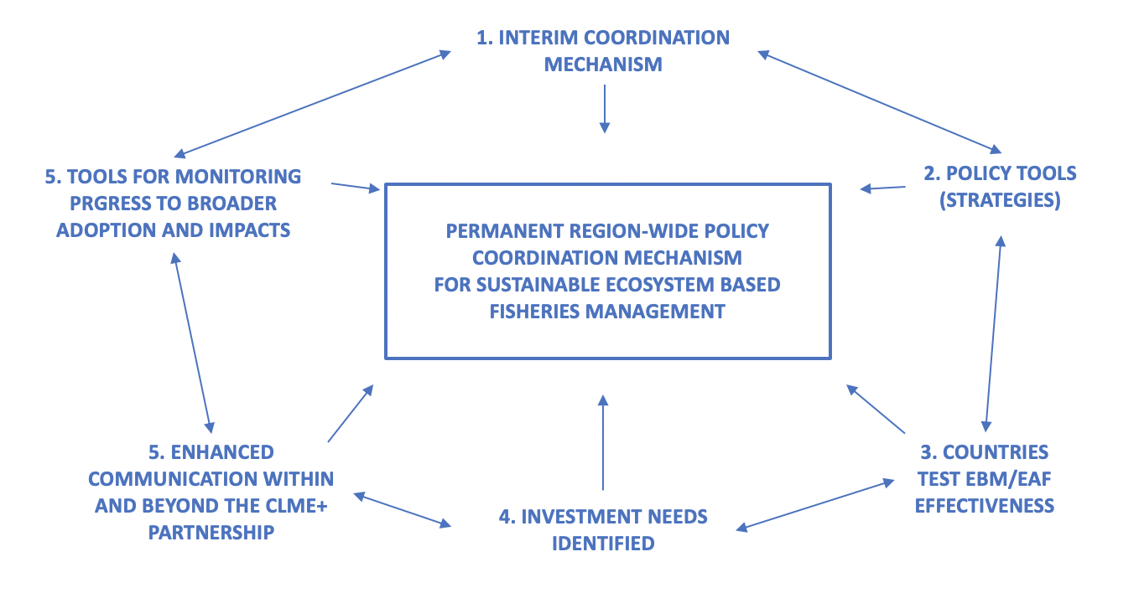

**Fig.2 – CLME+ Intervention logic**

The Project Document provides an extremely detailed description of all aspects of the project, in particular of the activities needed to produce the outputs. Somewhat less satisfactory are the formulations of the outcomes (see 3.5) and of the outputs/targets that often are described as “decisions”, “approval”, “endorsement” or “adoption” by countries and by country representatives in IGOs. As noted in the MTR, no project however can commit to deliver on something that lies beyond its control, such as the political decision of a sovereign nation. The formulation of the outputs/targets calls hence for a clarification: when the target involves a political decision (policy or institutional reform etc.), the commitment of the project is necessarily limited to preparing the grounds for, and facilitating the process leading to a decision by national governments or by the governing bodies of relevant IGOs.

### **4.1.1 The Results Framework**

The Results framework of the project follows the UNDP standard sequence: Outcome/Output, Indicator, Baseline, Milestones and targets, Source of Verification, Risks and Assumptions. It is quite detailed and comprehensive, as it covers 5 Components, 23 Outcomes, 69 Outputs, 151 Milestones/Targets and 66 Sub-targets. It has to be noted that the majority of these outputs and targets (75%) belongs to the “sub-projects” of Component 3. While this large number of elements reflects the ambitious objectives of the project and the unavoidable complexity of its design, the large set of outputs and indicators identified (69 and 62 resp.) appears to be excessive and possibly cause of complication in the definition of the typology and timing of the 159 targets, and of reduced flexibility in project design.

|  |  |  |  |  |
| --- | --- | --- | --- | --- |
| # Indicators | # Outcomes | # Outputs | # Targets/Milestones | # Sub-targets |
|  | Component 1 | | | |
| 12 | 1 | 5 | 12 | 8 |
|  | Component 2 | | | |
| 12 | 1 | 6 | 15 | 17 |
|  | Component 3 | | | |
| 13 | 19 | 53 | 112 | 41 |
|  | Component 4 | | | |
| 9 | 1 | 2 | 7 | - |
|  | Component 5 | | | |
| 16 | 1 | 3 | 13 | - |
| 62 | 23 | 69 | 159 | 66 |

**Table 7: Results Framework elements**

The formulation of Outcomes, as noted at 3.5, is sometime questionable; the indicators are often formulated as outputs (see the example below of process indicators for output 2.1).

|  |  |
| --- | --- |
| Output 2.1  Regional Action Plans for the management, conservation and sustainable use of fishery resources and for the protection of the marine environment, considering the implications on gender and the possible impacts of climate change | Process Indicator 1. Regional Strategy and Action Plan against IUU, and compatible model National Plan of Action (IUU-NPOA)  PI2. Regional Strategy and Action Plan for the valuation, protection and/or restoration of key marine habitats  PI3. Regional Action Plan for the reduction of impacts from excess nutrient loads on the marine environment |

In a number of instances, the Results Framework of the project calls for “decisions”, “agreements” and “consensus” to be made/reached by countries’ governments as indicators/targets of the achievement of specific outputs, such as for example: “*Formal agreement between Brazil and the Cartagena Convention Secretariat for the coordination of actions relevant to the Convention and its Protocols*”, or “*Consensus among CLME+ participating countries on a permanent, inclusive and sustainably financed policy coordination mechanism”* and *“Decision on a modality for the coordination of actions under the SPAW and LBS Protocols, at Cartagena Convention*”. No development assistance project however can commit to deliver something that is beyond itscontrol such as the political decision of a sovereign state. In the case of policy reforms, documents, plans, establishment of new regional bodies etc. that have been technically cleared by the Steering Committee, the correct formulation would have been “submitted for countries’ decision/approval/adoption”. In the present evaluation, technical clearance by the Steering Committee and/or the governing bodies of regional IGOs has been considered as achievement of the specific desired objective.

### 

### **4.1.2 Assumptions and Risks**

The Project Document contains a thorough and detailed description of the assumptions which are at the basis of project design, and of the major risks that the project might face that could jeopardize its overall success and its ability to deliver expected outcomes and carry out all foreseen activities. The analysis is in fact conducted at the level of the whole project, of each project component, and of each output. Most risks relate to the high number, and to the geographical and socio-economic diversity of the countries involved, and consequently of the many stakeholders to be engaged, to the critical need to secure countries sustained political commitment to transboundary cooperation and to SAP implementation in the long term, and the continuing support, including financial, to the overarching regional coordination mechanisms that the project will promote and assist in establishing. They were identified as follows:

* Operating the governance framework for sLMR is not financially sustainable in the long-term
* Failure of region to work together towards regional EBM/EAF governance
* Fragmentation of efforts and lack of coordination among projects and initiatives resulting in low return on investment and failure to achieve GEBs
* Environmental and Societal Change (including climate change, political change)
* Lack of parallel commitments on the part of Governments and potential donors to ensure financial sustainability beyond the life of the Project
* Limited public awareness and interest in ecosystem approaches, and inertia/resistance to change
* Limited scientific data and information, and limited willingness or capacity of national authorities to share data
* Significant differences in participating countries’ size, geographic configuration, development status and economic and logistical capacities may impact on feasibility of project outcomes & outputs
* The project is unable to successfully engage the full range of stakeholders
* Multitude of countries and stakeholders, multitude of initiatives in the region. Dependency on (long-term) commitments/partnerships and co-financing to achieve project outcomes and outputs.
* Project Coordination Unit and Management Team incapable of effectively executing and managing a highly complex project.

Being the CLME+ SAP implementation project based on the extensive diagnostic work and stakeholders’ consultations carried out during the foundational TDA/SAP CLME project, the identification of risks and assumptions appears correct, and the proposed mitigation measures adequate. In fact, the whole project design is geared towards the mitigation of the major risks. To this end, major stakeholders, in particular the regional environment and fisheries related IGOs, were involved in project design, and committed to actual project execution

### **4.1.3 Key stakeholders and partners involved in the project**

Three stakeholders’ groups were the critical targets of the Stakeholders Engagement Plan:

1. UN IGOs - Inter-agency arrangements were to be formalized with the three key UN system executing partners/stakeholders (through standard UN inter-agency agreements): the Regional Seas Cartagena Convention Secretariat - UNEP Caribbean Regional Coordinating Unit, the Western Central Atlantic Fisheries Commission of FAO, and IOCARIBE of the Intergovernmental Oceanographic Commission of UNESCO.
2. Similar arrangements were to be agreed upon with other, non-UN executing partners/stakeholders, including intergovernmental and non-governmental organizations: the Organization of the Fisheries and Aquaculture Sector of the Central-American Isthmus (OSPESCA/SICA), the Caribbean Regional Fisheries Mechanism (CRFM/CARICOM), the Caribbean Natural Resources Institute (CANARI), the Gulf and Caribbean Fisheries Institute (GCFI), the Centre for Resource Management and Environmental Studies (CERMES) of the University of the West Indies (UWI), Organisation of Eastern Caribbean States (OECS). The roles for these project partners were to be in alignment with their formal mandates and/or comparative advantage.
3. Engagement of beneficiary countries was to be fostered through the government appointed project National Focal Points, and through the country representatives in the governing bodies of the key executing partners/stakeholders.

While the full and effective involvement of the regional IGOs and CSOs is assured by their role as Executing Partners, less clear appears the effectiveness of the countries’ governments engagement through the project’s National Focal Points – members of the Project Steering Committee – and the national representatives in partner IGOs. In fact, the links and interaction between the two are not specified in the Project Document.

### **4.1.4 Gender Responsiveness of project design**

The assumption at the basis of the gender strategy of the project is that adopting the “Governance Effectiveness Assessment Framework” (GEAF) and promoting its systematic use as a planning and monitoring tool, will allow to systematically include the gender dimension in all project activities. The Project Document sections on Results Based Management, Projects Indicators and Monitoring, and Stakeholder Involvement make specific reference to the gender consideration and to the GEF’s “Results Framework for Gender Mainstreaming in GEF Operations”. The Project design and Results Framework however, not being based on a gender analysis, do not contain a specific “gender” outcome /output /activity framework. Emphasis is instead on generic assurances that gender consideration will be present in all relevant activities and outputs.

## **4.2 Project Implementation**

### **4.2.1 Adaptive management**

The project was endorsed by the GEF CEO on March 4th, 2015 and became fully operational in May 2015, when the first disbursements occurred. Administrative and organizational delays, both within the main Executing Agency (UNOPS) and key UN Executing Partners (UN Environment and FAO) affected the first three years of implementation. By the time of the Mid-term Review (June-October 2018), the project had met only a small fraction of the targets initially set at project mid-term (13 over a total of 65), and only few of the activities had produced concrete outputs for review. The emerging picture was one of “…. alarmingly slow progress, with most of the delayed mid-term targets and all end of project targets to be achieved within little more than one-year time (December 2019)”[5].

Approximately corresponding with the time of the MTR, all administrative and recruitment problems were finally solved. From then on, largely thanks to the crucial role played by the PCU in systematically monitoring the progress in execution, disbursements and co-financing, proposing solutions aimed at speeding up activities, presenting options for discussion with executing partners by calling frequent PEG meetings, and eventually facilitating decisions by the Steering Committee, the project implementation gained momentum and started making up for time lost during the initial stage. In line with the MTR recommendations, the solutions adopted by the Steering Committee[6] consisted in extending at no additional cost the project duration – moving the date of project technical completion first from April 2020 to April 2021, and then, due to the spread of the Covid pandemic , to October 31st 2021 - and in revisiting the Results Framework by adopting more realistic delivery dates for outputs and targets without modifying or eliminating any of the expected outputs of the project. As the Terminal Evaluation is being finalized (March 2021), the project is back on track, and will most likely be completed by the time of the revised deadline.

Starting in early 2020, the project had to face another major challenge: the Covid-19 pandemic. The coping strategy immediately adopted by the PCU and the executing partners consisted in utilizing teleworking at all levels, including for project Steering Committee meetings, building capacity in the use of modern video-conferencing platforms, and increasing reliance on national and local expertise for carrying out field work and data collection. As a result, it appears that the unprecedented situation created by the pandemic did not affect project delivery rates, and decision-making processes.

|  |  |  |
| --- | --- | --- |
| MTR recommendation | Level of response | Comments |
| The no-cost extension of the CLME + project must be of the order of 12 months | Fully implemented |  |
| Implementing partners should prioritize achieving outcomes and focus on critical goals | Fully implemented |  |
| Priority should be assigned to effective streamlined communication mechanisms to, from and within countries | Partially implemented | The unexpected scenario determined by the onset of the pandemic did hinder the PCU’s and the countries’ efforts to implement this recommendation of the MTR |
| Make efforts to engage development banks and other major donors | Not implemented | Although efforts were made to engage development banks and other donors during the first half of the project they were not successful particularly as the CLME+ partnership was not formally created. |

**Table 8: MTR key recommendations**

### **4.2.2 Actual stakeholder participation and partnership arrangements**

Governments, IGOs and Civil Society were actively engaged in project implementation. Given the project’s nature, the major role throughout the project was played by the regional level executing partners/stakeholders (IGOs and CSOs), in their efforts to harmonize their mandates, avoid fragmentation, build capacity, and capture complementarities in order to enable the region-wide adoption of EBM/EAF. Less apparent and verifiable, but not less important, has been the direct involvement of the many stakeholders at the country level, from government agencies, to fisherfolk, to NGOs, to the private sector etc., their engagement being delegated to the various executing partners and their role at times limited to that of data providers.

The involvement of the major regional stakeholders (IGOs, CSOs) as executing partners has been critical for the achievement of project outcomes. More difficult to assess is the role played by the extensive public awareness carried out as part of many project activities in contributing to the progress towards achievement of project objectives. It has to be noted that the documented overall growing awareness in the region of the crucial social, economic and health importance of preserving marine and coastal ecosystem services is certainly at the core of the progressive shift towards more environmentally friendly and sustainable policies and behaviors occurring in the region.

The MTR raised some questions on the effectiveness of the engagement of national focal points and representatives in IGOs/CSOs. Figure 3[7] shows the project related functions of national governments representatives – the final decision makers - from Project National Focal Points[8], to members of IGOs governing bodies, to GEF focal points. Their participation to the project appears to follow parallel lines without opportunities for coordination or “meeting points”. This, compounded by the fact that the various country focal points and representatives belong to different ministries/national entities, has been cause of fragmentation in the way’s countries participate, and of possible confusion on responsibilities for final decisions. The MTR concluded that in the absence of Inter-ministerial Committees (NIC), in place only in a limited number of countries[9], “…. some level of within-country coordination and information exchange between project focal point and representatives in IGOs would have been necessary and beneficial”.

While the Terminal Evaluation did not detect improved coordination at the national level, interviews with beneficiary countries did provide evidence of growing recognition of the importance of, and need for inter-ministerial and inter-agency dialogue and coordination among the national representatives in the various relevant regional intergovernmental bodies.

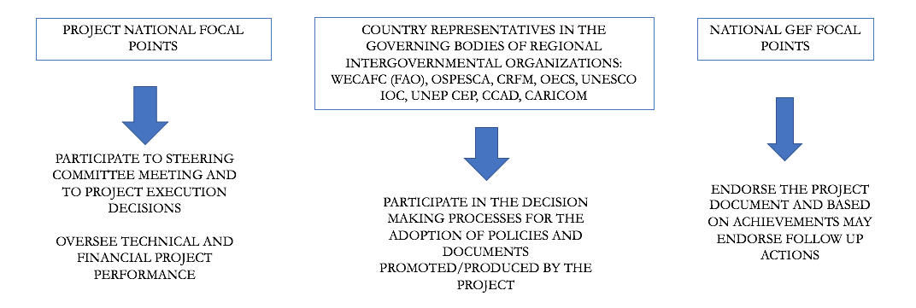

**Figure 3: The roles of country representatives**

Gender - The CLME+ Project was designed under GEF 5 and does not have a Gender Strategy based on a Gender Analysis, as these were not required by the donor nor by UNDP at that time. It relies instead on the adoption of the “Governance Effectiveness Assessment Framework” (GEAF) as a planning and monitoring tool to systematically include the gender dimension in all project activities. This notwithstanding, the Government of Canada provided co-financing for the implementation of a Gender Mainstreaming Project to support a number of small island developing states (SIDS) in the CARICOM region. Results from this initiative included a Gender Analysis Strategy and Action Plan (Gender ASAP) on Gender Mainstreaming in Fisheries in the Caribbean for CRFM countries; the development of indicators for tracking gender equality, youth empowerment and decent work conditions including in participation, governance, value chains, markets/financial empowerment, training/skills-learning/capacity building ; and the Five National Gender Action Plans (NGAPs) (Dominica, Grenada, Saint Lucia, St. Vincent and the Grenadines, Trinidad and Tobago).

The CLME+ team comprises of 60% women and 40% men, and the CLME+ National Focal Points are 48% female and 52% male. Interviews conducted as part of the Terminal Evaluation have provided evidence of broad women participation to project activities, consultations, and working groups.

### **4.2.3 Project Finance and Co-finance**

Disbursements reflect the slow progress of project execution during the initial two years, as well as a strong acceleration starting in the second half of 2018. As of march 2021, 92% of the total project budget has been expended, with remaining funds expected to be disbursed by the time of the administrative closure of the project in October 2021. No variances with respectto planned expenditures were observed.

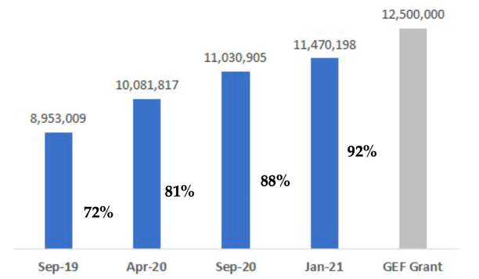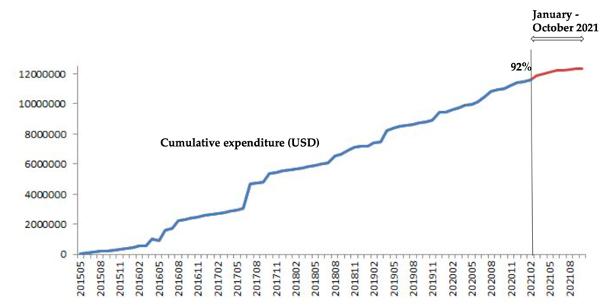

**Figures 4 and 5: Expenditure evolution over total budget, and Cumulative expenditures 2015 - 2021**

Financial controls were in place and effective throughout the project. Quarterly reporting allowed the project management and the Steering Committee to take informed decisions regarding budget, and to monitor the PCU and Executing Partners performance and flow of funds. In this respect, the situation at the time of the Terminal Evaluation for the three major executors (PCU/UNOPS, FAO and UNEP) is shown in Figures 6 and 7. FAO and UNEP have still to spend 13% and 24% respectively of their funding allocations. The PCU has spent 87% of its funding allocation, with considerable savings in the budget line “Events, Travels and Missions” likely due to the restrictions dictated by the pandemic. All three major executors are expected to disburse their pending budget by project closure. All other executing partners have fully delivered their products and disbursed all their allocations.

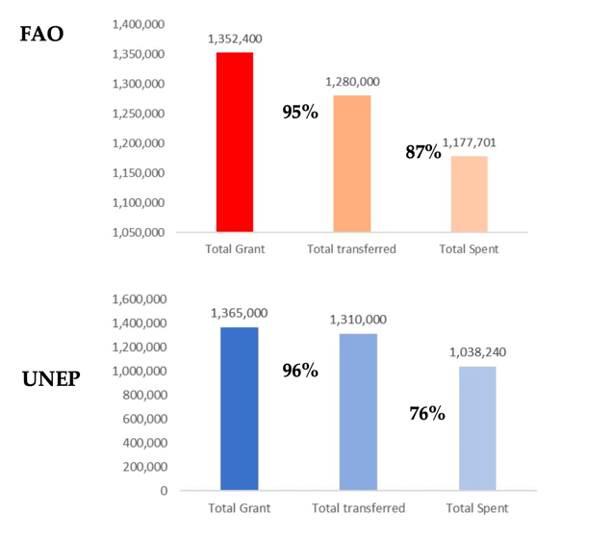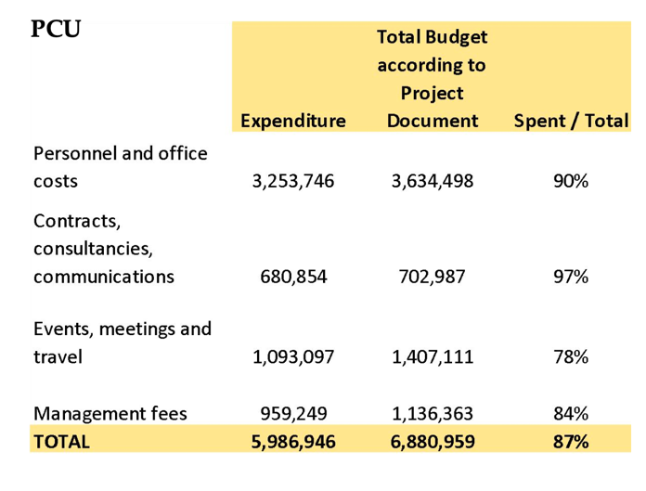

**Figure 6: Financial Implementation Progress of the three main executing partners**

With regards to co-finance, tables 9 and 10 reflect planned co-financing and actual co-financing commitments, the type and source of the co-financing contributions and indicate whether each type of contribution is considered to be ‘investment mobilized’ or ‘recurrent expenditures’. It is worth noting that actual co-financing is slightly higher than what initially planned.

The lack of reported co-financing from UNDP is due to the fact that the two UNDP initiatives that initially committed co-financing (Cap-Net and Guyana Shield Facility) underwent restructuring after the project initiation, their implementation having been transferred to GWP (Cap-Net) and the government of Guyana (GSF).

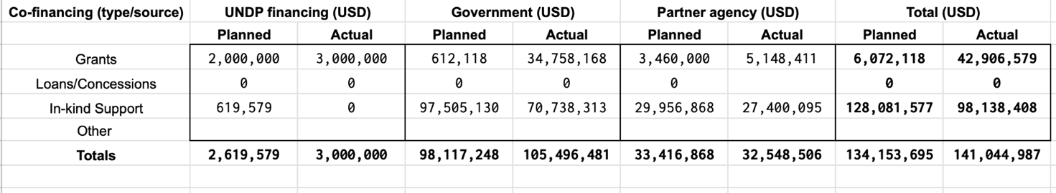

**Table 9: Co-financing**

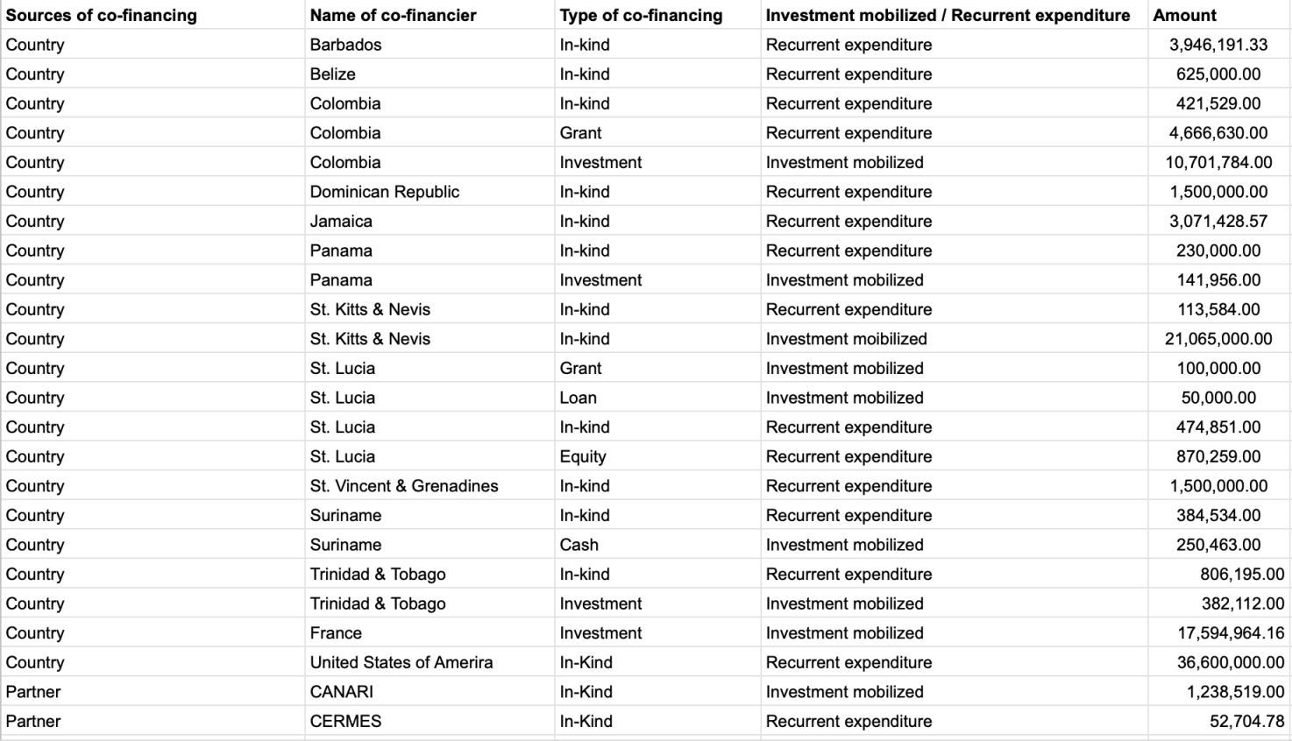

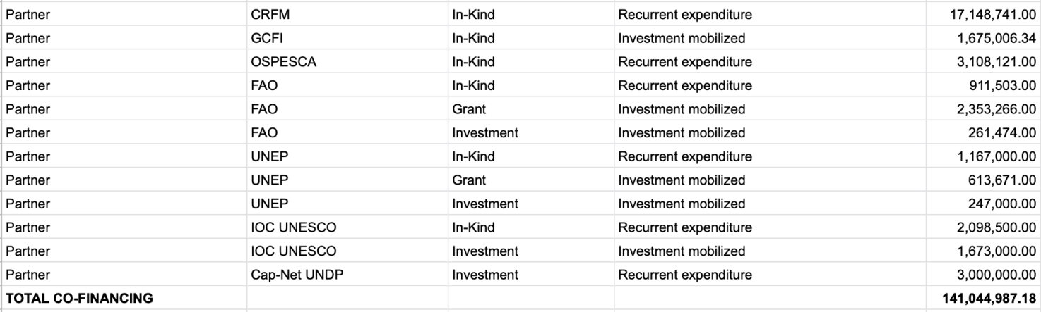

**Table 10. Confirmed Sources of Co-Financing at TE Stage**

### **4.2.4 Monitoring & Evaluation: design at entry, implementation, and overall assessment**

The quality of the M&E plan implementation is high, and adequately funded. It appears to have represented a valid support to project management. In particular the PIRs and the PEG meeting reports and preparatory documents, as well as the SC documentation, can be considered best practice: they are complete, factual, and the result of a thorough participatory process. These M&E tools were instrumental in supporting the adaptive management that has been key for the progress of the project notwithstanding the many obstacles posed by the initial delays, the large number of executing partners and stakeholders, and the Covid 19 pandemic.

Throughout its execution, the CLME+ Project used a solid Monitoring and Evaluation (M&E) framework to track and evaluate progress, and monitor impacts. This framework, consistent with GEF and UNDP requirements including those on gender, takes reference of the expected outcomes, outputs and indicators[10] of the Project Results Framework. In addition, the project also assisted in establishing a long-term M&E framework for managing progress towards the overall implementation of the CLME+ SAP. This SAP M&E framework, developed under Project Component 5 through collaborative efforts with executing partners and utilized during project execution, is supposed to continue its function beyond the lifespan of the CLME+ project itself.

|  |  |
| --- | --- |
| Monitoring and Evaluation | Rating |
| M&E design at entry | **HS** |
| M&E Plan Implementation | **HS** |
| Overall Quality of M&E | **HS** |

### **4.2.5 Implementing Agency (UNDP), Executing Agency (UNOPS): overall assessment of implementation/oversight and execution.**

**Initial Delays**

The project was endorsed by the GEF CEO on March 4th, 2015 and became fully operational about two months later, when the first disbursements occurred. Administrative, recruitment and organizational delays affected the first year of implementation, with only $580k disbursed during the first 10 months. The initial delays and slow pace in the execution of a number of activities have clearly hindered the progress of the project during the first three years of implementation. The result is that at the time of the MTR, in spite of having spent or transferred to partners 47% of the total budget, the project had met only a small fraction of the targets initially set at project mid-term, and only few of the activities had produced concrete outputs, particularly for Components 2 (providing policy tools) and 4 (catalyzing investments). Of the original set of mid-term targets (31 in total, excluding Component 3 that does not foresee mid-term targets), those actually met at the time of the Second Steering Committee Meeting in June 2018 were only 13. In view of this, and of the execution delays experienced by some of the executing partners, the SC implemented the MTR recommendation and requested a no-cost extension of one year, moving the final date for project completion to April 2021.

The GEF Implementing Agency (UNDP), both through its Headquarters and through the Panama Regional Office, has been a very effective main actor during the phases of project identification, concept preparation, appraisal, preparation of detailed proposal, approval and execution start-up. It also appears to have played an important role in providing support to the EA and its PCU during the difficult early organizational stages of the project, in following closely project implementation and, as part of the Steering Committee, maintaining focus on the expected results, and on the timely delivery of outputs.

The Executing Agency (EA), UNOPS, managed and administered the project’s day-to-day activities under the overall oversight and supervision of UNDP. UNOPS – whose Head Office has candidly recognized its, albeit limited, share of responsibility for the initial delays – has been successful in bringing about a drastic improvement in project performance ever since the mid-term.

The major contribution of the EA has been the establishment, staffing and operation of the Project Coordination Unit (PCU), tasked with the functions of project management, procurement, monitoring of progress, secretariat to the Steering Committee and of the Project Executive Group, and also of the execution of a number of highly relevant activities. There is clear evidence, confirmed by all interviewees, indicating that the PCU - in spite of some recruitment problems - performed at very high standards throughout the project lifespan. In particular, it is worth noting the critical role played by the PCU in recuperating the time lost during the first years of the project, in maintaining focus on the achievement of the main expected outcomes, and finally in overcoming the challenges posed by the spread of the Covid 19 pandemic.

Other Executing Partners - A number of executing partners were contracted by UNOPS (PCU) for the execution of specific activities and the delivery of relevant outputs (see Table 6). The same partners participated to the execution of the foundational CLME project.

These arrangements followed what established in the Project Document, and have been maintained until project completion. The number, diversified nature and roles, and different execution performances of these partners, were factors contributing to the delays that affected the project. As noted by the Mid Term Review, of particular interest is the Project Executive Group (PEG), an innovation introduced by the project in order to more effectively manage and coordinate the large number of executing partners that are involved in the project and do so in a participatory manner. At the same time the PEG allowed monitoring of progress and addressing issues of concern arisen during execution. This management tool was particularly tailored to the specificity of the project and recognized the double role played by the partners: at the same time responsible for the execution of project activities and main actors in the present governance framework of the CLME+ region.

|  |  |
| --- | --- |
| UNDP Implementation/Oversight & UNOPS Execution | Rating |
| Quality of UNDP Implementation/Oversight | **S** |
| Quality of Implementing Partner Execution | **S** |
| Overall quality of Implementation/Oversight and Execution | **S** |

### **4.2.6 Risk Management**

None of the risks identified in the Project Document has proven an unmanageable obstacle for project development and outcomes achievement. The threats posed by the geographic and socio-economic complexity of the region, the large number of stakeholders, and the fragmented approach to fisheries management have all been faced and their impacts mitigated thanks to the concerted action of the PCU and of the executing partners in the implementation of the mitigation strategies part of the project design.

One major threat manifested itself during the last phase of the project: the Covid 19 pandemic, which affected the region starting in mid 2020, and imposed serious restrictions of movement and social interchange. The PCU and its partners reacted swiftly by adopting precautionary measures, such as teleworking for all project staff, the thorough and effective use of online meeting software, and the empowerment of local expertise. This notwithstanding, some of the project activities requiring the physical presence of stakeholders and of external experts, in particular in Component 3 activities, did suffer from these unexpected and unprecedented circumstances.

### **4.2.7 Social and Environmental Standards**

The nature and objectives of project are fully in line with UNDP’s quality assurance and risk management approach to programming principles, in particular Sustainability and Resilience, Pollution Prevention and Resource Efficiency, Access to Information, and with GEF standards such as those on community health, safety, and security, and on climate and disaster risks. The project’s SESP was reviewed in 2021 and no revisions were suggested.

## 4.3 Project Results and Impacts

### **4.3.1 Progress Towards Objective and Expected Outcomes**

|  |
| --- |
| **Project Objective: Facilitating EBM/EAF in the CLME+ for the sustainable and climate-resilient provision of goods and services from shared living marine resources, in line with the endorsed CLME+ SAP**  The SAP developed under the UNDP/GEF “CLME Project” (2009-2014), is a 10-year program (2015-2025) which has, to date, been politically endorsed by 25 countries and outlines short-and medium-term priority actions for improved ocean governance and management in the CLME+ region. With countries and individuals heavily reliant on the shared goods and services provided by marine ecosystems, the SAP aims to improve transboundary governance for the management of shared living marine resources (sLMR). This will be achieved by addressing three transboundary problems present across the region: unsustainable fisheries, habitat degradation and pollution. The SAP aims to implement activities and achieve outcomes that will promote the implementation of six strategies: Strategy 1: Protecting the marine environment; Strategy 2: Achieving sustainable fisheries; Strategy 3: Integrated ocean governance, through inter-sectoral policy coordination; Strategy 4: Ecosystem-based management (EBM) for reefs and associated ecosystems; Strategy 5: An ecosystem approach to fisheries (EAF) for the pelagic ecosystem; and Strategy 6: EBM/EAF for the Guianas-Brazil continental shelf ecosystem, with special emphasis on shrimp and groundfish fisheries. |

| **Color coding for outputs - green: fully achieved; orange: partially achieved** | |
| --- | --- |
| **Outcomes/Outputs** | **TE Observations** |
| **Outcome 1:**  Integrative governance arrangements for sustainable fisheries and for the protection of the marine environment | The achievement of this outcome is strictly linked to the set of outputs listed below. Overall, it has been largely achieved, as countries and IGOs have established and operated effectively throughout project an Interim Regional Fisheries Coordination Mechanism, and an Interim Coordination Mechanism for the Caribbean and North Brazil Shelf LME, integrating fisheries management and environmental health. The transition to an overarching “Regional Coordination Mechanism to Support Integrated Ocean Governance in the Caribbean and North Brazil Shelf Large Marine Ecosystems” through a non-binding MoU agreed upon by countries and IGOs and technically cleared by the SC, is now pending the final decision of the countries. |
| Output 1.1 - Decisions on coordination & cooperation arrangements and institutional mandates, in line with CLME+ region SAP Strategies 1 (environment), 2 (fisheries) and 3 (cross-sectoral policy coordination). This includes the following targets: | The output is supposed to be the cumulative result of a number of complex targets, all of paramount importance in view of the project’s ultimate objective. The targets were:   1. *Formal agreement between Brazil and the Cartagena Convention* - Brazil not being a party to the Cartagena Convention, the project has strived to facilitate the joining of Brazil’s to this important treaty, so to reflect the strictly interconnected nature of the Caribbean and North Brazil Shelf LMEs. An MoU is ready (with brackets) and waiting for signature by Brazil. Not likely to happen within the project’s lifetime. (UNEP CAR/RCU) 2. *Establishment of a coordination mechanism among the region-wide arrangements dealing with pollution and habitat degradation* - The objectives of the Cartagena Convention are accomplished through the implementation of activities under two Sub-programs: (i) Assessment of Marine Environment Pollution (AMEP) sub-program, including activities under the LBS and Oil Spill Protocols, and the Specially Protected Areas and Wildlife sub-program. While many of the activities implemented under these two Sub-Programs often complement each other, human and financial resource constraints, donor demands and differing mandates have not enabled strategic joint implementation of AMEP and SPAW activities and maximized the potential impact at regional, national and local levels. The CLME+ project provided support for the enhanced coordination among the two Sub-Programs and the development of a roadmap for collaborative action that will continue after project closure. (UNEP CAR/RCU) 3. *Creation of an interim region-wide coordination mechanism for sustainable fisheries management (IFCM)*- An MoU for Interim Coordination on Sustainable Fisheries was agreed upon and signed in January 2016 by the three regional intergovernmental fisheries organizations covering the wider Caribbean: OSPESCA, CRFM and WECAFC. The ICM has fruitfully operated ever since. (Regional Fisheries Bodies) 4. *Establishment of region-wide permanent arrangement for sustainable, ecosystem-based fisheries management (RFMO)* – The transformation, promoted by the project, of the Western Central Atlantic Fishery Commission (FAO WECAFC) into a Regional Fisheries Management Organization (RFMO) was considered by WECAFC Members (October 2020). An agreement was tentatively reached on short, medium, and long-term approaches starting with the Areas Beyond National Jurisdiction (ABNJ) where binding measures can be implemented, and perhaps also including selected straddling and transboundary stocks, or highly migratory stocks within the Exclusive Economic Zones (EEZs) without prejudice of the sovereign rights of WECAFC Members. This falls short of the expectations, since there are no fisheries in the high seas of the WECAFC region (Western Atlantic). Negotiations will however continue within WECAFC. (FAO WECAFC) 5. Creation of the SAP implementation coordination mechanism, integrating the arrangements for sustainable fisheries and the protection of the marine environment (SAP ICM) – UN Environment CAR/RCU, FAO WECAFC, UNESCO IOC, OECS, CRFM, OSPESCA, CCAD, and CARICOM established in July 2017 through an MoU the Interim Coordination Mechanism for the Sustainable Management, Use and Protection of Shared Living Marine Resources in the Caribbean and North Brazil Shelf Large Marine Ecosystems. The ICM operated regularly since then and held its 10th meeting in February 2021. In this occasion, members agreed to the need for continuity of the CLME+ SAP ICM after the end of the CLME+ Project and until the commencement of the Memorandum of Understanding that creates the long-term Coordination Mechanism, and endorsed the approach that has been deployed to secure an institutional arrangement and operational mechanisms for coordinated ocean governance beyond the project lifespan. (PCU) 6. *Establishment of a permanent policy coordination mechanism* – In occasion of the third and last SC meeting held online in February 2021, members technically endorsed the content of the Memorandum of Understanding Enabling the Creation of a Coordination Mechanism to Support Integrated Ocean Governance in the Caribbean and North Brazil Shelf Large Marine Ecosystem, and encouraged States, Territories and Inter-governmental organizations listed in the MoU to submit the document to their legal departments for review to allow for the finalization and subsequent opening for signature of the Coordination Mechanism MoU. The thematic scope of the Coordination Mechanism includes land and marine based sources of pollution, marine and coastal habitats and biodiversity, and marine and coastal fisheries. (PCU)   Based on the above, it is the TE conclusion that this output, possibly the most important and challenging of the whole project, has been successfully completed. Final decisions on targets 1, 4 and 6 are beyond the control of the project, and lie within the countries’ (1,6) and the governing body of FAO WECAFC (4) purview. |
| Output 1.2 - National Inter-sectoral Coordination (NIC) mechanisms (including science-policy interfaces) in place. | A review of the current situation with respect to intersectoral coordination at governmental level, concluded that as of July 2019 60% of the countries of the of the CLME+ region had National Inter-ministerial Committees in place or in the process of being established. Guidelines for the creation and operation of sustainable and successful NICs, including examples of regional successes, have been published. (CERMES) |
| Output 1.3 - Regional policies, declarations and/or regulations, and associated national-level legislation and/or plans, are appropriate to enable effective EBM/EAF in the CLME+ region | The project produced a Strategy for mainstreaming EBM-EAF so that Regional policies, declarations and/or regulations, and associated national-level legislation and/or plans, are appropriate to enable effective EBM-EAF in the CLME+ region. The aim of this strategy is to maximize uptake of the provided guidance on EBM-EAF. A 2020 survey found that most of the 40 states and territories assessed are making incremental progress towards the implementation of EBM/EAF at the national level. |
| Output 1.4 - Data management, access & exchange arrangements support adaptive management and implementation of the CLME+ region Project and SAP. | All signatories of the MoUs establishing the ICM agreed to Coordinate knowledge management and facilitate data and information sharing, and support monitoring in the context of the production of SOMEE. (PCU) |
| Output 1.5 - Sustainable financing mechanism(s) to ensure short, medium and long-term operations of the sLMR governance arrangements | A proposal for a *Sustainable Financing Plan for Ocean Governance in the Wider Caribbean region* was submitted together with the draft CM MoU to the attention of the SC, and was technically cleared. Adoption is pending. |
| **Outcome 2:**  Enhanced institutional and stakeholder capacity for sLMR management at regional, sub-regional, national and local levels (with special attention to regional and sub-regional organizations with key roles in SAP implementation) | The cohort of outputs under Component 2 has been largely successful in (i) providing decision and policy makers in the region, including relevant IGOs, with the science, capacity and tools (strategies) that will enable them to address the 3 priority problems identified under the TDAs: unsustainable fisheries, habitat degradation and pollution, and (ii) assist stakeholders in achieving improved coordination, collaboration and integration among the wide array of ongoing and newly planned projects and initiatives that are of relevance to the wider objectives of the CLME+ SAP. The late completion of many of these outputs, and the impacts of the pandemic, might have prevented the full internalization of these highly valuable contributions. |
| Output 2.1 - Regional Action Plans for the management, conservation and sustainable use of fishery resources and for the protection of the marine o environment, considering the implications on gender and the possible impacts of climate change. | The output includes the preparation and validation of the three Strategies and Action Plans (see below) addressing key threats to the sustainability of the marine environment and its living marine resources. The IUU Plan has already been validated (WECAFC). The other two have been submitted to UNEP CEP governing body during the last year of the project lifespan, and are presently waiting for endorsement/adoption.   1. The Regional Plan of Action to Prevent, Deter and Eliminate Illegal, Unreported and Unregulated (IUU) Fishing in WECAFC Member Countries was submitted to the 17th Session of WECAFC in July 2019. The Commission (i) reviewed, and endorsed the RPOA-IUU, (ii) acknowledged the important collaborative framework which led to the development of this essential instrument and its potential for sustaining ownership throughout the region, and (iii) provided guidance for the effective implementation and gauging of progress at national and regional levels. Guidance to develop Model National Plans of Action against IUU has been developed and disseminated among CLME+ region countries by end of 2020. (WECAFC) 2. The overarching goal of the Regional Strategy and Action Plan for the Valuation, Protection and/or Restoration of Key Marine Habitats in the Wider Caribbean is to strengthen national and collective action by countries to manage coastal ecosystems, particularly coral reefs, mangroves and seagrasses, in order to maintain the integrity of the habitats and ensure the continued flow of ecosystem goods and services necessary for national development. The Strategy, published in 2020, is pending endorsement at the June 2021 Conference of Parties. . (UNEP CEP/CANARI) 3. The Regional Nutrients Reduction Strategy and Action Plan was submitted for validation at the Fifth Meeting of the Scientific and Technical Advisory Committee (STAC) to the Protocol Concerning Pollution from Land-Based Sources and Activities in the Wider Caribbean in March 2021. (UNEP CEP)At that meeting, the STAC recommended the endorsement of the document to the Conference of Parties which is to take place in June 2021. |
| Output 2.2 - Civil Society Action Program (C-SAP) sensitive to gender concerns, and private sector actions complement and support the implementation of the CLME+ regionSAP | All targets related with this output have been met. The gender sensitive Civil Society Action Program for the Sustainable Management of the Shared Living Marine Resources of the Caribbean and North Brazil Shelf Large Marine Ecosystems (CLME+ C-SAP) was endorsed in March 2020 by 51 CSOs/FFOs/SMEs. As a consequence, CNFO reported an increase of over 25*%* in interactions with women in the CNFO membership. A major IFI, and several private foundations (hotel associations) committed to actions in support of the Blue Economy and the CLME+ SAP implementation. Finally, the concept, road map and operationalization of a voluntary Small Grants Coordination Mechanism (SGCM) to enhance support for civil society to contribute to conservation and sustainable, was developed. (CANARI, CNFO, PCU) |
| Output 2.3 - Identification of good practices for data & information management (DIM), and of best available (innovative) technologies and tools, to support communication, awareness building (CAB) and decision-making (DM) processes | The inventory of best practices in DIM/CAB/DM has been updated and disseminated  (PCU) |
| Output 2.5 - Strategy for the training of selected stakeholders on issues of cross-cutting importance for the SAP Strategies. | The training component of the project was for some reason delayed to the last year of project execution. Likely due to the impact of the pandemic, the approach shifted from “training workshops” to online facilitation by implementing the marinetraining.eu portal technology thanks to the agreement between the Intergovernmental Oceanographic Commission –IOC of UNESCO and the Ghent University as developer, including a development of a sustainability and maintenance plan. (UNESCO IOC) |
| Output 2.6 - Targeted research strategies to address scientific demands from organizations dealing with fisheries and the protection and sustainable use of the marine environment | The project in 2020 produced an outstanding strategic document: *“Science and Research serving effective ocean governance in the wider Caribbean Region”.* The strategy focuses on the most pressing issue related to fisheries and EAF, i.e.: to provide sound scientific knowledge for the management of fish stocks that will ensure the long-term sustainability of fishing, minimize impacts to the environment, and facilitate the recovery of depleted fish stocks. It covers all three research agendas that represent the priority issues for decision makers and respond to the approach of the CLME+ project: 1) unsustainable fisheries of Spiny lobster, Flyingfish, and shrimp and groundfish, 2) habitat degradation, and 3) pollution.  *This effort represents a best practice.* (GCFI) |
| **Outcome 3:**  Progressive reduction of environmental stresses, and enhancement of livelihoods demonstrated, across the thematic and geographical scope of the CLME+ SAP | Of the five demonstration sub-projects that collectively were supposed to produce the expected outcome, three have been successfully completed as per the original plan, and did determine enabling conditions for stress reduction in relation with important issues of concern: the spiny lobster fishery; the flyingfish fishery; the creation of alternative livelihoods. The other two, started with great delays and impacted by the spread of the pandemic, are still ongoing, with a number of outputs expected to be finalized within April 2021, or that have been cancelled. This notwithstanding, and although actual stress reduction has not been produced, a number of ways to create the enabling conditions for reducing the stress on over-exploited fisheries, degraded habitats, and polluted marine environments have been effectively demonstrated. |
| Output (Sub-project) 3.1 - Well-planned, progressive transition to an ecosystem approach for the Caribbean spiny lobster fisheries (demonstration at the sub-regional level) | The primary objective, to which the Caribbean Spiny Lobster Sub-project contributed through the application of the EAF, was to maximize in a sustainable way the contributions of the spiny lobster fishery to the well-being of people and socio-economic development in the CLME + region, preserving the structure, diversity and the functioning of the ecosystems that host this species. Specifically, it accomplished: i) improved the regional and intersectoral coordination arrangements, and formulated a Regional Plan for the Spiny Lobster Fishery; ii) provided countries with the methodology for spiny lobster stock assessment and improved the capacity of stakeholders to effectively implement policy and decision-making cycles; iii) *Introduced region-wide standards for traceability of fisheries products* (i.e.: the ability to fully trace a product from the point of sale back to its point of origin, with information available about all transactions and movements in between); and iv) put in place protocols for the monitoring of progress towards the ecosystem approach to Caribbean lobster fisheries.  The area of ​​execution of the sub-project considered 11 countries: Belize, Costa Rica, El Salvador, Guatemala, Honduras, Nicaragua, Panama, Dominican Republic, Bahamas, Colombia and Jamaica. (OSPESCA) |
| Output (sub-project) 3.2 -  Well-planned, progressive transition to an ecosystem approach for the shrimp and groundfish (S&GF) fisheries of the NBSLME | The sub-project addresses one of the most threatened fisheries of the CLME+ LMEs: the shrimp and groundfish resources of the North Guianas-Brazil shelf, supporting one of the world’s most valuable export‐oriented shrimp fisheries with over 50% of the stocks over-exploited or collapsed. The main outputs that the sub-project, whose *activities are still ongoing*, has so far produced are the following documents and tools: a concept for a sub-regional Fisheries Management Plan; a Decision Support System (DSS) to make information, data and knowledge readily accessible, and a tool to track the level of EAF implementation by the partner countries; a gender analysis along the value chain for shrimp and groundfish fisheries with a long-term view to enhancing he role of women, and an “Environmental Sustainability Assessment of Guyana artisanal groundfish fisheries”.  Based on the above, the TE is unable to draw conclusions on the level of adoption by countries, and on whether the stress reduction targets indicated in the Project document have been achieved. (WECAFC) |
| Output (sub-project) 3.3 -  Well-planned, progressive transition to an ecosystem approach for the Eastern Caribbean flyingfish fisheries | The CRFM Executive Committee, at its 33rd meeting held electronically on 25-26 September 2019, approved the Sub-Regional Fisheries Management Plan for Flyingfish in the Eastern Caribbean 2020 – 25, based on the EAF approach. This was followed in March 2021 by the model Amendment to the Fisheries Act 2018 to regulate/enforce fishing of flyingfish in national waters. This achievement was accompanied by training of fisheries stakeholders, technical support to enhance the governance arrangements for implementing EAF for Flyingfish Fisheries; a sub-regional data policy; an After-Life Plan to provide the CRFM with a road map to continue improving regional management of pelagic fisheries, including the flyingfish fishery; a Communication Plan; a Gender Survey in selected island states; reports on the List of Registered Fishing Vessels, and on the Value chain of flyingfish fisheries. Further, recognizing that long-term sustainability of the flyingfish resources will be more effective with the cooperation of the French Overseas Departments that exploit the same stock, engagement of these Departments at the political level was to addressed; however, by mid-term it was recognized that political commitment would not be likely forthcoming, and the focus was shifted on a technical cooperation agreement. (CRFM) |
| Output (sub-project) 3.4 -  Demonstrating the transition to an Ecosystem-Based Management (EBM) approach at the sub-regional/site level in the CLME+, with special attention to the integration with Output 3.2 in the case of the NBSLME sub-region | Trinidad Tobago (completed) - The aim of the EBM intervention is to reduce pollution from agricultural activities in the Caroni Swamp through the implementation of community-based conservation activities in the Caroni River basin. The sub-project resulted in (i) increased farmers capacity in Integrated Pest Management and diseases control; (ii) definition of Bacterial Indicators in water and oysters; (iii) assessment of heavy metals in the blue land crab from the Caroni Swamp; (iv) definition of the baseline of nutrient pollution.  Guyana (completed) – The Wellington Park Mangrove Reserves was selected given the degraded mangroves found in the area. A management plan and governance structure for the site were developed to mitigate pollution, and rehabilitate the area.  Suriname - The sub-project had the objective of assessing and remediating the impacts of land-based sources of pollution in coastal mangroves and wetlands. Some activities on capacity building and baseline assessments are reported as completed, while others have been cancelled or reallocated. (UNEP CAR/RCU) |
| Output (sub-project) 3.5 -  Modest small grants support for the implementation of C-SAP and/or P-SAP actions (see Output 2.2) that will contribute to Outputs 3.1-3.4. (with special attention to livelihoods) | The sub-project supported two initiatives aimed at building the capacity of stakeholders in St. Kitts & Nevis in sea moss farming, as a demonstration of alternative livelihoods initiatives within the concept of Ecosystem Based Management. The small grant program met its objective of building capacity of stakeholders in St. Kitts and Nevis in sea moss farming. Project stakeholders noted improved knowledge and skills from their participation in the project particularly in cultivating and processing (drying) sea moss and creating value-added products from sea moss. Grantees also noted their continued interest in building their capacity in sea moss cultivation and commercialization, including operating sustainable SMEs. (CANARI) |
| **Outcome 4:**  Financing catalyzed for the up-scaling of priority actions for the protection of the marine environment and for ensuring sustainable, climate-resilient livelihoods and socio-economic development from sLMR use | While extensive work has been done to identify, characterize and assess at the level of pre-feasibility a number of priority investment opportunities and business cases related to all key issues of concern identified in the CLME+ TDAs, actual financing has not yet been “catalyzed”. |
| Output 4.1 - Pre-feasibility reports on major investment needs and opportunities (incl. budget estimates, scope of work, private sector involvement, potential benefits and required timescales) | Applying a prioritization methodology, a total of 48 large-scale high priority habitat restoration sites have been identified all of which present compelling reasons for investments. Replicable models for investment plans were developed utilizing an approach to pollution prevention, habitat restoration, and conservation linking blended finance, economic valuation of ecosystem services, and quantification of economic benefits. Site scorecards were also produced. (UNEP CAR/RCU) |
| Output 4.2 Investment plans (incl. specifications for private sector and civil society involvement) to deal with key issues identified under the CLME TDAs | Several “business cases” were prepared:   * Investing in Guyana’s artisanal finfish sector - Investments in supply-chain interventions to achieve better operational efficiency, decrease product loss and improve quality. * Investing in Grenada’s Yellowfin Tuna Export - Investments to incentivize and facilitate required reductions in billfish mortal * Scalable fisheries for shrimp and groundfish * Supporting Sustainable Development of Grenadian Tuna through a Value-Added Cured Tuna Enterprise. * Investment cases to address issues related to pollution mitigation and habitat restoration were defined for Bahamas, Colombia and Honduras   (UNEP CAR/RCU, WECAFC) |
| Outcome 5:  Regional socio-economic benefits and Global Environmental Benefits from SAP implementation are maximized through enhanced collaboration, planning & adaptive management, and exchange of experiences and lessons learnt | The project achieved a remarkable level of awareness, involvement and direct engagement of stakeholders throughout the region, and set the foundations and structure of sound monitoring and reporting mechanisms of SAP implementation progress and of the State of the Marine Environment and Associated Economies. The latter represents a pillar for guiding future remedial actions and advancing Blue Economy, and the sustainability of the coastal and marine environment and its living resources. |
| Output 5.1 - Cooperation (incl. through formal and/or informal frameworks and partnerships) among development partners, programs, projects, initiatives (PPIs) and countries/territories with a stake in the SAP (“CLME+ region SAP Partnership”) | The results presently reportedly as achieved are:  90% of CLME+ countries involved in Project & SAP implementation  33% of overseas territories involved in SAP Implementation  12 organizations actively involved in SAP implementation  Active participation by major CSOs and Private Sector  15% of regional PPIs actively involved in SAP implementation.  SAP implementation results in a total “portfolio”/investment value of USD 348 million. (PCU/CERMES) |
| Output 5.2 - A prototype CLME+ region ecosystem status and SAP implementation M&E mechanism | SAP Actions Tracking Portal that monitors progress in SAP implementation is online and operational;  The outline of the State of the Marine Environment and Associated Economies (SOMEE) has been defined and adopted by all contributing partners;  Content developed for the first SOMEE report and SAP M&E portal;  Responsibility for future implementation of the M&E process assigned to the ICM secretariat. |
| Output 5.3 - Communication, twinning and knowledge exchange activities targeting the CLME+ region Partnership and global LME Community of Practice (COP). | The Project website(s) with relevant content & functionality online since early project stages;  Active participation of CLME+ region in: 2 LME Conferences (2015-17-19); 3 LME Consultative Group Meetings; min. 2 LME: LEARN Twinnings/exchanges; 2 regional LME: LEARN workshops; two GEF IW Conferences;  Contributions to IW: LEARN-related twinning & exchange activities.  (PCU/Partners) |

### **4.3.2 Relevance**

The project aim is to jump start the implementation of the SAP which was negotiated by all relevant stakeholders, agreed upon and endorsed at the ministerial level by nearly all the countries sharing the Caribbean and the North Brazil Shelf Large Marine Ecosystems. The overall goal of the SAP, as well as of the project, is to reverse the alarming fisheries degradation trends affecting livelihoods, regional economy and ecosystems health and resilience. The project focuses on two SAP actions of paramount importance and fully in line with regional and national priorities: (i) facilitating the establishment of regional cross sectoral coordination mechanisms among countries and regional IGOs integrating consideration of environmental health and fisheries related aspects; (ii) enabling the transition to ecosystem based sustainable fisheries management by strengthening institutional capacity and providing management tools and science products. In doing so the project promotes compliance with a number of international soft and binding laws, fosters countries’ progress towards the achievement of several SDGs, and fully adheres with UNDP Strategic Plan, with UNSDCF, and with the GEF 6 strategic objective 2 of the International Waters Focal Area.

### **4.3.3 Effectiveness**

The project’s main objectives have been achieved. An MoU, technically cleared by all parties, enabling the creation of a “Coordination Mechanism to Support Integrated Ocean Governance in the Caribbean and North Brazil Shelf Large Marine Ecosystems”, is being submitted by States, Territories and Inter-governmental organizations to their legal departments for review and opening for signature. Relevant IGOs have been successfully encouraged to better coordinate/harmonize their actions, and even consider evolving into a Regional Fisheries Management Arrangement/Entity ; almost all the science-based assessments, pre-feasibility studies and other knowledge products, Strategies and Action Plans, management and ICT tools foreseen in the Project document have been produced, made broadly available, and are now in the process of being considered for internalization by countries and IGOs. Global environmental benefits in terms of increased transboundary cooperation, and of enabling conditions for stress reduction to living marine resources, have been accrued.

### **4.3.4 Efficiency**

Resources allocation and cost-effectiveness – Funding allocations to the various project components and executing entities (PCU, Partner Executing Agencies), appear to have been adequate for the completion of all foreseen activities within the revised deadline for technical closure of the project of April 2021.

Project management and timeliness – Notwithstanding the efficient flow of funds (47% disbursed at Mid-term), the project suffered serious delays during the first three years of execution (June 2015 – June 2018) due to administrative, staffing and organizational hurdles at the level of the two major executing partners (FAO and UNEP), and of the Executing Agency. This fact made a substantial no-cost project extension unavoidable, as clearly demonstrated and recommended by the Mid-Term Review in June 2018. The swift action and continuous monitoring of progress by the PCU, and the frequent interactions between the PCU and the executing partners through the Executive Group meetings, were decisive in overcoming the impacts of the initial delays that affected the timely progress of activities, and getting the project back on track. The total disbursement of the GEF grant at the end of March 2021 amounts to USD 11,773,321 USD (94%).

### 

### **4.3.5 Overall Project Outcome**

|  |  |
| --- | --- |
| Assessment of Outcomes | Rating |
| Relevance | HS |
| Effectiveness | S |
| Efficiency | S |
| Overall Project Outcome Rating | S |

### 

### **4.3.6 Sustainability**

Financial sustainability - The financial sustainability of the project outcomes, that is of the legal, institutional and policy reforms at the regional and national levels that the SAP is calling for and the project has facilitated, depends primarily on the results of the ongoing process of internalization by countries and IGOs of a number of the outputs produced by the project. The final decision lies with the countries, and is beyond the project’s control. In general terms, the commitment to providing continuing support and sustaining the project outcomes shown by all interviewees bodes well for the future sustainability of the project outcomes, including financial.

Socio-political sustainability – Risks of this nature might emerge in the future should the political agenda of countries move towards enhancing sovereign rights rather than towards the transboundary cooperation and joint management indispensable for the sustainability of the shared ecosystems and their living resources. At present, the global commitment to the SDGs, the tradition of multi-country cooperation existing in the Caribbean region demonstrated by the number of existing IGOs, and the long-term support provided by the GEF International Waters to the region’s cooperative processes, have created a very favorable socio-political environment.

Institutional framework and governance sustainability - The largest part of the project execution was responsibility of the relevant IGOs acting in the region, and of the countries, from governments to local communities: that is of the project beneficiaries. Hence no threat is expected from the existing institutional settings and policy environment.

Environmental sustainability – Climate change, and the spread of the pandemic are the environmental factors that, while not posing direct threats to project outcomes other than possibly delaying actions, will on the contrary reinforce the need for strong transboundary cooperative frameworks, and for healthy fisheries and related ecosystems.

|  |  |
| --- | --- |
| Sustainability | Rating |
| Financial Resources | ML |
| Socio-political | L |
| Institutional Frameworks and governance | L |
| Environmental | HL |
| Overall Likelihood of Sustainability | ML |

# **Part 5: Main Findings, Conclusions, Recommendations, Lessons Learned**

## **5.1 Main Findings**

Relevance – This SAP implementation project addresses the major transboundary concern affecting the Caribbean and North Brazil Shelf LMEs: the alarming decline of major straddling stocks and other fisheries resources of high economic and social value, impacted by over-exploitation, habitat degradation and pollution within a highly fragmented governance framework .The project promotes compliance with a number of international soft and binding laws, fosters countries’ progress towards the achievement of several SDGs, and fully adheres with UNDP Strategic Plan, with UNSDCF, and with the GEF 6 Strategic Objective 2 of the International Waters Focal Area.

Effectiveness – The project achieved its overall objective, and outcomes. One achievement stands out for its crucial importance and global relevance: the establishment during project execution of regional “interim” coordination mechanisms among countries and relevant IGOs tasked with the harmonization of relevant fisheries policies, the integration of environmental factors, and the coordination of the numerous and fragmented ongoing and planned initiatives that relate to SAP priority actions. This is something that has not been accomplished in any other regional sea/LME of similar complexity. The institutionalization of these mechanisms, that are key for the achievement of the ultimate objective of the restoration of fisheries and their sustainable exploitation, is presently being considered for adoption by governments.

Efficiency – The project had to confront with the challenges posed by unexpected initial delays in getting some of the many executing partners ready for action, and by the constraints imposed by the spreading of the pandemic during the project final years. The swift action of the project management structure with its commendable monitoring/reporting capacity, allowed the project to overcome these hurdles, and to complete the project with one-year extension and within budget.

Sustainability – Institutional capacity has been strengthened at the country and regional levels, and management and knowledge tools have been provided that will enable countries and IGOs to transition to the ecosystem approach to fisheries management. The future sustainability of the coordination mechanism between national and regional management bodies dealing with fisheries and environment that was created by the project, is pending the final decision by governments. The Final Project Steering Committee meeting of February 2021, having technically endorsed the draft *Memorandum of Understanding Enabling the Creation of a Coordination Mechanism to Support Integrated Ocean Governance in the Caribbean and North Brazil Shelf Large Marine Ecosystems* , requested the PCU to convene a special Meeting of the CLME+ Project Steering Committee with the aim of achieving finalization and opening for signature of the Coordination Mechanism Memorandum of Understanding before the end of June 2021.

## **5.2 Conclusions**

The CLME+ project is nearing a successful conclusion, having achieved most of the expected results. This is no minor accomplishment if one considers the geographic and environmental complexity of the region, the number of countries, regional organizations and stakeholders involved, and the need to balance the social, economic and environmental factors impinging on fisheries. In fact, marine and coastal environmental protection policies (pollution, habitats, biodiversity) are integral parts of sustainable approaches to wild capture fisheries, and a key facet of the blue economy. In this respect, the approach of the CLME+ project involving the engagement of both the fisheries and the environment sectors at the regional and the national levels, represents an innovative contribution and a globally replicable example.

With the aim of enabling the transition to ecosystem-based management of fisheries called for by the CLME SAP, the project has produced advancements in intersectoral coordination within countries and in the region, has reinforced institutional capacities, provided stakeholders with the required knowledge, policy and management tools, and field-tested examples, and opened the way for remarkable achievements, such as the Introduction of region-wide standards for traceability of fisheries products.

As with all projects aiming at promoting policy and institutional reforms and transformational changes, in this case of the fisheries sector, the final decisions lie with countries. The actual enactment of the legal, institutional and policy reforms at the regional and national levels that the SAP is calling for and that the project has promoted, depends primarily on the level of country ownership and internalization of the project outputs. The project has facilitated the decision-making processes by providing the technical basis, and the available options for the national governments and IGOs governing bodies to decide upon. This country “buy in” process, involving national institutions and their representatives in the governing bodies of relevant intergovernmental organizations, requires time and the support and facilitation of the project. The decisions taken by the final Steering Committee meeting bode well for the future sustainability of project outcomes.

The project has excelled in adaptive management, monitoring, and reporting of progress. This appears to be due to the quality and commitment of the PCU staff, and to the project’s execution arrangements which facilitated monitoring of progress, dialogue among all actors (UNDP, UNOPS, the PCU, and all executing partners), and decision making, through the creation of a Project Executive Group (PEG), which met virtually at regular intervals. These management settings were instrumental in overcoming the obstacles that the project had to overcome – delays in the inception phase, and more importantly, the pandemic.

## 

## **5.3 Lessons Learned and Recommendations**

A number of lessons learned, strengths, weaknesses and gaps have emerged from the Terminal Evaluation of the CLME+ project that can be translated into recommendations applicable in the region and elsewhere.

* Entrusting regional IGOs and CSOs with the formulation of many of the plans, strategies, policy reforms and governance mechanisms and tools called for in the SAP, and delegating their approval/adoption to their governance bodies and processes, was a strategic design choice of the CLME+ project, coherent with the approach taken in the foundational CLME project. The role of countries’ governments should not however be underestimated, particularly in IW projects aiming at determining policy, institutional, legislative reforms and investments at the country and regional levels, such as the CLME and CLME+ projects. In order to facilitate country ownership, and the internalization of project outputs, future efforts should consider expanding the direct role of countries in project execution, and putting in place effective communication mechanisms with and within countries, streamlined and implemented according to ad hoc protocols.
* Aligning marine and coastal environmental protection policies (coastal zone management, land-based sources of pollution, biodiversity, etc.) and sustainable approaches to wild capture fisheries is a key aspect of the blue economy and an innovative contribution of the CLME+ project that should be broadly replicated. Similarly, intersectoral consultation/coordination at country level is of paramount importance to forge and consolidate regional policies aimed at enhancing the sustainability of shared fisheries and other marine resources.
* In addition to, and alongside the highly commendable efforts to introduce ecosystem-based management of fisheries, strengthen RFMOs, fight against IUU fishing, and support more biodiversity friendly fishing practices, which characterize the CLME+ project, as well as the whole IW fisheries portfolio, the transition from wild capture fisheries, to “fish farming” and the creation of alternative livelihoods for fisherfolks have not received noticeable attention. Overall, production from the world's wild fisheries has levelled out and may be starting to decline, as a contrast to farmed fisheries and mariculture that are growing in importance, and are technological in nature, revolving around developments in aquaculture. The promotion of sustainable aquaculture – in many instances the only long-term solution – should be a relevant part of future efforts in the region. The rights of artisanal coastal fisherfolks communities, whose role in providing food security to coastal populations, as noted by an interviewee, has been made even more precious by the global economic crisis caused by the Covid 19 pandemic, need to be protected. This notwithstanding, there are cases where the priority of preserving living marine resources for future generations should prevail, and require the reduction or even the ban of wild capture fishing. Hence the imperative of promoting alternative livelihoods for affected fishing communities, a field that has received minor attention in the CLME+ project, limited to a small but notable pilot on sea moss farming in St Kitts and Nevis.
* As recommended by the TE of the foundational CLME project, broadening the partnership to include multilateral development banks (CAF, CDB, IDB, The World Bank) and other potential multilateral and bilateral donors, could be beneficial for fostering and coordinating SAP implementation in the long term. Systematic dialogue with these critical potential partners has not however happened in the CLME+ project. The CLME+ TE reiterates the recommendation to seek the involvement of development banks and major donors in future initiatives.
* Despite the challenging conditions under which the project had to operate, the execution modalities of the project have proven successful, and could serve as example for other similar projects characterized by multi-country transboundary settings and multiple executing partners. Two elements of the execution arrangements are worth noting: the strong PCU, established by UNOPS – the principal executing agency providing also administrative/procurement backstopping; the Project Executive Group, formally established and including the PCU, the implementing agency (in this case UNDP), UNOPS and all executing partners, tasked with ensuring the monitoring of progress, coordination and coherence, and meeting virtually. The use of virtual meetings and interactions in response to the spread of the pandemic had the unanticipated advantage of allowing engagement with stakeholders in countries that had not been originally planned for.
* A project executing partner (GCFI) as part of Component 2 of the project produced an outstanding strategic document: *“Science and Research serving effective ocean governance in the wider Caribbean Region”.* The study covers all three major issues of concern in the CLME+: 1) declining fisheries of Spiny lobster, Flyingfish, and shrimp and groundfish, 2) habitat degradation, and 3) pollution, and identifies the scientific research lines needed to fill the existing gaps in the understanding of the functioning of the various ecosystems, and to reach the comprehensive knowledge essential for the full deployment of the ecosystem approach to fisheries. Similar studies should guide all efforts to implement the EAF/EBM approaches.

1. A comprehensive analysis of global and (sub) regional organizations involved in sLMR governance in the CLME+ was prepared by the *Centre for Resource Management and Environmental Studies* (CERMES/UWI) under the CLME Project and is available from [www.clmeproject.org.](http://www.clmeproject.org/)
2. The ToC was not a requirement at the time of CLME+ design.
3. Secondary stakeholders don't have any direct engagement with the project, but can still be influential.   
     
   
4. From the MTR final report 2018
5. MTR Final Report, 2018
6. An initial extension from the original end date of April 2020, to August 31, 2020 was adopted during the intersessional SC meeting in February 2019. The intersessional SC meeting of June 2020 moved the project technical completion date to April 30, 2021.
7. From the Mid Term Review, 2018
8. Sub Project NFPs have also been appointed under Component 3. They have a more technical role and support implementation of sub projects.
9. According to the CERMENS assessment on National Intersectoral Coordination Mechanisms (Output 1.2, 2019), only half of the project countries have National Inter-ministerial Committees or equivalent bodies.
10. The CLME+ project aims at facilitate SAP implementation with a strong focus on regional governance processes, blended with on the ground demonstrations of the EBM effectiveness. As such, most CLME+ Project Indicators (especially those from Components 1, 2 and 5) fall under the “Process Indicators” Category, while “Stress Reduction” indicators measure achievements of demonstrations (Component 3)