Annex 1. Project Logical Framework and Theory of Change
  - Project Logical Framework - RS

 | Results chain | Indicators | Baseline  (incl. ref. year) | Current value, ref. date | Targets  (2021) | Sources and means of verification | Assumptions
Overall objective:  Impact | Overall objective of the Action:  To support the sustainable recovery of flood- and landslide-affected communities in the entity of Republika Srpska (RS). | Number of people in targeted areas directly benefiting from flood recovery assistance (disaggregated by gender). | Approximately 11,300 people in flood-affected areas still in need of housing recovery support (2016). |  | Target value for OO in total:  Approximately 1,850 people, out of which at least 40% are women, in flood-affected areas benefit directly from recovery assistance. | - Official entity recovery and reconstruction data (Solidarity Fund for Reconstruction of Republika Srpska)  - Official records and statistics by local governments.  - Relevant reports by interested international community actors.  - Action reports.  - Media reports.
Specific objective(s):  Outcome(s) | SO1: To improve living conditions for vulnerable households whose homes were substantially damaged or destroyed in the disaster.  SO2: To restore and develop economic and livelihood opportunities for low-income vulnerable households assisted with housing recovery. | SO1: Number of affected households provided with adequate and disaster-resilient housing.  SO2: Amount of additional annual income generated for beneficiary households as a result of the Action. | SO1: 3,711 disaster-affected households residing in temporary or substandard housing (2016).  SO2: N/A. |  | Target value for SO 1: 632 households provided with adequate and disaster-resilient housing (2021).  Target value for SO 2: Approximately EUR 105,000 in additional annual income generated (2020). | - Inception, progress and evaluation reports.  - Selection commission reports with endorsed lists of beneficiaries. | - Weather conditions are conducive to construction works and agriculture activities.  - Partner governments engage constructively with the Action, and meet their co-financing and in-kind commitments.  - Sufficient number of vulnerable households are eligible for assistance.  - Private sector partners and opportunities are available to facilitate implementation of non-agriculture livelihood interventions.
Outputs / Results | Output 1.1: Socially and economically vulnerable households, rendered homeless by the 2014 disaster, provided new homes.  Output 1.2: Socially and economically  vulnerable households, residing in disaster-  affected substandard  housing, benefit from  restored and improved  homes. | Output 1.1:  Number of new homes constructed in line with relevant national housing standards.  Output 1.2:  Number of homes rehabilitated as per the relevant national housing standards in flood-affected areas. | Output 1.1:  172 households reside in temporary shelter as their homes were destroyed in the 2014 disaster.  Output 1.2:  3,539 homes damaged in flood-affected areas. |  | Target value for Output 1.1: 219 (2021).  Target value for Output 1.2: 413 (2021). | - Selection commission report with endorsed list of beneficiaries.  - Action progress and evaluation reports.  - Quality assurance compliance reports for all new / rehabilitated homes. | - Qualified construction companies are available at set unit prices.  - Construction land is allocated for new homes away from hazardous areas.  - Relocation of affected households does not disrupt access to source of income / livelihoods.  - Damaged homes are not located in areas at immediate risk from flooding and / or landslides.
 | Output 2.1: Livelihoods needs identified, enabling tailoring of income generation support for housing assistance beneficiaries.  Output 2.2: Vulnerable households benefit from a steady and sustainable income stream. | Output 2.1:  Number of flood-affected households with identified opportunities for income generation support.  Output 2.2a: Number of flood-affected households engaged in sustainable farming.  Output 2.2b: Number of flood-affected households benefiting from self-employment and small business income streams. | Output 2.1:  N/A  Output 2.2a: N/A.  Output 2.2b:  N/A. |  | Target value for Output 2.1: At least 120 (2020).  Target value for Output 2.2a: 117 (2020).  Target value for Output 2.2b: 3 (2020). | - Livelihoods Needs Assessment report.  - Action progress and evaluation reports.  - Training attendance records and certificates for entrepreneurship / self-employment training.  - Registration certificates for new corporate entities.  - Mentoring reports.  - Quality assurance/monitoring reports for all livelihood beneficiaries. | - Availability of quality service provider to design and administer the assessment  - Availability of eligible beneficiaries with income generating  potential.  - Availability of eligible and interested beneficiaries for farming assistance.  - Availability of eligible and interested beneficiaries for self-employment and entrepreneurship assistance.

  - Theory of Change - RS

The logic behind this intervention is that if socially and economically vulnerable households, living in Bosnia and Herzegovina are rendered homeless by the 2014 disaster or residing in disaster-affected buildings, are provided with new or restored homes and, in parallel, are enabled to have a steady and sustainable income stream, a sustainable recovery from 2014 floods may be advanced. Ultimately, by targeting the most vulnerable dwellings and helping them to recover from the 2014 floods and strengthen their resilience to potential future disasters, the Project will contribute to the achievement of Outcomes 3 and 4 set in 2015-19 BiH UNDAF, and will contribute to the attainment of SDGs 8, 11 and 13.

The higher-level change will be attained through the identification of the neediest beneficiaries, in partnership with local authorities, and by providing them with durable housing solutions or restoring and improving the buildings affected by floods and landslides where they reside. To guarantee sustainability of the intervention, attention to energy efficiency, resilience to future disasters and, where needed, disabled-accessibility, will be ensured.

In addition, to ensure full recovery of those households that lost their means of sustainment, beneficiaries will be surveyed to identify livelihood needs. The assessment will guide the following intervention focused on revitalization of damaged small farms, development of incentives for entrepreneurship and self-employment and provision of vocational training to enhance employability of beneficiaries.

These activities will be followed by monitoring and post-implementation quality assurance to ensure beneficiary satisfaction with the quality of the works and assistance provided by the Project.

Delivery of the set objective rests on the assumption that weather conditions are conducive to construction works and agriculture activities, government partners engage constructively with the Project and there is sufficient qualified beneficiary interest in the type of assistance offered.

Hierarchy of objectives (including a visual snapshot)
F 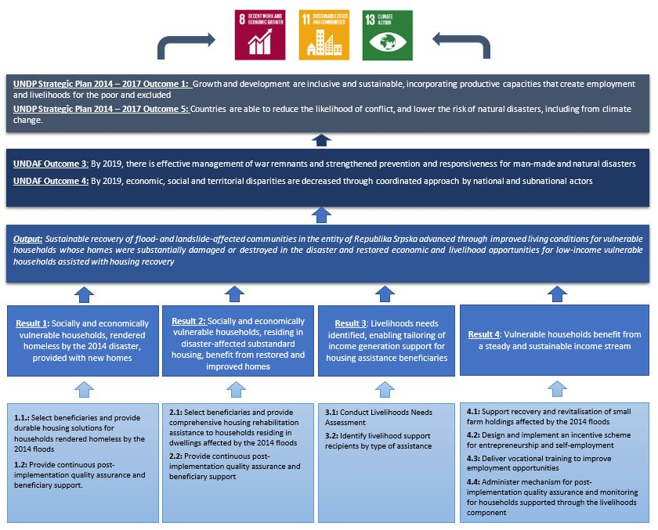

  - Project Logical Framework - FBIH

 | Results chain | Indicators | Baseline  (incl. ref. year) | Current value, ref.  date | Targets (2021) | Sources and means of verification | Assumptions
Overall objective:  Impact | Overall objective of the Action:  To support the sustainable recovery of flood- and  landslide-affected communities in the entity of Federation of Bosnia and  Herzegovina (FBiH). | Number of people in targeted areas  directly benefiting from flood recovery assistance (disaggregated by gender). | Approximately 3,700 people  in flood-affected areas still in need of housing recovery support (2016). |  | Target value:  Approximately 1,105 people, out of whom at least 40% are women, benefit directly from recovery assistance. | - Official entity recovery and reconstruction data (FBiH Fund for Support to the Areas Affected by Natural Disaster on the Territory of the FBiH).  - Official records and statistics by local governments.  - Relevant reports by the international community.  - Action reports.  - Media reports.
Specific objective(s):  Outcome(s) | SO1: To improve living conditions for vulnerable  households whose homes were  substantially  damaged or destroyed in the disaster.  SO2: To restore and develop economic and livelihood  opportunities for low-income vulnerable households assisted with housing recovery. | SO1: Number of affected households provided with adequate and  disaster resilient housing.  SO2: Amount of additional annual income generated for beneficiary households as a result of the Action. | SO1: 1,243  Disaster affected households residing in temporary or substandard housing  (2016).  SO2: N/A. |  | Target value for  SO 1: 378  households  provided with adequate and  disaster-resilient housing (2021).  Target value for  SO 2:  Approximately  EUR 57,000 in additional annual income generated  (2020). | - Inception, progress and evaluation reports.  - Selection commission reports with endorsed lists of beneficiaries. | - Weather conditions are conducive to construction works and agriculture activities.  - Partner governments engage  constructively with the Action, and  meet their co-financing and in-kind commitments.  - Sufficient number of vulnerable  - households are eligible for livelihood assistance.  - Private sector partners and opportunities are available to facilitate implementation of non-agriculture livelihood interventions.
Outputs  / Results | Output 1.1: Socially and economically  vulnerable households, rendered homeless by the 2014 disaster, provided new homes.  Output 1.2: Socially and economically vulnerable households, residing in disaster- affected substandard housing, benefit from  restored and improved homes. | Output 1.1:  Number of new homes constructed in line with  relevant national housing standards.  Output 1.2:  Number of  homes  rehabilitated as per the relevant national housing standards in  flood-affected areas. | Output 1.1:  208  households  reside in  temporary shelter as their homes were destroyed in the 2014 disaster.  Output 1.2:  1,035 homes damaged in  flood-affected areas. |  | Target value for  Output 1.1: 202  (2021).  Target value for  Output 1.2: 176  (2021). | - Selection commission report with endorsed list of beneficiaries.  - Action progress and evaluation reports.  - Quality assurance compliance reports for all new / rehabilitated homes. | - Qualified construction  companies are available at set unit prices.  - Construction land is allocated for new homes away from hazardous areas.  - Relocation of  affected  households does not disrupt access to source of income /livelihoods.  - Damaged homes are not located in areas at immediate risk from flooding and /or landslides.
 | Output 2.1:  Livelihoods needs identified, enabling tailoring of income generation support for housing assistance beneficiaries. | Output 2.1:  Number of  flood-affected households with identified opportunities  for income  generation support. | Output 2.1:  N/A |  | Target value for Output 2.1: At least 85 (2020). | - Livelihoods Needs  Assessment report.  - Action progress and evaluation reports.  - Training attendance records and certificates for entrepreneurship/self-employment training. | - Availability of quality service provider to design and administer the assessment.  - Availability of eligible beneficiaries with income-generating potential.
 | Output 2.2:  Vulnerable households benefit from a steady and sustainable income stream. | Output 2.2a: Number of  flood-affected households  engaged in  sustainable farming.  Output 2.2b: Number of  flood-affected households benefiting from self-  employment  and small  business income streams. | Output 2.2a:  N/A.  Output 2.2b:  N/A. |  | Target value for Output 2.2a: 82  (2020).  Target value for Output 2.2b: 3  (2020). | - Registration certificates for new corporate entities.  - Mentoring reports.  - Quality assurance/monitoring reports for all livelihood beneficiaries. | - Availability of eligible and interested beneficiaries for farming assistance.  - Availability of eligible and interested beneficiaries for self-employment and entrepreneurship assistance.

  - Theory of Change - FBIH
The logic behind this intervention is that if socially and economically vulnerable households, living in Bosnia and Herzegovina are rendered homeless by the 2014 disaster or residing in disaster-affected buildings, are provided with new or restored homes and, in parallel, are enabled to have a steady and sustainable income stream, a sustainable recovery from 2014 floods may be advanced. Ultimately, by targeting the most vulnerable dwellings and helping them to recover from the 2014 floods and strengthen their resilience to potential future disasters, the Project will contribute to the achievement of Outcomes 3 and 4 set in 2015-19 BiH UNDAF, and will contribute to the attainment of SDGs 8, 11 and 13.

The higher-level change will be attained through the identification of the neediest beneficiaries, in partnership with local authorities, and by providing them with durable housing solutions or restoring and improving the buildings affected by floods and landslides where they reside. To guarantee sustainability of the intervention, attention to energy efficiency, resilience to future disasters and, where needed, disabled-accessibility, will be ensured.

In addition, to ensure full recovery of those households that lost their means of sustainment, beneficiaries will be surveyed to identify livelihood needs. The assessment will guide the following intervention focused on revitalization of damaged small farms, development of incentives for entrepreneurship and self-employment and provision of vocational training to enhance employability of beneficiaries.

These activities will be followed by monitoring and post-implementation quality assurance to ensure beneficiary satisfaction with the quality of the works and assistance provided by the Project.

Delivery of the set objective rests on the assumption that weather conditions are conducive to construction works and agriculture activities, government partners engage constructively with the Project and there is sufficient qualified beneficiary interest in the type of assistance offered.

2.1.2 Hierarchy of objectives (including a visual snapshot)
- 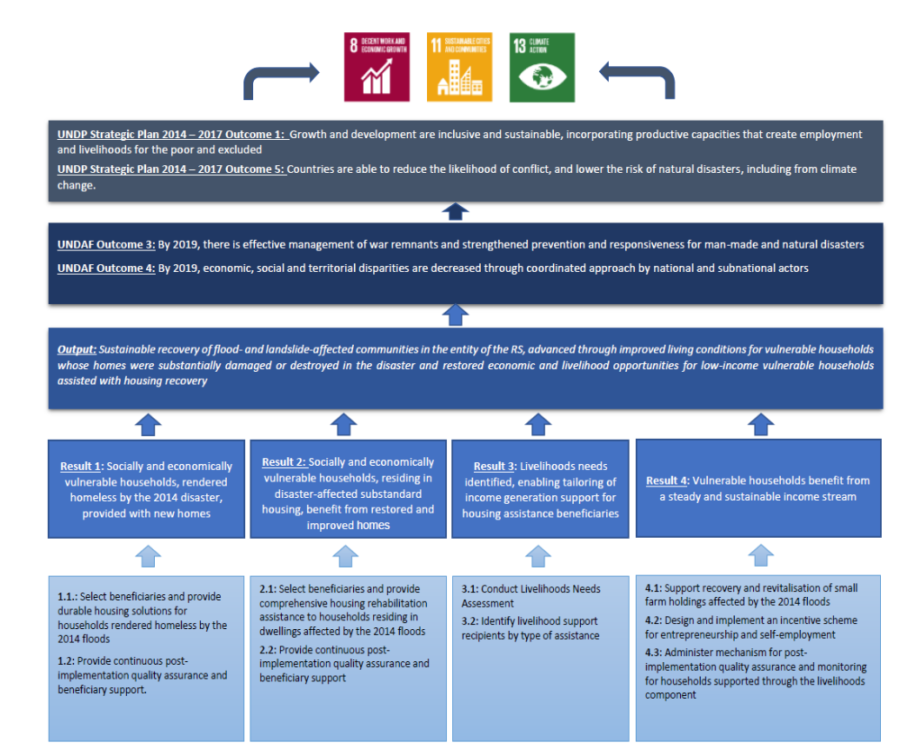

Source: UNDP Recovery Gap Assessment and statistics available at municipal and entity level. Findings are subject to verification during inception.
Ibid.
The standards are based on the relevant guidelines proscribed by the Sectoral Working Group of the State Ministry for Human Rights and Refugees.
While this is the number coming out of the preliminary assessment report, it is expected to increase substantially through the Public Call.
Source: UNDP Recovery Gap Assessment and statistics available at local and entity government levels. Findings are subject to verification during inception.
Ibid.
The standards are based on the relevant guidelines proscribed by the Sectoral Working Group of the State Ministry for Human Rights and Refugees.
While this is the number coming out of the preliminary assessment report, it is found to be underestimated and expected to increase through the Public Call.

