Evaluation of Policy Support Programme
2013-2020

[UNDP-IC-2021-112] ORPS-997

Final Evaluation Report

Submitted to UNDP Country Office, Islamabad, Pakistan

Abdul Hamid Khan, Evaluation Consultant

Final report submitted on September 19th, 2021
Revised final report submitted on October 1st, 2021
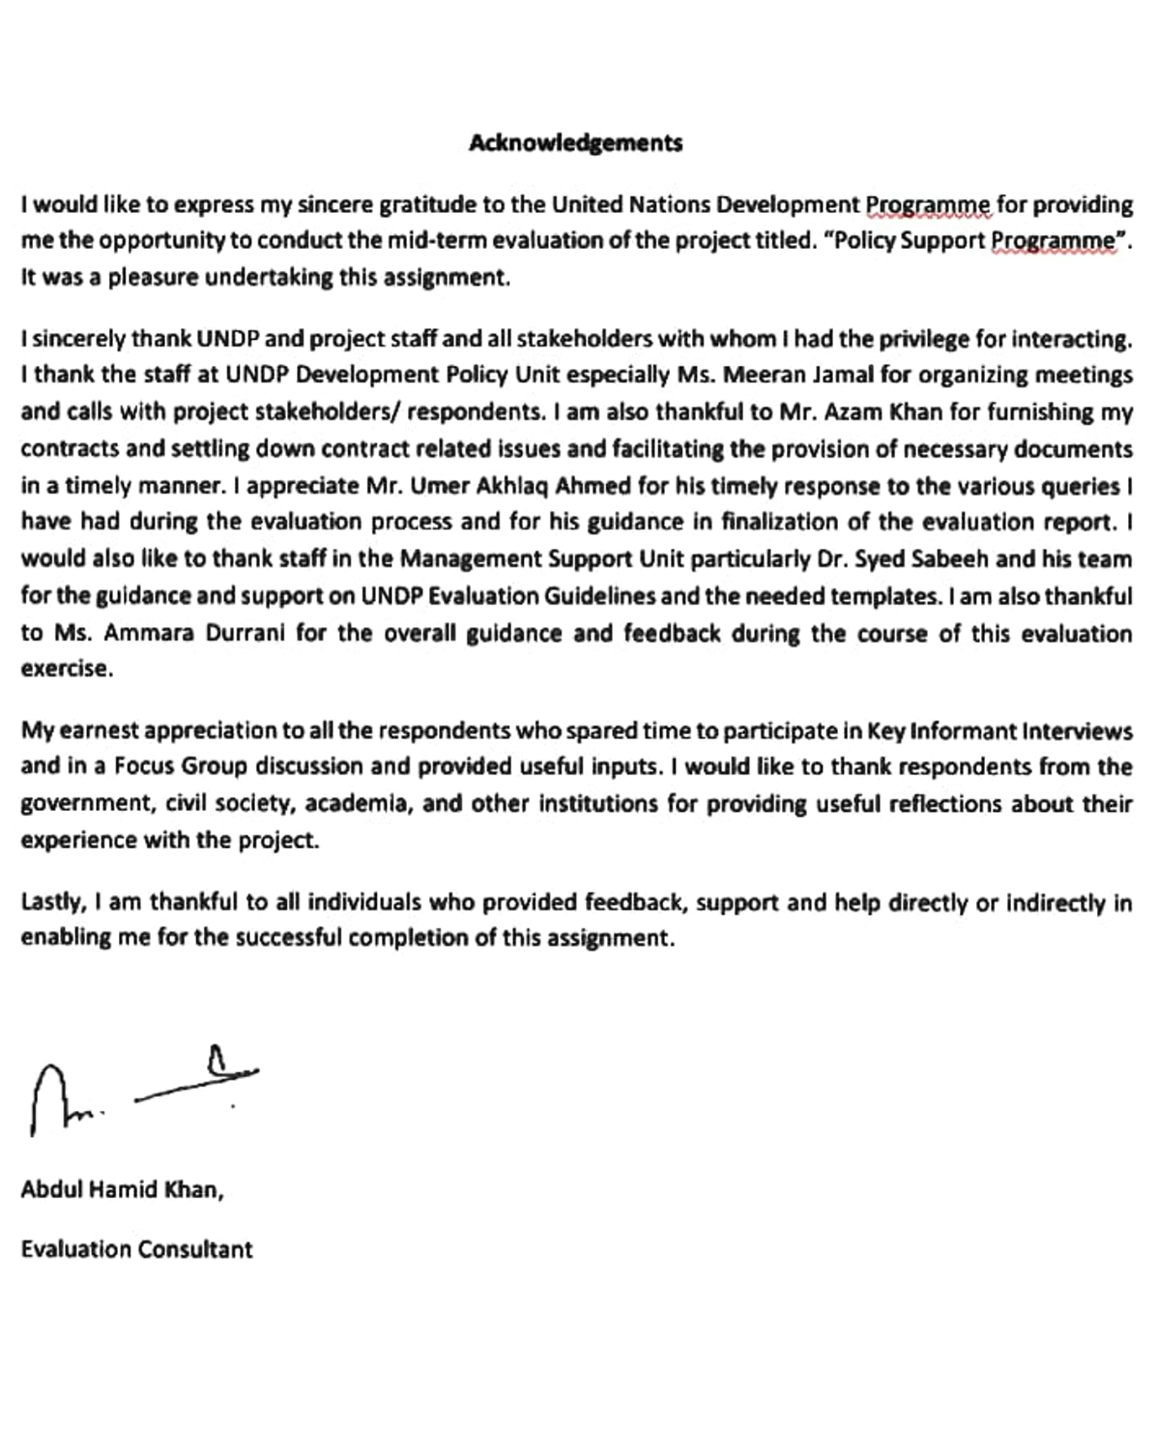

Table of Contents
Table of Contents 3
Abbreviations and Acronyms 5
1. Executive Summary 7
Programme Profile 11
2. Introduction and Project Overview 12
Project outputs 13
3. Evaluation Purpose, Objectives and Scope 13
3.1 Purpose and Objectives 13
3.2 Evaluation Audience 14
3.3 Evaluation Management 14
3.4 Key Stakeholders 15
3.5 Evaluation Scope 15
3.6 Evaluation Assurance 15
4. Evaluation Process and Methodology 16
4.1 Evaluation Phases 16
4.2 Phase 1: Inception 16
4.3 Phase 2: Data Collection and Analysis 16
4.4 Phase 3: Report Writing 17
5. Data, Sampling Frame and Evaluation Criteria 17
5.1 Secondary Data 17
5.2 Primary Data Collection: sampling frame 17
5.3 Data Collection Techniques 18
5.4 Key Informants Interviews 18
5.5 Evaluation Performance Rating 19
5.6 Methodological Limitations 19
5.7 Evaluation Schedule 20
5.8 Evaluation Questions and Sub-questions 20
6. Evaluation Findings 20
6.1 Relevance 20
6.1.1 Relevance to National Context 21
6.1.2 UNDP’s Corporate Objectives 21
6.1.3 UN Programme in Pakistan 21
6.1.4 Project Design 22
6.1.5 UNDP Country Programme Document 23
6.1.6 Leave No One Behind 24
6.1.7 Feedback from KIIs and FGDs 24
6.1.8 Conclusion 25
6.2 Coherence 26
6.2.1 Internal Coherence 26
6.2.2 External Coherence 27
6.2.3 Feedback from KIIs and FGDs 27
6.2.4 Conclusion 28
6.3 Effectiveness 29
6.3.1 Key Results 29
6.3.2 Output Performance’s Rating 31
6.3.3 Project Design 31
6.3.4 Leave No One Behind 32
6.3.5 Feedback from KIIs and FGDs 33
6.3.6 Conclusion 34
6.4 Efficiency 34
6.4.1 Financial Trends 34
6.4.2 Project Management Structure 35
6.4.3 Project Implementation 36
6.4.4 Project Monitoring and Oversight 36
6.4.5 Feedback from KIIS and FGDs 37
6.4.6 Conclusion 37
6.5 Impact 38
6.5.1 Effects on Public Policy 38
6.5.2 Effects on UNDP Programming 39
6.5.3 Leave No One Behind 40
6.6 Feedback from KIIs and FGDs 40
6.6.1 Conclusion 40
6.6.2 Sustainability 41
6.6.3 Sustaining Project Impact 41
6.6.4 Sustaining Project Interventions 42
6.6.5 Partnerships Management 42
6.6.6 Feedback from KIIs and FGDs 42
6.6.7 Conclusion 43
7. Summary and Conclusions 43
8. Recommendations 45
9. Lessons From Evaluation 46
10. Annexes 48
11. Annex 1: Terms of Reference 49
12. Annex 2: Evaluation Matrix: Policy Support Programme (PSP) 59
13. Annex 3: Budget (allocated, expended) 2013-2020 Policy Support Programme (PSP) 64
14. Annex 4: Questions for Primary Data Collection 65
15. Annex 5: Sampling frame for Key Informant Interviews 67
16. Annex-6: List of supporting documents reviewed 69
17. Annex 7. Summary of tables of progress towards outputs, targets, and goals 70
18. Annex 7.1: Progress Against Output Targets 71
19. Annex 7.2: Output Performance Rating 72
20. Annex 7.3: KIIs Respondents Performance Rating 73
21. Annex 8: Pledge of ethical conduct in evaluation signed by evaluator 74

Abbreviations and Acronyms
ADB Asian Development Bank
BPPL Byco Petroleum Pakistan Limited
CDA Capital Development authority
CPD Country Programme Document
CPRU Crisis Prevention and Recovery Unit
DAP Development Advocate Pakistan
DPU Development Policy Unit
FATA Federally Administered Tribal Areas
FGD Focus Group Discussion
GII Gender Inequality Index
HDI Human Development Index
IEO Independent Evaluation Office
KII Key Informant Interview
KP Khyber Pakhtunkhwa
LNOB Leave No One Behind
M&E Monitoring and Evaluation
MCI Metropolitan Corporation Islamabad
MPI Multi-dimensional Poverty Index
MOU Memorandum of Understanding
NGO Non-Governmental Organization
NHDR National Human Development Report
PBC Pakistan Business Council
PSP Policy Support Programme
PSLM Pakistan Social and Living Measurement survey
RCT Randomized Control Trial
SDGs Sustainable Development Goals
SP Strategic Plan
TOR Terms of Reference
UN United Nations
UNDAF United Nations Development Assistance Framework
UNGA United Nations General Assembly
UP Urban Platform
UNDP United Nations Development Programme
UNHABITAT United Nations Human Settlements Programme
UNICEF United Nations Children’s Fund
WASA Water And Sanitation Authority
WB World Bank

List of tables and Figures

Table 1: Programme Profile 11
Table 2: Project Outputs 13
Table 3: Evaluation Matrix 19
Table 4: Schedule of conducting KIIs 20
Table 5: Project Financial Delivery 35

1. Executive Summary
This report presents the finding of evaluation of Policy Support Programme (PSP) for the 2013 to 2020. The project was implemented in two phases: phase 1 from 2013 to 2017 and ongoing phase 2 from 2017-2022. The project has three outputs covering research and analysis, providing policy and research support to other projects of UNDP Pakistan, and promoting innovation through research and prototyping. The project is implemented through the Direct Implementation Modality (DIM) of UNDP across Pakistan. The evaluation was conducted during end April to mid-August 2021.

The purpose of evaluation is to assess the progress and achievement of the project according to the seven evaluation criteria of relevance, coherence, effectiveness, efficiency, impact, sustainability and leaving no one behind. The evaluation also documents lessons learned and provides recommendations for future similar initiatives. The audience of the evaluation are the UNDP Pakistan country office, cost sharing donors, government, civil society partners and other stakeholders.

The evaluation used a non-experimental design. It deployed a mix method of largely qualitative and to some extent quantitative tools to draw its conclusions. The project stakeholders were thoroughly consulted through Key Informant Interviews (KIIs) and Focus Group Discussions (FGDs). Because of COVID-19, all these consultations were held through online platforms. The evaluation deployed an innovative approach of inviting the project stakeholders to rate the performance of the project on the six evaluation areas (except leave no one behind). To avoid any biases, key messages from the KIIs and FGDs have been reproduced in a concise manner. The overall project performance rating is based on the triangulation of evaluator’s assessment based on secondary data and feedback from stakeholders and on the performance-rating conducted by the participants of KIIs and FGDs.

Following are the main findings and conclusions of the evaluation.

Relevance
The project is highly relevant to the national context, UNDP’s corporate priorities and the One UN Programme in Pakistan. Like many other middle-income countries, Pakistan is facing the challenge of inclusive economic growth. Income distribution has deteriorated during periods of high economic growth (NHDR 2020). The Policy Support Programme (PSP) focuses on promoting inclusive growth through policy research and analysis and innovation which are highly relevant to the MIC context of Pakistan and largely with respect to inclusive growth and inclusion. The technical support provided to the Planning Commission for the design of Multi-dimensional Poverty Index (MPI) was critical in institutionalizing a multi-facet approach to the measurement and monitoring of poverty. The data and policy debate on youth bulge helped the national institutions develop large scale youth programme.

Nevertheless, there are number of areas where the project design is weak. The situational analysis section does not sufficiently analyze the needs and issues of vulnerable populations including gender-based analysis. The output indicators and targets are not comprehensive enough and do not capture all aspects of the output statement. For example, the output on innovation does not have separate targets for innovation-oriented policy research and prototypes. The output on cross-unit support only has targets for joint research studies. It should also have targets covering the other areas of cross-unit support including project ideation and development. Project design could have benefited from a broader consultation with stakeholders at the design stage. The sustainability (environment and climate change) aspect has not been properly covered in the project design and its results framework.

Coherence
Both the internal and external project coherence is satisfactory. The project policy focus and the policy instruments, it produced, are unique and do not overlap with other UNDP projects. Regular internal communication and collaboration between DPU and other programme units, though platforms like the Development Advocate Pakistan (DAP) Advisory Board, helped in promoting programmatic synergies and avoiding duplications. The external coherence was achieved through engagement on joint initiatives with academia, civil society, think-tanks, UN agencies and government agencies. Internal coherence could be further enhanced through more joint initiatives, beyond DAP, between DPU and other programmatic pillars. External coherence with private sector has further improvement for improvement.

Effectiveness
The project outputs and interventions were highly effective. The project achieved 87% progress across all the three outputs. Project activities and products were delivered on time. All three outputs have largely been effective in achieving its objectives in influencing public policy and the work of other institutions in favour of inclusive development. Support to the National Statistics Institution has been effective in data collection and analysis through digital tools. DAP has produced some impressing analysis on development issues and have largely been acclaimed by the stakeholders.

The project design in terms of outputs and interventions is largely adequate. Some of the output indicators and targets should have been bifurcated for capturing all elements of an output statement. The project has adequately covered the concerns of vulnerable groups through indices like MPI, HDI, Gender Inequality Index etc. However, the project could have further enhanced its focus on “leaving no one behind” through the standalone and specific research and analyses concerning the needs and problems of vulnerable populations.

Efficiency
It is one of the highly efficient projects cost wise. Over the last seven years, the project has utilized around $2.4 million. Compared to the scale and impact of policy instruments the project has produced, this is a minimal cost. The cost of different policy products, for example the NHDRs, has reduced over time which means that the project has been learning and accumulating its expertise. The project management approach of maintaining a lean project structure comprising of national staff and the close of engagement of DPU core staff has been instrumental in generating efficiency. Other factors which contributed to cost efficiency is the comprehensive partnership approach that the project has used. It partnered with the think-tanks, academic institutions, UN agencies and others joint activities capitalizing on each other’s comparative advantage.

Project was able to consistently produce the quarterly publications of DAP on time. The NHDR on Youth took a slightly more time than the average time, however, the delay was not significant. The MPI was produced timely though it took some time for the government to endorse and adopt it as official poverty measure. Overall, all major activities were completed, and products produced on time. The project monitoring and oversight arrangements have been generally adequate. However, annual targets should have been better articulated and quantified. Assumption and risk logs should have been timely updated. Learnings and best practices should have been properly documented and disseminated.

Impact
Assessing the impact of a policy project, that too when the project is still ongoing, is difficult. It is also difficult to precisely attribute a policy action to a particular policy instrument. However, based on data and available information, the emerging project impact is satisfactory both in terms of effects on public policy and effects on UNDP programming. MPI has already been institutionalized by the government. It has been used by many government institutions, including the Planning Commission of Pakistan for its 12th Five Year, and has been referred to by many senior political leaders including the Prime Minister of Pakistan. The three Es (education, engagement, employment) have already been incorporated in the National Youth Programme – Kamyab Jawan. These are some concrete examples of how the project policy instruments have informed and influenced policy actions.

The project helped design of “reform and innovation” project. Through DAP, it helped the Crisis Prevention and Recovery Unit in the design of the SDG Acceleration Project by producing a special edition of DAP on Balochistan. The sub-national MPIs have been used by other UNDP projects for targeting and impact assessment. The water recycling prototype has been replicated across different cities of Pakistan through private sector self-financing.

Sustainability
Project sustainability is satisfactory mainly at the policy impact level. Some of the policy instruments introduced by the project are already sustainable. For example, MPI has been institutionalized by the government. According to government respondents, the MPI is being updated using the 2019-20 Pakistan Social and Living Measurement (PSLM) data. The key messages of the NHDR on Youth have already been incorporated in Kamyab Jawan programme.

In terms of financial sustainability, it is difficult that organizations outside UNDP will continue activities like the publication of DAP, NHDRs and others with their own funding. It is less because of the size of the funds required for these activities, but it is rather because most of these products have emerged as UNDP’s corporate flagship products. The annual cost of DAP publications, including the salary cost, is around $100,000. UNDP should be able to sustain this cost from its internal resources. Donors have also funded DAP and NHDRs in the past. Therefore, partial, or full funding from donors should also be possible. The fact that these products have now been well established, and their value added largely demonstrated, financial sustainability of some, if not all, project activities should not be a big challenge.

Leave No One Behind
The project coverage of “leave no one behind” theme is moderately satisfactory. The project design does not include analysis of the needs and problems of the vulnerable populations. The targets are also not disaggregated by gender and other parameters. The coverage of vulnerable populations has been mostly through composite indices. For example, the MPI uses gender lens during calculation of deprivations at the household level. The NHDRs have produced Gender Inequality and Youth Development Indices at the national and sub-national levels. The DAP publication has also dedicated sections for gathering inputs and feedback of women and youth on different development issues. However, given the severity of exclusion and discrimination, the project should have also considered specific research and analyses of issues concerning vulnerable population. For example, one issue could have been ‘violence against women’.

Recommendations
- Future policy project should include a clear Theory Of Change (TOC) and disaggregated targets for output indicators. The assumptions and risk logs should be timely updated. The annual work plan should have numeric targets.
- In a decentralized governance system like Pakistan’s, city and local governments / administrations play critical role in the adoption of different policy instruments like the district MPIs. The project should also engage with sub-national governments regarding the advocacy and application of different policy instruments.
- The approach to cover the concerns related to “leave no one behind” through inclusion in the composite indices like MPI and HDI is appropriate. However, there should also be subject specific research and analyses concerning the vulnerable populations. Policy projects should set specific targets for engagement with and promoting the interests of vulnerable populations.
- Policy projects, like other development projects, provide a wealth of knowledge and lessons for practitioners, policy makers and other stakeholders. Documentation of lessons and experiences is important in this regard. Any next iteration of PSP should pay special attention to this aspect.
- Policy products should be promoted as public goods. The policy instruments, like MPI, HDI, produced by the project are equally relevant to the work of other UN agencies. While PSP engaged various UN agencies during its implementation, such partnerships need to be further strengthened. The UN coordination office could play a critical role for this purpose.

The evaluator’s rating, based on the rating done by the stakeholders and review of documents and information, and using the evaluation criteria is provided below.
Evaluation Criteria | Rating | Description and Evidence
Relevance | 4 | The project focus on inclusive growth and human development is highly relevant to the national context. Policy instruments HDI, MPIs, DAP, and research studies have been very relevant in advocating for policy actions related to inclusive development.
Coherence | 3 | Internal coherence through unique project activities and products and platforms (DAP Advisory Board) for cross unit collaboration. Partnerships with diverse stakeholders including civil society, government, UN agencies and academic for external coherence.
Effectiveness | 4 | Achievement of more than 87% progress against targets. The production of flagship policy products including NHDRs, MPI and their contributions to the public policy actions. Water recycling prototype, a low-cost indigenous technology with huge potential for improving water conservation in urban settings.
Efficiency | 4 | Low budget, high impact project. Efficient project organogram and management arrangements. Efficient use of internal UNDP capacities. Timely completion of all major project interventions. Efficient project implementation and partnership arrangements.
Impact | 4 | Effects on public policy including the institutionalization of MPI as official poverty measure and the 3 Es of NHDR in government national youth programme (Kamyab Jawan). Effects on UNDP programming in terms of using PSP as platform for designing “reform and innovation” and “National SDG” projects. DAP informing project on SDG Acceleration in Balochistan.
Sustainability | 3 | Sustainability of policy impact in terms of institutionalization of MPI and key recommendations of NHDR on Youth. Financial sustainability in terms of low cost and high impact activities which could be easily funded from UNDP internal resources and donors’ contributions (there is already evidence of donors’ financing)
Leave no one behind | 2.5 | MPIs and HDIs for poverty targeting. Special sections of DAP for gathering women and youth inputs. No standalone focused work.
Overall | 4 | Highly Satisfactory
Rating scale: 1 (poor), 2 (average), 3 (satisfactory), 4 (highly satisfactory), 5 (excellent)

Programme Profile
Table 1: Programme Profile
Project/outcome title | Policy Support Programme
Atlas ID | 00087069
Corporate outcome and output | - Outcome - By 2022, the Pakistani people, benefit from transparent, accountable, and effective governance mechanisms and rule of law institutions.  - Output 9.3: Through active citizen engagement, national/provincial governments shape public policy priorities and establish planning, financing, and monitoring mechanisms, facilitating implementation of the Sustainable Development Goals.
Country | Pakistan
Region | South Asia
Date project document signed | 01 December 2017 (second phase)
Project dates | Phase 1:  Start: 01 July 2013  Phase 2:  Start: January 2018 | Phase 1:  End: 31 December 2017  Phase 2:  Planned End: 31 December 2022
Duration of evaluation | January 2016 – December 2020
Project budget | US $ 2.5 million
Expenditure at time of evaluation | US $ 2.4 million
Funding source | UNDP, UNCIEF, Swiss Agency for Development and Cooperation
Implementing Party | UNDP in collaboration with Ministry of Planning, Development and Special Initiatives, and Provincial Planning and Development Departments.

Evaluation information
Evaluation type (project/ outcome/thematic/country programme, etc.) | Policy Support Programme Evaluation
Final/midterm review/ other | Other
Period under evaluation | Start | End
 | 2013 | 2020
Evaluators | Abdul Hamid Khan
Evaluator email address | ahamid07@gmail.com | Khanhamid14@hotmail.com
Evaluation dates | Start | Completion
 | 26 April, 2021 | - August, 2021

Introduction and Project Overview
Policy Support Programme (PSP) aims to promote inclusive growth and sustainable human development in Pakistan. The current project is the second phase (2018-2022) whereas the first phase ran from 2013 to 2017. The project focuses on the achievement of three outputs. The first output focuses on improving evidence, research, analysis, and policy dialogues on issues of inclusive and sustainable growth and human development. Key project interventions under this output includes the quarterly publication of Development Advocate Pakistan (DAP), National Human Development Reports (NHDRs) and other policy-oriented research and analyses.

The second output is to provide demand based technical support to Programme units of UNDP for improved targeting, impact assessment, Programme design and related areas. Key activities for achieving this output include joint research studies, technical advice for project planning and design and providing needed information and analyses. The third project output is to promote innovation to address high priority development issues. This is being pursued through research on innovative tools and practices and piloting innovative initiatives.

Given its policy focus, the project’s outreach has largely been to national institutions at the federal level and which are operating mostly in research and policy domains. The tools and instruments used by the project have essentially been analysis, policy papers, policy dialogues, policy advocacy, awareness on key development challenges and multi-stakeholder engagement. While the project is based in Islamabad, however, it has engaged with different institutions, in public and outside, across the four provinces and regions including Azad Jammu and Kashmir, Gilgit Baltistan, and former Federally Administered Tribal Areas (now Merged Districts) of Pakistan.

The project works with diverse partners including the civil society organizations, think-tanks, academic institutions / universities, UN agencies and the government institutions. The key government counterparts of the project are the planning institutions at the federal and provincial levels. Most of the project funding has been provided by UNDP for its internal resources. The project has also mobilized funds from Swiss Agency for Development and Cooperation, UNICEF and UNFPA for some of its activities.

This is a Directly Implemented (DIM) project by UNDP. A small project team within the Development Policy Unit (DPU) manages the project. The DPU head / Assistant Resident Representative and Policy Specialist closely oversees the operations of the project. They advise the project staff on the design of policy instruments and lead partnerships with different stakeholders. PSP is considered as the implementation arm of DPU through which it pursues its policy work. The project staff comprises of national professionals. Short term consultants provide technical support to the project team and DPU on need basis.

Key policy instruments and products produced by the project includes the following. (1) Development Advocate Pakistan (DAP) which is a quarterly policy magazine. (2) Two NHDRs, one on youth and second on inequality; (3) Multi-dimensional Poverty Index for Pakistan; 4) Urban platform; (5) Water recycling prototype; (6) policy dialogues with different partners; (7) projects development; (8) analysis and research on different subjects; (9) research and project development support other programme units of UNDP.

The project design does not have the Theory Of Change (TOC). However, project results framework provides a set of outputs which are connected to the higher-level project result namely promoting inclusive growth and development through policy research and analysis and the design of different policy instruments.

Project outputs
Table 2: Project Outputs
Output
Output 1: Improved evidence, research and analysis and policy dialogues on issues of inclusive & sustainable growth and human development.
Output 2: Demand based technical support provided to program units of UNDP for improved targeting, impact assessment, program design and related areas
Output 3: Innovation promoted for addressing high priority development issues.

Evaluation Purpose, Objectives and Scope

Purpose and Objectives
UNDP corporate evaluation guidelines define evaluation as “an assessment, conducted as systematically and impartially as possible, of an activity, project, programme, strategy, policy, topic, theme, sector, operational area or institutional performance. It analyses the level of achievement of both expected and unexpected results, by examining the results chain, processes, contextual factors, and causality, using appropriate criteria such as relevance, coherence, effectiveness, efficiency, impact, and sustainability. An evaluation should provide credible, useful, evidence-based information that enables the timely incorporation of its findings, recommendations, and lessons into the decision-making processes of organizations and stakeholders”.

Evaluation intends to strengthen learning among all stakeholders and to provide evidence for better programme designs and decision-making for development projects. It promotes a culture of transparency and accountability within the organizations to its stakeholders in general and to its financiers and intended beneficiaries. UNDP considers high‐quality evaluations critical for results‐based management, knowledge generation for wider use and for accountability to programme partners. One of the requirements of UNDP evaluation policy is that programme units—headquarter bureaus, regional bureaus, and country offices—ensure that evaluations inform programme management and contribute to development results. In nutshell, evaluation is:
- A means to strengthen learning within our organization and among stakeholders, to support better decision-making.
- Essential for accountability and transparency, strengthening the ability of stakeholders to hold UNDP accountable for its development contributions.
- Often intended to generate empirical knowledge about what has worked, what has not, and why. Through the generation of evidence and objective information, evaluations enable programme managers and other stakeholders to make informed management decisions and plan strategically.

This evaluation is premised on UNDP’s priorities and principles of independent evaluation as described above. It undertakes an objective and evidence-based assessment of the results of the Policy Support Programme (PSP) in accordance with the Evaluation TOR. Being the project evaluation, it assesses progress towards the achievement of outputs and, where feasible and if data allows, its contributions towards the outcomes of UNDAF / Pakistan One United Nations Development Programme III (2018-2022) and the UNDP CPD (2018-2022). The evaluation has deployed the OECD / UNDP Evaluation Criteria of relevance, coherence, effectiveness, impact, sustainability, and cross cutting considerations and provides an independent and objective assessment of the progress made therein, lessons to be derived from project design and implementation. The evaluation frames recommendations which could further improve the design, focus and management of upstream policy projects like PSP in future.

It is understood that the evaluation has a forward-looking orientation so that lessons from the project not only inform UNDP projects, but also the design of new UN Sustainable Development Cooperation Framework and the new UNDP CPD for the period 2019-2023. The evaluation’s purpose and objectives are further defined by the TOR which are focused on the following areas:
- Assess project progress against project outputs and their contributions to UNDAF / One UN Programme and CPD outcomes.
- Assess project’s performance regarding relevance, coherence, effectiveness, efficiency, impact and sustainability of major project interventions.
- Review and analyze the value addition of the project to development policy and related development priorities.
- Assess and document lessons learned from project implementation and provide recommendations how the design and implementation of similar policy-oriented projects could be further improved.

This evaluation assess progress against the three project outputs including 1) improved evidence, research and analysis and policy dialogues on issues of inclusive & sustainable growth and human development; 2) demand based technical support provided to program units of UNDP for improved targeting, impact assessment, program design and related areas; and 3) innovation promoted for addressing high priority development issues. It also assesses the extent to which these outputs have been effective in promoting development policy for inclusive economic growth and increasing policy impact mainly in terms of policy actions.

Evaluation Audience
As per the evaluation TOR, the main audience of this evaluation are the UNDP Pakistan country office and project partners within and outside of the government. It is believed that the evaluation may serve as knowledge product for other offices of UNDP globally, the Independent Evaluation Office of UNDP as well as other development partners.

Evaluation Management
It is understood that the evaluation has been commissioned by the UNDP Development Policy Unit (DPU) and the Management Support Unit (MSU). PSP is implemented by the Development Policy Unit; hence they serve as the main client. The MSU is the quality insurer and the technical lead for the evaluation process. DPU provided required documents, reports, and written evidence in support of project progress. DPU organized virtual meetings or calls for the evaluator to gather information and feedback regarding project interventions and outputs. DPU provided list of key stakeholders and partners which the evaluator used for finalization the list for Key Information Interviews (KIIs).

Key Stakeholders
As per the initial information and documents provides, the following are the key stakeholders of the Policy Support Programme. Representatives from these organizations were selected for consultation in discussion with the Policy Unit (Annex 5).
- Government counterparts
- Academic institutions
- Civil society organizations
- UN agencies
- Private sector
- Youth, women, and other vulnerable groups

Evaluation Scope
The evaluation scope is limited to the activities and interventions directly funded by the project. The evaluation does not cover any parallel or in-kind or fully funded activities by other partners, including the government agencies, which may have been influenced by the project. The evaluation primarily focuses on the performance of the project regarding the achievement of its outputs. It provides qualitative assessment about the contribution of project outputs towards CPD and UNDAF outcomes. The evaluation does not use any economic analysis to measure the attribution of the project. The evaluation findings are based on qualitative information provided by the interview respondents and synthesized from secondary data provided by UNDP. While maximum care has been taken to provide objective and unbiased assessment of the results, human error and oversight within an acceptable level could not be completely overruled.

The evaluation scope is constrained by the COVID-19 pandemic. Face to face meetings and visits to different parts of Pakistan, where different stakeholders may reside, were not possible. Given the policy focused of the project, it is difficult to quantify the project beneficiaries and the extent of project direct impact on them. At this stage, only assessment of potential policy impact in terms of policy actions taken by government institutions has been undertaken. In terms of financial resources, PSP is not a huge project. Therefore, care was taken to limit the assessment of project impact in terms of policy actions. The field work for the evaluation included virtual discussion with selected respondents. Because of the COVID-19 restrictions, no field or onsite visits was undertaken.

Evaluation Assurance
This evaluation was designed and conducted according to the quality assurance mechanism which is part of the Norms and Standards for Evaluation developed by the United Nation Evaluation Group (UNEG) in 2016. The evaluation matrix and checklists were developed based on the evaluation TOR and as per the scope and focus of the project (Tables 1,2 and Annex-2). To ensure accuracy, validity, relevance and usefulness of information, wider consultations covering representatives from almost all categories of stakeholders were undertaken (Sampling Frame, Annex 5). Triangulations of data conducted through information and analysis and insights was generated from secondary information as well as from primary information collected through direct consultations with different stakeholders. The analyses are focused on quality rather than quantity from the broader perspectives of project objectives and outputs.

Evaluation Process and Methodology

Evaluation Phases
The evaluation used the standard process which comprises of three stages namely inception phase, data collection and analysis phase and report writing phase. An additional phase covered presentation to stakeholders. The three phases are interconnected in a linear manner. The deliverable of each phase feeds into the next phase as inputs. Further details about each phase and its activities are provided below.

Phase 1: Inception
This was the first stage of the evaluation process. Its main objective was to clarify the scope of work and evaluation TOR. At the end of this phase, an inception report was produced which detailed the table of content for the evaluation report. The inception report served as the written document of the evaluation process and provided the basis for the evaluation report. The inception report was the first deliverable of the evaluation process. This evaluation report built on the inception report with additional information, analysis, and data.

An inception meeting between the concerned UNDP staff and consultant was held on May 4, 2021 (virtually) wherein the TOR were discussed and clarified. It was agreed that the overall scope of the evaluation would remain as defined in the TOR. Due to mobility restrictions imposed by the COVID-19 pandemic, the evaluation mostly relied on the secondary data provided by UNDP and primary data collected through virtual discussion / meetings with the selected stakeholders. Given the policy focus of the project, the project’s stakeholders and beneficiaries are not necessarily the end users of a particular service. They rather include policy makers, academics, civil society actors and other partners. The impact in terms of “Leaving No One Behind” was assessed through the relevance of policy instruments and research, that the project produced, to the needs of the vulnerable populations.

Phase 2: Data Collection and Analysis
The second phase of the evaluation process was data collection, both primary and secondary, and its analysis to assess project’s performance. Mostly the data collected was qualitative given the policy focus of the project. Data collection techniques are elaborated in the following sections. Analysis is mostly qualitative and based on the ranking or rating provided by the interview respondents. The key messages from data analysis were presented in terms of statements which were clustered under the key evaluation criteria of relevance, coherence, effectiveness, impact, and sustainability. A scale of 1-5 was applied for assessing performance with 1 being the lowest and 5 the highest performance.

Extreme care was taken to ensure consistency, un-biasness in the analysis and due consideration was given to the external factors (contextual analysis) affecting the project results both positively and negatively. Where needed, the evaluator applied triangulation methods to make use of the data from different sources and especially in situation where data from single source was insufficient to make reliable conclusions.

Efforts were made to include maximum project stakeholders during the consultation process. Around 40% of the respondents in the Key Informant Interviews were women. Since PSP is a policy project and did not have direct beneficiaries on the ground, all project activities were analyzed from the angle of Leaving No One Behind (LNOB). There are specific sections on LNOB for almost every evaluation criterion. In other words, each evaluation criteria have been assessed through the lens of LNOB.

Phase 3: Report Writing
The evaluation report follows the same format as presented and agreed in the inception report. The evaluation methodology is based on two sets of data and information. First is the secondary data which was provided by UNDP in the shape of project progress reports, financial reports, workshop reports and others. Second, is the primary data gathered by the evaluator through consultation with project stakeholders. The report findings are based on the data and analysis and are representing the independent and unbiased views of the evaluator.

Data, Sampling Frame and Evaluation Criteria

Secondary Data
After the inception meeting with the concerned UNDP staff, the evaluator received several documents. These include the project document, annual work plans, UNDP corporate Results Oriented Annual Report, project progress reports, evaluation report of the Urban Platform and others. Complete bibliography of the documents is provided in Annex 6. These documents were analyzed by the evaluator and needed information has been included in this report. Based on the information provided, a table on project outputs, indicators and activities was compiled and included in section one of this report. The secondary data was also used to develop a draft list of stakeholders and partners who were contacted for gathering information and feedback. The literature review of documents also helped the evaluator to understand the scope and nature of work of the project and its mandate. Main findings and messages from project documents were corroborated with the primary data from Key Informant Interviews (KIIs) and Focus Group Discussions (FGDs).

Primary Data Collection: sampling frame
The primary data included qualitative information, which was collected from UNDP core and project staff, project partners, responsible agencies for project activities, consultants and experts, contributors to different knowledge products of the project and other service providers. The sampling frame (Annex 5) has been categorized into the following groups:

- Project and UNDP staff: Relevant UNDP and project staff were interviewed for further information and details about the project.
- Policy makers: These comprised of representatives from different government ministries and departments who were the intended target beneficiaries for different project interventions across all the three outputs.
- Academics: A significant set of project activities include engagement with academics from different universities. These academics have contributed to different project activities as consultants and op-ed writers. They provided useful insights on project performance and any recommendations for the future.
- Policy analysts: The project has worked with multiple think-tanks and research entities. They have served as project implementing or service providers. They were consulted to assess the level of their engagement and the impact of the project through partnerships with them.
- Civil society organizations: The project has involved a few civil society organizations for different activities including collection of data and feedback from communities for NHDRs. The Development Advocate Pakistan has also worked with different civil society organizations and women groups. The NHDR on youth had substantially engaged with youth and youth-based organizations.
- Women activists: Gender equality is the cross-cutting priority not only for PSP but for all UNDP development projects. The Development Advocate Pakistan has a special section for women feedback and messages in DAP.
- Youth: Different activities and interventions under PSP had specific focus on youth. The NHDR on youth comprehensively covered youth issues and priorities. Youth are also cross-cutting issue for the DAP.
- UN agencies: A couple of UN agencies had made financial contributions to PSP. These include UNFPA and UNICEF. Other UN agencies, for example FAO, ILO, UN RCO, WHO and others have worked through the PSP project in one or more project interventions. Some of the UN agencies have also participated in the advisory council for NHDR. Concerned UN representatives from UNICEF and UN RC were reached out for feedback and information.

The complete sampling frame, with number of respondents, their names and addresses were prepared in consultation with the Development Policy Unit. A total of 16 KIIs and one FGD comprising of 04 participants were conducted. Out of the 20 KIIs and FGD participants, 12 were men (60%) and 8 were women (40%). The FGD was conducted with four UNDP Pakistan internal staff with 50% gender ratio. KIIs were also conducted with one participant each from the Planning Commission of Pakistan, Islamabad (01 woman), Planning & Development department government of Sindh (01 man), Metropolitan Corporation Islamabad (01 man), Rawalpindi Development Authority (01 man), Sustainable Development Policy Institute Islamabad (01 man), as well as Academia, IBA Sindh, (01 woman). For details please see Annex-5.

Data Collection Techniques
Since the activities under the PSP involve senior public and private officials/ professionals/ and businessmen, the evaluator suggested at the inception phase that Focus Group Discussion (FGDs) at scale would not be feasible. Moreover, the COVID19 situation has made it difficult to engage 8-12 participants for as many as 2-3 hours for in-depth groups discussions, remotely/ or in person. Therefore, the FGD was restricted to only one and that too with limited UNDP staff. In lieu of FGDs, Key Informant Interviews (KIIs) were conducted to collect information for qualitative analysis. The respondents were asked to rate the project performance according to the 7 evaluation criteria. Aggregated table is available as Annex 5.

Key Informants Interviews
The evaluator conducted 20 interviews with the relevant stakeholders/ implementing and other partners of PSP. Out of these 20 respondents, four respondents attended one Focus Group Discussion. During the inception meeting, the evaluator was given the liberty to conduct as many KIIs as deemed necessary. The evaluator interviewed at least 1 - 2 respondents from each category of stakeholders (Annex 5). The interviews were conducted according to the stakeholder’s willingness, availability, and relevance to project activities. A general questionnaire / interview questions (Annex 4) were refined and slightly adjusted for different types of respondents and was administered by the evaluator. Keeping in view the COVID-19 SOPs, the evaluator strictly adhered to the UNDP prescribed SOPs/ protocols and conducted all interviews online.

Evaluation Performance Rating
The evaluation used qualitative criteria to assess the performance of the project against targets. The following is the summary of the evaluation rating matrix. There are two matrices. One assesses the performance at the output indicator level. The other provides an overall assessment against the 7 evaluation criteria. The objective is to provide a holistic picture of the project performance and capture all key products and services and their quality and impact. Please see Table 3 & Annex 8.3 for more details.

The following table summarizes the overall evaluation rating based on the 7 evaluation criteria namely relevance, coherence, effectiveness, efficiency, sustainability, impact, and cross cutting contributions.

Table 3: Evaluation Matrix
Evaluation Criteria | Rating | Description and Evidence
Relevance | 4 | The project focus on inclusive growth and human development is highly relevant to the national context. Policy instruments HDI, MPIs, DAP, and research studies have been very relevant in advocating for policy actions related to inclusive development.
Coherence | 3 | Internal coherence through unique project activities and products and platforms (DAP Advisory Board) for cross unit collaboration. Partnerships with diverse stakeholders including civil society, government, UN agencies and academic for external coherence.
Effectiveness | 4 | Achievement of more than 87% progress against targets. The production of flagship policy products including NHDRs, MPI and their contributions to the public policy actions. Water recycling prototype, a low-cost indigenous technology with huge potential for improving water conservation in urban settings.
Efficiency | 4 | Low budget, high impact project. Efficient project organogram and management arrangements. Efficient use of internal UNDP capacities. Timely completion of all major project interventions. Efficient project implementation and partnership arrangements.
Impact | 4 | Effects on public policy including the institutionalization of MPI as official poverty measure and the 3 Es of NHDR in government national youth programme (Kamyab Jawan). Effects on UNDP programming in terms of using PSP as platform for designing “reform and innovation” and “National SDG” projects. DAP informing project on SDG Acceleration in Balochistan.
Sustainability | 3 | Sustainability of policy impact in terms of institutionalization of MPI and key recommendations of NHDR on Youth. Financial sustainability in terms of low cost and high impact activities which could be easily funded from UNDP internal resources and donors’ contributions (there is already evidence of donors’ financing)
Leave no one behind | 2.5 | MPIs and HDIs for poverty targeting. Special sections of DAP for gathering women and youth inputs. No standalone focused work.
Overall | 4 | Highly Satisfactory
Rating scale: 1-5, 1 (poor), 2 (average), 3 (satisfactory); 4 (highly satisfactory), 5 (excellent)

Methodological Limitations
While qualitative methods, through individual interviews and groups discussions, provide valuable insights and help capture the diversity of perceptions across stakeholder groups, however, purposive or judgmental sampling is generally used in qualitative methods which has the shortcoming of selection bias and is, therefore, less representative, or generalizable to the entire population. To address this shortcoming, the evaluator has used triangulation of data including information from project reports, key insights from KIIs and the performance rating done by the interview respondents across stakeholder groups.

As indicated above, the sample for primary data collection does not include the people who benefit over the years from the achievement of PSP interventions and corresponding targets. Reaching out to ultimate beneficiaries of a policy intervention is beyond the scope of this evaluation. Such impact could be assessed better at the macro and national level though an analysis of macro level data often collected through national surveys by the national statistics institutions. UNDP may therefore like to consider an analysis of key social and economic indicators through Multi-dimensional Poverty Index, Human Development Index, and other similar tools for changes over time at a later stage.

Evaluation Schedule
KIIs and FGDs were conducted from July 12 to August 03, 2021 in consultation with UNDP-DPU and MSU. The following Table-6 reflects schedule of the KIIs and other timelines for the evaluation process.

Table 4: Schedule of conducting KIIs
S. No | Activity | Completion/ Submission date
1 | Additional review of secondary data and information and their analysis | June 28 – July 9
2 | Collection of primary data  Key Informant Interviews (KIIs) | July 12 – Aug 3, 2021
3 | Submission of the draft report | Aug 12, 2021
4 | Submission and approval of the final report | August 15, 2021
5 | Feedback from stakeholders and meeting with UNDP to discuss the feedback/ presentation RR, DRR, ARR. | 10th September, 2021

Evaluation Questions and Sub-questions
A list of evaluation questions on the five main evaluation criteria have been provided in the TOR. Building on these questions, an evaluation matrix consisting of key questions and associated sub-questions with corresponding data sources was developed (Annex-2 & 4).

Evaluation Findings
The following findings have been informed by the analysis of secondary data and documents provided by UNDP and the primary data collected through KIIs and FGDs. The findings are grouped under the five evaluation criteria namely relevance, coherence, effectiveness, efficiency, impact, and sustainability. Findings are based both on subjective and objective analyses. Subjective analysis is informed by the consultant’s review of secondary data and primary information gathered through KIIs and FGDs. Objective analysis is based on the rating by participants of the KIIs and FGDs. The objective analysis used a 5-scale rating measure with 1 being poor and 5 being excellent. The definition of the 5 evaluation criteria is based on UNDP’s and OECD’s guidelines for evaluation of development projects.

Relevance
To what extent is project intervention consistent with UNDP’s country program document, UNDAF, UNDP’s strategic plan and to the context in Pakistan – in terms of ground situation and needs of the target groups?

Sub-question 1.1: What is the value addition of project interventions regarding supporting national/ sub-national governments in evidence- based inclusive public policies development or roll out?
Sub-question 1.2: Are the project results/ interventions coherent with national/ sub-national upstream policy work?

Relevance to National Context
Pakistan is a Middle-Income Country and placed in the medium human development category, ranked 154th among 189 countries on the UNDP HDI 2020. Globally, MIC and emerging markets face challenges in keeping a balance between pursuing a higher economic growth while at the same time making it sustainable and inclusive. In other words, MIC often falls into the trap of higher economic growth at the expense of environmental degradation, greenhouse emissions and raising income inequalities. The national public policy (Vision 2025, 12th Five Year Development Plan) also affirms to the goals of sustainability and inclusion. The Vision 2025, which is the long-term strategy document, explicitly focuses on the priority of people centric inclusive growth. The key objective of PSP is to promote human development and inclusive growth. Therefore, PSP in its focus and scope, is highly relevant to the national context. Sustainability is also high on the current government agenda as reflected through its different initiatives including the 10 billion national plantation programme.

Sub-question 1.3: To what extent are the project outputs relevant to UNDP’s country level /UNDP Strategic Plan results, national policies, priorities and needs of the partners and target groups?

UNDP’s Corporate Objectives
The UNDP Strategic Plan 2018-2022 (page 3) summarizes the “key areas of collaboration” that UNDP offers across different country offices. At least three of these “key areas” namely eradicating poverty, gender equality and ensuring greater availability and use of disaggregated data are directly related to the PSP’s areas of focus. For example, PSP supported the Pakistan Bureau of Statistics for generating data on SDGs. The Multi-dimensional Poverty Report 2016 helped the Government of Pakistan measure and identify the pockets of poverty across the country. It later helped informed public resource allocations across different regions of Pakistan. Gender equality, together with youth participation, has remained the cross-cutting theme of Development Advocate Pakistan (DAP). Therefore, like its relevance to the national context, the PSP’s overall theme and focus have been highly relevant to the focus of the UNDP Strategic Plan (SP 2018-22).

The SP 2018-22 underlines the importance of “working together” at the country office level with other UN agencies and partners with the objective to improve efficiency and impact. PSP’s approach of working with other UN agencies to produce joint research and other products has also contributed to SP’s objectives. For example, UNFPA partnered with the UNDP for the NHDR on youth. UNICEF worked together with UNDP for the NHDR on Inequality: UNICEF was member of the NHDR advisory council. UNICEF also worked with UNDP for joint research and analysis on poverty, youth, and adolescent through the DAP platform. PSP has made contribution to the UNDP’s Integrator role as well (SP, page 9).

UN Programme in Pakistan
- The UN Sustainable Development Framework 2018-22, also known as One United National Joint Programme III, details the aim and focus of work for the entire UN system in Pakistan. The PSP reports on Outcome 9 of the One UN Programme Governance (Outcome 9): By 2022, the people in Pakistan will have increased knowledge of their rights and improved access to more accountable, transparent and effective governance mechanisms and rule of law institutions. The National Human Development Report on inequality (NHDR 2020) highlighted the issues of both income and non-income-based inequality and the underlying root causes. The NHDR 2017 (on youth) explicitly focused on the needs for youth education, engagement and employment, which are closely related to both the issues of inclusion and decent work. Several issues of DAP have analyzed the needs for building resilience to both human-made and natural shocks. Despite its close relevance to the issues of inclusive growth, it is strange to note that outcome 1 of the One UN Programme doesn’t mention UNDP as one of the contributing agencies.

It might because of this (UNDP not mentioned under outcome 1) that PSP is linked to different outcome (outcome 9) which is less relevant to the PSP work compared to outcome 1. This should be corrected, and PSP should be linked to the appropriate UN SDF outcome.

The PSP scope and focus are consistent with UNDP Country Programme Document (CPD 2018-22) although the project has not been linked to the right outcomes and outputs (more details in the next section). Paragraph 15 of CPD (page 4), under outcome 1, states that “UNDP will support the shaping and implementation of legislative reforms, regulatory frameworks and strategic policies that strengthen the application of democratic principles and processes of good governance”. Several PSP’s products and services correspond to this statement.

Sub-question 1.4: Are the projects outputs clearly articulated, feasible and realistic?
Sub-question 1.5: To what extent the project logic, concept and approach is appropriate and relevant to achieving the project targets and objectives?
Sub-question 1.6: Are the underlying assumptions, on which projects interventions have been based, valid? Is there a clear and relevant Theory of Change?

Project Design
The project does not have a specific Theory of Change (TOC). While the project results framework has well defined output statements, indicators, and targets, the intended UNDAF outcome, CPD results / outputs and SP results / outputs are not mentioned. The project’s monitoring plan, multi-year work plan and organizational chart are reasonably clear. While the project risk log is adequately filled, it mostly mentions the risks associated with political and natural shocks. The risk log does not cover the risks which might be associated with the management of the project and which would need regular monitoring.

There is not much evidence about the process through which the project was designed except for the corporate Local Project Appraisal Committee’s (LPAC) feedback and approval. While the project’s content is highly relevant to the national context, there is not much evidence to suggest that external partners and stakeholders were consulted during the design phase of the project. There is also not information if the project adequately considered the lessons learned from similar projects in the past.

The project was implemented through the Direct Implementation (DIM) modality of UNDP. Since the project intended to provide unbiased analysis and feedback on public policy and the development discourse in Pakistan, DIM was the right modality because it gave UNDP some sort of independent space for its programmatic interventions. The engagement of high government officials in different policy dialogues and especially in the Advisory Councils for NHDRs helped government ownership for the PSP’s products. For example, the current government built on the policy recommendations of NHDR on Youth for its youth programme. The Prime Minister himself launched the NDHR on Inequality and has referred to in public speeches later.

Most of the assumptions have held true during the life of the project. Different government agencies including the Ministry of Planning, Development and Reform, provincial planning departments, Pakistan Bureau of Statistics, parliamentarians, think-tanks, and civil society organizations remain active stakeholders of the project. The government adopted the Multi-dimensional Poverty Index as an official poverty measure. The government also launched national youth programme (Kamyab Jawan, a term similar to Jawan Pakistan coined by the NHDR on Youth), taking into account the recommendations laid down in the NHDR on Youth. This shows the interest of the national stakeholders for the policy-oriented analysis and advice produced by PSP.

Another assumption of the project was related to the availability of required technical and financial resources to implement the project activities on time. This assumption also holds true given the fact that the project was able to timely recruit the required staff as per the required skill sets. The project was able to engage with some of the most senior and well-known intellectuals of Pakistan as consultants and advisors. This shows that the project did not face any issues regarding technical capacities. On the financial side, there is no specific instant wherein an activity was dropped due to financial constraints. Though a low budget project, it seems that the available resources were adequate for the project to carry out the needed activities. However, additional resources, from donors, might have helped in expanding the reach and depth of the policy work of the project.

UNDP Country Programme Document
The UNDP Pakistan Country Programme Document (CPD 2018-22) only mentions outcome 9 and outcome 6 (enhanced resilience and socio-economic development of communities) of the UN Pakistan Sustainable Development Framework (UNSDF). These two outcomes are UNDP’s priority areas. These two outcomes do not completely capture the width and breadth of work that PSP has undertaken.

As per the information provided by DPU, PSP is linked to outcome 9 of UNSDF, which is titled as outcome-1 in the CPD. It states, “increased effectiveness and accountability of governance mechanisms”. As per the information provided to the evaluator, PSP is linked to the following output and outcome, which slightly differently worded from the way it has been worded in the CPD.

Outcome 9: “By 2022, the Pakistani people, benefit from transparent, accountable, and effective governance mechanisms and rule of law institutions”.
Output 9.3: Through active citizen engagement, national/provincial governments shape public policy priorities and establish planning, financing, and monitoring mechanisms, facilitating implementation of the Sustainable Development Goals

From the above, there seems to be quite a confusion regarding the linking of PSP to the right outcomes and outputs. UNDP should reconsider this. The most appropriate outcome to which PSP should be linked will be UNSDF outcome 1. It means that UNDP will also need to identify a different output under outcome 1. If an appropriate output under outcome 1 does not exist, UNDP may propose an output for inclusion in the Pakistan UNSDF 2018-22.

Sub-question 1.7: To what extent has project design incorporated the “Leave No One Behind” approach and focused on women empowerment, gender mainstreaming, youth, and other vulnerable populations?

Leave No One Behind
This is an overarching goal of UNDP’s programmes and projects, globally. The UNDP SP 2018-22 uses the term ‘universality’ while referring to “leave no one behind”. Universality implies that the project interventions should be such to benefit everyone without any discrimination. However, given that in countries like Pakistan where the power structure and resource distributions are highly skewed in favour of certain groups and genders, there is need for more “equitable” rather than “equal” approaches to the design and implementation of project interventions. In most of its activities and products, PSP has used the principles of equity. For example, the DAP, its structure, has dedicated space to gather feedback from women and youth groups. The NDHRs on youth and inequality both have used the principle of equity by focusing on the issues and constraints which impact marginalized groups (youth, women, poor) more than the powerful elites. Inclusion has remained one the central themes of PSP.

However, it should be noted in the context of Pakistan, there are other groups who are excluded and discriminated based on their religious and ethnic identities and sexual orientation. While the NHDR on Youth has touched on some of the issues facing the transgender communities, none of the DAP’s issues has discussed these excluded groups as their main themes.

Feedback from KIIs and FGDs
The overall feedback from the KIIs and FGDs largely affirmed the relevance of the project to the national context. All respondents underlined the need for inclusive public policy in Pakistan. Some of the key messages and feedback are summarized below.

- As part of the urban resilience/ urban regeneration work through the Urban Platform, UNDP conducted a thorough feasibility study for Tree plantation around Nulla Lai (water discharge channel) to stop siltation and land degradation. People were engaged not to pollute water. Different stakeholders were engaged including RWMC (Rawalpindi Wast Management Company), Metropolitan Cooperation Islamabad (MCI), Rescue 1122, and other stakeholders for inputs and suggestions to stabilize Nulla Lai and reduce its negative impacts during urban flooding. This is one of the relevant initiatives that the project supported for Rawalpindi city.
- The project also supported other two projects in Rawalpindi city. One is to make Raja Bazaar (Raja Market) more pedestrian friendly and improve the transport infrastructure. Second project is related to addressing the risks associated with multi story buildings and the ways and means to reduce such risks. The project provided support in terms of undertaking studies and feasibilities which were highly relevant to the needs of the city government. It has also helped the city government address capacity gaps in research and analysis.
- PSP supported the establishment of COVID-19 secretariat in the Planning Commission which played an instrumental role in defining government response to the pandemic. The secretariat also undertook the COVID-19 socio-economic study which provided useful information for informing public policy. All this support has been highly relevant to the needs of the government and national institutions during the time of pandemic.
- Being a programme, PSP does not really fit, officially, and rigidly in the description of a project. It is a flexible and nice, fluid and hotchpotch of ideas. This is a great approach. It reflects that there is an aspiration to walk in the domain of development with a focus on public policy.
- UNDP is in close coordination with government counterparts, especially it worked closely with MCI. UNDP established the Urban platform. The UNDP CO has aligned its priorities with the government priorities. Not only that most of the priorities are set by government, other stakeholders are also being consulted during the process.
- The water recycling prototype has been replicated in different cities of the country including Rawalpindi, Gilgit, Lahore, Karachi and Balochistan. It has been well received by people at large. The city governments have lent the required support. This has been one of the most relevant interventions to the needs of urban centres of Pakistan.
- The PSP is quite relevant to the middle-income country context of Pakistan. Many of the emerging economies are struggling in achieving inclusive growth. PSP intends to promote inclusive growth and address the needs of the vulnerable groups. The project builds on the lessons from MDGs project.
- The project has strengthened the capacity of the government on MPIs analysis. The government has now commissioned updating of MPI using the PSLM data 2019-20.

Conclusion
The project objectives and intended results are consistent with national needs and priorities. They are also in line with UNDP’s Strategic Plan 2018-22 as well as with the UN Sustainable Development Framework and UNDP CPD for Pakistan. The three outputs confirm to the policy focused nature of the project. The output statements are clear and interconnected towards the overall objective of the project. The project statements cover the elements of “leaving no one behind”. A couple of distinct approaches, for example those of DAP and NHDRs, have provided space for seeking inputs and feedback of marginalized groups (women, youth, transgender). Special editions of DAP have also covered the needs and issues of some of the lagging geographical regions including Balochistan and former Federally Administered Tribal Areas (FATA). The project has adjusted itself to the evolving needs of the stakeholders especially during the COVID-19 pandemic.

There is however not much evidence to suggest that the project was designed through broader consultation with stakeholders. Except for reference to overall inclusion issues, the project design had not sufficiently analyzed the different needs, roles, and access to / control of resources of women and men and other marginalized groups. However, during the implementation, there is much evidence to confirm that most of the analysis and research (for example for NHDRs and DAPs) have taken into accounts the needs and priorities of women, men, and other groups.

The overall project management has been simple and adequate. The project implementation modality (DIM) has been appropriate to the national context and focus of the project. However, it appears that the Project Board platform has not been properly used to discuss and adjust the project activities (no project minutes were provided). The assumptions and risks established at the start of the project have been revised once in 2017. The output indicators are clear. However, separate targets should have been set for the sub-thematic focus of a particular output indicator / statement. The project design does not have a clear theory of change.

Based on the analysis of secondary documents and the feedback provided by the project’s stakeholders, the project is rated “highly satisfactory – score 4” for its relevance to the national context and priorities of UNDP and UN system in Pakistan. The project’s design could have benefited more from stakeholders’ consultation during the project design phase. The project should have a clear “theory of change” based on its intended results framework, assumptions, and risks.

Coherence
To what extent the project is coherent with other UNDP projects and that of other partners?

Sub-question 2.1: How well coordinated the project is with other projects of UNDP with similar mandate? How is coordination promoted (internal coordination)?
Sub-question 2.3: What mechanisms exist in the project to avoid overlaps and duplication with other similar initiatives inside UNDP?
Sub-question 2.4: Do other interventions and policy level work in UNDP support or undermine PSP?
Sub-question 2.5: Do the project interventions add value without duplicating efforts?

Internal Coherence
The second output of PSP specifically focuses on support to other programme pillars of UNDP and promoting cross-unit collaboration. The MP analysis helped the design of the Balochistan SDG Acceleration project. The various issues of DAP supported the Governance and Crisis Prevention and Recovery pillars of the UNDP Pakistan in designing programmatic interventions, dissemination, and advocacy on their areas of focus as well as engaging different stakeholders on policy dialogues. For example, through the PSP platform, the Policy Unit designed the project on Reforms and Innovation which was implemented by the Governance Unit of UNDP. The project was initially government funded but has now mobilized resources from DFID. Similarly, the UNDP Youth Project has immensely utilized the analysis and findings of the NHDR on Youth. Through collaboration between the Youth Project and PSP, UNDP was able to provide substantive support to the government’s Kamyab Jawan (Successful Youth) programme. The NHDR provided a key entry point for building strong partnership with the national youth programme.

Similarly, DAP covered the themes of devolution, gender equality, election reforms and others which directly contributed to the ongoing initiatives of the UNDP Pakistan. A special issue of DAP on Balochistan informed the design of the SDG Acceleration Project. The Advisory Board for DAP consists of the Assistant Resident Representatives of all the four programmatic units. This also provides a good platform for building coherence across programmatic areas.

Policy work is cross cutting across the other programme pillars of UNDP Pakistan. Therefore, it cannot be said that PSP is the only policy focused project of UNDP Pakistan country office. For example, Climate Change Unit provides policy related support to the government institutions on climate financing, Nationally Determined Contributions (NDCs), and overall climate policy. The governance pillar has several ongoing policy-oriented projects including civil service reforms, public policy related to the merged districts, elections, and others. Same is true for CPRU which also have policy focused projects. However, there is no overlap of PSP initiatives with those of other programme pillars. The NHDRs, MPI, urban platforms etc. are all unique interventions. They do provide information and analysis which other programme pillars could utilize for their portfolios; however, they don’t duplicate efforts and resources.

One area where PSP’s coherence, or synergies, with other initiatives is limited relates to climate change and sustainability. This is an area where coherence could be further enhanced. Looking at the activities and products produced by PSP, the engagement with Climate Change Unit of UNDP is less compared to Governance and CPRU. The SDG on sustainable production and consumption is one of the key SDGs. Pakistan is highly vulnerable to the effects of climate change. The Long-Term Climate Risk Index (CRI 2020) produced by the Germanwatch has placed Pakistan at 8th position in terms the effects of climate change related fatalities and losses during 2000 and 2019. PSP should explore further how could it engages on the issues related to sustainability. Such work could be built on the “urban platform” initiative, water recycling and other partnerships with city governments.

Sub-question 2.2: How well coordinated the project is with projects of other development partners with similar mandate? How is coordination promoted (external coordination)?
Sub-question 2.3: What mechanisms exist in the project to avoid overlaps and duplication with other similar initiatives outside UNDP?
Sub-question 2.4: Do other interventions and policy level work outside UNDP support or undermine PSP?
Sub-question 2.5: Do the project interventions add value without duplicating efforts?

External Coherence
The project interventions were largely compatible with other interventions of the government and development agencies. For example, Multi-dimensional Poverty, from the angle of child poverty, is one of the key programmatic areas for UNICEF. PSP collaborated with UNICEF on issues related to child protection, national poverty measurement especially child poverty and gender equality. UNDP’s work in this area provided a good platform for collaboration with UNCIEF including its cost sharing contributions. The NHDR on Youth helped develop synergies with UNFPA, which also resulted into cost sharing contribution by the latter. The Human Development Indices produced as part of the NHDRs helped the government to inform its public policy related to distribution of resources.

The project collaborated with the Islamabad Metropolitan Cooperation for the urban platform. The project supported the development and testing of prototypes for water recycling at the car washing stations. The urban platform itself was a multi-stakeholder platform with representation from the WB, ADB, UNICEF, UNHABITAT, private sector, think-tanks, civil society and government organizations. The platform provided a useful space for programmatic coherence and coordination across different partners working on urban issues. Through the DAP, several academic institutions, policy experts and government organizations were engaged on policy issues.

The project engaged the private sector though to a limited extent. It engaged the hospitality sector in Islamabad on the issue of water recycling. Different stakeholders provided inputs and feedback into the design of innovative approaches for water conservation in Islamabad’s hotels. The project also worked with Pakistan Business Council for exploring ways and means to engage the private sector on the issues of sustainability and SDGs. The project arranged several policy dialogues jointly with various academic institutions across Pakistan on various topics related to human development, inclusive growth, and governance. Since the focus of the academic institutions is on research, these policy dialogues were effective in building coherence between the policy agenda of UNDP and the research agenda of respective academic institution.

Feedback from KIIs and FGDs
The overall feedback is positive. Partners mentioned that collaboration with UNDP / PSP has been very instrumental in taking forward their own mandates. Specific examples were provided including the collaboration with UNICEF which has resulted into bringing the agenda of child poverty in the domain of public policy. Some of the partners suggested that PSP / UNDP should further increase its synergies with the UN Coordinator Office for further strengthening and enhancing partnerships with other development partners including bilateral donors. The respondents also noted that given the scope and urgency of policy level support, UNDP would create a larger impact if partnerships with different stakeholders could be further enhanced. Other key messages from the KIIs are summarized below.

- NHDR and DAP are niche products in the development sector and even in the government. These don’t duplicate with those of any other agency.
- Coherence could be viewed at two levels. One is within UNDP and second outside of UNDP. Within UNDP, the PSP is different from other projects. None of the UNDP’s projects have worked on the products like DAP, NHDR, water recycling etc. In fact, building coherence with other UNDP projects is one of the project’s outputs (output 2). For example, CPRU was supported for an assessment study and producing a special issue of DAP on Balochistan. DAP promotes coherence through the DAP Advisory Board which has participation of all units’ heads.
- On the external side, the project has partnered with ADB on Urban platform and with WB on some issues related to human development. UNFPA and UNICEF have remained cost sharing and technical partners of the project.
- UNDP and UNICEF are partnering for updating the MPI. On the advice of the government, child poverty is now mainstreamed in the MPI. This a great example of coherence where instead of multiple poverty indices, which could produce confusion, integrated and comprehensive poverty index is being produced.
- The initiative on water recycling was coherent with the directives of the Supreme Court and provincial high courts on water conservation. This initiative was aligned to the national water conservation policy of 2018.

Conclusion
The project has ensured internal coherence using at least two approaches. First, the products and services which the project offered are unique. Other UNDP projects do not work on products like the NHDR and MPI. Second, the DAP Advisory Board, which has representation from all the programme units, has helped bring together all programme units to feed into and inform PSP’s interventions. This has helped in ensuring coherence, synergies and avoiding duplication across programme unit and development projects within UNDP Pakistan.

External coherence has mostly been pursued through joint policy dialogues with academic, UN agencies and other institutions. UNICEF and UNFPA have worked with the project through formal cost sharing agreements. The project has also worked with key think-tanks in the country. It has also tried to collaborate with ADB and WB though these efforts have not necessarily generated concrete results.

The overall project coherence is rated as “satisfactory (3)” based on the analysis of secondary information and the rating provided by the KII’s respondents. Coherence on issues related to sustainability could be further enhanced. While there is evidence of effective coherence with similar projects or initiatives of other UN agencies, however, there is still scope for further coherence and collaboration within the UN and with other development partners.

Effectiveness
To what extent, and through which approaches or interventions, have the project’s outputs, milestones, cross-cutting and other objectives, or results been achieved or expected to be achieved and what have their contributions to the country level or regional programs?

Sub-question 3.1: To what extent the project activities were delivered effectively in terms of quality, quantity, and timing?
Sub-question 3.2: What factors have contributed to achieving or not achieving the intended outputs? What were the lessons and how were feedback/learning incorporated in the subsequent process of planning and implementation?
Sub-question 3.3: How effective has the project been in enhancing the capacity of national counterparts and creating enabling environment for inclusive and participatory pro poor and sustainable development policy making? To what extent the project interventions were successful in this regard?

Key Results
Overall, the project has achieved more than 87% of its planned results. Output wise, progress on output 1 (research, analysis, policy dialogues) is the highest (117%) followed by output 2 (technical support to other units of UNDP) at 86%. Progress on output 3 (policy innovation, prototyping) is lagging at 40% against the cumulative targets for the entire duration of the project. Annex 8.1 & 8.2 summarizes the output targets / key activities results and corresponding progress.

The over achievement of output-1 targets is largely because of two flagship policy products: DAP and NHDR. Both DAP and NHDR were introduced at the start of the project. DAP is a quarterly publication which has been instrumental in generating debate on development issues related to inclusive growth and sustainable development. Political representatives, government officials, social activists and experts from academia are engaged for the publication. Their views provide different perspectives and insights on the issue at hand. The publication has reflected on numerous thematic areas ranging from mainstreaming of FATA, financing for development, water, environment and climate change and inequality.

It is commendable that the project has produced the quarterly DAP issues non-stop over the last five years. Besides the four publications each year, DAP has also covered additional themes as per needs of the other programme pillars. For example, a special issue of DAP on Balochistan was produced at the request of CPRU. This issue was instrumental in informing the SDG Acceleration project for geographical targeting. Both DAP and NHDR intensively engaged media. Several issues of DAP have been referred to in the print media. For example, the DAP on water security situation was mentioned in one of the prestigious newspapers of the country, Dawn. The newspaper produced a detailed story of how transboundary water issues could further complicate the already tense situation between Pakistan and India. The NHDR on Youth has even been quoted in research publications. The book titled “Youth and the National Narrative” mentions the NHDR and the Human Development Indices in its Bibliography and other references.

One of the regular features of DAP has been the op-ed on the same theme by the UNDP Resident Representative in leading newspapers. The op-eds have been used as an advocacy and dissemination instrument for the respective issue of DAP. On average, every DAP issue has been accompanied by an op-ed by the RR. This has proved to be an innovative mean of engagement on development policy at the highest management level of UNDP. As these op-eds have been written in a non-technical manner, their outreach and impact are expected to be high. It is praiseworthy to note that the DAPs and the corresponding op-eds have been published in each quarter of the year nonstop over almost 7 years.

The effectiveness of NHDR on Youth has been phenomenal. The report is available on the Researchgate.net and on many other online webpages. The report is even available on UNESCO website. The Dawn Newspaper produced a special supplement with the title, “To Be Young in Pakistan”, covering the report comprehensively. The NHDR on Youth has been instrumental in the launch of the Government of Pakistan’s youth programme, titled Kamyab Jawan. In fact, the Kamyab Jawan is an implementation instrument of the NHDR as it covers all the three Es (education, engagement, employment) advocated by the NHDR. The Kamyab Jawan programme has grown into a national programme providing subsidized loans, training, and other opportunities to the youth of Pakistan.

The NHDR on Youth has generated widespread policy dialogues, impact and call for action at various levels of the government, media and civil society. The extensive wealth of knowledge generated by the report has led to political parties and governments recognizing the need to invest in youth and design their policies around the findings of the report. This is evident from the Kamyab Jawan Programme mentioned above.

MPI has been another flagship product of PSP. The nationally representative MPI has enriched the understanding of multi facet poverty in Pakistan. The report was prepared in partnership with Planning Commission and Oxford Poverty and Human Development Initiative, University of Oxford. It provides time series data for almost 10 years at national, provincial and district level. Given its relevance and importance, the Planning Commission has adopted MPI as the official poverty measure to complement income poverty.

PSP’s achievements under output 2 are satisfactory. DAP has been the main instrument for cross-unit collaboration besides the NHDR on Youth. Several themes which DAP covered were directly related to other programme units. In fact, the selection of themes for DAP is being done by Advisory Board which comprises of all units’ heads. Therefore, all programme units are involved at the very start for the selection of themes for DAP.

Several innovative initiatives were undertaken under output 2. PSP developed the Urban Platform with the Metropolitan Corporation Islamabad (MCI). The Platform connects experts and researchers to government representatives for learning, knowledge sharing and generating new ideas to address urban challenges and improve urban management practices. The forum has been effective in undertaking research, conducting pilots, and developing prototypes. The urban platform and water recycling prototypes have been the flagship achievements under output 2.

Relate to output 2, in 2020, UNDP worked with UNDP regional office in Bangkok, on “Establishing a Matching Platform for Cities and Private Sector”. The project focused on issues of sustainable urbanization, including urban planning, municipal finance, water recycling, and energy efficiency which are key development issues for countries in the South. The project is also working with RBAP in developing an urban resilience strategy for Rawalpindi and promoting digital solutions for efficient water management. In partnership with National Information Society Agency, Korea UNDP is facilitating a pre-feasibility study for rain-water harvesting system in Rawalpindi. UNDP Pakistan with support from HQ is undertaking a diagnostic study on Insurance Risk Financing along with Algeria, Uzbekistan, Vietnam, Ghana, Argentina and Colombia. UNDP Pakistan also Chaired a meeting of SAARC planning Secretaries and Ministers on “Achieving Sustainable Development Goals (SDGs) 2030 - Vision for South Asia”.

Innovation is one the central focus areas for UNDP’s work globally. The establishment of Acceleration Labs is evidence of that. As PSP started much earlier than the Acceleration Lab in the country office, developing a dedicated output on innovation was the right thing to do. However, from the progress, it appears that PSP could have done much more than what it has accomplished under output 3, innovation. The only two significant achievements are urban platforms and water recycling prototyping. The Randomized Control Trial (RCT) experiment to test the effectiveness of nudges was a good initiative. In follow up to the water recycling prototyping at car wash stations, efforts were made to engage with more private sector for water conservation and recycling. While there is information of some initial dialogues and experimentation, there is not much evidence to suggest if these engagements have resulted into any concrete deliverables or products.

Output Performance’s Rating
The programme outputs were evaluated against the Performance Target Rating and the Evaluation Performance Rating on a scale of 1-5. Where a 1 represents ‘not adequate’ performance and 5 represents a ‘Fully’ achieved targets. Annex 8.2, reflects detailed analysis on indicators-based targets and achievements against the stated outputs.

Sub-question 3.4: To what extent the project implementation modalities have been appropriate to achieve the overall desired results?
Sub-question 3.5: To what extent do external factors such as government ownership, security constraints, have impacts on project implementation?

Project Design
The project has three outputs as outlined above. The results framework and work plans provide numeric targets for each output indicator. While output 1 is comparatively well defined, the other two outputs could have been better articulated in terms of output indicators and targets. For example, output 2 only uses DAP as the instrument for cross-unit collaboration together with joint research studies. The numeric targets are not bifurcated for DAP and research studies. It is also less clear as to what kind of joint research products were envisaged at the start of the project. There is not much evidence to suggest if recurring discussions have taken place between the project and other programme units around the themes or topics for joint research.

It is a bit of oversimplification to use DAP and research work as the only instruments for cross-unit collaboration under output 2. PSP could also have supported other units with ideation around which development projects could have been developed. The example of designing the “reform and innovation” project and then handing it over to the governance unit for implementation was a useful programmatic support. Therefore, the project should have diversified its targets under output 2 and should have included targets like the preparation of concept notes, ideas generation or innovation in programme implementation etc.

Similarly output 3 could also be further articulated. The development of water recycling prototype is the best example of innovation. The project should have set up concrete targets for prototypes. Same applies to the RCT experiment. It is not clear as to why did not the project do additional experiments like the RCT for nudges. Like output 2, there is one set of numeric targets for both innovations led policy research and innovative pilot initiatives. These two should have been bifurcated into two separate sets of targets.

Most of the project annual work plans do not have numeric targets for each output except for output 1 on DAP. The annual work plans formulation provides a good opportunity to revisit the project overall targets and articulate or adjust them accordingly with the approval of the Project Board. One it is done so, reporting against targets in the annual progress reports get easier. There is also no evidence if the assumptions and risks logs were regularly updated. Clear articulation of results, their monitoring and oversight constitute good management practices.

The project implementation and partnership strategy has been adequate. The project has partnered with multi-stakeholders across public and non-public organizations. Security and other external factors have not significantly impacted project implementation. It has engaged with the relevant government entities including the Planning Commission of Pakistan and provincial planning and development departments. It has collaborated with the civil society organizations and policy think-tanks for research and analytical work. For example, it has extensively engaged with the Sustainable Development Policy Institute (SDPI), which is one of the premier think-tanks of Pakistan. The project has undertaken joint research with the SDPI on the themes of financial decentralization and governance. It organized joint public dialogues with Forman Christian College on local governance. Similar joint research and policy dialogues were organized with Pakistan Institute of Development Economics (PIDE).

Sub-question 3.6: How successful the project has been in the areas of mainstreaming gender within PSP support evidence-based bottom-up public policies for inclusive and sustainable economic growth in the country?

Leave No One Behind
The two NHDRs have used gender as a core component of inequality and exclusion. The NHDR on Youth introduced the Youth Development Index at the sub-national level. It was effective in assessing the conditions of youth across different provinces and districts of Pakistan. The NHDR on Youth also produced gender disaggregated information and analysis. The NHDR on Inequality has computed distinct indices, Gender Development Index and Gender Inequality Index, to determine inequalities experienced by women in the country. Focus group consultations with women from different backgrounds – such as women living in poverty, young mothers, and women with disabilities – were conducted. The policy recommendations included in the NHDR 2020 also focus on women in the context of government quotas, labour unions for female workers, and supporting women-led entrepreneurial schemes.

DAP has dedicated sections for inputs and feedback from women and youth on selected thematic area. The analysis undertaken in the various issues of DAP have also provided insights on the disproportionate implications of different policies on different population groups. MPI also provided gender disaggregated analysis for men and women. A separate report of MPI for different age groups has also been produced jointly with OPHI. Mostly the issues concerning “leave no one behind” have been addressed as part of a comprehensive indices and analyses. There is no information if there has been any specific analysis of a particular issue facing the vulnerable groups, for example violence against women or women’s electoral participation. In the context of Pakistan, stand alone and focused analysis on issues like these could be helpful in framing equitable policy options.

Feedback from KIIs and FGDs
- NHDR and MPIs have guided the policy discourse. The government bought the idea of inequality and inequity from NHDR. The Prime Minister of Pakistan and other ministers are regularly referring to it. Similarly, the NHDR on Youth was an excellent report. Policy makers and those in the high-level policy circles regularly quote these reports.
- Development Advocate Pakistan is a red book for many of the youngsters and mid-career who want to know details of any development issue. In fact, I have asked my young colleagues and youngsters to regularly read it to get in-depth insight of the development issues in Pakistan. The Policy Support Programme has been quite useful tool for public policy discourse in Pakistan.
- The work that PSP produced is unmatched especially in wake of COVID-19. The same goes for NHDR, Urban development and resilience portfolio. Both MPI and HDI have been highly effective for public policy.
- The Civil service Reform project was designed in collaboration with DPU. The work of DPU in producing the ‘ProDoc’ is a good contribution towards paving the way for collaborative activities.
- The COVID-19 support initiative under the PSP has been very effective in assessing the socio-economic impact of the pandemic. Though a small initiative, it has been highly effective in setting up a platform on which further work could be built by the government.
- The water recycling prototype was an excellent idea. The prototype has already been installed at more than 10 places across Pakistan. This initiative needs more funding for upscaling and replication.
- DAP was featured in different newspaper and got international coverage. On the request of National Policy and Training Center (NPTC) Lahore, UNDP has kept sending them the DAP Journals/ newsletters. The NPTC said that the DAP was helpful in identifying the underdefined topics for research. Some universities, for example National University of Science and Technology, is one of the regular recipients of DAP.
- I believe all the policy work done by UNDP is quite effective. Unlike other countries, UNDP Pakistan has been very persistent in following up on recommendations once the report has been launched. The project has used three types of communication and advocacy strategies: 1. Pre-launch strategy; 2. On the day of launch and 3. Post launch strategy. In 2017 after the launch of Pakistan Youth NHDR, UNDP continued its advocacy and lobbying with government, development partners and other agencies and disseminating the findings. In this way, the Policy unit has been very effective in its policy work.
- Basically, Human development concept is completely embedded in the concept of “Leave No One Behind”. UNDP follows a very consultative approach on the SDGs, Human Development Report MPIs, NHDR. While talking to the World Bank, ADB, and other stakeholders in Pakistan, I got fully satisfied that there is a complete understanding and ownership of the MPIs. They know how the three Ps and tree Es are defined and indicators were designed. UNDP Pakistan is very closely working with other development partners on this and off course with the government.
- The UNDP / PSP work is very much relevant to the needs of the Bureau of statistics related to data for SDGs, youth and MPI. Youth development index has been highly effective. While earlier there was much resistance against MPI, with UNDP’s efforts, today it is being one of the official poverty measures. The MPI at the district level has been the most effective.
- We are in partnership with PSP / Development Policy Unit (DPU) on the PSP platform and designing a project under the Asia pacific programme and under this programme three countries have been selected. Basically, the work of this programme is to target slum areas in Karachi - - the policy unit will work on the policy side of the programme by carrying out mapping exercise and all the programmatic activities would be carried out by the programme unit. The DPU also conducted a socio-economic impact assessment study in the wake of the COVID-19 which has helped us to design development project.

Conclusion
In terms of numbers, the project’s achievement against the planned targets remains at 87%. Output 1 on policy research and analysis has been the most effective followed by output 2 on cross-unit support and output 3 on innovation. NHDRs, DAP and MPI have the flagship policy products which the project has produced. These products have been largely effective in meeting its objective to influence public policy and the work of other institutions in favour of inclusive and sustainable development. The support to National Statistics Institution for data collection and analysis through digital tools has helped in addressing some of the data gaps related to the Sustainable Development Goals (SDGs).

The project design in terms of choosing the right outputs and products have been appropriate. However, as noted above, some of the output indicators and targets are too simplistic. They don’t adequately capture the underlying objectives of the concerned output in a comprehensive manner. There should have been separate targets for some of the focus areas. For example, it is difficult to bifurcate the targets for innovation-oriented policy research and innovative initiatives. Similarly, the indicator for output 2 is not comprehensive enough to cover the different instruments for cross-unit collaboration and support.

The project’s coverage of vulnerable populations through HDIs, MPI and DAP is adequate. However, given the needs and context in Pakistan, the project should also have produced standalone specific analysis on some of the burning issues facing the vulnerable groups. These may include violence again women, social empowerment of different ethnic groups etc.

Based on the above analysis and feedback from KIIs, the project effectiveness is rated as highly satisfactory on the project relevance and satisfactory in terms of project design. The next phase of the project should consider the above-mentioned observations related to project design issues.

Efficiency
How optimal is the resource utilization of the project with reference to its actual and potential results?
Sub-question 4.1: What is the project status with respect to targeted outputs in terms of cost in comparison with similar activities?

Financial Trends
The total financial delivery of the project was 96%: $2.4 million delivery against $2.5 million target from 2016 to 2020 (Annex-3 & Table-1 Project Profile – Duration of evaluation). On the average, the project has spent $342,000 per year for the above mentioned period. Compared to the flagship policy products, including the 2 NHDRs, around 20 issues of DAP, the 2016 MPI report and other research work, the financial efficiency of the project appears to be quite high. While there is no standard criterion to compare costs across different projects, but those who know about the development sector in Pakistan, would agree that the so far financial cost of the project has been quite modest. For example, similar policy projects implemented by third party international contractors cost much more than what has costed the PSP. One reason for that is the overreliance of international contractors on international expertise.

Table 5: Project Financial Delivery
Year > | 2013 |  | 2014 |  | 2015 |  | 2016 |  | 2017 |  | 2018 |  | 2019 |  | 2020 |  | Total
 | Bud. | Exp. | Bud. | Exp. | Bud. | Exp. | Bud. | Exp. | Bud. | Exp. | Bud. | Exp. | Bud. | Exp. | Bud. | Exp. | Bud. | Exp.
 | 0.25 | 0.21 | 0.8 | 0.8 | 1.38 | 1.32 | 0.6 | 0.53 | 0.58 | 0.57 | 0.51 | 0.5 | 0.5 | 0.49 | 0.36 | 0.35 | 4.99 | 4.76
%age |  | 83 |  | 100 |  | 95 |  | 88 |  | 97 |  |  | 97 | 99 |  | 96 |  | 95

Sub-question 4.2: How economical are the project management arrangements in national context and in the context of a policy focused development project?
Sub-question 4.3: Is there evidence about specific measures that the project might have undertaken to reduce project cost without comprising on quality?

Project Management Structure
The project was managed through the UNDP DIM modality. A small project management structure comprising of national staff was established within the Development Policy Unit (DPU) of UNDP Pakistan country office. The core staff of the policy unit, namely the ARR and Policy Analyst, were deeply engaged in the oversight and quality assurance of the project. This has proved to be a very efficient model for policy related work on at least two accounts.

First, the UNDP core policy team had a lead role in defining the scope and direction of policy work. PSP has rather been used as an implementation arm for DPU. The engagement of core policy team in PSP efficiently utilized the skills and capacities within the UNDP country office. This is different when compared to other UNDP offices or other UN agencies where the reliance on external project staff and consultants is high. Perhaps this has been one of the reasons that UNDP’s corporate flagship policy products like the HDR and MPI were successfully adapted and rolled out in Pakistan. This arrangement has also helped UNDP to cover the cost for its policy services through project budget.

Second, the project staff comprised entirely of national staff. The full-time project staff for initiatives like the DAP has also helped in bringing cost efficiency to project management. For example, the average cost of DAP per issue, inclusive of staff cost, is around $15,000 which is quite low compared to the market situation. For example, on an average, a national consultant alone will cost around $30,000 to undertake the entire analysis for an issue of a DAP. The cost of design, editing and printing will be an addition to it. The entire DAP process is managed by a two-member team, an editor and a graphic designer, together with support from the ARR and policy analyst. The low cost of DAP might be one of the reasons that the project was able to produce 4 issues of DAP each year for the last 5/7 years without any break. In fact, over the years, the cost efficiency of DAP has increased. At the start of the process, external op-ed contributors were paid some honorarium. With the passage of time and gaining of expertise, DAP is now completely managed internally through PSP staff and the DPU team.

In addition to the lean project organizational structure, the project has mostly relied on national consultants for most of its policy products. The two NHDRs were produced with national staff and consultants. While the first NDHR on Youth comparatively took more time (around 2 years) and cost, the second NHDR 2020 was produced in much lesser time and with less resources. This implies that the project has been learning and improving its efficiency over time.

Sub-question 4.4: If there were any delays in the project targets achievement for the performance indicators, what were the causes of the delays and what was the effectiveness of corrective measures undertaken?
Sub-question 4.5: To what extent were adequate resources (financial and human) secured prior to project implementation? Were project financings available on time?

Project Implementation
The overall project implementation and partnership strategies have been efficient and cost effective. Most of the project activities have been implemented in a timely manner. The NHDR on Youth took comparatively more time than the usual 1.5-year average time, however, it was because of the comprehensive approach of national consultation which the report deployed. The MPI report was produced in a timely manner though it took some time for government’s endorsement. The project has been able to maintain the quarterly publication of DAP issues over the last five or seven years. There have been some instances of delays in the publication of DAP in the first quarter of the year, however, those are non-significant.

Of the three outputs, implementation of output 3 (innovation) has been comparatively lagging. While the urban platform and water recycling have been innovative project interventions, there is not much evidence to suggest if these interventions have been scaled up. The water recycling prototypes should have been replicated across different cities of the country at scale. However, it appears that resources and capacity constraints have impacted the scaling up of this important intervention. Similarly, the engagement with hotels to design appropriate technology for water recycling has been slow. The follow up to some of the other activities undertaken through urban platform, for example the city revenue generation study, is also comparatively slow.

Sub-question 4.6: Is there any appropriate mechanism for monitoring the progress of the project? If yes, is there adequate usage of results/ data for programming and decision making?
Sub-question 4.7: What are the potential challenges/ risks that may prevent the project from producing the intended results?

Project Monitoring and Oversight
The project does not have dedicated M&E staff. This function has mostly been performed by the Policy Analyst in DPU in his capacity as the quality assurance focal person. The second reason for it is that being a policy focused project, it does not require field monitoring, the way a development project would normally need. Therefore, despite the unavailability of a dedicated M&E capacity, overall project monitoring has been satisfactory as evident from the efficient use of project resources and the timely achievement of project milestones.

The project results framework is reasonably well defined except for the articulation of targets for different components of the same outputs (as discussed under the project design in the effectiveness section). However, the Annual Progress Reports are either not available or not properly documented. The project work plans, though approved and managed as per practice, does not have targets for the outputs. Without these targets, annual monitoring of results gets difficult. The annual monitoring plans have been properly maintained. However, the risks logs are not adequately updated. For example, the risk log for 2019 have the same risks repeated from previous years without any change. The date of risk identification is not mentioned. Generally, it is expected that the risks may or may not hold for the entire duration of the project. Second, a risk should be treated in a manner to reduce its effect if it happens. It is very unusual that the same risk will remain throughout the currency of the project. If a risk does not materialize for a couple of years, it could be assumed that either the risk does not remain valid or its nature has changed.

Feedback from KIIS and FGDs
- The project’s so far investment of $ 2.4 million against the results achieved is applaudable. The project could further improve efficiencies by reducing its reliance on consultants and building local capacities in the national institutions.
- A timely follow up on some of the initiatives, like the urban platform with MCI, could have generated higher impacts. A more robust risk management measures could have reduced the negative effect produced from the transfer of staff in the government organizations, like the MCI.
- UNDP’s policy work has been excellent. UNDP staff has been very efficient in responding to government needs. UNDP has extended training, provision of gadgets, consultants and other support when required by the government. At times, UNDP’s processes are bureaucratic and time consuming.
- This has been one of the most cost-efficient projects compared to similar projects of other agencies as well as those of UNDP. The MPI report was timely. NHDR on Youth took some time but that was helpful in improving its quality and impact.

Conclusion
Both the design and implementation of the project was highly cost and time efficient. Cost wise, all project products have been produced through the most economical manner. Cost has reduced over time per product which points to a culture of learning and improvement within the project. In terms of time efficiency, while largely all policy products have been produced within the allocated time (except for NHDR on Youth which was produced with some delays), however, timely follow ups on some of the interventions are slow. These includes the follow ups on urban platform initiatives. This is both due to resources and capacity constraints within the project as the change in project priorities.

The project monitoring and oversight arrangements have been generally adequate. However, the annual targets setting and reporting processes could be further enhanced. The assumption and risk logs should be treated and updated in a timely manner.

Based on the above evidence and analysis, the project is rated highly satisfactory on efficiency criterion. The project is one of the most efficient for producing flagship policy products including NHDRs, MPI and DAPs with minimum financial and human resources and in a timely manner.

Impact
To what extent, and how, has the project produced or is expected to produce positive impact on institutions and systems, people, and environment?

Measuring the impact of a policy project is difficult for two reasons. First, there is the issue of attribution. Public policy is influenced by many factors and it is very difficult to attribute a policy action to a particular project intervention. Second, there is a factor of political economy. Most of the public policies react to political conditions. Technical inputs may help advocate for a policy change or a particular policy, but it could not solely make a policy action happen. The following review therefore takes these assumptions in view while drawing it findings from KIIs and project documents.

Sub-question 5.1: Have intended government partners and other intended target groups used PSP’s research products in making evidence-based decisions in drafting policies or programmes?

Effects on Public Policy
The effect on public policy could be measured in different ways. For the sake of simplicity, we use the statement that “if because of a particular project intervention or policy products or policy instrument, the policy which it was aiming at, was implemented or not”. This rationale is applied to the three flagship policy instruments of the project namely MPI, NHDRs and DAP.

The project worked with the Planning Commission of Pakistan to produce the first MPI report in 2016. The objective of MPI was to introduce and institutionalize a multi-facet poverty measurement tool. It was also aimed to measure and highlight the unequal distribution of poverty across different regions of Pakistan. In other words, besides the national poverty numbers, the aim was to produce and institutionalize sub-national poverty numbers to inform targeting and allocation of public resources. The institutionalization of the MPI was to be measured at two levels. One, the publication of a government report on multi-dimensional poverty. If a report is launched with the government logo on it, it means that the content of the report is owned and agreed by the government agency. Second, the publication of the multi-dimensional poverty numbers in the government documents, especially in the annual Economic Survey report which traditionally publishes official poverty numbers.

On the above counts, MPI has affected public policy. The MPI report was launched with the government logo on it. The MPI numbers were published in the Economic Survey 2017 alongside the income-based poverty numbers. It was for the first time, that the Planning Commission officially released and published the MPI. Afterwards, the government and other partners have been referring to the multi-dimensional poverty numbers at different occasions. For example, on 24th September 2020, Pakistan and Chile cohosted a high-level poverty event at the UNGA on MPI. The Prime Minister of Pakistan himself presented Pakistan at this event. The national cash transfer programme, Ehsaas, has also used MPI for geographical targeting and research for its programmatic interventions.

During the KIIs, it was also shared that the government is planning to update the MPI with the new data for 2019-20. The Bureau of Statistics also referred to MPI as one of the effective policy products that UNDP has supported. Among other partners, UNICEF is partnering with UNDP for the next MPI and to include the deprivations related to child poverty. MPI has also been largely used by other development agencies for advocacy and targeting. For example, the Punjab Economic Research Institute (PERI) has built the Punjab Poverty Profiling based on the methodology and process introduced in the Multi-dimensional Poverty Report 2016, produced by the Planning Commission with UNDP’s technical support.

Among the two NHDRs produced so far, the NHDR on Youth (2017) has been the most effective in terms of its impact on public policy. The government Kamyab Jawan programme has significantly used the findings and recommendations of the NHDR. The Prime Minister National Youth Programme obtained technical advice from the lead author of the NHDR on Youth and other UNDP staff. In fact, the Special Assistant to the Prime Minister of Pakistan on youth had personally visited the UNDP office to get technical support. A simple search on internet displays hundreds of webpages, articles and references quoting the NHDR on Youth.

The effect of DAP is more difficult to measure because each quarterly publication takes up a separate theme. However, feedback received from readers of DAP reflects positive reviews.

Sub-question 5.2: Has other UNDP projects and units used the knowledge and analysis undertaken through PSP for their projects or work or decision making?
Sub-question 5.3: Has PSP’s products and services helped UNDP to develop further projects and service offers to government counterparts and other stakeholders?

Effects on UNDP Programming
The output 2 of PSP particularly focuses on cross-unit collaboration and support. It was envisioned that DPU / PSP will serve as think-tank within UNDP and will provide analysis and research which will inform UNDP’s programming. The key achievement under this output is the design of the “reforms and innovation” project which is being implemented by the governance unit. DPU, through the PSP platform, designed the project proposal, developed it into a full fledge project and mobilized government cost sharing. This has been an excellent example of the effect of PSP on UNDP programming. The reform and innovation project is still ongoing and it has expanded over time. The project has also mobilized resources from third party donors.

PSP was also used a launching pad for the National SDG Project, an ongoing initiative with around $15 million government financing. Initial technical support related to SDG planning and the design of the National SDG Project was provided by the PSP project. In other words, PSP was also instrumental in building the SDG portfolio of UNDP. Today, the federal and provincial SDG units based in the planning institutions across the country are the key policy, planning and oversight tools for the government and for the UN for SDG localization. PSP designed and piloted the Urban Platform which was intended to grow into a development project. However, this is a work in progress.

PSP supported a special issue of DAP on Balochistan. It provided data and analysis which in turn informed the design and focus of the Balochistan SDG Acceleration project. The MPI has helped informed the design and analysis of several UNDP projects and their interventions.

Sub-question 5.5: Is the project strategy effective in positively promoting the project to a wider audience?
Sub-question 5.6: Has the intended wider audience of the project been engaged in the project activities?

Leave No One Behind
The impact of a policy project on vulnerable populations is difficult to measure especially when the project is still ongoing. Given that the PSP did not implement any activity on the ground, a change in the lives of the vulnerable populations could not be assessed. There is also not much data and evidence to suggest if any policy proposal or instrument introduced by UNDP focusing on vulnerable populations has been implemented by the government or any other agency. Except the Gender Development Indices and Youth Development Indices, PSP has not introduced or designed any standalone policy instrument around which a public policy action could have been advocated for. Therefore, the evaluator does not have sufficient information to conclude about the project impact on vulnerable populations.

Feedback from KIIs and FGDs
- District level poverty data is being used by different institutions other than the government agencies. However, UNDP should undertake a deeper analysis to ascertain the actual use of data from the different research studies and analyses produced by the project.
- The various instrument tools introduced by PSP need more innovative approaches for their use by government and development partners. The next phase of PSP should pay special attention to this aspect.
- UNDP’s advocacy work, including a short video, has been quite effective in generating awareness on issues around water conservation. Even the advocacy messages are used by other media platforms which shows the impact of that initiative.
- The biggest impact of the PSP is embedded in bringing things to the limelight. Bringing national issues such as NHDR, MPI to the national level debate is quite important.
- District level data has been effective for policy and targeting. Youth has been the primary focus of different government initiatives for the last three years. The PM youth programme and the UNDP works on youth has been made possible due to the availability of youth related statistics.
- The NHDR on Youth has advanced the three Es: education, engagement, and employment. It has influenced the government policy e.g., Kamyab Jawan Programme followed this approach.
- MPI was launched in 2016. It did a great job. The 12th five-year plan 2018-2023 makes references to Multi-dimensional poverty for targeting. Using the MPI, it has identified 67 districts which were the most underdeveloped. This is an example of MPI influence on public policy.
- The socio-economic impact assessment of COVID-19 informed the government’s response plan. Measuring impact of the socio-economic framework is easier than a policy document where we need to contact the government whether the policy was applied or not. A future approach should suggest that when a policy instrument is devised then we need to know whether these policies were applied or not.

Conclusion
It is difficult to measure and delineate the policy impact of the project. However, some initial information and evidence suggests that some of the policy instruments and products developed by the project have positively impacted the public policy and UNDP programming. MPI has been institutionalized by the government and has informed government policy and poverty targeting. NHDR on Youth has made a significant impact on the National Youth Programme – Kamyab Jawan.

The project also informed the design and focus of the “reform and innovation” project currently implemented by the Governance Pillar. The project provided the platform for the development of National SDG Project. Some of the publications of DAP have helped informed the design and targeting of other UNDP projects including the Balochistan SDG Acceleration Project.

Overall, however it is early to arrive at a conclusion for the project impact. However, the initial information and analyses suggests that the project impact has so far been highly satisfactory at the level of impact.

Sustainability
To what extent are the project activities / approach sustainable in terms of institutional ownership, availability of financial resources and its impact?

Sub-question 6.1: What is the likelihood that the project impact will be sustained after the project duration? This may include the use of project products and services beyond project duration.
Sub-question 6.2: To what extent is there constructive cooperation among the project partners? What are the levels of satisfaction of government counterparts?

Sustaining Project Impact
Some of the policy instruments introduced by the project have already demonstrated sustainability. The MPI has already been institutionalized by the government. It has been published in the Economic Survey 2017 and has been used for policy actions and resource distributions by different government agencies. The three Es promoted through the NHDR on Youth have already been mainstreamed in the government’s National Youth Programme. The project has already trained a core team of researchers who can independently do analysis and develop the MPI. There are reasonable capacities within the government and outside to take forward MPI. Similarly, for youth empowerment, the government is already implementing a larger scale youth programme independently. Therefore, there is sufficient evidence that at least MPI and the key policy instruments introduced through the NHDR on Youth will continue beyond the project life.

It is difficult to assess the sustainability of the policy impact of DAP. Some of the policy themes analyzed by DAP have already been sustained by other development projects of UNDP Pakistan. These include local governance, elections, governance etc. Since each issue of DAP analyzes a different development issue, it is best to assess the sustainability of DAP from the angle of its continuity in terms of cost and internal capacities in UNDP.

Overall partners’ feedback on partnership strategies was positive. The government counterparts underlined the importance of building government officials’ capacities instead of relying on external consultants. PSP had arranged training for government officials and researchers on the calculation of MPI which was acknowledged and appreciated by different partners from the government. Overall, they rated the level and adequacy of partnership highly satisfactory.

Sub-question 6.3: What are national partners’ resources, motivation, and ability to continue implementing project till end and beyond?

Sustaining Project Interventions
As we mentioned before, this is a low-cost development project. It is not dependent on international expertise. On average, the annual budget requirements for the project have been less than $350,000. It is assumed that UNDP should be able to provide such resources even from its internal resources. Otherwise, mobilization this much of funds externally should not be a big issue. For example, DAP requires around $60,000 per year to sustain its operations. While it has largely been funded from UNDP core resources, the Swiss Agency for Development Cooperation provided funding for it in the past. UNICEF also contributed funding for it in 2019-2020. Similarly, donors have provided funding for NHDRs in the past. Therefore, while DAP and NHDRs would still require UNDP’s resources and lead in the future, the required resource envelope is small and could be mobilized internally. However, these interventions could not sustain on their own or by external partners including the government without UNDP’s role.

Sub-question 6.4: To what extent has the project been able to engage proactively and effectively in establishing partnerships with private sector, NGOs, and other national/ sub-national government institutions? What worked well and what didn’t and why and how this can be improved going forward?

Partnerships Management
The project has established constructive partnerships with the government, thin-tanks, and academic institutions. Partnerships with the government has enabled the institutionalization of different policy instruments including the MPI and the recommendations of the NHDRs. Partnerships with academic institutions and think-tanks have resulted into several joint research studies and policy dialogues. There is however limited evidence to suggest that partnership with private sector have been established at scale. The private sector representatives have participated in the urban platform. Byco Petroleum has installed the water recycling prototypes in few of their petrol / gas stations in Quetta and Karachi. The project has also worked with Tundra Pakistan Fund for SDG aligned private financing. However, these partnerships have been implemented at a limited scale.

Feedback from KIIs and FGDs
- Given the high-level ownership for the NDHRs on Youth and Inequality and for MPI, the policy impact of these initiatives will remain sustainable.
- UNDP should enhance capacities of the institutions. Building capacity of the government staff will results in strengthened institutions. The capacity building should be an upward continuous exercise as well as support should be provided in placing proper systems. A systematic and periodic review was suggested to ensure the impact and sustainability of the policy work.
- The urban platform should be able to sustain, especially regarding water issues. This is because of the severity of water issue in Pakistan and the need to identify innovative solutions. Water recycling has so far generated a good demonstration effect. However, resource mobilization for scaling up these activities is a challenge.
- The sustainability of policy recommendations is much higher. NHDR on youth recommendations are on the government agenda. In terms of financial sustainability of the project, it depends on the how one interprets things. Because of the low-cost activities they should be sustainable. A partial funding of around $ 100,000 yearly with some resources from UNDP should be sufficient to sustain a similar project in future.
- The MPI was a government initiative though UNDP provided technical support. Similarly, Kamyab Jawan programme, which has been influenced by NHDR on Youth, is also a government funded initiative. Some of the project interventions have already been sustained by the government.

Conclusion
The project impact, especially the MPI and NHDRs’ effects, is largely sustainable. There is already evidence that the MPI has been institutionalized by the government. The NHDR on Youth has already informed a government funded National Youth Programme. The financial sustainability of the project will still require UNDP’s investments and support. However, being a low-cost project, UNDP should be able to sustain such project interventions in future with some additional funding support from donors.

The sustainability of project is rated as satisfactory largely at the impact level.

Summary and Conclusions
The project focus, outputs and activities are highly relevant to the Middle-Income Country (MIC) context of Pakistan. The project design, however, could have been better in terms of a clear theory of change, bifurcation of targets for sub-thematic focus of outputs (especially output 2 and 3) and an improved project management system especially related to regular updating of assumptions, and risks. The “leave no one behind” agenda is moderately covered in the project design. There is evidence that women, youth, and other marginalized groups have been covered through policy instruments, however, no standalone intervention on a particular issue concerning a marginalized group has been undertaken. The project design process did not adequately include analysis related to the needs and priorities of marginalized groups.

The project policy instruments, especially NHDRs, DAP and MPI, have covered the most relevant development challenges in Pakistan including youth empowerment, multi-dimensional poverty, and decentralized governance. The project activities including policy dialogues, media, and dissemination (especially the op-eds UNDP Resident Representative), training of government and researchers on MPI, advocacy and awareness on water conservation and urban issues, are some of the most prominent and relevant activities to the context of Pakistan. The overall project management arrangements, in terms of staffing and implementation modality (DIM), have been adequate.

The internal coherence of the project is satisfactory. The DAP Advisory Board has been a useful platform of promoting internal coherence between PSP / DPU and other programmatic pillars. The project outputs and activities are unique and do not overlap with those of other UNDP projects. The external coherence is also appropriate though it could be further strengthened. Project has implemented serval policy dialogues jointly with the government (Planning Commission and other organizations), academia, think-tanks, and other development partners, including the UN agencies. However, collaboration at the sub-national level, especially with the local governments, is lagging and requires attention.

The project activities have been affective in contributing to the project outputs. The project has achieved an average 87% progress against its output targets. Output 1 (policy research and analysis) has been the most effective, in terms of achieving planned targets, followed by output 2 (cross-units support) and output 3 (innovation). The project implementation and partnership strategy has been satisfactory as reflected in the attainment of project outputs. The project has engaged diverse stakeholders in the implementation of its activities including the government, civil society, academia, and UN agencies. Engagement with the private sector has been limited except for a few activities.

The “leave no one behind” agenda has been covered through some of the policy instruments produced through NDHRs and MPI. For example, the Youth Development Index, Gender Inequality Index, and the Multi-dimensional Poverty Index (MPI) in itself, are useful tools to assess the conditions of the marginalized communities and thereby advocate for policy actions. The DAP has dedicated sections for gathering feedback and inputs from women and youth on different development issues. This is a good approach to ensure that the voices of the marginalized communities are heard and advocated for. The project could have further strengthened its focus on the “leave no one behind” agenda by producing specific analyses on issues concerning the marginalized communities. For example, the issues of violence against women, women electoral participation etc.

The project could be considered as one of the most efficient policy projects, especially in terms of cost. Its total expenditure over the last seven years has been around $2.4 million (96% budget utilization rate). Compared to the different policy instruments and the effects it has generated, the project’s cost efficiency is highly satisfactory. The low cost is driven by several factors. The most prominent is the lean project organogram which has a good mix of policy experts and advisors. One of the distinguishing features of the project organogram is the close involved of the ARR and Policy Analyst in steering the project, close engagement in designing the policy instruments and their oversight. This approach has not only helped in the effective utilization of in-house UNDP capacities but has perfectly integrated the policy work within the UNDP country office. Time wise too, the project has been largely able to achieve its targets on time.

It is not easy to measure the impact of a policy project because of the issues of attribution. The evaluation has only considered a few policy instruments and the policy actions which they have generated. The MPI, which was introduced in 2016, has been institutionalized as the official poverty measure. This was the first time that the government adopted MPI. The NHDR on Youth has informed the government National Youth Programme (Kamyab Jawan). The title of the programme was also borrowed from the NHDR and the UNDP Youth Project. Kamyab Jawan is a government owned and funded programme. This a great example of policy action to which NHDR has significantly contributed. The impact of other policy instruments, especially the DAP, is difficult to assess given that it is a quarterly publication mainly aiming at knowledge creation and dissemination on various development issues.

The impact of the project on UNDP programing is moderate to satisfactory. The “reform and innovation” project, designed through PSP support, has been sustained and expended by the Governance Pillar through third party donor funding. The PSP provided the launching pad for the National SDG Project and building sustained relationships with the Planning Commission of Pakistan. DAP has also informed the design of other UNDP projects and has helped in debate and dialogues on thematic areas of different projects. The project design only mentions DAP as a tool for cross-unit support and does not cover areas like concepts’ ideation, targeting and project design support. The next phase of the project design should deploy diverse instruments and should mention those clearly in the project document.

The sustainability of project impact (policy actions generated by PSP’s policy instruments) is more prominent than the financial sustainability of project activities (in terms of their funding by other agencies outside of UNDP). As noted above, MPI has already been institutionalized. The government intends to update the MPI based on the newly available PSLM data 2019-20. UNICEF is also partnering with UNDP, through technical advice and financial contribution, for supporting the government to update the MPI and include the elements of child poverty. The key recommendations / messages of the NHDR on Youth (3 Es: education, engagement, and employment) have been institutionalized by the Kamyab Jawan programme. While there is no evidence that the project activities (like producing DAP or NHDR) could be sustained by other partners, except the MPI, however, being a low-cost project, UNDP should be able to sustain such key policy interventions through its own and donors’ funding.

Recommendations
- Project Design: The project design has number of areas for improvement. Theory of Change is an important component of UNDP projects. A clear TOC with underlying assumptions and based on cause-effect rationale is critical for clarity about project’s scope, expected results and implementation pathways. Similarly, a well-articulated project results framework is important to assess project effectiveness and impact at a later stage. To the extent possible, the results framework should have output targets bifurcated by sub-thematic focus of an output. Project output indicators and targets should be disaggregated by gender and other filters. UNDP’s guidelines also require gender disaggregated needs analysis of different vulnerable groups during the design phase of the project. Therefore, the next iteration of the project should pay attention to these and other observations made in this report.

- PSP Linking to Outcome and Output: Currently, the project is not linked to the right UNSDF outcome and CPD output. UNDP should revisit this. The most appropriate outcome to which PSP should be linked will be UNSDF outcome 1. This needs to be catered to once the new UNSDF is developed.

- Sub-National Partnerships: The overall implementation and partnership for PSP remains appropriate. However, given the decentralized nature of governance in Pakistan, project partnerships should go beyond institutions at the federal and provincial levels. PSP has partnered with city governments / administrations (Islamabad and Rawalpindi) through the urban platform. Based on the analysis and feedback from KIIs, it is inferred that the policy instruments proposed by such policy projects could have higher impact and chances of sustainability through partnerships at sub-national level.

- Leave No One Behind: Both the project design and partnership strategies should clearly define how the objective of “leave no one behind” will be achieved. While composite indices like MPI, Gender Inequality Index, produced as part of a composite index, are important, policy projects should also produce standalone policy instruments and analyses on burning issues concerning marginalized groups of society. For example, violence against women is a serious and recurring issue in Pakistan. Analysis of the root causes of such an issue, policy dialogues and policy proposals against such issues could play an important role in addressing such matters. However, to ensure broader inclusion, the different policy instruments like NHDR and DAP should also cover issues faced by religious and other minorities.

- Project Documentation: The evaluator gathered a lot of information about the project through simple google searches and review of generally accessible documents on internet. A significant portion of this information was not available in the project reports. It is recommended lessons learned and project best practices are regularly documented and analyzed. This would play a critical role in knowledge and experience sharing about such important policy projects.

- Political Engagement: Policy instruments should not be treated as technical standalone tools. Policy actions in follow up to proposed policy instruments depend on political ownership. The engagement of concerned political offices is therefore critical. Policy projects must have a clear partnership strategy for political engagement. PSP has used some good practices (like the engagement of political parties in the Advisory Councils for NHDRs) which should also inform political engagement for other policy instruments.

- UN Participation: PSP forged constructive partnerships with some of the UN agencies including UNFPA and UNICEF. Many of the policy instruments – including HDI, MPI – are cross-cutting and applicable to the work of other UN agencies. The UN Country Team and the UN Resident Coordinator Office could play an instrumental role in the design of comprehensive policy proposals, their advocacy, and institutionalization by the government as well as UN agencies. PSP consulted many of the UN agencies for the NDHR on Youth. A next phase of PSP should further build on this and should deploy a mor systematic approach to the engagement of UN agencies for its policy work.

- Sustainable Development: Inclusive growth and sustainability (related to environment and climate change) should go hand in hand. These two, besides the overall issues concerning inclusion and leave no one behind, should be the building rocks of any policy project. PSP covered to a larger extent the issues of inclusive growth but could have done more on issues related to sustainable production and consumption. Sustainability should be the key area of focus for any future project on policy support. The engagement with Climate Change Unit of UNDP is less compared to Governance and CPRU and should be enhanced.

- Financing for Development: Through PSP platform, UNDP had initiated some interesting work on “financing for development” in 2019. The future work of PSP should also build on such and pursue financing for development as on its major stream of work.

Lessons From Evaluation
- Policy related work should be led by UNDP core team. One of the key lessons from PSP is that internal capacities within the UNDP offices is key to design and promote policy instruments for inclusive and sustainable development. The role of core UNDP staff, ARR and Policy Analyst and others, was key to the success of PSP policy impact along with support from senior management of UNDP, RR and DRRs. PSP was used as an implementation arm of DPU which was an innovative and effective modality.

- Clarity about policy focus is important. Policy work does not need significant financial resources. PSP has proven to highly cost-effective project. What is important in policy projects is the clarity about the policy instruments and policy issues which a policy project should prioritize. A single project could not do everything. It is important that the project prioritizes key policy issues which it wants to address rather than spreading itself too much.

- Direct implementation modality suits policy projects. NDHR on Inequality has covered some of the sensitive issues related to Pakistani elites and dominant institutions. A report to discuss such topics would not have been possible under a Nationally Implemented Modality (NIM) where every project activity needs to be approved and led by the concerned government organizations. DAP was also able to cover sensitive topics, like the cross-border water issues, because of the DIM nature of the project.

- NHDRs are produced better when led by UNDP. PSP produced two flagship NHDRs during its 7 years of duration compared to one NHDR which the country office produced during 1990 (year when the first Global HDR was produced) and 2013. This is phenomenal. Both the NHDRs have been rated high quality and has informed public debate on their specific topics.

- Political engagement is key to converting policy instruments into policy actions. Both the NHDRs used an unconventional management approach. Often the NDHR Advisory Council comprises of technical people only. The two NHDR rather engaged politicians, representatives of major political parties, in the Advisory Councils along with technical analysts and other representatives of other concerned organizations. The Advisory Councils both the NHDR had also representation from the concerned UN agencies (ILO and UNFPA for NHDR on Youth and UNICEF for NHDR on Inequality) along with the UN Resident Coordinator. The political engagement at the Advisory Council was an innovative idea and has greatly helped in the institutionalization of policy proposals by the two NHDRs. For example, the current Minister for Planning Ministry and Special Initiatives was part of the Advisory Councils for the NHDRs on Youth and Inequality which was helpful in pushing the findings of the NDHRs at the senior most level of the government.

Annexes

Annex 1: Terms of Reference
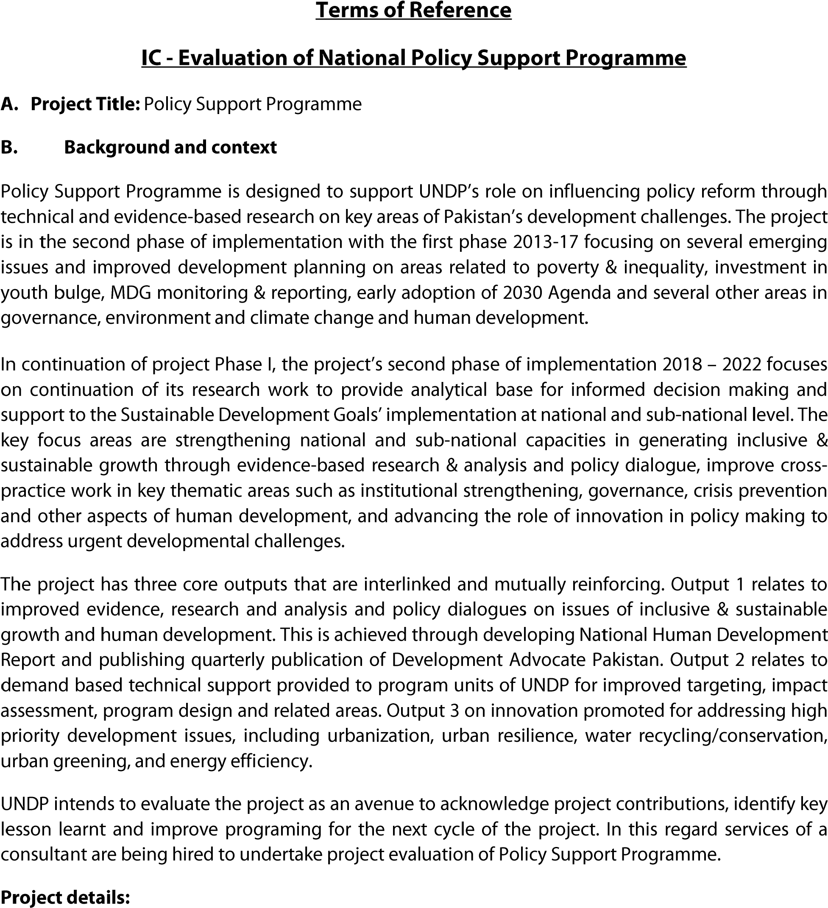
Project/outcome title | Policy Support Programme
Atlas ID | 00087069
Corporate outcome and output | - Outcome - By 2022, the Pakistani people, benefit from transparent, accountable, and effective governance mechanisms and rule of law institutions.  - Output 9.3: Through active citizen engagement, national/provincial governments shape public policy priorities and establish planning, financing, and monitoring mechanisms, facilitating implementation of the Sustainable Development Goals.
Country | Pakistan
Region | South Asia
Date project document signed | 01 December 2017 (second phase)
Project dates | Phase 1:  Start: 01 July 2013  Phase 2:  Start: January 2018 | Phase 1:  End: 31 December 2017  Phase 2:  Planned End: 31 December 2022
Duration of evaluation | January 2016 – December 2020
Project budget | US $ 2.5 million
Expenditure at time of evaluation | US $ 2.4 million
Funding source | UNDP, UNCIEF, Swiss Agency for Development and Cooperation
Implementing Party | UNDP in collaboration with Ministry of Planning, Development and Special Initiatives, and Provincial Planning and Development Departments.

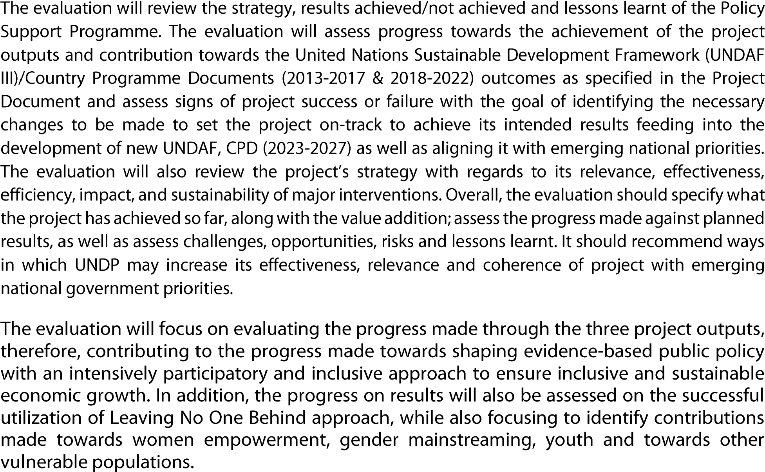
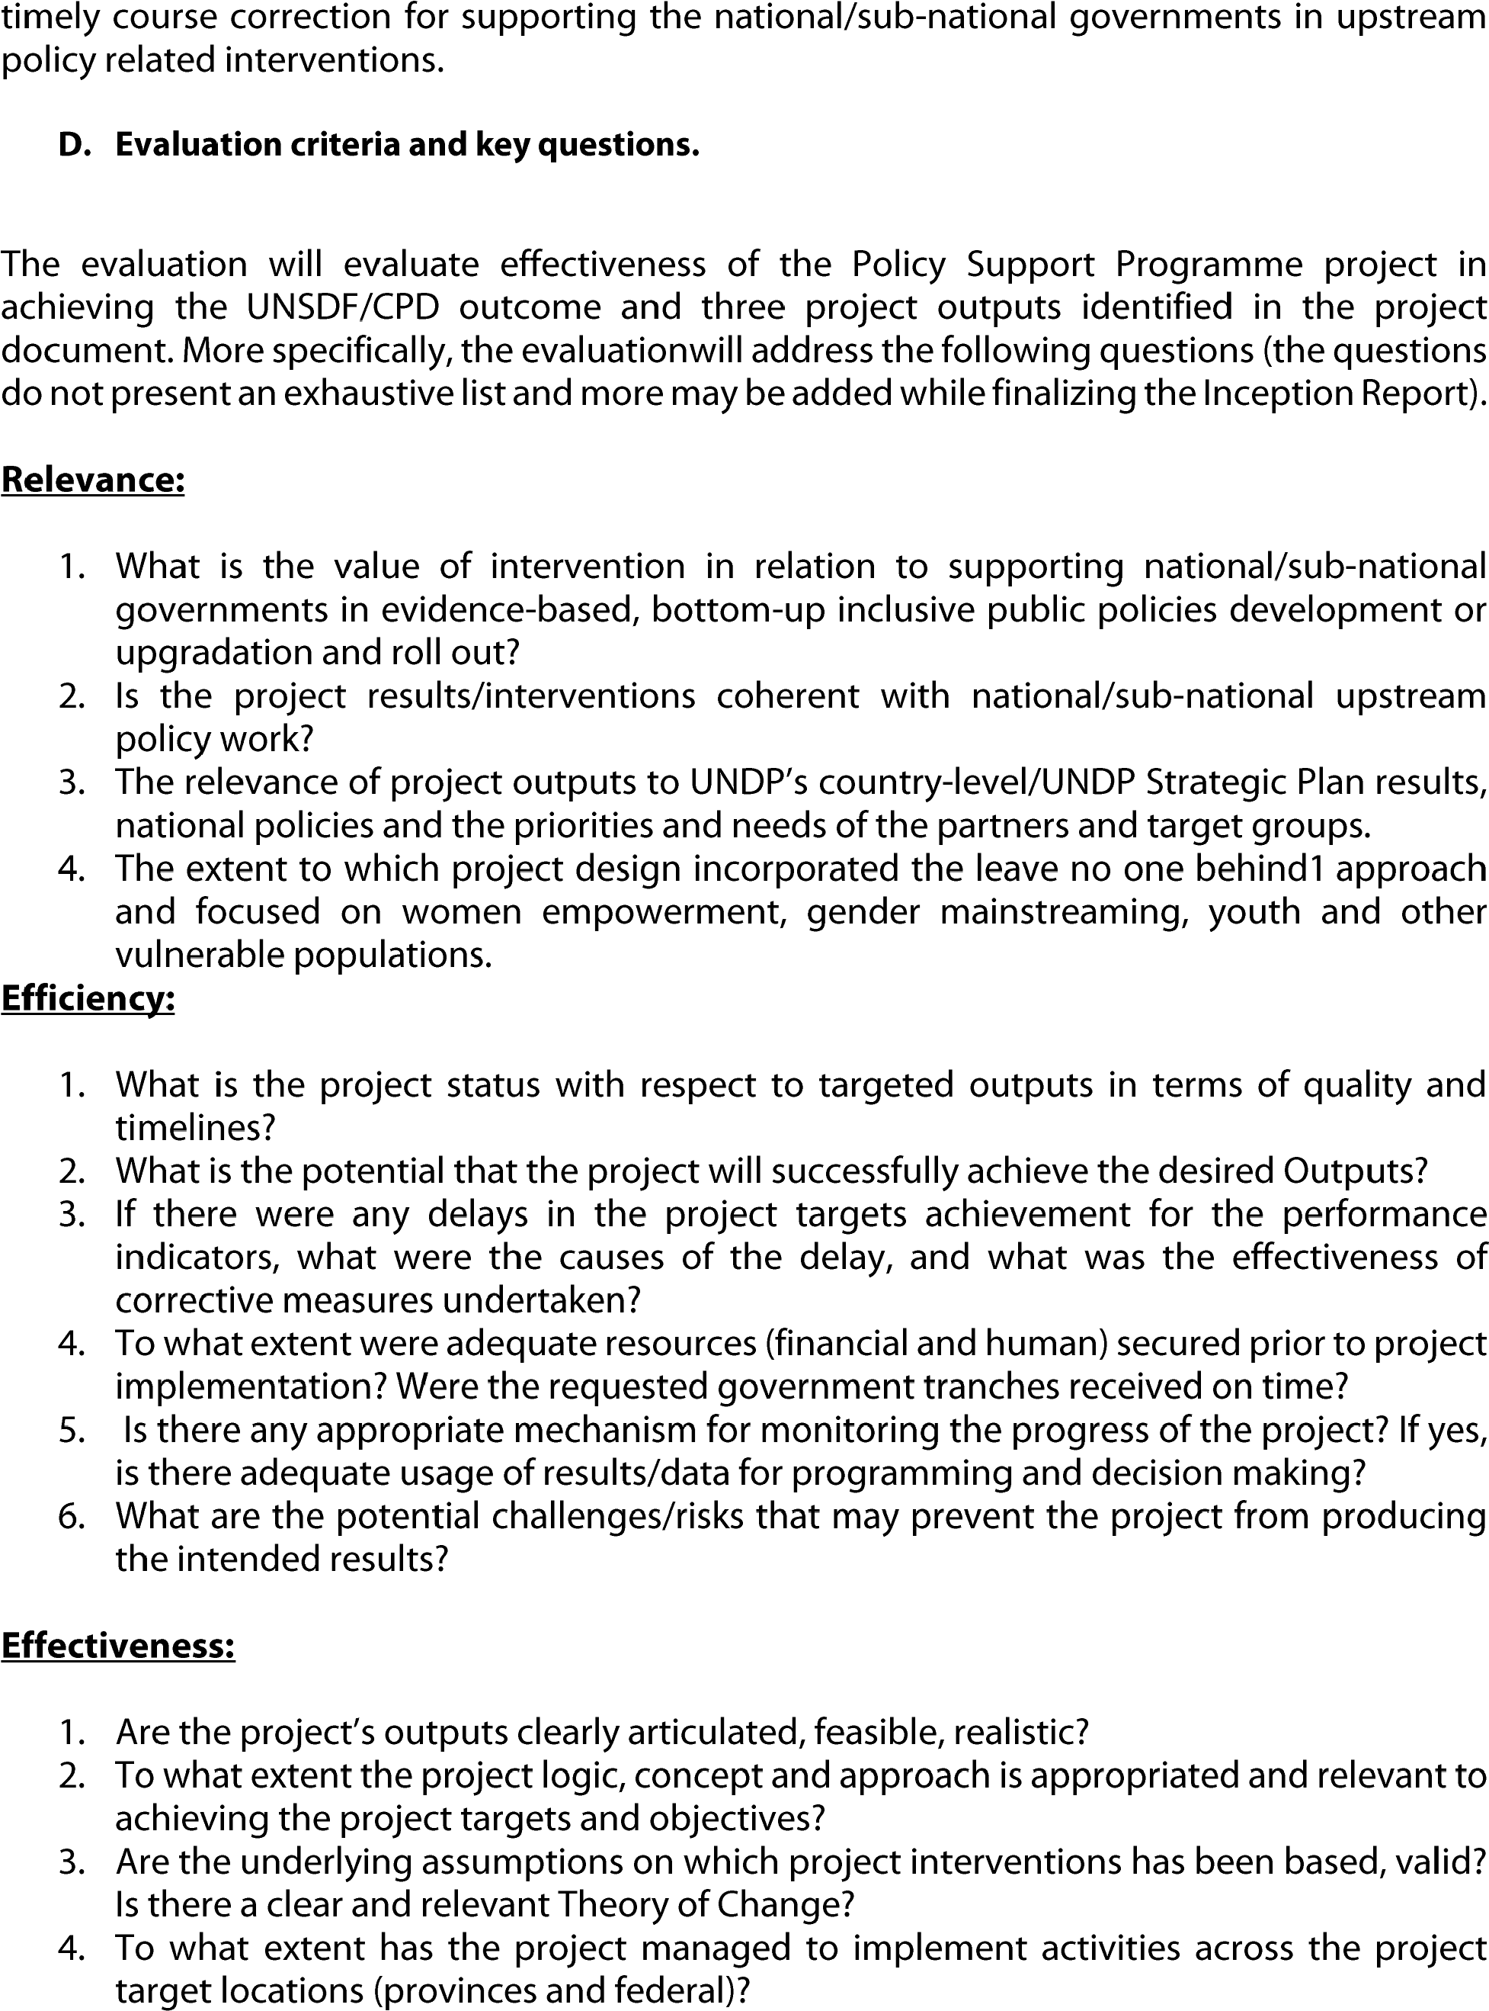
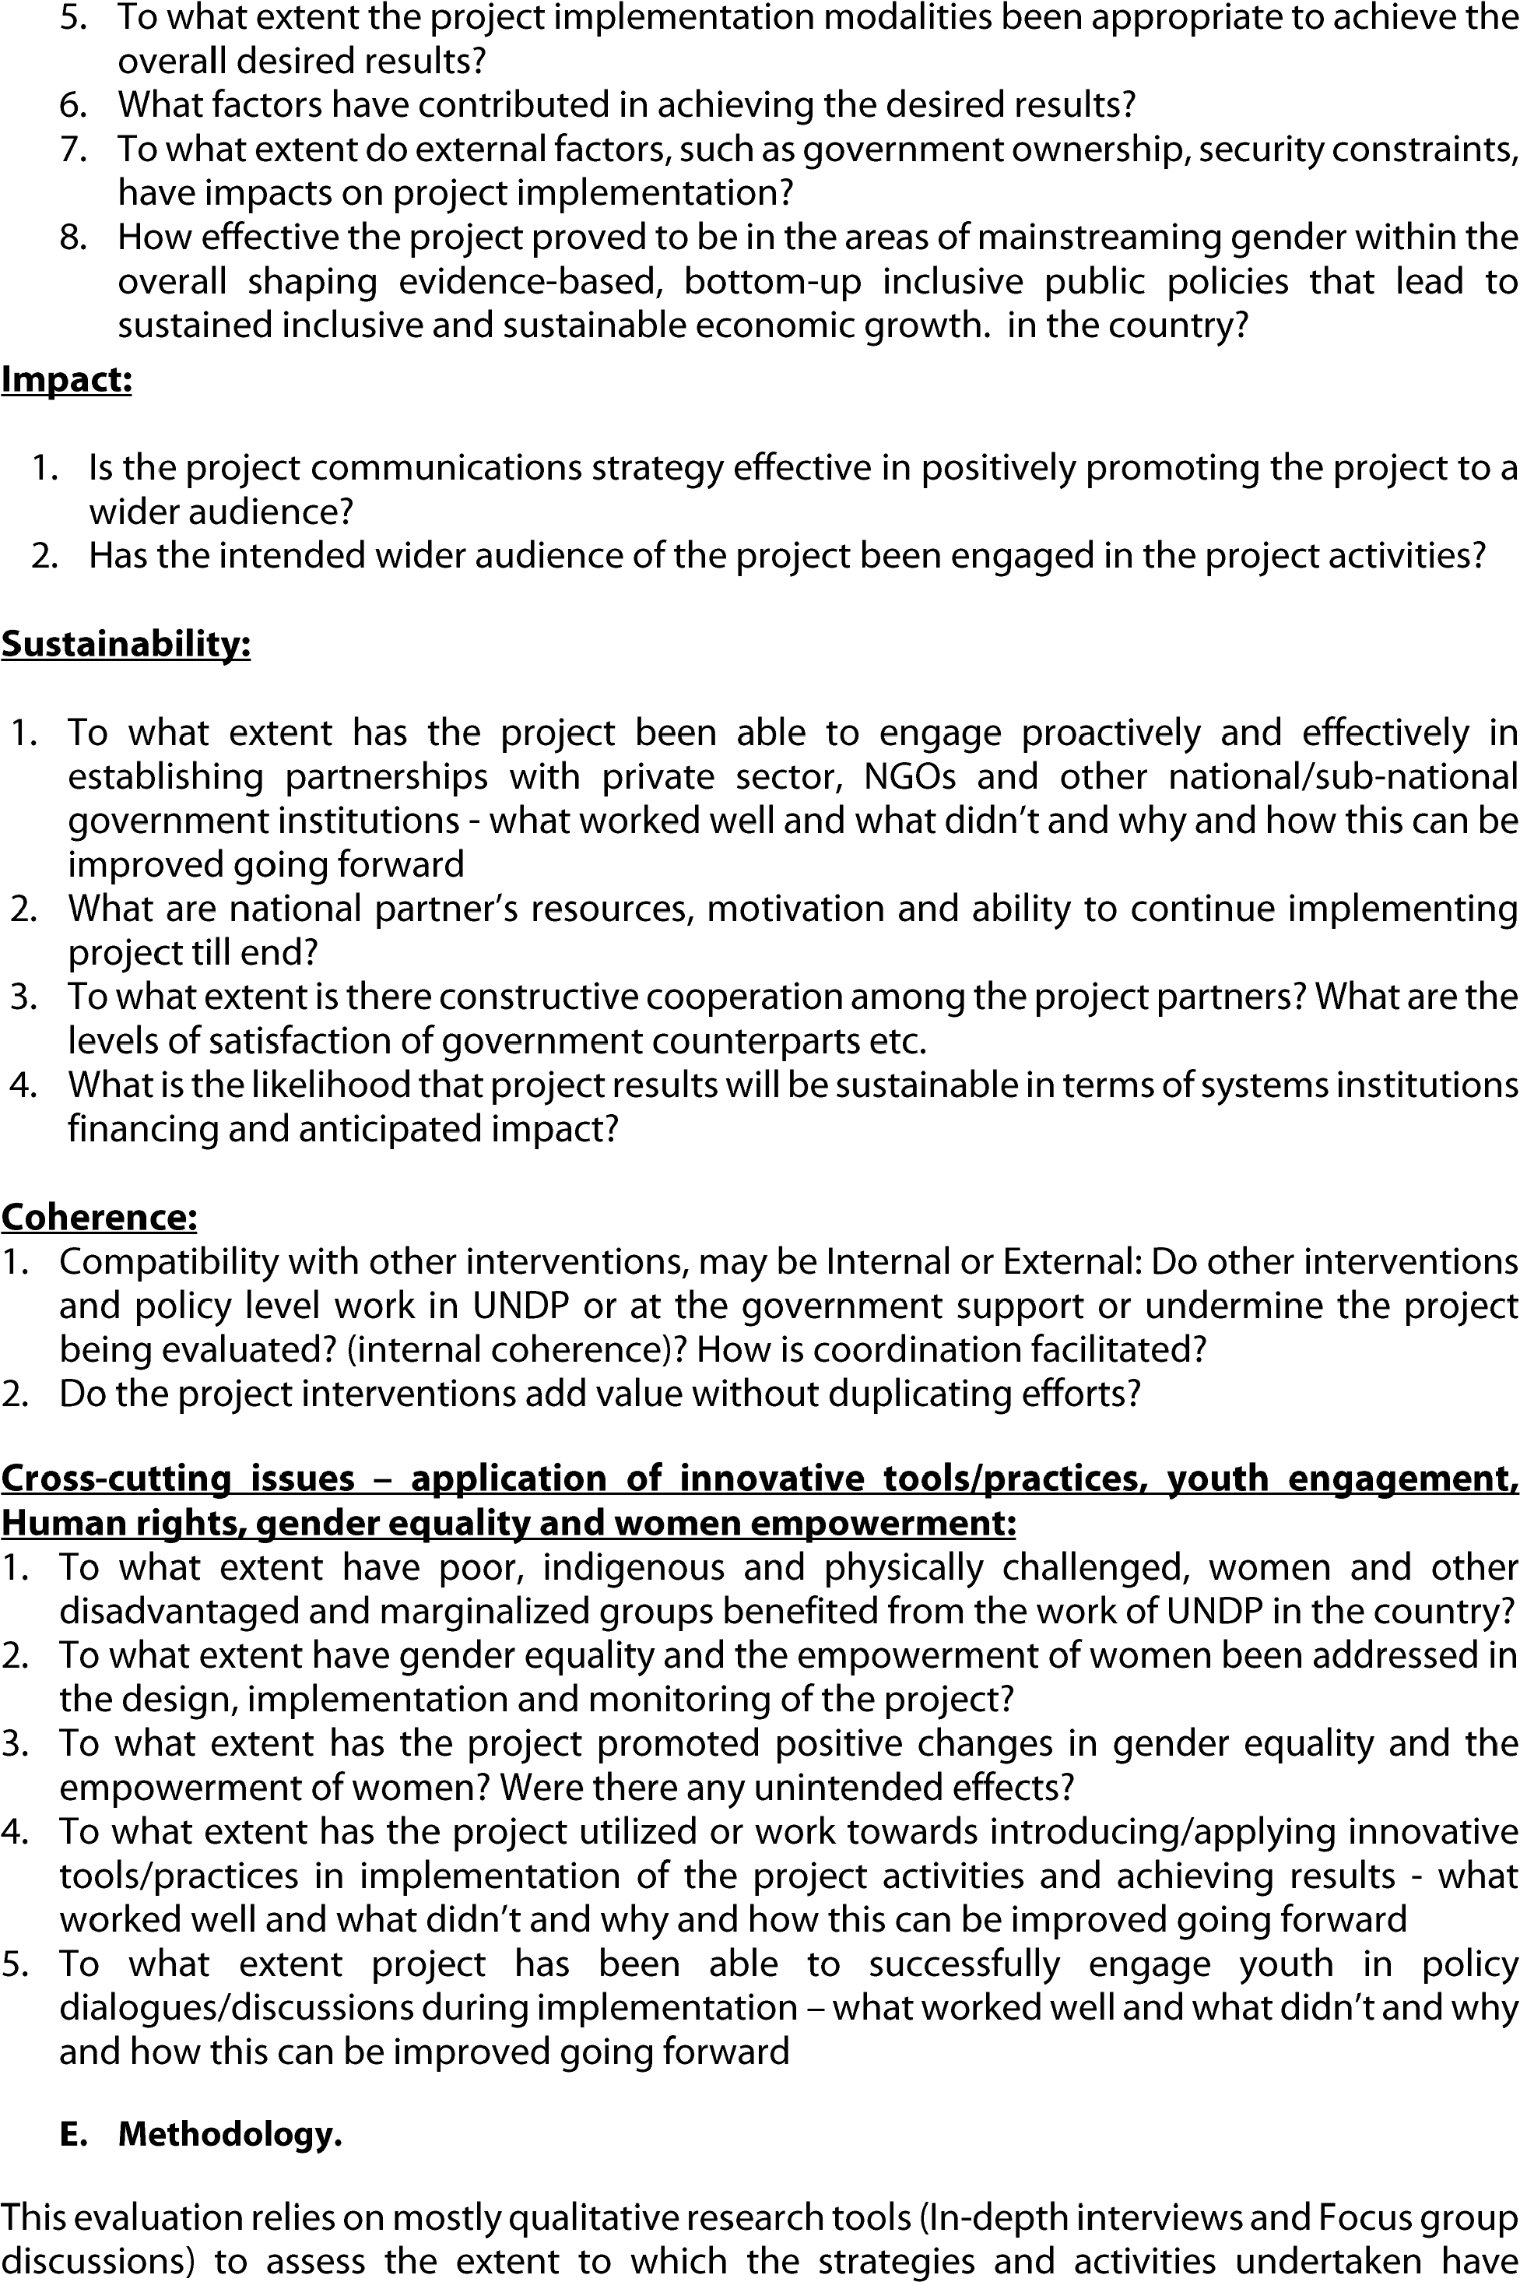
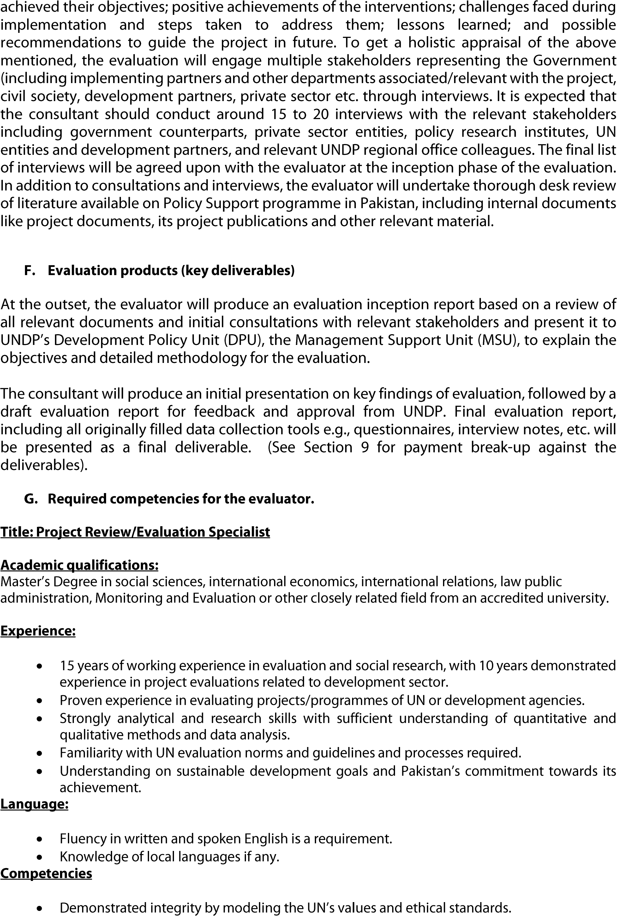
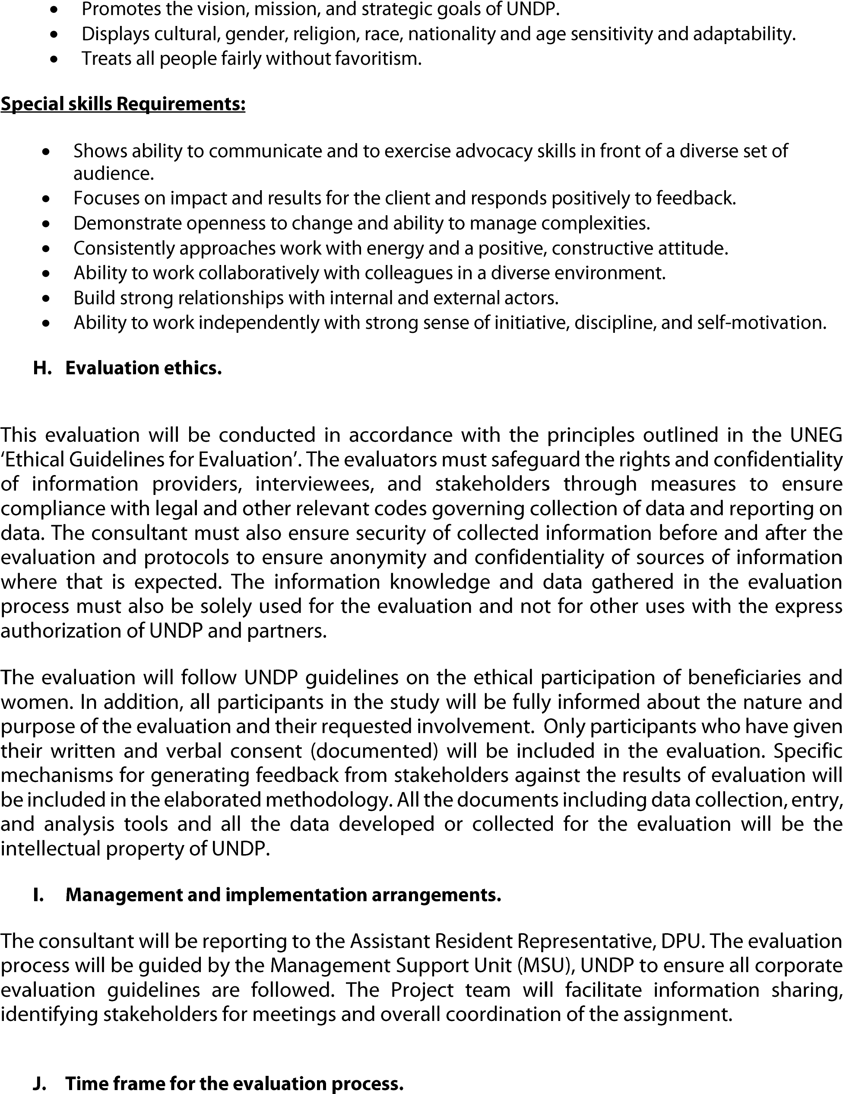
 | • | 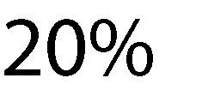
 | • •  •  • | 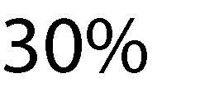
 | •
 | •
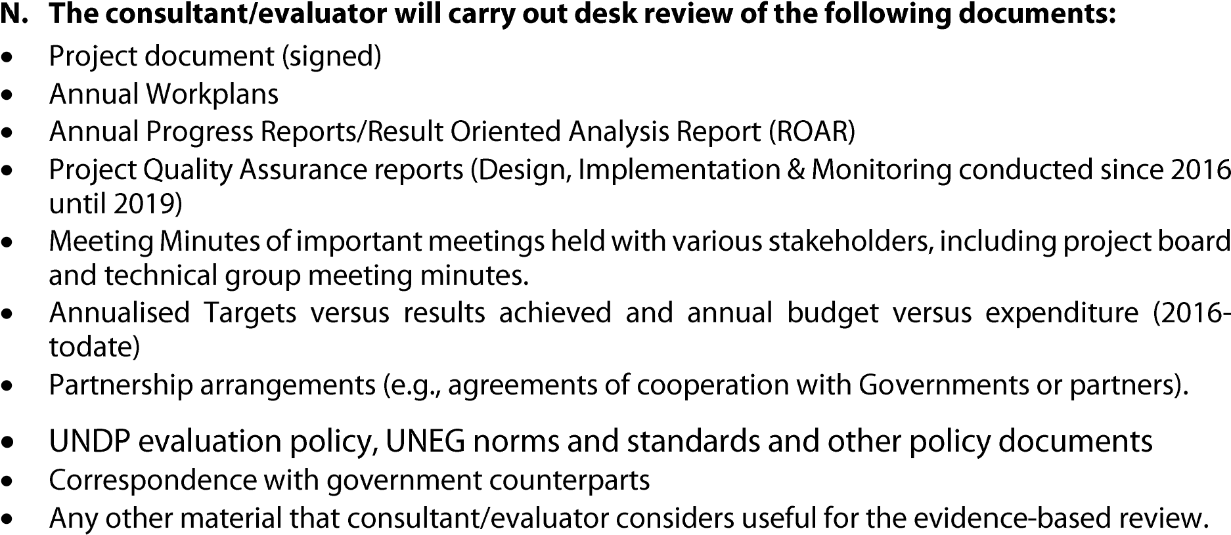

Annex 2: Evaluation Matrix: Policy Support Programme (PSP)
Evaluation Criteria | Key questions | Specific sub-questions and  Indicators / evidence | Indicators/ evidence | Data sources | Data collection methods / tools | Methods for data analysis
1.Relevance | 1. To what extent is project intervention consistent with UNDP’s country program document, UNDAF, UNDP’s strategic plan and to the context in Pakistan – in terms of ground situation and needs of the target groups? | Sub-question 1.1: What is the value addition of project interventions regarding supporting national/ sub-national governments in evidence- based inclusive public policies development or roll out?  Sub-question 1.2: Are the project results/ interventions coherent with national/ sub-national upstream policy work?  Sub-question 1.3: To what extent are the project outputs relevant to UNDP’s country level /UNDP Strategic Plan results, national policies, priorities and needs of the partners and target groups?  Sub-question 1.4: Are the projects outputs clearly articulated, feasible and realistic?  Sub-question 1.5: To what extent the project logic, concept and approach is appropriate and relevant to achieving the project targets and objectives?  Sub-question 1.6: Are the underlying assumptions on which projects interventions have been based, valid? Is there a clear and relevant Theory of Change?  Sub-question 1.7: To what extent has project design incorporated the “Leave No One Behind” approach and focused on women empowerment, gender mainstreaming, youth, and other vulnerable populations? | Extent to which objectives / results of PSP (as outlined in the relevant documents) are aligned to the objective / targeted results of UNDP Country Program Document, Regional Program, national polices and development challenges in Pakistan. | Project document / concept note.  UNDP Strategic Plan  Government’s policies / relevant national situational reports, Progress (Physical/ financial) reports.  Project reports | Review of relevant documents as mentioned in the “data sources”.  Online and in person interviews using structured questionnaires. | Qualitative analysis
2. Coherence: | 2. To what extent the project is coherent with other UNDP projects and that of other partners? | Sub-question 2.1: How well coordinated the project is with other projects of UNDP with similar mandate? How is coordination promoted (internal coordination)?  Sub-question 2.2: How well coordinated the project is with projects of other development partners with similar mandate? How is coordination promoted (external coordination)?  Sub-question 2.3: What mechanisms exist in the project to avoid overlaps and duplication with other similar initiatives inside and outside UNDP?  Sub-question 2.4: Do other interventions and policy level work in UNDP or the Government support or other partners undermine PSP?  Sub-question 2.5: Do the project interventions add value without duplicating efforts? | Evidence of co-creation  Collaboration, coordination and tapping of resources | Project reports, primary data collection | Secondary project reports, stakeholders’ interviews, online survey etc. | Qualitative and quantitative analysis
3. Effectiveness | 2. To what extent, and through which approaches or interventions, have the project’s outputs, milestones, cross-cutting and other objectives, or results been achieved or expected to be achieved and what have their contributions to the country level or regional programs? | Sub-question 3.1: To what extent the project activities were delivered effectively in terms of quality, quantity, and timing?  Sub-question 3.2: What factors have contributed to achieving or not achieving the intended outputs? What were the lessons and how were feedback/learning incorporated in the subsequent process of planning and implementation?  Sub-question 3.3: How effective has the project been in enhancing the capacity of national counterparts and to create enabling environment for inclusive and participatory pro poor and sustainable development policy making? To what extent the project interventions were successful in this regard?  Sub-question 3.4: To what extent the project implementation modalities have been appropriate to achieve the overall desired results?  Sub-question 3.5: To what extent do external factors such as government ownership, security constraints, have impacts on project implementation?  Sub-question 3.6: How successful the project has been in the areas of mainstreaming gender within PSP support evidence-based bottom public policies for inclusive and sustainable economic growth in the country? | Evidence of results achieved or expected to be achieved.  Evidence on project implementation modality  Evidence on capacity development of partners  The extent critical stakeholders / institutions are represented.  To the extent stakeholders and independent assessment have reported the PSP initiative as innovative and effective to the needs on the ground | Project progress reports, project impact assessment, third-party reports / stories, users’ feedback, stakeholders’ feedback | Project reports / relevant material to be provided by UNDP  Stakeholder’s interviews / feedback or online surveys | Qualitative and quantitative (subject to the availability of data)
4. Efficiency | 3. How optimal is the resource utilization of the project with reference to its actual and potential results? | Sub-question 4.1: What is the project status with respect to targeted outputs in terms of cost in comparison with similar activities?  Sub-question 4.2: How economical are the project management arrangements in national context and in the context of a policy focused development project?  Sub-question 4.3: Is there evidence about specific measures that the project might have undertaken to reduce project cost without comprising on quality?  Sub-question 4.4: If there were any delays in the project targets achievement for the performance indicators, what were the causes of the delays and what was the effectiveness of corrective measures undertaken?  Sub-question 4.5: To what extent were adequate resources (financial and human) secured prior to project implementation? Were project financings available on time?  Sub-question 4.6: Is there any appropriate mechanism for monitoring the progress of the project? If Yes, is there adequate usage of results/ data for programming and decision making?  Sub-question 4.7: What are the potential challenges/ risks that may prevent the project from producing the intended results? | The ratio of project benefits (actual, intended direct and indirect) to project cost.  Project management cost  Project progress towards its objective and outputs  The extent to which activities have been delayed resulting in cost escalation.  Availability of resources against needs. | Project reports, financial reports, impact reports, stakeholders’ feedback | Project reports and financial reports to be provided by UNDP  Deriving project benefits from secondary reports and stakeholders’ feedback | Quantitative and qualitative analysis
5. Impact | 4: To what extent, and how, has the project produced or is expected to produce positive impact on institutions / systems, people, and environment? | Sub-question 5.1: Have intended government partners and other intended target groups used PSP’s research products in making evidence-based decisions in drafting policies or programmes?  Sub-question 5.2: Has other UNDP projects and units used the knowledge and analysis undertaken through PSP for their projects or work or decision making?  Sub-question 5.3: Has PSP’s products and services helped UNDP to develop further projects and service offers to government counterparts and other stakeholders?  Sub-question 5.4: Has the project’s interventions produced any unintended negative externalities on the environment or vulnerable groups of society?  Sub-question 5.5: Is the project communications strategy effective in positively promoting the project to a wider audience?  Sub-question 5.6: Has the intended wider audience of the project been engaged in the project activities? | Evidence that project products and services are used by stakeholders – internal to UNDP and outside.  Evidence of project impact on government policies  Evidence that project interventions influenced government and UNDP programmes.  Evidence that policy support will generate impact on vulnerable population in the long term | Project reports, primary data collection | Secondary project reports, stakeholders’ interviews, online survey etc. | Qualitative and quantitative analysis
6. Sustainability | 5. To what extent are the project activities / approach sustainable in terms of institutional ownership, availability of financial resources and its impact? | Sub-question 6.1: What is the likelihood that the project impact will be sustained after the project duration? This may include the use of project products and services beyond project duration.  Sub-question 6.2: To what extent is there constructive cooperation among the project partners? What are the levels of satisfaction of government counterparts?  Sub-question 6.3: What are national partners’ resources, motivation, and ability to continue implementing project till end and beyond?  Sub-question 6.4: To what extent has the project been able to engage proactively and effectively in establishing partnerships with private sector, NGOs, and other national/ sub-national government institutions? What worked well and what didn’t and why and how this can be improved going forward? | Evidence on government’s use of project’s products and services (actual or intended)  Evidence that the project products and services or their impact have been institutionalized by government or other partners.  Evidence on multi stakeholder partnership that the project may have established. | Project reports, interviews with concerned stakeholders, feedback etc | Review of existing reports, collection of primary information through online discussion, calls, surveys and in-person discussions | Qualitative and quantitative analysis
7. Leaving no one behind - youth engagement, Human rights, gender equality, and women empowerment | The extent to which cross cutting issues have been addressed by the project and innovative practices across the three project outputs applied? | Sub-question 1: To what extent have poor, indigenous and physically challenged women and other disadvantaged and marginalized groups have been focused through project supported policies and other interventions?  Sub-question 2: To what extent have gender equality and the empowerment of women been addressed in the design, implementation and monitoring of the project?  Sub-question 3: To what extent has either the project interventions promoted or will contribute to positive changes in gender equality and the empowerment of women? Were there any unintended actual or future effects?  Sub-question 4: To what extent has the project utilized or work towards introducing / applying innovative tools/ practices in implementation of the project activities and achieving results? What worked well and what didn’t and why and how this scan be improved going forward?  Sub-question 5: To what extent has the project been able to successfully engage youth and women in policy dialogues/ discussions during implementation – What worked well and what didn’t and why and how this scan be improved going forward? | Evidence that the project activities, products, and services have explicitly focused on vulnerable populations.  Evidence that women, youth, and other groups have participated in project activities and have contributed to its products and services.  The extent to which the project has deployed innovative tools and instruments for public policy formulation and analysis and for stakeholder engagement.  Extent on co-designing for addressing wicked development challenges.  Evidence of any assessment / reports which might have reported PSP initiatives as innovative and effective. | Project reports and primary data collection | Review of reports, stakeholders’ consultations | Qualitative analysis

Annex 3: Budget (allocated, expended) 2013-2020 Policy Support Programme (PSP)

Year | Budget in USD | Expenses in USD | %age
2013 | 250,000.00 | 206,413.18 | 83%
2014 | 799,200.00 | 799,214.61 | 100%
2015 | 1,384,000.00 | 1,321,105.05 | 95%
2016 | 600,000.00 | 528,509.39 | 88%
2017 | 579,959.00 | 565,223.64 | 97%
2018 | 513,187.00 | 497,427.70 | 97%
2019 | 503,000.00 | 498,978.56 | 99%
2020 | 359,574.00 | 346,968.86 | 96%
Total | 4,988,920.00 | 4,763,840.99 | 95%

NB: Evaluation Time frame, as per the Terms of Reference is 2016-2020. Total budget allocation and expenditure, for the corresponding period, stands at USD 2.5 and 2.4 (96%), respectively.

Annex 4: Questions for Primary Data Collection
For UNDP and project staff
Relevance
- How was the project document designed? What process was followed, how were consulted, how was problem statement defined?
- What factors were considered in designing the scope and focus of the project? How were the vulnerable population (Leave No One Behind approach) was incorporated during the design phase of the project?
- What are the specific activities and interventions the project design which address the needs and priorities of the vulnerable population? Since it is a policy focused project, what policy instruments were envisaged to ensure positive impact for the vulnerable population?
- In what ways are development partners, policy makers, members of parliament and the provinces involved in the process?
Coherence
- How was it ensured to keep the project coherent to government policies, national priorities, and national context?
- How was it ensured that the project’s scope and activities do not duplicate those of other development projects of different entities? What mechanisms were introduced in the project so that regular coordination and collaboration with other entities and stakeholders are maintained?
- How the project ensures coherence with other projects of UNDP? Are their systems and mechanisms for two-way communication between PSP and other UNDP projects?
Effectiveness
- To what extent have your project achievements contributed to each of the 3 outputs and cross-cutting issues [Leave No One Behind, gender mainstreaming, youth and other vulnerable populations]? What has influenced this?
- In what ways do you provide and receive technical assistance? How adequate has this been?
- What steps have you taken for the communication and dissemination of your work? To what extent do you think this has influenced the intended audience?
- What could be done differently to enhance the performance of the project?
Efficiency
- How does the project ensure efficiency – in terms of time and cost – in its interventions? What are the tools being used or have been used so far?
- What is the evidence that the project is more efficient than similar projects by other entities or by UNDP? How is that comparison done?
- Would there be any impact on the quality of project interventions if project budget is increased? do you think that consideration for cost has impacted the quality of project products and services?
- How do you engage your counterparts as part of your activities?
- How do you identify, engage and supervise institutions and individuals as service providers? To what extent is the work completed on time and what influences this?
- How do you interpret the rating scales for assessing progress against indicators?
- How could the efficiency of the project be improved?
Impact
- What you think has been the greatest impact of the project? [policy impact, awareness and advocacy, knowledge management, policy innovation etc] What is the evidence?
- What kind of feedback have stakeholders given on project work?
- How could project impact be further enhanced?
Sustainability
- To what extent you think the project’s interventions and their impact are likely to be sustained and upscaled in the years to come?
- What are the products and services that the project has generated which you think have the highest chances of sustainability and replication?
- To what extent has the political and administrative leadership shown an interest in continuing the project?
For Service Providers / policy experts / academics
- What is the nature of the work you have done or are doing for the project? Mention the reports, notes and other documents you have prepared in the process.
- How does it fit into the national or provincial context? Identify the social, institutional, financial and other factors you consider relevant.
- What has been your experience of working with UNDP and its partner institutions? Consider the entire process from contracting to completion.
- What are your proposals and suggestions for UNDP to further enhance its policy related work and its impact?
For Policy Makers/Senior Officials
Relevance
- How relevant has been the policy work of UNDP to the objectives of your department or ministry or entity?
- What are the dos and don’ts you will suggest for UNDP policy related work? Are their specific areas where you think UNDP can add value and should focus on?
- How relevant is the UNDP’s Leave No One Behind and the need to focus on women empowerment, gender mainstreaming, youth, and other vulnerable populations?
Effectiveness
- To what extent do you think the policy related work of UNDP has been effective in influencing national policies, awareness, and innovation?
- How could the effectiveness of UNDP policy work be further improved? What would you suggest for the project design, implementation modalities, partnerships and other areas?
Impact
- In what ways and to what extent have you observed the impact of the project? [policy impact, awareness, institutionalization, innovation]
Sustainability
- To what extent is project impact likely to be sustained and enhanced in the years to come?
- To what extent are you willing and able to resource the project to sustain, upscale or replicate the project?

Annex 5: Sampling frame for Key Informant Interviews
Category | Implementing partners/ Key stakeholders | Relevance | Sample size – KIIs
1 | UNDP / Project Staff | - Overall owners and implementers of the project  - Project designer  - Project monitoring and quality assurance responsibility  - Project implementer | - Assistant Resident Representative DPU (woman)  - 8 UNDP PAK staff (including 3 women) 5 National and 3 international staff.  - 2 UNDP Pak MSU staff (one man and one women)
2 | Ministry of Planning, Development & Reform and other line Ministries | - Main planning institution of Pakistan  - UNDP main counterpart for policy and SDG related work  - Concerned govt. agency for poverty measurement and projects approval.  - Member of UNDP advisory councils for NHDR and others  - Lead partner for multi-dimensional poverty and private sector work | 2 persons (Planning Commission Islamabad (01 women) and Sindh P&D (01 Man)
3 | Metropolitan Corporation Islamabad (MCI), private sector partners | - Lead agency for urban platform  MCI: 1) Lead agency for water recycling plants at service stations; 2) Lead agency for urban revenue study; and 3) Lead agency for Randomized Control Trial.  Private sector: Piloting of water recycling plants, SDG innovation. | 2 persons - ex-Chief Metropolitan Officer (man), MCI and Chairman RDA (man)
4 | Pakistan Bureau of Statistics | - Providing required data from publications and surveys  - Facilitating collection of new data for research | Director, (PSLM, SD, CP&C) (women)
5 | Parliamentarians / SDG Parliamentary Committee | - Play a key role in generating ownership for new research findings and increase awareness.  - Engagement on community of practice / advisory council  - Partners for policy dissemination / consultations | Not available
6 | Contributors to DAP, NHDRs, policy papers and other project interventions | - Partners for collaborative research  - Op-ed contributors  - Policy advocates  - Involvement in communication and dissemination of knowledge products  - Policy influencers | CEO SDPI (01) (man)
7 | Academia | - Partners in research, policy dissemination workshops | IBA Karachi, Ex- Member Social Sector (women)
8 | UN Agencies (UNICEF, UNFPA, UN RCO) | - Jointly conducted activities.  - Funding partners  - Similar mandate and focus | UN RC (01 man), UNICEF Chief of Social Policy (01 man)

Annex-6: List of supporting documents reviewed

UNDP Documents
- UNDP Country Programme Document for Pakistan 2018-2022 (https://www.undp.org/content/dam/pakistan/docs/Legal%20Framework/Country%20programme%20document%20for%20Pakistan%20(2018-2022).pdf).
- UNDP Evaluation Policy, 2019 (http://web.undp.org/evaluation/documents/policy/2019/DP_2019_29_E.pdf).
- UNDP Evaluation Guidelines (http://web.undp.org/evaluation/guideline/documents/PDF/UNDP_Evaluation_Guidelines.pdf).
- UNDP, What Does It Mean To Leave No One Behind? A UNDP discussion paper and framework for implementation, July 2018 (https://www.undp.org/content/undp/en/home/librarypage/poverty-reduction/what-does-it-mean-to-leave-no-one-behind-.html).
- Evaluation Quality Assessment
http://web.undp.org/evaluation/guideline/documents/PDF/section-6.pdf
International Evaluation References
- Organization for Economic Cooperation and Development (OECD) Development Assistance Committee (DAC), “Glossary of Key Terms in Evaluation and Results Based Management” (http://www.oecd.org/dac/evaluation/2754804.pdf).
- United Nations Evaluation Group, Norms and Standards for Evaluation, 2016 (https://www.betterevaluation.org/en/resources/example/UNEG-evaluation-standards-2016).
Project Documents
- Policy Support Programme, Project Document Signed
- Policy Support Programme, Annual Work Plan 2016
- Policy Support Programme, Annual Work Plan 2017
- Policy Support Programme, Annual Work Plan 2018
- Policy Support Programme, Annual Work Plan 2019
- Policy Support Programme, Annual Work Plan 2020
- Contribution Agreement with UNICEF, 2019
- Cost Sharing Agreement with Swiss Agency for Development and Cooperation, 2018
- Quality Assessment Checklist for Project Evaluation
- Results Oriented Annual Report, 2020
- Policy Support Programme, Implementation Stage Quality Assurance Report, 2020

Annex 7. Summary of tables of progress towards outputs, targets, and goals
Indicators Level Evaluation Performance Rating
Indicator | Target Performance Rating | Evaluation Performance Rating
Output 1: Improved evidence, research and analysis and policy dialogues on issues of inclusive & sustainable growth and human development.
Indicator 1.1 Extent to which evidence-based research and analysis inform public policies / UNDP programming in Pakistan. | Baseline: 3=Partially  Target: 5=Fully  Description: Regular circulation of DAP (4 yearly issues) and meetings of Communities of Practice driving policy dialogue, research, and reform | 1) Not adequately; 2=Very partially; 3=Partially; 4=Largely; 5=Fully
Indicator 1.2: Extent to which national and sub-national policies / programmes are informed and benefited by UNDP’s led analysis and recommendations through NHDR. | Baseline: 3=Partially  Description: Extensive advocacy around the existing NHDR  Target: 5=Fully  Description: New NHDR initiated on a different thematic area | 1) Not adequately; 2=Very partially; 3=Partially; 4=Largely; 5=Fully
Output 2: Demand based technical support provided to program units of UNDP for improved targeting, impact assessment, program design and related areas
Indicator 2.1: Extent to which cross-unit support provided under the project is effective in delivering coordinated results | Baseline: 2=very partially  Target: 5=Fully | 1) Not adequately; 2=Very partially; 3=Partially; 4=Largely; 5=Fully
Output 3: Innovation promoted for addressing high priority development issues
Indicator 3.1: Extent to which innovative practices are adopted in addressing development challenges | Baseline: 1=Not adequately  Target: 4= Largely | 1) Not adequately; 2=Very partially; 3=Partially; 4=Largely; 5=Fully

Annex 7.1: Progress Against Output Targets
 | Output | Output Targets | Achievement | Progress Rate
Output 1: Improved evidence, research and analysis and policy dialogues on issues of inclusive & sustainable growth and human development. | Development Advocate Pakistan | 18 issues of DAP | 21 | 117%
 | National Human Development Reports | 2 | 2 | 100%
 | Op-eds, media coverage | 16 | 16 op-eds  At least 8 issues of DAP covered by media | 100%
Output 2: Demand based technical support provided to program units of UNDP for improved targeting, impact assessment, program design and related areas | DAPs published in coordination with other units  Joint research products | 14 | Total 12  At least 10 DAPs (local govt, elections, Balochistan, FATA, water etc)  Impact study with CPRU  One project on Reforms and Innovation | 86%
Output 3: Innovation promoted for addressing high priority development issues. | No of research undertaken to explore the role of innovation  No of pilot innovative initiatives | 10 | 1 randomized control trial on nudges  1 urban revenue study  1 urban platform  1 water recycling initiative | 40%
Overall |  |  |  | 87%

Annex 7.2: Output Performance Rating
Indicator | Target Performance Rating | Evaluation Performance Rating
Output 1: Improved evidence, research and analysis and policy dialogues on issues of inclusive & sustainable growth and human development.
Indicator 1.1 Extent to which evidence-based research and analysis inform public policies / UNDP programming in Pakistan. | Baseline: 3=Partially  Target: 5=Fully  Description: Regular circulation of DAP (4 yearly issues) and meetings of Communities of Practice driving policy dialogue, research, and reform | 4=Largely
Indicator 1.2: Extent to which national and sub-national policies / programmes are informed and benefited by UNDP’s led analysis and recommendations through NHDR. | Baseline: 3=Partially  Description: Extensive advocacy around the existing NHDR  Target: 5=Fully  Description: New NHDR initiated on a different thematic area | 4=Largely
Output 2: Demand based technical support provided to program units of UNDP for improved targeting, impact assessment, program design and related areas
Indicator 2.1: Extent to which cross-unit support provided under the project is effective in delivering coordinated results | Baseline: 2=very partially  Target: 5=Fully | 4=Largely
Output 3: Innovation promoted for addressing high priority development issues
Indicator 3.1: Extent to which innovative practices are adopted in addressing development challenges | Baseline: 1=Not adequately  Target: 4= Largely | 3=Partially

Annex 7.3: KIIs Respondents Performance Rating
Relevance | Coherence | Effectiveness | Efficiency | Impact | Sustainability | Overall ranking
4 | 4 | 4.5 | 4 | 5 | 2 | 4
3 | 4 | 4 | 3 | 5 | 3 | 4
4.5 | 3 | 4.5 | - | 4.5 | 3.5 | 4
4 | 4.5 | 4.5 | 5 | 4.75 | 4 | 4.46
4.5 | 4 | 5 | 4 | 4 | 4 | 4
4 | 3.5 | 4 | 3 | 4 | 4.5 | 4
5 | 4.5 | 5 | 4.5 | 5 | 5 | 5
5 | 5 | 4.5 | 3.5 | 4 | 4 | 4
5 | 5 | 5 | 4.5 | 5 | 4.5 | 5
5 | 5 | 5 | 4.5 | 5 | 4.5 | 5
4.5 | 3.75 | 5 | 4 | 4 | 3 | 4
2 | 2.5 | 3 | 2 | 1 | 0 | 2
3 | 2.5 | 3 | 2 | 1 | 0 | 2
3 | 3 | 3.5 | 2 | 3 | 4.5 | 3
4 | 4 | 4 | 2.5 | 3 | 2 | 3
3 | 0 | 0 | 0 | 4 | 0 | 4
- | - | - | - | - | - | -
4.0 | 3.6 | 4.0 | 3.0 | 3.9 | 3.0 | 4.0
Note: Both the arithmetic means and median is around 4. This is based on 19 responses.

Annex 8: Pledge of ethical conduct in evaluation signed by evaluator
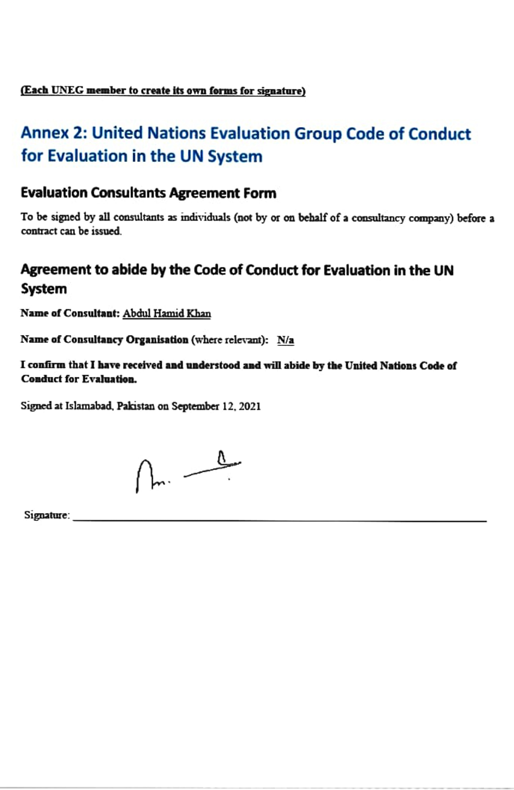

UNDP Evaluation Guidelines (http://web.undp.org/evaluation/guideline/documents/PDF/UNDP_Evaluation_Guidelines.pdf).
Ibid, page 4
https://www.pc.gov.pk/uploads/vision2025/Pakistan-Vision-2025.pdf
https://undocs.org/DP/2017/38, page 3
https://pakistan.un.org/en/44136-un-sustainable-development-framework-2018-2022, page 112,113 and 117
https://www.dawn.com/news/1616751
https://www.dawn.com/news/1312231
Maria Lall, Tania Saeed (2019), Youth and the National Narrative: Education, Terrorism and the Security State in Pakistan
https://www.dawn.com/news/1404423
https://kamyabjawan.gov.pk/kjhome/about
https://www.pass.gov.pk/NewsDetailWerFf65%5ES23d$gH243fabc2-f4f8-461d-a134-d9960c68be040ecFf65%5ES23d$Pd
https://peri.punjab.gov.pk/system/files/Chapter%202%20Poverty%20Profilling%20in%20Punjab_0.pdf

