Annex 1. Project Logical Framework and Strategy

Project Logical Framework

NAP PROJECT RESULTS FRAMEWORK
OUTCOMES | BASELINE | TARGET | ACTIVITIES  Please including key outputs or deliverables where applicable | Comments
1. Effective national adaptation coordination system established to drive the NAP process
1.1 National institutional arrangements to coordinate adaptation processes are in place | No effective coordination mechanism on climate change  No existing capacity assessments for climate change integration  Ineffective regulatory frameworks to advance NAP | Multi-sectoral inter-agency coordination mechanism established  Capacity gaps assessed and recommendations made for capacity building plan  Recommendations for amendment of existing laws and regulations  Draft NAP produced | 1.1.1 Establish an inter-agency working group to enable an active and participatory approach to advance the NAP  Deliverables:  i) Government decision appointing NDA to initiate the NAP process (months 0-3);  ii) Government decision establishing inter-agency working group and appointment of members (months 0-4)
1.1.2 Conduct gaps assessments focused on existing processes, technical capacity, frameworks and coordination to improve coordination across sectors and levels of government
Deliverable:
Report analysing gaps in existing processes, frameworks and coordination at individual skills and institutional capacity levels, with recommendations (months 4-9)
1.1.3 Analyse existing regulatory framework, policies and plans and assess entry points to identify opportunities to integrate climate risk considerations
Deliverable:
Report containing concrete review of existing laws, by-laws or policies and proposals for amending them (months 6-12)
1.1.4 Develop Standard Operating Procedures for coordination of adaptation within sectors and between agencies and among working groups at the state, entity, cantonal and municipal levels
Deliverable:
Standard Operating Procedures with roles of stakeholders (months 4-18)
1.1.5 Constitute a multi-disciplinary drafting team (a subset of the working group in 1.1.1), compile available technical studies and assessments and draft the NAP for B&H
Deliverables:
A multi-disciplinary drafting team appointed by the NDA (months 7-9)
Draft NAP produced for integration into CCA LEDS of B&H (10-20)
1.2 Mechanisms for regularly reviewing and updating NAP are in place | M&E of climate change done on ad-hoc, donor driven processes  Lack of available gender disaggregated assessments on CC | M&E framework and guidelines produced to track adaptation  Gender-sensitive indicators developed and stakeholders trained | 1.2.1 Development of technical guidelines for M&E activities  Deliverable:  Technical guidelines and M&E tools prepared to complement the SOP produced in 1.1.4 (months 3-12)
1.2.2 Identify appropriate gender-sensitive indicators for monitoring climate change impacts and a system to collect data
Deliverable:
Gender-sensitive indicators with data collection procedures developed (months 7-12)
1.2.3 Undertake capacity building on M&E
Deliverable:
Set of 6 workshops on reporting, monitoring and evaluation (months 13-24)
1.2.4 Establish and maintain an effective M&E system for adaptation and inter-alia the NAP process, adaptation investments and assess their effectiveness and relevance
Deliverable:
M&E system, in line with guidelines/SOP in place (months 4-24)
1.2.5 Undertake peer review of NAP and make it publicly available for information and comments from general public
Deliverable:
NAP review by relevant institutions and public discussion completed (months 19-21)
1.3 Communication and outreach for NAP process enhanced | No communication strategy for CCA  Low awareness of adaptation concerns | Communication strategy for CCA developed and promoted  Awareness raised through promotional activities  NAP disseminated in country | 1.3.1 Develop and implement communication and outreach strategy for medium to long-term adaptation planning  Deliverable:  Communication strategy developed (months 4-9)
1.3.2 Increase the coverage and visibility of project activities for both domestic and international audiences
Deliverable:
A set of promotional materials and activities developed and disseminated (project info, bi-annual bulletins, press statements, etc.) (months 9-24)
1.3.3 Document and communicate lessons learned and best practice in order to encourage replication of successful approaches
Deliverables:
i) Articles and footages to showcase project (months 4-36)
ii) Project summary with lessons learnt (months 30-36)
1.3.4 Finalise the NAP for official endorsement and place online and submit internationally to the UNFCCC NAP central
Deliverables:
i) NAP finalised and submitted to UNFCCC (months 22-24)
ii) NAP document translated in Bosnian, Serbian and Croatian and disseminated in country (months 22-24)
2. Capacity for climate vulnerability assessments, development of socio-economic scenarios strengthened and adaptation options prioritized for 2 key sectors
2.1 System to gather, organize and update relevant data and information on adaptation established or strengthened | No unified or central system for climate relevant data | A centralised system for climate data management developed and staff trained | 2.1.1 Create climate change data management system accessible to all stakeholders  Deliverable:  Database created, and populated delegated rights to identified institutions (months 9-21)
2.1.2 Capacity building of relevant sectors and levels of government to report on and utilize information for decision making on adaptation interventions
Deliverable:
Set of trainings and workshops with training assessment reports (months 21-28)
2.2 Capacity gaps and needs for design and implementation of adaptation strengthened | Limited capacity on assessment, prioritization and implementation of adaptation | Capacity of government staff strengthened for assessment, prioritization and implementation of adaptation | 2.2.1 Informed by 1.1.2, formulate a capacity development plan for upgrading skills and knowledge of government staff on adaptation.  Deliverable:  Capacity development plan, including capacity building programme for state and entity, sub-entity authorities (cantons and municipalities) developed (months 4-9)
2.2.2 Sensitize and train policy makers and stakeholders
Deliverable:
Set of 15 workshops conducted for the duration of the project (months 10-36)
2.3 Available information on climate change impacts, vulnerability and adaptation investments increased or shared in at least 2 priority sectors | Limited and scattered information on impacts, vulnerability and adaptation | Existing information reviewed and complemented with additional assessments for 2 sectors  Adaptation options prioritized for the 2 sectors | 2.3.1 Undertake a review of existing vulnerability assessments (including the information from National Communications) for key priority sectors  Deliverable:  Review of existing assessments (months 4-9)
2.3.2 Quantitatively assess socio-economic and environmental change scenarios for the medium to long-term, for agriculture and water sectors in B&H
Deliverable:
Assessment of socio-economic/environmental impacts for 2 sectors updated (months 4-9)
2.3.3 Identify and prioritize options for climate change adaptation in 2 priority sectors based on findings of 2.3.1-2
Deliverable:
Report on prioritized adaptation options for 2 sectors (months 9-15)
3. Innovative financing strategy for adaptation investments developed and tested in 4-5 selected municipalities
3.1 Studies to inform future investments in adaptation across sectors conducted and financing strategy developed | Limited or no non-government investment in local level adaptation interventions | Sources of finance (budgetary and extra-budgetary) analysed, identified and 2 suitable concepts developed | 3.1.1 Analyse current budgetary and extra-budgetary expenses, sources of funding and other financing mechanisms used to address climate change impacts  Deliverable:  Analysis of existing climate finance (months 9-12)
3.1.2 Identify financial resources required to meet adaptation strategies and develop a financing strategy
Deliverable:
Summary listing of identified financial resources (months 9-15)
3.1.3 Develop two GCF concepts along with pre-feasibility studies concepts for 2 of the priority sectors
Deliverable:
2 concepts for adaptation projects (months 12-30)
3.2 Policy options for scaling up financing adaptation analysed and recommended | Insufficient information on types of market barriers related to subnational finance and effective mitigation  Lack of effective approaches for linking municipalities with market financing  Lack of practical tools for strengthening municipal capacity in planning and access to CCA finance | Market assessment conducted and feasible opportunities recognized and agreed  Financing approach for municipal access to CCA finance defined and accepted for NAP framework.  Effective tools adopted for NAP under NAP framework | 3.2.1 Assess existing market barriers for up to 2 municipalities and identify effective means of de-risking market based adaptation financing transactions.  Deliverable:  Feasibility assessment for 2 municipalities (months 9-12)
3.2.2 Assess feasibility of complementary sources of finance, including private sector capital
Deliverables:
i) Feasibility assessment (combined with 3.2.1) of using complementary sources of finance (months 9-12)
ii) Summary of applicable financial mechanisms and available financing instruments (months 9-12)

3.2.3 Define and showcase new financing approach for accessing adaptation finance by municipalities
Deliverable:
Proposed approach for municipal adaptation finance (months 9-15)

3.2.4 Develop methodology and tools for multi-year capital investment risk informed programming and prioritization for financial planning at municipal level.
Deliverable:
Methodology and analytical tools for: (1) multi-year capital investment risk informed programming (2) investments prioritization and (3) financial forecasting and mid-term municipal finance planning (months 7-15)
3.3 Practical methodology for CCA planning and access to finance introduced in selected municipalities | CCA not included in municipal budget planning, external finances not considered to date for adaptation | Innovative tools and methods for CCA financing tested in 4 or 5 municipalities and capacity of local stakeholders built | 3.3.1 Test new financing approach (linked to activity 3.2) and prepare investment programming, prioritization and financial planning tools to support municipal access to domestic market financing to leverage additional sources of funding for effective adaptation implementation  Deliverable:  Package of tested software tools and manuals with data application examples (months 12-15)
3.3.2 Carry out municipal CCA finance start-up and orientation workshop
Deliverable:
Set of 4 workshops for representatives of selected municipalities (months 9-15)
3.3.3 Assist selected municipalities and local professionals through expert support and practical hands-on training on: i) formulation of multi-year climate resilient investment plan, ii) prioritization of investment projects, iii) preparation of financial plans and creditworthiness assessments, iv) preparation of long-term financing scenarios and formulation of proposals, and v) linking municipalities with financing institutions and supporting market transactions for co-financing of prioritized investment programs and projects.
Deliverables:
i) Initial investment plans for municipalities (months 12-18)
ii) Prioritized investment plans for assisted municipalities (months 18-21)
iii) Financial plan models for assisted municipalities (months 18-24)
iv) Municipal financing proposals prepared and approved (months 24-30)
v) Municipal financing agreements (months 30-36)

Strategy

- Authorities of Bosnia and Herzegovina and key domestic stakeholders realize the increasing threat posed to them and the development of the country by climate change and the need of adapting to it in order to avoid or minimise negative consequences. The government is motivated to support and implement the NAP process as adaptation issues are becoming very important for the country’s further development. The problem that this readiness and preparatory support project will address is that despite the government motivation and extreme climate events already observed in the country, climate change is insufficiently integrated into development planning processes in Bosnia and Herzegovina.

- The main identified barriers to change are:
a) Limited institutional capacities and weak vertical and horizontal coordination for adaptation planning and implementation caused by complex administrative structure and top-down approach, limited stakeholders’ participation in B&H strategic planning for adaptation, inadequate level of technical knowledge on CC adaptation of staff in sectoral ministries, limited training on climate change issues and low capacity to monitor, forecast, archive, analyse, communicate, and use climate risks and impacts for sectors.
b) Limited climate Information to support integration of climate change into planning and budgeting due to limited existence of scientific data and information on climate impacts and vulnerability assessments, limited knowledge of current climate variability, and a lack of systematic information on environmental protection.
c) Alternative sources of finance, including innovative funds are not optimized as neither CC adaptation, nor DRR activities are included in budgeting on any level (municipal, cantonal, entity) and effective finance plan for securing adequate funds from a range of sources for adaptation does not exist.

By addressing the above barriers, this project will contribute to the Sustainable Development Goal (SDG) 13: Take urgent action to combat climate change and its impacts.

- The preferred solution is to advance the NAP process through a) improving coordination mechanisms, b) strengthening technical expertise, and c) establishing mechanisms for financing climate change adaptation in the medium- to long-term. To achieve the solution, barriers listen in paragraph 9 will need to be addressed.

- The proposed project aims to overcome these barriers by:
a) Improving national coordination mechanisms for multi-sectoral planning and implementation at the national and sub-national levels. Capitalizing on lessons and knowledge gained from successful cross-entity and local development planning and management methodology such as that of Integrated Local Development Planning (ILDP), the proposed project will support the strengthening of coordination between: i) different levels of government within the country; ii) technical experts; iii) private sector; iv) local communities v) civil society and vi) academia. The improved coordination will increase efficiency, ensure vertical connectivity, avoid redundancy and allow Bosnia and Herzegovina to leverage capacity that is present or being supported by other initiatives. In order to strengthen national coordination mechanisms, climate adaptation planning at municipal and cantonal levels will need to be included in the planning process from the outset, by a) differentiating capacity needs in municipality and cantonal from those at the entity level, b) clearly establishing roles and responsibilities of different stakeholders at the entity, municipal and cantonal levels. This will clarify the institutional arrangements for formulation, implementation, and monitoring and evaluation (M&E) of Bosnia and Herzegovina’s NAP. Existing policies and strategies will be used as entry-points for advancing the NAP process. Building on existing plans such as the CCA LEDS will ensure avoidance of parallel structures and processes that may lead to conflict or redundancy.
b) Enhancing in-country knowledge and technical capacity to a) appropriately apply policy guidance on climate change adaptation planning, and b) use existing climate assessments and analyses to inform medium- to long term adaptation budgeting and planning. The project will support the government of Bosnia and Herzegovina by i) drawing on lessons from a successful Energy Management Information System (EMIS) in developing a management information system with database open to all stakeholders across different levels of government on the NAP process, on-going institutional and technical capacity building, etc., ii) identify institutional and technical capacity gaps in utilization of climate information, data collection and analysis, and iii) build capacity of relevant staff to generate and analyse climate and socio-economic data and to select most efficient adaptation solutions. This suite of solutions will support science and evidence-backed arguments (and proposed interventions) to convince policymakers at the planning and finance ministries and ensure appropriate attention is given to climate change adaptation and ensure sustainability of the National Adaptation Plan in Bosnia and Herzegovina.
c) Establishing a financing framework for climate change adaptation action in Bosnia and Herzegovina from the bottom-up. The project will support the development of a financing framework at the municipal level, including identification of possible innovative financing solutions for climate change adaptation action. The project will further seek to i) conduct studies to inform future investments in adaptation across sectors in selected municipalities; ii) identify policy options for scaling up adaptation, including by engaging and incentivizing the private sector in adaptation, in addition to its corporate social responsibility; iii) development of municipal assistance tools for adaptation planning and financing, and iv) training of staff to apply the tools in the design of ‘bankable’ adaptation interventions. By undertaking these interventions, appropriate financing for climate change adaptation action is expected to be met for medium- to long-term planning.

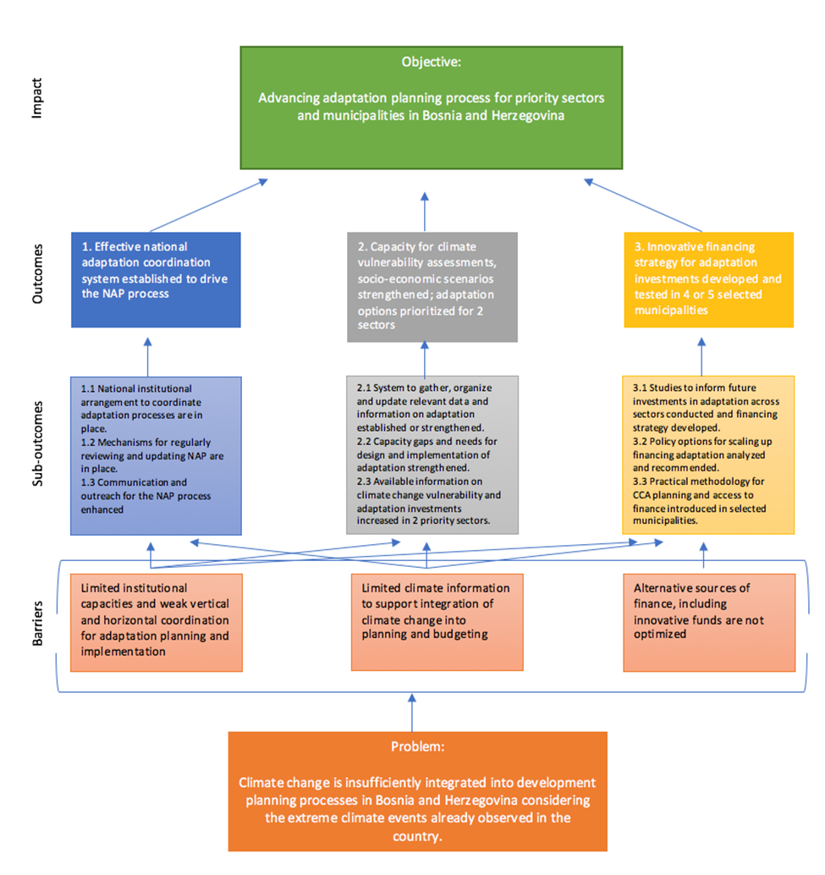

Working group to meet on regular intervals throughout the project
http://www.ba.undp.org/content/bosnia_and_herzegovina/en/home/operations/projects/poverty_reduction/integrated-local-development-project--ildp-.html
http://www.ba.undp.org/content/bosnia_and_herzegovina/en/home/ourwork/environmentandenergy/successstories/sustainable-energy-solutions.html

