Increasing Farmer Resilience to Climate Change-Upscaling Market Oriented Climate Smart Agriculture Project (CSMA)

End of Project Evaluation
Evaluation Report
August 2021
Project and evaluation details, including the project title, Atlas number, budgets and project dates and other key information.
Increasing Farmer Resilience to Climate Change-Upscaling Market Oriented Climate Smart Agriculture Project (CSMA)
Project Number: 00109500
Total Budget: Euro 675 763.64
UNDP TRAC Fund: EUR 39 400.00
[Donor] Contribution: Euro 636 363.64
Project dates: Start Date: 01 April 2018 End Date: 31 December 2020 PAC Meeting Date: 22 Sept. 2021

TABLE OF CONTENTS
TABLE OF CONTENTS ii
LIST OF FIGURES iv
LIST OF TABLES 4
LIST OF ABBREVIATIONS AND ACRONYMS vi
EXECUTIVE SUMMARY vii
1.0 INTRODUCTION AND OVERVIEW 1
1.1 THE INTERVENTION 1
1.2 Project Management 2
1.3 Project Objectives 3
2.0 PROJECT EVALUATION 4
2.1 Evaluation Scope and objectives 4
2.2 Evaluation Approach and Methodology 5
2.3 Data Analysis 6
2.4 Report Writing 6
3.0 EVALUATION RESULTS- MAJOR FINDINGS 7
3.1 Project Objectives 7
3.2 Project Implementation - How effective were the project management arrangements? Focusing on the roles and responsibilities of the PMU and NAMBoard as the implementing entity 12
3.3 Partnership arrangements established for the implementation of the Project with relevant stakeholders involved at the national and local levels including clarity on the roles and responsibilities. 13
3.4 Results achieved against Key Deliverables 16
4.0 PROJECT IMPACT 27
4.1 Project Lessons Learnt and Replication Approach 28
5.0 RECOMMENDATIONS, LESSONS LEARNT and POLICY INSIGHTS FOR SCALING UP CLIMATE SMART AGRICULTURE 33
5.1 RECOMMENDATIONS 33
5.2 LESSONS LEARNT 36
5.3 POLICY INSIGHTS FOR SCALING UP CLIMATE SMART AGRICULTURE 37
5.3.1 On upscaling, adoption and mechanizing conservation agriculture: 37
5.3.2 Conversation to Water-saving Irrigation Technologies 40
5.3.3 Successfully linking CSA farmers to formal markets 41
6.0 Annexes 43
6.1 TOR for the evaluation 44
TERMS OF REFERENCE 46
6.2 Evaluation matrix and data collection instruments 51
6.3 List of individuals or groups interviewed or consulted, and sites visited 52
6.3.1 Individuals or groups interviewed or consulted 52
6.3.2 Sites visited 52
6.4 List of supporting documents reviewed 53

LIST OF FIGURES
Figure 1: Map showing Mavulandlela Irrigation Scheme watershed 8
Figure 2: Map showing Intamakuphila Irrigation Scheme Watershed 9
Figure 3: in-field Cold Room Rehabilitation - Intamakuphila (on the left), and Mavulandlela (right) 10
Figure 4: CA farmer in front of his maize field planted and managed using CA practices and principles 11
Figure 5: Showing the beneficiary breakdown by gender in the participating schemes 16
Figure 6: Focus Group Discussion at Mpatheni, a site where drip was installed in the previous pilot scheme 21
Figure 7: Chart Showing the Amount of funds disbursed to farmers from the Revolving Fund, including payments from farmers 23
Figure 8: Economic value of produce sold by the farmers to the market - sourced from NAMBoard market 25
Figure 9: Showing a model of Market Oriented Climate Smart Agriculture Operations 26
Figure 10: Showing Mpatheni Irrigation Scheme, with good soil coverage and application of CSA technologies such as drip irrigation 28
Figure 11: Showing project results from Result Area 3, segregated by gender 30

LIST OF TABLES

Table 1: Achievements Against Targets 18

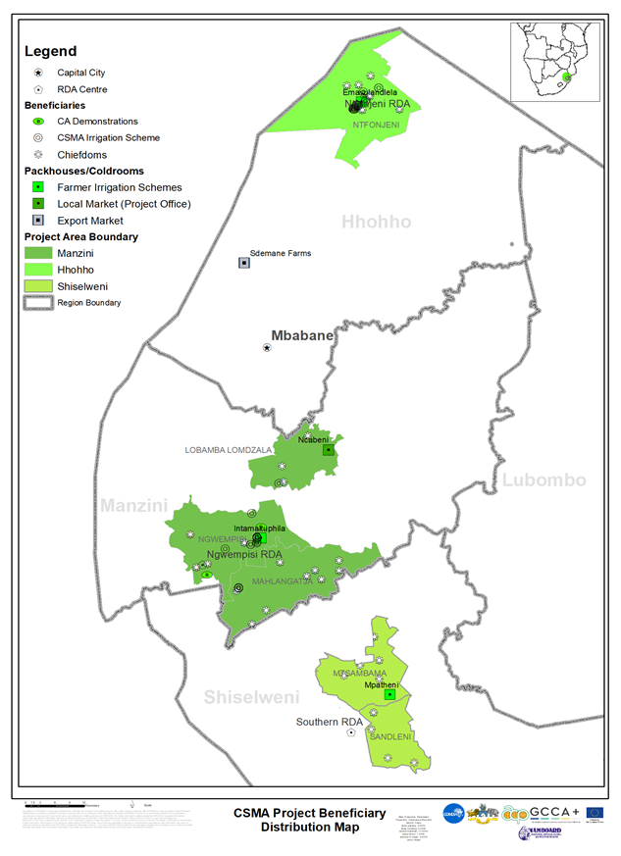

LIST OF ABBREVIATIONS AND ACRONYMS
COMESA | Common Market for East and Southern Africa
CSA | Climate Smart Agriculture
CSMA | Climate Smart Market oriented Agriculture Project
ESWADE | Eswatini Water and Agricultural Development Enterprise
FAO | Food and Agriculture Organization
FIS | Farmer Irrigation Scheme
GCCA+ | Global Climate Change Alliance Plus
HH | Household
HIV/ AIDS | Human Immunodeficiency Virus/ Acquired Immuno-Deficiency Syndrome
HVCHP | High Value Crop and Horticulture Project
IFAD | International Fund for Agriculture Development
LUSIP | Lower Usuthu Smallholder Irrigation Project
NAMBoard | National Agricultural Marketing Board
SHIMS 2 | Swaziland HIV Incidence Measurement Survey 2
NAS | Ntamakuphila Agricultural Scheme
SMLP | Small Holder Market Led Project
SNL | Swazi Nation Land
TDL | Title Deed Land
UNDP | United Nations Development Project
VAC | Vulnerability Assessment Committee
WASH | Water Sanitation and Hygiene

EXECUTIVE SUMMARY
A project evaluation was commissioned to determine the impact and overall achievement of a three year project on Increasing Farmer Resilience to Climate Change- Upscaling Market Oriented Climate Smart Agriculture Project (CSMA), which was implemented by the National Agricultural Marketing Board (NAMBoard) on behalf of the Ministry of Agriculture in Eswatini. Covering two main implementation areas, which are Mavulandlela and broader Northern Rural Development Area (RDA), and Ntamakuphila and broader Ngwemphisi RDA, the project sought to provide solutions for upscaling CSA technologies and practice, and to link farmers engaged in CSA practices to sustainable markets.
The implemented activities include conversion of high water use technologies for irrigation, such as furrow irrigation to water-saving technologies in this case drip irrigation; mapping of waterways and other land use resources in the project area; provision of mechanization equipment, mainly tractor drawn implements for conservation agriculture; linking farmers to markets to increase the income from CSA produce; and provision of cold-chain infrastructure to reduce produce waste and increase income for farmers. All these were implemented to achieve improved livelihoods for 1,500 beneficiaries in the target areas.
The results of the evaluation show that: there has been development of 16ha of drip irrigation as opposed to the original target of 60ha. This, according to the project management unit and farmers, was due to the fact that the resources allocated for the drip installation was only enough to cover a maximum of 16ha at a cost of E136, 000 / ha (including procurement of drip irrigation, design engineers, and pumping equipment) of drip irrigation. The project was able to provide clear watershed management plans for both Mavulandlela and Intamakuphila schemes.
Rehabilitation work was carried out on cold storage facilities at the two sites, with Mavulandlela able to have a fully functional holding facility that has a cold room connected to a power source and therefore functional, whilst at Intamakuphila the project was only able to rehabilitate the existing structure and upgrade it, however, there were no resources to put up a refrigeration unit.
The project was able to reach 400 farmers with CA training, and an estimated 128 farmers with CA practices and utilization of tractor drawn equipment as part of upscaling the practice in the country. This is against a target of 1,500 farmers, and the main contributing factor is the lack of training and mobilization as the COVID-19 pandemic restricted movement and prevented group training.
A total of 201 farmers in 2 schemes involved in commercial agricultural activities, and these signed contracts with NAMBoard for off-take of their produce. An additional 52 farmers were trained on post-harvest handling, and 128 farmers trained on crop management and sales. By the end of the project, there was a total of 401 (212males and 189 females) who were recorded to be actively trading produce with the formal market, in the main being sales through the NAMBoard market. Farmers were able to produce and sell a total of 462.2MT of produce, mainly consisting of baby vegetables and conventional vegetables.
The credit facility, known as the revolving loan facility, was established and administered by both the PMU and NAMBoard finance department. Capped at E4, 000 (estimated at $266) per farmer, the scheme dispersed a total of E1, 100, 306.91 (estimated at $75, 800) by the end of the project. This went to the finance of farming inputs, and was channeled through input suppliers, who would respond to a request for specific inputs, which were selected based on crop scheduling and market demand.
This introduction to the regular and project work by NAMBoard as an implementation partner is commendable as it provides the project with the weight that it deserves and it also provides farmers and other stakeholders with the attention that they need to be given for successful and effective delivery of results. However, in the discussions with the PMU and the management at NAMBoard, more work still needs to be done in ensuring that the implementing partner is able to embed the PMU within its structures, currently the coordination has a lot of room for improvement as the project did seem to be a semi-autonomous entity within the larger ecosystem. It must be understood that projects are catalysts of work that is already ongoing than an exceptional entity that has arrived to change the operations of the organizations.
On the overall, the evaluation found the project to have successfully introduced and put in the building blocks of linking climate smart agriculture interventions to sustainable markets. With that said, there is still a lot of work to be done from policy level down to practice in the field as there are many alignments that need to take place for this to be fully achieved. The project therefore provided a blueprint for work to continue, and it was noted that achievement of results takes much longer than 5 years as the farmers who participated in the previous pilot are still continuing to learn and are now better utilizing the CSA methods and also trying to overcome the problems they have identified as they conduct their business.

1.0 INTRODUCTION AND OVERVIEW
The project on Increasing Farmer Resilience to Climate Change- Upscaling Market Oriented was a three years project that was implemented by the National Agricultural Marketing Board (NAMBoard) on behalf of the Ministry of Agriculture. The overall outcome of the intervention is to strengthen the capacities of the African Caribbean – Pacific Regions and countries to undertake regional and national adaptation and mitigation actions in response to the challenges caused by the effects of global climate change. In Eswatini, the project was meant to upscale market-led small-scale commercial agriculture to increase horticulture, vegetable and field crops outputs for farmers who have been affected by the climate change related weather patterns.

1.1 THE INTERVENTION
The project is part of a regional undertaking involving five (5) countries, coordinated by the Common Market for East and Southern Africa (COMESA). In the Kingdom of Eswatini, it was expected to impact over 500 farmers (3,000 household members) producing fresh fruit, vegetables and high value field crops, 1,500 farmers practicing conservation agriculture, and create jobs for at least 1,000 people (mostly the youth and women). In addition, it would provide infrastructure worth over E9 Million (USD636 363.64 at 14.5 exchange rate) for irrigation, cold storage, farming equipment, and was expected to within the first three (3) years, generate at least E2 Million for participating farmers. In the medium to long-term, the lives of the communities will be transformed through the availability of fresh produce for improved food security and nutrition and creation of auxiliary industries (such as artisans for irrigation maintenance and retailers of fresh produce).
This all bodes well towards a significant contribution of the agriculture sector to the GDP and the broader economy of the country. COMESA provided a grant, funding the National Agricultural Marketing Board (NAMBoard), through the Ministry of Agriculture (MoA,) to pilot a market-focused Climate Smart Agriculture (CSA) project from 2014 to 2016 for implementation at Mpatheni. The pilot had three (3) project components: conversion of 32ha of sub-surface irrigation to a more efficient drip irrigation system, provision of mechanized conservation agriculture equipment, and linking of the farmers to a formal market for the sale of vegetables and fruit. A Revolving Fund was also established for capital costs for the farmers. The pilot project had a direct impact on over 400 farmers, delivering commodities worth over E500, 000 in the project duration.
Lessons from the pilot indicated the need to promote further uptake of climate change techniques in the country. Further observation showed limited climate change adaptation capacities and isolation of most rural farmers from formal and productive value chain mechanisms as well as market opportunities. The MoA, working with COMESA, undertook a feasibility review along water resource management for conservation agriculture production and sustainable livelihood schemes, as well as readiness of farmer groups to successfully implement and benefit from the action. From the schemes assessed, five (5) schemes were identified for scaling up, from all the four regions in the country. These schemes are: Mavulandlela and Magagane in the Hhohho Region; Nkhungwini in the Shiselweni Region; Intamakuphila in the Manzini Region; and Nceka in the Lubombo Region. The overall objective of the intervention was to increase income from commercial agricultural activities for 500 households in two (2) community-based schemes. This was to be achieved by the adoption of water-saving drip irrigation for high value crop production by the farmer schemes; improving cold chain management, linking farmers to sustainable local, regional and international markets; and, providing CSA mechanization options to at least 1,500 farmers.

1.2 Project Management
The Project was managed through a Project Management Unit, established by a letter of agreement between UNDP and National Marketing Board, a Government Parastatal. The team includes a Project Manager, Assistant Accountant and a part-time Monitoring and Evaluation assistant. The function of the team was to facilitate direct linkages with farmer irrigation schemes and support during the implementation of the project.
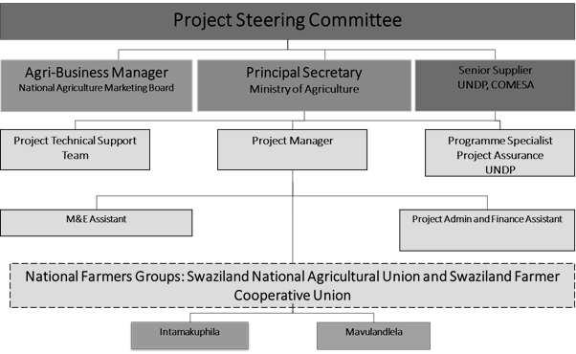

1.3 Project Objectives
The specific objectives were:
i. To convert 60 ha of furrow irrigated land to efficient, water-saving drip irrigation technology for high value crop production in two (2) community-based schemes.
ii. To improve cold chain management systems, and linking farmers to sustainable formal markets.
iii. To provide mechanization options for at least 1,500 farmers practicing conservation agriculture.
iv. To increase income from commercial agricultural activities for 1,500 households in four (4) community-based schemes.
v. To provide credit facility for rural farmers schemes.
The following were the expected project outputs:
i. Water courses and landscape rehabilitated in the two (2) community schemes: Intamakuphila and Mavulandlela.
ii. Improved climate change techniques for water saving through ensuring that 60ha of land is converted to water-efficient drip irrigation in the two (2) community schemes: Intamakuphila and Mavulandlela.
iii. 500 farmers linked to/participate in formal markets and at least 2,000 tonnes of produce procured from participating farmers.
iv. Field based cold storage facilities rehabilitated/installed in the 2 selected sites.
v. Rural farmers’ capacity for CSA built through training of 1,500 farmers on CSA in the four (4) selected sites Mavulandlela and Magagane in the Hhohho Region; Nkhungwini in the Shiselweni Region; Intamakuphila in the Manzini Region; and Nceka in the Lubombo Region, 500 farmers in management and agribusiness processes and establishing 2 demonstration plots in the two (2) community schemes: Intamakuphila and Mavulandlela.
vi. Revolving loan fund established and offering credit access to at least 200 farmers of whom 40% percent should fall in the category of female, disabled and youth.

The following were the measurable result areas for the project:
Result 1: Improved management of water sources, including watershed protection for reduced irrigation infrastructure leakages.
Result 2: 60ha of irrigated land converted to more water efficient systems through adoption of the drip irrigation technology.
Result 3: Farmers linked to formal value chains and generating an income from sustainable markets as provided by NAMBoard.
Result 4: Rehabilitated field-based cold storage facilities.
Result 5: Mechanized conservation agriculture equipment to upscale production.
Result 6: Improved access to resources through the establishment and management of a revolving loan fund.

2.0 PROJECT EVALUATION
Following the end of the project in December 2020, Qandelihle Simelane (PhD) was engaged to conduct an end of project evaluation, with the main objective being to assess the achievement of CSA Project results in selected communities and draw lessons that can improve the sustainability of benefits, and aid in the overall enhancement of climate change integration in agricultural productivity through its potential for replication in different agro-climatic zones within Eswatini.
The evaluation was meant to interrogate the marketing and value chain issues at various stages from inputs to production, culminating to household gains/losses. This evaluation was also meant to identify lessons learnt including strengths and weaknesses in project design and implementation strategy/approaches. The evaluation also provides recommendations to leverage on successes, address identified gaps and weaknesses- and ultimately to inform future programming for the sector.

2.1 Evaluation Scope and objectives
During the evaluation the following key intervention areas were interrogated in order to ascertain whether impact has been achieved through the following questions:
- Project Design - Was the project design well-structured to respond to the identified challenges? Compare baseline target indicators and current status of achievement.
- Project Implementation - How effective were the project management arrangements? Focusing on the roles and responsibilities of the different PMU cadres.
- Partnership arrangements established for the implementation of the Project with relevant stakeholders involved at the national and local levels including clarity on the roles and responsibilities.
- Implementation of the project M&E plans including any adaptation to changing conditions adaptive management
- Project Lesson and Replication Approach
- Understudy gender-based participation in the project as well as recommend opportunities for women and youth to create sustainable jobs through CSA.
- Assess the extent to which the project activities opportunities are being taken to scale-up lessons and experiences emerging from implementation of adaptation actions and make recommendations on how this could be achieved if necessary.
- Propose ways for widespread national adoption of climate smart techniques and other adaptive practices taking into consideration the social aspects of the populace.
- Describe the main lessons that have emerged in terms of: household production and income, strengthening national ownership; strengthening stakeholder participation; application of adaptive management strategies; efforts to secure sustainability; knowledge transfer; and, the role of M&E in Project implementation.

2.2 Evaluation Approach and Methodology
The consultant utilized both qualitative and quantitative methods for data collection, and further compile and submit a report with recommendations based on findings:
2.2.1 Qualitative Methods
  - Focus Group Discussions: This is to obtain information on impact and effectiveness of interventions on the participating beneficiaries, both at household and community level. Special focus was placed on farmers that are in the two production schemes (Mavulandlela and Intamakuphila).
However, some of the focus group discussions also included:
- farmers from Mpatheni, Nhletsheni, schemes who have been linked to markets through signing of contracts with NAMBoard,
- Farmers participating in/ benefiting from mechanized conservation agriculture equipment as part of scaling up and commercializing CA in rural development area (RDA) facilities in the two (2) community schemes: Intamakuphila and Mavulandlela.
  - Key Informant Interviews: The key informants to be interviewed, include the PMU, NAMBoard CEO, UNDP and COMESA.
The key informant interviews will provide insight on
- how schemes were managed
- access to production resources in the established revolving loan facility and its management as well as
- how the Climate Change mitigation efforts were effective and improvements that can be recommended by these thought leaders.
2.2.2 Quantitative Methods: These were used to measure quantifiable impact, which in turn has positive or negative outcomes on the livelihoods of the target populations and rural economies. Quantitative data were collected from records that include:
- Farm level records – production and financial records kept by individual farmers and farmer schemes
- Market Level Records – These include farmer payments receipts from markets such as NAMBoard and other markets
- Other documents that may include financial reports from the project and schemes
The main indicators that were measured using quantitative methods are:
- Income indicators: measuring change in household income both for participating households and non-participants within the catchment areas. Also measured were the significant contributors to this increase or decrease in income for the households.
- Improved Production Output Indicators: The evaluation measure how output from production has improved from the time the baseline assessment was carried out, and now at post-implementation stage. This is in the form of yields (tons/ha) and total output from individual farm units.
- Rate of uptake for all climate smart methods and technologies that were disseminated and demonstrated to farmers by the project. This includes the number of farmers that have taken up specific technology, the number of farmers that have adopted improved climate smart technology and change in area that has used improved CA/CSA technology to enhance their output.

2.3 Data Analysis
The collected data was transcribed, cleaned and analyzed to tease out all the responses provided by respondents, and with focus on answering to the research questions and specific impact areas that are being measured. Results are presented in various tables, graphs, charts, with the most suitable and relevant presentation methods used to get maximum analysis of selected variables.
Quantitative data, including market sales, income changes, volumes produced were analyzed in MS Excel spreadsheets, and results are presented in different tables, trends graphs, charts and provide responses to specific impact questions.

2.4 Report Writing
Following data collection and analysis, the consultant produced and submitted a report which contains responses, measures of change in livelihoods, income, and adoption of climate smart technologies and also make recommendations on implementation of future projects of similar nature, including requirements for upscaling the project to other areas.
The consultant also produced policy briefs and advocacy for climate smart technologies and practices, especially linking the climate smart interventions to market systems.

3.0 EVALUATION RESULTS- MAJOR FINDINGS
Project Design: Was the project design well-structured to respond to the identified challenges? Compare baseline target indicators and current status of achievement.
The evaluation was tasked with finding out whether the project design was properly crafted, and this includes whether the same was well-structured to respond to the identified challenges. The achievements were compared to baseline target indicators to test whether this was true.

3.1 Project Objectives
- To convert 60 ha of furrow irrigated land to efficient, water-saving drip irrigation technology for high value crop production in two (2) community-based schemes.
The findings of the evaluation show that there has been development of 16ha of drip irrigation as opposed to the original target of 60ha. This, according to the project management unit and farmers, was due to the fact that the resources allocated for the drip installation was only enough to cover a maximum of 16ha at a cost of E136, 000 / ha (including procurement of drip irrigation, design engineers, and pumping equipment) of drip irrigation. This is in contrast to the original budget of E29, 000 per ha. The installation was at Intamakuphila scheme under, and means that Mavulandlela scheme could not be covered by the present funds to install drip irrigation. Instead, the main support that they were provided with in this regard was to procure a water pump, which improved the availability of water at the scheme as this was also problematic and the canal is being rehabilitated to reduce water losses.
Also to be noted in both schemes is that there were major adjustments to be made on the existing system to enable conversion to drip irrigation. The costs for this conversation at Mavulandlela were prohibitive. The water catchment as well as the upstream dam which is the main source of water for irrigation were both compromised. For future work, the project, in collaboration with a sister project, Water Harvesting Development Project (WHDP) prepared detailed designs for bringing water from upstream to the irrigation scheme, but this will be beyond the life of the CSMA project.
The project was able to provide clear watershed management plans for both Mavulandlela and Intamakuphila schemes, which provides comprehensive mapping of features that include: Water Infrastructure; Water Supply Findings; Land uses within the watershed; Challenges; Environmental issues; Climate Smart Opportunities around Water Supply in NAS, and further made Recommendations for Water Resource Management Action Plan. The comprehensive nature of these documents makes them of great value to the project and future projects as most of the problems with the watershed and its management are long-term and require an integrated approach by stakeholders. These (stakeholders) include community leadership, who are responsible for allocating land and other resources. They should be taken through the paces to understand that water availability for now and the future greatly depends on activities on the upstream.
At Mavulandlela for example, the Watershed Assesment report revealed that the dam has been silted over the years by continuous soil disturbance, which resulted in a lot of soil being eroded into the waterway and gradually reducing the capacity of the dam and hence the volume of water it can hold. The assessment found that, “the main driver behind this scourge is overgrazing, hence, rangelands are the most degraded. Roadsides are eroded due to run off as manifested by occasional gullies and infestation with invasive alien plant species. The area under cultivation within MAS suffers from impact of soil erosion and the evidence of run-off from storm water that floods the plots from time to time. It is recommended that proper drainage should be installed in areas within and surrounding the scheme.”
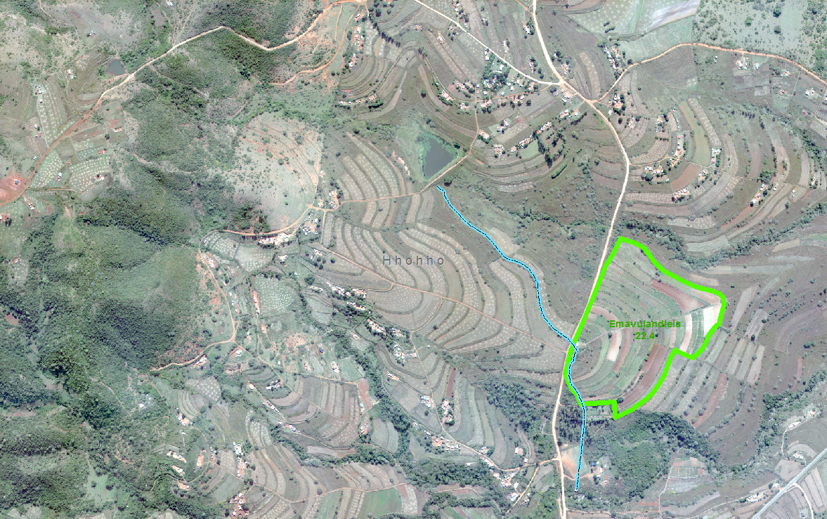
Figure 1: Map showing Mavulandlela Irrigation Scheme watershed
At Intamakuphila, for example, the assessment showed that, “The area under cultivation within NAS suffers from the impact of soil erosion and the evidence is run-off from storm water that floods the plots from time to time. It is recommended that proper drainage should be installed in areas within and surrounding the scheme.”
Further, to demonstrate the effects of poor land governance and resources planning, the report also states that, “The existence of 59 homesteads, the proximity of some of them to water bodies and the prevalence of pit latrines in the area have the potential to negatively affect the supply, health and quality of water resources. This underlines the fact that a climate sensitive land use planning and climate change capacity building in approach is required in the Velezizweni area.”
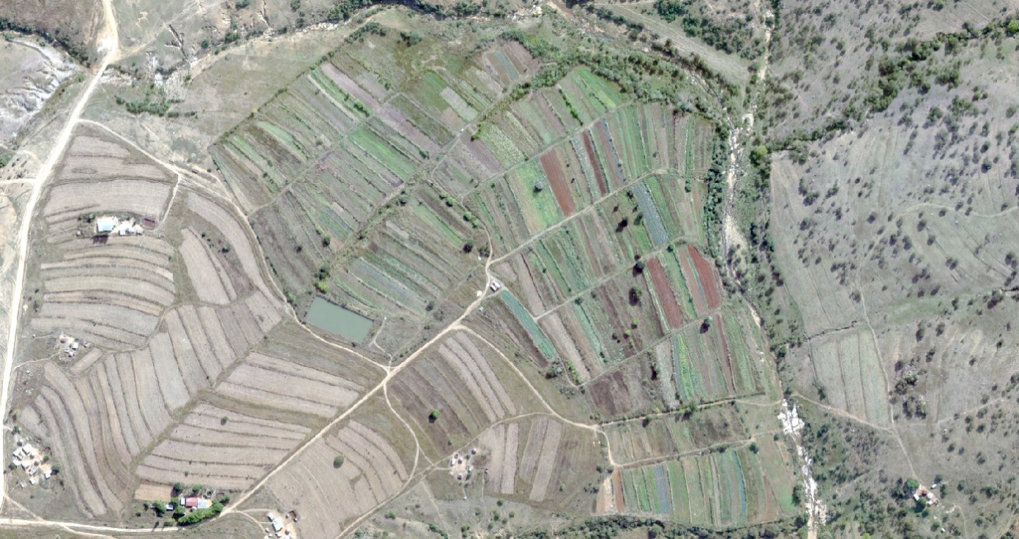
Figure 2: Map showing Intamakuphila Irrigation Scheme Watershed
- To improve cold chain management systems, and linking farmers to sustainable formal markets.
To achieve the improvement of cold chain management systems, the project set out to rehabilitate two existing facilities and further install refrigeration units (cold-rooms) in both those structures, which are in-field and facilitate the storage of produce in ideal conditions within a few hours of harvest. The justification for this is that, proper temperatures improve product shelf –life significantly. According to the Institute of Refrigeration’s International Refrigeration Committee, “Refrigeration is a means to maintain freshness whilst not detrimentally affecting quality through excessive processing and therefore is one of the primary ways to extend shelf life whilst maintaining consumer acceptability,”
Rehabilitation work was carried out on facilities at the two sites. Mavulandlela got to have a fully functional holding facility that has a cold room connected to a power source and therefore functional. At Intamakuphila, the project was only able to rehabilitate the existing structure and upgrade it. However, due to a limited budget, the project was unable to put up a refrigeration unit. The farmers at Mavulandlela indicated a wish for a storehouse for tools, pesticides and other supplies which provision is appreciated at Intamakuphila where the new structure provides office space over and above the store house.
On linking farmers to sustainable formal markets, the project has done well, and during farmer interviews, there was no hesitation from farmers, they know exactly where their main market is, and this shows the importance of having the project under the banner of NAMBoard. However, there are areas that need to be improved, including clear and timely communication by the market on product demand for instance. This is especially the case where crops such as baby vegetables are concerned, mainly due to their perishability. This should not drag such that farmers have high rates of rejection when the main market it an implementing partner. During the interviews, the high rejection rates were cited consistently by farmers, and this is an easily rectifiable. This can also cause breakdown in the supplier-market relationship. NAMBoard is therefore urged to pay special attention to this aspect of the farmer linkages as this is their key winning point, which is getting farmers to market with speed and providing maximum returns for farmers’ investments.
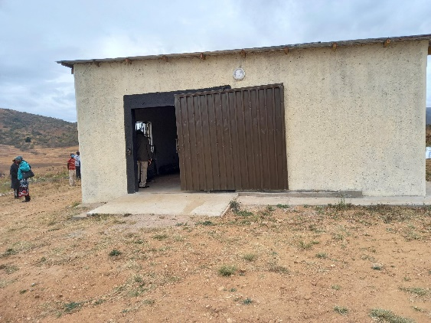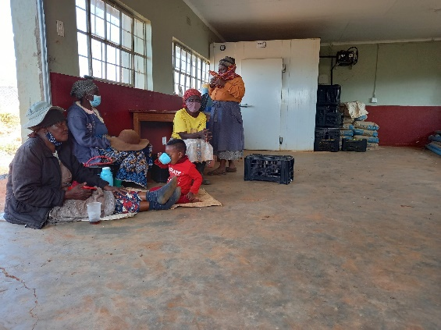
Figure 3: in-field Cold Room Rehabilitation - Intamakuphila (on the left), and Mavulandlela (right)
- To provide mechanization options for at least 1,500 farmers practicing conservation agriculture.
There is a record of 92 farmers that were trained and able to practice conservation agriculture during the life of the project, and these are located at Ngwemphisi rural development area (RDA), these include the 2 farmers that provided and managed demonstration sites for the different CA practices that include agro-forestry, no-till and maximum soil cover. The RDA was further equipped with 5 types of tractor operated CA equipment, which includes, a CA Planter, Slasher, Boom Sprayer, Rake, and Ripper. At the time of the evaluation, it was discovered that the CA component of the project was well managed by the Ngwemphisi RDA. It is expected to continue seamlessly at the end of the project, when all equipment is handed to the RDA, and also manages the tractor pool, which is critical for the upscaling of CA in the targeted areas.
In Northern RDA, actual figures of farmers that were supported with CA services were not available as they use a different system, in which they were able to report that a total of 36 hours covered by the CA implements, and utilizing a conversion of 1 hour per hectare, the evaluation estimates that a total of 36 farmers utilized the CA equipment. There were also two farmers that hosted demonstration plots that incorporated practices that include; agro-forestry, no-till and maximum soil cover. Northern RDA was also equipped with 5 types of tractor operated CA equipment, which includes, CA Planter, Slasher, Boom Sprayer, Rake, and Ripper. As opposed to Ngwemphisi RDA, the Northern RDA still has more work and support required to advance CA practices and entrench the use of CA equipment in the mind of farmers as a method to combat the negative effects of climate change on farming practices.
The project has therefore reached 400 farmers with CA training, and an estimated 128 farmers with CA practices and utilization of tractor drawn equipment as part of upscaling the practice in the country. This is against a target of 1,500 farmers, and the main contributing factor is the lack of training and mobilization as the COVID-19 pandemic restricted movement and prevented group training. It is envisaged that, as the restrictions on movement start easing, and the farming season begins for the 2021/22 season, the uptake of CA equipment is expected to increase significantly, and as the practice rests on the Ministry of Agriculture, there should be minimal impediments to upscaling CA practices.
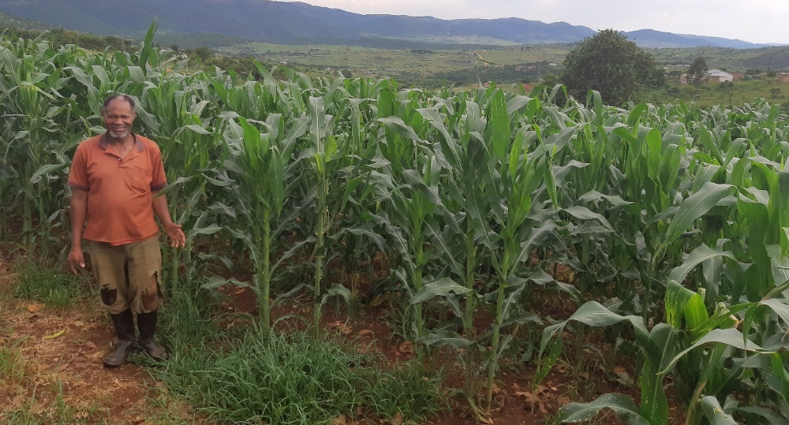
Figure 4: CA farmer in front of his maize field planted and managed using CA practices and principles
- To increase income from commercial agricultural activities for 1,500 households in four (4) community-based schemes.
A total of 401 (212males and 189 females) in 2 schemes involved in commercial agricultural activities, and these signed contracts with NAMBoard for off-take of their produce. An additional 52 farmers were trained on post-harvest handling, and 128 farmers trained on crop management and sales. By the end of the project, there was a total of 283 farmers (165 females and 118 males) who were recorded to be actively trading produce with the formal market, in the main being sales through the NAMBoard market.
Farmers were able to produce and sell a total of 462.2MT of produce, mainly consisting of baby vegetables and conventional vegetables. From these sales, the total value of produce sold to the formal market is E1, 391,752 (E800, 208 in 2020 and E591, 543 in 2021). And of this produce, key commodities include: Tomatoes (51.3 Mt), Butternut 64.2 Mt), Beetroot (29.4 Mt), and green pepper (24.8 Mt); Baby vegetables grown include: Green Beans (9.7 Mt); Baby Marrow (16.25Mt); Baby gem squash (0.75Mt); and Mangetout Peas (0.95 Mt).
It should be noted that the abovementioned sales values exclude produce sold to other formal markets, informal traders and secondary markets (some of the produce was sold at farm gate as it did not meet the standard but was still perfectly safe and therefore edible). This greatly discounted the overall value contributed by the project to the income of farmers involved and needs to be factored in going forward.
- To provide credit facility for rural farmers schemes.
The credit facility, known as the Revolving Loan Facility (RLF), was established and administered by both the PMU and NAMBoard finance department. It was capped at E4, 000 (estimated at $266) per farmer, the RLF dispersed a total of E1, 100, 306.91 (estimated at $75, 800) by the end of the project. This went to the finance of farming inputs, and was channeled through input suppliers, who would respond to a request for specific inputs, which were selected based on crop scheduling and market demand.
A total of 249 farmers (including 29 at Intamakuphila and 20 in Mavulandlela as well as other beneficiaries shown in Figure 5) benefitted from the revolving loan fund, and it is this money that enabled farmers to produce and sell produce to the formal market. This fund of which E1, 100, 306.91 has been disbursed has leveraged and resulted in E1, 391,752 income for farmers as proceeds from sale of 462.2MT. This shows that with finance availed, there is much that can be done to improve the income and ultimately livelihoods of rural populations. The Revolving loan facility was set up following the baseline assessment, which identified poor access to credit as a major barrier to entry and commercialization of agriculture in the rural areas, and therefore this project targeted mainly the farmers, who would not be able to attract credit from financial institutions due to the size of operations and lack of banking and credit history.
  - Project Implementation - How effective were the project management arrangements? Focusing on the roles and responsibilities of the PMU and NAMBoard as the implementing entity
The Project Management Unit (PMU)
This was a new unit at NAMBoard as the pilot and other projects were managed within the regular agribusiness and development department. Having a PMU dedicated to the project provided an opportunity for NAMBoard to grow in project management. It also meant that there were dedicated officers responsible for implementation, financial management and M&E. Thus, the project was able to cover a lot of ground and quickly troubleshoot where things were not going well. The resources availed to the project management unit for implementation, which include a dedicated vehicle, communication equipment, an office and fuel to make regular visits to the field also provided the PMU with an opportunity to interact with the farmers closely, liaise between the farmers and the market, and effectively coordinate the project with external partners such as extension officers in the Rural Development Area (RDA), and the Project Steering Committee (PSC). The skills within the PMU were adequate to have the unit functioning semi-autonomous mode, but also coordinating operations with the management in NAMBoard for successful implementation of the project. It also meant that there was less reliance on external approvals and actions to carry out day to day activities.
The Project Management Function
The PMU provided secretariat services to the stakeholders and the PSC, specifically. Their role was to ensure project implementation on the ground under the supervision and guidance of NAMBoard. The project manager’s role was to further ensure that relationships function effectively to ensure proper delivery of results. Other critical processes included joint planning, effective coordination in implementation, reporting and arranging for stakeholder meetings to provide feedback and derive the mandate for implementation and continuity.
However, the project experienced a high turnover of personnel in this role which had a negative impact on project delivery as well as the performance and the morale of the PMU.
The Accounting / Financial Management Function
The presence of a dedicated accounting officer in the project enabled faster implementation and reduced non-compliance with financial management and control procedures. This was highlighted by the fact that there were no major audit findings and that payments were done timely. The financial control systems also included NAMBoard core finance and executive staff as signatories for the CSMA account. Based on the fact that this was a recommendation following the previous pilot, the decision to have a project accountant was highly effective and will also help NAMBoard build its capacity in grant management and accounting.
Monitoring, Evaluation and Learning
Having a dedicated consultant for MEL was also highly advantageous, and this can be seen by the number of learning documents that have been produced, which include; lessons learnt document, most significant stories document outlining the success of individuals within the project areas, beneficiary and stakeholder mapping report among others. As this is a project that was meant to start the process of upscaling CSA practice in the country, the documentation by the MEL consultant and the team means that there will be records and a blueprint to follow in the pursuit of replicating the project in other areas of the country.
  - Partnership arrangements established for the implementation of the Project with relevant stakeholders involved at the national and local levels including clarity on the roles and responsibilities.

The project as outlined in the organogram was based on a multi-stakeholder approach and ownership by various stakeholders, with the PMU providing secretariat services to the stakeholders and ensuring on the ground implementation under the supervision and guidance of NAMBoard. The project manager’s role was to ensure that relationships function effectively to ensure proper delivery of results. This was to be clear in the processes that include; joint planning, effective coordination in implementation, reporting and arranging for stakeholder meetings to provide feedback and derive the mandate for implementation and continuity.
- Government: Ministry of Agriculture (MOA) which had the overall mandate for the coordination of climate smart agriculture (CSA) activities was to provide technical support and advisory services through the Extension Department and the Rural Development Areas (RDA). Based on the evaluation, which included discussions with farmers and officers in the RDA, the project was in constant interaction with the Ministry, especially the two RDAs, which were Ngwemphisi (within which Intamakuphila scheme falls), and Northern RDA (under which Mavulandlela falls). There is evidence that the RDA was instrumental in the project implementation, especially on activities that involved conservation agriculture. In Mavulandlela, the RDA was also very helpful in mediating in issues where there were disputes between members, the committee and at times where there were challenges between the farmers and the PMU. This was critical as all activities will continue to fall under the jurisdiction and support of the RDAs cannot be overemphasized for sustainability and growth of the activities and initiatives started during the project life.

- Eswatini Water and Agriculture Enterprise (ESWADE) in two projects:
i) High Value Crop and Horticulture Production
CSMA and SMLP (funded by the European Union) have established a rapport in building capacities for smallholder irrigation schemes. In the project, the focus area for collaboration has been sharing information on the business model of the farmer irrigation schemes to ensure that they reduce running costs while generating higher revenues.
ii) ESWADE Small holder Market-led Production (SMLP)
Furthermore, ESWADE has linked the two projects. Together the projects have been able to pull resources towards ensuring that Nhletsheni Farmer Irrigation Scheme (NFIS) has a well-resourced, water saving irrigation system and building their capacities in terms of governance issues.

- Water Harvesting Development Project (WHDP)
Funded by the EU and implemented by a joint team Lead by LUPD a department of MOA, in partnership ESWADE and NAMBoard. The project and WHDP have collaborated mainly to provide Mavulandlela Farmer Irrigation Scheme with a well-resourced, water saving irrigation system.

- CA Implements Suppliers
Suppliers of Climate Smart implements (Triomf, Swazi Track, AgriMech and others) further provided practical demonstration of the usage of their respective implements to the RDA tractor drivers and extension officers and farmers. This improves the after-service support reducing the down times during implementation as maintenance and repairs were promptly attended to.

- World Vision Eswatini
Farmers within the Velezizweni Constituency including the Intamakuphila Farmer Irrigation Scheme were empowered with training on nursery management to facilitate usage of the project newly built nursery. The training included a practical demonstration that was held at the Taiwanese Agricultural Technical Mission. This provided an opportunity for the farmers to also tour the Mission and be experience agriculture from a practical perspective.

- Ministry of Commerce Industry and Trade
Through the Cooperative Development College department, four schemes namely Mavulandlela, Intamakuphila, Mpatheni and Nhletsheni were trained on cooperative law and incorporation to the cooperative movement. Mavulandlela, Mpatheni and Nhletsheni schemes were awarded certificates qualifying them as a legal entity which can participate fully in the credit market. Intamakuphila scheme completed application processes and they are awaiting ratification of their membership to be awarded certificates.

- Eswatini Farmers Cooperative Union (ESWAFCU)
Assisted in the development of operational guidelines for schemes to enhance their participation in the revolving fund. Furthermore, ESWAFCU contributed in the reviewed guidelines using their road based affiliate cooperative for the revolving fund.

- CATALYZE / SEPARC project partially funded by the European Union collaborated with the project in the support of youth aspiring to start climate smart agriculture businesses. This was in the evaluation and coaching of hopefuls submitting climate smart proposals to tap into the grant available for agri-business focusing on climate smart technologies.

- Alliance Francaise

Through the EU funded project in the framework of Green Diplomacy the organization provided Visual Aid and Communication training to CSMA personnel. This collaboration improved on visibility and communication strategy document produced for the project.

- United Nations Development Programme (UNDP) Accelerator Labs Initiative
The initiative aims to transform a collective approach by introducing new services, backed by evidence and practice, and by accelerating the testing and dissemination of solutions from UNDP. The project collaborated in the publicity of market led vegetable farming to youth and other interested stakeholder. The collaboration resulted in a video depicting how youth can tap into Climate Smart farming as a future employment and a source of inspiration for new ideas.

- National Agriculture Marketing Board (NAMBoard) was responsible for the implementation of the project outcomes and ensuring effective project management through the project management unit (PMU) constituted by the Project Manager and Finance and Administrative Assistant. NAMBoard will focus on market-based CSA ensuring strengthened coordination of the partners participating in the project and reporting on activity implementation. NAMBoard was heavily involved in the implementation of the project on behalf of the Government, they also provided support which includes office space, a project vehicle, communication devices, and computers and also deployed human resources that include the chief financial officer, agribusiness manager and extension officers to ensure successful implementation of the project. Post-project, NAMBoard has agreed to follow up on implementation, and incorporate all activities and beneficiaries into their mainstream activities.

- Civil Society Organizations Coordination Assembly of Non-Government Organizations (CANGO) members in particular under the Food Security Consortium (World Vision, ACAT) will be strengthened for enhanced capacity development for communities through training for CSA uptake and conservation agriculture and project results monitoring. There was no evidence or visibility of civil society organizations actively involved or participating in project implementation.

- Farmers Association and Communities the Swaziland National Agricultural Union and community schemes are the ultimate targeted beneficiaries for all the interventions that will be implemented under the project. It is envisaged that all activities implemented would have an element of community capacity building and therefore their active involvement for monitoring of project results is of importance. The participation of the national farmers union was mainly through the project steering committee, where SNAU was represented by the Executive Director, indicating the importance of this project to the farmers that they represent. At all levels, that include the schemes’ level, committees elected by the farmers were in constant liaison with the PMU, thus planning, implementation and oversight was done in conjunction with farmers and their representatives.

Results achieved against Key Deliverables
Project beneficiaries were almost balanced at 49% females and 51% males across the whole project area, this is reflective of land ownership land is registered under the name of the household head. This however, is slightly different when looking at the actual attendance in activities such as training and the actual people doing the work on the ground, which is significantly implemented by women and the youth.

Figure 5: Showing the beneficiary breakdown by gender in the participating schemes

The project further supported income within the target communities through direct employment of community members for activities such as weeding, harvesting and bush clearing. In total 208 short term employees consisting of 161 females and 47 males were employed by the schemes at various stages of production.

    - Results achieved against Key Deliverables

      - Outcome - Rural households and two (2) community-based irrigation schemes having sustainable and increased income from climate resilient agricultural livelihoods.
Indicators: Average monthly household income - E1,700.00
% of household earning income from agri-business - 60%
% of farmer enterprises that are linked to formal value chains generate sustainable income - 32%

Table 1: Achievements Against Targets
Output |  | Indicator | Baseline | Target | Actual
Result 1: Improvement of water sources, including water shed protection, reducing leakages and improving conveyance to downstream
1.1 | Mapping of waterways and watersheds | Mapping assessments of water resources, waterways and rehabilitation Reports, Maps and Designs |  | Watershed Assessment Report  Designs and Maps | 2 detailed watershed documents prepared, implementation ongoing  Partial work done  - Bush and Alien Invasive Species Clearing  - Fencing  Assessment reports  - Water shed  - Gender  - Communication and visibility  - Farming Practices situational analysis  - Irrigation system evaluation  - Designs in-field designs for: Mpatheni, Mavulandlela and Intamakuphila FIS Maps  - Mavulandlela and Intamakuphila water catchment maps and aerial photographs  - Mpatheni in-filed maps for Mpatheni, Mavulandlela, Intamakuphila, Nhletjeni and Nkhungwini
1.2 | Waterways, inlets and outlets rehabilitated to reduce leakages, including revegetation. | Number of water way inlets, outlets, main lines and other conveyance infrastructure rehabilitated to reduce leakage, and increase water-use efficiency |  |  | Inputs for the installation of Intamakuphila FIS drip irrigation system procured and installed
1.3 | Main lines and other conveyance infrastructure will be rehabilitated for increased water use efficiency.
Result 2: 60 ha of irrigated land converted to water efficient system, which includes drip irrigation system installation.
2.1 | 60 ha of land from existing farmer schemes identified for conversion from furrow to drip irrigation and other water saving irrigation systems that are appropriate for context. | Number of hectares converted into water saving irrigation systems | 0ha | 60ha | 16ha
2.2 | Detailed needs assessments conducted, with drawings and bills of quantities completed and documented.
2.3 | 500 farmers trained in drip and other irrigation maintenance and use. | Number of farmers trained in drip irrigation | 46 | 500 | 342
Result 3: 500 farmers linked to formal value chains and generating sustainable income from the market linkages provided by NAMBOARD.
3.1 | 500 farmers mobilized and trained on formal markets management. | Number of farmers linked to formal value chains and generating sustainable income | 46 | 500 | 5 schemes  (185Males 157females)
 |  | Number of famers trained in product standards, produce management and marketing. | 46 | 250 | 401 (212males and 189 females)
 |  | Number of farmers trained in marketing and sales | 400 | 250 | 5 schemes (185Males 157females)
3.2 | 500 farmers trained on business management, group dynamics, record keeping and agribusiness processes. | Number of dialogues on pricing | 0 | 3 | 1
 |  | Number of farmers trained on market-based production | 0 | 250 | 58
3.3 | 500 Farmers trained on market based conduct and contracting for supplying the markets. | Number of farmer supplier contracts signed. | 0 | 150 | 4 contracts from 4 schemes
3.4 | At least 2,000 MT of produce procured from farmers participating in the schemes. | Tonnage of produce procured from farmers participating in the schemes | 32 MT | 2000 MT | 462.2MT
3.5 | At least E2 Million ($166,000) paid to farmers for their produce within the 3 years’ period. | Total income generated directly from using the revolving loan fund. | 0 | E2 Million | E1, 391, 732
Result 4: 2 field based cold storage facilities constructed (or rehabilitated) within 5km radius of main production areas.
4.1 | Central site for cold storage (holding facilities) identified.
4.2 | 2 Cold storage facilities constructed (or rehabilitated). | Number of cold chain facilities rehabilitated, and operational. | 0 | 2 | 1 functional  1 partly rehabilitated
4.3 | At least 2,000 MT of produce stored and transported to markets in good condition. | Tonnage of produce procured from farmers participating in the schemes | 32 MT | 2000 MT | 462.2MT
Result 5: Provision of mechanized conservation agriculture equipment as part of scaling up and commercializing CA in 3 rural development area (RDA) facilities.
5.1 | At least 1500 farmers provided with training and awareness on conservation agriculture practices and principles. | Number of farmers incorporating CSA technologies into their production model | 118 farmers | 1,500 farmers | 350 farmers
5.2 | 2 RDAs equipped with mechanized conservation agriculture equipment (planters, rippers and boom sprayers) to scale up and commercialize CA. | Number of RDA equipped with mechanized conservation agriculture equipment | 0 | 2 | 2
5.3 | At least 1500 farmers utilizing the services of the RDA for equipment hire. | Number of farmers trained on conservation agriculture practices and principles | 0 | 1,500 farmers | 350 farmers
 |  | Number of demonstration plots established. | 0 | 4 | 4
Result 6: Improved access to production resources through establishment and management of a revolving loan facility
6.1 | A loan facility with an initial capitalization of E600,000 ($50,000) established | Number of farmers that have received loan from revolving fund (disaggregated by women/youth/disability). | 0 | 500 farmers | 481 farmers
6.2 | A total income of at least E1.3 Million ($110,000) generated directly from using the revolving loan fund. | Total income generated directly from using the revolving loan fund. | 0 | E2 Million | E1, 391, 752.23

  - Implementation of the project M&E plans including any adaptation to changing conditions adaptive management
Monitoring and evaluation was one of the strong points within the project, and as such it is evident that problems were identified early within the project management unit and attempts were made to address these based on recommendations provided. The project produced very well written reports throughout its life, and whilst some of these were for implementation within this period, most of the documents contents will also provide for further support to climate smart interventions that will be implemented after the project has been completed.

Key documents generated by M&E function include:

- Beneficiary and stakeholder mapping assessment report
- Lessons Learnt Report, FY19
- Stories of significant change
- Monthly Reports
- Quarterly
- And Annual reports

The reports were well written and it was evident that implementation of activities for the subsequent period was following through with recommendations made in the previous period, for example all monthly quarterly reports outlined a plan for the next quarter, and figures were cumulated as the year went along. This is commendable and shows a well thought-out M&E function was put in place at the inception of the project.

  - Project Lesson and Replication Approach

- Understudy gender-based participation in the project as well as recommend opportunities for women and youth to create sustainable jobs through CSA.
- Assess the extent to which the project activities opportunities are being taken to scale-up lessons and experiences emerging from implementation of adaptation actions and make recommendations on how this could be achieved if necessary.
- Propose ways for widespread national adoption of climate smart techniques and other adaptive practices taking into consideration the social aspects of the populace.
- Describe the main lessons that have emerged in terms of: household production and income, strengthening national ownership; strengthening stakeholder participation; application of adaptive management strategies; efforts to secure sustainability; knowledge transfer; and, the role of M&E in Project implementation.

3.6.1 Findings from Focused Group discussions and Key Informants
All data sourced was structured to answer to the questions that the evaluation ought to provide responses to, and these mainly are set on the project objectives and expected outcomes. All responses from focused group discussions and key informant discussions such as the Ministry, the Project Management Unit and NAMBoard executive were used to triangulate data that was received from the field and from secondary sources.
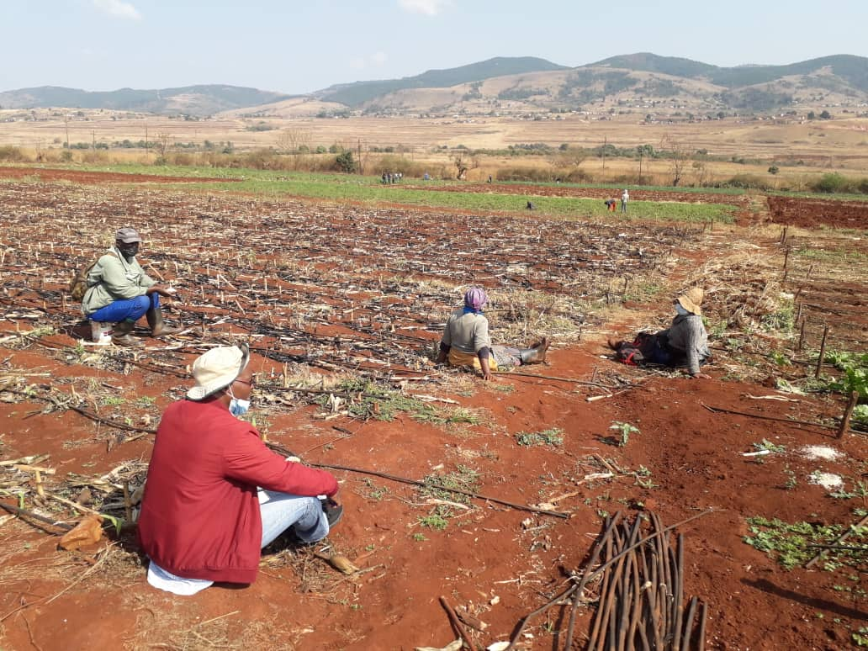
Figure 6: Focus Group Discussion at Mpatheni, a site where drip was installed in the previous pilot scheme

  - Project Timing and Timelines
Whilst the project was well designed, the timing of implementation seems to have been misaligned, therefore, implementation started very slowly and picked up paced way into the second year. This meant that at times whole seasons were missed, for example with CA practices, there are activities for every season, however production is mainly active in spring and summer, thus results were at the lower end.
  - Resource Allocation
There was evident mismatch between resources available and expected achievements and this was more gaping in the infrastructure installation and rehabilitation, e.g. irrigation and cold storage facilities. The activity that suffered significantly from this insufficient resource allocation is the installation of drip irrigation, where all quotes obtained were more than 4 times greater than the budget. This was a negative in the project as the crux of the project was on resource conservation, especially installation of water saving technologies.

There was also no clear documentation and allocation of resources provided by NAMBoard as cost-share to the project funds. Whilst it is evident that the contribution was significant, for example the purchase of a vehicle, providing for maintenance, surveillance, office space, computers, consumables and staff time. This was not monetized nor was it documented, and at present the level of funding provided by NAMBoard cannot be quantified.
- The Project Management Unit (PMU)
This introduction to the regular and project work by NAMBoard as an implementation partner is commendable as it provides the project with the weight that it deserves and it also provides farmers and other stakeholders with the attention that they need to be given for successful and effective delivery of results. However, in the discussions with the PMU and the management at NAMBoard, more work still needs to be done in ensuring that the implementing partner is able to embed the PMU within its structures, currently the coordination has a lot of room for improvement as the project did seem to be a semi-autonomous entity within the larger ecosystem. It must be understood that projects are catalysts of work that is already ongoing than an exceptional entity that has arrived to change the operations of the organizations.
- The revolving loan facility
The revolving loan facility is an innovative approach to provide working capital to the unbanked. Whilst it is not meant to cover major expenditure such as infrastructure, it enables farmers to overcome one of the most important impediments, which is poor access to finance. The facility was indeed catalytic as it provided working capital to the value of over E1, 100, 000 (Figure 7), which enhanced production, and however, this was not explored to the full and thus did not achieve the intended result. One key challenge was coordination between the project management team and the finance team within the NAMBoard operations, as such recovery rates of the funds advanced took exceptionally long, mainly due to poor reconciliation and communication. NAMBoard also did not take full advantage of the presence of this fund to ensure that farmers received inputs timely, and this is not acceptable when the people in charge are sitting in the same compound. More work needs to be done on management and utilization of the facility, and the NAMBoard executive leadership could do much more.

Figure 7: Chart Showing the Amount of funds disbursed to farmers from the Revolving Fund, including payments from farmers
- Equipment for upscaling Conservation Agriculture
CA equipment was purchased according to the planned pieces of equipment, and this was dispatched to the RDAs, which were quite conversant in its utilization. The equipment will form part of the Government tractor pool and therefore is in synch with what it was meant to achieve. The only challenge cited by officers within the tractor pool is that some of the equipment is from brands they are not used to and therefore may struggle to obtain spare parts timely. The CA equipment came at a time when the Government Tractor and Implements Pool is under transition, and this caused a lot of confusion on operations and maintenance of equipment. It is also incumbent upon the national conservation agriculture teams to encourage the utilization of the CA equipment as there are advantages in practicing CA for farmers and the land, especially in this era of negative climate related changes.
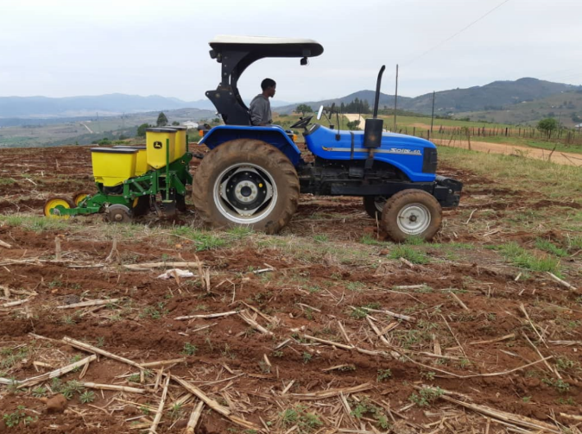
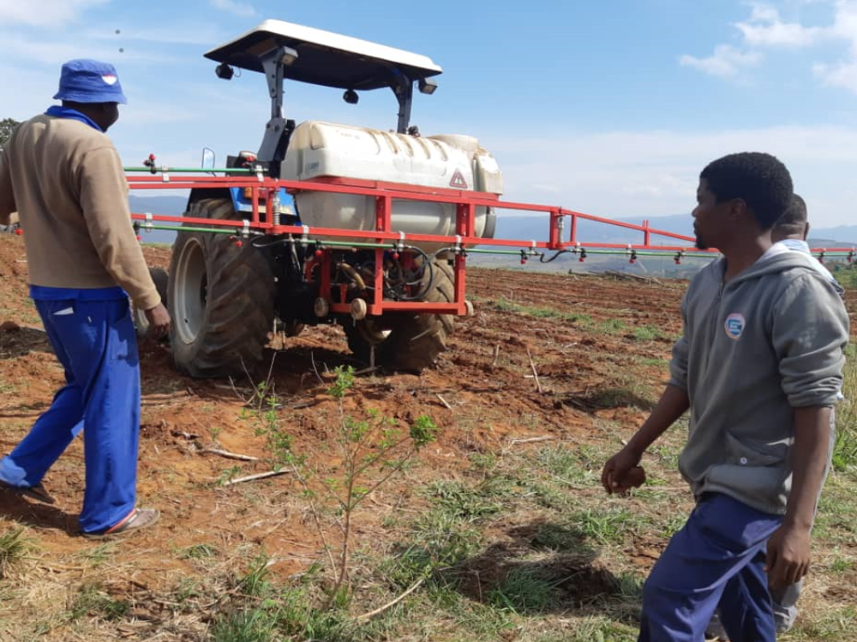
Project CA implements (No-till Direct Seeder and Herbicide Boom Sprayer) in use at Ngwempisi Field Demonstration.

- Effective Linking of Farmers to Sustainable Markets
Dealing with the formal market is always an intricate and balancing act, which requires meticulous planning, execution and reflection after every harvest period. Discussions with the farmers, the project team and the main market (NAMBoard), it is obvious that more still needs to be done to achieve this balance and precision. Having a reliable market was a positive for the project, however, getting farmers to understand the working of the market, and more so, baby vegetable production was always going to take time longer than the project period to understand and fully benefit from the same. One of the glaring misnomers in a project moving farmers towards a commercial model is the high number of crops that they were required (or insisted) to produce, which numbers 22 on record, which means that farmers were not afforded a chance to specialize on crops that suited the land on which they produced and met their objectives, and this is a serious misunderstanding of the market demand. Going forward, the number of crops need not exceed 4, as it was apparent from the project which crops did well, and which were marginal and need to be discarded from the planning process. The graph below shows clearly that tomatoes, butternuts, green beans, potatoes, baby marrows and green peppers should form the key crops as every commercial undertaking has only one or two anchor crops and another one or two supplementary crops.

Figure 8: Economic value of produce sold by the farmers to the market - sourced from NAMBoard market

- Sustainability and protecting gains and achievements
All partners agreed that the project started showing results late due to many adjustments, prime of which was rearranging implementation to fit within the available budget and changes in project management team. However, it was also agreed that the project put in place a foundation on which much more can be achieved, and it is in the best interest of NAMBoard to continue investing in ensuring that the two project sites are brought up to commercial standard and gradually install the planned infrastructure as the institution will gain massively if the two schemes are functional and operate as originally envisaged. This investment can be recouped within two to three years through sales of produce from the schemes as there would be high levels of quality assurance as the scheme can control the production of seedlings, field production and post-harvest handling. In discussions with the NAMBoard CEO, the entity is already investing own resources to complete the irrigation system in Intamakuphila, therefore it would make more business to ensure that the job is properly completed, include the cold storage facility and nursery.
- Replicability of Project in other areas
The evidence from the implementation and evaluation of this project shows that climate smart agriculture interventions can be commercialized, however, the initial costs of conversion from conventional systems and practices are high. This is mainly because there is a need to take a holistic approach as CSA thrives in a suitable ecosystem and the planning of this project had captured it well, the only challenge was a project that tried to achieve too many things with limited time and financial resources. The diagram below endeavors to capture the model that the project was introducing and shows that there are major investments necessary as no facet within the system can exist and achieve CSA goals in isolation.

Figure 9: Showing a model of Market Oriented Climate Smart Agriculture Operations
When replicating CSMA as a prototype, all the above considerations should be taken into place, and more importantly, it is much better to invest resources in making one or two sites work well before moving on to the next, therefore patience and focused investments, including upgrading skillsets of key institutions is critical for all CSMA projects and programmes.

4.0 PROJECT IMPACT
The project was meant to contribute to the key result area, which is poverty eradication, and the theory of change in the project implementation, being that:
a. increased adoption of appropriate climate smart technologies will improve livelihoods and enable farmers to maximize production, whilst mitigating the impact of climate change on agriculture and agriculture systems; and
b. Incorporating value chain, and commercial approach to this adoption of CSA practices will result in increased production, leading to increased sales to

(i) reliable market (s), and
(ii) in turn increase income and subsequently the quality of life (improved livelihoods), and ultimately reduce hunger and poverty.
The evaluation shows that the project that using the theory of change and hypothesis, the design was in the correct frame, and had correctly set out to achieve objectives and outcomes related to both increase awareness of the effects of climate change on agriculture, and pilot mitigation measures that are not only environmentally sound, but also seek to ensure posterity through reliable house hold income derived from linkages to sustainable value chains.
The project was therefore able to provide tangible results that include; i) studies that are a critical part of upscaling climate smart agriculture interventions such as watershed management, gender dynamics in climate smart agriculture actions, and costing the value chain processes; ii) providing farmers with a clear and sustainable model for access to the formal markets, resulting in farmers making over E1.3 Million (($60,000) in the process of producing and selling to the formal market, which is only a fraction of the capability of their land and the market relationship that they have forged; iii) providing a practical intervention in upscaling CA practices, which is provision of specific equipment to be incorporated into the Government services tractor pool, which a majority of farmers rely on; and iv) Showing the importance of access to finance, especially to smallholder farmers by establishing a revolving loan facility, which was able to jumpstart the process of supplying the already secured markets.
Whilst it is naturally expected that impact is the apex measurement of the end result of interventions or deliverables, in this case, most of the core investments in the project will only elicit reciprocal outcomes in the long term. For example, one cannot expect a whole watershed system to be rehabilitated within the life of the project, or CA farmers to start seeing any significant changes in their yields within a year or two. Both these actions require consistent practice, taking seasons into account, and significant changes in the ecosystem, whether in the soil fertility, water flow, and even soil structure. Therefore when projects such as this one are implemented, there should not be too much expectation of short term benefits, but that they provide the critical infrastructure, systems, knowledge and practices that will result in medium to long term positive changes.
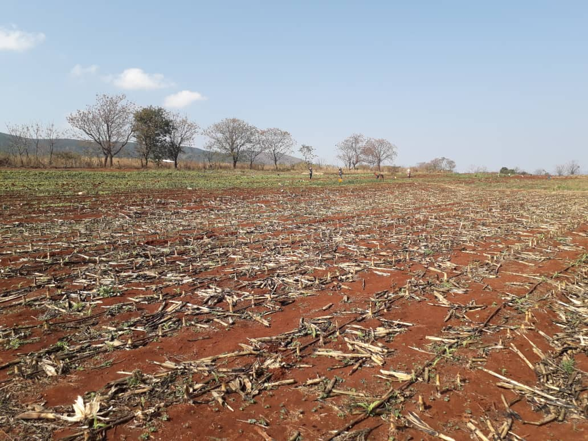
Figure 10: Showing Mpatheni Irrigation Scheme, with good soil coverage and application of CSA technologies such as drip irrigation
The photo above (Figure 10), taken from Mpatheni irrigation scheme, which was funded in the previous pilot project, which was smaller and had a shorter lifespan. Whilst the farmers have highlighted some teething problems, there is visible progress in the fields and drip irrigation is still being utilized. The farmers expressed a need for continued investment, including filtration system to reduce clogging of drip emitters, however, they have learnt a lot and practiced CSA over the time between the close out of that phase of the previous project. To achieve maximum impact, it is important that the institutions to which the projects are handed over continue to invest, supervise and provide mentoring to help the farmers grow their commercial operations.

4.1 Project Lessons Learnt and Replication Approach
Gender-based participation- including opportunities for women and youth to create sustainable jobs through CSA. The project commissioned a gender strategy in 2019, and from this report outlined recommendations that included project related, and policy level related actions to improve gender considerations and actions. From this strategy, the following achievements have been recorded by the project:

  - Access to land
The project, whilst it worked on existing land for households, however training and skilling meant that the women and youth forming part of the project were able to better utilize the land for increased returns. There were a total of 154 women and 37 youth that were part of the project and benefitted from being able to utilize the land allocated to them and their families.
Issues of policy with regards to land rights and access for women and youth were highlighted in the gender assessment report. And these are recommendations that are appended to this report as part of the gender strategy.
  - Opportunities for Women and the Youth
The installation of water saving – drip irrigation is a game changer for the all participants, especially the women, who form a majority of the scheme membership. Drip irrigation saves time in comparison with current practice of furrow irrigation which actually makes irrigation a laborious activity that eats significantly into productivity. Whilst it is acknowledged that the installation has been late in the project, and has also covered only 25% of the envisaged target, partners should ensure that this process continues and source additional resources to ensure that the whole 60ha is covered even after the life of the project. Labor saving as well water and energy efficiency are critical for the success of climate smart agriculture, reducing the burden on women and attracting the youth into agriculture, as well as drastically increasing yield, whilst utilizing water much more efficiently.
The project further enabled the piloting of a commercial model, which brought the employment and utilization of labor external to the scheme owners to greatly increase the benefits to the wider community. During operations, over 400 workers benefitted in the two schemes, and this is mainly for land clearing, planting and harvesting activities. There were, of course many challenges, such, inefficient labor management, resulting in high labor costs and lower corresponding productivity, however, these can be overcome by further refining models and ensuring that farmers are well trained in labor management. If well pursued, using this model can unlock the contribution to rural economic improvement, and increase employment, which is a critical need for economic development.
  - Access to finances
One of the key contributions of the project was the piloting of a revolving loan scheme with farmers, who ordinarily would struggle to access funding from financial institutions in the country due to lack of collateral, size of operations, and transaction history. This was mainly disadvantaging women and the youth as they have no assets to use as collateral, and most do not have land ownership, greatly increasing the limitations to production, even when irrigated land was availed to them for utilization.
The revolving fund was set out to be catalytic and enable seasonal production and purchase of inputs to ensure continuity of production, during the life of the project, the fund disbursed a total of E1, 100, 306.91 ($75, 800) to farmers for purchase of inputs, from which, farmers were able to produce and send produce to the market to the value of E1, 391,752 ($92,783) within a year and a half. This shows that improving access to farmers greatly enhances the outputs and ability to produce and meet market requirements sustainably.
The revolving fund, obviously had significant challenges, but these were mainly operational in the PMU and NAMBoard systems. For the facility to continue benefiting farmers and the whole value chain, these need to be overcome. This includes timely payment of farmers by NAMBoard and other markets to reduce time lag between harvesting and planting, providing timely and accurate statements on amounts owed and reducing balances, collection of funds owed by farmers to the market which avoids depleting the fund, and improving the self-governance of this and other such funds by schemes’ committees, and increasing the use of peer-pressure for keeping members in line with use of funds and ensuring productivity so as to enhance the fund performance.
  - Access to Knowledge, Information and Education
The gender strategy outlined that, due to generally lower education levels and exposure, most women had highlighted that they were generally in the dark as to how the formal market operates and how they are expected to produce, prepare for markets and engage markets when there are challenges.
The CMSA project, NAMBoard, Cooperatives department, Extension services in the Ministry of Agriculture, and service providers such as where machinery was procured from, provided training to schemes on different topics. These include crop management and sales (128 farmers); post- harvest handling (52 farmers); Contracting (201 farmers in 2 schemes); conservation agriculture practices (400 farmers). An example of gender consideration in the focus of CSMA project can be seen in the table below, where disaggregation by gender has obviously been implemented as part of the project. This also started to show the project where emphasis needs to be placed. For example, it was obvious that more women were attending training, however when it came to the actual contracts, the names on the contract were still those of household heads, in the main being men.

Result 3: Farmers linked to formal markets | 3.1 Number of farmers linked to formal value chains and generating sustainable income | Project Reports | 200 | 2 schemes  (31 females and 43 males). | Number of Farmer contracts  Employees and farmer payment schedule
 | 3.2 Number of famers trained in product standards, produce management and marketing. | Project Reports | 250 | 69 (41 females and 28 males). | Training reports, progress reports
 | 3.3 Number of farmers trained in business management | Project Reports | 250 | 69 (41 females and 28 males). | Training reports, progress reports
 | 3.4 Number of farmers trained on market-based production | Project Reports | 250 | 58 (27 females and 31 males). | Training reports, progress reports
 | 3.7 Number of farmers trained in marketing and sales | Project Reports | 250 | 69 (41 females and 28 males). | Training reports, progress reports
 | 3.8 Number of dialogues on pricing | Project Reports | 3 | 01 | Training reports, progress reports
 | 3.9 Number of contracts signed | Project Reports | 150 | 4 contracts from 4 schemes with  (31 females and 43 males) contracts signed. | Buyer Farmer contracts, Planting Schedules of Supply
Figure 11: Showing project results from Result Area 3, segregated by gender

  - Limited Access to Markets
The CSMA project provided an opportunity for all scheme participants to engage in marketing produce to both the formal and informal market. Due to the fact that most of the production finance came from the revolving loan fund, sales to the formal market, and in the main, NAMBoard was emphasized to increase the rate of recovery on the loans as these are easily deductible in this arrangement. This also provide much-needed training to the farmers as NAMBoard was able to outline requirements to meet the market conditions, with the end of year CSMA report indicating that there were initially very high rejection rates for crops, especially baby vegetables, however, with training, mentoring and visits to NAMBoard facilities where the packaging takes place, rejection rates were reduced from over 70% to less than 26%. Whilst this rate is still high and reduces profitability and sustainability, it is a learning process which needs to be consistently pursued.
There is also a need to increase the available market options, whilst having one formal market is a good start, this tends to limit the scope for farmers as there is a lot of learning involved in marketing and flexibility is also required as experienced when the main market was struggling with issues including collection and payment deadlines. In a normal commercial setting, cash-flow sequencing is important, and therefore use of the informal market should not be viewed as a taboo but as an integral combination to ensure farmers always have means of production. This reduces pressure on NAMBoard to pay within at times unreasonable timelines, but also ensures that whatever produce does not meet NAMBoard’s specification is not collected at all, and farmers have the option to sell that off as second grade, and will also ensure accountability by farmers for the funds accrued from the sales to the formal market (which at the moment is a missing puzzle and thus the income has been understated).
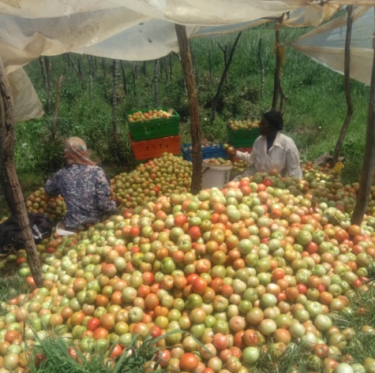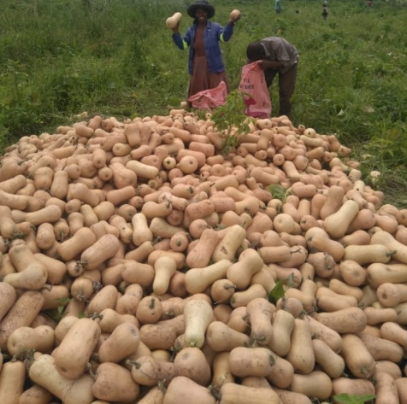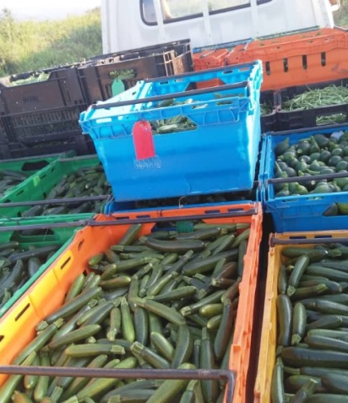

  - Project Exit Strategy and Continuation of activities under designated institutions
The project document had anchored sustainability on implementation through partners, who are already working within those specific areas of focus, therefore market linkages were implemented around the structures and systems set up by NAMBoard, the CA mechanization implemented in RDAs as they are already conversant with introducing and upscaling CA activities. The evaluation visited Mpatheni scheme, which benefitted from the previous pilot (2014-2016), and it was evident that the CSA structures put in place are still operational, however, there are maintenance issues (such as the drip irrigation system that needs new upstream filters), and underutilization (the production is not enough to justify full usage of the packhouse facility at Mpatheni). It is therefore incumbent on the entities that inherit any component of the project to keep the activities going, and make further investments in supporting farmers to develop even further.
Whilst at the time of the evaluation there was no evidence of an exit strategy that has been crafted, the project document, the constitution of the project steering committee and the vast knowledge documentation, there is a clear direction on what should happen with project funded activities beyond the life of the project.

5.0 RECOMMENDATIONS, LESSONS LEARNT and POLICY INSIGHTS FOR SCALING UP CLIMATE SMART AGRICULTURE
Project activities opportunities to scale-up lessons and experiences emerging from implementation of adaptation actions and recommendations.
When addressing CSA and its implementation, the Food and Agricultural Organization highlights five critical areas, which are:
- Expanding the evidence base;
- Supporting enabling policy frameworks;
- Strengthening national and local institutions;
- Enhancing financing options; and
- Implementing practices at field level.
The project being evaluated was planned with all these components factored in as key deliverables, which shows that the project design was sound, well thought through and incorporated global good practice when implementing and upscaling CSA interventions.

5.1 RECOMMENDATIONS
5.1.1 Widespread national adoption of climate smart techniques and other adaptive practices
Recommendation 5.1.1: Based on project results, adoption at national level and scale is possible, however, caution should be taken not to try and achieve too much in a limited time and resources frame. Stakeholders and resources are pooled together to achieve a common goal.
The Consultative Group on International Agricultural Research (CGIAR) states clearly that, “New climate risks, require changes in agricultural technologies and approaches to improve the lives of those still locked in food insecurity and poverty and to prevent the loss of gains already achieved.” With the ongoing climate risks, all Governments, including that of Eswatini, are looking for ways to rapidly inculcate the CSA thinking and practice among farmers to avoid total collapse of food security and agribusiness systems.
This project sought to answer the how part of the Government of Eswatini’ s intent to implement climate smart agriculture practices, and thus incorporated facets such as market assurance, mechanization, skills transfer and knowledge management to enhance farmer response to climate change induced occurrences. As a pilot project, this was demonstrated to an extent, and this includes the financing of climate smart agriculture, the use of value chain approaches, incorporation of conservation agriculture practices to market oriented production, resources management and stakeholder coordination to achieve better results in CSA.
For example, the results would have been much different had the original arrangement of the upstream irrigation been successfully provided by the Small Earth dams’ project, leaving the resources from this smaller project to concentrate in activities in-field.
5.1.2 Institutional Framework for Market –oriented Climate Smart Agriculture Implementation
Recommendation 5.1.2: There is need to ensure that the institution itself is up to the pace of project implementation to avoid slowing down the rate of implementation and deliverables. That is why it has been recommended that NAMBoard as an implementer needs to set up a PMU for all their projects, and projects should work within their PMU to reduce friction of systems and knowledge gaps from both ends.
The institutional framework for placing projects with a marketing institution such as NAMBoard is commendable, and builds both the capacity of managing projects at NAMBoard, but also entrenches projects into regular value chain activities.
This will ensure that there is a good balance between enabling NAMBoard systems to deliver on project expectations, and at the same time ensure that the project works within a long-term continuum and project activities do not cease at the close of the funded stage.
    - Project timing and adhering to timelines
Recommendation 5.1.3: CSA activities should get the timing right.
As noted earlier, the project started very late and picked up paced way into the second year. It was further hampered by the advent of COVID-19 and the related travel and meeting restrictions.
Planning involves a lot of precision, down to planting date, and the provision of inputs and equipment at the wrong time reduces effectiveness and may make farmers miss crucial times and whole seasons. This then has negative impacts on many deliverables including revolving funds as was experienced in this project where farmers at times planted out of season as they were not agile enough to change their plans when funds were released late or tractor services delayed land preparation.
5.1.4 Resource Allocation
Recommendation 5.1.4: To avoid improper allocation of resources, all projects should involve the Ministry at planning level, including the relevant department, this will enable identification of efforts and resources that are duplicated are deployed somewhere else.
One glaring facts in the evaluation of this project is that it tried to do too much within a limited time period and an even tighter budget. As such, it seems to have underachieved its target. However, there are more achievements than can be expected in a 3 year project (which effectively was implemented for just under 2 years). Within the project are long-term activities such as watershed protection, in discussion with among other stakeholders, the farmers, project manager, NAMBoard executive and RDA employees, they all stated that “There was evident mismatch between resources available and expected achievements and this was more gaping in the infrastructure installation and rehabilitation, e.g. irrigation and cold storage facilities.” This also has the effect of causing a strain between farmers and the PMU, and also the PMU and the implementing institution (NAMBoard) as there is a creation of expectations, which cannot be fulfilled with the allocated resources.
5.1.5 Funding of Market- Oriented Climate Smart Agriculture
Recommendation 5.1.5.1: Address cash-flow constraints farmers experienced as a result of payment cycles at NAMBoard and the lack of clarity on how to sell to other markets and more importantly, how to recover the funds from sales made outside the NAMBoard route.
Recommendation 5.1.5.2: Collaboration with existing financial service providers (Eswatini Bank has indicated keenness) needs to be explored to ensure linkages of farmers who benefitted from the revolving loan fund to more structured and conventional funding.
It is evident that, with seed capital, especially for already existing schemes can go a long way in increasing productivity and outputs from these schemes. The revolving loan facility ensured that farmers were able to employ labor, which is an overlooked facet of commercialization in small holder contexts as many farmers rely on own labor to the detriment of operations. In addition, this facility provided an opportunity to produce in a defined land area (estimated at 1 ha per farmer).
However, it is important to note that for such a facility to operate, the underlying context and systems is more important than the disbursement of the funds. This includes good crop selection, proper calculations of the amount needed per farmer and crop management to ensure adequate returns and repayment of the loan.
The revolving fund should mainly be used to help farmers create the necessary pedigree to borrow and service loans, and to create a credit history, and then they can graduate to formal institutions so as to enroll new farmers into the revolving loan facility.
5.1.6 CSA (CA) Mechanization equipment
Recommendation 5.1.6.1: Any up-scaling of CSA in the country considers mechanization more than hand held operations.
This considers the fact of the relatively rate of mechanization for activities that include ploughing and planting in the country, attributable to the Government and private tractor pools. Projects such as CSMA have done well to capitalize the available pool of CA equipment for RDAs to use and increase appetite among farmers to employ CA practices in production of their crops, and this is commendable.
Recommendation 5.1.6.2: Ensure that the whole extension system is able to drive their message to farmers to engage in CSA, and ensure that the machinery is kept in a useable and well serviced condition to enable farmers to take full advantage of its availability in the RDA and increase reliance on CSA for their livelihoods.
Initially there was confusion on who manages the equipment as this had not been provided for in the project budget, and at same time the equipment was not within the Government asset register and time was lost trying to sort this out. These are administration issues that should be sorted before receiving machinery and ensure farmers do not suffer as a result of machinery sitting in unusable state when needed.
5.1.7 Critical Value Chain Infrastructure for Commercializing CSA
Recommendation 5.1.7.1: Synchronization of value chain development process and critical infrastructure in implementation.
The project mapped out the value chain development process carefully and considered critical infrastructure that included irrigation, production systems, markets and knowledge. Value chains, especially for sensitive products such as vegetables rely on precision and all pieces working together efficiently, which did not happen as planned. For example, farmers indicated that they did not receive market information timely, including payment rationale, rejection records and where they need to improve their operations. On the other hand, the market also had constraints with timely collection of produce, and this greatly increased the rate of rejection and the benefit that both the market and the farmer accrued from sale of crops. Cold rooms, which were central to reduction of post-harvest losses were left too late to be rehabilitated, so farmers lost a lot of produce before they could realize the benefit of the in-field cold-rooms.
Recommendation 5.1.7.2: NAMBoard should consider completing the packhouse structures to fully fledged cold storage facilities, to ensure that they benefit from the work that has been started. NAMBoard revisits all these structures and ensure they are completed and utilized to the full before moving on to engage in any new infrastructure.
In one year of imperfect working conditions, the market was able to receive over E1.3 Million worth of produce, and this highlights the significance of incorporating these two schemes into a proper running value chain. It should also be borne in mind that there are other schemes that were developed in the earlier project, where a complete facility is currently under-utilized.
5.1.8 Farmer linkages
Recommendation 5.1.8: NAMBoard should pay special attention to this aspect of the farmer linkages, the high rejection rates.
High rejection rates were cited consistently by farmers. However, this is an easily rectifiable. Notably, this has the implication of causing breakdown in the supplier-market relationship. This is a key winning point for NAMBoard, which is getting farmers to market with speed and providing maximum returns for farmers’ investments.

5.2 LESSONS LEARNT
A summary of the lessons learnt in implementation of the different components of the project is presented below.
5.2.1 Knowledge transfer, and the role of M&E in Project implementation
From the planning stage, the project set out to have in place a good knowledge management and M&E systems as part of the learning process. Based on the available reports and initiatives, the project did very well in this regard, and generated information and reports that can be used for future programming. It is however, not evident where this knowledge has been broken down into useable packages and feedback provided to the users of the information, mainly the farmers. During the focus group discussions, farmers indicated that there has been a lot of data collected from various sessions that they have had with internal and external partners, however, they do not see this being used to enhance their operations. This shows that knowledge is still maintained at levels above the actual implementation levels, and this is an area that all stakeholders need to work towards rectifying for CSA interventions to be relevant to the users of the information for implementing. Partners working with farmers should always be cognizant that “Farmers are the primary custodians of knowledge about their environment, agro-ecosystems, crops, livestock, and local climatic patterns” Therefore, all information that is generated should filter back to them to incorporate in decision making.
5.2.2 Adaptive Management and Sustainability
The project had limited resources and much to cover, therefore there were a lot of adaptation techniques that the project team and farmers implemented to make it a success. This includes management systems within the schemes, where committees were revamped to include a broad scope of the demographics. This entailed increase of the youth and women in the executive positions. For example, at Intamakuphila, the leader was a young man and at Mavulandlela more women were incorporated into the committee. This is with the understanding that women and the youth form a good majority of the community and, therefore, having them represented in decision making is critical for success and continuity of commercial interventions. Contextualization of interventions also proved to be very critical, it is not advisable to copy actions from one scheme and implement in another without understanding the context.
The sustainability of the project activities was incorporated into the project design, by making NAMBoard the implementing partner, and housing the PMU at NAMBoard, the Government was clear in her intentions that they would like the entity to continue with all work that was started by the project. The equipment was already housed in RDAs, which shows that the Government has already set these in place, and that there should be an emphasis that projects do not create new institutions, but work within Government designed institutions, building the capacity of these institutions and ensuring that projects benefit the greater discourse by the Government.

5.3 POLICY INSIGHTS FOR SCALING UP CLIMATE SMART AGRICULTURE

5.3.1 On upscaling, adoption and mechanizing conservation agriculture:
1) Establish database repository on conservation agriculture
Currently, there is no structured mechanism for tracking the adoption and maintaining database on CA/resource conservation technologies (RCTs) in different crops/cropping systems/ecologies of the country. Quality data on availability of CA machinery/Custom-hiring centres, amount of crop residues left in field in different crops and cropping systems, farmers practice for management of these crop residues, etc. is also lacking. The agriculture statistics censors should incorporate these aspects in their data collection. The Ministry of Agriculture must develop a data base for CA machineries available, important distributers of CA machineries, local and regionally, including repair and maintenance centres. A systematic study on constraints in adoption of CA technologies in different crops and ecologies of the region also need to be prepared. The Agriculture Research Division needs to map the CA research under all initiatives in the country to define recommendation domains considering soil, climate, cropping systems as well as socio-economic conditions of the stakeholders.
2) Setting-up common learning platform and sites of science-based evidence generation on CA
The most important limiting factor in adoption of CA has been the lack of intensive promotion of this Practice. There is a need to create mass awareness of the CA technologies and demonstration of their benefits through creating a common platform of learning and knowledge sharing. The Multi-stakeholder, Conservation Agriculture Task force is a step in the direction and Government is encouraged to support his forum as all stakeholders need to be involved for creating the awareness and providing opportunities for sharing.
3) Development of effective and productive supply chain system for CA
There are few manufactures dealing with CA machineries locally, even for spare parts, repair & maintenance of existing machineries, the stakeholders have to depend on the markets available in South Africa and elsewhere. Though tractor hire is available at all RDA’s, Conservation agriculture machinery hiring has not been their sole mandates. Limited availability and repair or maintenance support services and lack of spare parts are major limitations. These issues create tangible barriers to adoption and wider acceptance of the benefits of CA practices. Manufacturers and dealers must provide the required incentives to stock machines as well as spare parts within the country.
4) Subsidies for CA machinery as incentives to the farmers
The slow pace of adoption of CA based practices in Swaziland. The farmers are not financially positioned to purchase drill seeders, and will access the technology primarily through RDA’s. In order to promote CA on large scale, subsidy/incentives needs to be extended to the farmers. However, subsidy should be released based on ground compliance monitoring and assessment. It is also envisaged that there is a need to incentivize the purchase of CA seeder and zero-till seed-cum-fertilizer drill to facilitate in-situ management of crop residue and retaining the straw as surface mulching. Refinement is needed in current prototypes of CA machineries. In accordance with the farmers’ need and besides cost reduction without quality machines such as Zero-till multi-crop and multi-utility planters need to be made available and popularized.
5) Pricing strategies to achieve market demand driven approaches
It has also been deliberated that subsidy extended on purchase of machines should be based on quality of the machines. Similar is the case with spares. Charges also need to be waved off on CA machines to reduce price barriers to adoption.
Promotions for CA produced maize should be periodically offered premium price to encourage technology adoption and production. The Ministry of Environment should be fully involved in this initiative through crop inspections together with the MoA who will carry out crop yield assessment and supervise harvesting practices and delivery to Maize buyers.
6) Sustainable intensification crop establishment technologies for fallow lands
Adoption of CA based resource conservation technologies involving suitable crop varieties would offer opportunities to cultivate at least 50% of fallow area through rotation or relay with pulses and legumes. Conservation agriculture-based crop establishment of these crops has a potential for sustainable intensification and reducing fallow land. Systemic future research on nutrient management, crop/cultivar combination, and farm mechanization is warranted that may further help to upscale system productivity potential in fallow areas.
7) Cropping systems approach to CA and pest dynamics
Soil biology and pest (including insects, pathogens, nematodes and weeds) dynamics under CA is the subject matter of a thorough investigation due to change in hydrothermal regime of the soil in presence of crop residue cover and non-disturbance of soil. Changes in community structure of microbes, microbial dynamics (beneficial vs. pathogenic) and microbial mediated processes under CA need to be studied. Intensive research programmes also need to be initiated on sustainable use of crop residues, use of micro-organisms for faster degradation of crop residues, quantification of crop residues suitable for mulching in different crops and cropping systems, development of climate smart crop varieties, crop diversification, must be promoted.
8) Crop Residue management
The amount of available crop residue (Tons) generated every year in Eswatini needs to be established. Large portion of crop residue is used as animal fodder for the winter period while some gets burnt ‘on-farm’ primarily to clean the field for sowing of the next crop. Even though the focus of CA so far in Eswatini has been on Maize and legume crops as cover crops, the extent of residues in Sugar also warrants research as these are prone to crop residue burning. There is need to develop, disseminate and incorporate technological options for sustainable management of crop residues; and to formulate and implement suitable law and legislations/policy measures to curb burning of crop residue. Diversified uses of crop residue for various purposes primarily for in-situ recycling and also other purposes viz., animal fodder, power generation, as industrial raw material for production of bioethanol, packing material for fruits and vegetables, and glassware, utilization for paper/board/panel industry, biogas generation/composting and mushroom cultivation in Public Private Partnership (PPP) mode need to be promoted.
9) Developing Synergies among Institutional landscape
Effective coordination between NARS and CGIAR Centres at regional level would greatly help in accelerated adoption of CA through bringing more synergies and complementarity and bridging knowledge gaps. Therefore, there is a need to develop a mechanism for regular meetings and interactions at the regional level. While strengthening the long-term CA research platforms as sites of learning as well as new scientific insights and evidence generations, the on-farm research-trials and demonstrations with farmers’ participation. This is the key for its upscaling/out scaling and promotion on large areas. Duplication in research across the institutions/organization also needs to be avoided. For our research Institution, Adaptive research on CA, and the setting up of a Conservation Agriculture Unit be made a priority.
10) Capacity Building of Stakeholders
Multi- stakeholder capacity building of stakeholders on CA is essentially required. Training programs to address the skill-gap could be based on existing arrangements with Non-Governmental Organizations Frequent demonstrations of machines (seed drills/Tractors.) also needs to be arranged in order to increase awareness among stakeholders and farmers in general. Therefore, different training modules targeted to diverse stakeholders need to be developed. Based on the strengths on various aspects of CA-based practices, key institutions should be identified to lead and facilitate the capacity development programs in areas of their expertise in different geographies. The University of Eswatini’s Faculty of Agriculture should also be encouraged to introduce a course on CA as a part of course curriculum and also more students and young researchers should be trained through mainstreaming CA in the programmes like in Schools Agriculture Programmes, and practical crop production course at under-graduate level and increased post-graduate research on CA.

5.3.2 Conversation to Water-saving Irrigation Technologies
1) Adopt an integrated approach
From the project implementation it is imperative that all available resources within the watershed, even within the water basin should be harnessed to achieve a specific objective, which is ensuring that available water is utilized in a systematic, conservation based and value for every drop approach. Proper research needs to be undertaken on the current status of the available water resources, including projections for the future, this is to avoid over-allocation of water permits, keeping in touching with current water use practices and extraction patterns, and more importantly ensuring that waterways are free from impediments such as alien invasive plant species and heavy sedimentation, which in both schemes were noted as core problems resulting in reduced water levels.
2) Implementation of policies that encourage water conservation and utilization of the water saving technologies
The Government, through among other initiatives, the irrigation policy outlined how the country seeks to move towards better water utilization, including adopting technologies that save on water. Through projects such as this one being evaluated, the Government should seek to upscale the conversion from high water requirement irrigation systems including furrow irrigation to water saving technologies. The challenges that have been noted in this project and others is the slow pace of skills transfer to where they are most needed, which is at farmer (water-user) level, which then manifests in high breakdown rates and poor maintenance of the systems. The Government has competent engineers and technicians, who need to be tasked with passing the information down to farmer level, and this should be in a structured manner which will include relevant training material, user manuals and in the field coaching. As it is, there is a disparity between implementers of the technology and the Government technical experts, which manifests as technology and skills mismatch and project failure, however this can be corrected by having the correct people in the field and actively having interactions with the farmers, community based artisans and extension staff.
3) Incentives for procurement and installation of appropriate water saving technologies
Adopting technology is inhibited by the cost of this technology, for example, the price of drip irrigation is very high as it is currently not manufactured locally, and actually most of it comes from outside the region. This is defeating the Government intention of saving water through appropriate technology, and as the Government also implements schemes to provide farming inputs and mechanization to promote the use of appropriate seed varieties and mechanization, so the same should be for water saving technologies. Farmers within irrigation schemes, and small holder individuals should either be considered for revolving loans or grants to ensure that the technology is widespread and this will with time also result in reduced prices as drip irrigation will become more common and affordable. The Government should also make it policy that training on irrigation technology will be a priority, which can be achieved by forging partnership with training institutions, manufacturers, wholesalers and other technology based trainers.
4) Standards setting for irrigation systems with an aim of reducing water losses and increasing efficiency
Currently, there are no specific standards on what is allowable as irrigation systems, and as such most water sources are under a threat of running dry due to improper utilization, non-observation of buffer capacities and no clear extraction strategies, especially in smaller, far-removed streams and rivers. This has resulted in even larger rivers struggling to be recharged, and downstream irrigation suffering with accessing enough water, and in some instances high water losses within the conveyance system as some irrigation methods do not return water into the natural flow path.

5.3.3 Successfully linking CSA farmers to formal markets
Attain success with farmers adopting CSA practices and continuing to practice highly depends on the benefits that they can obtain, which should translate into livelihoods improvement. And successfully linking farmers to market is the greatest incentive that can be provided to any farmer. In linking farmers practicing CSA, the following key considerations need to be made:
- The market (s) of choice must be fully functional, with simple to understand standards, and where possible provide an avenue for growth and graduation to other markets or more lucrative options of the same market.
- Crops should be defined and well researched to fit well into the system and ensure that maximum benefit is derived from participating in the targeted markets. This should take into cognisance that some crops are high water consuming and will therefore not fit into the overall objective of climate smart agriculture actions, therefore, even though all crops should be market-led, but they should also be in synch with the climatic requirements and it should be Government policy to research marketable crops that fit the climate smart agriculture framework and include in documentation such as crop planting schedules that are released by the Ministry.
- Market infrastructure including refrigerated facilities close to the production areas, refrigerated vehicles and a grading system are essential to ensure that all produce is utilized and reduce wastage. Producing using climate smart agriculture systems means that there is less use of chemicals and other conventional means of achieving crop uniformity, it is therefore important that all grades and sizes are captured, and remunerated accordingly for farmers to benefit. The cold chain should start as close as possible to harvesting areas, and these should be small enough for farmers and groups to easily maintain, and large enough to ensure that they hold at least 48 hours produce volumes. To ensure that these are able to pay for themselves, markets should create collection clusters, with the areas with the cold storage facilities being supported by the neighbouring enterprises financially to sustain the facilities.

6.0 Annexes

6.1 TOR for the evaluation

TERMS OF REFERENCE
For
Increasing Farmer Resilience to Climate Change-Upscaling Market Oriented Climate Smart Agriculture Project

Location: | Mbabane, ESWATINI
Application Deadline: | 20-May-21 (Midnight New York, USA)
Time left:
Type of Contract: | One Individual Contract/s
Post Level: | National Consultant
Languages Required: | English
Duration of Initial Contract: | National Consultant- 25 working days  spread-out within 2 months
Expected Duration of Assignment: | Total of 25 working days spread-out within 2 months

Background
The Ministry of Agriculture – National Agriculture Marketing Board (NAMBOARD) is seeking the technical services of a Consultancy Firm/National Consultant to conduct a comprehensive Terminal Evaluation for the Increasing Farmer Resilience to Climate Change-Upscaling Market Oriented Climate Smart Agriculture (CSA) Project. The COMESA-funded Project has been implemented since July 2018 and will be coming to an end in June 2021. The project focused on upscaling support on the adoption of markets-driven climate smart agriculture to 1,500 rural farmers in two rural areas namely Intamakuphila at Ngwempisi in the Manzini Region and Mavulandlela at Ntfonjeni in Hhohho Region. The project sought to assist government to identify policy and programmatic gaps as well as opportunities that will inform CSA strategic development and sectoral planning to assist small-holder farmers with greater integration into sustainable commercial production and markets, considering existing climate risks. The project also sought to enable the formulation of adaptation strategies and programmes within the agriculture sector as well as replication in different agro-climatic zones.
Objective
To assess the achievement of CSA Project results in selected communities and draw lessons that can improve the sustainability of benefits, and aid in the overall enhancement of climate change integration in agricultural productivity through its potential for replication in different agro-climatic zones within Eswatini. The evaluation will highlight the marketing and value chain issues at various stages from inputs to production, culminating to household gains/losses. This evaluation will identify lessons learnt including strengths and weaknesses in project design and implementation strategy/approaches. The evaluation will also come up with recommendations to leverage on successes, address identified gaps and weaknesses including to inform future programming for the sector.

Duties and Responsibilities
The Terminal Evaluation will be framed along the criteria of relevance, effectiveness, efficiency, sustainability and impact, through use of credible, reliable and useful data and information.

The specific tasks in the terminal assessment will include, but not limited to the following:
- Project Design:
- Review original project objectives and assess quality of design for delivery of planned outputs
- Compare baseline target indicators and current status of achievement.
- Project Implementation: Assess:
- Project management arrangements- Focusing on the roles and responsibilities of the different PMU cadres
- Effectiveness of project strategy for the achievement of project objectives
- Quality, timeliness and cost-effectiveness of outputs and activities.
- Project reporting systems and their efficiency.
- Financial situation including co-financing planed and realised, that is budget, expense status and the financial control system including financial reporting and planning.
- Flow of funds from UNDP to the implementing partner, NAMBOARD.
- Responsiveness of Project management to adapt and implement changes in project execution based on Project Steering Committee, UNDP, COMESA as well as local stakeholders.
- Partnership arrangements established for the implementation of the Project with relevant stakeholders involved at the national and local levels including clarity on the roles and responsibilities.
- Implementation of the project M&E plans including any adaptation to changing conditions (adaptive management).
- Project Impact and Sustainability
- Assess achievements of the Project to date against the original objectives, outputs and activities using the indicators as defined in the proposal.
- Review and evaluate the extent to which the Project impacts have reached the intended beneficiaries by assessing household production, productivity and incomes in relation to targeted produce.
- Assess associated impact on value chains for market-driven production using the community-based model, with focus on the selected study areas.
- Make recommendations on Project performance improvement in terms of effectiveness and efficiency in achieving impact on both capacity building and the targeted climate adaptation actions.
- Assess the likelihood of continuation of the Project outcomes/benefits after completion of the findings; describe the key factors that will require attention in order to improve prospects for sustainability of Project outcomes. Factors of sustainability including, institutional policy and regulatory framework that further the project objectives.
- Project Lesson and Replication Approach
- Understudy gender-based participation in the project as well as recommend opportunities for women and youth to create sustainable jobs through CSA.
- Assess the extent to which the project activities opportunities are being taken to scale-up lessons and experiences emerging from implementation of adaptation actions and make recommendations on how this could be achieved if necessary.
- Propose ways for widespread national adoption of climate smart techniques and other adaptive practices taking into consideration the social aspects of the populace.
- Describe the main lessons that have emerged in terms of: household production and income, strengthening national ownership; strengthening stakeholder participation; application of adaptive management strategies; efforts to secure sustainability; knowledge transfer; and, the role of M&E in Project implementation.
- Report preparation
- Develop a Project Terminal Evaluation report that responds to the specified tasks listed above.
- Present findings of the study to a stakeholder meeting for validation purposes.
- Submit soft copies of the report, data collection tools to the Monitoring and Evaluation Specialist at UNDP.

Deliverables

The consultant will conduct the study and produce the following deliverables:
- Inception Report- detailing the methodology, work plan with clear timelines, and roles and responsibilities for the various partners participating in the study as well as related costs.
- First draft Terminal Evaluation Report, based on the reviews, fieldwork and consultations.
- Conduct validation workshop to present findings to national stakeholders.
- Final draft Terminal Evaluation Report

Evaluation management
With overall reporting to the UNDP Resident Representative, the Consultant will work on day to day basis with the project team at NAMBOARD and shall be supervised by the Monitoring and Evaluation Specialists at NAMBOARD and UNDP.
The Project Implementing partner, Ministry of Agriculture-NAMBOARD, will be responsible for liaising with the evaluation team to set up stakeholder interviews, arrange field visits and coordinate with Government. The planning and the administrative arrangements for the TE will be done in collaboration with the UNDP Eswatini and COMESA. UNDP will support organization of stakeholder workshop to review and validate the report.
Reporting: The consultant will report to the Principal Secretary Ministry of Agriculture on technical aspects of the assignment and to UNDP Resident representative on contractual obligations.
The consultant will include travel costs and per diems within the country in their financial proposals.
Competencies
- Demonstrated data collating, management and analysis skills.
- Excellent communication skills.
- Team building approach.

Required Skills and Experience

International Consultant
Qualification:
- A Master’s degree in Agriculture Management/Economics, Demography/Statistics, Climate Change, Environmental Sciences, Monitoring and Evaluation or other closely related field. A PhD will be an added advantage.
Experience:
- Work experience in relevant technical areas (sustainable development assessments) for at least 10 years.
- Experience working on research and monitoring of climate change adaptation and mitigation interventions in the agriculture sector.
- Experience in adaptive management working with communities/ schemes engaged in livelihoods sustainability interventions.
- A demonstrated understanding of issues related to gender equality and Climate Change Adaptation with experience in gender sensitive evaluation and analysis.
- Project evaluation/review experiences within United Nations system will be considered an asset.
- Work experience in Southern Africa will be an added advantage.

Language:
- Fluency in English.

Qualification:
- A Master’s degree in Agriculture Management/Economics, Demography/Statistics, Climate Change, Environmental Sciences, Monitoring and Evaluation or other closely related field.
Experience:
- Work experience in relevant technical areas (sustainable development assessments) for at least 7 years.
- Experience working on research and monitoring of climate change adaptation and mitigation interventions in the agriculture sector.
- Experience in adaptive management working with communities/ schemes engaged in livelihoods sustainability interventions.
- A demonstrated understanding of issues related to gender equality and Climate Change Adaptation with experience in gender sensitive evaluation and analysis.
- Project evaluation/review experiences within United Nations system will be considered an asset.
- Work experience in Eswatini will be an added advantage.
Language:
- Fluency in Siswati and English.

Submission of Application
Qualified candidates may to submit an electronic application directly uploaded on the UNDP jobs website with all the requirements as listed here below. Annexes and further information may be downloaded on the website - http://jobs.undp.org no.XX .
- Duly accomplished Letter of Confirmation of Interest and Availability using the template provided by UNDP (Annex II);
- Personal CV, indicating all past experience from similar projects, as well as the contact details (email and telephone number) of the Candidate and at least three (3) professional references.
Technical proposal:
- Brief description of why the individual considers him/herself as the most suitable for the assignment.
- A methodology, on how they will approach and complete the assignment;
- Financial proposal that indicates the all-inclusive fixed total contract price, supported by a breakdown of costs, as per template provided (Annex II);

Annexes 1 and II - may be downloaded from the UNDP Procurement Notices Website -http://procurement-notices.undp.org/. For further clarifications, please contact;

ADDITIONAL CONSIDERATIONS
- Applications received after the closing date will not be considered.
- Only those candidates that are short-listed for interviews will be notified.
- Qualified female candidates are strongly encouraged to apply.
UNDP is committed to achieving workforce diversity in terms of gender, nationality and culture. Individuals from minority groups, indigenous groups and persons with disabilities are equally encouraged to apply. All applications will be treated with the strictest confidence.

UNDP does not tolerate sexual exploitation and abuse, any kind of harassment, including sexual harassment, and discrimination. All selected candidates will, therefore, undergo rigorous reference and background checks.

No application fee is charged for applying for this consultancy.

6.2 Evaluation matrix and data collection instruments

6.3 List of individuals or groups interviewed or consulted, and sites visited

6.3.1 Individuals or groups interviewed or consulted
PMU | Finance | Lomalungelo Dlamini
 | M&E | Nqobile Dludlu
 | PM | Musa Ngwenya
Focus Group Discussion | Intamakuphila FIS
 | Mavulandlela FIS
 | Mpatheni FIS
Namboard | CEO | Siphephiso Dlamini
UNDP | Onesimus Muhwezi
 | Gugulethu Dlamini
Extension Service | Hhohho CA Regional Coordinator | Sandile Magongo
 | Manzini CA Regional Coordinator

6.3.2 Sites visited

      - Intamakuphila FIS
      - Mavulandlela FIS
      - Mpatheni FIS

6.4 List of supporting documents reviewed
a. FY2019 Project Lessons Learnt Report Summary, MARCH 2020
b. Beneficiary and Stakeholder Mapping Assessment Report
c. Assessment, Mapping and Development of Water Supply Bulk Water Management Plan
- Annual Report, Reporting Period: January-December 2019

Assessment, Mapping and Development of Water Supply Bulk Water Management Plan – Intamakuphila and Mavulandlela
Increasing Farmer Resilience To Climate Change-Upscaling Market Oriented Climate Smart Agriculture Project: Climate Smart Market Oriented Project (CSMA)- Annual Report Reporting Period: January-December 2019
Situational analysis report Outlining the challenges and opportunities for increased women and youth participation at each stage of the value chain and an action plan and budget to respond to value chain recommendations.
Situational analysis report Outlining the challenges and opportunities for increased women and youth participation at each stage of the value chain and an action plan and budget to respond to value chain recommendations.
http://www.fao.org/documents/card/en/c/cb5359en/
https://ccafs.cgiar.org/climate-smart-agriculture-0
http://www.fao.org/climate-smart-agriculture/overview/en/

