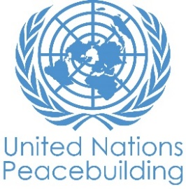
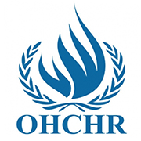
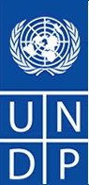
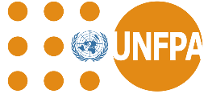

End-term Evaluation Report of UN Secretary General's Peace Building Fund (PBF): Harnessing Youth’s Potential for Peace in Central and Rwenzori Regions in Uganda

By

November 2021

TABLE OF CONTENT

TABLE OF CONTENT ii
LIST OF TABLES v
LIST OF FIGURES v
ACKNOWLEDGEMENT vi
EXECUTIVE SUMMARY vii
LIST OF ABBREVIATIONS 12
1. INTRODUCTION 13
1.1 Report Overview 13
1.2 Harnessing Youth’s Potential for Peace Project in Uganda 13
1.2.1 The Projects’ Theory of Change 14
1.3 Purpose and Objectives of the End-term Evaluation 15
2 EVALUATION METHODOLOGY 16
2.1 Evaluation Framework/Strategy 16
2.2 Evaluation Design 16
2.3 Scope of Project Evaluation - Geographic and Stakeholders 16
2.4 Sampling Design and Sample size 17
2.5 Data Collection Methods and Techniques 17
2.5.1 Quantitative Methods 17
2.5.2 Key informant Interviews (KIIs) 18
2.5.3 Focus Group Discussions (FGDs) 18
2.5.4 Case Studies 18
2.5.5 Desk/Document Review 18
2.5.6 Documentation through Short Videos & Photos 19
2.6 Covid19 Contingency Measures 19
2.7 Data Analysis Techniques 19
2.7.1 Quantitative Data 19
2.7.2 Qualitative Data 19
2.8 Ethical Considerations 20
2.9 The Evaluation Team 20
3. EVALUATION FINDINGS 22
3.1 Introduction and Socio-demographic characteristics 22
3.2 Relevance of PBF to the Local Context of the Youth & Communities 24
3.3 Coherence with Global and National Development agenda 26
3.4 Effectiveness of PBF Project 27
3.4.1 Project Results under Outcome One 27
2.4.1 a) Youth pro-actively engage with leaders and elders 27
3.4.2 Project Results Under Outcome 2 33
3.5.1 Project Design 36
3.5.2 Project’s M&E Mechanism 36
3.5.3 Project Management and Coordination 36
3.5.4 Utilization of Funds 37
3.6 Project Impact/outcomes 38
3.6.1 Knowledge Management and Knowledge Sharing 38
3.6.2 Outcome at Implementing Stakeholder 39
3.6.3 Outcomes at Beneficiaries Level 39
3.6.4 Negative Outcomes 42
3.6.5 Innovations and Factors for PBF project success 42
3.6.6 Unintended PBF project Outcomes 43
3.7 Sustainability and Innovations: Best Practices and Lessons Learnt 44
1.8 Project Challenges: factors affecting the achievement of intended results 45
9.8.3 Beneficiary level 46
2. RECOMMENDATIONS 46
4.1 UN Agencies Level 47
REFERENCES 48
APPENDICES 49
Appendix 1: Terms of Reference 49
Appendix 2: Youth Survey Questionnaire 49
Appendix 3 & 4: Key Informant Guide: Implementing Partners and Stakeholders 49
Appendix 5: FGD Guide 49
Appendix 6: Case Study Guide 49
Appendix 7: List of Key Informants 49
Appendix 8: Number of FGD by District 49
Appendix 9: Results Framework 49

LIST OF TABLES
Table 1: The Evaluation Team 19
Table 2: Summary of Social-demographic Characteristics of Respondents 21
Table 3: Disaggregation of Primary Source of Income by District 22
Table 4: Drivers of Conflicts 24
Table 5: PBF project Efforts for Peace Building and youth engagement 29
Table 6: Additional Youth Engagement Strategies 30
Table 7: Youth Capacity building activities 30
Table 8: Youth Knowledge and Vocational skilling 31

LIST OF FIGURES
Figure 1: A map showing the evaluation area 15
Figure 2: Main Source of Income/Livelihood 22
Figure 3: Summary of the mandate and benefits of Group/Network association. 23
Figure 4: Local platforms and structures Used to enhance peace building 27
Figure 5: PBF project engagement Strategies 27
Figure 6: Peace messages of Obuntubulamu 28
Figure 7: Youth Skilling and Livelihood Activities 31
Figure 8: Project budget and utilization for IPs 36
Figure 9: Sports for Peace Activities 40

ACKNOWLEDGEMENT
This work would not have been possible without financial support from the UN Secretary General's Office through the Peace Building Fund (PBF) in Uganda. Rhamz International Ltd (Consultant) would like to extend gratitude to the UN family in Uganda particularly UNDP, UNFPA and OHCHR for commissioning this evaluation. Thank you for participating in the evaluation and introducing the team to the project partners and stakeholders at the national, regional and local level.

The evaluation team would like to acknowledge the input of Government of Uganda into the evaluation, particularly the Office of the Prime Minister (OPM) who coordinated participation of government agencies at national level and through the structures at District Level. Thank you to the Permanent Secretary OPM, Chief Administrative Officers (CAOs) of Kasese, Bundibugyo, and Wakiso and the Executive Director (ED) Kampala Capital City Authority (KCCA) for your precious time and input into the evaluation.

To the partners i.e. Inter-Religious Council of Uganda (IRCU), Nnabagereka Development Foundation (NDF), Rwenzori Forum for Peace and Justice (RFPJ), Agency for Cooperation in Research and Development – Uganda (ACORD-U), Uganda Police, Uganda Human Rights Commission, Wakiso Human Rights Committee, cultural leaders of Buganda Kingdom, Tooro Kingdom, Obusinga Bwa Rwenzururu, Obudhingiya Bwa Bwamba, Banyabindi and Basongora, youth structures and relevant local government structures and district COVID task force committees.

Thank you for cooperating with the evaluation team and the value added to this study cannot be emphasized enough in this write up. To the men, women, and youth beneficiaries and households that participated in the study, thank you for giving us the information that we required from you without any hesitation.

Lastly the Project Management Unit (PMU) for having coordinated with sufficient detail, particularly your input in the harmonization of the entire evaluation process and providing prompt feedback amidst competing priorities. On the basis of this interaction with key stakeholders in the project area, we hope that this evaluation will help guide future interventions.

EXECUTIVE SUMMARY
Introduction
This report presents the findings from an independent evaluation of the UN Secretary General's Peacebuilding Fund (PBF) in Uganda under the project titled “Harnessing Youth’s Potential for Peace in Uganda.” The PBF project was jointly implemented by the United Nations Development Programme (UNDP) in partnership with the United Nations Population Fund (UNFPA) and Office of the High Commissioner for Human Rights (OHCHR). The project focused on addressing the exclusion of youth, including girls and women, from political and economic discourse in the country with a focus on the regional hotspots of Rwenzori and Central Buganda regions. The project was anchored at achieving two outcomes; 1) Outcome 1: State and civil society actors’ decision-making processes are more inclusive by enabling proactive participation of youth as positive agents of peace in political, and peacebuilding processes. 2) Outcome 2: Mistrust between law enforcement and security agencies and communities is reduced by enhancing the strict application of human rights standards.

The purpose of the evaluation was to examine project’s implementation process and peacebuilding results, drawing upon the project’s results framework as well as other monitoring data collected on the project outputs and outcomes in relation to the projects theory of change and underlying assumptions. Specifically, the evaluation was done in full compliance with the DAC Principles for the Evaluation of Development Assistance of the Organization for Economic Co-operation and Development (OECD) Development Assistance Committee (DAC) (OECD 2019 and 1991).
Methodology
A descriptive summative evaluation design was adopted unravelling what the project achieved or not achieved while quantitatively & qualitatively describing in-depth; the relevance, effectiveness, efficiency, impact and sustainability of PBF interventions to the intended beneficiaries. Participatory mixed research methods (quantitative and qualitative) were triangulated concurrently thereby harnessing the benefits from both methods. Specifically, the methods employed include; beneficiary survey questionnaire, key informant interviews (KIIs), focus group discussions (FGDs), case studies, desk/document review, documentation through short videos & Photos. In order to have a sample that represent the population, the study design based on the total youth population reach (60%), a confidence interval of 5%, confidence level of 95% the study applied an online statistical sample size calculator, and this resulted in 382 sample which was later adjusted to 414 to take care of non-responses. On a good note a total of 420 youth were reached with the evaluation questionnaire by the evaluation which was equally distributed across the two study districts of Kampala (27%), Wakiso (20%), Kasese (29%) and Bundibugyo (24%) distributed between female (55%) and male 45% with an average age 25 years and majority were school drop outs (O level secondary education (34%), primary (23%) and single (65%) never married.
The evaluation reached all the project stakeholders in Central (Kampala, Wakiso) and Western (Kasese & Bundibugyo) Uganda who included; UNFPA, OHCHR, UNDP, Uganda Police, Inter-Religious Council of Uganda (IRCU), Nnabagereka Development Foundation (NDF), Rwenzori Forum for Peace and Justice (RFPJ) and Agency for Cooperation in Research and Development – Uganda (ACORD-U), project beneficiaries i.e. women and Youth, cultural leaders of Buganda Kingdom, Tooro Kingdom, Obusinga Bwa Rwenzururu, Obudhingiya Bwa Bwamba, Banyabindi and Basongora , youth structures established/enhanced and local authorities in the project area.

Evaluation Results
The evaluation findings are structured according to the core evaluation criteria of project relevancy, coherence, effectiveness, efficiency, impact and sustainability.
Relevance of PBF to the Local Context of the Youth & Communities
- A total of 420 youths answered the beneficiaries’ survey questionnaire. Participants were drawn from central region in the districts of Kampala (27%) and Wakiso (20%), and South western Uganda in the districts of Kasese (29%) and Bundibugyo (24%).
- The evaluation revealed that the project was relevant and appropriate to the different groups of the youth in their gender diversities of whom 88% indicated that they have witnessed conflicts in their community.
- Overall, the PBF project was relevant more especially its design to respond to the context of conflict; political and ethnic fragile conditions such as unemployment (74%), multiple ethnic groups (40%), multiple political grouping (31%) and elections as a trigger of violence (24%). The project contributed to addressing the immediate basic needs of the male and female youths namely gainful employment, and turning the youth energies into positive livelihood activities and vocational skilling.
- The project also bridged the gap between the community, law enforcement and security agencies. Through the training of police officers, youth leaders, Human Rights defenders and journalists on human rights issues, this greatly addressed the mistrust between law enforcement and security agencies and communities.
Coherence with Global and National Development agenda
- The PBF was whole embedded in the globally SDGs especially SDG 16, the UNSCR 2250, UN Uganda programming agenda, UN Youth Strategy, UNSCR 1325 on women peace and security, the African Union's Agenda 2063, Aspiration 4, and Aspiration 6.
- At a regional level, the East Africa Community (EAC) member states are committed to peace and security. Pillar 3.6 of the EAC Vision 2050.
- The project was well aligned to Uganda’s National Development Plan II 2015/16-2020/21 Strategic Intent on Inclusive Governance. As well as the new NDP III 020/21-2024/25, that highlights governance and Security Programme with the aim of improving adherence to the rule of law and capacity to contain prevailing and emerging security threats. The project also fits well within the Uganda Vision 2040 and the Peace, Recovery and Development Plan III.
- The PBF project was customized to the Uganda National Youth Policy of 2016, UN Uganda Youth and Adolescent Strategy and Youth Livelihood Programme (YLP); to contribute to the promotion of equitable youth participation in decision-making processes at all levels. It is one of the projects that has contributed to the achievement of the country’s development goal of peace and security, harmonious co-existence, creating of income and employment for the youthful population of Uganda.

Effectiveness of PBF Project
- The evaluation revealed that the project achieved its intended objectives reflected in the realized outputs and outcomes despite the COVID 19 disruptions. For instance, the table below shows a sample of the indicators and their rate of achievement. It is good to note that the project surpassed its target for most of the indicators as displayed in this table as follows;
Outcomes & outputs | Performance Indicators | Indicator Baseline | End of project Indicator Target | Indicator Milestone | End of Project Evaluation Value | Evaluation Comment
Outcome 1: State and civil society actor decisionmaking processes are more inclusive and enable proactive participation of youth
Output 1.1  Capacity of selected government ministries and departments is enhanced to effectively mainstream youth issues in decision-making mechanisms | Indicator 1.1.1.1  Number of districts that undertake consultations with youth | 0 | 3 | 3 | 4 | 133% achievement rate
 | Indicator 1.1.1.2  Number of target districts that integrate youth-interventions in their development plans and budgets | 0 | 2 | 4 | 4 | 200% achievement rate
 | Indicator 1.1.1.3  Number of kingdoms that integrate youth issues in the strategic plans | 2 | 5 |  | 8 | 160% achievement rate
 | Indicator 1.1.1.5  Assessment on youth inclusion in peacebuilding | 0 | 1 |  | 1 | 100% achievement
 | Indicator 1.1.1.6  Number of fora promoting youth leadership and peacebuilding | 2 | 4 | 4 | 16 | 400% achievement rate
Output 1.2 Youth pro-actively engage with leaders and elders and advocate for their own inclusion in peacebuilding processes and new peacebuilding initiatives | Indicator 1.2.1.1  Number of young people reached with peacebuilding information disaggregated by gender and age.  b) Number of Radio presenters engaged/trained | 0  0 |  |  | 685,800  86 | There is no project target, however the achievement was 685,800 more than the baseline values  There is no project target, however the achievement was 86 times more than the baseline values
 | Indicator 1.2.1.2  Number of EKNs conducted |  | 2 |  | 8 | 400% achievement rate
 | Indicator 1.2.1.3  No of youth platforms supported | 0 | 2 |  | 16 | 800% achievement rate
 | Indicator 1.2.1.4  No. of youth supported by the programme disaggregated by various levels at the national and sub national levels | 250 cultural leaders and elders, 250 youth from cultural institutions, 200 youth outside of cultural institutions from elected youth structures, youth out of school and youth caught up in conflict situations, 360 technical and political leaders in the targeted sub counties and districts, 40 members of the district security team. Of these targeted groups, by consensus, at least 50% of targeted groups were female |  |  |  | No baseline value and project target to measure achievement rate.
 | Indicator 1.2.1.6  Number of social change entrepreneurs reached | 0 | 4 | 105 hairdressing (103F: 02M); 106 Tailoring (99F:07M); 101Welding (09F:92M); 98 Carpentry (13F:85M) Making a total of 224F:186M; 71 male boda boda riders (motorcycle taxis); 48 female street market vendors; 51 male mechanics/taxi operators |  | Over 100% achievement rate
 | Indicator 1.2.1.7  Number of artists, musicians, celebrities reached | 0 | 20 |  | 57 | 285% achievement rate
 | Indicator 1.2.1.9  Number of youths reached through sports activities | 0 | 50 |  | 1000 | Project achieved 950 more than the set target
 | Indicator 1.2.1.10  Number of young leaders trained | 0 | 50 |  | 260 | Project achieved 210 more than the set target
Output 1.3 Selected government and civil society actors promote youth participation in political and peacebuilding processes | Indicator 1.3.1.1  Mentorship platform established |  | 4 |  | 4 | 100% achievement rate
 | Indicator 1.3.1.3  Number of developments plans integrated with youth issues |  |  | 4 | 4 | 100% achievement rate
 | Indicator 1.3.1.4  Number of cultural institutions supported |  |  | 8 | 8 | 100% achievement rate
 | Indicator 1.3.1.5  number of strategic engagements with government, to include youth issues in the draft National Peace Policy |  |  | 2 | 1 | 50% achievement rate
 | Indicator 1.3.1.6  Number of capacity building activities organized and implemented |  |  | 10 | 10 | 100% achievement rate
 | Indicator 1.3.1.7  Number of youth-led Organisations trained |  | 4 | 5 | 5 | 125% achievement rate
Outcome 2: Mistrust between law enforcement and security agencies and communities is reduced by enhancing the strict application of human rights standards
Output 2.1  Capacity building is provided for law enforcement and security agencies on human rights standards in their operations engaging the youth | Indicator 2.1.1.1  Number of law enforcement and security agencies staff trained on human rights standards |  |  | 72 (22 women:50 men) |  | No baseline and target value to measure achievement rate
Output 2.2  The effectiveness of a monitoring, reporting and advocacy framework for human rights violations in law enforcement operations aimed at engaging the youth is strengthened | Indicator 2.2.1.1  No. of High-level meetings to address human rights situation of the youth |  |  | 2 | 2 | No baseline and target value to measure achievement
 | Indicator 2.2.1.2  Number of CSOs and youth organizations trained to monitor, report, raise and advocate on human rights concerns related to youth issues |  |  |  | 84 (50 women; 34 men) | No baseline and target value to measure achievement rate
- The multi-dimensional strategy of the PBF project approach; with cultural, religious, political and economic empowerment of youth is one such model commendable that needs to be duplicated, and contextually modified to enhance peace building and conflict resolution within and among communities in Uganda. This was the most appropriate implementation approaches to achieving the project outcomes in comparison with other alternative approaches such as national elder’s forum and the Interparty Organisation for Dialogue (IPOD), which are highly centralised with limited reach to the community and most vulnerable youth and women.
- Youth were engaged through various strategies namely community level mediation: cultural, religious and political leaders dialogue (94%), generation for generation conversations (57%), cultural events (25%), Religious events (43%), and community dialogues with political and security officers (75%) and media engagement (69%).
- There was proactive engagement of national, community, and local platforms and structures including; youth leadership (64%) at all level of the 4 project districts, religious leaders (64%) and local government (60%) as the main centers of influence and youth engagement.
- Young people were also engaged through mentorship programs and sports for peace (76%) (Buganda County football cup tournament), livelihood projects (86%), Civic competence and empowerment seminar (24%), local radio talk show (45%), orally person to person engagement (35%), Television (15%) and social media (10%), Information Education and Communication (IEC) materials (6%) and newspapers (2%).
Project Efficiency
- The evaluation positively appraised the clarity of the project design with clear result areas translated itself to the field implementation approaches, implemented within the required time, resources and efforts.
- The project however did not conduct a baseline study against which the partner targets would benchmark. This deprived the project an opportunity to have a solid learning to guide indicator and target setting as well as form a basis for the selection of the beneficiaries.
- The project costed a total budget of $2,487,750, UNDP as the lead UN Agency received $1,537,500 (60%), UNFPA $505,000 (22%) and OHCHR received $430,000 (18%) of the funds. The project funds were efficiently utilized with UNDP, UNFPA and OHCHR delivering 100%, 100% and 74% respectively and overall at 96%. However, OHCHR experienced major delays with a myriad of implementation challenges most due to the outbreak of the COVID19 pandemic. Some implementing partners also reported the delayed disbursements of project funds yet with limited timeframe to implement the project activities.

Project Impact/outcomes
- The project enhanced knowledge management and knowledge sharing, for example it supported the printing and publication of Wakiso District Human Rights Committee First Annual Human Rights Report 2020, and publication of a Rapid Assessment Report on Youth and Peacebuilding in Uganda 2020 by UNFPA among others.
- There was reported increased youth and women engagement and involvement in political discussions and electoral processes, including in the previous national and local government elections 2021, e.g. more youth were elected in the local council elections of 2021 in Kasese District.
- Within the community, there was reported increasing level of mutual respect and mutual existence amidst the multi-ethnic settings esp. in Rwenzori region which has had historical ethnic conflict; increased messaging on peace building e.g. the 2021 Peace Day under the #PEACEDAY2021, MalalaUG ft Jaffer under the Harnessing Youth's Potential Project calls upon young people to center their world sharing #peace in a song titled peace lover, see link for the song https://t.co/hzMtOsSR9x.
- Under Outcome 2; Mistrust between law enforcement and security agencies and communities is reduced by enhancing the strict application of human rights standards; there was a series of technical capacity/trainings on human rights offered to UHRC, security agencies, Wakiso district Human Rights committee, media personnel, political leaders and religious leaders. There was also institutional infrastructural support through provision of ICT equipment’s (laptops, computers, printers among others) to enhance communication, advocacy and engagement of stakeholders on human rights issues and peace building.

Sustainability
- PBF project attested to the high-level cooperation and integration of project activities among the UN agencies (UNDP, UNFPA and OHCHR). Hence, the PBF project is a model example of UN delivery as one: ‘UN agencies as One’
- The implementation approach was tailored to the community cultural, religious and political structures that are vital for easy project buy-in, public legitimacy, trust and confidence for participation in project activities, and subsequent sustainability of the project outcomes.
- Formalization of youth livelihood informal groups will enhance the sustainability of the results
- Involvement of district local governments – to take up the skills groups, youth peace chapters, vocational youth skilling centers, and dialogue platforms enhance ownership and continued political and technical support.

Best Practices and Lessons Learnt
- Strikingly was the One UN working Together (UN inter-agency project, UNDP, UNFPA and OHCHR); despite the difference in the implementation approaches, hence, this proved the possibility of UN delivery as one: ‘UN agencies as One’.
- Working with the existing structures of implementing stakeholders such as IRCU structures (District Interfaith Committees, Interfaith Action for Youth and Children, Youth of Faith for Peace- Yo4P and Regional Peace and Stability Forum), NDF, UHRC, RFPJ and traditional kingdoms in Buganda and Rwenzori region was a game changer.
- Livelihoods for peace was vital to meaningfully engage young people, change of mind-set and trigger them for economic development instead of participating in violence.
- Peace building as both software (values-mind-set changes) and hardware (livelihood) intervention. Peace building through sports and music reached more young people
- The integration of ICT innovation and other non-conventional implementation strategies especially leveraging on key social media and other online platforms will continues even after the project lifecycle.
- Due to COVID19, implementing partners innovatively created social media such as WhatsApp’s groups, use of radio and Television and small groups to reach young people with peace messages.

Recommendations
- Future joint UN agencies project implementation should agree on the uniform implementation approach to create harmony among stakeholders.
- Future peace building programming should cater for a long period of time like at least five years.
- Peace building and conflict resolution projects should continue to tap into young peoples` passions and talents; strengthening investment in youth talents for sustainable peace e.g. football for peace, music for peace and other talents that are within the natural endowments of young people.
- Because peace and stability and governance are a national duty of the government, there is need to advocate for the government to prioritize all processes of peace building and good governance at local levels going beyond legislation and policy formulation to engage the communities (local solutions for peace) in peace building through multi-sectoral approach including periodic monitoring of these processes.
- There is a serious appeal from CSOs for government to commission constitutional review to ensure smooth and peaceful transition of power at the national and local government levels. The reforms in the legal regime should cater for strong institutions and accountabilities for peace building to ensure certainty for leadership in “the Uganda we want”.

LIST OF ABBREVIATIONS
ACORD-U Agency for Cooperation in Research and Development – Uganda
CCEDU Centre for Electoral Democracy in Uganda
DAC Development Assistance Committee
DPCs District Police Commanders
FGDs Focused Group Discussions
FSP Farmer Support programme
GoU Government of Uganda
GPS Global Position System
ICRC International Committee of the Red Cross
IRCU Inter-Religious Council of Uganda
IP Implementing Partners
KIIs Key Informants Interviews
KIs Key Informants
NDF Nnabagereka Development Foundation
NDP National Development Plan
OC Station Officer in charge of Station
OECD Organization for Economic Co-operation and Development
OHCHR Office of the High Commissioner for Human Rights
OCCID Officer in charge of Criminal Investigations
PBF UN Secretary General's Peacebuilding Fund
RA Research Assistants
RPC Regional Police Commander
RFPJ Rwenzori Forum for Peace and Justice
SDGs Sustainable Development Plan
TOR Terms of Reference
UHRC Uganda Human Rights Commission
UNDP United Nations Development Programme
UNFPA United Nations Population Fund

- INTRODUCTION

1.1 Report Overview
This report presents the findings from an independent evaluation of the UN Secretary General's Peacebuilding Fund (PBF) in Uganda under the project titled “Harnessing Youth’s Potential for Peace in Uganda.” The purpose of the evaluation was to examine the project’s implementation process and peacebuilding results, drawing upon the project’s results framework as well as other monitoring data collected on the project outputs and outcomes as well as context. This report has four (IV) main sections. Section one (I) presents the introduction and project context. Section two (II) presents the evaluation methodology; evaluation design, framework and methods. Section three (III) presents the evaluation findings including innovations, lessons learnt project challenges, as well as conclusions and recommendation. Section four (IV) are the references and appendices.

  - Harnessing Youth’s Potential for Peace Project in Uganda
The United Nations Development Programme (UNDP) in partnership with the United Nations Population Fund (UNFPA) and Office of the High Commissioner for Human Rights (OHCHR), have been jointly implementing the UN Secretary General's Peacebuilding Fund (PBF) in Uganda under the project titled “Harnessing Youth’s Potential for Peace in Uganda.” The project focused on addressing the exclusion of youth, including girls and women, from political and economic discourse in the country with a focus on the regional hotspots of Rwenzori and Central Buganda regions. The project addressed youth exclusion through initiatives that enable greater engagement of young women and men in decision-making processes at national, district and local level, and initiatives that aim to restore trust between government (in particular security and law enforcement) entities and communities in the regional hotspots. The project was catalytic, innovative and time-sensitive (18months), aiming at strengthening the engagement of young women and men in peacebuilding and political processes in Uganda and that the project had two outcomes and six corresponding outputs.
·

The project focused on addressing two of the key factors identified in the peacebuilding context section: i) the exclusion of youth including girls and women from political and economic discourse in the country and ii) the regional hotspots of Rwenzori and Central/ Buganda regions. The project addressed these conflict factors through initiatives that enable greater engagement of young women and young men in decision-making processes at national, district and local level, and initiatives that aim to restore trust between government (in particular security and law enforcement) entities and communities in regional hotspots. The project had 2 outcomes and six corresponding outputs as detailed below;
- Outcome 1: State and civil society actors’ decision-making processes are more inclusive by enabling proactive participation of youth as positive agents of peace in political, and peacebuilding processes.
    - Output 1: Capacity of selected government ministries and departments is enhanced to effectively mainstream youth issues in decision-making mechanisms.
    - Output 2: Youth pro-actively engage with leaders and elders and advocate for their own inclusion in peacebuilding processes and new peacebuilding initiatives
    - Output 3: Selected government and civil society actors promote youth participation in political and peacebuilding processes.
- Outcome 2: Mistrust between law enforcement and security agencies and communities is reduced by enhancing the strict application of human rights standards.
    - Output 1: Capacity building is provided for law enforcement and security agencies on human rights standards in their operations engaging the youth.
    - Output 2: The effectiveness of a monitoring, reporting and advocacy framework for human rights violations in law enforcement operations aimed at engaging the youth is strengthened.
    - Output 3: The youth capacity on human rights issues has been strengthened.

    - The Projects’ Theory of Change
The Project Theory of Change was based on the understanding that if government, political and civil society actors create and maintain safe spaces for meaningful youth participation in dialogue, mediation, and reconciliation and, if youth are supported to diversify their livelihoods, then the youth will be empowered to effectively engage government, political and civil society actors and contribute to the development and implementation of home-grown solutions to the increasing inter-communal tensions and violence, and thus contribute to promoting peace in Uganda. The project envisaged that;
          - If relevant government, political and civil society actors are equipped to include young women and young men in political, socio-economic and peacebuilding processes; and
          - If the young women and young men in Central/ Buganda and Rwenzori regions are mobilized and empowered to peacefully engage with the state, political and civil society actors in political, socio-economic and peace building processes;
          - Then young women and young men will be able to act as effective change agents for inclusive and peaceful decision-making processes and national, district and local level and will be less likely to nurture frustration linked to a sense of exclusion.
          - If law enforcement and security institutions refrain from using excessive violence and from violating human rights when engaging with youth; then
          - The mistrust between communities and the central government will be mitigated and tensions between them will be reduced.

As a result of youth engagement in decision-making processes at all levels, including in the conflict hotspots of Central/Buganda region and Rwenzori region; and of restored trust between youth and security/peace institutions, violence will be less likely to escalate as a result of built-up tensions, including during electoral/pre-electoral periods, and peace will be consolidated in Uganda.

This Theory of Change assumed government leadership and ownership of peace building interventions as well as political will and commitment to deploying adequate national human, financial and material resources for peace building and security. Other critical conditions jointly identified with Government of Uganda (GoU) included: Assurance by GoU of adequate institutional stability as well as enhanced functionality and engagement of local Governments.

  - Purpose and Objectives of the End-term Evaluation
The purpose of this evaluation was to examine project’s implementation process and peacebuilding results, drawing upon the project’s results framework as well as other monitoring data collected on the project outputs and outcomes as well as context. The evaluation assessed the extent to which this theory of change has been proved or otherwise by the project interventions. The evaluation also assessed the extent to which the project theory of change and underlying assumptions were relevant in delivering the anticipated outcomes of the project as well as contributing to the overall impact in terms of improving intercommoned relations and overall development outcomes for the beneficiaries. Specifically, the evaluation was guided by the following objectives;
    - To assess the relevance and appropriateness of the project in terms of: addressing key drivers of conflict and the most relevant peacebuilding issues. The degree to which the project addressed cross-cutting issues such as conflict and gender-sensitivity in Bundibugyo, Wakiso and Kampala districts;
    - To assess to what extent the PBF project has made a concrete contribution to reducing conflict factors in Uganda and whether the project helped advance achievement of the SDGs in particular SDG 16.
    - To evaluate the project’s efficiency, including its implementation strategy, institutional arrangements as well as its management and operational systems and value for money.
    - To assess whether the support provided by the PBF has promoted the Women, Peace and Security agenda (WPS), allowed a specific focus on women’s participation in peacebuilding processes, and whether it was accountable to gender equality.
    - To assess the contribution/impact of the project on youth economic base and political engagement in decision-making process.
    - To assess whether the project has been implemented through a conflict-sensitive approach.
    - To document good practices, innovations and lessons emerging from the project.
    - To provide actionable recommendations for future programming.

        - EVALUATION METHODOLOGY
This section describes the evaluation methodology and techniques that were used during the evaluation. It specifies evaluation design and framework, target beneficiaries, study area and sample size, sampling procedure. It also details techniques and procedures of data collection and analysis. The section also states the evaluation principles/standards that were considered as part of the international ethical evaluation standards.

2.1 Evaluation Framework/Strategy
The evaluation was done in full compliance with the DAC Principles for the Evaluation of Development Assistance of the Organization for Economic Co-operation and Development (OECD) Development Assistance Committee (DAC) (OECD 2019 and 1991). The OECD/DAC evaluation criteria focused on the principles of relevance, coherence, effectiveness, efficiency, impact and sustainability of PBF project interventions

2.2 Evaluation Design
A descriptive summative evaluation design was adopted; focusing on impact of the project interventions on the target groups. This type of evaluation was most appropriate because it helped to unravel what the program achieved or not achieved while quantitatively & qualitatively describing in-depth; the relevance, effectiveness, efficiency, impact and sustainability of PBF interventions to the intended beneficiaries. The participatory mixed research methods (quantitative and qualitative) were triangulated concurrently to achieve the situation where the evaluation report highlights the significance of contributions of both methods.

2.3 Scope of Project Evaluation - Geographic and Stakeholders
The geographic scope of the evaluation included project catchment areas and project activities implemented in Kampala City, Wakiso district, Fort Portal City and other districts of Ntoroko, Bunyangabu, Bundibugyo and Kasese. Below is a map showing the evaluation geographical area.
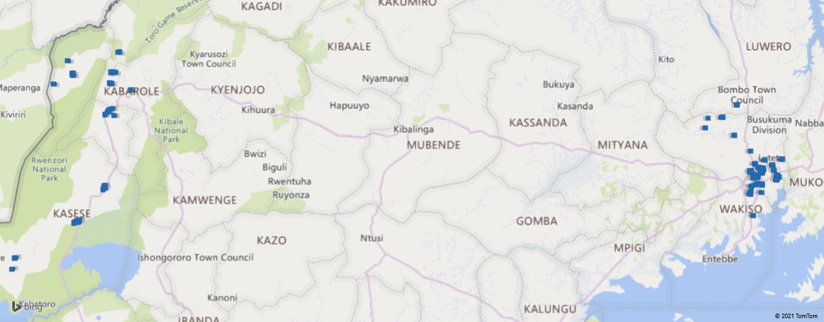
Figure 1: A map showing the evaluation area

The evaluation engaged the project partners and stakeholders who included; UNFPA, OHCHR, UNDP, Uganda Police, Inter-Religious Council of Uganda (IRCU), Nnabagereka Development Foundation (NDF), Rwenzori Forum for Peace and Justice (RFPJ) and Agency for Cooperation in Research and Development-Uganda (ACORD-U), Wakiso District Human Rights Committee, Umbrella Network of journalists in Kasese, Foundation for Human Rights Initiative (FHRI), National Coalition of Human Rights Defenders- Uganda, Foundation for Human Rights initiative, Uganda Human Rights Commission (UHRC). In addition, project beneficiaries that participated in the evaluation included women and Youth, cultural leaders of Buganda Kingdom, Tooro Kingdom, Obusinga Bwa Rwenzururu, Obudhingiya Bwa Bwamba, Banyabindi and Basongola, youth structures established/enhanced and local authorities in the project area.

2.4 Sampling Design and Sample size
The evaluation utilized a simple random sampling technique, in which participants were randomly drawn from the sampling frame of project beneficiaries by category. The sample size was determined basing on 3 parameters;
    - Confidence interval of 4, the amount of error that the study design can tolerate. The evaluation utilized 5% confidence interval.
    - Confidence Level: this is the amount of uncertainty the survey design can tolerate. A confidence level of 95 percent was adopted.
    - Population Size; this refers to the number of subjects from which a representative random sample should be selected. According to the project reports, a total of 60,000 young people (male and female) were reached by the project and this is the population considered in calculating the sample.
    - Using the online statistical sample size calculator, the sample size determined was 382 which was later adjusted to 414 to take care of non-responses. On a good note a total of 420 youth were reached by the evaluation
This sample was equally distributed across the two study regions of Central (Kampala and Wakiso) and Rwenzori (Kasese and Bundibugyo). On the other hand, qualitative sample of Key Informants, FGDs & case study participants were determined using Non-random (purposive) sampling methods. These were purposely selected based on their participation in the project.
  - Data Collection Methods and Techniques

2.5.1 Quantitative Methods
The evaluation team administered a beneficiary survey questionnaire with 420 randomly selected project participants. The questionnaire was electronically programmed and customized on Kobo Collect mobile data collection platform. Appendix 2 shows the copy of the survey questionnaire. The electronic questionnaire was designed with specific questions for each category of youths and women respondents with filters and skip patterns accordingly to capture the different forms of project interventions i.e. youth skilling, financial literacy, sports for peace, livelihood empowerment and peer to peer change agents. This helped to eliminate manual data entry; entry errors and saved time taken to design data entry screens and data entry. This also allowed real time data capture with GPS of youth locations for traceability and visualization using maps. For real time data monitoring, data was on a daily basis uploaded to the RHAMZ-International data management system/the server, with capacity of virtual monitoring of incoming responses.

2.5.2 Key informant Interviews (KIIs)
The study adopted Key informants as one of the primary methods of data collection. Key informants were purposively identified and proactively reached with reference and approval of UNDP project coordination office. Using interview guides (for IPs and key stakeholders), responses were solicited from resourceful persons to understand the local context but also provide an insight into the study objectives, refer to appendix 3 and 4. A total of 28 key informants were interviewed: 15 at the district levels and 13 were at national level with IPs and key stakeholders. Attached in appendix 7 is a list of key informants. The key informants were interviewed so as to obtain in-depth relevant information for the study at district and national level.

2.5.3 Focus Group Discussions (FGDs)
FGDs were conducted with project beneficiaries selected based on gender, project intervention category, geographical location and age. An FGD guide was used to facilitate the group discussions comprising of 8-12 young people in the sampled study areas, appendix 5 shows the FGD guide. The purpose of FGDs was to get in-depth information, ensure data harmonization and factual analysis of the project relevance, effectiveness, efficiency, impact and sustainability. This reinforced validity and reliability of the assessment outcomes through triangulation. A total of 13 FGDs were conducted: 2 for male, 2 for female and 9 were both male and female participants. The FGDs were conducted physically with in the communities at common community meeting points. Appendix 8 shows the number of FGDs conducted by district. Adherence to COVID19 SOPs was emphasized including putting on a face mask, social distancing and an open/natural aerated environment. The moderators ensured that the whole process was participatory-minimizing few members dominating the discussions. Information collected from the focus group discussions was analyzed and triangulated with the data from other sources to enable us to draw assessment values. The Data collected from the FGDs was digital recorded as support information from other data sources.

2.5.4 Case Studies
We conducted case studies capturing unique experiences of both female and male youths in Kampala, Wakiso, Kasese and Bundibugyo districts. The case studies were taken based on the equity, diversity and inclusion criteria of youth and women-led groups, rural-urban representation and other vulnerability representation. Case studies were captured using a guide in appendix 6. Case studies also helped to learn more from the project interventions and gather anecdotal evidence about their distributional impact. Data generated from case studies helped to prioritize project impact opportunities, challenges, and best practices to inform future development programing of youth interventions. A total of 14 case studies (12 are individual and 2 are group case studies) were conducted and documented across the study districts and project interventions. The cases were evenly selected from the study districts. Out of the14 cases, 7 were female, 5 male and the 2 group cases were all male.

2.5.5 Desk/Document Review
The evaluation conducted an analytical review of project documents to collect some information that feeds into the assignment parameters. The documents reviewed included; proposal document, partner reports, monitoring reports, activity reports and other relevant documents as detailed in bibliography appended to this report. These were accessed electronically through e-mail while others were accessed through shared links. A list of reviewed documents is attached in reference section.

2.5.6 Documentation through Short Videos & Photos
The evaluation documented short videos and photos to provide a visual presentation of messages coming out of the evaluation. These combined different kinds of images and sounds and provided a flexible and immediate medium, to connect with emotional sentiments of the project beneficiaries. A total of 9 video clips were recorded from the case study participants in the study districts.

  - Covid19 Contingency Measures
The evaluation team adopted the following measure to mitigate the challenges of COVI19:
- Use of mobile data collection technology to administer questionnaires. This helped to avoid the physical contact of paper-based questionnaires. In addition, some KIIs whenever possible were conducted by telephone, zoom meetings, and email. This limited interaction and minimized the spread of COVID 19.
- All study participants and research team were given facemasks before engaging them in any form of interview. The study team also frequently sanitized at the beginning, during and at the end of every interview session.
- The study also adopted local data collectors/Research assistants to minimize movements inter-district and avoid community transmission of COVID19.
- Study participants maintained physical distance of 4 meters from each other as recommended by MOH at all times especially while conducting Youth Focus group discussion, and KIIs consultations.
- The research team was tested for COVID19 before they engaged in any field activity and only those that tested negative were cleared to access the study respondents.

  - Data Analysis Techniques

2.7.1 Quantitative Data
Preliminary review of data was done to identify errors, omissions and also did final coding of open-ended questions and any other new responses. This was necessary to ensure quality data set. Questionnaire data in the Kobo Tool Box was uploaded on the data management system every field day. Then data was down loaded as CVS file and exported to SPSS 20 or STATA 12 to support the analysis. All quantitative data was then analyzed using descriptive statistics e.g. mean, frequencies, percentage, totals, and cross-tabulations generated on the basis of key evaluation variables.

2.7.2 Qualitative Data
To ensure consistency, interview guide, scripts, and audio recordings were edited systematically from the first questions asked to the last question in a systematic way. This was aimed at analyzing patterns of data. Completeness was safeguarded by revalidation of data through adopting a hierarchical data editing approach. According to Dyer et al., (2018: 352) safeguards in editing hierarchical data was put in place when editing data. The study achieved this hierarchy by deploying two research assistants in editing data at two tiers of editing where each of the research assistants edited data after each other. Where variances arose, the lead consultant provided yet another tier of edition by crosschecking and reconciling varying data texts. Qualitative data was analysed using content analysis based on emerging themes and domains.

The analysis was carried out through multiple readings and interpretations of the raw data: This followed the analysis of data using content analysis. All project data was kept in safe and password locked online and offline systems, and this was only accessible by the research team.

2.8 Ethical Considerations
The evaluation adopted the following ethical considerations;
- The evaluation process was guided by the Uganda Evaluation Association Evaluation Standards and DAC International Evaluation Standards (OECD DAC 1991 and 2010). The evaluation was undertaken with high level of integrity and honesty by the team. Only findings which were usable, relevant and enhance learning of UNDP and implementing partners was documented.
- The consulting team heeded to the principles of informed consent, confidentiality, privacy, protection from potential damage or threat, and scientific validity (Nigel, Amanda and Amanda, 1998). During fieldwork, no names of respondents were recorded anywhere on the consent form and information collected from one respondent was not shared with the other. Unique identifiers were allocated to each respondent for purposes of tracking.
- Rhamz International has an anti-sexual harassment policy which guided the consultants and research assistants during interaction with the evaluation respondents.
- The consulting team sought informed consent from all respondents. The evaluation included a statement of confidentiality for the beneficiary in all the tools, explaining the purpose of the research and committing not to divulge individual respondent details but rather report on them as an aggregate thus protecting them.
- Only the study team had access to the information. The data sets and videos were password protected with limited access by the research department or any other user who meets the requirements to access.
  - The Evaluation Team
The evaluation was conducted by a multidisciplinary team with professional backgrounds and experience in conducting high level evaluations of peace building projects in Uganda. These worked with partners and local government structures to identify and reach the target beneficiaries for the evaluation. The table 1 below shows the breakdown of the team, their roles on the assignment and key competences and qualifications.
Table 1: The Evaluation Team
Name of Evaluator | Role
- Haam Rukundo, PhD | - Team Leader & Livelihoods Specialist
- Nicholas Mugabi, PhD | - Lead Consultant & Peace Building Specialist
- Henry Owora | - Qualitative Data Analysis and M&E Specialist
- Kenneth Mubiru | - Field Team Supervisor Central Region
- Ruth Nakalembe | - Field Team Supervisor Rwenzori Region
- Best Taremwa | - Research Assistant
- Hillary Etenu | - Research Assistant
- Akemo Flavia | - Research Assistant
- Mwesigwa Enock | - Research Assistant
- Brian Mugabi | - Research Assistant
- David Kigobe | - Logistics Support
- Davis Ainebyona | - Research Assistant
- Nakaima Faith | - Research Assistant
- Apila Dorothy | - Research Assistant
- Collins Tweheyo | - Research Assistant

  - Major Limitations of the Study
COVID19 restrictions on gathering; the study was limited by the number of youths allowed in each particular meeting. The number allowed varied per region and district. The evaluation worked alongside the District COVID 19 taskforces to clear meetings that needed attendance of more than the allowed number.
Geographical Spread of the participants: the initial project reach was Central region-Kampala, Wakiso, and Rwenzori region was Kasese and Bundibugyo. However, during data collection, it was revealed that the project reached other districts of Bunyangabu, Ntoroko and Kabarole where Rwenzori Forum for Peace & Justice (RFPJ) worked and had beneficiaries. At the learning of this fact, the study quickly adjusted the sampling frame and procedure to take care of these extended geographical scope but only applied to qualitative methods.
The project had a very limited life cycle to measure the possible outcome. The PBF project addressed very complex cultural, political and economic dimensions of community peace building.

3. EVALUATION FINDINGS

3.1 Introduction and Socio-demographic characteristics
The evaluation findings are presented and discussed according to the OECD DAC core evaluation criteria of relevance, coherence, effectiveness, efficiency, impact and sustainability. The report also underscores the factors affecting the achievement of intended project results and the project unintended outcomes. The conclusions, recommendation, best practices and lessons learnt are also documented.

The initial part of the findings highlights the socio-demographic characteristics of evaluation participants. A total of 420 youths answered the beneficiaries’ survey questionnaire. Participants were drawn from central region in the districts of Kampala (27%) and Wakiso (20%), and South western Uganda in the districts of Kasese (29%) and Bundibugyo (24%). As far as sex composition was concerned, most respondents were female (55%) compared to 45% males. The average and median age of surveyed responded was 25 and 24 years respectively. Most youths were between the age bracket of 20-29 (63%), 18% were less than 19 years and 19% were between 30-39 years. Majority of the young people were single (65%), 32% were married, and very few were divorced/separated (2%) and windowed (0.2%).

In terms of high level of education qualification, results show that, most youths had completed O level secondary education (34%), primary (23%), tertiary certificates (16%). Some had A level secondary, with very few who had no formal education and university degrees. Below is table 2 showing a summary of the social-demographic characteristics of survey respondents.

Table 2: Summary of Social-demographic Characteristics of Respondents
Social-demographics Variables | Responses | Frequency | Percentage  n=420
Districts | Kampala | 115 | 27
 | Wakiso | 85 | 20
 | Kasese | 121 | 29
 | Bundibugyo | 99 | 24
Sex of Respondent | Male | 189 | 45
 | Female | 231 | 55
Marital status | Single | 274 | 65
 | Married | 136 | 32
 | Divorced/Separated | 9 | 2
 | Widowed | 1 | 0.2
Level of Education | No formal education | 4 | 1
 | Primary | 97 | 23
 | Secondary O level | 141 | 34
 | Secondary A level | 51 | 12
 | Tertiary-certificate | 66 | 16
 | University/Graduate | 61 | 15
Age of the respondent | <19 years | 74 | 18
 | 20-29 years | 264 | 63
 | 30-39 Years | 82 | 19
The distribution of the demographic characteristics indicates that there were no significant variations across the districts (p<0.05) implying that the sample is representative in the same way across the districts and district level estimates are possible with this data. At 5% confidence level, accurate conclusions on statistical significance of estimates can be relied on and appropriate conclusions about the project performance are possible.

Primary Livelihood/Income
Concerning the primary source of income and livelihood, results show that most young people are engaged in business and trade, followed by farming, casual labour and formal employment. Some young people had no income or livelihood and are dependent as students, refer to figure 2 below.

Figure 2: Main Source of Income/Livelihood

Further disaggregation showed a variation in the primary sources of income/livelihood across districts as illustrated in table 3 below.

Table 3: Disaggregation of Primary Source of Income by District
Districts | Formal Employment | Business & Trade | Farming | Casual Labour | No Income/Dependent
Bundibugyo | 10% | 36% | 32% | 9% | 10%
Kampala | 18% | 42% | 7% | 22% | 11%
Kasese | 3% | 26% | 37% | 6% | 27%
Wakiso | 13% | 18% | 22% | 24% | 24%
Over all | 11% | 31% | 24% | 15% | 18%

Table 3 above shows that youth with formal employment were mainly in Kampala and Wakiso, business and trade was majorly in Kampala, Bundibugyo and Kasese, while farming was more in Bundibugyo and Kasese. Youth surviving on casual labour were mainly in urban centres of Kampala and Wakiso.
Social Networks/Group Membership
Majority of youths (89%) belong to some form of group/network associations, and only 11% were not members to any social groupings. Out of the 89% who belong to groups/networks, the main category of groups/network association young people belong to were most youth clubs/networks (85%), women groups (10%) and only 0.3% were members of political parties/groups. It was also revealed that with in these groups, young people are actively engaged as members (61%), executive committee members (25%) and other key positions in committees (14%). It was noted that groups/network association are vital structures of youth social and economic livelihoods. The main mandate and benefits of the groups/network associations were mainly capacity development, livelihood activities and financial services inform of Village savings and loan associations. Other benefits included religious functions, and sports and games. Figure 3 below shows a summary of the mandate and benefits of belonging to a group/network association.

Figure 3: Summary of the mandate and benefits of Group/Network association.

3.2 Relevance of PBF to the Local Context of the Youth & Communities
This section describes the relevance of the design and modalities of implementation of the project to respond to the context and contribute to addressing the immediate basic needs of the target beneficiaries e.g. cause of conflict and youth involvement. The evaluation determined the relevance and appropriateness of the project to different groups, genders and to other individual diversities. In the survey, participants were asked whether they see conflict and dispute situation in their community. It was found out that 88% of youths have witnessed conflicts in their community, and 12% don’t know. The main drivers of conflict in the community central and Rwenzori regions are unemployment (74%), Multiple ethnic groups (40%), Multiple political grouping (31%) and Elections as a trigger of violence (24%). Youth and women exclusion from economic and political discourses were also reported by young people as drivers of conflicts in central and south-western regions of Uganda, see table 4 below.
Table 4: Drivers of Conflicts
No | Drivers of Conflict | Freq | Percent
1 | Unemployment | 309 | 74
2 | Multi -ethnic grouping | 168 | 40
3 | Multiple political groupings | 141 | 34
4 | Land and natural resources | 132 | 31
5 | Elections as a trigger of violence | 101 | 24
6 | Exclusion of youth and women from economic discourse | 55 | 13
7 | Incomplete reconciliation process & legacies of conflicts past | 55 | 13
8 | Exclusion of youth & women from political discourse | 52 | 12
*Multiple responses n=420
Likewise, key informants also attested to the prevalence of violence in the study districts. For example, one officer narrated that:
You see Wakiso is very tricky. It is one of the hotspots in the country, most of the political Human rights violations cases are either in Wakiso or Kampala. Wakiso has a faster growing population, heavily populated with over 3 million people. Because of this there are many issues of land grabbing for development, domestic violence issues. In just one-year 2020, most cases of violence cases were domestic violence with mostly women affected. Then child labour issues. But also, during the recent election we saw cases of youth political kidnaps, media harassment by security agencies and youth violence (Wakiso District Human Rights Committee Chairperson).

The situation is not any different in Rwenzori region as reported by a female key informant in Bundibugyo district Before the peace building project was initiated by Rwenzori Forum for Peace and Justice, we used to have a lot of chaos before and after elections for example in 2016, there was a lot of chaos and even some people lost lives. But when the PBF project started, many youths were mobilized by RFPJ and they were trained about peace, even skilling them helped to keep them busy so they started living a peaceful life slowly. In fact, I give RFPJ credit for promoting peace in the Rwenzori region. Before police was using a lot of force and you could see tear gas and mambas all over but through this project we did not see any of these during the just concluded elections, the youth were very calm and in fact they are the ones who were teaching about peace (Probation officer, Bundibugyo District).

For the first time in History, Kasese and Bundibugyo had a peaceful election in 2021 (A female FGD participant in Kasese District).
Besides, a young female participant noted that conflict is very rampant in the community dues to several factors, namely:
Politics has caused a lot of conflicts in the community; the politicians always bring youth on their side and in case they do not win they tell their supporters to riot against the results. Another cause of conflict is polygamy where a man in most cases does not balance love at home. Land has also caused conflicts. We have different tribes here like the Bamba, Bakonjo and they always fight for land, they always claim ownership especially at boarder areas (Female Leader, Bundibugyo Youth Chapter).

Overall, the above evaluation findings reveal that PBF project was very relevant more especially its design to respond to the context of conflict; political and ethnic fragile conditions in central and Rwenzori regions of Uganda. The project contributed to addressing the immediate basic needs of the male and female youth namely gainful employment, and turning the youth energies into positive livelihood activities and vocational skilling. The findings reveal that 59% of the youth who were equipped with skills successfully started businesses and are gainfully employed while 15% are employed by other businesses.
“I started a backyard garden when I harvest vegetables and take to the market every Tuesday of the week. I am happy, now i am employed. I started a local poultry business. I am full time engaged into this business and I make money to take care of my needs. I am into making floor carpets and I make money from it. Thanks to IRCU for supporting me with skills to do this”. Voices of youth who have gained employment from the skills acquired from the project interventions.

The project also bridged the gap between the community and law enforcement and security agencies. Through the training of police officers, youth leaders, Human Rights defenders and journalists on human rights issues, this greatly addressed the mistrust between law enforcement and security agencies and communities.

3.3 Coherence with Global and National Development agenda
The evaluation revealed that the PBF was very much aligned to the global and national development goals and strategies. The PBF project underscored the SDG 16: “Peace, Justice and Strong Institutions” and with UNSCR 2,250, which recognizes the importance of engaging young women and men in shaping and sustaining peace. This complemented UN Uganda programming on governance and institutional effectiveness, the potential new streams of financing through other joint UN initiatives such as the National Initiative for Civic Education in Uganda (NICE-UG) and Uganda’s efforts to harness the demographic dividend and the Karamoja Cluster Cross Border among others.

Globally, the project contributed to the aspirations of the UN Youth Strategy. The project is in line with UNSCR 1325 on women peace and security, and contributed to the African Union's Agenda 2063, Aspiration 4 of "A peaceful and secure Africa" and Aspiration 6 of "An Africa whose development is people-driven, relying on the potential of African people especially its women and youth, and caring for children".

At a regional level, the East Africa Community (EAC) member states are committed to peace and security. Pillar 3.6 of the EAC Vision 2050, calls for democratic values, human rights, access to justice and the rule of law entrenched in all East African Partner States (NPA 2020).

At the national level, since 1986, Uganda government has emphasized the need for sustainable peace and security, underpinned by resilient communities and institutional systems that are effective and efficient in preventing and responding to natural and man­ made disasters. The PBF project is well aligned to Uganda’s National Development Plan II1 2015/16 -2020/21 Strategic Intent on Inclusive Governance. As well as the new NDP III 020/21-2024/25, that highlights governance and Security Programme with the aim of improving adherence to the rule of law and capacity to contain prevailing and emerging security threats. To promote a stable, predictable and secure political environment is a pre-requisite for socioeconomic development. According to the Uganda Vision 2040, the tenets of good governance include constitutional democracy, protection of human rights, rule of law, political and electoral processes, transparency and accountability, government effectiveness and regulatory quality and security (NPA 2020). This project was also aligned to the Peace, Recovery and Development Plan Ill on consolidation of peace in the formerly war-ravaged areas. Particularly, the Vision 2040 that identified human rights observance as a critical feature of good governance and the rule of law.

Specifically, the PBF livelihood for peace programs contributed to the Third National Development Plan (NDP III) Goal which focuses on increasing average household Incomes and Improve the quality life of Ugandans. The project also alludes to the new development strategy of the Parish model: the parish as the lowest reference unit for planning, budgeting and delivery of interventions to drive socio-economic transformation. The Parish model is aimed at creating Wealth, Employment and increase Household Incomes., which the PBF peace for livelihood intervention was aligned to.

In line with the Uganda National Youth Policy of 2016, this project contributed to the promotion of equitable youth participation in decision-making processes at all levels. Directly, the project contributes to the UN Uganda Youth and Adolescent Strategy on harnessing the demographic dividend. Further, PBF project matches well with the Youth Livelihood Programme (YLP) is a Government of Uganda programme which targets poor and unemployed youth aged 18-30 years throughout the country; through the provision of affordable start-up credit (Bukenya, Omala, Kasirye and Miranda, 2019).

In-line with the cultural values and norms of cultural institutions, formed around engaging in the conservation, interpretation and dissemination of cultural, scientific, and environmental knowledge, and promote activities meant to inform and educate citizens on associated aspects of culture, history, science and the environment, the PBF project particularly was coherent in mobilizing the youth to engage in cultural activities such as sports for peace there by upholding cultural norms and values and religious belief of beneficiaries

Thus, the PBF was whole embedded in the globally SDGs, region development agenda, the National development Plan, cultural context and community needs. It is one of the projects that has contributed to the achievement of the country’s development goal of peace and security, harmonious co-existence, creating of income and employment for the youthful population of Uganda.

3.4 Effectiveness of PBF Project
As contribution to reducing conflict factors in Uganda, the PBF had two core outcomes and 6 outputs. The findings below correspond to the project outputs. Outcome 1: State and civil society actor decision-making processes are more inclusive by enabling proactive participation of youth as positive agents of peace in political, and peacebuilding processes. Outcome 2: Mistrust between law enforcement and security agencies and communities is reduced by enhancing the strict application of human rights standards. According to the project results framework, almost all outcomes, outputs and indicators were achieved. The table that follows shows a snap shot of the project results; detailed M&E framework with each indicator is attached as appendix 9.
Outcomes & outputs | Performance Indicators | Indicator Baseline | End of project Indicator Target | Indicator Milestone | End of Project Evaluation Value | Evaluation Comment
Outcome 1: State and civil society actor decisionmaking processes are more inclusive and enable proactive participation of youth
Output 1.1  Capacity of selected government ministries and departments is enhanced to effectively mainstream youth issues in decision-making mechanisms | Indicator 1.1.1.1  Number of districts that undertake consultations with youth | 0 | 3 | 3 | 4 | 133% achievement rate
 | Indicator 1.1.1.2  Number of target districts that integrate youth-interventions in their development plans and budgets | 0 | 2 | 4 | 4 | 200% achievement rate
 | Indicator 1.1.1.3  Number of kingdoms that integrate youth issues in the strategic plans | 2 | 5 |  | 8 | 160% achievement rate
 | Indicator 1.1.1.5  Assessment on youth inclusion in peacebuilding | 0 | 1 |  | 1 | 100% achievement
 | Indicator 1.1.1.6  Number of fora promoting youth leadership and peacebuilding | 2 | 4 | 4 | 16 | 400% achievement rate
Output 1.2 Youth pro-actively engage with leaders and elders and advocate for their own inclusion in peacebuilding processes and new peacebuilding initiatives | Indicator 1.2.1.1  Number of young people reached with peacebuilding information disaggregated by gender and age.  b) Number of Radio presenters engaged/trained | 0  0 |  |  | 685,800  86 | There is no project target, however the achievement was 685,800 more than the baseline values  There is no project target, however the achievement was 86 times more than the baseline values
 | Indicator 1.2.1.2  Number of EKNs conducted |  | 2 |  | 8 | 400% achievement rate
 | Indicator 1.2.1.3  No of youth platforms supported | 0 | 2 |  | 16 | 800% achievement rate
 | Indicator 1.2.1.4  No. of youth supported by the programme disaggregated by various levels at the national and sub national levels | 250 cultural leaders and elders, 250 youth from cultural institutions, 200 youth outside of cultural institutions from elected youth structures, youth out of school and youth caught up in conflict situations, 360 technical and political leaders in the targeted sub counties and districts, 40 members of the district security team. Of these targeted groups, by consensus, at least 50% of targeted groups were female |  |  |  | No baseline value and project target to measure achievement rate.
 | Indicator 1.2.1.6  Number of social change entrepreneurs reached | 0 | 4 | 105 hairdressing (103F: 02M); 106 Tailoring (99F:07M); 101Welding (09F:92M); 98 Carpentry (13F:85M) Making a total of 224F:186M; 71 male boda boda riders (motorcycle taxis); 48 female street market vendors; 51 male mechanics/taxi operators |  | Over 100% achievement rate
 | Indicator 1.2.1.7  Number of artists, musicians, celebrities reached | 0 | 20 |  | 57 | 285% achievement rate
 | Indicator 1.2.1.9  Number of youths reached through sports activities | 0 | 50 |  | 1000 | Project achieved 950 more than the set target
 | Indicator 1.2.1.10  Number of young leaders trained | 0 | 50 |  | 260 | Project achieved 210 more than the set target
Output 1.3 Selected government and civil society actors promote youth participation in political and peacebuilding processes | Indicator 1.3.1.1  Mentorship platform established |  | 4 |  | 4 | 100% achievement rate
 | Indicator 1.3.1.3  Number of developments plans integrated with youth issues |  |  | 4 | 4 | 100% achievement rate
 | Indicator 1.3.1.4  Number of cultural institutions supported |  |  | 8 | 8 | 100% achievement rate
 | Indicator 1.3.1.5  number of strategic engagements with government, to include youth issues in the draft National Peace Policy |  |  | 2 | 1 | 50% achievement rate
 | Indicator 1.3.1.6  Number of capacity building activities organized and implemented |  |  | 10 | 10 | 100% achievement rate
 | Indicator 1.3.1.7  Number of youth-led Organisations trained |  | 4 | 5 | 5 | 125% achievement rate
Outcome 2: Mistrust between law enforcement and security agencies and communities is reduced by enhancing the strict application of human rights standards
Output 2.1  Capacity building is provided for law enforcement and security agencies on human rights standards in their operations engaging the youth | Indicator 2.1.1.1  Number of law enforcement and security agencies staff trained on human rights standards |  |  | 72 (22 women:50 men) |  | No baseline and target value to measure achievement rate
Output 2.2  The effectiveness of a monitoring, reporting and advocacy framework for human rights violations in law enforcement operations aimed at engaging the youth is strengthened | Indicator 2.2.1.1  No. of High-level meetings to address human rights situation of the youth |  |  | 2 | 2 | No baseline and target value to measure achievement
 | Indicator 2.2.1.2  Number of CSOs and youth organizations trained to monitor, report, raise and advocate on human rights concerns related to youth issues |  |  |  | 84 (50 women; 34 men) | No baseline and target value to measure achievement rate
In addition, below is the summary narrative of project outputs as reported by the project beneficiaries.

3.4.1 Project Results under Outcome One
Outcome was concerned with: State and civil society actors’ decision-making processes are more inclusive by enabling proactive participation of youth as positive agents of peace in political, and peacebuilding processes. Under output 1, the project the PBF project reached a total of 8 cultural institutions in central and Rwenzori region, with 4 major districts. For example, through the NDF, 5 kingdoms are being engaged while 3 kingdoms in Rwenzori region respectively. The district of Kampala, Wakiso, Kasese and Bundibugyo were empowered to integrate youth-interventions in their development plans and budgets.

2.4.1 a) Youth pro-actively engage with leaders and elders
The youth engagements were based on two principles of peace building. First was building the software of social values and behavioural change for peace and co-existence. Secondly, was the hardware concerned with livelihood and skilling of young men and women. In this regard, primary beneficiaries were asked about the national, community, and local platforms and structures that have been engaged with peace building.
Software/values and virtues
The PBF project was implemented using national, community, and local platforms and structures. The most significant structures reported include; youth leadership (64%) at all level of the 4 project districts, religious leaders (64%), local government (60%) and cultural leaders see figure 4 below.

Figure 4: Local platforms and structures Used to enhance peace building

*Multiple responses n=420

According to the UNDP 2020 end of PBF project report, the project supported and empowered 250 cultural leaders and elders, 250 youth from cultural institutions, 200 youth outside of cultural institutions from elected youth structures, youth out of school and youth caught up in conflict situations, 360 technical and political leaders in the targeted sub counties and districts, and 40 members of the district security team. Of these targeted groups, at least 50% of targeted groups were female. However, there were four instrumental local platforms and structures that were used by PBF project to empower and engage youth in peace building and reconciliation process in the community. Youth leadership, Religious leaders, local government and cultural leadership were the main centers of influence and youth engagement platforms. When asked about the effectiveness of this approach of delivering the project through local structures, the following is a narrative from the evaluation participants;

Working with local institutions enabled us uphold our cultural identity. It made meaning to us when we engaged with structures we are familiar with and this created a sense of belonging, recognition, respect and freedom of expression. A male FGD participant in Bundibugyo District.
We accepted to working with RFPJ because they were introduced by our kingdom. It’s through our leaders that peace was enhanced since acts of violence always are fueled through the cultural differences. A female participant in an FGD in Kasese District.

Many voices from the participants indicate that the results that they experience was because the intervention was championed through their local leaders. This affirms to the fact that the approach was fundamental in fostering peace and reconciliation. These were the main structures of youth to pro-actively engage with leaders and elders, and advocate for their own inclusion in peacebuilding processes and new peacebuilding initiatives. Youth were engaged through various strategies namely community level mediation: cultural, religious and political leader’s dialogue (94%), generation for generation conversations (57%), community dialogues with political and security officers (75%) and media engagement (69%). Young people were also engaged through mentorship programs and sports for peace (76%) (Buganda County football cup tournament), livelihood projects, see a summary in the figure 5 below

Figure 5: PBF project engagement Strategies

*Multiple response n=420

Community level mediation and media engagement messages were mainly through local radio talk show (45%), orally person to person engagement (35%), Television (15%) and social media (10%). About 6% and 2% of young people reported to have received messages through Information Education and Communication (IEC) materials and newspapers. A classic example of the IEC materials and peace message poster was by NDF with the brand of Obuntubulamu, see figure 6 below. With an appeal to revamp humanity and social values of co-existence and mutual respect.

Figure 6: Peace messages of Obuntubulamu
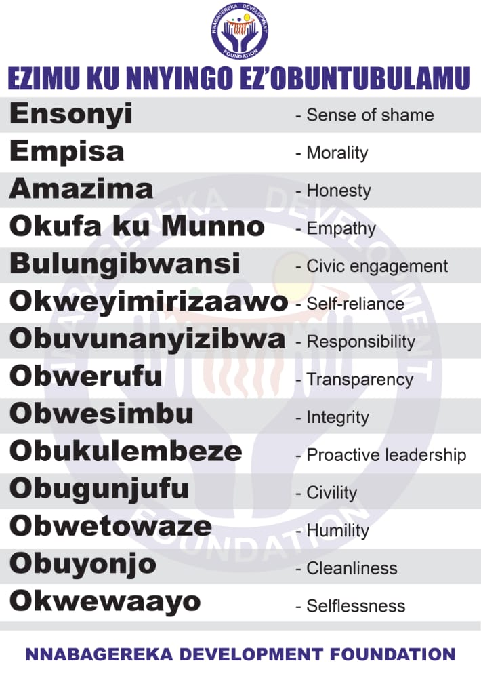
The message of obuntubulamu was also echoed by many participants in central region, a case in point, a female youth said:
Being combined with old women has helped us as the youth in this community to develop fear and to feel shamed about engaging in violent acts, morals in the community’. The activities in which we are engaged have a business army which limits us from being violent which can cause a loss. ‘We have rules governing us in the group and morals (obuntu) is one of them (Female FGD participant, Wakiso).

Using the different fora and approaches, it was found out that 685,800 (50% female; 50% male) young people were reached with peacebuilding information through awareness sessions, dialogues, other peace building events and social media engagement. Community awareness about peace building and human rights was also through training of 86 Radio presenters, 260 youth leaders were trained, 800 youths (50% female) were trained on community level mediation, early warning and conflict prevention and policy. There was also 50 South to South learning and exchange visits for target youth /peacebuilders.

In addition, in the survey, participants were asked about the kind of efforts/accountability that have been made by PBF project to enhance peace building and reconciliation process in the community. It was found out that PBF project had implemented activities related to; Youth/women economic empowerment livelihoods (86%), Peace messaging (37%), 31% and 30% reported sports for peace and curriculum inculcation of social values of obuntubulamu respectively. Other project activities included media training and engagement, youth inclusion in political dialogue and social media engagement, see table 5 below.

Table 5: PBF project Efforts for Peace Building and youth engagement
Efforts to enhance peace building | Frequency | Percent
Youth/women economic empowerment livelihoods | 362 | 86
Sports for peace | 129 | 31
Youth inclusion in political processes | 68 | 16
Media training on conflict-sensitive reporting | 82 | 20
Social media engagement for targeted peace messaging | 53 | 13
Curriculum inculcation for youths regarding principals of ‘obuntubulamu | 126 | 30
Peace messaging | 155 | 37
*Multiple response n=420

Also, the qualitative evidence alludes to the PBF project efforts meaning engagement and inclusion of youth in economic activities for peace and behavioural change as explained by a female participant
We girls used to think we are inferior that we cannot do anything but after this training, we discovered we can also do everything. We learnt different styles and designs of making door mats whereby at the end of the day, we sit and discuss on how best we do cuter door mats according to our customer demands other than just sitting home (Female FGD participant, Religious Group Namugoona Kampala).

In addition, sports and games were singled out by leaders in Rwenzori region and vital community peaceful existence and integration as explain by a district technical staff.
Yes, and this is because the youth who were involved in this project were selected from different Sub-counties, different ethnic groups, different religions and from different cultures. They were united in one place and were trained together and this is because the project was targeting bringing together the youth with the aim of building peace. Even in sports tournaments were organized and all tribes were given a green light to participate, even in most cases players from different tribes were found playing in one team and this helped to create harmony. (Probation Officer, Bundibugyo district)

Besides, youth were trained as trainers (62%), they participated in ccommunity level mediation (49%), Religious event (43%), Civic competence and empowerment seminar (24%) and cultural events (25%) as ways to empower youth and promote peace building and conflict resolution. However, national e-dialogues and digital safety training were the least attended targeting mainly youth leaders, as shown in table 6 below.

Table 6: Additional Youth Engagement Strategies
Additional Youth engagements | Frequency | Percent
Community level mediation | 206 | 49
Civic competence/empowerment seminar | 98 | 24
Training of trainers | 256 | 62
National e-dialogue | 7 | 2
Digital safety training | 11 | 3
Cultural events | 105 | 25
Religious events | 180 | 43
*Multiple response n=420

2.4.1 b) Livelihood for Peace and Vocational Skilling
One of the key components for sustainable peace building was concerned with community livelihoods. The PBF project had a novel strategy of livelihood and vocational skilling to empower young men and women to be in-charge of their lives and not engage in violence and conflict due to economic deprivation. The livelihood strategy was to enhance youth capacity on human rights including economic rights of descent employment and income. According the evaluation sought to assess the kind of livelihood activities and vocational skilling in which youth were engage in. The main livelihood and skilling were in was Financial literacy and business inclusion (74%), Industrial skilling (54%), farming/urban farming in small spaces (34%) and 27% learnt animal value chains management for agri-business. Personal skilling in media/ radio talk shows, and intergenerational dialogue were promoted for youth engagement, see table 7 below.

Table 7: Youth Capacity building activities
 | Capacity building activities | Frequency | Percent
1 | Industrial skilling | 228 | 54
2 | Intergenerational dialogues | 72 | 17
3 | Radio talk shows | 75 | 18
4 | Farming in small spaces | 143 | 34
5 | Financial literacy and business inclusion | 310 | 74
6 | Animal value chains management for agribusiness | 113 | 27
7 | Others | 27 | 7
*Multiple response n=420

The skilling of female and male youth was mainly in leadership (72%), negotiation and dialoging (49%), communication skills (36%). While the vocational skilling was concerned with small scale farming especially in urban areas, tailoring and hairdressing mostly for female youths, carpentry and welding for male youths, as shown in the table 8 below.

Table 8: Youth Knowledge and Vocational skilling
Knowledge and Skilling | Frequency | Percent
Tailoring + Hairdressing | 80 | 19
Carpentry | 45 | 11
Welding | 22 | 5
Urban small-scale farming | 86 | 21
Communication skills | 148 | 36
Leadership | 300 | 72
Negotiation & Dialogue | 202 | 49
*Multiple response n=420

The UNDP end of project report 2020 attested that youth were trained in a number of life skills namely; 105 hairdressing (98% female and only 2% male), Tailoring 106 (99 female and 7 male), 101 welding (91% male and 9% female), 98 Carpentry (13F:85M). Also, 71 male bodaboda riders (motorcycle taxis), 48 female street market vendors, 51 male mechanics/taxi operators were empowered. In addition to the survey results, observation revealed a number of livelihood activities youth engaged in as a drive for peaceful and productive young generation, see figure 7 below

Figure 7: Youth Skilling and Livelihood Activities
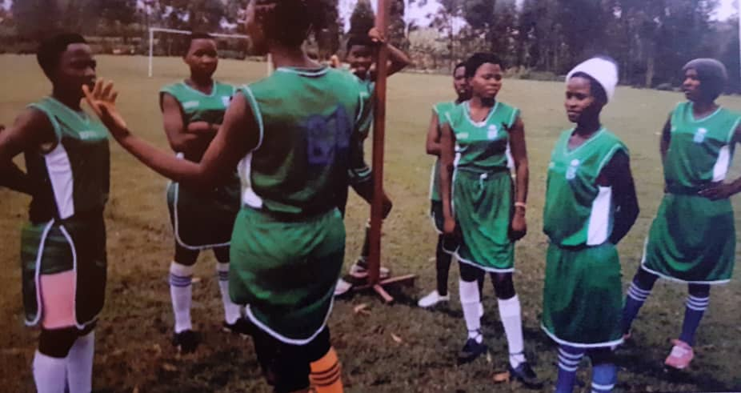
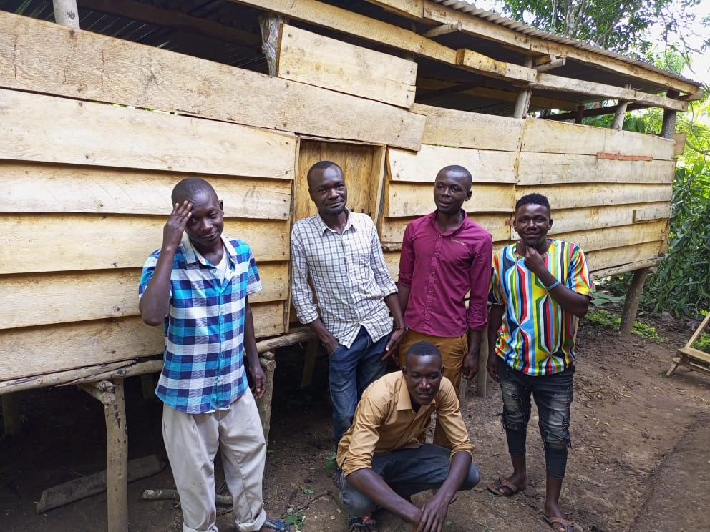
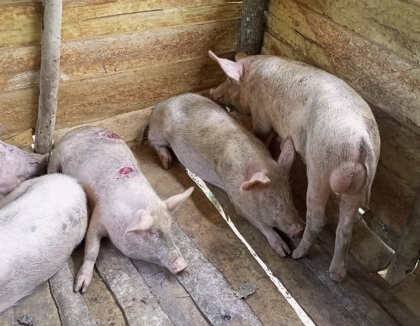
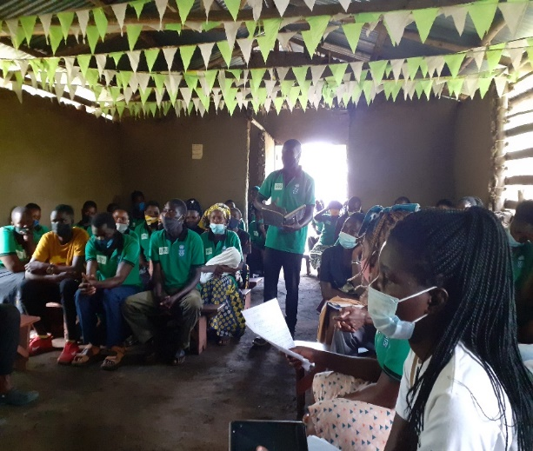

Some of the members of Bundibugyo youth entrepreneur carpentry group in front of their piggery project and
Members of Banyabindi youth SACCO during their AGM & Netball team of Kasese youth link in the field

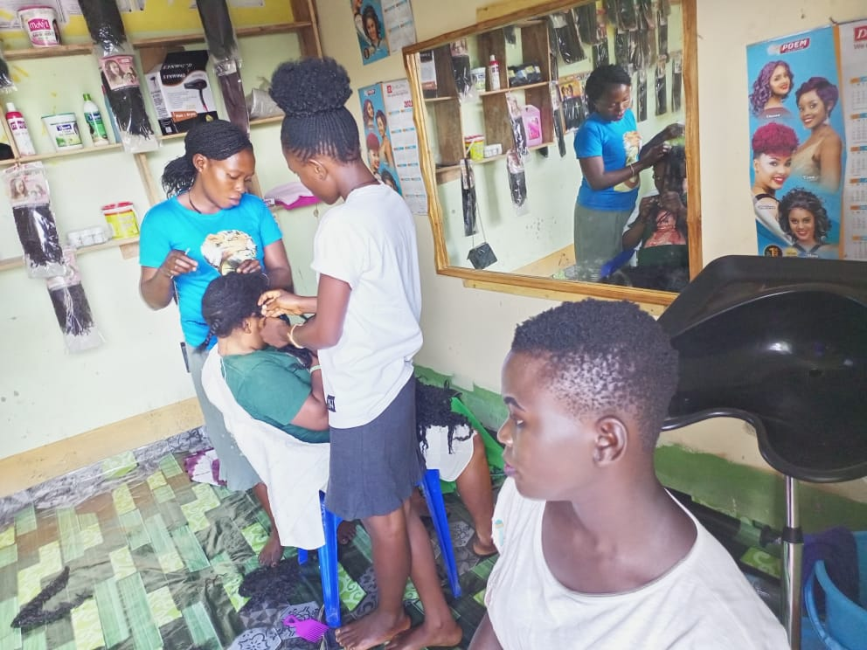
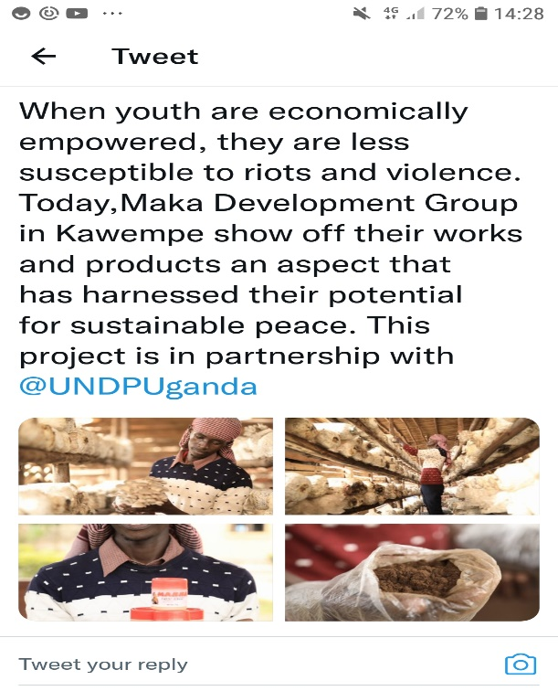
A Tweet by NDF

Bundibugyo Youth entrepreneur hairdressing group in their newly opened saloon

Likewise, the livelihood intervention beneficiaries narrated their experience:
Film production has helped us the youth and women to utilize our free time profitably and avoid by avoiding joining the company of people who trigger violence by gossiping and inciting others to fight. We now spend our time, writing plays, adverts and video recording local ceremonial for a pay (Male FGD participant, Youth Missionary group Kinawataka Kampala).

Project Results Under Outcome 2
Despite the delays in the implementation caused by the lockdown for over five months, between March and August 2020, caused by the COVID 19 pandemic in Uganda, it was reported that fourteen sub-activities under Outcome 2 were fully and successfully implemented. The outcome was concerned with: Mistrust between law enforcement and security agencies and communities is reduced by enhancing the strict application of human rights standards.

Institutional and Individual Capacity Building
The PBF project engaged a number of cultural and political institutions and leaders. It was revealed that 84 (50 for women and 34 targeting men) Civil society organisations (CSOs) and youth organizations were trained to monitor, report, raise and advocate on human rights concerns related to youth issues in the project four districts.

The UN also supported the Uganda Human Rights Commission (UHRC) with Information Technology (IT) and telecommunication equipment to establish three situation rooms in the Central and in Rwenzori sub-regions. The project support to the UHRC equipped the UHRC regional offices in Central and the regional Office in Fort Portal, Kabarole, covering the Rwenzori sub-region. The situation rooms enabled the UHRC monitor the human rights situation affecting the youth during the general elections of January 2021. The institutional infrastructural support included provision of ICT equipment’s (laptops, computers, printers among others) to enhance communication, advocacy and engagement of stakeholders on human rights issues and peace building. Similar support had been provided to the Wakiso District Human Rights Committee.

In relation to the outcome 2 of the project, the United Nations (UN) in Uganda implemented fourteen different activities that included the human rights training in the four districts of the project implementation for security and law enforcement agencies -particularly for the Internal Security Office (ISO) and for the Uganda Police Force (UPF)-, for with Human Rights Defenders (HRDs) and youth groups, and for the Wakiso District Human Rights Committee. The project funded the organization a high-level diplomacy meeting with the UN Resident Coordinator, political parties and senior representation of state institutions engaged in the electoral process 2020/2021. Among these activities, the project supported the Uganda Human Rights Commission (UHRC) to establish three situation rooms to monitor, report and advocate on human rights arising during the electoral process 2020-2021. The project also supported community dialogue between the youth and police in Wakiso Division, as well as the commemoration of the World Press Freedom Day by young journalists in Kasese district.

Specifically, the activities implemented under outcome 2 included; the human rights training in the four districts of the project implementation for security and law enforcement agencies -particularly for the Internal Security Office (ISO) and for the Uganda Police Force (UPF)-, for with Human Rights Defenders (HRDs) and youth groups, and for the Wakiso District Human Rights Committee, youth leaders, journalists and Human Rights defenders from the four districts. More specifically, five workshops for senior officers of security and law enforcement agencies were conducted on human rights issues. Overall, the project trained a total of 549 participants, out of which 190 were women (35 percent), and 359 were men (65 percent). These were acquired with knowledge on human rights concepts, on gender mainstreaming, on the rights of the youth, and on human rights standards applicable to security and law enforcement operations when engaging with the youth.

Additionally, under outcome 2, the project funded the organization a high-level diplomacy meeting with the UN Resident Coordinator, political parties and senior representation of state institutions engaged in the electoral process 2020/2021 and supported the Uganda Human Rights Commission (UHRC) to establish three situation rooms to monitor, report and advocate on human rights arising during the electoral process 2020-2021. The project also supported community dialogue between the youth and police in Wakiso Division, as well as the commemoration of the World Press Freedom Day by young journalists in Kasese district.
As soon as the COVID-19 situation and the elections of 2021 allowed to hold public meetings, the PBF project-built capacity of 98 HRDs and youth (33 women; 65 men) to report to the UN Human Rights Council, under the Universal Periodic Review (UPR). At the national level 5 policy dialogues were held. One larger national policy dialogue with 32 representatives from the National youth focused organizations was held in phase III after first conducting regional and local dialogues. The representatives included officials from Ministry of Gender, the Parliament and other national level youth network organizations reviewed messages generated from the G4G to come up with clear advocacy messages. Further, 23 young men and women had been engaged to review key actions from the G4G dialogues in preparation for a dialogue with parliamentarians. For example, 26 (11 female and 15 male) participated in national MP-Youth dialogue, 30 (8 female, 22 male) youth participated in Bundibugyo dialogue and 35 (15 female, 20 male) participate in Kasese. All these efforts were geared at individual and institutional capacity development to promote human rights and peacebuilding.

Additional qualitative evidences also attested to the individual and institutional capacity development for peace building. The following was stated by the head of department human rights during an interview;
The senior police to command including RPC, DPCs, OC stations, head of human rights in the regional OCCIDs, staff of professional standards unit, Crime Intelligence unit, officers were trained on a number of topics including; international human rights principles, procedure for arrest and detention, human resource and legitimate use of force during riots and demonstrations, Standard Procedures during interrogation, proper use of firearms, anti-torture principles, gender dynamics. The trainings were facilitated using highly participatory approaches including experiential sharing for participants and facilitators, review of case studies, case scenarios, and ICRC Videos. The trainings were very helpful as the police implemented the Order Management Policy and handling of suspects during the elections period and this skill still continues to be relevant as the police go on with their duties. This has gone a long way to avoid violence that is triggered by the police conduct.

The total number of participants in these human rights trainings was 549, out of which 190 were women, and 359 men and this contributed towards bridging the mistrust between law enforcement and security agencies and communities through enhanced strict application of human rights standards.
“For the first time in history, we had peaceful elections in Kasese and Bundibugyo”. An FGD participants in Kasese District”

It was reported that the interventions under outcome 2 reduced human rights violations in law enforcement operations that used to spark conflict violent situations by the youth.
“Because of the trainings received, we observe reduced violence cases which used to be a result of police behaviour while handling suspects” (Commissioner Police – Human rights Department).

Findings show that the implementation approach used in PBF project was appropriate and the best way of achieving the outputs in comparison with the other available alternative approaches such as national elder’s forum and the Interparty Organisation for Dialogue (IPOD), which are highly centralised with limited reach to the community and most vulnerable youth and women. These fora hardly focus on youth and women as core stakeholders in peace building and national development. The multi-dimensional strategy of the PBF project approach; with cultural, religious, political and economic empowerment of youth is one such model that needs to be duplicated, and contextually modified to enhance peace building and conflict resolution within and among communities in Uganda.

3.5 Efficiency
This section is concerned with how resources/inputs (funds, expertise, time, etc.) are converted into results and the extent to which the project’s input- output/outcome/impact ratio seem reasonable to deliver results in an economic and timely manner. The section further discusses the efficiency of the project design, project M&E mechanism, project management & coordination.

3.5.1 Project Design
There is consistency between the project 2 project outcomes and their corresponding outputs and activities and the evaluation appraises the design as it clearly articulates the relationships between the outcomes and outputs in the intervention logic reflected in the theory of change. The evaluation team observes that there is a clear inter-linkage between the 2 results areas. The progression from each outcome feeds into the other and thus at the design level this was well arranged. The design of the project on 2 outcomes was an efficient way of realising the project results and the clarity of the focus was the design strength of the PBF project.

The evaluation positively appraised the clarity of the project design with clear result areas translated itself to the field implementation approaches, implemented within the required time, resources and efforts. Though the design of the project does not state the overall goal which would translate into the project impact and corresponding impact indicators the project period, was short and thus measuring impact at this level would not yield results. It is important therefore to note that the design was sensitive about the time period for project implementation.

3.5.2 Project’s M&E Mechanism
The project design contains a results framework with clear indicators, indicator milestones, sources of verification, and the responsible party for data collection. The project partners (UNDP, UNFPA and OHCHR) benefited from the respective M&E departments of their organisations. UNDP the lead partner regularly carried out M&E reviews and consolidated this information and informed programming. The project however did not conduct a baseline study against which the partner targets would benchmark. This deprived the project an opportunity to have a solid learning to guide indicator and target setting as well as form a basis for the selection of the beneficiaries. It is important to note however that the inception phases of this assignment were vigorously conducted involving all project stakeholders. Coupled with the learning from previous UN peacebuilding initiatives, there was adequate information relied on to design the project and corresponding results framework. The stakeholder engagements at inception phases of the project before activities rolled out improved project efficiency as activities were adequately informed. This implies that there was adequate time and reflection to inform the design of project activities.

3.5.3 Project Management and Coordination
The coordination structures put in place to support the project at the country level was robust. At the strategic level was the country representatives from the three implementing partners i.e. UNDP, UNFPA and OHCHR. At the coordination level (UNDP), there was a project focal staff who coordinated the project activities of UNDP and the implementing partners. At Implementation partner level, the two partners i.e. UNFPA and UNDP worked with sub grantees i.e. NDP and IRCU while UNFPA worked with ACORD – U. OHCHR directly implemented activities and the partners helped in consultatively nominating participants for the activities as per the global OHCHR on project implementation. At community level was a network of community, cultural and religious structures that formed a strong network and linkage between the project and the project beneficiaries. These included Rwenzori Forum for Peace and Justice (RFPJ), Buganda Kingdom, Tooro Kingdom, Obusinga Bwa Rwenzururu, Obudhingiya Bwa Bwamba, Banyabindi and Basongora youth structures and relevant local government structures and district COVID task force committees.

At the implementing partner level, there was flexibility in adoption of partner specific management structures, staff and infrastructural support. The consultant commends the fact that the UN family worked together on a project despite the diversity in operational frameworks. Though different voices expressed concern about the long bureaucratic processes with UN agencies, this did not seem to have an effect on the project implementation as funds were directly dispensed to local partners i.e. for UNFPA and UNDP. OHCHR leveraged from the existing network of service providers existing in the organisations database to expedite payments for services. It should be noted that funds were dispensed directly from the UNDP account as OHCHR did not have a project account for this project. Though this affected the speed at delivery of activities, delays on project implementation was more to do with Covid.19 restrictions and effects of the election period.

In addition, a robust UN structure and operational systems were visibly a clear asset to the project. Regarding financial management, the project benefited from the financial management structures of implementing partners, following a robust finance management and procurement systems and this was indeed an asset to the project.

3.5.4 Utilization of Funds
According to the Joint UN PBF project monitoring report 2021, project report; out of a total budget of $2,487,750, UNDP as the lead UN Agency received $1,537,500 (60%), UNFPA $505,000 (22%) and OHCHR received $430,000 (18%) of the funds. The project funds were efficiently utilized with UNDP, UNFPA and OHCHR delivering 99%, 97% and 89% respectively, below is figure 8 showing the distribution and utilisation of project funds.

Figure 8: Project budget and utilization for IPs

However, OHCHR experienced major delays with a current delivery of 74% coupled with a myriad of implementation challenges mostly to the outbreak of the COVID19 pandemic and the strict control measures instituted by the Government of Uganda to manage the pandemic. It is important to note that, unlike other UN agencies, OHCHR can only implement the activities in a modality of direct implementation, without bank transfers to the implementing partners. And that the majority of activities assigned to OHCHR in the PBF project involved public gatherings, such as the community Barazas and the dialogue processes between police and youth groups. The implementation of these activities was mainly affected by the Presidential Directives on COVID-19, which banned public meeting for long periods of the project implementation, and by the electoral period 2020- 2021, as the Uganda Police Force (UPF) had to prioritize the security deployments related to the electoral campaigns and to the holding of the elections, rather than to engage in the activities planned under the PBF project.

Worth noting, the project was partly affected by delays in release of funds especially for the last batch of disbursement. This was due to the bureaucratic process of UN agencies to approve and release funds. For example, one staff of implementing stakeholders said that:
The project involved 3 UN agencies, each agency had different rate of implementation of activities. However, disbursement of project funds was in trenches. The first trench and the subsequent implementation of activities determined the next disbursement. However, some agencies had low implementation rate, we had to wait for the next disbursement for all agencies to be at the same level and due for disbursement. We had to wait a bit for the 2nd and 3rd disbursements, this had a negative effect on how we also disburse money to implementing partners and stakeholders (Staff UNFPA Uganda).

The same challenge was also reported by the implementing partners as below:
UNDP delays to fund yet they expect much in a short period. The project was short, they say project was catalytic (instantly), we had little time though we did the activities but we achieved by the help of volunteers who came on time, but we were in a hurry. (Tuhaise Francis, Executive Director, RFPJ)

It was noted from UNDP that UNDP releases funds quarterly based on partner’s submission of proper accountability and supporting documents. The accountability submitted should be not less than 80% of the previous funds released. It was thus noted that the delay in disbursement of funds was due to the fact that partners at times did not meet this requirement and so the delays in the next tranche release. On a good note however the delay in disbursement of funds did not significantly affect the delivery of project outputs as highlighted in the previous section of effectiveness.

3.6 Project Impact/outcomes
It was not easy to measure the impact for such a short time project. However, the evaluation focused on tracing the project outcomes. The PBF had two Outcome 1: State and civil society actor decision-making processes are more inclusive by enabling proactive participation of youth as positive agents of peace in political, and peacebuilding processes. Outcome 2: Mistrust between law enforcement and security agencies and communities is reduced by enhancing the strict application of human rights standards. The evaluation revealed outcomes at IP levels and implementing stakeholder involving knowledge management and sharing, and outcomes at the beneficiary’s levels among others. We also document the positive and primary outcomes as well as the unintended short and long-term effects produced by the project.

3.6.1 Knowledge Management and Knowledge Sharing
- PBF supported the printing and publication of Wakiso District Human Rights Committee First Annual Human Rights Report 2020.
- The research, production and publication of a Rapid Assessment Report on Youth and Peacebuilding in Uganda 2020 by UNFPA. The rapid assessment report is now a public resource for anyone to use on youth and peacebuilding in Uganda, refer to this link: https://uganda.unfpa.org/en/news/increasing-youth-inclusion-peacebuilding-uganda
- Social media engagement/ on online platforms; three of IP and implementing stakeholders such as ACCORD, IRCU and NDF website, Facebook accounts and Tweeter handle, and other social media platforms are real time tool for disseminating peace messages to youths and the general public.
- Foundation for Human Rights Initiative authored and finalizing the Post-election Report 2021, this is an indirect contribution of the PBF, where the human rights defenders who were trained with funding of PBF project have contributed to writing this report.
- Knowledge sharing and peace messaging through music; MalalaUG ft Jaffer’s peace lover song: https://t.co/hzMtOsSR9x, the song will continue to be played and shared with a call upon young people to center their world sharing #peace in a song titled

3.6.2 Outcome at Implementing Stakeholder
- Institution infrastructure capacity building, the PBF empowered project stakeholders with ICT equipment such as computers, laptops, printers and internet connectivity, under Outcome 2. This was most reported by Wakiso District Human Rights Committee.
- Increased awareness of human rights among implementing partners and government agencies including government security agencies and media personnel.

3.6.3 Outcomes at Beneficiaries Level
- Vocational Skilling and Livelihood
The PBF project strengthen the livelihood and vocational skilling of female and male participants. Youth were support financially, mentored and skilled in a range of livelihood enterprises were namely bar and liquid soap making, piggery, tailoring, hair dressing and urban agriculture among others.
In the past before I used to spend more time watching soccer and participating in gambling but as of now as we speak, I have much to do on the farm that I even don’t ever think of soccer. I even spend more time in making research for example we were taught to visit a website called calculator and inquire anything from there such as how can I mix food for pigs, how to construct a pigsty and indeed I have learnt much from it (Male FGD, participant, Religion group, Namungoona Kampala).
In addition, there were a number of case studies that testified about skilling and livelihood project impact, below is a summary of some of the case studies for skilling and livelihood:
My name is Biira Mutabali Beatrice 29 years old and I am the Secretary Bundibugyo Youth Chapter. The peace chapter has helped us in Bundibugyo because for my case I never knew there is peace in the world because I thought fighting is good. But when RFPJ came we were taught many things, we learnt how to start business, we learnt how to promote peace, keep peace in the community, keep peace in our homes and keeping peace in the world. We started this youth peace chapter when we were 17 but currently we are more than 100 in the youth peace chapter. Madam Fosca from RFPJ taught us that when you get 20,000 shillings, you can start business and end up getting 1,000,000 shillings. Many youths disagreed and were asking how but for my case I tried it. I used 20,000 to buy “John Black” (small long fish) and started selling, so when I went back for a meeting with RFPJ, I was given another 20,000 shillings which I used to buy more “John Black”. After sometime I started buying Cocoa and left the John Black business, I sold Cocoa for some time and got capital of 500,000. So I used this money to start a mobile money business and every month if I get less it is always 150,000 shillings but when business is fine I get between 200,000-300,000 shillings monthly. That is the greatest achievement from the Peace Chapter. Currently even if I need money to go to the saloon I just use the one I earn, I cannot ask anyone for money because I am currently earning. If it was not RFPJ, I think by now I would be still dormant and very idle

I am Nganda Ibrahim, a resident of Kakiri said I used not to value my wife for example, I could order her to carry my and her hoes to the garden, on our way back, she carries the two hoes, a child on the back plus firewood and some matoke on her head as I walk freely carrying nothing. When we reach home, the wife is supposed to take water in the bathroom, cook for us, as I sit under the tree relaxing or drinking. But as per now, because of PBF through their organized seminars, workshops they taught us the rights and value of women and rights of women, I now resorted to doing everything jointly as husband and wife and I really sees everything is moving smoothly and we are living peaceful and happily.

- Youth Capacity Development and engagement
- Increased youth and women engagement and involvement in political and economic decision making and electoral processes, including in the previous national and local government elections 2021. For example, IRCU reported that youth are now represented on the IRCU Board of Trustees. This was also emphasized by most key informants for instance,
We mentored and empowered over 40 Youth to actively participate in political leadership and 32 went through. I.e. the Speaker Fort Portal Tourism city is our chairperson Kabarole peace chapter. Chairperson LC Kitswamba sub-county in Kasese district is also a member of Kasese peace chapter, the mayor Hima town council is also a member of the Kasese peace chapter. We also have female and youth councilors who are peace chapter members from the Kasese, Kabarole and Bundibugyo districts (KII, Peace building specialist RFPJ).
Another leader in Rwenzori region underscored the relevance of youth and women inclusion in political affairs of their community. This create a peaceful environment as young people take part in decision making through their leadership.
It changed the youth positively in that in our recent concluded elections all can testify that we had a lot of peace. These youths had been trained by RFPJ about peace building and they were given hope so they did not get involved in chaos. Youths have been encouraged to actively participate in different positions so they felt good being involved. Even the L.C 3 Mayor is now a youth and his success are attributed to the work of RFPJ groups. (Community Development Officer, Hima Town council Kasese).

- Within the community, there is increasing level of mutual respect and mutual existence amidst the multi-ethnic settings. This was mainly revealed in Rwenzori region which has had historical ethnic conflict. The PBF project has tried to build the capacity of youths for peaceful-mutual existence and respect. In case one Female youth reported that:
As me Kess (Pseudo name) before being trained by RFPJ on peace, I would not take the people of Kasese, the Konjo as human beings, I used to hate them a lot and I would see them as people who kill. But ever since I received the training on peace by RFPJ, I changed and now I can interact with them freely, and I can easily get married to a Mukonzo (Female FGD participant, Bundibugyo Youth Chapter).
In the same way, another project beneficiary explained the transition to behaviour change:
In the past I used to contest a lot for different positions and they could win me, so I could mobilize some youth to cause chaos. But when RFPJ came with the peace message, I accepted to change and even changed the behaviors of my fellow youth. So, when I contested recently I even won and I am a counselor at the district and this came after taking the peace message (Male FGD participant, Kasese Youth chapter).

Below is a case study highlighting the role of sports in influencing peace building;

My name is Kabachurezi Mary, 18 years old and I am a footballer from Bundibugyo from a village called Busaru. Since Rwenzori Forum for Peace and Justice started its activities in the area, there has been many peace keeping initiatives which have been put in place and one of them is promoting sports for peace keeping. There has been a lot of conflicts and chaos in the region but ever since the project of peace keeping was introduced the place has been a bit stabilized. I am a youth and we grew up playing football as girls, so this is a unique talent and when RFPJ came to Bundibugyo, it was looking for some youth to be peace ambassadors so under sports our team was selected and my coach selected me so I was registered. By then we were playing for Harvens High School.

I was trained on how to live peaceful and how to promote peace through playing football. I started playing football since I joined school so I started meeting different people while I was still young. So, when RFPJ introduced the peace project, at school we had the Bakonzo and also the Bamba, so through this peace project we formed one team which involved players from the two tribes and even other tribes like the Batoro. So, when we started going for tournaments we were united and even we had stopped fighting each other. The peace project trained us on how to live in a peaceful world through having regional tours for example we used to move from Bundibugyo to Kabarole to play and this helped to be engaged with many other people from different places. Our team is comprised of mostly ladies so women have participated more in peace building.

- Increased youth awareness of peace message through media, cultural leaders, religious leaders, music and sports. Peace messaging through music reaches many young people and the general public. For example, the 2021 Peace Day under the #PEACEDAY2021, MalalaUG ft Jaffer under the Harnessing Youth's Potential Project calls upon young people to center their world sharing #peace in a song titled peace lover, see link for the song https://t.co/hzMtOsSR9x
For instance, the project reached 57 (28 male and 29 female) musicians and celebrities, 37 non-traditional artists were trained in Kasese on peace building. This was in addition to the 20 artists consisting of musicians, comedians and music producers reached in Kampala

In addition, sports such as football and netball were used to reach Uganda people with peace building message. The NDF for instance implemented the County Football tournament and netball: the Malala youth group in Busega. #sports4peace receive the netball equipment, see link https://t.co/ZOjXh1tr6j. The county football tournament was broadcast on TV and radio stations with a wide reach of over a million audience. It was noted that a number of coaches, ex-players & cheer-leaders were trained on peacebuilding integration in sports, with over 1,000 youths reached through sports activities. In figure 9 below is also an example of youth who were engaged in sports for peace in Rwenzori region.
Figure 9: Sports for Peace Activities
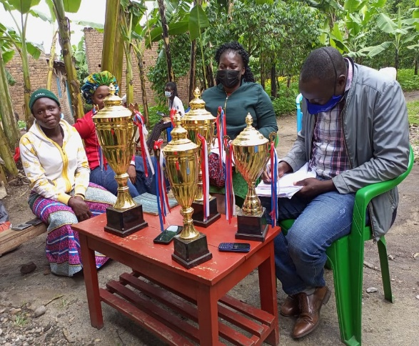
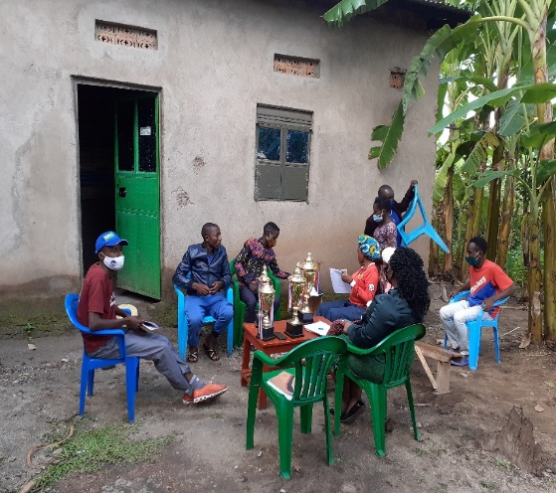
Members of Kasese Youth link group showcasing some of the triumph’s they won during the sports gala organized by RFPJ

Negative Outcomes
- The project was only implemented in 4 districts and among a few youth and women, As a result, this created some form of discrimination against majority of youth who were not targeted; did not benefit from project interventions especially livelihoods and vocational skilling. Youth leave in social web however, when one group is target and leave out the rest, it paints a bad image. This is not only unique to the PBF, but all project because they can reach everyone, including government programs.
- The project worked with youth and women through local implementing partners that had previous working relationship with UN IPs or institutionalized stakeholders. This left out informal and less institutionally strong local community based organisation and association, yet they have strong community base to influence youth behavioral changes.
- The PBF project was mainly centered in the urban and peri-urban areas of central and Rwenzori communities of Uganda. The Project left out the remote and rural areas which have strong traditional customs and beliefs some of which have a bearing on historical ethnical conflicts and ethnic stereotyping. For sustainable peace building, the project would have balanced her catchment areas in both urban, and remote and rural areas. This is critical because for every urban youth, they have a strong linkage and attachment to their rural heritage.
- The misconception of IP facilitation during capacity building activities. Participants especially from government agencies expressed concerns that the UN policy of facilitation of participants in capacity building activities was rather below their expectations. It is important to note that the evaluation consultant verified that payments for transport refund and Daily Subsistence Allowance (DSA) are calculated in implementation of UN policies and based on the Agreement between the Government of Uganda, and the Local Development Partners Group (LDPG), which is signed by the UN Resident Coordinator on behalf of the LDPG. The calculations of the transport refund are done on the basis of the distance between the duty station of the participant and the venue where the workshop was conducted. After review of some payment sheets of workshop participants, it was discovered that the payments indeed differed based on distance and complied with the UN policy on facilitation of workshop participants. Despite the UN principle on the facilitation of local partners, there was misconception of this principle. This created a negative attitude among government agencies towards UN project facilitation.
- Some government agencies were uncomfortable with the OHCHR approach of direct implementation of project activities. In the case of outcome 2 under OHCHR, the implementation was directly done by the same UN agency, through collaboration with the Implementing Partners (IPs), who provided list of participants to organize the different workshops and activities under the PBF project. Though this appear a deviation from the other UN partners, it is important to note that this is the global policy of OHCHR while dealing with local implementing partners.

3.6.5 Innovations and Factors for PBF project success
- Working with partners and stakeholders with strong community and regional structures: cultural religious and social structures. This helped to have mileage with project buy-in, mobilization and engagement of youths and women, as well as community and cultural leaders. In addition, local stakeholders engaged local government staff to support livelihood projects and capacity building of youth and women.
- Working with implementing stakeholders with previous experience of UN systems; the project was enabled by the excellent relationship of implementing partners and stakeholders built over time. This facilitated the smooth and faster implementation of activities with the shortest time possible, as well as following UN reporting systems and guidelines with ease. The previous working relationship among project IPs and implementing stakeholders was strengthened with mutual objectives on the issues of human rights and youth engagement. The project tapped into the strengthen and resources each partner to deliver on the project outputs and outcomes.
- Strong partnership and linkages with local government structures at districts and sub-counties to sustain the project outcomes. This has created more community ownership, accountability and transparency for sustainability, a case in point is the Buikwe WELL farm established by IRCU to enhance young livelihoods for peace.
- Integration of youth passions and talents for peace helped to reach many youths for mindset changes. For example, the implementation of sports for peace and music for peace by NDF helped to mobile many youths for peace messaging.
- Integration of ICT innovation and other non-conventional implementation strategies especially leveraging on key social media and other online platforms helped to have a wide geographical reach of youth and the general public not only in Wakiso, Kampala, Kasese and Bundibugyo, but the entire country.
- Targeting of youths and women small and informal sector groupings such as market vendors, Bodaboda, Ghettos and sports helped to ease mobilization, youth participation and continuity of the project outcomes. In additional the responsiveness to youth issues through community follow up activities helped a lot in learning and improvement.
- The PBF project implementing stakeholders embedded the cultural values and religious values in their implementation: the traditional kingdoms (e.g. obuntubulamu) and IRCU and her subsequent community structures respectively.
- Livelihood for peace: A hungry stomach Never listens said one leader at NDF. This helped to keep the youth committed and busy with their enterprises.

3.6.6 Unintended PBF project Outcomes
  - Under the livelihood project activities; IRCU initiated the livelihood activities for young people under the flagship of the WELL model: WORK and LEARN Center in Buikwe district (Paradise farm). With the complementary support of Government of Uganda Operation Wealth creation and the Emyooga program support, the center now has over 200 young people empowered in various enterprises such as farming, rabbit raring, piggery, carpentry and poultry among others
  - Implementing stakeholders also reported the have benefited through institutional capacity building. UN agencies helped partners to strengthen their financial reporting, reporting and Monitoring and evaluation systems through technical support, back stopping
  - Increase in the number people seeking the services of district human rights committee at Wakiso. For example, in 2020 20 cases were reported. This year 2021, by September 50cases were reported including high profile leaders in district. The strengthen capacity of Wakiso District Human Rights committee has enhanced the demand for services by the public.
  - Some implementing stakeholders have had increased partnership with development partners. For instance, Wakiso Human Rights Committee was empowered and now has prospective partnership with USAID, CSOs such as NCHRD, ACCORD and Food Rights Center. In addition, Wakiso Human Rights committee is now a learning and knowledge sharing structure inspiring as districts such as Kampala, Kaliro, Ibanda and Jinja etc. that have shown interest to also establish human rights committees in the respective districts.
  - The cultural Bootcamp (Ekisakatte) concept which is implemented by NDF in Buganda Kingdom, is now adopted by other kingdoms such as the Tooro Kingdom and Obudhingiya bwa Bamba to promote human value, peace building and youth empowerment.
  - Continued human rights advocacy through youths and human rights defenders that were trained by PBF project capacity building support. For example, a staff at The FHRI narrated that:
With respect to the people we trained, some continue to provide us with vital information on human rights in their regions including information about election and post-election violence and human rights abuse. This helps our advocacy work in the media and other forum (Leader at FHRI Uganda).

3.7 Sustainability and Innovations: Best Practices and Lessons Learnt
This section includes strategies for continuity of project gains, institutional capacity of partners to sustain the positive impacts of the intervention beyond the PBF project cycle lifetime. It also describes the best practices and lessons learnt for institutional learning and accountability. In view of the above findings, the following best practices/lessons learnt are worth noting:
- One UN working Together (UN inter-agency project); despite the difference in the implementation approaches, the PBF project attested to the high-level cooperation and integration of project activities among the UN agencies (UNDP, UNFPA and OHCHR). Hence, the PBF project is a model example of UN delivery as one: ‘UN agencies as One’
- Outcome 1 of PBF project was implemented using the existing structures of implementing stakeholders such as IRCU structures (District Interfaith Committees, Interfaith Action for Youth and Children, Youth of Faith for Peace- Yo4P and Regional Peace and Stability Forum), NDF, UHRC, RFPJ and traditional kingdoms in Buganda and Rwenzori regions among others. These structures are vital for easy project buy-in, public legitimacy, trust and confidence for participation in project activities, and subsequent sustainability of the project outcomes. This noted by most participants in the FGD, for instance:
Local leadership approach is another approach that we use to reach out to the community, the area LC chairperson, secretary for the Youth, secretary for Women and secretary for Defense have been our frontline person when we want to mobilize the youth and women for PBF activities are approached while conducting trainings and during sensitizing the community on peace and conflict. The women leaders with in the community organize and conduct counselling sessions for young people in the community on life skills and human rights and we used the Mbuya outreach gardens (FGD Participant, Kinawataka Kampala).
- Livelihood for peace was vital to meaningful engage young people, change of mindset and trigger them for economic development instead of participating in violence. Peace building as both software (values-mindset changes) and hardware (livelihood) intervention. For example, through livelihood activities IRCU started the livelihood activities for young people under the flagship of the WELL model: WORK and LEAR N Center in Buikwe district. The youth livelihood groups have a good working relationship with district technical staff for further mentorship and support supervision, for example in Kasese the CDO support these groups as noted below:
Linking these groups to other government structures it was for sustainability. For example, the CDO of Bundibugyo district is a signatory on these group Bank accounts, before they do anything they first consult him, and can link these groups to other opportunities in local government (Peace Building Specialist, RFPJ).
- Peace building through sports and music created reached more young people. Music and sports are attractive to youths and even continues after the project cycle. For example, the peace messaging at Masaza Football tournament (Bill Board) and Peace Love Song by Malala x is shared on different social media platforms with several views and likes.
- The integration of ICT innovation and other non-conventional implementation strategies especially leveraging on key social media and other online platforms will continues even after the project lifecycle. Due to COVID19, implementing partners innovatively created WhatsApp groups to reach young people with peace messages, a case in point:
Was were able to form a WhatsApp group for the youth and that is where we pass most of the information about peace and God. Because of Covid-19 we found WhatsApp as the easiest way of communicating with the youth faster (Youth Pastor, Kagandu Hospital, Kasese district).
Additionally, as part of sustainability, there was hand- over of IT equipment by the PBF project to the UHRC to equip the UHRC Central Office, the UHRC regional Office in central region, and the UHRC regional Office in Fort Portal, Kabarole, covering the Rwenzori sub-region.
- Formalization of youth livelihood informal groups; It was revealed that most youth groups were supported registered as Community Development activities for continuity. The NDF supported over 17 groups to be registered as CBOs. Likewise, in Rwenzori region:
Support formation and registration of youth groups. Twenty-one groups of livelihoods have now been registered as Community Based Organizations and they now have their own structures (Tuhaise Francis, the Executive Director, RFPJ).
- Involvement of district local governments – to take up the skills groups, youth peace chapters, vocational youth skilling centers, and dialogue platforms.
- Vigorous stakeholder meetings at the inception phases of the project helped to have all the stakeholders have an input into project design. This also helped to create ownership of the project by all the stakeholders that were involved into implementation.
- Deliberate enrollment of female youth into project implementation gave an opportunity for them to engage in project activities and accelerated peace building in the communities.

Project Challenges: factors affecting the achievement of intended results
In this evaluation we noted some challenges that affected the achievement of intended project results; the challenges are structured at IP level, Stakeholders implementation and Beneficiary level.
- All implementing partners, stakeholders and beneficiaries reported of COVID19 Pandemic and the subsequent national wide lock down. The challenges of COVID19 pandemic and the restrictive movements of the first (March-July 2020) and second lockdown (May-September 2021) - with continuity of the limitations to organize public meetings and gatherings in the periods in between the two lockdowns- hampered the time delivery of project activities. For example, due to the restriction on movements and Standard Operating procedures against public meetings (community Barazas), conferences and gathering, some planned activities where not implemented as planned.
- Project Life Span; all implementing stakeholders decried the short life cycle of the PBF (only 18 month). The approach of projectization of complex social and political issues such as peace -building and conflict resolution leaves a lot to be desired. Partners felt that 18 months was a very short period to have vivid impact of the complex issues of peace -building and conflict resolution (behavioral changes and mindset change) which have historical, social, ethnical and political implications.
- The timing of the project in the pre-2021 election, during and post-elections. This was a very tense and sensitive period to implement some activities especially on human rights issues, civic competence and youth engagement. One key informant narrated that:
Gathering young people was very hard. What was happening during the elections (human rights violations and violence) was contradicting the peace messaging we were doing to young people. The pain that comes with choosing the path of peace. This could be seen in the faces of young people. It looked as if it is the path of the weak ones, yet it is the path of the brave and strong ones (Program Manager IRCU Kampala)
Worse still, some government officers misconceived the project activities as mobilization in support of the opposition political parties as well as reporting of human rights violations. The election period in Uganda also affected project implementation resulting in postponements of various activities.
- Differences in the implementation modalities/approaches of the UN agencies. While, UNDP and UNFPA directly transferred money to their implementing stakeholders, OHCHR global policy on working with implementing partners is different. This resulted in differences in implementing stakeholder’s perceptions on the level of satisfaction with the projects` meeting all their expectations.
- Dealing with the complexity of youths in diversity was not easy especially in urban areas of Wakiso and Kampala. Youth are a diverse category (youth in Ghettos and informal sector youths) with varying demands of livelihoods, social-psycho issues to be mobilized for engagement in complex issues of peace building and conflict resolution within a short time of 18 months.
- Delays in disbursements due to incomplete accountabilities and supporting documents leading to delays in the next tranche release. This delayed implementation of some activities for some project partners as explained in this report.
- Short project life cycle with disruption of COVID19 and elections; this created work overload of implementing partner’s staff within a very short period of time.

    - Beneficiary level
- High community expectation and the projectization mindset where community members always look at project as avenues of handouts and financial relief for their unmet livelihood and basic needs.

RECOMMENDATIONS
4.2 Primary Beneficiaries and Intervention Strategy
- Youth passions and talents are serious avenues for mobilisation and youth engagement in livelihoods and peace messaging. As a results peace building and conflict resolution programs should continue to tap into youth passions and talents; strengthening investment in youth talents for sustainable peace. For example, Football for peace, music for peace and other talents that are within the natural endowments of young people.
- Livelihoods interventions are good at refocusing energies of the youth into productive engagements. Future interventions should leverage this approach.
- Uganda has a strong network of cultural and religious institutions that are deep rooted at the grass root level. Targeting these institutions for community mobilisation is a sure way of reaching the intended groups of the communities. The youth are also considered as active members of these cultural and religious institutions and past violent situations that are culturally motivated were sparked by the youth. This is evidence that targeting the youth in such a cultural setup through the cultural institution is a good strategy on peace building programming.
- The reality of porous borders for Kasese and Bundibugyo should be considered during programming for such cross-border districts as the conflicts usually affect communities across the borders.
4.3 Government Level
- The youth livelihood and sports groups formed household be taken up by the existing government community support programs such as Emyooga, Youth Livelihoods Program and or absorbed in the parish development model interventions under NDP III.
- Peace and stability and governance are a national duty of the government. Thus, there is need for the government to prioritize all processes of peace building and good governance at local levels. Government need to go beyond legislation and policy formulation to engage the communities (local solutions for peace) in peace building through multi-sectoral approach. Including periodic monitoring of these processes.

4.1 UN Agencies Level
- Due to the short time period of the project implementation, and the short time period of the evaluation, there is need to commission further impact evaluation after some period of time to comprehensively assess the actual impact of the project in the implementation sites but also at the national level. The impact evaluation will help to ascertain the net impact and attribution of the PBF project.
- It was noted that peace and peace building is a complex process that requires a long time of project implementation for effective behavioral change of local communities. Future peace building programming should cater for a long period of time like at least five years.
- The evaluation revealed a delay (bureaucracy) in transfer of funds to implementing partners, yet the project had a short lifespan. Future UN project implementation should cater for efficiency in her financial systems vis-à-vis the life time of the project.
- To address the issues of misconception of OHCHR implementation approach and payment for facilitation to implementing partners, in future UN agencies should effectively engage government agencies about this principle at the inception of the project and address unrealistic expectations and misconception from onset.

REFERENCES
- Bukenya, B, Omala, SK, Kasirye, R and Miranda, J, 2019. Do revolving funds generate self-employment and increase incomes for the poor? Experimental evidence from Uganda’s Youth Livelihood Programme, 3ie Grantee Final Report. New Delhi: International Initiative for Impact Evaluation (3ie).
- NPA. 2020. Third National Development Plan (NDP III) 2020/21-2024/25. Kampala, National Planning Authority.
- NPA. 2015. Second National Development Plan (NDP II) 2015/16-2019/20. Kampala, National Planning Authority.
- UNDP. 2021. Request for Proposal terms of Reference: UNDP/UGA/RFP/2021/008. Kampala. United Nations Development Programme (UNDP).
- UNDP. 2021. PBF Joint Monitoring Report April 2021. Kampala, UNDP, UNFPA and OHCHR.
- UNDP. 2020. PBF Project Progress Report Country: Uganda 2021. Kampala, UNDP, UNFPA and OHCHR.
- IRCU. 2021. Harnessing Youth Potential for Sustaining Peace in Uganda Project 2020-21: End of Project Report. Kampala: Interreligious Council of Uganda (IRCU).
- UNFPA. 2020. A Rapid Assessment Report on Youth and Peacebuilding in Uganda. Kampala: United Nations Population Fund (UNFPA).

APPENDICES

Appendix 1: Terms of Reference

Appendix 2: Youth Survey Questionnaire

Appendix 3 & 4: Key Informant Guide: Implementing Partners and Stakeholders

Appendix 5: FGD Guide

Appendix 6: Case Study Guide

Appendix 7: List of Key Informants

Appendix 8: Number of FGD by District

Appendix 9: Results Framework

Sample Size Calculator, https://www.surveysystem.com/sscalc.htm
Sample Size Calculator, https://www.surveysystem.com/sscalc.htm
Third National Development Plan (NDP II) 2015/16 -2020/21 National Planning Authority
Third National Development Plan (NDP III) 2020/21-2024/25, National Planning Authority
Model positions the PARISH as the epicenter of multi-sectoral community development, planning, implementation, supervision and accountability.
Youth Livelihood Program is implemented in all the Local Governments and Municipal Councils in Uganda overseen by the Ministry of Gender, Labour and Social Development (MGLSD).
End of project Partner Report, OHCHR July 2021

