ECONOMIC GOVERNANCE FOR GROWTH

FINAL EVALUATION

October, 2021

Project information

Project title | Economic Governance for Growth
Atlas ID | 00113375
Corporate outcome and output | UNDP Strategic Plan 2018-2021, Outcome 2, Output 1.2.1
Country | Bosnia and Herzegovina
Date Project document signed | 1 December 2018
Project dates | 1 December 2018 | 30 September 2021
Project budget | USD 2,399,114.00
Project expenditure at the time of evaluation | USD 1,593,858.32
Funding source | The Kingdom of Norway
Implementing party | UNDP

Author: prof. dr Nedim Čelebić

Table of contents

Table of contents 3
List of Figures 4
List of acronyms and abbreviations 5
Executive summary 6
1 Introduction and overview 15
2 Description of the intervention being evaluated 17
3 Evaluation Scope and Objectives 22
3.1 Purpose 22
3.2 Objective 22
3.3 Utilization 22
3.4 Scope 23
4 Evaluation approach and methods 24
5 Evaluation Findings 25
5.1 Relevance 25
5.2 Effectiveness 31
5.2.1 Overview of Project Indicators 31
5.2.2 Output 1 - Increased entrepreneurship capabilities for economy of the future 35
5.2.3 Output 2 - Private sector development enabled by conducive governance frameworks 39
5.3 Efficiency 41
5.3.1 Project Management 41
5.3.2 Budget execution overview 42
5.4 Sustainability 44
5.5 Impact 50
6 Conclusions 53
7 Lessons Learned 58
8 Recommendations 60
Annex 1 Interview Guides 65
Annex 2 List of Interviewees 72
Annex 3 List of Documents 74
Annex 4 Results and Resources Framework (Project Application Results Framework) 75
Annex 5 Evaluation Matrix 77
Annex 6 Project Budget Execution 85

List of Figures

Figure 1 EGG Theory of Change 18
Figure 2 Project Outputs 21
Figure 3 Presentation of start-up projects 26
Figure 4 Increased entrepreneurship capabilities - activity results 37
Figure 5 STEAM education simulation 38
Figure 6 SMART classroom 46
Figure 7 Visit to University of Sarajevo 49
Figure 8 Entrepreneurship barriers - panel discussion 52
Figure 9 Project results presentation to donors 59

List of acronyms and abbreviations

BIH | Bosnia and Herzegovina
FBiH | Federation of Bosnia and Herzegovina Entity
RS | Republika Srpska Entity
CPD | Country Programme Document
EU | European Union
GDP | Gross Domestic Product
MSMEs | Micro, small and medium enterprises
SDGs | Sustainable Development Goals
STEAM | Science, technology, engineering, arts and mathematics
UNDAF | United Nations Development Assistance Framework
UNDP | United Nations Development Programme
UNEG | United Nations Evaluation Group
EGG | Economic Governance for Growth

Executive summary
This report presents the final evaluation findings of the The Economic Governance for Growth project, financed by the Kingdom of Norway and implemented by UNDP. Project is designed to contribute to economic growth and entrepreneurship development, improving economic governance and fostering the growth of market-oriented capabilities for a knowledge-based economy in BiH.
EGG was evaluated based on the DAC evaluation criteria, relevance and coherence, effectiveness of implementation (based on project indicators), efficiency, impact and sustainability. Other components covered in the evaluation were: gender equality and inclusiveness as cross-cutting themes. Within the various evaluation criteria, aspects of ownership of stakeholders at different levels and potential for scaling up and replication were analysed. UNDP’s results-based approach to capacity measurement assisted the evaluation process in measuring development results within the context of capacity development. Desk research of various project documents, consultation with a number of stakeholders and available quantitative data provided the background context, and enabled enlisting of the achievements under EGG. Interviews also helped highlight the challenges that still plague the operating environment of the project in the target operational area. Based on the evaluation findings, the recommendations and way forward have been postulated.
At the Outcome level, the Project worked on improvements in economic governance by partner authorities, illustrated by better public spending and more investment in economic incentives, and a marked increase in employability of targeted individuals, brought about by short-, mid- and long-term investment in knowledge, skills and attitudes.
Envisioned Project outputs were as follows:
- Output 1. Increased entrepreneurship capabilities for economy of the future; and
- Output 2. Private sector development enabled by conducive governance frameworks.
The evaluation came to the following findings and conclusions.

Relevance
The evaluation finds that the project is highly relevant, but considering slow and insufficient economic growth, unemployment rate in the country and political instability, the needs of the beneficiaries outweigh the resources of a single project. Implementing a project such as EGG was a challenging process, from project design perspective and its goals, limited capacities of institutions at different levels of government to COVID 19 pandemic implications. The design of the project positioned EGG to achieve wide impact on future economic growth of the country. Based on previously presented findings, it is evident that EGG has successfully addressed capacity gap for local economic growth and governance in BiH. Influenced by the global fourth industrial revolution, EGG had the perfect timing and purpose for all stakeholders involved in the project. Project design and results were relevant for both economic and governance needs of students, unemployed people, companies, academicians and scientists, local and cantonal governments and all citizens in partner municipalities.

All stakeholders in partner local communities agreed that EGG had very important role in embedding cost optimization and revenue maximization within budget frameworks as well as instrumental role in embedding entrepreneurship and STEAM learning and processes within pilot elementary and high schools as well as companies in the fast-growing industries. Additionally, infrastructural projects supported through financial grants fully addressed priorities from local development strategies in partner municipalities. Similarly, financial grants spent on creation of start-up companies, development of the existing IT companies and R&D initiatives at the University of Sarajevo were fully aligned with both municipal and cantonal strategies as well as institutional strategies and priorities of beneficiaries. Pilot studies with analysis and recommendations about ICT and automotive sectors as well as Analysis about barriers in Entrepreneurship in BiH had perfect timing and relevance for future strategies related to overall economic growth in the country. Project design and results proved to be aligned and relevant to UN Agenda 2030 and sustainable development goals and particularly to Quality Education, Decent Work and Economic Growth and Industry, Innovation and Infrastructure goals.

From local businesses which were supported through grant schemes in improving infrastructural capacities and services of business zones, through kids and parents who got access in kindergartens to all other citizens and civil society who benefited by getting enriched cultural offer (amphitheaters and City Hall), the project proved to address the key issues which local communities face. When it comes to financial grant schemes, the evaluation proved that several beneficiaries were positively influenced by redesign of schemes such as already existing IT companies which improved internal capacities and opened new job positions, young entrepreneurs who got both financial support and mentorship for starting business and unemployed citizens who got a job either in already existing IT companies or newly established start-up companies. Out of 133 aspiring entrepreneurs who benefited from the project, 65 were women. Similarly, 50% of teachers who went through entrepreneurship training in partner high schools were women. SMART classrooms supported by the project enabled equal access to all social categories of high school students including students with disabilities. During the selection of priority infrastructural projects in four partner municipalities, social inclusiveness was one of the key criteria in selecting them. Out of 400 pupils who benefited from SMART classrooms and entrepreneurship trainings, more than 40% were women. The report section related to relevance of the project contains more detailed analysis and overview of beneficiaries who benefited from the project.
However, the evaluation concludes that more is required to institutionalize positive budget optimization practices through official adoption of Methodology for cost optimization and revenue maximization. The theory of change was strategic enough to cover all key elements of integrated entrepreneurship development system. Both quantitative and qualitative indicators proved to be relevant and directly related to outcome results.

Effectiveness

Highlights
(1) Total outreach of the project includes 778 individuals deriving immediate and long-term benefits from the project, while total number of people employed was 146.
(2) Total amount of grant schemes for output 1 were BAM 2.4 million, while total amount of grant schemes for output 2 were BAM 900,000.
(3) Activity ended up creating total of 64 new businesses with 133 aspiring entrepreneurs benefited from project-instigated ecosystem infrastructure.
(4) EGG established a network of 22 STEAM classrooms and fab labs
(5) 86 teachers (50% women) successfully completed the requisite training program for STEAM classrooms and fab labs.
(6) EGG supported 9 ICT companies which created 51 new jobs as a result.
*Additional and more detailed results are presented in the main body of the Report under Relevance section.

The COVID 19 pandemic clearly had an impact on many of the activities as well as the project management issues which led to some delays throughout the project. However, the project was able to achieve almost all established targets. This criterion is rated as highly satisfactory. Project results improved effectiveness of local governments and schools to ensure labor market-oriented budgeting and education which should result in overall economic development throughout the country. Although the project showed excellent results in pilot local communities and education institutions, much remains to be achieved. The project has set up excellent base and case for horizontal scale and harmonization. It has also made satisfactory results in closing the gender gap and social inclusiveness through several examples such as infrastructural support to kindergartens and schools in partner municipalities which took in consideration needs of young and people with disabilities on one side, and through equal treatment of male and female participants of entrepreneurship trainings in schools (50% were female teachers), and well-planned distribution of male and female participants in R&D projects at the University on the other side.

Output one, beside facing several challenges due to the impact of the COVID 19 pandemic, proved to be successful in terms of outputs and targets reached. The project successfully identified some of the gaps in the entrepreneurial environment and addressed most important obstacles that hinder increase in entrepreneurial and innovation activity, prevent exploitation of developmental opportunities and consequently transfer to knowledge-based economy. Output two was also significantly influenced by COVID 19 pandemic as budgets at all levels of government in the country were hit by negative effects of the pandemic. Anyway, EGG successfully reviewed public management practices at local and cantonal level in order to increase capacity of partner governments in determining their efficiency in provision of support to private sector through reduction of operating budgets and freeing up resources to use to support capital projects. In terms of incentive schemes supporting entrepreneurial activities, project did formidable work, but due to the pandemic their full completion was halted and impossible to finalize.

At the end of the process, good number of positive practices have arisen which could be scaled for wider application across local communities, cantons and both entities: (1) Positive case studies of cost optimization and revenue maximization within budgetary frameworks in local governments as well as redesigned procedures of financial grant schemes which should serve more for entrepreneurship development, new and better jobs creation and overall local economic development (2) Very effective financial support to municipal infrastructural projects which are aligned with local development strategies and needs (3) Piloting of both formal and informal entrepreneurship and STEAM learning with the high scope for replication in all elementary and high schools (4) Piloting of intrapreneurship and innovation development within companies in fast-growing industries (5) Piloting of financial support for high impact university-level R&D projects in the fast-growing industries (6) Noticeable number of newly established start-up businesses and new jobs (7) Very effective pilot studies on the current situation in ICT and automotive sectors as well as Analysis of barriers in entrepreneurial ecosystem in BiH with the proposed “the way forward “, etc. The evaluation process also confirmed satisfactory level of participation of all relevant stakeholders in both entities. Project Management team was fully involved in implementation of all activities as well as monitoring of the progress. Participation of stakeholders was visible in all activities, but particularly in defining and selection of infrastructural projects which project supported, R&D grants users’ selection, entrepreneurial trainings and startup creations, preparation of pilot studies about ICT sector and entrepreneurship etc.

Efficiency
The overall efficiency of the project is deemed highly satisfactory and governance mechanisms are adequate. The evaluation process confirmed satisfactory level on participation of all relevant stakeholders in both entities and Brčko district. Project Management team was fully involved in implementation of all activities as well as monitoring of the progress. Participation of stakeholders was visible in all activities, but particularly in defining and selection of infrastructural projects which project supported, R&D grants users’ selection, entrepreneurial trainings and startup creations, preparation of pilot studies about ICT sector and entrepreneurship etc. Project Management has worked efficiently and ensured timely delivery of majority of the outputs. Interviews supported conclusion about the efficient work of the project team as that each and every partner appreciated their efforts. The project team ensured timely planning, procurement of services and delivery of the activities as per the annual plans. They have prepared timely and good quality progress reports as well. The monitoring of the project is adequate, and reports are quality and informative. The financial operations appear to be managed in a satisfactory manner. A cost-benefit analysis was outside the scope of this evaluation and therefore, we did not look into details of the direct funding allocated for the particular activities, but only activities as a whole.

Sustainability
The sustainability of the project is rated as satisfactory. The overall aim of the project was to build a foundation for future economic growth and governance whereby the support to governments, youth, companies, students and academicians has been important and can help shape the face of economics in the future. The project established excellent base for sustainability of future of work skills development as well as entrepreneurship development through improvement of already existing procedures and criteria for financial grant schemes in partner municipal and cantonal governments. It is very important that all project activities are aligned with UN Agenda 2030 and sustainable development goals which serves as foundation for future financing of similar activities in partner local communities and cantons. However, due to COVID 19 negative implications, the project did not succeed to institutionalize cost optimization and revenue maximization activities within budgetary framework in partner local communities and cantons. EGG established noticeable sustainability base for further development of entrepreneurship and STEAM education in partner elementary and high schools. The project implemented excellent training and financial support programs by hiring external consulting company. Pilot studies conducted for ICT and automotive sectors as well as Analysis for barriers in entrepreneurship in BiH setup excellent base for further government strategies and policies in those fields. Finally, R&D projects implemented through financial grants support established platform for future collaboration of the university with governments, companies and individual researchers. Sustainability section of the report contains detailed analysis on institutional, individual and financial sustainability of the project.

Impact

Highlights
Total outreach of the project is 64 new businesses created, while total number of people employed was 95, out of which 30% were women.

The impact of the project is deemed very satisfactory, where there are key individual successes which have literally transformed people’s lives such as creation of new entrepreneurs as well as creation of new jobs for unemployed people in both start-up companies as well as already existing IT companies. Impact is characterized by the assessment of the overall effect of the intervention and is measured as qualitative indications on how the intervention was able to influence and contribute to economic growth and employment in BiH. EGG proved to be successful in initiating several systemic changes to include: education curricula reforms in order to improve entrepreneurial environment; positive short-term budget effects reflected in more funds dedicated to support economic development and develop grant schemes; unpacking the entrepreneurial potential through its support to start-up ideas etc.
Additionally, the evaluation proved significant impact of the project results on different beneficiaries such as access to kindergartens for kids (including kids with disabilities) and parents, citizens in local communities with access to new cultural attractions and jobs, employers with improved infrastructure in local business zones, companies with better local offer of labor force with necessary skills for work, companies which through financial grants improved productivity and number of jobs, youth which through entrepreneurship education and financial grants started new companies and created new jobs, academicians which through R&D grants improved their research capacities and alignment with labor market needs etc.

Recommendations

Recommendation with Comment | Linked to Criterion | Forward-looking actionable recommendations
Strengthen institutionalization of entrepreneurship and STEAM learning.  Interventions initiated through EGG project, need to be expanded to all high schools, both vocational and gymnasiums, as well as in the last years of elementary schools throughout the country. Introduction of formal entrepreneurship curriculum in as many as possible elementary and high schools represents one of the major prerequisites for future long-term entrepreneurship and innovation development resulting in overall economic growth and prosperity. Both introduction of new entrepreneurship courses or modification of already existing but outdated economics related courses can satisfy this important activity. Institutionalization of entrepreneurship and STEAM learning that will ensure consolidation of EGG in potential new phase should be planned for a period of four to five years. The details are emphasized in the Forward-looking actionable recommendation section. | Sustainability and Relevance | Beside institutionalization of entrepreneurship and STEAM in formal curricula of all elementary and high schools (both vocational and gymnasiums), future activities and initiatives should also integrate teaching of entrepreneurship and STEAM through informal education in elementary and high schools. One of the possible initiatives could focus on activation of Entrepreneurship and STEAM student clubs in elementary and high schools which would develop customized entrepreneurship programs in collaboration with relevant companies and interested universities. After completion of informal and integrated entrepreneurship programs, schools should organize start-up/innovation/hackathon competitions on the level of school. With the help of local governments and cantonal ministries of education and/or economy, students with best business ideas could qualify for municipal and cantonal or regional final competitions. Wherever and whenever it is possible, cantonal or regional competitions should organize at one of regional universities which could offer its infrastructure and expertise through mentorship. Competition would further expand to entity and national level. Final national competition should bring interested universities, government institutions, companies, donors and investors at one place to demonstrate entrepreneurial culture and dedication of all relevant stakeholders.  All mentioned competitions could have different models or approach and one of them could include involvement of companies from the strategic and fast-growing industries from the early stage of entrepreneurship programs and competitions where students would, through competition and entrepreneurship program, work on solutions for the problems proposed by partner companies. Same companies would provide adequate mentors who would accompany teachers from schools in guidance and mentorship of business ideas. Government should have facilitation role from the beginning of process and specially by ensuring adequate financial support through grant schemes for the best start-up ideas.  Initial phase of the proposed programs could be implemented at the pilot municipalities and schools and later on expanded to the rest of the country.
Focus on consolidation and expansion of SMART classrooms and technology-based infrastructure.  Having in mind enthusiasm expressed by students and pilot schools’ authorities, further equipping of the current and new elementary and high schools with technology and SMART classrooms represents one of the top priority future activities which will strengthen hands on learning and experience of students. The follow up phase should focus on consolidating the demonstrated good practices throughout the project implementation in pilot schools. | Sustainability and Effectiveness | Beside horizontal expansion of SMART classrooms throughout different elementary and high schools all over the country, schools accompanied with relevant municipal and cantonal institutions should further work on integration and institutionalization of business sector involvement in the process of equipping SMART classrooms and other technology-based infrastructure. Development of SMART classrooms could be developed within the schools, but also within partner local companies which would open their doors for students and their potential future employees. Institutionalization of the proposed model could be realized by modification of grant scheme procedures which would specially award companies with SMART infrastructure project proposals which would satisfy needs of both companies and local schools.
Target capacity development of high school teachers for hands on learning, entrepreneurship and STEAM.  Having different experiences in different pilot schools, capacity development of teachers remains one of the most important things for future sustainability of entrepreneurial and STEAM learning in elementary and high schools. Capacity development should combine trainings and mentorship of teachers with in person contacts as much as possible. Two challenges should be carefully examined, high turnover and frequent changes of teachers in schools as well as their age. As evaluation process confirmed resistance of certain number of teachers towards new technological tools and entrepreneurship in learning, careful combination of in person and online learning should be implemented. | Relevance and Sustainability | Due to high turnover rate of teachers, recommendation is to develop online modules and simulations which could be used as training materials and videos for new teachers. Meanwhile, train the trainers programs could serve as good mechanism for ensuring continuity of knowledge sharing within schools. Ministries of education through pedagogical institutes could also ensure intro trainings to all relevant teachers at the beginning of each academic year.
Integration of research findings on the future of information technology sector and automotive sector into formal curricula.  Having all relevant stakeholders at different levels of government satisfied with conducted research reports and proposed recommendations for aligning of education sector with labor market, activities on integration of research findings into country’s different curricula and education policy frameworks should be intensified. It is especially relevant for introduction of as many as possible project and product-based learning through academia-industry relations which could be implemented through various already existing courses in addition to newly established entrepreneurship course. | Relevance and Sustainability | After formal integration of research findings into formal education curricula, further activities should focus on expanding academia-enterprise collaboration through range of informal activities. Local schools through municipal governments should establish relations with local employers’ associations and local business sector leaders which could get involved in the formal education process (labs and practical teaching). Wherever it is possible, local business sector leaders could be part of informal or formal school advisory boards directing especially informal entrepreneurship programs within schools as well as practical lessons. By signing formal Memorandums of Understanding, schools could provide students with adequate and customized internship programs and on-site practical work.
Support start-up and MSME development through access to financing, entrepreneurship courses, mentoring, SMART classrooms, life-long learning.  Having in mind noticeable success of comprehensive entrepreneurship trainings implemented in two start-up cycles, this project activity and initiative should scale to as many as possible local communities and schools. Institutionalization of STEAM and should be base for long-term sustainability and continuation of entrepreneurship development. Ad hoc entrepreneurship and start-up programs usually provide excellent results and enthusiasm which usually disappears as external projects end. Therefore, through collaboration with government institutions and local business leaders, future sustainable entrepreneurship and start-up programs and mentorships should be developed (continuation of provision of financial support to young entrepreneurs coupled with tailored mentoring and advisory support during the first year). Forward looking actionable recommendations section reveals several potential options for the institutionalization and sustainability of these programs. | Effectiveness and Impact | Support to start-up and MSME development represents one of the highest priorities in a wide range of policy papers and strategies from municipal over cantonal and entity level strategies to SDG Framework 2030 for BiH. Further support and initiatives could go in several directions:  - within schools and universities for the purpose of developing start-ups within university/school ecosystem. Schools in collaboration with local and cantonal governments, companies and universities, should start the process of creating start-up incubators and innovation labs (on the basis of SMART classrooms) which would be the spring of future business ideas and initiatives  - under the relevant ministries or development agencies/departments at local, cantonal and entity level to serve through trainings and financial support both new start-ups and/or innovation of existing companies. This activity is especially important for future direction of grants intended for local economic development.  - formation of lifelong learning public-private partnerships which would end up with formation of capacity building and development centers directed towards concrete needs of existing companies as well as new start-up companies.  Local governments’ grant schemes for mentorship and investments should be directly linked to start-up programs implemented through development centers in schools/university or relevant government agencies/institutions. Development centers should be directly financed through these grant schemes in order to ensure their sustainability.  Competitiveness of IT and automotive companies should be continuously supported both through grant schemes as well as development centers by providing of adequate and necessary equipment as well as training of employees for new product developments.
Focus on consolidation and expansion of R&D projects at universities  Considering success of the initial call for R&D projects and research at University of Sarajevo, similar activity should be further continued and expanded to other universities by combining financial participation of university and financial support of external partners including government funds. Since initial R&D call focused only on IT and automotive sectors at University of Sarajevo, evaluation revealed certain limitations in number of applications. Therefore, future calls should be additionally promoted and expanded to other growing sectors and industries in order to become interesting for larger number of academicians and researchers. | Effectiveness and Sustainability | Beside expansion of R&D application calls at all universities and more sectors, further initiatives should carefully focus on joint R&D projects between universities and relevant companies. Companies would express concrete needs and problems which they face in everyday business and universities should in collaboration with them work on development of practical R&D solutions with commercialization potential. Beside joint R&D projects which would share financial costs, future model of cooperation and joint R&D could involve formation of specialized master by research master programs which would be jointly financed by companies, students and governments/external projects. Furthermore, development of university entrepreneurial ecosystem should also include formation of start-up and innovation incubators at individual faculties, as well as technological parks, through implementation of tripe-helix (University-Industry-Government) collaboration mechanisms.
Strengthen institutionalization of smarter spending and revenue generation by local and cantonal governments.  The outreach of the interventions initiated through EGG need to be consolidated and expanded in specific areas in order to ensure long-term impact on socio-economic development. Beside decline of local revenues in partner municipalities caused by negative COVID 19 pandemic implications, Methodology for cost optimization and revenue maximization proved to be good base for further development and expansion. COVID 19 pandemic just showed how even more important is smart and rational budget spending. | Effectiveness, Efficiency and Sustainability | EGG budget analysis activity was based on developed methodology used by contracted consultants to conduct the analysis. However, aforementioned methodology was not shared with the partner governments in its entirety, nor were the civil servants in local and cantonal governments instructed or trained to use it. Therefore, future activities should involve further improvements and institutionalization of proposed Methodology accompanied by capacity development of all relevant public servants working on budgeting processes through implementation of training programs as well as assigning the responsibility to conduct the analysis on annual bases. This would ensure sustainability of the efforts to control budgetary expenditures and maximize revenues, so funds are freed up for other productive purposes that drive economic growth.
Focus on scale of redesigning and restructuring of government incentive schemes aimed at supporting entrepreneurship, private sector development and job creation.  Prepared Manual for preparation of grant schemes as well as Guide for the verification, monitoring and evaluation of projects funded through the grant programs should be institutionalized in as many as possible local communities, but also cantons and even entities (with necessary adaptations). By observing the wider economic development context where investments into SME sector and entrepreneurial infrastructure present top national priority and focus, this activity would significantly contribute to efficiency, effectiveness as well as monitoring and evaluation of whole process. Civil servants working on “grant schemes jobs “should be widely trained about the new methodology with accompanied monitoring system for projects’ implementation. Wherever and whenever possible, good performing governments should be ‘rewarded’ and financially supported for implementation of high impact projects proposed by development-oriented budgets. | Effectiveness and Impact | In the context of challenging economic conditions for local and other levels of government, the level of funding available and the way in which it is distributed will inevitably come under scrutiny, and the governments must ensure that the local economy derives the maximum amount of benefit from any public expenditure. Through grant schemes financial assistance is provided to assist applicants with the costs related to developing projects, where these projects meet key eligibility criteria and will result in extensive local benefits. Therefore, one of the main pathways towards widespread use of this tool is institutionalization. Institutionalization can succeed only when reinforced by a wide variety of activities, including legislation and pilot projects, political advocacy, professional training, information sharing, and incentive-based funding, and any or all of these may be used in this context.

Introduction and overview

Bosnia and Herzegovina (BIH) is an upper middle-income country in Southeast Europe with a population of 3.5 million. Accession to the European Union (EU) is an over-arching priority. Over two decades after the signing of the Dayton Peace Agreement, the EU accession is constrained by limited reform progress, frequent institutional and political deadlocks that hamper public sector performance and weaken citizens’ trust in government. The Opinion on BIH’ EU membership application3 indicates the country needs to significantly step up its efforts to align with the EU Acquis and enforce related legislation.
The human development and economic development trends show vulnerability. The 2020 Human Development Index is 0.780, placing the country in the high human development category. In 2020, unemployment stands high at 16.6%, particularly among young people (63.2%).
The governance system of BIH is extremely complex. The country comprises two entities - the Federation of Bosnia and Herzegovina (FBIH) and Republika Srpska (RS), with Brčko District as autonomous self-government, 10 cantons within the FBiH, as well as 145 local governments country-wide.
Policy design and delivery capabilities and systems are insufficient, challenged by complex vertical and horizontal cross-governmental coordination, which undermines quality of public service delivery and the potential to lift the country’s growth potential. The speed of public administration reform is slow, guided by the Strategic Framework of Public Administration Reform in BIH 2018-2022.
Importantly, authorities at all levels in the country collaborated in the design of the 2030 Sustainable Development Goals Framework in BIH (SDG Framework in BIH), adopted in April 2030, which offers a unique opportunity for a common long-term sustainable development agenda.
BiH economy was growing slightly above 3% per annum 2016-2018, but the rate of growth slowed down to 2.7% in 2019. The COVID-related shock disrupted BiH’s economic growth. The real GDP contraction of over 5% in 2020 implied GDP loss of 8% compared to the pre-COVID-19 growth trend. Expected recovery GDP rate is at 3.5% in 2021. The expected negative shock in BiH is smaller compared to the EU average of -8.3%.
One of the major obstacles reported by businesses in BiH, especially those that are expanding and adopting innovative technologies that are a prerequisite for accessing high value markets, is the lack of skilled labor despite the high numbers of formally unemployed registered by the relevant government agencies. This is especially relevant for the ICT sector, which is facing very serious shortage of skilled labor force. Businesses thus tend to invest substantial resources and time to train and retrain newly recruited employees, representing a real financial burden and causing significant financial losses due to delays in delivery of goods to buyers, low quality of products, waste of raw materials etc. All of this has a negative impact on their competitiveness in the market. The abundance of unemployed labor, especially youth, represents an important potential to meet the labor demand of the growing industries, but this is only possible if their skills are aligned with the needs of growing industries.

The efforts in this area are mostly structured around support to private sector through active employment measures, upgrading value chains and facilitating access to markets, leading to the creation of sustainable and equitable employment opportunities. A great part of these efforts also regards cooperation with the private sector to raise capacities of local labor force, with focus on youth and women. In addition to this this, sustainable development requires structural transformations in order to create and sustain progress. This is primarily envisioned through building more effective governance systems that can respond to trends such as technological and demographic changes. Inclusive and accountable governance is a key driver of structural transformations.

BiH still faces a challenge achieving sustainable growth and development. As the most important activity that can contribute to that is the development of entrepreneurship in all its aspects, since it is a powerful mechanism economic development. Therefore, it is necessary to determine limiting factors in development of entrepreneurship in BiH and focus on changes that need to be made in order to improve it ease of doing business and provide financial, training and every other type of support to entrepreneurial activities.

Description of the intervention being evaluated

The Economic Governance for Growth financed by the Kingdom of Norway and implemented by UNDP, is designed to contribute to economic growth and entrepreneurship development, improving economic governance and fostering the growth of market-oriented capabilities for a knowledge-based economy in BiH.
The Project pursued an integrated approach to generating and utilizing economic growth opportunities in target localities. It aimed to help addressing pressing workforce development needs through short, medium and long-term measures aimed at increasing youth employment and reducing shortages in skilled labor across growth-oriented industries. It simultaneously worked on increasing financial management capacities of local governments in order to create business friendly environment.
Concretely, the Project focus was on:
- Supporting fast-growing and export-oriented industries and increasing employment;
- Aligning outdated vocational education curricula with the pressing industry trends;
- Introducing STEAM (science, technology, engineering, arts and mathematics) training in secondary and elementary schools to cultivate interest in technological disciplines in children;
- Upgrading economic infrastructure and increasing effectiveness and size of government-to-business incentive programs through better public expenditure management.
- The Project will simultaneously operate along two principal areas of intervention. On the one hand, it will address a systemic flaw in entrepreneurship development through upgrading future-market oriented skills and supporting innovation and start-up ecosystem. On the other, it will support optimized public spending and targeted deployment of public incentive schemes in support of economic development.

Project helped addressing gaps in the entrepreneurial environment, via delivering short, medium and long-term measures aimed at boosting the ranks and improving the competitiveness of entrepreneurs pursuing a market-share in future-facing industries through the activities in the Entrepreneurship pillar, while it will simultaneously work at restructuring financial governance in order to support private sector development through the Good governance pillar.

The Entrepreneurship pillar focused on supporting fast-growing, export-oriented industries via tailor-made assistance to emerging and mature entrepreneurs. In addition to this, Project worked on setting up STEM academies through piloted entrepreneurship curricula and “fab labs” in selected primary and secondary schools, thus supporting entrepreneurship development in targeted areas, as well as enabling grant schemes to support these activities. All these actions in long-term were supposed to lead to upgrade of entrepreneurship and innovation ecosystem and establishment of local networking and partnership opportunities for emerging entrepreneurs.

Through the second pillar which focused on improvement of financial management capacity for local government officials, the Project worked to upgrade economic infrastructure and increase both size and effectiveness of financial incentives aimed for the private sector.

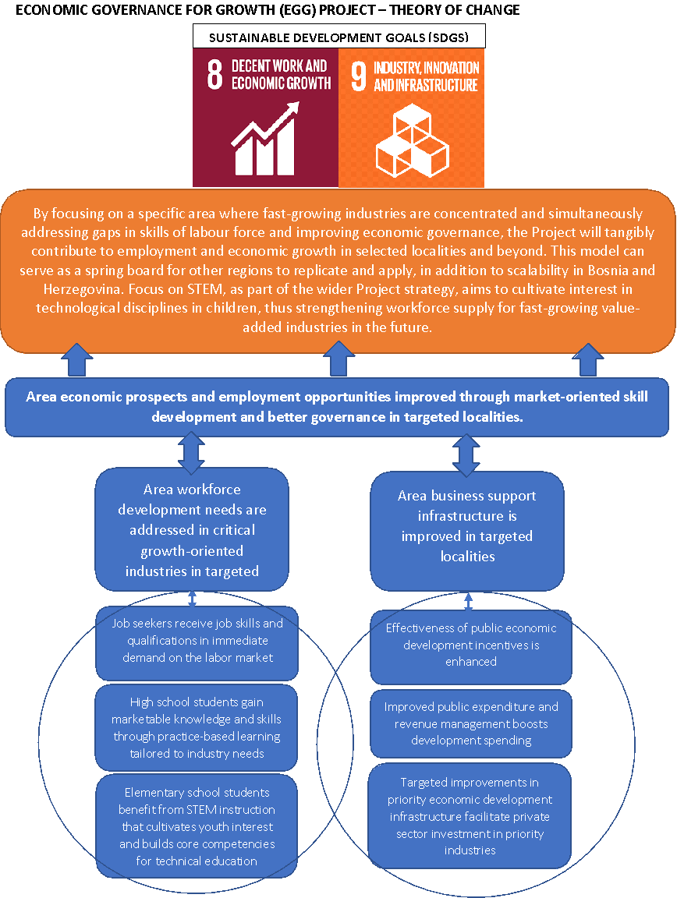
Figure 1 EGG Theory of Change

At the highest level of Project’s impact, envisioned is the creation of new jobs, thus bringing about a direct and immediate improvement in the quality of life for the selected households in target areas.
At outcome level, the result will be a combination of improvements in economic governance by partner authorities, illustrated by smarter public spending on economic incentives, and a marked increase in employability of targeted individuals, brought about by the designed short, mid and long-term measures.
So, at the level of Impact, the Project aimed to contribute to economic growth and employment in BiH.
At the Outcome level, the Project worked on improvements in economic governance by partner authorities, illustrated by better public spending and more investment in economic incentives, and a marked increase in employability of targeted individuals, brought about by short-, mid- and long-term investment in knowledge, skills and attitudes.

Envisioned Project outputs were as follows:
- Output 1. Increased entrepreneurship capabilities for economy of the future; and
- Output 2. Private sector development enabled by conducive governance frameworks.

The Project’s output was planned to be achieved through following activities, interrelated and interconnected through the mentioned pillars:

Entrepreneurship pillar

Activity 1.1 Forecast entrepreneurship development opportunities

Includes forecasting entrepreneurship development opportunities in such a way as to create both short as well as medium- and long-term strategies for growth. the Project commissioned, developed and presented a comprehensive study of the automotive sector in BiH as well as a research report into the future of the information technology sector, and automotive industry report.

Activity 1.2 Support start-up and MSME development.

This activity focused on competitive selection of start-ups and MSMEs as final beneficiaries and provision of tailored assistance, as per the broader objectives of the Project. Project implemented start-up support scheme that will continue to be included as a standard part of the economic incentive program in the Government’s budget document ensuring sustainability of this activity.

Activity 1.3 Nurture entrepreneurs of the future

Includes creation of a network of workshops focused on STEM topics across selected primary and secondary schools in target local governments, which is expected to cultivate interest in technological disciplines (establishment of a network of 22 STEM classrooms and fab-labs; implementation of requisite training program for teachers; development of a comprehensive curriculum for entrepreneurship learning in vocational schools and piloting in two schools; policy report with recommendations on barriers to entrepreneurship).

Activity 1.4 Enable local and regional networking and partnership

In cooperation with relevant line ministries as well as education and private sector stakeholders., developing initiatives that will greatly facilitate identification of bottleneck to entrepreneurship activities and their subsequent removals. Project provided technical assistance in revising the Employment Action Plan, to reflect the impact of the Covid-19 pandemic. In addition, updated recommendations from the Action Plan have been embedded into the draft version of the Canton Sarajevo Development Strategy 2021-2027.

Good governance pillar

Activity 1.5 Based on a comprehensive expenditure and revenue review of partner public administrations, support implementation of identified measures

Focus of the activity was on reviewing public finance management practices at the local and cantonal level, with focus on expenditure and revenue management. Project created a thorough financial analysis for all partner governments as well as monitoring plan for implementation of recommendations.

Activity 1.6 Redesign and restructure partner government incentive schemes aimed at supporting entrepreneurship, private sector development, and job creation

Work with the current public incentives aimed at supporting entrepreneurship, private sector development and job creation. Project reviewed public calls aimed at supporting entrepreneurship, prepared Manual for preparation of grant schemes as well as a short guide for the verification, monitoring and evaluation of projects funded through the grant programs; Project supported the Sarajevo Cantonal Government in establishing a Credit Guarantee Fund (CGF), and provided direct grant support to local governments in the amount of 80,000 BAM.

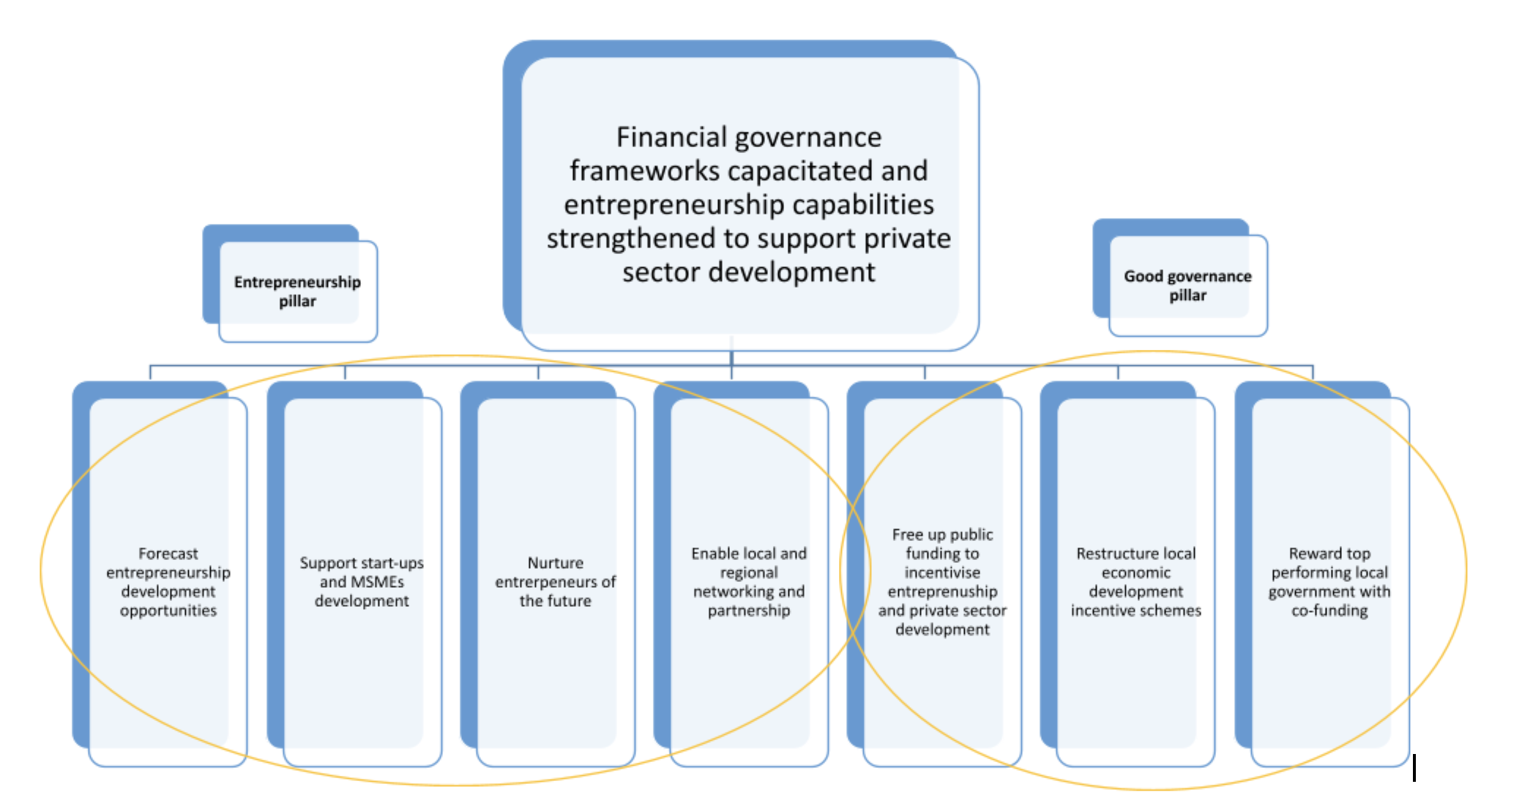
Figure 2 Project Outputs

This Project contributed mainly to the UNDAF Focus Area 2: Sustainable and equitable development and employment, Outcome 4: by 2019, economic and social and territorial disparities between units of local self-governance are decreased through coordinated approach by national and subnational actors. Also, this intervention is in line with Development strategies of FBiH and RS.

Evaluation Scope and Objectives

Purpose

According to the Terms of Reference (ToR), the purpose of this Final Project Evaluation (the Evaluation) is to provide an impartial review of the Economic Governance for Growth (EGG) Project, in terms of its relevance, coherence, effectiveness, efficiency, impact, sustainability, overall performance, management, and achievements. The information, findings, lessons learned and recommendations generated by the Evaluation will be used by the Project Board, UNDP, the Kingdom of Norway and other relevant stakeholders to inform future programming in the area of inclusive economic development.

Objective

The Evaluation objective is to examine the overall performance of the Project, its results, inputs and activities, and how the output delivered added value to project’s target groups and institutional beneficiaries.
In a substantive analysis of the effectiveness of the project approach and feedback from beneficiaries and relevant stakeholders, the Evaluation should assess cause and effect relations within the project, identifying the extent to which the observed changes can be attributed to the project.

Utilization

This Evaluation aims to provide forward-looking recommendations to the Kingdom of Norway and UNDP on the sustainability of the Project results and the Project’s scaling up potentials.
The evaluation will also generate knowledge for wider uses, assess the scope for scaling up the current Project and serve as a quality assurance tool for both upward and downward accountability. UNDP will take in consideration all useful findings, conclusions and recommendations from the evaluation, prepare a systematic management response for each recommendation, and implement follow-up actions as per UNDP Evaluation Resource Center guidance/policies.

Scope

The scope of the evaluation has been outlined in the Inception Report and states that the evaluation covers the entire period of the Project implementation. The Evaluation identified the extent to which the planned Project outcomes and outputs have been achieved since the beginning of the Project on 1 December 2018 until the end of the Project on 30 September 2021 (based on the Project Document and its results framework). The Evaluation investigated the overall Project performance and results (reviewing the set of activities implemented and their contribution to the set outputs and outcomes), capturing the changes triggered by the Project in the area of development planning and management.
To the extent possible, the Evaluation considered the results of the Project’s contribution to address the COVID-19 pandemic.
In assessing the achievements and the lessons learned from the project the evaluation aimed to include a vast number of stakeholders as key informants using interviews and based on a desk study.
The Evaluation investigated Project’s processes, innovations, strategic partnerships and linkages in the specific country’s context that proved critical in producing the intended outputs and the factors that facilitated and/or hindered the progress in achieving the outputs, both in terms of the external environment and risks, crisis caused by the pandemic, as well as internal, including weaknesses in project design, management and implementation, human resource skills, and resources.
It was not possible to obtain data from all key informants yet sufficient data were collected to fulfil the objectives of the evaluation credibly. The evaluation was carried out in October 2021 and field work undertaken in period of 20-23 October 2021. The evaluation also collaborated closely with the Project team. A list of people met during the evaluation is presented in Annex 2.

Evaluation approach and methods

Based on the UNDP Evaluation Guidelines, UNEG Norms and Stand for Evaluations and in consultations with UNDP Country Office, the Evaluation is designed to be participatory, involving relevant stakeholders.
The proposed methodology included a three-phased approach - an inception phase, a data collection phase and a finalization phase.
The inception phase included initial communication with Project Team in which various issues were discussed and changes to the implementation proposal made, and a desk study of key documents and the production of an Inception Report.
When it comes to data collection, standard UNDP evaluation methodology used the following methods:

- Desk review: The Evaluator will conduct a detailed review of the projects materials and deliverables including but not limited to the Project Documents and Addendums, theory of change and results framework, monitoring and Project quality assurance reports, annual workplans, consolidated progress reports etc.
- Key informant interviews: Using virtual technological solutions, interviews with representatives of UNDP, the Royal Norwegian Embassy, BIT Alliance, Posavina-Canton Government, BiH Ministry of Civil Affairs, Cabinet of the Prime Minister of the FBiH, RS Ministry of Administration and Local Self-government were conducted.
- Meetings / focus group discussions with relevant stakeholders
- Other methodologies, as appropriate.

The proposed methodology employed relevant quantitative, qualitative or combined methods to conduct the evaluation, was focused on gender sensitive data collecting and analytical methods and tools applicable in the concrete case. Standard and other evaluation tools and techniques were combined to ensure maximum reliability of data and validity of the evaluation findings.
As an integral part of the Evaluation report and specifically under the impact criteria, the project effects and impact on the target groups were evaluated.
The final stage included preparing and submitting the draft final report, and receiving comments and submitting the final report. This version is the draft final report.

Evaluation Findings

Relevance

OVERALL FINDING

Considering the chronical administrative and financial inefficiencies of municipal governments in provision of business-friendly environment and private sector development at the local level, citizens who are increasingly dissatisfied with lack of meaningful job opportunities, students who are robbed of opportunities to gain relevant education corresponding to market needs, educational institutions whose activities are hampered by the lack of know-how as well as resources to upgrade service delivery and local businesses which need conducive business environment in order to operate smoothly, an external project of this nature was timely and needed for the country. The EGG objective of capacitating financial governance frameworks and strengthening entrepreneurship capabilities in order to support private sector development was found to be consistent with the requirement of the national priorities, appropriate to the EU context and strategically designed for maximum impact. Influenced by the global fourth industrial revolution, EGG had the perfect timing and purpose for all stakeholders involved in the project. Project design and results were relevant for both economic and governance needs of students, unemployed people, companies, academicians and scientists, local and cantonal governments and all citizens in partner municipalities. All mentioned conclusions were strongly confirmed by the stakeholders’ interviews as well as detailed desk research documentation reviewed during the evaluation process.

EGG relevance to national priorities and EU requirements
FINDING
The evaluation process confirmed that the Project is in line with the priority “Competitiveness and innovation, local development strategies” of European Union’s Revised Indicative Strategy Paper for BIH (2014-2020) as well as with “Economic Criteria “of EU Commission Opinion from 2019 on BiH’s application for membership of the European Union.

Project originated from the Outcome 4 related to both, the United Nations Development Assistance Framework (UNDAF) 2015-2020 and the UNDP Country Programme Document (CPD) 2015-2020. The Project is also linked to the new UNDP Country Programme Document for BiH, Outcome 1. By 2025, people benefit from resilient, inclusive and sustainable growth ensured by the convergence of economic development, and management of environment and cultural resources.
The Project worked with local actors to promote development-oriented policies that support productive activities, decent job creation, entrepreneurship, creativity and innovation. In parallel, the Project was engaged with the private sector to increase its competitiveness by achieving higher levels of economic productivity through technological upgrading and innovation, including through a focus on high-value added and labor-intensive sectors such as ICT sector. As such, the Project contributes to the achievement of targets set under the SDG 8: Decent Work and Economic Growth as well as the SDG 9: Industry, Innovation and Infrastructure. When it comes to strengthening of governance pillar, wide range of beneficiaries experienced benefits of the project activities. From local businesses which were supported through grant schemes in improving infrastructural capacities and services of business zones, through kids and parents who got access in kindergartens to all other citizens and civil society who benefited by getting enriched cultural offer (amphitheaters and City Hall), the project proved to address the key issues which local communities face.
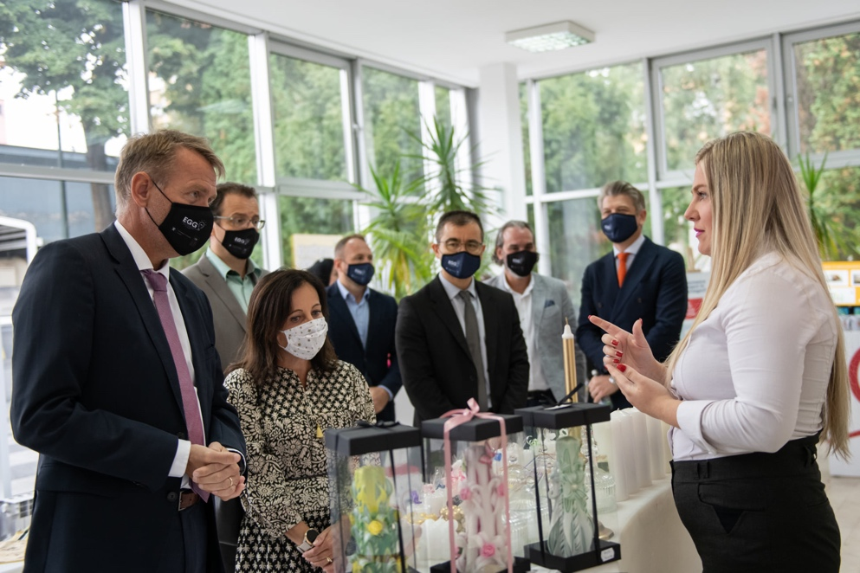
Figure 3 Presentation of start-up projects
EGG Project corresponds to the SDGs Framework in BiH and its development pathways “Smart Growth “and “Good Governance and Public Sector Management “. EGG project is also aligned with priorities defined in Integrated Development Strategy for FBiH 2021-2027 and 10 cantonal strategies for the same period which all put strategic focus on improved entrepreneurial environment and better governance, and as well is aligned with Priorities in integration of entrepreneurial studies in education system in BiH 2021-2030. Additionally, EGG is aligned with 2020 IMF Article IV Consultation-Press Release which states “ The authorities remain committed to a sustained fiscal consolidation in the medium-term with assistance from the developing partners. It should strike the right balance between supporting growth friendly structural reforms and development projects and preserving long-term public debt sustainability, financial stability, and credibility of the CBA. The aim is to strengthen revenue mobilization and further improve the composition and quality of public spending to correct unfavorable bias towards consumption relative to investment. Reforms in public financial management will continue, with a priority to clear the accumulated arrears and incentivize fiscal discipline, especially of the cantonal and municipal governments and public enterprises.”
Finally, the Project’s results are coherent with some of the major strategic documents in RS such as Industry Development Strategy of RS 2021-2027, SME Development Strategy of RS 2016-2020 and Female Entrepreneurship Development Strategy of RS 2019-2023.
The interviewees from municipal and cantonal governments indicated the budgeting process in the country was fragmented, mostly operational and not sufficiently focused on development. Political disagreements and individual interests paralyzed systematic approach towards development budgeting and local entrepreneurship development. In whole country, criteria for distribution of financial grants to local and new entrepreneurs was superficial, easily manipulated and incomplete. Thus, all key stakeholders identified the EGG project activities and specially improvement of financial grants schemes and financial support to infrastructural projects as critical interventions in strengthening support to local economic development and good governance. When it comes to financial grant schemes, the evaluation proved that several beneficiaries were positively influenced by redesign of schemes such as already existing IT companies which improved internal capacities and opened new job positions, young entrepreneurs who got both financial support and mentorship for starting business and unemployed citizens who got a job either in already existing IT companies or newly established start-up companies. During the design phase of the project, EGG incorporated relevant situational analysis reflecting real and the most important needs of the country and its citizens. It is very evident that local and cantonal government authorities recognize this project as top priority for further socio-economic development.
The relevance of EGG project is particularly evident in the component of the project related to entrepreneurship pillar. The interviewees from educational institutions see many barriers in education reform process and its alignment with labor market needs. BiH devote no more than 0,2% of its GDP in R&D what makes innovation capacity at very low level. High schools as well as primary schools have old and inadequate infrastructure accompanied with lack of know-how to respond to the global technological advancements on labor market. Teaching staff working in the schools usually lack necessary and up to date STEAM and entrepreneurship knowledge and skills which could be transferred to students. Students are missing adequate incentive, mentorship, infrastructure and financial capital for business and innovation experimentation. High schools in the whole country are missing adequate and formal entrepreneurship courses in curricula. Companies in the fast-growing sectors such as ICT and automotive lack working force with adequate STEAM knowledge and skills which could boost internal entrepreneurship and innovation capacity and therefore ensure long-term productivity and competitiveness on global markets. The evaluation proved that project addressed knowledge and skills gaps of high school students who were missing key STEAM and entrepreneurship skills which modern companies demand. Thanks to the project, high school students in partner schools improved their knowledge and skills and therefore improved their chances for getting or creating the job. On the other hand, companies increased their innovation and infrastructural capacity for increasing competitiveness.
The above makes a good case for a unified and systemic approach to R&D development in education institutions as well as SMEs with particular focus on entrepreneurship and innovation development and thus the relevance of EGG towards realization of country-wide development goals. Through financial grants, the project proved to be very relevant for academicians, researchers and students at universities in order to increase their research and innovation capacity. At the same time, companies in ICT and automotive sectors benefited by getting new scientific based solutions for their industries. The development of a long-term perspective is imperative, because it integrates roles and responsibilities of government authorities, academic institutions and business sector. A well-reasoned R&D, both formal and informal education and public expenditure strategies become a guiding framework in deciding and justifying the expenditure priorities of the government over the long-term. The relevance of integration of entrepreneurship into formal curricula was further confirmed when pilot schools and cantonal ministries of education officially adopted new curricula. Discussions with cantonal and municipal authorities as well as pilot schools’ authorities confirmed this further where they indicated that STEAM classrooms and entrepreneurship courses had been fully adopted and accepted in practice. By revealing concrete human resources needs, “Research report into the future of the information technology “was widely accepted and welcomed by all levels of government indicating interest in integrating findings into the country’s education policy framework.
The evaluation report reveals the highest enthusiasm and thus very high project relevance among aspiring entrepreneurs who attended comprehensive trainings and started new businesses with significant mentorship and financial support. The interviewees particularly find it relevant because of the fact that this process created new and high-value jobs. Entrepreneurs find of very high importance that start-up schemes are becoming standard part of the future economic incentive program in the Government’s budget document ensuring sustainability of this activity. Students, women, and other marginalized groups had equal access and opportunity to apply and get both financial and mentorship support to start their own business.
Furthermore, development and implementation of a grant scheme aimed at increasing competitiveness of IT companies in the sphere of technological advancement and workforce development was widely welcomed among ICT companies in Canton Sarajevo. The interviewees find it very relevant as it directly contributed to creation of new high-value jobs. Therefore, further expansion of grant scheme for IT companies from partner local authorities is expected to bring excellent results in both creation of new jobs as well as competitiveness.
Finally, considering various barriers and obstacles for entrepreneurship development in the country, Policy report with recommendations for further entrepreneurship development is welcomed by local authorities, companies in fast-growing industries and aspiring entrepreneurs.

Relevance of project design and approach

FINDING
The project design is closely linked to its strategic objectives and therefore facilitated the direction of intervention towards achievement of set outcomes. The critical pillars of the project (entrepreneurship and governance) articulate capacity development at institutional, organizational and individual levels. Throughout the whole implementation process, high participation of all relevant stakeholders with gender equality evidence is evident. Out of 133 aspiring entrepreneurs who benefited from the project, 50% were women. Similarly, 50% of teachers who went through entrepreneurship training in partner high schools were women. SMART classrooms supported by the project enabled equal access to all social categories of high school students including students with disabilities. During the selection of priority infrastructural projects in four partner municipalities, social inclusiveness was one of the key criteria in selecting them. Out of 400 pupils who benefited from SMART classrooms and entrepreneurship trainings, more than 40% were women.

The strategic design of the project positioned EGG for maximum impact. As previously mentioned, EGG strategy was consistent with the earlier UNDP Country Programme and continues to remain so with the current UNDP Development Strategy until 2025. EGG has also been a flagship programme of the country-wide incentive for introducing innovation and entrepreneurship in education processes (all study cycles) as well as for developing internal innovation and entrepreneurship (intrapreneurship) within existing businesses in the fast-growing industries. EGG was designed to address the key gaps in unemployment, lack of necessary skills for the market, lack of new and high-quality jobs, strategic public expenditure with focus on entrepreneurship development and STEAM education in order to provide clear direction for further economic development of the country.
However, due to the COVID 19 pandemic, the Project experienced several challenges throughout implementation. The negative effects were primarily noticed in delay of several project activities and specially during the 2020 when the government authorities made decision to lockdown the whole country. Collection of data from local and cantonal government authorities slowed down due to aggravated work from home with inadequate technology. However, situation significantly improved during the 2021 when remote work became much more efficient and more in-person meetings were allowed to happen. Similarly, lack of students in the classrooms as well as online trainings of teaching staff seemed to bring many difficulties and anxiety among teaching staff who were not prepared for online model of education. Anyway, the Project successfully overcame these challenges by offering online services, online trainings and online consultations which were later on mixed with in person meetings.
The interviewees confirmed that throughout the whole implementation of the Project, gender equality, inclusiveness as well as conflict-sensitive approaches were carefully implemented. Some of the most visible areas are criteria for grant schemes, selection of training participants, selection of aspiring entrepreneurs etc. It is confirmed that EGG project did not have duplication with other development projects and donors. Evaluation process also revealed that special coordination and harmonization was made with other UNDP projects such as ILDP and MEG which conducted complementary activities in the country. The project made noteworthy efforts to coordinate its initiatives with other projects.
Communication and outreach of the Project proved to be satisfactory. The overall highly participatory approach was evident through several levels of stakeholder consultations such as policy debates, informed situational analysis of fast-growing sectors and overall entrepreneurship in the country etc. All partners expressed overwhelming appreciation as well as sense of ownership over each of the project intervention.
The evaluation process showed that redesigned grant schemes, SMART classrooms, entrepreneurship trainings and hackathons for aspiring entrepreneurs are recognized as the best innovations and practices which should scale to larger number of schools, students, teachers and municipalities in order to ensure country-wide impact.

Effectiveness
OVERALL FINDING

With reference to the two key project pillars, namely, a) entrepreneurship pillar; and b) good governance pillar project made significant achievements, there has been notable progress towards the overall objective of creating an improved entrepreneurial environment in the target area, as well as creating increased entrepreneurship capabilities for the economy of the future. Through implemented activities project addressed several of the key obstacles to local economic development - an operating environment that is ill equipped to support and enable innovation and entrepreneurship, an absence of technical and entrepreneurial skills among the unemployed youth and lagging support by government for local economic development. Activity ended up creating total of 64 new businesses with 133 aspiring entrepreneurs benefited from project-instigated ecosystem infrastructure. EGG established a network of 22 STEAM classrooms and fab labs and created an entrepreneurship curriculum which was pilot in two high schools. 86 teachers successfully completed the requisite training program for STEAM classrooms and fab labs. Also, total of nine public calls aimed at supporting entrepreneurship, private sector development and job creation were implemented in partner local governments. Furthermore, with the support of EGG, Sarajevo Canton established Credit Guarantee fund.
Total outreach of the project was 778 individuals benefiting from the project, while total number of people employed was 146.

Overview of Project Indicators

Outcome | Indicator | Comment
Entrepreneurship ecosystem improved in target area | Number of local governments and cantons with improved economic governance through sustained optimization of public spending and effective incentives  Target (final): At least 10 local governments and 2 cantons | This was partially achieved. Outcome indicator is relevant to measure if (and to what extent) partner local and cantonal governments achieved sustainable reduction of local and cantonal government operating budgets so as to free up financial resources for local development.  EGG completed planned cost optimization reports for planned 10 local, 2 cantonal governments and Brčko District. EGG also planned and carried out monitoring of implementation of planned measures.  However, there is limited evidence of the sustainability of the process.
 | Percentage increase in sales across key sectors  Target (2021): 3% | It is not possible to assess this indicator fully due to lack of full data.  Indicator has been set quite ambitiously. Automotive industry exports sales account for more that 900 million BAM. Hence the target increases in sales, if we take into account both exports and domestic sales, just for automotive would be much more than 27 million BAM in order to fully achieve this indicator.  Also, it is virtually impossible to measure the impact of implemented activities on business results of companies in target sectors.  So, although indicator is relevant to measure effect of support to fast-growing, export-oriented industries via tailor-made assistance to emerging and mature entrepreneurs, correlation, and impact of project intervention on stated indicator could not be established.
 | Number of start-ups created  Target (2021): 15 | This has been fully achieved. Activity ended up creating total of 64 new businesses through two cycles of start/up scheme accompanied with entrepreneurial training.

Output | Outputs, indicators and benchmarks | Comments
Increased entrepreneurship capabilities for economy of the future | Number of established and aspiring entrepreneurs benefiting from project-instigated ecosystem infrastructure  Target (2021): 135  Number of educational institutions offering STEAM, “fab lab” and entrepreneurship development capabilities  Target (2021): 10  Number of students benefitting from skill upgrade  Target (2021): 300 (at least 40% females) | Target was almost 100% achieved as 133 aspiring entrepreneurs benefited from project-instigated ecosystem infrastructure and 64 start-up companies were established.  This has been fully achieved. During the 2019 and 2020, EGG established a network of 22 STEAM classrooms and fab labs.  Furthermore, following the development of a comprehensive curriculum for entrepreneurship learning in vocational schools to help secondary school graduates better cope with the demands of the market, the new subject was successfully piloted in two high schools.  This is expected to be completed, since all prerequisites have been met, and preparatory activities implemented.  Namely, 86 teachers successfully completed the requisite training program for STEAM classrooms and fab labs.  Once the conditions for a full return to school have been met, it is expected that some 400 pupils will benefit from the new equipment and training (287 students prior to COVID 19 outbreak)
Private sector development enabled by conducive governance frameworks | Amount of total savings / additional revenues generated annually through improved public finance management by 10 local governments and two cantons  Target: (2021): BAM 4 million  Number of restructured government economic incentive schemes  Target: (2021): 10  Number of priority economic infrastructure interventions implemented  Target: (2021): 3 | This has not been achieved.  Due to the pandemic, expected local revenues have been significantly depressed, leading all partner authorities to miss their targets when it comes to generating additional revenues, albeit four out od 10 did still record overall positive results when it comes to expenditure management.  This has been fully achieved. Total of nine public calls aimed at supporting entrepreneurship, private sector development and job creation were implemented in partner local governments.  Also, with the support of EGG, Sarajevo Canton established Credit Guarantee fund.  This has been achieved. Four partner local governments with best overall project results were awarded grants to implement priority infrastructure interventions.

The project effectiveness is reflected below against the outputs.

Output 1 - Increased entrepreneurship capabilities for economy of the future

FINDING
Project successfully identified some of the gaps in the entrepreneurial environment and addressed most important obstacles that hinder increase in entrepreneurial and innovation activity, prevent exploitation of developmental opportunities and consequently transfer to knowledge-based economy.

In order to achieve increased entrepreneurship capabilities, the Project worked on addressing gaps in the entrepreneurial environment in BiH, by delivering short, medium and long-term measures aimed at boosting the ranks and improving the competitiveness of entrepreneurs and pursuing a market-share in future-facing industries. The Project was focused on supporting fast-growing, export-oriented industries via tailor-made assistance to emerging and mature entrepreneurs, along with support to BIH ICT companies to implement projects of technological advancement and workforce development, aiming to improve their overall competitiveness.
In addition to this, the Project worked on establishing STEAM academies through piloted entrepreneurship curricula and “fab labs” in selected primary and secondary schools. These activities in long-term lead to upgrade of entrepreneurship and innovation ecosystem and establishment of local networking and partnership opportunities for emerging entrepreneurs.
The first set of implemented activities included forecasting entrepreneurship development opportunities in such a way as to create both short as well as medium- and long-term strategies for growth. To achieve this, EGG supported assessment to two selected sectors - ICT and automotive. These analyses resulted in identification of main challenges as well as opportunities for growth.
EGG commissioned an in-depth analysis of BiH automotive companies with regard to their technological background, workforce demand, market position, future development plans and visions, models of cooperation and market approach - “2019 BiH Automotive Industry Assessment: Trends, Challenges and Opportunities”. Study provided a structured overview of future trends in the automotive industry, regional automotive industry, along with connections and synergies with the region and global automotive market, BiH automotive industry, with general overview of BiH companies and their characteristics, BiH industry’s share in the future automotive industry, with impact analysis of the global trends on BiH automotive companies, identification of major threats and growth opportunities for BiH automotive industry. Key findings were used to develop the matrix of recommended actions tailored to the specific groups of companies, based on their readiness to face the new trends.
Project also commissioned, developed and presented a research report into the future of the information technology sector – “2019 BiH Software Industry Skills Needs Assessment”. Report was looking in particular at the human resources needs expressed by the industry and analyzed existing formal and informal educational institutions in BiH relevant to IT industry, in relation to level of their curricula synchronization with the same at major international universities. The report was welcomed by all levels of government with the State Minister of Civil Affairs indicating interest in integrating findings into the country’s education policy framework. This particular study also generated interest by the Canton Sarajevo authorities with new high school and university programs discussed as a result of the report.
Through these studies Project intended to asses/review trends in target industries, identify challenges and opportunities for growth in short, mid and long term (technologies, digitalization, human capital, production processes, etc.), map successful mature companies/start-ups in the target industry against short and mid-term industry needs and map relevant entrepreneurship support and resource networks.

There has been some level of EGG contribution in establishing partnership network bringing together educators, private actors and government enablers. Following the establishment of the Sarajevo Labor Market Reform Council in 2019, a policy coordination body aimed at bridging the gap between supply and demand sides of the labor equation, and its subsequent adoption of the Employment Action Plan, the Project provided technical assistance in both development and revision of the document, to reflect the impact of the Covid-19 pandemic. These updated recommendations from the Action Plan have been embedded into the draft version of the Canton Sarajevo Development Strategy 2021-2027. It is important to note that this was a first document of a kind in BiH. EGG supported three already exiting HUBs – Innovation Center in Banja Luka (ICBL), Intera Technological Park Mostar and BIT Center Tuzla with grant funds of 20.000 BAM per institution.
Project support to start-up and MSME development was focused on competitive selection of start-ups and MSMEs as final beneficiaries and provision of tailored assistance, as well as financial assistance to the entrepreneurship promotion and support to start-ups through design and implementation of support scheme aiming to stimulate entrepreneurship among the economically active population in the target localities with the expected result of adding to the stock of new MSMEs, and ultimately contributing to job creation.
Following the successful implementation of the first start-up cycle, generating some 1.4 million KM in investments with 41 new businesses created, the Project re-launched the scheme in 2020, adjusting the scope and methodology to the conditions created by the pandemic. A total of 33 aspiring entrepreneurs attended the comprehensive training and 23 started new businesses, with a total of 1 million KM raised in funding.
Overall, this activity ended up creating a total of 64 new businesses and 95 new jobs, with almost 2.5 million generated in investments.

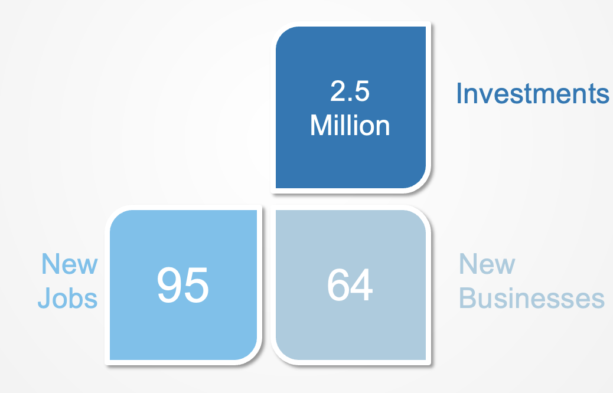
Figure 4 Increased entrepreneurship capabilities - activity results

Designed start-up scheme will be included as a standard part of the economic incentive program in the Government’s budget document ensuring sustainability of this action.
Also, during 2020, the project cooperated with the Canton Sarajevo Ministry of Economy in the development and implementation of a grant scheme aimed at increasing competitiveness of IT companies in the sphere of technological advancement and workforce development. Three BiH software companies received financial support to implement projects that have led to the creation of 15 new high-quality jobs, with the total value of investment projects amounting to BAM 221,500.
In 2021 the Project launched another grant scheme for IT companies from partner local authorities, also aimed at enhancing competitiveness and workforce skills development. In total, 6 BiH IT companies were supported under this grant scheme, whereby the total value of investment projects amounted to BAM 605,000.
In order to cultivate interest in technological disciplines Project created a network of STEAM classrooms and fab labs in target local communities. Network of 22 STEAM classrooms and fab-labs in 2019 and 2020 was established. Also, 86 teachers successfully completed the requisite training program. Prior to COVID 19 pandemic outbreak, there were 287 students attending project supported STEAM education.

Figure 5 STEAM education simulation

In line with planned project activities comprehensive curriculum for entrepreneurship learning in vocational schools to help secondary school graduates better cope with the demands of the market was developed in two versions – one as part of the existing course, and one as a full new course. Total of 9 IT companies were supported with the total value of investment projects amounting to BAM 826,500, with 51 new jobs created. Following the development of the curriculum, the new subject was successfully piloted in two high schools. The roll-out was supported by a comprehensive training program for 22 instructors tasked with bringing the curriculum to the students of the two pilot schools.
With the aim of improving the overall enabling environment for entrepreneurs in BiH, the project designed and administered a survey to 56 entrepreneurs from IT, automotive, creative and other prospective industries in an attempt to map our critical barriers to entrepreneurship. In addition to quantitative data collection and analysis, the mapping exercise also included interviews with an additional 10 entrepreneurs, and representatives of relevant BiH institutions important for the entrepreneurship context, in an attempt to establish what the prevalent obstacles faced by enterprises are, taking in both perspectives.
As a result of this action, the Project produced a policy report with specific recommendations on how to most effectively remove or depress barriers to entrepreneurship and better utilize available development opportunities to include company creation procedures, increasing financial support, especially to new companies, and by introducing specific educational entrepreneurial programs – all interventions that were in some form addressed withing the framework of the project.

Output 2 - Private sector development enabled by conducive governance frameworks

FINDING

EGG successfully reviewed public management practices at local and cantonal level in order to increase capacity of partner governments in determining their efficiency in provision of support to private sector through reduction of operating budgets and freeing up resources to use to support capital projects. Even though results show some success in terms of achieved reductions, lack of transfer of methodology and know-how may indicate this as one-off activity and put its sustainability in question. However, by looking into wider picture of UNDP projects and interventions, this activity can be observed as part of wider context and therefore more sustainable. In terms of incentive schemes supporting entrepreneurial activities, project did formidable work, but due to the pandemic their full completion was halted and impossible to finalize.

Each of 10 partner local, two cantonal governments and Brčko District government were provided with a set of concrete recommendations and cost-efficiency measures in individually created analytical reports. Project signed an agreement with each of the governments upholding them to fulfillment of set objectives in terms of increased revenue generation and cost reductions within their operating budgets, and monitored implementation of protocols.
Public finance management expertise was provided so as to ensure guidance for local governments in translating the identified measures into concrete projects and initiatives, as well as review performance progress.
Due to the pandemic, expected local revenues have been significantly depressed, leading all partner authorities to miss their targets when it comes to generating additional revenues, albeit four did still record impressive overall results when it comes to expenditure management.
Following lobbying and advocacy by the Project, the Sarajevo Cantonal Government adopted the findings and recommendations laid out in the spending review in September 2020 conducted by EGG, enabling further engagement in the area of fiscal optimization.
Also, aiming to contribute to improved public finance management at the Brčko District level, the Project provided a detailed government budget review of Brčko District, providing a series of recommendations and optimization measures.
Following the review of the public finance management practices, the Project focused on the current public incentives aimed at supporting entrepreneurship, private sector development and job creation.

In order to conduct meaningful evaluation of contemporary incentive schemes, the review of public calls aimed at supporting entrepreneurship, private sector development and job creation in 9 local governments was implemented by September 2020. Brief reports outlining findings on relevance and effectiveness of grant schemes as well as recommendations for future programming were prepared for all LGs. The Project helped local governments to develop a single grant scheme, based on their economic development priorities, for implementation in 2020. Total of 32 civil servants from local governments went through training on Project Monitoring and evaluation.

However, due to COVID 19 pandemic, grant schemes were not realized. In addition, the Project prepared Manual for preparation of grant schemes as well as a short guide for the verification, monitoring and evaluation of projects funded through the grant programs.

Responding to the needs of its pandemic-affected partner communities, the Project provided on-demand, tailor-made recovery assistance to local and cantonal authorities. In that regard, the Project supported the Sarajevo Cantonal Government in establishing a Credit Guarantee Fund (CGF) to enable affected SMEs to access the financing necessary to drive their recovery. The total value of the Fund amounts to 3.8 million BAM.
As part of its aim to incentivize good performance, 4 selected partner governments received a maximum amount of 80,000 BAM while providing 60% of the overall financial framework for the project. Co-financed projects include amphitheater in Modriča (wide social importance), City Hall in Odžak (cultural and historical landmark), kindergarten in Orašje (preschool social inclusiveness and parent employment benefits), business zone in Gradiška (environmental protection benefits – waste water management).

Efficiency
OVERALL FINDING

The project appears to have strong management capacity with appropriate cost-effective measures in place.

Project Management
Efficiency is often related to ratio of outputs to inputs or to benefit-cost analysis indicators and is dealt with by the efficiency audit carried out in parallel with this evaluation. For this evaluation the efficiency criterion focusses directly to how EGG has been able to organize itself in delivering its mandatory work. As such we have focus primarily on the following key aspects of efficiency of EGG: management, governance, collaboration and delivery.
The institutional structure of UNDP interventions includes the Project Board and the Project Team, interacting in a broader context with partners and all interested stakeholders.
The Project Board was responsible for making management decisions for the Project. Its scope of work included program oversight, as well as regular review of work plans, progress reports and relevant procedures submitted by the Project Team. It also provided strategic guidance, as well as final approval to milestone strategic and operational matters. The Project Board was comprised of partner institutions: the Ministry of Human Rights and Refugees of BiH, the Ministry of Justice of FBiH, the Ministry of Administration and Local Self- Governance of RS and the Ministry of Administration and Local Self-Governance of Brčko District.
The Project managed to achieve balanced representation among the participating local governments in both entities and Brčko District. The Project activities were planned at the design stage and outlined in the logical framework.
The UNDP Project team is highly experienced. It is comprised of the Project Manager and core members. The Project Manager is full-time and has the authority to run the Project on a day-to-day basis on behalf of UNDP. This includes daily communication with all of the key stakeholders and maintaining an insight into all aspects of the Project. The Project Manager is responsible for ensuring that the Project produces the required results to the required corporate standards and within the set constraints of time and cost, the day-to-day project management, reporting and coordination.
Project core members include one senior officer, three officers and one associate.
Evaluation noticed deviation from the planned structure of the team, as Junior Economic Officer was replaced with Senior Project Officer.
Efficiency is also reflected in the procurement processes. These are in general carried out in accordance with UNDP agreed procedures (UNDP methods of open and transparent processes). No negative observations were found in the Project Progress Reports. Maintaining competitive procurement processes for hiring Experts, Consultants and other Service Providers has led to cost effectiveness through the selection of lowest bidders and observation of appropriate procedures.
Project Management has worked efficiently and ensured timely delivery of majority of the outputs. Interviews supported conclusion about the efficient work of the project team as that each and every partner appreciated their efforts. The project team ensured timely planning, procurement of services and delivery of the activities as per the annual plans. They have prepared timely and good quality progress reports as well.

Budget execution overview
EGG annual work plans and budgets that are shared with the partners and donors in order to secure their approval. The UNDP office is responsible for the receipt of donor contributions, the distribution of funds for the grants scheme, the consolidation of financial and narrative reports and reporting back to the Project Board and the donors. It is also responsible for the receipt of BIH government financial contributions and for the procurement of local project supplies.
The Project contract is between UNDP and the Government of Norway, which regulates operations and finance.
The total budgeted amount was 2.399.114 USD. The total amount spent for the project was 1.994.428 USD which is 83% of the budgeted amount.
Total Government of Norway contribution was 1.678.638 USD; UNDP contribution was 122.989 USD; BiH Government contribution was 192.802 USD.
Budget execution in terms of specific project-related costs was 77%. There were several budget lines that were not fully spent - Support to selected startups to expand their business (127.507 USD), Support to MSMEs to advance their competitiveness (28.229 USD), Establishment of STEM and fab-labs (41.943 USD), Research and development grants (7.835 USD) and Grants (165.804 USD).

Description | Budget Plan
 | USD | 2019 | 2020 | 2021 | Total
Personnel costs | 531,589 | 194,929 | 195,062 | 131,274 | 521,265
Travel | 18,329 | 9,410 | 7,618 | 1,731 | 18,759
Specific project-related costs | 1,583,424 | 439,704 | 494,057 | 287,328 | 1,221,089
Operating Costs | 103,172 | 24,752 | 43,520 | 35,083 | 103,355
Evaluation | 11,630
Final external project evaluation | 11,630
Audit
Direct operating costs, total | 2.248.145 | 668,795 | 740,257 | 455,416 | 1,864,468
Indirect operating costs [8 % for Norway, 3% for BiH] | 150.969 | 40,511 | 53,016 | 36,433 | 129,960
Project costs total | 2.399.114 | 709,306 | 793,273 | 491,849 | 1,994,428

Only three specific project related cost lines were spent in the amount over the budget in total amount of 9.078 USD.
The financial operations appear to be managed in a satisfactory manner. A cost-benefit analysis was outside the scope of this evaluation and therefore, we did not look into details of the direct funding allocated for the particular activities, but only activities as a whole.

Sustainability

OVERALL FINDING

The project established excellent base for sustainability of future of work skills development as well as entrepreneurship development through improvement of already existing procedures and criteria for financial grant schemes in partner municipal and cantonal governments. However, due to COVID 19 negative implications, the project did not succeed to institutionalize cost optimization and revenue maximization activities within budgetary framework in partner local communities and cantons. EGG established noticeable sustainability base for further development of entrepreneurship and STEAM education in partner elementary and high schools. The project implemented excellent training and financial support programs by hiring external consulting company.

As part of the project design, EGG had envisaged transfer of knowledge and various tools on domestic stakeholders (municipal and cantonal government institutions, elementary and secondary schools, universities) to ensure ownership and secure sustainability, employing existing institutional platforms. The project strived towards ensuring reduction of external project assistance and change of roles of national stakeholders towards full ownership, as contributive factors to sustainability of the project interventions.
The evaluation proved that key beneficiaries as well as other stakeholders had an active role in implementing the project. From Project Management Board which actively monitored and directed activities (both live and online) in accordance with Project goals, through collaboration with municipal representatives in mapping and selecting priority projects to be financially supported, to joint discussion and agreement with University of Sarajevo representatives on defining criteria for grants delivery, the project management proved to have active participation of all key beneficiaries in project implementation. Although the Project experienced certain delays due to COVID 19 pandemic, Project Monitoring and Evaluation System proved to be effective as it provided management with a stream of data that allowed it to learn and adjust implementation accordingly. What proved to be very useful in project monitoring process were regular project highlights reports which served to Management Board and donors as good management tool.

The evaluation examined sustainability of project activities in a broader context and focused on institutional, individual and financial perspectives to measure the extent and potential for future scale up without external assistance.

Institutional and individual sustainability is considered strong.
Institutional and individual sustainability measured institutional capacities in partner government institutions as well as elementary schools, high schools, University of Sarajevo and companies. Special attention was devoted to examination of potential horizontal replication of good budgeting experiences in municipalities and cantons, allocation of financial grants for new start-up companies and already existing companies in fast-growing industries (ICT, automotive), SMART classrooms, formal and informal entrepreneurship teaching of both students and teaching staff, successful internal innovations within partner companies in ICT sector, R&D financial support at university level etc. Full and genuine ownership by partner government institutions, schools and companies as well as their continued engagement in the implementation and monitoring of municipal budgets, grant schemes, entrepreneurship curricula (formal and informal), further development of SMART classrooms in elementary and high schools, training of teaching staff and R&D mentorship accompanied with financial support to universities, new start-up and existing companies are critical for enhancing project sustainability.
- The evaluation confirmed the long-term viability of changes to curricula were reviewed and agreed through institutional channels. The project also ensured continuous educator-employer dialogue in order to ensure local buy-in across the stakeholder spectrum and especially future plans and needs for vocational training. Introduction of entrepreneurship course in curricula of selected schools is another great and sustainable achievement which could be horizontally replicated to other schools in the future. The interviewees from government institutions and specially Ministry of education in Sarajevo Canton showed great commitment to wider expansion of entrepreneurship in all vocational schools and gymnasiums within the canton.

- Train the trainers programs capacitated majority of teachers who went through the program and therefore created good base for sustainability of entrepreneurship programs in selected schools. Training of teaching staff (entrepreneurship and STEAM) in selected schools seemed to be right approach for future institutionalization of entrepreneurship and STEAM education in elementary and high schools. What remains as a challenge is a limited number of old fashioned and elder teachers who found programs a bit too demanding as well as disrupting to their current way of teaching. The interviewees from partner schools confirmed that majority of teachers are fully comfortable and equipped to continue practical and innovative education in SMART classrooms on their own. The organizational structures to sustain entrepreneurship and STEAM education have been taking shape in all selected schools, but continual capacity enhancement needs to be ensured.

- SMART Classrooms proved to be excellent base for both formal and informal innovative education of students. Students from Electrotechnical High School from Sarajevo thanks to SMART classroom already won several awards in regional STEAM competition in Croatia.

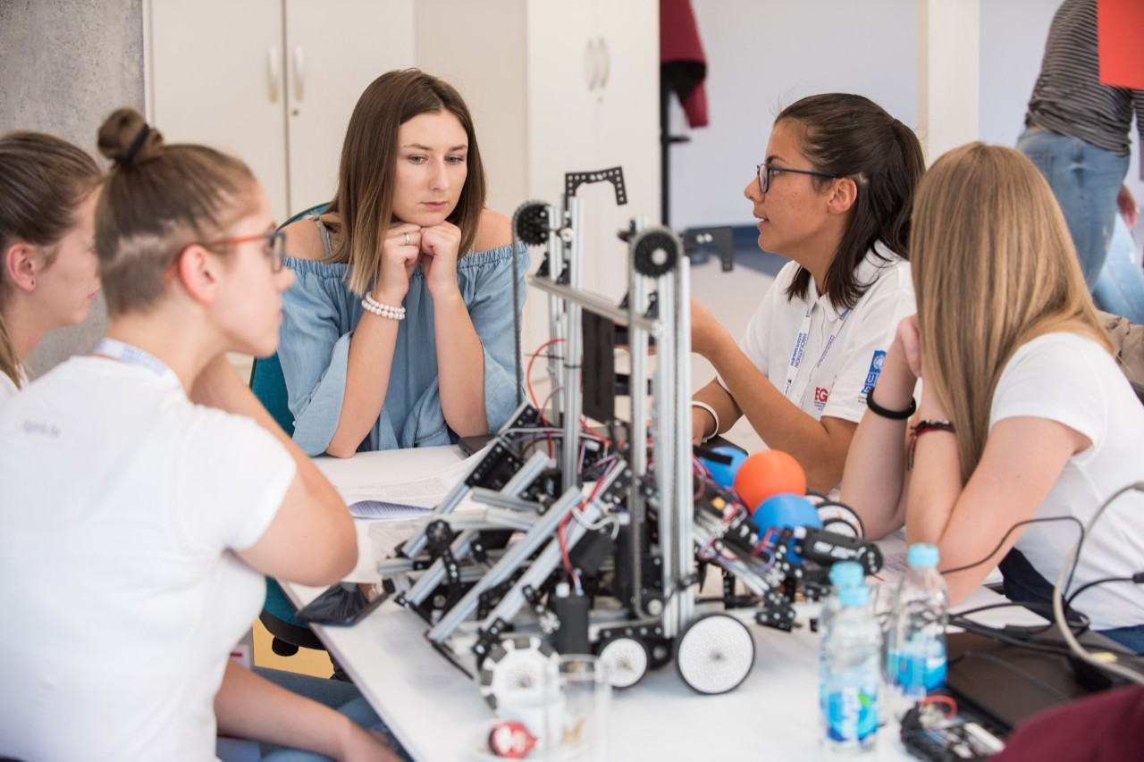
Figure 6 SMART classroom

- One of the most enthusiastic activities of the project were trainings, mentorship and financial support to new start-up companies and aspiring entrepreneurs. Based on conducted interviews, both mentorship as well as financial support to start-up companies proved to be one of the most influential activities of the project. Young entrepreneurs gained necessary knowledge and financial support which helped them to start the business. However, interviewed entrepreneurs expressed high need in further mentorship and financial support in order to ensure further growth and development. Overall, this activity ended up creating a total of 64 new businesses and 95 new jobs, with almost BAM 2.5 million generated in investments. The evaluation process found that combination of start-up scheme as a standard part of the economic incentive program in Government's budget document and introduction of entrepreneurship and STEAM education in elementary and high schools and vocational trainings for new entrepreneurs has excellent sustainability base for future horizontal scale and overall local economic development.
- During 2020, the project cooperated with the Canton Sarajevo Ministry of Economy in the development and implementation of a grant scheme aimed at increasing competitiveness of IT companies in the sphere of technological advancement and workforce development. To that end, 3 BiH software companies received financial support to implement projects that have led to the creation of 15 new high-quality jobs. Furthermore, in 2021 the Project launched another grant scheme for IT companies from partner local authorities, also aimed at enhancing competitiveness, with evaluation of applications already completed. In total, 6 IT companies were supported to implement projects that have led to the creation of 36 new jobs with a total of 51 jobs created under this activity. Evaluation interviews proved strong base for further sustainability of supported companies as financial support enhanced their capacities for further development and competitiveness.

- Pilot studies on ICT sector and Entrepreneurship are excellent base for further development and institutionalization of proposed recommendations. Ministry of Civil Affairs BiH as well as Ministries of education in Cantons of Sarajevo and Posavina confirmed their dedication for further institutionalization and integration of proposed recommendations in formal curricula. However, they also expressed necessity for external support through both advisory and financial aspect.

- Another project activity which proved to be unique in BiH is support to Canton Sarajevo in preparation of Employment Action Plan. Contribution of the project to sustainability was confirmed by adoption of the plan by Government of Canton Sarajevo as well as through integration of proposed measures into Development Strategy of Canton Sarajevo 2021-2027.

Financial sustainability still requires further support.

Financial sustainability is determined by the setting up of financial mechanisms and processes to support implementation of budget plans, financial schemes, entrepreneurship trainings, R&D mentorship and investment etc. Overall, project design and results proved to be aligned and relevant to UN Agenda 2030 and sustainable development goals and particularly to Quality Education, Decent Work and Economic Growth and Industry, Innovation and Infrastructure goals.

- EGG tended to address financial sustainability through realistic budgeting and new ventures creation-oriented grant schemes. However, this proved to be an issue given the unpredictable inter-governmental transfers, low local government revenue, negative external environment factors (COVID 19) and inadequate fiscal decentralization policies. The project made limited contribution in ensuring partner government institutions have regulatory framework for optimization of cost and maximization of revenues within long-term budget frameworks, for financial grant schemes intended for development of new entrepreneurs and development of the already existing companies. The fact is that Project did manage to provide support to partner local and cantonal governments in reaching desired cost reduction and revenue maximization goals, however there is little evidence that these activities were implemented in a way that ensures their sustainability.

- Infrastructures financial grants provided to four partner municipalities were highly welcomed by municipal governments as well as citizens and business sector as they helped in resolving some of the priority issues from municipal development strategies. Although municipal governments provided in kind contribution for infrastructural grants, it is questionable whether they will be able to continue financing similar projects on their own and therefore, high dependency on external financial support remains as necessity in the future.

- EGG initiatives led to improved criteria for financial grant schemes intended for local economic development. This has been implemented through creating strong ownership leading to institutionalization of financial grant schemes for local economic development. The good experiences from selected municipalities and cantons might serve as a good role model for horizontal expansion of similar services to other municipalities and cantons in the country. Procedures for the allocation of public incentive funding by local governments were developed to ensure that positive practices in delivering economic development support are enshrined as part of the administration’s operating framework. These included measures to annually survey the needs of the private sector as well as to assess the impact of grants allocated in the previous period. All products, needs assessments, action plans and coordination functions were embedded with local stakeholders and existing mechanisms, to ensure their further use, as well as follow up activities. Improved criteria for financial grant schemes will lead to better, effective and efficient selection and delivery of government’s funds for new start-up businesses, development of existing companies and overall new jobs creation.

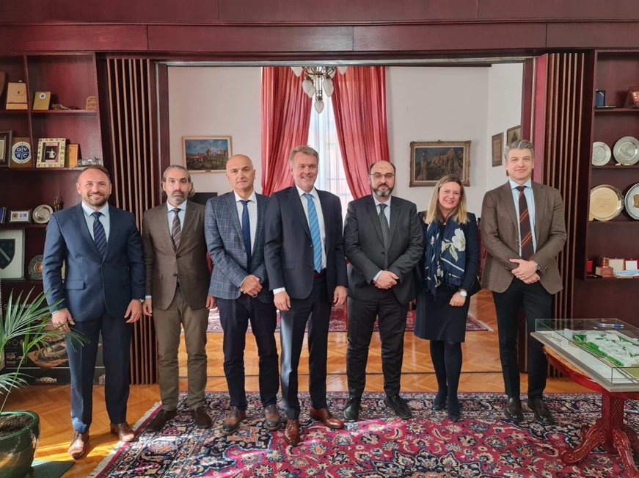
Figure 7 Visit to University of Sarajevo

- R&D financial grant support to University of Sarajevo proved to have good sustainability base as the university made financial contribution to EGG’s funds and decided to increase future R&D budget for its own projects as well as for in kind contribution for externally supported projects. The interviewees confirmed the university’s commitment to further develop R&D budget and overall financial participation also for other donors. By integration of already existing companies with the highest innovation potential and infrastructure and well-planned R&D activities and investments at university level, it might be stated that EGG project created excellent base for future integrated entrepreneurship development in the country with overall contribution to economic and social development.

Impact

OVERALL FINDING
Impact is characterized by the assessment of the overall effect of the intervention and is measured as qualitative indications on how the intervention was able to influence and contribute to economic growth and employment in BiH. EGG proved to be successful in initiating several systemic changes to include: education curricula reforms in order to improve entrepreneurial environment; positive short-term budget effects reflected in more funds dedicated to support economic development and develop grant schemes; unpacking the entrepreneurial potential through its support to start-up ideas.

The most significant impact confirmed by majority of stakeholders is seen in introduction of entrepreneurship and STEAM in formal education of high schools. Donors especially emphasized this initiative as one with the highest possible long-term impact. EGG is on the good path of institutionalizing entrepreneurship and STEAM education in selected cantons. This includes establishing entrepreneurship and STEAM education system through both learning and infrastructure in selected schools. As a result, entrepreneurship and STEAM classrooms have now become formalized part of learning process in all selected schools. While all students in selected schools experienced high satisfaction with practical entrepreneurship learning tools and STEAM classrooms, majority of teaching staff found it extremely important for the future education and labor market needs. Another important initiative which left significant impact on future entrepreneurs and already existing IT companies were modifications of procedures and criteria for local and cantonal government’s financial grant schemes with purpose for more transparent and impactful selection of the best start-up initiatives as well as projects within existing IT companies.
EGG initiatives succeeded to bring together all necessary elements (grant schemes, STEAM and entrepreneurship education in elementary and high schools, R&D at universities, innovation driven vocational learning, and intrapreneurship and innovation development within existing companies) of the future integrated entrepreneurship development and thus competitiveness of national economy. However, having in mind that the Project was implemented only in several pilot schools, long-term impact will be significantly visible after scaling up of all project activities in larger number of high schools, universities, and companies in fast-growing industries. Thus, introducing such systemic changes in pilot municipalities, cantons, schools and university has influenced and benefited large number of young people, professors, citizens and local businesses. It was here that EGG had been instrumental in establishing leadership in introducing entrepreneurial education in elementary and high schools as well as entrepreneurial culture in already existing companies.
The stakeholders in municipalities of Modriča, Žepče, Tešanj, Stari Grad, Orašje, Odžak, Centar, Gradiška, Doboj, Banja Luka, Brčko District as well as Posavina Canton and Sarajevo Canton see tangible changes in their budgeting process resulting in savings which are transferred to development initiatives and particularly those related to local investments in infrastructural projects. Direct impact of these initiatives was experienced by local businesses, kids, parents, youth and ordinary citizens through financial support to infrastructural projects which resulted in improvements of kindergartens, amphitheaters, city hall and business zones. Quality of life of previously mentioned beneficiaries is especially visible through better access to kindergartens for kids and parents, more places for cultural and other social events, better services in business zones and overall job opportunities. However, political interference and ad hoc interventions remain an obvious challenge in achieving sustainability of implemented activities in local budgeting processes. Additionally, both local and cantonal governments as well as local companies and new aspiring entrepreneurs see significant benefits of improved criteria for grant schemes which encourage and support innovation and entrepreneurship development. Above all, the highest importance for both parties represent new job creations which are achieved through EGG initiatives.
Financial streamlining has been another area of change. Selected local governments increased their capacities to perform functions which allow them to address concrete preferences of the existing and new businesses as well as ordinary citizens. Start-up companies as well as existing companies in ICT industry noted that they were able to attract new funds and investments for innovation and product development projects.
However, while these changes have taken place as a result of the project, the sustainability of these systems face challenges in terms of financial resources, organizational capacities and political coordination. This includes, for instance, the political environment where political instability and often changes of government can influence budgeting priorities.
Following the successful implementation of the first start-up cycle, generating some 1.4 million KM in investments with 41 new businesses created, the Project re-launched the scheme in 2020, adjusting the scope and methodology to the conditions created by the pandemic. A total of 33 aspiring entrepreneurs attended the comprehensive training and 23 started new businesses, with a total of 1 million KM raised in funding. The project made noticeable benefit through creation of 64 new businesses and 95 new jobs through them, with almost 2.5 million generated in investments. Additionally, 9 BiH software companies received financial support to implement projects that have led to the creation of 51 new high-quality jobs. After the establishment of a network of 22 SMART classrooms and fab-labs in 2019 and 2020, 86 teachers (50% female and 50% male teachers) successfully completed the requisite training program. Important to mention that before COVID 19 pandemic, there were 287 students in STEAM sections. Once the conditions for a full return to school have been met, it is expected that some 400 pupils will benefit from the new equipment and training.
The grant schemes, cost optimization and revenues maximization initiative, as well as both trainings for students and teachers addressed inclusion of specific vulnerable groups such as women, minorities and people with disabilities. The project has enabled local governments and selected elementary and high schools to act as catalysts for local entrepreneurship and economic development based on well-planned development budgets and grant schemes oriented towards entrepreneurs and needs of local labor market.
Regardless of all positive achievements of the project, it needs to be emphasized that there are also certain limitations in assessing these gains. Real long-term effect of newly started businesses will be possible to measure only in the next 3-5 years as this is the critical period in which start-up businesses survive or fail. Another limitation is associated with selected schools’ annual reports which do not present exact and quantitative results which might precisely measure the effects of entrepreneurial education and usage of SMART classrooms. Additionally, given the nature of the evaluation, it is difficult to fully discern whether benefits to people can be directly and exclusively attributed to EGG support.
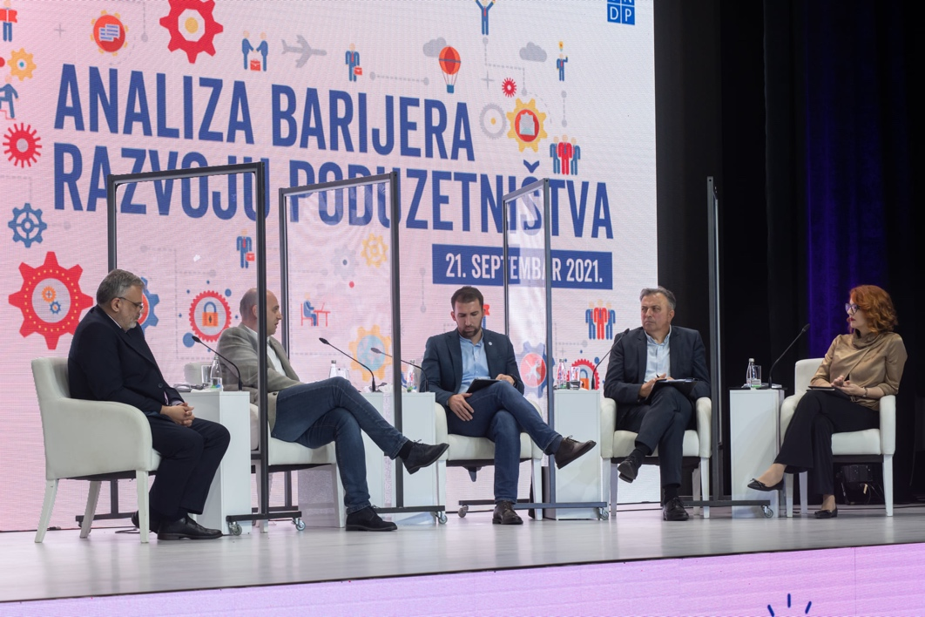
Figure 8 Entrepreneurship barriers - panel discussion

Conclusions

Relevance

The evaluation finds that the project is highly relevant, but considering slow and insufficient economic growth, unemployment rate in the country and political instability, the needs of the beneficiaries outweigh the resources of a single project. Implementing a project such as EGG was a challenging process, from project design perspective and its goals, limited capacities of institutions at different levels of government to COVID 19 pandemic implications. The design of the project positioned EGG to achieve wide impact on future economic growth of the country. Based on previously presented findings, it is evident that EGG has successfully addressed capacity gap for local economic growth and governance in BiH. Influenced by the global fourth industrial revolution, EGG had the perfect timing and purpose for all stakeholders involved in the project. Project design and results were relevant for both economic and governance needs of students, unemployed people, companies, academicians and scientists, local and cantonal governments and all citizens in partner municipalities.

All stakeholders in partner local communities agreed that EGG had very important role in embedding cost optimization and revenue maximization within budget frameworks as well as instrumental role in embedding entrepreneurship and STEAM learning and processes within pilot elementary and high schools as well as companies in the fast-growing industries. Additionally, infrastructural projects supported through financial grants fully addressed priorities from local development strategies in partner municipalities. Similarly, financial grants spent on creation of startup companies, development of the existing IT companies and R&D initiatives at the University of Sarajevo were fully aligned with both municipal and cantonal strategies as well as institutional strategies and priorities of beneficiaries. Studies with analysis and recommendations on ICT sector and Entrepreneurship had perfect timing and relevance for future strategies related to overall economic growth in the country. Overall, project design and results proved to be aligned and relevant to UN Agenda 2030 and sustainable development goals and particularly to Quality Education, Decent Work and Economic Growth and Industry, Innovation and Infrastructure goals.

From local businesses which were supported through grant schemes in improving infrastructural capacities and services of business zones, through kids and parents who got access in kindergartens to all other citizens and civil society who benefited by getting enriched cultural offer (amphitheaters and City Hall), the project proved to address the key issues which local communities face. When it comes to financial grant schemes, the evaluation proved that several beneficiaries were positively influenced by redesign of schemes such as already existing IT companies which improved internal capacities and opened new job positions, young entrepreneurs who got both financial support and mentoriship for starting business and unemployed citizens who got a job either in already existing IT companies or newly established start-up companies.

However, the evaluation concludes that more is required to institutionalize positive budget optimization practices through official adoption of Methodology for cost optimization and revenue maximization. The theory of change was strategic enough to cover all key elements of integrated entrepreneurship development system. Both quantitative and qualitative indicators proved to be relevant and directly related to outcome results.

Effectiveness

The COVID 19 pandemic clearly had an impact on many of the activities as well as the project management issues which led to some delays throughout the project. However, the project was able to achieve almost all established targets. This criterion is rated as highly satisfactory. Project results improved effectiveness of local governments and schools to ensure labor market-oriented budgeting and education which should result in overall economic development throughout the country. Although the project showed excellent results in pilot local communities and education institutions, much remains to be achieved. The project has set up excellent base and case for horizontal scale and harmonization. It has also made satisfactory results in closing the gender gap and social inclusiveness through several examples such as infrastructural support to kindergartens and schools in partner municipalities which took in consideration needs of young and people with disabilities on one side, and through equal treatment of male and female participants of entrepreneurship trainings in schools (50% were female teachers), and well-planned distribution of male and female participants in R&D projects at the University on the other side.

Output one, beside facing several challenges due to the impact of the COVID 19 pandemic, proved to be successful in terms of outputs and targets reached. The project successfully identified some of the gaps in the entrepreneurial environment and addressed most important obstacles that hinder increase in entrepreneurial and innovation activity, prevent exploitation of developmental opportunities and consequently transfer to knowledge-based economy.

Output two was also significantly influenced by COVID 19 pandemic as budgets at all levels of government in the country were hit by negative effects of the pandemic. Anyway, EGG successfully reviewed public management practices at local and cantonal level in order to increase capacity of partner governments in determining their efficiency in provision of support to private sector through reduction of operating budgets and freeing up resources to use to support capital projects. In terms of incentive schemes supporting entrepreneurial activities, project did formidable work, but due to the pandemic their full completion was halted and impossible to finalize.

At the end of the process, good number of positive practices have arisen which could be scaled for wider application across local communities, cantons and both entities:
- Positive case studies of cost optimization and revenue maximization within budgetary frameworks in local governments as well as redesigned procedures of financial grant schemes which should serve more for entrepreneurship development, new and better jobs creation and overall local economic development.
- Very effective financial support to municipal infrastructural projects which are aligned with local development strategies and needs
- Piloting of both formal and informal entrepreneurship and STEAM learning with the high scope for replication in all elementary and high schools.
- Piloting of intrapreneurship and innovation development within companies in fast-growing industries
- Piloting of financial support for high impact university-level R&D projects in the fast-growing industries
- Noticeable number of newly established start-up businesses and new jobs
- Very effective pilot studies on the current situation in ICT and automotive sectors as well as Analysis of barriers in entrepreneurial ecosystem in BiH with the proposed “the way forward “, etc.
The evaluation process also confirmed satisfactory level of participation of all relevant stakeholders in both entities. Project Management team was fully involved in implementation of all activities as well as monitoring of the progress. Participation of stakeholders was visible in all activities, but particularly in defining and selection of infrastructural projects which project supported, R&D grants users’ selection, entrepreneurial trainings and startup creations, preparation of pilot studies about ICT sector and entrepreneurship etc.

Efficiency
The overall efficiency of the project is deemed highly satisfactory and governance mechanisms are adequate. The evaluation process confirmed satisfactory level on participation of all relevant stakeholders in both entities and Brčko district. Project Management team was fully involved in implementation of all activities as well as monitoring of the progress. Participation of stakeholders was visible in all activities, but particularly in defining and selection of infrastructural projects which project supported, R&D grants users’ selection, entrepreneurial trainings and startup creations, preparation of pilot studies about ICT sector and entrepreneurship etc.
Project Management has worked efficiently and ensured timely delivery of majority of the outputs. Interviews supported conclusion about the efficient work of the project team as that each and every partner appreciated their efforts. The project team ensured timely planning, procurement of services and delivery of the activities as per the annual plans. They have prepared timely and good quality progress reports as well.
The monitoring of the project is adequate, and reports are quality and informative. The financial operations appear to be managed in a satisfactory manner. A cost-benefit analysis was outside the scope of this evaluation and therefore, we did not look into details of the direct funding allocated for the particular activities, but only activities as a whole.

Impact
The impact of the project is deemed very satisfactory, where there are key individual successes which have literally transformed people’s lives such as creation of new entrepreneurs as well as creation of new jobs for unemployed people in both start-up companies as well as already existing IT companies.
Impact is characterized by the assessment of the overall effect of the intervention and is measured as qualitative indications on how the intervention was able to influence and contribute to economic growth and employment in BiH. EGG proved to be successful in initiating several systemic changes to include: education curricula reforms in order to improve entrepreneurial environment; positive short-term budget effects reflected in more funds dedicated to support economic development and develop grant schemes; unpacking the entrepreneurial potential through its support to start-up ideas etc.
Additionally, the evaluation proved significant impact of the project results on different beneficiaries such as access to kindergartens for kids (including kids with disabilities) and parents, citizens in local communities with access to new cultural attractions and jobs, employers with improved infrastructure in local business zones, companies with better local offer of labor force with necessary skills for work, companies which through financial grants improved productivity and number of jobs, youth which through entrepreneurship education and financial grants started new companies and created new jobs, academicians which through R&D grants improved their research capacities and alignment with labor market needs etc.
Sustainability
The sustainability of the project is rated as satisfactory. The overall aim of the project was to build a foundation for future economic growth and governance whereby the support to governments, youth, companies, students and academicians has been important and can help shape the face of economics in the future. The project established excellent base for sustainability of future of work skills development as well as entrepreneurship development through improvement of already existing procedures and criteria for financial grant schemes in partner municipal and cantonal governments. It is very important that all project activities are aligned with UN Agenda 2030 and sustainable development goals which serves as foundation for future financing of similar activities in partner local communities and cantons. However, due to COVID 19 negative implications, the project did not succeed to institutionalize cost optimization and revenue maximization activities within budgetary framework in partner local communities and cantons. EGG established noticeable sustainability base for further development of entrepreneurship and STEAM education in partner elementary and high schools. The project implemented excellent training and financial support programs by hiring external consulting company. Pilot studies conducted for ICT and automotive sectors as well as Analysis of barriers in entrepreneurship in BiH setup excellent base for further government strategies and policies in those fields. Finally, R&D projects implemented through financial grants support established platform for future collaboration of the university with governments, companies and individual researchers.

Gender and Social Inclusiveness
Out of 133 aspiring entrepreneurs who benefited from the project, 65 were women. Similarly, 50% of teachers who went through entrepreneurship training in partner high schools were women. SMART classrooms supported by the project enabled equal access to all social categories of high school students including students with disabilities. During the selection of priority infrastructural projects in four partner municipalities, social inclusiveness was one of the key criteria in selecting them. Out of 400 pupils who benefited from SMART classrooms and entrepreneurship trainings, more than 40% were women.

Lessons Learned

- A more engagement of authorities from local and cantonal governments is necessary for establishment of development driven i.e., cost optimization and revenue maximization budget as well as entrepreneurial and innovation oriented financial grant schemes. Policy process takes time and especially if intention is to establish widely accepted methodology for cost optimization and revenue maximization within budgetary frameworks. Having in mind high political impact on budgeting priorities, institutionalization of methodologies for development driven budgeting will remain a challenge and will need much higher effort of all relevant stakeholders in local and cantonal governments.

- High level of interest and participation of different stakeholders in local communities confirm political interest and commitment for budgeting reforms which will be more oriented towards local businesses, new entrepreneurs and overall economic development. However, not all Mayors who participated in EGG project activities showed the same political willingness for changes proposed by the project. The highest enthusiasm and buy-in was shown and demonstrated among senior management of selected pilot schools for SMART and entrepreneurship education as well as participants of entrepreneurship and start-up programs. University of Sarajevo together with companies involved in the project activities also expressed high satisfaction with services provided by the project.

- Having in mind that several international projects related to budgeting process are being implemented in the country, there is possibility for potential conflict and duplication of activities and approach. Therefore, it is very important to ensure proper coordination of all interested and involved actors.

- Entrepreneurship and start-up programs proved to have the highest impact on social inclusion and minority groups as application calls were open to everyone with equal opportunity to join the program and gain financial and mentorship support. Also, the evaluation revealed that beside providing financial support to newly established start-up companies, it is even more important to provide adequate and continuous mentorship and advisory support to entrepreneurs and specially during the first year of business operations. However, good initiatives to ensure gender sensitive budgeting and financial grants schemes did not demonstrate high impact on these groups. More effective support is needed in this area.

- When it comes to STEAM education and infrastructure in elementary and high schools, the project put significant effort to ensure leadership of partners in project interventions. Similar outcomes were noticed at University of Sarajevo which took leadership in execution of R&D project activities within the university. However, there is additional space for reducing dependence on external support in optimization of budgets in local governments.

- When it comes to detected capacity gaps related to budgeting process and financial grants schemes in local communities, there is still interest and necessity for project staff to push for achievement of project outputs. Mechanisms for providing explicit decision-making authority and leadership of domestic partners for project activities despite their capacity gaps should be pursued along with risk assessment measures.

- High percentage of teachers in some of pilot vocational schools did not react to online entrepreneurship and STEAM education related trainings in the best way. They found it too complicated for them and irrelevant as it is significantly changing their old habits and methodologies of teaching. Some teachers showed resistance to new way of teaching in SMART classrooms due to the fact that they will be retired in shorter period of time and therefore do not see the meaning for training attendance. This problem should be carefully observed as it has high implications on sustainability of the project.

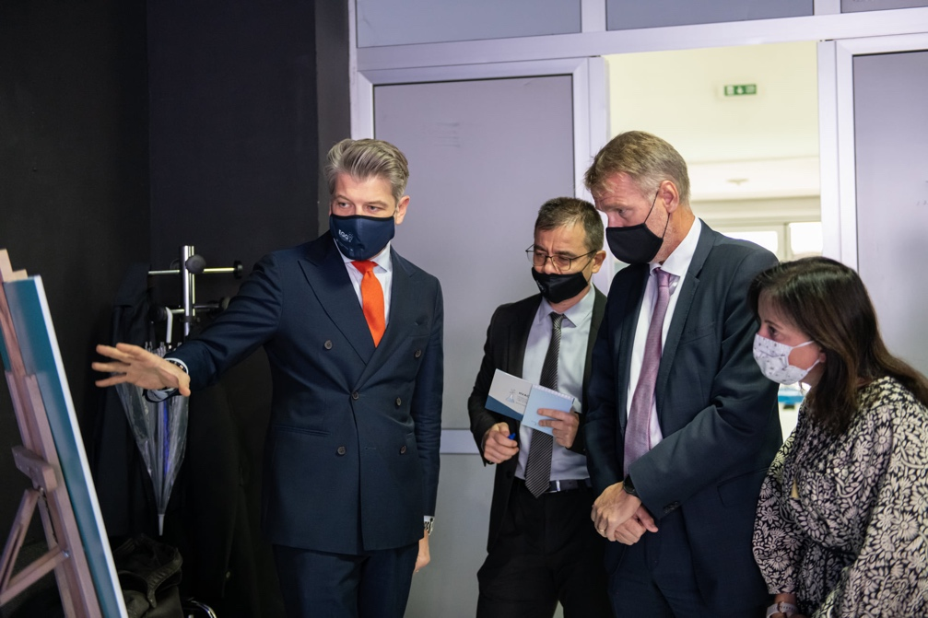
Figure 9 Project results presentation to donors

Recommendations

This section outlines the key recommendations in relation to the conclusions of this evaluation.
Recommendation with Comment | Linked to Criterion | Forward-looking actionable recommendations
Strengthen institutionalization of entrepreneurship and STEAM learning.  Interventions initiated through EGG project, need to be expanded to all high schools, both vocational and gymnasiums, as well as in the last years of elementary schools throughout the country. Introduction of formal entrepreneurship curriculum in as many as possible elementary and high schools represents one of the major prerequisites for future long-term entrepreneurship and innovation development resulting in overall economic growth and prosperity. Both introduction of new entrepreneurship courses or modification of already existing but outdated economics related courses can satisfy this important activity. Institutionalization of entrepreneurship and STEAM learning that will ensure consolidation of EGG in potential new phase should be planned for a period of four to five years. The details are emphasized in the Forward-looking actionable recommendation section. | Sustainability and Relevance | Beside institutionalization of entrepreneurship and STEAM in formal curricula of all elementary and high schools (both vocational and gymnasiums), future activities and initiatives should also integrate teaching of entrepreneurship and STEAM through informal education in elementary and high schools. One of the possible initiatives could focus on activation of Entrepreneurship and STEAM student clubs in elementary and high schools which would develop customized entrepreneurship programs in collaboration with relevant companies and interested universities. After completion of informal and integrated entrepreneurship programs, schools should organize start-up/innovation/hackathon competitions on the level of school. With the help of local governments and cantonal ministries of education and/or economy, students with best business ideas could qualify for municipal and cantonal or regional final competitions. Wherever and whenever it is possible, cantonal or regional competitions should organize at one of regional universities which could offer its infrastructure and expertise through mentorship. Competition would further expand to entity and national level. Final national competition should bring interested universities, government institutions, companies, donors and investors at one place to demonstrate entrepreneurial culture and dedication of all relevant stakeholders.  All mentioned competitions could have different models or approach and one of them could include involvement of companies from the strategic and fast-growing industries from the early stage of entrepreneurship programs and competitions where students would, through competition and entrepreneurship program, work on solutions for the problems proposed by partner companies. Same companies would provide adequate mentors who would accompany teachers from schools in guidance and mentorship of business ideas. Government should have facilitation role from the beginning of process and specially by ensuring adequate financial support through grant schemes for the best start-up ideas.  Initial phase of the proposed programs could be implemented at the pilot municipalities and schools and later on expanded to the rest of the country.
Focus on consolidation and expansion of SMART classrooms and technology-based infrastructure.  Having in mind enthusiasm expressed by students and pilot schools’ authorities, further equipping of the current and new elementary and high schools with technology and SMART classrooms represents one of the top priority future activities which will strengthen hands on learning and experience of students. The follow up phase should focus on consolidating the demonstrated good practices throughout the project implementation in pilot schools. | Sustainability and Effectiveness | Beside horizontal expansion of SMART classrooms throughout different elementary and high schools all over the country, schools accompanied with relevant municipal and cantonal institutions should further work on integration and institutionalization of business sector involvement in the process of equipping SMART classrooms and other technology-based infrastructure. Development of SMART classrooms could be developed within the schools, but also within partner local companies which would open their doors for students and their potential future employees. Institutionalization of the proposed model could be realized by modification of grant scheme procedures which would specially award companies with SMART infrastructure project proposals which would satisfy needs of both companies and local schools.
Target capacity development of high school teachers for hands on learning, entrepreneurship and STEAM.  Having different experiences in different pilot schools, capacity development of teachers remains one of the most important things for future sustainability of entrepreneurial and STEAM learning in elementary and high schools. Capacity development should combine trainings and mentorship of teachers with in person contacts as much as possible. Two challenges should be carefully examined, high turnover and frequent changes of teachers in schools as well as their age. As evaluation process confirmed resistance of certain number of teachers towards new technological tools and entrepreneurship in learning, careful combination of in person and online learning should be implemented. | Relevance and Sustainability | Due to high turnover rate of teachers, recommendation is to develop online modules and simulations which could be used as training materials and videos for new teachers. Meanwhile, train the trainers programs could serve as good mechanism for ensuring continuity of knowledge sharing within schools. Ministries of education through pedagogical institutes could also ensure intro trainings to all relevant teachers at the beginning of each academic year.
Integration of research findings on the future of information technology sector and automotive sector into formal curricula.  Having all relevant stakeholders at different levels of government satisfied with conducted research reports and proposed recommendations for aligning of education sector with labour market, activities on integration of research findings into country’s different curricula and education policy frameworks should be intensified. It is especially relevant for introduction of as many as possible project and product-based learning through academia-industry relations which could be implemented through various already existing courses in addition to newly established entrepreneurship course. | Relevance and Sustainability | After formal integration of research findings into formal education curricula, further activities should focus on expanding academia-enterprise collaboration through range of informal activities. Local schools through municipal governments should establish relations with local employers’ associations and local business sector leaders which could get involved in the formal education process (labs and practical teaching). Wherever it is possible, local business sector leaders could be part of informal or formal school advisory boards directing especially informal entrepreneurship programs within schools as well as practical lessons. By signing formal Memorandums of Understanding, schools could provide students with adequate and customized internship programs and on-site practical work.
Support start-up and MSME development through access to financing, entrepreneurship courses, mentoring, SMART classrooms, life-long learning/development centers.  Having in mind noticeable success of comprehensive entrepreneurship trainings implemented in two start-up cycles, this project activity and initiative should scale to as many as possible local communities and schools. Institutionalization of STEAM and entrepreneurship development centers should be base for long-term sustainability and continuation of entrepreneurship development. However, institutionalization of capacity development centers remains one of the top priorities in the future in order to ensure continuity and sustainability of entrepreneurship programs. Ad hoc entrepreneurship and start-up programs usually provide excellent results and enthusiasm which usually disappears as external projects end. Therefore, through collaboration with government institutions and local business leaders, future sustainable entrepreneurship and start-up programs and mentorships should be developed (continuation of provision of financial support to young entrepreneurs coupled with tailored mentoring and advisory support during the first year). Forward looking actionable recommendations section reveals several potential options for the institutionalization and sustainability of these programs. | Effectiveness and Impact | Support to start-up and MSME development represents one of the highest priorities in a wide range of policy papers and strategies from municipal over cantonal and entity level strategies to SDG Framework 2030 for BiH. Further support and initiatives could go in several directions:  - within schools and universities for the purpose of developing start-ups within university/school ecosystem. Schools in collaboration with local and cantonal governments, companies and universities, should start the process of creating start-up incubators and innovation labs (on the basis of SMART classrooms) which would be the spring of future business ideas and initiatives  - under the relevant ministries or development agencies/departments at local, cantonal and entity level to serve through trainings and financial support both new start-ups and/or innovation of existing companies. This activity is especially important for future direction of grants intended for local economic development.  - formation of lifelong learning public-private partnerships which would end up with formation of capacity building and development centers directed towards concrete needs of existing companies as well as new start-up companies.  Local governments’ grant schemes for mentorship and investments should be directly linked to start-up programs implemented through development centers in schools/university or relevant government agencies/institutions. Development centers should be directly financed through these grant schemes in order to ensure their sustainability.  Competitiveness of IT and automotive companies should be continuously supported both through grant schemes as well as development centers by providing of adequate and necessary equipment as well as training of employees for new product developments.
Focus on consolidation and expansion of R&D projects at universities  Considering success of the initial call for R&D projects and research at University of Sarajevo, similar activity should be further continued and expanded to other universities by combining financial participation of university and financial support of external partners including government funds. Since initial R&D call focused only on IT and automotive sectors at University of Sarajevo, evaluation revealed certain limitations in number of applications. Therefore, future calls should be additionally promoted and expanded to other growing sectors and industries in order to become interesting for larger number of academicians and researchers. | Effectiveness and Sustainability | Beside expansion of R&D application calls at all universities and more sectors, further initiatives should carefully focus on joint R&D projects between universities and relevant companies. Companies would express concrete needs and problems which they face in everyday business and universities should in collaboration with them work on development of practical R&D solutions with commercialization potential. Beside joint R&D projects which would share financial costs, future model of cooperation and joint R&D could involve formation of specialized master by research master programs which would be jointly financed by companies, students and governments/external projects. Furthermore, development of university entrepreneurial ecosystem should also include formation of start-up and innovation incubators at individual faculties, as well as technological parks, through implementation of tripe-helix (University-Industry-Government) collaboration mechanisms.
Strengthen institutionalization of smarter spending and revenue generation by local and cantonal governments.  The outreach of the interventions initiated through EGG need to be consolidated and expanded in specific areas in order to ensure long-term impact on socio-economic development. Beside decline of local revenues in partner municipalities caused by negative COVID 19 pandemic implications, Methodology for cost optimization and revenue maximization proved to be good base for further development and expansion. COVID 19 pandemic just showed how even more important is smart and rational budget spending. | Effectiveness, Efficiency and Sustainability | EGG budget analysis activity was based on developed methodology used by contracted consultants to conduct the analysis. However, aforementioned methodology was not shared with the partner governments in its entirety, nor were the civil servants in local and cantonal governments instructed or trained to use it. Therefore, future activities should involve further improvements and institutionalization of proposed Methodology accompanied by capacity development of all relevant public servants working on budgeting processes through implementation of training programs as well as assigning the responsibility to conduct the analysis on annual bases. This would ensure sustainability of the efforts to control budgetary expenditures and maximize revenues, so funds are freed up for other productive purposes that drive economic growth.
Focus on scale of redesigning and restructuring of government incentive schemes aimed at supporting entrepreneurship, private sector development and job creation.  Prepared Manual for preparation of grant schemes as well as Guide for the verification, monitoring and evaluation of projects funded through the grant programs should be institutionalized in as many as possible local communities, but also cantons and even entities (with necessary adaptations). By observing the wider economic development context where investments into SME sector and entrepreneurial infrastructure present top national priority and focus, this activity would significantly contribute to efficiency, effectiveness as well as monitoring and evaluation of whole process. Civil servants working on “grant schemes jobs “should be widely trained about the new methodology with accompanied monitoring system for projects’ implementation. Wherever and whenever possible, good performing governments should be ‘rewarded’ and financially supported for implementation of high impact projects proposed by development-oriented budgets. | Effectiveness and Impact | In the context of challenging economic conditions for local and other levels of government, the level of funding available and the way in which it is distributed will inevitably come under scrutiny, and the governments must ensure that the local economy derives the maximum amount of benefit from any public expenditure. Through grant schemes financial assistance is provided to assist applicants with the costs related to developing projects, where these projects meet key eligibility criteria and will result in extensive local benefits. Therefore, one of the main pathways towards widespread use of this tool is institutionalization. Institutionalization can succeed only when reinforced by a wide variety of activities, including legislation and pilot projects, political advocacy, professional training, information sharing, and incentive-based funding, and any or all of these may be used in this context.

Annex 1 Interview Guides

Key stakeholder interview guide: UNDP/ Project team

Please describe the circumstances under which you have engaged in the project design and/or implementation.

Please describe the process of project design. What do you find very successful, and where were the challenging issues? How did the designing project team address these issues?
What was the role of national and main project teams during project design?

Relevance
- In your opinion, how this project design was well suited to the context and objectives in terms of the contribution to economic growth and entrepreneurship development, improving economic governance and fostering the growth of market-oriented capabilities for a knowledge-based economy in BiH? Were there some aspects of the project that should be set differently and why?
- Do you think that project objectives are properly aligned with current national policies?
- Do you think that project interventions are designed adequately to the needs and potentials of beneficiaries to actively contribute to entrepreneurship development and economic governance?
- Have the external developments affected your EGG: how flexible and responsive was the Project Team in addressing the COVID19 pandemic and its implications? Are there other examples of flexibility?
- From your perspective do you think that some important areas or forms of interventions that can contribute to the regional cooperation and cohesion were left out of the project scope? If YES, what were those, and why?
- To what extent has the EGG Project incorporated principles of gender equality and human rights during its design and implementation? Please provide your opinion and some examples.
- How much Agenda for Sustainable Development until 2030 was taken into account during project design? If you can indicate to which specific SDGs and targets this project was meant to contribute? How was that discussed in the designing team?
Coherence:
- Has it been well-integrated in the portfolio of UNDP? Have synergies with other intervention of UNDP been established? If YES, which ones? If NOT, why not?
Effectiveness
- In your opinion, how effective was the implementation of the project? What were the main achieved results? Are there any shortcomings? Are there any unforeseen positive or negative outcomes?
Efficiency
- Do you think that the EGG project been implemented efficiently?
- Have the management practices, policies, processes and decision-making capabilities contributed to the efficiency of the EGG Project?
Impact
- Has the EGG contributed to an enabling environment for development of entrepreneurship and economic governance? On what evidence you base this opinion?
- What are the main benefits (qualitative and quantitative) for the target groups, including for vulnerable groups? On what evidence you base this opinion?
Sustainability
- Has the EGG contributed to sustainable partnerships, polices and capacities of stakeholders to continue activities aimed at entrepreneurship development, improving economic governance and fostering the growth of market-oriented capabilities for a knowledge-based economy?
- To what extent are the Project outputs sustainable? How could the Project results be further sustainably projected and expanded?
- What would be future priority interventions to ensure long-term sustainability of the Project achievements, having in mind the current COVID- 19 related context?

Key stakeholder interview guide: Project Board Members

Please, describe what was your role during the design and implementation of the EGG project?
How well you were informed about the project implementation and results? (Based on the answer, questions will be selected among following)
Relevance
- Have you been involved in the design of the EGG Project? If yes, how would you assess the design process- has it been based on analysis and participation? To what extent have your views been considered and reflected?
- In your opinion, was EGG designed to address key issues of development of entrepreneurial activities and economic governance in line with needs and potentials of beneficiary groups?
- Has the EGG been addressing economic governance and entrepreneurial development issues that are prevailing in BiH?
- Have the external developments affected implementation of the EGG and how? flexible and responsive was the Project Team in addressing the COVID19 pandemic and its implications?
- To what extent has the EGG Project incorporated in its design and implementation the key principles of gender equality and human rights? Please, provide your opinion and some examples.
- How EGG Project contributed to the achievement of the SDGs in BiH? Please provide examples and targets (if available).
Effectiveness
- What are the main results of the EGG initiative, from your perspective?
- To your knowledge, has the EGG been effective in supporting policies and other actions to improve entrepreneurship development and economic governance? Please provide some examples if possible.
- What are the positive or negative, intended or unintended, changes brought about by the Project from the perspective of fostering entrepreneurial education and fostering entrepreneurial environment, and economic governance?
Impact
- In your opinion, has the EGG contributed to an enabling environment for improvement of entrepreneurial environment and economic governance? If YES, what are the most prominent achievements? If YES, how the project managed to contribute to that? Please provide examples.
- In your opinion, what are the main benefits (qualitative and quantitative) of the project for the target groups, including for vulnerable groups? Could you provide concrete examples?
Sustainability
- Has the EGG contributed to sustainable polices, capacities and practices of stakeholders to continue development of entrepreneurial supporting environment and good economic governance?
- Could you estimate to what extent are the Project outputs sustainable? How could the Project results be further sustainably projected and replicated or upscaled?
- What would be future priority interventions to ensure long-term sustainability of the Project achievements?

Key stakeholder interview guide: Beneficiary LGs

Please, describe what was your role during the design and implementation of the EGG project?
How well you were informed about the project implementation and results? (Based on the answer, questions will be selected among following)

Relevance
- In your opinion, was EGG designed to address key issues of good governance in line with needs and potentials of your organization?
- Has the EGG responded to the mission and needs of your organization and groups that you are representing?
- Has the EGG been flexible and responsive to your needs? Are there other examples of flexibility? Could you provide some examples?
- Have the external developments affected implementation of the EGG and how flexible and responsive was the Project Team in addressing the COVID19 pandemic and its implications?

Effectiveness
- What are the main results of the EGG initiative, from your perspective?
- How would you assess your partnership with the EGG Project? Did it contribute to more effective delivery of results?
- What would you identify as key positive factors that contributed to the achievement of results in the project components in which you participated? And what would you identify as negative, inhibiting factors? How did you address these negative factors if they were under your area of responsibility?
- To your knowledge, has the EGG been effective in supporting policies and other actions to improve economic governance? Please provide some examples if possible.
- What are the positive or negative, intended or unintended, changes brought about by the Project from the perspective of fostering economic governance?
- Did you get any support from the project team to adjust your project activities to online format or other forms that were introduced as adjustments to the COVID pandemic? Please describe. Was that support sufficient for you to implement your activities in accordance with your obligations? If not, what were shortcomings?

Impact
- In your opinion, has the EGG contributed to an enabling environment for improvement of economic governance? If YES, what are the most prominent achievements? If YES, how the project managed to contribute to that? Please provide examples.
- In your opinion, what are the main benefits (qualitative and quantitative) of the project for the target groups, including for vulnerable groups? Could you provide concrete examples?

Efficiency
- From your perspective, has the Project been timely implemented? Were there deviations or delays that you are aware off? What were the reasons for these deviations or delays?
- How was your communication and cooperation with the EGG Project?
- How would you describe your reporting obligations, were procedures very demanding?

Sustainability
- Do you think that the established results will last after the end of the assistance through the EGG?
- How effective was the EGG team in coordinating activities with your organization?
- Have you participated in planning and implementation of Project activities? Do you think that involvement of your organization was sufficient and adequate?
- Has the Project responded to the capacity development needs of your organization in the areas of intervention?
- What would be future priority interventions to ensure long-term sustainability of the Project achievements, having in mind the current COVID- 19 related context?

Key stakeholder interview guide: Project Beneficiaries

Please, describe what was your role during the design and implementation of the EGG project?
How well you were informed about the project implementation and results? (Based on the answer, questions will be selected among following)

Relevance
- In your opinion, was EGG designed to address key issues of entrepreneurship development in line with needs and potentials of your organization?
- Has the EGG responded to the mission and needs of your organization and groups that you are representing?
- Has the EGG been flexible and responsive to your needs? Are there other examples of flexibility? Could you provide some examples?
- Have the external developments affected implementation of the EGG and how flexible and responsive was the Project Team in addressing the COVID19 pandemic and its implications?

Effectiveness
- What are the main results of the EGG initiative, from your perspective?
- How would you assess your partnership with the EGG Project? Did it contribute to more effective delivery of results?
- What would you identify as key positive factors that contributed to the achievement of results in the project components in which you participated? And what would you identify as negative, inhibiting factors? How did you address these negative factors if they were under your area of responsibility?
- What are the positive or negative, intended or unintended, changes brought about by the Project from the perspective of fostering entrepreneurial education and fostering entrepreneurial environment?
- Did you get any support from the project team to adjust your project activities to online format or other forms that were introduced as adjustments to the COVID pandemic? Please describe. Was that support sufficient for you to implement your activities in accordance with your obligations? If not, what were shortcomings?

Impact
- In your opinion, has the EGG contributed to an enabling environment for improvement of entrepreneurial environment? If YES, what are the most prominent achievements? If YES, how the project managed to contribute to that? Please provide examples.
- In your opinion, what are the main benefits (qualitative and quantitative) of the project for the target groups, including for vulnerable groups? Could you provide concrete examples?

Efficiency
- From your perspective, has the Project been timely implemented? Were there deviations or delays that you are aware off? What were the reasons for these deviations or delays?
- How was your communication and cooperation with the EGG Project?
- How would you describe your reporting obligations, were procedures very demanding?

Sustainability
- Do you think that the established results will last after the end of the assistance through the EGG?
- How effective was the EGG team in coordinating activities with your organization?
- Have you participated in planning and implementation of Project activities? Do you think that involvement of your organization was sufficient and adequate?
- Has the Project responded to the capacity development needs of your organization in the areas of intervention?
- What would be future priority interventions to ensure long-term sustainability of the Project achievements, having in mind the current COVID- 19 related context?

Annex 2 List of Interviewees

Date | Organization/Institution | Name and title of representative
29.10. | UNDP Senior Staff | Ms Steliana Nedera, UNDP BiH Resident Representative  Ms Adela Pozder - Cengic, UNDP Sector Leader for Rural and Regional Development  Mr Edis Arifagic, Local Development Programme Manager
06.10. | EGG Project Team | Mr Aldin Medjedovic, EGG Project Manager  Mr Muamer Mulahasanovic, EGG Project Officer
18.10. | Royal Norwegian Embassy | Mr Ognjen Grujic, Head of Project Department
 | Ministry of Civil Affairs BiH | Mr Adnan Husic
19.10. | Government of FBiH | Mr Goran Mirascic
19.10. | Ministry of Administration and Local Self-Government RS | Mr Dusko Milojevic
19.10. | Bit Alijansa | Ms Tatjana Vucic
18.10. | Office for Development and European Integration of Posavina Canton | Marko Vukic  Franc Kljaic
19.10. | Centar Sarajevo Municipality | Mr Srdjan Mandic, mayor  Haris Sijarić
18.10. | Odzak Municipality | Ms Nada Culap, mayor
19.10. | City of Gradiska | Zoran Adzic, mayor  Danijela Miletić
18.10. | Sarajevo Canton Ministry of Education | Ms Lamija Husic, assistant to minister
20.10. | Sarajevo High School of Electrical Engineering | Ms Fahrudin Alihodzic, director
18.10. | University of Sarajevo | Mr. Rifat Škrijelj, rector  Maja Arslanagić Kalajdžić
21.10. | Elektrotehnička High School in Banja Luka | Irina Čavić, Director
21.10. | 3 Start-up companies (individual + focus group) | Edita Vejselović, Zoran Kulundžija, Nataša Vasić
18.10. | Foreign Trade Chamber BiH | Amir Hujic, COSME coordinator

Annex 3 List of Documents

- UNDAF for Bosnia and Herzegovina 2015-2020 / 2021-2025
- CPD for Bosnia and Herzegovina 2015-2020 / 2021-2025
- 2019 BiH Automotive Industry Assessment: Trends, Challenges and Opportunities
- 2020 Software Industry Skills Needs Assessment
- Sarajevo Canton Employment Action Plan 2020
- Sarajevo Canton Curriculum on Entrepreneurship 2020
- Sarajevo Canton Protocol on Credit Guarantee Fund
- Law on Mitigation of Negative Economic Consequences and Savings of Sarajevo Canton
- Financial reviews for Banja Luka, Doboj, Gradiška, Modriča, Odžak, Orašje, Tešanj. Žepče, Stari Grad, Centar, Sarajevo Canton, Posavina Canton and Brčko District 2018-2020
- Study: Barriers to Entrepreneurship in Bosnia and Herzegovina 2020
- Municipal Financial Analysis (10 municipalities)
- Cantonal Spending Reviews (2)
- Brčko Distrikt Budget analysis
- EGG Project Reports
- EGG Project Budget

Annex 4 Results and Resources Framework (Project Application Results Framework)
ECONOMIC GOVERNANCE FOR GROWTH (EGG) PROJECT – RESULTS FRAMEWORK
Level | Goal  (expected result) | Indicator and Source Reference | Indicator Values |  |  | Comments
 |  |  | Baseline  (2017) | Milestone (target) Year 1 | Milestone (target)  Final
Impact | To contribute to economic growth and employment in Bosnia and Herzegovina | - Number of jobs created in target areas  Source: Project reports, employment records, media | 0 | 0 | 100 (at least 30% for women)
Outcome | Entrepreneurship ecosystem improved in target area | - Number of local governments and cantons with improved economic governance through sustained optimisation of public spending and effective incentives  Source: Project reports, partner government decisions / reports, reports on effects of incentives | 0 | 0 | At least 10 local governments and 2 cantons | -Local leadership buy-in to be secured  - Global and EU economic trends remain positive  -Sufficient number of qualified participants/quality ideas under the start-up support scheme
 |  | - Percentage increase in sales across key sectors  Source: Project reports, Annual Income Statement and Balance Sheet | 0 | 1.5% | 3%
 |  | - Number of start-ups created  Source: Tax Authority Registration papers, Project reports | 0 | 5 | 15
Output 1 | Increased entrepreneurship capabilities for economy of the future | -Number of established and aspiring entrepreneurs benefiting from project-instigated ecosystem infrastructure  Source: Project reports, media | 0 | 40 | 135 | Support to be secured by policy makers and schools
 |  | -Number of educational institutions offering STEM, “fab lab” and entrepreneurship development capabilities  Source: Project reports, school and line ministry’s decisions, course material, media | 0 | 3 | 10
 |  | - Number of students benefitting from skill upgrade  Source: Project reports, school / line ministry records, media | 0 | 120 (at least 40% females) | 300 (at least 40% females)
Output 2 | Private sector development enabled by conducive governance frameworks | - Amount of total savings / additional revenues generated annually through improved public finance management by 10 local governments and two cantons  Source: Project reports, annual budget reports | 0 | 0 | BAM 4 million | Local leadership buy-in to be secured
 |  | - Number of restructured government economic incentive schemes  Source: Project reports, partner government decisions and reports | 0 | 5 | 10
 |  | - Number of priority economic infrastructure interventions implemented  Source: Local governance records, project reports, media | 0 | 0 | 3

Annex 5 Evaluation Matrix
Relevant evaluation criteria | Key Questions | Specific Sub-Questions | Data Sources | Data collection Methods / Tools | Indicators/ Success Standard | Methods for Data Analysis
Relevance and coherence | Is the project relevant? – Has it conformed to the needs and priorities of stakeholders, beneficiaries and policies | - Were the Project’ objectives relevant to the needs of their beneficiaries, having in mind political, social, legal and institutional context of the country, and what are the Projects’ potentials to adequately contribute to development processes in the future?  - Were the Projects’ objectives consistent with the country’s priorities, including the EU accession agenda, Agenda 2030, UNDP and other effective strategic frameworks?  - To what extent did UNDP adopt gender-sensitive, human rights-based and conflict-sensitive approaches to the Project implementation?  - Were adequate steps taken by the Project to adjust its implementation strategy to the new circumstances and needs imposed by COVID-19 pandemic relevant?  - To what extent other complementary interventions influenced the Project, including complementarity, harmonization and co-ordination with others, and the extent to which the intervention is adding value while avoiding duplication of effort?  - Has the communication and outreach of the Projects been satisfactory? What are the innovations/ best practices that need to be further build upon? | Project management / reports  Relevant Documentation  All stakeholders | Desk/literature review of relevant documents  Interviews with key stakeholders (semi-structured)  Survey/Questionnaire | Alignment with country priorities, other relevant strategic frameworks  Evidences that EGG recognized and addressed the needs of beneficiaries and target groups  Alignment with gender-sensitive, human rights-based and conflict-sensitive approaches in implementation.  Examples of EGG activities to adjust its intervention during the COVID-19 pandemic  Opinions of stakeholders and examples of responsiveness and flexibility of the EGG Project during implementation | Triangulate data collected from various sources and means (e.g., cross check interview data with desk review to validate or refute TOC; primary and secondary data sources).  Qualitative content analysis of interviews with the key stakeholders and results of survey
Effectiveness | Has the EGG contributed to development of new businesses, skills-development of the targeted groups and job creation?  Has the EGG contributed to improved public finance management in partner governments? | - To what extent were the Project activities implemented and the intended results achieved? What are the main Project’s accomplishments?  - To what extent and how effectively have the Project specific approach and actions contributed to its outputs and outcomes? If so, why? If not, why not?  - What factors have contributed to achieving or not achieving the intended specific objective/outcome and outputs/results? To what extent the Project engaged and promoted sustainable development in the private sector in BIH?  - What are the concrete effects of the Project on the entrepreneurship in terms of new jobs created and businesses supported?  - What innovative approaches the Project applied in terms of introducing new potential areas for targeted entrepreneurs?  - What are the Project results in the area of education driven by labour market needs?  - To what extent the project activities contributed to improved public finance management? | Project management / reports  Relevant Documentation  All stakeholders | Project relevant data extraction  Interviews with key stakeholders;  On-line survey  Other as appropriate | Evidences of improved skills of target groups  Evidences about established (new) businesses  Opinions of stakeholders regarding their application of acquired skills and knowledge  Perception of improved capacities and practices in regrads to entrepreneurial activities  Evidences of improved public finance management practices of partner governments | Contribution analysis against the outcomes and outcome indicators  Analysis of the EGG achievements versus established targets
Efficiency | Has the implementation of the EGG been efficient concerning adherence to the work plans (timely implementation), flexibility and responsiveness? | - Have resources (financial, human, technical) been allocated strategically to achieve the Project results? Were the Project activities implemented as scheduled and with the planned financial resources?  - Are there any weaknesses in Project design, management, human resource skills, and resources?  - To what extent have the target groups and other stakeholders taken an active role in implementing the Projects? What modes of participation have taken place? How efficient have partner institutions been in supporting the Projects’ implementation?  - To what extent did the Project M&E systems provide management with a stream of data that allowed it to learn and adjust implementation accordingly? | Project management / reports  Relevant Documentation  All stakeholders | Desk review of the EGG documents and project management practices  Interviews with EGG Project Team  Interviews with key stakeholders | Evidences of timely implementation of activities (without delays)- analysis of planned vs implemented activities including utilization of inputs  Evidences and records on timely implementation or delays and changes in implementation of plans  Evidence that sound of management system was in place and facilitated efficient implementation of the EGG  Existence of results-oriented and quality monitoring system and reporting systems and examples of monitoring and results reports  Existence of a sound risk management practice and evidence that risks were adequately monitored and mitigated | Analysis of the EGG management practices  Desk review of the critical indicators  Triangulation of the collected data
Impact | Are there indications on overall effects (impact) of the intervention? | - What are the positive or negative, intended or unintended, changes brought about by the Project interventions?  - To what extent are key institutional and private sector stakeholders/final beneficiaries satisfied with the implementation of the Project, specifically in terms of the partnership support and what are specific remaining issues in the area of concern? | Relevant Documentation  All stakeholders | Desk/literature review of relevant documents  Interviews with key stakeholders (semi-structured) | Evidence (including opinions of stakeholders) that people/organizations  benefited from the EGG  Opinions of the stakeholders about the EGG implementation | Desk review of the critical indicators  Triangulation of the collected data  Qualitative analysis of interview data
Sustainability | Will the benefits produced by the intervention be maintained after the cessation of the programme? | - To what extent are the Project’s outcomes and outputs sustainable? How could the Project results be further sustainably projected and expanded, having in mind the remaining and emerging needs?  - To what extent the Project approaches triggered the behavioural and policy and regulatory change among the target institutional beneficiaries and private sector?  - To what extent has the Project approaches (intervention strategy) managed to create ownership of the key institutional stakeholders and private sector?  - To what extent have the capacities of relevant government institutions been strengthened to sustain the results of the projects? Which are, in this regard, challenges to overcome or potentials to be unlocked in the future?  - To what extent have development partners committed to providing continuing support? | Project management / reports  Relevant Documentation  All stakeholders | Desk/literature review of relevant documents  Interviews with key stakeholders (semi-structured)  Survey/Questionnaire | Opinions of the stakeholders regarding sustainability of the achieved results and progress in the areas of the EGG’s intervention  Evidences that the EGG and partners have ensured financial and operational sustainability of the achieved results  Stakeholders’ opinions about partnership, actual involvement and ownership of results achieved during implementation of the EGG  Opinions of the stakeholders about areas for future considerations and follow-up actions | Desk review of the critical indicators  Triangulation of the collected data  Qualitative analysis of interview data
Leave no one behind / Gender | Has the EGG project considered gender mainstreaming and the “no-one is left behind” principle? | - To what extend have the Project outreached marginalized groups (i.e. youth, persons with disabilities, returnees, internally displaced, minorities…)?  - Have the projects been implemented in accordance with a civic and human rights perspective: i.e. Have target groups been participating in planning, implementation and follow up? Has anyone been discriminated by the Projects through the implementation? Have the Projects been implemented in a transparent fashion? Are there accountability mechanisms in the Project?  - To what extent is gender equality respected and mainstreamed within the project? | Project management / reports  Relevant Documentation  All stakeholders | Desk/literature review of relevant documents  Interviews with key stakeholders (semi-structured)  Survey/Questionnaire | Opinions of the EGG project team and stakeholders about the degree of mainstreaming gender equality and no one left behind principle during the project preparation and implementation | Triangulation of the collected primary and secondary data
Future-looking concept and recommendations | What are the major courses of action to exploit positive effects of the Project | - What would be directions to expand positive effects of the Project concept to support economic development and stimulate entrepreneurship with quality job creation and enable education system in BIH to respond to labour-market needs?  - What could be possible after-project priority interventions which could further ensure sustainability and scaling up of project achievements? | Project management / reports  Relevant Documentation  All stakeholders | Interviews with key stakeholders (semi-structured)  Survey/Questionnaire | Identified directions to expand positive effects of the project and possible future interventions | Qualitative analysis of interview data

Annex 6 Project Budget Execution

Description | Budget Plan | Budget Execution |  |  |  | Index | Balance
 | USD | Norway | BIH | UNDP | TOTAL
Personnel costs | 531.589 | 398.276 |  | 122.989 | 521.265 | 98% | 10.324
Project Manager | 111.935 | 71.172 |  | 36.840 | 108.012 | 96% | 3.923
Project Officer (private sector development) | 89.990 | 72.956 |  | 18.461 | 91.416 | 102% | -1.426
Project Officer (public finance) | 89.990 | 72.956 |  | 18.461 | 91.416 | 102% | -1.426
Project Officer (grants management) | 79.190 | 61.100 |  | 18.461 | 79.561 | 100% | -371
Project Associate | 66.042 | 50.917 |  | 15.384 | 66.300 | 100% | -258
Junior Economic Officer | 66.442 | 50.917 |  | 15.384 | 66.300 | 100% | 142
Sector Quality Assurance | 17.362 | 17.648 |  |  | 17.648 | 102% | -286
Programme Operations Support | 10.639 | 611 |  |  | 611 | 6% | 10.028
Travel | 18.329 | 18.759 |  |  | 18.759 | 102% | -430
Travel for the implementation of activities | 18.329 | 18.759 |  |  | 18.759 | 102% | -430
Specific project-related costs | 1.583.424 | 1.033.904 | 187.186 |  | 1.221.090 | 77% | 362.335
Assess/review trends and mapping of successful companies and recent startups in the target industries | 81.501 | 81.501 |  |  | 81.501 | 100% | 0
Mapping of relevant existing support and resource networks | 8.271 | 8.271 |  |  | 8.271 | 100% | 0
Organisation of regional network partnership events | 3.630 | 3.630 |  |  | 3.630 | 100% | 0
Support to selected startups to expand their business | 229.779 | 102.272 |  |  | 102.272 | 45% | 127.507
Support to MSMEs to advance their competitivness | 199.819 | 171.590 |  |  | 171.590 | 86% | 28.229
Assessment of outsourcing opportunities for new start ups |  |  |  |  | 0 |  | 0
Entrepreneurship programme | 5.444 | 5.444 |  |  | 5.444 | 100% | 0
Grant support to new startups |  |  |  |  | 0 |  | 0
Support to hubs and centers for startups | 49.945 | 49.945 |  |  | 49.945 | 100% | 0
Establishment of STEM and fab-labs | 551.962 | 351.839 | 158.181 |  | 510.019 | 92% | 41.943
Support to hackathon events | 8.777 | 13.443 |  |  | 13.443 | 153% | -4.666
Research and development grants | 61.881 | 54.046 |  |  | 54.046 | 87% | 7.835
Introduce entrepreneurship curricula | 10.293 | 10.293 |  |  | 10.293 | 100% | 0
Study trip
Organisation of round table on EU framework | 320 | 320 |  |  | 320 | 100% | 0
Comprehensive expenditure and revenue review | 22.591 | 26.820 |  |  | 26.820 | 119% | -4.229
Monitoring and technical assistance to LGs/cantons | 13.442 | 13.530 |  |  | 13.530 | 101% | -88
Support to restructuring local economic development schemes | 22.726 | 22.726 |  |  | 22.726 | 100% | 0
Establishment of impact assessment mechanism
Grants | 313.041 | 118.232 | 29.005 |  | 147.237 | 47% | 165.804
Operating Costs | 103.172 | 103.355 |  |  | 103.355 | 100% | -183
Operations costs (rent of offices, IT equipment, etc.) | 90.731 | 90.913 |  |  | 90.913 | 100% | -182
Visibility | 12.442 | 12.442 |  |  | 12.442 | 100% | 0
Purchase of equipment
Evaluation | 11.630 |  |  |  |  | 0% | 11.630
Final external project evaluation | 11.630 |  |  |  |  | 0% | 11.630
Audit
Direct operating costs, total | 2.248.145 | 1.554.294 | 187.186 |  | 1.864.469 | 83% | 383.676
Indirect operating costs [8 % for Norway, 3% for BiH] | 150.969 | 124.344 | 5.616 | 122.989 | 129.959 | 86% | 21.010
Project costs total | 2.399.114 | 1.678.638 | 192.802 | 122.989 | 1.994.428 | 83% | 404.686

IV quarter 2020 Labour Force Survey, Agency for Statistics of Bosnia and Herzegovina.
Reference: http://rju.parco.gov.ba/en/o-rju/strateski-okviri-za-rju/.
https://fzzpr.gov.ba/bh/strategija-razvoja
http://www.mcp.gov.ba/attachments/bs_Migrirani_dokumenti/Sektori/Obrazovanje/Obrazovanje-strateški/Prioriteti_u_integraciji_poduzetnicke_kompetencije_FINAL_Bosanski.pdf
https://www.imf.org/en/Publications/CR/Issues/2021/02/26/Bosnia-and-Herzegovina-2020-Article-IV-Consultation-Press-Release-Staff-Report-and-Statement-50127
https://vladars.net/sr-SP-Cyrl/Vlada/Ministarstva/mpp/stratdok/Pages/default.aspx
https://mrsri.ks.gov.ba/sites/mrsri.ks.gov.ba/files/akcioni_plan_zaposljavanja_u_kantonu_sarajevo_0.pdf
The financial data refer to the period ending on October 27, 2021.

