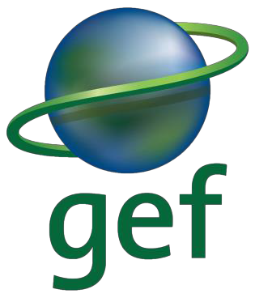
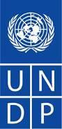

United Nations Development Programme
Global Environmental Facility
DRAFT REPORT (15 April 2022)
Mid-Term Review of the UNDP-Supported GEF-Financed Project

Creation of Marine Protected Areas in Angola
GEF Project ID: 9748 UNDP PIMS ID: 6051

picture
picture

Country: Angola
Region: Africa
GEF Focal Area: Biodiversity (GEF-6)
GEF Agency: United Nations Development Programme (UNDP)
Project Executing Agency: Ministry of Culture, Tourism and Environment (MCTA)
Evaluation Time Frame: 18 November 2021 – 20 April 2022
Evaluation Consultant: Vincent LEFEBVRE, Environmentalist

Acknowledgements:
The consultant wishes to thank the project team as well as the MPA Department within INBAC for their availability as well as the overall support provided by INBAC, in particular, from the local Project Coordinator, to facilitate interviews in the Namib region.

Table of Contents

Executive Summary v
Project summary table v
Project description v
Project’s main achievements vii
Evaluation rating table vii
Summary of conclusions, recommendations and lessons learned vii
List of Abbreviations ix
1. Introduction 1
1.1 Purpose of the evaluation 1
1.2 Scope and methodology 1
1.2.1 Scope 1
1.2.2 Methodology 3
1.3 MTR limitations 4
1.3.1 Ethics 4
1.4 Structure of the evaluation report 5
2. Project description and development context 6
2.1 Environment and development context 6
2.2 Problems that the project sought to address 6
2.3 Project description and strategy: objective, outcomes and expected results, description of field sites 7
2.4 Project implementation arrangements 10
2.5 Project timing and milestones 11
2.6 Main stakeholders 11
3. Findings 13
3.1 Project design / Formulation 13
3.1.1 Relevance of project formulation 13
3.1.2 Analysis of the Results Framework 15
3.1.3 Lessons learned from other projects incorporated into project design 19
3.2 Progress towards results 21
3.2.1 Progress towards outcome analysis 22
3.2.2 Obstacles to the achievement of the objective until the closure of the project 27
3.3 Project implementation and adaptive management 28
3.3.1 Management arrangements 28
3.3.2 Work planning 32
3.3.3 Finance and co-finance 33
3.3.4 Project-level Monitoring and Evaluation Systems – adaptive management 35
3.3.5 Stakeholders’ engagement 37
3.3.6 Social and Environmental Safeguards 38
3.3.7 Reporting 39
3.3.8 Communication and knowledge management 39
3.3.9 Impact of COVID-19 on project implementation 41
3.4 Sustainability 41
3.4.1 Social & cultural risks to sustainability 42
3.4.2 Financial risks to sustainability 42
3.4.3 Institutional framework and governance risks to sustainability 43
3.4.4 Socio-economic risks to sustainability 43
3.4.5 Environmental risks to sustainability 44
4. Conclusions and recommendations 45
4.1 Conclusions 45
4.2 Recommendations 48
4.2.1 Recommendations to ensure more impactful results: 48
4.2.2 Recommendations to accelerate implementation: 49
4.2.3 Recommendations to improve the project governance system: 50
5. List of Tables 53
6. List of Boxes 53
7. List of Figures 53
8. List of Maps 53
9. Annexes 53

Executive Summary

Project summary table
Project Title: | Creation of Marine Protected Areas in Angola
GEF Project ID: |  | 9748 |  | at endorsement (US$) | at MTR (US$)
UNDP PIMS ID: |  | 6051 | GEF financing: | 1.776.484 | 447.311
Country: |  | Angola | IA/EA (UNDP) own: | - | -
Region: |  | Africa | Government (in-kind): | 5.218.440 | No info
Focal Area: |  | Biodiversity | Other Co-financing:
FA Objectives, (OP/SP): |  | BD 1 Program 2: Expanding the Reach of the Global Protected Area Estate | Bilateral Development Agency | 1.150.000 | No info
Executing Agency: |  | UNDP | Total Project Cost: | 8.144.924 | 447.311
Other Partners involved: |  | Ministry of Culture, Tourism and Environment | ProDoc Signature (date project began): |  | 05/07/2019
 |  |  | (Operational) Closing Date: | Proposed: 31/12/2023 | Actual: 30/06/2023

Project description

Objective: To expand the protected area network into the marine environment through the creation of Angola’s first marine protected area | Indicators:  - Area of sustainable management solutions at sub-national level for conservation of biodiversity and ecosystem services that benefit from integrated landscape and seascape planning and management approaches  - Number of households participating in improved and sustainable marine resources use and best practice Number of integrated watershed management plans integrating biodiversity conservation, SLM and CSA covering at least 50% of the 5 prioritized watersheds and operationalized  - Extent to which legal and regulatory frameworks enabled to ensure conservation and sustainable marine resource management
Component 1: National framework for integrated marine spatial planning and management to mainstream biodiversity across sectors  Outcome 1: Strengthened policy, legal and institutional framework for creation and management of Marine Protected Areas | Indicators:  - Level of institutional capacities for planning, implementation and monitoring integrated MPA planning and management as measured by UNDP’s capacity development scorecard  - Extent to which MPAs are integrated and coordinated with marine spatial planning and sectoral planning and to which institutional responsibilities and collaboration in the creation and management of MPAs has been established and formalized
Outputs:
- Functional institutional mechanism established to support dialogue, information flow and decision–making between key national and provincial development sectors to facilitate the creation and management of marine protected areas.
- National strategy and plan for integration of Angola’s Marine Spatial framework approved and implemented to improve effective coordination and partnerships for effective management of marine protected areas and balanced utilization of marine and coastal resources.
- Implementation of regulations, guidelines and best practices for promoting marine protected areas developed, endorsed and adopted.
- Coastal and Marine protected area unit established within the National Institute of Biodiversity and Conservation Areas (INBAC) with adequate staffing and capacities and partnership arrangements for co-management of MPAs developed and adopted to effectively engage with key sectoral and extractive agencies.
Component 2: Operationalization of a marine protected area in a location of high biodiversity priority  Outcome 2 - Integrated management plan implemented for a priority high biodiversity marine protected area to protect endangered marine species and reduce threats | Indicators:  - Extent to which Institutional frameworks are in place for integration of conservation, sustainable marine resource use, control and management of biodiversity and ecosystems and improved livelihoods into integrated seascape planning and management  - Level of improvement of management effectiveness of MPA as measured by METT tracking Tool  - Level of transboundary collaboration in managing cross-border marine conservation, marine resource use and control of threats
Outputs:
- Site confirmation, assessment of key threats and management measures, reaching agreement on agency mandates and institutional arrangements, and financing and stakeholder arrangements that enable preparation, submission of proclamation dossier and approval of Angola’s first MPA.
- Integrated management plan for new MPA developed on the basis of inclusive consultative process agreed by all stakeholders and formally approved by the government.
- Establishment of local level MPA management unit with defined roles, responsibilities and partnership arrangements for the planning, management and protection of the MPA.
- Implementation of integrated MPA management plan to conserve marine biodiversity and ecosystems, promote sustainable fisheries and responsible tourism and strengthening livelihood opportunities for women.
- Mechanism for partnerships on transboundary cooperation for improving marine species conservation, monitoring and information sharing developed and implemented.
Component 3: Project learning, knowledge sharing, communication and M&E  Outcome 3 - Lessons learned through knowledge management, monitoring and evaluation, and equitable gender mainstreaming available to support the creation and implementation of MPAs nationally and internationally | Indicators:  - Increase in community and stakeholder awareness of conservation and sustainable use and threats to marine biodiversity  - Number of best practice conservation and sustainable marine resource management codified and disseminated nationally and internationally
Outputs:
- Long-term status of marine ecosystem, fisheries and climate impacts assessed, monitored and disseminated.
- Communication and gender strategies and education campaigns increase awareness on marine conservation and sustainable marine resource use at national, provincial and local levels.
- Project learning and knowledge inform policy and legislative changes relating to integrated marine seascape management.
Box 1: Summary of project objective, components, outcomes and outputs

Project’s main achievements

Evaluation rating table
A summary of the evaluation ratings is provided in Table 1.
Measure | MTR Rating
Overall Objective: To expand the protected area network into the marine environment through the creation of Angola’s first marine protected area | MU
Outcome 1: Strengthened policy, legal and institutional framework for creation and management of Marine Protected Areas | MU
Outcome 2: Integrated management plan implemented for a priority high biodiversity marine protected area to protect endangered marine species and reduce threats | MS
Outcome 3: Lessons learned through knowledge management, monitoring and evaluation, and equitable gender mainstreaming available to support the creation and implementation of MPAs nationally and internationally | U
Project Implementation & Adaptive Management | MU and U
Likelihood of Sustainability | ML
Table 1: Evaluation ratings

Summary of conclusions, recommendations and lessons learned
Conclusions:

Recommendations:

Rec  # | MTR Recommendation | Entity Responsible | Timeframe for implementation
A | Category 1: ensuring impactful results
A.1 | Hand over/share transport and communication equipment with relevant stakeholders | PMU | 1 month
A.2 | Local project implementation to be align with municipal/provincial priorities and plans | PMU | 3 months
A.3 | Logical Framework and indicator changes | PSC | 1 month
A.4 | Take advantage of local expertise | PMU | 3 months
B | Category 2: accelerating implementation
B.1 | Accelerate project delivery | PMU and PSC | 3 months
B.2 | Request of no-cost extension | PSC | 2 months
B.3 | Increase project (PMU) effectiveness | PMU | 3 months
C | Category 3: Improve the project governance system
C.1 | Lobbying to facilitate bilateral dialogue on MPA | INBAC | 3 months
C.2 | Seek stronger local stakeholders’ engagement | PMU with MCO support (?) | 2 months

List of Abbreviations

ADECOS Agente de Desenvolvimento Sanitário e Comunitário - Community Development and Sanitary Agent
ASAP As Soon As Possible
AWP Annual Work Plan
BCC Benguela Current Commission
BCLME Benguela Current Large Marine Ecosystem
BD Biodiversity
CBA Cost-Benefit Analysis
CBD Convention on Biological Diversity
CDR Combined Delivery Report
DAC Development Assistance Committee
EBSA Ecologically or Biologically Significant Marine Areas
GDP Gross Domestic Product
GEB Global Environmental Benefits
GEF Global Environment Facility
GIZ Deutsche Gesellschaft für Internationale Zusammenarbeit GmbH - German Society for International Cooperation, Ltd.
GSSC Global-Shared Service Centre
HR Human Resources
IA Implementing Agency
ID Identification
IEC Information Education Communication
IGA Income Generating Activities
INBAC Instituto Nacional da Biodiversidade e Áreas de Conservação – National Institute for Biodiversity and Protected Areas
INIP Instituto Nacional de Investigação Pesqueira - National Institute of Fisheries Research
ISP Instituto Superior das Pescas – Fisheries Higher Institute
JUCARENTE Associação Juvenil de Apoio aos Jovens Carentes
KAP Knowledge, Attitude, Practices
LDC Least Developed Country
LED Local Economic Development
MARISMA Benguela Current Marine Spatial Management and Governance
MASFAMU Ministério da Acção Social, Família e Promoção da Mulher - Ministry of Social Action, Family and Women's Promotion
MCTA Ministério da Culture, Turismo e Ambiente – Ministry of Culture, Tourism and Environment
M&E Monitoring and Evaluation
MED Ministério da Educação – Ministry of Education
MEP Ministério da Economia e Planeamento – Ministry of Economy and Planning
MESCTI Ministério do Ensino Superior, Ciência, Tecnologia e Inovação – Ministry of Higher Education, Science, Technology and Innovation
METT Management Effectiveness Tracking Tool
MIDEN Ministério da Defesa – Ministry of Defense
MINAMB Ministério do Ambiente – Ministry of Environment
MINAGRIP Ministério da Agricultura e Pescas - Ministry of Agriculture and Fisheries
MIN(P)ESPAR Ministério das Pescas e do Mar - Ministry of Fisheries and the Sea
MIREMPET Ministério dos Recursos Minerais, Petróleo e Gás - Ministry of Mineral Resources, Petroleum and Gas
MINREPET Ministério dos Recursos Minerais e Petróleo – Ministry of Mineral Resource and Petroleum
MINTRANS Ministério dos Transportes – Ministry of Transport
MPA Marine Protected Area
MTR Mid-Term Review
NAP National Action Plan
NBSAP National Biodiversity Strategy and Action Plan
NGO Non-Government Organization
NIM National Implementation Modality
NP National Park
PA Protected Area
PAC Project Appraisal Committee
PBA Performance-Based Agreement
PESAP Plano Estratégico para o Sistema de Áreas Protegidas de Angola – Angola’s Strategic Plan for the Protected Area System
PIF Project Identification Form (of GEF)
PIMS Project Information Management System (of UNDP)
PIR Project Implementation Review
PMU Project Management Unit
PPG Project Preparation Grant
PRODOC Project Document
PSC Project Steering Committee
Q1 Quarter 1
RfP Request for Proposals
SMART Specific, Measurable, Achievable, Relevant, Time-bound
STAR System for Transparent Allocation of Resources
SWOT Strengths, Weaknesses, Opportunities and Threats
TDA Transboundary Diagnostics Analysis
ToR Terms of Reference
TPA Terrestrial Protected Area
UNDAF United Nations Development Assistance Framework
UNDP United Nations Development Programme
UNIMBE Universidade do Namibe – Namibe University
VC Video-Conference

Introduction
This report presents the findings of the Mid-Term Review (MTR) of the mid-sized project entitled “Creation of Marine Protected Areas in Angola”. The mid-term review was carried out by an independent consultant, on behalf of the United Nations Development Programme (UNDP).

Purpose of the evaluation
Pursuing the UNDP and Global Environment Facility (GEF) monitoring and evaluation (M&E) policies and procedures, all UNDP-implemented and GEF-funded full-size projects are required to undergo a mid-term review. In this particular case, being a mid-size project, an MTR was not a requirement per se, but deemed necessary given the innovative nature of this project for Angola (first marine conservation area in the country). Towards this end, UNDP has commissioned this evaluation by contracting an independent evaluator. It was carried out in accordance with the UNDP-GEF Monitoring and Evaluation Policy and facilitated by the UNDP Country Office in Luanda.
As per terms of reference (ToR), the purpose of this mid-term evaluation is to assess the progress made in achieving the project results and objectives defined in the project document and to evaluate the success or failure indices of the project in order to identify the necessary changes and/or reorientations to improve its implementation to achieve the expected results. The MTR also reviewed the project’s strategy, its sustainability risks.
To assess the progress of the project, the following four thematic areas were reviewed in detail:
(i) Project Strategy: project design and relevance in relation to climate change, review of log frame and results’ framework including analysis of (SMART) indicators and taking into account gender and externalities
(ii) Degree of progress of the project: review of the tracking tools and analysis of the achievement of results and effects and progress towards the objectives (colour code to complete the results matrix and scoring scale of project progress)
(iii) Project implementation and adaptive management: analysis of project management and implementation including work plans, financial planning and co-financing, monitoring and evaluation system, stakeholder involvement, reporting system and communication
(iv) Mid-term sustainability (analysis of risks that could affect the maintenance of project results and effects over the project's expected life span): analysis of financial, socio-economic, governance and institutional risks, environmental risks.

Scope and methodology

Scope
The mid-term evaluation focused on the implementation of project activities and analysis of the project's performance taking into account results, objectives and effects achieved and using the evaluation criteria of relevance, effectiveness, efficiency and potential sustainability/impact.
The key areas that were assessed based on priorities identified within the context of the current project include Project Strategy, Progress Towards Results, Project Implementation and Adaptive Management, Sustainability.

Box 2: Key areas to be assessed during the MTR
A more detailed analysis of implementation modalities and adaptive management included:
    - Management arrangements
    - Work planning
    - Finance and co-finance
    - Project-level monitoring and evaluation systems
    - Stakeholder engagement
    - Social and environmental standards (safeguards)

The long-term sustainability included assessing risks such as:
- Financial risks to sustainability
- Socio-economic risks to sustainability
- Institutional Framework and Governance risks to sustainability
- Environmental risks to sustainability

The project was reviewed according to the following evaluation criteria:
Relevance assesses how the project relates to the development priorities at the local, regional and national levels for climate change and is coherent with the main objectives of GEF focal areas. It also assesses whether the project addressed the needs of targeted beneficiaries at the local and national levels.
Effectiveness measures the extent to which the project achieved the expected outcomes and objectives, how risks and risk mitigation were being managed, and what lessons can be drawn for other similar projects in the future.
Efficiency is the measure of how economically, resources (funds, expertise, time, etc.) are converted to results. It also examines how efficient were partnership arrangements (linkages between institutions/ organizations) for the project.
Impact and potential sustainability examine the positive and negative, primary and secondary long-term effects produced by the development intervention, directly or indirectly, intended or unintended. It looks at whether the project is on the way to achieving the intended changes or improvements (technical, economic, social, cultural, political and ecological). In GEF terms, impact/results include direct project outputs, short to medium-term outcomes and longer-term impact including global environmental benefits, replication effects and other local effects including on communities.
Using the above-explained evaluation criteria, the mid-term review covered all activities supported by UNDP, the project team and the Government as well as activities that other collaborating partners including beneficiaries may have participated in.
With timing, the evaluation reviewed all activities of the project from project signature in July 2019 to February 2022.
The evaluation has been conducted in a way that provides evidence-based information that is credible, reliable and useful.

Methodology
The Evaluator adopted a participatory and consultative approach ensuring close engagement with government counterparts, UNDP Country Office, the project team and any other stakeholder at national and community levels.
Several basic principles used to conduct the evaluation include:
- Effective participation of all stakeholders (government, agencies, donors, final beneficiaries)
- Crosschecking of gathered information
- Emphasis on consensus and agreement on the recommendations by the stakeholders.
- Transparency of debriefing
Overall, the evaluation tools used during the evaluation were the following: a review of key documents and literature, consultation and interview of stakeholders and field missions to any project site. The data collection tools included semi-structured questionnaires for key informants (checklists) and interview guides for focus group discussions with beneficiaries. The tools were developed by the evaluators focusing on the evaluation criteria and major outcomes planned. The interview guides and semi-structured questionnaires are presented in Annexe 3.
The adopted methodology is detailed in Annex 2.
As per GEF IEO (2017) and UNDP (2014) guidelines requirements for evaluations, specific Evaluation Rating Criteria were used in combination with the 5 DAC evaluation criteria: these are outcomes, quality of monitoring and evaluation (M&E), quality of implementation and execution and sustainability (environmental, social, financial and institutional).
Project performance was evaluated and rated using the criteria of relevance, effectiveness, efficiency and impact using the standard rating scales (see Annexe 4 for a summary). The primary reference points for assessing the performance were the indicators and targets set in the Strategic Results Framework, with consideration given to contextual factors.
Ratings: In accordance with GEF guidelines for project evaluations, achievement ratings, as well as sustainability ratings, were assigned by the MTRT. The MTRT rated various aspects of the project according to the GEF project review criteria using the obligatory GEF ratings of: Highly Satisfactory (HS), Satisfactory (S), Moderately Satisfactory (MS), Moderately Unsatisfactory (MU), Unsatisfactory (U) and Highly Unsatisfactory (HU).
A full description of these ratings and other GEF rating scales is provided in Annexe 4. The MTR evaluator also rated various dimensions of sustainability of project outcomes using the GEF obligatory rating scale of Likely (L), Moderately Likely (ML), Moderately Unlikely (MU) and, Unlikely (U).

MTR limitations
Due to the COVID pandemic restrictions, the MTR was conducted entirely on a remote basis using audio and video conference tools only with the usual limitations on actual project physical achievements.
Additional challenges:
A limited list of stakeholders was provided before the MTR so as to start interviews. This proved invaluable and was further expanded with secondary interviews. However, there was no official communication by INBAC to advice external stakeholders, in particular ministries and other national institutions on the review, so it was really up to informally contacted participants to agree to discuss project’s participation often after background check on the evaluation and more formal emails by the evaluator, that delayed the interview scheduling. In some cases, there was no further contact possible because there had not been any official communication.
The consultant was affected by COVID which delayed further the evaluation exercise.
Finally, communications with the project area were very difficult. Internet communication was nearly impossible and conventional telephone quality so poor that it resulted with the rescheduling of numerous interviews from urban centres (Tombwâ, Namibe).
As for discussions with final beneficiaries, often in peripherical neighbourhoods, very few went to completion. As an example, despite many attempts, it was not possible to discuss conclusively with any potential female beneficiary from the fish-processing industry.
All in all, the consultant was not able to bring into the report a clear view on the final beneficiary’s side with most findings coming from secondary data and not directly from the involved parties.
There were very limited project activities and demonstration sites, evidencing a low level of implementation. There was not much strong evidence to make a case for how implementation modalities can be improved since activities had barely started.
As for mid-term evaluations, the allocated time to gather data did not enable the collection of any statistical data. All information was based on data crosschecking from different sources of information (documents, interviews and in-situ assessments [pictures]).

Ethics
The evaluation was conducted in accordance with the UNEG Ethical Guidelines for Evaluators (Evaluation Consultant Code of Conduct Agreement attached in
Annexe 13).
The rights and dignity of all stakeholders were respected, including interviewees, project participants (project, UNDP, Government staff), potential beneficiaries (beneficiary institutions and communities) and other evaluation stakeholders including co-financing partners. The evaluators preserved the confidentiality and anonymity of the participants so that those who participated in the evaluation were free from external pressure and that their involvement in no way disadvantaged them.
The report of the evaluation does not indicate a specific source of citations or qualitative data to preserve this confidentiality.
The confidentiality of stakeholders was ensured and consultation processes were appropriately contextualised and culturally sensitive, with attention given to issues such as gender empowerment and fair representation for vulnerable groups, wherever possible. To provide stakeholders with uninhibited opportunities for providing feedback, project staff and UNDP representatives were not present during the interviews.
Whilst every effort was made to reflect the inputs of stakeholders fairly and accurately in the report, the evaluation ratings, conclusions and key recommendations are those of the sole evaluator, not binding on any individual or institutional stakeholder.

Structure of the evaluation report
The mid-term evaluation report is structured according to the guidelines provided in the “Guidance for Conducting Midterm Reviews of UNDP-Supported GEF- Financed Projects” (July 2014).
This report is presented in five sections. It initially presents an executive summary of the mid-term evaluation, giving a brief background of the project and its design, a summary of its findings related to the activities, management and important aspects such as partnership and sustainability, conclusions and recommendations for future action.
It is followed by an introduction, which describes the context and background of the evaluation and gives a brief description of the purpose, scope and focus of the evaluation, the methodology used and the structure of the report. The next section presents information on the project, including project description, development context and strategy.
The findings section is dedicated to the results achieved towards the outcomes of the project, which is the core of the report, presented under three subheadings related to programme design, implementation and evaluation criteria. The final section considers the conclusions of the evaluation and recommendations for future action.

Project description and development context

Environment and development context
Angola has one of the richest biodiversity in Africa with great variations in soils, climate resulting in ecological variability ranging from dense tropical forests to deserts but also a unique costal area.
Great strides have been made to increase the protection of its biodiversity – mainly terrestrial - since the adoption in 1998 of the Basic Law for Environment that resulted in a series of strategies and policies including the creation of a network of conservation areas and associated legislation amongst many other measures.
The coastal area of Angola is over 1.650km² and its continental shelf over 50.000km². The Benguela current marine ecosystem occupy most of it and is of the most productive in the world, sustaining intensive fishing.
Maritime activities such as fishing, mining and transport, storage and communication make up some 45-50% of the GDP. After oil and mining, the fisheries sector is the third-most important industry in Angola and although it represents less than 2% of GPD (2012), it provides nearly half of the animal protein of the country including for livestock production, contributing to food security and livelihoods in the coastal regions.
With over 30% of the population living within 100 km of the coastline, marine fisheries account for more than 70% of the estimated Angolan total fish production, with the main marine resources being small pelagic fish (mostly sardinellas and horse mackerels), crustaceans, demersal finfish, tuna and tuna-like species, cephalopods and molluscs^{Error! Bookmark not defined.}, albeit more intense fisheries exploitation is significantly affecting its recovery capacity nowadays with declining fish stock in virtually all fisheries subsectors. This combined with coastal diamond and oil and gas production has resulted in accelerated deterioration, that has translated in stagnation and/or decline of living conditions of coastal communities that mostly rely on coastal fisheries.
Angola submitted its National Biodiversity Strategies and Action Plan (2019-2025) with direct references to the Aichi national targets. Under the fisheries sector, an action plan was designed, focussing on (i) fishing catches compliance, illegal fishing control and sustainable management of fisheries resources, (ii) assessing traditional fishing practices and their actual impact, (iii) controlling seal catches and (iv) creating two marine protected areas.

Problems that the project sought to address
The creation of marine protected areas is a direct response to the degradation coastal and marine ecosystems. These are threatened mostly through anthropic activities such as illegal fishing/overfishing, unsustainable coastal development and pollution, oil and gas exploration, and an overall lack of conscientisation of stakeholders that still largely view marine and coastal resources as infinite:
- Uncontrolled coastal zone development: the decades-long war has resulted in significant generational population moves with most of the population living in the West of the country, in particular, along coastal areas, resulting in farming in arid areas with very limited agricultural potential, extensive deforestation of already environmentally sensitive areas or even hot spots and resulting waste water, plastic, industrial pollution due to rapid urbanization and associated consequences.
- Oil and gas exploration: so far through illegal oil discharges for tankers cleaning, a significant risk in oil exploration allocation nearby the coast and on the continental shelf with resulting increased risks of major spills and through expansion on off-shore mining.
- Overfishing: this is the main threat, especially on the southern coast where the largest fish stocks are located, through industrial (mostly foreign companies with off-shore processing capabilities), semi-industrial (mostly national family-based companies with medium-sized fleets with/without onshore processing in large urban centres) and artisanal fishing (small powered vessels, family or community-managed with no processing capacity with direct shore sales to intermediaries).
These threats are actually the result of a lack of conservation awareness and involvement of key stakeholders but also the inability of the State to enforce laws and regulations in virtually all sectors that depend on coastal and marine natural resources.
In that context, the Government is prioritising the creation of marine protected areas with the objective to enlarge its network of protected areas towards the sea so as to contain marine and coastal biodiversity degradation but also as a strategy to foster social and economic development as well as to ensuring sustainable livelihoods of people depending on both artisanal and large-scale fishery activities for local food security and employment.
To successfully implement this strategy, the project is addressing key barriers including (i) the insufficient systemic and institutional capacity for the creation and management of marine protected areas with currently no legislative enabling environment for the creation of Angola’s new MPAs, (ii) the insufficient protection of coastal and marine biodiversity and resources, especially at sites that have not yet come under conservation management with a view to reduce threats on marine species habitat and regulate/protect fishing stocks from irremediable degradation, (iii) the insufficient knowledge, awareness and access to useful and detailed information relating to effective conservation and sustainable use of the marine and coastal environment, that may actually be ultimately the main cause for marine resources degradation.

Project description and strategy: objective, outcomes and expected results, description of field sites
The creation of marine protected areas is a direct response to the degradation coastal and marine ecosystems. These are threatened mostly through anthropic activities such as illegal fishing/overfishing, unsustainable coastal development and pollution, oil and gas exploration, and an overall lack of conscientisation of stakeholders that still largely view marine and coastal resources as infinite.
The primary objective of the project is the creation of one marine protected area, basis of this project.
A comprehensive theory of change was designed with clear project outcomes and short/long-term impacts. The TOC has addressed a wide range of issues (see Annexe 6) and include just as well a wide range of assumptions, some of which if wrong could jeopardise the overall project’s success. Hence the need for careful considerations to ensure minimising project risks.
Three project’s components, each with an outcome characterise the anticipated approach based on (i) adopting a marine and coastal spatial zoning approach, (ii) supporting and implementing a participatory/consultative bottom-up MPA planning and implementation approach, (iii) supporting decentralized planning and management provincial and municipal government institutions, and community-based organizations, (iv) strengthening capacities of all stakeholders in effective enhancement of conservation and sustainable use of marine and coastal biodiversity and improving coordination and collaboration between municipal, provincial and national governments, (v) adopting an integrated multi-sectoral approach, (vi) creating an effective knowledge base building on successful lessons and experiences, (vii) ensuring an adaptive management approach and finally (viii) Ensuring that key defining activities (regulations, safeguards, implementation and administrative arrangements) provide the basis for ensuring that management of the MPA is based on effective, efficient and coordinated use of existing national, provincial and sector capacities and resources.
The project ’s objective is to be achieved through three outcomes under three components, roughly formulated as responses to the above-mentioned key barriers.
- Component 1: National framework for integrated marine spatial planning and management to mainstream biodiversity across sectors
  - Outcome 1: Strengthened policy, legal and institutional framework for creation and management of Marine Protected Areas
- Component 2: Operationalization of a marine protected area in a location of high biodiversity priority
  - Outcome 2: Integrated management plan implemented for a priority high biodiversity marine protected area to protect endangered marine species and reduce threats; and
- Component 3: Project learning, knowledge sharing, communication and M&E
  - Outcome 3: Lessons learned through knowledge management, monitoring and evaluation, and equitable gender mainstreaming available to support the creation and implementation of MPAs nationally and internationally.
The project details are in Box 1.

Figure 1: key project components
Objective: To expand the protected area network into the marine environment through the creation of Angola’s first marine protected area.

Component 1: National framework for integrated marine spatial planning and management to mainstream biodiversity across sectors.
Outcome 1: Strengthened policy, legal and institutional framework for creation and management of Marine Protected Areas.

Outputs:
1.1 Functional institutional mechanism established to support dialogue, information flow and decision–making between key national and provincial development sectors to facilitate the creation and management of marine protected areas.
1.2 National strategy and plan for integration of Angola’s Marine Spatial framework approved and implemented to improve effective coordination and partnerships for effective management of marine protected areas and balanced utilization of marine and coastal resources.
1.3 Implementation of regulations, guidelines and best practices for promoting marine protected areas developed, endorsed and adopted.
1.4 Coastal and Marine protected area unit established within the National Institute of Biodiversity and Conservation Areas (INBAC) with adequate staffing and capacities and partnership arrangements for co-management of MPAs developed and adopted to effectively engage with key sectoral and extractive agencies.

Component 2: Operationalization of a marine protected area in a location of high biodiversity priority.
Outcome 2: Integrated management plan implemented for a priority high biodiversity marine protected area to protect endangered marine species and reduce threats.
Outputs:
2.1. Site confirmation, assessment of key threats and management measures, reaching agreement on agency mandates and institutional arrangements, and financing and stakeholder arrangements that enable preparation, submission of proclamation dossier and approval of Angola’s first MPA.
2.2 Integrated management plan for new MPA developed on the basis of inclusive consultative process agreed by all stakeholders and formally approved by the government.
2.3 Establishment of local level MPA management unit with defined roles, responsibilities and partnership arrangements for the planning, management and protection of the MPA.
2.4 Implementation of integrated MPA management plan to conserve marine biodiversity and ecosystems, promote sustainable fisheries and responsible tourism and strengthening livelihood opportunities for women.
2.5 Mechanism for partnerships on transboundary cooperation for improving marine species conservation, monitoring and information sharing developed and implemented.

Component 3: Project learning, knowledge sharing, communication and M&E.
Outcome 3: Lessons learned through knowledge management, monitoring and evaluation, and equitable gender mainstreaming available to support the creation and implementation of MPAs nationally and internationally.
Outputs:
3.1. Long-term status of marine ecosystem, fisheries and climate impacts assessed, monitored and disseminated.
3.2 Communication and gender strategies and education campaigns increase awareness on marine conservation and sustainable marine resource use at national, provincial and local levels.
3.3 Project learning and knowledge inform policy and legislative changes relating to integrated marine seascape management.
Box 3: project objective, components, outcomes and outputs

The Project Area
The project is to carry out activities in the Namibe province coastal area.
The selection of the project area took into consideration several criteria of remoteness, urgency of protection in view of marine resource degradation, population density and potential for collaboration with other protected entities (see chapter on project formulation).

Annexe 5 includes the map of the project areas.

Project implementation arrangements
The implementation period of the project was planned for four years from July 2019 under the NIM modality.
UNDP (through its Energy, Environment and Climate Change Unit) acts as the Implementing Agency for GEF. The Ministry of Environment was designated as the Implementing Partner. This was later changed by July 2020 to the Ministry of Tourism, Culture and Environment.
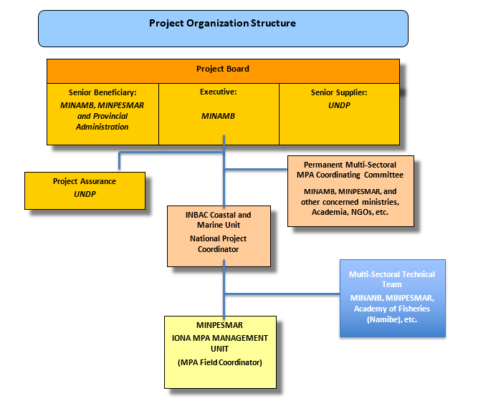
Figure 2: Original governance structure
At the technical implementation level, the National Institute for Biodiversity and Protected Areas (INBAC) under the Ministry of Environment was the main executive partner for project activities on the Government’s side.
The project includes three main Institutional Beneficiaries: National Institute for Biodiversity and Protected Areas (INBAC) under the Ministry of Environment, the Ministry of Fisheries and Sea (MINPESMAR), the Namibe provincial Administration, and implicitly the Tômbua and Moçâmedes municipal administrations.
A Project Management Unit under INBAC was to implement activities on a day-to-day basis supported by contractors, consultants and other service providers.
A three-tier quality assurance system was ensured through UNDP CO, Regional and Global Offices.
The Project Board comprises the Project Supplier, the Project Beneficiary and the Implementing Partner. Its main responsibilities are to provide policy and technical guidance and direction towards the implementation of the project, provide input/endorse/approve changes into work plans, budgets and implementation schedules, approve project implementation schedule, annual work plan (AWP) and indicative project budget, provide guidance and agree on issues to address specific project risks and/or raised by the Project Coordinator, monitor project implementation and provide direction and recommendations.

Project timing and milestones
Type of activity | Planned timeframe | Actual timeframe
Project signature | July 2019 | July 2019
Project start-up | July 2019 | July 2019
Inception workshop | Before October 2019 | July 2019
Periodic reporting | Quarterly basis | Quarterly basis
PIR | Annual | June 2021 (1st)
Mid-Term Review | Around July 2021  (between 2nd and 3rd PIR) | December 2021 - April 2022 (after 1st PIR)
Final evaluation | Before May 2023 | -
Project closure | July 2023 | -
Table 2: Project timing

Main stakeholders
The PRODOC did not prepare a detailed assessment of planned and potential project’s stakeholders in the sector under consideration (donors, governmental institutions, local and international NGOs, beneficiaries) but information from the PRODOC assumed the following:
- Government:
  - Ministry of Environment (MA) and its National Institute of Biodiversity and Protected Areas (INBAC)
  - Ministry of Fisheries and the Sea (MINPESMAR)
  - Ministry of Defence (MINDEN)
  - Ministry of Industry (MINED)
  - Ministry of Economy and Planning (MEP)
  - Ministry of Interior (MININT)
  - Ministry of Mineral Resources and Petroleum (MINREPET)
  - Namibe provincial, Moçâmedes and Tômbua municipal authorities
  - Coast Guards
  - Ministry of Education (MED)
- Academics: higher schools and universities
- Non-Government Organisations
- Fish sector commercial operators
- Final beneficiaries:
  - Coastal/fishing community organisations
  - Individual fishermen
  - Fish processors (individual / groups / cooperatives)
  - Coastal farming sector
- Other donors: GIZ on the MARISMA project

Actually, this list will be substantially expanded with implementation (See chapter 2.6 on Main Stakeholders) – in particular - with the setting-up of the cross-sectoral mechanism (“Commissão Multi-Sectorial”).

Findings

Project design / Formulation

Relevance of project formulation

Design/relevance:
The creation of marine conservation areas has been high on the Government’s agenda since at least the formulation of the 2007-2014 National Biodiversity Strategy and Action Plan (NBSAP). This was further reiterated with the 2017 Angola’s Strategic Plan for the Protected Area System and the 2019-2024 National Biodiversity Strategy and Action Plan with direct references to the Aichi national targets. In particular, under the fisheries sector, an action plan was designed, focussing on (i) fishing catches compliance, illegal fishing control and sustainable management of fisheries resources, (ii) assessing traditional fishing practices and their actual impact, (iii) controlling seal catches and (iv) creating two marine protected areas.
The project is therefore a starting point in achieving this particular Government’s goal.

Several unsuccessful proposals were discussed from 2016 onwards to allocate GEF funds for climate change and biodiversity covering the creation of MPAs. These included: (i) a generic full-sized project on MPA creation and combatting illegal trade, (ii) using a large chunk of the GEF-6 STAR allocation on MPA (with other funding sources on illegal wildlife trading). Eventually was agreed with GEF the STAR resources allocation with a full-sized project on Combating Illegal Wildlife Trade and Human Wildlife Conflict and a medium-size project on MPA creation.
Further refinements were made with abandoning the creation of two MPAs linked to terrestrial parks (both Kissane National Park and Iona National Park) with a final selection on the latter one as there was a lower (perceived) risk of human conflicts (very sparsely populated coastal area) and the possibility to link this new MPA with the coastal Iona National Park that had benefitted from GEF-4 funding.
The logic for a medium-sized project was basically to establish a blueprint for future MPAs, in particular creating a consensus among maritime stakeholders and natural resources users on the need to protect marine resources and establishing procedures and lessons learned on community participation/integration into marine natural resources protection.
This is to be achieved through (i) inter-institutional dialogue, (ii) capacity building of and collaboration between institutions linked to biodiversity protection, marine law enforcement, (iii) marine resources management, (iv) testing methodological approaches for community conscientisation and participation in marine protected areas and (v) direct support to fishing communities and operators with more sustainable catch methods and alternative income generating activities (IGAs).
At the time of formulation, the country was in the process of finalising the 2019-2024 National Biodiversity Strategy and Action Plan (see above) with a strong emphasis on the need for MPAs.
The project’s strategy is set out in the Theory of Change (see Annexe 6). The ToC is useful because it sets out the causal pathways from intervention through to the long-term impacts – in particular GEF’s Global Environmental Benefits (GEB).
The ToC is comprehensive taking into account a series of key issues, postulating a 3-components intervention:
          - ‘Setting-up a national framework for integrated marine spatial planning and management to mainstream biodiversity across sectors’: this component is key for sharing a common understanding of marine protection amongst a wide variety of sectors with different if not opposed goals on marine resources use.
          - ‘Operationalization of a marine protected area in a location of high biodiversity priority’: this is basically a blueprint that will guide how Angola will protect its marine natural resources, how it will interact with neighbouring communities and the private sector; the objective is to set-up and test methodologies for establishing a new MPA with legislative requirements, management planning, assessing needs in different sectors, including possibly combining TPAs and MPAs to ensure biodiversity continuity.
          - ‘Project learning, knowledge sharing, communication and M&E’: taking stocks of lessons learned and good practices on MPA creation, evidencing difficulties and success stories for future MPA creation.
Because this is a medium-sized project, the design falls short of actually operationalizing a brand new MPA from scratch with extensive equipment, HR. Instead, it is focussing more on how sectors can cooperate to ensure marine natural resources protection – hence taking advantage of existing institutions and emphasizing more on existing / new collaborative mechanisms between institutions and other stakeholders.
The project has a strong gender focus based on women representativeness and participation both at national and local levels within decision-making structures (e.g., local project committees, inclusion of women for capacity building…) as well as inclusion of local community representatives to ensure fairness and transparency, so as to ensure participation of both local community stakeholders and local and provincial population representatives (including municipalities, provincial government or non-government organisations).
Because the project may have a significant impact on local populations through the setting-up of an MPA with more or less severe restrictions on marine resources utilisation within its future boundaries, the project design took into consideration the need for setting up a “grievance system mechanism” as per new SESP guidelines to that local population concerns are taken into consideration when setting-up the MPA. This is most relevant but the project did not elaborate much how to actually operationalise such a system.
Finally, great attention was made to sustainability with the support to creating a new coastal and marine protected area unit within INBAC. If such a unit is at first project-induced, it remains to be seen whether it will survive the project and be institutionalised though integration within the INBAC organigramme.

Co-financing:
The PRODOC shows substantial Government co-financing (in a ratio of one to four) although there are no specifics; it is assumed to cover INBAC pre-existing projects and programmes as well as fixed costs (transport, salaries, premises…) withing INBAC to support the project team but also any complementary Government initiative monitored from an ad-hoc multisectoral coordinating committee.
The non-Government co-financing originates from one Norwegian Cooperation-funded project with ISP in the Namibe province through a complementary program of technical support for fisheries management. The project is now closed and there is little recollection from current stakeholders on this project and how an articulation could be made since the ISF / Academy of Fisheries and Marine Science is now integrated within the new Namibe University (UNIMBE).

Analysis of the Results Framework

Log framework:
The review of the log frame shows that the project is structured under a simple design: 1 outcome per component.
- Project objective, outcomes and outputs:
See Box 1 above for details.
Overall, the linkage between the project’s overall objective and its outcomes is very clear as are the linkages between outputs and outcomes for the 3 project components; although it is mentioned at indicator level, one might have also considered the need to formulate several outputs (or even a component) on local stakeholders’/neighbouring communities’ involvement in the project. This would have emphasized the role of local populations both as potential beneficiaries of MPA or stakeholders that might suffer from it because of changes in resources access/ allocation. In the current set-up, their contribution is somewhat hidden by the final project components and outputs’ sharing but it is still in the project under outcome 3 or at indicator level.
- Indicators and targets:
This project is characterised by a very limited number of indicators (10) which brings excellent legibility and facilitates understanding of key project actions as per outputs.
The indicators under the objective broadly refer to (i) the actual MPA set-up, (ii) participation and awareness of neighbouring communities and (iii) the need for a common understanding of MPAs amongst institutional stakeholders.
Under component 1 on national framework creation, the outputs are tightly linked to the outcome with the need to create an enabling inter-institutional environment as well as the conditions for institutional INBAC/MCTA project ownership and setup of internal appropriation of project results. Component 2 on operationalisation evidences the need for a management plan as a prerequisite to go further on MPAs, with a minimum of activities linked to boundaries, management unit and agreements to mainstream the MPA into existing SNAP or similar transboundary mechanisms. As for Component 3 on dissemination and divulgation, the emphasis is put on lessons learned, MPA situation assessments as well as awareness and communication – a focus on neighbouring communities -.
Most if not all indicators are SMART, a feat in itself with only some with minor issues:
Overall, the main issues with indicators lie with their level of achievement within the project timeframe – especially when considering the targets at mid-term. As an example, it would seem very unlikely to have any document drafted, reviewed and even approved by the Council of Ministers by mid-term (indicator 6). This is similar for indicators 9 or 10 on best practices or stakeholders’ awareness, likely to be achieved more by the end of the project. Other indicators could have been mentioned targeting intermediary steps/milestones instead of absolute percentages or number of occurrences.
Indicator 7 is not relevant as there is no way to measure any management effectiveness increase from a hypothetical baseline since there is no starting point (no existing MPA).
It is worth mentioning that the project carefully avoided measuring any change in biodiversity because of new MPAs. Logic as any MPA would be established by project’s end and it is unlikely to see any biodiversity improvement in-between from any action of the project.
All in all, the project log frame is simple and straightforward.
Description | Description of Indicator | Target Level at mid-term of the project | Specific | Measurable | Achievable | Relevant | Time-bound
Objective:  To expand the protected areas network into the marine environment through creation of Angola’s first marine protected area (MPA). | (1) Area of sustainable management solutions at sub-national level for conservation of biodiversity and ecosystem services that benefit from integrated landscape and seascape planning and management approaches | Baseline surveys and assessment completed and proclamation dossier for new MPA submitted under Law of Biological Aquatic Resources | Y | Y | Y | Y | Y
 | (2) Number of households participating in improved and sustainable marine resources use and best practice | Agreement reached with marine resource users on sustainable resource use practices and capture targets and species | Y | Y | Y | Y | Y
 | (3) Extent to which legal and regulatory frameworks enabled to ensure conservation and sustainable marine resource management | Proclamation dossier submitted to Council of Ministers for MPA with defined boundaries, agency mandates, management structure, community | Y | Y | Y | Y | Y
Component 1  Outcome 1:  Strengthened policy, legal and institutional framework for creation and management of Marine Protected Areas | (4) Level of institutional capacities for planning, implementation and monitoring integrated MPA planning and management as measured by UNDP’s capacity development scorecard | Increase of institutional capacity as measured by a 10% increase in UNDP Seascape Capacity Development Scorecard at National and Provincial levels over baseline value of 39 (Systemic-11; Institutional-20 and Individual-8) | Y | Y | Y | Y | Y
 | (5) Extent to which MPAs are integrated and coordinated with marine spatial planning and sectoral planning and to which institutional responsibilities and collaboration in the creation and management of MPAs has been established and formalized | National MPA strategy and action plan submitted for Council of Ministers review and approval | Y | Y | N | Y | Y
Component 2  Outcome 2:  Integrated management plan implemented for a priority high biodiversity marine protected area to protect endangered marine species and reduce threats | (6) Extent to which Institutional frameworks are in place for integration of conservation, sustainable marine resource use, control and management of biodiversity and ecosystems and improved livelihoods into integrated seascape planning and management | Institutional arrangements and planning process for multiple use and sustainable seascape on-going for target MPA | Y | Y | N | Y | Y
 | (7) Level of improvement of management effectiveness of MPA as measured by METT tracking Tool | Increase by at least 10 points in METT from current MPA baseline | Y | Y | Y | N | Y
 | (8) Level of transboundary collaboration in managing cross-border marine conservation, marine resource use and control of threats | At least one trans-boundary agreement to reduce threats and improve marine species conservation negotiated | Y | Y | Y | Y | Y
Component 3  Outcome 3:  Lessons learned through knowledge management, monitoring and evaluation, and equitable gender mainstreaming are available to support the creation and implementation of MPAs nationally and internationally | (9) Increase in community and stakeholder awareness of conservation and sustainable use and threats to marine biodiversity | At least 20% of participating households and stakeholders (of which 50% of whom are women) have good awareness of conservation, sustainable marine resource use and threat prevention benefits | Y | Y | N | Y | Y
 | (10) Number of best practice conservation and sustainable marine resource management codified and disseminated nationally and internationally | A majority of best practice and lessons identified and at least 2 under documentation | Y | Y | N | Y | Y
Table 3: SMART analysis of the logical framework

Analysis of risks and assumptions:
An analysis of the risks and assumptions is presented in Table 4. The risks and assumptions identified in the PRODOC are part of the results framework. Although the original PRODOC risk log was not available for review, the (first and only) PIR also assessed and updated project’s risks.
Under logframe, a comprehensive analysis of risks was carried out with a mix of technical and institutional risks. Some critical risks that significantly (still) affect the project delivery were not mentioned because they were supposed to be addressed in the project design or mentioned as assumptions; it is particularly the case for institutional instability:
- The Government operated a rationalisation of ministries with the dissolution of the Ministry of Environment and the establishment of the Ministry of Culture, Tourism and Environment in May 2020 combined with a succession of ministers (3) with different backgrounds that did not necessarily pay equal attention to all three sectors, with subsequent temporary project stalling during new ministers’ office taking
- The decision by the Ministry of Finance to close down projects’ accounts to centralise donor funding resulted in most projects’ requesting direct UNPD fund transfers to avoid unnecessarily internal delays but also constrained significantly UNDP to respond to a tremendous increase in direct payment requests from its portfolio of projects, that resulted as well in activity delay. Finally, the new UNDP GSSC mechanism was set up in 2020 and early 2021, resulting in delayed payments during an adaptation period of several months

 | Risk and assumptions | MTR comments
Project objective: To expand the protected areas network into the marine environment through creation of Angola’s first marine protected area | Assumptions:  - There is sufficient political will to support establishment of MPAs  - There are no major bureaucratic delays in approval legislation and regulations for MPAs  - Continuing level of municipal government support for artisanal fisheries communities  Risks:  - Communities do not accept project intervention in their areas  - Natural disasters may affect political commitments  - Conflicts over territorial issues could undermine conservation efforts | - There is a broad consensus amongst institutions to move on with MPAs, through the actual participation of ministries in the inter-institutional committee. The only discordant institutions are the lack of proactivity and/or absence of participation of the MINTRANS and MIREMPET.  - Although not yet experienced first-hand for the approval of any official key project decision at ministerial level, the bureaucratic procedures to ensure stakeholders’ participation, calls upon officials for meeting, approval of internal decisions or documents does not bode well for swift strategic decision making in formalising a new MPA, not to mention priorizing it at the highest level. There is obviously a need to plan well in advance any moving forward at higher level on MPA and lobby as much as possible key decision makers to ensure project’s success  - There has been indeed excellent municipal level support on this project (through meetings’ participation) – at least on principles – (see comments on stakeholders’ engagement plan)  - Along the institutional risks, this may be the highest risk to project success but the project design took it into consideration with extensive support on (i) awareness and communication (through local committee participation) and (ii) the need to develop IGAs (both in the fishing sector or as non-fisheries alternatives  - Except for COVID that significantly affected local communities (through impeding project activities for an unusual long time (03 – 11/2020) due to specific Namibe province lockdown) there was no significant natural disaster  - There are already signs of conflicts within the potential MPA between industrial, semi-industrial and artisanal fishing industries on fishing areas infringements between stakeholders, a clear sign of depleting fishing stocks with so far insufficient reaction by the project or the relevant sectoral authorities
Project Outcome 1: Strengthened policy, legal and institutional framework for creation and management of Marine Protected Areas | Assumptions:  - The national government will develop appropriate legislation, policy and institutional measures to facilitate seascape planning in a timely manner  - The government will allocate appropriate staff and funding for MPAs  - The provinces will take part in promoting the concept of MPAs  Risks:  - Priorities of national government shifts due to economic constraints  - Policies and regulations are not used | - There is no doubt that there is a very high commitment within MCTA and INBAC to ensure proper legislation, policy and institutional measures to ensure project’s success; the main constraint has been so far the institutional stability that affected seriously until 2021 the project’s delivery  - The establishment of an MPA unit (“Unidad Costeira”) within INBAC, albeit, apparently not formally institutionalised within the organic structure of INBAC is a clear sign that any newly established MPA has institutional backup for viability and subsequent development  - There is a strong interest of the provincial government in this project – at least on principles - but the communication is impaired with weak provincial (and similarly municipal) engagement, ill-fitted communication channels between the province and INBAC that do not recognise the potential value addition / contribution of provincial environment provincial staff, all of which might eventually lead to weak project’s provincial ownership and empowerment  - This may have definitely occurred in the initial stages of the COVID pandemic but the project was so affected by institutional problems that these may actually have gone unnoticed  - There are lots of precedents in the sector, starting with the underfunding of the fisheries sector that is unable to monitor and enforce rules and regulations (quotas, offloads and equipment controls…)
Project Outcome 2: Integrated management plan implemented for a priority high biodiversity marine protected area to protect endangered marine species and reduce threats | Assumptions:  - The target province will take active part in promoting the creation of MPA  - Local communities and sector agencies are convinced that the sustainable management and use of marine resources is in their long-term interests  Risk:  - Priorities of provincial government and local communities might shift if development benefits take long to manifest  Assumption:  - There is enough political interest and commitment to collaboration among neighbouring countries for collaboration in information sharing and establishment of common conservation outcomes | - Communication issues have so far limited the value addition of the provincial government in the project, that identifies itself more as a beneficiary than a project partner, much to its disappointment  - This is recognised by all stakeholders but there is no consensus on how to achieve sustainable management with fishing stakeholders blaming each other on depleting stocks and minimising their own industry’s impacts  - There is no evidence to suggest any priority shift but the project has created high expectations that yet have to be met (e.g., IGAs)  - Due to COVIG, interactions were limited in number and quality (virtual) with deeper interactions with neighbouring countries (e.g., on BCC) as recently as March 2022
Project Outcome 3: Lessons learned through knowledge management, monitoring and evaluation, and equitable gender mainstreaming are available to support the creation and implementation of MPAs nationally and internationally | Assumptions:  - Stakeholders willing to actively participate in the review process  - Best practices in sustainable marine resources use are available to resource users  - Gender and social inclusion plan followed and benefits distributed equitably  Risks:  - Actions among associated agencies remain uncoordinated  - Vulnerable groups are left out of project benefits  - Actions among assorted entities remain uncoordinated | - The project is characterised by low stakeholders’ engagement, especially at local level (participation but little active contribution); this is not the case at higher (ministry) level with better interactions although interviews showed there should be room for more dynamic engagement  - ---  - The project is making efforts to ensure gender and social inclusion through supporting stakeholders that contribute little value additions (e.g., artisanal agro-processing run by women)  - There is some evidence that this is occurring to some level (e.g., between MCTA and MINESPAR on not sharing strategic studies TORs; e.g., MINESPAR did not share to INBAC its TORs on the formulation of its Strategy to the Sea while INBAC sent over the TORs for the establishment of an MPA national development strategy and implementation plan)  - No evidence of this occurring but actual IGA support is coming at a very late stage during implementation (not before mid-term)  - ----
Table 4: PRODOC risk analysis review

Lessons learned from other projects incorporated into project design
The project is, by default, innovative as there is no other precedent in Angola for MPAs.
Still, this GEF-6 project is a culmination of GEF support over the years that started back in 2003 with the support to National Biodiversity Strategy and Action Plan and Preparation of the First National Report to the Conference of the Parties (GEF-3), the National Biodiversity Project in 2012 (GEF-4) and later in 2013 with the Expansion and Strengthening of Angola’s Protected Area System (GEF-5).
Surprisingly, the PRODOC did not mention lessons learned from other countries that initiated similar new approaches (e.g., at the very least new MPAs in neighbouring countries like Namibia or South Africa).
One key issue that was well taken into account is the need to coordinate any initiative with the fisheries’ sector and in particular the Ministry of Agriculture and Fisheries.

Progress towards results
The tables below provide information as per 2021 PIR. Furthermore, although the information presented in the PIR is dating back from 06/2021, several MTR findings are drawn from a combination of interviews, observations, perceptions and anecdotal data (crosschecked) as presenting a relatively up-to-date situation by early 2022. The progress ratings below are based on the existing indicators and targets as described in the Results Framework.

Progress towards outcome analysis

Progress towards Project Objective
As can be seen in Table 5 (below), the Project is not on course to achieve its overall objective by project end (within the next 20 months or so). MTR achievement ratings with the “traffic colour system” are used in the tables below.
Objective: To operationalize integrated agroecosystem management through mainstreaming biodiversity conservation in the production landscape and increasing resilience of the agricultural system
Indicator | Target mid-term / end of the project | Progress Level & Justification for Rating | Achievement Rating
(1) Area of sustainable management solutions at sub-national level for conservation of biodiversity and ecosystem services that benefit from integrated landscape and seascape planning and management approaches | Baseline surveys and assessment completed and proclamation dossier for new MPA submitted under Law of Biological Aquatic Resources / At least 150,000 hectares of new MPA formally established expanding marine species protection | Despite a very late start, progress has been made with the contracting of Holísticos that in 2022 finalised the baseline surveys and assessments that should lead to the proposal for the creation of the marine conservation area in the Bay of Tigres in the Namibe province; preliminary mapping of the proposed borders for the Conservation Area were presented to the project team; Holísticos also carried out biodiversity surveys from The Bay of Tigers to Foz do Cunene. With the COVID pandemic, these studies can be over one year late (due to be finalised in early 2021), hence evidencing the impact of the pandemic. The project is now in the early stages for approving these studies (need for approval by PCS, INBAC, Secretary of State…); in that context, the proclamation dossier has yet to be drafted. | YELLOW
(2) Number of households participating in improved and sustainable marine resources use and best practice | Agreement reached with marine resource users on sustainable resource use practices and capture targets / At least 300 of 550 households practicing sustainable marine resource use based on agreed capture targets and species composition and species | At MTR stage, INBAC in collaboration with municipal authorities and UNIBET assessed a number of communities in Tômbua, Rocha and Cabo Negro evidencing the precarious conditions of coastal communities with a near total lack of employment prospects but unsustainably making use of the coastal and marine resources. This is particularly the case for both agricultural and fishing activities that are destructive to the local environment. These sessions conducted internally exhaust project resources and the team worked back in 2021 to contract a firm/NGO that would deliver a specialised training programme to communities; the whole process was delayed as recently as March 2022 with the project’s lack of funds.  Despite a low population density, it is clear that the project will be faced with opposition if no genuine IGA alternatives and/or more sustainable agricultural and marine practices are proposed and endorsed by communities.  Per se, there has yet any agreement to be set on as capture targets and more sustainable practices as targets will established in the new MPA management plan (still to be formulated), not mentioning that the existing regulations are nowhere to be respected in any case neither by fishing communities nor by the industrial and semi-industrial fishing sectors or even enforced by relevant sectoral institutions due to chronic underfunding.  Community endorsement on MPA principles (including overall, all other fisheries stakeholders) may be the greatest project hurdle yet. | RED
(3) Extent to which legal and regulatory frameworks enabled to ensure conservation and sustainable marine resource management | Proclamation dossier submitted to Council of Ministers for MPA with defined boundaries, agency mandates, management structure, community / Creation of first Angolan MPA approved by Government of Angola on basis of existing legislation with clear-defined responsibilities for their management | Holísticos was contracted to assist INBAC with the development of a National Strategy for Conservation/Protection of Marine and Coastal Areas in Angola and its Implementation Plan, which is aimed at integrating the marine environment into the national legal framework of environmental conservation and improve the consistency between Marine and Terrestrial policies for biodiversity conservation. The strategy was presented in early 2022 to the project team.  It has yet to be shared for public consultation, in particular with other relevant partners (e.g., member of the project’s interinstitutional committee including MINAGRIP in priority, provincial and municipal authorities, local communities and representatives of the fishing sector). In that context, a proclamation dossier to be introduced to the Council of Ministers is still months away.  Back in mid-2021, INBAC held a meeting directed at the fishing communities of Cafufu to disseminate the MCTA current legislative package (with emphasis on fines, infringements) in National Conservation Areas. It remains to be seen what effect these sessions can have if they are not coupled with IGA alternatives. | RED
Table 5: Rating Progress toward Achievement of Project Objective

Objective RATING: Moderately Unsatisfactory (MU)

Progress towards Project Outcomes

Tables 7, 8, 9 and 10 show progress for all 7 outcomes by component.

Component 1: National framework for integrated marine spatial planning and management to mainstream biodiversity across sectors
Outcome 1: Strengthened policy, legal and institutional framework for creation and management of Marine Protected Areas

Indicator | Target mid-term / end of the project | Progress Level & Justification for Rating | Achievement Rating
(4) Level of institutional capacities for planning, implementation and monitoring integrated MPA planning and management as measured by UNDP’s capacity development scorecard | Increase of institutional capacity as measured by a 10% increase in UNDP Seascape Capacity Development Scorecard at National and Provincial levels over baseline value of 39 (Systemic-11; Institutional-20 and Individual-8) / Increase of institutional capacity as measured by a 50 % increase in UNDP Seascape Capacity Development Scorecard at national and provincial levels from baseline value of 39 (Systemic-11; Institutional-20 and Individual-8) | Some anecdotic training sessions were held in 2021 benefitting some members of the INBAC’s Coastal Unit but overall, the planned capacity building program was first affected with the closure of movements between provinces (in particular the Namibe lockdown) due to COVID and further a relaunch of it for the end of 2021 was stalled because of project’s fund shortages. It may eventually be (re)initiated for the month of March 2022 at the earliest.  At MTR stage, there has been no capacity building increase of relevant stakeholders but that does not mean that the end-target will not be achieved | RED
(5) Extent to which MPAs are integrated and coordinated with marine spatial planning and sectoral planning and to which institutional responsibilities and collaboration in the creation and management of MPAs has been established and formalized | National MPA strategy and action plan submitted for Council of Ministers review and approval / National MPA strategy and action plan approved by Council of Ministers along with functional inter-ministerial and inter-sectoral coordination arrangements, activities and time frame for creation and management of MPAs in Angola | The cross-sectoral mechanism to integrate and facilitate coordination with senior representatives from other sectors involved in the design of the marine conservation framework in Angola is up and operational since August 2020 with the appointment of institutional focal points. Meetings are regularly held and interviews showed a strong interest from instated focal points in how to contribute to the project through their own routine activities. The project has yet to attract interest from at least two key stakeholders: MIREMPET and MINTRANS.  In November 2020, presentation workshops were held in Moçamedes and Tômbua to integrate all key actors of marine conservation and the fisheries’ sector in the project to ensure participation and awareness of project activities.  A local project committee was established with the objective to give institutional support to the consultancies that have developed the work in the pilot area, as well as contributing to the preparation of activity plan, and review of terms of reference among other functions.  Holísticos was contracted to develop the National Strategy for Conservation/Protection of Marine and Coastal Areas in Angola (see indicator 3 above)  The strategy and action plan had yet to be approved within MCTA before any submission to the Council of Ministers | RED
Table 6: Rating Progress toward Achievement of Project Outcome 1

Outcome 1 RATING: Moderately Unsatisfactory (MU)

Component 2: Operationalization of a marine protected area in a location of high biodiversity priority
Outcome 2: Integrated management plan implemented for a priority high biodiversity marine protected area to protect endangered marine species and reduce threats
Indicator | Target mid-term / end of the project | Progress Level & Justification for Rating | Achievement Rating
(6) Extent to which Institutional frameworks are in place for integration of conservation, sustainable marine resource use, control and management of biodiversity and ecosystems and improved livelihoods into integrated seascape planning and management | Institutional arrangements and planning process for multiple use and sustainable seascape on-going for target MPA / Multiple use and sustainable seascape approaches institutionalized by national legislative, policy, and institutional arrangements and planning and practice effected in target MPA | INBAC has been trying since mid-2021 to recruit a consultant to assist the institute with the development of the Bay of the Tômbua management plan so as to strengthen the institutional arrangements for sustainable management of multiple use seascape (in close coordination with MINAGRIP). This is to establish sustainable livelihoods initiatives (most probably micro-projects) that could be supported by the project through its own fund (around 100.000$). This is to be eventually initiated in Q1 2022 after excessive delays because of lack of project funding.  PMU has successfully contracted a company in early 2021 to enhance communication (cel phone repeaters and communication car/individual equipment); the contract has yet to be finalised as there is evidence of several technical issues (e.g., less repeaters than planned, listing repeater) and to be handed over to Iona NP Administration | YELLOW
(7) Level of improvement of management effectiveness of MPA as measured by METT tracking Tool | Increase by at least 10 points in METT from current MPA baseline / Increase by at least 30 points in METT from current MPA baseline | The METT tracking tool can only be utilized once the declaration of the first MPA has been secured. Institutional structure remains at baseline level. However, there is an ongoing exercise for the development of the first Angolan MPA management plan, which also includes zoning and/or definition of the MPA boundaries. It is foreseen that the management plan will also define and establish limits for sustainable multiple use of the Angolan marine environment. | GREY
(8) Level of transboundary collaboration in managing cross-border marine conservation, marine resource use and control of threats | At least one trans-boundary agreement to reduce threats and improve marine species conservation negotiated / At least one trans-boundary agreement to reduce threats and improve marine species conservation effective | This output was affected by COVID regarding conventional transboundary meetings although routine alternatives could have been established (virtual meetings).  Still, under the cross-border cooperation mechanism (Namibia / South Africa), INBAC held three meetings with MINAGRIP to assess the state of evolution of Ecologically or Biologically Significant Marine Areas (EBSAs) in Angola (i) for submission to the CBD Secretariat, (ii) as a strategy to create synergies with possible partners from Namibia and South Africa, and (iii) to draw up a joint-seminar plan with cross-border partners.  INBAC participated in early 2020 to the committee for the review of the Transboundary Diagnostic Analysis (TDA) update, the development of the Strategic Action Programme (SAP) and National Action Plans (NAPs) for the Benguela Current Large Marine Ecosystem III (BCLME) project.  In April 2021, INBAC as co-lead with MINAGRIP on the Cross-Border Maritime Management program, (i) worked on the establishment of the demonstration of cross-border MSP around the EBSAs shared within the BCLME and (ii) was part of the bilateral meeting between Angola and Namibia on national management recommendations (zoning and sea use/activity tables) for each of the shared cross-border EBSAS.  Yet, there is no formal transboundary agreement established so far | YELLOW
Table 7: Rating Progress toward Achievement of Project Outcome 2

Outcome 2 RATING: Moderately Satisfactory (MS)

Component 3: Project learning, knowledge sharing, communication and M&E
Outcome 3: Lessons learned through knowledge management, monitoring and evaluation, and equitable gender mainstreaming available to support the creation and implementation of MPAs nationally and internationally
Indicator | Target mid-term / end of the project | Progress Level & Justification for Rating | Achievement Rating
(9) Increase in community and stakeholder awareness of conservation and sustainable use and threats to marine biodiversity | At least 20% of participating households and stakeholders (of which 50% of whom are women) have good awareness of conservation, sustainable marine resource use and threat prevention benefits / At least 50% of participating households and stakeholders (of which 50% of whom are women) are aware of value of conservation, sustainable marine resources use and threat prevention benefits | While the project team proceeded in carrying out awareness meetings with communities (e.g., communities of Cabo Negro, Bentiaba, Cafunfu, Paiva, Rocha, Mariquinha and Baía das Pipas), it is focussing its efforts on the contracting of a service provider to set up a larger-scale/more systematic awareness raising / capacity building campaign to (i) integrate the local population into decision-making on conservation projects carried out in their respective areas, which are integral part of the Marine PA being establish and (ii)  This activity has been delayed by months since late 2021 and is about to be initiated in Q1 2022. In particular, the association Jucarente is expected to provide support to communities soon in 2022. | RED
(10) Number of best practice conservation and sustainable marine resource management codified and disseminated nationally and internationally | A majority of best practice and lessons identified and at least 2 under documentation / At least 3-4 best practices of sustainable marine resource use, such as sustainable fisheries practices; MPA zoning practices; responsible ecotourism and revenue sharing; gender mainstreaming, etc., readily available and accessed nationally and internationally | INBAC is in close contact with the scientific community of UNIMBE with participation in awareness raising campaigns in communities and dialogue at local project committee meetings  INBAC has lead dissemination campaigns on national radio stations, and presentations in seminars in partnership with MINAGRIP, on issues related to conservation and sustainable marine resource management.  It is however too early to evidence any good practices since systematic awareness raising campaigns have yet to initiate as should alternative IGAs for potentially MPA-affected communities | RED
Table 8: Rating Progress toward Achievement of Project Outcome 3

Outcome 3 RATING: Unsatisfactory (U)

Obstacles to the achievement of the objective until the closure of the project
The project delivery has been overall extremely low, of course, because of the COVID pandemic but also due to several other reasons such as a lack of progress by PMU, institutional instability (three Ministers since project start-up that stall project progress with their induction period as new Minister), direct payments requests processed by UNDP with extensive delays resulting in simple activities (publish TORs, select contractor, sign contract and make 1st payment) taking months to complete instead of weeks. Remarkably, virtually all mid-term targets are not achieved despite efforts made y the project team.
The main project obstacles are the following:
- Bureaucratic procedures that may delay approval of key documents for approval at Council of Ministers: this may result in having strategies, plans, legislative packages ready by project’s end but not approved
- The current financial procedures with direct requests of payments are untenable with UNDP submerged by projects’ requests following the closure of project accounts by the Ministry of Finance
- Intersectoral consensus on MPA through the interministerial committee has yet to be put to the test with very slow progress on discussions how other sectors can contribute to the overall project objective, despite (as per interviews) renewed interest from several sectors. This may be key in envisioning what kind of MPA (whether synergetic or not with other sectors) may be established in the future in Angola
- Interviews showed that local stakeholders (both communities and professional fisheries sectors) are highly undisciplined with regards to legislation due to the combination of insecure livelihoods and lack of enforcement capability; securing their endorsement in a new MPA might be the highest project challenge; hence the need to address ASAP key livelihood problems
- Local Institutional empowerment (municipalities, provincial Government) remains very low albeit participation is not, as per lack of response to INBAC’s interaction attempts beyond conventional committee meetings; still, their support and even more importantly their embedding into the project is a necessary to establish a link between communities and the State. This may be due to an inappropriate communication strategy on the part of INBAC (see recommendations).

At this rate of implementation, there is a risk of abandoning original activity sequencing and delivering project results in parallel with activities initiated before others were supposed to be completed (e.g., IGA / micro-projects’ support and local management plans, awareness raising activities and IGAs).
Lifting these obstacles will require (i) a review of the implementation approach – it is necessary to end delayed direct payments, (ii) some lobbying efforts that could be necessary to ensure swifter interaction within MCTA and between institutions to ensure final approval of key results and MPA proclamation, (iii) INBAC through the MCTA has to review its interaction approach with local institutions to ensure strong project support (iv) some additional time to cover lost grounds because of COVID lockdown and the issue linked to direct payment delays.

Project implementation and adaptive management

Management arrangements

Implementation modality
The project of a duration of 4 years is being implemented under the NIM modality. However, the LoA between Government and UNDP specifies that external recruiting, procurement of goods and services and facilitation of training activities could be provided by UNDP (“direct payment request”).
The project made full use of this facility when the Ministry of Finance decided in 2020 to close down all project-specific accounts in order to channel aid through its premises as a way to control better development aid. This resulted in near immediate requests from all affected projects to continue project financing through direct payment requests to UNDP to bypass the Ministry of Finance. This has put excessive strain on UNDP, submerging its Finance unit with an excessive amount of requests (in relation to its staff).
NIM with direct payment requests normally ensures adequate implementation through UNDP transparent procurement procedures. Nonetheless, the IP remains responsible for project implementation with PMU in charge of implementation.

Governance structure
The project governance structure is aligned with UNDP’s rules for Results-Based Management and is composed of: (i) Project Steering Committee (PSC); (ii) Project Management Unit (PMU); (iii) Project Assurance; and (iv) Project Support.
The original governance structure is illustrated in Figure 3 as per PRODOC.
Figure 3: Original governance structure
The current project’s organisational structure has remained the same but ministerial functions reshuffling resulted in ministries’ name changes: from Ministry of Environment (MINAMB) to Ministry of Culture, Tourism and Environment (MCTA), from the Ministry of Fisheries and the Sea (MINPESMAR) to the Ministry of Agriculture and Fisheries (MINAGRIP) or the integration of the Namibe Academy of Fisheries into the Namibe University (UNIMBE).
This did not affect the governance structure of the project but resulted in implementation delays with renewed ministers and associated decision-making teams (new State Secretaries, Cabinet members…).
Finally, the INBAC premises were moved in March 2022 with a somewhat short period of uncertainty (weeks).
The slightly amended governance structure is under Figure 4.
Multi-Sectoral Technical Team
MCTA, MINAGRIP, UNIMBE (Namibe), etc.
INBAC Coastal and Marine Unit
National Project Coordinator

Project Board
Senior Beneficiary:
MCTA, MINAGRIP and Provincial Administration
Executive:
MCTA

Senior Supplier:
UNDP

Project Assurance
UNDP

Permanent Multi-Sectoral MPA Coordinating Committee
MCTA, MINAGRIP, and other concerned ministries, Academia, NGOs, etc.

Project Organization Structure
MINAGRIPR
IONA MPA MANAGEMENT UNIT
(MPA Field Coordinator)
Figure 4: current project governance structure
The project governance system is somewhat different from regular GEF project with a series of extra institutional structures that should be seen as facilitating project’s embedding into institutions; in addition to regular GEF/UNDP PSC and project team, these included (i) a multi-sectoral coordinating committee, (ii) a coastal and marine unit within INBAC, (iii) a multisectoral technical team, (iv) a local (Tômbua/Namibe province) coordination committee and (iv) a field coordinator located in Tômbua Administration.
All these point towards the obvious provision at formulation stage to ensure stakeholders’ participation, project transparency and overall institutional agreement and common understanding on the setting-up of new MPAs in the country.

Project Steering Committee
The current PSC includes the senior supplier (UNDP), the executive (MCTA), and senior beneficiaries (MCTA/INBAC, MINAGRIP, Tômbua municipal administration and Namibe provincial government).
Two PSC meetings were held so far in May and December 2021, hence particularly late as the 1st PSC should have been held in late 2019.
During the 1st PSC, there was no representative of neither Tômbua administration nor the Namibe provincial Government. The Namibe lockdown (03/2020 to 11/2020) did not enable local institutions participation and as for the 2nd PSC, the late scheduling in December during annual activities closure resulted in both local institutions being able to attend through video link only due to resulting intense schedules.
This absence is a problem for governance since there has been high local expectations as to how the new MPA might reinvigorate economic development and improve communities’ livelihoods.
The PSC is functional with its usual role in assessing project delivery, endorsing products, approving the annual workplan and 1st PIR in mid-2021, and addressing any outstanding issues not solved at project team or technical committee levels.

PMU staffing and actual implementation
Despite a relatively swift National Project Coordinator contracting by early 2020 at INBAC (with extensive in-house experience), the PMU became effective only by late 2020, hence an unusual long inception period (by 12/2020) with:
- The Project Coordinator
- Finance and Administrative Assistant (UNDP staff)
- Local Field Coordinator
There was a succession of two National Project Directors (INBAC former director and current ad-interim Director since April 2020).
It is worth mentioning that there is a fairly good representation of women both in PMU and the INBAC Coastal Unit (50%).
This project team is quite limited but operationally strengthened through the establishment of the Coastal and Marine Unit within INBAC with 5-6 in-house staff with long experience in biodiversity/coastal conservation. At local level, the project is represented by a local Coordinator.
Implementation issues include:
- The absence of more specific in-house or externalised expertise like a communication/lobbying specialist, gender, M&E or capacity building specialist that could prove useful for such a project. Most committees (including PSC) are functional in the sense that there is excellent participation but constructive dialogue remains elusive with stakeholders not fully committed to the project; it appears that INBAC is too prescriptive with little leeway on how members can effectively contribute to project delivery.
- No strong project presence at local level (just the Field Coordinator); he relies primarily on INBAC’s central in-house expertise for delivery; hence, his role is quite limited to support and facilitation; INBAC has yet to take advantage of Iona national park both HR and overall African Parks expertise for project delivery (given that African Parks has a long experience in running MPAs [e.g., Bazaruto NP in Mozambique])
- Bureaucratic procedures and INBAC corporate culture: as with national execution, operational matters (TORs drafting, contractor’s selection, activity delivery, site visits...) are hampered by time consuming operating procedures; it seems that despite AWP agreement at PSC level and approval by INBAC Director and even State Secretary, PMU is still confronted to a long chain of decision-making and control within MCTA to initiate project activities; in that context, its autonomy to move swiftly and test accelerated implementation solutions is rather limited within a bureaucratic environment that does not allow deviations from fixed procedures.
This, combined with delayed activity payments on UNDP’s side has resulted in project implementation barely moving for months at a time in 2021 and early 2022.
In terms of timing, the implementation was very limited in 2019 and 2020 with most activities linked to project presentation/induction to stakeholders, the establishment of the various committees, the contracting of Holísticos on MPA establishment and strategy and the contracting of a communication firm to ensure minimum communication coverage in the potential coastal area adjacent to the MPA and procurement of materials/vehicles (project cars) in early 2021.

Work planning
Despite an initial workshop held shortly after project signature and AWP in line with the PRODOC, there were no activities back in 2019, possibly the result of the new MCTA operationalisation and succession of (2) ministers. The level of delivery was much higher in 2020 and 2021 despite COVID but still a fraction of what it should have been.
Worth mentioning is:
- The disparity between the AWP and actual expenditures (1 to 3 factor on average), a sign that planning is not well managed by the project team
- The relatively slight improvement in delivery between 2020 and 2021 from 35% to 58%, a sign that the team is on a learning curve
- AWP drafting is a rather internal exercise within INBAC with welcomed contributions from external partners through draft or semi-finished AWP presentations at the various committees; still, this approach does not encourage empowerment and ownership of project results by other stakeholders, in particular at provincial and municipal levels; INBAC should consider reversing this approach with building AWP from stakeholders contributions and inputs; this would enable better collaboration and local support

Still, the delivery is so low that it is highly unlikely to achieve the results by initial PRODOC timeframe unless there is a fundamental change in project implementation; the project would need to deliver 75% of the budget in less than 18 months while it struggled to deliver 25% during the last 30 months, hence requiring a 2.3X delivery effort in relation to what was achieved so far. Even with a 12 months extension, the delivery effort would still amount to 1.6X the current achievements.
These reviews as indicated in Table 9 are consequences of initial institutional instability, COVID that slowed down delivery, the 2021 delayed direct payment requests to UNDP but also the difficulty of the project team to actually accelerate project delivery through more innovative approaches instead of sticking to the relative safety of PRODOC plan (see recommendations).
Year | PRODOC (US$) by year 1, 2, 3, 4 | PRODOC (US$) adjusted (Jan – Dec) | AWP (US$) | Yearly expenditure (US$) | % Expenditure /AWP | % Expenditure / adjusted PRODOC
2019 | 498.000 | 249.000 | 498.000 | 5.075 | 1 | 2
2020 | 625.000 | 561.500 | 625.000 | 219.426 | 35 | 39
2021 | 383.511 | 504.256 | 383.500 | 222.810 | 58 | 44
2022 | 269.973 | 326.742 | - | - | - | -
2023 | - | 134.987 | - | - | - | -
Total | 1.776.484 | 1.776.484 | - | 447.311 | 25 | 25
Table 9: Annual work plan vs actual expenditure
Table 9 shows that there is as well an improvement in delivery against adjusted AWP (from 39% to 44%) but the overall delivery remains very low at 25% by MTR.

Finance and co-finance

Finance
Table 10 shows a low level of implementation.
As for project’s outcomes, the highest level of delivery is logically with component 2 (studies and operationalization of MPA / 29% of budget) followed by outcome 1 on policy making and institutional frameworks / 15%). As for outcome 3, next to no engagement was made yet (4% of component’s budget) but it is anticipated that the bulk of delivery would be made by project’s end.
The component on project management is remarkably consistent with the timeframe (55% of budget). This might prove an issue, should there be a no-cost extension, requiring Government to cover additional project management costs. Furthermore, there is no safety net, should additional staff be required during implementation.
Consultants were hired in 2020 (e.g., Holísticos, Barima), due to be hired in 2021 but cancelled to 2022 (Tômbwa management plan, systematic community awareness raising and capacity training on financial management of women fish processors); so, capacity building activities should ensue in 2022, resulting in increased delivery. Still, these delays also put much more pressure on the 2022 AWP.
 | 2019 | 2020 | 2021 | 2022 | 2023 | Total expended | Total planned PRODOC | % expended / planned PRODOC
Total Allocated (GEF) (adjusted) | 249.000 | 561.500 | 504.256 | 326.742 | 134.987 | 1.776.484 | 1.776.484 | -
Total Expended (ledger expenditure) | 5.075 | 222.727 | 232.747 | - | - | 460.549 | -- | -
Outcome 1 Expended | 2.447 | 41.586 | 39.081 | - | - | 83.114 | 543.000 | 15
Outcome 2 Expended | 506 | 139.816 | 142.495 | - | - | 282.817 | 983.000 | 29
Outcome 3 Expended | 2.122 | 0 | 1.344 | - | - | 3.466 | 89.011 | 4
Project management costs Expended | 0 | 39.908 | 49.827 | - | - | 89.735 | 161.473 | 55
Table 10: Delivery over the years
It is noted that the project has already exceeded 60% of the planned time, however, only over 25% of the budget has been expended. It means that not only a major planning effort must be made but the implementation approach reviewed to accelerate substantially the execution of planned activities.

Co-financing
PMU has not proceeded to recording co-financing so far.
This may be due to the late project start-up but it is a GEF requirement.
Interviews of members of the interinstitutional committee showed that there is interest in either pooling resources or at least, coordinating existing interventions from other sectors; that could constitute the main source of co-financing, in addition to conventional cofinancing by the executing agency (premises rental, HR…).
Despite discussions on the project and overall excellent stakeholders’ participation, interviewees mentioned a lack of proactivity from INBAC’s side to seek through bilateral discussions practical solutions on how to collaborate together whether at national or local levels. This opinion was also similarly shared at provincial and municipal levels but to a lesser extent.
In any case, it seems that there are opportunities of collaborations that should be explored by INBAC.
 | 2019/2020 | 2020/2021 | 2021/2022 | 2022/2023 | Total
Government | 850,000 | 1,509,220 | 1,709,220 | 1,150,000 | 5.218.440
Norwegian Government | 1,150,000 | 0 | 0 | 0 | 1.150.000  4.792.550
TOTAL | 2.000.000 | 1.509.220 | 1.709.220 | 1.150.000 | 6.368.440
Table 11: Planned co-financing
A 50.000 US$ PPG was granted back in 2016 to prepare the project.
There is no recollection of the cofinancing by NORAD at UNIMBE, so it is assumed that the project closed quite some time ago.
As for Government co-financing, the project team did not record actual contribution.
The co-financing is an important condition for sustainability, effectiveness and impacts of GEF projects and programs. The GEF expected that the ratio of investment mobilized to GEF financing of at least 5:1 which is nearly the case for the project.

Financial management
The project has been managed under full NIM. Until the decision by MINFIN to close down project’s accounts, project financing was a mix of advance requests managed by INBAC and direct payment requests to UNDP; a system that suited well PMU as it was able to manage operational matters and HR salaries through advance requests and leaving larger activity packages financing to UNDP (e.g., consultancies).
INBAC decided to avoid channelling project funds to MINFIN fearing unknown delays, and in agreement with UNDP, the project has been run ever since with direct payment requests to UNDP; this means that every single expense from office supplies to consultancies goes through the same procedure; combined with requests from most if not all NIM-run projects, this has overwhelmed UNDP’s capacity to respond to projects and resulted in extensive payment delays.
In addition, the 2022 AWP that was presented in last December’s PSC was not finalised/endorsed officially until late February 2022, leaving the project without funds for several months.
All this has resulted in delaying project activities, postponing TORs publications, selection committees or contract signatures to this day, straining even further the 2022 AWP with 2021 activities.
This situation is not helping delivery acceleration and PMU will have to come up with alternative solutions.

Project-level Monitoring and Evaluation Systems – adaptive management

M&E mechanism
Project M&E is to be conducted using the following tools:
- Inception workshop (nearly immediately after project signature but project remained stalled for over year afterwards):
- Follow-up of AWP
- Regular technical committee meetings
- Periodic monitoring through site visits although these actually were initiated rather in 2021 than early 2020 because of the Namibe province lockdown.
- Regular meetings of the local committee in place since end 2020
- SESP monitoring and update if necessary
- Annual PIRs (one so far)
- Independent mid-term and final project evaluations
- Lessons learned and knowledge sharing (under component 3)
In practice, there are several issues associated with M&E:
- The project team has no specific M&E tool to follow-up project delivery (contract and activity timing/sequencing) but the AWP; this approach is rather passive evidencing delays (COVID impact, UNDP direct payment delays), the need to catch up but little more. It does not encourage out-of-the box thinking to review and reassess project delivery through more innovative activities or approaches (see recommendations on how to accelerate delivery)
- There is little if any feedback from stakeholders including those that participate in local, technical or even interinstitutional committees despite PMU making every effort to communicate of project activities, asking for inputs and advice from stakeholders. This situation is typical of projects with insufficient stakeholders’ engagement despite an agreed stakeholders’ engagement plan and would require INBAC to review how it interacts with them. The question is why there is little stakeholders’ engagement (see 3.3.5 on stakeholders’ engagement plan)?

Adaptative management
In view of the extensive implementation delays, it is surprising that PMU has not yet operated a major shift in implementation approach to accelerate project delivery. Indeed, there is little evidence of adaptive management by PMU / INBAC so far: implementation follows strictly AWP and delays are followed-up accordingly with activity postponing…
Some notable changes include (i) the need to move forward on community awareness raising through subcontracting, (ii) plan for parallel instead of sequential activity delivery with (planned) near-simultaneous Tômbua management plan formulation and communities micro-project / IGA alternatives delivery through grants (e.g., on fish storage, selective fishing techniques), (iii) existing contract addendum instead of time-consuming new calls for proposals (e.g., Holísticos).
PMU has yet to rethink how to accelerate implementation through more innovative procedures like Requests for Proposals, Performance-Based Agreements/direct contracting, grouping activities in clusters for subcontracting, making better use of African Parks expertise, requesting streamlined procedures within INBAC to move on with implementation…
Furthermore, PMU has yet to make smart use of institutional members from the interinstitutional and local committees by associating ministries and other institutions into the project (either through better coordination of existing workplans / technical HR, improved communication to avoid overlapping, MoUs for achieving common objectives/joint programming…).

Gender-based monitoring
Gender monitoring is all the more important as Angola is within the lowest quartile for the Global Gender Gap Index and it is anticipated that the project will impact both vulnerable parts of the population and women through the establishment of a new MPA – in particular the artisanal fishing industry -.
In the sector, women are associated with catch sales, (basic) processing and resale to intermediaries, mostly if not all on an informal basis; their activities and resulting income are highly variable, depending on catch volumes on a day-to-day basis. As part of the value chain, they are often underrepresented in working groups/associations but many are regrouped into associations.
The PRODOC includes a detailed gender mainstreaming management plan. It covers building capacity of women both at national and local levels, supporting studies and training/skills development sessions for women (in particular entrepreneurial skills) and enhancing participation for key decision-making and leadership.
At this stage, there is little evidence that the project has provided extensive gender-based support.
Nonetheless, support provided so far include:
- Women representativity in most if not all project presentation events
- Gender-based awareness raising exercises on sustainable use of marine resources in close collaboration with Iona National Park Administration
- Women members in project committees (including at local level)
- Planning support to women-led associations of fish processors on financial management (due to begin in Q1 2022)
- Support of women registration in fishing cooperatives through with the leadership of the Provincial Fisheries Directorate
The project, however, lacks specific gender expertise to ensure gender mainstreaming at project level in a more systematic way and could use a gender specialist to aid PMU in ensuring adequate women support throughout the project (like the drafting of a medium/long term gender strategy for MPAs).

Stakeholders’ engagement
There are three kinds of stakeholders under the MPA project: (i) central State institutions (mainly ministries and associated agencies), (ii) local stakeholders (institutional, academical and beneficiaries ranging from fishing industry organisations to communities and fishing associations) and (iii) support/service providers (private sector, consulting companies).
The PRODOC stakeholder engagement plan has identified a fairly comprehensive list of potential stakeholders with their primarily role, responsibilities and potential involvement in the project. To ensure participation, a number of governance mechanisms were put in place.
The following can be pointed out:
- An interinstitutional committee (set up in 08/2020) overseeing the project at national level, comprising key ministries with designated focal points
- A local committee (set up in 01/2021) in the project area (Namibe province) comprising representatives of academia, fishing industry representatives (mainly artisanal and semi-industrial), provincial and municipal authorities
Operationally speaking, as per interviews, there is adequate participation in both committees but members’ engagement remains low, especially for the local committee with a wait-and-see attitude from most members.
As for the local committee, this may have to do with the fact that it has mainly an advisory role with decision-making for local project matters remaining centralised in Luanda, so there is a sense of helplessness from local stakeholders (in particular on advice to use local expertise, taking advantage of existing local plans and strategies on livelihoods…). This is to be contextualised with the role of the local Coordinator that has no technical team to operationalise local project activities and has no (recognised) leading role on project implementation. Furthermore, INBAC has yet to take advantage of local expertise from the Iona National Park authority.
As for the interinstitutional committee, the logic is to create a wide consensus on project’s products (Ex1: MPA strategy and MPA management plan) leading eventually to the establishment of a new MPA. Overall, this strategy is successful but more interactions between institutions could add value; e.g., coordinate project activities with routine ministries’ activities (and their sectoral counterparts at municipal and provincial levels), ex2: have the project finance complementary activities from other ministries (and their sectoral counterparts at municipal and provincial levels) - see recommendations - to enhance project impact.

Social and Environmental Safeguards
The Social and Environmental Screening Procedure (SESP) identified a number of risks; these included the following:
- R1: Restrict availability, quality of and access to resources or basic services, in particular to marginalized individuals or groups. Overall restrictions might be applied to the project intervention sites that might limit the activities of communities living near the intervention areas
The new MPA will very probably restrict access to marine resources (e.g., core area with full restrictions) but most probably, a consensus will (should?) be found on how to use marine resources in a more sustainable manner; finding a consensus and enforcing any agreement will be key given that most if not all fisheries stakeholders do not respect the current legislation

- R2: Exclude any potentially affected stakeholders, particular women from fully participating in decisions that may affect them
Given that catches may be reduced both in terms of volumes and period of the year, processing, mostly women-led would need special attention; the project is covering this issue with enhancing fish processors capacity building to better manage their activity (to be initiated in 2022).
- R3: Project activities proposed within or adjacent to critical habitats and/or environmentally sensitive areas, including legally protected areas (e.g., nature reserve, national park), areas proposed for protection, or recognized as such by authoritative sources and/or indigenous peoples or local communities
The initial logic behind the project was to tie the new MPA with Iona National Park as it covers the coastal area in front of the new MPA. Interviews showed that there is still some hesitation as to whether one unified or two management structures should be devoted to these PAs. As for the local populations, the area is very scarcely populated along the coast but precarious conditions do result locally in encroachment in fragile coastal habitats (e.g., agriculture in poor soils along the shores).

- R4: There could be potential climate change risks including precipitation and temperature changes that could have an impact on people's livelihoods as well as on ecological systems
This external risk is not project-related but the fact that an MPA with restricted/limited access may have negative effects, should adverse natural conditions affect fisheries productivity, and in cascade, fishing communities’ livelihoods; overall, the project is also covering this risk with the introduction of resilient fishing practices and resilient IGA alternatives.
There is no sign that the SESP were updated prior to the MTR. Risks are monitored through the PIR. No change has been observed.
Still, on R1, it appears that awareness raising of local population may not automatically result in effectively creating a conducive environment for MPA establishment; in particular, by itself, it is unable to initiate behaviour change because livelihoods are so dependent of current practices and knowledge. So additional support like IGAs and other livelihoods opportunities are a necessity for successful MPA creation. PMU is working on this with (i) the formulation of the Tômbua management plan, (ii) the availability of a small fund, benefitting the local population to develop IGAs and (iii) the finalisation of Holísticos consultancy on the definition and management plan of the new MPA that should be presented publicly for comments by all stakeholders.
However, all this is coming very late during implementation as with behaviour change, time is the essence, and little time is remaining to change hearts and minds of the local population before the MPA is effectively established by project’s end.

Reporting
Reporting is to be conducted on an annual basis through PIR. There is no evidence of quarterly or even semestral reports (or at least sharing). This may be compensated by relatively detailed syntheses and reports for project activities and field missions. In addition, PSC and other committee meeting minutes are fairly comprehensive.
The first PIR was produced in June 2021 24 months after project signature. This has to do with the initial difficulty to design realistic AWP and deliver project activities in an overall difficult COVID-related and institutional environment and possibly insufficient M&E capability to follow-up activities and adapt to changing conditions.
The PIR has been poorly rated and PMU has been trying ever since to accelerate implementation with the development of TORs for several activities. Due funding issues, exacerbated in late 2021 and early 2022, there has been no significative improvement in delivery.
One of the main constraints evidenced during interviews with virtually all external stakeholders has been the lack of information on project progress. This seems contradictory as PMU does communicate during committees and seeks feedback from stakeholders (with very mixed results). It remains to be seen whether it is related to an apparent lack of reporting capability (or information sharing) due to insufficient project’s progress that is frustrating stakeholders: at local level, municipality and provincial Government have been waiting since start-up for impactful activities that could be more in line with local priorities and that actually are yet to be initiated. The situation is similar for local stakeholders (fishing industry and communities) who are expecting to hear from committee meetings concrete actions that would impact their livelihoods and/or improve marine and coastal resources sustainable management.
In any case, there is a general feeling among stakeholders that there is a widening gap between expectations and actual project delivery from one AWP to another, a situation exacerbated with recent funding gaps in late 2021 and early 2022.

Communication and knowledge management
Overall, project component 3 covers knowledge management and communication; so far, less than 5% of its budget was expended; it appears that the project implementation has not reached any significative level so that dissemination and divulgation of key project results can be made at this stage.

Communication
Under the MPA project, communication has been one of the weakest areas: there is no project specific expertise in communication, INBAC has no functional website with UNDP ensuring minimum project visibility through its own website. INBAC does have a Facebook page but it is not updated (latest posts in mid-2021). One can mention leaflets on the project and info from UNDP Twitter.
PMU has operated until around the end of 2021, mostly awareness raising events, explaining the objectives of the project and assessment exercises, capturing information on livelihoods from coastal residents – mostly fishing communities -. This is necessary but not sufficient to ensure communities’ buy-in in the project.
Interviews with community representatives/leaders have shown that these awareness raising sessions alone would remain fruitless and interest on MPA can only come if IGAs and employment prospects are created with the project.
So far, this has yet to materialise and with over two years on since start-up, there are signs that people are becoming either indifferent to the project or very anxious on accelerating delivery and bringing to communities’ concrete livelihood improvements.
As for communication with stakeholders, these, systematically, suggested INBAC/PMU to improve its communication strategy towards them; in particular, on the need to nurture bilateral relationships with stakeholders in addition to conventional committee meetings as a strategy to find out common grounds for action, inform better on project status and ensure project results ownership and empowerment.

Knowledge Management
Under component 3, the project has engaged on extensive awareness raising sessions to inform stakeholders on project’s objective and anticipated results. This has yet to be enhanced (Q1 2022 onwards) with the contracting of an NGO to increase awareness in project areas.
The project approach to disseminating the best practices and lessons learned, first, is the dissemination of information through environmental awareness campaigns in the fishing community, directed to the scientific community both formally and informally, visits to the pilot area, and dissemination on radio and television. By MTR, there was little if any results on knowledge management, given the slow project delivery rate.

Global Environmental Benefits
The GEB are focussing on (i) stabilising or increasing marine species populations, (ii) creating an enabling environment for marine habitat stabilisation, (iii) improved sustainability and livelihoods of local communities benefitting from marine resource conservation and sustainable management. Progress is to be measured (partly) through the use of GEF tracking tools. These are yet to be updated by PMU.
It is anticipated that, overall, the slow implementation progress did not result in any significant improvement of tracking tools.

Project implementation RATING: Moderately Unsatisfactory (MU)
Adaptive management RATING: Unsatisfactory (U)

Impact of COVID-19 on project implementation
A global pandemic was unheard of and never taken into account. Experience has shown that projects that were initiated before the pandemic were relatively easy – albeit with numerous issues – to relaunch after the initial shock of the pandemic. Projects that were due to be launched at the start or in the middle of the pandemic have had serious implementation problems with extensive delays including the difficulty to launch in the first place, to contract staff, to setup an efficient approach to meet with stakeholders and more broadly an overall lack of commitment from all parties for an intervention that did not start while people are already struggling with existing activities in a difficult context.
The MPA project was in the latter category.
Furthermore, the Namibe province, not affected for a very long time by the pandemic remained cut off from the rest of the country for many more months, hence any on-site activity was delayed until the province opened up in back in late 2020 / early 2021.
Still, with a 25% of resources used by mid-term, delivery has been very slow; the COVID pandemic has a lot to do with it but it is not the main cause; one should question why so little was implemented for the first 6-9 months prior to COVID; institutional instability may have played a large role in it; then COVID stalled any attempt to initiate the project and it became all the more difficult to start implementation during COVID.
Indeed, the pandemic has drawn the attention of Government to other more pressing/short-term issues than development cooperation that came to a standstill, such as the health and tourism sectors and support to the economic sector.

Sustainability
Potential sustainability refers to the likelihood that the benefits of the intervention will continue after the end of the intervention. In this section, the evaluators present the risks likely to negatively impact the viability of the project on a medium- and long-term basis.

Social & cultural risks to sustainability
At this stage, the risks remain very high: PMU is in the later stages on awareness raising but has yet to commit resources to offer alternatives to unsustainable fishing practices.
Interviews have shown that:
- There is (still) a major misunderstanding as to what value addition an MPA can bring to communities if it restricts to some degree access to natural resources without credible/economic alternatives.
- Fishing communities are deeply attached to their way of life and shared their reluctance to change it; this is an issue with little information yet produced by the project as to how acceptable can IGAs be for fishing communities
- Associations/community representatives are aware that drastic changes in marine resource utilisation are needed but that any negative impact on livelihoods should be compensated with alternatives; otherwise, scepticism will increase and lead to little if any endorsement of new MPA concept
With still insufficient information shared on a new MPA potential on tourism opportunities, fishing stocks recovery and more long-term/sustainable livelihoods, engagement and ownership of project results is likely to remain low – especially at community level - despite project’s efforts so far. The results of awareness raising sessions on the PA legislative package with emphasis on fines, infringements speak for themselves; community representatives indicated that these meetings as such are unhelpful resulting in no behaviour change whatsoever. They need to be tied with concrete alternatives.
In a sense, this project is a laboratory for MPA social acceptance and PMU should engage in testing different paths, approaches and methodologies to assess endorsement for such an innovative project.
Socio-cultural sustainability RATING: Moderately Unlikely (MU)

Financial risks to sustainability
Overall, the financial risk of the project is very limited with the exception of committed funds for testing IGAs (100.000US$).
The risks are high in this particular case as this is basically sunk costs in the form of non-refundable grants used in a somewhat experimental way for the region. Furthermore, it is likely that funds will be engaged before any comprehensive Tômbua management plan is drafted, discussed and endorsed locally. Hence, these IGAs might be relevant for beneficiaries at individual level but overall, they might not necessarily follow-up general principles /guidelines of a newly drafted management plan. Ideally, grants should be released after MPA rules and regulations are agreed upon by all stakeholders but the timeframe does not allow that anymore.
Risks might be minimised targeting the institutional strengthening of associations and cooperatives and/or formalization of fishing groups; however, it might not be targeting alternative sources of income, therefore not necessarily acceptable.
The project is not committing any significant hardware and most equipment can directly benefit existing stakeholders (e.g., police, Iona National Park rangers for communication equipment, Iona NP Administration for (local) project cars…).
Financial sustainability RATING: Likely (L)

Institutional framework and governance risks to sustainability
If more in-depth dialogue on MPA can be established with members of the interinstitutional committee leading to practical collaboration and cooperation (with relevant agreements and MoUs), there is a good chance that eventually, an overall agreement might be achieved on MPA establishment and sharing of responsibilities. It remains to be seen, however, how swiftly – preferably before project closure – the Council of Ministers might adopt the new MPA legislation, rules and regulations.
The current project setup at local level (one local Coordinator) is far from satisfactory, not encouraging local stakeholders’ adhesion since the project is viewed as piloted from Luanda. The very top-down implementation approach, characteristic of INBAC and other national institutions, is discouraging project area stakeholders to engage in closer collaboration with PMU; this is translating into minimal contribution of local expertise and experience. Interviews showed to a lesser extent a relatively similar situation with Iona NP Administration, meaning this may have to do more with the business culture of INBAC than with PMU itself.
A more participatory approach in project planning – including formalized rules on the contribution of stakeholders at local level (e.g., in planning, project support, mainstreaming of local plans, strategies…) might lead to a more conducive relationship with the project through both formal committee meetings and closer bilateral relations, ensuring adhesion to new MPA concepts.
Local adhesion is key to project success as the alternative is the establishment of protected areas with little or no local recognition.
Governance sustainability RATING: Moderately Likely (L)

Socio-economic risks to sustainability
A negative side-effect of the project would be to alienate local residents because of new MPA rules that limit their sources of income through quotas, exclusion zones, reduced catches because of more sustainable fishing practices… This is why provisions were made to (i) raise awareness on the limits of marine resources and (ii) propose IGA alternatives, should an MPA be established in the project area.
So far, resources for (i) have been engaged but none yet for (ii).
Because there are no direct precedents in the country, IGA alternatives instead of and/or complementary to more sustainable fishing practices will be pilot initiatives which lessons learned will be taken from. Given the limits in terms of alternative sources of income in the Namibe region, other IGAs away from the fishing industry might be not necessarily economically sustainable on a short-term basis, hence there might be a significant risk when the project closes that these will be abandoned and beneficiaries returning to traditional fishing. Provisions should be made right now to avoid this, adopting a long-term approach that would benefit /support grantees beyond the project’s timeframe (hence again, the need to establish ties with relevant sector representatives for follow-up).
Socio-economic sustainability RATING: Moderately unlikely (MU)

Environmental risks to sustainability
A priori, these are minimum if not irrelevant for the project as many activities target the restauration of marine and coastal biodiversity.
Still, risks are not nil with the need to support fishing communities with IGA alternatives that may result in environmental damage if not properly designed and assessed; e.g., switching from fishing to farming in desert-like conditions, engaging in agricultural activities using harmful/unsustainable agricultural practices.

Environmental sustainability RATING: Likely (L)
Overall likelihood of project sustainability RATING: Moderately Likely (ML)

Conclusions and recommendations

Conclusions
On relevance:
The project is highly relevant and responding to long-established but not yet operationalised Government priorities. For quite some time as well, the fishing industry, from beach-based women processors associations to industrial fisheries have seen a steady decline in stocks whether human or climate change-induced, resulting in reduced catches volumes and/or diversity. At individual level, this has yet to impact seriously fisherman that compensate this issue with longer time at sea, more indiscriminate fishing practices or overlapping into unauthorised fishing areas, accelerating decline, revealing the difficulty of Government to operate controls and enforce legislation. This will eventually impact incomes and there is a demand to address this issue through new sources of income or more effective and less wasteful fishing practices. Therefore, the sector recognises the need to protect stocks but there is little knowledge or any consensus on how to achieve that.
In that context, the project proposes the establishment of an MPA to (i) protect fish stocks, (ii) establish areas for sustainable fishing. The concept of the MPA in this case is to concentrate surveillance efforts in/around an MPA instead of trying to control the fishing industry, coast-wide.

On design:
This is a mid-size project, meaning, there are chances that GEF will provide additional funding for initial project strengthening; this might prove key for an effective MPA as the pilot nature of this project, by definition, will face constraints, resistances and difficulties that will impact effective MPA establishment.
This project adopted a step-by-step approach with the creation of an enabling environment first leading to MPA establishment. It is anticipated that at a later stage, strengthened ministries would provide most of the support for effective MPA operationalisation (equipment, HR, park infrastructures, tourism development…).
Therefore, the emphasis is put on (i) creating frameworks and legislation, (ii) capacity building of stakeholders to empower them into, (iii) establishing long-term relationships between sectors that may have interests in marine affairs and (iv) creating local ownership so that there is a genuine interest from marine stakeholders in MPA to conserve and sustain marine life resources, ultimately leading to more secured sources of income.
The project design is very conventional adopting a top-down approach with centralised control at INBAC HQ in Luanda. There is no decision-taking structure at local level with only a local Coordinator – that is not facilitating local stakeholders’ engagement. Indeed, most onsite visits to present the project, assess progress, take decision and key meetings with stakeholders is managed and/or lead by INBAC Luanda (albeit prepared or followed-up efficiently by the Local Coordinator). In that context, the added value of a Coordinator is very limited. Much more could be done starting with beefing up the local team to engage more consistently with local stakeholders.

Only hinted within the PRODOC, the role of Iona NP Administration as the logical institution managing the new MPA remains unclear:
- The Administration is considered a member of the local committee but not part of the project implementation unit
- The local Coordinator is not embedded within the Iona NP Administration
- No (relevant) project equipment transfer has been completed so far to the park
- The project local Coordinator effectively works separately from the Iona NP Administration, albeit in close collaboration; so, the project unit is not embedded within Iona NP.

On implementation / activities’ operationalisation:
The project was already having difficulties prior to COVID to initiate activities, most probably the result of institutional instability with ministerial reorganisations, new rules that centralise project fund access, changes of key decision-making people like Environment Ministers or within INBAC direction. Then, it is within a depressing COVID environment that the project began implementation at a very slow gear due to extended project area lockdowns. The project funding procedure abandoning advance payments by mid-2020 continued to affect delivery, straining UNDP’s financial unit capability that basically took over the entire project financial management, culminating in several months of fundings gaps in late 2021 and early 2022. This has resulted in a temporary suspension of project activities and putting off late 2021 activities to Q1 2022. If the project wants to achieve its main results, there is no doubt that the implementation approach must be reviewed to accelerate.
The verticality of the governance system is creating an issue for local ownership with local institutions and marine stakeholders alike adopting an apprehensive posture with insufficient engagement; project information is shared in a benevolent way, the result of a much top-down implementation style within INBAC with interactions limited to requests of contributions and information rather than actual common bottom-up dialogue (at least for local activities) – a one way contribution rather than two-way discussions on devising project activities and plans. This is literally exasperating all local stakeholders alike. PMU has to devise another approach to increase local stakeholders’ engagement and secure their contribution in the project. There is little if any evidence of this issue for activities at national level; on the contrary, the interinstitutional committee has created a lot of interest amongst participating focal points – albeit not yet objectified - into actual collaboration and coordination, hence anticipating good prospects to define common interinstitutional objectives on MPA by project’s end.
Implementation issues include the following:
- Insufficient (local) stakeholders’ engagement, the result of a centralised implementation approach, characteristic of INBAC that leaves little space for two-way interactions between INBAC and local stakeholders
- Overall, PMU (and the project technical unit) has extensive technical capability but insufficient leeway to mobilise non-INBAC stakeholders (e.g., other ministries) and not enough latitude to engage them directly without extensive time-consuming bureaucratic procedures; this is limiting PMU value addition since the project is more about creating an enabling environment and accumulating experience on the MPA creation process rather than operationalising and managing a new MPA. In that sense, there is much room for improving PMU effectiveness with closer support of higher decision-making staff
- The current implementation approach with requests of direct payments is too time-consuming, results in payment delays and even fund shortages; another approach for financial management has to be sought
By early 2022, the project had managed to:
- Secure basic equipment (transport, communication) for project delivery
- Initiate stakeholders’ awareness raising on MPA for the local institutions and the fishing sector by PMU and the INBAC MPA unit although a more comprehensive program in expected in 2022
- Initiate and complete through consultancies the draft proposal on actual MPA definition, limits…, legislative package (national strategy for conservation of marine and coastal resources) essential to create a dossier for MPA creation; still to be debated publicly
- Set-up an interinstitutional committee at national level to initiate a dialogue between national institutions on each other value addition in MPA creation, operationalisation and follow-up
- Set-up a local committee in the Namibe province to inform on project progress and support implementation
- Initiate a series of activities regarding EBSAs and contacts to create synergies with BCC for transborder collaboration on strategic planning and national action plans
These may be quite a number of activities, especially since the project took off during the COVID crisis but actually, these were supposed to be completed within a few months after the inception period in a normal working environment.

On planning, M&E and reporting:
The PMU planning capability is improving but remains insufficiently effective:
- To initiate delivery acceleration; PMU has to rethink adaptive management and come up with new solutions to accelerate delivery
- To plan activities that can be realistically carried out (a too-wide gap between AWP and finalised project expenses), efficiently monitor them (lack of M&E plan) and develop a feedback mechanism that enables periodic/continuous reassessment to ensure delivery adaptations
- PMU is lacking specific expertise that could guide it on several themes (gender strategy for MPAs, communication and lobbying to ensure swift decision making at Government level, capacity building of staff, more operational M&E)

As a conclusion, it appears that (i) PMU is still in a learning curve on project management (e.g., AWP, M&E, PSC timing) (ii) it has insufficient autonomy to engage efficiently with external stakeholders, (iii) local stakeholders’ engagement is weak, (iv) the current financial management mechanism of the project is defective.
All in all, the result is a project that is way behind schedule and at risk of operationalising activities at all costs to ensure delivery but not necessarily in a meaningful way, all the more since some outputs appear to be sequential: e.g., Tômbua management plan drafting before grant allowances.
Adaptive management remains insufficient and new ways to accelerate delivery must be devised.

Recommendations
The recommendations were clustered around three themes: impact, implementation and governance.

Recommendations to ensure more impactful results:
(A.1) Transport and communication equipment:
PMU has to hand over/share ASAP transport and communication equipment with relevant stakeholders (e.g., radios to Iona Administration, naval/land police, and relevant rangers/ fisheries’ controllers). So far, this equipment has remained in the hands of the local PMU unit. There is little added value, in particular, for communication equipment to retain it within the project; a fair allocation table should be devised for handling over the relevant material to project stakeholders.

(A.2) Local project implementation to align with municipal/provincial priorities and plans:
Planning for project area activities remains insufficiently local and needs to be decentralised to ensure genuine participation; it requires a stronger PMU representation at local level; this can be achieved through expanding the local project coordination function with additional staff or responsibilities or embedding it within the Iona NP Administration – at least on a temporary basis until integration is fully endorsed at central level - ; the objective is to add value to the project taking into account and possibly mainstreaming, where relevant, existing municipal and provincial action plans and strategies and/or supporting relevant already existing initiatives within the province or municipality (e.g. provincial environmental education plan, LED strategies, Tômbua Municipal Master Plan, support to relevant institutions to increase capacity for maritime monitoring and legislation enforcement…); this would add consistency in delivery and build strong local footholds, a key element for ownership.

(A.3) Review the log frame and change/delete indicator 7:
Indicator 7 - “Level of improvement of management effectiveness of MPA as measured by METT tracking Tool” - under component 2 is not relevant as there is no way to measure any management effectiveness change from a hypothetical baseline since there is no starting point (no existing MPA).
The indicator should be reviewed (e.g., tracking institutional mainstreaming amongst stakeholders) or deleted altogether.

(A.4) Take advantage of local expertise and train local staff:
The elaboration of TORs for the provision of works and services should take more into account local experience: it appears that most providers, virtually all from Luanda, are not well experienced in the region; this is resulting in delays to complete works (e.g., product delivery delays for Holísticos) or even non-optimised works (e.g., Barima on communication equipment).
- TORs drafting should emphasize more the need for pre-existing experience in the Namibe region
- PMU should sign an MoU with the Namibe University to take advantage of its students in monitoring project activities and conducting research
- PMU should more systematically take advantage of ADECOS when reaching out to communities (both sobas and individual community members) as they have extensive on-site experience but also train them on issues related to biodiversity conservation (e.g., on fish and sanitation, fish industry residue management), hence developing a closer relationship with MASFAMU
- Capacity building sessions should be designed to enhance knowledge of provincial Government and municipal staff on MPAs including on legislation, inspection and controls

Recommendations to accelerate implementation:

(B.1) Accelerate project delivery:
This will require a range of adaptive management measures:
    - Prioritize activities and possibly streamline the results framework abandoning peripherical activities and concentrating on most impactful ones; a set of meetings should be considered to assess the situation (PMU and the Marine and Coastal Unit, respective local and national committees and finally an extraordinary PSC session to endorse any change)
    - Cluster activities for subcontracting into packages using RfP
    - Review the project financial management seeking a drastic reduction of requests for direct payments from UNDP; this requires the reopening of the project bank account to request part of the budget as advance payment or seek a PBA with a service provider that can handle project budget and respond swiftly to payment requests.
    - Go into higher gear prioritizing IGAs testing: to ensure ownership, IGAs should be swiftly proposed after awareness raising sessions with local community so as not to lose local interest dynamics.

(B.2) Request a no-cost extension:
The Namibe province experienced a longer than usual COVID lockdown resulting from a lack of cases in the province. To minimise infection, the province was placed under lockdown several months longer than for the rest of the country. It is recommended at the very least to grant a 6-9months no-cost extension to the project; this would facilitate the following: (i) allow more time to enable sequencing the Tômbua management plan with grant allocation, (ii) finalise awareness raising activities prior to grant release and (iii) allow time for public discussions on MPA strategy and operational MPA modalities before its creation

(B.3) Increase project (PMU) effectiveness:
PMU has to seek additional expertise on gender, M&E, capacity building, communication:
    - Gender: despite a PRODOC gender action plan and evidently the inclusion of women into project activities, there is no long-term vision on how to associate women into decision-making processes on marine resource management
    - M&E: whether sought externally or devised internally, PMU should redesign the project M&E system – in particular on following up consultancies’ progress and establishing calendars of activities – in particular a procurement plan - with clear milestones for each activity
    - Capacity building: some INBAC internal capacity building sessions have been conducted successfully but remain anecdotic in their scope. A internal and external capacity building program should be devised to strengthen INBAC’s expertise but also initiate local stakeholders (in particular at municipal and provincials levels) on MPA concept, management…
    - Communication: the development of a specific communication strategy specifically for marine BD conservation should be sought as a blueprint for future interventions

Recommendations to improve the project governance system:

(C.1) Lobbying to facilitate bilateral dialogue on MPA:
INBAC has to lobby at higher level (INBAC director / State Secretary) to facilitate bilateral technical dialogue between ministries to cooperate and collaborate on common MPA objectives; PMU, as a project-specific mechanism, is not empowered to call upon other institutions to collaborate and coordinate actions; so far, the only entry point has been the interinstitutional committee that has generated interest from several focal points as to how bridges between institutions could be built on this specific thematic.
Interviews have shown that there is much potential to engage more directly at a bilateral level seeking coordination or even collaboration between the project and other institutions through their existing interventions or routine actions (as evidenced for the successful coordination between MCTE and MINAGRIP).
Finally, lobbying is necessary to integrate MIREMPET, MINTRANS into the interinstitutional committee and integrate the Tourism sector at some point into the project; PMU has been unable to reach them out; higher ranking staff within MCTE / INBAC should be called upon to ensure these ministries’ participation as well as the tourism sector.

(C.2) Seek stronger local stakeholders’ engagement:
PMU has to review how it interacts with local stakeholders, in particular seeking stronger engagement and technical/strategic contribution : PMU should have local structures (industry representatives, Government institutions) participate more directly into project planning at local level (e.g. under the local Coordination Unit/Iona Administration in charge of AWP for local/provincial activities based on advice and recommendations from local committee members); project AWP should be consolidated from local proposals and fused with national project planning ; a workshop should be devised with members of the local committee to discuss their effective engagement ; finally, an MoU should be signed between INBAC and the provincial Government on rules of engagement on this project (taking into account provincial Government contributions, informing officially the Provincial Government on TORs and calls for proposals...). Local Committee members are not well enough informed about the project status. PMU should increase the frequency of meetings or devise a mechanism (e.g., Facebook page, WhatsApp group) to inform more regularly (e.g., on a monthly basis) local committee members of project status (activities completed, issues, planned activities for the next period, request of support/information….)

List of Tables

Table 1: Evaluation ratings vii
Table 2: Project timing 11
Table 3: SMART analysis of the logical framework 17
Table 4: PRODOC risk analysis review 19
Table 5: Rating Progress toward Achievement of Project Objective 23
Table 6: Rating Progress toward Achievement of Project Outcome 1 24
Table 7: Rating Progress toward Achievement of Project Outcome 2 25
Table 8: Rating Progress toward Achievement of Project Outcome 3 26
Table 9: Annual work plan vs actual expenditure 33
Table 10: Delivery over the years 34
Table 11: Planned co-financing 34

List of Boxes
Box 1: Summary of project objective, components, outcomes and outputs vii
Box 2: Key areas to be assessed during the MTR 2
Box 3: project objective, components, outcomes and outputs 9

List of Figures

Figure 1: key project components 8
Figure 2: Original governance structure 10
Figure 3: Original governance structure 29
Figure 4: current project governance structure 30
Figure 5: Methodological Design and Approach 74

List of Maps
Map 1: Proposed project area 82

Annexes
Annexe 1: Terms of Reference 55
Annexe 2: Methodological Approach 71
Annexe 3: Interview guides and questionnaires 75
Annexe 4: GEF MTR Rating Scales 80
Annexe 5: Map of Project Areas 82
Annexe 6: Project’s Theory of Change 83
Annexe 7: Mission Schedule 84
Annexe 8: List of Persons Consulted 86
Annexe 9: List of Documents Consulted 88
Annexe 10: Evaluation questions matrix 89
Annexe 11: Debriefing Presentation 92
Annexe 12: Brief Expertise of Consultant 102
Annexe 13: Evaluation Consultant Code of Conduct and Agreement Form 103
Annexe 14: Evaluation Report Clearance Form 104

Annexe 1: Terms of Reference

UNDP-GEF Midterm Review Terms of Reference
Creation of Marine Protected Areas Project

INTRODUCTION
This is the Terms of Reference (ToR) for the UNDP-GEF Midterm Review (MTR) of the medium-sized project titled Creation of Marine Protected Areas in Angola (PIMS# 6051) implemented by the Ministry of Culture, Tourism and Environment (MCTA) through the National Institute of Biodiversity and Conservation (INBC), which is to be undertaken between end 2021 and early 2022. The project started on the 5th July 2019 with the inception workshop held on July 30, 2019, however, due to delays the project management unit was only functional by mid-2020 and the project is currently in its first (effective) year of implementation (July 2020 – June 2021). In line with the UNDP-GEF Guidance on MTRs, this MTR process was initiated before the submission of the second Project Implementation Report (PIR). This ToR sets out the expectations for this MTR. The MTR process must follow the guidance outlined in the document Guidance For Conducting Midterm Reviews of UNDP-Supported, GEF-Financed Projects (http://web.undp.org/evaluation/documents/guidance/GEF/mid- term/Guidance_Midterm%20Review%20_EN_2014.pdf).

PROJECT BACKGROUND INFORMATION

The project was designed at a time when Angola’s economy became increasingly dependent on marine resources and mineral oil and there is still increasing movement of the population to coastal areas. This is particularly important because development pressures from fisheries, oil and gas exploration and coastal development could potentially result in mounting pressures on the country’s natural marine resources and biodiversity. Moreover, the rich marine natural resources on which these three economic sectors depend are especially vulnerable to such pressures. However, in part as a result of the low oil prices, there is currently large interest of the Government of Angola in the diversification of the economy, including through developing the significant potential for tourism. This interest as well as Angola’s international obligations under agreements such as CBD and CITES have reinforced political support for the expansion and strengthening of the country’s marine protected areas (MPA) system.
This project aims to address the negative impacts of unsustainable sector-led development practices on biodiversity-rich coastal and marine ecosystems of Angola, while taking into account inclusive and equitable social and economic development for dependent communities and local economies, as well as safeguarding against threats to marine biodiversity from unplanned and haphazard developments. The objective of the project is to expand the protected area network into the marine environment through the creation of Angola’s first marine protected area.
The project recognizes the fact that the seascapes underpin the lives and livelihoods of a large number of local communities and that implementation of a coherent strategy to promote sustainable, biodiversity- friendly livelihood and economic options is an integral part of the solution. The project objective is to be achieved through the implementation of three inter-related and mutually complementary Project Outcomes that are focused on addressing existing barriers. The three Outcomes of the project are:
Outcome 1: Strengthened policy, legal and institutional framework for creation and management of Marine Protected Areas;
Outcome 2: Integrated management plan implemented for a priority high biodiversity marine protected area to protect endangered marine species and reduce threats; and
Outcome 3: Lessons learned through knowledge management, monitoring and evaluation, and equitable gender mainstreaming available to support the creation and implementation of MPAs nationally and internationally.
The project duration is 4 years from July 2019 to June 2023 with a total budget is 1,776,484 USD and planned co-financing of 6,368,440 USD from the Government of Angola and Bilateral Development Agencies.

Institutional arrangements of the project, relevant partners, and stakeholders
The project is implemented by UNDP and executed by the Ministry of Culture, Tourism and Environment (MCTA), through the National Institute for Biodiversity and Conservation (INBC). INBC is a public institution within the Ministry of Environment of the Republic of Angola and has legal, administrative, financial and patrimonial autonomy. The INBC was establish in 2011 through a Presidential Decree n.º10/11 of 7th January to ensure the implementation and coordination of the National Biodiversity Conservation Policies and the Management of the National Protected Areas Network. Among others, constitutes INBC’s duties the following:
to execute policies and strategies in the domain of biodiversity conservation and management of the national protected areas network;
to promote scientific research to improve the knowledge of the national biodiversity;
to propose the creation of new protected areas and ensure their effective management;
to establish partnerships in the domain of biodiversity with national, regional or international institutions;
to participate in the implementation of international Conventions related to biodiversity conservation and management of natural resources;
to promote an inclusive and integrated management of protected areas ensuring a fair and equitable sharing of benefits arising from the utilisation of biodiversity resources;
to disseminate and publish information related to national biodiversity and protected areas and other relevant issues;
to promote capacity building in all areas of biological diversity and related scientific applied technologies;
- to participate in national, regional and international forum of discussions on biodiversity related issues.
The Project Management Unit (PMU) is hosted at INBC offices, based in Luanda. The PMU is comprised of a Project Manager and Field Project Coordinator (based in Namibe).
As of 04 October 2021, Angola reported a total 58,076 of confirmed cases of COVID, of which 48,079 are fully recovered. The country registered 1,567 deaths due to COVID. The country is exercising smart sanitary fencing in areas where there is increased number of reported cases (particularly for the capital city
– Luanda). Travelers moving from Luanda to the provinces are required to undergo mandatory COVID testing. The flights are open for few airline companies with limited weekly flights. The pandemic affected negatively some of the project planned activities as a result of limited travels in-country and internationally.

OBJECTIVES OF THE MTR
The MTR will assess progress towards the achievement of the project objectives and outcomes as specified in the Project Document, and assess early signs of project success or failure with the goal of identifying the necessary changes to be made in order to set the project on-track to achieve its intended results. The MTR will also review the project’s strategy and its risks to sustainability.
MTR APPROACH & METHODOLOGY
The MTR must provide evidence-based information that is credible, reliable and useful. The MTR consultant will review all relevant sources of information including documents prepared during the preparation phase (i.e. PIF, UNDP Initiation Plan, UNDP Environmental & Social Safeguard Policy, the Project Document, project reports including Annual Project Review/PIRs, project budget revisions, lesson learned reports, national strategic and legal documents, and any other materials that the team considers useful for this evidence-based review). The MTR consultant will review the baseline GEF focal area Tracking Tool submitted to the GEF at CEO endorsement, and the midterm GEF focal area Tracking Tool that must be completed before the MTR field mission begins.

The MTR consultant is expected to follow a collaborative and participatory approach1 ensuring close engagement with the Project Team, government counterparts (the GEF Operational Focal Point), the UNDP Country Office(s), UNDP-GEF Regional Technical Advisers, and other key stakeholders.
Engagement of stakeholders is vital to a successful MTR.2 Stakeholder involvement should include interviews with stakeholders who have project responsibilities, including but not limited to the Ministry of Culture, Tourism and Environment / National Institute for Biodiversity and Conservation, Ministry of Fisheries and Sea, Ministry of Interior, Ministry of Defense, Ministry of Higher Education, Science, Technology and Innovation, Ministry of Mineral Resources, Oil and Gas, academia and NGOs. The evaluator is also expected to conduct consultations with relevant INBC development partner (detailed list to be provided during the inception phase), and ultimately with Local Government and Communities, CSOs in the project site.
The final MTR report should describe the full MTR approach taken and the rationale for the approach making explicit the underlying assumptions, challenges, strengths and weaknesses about the methods and approach of the review.
As of 11 March 2020, the World Health Organization (WHO) declared COVID-19 a global pandemic as the new coronavirus rapidly spread to all regions of the world. Travel to the country has been restricted since 25 March and travel in the country is also restricted. If it is not possible to travel to or within the country for the evaluation, then the evaluator should develop a methodology that takes this into account virtual and remote process, including the use of remote interview methods and extended desk reviews, data analysis, surveys and evaluation questionnaires. This should be detailed in the Inception report and agreed with the Country Office.
If all or part of the evaluation is to be carried out virtually then consideration should be taken for stakeholder availability, ability or willingness to be interviewed remotely. In addition, their accessibility to the internet/ computer may be an issue as many government and national counterparts may be working from home. These limitations must be reflected in the evaluation report.
The specific design and methodology for the MTR should emerge from consultations between the MTR team and the above-mentioned parties regarding what is appropriate and feasible for meeting the MTR purpose and objectives and answering the evaluation questions, given limitations of budget, time and data. The MTR team must use gender-responsive methodologies and tools and ensure that gender equality and women’s empowerment, as well as other cross-cutting issues and SDGs are incorporated into the MTR report.
The final methodological approach including interview schedule, field visits and data to be used in the MTR must be clearly outlined in the Inception Report and be fully discussed and agreed between UNDP, stakeholders and the MTR team.
The final MTR report must describe the full MTR approach taken and the rationale for the approach making explicit the underlying assumptions, challenges, strengths and weaknesses about the methods and approach of the review.

DETAILED SCOPE OF THE MTR
The MTR team will assess the following four categories of project progress. See the Guidance For Conducting Midterm Reviews of UNDP-Supported, GEF-Financed Projects for extended descriptions.
Project Strategy
Project design:

1 For ideas on innovative and participatory Monitoring and Evaluation strategies and techniques, see UNDP Discussion Paper: Innovations in Monitoring & Evaluating Results, 05 Nov 2013.
2 For more stakeholder engagement in the M&E process, see the UNDP Handbook on Planning, Monitoring and Evaluating for Development Results, Chapter 3, pg. 93.

Review the problem addressed by the project and the underlying assumptions. Review the effect of any incorrect assumptions or changes to the context to achieving the project results as outlined in the Project Document.
Review the relevance of the project strategy and assess whether it provides the most effective route towards expected/intended results. Were lessons from other relevant projects properly incorporated into the project design?
Review how the project addresses country priorities. Review country ownership. Was the project concept in line with the national sector development priorities and plans of the country (or of participating countries in the case of multi-country projects)?
Review decision-making processes: were perspectives of those who would be affected by project decisions, those who could affect the outcomes, and those who could contribute information or other resources to the process, taken into account during project design processes?
Review the extent to which relevant gender issues were raised in the project design. See Annex 9 of Guidance For Conducting Midterm Reviews of UNDP-Supported, GEF-Financed Projects for further guidelines. o Were relevant gender issues (e.g. the impact of the project on gender equality in the programme country, involvement of women’s groups, engaging women in project activities)
raised in the Project Document?
If there are major areas of concern, recommend areas for improvement.

Results Framework/Logframe:
Undertake a critical analysis of the project’s logframe indicators and targets, assess how “SMART” the midterm and end-of-project targets are (Specific, Measurable, Attainable, Relevant, Time-bound), and suggest specific amendments/revisions to the targets and indicators as necessary.
Are the project’s objectives and outcomes or components clear, practical, and feasible within its time
frame?
Examine if progress so far has led to, or could in the future catalyse beneficial development effects (i.e. income generation, gender equality and women’s empowerment, improved governance etc...) that should be included in the project results framework and monitored on an annual basis.
Ensure broader development and gender aspects of the project are being monitored effectively. Develop and recommend SMART ‘development’ indicators, including sex-disaggregated indicators and indicators that capture development benefits.

Progress Towards Results

Progress Towards Outcomes Analysis:
Review the logframe indicators against progress made towards the end-of-project targets using the Progress Towards Results Matrix and following the Guidance For Conducting Midterm Reviews of UNDP-Supported, GEF-Financed Projects; colour code progress in a “traffic light system” based on the level of progress achieved; assign a rating on progress for each outcome; make recommendations from the areas marked as “Not on target to be achieved” (red).

Table. Progress Towards Results Matrix (Achievement of outcomes against End-of-project Targets)
Project Strategy | Indicator | Baseline Level | Level in 1st PIR (self- reported) | Midterm Target | End-of-project Target | Midterm Level & Assessment3 | Achievement Rating4 | Justification for Rating
Objective:  To expand the protected areas network into the marine environment through creation of Angola’s first marine protected area5 (MPA). | Mandatory Indicator 1.3.1: Area of sustainable management solutions at sub- national level for conservation of biodiversity and ecosystem services that benefit from integrated landscape and seascape planning and management approaches | No MPAs established in Angola | N/A | Baseline surveys and assessment completed and proclamation dossier for new MPA submitted under Law of Biological Aquatic Resources | At least 150,000 hectares of new MPA formally established expanding marine species protection.
 | Mandatory indicator 1.3.2: Number of households participating in improved and sustainable marine resources use and best practice | Little of no sustainable marine resource use practices | N/A | Agreement reached with marine resource users on sustainable resource use practices and capture targets and species | At least 300 of 550 households practicing sustainable marine resource use based on agreed capture targets and species composition
 | Mandatory indicator 2.5: Extent to which legal and regulatory frameworks enabled to ensure conservation and sustainable marine resource management | Law of Biological Aquatic Resources provides overarching framework for MPAs, but lack clear criteria and institutional responsibilities for planning and management | N/A | Proclamation dossier submitted to Council of Ministers for MPA with defined boundaries, agency mandates, management structure, community | Creation of first Angolan MPA approved by Government of Angola on basis of existing legislation with clear defined responsibilities for their management
Outcome 1: Strengthened policy, legal and institutional framework for creation and management of Marine Protected Areas | Indicator 4: Level of institutional capacities for planning, implementation and monitoring integrated MPA planning and management as measured by UNDP’s capacity development scorecard (refer Annex 14) | Limited institutional capacities for planning, implementation and monitoring of multiple use seascapes as measured by UNDP Capacity Development Scorecard |  | Increase of institutional capacity as measured by a 10% increase in UNDP Seascape Capacity Development Scorecard at National and Provincial levels over baseline value of 39 (Systemic-11; Institutional-20 and Individual-8) | Increase of institutional capacity as measured by a 50 % increase in UNDP Seascape Capacity Development Scorecard at national and provincial levels from baseline value of 39 (Systemic-11; Institutional-20 and Individual-8)

3 Colour code this column only
4 Use the 6 point Progress Towards Results Rating Scale: HS, S, MS, MU, U, HU
5 The CBD describes an MPA as ‘any defined area within or adjacent to the marine environment, together with its overlying waters and associated flora, fauna and historical and cultural features, which has been reserved by legislation or other effective means, including custom, with the effect that its marine and/or coastal biodiversity enjoys a higher level of protection than its surroundings’ (Decision VII/5, paragraph 10). This definition incorporates all protection levels of the IUCN categories.

Project Strategy | Indicator | Baseline Level | Level in 1st PIR (self- reported) | Midterm Target | End-of-project Target | Midterm Level & Assessment3 | Achievement Rating4 | Justification for Rating
 | Indicator 5: Extent to which MPAs are integrated and coordinated with marine spatial planning and sectoral planning and to which institutional responsibilities and collaboration in the creation and management of MPAs has been established and formalized | National MPA strategy and action plan under development |  | National MPA strategy and action plan submitted for Council of Ministers review and approval | National MPA strategy and action plan approved by Council of Ministers along with functional inter-ministerial and inter- sectoral coordination arrangements, activities and time frame for creation and management of MPAs in Angola
Outcome 2:  Integrated management plan implemented for a priority high biodiversity marine protected area to protect endangered marine species and reduce threats | Indicator 6: Extent to which Institutional frameworks are in place for integration of conservation, sustainable marine resource use, control and management of biodiversity and ecosystems and improved livelihoods into integrated seascape planning and management | No comprehensive seascape planning and management approaches exists in the country |  | Institutional arrangements and planning process for multiple use and sustainable seascape on- going for target MPA | Multiple use and sustainable seascape approaches institutionalized by national legislative, policy, and institutional arrangements and planning and practice effected in target MPA
 | Indicator 7: Level of improvement of management effectiveness of MPA as measured by METT tracking Tool (refer Annex 15) | No institutional structure, management plan, zonation and monitoring of multiple use marine environment within Iona MPA with baseline METT score of 17 |  | Increase by at least 10 points in METT from current MPA baseline | Increase by at least 30 points in METT from current MPA baseline
 | Indicator 8: Level of transboundary collaboration in managing cross- border marine conservation, marine resource use and control of threats | Trans-boundary collaboration exists, but this is focused broadly on collaborative research, capacity development and information sharing on spatial planning and governance related to BCLME |  | At least one trans-boundary agreement to reduce threats and improve marine species conservation negotiated | At least one trans-boundary agreement to reduce threats and improve marine species conservation effective
Outcome 3: Lessons learned through knowledge management, monitoring and evaluation, and equitable gender mainstreaming are available to support the creation and implementation of MPAs | Indicator 9: Increase in community and stakeholder awareness of conservation and sustainable use and threats to marine biodiversity | Baseline to be established in Year 1 |  | At least 20% of participating households and stakeholders (of which 50% of whom are women) have good awareness of conservation, sustainable marine resource use and threat prevention benefits | At least 50% of participating households and stakeholders (of which 50% of whom are women) are aware of value of conservation, sustainable marine resources use and threat prevention benefits

Project Strategy | Indicator | Baseline Level | Level in 1st PIR (self- reported) | Midterm Target | End-of-project Target | Midterm Level & Assessment3 | Achievement Rating4 | Justification for Rating
nationally and internationally | Indicator 10: Number of best practice conservation and sustainable marine resource management codified and disseminated nationally and internationally | No concerted effort exists in promoting best practices |  | A majority of best practice and lessons identified and at least 2under documentation | At least 3-4 best practices of sustainable marine resource use, such as sustainable fisheries practices; MPA zoning practices; responsible ecotourism and revenue sharing; gender mainstreaming, etc. readily available and accessed nationally and internationally

Indicator Assessment Key
Green= Achieved | Yellow= On target to be achieved | Red= Not on target to be achieved

In addition to the progress towards outcomes analysis:
Compare and analyse the GEF Tracking Tool at the Baseline with the one completed right before the Midterm Review.
Identify remaining barriers to achieving the project objective in the remainder of the project.
By reviewing the aspects of the project that have already been successful, identify ways in which the project can further expand these benefits.

Project Implementation and Adaptive Management

Management Arrangements:
Review overall effectiveness of project management as outlined in the Project Document. Have changes been made and are they effective? Are responsibilities and reporting lines clear? Is decision- making transparent and undertaken in a timely manner? Recommend areas for improvement.
Review the quality of execution of the Executing Agency/Implementing Partner(s) and recommend areas for improvement.
Review the quality of support provided by the GEF Partner Agency (UNDP) and recommend areas for improvement.
Do the Executing Agency/Implementing Partner and/or UNDP and other partners have the capacity to deliver benefits to or involve women? If yes, how?
What is the gender balance of project staff? What steps have been taken to ensure gender balance in project staff?
What is the gender balance of the Project Board? What steps have been taken to ensure gender balance in the Project Board?

Work Planning:
Review any delays in project start-up and implementation, identify the causes and examine if they have been resolved.
Are work-planning processes results-based? If not, suggest ways to re-orientate work planning to focus on results?
Examine the use of the project’s results framework/ log-frame as a management tool and review any changes made to it since project start.

Finance and co-finance:
Consider the financial management of the project, with specific reference to the cost-effectiveness of interventions.
Review the changes to fund allocations as a result of budget revisions and assess the appropriateness and relevance of such revisions.
Does the project have the appropriate financial controls, including reporting and planning, that allow management to make informed decisions regarding the budget and allow for timely flow of funds?
Informed by the co-financing monitoring table to be filled out, provide commentary on co-financing: is co-financing being used strategically to help the objectives of the project? Is the Project Team meeting with all co-financing partners regularly in order to align financing priorities and annual work plans?

Sources of Co- financing | Name of Co- financer | Type of Co- financing | Co-financing amount confirmed at CEO  Endorsement (US$) | Actual Amount Contributed at stage of Midterm Review (US$) | Actual % of Expected Amount
Recipient Country Government | Ministry of Environment | Government | 5,218,440 | To be provided during MTR
Donor Agency | Royal Norwegian Embassy | Bilateral Development Agency | 1,150,000 | To be provided during MTR
 |  | TOTAL | 6,368,440

Include the separate GEF Co-Financing template (filled out by the Commissioning Unit and project team) which categorizes each co-financing amount as ‘investment mobilized’ or ‘recurrent expenditures’. (This template will be annexed as a separate file.)

Project-level Monitoring and Evaluation Systems:
Review the monitoring tools currently being used: Do they provide the necessary information? Do they involve key partners? Are they aligned or mainstreamed with national systems? Do they use existing information? Are they efficient? Are they cost-effective? Are additional tools required? How could they be made more participatory and inclusive?
Examine the financial management of the project monitoring and evaluation budget. Are sufficient resources being allocated to monitoring and evaluation? Are these resources being allocated effectively?
Review the extent to which relevant gender issues were incorporated in monitoring systems. See Annex 9 of Guidance For Conducting Midterm Reviews of UNDP-Supported, GEF-Financed Projects for further guidelines

Stakeholder Engagement:
Project management: Has the project developed and leveraged the necessary and appropriate partnerships with direct and tangential stakeholders?
Participation and country-driven processes: Do local and national government stakeholders support the objectives of the project? Do they continue to have an active role in project decision-making that supports efficient and effective project implementation?
Participation and public awareness: To what extent has stakeholder involvement and public awareness contributed to the progress towards achievement of project objectives?
How does the project engage women and girls? Is the project likely to have the same positive and/or negative effects on women and men, girls and boys? Identify, if possible, legal, cultural, or religious constraints on women’s participation in the project. What can the project do to enhance its gender benefits?

Social and Environmental Standards (Safeguards)
Validate the risks identified in the project’s most current SESP, and those risks’ ratings; are any
revisions needed?
Summarize and assess the revisions made since CEO Endorsement/Approval (if any) to:
The project’s overall safeguards risk categorization.
The identified types of risks6 (in the SESP).
The individual risk ratings (in the SESP) .
Describe and assess progress made in the implementation of the project’s social and environmental management measures as outlined in the SESP submitted at CEO Endorsement/Approval (and prepared during implementation, if any), including any revisions to those measures. Such management measures might include Environmental and Social Management Plans (ESMPs) or other management plans, though can also include aspects of a project’s design; refer to Question 6 in the SESP template for a summary of the identified management measures.
A given project should be assessed against the version of UNDP’s safeguards policy that was in effect at the time of the project’s approval.

Reporting:
Assess how adaptive management changes have been reported by the project management and shared with the Project Board.
Assess how well the Project Team and partners undertake and fulfil GEF reporting requirements (i.e. how have they addressed poorly-rated PIRs, if applicable?)
Assess how lessons derived from the adaptive management process have been documented, shared with key partners and internalized by partners.

Communications & Knowledge Management::
Review internal project communication with stakeholders: Is communication regular and effective? Are there key stakeholders left out of communication? Are there feedback mechanisms when communication is received? Does this communication with stakeholders contribute to their awareness of project outcomes and activities and investment in the sustainability of project results?
Review external project communication: Are proper means of communication established or being established to express the project progress and intended impact to the public (is there a web presence, for example? Or did the project implement appropriate outreach and public awareness campaigns?)
For reporting purposes, write one half-page paragraph that summarizes the project’s progress towards results in terms of contribution to sustainable development benefits, as well as global environmental benefits.
List knowledge activities/products developed (based on knowledge management approach approved at CEO Endorsement/Approval).
Impact of COVID-19 on project implementation:
Assess the impacts of COVID-19 on the execution of the project, in the past year and for the remaining duration of the project, and provide recommendations on how the project can mitigate these.

6 Risks are to be labeled with both the UNDP SES Principles and Standards, and the GEF’s “types of risks and potential impacts”: Climate Change and Disaster; Disadvantaged or Vulnerable Individuals or Groups; Disability Inclusion; Adverse Gender-Related impact, including Gender-based Violence and Sexual Exploitation; Biodiversity Conservation and the Sustainable Management of Living Natural Resources; Restrictions on Land Use and Involuntary Resettlement; Indigenous Peoples; Cultural Heritage; Resource Efficiency and Pollution Prevention; Labor and Working Conditions; Community Health, Safety and Security.

Sustainability

Validate whether the risks identified in the Project Document, Annual Project Review/PIRs and the ATLAS Risk Management Module are the most important and whether the risk ratings applied are appropriate and up to date. If not, explain why.
In addition, assess the following risks to sustainability:

Financial risks to sustainability:
What is the likelihood of financial and economic resources not being available once the GEF assistance ends (consider potential resources can be from multiple sources, such as the public and private sectors, income generating activities, and other funding that will be adequate financial resources for sustaining project’s outcomes)?

Socio-economic risks to sustainability:
Are there any social or political risks that may jeopardize sustainability of project outcomes? What is the risk that the level of stakeholder ownership (including ownership by governments and other key stakeholders) will be insufficient to allow for the project outcomes/benefits to be sustained? Do the various key stakeholders see that it is in their interest that the project benefits continue to flow? Is there sufficient public / stakeholder awareness in support of the long-term objectives of the project? Are lessons learned being documented by the Project Team on a continual basis and shared/ transferred to appropriate parties who could learn from the project and potentially replicate and/or scale it in the future?
Institutional Framework and Governance risks to sustainability:
Do the legal frameworks, policies, governance structures and processes pose risks that may jeopardize sustenance of project benefits? While assessing this parameter, also consider if the required systems/ mechanisms for accountability, transparency, and technical knowledge transfer are in place.
Environmental risks to sustainability:
Are there any environmental risks that may jeopardize sustenance of project outcomes?

Conclusions & Recommendations

The MTR team will include a section of the report setting out the MTR’s evidence-based conclusions, in light of the findings.7
Recommendations should be succinct suggestions for critical intervention that are specific, measurable, achievable, and relevant. A recommendation table should be put in the report’s executive summary. See the Guidance For Conducting Midterm Reviews of UNDP-Supported, GEF-Financed Projects for guidance on a recommendation table.

The MTR consultant should make no more than 15 recommendations total.

Ratings

The MTR team will include its ratings of the project’s results and brief descriptions of the associated achievements in a MTR Ratings & Achievement Summary Table in the Executive Summary of the MTR report. See Annex E for ratings scales. No rating on Project Strategy and no overall project rating is required.

7 Alternatively, MTR conclusions may be integrated into the body of the report.

Table. MTR Ratings & Achievement Summary Table for (Support to the Cubango-Okavango River Basin Strategic Action Programme Implementation)

Measure | MTR Rating | Achievement Description
Project Strategy | N/A
Progress Towards Results | Objective Achievement Rating: (rate 6 pt. scale)
 | Outcome 1 Achievement Rating: (rate 6 pt. scale)
 | Outcome 2 Achievement Rating: (rate 6 pt. scale)
 | Outcome 3 Achievement Rating: (rate 6 pt. scale)
 | Etc.
Project Implementation & Adaptive Management | (rate 6 pt. scale)
Sustainability | (rate 4 pt. scale)

6. TIMEFRAME

In line with the UNDP’s financial regulations, when determined by the Country Office and/or the consultant that a deliverable or service cannot be satisfactorily completed due to the impact of COVID19 and limitations to the evaluation, that deliverable or service will not be paid.
The total duration of the MTR will be approximately 30 days over a time period of 16 of weeks starting 01 November 2021 and shall not exceed five months from when the consultant is hired. The tentative MTR timeframe is as follows:

TIMEFRAME NUMBER OF WORKING DAYS and COMPLETION DATE | ACTIVITY | Responsibility
18 October 2021 | Application closes (through existing roster) | UNDP CO
25 October 2021 | Select MTR Consultant | UNDP CO
01 November 2021 | Prep the MTR Consultant (handover of Project Documents) | UNDP CO & PCU
The week of 01 – 05  November 2021 (3 days) | Document review and preparing MTR Inception Report | MTR Evaluator
The week of 15 – 19  November 2021 (2 days) | Finalization and Validation of MTR Inception Report | MTR Evaluator, UNDP CO, UNDP RTA, PCU
22 November 2021 – 17  January 2022 (15 days) [includes potential delays with Christmas and Year End holidays] | MTR Consultations (remote / virtual): stakeholder meetings and interviews | MTR Evaluator, UNDP CO, PCU
The week of 24 - 28 January 2022 (exact date to be confirmed) (1 day) | Consultations wrap-up meeting & presentation of initial findings- earliest end of MTR consultations (this includes presentation of preliminary findings to the Project Steering Committee if possible) | MTR Consultant, UNDP CO, UNDP RTA, PCU
The week of 07 – 18  February 2022 (5 days) | Preparing draft report | MTR Consultant
01 and 02 March 2022  (2 days) | Incorporating audit trail from feedback on draft report/Finalization of MTR report. | MTR Consultant, UNDP CO, UNDP RTA
15 and 16 March 2022  (2 days) | Preparation & Issue of Management Response | UNDP CO
31 March 2022 | Expected date of full MTR completion | UNDP CO, UNDP-GEF RTA

MIDTERM REVIEW DELIVERABLES

# | Deliverable | Description | Timing | Responsibilities
1 | MTR Inception Report | MTR consultant clarifies objectives and methods of Midterm Review | No later than 2 weeks before the MTR consultations: November 19, 2021 | MTR consultant submits to the Commissioning Unit and project management unit
2 | Presentation | Initial Findings | End of MTR Consultations: January 28, 2022 | MTR consultant presents to project management unit and the Commissioning Unit (PSC if possible)
3 | Draft Final Report | Full report (using guidelines on content outlined in Annex B) with annexes | Within 2 weeks of the MTR Consultations: February 18, 2021 | Sent to the Commissioning Unit, reviewed by RTA, Project Coordinating Unit, GEF OFP
4 | Final Report* | Revised report with audit trail detailing how all received comments have (and have not) been addressed in the final MTR report | Within 1 week of receiving UNDP comments on draft: March 31, 2022 | Sent to the Commissioning Unit
*The final MTR report must be in English. If applicable, the Commissioning Unit may choose to arrange for a translation of the report into a language more widely shared by national stakeholders.

MTR ARRANGEMENTS
The principal responsibility for managing this MTR resides with the Commissioning Unit. The
Commissioning Unit for this project’s MTR is UNDP Angola Country Office (CO).
The Project Team will be responsible for liaising with the MTR consultant to provide all relevant documents and set up stakeholder interviews.
UNDP Country Office will support the implementation of remote/ virtual meetings. An updated stakeholder list with contact details (phone and email) will be provided by the Project Manager to the evaluation Consultant.
The Project Team will arrange introductory virtual meetings within the CO and the DRR, also to establish initial contacts with partners and project staff.
The Project Team will convene an Advisory Panel comprising of technical experts to enhance the quality of the evaluation. This Panel will review the inception report and the draft evaluation report to provide detail comments related to the quality of methodology, evidence collected, analysis and reporting. The Panel will also advise on the conformity of evaluation processes to the UNEG standards.
The Consultant is required to address all comments of the Panel completely and comprehensively. The Evaluator will provide a detail rationale to the advisory panel for any comment that remain unaddressed. The evaluation will use a system of ratings standardizing assessments proposed by the evaluator in the inception report. The evaluation acknowledges that rating cannot be a standalone assessment, and it will

not be feasible to entirely quantify judgements. Performance rating will be carried out for the four evaluation criteria: relevance, effectiveness, efficiency and sustainability.
The Project Team will provide support to assisting in setting virtual interviews with senior government officials and to arrange most interviews with project beneficiaries.

TEAM COMPOSITION

The MTR will be conducted by 1 consultant (with experience and exposure to projects and evaluations in the region or globally). The consultant cannot have participated in the project preparation, formulation, and/or implementation (including the writing of the Project Document) and should not have a conflict of interest with project’s related activities.
The selection of the consultant will be aimed at maximizing the qualities in the areas indicated below, such as the qualification, experience, and technical expertise and competencies of the applicants, which will be evaluated using the criteria indicated below; thus, it is important that the relevant expertise and experience are highlighted in the applications. The overall assessment rating is out of 100.
Education (20):
Minimum a master’s degree in natural resources management, ecology, protected areas management, natural sciences, environmental management, environment, development studies, or other closely related field; (20 points)
Professional Experiences (70):
Previous work experience in protected areas management, biodiversity and ecosystems or related fields for at least 10 years; (10 points)
Recent experience with result-based management evaluation methodologies; (10 points)
Competence in adaptive management, as applied to biodiversity and ecosystems projects; (10 points)
Experience in evaluation of UNDP-GEF funded projects (MSP and/or FSP); (15 points)
Experience working in SADC region, exposure into the realities of Angola is an added value; (5 points)
Demonstrated understanding of issues related to gender and natural resources management; experience in gender sensitive evaluation and analysis; (10 points)
Demonstrated experience in the (re-)construction of Theory of Change; (5 points)
Project evaluation/review experiences within United Nations system will be considered an asset; (5 points)
Language (10):
Excellent English and Portuguese communication and report writing skills. (10 points)

10. ETHICS
The MTR team will be held to the highest ethical standards and is required to sign a code of conduct upon acceptance of the assignment. This MTR will be conducted in accordance with the principles outlined in the UNEG ‘Ethical Guidelines for Evaluation’. The MTR team must safeguard the rights and confidentiality of information providers, interviewees and stakeholders through measures to ensure compliance with legal and other relevant codes governing collection of data and reporting on data. The MTR team must also ensure security of collected information before and after the MTR and protocols to ensure anonymity and confidentiality of sources of information where that is expected. The information, knowledge and data gathered in the MTR process must also be solely used for the MTR and not for other uses without the express authorization of UNDP and partners.

PAYMENT MODALITIES AND SPECIFICATIONS

20% payment upon satisfactory delivery of the final MTR Inception Report (with an evaluation design matrix, and a data collection plan and tools) and approval of work plan by the Commissioning Unit
40% payment upon satisfactory delivery of the draft MTR report to the Commissioning Unit
40% payment upon satisfactory delivery of the final MTR report and approval by the Commissioning Unit and RTA (via signatures on the TE Report Clearance Form) and delivery of completed TE Audit Trail

Criteria for issuing the final payment of 40%8:
The final MTR report includes all requirements outlined in the MTR TOR and is in accordance with the MTR guidance.
The final MTR report is clearly written, logically organized, and is specific for this project (i.e. text has not been cut & pasted from other MTR reports).
The Audit Trail includes responses to and justification for each comment listed.

APPLICATION PROCESS9
Recommended Presentation of Proposal:

Letter of Confirmation of Interest and Availability using the template10 provided by UNDP;
CV and a Personal History Form (P11 form11);
Brief description of approach to work/technical proposal of why the individual considers him/herself as the most suitable for the assignment, and a proposed methodology on how they will approach and complete the assignment; (max 1 page)
Financial Proposal that indicates the all-inclusive fixed total contract price and all other related costs, supported by a breakdown of costs, as per template attached to the Letter of Confirmation of Interest template. If an applicant is employed by an organization/company/institution, and he/she expects his/her employer to charge a management fee in the process of releasing him/her to UNDP under Reimbursable Loan Agreement (RLA), the applicant must indicate at this point, and ensure that all such costs are duly incorporated in the financial proposal submitted to UNDP.

All application materials should be submitted by email at the following address ONLY: aguiar.cuiundana@undp.org by October, 18 2021 at 5 pm. Incomplete applications will be excluded from further consideration.

Criteria for Evaluation of Proposal: Only those applications which are responsive and compliant will be evaluated. Offers will be evaluated according to the Combined Scoring method – where the educational background and experience on similar assignments will be weighted at 70% and the price proposal will weigh as 30% of the total scoring. The applicant receiving the Highest Combined Score that has also accepted UNDP’s General Terms and Conditions will be awarded the contract.

Annexe 2: Methodological Approach

The MTR process follows guidance outlined in the document Guidance for Conducting Midterm Reviews of UNDP Supported, GEF Financed Projects
Preparing the MTR ToR: before the 2nd PIR is submitted
Engage the
MTR Team
MTR Inception report MTR report draft, review, and & mission finalization; Management
response & follow-up action
Should not exceed 5 months total
Pre-MTR
Preparation
Implementation
Post- Mission*
3-4 months
between stages
1-2 months
between stages
GEF Tracking Tools started early and finalized before MTR mission
*MTR report must be completed before the 3rd PIR is submitted

- Guiding Principles

The Guiding Principles for conducting the Mid Term Review included:

- Evidence-based approaches including cross-checking of collected data, ensuring diversity of data collection sources
- Gender responsiveness
- Alignment to sustainable development goals
- Stakeholder input, participation and collaboration (circulation and feedback on findings)
- Strong communication and alliance with the project team (including joint decision making)
- Flexibility and organization

- Data Collection Methods
Data Collection Methods comprised of:
- Literature/ desktop review of project data
- Interviews
- Site Visits (not possible as remotely-based)

The main sources of information included:
- Project Documents
- Key stakeholders identified by the project
- Field data collected during site visits

- Analysis and Review: MTR Evaluation Matrix

The data and information collected were analysed based on the following criteria and indicators:

The Question and Evaluation Matrix were built upon the following key areas

Topics and areas to review according to the evaluation criteria:

Project design

Adequacy of project design in relation to identified critical issues & resulting objectives

Project design re. other donor funded-interventions

Design changes over time according to changing conditions

Relevance

Adequacy of thematic & sectors in relation to issues / national priorities

Relevance re. final beneficiaries

Level of consulting / participation of other stakeholders

Effectiveness

Degree of progress towards achieving project’s results

Level of streamlining with UNDP Country Programme / GEF priorities

How were risks and assumptions taken into account during implementation

Communication and visibility including towards donors

Lessons learned on implementation modalities / mechanisms

Efficiency

Activity costs and actual results?

Delivery as per work plan?

Project’s results delivery:

Effective operational & financial management of the project / RBM

M&E system and mechanisms to discuss progress

Quality of communication between stakeholders

Promotion of joint activities for improved efficiency / partnerships

Adaptive management:

Log frame changes and analysis of indicators

Review of procurement plan

Responsiveness according to changing conditions / Ability to adjust to change

Impact

Visible change re. final beneficiaries / GoA

Contribution to change as per outcomes

Partnerships / synergies to enhance the impact

Added value of project for beneficiaries

Communicating on project’s results

Sustainability

Level of participation of national stakeholders

UNDP exit strategy options and potential appropriation of results by beneficiaries

Level of ownership & empowerment of beneficiaries to follow-up / upscale / replicate

Potential institutional, environmental, financial and socio-economic sustainability

Analysis

The data and information gathered were analysed within the context of three major project phases that emerged from the process:
Preparation draft / final reports

Figure 5: Methodological Design and Approach

- Presentation of initial findings
Initial findings were presented to the UNDP Project Team over Microsoft Teams Platform. The main objective of this presentation was to share initial findings, conclusions and recommendations to be incorporated as part of the final review process and to collaborate on joint decision making and feedback.

Annexe 3: Interview guides and questionnaires

- Equipa de coordenação de projetos (e PNUD)

Relevância e design:
  - História do design
  - Quais são as principais questões que devem ser abordadas em relação à criação de uma ACM?
  - As necessidades foram identificadas para alcançar os resultados (componentes 1, 2, 3) (Capacitação institucional, equipamentos, aspectos legislativos…) para criar uma ACM? Quais foram os componentes tomados em conta no projeto e porquê?
  - Existe alguma atividade relevante no início do projeto que já não seja relevante neste momento? Existe alguma atividade não relevante /não verificada no início do projeto que seja relevante hoje em dia?
  - Qual é a relevância dos pressupostos iniciais do projeto e dos riscos potenciais/o que foi feito para mitigar estes riscos? Foi implementada uma estratégia de mitigação de riscos no início do projeto?
  - Mudanças de política do Gov que afetam os objetivos/resultados do projeto?

Eficiência:
  - Histórico de implementação / gestão adaptativa
  - Quais são os principais problemas de implementação do projeto? Fatores internos/ externos & COVID? Que medidas foram tomadas para reduzir o seu impacto?
  - As lacunas de financiamento afetaram a implementação global do projeto?
  - Disponibilidade de recursos financeiros para implementação/oportunidade?
  - Funções e responsabilidades claramente definidas das partes interessadas em termos de planeamento, implementação, reporte (recolha e reporte de dados), M&E? Melhorias a tomar em conta?
  - Os indicadores são SMART (resultados/impacto)?
  - Existe um mecanismo para coordenar as atividades do projeto com outras intervenções do Gov/doadores (por exemplo, cofinanciamento/implementação paralela ou competitiva)?
  - Que sistema de governação de projetos e M&E foi estabelecido? Eficacia? Quem está no comando – funcionalidade do PSC, Comité Técnico/interinstitucional; interações com a equipa do projeto?
  - Grau de contribuição dos parceiros nacionais e eficiência para garantir a correta implementação do projeto / Quais são os principais fatores limitadores?
  - Qual é o impacto/valor acrescentado do cofinanciamento na implementação e realização dos resultados do projeto?
  - Que tipo de medidas de adaptação estão a ser tomadas para melhorar a implementação – especialmente com o COVID (por exemplo, interações com o Gov & beneficiários finais no reforço de capacidades, contratando especialistas? Alguma recomendação?
  - Valor acrescentado do cofinanciamento gov / UNDP Country Office

Eficácia:
  - Quais são os resultados (não) alcançados? Porquê? Dificuldades?
  - Revisão detalhada de cada resultado/actividade
  - Quais são os principais fatores de sucesso/insucesso de cada resultado?
  - Quais são os principais constrangimentos à implementação do projeto? COVID e outros
  - A estratégia de implementação é suficientemente flexível para se adaptar às condições de mudança – em particular com o GEF e o Gov? Foi ajustado para maximizar a eficácia?
  - Mainstreaming de género: está a implementar as atividades de forma diferente devido às especificidades de género?

Impacto potencial:
  - Antecipa efeitos positivos ou negativos (não intencionais) do projeto?
  - O projeto contribui para a capacitação/reforço das responsabilidades e capacidades das instituições/beneficiários finais? Através de que resultados? Com qual resultado/impacto?
  - Antecipa qualquer efeito multiplicador (para que atividades/resultados)?
  - Impacto na igualdade de género?
  - As atividades estão a contribuir para a melhoria da BD/das condições socioeconómicas dos beneficiários finais/aumento da capacidade do Governo? Por que (não) ou como? Quais são os fatores limitadores?
  - Que mudança de comportamento observou-se (atividades do dia-a-dia/de rotina de pessoal treinado/exposto gov e beneficiários finais?

Sustentabilidade:
  - Que resultados/realizações são mais /menos sustentáveis? Como fortalecê-los?
  - Quais são os resultados mais adequados para os beneficiários (incluindo as instituições); probabilidade de sustentabilidade após encerramento do projeto / o que deve-se fazer para melhorar a sustentabilidade?
  - Existe algum interesse e apoio para implementar intervenções semelhantes / alguns resultados do projeto no futuro / por quem/como?
  - Qual é a estratégia de saída do projeto? Que mecanismo deveria ser implementado após o projeto?

- Actores Institucionais

Relevância:
  - Quais são as responsabilidades da sua instituição em relação à BD/ACM?
  - Quais são as necessidades da sua instituição para reforçar a BD/ACM no seu setor?
  - As atividades planeadas do projeto adequaram-se às necessidades da instituição/sector?
  - O projeto baseia-se numa (i) análise contextual, (ii) avaliação participativa das necessidades? Esteve (ou a sua instituição) envolvido no design do projeto?
  - As áreas/beneficiários selecionados são as mais vulneráveis ou estratégicas para o seu setor? Em vez disso, escolheria outras áreas/beneficiários e porquê?

Eficiência:
  - As atividades visam efetivamente as partes interessadas/respondem às necessidades do sector?
  - Existem actividades que poderiam ser mais eficazes na obtenção dos mesmos resultados?
  - Qual foi o seu envolvimento real (ou envolvimento da sua instituição) no projeto (como parceiro de execução/beneficiário/mecanismo de governação)?

Eficácia:
  - As atividades planeadas são suficientemente eficazes para alcançar resultados/resultados do projeto?
  - Que benefício obtém-se da participação do projeto?
  - O que poderia ter sido feito para tornar o projeto mais eficaz (adicionar atividades, aumentar a sensibilização para as atividades, eliminar atividades não relevantes/ineficazes...)?
  - Considera que os resultados até a data refletem o montante das despesas/esforços efetuados?
  - O projeto tomou em conta o género e as pessoas vulneráveis? (Actividades diferenciadas, adaptações de género, equidade no apoio...)?

Impacto:
  - Que alterações +/- o projeto fez até à data no sector/instituição?
  - Que alteração foi observada no comportamento das partes interessadas (o seu pessoal ou beneficiários finais) ?
  - Integrou (ou pretende integrar) alguma atividade/projeto nas atividades rotineiras da instituição (em caso afirmativo, necessidade de recursos humanos adicionais, recursos financeiros/orçamento do Estado?)

Sustentabilidade:
  - As alterações induzidas podem ser mantidas ao longo do tempo?
  - Existem mecanismos para se adaptar à mudança e manter os benefícios dos resultados? Algumas sugestões sobre como manter os benefícios do projeto (mecanismos fiscais/financeiros, atividades adicionais...)
  - Como é que a sua instituição se compromete a alcançar resultados sustentáveis do projeto?

- Parceiros / intervenientes externos / instituições colaborativas e subempreiteiros-consultores (cofinanciamento / parceiros de implementação locais)

Relevância:
  - Qual é o seu papel no projeto?
  - Qual foi a sua contribuição para o projeto até à data?
  - Já apoiou o design/formulação (mesmo indiretamente) do projeto/ melhorou (in)diretamente para a sua implementação?

Eficiência:
  - Recebeu recursos financeiros/técnicos/outros para realizar as suas actividades?
  - Quais são os limites/problemas que enfrentou na implementação de actividades planeadas?

Eficácia:
  - As actividades implementadas contribuem para o objetivo global do projeto/as questões em jogo na sua área?
  - Precisa de apoio adicional (das suas /outras instituições) para melhorar a eficácia das actividades que tem vindo a implementar?
  - O projeto deve focar-se mais em tópicos/áreas específicos?
  - O que ainda precisa de ser abordado para tornar o projeto mais eficaz?
  - Quais são os principais problemas do projeto em relação às questões da BD marinha/costeira e ACM?
  - Integração de género e pessoas vulneráveis no projeto?

Impacto:
  - Quais são as alterações que resultaram do apoio que prestou aos beneficiários (incluindo o pessoal do Gov) / a sua atividade
  - É preciso mais apoio? Para quê?
  - O que há de diferente no apoio que o projeto proporcionou?

Sustentabilidade:
  - Qual é a probabilidade dos beneficiários de beneficiarem das alterações induzidas pelo projeto (com pouca ou nenhuma atividade adicional) (necessidade de acompanhamento, para outros apoios para complementar/consolidar resultados)?

- Estruturas colaboradoras – ONG / grupo local-lobby sectorial / cooperativa...

Relevância:
  - Quais necessidades que os beneficiários expressam em relação a problemas ambientais/técnicos (socioeconómicos) /que necessidades não são abordadas pelo projeto?
  - Se houvesse alterações na forma, como o projeto abordaria os problemas dos beneficiários?

Eficiência:
  - Oportunidade de implementar actividades? Adaptação de calendários?
  - Alinhamento das suas atividades com resultados/atividades do projeto?
  - Quais são as barreiras/limitações? Como é que são ultrapassados?
  - Organização do trabalho de equipa no terreno? (Divisão de tarefas de equipa, preparação/gestão do tempo, execução)? Adequação do equipamento em relação à carga de trabalho?
  - A logística? Instalações / Dificuldades?
  - Aquisição de bens/serviços versus situação de campo?
  - Mecanismo de coordenação/comunicação com os intervenientes/intervenientes locais?
  - Apoio da equipa do projeto (visitas, conselhos...)

Eficácia:
  - Listar o apoio prestado /recebido pelo projeto
  - As atividades do projeto contribuem para melhorar a adoção/consenso de/sobre ACM?
  - O projeto tem tomado em conta o género? (Actividades diferenciadas, adaptações de género, equidade no apoio...)
  - Opinião sobre novos mecanismos técnicos/financeiros para garantir a realização de resultados (sobre a integração da conservação da BD marinha e ACM)? Algumas sugestões para melhorar?

Impacto:
  - Que mudança o seu projeto traz para as áreas do projeto aos beneficiários finais? (Aumento do rendimento, melhores condições de trabalho, mais tempo de lazer, género , maio envolvimento do Gov....) ?
  - Alterações positivas e/ou negativas? Como foram lilitados os efeitos das alterações negativas?

Sustentabilidade:
  - As alterações introduzidas pelo projeto podem ser sustentadas a longo prazo? Como melhorar?
  - É necessário um apoio adicional para sustentar estas alterações a longo prazo?

- Grupos focais - beneficiários finais (agricultores, pescadores, agro-processadores, representantes de organizações comunitárias)

Relevância:
  - Que tipo de problema/práticas levam à degradação ambiental? Estes problemas afetam as suas atividades?
  - Quais são as vantagens/desvantagens pelo facto de participar neste tipo de projeto (em relação às suas atividades centrais)?
  - Quais os benefícios (ainda) esperados das atividades do projeto (explicar)?

Eficiência:
  - Apoio recebido: lista de vantagens/desvantagens de cada suporte/prática/formação... probabilidade de adoção? exemplos
  - Oportunidade de implementar atividades seguindo recomendações de projeto
  - Que problemas/necessidades não foram abordados/satisfeitos pelo projeto?

Eficácia:
  - O apoio recebido está a ajudar a resolver/melhorar alguma questão técnica?
  - Considera que o projeto aborda questões fundamentais (por exemplo, económicas, ambientais) dos beneficiários finais/da sua comunidade (incluindo mulheres e pessoas vulneráveis)? Com que grau de sucesso?

Impacto:
  - Que mudanças trouxe o projeto em relação aos beneficiários finais? (Aumento de capturas / do rendimento, melhores condições de trabalho, tempos de lazer adicionais...) / O que é feito de forma diferente com o projecto – qualquer copy-effect (por exemplo, comunidades vizinhas, conhecimentos/amigos)
  - Alterações positivas e/ou negativas? Como limitar os impactos negativos?

Sustentabilidade:
  - Podem ser apoiadas atividades ou resultados de projetos de longo prazo/ práticas adotadas?
  - É necessário um apoio adicional? Porquê?
  - Como é que este apoio adicional contribuirá para melhorar a sua situação (ambiental/socioeconómica) ?

Annexe 4: GEF MTR Rating Scales

Ratings for Progress Towards Results: (one rating for each outcome and the objective)
6 | Highly Satisfactory (HS) | The objective/outcome is expected to achieve or exceed all its end-of-project targets, without major shortcomings. The progress towards the objective/outcome can be presented as “good practice”.
5 | Satisfactory (S) | The objective/outcome is expected to achieve most of its end-of-project targets, with only minor shortcomings.
4 | Moderately Satisfactory (MS) | The objective/outcome is expected to achieve most of its end-of-project targets but with significant shortcomings.
3 | Moderately Unsatisfactory (MU) | The objective/outcome is expected to achieve its end-of-project targets with major shortcomings.
2 | Unsatisfactory (U) | The objective/outcome is expected not to achieve most of its end-of-project targets.
1 | Highly Unsatisfactory (HU) | The objective/outcome has failed to achieve its mid-term targets and is not expected to achieve any of its end-of-project targets.

Ratings for Project Implementation & Adaptive Management: (one overall rating)
6 | Highly Satisfactory (HS) | Implementation of all seven components – management arrangements, work planning, finance and co-finance, project-level monitoring and evaluation systems, stakeholder engagement, reporting, and communications – is leading to efficient and effective project implementation and adaptive management. The project can be presented as “good practice”.
5 | Satisfactory (S) | Implementation of most of the seven components is leading to efficient and effective project implementation and adaptive management except for only few that are subject to remedial action.
4 | Moderately Satisfactory (MS) | Implementation of some of the seven components is leading to efficient and effective project implementation and adaptive management, with some components requiring remedial action.
3 | Moderately Unsatisfactory (MU) | Implementation of some of the seven components is not leading to efficient and effective project implementation and adaptive, with most components requiring remedial action.
2 | Unsatisfactory (U) | Implementation of most of the seven components is not leading to efficient and effective project implementation and adaptive management.
1 | Highly Unsatisfactory (HU) | Implementation of none of the seven components is leading to efficient and effective project implementation and adaptive management.

Ratings for Sustainability: (one overall rating)
4 | Likely (L) | Negligible risks to sustainability, with key outcomes on track to be achieved by the project’s closure and expected to continue into the foreseeable future
3 | Moderately Likely (ML) | Moderate risks, but expectations that at least some outcomes will be sustained due to the progress towards results on outcomes at the Midterm Review
2 | Moderately Unlikely (MU) | Significant risk that key outcomes will not carry on after project closure, although some outputs and activities should carry on
1 | Unlikely (U) | Severe risks that project outcomes, as well as key outputs, will not be sustained

Annexe 5: Map of Project Areas

(Project sites in colour)

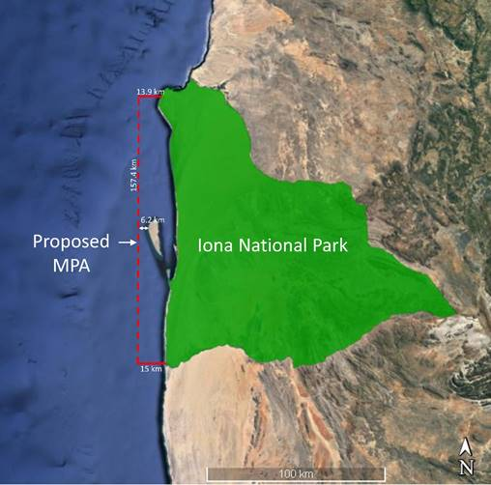

Map 1: Proposed project area

Annexe 6: Project’s Theory of Change

Annexe 7: Mission Schedule

Date | Time | Location | Name/s of Person/s | Function / organisation
03/02/22 | 10h30 | (virtual VC) | Noé Quelengue | Unidade Costeira INBC / GEF Focal Point
04/02/22 | 15h00 |  | João Manuel Simão | Coordenador Local do Projecto
07/02/22 | 09h00 |  | Janeiro Avelino Janeiro | UNDP Programme Officer
 | 11h45 |  | Bruce Bennet | African Parks
 | 17h00 |  | Tânia Mandinga | Chefe Departamento Proteção dos Ecosistemas (DNAM), MINAGRIP
08/02/22 | 11h30 |  | Tresor Jorge | Unidade Costeira INBC
09/02/22 | 09h00 |  | Joyce Janota | Coordenadora Nacional do Projecto
 | 10h30 |  | Edgar Soki | Técnico Sénior Pesca Artesanal Marinha, IPA
 | 12h30 |  | Onesimus Muhwezi | Current GEF RTA
 | 17h00 |  | Sophia Mauline | Former UNDP CO – Project Management Specialist (International UNV)
10/02/22 | 14h00 |  | Nádia Cristovão | Unidade Costeira INBC
11/02/22 | 08h00 |  | Vladmir Russo | Director Técnico, Holísticos / Kissama
11/02/22 | 12h00 |  | Goetz Schroth | Former UNDP CO – Programme Specialist
14/02/22 | 09h00 |  | Joice Diogo | Unidade Costeira INBC
 | 14h00 |  | Joyce Janota | Coordinadora Nacional do Projecto
 | 15h30 |  | Janeiro Avelino Janeiro | UNDP Programme Officer
 | 17h00 |  | Baptista Barros | Director Técnico, Barima
15/02/22 | 15h30 |  | Sango de Sá | Administrador do Parque Nacional do Iona
16/02/22 | 09h00 |  | Dr. Agostinho Cachapa | Coordenador Adjunto, Universidade do Namibe
 | 10h00 |  | Joyce Janota | Coordenadora Nacional do Projecto
 | 15h30 |  | Dr. Alexandre | Administrador Municipal de Tômbua
 | 16h30 |  | Director Diniz da Costa | Director Instituto Superior Politécnico Semedo Namibe
17/02/22 | 10h00 |  | Domingas Quiatuhanga | Universidade de Pescas do Namibe, Bióloga Marinha
 | 14h30 |  | Janeiro Avelino Janeiro | UNDP Programme Officer
 | 08h30 |  | Ester Santiago | Ministério de Ação Social, Família e Promoção da Mulher/Ponto Focal
18/02/22 | 11h30 |  | Tito Vilinga | UNDP CO – Programme Associate  Financial & Administrative Officer
 | 20h00 |  | Alice Capita | Unidade Costeira INBC / BCC
19/02/22 | 10h00 |  | Sr. Paulino | Coordenador dos Pescadores e Colega dos Sobas nos Bairros Rocha e Estuário do Rio Curica
 | 11h00 |  | Jorge Hilário de Sousa | Associação de Pescas do Namibe  Provincial Chairman for the Fisherman Association (semi-industrial)
 | 17h00 |  | Fernando Condo | Vice-Presidente Associação de Pesca do Namibe para a Pesca Artesanal
 | 18h00 |  | Chefe Domingos Chicoti | Chefe do estuário Rio Curoca  Mobilizador sobre projeto ACM, pescador bairros Rocha e estuário Rio Curica
23/02/22 | 11h00 |  | Claudia Fernandes | UNDP CO – Results Based Management (M&E)
 | 11h45 |  | Benvinda Matteos | Administradora Adjunta Tômbua
 | 12h30 |  | Ana Maria | Laboratório de Engenharia de Angola/Ponto Focal
 | 16h00 |  | Domingos Paulo | Ministério da Administração de do Território/Ponto Focal
 | 18h00 |  | Pedro Hangula | Director Gabinete Provincial do Ambiente - Namibe
24/02/22 | 14h00 |  | Odette Trigo | Ministério de Energia e Águas/Ponto Focal
21/03/22 | (by email) |  | Albertina Nzuzi Matias | Directora Nacional do Projecto / Directora a.i. INBAC
27/03/22 | 10h00 |  | Joyce Janota | Coordenadora Nacional do Projecto
28/03/22 | 15h00 |  | Debriefing evaluation

Annexe 8: List of Persons Consulted

Name/s of Person/s | Title, Institutional Affiliation
Dr. ALEXANDRE | Administrador Municipal de Tômbwa
BARROS Baptista | Director Técnico, Barima
BENNET Bruce | African Parks
CACHAPA Dr. Agostinho | Coordenador Adjunto, Universidade do Namibe
CAPITA Alice | Unidade Costeira INBC / BCC
CHICOTI Chefe Domingos | Chefe do estuário Rio Curoca, Mobilizador do projeto ACM, pescador bairros Rocha e estuário Rio Curica
CONDO Fernando | Vice-Presidente Associação de Pesca do Namibe para a Pesca Artesanal
Da COSTA | Director Instituto Superior Politécnico Semedo Namibe
DIOGO Joice | Unidade Costeira INBC
FERNANDES Claudia | UNDP CO – Results Based Management (M&E)
HANGULA Pedro | Director Gabinete Provincial do Ambiente – Namibe
JANEIRO Avelino Janeiro | UNDP Programme Officer
JANOTA Joyce | Coordinadora Nacional do Projecto
JORGE Tresor | Unidade Costeira INBC
MANDINGA Tânia | Chefe Departamento Proteção dos Ecosistemas (DNAM), MINAGRIP
MARIA Ana | Laboratório de Engenharia de Angola/Ponto Focal
MATTEOS Benvinda | Administradora Adjunta Tômbua
MAULINE Sophia | Former UNDP CO – Project Management Specialist (International UNV)
MUHWEZI Onesimus | Current GEF RTA
NZUZI Matias Albertina | Directora Nacional do Projecto / Directora ai INBAC
PAULINO Sr. | Coordenador dos Pescadores e Colega dos Sobas nos Bairros Rocha e Estuário do Rio Curica
PAULO Domingos | Ministério da Administração de do Território/Ponto Focal
QUELENGE, Noé | Unidade Costeira INBC / GEF Focal Point
QUIATUHANGA Domingas | Universidade de Pescas do Namibe, Biologa Marinha
de SÁ Sango | Administrador do Parque Nacional do Iona
SANTIAGO Ester | Ministério de Acção Social, Família e Promoção da Mulher/Ponto Focal
SCHROTH Goetz | Former UNDP CO – Programme Specialist
SIMÃO João Manuel | Coordenador Local do Projecto
SOKI Edgar | Técnico Senior Pesca Artesanal Marinha, IPA
De SOUZA Jorge Hilário | Associação de Pescas do Namibe - Provincial Chairman for the Fisherman Association (semi-industrial)
TRIGO Odete | Ministério de Energia e Águas/Ponto Focal
VILINGA Tito | UNDP CO – Programme Associate, Financial & Administrative Officer

Annexe 9: List of Documents Consulted

GEF 6 Core indicators
PRODOC, Gender Action Plan
Project Board Terms of Reference
Project Document, July 2019
Project Implementation Report, 2021
Project Annual Workplan, 2019
Project Annual Workplan, 2020
Project Annual Workplan, 2021
Project Inception Workshop Report, July 2019
Project Steering Committee minutes, June 2021
Project Steering Committee minutes, December 2021
Social and Environmental Screening Procedure, April 2019
UNDP, Combined Delivery Report, 2019
UNDP, Combined Delivery Report, 2020
UNDP, Combined Delivery Report, 2021

Annexe 10: Evaluation questions matrix

Criteria | Evaluation question | Judgment / Indicator | Source of information
• Intervention relevance | - Adequacy of the project design in relation to the identified issues and actual objective  - Project design in relation to interventions financed by other donors  - Design changes during implementation in real conditions  - Adequacy of topics and sectors in relation to national issues / priorities  - Relevance to final beneficiaries  - Degree of consultation / participation of other stakeholders | - Comparison of the needs addressed with the needs identified and prioritized by the GoA during the initial consultations  - Establish to what degree the proposals / needs of the beneficiary institutions have been taken into account in determining the objectives and activities to be undertaken  - Determine the criteria for choosing beneficiaries and compare with the vulnerability criteria  - Compare all the needs addressed by the project against the needs expressed by the institutions  - Refer to the national policies of the GoA in terms of policies and management strategy for adaptation to CC in order to compare the strategy promoted by the project. | - PRODOC and national policies  - UNDP meetings, project team  - Meeting project team and beneficiary institutions  - Meeting project team and national policies
• Effectiveness | - Rate of completion of project activities  - Level of alignment with UNDP / GEF country program priorities  - How are the risks and assumptions taken into account during the implementation?  - Communication and visibility including external stakeholders / donors  - Lessons learned regarding the implementation mechanism / approach | - Compare the time to complete the activities compared to the actual project timeframe  - Measure the indicators of achievement of objectives /results against the indicators set in the Logical Framework  - Analysis of the difficulties encountered and the facilitations offered to the implementation of the project  - Level of satisfaction with the activities of the project and the facilities offered to the beneficiary institutions | - Reports – annual plans, meeting project team  - Meeting project team / periodic reports  - Meeting project team  - Meeting beneficiary institution
• Efficiency | - Relationship between the resources mobilized and the results obtained  - Assessment of the adequacy of the budget in relation to the actual costs of project activities within the allotted timeframe  - Cost / benefit ratio of the activities carried out | - Analysis of the project cost-effectiveness  - Comparison of the actual costs agreed with those of the budget  - Analysis of the absorption capacity of the Project to ensure delivery over the allocated period | - CDR review  - Project team meeting (+UNDP Finances)
• Impact | - Visible change according to final beneficiaries / GoA  - Contribution to change according to results  - Partnerships / synergies to strengthen the impact  - Added value of the project for the beneficiaries  - Intensity and quality of communication on the results of the project | - Identification and analysis of changes in work patterns within the targeted / beneficiary institutions  - Adoption / appropriation of tools  - Institutionalization of tools  - Degree of collaboration between interventions  - Effectiveness of communication actions on participation in the project | - Meetings project team and beneficiary institutions  - Meeting UNDP
• Sustainability | - Level of participation of national stakeholders  - Likelihood of sustaining results after project closure  - Institutional, environmental, financial and socio-economic sustainability  - Likelihood of ownership of results and empowerment / accountability | - Assess the level of implication and participation of local authorities and national institutions in the project  - Assess the level of commitment and capacity of public stakeholders to capitalise and project key project results  - Assess the potential institutional, environmental and socioeconomic change/sustainability that could come out of the project | - Meeting project team and beneficiary institutions, beneficiaries, UNDP  - Periodic reports
•Cross-cutting gender and rights | - To what extent has gender equity and the Leave No One behind policy, been addressed?  - How has the project contributed to the empowerment of women? | - Analysis of actions and potential effects on marginalised populations  - Contribution of women in project implementation  - Degree of support of women groups through capacity building activities | - Meeting UNDP, project team, beneficiaries and relevant sectoral representatives  - Meeting consultants for capacity building activities
•GEF/UNDP added value | - GEF/UNDP's added value as a donor compared to the donor community | - Specific GEF contributions (implementation, thematic aspects, intervention methodologies, etc.) in order to improve marine and coastal biodiversity | - Meeting UNDP / GEF, project team and other donors

Annexe 11: Debriefing Presentation

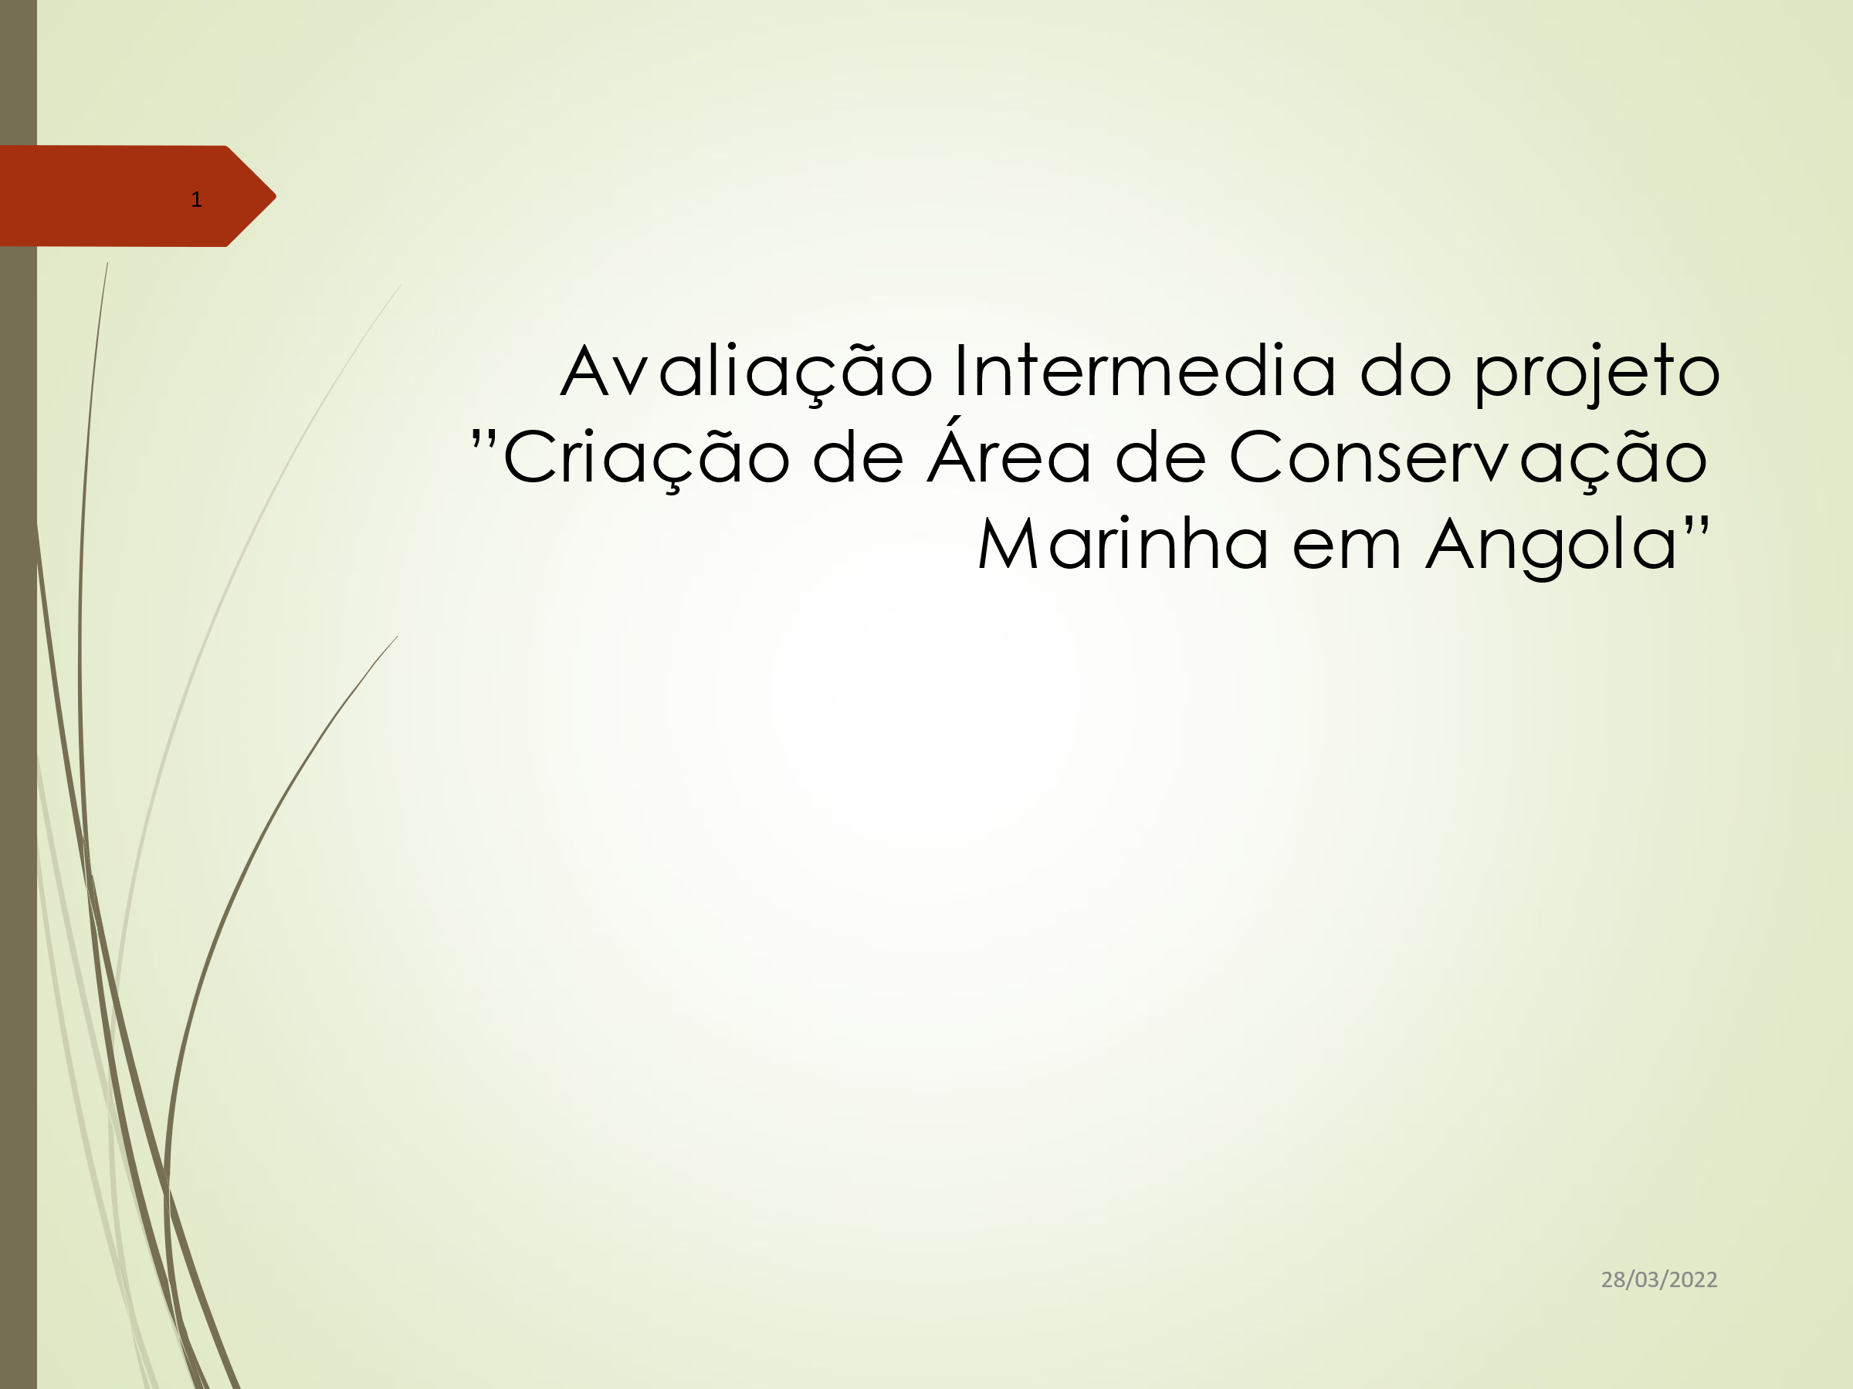
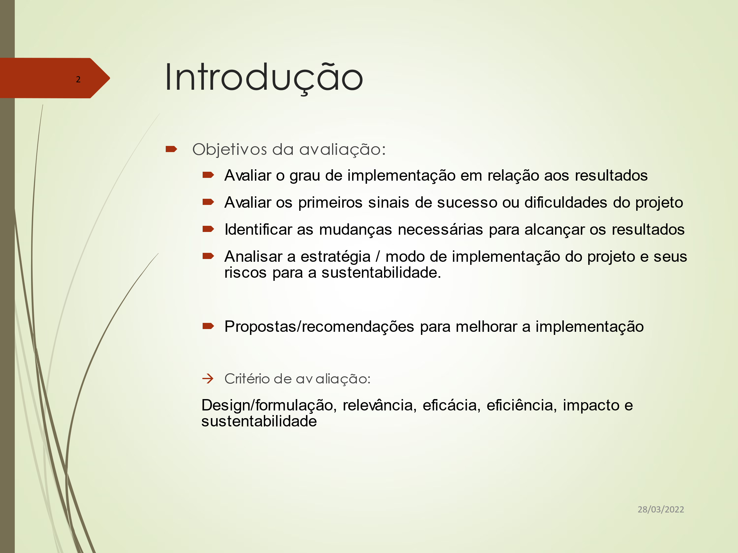

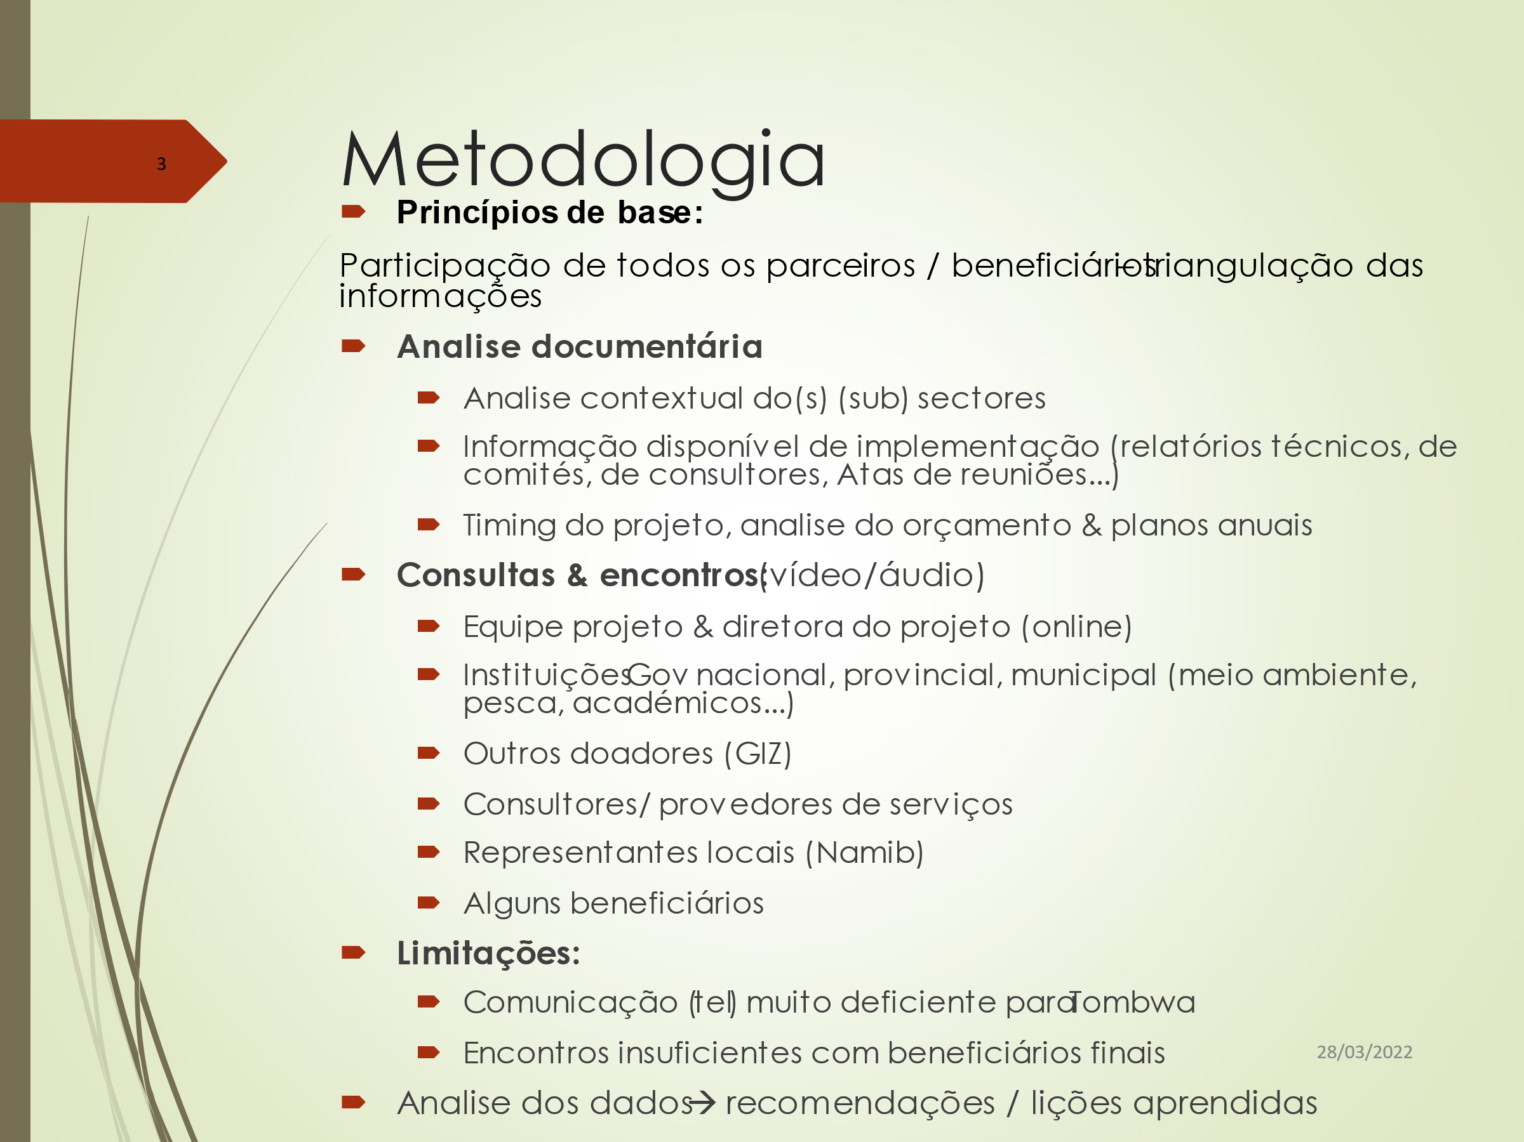

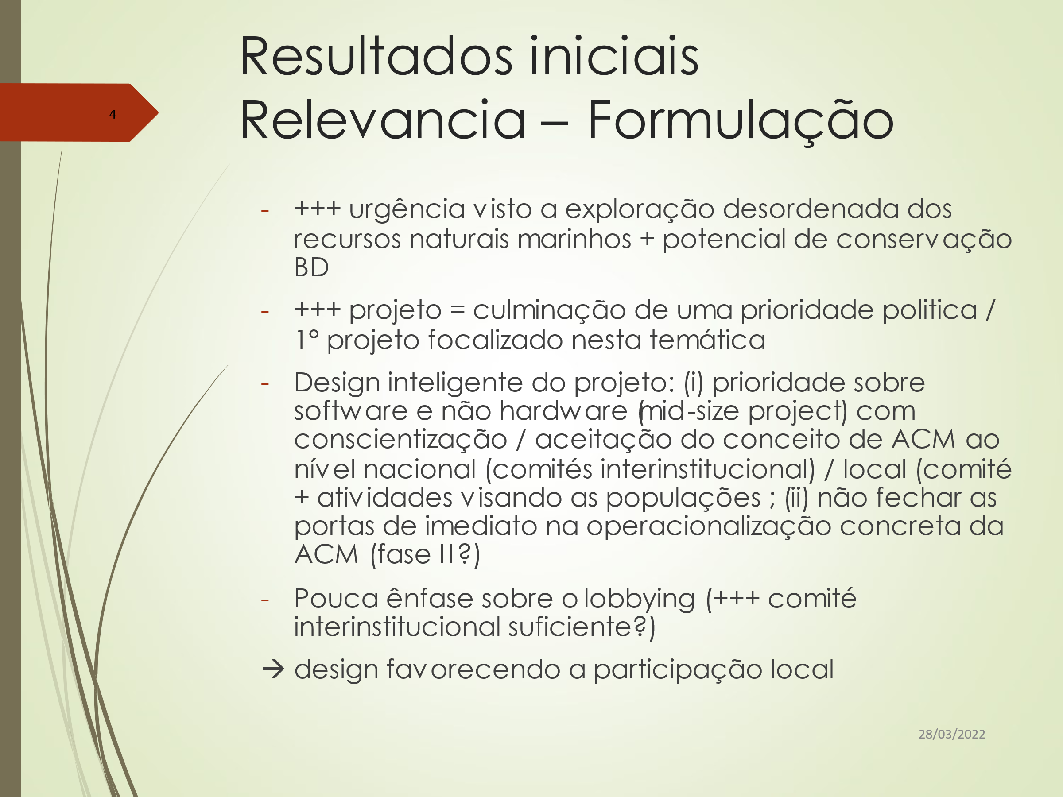
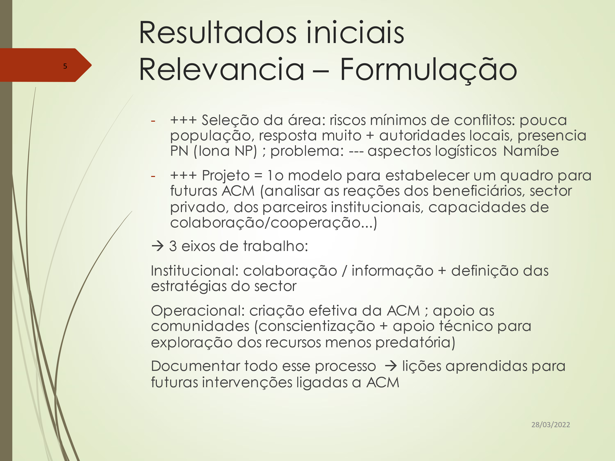

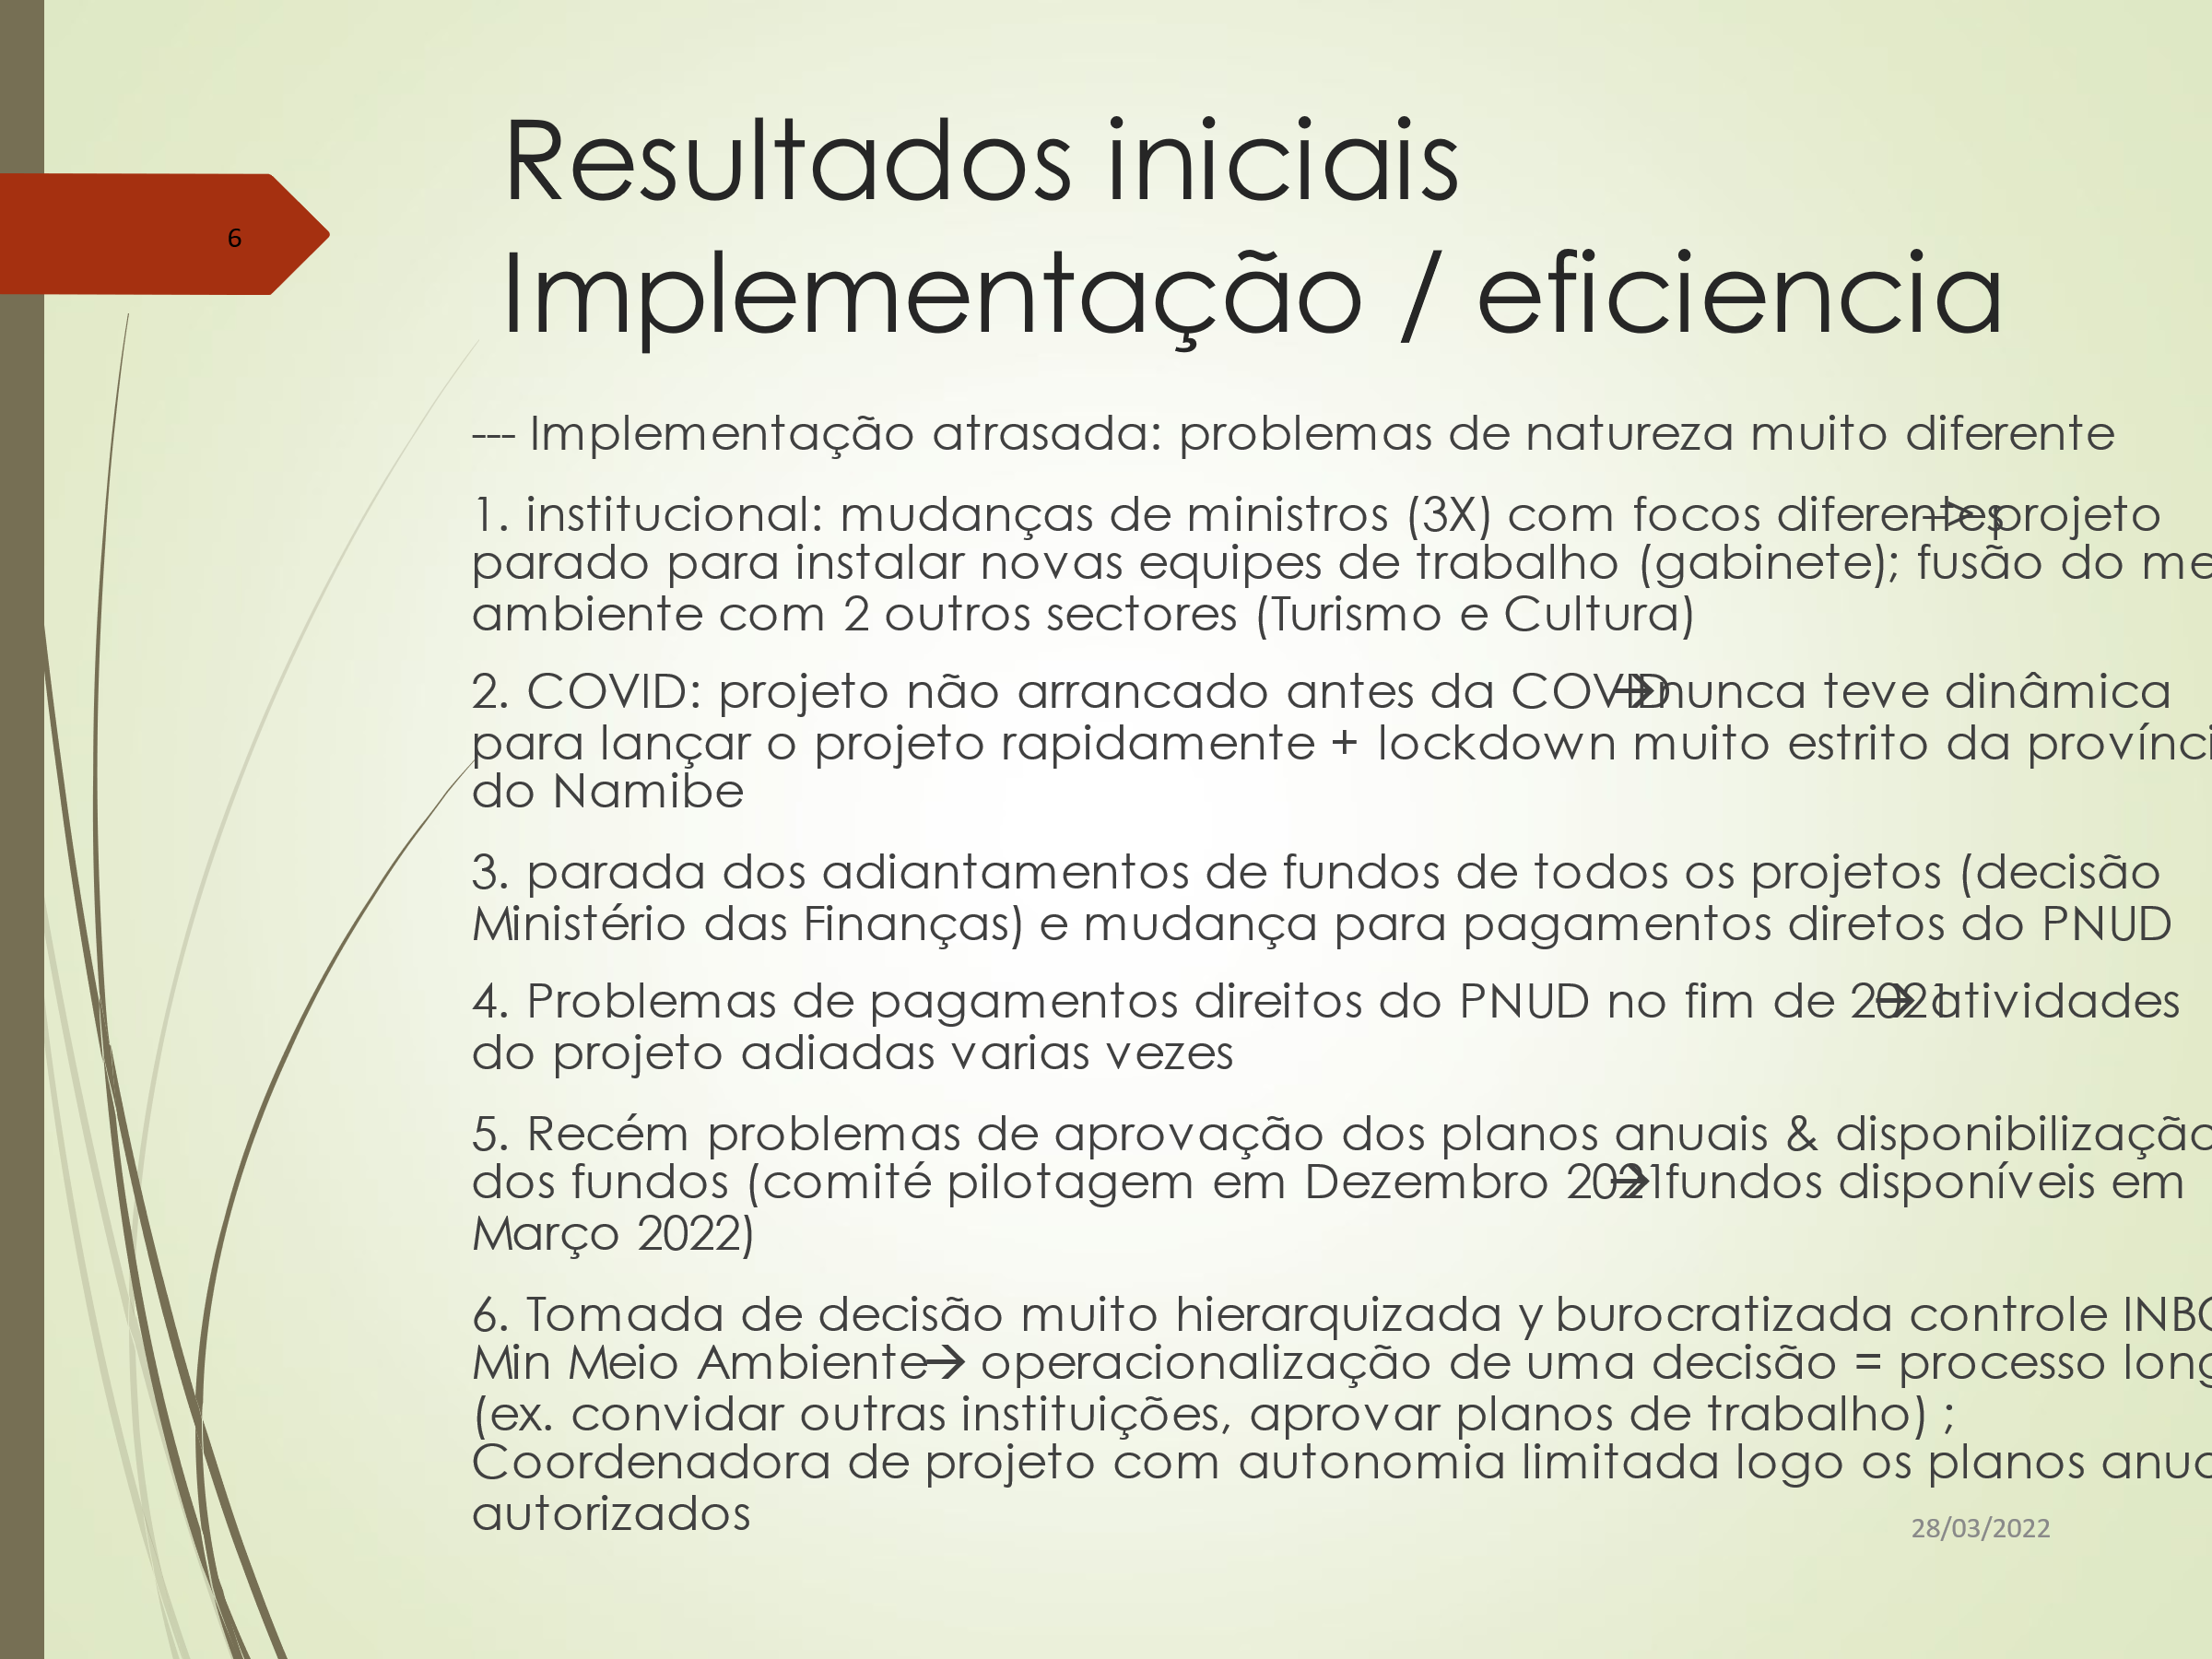
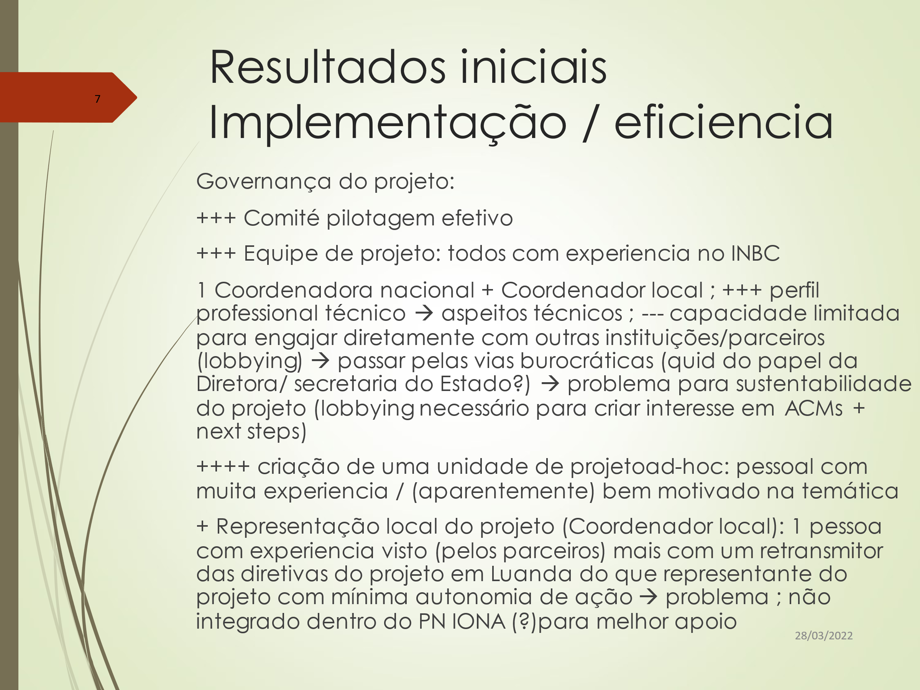

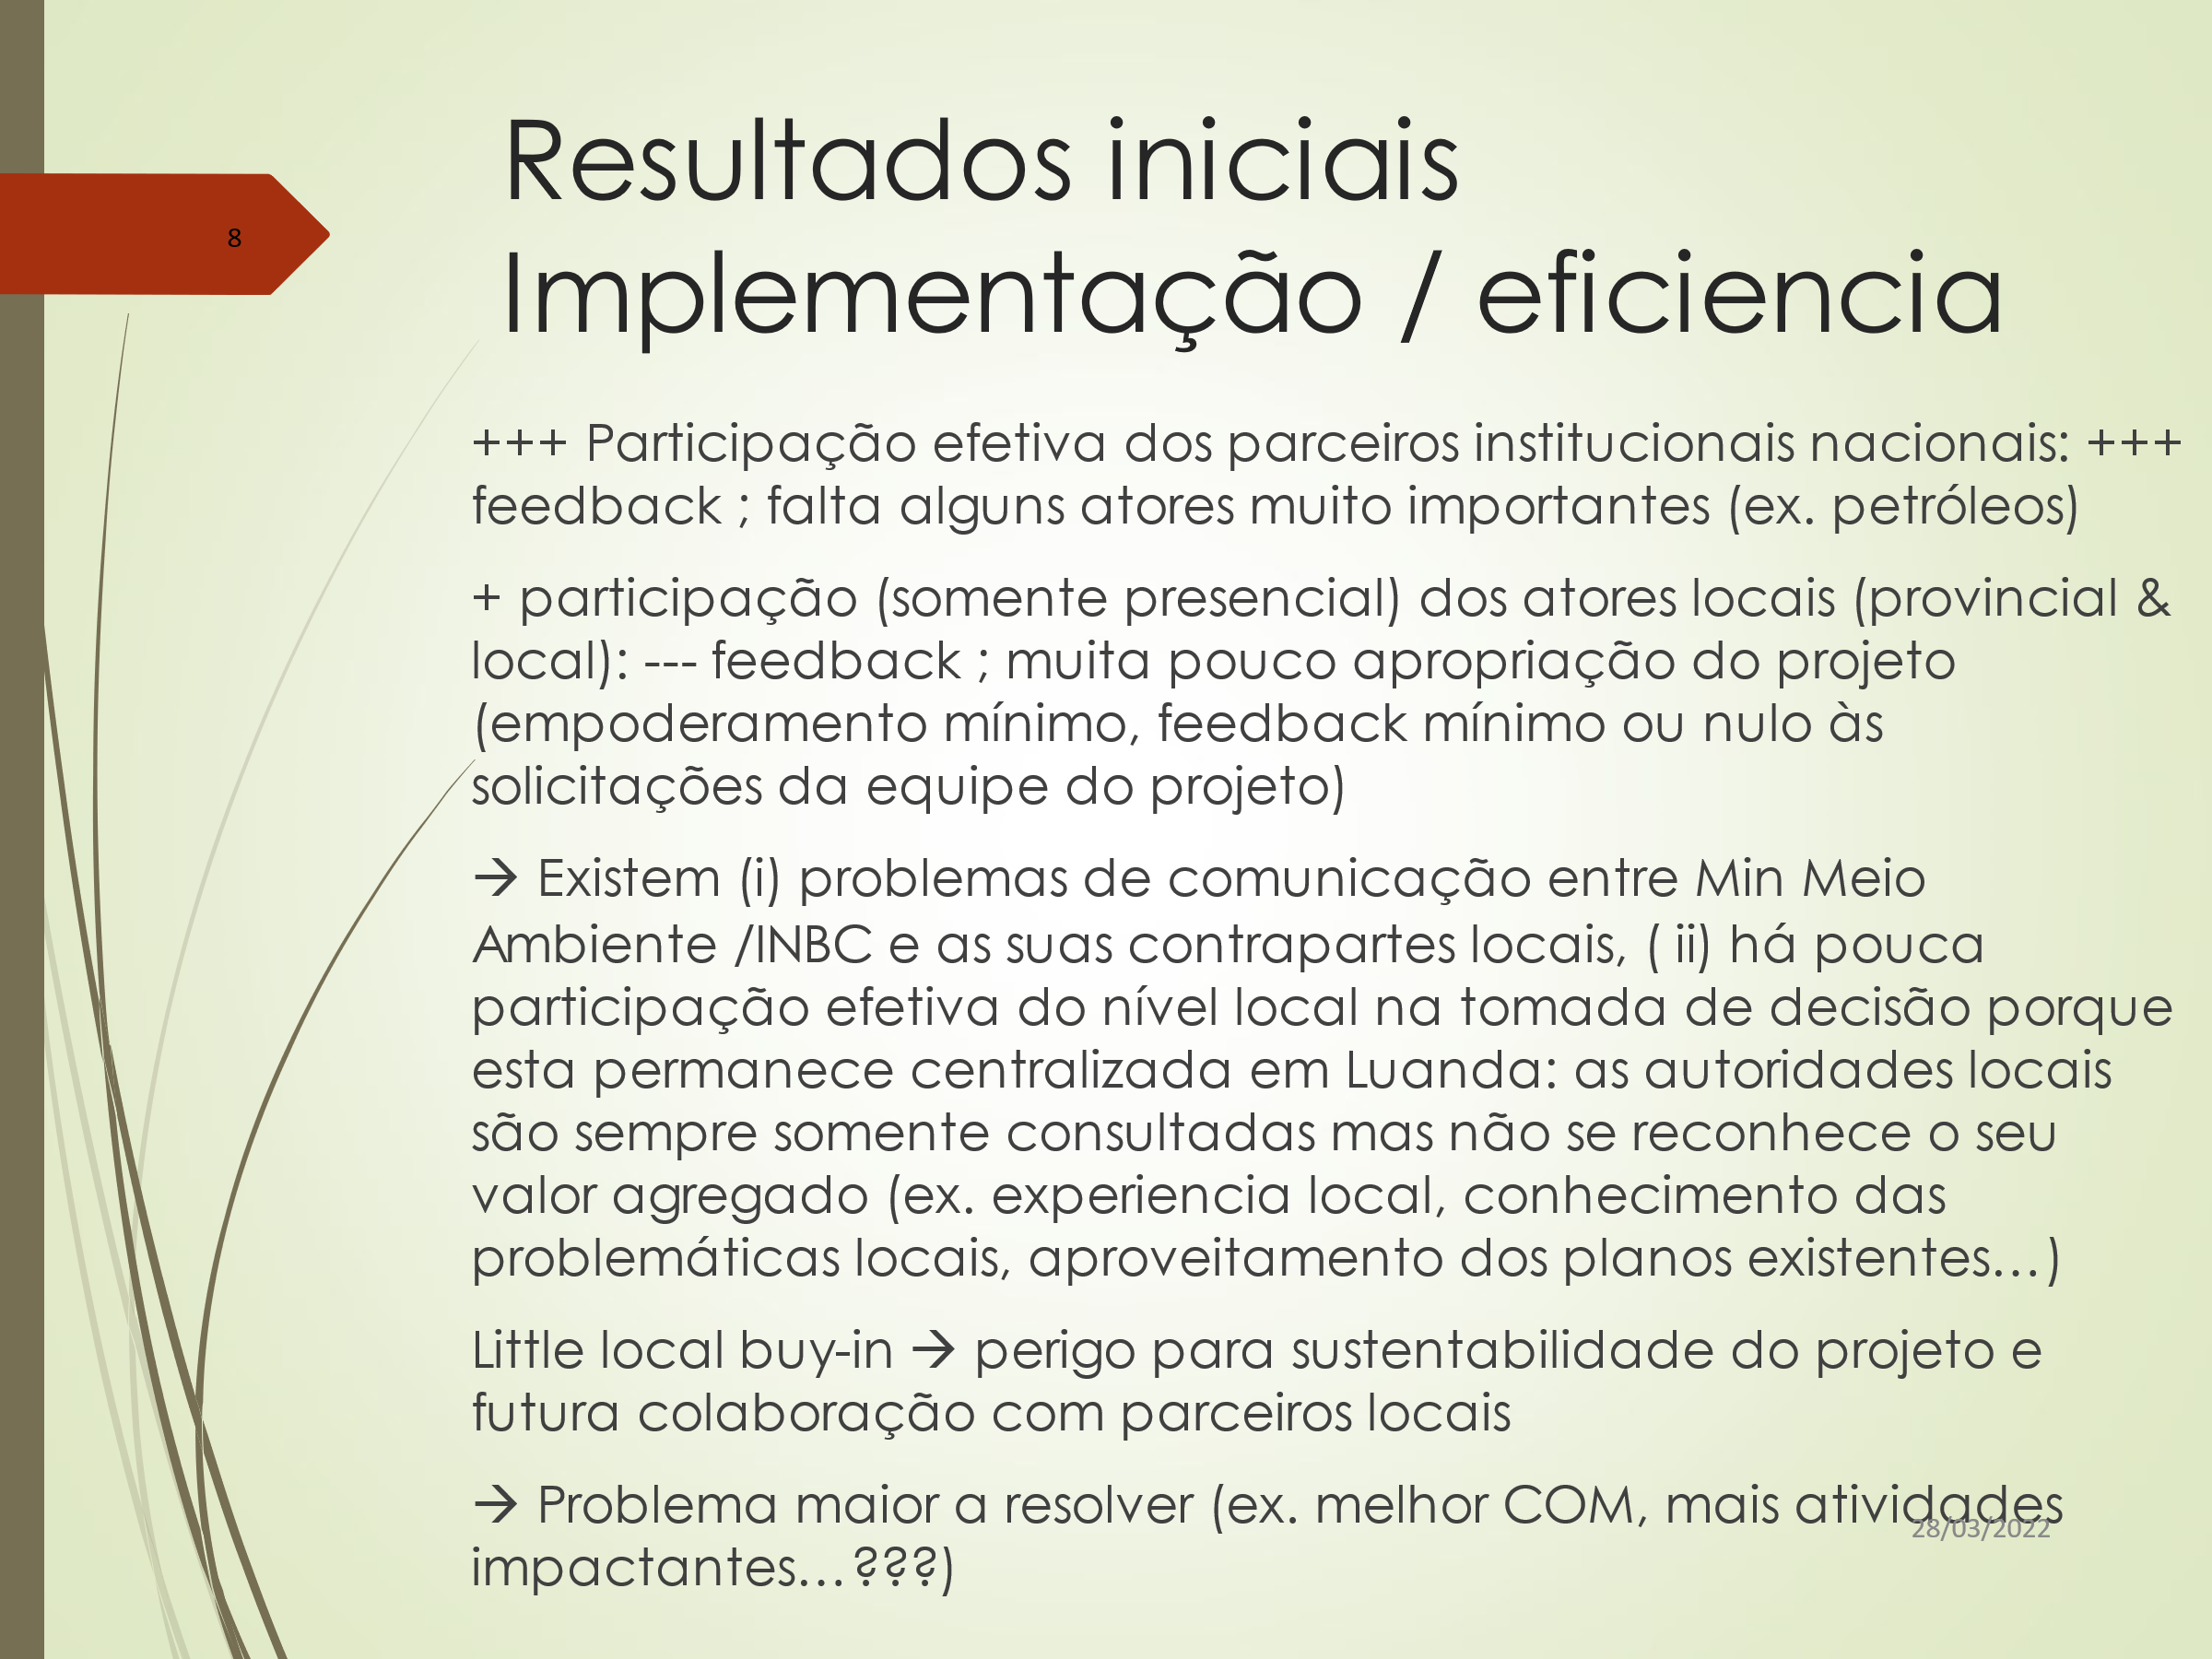
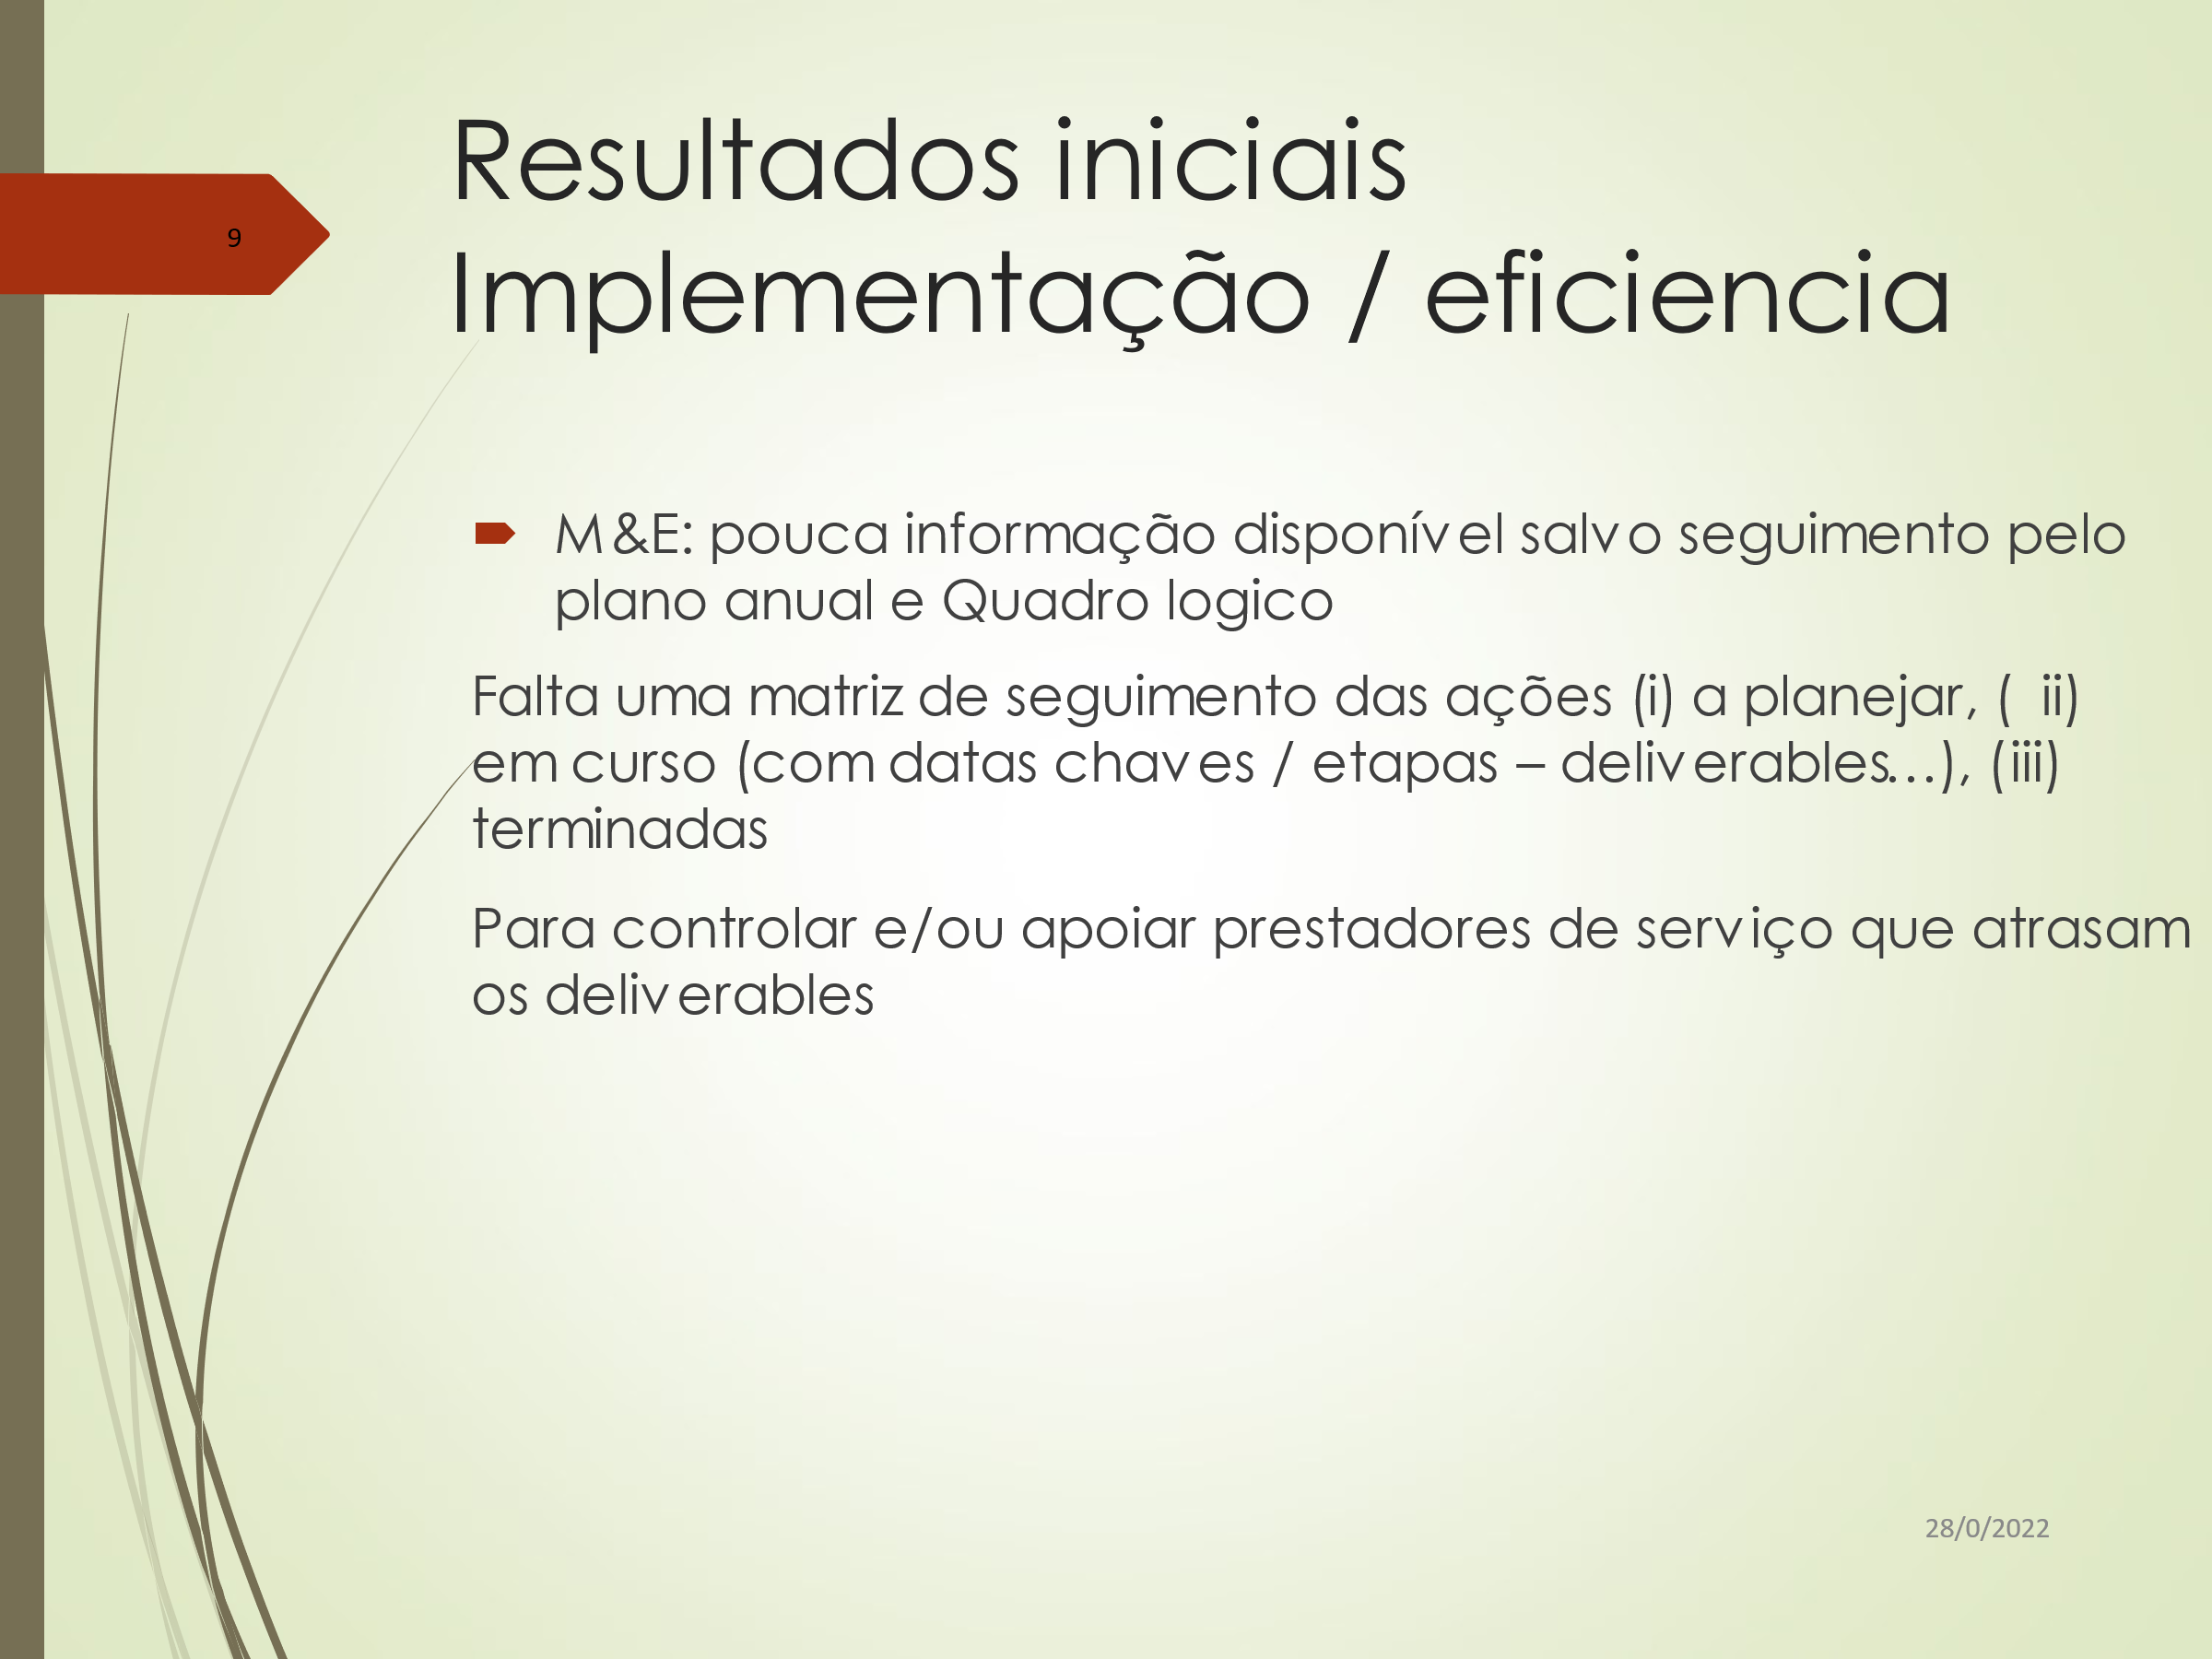

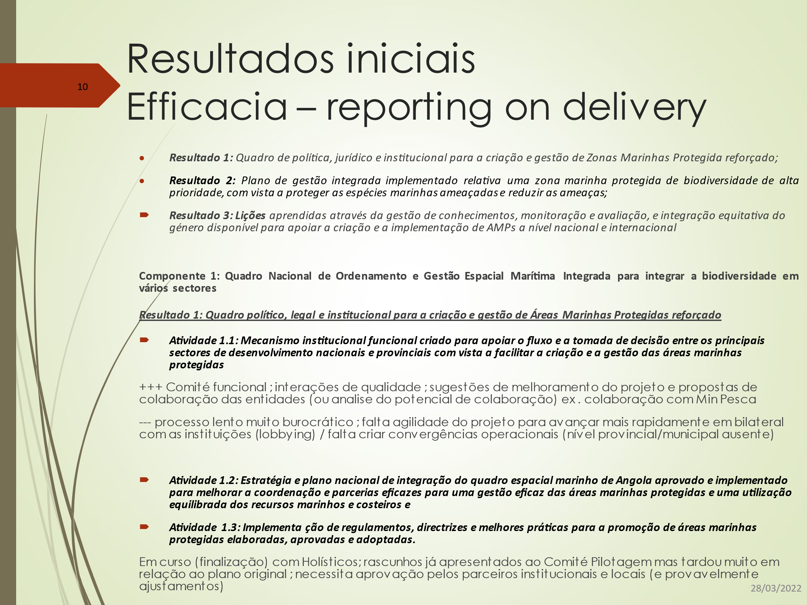

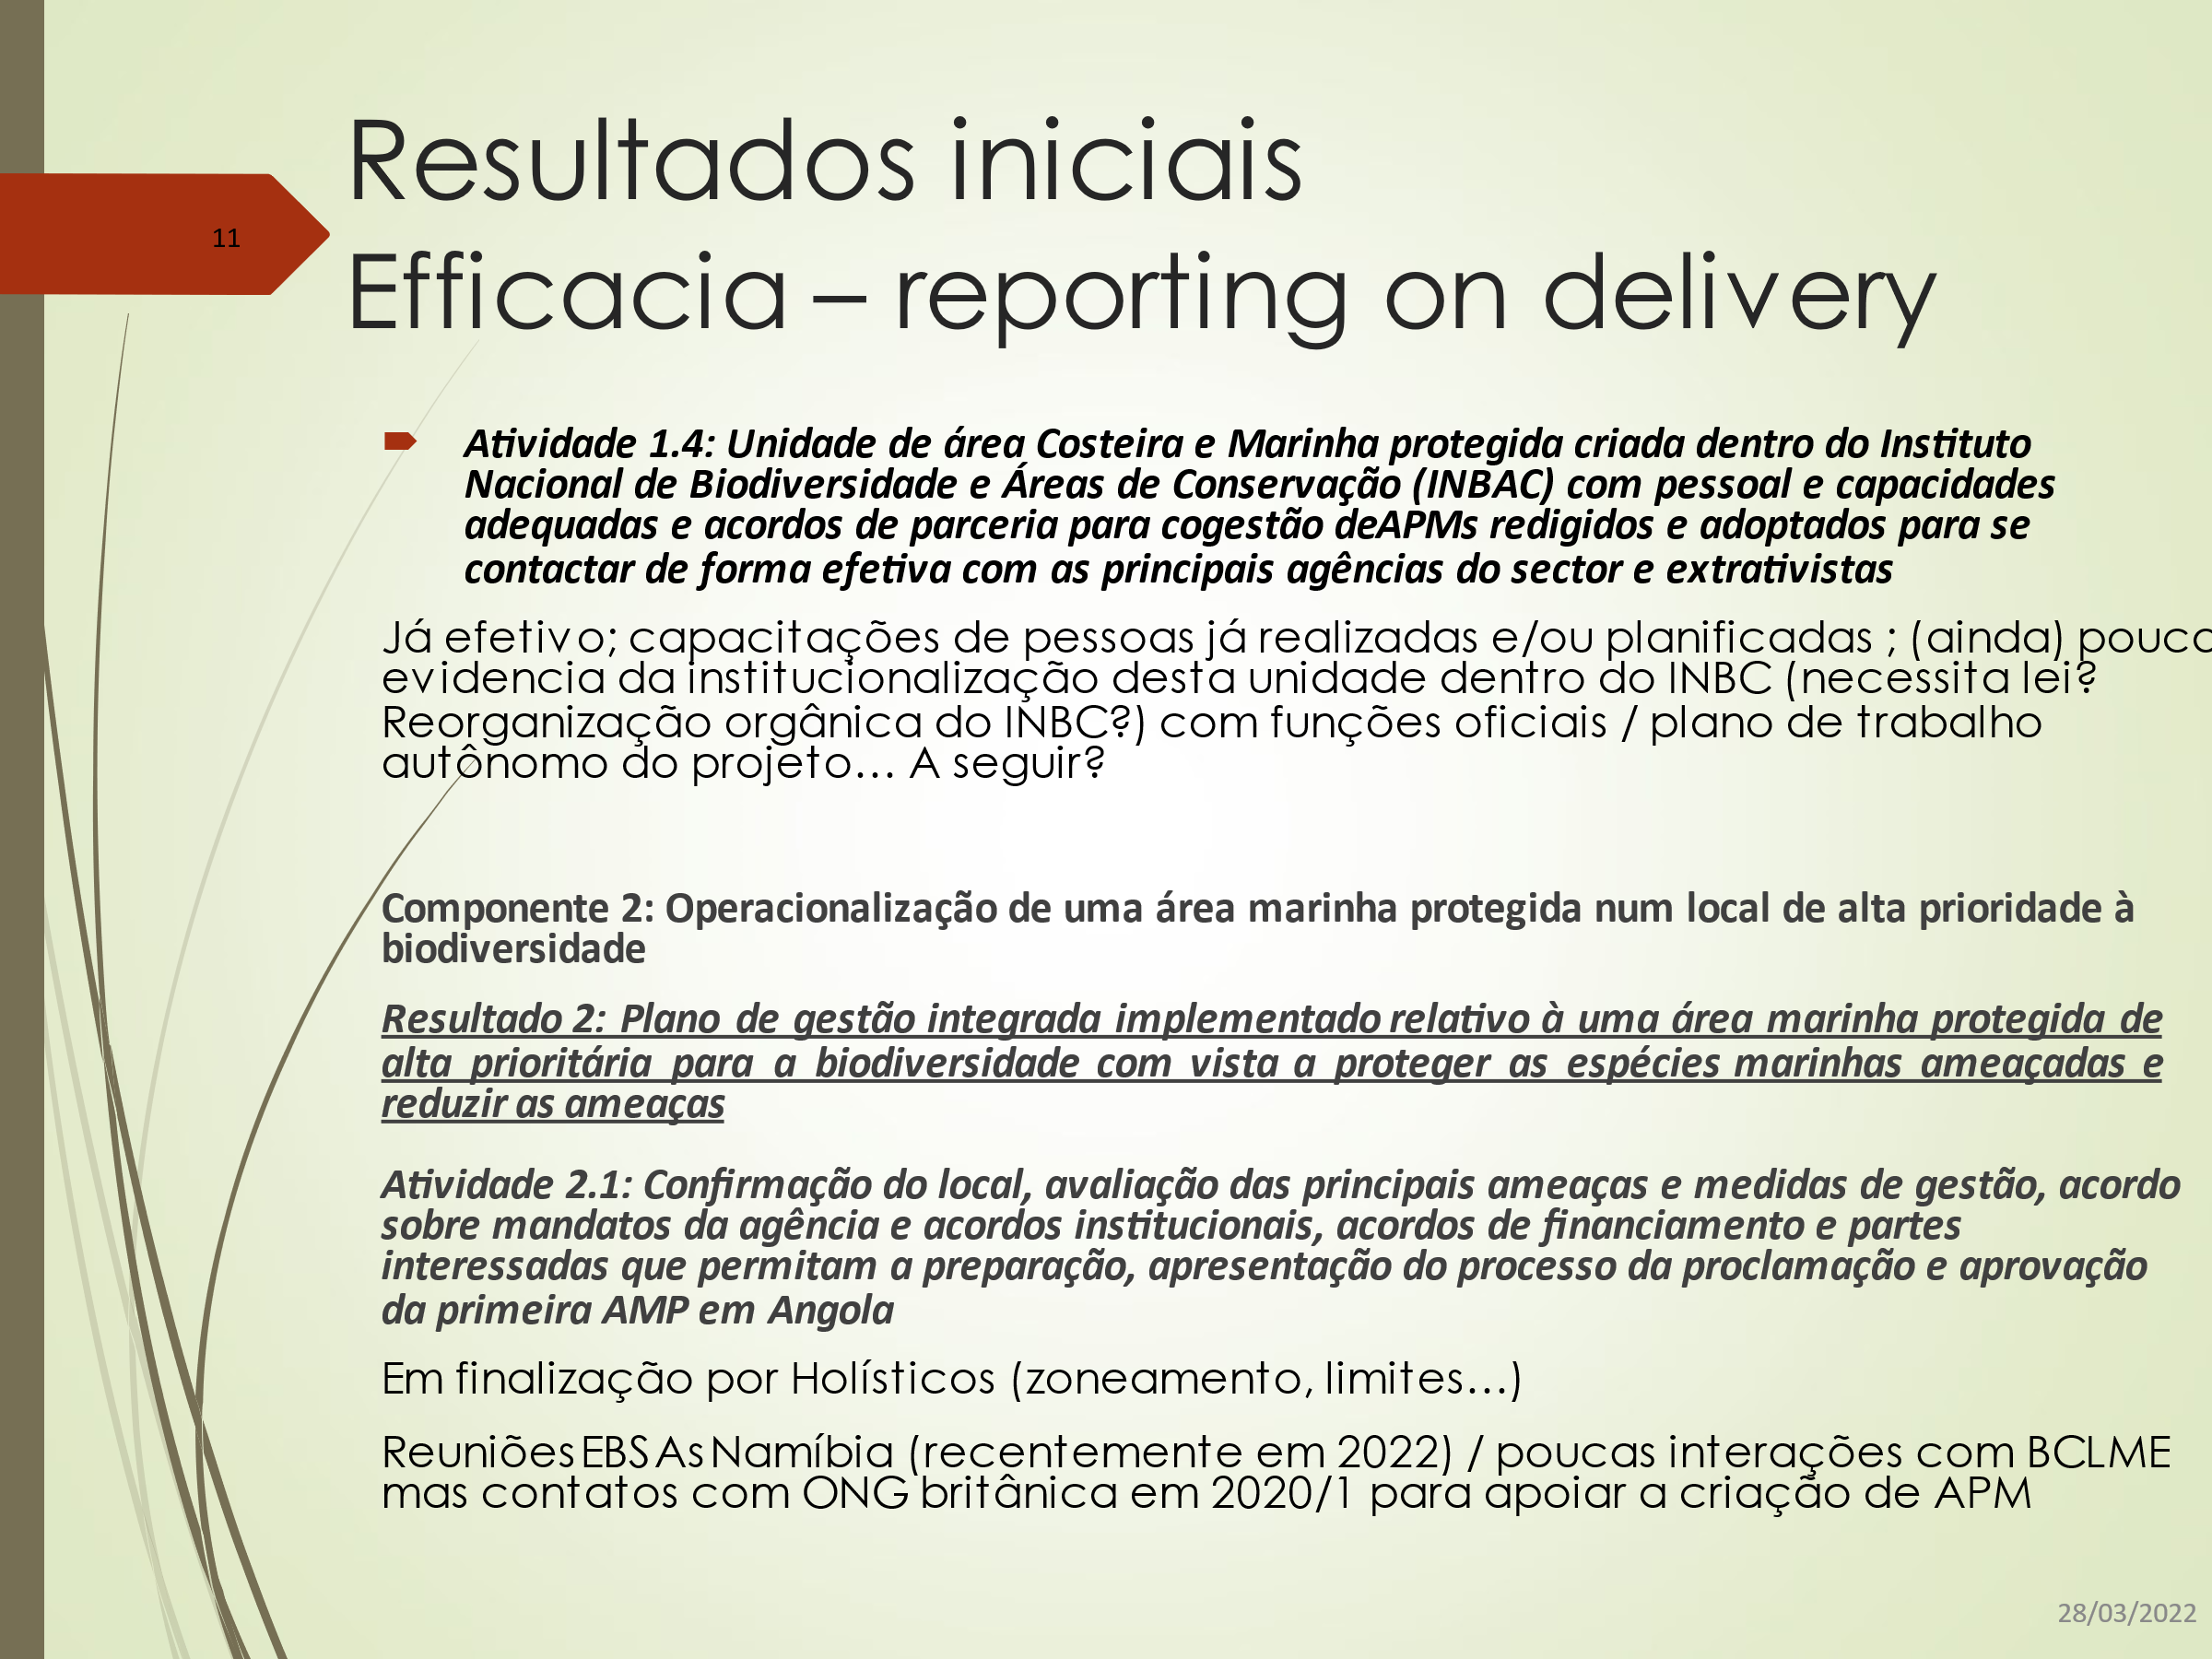

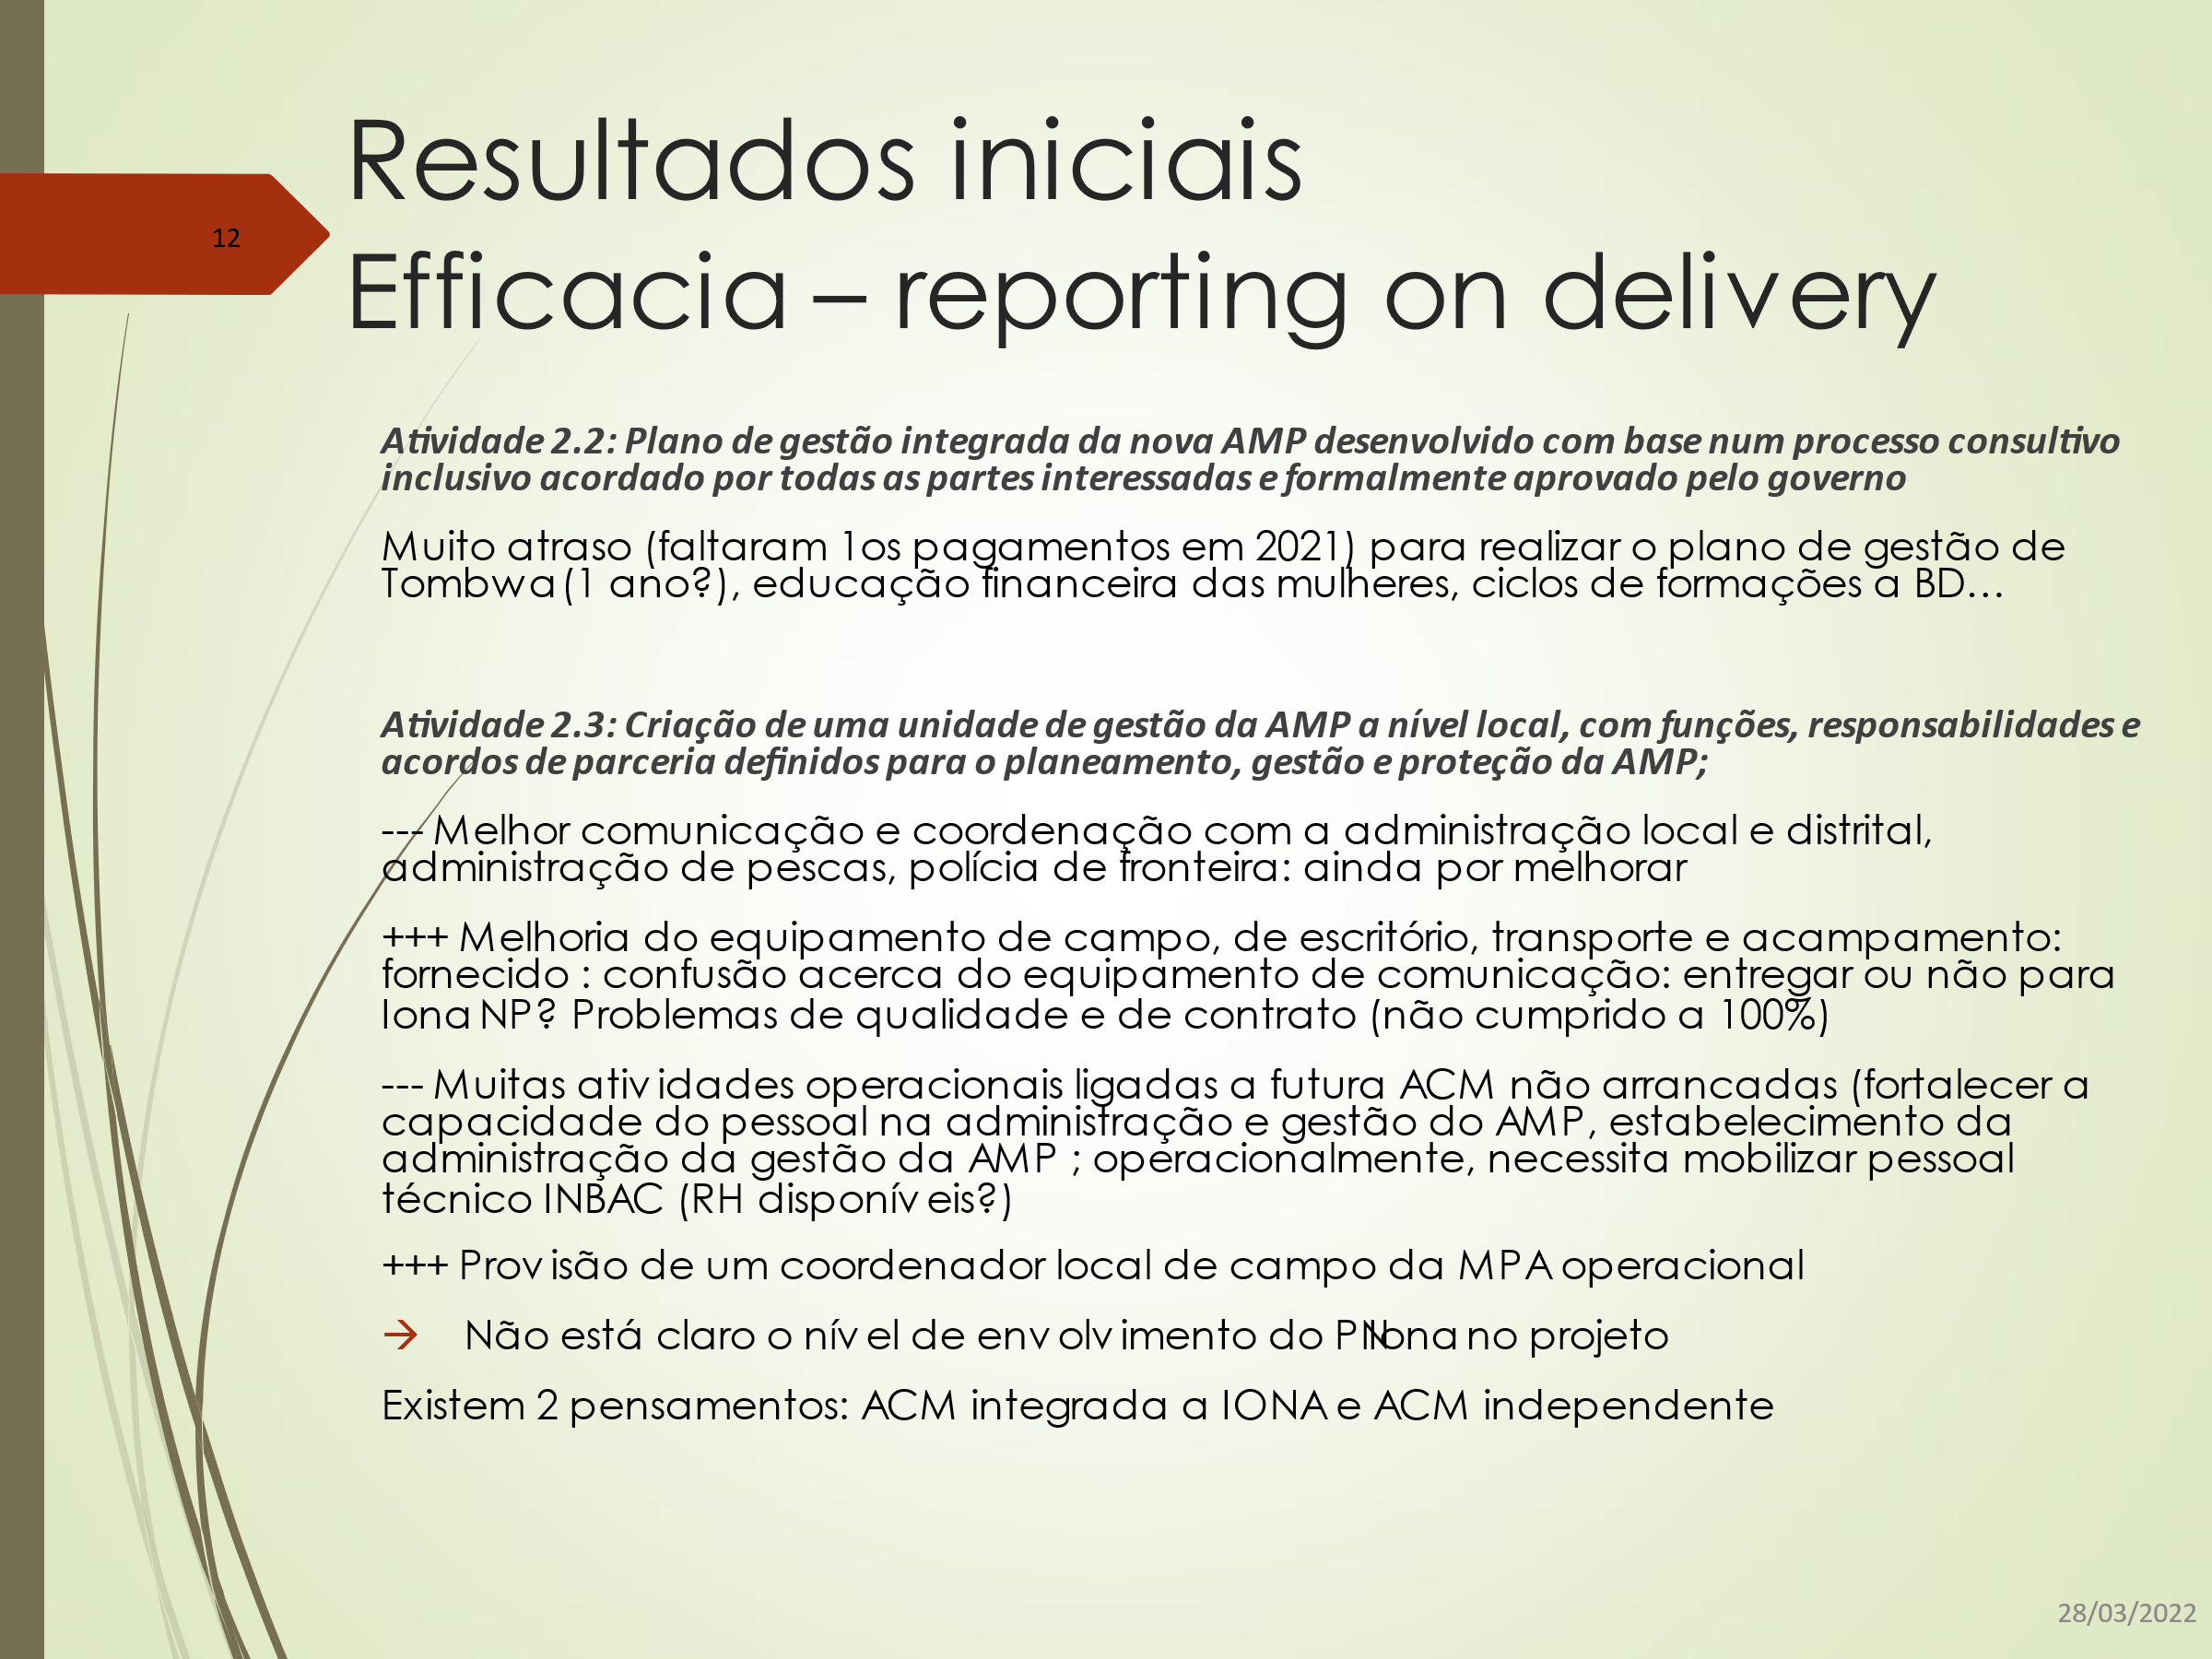

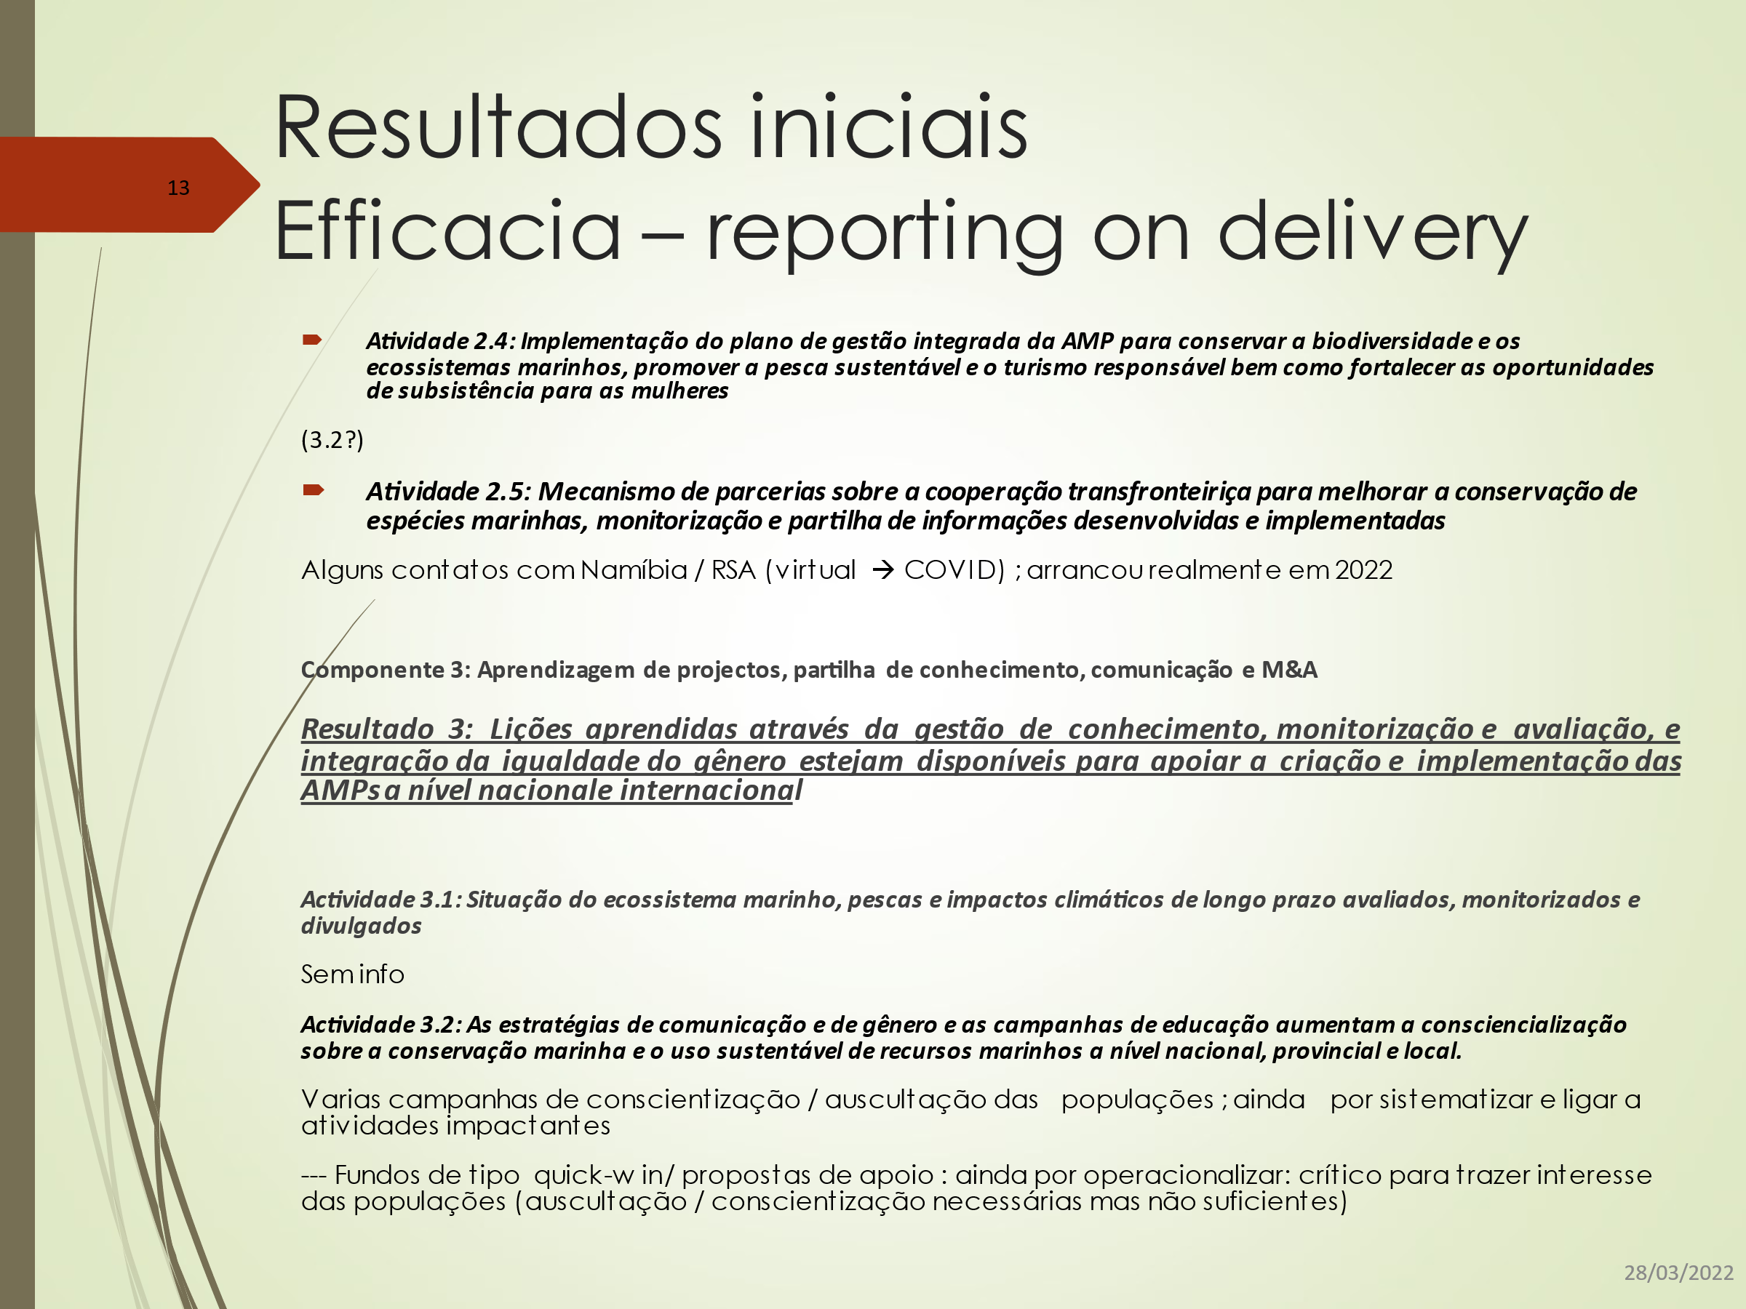

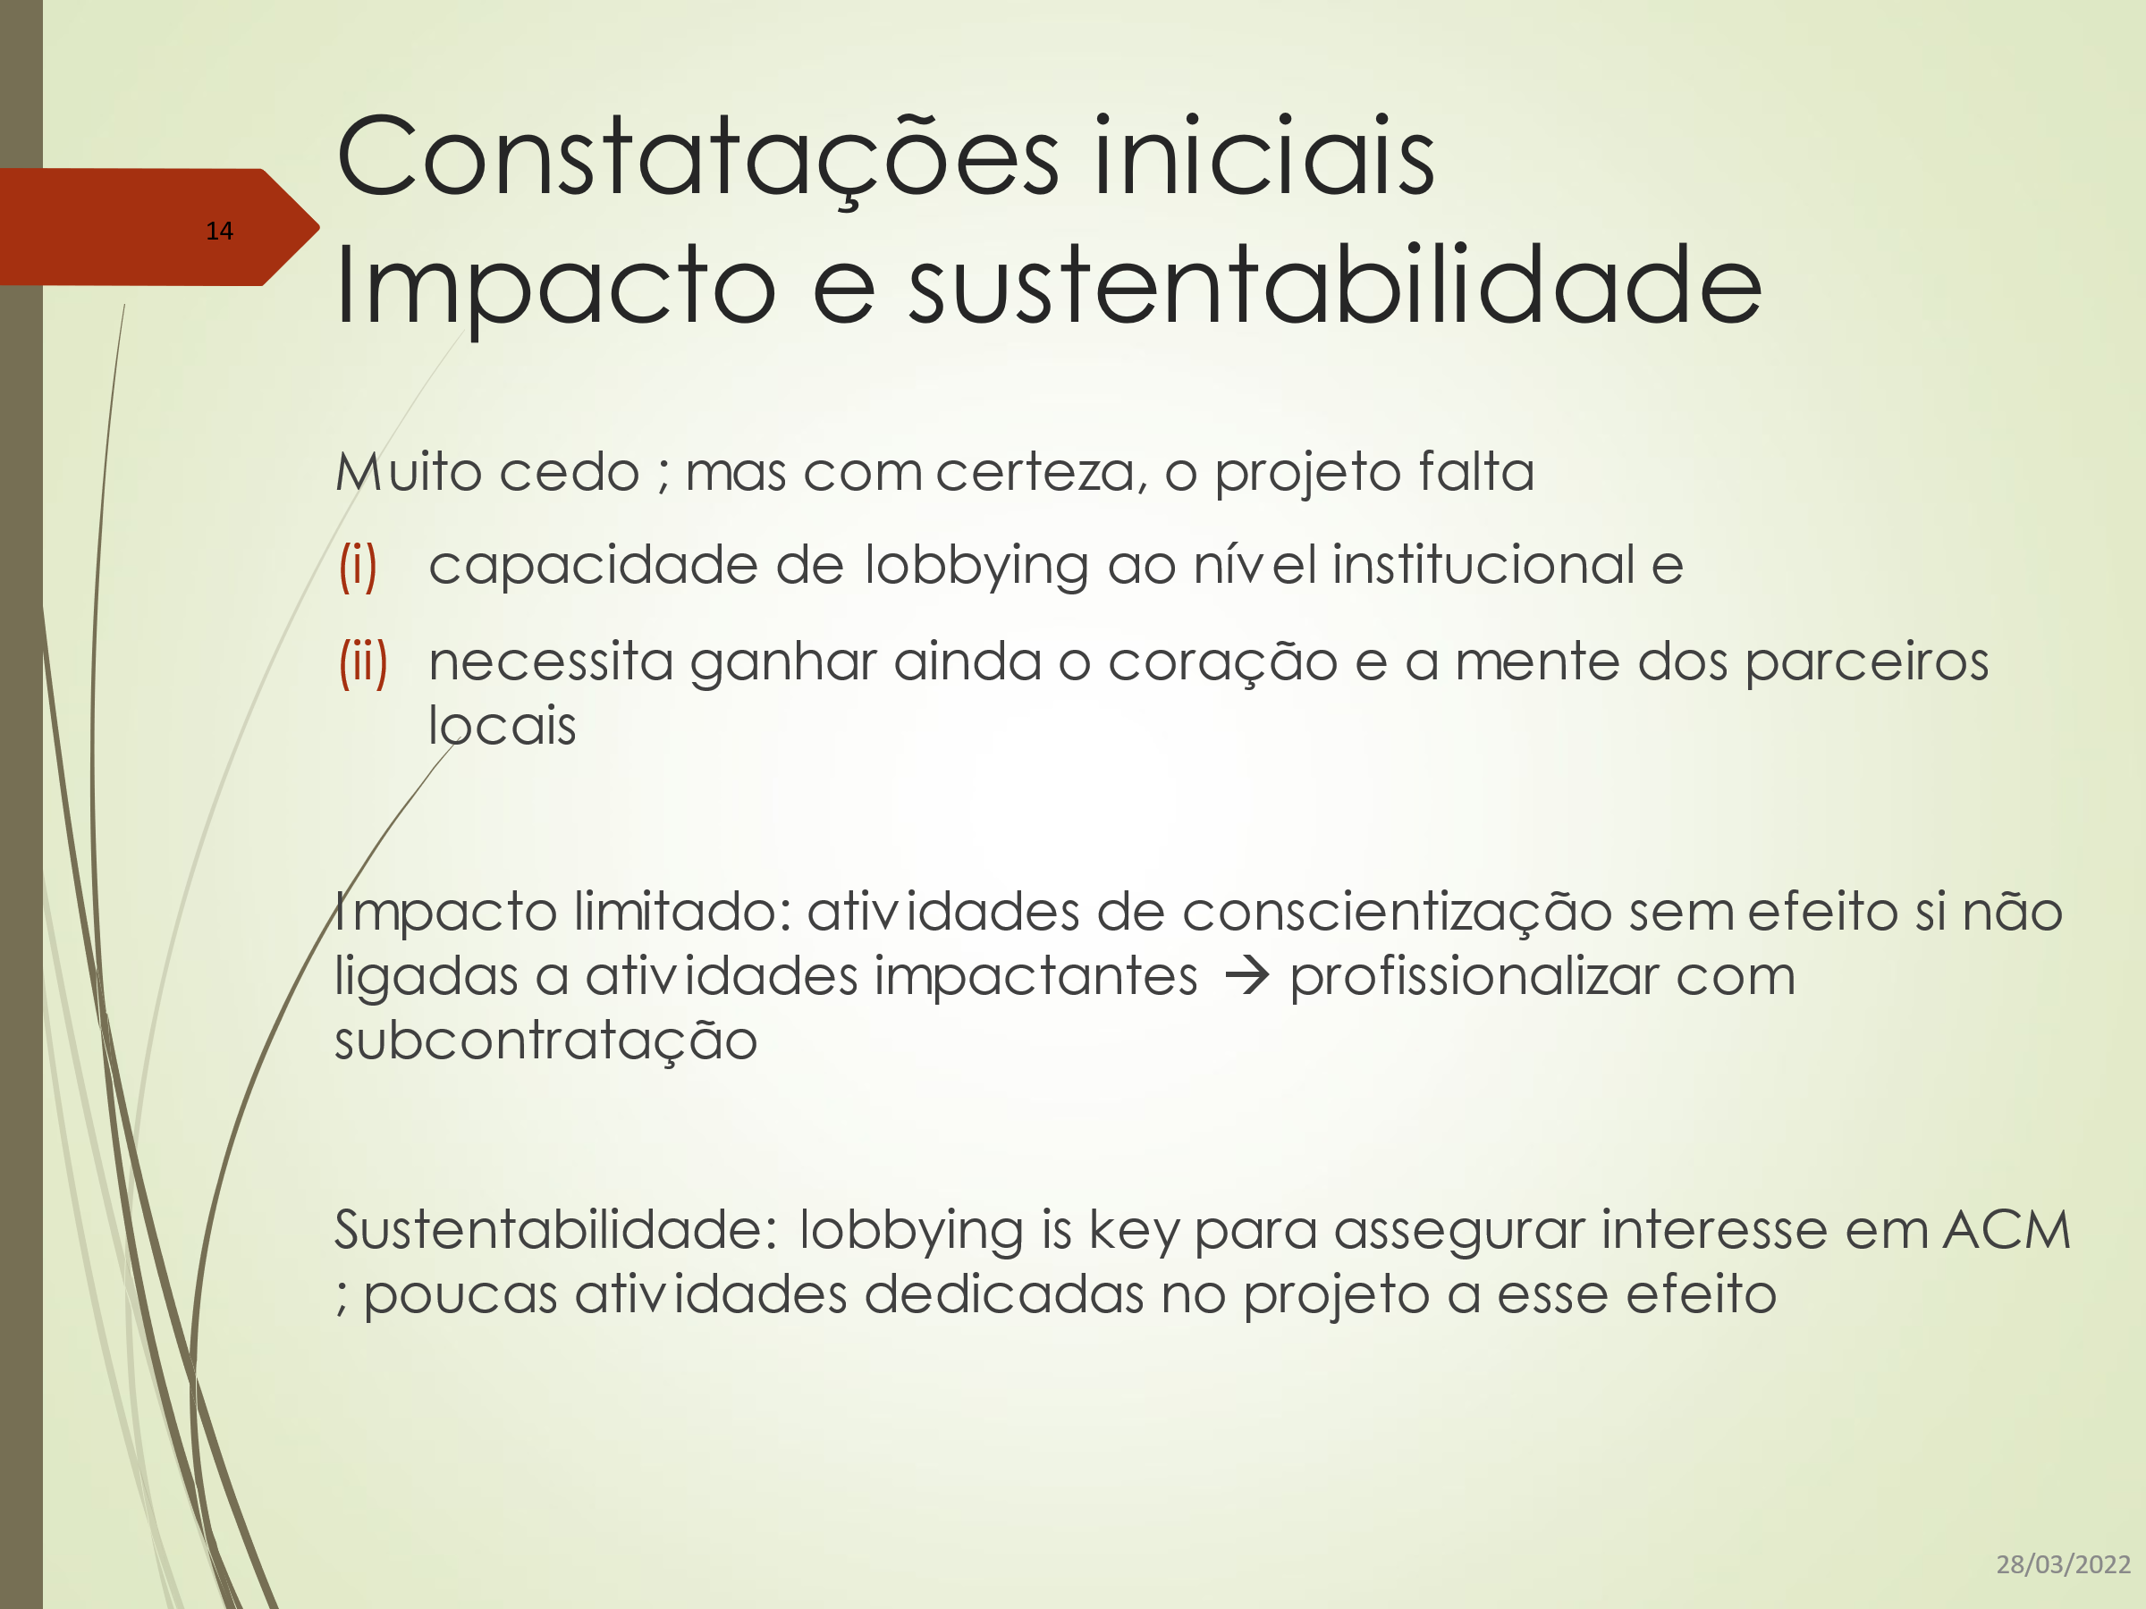
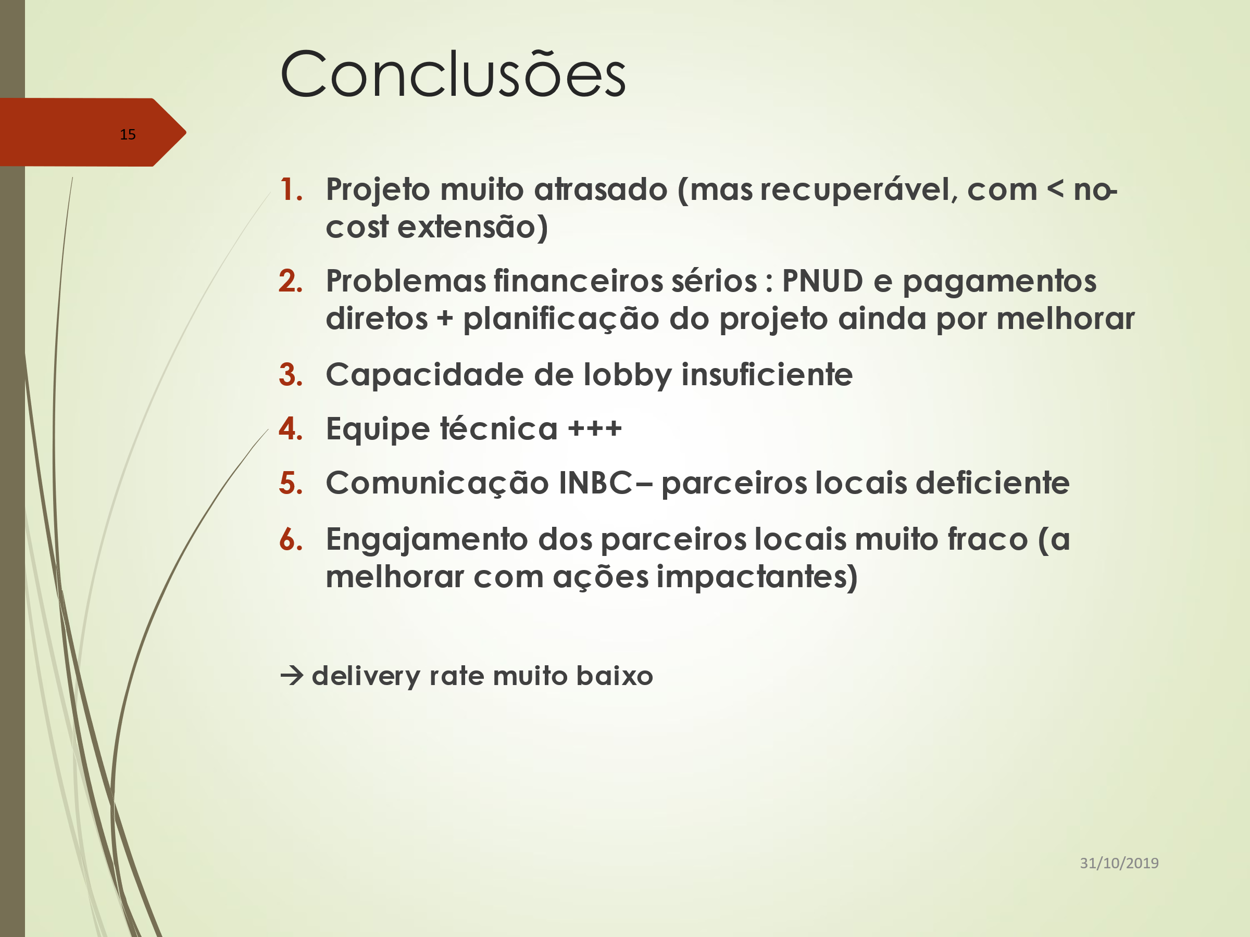

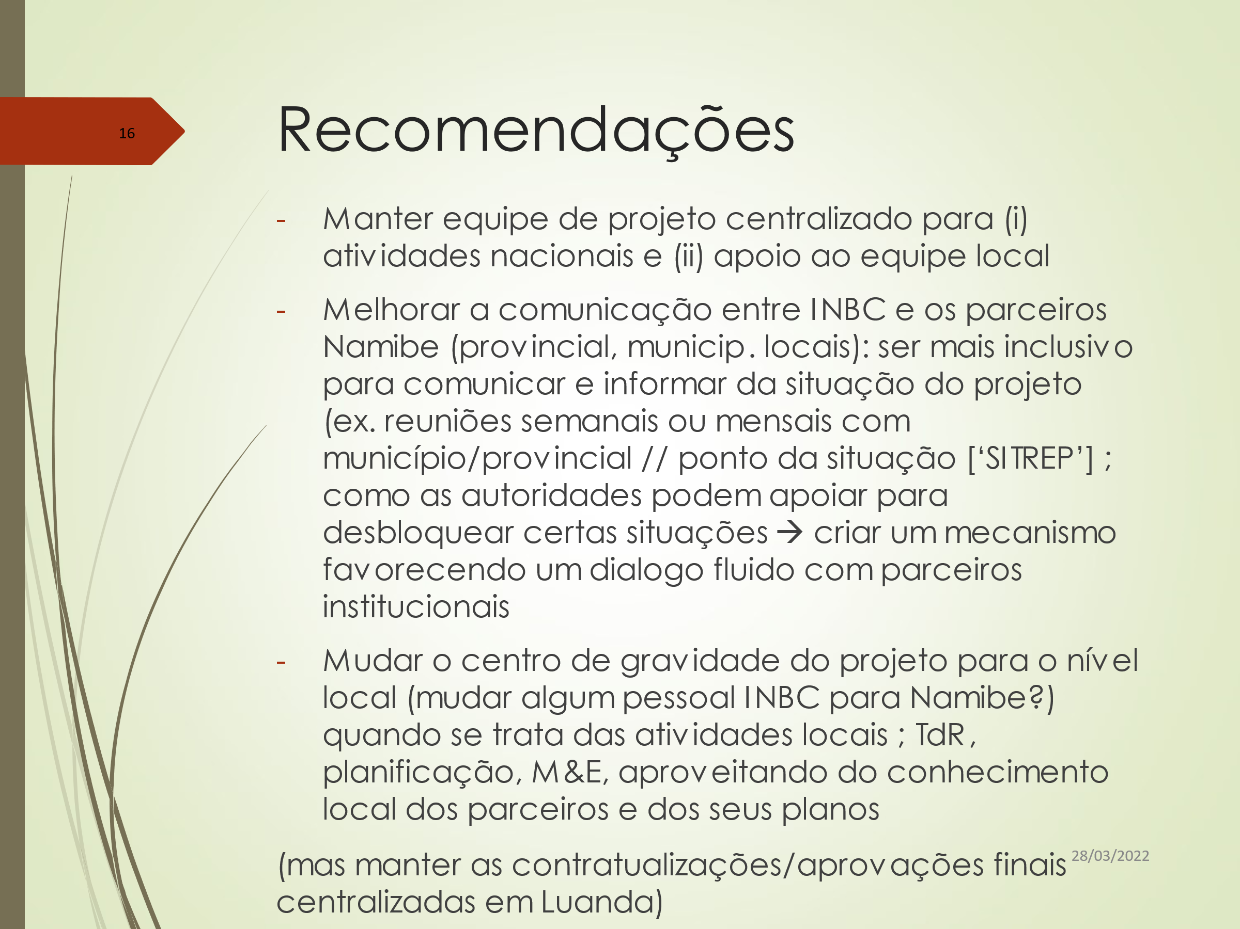
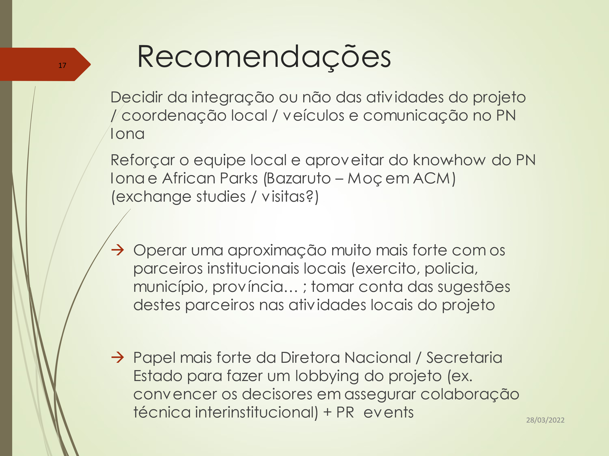

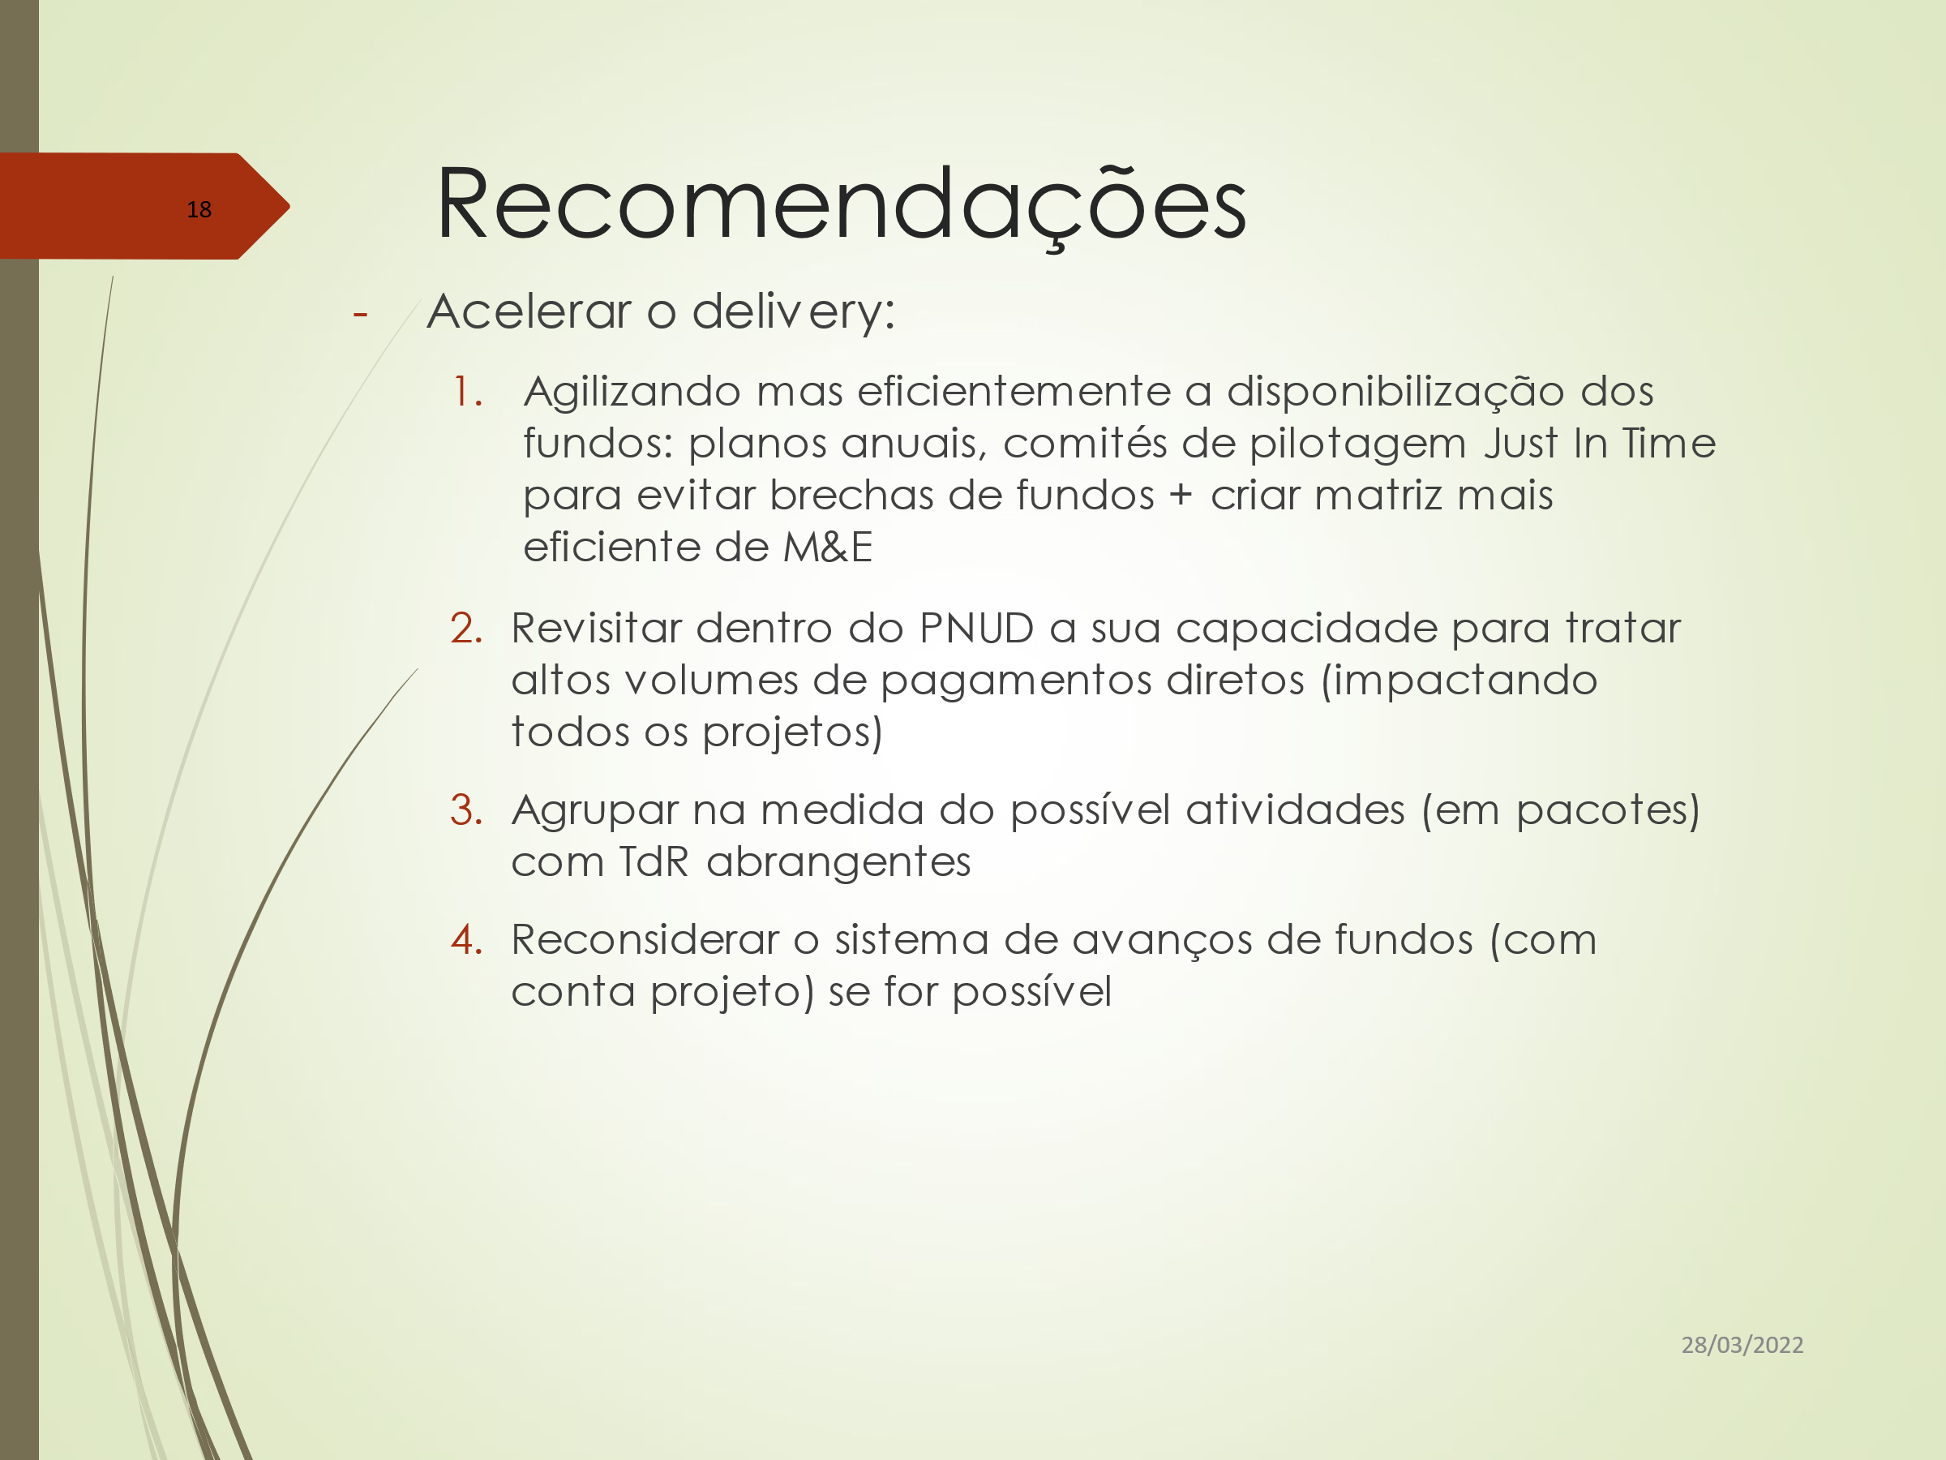

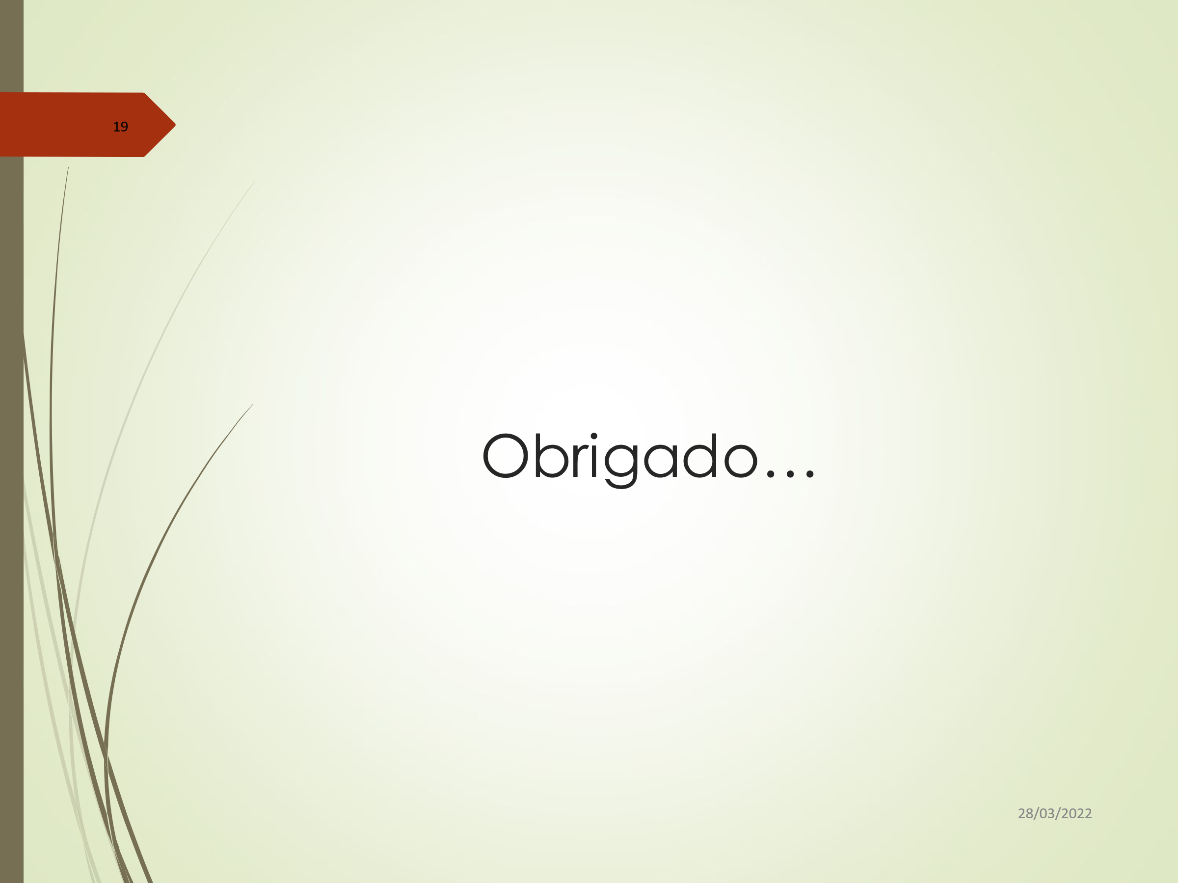

Annexe 12: Brief Expertise of Consultant

Mr Vincent Lefebvre:
(lefebvrevinc@gmail.com)
- Programme management & coordination / project formulation & implementation, M&E - knowledge of PCM, logical framework & ZOPP methodologies / equipment specifications.
- MA in tropical agriculture and post-graduation in business administration
- Programme & project evaluation / technical audit / institutional appraisal: analysis of relevance / effectiveness / efficiency / social, institutional & economic impact / political, social & cultural, technological, institutional & financial sustainability / cross cutting issues (gender, AIDS, environment & institutional capacity building); questionnaires design & interviews of beneficiaries.
- Data acquisition methods for evaluations: questionnaires drafting & interviews of beneficiaries; SWOT analysis; (semi-) structured interviews, focus groups.
- Knowledge of monitoring & evaluation methodologies (incl. Management Effectiveness Tracking Tool).
- Food security / Agronomy / agro-forestry / agro-industry / agro-climate and climate mitigation - adaptation / horticulture.
- Cartography / remote sensing / mapping / GIS (Arcinfo, Mapinfo, Ilwis) / Database management systems (MECOSIG, COONGO).
- Land & water resources evaluation / crop potential analysis / participatory rural appraisals / natural resources management / mountain agro-ecosystems.
- Soil survey/soil conservation/soil fertility.
- Statistics including programming in SAS & Delphi.
- Renewable energies (wind, bio-diesel, rapeseed oil).

Annexe 13: Evaluation Consultant Code of Conduct and Agreement Form

Evaluators:
- Must present information that is complete and fair in its assessment of strengths and weaknesses so that decisions or actions taken are well-founded.
- Must disclose the full set of evaluation findings along with information on their limitations and have this accessible to all affected by the evaluation with expressed legal rights to receive results.
- Should protect the anonymity and confidentiality of individual informants. They should provide maximum notice, minimize demands on time, and respect people’s right not to engage. Evaluators must respect people’s right to provide information in confidence, and must ensure that sensitive information cannot be traced to its source. Evaluators are not expected to evaluate individuals and must balance an evaluation of management functions with this general principle.
- Sometimes uncover evidence of wrongdoing while conducting evaluations. Such cases must be reported discreetly to the appropriate investigative body. Evaluators should consult with other relevant oversight entities when there is any doubt about if and how issues should be reported.
- Should be sensitive to beliefs, manners and customs and act with integrity and honesty in their relations with all stakeholders. In line with the UN Universal Declaration of Human Rights, evaluators must be sensitive to and address issues of discrimination and gender equality. They should avoid offending the dignity and self-respect of those persons with whom they come in contact in the course of the evaluation. Knowing that evaluation might negatively affect the interests of some stakeholders, evaluators should conduct the evaluation and communicate its purpose and results in a way that clearly respects the stakeholders’ dignity and self-worth.
- Are responsible for their performance and their product(s). They are responsible for the clear, accurate and fair written and/or oral presentation of study limitations, findings and recommendations.
- Should reflect sound accounting procedures and be prudent in using the resources of the evaluation.
Evaluation Consultant Agreement Form
Agreement to abide by the Code of Conduct for Evaluation in the UN System
Name of Consultant: __Vincent LEFEBVRE____________________________________________
Name of Consultancy Organization (where relevant): ________________________
I confirm that I have received and understood and will abide by the United Nations Code of Conduct for Evaluation.
Signed at Maputo on 20/04/2022
Signature: ________________________________________

Annexe 14: Evaluation Report Clearance Form

(to be completed by CO and UNDP GEF Technical Adviser based in the region and included in the final document)
Evaluation Report Reviewed and Cleared by
UNDP Country Office
Name: ___________________________________________________
Signature: ______________________________ Date: _________________________________
UNDP GEF RTA
Name: ___________________________________________________
Signature: ______________________________ Date: _________________________________

Rating scales in Annexe 4
Specific, Measurable, Accessible, Relevant, Time-bound
Independent Evaluation Office
Development Assistance Committee
United Nations Evaluation Group
Data from domestic authorities in http://www.africaneconomicoutlook.org/en/country-notes/angola
http://earthtrends.wri.org
National Implementation Modality
Project Implementation Review
Three strategic areas had been defined: “Strategic Area A” on research and Information dissemination, in particular to conduct mapping and zoning of ecological sensitive coastal and marine zones, “Strategic Area C” on biodiversity management in protected areas, namely to identify and create protected areas to include samples of important ecosystems, habitats and species not yet covered (like marine areas) and “Strategic Area E” on the role of communities in biodiversity management, with an emphasis on awareness programs and implementing study mechanisms of community participation in biodiversity management
In particular, Aichi Target 6 (by 2020, all fish and invertebrate stocks and aquatic plants are managed and harvested sustainably, so that overfishing is avoided) and Aichi Target 11 (by 2020, at least 17 per cent of terrestrial and inland water, and 10 per cent of coastal and marine area, especially areas of particular importance for biodiversity and ecosystem services, are conserved).
Specific, Measurable, Achievable, Relevant, Time-bound
The pandemic has created an overall non-conducive environment for project implementation, resulting in significant delays; this issue is project-wide and will not be constantly repeated for each target; it is one of the key issues for implementation (but not the only one)
The Traffic Colour System used by GEF is Green = Achieved, Yellow=On target, Red=Not on target, Grey= Cannot be assessed or not being monitored.
Examples: training on birds census, species monitoring
The delivery rate for 2021 could have been much higher, should several key activities not have been postponed to 2022 for lack of project’s funding
Source: UNDP Atlas extract
Source: CDR 2020
Source: CDR 2021
Source: UNDP Atlas; slight discrepancy in 2020 between CDR and Atlas info
https://pims.undp.org/attachments/6051/215978/1748192/1784517/Desdobr%C3%A1vel%20Oceanos.pdf
https://twitter.com/undpangola/status/1131158471888515072
The centralisation of the project in Luanda does not allow the Local Coordinator to take any initiative but facilitate and follow-up PMU and Marine and Coastal Unit site visits
With elections due in 08/2022, it is likely that the project implementation will slow down if not halted altogether; that should be taken into account when revising the AWP for the next PIR
PBA is a more direct procedure that can be initiated very rapidly; RfP can be alternatives but take months to be finalised
The official Angola journal is not available in the Namibe province and with intermittent/ poor quality internet connection, local companies are having difficulties in responding to CfP.
www.unevaluation.org/unegcodeofconduct

