Annex 1: Terms of Reference

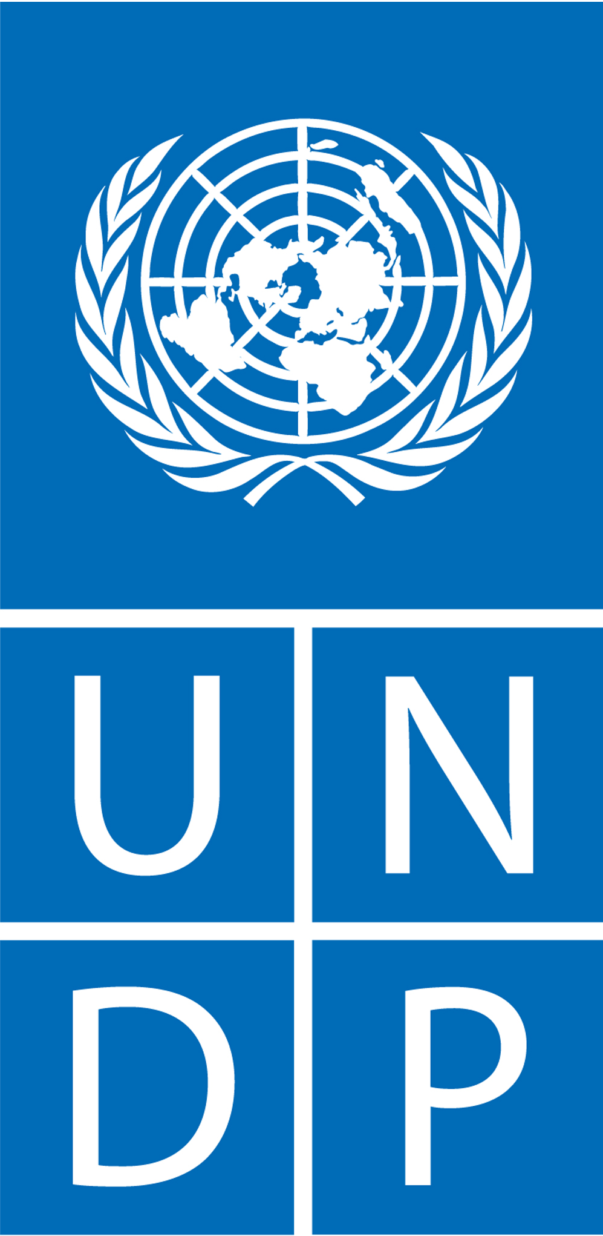

Terms of Reference
Terminal Evaluation of the Uganda Green Growth Incubation Center Project -Songhai Integrated Model Project (Songhai Initiative)

General Information

Duty Station: Kampala
Expected Places of Travel: Within Kampala, Wakiso and Mpigi
Type of Contract: International/National Consultant
Languages Required: English
Starting date: Upon signing contract
Expected Duration of Assignment: 25 days spread over the period October – November 2021

Background
Uganda’s population has grown from 9.5 million in 1969 to 45.5 million in 2019 (UBOS, 2019) and is projected to reach 75 million by 2040. With a growth rate of 3 per cent per annum, Uganda has the second fastest growing population in the world (UBOS 2019). The growing population places a huge burden on employment, labour productivity, and natural resources.

While the medium-term growth of the economy is very positive with government projecting the economy to grow by 6.2% in 2019/20, and agriculture, industry and services projected to grow at 3.8%, 5.6% and 7.8% respectively (PCW, 2019), the unemployment situation remains critically high and above the average unemployment rate in Sub-Saharan Africa.

Uganda’s recent high economic growth rates have not been accompanied by high growth in jobs which situation has retarded poverty reduction. UBOS (2018) reports that although the economy grew by an average of 4.5% between FY15/16 and FY17/18, the number of people living in poverty increased in the same period from 19.7% in FY15/16 to 21.4% in FY17/18.

The unemployment rate has been increasing and stood at 9.7% in 2017, and is most prevalent among women at 11% compared to men at 8%. Youth unemployment is even higher at 13 % and worst for those with higher levels of education and are living in urban centres (UBOS NLFS, 2017). Unemployment and under employment levels are even higher amongst the female youth and youth with disabilities who are sometimes denied job opportunities due to negative attitudes and stigma. It is estimated that out of 700,000 individuals who enter the labour market each year, only 90,000 get employed and yet it is projected that the number entering the job market will increase to over 1.5 million per annum by 2040 (MFPED, 2014).

According to ILO (2018), Uganda has a low labour productivity compared to its East African neighbors, which negatively impacts on direct foreign investment and economic expansion and hampers the country’s labour competitiveness within the region and internationally. Low labour productivity in the country is largely a result of poor technology and skills gaps.

Declining natural resources. Uganda’s natural resource base is declining rapidly largely due to human activities. A recent study by the Uganda National Association of Community and Occupational Health (UNACOH, 2019) conducted in all regions of the country found out that a lot of tomatoes were contaminated with harmful pesticide residues. A more worrying situation is the community water source pollution, where there were up to 23 different pesticide contaminants. These chemicals pause a wide range of health risks including fertility problems, respiratory problems and several cancers including the increase in the Human Papilloma Virus.

It is against this background that the Ministry of Gender, Labor and Social Development in partnership with United Nations Development Programme (UNDP) is implementing Uganda Green Growth Incubation Project (UGIP) – Songhai Model at Kampiringisa. The Songhai Model is an integrated production system that seeks to reduce poverty, unemployment and food insecurity by strengthening the technical and organizational capacities of communities to produce efficiently and sustainably using scarce resources.

The model aims at building the entrepreneurial capacity of local communities to expand green employment for youth, women and other interest groups. The model applies authentic technology to harness environmental capital to produce more and better-quality food for a growing population. while protecting and enhancing it.

The Songhai model applies principles and practices of regenerative agriculture. Through an ecosystem, approach the Songhai model draws on nature’s contributions to crop and animal growth, such as soil organic matter and soil micro-organisms, rainfall, pollination and biocontrol and integrated pest management, Eco services (water shades and landscapes) to promote a real “greening” of Agriculture.

The overall objective of the Songhai project component (under the inclusive Green Growth Project) is to improve the livelihoods of communities through creating green jobs and enhancing microbiological capital for productivity through:

- promoting integrated climate smart production systems
- enhancing rural employment and productivity of youth, PWDs and women
- promoting mindset transformation, business skills development and behavioral change among youth and other vulnerable groups
- promoting informal skills development in integrated climate smart production systems and value addition technologies

Following Cabinet approval of this Programme on 7th December 2016, a rapid feasibility study for adopting the Songhai model was conducted. The study recommended the pilot be established at Kampiringisa. Prof. Rev. Godfrey Nzamujo, the founder of Songhai Model and Centre was contracted to design and set up Kampiringisa rehabilitation center land as a model site. Initial mapping, design and setup of the pilot site was completed in December 2017. The model utilizes local labour (women and youth/young people) especially those being rehabilitated at Kampiringisa and surrounding villages from neighboring districts.

The pilot initiative was launched by H.E Yoweri K. Museveni, President of the Republic of Uganda on 12th August 2018, who further directed the completion of project scientific integration model activities to enable the commercial rollout of the Project to the entire country. The activities to be undertaken and completed include bioenergy, livestock, irrigation system, and processing units among others. The President stressed the need for the use of cost-effective methods of production and encouraged cost benefit analysis of the project to be undertaken.

Similarly, Cabinet under Minute No. 359 (CT 2018) directed the Minister of Finance, Planning and Economic Development to prioritize funding for the scaling up of Songhai Model in the different regions of the Country. The pilot is in the process of establishing primary production systems and is yet to embark on secondary and tertiary production levels of the integrated model before it can be rolled out.

The consultants will assess the performance of the Songhai Initiative, highlight achievements, identify bottlenecks and constraints to implementation, and draw key lessons learned during the implementation of the pilot phase and make recommendations on the strategies for completion of the primary production phase and the implementation of the secondary and tertiary production levels of the pilot.

Purpose of Evaluation

The objective of this assignment is to conduct a comprehensive terminal evaluation of the Songhai pilot initiative to assess the overall performance of the Songhai pilot initiative, which was a component of the IGG Flagship Project. The consultants will be required to assess the progress, record the outputs achieved, identify implementation challenges, and draw lessons that will inform the completion of the primary production phase and the design of activities to establish the secondary and tertiary production levels of the pilot, and the roll the out of the Songhai Initiative to other regions of the country.

Scope of Evaluation

The terminal evaluation will look at the following areas: Songhai Initiative management; activities; reflection of engagement and partnerships between Government and other development partners. It will assess the results achieved, the partnerships established, as well as issues of capacity and approach. The evaluation will look at the success in strengthening the local technical capabilities, and the viability and sustainability of the model. The evaluation will generate knowledge to make corrective adjustments to the implementation of the pilot primary production phase and the design of activities to establish the secondary and tertiary production levels, as well as to inform the strategy for rolling out the model to other areas of the country. The scope of the evaluation will cover the entire implementation period from 2016 to date.

The key tasks to be undertaken include (but not limited to):

- Review the Country Programme Document (CPD) 2016-2020 and the IGG Flagship Programme to understand the programmatic context of the (UGIP) Songhai Model – here referred to as the Songhai Initiative.

- Conduct a comprehensive literature review of the Songhai Initiative including the profile, progress reports and annual reports.

- Hold consultative meetings with stakeholders to review the relevance of the Songhai Initiative objectives to the national development objectives and priorities, the NDP III areas of interest and the needs of beneficiaries and recommend means of incorporating those priorities in the roll out of the project.

- Review the appropriateness and clarity of the roles and responsibilities of stakeholders and the level of coordination between them.

- Review the Songhai Initiative profile and identify ways of resource mobilization for its roll out.

- Assess the performance of the Initiative in terms of results achieved, the timeliness, quality, quantity, and cost effectiveness of the interventions undertaken including its management.

- Assess the prospects for the sustainability of the results and benefits and recommend measures for its further improvement, including the financial resources needed for its roll out.

- Identify and describe the main lessons learned from the performance of the Songhai initiative.

- The terminal evaluation should be in position to address the issues of relevance, effectiveness, efficiency, and sustainability. The recommendations should provide comprehensive proposals for the roll out of the model based on the evaluation findings.

- Develop an exit strategy clearly outlining a roadmap on how the UGIP Centre will continue beyond UNDP support.
- The consultants will undertake consultations with government in particular the Ministries of Gender, Labour and Social Development; Agriculture, Animal Industry and Fisheries; Water and Environment; Finance, Planning and Economic Development; Trade, Industry and Cooperatives; the Mpigi District Local Government and UNDP Uganda Country Office as well as Private Sector Foundation. The consultant must also use gender-responsive methodologies and tools and ensure that gender specific issues are captured.
Expected Deliverables

The expected deliverables of the assignment are detailed in the table below:
# | Deliverable | Timeline
1 | Agreed and approved upon inception report outlining the  consultant teams’ understanding of the assignment, detailing the methodology of undertaking the assignment, work plan and evaluation questions | Within 5 days from the date of signing the contract
2 | Draft technical evaluation report presented to key stakeholders  for input/comments/validation. This should include the various options for completion of the establishment of a sustainable Songhai Model Pilot at the Uganda Green Growth Incubation Centre | 17 days
3 | Final Terminal Evaluation Report with clear recommendations on the most feasible strategies for the completion of the establishment of a sustainable Songhai Model Pilot at the Uganda Green Growth Incubation Centre | 3 days

The draft report shall include the following at a minimum (as per evaluation report template that will be shared):
1) Executive Summary
2) Introduction and Background
3) Purpose of the evaluation and the methodology
4) The main findings: project relevance, efficiency, effectiveness, outputs achieved, impact of
project activities, sustainability with recommendations for Pilot completion and scaling up.
5) Lessons learned: Assessment of attainment of indicators, operational and developmental lessons.
6) Conclusions and recommendations
Schedule and Method of Payment

Payment will be made after satisfactory acceptance and certification of the deliverables/outputs in accordance with UNDP procedures and as per below percentages:
# | Deliverables/ Outputs | Target date | Payment terms  (% of contract value) | Review and  Approvals  Required
1 | Upon submission of an agreed and approved  upon inception report outlining the consultancy team’s understanding of the assignment, detailing the methodology of undertaking the assignment, work plan and evaluation questions | Within 5 days  from the date of signing the contract | 25% | UGIP Project  Steering Committee/Team Leader-Inclusive and Sustainable Growth
2 | Upon submission of an acceptable draft  terminal evaluation report to be presented to key stakeholders for input/comments/validation. This should include the various options for completion of the establishment of a sustainable Songhai Model Pilot at the Uganda Green Growth Incubation Centre | 22 days from  the date of signing the contract | 25% | UGIP Project  Steering Committee/Team Leader-Inclusive and Sustainable Growth
3 | Final Terminal Evaluation Report with clear  recommendations on the most feasible strategies for the completion of the establishment of a sustainable Songhai Model Pilot at the Uganda Green Growth Incubation Centre | Within 25 days  from the date of signing the contract | 50% | UGIP Project  Steering Committee/Team Leader-Inclusive and Sustainable Growth

The method of payment is an output-based lump-sum scheme. The payments shall be released upon the UGIP steering committee and UNDP’s satisfaction of the consultancy team’s submission of each deliverable by or before the due dates as agreed with the UGIP steering committee and UNDP Uganda team.

Management Arrangements

The consultants will work under the overall guidance the UNDP Resident Representative working closely with the Permanent Secretary, Ministry of Gender, Labour and Social Development, who is the accounting officer of the Ministry. The Team Leader of the Inclusive and Sustainable Growth Portfolio working with Management Support Unit (MSU) will be responsible for quality assurance of all the deliverables of the assignment. The consultancy team will work closely with the Uganda Green Incubation Program Steering Committee, the Technical team from MGLSD headed by the National Project Coordinator, as well as the public and private sector in undertaking the assignment.

Team Composition

The evaluation will be undertaken by a national and international consultant. UNDP will sign the contract with a National and International Consultant in accordance with the approved UNDP procurement procedures for contracts for national and international consultants, respectively.
Required Skills and Experience

The International consultant is expected to possess the following competencies and qualifications:

Education:
• Master’s Degree in Development Studies, Business Administration, Monitoring and Evaluation, Social Sciences, Development Economics, international relations, public administration, project planning and management or related field.

Experience:
• Minimum of 7 years’ development project/programme evaluation experience, with
evaluations in the area of agriculture/agribusiness/green growth
• Demonstrated sound knowledge of and experience in results-based management evaluation methodologies; and in conducting gender responsive evaluation and analysis
• Demonstrated understanding of issues related to project management, agriculture and agribusiness.
• Excellent oral and written skills; excellent drafting, formulation, reporting skills
• Strong ability to work effectively in multi-disciplinary and multi-cultural teams
• Solid overall computer literacy, including proficiency in various MS Office applications (Excel, Word, etc.) and email/internet; familiarity with database management; and office technology equipment.
• Project evaluation experience with UNDP, or another UN agency will be considered an asset;
• Experience in conducting evaluations remotely will be considered an asset.

Competencies
Corporate Competencies:
• Demonstrates integrity by modelling the UN’s values and ethical standards;
• Strong project management skills;
• Positive, constructive attitude and consistently approaches work with energy;
• Demonstrates openness to change and ability to receive / integrate feedback.

Language Requirements
• Fluency of English language is required

The national consultant is expected to possess the following competencies and qualifications:

Education:
• Master’s Degree in Development Studies, Business Administration, Monitoring and Evaluation, Social Sciences, Development Economics, international relations, public administration, project planning and management or related field.

Experience:
• Minimum of 7 years’ development project/programme evaluation experience, with
evaluations in the area of agriculture/agribusiness/green growth
• Demonstrated sound knowledge of and experience in results-based management evaluation methodologies; and in conducting gender responsive evaluation and analysis
• Demonstrated understanding of issues related to project management, agriculture and agribusiness.
• Excellent oral and written skills; excellent drafting, formulation, reporting skills
• Strong ability to work effectively in multi-disciplinary and multi-cultural teams
• Solid overall computer literacy, including proficiency in various MS Office applications (Excel, Word, etc.) and email/internet; familiarity with database management; and office technology equipment.
• Project evaluation experience with UNDP, or another UN agency will be considered an asset;
• Experience in conducting evaluations remotely will be considered an asset.

Competencies
Corporate Competencies:
• Demonstrates integrity by modelling the UN’s values and ethical standards;
• Strong project management skills;
• Positive, constructive attitude and consistently approaches work with energy;
• Demonstrates openness to change and ability to receive / integrate feedback.

Language Requirements
• Fluency of English language is required

