Final Evaluation for Global Programme

‘Legal Identity for All’

dECEMBER 2022

|  |  |  |
| --- | --- | --- |
| **Project and Outcome Information** | | |
| **Project/outcome title** | Global Programme ‘Legal Identity for All’ | |
| **Atlas ID** | Project Number 00115752, Output ID 00113213 | |
| **Corporate outcome and output** | UNDP Strategic Plan, 2018-21: Outcome 1 - Accelerate structural transformations for sustainable development.  UNDP Strategic Plan, 2018-21: Output 2.2.1 - Use of digital technologies and big data enabled for improved public services and other government functions. | |
| **Country** | Global | |
| **Region** | Global | |
| **Date project document signed** | 28 November 2019 | |
| **Project dates** | **Start** | **Planned end** |
| 1 December 2019 | 28 February 2022 (No-cost extension to 31 December 2022, further no-cost extension to 30 April, 2023 is being processed) |
| **Total committed budget** | 6,492,126 USD | |
| **Project expenditure at the time of evaluation** | TBC USD | |
| **Funding source** | UNDP, Japan, Sweden, and Switzerland | |
| **Implementing party** | UNDP BPPS | |

|  |  |  |
| --- | --- | --- |
| **Evaluation Information** | | |
| **Evaluation type** | Project Evaluation | |
| **Final/midterm review/ other** | Final | |
| **Period under evaluation** | **Start** | **End** |
| 1 December 2019 | 31 December 2022 |
| **Evaluator** | Sean Gralton | |
| **Evaluator contact information** | c/o risa.arai@undp.org | |
| **Evaluation dates** | **Start** | **Completion** |
|  | June 2022 | December 2022 |

**Acknowledgements**

The evaluator wishes to thank UNDP staff member Risa Arai, who supported the implementation of this evaluation, including providing extensive documentation and data and arranging for meetings with more than 40 individuals. Thanks also to national and international electoral stakeholders who took the time to share their views and experiences. The evaluator is also grateful to the Evaluation Reference Committee and those who provided comments on the preliminary findings and draft report which strengthened the report and its findings.

Contents

Abbreviations 5

1 Executive Summary 7

2 Introduction and background 14

2.1 Evaluation of Global Programme ‘Legal Identity for All’ 15

2.2. Context 16

2.3. Global Programme ‘Legal Identity for All’ 17

3. Evaluation Findings 18

3.1 Relevance and Coherence 19

3.2 UNLIA Pillar 2: Country Support 22

3.2.1. Efficiency and Programmatic Support 22

3.2.2. Added value 24

3.3.3. Effectiveness and Impact 24

3.2.4. Way of Working 30

3.2.5. Coordination 31

3.2.6 Sustainability 32

3.3 UNLIA Pillar 1: Global Activities 33

3.3.1 Coordination and Partnership 34

3.3.2. Effectiveness and Impact: Strategic Positioning and Policy Development 35

3.3.3 Added value 36

3.3.4 Sustainability 36

3.4 UNLIA Pillar 3: Program Management 36

3.4.1 Administration 37

3.4.2. Resources 39

3.4.3. Meeting donor expectations 39

3.4.4. Sustainability 40

3.4.5. Monitoring and Evaluation 41

3.5 Lessons Learned 42

4. Conclusions and Recommendations 43

4.1. Conclusions 43

4.2 Recommendations 45

Annex 1 – KIIs 47

Annex 2 – Key Consulted Resources 49

Annex 3 – Inception Report 50

Annex 4 – Terms of Reference 65

# Abbreviations

|  |  |
| --- | --- |
| AWP | Annual Work Plan |
| BPPS | Bureau for Program and Policy Support |
| CDO | UNDP’s Chief Digital Office |
| CO | Country Office |
| CRVS | Civil Registration and Vital Statistics |
| DAC | Development Assistance Committee |
| DESA | United Nations Department of Economic and Social Affairs |
| DRC | Democratic Republic of Congo |
| DSG | Deputy Secretary-General |
| ECA | United Nations Economic Commission for Africa |
| ECOSOC | United Nations Economic and Social Council |
| GFF | Global Financing Facility |
| INRIS | Integrated National Registration and Identity System |
| IOM | International Organization for Migration |
| KAP | Knowledge, attitudes, and practice |
| KII | Key Informant Interviews |
| LI | Legal Identity |
| LIA | Legal Identity for All Global Programme |
| LIEG | Legal Identity Experts Group |
| MPTF | Multi-Partner Trust Fund |
| NIIMS | National Integrated Identity Management System |
| OECD | Organization for Economic Cooperation and Development |
| OHCHR | Office of the United Nations High Commissioner for Human Rights |
| PIP | Project initiation plan |
| Programme | UNDP’s Global Programme ‘Legal Identity for All’ implementing the UNLIA TF AWP using Swiss and Swedish fund and a stand-alone project funded by Japan |
| RBA | Regional Bureau for Africa |
| RCO | UN Resident Coordinator’s Office |
| SDG | Sustainable Development Goals |
| Secretariat | UNLIA TF’s Secretariat composed by UNDESA P5, P3 and P2, UNICEF P5 and P4, P4 and 2ICs in UNECA and UNDP P5 and P3 Global Programme Staff |
| ToR | Terms of Reference |
| UN | United Nations |
| UNCT | United Nations Country Team |
| UNDP | United Nations Development Programme |
| UNECA | United Nations Economic Commission for Africa |
| UNESCAP | United Nations Economic and Social Commission for Asia and the Pacific |
| UNICEF | United Nations Children's Fund |
| UNLIA TF | United Nations Legal Identity Agenda Task Force |
| UNLIEG | United Nations Legal Identity Experts Group |
| UNFPA | United Nations Population Fund |
| UNHCR | United Nations High Commissioner for Refugees |
| UNRCO | United Nations Resident Coordinator Office |
| UNSD | United Nations Statistics Division |
| WBG | World Bank Group |
| WFP | World Food Program |
| WHO | World Health Organization |

# 1 Executive Summary

The United Nations Development Programme (UNDP) Global Programme Legal Identity for All (Programme) is a 6.5 million USD programme which is running from 1 December, 2019 through 30 April, 2023, intended to help Member States build holistic, country-owned, sustainable civil registration (CR), vital statistics (VS), and identity management systems implemented through a One UN modality using a multi-partner trust fund (MPTF).

Due to a late donor withdrawal due to the exigencies of the COVID 19 pandemic, the MPTF was never established. Instead, UNDP mobilized sufficient funding to implement the Programme and allocated funding to other UN agencies through UN-to-UN agreements. The Programme was funded by Japan, Sweden, Switzerland, and various components of UNDP.

The Programme has three Pillars. Pillar 1 is Global Activities implemented by the United Nations Legal Identity for All (UNLIA) Task Force (TF). The UNLIA TF is supported by UNDP through the UNLIA Secretariat (Secretariat) under Pillar 3. Pillar 2 is Country Support, implemented by United Nations (UN) agency country offices (CO) under the supervision of the Secretariat.

This independent evaluation of the Programme took place from June – December 2022.

**FINDINGS**

**Relevance**

The project was designed following the Deputy Secretary General’s (DSG) creation of the inter-entity coordinating UNLIEG (United Nations Legal Identity Experts Group, later changing its name to UNLIA TF), composed of 14 UN entities with an interest in legal identity (LI), co-chaired by UN Department of Economic and Social Affairs (DESA), UNDP, and the United Nations Children’s Fund (UNICEF). The Programme was intended to “promote the empowerment of the word’s “invisible” people with legal identity deriving from sustainable, holistic civil registration and identity management systems that are secure, universal, and accurate and which protect the data and privacy of users. At the same time, the TF would assist UN Member States to maximize these systems for optimum public administration, socio-economic planning, and demographic planning.”

The Programme was designed to partner with the UN, the World Bank Group (WBG), the wider international development community, the private technology sector, and national identity providers/advocates. The Programme goals were in alignment with the SDG Target 16.9 – “Legal identity for all (including birth registration) by 2030” and corresponded with Outcome 1 and Output 2.2.1 of UNDP’s 2018 – 2021 Strategic Plan and with donor aims to make legal identity more accessible to all.

The Programmes two-level design, with multi-stakeholder policy work at the UNLIA TF’s global level and One UN implementation at the country level, was relevant and well aligned with these aims. However, the evaluation found that the execution was unable to deliver on some of the multi-stakeholder intent.

**UNLIA Pillar 2: Country Support**

To keep the evaluation manageable in size, of the eight countries chosen to receive Programme funding (6 under UNLIA TF, 1 under Chief Digital Office (CDO) funding and 3 under the Japan-funded project, 2 of which overlap with UNLIA TF), the evaluation looked at Kenya, Sierra Leone, and Zambia, with a short look at the Democratic Republic of the Congo (DRC). Pillar 2 activities were part of UNLIA Output 2.1: “The capacities of UN Member States achieve SDG Target 16.9 at the country level is coordinated, financed and supported on a ‘One UN’ basis.”

Country activities were based upon ten country rapid assessments conducted by the Economic Commission for Africa (ECA).[1] Six of these ten countries were chosen to be UNLIA pilot countries through a joint call for proposals under the UNLIA TF. These proposals were coordinated by RCO offices and the respective governments and required that at least two UN agencies would work collaboratively, in order to promote a ‘One UN’ approach.

***Efficiency and Programmatic Support***

The evaluation found that as a result of the selection process, Programme outputs and activities were highly relevant and responsive to each country’s needs. The requirement that each application include at least two agencies working together ensured that the goal of One UN delivery was also achieved.

Because there was no MPTF, UNDP’s provision of funds to other agencies required establishing inter-agency agreements, with both agencies retaining general management support (GMS) funds, diverting resources from implementation. The evaluation found that with some agencies, sharing funding was practically impossible, forcing UNDP to directly pay for some procurement for other agencies, undermining One UN implementation.

The inter-agency funding agreements included reporting requirements, however, these were not always respected. Furthermore, the Secretariat was not always informed of implementation challenges, in some cases delaying project implementation and causing confusion. These differences in reporting seem to have been the cause of donor progress reports that are somewhat uneven in data and narrative from country to country and was compounded by the fact that UNCTs were not requested to provide a clear results framework to report against at the stage of country selection and implementation, aside from those activities funded with Japanese money. The Secretariat did provide technical support to COs when asked.

***Added Value***

Country level KIIs credited the Programme with “galvanizing the political will to build sustainable improvements in civil registration and legal identity,” which was the leverage needed to make the small amount of UNLIA country level programming effective.

The Programme showcased UN coordination. RCOs used their convening power with the UNCT to form country level UNLIA task forces, coordinating the work of the UNLIA implementing agencies. Each UN agency liaised with different ministries, facilitating overall UNLIA access to government agencies. UNDP and partner agencies cooperation to work around the financial challenges was impressive, though fixing the disjointed nature of UN system finances was well beyond the scope of the Programme to address.

***Effectiveness and Impact***

Some UNLIA activities were affected by COVID related delays, requiring that tasks be completed under a no-cost extension, with all activities intended to be completed by the end of 2022. This has not happened, leading the Programme to request a no-cost extension until 30 April, 2023. Political considerations also affected government priorities, slowing activities in politically sensitive areas. Overall, however, the Programme achieved most of its goals in the countries evaluated.

Kenya

In Kenya, UNLIA had two outputs. Implementation began in February 2021. Kenya was also supported independently by UNDP through a Japan-funded project.

Output 1: UNDP coordinated the UNLIA TF and held a change management workshop. With the World Health Organization (WHO), UNDP conducted a Rapid Mortality Surveillance pilot in six counties to support the production of the Kenya Vital Statistics report. UNDP also conducted knowledge exchange visits to civil registration sites with WHO.

Output 2: These activities were led by UNDP, United Nations High Commissioner for Refugees (UNHCR), and UNICEF, and targeted at the passage of the Huduma Bill, 2021. This bill, if passed, would become the primary law on civil registration and legal identity management. UNICEF led the support to the government in updating the legal framework for civil registration and vital statistics, which resulted in the Huduma Bill. UNHCR supported a legal review of this Huduma Bill and created a joint memo with comments to ensure a comprehensive law and inclusion of marginalized populations and briefed the memo to key government officials. UNHCR also organized forums with CSO partners to collect views from refugees and asylum seekers on the Huduma Bill and civil registration. UNDP hired a consultant to review the legal identity legal framework and design a framework for alternative dispute resolution (ADR) of complaints arising from the civil registration process. Unfortunately, while the bill was scheduled to be read in the National Assembly in December 2021, consideration of the bill has stalled.

UNDP also conducted an assessment of bottlenecks affecting registration of vulnerable/marginalized populations, and a nation-wide knowledge, attitudes, and practice (KAP) study on barriers to civil registration within the National Integrated Identity Management System (NIIMS) context was also conducted. UNDP also supported procuring IT equipment to support digitization of civil registration.

Sierra Leone

In Sierra Leone, UNLIA had three outputs, with implementation responsibilities distributed among three agencies: International Organization for Migration (IOM), UNICEF, and UNDP.

Output 1: UNDP and UNICEF provided support to the NCRA to create an enabling environment for implementation of Civil Registration and Vital Statistics (CRVS) reforms by strengthening government-led coordination. This included providing direct technical support to the NCRA, facilitating intra-governmental consultations, and coordinating a mid-term review of the National Strategy and Costed Action plan, delayed due to political considerations.

Output 2: IOM partnered with the NCRA to create SOP to enable vital event registration with a focus on vulnerable groups. These SOP are now being used by the government.

Output 3: UNICEF worked with District Health Management Teams (DHMT) to develop key messages on the importance of vital event registration and roll them out through national and local media, community actors, and religious and traditional leaders, with attention to inclusion of women and girls.

Zambia

UNDP has been bilaterally supporting Zambia’s Integrated National Registration and Identity System (INRIS) system through the Japan-funded project since before the inception of the UNLIA Programme. Zambia’s UNLIA TF, whose implementing members were IOM, UNDP, and UNICEF, focused on revising the legal framework around data protection as well as data management.

Output 1: IOM partnered with the government to estimate the number of people without legal identity and to influence the conduct of the latest census. However, the report was delayed until after the 2022 census was complete. The findings may be used to influence the conduct of the next census.

Output 2: UNDP supported the integration of the Integrated National Registration System and the Ministry of Health Information Management System (HIMS), which will make birth records, birth certificates, and national ID interoperable. UNDP also procured 116 registration kits for deployment in 2022. Unfortunately, due to UNDP procurement rules, the required software licenses could not be procured at the same time, delaying deployment. UNDP also trained staff on the use of the systems.

UNICEF provided training for health workers on a new e-registration system which will integrate civil registration and health services. UNICEF sponsored two study tours on a pilot project on integrated birth registration and health services. UNICEF, in coordination with CSOs and government, also led community-based sensitization and awareness activities, leading to the first birth registrations in health facilities which had not previously been conducting registrations.

The Programme also convened government departments to review Phase II implementation of INRIS and plan for Phase III.

DRC

The DRC was not main target of the evaluation. In DRC, UNDP provided money that UNDP mobilized and was used by UNICEF to implement programming.

***Way of Working***

The evaluator found that Programme support has been consistent with corporate standard of practice. UNDP’s commitment to Leave No One Behind, “taking explicit action to end extreme poverty, curb inequalities, confront discrimination and fast-track progress for the furthest behind,” is a is a key part of the 2030 agenda and the SDGs. In all cases the evaluation found that populations of concern identified by national partners were also noted by UNLIA TF members. Government OFFICIALs noted UNLIA TF members maintained focus on ensuring that these populations are not left behind.

***Coordination***

The coordination among UNLIA implementers, especially UNDP and UNICEF, was described as strong, while coordination among more UNLIA participants in-country was less so. The evaluation found that UNLIA also coordinated well with the government. In-country UNLIA TFs made the most of UN agencies unique access to organs of government, working across several agencies in each country evaluated.

Accountability was often a problem between the COs and the Secretariat. As described in Section 3.2.1, gathering information was a challenge for the Programme Secretariat as reporting agreements were not always respected, though some COs did abide by these agreements.

***Sustainability***

UNLIA were well chosen to have long term impact on the advancement of legal identity within each country, even in the absence of continued UNLIA support. Procurement was targeted to work in a complimentary fashion with existing legal identity infrastructure and was selected in coordination with national partners. UNLIA aligned with and strengthened the national political will to improve access to legal identity.

UNLIA programs were intended to provide seed money to catalyze further resource mobilization. Unfortunately, the evaluation found that this follow-on funding was not secured at the time of evaluation, though efforts to secure such funding continue. It is possible that the country projects under the current iteration of UNLIA were too small to attract and hold the interest of stakeholders on all sides.

**UNLIA Pillar 1: Global Activities**

The six outputs listed under Pillar 1 are all aimed at coordinating the UN-wide response to the imperatives of SDG Target 16.9 as well as coordination with the WBG. The evaluation TOR did not ask for a detailed review of Programme activities at the global level, and instead reserved that focus for Pillar 2: Country Support.

***Coordination and Partnership***

From UNDP’s perspective, coordination between the three UNLIA TF co-chairs, UNDP, UNICEF, and UNDESA, went well. Those working with UNDP described UNDP Secretariat staff, almost universally, as positive, professional, and collegial. Meetings among the TF at large were held about every two months to finalize the various policy documents, approve country level programming, and update and finalize UNLIA TF workplans. Working level e-mails contact happened regularly amongst TF members, and the Secretariat staff were in daily contact. Non-chair TF members complained that at times TF decisions seemed to be made with insufficient consultation with all TF members. The evaluation found, however, that the TF managed consultation relatively well in most cases, though not every TF member agreed in every case.

UNDP provided nearly all the money for TF activities, however, cross-agency funding in the UN system as extremely difficult and inefficient absent a MPTF.

***Effectiveness and Impact: Strategic Positioning and Policy Development***

The UNLIA TF co-chair institutions were well chosen for their roles based on their direct interest in legal identity. The other agencies involved, IOM, the Office of the United Nations High Commissioner for Human Rights (OHCHR), the United Nations Population Fund (UNFPA), UNHCR, UN Women, the United Nations Statistics Division (UNSD), the World Food Program (WFP), WHO, the United Nations Economic Commission for Africa (UNECA) and the Economic and Social Commission for Asia and the Pacific (UNESCAP), all have a core interest in ensuring that the world’s undocumented people, or their client population (in the case of UNHCR, WFP and IOM) have access to legal identity, though this did not always mean that they chose to engage closely with the TF.

Internally, through UNDP’s participation in UNLIA, UNDP is understanding more how digital legal identity fits into future policy and programming decisions, and how this relates to human rights.

***Added value***

The evaluation found that UNDP’s role in the UNLIA TF has put UNDP in a leadership position in the field of legal identity. Among the government officials interviewed, the UNLIA whole life approach to legal identity was favored. UNDP’s leadership role in UNLIA should enable UNDP to strengthen its financial and technical offers to support Member States in developing birth to death comprehensive and interoperable legal identity systems in the future. However, until this point, UNDP has been unable to create the donor interest necessary to transform this position into mobilized resources.

***Sustainability***

The evaluation found that the sustainability of the UNLIA TF is dependent entirely on whether the partner UN entities choose to continue the work of the TF. The investment from each involved entity is rather small.

**UNLIA Pillar 3: Programme Management**

***Administration***

The Programme’s management structure was outlined in a Project Implementation Plan (PIP), approved in January 2019, and updated four times. The PIP functioned as the Project Document (PD) and contains most of the elements required in a full PD.

The PIP established the management structure of the Programme. Top level guidance was through a Project Board (PB), meeting once a year to make all management decisions for the project, though in practice, donor PB members did not always respond to meeting requests, leaving these duties to the UNLIA co-chair meeting. The Project Technical Committee (PTC), mirrored the wider UNLIA TF membership as well as representatives of the wider project stakeholders, and met every quarter. The Project Secretariat Management Unit (PSMU, known in the evaluation as the Secretariat) was responsible for the day-to-day management and implementation of both the PIP and Programme and was the core of UNDP’s Programme. The Project Secretariat was composed of a P5 Policy Advisor, Legal Identity/Project Manager, and a P3 Programme Specialist (Finance and Operations) who assisted with the management of the project, both full-time.

The evaluation found that the Programme staff was very thin, making it vulnerable to staff turnover or other personnel issues that arise during the lifetime of a programme. While Programme staff did not appear to make errors, there were certainly instances, such as financial transfers, donor outreach, country level follow-up, etc., where additional staff would have enabled the Programme to accomplish more.

***Resources***

The UNLIA project was initially intended to be funded by an MPTF and a foundational donor had been secured by Q1 2020, however, this donor pulled out. The Secretariat’s rapid response and “passionate” promotion of the project, along with donors’ flexibility and willingness to trust that UNDP would be able to put together a worthwhile project, enabled UNDP to mobilize sufficient resources to begin the project. The eventual funding structure, with three donors providing nearly all the UNLIA money directly to UNDP was far more complex than the contemplated MPTF. The financing structure made it difficult to share UNLIA funding with different agencies, and each donor required tailored reports.

***Meeting Donor Expectations***

Donors showed little interest in the Programme. The Secretariat’s quick funding mobilization made the project possible, but the donor structures used put the program in awkward positions within donor bureaucracies. Donor personnel changes also reduced the visibility of the Programme.

Some donors stated that there was no communication between donor personnel on the country level and the donors’ HQ on UNLIA issues. The relatively small level of funding in each country may have let Programme activities get lost or confused with other projects by UNDP, agency partners, or donors.

***Sustainability***

UNDP is initiating the Global Governance Program and is mainstreaming legal identity work into that program. The need to support legal identity with long term staff was a key concern expressed by several interviewees. From the larger perspective of the UNLIA TF, the evaluation found that UNLIA may need to move beyond its current UN only structure.

***Monitoring and Evaluation***

Reporting did not follow the MPTF standard reporting structure. All three donors required bespoke annual progress reports, documenting progress against results frameworks agreed to with individual donors as well as against the UNLIA TF workplan, adding to the complexity of reporting. Progress reports were primarily descriptive and were often highly detailed. One donor wanted success stories in the reporting, to enable donor officials to “sell” the project within donor agencies.

The UNLIA TF had an annual work plan for 2020, 2021, and 2022, which used a modified UNDP results framework template, but no indicators or baselines were provided. At the country level, implementing agencies were not given a results framework against which their progress on activities could be measured, though Japanese funded projects did have them. No mid-term evaluation was conducted.

**Conclusions**

The Programme faced serious obstacles to its execution, most notably the COVID-19 pandemic, which caused the keystone MPTF donor to pull out just prior to Programme launch. The Programme never fully recovered from this blow, and was never able to establish a MPTF.

Within its resource restricted scope, the Programme was able to make considerable progress on the DSG’s mandate “to develop…. a common approach to the broader issue of registration and legal identity...” The project was also able to take significant steps to meet SDG Target 16.9: “legal identity for all (including birth registration) by 2030.” The Programme was in alignment with the UNDP Strategic Plan 2018-2021, Outcome 1 and Output 2.2.1.

There was a disconnect in UNLIA-WBG coordination between the highest, policy levels of UNLIA and the implementation levels, where coordination, though not communication, had stalled. The evaluation found reason to be optimistic about future collaboration as organizational viewpoints are converging, however differences in organizational resources will remain a challenge.

Under Pillar 2, country activities, the requirement that at least two UN agency COs collaborate with the RCO and the government in applications for legal identity seed money ensured Programme alignment with government priorities, national ownership of Programme activities, and long term sustainably of completed activities. UN COs generally collaborated well at the country level, with RCOs and the UNCTs providing an effective umbrella for country level UNLIA TFs to operate.

Most activities at the country level were delivered on time, however, reporting and accountability were consistent problems at the country level. While there were reporting arrangements included in the funding agreements, UNCTs did not always live up to those agreements.

Under Pillar 1, the evaluation found that the coordination of the participating UNLIA TF agencies was a success, with UNDP’s leadership in the Secretariat providing a solid basis for coordination across agencies. The three TF co-chairs had a successful and collegial working relationship.

Funding was the most serious challenge for the Programme. Once the attempt to create a MPTF failed, only UNDP seemed able to mobilize significant Programme resources to be shared with other UNLIA TF partners. The financial transfers necessitated by this structure meant that programme resources were diverted to GMS for both UNDP and the receiving agency.

At the working level, donors claimed little knowledge of or interest in the Programme, in part due to the rapid and *ad hoc* way in which funding was mobilized, resulting in the Programme being housed in unsuitable places in donor’s bureaucracy. Donor interest was not helped by the fact that donors stated that they did not receive feedback from country activities through their own bureaucracy.

The Programme’s monitoring and evaluation was hampered by the lack of results frameworks. This was compounded by the already noted problems with reporting from COs to the Secretariat.

**Recommendations**

1. *Continue to show flexibility in programme management and funding.*
2. *Flexibly should not cause all programme safeguards to be eliminated.*
3. *RCOs and UNCTs are a valuable resource to facilitate delivery as One UN.*
4. *Work more closely with donors to ensure continuity in knowledge and understanding of programmes through donor staff turnover.*
5. *Ensure greater retention in UNDP legal identity staff.*
6. *The UN system should develop better methods to transfer funds between agencies.*
7. *UNDP should work with donors to ensure a common reporting structure for single programmes with multiple donors.*
8. *UNDP should ensure that donors get the type of reports that they need to “sell” the programme.*
9. *The UN should continue to encourage normative and executive UN entities to work together on setting standards.*
10. *When partner agencies do not perform on time or up to standard, UNDP should be willing to pull funding*
11. *Expectations for cooperation with outside entities need to be tempered by an understanding of the incentives for such cooperation.*
12. *Policy levels and implementation levels should coordinate more effectively.*

2 Introduction and background

This section contains details about this evaluation, the general context and background to the Programme and the Programme itself.

## 2.1 Evaluation of Global Programme ‘Legal Identity for All’

This report is prepared in accordance with the Terms of Reference (TOR) prepared for the consultant conducting the evaluation for the UNDP Global Programme Legal Identity for All (Programme). This evaluation covers Programme activities from project initiation on 1 December 2019 through its end, December 31, 2022 (the project is in the process of receiving another no-cost extension until 30 April, 2023.

The evaluation was conducted by Sean Gralton, International Consultant, an expert in democratic governance and electoral administration, including voter registration and related legal identity issues. The duration of the evaluation consultancy was 60 days, starting June 14, 2022, and running through December 31, 2022. The extended timeline was due to the need to accommodate UNDP personnel issues. Interviews were done virtually due to the COVID-19 pandemic.

In particular, the evaluator was asked to:

1. Assess the performance of the Programme in achieving its intended results as well in meeting its objectives, specifically also at the outcome level and impact achieved during the Programme period of December 2018 through December 2022.

2. Provide general insights on:

* The ability of UNDP to function as an effective provider of technical support in the area of civil registration, vital statistics, and national identity; the extent to which the Global Programme is able to respond to the needs of UNDP Country Offices (CO), United Nations (UN) Resident Coordinator Offices (RCO), and UN Country Teams (UNCT).
* The ability of the Global Programme to leverage UNDP’s role as an international policy maker and thought leader on legal identity issues.
* The effectiveness and achievements of UNDP in coordinating and ensuring a ‘One UN’ approach at both the global and country levels to develop robust birth-to-death comprehensive and interoperable legal identity ecosystems.
* The Global Programme’s contributions to UNDP’s Integrated Results and Resources Framework for the 2018-2021 and 2022-2025 UNDP Strategic Plans.
* The ability of the structure of the Global Programme to manage finances and operations, meet partner expectations, and respond to the needs of priority countries.

The evaluator undertook a qualitative assessment of the relevance, effectiveness, efficiency, and sustainability of the Programme’s activities and the factors that affected the Programme’s performance. The evaluator used a triangulation methodology and mixed methods of analysis to draw conclusions and make recommendations based on stakeholder perceptions, the information provided, and available relevant third-party information. In particular, the evaluator engaged in the following:

* Virtual key KII of UNLIA TF and other UN headquarters staff, UNDP and other UN agency in-country staff, donors, key partners in government and civil society at the country level, and other selected stakeholders (Annex 1).
* Desk study and review of relevant documents, many provided by the UNLIA TF, including project documents and reporting, reports of government agencies and civil society organizations, available monitoring and evaluation (M&E) data, and any other documents deemed relevant to the evaluation (Annex 2).
* Validation of information collected through KII, document reviews, and third-party data sources.
* Assessed the relevance, effectiveness, efficiency, and sustainability of the Programme, its implementation, and management.
* Reviewed and revised the preliminary evaluation findings with discussions, interviews, and comments on the draft evaluation report.

The complete methodology is available in the Inception Report, Annex 3. The evaluator’s TOR are Annex 4.

The evaluation was limited by the complexity of the Programme, the limited reporting on some aspects of the Programme, and the unwillingness of some key informants to participate in the evaluation process. To keep the evaluation manageable in size, UNDP, in consultation with the Consultant, limited the scope of the evaluation of the Programme’s Pillar 2: Country Support, to three of the eight countries supported, Kenya, Sierra Leone, and Zambia, with a short look also at the DRC, where UNDP funded UNLIA activities, but did not participate in implementation. Pursuant to the TOR, a detailed review of activities was limited to Pillar 2.

The evaluation findings are organized in this report according to levels of analysis and categories established in the Terms of Reference, in the order used in the TOR: country (Pillar 2), global (Pillar 1), and programmatic (Pillar 3). The Organization for Economic Cooperation and Development (OECD) Development Assistance Committee (DAC) criteria of relevance, effectiveness, efficiency, and sustainability are incorporated into those categories where appropriate and separated out where necessary.

## 2.2. Context

The 2030 Agenda for Sustainable Development recognized an enormous gap in equal access to legal identity around the globe. To address this gap, the Sustainable Development Goals (SDG) include Target 16.9, a commitment to provide “legal identity for all (including birth registration) by 2030.” Inspired by the Secretary-General’s (SG) determination to tackle the global problem of statelessness (affecting more than 10 million people worldwide), in January 2018, the SG’s Executive Committee mandated the Deputy Secretary-General (DSG) to convene “UN entities to develop, in collaboration with the WBG, a common approach to the broader issue of registration and legal identity...” To operationalize the decision of the Executive Committee, a time-bound inter-agency group – the UN Legal Identity Expert Group (UN LIEG) – was established from September 2018 to June 2019, and the United Nations Legal Identity Agenda 2020-2030 was launched as a One UN approach to support Member States in building holistic, country-owned, sustainable civil registration, vital statistics, and identity management systems.

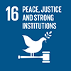 SDG Target 16.9: By 2030, provide legal identity for all, including birth registration

The ‘Legal Identify for All’ Programme was originally developed and documented in a PIP as the precursor to a proposed ‘One UN’ global UN MPTF on ‘Legal Identity for All’ to be formally launched in Q1 2020. That MPTF should have served as the main vehicle to implement the UN LIA at the global and country levels. Due to COVID-19, however, the MPTF’s foundation donor, which had verbally committed approximately 5 million USD, withdrew its financial commitment, repurposing the funding for domestic COVID-19 response. As a result, the PIP was repurposed to form the foundation of the Programme until the MPTF was established or further resources were mobilised. To fill the gap produced by the delay of the MPTF, the allocation of Programme funding to the UN Country Teams was implemented through UN-to-UN agreements between UNDP and other implementing agencies. In the end, the MPTF was never launched, resulting in the project remaining in this *ad hoc* state, as established in the PIP, until completion.

## 2.3. Global Programme ‘Legal Identity for All’

The UN SG's Executive Committee’s January 2018 mandate led the DSG to establish an inter-entity coordination mechanism, the UN Legal Identity Agenda Task Force (UNLIA TF) in September 2018. The UNLIA TF’s purpose is to assist Member States in achieving SDG target 16.9 by supporting their development of holistic, comprehensive, and interoperable civil registration, vital statistics, and identity management systems, from birth-to-death.

This UNDP Programme, ‘Legal Identity for All’ was established in 2018 as a PIP to kickstart UNLIA TF coordination and implement UNLIA TF annual work plan (AWP) prior to the establishment of a Multi-Partner Trust Fund (MPTF). Due to the donor pull-out and the TF’s inability to establish the MPTF, the TF decided to implement the AWP through the UNDP Programme pursuant to the PIP. The Programme was also used to implement other UNDP legal identity initiatives.

The Programme has three primary components -- 1) global policy and coordination work as UNLIA TF, 2) country support in Africa and 3) digital innovation as UNDP’s own initiative.

|  |  |
| --- | --- |
| Donor Committed Funds | Amounts |
| Japan | 4,000,000 USD |
| Sweden | 200,000 USD |
| Switzerland | 2,000,000 USD |
| Internal UNDP Funds | Amounts |
| Digital Governance Innovation and Transformation (DGIT) | 120,000 USD |
| Governance Thematic Trust Fund (GTTF) | 122,126 USD |
| Chief Digital Office (CDO) | 50,000 USD |
| Total Project Funding | 6,492,126 USD |

The Programme was located in UNDP’s Bureau for Policy and Program Support (BPPS) and received funding from Japan, Switzerland, and Sweden, as well as from UNDP internal resources including the Digital Governance Innovation and Transformation (DGIT), the Governance Thematic Trust Fund (GTTF), and the CDO.

The UNLIA TF is currently composed of co-chairs UNICEF, DESA, UNDP. Other members included IOM, OHCHR, UNFPA, UNHCR, UN Women, UNODC, UNSD, WFP, WHO, UNECA and UNESCAP. UNDP’s dedicated P5 and P3 functioned as the core members of the UNLIA TF Secretariat, which is composed of the above mentioned 2 UNDP staff, one P5, one P3, and one P2 staff from DESA, one P5 and one P4 staff from UNICEF, and one P4 staff and 2 ICs Individual Consultants from UNECA.

The Secretariat also coordinated UNLIA’s country level programming. Eight countries were targeted with this funding: Cameroon, DRC, Kenya, Liberia, Mozambique, Namibia, Sierra Leone, and Zambia.

|  |
| --- |
| Pillar 1: Global Activities |
| Output 1 |
| 1.1: The comprehensive international normative and policy framework on CRVS/identity management, continuously codified to address emerging challenges and opportunities, is further refined by the UN, in partnership with partners. |
| 1.2: The comprehensive international normative and policy framework on CRVS/identity management, continuously codified to address emerging challenges and opportunities, is further refined by the UN, in partnership with partners. |
| 1.3: Data tracking the global population lacking legal identity is informed by sound methodological practice and clearly reported and documented key achievements, priorities and remaining challenges. |
| 1.4: The legal identity rights and perspectives of women and gender minorities are mainstreamed throughout all UN LIA policy development. |
| 1.5: From the Secretary-General down, the UN speaks as ‘One UN’ in strategic advocacy for SDG target 16.9 |
| 1.6: Regional harmonization of CRVS/identity management is expanded. |
| Pillar 2: Country Support |
| Output 2 |
| 2.1: The capacities of UN Member States to achieve SDG Target 16.9 at the country level is coordinated, financed and supported on a ‘One UN’ basis |
| Pillar 3: Coordination and Programming Support |
| Output 3 |
| 3.1: UNLIA TF will operate with a regular coordination backed by an established funding mechanism. |

The UNLIA TF’s three annual work plans were divided up into three pillars with associated outputs and sub-outputs, as follows:

Each Output had activities which were revised in three annual workplans, 2020, 2021, and 2022, as activities were completed and the Programme moved on. To prevent the evaluation from becoming unwieldy, specific activities will not be broken out for each output, although key events may be discussed to illustrate findings. It is worth noting that one donor INFORMANT stated that Programme progress reports had been “too technical, too focused on activities.”

The Programme’s annual workplans were a follow on to the 2019 UNLIEG workplan, though the structure of this initial document, prepared before the Programme’s implementation, was somewhat different.

3. Evaluation Findings

Section 3 details the evaluation findings. This section first breaks out the OECD-DAC criteria of relevance, and then looks at the three separate Pillars of the Programme. Pillars are discussed in the order specified in the TOR and Inception Report, reflecting the priorities of the evaluation: first, Country Support (Pillar 2), then Global Activities (Pillar 1), and finally, Coordination and Programming Support (Pillar 3). The remaining OECD-DAC criteria of effectiveness, efficiency, and sustainability are included as sub-headings as relevant within each pillar. The findings section concludes with lessons learned.

## 3.1 Relevance and Coherence

This section looks at the relevance of the project to the global legal identity context, the UN’s mandate on legal identity, UNDP, the UNLIA TF role, and comparative advantages, and the projects’ intended outputs and activities.

The Programme was initially designed following the DSG’s creation of the inter-entity coordinating UNLIA TF. The Programme built upon the expertise of each agency in the TF, with particular reliance on the skills and capacity of the three co-chairs, UNDESA, UNDP, and UNICEF.

The Programme intended to partner with five sets of stakeholders, the UN, the World Bank Group, the wider international development community (including civil society), the private technology sector, and national identity providers/advocates,[2] in order to assist UN Member States in achieving SDG Target 16.9 – “Legal identity for all (including birth registration) by 2030.” This goal corresponded with Outcome 1 and Output 2.2.1 of UNDP’s strategic plan,[3] and with donor aims to make legal identity more accessible to all.

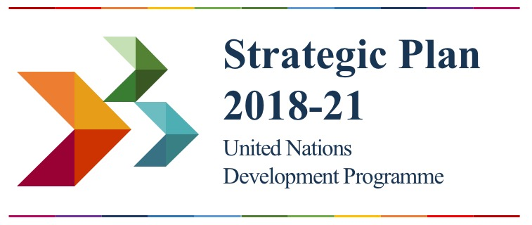Outcome: SP 2018-21: Outcome 1 - Accelerate structural transformations for sustainable development

Output: SP 2018-21 Output: 2.2.1 Use of digital technologies and big data enabled for improved public services and other government functions

The UNLIA TF aimed to “promote the empowerment of the word’s “invisible” people with legal identity deriving from sustainable, holistic civil registration and identity management systems that are secure, universal, and accurate and which protect the data and privacy of users. At the same time, the TF would assist UN Member States to maximize these systems for optimum public administration, socio-economic planning, and demographic planning.”[4]

This two-level project design reflected the initial ambition of the project, which was predicated on establishing an MPTF. When the MPTF was not created, the project moved forward with fundamentally the same structure under an amended, though fundamentally similar, PIP but with less funding.

The Programme’s theory of change is not stated explicitly, but can be inferred from the PIP, as follows:

Significantly contribute to closing the identity gap in the world through by:

1) Strengthening capacity of Member States to maintain comprehensive civil registration, vital statistics, and identity management systems, and;

2) Developing a comprehensive international normative and policy framework on civil registration, vital statistics, and identity management.

Managing a large number of stakeholders was a continuing challenge for the TF. However, the UNLIA TF Secretariat was able to keep the global work relevant to developing accepted UN-wide standards for legal identity, and through UNDESA, getting these standards endorsed by the Member States through the UN Statistical Commission, and later, the UN Economic and Social Council (ECOSOC). The TF held regular meetings every two to three months and there was regular contact among the UN stakeholders. According to INFORMANTs, the UNLIA TF was a functional collaboration facilitation structure, which increased the coherence of the UN’s approach to legal identity: “The fact that we are generally speaking the same language now makes a huge difference.” This increased alignment in the UN approach to legal identity will facilitate UN LIA delivery in the future as “One UN.”

With regards to stakeholders outside the UNLIA TF, the design of the Programme was relevant and aligned with the goal of broad stakeholder participation. However, the evaluation found that the execution did not deliver on this intent.

*Impressions of UNLIA TF:*

*“They were a coordination force and they did the coordination very well.”*

*“UNDP played a pivotal role at setting the global framework. I wish that it had happened five years earlier but it was really good that it did happen. The work has been great, but it is nowhere near finished.”*

*“UNLIA made the achievement of SDG 16 much more likely.”*

*“UNLIA is too limited by its UN only structure. It was appropriate to make UNLIA UN-only before, but now the project needs to grow.”*

*“We would like to bring WB into the UNLIA (country level) process. It’s not that the WB is terribly active, but whenever there is a meeting on UNLIA they are invited, but they do not necessarily come.”*

* *Various KIIs*

The project design initially intended the UNLIA TF to be inclusive, with a wide range of stakeholders, However, KIIs described UNLIA TF interactions outside the UN system as limited. One INTERVIEWEE from outside the UN system said, referring to UNLIA TF’s global level activities: “I didn’t see the program coming into shape for us, until about 2 years ago when the webinars started.” Another outside stakeholder expressed disappointment that country level Programme activities did not include them, while a third outside stakeholder claimed to have never heard of UNLIA’s country level activities.

Other KIIs expressed concern that the Programme may have displaced the Global CRVS task force, described as more inclusive than the UNLIA TF. They stated that due to the activity of UNLIA, the Global CRVS task force is now primarily an information sharing forum. The TF’s UN focus was not lost on KIIs, one of whom said: “We are maintaining the core, which is the UN, through UNLIA. The CRVS group is the outer ring.”

There were positive high-level contacts with the WBG on legal identity issues; the UNDP Administrator, Achim Steiner, sits on the High Level Advisory Council of the WBG’s ID4D. And one KII stated that there was regular and lasting working level contact with ID4D at the global level. However, there was no substantive progress on UN-WBG collaboration at country level. The opinions at the WBG regarding communications was not universal, with one KII describing UNLIA-WBG interactions as nearly non-existent since April 2021. This person said there was a lot of interaction when UNLIA started, but “at some point the World Bank was left behind.” Another stated that there were bilateral contacts between the WBG and individual UN agencies, but not with the UNLIA TF.

It should be noted that there are two well-resourced WBG entities working on legal identity, the GFF (Global Financing Facility) and ID4D, which were described by interviewees as having different approaches to legal identity, with the former linking legal identity closely to civil registration, a life cycle approach UNLIA is following, and the latter supporting digital identification systems more independent of civil registration. The evaluation found that it is likely that a large part of the divergence between UNLIA and the WBG, especially ID4D, can be attributed to this fundamental difference in approach. Communications between ID4D and the TF appeared more robust than with GFF, perhaps, ironically, due to their differences in approach. KIIs were nearly universal in stating that these two approaches seem to be converging, improving the prospects for cooperation in the future.

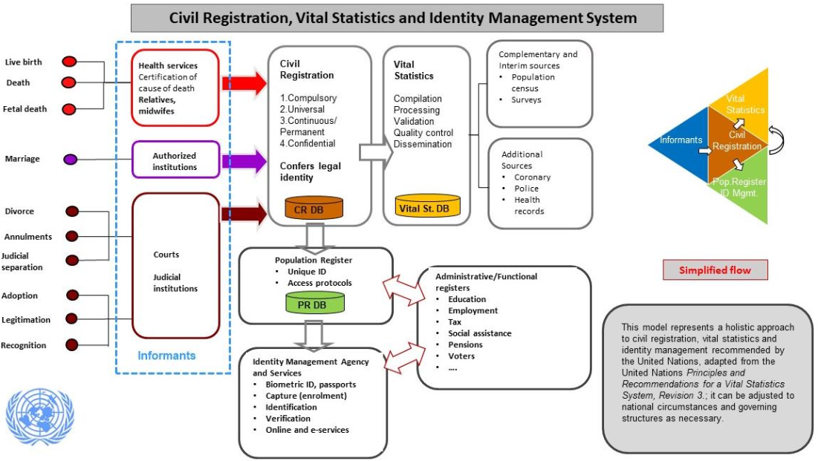

Figure : A diagram of the life cycle systemic UNLIA approach to legal identity. See:<https://unstats.un.org/legal-identity-agenda/documents/Conference%20in%20Prep%20for%20HLPF2019%201%20pager_final.pdf>

While interlocutors stated that GFF and UNLIA have always been more aligned in their approach to legal identity, cooperation between the two faded away in the second quarter of 2021. KIIs from both sides were unable to identify a reason, citing a collegial relationship. Speculating, one noted that GFF has a much broader mandate than just legal identity, leading to UNLIA *and* GFF putting less emphasis on their relationship. Another argued that ID4D’s emphasis on “digital” enabled it to pull attract greater interest, on both the donor and policy level, leaving the relationship with GFF to languish. The Secretariat’s limited staffing, exacerbated in 2022 with the permanent loss of UNDP’s P5 and reduce availability of the P3, may also have been a factor, with staff no longer having the capacity to manage outside relationships.

At the country level, contacts between the WBG and UNLIA were also limited. The WBG worked in parallel with UNLIA in several countries, including Kenya and Sierra Leone, and now has a project starting in Zambia. However, KIIs in-country stated that while the WBG was invited and welcome at UNLIA meetings, it either participated sporadically or not at all.

Regardless of the causes, as one interviewee noted, there were no clear incentives for UNLIA and the WBG to work together, even with harmonized approaches. This is especially true from the perspective of the WBG, whose ID4D program has first mover advantage and has far more donor resources and attention than UNLIA.

## 3.2 UNLIA Pillar 2: Country Support

UNLIA’s Pillar 2, is dedicated to country support. To keep the evaluation manageable in size, UNDP, in coordination with the consultant, limited the scope of the evaluation to three countries, Kenya, Sierra Leone, and Zambia, with a short look also at the DRC. These were chosen to give a broadly representative sample of UNLIA performance on the ground. All four were supported by UNLIA. Out of the remaining four working on legal identity, only two, Liberia and Mozambique fell under the UNLIA TF, but Cameroon and Namibia were still supported through UNDP’s other projects: Cameroon on a Japan funded project and Namibia on a CDO funded project.

UNLIA Output 2.1: The capacities of UN Member States achieve SDG Target 16.9 at the country level is coordinated, financed, and supported on a ‘One UN’ basis.

Initial selection of countries eligible to participate in UNLIA’s activities was based upon rapid assessments, conducted by the ECA. UNLIA intended to complete these assessments in thirteen countries. Ten assessments were completed by the time of this evaluation. The completed assessments were discussed by UNLIA TF members online. These ten countries were invited to submit proposals to the UNLIA TF.

These proposals were coordinated by RCOs and the respective governments and required that at least two UN agencies work collaboratively, in order to promote a ‘One UN’ approach. After reviewing the proposals, the UNLIA TF chose to provide seed funding to six countries: DRC, Kenya, Liberia, Mozambique, Sierra Leone, and Zambia. Among the six countries, the Programme was completed in DRC, Kenya, and Mozambique. Activities in Liberia, Sierra Leone, and Zambia continued through 2022.

Although the work under Pillar 2 was intended to have a global reach, due to DSG’s preferences and resource limitations, in the end, only African countries were funded. Activities in other regions were limited to awareness building at the global level, most notably the successful ministerial conference in the Asia Pacific region held in 2021.

### 3.2.1. Efficiency and Programmatic Support

The Programme’s selection of the countries funded was based on a rapid assessment followed by an application from each country’s RCO and UNCT, made in collaboration with the government. The evaluation found that as a result of this process, outputs and activities were highly relevant and responsive to each country’s needs. The requirement that each application include at least two UN agencies working together ensured that during implementation, One UN delivery was achieved.

Some KIIs raised concerns that UNLIA expected the rapid assessments too quickly and raised concerns that a consistent methodology was not used and that quality of the assessments was not uniform. However, the evaluation found that this did not affect the resulting activities as they were based upon the applications provided by the country offices in consultation with the government.

Funding for the Programme’s country level programming is detailed in the adjacent chart:

|  |  |  |
| --- | --- | --- |
| Country | Donor | Funds in USD |
| Cameroon | Japan | 1,400,000 |
| DRC | Switzerland | 103,140 |
| Kenya | Japan | 800,000 |
| Switzerland | 54,000 |
| Liberia | Switzerland | 151,092 |
| Mozambique | Sweden | 59,400 |
| Namibia | CDO | 12,000 |
| Sierra Leone | Switzerland | 192,240 |
| Zambia | Japan | 1,100,000 |
| Sweden | 45,144 |
| Total: | | 3,917,016 |

Because there was no MPTF, UNDP’s provision of funds to other agencies at the country level required establishing UN-to-UN inter-agency agreements. This necessitated UNDP and the recipient agency retaining GMS funds, which diverted resources from implementation. This problem happened at the global level as well.

The evaluation found that with some agencies, sharing funding through a UN-to-UN mechanism was almost impossible, leading UNDP to lead procurement of both consultants and hardware. At times UNDP was forced to procure items in order to keep the Programme running, which was not how the One UN Programme was intended to run, nor was it the most efficient. It should be noted that there were also times where consolidation of procurement under the UNDP umbrella was a choice made by the involved agencies to maximize value for money, as in Zambia, where a small order of IT equipment by UNICEF was folded into a larger order of identical products by UNDP.

The evaluation found that that the Secretariat made agreements with UNDP COs to provide mid-term and final narrative and financial reports. In DRC, the UNICEF CO was to provide such reports to the Secretariat. However, in some countries, this reporting schedule was not respected, forcing the Secretariat to conduct verbal interviews to put together donor reporting. Further, there was no agreement to inform the Secretariat about challenges with country level implementation outside these reports. As a result, challenges with country level implementation were sometimes missed by the Secretariat, in some cases delaying project implementation and creating confusion.

Interviewees attributed some of these reporting problems to the small size of the country level projects. Additionally, within UNDP, there was some confusion as to whether country offices should be reporting directly to the Secretariat in BPPS or through UNDP’s Regional Bureau for Africa, even with the agreements. Non-UNDP CO KIIs stated that their reporting lines were through their own agency’s headquarters, who were then responsible for providing reporting to the Secretariat, an inherently time-consuming process.

These challenges in reporting resulted in donor progress reports that are somewhat uneven in data collected and narrative structure from country to country. This reporting problem was compounded by the fact that COs were not given a clear results framework to report against.

Country level interviewees said that the Secretariat was responsive when they needed technical assistance on legal identity issues. Some COs took much greater advantage of the Secretariat’s technical expertise than others. One UNDP CO noted that it was able to reach back to UNDP’s Regional Bureau for Africa (RBA) for advice on regional identity issues. Another office described their link with UNDP’s procurement HQ for assistance in technical procurement matters. These linkages demonstrated the strength of the UNDP’s global structure.

### 3.2.2. Added value

While the Programme had internal problems with country level reporting and accountability to the Secretariat, the evaluation found that these programmatic challenges were not noted by country level interlocutors. Government officials universally expressed appreciation for Programme’s contributions in advancing legal identity and “galvanizing the political will to build sustainable improvements in civil registration and legal identity.” The evaluation found that the Programme’s strengthening of political will is the leverage that will make UNLIA’s relatively small country level programming effective in advancing the cause of legal identity for all.

Notably, the evaluation found that the Programme showcased UN coordination. RCOs used their convening power with the UNCT to form country level UNLIA task teams, coordinating the work of the UNLIA implementing agencies, though in at least one instance UNDP had to push the RCO to do so.

Each UN agency on the country UNLIA task teams liaised with different ministries, facilitating overall UNLIA access to government agencies. According to one KII, “Having the UN legal identity task force reduced duplication and enriched the spirit of delivering as one.” The evaluation found that there were exceptions to this cooperation and one interlocutor said that at least one RCO was underinformed on UNLIA issues. And while UNDP and UNICEF were consistently strong participants in country level UNLIA coordination, other agencies were less so, especially if they did not have UNLIA activities to implement.

Effective One UN coordination among the various agencies was noticed by national interlocutors. National interlocutors stated that the UN implementation of the Programme was, from their perspective, “seamless.” One interviewee said: “Each agency has a comparative advantage, but at the end of the day the Programme seems like a joint effort by the different UN agencies.”

### 3.3.3. Effectiveness and Impact

Each donor required an individual report, with a customized results framework. As a result, in consultation with UNDP, the listing of specific activities and outputs at the country level have been customized for this evaluation, with some outputs and activities combined or renumbered so they do not exactly match project reporting in all cases. The overall coverage, however, is effectively the same in scope.

In each country, the evaluation found that there were some activities affected by COVID related delays, especially in Sierra Leone and Zambia, compressing the timeline in which activities could be completed and requiring that tasks be completed under a no-cost extension, with all activities intended to be completed by the end of 2022. As some activities were still not completed, a no cost extension until 30 April, 2023 is currently being processed. Additionally, as would be expected, political considerations affected government priorities, and slowed activities in politically sensitive areas. Overall, however, the UNLIA achieved most of its goals in the countries evaluated.

UNLIA activities were coordinated in each country among the responsible agencies under the auspices of the RCOs office through the UNCT structure.

#### Kenya

The project in Kenya began in February 2021. Implementation was led by UNICEF in cooperation with other UNCT members of the UNLIA TF: IOM, OHCHR, UNDP, UNFPA, UNHCR, and WHO.

Output 1: Strengthened coordination and collaboration between the UNCT and the Government of Kenya in the implementation of the national integrated identity system in line with the UN LIA framework.

There was one activity under Output 1, led by UNDP.

*Activity 1.1:* Coordination of UN agencies, funds, and programmes for the implementation of UN Legal Identity Agenda in Kenya.

UNDP successfully executed these tasks, including UN coordination, through eight monthly UNLIA TF coordination meetings, a change management workshop reviewing roles and operations of agencies working on legal identity, and in anticipation of new registration procedures under the new Kenyan legal framework, knowledge exchange visits to civil registration sites with partners from WHO HQ. In cooperation with the WHO, a Rapid Mortality Surveillance pilot was conducted in six counties to generate timely, quality mortality data during the COVID-19 pandemic and to strengthen death and cause of death notification and registration, and support the production of the Kenya Vital Statistics Report 2020.

Output 2: Capacity strengthened for integration of civil registration, vital statistics and identity management systems that are interoperable and with more streamlined business processes.

Output 2 included activities led by UNDP, UNHCR, and UNICEF, and targeted at the passage of the Huduma Bill, 2021, which, if passed, would be the primary law on civil registration and legal identity management. Unfortunately, while the bill was scheduled to be read in the National Assembly in December 2021, consideration of the bill is currently stalled.

*Activity 2.1:* Engage a legal partner to provide analysis of the current Huduma Bill, 2020, to be discussed at a legal review meeting to strengthen the Huduma Bill, 2020, and the two special purpose vehicles - the civil registration Data Protection Regulations, 2020 and the NIIMS Registration of Persons Regulations, 2020.

UNICEF led the support to the government in updating the legal framework for civil registration and vital statistics, which resulted in the Huduma Bill. This also included supporting a mid-term review of the Civil Registration Strategic Plan 2018-2023, with the results emphasizing the need for a regular monitoring and evaluation program and client centred service delivery.

UNHCR supported a legal review of the Huduma Bill and created a joint memo with comments to ensure a comprehensive law and inclusion of marginalized populations and briefed the memo to key government officials. UNHCR also organized 13 forums with civil society organization (CSO) partners to collect views from refugees and asylum seekers on the Huduma Bill and civil registration. A consultant was engaged to review the comments and identify policy gaps for inclusion of refugees in civil registration. Some of the recommendations included issuing ID cards to asylum seekers and training refugees on the benefits of Kenyan civil registration.

UNDP hired a consultant to review the legal identity legal framework and design a framework for alternative dispute resolution (ADR) of complaints arising from the civil registration process. The key output of this consultancy was a proposal for a complete ADR structure, which included the following:

* Concept paper defining the processes of Mediation, Conciliation, Arbitration, and Negotiation of Disputes pursuant to the Data Protection Act, 2019;
* Detailed ADR frameworks for each of the ADR processes identified above;
* Detailed ADR SOP;
* Detailed report containing any other consideration/procedures relating to the implementation of ADR, gap analysis of current legal framework, and recommendations;
* Bidding documents for any items to be procured in the implementation of the ADR processes;
* ADR document retention policy;
* Draft guidance notes on ADR processes, and;
* Monitoring and evaluation framework.

*Activity 2.2:* Provide technical support to the NIIMS/Huduma Namba Secretariat for pre-public participation consultations, ahead of parliamentary processes and formal public participation.

This activity was led by UNDP and included an assessment of bottlenecks affecting registration of vulnerable/marginalized populations, including children in residential institutions, children with disabilities, mobile communities, and others. The findings of this study will guide policy to ensure that vulnerable and marginalized populations are not left behind in registration and access to legal identity.

UNDP also led a nation-wide KAP study on barriers to civil registration within the NIIMS context. Results of the KAP study were shared with government stakeholders and continue to guide the development of messages aimed at increasing demand for civil registration services. UNDP also supported procurement of ICT equipment for civil registration centres to promote digitization.

#### Sierra Leone

In Sierra Leone, UNLIA had three outputs, with implementation responsibilities distributed among three agencies: IOM, UNICEF, and UNDP. UNICEF worked with the Ministry of Health and Sanitation (MOHS) and IOM worked on statelessness with the National Civil Registration Authority (NCRA). UNDP worked with the NCRA and on UNLIA coordination, which was described as effective by non-UNDP interlocutors, with the one stating that the three agencies were “always in discussions, always in communication.” This enabled the agencies present themselves on UNLIA issues as One UN.

Output 1: Create enabling environment for implementation of the CRVS reforms and the National Strategic Plan by strengthening government-led coordination.

*Activity 1.1:* Provide technical support to NCRA to run an effective secretariat and revitalize the CRVS National Steering Committee and Donor Coordination Platform. (Technical staff embedded in NCRA).

UNDP embedded a consultant in the NCRA for six months, starting in March, 2022. The consultant had initially been expected to start earlier, but the consultant’s start was delayed by the pandemic. The evaluation found that the consultant successfully facilitated coordination between donors and partners, and ensured that the quarterly CRVS National Steering Committee meetings happened on schedule. The consultant also facilitated ensuring that the standing committee had the participation of all relevant development partners that worked with the CRVS, including CSOs and government agencies. The consultant also facilitated the development of a monthly newsletters and an online platform.

*Activity 1.2:* Provide technical support to ensure smooth implementation of the birth, death, and other vital events registration agenda as a vital part of the LI and CRVS system, including increased partnership with the health sector. (Contribution to NOC Birth Registration staff.)

This UNICEF had responsibility for this activity, still ongoing at the time of the evaluation. UNICEF’s activities enabled NCRA participation in MOHS regional consultations to facilitate continued birth and death registration at district health facilities and also provided the legal justification for the continuation of this activity.

*Activity 1.3:* Support a decentralized mid-term review of implementation of the National CRVS Strategy and Costed Plan of Action.

UNDP coordinated with NCRA management to complete a preliminary desk mid-term Review of the National Strategy and Costed Action plan. UNDP has also developed a TOR to form the basis to call for consultants. However, as elections are approaching UNDP has found that completing this activity to be a challenge and, at the time of this evaluation, has not yet done so.

Output 2: Policy and strategy development and harmonization, development, and integration of provisions to reflect refugees' needs, returned migrant, stateless, and displaced population in the current legal, policy, and procedural reform initiatives.

This output has one activity, handled by IOM working with the NCRA.

*Activity 2.1:* Provide technical assistance to review the European Union and UNDP's current reports and recommendations, develop specific SOP and guidance to link registration and legal identity confirmation for refugee, migrant, displaced, and stateless populations.

An IOM consultant worked with the NCRA to develop SOP to enable vital event registration and the conferral of legal identity in Sierra Leone. The consultant worked with the NCRA and other relevant agencies, both in government and in the UN, to propose strategies to register migrants, single/double orphaned children, refugees, migrants, stateless individuals, and other unregistered vulnerable groups, in line with national law. These SOP were successfully validated and printed for use by the NCRA and other government agencies addressing statelessness.

The consultant also made recommendations for legal changes to facilitate the registration process. Ongoing support for the implementation of these recommendations will be supported by IOM under its ongoing regular programming.

Output 3: Increased public awareness on fundamental rights to legal identity and its benefits based on NCRA Advocacy and Communications Strategy.

This output had one activity, handled by UNICEF.

*Activity 3.1:* Develop key messages and integrate and roll them out through national and local media, community actors, religious and traditional leaders, with attention to inclusion of women and girls.

In partnership with NCRA and in collaboration with the District Health Management Teams (DHMTs) of MOHS, UNICEF facilitated education and awareness on the importance of births and death registration across the country, particularly among rural populations. This was done through a national campaign using radio, television, stakeholder engagement, and town hall meetings across the country, conducted to celebrate CRVS Day on August 10, 2021. Engagement meetings included the participation of the leadership of several government ministries and departments, including the MOHS, the National Revenue Authority, Statistics Sierra Leone, National Commission for Children, local councils, and CSOs to clarify their roles and responsibilities and strengthen collaboration for improved birth and death registration coverage.

#### Zambia

UNDP has been bilaterally supporting Zambia’s INRIS system since before the inception of the UNLIA Programme. Zambia’s UNLIA TF, whose implementing members were IOM, UNDP, and UNICEF, focused on revising the legal framework around data protection as well as data management.

Output 1: Strengthened data and knowledge management (including information sharing, filing systems, archiving etc.)

*Activity 1.1:* Undertake a systematic assessment of 2000, 2010, and 2020/21 census data on possession of proof of official legal identity in Zambia.

In order to estimate the number of people without legal identity in Zambia, IOM, in partnership with the government, analysed the census data of 2000 and 2010. This analysis was intended to influence the conduct of the census, which the government had postponed from 2020/21 to 2022. However, even with the delay, the analysis was not presented until after the 2022 census was complete, though the findings may be useful in conducting the next census. One informant stated that it was difficult to get broad UNLIA engagement on this issue in-country which the informant claimed delayed the presentation of the analysis.

Output 2: Strengthened capacity and interoperability of civil registration and identity management systems in Zambia

*Activity 2.1:* Strengthening the digitization of CRVS/IM.

Through UNDP, the Programme supported consultations across government institutions to develop parameters for the integration of the INRIS and web-based SmartCare+, an electronic health record system designed to provide continuity of care to patients. Through this integration, birth records, birth certificates, and national ID will become interoperable, and will in the long-term negate the need for a parallel system for birth registration and identity management. Once complete, the integration is also expected to raise birth registration from 14% to at least 84% of births occurring at health facilities.

With Programme support, the government validated specifications for the procurement of stationary biometric enrolment kits. Using these specifications, UNDP procured 116 kits for deployment in 2022 in each of Zambia’s 116 districts to extend registration to underserved parts of the population. Due to restrictions in UNDPs procurement system, however, UNDP was unable to obtain the software licences from the same vendor as provided the kits. As a result, the use of these 116 kits has been delayed while procurement of the required licenses is underway.

The Programme also supported training of staff on these systems to test the roll out of national identity registration cards. This training initially facilitated the pilot registration of 3,318 men and 3,511 women, out of a targeted 1,000,000. The pilot was delayed due to COVID related supply chain issues and the full roll out was delayed by the government due to the electoral process. The full roll out is currently ongoing.

*Activity 2.2:* Strengthening the capacity of health facilities to register vital events.

Through UNICEF, the Programme supported government ministries in conducting birth registration training for 77 (37 men, 40 women) health workers drawn from 25 key health facilities of Lusaka province. The training included orientation on the newly integrated SmartCare+ and INRIS system.

UNICEF also sponsored a joint UN-Government study tour to two hospitals (Livingstone and Marimba) in Southern province, to learn more on the implementation and performance of a pilot project on integrated birth registration and health services. The pilot project has been part of the Government’s evidence generation initiatives since 2015 and is aimed at informing the final design of a national integrated system.

*Activity 2.3:* Civic engagement and awareness raising on the importance and benefits of civil registration and legal identity.

This activity was led by UNICEF in coordination with CSOs and the government. The main target groups included parents and caregivers, community health volunteers, and key influencers, such as traditional leaders. The activity focused on Lusaka province, covering communities around 25 selected health facilities, however, surrounding provinces have also benefited through the radio and television sensitisation and awareness messages on the importance and benefits of civil registration and legal identity.

The community-based sensitisation and awareness activities were led by the 45 (13 men, 32 women) community health volunteers and 92 (48 men and 44 women) community influencers who were trained on the importance and procedures for birth registration by CSOs and the government with support from UNICEF. Through these efforts, the targeted health facilities were able to register a total of 1,736 children in the period June-July 2021, which is a major achievement as such service did not exist before in these health facilities.

*Activity 2.4:* Technical assistance to ensure coordination among relevant national agencies.

The Programme convened various government departments to review the implementation of INRIS Phase II and to develop the INRIS Phase III action plan. Among other aspects, the consultations process resulted in consensus on the features of the biometric card, the roll-out plan, including linkages with the national identity system, as well as the birth and death registration system.

#### DRC

The DRC was not main target of the evaluation. In DRC, UNDP provided money that UNDP mobilized and was used by UNICEF to implement programming. Outputs and activities are noted here only for reference.

Output 1: The political ownership of the reform process is available through an effective steering committee (A national coordination mechanism on civil registration and legal identity at technical and political level is strengthened) established.

Output 2: A UN joint strategy including joint working plans to support legal identity is developed in consultation with all UN agencies, government and development and other partners.

Output 3: The Family Code is endorsed by the National Parliament, which will clarify the roles and responsibilities of the key stakeholders, provide the legal foundation for modernisation of the civil registration system.

Output 4: A comprehensive law on data protection in compliance with international human rights law, norms and standards, is reviewed with key stakeholders and proposed for adoption.

### 3.2.4. Way of Working

The evaluator found that the Programmes support has been consistent with the corporate standard of practice, specifically defined as prioritizing Leave No One Behind, analytical foundations, national ownership, country context sensitive, gender sensitivity, conflict sensitivity, and supportive of innovation.

“We made sure that the enough devices were produced to include even the most remote areas. There are portable kids and decentralized kits. Equipment has alternative biometrics if someone is unable to use fingerprints.”

* *UNDP Country Office KII*

UNDP’s commitment to Leave No One Behind, “taking explicit action to end extreme poverty, curb inequalities, confront discrimination and fast-track progress for the furthest behind,”[5] is a is a key part of the 2030 agenda and the SDGs. Almost by definition, those without legal identity are those most vulnerable in a society, as their lack of identification makes them unable to access a range of services, in both the private and public sector, including healthcare, schooling, banking, and government assistance, as well as an inability to prove their identity to the police should that become necessary.

Country level KIIs were asked to detail which populations they identified as most vulnerable and how they prioritized their participation. In all cases the evaluation found that populations of concern identified by national partners were also noted by UNLIA TF members. Rural, poor, and mobile communities, refugees and IDPs, were of concern across all countries. Sierra Leone emphasized children, particularly those who were orphaned, as well as noting discrimination that can occur based upon skin colour. Persons with disabilities were also a key group of concern. Kenya had what appeared to be a unique 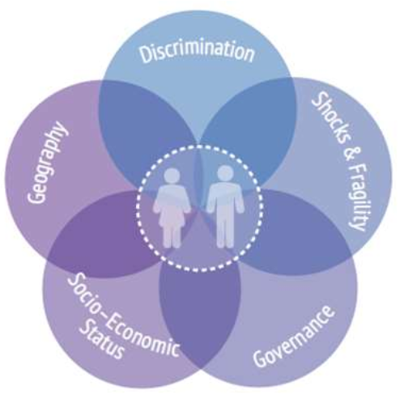problem registering a large number of people who claimed to be Kenyan, yet had applied for refugee status during a conflict some time before, and thus were not considered Kenyan under the Kenyan law. KIIs stated that this issue was being addressed, in part with UNLIA support. Kenyan interviewees also noted that, with the assistance of UNLIA, they were innovating procedures so that gender non-conforming populations can be included in the registration process. Zambia and Sierra Leone KIIs noted that there was lower participation of women in decision making positions in the area of legal identity, but, due to a focus on ensuring that women are included in the registration processes, this did not seem to have a direct impact on increasing access to legal identity.

Figure : What Does It Mean to Leave No One Behind?, UNDP, July 2018, p. 3.

UNLIA’s country selection process, based as it was on applications prepared jointly by the UN and national governments ensured that activities were suited to the national context and that the Programme facilitated national ownership of the process. UNLIA agencies always partnered with government and CSOs in every UNLIA country and interviewees expressed satisfaction with the aims of the activities, if not the results. KIIs stated that national CSOs, such as Don Bosco Fambul in Sierra Leone, which was regularly cited, were involved in the work of UNLIA as “key stakeholders.”

UNLIA used innovative approaches to the problem of legal identity, providing support for database integration, IT upgrades, and agency coordination. One KII stated: “When I look at the equipment provided by UNLIA, they have really assisted in scanning paper records into digital, and converting digital records into manipulable data. This will be more durable than paper records, and allows us access to records all across the country, not just where the paper records were kept.”

### 3.2.5. Coordination

At the country level, UNLIA coordination was described positively. Though UNDP was one of the co-chairs of UNLIA at the global level, it was not the lead agency in every country.

In Zambia, there was a local task force for all UN agencies working on LIA sitting in the RCO and co-chaired by UNDP and UNICEF with UNFPA, UNHCR, and IOM also participating. This was described as a relatively loose network, with “room for stronger collaboration.” Coordination among the co-chair agencies, UNDP and UNICEF, was much stronger. In order to keep value for money, procurement for the activities was consolidated under UNDP. UNDP claimed that it reached out the WBG, but that after completing a report on digital identity the WBG is not currently active in Zambia.

In Kenya, while UNDP provided funding for UNICEF’s UNLIA implementation, UNICEF took the lead on the country level UNLIA task team. Under UNICEF leadership, the UNLIA task force holds monthly meetings where UNDP’s participation and coordination was noted positively.

UNDP led the UNLIA team in Sierra Leone, bringing together two other agencies, UNICEF and IOM. In DRC, UNDP provided UNICEF the funding for UNLIA’s work in country, but did not have UNLIA activities to implement there.

The evaluation found that UNLIA also coordinated well with the government. Unlike many bilateral embassies, which are limited to relationships with foreign ministries, UN agencies demonstrated the ability to reach out to a variety of executive ministries in the government at the highest levels. In-country UNLIA TFs made the most of this access, working across several agencies in each country the evaluation examined.

The evaluation found that coordination was a problem between the COs and the Secretariat. As described in Section 3.2.1, gathering information was a challenge for the Secretariat as reporting agreements were not respected. The Secretariat had to chase UNDP country offices to report back on project issues. Some UNLIA TF non-UNDP COs agencies did not report back to their own HQs at all. One stakeholder attributed this to the relatively small size of the grants involved as well as the unusual structure of funding the project through the policy bureau, rather than through the regional bureau.

COs received funds from the Secretariat, but had a free hand in implementation and did their work without a clear results framework keeping them accountable

“Bringing us all together around the table with a common objective was great. This is a huge step in a place like DRC.”

“We (agencies) have a thousand reasons to not go in the same direction. It helps having a clear narrative with external partners, such as donors and government.”

“On procurement, we (UNDP Country Office) didn’t have the expertise on purchasing items for digital ID on specs, up to the proper international standards. UNDP NY was able to bring in an expert consultant to assist.”

* *UNCT KIIs*

The problems that UNDP had sharing funding across agencies required cross agency cooperation to find solutions. Most often this was done by coordinating procurement. UNDP and partner agency cooperation in working around the financial challenges was impressive, though fixing the disjointed nature of the UN systems finances was well beyond the scope of the Programme to address.

### 3.2.6 Sustainability

The projects which UNLIA supported at the country level were well chosen to have long term impact on the advancement of LI within each country, even in the absence of continued UNLIA support. The evaluation found that procurement was targeted to work in a complimentary fashion with existing LI infrastructure and was selected in coordination with national partners according to agreed upon specifications. While UNLIA facilitation of coordination of government agencies and donors is less likely to continue absent direct UNLIA support, the evaluation found that UNLIA did align with and strengthen the national political will to improve access to legal identity, strengthening the likelihood that Programme accomplishments will endure and be built upon.

At the country level, UNLIA programs were intended to provide seed money to catalyse further resource mobilization. Unfortunately, the evaluation found that this follow-on funding was not secured at the time of evaluation, though efforts to do so are ongoing. It is possible that the country projects under the current iteration of UNLIA were too small to attract and hold the interest of stakeholders on all sides. One interviewee said “We don’t hear about the programs; we don’t see them. We suspect because their funding was minuscule.” The small size of projects may have contributed to the problems noted in Section 3.3.3, with current donors stating that they never heard about UNLIA’s country-level activities through their own internal channels.

UN COs themselves may have let attention to LI issues, including reporting, fundraising, and donor communication, fall through the cracks due to the Programme’s relatively small size. One KII said “The burden on reporting is the same for 50,000 USD as it is for 500,000 USD,” resulting in smaller projects with already limited resources required to devote a much larger percentage of their resources to satisfying formal reporting requirements than project implementation, resource mobilization, or donor communication.

## 3.3 UNLIA Pillar 1: Global Activities

UNLIA’s first pillar is Pillar 1: Global Activities. Although there are six outputs listed under Pillar 1, they are all aimed at coordinating the UN-wide response to the imperatives of SDG Target 16.9 as well as coordination with the World Bank.

UNLIA Output 1.1: The comprehensive international normative and policy framework on CRVS/identity management, continuously codified to address emerging challenges and opportunities, is further refined by the UN, in partnership with partners.

UNLIA Output 1.2: The UN’s Legal Identity Agenda is supported and enhanced by common UN positions on innovation, including on biometrics.

UNLIA Output 1.3: Data tracking the global population lacking legal identity is informed by sound methodological practice and clearly reported and documented key achievements, priorities and remaining challenges.

UNLIA Output 1.4: The legal identity rights and perspectives of women and gender minorities are mainstreamed throughout all UN LIA policy development.

UNLIA Output 1.5: From the Secretary-General down, the UN speaks as ‘One UN’ in strategic advocacy for SDG target 16.9

UNLIA Output 1.6: Regional harmonization of CRVS/identity management is expanded.

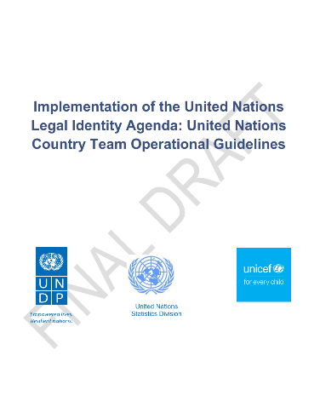Pillar 1 activities were listed in three workplans, 2020, 2021, and 2022. The activities described changed from year to year as the Programme achieved its goals and evolved. The activities were primarily the completion of intellectual products, such as concept notes, reports, SOPs, and comments on such intellectual products, versions of which can be found at the UNDESA UNLIA webpage.[6] Two of the foundational products completed were the Report of the Secretary-General on Introduction of the UN Legal Identity Agenda – a Holistic Approach to Civil Registration, Vital Statistics, and Identity Management, and the Overview of the United Nations Legal Identity Agenda. One activity consistent throughout all three years of the workplan was coordination with the WBG.

The evaluation TOR did not ask for a detailed review of Programme activities at the global level, instead reserved that focus for Pillar 2: Country Support. Regardless, it would be difficult to assess the impact, effectiveness, or efficiency of Pillar 1 activities in a quantitative way due to the number of different bodies implementing each activity. In 2020, activity leads included ECA, IOM, OHCHR, UNDESA, UNDP, UNFPA, UNICEF, UN Women, WFP, WHO, and the UNLIA TF Secretariat.

From the perspective of UNDP and the Secretariat, delivery of these products was not perfect, but generally satisfactory. “Consultants have not always delivered as quickly as we could have wanted,” but regardless the Programme has “delivered on knowledge products.”

### 3.3.1 Coordination and Partnership

This evaluation divides coordination at the global level into three separate components. This section will be limited to coordination among the three co-chairs of the UNLIA TF and coordination among all the members of the UNLIA TF. Coordination outside the UNLIA TF, with actors such as the WBG, etc., is discussed in detail in 3.1.

From UNDP’s perspective, coordination between the three co-chairs, UNDP, UNICEF, and UNDESA, went well. Interviewees noted that there are traditionally frictions between agencies and Secretariat-based institutions due to their different mandates and perspectives, however, in this case, these differing mandates and perspectives were described as a net positive. UNDESA was credited as being “quite respectful” of the agencies, and agency interlocutors found that the ability of UNDESA to get Member State approval of documents by ECOSOC and the Statistical Commission to be “quite helpful” and motivated some agencies to contribute to TF work when they might not have otherwise.

*“At the global level we now have a methodological framework to meet the SDG target. We have a clear understanding on how to get legal identity issues improved. UNLIA is the first time that I’ve clearly witnessed joint coordination and work on legal identity.”*

* *UNLIA TF KII*

With such a small group of individuals driving the UNLIA TF process, personalities loomed large. Informants described UNDP’s Secretariat staff, almost universally, as positive, professional, and collegial. This was not always the case among other stakeholders, though relationships among the co-chairs was good. Among the larger TF, KIIs stated that the relationships were positive but there was less contact, due to their agencies’ more peripheral participation in the TF. None of the non-chair members of the TF that the evaluator spoke with had staff dedicated exclusively to the TF.

Due to the departure of the Programme’s P-5 in March, 2022, and the subsequent maternity leave of the project’s P-3, extending from June through September 2022, interlocutors noted a decrease in UNDP’s work on the TF. UNDESA covered UNDP’s UNLIA TF secretariat role while the P3 was unavailable, a change in coverage which was described by interlocutors as smooth and problem free. Such collegial distribution of work characterized the relationship between the co-chair agencies.

Meetings among the TF at large were held approximately once every two months to finalize the various policy documents the TF produced, approve country level programming, and update and finalize UNLIA TF workplans. Working level e-mails contact happened regularly amongst TF members, and co-chair staff interviewees stated that they were in daily contact with the other co-chair staff.

Non-chair TF members complained that at times TF decisions seemed to be made with insufficient consultation with all TF members. Given the size of the TF it is not surprising that not every TF member felt that there was sufficient consultation on particular decisions. Overall, balancing sufficient consultation with accomplishing tasks on schedule is always a challenge. It seems that the TF managed this balancing act relatively well in most cases, though, unsurprisingly, not every TF member agreed in every case.

Funding was the biggest problem at the global level, as it was at the national level. UNDP provided nearly all the money for TF activities aside from the salaries of agency staff working on TF activities. UNDP staff had expected that other agencies would also mobilize resources to help fund UNLIA TF functions, but the evaluator found no evidence that this occurred to any significant extent. Agencies were happy to cooperate with UNDP and the TF as long as UNDP provided the funding for significant activities, but they did not engage in major self-funded activities.

Numerous KIIs described cross-agency funding in the UN system in many instances as extremely difficult or practically impossible, absent a MPTF. This, combined with the relatively small amount of money UNDP was able to raise, limited the amount of work that the TF could accomplish. It also led to some tensions as UNDP would be asked for money by other agencies for some TF activities, such as staff travel expenses, and UNDP would feel obligated to refuse as such use would be outside the scope of the funding provided by UNDP’s donors.

*“Transferring funding between agencies, is technically possible, but functionally impossible, especially in small amounts.”*

* *UNLIA TF KII*

### 3.3.2. Effectiveness and Impact: Strategic Positioning and Policy Development

The UNLIA TF co-chair institutions were well chosen for their roles. The UN has the mandate to determine the global standards for legal identity through ECOSOC, of which UNDESA is the secretariat. UNDESA was well placed to present UNLIA TF decisions to ECOSOC for approval by Member States as a global standard. UNDP has extensive experience on using legal identity for the purposes of voter registration and is the largest UN development aid agency with a presence in 170 counties. UNICEF has offices in 192 countries and has a long-standing interest in ensuring that all children get birth certificates, documents which form the foundation of a “whole life” civil registration system.

The other agencies involved, IOM, OHCHR, UNFPA, UNHCR, UN Women, UNSD, WFP, WHO, UNECA and UNESCAP, all have a core interest in ensuring that the world’s undocumented people, or their client population (in the case of UNHCR, WFP and IOM) have access to legal identity, though this did not always mean that they chose to engage closely with the TF. Some, such as IOM, UNDP, and UNHCR have had a more transactional approach to legal identity, as their interest is in identifying people in need of assistance. Others, such as UNICEF and WHO, have longstanding interest in a whole life approach, with legal identity based upon a functioning civil registration system. Including both perspectives on the UNLIA TF ensured that a broad range of interests were represented in the standard setting process for legal identity, ensuring cross agency buy-in to the new standards and also ensuring that no key issues were left out of the standard setting discussions. While KIIs admitted that the agreed upon standards were not perfect, the majority said they were generally satisfactory.

*“As the world piles down the digital identity transformation route at frightening speed, having the UN look at the norms and human rights of the people affected is really, really important. Digital transformation can be a route to inclusion. But you need to bring that lens explicitly.”*

* *UNLIA TF KII*

The UNLIA TF has highlighted the importance of legal identity work for all these agencies. According to interviewees, legal identity is being recognized as a key component of human development and service delivery. By participating in a leadership role in this emergent area of interest, UNDP has carved itself a role as a thought leader role in the UN system overall in LI.

Internally, through UNDP’s participation in UNLIA, UNDP in general, and BPPS in particular, is understanding more how digital legal identity fits into future policy and programming decisions, and how this relates to human rights. Rather than treat legal identity as its own stand-alone issue, UNDP BPPS plans to incorporate LI into its digital transformation work and make it a key cross cutting component of programming.

### 3.3.3 Added value

The evaluation found that UNDP’s role in the UNLIA TF has put it in a leadership position in the field of legal identity. Outside KIIs recognized this: “UNDP played a pivotal role at setting the global framework with UNICEF and ECOSOC.”

Among the government officials interviewed, the UNLIA whole life approach to legal identity is favoured. While it was not possible to attribute this to UNLIA’s activities, UNLIA’s work to design uniform standards for legal identity make it more likely that countries will adopt the UN’s rights-based approach to legal identity.

*“Countries have benefited positively from these efforts; they have elicited the political will which will enable these improvements to be sustained. The support period was a little short.”*

* *Government KII*

UNDP’s leadership role in UNLIA should enable UNDP to strengthen its financial and technical offers to support Members States in developing birth to death comprehensive and interoperable legal identity systems in the future. However, until this point, UNDP has been unable to create the donor interest necessary to transform this position into mobilized resources. Country KIIs recognized the benefit of UNLIA’s assistance but lamented that it was relatively limited in time and resources. The competition for funding among implementers, most notably including the WBG, is undoubtedly part of the issue.

### 3.3.4 Sustainability

The evaluation found that the sustainability of the UNLIA TF is dependent entirely on whether the partner UN entities choose to continue the work of the TF. Future investment from each entity involved in such a TF would likely be rather small. Even in the case of this Programme, where UNDP assisted in providing support to the UNLIA TF, as well as overseeing the UNLIA country level programming, the personnel burden on UNDP of one P5 and one P3 has been relatively small.

For most KIIs, continuing the work of the UNLIA TF is important, however, most believe the TF should be expanded to include non-UN entities, including the private sector, the WBG, and key CSOs. The role of the Global CRVS task force vs the UNLIA TF should also be clarified. It may be the case that one can be folded into the other, but at the moment, there is a lack of mission clarity between the two entities.

## 3.4 UNLIA Pillar 3: Program Management

This section discusses Programme administration, including Programme staffing, the Programme’s strategic positioning, and added value.

### 3.4.1 Administration

The Programme’s management structure was outlined in a PIP, approved in January 2019, and updated four times. The PIP functioned as the Project Document (PD) and contains most of the elements required in a full PD. The first two of the PIP amendments state that they were required to account for continuing high level discussions on the optimal funding vehicle. The third and fourth amendments to the PIP state that they were required due to donor commitments to the MPTF being withdrawn, as discussed in more detail in the next section, in part due to the exigencies of the COVID pandemic.

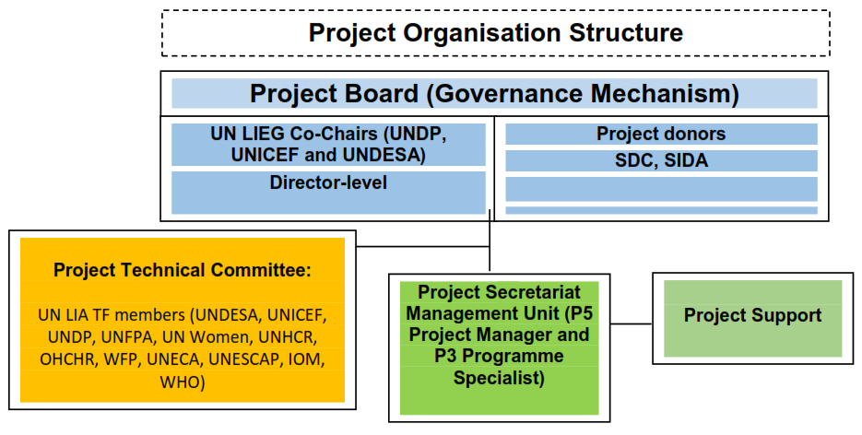A separate PD was drafted for the Japanese funds expended on the project, but that PD linked directly into the Programme’s already existing structure as detailed in the PIP.[7] The PD was amended once to extend that portion of the Programme from 30 June 2021 to December 31 2021.

The PIP established the management structure of the Programme. Top level guidance was through a Project Board composed of the three Co-Chairs (Director-level) of the UN Legal Identity Agenda Task Force (UNDP, UNICEF and DESA), and donors to the project. The Board provided overall strategic direction and oversight for the project, and would have overseen the transition of the PIP to the MPTF had it occurred.

Figure : Project Implementation Plan, p 4.

The Project Board (PB) was intended to be the preeminent decision-making body of the Project, meeting once a year to make all management decisions for the project, specifically:

* Overall direction and project guidance;
* Oversight and ensuring effective management and implementation of the project;
* Agreeing on countries/regions that received financial assistance from the project (following applications from UN Resident Coordinators), including the ten pilot countries for UN-World Bank collaboration;
* Allocate funding to 6 UNCTs (DRC, Kenya, Liberia, Mozambique, Sierra Leone, and Zambia) and monitor its implementation;
* Monitor progress in project implementation against both output achievements and financial plans;
* Review and approve the final MPTF programming documents (and the UNDP component project document) and annual work plans deriving thereof;
* Propose financial allocations to members of the Legal Identity Experts Group for implementation of project activities;
* Propose new strategic areas of collaboration or joint initiatives, as appropriate, with external partners;
* Relay key messages and action points to Legal Identity Agenda Task Force Co-Chairs’ Under-Secretaries-General and to the Deputy-Secretary-General (through the EOSG).

However, donors did not respond to invitations to participate in the PB, leaving decisions to be made by the UNLIA co-chairs.

The Project Technical Committee (PTC), mirrored the wider UNLIA TF membership as well as representatives of the wider project stakeholders, and met every quarter to:

* Review progress against annual work plans (for communication to Project Board);
* Monitor delivery of results and objectives under the various project outputs (for communication to Project Board);
* Review country-level proposals for funding that the project will receive, and make recommendations to the Project Board for acceptance of refusal.

The Project Secretariat Management Unit (PSMU – otherwise known in this document as the Secretariat) was responsible for the day-to-day management and implementation of both the PIP and Programme and was the core of UNDP’s Programme. The Project Secretariat was composed of a P5 Policy Advisor, Legal Identity/Project Manager, and a P3 Programme Specialist (Finance and Operations) who assisted with the management of the project, both full-time. The work on supporting the UNLIA co-chair and TF was divided up amongst the three UNLIA co-chairs supported by the UNLIA TF Secretariat, but since UNDP hosted a global programme on legal identity which serves as the funding vehicle for UNLIA TF, the responsibility of programme management remained at UNDP. A part-time finance and administration officer was included in the PIP but never hired.

The P5 Policy Advisor, Legal Identity/Project Manager’s responsibilities will include, among others:

* Leading on day-to-day project implementation;
* Managing all project consultants and other project staff;
* Providing support to the UNDP Co-Chair of the UN Legal Identity Agenda Task Force;
* Ensuring project progress against annual work plans and project outputs;
* Engaging with other members of the UN Legal Identity Agenda Task Force, and external partners, on policy and other developments in the legal identity arena;
* Resource mobilisation for the MPTF and the component UNDP project;
* Being the UNDP focal point on legal identity matters for UNDP Country Offices, regional bureaux, the Executive Office and donors to the project.

The P3 Programme Specialist (Finance and Operations)’s responsibilities will include, among others:

* Ensuring that all project funds are expended as per UNDP rules and regulations as outlined in the Programme and Operations Policies and Procedures guide;
* Assisting the P5 Project Manager on day-to-day project implementation, particularly as it pertains to expenditures;
* Managing the procurement of all project consultants and equipment;
* Preparing project implementation and financial progress reports for the Project Board.

For the past year, day to day staff coverage was limited as the P3 project manager was on maternity leave from June 2022 through September 2022 and detailed assignments from June 2021 till Dec 2021 and the P5 left in early 2022, though was brought back on a limited consultancy to help cover contingencies through the end of the Programme. In part, this was in order conserve resources and maintain coverage through the end of the Programme. As noted above, this led to the temporary informal transfer of the lead coordination role of UNLIA TF and UNLIA Secretariat from UNDP to UNDESA from June through December 2021 and June through Sep 2022.

The evaluator found that the Programme staff was very thin, making it vulnerable to staff turnover or other personnel issues that arise during the lifetime of a programme. While Programme staff did not appear to make errors, there were certainly instances, such as financial transfers, donor and stakeholder outreach, country level follow-up etc, where additional staff would have enabled the Programme to accomplish more.

### 3.4.2. Resources

While the UNLIA TF was established under the DSG, the DSG did not provide funding for the project. The UNLIA project was initially intended to be funded by a MPTF and a foundational donor had been secured by Q1 2020.[8] This mechanism would have allowed for easy use of funds by different partner agencies in order to implement the UNLIA TF’s workplan. However, a few weeks before finalizing the MPTF, the MPTF’s foundation donor pulled out, citing a need to reprogram previously committed money to COVID response. To fill this gap, the project began fundraising from other donors. The Secretariat’s rapid response and “passionate” promotion of the project, along with donors’ flexibility and willingness to trust that UNDP would be able to put together a worthwhile project, enabled UNDP to mobilize sufficient resources to begin the project.

*“Legal identity is fundamental to the digital transformation of society and we’ve had trouble making this case to our donors.”*

*“We were hard hit by the pandemic, which made us unable to raise additional money. The only thing that could have been done better was fundraising. However, given the exigencies of the pandemic, this may not have been realistic.”*

* *UNLIA TF KIIs*

The eventual funding structure, with three donors providing nearly all the UNLIA money directly to UNDP, was far more complex than the contemplated MPTF. Some other agencies provided some funding for some of the activities they led in the UNLIA TF, as UNDP did with a contribution of 252,126 USD. While the UNLIA TF was a cross agency institution, for the lion’s share of the money it was UNDP alone that had the fiduciary duty to each donor.

The evaluation found that the financing structure made it extremely difficult to share UNLIA funding with different agencies. In several cases, the evaluator found that agencies gave up transferring funds as practically impossible. Further increasing the burden on UNDP’s small program staff, each donor required individually tailored progress reports.

3.4.3. Meeting donor expectations

The evaluation found that some donors expressed little interest in UNLIA. For example, some donors did not respond to the request for participating the PB meeting, declining to play their part in Programme management.

Part of their disinterest may be due to how the program was funded. Though putting together the funding quickly made the project possible, some of the donor structures used appeared to hurt donor’s impressions of the project down the line. One donor provided money through its industrial development fund, rather than its international development agency, and its mandate to promote the donor’s national industries was not aligned with the project’s mandate to advance LI in a way best suited for beneficiary each countries. Other donors stated that UNLIA got lost in 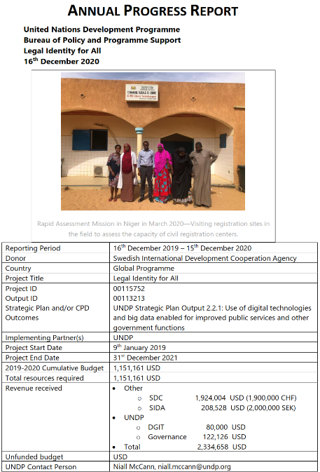their donor bureaucracy, either attached to a much larger, seemingly unrelated project, making UNLIA almost a bureaucratic orphan in the donor’s bureaucracy, struggling for attention and interest or not properly bureaucratically anchored anywhere at all. Donor personnel changes were an issue too, with one donor saying: “I’ve had limited visibility on this project. A series of focal persons have taken over the program which has created a lack of continuity. That is a deficit on our part.”

Of greater concern was the complaint from some donors that there was no communication between their people on the country level and the donors’ HQ on UNLIA issues. Donors stated that normally they hear from their own country level representatives about projects, but that this was not the case with UNLIA. UNDP country staff credibly claimed that there was contact with at least some donors some of the time at the country level. In Zambia and DRC, interviewees specifically noted reaching out to Japanese and other donor representatives, but overall, the evaluation found that Swiss and Swedish donors may have been left out of consultations.

The evaluator found no evidence pointing to a single reason for this apparent lack of communication, but the relatively small level of funding in each country may have let UNLIA specific projects to be lost or confused with other projects by UNDP, agency partners, or donors. Reporting challenges noted elsewhere in this report also prevented timely intervention by the Secretariat. One donor speculated that BPPS’ relative lack of experience running country level projects on the ground led UNLIA to be less attentive than it should have been to the communications issue, but the donors’ lack of interest or capacity to attend PB meetings were also a serious contributing factor.

The evaluation found that there is interest in legal identity issues among donor institutions. One donor informant emphasized their institutional interest in legal identity going forward, though not in the part of the donor bureaucracy that currently houses UNLIA.

### 3.4.4. Sustainability

As the Programme winds down, UNDP has begun transitioning to the next stage of its LI efforts at the global level. Acknowledging that the current structure of the Programme is less than ideal, UNDP is initiating the Global Governance Program and is mainstreaming LI work into that program. This will integrate LI work into the larger democracy program with core funding and making it part of a larger programmatic narrative.

The need to support LI with long term staff was a key concern expressed by several KIIs. Referring to the current Programme staff, one donor said: “You have dedicated people within the UN who drive these programs, but then the programs come to an end and, it seems that we lose people.” Another interlocutor criticized funding positions through program money as promoting a “mercenary” mindset among staff members and that UNDP’s work on LI cannot be successful unless it is institutionalized, with stability and long-term staff.

Interviewees also made the point that legal identity issues must have more resources devoted to them in the future in order to ensure that project accomplishments can be maintained. One said, “We couldn’t come to systematic change with this project as the funding was too small.”

From the larger perspective of the UNLIA TF, the evaluation found that UNLIA may need to move beyond its current UN only structure. Numerous KIIs stated that while the current UNLIA structure was useful to bring all the UN entities into coherence on legal identity issues, UNLIA now needs to reach out to other stakeholders. Resetting the relationship with the WBG, most importantly, with ID4D, which has the most resources of any organization working on legal identity, will be essential for UNDP to move forward as the WBG has dominated resource mobilization in the legal identity arena. However, the WBG also needs to be willing to engage in coordination.

### 3.4.5. Monitoring and Evaluation

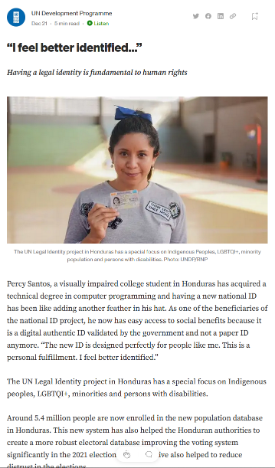Due to the unusual funding structure of the Programme, reporting did not follow the MPTF standard reporting structure. All three donors required bespoke annual progress reports, placing an additional burden on UNDP’s small UNLIA staff. Reports documented progress against results frameworks agreed to with individual donors as well as against the UNLIA TF workplan, adding to the complexity of reporting. Of the three donors, only one donor required a framework which included outputs, indicators, baselines, and targets. The other two donors required frameworks with only outputs, activities, and a narrative description of progress included.

Progress reports were primarily descriptive and were often highly detailed. One donor stated that the reports met expectations of donor needs. Another expressed some frustration, saying that reports were “too technical, too focused on activities, and had too much detail.” This KII also would have preferred some success stories in the reporting, pointing out that such stories enable donor officials to “sell” the project within donor agencies. The Programme did post a blog, which covered success stories on the UNDP Stories page on November 10, 2021[9] and a second set of success stories to the UNDP blog on medium on December 21, 2022. The Secretariat said that the first was provided to donors, but donors did not mention it.

Figure . Legal identity success stories posted in December 2022 at <https://undp.medium.com/i-feel-better-identified-61c5c4eba1d7>.

The UNLIA TF had an annual work plan for 2020, 2021, and 2022, which used a modified UNDP results framework template, which listed the expected outputs, lead agencies, activities and tasks, timeframes, funding sources, COVID-19 relevance and notes on progress and other issues. No indicators or baselines were provided, making monitoring performance and evaluating the projects efforts extremely difficult.

The UNLIA TF provided the oversight for accomplishing these goals at the global level. The work plans maintained the same outputs for all three years, but added or removed tasks as they were completed or changed.

At the country level, implementing agencies were not given a results framework against which their progress on activities could be measured. There was little formal accountability to UNDP HQ and Programme staff struggled to get information from country level agencies, including UNDP COs. This resulted in an unevenness in detail in reports from country to country.

Future projects should ensure that results frameworks are agreed upon before disbursing resources. Baselines and indicators should also be included in all results frameworks to ensure accountability and to manage donor expectations. Programme reporting could be strengthened by breaking down expenditures by output as it was difficult to determine how donor money was spent during the reporting period.

Due to the *ad hoc* nature and relatively short duration of the Programme, no mid-term evaluation was conducted. While such an evaluation would likely not have changed the trajectory of the Programme, it might have ensured better capture of programme results, especially at the country level, by ensuring the use of results frameworks as well as remedying the absence of baselines and indicators.

## 3.5 Lessons Learned

* UNCT members have direct access to a variety of government ministries, making them uniquely able to address legal identity from numerous angles.
* Small projects can struggle to hold the interest of donors, making follow on funding harder to achieve.
* Reporting on small projects is the same as for large projects, but the reporting burden is proportionately greater for small projects.
* UN agencies can effectively work together on coordinated programming with an active RCO and engaged UNCT.
* Government beneficiaries recognize and respect that each UN agency has its own comparative advantage, but appreciate when the UNCT coordinates delivery as One UN.
* Sharing funds between UN agencies is extremely challenging if not practically impossible.
* Creating programming with government involved from the start results in more relevant, efficient, sustainable, and effective programming.
* Coordination and collegiality at agencies’ highest levels of does not always translate into a functional working level relationship.
* Identifying UN entities with strong common interests and bringing them on board to coordinate common standards ensures broad UN buy-in and complete coverage of relevant issues.
* The UNLIA cross-entity task force worked well, in part due to having a respected and responsive secretariat facilitating the process.
* A lack of financial incentives for organizations to work together made working with organizations outside the UNLIA TF extremely challenging.
* Differences in technical approaches made cooperation between organizations difficult.
* There can be strong and unique synergies between the normative organs of the UN system, such as UNDESA, and the executive agencies, such as UNDP and UNICEF.
* UNDP’s investment and leadership in LI issues has put UNDP into a leadership role in the LI field.
* Thin project staffing increases programme vulnerable to personnel shifts.
* A lack of baselines makes evaluating the accomplishments of a program difficult.
* Programs, especially small programs, without aggressive outreach to donors at the country level run the risk of information about that program not rising through the chain to donor headquarters where funding decisions are eventually made.
* Projects that are not nested in the appropriate part of donor bureaucracy may struggle to maintain donor interest and secure future funding.
* UNDP is perceived by some as unable to hold on to experienced staff with specific technical skills in LI.
* Creating bespoke reports for each individual donor, especially on small projects, diverts resources from other core project tasks and can result in lower overall quality of reporting.
* Project reports should include success stories which highlight project accomplishments that can be used by donors to sell a program within their agencies.
* Projects not funded against a results framework can have problems with accountability and reporting.

# 4. Conclusions and Recommendations

## 4.1. Conclusions

This evaluation finds that the Programme faced serious obstacles to its execution *ab initio.* Under normal circumstances, uniting 14 UN entities into one task force would be a challenge. The COVID pandemic exacerbated the situation, causing a donor to pull the funding necessary to create an MPTF weeks before the Programme’s formal launch. The Programme never fully recovered from this blow, and was never able to establish a MPTF.

Absent flexibility from donors and agency management and hard work and creativity on the part of UNDP Programme staff in mobilizing resources, these challenges would have prevented or severely restricted Programme implementation. As it was, the Programme was unable to fully live up to the ambition presented in the PIPs. More importantly, the flexibility which made this Programme possible introduced weaknesses into the Programme which would likely not have existed had the Programme been able to follow its initially planned trajectory. The choice was between a Programme with notable deficiencies and no Programme at all.

Regardless, the Programme represented an important step in addressing the SDG Target 16.9: “legal identity for all (including birth registration) by 2030.” The Programme was also in alignment with the UNDP Strategic Plan 2018-2021, Outcome 1 and Output 2.2.1.

Within its resource restricted scope, the Programme was able to make considerable progress on the DSG’s mandate “to develop…. a common approach to the broader issue of registration and legal identity...” The key failing of the Programme was to do so consistently in collaboration with outside stakeholders, especially the WBG, however, achieving this aim was never entirely within the control of the Programme itself. The evaluation found that much of the failure to collaborate was due to distinct differences between UNLIA’s more CR-based approach, and ID4D’s more CR-independent approach.

There was a disconnect between the highest, policy levels of UNLIA and the implementation levels. At the same time as UNLIA and the WBG met regularly at the highest levels on legal identity with seemingly positive outcomes, collaboration at the working level had stalled. The evaluation found reason to be optimistic about future collaboration as there appears that a convergence between the two viewpoints is developing. However, the disparity in funding between the UNLIA partners and the World Bank Group dramatically reduces the incentives for cooperation on the WBG side.

Under Pillar 2, the evaluation found that the rapid assessment and application process’ was an effective method to choose which countries would receive seed money for LI activities. While there were critiques about the quality of the rapid assessments across countries, they provided sufficient foundation to bring country level support to the application stage. The requirement that at least two UN agency COs collaborate with the RCO and the government in applications for LI seed money ensured alignment with government priorities, national ownership of Programme activities, and long term sustainably of completed activities.

UN COs generally collaborated well at the country level, with RCOs and the UNCTs providing an effective umbrella for country level UNLIA TFs to operate, even if actual leadership came from one of the executive agencies. From the perspective of government partners, UN agencies delivered as One UN, which was appreciated by those government partners.

Most activities at the country level were delivered on time. There were expected delays in delivery due to COVID-19 and government political decisions. There were isolated cases where delays were caused by a consultant either being contracted late or delivering after a deadline had passed. One major delay was due to UNDP procurement rules which prevented hardware and software licences from being procured from the same company. Some of these delays may have been avoidable had COs relayed information regarding these challenges to the Secretariat, as the Secretariat was not always kept in the loop when there were delays in execution.

Reporting and accountability were consistent problems at the country level. While there were reporting arrangements included in the funding agreements, UNCTs did not always live up to those agreements. The evaluation concludes that this failure was likely due to several reasons, one being disinterest due to the small amount of funds involved. For UNDP COs, the unusual reporting line to the Secretariat in BPPS rather than through UNDP’s RBA, may have caused confusion. For non-UNDP COs, reporting to a different agency seemed to have caused similar problems. Compounding the reporting failures was the fact that there were no results frameworks created for country activities, making it difficult for the Secretariat to determine activity progress.

Under Pillar 2, the evaluation found that the coordination of the participating UNLIA TF agencies was a success. UNDP’s Secretariat provided a solid basis for coordination across agencies and the three co-chairs, UNDESA, UNDP, and UNICEF had a successful and collegial working relationship for much of the Programme.

As initially structured, the Secretariat was functional, but its small size meant that there was no redundancy. Once staff left or were on leave, the work of the lead coordination role for TF had to be outsourced (as it was, successfully) to another entity or delayed.

Members of the broader UNLIA TF generally had a positive impression of TF cooperation. Some complained that they felt left out of decisions from time to time, however, the size of the TF as well as the part time investment that characterized most entities’ participation would seem to make this somewhat inevitable.

Funding was the most serious challenge across both the global and country level aspects of the Programme. Once the attempt to create a MPTF failed, only UNDP seemed able to mobilize significant Programme resources. Other agencies either devoted small amounts of their own funds or required UNDP to transfer funds to them in order for them to complete UNLIA activities, and while the mandate for the UNLIA TF came from the DSG, the mandate did not come with any funding. This meant that UNDP was the only UNLIA TF member with any accountability to donors.

The financial transfers necessitated by this structure meant that already limited program resources were diverted to GMS for UNDP and the receiving agency. Further, such transfers were credibly described as “incredibly difficult or impossible” because each entity has its own financial system.

The continued use of the PIP rather than the creation of a PD for the Programme meant that there were gaps in the Programme’s structure. Notable was the absence of an explicit theory of change and the lack of Programme results frameworks at both the global and the country level.

The Programme’s funding challenges seeped into its core and may pose a threat to future UN LI activities. At the working level, donors claimed little knowledge of or interest in the Programme. The evaluation found that part of this disinterest was due to the rapid and *ad hoc* way in which funding was mobilized, resulting in the Programme being housed in unsuitable places in the various donor’s bureaucracy. At the Programme’s inception this represented extraordinary donor flexibility and willingness to work with UNDP to get the Programme off the ground. Unfortunately, later donor staff with no knowledge of the Programme’s initial troubles merely viewed the Programme as a misplaced oddity. As a result, the evaluation did not find any enthusiasm for further funding on LI among donors, at least on the working level, though interest was noted at the policy level.

Donor interest was not helped by the fact that donors did not get any feedback from country activities through their own bureaucracy. Programme staff should have tried to ensure that such communication was happening, though, due to the size of the Programme’s country level activities, the lack of interest at the donor headquarters level, and the slim Secretariat staff, this may have been impossible.

The Programme’s monitoring and evaluation at country level was hampered by the lack of results frameworks, in the case of UNLIA countries (note: the Japan funded projects had a results framework). This was compounded by the already noted problems with reporting from COs to the Secretariat. Progress reports were acceptable to donors, though the lack of success stories to “sell” the program within donor bureaucracy was noted. The Programme blog, which covered success stories, was provided to donors, but donors were seemingly not aware of it. The lack of a mid-term evaluation meant that such problems were not noted, but the short length of the Programme and its *ad hoc* nature would have made such an evaluation difficult.

## 4.2 Recommendations

1. *Continue to show flexibility in programme management and funding.* UNDP’s rapid response to the failure of the MPTF was admirable and showed a “can do” attitude. When necessary, UNDP should continue to show flexibility in funding and programme management.
2. *Flexibly should not cause all programme safeguards to be eliminated.* While the *ad hoc* nature of the Programme required some creative thinking, in the future key programmatic monitoring tools, such as results frameworks, including baselines and indicators, should not be cast aside.
3. *RCOs and UNCTs are a valuable resource to facilitate delivery as One UN.* The Programme made excellent use of the RCO and UNCT structure and this should be emulated by future programmes.
4. *Work more closely with donors to ensure continuity in knowledge and understanding of programmes through donor staff turnover.* UNDP staff showed an impressive ability to mobilize rapid and flexible donor support in the initial stages of the Programme. In the future, as donor staff changes over time, there should be a similar effort put into re-selling the project to new donor staff.
5. *Ensure greater retention in UNDP LI staff.* Under the current UNDP LI structure, LI staff is all project funded. The stability of core funded, rather than project funded positions, would show a greater commitment to LI and might facilitate the retention of UNDP LI expertise.
6. *The UN system needs better methods to transfer funds between agencies.* The inability of UNDP to easily transfer funds between agencies was a major barrier to Programme delivery. The UN should develop methods to transfer funds between agencies absent a MPTF and without diverting funds for GMS for both transferring and recipient agencies.
7. *UNDP should work with donors to ensure a common reporting structure for single programmes with multiple donors.* The Programme was required to create three bespoke donor reports, diverting Programme efforts away from Programme delivery to produce three duplicative reports. UNDP should work with donors to prevent such duplication in the future.
8. *UNDP should ensure that donors get they type of reports that they need to “sell” the programme.* In order to “sell” UNDP programmes in donor bureaucracies, donors need to be given clear and persuasive examples of success stories in addition to whatever technical information about progress on activities and donors require.
9. *The UN should continue to encourage normative and executive UN entities to work together on setting standards.* Placing UNDP and UNICEF, executive agencies, and UNDESA, a normative entity, in partnership as co-chairs of the TF was a successful match. Both types of entities have as both have unique strengths and perspectives.
10. *When partner agencies do not perform on time or up to standard, UNDP should be willing to pull funding.* At times, some of the UNLIA TF work was not performed on time or up to standard, and, absent pulling funding, UNDP had no way to ensure performance. While pulling funding is not the solution in every situation, UNDP should be willing to do so where necessary.
11. *Expectations for cooperation with outside entities need to be tempered by an understanding of the incentives for such cooperation.* While cooperation with outside entities is usually desirable, it needs to be recognized that differences in approach and differences in resources may make achieving cooperation extremely difficult.
12. *Policy levels and implementation levels should coordinate more effectively.* While cooperation between entities may be successful at one level, there should be a check to ensure that such cooperation extends throughout each organization.

# Annex 1 – KIIs

|  |  |  |
| --- | --- | --- |
| **Organization/ Department/ Unit** | **Affiliation** | **Name** |
| UNLIA TF  (10) | DESA | Stefan Schweinfest  Srdjan Mrkic  Predrag Savic  Elena de Jesus |
| UNICEF | Cornelius Williams  Kirsten Di Martino  Bhaskar Mishra |
| UNECA | Oliver Chinganya  William Muhwava  Violet Kinuthia  David Nzeyimana |
| IOM | Nelson Goncalves |
| UNHCR | Salam Shahin  Nicholas Oakeshott  Radha Govil  Sanjay Dharwadker  Conor Flavin |
| UNFPA | Rachel Snow  Romesh Silva  Sandile Simelane |
| OHCHR | Tim Engelhardt  Yoo Jin Kim |
| WFP | Carmen Casado  Sarah Pedersen  Sylvia Moreira |
| WHO | Azza Badr |
| UNESCAP | Tanja B. Sejersen  Petra Nahmias |
| UNDP RRs and programming team  (3) | UNDP Kenya | Bokayo Sora (Programme Officer)  Dan Juma (Team Leader - Governance & Inclusive Growth)  Joan Vwamu (Portfolio Analyst) |
| UNDP Zambia | Gregory Saili (Governance Advisor)  Roland Seri (DRR) |
| UNDP Sierra Leone | Josephine Scott-Manga (Programme Specialist)  Kadi Jumu-Peters  Mahmoud Massaquoi |
| UNDP CO National Counterparts  (6) | Kenya | Eric Mugo Head of ICT, CRS |
| Kenya | Alex Chege, CRS |
| Zambia | Kabanda Lisuba, Ministry of Home Affairs |
| Zambia | TBC |
| Sierra Leone | Grace Harman  Aminata Mansaray  Christian Sida  Moses Dibi |
| Sierra Leone | TBC |
| UNCT non-UNDP agencies  (7) | UNICEF DRC | Ramatou Torre  Lorrene de Limelette |
| UNICEF Kenya | Wanja Munaita |
| UNHCR Kenya | TBC |
| UNICEF Zambia | Innocent Mofya |
| UNFPA Zambia | Namuunda Mutombo |
| UNICEF Sierra Leone | Nassal Millicent Kebbie |
| IOM Sierra Leone | Idriss Koroma |
| Donors  (3) | Sweden | Arto Immonen |
| Switzerland | Berti Stefano EDA BERST |
| Japan |  |
| UNDP  (4) | Programming Team | Sarah Lister  Niall McCann  Risa Arai |
| Japan Unit | Ayaka Ito  Noriyuki Shiina  Tomohiro Kawase |
| CDO | Samuel Ng  Ben Bertelsen |
| External Partners  (6) | World Bank (ID4D) | Vyjayanti T. Desai  Julia Michal Clark  Jonathan Marskell |
| World Bank (GFF) | Maletela Tuoane  Samuel Lantei Mills |
| ID4Africa | Joseph Atick |
| AccessNow | Laura O’Brien |
| Privacy International | Tom Fisher  Tomaso Falchetta  Alexandrine Pirot de Corbion |
| Secure Identity Alliance | Stephanie Delabriolle |

# Annex 2 – Key Consulted Resources

Decision Tree Standards

<https://id4d.worldbank.org/sites/id4d.worldbank.org/files/Decision_Tree_ID4D_Technical_Standards.PNG>

Guidelines for ID4D Diagnostics

<https://documents1.worldbank.org/curated/en/370121518449921710/Guidelines-for-ID4D-Diagnostics.pdf>

World Bank. 2018. Guidelines for ID4D Diagnostics, Washington, DC: World Bank License: Creative Commons Attribution 3.0 IGO (CC BY 3.0 IGO)

ID4D Country Diagnostic: Kenya

<https://documents1.worldbank.org/curated/en/575001469771718036/pdf/Kenya-ID4D-Diagnostic-WebV42018.pdf>

World Bank. 2016. ID4D Country Diagnostic: Kenya, Washington, DC: World Bank License: Creative Commons Attribution 3.0 IGO (CC BY 3.0 IGO)

ID4D Country Diagnostic: Liberia

<https://documents1.worldbank.org/curated/en/281811489660798714/pdf/113549-REPL-Liberia-ID4D-Diagnostics-Web.pdf>

World Bank. 2016. ID4D Country Diagnostic: Liberia, Washington, DC: World Bank License: Creative Commons Attribution 3.0 IGO (CC BY 3.0 IGO)

ID4D Country Diagnostic: Sierra Leone <https://documents1.worldbank.org/curated/en/844991489661178352/pdf/113550-REPL-Sierra-Leone-ID4D-Diagnostics-Web.pdf>

World Bank. 2016. ID4D Country Diagnostic: Sierra Leone, Washington, DC: World Bank License: Creative Commons Attribution 3.0 IGO (CC BY 3.0 IGO)

What Does it Mean to Leave No One Behind?

<https://www.undp.org/publications/what-does-it-mean-leave-no-one-behind>

UNDP. August 2018.

United Nations Development Programme Strategic Plan, 2022–2025

<https://strategicplan.undp.org/>

# Annex 3 – Inception Report

Inception Report of the Final Evaluation for Global Programme ‘Legal Identity for All’

June 2022

Table of Contents

Table of Acronyms and Abbreviations 52

Introduction 54

Background and Context 54

Purpose 54

Objectives 55

Scope of Work 55

Methodology 56

Evaluation Approach 56

Data Sources, Processing, and Measuring Results 56

Evaluation Questions 57

Expected Outputs 59

Expected Deliverables 59

Detailed Work Plan and Timelines 60

Annex 1 – Interview List 61

Annex 2 – Outline of the Draft/Final Report 63

Annex 3 – Terms of Reference **Error! Bookmark not defined.**

# Table of Acronyms and Abbreviations

|  |  |
| --- | --- |
| ADR | Alternative Dispute Resolution |
| AWP | Annual Work Plan |
| BPPS | UNDP’s Bureau for Program and Policy Support |
| CRVS | Civil Registration and Vital Statistics |
| CSO | Civil Society Organization |
| CO | Country Office |
| DAC | Development Assistance Committee |
| DESA | United Nations Department of Economic and Social Affairs |
| DHMT | District Health Management Teams (Sierra Leone) |
| DRC | Democratic Republic of the Congo |
| DSG | Deputy Secretary-General |
| ECA | United Nations Economic Commission for Africa |
| UNESCAP | United Nations Economic and Social Commission for Asia and the Pacific |
| GFF | WBG’s Global Financing Facility |
| ID | Identification |
| ID4D | WBG’s Identification for Development |
| INRIS | Integrated National Registration Information System (Zambia) |
| IOM | International Organization for Migration |
| KAP | Knowledge, Attitudes, and Practices |
| KII | Key Informant Interviews |
| LIA | Legal Identity for All |
| LIEG | Legal Identity Experts Group |
| MOHS | Ministry of Health and Sanitation (Sierra Leone) |
| MPTF | Multi-Partner Trust Fund |
| NCRA | National (Sierra Leone) |
| NIIMS | National Integrated Identity Management System (Kenya) |
| OECD | Organization for Economic Cooperation and Development |
| OHCHR | Office of the United Nations High Commissioner for Human Rights |
| PIP | Project Implementation Plan |
| PMSU | Project Secretariat Management Unit, also referenced in this document as the UNDP Global Programme Staff, or Secretariat |
| Programme | UNDP’s Global Programme ‘Legal Identity for All’ implementing the UNLIA TF AWPs |
| RCO | UN Resident Coordinator’s Office |
| SDG | Sustainable Development Goals |
| SG | UN Secretary-General |
| Secretariat | UNDP Global Programme Staff (P5 and P3), also referenced in this document as the Project Secretariat Management Unit or PMSU |
| TOR | Terms of Reference |
| UN | United Nations |
| UNCT | United Nations Country Team |
| UNDP | United Nations Development Programme |
| UNICEF | United Nations Children's Fund |
| UNLIA | United Nations Legal Identity for All |
| UNLIA TF | United Nations Legal Identity Agenda Task Force |
| UNLIEG | United Nations Legal Identity Experts Group |
| UNFPA | United Nations Population Fund |
| UNHCR | United Nations High Commissioner for Refugees |
| UNRCO | UN Resident Coordinator Office |
| WBG | World Bank Group |
| WHO | World Health Organization |

# Introduction

This report is prepared in accordance with the Terms of Reference (TOR) prepared for the Consultant conducting the Evaluation for the United Nations Development Programme (UNDP) Global Programme Legal Identity for All (Programme). The Programme closes in November 2022, occasioning this evaluation for Programme activities from project initiation in December 2018 through project closure. The duration of the consultancy is expected to be 60 days, starting June 14, 2022 and running through December 31, 2022.

# Background and Context

The 2030 Agenda for Sustainable Development addresses legal identity within Sustainable Development Goal (SDG) 16: Promote peaceful and inclusive societies for sustainable development, provide access to justice for all and build effective, accountable and inclusive institutions at all levels.[10] Target 16.9 specifically calls for “Legal identity for all, including birth registration, by 2030.”

The United Nations (UN) Secretary-General's Executive Committee, in January 2018, mandated the Deputy Secretary-General (DSG) to convene "UN entities to develop, in collaboration with the World Bank Group (WBG), a common approach to the broader issue of registration and legal identity..." To this end, in September 2018, the DSG established an inter-agency coordination mechanism, the UN Legal Identity Agenda Task Force (UNLIA TF). The UNLIA TF includes 13 UN agencies, under the chairmanship of UNDP, UNICEF, and the UN Department of Economic and Social Affairs, to assist Member States in achieving SDG target 16.9 by supporting their development of holistic, comprehensive, and interoperable civil registration, vital statistics, and identity management systems, from birth-to-death.

This UNDP programme, ‘Legal Identity for All’ was established in 2018 as a project initiation plan (PIP) to kickstart UNLIA TF coordination. The UNLIA TF originally planned to establish a Multi-Partner Trust Fund (MPTF) in order to implement UNLIA TF’s annual work plan (AWP). However, Covid-19 exigencies caused the initiating donor to repurpose funds committed to the MPTF. As a result, the UNLIA TF was unable to establish the MPTF and decided to implement the AWP through the UNDP Programme. The Programme was also used to implement other UNDP legal identity initiatives.

The Programme has three primary components -- i) global policy and coordination work as UNLIA TF, ii) country support in Africa and iii) digital innovation as UNDP’s own initiative.

|  |  |
| --- | --- |
| Donor | Committed funds |
| Japan | 4,000,000 USD |
| Sweden | 200,000 USD |
| Switzerland | 2,000,000 USD |

The Programme received funding from Japan, Switzerland, Sweden as well as UNDP internal resources from UNDP’s Bureau for Policy and Program Support (BPPS) and Chief Digital Office. Eight countries were targeted: Cameroon, Democratic Republic of Congo (DRC), Kenya, Liberia, Mozambique, Namibia, Sierra Leone, and Zambia.

# Purpose

This final evaluation is being undertaken to inform UNDP and its partners of lessons learned, results achieved, and areas for improvements. The lessons of the final evaluation will be used to strengthen UNDP’s future intervention in the work of legal identity which will be a part of a future ‘Global Governance Programme,’ planned to begin in 2023.

# Objectives

1. This final evaluation is being undertaken to assess the performance of the Programme in achieving its intended results as well in meeting its objectives, specifically also at the outcome level and impact achieved during the Programme period of December 2018 through November 2022.

2. Additionally, this final evaluation will provide general insights on:

* The ability of UNDP to function as an effective provider of technical support in the area of civil registration, vital statistics, and national identity; the extent to which the Global Programme is able to respond to the needs of UNDP Country Offices, UN Resident Coordinator Offices (UNRCO), and UN Country Teams (UNCT).
* The ability of the Global Programme to leverage UNDP’s role as an international policy maker and thought leader on legal identity issues.
* The effectiveness and achievements of UNDP in coordinating and ensuring ‘One UN’ approach in both global and country level to develop robust birth to death comprehensive and interoperable legal identity ecosystem.
* Global Programme’s contributions to UNDP’s Integrated Results and Resources Framework for the 2018-2021 and 2022-2025 UNDP Strategic Plans.
* The ability of the structure of the Global Programme to manage finances and operations, meet partner expectations, and respond to the needs of priority countries.

# Scope of Work

This evaluation will be carried out by a consultant with the support of Programme Specialist (Legal Identity) based in New York, BPPS. The evaluator will undertake the following tasks:

* Consult with the Programme Specialist (legal identity) and UNLIA TF Secretariat in New York on the scope of work, methodology, and country case studies to be selected;
* Draft the inception report outlining the evaluation methodology as well as interview plan and schedule (three case studies to be included out of the eight countries in the project);
* Develop the research questions and interview questionnaires based on the agreed evaluation plan;
* Conduct key informant interviews (KII) with the relevant UN colleagues (members of UNLIA TF), donors, Resident Representatives, and other selected stakeholders;
* Review relevant documents, including project documents and reporting, project and project related documents, and available monitoring and evaluation (M&E) data.
* Draft the evaluation report based on the findings for the review of the Global Programme management team;
* Consult with the BPPS Programme Specialist and UNLIA TF Secretariat and adjust the report based on feedback;
* Submit final evaluation report to the BPPS Governance team.

The evaluation will cover Programme activities from December 2018 until the completion of the project in November 2022.

# Methodology

## Evaluation Approach

The evaluation shall be approached from three levels, national, global, and programmatic. As evaluating all 8 countries involved in the programme would be too labor intensive, the evaluator will choose, in consultation with the BPPS Programme Specialist, three countries to use as national level case studies. The current intention is to fully evaluate activities in Kenya, Sierra Leone, and Zambia, with a more limited look at the Democratic Republic of the Congo, to provide geographic and programmatic diversity.

The evaluator will use mixed methods for analysis, synthesis, and drawing conclusions. This will include an analysis of the associations between inputs, outputs, and outcomes, and assessments of the effectiveness, efficiency, sustainability, coherency, and relevance of the Programmes’ efforts. All data collected will, to the extent possible, be triangulated with independent sources of data.

An initial list of key informants is included in Annex 1, and includes staff members of the UNLIA TF Secretariat, UN country offices, donors, and other selected stakeholders. To the extent necessary, this list may be expanded during the evaluation process as new information is processed and particular insights are deemed necessary, or if a particular identified informant is unavailable for some reason.

For interviews with key informants, evaluation questions will be adapted to each informant’s institutional affiliations, location, mandate, and other relevant details. The questions outlined in the above section are general enough to allow for flexibility in questioning and responses while specific enough to elicit useful information. The evaluator will begin each interview by asking general questions and, as questioning develops, go into more specific, targeted questions. To ensure that as many questions as possible are answered, any questions which the evaluator believes may be sensitive will be asked at the end of the interview, after a rapport has been built with the subject. The evaluator will follow up on issues identified in these interviews with additional questions and each interview will be used as an opportunity to refine questions with later informants.

Given the multi-national nature of the Programme, particular attention shall be given to country context and its impact on implementation, programmatic content and value, timeliness of implementation, political constraints, and sustainability of efforts.

The evaluator is an outside expert recruited by UNDP, and will maintain a professional, impartial stance toward the evaluation process, and will base findings on the evidence found against the anticipated results as described in the project document. The evaluator will deliver an inception report, initial findings, a draft final report for the review of the UNLIA TF, and final report based upon the feedback from the TF. UNDP will ensure the delivery of project and related documents, any necessary translations, and will assist in scheduling interviews as required.

## Data Sources, Processing, and Measuring Results

The evaluator will rely mainly on the following methods for obtaining the necessary information:

• Desk review of relevant programme and policy documents, and

• Interviews with a wide range of stakeholders and partners, including but not limited to UNDP HQ, regional and country level colleagues, UNLIA TF members, donors and key partners in government and civil society in country level.

Relevant Programme and policy documents shall include, but not be limited to, project documents and reporting, project and project related documents,

The evaluation will use both primary and secondary sources for obtaining the necessary information. Such sources will likely include:

* Desk study and review of relevant documents and reporting, provided by the UNLIA TF. These documents are expected to include project documents and reporting, reports of government agencies and NGOs, available monitoring and evaluation (M&E) data, and any other documents relevant to the evaluation.
* Interviews of UNLIA TF and other UN staff, UNDP Resident Representatives and other in-country staff, donors, key partners in government and civil society at the country level, and other selected stakeholders (see Annex 1 for a preliminary list).

The evaluator will use his professional judgment to assess the information collected and answer the evaluation questions. Data shall be analyzed with the main findings organized by level of analysis: country, global, and programmatic. Each level of analysis shall address the key topics bolded in the evaluation questions. At the country level, where possible, comparisons between country implementation shall be used to highlight findings. Findings will be based upon informants’ perceptions of the Programme as well as the evidence found through the desk review. Results will be measured by the expected results outlined in the initial project documents, results, resource frameworks, and M&E plans. Not all outcomes will be able to be clearly attributed to the Programme, however, where correlations exist, they will be noted.

Interviewees will be identified in coordination with the BPPS Programme Specialist (Legal Identity) and the UNLIA TF Secretariat. The BPPS Programme Specialist (Legal Identity) will facilitate the consultant’s access to the relevant information necessary for the completion of the tasks detailed in the TOR.

All information will be treated as confidential and no reports will identify individual informant responses, unless necessary and agreed to by the informant. The evaluation will follow UNDP standards for independent evaluation reporting as detailed in the UNDP Evaluation Guidelines.[11]

## Evaluation Questions

Questions will be framed using the Organization for Economic Cooperation and Development, Development Assistance Committee criteria of relevance, effectiveness, efficiency, and sustainability and designed to determine whether the programme meets UNDP quality standards for programming.[12]

|  |  |  |
| --- | --- | --- |
| **Level of Analysis** | **Questions** | **Data Sources** |
| Country (Kenya, Sierra Leone, Zambia, and DRC (limited)) | •**Programmatic support:** Has the Global Programme’s technical, financial, operational, and strategic support been relevant and responsive to the needs and priorities of UNDP Country Offices in the field of legal identity?  •**Added value:** Has the Global Programme modality added value to UNDP’s offer on legal identity in the field and in what way i.e. in flexible funding, expertise, comprehensive programming, coordination with the UN system, etc.? Has the work of legal identity been implemented in relation to other relevant governance programming such as elections or e-governance and what value was added to other projects? What are the metrics used for measuring evaluating program outputs and outcomes?  •**Impact:** To what extent has the Global Programme contributed to closing identity gap in priority countries? What examples can be shared?  •**Way of working:** How consistent has Global Programme support been with UNDP corporate standards of practice (e.g., prioritizing Leave No One Behind, human rights-based, nationally-owned, based on analytical assessment, adapted to country context, gender sensitive and conflict-sensitive, supportive of innovation)? How sustainable are the results?  •**Coordination:** Has the ‘One UN’ approach been effective in improving the legal identity system in the country?  **Cross cutting issues:** What were the cross-cutting issues, such as gender, disability, age, et al., encountered and how were they addressed?  •**Lessons learned:** Identify lessons learned, best practices, and innovative approaches at the field level that can inform other programmatic engagements supported by the Global Programme. | Focusing on the country level, key informant interviews (KII) of UN staff, including staff members of the UNLIA TF Secretariat, UN country offices, donors, government officials, and other selected stakeholders.  Review of relevant documents and reports from the key informants described above, including programme documents and reporting, reports of government agencies and NGOs, and any other documents relevant to the programme. |
| Global | •**Coordination and partnership:** To what extent has the Global Programme promoted coordination and partnership across the UN system and external partners such as World Bank or private sector? How does the Global Programme support joint engagement across the UN pillars? Is the Global Programme an effective platform for financially and operationally supporting UNLIA TF?  •**Strategic positioning and policy development:** How has the Global Programme shaped UNDP's relevance as an international leader and/or partner in the legal identity field(s)? Is UNDP recognized as a key actor on legal identity and what has the impact of this been on the organization? What is the contribution of the Global Programme to achieving SDG 16.9 ‘Legal Identity for All by 2030’?  •**Added value:** To what extent has UNDP and UNLIA TF leveraged the Global Programme to strengthen its financial and technical offer to support Member States on developing birth to death comprehensive and interoprable legal identity system? How was the global coordination effective in influencing decisions of Member States—i.e. strategic plan priorities, designing of the legal identity system etc? How UNLIA TF leveraged this Global Programme to formulate policies and guidelines in the global level? How the Global Programme was an effective vehicle for global advocacy on UNLIA TF? What are the metrics used for measuring evaluating program outputs and outcomes?  **Cross cutting issues:** What were the cross-cutting issues, such as gender, disability, age, et al., encountered and how were they addressed?  •**Lessons learned:** Identify lessons learned, best practices and innovative approaches from the field that can be scaled up to inform Global Programme-supported policy development. | Same as above for KIIs and document review, focusing on the global level. |
| Programmatic | •**Administration:** Are the management, operational, financial and administrative structures, including SOPs and business processes of the Global Programme fit for purpose? Where are the current challenges and what improvements could be made?  •**Resources:** Does the Global Programme have the required resources (human and financial) to achieve its intended programme objectives? If not, where is more investment needed?  •**Meeting donor expectations:** Does the Global Programme management meet partners’ expectations? If not, what can be done to facilitate this?  •**Sustainability:** Is the trajectory of the Global Programme sustainable, assuming it should stay or grow beyond its current portfolio? What else might be needed to ensure the Global Programme can continue to perform at a high-level?  •**M&E:** Is the Monitoring, Evaluation and Learning capacity in the Global Programme sufficient and how could it be improved? How does the Global programme integrate results-based management? What are the metrics used for measuring evaluating program outputs and outcomes?  **Cross cutting issues:** What were the cross-cutting issues, such as gender, disability, age, et al., encountered and how were they addressed?  •**Lessons learned:** Identify lessons learned, best practices and innovative approaches from the Programme that can be applied in the future in this and other UNDP programmes. | Same as above for KIIs and document review, with a focus on programmatic issues. |

# Expected Outputs

The evaluation shall culminate in a comprehensive analytical report that shall include, but is not necessarily limited to, the following components:

* Executive summary
* Introduction
* Description of the evaluation methodology
* Analysis of the results, impact, resources, partnerships, management/working methods, and implementation strategy
* Presentation of key findings
* Conclusions and recommendations (including for M&E framework)
* Annexes
  + Questionnaires developed by consultants and used for the evaluation
  + List of persons interviewed, summary interview and mission reports
  + Any other relevant material that supports evaluation findings and recommendations
  + List of documents reviewed

# Expected Deliverables

The following is a description of the required deliverables followed by an indicative timeline. Considerable flexibility has been built into the timeline of this evaluation, anticipating personnel changes in UNDP, and thus significant deviations may occur during the consultancy. However, the final target date of December 31, 2022 is expected to remain unchanged.

Deliverable 1: **Inception report** outlining the evaluation methodology and suggested outline of the final report.

Deliverable 2: **Presentation of the initial findings** to the Programme Specialist (Legal Identity) and UNLIA TF Secretariat.

Deliverable 3: **Draft evaluation report** for the team review and comments to be returned to the evaluator.

Deliverable 4: **Final report**, based on feedback received

# Detailed Work Plan and Timelines

|  |  |
| --- | --- |
| **Time Frame** | **Task** |
| **Phase 1: Review of documents and draft inception report: August 1 – September 19** | |
| August 1 – 10  August 11  September 13  September 15  September 19 | * Desk review of program documents * Submission of draft inception report * Receive comments on draft inception report * Finalize inception report * Submit final inception report |
| **Phase 2: Data collection and analysis: September 19 – October 14** | |
| September 19 – October 12  October 13 – 17  October 19 | * Schedule and conduct virtual interviews * Analyze data collected and develop preliminary findings * Virtual debriefing on preliminary findings, main recommendations, & discussion of findings with ERG |
| **Phase 3: Report Writing and Delivery 23 March – 26 April** | |
| October 24 – November 4  November 7  November 14 – 25  November 26  TBD | * Draft report * Submit draft report to UNDP/ERG * Receive UNDP/ERG feedback and incorporate into report * Finalize and submit final evaluation report * Presentation of final Evaluation Report to ERG and key stakeholders. |

# Annex 1 – Interview List

Key informants to be interviewed will be drawn from this list. There may be other informants added as the evaluation progresses to follow up on information or to ensure all key aspects of the project are covered or to replace those who may not be available during the time frame of this evaluation.

|  |  |  |
| --- | --- | --- |
| **Organization/ Department/ Unit** | **Affiliation** | **Name** |
| UNLIA TF  (10) | DESA | Stefan Schweinfest  Srdjan Mrkic  Predrag Savic |
| UNICEF | Cornelius Williams  Kirsten Di Martino  Bhaskar Mishra |
| UNECA | Oliver Chinganya  William Muhwava  Violet Kinuthia  David Nzeyimana |
| IOM | Nelson Goncalves |
| UNHCR | Salam Shahin  Nicholas Oakeshott  Radha Govil |
| UNFPA | Rachel Snow  Romesh Silva  Sandile Simelane |
| OHCHR | Tim Engelhardt  Yoo Jin Kim |
| WFP | Carmen Casado |
| WHO | TBC |
| UNESCAP | Tanja B. Sejersen  Petra Nahmias |
| UNDP RRs and programming team  (3) | UNDP Kenya | Bokayo Sora (Programme Officer)  Dan Juma (Team Leader - Governance & Inclusive Growth)  Joan Vwamu (Portfolio Analyst) |
| UNDP Zambia | Gregory Saili (Governance Advisor)  Roland Seri (DRR) |
| UNDP Sierra Leone | Josephine Scott-Manga (Programme Specialist) |
| UNDP CO National Counterparts  (6) | Kenya | TBC |
| Kenya | TBC |
| Zambia | TBC |
| Zambia | TBC |
| Sierra Leone | TBC |
|  | Sierra Leone | TBC |
| UNCT non-UNDP agencies  (7) | UNICEF DRC | TBC |
| UNICEF Kenya | TBC |
| UNHCR Kenya | TBC |
| UNICEF Zambia | TBC |
| UNFPA Zambia | TBC |
| UNICEF Sierra Leone | TBC |
| IOM Sierra Leone | TBC |
| Donors  (3) | Sweden | Arto Immonen |
| Switzerland | Berti Stefano EDA BERST |
| Japan |  |
| UNDP  (4) | Programming Team | Sarah Lister  Niall McCann  Risa Arai |
| Japan Unit | Ayaka Ito  Noriyuki Shiina  Tomohiro Kawase |
| CDO | Samuel Ng |
| RBA? |  |
| External Partners  (6) | World Bank (ID4D) | Vyjayanti T. Desai  Julia Michal Clark  Jonathan Marskell |
| World Bank (GFF) | Maletela Tuoane  Samuel Lantei Mills |
| ID4Africa | Joseph Atik |
| AccessNow | Laura O’Brien |
| Privacy International | Tom Fisher  Tomaso Falchetta |
| Private Sector (Secure Identity Alliance) | Stephanie Delabriolle |

# Annex 2 – Outline of the Draft/Final Report

The evaluation shall culminate with a comprehensive analytical report that shall include, but is not necessarily limited to, the following components:

* Executive summary
* Introduction
* Description of the evaluation methodology
* Analysis of the results, impact, resources, partnerships, management/working methods, and implementation strategy
* Presentation of key findings
* Conclusions and recommendations (including for M&E framework)
* Annexes
  + Questionnaires developed by consultants and used for the evaluation
  + List of persons interviewed, summary interview and mission reports
  + Any other relevant material that supports evaluation findings and recommendations
  + List of documents reviewed

**Illustrative detailed outline:**

**Executive Summary**

1. **Introduction and background** *Part 1 is the factual information needed to understand the evaluation findings.* 
   1. Evaluation of Global Programme ‘Legal Identity for All’

*Information on purpose and scope of the evaluation, methodology, and limitations*

* 1. Legal, Political, and Social Context

*Brief background for context*

* 1. Global Programme ‘Legal Identity for All’

*Factual information on the project: duration, amount, objectives/outputs, management*

1. **Evaluation Findings** *Part 2 provides the main findings of the Evaluation.* 
   1. Country Level

*A sample of three countries representative of the programme shall be selected for a close analysis.*

* + 1. Programmatic support
    2. Added value
    3. Impact
    4. Way of working
    5. Coordination:
    6. Lessons learned
  1. At the global level:
     1. Coordination and partnership
     2. Strategic positioning and policy development
     3. Added value
     4. Lessons learned
  2. At the program management level:
     1. Administration
     2. Resources
     3. Meeting donor expectations
     4. Sustainability
     5. M&E
     6. Lessons Learned

1. **Conclusions and Recommendations**

*Provides the evaluation’s main conclusions and recommendations.*

3.1. Conclusions

*Main conclusions of the evaluation tied back to findings*

3.2 Recommendations

*Main recommendations tied to main conclusions*

**Annexes**

* Questionnaires developed by consultants and used for the evaluation
* List of persons interviewed and summary interviews
* Any other relevant material that supports evaluation findings and recommendations
* List of documents reviewed
* Evaluation Inception Report
* TOR
* References

# Annex 4 – Terms of Reference

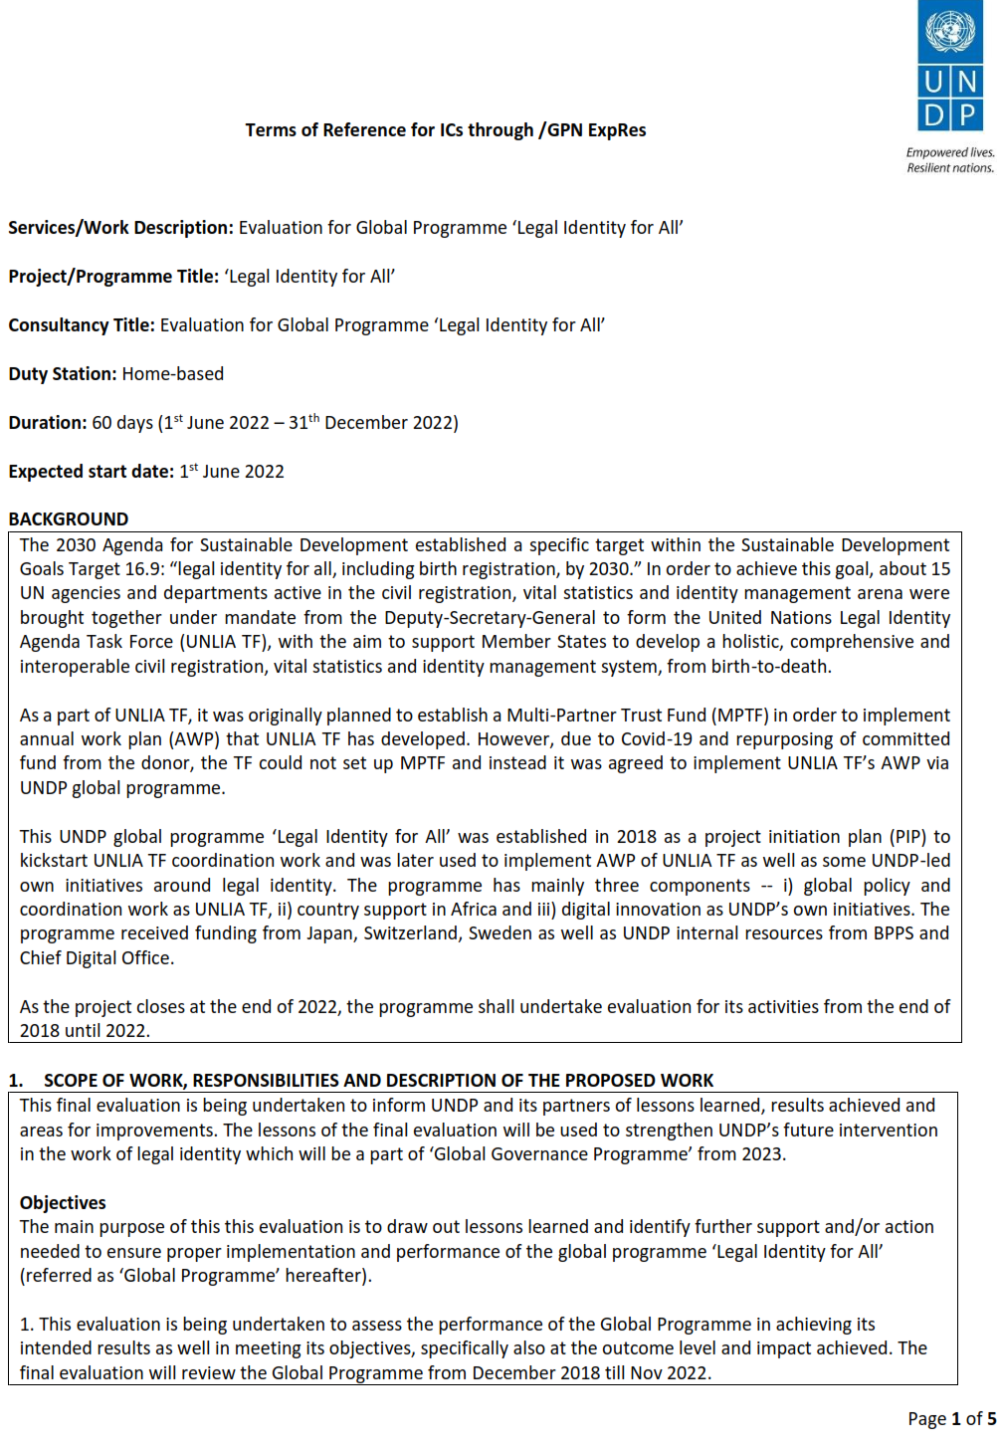

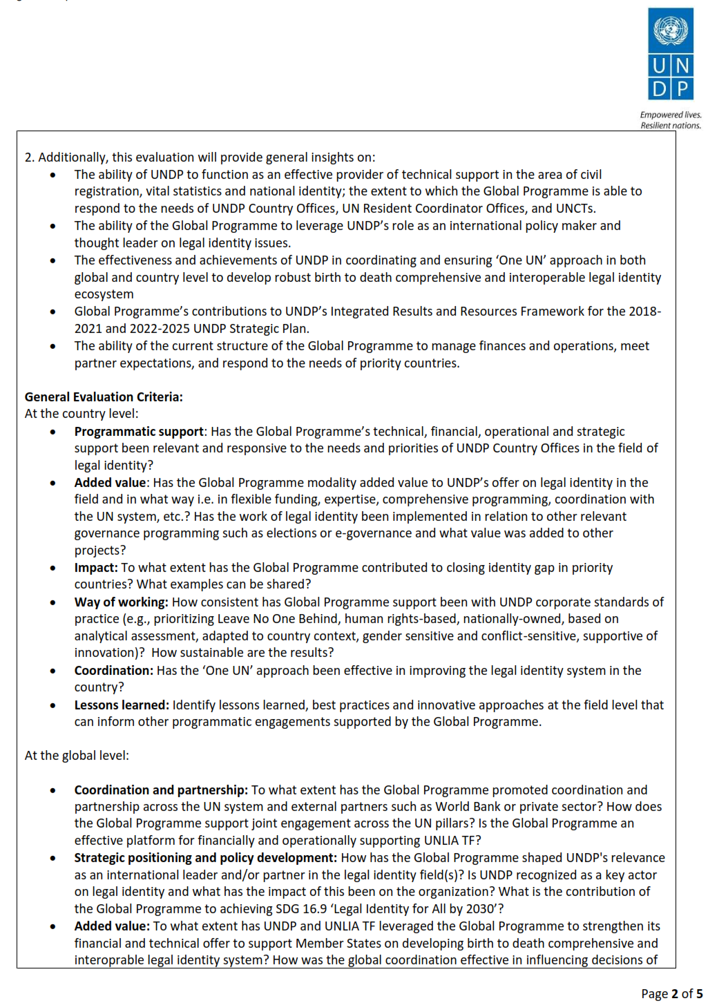

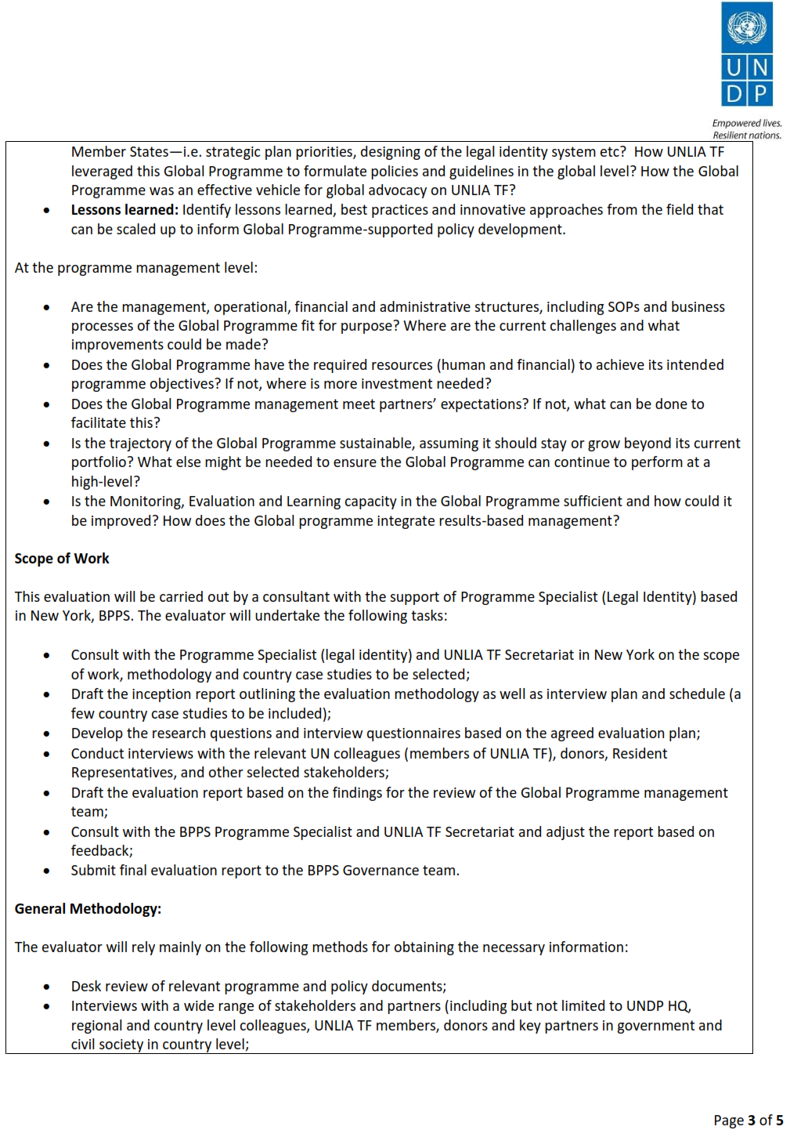

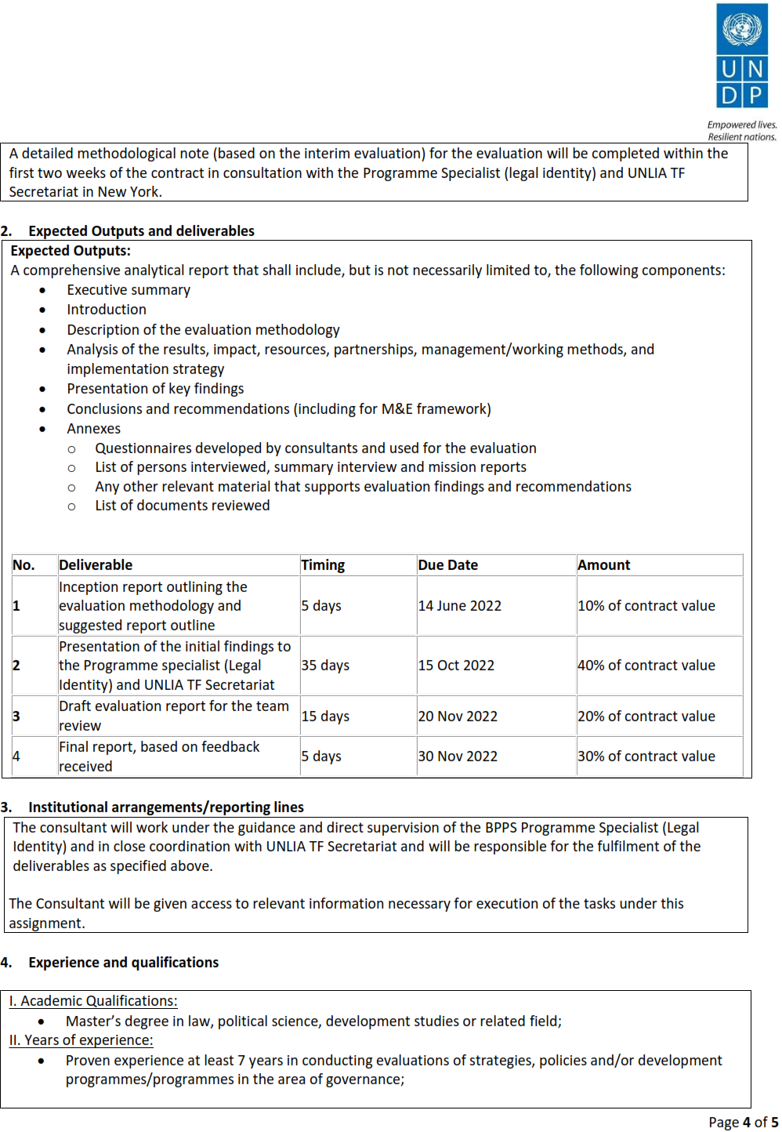

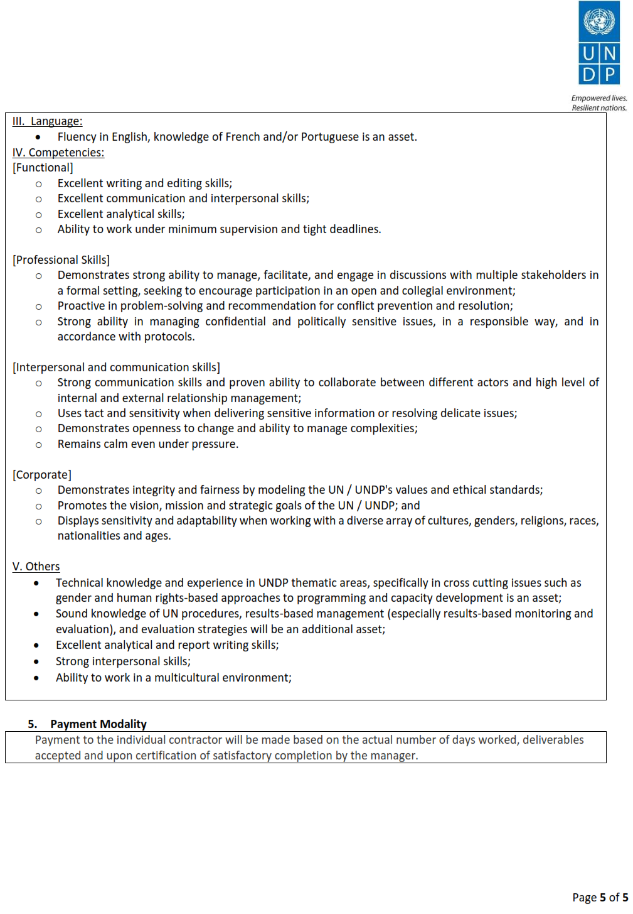

1. After the first round of ‘call for proposal’ to 10 countries, rapid assessment missions were conducted in 3 remaining pilot countries.
2. Project Implementation Plan, p. 2.
3. UNDP Strategic Plan.
4. Project Implementation Plan, p. 2.
5. *What Does It Mean to Leave No One Behind?,* UNDP, July 2018, p. 3.
6. See: <https://unstats.un.org/legal-identity-agenda/publications/>.
7. “The project will be managed from UNDP-BPPS, with support of RBA (especially procurement support unit) and the UNLIATF.” Project Document, P. 19.
8. Project Implementation Plan, p 1.
9. Available at <https://stories.undp.org/finally-i-exist>.
10. <https://sdgs.un.org/goals/goal16>.
11. <http://web.undp.org/evaluation/guideline/documents/PDF/UNDP_Evaluation_Guidelines.pdf>.
12. UNDP’s quality standards for programming are strategic, relevant, principled, management and monitoring, efficient, effective, sustainability and national ownership. *Ibid.,* Section 4.3.1.