|  |  |  |
| --- | --- | --- |
|  | New Image-UNDP-logo.JPG |  |

Government of Japan

Implementing Partner:

UNDP Pacific Office in Fiji

**Terminal Evaluation of UNDP Project:** **Enhancing Disaster and Climate Resilience in Palau through improved Disaster Preparedness and Infrastructure (EDCR Project)**

(Project#: 00115303)

**Final Report**

***Mission Members:***

Mr. Roland Wong, International Evaluator

Ms. Cheryl-Ann Udui, National Evaluator

February 2023

# synopsis

**Title of UNDP project:** Enhancing Disaster and Climate Resilience in Palau through improved Disaster Preparedness and Infrastructure (EDCR Project)

**Award ID:** 00118499

**Project #:** 00115303

**Evaluation time frame:** April 2019 to 31 August 2022

**Project implementation start date**: 1 April 2019

**Project end date**: 31 March 2023

**Date of evaluation report:** 31 January 2023

**Region and Countries included in the project:** Palau

**Implementing partner:** UNDP Pacific Office in Fiji

**Evaluation team members:** Mr. Roland Wong, International Evaluator

Ms. Cheryl-Ann Udui, National Evaluator

**Acknowledgements**:

The Evaluators wish to acknowledge with gratitude the time and effort expended by all project participants and stakeholders during the course of the EDCR Terminal Evaluation. In particular, gratitude is extended to the UNDP Pacifici Office in Fiji and the EDCR PMU Team based in Palau. The Evaluators sincerely appreciates the interactions with all of you, and sincerely hopes that this report contributes towards a safer and more climate resilient Palau.

# abbreviations

| **Acronym** | | **Meaning** |
| --- | --- | --- |
| AM | Amplitude modulation | |
| APR | Annual Progress Report | |
| AWS | Automated weather stations | |
| BADG | Bureau of Aging, Disability and Gender | |
| CCA | Climate change adaptation | |
| CCM | Climate change mitigation | |
| CDR | Combined Delivery Report | |
| CO | Country Office | |
| DART | Deep ocean assessment and reporting of tsunamis | |
| DEM | High Resolution Digital Elevation Models | |
| DIM | Direct Implementation Modality | |
| DRF | Disaster Recovery Training | |
| DRM | Disaster Risk Management | |
| DRR | Disaster Risk Reduction | |
| DSA | Daily Subsistence Allowance | |
| EDCR | The UNDP Project “Enhancing Disaster and Climate Resilience in the Republic of Palau through Improved Disaster Preparedness and Infrastructure” | |
| FSM | Federated Staes of Micronesia | |
| GBV | Gender-based violence | |
| GDP | Gross domestic product | |
| GEF | Global Environment Facility | |
| GESI | Gender Equality and Social Inclusion | |
| GHG | Greenhouse gas | |
| GIS | Geographic Information System | |
| GPS | Global positioning system | |
| GRoP | Government of the Republic of Palau | |
| HACT | Harmonized Approach to Cash Transfers | |
| HF | High frequencies for radios | |
| ICT | Information and Communications Technology | |
| IFRC | International Federation of Red Cross and Red Crescent Societies | |
| LIDAR | Light Detection And Ranging | |
| LPAC | Local project appraisal committee | |
| M&E | Monitoring and Evaluation | |
| MoE | Ministry of Education | |
| MPR | Monthly progress report | |
| NDC | Nationally Determined Contributions | |
| NDMO | National Disaster Management Office | |
| NDRMF | National Disaster Risk Management Framework | |
| NEC | National Emergency Committee | |
| NEMO | National Emergency Management Office | |
| NEOC | National Emergency Operations Centre | |
| NGO | Non-Government Organization | |
| NIM | National Implementation Modality | |
| NIWA | National Institute of Water and Atmospheric Research | |
| NWSO | National Weather Service Offic | |
| PacIOOS | Pacific Islands Ocean Observing System | |
| PALARIS | Office of the Palau Automated Land and Resource Information System | |
| PCC | Palau Community College | |
| PCCP | Palau Climate Change Policy for Climate and Disaster Resilient Low Emissions Development 2015 | |
| PDNA | Post Disaster Needs Assessments | |
| PEA | Palau Energy Authority | |
| PIF | Project Identification Form | |
| PM | Project Manager | |
| PMU | Project Management Unit | |
| PNCC | Palau National Communication Corporation | |
| POPP | Program and Operations Policies and Procedures | |
| ProDoc | UNDP Project Document | |
| PV | Photovoltaic | |
| QPR | Quarterly progress reports | |
| RESPAC | UNDP project “Disaster Resilience for Pacific Small Island Developing States” | |
| RF | Results Framework | |
| RMI | Republic of the Marshall Islands | |
| SDG | Sustainable Development Goal | |
| SESP | Social and Environmental Screening Procedure | |
| SMART | Specific, Measurable, Attainable, Relevant and Time-bound | |
| SPC | The Pacific Community (formerly known as South Pacific Commission) | |
| SUV | Sports utility vehicle | |
| SW | Southwest | |
| TE | Terminal Evaluation | |
| ToC | Theory of Change | |
| ToR | Terms of Reference | |
| UNDAF | United Nations Development Assistance Framework | |
| UNDP | United Nations Development Programme | |
| UNEP | United Nations Environmental Programme | |
| VHF | Lower frequencies for radios | |
| WMO | World Meteorological Organization | |

TABLE OF CONTENTS

Page

synopsis ii

abbreviations iii

Executive Summary iii

1. introduction 1

1.1 Evaluation Purpose 1

1.2 Approach and Scope 1

1.3 Methodology 2

1.4 Structure of the Evaluation 3

1.5 Data Collection and Analysis 4

1.6 Ethics 5

1.7 Limitations 5

2. Project description and development context 6

2.1 Project Start and Duration 6

2.2 Development Context 6

2.3 Problems that the EDCR Project sought to address 6

2.4 Development Objective of EDCR Project 7

2.5 Description of the Project’s Theory of Change 7

2.6 Expected Results 8

2.7 Total Resources for EDCR Project 8

2.8 Key Partners involved with the EDCR Project 8

2.9 Context of other ongoing and previous evaluations 8

3. Findings 10

3.1 Project Design and Formulation 10

3.1.1 Analysis of Results Framework for EDCR Project 10

3.1.2 Assumptions and Risks 10

3.1.3 Lessons from Other Relevant Projects Incorporated into EDCR Project Design 10

3.1.4 Planned Stakeholder Participation 10

3.1.5 Linkages between the EDCR Project and other interventions in the sector 11

3.1.6 Gender responsiveness of Project design 11

3.1.7 Social and Environmental Safeguards 12

3.2 Project Implementation 12

3.2.1 Adaptive Management 12

3.2.2 Actual Stakeholder Participation Partnership Arrangements 14

3.2.3 Project Finance 14

3.2.4 Monitoring and Evaluation (M&E) Design at Entry and Implementation 16

3.2.5 Performance of Implementing Agency 16

3.3 Project Results and Impacts 16

3.3.1 Progress of planned activities towards intended outcomes 17

3.3.2 Progress towards Output 1: Strengthened Disaster Communication and Climate and Tsunami Monitoring Systems 17

3.3.3 Progress towards Output 2: Enhanced National and State Disaster Preparedness capacity & better resourced to minimize loss of lives and damages 24

3.3.4 Progress towards Output 3: Enhanced community disaster and climate resilience through improved water and food resource management, inclusive livelihood diversification 27

3.3.5 Relevance 30

3.3.6 Effectiveness 30

3.3.7 Efficiency 31

3.3.8 Mainstreaming 31

3.3.9 Overall Project Outcome 31

3.3.10 Sustainability of Project Outcomes 31

3.3.11 Country Ownership 32

3.3.12 Gender equality and women’s empowerment 32

3.3.13 Cross cutting issues 34

3.3.14 Catalytic/Replication Effect 34

3.3.15 Progress to impact 34

4. main conclusions, recommendations and lessons 36

4.1 Conclusions 36

4.2 Recommendations 36

4.3 Lessons learned 37

Appendix A - Mission Terms of Reference for EDCR Project terminal Evaluation 39

Appendix B - Mission Itinerary (for September-october 2022) 44

Appendix C - List of Persons contacted 45

Appendix D - List of documents reviewed 46

Appendix E – general questionnaire provided to stakeholders 47

Appendix F – results framework for EDCR Project (up to April 2020) 49

APPENDIX G – evaluation matrix 52

APPENDIX H – audit trail (based responses to comments received on draft te report) 55

APPENDIX I - evaluation consultant agreement form 57

# Executive Summary

1. This report summarizes the findings of the Terminal Evaluation (TE) conducted during the August-September 2022 period for the UNDP project: “*Enhancing Disaster and Climate Resilience in the Republic of Palau through Improved Disaster Preparedness and Infrastructure*” (hereby referred to as EDCR, the EDCR Project or the Project). This TE was prepared to provide a comprehensive and systematic account of the performance of the completed project by evaluating its design, process of implementation and achievements vis-à-vis its objectives, and any agreed changes during implementation of the EDCR Project. It also evaluates the Project’s relevance, effectiveness, efficiency, sustainability, country ownership, gender equality, and cross cutting issues.

1. Key issues addressed on this TE include:

* that the TE is independent of EDCR Project management to ensure independent quality assurance;
* the application of UNDP norms and standards for evaluations;
* assessment of achievements of outputs, likelihood of the sustainability of outputs, and if the Project met the minimum M&E requirements; and
* reporting basic data of the evaluation and the Project, as well as provide lessons from the Project on broader applicability.

1. Key strategic issues addressed on this TE include:

* effectiveness of mechanisms used to trigger 5 multi-hazard warning siren systems in two states (Airai and Koror) for disaster communications by national disaster responders (i.e. Emergency Operational Centre and the National Emergency Committee) that affects 80% of the population;
* the effectiveness of training for policies and practices of disaster risk management including training for Post Disaster Needs Assessments; and
* the capacities of National Emergency Management Office (NEMO), National Weather Service Office (NWSO), and others to assess and support evacuation and humanitarian assistance in case of disasters.

1. Data and information for this TE was sourced from:

* a review of Project documentation including quarterly progress reports to establish information pertaining to Palau’s perceptions of capacity building activities of the Project;
* interviewing selected stakeholders including the team members and technical advisors to triangulate information on key issues in capacity building to the EDCR Project team. With the International Evaluator unable to travel to Palau due to the COVID-19 pandemic, information on the Evaluation was collected on interviews conducted by the National Evaluator on the Zoom platform with involvement on some of the interviews by the International Evaluator;
* Project evaluation was based on evaluability analysis consisting of formal (clear outputs, indicators, baselines, data) and substantive (identification of problem addressed, theory of change, results framework) inputs.

**Project Summary Table**

| Project Details |  | Project Milestones |  |
| --- | --- | --- | --- |
| Project Title | Enhancing Disaster and Climate Resilience in the Republic of Palau through Improved Disaster Preparedness and Infrastructure (EDCR Project) | PIF Approval Date: | n/a |
| Award ID: | 00118499 | Project ID: | 00115303 |
| Country/Countries: | Palau | Date Project Manager hired: | April 2019 |
| Region: | PAC | Mid-Term Review Completion Date: | n/a |
| Focal Area: | Climate Change | Terminal Evaluation Completion date: | 31 January 2023 |
| Planned Operational Closure Date: | 31 March 2023 | | |
| Implementing Partner: | UNDP Pacific Office in Fiji | | |
| Responsible Parties: | Palau National Communication Corporation (PNCC) (Activity 1.1/1.2/2.1)  National Weather Service Office (NWSO) (Activity 1.3/1.4)  Bureau of Public Works (Activity 2.2)  Bureau of Cultural and Historical Preservation (Activity 3.2) | | |
| Private sector involvement: | N/A | | |

| Financial Information | | |
| --- | --- | --- |
| **Project** | **At Approval (US$)** | **At TE to 31 October 2022 (US$)** |
| [1] UNDP contribution: | **0** | **0** |
| [2] Government of Japan: | **7,500,000** | **7,109,802** |
| [3] Other multi-/bi-laterals: | **0** | **0** |
| [4] Private Sector: | **0** | **0** |
| [5] NGOs: | **0** | **0** |
| [7] Total Project funding: | **7,500,000** | **7,109,802** |

**Project Description**

1. Palau experiences frequent natural disasters which result in human casualties. While not all disasters are due to climate change, extreme weather events are more likely in the future, heightening the country’s vulnerability to climate change. With tourism being the main economic driver, external shocks due to natural disasters slow down and even halt progressive development of the country. Palau’s tourism sector also suffered from urgent challenges in 2018 such as suspension of flights from Japan, restrictions imposed on Chinese tourists and the suspension of the operations of Palau Pacific Airways, all exacerbated by the COVID-19 pandemic.
2. The EDCR Project aims to improve the capacity for preparedness and mitigation of Palau’s resilience to different types of related hazards and enhancing resilience to climate change impacts. The Project is supposed to respond to Outcome 1 of the UN Pacific Strategy 2018 – 2022: “By 2022, people and ecosystems in the Pacific are more resilient to the impacts of climate change, climate variability and disasters; and environmental protection is strengthened”. This cooperation with the Government of Japan has contributed to achieving the goals of the Sendai Framework for Disaster Risk Reduction, elimination of threat to human security and protect gains of sustainable development and inclusive of the Sustainable Development Goals. The EDCR Project is consistent with the 2020 Palau National Master Development Plan priority of mainstreaming disaster risk reduction and aligned with the National Disaster Risk Management Framework (NDRMF) vision of “safe, resilient and prepared communities in Palau.
3. Concerted efforts have been devoted to responding to urgent and unpredicted needs arising out of slow and sudden onset of natural hazards impacting livelihoods, economy, and persistent inequalities. Under a Direct Implementation Modality (DIM), the implementing agency for the EDCR Project is the UNDP. The Project was to achieve Outcome 1 of the UN Pacific Strategy 2018-2022 through 3 expected outputs:

* Output 1: Strengthened gender sensitive Disaster Communication and Climate Monitoring Systems;
* Output 2: Enhanced gender sensitive National and State Disaster Responders readiness capacity; and
* Output 3: Enhanced Community Disaster Resilience through improved water resource management, and integrated gender and social inclusion awareness).

**Project Results**

1. Main highlights of the efforts as of December 2022 are portrayed on Table A.

**Table A: Comparison of Intended Project Outputs from the ProDoc to Actual Outputs**

| **Intended Outputs in Results Framework of April 2019**  **(see Appendix E)** | **Actual Outcomes as of December 2022** |
| --- | --- |
| **Output 1:** Strengthened disaster communication and climate and tsunami monitoring systems | **Actual Output 1**: With the installation of VHF and HF radios, automated weather stations, and an AM Tower broadcasting system, disaster communication and climate and tsunami monitoring systems have been strengthened covering the entire Palauan population (Paras 51 to 61). |
| **Output 2:** Enhanced national and state disaster preparedness capacity. | **Actual Output 2**: With training to staff and members of the Emergency Operational Centre and National Emergency Committee on information management and coordination, and installed emergency storage facilities, National and State disaster preparedness capacity has been enhanced and better resourced to minimise loss of lives and damages (Paras 62-71). |
| **Output 3:** Enhanced community disaster and climate resilience through improved water and food resource management, inclusive livelihood diversification | **Actual Output 3**: With the installation of renewable energy services within 3 Southwestern islands for access to educational/evacuation facilities, and training in food preservation, Gender Equality and Social Inclusion (GESI) in disaster risk management (DRM), community resilience to disasters and climate change has been enhanced (Paras 72-80). |

**Summary of Conclusions, Recommendations and Lessons**

1. With no dedicated financing available for responses to man-made, geo-physical, and climate hazards, there was a need for strengthened resilience in Palau to immediate disaster response, early recovery and reconstruction. In 2022, the EDCR Project has managed to revitalize communications systems, vastly improve disaster preparedness, and improve school shelters for Palauans to safely evacuate during extreme climate emergencies and disasters. With the improved equipment and infrastructure to support evacuations during extreme climate emergencies and disasters, Palauan government personnel and responsible stakeholders will be able to coordinate all residents of Palau with information necessary for the safety and security of Palauan residents, laying a strong foundation for a climate resilient and disaster response system that could save lives.
2. Though disaster and climate resilience infrastructure and equipment is a long-term fix for DRR and CCA, the Project has catalyzed stakeholder interest in additional tsunami and multi-hazard warning sirens, automated weather stations for other areas of Palau, and additional solar PV systems for other schools and government buildings to serve as emergency backup power. This comes with the backdrop of stakeholders effectively working together across institutions and organizations that reaches all Palauans. This sets a solid basis for further and effective training in combination with the installation of new infrastructure such solar systems for schools and government buildings. Project ratings are provided in Table B.

**Table B: Evaluation Ratings Table**

|  |  |
| --- | --- |
| 1. Monitoring & Evaluation (M&E) | Rating**[1]** |
| M&E design at entry | **5** |
| M&E Plan Implementation | **5** |
| Overall Quality of M&E | **5** |
| 2. Implementing Agency (IA) Implementation & Executing Agency (EA) Execution |  |
| Quality of UNDP Implementation/Oversight | **5** |
| Quality of Implementing Partner Execution | **n/a** |
| Overall quality of Implementation/Execution | **5** |
| 3. Assessment of Outcomes |  |
| Relevance | **2[2]** |
| Effectiveness | **5** |
| Efficiency | **5** |
| Overall Project Outcome Rating | **5** |
| 4. Sustainability | Rating[3] |
| Financial sustainability | **3** |
| Socio-political sustainability | **3** |
| Institutional framework and governance sustainability | **3** |
| Environmental sustainability | **3** |
| Overall Likelihood of Sustainability | **3** |

1. *Recommendation 1 (to the Government of Palau and UNDP): Provide more training for state staff on how to provide stronger Project oversight (see Para 102)*.
2. *Recommendation 2 (to the Government of Palau): Conduct join quarterly trips to the SW islands to provide general support and rotating alternate staff allowing them to assess different areas (see Para 103)*.
3. *Recommendation 3 (to the Government of Palau): Address the lack of internet connection at some schools in remote areas* (see Para 104).
4. *Recommendation 4 (to the Government of Palau): Sustain and raise community awareness and participation in climate resilience and disaster management (see Para 105).*
5. *Recommendation 5 (to the Government of Palau): Focus more on climate resilience and disaster management for vulnerable populations (see Para 106).*
6. *Lesson #1: Project preparations should be more than 12 months duration* (see Para 107).
7. *Lesson #2: In small countries where expertise is limited, pooling experts to undertake certain tasks should generally yield positive results (see Para 108).*
8. *Lesson #3: Mapping of preferred or existing suppliers and internal arrangements can still be made based on best practices consistent with UNDP Procurement guidelines (see Para 109).*
9. *Lesson #4: There is a need to ensure at least 3-4 personnel from the relevant government line Ministries are part of the project design, conceptualization, and implementation (see Para 110).*
10. *Lesson #5: For pandemic planning, ensure that a project has a contingency plan that outlines different activities that may be impacted in delivery time by flight restrictions and social distancing (see Para 111).*
11. *Lesson #6: Installation work for solar systems in schools worked very well with strong partnership with various counterparts (Para 112).*

# introduction

1. The Terminal Evaluation (TE) for the Project entitled “*Enhancing Disaster and Climate Resilience in the Republic of Palau through Improved Disaster Preparedness and Infrastructure*”, otherwise referred to as “EDCR”, “the EDCR Project” or “the Project”, was conducted for the UNDP Pacific Office in Fiji as an impartial assessment of EDCR activities, mainly comprised of capacity building, technical assistance and investment facilitative activities.

## Evaluation Purpose

1. In accordance with UNDP M&E policies and procedures, all UNDP supported projects are required to undergo a TE upon completion of implementation of a project to *provide a comprehensive and systematic account of the performance of the completed project by evaluating its design, process of implementation and achievements vis-à-vis its objectives, and any agreed changes during project implementation.* As such, the TE for the EDCR Project serves to:

* promote accountability and transparency, and to assess and disclose levels of accomplishments of the Project in the context of providing technical assistance to the Government of Palau to to achieve Outcome 1 of the UN Pacific Strategy 2018-2022: “By 2022, people and ecosystems in the Pacific are more resilient to the impacts of climate change, climate variability and disasters; and environmental protection is strengthened”;
* evaluate the Project’s outputs against the Results Framework (RF) in the Project Document signed on 31 March 2019;
* synthesize lessons that may help improve the selection, design, and implementation of future activities in this sector;
* provide feedback on issues that are recurrent across the disaster management and climate change portfolio in Palau that require attention; and
* contribute to the UNDP Evaluation Office databases for aggregation, analysis and reporting on effectiveness of UNDP operations in achieving global environmental benefits and on the quality of monitoring and evaluation across the UNDP system.

## Approach and Scope

1. The TE approach is to ensure that the evaluation serves as an important learning and accountability tool, providing the Government of Palau, UNDP, and its national stakeholders and partners with an impartial assessment of the results and outcomes achieved by the Project. As such, the scope of this TE was to evaluate all activities funded by the Government of Japan. The Terms of Reference (ToRs) for the TE are contained in Appendix A. The UNDP Evaluation process is illustrated on Figure 1. Key issues addressed on this TE include:

* that the TE is independent of EDCR Project management to ensure independent quality assurance;
* the application of UNDP norms and standards for evaluations[4];

**Figure 1: UNDP Evaluation Process**

* assessment of achievements of outputs and outcomes, likelihood of the sustainability of outcomes, and if the Project met the minimum M&E requirements; and
* reporting basic data of this TE and the Project to provide lessons from the Project on broader applicability. This would include an outlook and guidance in charting future directions by UNDP and their future support for a possible follow-up phase to the EDCR Project.

1. With this scope, the entire country of Palau and its population is covered under this TE. The following issues were identified for further discussion:

* the role of EDCR in adaptively managing the Project;
* the role of EDCR on conducting awareness raising workshops and training for the general population where there was a lot of effort;
* the role of the various Bureaus in EDCR initiatives;
* the financial position of the Project and what has been achieved;
* the work being done by EDCR to institutionalize monitoring and evaluation of an EDCR benchmarking system;
* an assessment of EDCR Project management, monitoring and evaluation and stakeholder outreach to be discussed with the Project Management Unit (PMU).

## Methodology

1. The methodology of this TE assesses the Project’s performance from April 2019 to December 2022 in addressing the capacity gaps in managing EDCR affairs, through the lens of UNDP evaluation criteria of **relevance, effectiveness, efficiency, sustainability**, **impact** and **cross-cutting issues** for 3 expected outputs that were achieved through activities contained within the EDCR Project:

* *Relevance* – the extent to which the outcome and outputs are suited to local and national development priorities and organizational policies, including changes over time;
* *Effectiveness* – the extent to which an outcome and outputs were achieved or how likely it is to be achieved. This would include the effectiveness of the EDCR Project to assist implementation and facilitate capacity building (through technical assistance of the Project), and the quality of EDCR Project management (including M&E performance);
* *Efficiency* – the extent to which results were delivered with the least costly resources possible. This would include the pace of capacity building based on the baseline capacities of the institutions and potential beneficiaries;
* *Sustainability* - the likely ability of an intervention to continue to deliver benefits for an extended period of time after completion. This would include the sustained acceptance of EDCR methodologies for capacity building at the national level; and
* *Impact* – the positive and negative, foreseen and unforeseen changes to and effects produced by a development intervention. This may include the extent of uptake by the national implementation team to the EDCR Project, and their resulting ability to confidently manage disaster preparedness and climate resilience solutions;
* *Cross cutting issues* – the contributions of the Project to gender equality, disability, vulnerability, and social inclusion. This would include the use of disaggregated data and analysis methods that integrate gender considerations, and outreach to diverse stakeholder groups to empower women and strive towards gender balance both within the Project itself and further afield.

1. The TE is supposed to achieve the assessment of Project performance by:

* collecting credible, useful, and evidence-based information of the Project;
* interviewing selected stakeholders to triangulate information to bring up key issues in capacity building and investments to the EDCR Project team; and
* bringing up these key issues in strengthening capacity building within the EDCR team and its stakeholders.

The terminal evaluation of the Project is based on evaluability analysis consisting of formal (clear outputs, indicators, baselines, data) and substantive (identification of problem addressed, theory of change, results framework) inputs. Considering the information to be provided into this TE (which is mainly whether or not the technical assistance of the Project was effective to the Government of Palau and its stakeholders), the implication of the proposed evaluation methodology is that it should be effective in the evaluation process, and should inform stakeholders and the EDCR Project team as it possibly transitions into a second phase.

1. This TE also evaluates the progress and quality of implementation against the indicators of the outcome and output in the RF as provided in Appendix F. The TE process was conducted in a spirit of collaboration with EDCR Project personnel with the intention of providing constructive inputs that can inform activities of a potential follow-up phase and future programming**.**

## Structure of the Evaluation

1. This evaluation report is presented as follows:

* An overview of Project activities from commencement of operations in April 2019 to October 2022 activities of the EDCR Project;
* A review of all relevant sources of information including the Project Document, project progress reports, and any other materials that the team considers useful for this evidence-based evaluation;
* A participatory and consultative approach to ensure close engagement with the Project Team, government counterparts, implementing partners, the UNDP Pacific Office in Fiji (CO), and other stakeholders. Stakeholder involvement includes interviews with stakeholders (with a target of at least 50% women) who have Project responsibilities;
* An assessment of results based on Project objectives and outcomes through relevance, effectiveness, and efficiency criteria;
* Assessment of sustainability of Project outcomes;
* Assessment of monitoring and evaluation systems;
* Assessment of progress that affected Project outcomes and sustainability; and
* Conclusions, recommendations and lessons learned.

1. Though the EDCR Project is not a GEF-financed project, the EDCR Terminal Evaluation report has been designed to meet UNDP-GEF’s “Guidelines for Conducting Terminal Evaluations of UNDP-Supported, GEF Financed Projects” of 2020[5] in the absence of specific guidelines for UNDP projects financed by other sources. The TE also abides by UNDP guidelines “Evaluation during COVID-19” (updated to June 2021)[6].

## Data Collection and Analysis

1. Different key Project personnel who were consulted about the Project included:

* The Project Management team. This involved interviews with the EDCR’s PMU that included the UNDP Project Manager, the Procurement Associate, UNDP Country Project Coordinator, the UNDP Finance/Admin Officer, and UNDP Logistics and Procurement Officer. The purpose of contact with the PMU were the “rich” issues of implementation and execution;
* Project partners. This involved the Second Secretary of the Embassy of Japan in Palau;
* Beneficiaries. This involved ministries and public agencies responsible for Project activities. This involved Government personnel who were beneficiaries of EDCR (Minister of Justice, Minister of Public Infrastructure, Industries & Commerce, Office of the Vice President, National Emergency Management Office (NEMO), National Weather Service Office (NWSO)).

Appendix C presents a summary of persons consulted during the EDCR TE.

1. Data and information for this TE was sourced from:

* Project documentation including annual progress reports (APRs), quarterly progress reports (QPRs) and monthly progress reports (MPRs). This was important in establishing information pertaining to Palau’s perceptions of capacity building activities of the Project. This was done at the home bases of the International Evaluator and the National Evaluator. A full listing of data and information sources is provided in Appendix D;
* detailed responses to questionnaires which were provided to stakeholders listed in Para 10. Some of the respondents did not have a follow-up interview with the National Evaluator. Questionnaires provided to stakeholders are provided in Appendix E;
* follow-up interviews with respondents including the key stakeholders listed in Para 10 of Project personnel, technical advisors, consultants, and equipment installers and suppliers. Discussions were undertaken by e-mail and Zoom calls from the home bases of the National and International Evaluator. A listing of activities for stakeholder contact for the TE is provided in Appendix B.

## Ethics

1. This Terminal Evaluation has been undertaken as an independent, impartial, and rigorous process, with personal and professional integrity and is conducted in accordance with the principles outlined in the UNEG Ethical Guidelines for Evaluations, and the UNDP M&E policies, specifically the August 2020 UNDP “Guidance for Conducting Terminal Evaluations of UNDP-supported, GEF-financed Projects”.

## Limitations

1. There were limitations to this TE process, mainly due to the COVID-19 pandemic and the inability of the International Evaluator to travel to Palau to conduct face-to-face meetings with stakeholders and the PMU. This was a lost opportunity for the International Evaluator to get to know the stakeholders better. Actual visits to the offices of the stakeholders and the PMU by the International Evaluator are usually an opportunity for the stakeholders and the PMU to make a 2–3-hour presentations followed by a question-and-answer period. This has many intangible benefits including the collection of information not documented. With the virtual visits on Zoom, the opportunity to make these 2–3-hour presentations and conduct a question-and-answer period was limited. This limitation to the International Evaluator was somewhat mitigated by the presence of the National Evaluator who was able to visit and have discussion with many of the stakeholders.

# Project description and development context

## Project Start and Duration

1. The EDCR Project commenced in April 2019. The Project was being implemented by UNDP up to the time of writing of this report (as of January 2023). The Project is closed as of March 2023.

## Development Context

1. Palau experiences frequent natural disasters which result in human casualties. While not all disasters are due to climate change, extreme weather events are more likely to be more frequent in the future, heightening the country’s vulnerability to climate change. With tourism being the main economic driver, external shocks due to natural disasters slow down and even halt progressive development of the country. There have been three states of emergency related to natural hazards declared since 2012:

* in 2012, Typhoon Bopha caused about US$6.3 million in initial damages (2.9% of GDP);
* in 2013, initial damage from Typhoon Haiyan was estimated to be US$8.5 million (3.7% of GDP);
* in 2016, severe drought associated with El Niño weather conditions led to water shortages across Palau and generated significant sanitation and hygiene risks. The drought also led to closure of Jellyfish Lake, a major tourist attraction. GDP growth fell to 0.5% in 2017 as tourist arrivals declined.

Palau’s tourism sector also suffered from challenges in 2018 such as suspension of flights from Japan, restrictions imposed on Chinese tourists and the suspension of the operations of Palau Pacific Airways, and in 2020 with COVID-19 pandemic restrictions closing off the country to foreign visitors.

1. Given the cessation of the Compacts of Free Association with the United States in 2024[7], the narrow economic base and resilience development is viewed as the panacea for Palau’s development agenda. Hardship is persistent in Palau, especially for disadvantaged groups in rural areas, fast-growing urban settlements, and the outer islands. The smallness, remoteness, geographic dispersion, significant exposure of the islands in Palau to climate change and natural hazards, and the narrow economic base magnify the effects of economic shocks. GDP growth is generally low and volatile.
2. In 2019, there was also inadequate community-based planning and preparedness (including coping mechanisms, public awareness, and emergency response capacity) that has affected disaster response and recovery. This has been due to the lack of attention with competing priorities exposing weaknesses for disaster response, and exacerbating the indirect economic and social costs when disasters occur; hence, the critical need for Disaster Risk Reduction (DRR).

## Problems that the EDCR Project sought to address

1. The EDCR Project seeks to strengthen resilience in Palau to man-made, geo-physical, climate and different types of related hazards. With no dedicated financing available for immediate disaster response, early recovery and reconstruction, there was a reliance on reallocation of internal revenues and drawdown from the permanent General Fund Reserve, a continency allocation within the Palau Budgetary system. This was due to much of the funding needs always being met by the United States under the Compact Agreement tied solely for development purposes. With the end of the Compact Agreement in 2024, there was a need for UNDP to seek multilateral development assistance on Palau’s behalf for disaster risk management (DRM) and climate change adaptation (CCA).

## Development Objective of EDCR Project

1. The EDCR Project aims to improve Palau’s resilience to man-made, geo-physical and climate-related hazards in cooperation with and funding from the Government of Japan. The Project is supposed to respond to needs for improved responses to DRM and CCA by addressing Outcome 1 of the UN Pacific Strategy 2018-2022: “By 2022, people and ecosystems in the Pacific are more resilient to the impacts of climate change, climate variability and disasters; and environmental protection is strengthened”. The Project is also contributing to achieving the goals of the Sendai Framework for Disaster Risk Reduction to “eliminate the threat to human security, and to protect gains of sustainable development of the Sustainable Development Goals (SDGs)”. The EDCR Project is also consistent with the 2020 Palau National Master Development Plan’s priority of mainstreaming disaster risk reduction and aligned with the National Disaster Risk Management Framework (NDRMF) vision of “safe, resilient and prepared communities in Palau”.

## Description of the Project’s Theory of Change

1. A Theory of Change (ToC) was provided for this Project as shown on Figure 2.

**Figure 2: Theory of Change**

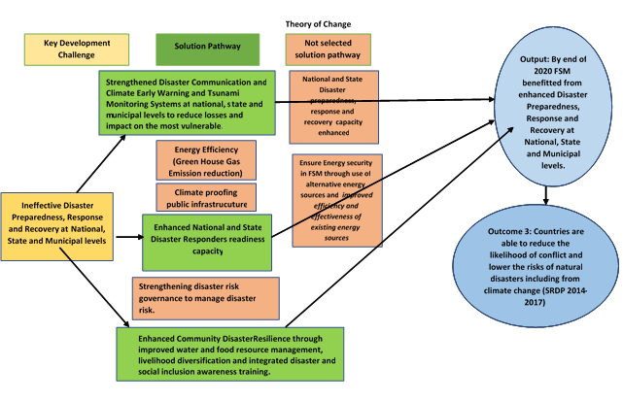

## Expected Results

1. Concerted efforts have been devoted to responding to urgent and unpredicted needs arising out of slow and sudden onset of natural hazards impacting livelihoods and the economy, and persistent inequalities. Under Direct Implementation Modality (DIM), the implementing agency for the EDCR Project was UNDP. Outcome 1 of the UN Pacific Strategy 2018-2022 was to be achieved through 3 expected outputs:

* Output 1: Strengthened Disaster Communication and Climate Monitoring Systems;
* Output 2: Enhanced National and State Disaster Responders readiness capacity; and
* Output 3: Enhanced Community Disaster Resilience through improved water resource management, and integrated gender and social inclusion awareness.

## Total Resources for EDCR Project

1. The total resources allocated to this Project at time of the original ProDoc signature is provided in Table 1. The actual budget for the Project as per received funds is US$ 7,500,000.

**Table 1: Total Resources for EDCR Project**

|  |  |
| --- | --- |
| **Component** | **Resources from Government of Japan (US$)** |
| Output 1 | $2,373,333 |
| Output 2 | $2,285,001 |
| Output 3 | $2,012,732 |
| Staff in Country and in Pac Office Suva | $148,667 |
| Communication & Visibility | $ 40,000 |
| Evaluation | $ 15,000 |
| Audit | $ 3,000 |
| M&E | $ 66,711 |
| General Management Support (8%) | $555,556 |
| Total | **$7,500,000** |

## Key Partners involved with the EDCR Project

1. Key partners on the EDCR Project are listed in Table 2. More details on these stakeholders are provided in Sections 3.1.4. and 3.2.2.

## Context of other ongoing and previous evaluations

1. There are no other ongoing or previous evaluations of the EDCR Project.

**Table 2: Main Stakeholders on EDCR Project**

|  |  |
| --- | --- |
| **Stakeholder Type** | **Name** |
| Government | Vice-President’s Office |
| National Emergency Management Office (NEMO) |
| Palau National Communication Corporation (PNCC) |
| National Weather Service Office (NWSO) |
| Bureau of Archives and Media |
| Palau Community College |
| Bureau of Aging, Disability and Gender (BADG) |
| Bureau of Public Works |
| Office of the Palau Automated Land and Resource Information System (PALARIS) |
| Bureau of Public Safety |
| Bureau of Cultural and Historical Preservation |
| Bureau of Archives |
| Ministry of Education |

# Findings

## Project Design and Formulation

1. From January to March 2019, the EDCR Project was prepared by UNDP through the RESPAC Project team[8], and in consultation with various stakeholders including PNCC, Bureau of Cultural and Historical Preservation, Bureau of Public Safety, Ministry of Justice, Bureau of Archives and Media, Ministry of State, Ministry of Education, but not the Bureau of Public Works. Project coordination was conducted with the Government of the Republic of Palau (GRoP) and the Embassy of Japan to Palau. The Japan Ministry of Foreign Affairs approved the EDCR Project during the 1st half of March 2019. After an e-LPAC was undertaken to get the final comments from the GRoP and UNDP, the ProDoc was signed by the GRoP on 22 April 2019.

### Analysis of Results Framework for EDCR Project

1. The Project was designed based on an RF that includes intended outputs with indicators that generally meet SMART criteria with “output targets” for each Project output. These RF indicators and their targets are listed as shown in Appendix F. The RF setup is sufficient to monitor and evaluate the Project’s activities.

### Assumptions and Risks

1. There were no assumptions or risks mentioned in the EDCR RF.

### Lessons from Other Relevant Projects Incorporated into EDCR Project Design

1. There were 16 lessons learnt from the GEF 6: Terminal Evaluation of the Sustainable Land Management project (2012) for Palau that were to be employed as a guidance tool. Issues brought to implementation of EDCR include stakeholder ownership at design phase, M&E, institutional arrangements, government protocol, fiduciary compliance (cost-sharing agreement between UNDP and IP), commitment, recruitment, and appropriate technical assistance. Otherwise, there were no lessons learned from other projects in the region.

### Planned Stakeholder Participation

1. The EDCR ProDoc does not detail planned stakeholder participation. However, the ProDoc does imply that stakeholder participation will be realized through empowering line ministries and local municipalities to foster strong working relationships with key stakeholders, to enhance resilience to climate change and disasters in ways that contribute to Palau’s sustainable development.
2. There were also plans for government stakeholders to implement the NDRMF to realize the vision of “safe, resilient and prepared communities in Palau” by (i) establishing organizational arrangements that maximize the use of available resources to strengthen mitigation, preparedness, response, and relief and recovery planning for natural hazards; (ii) promoting integrated planning and collaboration for DRM across all levels of government, departments, sectors, and communities; and (iii) integrating climate change adaptation and disaster management into national and sectoral planning and strategy.
3. Government stakeholders were also in the process of adopting the “Palau Climate Change Policy for Climate and Disaster Resilient Low Emissions Development 2015” (PCCP) that reiterates and expands on NDRMF objectives to 2020 to (i) enhance adaptation and resilience to the expected impacts of global climate change across sectors; (ii) improve Palau’s ability to manage unexpected disasters and minimize disaster risk; and (iii) mitigate global climate change by working toward low-carbon emission development, maximizing energy efficiency, protecting carbon sinks, and minimizing greenhouse gas emissions. Stakeholders were to become involved with the proactive PCCP approach to community-level DRM, to build knowledge and understanding of the hazards and risks to which communities may be exposed. The PCCP was set for implementation up to 2021 covering climate change adaptation, DRM, mitigation and low-emission development, and institutional strengthening for effective policy implementation.

### Linkages between the EDCR Project and other interventions in the sector

1. Linkages identified include:

* the Palau National Communication Corporation (PNCC) for the installation (and subsequent maintenance of the telecommunication equipment;
* the Palau Energy Authority (PEA) for the installation of solar panels in the 3 schools in the Southwestern islands and the potential use as pilot initiative for renewable energy;
* the Palau Community College (PCC) for the training of technical staff from government entities and young technicians from specializations related to telecommunication;
* a UNEP project oriented to enhance capacities of the NWSO for inundation modelling and monitoring;
* the NWSO and University of Hawaii (e.g. TASI and the Pacific Islands Ocean Observing System (PacIOOS)) for the installation and management of communication and climate monitoring equipment; and
* the joint disaster management initiative implemented by the Palau Red Cross Society (PRCS) and government counterparts, with the support of UN Women.

### Gender responsiveness of Project design

1. Project design is responsive to gender equality and social inclusion to reduce vulnerability of minority or socially excluded groups such as women and girls, persons with disability and ethnic minorities. Around 50% of Palau’s 17,661 people are female. Efforts were to be made to identify marginalised groups in relevant Project training such as the elderly, youth, and children, all of whom are geographically spread amongst 16 states, and whose data is to be disaggregated by gender. This was to inform the gender analysis training earmarked as an initial priority activity before the implementation roll-out of the Project.
2. Palau is a matrilineal society, passing land and clan membership down maternal familial lines. Concerns have been raised on the level of intimate partner violence and gender-based violence (GBV) with one quarter of women (25%) having experienced physical or sexual violence by a partner in their lifetime. With limited resources available to support survivors of GBV, there is a need to strengthen the entire GBV prevention and response system which can be done through initial gender analysis training and a Gender Equality and Social Inclusion (GESI) approach.

### Social and Environmental Safeguards

1. An SESP was available for this Project on pg 38 of the ProDoc. Specifically, the SESP responds to the community needs for health and food security through better climate services in these sectors. The Project was also to contribute to building national and regional gender mainstreaming capacities to analyze and integrate gender-sensitive data into disaster recovery capacity building, policy, and planning, and to promote gender sensitive capacity development and training strategy, curriculum, and instruction, as well as female participation in the geo-sciences. Finally, increased capacity of regional and national meteorological services is to produce and disseminate user-relevant information on climate risks, a key to informed decision-making and environmental sustainability. The Project was to address environment-development linkages, and address adaptation and environmental dimension of recovery.

## Project Implementation

1. Overall, the EDCR Project management arrangements and strategies were well-conceived and efficient in delivering the Project as shown on Figure 3. The major focus of the Project during the first 3 months was on recruitment of Project staff and preparatory works for major procurement. The Project staff was on board during the 3rd quarter and the inception workshop and the first Project board meeting were held in August 2019. As such, there were no substantial results achieved in 2019. Project extension was approved by the Government of Japan until 31 March 2023.
2. From 2019-2021, there was a UNDP Project Manager (PM), 3 staff in Palau (Country coordinator, admin finance officer, procurement officer). In addition, there was a Project Manager, Procurement Specialist, Project Associate (who left in 2021) and Finance Officer (who left in 2022), and a communication officer (who left in 2020 and was replaced by a contracted local firm) based in Fiji and a deputy PM based in FSM (who left in January 2020). The procurement officer changed in 2021 due to COVID. The current PM was working a high percentage of her time with EDCR since early 2022.

### Adaptive Management

1. Adaptive management is discussed in UNDP evaluations to gauge performance of Project personnel to adapt to changing regulatory and environmental conditions and unexpected situations encountered during the course of implementation, both common occurrences that afflict the majority of UNDP projects. Without adaptive management, donor investments into UNDP projects would not be effective in achieving their intended outcomes, outputs and targets. Much of the adaptive management by EDCR staff came in the form of:

* installing tsunami and multi-hazard warning sirens in key vulnerable locations[9];
* installing wave rider buoys to determine ocean conditions and surface wave monitoring instead of DART tsunami buoys warning systems in strategic and vulnerable locations;
* providing mobile storage facilities at 5 locations as a key to containerized storage facilities to store emergency supplies and emergency equipment;
* procuring a double function vehicle for the Fire Department to secure water resources during droughts instead of installing a reverse osmosis emergency water system which would have included solar PV for low lying islands and the installation of one drilling rig;

**Figure 3: EDCR Project Organization Structure**

**Technical Advisory Group**

* UNDP/RESPAC
* IOM
* SPC
* SPREP
* UNISDR
* UNOCHA
* WMO
* UNWOMEN
* WFP

**Regional**

**Project Support team (UNDP Suva)**

* Deputy Project Manager (P3)
* Procurement Specialist (P3)
* Communication Associate (SC3)
* Finance Officer (SC4)
* Project Associate (SC3)

**Project Manager (P4)**

**Project Board**

**Senior Beneficiary**

**Government**

**Executive**

**UNDP Pacific Office**

**Development Partner**

**Gov. of Japan**

**Project Assurance:**

UNDP BRH, UNDP Pacific Office, UNDP Pacific M&E Office

**Project Organisation Structure**

**RMI In-country team:**

* National Project Coordinator (Structural engineering)-P3
* Procurement/logistics Officer – SC4
* Finance/Admin Officer (SC4)
* Project Associate (SC3)

**Palau In-country team:**

* Project Coordinator (Telecomm)-P3
* Procurement/logistics Officer – SC4
* Finance/Admin Officer SC4

**FSM In-country team:**

* Project Coordinator (Water management)-P3
* Procurement/logistics Officer – SC4
* Finance / Admin Officer SC4
* cancellation of the activity to provide food preservation training to vulnerable communities to enhance community resilience;
* HACT micro assessment was conducted for PNCC and NWSO in March 2020;
* rescue pumper fire truck was delivered to the Division of Fire and Rescue in May 2021;
* the National Emergency Operations Centre (NEOC) at NEMO has been retrofitted and outfitted with modernized equipment and furniture in June 2021;
* reconstruction of the AM Tower broadcasting system was completed in May 2022;
* VHF and HF radios installed in remote Southwestern outer islands was officially handed over to NEMO in September 2022.

1. In conclusion, UNDP’s efforts to adaptively manage this Project were sincere and ***satisfactory*** in consideration of the adaptive measures undertaken to ensure community resilience to disasters and climate change.

### Actual Stakeholder Participation Partnership Arrangements

1. The Project worked closely with many stakeholders towards the outcome of improving the country’s resilience to the impacts of climate change, climate variability and disasters and strengthening environmental protection. Stakeholders included the Office of Chief Secretary, National Disaster Management Office (NDMO), Palau National Communication Corporation (PNCC), NWSO, NEMO. NOAA, Bureau of Domestic Affairs, Palau Community College, Bureau of Aging, Disability and Gender, Bureau of Public Works, PALARIS, Bureau of Public Safety, Bureau of Cultural and Historical Preservation, Ministry of Education, Palau Community College, and the Ministry of Finance. The Project has also established a partnership with the University of Hawai’i for the installation of wave rider buoys as the University has provided support to the NWSO via NOAA. The Project has also cooperated with SPC and the Red Cross for conducting Post Disaster Needs Assessments (PDNA) and gender trainings. Overall efforts by the EDCR team to forge effective partnership arrangements with various stakeholders have been ***highly satisfactory***.

### Project Finance

1. The total Government of Japan budget allocation for the Palau EDCR Project was originally US$7,500,000 that was to be disbursed over a 12-month period, managed by a UNDP-PMU under the direction of the UNDP Pacific Office in Fiji. Table 3 depicts disbursement levels up to 31 October 2022, 5 months prior to the actual terminal date of the EDCR Project of 31 March 2023, revealing the following:

* there were budget surpluses for all 3 outputs;
* a large proportion of funds were spent on management activities (US$ 557,951 over the budgeted amount of US$828,934);
* there is an estimate that roughly 50% of the funds were spent on equipment and furniture;
* the remainder of the funds were spent mainly on DSAs, travel, construction services, media and office operations.

1. The Project has also demonstrated that appropriate financial controls are in place, notably through:

* Combined Delivery Reports (CDRs) and Project Budget Balance Report which shows the expenditure and commitments in the current year up to date (both as generated by Atlas);
* manual monitoring of Project expenditures against budget lines to attain an in-depth understanding of the financial progress and the pending commitments.

1. Overall, the cost effectiveness of the EDCR Project has been **satisfactory** in consideration of the excellent results achieved in the facilitation of disaster and climate resilience initiatives taken, the capacity building of the stakeholders involved, and the lower costs associated with UNDP works.

**Table 3: Government of Japan Project Budget and Expenditures for Palau EDCR Project (in USD as of 31 October 2022)**

| **Outputs** | **Resource Allocation (from ProDoc)** | **2019[10]** | **2020** | **2021** | **2022[11]** | **Total Disbursed** | **Total Remaining** |
| --- | --- | --- | --- | --- | --- | --- | --- |
| Output 1: Strengthened disaster communication and climate and tsunami monitoring systems | 2,273,333 | 66,156 | 201,734 | 1,104,574 | 549,061 | 1,921,525 | 351,808 |
| Output 2: Enhanced national and state disaster preparedness capacity and better resourced to minimize loss of lives and damages | 2,385,001 | 63,361 | 542,155 | 1,218,957 | 359,683 | 2,184,156 | 200,845 |
| Output 3: Enhanced community disaster and climate resilience through improved water and food resource management, inclusive livelihood diversification | 2,012,732 | 69,800 | 597,602 | 955,981 | 81,853 | 1,705,237 | 307,495 |
| Management activities | 273,378 | 273,120 | 192,519 | 233,060 | 132,630 | 831,329 | -557,951 |
| General management support (8%)[12] | 555,556 | 175,000 | 125,000 | 150,000 | 105,556 | 555,556 | 0 |
| Total (Actual) | **7,500,000** | **647,436** | **1,659,011** | **3,662,572** | **1,228,783** | **7,197,802** | **302,198** |

### Monitoring and Evaluation (M&E) Design at Entry and Implementation

1. The Project Document does provide for an M&E design in Section VII (pg 17 in the ProDoc) that is tied to the RF in terms of timing of the achievement of targets. The design follows UNDP’s programming policies and procedures of M&E designs, and details the monitoring plan (from tracking Project results to Project quality assurances to Project review) and the evaluation plan of the Project. However, there was no budget for monitoring activities implying that the M&E activities would be done under management activities of the EDCR Project. As such, the M&E design is rated as***satisfactory.***
2. In terms of M&E plan implementation, the Evaluator had access to annual progress reports for 2019 to 2021, quarterly progress reports (Q1 to Q3 2020, Q1-Q3 2021 and Q1 2022), and monthly progress reports (November and December 2019, all months of 2020, all months of 2021, and January to June 2022) which were all informative in terms of the progress made on various initiatives and actions taken by the Project. All progress reports provided details and reports on the targets to be achieved.
3. As such, M&E plan implementation is rated as***satisfactory***. Ratings according to the GEF Monitoring and Evaluation system[13] are as follows:

* *M&E design at entry – 5;*
* *M&E plan implementation – 5;*
* *Overall quality of M&E – 5.*

### Performance of Implementing Agency

1. The performance of UNDP (the Implementing Agency) can be characterized as follows:

* UNDP was the main driver behind the Project involved in engaging stakeholders and consultants in Project activities and in providing management arrangements that follow global UNDP POPP guidelines. This involvement helped the EDCR gain stature and reduced the cost of services;
* UNDP sustained its cooperation with government, training organizations and private stakeholders throughout implementation of EDCR. Their collaboration with the GRoP produced important synergies that prolonged and extended the impact of the Project-sponsored training activities and collaborations with other government entities;
* Overall performance of UNDP on the EDCR Project can be assessed as being **satisfactory**.

## Project Results and Impacts

1. This section provides an overview of the overall results of the EDCR Project and an assessment of the relevance, effectiveness and efficiency, country ownership, mainstreaming, sustainability, and impact of the EDCR Project. For Table 4, EDCR “progress of activities against planned activities” is color-coded according to the following color-coding scheme. Table 5 shows the “summary of targets achieved against the output indicators” of the EDCR Results Framework where progress of the output indicators is also color-coded according to the color-coding scheme:

|  |  |  |
| --- | --- | --- |
| Green: Completed, indicator shows successful achievements | Yellow: Indicator shows expected completion by the EOP | Red: Indicator shows poor achievement – unlikely to be completed by Project closure |

### 

### Progress of planned activities towards intended outcomes

1. With the overall objective of the EDCR Project being “by 2022, people and ecosystems in the Pacific are more resilient to the impacts of climate change, climate variability and disasters; and environmental protection is strengthened”, the work by the EDCR Project has assisted Palauans and ecosystems in the Pacific to become more resilient to the impacts of climate change, variability and disasters, and to strengthen environmental protection.
2. The overall, the work is rated as **satisfactory**.

### Progress towards Output 1: Strengthened Disaster Communication and Climate and Tsunami Monitoring Systems

1. Activity 1.1 involved the installation of VHF and HF radios on the remote Southwestern outer islands from December 2020 to March 2021. This was followed by a 2-day training of the installation and maintenance of solar system for radio operation on 16 and 17 August 2021, attended by 22 people (20 men and 2 women) from PNCC, the States and NEMO. With successful emergency e-mail communications with HF radios and modems confirmed in Fiji, modems were installed to the HF radios and radios which were shipped to Palau in December 2021[14].
2. PNCC, NEMO and UNDP worked out the installation plan logistics being mindful of transportation issues and distance to be covered within the outer islands in June 2022. HF radios and modems were installed at key facilities such as NEMO, Ministry of Health, Ministry of Education, and the 2 remote island states of Sonsorol and Hatohobei to cover Tobi state (Koror and Tobi with email), Sonsorol state (Koror and Sonsorol with email), Helen reef (1 site without HF email), Merir island (1 site without HF email) and Pulo Ana (1 site without HF email). VHF radios were also installed on 3 offshore islands (Kayangel, Peleliu and Angaur). Training on HF and VHF communications was conducted by Palau Community College in February 2022. The Japan-funded “COVID-19 support project” co-financed the HF and VHF radios. Use of the radios is provided on Figure 4.

**Table 4:** **EDCR progress of activities against planned activities**

| **Project Strategy** | **Planned Activities** | **Summary of Progress** | **Evaluation Comments** | **Rating[15]** |
| --- | --- | --- | --- | --- |
| **Output 1:** Strengthened Disaster Communication and Climate and Tsunami Monitoring Systems | 1.1 Install VHF and HF radio (incl. of climate proofing) in key emergency operations facilities (i.e. MET, NEMO and vulnerable schools) in line with PICI Panel work plan | VHF and HF radios were installed on the remote Southwestern outer islands and officially handed over to NEMO on 9 September 2022. | See Paras 51-52 | 6 |
| 1.2 Install tsunami and multi-hazard warning sirens (incl of repeater stations) in key vulnerable locations. | 21 tsunami and multi-hazard warning sirens have been installed and tested by PNCC.  3 are yet to be remotely connected. | See Paras 53-54 | 5 |
| 1.3 Repair/Install Automated weather stations related equipment in key strategic and vulnerable locations both existing and non-existing according to WMO guidelines. | First AWS installed at Airai in early 2022. Remaining 3 AWSs are currently being installed. | See Para 55 | 5 |
| 1.4 Install DART[16] Tsunami buoys warning systems in strategic and vulnerable locations. | Due to the limitation of allocated budget, two wave rider buoys were supplied and installed. | See Para 56 | 5 |
| 1.5 Reconstruction of AM Frequency Modulation Tower[17] | Work on the reconstruction of the AM Tower broadcasting system was completed in May 2022. | See Paras 57-58 | 6 |
| 1.6 Training course for young technicians on how to maintain the current communications Infrastructure | Training program on operation and maintenance on HF and VHF radios was conducted. | See Para 59 | 5 |
| 1.7 Monitoring including Gender Analysis & perception assessment on the impact of the project on beneficiaries | A two-day workshop to integrate gender, age, disability and cultural perspective in policies and practices of disaster risk management was conducted on 10-11 February 2021 with final recommendations was handed over to NEC in March 2021. | See Para 60 | 5 |
| **Output 2:**  Enhanced National and State Disaster Preparedness capacity & better resourced to minimise loss of lives and damages | 2.1 Provide appropriate and improved disaster preparedness and response equipment to NEMO (purchase of genset to complement existing one) | ICT equipment for NEMO was installed in June 2022 to improve disaster preparedness and response. Software for the equipment is being procured. | See Para 62 | 5 |
| 2.2 Retrofit the National Emergency Operations Centre (NEOC) facility to meet international and functional standards. | The new NEOC at NEMO has been retrofitted and outfitted with modernized equipment and furniture as of 25 June 2021. | See Paras 63-64 | 6 |
| 2.3 Conduct LIDAR Imagery remote sensing mapping over key and vulnerable locations. High Resolution Digital Elevation Models (DEM) for Inhabited Coastal Areas developed | LiDAR survey mission completed and DEMs completed for inhabited coastal areas. | See Paras 64-65 | 5 |
| 2.4 Provide key strategic islands with containerised storage facilities to store emergency stockpiles/ supplies, emergency equipment. | 5 containerized storage facilities were provided and handed over to GRoP in December 2019 | See Para 66 | 5 |
| 2.5 Appropriate equipping of emergency disaster response stations, East coast and Westcoast of Babeldaob island with response and rescue vehicles (specifically fire trucks and first responders’ vehicles) | The Rescue Pumper Fire truck was delivered to the Division of Fire and Rescue in May 2021. | See Para 68 | 5 |
| 2.6 Provide key disaster responders and Search & Rescue institutions with 2 portable man packs VHF radio | 2 portable man packs HF radio were provided to GRoP in December 2019. | See Paras 69-70 | 5 |
| **Output 3:**  Enhanced Community Disaster and Climate Resilience through improved water and food resource management, inclusive livelihood diversification | 3.1 Provide emergency backup power for schools as evacuation centres (Low tech off grid electrical power system for three schools in Sonsorol, Pulo Anna and Hatohobei, Southern most islands). | Emergency backup power has been installed for 3 schools as evacuation centres | See Paras 72-73 | 5 |
| 3.2. Restoration and protection of cultural heritage sites in coastal communities rated high risk (Palau Historical Preservation Office, Vulnerability Assessment) – in line with Palau Climate Change Policy (PCCP) for Climate & Disaster Resilient Low Emissions Development. | The Ministry of Communities and Cultural Affairs continues the interventions at Ngeremlengui and Tobi States in February 2022. | See Para 74 | 6 |
| 3.3 Install emergency water systems (e.g. reverse osmosis system incl. solar powered) in low lying islands) enhancement through installation of 1 drilling rig. | An Elliptical Tanker Fire Truck was delivered to the Division of Fire and Rescue on 3 March 2021 with a 3,500 gallon water tank | See Para 75 | 6 |
| 3.4 Inspect, assess and upgrade critical infrastructure conditions and upgrade needs to withstand climate change and disasters. | The capacity of NEMO and NWSO to support evacuation and humanitarian assistance in disasters has been improved. | See Paras 76-77 | 5 |
| 3.5 Provide food preservation training to vulnerable communities through all relevant national and state actors to enhance community resilience. | This activity was cancelled. | See Para 78 |  |
| 3.6 Conduct Integrated GESI[18] and DRM Training of Trainers with key national and state government sectors including CSOs that work with communities. | This activity was merged with Activity 1.7. |  |  |
| 3.7 Conduct Post Disaster Needs Assessment (PDNA) and DRF Training of Trainers to key government sectors | PDNA training was conducted in February 2020 attended by 34 participants (18 men and 16 women). | See Para 79 | 5 |

**Table 5: Status of EDCR Results Framework**

| **Project Strategy** | **Output Indicator** | **Baseline** | **Target** | **Status of Target Achieved** | **Evaluation Comments** | **Rating[19]** |
| --- | --- | --- | --- | --- | --- | --- |
| **Output 1:** Strengthened Disaster Communication and Climate and Tsunami Monitoring Systems | 1.1 # of States with upgraded (i.e. redundancy, marine grade, energy efficient, gender sensitive) climate and tsunami early warning system installed and operational. | 0 | 16 | 16 | See Paras 51 to 61 | 5 |
| 1.2 # of men and women with access to early warning information through the upgraded gender sensitive disaster communications, climate and tsunami early warning systems | 0 | 17,661[20]  Male=9,433  Female= 8,228 | 17,413  Male=9,364  Female=8,049 | 5 |
| 1.3 # men and women with potential access to AM radio broadcasting coverage | 0 | 17,661  Male=9,433  Female= 8,228 | 17,413  Male=9,364  Female=8,049  AM broadcasting system installed which covered all Palauan population | 5 |
| **Output 2:**  Enhanced National and State Disaster Preparedness capacity & better resourced to minimise loss of lives and damages | 2.1 # staff and members of the Emergency Operational Centre and National Emergency Committee have improved their capacities in information management and coordination (i.e. infrastructure, physical base data, equipment and gender sensitive guidelines) | 0 | 33  (Women=8) | 53 (37 men and 16 women) including NEMO staff (4 men and 2 women), NEC (20 men and 8 women), NSWO staff (9 men and 3 women) | See Paras 62-71 | 6 |
| 2.2 Scale (%) of upgrading of the National Emergency Operational Centre with appropriate infrastructure and equipment to facilitate information management and effective coordination | 0 | 100% | 100% | 5 |
| 2.3 # emergency storage facilities provided/installed, including humanitarian assistance supplies under gender and age sensitive requirements | 0 | 5 | 5 | 5 |
| **Output 3:**  Enhanced Community Disaster and Climate Resilience through improved energy, water and food resource management | 3.1 # men and women with access to access to educational / evacuation facilities provided with renewable energy services within 3 Southwestern islands (2 states: Sonsorol and Hatohobei) | 0 | 64  Male= 37  Female= 27 | 65 (39 men and 26 women) | See Paras 72-80 | 5 |
| 3.2 # cultural heritage sites with vulnerability assessment and DRR strategies owned by the Palau Government | 0 | 10 | 10 | 5 |
| 3.3 Number of men and women with increased capacities in food preservation, GESI in DRM, PDNA/DRF | 0 | 90 (women= 36) | 76 (40 men and 36  women) | 5 |

**Figure 4: HF/VHF radios being used under Activity 1.1**



1. For Activity 1.2, 21 multi-hazard warning sirens have been installed by PNCC in 14 states including all main islands and offshore islands as of October 2022. PNCC was in charge of siren system equipment procurement and NEMO in charge of radio systems procurement. Three-month delays in delivery of the equipment from China were experienced due to COVID-19. The first three sirens were installed at ITMC (Meyuns), Yelch and NEMO that were all tested publicly on 14 October 2021 to ensure communications to the public can be done more efficiently. The interoperability of the tsunami and multi-hazard warning sirens system installation was tested in early 2022. One controller for the siren system was located at the NEMO office, and the second controller was placed at NWSO. Final testing and commissioning of the system and training for the system, all through PNCC, is expected to be completed in 2023. The Japan-funded “COVID-19 support project” co-financed the sirens.
2. PNCC staff also received training on:

* installation, maintenance and operations of the siren systems;
* installation of solar systems in the southwest islands;
* maintenance plan that was drafted by PNCC and shared with UNDP and NEMO;
* preventive maintenance of systems where PNCC will bear the cost.

Four teams were part of the training sessions, attended mostly by men since the work is physically intensive.

1. On Activity 1.3, work on the 4 automated weather stations (AWS) started in May 2020 with the National Weather Service Office (NWSO) having this activity executed by National Institute of Water and Atmospheric Research (NIWA). Virtual training on disaster resilience was conducted to 3 NWSO staff in September 2020 and assembled AWSs were shipped to Palau in March 2021. With the assistance of the Civil Action Team commencing in April 2021, NIWA installed the AWSs in Airai. The other AWS sites in Kayangel, Melekeok, and Koror States had installation completed by December 2022 with Peleliu State still outstanding.
2. On Activity 1.4, 2 wave rider buoys were supplied instead of 3 due to the limitation of allocated budget. After a failed attempt to secure the services of the Pacific Islands Ocean Observing System (PacIOOS) under the University of Hawaii to provide continuous support in this area, an agreement was struck with NWSO in May 2020. The location of the 2 wave rider buoys was determined after collecting bathymetry data. Despite delays caused by the COVID-19 pandemic in Palau, the University undertook installation of 2 buoys in June 2022.
3. For Activity 1.5, the baseline scenario was no reception for AM radio and FM was only heard in Koror, parts of Airai and Aimeliik and spotty in other states, and the public being able to listen to radio broadcast through audio on the local television channel that required having cable. At present, the AM tower allows all the Palauan population to share common information on impending disasters.  For the AM tower, tendering for procuring materials and installation was awarded in November 2020 with equipment arriving between May and September 2021. Work was delayed due to the Ministry of State who did not secure the official permit of land use. The site location was only finalized in August 2021 after series of discussions between the Palau Government and the Koror State.
4. After securing the lease for site of the AM tower, radio and tower equipment arrived in October 2021. Construction work for the AM Tower broadcasting system reconstruction began in January 2022 and was completed in May 2022. Testing communications with the farthest state, Sonsorol, was conducted in August 2022, allowing all stakeholders during emergencies to disseminate real-time accurate information to all residents over the national radio station, even those in the Southwest Islands. The handover ceremony for AM Tower was held in September of 2022[21].  The Bureau of Archive & Media staff have been also trained on the use and operability of the AM Broadcasting system equipment. Without the assistance from the Koror State Public Land Authority, the Project would have had to settle with a tower that cannot reach all remote areas of the country. Antennae equipment is shown on Figures 5 and 6.

**Figures 5 and 6: Equipment related to AM broadcasting system and antennae procured under Activity 1.5**

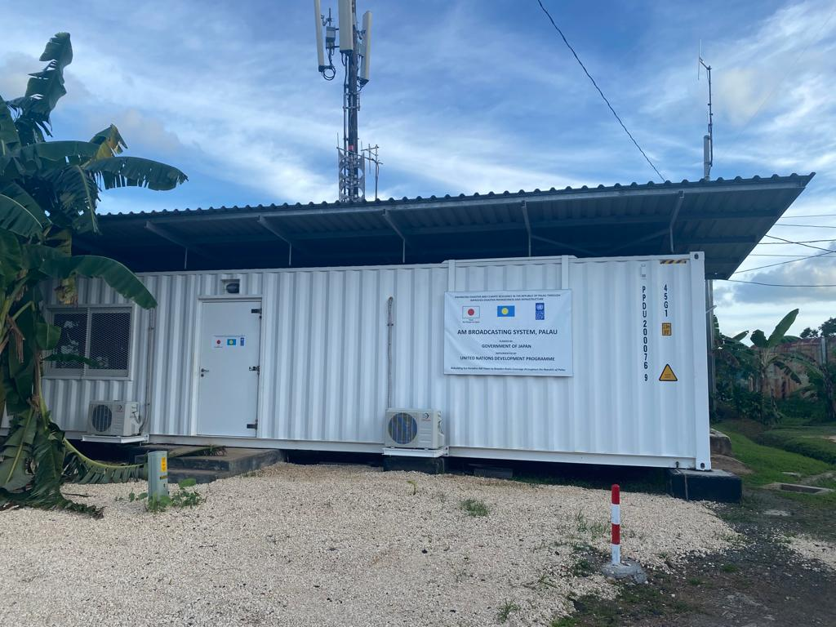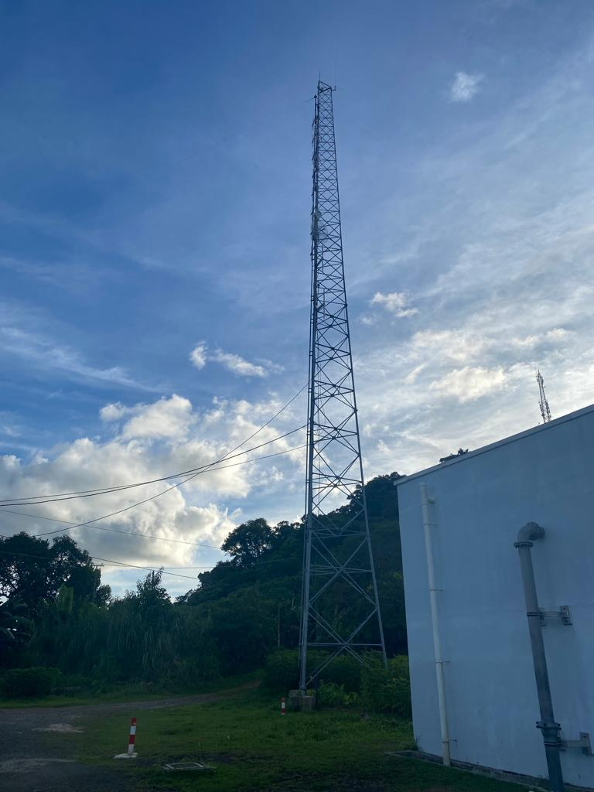

1. For Activity 1.6, training of HF/VHF radio basic operability and maintenance training was conducted on 2-8 February 2022, attended by 23 participants (2 female & 21 male). Another training on HF radio installation with data to send and receive emails using local HF network (without the need to connect to an external server or ISP) was completed on 16-17 May 2022 at NEMO, attended by 28 men and 7 women from NEMO, PNCC, Sonsorol and Hatohobei State Offices and the Ministries of Health and Education. During the mission to Southwest islands on during the 15 -25 June 2022 period, 18 people (5 women and 13 men) were trained with additional participants trained earlier at NDMO to operate the HF radio with its email operability features.
2. Activity 1.7 was completed after a 2-day workshop to integrate gender, age, disability and cultural perspective in policies and practices of disaster risk management on 10-11 February 2021 attended by 42 staff (20 women and 22 men) from public sector and civil society organizations. The workshop focused on implementing safety and relief practices which take into account people of different genders and social statuses. The sessions examined steps which government entities looked at ways to provide shelter and resource assistance to vulnerable people when disaster strikes (such as securing separate shelters for women and children as well as special shelters to house those with disabilities), and ensuring information makes its way to those with limited access to it. Participants included the Palau Red Cross, the International Federation of Red Cross and Red Crescent Societies (IFRC), Pacific Community (SPC), and Omekesang Association of Palau. A final report and presentation of recommendations was handed over to National Emergency Committee (NEC) in March 2021. UNDP tried to get UN Women to work with them on the workshops. In the end, there was no resources with the Project working instead with the International Red Cross and SPC.
3. The overall work by the Project in Output 1 to strengthen disaster communication and climate and tsunami monitoring systemscan be rated as **satisfactory**. This is primarily due to the equipment procured and installed, and training activities being implemented.

### Progress towards Output 2: Enhanced National and State Disaster Preparedness capacity & better resourced to minimize loss of lives and damages

1. Activity 2.1 was completed with disaster preparedness and response equipment being delivered to NEMO including a generator in April 2020, furniture in June 2020, and 8 mobile phones in June 2020. Internet capacity was also improved in July 2020 for NEOC. ICT equipment for NEMO was installed in June 2022. PNCC, UNDP and NEMO procured appropriate software to improve interface operability and functionality.
2. For Activity 2.2, a NEOC extension was needed as the NEOC room was too small to effectively be used to serve emergency committee needs and capacity requirements during disasters. Major functions of the NEOC include:

* providing the overall command, control and coordination in response to national disasters;
* gathering, collating, and disseminating information;
* serving as point of contact for the media through the Public Information Officer;
* preparing and disseminating situation reports;
* facilitating damage and needs assessment processes;
* maintaining effective communication and information systems;
* coordinating all government, non-government, private, and regional donor assistance; and
* managing the logistic arrangements of the immediate and medium-term relief supplies.

1. Procurement of equipment and supplies and construction all proceeded smoothly with no issues encountered.  PALARIS was asked to assist with set-up of the NEOC extension to allow for real-time visualization of maps and imaging technology at NEOC using new equipment procured through Project. In the past, PALARIS has provided maps to support responses by NEMO with maps that were not contemporary or dynamic. Instead of printing maps, the new capacities allow for visualization of maps on screens in NEOC in real-time. PALARIS procured servers to store the data and upgraded all of their computers to have the capacity to process large amounts of data. The NEOC room extension is shown on Figure 7.
2. For Activity 2.3, a LiDAR survey mission was dispatched from 16 March to 23 April 2021 for remote sensing of key and vulnerable areas, notwithstanding difficulties in holding survey session during COVID. The main rationale for a Project-sponsored LIDAR survey was to support DRR work where the survey data could be used to develop high-resolution topographic models to map out risks to the coastline. This was needed, especially based on past experience with the two recent typhoons (Bopha in 2012 and Haiyan in 2013) where the east-coast was greatly impacted, mainly due to the strength and direction of the typhoon. The topographic models would be needed study to identify areas of risk, especially with new housing initiatives. Funding constraints limited the LIDAR survey to only the terrestrial environment. However, the US Army conducting the Palau LIDAR survey included both marine and terrestrial areas that complemented the previous US Army survey.
3. The results of the Fugro survey mission are currently being reviewed in collaboration with PALARIS through Project assistance. In early January 2022, PALARIS completed a review of colorized classified point clouds, color orthophotos and intensity imagery to ascertain its applicability to use serve as DEMs. PALARIS initiated in-house training on how to use the data to develop products such as the DEMS and accessed technical support from external partners. PALARIS supported some of the other activities such as identifying suitable alternate sites for the AM Tower, helping with analysis of coverage and suitability of terrain for constructing the tower, and assisting with GIS training.

**Figure 7: NEOC room extension under Activity 2.2**

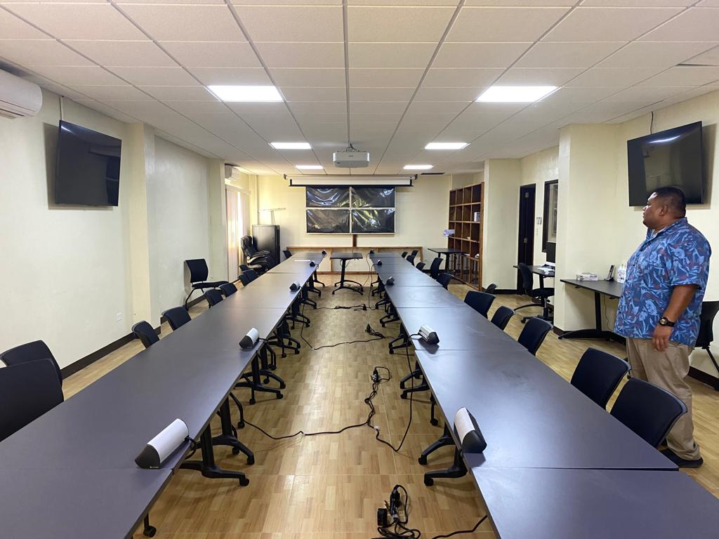

1. For Activity 2.4, 5 containerized storage facilities were provided to safeguard and store important rescue equipment and emergency supplies that were handed over to NEMO in December 2019. Their portable design makes them easy to be transported when required. The HF radio portable manpacks, which can be transported and operated in a backpack device, which can then be used for communication with remote regions when a disaster strikes. The generator is to be used at NEOC to sustain electricity during power outages, doubling the power of the existing one. Training on maintenance of the storage units was delivered to NEMO in January 2020 virtually through Skype.
2. For Activity 2.5, a 3,000-gallon Elliptical Tanker Fire Truck and a rescue fire truck was shipped to Palau on 1 May 2021 to the Division of Fire and Rescue in addition to 3 old firetrucks (with capacities of 1000 gallons, 800 gallons, and 600 gallons) donated from the USA in the 1970s where it was impossible and expensive to find spare parts for these trucks. Bureau of Public Works (BPW) and Project also extended the roof of the fire station in November 2021 to provide safe parking spaces. This improves firefighting capabilities although there is still the issue of where to source the water. Training on the use of the new fire truck equipment was conducted from 6-9 December 2021 by the manufacturer, NAFFCO from Dubai, with 24 fire personnel (21 male/3 female). Special training on preventive maintenance of the vehicles was given to the mechanics who take care of the trucks. Whenever Fire and Rescue personnel need assistance, they are referred to the manual or communicate with the Dubai-based trainers. The 3,000-gallon Elliptical Tanker Fire Truck is sown on Figure 8.

**Figure 8: 3,000-gallon elliptical tanker and a rescue fire truck procured under Activity 2.5**

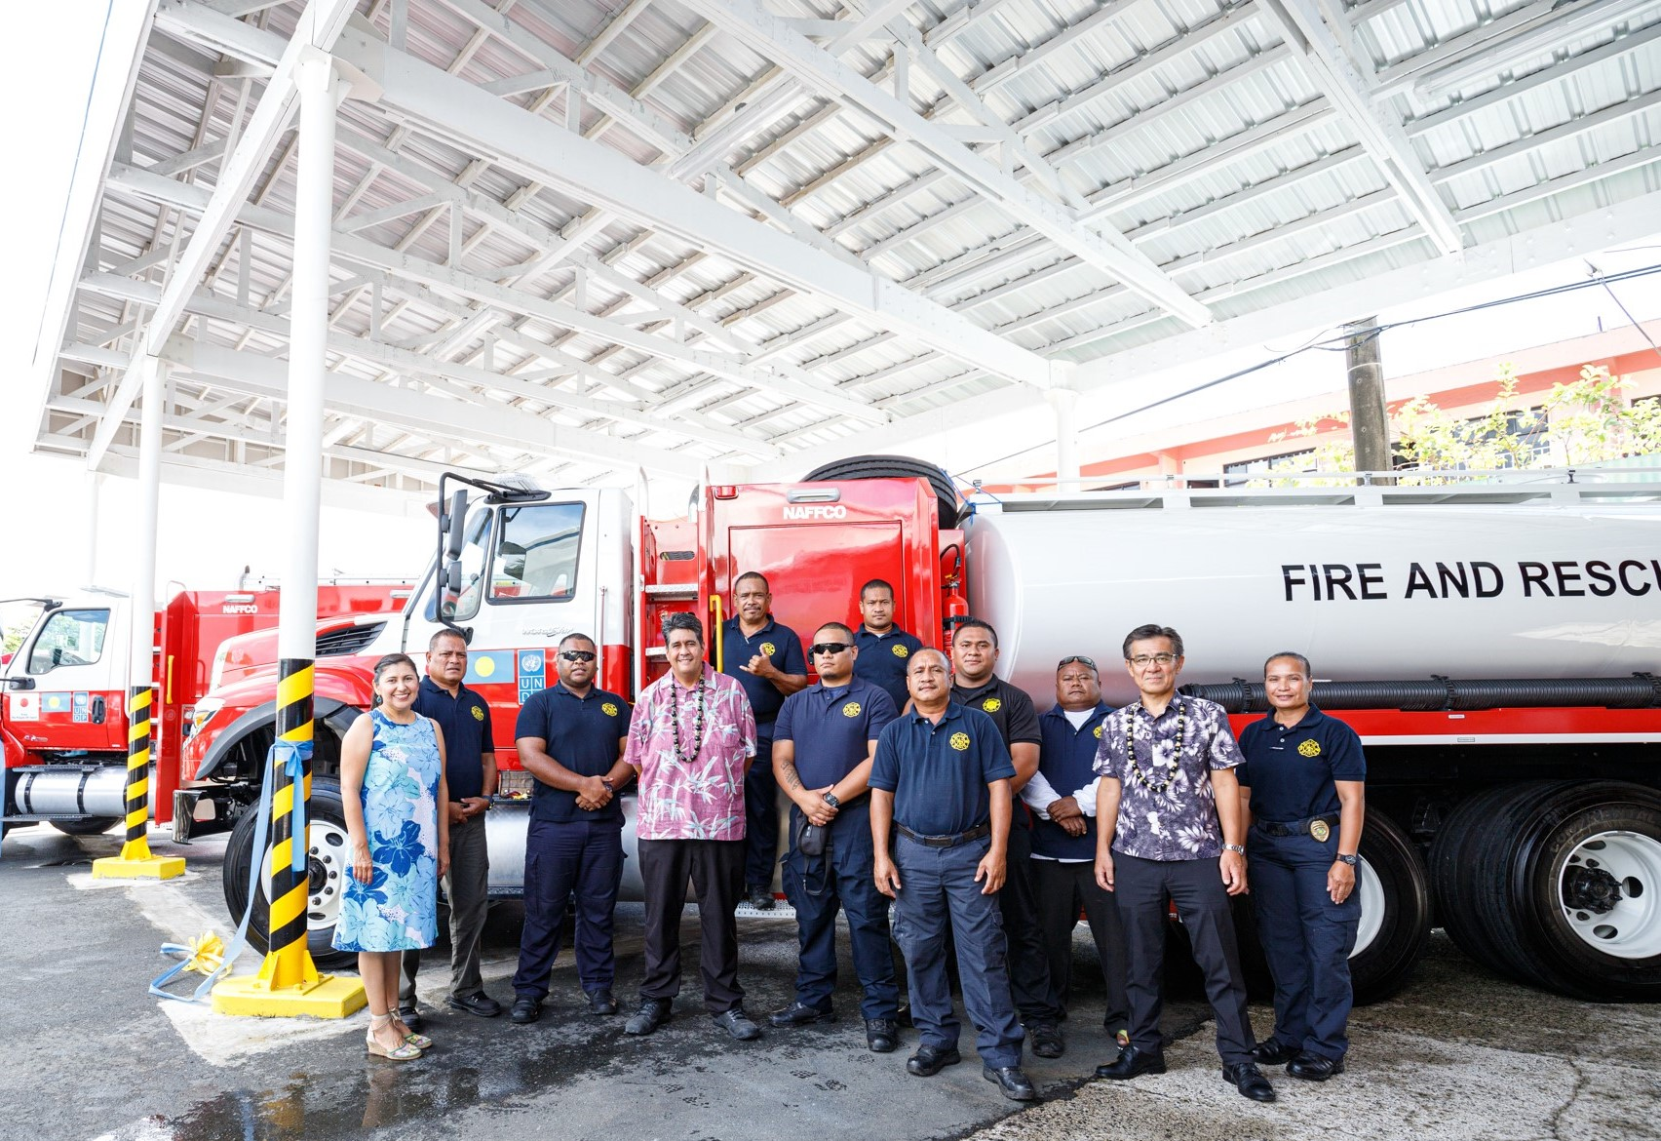

1. For Activity 2.6, two HF radio portable manpacks and one generator were handed over to NEMO in Kayangel, Peleliu and Angaur in December 2019. This provides the ability to communicate during rescue activities. Training regarding operation and maintenance of the equipment was delivered online in January 2020. PALARIS also procured two trucks through the Project to assist with these disaster surveys. Survey equipment includes survey grade GPS equipment and some software. They also purchased a drone to assess for damages safely and rapidly and to provide real-time data and insight during a disaster. They have used the drones in a joint project with SPC for soil erosion change detection surveys. Activities are portrayed on Figure 9.
2. A second series of handovers of items obtained through the Project took place at NWSO in Koror which included a utility boat with a trailer, two SUVs, one pickup truck and a range of search and rescue equipment. The vehicles, trailer and search and rescue equipment served as a vital resource for Palau officials during search and rescue missions when disasters strike. The enhancement of current emergency equipment was essential to improve the GRoP’s overall response to emergencies and to continue to protect the people of Palau from any disasters in future.

**Figure 9: Trained firefighters under Activity 2.5**

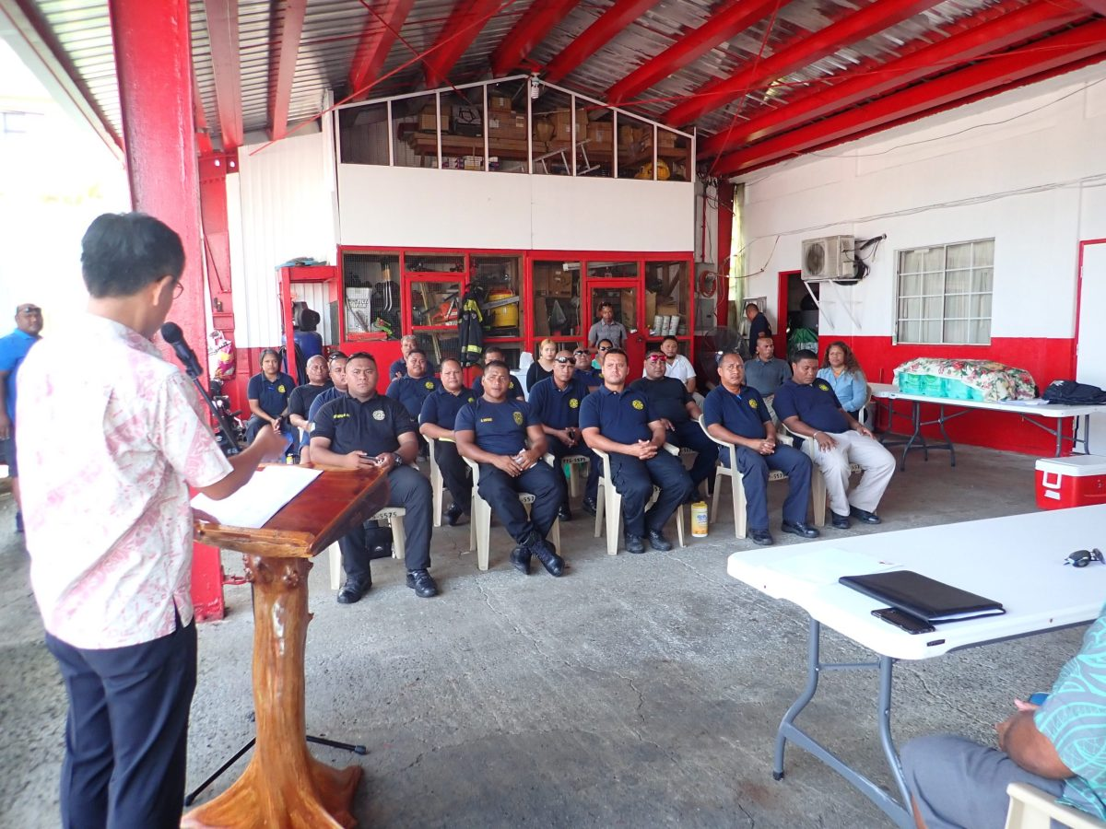

1. In conclusion, the work by the Project in Output 2 to “enhance national and state disaster preparedness capacity that is better resourced to minimize loss of lives and damages” is rated as **highly satisfactory** based on equipment procured and the training on remote sensing mapping over key and vulnerable locations, and the operation and maintenance of the equipment procured.

### Progress towards Output 3: Enhanced community disaster and climate resilience through improved water and food resource management, inclusive livelihood diversification

1. For Activity 3.1, equipment for solar-PV systems for 3 schools has been installed. After delays in contracting and shipment delays due to COVID-19 (for goods from Japan, Australia, and the USA), solar systems were assembled and tested first at MoE central office before transport to school sites. Installation was completed for Sonsorol (20-29 September 2021), Pulo Ana (12-22 October 2021) and Tobi (9-22 November 2021). The solar-PV systems were to provide emergency backup power for the schools as they are to be used as evacuation centers during the typhoon season between July to November. Handover ceremonies and training were conducted in Sonsorol and Pulo Anna islands on 21 October 2021, and in Tobi on 28 December 2021. The system is shown on Figure 10.

**Figure 10: New solar system for Tobi school under Activity 3.1**

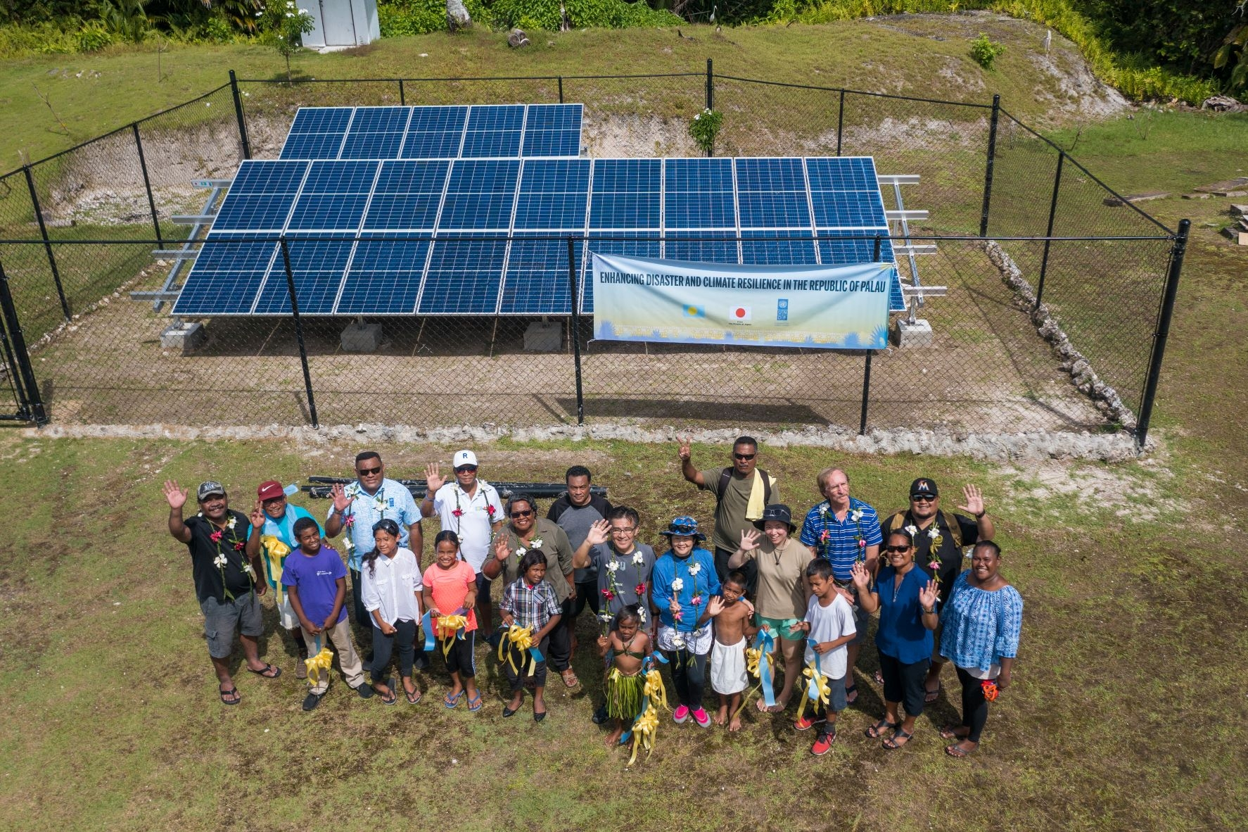

1. Training was delivered by Project-recruited consultants and the supplier who could not travel due to the COVID-19 pandemic. Training included review of solar system components, including controller and battery, theory of solar energy and functions as well as preventive maintenance. There were 20 participants (19 men and 1 women) from Ministry of Education (MoE), PNCC, NEMO and PEA and States of Sonsorol and Hatohobei who were all trained on the installation and maintenance of solar system from 9-13 August 2021. Another MoE de-briefing session was convened in December 2022 for the solar installations at Sonsorol, Pulo Anna and Tobi to acknowledge the collection efforts rendered and map out a way forward on routine maintenance and monitoring. Indicative date put forward, will still to be discussed subject to NEMO’s approval. A challenge that was not anticipated involved birds attracted to solar systems resulting in a large amount of droppings on the solar panels, and cleaning the panels on a daily basis.

1. For Activity 3.2, the Bureau of Cultural and Historical Preservation (formerly the Ministry of Communities and Cultural Affairs) in October 2019 conducted vulnerability assessments for 10 cultural heritage sites in 8 states and a Disaster Risk and Climate Change Impact Survey report and the comic book for communication as of June 2021. Implementation of actual climate risk mitigation measures at 2 prioritized sites with a team included 5 archaeologists. Civil works as of October 2022 are underway at:

* a cultural site in Hatohobei (Tobi State), a burial ground for young children and more specifically stillborn babies. Funds were used to build a “hut” to be used as a storage site for the remains;
* the Ngeremlengui State site, an historical site including a monolith, stone platform, bathing pool, and stone paths needing restoration and mitigation against inundation due to rising sea-levels and extreme-weather events causing flooding.

1. For Activity 3.3, an Elliptical Tanker Fire Truck was delivered to the Division of Fire and Rescue on 3 March 2021 as an emergency water system (see Para 68 and Figure 6). This truck with a 3,500-gallon water tank possesses the capacity to transport water to schools, hospitals and communities affected by water shortage due to droughts or any deficiency in the water. Training on the use of equipment was conducted by manufacturer, NAFFCO, from 6-9 December 2021. There were 24 fire personnel (21 male/3 female) who were trained.
2. For Activity 3.4, the capacity of NEMO and NWSO to support evacuation and humanitarian assistance in disasters has been improved with the August 2020 delivery of a boat, 2 SUVs and a pick-up truck and search and rescue equipment. A 3.5 t truck was delivered to NEMO in March 2021. Civil works for an extension of the roof at the Fire Department was also completed in April 2021 with Bureau of Public Works. Some of the search and rescue equipment is shown on Figures 11 and 12.

**Figures 11 and 12: Search and rescue equipment procured by the Project under Activity 3.4**

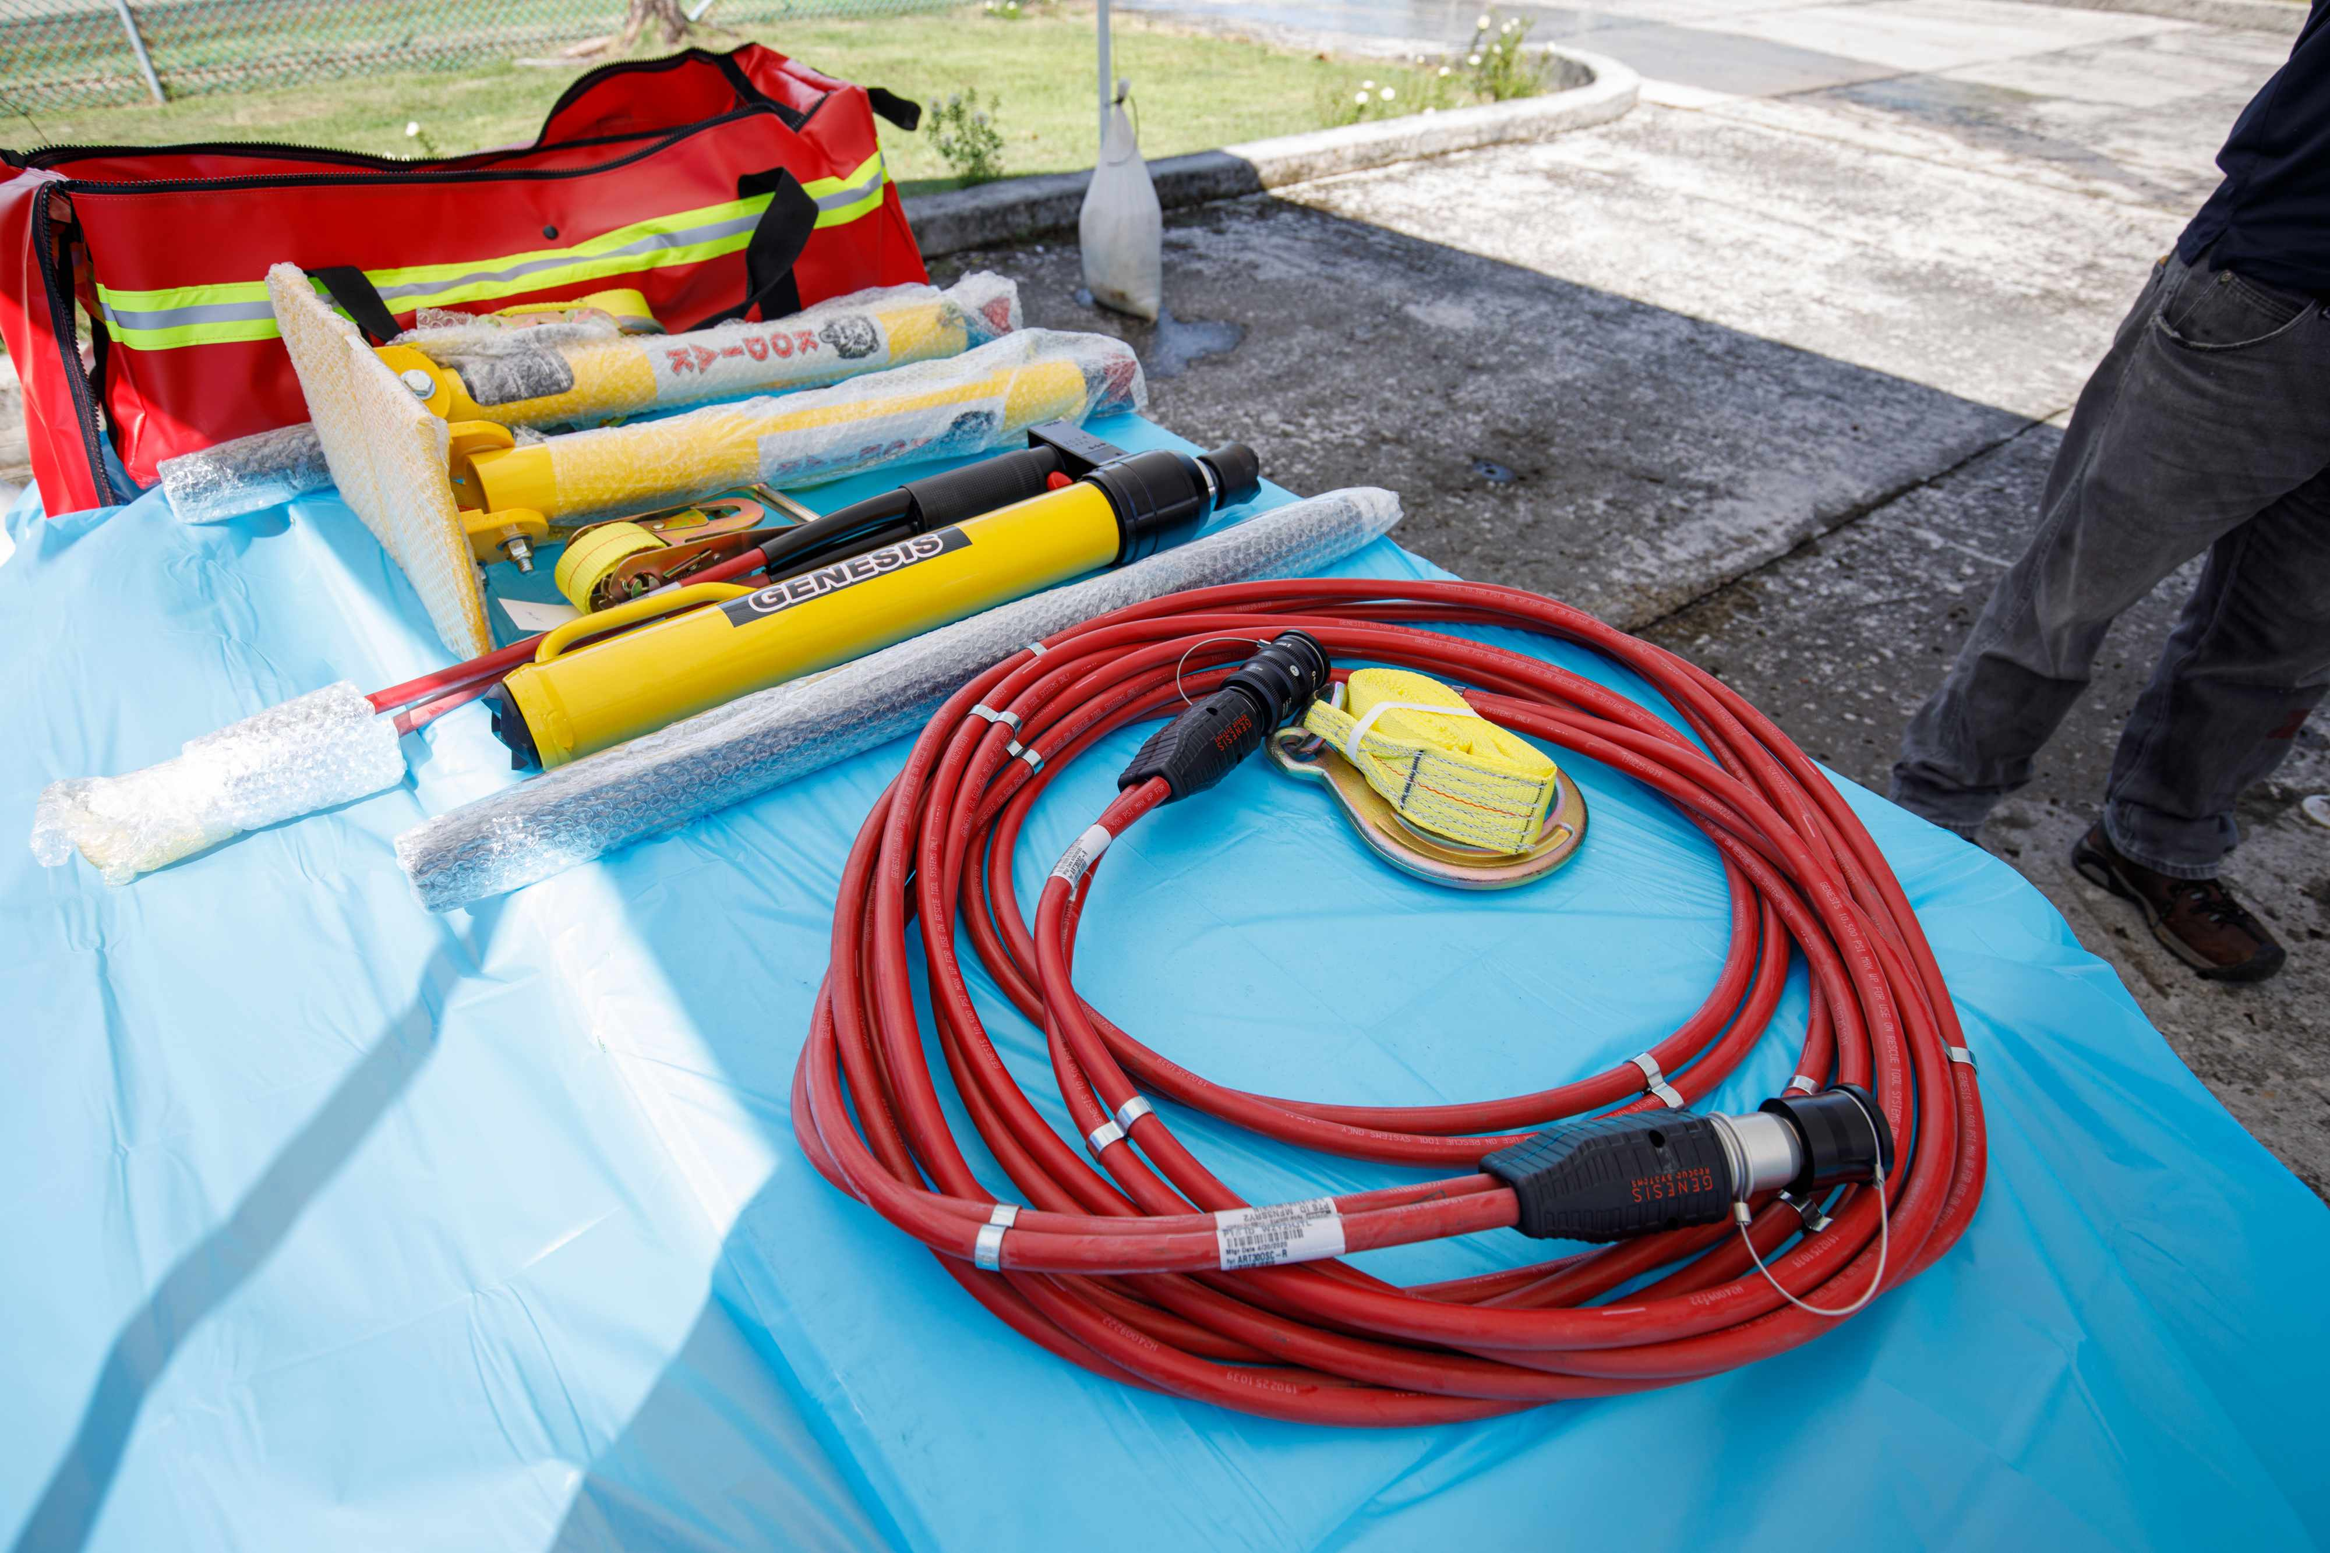 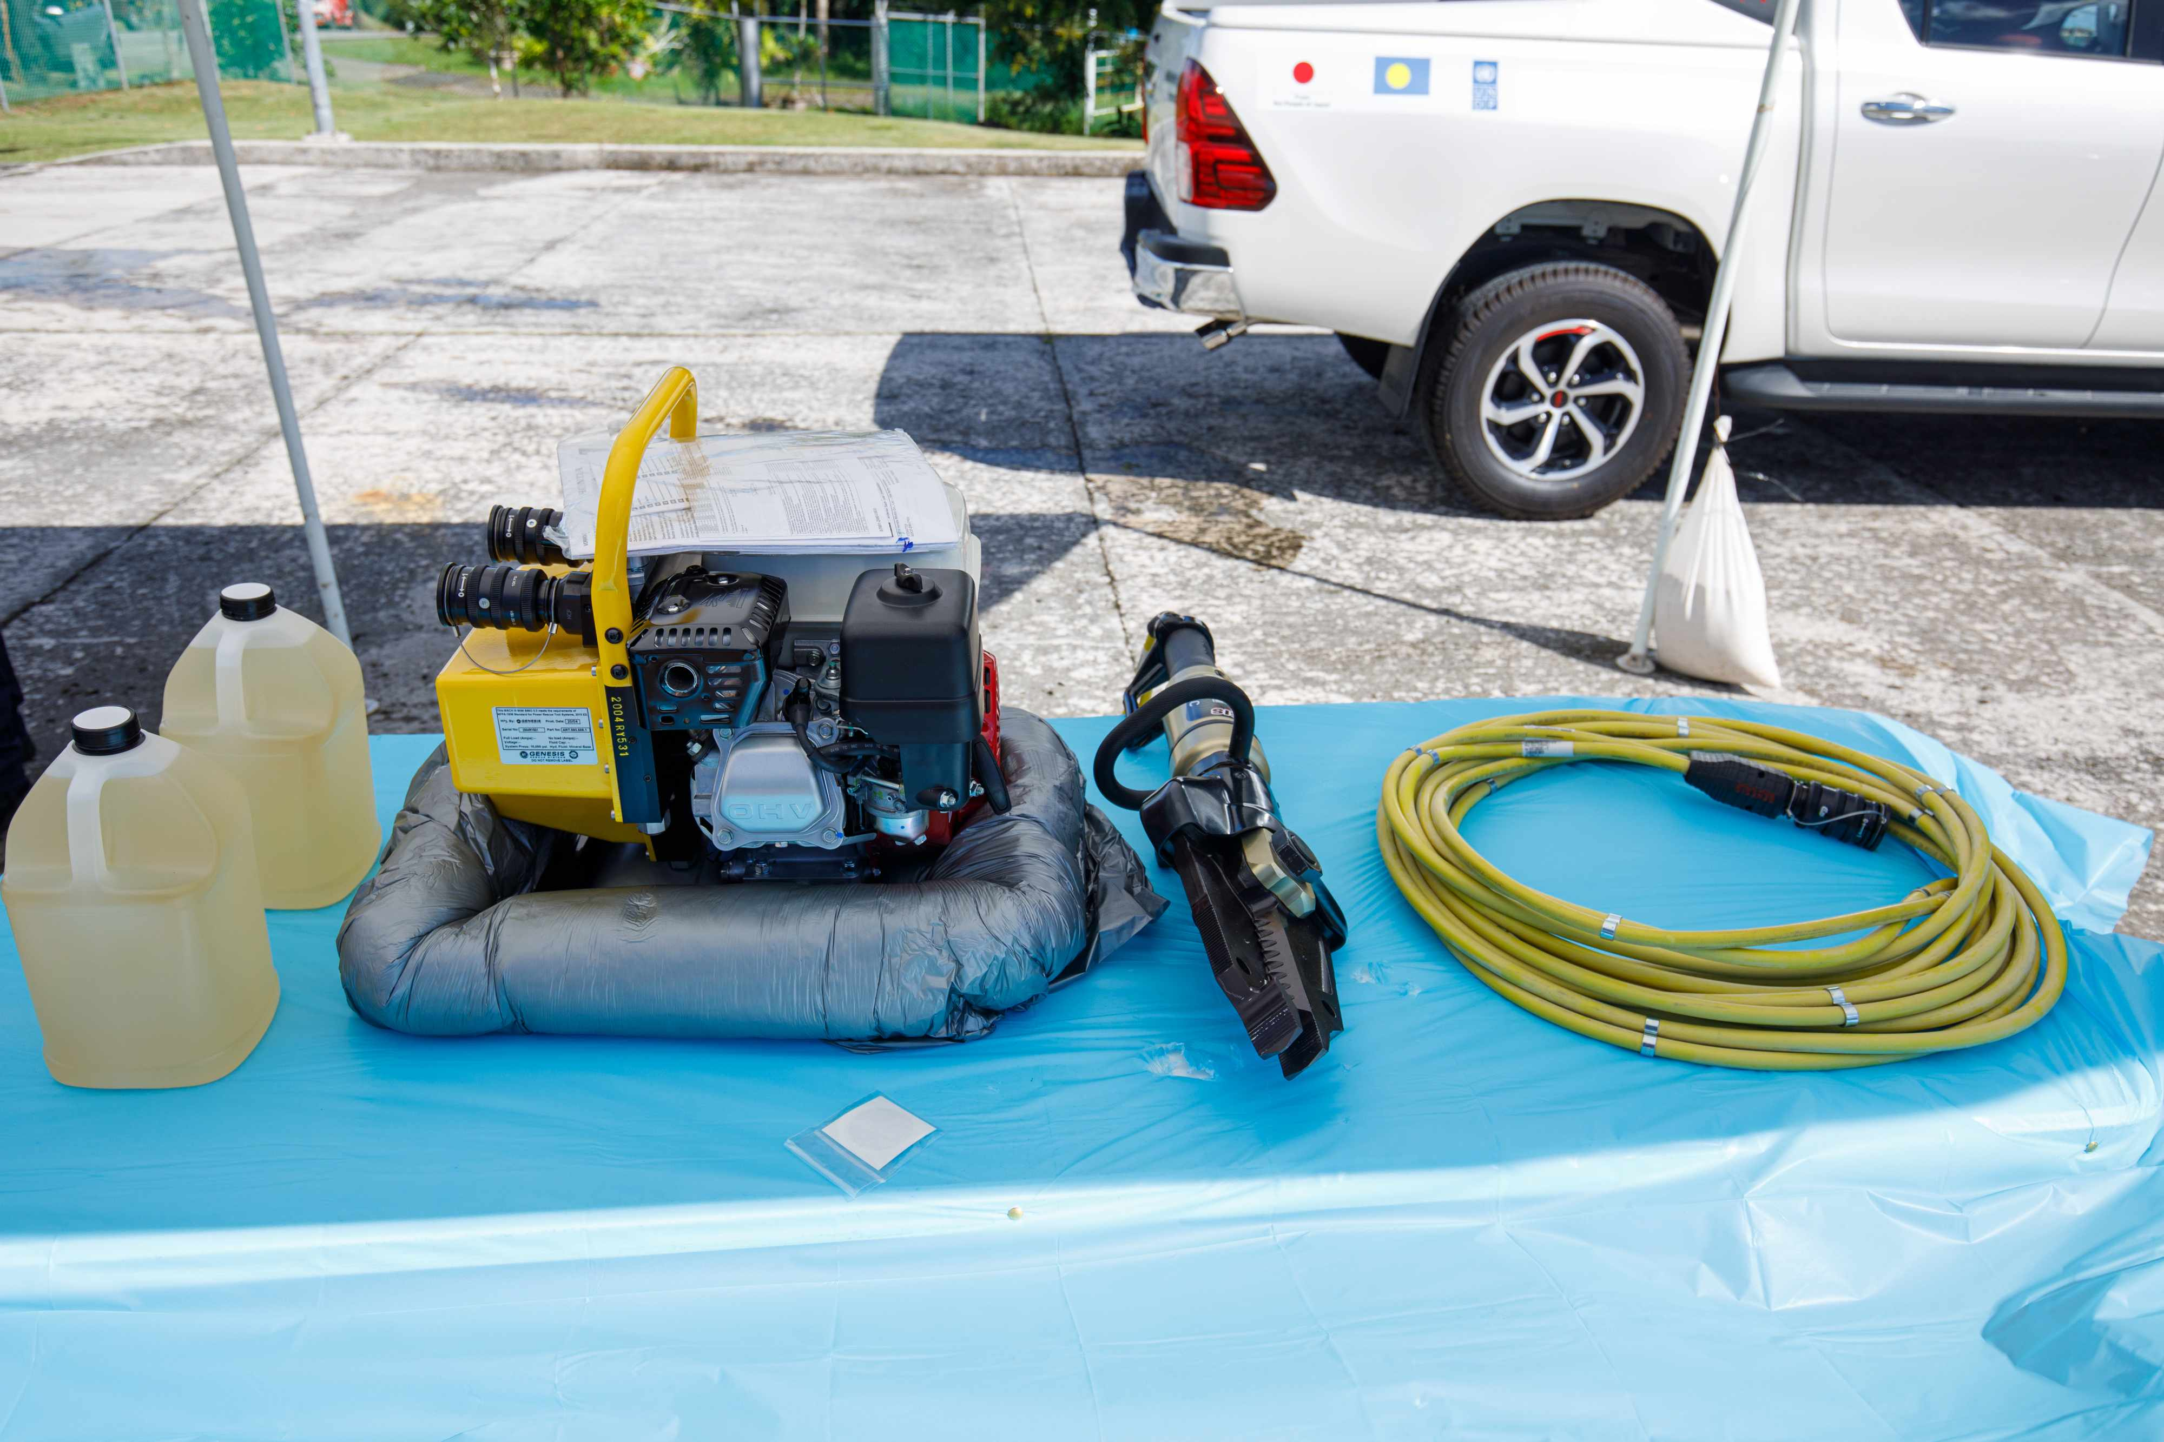

1. UNDP projects often push to use UNDP-certified companies for procurement of goods. NWSO and HPO procured their trucks from a vendor in Dubai that was UNDP recommended. PALARIS wanted to procure trucks through a local vendor (Surangel and Son’s Company) to get warranty and preventive maintenance support. Some effort was required to source the trucks from a local vendor, who provided a warranty from the manufacturer and preventive maintenance for 3 years through the Project.
2. Activity 3.5 was cancelled after discussions with NEMO, Bureau of Agriculture, Red Cross and NWSO to seek partnership with other UN agencies. The cancellation of this activity resulted in the reallocation of the budget to other activities.
3. For Activity 3.7, PDNA training was done in February 2020 through a standardized approach developed by multi-lateral (i.e. World Bank and UNDP) adopted for Palau. The training was done with the RESPAC project under UNDP along with the Red Cross, SPC, NEMO, and the Bureau of Aging, Disability and Gender. The 5-day training session brought together 30 participants (including 12 women) focusing on empowering Palau Government officials and key stakeholders for undertaking assessments, policy development and implementation of post disaster recovery. Participants represented were from across key sectors including agriculture, housing, education, gender, water and sanitation and health.

1. In conclusion, the work by the Project in Output 3 to “enhance community disaster and climate resilience through improved water and food resource management, inclusive livelihood diversification” is rated as **satisfactory** based on equipment procured and the training on capacity building measures.

### Relevance

1. The EDCR Project is **relevant** to the development priorities of Palau, namely:

* Palau’s 2020 Palau National Development Plan which mainstreams disaster risk reduction;
* Palau’s National Disaster Risk Management Framework which has a vision for “safe, resilient and prepared communities in Palau;
* Framework for the Resilient Development in the Pacific 2017-2030 which recognizes that climate change and disaster risks increase the vulnerability of Pacific Island people undermining sustainable development in the Pacific region; and provides high level strategic guidance to different stakeholder groups on how to enhance resilience to climate change and disasters in ways that contribute to sustainable development;
* UN Pacific Strategy Outcome 1 were by 2022, people and ecosystems in the Pacific are more resilient to the impact of climate change, climate variability and disasters; and environmental protection is strengthened with specific intervention on Output 1.1 of the sub-regional programme document on “Scale up action on climate change adaptation and mitigation across sectors which is funded and implemented in the Pacific”.

### Effectiveness

1. The effectiveness of the EDCR Project has been ***satisfactory***, in consideration of holding training sessions and the overcoming of difficulties in getting equipment imported into Palau, and the issues of holding training sessions during the COVID-19 pandemic. In the end, though, the effectiveness of training boiled down to the capacity of the persons being trained, and the continuous support of consultant trainers to teach the operation of the equipment.

1. The stakeholders focused in earnest in working together across organizations to reach the last and furthest person. The initiatives included how to organize communities and how to interpret special weather patterns and statements, laying a solid foundation for further training in combination with the installation of new infrastructure such as the siren system and the AM tower as efforts to reach the most remote communities. The information from post disaster assessments including PDNAs, helps determine how best to support Palau in understanding the future impact of disasters with climate change already affecting the region with increased risks. The partnerships formed by the Project help foster an environment of improved understanding and working alongside of these partners to reduce and mitigate the impacts to economic and social development of countries through a robust approach underpinned by evidence collected through processes such as PDNA.

### Efficiency

1. The efficiency of the EDCR Project has been rated as ***satisfactory*** in consideration that the majority of works did not occur until after 2020 notwithstanding delays caused by the COVID-19 pandemic. There were some inefficiencies that caused delays. PNCC experienced issues with UNDP; for every US$50,000 spent, the UNDP auditor needed to hire an auditing company to do “spot checks”. UNDP needs be mindful of the burden to PNCC or any other government entity and improve communication so that it is not additional burden.

### Mainstreaming

1. Opinions of disaster management and climate resilience were rapidly changing in the Republic of Palau. The infrastructure and training of government staff and relevant stakeholders efficiently mainstreams DRR and CCA. The VHF/HF radios, the AM tower, the siren systems, and other infrastructure and equipment is for the benefit all Palauans especially for those in the remote southwest islands. In addition, communication with all stakeholders on platforms such as UNDP press releases, UNDP Facebook and Twitter accounts, and the Island Times web and print media, was regular and informative. With the gradual equipping of all states and strong communications on various platforms, the opinions of DRR and CCA are trending more positively.

### Overall Project Outcome

1. The delivery of intended Project outputs has been ***satisfactory***. The EDCR Project has been able to:

* strengthen disaster communication and climate and tsunami monitoring systems by equipping most Palauan islands with HF and VHF radios, and training key stakeholders on the use of those systems;
* enhance disaster preparedness at the national and state levels through the provision of equipment, tools and infrastructure that will provide appropriate responses to disasters and extreme climate events;
* improve storage of emergency stockpiles, supplies, and emergency equipment as well as emergency responses with rescue vehicles, to minimize loss of lives and damages; and
* enhance community disaster and climate resilience through:
  + solar PV systems to improve emergency backup power in schools, a fire truck with emergency water supplies, and gender-sensitive training on policies and practices of disaster risk management to key stakeholders; and
  + strong communication to all stakeholders through UNDP press releases, UNDP Facebook and Twitter accounts, and the Island Times web and print media.

1. There have been no unintended outcomes of the EDCR Project.

### Sustainability of Project Outcomes

1. In assessing sustainability of the EDCR Project, the Evaluator asked “how likely will the Project outcomes be sustained beyond Project termination?” Sustainability of EDCR’s outcomes was evaluated in the dimensions of financial resources, socio-political risks, institutional framework and governance, and environmental factors, using a simple ranking scheme:

* *4 = Likely (L):* negligible risks to sustainability;
* *3 = Moderately Likely (ML):* moderate risks to sustainability;
* *2 = Moderately Unlikely (MU):* significant risks to sustainability; and
* *1 = Unlikely (U):* severe risks to sustainability; and
* *U/A = unable to assess*.

The overall rating given is equivalent to the lowest sustainability ranking score of the 4 dimensions*.* Details of sustainability ratings for EDCR Project are provided on Table 8.

1. *The overall EDCR Project sustainability rating is moderately likely (ML).* This is primarily due to:

a possible issue of securing fiscal resources for all refresher training sessions and introductory courses for junior to mid-level officers. Donor support for these sessions and courses is not yet guaranteed;

periodic training will be required as refresher courses for senior staff and introductory courses for junior to mid-level officers in the GRoP. There may be an issue with who will host the training sessions.

### Country Ownership

1. Country ownership of the EDCR Project is demonstrated through the 2020 Palau National Development Plan, and Palau’s National Disaster Risk Management Framework as detailed in Para 81. Country ownership was further confirmed by the President of Palau who said “the rebuilding of the AM tower serves an important purpose for the people of Palau. We thank our friends and partners of the People of Japan and the United Nations. In our various state visits, ‘a rechad er Belau’ voiced concerns about staying informed of health and safety news. This is particularly important when our nation is facing typhoons or other natural disasters, which have been getting stronger and more frequent because of climate change. This Project allows our emergency officials to share information to help all the people in Palau ensure their families, homes and businesses are safe.”

### Gender equality and women’s empowerment

1. To mainstream the issue of gender and social inclusion in the area of disaster risk management, the Project explored partnerships with the Bureau of Aging, Disability, and Gender (BADG); Palau Red Cross; and SPC. Due to changing government administrations in 2021, the Project was only able to conduct one workshop. The dismantling of BADG was a contributing factor to holding only one workshop. The Gender Office was moved to the Office of the Vice President who was Minister of State at the time, while Aging and Disability went to the Ministry of Health and Human Services. BADG wanted to train people as a part of their mandate in accordance with national policy is to mainstream GESI.
2. There was a long period of no activity or planning for the workshop. PRCS initiated discussion with SPC about gender and social inclusion workshop, reaching out to Klouldil to assist with a facilitating another workshop with gender mainstreaming. A 2-day workshop to integrate gender, age, disability and cultural perspectives in policies and practices of disaster risk management was conducted on 10-11 February 2021. The workshop introduced partners and stakeholders on gender and what it means to talk about gender and social inclusion (GESI) and how to implement the Project with GESI lens. There were 42 staff (20 women and 22 men) from the public sector and civil society organizations who attended the training.

| **Table 8: Assessment of Sustainability of EDCR Outputs** | | |
| --- | --- | --- |
| **Actual Outputs**  **(as of December 2022)** | **Assessment of Sustainability** | **Dimensions of Sustainability** |
| **Actual Output 1**: Disaster communication, and climate and tsunami monitoring systems have been strengthened | * *Financial Resources:* Financing of the maintenance of the monitoring systems within GRoP entities is confirmed for the foreseeable future including NEMO planning to expand the VHF network with other funds, and NWSO plans to expand AWS network and wave rider buoys through a proposed GCF funded project; * *Socio-Political Risks*: No socio-political risks. Stakeholders are on-board with all monitoring systems; * *Institutional Framework and Governance:* GRoP personnel now willing to monitor extreme climate events with the required equipment and infrastructure. However, there is a need to increase or sustain human capacities for the O&M of AM broadcasting system as there is no technical person in the Ministry of State; * *Environmental Factors:* No risk.   ***Overall Rating*** | 4  4  3  4  **3** |
| **Actual Output 2**: Preparedness for disasters has been enhanced through better tools to predict extreme climate events, containerized storage facilities for emergency equipment and stockpiles, appropriate equipment for disaster responses, and building capacities of relevant stakeholders for responses to disasters. | * *Financial Resources:* Financing for training and building institutional capacity is confirmed for the foreseeable future. However, there may be an issue of securing resources for refresher training sessions and introductory courses for junior to mid-level officers as donor support is not guaranteed; * *Socio-Political Risks*: No socio-political risks foreseen; * *Institutional Framework and Governance:* Periodic training will be required as refresher courses for senior staff and introductory courses for junior to mid-level officers in the GRoP. This may be an issue with who will host the training sessions; * *Environmental Factors:* No risk.   ***Overall Rating*** | 3  4  3  4  **3** |
| **Actual Output 3:** There has been enhanced community disaster and climate resilience through improved emergency backup power for schools through solar PV, improved back-up water supplies from a 3,500-gallon fire truck, and improved capacities of NEMO, NWSO and other key government entities to support evacuation and humanitarian assistance in disasters | * *Financial Resources:* Financing for operation and maintenance of back-up power and improved water supplies is confirmed for the foreseeable future of GRoP operations. However, there may be an issue of securing resources for refresher training sessions and introductory courses for junior to mid-level officers as donor support is not guaranteed; * *Socio-Political Risks*: No socio-political risks foreseen; * *Institutional Framework and Governance:* Periodic training will be required as refresher courses for senior staff and introductory courses for junior to mid-level officers in the GRoP. This may be an issue with who will host the training sessions; * *Environmental Factors:* No risk.   ***Overall Rating*** | 3  4  3  4  **3** |
|  | ***Overall Rating of Project Sustainability:*** | **3** |

1. The workshop was held in the middle of the COVID-19 pandemic with SPC serving as a partner with experts on gender and DRR. The workshop was one of the first times the Project worked with DRR people, although the majority of people in this sector are men who do not understand gender mainstreaming. The workshop provided clarity on cultural values in the context of gender mainstreaming. More work is required to evaluate the effectiveness of the workshop and engage with stakeholders about gender mainstreaming and its importance. A final report and presentation of recommendations was handed over to National Emergency Committee (NEC) in March 2021.
2. A significant proportion of users of HF and VHF radios are women. This includes radio users in remote islands, a likely occurrence given that women are home-based.

### Cross cutting issues

1. For cross-cutting issues, the Project has made a significant contribution to SDG 1 (No poverty), SDG 2 (No hunger), SGD 5 (Gender Equality), SDG 6 (Clean water and sanitation), and SDG 13 (Climate Action).

### Catalytic/Replication Effect

1. The only catalytic and replication effects are mainly found in stakeholders wanting additional tsunami and multi-hazard warning sirens, automated weather stations, and training courses in Output 1, and additional solar PV systems for schools and government buildings to serve as emergency backup power in Output 3. To a large extent, the disaster and climate resilience infrastructure and equipment is a long-term fix for DRR and CCA, minimizing catalytic and replication effects.

### Progress to impact

1. Before EDCR, there was no clear vision or set targets on how to deal disasters and extreme climate events. The impact of EDCR implementation on Palau’s climate resilience to extreme climate events has been:

* the restoration of siren systems, VHF/HF radios and an AM tower to re-vitalize a communication tool for emergency and disasters that will receive reports and information necessary for safety and security all Palauans, a system that could save lives. There were huge improvements in the 21 sirens located strategically in priority areas from the Kayangel (northernmost island) to Angaur (southernmost of main island chain) added to the one siren at the Ministry of Justice with 2 controllers located at NEMO and NWSO;
* the enhanced nature of disaster preparedness in Palau that includes new equipment and infrastructure for NEMO and NEOC, capacity for LIDAR remote sensing for key vulnerable locations;
* all Palauan citizens being able to evacuate to a school shelter during an emergency. The MoE coordinated the installation of solar systems, LED lights, fans and other improvements in all schools, where solar power can be used as backup emergency power and every day operations at the school;
* solar power at schools providing children and teachers at public schools with access to electronic devices with different apps supporting a range of content that supports learning. This addresses equity where children in the remote Southwest Islands can use their electronic devices to access the same applications for learning that their peers on the main island have access to. Prior to the Project, there was not no reliable and accessible source of electricity to power the devices;
* improved classroom environments to the extent that light sources are available when it rains or evening time when the classroom is dark. PTA meetings and state events may now be held in the evenings at the schools when there will be light;
* MoE and the state governments purchasing freezers for community use using extra power from installed solar PV systems allowing community members to store fish in the freezer for consumption on days when it is not ideal to go out fishing;
* improved communication between stakeholders and the Government on all developments related to the enhancement of national and state disaster preparedness and community disaster and climate resilience.

1. Despite the successes of the Project, the impact of the EDCR Project was nearly sidelined by the COVID-19 pandemic. Though the risks related to the COVID-19 pandemic affected the progress of the Project, notably pricing change of equipment and services and delays related to the importation of equipment and services, the Project managed to deliver all intended outputs overcoming the aforementioned challenges.

# main conclusions, recommendations and lessons

## Conclusions

1. With no dedicated financing available for responses to man-made, geo-physical, and climate hazards, there was a need for strengthened resilience in Palau to immediate disaster response, early recovery, and reconstruction. In 2022, the EDCR Project has managed to revitalize communications systems, vastly improve disaster preparedness, and improve school shelters for Palauans to safely evacuate during extreme climate emergencies and disasters. With the improved equipment and infrastructure to support evacuations during extreme climate emergencies and disasters, Palauan government personnel and responsible stakeholders are in a position to coordinate all residents of Palau to receive information necessary for their safety and security, laying a strong foundation for a climate resilient and disaster response system that could save lives.
2. Though disaster and climate resilience infrastructure and equipment is a long-term fix for DRR and CCA, the Project has catalyzed stakeholder interest in additional tsunami and multi-hazard warning sirens, automated weather stations for other areas of Palau, and additional solar PV systems for other schools and government buildings to serve as emergency backup power. This comes with the backdrop of stakeholders effectively working together across institutions and organizations to reach all Palauans, setting a solid basis for further and effective training in combination with the installation of new infrastructure such solar systems for schools and government buildings.

## Recommendations

1. With long-term infrastructure and equipment being supplied by the Project, a few recommendations are made on the basis of the lessons learned during implementation of the EDCR Project, and in the spirit of improving ongoing future delivery of other projects in Palau.
2. *Recommendation 1 (to the Government of Palau and UNDP): Provide more training for state staff on how to provide stronger Project oversight*. This would be an effort on “how to receive and implement projects” and to ensure everyone was informed and aligned with a project. Topics could include the activities to prepare for a project, liaising with stakeholders, effective communication skills, the use of GIS, conflict resolution, managing project activities, and estimating the cost of planned activities[22]. This could also be an effort by UNDP to train local people in Palau and other regional SIDS on the complex UNDP administrative procedures for fund transfers and procurement so that they can manage projects under NIM.
3. *Recommendation 2* *(to the Government of Palau**): Conduct join quarterly trips to the SW islands to provide general support and rotating alternate staff allowing them to assess different areas.* With limited opportunities to travel to the SW islands, there is a need to take advantage of regularly scheduled, quarterly trips to the SW islands sponsored by GRoP to send MoE technicians to the SW Islands for monitoring and inspection.
4. *Recommendation 3 (to the Government of Palau): Address the lack of internet connection at some schools in remote areas*. The Ministry of Education recently implemented an online reading program and procured a student information system at other schools. In ensuring equitable access to learning opportunities and tools by all students, there is a need to provide the same opportunities to children in remote areas using satellite internet access. Online high school teaching is not available to SW island students, resulting in high school-aged children sometimes leaving their homes to attend high school, and a lack of youth to help with family and community. Providing internet access to all children should be a long-term goal.
5. *Recommendation 4 (to the Government of Palau): Sustain and raise community awareness and participation in climate resilience and disaster management*. The initial phase of the EDCR Project was largely aimed at building and improving infrastructure and systems. A subsequent phase should have an emphasis on raising community awareness and participation such as in Japan where raising levels of public awareness is of a second nature.
6. *Recommendation 5 (to the Government of Palau): Focus more on climate resilience and disaster management for vulnerable populations*. The benefits of the LIDAR survey mapping showed low-lying areas and GIS coordinates of households with vulnerable populations. This is useful for planning and increased focus on those households most at risk to extreme climate events and disasters.

## Lessons learned

1. *Lesson #1:* *Project preparations should be more than 12 months duration*. The donor is the Japan Government using the GoJ supplementary fund. Due to the nature of that fund, Project preparations were supposed to be one year. With EDCR preparations done very quickly, Project formulation could have been more realistic. Only after the Project implementation was started did the Project realities kick-in with a lot of adjustments.
2. *Lesson #2: In small countries where expertise is limited, pooling experts to undertake certain tasks should generally yield positive results*. For example, teams working on solar PV installations also worked on HF and VHF radio installations. This is better than relying on experts from counterpart agencies.
3. *Lesson #3: Mapping of preferred or existing suppliers and internal arrangements can still be made based on best practices consistent with UNDP Procurement guidelines*. A procurement specialist and country procurement officer need to be in place, coordinating UNDP’s implementation procurement plan with counterparts.
4. *Lesson #4: There is a need to ensure at least 3-4 personnel from the relevant government line Ministries are part of the project design, conceptualization, and implementation*. This is to ensure there are no staff shortages, and that ownership of the project can be sustained.
5. *Lesson #5: For pandemic planning, ensure that a project has a contingency plan that outlines different activities that may be impacted in delivery time by flight restrictions and social distancing*. Project did progress on procurement and evaluations during the time of the outbreak, and maximized the use of virtual meetings. The Project also sought support from counterparts and additional costs to permit some essential persons to enter into Palau.

1. *Lesson #6: Installation work for solar systems in schools worked very well with strong partnership with various counterparts*. This included MoE, PEA, PNCC, NEMO who consolidated available technicians for an installation mission instead of dispatching a single organization.

# Appendix A - Mission Terms of Reference for EDCR Project terminal Evaluation

**Services/Work Description:** International Consultant to conduct the Final evaluation of the “**Enhancing Disaster and Climate Resilience in the Republic of Palau through improved Disaster Preparedness and Infrastructure**” Project in Palau under UNDP Pacific Office – FSM Sub Office

**Project/Programme Title: Enhancing Disaster and Climate Resilience in the Republic of Palau through improved Disaster Preparedness and Infrastructure (EDCR)**

**Consultancy Title:**  Individual Consultant (IC)- Termina Evaluation Team Leader

**Duty Station:** Palau

**Duration:** Up to 30 working days within February-March 2022 (incl. 3 days for the deskwork and preparation, 12-14 days in-country mission to Palau, 10 days for report finalization and presentation to the Country Teams of FSM and Fiji Pacific Office

**Expected start date: 28 January 2021**

1. **BACKGROUND**

|  |
| --- |
| The Palau EDCR project was launched in December 2015, for an initial period of 18 months, funded by the Japan Government Complementary Fund and extended for 18 month in March 2020 with a completion date in march 2022. The project is implemented by UNDP Pacific Office as Direct Implementation, with the aim to enhance disaster and climate resilience in Palau through improved Disaster Preparedness and Infrastructure.  According to the UNDP Evaluation Policy every project with more than 5 million expenditures need to undertake a Terminal Evaluation. The aim of this evaluation is to assess the results achieved by the project “**Enhancing Disaster and Climate Resilience in the Republic of Palau through improved Disaster Preparedness and Infrastructure** Project in Palau in the timeframe April 2020 – March 2022. |

1. **SCOPE OF WORK, RESPONSIBILITIES AND DESCRIPTION OF THE PROPOSED WORK**

|  |
| --- |
| The evaluation presents an excellent opportunity to assess the achievements of this project and its overall added value to disaster risks management in the Pacific. Further to this, the objectives of the evaluation will be to:   * assess the achievement of project results supported by evidence (i.e. progress of project’s outcome targets); * assess the contribution and alignment of the project to relevant national development plan or environmental policies; * assess the contribution of the project results towards the relevant outcome and output of the Sub Regional Programme Document (SRPD) & United Nation Pacific Strategy (UNPS/UNDAF); * assess any cross cutting and gender issues; * examination on the use of funds and value for money; * assess the impact of COVID19 on project’s implementation   The evaluation will be used for learning and accountability, and to contribute to the UNDP and Government of Japan decision-making regarding further engagement on this issue. The evaluation must apply any political sensitivity to the evaluation methods.  The Evaluation will assess the Project according to standard evaluation criteria, as elaborated below, in line with the OECD DAC Guidelines on Evaluating Disaster Risks Management Projects and United Nations Evaluations Group norms and principles.   * Relevance   + The degree to which the objectives are (and continue to be) relevant vis-à-vis the disaster risks management and climate resilience, i.e. whether they address the key drivers of weak disaster risks management identified in the Theory of Change analysis.   + Whether important disaster risks management gaps exist or opportunities are being missed?   + Did the activities and strategies fit the objectives, i.e. is there internal coherence between what the programme is doing and what it is trying to achieve?   + To what extent were the interventions relevant to the needs and priorities of the target groups/beneficiaries?   + To what extent have gender, human rights and other cross cutting issues considerations been integrated into the project design and implementation * Effectiveness * To assess the degree to which envisaged outputs and outcomes have been achieved and reported achievements, and whether the project has contributed to a reduction of the drivers of the conflict[23]. * Was the theory of change based on valid assumptions? * the effectiveness of coordination and co-implementation between the UNCTs on both sides of the border * the degree of coordination and collaboration with the authorities on both sides of the border * Assess the degree to which project implementation was flexible and adaptive to the context. * To what extend did the Palau EDCR Project mainstream a gender dimension and support gender-responsive? * To what extent did the Palau EDCR Project complement work with different entities, , and have a strategic coherence of approach? * How have stakeholders have been involved in the programme’s design and implementation? * Efficiency * Assess whether the Project has utilized Project funding as per the agreed work plan to achieve the projected targets. * Analyze the role of the Project Board and whether this forum is optimally being used for decision making. * Assess the timeline and quality of the reporting followed by the Project. * Analyze the performance of the M&E mechanism of the Project and the use of various M&E tools (any socio-economic data available to the project etc.). * Assess the qualitative and quantitative aspects of management and other inputs (such as equipment, monitoring and review and other technical assistance and budgetary inputs) provided by the project vis-à-vis achievement of outputs and targets. * Identify factors and constraints, which have affected Project implementation including technical, managerial, organizational, institutional and socio-economic policy issues in addition to other external factors unforeseen during the Project design. * To what extent did Palau EDCR project support achieve the results in its proposed timeline? * How efficient was the overall staffing, planning and coordination within the project (including between the two implementing agencies and with stakeholders? Have project funds and activities been delivered in a timely manner? * How efficient and successful was the project’s implementation approach, including procurement and other activities? * How efficiently did the project use the project board? * How well did the project collect and use data to monitor results? How well did it communicate with stakeholders and project beneficiaries on its progress? Did it use data to inform its implementation strategy? * How well did the project communicate on its implementation and results? * Overall, did the Palau EDCR project provide value for money? Have resources been used efficiently? * Sustainability and Impact   + Assess preliminary indications of the degree to which the Project results are likely to be sustainable beyond the Project’s lifetime (both at the community and government level), and provide recommendations for strengthening sustainability.   + Did the intervention design include an appropriate sustainability and exit strategy?   + How strong is the commitment of the Government and other stakeholders to sustaining the results of Palau EDCR support and continuing initiatives?   + How has the project enhanced and contributed to the development of national capacity? * National ownership   + Assess the degree of involvement of national partners, and aligning to existing priorities of the local government in targeted areas * Lessons learnt/ Conclusions   + An analysis of the main lessons learnt in relation to the effectiveness of foreseen strategies and theories of change to achieve a disaster risks management and climate resilience impact   + An analysis of the main lessons learnt in relation to the effectiveness of implementation modalities   The review will cover the full period the project has been operational.  Methodology  The evaluation will be summative and will employ a participatory approach whereby discussions with and surveys of key stakeholders provide/ verify the substance of the findings. The evaluation will be based on gender and human rights principles and adhere to the UNEG Norms and Standards and Ethical Code of Conduct. Proposals submitted by prospective consultants should outline a strong mixed method approach to data collection and analysis, clearly noting how various forms of evidence will be employed vis-à-vis each other to triangulate gathered information.    Proposals should be clear on the specific role each of the various methodological approaches plays in helping to address each of the evaluation questions. The methodologies for data collection may include but not necessarily be limited to:   * Rigorous desk review of documentation supplied by country Palau EDCR team including: Project documents, previous evaluations, project reports, key intervention reports and policies, etc. Where possible and relevant more detailed monitoring information will be analysed, such as community monitoring data and activity reporting;[24] * Key informant interviews and focus group discussions, as appropriate, with major stakeholders (Interviews will be conducted in person or over video connection.) Stakeholders will be selected in close coordination with the UNCTs, and will at minimum include:   + Government authorities with a key responsibility towards the project, including – primarily - relevant authorities at district level;   + UN RC, UNDP-Japan, and UN implementing agencies;   + Other implementing agencies, such as local NGOs;   + Other civil society organisations with no direct role in the project;   + Project beneficiaries in the village clusters, i.e. villagers, border guards, youth, women;   + Survey of key stakeholders, if relevant and direct observation in the field. * *Desk research:* * *Interviews & focus group discussions with stakeholders:*   These interviews can take place on an individual basis or in groups. Especially for the project beneficiaries, focus group discussions are envisaged.  All meetings and conversations will be held only once the appropriate approvals have been obtained, for which the UNDP will take primary responsibility. If approvals cannot be obtained on time, it is possible that some of these stakeholders may not be interviewed.   * *Validation*   The review findings will be presented to the UNDP FSM Sub Offices to collect feedback on these main findings, and serve as a validation exercise.  Products expected from the evaluation:  1) Inception report with finalized and agreed terms of reference, evaluation matrix, questionnaires and agreed methodology of evaluation (3 working days after beginning of assignment/contract);  2) A comprehensive evaluation report with findings, recommendations, lessons learned.    It is expected that draft report will be submitted to UNDP in two working weeks after in-country mission, and the final report with all comments and recommendations incorporated submitted to UNDP for final endorsement not later that in two working weeks after receipt of consolidated formal feedback with comments to a draft from the UNDP.  The draft Report and Final Reports: The Report should be logically structured, contain evidence-based findings, conclusions, lessons and recommendations, and should be free of information that is not relevant to the overall analysis. The Report should respond in detail to the key focus areas described above.  Presentation: For presenting and discussing the draft final report interactively, the consultants will facilitate a concluding workshop for the Project stakeholders. |

1. **Expected Outputs and deliverables**

|  |  |  |  |  |  |  |  |  |  |  |  |  |  |  |  |  |
| --- | --- | --- | --- | --- | --- | --- | --- | --- | --- | --- | --- | --- | --- | --- | --- | --- |
| |  |  |  |  | | --- | --- | --- | --- | | **Deliverables** | | **Due date** | **Payment structure** | | 1 | An interim report based on initial desk research | 15Feb | 20% | | 2 | A presentation of main findings at the final workshop | 15 Mar | 40% | | 3 | A final report, max of 25 pages | 20 Mar | 40% | |

1. **Institutional arrangements/reporting lines**

|  |
| --- |
| **Accountability and reporting:**   1. The Consultant will report to Monitoring and Evaluation Analyst, UNDP Pacific Office in Fiji   All reports should be provided in both printed and electronic versions in English language, with the detailed description of the fulfilled tasks, according to the present Terms of Reference, and the direct contribution of the expert. Analytical documents, reports and notes developed by experts should be attached to the reports as annexes, which will serve as a justification for payment. |

1. **Experience and qualifications**

|  |
| --- |
| I. Academic Qualifications:   * Minimum Master’s degree in a relevant area   II. Years of experience:   * No less than 7 years’ experience of conducting evaluations of strategies, policies and/or development programmes in the area of Disaster Risks Management and Climate Resilience;   III. Language:   * Fluency in English   IV. Competencies:   * Minimum Master’s degree in a relevant area * No less than 7 years’ experience of conducting evaluations of strategies, policies and/or development programmes in the area of Disaster Risks Management and Climate Resilience; * Knowledge of UN procedures and evaluation strategies will be additional asset; * Good report writing skills, proven by evidence; * Conducted Terminal Evaluation for UNDP with at least a moderate rating and above score * Familiarity with the political, economic, social and gender situation in Pacific – Palau in specific would be an asset * Fluency in English |

1. **Payment Modality**

|  |
| --- |
| Payment to the individual contractor will be made based on the actual number of days worked, deliverables accepted and upon certification of satisfactory completion by the manager. |

# Appendix B - Mission Itinerary (for September-october 2022)

| **#** | **Activity** | **Stakeholder involved** | **Place** |
| --- | --- | --- | --- |
| ***31 July 2022 (Sunday)*** | | | |
| 1 | Kick-off meeting | UNDP | Zoom |
| ***24 August 2022 (Friday)*** | | | |
| 2 | Meeting with EDCR Project Manager | UNDP | Zoom |
| ***31 August 2022 (Friday)*** | | | |
| 3 | Meeting with Director of NEMO | NEMO | Zoom |
| ***12 September 2022 (Monday)*** | | | |
| 4 | Meeting with Palau National Communications Corporation (PNCC) | PNCC | Ngerulmud, Palau |
| 5 | Meeting with Bureau of Archives and Media | Bureau of Archives and Media | Ngerulmud, Palau |
| ***20 September 2022 (Tuesday)*** | | | |
| 6 | Meeting with Bureau of Public Works | Bureau of Public Works | Ngerulmud, Palau |
| ***22 September 2022 (Thursday)*** | | | |
| 7 | Meeting with Bureau of Public Safety, Division of Fire and Rescue | Bureau of Public Safety, Division of Fire and Rescue | Ngerulmud, Palau |
| ***23 September 2022 (Sunday)*** | | | |
| 8 | Meeting with Bureau of Cultural and Historical Preservation | Bureau of Cultural and Historical Preservation | Ngerulmud, Palau |
| ***29 September 2022 (Thursday)*** | | | |
| 9 | Meeting with Bureau of Cultural and Historical Preservation | Bureau of Cultural and Historical Preservation | Ngerulmud, Palau |
| 10 | Meeting with Ministry of Education | Ministry of Education | Ngerulmud, Palau |
| ***5 October 2022 (Wednesday)*** | | | |
| 11 | Meeting with PALARIS | PALARIS | Ngerulmud, Palau |
| ***12 October 2022 (Wednesday)*** | | | |
| 12 | Meeting with NWSO | NWSO | Ngerulmud, Palau |

Total number of meetings conducted: 12

# Appendix C - List of Persons contacted

This is a listing of persons contacted in the EDCR Project (unless otherwise noted) during the Terminal Evaluation Period only. The Evaluators regret any omissions to this list.

1. Ms. Yoko Ebisawa, Project Manager, UNDP Fiji;
2. Mr. Paula Cirikiyasawa, Project Coordinator, UNDP Fiji;
3. Ms. Merewalesi Laveti, Monitoring, Evaluation and Country Coordination, UNDP Fiji;
4. Mr. Waymine Towai, Director, NEMO;
5. Mr. Robert Ramarui, Chief Financial Officer, PNCC;
6. Mr. HungWei Tomas Tseng, PNCC, Acting COO/ P/T Senior Manager;
7. Ms. Maria Ngemaes, NWSO;
8. Ms. Linda Ngirameketii, Acting Director, Bureau of Archives and Media;
9. Ms. Shirley B. Tulop-Ngirailild, Administrative Assistant, Bureau of Archives and Media;
10. Ms. Lorraine Franz, Chief, Division of Media and Information Systems (DMIS);
11. Ms. Klouldil Singeo, Former Director of Bureau of Aging, Disability and Gender, Ministry of Community and Cultural Affairs (MCCA);
12. Mr. Brian Melairei, Director, Bureau of Public Works;
13. Mr. David Idip, PALARIS, Bureau of Budget and Planning, Ministry of Finance;
14. Mr. Jefferson Eriich, Chief, Bureau of Public Safety, Division of Fire and Rescue;
15. Mr. Derrick David, Lieutenant, Bureau of Public Safety, Division of Fire and Rescue;
16. Ms. Kiblas Soaladaob, Director, Bureau of Cultural and Historical Preservation, Ministry of Human Resource, Culture, Tourism and Development ;

1. Ms. Sunny Ngirmang, Bureau of Cultural and Historical Preservation;

1. Mr. McMichael Mutok, Registrar, Bureau of Cultural and Historical Preservation, Ministry of Human Resource, Culture, Tourism and Development ;
2. Mr. Raynold Mechol, Director, Bureau of School Operations, Ministry of Education;
3. Ms. Roxanne Blesam, Vice-President’s Office.

# Appendix D - List of documents reviewed

1. UNDP Project Document for ““Enhancing Disaster and Climate Resilience in the Republic of Palau through Improved Disaster Preparedness and Infrastructure” (EDCR Project) (Project #: 00115303);
2. Annual Work Plans for November 2019, March 2020, July 2020,November 2020, August 2021 and December 2021;
3. Monthly Progress Reports for 2019, 2020, 2021 and 2022 (up to June 2022);
4. Quarterly Progress Report for 2020, 2021 and 2022;
5. Annual Progress Reports for 2019, 2020 and 2021;
6. BTOR reports from August 2019 to June 2022;
7. Project Board meeting minutes from August 2019 to March 2022;
8. UN’s Subregional programme document for the Pacific Island Countries and Territories (2018-2022);
9. UNDP-GEF Terminal Evaluation of Sustainable Land Management Project for the Republic of Palau, October 2012;
10. EDCR Training Workshop Report on “Protection, Gender and Social Inclusion in Disaster Risk Management,” 2021.

# Appendix E – general questionnaire provided to stakeholders

**Stakeholder Questions and Discussion for the PMU and Government agencies**

* + - 1. How well has the project aligned with government and agency priorities?
      2. To what extent has EDCR’s selected method of delivery been appropriate to the development context?
      3. Has the EDCR Project been influential in influencing national policies on disaster management and climate change?
      4. What evidence is there that the Project has contributed towards an improvement in national government capacity and institutional strengthening?
      5. Has the EDCR Project been effective in helping improve disaster management and climate change planning?
      6. What has been the contribution of partners and other organizations to the outputs, and how effective have the programme partnerships been in contributing to achieving the outputs?
      7. What were the positive or negative, intended or unintended, changes brought about during project implementation?
      8. What were the contributing factors and impediments that enhanced or impeded project performance?
      9. To what extent did the Project contribute to gender equality, the empowerment of women, and/or a human-rights based approach?
      10. To what extent are the approaches, resources, models, conceptual framework relevant to achieve the planned outputs?
      11. To what extent were quality outputs delivered on time?
      12. Has there been an economical use of financial and human resources and strategic allocation of resources (funds, human resources, time, expertise, etc.)?
      13. Did the monitoring and evaluation systems that the Project has in place help to ensure that activities and outputs were managed efficiently and effectively?
      14. Were alternative approaches considered in designing the programme?
      15. What is the likelihood that the Project interventions are sustainable?
      16. What mechanisms have been set in place by the Project to support the Government of Palau to sustain the results made through these interventions?
      17. To what extent have partners committed to providing continuing support?
      18. What opportunities for financial sustainability exist?
      19. How has the Project developed appropriate institutional capacity (systems, structures, staff, expertise, etc.) that will be self-sufficient after the Project closure date?
      20. What has happened because of the Project?
      21. What real difference has the activity made to the beneficiaries?
      22. Were there contributions to changes in policy/legal/regulatory frameworks, including observed changes in capacities (awareness, knowledge, skills, infrastructure, monitoring systems, etc.) and governance architecture, including access to and use of information (laws, administrative bodies, trust building and conflict resolution processes, information-sharing systems, etc.)?
      23. Were there any unintended impacts of the Project (both positive and negative)? If so, assess their overall scope and implications.
      24. Identify barriers and risks that may prevent further progress towards long term impact.
      25. Assess any real change in gender equality, e.g. access to and control of resources, decision‐making power, division of labor, etc.

**Stakeholder Questions and Discussion for Beneficiaries**

Has there been any capacity development of key beneficiaries?

Has the EDCR Project been influential in influencing national policies on disaster management and climate change adaptation?

What evidence is there that the Project has contributed towards an improvement in disaster management and climate change adaptation?

Has the EDCR Project been effective in helping improve disaster management and climate change planning?

How would you rate the training conducted by the Project? Was it effective in transferring knowledge on disaster management and climate change?

How have you used the knowledge transferred by the Project?

What were the contributing factors and impediments that enhanced or impeded Project performance?

To what extent did the project contribute to gender equality, and the empowerment of women?

How many people have benefited?

Can you identify barriers and risks that may prevent further progress towards the long-term impact of improving the capacity for preparedness and mitigation of Palau’s resilience to different types of related hazards and enhancing resilience to climate change impacts?

To what extent have partners committed to providing continuing support?

What has happened because of the project?

# Appendix F – results framework for EDCR Project (up to April 2020)

|  |
| --- |
| **Contributing Outcome (UNDAF/CPD, RPD or GPD):**  Outcome 1 of the UN Pacific Strategy 2018 – 2022: By 2022, people and ecosystems in the Pacific are more resilient to the impacts of climate change, climate variability and disasters; and environmental protection is strengthened.  Indicative Output(s) with gender marker:  Output 3.2. Preparedness systems in place to effectively address the consequences of and response to natural hazards (geo-physical and climate related) and man-made crisis at all levels of government and community. Gender Marker: GEN2 (Gender equality as a significant objective) |
| **Outcome indicators as stated in the Country Programme [or Global/Regional] Results and Resources Framework, including baseline and targets:** RBAP Regional Programme Document- Outcome 3. Countries are able to reduce the likelihood of conflict, and lower the risks of natural disasters, including from climate change |
| **Intended SDG the project will support:** Goal 1: No poverty, Goal 2: zero hunger, Goal 5: gender equality, Goal 6: clean water and sanitation, Goal 13: climate action. |
| **Regional priority:** Pacific people, societies, economies, cultures and natural environments are resilient to changing conditions and extreme events resulting from climate change, climate variability and geological processes, to enhance the well-being of the people and to promote their sustainable development (Framework for Resilient Development in the Pacific (FRDP) |
| **Applicable Output(s) from the UNDP Strategic Plan:** Output 3.2. Preparedness systems in place to effectively address the consequences of and response to natural hazards (geo-physical and climate related) and man-made crisis at all levels of government and community. |
| **Project title and Atlas Project Number:** **“Enhancing PALAU Resilience Capacity to Disasters”** |

| **EXPECTED OUTPUTS** | **OUTPUT INDICATORS** | **DATA SOURCE** | **BASELINE** | | **TARGETS (by frequency of data collection)** | | | | | | **DATA COLLECTION METHODS & RISKS** |
| --- | --- | --- | --- | --- | --- | --- | --- | --- | --- | --- | --- |
| **Value** | **Year** | **Q1**  **2020** | **Q2 2020** | **Q3**  **2020** | **Q4**  **2020** | **Q1 2021** | **FINAL** |
| **Output 1**  Strengthened Disaster Communication and Climate and Tsunami Monitoring Systems  GEN 2 | 1.1   # of States with upgraded (i.e. redundancy, marine grade, energy efficient, gender sensitive) climate and tsunami early warning system installed and operational1 | *Quarterly progress Reports* | 0 | 2019 |  |  |  |  |  | 16 | *Procurement and installation report*  *Guidance note including gender sensitive information* |
| * 1. # of men and women with access to early warning information through the upgraded disaster gender sensitive communications, climate and tsunami early warning systems | *Quarterly progress Reports* | 0 | 2019 |  |  |  |  |  | 17,6612  Male=9,433  Female= 8,228 | *Early warning coverage report* |
| 1.3   # men and women with potential access to AM radio broadcasting coverage | *Quarterly progress Reports* | 0 | 2019 |  |  |  |  |  | 17,6613  Male=9,433  Female= 8,228 | *AM tower coverage report*  *Guidance in gender DRM* |
| **Output 2**  Enhanced National and State Disaster Preparedness capacity  GEN 2 | 2.1   # staff and members of the Emergency Operational Centre and National Emergency Committee have improved their capacities in information management and coordination (i.e. infrastructure, physical base data, equipment and gender sensitive guidelines) | *Quarterly progress Reports* | 0 | 2019 |  |  |  |  |  | 33 (women=8) | *EOC report*  *Topographic map*  *Training reports* |
| 2.2   Scale (%) of upgrading of the National Emergency Operational Centre with appropriate infrastructure and equipment to facilitate information management and effective coordination | *Quarterly progress Reports* | 0 | 2019 | 10% tender doc. |  | 25% procurement processed | 75%  Construction in process | 100% Building finalized | 100% | *EOC report* |
| 2.3   # emergency storage facilities provided/ installed | *Quarterly progress Reports* | 0 | 2019 |  |  |  |  |  | 5 | *EOC report* |
| **Output 3**  Enhanced Community Disaster and Climate Resilience through improved energy, water, food and cultural resources management  GEN 2 | 3.1   # men and women with access to access to educational / evacuation facilities provided with renewable energy services within 3 Southwestern islands (2 states: Sonsorol and Hato Hobei) | *Quarterly progress Reports* | 0 | 2019 |  |  |  |  |  | 65  Male= ##  Female=  ## | *MoE report* |
| 3.2   # cultural heritage sites with vulnerability assessment and DRR strategies owned by the Palau Government | *Quarterly progress Reports* | 0 | 2019 |  |  |  |  |  | 10 | *BoCHP report* |
| 3.3    Number of men and women with increased capacities in GESI in DRM, PDNA/DRF | *Quarterly progress Reports* | 0 | 2019 |  |  |  |  |  | 90 (women= 364) | *Pre and post tests for trainings* |

# APPENDIX G – evaluation matrix

| Evaluative Questions | Indicators | Data Sources/Methods | Methods for Data Analysis |
| --- | --- | --- | --- |
| Project relevance: To what extent is the project strategy relevant to country priorities, country ownership, and the best route towards expected results? | | | |
| * To what extent was the project in line with national development priorities, UNDP Strategic Plan, country programme outputs and outcomes? * To what extent was the project in line with the SDG 7 (affordable & clean energy) & SDG 13 (climate action)? * To what extent have project management and implementation partner contributed towards achievement of the project objectives? * To what extent are methodologies, plans, outcomes and lessons learned in this project relevant to other similar projects that may be designed for other countries/ regions the UNDP operates in? * To what extent were perspectives of men and women who could affect the outcomes, and those who could contribute information or other resources to the attainment of stated results, taken into account during project design processes? * To what extent does the project contribute to gender equality, the empowerment of women and the human rights-based approach? * To what extent has the project been appropriately responsive to political, legal, economic, institutional, etc., changes in the country? | - Alignment with National developmental policies and plans  - Alignment with global development and environmental agenda  - Alignment with needs of the target communities especially women and vulnerable groups | * Review of documents including secondary sources * Key informant interviews * Focus group discussion | Qualitative methods  - Triangulation  - Validations  - Interpretations  - Abstractions |
| Effectiveness: To what extent have the expected outcomes and objectives of the project been achieved thus far? | | | |
| * Are the project objectives and outputs clear, practical and feasible within its frame? * To what extent did the project contribute to the national development priorities, UNDP Strategic Plan, country programme outputs and outcomes? * To what extent did the project contribute to the SDG 7 (affordable & clean energy) & SDG 13 (climate action) and SGD 5 (Gender Equality)? * In which areas does the project have the greatest achievements? Why and what have been the supporting factors? How can the project build on or expand these achievements? * In which areas does the project have the fewest achievements? What have been the constraining factors and why? How can or could they be overcome? * What factors contributed towards the project effectiveness or ineffectiveness? | - Objective, Outcome level indicators from the project results and resources framework | * Review of documents * Key informant interviews * Focus group discussion | Qualitative methods  - Triangulation  - Validations  - Interpretations  - Abstractions  Quantitative methods  - Progress and trend analysis |
| Efficiency: Has the project been implemented efficiently, cost-effectively, and been able to adapt to any changing conditions thus far? | | | |
| * To what extent was the project management structure as outlined in the project document efficient in generating the expected results? * To what extent have project funds and activities been delivered in a timely manner? * To what extent have the UNDP project implementation strategy and execution been efficient and cost-effective? * To what extent do the monitoring and evaluation (M&E) systems utilized by UNDP ensure effective and efficient project management? | - Changes made in the resource framework or project design, if any  - Level of stakeholder involvement and coordination mechanisms  - Availability of work plans and M&E system  - Availability and effectiveness of communication mechanisms  - Efficient and timely use of financial resources | * Review of documents including financial statements * Key informant interviews * Focus group discussion | Qualitative methods  - Triangulation  - Validations  Quantitative methods  - Progress and trend analysis |
| Sustainability: To what extent are there financial, institutional, socio-economic, and/or environmental risks to sustaining long-term project results? | | | |
| * Are there any risks that may jeopardize the sustainability of project outputs going forward? * To what extent will financial and economic resources be available to sustain the benefits achieved by the project? * Are there any risks that may jeopardize sustainability of project outputs and the project contributions to country programme outputs and outcomes? * Do the legal frameworks, policies and governance structures and processes within which the project operated pose risks that may jeopardize sustainability of project benefits? * To what extent do stakeholders support the project’s long-term objectives? * What factors contributed towards the project sustainability? * What could be done to strengthen exit strategies and sustainability in order to support female and male project beneficiaries as well as marginalized groups? | - Financial, Social, Institutional and Environmental risks to sustainability of interventions and benefits | * Review of documents * Key informant interviews * Focus group discussion | Qualitative methods  - Triangulation  - Validations  - Interpretations  - Abstractions |
| Cross-cutting issues: To what extent are cross-cutting issues contributing to long-term project results? | | | |
| * To what extent has the project promoted and contributed towards the other SDG’s (excluding 5, 7 & 13)? * To what extent did the project and its outcomes contribute to women’s empowerment and gender balance both within the Project itself and further afield? | - Achievement of SDG objectives  - Level of women’s recruitment in EDCR and other government institutions and private entities | * Review of documents * Key informant interviews * Focus group discussion | Qualitative methods  - Triangulation  - Validations  - Interpretations  - Abstractions |

# APPENDIX I - evaluation consultant agreement form

**Evaluators:**

1. Must present information that is complete and fair in its assessment of strengths and weaknesses so that decisions or actions taken are well founded.
2. Must disclose the full set of evaluation findings along with information on their limitations and have this accessible to all affected by the evaluation with expressed legal rights to receive results.
3. Should protect the anonymity and confidentiality of individual informants. They should provide maximum notice, minimize demands on time, and respect people’s right not to engage. Evaluators must respect people’s right to provide information in confidence, and must ensure that sensitive information cannot be traced to its source. Evaluators are not expected to evaluate individuals, and must balance an evaluation of management functions with this general principle.
4. Sometimes uncover evidence of wrongdoing while conducting evaluations. Such cases must be reported discreetly to the appropriate investigative body. Evaluators should consult with other relevant oversight entities when there is any doubt about if and how issues should be reported.
5. Should be sensitive to beliefs, manners and customs and act with integrity and honesty in their relations with all stakeholders. In line with the UN Universal Declaration of Human Rights, evaluators must be sensitive to and address issues of discrimination and gender equality. They should avoid offending the dignity and self-respect of those persons with whom they come in contact in the course of the evaluation. Knowing that evaluation might negatively affect the interests of some stakeholders, evaluators should conduct the evaluation and communicate its purpose and results in a way that clearly respects the stakeholders’ dignity and self-worth.
6. Are responsible for their performance and their product(s). They are responsible for the clear, accurate and fair written and/or oral presentation of study imitations, findings and recommendations.
7. Should reflect sound accounting procedures and be prudent in using the resources of the evaluation.

**Evaluation Consultant Agreement Form[25]**

**Agreement to abide by the Code of Conduct for Evaluation in the UN System**

**Name of Consultant:** __Roland Wong_________________________________________________

**Name of Consultancy Organization** (where relevant)**:** ________________________

****I confirm that I have received and understood and will abide by the United Nations Code of Conduct for Evaluation.**

Signed at *Surrey, BC, Canada* on *31 January 2023*

**Evaluators:**

1. Must present information that is complete and fair in its assessment of strengths and weaknesses so that decisions or actions taken are well founded.
2. Must disclose the full set of evaluation findings along with information on their limitations and have this accessible to all affected by the evaluation with expressed legal rights to receive results.
3. Should protect the anonymity and confidentiality of individual informants. They should provide maximum notice, minimize demands on time, and respect people’s right not to engage. Evaluators must respect people’s right to provide information in confidence, and must ensure that sensitive information cannot be traced to its source. Evaluators are not expected to evaluate individuals, and must balance an evaluation of management functions with this general principle.
4. Sometimes uncover evidence of wrongdoing while conducting evaluations. Such cases must be reported discreetly to the appropriate investigative body. Evaluators should consult with other relevant oversight entities when there is any doubt about if and how issues should be reported.
5. Should be sensitive to beliefs, manners and customs and act with integrity and honesty in their relations with all stakeholders. In line with the UN Universal Declaration of Human Rights, evaluators must be sensitive to and address issues of discrimination and gender equality. They should avoid offending the dignity and self-respect of those persons with whom they come in contact in the course of the evaluation. Knowing that evaluation might negatively affect the interests of some stakeholders, evaluators should conduct the evaluation and communicate its purpose and results in a way that clearly respects the stakeholders’ dignity and self-worth.
6. Are responsible for their performance and their product(s). They are responsible for the clear, accurate and fair written and/or oral presentation of study imitations, findings and recommendations.
7. Should reflect sound accounting procedures and be prudent in using the resources of the evaluation.

**Evaluation Consultant Agreement Form[26]**

**Agreement to abide by the Code of Conduct for Evaluation in the UN System**

**Name of Consultant:** __Cheryl-Ann Udui_________________________________________________

**Name of Consultancy Organization** (where relevant)**:** ________________________

**I confirm that I have received and understood and will abide by the United Nations Code of Conduct for Evaluation.**

Signed at *Palau* on *31 January 2023*

1. Evaluation rating indices: 6=*Highly Satisfactory (HS)*: The project has no shortcomings in the achievement of its objectives; 5=*Satisfactory (S)*: The project has minor shortcomings in the achievement of its objectives; 4=*Moderately Satisfactory (MS)*: The project has moderate shortcomings in the achievement of its objectives; 3=*Moderately Unsatisfactory (MU):* The project has significant shortcomings in the achievement of its objectives; 2=*Unsatisfactory (U)* The project has major shortcomings in the achievement of its objectives; 1=*Highly Unsatisfactory (HU):* The project has severe shortcomings in the achievement of its objectives.
2. Relevance ratings: 1=Not relevant; 2=Relevant
3. *4 = Likely (L):* negligible risks to sustainability;

   *3 = Moderately Likely (ML):* moderate risks to sustainability;

   *2 = Moderately Unlikely (MU):* significant risks to sustainability;

   *1 = Unlikely (U):* severe risks to sustainability; and

   *U/A = unable to assess*.
4. This TE was conducted to closely adhere to GEF guidelines for evaluations. The Table of Contents of this report reflects these GEF guidelines that were accepted by UNDP in the Evaluator’s Inception Report from 8 June 2022.
5. Available at: <http://web.undp.org/evaluation/guideline/documents/GEF/TE_GuidanceforUNDP-supportedGEF-financedProjects.pdf>
6. Available at: <http://web.undp.org/evaluation/guideline/documents/covid19/update/June2021/UNDP%20DE%20Guidance%20Planning%20and%20Implementation%20during%20COVID19%203%20June%202021.pdf>
7. This US federal programmatic (access to grants/services/etc.) and financial (direct budgetary support and trust fund contributions) assistance comes to an end in 2024. However, fundamental provisions of security remain.
8. Refers to the Project “Disaster Resilience for Pacific Small Island Developing States”.
9. Repeater station not included after the decision of GRoP to use fiber optics/GSM for activation of siren system.
10. From 1 April 2019
11. Up to 31 October 2022
12. Estimated
13. 6 = HS or Highly Satisfactory: There were no shortcomings;

    5 = S or Satisfactory: There were minor shortcomings,

    4 = MS or Moderately Satisfactory: There were moderate shortcomings;

    3 = MU or Moderately Unsatisfactory: There were significant shortcomings;

    2 = U or Unsatisfactory: There were major shortcomings;

    1 = HU or Highly Unsatisfactory

    U/A = Unable to assess

    N/A = Not applicable.
14. HF and VHF radios are important for offshore islands where there is no telephone and internet communications.
15. Ibid 17
16. DART - [Deep-ocean Assessment and Reporting of Tsunamis](https://www.ndbc.noaa.gov/dart/dart.shtml) 
17. strengthening/enhancing emergency communications capacity of AM station (with backup generators, etc.)
18. GESI - Gender Equality & Social Inclusion
19. Ibid 17
20. Population of Palau according to the Census, 2015
21. <https://islandtimes.org/am-tower-handover-ceremony-held-project-helps-ensure-safety-of-palauans/>
22. An example includes PALARIS who were asked to give up some of their already limited funding support to assist with a different activity. There should be better planning and cost-estimation to avoid these under-funded situations.
23. In terms of the achieved outcomes, an important caveat is that this review will not be able within its limited scope and timeframe to provide hard evidence for whether outcomes have been achieved. The review will base itself on existing data where possible, and will complement this with largely anecdotal evidence on these outcomes. For the purpose of this lessons learnt exercise this should be sufficient.
24. This data will only be included in the desk research when it is in a format that is accessible and relatively easily digestible for the reviewer.
25. www.unevaluation.org/unegcodeofconduct
26. www.unevaluation.org/unegcodeofconduct