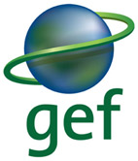 | 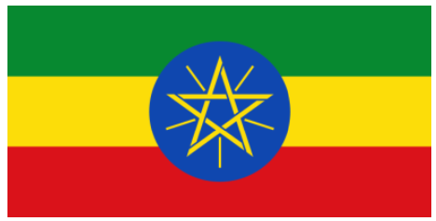 | 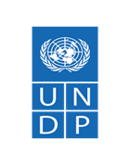

Terminal Evaluation
Final Report

UNDP-Supported GEF-Financed Full Size Project:

“Enhanced Management and Enforcement of Ethiopia’s Protected Area Estate Project “EMEPA”
(PIMS 5609)
GEF ID: 9157
Project Title: | Enhanced Management and Enforcement of Ethiopia’s Protected Area Estate
Country: | Ethiopia
Region: | Africa
Focal Area: | Biodiversity
Implementing Agency: | United Nations Development Programme
Implementing Partner: | Ethiopian Wildlife Conservation Authority (EWCA) and Ethiopian Biodiversity Institute (EBI)
Project Timeframe: | August 2017 to September 2023
Evaluation Team
Name: | Kevin Enongene
Role: | Team Leader
Email: | kenongene@fokabs.com
Name: | Yilikal Addisu
Role: | National Consultant
Email: | yilikaladdisu@gmail.com

November 2023

DOCUMENT REVIEW
This Terminal Evaluation, version 2.0, dated 30 October 2023, for the UNDP-Supported GEF-Financed Full Size Project “Enhanced Management and Enforcement of Ethiopia’s Protected Area Estate Project “EMEPA” has been reviewed by the following individuals.

Reviewed By:
Name:
Office:

Name:
Office:

Please also refer to Annex M for the formal Terminal Evaluation Report Clearance form to be signed by the Commissioning Unit and UNDP NCE Regional Technical Advisor
Contact Information:
If you wish to discuss this document, please contact:
Name: Kevin Enongene
Role: Team Leader and Lead Evaluator
Location: Ottawa, Canada
Email: kenongene@fokabs.com

Name: Yilikal Addisu
Role: National Consultant
Location: Addis Ababa, Ethiopia
Email: yilikaladdisu@gmail.com

REVISION HISTORY
Document Version Number | Version Release Date | Summary of Changes | Changed By
1.0 | October 5, 2023 | Draft TE Report | Kevin Enongene  Yilikal Addisu
2.0 | October 29, 2023 | Final TE Report | Kevin Enongene  Yilikal Addisu

ACKNOWLEDGEMENTS
The Evaluators wish to express their profound gratitude for the time and effort expended by all project participants and stakeholders during the evaluation interviews. This provided valuable insights, candid perspectives, and above all informed the evaluation findings. The Evaluators appreciate the guidance, feedback and support of the Government of Ethiopia through the Ethiopian Wildlife Conservation Authority (EWCA) and the Ethiopian Biodiversity Institute (EBI). The evaluators are equally thankful to the United Nations Development Programme (UNDP) Ethiopia Country Office team, especially Mrs. Wubua Mekonnen, Mr. Berhanu Alemu, Mrs. Meseret Amsalu for their feedback, guidance and support provided for the successful completion of the evaluation. We are thankful to the UNDP Regional Technical Advisor (RTA) Mrs. Kaavya Varma and programme associate Mrs. Mahlet Ambachew for their feedback and orientations provided to the evaluators. The evaluators also appreciate the support of the Project Management Unit (PMU), particularly Mr. Arega Mekonnen, Dr. Fanuel Kebede, Dr. Demeke Datiko and Mr. Behailu Mekonnen for their feedback and timely response to the evaluators’ request for additional information or documentation and facilitating the field mission. Special thanks to the community members who participated in the Focus Group Discussions conducted as part of the data collection process of the evaluation. We are indebted to Omo, Mago and Chebera Churchura National Parks and Babile Elephant Sanctuary Managers and Staff for providing factual information and additional data for the evaluation. Our appreciation also goes to government offices from federal, regional, zonal and woreda levels who have been implementing the project for their candid response during the interviews. We hope that this report will inform the design and implementation of subsequent projects in Ethiopia and beyond.

DISCLAIMER
The TE views expressed in this document were reviewed by UNDP and Implementing Partners. The UNDP Ethiopia Country Office, UNDP NCE Regional Technical Advisor and the Project Management Unit (PMU) provided comment on the draft report prior to its finalization. The views held within this report are those of the TE consultant team.

TABLE OF CONTENTS

Table of Contents
ACKNOWLEDGEMENTS iv
DISCLAIMER v
ACRONYMS AND ABBREVIATIONS x
I. EXECUTIVE SUMMARY xi
II. INTRODUCTION 23
A. Purpose and objective of the Terminal Evaluation 23
B. Scope and Methodology 23
C. Data Collection & Analysis 24
D. Ethics 26
E. Limitations to the Evaluation 26
F. Structure of the Evaluation Report 26
III. PROJECT DESCRIPTION AND BACKGROUND 30
A. Project start and duration, including milestones 30
B. Development context: environmental, socio-economic, institutional, and policy factors relevant to the project objectives and scope 30
C. Problems that the project sought to address: threats and barriers targeted 31
D. Project area and key sites 33
E. Immediate and development objectives of the project 34
F. Expected results 35
G. Main stakeholders 36
H. Theory of change 37
IV. FINDINGS 38
A. Project Design and Formulation 38
Analysis of Results Framework 38
Assumptions and Risks 43
Lessons from other Relevant Projects 46
Planned Stakeholder Participation 46
Linkages between Project and other Interventions within the Sector 47
Gender responsiveness of project design 50
B. Project Implementation 51
Adaptive Management 51
Actual Stakeholder Participation and Partnership Arrangements 51
Communications 58
Project Finance and Co-finance 59
Monitoring and Evaluation 59
Project Implementation and Execution 62
Risk Management 63
C. Project Results 64
Progress towards Objective and Expected Outcomes 64
Relevance 64
Effectiveness 67
Efficiency 87
Overall Outcome 90
Country Ownership 90
Gender 90
Cross-cutting Issues 92
Disability 92
Social and Environmental Standards 92
Sustainability 93
Socio-political risk 95
GEF Additionality 97
Catalytic Role/Replication 97
Progress to Impact 98
V. CONCLUSIONS, RECOMMENDATIONS AND LESSONS LEARNED 100
A. Conclusions 100
B. Lessons Learnt 100
C. Recommendations 101
LIST OF ANNEXES 105
Annex A: Terms of Reference of the Terminal Evaluation (attached as a separate file) 105
Annex B: Inception Report of the Terminal Evaluation (attached as a separate file 105
Annex C: TE Mission Itinerary 106
Annex D: Stakeholders Consulted 107
Annex E List of Documents/Resources Reviewed 111
Annex F: Evaluation Question Matrix 112
Annex G: Questionnaire used for Data Collection 120
Annex H: TE Rating Scales 126
Annex I: Co-financing Table 127
Annex J: GEF Core Indicators 128
Annex K: TE Audit Trail (attached as a separate file) 133
Annex L: Signed UNEG Code of Conduct Form 134
UNEG Code of Conduct for Evaluators 134
Annex M: Signed TE Clearance Form 136

LIST OF TABLES
Table 1: Project timeline and key milestones 30
Table 2: Selected sites for livelihood activities 34
Table 3: Terminal evaluation SMART analysis of the project’s objective and outcome indicators 39
Table 4: Project risks and Proposed Mitigating Measures 44
Table 5: Summary of Partnership with Similar Projects/Programmes 48
Table 6: Summary of stakeholder analysis 52
Table 7: EMEPA M & E roles and responsibilities 60
Table 8: M&E design and implementation rating 62
Table 9: Risks identified during project implementation 63
Table 10: Results analysis of level of attainment of objectives indicators 67
Table 11: Results analysis of the level of attainment of outcome indicators 71
Table 12: Total budget utilized by the cooperatives 81
Table 13: Average percentage of income increase in cash (birr) between 2019 to 2023 of cooperative 81
Table 14: EMEPA sustainability rating 96

LIST OF FIGURES
Figure 1: Location Map of the Project Sites 33
Figure 2: Regulations and Manual for effective protected area management 76
Figure 3: 10 Year management plans of the target PAs 77
Figure 4: Group of African Elephants (Photo taken during the field mission for the TE at Babile ES) 77
Figure 5: Group of Buffalo (Photo taken during the field mission for the TE at CCNP) 78
Figure 6: Wildlife in Omo NP (Photo taken during game drive) 78
Figure 7: Instruments for law enforcement 79
Figure 8: MoU signed by the relevant actors and annual activity plan for law enforcement 80
Figure 10: Agro-forestry and modern bee keeping in Mago (by beneficiary cooperatives) 82
Figure 11: Goats and Oxen fattening in Babile (by beneficiary cooperatives) 82
Figure 12: Picture of FGDs with Male and Female beneficiaries in Mago 83
Figure 12: Demonstration site and Medicinal plants gene bank in Mago 84
Figure 12: Financial records, receipts and registration certificate of the cooperatives (Mago) 89

ACRONYMS AND ABBREVIATIONS
AWF | African Wildlife Foundation
AWP | Annual Work Plan
BFF | Born Free Foundation
EBI | Ethiopian Biodiversity Institute
ECU | Environmental Crime Unit
EMEPA | Enhanced Management and Enforcement of Ethiopia’s Protected Area Estate
ERCA | Ethiopian Revenue and Customs Authority
EWCA | Ethiopian Wildlife Conservation Authority
EWCP | Ethiopian Wolf Conservation Programme
FGD | Focus Group Discussion
GEF | Global Environment Facility
GoE | Government of Ethiopia
GIZ-BFP | Ethio-German Technical Cooperation Biodiversity Forest Project
HAWEN | Horn of Africa Wildlife Enforcement Network
HoA-REC/N | Horn of Africa Regional Environment Centre and Network
KII  M & E | Key Informant Interview  Monitoring and Evaluation
MTR | Mid Term Review
NPC | National Project Coordinator
OFP | Operational Focal Point
PB | Project Board
PFO | Procurement and Financial Officer
PIR | Project Implementation Report
ProDoc | Project Document
PSC | Project Steering Committee
PMU | Project Management Unit
SMART | Specific, Measurable, Achievable, Relevant and Time-bound
SNNPR | Southern Nation, Nationality and Peoples’ Region
TE | Terminal Evaluation
ToR | Terms of Reference
UNDP | United Nations Development Programme
UNEG | United Nations Evaluation Group

EXECUTIVE SUMMARY
- Project Information Table
Project Details |  | Project Milestones
Project Title | Enhanced Management and Enforcement of Ethiopia’s Protected Area Estate | PIF Approval Date: | June 2016
UNDP Project ID (PIMS #): | 5609 | CEO Endorsement Date (FSP) / Approval date (MSP): | June 9, 2017
GEF Project ID: | 9157 | ProDoc Signature Date:
UNDP Atlas Business Unit, Award ID, Project ID: | 00100238 | Date Project Manager hired: | January 2018
Country/Countries: | Ethiopia | Inception Workshop Date: | March 6, 2018
Region: | Africa | Mid-Term Review Completion Date: | December 2020
Focal Area: | Multi-Focal Areas, Cross Cutting Capacity Development | Terminal Evaluation Completion date: | October 30, 2023
GEF Operational Programme or Strategic Priorities/Objectives: |  | Planned Operational Closure Date: | December 2023
Trust Fund: | GEF Trust Fund
Implementing Partner (GEF Executing Entity): | UNDP
NGOs/CBOs involvement:
Private sector involvement:
Geospatial coordinates of project sites:
Financial Information
PDF/PPG | at approval (US$M) | at PDF/PPG completion (US$M)
GEF PDF/PPG grants for project preparation
Co-financing for project preparation
Project | at CEO Endorsement (US$M) | at TE (US$M)
[1] UNDP Contribution | 200,000 | 200,000
[2] GoE (Ethiopian Wildlife Conservation Authority) | 30,868,725 | 30,868,725
[3] GoE (Ethiopian Biodiversity Institute) | 3,161,356 | 3,161,356
[4] IGAD/EU/HoAREC | 6,380,000 | 0
[5] KfW | 21,267,000 | 21,267,000
[6] GIZ | 12,234,400 | 12,234,400
[7] Born Free Foundation | 1,500,000 | 1,500,000
[8] Frankfurt Zoological Society | 1,800,000 | 1,800,000
[9] Wildlife Conservation Society (WCS) | 1,000,000 | 0
[10] African Wildlife Foundation (AWF) | 5,000,000 | 5,000,000
[11] Total co-financing [1 + 2 + 3 + 4 + 5+6+7+8+9]: | 83,411,481 USD | 76,031,481 USD
[12] Total GEF funding: | 7,294,495 USD | 7,294,495 USD
[13] Total Project Funding [11 +12] | 90,705,976 USD | 83,325,976 USD

- Project Description
The United Nations Development Programme (UNDP)-supported, Ethiopia project " Enhanced Management and Enforcement of Ethiopia’s Protected Area Estate " is financed by the Global Environment Facility (GEF). As per the project document (ProDoc), the project has as start and end dates August 2017 and September 2023 respectively. Due to delays in the recruitment of the project staff, the project inception workshop only happened in March 2018 and the official project operational closure date is now December 2023. The implementing entity of the project is the Ethiopian Wildlife Conservation Authority (EWCA) and the Ethiopian Biodiversity Institute (EBI). The EMEPA project was implemented through four main components:
- Component 1: Protected area management and biodiversity conservation.
- Component 2: Implementation of anti-trafficking measures.
- Component 3: Landscape approach to forest and agro-biodiversity conservation.
- Component 4: Knowledge Management, Gender mainstreaming, and M&E.

- Evaluation Ratings
Criteria | Rating | Comments
1. Monitoring & Evaluation (M&E)
M&E design at entry | 6:Highly Satisfactory (HS) | In its preparation phase, a monitoring and evaluation plan was designed for the EMEPA project. The plan outlined details including how the project will be monitored at different levels – federal and regional, cost for M&E activities and responsible actors for each of the monitoring activities.
M&E Plan Implementation | 6:Highly Satisfactory (HS) | The project team embarked on the collection of data for the different project indicators, and these were used in the elaboration of the annual PIRs and quarterly progress reports. Where relevant, the M&E collected and presented gender-disaggregated data.  During the delivery of the project, M&E happened through the following activities: organization of an inception workshop; elaboration of annual work plans (AWPs) and organization of project steering committee meetings to validate the AWPs and budget and stock taking of project implementation progress including provision of recommendations for an enhanced delivery of the project; field monitoring missions; spot checks; midterm review (MTR); and project terminal evaluation (TE).  In a nutshell, the project M&E provided feedback for improvement in implementation. The project team at the national level conducted regular monitoring visits to the field sites and at the end of each mission, the project team provides an update to the steering committee and the project office to discuss on the key challenges identified by the field visit and identify proposed measures to be adopted by the project. The budget reserved for M&E was judged by the project team and the evaluators to be modest.
Overall Quality of M&E | 6:Highly Satisfactory (HS) | The overall quality of M&E rating is Highly Satisfactory. This is a combination of the ratings for M&E design at entry and M&E plan implementation which were both rated Highly Satisfactory.
2. Implementing Agency (IA) Implementation & Executing Agency (EA) Execution
Quality of UNDP Implementation / Oversight | 6:Highly Satisfactory (HS) | UNDP played a pivotal role as the GEF implementing entity by providing implementation oversight. UNDP supported the recruitment of project staff and ensured technical and financial reports were prepared and submitted to the project board in a timely manner.  UNDP internal project and financial management system provided support to the implementation of the EMEPA project. UNDP equally provided support in the procurement of services under the project using its internal procurement system and guidelines. The UNDP team provided technical support through the review of the annual PIRs, providing feedback to the project team for improvement of its quality.
Quality of Implementing Partner Execution | 6:Highly Satisfactory (HS) | The implementing partners of the project (EWCA and EBI) worked in collaboration with UNDP and the Project Management Unit (PMU) for the delivery of the project. The support from the government emerged as a factor that contributed to the successful delivery of the EMEPA project. The Director Generals of EBI and EWCA were very engaged in the project and were instrumental in successful mobilizing their respective staff to be engaged in the implementation of the project.
Overall Quality of Implementation / Execution | 6:Highly Satisfactory (HS) | The overall quality of implementation / execution is Highly Satisfactory. This is a combination of the ratings for the quality of UNDP Implementation and quality of implementing partner execution which were both rated Highly Satisfactory.
3. Assessment of Outcomes
Project Objectives | 5: Satisfactory (S) | The EMEPA project made significant progress towards the realization of its objectives. The project objective comprised of four (4) mandatory indicators. Indicator 1 has four sub indicators of which the end-of-project (EOP) targets for three were achieved and one was partially achieved. Indicator 2 had no sub indicators and its EOP target was exceeded at the time of the TE. Indicator 3 comprises of 2 sub indicators of which the EOP targets for one is achieved and one is partially achieved. The EOP for indicator four was achieved. For partially achieved indicators, the values recorded at the TE represented a substantial improvement from the baseline values.
Relevance | 6:Highly Satisfactory (HS) | The EMEPA project was relevant to the national priorities of Ethiopia as well as global priorities. The Government of Ethiopia is signatory to environmental related conventions such as the United Nations Framework Convention on Climate Change (UNFCCC), the United Nations Framework Convention on Biodiversity (UNFCBD), and the United Nations Framework Convention to Combat Desertification (UNFCCD). The activities of the project makes it aligned to these three environmental conventions.  The project also shows strong alignment with existing national development plans and strategies. By contributing to livelihood improvement and food security of the communities living around the protected areas, the EMEPA projects supports two of the four pillars of Ethiopia’s Climate‐resilient Green Economic Strategy focusing on: improving crop and livestock production practices for higher food security and farmer income while reducing emissions; and protecting and re‐establishing forests for their economic and ecosystem services, including as carbon stocks. The project equally aligns with Ethiopia’s Ten Years Development Plan 2021-2030.  The project strongly aligns with the needs of the local communities around its targeted implementation sites. The livelihood activities promoted by the project were appreciated by local communities as they found these to be directly responding to their needs.
Effectiveness | 5: Satisfactory (S) | The rating of the project’s effectiveness is based on the progress realised towards the achievement of the objectives and outcomes of the project. The rating of the achievement of the project’s outcome are as follows: Outcome 1 (Satisfactory), Outcome 2, Outcomes 3 and 4 (Highly Satisfactory). The progress towards objective is rated Satisfactory. Hence, the effectiveness rating is a combination of the ratings for the outcomes and objective.
Efficiency | 5: Satisfactory (S) | For each financial year, the project team elaborated the annual work plan and budget and this was accompanied by reflections on how the workplans could be achieved through the efficient use of the project’s resources. In implementing some capacity building events, the project ensured efficiency by liaising with other ongoing government capacity building initiatives. The project also explored and established partnerships that culminated in efficient use of resources. For instance, in the elaboration of the management plan of the Chebera Churchura National Park, the EMEPA project collaborated with an ongoing GIZ project being implemented in the area and this led to cost sharing between the EMEPA and the GIZ project.  The PMU followed the approach the financial management approach developed by the Ministry of Finance, while also integrating UNDP financial management requirements. The UNDP system ensured for a strict control and monitoring of the utilization of the budget for each project activity. The project was subjected to an external audit annually and the opinion of the auditor has been unqualified over the years, depicting good financial management and utilization of project’s resources.
Overall Project Outcome Rating | 5: Satisfactory (S) | The overall outcome assessment is based on the combined ratings for effectiveness (Satisfactory), efficiency (Satisfactory) and Relevance (Highly Satisfactory).
4. Sustainability
Financial Sustainability | 3: Moderately Likely (ML) | Elements of the project that poses a financial risk to sustainability includes the GIS-based applications provided within the framework of the project. Such applications likely require licences and upon expiration of the current licence and failure to renew the subscription by the government due to the non-existence of a budget line to cater for this, may lead to non-functionality of the application. The same applies to likely scenario where a drone employed in protected area monitoring gets broken and requires replacement.
Socio-political Sustainability | 3: Moderately Likely (ML) | Ongoing conflict in the Kafta Shiraro protected area emerged as a socio-political risk to sustainability of the EMEPA project. In the absence of political stability, it is challenging for conservation and sustainable management of natural resources. The possible recurrence of the corona virus pandemic or a similar one and population growth around protected areas also represents socio-political risk to sustainability of the EMEPA project.
Institutional Framework and Governance Sustainability | 3: Moderately Likely (ML) | The elaborated protected area management plans will require revision and updating at some point, and this will entail collaboration among stakeholders. Inadequate collaboration may jeopardise the possibility of these plans to be updated. The project proposed policy amendments which at the time of the TE, these were already sub mitted to the relevant government bodies but were yet to be approved by them. There is a risk that these amendments may end up not being approved.
Environmental Sustainability | 3: Moderately Likely (ML) | Climate change represents an environmental risk which may impeded the management of protected areas. Rising temperature trends, changes in precipitation patterns and occurrence of droughts could negatively affect wildlife and impact on the conserved protected areas.
Overall likelihood of Sustainability | 3: Moderately Likely (ML) | The overall risk to sustainability is based on the combination of the individual ratings of the dimensions to sustainability: financial, environmental, institutional framework and governance, and socio-political

Terminal evaluation rating scales
Ratings for Outcomes, Effectiveness, Efficiency, M&E, Implementation/Oversight, Execution, Relevance: | Sustainability ratings:
6 = Highly Satisfactory (HS): exceeds expectations and/or no shortcomings | 4 = Likely (L): negligible risks to sustainability
5 = Satisfactory (S): meets expectations and/or no or minor shortcomings | 3 = Moderately Likely (ML): moderate risks to sustainability
4 = Moderately Satisfactory (MS): more or less meets expectations and/or some shortcomings | 2 = Moderately Unlikely (MU): significant risks to sustainability
3 = Moderately Unsatisfactory (MU): somewhat below expectations and/or significant shortcomings | 1 = Unlikely (U): severe risks to sustainability
2 = Unsatisfactory (U): substantially below expectations and/or major shortcomings | Unable to Assess (U/A): Unable to assess the expected incidence and magnitude of risks to sustainability
1 = Highly Unsatisfactory (HU): severe shortcomings
Unable to Assess (U/A): available information does not allow an assessment

- Concise Summary of Conclusions, Lessons and Recommendations
Conclusions summary
The GEF 6 project “EMEPA: Enhanced Management and Enforcement of Ethiopia’s Protected Area Estate” (PIMS 5609) project has been implemented in Ethiopia with positive results. The project was firmly anchored on the global environment benefits with innovations such as mobilising a broad range of stakeholders, building the capacity of high-level government officials and protected area management staff, using of social media, TV and radio stations, and technological tools like drones and GIS-based applications, and others.
From the perspective of the project developers and beneficiaries, the multi-stakeholders play their respective roles and provide meaningful contributions which added up and ensured a holistic approach to tackling wildlife crimes and conserving biodiversity, integrating projects activities in government initiatives enabled the project to cut down on expenditures and enhanced efficiency in the utilization of its funds, capacity building of high-level government officials and conservation managers provided different skills and knowledge at different levels capacitating and enabling each actor in discharging their duties in an effective and efficient manner while contributing to the successful delivery of the project, the use of the different media outlets or streams in awareness raising on biodiversity conservation and wildlife crime; the use of the technological tools (drone and GPS) permitted not only promising in increasing the effectiveness of the protected areas management but also cut cost as monitoring of wildlife populations that was done by airplanes were accomplished using drones. Furthermore, the project supported beneficiaries in establishing cooperatives, and built capacity of members, permitting them to develop entrepreneurial spirit and engage in income-generating livelihood activities which culminated in financial gains and overall improvement in the quality of their lives.
However, Covid 19 pandemic negatively impacted travel and in-person meeting, as restrictions were imposed by the Government of Ethiopia, and this rendered the management and protection of protected areas from illegal activities challenging. Travel or patrol was required for these sites to be kept secured from perpetrators of wildlife crime. Furthermore, political instability and insecurity in some parts of the country was a challenge for the delivery of the EMEPA project.
Lessons learned
A multi-stakeholder approach is important for achieving protected area management and biodiversity conservation goals. The project mobilized a broad range of stakeholders to join forces to ensure effective management of protected areas and combat illegal trade and trafficking of wildlife. Stakeholders could play their respective roles and provide meaningful contributions which added up and ensured a holistic approach to tackling wildlife crimes and conserving biodiversity.

Integrating project activities within government initiatives to the extent possible is an effective approach in ensuring project financial efficiency. In conducting capacity building activities within the framework of the project, the project team explored options and integrated the trainings of project within other planned capacity building events of the government. This approach enabled the project to cut down on expenditures and enhance efficiency in the utilization of its funds.

Capacity building of project stakeholders involved in project implementation at different levels is important for project success. The project embarked on building the capacity of high-level government officials and protected area management staff at the project sites. The trainings were destined to provide different skills and knowledge to the actors at different levels to enable each actor to be better capacitated in discharging their duties conferred on them by the state, in an effective and efficient manner while contributing to the successful delivery of the project.

The use of diverse media network and ongoing renown broadcasting programmes are effective approaches to awareness raising within the context of a project. The project employed made use of different media such as social media, TV and radio stations for awareness raising of the population. The project used an existing and popular TV programme to raise awareness on biodiversity conservation and wildlife crime. Broadcasting of the information happened in the first most popular and spoken language in Ethiopia.

Technological applications have the potential for enhancing the management of protected areas. The project introduced technological tools like drones and GIS-based applications which are not only promising in increasing the effectiveness of protected areas management but will cut cost as monitoring of wildlife populations that was done by aeroplanes will now be accomplished using drones.

Impacting change within communities goes beyond providing them with money. In addition to providing financial assistance to the beneficiaries, the project supported the beneficiaries in the establishment of cooperatives and trained the cooperative members on diverse themes. This enabled the members to develop an entrepreneurial spirit and engage in income-generating livelihood activities which culminated in financial gains and overall improvement in their quality of life.

Recommendations
NO. | FINDING/CHALLENGE | RECOMMENDATIONS
Project financing
 | At TE, two of the committed co-financiers (WCS and IGAD/EU/HoAREC had 0% materialization. While the reason for the on materialization of the co-financing from these two financiers is understandable – project delay and interruption, the TE did not identify any effort or strategy used by the project to address the co-financing gap. | It is important for project co-financing to be monitored and analysed periodically to identify risks related to non-materialization of co-financing. In the event it is identified that a particular co-financier is likely not to commit to its co-financing pledged during the project design, the implementing partners should analyse the potential impacts of the non-materialization of co-financing on the project and explore possibilities of obtaining co-financing from other sources to close the gap. This is something that the UNDP Country Office would have undertaken.  Responsibility: UNDP  Timeline: Subsequent projects
Sustainability
 | The project has been instrumental in building the capacity of staff of protected areas alongside other stakeholders. However, staff turnover emerged as an issue which could hamper the sustainability of the project. | For subsequent project of this nature, it will be important for the project to partner with a national institute which has the mandate to provide capacity building to public institutions. In this way, the institution could continue to build capacities beyond the project based on the request of institutions. In this way, the national institute could take the relay in providing capacity building to staff of protected areas among others beyond the life of the project. Hence, in the event of staff turnover, the new staff could receive training from the national institute. Another beneficial approach would be to develop detailed training manuals for the different trainings conducted and these manuals could be used by new staff of institutions to build their capacity on an independent learning basis.  Responsibility: UNDP, Government of Ethiopia  Timeline: Subsequent projects
 | The project has introduced technologies in the management of protected areas, some of which may require a valid licence to function. Upon licence expiration or breakdown of a technology (e.g. drone), unclear funding for the renewal of the licence or replacement of a technology could impact on the sustainability of the project. | For sustained use of the introduced technologies by the project in the management of protected areas, there is need for clarity of a funding source for the renewal of software licences and replacement of broken drones among others. It is therefore important for the Government of Ethiopia to allocate resources in this regard lest the application of these technologies in the management of protected areas could discontinue at some point.  Responsibility: Government of Ethiopia  Timeline: Before project closure
 | The project’s exit strategy was still under elaboration at the time of the TE and was finalized in September 2023. This should have been elaborated earlier on | While an attempt was made in the elaboration of the exit strategy for the project, this happened towards the end of the project. Such a strategy would have ideally been elaborated just after the mid-term review of the project, giving room for necessary amendments to be made to the document over time. Hence, for subsequent projects, it is recommended for the exit strategy to happen earlier on during the project implementation, precisely after the completion of the mid-term review or at the mid-point of implementation of a project – for those project that do not qualify for a mid-term evaluation.  Responsibility: Implementing partners (UNDP, Government of Ethiopia).  Timeline: Subsequent projects
 | While the project supported communities around protected areas with livelihood opportunities, it emerged from the evaluation that pastoralist communities around the protected areas may jeopardise the law enforcement efforts and sustainability of the project as they tend to move from place to place, in search of grazing land and water for their livestock. | Pastoralists have a nomadic lifestyle and often move from one place to another in search of pasture and water for their herd. It is important for the pastoralist communities to be organised and be provided with water points which are out of the protected areas and farmlands of community members. This will involve close consultations with them, understanding their needs and co-designing solutions to meet their needs. This is a sensitive issue that must be cautiously handled as nomadic pastoralists are often recognised as marginalised or indigenous groups under international climate funds like the Green Climate Fund (GCF) and GEF. Hence, adequate care must be taken to ensure that the project does not adversely affect this group of people.  Responsibility: Implementing partners (UNDP, Government of Ethiopia)  Timeline: Future projects
 | The project supported the revision of the Wildlife Act which now makes provision for stricter and more punitive measures for wildlife crime. The revised Act in itself would not combat wildlife crime but its effective enforcement. | The Government of Ethiopia should ensure the strict implementation of the Wildlife Act and sanctions meted on to wildlife criminals should be widely publicised in the country – through TV and radio networks, newspapers, social media, etc. This will play an important role to deter others from indulging into illegal wildlife trade and other associated wildlife crimes in the country.  Responsibility: Government of Ethiopia)  Timeline: Ongoing basis
 | The project supported the demarcation of protected areas but these demarcated boundaries are yet to be legalized. | The national project counterparts should work tirelessly to secure the House of Representative’s legalization of the demarcated boundaries of the protected areas supported by the project. This is an important element that will support the sustainability of the project’s outcomes relating to its interventions in protected areas.  Responsibility: EWCA and EBI  Timeline: Before the end of 2023
 | The main challenge for effective protected area management is scarcity of potable water for the community living around the parks and their cattle that is forcing the farmers and pastoralists to trespass the park territories to fetch water. Some parks such as Omo NP also need water, sanitation and health facilities. | To alleviate this threat effective water sanitation and hygiene (WaSH) interventions in and around the protected areas are required. This is actually beyond the scope of the project. Therefore, the TE team recommend that future similar interventions should incorporate WASH interventions to ensure the safety of the parks. To achieve this, it is wise to link the parks with other development partners working on WASH in Ethiopia such as One WaSH Project, GIZ, UNICEF, UNHCR among the rest.  Responsibility: Implementing partners (UNDP, EWCA, EBI), the GoE, and other development partners  Timeline: Future projects
Environmental and social safeguards
 | The evaluation did not generate evidence pertaining to the inclusion of people with disabilities in its interventions, especially those related to livelihoods. | For subsequent projects, dedicated efforts or strategies should be adopted during the project design and implementation phases to ensure the participation of people with disabilities. This will boost the inclusivity of the project. While it is understandable that it could be sometime challenging to ensure the participation of individuals with disabilities in project activities, no effort was made in the case of the EMEPA project to achieve this.  Responsibility: Implementing partners (UNDP, EWCA, EBI)  Timeline: Future projects
 | The evaluation did not identify the existence of an accountability and grievance readdress mechanism for the project. Most TE respondents were unaware of the existence of such a mechanism for the project. Equally, other safeguard management plans were not developed for the project at its outset. The 2020 PIR and the mid-term review of the EMEPA project recommended that actions be taken to address safeguard issues including the elaboration of some safeguard plans (AGM, LAP, IPP and ESMP). These were however not addressed in the 2021 and 2022 PIRs. | It is important for an accountability and grievance redress mechanism be designed for subsequent projects early enough, preferably at the inception phase of the project. The AGM should be widely publicized during the inception workshop and at each project event so that project stakeholders know exactly the procedures and channels to follow in submitting complaints they may have about the project.  Other environmental and social safeguards management plans (e.g. livelihood action plan - LAC, environmental and social management plan - ESMP, biodiversity action plan, indigenous peoples plan - IPP etc.) as identified in the SESP and highlighted in the environmental and social management framework of the project should equally be developed at the early stage of the project, ideally prior to the commencement of the activities for which they are needed. This will ensure adequate safeguarding of the identified risks. This is particularly important of a project of this nature which presents risks for economic displacement and the introduction of invasive species through its rehabilitation pr reforestation interventions.  Responsibility: Implementing partners (UNDP, EWCA, EBI)  Timeline: Future projects

INTRODUCTION
- Purpose and objective of the Terminal Evaluation
The objective of the Terminal Evaluation (TE) is to enable the Global Environment Facility (GEF), UNDP and the participating countries to assess the relevance, efficiency, effectiveness, impact and sustainability of the EMEPA: Implementing Enhanced Management and Enforcement of Ethiopia’s Protected Area Estate Project. The terminal evaluation (TE) assessed achievements of the project against its objectives. It also identified factors that have facilitated or impeded the achievement of the objectives. While a thorough review of the past is in itself very important, the in-depth evaluation is expected to lead to detailed overview and lessons learned for the future and particularly provide recommendations that will contribute to sustaining the outcomes of the project to the stakeholders in the country. The TE report assessed the achievement of project results against what was expected to be achieved and draw lessons that can both improve the sustainability of benefits from this project, and aid in the overall enhancement of UNDP programming.
The Terminal Evaluation had as purpose to promote accountability and transparency; synthesize lessons that can help to improve the selection, design and implementation of future UNDP-supported GEF-financed initiatives; improve the sustainability of benefits and aid in overall enhancement of UNDP programming; assess and document project results, and the contribution of these results towards achieving GEF strategic objectives aimed at global environmental benefits; and gauge the extent of project convergence with other priorities within the UNDP country programme, including poverty alleviation, strengthening resilience to the impacts of climate change, reducing disaster risk and vulnerability, as well as cross-cutting issues such as gender equality, empowering women and supporting human rights. The TE process followed a collaborative and participatory approach ensuring close engagement with key participants including the Commissioning Unit (the UNDP Ethiopia Country Office), RTAs, Regional M&E Advisors, Country Office M&E Focal Points and Programme Officers, Government counterparts including the GEF Operational Focal Point (OFP), and other key stakeholders. Ideally, the TE should occur during the last few months of project activities, allowing the TE team to proceed while the Project Team is still in place, yet ensuring the project is close enough to completion for the evaluation team to reach conclusions on key aspects such as the sustainability project activities. The results of the evaluation will significantly benefit the Government of Ethiopia, i.e., the regional states, programs/projects, the local governments, and communities. The best practices, approaches and principles from the TE can be adopted/ adapted to similar areas for similar purposes. The recommendations from the evaluation can be used to inform the design of future projects and programs.
- Scope and Methodology
- Scope of the TE
The overall approach and methodology of the evaluation followed the guidelines and requirements outlined in UNDP Guidance for TEs of UNDP-supported GEF-financed projects, which guided the assessment of results. The TE results are evidence-based relying on feedback from persons or stakeholders who were involved in the design, implementation, and supervision of the EMEPA project. The TE team reviewed comprehensive relevant documentation related to the project that were made available to the team and also held stakeholder consultations to gather primary data. Such documents included those prepared during the preparation phase, the Project Document (Pro-Doc), project reports such as annual PIRs, project budget revisions, best practice compiled, national strategic and legal documents and any other relevant project-related materials.
The team leader for this assignment was the international consultant who was responsible for quality assurance and consolidation of the findings of the evaluation, led and ensured the writing of the TE report in close collaboration and discussion with the national consultant. The TE process was expected to follow a participatory and consultative approach, while making sure that there is close engagement with the Project Team, government counterparts (the GEF Operational Focal Point), Implementing Partners, the UNDP Country Office(s), the Regional project focal persons, protected area wardens of the Project sites, direct beneficiaries in and adjacent to protected areas and other stakeholders.
The findings section of the TE report covers the following as suggested in the Terms of Reference (ToR):
- Project Design / Formulation
- Project Implementation
- Project Results
- Main findings, conclusions, recommendations and lessons learned
- Methodology
The TE of the EMEPA project has been carried out in accordance with GEF-UNDP Evaluation guidelines, Evaluation norms, and ethical standards. The report represents a summative evaluation comprising both qualitative and quantitative methods, used to evaluate the project’s performance, document lessons learned and make recommendations. The approach for the TE was participatory whereby discussions with key stakeholders provided and verified the findings, while ensuring close engagement with the Project Team, government authorities, relevant regional and local stakeholders as well as project beneficiaries.
Stakeholder engagement is pivotal for a successful TE assignment and this was done through interviews with relevant stakeholders who had project responsibilities, key experts in project subject area, project team leaders, local communities and senior officials. The team also conducted field missions in the following project sites - Omo, Mago and Chebera Churchura National Parks and Babile Elephant Sanctuary. During these field visits, the TE team assessed the impact of the project activities on the target protected areas (PAs), the people in the project sites and also their contributions the project made to the environmental objectives of the country.
- Data Collection & Analysis
Data collection for this assignment has been carried out using a mixed methods approach which constitutes a review of secondary literature to generate both qualitative and quantitative data, and primary data collection through interviews, consultations, focus group discussions and field observations. Reporting was also done in an interactive manner involving collaboration between the team leader and national consultant. The data collection was done in a three-phased manner: i) inception phase, ii) data collection and analysis phase and iii) close out or reporting phase. The evaluation framework containing key questions by category is presented in Annex F.
- Inception phase
The inception phase was intended to bring both the project stakeholders and the evaluation team on a common ground, in relation to the objectives and scope of the assignment. This phase started with an initial virtual inception meeting held on the 3rd of July 2023, between the international consultant (Team Leader) and an Expert from UNDP Ethiopia. A kick-off meeting was organised by UNDP Ethiopia CO on the 18th of July 2023, to introduce the national and international consultants with the PMU, GEF and UNDP staff who were responsible to facilitate the TE. An exchange of relevant project-related documentation, ideas and agreement on initially proposed timelines followed suit during the inception meeting. This also included a tentative field visit plan agreed upon by all participants. An inception report was written in accordance with the GEF-UNDP guidelines for TEs, and submitted to the client, outlining the proposed approach to the assignment, a detailed work plan of activities and the methodology, and this marked the end of the inception phase of the assignment.
An evaluation matrix was designed during the inception phase, as well as an interview guide which were both used for the interviews and field data collection process.
- Data Collection and Analysis
Data collection for this assignment involved a desk review, research and analysis, which represented the core part of the TE. Project documents were reviewed to be able to assess the contributions of the project to the national priorities and also environmental objectives of the country. Documents such as the Project Document, results framework, annual work plans and budgets, progress reports, reports from workshops and meetings, quarterly monitoring and evaluation plans and reports, project assurance reports, combined delivery reports (CDR), minutes of technical project team and Project Board meetings, document on best practices, Output verification reports, project intervention maps, project exit strategy, contract products, midterm review (MTR) among other national documents were reviewed to provide secondary data for the assignment.
Desk Study and Deeper Dive of Documentation
Once the inception phase of the TE was concluded, the TE team proceeded to carry out a thorough review of the relevant documentation provided. The data analysis for this TE assignment comprised of content analysis in the review of secondary data, while data from interviews and discussions were recorded and transcribed and / or translated where necessary. Thanks to the mixed methods approach used, the evaluation team was able to triangulate the findings on the ground to ensure that the results are reliable and robust.
Primary data collection took place through a quantitative and qualitative approach. Regarding the quantitative approach, we reviewed the secondary data provided to assess progress, in line with the results framework. The TE ensured that a collaborative and participatory approach was applied during the data collection, and close engagement maintained with the Project teams, government counterparts, including the EWCA and EBI; relevant ministries; donor agencies; the UNDP Country Office(s); as well as beneficiaries. The approach entailed comparing reported achievements against project baselines and working out the level of achievement of the project indicators, outputs, and outcomes.
Semi-structured interviews and Stakeholder Consultation
Regarding qualitative approach, the evaluators collected data through in-person interviews with identified key partners and stakeholders, based on the list of stakeholders agreed upon during the inception phase. The evaluation team ensured a strong engagement of stakeholders, especially those who had project responsibilities such as executing agencies, senior officials and task team leaders, key experts in the subject area, Project Steering Committee, local communities and etc. Field visits to four (4) selected project sites were also carried out and ensured that local authorities, beneficiary groups – men, women, youth perceptions of the project were captured in the evaluation assignment. Semi-structured interviews were conducted with 53 respondents (see Annex D).
Focus Group
Data collection was equally conducted through focus group discussions with beneficiary groups at project sites. Data collection was conducted in strict confidence and anonymity. The consultants maintained the anonymity of all information provided and sought and requested the informed consent of evaluation participants. In carrying out the group discussions, detailed notes were taken by the national consultant. Overall, the Focus group discussions involved a total of 25 individuals. The list of stakeholders consulted as part of this evaluation is appended to Annex D.
During the field visits, the evaluators also assessed the impact of the programme activities on people and its contribution to environmental objectives. Obviously, the impact was reviewed in line with the indicators provided in the programme log frame, in terms of expected long term changes but also probe into any noticeable unintended impacts.
- Draft and Final Terminal Evaluation Report Elaboration
The data gathered through the field visits was analysed, content analysis was done, and triangulation techniques were used to ensure the validity and reliability of the findings. The four project components were each assessed or evaluated for efficiency, relevance, effectiveness, and sustainability, as well as the quality of project implementation, environmental and social safeguards, gender, stakeholder engagement and accountability and grievance mechanism. The draft report is prepared based on the outline provided in the ToR and GEF-UNDP template for terminal evaluations.
- Ethics
Ethics and norms
The evaluators adhere strictly to the ethical and professional requirements of the United Nations Evaluation Group, accepting and scrupulously respecting its Code of Conduct. More specifically, to ensure the highest standard of the mission, the following attitudes were observed:
- Ensuring sources all necessary confidentiality and anonymity
- Giving equal respect to interviewed stakeholders
- Respect the freedom of speech of interviewees
- Respect the diversity of stakeholders and reflect it in an inclusive sampling, with special attention towards women and vulnerable parties
- Use appropriate protocols to adequately reach women and the most disadvantaged groups
- Make it clear, at the outset, to all interlocutors that the Evaluator is neither a UNDP staff member nor a member of any other stakeholder, but an external and independent professional seeking feedback on the Programme and its implementation, and that information shared is done so anonymously
- Dealing with all in a transparent, respectful and calm manner
- To refrain from any practices prohibited by law and morality
- Limitations to the Evaluation
The main challenge encountered during the evaluation relates to the non-availability of some of the stakeholders during the period when the data collection was conducted. The evaluators had to exercise patience and conducted interviews of these stakeholders at a time when they were available, and this delayed the data collection process.
- Structure of the Evaluation Report
The structure of this TE report follows the outline below as suggested by the GEF-UNDP Guidelines for Terminal Evaluation
i. Basic Report Information (to be included in title page)
Title of UNDP-supported GEF-financed project UNDP PIMS ID and GEF ID
TE timeframe and date of final TE report
Region and countries included in the project
GEF Focal Area/Strategic Program Executing Agency, Implementing partner and other
project partners TE Team members
ii. Acknowledgements
iii. Table of Contents
iv. Acronyms and Abbreviations
1. Executive Summary (3-4 pages)
• Project Information Table Project
• Description (brief)
• Evaluation Ratings Table
• Concise summary of findings, conclusions and lessons learned
• Recommendations summary table
2. Introduction (2-3 pages)
• Purpose and objective of the TE
• Scope Methodology
• Data Collection & Analysis
• Ethics
• Limitations to the evaluation
• Structure of the TE report
3. Project Description (3-5 pages)
• Project start and duration, including milestones
• Development context: environmental, socio - economic, institutional, and policy
factors relevant to the project objective and scope
• Problems that the project sought to address: threats and barriers targeted
• Immediate and development objectives of the project
• Expected results
• Main stakeholders: summary list
• Theory of Change
4. Findings
4.1 Project Design/Formulation
o Analysis of Results Framework: project logic and strategy, indicators
o Assumptions and Risks
o Lessons from other relevant projects (e.g. same focal area) incorporated into
project design Planned stakeholder participation
o Linkages between project and other interventions within the sector
4.2 Project Implementation
o Adaptive management (changes to the project design and project outputs
during implementation)
o Actual stakeholder participation and partnership arrangements
o Project Finance and Co -finance
o Monitoring & Evaluation: design at entry (*), implementation (*), and overall
o Assessment (*) UNDP implementation/oversight (*) and Implementing Partner
o Risk Management, including Social and Environmental Standards
(Safeguards)
4.3 Project Results and Impacts
o Progress towards objective and expected outcomes
o Relevance (*)
o Effectiveness (*)
o Efficiency (*)
o Overall outcome (*)
o Sustainability: financial (*), socio -political (*), institutional framework and
governance (*), environmental (*), and overall likelihood (*)
o Country ownership
o Gender equality and women’s empowerment
o Cross -cutting Issues
o GEF Additionality
o Catalytic /Replication Effect
o Progress to Impact
5. Main Findings, Conclusions, Recommendations and Lessons
• Main Findings
• Conclusions
• Recommendations
• Lessons Learned
6. Annexes
• TE ToR (excluding ToR annexes)
• TE Mission itinerary including summary of field visits
• List of persons interviewed
• List of documents reviewed
• Evaluation Question Matrix (evaluation criteria with key questions, indicators, sources
of data, and methodology)
• Questionnaire used and summary of results
• Co -financing tables (if not included in body of report)
• TE Rating scales
• Signed Evaluation Consultant Agreement form
• Signed UNEG Code of Conduct form
• Signed TE Report Clearance form
• Annexed in a separate file: TE Audit Trail
• Annexed in a separate file: relevant GEF/LDCF/SCCF Core Indicators or Tracking
Tools

PROJECT DESCRIPTION AND BACKGROUND
- Project start and duration, including milestones
The GEF financed UNDP supported “EMEPA: Enhanced Management and Enforcement of Ethiopia’s Protected Area Estate” (PIMS 5609) project was designed to be implemented for six years through the National Implementation Modality (NIM). The project was implemented through the Ethiopian Wildlife Conservation Authority (EWCA) and the Ethiopian Biodiversity Institute (EBI). The project started on August 2017 and is scheduled for operational closure in December 2023.
The total project finance was USD 90,705,976; with GEF trust fund USD 7,294,495, UNDP TRAC resources USD 200,000, and USD 83,211,481 total parallel co-finance from the Government of Ethiopia (GoE) and other development partners.
The project concept (PIF) was signed in June 2015, and was granted approval (CEO endorsement) in June 2017 after 2 years. The ProDoc was signed and the project was officially started in October 2017 and inception workshop was conducted in March 2018. Though COVID 19 and internal conflicts impacted the project the interventions were implemented as per plan.
Substantial internal delays were recorded because of administrative procedures, culminating in a gap of 9 months between CEO endorsement and the organization of the inception report. While CEO endorsement was obtained on June 9, 2017, letter of agreement (LOA) signed on October 4, 2017 and first payment released on October 4, 2017, the UNDP Ethiopia Country Office was only able to recruit project staff in the first quarter of 2018 after which the inception report of the project was organised on March 6, 2018. The midterm review experienced some delays due to the Covid-19 pandemic.
Table 1: Project timeline and key milestones
Timeline | June 2015 | June 2017 | October 2017 | March 2018 | December 2020 | October 2023 | December 2023
Milestones | PIF approved | Full project approved (CEO endorsement) | ProDoc signed; Official project start | Inception workshop | Midterm Review (MTR) | Terminal evaluation (TE) | Official project operational closure

- Development context: environmental, socio-economic, institutional, and policy factors relevant to the project objectives and scope
Environmental context
Ethiopia has for the last decades been challenged by biodiversity degradation being worsened by human population pressure, the overexploitation of natural resources leading to the destruction of the country’s natural vegetation and forests. The challenges range from loss of land cover/vegetation, reduced size and habitat fragmentation of wildlife habitat due to unattainable resource resulted in land use changes (land transformed to agricultural use and livestock grazing and settlements), wild animal populations being declined or locally extinct due to cumulative effect of human and livestock encroachment to protected areas. As stated in the ProDoc the baseline for protected area management effectiveness is an average METT score of 23.4 among the selected pilot PAs. It is assumed that most productive land in the highlands of the country has been transformed, and thus left only the vegetation that is not consumable by humans. An estimated 97% of the vegetation has been lost in the highlands and 95% of the vegetation in the eastern lowlands degraded due to human activities. With a significant human population increase overtime and a very large part of the population involved in traditional agriculture activities and trade of livestock, it is obvious that landuse changes are inevitable and overgrazing practices are increasingly observed.
Socio-economic context
The sustainable management of the biodiversity sector takes an important place within the national development strategy and the environmental policy of Ethiopia, with well-defined institutions mandated to handle the sector. These institutions face a limited capacity to tackle some of the challenges faced in the management of protected areas and conservation of biodiversity in Ethiopia. A challenge has been the trade in wildlife products such as ivory, rhino horn, leopard and lion skin which dates back to 2500BC and continues to be an issue. This has brought with it a decline in animal populations such as elephants with an estimated 90% loss of elephants by 1980 among other animal species (Ethiopian wolf, African wild ass, Swayne’s hartebeest, and mountain nyalas) within Ethiopia and its neighbouring countries. Live animal trade too has been rampant with cheetahs being traded and supplied to markets in the Middle East and leopard skins to Sudan.
Institutional and Policy factors
Ethiopia pays attention to illegal wildlife trade and degradation in biodiversity resources as an important part of its development and has put in place policies and strategies including the Environmental Policy of Ethiopia, the two strategic documents which are the Second Growth and Transformation Plan (GTP-II) and the Climate Resilient Green Economy (CRGE) Strategy.
- Problems that the project sought to address: threats and barriers targeted
The main factors for biodiversity degradation in Ethiopia are population growth and large herd of domestic livestock that led to destruction of natural environment mainly due to unsustainable resource use and ever increasing expansion of agriculture fuel and construction wood production, and overgrazing. The sum of these factors has resulted in a massive transformation of the environment, and it is estimated that as much as 97% of the original vegetation cover has been lost in the highlands and that 95% has been degraded in the eastern lowlands. The degree to which the natural vegetation and wild animal populations decline in quality and quantity and species have been lost means that the region’s biological diversity is acutely threatened.
The ProDoc identified that the root causes of poaching, IWT and habitat degradation in Ethiopia being high international demand for wildlife products, poverty of local communities (coupled with absolute dependence on natural resources), and limited capacity of key institutions for natural resource conservation. It also recognised five overarching barriers to eliminate these treats and conserve natural resources.
- Limited functional consistency among environmental agencies: The baseline scores for the METT for the five pilot PAs for this project are (out of a potential total score of 100): Omo NP: 13, Mago NP: 15, CCNP: 30, Babille: 13, Kafta Shiraro NP: 46). This fact shows that the management effectiveness (METT) is low and many of the protected areas are severely degrade. The Ethiopia Wildlife Conservation Authority (EWCA), the government institution with the mandate to manage wildlife and federal protected areas in the country has been restructured (most of the time down grading the status) and put under different ministries. Record indicates that this institution restructure ten times over the past three decades at different levels, as a result it is recognized as the most unstable institution among the country’s institutions. This institutional instability added with the weak collaboration, coordination and communication among the relevant PA and biodiversity conservation stakeholders had given rise to a new threat - large-scale agricultural developments within the Omo-Mago National Parks that threaten to undermine their ecological integrity and functionality.

- Capacity for law enforcement and PA management: There is a room for institutional capacity building for effective protected area management, including resources, tools and materials that would otherwise allow PA staff to carry out their tasks optimally. Other aspects that could be improved include logistical support, and training systems and opportunities. In addition, there is a profound shortage of the number of professionals working in the environment – and particularly the conservation – sector. EWCA has only relatively recently improved the effectiveness of its engagement with other organizations and institutions for law enforcement to combatting illegal wildlife trade.

- Insufficient conservation legislation: Generally, Ethiopia has good policies and legislation which support conservation of natural resources and PA management and there have been improvements in the legislation over the past few years. However, there are rooms for improvement as there has been recognition of some flaws within the legislation as it currently stands. In addition there are legislative barriers regarding to: i) the application of international PA frameworks without analysis of the validity or applicability of such approaches in the context of Ethiopia – coupled with the perception that the higher the status conferred to any given area, the better, ii) the legislation has on numerous occasions proved to be a barrier to contextually appropriate pilot work that might, if tried, have led to more effectively managed protected areas (including, for example, seeking agreements with local communities for access to and use of natural resources within protected areas), and iii) the inability to adapt to some of the recent shifts in conservation thinking and paradigms.

- Marginalisation and limited knowledge of the environment sector: Though the CRGE has focused on climate resilient sustainable development, in general, the environment sector – and protected areas conservation in particular – remains marginalized off the public and political agenda. Although many policy makers and members of the public are aware of the degradation of the environment in the country, there are sections of society that do lack awareness, particularly in the value of conservation, and connecting conservation and their livelihoods. This is not limited to wildlife conservation but also extends to agro-biodiversity.

- Project area and key sites
The project has been implemented in selected areas of the country; the sites were specifically selected because they contain the majority of the remaining elephant populations and big cats in the country. The project sites include the landscapes encompassing i) the Omo-Mago-Chebera Chochora NPs, ii) the Babille Elephant sanctuary and iii) the Kaft Shiraro NP.
The target parks cover a total area of around 15,144 square kilometres, among this Babile Elephant Sanctuary alone covers about 6,900km², the Omo-Mago-Chebera Churchura National Parks cover 5,152km²; 1,942km²; and 1,190km² respectively and Kafta Shiraro National Park encompasses around 2,176km² of land.
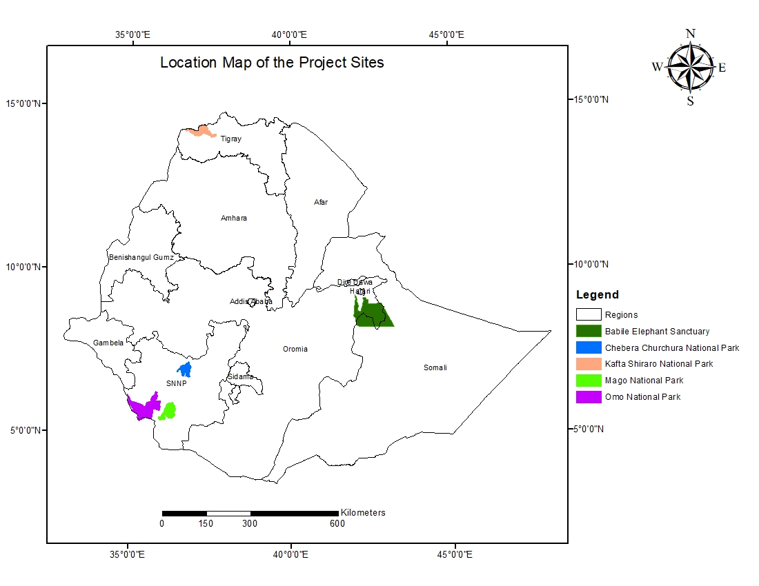
Figure 1: Location Map of the Project Sites
The project has also been implementing livelihood activities around Omo, Mago and Chebera Churcura national parks and Babile elephant sanctuary. Each of the project sites established around the selected four protected areas cover 15,000 hectares of land.
Table 2: Selected sites for livelihood activities
S/N | Name of National Parks/PAs | Project sites | Districts | No. of Cooperatives | No. of Beneficiaries
1 | Mago NP | Kurie and Bitsemal | Bako Dawla Woreda | 9 | 375
2 | Omo NP | Seski, Adikas, Muyi & Shalt Kebeles | Maji Woreda | 9 | 350
3 | Chebera Churchura NP | Gudumu and Neda Safer | Esara Woreda | 9 | 375
4 | Babile Elephant Sanctuary | Fedis and Midega | Fedis and Midega Woreda | 9 | 350
Total | 4 | 4 | 4 | 36 | 1,450

- Immediate and development objectives of the project
The main objective of the project is to build Ethiopia’s capacity for biodiversity conservation through increased effectiveness of protected area management and implementation of measures to reduce Illegal Wildlife Trade (IWT) and poaching. To meet this objective the project designed four interrelated components and four outcomes.
Component 1: Protected area management and biodiversity conservation. This component focused on demonstrating how effective management of protected areas in Ethiopia can be achieved by targeting a small number of protected areas. To ensure synergy with the objectives of the Global Wildlife Program, the selected pilot sites are those protected areas in which the key target species (elephants and big cats) are found. The improvement of law enforcement within those different sites was therefore a primary focus. The component focused strongly on site-level activities (as opposed to systemic activities as these are beyond the scope and resources of the project).
Component 2: Implementation of anti-trafficking measures. This component had focused on several different activities that are designed to improve different aspects of law enforcement to increase the deterrent to illegal trafficking of wildlife. A key aspect of the component is that it demands the cooperation and collaboration of different agencies and, therefore, takes wildlife crime investigation and prosecution into the mainstream.
Component 3: Landscape approach to forest and agro-biodiversity conservation. This component focused on realising the value of agro-biodiversity for the country and specifically for people living in the vicinity of the protected areas targeted in Component 1.
Component 4: Knowledge Management, Gender mainstreaming, and M&E. The focus of this component is on using lessons generated from the project through participatory monitoring and evaluation to combat poaching, illegal wildlife trade, and promotion of community-based conservation at the national and international levels.
In addition, lessons learned from the project via active participation of all stakeholder groups in the project implementation and M&E was envisaged to be made available nationally and internationally to facilitate IWT fight through implementation of Component 4 Knowledge Management, Gender Mainstreaming, and M&E.
- Expected results
The project had identified the immediate impacts and long-term benefits of the interventions. The long-term impacts or global environmental benefits (GEB) – to which the project was expected to contribute (in a 10-15-year timeframe) are:
- Recovery of wildlife populations in project sites Ethiopia, specifically targeting elephants (PIKE: baseline = 1; EOP target = 0.2), lions and cheetahs (EOP target: a 300% decline from peak seizure rates): these were selected as GWP flagship species to measure the success of the proposed project.
- Forests and agro-biodiversity are valued and, as a consequence, there is no loss of habitat, species or varieties (EOP target: 50,000ha within implemented integrated land management plans)
The long-term impacts of the project were planned to be realised through achieving the objective level outcomes: Improved protection of key wildlife populations and ecosystems; Increased deterrent effect of improved law enforcement and Improved wellbeing of local communities.
The project was also expected to achieve four major outcomes during project lifetime (6 years) to meet the project objective and contribute to global environmental benefits in the long run (10-15 years). The expected immediate results of the project are:
Outcome One: Improved protected area management effectiveness delivers enhanced protection in the targeted protected areas, by: developing and implementing up-to-date PA management plans for the 5 target sites; building the capacity of up to 300 PA and wildlife agency staff by providing sufficient knowledge, skills and relevant tools for effective PA management and law enforcement; and by signing and implementing at least 5 inter-agency agreement to fight poaching and IWT with participation of target PAs.
Outcome Two: Strengthened national and local capacity for conservation of endangered fauna and flora through implementation of anti-trafficking measures, by: supporting Ethiopia and adjacent countries (Kenya, Somaliland, South Sudan, Sudan and Djibouti) to sign four international agreements on IWT control; establishing National IWT Steering Committee with clear mandate and TOR to operate at full capacity; organizing at least 2 functional IWT Task Forces in pilot regions; eliminating Critical gaps in IWT legislation; establishing Environmental Crime Unit (ECU) within the Federal Serious Crime Unit with necessary staff and funding; creating functional Management system for wildlife products and live animals that are confiscated, seized and/or collecting in the field; equipping the National CITES management and scientific authorities with the necessary knowledge and skills to facilitate its implementation; creating awareness to at least 10% of the general public in Ethiopia about negative impact of IWT and supportive to conservation; and increasing the Capacity of government agencies on IWT control at least by 20%.
Outcome Three: Improved conservation of forestry and agro-biodiversity resources through a landscape approach based on community-based natural resource management, through development and implementation of two integrated landscape management plans covering 50,000ha; signing and implementation of four stakeholder agreements on access to and sustainable use of natural resources within and surrounding target PAs; enabling the local communities to generate sustainable income by designing at least three new value chains for agro-biodiversity and forest products; supporting the local communities in the project areas to get access to funding (up to $150,000 a year) for implementation of CBNRM projects; ensuring the development of ~35 sustainable small businesses by local communities based on CBNRM principles; increasing average household impact of participating local communities by 30%; and by establishing 100 ha. agro-biodiversity farms at the target areas.
Outcome Four: Lessons learned by the project through participatory M&E, including gender mainstreaming, are used to fight poaching and IWT, and promote community-based conservation nationally and internationally, by: supporting utilization of five project lessons by other conservation projects; and promoting at least ten national and international organisations to participate in project M&E.
- Main stakeholders
The project identified the implementing partners (IPs) and key stakeholders at national and regional levels and strengthened and utilized the existing government structures at all levels for effective implementation of the project interventions. The UNDP Ethiopia CO played an overall overseeing role to the project implementation. Ethiopian Wildlife Conservation Authority (EWCA) was responsible for the implementation of Components 1, 2, and 4 and the Ethiopian Biodiversity institute (EBI) was implementing component 3 and 4. The PMU established under EWCA was responsible for the day-to-day activities of the project. The park managers of the target areas were recognised as project coordinators and project site coordinators were also assigned to facilitate the livelihood activities. The project steering committee (PSC) was responsible for strategic level guidance and overall coordination of the project. The project stakeholders as per ProDoc include:
- Government of Ethiopia (GoE):
- FDRE Ministry of Environment, Forestry and Climate Change (MoEFCC)
- FDRE Ministry of Culture and Tourism
- Ministry of Finance and Economic Cooperation
- Ministry of Agriculture and Natural Resources
- Ministry of Livestock and Fisheries
- FDRE of Police Commission (FPC)
- FDRE National Security and Security Service
- Ethiopian Wildlife Conservation Authority (EWCA)
- Ethiopian Biodiversity Institute (EBI)
- Ethiopian Revenue and Customs Authority (ERCA)\
- Southern Nation, Nationality and Peoples’ Region Culture and Tourism Bureau
- Somali Region Culture and Tourism Bureau
- Tigray Region Culture and Tourism Bureau
- KfW Development Bank
- Ethio-German Technical Cooperation Biodiversity Forest Project (GIZ-BFP)
- Frankfurt Zoological Society (FZS)
- Born Freen Foundation (BFF)
- Horn of African Regional Environment Centre and Network (HoA-REC/N)
- Horn of Africa Wildlife Enforcement Network (HAWEN)
- Ethiopian Wolf Conservation Programme (EWCP)
- African Wildlife Foundation (AWF)
- Zone, woreda and kebele level authorities and local communities
- Federal and Regional Protected Areas Authorities
- Indigenous communities
- UNDP
- Theory of change
The EMEPA: Enhanced Management and Enforcement of Ethiopia’s Protected Area Estate project was designed and implemented based on the requirements of the Global Wildlife Program (GWP) launched in June 2015 by the Global Environment Facility (GEF) to respond to the growing wildlife crisis and international call for action. The GWP, led by the World Bank, is a $131 million grant program designed to address wildlife crime across 19 countries in Africa and Asia. The GWP serves as a platform for international coordination, knowledge exchange, and delivering action on the ground. The GWP further builds and strengthens partnerships by supporting collaboration amongst national projects, captures and disseminates lessons learned, and coordinates with implementing agencies and international donors to combat IWT globally. National projects within the GWP form an integral part of a community of practice that promotes the sharing of best practices and technical resources. Ethiopia is a national project under the GWP and during the first year of implementation of the global program, Ethiopia already benefited from participation in two in person knowledge exchange events that were held in Kenya and Vietnam. These events brought the GWP countries together to exchange experiences on various anti-poaching, anti-trafficking, and demand reduction issues.
To this end, the project’s Theory of Change (ToC) was embedded within the overall ToC underlying the Global Partnership on Wildlife Conservation and Crime Prevention for Sustainable Development Programme (GWP) and the project was designed to directly contribute to three GWP Components. The project is almost unique in the degree to which it is also contributing to the implementation of the Ethiopian Elephant Action Plan (2015) in which Ethiopia is acting as the Secretariat.

FINDINGS
- Project Design and Formulation

Analysis of Results Framework
An analysis of the result framework of the EMEPA project was carried out to assess the extent to which the project indicators and targets are Specific, Measurable, Achievable, Relevant and Time-bound (SMART). The design of the project is coherent and in line with the indicators of the project. Overall, the project indicators were found to be SMART but for three indicators (indicator 2 of outcome 2; and indicator 1 and 2 of outcome 3) were judged not to be compliant to the Specific criterion (Table 3).

Table 3: Terminal evaluation SMART analysis of the project’s objective and outcome indicators
Indicator | End-of-project Target | Terminal evaluation SMART analysis |  |  |  |  | Evaluators’ Feedback
 |  | S | M | A | R | T
Project Objective: To build Ethiopia’s capacity for biodiversity conservation through increased effectiveness of protected area management and implementation of measures to reduce Illegal Wildlife Trade (IWT) and poaching.
Indicator 1 (Output 1) Extent to which national legal, policy, and institutional frameworks are in place for conservation, sustainable use, and access and benefit sharing of natural resources, biodiversity and ecosystems
Indicator 1.1: Number of international agreements on IWT control signed | Four |  |  |  |  |  | Indicator is fully SMART compliant
Indicator 1.2: Number of legislation documents strengthened | Amendment(s) in the process of approval or approved by the government |  |  |  |  |  | Indicator is fully SMART compliant
Indicator 1.3: Number of regional IWT Task forces established | Two (in SNNPR and Somali region) |  |  |  |  |  | Indicator is fully SMART compliant
Indicator 1.4: Presence of wildlife derivatives management system | System in place, functioning and audited |  |  |  |  |  | Indicator is fully SMART compliant
Indicator 2 (Output 2): Mandatory Indicator 2. Number of direct project beneficiaries: - Number of local people in project areas benefiting from engagement in CBNRM (male/female)
Indicator 2.1: Number of local people in project areas benefitting from engagement in CBNRM (male/female) |  |  |  |  |  |  | Indicator is fully SMART compliant
Indicator 3 (Output 3): Number of flagship species poached
3.1. Proportion of illegally killed elephants (total number of dead elephants in parentheses) | Omo NP: 0.2  Mago NP: 0.2  CCNP: 0.2  Babille: 0.2  Kafto Shiraro: 0.2 |  |  |  |  |  | Indicator is fully SMART compliant
3.2. Number of Big Cats (specifically lions, cheetahs and leopards) seized (at project sites per unit effort ) | Demonstrated decline in seizures per unit effort as deterrent impact takes effect at least a 300% decline from peak seizure rates). |  |  |  |  |  | Indicator is fully SMART compliant
Indicator 4 (Output 4): METT for PAs | Omo NP: 83  Mago NP: 84  CCNP: 81  Babille: 82  Kafto Shiraro: 84 |  |  |  |  |  | Indicator is fully SMART compliant
Component One: Protected area management and biodiversity conservation
Outcome One: Improved protected area management effectiveness delivers enhanced protection in the targeted protected areas
Indicator 1. Number of PAs that have up-to-date management plans approved by the government and under implementation | Five |  |  |  |  |  | Indicator is fully SMART compliant
Indicator 2. Proportion of successful prosecutions of wildlife crimes in Pas and surrounding areas (measured annually) | Of the cases that are presented in courts, at least 90% result in convictions with appropriate sentences |  |  |  |  |  | Indicator is fully SMART compliant
Component Two: Implementation of anti-trafficking measures
Outcome Two: Strengthened national and local capacity for conservation of endangered fauna and flora through implementation of anti-trafficking measures
Indicator 1. Proportion of successful prosecutions of crimes related to wildlife trafficking at national level (measured annually) | >95% of IWT cases presented in court leading to convictions with appropriate sentences |  |  |  |  |  | Indicator is fully SMART compliant
Indicator 2. Capacity of government agencies on IWT control as indicated by customized UNDP Capacity Development Scorecard | A 20% improvement across all possible scores |  |  |  |  |  | The framing of the indicator does not render it compliant to the Specific criterion. What about the capacity of government agencies on IWT control? The indicator could have been more specific if framed as follows “Percent improvement in the capacity of government agencies on IWT control as indicated by customized UNDP Capacity Development Scorecard”
Component Three: Landscape approach to forest landscape and agro-biodiversity conservation
Outcome Three: Improved conservation of forestry and agro-biodiversity resources through a landscape approach based on community-based natural resource management
Indicator 1. Approved landscape/ ecosystem level plans | Two |  |  |  |  |  | The framing of the indicator does not render it compliant to the Specific criterion. The indicator could have been more specific if framed as follows “Number of approved landscape/ ecosystem level plans”.
Total area covered by approved ILM plans (ha) | 3.50,000ha |  |  |  |  |  | Indicator is fully SMART compliant
Indicator 2. Natural resource use agreements with stakeholders – including local and indigenous communities | Four agreements with communities and indigenous people in place and being implemented |  |  |  |  |  | The framing of the indicator does not render it compliant to the Specific criterion. What about natural resource use agreements with stakeholders? The indicator could have been more specific if framed as follows “Number of natural resource use agreements with stakeholders – including local and indigenous communities”
Indicator 3. Total number/area of small sustainable businesses developed by local people – recipients of micro-credit schemes | 35 |  |  |  |  |  | Indicator is fully SMART compliant
Indicator 4. Average percentage of household income increase of recipients of micro-credit schemes in the project areas | Household income increased by at least 30% above baseline |  |  |  |  |  | Indicator is fully SMART compliant
Indicator 5. Area (ha) of demonstration farm(s) protecting rare and valuable genetic agro-biodiversity | At least 100ha |  |  |  |  |  | Indicator is fully SMART compliant
Component Four: Knowledge Management, Gender mainstreaming, and M&E
Outcome Four: Lessons learned by the project through participatory M&E, including gender mainstreaming, are used to fight poaching and IWT, and promote community based conservation nationally and internationally
Indicator 1. Number of the project lessons used in development and implementation of other conservation projects | 5 |  |  |  |  |  | Indicator is fully SMART compliant
Indicator 2. Number of national and international organizations that participate in the project M&E and provide feedback to the Management Team | At least 10 |  |  |  |  |  | Indicator is fully SMART compliant

Legend
SMART criteria compliant | Questionably compliant to SMART criteria | Non-compliant to SMART criteria

Assumptions and Risks
At the project design phase, a risk analysis was conducted to identify the project risks, among which were organizational, financial or strategic, political, and environmental risks. At the organizational level, limited institutional capacity to effectively manage PAs and to counter IWT effectively, was cited as a risk that continued throughout the implementation process of the project. It was concluded that organizational risks were very severe all through the project lifetime.
Another severe risk was financial, related to the allocation of resources by the GoE to ensure an efficient and effective implementation of the project and ensure the sustainability of the processes initiated by the project as well as project impacts. The severity of this risk remained the same throughout the lifespan of the project.
Political risks identified were assessed as moderately severe in nature even though no change in the risks were noticed. These risks included other development sectors being prioritised above the environment resulting in low levels of funding, staffing and political leverage. Secondly, the political situation in Ethiopia during the PPG phase in 2016 led to a State of Emergency and this has continued throughout the life of the project. Ethiopia’s land-use policies, by the PPG phase of the project did not encompass the identification, selection and appropriation of suitable areas for development, including conservation and/or natural resource management. This posed as a third political risk to the project with a moderate rate of severity.
The environmental risk identified at the PPG phase was related to climate change which could lead to a more variable climate in Ethiopia with impacts such as increased temperatures, more extreme climatic events, and other weather events that may impact the livelihoods of people living in the vicinity of PAs who depend economically on crops or livestock. Crop failure or livestock losses may exacerbate poaching as people become increasingly dependent on natural resources. This environmental risk was assessed moderate and not likely to occur.
The initial risk analysis assumptions risks and liabilities related to the project implementation were presented in the following table.

Table 4: Project risks and Proposed Mitigating Measures
No | Risk description Category / | Rating (R) | Mitigation Measures
1 | Limited institutional capacity to manage PAs effectively and to counter IWT effectively. | Organizational R: Severe | During the project design phase, GIZ had the intent to implement a programme to address some of these systemic issues that afflict EWCA (in particular) and, as a result, the aim of the EMEPA project remained strictly focused at the level of the protected areas. GIZ’s intent was brought to realization through the implementation of the project Ethio-German Technical Cooperation Biodiversity Forest Project (GIZ- BFP) which carried out a key institutional re-engineering of EWCA. The project also provided co-financing to the EMEPA project under component 1.
2 | Resource allocation by GoE to ensure efficient and effective project implementation and sustainability of processes initiated by the project and project impacts | Financial R: Severe | Project sought firm commitments from the GoE to ensure a reciprocal increase in resources being allocated to all areas covered by the project during its lifetime and beyond. The project sought commitments from GoE and explored mechanisms to ensure approval at the highest levels, of plans developed under the project such as PA management plans,
3 | Prioritisation of other development sectors and processes above the environment and particularly the conservation sector, resulting in low levels of funding, staffing and political leverage | Political R: Moderate | The project brought in other pertinent actors, especially with regards to law enforcement so as to overcome the risks associated with the marginalization of the environment sector
4 | State of Emergency in Ethiopia during the PPG phase | Political R: Severe | Mitigation to go beyond project scope, UNDP-CO was to decide on the implementation if situation deteriorates seriously.
5 | Land-use policies in Ethiopia do not encompass the identification, selection and appropriation of suitable areas for development including conservation and/or natural resource management | Political R: Moderate | The project intended to try to influence the further development of policies, including land use policies by aligning itself closely with the MoEFCC. The project ended up drafting amendments to the Wildlife policy and wildlife laws but not the land use policy. The project conducted a mass media campaign designed to gather public support and increase understanding of the value of biodiversity, ecosystem services and agro-biodiversity.
6 | Climate change will lead to climate variability in Ethiopia, which may impact the livelihoods of people living around protected areas and exacerbate poaching | Environmental R: Moderate | The project employed strategies to mitigate the impacts of climate change, through the increased effectiveness of protected area management as well as work on protecting agro-biodiversity. The project ensured that local communities and their use of natural resources remain adaptable in the face of climate change.  The agro-biodiversity aspects of the project are designed to protect different varieties that should allow for efficient adaptation to all climate scenarios. Project target communities were empowered through information to ensure they remain adaptable

Lessons from other Relevant Projects
The EMEPA project in Ethiopia followed policies and drawn lessons from other projects in Ethiopia namely:
- Conservation Strategy of Ethiopia, 1997
- Environmental Policy of Ethiopia, which was approved by the Council of Ministers in 1997
- The National Biodiversity Strategy and Action Plan of Ethiopia, 2005
- Wildlife Policy and Strategies of Ethiopia, 2007
- Proclamation provided for the conservation, development and utilization of wildlife of Ethiopia, 2007
- Wildlife Development, Conservation and Utilization Regulations of 2008;
- The Growth and Transformation Plan, 2010;
- The Climate-Resilient Green Economy Strategy of Ethiopia, 2011
- Global Wildlife Program launched by GEF in 2015;
The project design was mainly informed by the Country Programme, which emphasizes strengthening institutional capacity towards sustainable natural resource management and climate change adaptation and mitigation actions. The UNDP Strategic Plan Integrated Results and Resources Framework also informs the design of the EMEPA project, with major focus on putting in place national legal, policy and institutional frameworks to enable conservation, sustainable use and management of natural resources. The two main strategy documents for development in Ethiopia – the Growth and Transformation Plan and the Climate-Resilient Green Economy also played a role in designing the EMEPA project, by putting emphasis on fighting unsustainable use of natural resources and preventing degradation through the conservation of biodiversity.
The project was also in line with a number of strategic goals of the country’s National Biodiversity Strategy and Action Plan (NBSAP), with four strategic objectives related to ensuring biodiversity conservation and sustainable use and equitable cost and benefit sharing for the well-being and security of the country; and also aligns with Ethiopia’s commitments under the Convention on International Trade in Endangered Species of Wild Fauna and Flora (CITES).

Planned Stakeholder Participation
The EMEPA project had an elaborated stakeholder engagement component developed during the PPG phase of the project. The engagement of stakeholders including the local communities were defined and communicated before the program implementation. The duties and responsibilities of all stakeholders were defined and set for the project implementation at national, regional and district levels. At the project sites frameworks such as use rights, tenure arrangements, and safeguards and benefit sharing arrangements were identified and proper safeguard mechanism adopted for the project implementation. Local program arrangements were agreed and signed at different levels to build confidence and ensure sustainability of land use changes mainly at project site as the result of the afforestation/ reforestation and re-vegetation program.
As per the ProDoc, the project had a Stakeholder Engagement Plan elaborated for implementation
The stakeholders participated in the implementation of the project include:
- Government of Ethiopia (GoE):
- FDRE Ministry of Environment, Forestry and Climate Change (MoEFCC)
- FDRE Ministry of Culture and Tourism
- Ministry of Finance and Economic Cooperation
- Ministry of Agriculture and Natural Resources
- Ministry of Livestock and Fisheries
- FDRE of Police Commission (FPC)
- FDRE National Security and Security Service
- Ethiopian Wildlife Conservation Authority (EWCA)
- Ethiopian Biodiversity Institute (EBI)
- Ethiopian Revenue and Customs Authority (ERCA)\
- Southern Nation, Nationality and Peoples’ Region Culture and Tourism Bureau
- Somali Region Culture and Tourism Bureau
- Tigray Region Culture and Tourism Bureau
- KfW Development Bank
- Ethio-German Technical Cooperation Biodiversity Forest Project (GIZ-BFP)
- Frankfurt Zoological Society (FZS)
- Born Freen Foundation (BFF)
- Horn of African Regional Environment Centre and Network (HoA-REC/N)
- Horn of Africa Wildlife Enforcement Network (HAWEN)
- Ethiopian Wolf Conservation Programme (EWCP)
- African Wildlife Foundation (AWF)
- Zone, woreda and kebele level authorities and local communities
- Federal and Regional Protected Areas Authorities
- Indigenous communities
- UNDP

Linkages between Project and other Interventions within the Sector
The project recognised that partnerships are pivotal both to the success of the project and to the long-term sustainability and impacts within the biodiversity conservation sector in Ethiopia and established collaboration with several ongoing projects and programmes within the country with the objective of leveraging funding and avoiding duplications (Table 5).
Table 5: Summary of Partnership with Similar Projects/Programmes
Project/Programme | Synergies and/or relationship with project as outlined in the ProDoc | Actual relationship with the project during implementation
CRGE, Government of Ethiopia Policy – the CRGE is one of the principal development policies for the country. It recognises that following a conventional development path results in “unsustainable use of natural resources”. It recognises i) the role that agro-biodiversity (both crops and livestock) play in food security, and ii) the role of biodiversity for its economic and ecosystem services. | The CRGE provides the springboard and framework for this project. Thus, the project has been designed to fit within this framework | The project has contributed to the implementation of some strategic actions outlined within the CRGE and specifically achieved the outcomes related to ecosystem management, biodiversity conservation, climate mitigation and adaption and sustainable livelihood interventions.
On going UNDP-GEF projects: Mmainstreaming Incentives for Biodiversity Conservation in the Climate Resilient Green Economy Strategy, and Mainstreaming Agrobiodiversity into the Agricultural Production System of Ethiopia | There are synergies between the project and these other ongoing projects and the project managers will meet regularly to ensure that there is a good exchange of information, best practices and lessons. | The project has actually benefited from the best practices shared and lessons learnt from the management of these projects as both projects have been seniors of this project.
KfW Biodiversity Programme – in 2013, KfW added the conservation of biodiversity and sustainable management of natural resources as one (of three) pillars of investment in Ethiopia. In the coming years, KfW will be focusing on protected area management and larger capital investments in protected area infrastructure. | As one of the key actors in biodiversity conservation in the country, the project will collaborate and cooperate with KfW. In order to facilitate dialogue and to foster collaboration, i) the selected PAs for this project are not currently receiving funding from KfW, and ii) KfW will  be invited to be a member of the PB (as the representative of the donor community). Because of the synergies, GIZ’s financing of the protected areas in Ethiopia is considered as co-finance for this project. | The project has made synergies with this prgramme with regards to sharing experiences, implementing common plans such as public awareness and trainings in wildlife management and protected area conservation.
GIZ Protection Areas Programme – in parallel with the KfW investment in protected areas, GIZ is also investing in protected areas. The program aims to put  institutions charged with the management of protected areas in a position to implement strategies, instruments and measures for the protection and sustainable management of biological diversity on a broad scale.  The program will work at local, regional and national level in order to strengthen the capacities for managing selected national parks (NechiSar, Awash, Hallidegh, Borena-Saint National Parks), biosphere reserves and other protected areas and create benefit-sharing mechanisms for the population; and at regional level it will strengthen administrative structures that are responsible for the management of nine protected areas (composed of 5 national parks, two biosphere reserves and two national forest priority areas). | Synergies, coordination and collaboration with the GIZ programme will be assured by including their representative in the PB (as a representative of conservation actors in the country). Because of the synergies, GIZ’s financing of the protected areas in Ethiopia is considered as co-finance for this project. | The project has also made synergies with this programme with regards to sharing experiences, implementing common plans such as public awareness and trainings in wildlife management and protected area conservation. For instance, the project has developed the General Management Plan of Chebera Churchura National Park in collaboration with the GIZ PA program. The GIZ PA project has been continuously supporting the management of Chebera Churchura National Park and the Borena Saynt National Parks during the previous six years.
Born Free Foundation, Border Point Project – this project is designed to strengthen law enforcement and the role of the criminal Justice in IWT (funded by the UK’s DEFRA).  BFF also operates in Babille Elephant Sanctuary on a conservation project that aims to halt or reduce significantly elephant poaching in the Babille Elephant  Sanctuary and reduce other anthropogenic pressures at the site. | There are strong synergies between the activities of the BFF and this project: indeed, BFF could apply for implementation of some of the aspects of the project (both Component One – activities in Babille, and Component Two – IWT activities – this would ensure synergy and build on their previous activities in the area). The funding that BFF is using to implement both of these activity sets as co-finance for the proposed project. | In the Babile Elephant Sanctuary law enforcement plans have been implemented in collaboration with the BFF project. Collaboration has also been made on combating illegal wildlife trafficking and the project has supported delivery of confiscated wild animals from illegal traffickers to the Insisat Kotte Wildlife Rescue Center in Holleta which is being managed by the BFF.
FZS has been working in Ethiopia in the field of wildlife conservation and supporting protected area management since 2008 and mainly focusing in the protection of the Afro-alpine ecosystem mainly in Bale and Simien Mountain National Parks as well as the community conserved areas of Guassa-Menz and Abune Yoseph. Major activity has been capacity building and provision of logistic for effective running of the protected areas and conducting ecological monitoring of threats in the protected areas | FZS is a partner mainly in the area of protected area management and capacity building of protected area  management based on their many years of experience working in the country. They have available experience in this regard and as a co-financing partner to the project (Component One). If and when necessary, technical cooperation and collaboration with FZS will be sought. | As both are conservation projects under the Ethiopian Wildlife Conservation Authority, the project take part in the partners platform on quarterly basis where experiences are shared and collaboration actions planned for implementation. In this regard collaboration has been made in developing the institution’s 10 years strategic plan and staff trainings. The project has also supported the Bale Mountains National Park (provided a vehicle and built staff capacities) that has been registered as UNESCO World Heritage Site a few weeks ago. The FZS wildlife project has continuously supported the Bale Mountains National Park.
AWF – this NGO has two programmes of interest to the project – i) a cultural tourism programme in northern Ethiopia (both for the concept and the proximity to  Kafta Shiraro NP – one of the proposed project’s selected areas), ii) a “Canines for Conservation” initiative which is attempting to place sniffer dogs at Bole International Airport, and iii) working to train the law enforcement bodies such as the police and judiciary. | Both of AWF’s projects are of significance to the project and the project will have much to learn from their experiences. The PMU will seek to establish good relationships with the AWF staff in Ethiopia to foster this joint learning. | AWF has been cooperating in strengthening anti-trafficking measures and combating illegal wildlife trade. In additions there have been a number of experiences sharing programs with the AWF project. AWF has also been supporting the overall management of the Simien Mountains National Park.

Gender responsiveness of project design
A gender assessment and mainstreaming was conducted for the project. The analysis focussed on the three regions in Ethiopia targeted by the project and highlighted gender differences and the relevance of gender roles and power dynamics. Specifically, the analysis dwelled on the roles and responsibilities of men and women, access to resources, participation of women in development projects and other key gender issues such as reproductive rights and polygamy. Following the gender assessment and the gender screening that was conducted for the project by the PPG team, measures for mainstreaming gender in the project were adopted. These measures among others included:
- Empowering women through involving them in intelligence networks, in the shaping of altitudes and in law enforcement processes;
- Ensuring strong focus on gender within component 3 with emphasis on the provision of microcredit loans to female led households or households that apply for loans for implementing women-led activities;
- Targeting of women in awareness raising activities and encouraging them to take responsibility including engaging with authorities on issues related to natural resource management;
- Encouraging women leadership in the natural resource management agreements that will be negotiated within the project; conducting awareness and sensitization campaigns with specific gender focus; and
- Encouraging applications from qualified women for positions under the project such as social mobilizers.
In a nutshell, a gender mainstreaming matrix was developed for the project providing detials on the proposed gender mainstreaming measures per output of the project. However, a key aspect that was lacking in the gender mainstreaming is the attribution of gender targets.
- Project Implementation

Adaptive Management
The project exhibited adaptive management during its delivery. With the advent of the Covid-19 pandemic, lockdown measures and restrictions to in-person meetings were imposed by the Government of Ethiopia. In response to the pandemic, the project switched most of its activities to virtual mode and provided support to field staff in the protected area through the provision of hydroalcoholic gels and face masks. The work plans for the project were equally revised so that those activities that could not be implemented at the time were rescheduled. Following the mid-term review of the project, the PMU drafted a management response to the MTR recommendations which were being implemented for a successful delivery of the project. At TE, documentary evidence provided by the PMU indicates that the management responses had been completely implemented by the project.

Actual Stakeholder Participation and Partnership Arrangements
During the PPG phase, the Project Document identified a list of project stakeholders and outlined their roles and responsibilities with regards to the implementation of project activities. The list includes key stakeholders from the Ministry of Environment, Forests and Climate Change, the Ethiopian Wildlife Conservation Authority, the Ministry of Culture and Tourism, The Ministry of Finance and Economic Cooperation, Ministry of Agriculture and Natural Resources, Ministry of Livestock and Fisheries, FDRE of Police Commission, FDRE National Security and Security Service, Ethiopian Wildlife Conservation Authority, Ethiopian Biodiversity Institute, Ethiopian Revenue and Customs Authority, Southern Nation, Nationality and People’s Region (SNNPR) Culture and Tourism Bureau, Somali Region Culture and Tourism Bureau, Tigray Region Culture and Tourism Bureau, KfW Development Bank, Ethio-German Technical Cooperation Biodiversity Forest Project (GIZ-BFP), Frankfurt Zoological Society (FZS), Born Free Foundation (BFF), Horn of African Regional Environment Centre and Network (HoA-REC/N), Horn of Africa Wildlife Enforcement Network (HAWEN), Ethiopian Wolf Conservation Programme (EWCP), African Wildlife Foundation (AWF), Zone, woreda and kebele level authorities and local communities, Federal and Regional Protected Areas Authorities, and Indigenous Communities. The key stakeholders and their roles and responsibilities as per the ProDoc, and actual role during project implementation are presented in Table 6.
Table 6: Summary of stakeholder analysis
Stakeholder | Roles and Responsibility as per the ProDoc | Roles and Responsibility during Project Implementation
FDRE Ministry of Environment, Forestry and Climate Change (MoEFCC) | The MoEFCC is the Ministry in which the GEF OFP sits; as Implementing Partner, it is also the key ministry for the oversight, coordination and implementation of this project. | The MoEFCC has been actively functioning and overcoming its role until the government restructuring in 2020 as the GEF OFP and the chair of the project board.  However, this institution does not exist after the government restructuring since 2020. The GEF OFP is now the Ministry of Planning and Development. The chair of the project board is now the Environmental Protection Authority (EPA).
FDRE Ministry of Culture & Tourism | EWCA is (currently) housed in this  ministry and thus falls under its  mandate. | EWCA had been housed within this ministry until it was relocated to MoEFCC in 2019 and then a new Ministry (Ministry of Tourism) established after the government restructuring and EWCA has been housed within it and mandated to supervise EWCA and the project implementation.
Ministry of Finance and  Economic Cooperation,  Ministry of Agriculture and Natural Resources and Ministry of Livestock and Fisheries | The project will ensure contact with these key stakeholders is maintained throughout the project’s implementation and that they are consulted as necessary and included as stakeholders in all consultative forums. | The project has been in close contact with all the mentioned ministries and kept informed with all the relevant issues of the project. More specifically the Ministry of Finance and Economic Cooperation (currently named as the Ministry of Finance) has a mandate to approve the project’s annual work plan as well as develop guidelines (for all the UN agency projects), provide training and follow up its performance all the way through its implementation.
FDRE of Police Commission (FPC) | Beneficiaries of Component Two By the virtue of power vested in it by the Government of Ethiopia, the police force is entitled to prevent any crime including environmental crime. The police force will be a prime partner in the implementation of activities to counter IWT and put in place measures to counter trafficking of wildlife and their products/derivatives (Component Two). A high-ranking member of the Federal Police will also serve as a member of the Project Steering Committee. The Federal Police will also house the Environmental Crime Unit (ECU) that will be established under the project (Component Two). | The FDRE Police Commission is member of the Environmental Crime Unit (ECU) established by the project. 10,000 polices were trained on wildlife protection and follow up of IWT and dispatched over the country. The police force is responsible to follow up cases of IWT and take the trespassers to court.
FDRE National Security & Security Service | Beneficiaries of Component Two Given the issues of national security and sovereignty that are associated with IWT, the NISS will be an essential partner to the project and member of the IWT SC. The project proposes that members of organizations including NISS second staff members to the ECU (Component Two). | As member of the illegal wildlife trade and trafficking (IWT) national steering committee and/or taskforce and later as the establishing partner of the Environmental Crime Unit (ECU), NISS has been actively participating in quarterly meeting organized by the project and provided its inputs for the successful accomplishment of the national level sectoral collaboration platform in fighting wildlife crimes in the country.
Ethiopian Wildlife Conservation Authority  (EWCA) | Beneficiaries of Components One and Two. Three of the selected pilot PAs fall under its jurisdiction: Omo National Park, Babille Elephant Sanctuary and Kafta-Shiraro National Park. | EWCA has been the primary implementing partner for the project. The PMU resides under it. Established the Environmental Crime Unit by including key stakeholders. Supported the selected five parks to implement component one and two. Conducted capacity building trainings and experience sharing campaigns at national and international level. Drafted multilateral agreements and collaborated with neighboring countries stipulated in the ProDoc. Conducted M&E for project interventions and provided technical support. Worked with regionally administered parks for implementation of the project interventions. Prepared ten-year management plans for the five target parks and is supporting for its implementation.
Ethiopian Biodiversity  Institute (EBI) | Beneficiaries of Component Three. EBI is the principal government partner in the implement of the third component of the project. | EBI was the implementing partner and was implementing component three. A project office was established under EBI and was liaising with the PMU. Assigned project site coordinators and established cooperatives in collaboration with cooperative offices in the project sites. Provided capacity building trainings and experience sharing on livelihood activities for the beneficiaries. Developed various packages and implemented in the selected pilot sites. Established demonstration sites and supported existing nursery sites. Preserved indigenous and medicinal plants and distributed seedlings for rehabilitation works.
Ethiopian Revenue &  Customs Authority (ERCA) | Beneficiaries of Component Two ERCA is a key partner given their responsibility in countering smuggling and trafficking. Also, can be a member of the national steering committee for IWT and the ECU (Component Two). | As member of the illegal wildlife trade and trafficking (IWT) national steering committee and/or taskforce and later as the establishing partner of the Environmental Crime Unit (ECU), ERCA has been actively participating in quarterly meeting organized by the project and provided its inputs for the successful accomplishment of the national level sectoral collaboration platform in fighting wildlife crimes in the country. In addition, ERCA has a significant role in controlling the illegal wildlife trafficking (both live animals and their products) in selected checkpoints including border points and the Bole International Airport in collaboration with the regional wildlife authorities and EWCA.
Southern Nation, Nationality & Peoples’ Region Culture and Tourism Bureau | Beneficiaries of Components One, Two and Three. The Bureau manages PAs involved in this project (Mago and Chebera Churchura National Parks). The Bureau will, as a result, be a key partner in these areas and will be targeted for capacity development. The Bureau also has the mandate to approve some of the outputs of the project (e.g., management plans for regional protected areas). The Bureau will also have representation on the PB. | As beneficiary of components 1,2 and 3, the Southern Nation, Nationality & Peoples’ Region Culture and Tourism Bureau had a significant role of managing the Mago and Chebera Churchura National Parks. For component 2, the regional state had established the regional illegal wildlife trade and trafficking taskforce (RTF). For component 3, the regional state had a coordination role to establish livelihood cooperatives of the respective project sites, establishment, and allocation of land for demonstration farms and integrated landscape management for component 3. However after the restructuring of this regional state before two years ago, its roles were disintegrated to the newly established regional states namely the South Western Ethiopia People’s Regional State to manage Chebera Churchura National Park (component1) and the South Ethiopia People’s Regional State to manage Mago National Park (component 1) together with the respective activities of component 3 with regard to agro-biodiversity conservation through community based natural resources management.
Somali Region Culture and Tourism Bureau | Beneficiaries of Components Two and Three.  The Bureau will be primarily involved in i) working with the relevant organisations to counter IWT (Component Two), and Integrated Landscape Plans in the vicinity of Babille Elephant Sanctuary. | The Somali Regional State Bureau of Cuture and Tourism as well as Bureau of Agriculture and Natural Resources had a role in supporting the management of Babile Elephant Sanctury (component 1) and the establishment of the Regional Illegal Wildlife Trafficking Taskforce (component 2). The two mentional bureaus of the regional state and other bureaus including bureau of peace and security, the bureau of environment, forest and climate change, police commission and office of the president had been supporting border point operation to counter illegal wildlife trafficking to the Somaliland,
Oromia Regional State, East Harerghe Zone Administration | NA | The Oromia Regional State, East Harerghe Zone Admiration had a significant role providing support for the management of Babile Elephant Sanctuary (component 1) and a role for the successful implementation of component 3 of the project with regard to Agro-biodiversity Conservation through community based natural resource management that also includes implementation of the different livelihood initiatives of the project.
Tigray Region Culture and Tourism Bureau | Beneficiaries of Components Two and  Three The Bureau wil be primarily involved in i) working with the relevant organisations to counter IWT (Component Two), and Integrated Landscape Plans in the vicinity of Kafta Shiraro National Park. | Tigray Region Culture and Tourism Bureau had been supporting the management of Kafta-Sheraro National Park (component 1), involved in anti-poaching and anti-trafficking operations (for component 2) and as well as participated in the implementation of activities for component 3 (i.e for establishment of demonstration farms, establishment of cooperatives for different livelihood initiatives and for studies undertaken for value chain and socio-economic studies) until the time the Northern Ethiopia conflict exploded.
KfW Development  Bank | KfW is a co-financing partner for this project – financing protected areas work in the country (Component One). KfW will represent the donor community on the PB. | Supported the project on experience sharing campaigns. Implementing common plans such as public awareness and trainings in wildlife management and protected area conservation.
Ethio-German Technical  Cooperation Biodiversity  Forest Project (GIZ-BFP) | The role of this program in the project is  participate in the management and protection of other protected area (sharing lessons, experiences and best practices) and also participate as co-financing institution for this project (Component One). In addition, the program is carrying out a key  institutional re-engineering of EWCA. | Supported the project on experience sharing campaigns. Implementing common plans such as public awareness and trainings in wildlife management and protected area conservation.  Participated on the preparation of the 10 years General Management Plan of Chebera Churchura National Park.  The GIZ PA project has been continuously supporting the management of Chebera Churchura National Park and the Borena Saynt National Parks during the previous six years.  It also participated on livelihood activities and provided material support to selected parks.
Frankfurt Zoological  Society (FZS) | FZS is a partner in the area of protected area management and capacity building of protected area management based on their many years of experience working in the country. They are a co-financing partner to the project (Component One). If and when necessary, technical cooperation and collaboration with FZS will be sought. | Supported the development of the institution’s (EWCA) 10 years strategic plan and staff trainings. FZS has also supported the Bale Mountains National Park (provided a vehicle and built staff capacities) that has been registered as UNESCO World Heritage Site a few weeks ago and continued its support.
Elephant Protection Initiative Foundation (EPIF) | - | Supported the management system of wildlife products through development of standard operation procedures and procurement of materials and also supported management of human wildlife conflict
Born Free Foundation (BFF) | Two of the BFF projects, the Border Point  Project and the Babille Elephant Conservation and Awareness project, are in line with the proposed GEF project. As such, BFF could be a key partner (if not Responsible Party) for the project. | Collaborated in the implementation of law enforcement plans in the Babile Elephant Sanctuary.  Collaborated on combating illegal wildlife trafficking and the project has supported delivery of confiscated wild animals from illegal traffickers to the Insisat Kotte Wildlife Rescue Center in Holleta which is being managed by the BFF.
Horn of African Regional  Environment Centre and  Network (HoA-REC/N) | This Network manages a project entitled Strengthening Biodiversity Management in the Boma-Gambella landscape Gambella Region (Ethiopia) and Boma Landscape (South Sudan). This is a multifaceted project but it has a component of designing and implementation of an integrated law enforcement strategy over the Boma –Gambella landscape. It aims to conduct a survey on the extent of IWT, and training and capacity building of the park rangers as well as training on IWT for law enforcement authorities and partners in the region. In general, this project will implement activities in the Boma – Gambella landscape (Component Two). | The project had been inactive and didn’t realize its plan after this project was launched in 2018.  This project does not exist this time.
Horn of Africa Wildlife  Enforcement Network  (HAWEN) | The network could play an important role to control inter-boundary IWT among the Horn of African countries. The project will work with representatives of the Network to seek synergies  . | The Horn of Africa Wildlife  Enforcement Network  (HAWEN) has been active since the project started and EWCA has been closely working with the member countries of this initiative to strengthen cross border cooperation in fighting illegal wildlife trade and trafficking and also participated in its regular meetings in different member countries.
Ethiopian Wolf Conservation Programme  (EWCP) | The programme is a conservation partner for the Afroalpine areas and helps in exchanging experience in monitoring and management of single species. Because of the historic role of EWCP as a catalyst for conservation in Ethiopia, a close working relationship will be established with the EWCP. | As a conservation partner, the project has been sharing experiences with the Ethiopian Wolf Conservation Programme (EWCP). EWCP had a significant role in the conservation and research of the Ethiopian Wolf in its range in the highland of the country.
African Wildlife Foundation (AWF) | There are strong synergies with the law enforcement and IWT work that has been carried out by AWF. As such, they are a co-financier to the project and have the potential to play various roles in the project related to these areas> (Component Two). | Cooperated in strengthening of anti-trafficking measures and combating illegal wildlife trade. In addition, there have been several experiences sharing programs with the AWF project. AWF has also been supporting the overall management of the Simien Mountains National Park.
Zone, woreda and kebele level authorities, and local communities | Beneficiaries of Components One, Two and Three.  Because of the judicial and administrative functions of the zonal and woreda authorities, these people are important for all law enforcement activities of the project and for coordinating activities with local communities. The project actors at a local level will engage and coordinate all the activities with these authorities. One mechanism – the IWT WG at the regional level – will contribute to ensuring that this will function optimally. | The project has strengthened and utilized the existing government structures at all levels. These stakeholders had benefited from capacity building trainings and experience sharing campaigns. They are also members of the task forces established by the project for law enforcement in the selected parks. Patrols have been conducted by the task forces at regular basis. IWT cases have been brought to courts and appropriate legal measures were taken. The cooperative offices were responsible for establishing cooperatives of beneficiaries and legalizing the same. Administered the project fund for livelihood activities and provided the necessary support for the beneficiaries. Had participated in the rehabilitation of degraded lands. They have also became the primary protectors of the parks and protected areas.
Federal and Regional  Protected areas Authorities | Beneficiaries of Components One, Two and Three. The project will work with the protected areas that have been selected as pilots and demonstration sites (specifically Omo, Mago, Chebera Chochora and Kafta Shiraro National Parks and Babille Elephant Sanctuary).  All three components of the project have implementation implications for these protected areas. Representatives from the protected areas will sit on the PB. | The selected parks were the primary implementers of the project interventions. The parks worked in collaboration with various stakeholders. They created awareness and mobilized the community for law enforcement.
Indigenous communities | Beneficiaries of Component Three. One of the principal outcomes that is being sought by the project is to pilot agreeing on mechanisms to allow indigenous people access to and use of resources within and surrounding protected areas. As such, working with these indigenous communities is a key part of Component Three. | The direct beneficiaries of the project were supported to establish cooperatives. The cooperatives were legalized and implemented the various packages developed by the project. Awareness was also created at community level. The community is serving as protector of the park by participating in patrols with scouts and police.

Communications
A communication strategy was elaborated for the project and this was shared with the GWP. The knowledge management approach of the project was equally presented to the GWP. Regular updates and presentations were delivered to the GWP and the project participated in knowledge exchange platforms organized by the GWP. Within the country, quarterly and annual project reports were communicated to stakeholders within the country.
A dedicated project website was developed for the dissemination of project results and progress. The project equally used online publications/social media to communicate its achievements. Some of the documentary or materials from the project published online include:
Film on Ethiopia’s Elephant Crisis;
- https://www.youtube.com/watch?v=fjghiaX_2UI
Five documentaries on community-based management of natural resources and ILM:
- https://www.youtube.com/watch?v=XHyLn0imcv4
- https://www.youtube.com/watch?v=DrypF27G770
- https://www.youtube.com/watch?v=b4a32MP9I44
- https://www.youtube.com/watch?v=wXwBS-v2RCw&pbjreload=101
- https://www.youtube.com/watch?v=XJ36RZqC_IU
Other documentary film;
- https://www.youtube.com/watch?v=fjghiaX_2UI
- https://www.youtube.com/watch?v=5-1pMuQDXV8

Project Finance and Co-finance
The total financing budget of the project was US$ 90,705,976 coming from the various donors all with the aim of achieving project objectives. The funding for the project came from the GEF Trust Fund US$ 7,294,495; UNDP provided US$ 200,000; US$ 34,030,081 contributed by The Government of Ethiopia (from GoE (EWCA) US$ 30,868,725 and GoE (EBI) US$ 3,161,356; IGAD/EU/HoAREC provided the sum of US$ 6,380,000; KfW supported with US$ 21,267,000; GIZ funded with US$ 12,234,400; Born Free Foundation US$ 1,500,000; Frankfurt Zoological Society US$ 1,800,000; Wildlife Conservation Society US$ 1,000,000; and the African Wildlife Foundation US$ 5,000,000. With the exceptions of the co-financing from WCS and IGAD/EU/HoAREC/N with a 0% materialization rate, co-financing from the other co-financiers fully materialized (100%).
While co-financing from WCS failed to materialize due to delays in the project that was envisaged to provide the co-financing, the non-materialization of co-financing from IGAD/EU/HoAREC was because 70% of the sum of 6,380,000 USD committed co-financing had been utilized prior to the launching of the EMEPA project in March 2018. While the reasons for the non-materialization of both co-financing sources are beyond the control of the project, the evaluation did not identify any measures taken by the project to close the co-financing gaps. Co-financing would have benefitted from regular monitoring and analysis by the UNDP CO which could be the basis for actions to be taken to mitigate any co-financing risks.

Monitoring and Evaluation
Monitoring and Evaluation of the EMEPA project is rated Highly Satisfactory.
M&E Design at Entry
During the project preparation phase of the EMEPA project, a monitoring and evaluation plan was developed as part of the Project Document, clearly outlining how the project was to be monitored at the federal and regional levels, and costs for the various M & E activities, in accordance with the UNDP POPP and UNDP Evaluation Policy as well as the GEF M & E policy and other GEF policies. M & E for the project will be supported by Component Four of the project: Knowledge Management and M & E. The M & E plan was also intended to facilitate learning and ensure that knowledge is shared and widely disseminated to support scaling up and replication of project results.
The M & E package comprised of the following elements:

- Inception workshop and report;
- Quarterly progress reports (both technical and financial);
- GEF Project Implementation Reports;
- Quarterly Risk Log
- Lessons learned and knowledge generation;
- GEF Focal Area Tracking Tools
- Independent Mid-term Review
- Monitoring Schedule Plan in project results framework;
- Annual Review Report;
- Project steering committee meetings;
- Stakeholder engagement plan;
- Terminal evaluation
- Final Report (final PIR).

The M & E plan outlined the responsibilities of the different parties involved in the project as presented in Table 7.
Table 7: EMEPA M & E roles and responsibilities
Actor | M&E Responsibility
Project Manager | -Responsible for day-to-day project management and regular monitoring of project results and social and environmental risks  -ensures a high level of transparency, responsibility and accountability among staff in M & E and reporting project results;  -informs the PB, UNDP CO and UNDP-GEF RTA of any delays or difficulties encountered during implementation for appropriate support and corrective measures;  -develops annual workplans based on the multi-year workplan;  -ensures that the UNDP standard and GEF M & E requirements are fulfilled to the highest quality  -has a technical function in the project, provides oversight of the technical M & E for the project
Project Board | -takes needed corrective action to ensure desired results are achieved;  -holds reviews to assess project performance and appraise AWP for following year;  Will hold an end-of-project review to capture lessons learned and discuss opportunities for scaling up and highlight ptoject results and lessons learned
Project Implementing Partner | -responsible for providing any required information and data to ensure a timely comprehensive and evidence-based project reporting;  -ensures project-level M & E is undertaken by national institutes
UNDP Country Office | -Annual supervision missions;  -Initiates and organizes key GEF M & E activities including the GEF PIR, the independent mid-term review and independent terminal evaluation;  -ensures UNDP and GEF M & E requirements are fulfilled to highest quality;  Ensures compliance with all UNDP project-level M & E requirements while making sure any quality concerns highlighted are addressed;  -retains all M & E records for the project for up to 7 years after project closure
UNDP-GEF Unit | -Provides additional M & E and project implementation quality assurance and troubleshooting support

The M&E design at entry of the EMEPA project is rated Highly Satisfactory.
M & E implementation
The estimated budget for M&E was USD$ 407,944.94 and this was judged by the project team and the evaluators to be sufficient relative to the size of the project. Data pertaining to the progress of the different indicators were collected and reported in the project’s annual PIR, disaggregated by gender where applicable. Overall, M&E during the project implementation occurred through the following activities:
Inception
- Organization of inception workshop and elaboration of inception report
Planning
- Annual Workplans (AWPs) preparation; and
- Organization of project steering committee meeting to validate the AWP and budget
Monitoring and review
- Project steering committee meetings to take stock of project implementation progress and for the provision of recommendations and/or endorsement of any changes; and
- Field monitoring missions
Quality assurance
- Spot check - implementing partner's technical and financial reports
Evaluation
- Project terminal evaluation
Reporting
- Project specific reporting (PIRs)

While the M&E activities of the project unfolded as planned, this was not without some challenges. The Covid-19 pandemic brought about lock down measures and restrictions imposed by the Government of Ethiopia in 2020 and this necessitated the readjustment of the project’s planned activities on the AWP and budget for 2020 and 2021.
Overall, project M&E provided feedback for enhanced delivery of the project. The project manager organized quarterly evaluation workshops to monitor any risks and report on the status of risks to the UNDP Country Office. During the workshop, relevant representatives are invited, and the achievements and challenges of the project are presented to the workshop participants. Participants brainstorm to identify possible solutions to the challenges faced by the project. The evaluation meetings were therefore important for the delivery of the project as they enabled corrective measures or solutions to be adopted for an enhanced delivery of the project. M&E findings from the previous year informs the elaboration of the annual work plan for the current financial year. M&E is being conducted at kebele, woreda, zone and regional levels and reports were delivered to the project office for onward compilation, The project team at the national level embarks on regular field monitoring visits to the project sites. At the end of such visits, the team from the national level will meet with the steering committee and the project office to discuss specific issues emanating from the monitoring visits and propose measures for an improved project implementation.

The project had a monitoring and evaluation officer who oversaw the monitoring activities of the project. The Ethiopian Biodiversity Institute and the Planning Directorate of the EWCA were also involved in undertaking monitoring of the project activities and provided findings periodically to the PMU. The M&E findings were being compiled into a quarterly report by the M&E Officer of the project. The M&E Officer also leads the elaboration of the PIR annually. The budget allocated for M&E was deemed to be sufficient to cater for the M&E activities of the project

Table 8: M&E design and implementation rating
Monitoring and Evaluation | Rating
M & E Design | Highly Satisfactory
M & E Implementation | Highly Satisfactory
Overall M & E | Highly Satisfactory

Project Implementation and Execution
UNDP Implementation oversight
UNDP implementation oversight role is rated as Highly Satisfactory.
The UNDP and the Implementing Partners, MoEFCC, EWCA and EBI in close collaboration with the other key stakeholders played an important part in the implementation of the EMEPA project, by closely following up on the implementation process and making sure that the project activities are conducted as expected. The UNDP had the responsibility of recruiting project staff and ensuring that the financial and technical reports are elaborated and submitted to the Project Board as expected and this was done. Consultations of stakeholders as part of the TE revealed that UNDP performed very well its oversight role in the implementation of the EMEPA project. As the GEF implementing partner, UNDP’s internal project and financial management system has been instrumental in supporting the delivery of the EMEPA project. UNDP provided financial management support as well as support in the procurement of services within the framework of the project. In the preparation of annual progress reports, UNDP provided technical support in the review of the PIRS.
The UNDP also provided the technical support in the adaptive management of the project activities, even with the unexpected Covid-19 pandemic. With the coming of the pandemic during the implementation of EMEPA activities, the Government of Ethiopia like many other governments, imposed movement restrictions and lockdown measures to help contain the pandemic. These measures included restricting the organization of physical or in-person meetings and/or limiting the number of people who could take part in physical meetings or gatherings. With these measures imposed, the project activities were impacted as they could not be carried out promptly. Capacity building activities that were planned during the Covid period had to be pushed to a later date and signing of international agreements had to be delayed. PIRs indicated however that despite the delays due to Covid-19, planned activities still got achieved as expected.
The challenges were made worse by the armed conflict that took place in the Tigray region, making it impossible for site visits or proper coordination of protected area management at the Kafta Shiraro National Park. The National Election which also took place during the implementation of the project, and the replacement of the previous parliament by a new one, slowed down activities such as the signing of agreements, though these were later signed and so not negatively impacted. Disagreements between the two bordering regional states around the Babille Elephant Sanctuary caused delays in the development of a management plan for the site.
The oversight role of the UNDP in project implementation as Highly Satisfactory.
Implementing Partner execution
The main Implementing Partners for the EMEPA project were the) Ethiopian Wildlife Conservation Authority (EWCA) and Ethiopian Biodiversity Institute (EBI) in close collaboration with UNDP. These partners were expected to work closely with the PCO which was tasked with preparing the consolidated annual and quarterly work plan for the project, the M & E plans with the indicators to be used by the Government and UN agencies to monitor the progress of the programme and draw lessons learned for possible replication.
The evaluation generated evidence that the support of the government was paramount to the successful implementation of the EMEPA project. The Director Generals of the EWCA and EBI were very engaged in the project and participated in project meetings and were key in the mobilization of their staff to engage in the implementation of their respective components in the project. The EWCA and EBI supported the project reviews and cooperated with the PMU in the implementation of project activities. The PMU was effective in implementation project interventions and the selected parks were also committed in executing planned activities on time.

Communication between the different partners involved in the project execution was well coordinated and effective, as each of them tried to meet up with their various roles and responsibilities and in a timely manner.
The execution role of the government counterparts is rated Highly Satisfactory.

Risk Management
The project risks identified at the project design phase were constantly monitored during implementation, to permit for any mitigative measures to be implemented as needed where risks got triggered. A review of the project implementation reports indicated that few of the identified risks at project design occurred during project implementation. However, other risks emerged during project implementation which were not identified earlier. The PB identified them and carried out measures to mitigate them where possible. The Table below shows the risks identified and mitigation measures taken.
Table 9: Risks identified during project implementation
Risk | Mitigation measure
Covid-19 pandemic – this delayed the implementation of some project activities in 2020, especially activities that involved movements and in-person presence such as signing of agreements and meetings. | A risk management plan was developed to help stakeholders mitigate the impacts.  Training activities and signing of bilateral and international agreements were rescheduled
Late approval of the annual workplan at the start of the year caused delays in project activities
Armed conflict and security issues in the Northern province of Tigray negatively affected the development of PA management plans in one project site (Kafta Shiraro NP) | The project adopted the following measures:  Component 1 activities  -The impact of the conflict was studied and submitted to relevant government bodies at national and local level  -An action plan was developed and approved  -Dialogue held with security forces who were deployed in the area  -A multi-stakeholder taskforce was established to assist park management  Component 3 activities  -Amendment was made to the activities. Initially, 7 cooperatives were planned to be established per project site, amounting to 35 cooperatives. Due to the security challenges experienced in the area rendering it difficult for cooperative to be established and operational, the number of cooperatives in the other four project sites were increased from 7 to 9, bringing the total number of cooperatives to 36.
Replacement of current parliament with a new one

- Project Results

Progress towards Objective and Expected Outcomes

Relevance
Relevance to Global and Ethiopian National Priorities
Ethiopia being a signatory to various initiatives on environmental protection including the three RIO Conventions (UNFCCC, UNFCBD and UNFCCD) has made significant efforts in that direction to demonstrate its commitment towards natural resource protection. This is further supported by its numerous efforts towards achieving its environmental goals and objectives, in a bid to safeguard the environment and improve the livelihoods of its people. The Government of Ethiopia has shown commitment through initiatives financed by both bilateral and multilateral agencies.

The Environment Policy of Ethiopia states as its goal “to improve and enhance the health and quality of life of all Ethiopians and promote sustainable social and economic development, through the sound management and use of natural, human-made and cultural resources and the environment as a whole to meet the needs of the present generation without compromising the ability of future generations to meet their own needs”. In addition, forest conservation and development remain one of the ten sectorial policy provisions of Ethiopia’s Environmental Policy. The EMEPA project was fully relevant to global and Ethiopian national priorities.
Ethiopia’s Climate‐resilient Green Economic Strategy
The EMEPA project aligns with the Climate-resilient Green Economy Strategy of the country, and it contributes to the economic and sustainable development of the country. Ethiopia’s Climate‐resilient Green Economic strategy seeks to achieve economic development goals sustainably. Two of the four pillars of the strategy focus on: improving crop and livestock production practices for higher food security and farmer income while reducing emissions; and protecting and re‐establishing forests for their economic and ecosystem services, including as carbon stocks. The EMEPA project support these two pillars of the strategy by contributing to livelihood improvement and food security of the communities living around the protected areas through the implementation of agro-biodiversity and biodiversity conservation activities.

Ethiopia’s Ten Years Development Plan 2021-2030
The EMPEA project also exhibits alignment with the Ten years Development Plan of Ethiopia. In the area of environment and climate change, the plan has as objectives to mitigate the damage caused by invasive species, reduce the amount of sectoral greenhouse gas emissions, collect and preserve biodiversity and genetic resources, and strengthen the development and protection of forests, the ecosystem as well as the wildlife. The activities of the EMEPA project contributes to these objectives. For instance, the enhancement of protected areas management, combatting illegal trafficking of wildlife and rehabilitation of degraded land around protected areas respectively culminate in enhanced forest protection, reduced wildlife crime, and increased carbon sequestration potentials of protected areas.

Relevance to Regional Focal Area and/Operational Program Strategies
The GoE has taken initiatives towards the effective management of protected areas as they form an integral part of its sustainable development objectives, as well as its environmental goals such as climate change mitigation and erosion control. The protected areas are severely impacted by the various climate change effects, extreme deforestation and limited financial and institutional capacity to effectively manage them. This makes it hard for the PAs to fully contribute to the fight against poverty and to sustainable development, as expected.

Protected areas in Ethiopia need an effective management system for them to function properly and provide the benefits as expected. The Ethiopian Wildlife Conservation Authority (EWCA) therefore needs lots of capacity building in order to improve on the management of protected areas and biodiversity conservation in general. Through the components of the EMEPA project, the GoE will be able to better manage these areas, curb IWT and poaching and help the community enjoy the benefits from them. For example, by 2023 joint anti-poaching operations had been consistently carried out and there had been a significant reduction in the number of illegally killed elephants in some of the protected areas.

The EMEPA project provided capacity building as part of its activities which will be of good help to the stakeholders and institutions concerned. It will also help improve the effective management of protected areas. The overall objective of the project to “build Ethiopia’s capacity for biodiversity conservation through increased effectiveness of protected area management and anti-trafficking measures” will enhance the ability of the protected areas to contribute to the sustainable development of the country by providing the economic and social benefits it is expected to provide especially to the local population around these areas.

The project also helped in developing management plans and systems for the different PAs in the targeted areas, law enforcement regulations have been reinforced and strict measures taken to penalize poachers, which has been of great impact to the parks, communities as well as the country.
Relevance to the local context
The evaluation generated evidence that the project strongly aligned with the needs of local communities. Unlike previous conservation interventions in protected areas within the country which ignored the inclusion of communities around parks, the EMEPA project included livelihood support to communities and this was considered as a smart move. Beneficiary groups expressed positive opinions that the project’s livelihood interventions responded to their needs and enhanced their livelihoods. “The project did not only support us in legalizing our cooperative but provided financial support, hybrid cows, ox, goat, sheep, fruits and vegetable seeds, spices, peanuts, modern bee hives, and we have been able to rent farmlands based on our needs. Prior to receiving support, some individuals among us were unable to farm due to lack of financial resources to procure seeds but we are now producing and selling our products, generating profits out of the venture”, reported the Babile beneficiaries.

The project supported the targeted protected areas to address some of the challenges that were affecting their effective management. The Babile area for instance, illegal settlement, deforestation, extension of agricultural lands to protected areas, charcoal production, trespassing into the Sanctuary for water fetching, cutting of trees for fuel wood, and Ivory trade were the main challenges faced and these affected the Sanctuary and the wellbeing.
Alignment of project activities and the needs of target beneficiaries
The EMEPA project supported communities to improve their livelihoods through the implementation of different alternative livelihood initiatives. In the development of protected area management plans, the project ensured the participation of communities living around protected areas in order to ensure that the tourism aspects of the protected area management generate benefits for the communities as well. The project has equally been working to fill the policy and legal gaps relating to community participation and benefits from protected area and wildlife management since the policy and legal documents did not make provision for the percentage tourism-generated income from protected areas allocated to communities. In this way, communities would be entitled to a percentage of income generated from tourism activities as their benefits.
In managing the protected areas, watershed management is ensured, and this contributes to a sustained flow of water and rivers, supporting the sustainability of the small-scale agriculture undertaken by the communities around the protected areas. Equally, the project has promoted sustainable access to resources by the local communities living in the environs of protected areas. These communities enjoy improved access to non-timber forest products (NTFPs) including fruits and medicinal plants. During periods of droughts, pastoralists within communities’ benefits from the pasture in the grass farms established by the project in its areas of interventions, thereby strengthening the resilience of the livestock farmers to cope with the droughts.
There are also ecological benefits enjoyed by the communities. Some communities have now directly engaged in the conservation and protection of protected areas and their surroundings. These communities are part of a task force that work tirelessly on conserving their environment and have become a big alliance for conservation. As part of the process, some community members have received trainings on conservation and now self-identify as alliances of conservation, with some already engaged in restoration initiatives in their surroundings.
Synergies of EMEPA with other projects
The EMEPA project developed synergies with the activities of the government in its regions of interventions. From an environmental protection stance, the project contributes to the protection of biodiversity, habitat and wildlife in line with the National Biodiversity Strategy and Action Plan. Ethiopia has in place a Tourism Development Strategy which is being operationalized by the Ministry of Tourism which working in collaboration with different law enforcement agencies to combat the loss of wildlife. Through its implementation, the EMEPA project team worked synergistically with different law enforcement agencies – the Ethiopian Federal Police Commission, custom authorities, and the Ministry of Justice to combat wildlife crime which leads to the depletion of wildlife resources. The project has also been coordinating efforts with institutions at the provincial/regional levels in charge of wildlife protection, forest management, protected areas management and watershed management.

Effectiveness
The effectiveness of the EMEPA project is rated Satisfactory based on the level of progress made by the project towards the achievement of its objectives and outcomes.
Progress towards objectives
The EMEPA project made reasonable progress towards the attainment of its objective. An analysis of the end-of-project target objective indicators and the actual indicators achievement at TE (Table 10) revealed that some of the indicator(s) targets were close to be achieved, achieved or exceeded. However, the indicators whose achievement were rated as close to target showed substantial improvement from the baseline situation. The progress towards attainment of the objective of the project is therefore rated Satisfactory.
Table 10: Results analysis of level of attainment of objectives indicators
Outcome Indicator | End-of-project Target | Actual achievement at TE | Rating
Objective: To build Ethiopia’s capacity for biodiversity conservation through increased effectiveness of protected area management and implementation of measures to reduce Illegal Wildlife Trade (IWT) and poaching
Mandatory Indicator 1. IRR Output 2.5 indicator 2.5.1: Extent to which national legal, policy, and institutional frameworks are in place for conservation, sustainable use, and access and benefit sharing of natural resources, biodiversity and ecosystems.
A) Number of international agreements on IWT control signed | Four | The project target was related to the establishment of international cooperation through developing four bilateral agreements with at least four neighbouring countries (Somali, Djibouti, Kenya and South Sudan) to address wildlife trafficking and trade. The project made contacts with wildlife authorities of the respective countries and developed MOUs for bilateral agreements to be established between each country and Ethiopia. However, frequent issue was raised relating to the strengthening of the already existing cooperation platform of the Horn of African Countries Wildlife Enforcement Network (HAWEN).  Cooperation platform established among the five neighbouring countries (Ethiopia, Djibouti, Somalia, Sudan and Kenya) to combat illegal wildlife trade and trafficking in the region through the Horn of African countries Wildlife Enforcement Network (HAWEN)  The target achievement is assessed at 60% | Achieved  (The shift of focus was beyond the control of the project. The project however facilitated multilateral agreement between Ethiopia and the four neighbouring countries)
B) Number of legislation documents strengthened | Amendment(s) are in the process of approval (or approved) by the government | The project made amendments on the following: i) proclamation No. 541/2007 a proclamation to provide for the development, conservation and utilization of wildlife ii) proclamation No. 575/2008 to provide for the re-establishment of the Ethiopian Wildlife Development and Conservation Authority, iii) Proclamation on wildlife conservation trust fund, and iv) Wildlife Conservation policy and strategy. The final legal documents were submitted to the council of ministries through the Ministry of Tourism for approval. However, the approval is still pending because of other country priority issues being handled by the concerned administrative bodies. The target is achieved at 100%. | Achieved
C) Number of regional IWT Task forces established | Two (SNNPR & Somali region) | Two regional task forces were established on IWT SNNPR and the Somali regional states to tackle illegal wildlife trafficking and trade within the respective provinces. | Achieved
D) Presence of wildlife derivatives management system | System in place, functioning and audited | A management system has been under development on the national and site level. Staff working in the storehouse established by the project for confiscated ivory have received trainings on management of wildlife products. A database for all confiscated raw ivory and ivory products at the headquarters has been developed in collaboration with Elephant Protection Initiative (EPI) and Stop Ivory. The project supported the establishment of a storehouse for Chebera Churchura National Park and this is functional. A Gold Standard storage and management system for wildlife products has been adopted by Ethiopia.  The project has supported the inventory of wildlife products found in the headquarters of the Ethiopian Wildlife Conservation Authority. | Achieved
Mandatory Indicator 2. Number of direct project beneficiaries:
- Number of local people in project areas benefiting from engagement in CBNRM (male/female) | 1200 | The project engaged over 1,436 individuals under 36 cooperatives in CBNRM activities, of which 49% male and 51% female. | Exceeded
Indicator 3. Number of flagship species poached:
a) Proportion of illegally killed elephants (total number of dead elephants in parentheses) | Omo NP: 0.2  Mago NP: 0.2  CCNP: 0.2  Babille: 0.2  Kafto Shiraro: 0.2 | Omo NP = The cumulative is 0.1.  -Mago NP = 0 death of elephant recorded  -CCNP = 0.1. Although human-wildlife conflict increased, no elephant was killed in the area and this is because of the awareness raising programmes and the sense of ownership created among the community.  -Babile ES = 0.4 The human elephant conflict in the BES increased due to increasing human population, habitat encroachment in the sanctuary and competition for resources increased. Five (5) elephants were found dead in the areas of which two (2) were confirmed to have been illegally killed by community members who were injured by elephants.  Stakeholder consultation has been supported by the project. The engagement of Haromaya University to support the sanctuary and community relation has been one of the achievements made in terms of stakeholder cooperation. In this regard, it has been possible to retard the increasing trend of wildlife crimes which could have been worse than what is on the ground now.  -Kafta Sheraro NP = 0.1 Last year it has been reported that KSNP has been within the conflict area raised in the Norther part of the country. The conflict situation is now lessoned and a number of interventions have been continued to rehabilitate the park after a shock of disaster from the impacts of the conflict. | Achieved  (The average is 0.14)
b) Number of Big Cats (specifically lions, cheetahs and leopards) seized (at project sites per unit effort) | Demonstrated decline in seizures per unit effort as deterrent impact takes effect at least a 300% decline from peak seizure rates). | - Omo NP: 0  - Mago NP: 0  - CCNP: 0  - Babile: 1. A cheetah was found captured in a village near BES and rescued by the park management.  -Kafta Sheraro: 0. No record of arrest. | Close to target  (200% of decline in seizure data in total)
Indicator 4. METT for PAs | Omo NP: 83  Mago NP: 84  CCNP: 81  Babille: 82  Kafto Shiraro: 84 | Omo NP: 72  Mago NP: 70  CCNP: 81  Babile: 61  Kafta Shiraro: 68 | Close to target  (Project target achieved by 86%. The indicators are ambitious and would have been better if reviewed during the MTR. The average METT at baseline was 23.4. There is significant increase in the average METT i.e. 70.4)

An assessment of the end-of project target of the indicators relative to the actual achievement at the time of this TE is presented in Table 11. With the exception of outcome 1 with close to target indicator, the other outcomes either have their indicators achieved or exceeded.

Table 11: Results analysis of the level of attainment of outcome indicators
Outcome Indicator | End-of-project Target | Actual achievement at TE | Rating
Component One: Protected area management and biodiversity conservation:
Outcome 1: Improved protected area management effectiveness delivers enhanced protection in the targeted protected areas
Indicator 1. Number of PAs that have up-to-date management plans approved by the government and under implementation | Five: Management plans for five protected areas formulated, approved and being implemented leading to demonstrable improvement in management (management systems in place and in use; staff trained and training being used; appropriate tools and technologies in place and in use) | Five General Management Plans (GMPs) have been elaborated and approved for all project sites Kafta Sheraro, Chebera Churchura, Mago and Omo National Parks and Babile Elephant Sanctuary). For the Babile Elephant Sanctuary, the GMP developed is an interim one to enable the sanctuary management to complete the prerequisites for elaborating the GMP after resolving issues of its re-demarcation and addressing the challenges that the sanctuary will be facing in the coming years. The implementation of the GMPs for the Pas had been initiated by the project. | Achieved
Indicator 2. Proportion of successful prosecutions of wildlife crimes in PAs and surrounding areas (measured annually) | Of the cases that are presented in courts, at least 90% result in convictions with appropriate sentences | Target achieved by 93%  Data on the cases of wildlife crimes in protected areas show that 83.3% of these cases presented in courts result in convictions. | Close to target
Component Two: Implementation of anti-trafficking measures
Outcome 2: Strengthened national and local capacity for conservation of endangered fauna and flora through implementation of anti-trafficking measures
Indicator 1. Proportion of successful prosecutions of crimes related to wildlife trafficking at national level (measured annually) | >95% of IWT cases presented in court leading to convictions with appropriate sentences | Target has been achieved by >100%.  Up to this time 97% of the IWT cases presented in court result in convictions with appropriate sentences at national level. As part of reducing illegal wildlife trade and trafficking, the trend and capacity of presenting cases to court has been progressing with better overt and covert operations being undertaken by law enforcement agencies who are working in the environmental crime unit and the national IWT taskforce. | Exceeded
Indicator 2. Capacity of government agencies on IWT control as indicated by customized UNDP Capacity | A 20% improvement across all possible scores | For government law enforcement agents at national and site levels, a 20% increase across all possible scores was recorded by the project. Government enforcement agencies received capacity building support from the project (250 individuals trained including 25% females), material support including 10 vehicles, office materials, and development of different working manuals among others. | Achieved
Component Three: Landscape approach to forest landscape and agro-biodiversity conservation:
Outcome 3: Improved conservation of forestry and agro-biodiversity resources through a landscape approach based on community-based natural resource management
Indicator 1. Approved landscape/ ecosystem level plans  Total area covered by approved Integrated Landscape Management (ILM) plans (ha) | 1.Two.  2. Approved plans in place and being implemented  3. 50,000ha | 1. Two ILM plans developed and approved for Chebera Churchura NP and Babile ES.  2. Technical assistance delivered on principles of plantation, reforestation and/area closure for ILM implementation; >500,000 indigenous trees species seedlings provided for planting on degraded sites; restrictions imposed on unsustainable uses or practices including farming, cutting of woody plants and grazing, and rehabilitation of degraded sites; support to 1000 selected households through the provision of hand tools and inputs for ILM implementation.  3. 50,000 ha already designated in two protected areas – CCNP (15,000 ha) and Babile ES – (35,000ha) | Achieved
Indicator 2. Natural resource use agreements with stakeholders – including local and indigenous communities | Four agreements with communities and indigenous people in place and being implemented | 5 agreements developed and established with communities and indigenous people in five project sites (Omo, Mago, Chebera Churchura, Kafta Sheraro, Babile). Local communities are made aware of the implementation of the agreements.  800 community members (412 women and 388 men) received training on the community developed bylaws to sustainably use natural resources | Achieved
Indicator 3. Total number/area of small sustainable businesses developed by local people – recipients of microcredit schemes | 35 | Due to conflict issues in the KSNP, amendments were made in the other four project sites (CCNP, Omo NP, Mago NP and BES) by increasing the number of beneficiary cooperatives from 7 in each site to 9, bringing the total number of business cooperatives to 36. The total number of households is 1436 (46% female and 54% male). | Exceeded
Indicator 4. Average percentage of household income increase of recipients of microcredit schemes in the project areas | Household income increased by at least 30% above baseline | Following the preparation of a Low Value Grant (LVG) Operational Manual, small businesses are being implemented following the UNDP (LVG) procedure which has now been adopted. At TE, the project had disbursed $600,000 for a total of 36 business associations with $150,000 disbursement for each site. A study to determine the increase in the revenue of concerned households was conducted and shows that the average income increase is 36.55. | Exceeded
Indicator 5. Area (ha) of demonstration farm(s) protecting rare and valuable genetic agro-biodiversity | At least 100ha | 80 ha of demonstration farms established to protect rare and valuable genetic agro-biodiversity resources in Chebera Churchura, Mago, Omo and Babile. 20 ha established in KSNP but this was affected by the security situation in the area. The budget for the KSNP was distributed for the four demonstration farms and medicinal and indigenous plants were preserved. The 20 ha in the KSNP was compensated for in the Babille Elephant Sanctuary as over 40 ha was covered by the project across two districts/woredas. Hence, the total surface area covered for the demonstration farms is 100 ha. | Achieved
Component Four: Knowledge Management, Gender mainstreaming, and M&E
Outcome 4: Lessons learned by the project through participatory M&E, including gender mainstreaming, are used to fight poaching and IWT, and promote community-based conservation nationally and internationally
Indicator 1. Number of the project lessons used in development and implementation of other conservation projects | 5 | Lessons have been shared by the project of which the most important five shared with conservation projects include:  -Elaboration of PA management plans. The plans were prepared through a bottom-up approach involving the participation of stakeholders who will be responsible for the implementation of the plans;  -Integrated law enforcement initiatives in project sites. As park management cannot sustain conservation without the active participation of other partners, the project initiated contact among key stakeholders and established agreements between them.  -Extensive awareness creation campaigns. Since limited awareness has been a problem of wildlife conservation in Ethiopia, the project employed both national and local FM radios broadcasting in different local languages, Televisions, conservation education for targeted community groups, workshops, posters, brochures, and booklets to enhance the awareness of the public on wildlife conservation.  Community based natural resource management. Several approaches were adopted by the project in this regard: agreements established on access and sustainable use of natural resources; integrated landscape management plan which provides equal mandate to protected area managers, indigenous communities, and other stakeholders to manage selected and mapped landscapes; and identification and prioritization of agro-biodiversity products and value chain studies conducted.  Sectoral Integration in reducing illegal wildlife trade and trafficking. The project established strong sectoral integration to reduce IWT in the country including the Bole International airport. The project equally established an Environmental Crime Unit whose mandate is to ensure the strengthening of the country’s capacity to increase arrests of wildlife criminals, improving investigation and prosecution in order to provide appropriate sentences on wildlife criminals. | Achieved
Indicator 2. Number of national and international organizations that participate in the project M&E and provide feedback to the Management Team | At least 10 | 10 Organizations participated in the provision of inputs for M&E and feedback to enable adaptive management. These institutions include: Ethiopian Wildlife Conservation Authority (components 1 & 2 of the project), the Born Free Foundation (BFF) (law enforcement in Babile sanctuary and wildlife trafficking issues), Ethiopian Biodiversity Institute (component 3 of the project) and Bureau of Culture and Tourism of Southern Nations, Nationalities and Peoples Regional State (with regard to the activities done in Mago and Chebera Churchura national parks). The ministry of finance, the Ethiopian Environmental Authority and the project board are involved in the overall performance and status of the project and provide their feedback. Equally, the Global Wildlife Program, the United Nations Development Program Country Office, and the GEF engage in monitoring the project’s progress and provide feedback. | Achieved

Source: 2022 PIR; 2023 PIR; 2023 OVR
Outcome 1: Improved protected area management effectiveness delivers enhanced protection in the targeted protected areas
Outcome 1 of the EMEPA project focused on activities to help improve on the effectiveness of protected area management in the project areas, and making sure that the level of protection provided to PAs in those areas gets better. Under this outcome, general management plans (GMPs) were formulated and approved for implementation, tools and systems were developed with the support of the project and these have enhanced the effectiveness of protected area management. The staff of protected areas were also equipped with knowledge and skills required to utilise the management tools and systems developed. Protected areas staff received training on different aspects of wildlife management – over 200 rangers were trained on law enforcement techniques at site level, 15 wardens of protected areas were trained in the effective conservation of protected areas, and 30 ecologists trained on the application of technologies such as drones in wildlife conservation. The project supported three PhD students who researched on elephant populations and suitable habitats, contributing to the monitoring capacity of the species. Through the establishment of taskforces in the project sites comprising of PA staff (wardens, experts and rangers), local polices, local administrations, community leaders, site level law enforcement has been improved. The project succeeded in drafting a document detailing the effectiveness of project interventions on law enforcement and strengthened the involvement of the different law enforcement agents and stakeholders.
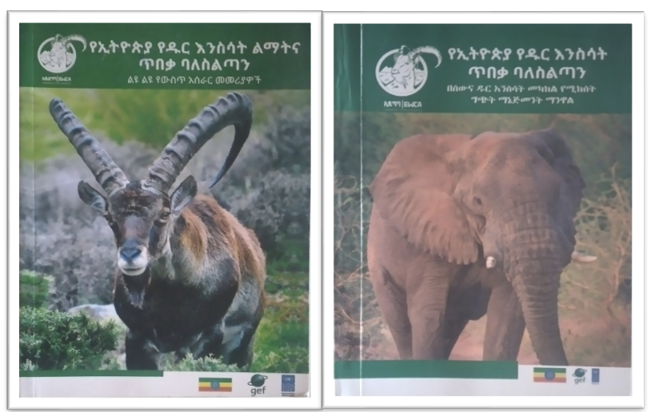
Figure 2: Regulations and Manual for effective protected area management
By the TE, one management plan had been approved for the Elephant sanctuary in Babile, bringing the total number of PAs with a management plan to five. In addition, four management plans had been developed and under initial implementation while more than 10 percent of PA staff including 70% males and 30% females, had received training on the utilization of the tools and systems developed under the project activities.
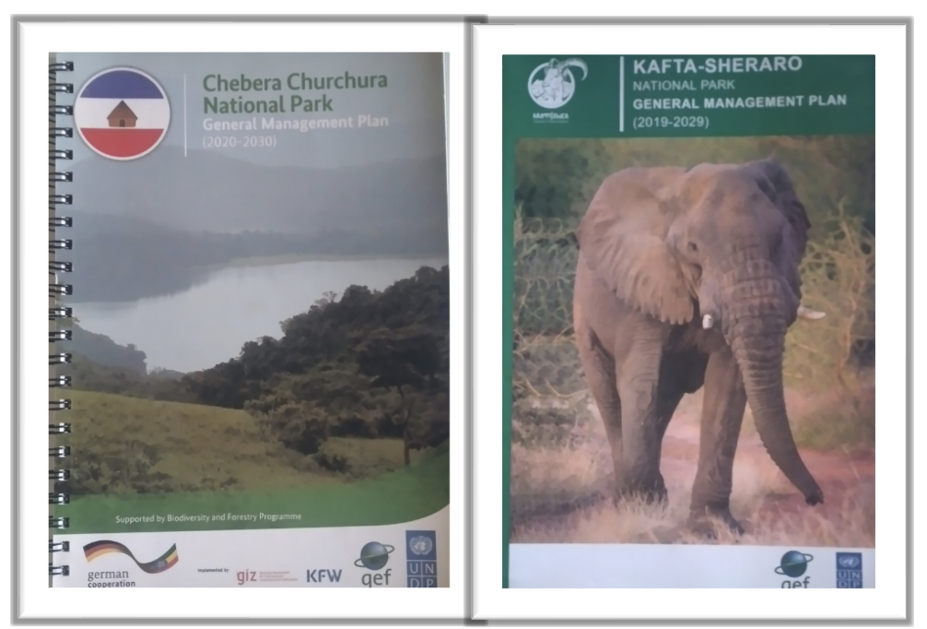
Figure 3: 10 Year management plans of the target PAs
In order to strengthen the targeted PAs for effective protected area management and enhanced protection of wildlife the project conducted various assessments:
- Need Assessment to Enhance Effectiveness of Protected Area Management in Five Project Sites
- Gaps analysis of Ethiopian wildlife legal frameworks and challenges to implement the existing laws
- A report on assessment of threat status in five selected wildlife protected areas of Ethiopia
Based on the findings of the assessments 10 years management plans were developed for the target protected areas. Capacity building trainings and experience sharing were delivered for the park staffs and relevant stakeholders. Logistics, equipment, financial and technical supports were also provided for effective protected area management and wildlife protection. Due to the project interventions the parks are now in a better state, demarcation of park areas was conducted, and additional areas have been protected outside the parks. Overall, because of the elaborated management plans, enhanced capacity of PA staff, strengthened law enforcement at site level, and the application of tools and systems for protected area management, the respective project sites have witnessed a declining poaching trend, increased wildlife populations and improvement in the habitats of wildlife.
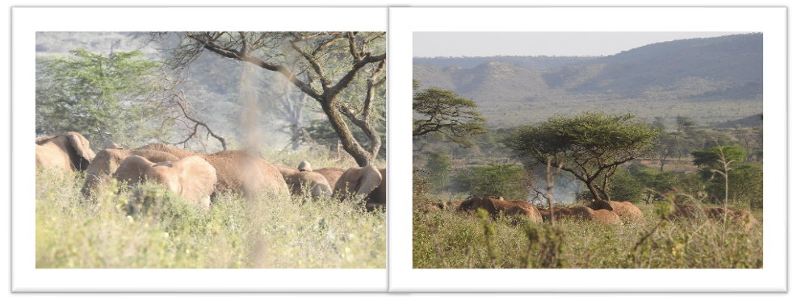
Figure 4: Group of African Elephants (Photo taken during the field mission for the TE at Babile ES)
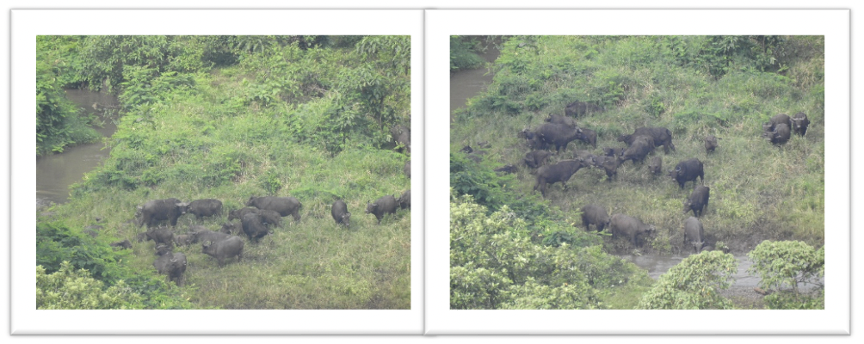
Figure 5: Group of Buffalo (Photo taken during the field mission for the TE at CCNP)
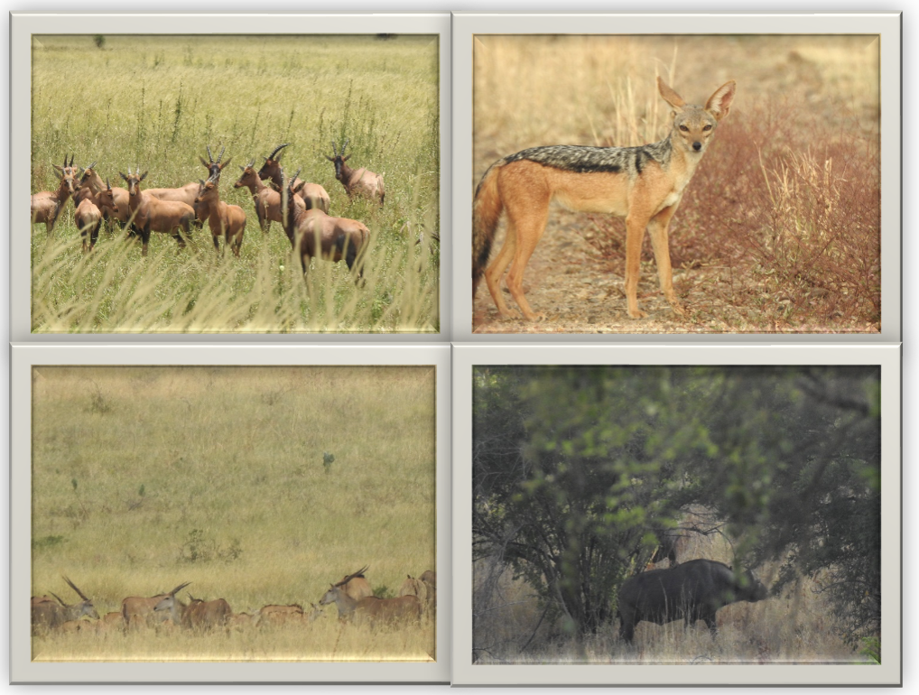
Figure 6: Wildlife in Omo NP (Photo taken during game drive)
Progress towards the achievement of outcome 1 is rated Satisfactory as one indicator is close to target and the other achieved its EOP target (Table 11).
Outcome 2: Strengthened national and local capacity for conservation of endangered fauna and flora through implementation of anti-trafficking measures
Outcome 2 was aimed at supporting and fostering international cooperation on illegal wildlife trade by signing agreements and MoU with neighbouring countries geared at controlling IWT, as well as developing proposals to strengthen the existing National IWT Steering Committee and regional IWT taskforces to reduce wildlife crimes. Guidance legislation was developed by the project to serve as a handbook on wildlife and other natural resources and distributed to the relevant personnel including judiciaries, prosecutors, other law enforcement agencies. Through Outcome 2, EMEPA provided support in the development of proposals on the ways in which wildlife legislation can be improved, and supported the establishment of an Environmental Crime Unit within the Federal Series Crime Unit. An information campaign to increase public knowledge and promote responsiveness towards wildlife and wildlife crime was conducted as part of the activities for Outcome 2.
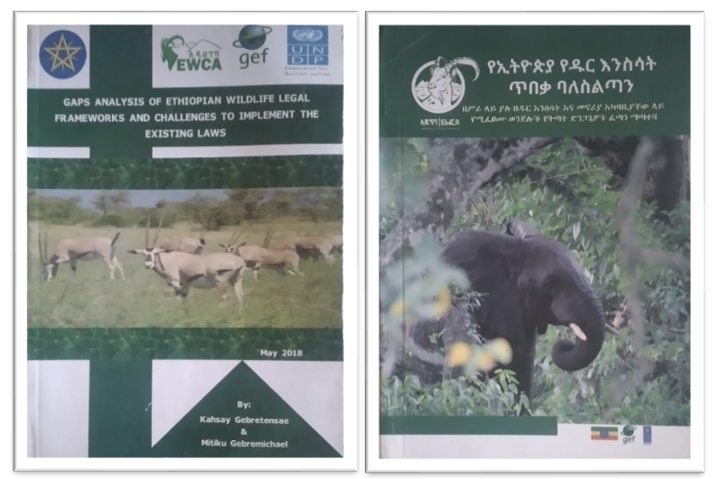
Figure 7: Instruments for law enforcement
Under the project, four bilateral agreements were signed by Ethiopia and its neighbouring countries and a regional taskforce has been established with the aim of fighting IWT through continuous collaboration. Following consecutive discussions, a recommendation emerged for the countries to establish a cooperation platform under the umbrella of the existing modality the Horn of African Countries Wildlife Enforcement Network (HAWEN). The proposal was accepted by HAWEN, leading to the member countries strengthening the institution’s capacity to tackle illegal wildlife trade and trafficking in the region. An IWT taskforce has been established that includes relevant stakeholders from government agencies and training provided to them as a way to strengthen the taskforce. A quick reference handbook has been compiled on wildlife and natural resource legislations to help the law enforcement agencies and improve implementations. About 500 copies distributed to judiciaries, prosecutors and other law enforcement agencies. A unit has been created called the Environmental Crime Unit within the EWCA through which to provide training and material support to the relevant stakeholders involved in the fight against poaching and illegal wildlife trade. An information campaign was carried out and over 30% of the general public in Ethiopia was reached through the campaign using different medias such as National TV channels (FBC and EBC), FM radios, social medias, websites, printed materials, etc.
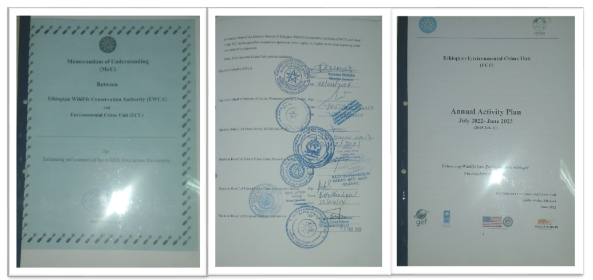
Figure 8: MoU signed by the relevant actors and annual activity plan for law enforcement
Progress towards the achievement of outcome 2 is rated Highly Satisfactory since the end-of-project target for one of its indicators was achieved and the other exceeded its EOP target.
Outcome 3: Improved conservation of forestry and agro-biodiversity resources through a landscape approach based on community-based natural resource management
The EMEPA project supported the elaboration and approval of two ILM plans for the Chebera Churchura NP and Babile ES. The elaboration of the plans was complemented by technical support from the project on the plantation, reforestation/area closure for implementation of ILM, culminating in 50,000ha of degraded land around protected areas (15,000 ha in CCNP; and 35,000 ha in the Gobele area of Babile ES) being biologically and physically rehabilitated. For the rehabilitation work, the project provided 500,000 seedlings of indigenous trees species to be planted from the nursery which has been supported by the project. The project engaged with indigenous and local communities to elaborate 5 agreements in five project sites (Omo, Mago, Chebera Churchura, Kafta Sheraro, Babile), and provided training to 800 community members (412 women and 388 men) on the elaboration of community bylaws and sustainable utilization of natural resources.
The project supported the establishment of 36 cooperative across four sites (CCNP, Omo, Mago NP and BES – 9 per site), involving a total of 1436 households (46% female and 54% male). The KSNP did not receive support in the establishment of cooperatives due to the security issues at the time. A low Value Grant (LVG) manual was prepared and used in the issuance of micro-credits to small businesses. At the time of the TE, a total of $600,000 had been disbursed to total of 36 business associations in the project areas. Recipient households who are part of the cooperative have commenced generating income from small business activities such as selling honey, cattle, goat, sheep, vegetables, fruits, spices, cash crops and grain milling service among others.
The Low Value Trust Fund/microcredit scheme grant is meant to make finance support for 36 legally established cooperatives. The capital for this portion of the grant fund is totally 600,000 USD, and a total of 150,000 USD was disbursed for each project site (nine cooperatives in each PA).

Table 12: Total budget utilized by the cooperatives
Sr.No | Project Site districts/villages (PA) | No. of  cooperatives | Total amount Disbursed (in  USD)
1 | Kurie and Bitsemal project site (MNP) | 9 | 150,000.00
2 | Maji Woreda (Seski, Adikas, Muyi & Shalt Kebeles) project site (ONP) | 9 | 150,000.00
3 | Gudumu and Neda Safer Project Site (CCNP) | 9 | 150,000.00
4 | Fedis and Midega Districts project site (BES) | 9 | 150,000.00
Total | 4 | 36 | 600,000.00

A rapid assessment was conducted to evaluate the impact of the Low Value Trust Fund/microcredit scheme grant by the project. During the assessment a total of 648 cooperative members (44.69%) were interviewed face to face. The result shows that an average of 36.55% of household income increase was observed in 2023 (Table 13).
Table 13: Average percentage of income increase in cash (birr) between 2019 to 2023 of cooperative
Name of PA | Sex | No. | Percentage of HH Income increase in birr/saving at bank in 202 | Average
ONP | M | 81 | 31.9 | 32.5
 | F | 81 | 33.1
MNP | M | 81 | 39.0 | 40.2
 | F | 81 | 41.4
CCNP | M | 81 | 37.5 | 38.6
 | F | 81 | 39.7
BES | M | 81 | 34.2 | 34.9
 | F | 81 | 35.6
Average |  | 648 | 36.55 | 36.55

The beneficiaries also benefited from various trainings, on home farming, selecting profitable fruits and vegetables, fattening and farming, seed processing, modern bee keeping, financial management and bookkeeping among others, and experience sharing organized by the project such as seed selection in Alaba, fruit production (grafted avocado plantation in Wolkite, sheep and ox fattening in Silte, milking cow raring in Debreziet, modern beekeeping in Holeta Agriculture Research Centre.

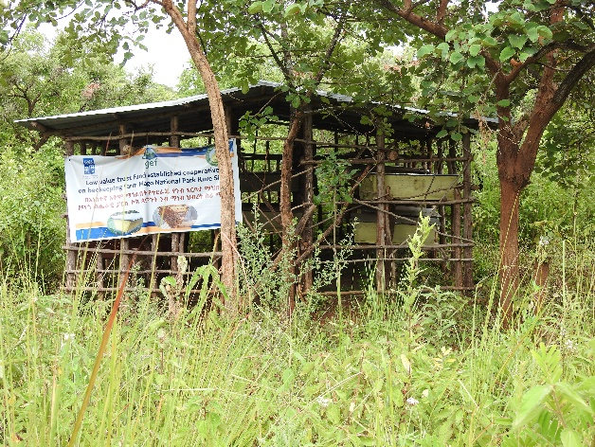
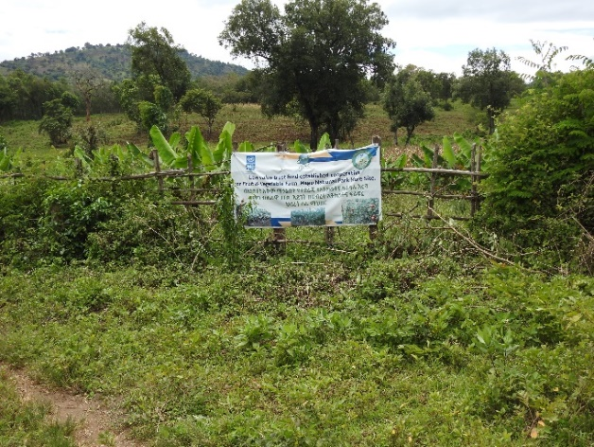
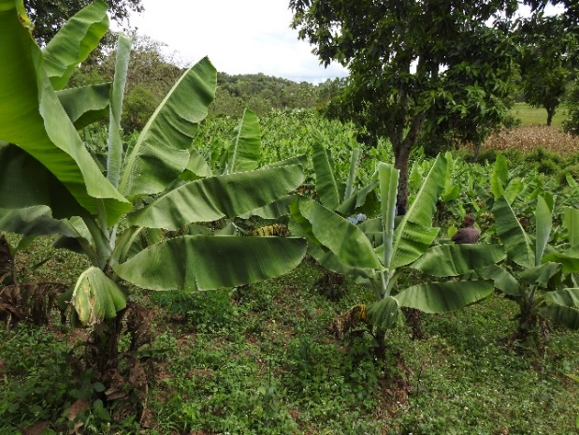
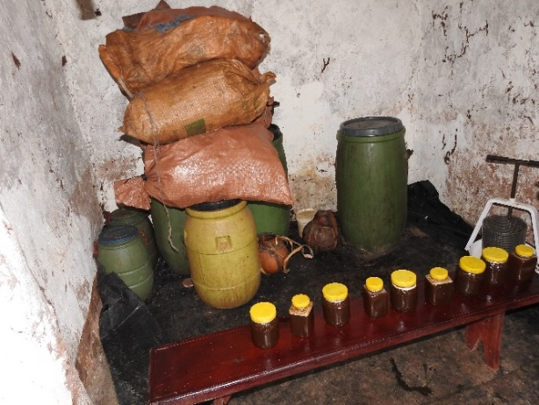
Figure 9: Agro-forestry and modern bee keeping in Mago (by beneficiary cooperatives)
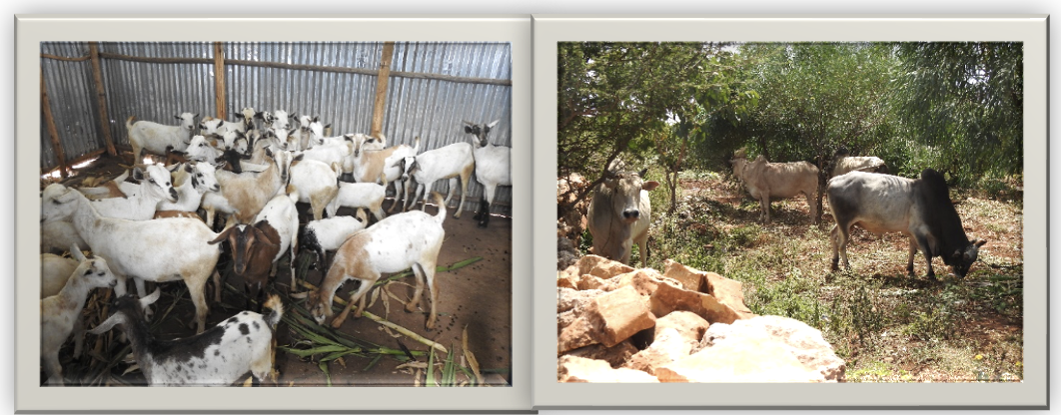
Figure 10: Goats and Oxen fattening in Babile (by beneficiary cooperatives)
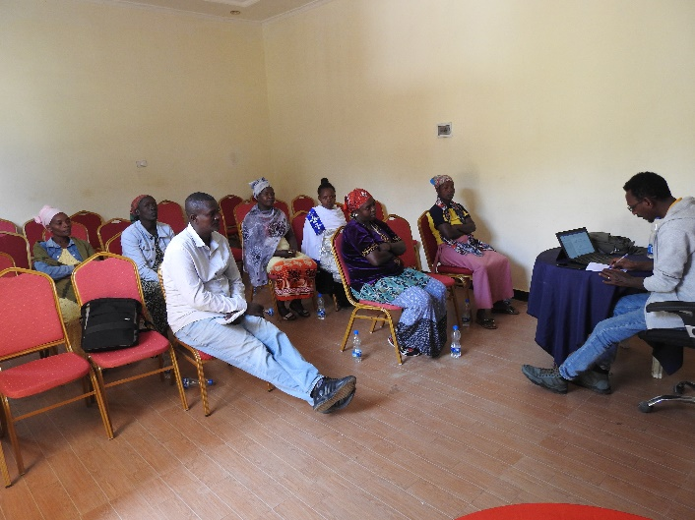
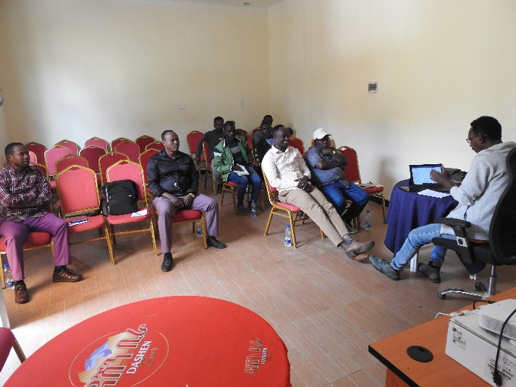
“We plant seedlings in the protected areas every year to protect our environment from the impacts of climate change. We have planted banana on 0.5 hectares, 0.2 hectares of land is covered by coffee by the support of the project. We have produced and bought thousands of kgs of forest honey and sold for profit. Our success is even broadcasted by South Nations Nationalities and People Region (SNNPR) radio and television programme.”, reported by Mago male beneficiaries.

Figure 11: Picture of FGDs with Male and Female beneficiaries in Mago
In addition, several project products were produced for the successful implementation of component 3:
- Proposal for Establishing Microcredit scheme in the Gudumu Catchment Priority Area
- Socioeconomic study report in the Gudumu Catchment Priority Area
- Business proposals for the various packages
Demonstration sites amounting to 80 ha were established by the project for the protection of rare and valuable genetic agro-biodiversity resources in Chebera Churchura, Mago, Omo and Babile, comprising of more than 300 rare and valuable plant species (endemic, indigenous, medicinal, fruit trees and fodder species) being conserved. Established nurseries within the demonstration farms comprised of about 500,000 seedlings for 18 endemic and indigenous plant species which were raised and distributed to local communities for onward rehabilitation of their land. In the KSNP, 20 ha of demonstration farm was equally established but this stalled due to the security crisis experienced in the area during project delivery.
Progress towards the attainment of outcome 3 is rated Highly Satisfactory as two of its indicators had their end-of-project target exceeded while those for the three other indicators were achieved (Table 11).
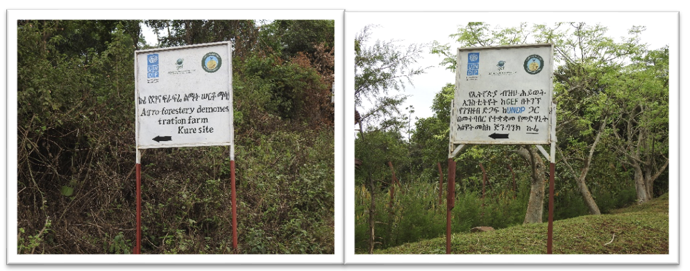
Figure 12: Demonstration site and Medicinal plants gene bank in Mago
Outcome 4: Lessons learned by the project through participatory M & E, including gender mainstreaming, are used to fight poaching and IWT, and promote community-based conservation nationally and internationally.
Outcome 4 focused on frequent monitoring and evaluation of the project and effective management of its implementation as well as documentation of lessons learned. Monitoring was done on a quarterly basis and feedback provided on adaptive management, gender mainstreaming and active lesson learning so as to inform and improve protected area management procedures. Lessons learned on project implementation have so far been compiled and shared regarding IWT and reducing poaching. These lessons learned have been shared among the different project partners involved both nationally and internationally. Progress towards the achievement of outcome 4 is rated Highly Satisfactory as both of its indicators’ end-of-project targets were achieved (Table 11).
Innovations in the project
The EMEPA project is part of the global wildlife programme implemented in countries in Asia, Africa and Latin America. Through the GWP platform, the project has been sharing its lessons learned and best practices with other countries and has equally been learning from the success stories and good practices emerging from different countries under the programme. The approach to stakeholder engagement within the EMEPA project is also an element of innovation. Firstly, the project engaged with communities around protected areas and identified indigenous knowledge and approaches which could be integrated into modern day protected area and wildlife management, such as indigenous knowledge in managing human-wildlife conflict. Secondly, the collaborative management systems established by the project enabled the engagement of diverse stakeholders at different levels. To curb illegal wildlife trade, the EMEPA project engaged with the defense forces, the judiciary, customs, and local communities and established task forces at the national, regional and local levels so that the different actors could come together to combat illegal wildlife trade and promote conservation in general. EMEPA equally demonstrated innovation in its approach to capacity building. To train law enforcement bodies, EMEPA did not organize a stand-alone capacity building event but rather resorted to integrating such trainings under already established or planned trainings for law enforcement officials organized by actors external to the project. This approach adopted ensured knowledge is transferred in a very cost-effective manner and within a short time.
The project adopted a modern approach to conservation which integrates elements of technology. The project employed the use of drones for monitoring the situation inside protected areas. The drones are used for mapping and assessing habitat distributions and links the mapping through GIS, enabling protected area staff to visualize and represent the generated information in a model. The model could then provide some useful information such as optimal sites of habitats that can be used for animal introductions or translocations. At the time of the TE, it was confirmed that staff of protected areas were being trained on the use of the drones for counting animals (animal census), something that was done in the past with the use of aeroplane, and this required substantial financial resources. These novel technologies introduced in the conservation space of Ethiopia through the EMEPA project have potentials for ensuring a more efficient and cost-effective monitoring and management of protected areas in the country.
The project produced posters on wildlife crime and associated sentencing which were displayed on walls at the Bole International Airport for international travelers to see as they pass through the transit lounges. This was probably the first time such an attempt has been made to sensitize individuals traveling from, to or through Ethiopia.
Several innovations were introduced for wildlife conservation and livelihood components. The project established environmental crime unit (ECU) platform and a finance intelligence service included in the ECU to tackle money laundry. Sniffer dogs were introduced by the project and a toll-free call line (6144) was established to gather information on illegal wildlife trade from the public. The project equally supported the inclusion of wildlife crime protection in Oromia Police training college Curriculum (on process) – this was still ongoing at the time of the terminal evaluation. In addition, cooperatives have been established and legalized as part of the livelihood component and various products have been delivered by the project. The products include modern bee hives, improved vegetables and fruit seeds, oxen, sheep, goats, seedlings, etc. for the beneficiaries and local communities participating in rehabilitation of degraded lands. Demonstration sites were established in selected PAs and indigenous and medicinal plants were conserved.

Contributory factors to success
The integration of different sectors and engagement of stakeholders who are supporting and benefiting from the project is an element that favored success of the project. The project involved the Ethiopian Wildlife Conservation Authority (EWCA) and the Ethiopian Biodiversity Institute and the commitment of these two institutions in the implementation of the project was important for project success. EWCA managed some of the project sites such as the Omo National Park among others and implemented component 2 of the project focused on combatting illegal wildlife trade and trafficking. The Director General of the EWCA was in support of the project and was able to mobilize the staff of the institution to be engaged in the project. The media (radio and TV stations) have been mobilized by the project to broadcasting conservation-related messages to communities in local languages through the project life.

The assistance provided by the UNDP Country Office emerged from the evaluation as a factor that greatly contributed to the success of the project.

The project is part of the Global Wildlife Programme and the GWP platform established as part of the programme enabled knowledge exchanges and sharing of lessons learned and best practices among the participating countries in the programme. Through this, the EMEPA project was able to benefit from experiences and best practices generated in other countries and this represents a factor of success of the EMEPA project.

The project had a dedicated and hardworking team within the PMU. The project team was good at raising the profile of the EMEPA project among the child projects under the Global Wildlife Programme using the GWP platform. The team shared lessons leant with other countries and showcased the project’s achievements on the platform. The project team also demonstrated adaptive management especially to the Covid-19 pandemic during which measures were adopted to ensure continuity of project activities while complying to the Covid-19 guidelines and restrictions imposed by the Government of Ethiopia. The project team was found to be very responsive to comments from UNDP and provided feedback in a timely manner.

The establishment of task forces at the local level was a factor that favored project’s success. The task forces embarked on patrols of the protected area – twice a week and eight times per month. These patrols were effective and legal actions were taken against trespassers

The awareness creation campaigns and training workshops conducted at national, regional, zonal, woreda, kebele and community levels were key for successful delivery of the project. The trainings were also helpful in equipping the community living around the protected areas to explore alternative income generation activities that are environment friendly. Various trainings were also conducted for farmers, pastoralists, park experts, officials and experts of various stakeholders on issues including but not limited to wildlife conservation and law enforcement.

The lifestyle of the pastoralist community was a constraining factor to the project. The pastoralist community mobilized their cattle to places where there is water and grazing land including the park area. This affected the law enforcement efforts of the project to protect the park. This lifestyle of the pastoralist equally impacted on the livelihood component which is very much effective in the farming communities.
Constraining factors to success
The Covid 19 pandemic negatively impacted on the project. During the pandemic, travel and in-person meeting restrictions were being imposed by the Government of Ethiopia and this rendered the management and protection of protected areas from illegal activities challenging and travel or patrol is required for these sites to be kept secured from perpetrators of wildlife crime.

Political instability and insecurity in some parts of the country was a challenge for the delivery of the EMEPA project. During the implementation of the project, the Northern part of the country experienced conflict and this negatively impacted implementation of project activities in one of the targeted national parks of the project. The civil conflict experienced in the country during the delivery of the project necessitated for a permission to be obtained for protected area management staff to be trained on the use of drones as drones became a sensitive issue at the time. The permission was finally secured for the organization of the drone trainings it is important to note that the instability and insecurity-related challenges were beyond the control of the project.

High turnover pertaining to rearrangement/formulation of new administrative bodies of high, medium and low-level government officials emerged as an impeding factor to the project. The government restructuring in 2020 led to the phase out and non-existence of MoEFCC which was the GEF operational focal point (OFC). The OFC was then transferred to Ministry of Planning and Development.

The dependence of communities on nature and the relatively limited resources allocated for livelihood vis-à-vis the demands of the communities was a challenge. Communities living around protected areas are highly dependent on nature. Given the Ethiopian context where over 80% of the population are farmers or pastoralist, communities around protected areas experience and increasing population trend and consequently, communities are always craving for extra land for agriculture and grazing of cattle. The project implemented livelihood activities in its sites of intervention and more people expressed support in this regard than the project’s finances could cater for.

The project experienced a low co-financing materialization. At the time of the TE, the co-financing of the project had not fully materialized and this is something that should have required the close follow-up of the UNDP Ethiopia Country Office but this seemed not to have been the case. Issues of co-financing materialization would have benefitted from an ongoing monitoring and analysis by UNDP Ethiopia, identifying obstacles and taking measures where applicable to address the challenges encountered.

Synergistic relationship between EMEPA and other ongoing initiatives
The project built synergistic relationship with other similar projects. In the elaboration of the management plan of the Chebere Churchura National Park, the EMEPA project team collaborated with a GIZ project that was under implementation in the area. The EMEPA project also collaborated with USAID and the African Wildlife Foundation on wildlife crime and the establishment of a wildlife crime unit at the Bole International Airport in Addis Ababa. The EMEPA project collaborated with the Cheetah Conservation Fund (CCF) and the International Fund for Animal Welfare (IFAW) in 2020 to organize a meeting between the Somali region of Ethiopia and Somaliland focused on discussing the urgent need for an enhanced bilateral cooperation to halt the illegal trade in live cheetah cubs obtained from the wild in Somaliland and the Somali region, and trafficked to the Middle East for sale as exotic pets. More details about the collaboration of the EMEPA project and other initiatives in the country has been provided in Table 5

Efficiency
The efficiency of the project is rated Satisfactory.
Role of government in successful delivery of the project
The EMEPA project would not have been delivered to completion without the role played by the government of Ethiopia as the project implementing partner. The achievements of the project would not have been possible without the collaboration between the government and other stakeholders, as well as the day-to-day overview provided by the government and its institutions. The government was also responsible for providing financial support for the implementation of project activities. The Environmental Protection Authority (EPA) took over the previous EFCCC as the implementing partner in charge of providing oversight, coordination and project implementation. The EWCA which is another government institution had the role of coordinating the activities to combat IWT and served as a member of the PSC. Through the PSC, the government resolved challenges faced during the implementation of the project to ensure that project objectives were achieved to a larger extent. EBI was responsible for the implementation of component 3: Landscape approach to forest and agro-biodiversity conservation, and was successful in providing alternative income generation mechanisms for the beneficiaries as part of the livelihood activities and established demonstration sites and supported the existing nursery sites in the targeted project sites. It also mobilized the community and government offices in restoration of degraded lands around the selected parks.
Efficiency in the use of project resources
Measures were taken by the project team to ensure the efficient utilization of project material and financial resources. For each financial year, an annual work plan was developed for the project and this is accompanied by reflections on how the project limited resources could be used efficiently. The project does not cover every cost but rather capitalize on ongoing government efforts to minimize expenditure. For instance, for the organization of training, the project covered the travel cost and daily subsistence allowance (DSA) of the experts travelling to take part in the training and in most cases do not cover the cost of the training as trainings under the project were integrated within other ongoing training platforms or meetings. In this way, the project saved considerable amounts of financial resources.

The EMEPA project also integrated its impact with other conservation projects. For instance, in the elaboration of the management plan of the Chebera Churchura National Park, the project collaborated with the ongoing GIZ biodiversity and forestry project implemented in the area and shared the cost. For communication, the project made use of the public media (radio and TV stations) and social media such as YouTube, Facebook to reach out to millions of people at minimal cost.

The government institutions serving as implementing partners of the project have ground presence in the intervention sites that predates the project. Hence, the project partners are providing co-financing or providing the materials required for the implementation of the project activities. “For anti-poaching or patrol operations, the project does not over 100% of the associated cost, but partially covers the cost while the remainder is being covered by the government and this approach has guaranteed the efficient utilization of the project’s financial resources” indicated a staff of the PMU.
Financial Management
Pertaining to financial management, the project management unit followed the approach developed by the Ministry of Finance of the Government of Ethiopia while also integrating the financial management requirements of UNDP. The project established a strong internal audit system and used the UNDP financial control and management system which ensures a strict control and monitoring of the utilization of the budget for each project activity. For each activity, a term of reference is developed by the PMU and the disbursement of funds is done in line with the ToR and the guidelines in place by UNDP and the government. The project possessed an accountant, a cashier and a procurement staff from the government who all work together to ensure the strict compliance of the project to the procurement guidelines of the government and UNDP.

The parks were responsible to manage the funds allocated for law enforcement and the cooperative office was responsible for management of the funds for the beneficiaries. The cooperatives opened bank accounts and funds were transferred by EBI to woredas cooperatives who in turn transferred the funds as seed grants to individual cooperatives within their respective jurisdictions. EBI followed up to ensure the efficient and cost-effective utilization of the funds by the cooperatives. The established cooperatives had been trained on financial management and record keeping, and prepare legers on income and expense. Annual audits also conducted for the cooperatives. As indicated in interviews with woreda cooperative offices.
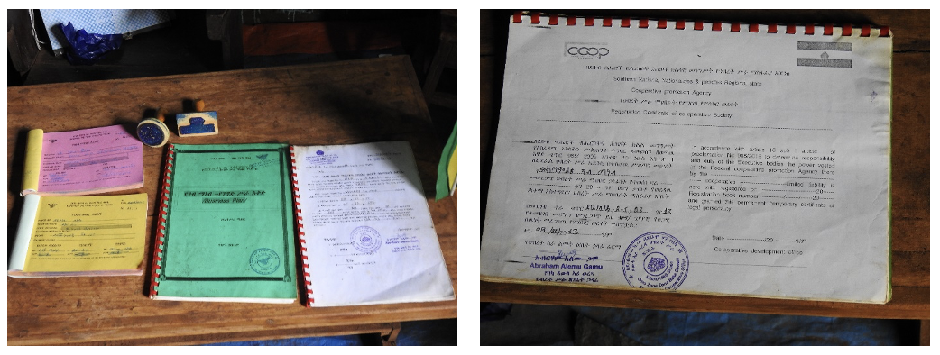
Figure 13: Financial records, receipts and registration certificate of the cooperatives (Mago)
Annually, an annual workplan is prepared for the project by the PMU and this is signed by the Ministry of Finance, EWCA and UNDP. Quarterly work plans are then prepared from the approved annual work plan on the basis of the budget of the quarterly workplan that project fund was being disbursed by UNDP to the government counterpart in charge of execution of the project – EWCA. At the end of a quarter, the government counterpart submits to UNDP, a progress report and a financial report which provides a justification for funds expended for that quarter, prior to making a request for funds for the subsequent quarter. Once the justification submitted to UNDP is approved, funds for the subsequent quarter is transferred accordingly by UNDP. UNDP conducted spot checks to assess the quality of the financial record provided by the government counterpart for the funds received from UNDP. The spot checks also verified if the financial records align with the workplan and in the event of irregularities, a follow-up is made to the implementing partner for corrective measures to be adopted for future utilization and reporting of project funds.

The evaluation revealed that fund transfer by UNDP to the government counterpart happened timely, with slight delays in the disbursement of funds experienced at the start of each year due to delays in the signing of the work plan by the government. The migration of the UNDP Atlas system to Quantum at the end of 2022 and beginning of 2023, delays in the transfer of funds were experienced. This was however a common problem across UNDP offices globally.

The project is being subjected to an external audit annually. From the government’s side, the Ministry of Finance conducts an audit on EWCA while another audit is commissioned by UNDP, and it is conducted by a third-party auditor contracted by UNDP.

Response of the project to the Covid-19 pandemic
During the Covid 19 pandemic, the Government of Ethiopia introduced measures to curb the spread of the virus and the project strictly followed the guidelines that were established by the Ministry of Health. Restrictions were placed on travels and on the organization of in-person meetings and this posed a challenge in the implementation of those project activities that either required travels or necessitated the convening of individuals in a meeting. The project adopted measures to continue its activities despite the threat posed by the pandemic. Firstly, the project resorted to the use of virtual communication channels such as Zoom among others to organize meetings. The project team capitalized on the use of email, WhatsApp and telephones for exchanging information and the PMU communicated with protected areas’ staff in the project sites via telephone, informing them to respect the Covid-19 guidelines established by the government. The staff of the protected areas were supported through the provision of face masks and hand sanitizers by the project to protect them from contracting the virus. Secondly, relating to travels, the project team used more vehicles for travel so that fewer persons travel in a vehicle to ensure that social distancing is respected.

Overall Outcome
The overall outcome of the project is Satisfactory. This overall assessment is based on the ratings for relevance (Highly Satisfactory), effectiveness (Satisfactory), and efficiency (Satisfactory).

Country Ownership
Country ownership of the EMEPA project was ensured through the strong involvement of national stakeholders from the project design phase to the implementation. The project activities were aligned with the needs and national priorities of Ethiopia, relating to environment and climate change mitigation, natural resource management and protected area management. The project implementation and management involved collaboration between government institutions and partners from the different levels of government, regional, local and community level decision-makers and law enforcement agencies, all making sure the project activities were implemented successfully.
The project focuses on fighting illegal wildlife trade and poaching and preventing the degradation of Ethiopia’s biodiversity resources, which are both important to the development priorities of the country. These are also important plans discussed in the Second Growth and Transformation Plan (GTP-II) and the Climate Resilient Green Economy (CRGE) strategy, which are two important documents when Ethiopia’s development objectives are concerned.

Gender
Gender mainstreaming is rated Highly Satisfactory.
A gender mainstreaming strategy was elaborated during the project design stage, which included a gender analysis and an action plan. This strategy discusses the nature of gender relations in the different project sites and the differences in terms of access to and control of natural resources, gender division of labour as well as provide insight into the level of awareness on natural resource management between the different gender among others. The ways in which gender considerations were to be mainstreamed into the EMEPA project was clearly discussed under each of the project components, in the gender strategy.
Under Component 1, the project had to carry out awareness campaigns that were in line with the roles and interests of both males and females and also encourage the participation of women in decision making processes by including them in workshops and trainings on natural resource management and law enforcement activities where possible. Membership for PA management committees were expected to be comprised of at least 40% women and training planning, implementation, reporting and participation had to be reported in a gender disaggregated manner.
For Component 2, access to finance such as microcredits was to be provided to female-headed households and women were to be included in micro-loan committees, with gender disaggregated reporting on the micro-loan. Women had to be included in income generating schemes such as weaving, and tour guides and the capacity of women’s associations strengthened, on financial management, business planning, and other trainings that could improve their livelihoods.
Component 3 was expected to improve on access to modern fuels saving and lighter cooking technologies so as to increase time for opportunities, getting both men and women involved in bio energy production for improved incomes and livelihoods, and thus understand gender relations in terms of energy use and other consumption patterns.
Finally, as per the gender strategy, Component 4 focused on improving the community’s ability to fight against IWT and poaching while strengthening law enforcement.
During project implementation, gender mainstreaming was monitored and reported in the PIRs elaborated annually. By 2021, 1450 individuals in the local communities had been trained in the regulations and effective use of Low Value Trust Fund (LVTF) including 46.5% males and 54.5% females. Additional training on access to and use of natural resources saw the participation of 49% males and 51% females out of the total 1500 participants. Out of 14 new cooperatives established within the 1450 households for the LVTF utilization, 4 belonged to women. The percentage of males versus females trained on the utilization of the LVTF increased to 46.5% males and 53.5% females, with a total of 775 women having benefitted from the fund by 2022. In the same year, women got more involved in the project activities such as conservation and management of rare and endemic plant species, seedling production and management and also worked as day laborers for the project. Out of 2,038 individual households that were involved, 1,049 (51.47%) were women. Not much was discussed on gender mainstreaming for the year 2023, as per the PIR.
Overall, in the implementation of project activities, the project team had to ensure that gender consideration is taken into account as much as possible. This was corroborated from the views shared by some of the beneficiaries (cooperatives) of the project that the selection criteria for the beneficiaries of the livelihood support provided by the project was inclusive and transparent, which led to the selection of women, men and youths. Some TE respondents also opined that achieving gender mainstreaming into the project posed a challenge. “Due to the difficulties and challenges associated with the nature of the project it was not possible to maintain the gender ratio at the police force, scouts and rangers. We tried our best to mainstream gender at park level and women are doing scout and patrol as good as the men”, reported an official from Chebera. One female scout won the international Ranger award in 2023 as best ranger, and this served as a motivation for other women to work in the parks. Another woman had received an international recognition for best livelihood practices in 2019.Theye are the fruits of the project support under this matter.

Cross-cutting Issues
The EMEPA project components were designed to create opportunities for better or improved livelihoods through income generating activities and increasing access to credit to the target communities (Indicator 4 and 5). Studies on value chains on forestry and agro-biodiversity were conducted, with the aim of suggesting various options for sustainable income to the communities. The project succeeded in mobilizing funds for some of the cooperatives and 36 business associations established in four project sites, to engage in generating income and carried out capacity building activities on small business activities such as selling honey, cattle, goat, sheep, vegetables, fruits, spices, cash crops, grain milling services among others. Business plans were developed for each type of livelihood alternative, to help improve the economies of the local communities. By 2023, about US$ 450,000 had been disbursed to the 36 cooperatives established and income generating initiatives have begun, with an increase in household income as a result.

Disability
Scant evidence was generated by the evaluation revealing the integration of people with disabilities in the implementation of the project. “Though no special emphasis was given to include persons with disabilities in the project they were not ignored intentionally”. Indicated in KIIs and FGDs.

Social and Environmental Standards
The EMEPA project was subjected to an SESP during its design phase. The SESP at design phase categorized the project as low risk. Following a poaching that occurred in one of the project’s targeted protected areas in May 2020, the PMU reviewed and revised the project’s SESP, providing a new categorization of the project as high risk. UNDP’s Nature, Climate and Energy (NCE) equally commissioned a review of the project’s safeguard in 2019 and recommended that the project’s risk rating be revised from Moderate/Low to High. In view of the revised risk rating, the PMU was meant to take steps required to elaboration of risk mitigation plans, including Indigenous Peoples Plan, Livelihoods Action Plan and Stakeholder Engagement Plan to complement the already existing Park Management Plans. A Grievance Redress Mechanisms also required to be developed. In the 2021 PIR, no signs of elaboration of the recommended safeguard management plans were presented.
The mid-term review of the project in 2021 emerged with similar findings and recommendations. The MTR highlighted the low attention given by the project to social and environmental risks and mentioned that risk assessment at the project design phase was weak, missing critical risks and risk management tools related to indigenous and other communities. The MTR recommended that the following management plans be formulated: indigenous Peoples’ Plan (IPP) and an Environment and Socio Impact Management Plan (ESMP). The MTR management response that was prepared by the Project Manager and approved by UNDP Ethiopia Country Office stated that key actions that would be taken starting from March 2021 to address the recommendation from the MTR included: an “indigenous people’s impact management plan” and an “environmental and socio-economic impact management plan. However, no progress on these was reported in the 2022 PIR and the PIR recommended that urgent measures be taken to address the recommended safeguard measures. At TE, the evaluators did not identify measures that were taken to address the safeguards concerns raised. The project team however prepared livelihood plans in 2019 for the national parks and business plans. Although the TE did not identify an IPP prepared for project, positive opinions were expressed by community members consulted pertaining to the benefits of the project on them. Equally, the TE did not identify any unintended undesirable impacts of the project on communities.
Accountability and Grievance Mechanism (AGM)
The PMU confirmed the existence of an accountability and grievance mechanism in place which is open and transparent and can be used by the communities or other project stakeholders to voice their concerns about the project. However, this could not be validated as some respondents were not aware of the existence of the mechanism. For instance, a respondent from UNDP confirmed not having sufficient knowledge on the existence of an accountability and grievance mechanism for the project. Another respondent could not confirm but rather made a guess to the existence of the grievance mechanism. “I do not think a project like this can exist without a grievance mechanism. Therefore, as far as I am aware, there is a grievance mechanism in place for the project because I do not think there can be a GEF project without a grievance mechanism. I am pretty sure there is a grievance mechanism in place for the project”, reported a respondent. Triangulating the views of stakeholder with secondary data from project document revealed that a project-level AGM was non-existent at the start of the project. As a matter of fact, the 2020 PIR recommended that an AGM be developed for the project. An AGM would ideally be developed before the inception workshop of the project and publicized during the inception workshop and in other project events. This was however not the case with the EMEPA project.

Sustainability
The Sustainability of the EMEPA project is rated Moderately Likely.
The government ensured that it was aware of the state of project implementation, and this was made easy by the fact that government institutions oversaw the implementation process. This gave the government an upper hand in engaging with other partners and stakeholders on ensuring the sustainability of the project results. The stakeholders and law enforcement agencies received capacity building and strengthening through the project, which is expected to help them to fight IWT and poaching. It is expected that they use the knowledge they have gained during the project even after the project ends. The government took the lead in signing MoUs and international agreements with neighboring countries to reinforce the partnership between them in fighting against IWT trafficking across the region. The target communities got involved and were fully engaged in the project activities in the various sites and it is likely that the impact of the project in these communities, will still be felt even after the end of its implementation. IWT and poaching have been reduced significantly in the protected areas, law enforcement agencies are doing their best to help curb illegal wildlife activities. Public awareness campaigns were held within the project communities, to equip the public with relevant knowledge on protected area and wildlife conservation. It is therefore expected that they will continue to utilize this knowledge even after the project activities end. “Ownership is enhanced at community, kebele, woreda, zone, regional and federal levels. This will insure the sustainability of the park and wildlife. The established cooperatives have become stronger in finance, knowledge and experience. We will share our knowledge for others and will support them to change their lives for good like ours. We are now models for the community and the spillover effect of the project is great. This will insure the sustainability of project interventions”. Other elements of the EMEPA project that could likely be sustained beyond the life of the project are as follows:
- From the design of the project, sustainability has been reflected upon and the project took steps to enhance its sustainability through the provision of capacity building to its implementers. For instance, standard operating procedures have been developed for protected areas and the staff have been trained on the use of different technologies including GIS among others for the management of protected areas. To ensure that initial results of the project are sustained beyond its life, the project partners have worked on elaborating a GEF-8 project for Ethiopia. It is hoped that once improved and under implementation, the GEF-8 project will capitalize on the initial results of the EMEPA project to guarantee its sustainability.

- The project has developed a website to disseminate information. The website is packed with a lot of information available for users. Equally, many wildlife films have been developed for present and future use in teaching. Pertaining to publications, at least five or more scientific articles have been published from the project and contain best practices generated by the EMEPA project. All these information generated by the project will continue to be useful beyond its life.

- The integrative approach employed by the project has supported trust building among stakeholders, enabling different stakeholders to work together to combat illegal wildlife activities and enhance conservation efforts. This established trust among stakeholders will likely continue to exist beyond the life of the EMEPA project, enabling a continuous interaction between stakeholders for an enhanced conservation of biodiversity.

- The five to ten years management plans, tourism development plan, and fire management plan that have been developed for the protected areas will remain valid and destined for implementation beyond the life of the EMEPA project. Equally, the revised Wildlife Act which now contains more severe sanctions for wildlife criminals will likely continue to serve as a deterrent to wildlife criminals which would translate into reduced wildlife crimes in the nation beyond the life of the EMEPA project, Moreover, the technological tools, skills and knowledge gained through the project will continue to be useful in the generation of data which will be used to inform conservation measures beyond the life of the project.

- The established cooperatives by the project have been formally registered and are in possession of bank accounts. Members have been trained on several issues including but not limited to home farming, selecting profitable fruits and vegetables, fattening and farming, seed processing, modern bee keeping, financial management and bookkeeping. This solid foundation provided to the cooperatives means that they can continue with their activities beyond the life of the EMEPA project. Cooperative members are now seen as models in their respective communities are willing to share their knowledge with other community members.

- The project utilized the existing government structures to implement its interventions and the parks did exist even before the project. The livelihood component also utilized the existing relevant government offices. The project strengthened the parks, government offices at all levels and the community through financial, technical and logistics support and awareness creation. Therefore, the parks will likely sustain the project interventions and the cooperatives will also likely sustain the livelihood component since they are benefitting from it.

Exit strategy
The project document indicated that an exit strategy for the project was to be prepared within the first two years of the project implementation. At the time of the evaluation, an exit strategy was being elaborated for the project to enhance its sustainability. The elaboration process of the strategy entailed consultations with the government and other relevant stakeholders which led to the identification of the most important elements of the project that needs to be sustained including community engagement, law enforcement, management of human-wildlife conflict and curbing illegal wildlife trade and conflict. The elaboration of the of the strategy was finalized in September 2023, during the period when the TE draft report was being finalized. The elaborated exit strategy provides recommendations for strengthening the sustainability of achievements under each output, a timeline for the implementation of recommended actions and the associated responsible parties.

However, the evaluators are of the opinion that it would have been more ideal for the project to elaborate its exit strategy immediately after the mid-term review and not few months to project closure.

The risks to the sustainability of project results are discussed below.
Financial risk
At the beginning of the project, the ProDoc highlighted a financial risk to the sustainability of the project which was rated severe. This was the allocation of resources by the GoE to ensure sustainability of processes initiated by the project and project impacts. Financial analysis carried out during the lifespan of the project and on annual work plans did not indicate any financial issues related to the available funds for the achievement of project results. However, the 2023 Output Verification Report highlighted some financial risks to the sustainability of the project. An expected delay of the first quarter budget of the project was discussed to have affected the timely implementation of planned project activities. Inflation also stood as a challenge to the sustainability of project impacts.
Th GIS-based applications provided within the framework of the project will likely require valid licenses for their functionality. Upon expiration of the current license, its renewal could be challenged by the lack of dedicated funds. This could jeopardize the continuity of the application of technologies in the management of the protected areas. The same applies to the drones introduced by the project. In case of breakdown of a drone necessitating a replacement, it is unclear where the finances for the purchase of a new drone will come from.
The financial risk to sustainability is Moderately Likely.

Socio-political risk
Political instability in some of the project intervention sites had been discussed in the ProDoc as posing a risk to the sustainability of project results. Corruption, political will, government commitment, armed conflict, adverse public opinion and change in government were also discussed as socio-political risks to the project. In 2020, there was security issues that came up making travel restricted across some of the project sites, though temporary. However, at the time of TE, ongoing security issues in one of the selected pilot PAs - Kafta Shiraro stood as one of the socio-political challenges faced. In the absence of peace and security, it is challenging for any development or investment to thrive and the same applies to the results achieved from the implementation of the EMEPA project.
The global coronavirus pandemic also posed a social risk to the project as poaching became rampant during the health crisis, due to limited movement imposed by the government which made it hard for PA staff to intervene against any cases of poaching. Some activities had to be delayed which meant that the implementation could not be done in a timely fashion. The Ukraine crisis also slowed down the project implementation as well as a drought in 2022. It would appear at the time of TE, some of the project activities which had been delayed because of Covid-19, such as the signing of bilateral agreements were achieved.
Population increases around the protected areas where the EMEPA project intervened could lead to overexploitation and unsustainable use of natural resources and this might challenge the efforts or results achieved from the implementation of the EMEPA project.
The lifestyle of the pastoralist communities around the protected areas could dampen the law enforcement efforts of the project. These pastoralists are nomadic and are always on the move in search of grazing land and water even within the protected areas. There is therefore need for such communities to be organized to limit the possible impacts of their lifestyle on the sustainability of the project.
The project’s socio-economic risk to sustainability is rated Moderately Likely.
Institutional framework and governance risk
The protected area management and conservation plans that have been developed, launched and operationalised within the lifespan of the EMEPA project require regular monitoring or follow-up. This will require close collaboration among the various stakeholders involved, a lack of which may hinder the sustainability of protected area activities according to the established plans.
The project supported the training of local, regional and national authorities and the development of regional protected area conservation and management plans. Some of these regional authorities are elected to their positions with a fixed term mandate. If they happen to be voted out of their positions and new individuals are voted in, the new authorities may lack knowledge, capacity and awareness on forest conservation and development issues and may not be committed to the implementation of the protected area management and conservation plans. The EWCA had been shifted among different ministries and at different levels over ten times within the last three decades, which may pose an institutional risk to the sustainability of the project. Equally, the project supported the amendments of policies which have been submitted to the relevant government bodies for approval. There is a risk that these elaborated amendments could end up not being approved and consequently, will not be implemented.
The Institutional framework and governance risk is rated Moderately Unlikely by the evaluators.
Environmental Risk
Climate change represents a risk to the project. Increasing temperature trends, changes in precipitation patterns and occurrence of droughts could negatively impact on the conserved protected areas, and may even worsen the situation with some of the endangered wildlife. Equally, the outbreak of diseases and pest (invasive species) could negatively impact the protected wildlife.
The Environmental risk of the project is Moderately Likely.
Table 14: EMEPA sustainability rating
Sustainability dimension | Rating
Financial risk | Moderately Likely
Socio-political risk | Moderately Likely
Institutional risk | Moderately Unlikely
Environmental risk | Moderately Likely
Overall Sustainability ranking | Moderately Likely

GEF Additionality
Through GEF funding, the project has been able to combat illegal wildlife trade and enhance the management capacity of protected areas in the project sites. The project achieved community engagement and generated environmental benefits relating curbing habitat loss. EMEPA intervened in securing the elephant population in five project sites, developed protected areas management plans and supported their initial implementation, achieved agrobiodiversity conservation through community-based natural resource management, and supported the rehabilitation of over 50,000ha of land around protected areas through a landscape approach. All these are attributable to GEF funding.

The elaboration of up-to-date state-of-the-art management plans of the various protected areas covered by the EMEPA project, and their consequent implementation has led to an improvement in the management of the protected areas. These plans came into existence through the funding provided by the GEF. All five protected areas under the project have shown improvements in their capacities on managing the protected areas, reducing poaching, and implementing different interventions for addressing illegal wildlife trade
While conservation work has been ongoing in Ethiopia long before the advent of the EMEPA project, this did not integrate aspects of technology. Through funding from the GEF, it was possible to pilot the use of technologies like drones and GIS-based applications for the monitoring of habitats, wildlife population, and for an effective and efficient management of the protected areas. The introduction of these novel technologies was accompanied by trainings delivered to the staff of the protected areas which were also conducted with GEF resources.
The Wildlife Act of Ethiopia has been in existence before the project but has been updated through GEF resources. The updated version now makes provisions for stricter and more severe sanctions for actors engaged in wildlife crime. In the old version of the Wildlife Act, wildlife criminals could either be served a fine or a custodial sentence but in the updated version, defaulters are liable to both a fine and a custodial sentence. These more severe sanctions to be meted out to defaulters of the Wildlife Act will likely serve as a deterrent to individuals engaged in wildlife crime.
The project supported communities with livelihood opportunities and a total of 36 cooperatives were supported in this regard. Without funding from the GEF, it would have been unlikely to achieve the same level of results in terms of the number of cooperatives and communities that were reached.

Catalytic Role/Replication
The evaluation did not identify cases of replication or upscaling that happened during the implementation of the EMEPA project. However, project partners shared positive views relating to the replicability of the achievements of the project. The best practices of the project relating to conservation and natural resource management could be replicated by other conservation and natural resource management projects. For instance, lessons and best practices generated from EMEPA relating to the implication of communities in biodiversity conservation and the resulting benefits from their involvement could be capitalized upon by other forestry projects implemented in Ethiopia. The collaborative approach to the implementation of the EMEPA project involving diverse stakeholders and communities is an aspect that could be replicated by other projects in the country. Equally, the application of GIS-based technologies and drones in the EMEPA project for enhanced conservation and protected areas management could be easily replicated in other protected areas in the country

Progress to Impact
The EMEPA project recorded several environmental, social and economic impacts during its delivery, some of which are long-term namely:
Environmental impacts: through protected area management and conservation, poaching and illegal wildlife trade was reduced, and law enforcement processes were enhanced. Local communities noticed less killing of elephants, lions and cheetahs which was linked to conservation work executed by the project. This eliminated the fear of community members being attacked by poachers and illegal wildlife traders. Also, the conservation activities supported biodiversity restoration, and natural resource management in some areas seeing the return of animal species that had fled the area because of poachers.
Another impact of the EMEPA project is related to the reduced trend of illegal wildlife trafficking in the country. Prior to the commencement of the project, there were cases of arrest around the country and at the Bole International Airport involving individuals engaged in illegal wildlife trafficking, but this has declined significantly over the years due to the influence of the project. The number of cases of arrests involving illegal wildlife traffickers from China, Japan and Korea has declined. In some cases, stakeholders reported a decline of illegal wildlife trade to zero due to the intervention of the project. “We engaged with the youths to reduce hunting and ivory trade in our area had reached zero. There are security check points established to combat illegal wildlife trade. We have confiscated Ivory in the past years but since 2022/2023 to this day, there is no record of Ivory confiscation. Now elephants and other wild animals are dying of old age and natural cause only”, reported a law enforcement official in Omo.
The encroachment of agricultural fields into protected areas has reduced due to increasing awareness raising of the public. Awareness raising by the project culminated in an increase in awareness on wildlife conservation and wildlife by 30% in the country. Communities around protected areas are now aware of the importance of wildlife and their habitats, and now know that it is illegal to kill wild animals in the protected areas.

The degraded areas around the protected areas have been rehabilitated, providing biodiversity benefits and climate benefits through the enhanced carbon sequestration potentials of the rehabilitated sites. “We plant seedlings in the protected areas every year to protect our environment from the impacts of climate change”, reported a beneficiary from Mago.

The demarcation of the protected areas was also achieved with support of the EMEPA project. However, the demarcated boundaries will need to be legalized.

Social impacts: through the protected area management activities, the people experienced more safety in their communities as poaching was reduced. The community members have been more forthcoming in collaborating with the law enforcement officers to carry out joint anti-poaching operations. Human pressure on some of the PAs has significantly reduced. This has enabled community members to be self-sufficient and more financially capacitated.
The project supported communities around protected areas with livelihood opportunities and this culminated in an improvement of the livelihoods of these communities. “We were poor and destroying the park for a living, and the degraded natural resources were impacting our lives, but the project gave us the chance to change our lives for good and live in harmony with our environment. Prior to the project, we were unable to support our family but the situation is different now. Thanks to the project are now able feed our families properly, afford school fees and school materials for our children, generate some wealth and even started saving for rainy days”, reported beneficiaries in Babile.

Economic impacts: Local communities, through the project, obtained considerable amount of grants which permitted them to earn from alternative livelihood options such as beehiving, cattle fattening, cash crop, spices production, grain mill among others. Livelihoods were improved within the communities while enhancing ecological services in the conserved forests in the project sites.
The project provided material support and strengthened the capacities of protected area management staff. This has culminated in an improved management capacity of protected areas management staff which has in turn led to reduced occurrences of wildlife crimes in the project sites. The improved management of the protected areas has led to a decrease in habitat degradation and an increase in the wildlife population, enhancing the touristic attractions and tourism potentials of the concerned protected areas. For instance, following the delivery of the EMEPA project, six five-star lodges were being constructed around the Chebera Churchura National Park. However, it is challenging to ascertain the additionality of the EMEPA project relating to the construction of lodges around the park. That is, to what extent did the EMEPA project influenced the investors or proponents to embark on the building of the lodges around the park? The evaluation could not determine whether the construction of the lodges could have happened irrespective of the implementation of the EMEPA project. A discussion with the proponents of these building projects happening around the national park would have been ideal in providing clarification on this issue.

The massive awareness raising campaigns have led to positive attitudes of policy and decision-makers and this rendered it easy for the project team to approach high-level government officials to have them approve amendments made to policies, laws and regulations by the project.

Unintended impacts
The evaluation did not identify any unintended negative impacts of the project. In planning the activities of the project, the communities were engaged and they were supported with livelihood alternatives thereby positively impacting their lives.

CONCLUSIONS, RECOMMENDATIONS AND LESSONS LEARNED
- Conclusions
The GEF 6 project “EMEPA: Enhanced Management and Enforcement of Ethiopia’s Protected Area Estate” (PIMS 5609) project has been implemented in Ethiopia with positive results. The project was firmly anchored on the global environment benefits with innovations such as mobilising a broad range of stakeholders, building capacity of high-level government officials and protected area management staff, using of social media, TV and radio stations, and technological tools like drones and GIS-based applications, and others. From the perspective of the project developers and beneficiaries, the multi-stakeholders play their respective roles and provide meaningful contributions which added up and ensured a holistic approach to tackling wildlife crimes and conserving biodiversity, integrating projects activities in government initiatives enabled the project to cut down on expenditures and enhanced efficiency in the utilization of its funds, capacity building of high-level government officials and conservation managers provided different skills and knowledge at different levels capacitating and enabling each actor in discharging their duties in an effective and efficient manner while contributing to the successful delivery of the project, the use of the different media outlets or streams in awareness raising on biodiversity conservation and wildlife crime; the use of the technological tools (drone and GPS) permitted not only promising in increasing the effectiveness of the protected areas management but also cut cost as monitoring of wildlife populations that was done by airplanes were accomplished using drones. Furthermore, the project supported beneficiaries in establishing cooperatives, built capacity of members, permitting them to develop entrepreneurial spirit and engage in income-generating livelihood activities which culminated in financial gains and overall improvement in the quality of their lives.
However, Covid 19 pandemic negatively impacted travel and in-person meeting, as restrictions were imposed by the Government of Ethiopia, and this rendered the management and protection of protected areas from illegal activities challenging. Travel or patrol was required for these sites to be kept secured from perpetrators of wildlife crime. Furthermore, political instability and insecurity in some parts of the country was a challenge for the delivery of the EMEPA project.
- Lessons Learnt
A multi-stakeholder approach is important for achieving protected area management and biodiversity conservation goals. The project mobilized a broad range of stakeholders to join forces to ensure effective management of protected areas and combat illegal trade and trafficking of wildlife. Stakeholders could play their respective roles and provide meaningful contributions which added up and ensured a holistic approach to tackling wildlife crimes and conserving biodiversity.

Integrating project activities within government initiatives to the extent possible is an effective approach in ensuring project financial efficiency. In conducting capacity building activities within the framework of the project, the project team explored options and integrated the trainings of project within other planned capacity building events of the government. This approach enabled the project to cut down on expenditures and enhance efficiency in the utilization of its funds.

Capacity building of project stakeholders involved in project implementation at different levels is important for project success. The project embarked on building the capacity of high-level government officials and protected area management staff at the project sites. The trainings were destined to provide different skills and knowledge to the actors at different levels to enable each actor to be better capacitated in discharging their duties conferred on them by the state, effectively and efficiently while contributing to the successful delivery of the project.

The use of diverse media network and ongoing renown broadcasting programmes are effective approaches to awareness raising within the context of a project. The project employed made use of different media such as social media, TV and radio stations for awareness raising of the population. The project used an existing and popular TV programme to raise awareness on biodiversity conservation and wildlife crime. Broadcasting of the information happened in the first most popular and spoken language in Ethiopia.

Technological applications have potential for enhancing the management of protected areas. The project introduced technological tools like drones and GIS-based applications which are not only promising in increasing the effectiveness of protected areas management but will cut cost as monitoring of wildlife populations that was done by aeroplanes will now be accomplished using drones.

Impacting change within communities goes beyond providing them with money. In addition to providing financial assistance to the beneficiaries, the project supported the beneficiaries in the establishment of cooperatives and trained the cooperative members on diverse themes. This enabled the members to develop an entrepreneurial spirit and engage in income-generating livelihood activities which culminated in financial gains and overall improvement in their quality of life.
- Recommendations
NO. | FINDING/CHALLENGE | RECOMMENDATIONS
Project financing
 | At TE, two of the committed co-financiers (WCS and IGAD/EU/HoAREC had 0% materialization. While the reason for the on materialization of the co-financing from these two financiers is understandable – project delay and interruption, the TE did not identify any effort or strategy used by the project to address the co-financing gap. | It is important for project co-financing to be monitored and analysed periodically to identify risks related to non-materialization of co-financing. In the event it is identified that a particular co-financier is likely not to commit to its co-financing pledged during the project design, the implementing partners should analyse the potential impacts of the non-materialization of co-financing on the project and explore possibilities of obtaining co-financing from other sources to close the gap. This is something that the UNDP Country Office would have undertaken.  Responsibility: UNDP  Timeline: Subsequent projects
Sustainability
 | The project has been instrumental in building the capacity of staff of protected areas alongside other stakeholders. However, staff turnover emerged as an issue which could hamper the sustainability of the project. | For subsequent project of this nature, it will be important for the project to partner with a national institute which has the mandate to provide capacity building to public institutions. In this way, the institution could continue to build capacities beyond the project based on the request of institutions. In this way, the national institute could take the relay in providing capacity building to staff of protected areas among others beyond the life of the project. Hence, in the event of staff turnover, the new staff could receive training from the national institute. Another beneficial approach would be to develop detailed training manuals for the different trainings conducted and these manuals could be used by new staff of institutions to build their capacity on an independent learning basis.  Responsibility: UNDP, Government of Ethiopia  Timeline: Subsequent projects
 | The project has introduced technologies in the management of protected areas, some of which may require a valid licence to function. Upon licence expiration or breakdown of a technology (e.g. drone), unclear funding for the renewal of the licence or replacement of a technology could impact on the sustainability of the project. | For sustained use of the introduced technologies by the project in the management of protected areas, there is need for clarity of a funding source for the renewal of software licences and replacement of broken drones among others. It is therefore important for the Government of Ethiopia to allocate resources in this regard lest the application of these technologies in the management of protected areas could discontinue at some point.  Responsibility: Government of Ethiopia  Timeline: Before project closure
 | The project’s exit strategy was still under elaboration at the time of the TE and was finalized in September 2023. This should have been elaborated earlier on | While an attempt was made in the elaboration of the exit strategy for the project, this happened towards the end of the project. Such a strategy would have ideally been elaborated just after the mid-term review of the project, giving room for necessary amendments to be made to the document over time. Hence, for subsequent projects, it is recommended for the exit strategy to happen earlier on during the project implementation, precisely after the completion of the mid-term review or at the mid-point of implementation of a project – for those project that do not qualify for a mid-term evaluation.  Responsibility: Implementing partners (UNDP, Government of Ethiopia).  Timeline: Subsequent projects
 | While the project supported communities around protected areas with livelihood opportunities, it emerged from the evaluation that pastoralist communities around the protected areas may jeopardise the law enforcement efforts and sustainability of the project as they tend to move from place to place, in search of grazing land and water for their livestock. | Pastoralists have a nomadic lifestyle and often move from one place to another in search of pasture and water for their herd. It is important for the pastoralist communities to be organised and be provided with water points which are out of the protected areas and farmlands of community members. This will involve close consultations with them, understanding their needs and co-designing solutions to meet their needs. This is a sensitive issue that must be cautiously handled as nomadic pastoralists are often recognised as marginalised or indigenous groups under international climate funds like the Green Climate Fund (GCF) and GEF. Hence, adequate care must be taken to ensure that the project does not adversely affect this group of people.  Responsibility: Implementing partners (UNDP, Government of Ethiopia)  Timeline: Future projects
 | The project supported the revision of the Wildlife Act which now makes provision for stricter and more punitive measures for wildlife crime. The revised Act in itself would not combat wildlife crime but its effective enforcement. | The Government of Ethiopia should ensure the strict implementation of the Wildlife Act and sanctions meted on to wildlife criminals should be widely publicised in the country – through TV and radio networks, newspapers, social media, etc. This will play an important role to deter others from indulging into illegal wildlife trade and other associated wildlife crimes in the country.  Responsibility: Government of Ethiopia)  Timeline: Ongoing basis
 | The project supported the demarcation of protected areas but these demarcated boundaries are yet to be legalized. | The national project counterparts should work tirelessly to secure the House of Representative’s legalization of the demarcated boundaries of the protected areas supported by the project. This is an important element that will support the sustainability of the project’s outcomes relating to its interventions in protected areas.  Responsibility: EWCA and EBI  Timeline: Before the end of 2023
 | The main challenge for effective protected area management is scarcity of potable water for the community living around the parks and their cattle that is forcing the farmers and pastoralists to trespass the park territories to fetch water. Some parks such as Omo NP also need water, sanitation and health facilities. | To alleviate this threat effective water sanitation and hygiene (WaSH) interventions in and around the protected areas are required. This is actually beyond the scope of the project. Therefore, the TE team recommend that future similar interventions should incorporate WASH interventions to ensure the safety of the parks. To achieve this, it is wise to link the parks with other development partners working on WASH in Ethiopia such as One WaSH Project, GIZ, UNICEF, UNHCR among the rest.  Responsibility: Implementing partners (UNDP, EWCA, EBI), the GoE, and other development partners  Timeline: Future projects
Environmental and social safeguards
 | The evaluation did not generate evidence pertaining to the inclusion of people with disabilities in its interventions, especially those related to livelihoods. | For subsequent projects, dedicated efforts or strategies should be adopted during the project design and implementation phases to ensure the participation of people with disabilities. This will boost the inclusivity of the project. While it is understandable that it could be sometime challenging to ensure the participation of individuals with disabilities in project activities, no effort was made in the case of the EMEPA project to achieve this.  Responsibility: Implementing partners (UNDP, EWCA, EBI)  Timeline: Future projects
 | The evaluation did not identify the existence of an accountability and grievance readdress mechanism for the project. Most TE respondents were unaware of the existence of such a mechanism for the project. Equally, other safeguard management plans were not developed for the project at its outset. The 2020 PIR and the mid-term review of the EMEPA project recommended that actions be taken to address safeguard issues including the elaboration of some safeguard plans (AGM, LAP, IPP and ESMP). These were however not addressed in the 2021 and 2022 PIRs. | It is important for an accountability and grievance redress mechanism be designed for subsequent projects early enough, preferably at the inception phase of the project. The AGM should be widely publicized during the inception workshop and at each project event so that project stakeholders know exactly the procedures and channels to follow in submitting complaints they may have about the project.  Other environmental and social safeguards management plans (e.g. livelihood action plan - LAC, environmental and social management plan - ESMP, biodiversity action plan, indigenous peoples plan - IPP etc.) as identified in the SESP and highlighted in the environmental and social management framework of the project should equally be developed at the early stage of the project, ideally prior to the commencement of the activities for which they are needed. This will ensure adequate safeguarding of the identified risks. This is particularly important of a project of this nature which presents risks for economic displacement and the introduction of invasive species through its rehabilitation pr reforestation interventions.  Responsibility: Implementing partners (UNDP, EWCA, EBI)  Timeline: Future projects

LIST OF ANNEXES

Annex A: Terms of Reference of the Terminal Evaluation (attached as a separate file)

Annex B: Inception Report of the Terminal Evaluation (attached as a separate file

Annex C: TE Mission Itinerary
Timeframe | Location/place of Work | Activity | Responsible body | Responsible person
04 Aug. 2023 | Addis to Jinka | Travel and arrive at Jinka | TE Team | Yilikal
05 Aug. 2023 | Travel and Work at Mago | - Interview project team members & beneficiaries  - Site visit (capturing Pictures and Video) | TE Team | Yilikal
06 Aug. 2023 | Jinka to Omo | Arrive at Omo NP | TE Team | Yilikal
07 Aug. 2023 | Work at Omo | - Interview project team members  - Site visit and Game drive (capturing Pictures) | TE Team | Yilikal
08 Aug. 2023 | Omo - Jinka | Arrive at Jinka | TE Team | Yilikal
09 Aug. 2023 | Jinka to Chebera Churchura | - Arrive at Chebera Churchura NP | TE Team | Yilikal
10 Aug. 2022 | Work at Chebera Churchura | - Interview project team members & beneficiaries  - Site visit and Game drive (capturing Pictures) | TE Team | Yilikal
11 Aug. 2023 | Chebera Churchura to Hawassa | Arrive at Hawassa | TE Team | Yilikal
12 Aug. 2023 | Work at Hawassa and travel to Addis Ababa | - Interview project team member in SNNPR | TE Team | Yilikal
15 Aug. 2023 | Addis Ababa to Dire Dawa to Babile | Arrive at Babile | TE Team | Yilikal
16 Aug. 2023 | Work at Babile | - Interview project team members  - Site visit and Game drive (capturing Pictures) | TE Team | Yilikal
17 Aug. 2023 | Travel and Work at Fedis and Back to Dire Dawa | - Interview project team members & beneficiaries  - Site visit (capturing Pictures) | TE Team | Yilikal
18 Aug. 2023 | Dire Dawa to Addis Ababa | Arrive at Addis Ababa (end of field mission) | TE Team | Yilikal

Annex D: Stakeholders Consulted
Mago National Park (Experts and Officials) - SSIs
No | Respondent’s Name | Institution | Job title | Role in the Project | Gender | Phone
1 | Petros Gebre | South Omo Zone Police Department | Commissioner | Law Enforcement | M | +251 916832176
2 | Gizachew Belay | Bakadawla Woreda Office | Head of Office | Law Enforcement | M | +251 934708995
3 | Matado Berbi | Bakadawla Woreda Office | Peace and Security | Law Enforcement | M | +251 28738371
4 | Adego Melese | Mago National Park | Expert | Law Enforcement | M | +251 910555239
5 | Kebede Bogale | Mago National Park | Scout Coordinator | Law Enforcement | M | +251 903074391
6 | Demelash Delelegn | Mago National Park | Information and Statistics Expert | Law Enforcement | M | +251 916711722
7 | Melkamu Shichi | Bakadawla Woreda Office | Head of Forest Protection Office | Law Enforcement | M | +251 926104147
8 | Fekadu Meke | Goldia Kebele Office | Head of Kebele Office | Law Enforcement | M | +251 916567972
9 | Ganabul Bulmi | Mago National Park | Park Manager | Law Enforcement | M | +251 910038969
10 | Netsanet Chane | EBI | Project Coordinator | Livelihood component | M | +251 961414766
11 | Abriham Alemu | Bakadawla Woreda Cooperative Office | Head | Cooperatives | M | +251
12 | Wogderes Ashebre |  | Expert | Cooperative Accounting and Auditing | M | +251 961414766
Mago National Park (Beneficiaries) - FGD
No | Respondent’s Name | Cooperative | No. of beneficiaries | Position | Gender | Phone
1 | Sara Berekez | Anegepost Milking Cow Raring | 25 (female) | Chair | F | 0963400070
2 | Belaynesh Lugaye |  |  | Co-Chair | F | 0988952219
3 | Dame Beno |  |  | Finance | F | 0948911870
4 | Aster Adamu | Yechalal Goat and Sheep Fattening | 50 (25 male and 25 female) | Member | F | 0909663198
5 | Netsanet Ferenja | Neri Fruits and Vegetables Production | 50 (25 male and 25 female) | Chair of Control Committee | F
6 | Aster Admassu | Ediget Behibret Fruits and Vegetables Production | 50 (25 male and 25 female) | Finance officer and Kure kebele women’s affair office head | F | 0991702696
7 | Addisu Belay | Andenet OX fattening | 50 (25 female and 25 male) | Member | M | 0953376162
8 | Bezu Bameso | Koktamet Modern Bee Keeping | 50 (25 female and 25 male) | Chair | M | 0986487208
9 | Getahun Seka |  |  | Member | M | 0966723492
10 | Agegnehu Gebremariam | Ediget Behibret Fruits and Vegetables Production | 50 (25 female and 25 male) | Chair | M | 0953769283
Omo National Park (Experts and Officials) - SSIs
No | Respondent’s Name | Institution | Job title | Role in the Project | Gender | Phone
1 | Lomo Naske | Egnangato Police Office | Inspector | Law Enforcement | M | +251 912338352
2 | Nuru Yimer | Omo National Park | Park Manager | Law Enforcement | M | +251 910272792
3 | Mikias Wochai | Omo National Park | Community Expert | Law Enforcement | M | +251 916331058
4 | Tiblet Misle | Omo National Park | Scout | Law Enforcement | F | +251 916695047
5 | Bekalu Worku | Omo National Park | Ranger Head | Law Enforcement | M | +251 916546192
6 | Kiaz Yala | Omo National Park | Scout | Law Enforcement | M | +251 948056707
7 | Yordanos Yakob | Omo National Park | Store Head | Law Enforcement | F | +251 932453040
Chebera Churchura National Park (Experts and Officials) - SSIs
No | Respondent’s Name | Institution | Job title | Role in the Project | Gender | Phone
1 | Nega Abera | Zone Administration | Zone Head | Law Enforcement | M | +251 91783279
2 | Tekle Tesfu | Tourism Office | Head | Law Enforcement | M | +251 913048874
3 | Zelalem Gizaw | Zone High Court | Head | Law Enforcement | M | +251 913347517
4 | Beyene Hadie | Zone Police Office | Head/Inspector | Law Enforcement | M | +251 916546192
5 | Mitiku Bezabih | Zone Peace and Security | Expert | Law Enforcement | M | +251 917835804
6 | Teshale Aymeta | Chebera Churchura National Park | Park Manger | Park management | M | +251 917835845
7 | Bibiso Wojo | Chebera Churchura National Park | Scout coordinator | Law Enforcement | M | +251 902828803
8 | Workineh Wonde | Chebera Churchura National Park | Human Resource | Law Enforcement | M | +251 917007656
9 | Shashala Shashale | EBI | Site Coordinator | Livelihood | M | +251 977362405
10 | Mekashaw Mesele | Cooperative Office | Head | Livelihood | M | +251 916347535
Chebera Churchura National Park (Beneficiaries) - FGD
No | Respondent’s Name | Cooperative | No. of beneficiaries | Position | Gender | Phone
1 | Adesse Adulo | Beneficiary | 50 (25 male and 25 female) | Chair | F
2 | Aserat Adeno | Beneficiary | 50 (25 male and 25 female) | Co-Chair | F
3 | Atalelech Woju | Beneficiary | 50 (25 male and 25 female) | Finance | F | +251 954726781
4 | Alemayehu Asfaw | Beneficiary | 50 (25 male and 25 female) | Member | M
5 | Uta Anamo | Beneficiary | 50 (25 male and 25 female) | Chair of Control Committee | M | +251 984119647
Babile Elephant Sanctuary (Experts and Officials) - SSIs
No | Respondent’s Name | Institution | Job title | Role in the Project | Gender | Phone
1 | Ahmed Abdule | Babile Woreda Culture and Tourism Office | Security & Tourism officer | Law Enforcement | M | +251 91095
2 | Abdulhamid Edris | Zone environmental protection authority | Forest conservation and Management | Livelihood | M | +251 902590567
3 | Tigabeneh Shimeles | Harar Biodiversity Centre | Project Coordinator | Livelihood | M | +251 920535707
4 | Suzit Mohamed | Fedis Woreda Administration | Head | Law Enforcement and Livelihood | F | +251 964648107
5 | Foad Abas | Fedis Woreda Cooperative Office | Head | Livelihood | M | +251 912745407
6 | Adem Mohamed | Babile Elephant Sanctuary | Park Manager | Law Enforcement | M | +251 912152171
7 | Netsanet Gebeyehu |  | Store Administration | Law Enforcement | F | +251 913388620
8 | Teshite Osolo |  | Research team leader | Law Enforcement | M | +251 975159631
9 | Desalegne Bezu |  | Community expert | Law Enforcement | M | +251 934433929
10 | Bedri Amin |  | Rangers Coordinator | Law Enforcement | M | +251 913284180
11 | Fatiya Ousman |  | Law enforcement team leader | Law Enforcement | F | +251 987371428
Babile Elephant Sanctuary (Beneficiaries) - FGD
No | Respondent’s Name | Cooperative | No. of beneficiaries | Position | Gender | Phone
1 | Tujar Ahmed | Fedis cooperative | 350 beneficiaries (50% M and 50% F) | Beneficiary | M | +251 910955717
2 | Remedan Ahmed |  |  | Beneficiary | M | +251 951161114
3 | Abrahim Bekri |  |  | Beneficiary | M | +251 970623508
4 | Abrahim Ahmed |  |  | Beneficiary | M | +251 945447489
5 | Sheref Usman |  |  | Beneficiary | M | +251 935287093
6 | Nuriya Ararso |  |  | Beneficiary | F
7 | Zenni Mahammed |  |  | Beneficiary | F | +251 996204678
8 | Asha Mahammed |  |  | Beneficiary | F | +251 915180103
9 | Aliya Abrahim |  |  | Beneficiary | F
10 | Fatuma Mahammed |  |  | Beneficiary | F
National and Regional level (Experts and officials - SSIs
No | Respondent’s Name | Institution | Job title | Role in the Project | Gender | Phone
1 | Atrage Gebremichael | South Nations, Nationalities and People Region Culture and Tourism Office |  | Focal Person | M | +251 911772064
2 | Daniel Assefa | EWCA | Wildlife Law Enforcement Head | Law Enforcement | M | +251 975760694
3 | Daniel Paulos | EWCA | Trafficking Control Officer | Law Enforcement | M | +251 975760635
4 | Lelisa Mekonnen | EWCA | Wildlife Crime Prevention Expert | Law Enforcement | M | +251 921763497
5 | Birhane Yesuf | EWCA | Gender Department Head | Gender Mainstreaming | F | +251 911727829
6 | Demeke Datiko (Phd) | EBI/UNDP | Project Officer | Livelihood Component | M | +251 911745916
UNDP and PMU - SSIs
1 | Kaavya Varma | UNDP | Technical Advisor |  | F | kaavya.varma@undp.org
2 | Berhanu Alemu | UNDP | UNDP country office M&E specialist |  | M | berhanu.alemu@undp.org
3 | Julian Bayliss |  | Chief technical advisor |  | M | jlbayliss@yahoo.co.uk
4 | Behailu Mekonnen | PMU | Project M&E Officer |  | M | behilum83@gmail.com
5 | Arega Mekonnen | PMU | Project Manager |  | M | aregaa3@gmail.com
6 | Fanuel Kabede | PMU | Wildlife Ecologist |  | M | fanuel.kebede@gmail.com
7 | Yimer Hassen | UNDP | UNDP country office program support unit officer |  | M | Yimer.hassen@undp.org

Annex E List of Documents/Resources Reviewed
- Progress implementation reports (PIRS, 2019, 2020, 2021, 2022, 2023)
- ProDoC
- Other relevnat strategic national documents (NDCs, Ethiopia Climate Resilience and Green Economy Strategy, Ethiopia Ten-year Development Plan)
- Project Spot check Reports
- Project Audit Reports
- Project Exit Strategy
- Project Midterm Review Report
- Project Report on Best Practices
- Project website
- Project Products

Annex F: Evaluation Question Matrix
Evaluation Questions | Sub-Questions/Indicators | Sources | Methods/Informants
1. Relevance: The extent to which the project relates to the main objectives of the GEF Focal area and to the environment and development priorities at the local, regional and national level
Question 1.1: Was the project relevant to the needs and priorities of the target groups/ beneficiaries? | 1a. Was the project design in alignment with the country’s priorities? | Project documents, Inception reports  National policy documents  GEF strategic goals and objectives | Documentary review and thematic analyses
 | 1b. Were there synergies between the project and other initiatives in the same country and/or region? If so, to what extent and how did the project take advantage of them (e.g., by establishing partnerships)?
 | 1c. Did the project design include specific activities that were relevant to the needs of the target beneficiaries?
Question 1.2: Did the project’s theory of change clearly articulate assumptions about why the project approach is expected to produce the desired change? Was the theory of change grounded in evidence? | 1d. Was the project theory of change aligned to the project approach to produce the desired/expected results? | Interviews and FGDs with beneficiaries and stakeholders | Thematic analysis of primary data from interviews and FGDs
Question 1.3: To what extent was the project in line with the national development priorities, the country’s outputs and outcomes, the UNDP Strategic Plan and the SDGs? | 1f. To what extent has the program addressed immediate and long-term gender development concerns? | Gender action plan  Results framework  Project stakeholders | Documentary Review:  Interviews with beneficiary groups and stakeholders
2. Effectiveness: The extent to which the expected outcomes and objectives of the project been achieved
Question 2.1: To what extent did the project contribute to the country programme outcomes and outputs, the SDGs, the UNDP Strategic Plan and the national development priorities? | 2a.  2b. | PIRs  Project teams, partners, beneficiaries | Documentary review: comparison of project targets (indicators) and level of realization  Interviews and FGDs
Question 2.2: To what extent were the project outcomes and outputs achieved? | 2c. Did the project achieve its outcomes and outputs as expected? If not, why?  2d. To what extent can the achievement of these outcomes (including any spillover effects) be attributed to the GEF funding: GEF additionality)?  2e.  2f. What other contextual factors and actors contributed to the results achieved and how?  2g. Did the project develop or adopt innovative solutions to achieve its results? | Prodoc  Stakeholder engagement plan  PIRs, progress reports  Project stakeholders | Documentary review  FGDs  Interviews:
Results, Outcome level
3. Efficiency: The extent to which the project was implemented efficiently, in line with international and national norms and standards
Question 3.1: To what extent have resources been used efficiently? Have activities supporting the strategy been cost-effective? | 3a. To what extent did the government deliver on their roles and responsibilities in terms of management and project management.? | EWCA/EBI and relevant government agencies  Project team members  Financial reports | Documentary review –  Interviews:
 | 3b. To what extent was the project implemented in an efficient and valuable manner?
Question 3.2: To what extent have project funds and activities been delivered in a timely manner? | 3c. To what extent was the leadership able to adapt to changing context to improve on the efficiency of delivery ?
Question 3.3: To what extent was the project budget realistic and co-financing mechanisms realistic and how did this impact project delivery? | 3d. Was the budget sufficient to deliver on the objectives of the project?  3e. Were the co-financing arrangements feasible and how did this affect delivery?  3f. What budget adjustments have been made and why?
Question 3.4: Were the human and material resources sufficient in quality and quantity and how did this inform delivery? | 3g. Did the project team have sufficient technical, financial and human resources?  3h. What is the level of participation of beneficiaries and external stakeholders in the project and what was the impact?
4. Sustainability: The extent to which there are financial, institutional, socio-political and/or environmental risks to sustaining long-term project results?
Question 4.1: To what extent do the interventions have well-designed and well-planned exit strategy? | 4a. What is the likelihood that the results of the project will continue to be useful or remain even after the project has ended? | Government agencies  Project team and GEF focal point  UNDP team  Project stakeholders  Project reports | Documentary review –  Interviews:  Focus group discussions
 | 4b. What results, lessons or experiences have been replicated?
Question 4.2: Are there any financial risks that may jeopardize the sustainability of project outputs? | 4d. To what extent can the government of Ethiopia ensure wider adoption of project activities and results (through sustaining progress, scaling up, mainstreaming, replication and market change) after the project ends? (applies to all results)?
Question 4.3: To what extent will financial and economic resources be available to sustain the benefits achieved by the project? | 4e. What are the main risks that may affect the sustainability of the project benefits (considering financial, socio-economic, institutional and environmental and governance aspects)?
Question 4.4: Does the negative impacts of COVID_19 hinder the sustainability of the project gains?
5. Factors affecting performance: To what extent did the M&E design and implementation, and management and supervision mechanisms affect project performance? How did the project document best practices, manage knowledge and ensure inclusive participation of beneficiaries and stakeholders
Question 5.1: To what extent did the M&E design and implementation, and management and supervision mechanisms affect project performance? How did the project document best practices, manage knowledge and ensure inclusive participation of beneficiaries and stakeholders? | Monitoring and evaluation (M&E)  5a Was the monitoring and evaluation plan practical and sufficient?  5b. Did the monitoring and evaluation system function according to the M&E plan? Was information systematically collected and used to make timely decisions and promote learning during project implementation? | Prodoc  M&E Plan and results framework  MTR management response  Interviews with project teams | Documentary review  Interviews:
 | Project supervision, implementation role :  5c. To what extent did UNDP provide project identification, concept preparation, appraisal, preparation, approval and start-up, monitoring and supervision (technical, administrative and operational)? | Project team  Prodoc  Stakeholders | Documentary report:  Interviews:
 | Project implementation and management :  5d. How effectively did UNDP carry out its role and responsibilities in the management and administration of the project? What were the main challenges in terms of project management and administration? To what extent were risks identified and managed? | Project team  Stakeholders  Progress reports, PIRs, prodoc | Documentary report:  Interviews:
 | Financial management and mobilization of expected co-financing  5e. To what extent did the expected co-financing materialise and did this affect the project results?  5f. What funding management challenges did the project face? | Co-financing table  Project team | Review:  Interviews with all stakeholders on the funding management challenges of the project
 | Knowledge management, communication and public awareness  5g. How does the project evaluate, document and share its results, lessons learned and experiences?  5h. To what extent are communication products and activities likely to support the sustainability and scaling up of project results? | PIR reports, training reports, publications, studies, project website (if exist) | Documentary report:  Interviews:
 | Project partnership and stakeholder engagement (including the degree of stakeholder ownership of project results) :  5i. Which stakeholders were involved in the design and/or implementation of the project? What was the effect of this involvement on the project results and to what extent do the project results belong to the stakeholders involved? | Project document, PIR, | Review:  Interviews with all stakeholders
6. Social and environmental safeguards: To what extent were environmental safeguard concerns effectively identified and addressed during project implementation?
Question 6.1: To what extent were environmental safeguard concerns effectively identified and addressed during project implementation? | 6a. To what extent were environmental and social concerns taken into account in the design and implementation of the project?  6.b. where there unintended impacts created by this project?  6c. Was there a complaints and redress mechanism and how did it work? | Project document, PIR | Review:  Interviews with all stakeholders
7. Gender equality, women’s empowerment and the human rights: How did the project contribute to gender equality and women’s empowerment?
Question 7.1: To what extent does the project contribute to gender equality, the empowerment of women and the human rights-based approach? | 7a. To what extent have gender equality and women's empowerment considerations been taken into account in the design and implementation of the project, and has the project been implemented in a way that ensures equitable participation and benefits for both sexes? | Project document, PIRs Project stakeholders | Documentary review  Interviews  Focus group discussions
 | 7b. Were there any missed opportunities or lessons learned with regard to gender mainstreaming?
 | 7c. To what extent were vulnerable and marginalized groups involved in the project?
 | 7d. Has there been any unintended effects on women, men and vulnerable groups
Question 7.2. To what extent has the project promoted positive changes in women participation? Were there any unintended effects? | 7e. Did women participate in the project activities as planned or expected? |  | Informant interviews  Focus Group Discussions  Documentary review
 | 7f. What proportion of the project beneficiaries were women?
Question 7.3. What impacts did COVID-19 bring to women empowerment brought by the project? | 7g. Was COVID-19 a hindrance to women empowerment activities? Please explain
Question 7.4. To what extent have poor, indigenous and physically challenged women and other disadvantaged and marginalized groups benefited from the project? | 7h. Did the beneficiaries of the project include people from poor, indigenous, disadvantaged or marginalized groups?
8. Progress to Impacts: Are there indications that the project has contributed to, or enabled progress toward reduced environmental stress and/or improved ecological status?
Question 8.1: What evidence exists that the project is contributing to project and GEF strategic goals and targets? | 8a. Is the project contributing to expected impacts? | GEF tracking tools  PIRs  Prodoc | Compare trends regarding GEF indicators
9. Lessons to be learned to inform future programming: To what extent have the lessons learned been documented and available to inform future project design?
Question 9.1: To what extent have the lessons learned been documented and available to inform future project design? | 9a. What lessons learned from the design and implementation of the project could be useful for improving the implementation and/or design of future projects? | Project stakeholders  Project teams  PIRs, progress reports | Interviews:  Documentary review

Annex G: Questionnaire used for Data Collection
Data collection protocol for UNDP/ EWCA/EBI Teams/PSC
Respondent’s Information
Respondent’s Name:
Institution:
Job title:
Email:
Gender:
Country of institution:

What has been your institution’s role in the project?
Relevance
- Did the project design resonate with the national priorities of the country?
- Were there any synergies developed between the project and other initiatives, past and present in the same country and/or region? If so, to what extent and how did the project take advantage of them (e.g., by establishing partnerships or long-term collaboration)?
- Did the project design include specific activities that were relevant to the needs of the target beneficiaries?

Effectiveness:
- What types of innovations were introduced by this project – in terms of products, services, processes, organizational, marketing etc.)?
- To what extent can the achievement of the project outcomes (including any spillover effects) be attributed to the GEF funding: GEF additionality – 1 to the least extent and 5 to a great extent
- Please give an example of GEF additionality if applicable
- What were the contributing factors to project success?
- What were the constraining factors to project success - (internal or external to the project – political, economic, social, technological, environment, environmental?
- What synergistic relationships were established with other ongoing initiatives? Give examples

Efficiency
- How would you assess the manner in which resources have been used? Efficient, cost-effective? Please explain briefly.
- Was the budget sufficient in line with the expected results?
- What financial management controls were in place to ensure good financial management of project funds and timely submission of financial management reports to the GEF?
- How did the project adjust and adapt to the changing context (Covid, war in Ukraine, fuel price increases etc.) and how did this affect project results?

Sustainability
- Was there an exit strategy?
- How do you assess the likelihood of the achievements of this project to continue beyond the end of the project – give some examples of why you think so?
- What are the most likely financial risk to the sustainability of project outputs?
- Will there be sufficient financial resources to sustain project activities?

Impact
- What in your view are the long-term impacts of this project:
  - At individual level
  - At the level of your community
  - At national level
- Are there any negative or unintended consequences of this project at any of these levels? Please explain.

Replication/upscaling
- To what extent has the project been replicated/upscaled by the government to other interventions in Ethiopia?
- To what extent has other UN agencies and NGOs have been replicating some of the project interventions?

Factors affecting Performance
Assessment of Monitoring & Evaluation Systems
- Did the M&E system operate as per the M&E plan and were progress reported completed and submitted on time?
- Did the M&E plan undergo revision in the course of the project implementation? If yes, comment on the timeliness of the revisions.
- Were the resources allocated for M&E sufficient?
- How was M&E data used to inform and enhance the delivery of the project?

Assessment of Implementation and Execution
- What is your assessment of the manner in which UNDP performed its oversight role to project implementation?
- How would you assess the role of the government in the delivery of this project and how did it affect the achievement of the project objectives?

Assessment of the Environmental and Social Safeguards
- Please explain how environmental and social concerns were taken into account in the design and implementation of the project?
Gender
- To what extent was gender mainstreamed into the project cycle?
  - At design phase? – 1 to the least extent and 5 to a great extent
  - During implementation: – 1 to the least extent and 5 to a great extent
  - During monitoring and evaluation: – 1 to the least extent and 5 to a great extent
Please explain with some examples.
- To what extent has the project promoted positive changes in gender equality and women’s empowerment
- Has there been any unintended effects on women, men and vulnerable groups

Disability
- Were people with disabilities consulted and meaningfully involved in project planning and implementation?
- What barriers did the project face in this process and what actions were undertaken by the project

Stakeholder engagement
- In what ways did the project engage with national stakeholders to deliver on this action? Were there any challenges?
- What actions were taken to ensure no one was left behind?

Accountability and Grievance Mechanism (AGM)
- What measures were put in place to ensure stakeholders were aware about the project’s grievance mechanism if at all?
- Were any grievances received and dealt with?

Other Assessments
Knowledge Management
- Please kindly explain how knowledge management took place in this project.
- Were there opportunities for experience sharing, were lessons documented?
- How did the project share its results and lessons?

Lessons learned and recommendations
- In your view, what are some of the lessons that can be learned from this project?
- What are your recommendations for the future?

Data collection protocol for individual interviews – for other project stakeholders
Respondent’s Information
Respondent’s Name:
Institution:
Job title:
Email:
Gender:
Country of institution:

How did you first become aware of this project and how have you been involved?
Relevance
- In your opinion, did the project design resonate with the national priorities of the country?
- Did the project design include specific activities that were relevant to the needs of the target beneficiaries?

Effectiveness:
- What types of innovations were introduced by this project – could be in terms of products, services, processes, organizational, marketing etc)?
- What were the contributing factors to project success?
- What were the constraining factors to project success (internal or external to the project – political, economic, social, technological, environment, environmental?

Sustainability
- In what ways do you think the achievements of this project will continue after it ends?
- What are the most likely risks to sustainability?
- Given another chance, would you still be interested to be involved?

Impact
- What in your view are the long-term impacts of this project:
  - At individual level
  - at the level of your community?
  - at national level?
- Are there any negative or unintended consequences of this project at any of these levels? Please explain.

Performance Factors
Assessment of Implementation and Execution
- What can you recommend to improve UNDP’s role in the project?

- Do you have any recommendations to improve the performance of the Project Steering Committee?
Assessment of the Environmental and Social Safeguards
- Please explain how environmental and social concerns were taken into account in the design and implementation of the project?

Gender
- To what extent was gender mainstreamed into the project cycle?
- At design phase? – 1 to the least extent and 5 to a great extent
- During implementation: – 1 to the least extent and 5 to a great extent
- During monitoring and evaluation: – 1 to the least extent and 5 to a great extent
Please explain with some examples
- To what extent has the project promoted positive changes in gender equality and women’s empowerment
- Has there been any unintended effects on women, men and vulnerable groups

Disability
- Were people with disabilities consulted and meaningfully involved in project planning and implementation?
- What barriers did the project face in this process and what actions were undertaken by the project

Stakeholder engagement
- How would you assess the way in which the project brought in other stakeholders?
- Are there any groups that were left behind or not involved – which ones?

Accountability and Grievance Mechanism (AGM)
- Were you aware whether the project had an accountability and grievance mechanism?
Replication/upscaling
- To what extent has the project been replicated/upscaled by the government to other interventions in Ethiopia?
- To what extent has other UN agencies and NGOs have been replicating some of the project interventions?

Other Assessments
Knowledge Management
- Did you take part in any training events? If so, please mention.
- Were there opportunities to share experiences and learn from others during this project?

Lessons learned and recommendations
- In your view, what are some of the lessons that can be learned from this project?
- What are your recommendations for the future of this project?

Interview guide for focus group discussions with beneficiaries
Name of group/community:
Location:
Date:

What has been the involvement of your group in the project?
How align is the project to your needs/priorities?
What are the achievements of the project you are most proud of?
What has been the facilitating factors for project success(es)?
What have been some of the challenging factors or weaknesses of the project?
What has been the impact of the project in your lives/community?
Specifically, how did the project ensure the involvement of women? Are there some specific impacts of the project on women?
Did the project have an unintended negative impact on you/your community?
How satisfied are you with the way the project was implemented?
Were you aware of the existence of a project-level accountability and grievance mechanism for channeling concerns you may have about the project?
To what extent do you believe the project outcomes will be sustainable following the end of the project?
In your opinion, what are some of the key risks that could hamper the sustainability of the project after project funding phases out?
What measures could be taken to address the sustainability risks cited in the preceding question?
In the future, what would be your recommendations should a similar initiative be implemented in Ethiopia?

Annex H: TE Rating Scales
Rating | Description
Relevance, Effectiveness, Efficiency Rating Description
6 = Highly Satisfactory (HS) | Level of outcomes achieved clearly exceeds expectations and/or there were no shortcomings
5 = Satisfactory (S) | Level of outcomes achieved was as expected and/or there were no or minor shortcomings
4 = Moderately Satisfactory (MS) | Level of outcomes achieved as expected and/or there were moderate shortcomings.
3 = Moderately Unsatisfactory (MU) | Level of outcomes achieved somewhat lower than expected and/or there were significant shortcomings
2 = Unsatisfactory (U) | Level of outcomes achieved substantially lower than expected and/or there were major shortcomings.
1 = Highly Unsatisfactory (HU) | Only a negligible level of outcomes achieved and/or there were severe shortcomings
Unable to Assess (UA) | The available information does not allow an assessment of the level of outcome achievements
Sustainability
4 = Likely (L) | There are little or no risks to sustainability
3 = Moderately Likely (ML) | There are moderate risks to sustainability
2 = Moderately unlikely (MU) | There are significant risks to sustainability
1 = Unlikely (U) | There are severe risks to sustainability
Unable to Assess (UA) | Unable to assess the expected incidence and magnitude of risks to sustainability

Annex I: Co-financing Table
Parallel co-financing |  | Comments
GoE (Ethiopian Wildlife Conservation Authority) | USD 30,868,725 | Materialized
GoE (Ethiopian Biodiversity Institute) | USD 3,161,356 | Materialized
IGAD/EU/HoAREC | USD 6,380,000 | Not materialized (70% of committed co-financing amount had been expended prior to the launching of the EMEPA project in March 2018)
KfW | USD 21,267,000 | Materialized
GIZ | USD 12,234,400 | Materialized
Born Free Foundation | USD 1,500,000 | Materialized
Frankfurt Zoological Society | USD 1,800,000 | Materialized
Wildlife Conservation Society (WCS) | USD 1,000,000 | Not materialized because of project delay
African Wildlife Foundation (AWF) | USD 5,000,000 | Materialized
Total planned co-financing | USD 83,211,481
Total materialized co-financing | USD 75,831,481

Annex J: GEF Core Indicators

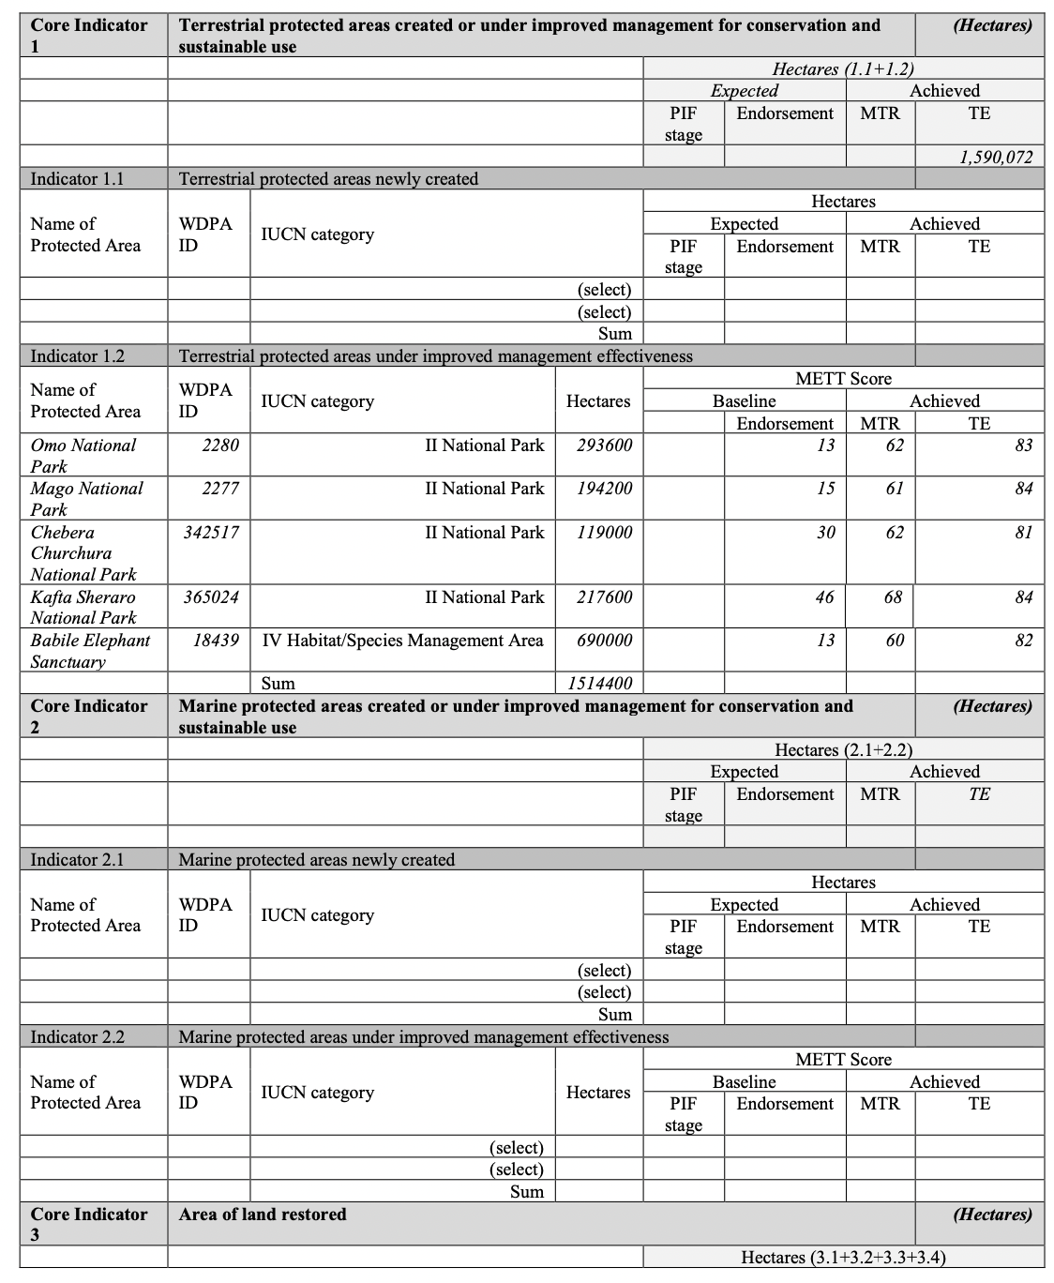
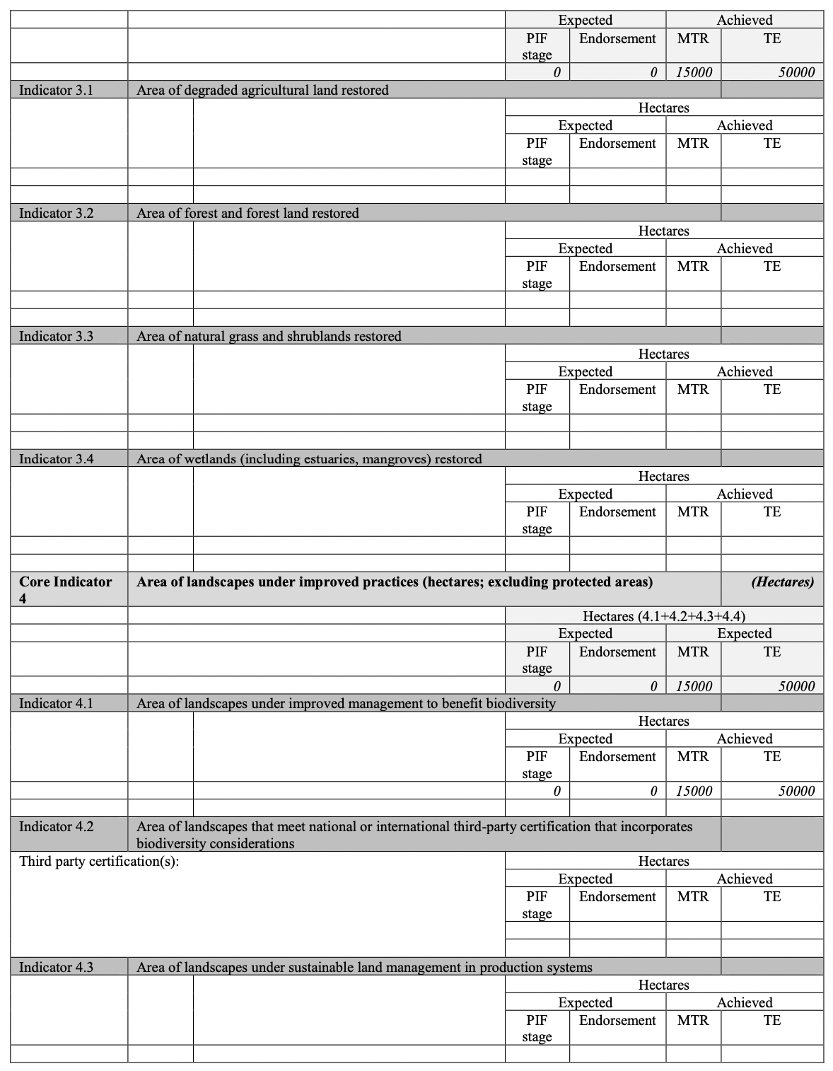

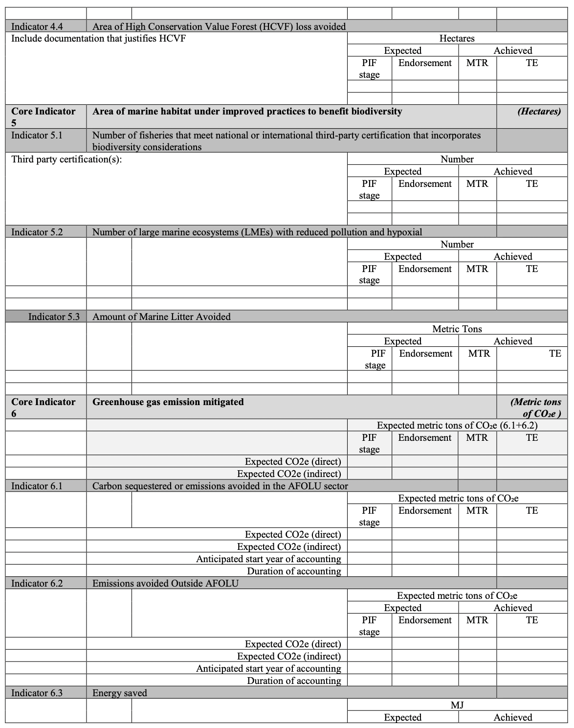
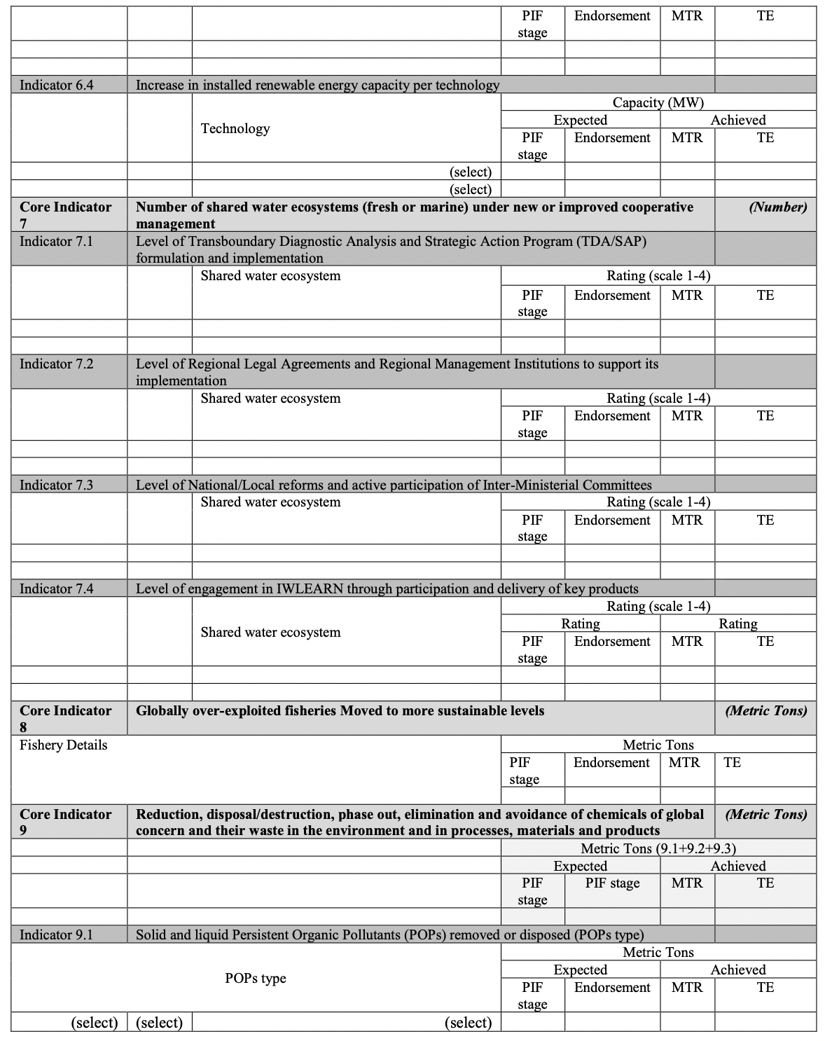

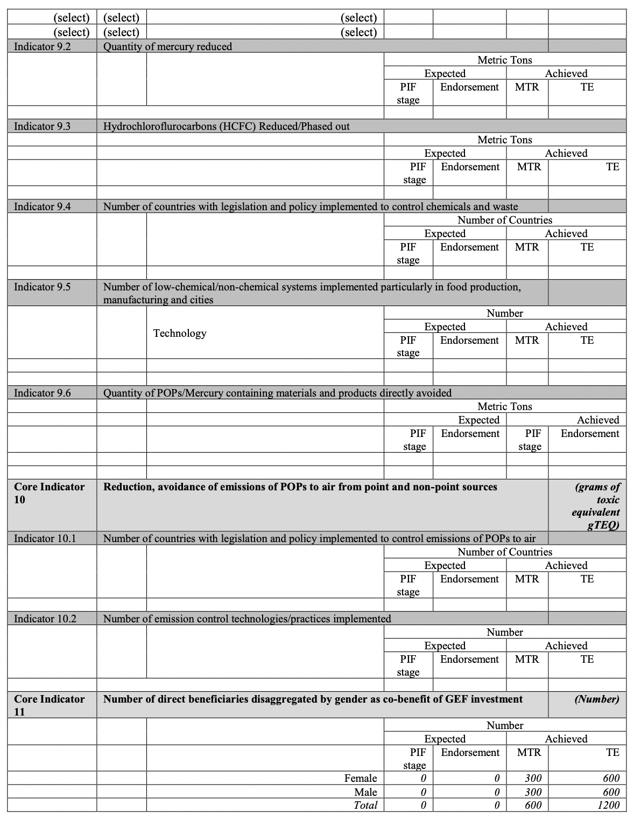

Annex K: TE Audit Trail (attached as a separate file)

Annex L: Signed UNEG Code of Conduct Form

UNEG Code of Conduct for Evaluators
Independence entails the ability to evaluate without undue influence or pressure by any party (including the hiring unit) and providing evaluators with free access to information on the evaluation subject. Independence provides legitimacy to and ensures an objective perspective on evaluations. An independent evaluation reduces the potential for conflicts of interest which might arise with self-reported ratings by those involved in the management of the project being evaluated. Independence is one of ten general principles for evaluations (together with internationally agreed principles, goals and targets: utility, credibility, impartiality, ethics, transparency, human rights and gender equality, national evaluation capacities, and professionalism).


Independence entails the ability to evaluate without undue influence or pressure by any party (including the hiring unit) and providing evaluators with free access to information on the evaluation subject. Independence provides legitimacy to and ensures an objective perspective on evaluations. An independent evaluation reduces the potential for conflicts of interest which might arise with self-reported ratings by those involved in the management of the project being evaluated. Independence is one of ten general principles for evaluations (together with internationally agreed principles, goals and targets: utility, credibility, impartiality, ethics, transparency, human rights and gender equality, national evaluation capacities, and professionalism).
Evaluators/Consultants:

- Must present information that is complete and fair in its assessment of strengths and weaknesses so that decisions or actions taken are well founded.
- Must disclose the full set of evaluation findings along with information on their limitations and have this accessible to all affected by the evaluation with expressed legal rights to receive results.
- Should protect the anonymity and confidentiality of individual informants. They should provide maximum notice, minimize demands on time, and respect people’s right not to engage. Evaluators must respect people’s right to provide information in confidence, and must ensure that sensitive information cannot be traced to its source. Evaluators are not expected to evaluate individuals, and must balance an evaluation of management functions with this general principle.
- Sometimes uncover evidence of wrongdoing while conducting evaluations. Such cases must be reported discreetly to the appropriate investigative body. Evaluators should consult with other relevant oversight entities when there is any doubt about if and how issues should be reported.
- Should be sensitive to beliefs, manners and customs and act with integrity and honesty in their relations with all stakeholders. In line with the UN Universal Declaration of Human Rights, evaluators must be sensitive to and address issues of discrimination and gender equality. They should avoid offending the dignity and self-respect of those persons with whom they come in contact in the course of the evaluation. Knowing that evaluation might negatively affect the interests of some stakeholders, evaluators should conduct the evaluation and communicate its purpose and results in a way that clearly respects the stakeholders’ dignity and self-worth.
- Are responsible for their performance and their product(s). They are responsible for the clear, accurate and fair written and/or oral presentation of study imitations, findings and recommendations.
- Should reflect sound accounting procedures and be prudent in using the resources of the evaluation.
- Must ensure that independence of judgement is maintained, and that evaluation findings and recommendations are independently presented.
- Must confirm that they have not been involved in designing, executing or advising on the project being evaluated and did not carry out the project’s Mid-Term Review.
Evaluation Consultant Agreement Form

Agreement to abide by the Code of Conduct for Evaluation in the UN System:

Name of Evaluator: _______________Yilikal Addisu Yayeh_______________________________________________

Name of Consultancy Organization (where relevant): ____________________________________

I confirm that I have received and understood and will abide by the United Nations Code of Conduct for Evaluation.

Signed at _____Addis Ababa_____________________________ (Place) on __July 5, 2023____________________ (Date)

Signature: _____________________________________________________________________

Annex M: Signed TE Clearance Form
Terminal Evaluation Report for (Enhanced Management and Enforcement of Ethiopia’s Protected Area Estate Project “EMEPA” PIMS 5609) Reviewed and Cleared By:

Commissioning Unit (M&E Focal Point)

Name: __________________________________

Signature: _______________________________ Date: _______________________________

Regional Technical Advisor (Nature, Climate and Energy)

Name: ___________________________________

Signature: ________________________________ Date: _______________________________

2019 PIR
ProDoc
Williams, S.D., Vivero Pol, J-L., Spawls, S., Shimelis, A. & Kelbessa, E. (2005) Ethiopian Highlands. In Hotspots Revisited (eds. Mittermeier, R.A. et al.). Conservation International: Cemex Press
Friis, I (2005) Horn of Africa. In Hotspots Revisited (eds. Mittermeier, R.A. et al.). Conservation International: Cemex Press
The sites were selected on the basis of a discussion held within the Ethiopian Wildlife Conservation Authority (EWCA) on 09 June 2016.
The only protected area that also harbours an elephant population that was not included as a direct recipient of the proposed project is Gambella National Park. During the PPG phase, Gambella NP was the recipient of other donors and partners, with the additional possibility that African Parks would also engage in the area. The idea was that practices would be shared such that efficiency and effectiveness was enhanced.
See https://www.thegef.org/gef/project_detail?projID=9071 for the comprehensive Programme Framework Document (PDF). The included TOC of the Global Programme focuses on strengthening the conservation of globally threatened species and reducing wildlife crime by ensuring that local communities feel the value of preserving healthy natural resources and populations of wildlife species in order to secure their own livelihoods.
Ethiopian Wildlife Conservation Authority (2015) Ethiopian Elephant Action Plan 2015 – 2020. Addis Ababa, Ethiopia. March 2015
ProDoc Mandatory Annexes
For example, see http://www.ifaw.org/international/news/wildlife-law-enforcement-agencies-gather-enhance-skills-wildlife-law-prosecution
At the point of the PPG phase, it was apparent that some institutional restructuring was being discussed with a significant possibility that EWCA was to be moved from the Ministry of Culture and Tourism into the MOEFCC. If this move does not occur before project commencement, the Ministry of Culture and Tourism will be a member of the PB.
1 If the Network is fully operational, it may have representation on the PB, to be confirmed during the Inception Phase.
ProDoc
Interview with an official in the Babile Aarea
Interview with a staff of UNDP
2020 PIR; 2021 PIR
Interview with a staff of the PMU
PIRs
Interview with a staff of the PMU
See: Federal Republic of Ethiopia (2011). Ethiopia’s ClimateResilient Green Economy Strategy. Available online at: https://www.adaptation-undp.org/sites/default/files/downloads/ethiopia_climate_resilient_green_economy_strategy.pdf
Ethiopia’s Ten Years Development Plan 2021-2030.. Available online at: https://www.ircwash.org/sites/default/files/ten_year_development_plan_a_pathway_to_prosperity.2021-2030_version.pdf
EWCA (cbd.int)
2023 PIR
Interview with a staff of EBI
FGD with Babile beneficiaries
Interview with staff of the PMU
Interview with a staff of the PMU
Rapid Assessment on Measuring the Impacts of Microfinance/Low Value Trust Fund upon the Household Income in the Project Sites Around Protected Areas, Ethiopian Biodiversity Institute Team & EMEPA Project Office, April 2023
2023 OVR; 2023 PIR
Source: Rapid Assessment on Measuring the Impacts of Microfinance/Low Value Trust Fund upon the Household Income in the Project Sites Around Protected Areas, Ethiopian Biodiversity Institute Team & EMEPA Project Office, April 2023
FGDs with male beneficiaries in Mago
Interviews with a staff of PMU and a staff of EBI
Interview with a staff of EWCA
Interview with a staff of EWCA
Interview with a staff of UNDP
Interviews with the officials in the Chebera area
Interview with officials of Mago
Interview with a staff of EBI
Interview with a staff of EBI
See: https://cheetah.org/ccf-blog/illegal-pet-trade/somali-state-somaliland-border-meeting-on-cheetah-trafficking/
Interview with a staff of the PMU
Interview with woreda cooperative ofices
Interviews with a finance staff of the project
2021 PIR
2022 PIR
Focus group discussion with Babile beneficiaries
Interview with a staff of EWCA
https://www.undp.org/ethiopia/about-us
2023 PIR
Interviews with experts, officials and FGDs
ProDoc (Annex F)
Interview with a staff of EBI
FGDs with beneficiaries at Mago NP
FGD with Babile beneficiaries
Interviews with a staff of UNDP and a staff of the PMU; 2023 PIR
EMEPA project Exit Strategy (2023)
2020 PIR; 2021 PIR; 2022 PIR
ProDoc
Interview with a staff of the PMU.
Interview with a staff of EBI
Interview with law enforcement officials in Omo
FGD with male beneficiaries in Mago
For instance budget monitoring, timely flow of funds and payment of satisfactory project deliverables

