



Conservation of globally important biodiversity and associated land and forest resources of

Western Tian Shan Forest Mountain ecosystems and support to sustainable livelihoods

Terminal evaluation

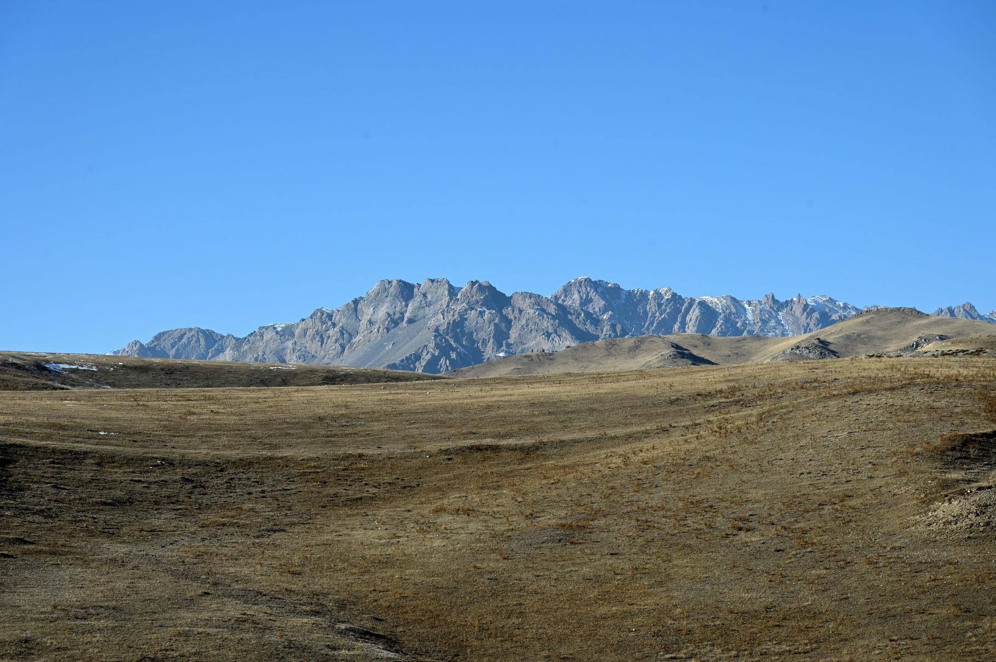
Evaluation report

Final version – 8 January 2024

Conservation of globally important biodiversity and association land and forest resources of Western Tian Shan Forest Mountain ecosystems and support to sustainable livelihoods

Terminal evaluation
Evaluation report
Date: Final version 8 January 2024

Project title: | Conservation of globally important biodiversity and association land and forest resources of Western Tian Shan Forest Mountain ecosystems and support to sustainable livelihoods
Date of final TE report : | xxx
GEF Operational Program/Strategic Program: | GEF-6
GEF Project ID: | 6958
UNDP PIMS: | 5411
Evaluation time frame: | 2017 -2023
Region and countries included in the project: | Kyrgyz Republic
Executing Agency: | UNDP
Implementing Partner and other project partners: | Ministry of Natural Resources, Environment and Technical Supervision of the Kyrgyz Republic
Evaluation team members: | Floris Deodatus, team leader, international expert  Gulmira Akhmatova, national expert

The designations of geographic entities in this document and the presentations of materials, do not imply the expression of any opinion whatsoever on the part of the Government of the Kyrgyz Republic, the United Nations Development Programme or the Global Environmental Facility concerning the legal status of any country, territory, or area, or its authorities, or concerning the delimitation of its frontiers or boundaries. The views expressed in this paper have been derived from different sources by the evaluation team during the Terminal Evaluation of the project " Conservation of globally important biodiversity and association land and forest resources of Western Tian Shan Forest Mountain ecosystems and support to sustainable livelihoods” from 8 to 22 November 2023, and they do not necessarily represent those of the Government of the Kyrgyz Republic, the United Nations Development Programme or the Global Environmental Facility.

Acknowledgements
- We would like to express our sincere gratitude to the staff of the UNDP-CO in Kyrgyzstan for their unwavering support throughout the course of this evaluation, particularly Lira Zholdubaeva, Aidai Ashiralieva and Aida Aidaralieva.
- We would also like to extend our gratitude and appreciation to the project staff of the project "Conservation of globally important biodiversity and associated land and forest resources of Western Tian Shan Forest Mountain ecosystems and support to sustainable livelihoods", particularly the ever-helpful project coordinator Umut Zholdoshova, supported by Barchynai Kydykeeva and, indispensable for the field visits, Sardarbek Momunaliev.
- In conclusion, we are very grateful to our translator Kanybek Baizakov bridging our contact with local stakeholders and to Kamchybek Turtemirov our driver who drove us safely to all our destinations over difficult roads.

Table of contents

1 Executive summary 10
1.1 Project Information Table 10
1.2 Project Description 11
1.3 Evaluation Ratings Table 12
1.4 Findings 12
1.5 Conclusions 13
1.6 Lessons learned 13
1.7 Recommendations summary table 15
2 Introduction 16
2.1 Scope and objective of the TE 16
2.2 Methodology 16
2.3 Cross-cutting issues and gender-responsive methodology 17
2.4 Ethics 18
2.5 Limitations to the evaluation 18
2.6 Structure of the TE report 18
3 Project description 20
3.1 Project start and duration, including milestones 20
3.2 Development context 20
3.3 Problems that the project sought to address: threats and barriers targeted 21
3.4 Immediate and development objectives of the project 21
3.5 Expected results 22
3.6 Main stakeholders 22
3.7 Theory of Change 24
4 Findings 25
4.1 Project Design/Formulation 25
4.1.1 Project relevance, Implementation approach 25
4.1.2 Analysis of results framework: project logic and strategy, indicators 26
4.1.3 Assumptions and Risks 27
4.1.4 Lessons from other relevant projects (e.g. same focal area) incorporated into project design 28
4.1.5 Replication approach 29
4.1.6 Cost-effectiveness 29
4.1.7 Sustainability 29
4.1.8 Planned stakeholder participation 30
4.1.9 Linkages between project and other interventions within the sector 30
4.1.10 Management arrangements 31
4.2 Project Implementation 32
4.2.1 Adaptive management (changes to the project design and project outputs during implementation) 32
4.2.2 Actual stakeholder participation and partnership arrangements 32
4.2.3 Project Finance and Co-finance 33
4.2.4 Monitoring & Evaluation: design at entry (*), implementation (*), and overall assessment of M&E (*) 35
4.2.5 UNDP implementation/oversight (*) and Implementing Partner execution (*), overall project implementation/execution (*), coordination, and operational issues 35
4.3 Project Results 36
4.3.1 Progress towards objective and expected outcomes (*) 36
4.3.2 Relevance (*) 36
4.3.3 Effectiveness (*) 37
4.3.4 Efficiency (*) 39
4.3.5 Overall Outcome 40
4.3.6 Country ownership 40
4.3.7 Social and Environmental Standards 40
4.3.8 Sustainability 41
4.3.9 Gender equality and women’s empowerment 42
4.3.10 Cross-cutting Issues 42
4.3.11 Catalytic Role / Replication Effect 43
4.3.12 Progress to Impact 43
5 Main Findings, Conclusions, Recommendations & Lessons 45
5.1 Main Findings 45
5.2 Conclusions 46
5.3 Recommendations 47
5.4 Lessons Learned 48

Appendices
Appendix 1. Terms of reference (excluding ToR annexes) 51
Appendix 2. Maps 61
Appendix 3. Photos 63
Appendix 4. TE Mission itinerary 67
Appendix 5. List of persons interviewed 71
Appendix 6. List of documents reviewed 75
Appendix 7. Evaluation Question Matrix (evaluation criteria with key questions, indicators, sources of data, and methodology) 76
Appendix 8. TE Rating scales 86
Appendix 9. Progress towards results matrix (Achievement of outcomes against End-of-project Targets) 87
Appendix 10. Project contributions to the GEF Biodiversity Results Framework 104
Appendix 11. Code of conduct and signed Evaluation Consultant Agreement form 106
Appendix 12. Signed TE Report Clearance form 107
Appendix 13. Management Effectiveness Tracking Tool (METT) 108
Appendix 14. Equipment purchased between 2017 and 2022 (>US$ 1000) 109
Appendix 15. Annexed in a separate file: TE Audit Trail 111

Tables
Table 1. Project stakeholders and roles 22
Table 2. Contributions of the project to GEF focal areas 25
Table 3. Annual disbursement from 2017 up to November 2023 33
Table 4. Annual disbursement relative to budget (%) from 2017 up to November 2023 34
Table 5. Confirmed Sources of Co-Financing at TE Stage 34

Figures, maps and photos

Figure 1. Inflation from 2017 to 2022 in Kyrgyzstan and world average 34
Figure 2. Kygyzstan protected areas 61
Figure 3. Project wildlife area and corridors 61
Figure 4. Pasture lands Toktogul District 62
Figure 5. Pasture land Toguz-Toro District 62
Figure 6. Car operational for Toktogul park's office provided by the project 63
Figure 7. Bee keeping 63
Figure 8. Camera trap slightly damaged by bear 63
Figure 9. Newly constructed ranger accommodation in Alatai SNP 64
Figure 10. Micro project: chicken farming 64
Figure 11. Administrative building in Toguz -Toro District 64
Figure 12. Rangers with horses and equipment provided by project in Toguz-Toro 65
Figure 13. Various equipment for Kan-Achuu SNP, provided by project 65
Figure 14. Ranger instruction book provided by project 65
Figure 15. Micro project: sewing workshop 66
Figure 16. Recovering vegetation in fenced enclosure 66

Acronyms

APR Annual Progress Report
AWP Annual Work Plan
CBD Convention on Biological Diversity
CBO Civil Based Organization
CDR Combined Delivery Report
CPAP Country Programme Action Plan
DAC Development Assistance Committee
DIM Direct Implementation Modality
DPAB Department of Protected Areas and Biodiversity
EoP End of project
FAO Food and Agriculture Organization
GEF Global Environment Facility
GIZ Deutsche Gesellschaft für Internationale Zusammenarbeit
GSLEP Global Snow Leopard and Ecosystem Program
ha Hectare
HCVF Hight Conservation Value Forest
IFAD International Fund for Agricultural Development
JFM Joint Forestry Management
JFMC Joint Forest Management Councils
KAFLU Kyrgyzstan Association of Forest and Land Users
KBA Key Biodiversity Area
LD Land Degradation
LH Leskhoz (forestry enterpise)
M&E Monitoring and Evaluation
METT Management Effectiveness Tracking Tool
MNRETS Ministry of Natural Resources, Environment and Technical Supervision
MTR Mid-Term Review
NAS National Academy of Sciences of the Kyrgyz Republic
NBSAP National Biodiversity Strategy and Action Plan
NGO Non-Governmental Organization
OECD Organization for Economic Co-operation and Development
PA Protected Area
PB Project Board
PC Pasture Committee
PC Project Coordinator
PES Payment for Ecosystem Services
PIR Project Implementation Review
PIU Project Implementation Unit
PMU Project Management Unit
PPG Project Preparation Grant
RBEC Regional Bureau for Europe and the CIS
RDF Rural Development Foundation
RNPFDF Republican Nature Protection and Forestry Development Fund
SAEPF State Agency for Environment Protection and Forestry
SDG Sustainable Development Goal
SFM Sustainable Forest Management
SL Snow Leopard
SLM Sustainable Land Management
SLT Snow Leopard Trust
SMART Specific, Measurable, Attainable, Relevant and Time-bound
SNP State National Park
SPNA Specially Protected Nature Areas
SRS State Registration Service of the Kyrgyz Republic
TOR Terms of Reference
TT Tracking Tool
UN United Nations
UNCT United Nations Country Team
UNDAF United Nations Development Assistance Framework
UNDP United Nations Development Programme
UNEG United Nations Evaluation Group
UNEP United Nations Environmental Programme
USD United States Dollar
WB World Bank
WTS Western Tian Shan
WWF World Wildlife Fund

Executive summary

Project Information Table
Project Title | Conservation of globally important biodiversity and association land and forest resources of Western Tian Shan Forest Mountain ecosystems and support to sustainable livelihoods | PIF Approval Date: | 04/06/2015
UNDP Project ID (PIMS #): | 5411 | CEO Endorsement Date (FSP)  / Approval date (MSP): | 27/12/2016
GEF Project ID: | 6958 | ProDoc Signature Date: | 17/03/2017
UNDP Atlas Business Unit, Award ID, Project ID: | 00097902 | Date Project Manager hired: | 01/10/2017
Country/Countries: | Kyrgyz Republic | Inception Workshop Date: | 07/12/2017
Region: | Central Asia | Mid-Term Review completion | 06/12/2019
Focal Area: |  | Terminal Evaluation completion date | 20/12/2023
GEF Operational Programme or  Strategic Priorities/Objectives: | GEF 6 | Planned Operational Closure | 31/12/2023
Trust Fund: | GEF TF
Implementing Partner (GEF Executing Entity): | UNDP
NGOs/CBOs involvement: | N.A.
Private sector involvement: | N.A.
Geospatial coordinates of  project sites: | The Western Tian Shan is located between 67 - 76º eastern longitudes and 40 - 45º northern latitudes.

Financial Information
PDF/PPG | at approval (US$) | at PDF/PPG completion (US$)
GEF PDF/PPG grants for project  preparation | 132,509
Co-financing for project
preparation
Project | at CEO Endorsement (US$) | at TE (US$)
[1] UNDP contribution: | 5 527 383 | 6 994 883
[2] Government: | 18 064 800 | 52 646 053
[3] Other multi-/bi-laterals: (GIZ) | 627 000
[4] Private Sector:
[5] NGOs: (Panthera) | 300 000 | 300 000
[6] Total co-financing  [1 + 2 + 3 + 4 + 5]: | 24 519 183 | 59 940 936
[7] Total GEF funding: | 3 988 575* | 3 988 575
[8] Total Project Funding [6 + 7] | 28 507 758* | 63 929 511
 | *excluding agency fee

Project Description

Context
- The project intervention area is located in the Toktogul district and Toguz-Toro district in Jalal-Abad Province in Western Kyrgyzstan and includes two new protected areas, established just before the project started in 2016: (1) the State Nature Park “Alatai”, and (2) the State Nature Park “Kan-Achuu”. Furthermore, the project covers mountain pastures and forest stands located in the surrounding landscape of the Alatai and Kan-Achuu State Nature Parks. The area is a priority ecoregion and a global biodiversity hotspot, harbouring significant biodiversity, including 2,500 plant species and 400 vertebrate species. Endemism of the flora is 12% and there are 54 Red List plant species. The fauna counts 27 Red List species of fauna, including the snow leopard. The area is part of the transnational World Heritage Site "Western Tien-Shan" .
- The forests in the landscape are shrinking due to inadequate forest management and enforcement in relation to degradation by intensive land use. Natural regeneration and reforestation do not keep pace with degradation. Grassland areas of the Western Tian Shan are subject to extensive, uncontrolled agro-pastoral land use. Growing livestock numbers lead to extensive unregulated use of mountainous grasslands for grazing and cause high disturbance of snow leopard prey species. The area is susceptible to overgrazing, droughts, and inadequate natural regeneration in the face of these pressures.

Objectives
- The project objective is: To promote a landscape approach to protection of internationally important biodiversity, and land and forest resources in the Western Tian Shan mountains in Kyrgyzstan, which is achieved by activities under the following project components :
- Component 1. Conservation and sustainable management of Key Biodiversity Areas within the Western Tian Shan landscape.
- Component 2. Ecosystem resilience and habitat connectivity in Western Tian Shan are enhanced by regulating land and forest use in buffer zones and corridors and support to sustainable livelihoods.
- Component 3. Strengthening national capacities for Kyrgyz regional and global cooperation and setting the scene for scaling-up snow leopard conservation.
- The project interventions target conservation areas, forest areas, livestock pasture areas and the development of national scientific monitoring and law enforcement capacities for snow leopard conservation in order to :
- prevent the further fragmentation of key biodiversity landscapes and degradation of forest and land resources in Kyrgyzstan that provide critical ecosystem services;
- ensure habitat connectivity across the Western Tian Shan landscape for key species, including snow leopard and prey;
- improve the conservation status, and sustainability of pasture and forest use in mountain ecosystems;
- implement snow leopard and prey monitoring and conservation measures, and reduction of direct threats, in the Western Tian Shan and other Kyrgyzstan priority snow leopard conservation landscapes.

Evaluation Ratings Table
Monitoring & Evaluation (M&E) | Rating
M&E design at entry | MS
M&E Plan Implementation | S
Overall Quality of M&E | MS
Implementation & Execution | Rating
Quality of UNDP Implementation/Oversight | MS
Quality of Implementing Partner Execution | MS
Overall quality of Implementation/Execution | MS
Assessment of Outcomes | Rating
Relevance | HS
Effectiveness | S
Efficiency | MS
Overall Project Outcome Rating | S
Sustainability | Rating
Financial resources | ML
Socio-political/economic | L
Institutional framework and governance | ML
Environmental | L
Overall Likelihood of Sustainability | ML/L

Findings
- The project did contribute to improved sustainability of protected area systems (BD-1) by strengthening the management of the Alatai and Kan-Achuu SNP as well as by the creation of corridors, buffer zones and HCV forests in the landscape, while mainstreaming biodiversity conservation and sustainable use in production landscape through habitat restoration and sustainable management planning of pastures and forest use (Appendix 10, page 104).
- The results framework indicators (Appendix 9, page 87) show that most end-of-project targets have been well achieved. The project contributed to the sustainability of the protected area system in Western Tian Shan (GEF BD-1), by mainstreaming biodiversity conservation and sustainable use into production landscapes and production sectors (GEF BD-4), by reducing pressures on natural resources from competing land uses (GEF LD-3), by reducing the pressures on high conservation value forests by addressing the drivers of deforestation (SFM-1), maintaining flows of forest ecosystem services and improve resilience to climate change through SFM (GEF SFM-2) and reversing loss of ecosystem services within degraded forest landscapes (GEF SFM-3).
- The decrease in degraded pasture land as well as benefits from micro-finance lagged behind. Efforts on snow leopard protection intensified, including trafficking of derivates, but the indicator used is not suitable for measuring the effect of these efforts.
- The project progress has been delayed considerably due to external factors (COVID-19, Government and UNDP institutional and staff changes), but before 2021, poor result-oriented planning was also playing a role, including insufficient adjustment by the inception and the MTR. The use of adequate and regular AWP and PIR reports, project board meetings and internal monitoring indicate that management standards have been followed, but during the first phase of the project, planning was done on a year-to-year basis, lacking a long-term strategic vision on the realisation of results and outcomes. From 2021 on, necessary adjustments were made to project implementation.
- Local stakeholders reported a decrease in illegal activities such as poaching and an increase of wildlife abundance. Habitat restoration with fencing shows direct effects within one season. However, recent effects of climate change (droughts, high temperatures) intervened with the results of the project. A reciprocal impact of the project at local governance level is the increasing integration of sustainability and green development in local development planning.
- Socio-economic and institutional sustainability appears to be high, due to established partnerships, regulatory frameworks and extensive capacity building efforts. Interest by the local government for uptake of outcomes is a strong indication of sustainability. The environmental sustainability of the project is evident. Financial sustainability of the implementation of PA management plans and the micro projects is a point of concern as these results have been realised at the end of the project and follow up funding and monitoring arrangements have not yet been established.

Conclusions
- The goals of the project design have high ambitions regarding sustainable and integrated landscape management, but require considerable expertise for their achievement.
- The project design is based on a coordinating and mobilising/moderating role of the UNDP project staff, which is supplemented with considerable outsourced technical assistance to provide the necessary required specific expertise (protected area management, wildlife monitoring, forestry, livelihood development, etc.).
- The results of TE interviews and the project indicator values provide evidence that the project contributed to biodiversity conservation including snow leopard, and to the development of livelihoods around protected areas.
- Partnerships created and maintained for the implementation of project activities contributed to collaboration and synergy between key actors in sustainable natural resources management and snow leopard conservation.
- Several factors caused significant delays of progress from 2017 to 2021, including COVID-19, institutional changes and staff changes in the government and UNDP, as well as poor strategic planning.
- Neither the project Inception, nor the MTR resulted in appropriate (re)orientation of project activities.
- Poor strategic planning observed during the first phase (2017-2020) of the project was partly compensated by a considerable acceleration of efficiency and progress during the last phase of the project (2021-2023).
- Institutional changes of the government and UNDP, as well as replacement of key actors in both the project and the government affected the institutional memory and the efficient implementation of the project.
- The government's engagement in the project is more visible at local and regional levels than at national level.

Lessons learned
- Strategic work planning during inception phase and MTR is essential for optimal project performance.
- Effective component management and implementation requires sufficient technical leadership and skills in the project team to assure oversight of the implementation of specific components and activities.
- Adequate institutional memory mechanisms are a prerequisite for efficient project implementation as well as for M&E and replication (proper reporting, transparent information management, handover reports, and systematic and accessible storage of project outputs, etc.).
- Regular involvement of relevant government partners in planning, decision taking and monitoring facilitates ownership of project results.
- The application of tested and proved work practices developed by experts lead to accuracy and efficiency and contributes to coherence and compatibility with the results of these practices applied elsewhere.
- The use of sea containers is a cheap alternative for the construction of staff accommodation. An additional advantage is the possibility to carry out part of the work in a well-equipped workshop elsewhere, which means that the local impact of the finish when installed on location is limited.

Recommendations summary table
Rec  # | TE Recommendation | Entity Responsible | Time  frame
A | Category 1: Actions to strengthen or reinforce benefits from the project;
A.1 | Create coherence between Land code and PA legislation with regard to the creation of ecological corridors, buffer zones and quiet zones outside protected areas. | MNRETS, Ministry of Agriculture | 2024
B | Category 2: Proposals for future directions underlining main objectives
B.1 | Improve donor coordination in Kyrgyzstan on key themes | UNDP | 2024
B.2 | Develop legal measures to control shepherd dogs in PAs and buffer zones. | MNRETS, Kyrgyz Research Institute of Livestock and Pastures under the Ministry of Agriculture | 2024
B.3 | Conduct research on the relation between grazing pressure and habitat when using e-pasture management tool. | National Academy of Sciences,  Kyrgyz Research Institute of Livestock and Pastures under the Ministry of Agriculture | Future projects on PA management and corridors
B.4 | Develop funding mechanism to promote local initiatives and conservation. | BIOFIN, UNDP | Future projects integrated conservation and development
B.5 | Apply WCPA guidelines for the elaboration of future PA management plans. | UNDP in the frame of future GEF projects | Future projects on PA management and corridors
B.6 | Establish adequate information management and institutional memory mechanisms in project management units | UNDP, MNRETS | Future GEF projects
B.7 | Quality and usability should be crucial criteria set by technicians when procuring equipment | UNDP | Future GEF projects
C | Category 3: Suggestions for strengthening ownership
C.1 | Increase engagement of government partners in project formulation and management. | UNDP | December 2023 and after  Future GEF projects
C.2 | Support participation to Parks Board and JFM Council. | MNRETS, UNDP | December 2023 and after  Future GEF projects
C.3 | Encourage participation of volunteer rangers in conservation. | MNRETS, UNDP | December 2023 and after  Future GEF projects
D | Category 4: management of potential risks
D.1 | Evaluate regularly policies to control overgrazing. | Academy of Sciences,  Kyrgyz Research Institute of Livestock and Pastures under the Ministry of Agriculture | Future GEF projects

Introduction

Scope and objective of the TE
- The project “Conservation of globally important biodiversity and association land and forest resources of Western Tian Shan Forest Mountain ecosystems and support to sustainable livelihoods” in Kyrgyzstan (17 March 2017 to 31 December 2023) is implemented by UNDP and funded by the GEF, UNDP, the national and local governments of the Kyrgyz Republic as well as bilateral partners and NGOs. In accordance with UNDP and GEF M&E policies and procedures, all full- and medium-sized UNDP-supported GEF-financed projects are required to undergo a Terminal Evaluation (TE) at the end of this project.
- According to the ToR of the TE (Appendix 1, page 51), the TE report will assess the achievement of project results against the expectations, and draw lessons that can both improve the sustainability of benefits from this project, and aid in the overall enhancement of UNDP programming. Furthermore, the TE will determine and describe lessons learned and will develop recommendations to be used by project partners in order to improve their capacity in planning and implementing similar projects and programs. Therefore, the final evaluation will:
- identify factors, which have had positive or negative impacts on project implementation;
- assess the correlation of project activities with local and national development priorities and organizational policy, including progressive changes;
- assess the project efficiency, i.e. level of project goal achievement;
- assess sustainability of project results, i.e. potential positive results to be observed after project close;
- present lessons learned from project development, implementation and management.

Methodology
- The evaluation (TE) has been carried out according to UNDP guidelines of results-based evaluation and according to the Terms of Reference related to the assignment provided by UNDP (Appendix 1, page 51). The TE included a preparatory desk study to familiarize the evaluators with the project and its context and to focus evaluation questions and criteria (Appendix 7, page 76). The following information is being collected during this phase:
- documents related to the project cycle (e.g. ProDoc, results framework, Inception Report, Progress Reports, Project Board meeting minutes, AWPs, PIRs),
- documents produced by the project on technical and strategic issues,
- background documentation, maps and internet sources.
Based on the preparatory desk study, issues and questions as specified in the ToR were elaborated, and an Inception report prepared and shared with UNDP and the project.

Data collection
- The following approaches were used for information collection in Bishkek and the project area:
- Meetings and individual interviews with stakeholders, covering the project management unit and key project stakeholders, such as UNDP Country Office (KR), GEF Istanbul Regional Hub, the Ministry of Natural Resources, Environment and Technical Supervision of the Kyrgyz Republic, Forest Service under the Ministry of Agriculture of the Kyrgyz Republic, etc. (Appendix 5, page 71).
- Analysis of monitoring data from various project reports.
- Use of secondary statistics (biodiversity, environment, socio-economics).
- Project site visits including meeting local stakeholders.
- Apart from the various project reports provided to the evaluation team, the following information was provided by the project:
- An updated METT
- Updated strategic results framework indicator values
- Co-funding information
- List of purchased equipment
- List of realized infrastructure
- List of contracts for services

Analysis
- Analysis and assessments were carried out following the DAC criteria for evaluating development projects. Evaluation questions (Appendix 7, page 76) in relation to these criteria have been formulated to guide the interviews and discussions, mainly addressing aspects such as perceptions, constraints, challenges, success factors and suggestions related to design, implementation and achievement. No questionnaires were used but focal group sessions and key informant interviews were conducted at community level and with other partners.
- A sustainability analysis included made use of sustainability criteria such as (a) financial, (b) socio-political, (c) institutional framework and governance, (d) environmental, (e) overall likelihood of sustainability.
- Data analysis consists partly of triangulation of qualitative information as well as simple statistical analysis to visualize quantitative data on the project context and impact. A project progress towards results matrix has been prepared to indicate progress and achievements of different project components according to defined indicators (Appendix 9, page 87). Ratings (Appendix 8, page 86) have been applied to the following aspects of key criteria concerning the implementation approach and management:
- Monitoring & Evaluation: design at entry, implementation, and overall assessment of M&E;
- Implementing Agency (UNDP) and Executing Agency, overall project oversight/implementation and execution;
- Relevance, Effectiveness, Efficiency and overall project outcome;
- Sustainability: financial, socio-political, institutional framework and governance, environmental, overall likelihood of sustainability.

Cross-cutting issues and gender-responsive methodology
- Regarding the gender-sensitive and cross-cutting issues in our methodology, the following approaches have been applied:
- Ensuring equal participation of women and men in meetings.
- Facilitating an inclusive environment where all voices are heard.
- Identifying specific impacts on distinct groups, gather data that has been disaggregated by gender and other social factors (age, income, and other relevant categories).
- Guarantee representation from a range of social backgrounds, employ participatory techniques such as focus group discussions.
- Integrating gender analysis into data interpretation, understanding differential impacts and opportunities for various genders.
- Evaluating effectiveness of capacity-building programs, particularly for women and marginalized groups, focusing on skill acquisition and empowerment. Gather data on attendees of the workshops, trainings, seminars and etc. on gender issues and social dynamics, making sure that interactions are respectful of cultural differences.
- Assessing impact of conservation efforts on local livelihoods, specifically focusing on poverty reduction and income generation, with a gender lens.
- Evaluating community vulnerabilities to crises and assess the project’s resilience-building impact, especially for vulnerable groups.

Ethics
- The evaluation was conducted following the UNEG Ethical Guidelines for Evaluators. The rights and dignity of all stakeholders were respected, including interviewees, project participants, beneficiaries and other evaluation stakeholders including co-financing partners. The evaluators explained and preserved the confidentiality and anonymity of the participants so that those who participate in the evaluation are free from external pressure and that their involvement in no way disadvantages them.
- The final report of the evaluation does not indicate a specific source of citations or qualitative data to preserve this confidentiality. The confidentiality of stakeholders was ensured throughout and consultation processes were appropriately contextualised and culturally sensitive, with attention given to issues such as gender empowerment and fair representation for vulnerable groups, wherever possible.
- Whilst every effort was made to reflect the inputs of stakeholders fairly and accurately in the report, the evaluation ratings, conclusions and key recommendations are those of the evaluators, they do not necessarily reflect the opinions and views of the Implementing and Executing Agencies or other project partners. As such they are not binding on any individual or institutional stakeholder.

Limitations to the evaluation
- The project lifetime was characterized by a number staff changes at the level at the project, UNDP and the government counterpart, among others due to institutional changes in both UNDP and the government. More over the project period was thwarted by the COVID-19 pandemic. Due to these factors, the availability of sources (source persons and additional documentation) about the period before the year 2020 was limited. Information on this period is mainly based on the MTR report and the PIRs.
- There are no Annual Progress Reports (APR) available for this project, only PIR.

Structure of the TE report
- The structure of the report is based on the table of contents presented in the appendix of the ToR for the TE. The report is composed of the following chapters:
(1) an executive summary,
(2) an introduction on the purpose and context of the evaluation,
(3) a description of the project,
(4) a chapter presenting the evaluation findings structured according to evaluation criteria,
(5) a chapter with the summary of findings, conclusions, recommendations and recommendations,
TE ToR, mission programme and other additional information are included in the annexes of this report.

Project description

Project start and duration, including milestones
- The PIF for the project has been approved on the 4th of June 2015, followed by the drafting of the Project Document and the CEO Endorsement 27 December 2016, and the contract for the implementation of the project was signed on 17 March 2017. Following the contract signature, it took 7 months to find and recruit the Project Manager (01/10/2017). The Inception Workshop was held on 7 December 2017 (Inception report 18 September 2018). The Mid-Term Review was carried out in July-Augustus 2019 and the MTR Final report submitted 06/12/2019.
- Initially the project was planned to run five years up to 16 March 2022. However, due to delays related to (among others) institutional changes of the Kyrgyz Government counterpart in 2019, the COVID-19 pandemic in 2020, implementation slow-down following two replacements of the project coordinator in 2021, changes at UNDP CO and RO, the project term has been extended to 30 June 2023 initially and to 31 December 2023 finally.
- The Terminal Evaluation was done in November-December 2023, and completed 20/12/2023.

Development context
- Kyrgyzstan is a natural crossroads between flora and fauna of Kazakhstan, Uzbekistan and China, which are different biogeographic regions. The Tian Shan and Alay ranges act as a bridge connecting fauna and flora of Himalayas and Hindu Kush across Pamir with biota of Siberia, and across Dzhungar Ala-Tau and Altay with biota of Mongolia. The project intervention area is located in the Toktogul district and Toguz-Toro district in Jalal-Abad Province in Western Kyrgyzstan and includes two new protected areas, established just before the project started in 2016: (1) the State Nature Park “Alatai”, and (2) the State Nature Park “Kan-Achuu”. Furthermore, the project covers mountain pastures and forest stands located in the surrounding landscape of the Alatai and Kan-Achuu State Nature Parks. The area is a priority ecoregion and a global biodiversity hot spot, harbouring significant biodiversity, including 2,500 plant species and 400 vertebrate species. Endemism of the flora is 12% and there are 54 Red List plant species. The fauna counts 27 Red List species of fauna, including the snow leopard. The area is part of the transnational World heritage Site "Western Tien-Shan".
- The Kyrgyzstan's population counted approximately 7 million people in 2023 with an average annual growth of 1.7%. The BNP per capita is US$ 1606 (2022). Kyrgyzstan´s economy is highly dependent on the exports of gold and other precious metals and stones (34% of total exports). Other exports include: oil, gas and other mineral products (15% of total exports), textiles (12%), vegetables (9%) and transport equipment (8%). Agriculture lands comprise 32.8 % of the national territory, including 12% of arable lands and 89% of pasturelands.
- The National Development Strategy of the Kyrgyz Republic (2018-2040) states that the country "will form industrial, energy, financial, transport and logistics, information, social ecosystems and build a new model of economy based on harmonious coexistence with nature. The economy of the country will be well diversified, incorporated into the system of international division of labour with high added value, clean energy and organic agriculture." Recognizing their great ecological value, according to the Forest Code all the forests of the Kyrgyz Republic are classified as performing environmental, sanitation, health and other environmental functions, and bans commercial harvesting.

Problems that the project sought to address: threats and barriers targeted
- The forests in the West Tian Shan landscape are shrinking due to inadequate forest management and policy enforcement in relation to degradation by intensive land use. Natural regeneration and reforestation do not keep pace with degradation. Grassland areas of the Western Tian Shan are subject to extensive, uncontrolled agro-pastoral land use. Growing livestock numbers lead to extensive unregulated use of mountainous grasslands for grazing and cause high disturbance of snow leopard prey species. The area is susceptible to overgrazing, droughts, and inadequate natural regeneration in the face of these pressures. Overgrazing and degradation of pastures due to growth in the number of livestock also leads to growth in conflicts between humans and wildlife. Besides unsustainable hunting, unsustainable forest use for fire wood and other NTFP is an increasing pressure on the ecosystems due to the increasing population and lack of alternatives. Strategies to counter the threats to the ecosystem face the following barriers:
- Weak management of Key Biodiversity Areas;
- Unsustainable management of land and forest in wider landscape;
- Low uptake of and capacity to implement international best practices for snow leopard conservation and management of its habitat.

Immediate and development objectives of the project
- The project objective is: To promote a landscape approach to protection of internationally important biodiversity, and land and forest resources in the Western Tian Shan mountains in Kyrgyzstan, which is achieved by activities under the following project components in connection with barriers identified:
- Component 1. Conservation and sustainable management of Key Biodiversity Areas within the Western Tian Shan landscape.
- Component 2. Ecosystem resilience and habitat connectivity in Western Tian Shan are enhanced by regulating land and forest use in buffer zones and corridors and support to sustainable livelihoods.
- Component 3. Strengthening national capacities for Kyrgyz regional and global cooperation and setting the scene for scaling-up snow leopard conservation.
- The project interventions target conservation areas, forest areas, livestock pasture areas and the development of national scientific monitoring and law enforcement capacities for snow leopard conservation in order to :
- prevent the further fragmentation of key biodiversity landscapes and degradation of forest and land resources in Kyrgyzstan that provide critical ecosystem services;
- ensure habitat connectivity across the Western Tian Shan landscape for key species, including snow leopard and prey; improve the conservation status, and sustainability of pasture and forest use in mountain ecosystems;
- implement snow leopard and prey monitoring and conservation measures, and reduction of direct threats, in the Western Tian Shan and other Kyrgyzstan priority snow leopard conservation landscapes.

Expected results
- The aim of the project is to ensure continuity and congruence between key biodiversity areas (KBA) and the use of land and forest resources in the wider productive landscapes of the Western Tian Shan ecoregion. The project includes the development and strengthening of two newly established PAs and four existing key PAs to support underrepresented globally significant biodiversity species.
- Strengthened PAs under this project cover a total area of 226 621 ha, including 25 000 ha of High Conservation Value Forest. Furthermore, wildlife corridors and buffer zones are created with a total area of 50 000 ha. The direct result is thus 2800 km² of protected landscape. The project also supports work on the improvement and sustainable use of pastures. The total area of pastures in the region exceeds 600 000 ha and the project aims to restore at least 65 000 ha of degraded pastures in Toktogul and Toguz-Toro districts.

Main stakeholders
- At the start of the project, the Responsible Partner of the project was the State Agency on Environment Protection and Forestry (SAEPF). In May 2021, the State Agency on Environmental Protection and Forestry under the Government of the Kyrgyz Republic was transformed into the State Committee on Ecology and Climate of the Kyrgyz Republic, subsequently in December 2021 into the Ministry of Natural Resources, Ecology, and Technical Supervision of the Kyrgyz Republic. At the same time, the forestry sector was moved apart to the Ministry of Agriculture of the Kyrgyz Republic.
- Ministry of Natural Resources, Environment and Technical Supervision of the Kyrgyz Republic.
- Forestry Service under the Ministry of Agriculture of the Kyrgyz Republic managing rangelands within the State Forestry Fund.
- Local Self-Governments and the Pasture Users’ Associations (PUA) managing rangelands classified as major part of state-owned agriculture land.
- Project stakeholders and roles
Stakeholder | Role
Government Agencies
Ministry of Natural Resources, Environment and Technical Supervision of the Kyrgyz Republic and Working Secretariat GSLEPP | Main implementation partner hosting the Department on Protected Areas, the key stakeholder for the elaboration of the National PA planning framework, WS GSLEPP, ensuring organization of new PA; as well as managerial and financial sustainability of the national PA system (Output 1.1, 1.3, 1.4, 3.1, 3.2, 3.3 and 3.4).
Ministry of Agriculture of the Kyrgyz Republic, Forestry Service under the Ministry of Agriculture of the Kyrgyz Republic | Key partner in the development and implementation of the pasture management plans at target areas (Output 2.3.),  Forestry Service with their regional departments and leskhozes is key partner assuring stability of forest ecosystem, increase of forest cover, forest management, SPNA and hunting lands inventory, and forest cadastre management (Output 1.2., 2.2., 2.4)
State Registration Service of the Kyrgyz Republic (SRS) | Coordinates and controls the registration of land property rights in the vicinity of the project sites. Within its mandate, it is responsible for the following: (1) regulating of land relations (state registration deed, land cadastre) in the new PA, corridors and buffer zone (Output 2.1); and (2) topography survey and mapping of the PA to prepare state registration deed for land users (ibid)
State Agency for Civil Service and Local Self-Government under the Cabinet of Ministries | Integration of SLM and biodiversity conservation and sustainable land management issues into local development plans and their further implementation (Output 2.1., 2.2.)
Department of Tourism under the Ministry of Economy and Commerce | Implements a unified state policy in the field of tourism, creates favourable conditions for the development of the tourism industry in the Kyrgyz Republic
State Customs Service, Manas international  Airport (Bishkek) | Cooperation to combat illegal activities of wild animals and their illegal export at border crossings. Support to the Canine service of the State Customs Service (dog enclosures, training)
Province and District administrations | Support to the establishment of the new PAs and integration of biodiversity conservation into corresponding administrative level development strategies and plans (Output 2.2.)
Local Communities
Local Self Governance Bodies | These bodies are responsible for the elaboration and implementation of local communities’ development strategies including local environment issues. They will be among the main project implementing partners at the local level in integrated land use planning, buffer zones and corridors (Outputs 2.1.1 and 2.1.3)
Associations of Pasture and Water Users | They are the users of ecosystem services regulating access of local communities to natural resources and sustainable use of biodiversity and they will provide inputs to the development of the landscape level management plan for Tian Shan that defines buffer zones and conservation-friendly uses in sensitive areas, as well as play a role in the development and implementation of alternative sustainable livelihoods (Outputs 2.3.)
Communities of the PA buffer zones | Active users of ecosystem services and to be involved in PA management and sustainable use practices to be promoted by the project. (Output 1.4., Outputs 2.1., 2.2., 2.3.)
Non-government Organizations
Snow Leopard Trust,  Snow Leopard Foundation, PF Ilbirs,  WWF, NABU | National and international non-governmental organizations are implementing snow leopard conservation activities in the Tian Shan aimed at habitat range monitoring, promoting anti-poaching and livelihoods for local communities, will be a partner in the project for relevant activities. (Output 19, 20, 21).
Kyrgyz Association of Forest and Land Users, CAMP Alatoo, and RDF, | These local NGOs were involved to advocate for sustainable biodiversity conservation and use and to promote Joint Forest Management practice and HCVF concept and SFM certification piloting, as well as joint patrolling (Outputs 1.11, 1.2, 1.4.). They were also involved into development of the pasture management plans and land use plans in buffer zones and corridors jointly with local communities and state administrations (Outputs 2.1., 2.2., 2.3.).
Tourism Development Support and Fund of the Kyrgyz Republic (Open Joint Stock Company) | In cooperation with the Department of tourism, the Fund is lobbying policy documents and laws of the tourism in all levels of government. The Fund was involved to cooperate on the development of tourist routes.
Research and Expertise
The National Academy of Sciences (NAS KR) with its two institutes: Institute of Biology and Scientific and Production Centre for Forest Research under the Institute of Biology | Based on their experience and expertise, these institutes will play a role in elaboration of the scientific grounds for biodiversity monitoring, improving participation in biodiversity inventory, development of biodiversity sustainable use norms, identification of the areas under strong pressure, PA management effectiveness assessment (Outputs 1.1., 1.2., 1.3.). Additionally they were also involved into fostering Kyrgyzstan participation in GSLEP activities on snow leopard monitoring and research (Component 3 all Outputs).
Private Sector
Kyrgyz community-based tourism association (KCBTA) | To be involved in training of local communities to develop ecological tourism facilities and infrastructure for PAs financial sustainability as well as marketing of such community-based tours (Output 1.2 and 2.5).
Kyrgyz Association of Tour Operators (KATO) | Promotes the development of the tourism industry at the national level, works with local tour operators.

Theory of Change
- A theory of change has not been elaborated in the Project Document and this was also not addressed in the MTR report. The justification for the project strategy has been based on the analysis of threats, root causes and impacts as well as the barriers that impede the change to the desired (alternative) scenario leading to improved landscape conservation. Identified threats to ecosystems and biodiversity in the Tian Shan landscape relate to:
- Pasture degradation due to poor grazing management
- Human-Wildlife Conflicts resulting from resource degradation and competition between people and wildlife
- Overgrazing in forests resulting from unsustainable land use planning and implementation
- Unsustainable use of forests due to energy shortage and weak implementation of sustainable forestry
- Legal and illegal hunting of ungulates, due to not taking broad ecological considerations into account in hunting management
- The solutions presented to counter these threats involve the promotion of a large-scale integrated landscape management approach clearly taking into account the livelihood needs of local populations, while applying international good practices in land-use planning and natural resource management.
- The following barriers have been identified impeding the realization of these solutions in the context of existing baseline initiatives:
- 1: Weak management of Key Biodiversity Areas
- 2: Unsustainable management systems of land and forest in the wider landscape
- 3: Low uptake of and capacity to implement international best practices for snow leopard conservation and management of its habitat
- The actual root-causes are in fact hidden under these barriers, such as historical governance changes, uncoordinated management approaches, government budget limitations, stakeholder capacity limitations and climate change. The project addresses these issues by improving integrated management at landscape level of conservation areas, forest areas and livestock pasture areas and the development of national scientific monitoring and law enforcement capacities for snow leopard conservation through the three project components presented in the previous section (section 3.4, page 21).
- In brief, the assumption is that improved management and conservation of protected areas (Component 1) and the wider productive landscapes (Component 2) as well as capacity building promoting professional and international standards (Component 3) address the main barriers for sustainable landscape management. And the application of a large-scale integrated landscape management approach taking into account the livelihood needs of local populations, provide an enabling environment for contributions and synergy of baseline projects with regard to conservation and sustainable resource use. This will lead to an improved status of globally significant biodiversity, and improved provision of ecosystem services from forest and land resources in Kyrgyzstan’s Western Tian Shan mountains, supporting sustainable livelihoods.

Findings

Project Design/Formulation

Project relevance, Implementation approach
- Kyrgyzstan is located in the Mountains of Central Asia biodiversity hotspot. Considering the high conservation value of the Western Tian Shan transboundary ecoregion, covering parts of Kyrgyzstan, Kazakhstan and Uzbekistan, the area is listed as UNESCO World Heritage possessing outstanding natural characteristics. Its flora and fauna are characterized by high diversity concentrated in a relatively small area. Among the Red List of fauna occurring in the Western Tian Shan are 27 species of birds and mammals, including snow leopard. The principal threats to the area are the following:
- Pasture degradation from poor grazing management leading to displacement of grasses by weeds, soil erosion, landslides and mudflows, and flooding.
- Human-Wildlife Conflicts due to increasing competition between livestock and wild herbivores and increasing penetration of livestock in wildlife areas leading to conflicts with wolf and bear
- Overgrazing in forests due to degrading pastures and overstocking as well as unsustainable use of Forests, mainly due to, but not limited to firewood collection, leading to forest and habitat degradation
- Legal and Illegal hunting of ungulates decrease prey for snow leopard
- The project addresses the threats to the high biodiversity values through an integrated landscape approach coherent with national policies and priorities of the Government's development partners (see section 4.3.2, page 36, for policy coherence). The project design provides for project execution by on the one hand the government organization(s) responsible for the implementation of the national policy and international commitments regarding natural resources management and biodiversity conservation (initially SAEPF), and on the other hand by UNDP as GEF agency. The managerial role of UNDP (DIM modality) in the management of the project is justified by the limited management capacity of the government, and the important role UNDP plays in other sustainable development and biodiversity management initiatives in the region.
- The project contributes to the following GEF Focal Area Strategies and Strategic Programs (Table 2, page 25): Biodiversity (BD), Land Degradation (LD), Sustainable Forest Management (SFM).
- Contributions of the project to GEF focal areas
Objective | Program | Outcome
Biodiversity Focal Area
BD-1 Improve sustainability of protected area systems | 1: Improving Financial Sustainability and Effective Management of the National Ecological Infrastructure | 1.2: Improve management effectiveness of protected areas
 | 2: Nature’s Last Stand: Expanding the reach of the global protected area estate | 2.1: Increase in area of terrestrial and marine ecosystems of global significance in new protected areas and increase in threatened species of global significance protected in new protected areas.
 |  | 2.2: Improved management effectiveness of new protected areas
BD-4 Mainstream biodiversity conservation and sustainable use into production landscapes and seascapes and production sectors | 9: Managing the Human-Biodiversity Interface | 9.1 Increased area of production landscapes and seascapes that integrate conservation and sustainable use of biodiversity into management.
Land Degradation Focal Area
LD-3 Integrated Landscapes: Reduce pressures on natural resources from competing land uses in the wider landscape | 4: Scaling-up sustainable land management through the landscape approach | 3.2: Integrated landscape management practices adopted by local communities based on gender sensitive needs
Sustainable Forest Management Focal Area
SFM-1 Maintained Forest Resources: Reduce the pressures on high conservation value forests by addressing the drivers of deforestation. | 2: Identification and maintenance of high conservation value forests. | 1: Cross-sector policy and planning approaches at appropriate governance scales, avoid loss of high conservation value forests
SFM-2: Enhanced Forest Management: Maintain flows of forest ecosystem services and improve resilience to climate change through SFM. | 5: Capacity development for SFM within local communities. | 3: Increased application of good management practices in all forests by relevant government, local community (both women and men) and private sector actors.
SFM-3 Restored Forest Ecosystems: Reverse the loss of ecosystem services within degraded forest landscapes | 7: Building technical and institutional capacities to identify degraded forest landscapes and monitor forest restoration. | 5: Integrated landscape restoration plans to maintain forest ecosystem services are implemented at appropriate scales by government, private sector and local community actors, both women and men.

Analysis of results framework: project logic and strategy, indicators
- Applying an integrated landscape approach in the Western Tian Shan, the project aims at (alternative scenario):
- Preventing further fragmentation of key biodiversity landscapes and degradation of forest and land resources;
- Ensuring habitat connectivity across the Western Tian Shan landscape for key species, including snow leopard and prey;
- Improving the conservation status, and sustainability of pasture and forest use in mountain ecosystems;
- Implementation of snow leopard and prey monitoring and conservation measures.
- The project interventions target the following strategic areas: (1) conservation areas, (2) forest areas, (3) livestock pasture areas and (4) the national capacity for scientific monitoring and law enforcement concerning snow leopard conservation.
- However, the connection between the Outcomes of the different GEF focal areas and the Outcomes of the project is confusing in the project document. The project Document states: " The project is structured into three components, with each component comprised of two outcomes with four to five outputs, which will jointly contribute to the achievement the targeted outcomes for the components." Subsequently it is then explained that each Component is related to only one Outcome, whereby these three Outcomes no longer corresponds to the GEF Outcomes. Furthermore, project outcomes (components) are not always clear nor consistent. For example, it is not always clear whether corridors, buffer zones and HCV forest fall under component 1 or component 2. Nevertheless, the strategic approach offers a very broad package of interventions at both the level of resource use and governance, which together form the essential ingredients of integrated sustainable landscape management.
- The set of indicators accompanying the results framework is elaborate. The project's overall objective is covered by 6 indicators, component 1 by 4, component 2 by 8 and component 3 by 3, but several of these indicators are subdivided in sub-indicators. Some indicators appear not to be SMART (8, 10, 18 and 20). Furthermore it needs to be noted that the current methodology for the estimation of wildlife populations is based mainly on footprints in snow. Although this approach may be useful for determining relative species abundance trends, the statistical reliability for population estimation is low. The camera trapping methodology is being developed and will bring more accurate information soon on species which can be recognized individually such as snow leopard.

Assumptions and Risks
The indicators in the results framework are accompanied by a complete and elaborate set of assumptions and risks as well. Some of these need to be highlighted:

Assumption/Risk | Comment
- Assumption (indicator 3): Key driver of degradation is non-alignment of dynamic annual land carrying capacity with annual stocking levels  - Risk: (indicator 3, 17): Community members continue to increase livestock numbers beyond carrying capacity of pastureland | Vegetation differences between fenced and unfenced areas (Figure 16, page 66) provide evidence for the impact of grazing on habitat. E-Pasture management is a tool for carrying capacity management using preset parameters. However, the great importance of pasture production for both sustainable livestock farming and for wild herbivores calls for scientific research into grazing pressure and habitat properties in relation to the use of this tool. Unfortunately, the project neglects this aspect.
- Several assumptions and risks related to capacity (indicators 1, 7 , 8, 11, 18, 21) | Insufficient capacity is repeatedly considered as a risk for implementation/continuation of project results. This indicates the crucial relevance of a well developed and implemented capacity building programme. Furthermore, capacity is also related to funding and therefore sustainable funding is also essential.
- Risk (indicator 4): Land use and natural resource management approaches necessary for biodiversity and ecosystem-integrity considerations are not compatible with local economic land use needs and priorities | This should have been addressed in a feasibility study preceding the introduction/promotion of these approaches.
- Assumption (indicator 5): Community and local government stakeholders maintain commitment to mainstream biodiversity considerations in economic activities in the wider landscape | In this case, the Development Plan of Toguz-Toro is a great example in which project results such as pasture management, ecotourism park buffer zone, fencing and tree planting have been integrated.
- Risk (Indicator 7): Development and adoption of PA management plans for new PAs requires more time than the project implementation period | This was actually the case, and the late start of this activity should have been avoided after the identification of the risk.
- Risk (indicator 10): Local community members unwilling to participate in joint patrols due to time demands or other economic commitments | So far community members were willing to participate, but despite the identified risk, no measures have been taken to stimulate participation (compensation provisions) and it turns out that the main blockage for their participation is the delay in ID issue and extension.
- Risk (indicator 18): Alternative livelihoods do not have foreseen environmental benefits. | This should have also been presented as assumption, however, the risk is justified and indicated in earlier studies. Explicit criteria should have been applied for awarding grants to ensure sustainability and expected environmental benefits
- Risk (indicator 18): Implementation of micro- finance /grant program delayed such that benefits are not seen before end of project | This was actually the case, and the late start of this activity should have been avoided after the identification of the risk.
- Assumption (indicator 21): Accurately estimating snow leopard population can be done in a single year | This is not the case and this should have been foreseen during the preparation of the project (see comments on snow leopard estimation in section 4.1.2, page 26).

Lessons from other relevant projects (e.g. same focal area) incorporated into project design
- The project design provides for the use of multiple international best practices for biodiversity conservation and sustainable land use. These include integrated ecosystem management, implementation of internationally recognized PA management good practices, coordinated technical approach such as geo-referenced databases available to multiple stakeholders via centralized online systems, the latest tools of wildlife monitoring technology and innovation, and international good practices and lessons learned in wildlife management. Project resources will thus primarily be used to improve current efforts by the government and other partner institutions to plan and effectively manage PAs, pastures, forests and knowledge systems, rather than incur the high costs of developing completely new tools, mechanisms and approaches. Some of the projects which have inspired the current GEF project are the following:
- The regional UNDP/GEF project “Transboundary Cooperation for Snow Leopard and Ecosystem Conservation” in Kazakhstan, Kyrgyz Republic, Tajikistan and Uzbekistan (2015-2018).
- The project UNDP/GEF Project “Improving the coverage and management effectiveness of PAs in the Central Tian Shan Mountains” in the Kyrgyz Republic (2012-2017).
- GIZ “Adaptation to climate change through sustainable forest management” (2013 to 2018).
- GIZ project “Biodiversity Conservation and Poverty Reduction through Community-based Management of Walnut Forests and Pastures in Southern Kyrgyzstan” (2015-2018).
- Examples of using lessons and practices from other projects are sustainable pasture management (GIZ), SFM (World Bank, GIZ), METT UDP/GEF), JFM (GIZ), e-Pasture management (GIZ), PAWS (GSLEP, SLT), HCVF (World Bank, GIZ).
- Building on the lessons learnt from the previous experience on cooperation with communities and local and regional authorities in the implementation of project interventions on democratic governance, poverty reduction, disaster risks reduction and environment, a high level of engagement and local ownership among local stakeholders was expected to be maintained in this project, with careful attention given to stakeholder consultation, participation and conflict resolution. Evidence for the achievement of this approach is the strong ownership by local stakeholders (section 4.3.6, page 40) observed by the TE team.

Replication approach
- The replication approach of the project is based on the following strategies:
- Using existing good practices (e.g. pasture management GIZ, SFM World Bank, METT, JFM, e-Pasture management, PAWS, HCVF);
- Involving key players in conservation and development active in the region (e.g. GSLEP, CAMP Alatoo, FAO, …);
- Attending and organising knowledge sharing events (e.g. SL events and organisation of SL conference in Bishkek);
- Developing an enabling policy environment (e.g. SFM, HCVF, Corridor development framework, …);
- Development and sharing of instruction materials (Figure 14, page 65).

Cost-effectiveness
- The project design aims for a high return on investment in landscape management to ensure that benefits can be generated and sustained across the landscape in the most cost-effective manner. High return on projects interventions was planned to be realized through the following principles:
- optimal stakeholder engagement;
- national and global integration of snow leopard conservation to maximize synergy;
- coordination with other donor funded initiatives;
- replication and upscaling proved good practices;
- providing key incremental assistance to the government and other stakeholders for conservation and sustainable development;
- using local and national expertise where possible;
- using international best practices rather than developing new tools;
- piloting of approaches which were new to Kyrgyzstan for learning and limit risks;
- benefiting from UNDPs experience and network in the Central Asia region.

Sustainability
- The sustainability of project outcomes is anchored in the project design through four sustainability intervention strategies identified by the GEF: financial sustainability, institutional sustainability, socio-economic sustainability, and environmental sustainability. These have been realized in the project strategy by (among others) the following approaches:
- stakeholder ownership at the local, district and national levels based on participation;
- the development of sustainable finance for conservation with assistance of the UNDP BioFin project (2016);
- the application of the financially self-sustaining forest restoration fencing approach developed by GIZ, involving reuse of fencing after the completion of the critical growth phase of plantation;
- capacity building of key institutions implementing results after project completion such as SAEPF, LSG, leskhoz, PA/SNP and PMC;
- supporting local economy with sustainable natural resources management approaches and livelihood activities;
- improved core zone management and sustainable natural resources management in buffer zones and corridors;
- supporting and promoting replication of good practices.
Poor planning during the Inception resulted in late completion of crucial project results such as livelihood projects and PA management plans. The project document states under the key issues to be addressed during Inception: "b) Based on the Project Results Framework and the relevant GEF Tracking Tool, if appropriate, finalize the first Annual Work Plan (AWP)." The project document should indicate here that apart from AWP, strategic planning is required for the entire project lifetime to ensure the correct timing of activities in conjunction with each other.

Planned stakeholder participation
In the initial stages of project preparation, a thorough stakeholder analysis was conducted to identify and evaluate the roles and responsibilities of all involved parties within the proposed project's context. However, the TE-team based its assessment of the stakeholder engagement on the respective sections in the Project Document as the Stakeholder Engagement Plan was not available.
The project initially outlined collaboration with the SAEPF and the Ministry of Agriculture, Processing Industry, and Melioration. Yet, significant institutional changes in 2019 led to the formation of a new Ministry of Natural Resources, encompassing the Department of Biodiversity Conservation and Protected Areas, while the Forest Service and its forestry enterprises transitioned to another Ministry of Agriculture. Research-related work was carried out in collaboration with the NAS. The names of the respective NAS institutes (Biology and Soils Institute and Forest Research Institute) were changed during the project in Institute of Biology and the Scientific and Production Centre for Forest Research, but the collaboration continued.
The project envisaged close collaboration with the administrations of target protected areas, forestry enterprises, local state administrations, and self-government bodies. Additionally, it was planned to engage with coordination structures like Community Park Councils, Pasture Committees, and Joint Forest Management Councils to enhance communication and collaboration among stakeholders.
Planned cooperation with the Agency for Development and Investment of Communities (ARIS) on pasture management did not materialize as intended. Concerning the micro-grant program, the project aimed to work with Ayil Bank and local microcredit organizations. However, in practice, the project issued grants without the anticipated involvement of these organizations.
Partnerships with international and national NGOs, including GSLEP, WWF, SLT, NABU, Ilbirs, KAFLU, CAMP Alatoo, and RDF, were anticipated to promote sustainable land and forest management practices, support snow leopard conservation efforts, and enhance the capacity of local stakeholders.
In essence, while the project's planned stakeholder participation was comprehensive, the actual implementation faced challenges and deviations from the initial design due to dynamic institutional changes and unforeseen circumstances.

Linkages between project and other interventions within the sector
- Collaborative links have been developed with several other development initiatives in the project area:
- The GEF project collaborates with important international and national organisations playing a key role in the field of SL conservation such as GSLEP, Panthera, NABU, SLF, SLT, and ILBIRS.
- UNDP's BIOFIN project provides support to Kyrgyzstan to initiate a national policy dialogue and transformational process to identify and mobilise the resources and policies required to bridge the gap between the current approach to financing biodiversity and that needed to successfully implement national biodiversity plans and achieve national biodiversity targets. BIOFIN has prepared business plans for the Alatai and Kan-Achuu SNP.
- There is significant synergy between the Component 2 of the current GEF project and the Project on “Integrated Forest ecosystems management of the Kyrgyz Republic” funded by World Bank-GEF (2017-2022), particularly concerning livelihood development and sustainable forest management.
- The NGO CAMP Alatoo is directly involved in the implementation of project activities (protected area and ecological corridor development, pasture management, training, surveys, etc.). The NGO has a significant experience with other projects in the region and plays therefore an important role in replication.
- UNDP's Aid for Trade project (2022-2025) works on promoting inclusive growth in Kyrgyzstan, Tajikistan and Uzbekistan through promotion of green productive capacities and competitiveness to support the countries’ efforts to diversify their economies and export baskets and promote trade. The project supports value chain initiatives in the Toktogul project area (NTFP, adventure tourism). With their support this year several tonnes of honey have been exported to Saudi Arabia, and tourists utilized and visited the tourist equestrian route from Alatai National Park to Sary-Chelek Lake generating 450,000 Som (app. US$ 5000).
- Rural Development Fund with funding from the CEPF (2022-2024) in Toktogul District collaborates with CAMP Alatoo and GEF project on livelihood activities (beekeeping, livestock, handicraft), environment (waste management) and awareness and education

Management arrangements
- The DIM modality of project management was chosen in order not to burden the limited management capacity of the government with the administration of the project. The project organization structure consists of a Project Board, Project Assurance, Project Management and Implementation Units. The project is managed by the National Project Management Unit of UNDP in Bishkek, whose main function is to provide everyday technical level implementation support to the projects managed by the unit. The Project Board was chaired by the SAEPF and further composed by UNDP-CO and beneficiary representatives. The Project Assurance role rests with the Programme and Policy Analyst of the Environment/Energy and Disaster Risk Management of UNDP-CO and its Programme Oversight and Support Unit. The project Coordinator is based in Bishkek and hosted by the UNDP, and in charge of the overall project implementation with an implementation function of the Component III of the project at the national level aimed at improving national biodiversity legal framework, promoting regional and global cooperation on snow leopard and ecosystem protection, and working closely with the GSLEP Secretariat, which is based in Bishkek and other Snow Leopard network partners. A PIU is established in the Toktogul district of Jalal-Abad province comprising two regular Field Specialists respectively responsible for moderating component 1 and 2 activities and the Project Driver.
- It is noteworthy that in the proposed management structure the technical tasks are delegated to other parties (especially NGOs such as CAMP Alatoo) while there are few specific technical responsibilities within the project team. This creates the risk that considerations of a technical nature are given less weight in planning decisions.

Project Implementation

Adaptive management (changes to the project design and project outputs during implementation)
- The UNDP/GEF project document is result oriented and therefore careful and strategic activity planning is required at the start of the project and thereafter, ensuring that inter-dependency of activity results and the sequence of their achievement are taken into account as well as context changes. The inception phase and MTR are crucial phases in this planning process. However, both the Inception and MTR reports have not given clear orientation to the project management in that regard. The inception phase appeared to be just a review of the project document but not a planning exercise, and MTR recommendations considered mainly the implementation of specific activities but not strategic planning. The most rigorous and necessary review of progress took place in 2021 by the 2nd project coordinator. His hand-over report was an important ingredient for the reorientation and acceleration directed by the 3rd project coordinator.
- Intensive internal monitoring (see also 4.2.4, page 35) has been implemented during the last 2 years of the project according to the project team questioned during the TE. Apart from PIR few written reports are available in relation to the period before 2021.
- Since APRs have not been used, the PIR is the main reporting tool on progress which should support adaptive management. The PIR could be more effective for this purpose (and for M&E assessment and consultation) if an accessible table of contents would be included with page numbers and electronic links to section. It is also noted that the format of the consecutive PIRs is not consistent.

Actual stakeholder participation and partnership arrangements
- The WTS project has been actively interacting with a range of stakeholders, such as local communities, non-governmental organizations, government agencies, target PAs and leskhozes, and research institutions. The project has been guided in line with national conservation and sustainable development goals by the MNRETS. The project's application of methodological tools for conservation management planning to the nation's non-pilot protected areas has been guided by the Department of Protected Areas and Biodiversity Conservation of MNRETS. The MNRETS has seen huge changes in its status and functional responsibilities as a result of administrative reforms in recent years. The Project Board's composition was modified following these reforms. The National Academy of Sciences (NAS) has been contributed to the development of evidence-based plans for resource use and conservation efforts in the project area. A team of experts from its Institute of Biology investigated in the Chatkal and Kan-Achuu mountains the biodiversity and migration routes in order to identify ecological corridors, buffer zones, and "quiet" zones in the Toktogul and Toguz-Toro districts.
- The Kyrgyz Association of Forest and Land Users, GSLEP, WWF, SLT, NABU, Ilbirs, and CAMP Alatoo are just a few of the national and international NGOs with which the project has partnered. These organizations have made significant contributions to the project's capacity-building efforts, sustainable land and forest management practices, and the conservation of snow leopards. Participating in consultations with the local communities in the Chychkan Gorge of the Toktogul district, the project also collaborates with the Public Foundation Rural Development Fund.
- Local communities have been involved through district administrations, local self-government organizations, and pasture management committees. Their engagement has encouraged local buy-in by frequent communication, comprehension of their needs, worries, viewpoints and participation in decision-making processes. Building trust between park staff and the local communities in Kan-Achuu and Alatai SNP, was realized by the creation of forums for dialogue with local residents and followed by the creation of elected Public Councils. Active participation of local organizations carrying out livelihood projects with a conservation focus promotes empowerment, promotes sustainable livelihoods, strengthens local capacity for biodiversity conservation, and emphasizes the empowerment of women. Youth participation in these programs gives them priceless skills and creates chances for future leaders in conservation.

Project Finance and Co-finance
- On 16 November 2023 the total project expenditures (including outstanding and commitments) were US$ 3 952 620.62 (Table 3, page 33) or 97% (Table 4, page 34) of the project budget. During the course of the project from 2017 to 2023, annual expenditures appeared low during the first year 2017 (38% of annual average budget), high in 2018 and 2019 (respectively 124% and 150%), decreasing from 2020 to 2022 (respectively 90%, 69%, 64%) and a gain high in 2023, the last project year (141%). This trend matches the activity intensity of the project during the project lifetime, determined by COVID-19, as well as institutional and staff changes (section 3.1, page 20). The progress acceleration of the project activities and related expenditures in 2022 and 2023 are clearly reflected in these figures.
- Reduction of field activities during the COVID-19 pandemic led to a reduction of expenditures. However, high inflation due following COVID-19 and the Ukraine invasion resulted in a sharp rise of costs (Figure 1, page 34).
- At TE stage the total co-financing amounted to US$ 54 163 371 (Table 5, page 34). The contribution from Toktogul District increased significantly while other sources were discontinued. SAEPF and the State Inspectorate for Environmental and Technical Safety were merged into the MNRETS and Kyrgyz Republic Fund for Nature Protection and Forestry Development was abolished. Co-finance letters have been received from MNRETS, Forestry Service, Toktogul District Government, Toguz-Toro District Government and the NGO PF Ilbirs, but not from RNPFDF, GIZ, WWF and NABU, which were mentioned in the PIF and Project Document.
- Annual disbursement from 2017 up to November 2023
 | 2017 | 2018 | 2019 | 2020 | 2021 | 2022 | 2023/Nov | TOTAL
Component 1 | $54 974.88 | $357 691.15 | $347 995.55 | $328 426.88 | $337 722.42 | $107 988.14 | $429 225.89 | $1 964 024.91
Component 2 | $19 413.68 | $243 107.17 | $402 994.27 | $107 241.85 | $9 198.36 | $214 374.64 | $303 329.13 | $1 299 659.10
Component3 | $134 969.73 | $91 655.52 | $90 308.73 | $67 713.32 | $13 608.42 | $28 463.30 | $76 993.95 | $503 712.97
Management | $12 630.84 | $29 763.30 | $37 094.65 | $23 204.24 | $40 893.26 | $25 872.39 | $15 764.96 | $185 223.64
TOTAL | $221 989.13 | $722 217.14 | $878 393.20 | $526 586.29 | $401 422.46 | $376 698.47 | $825 313.93 | $3 952 620.62
- Annual disbursement relative to budget (%) from 2017 up to November 2023
 | 2017 | 2018 | 2019 | 2020 | 2021 | 2022 | 2023/Nov | TOTAL
Component 1 | 23% | 147% | 143% | 135% | 139% | 44% | 177% | 115.53%
Component 2 | 8% | 106% | 175% | 47% | 4% | 93% | 132% | 80.80%
Component 3 | 160% | 109% | 107% | 80% | 16% | 34% | 91% | 85.37%
Management | 47% | 110% | 137% | 86% | 151% | 95% | 58% | 97.52%
TOTAL | 38% | 124% | 150% | 90% | 69% | 64% | 141% | 96.67%
- Confirmed Sources of Co-Financing at TE Stage
Name of Co-financier | Type of Co-financing | Investment Mobilized | Amount (US$)
UNDP: Area-Based Development office | Grant | investment/recurrent | 3 500 000
UNDP: Poverty and Environment Initiative Phase II | Grant | investment/recurrent | 1 027 383
UNDP: UNDP Environment Protection for Sustainable Development Program | Grant | investment/recurrent | 300 000
UNDP: Biodiversity Finance Initiative, Phase I | Grant | investment/recurrent | 470 000
UNDP: Biodiversity Finance Initiative, Phase II | Grant | investment/recurrent | 1 397 500
UNDP: Aid for Trade (Kyrgyzstan) I and II phases | Grant | Investment | 300 000
MNRETS | Public Investment/in-kind | investment/recurrent | 4 210 065
Forestry Service | Public Investment/in-kind | investment/recurrent | 1 028 760
PF Ilbirs | Grant | investment/recurrent | 300 000
Toktogul District Government | Public Investment/in-kind | investment/recurrent | 46 564 535
Toguz-Toro districts | Public Investment/in-kind | investment/recurrent | 842 693
TOTAL CO-FINANCING |  |  | 59 940 936

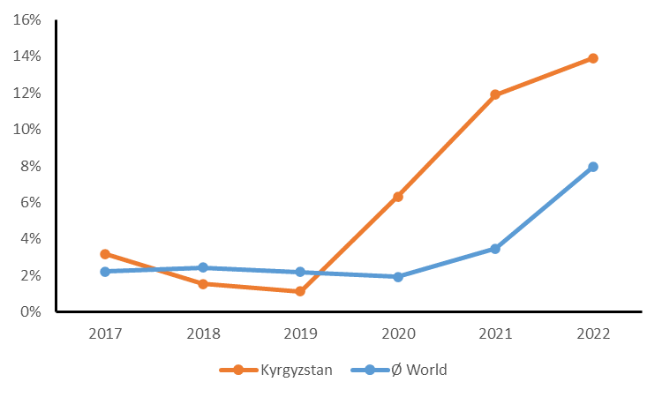
Inflation from 2017 to 2022 in Kyrgyzstan and world average

Monitoring & Evaluation: design at entry (*), implementation (*), and overall assessment of M&E (*)
- The WTS project's Monitoring and Evaluation (M&E) plan incorporates a complex array of quantitative indicators and targets, emphasizing numerical metrics over qualitative assessments. This approach, while providing numerical comparability, lacks depth in capturing the qualitative aspects of capacity development. The M&E framework disproportionately focuses on measurable outcomes like hectares covered and session attendance, neglecting the crucial aspects of knowledge creation and stakeholder competency enhancement. Kyrgyzstan's strong ownership of the project is evident, but challenges arise from the absence of a baseline study and indicators that do not align with SMART criteria. Further complicating matters, some indicators lack clear definitions, requiring additional clarification on their determination methods. For instance, Indicator 18 “Herder/farmer income change (+10%) based on benefits from microfinance/grant program for individuals participating in the program” lacks clarity, and the gender quantitative units used are questioned. The budget allocated for M&E was deemed sufficient. However, the project maintained a consistent practice of timely reporting and underwent regular reviews at Project Board meetings and was able to ultimately achieve results with good performance, in some cases exceeding the baseline.
- Notably, the PAWS methodology was employed to monitor snow leopards, with the project supporting the development of PASK for Kyrgyzstan. Despite delays due to government structural changes, PASK, an integral part of the PAWS process, aims to provide a more accurate estimate of the global snow leopard population, contributing significantly to conservation efforts.
- Intensive internal routine monitoring has been implemented by the UNDP project management and monitoring unit during the last 2 years of the project according to the project team questioned during the TE, including weekly staff meetings and 2-weekly cluster meetings on progress and planning. Apart from PIR, few written reports are available in relation to the period before 2021.
- The MTR came up with a number of conclusions and recommendation which still stand 4 years after, particularly recommendations 2, 3 and 4 of the MTR. However, the MTR seems to have over-estimated progress under Component 1, and it did not address and correct effectively result-targeted planning issues. For example, the MTR signalled low disbursement without further analysis and without proposing corrective measures supporting the achievement of final results.

Monitoring & Evaluation (M&E) | Rating
M&E design at entry | MS
M&E Plan Implementation | S
Overall Quality of M&E | MS

UNDP implementation/oversight (*) and Implementing Partner execution (*), overall project implementation/execution (*), coordination, and operational issues
- The project is being implemented under the DIM modality, which means that both implementation and execution are under UNDP. The additional value of UNDP in this case were obviously the international network role of UNDP and the facilitation of links with other projects such as BIOFIN and Aid for Trade as well as links with other past and future GEF projects. Placing project management under the UNDP Project Management Unit has important efficiency benefits because it is not necessary to create new infrastructure and procedures for project management. However, this setup also resulted in the project's dependency on UNDP management mechanisms risking negative repercussions for the project. Examples of these are the delays related to the introduction of the new procurement management system "Quantum", and the long recruitment procedures when replacing project staff. In the first years of the project, UNDP intervened too little in the project planning, resulting in a number of important activities being delayed (construction of park infrastructure, PA management planning, introduction of SFM, micro grants). As of 2021, coordination between UNDP and the project appears to have improved significantly.

Implementation & Execution | Rating
Quality of UNDP Implementation/Oversight | MS
Quality of Implementing Partner Execution | MS
Overall quality of Implementation/Execution | MS

Project Results

Progress towards objective and expected outcomes (*)
- The project strategic results framework aims at three outcomes realized through three components. The progress of the realisation of these outcomes is measured though a set of 21 indicators and their respective end of project targets. The achievement of these outcome indicators assessed during the TE is presented in Appendix 9 (page 87). Additionally, a colour “traffic light system” code was used to represent the level of progress achieved at the TE level by the project, as well as a justification for the given rating (colour code).
- Despite significant delays during the first years of the project's lifetime, end of project targets were achieved for most progress indicators (mainly HS). Only results of pasture management (75 % achieved) and income improvement through micro-grant projects (50% achieved) lagged behind.

Relevance (*)
- Joining the Convention on Biological Diversity (CBD) in 1996, the Kyrgyz Republic has biodiversity conservation high on the political agenda. The current GEF project contributes significantly to among other its ambitions in the frame of the National Biodiversity Strategy and Action Plan, such as the extension of the protected area network including the development of ecological corridors, enhanced buffer zone management, participatory approaches and the development of sustainable finance. The Kyrgyz National Strategy on Snow Leopard Conservation (2013), emphasizes the driving role of this charismatic species in its conservation policy. The project's support to reduce unsustainable livelihood activities to alternatives such as ecotourism matches the priority given to sustainable tourism development set in the National Development Strategy of the Kyrgyz Republic (2018-2040).
- The project is also relevant in relation to the programme priorities of Kyrgyzstan's development partners, including the GEF and UNDP. In 2016 GEF and UNDP promoted SL as flagship, indicator and keystone species for the conservation of Central Asian mountain ecosystems through their publication "Silent Roar".
- The project contributes directly to Output 3.2 of the UNDP Country programme document (CDP) for the Kyrgyz Republic (2023-2027): National and subnational mechanisms and systems are in place to introduce solutions for improved conservation of biodiversity and management of natural resources. However, the project contributes also to the UNDP CPD Outputs 3.1 and 3.3 through the development of capacities and policy frameworks for resilience to climate risks, mitigation and adaption. Furthermore, the project is contributing to Output 3.3 of the United Nations Sustainable Development Cooperation Framework 2023-2027 for the Kyrgyz Republic: Critical ecosystems are better protected throughout the country, and the rational and sustainable use of natural resources, including water and land, is improved through gender-responsive, participatory and conflict sensitive systems at all levels. The efforts of the project in the field of developing sustainable finance for protected areas match with the UNDP Strategic Plan 2022-2025 enabling capacities and approaches to scale-up development impact by partnering with governments and the private sector to align public and private capital ﬂows with the SDGs and mobilise ﬁnance at scale.

Effectiveness (*)

Component 1. Conservation and sustainable management of Key Biodiversity Areas within the Western Tian Shan landscape.
Achievements
- Management plans being developed for SNP Alatai and SNP Kan-Achuu
- Model business plans developed for protected areas
- Logistics provided (cars and horses) for SNP Alatai and SNP Kan-Achuu
- Equipment purchased (GPS, VHF, binocs, camera traps, cameras, bodycams, tents, sleeping bags, etc.)
- Office, ranger houses and park gates construction almost completed
- Surveillance in both parks ongoing
- Tian Shan Park staff and hunting services training accomplished
- Wildlife monitoring ongoing with camera traps
- Awareness raising delivered for schools and stakeholders
- SFM, HCV and certification frameworks developed
- Adapted forest management plans for SFM developed (2024-2027)
- Park Boards and JFM Councils established for protected areas and Leshkozes
- Protected area database developed at the Ministry of Natural Resources
- METT completed for SNPs Alatai and Kan-Achuu (2018, 2019, 2021, 2023), Saimaluu-Tash , the Sary-Chelek Biosphere Reserve, as well as for SNRs Padysha-Ata, Besh-Aral, and Dashman
- Integrated pasture management plans elaborated
- Legal procedures for the creation of ecological corridors developed
- Corridor plan Toktogul connecting Padysha-Ata SNP, the Sary-Chelek SNP and the Alatai SNP submitted to the Ministry of Natural Resources
- The establishment of Quiet zone adjacent to SNP Kan-Achuu to improve conservation of winter grazing areas of ungulates outside protected areas
Comments
- SMART tool being introduced in Ministry with support ILBIRS
- PA management plans pending budgeting
- PA management plans approach criticised by CAMP Ala-Too and former project coordinator (see also section 4.3.3, page 37)
- Ecological corridor plan pending signature of Plenipotentiary representative of the President of Jalal-Abad region
- Integration HCV management in forest management plan 2027-2037
- Voluntary rangers engaged, but discontinued since a year due to pending ID extension
- Quality some equipment doubtful (price/quality)

Component 2. Ecosystem resilience and habitat connectivity in Western Tian Shan are enhanced by regulating land and forest use in buffer zones and corridors and support to sustainable livelihoods
Achievements
- Forest improvement: fencing 8923 ha to promote for natural regeneration, and 528ha of reforestation re/afforestation measures (planting forest crops of Tien Shan spruce, walnut, pistachio, almond, etc.)
- Support to regional development plans and biodiversity conservation strategies
- Capacity building and awareness raising of stakeholders including schools
- Forest management plans developed for leskhoz in Toktogul and Toguz-Toro districts were developed and amended on HCVF issues
- Pastures committees were assisted developing integrated pasture management plans with help of EPC
- Revision and promotion of “Electronic pasture committee (EPC) information management system“
- Rehabilitation of degraded pastures
- Avoided lifetime indirect GHG emissions estimated
- Ecotourism itineraries developed in State Nature Parks
- Cartographic materials of the Zakazniks prepared
- Exchange visits of stakeholders on alternative livelihood activities organized to other districts
- 15 micro grant projects completed (ecotourism, bird watching, beekeeping, sewing, wool processing, fruit processing, bakery etc.)
- Quiet zone in hunting zone adjacent to Kan-Achuu SNP established
Comments
- Reduced poaching observed by stakeholders
- Leadership of target districts are supporting project activities
- Good engagement of women, young & elderly people, vulnerable households
- No unified database on pastures due to different projects approaches
- Low willingness to use E-pasture management by other pasture committees
- Collaboration with pasture-related projects of ARIS, World Bank, GIZ and the Pasture Department under the Ministry of Agriculture
- No accurate data on number of tourist arrivals
- Micro-grants activities significantly delayed
- Questionable sustainability of micro-grant activities after project
- Synergy with World Bank-GEF Project on “Integrated forest ecosystems management of the Kyrgyz Republic” (2017-2022)

Component 3. Strengthening national capacities for Kyrgyz regional and global cooperation and setting the scene for scaling-up snow leopard conservation
Achievements
- MoU concluded with national law enforcement agencies
- MoU concluded with Tajikistan and Uzbekistan on the Conservation of the Snow Leopard, its Prey Base and Habitat in the Western Tien Shan and Pamir-Alai
- Development of instructive materials to support law enforcement
- Training on law enforcement, hunting and other topics implemented
- Law enforcement with dogs at Bishkek airport facilitated
- e-PA Information System developed for managing information on protected areas and law enforcement
- Meetings attended in Tashkent (Uzbekistan) and Khujand (Tajikistan)
- Conservation of Snow Leopard Forum organized in Bishkek in 2019 for app. 500 participants from 12 range countries
- Snow Leopard monitoring methodology developed/implemented (PAWS/PASK) and camera trapping ongoing (GSLEP, ILBIRS, SLT, SLF)
- Communication plans regularly developed, implemented, monitored and updated
Comments
- Results of current snow leopard survey provided 15 December
- Snow leopard related activities with (inter)national partners such as GSLEP, Panthera, NABU, SLF, SLT, ILBIRS and governmental partners strengthening networking and collaboration at national and international level (SL range countries)

Efficiency (*)
- The project was efficient by using intervention approaches which had been developed and proved to be efficient and effective in different project, such as camera trapping for wildlife population inventories, PAWS for snow leopard population assessment, E-Pasture management, fencing for forest regeneration and plantation, and HCVF management, etc.
- The E-PA Information Management System which was developed in the Ministry of Natural Resources with assistance from the project, helps information sharing and analysis for the main users (management, law enforcement). The system is also a mechanism reducing corruption risks.
- Learning and knowledge sharing events organized particularly during the first part of the project contributed to landscape-wide collaboration and the promotion of such coherent practices. However, a negative factor in this regard was the high staff turnover in the project team and the government partners. Staff replacement leads to loss of knowledge concerning the rationale and implementation of project strategy and activities ("institutional memory"), requiring loss of time for closing these knowledge gaps.
- The efficiency and effectiveness of some activities could have benefited more from existing good practices. For example, the utility of PA management plans has justifiably been questioned by some stakeholders, while good practices on PA planning are abundant worldwide. The understandability and feasibility of these plans would improve by structuring them according to internationally recommended standards.
- The promotion of alternative livelihood through micro-projects is justified by the assumption that increasing income of populations living near protected areas reduces pressure on biodiversity. However, studies show that this is not always the case. Although working on alternative livelihood may contribute to a good relationship between local populations involved and conservationists, the impact on biodiversity of these microprojects in the short and long term remains unknown when ecological/environmental criteria and indicators related to these projects are not assessed and monitored. less than 750 people benefited from micro-project contributions. Without further upscaling, this number is insignificant in relation to the total population in the area adjacent to the protected areas (2 rayon populations app. 128 000).
- Ecotourism development is perceived as promising by many stakeholders. At present, tourism development is particularly focussing at destination development. However, without looking (for example) at potential markets, feasibility and impacts there, there is a risk of wrong investments.

Overall Outcome
Assessment of Outcomes | Rating
Relevance | HS
Effectiveness | S
Efficiency | MS
Overall Project Outcome Rating | S

Country ownership
- Kyrgyzstan has exemplified robust country ownership in the implementation of the WTS project. As a dedicated member of the United Nations Convention on Biological Diversity (CBD), Kyrgyzstan aligns its efforts with the Strategic Plan for Biodiversity 2011-2020, focusing on Aichi Target 12 and complementary goals such as incentivizing conservation, reducing habitat loss, and effective conservation of critical biodiversity areas. The country's commitment extends to the United Nations Convention to Combat Desertification (UNCCD), where the project contributes significantly to enhancing land productivity, diversifying livelihoods, and restoring ecosystem services.
- In addition, Kyrgyzstan actively participates in global initiatives such as the Bishkek Declaration on the Conservation of Snow Leopards and the Global Snow Leopard Ecosystem Protection Program (GSLEP). These commitments underscore the country's dedication to coordinated international efforts in addressing threats to snow leopards and promoting national and global conservation actions.
- At the regional level, Kyrgyzstan's ownership is explicit through the involvement of local communities, ministries, and organizations in project planning and implementation. The inclusion of environmental protection and conservation activities in the updated Socio-economic Development Plans for the Toktogul and Toguz-Toro districts demonstrates the integration of project results into National Sectoral Development plans. The government's financial commitments, regulatory amendments, and active engagement of ministries and civil society further underscore Kyrgyzstan's strong ownership and commitment to the success of the project.

Social and Environmental Standards
- The project team rigorously upholds UNDP's Social and Environmental Standards (SES), aligning their reports with the Social and Environmental Screening Template, which includes a comprehensive Social and Environmental Risk Screening Checklist.
- The SESP prepared during the PPG phase describes quite detailed how the landscape approach is elaborated in this project respecting environmental and social standards, including involvement of local stakeholders and authorities, as well as the integration of land use and conservation in the area around the protected areas.
- Infrastructure inside the protected areas is very modest. and involves only small and simple "prefab" ranger accommodation for temporary use (Figure 9, page 64) and unpaved roads for surveillance and tourism. Administration buildings are (pre)constructed in settled areas outside the parks using "prefab" construction based on sea-containers (Figure 11, page 64). Employing prefabricated structures for administrative purposes has effectively addressed resettlement concerns, mitigating potential social implications.
- The Toktogul and Toguz-Toro district offices have been provided cars (Nissan Double-Cab, Figure 6, page 63), but surveillance inside the parks is done entirely "low-impact" on horseback (Figure 12, page 65). Project interventions include measures for habitat improvement and soil protection re-enforcing environmental resilience (e.g. pasture management, re/afforestation of degraded areas).
- Notably, the project demonstrates a commendable commitment to inclusivity, with a dedicated focus on women and vulnerable groups. The integration of measures that empower and involve these demographics in various project activities underscores the project's dedication to social equity. Moreover, the project proudly bears the UNDP GEN-2 gender marker, signifying its role as a gender-sensitive initiative poised to make substantial contributions to advancing gender equality.
- Remarkably, the project stands out for its absence of adverse social or environmental impacts. The consistent categorization of potential risks as "negligible" or "minor," emphasizing their limited severity and scale, is in line with the UNDP Social and Environmental Screening Procedure.

Sustainability

Financial sustainability (*)
- Outcomes under component 1 will depend mainly on government funding after the project. Budgets have still not been determined for the implementation of PA management plans of Alatai and Kan-Achuu SNP and the implementation of these plans starts after the project in 2024. The financial sustainability of the micro-projects under Component 2 are of concern as sustainability criteria have not been applied for awarding the projects (micro-business plan).
- Meanwhile, the implementation of management plans for leskhozes and pasture associations under component 2 will be covered by their current financing system sourced by resource use fees. Financial sustainability of Component 3 activities will most probably will be covered by multi-donor and government sources after the project, including future projects.

Socio-economic sustainability (*)
- Socio-economic sustainability appears to be high due to the partnerships created and/or supported by the project (Ministry of Natural Resources, Forest Service and NGOs, including CAMP-Ala-Too, ILBIRS, SLT, SLF, KAFLU, and Pasture Users Association). The TE also revealed that the feeling of ownership of project outputs is considerable among park staff and LSG authorities (particularly SNP Kan-Achuu).

Institutional sustainability and governance (*)
- The project has made an important contribution to the institutional framework for natural resource management in the project area and at national level. Mainstreaming of biodiversity conservation is realized in regulations, management plans and Development Plans (Oblast, Region, LSG authorities). However, matters of concern in this context are the interruption of the engagement of volunteer rangers, the pending operationalisation of management plans (SNPs, leskhoz) and the absence of a framework for post-project monitoring and scaling up of micro-grant activities.

Environmental sustainability (*)
- The environmental sustainability of the project is evident and eventual negative environmental impacts are negligible.

Overall likelihood (*)
Sustainability | Rating
Financial resources | ML
Socio-political/economic | L
Institutional framework and governance | ML
Environmental | L
Overall Likelihood of Sustainability | ML/L

Gender equality and women’s empowerment
- The WTS project aims to ensure equal participation of women-owned and managed businesses in the procurement of project-funded equipment and infrastructure. It has targeted at least 30% women participation in all project activities and events, with direct benefits for women of at least 30% project micro-financing of sustainable livelihoods program. The WTS project addresses gender-equality and women empowerment through various initiatives. It improves women representation in community-based bodies up to 25%, creating opportunities for 744 individuals, of which 63% are women. Also from 744 individuals the project helped 45 vulnerable women individuals, including widows, orphans, and people with disabilities (chicken breeding micro-project). The project also encourages women's active involvement in decision-making processes of the SNP Alatai and SNP Kan-Achuu, which have operational Public Councils that evaluate conservation practices and ensure environmental that tasks are completed. The project pilot PAs currently have two ranger women, Raimkan Baisalbekva and Nurgul Omurova. Technical guidelines for communication and outreach products emphasize gender perspectives, aiming to influence people's consciousness and provoke change in behaviour. Women-led initiatives integrate conservation with community well-being, underscoring the vital role of gender inclusivity in achieving sustainable outcomes.
- In conclusion, WTS project has successfully increased women's participation, promoting gender equality and empowering women for a more sustainable future.

Cross-cutting Issues
- Analysis of the future climate change scenarios in Kyrgyzstan show a temperature increase by more than 4^{о}С by the year 2100. It is expected that the annual precipitation will decrease in the future, but at a low rate leading to a reduction of approximately 6 mm compared to the current level in 2100. The most affected sectors will be water resources, hydropower, emergencies, agriculture, public health, forest and biodiversity. Generally, adverse change in environmental parameters, including climatic, poor people are the most vulnerable, because they cannot use the whole range of adaptation practices. Poverty among women is increasing, making the consequences of climate change an increasing concern for this group.
- Several results of the project such as SLM, SFM, protected area creation, ecological corridor development and alternative livelihood projects contribute to resilience of people and ecosystems against climate change impacts. Moreover, some of these also reduce carbon emissions and hence contribute to climate change mitigation. In this context, it is important that a large group of women has been reached with the micro projects (livelihood project). But it must be taken into account that these projects only involve a very small part of the local population and that scaling up is necessary if there is to be a significant impact.

Catalytic Role / Replication Effect
- Within the regional and global context, the project strategy focuses on scaling up known good practices rather than on developing and promoting new approaches. Examples in this regard are the application of PAWS, camera trapping, SFM/HVCF, livelihood projects, SLM approaches, etc. At national level however the project is piloting some of these approaches in order to develop their role in further upscaling in Kyrgyzstan. Particularly for the introduction and promotion of SFM/HCVF in Kyrgyzstan the project plays not only a key role in piloting this approach at leskhoz level, but also in the creation of an enabling policy and regulatory environment for the replication of this approach.
- Training to support the introduction of new technologies and approaches is part of all project components and the project was proactive in the organisation and participation national and international knowledge sharing events. The project communication plans envisaged the production of communication products to support capacity building and knowledge sharing (e.g. press and social media coverage, outreach materials).

Progress to Impact
- Even after the relative long duration of this project, it is difficult to obtain a full picture of the progress to impact. Some of the current indicators for impact measurement such as wildlife abundance estimates (Indicators 1 and 21) and law enforcement (Indicator 3) are not yet fully developed for this purpose (Appendix 9, page 87). Wildlife abundance estimate methodology is shifting from track-based approach to camera trapping. The very first result of the latter approach has just been finalised. These results cannot be compared with results from track-based surveys (which have very large confidence limits anyway). The current indicators for law enforcement give an impression of efforts, but not of impact. The intelligent development of SMART surveillance monitoring (which has recently started in the concerned PAs) could help in the future.
- Other indicators as well as evidence from the field do indicate impact. The project is projected to prevent and absorb 4,905,020 tons CO2-equivalent, exceeding the EoP target of 2,979,548 tons CO2 equivalent, and this positive impact on the carbon balance was assessed in 2023 using the latest EX-ACT tool (Indicator 13). Visual assessment in the field (Figure 16, page 66) confirm direct impact of fencing on the vegetation, particularly with regard to grasses and herbs (Indicator 12). Tree growth is however slow. Large areas are planted with trees, but achieving significant cover will take time. The economic contribution of planting fruit trees will also take time as all species need 5 years or more before they start bearing fruit. Furthermore, the scale at which interventions are implemented is important and consequently the degree of dependence on further upscaling to reach significant impact. The coverage of improved pasture management is for example 25% of the total pasture area, while fencing covered 5% of the total leskhoz area.
- A large part of the population is involved in resource use and therefore the socio-economic consequences of the various project interventions are felt by an important part of the population. This is visible in related indicators (Indicators 6 and 17). However, the degree of impact remains unknown because this is difficult to determine. Determination would require trends in production figures in relation to specific project interventions. Anyway, the socio-economic contribution of the micro-projects is limited. Only 744 people benefited from this intervention (3.1% of the population) and their participation resulted in a 5% income increase equal to 15% of the average grant received. Without a proper business approach and without measures to ensure sustainability, this will bring little change in the long term. It is a pity that the grant amount (US$ 199 361) was not used to create a permanent credit facility. However, in terms of economic perspectives, beekeeping and ecotourism are promising.
- Considerable contributions of the project fostering long term impact (besides our critical comments) are (1) the institutional and regulatory products and arrangements realized, (2) tools promoted to assist sustainable resource management, (3) awareness raising at many levels, and (4) international networking. These different elements made landscape-wide an enabling environment for the promotion of SFM, and other innovative and participatory approaches for sustainable management of forest pastures, protected areas and new land resource management concepts such as HCV forests, ecological corridors, buffer zones and quiet zones. A promising development consolidating impact, is the interest and integration of sustainable development and biodiversity conservation in local development planning by local governments.
- Generally the participation of women in project activities is high. There is obviously a high potential for increasing participation by women at local level. Priority needs to be given to increasing participation of women in Park Boards and JFMC.
- The key barrier for further progress towards impact are frequent institutional changes, which result in rapid change of key actors and loss of access to information. Furthermore, existing and potential land use pressure is a risk factor, particularly increasing livestock and land conversion for other landuse purposes, including private farms, mining, transport infrastructure and large-scale tourism. Implementation of transparent land use planning and effective environmental governance is crucial to match such developments with natural values of the landscape.

Main Findings, Conclusions, Recommendations & Lessons

Main Findings
How does the project relate to the main objectives of the GEF, UNDP and of Kyrgyzstan to strengthen its capacity to manage land and forest resources, including biodiversity conservation?
- The project did contribute (Appendix 10, page 104) to improved sustainability of protected area systems (BD-1) by strengthening the management of the Alatai and Kan-Achuu SNP as well as by the creation of ecological corridors, buffer zones and HCV forests in the landscape, while mainstreaming biodiversity conservation and sustainable use in production landscape (BD-4) through habitat restoration (SFM-3) and sustainable management planning of pastures (LD-3) and forest use (SFM-1, SFM-2). The contributions to GEF objectives are illustrated by the positive trends of the METT scores for the protected areas by the project (Appendix 9, page 87). The project outcomes stem also well with the development objectives formulated in key strategies for sustainable development and biodiversity conservation of Kyrgyzstan as well as those of UNDP's country plans and programmes for the Kyrgyz Republic (section 4.3.2, page 36). The project strategy and outcomes match well with other projects such as the GEF/World Bank's project “Integrated forest ecosystems management of the Kyrgyz Republic” (2017-2022) and future GEF projects.
To what extent have the expected outcomes and objectives of the project been achieved?
- Indicators of the results framework (Appendix 9, page 87) show that most of the end of project targets have been more than achieved. The project contributed to the sustainability of the protected area system in the Tian Shan landscape (GEF BD-1), by mainstreaming biodiversity conservation and sustainable use into production landscapes and production sectors (GEF BD-4), by reducing pressures on natural resources from competing land uses in the wider landscape (GEF LD-3), reducing the pressures on high conservation value forests by addressing the drivers of deforestation (SFM-1), maintaining flows of forest ecosystem services and improve resilience to climate change through SFM (GEF SFM-2) and reversing the loss of ecosystem services within degraded forest landscapes (GEF SFM-3).
- The decrease in degraded pasture land lagged somewhat behind and this was also the case for benefits from micro-finance. Efforts on snow leopard protection intensified including trafficking of derivates. However, the indicator used is not suitable for measuring the effect of these efforts.
Has the project been implemented efficiently, cost-effectively and in-line with international and national norms and standards?
- The project progress has been delayed considerably due to a number of external factors (COVID-19, Government and UNDP institutional and staff changes), but before 2021, poor result-oriented planning was also playing a role, including insufficient adjustment by the inception and MTR. High inflation during the project duration complicated also implementation due to increasing operational costs. The use of adequate and regular AWP and PIR reports, project board meetings and internal monitoring indicate that management standards have been followed, but it seemed that during the first phase of the project, planning was done on a year-to-year basis, mission a long-term strategic vision on the realisation of results and outcomes. From 2021 on (late but effective) adjustments were made to project implementation.
- The use of proved good practices contributed to the efficiency of project implementation. PA management planning and the promotion of micro projects could have benefitted more from experience elsewhere.
Are there indications that the project has contributed to the improvement of the management of land and forest resources, including biodiversity conservation in Kyrgyzstan?
- Local stakeholders reported a decrease in illegal activities such as poaching and an increase of wildlife abundance. Some resource use activities need more time before the benefits can be reaped (e.g. planting of fruit trees, improved pasture management, SFM), other activities can benefit directly from improved natural resource management, such as beekeeping. Habitat restoration with fencing shows direct effects within one season (Figure 16, page 66). However, recent effects of climate change (droughts, high temperatures) intervene with the results of the project. A reciprocal impact of the project at local governance level is the increasing integration of sustainability and green development in local development planning.
To what extent are there financial, institutional, social-economic, and/or environmental risks to sustaining long-term project results?
- Socio-economic and institutional sustainability appears to be generally high due to established partnerships, regulatory frameworks and extensive capacity building efforts. Interest by the local government for uptake of outcomes is an indication of sustainability. The environmental sustainability of the project is evident and eventual negative environmental impacts are negligible. However, financial sustainability of the implementation of PA management plans and the initiated micro projects is a point of concern as these results have been realised at the end of the project and follow up funding and monitoring arrangements have not yet been established.

Conclusions
The principal conclusions of the TE are the following:
- The goals of the project design have high ambitions regarding sustainable landscape management, but require considerable expertise for their achievement.
- The project design is based on a coordinating and mobilising/moderating role of the UNDP project staff, which is supplemented with considerable outsourced technical assistance to provide the necessary required specific expertise (protected area management, wildlife monitoring, forestry, livelihood, etc.).
- The results of TE interviews and the project indicator values provide evidence that the project contributed to biodiversity conservation including the protection of snow leopard, and to the development of livelihoods around protected areas.
- Partnerships created and maintained for the implementation of project activities contributed to collaboration and synergy between key actors in sustainable natural resources management and snow leopard conservation.
- Several factors caused significant delays of progress from 2017 to 2021, including COVID-19, institutional changes and staff changes in the government and UNDP, as well as poor strategic planning.
- Neither the project Inception, nor the MTR resulted in appropriate (re)orientation of project activities.
- Poor strategic planning observed during the first phase (2017-2020) of the project was partly compensated by a considerable acceleration in the last phase of the project (2021-2023).
- Institutional changes of the government and UNDP, as well as replacement of key actors in both the project and the government affected the institutional memory and the efficient implementation of the project.
- The government's engagement in the project is more visible at local and regional levels than at national level.

Recommendations
Rec  # | TE Recommendation | Entity Responsible | Time  frame
A | Category 1: Actions to strengthen or reinforce benefits from the project;
A.1 | Create coherence between Land code and PA legislation with regard to the creation of corridors, buffer zones and quiet zones outside protected areas. Actually the Land code does not provide modalities for partial protection, such as seasonal restrictive measures to reduce conflicts and competition between wildlife and economic use during migration or reproduction seasons. | MNRETS, Ministry of Agriculture | 2024
B | Category 2: Proposals for future directions underlining main objectives
B.1 | Improve donor coordination in Kyrgyzstan on key themes such as environment, biodiversity conservation, and climate change in order to realize synergy between agendas of development partners and consistent approaches. | UNDP | 2024
B.2 | Develop legal measures to control shepherd dogs in PAs and buffer zones. Shepherd dogs usually feed on wildlife and therefore, grazing in areas for wildlife leads to an undesirable impact on ecosystems. To control this, agreements with herders are required on the one hand, and effective legislation to be enforced on the other hand. The first steps to achieve this are a dialogue with the pasture associations and a study of the possibilities and gaps of the current legislation | MNRETS | 2024
B.3 | Conduct research on the relation between grazing pressure and habitat when using e-pasture management tool. Pasture ecology is complex and under influence of many variables such as livestock grazing, wildlife grazing, rainfall, temperature and fire. The timing and duration of these factors play a role as well. More research and pasture monitoring are required to fully understand the use of E-pasture management in relation to floristic and structural characteristics of pastures, and the consequences for resilience, biodiversity, soil protection and fodder quality. | Academy of Sciences,  Kyrgyz Research Institute of Livestock and Pastures under the Ministry of Agriculture | future projects on PA management and corridors
B.4 | Develop funding mechanism to promote local initiatives and conservation. The current micro project approach is not sustainable and does not necessarily promote development compatible with biodiversity conservation. A sustainable funding mechanism for local initiatives compatible with conservation would support the development of a green economy and support for nature conservation at local level. | BIOFIN, UNDP | future projects integrated conservation and development
B.5 | Apply WCPA guidelines for the elaboration of management plans in future PA management plans.  The Government sets the standards for protected area management plans, but GEF projects can help improving quality standards. Improvements for quality and utility to be applied would be among others the following: a simplified and logical structure of the plan, an elaborated management strategy based on analysis of natural values and threats, an elaborated zoning system with maps in the plan, a detailed description of management measures in relation to the zoning plan, followed by a clear (integrated) work/action plan in which all measures, timing and responsibilities are clearly indicated. | UNDP in the frame of future GEF projects | future projects on PA management and corridors
B.6 | Establish adequate information management and institutional memory mechanisms in project management units  Efficient project implementation as well as for M&E and replication requires proper reporting, transparent information management, handover reports, and systematic and accessible storage of project outputs, etc. Accessibility of information and transparency improves also usually ownership. | UNDP, MNRETS | future GEF projects
B.7 | Quality and usability should be crucial criteria set by technicians when procuring equipment  Equipment to be used in projects are meant for professional use, often under difficult conditions. Low-cost often coincides with low quality and poor durability, which reduces effectiveness and efficiency of such equipment. | UNDP | future GEF projects
C | Category 3: Suggestions for strengthening ownership
C.1 | Increase engagement of government partners in project formulation and management.  Engagement of government partners is crucial for the take-up of project results. Ownership of current project results can be improved by developing an exit strategy jointly before the end of the project.  For future projects a more prominent place of the government in day-to-day management would be beneficial, for example using NIM modality with additional support for management and monitoring. | UNDP | December 2023 and after  future GEF projects
C.2 | Support participation to Parks Board and JFM Council.  The participation of local stakeholders in natural resource management is a prerequisite for changing current practices. Actually the cost for participation is born by the participants themselves. Compensation for travel cost and refreshment during meetings would favour participation to Board and Council meetings. | MNRETS, UNDP | December 2023 and after  future GEF projects
C.3 | Encourage volunteer rangers in conservation.  Volunteer rangers have an important additional value to the current surveillance of protected areas. Apart from the equipment provided by the project, other costs are born by the volunteers themselves. A more complete compensation package including food during patrols, fodder for horses and maintenance of equipment and uniforms is justifiable and necessary to keep them on board. | MNRETS, UNDP | December 2023 and after  future GEF projects
D | Category 4: management of potential risks
D.1 | Evaluate regularly policies to control overgrazing.  The number of livestock keeps on increasing and external factors determine the dynamics of the sector. Responding effectively to these dynamics requires regular evaluation of grazing policies and adaptive management at landscape level that goes beyond pasture management, but also involves evaluating the size and composition of the livestock at landscape level, as well as productivity, health, impacts, etc. | Academy of Sciences,  Kyrgyz Research Institute of Livestock and Pastures under the Ministry of Agriculture | future GEF projects

Lessons Learned
- The following lessons-learned may be applied in future GEWF projects in Kyrgyzstan:
- Strategic work planning during inception phase and MTR is essential for optimal project performance. The Project Document is result-oriented, but it is the task of the project management to plan activities during inception with a strategic vision on the completion of the expected project results, taking into account inter-dependency of results and timing. The MTR is a crucial check half-way of this adaptive planning process.
- Effective component management and implementation requires sufficient technical leadership and skills in the project team to assure oversight of the implementation of specific components and activities. Without technical expertise in the team, technical considerations may be overlooked during activity planning and monitoring.
- Adequate institutional memory mechanisms are a prerequisite for efficient project implementation as well as for M&E and replication (proper reporting, transparent information management, handover reports, and systematic and accessible storage of project outputs, etc.).
- Regular involvement of relevant government partners in planning, decision taking and monitoring facilitates ownership of project results. Ownership is more likely to be perceived and materialised if the location of the project management is close to the beneficiary, preferably at the same location. Any limitations in management capacity can be accommodated by deploying additional support in the areas of administration, monitoring and audit.
- The application of tested and proved work practices developed by experts lead to accuracy and efficiency and contributes to coherence and compatibility with the results of these practices applied elsewhere. Good examples applied in this project are the application of PAWS for the estimation of snow leopard populations, EPC for the sustainable management of pastures. The introduction of the SMART system for protected area surveillance supported by ILBIRS is another good example. The World Commission on Protected Areas (WCPA) offers tools for the enhancement of conservation practices, such as guidelines for protected area management planning.
- The use of sea containers is a cheap alternative for the construction of staff accommodation. An additional advantage is the possibility to carry out part of the work in a well-equipped workshop elsewhere, which means that the local impact of the finish when installed on location is limited.

Appendices
- Terms of reference (excluding ToR annexes)

INTRODUCTION
In accordance with UNDP and GEF M&E policies and procedures, all full- and medium-sized UNDP-supported GEF-financed projects are required to undergo a Terminal Evaluation (TE) at the end of the project. This Terms of Reference (ToR) sets out the expectations for the TE of the full-sized project titled “Conservation of globally important biodiversity and association land and forest resources of Western Tian Shan Forest Mountain ecosystems and support to sustainable livelihoods.” (PIMS #5411) implemented through the UNDP CO in Kyrgyzstan. The project started on the 17 March 2017 and is in its sixth year of implementation. The TE process must follow the guidance outlined in the document ‘Guidance For Conducting Terminal Evaluations of UNDP-Supported, GEF-Financed Projects’ (http://web.undp.org/evaluation/guideline/documents/GEF/TE_GuidanceforUNDP-supportedGEF-financedProjects.pdf). The final evaluation will determine and describe lessons learned and will develop recommendations to be used by project partners in order to improve their capacity in planning and implementing similar projects and programs.
The final evaluation will:
(i) identify factors, which have had positive or negative impacts on project implementation;
(ii) assess the correlation of project activities with local and national development priorities and
organizational policy, including progressive changes;
(iii) assess the project efficiency, i.e. level of project goal achievement;
(iv) assess sustainability of project results, i.e. potential positive results to be observed after
project close;
(v) present lessons learned from project development, implementation and management.
Findings of this evaluation will be considered as lessons learned and will assist in developing
recommendations to improve institutional sustainability of project outputs, e.g. possible implementation of such activity in other regions. This final evaluation will contain description of project outcomes and their potential sustainability, as well as a project implementation monitoring table.

PROJECT BACKGROUND AND CONTEXT`
The project is focused on biodiversity, land and forest resources in Western Tian Shan in Kyrgyzstan. Aim of the project on key biodiversity areas is establishing new formal PAs for underrepresented globally significant species and strengthening the key existing PAs, with special focus on Western Tian Shan. Project will ensure continuity and congruence between KBAs and use of land and forest resources in wider productive landscapes. The project creates new and strengthens PAs at a total area of 226,621 ha (which includes 25,000 ha of High Conservation Value Forests) and creates wildlife corridors and buffer zones at a total area of 50,000 ha. The direct effect thus is 0.28 mln ha. The project will further support work on improvement and sustainable use of pastures. The total area of pastures in the region exceeds 0.6 mln ha; the project aims to restore at least 65,000 ha of degraded pastures in Toktogul and Toguz-Toro districts.
To achieve the project objective, and address the barriers, the project’s intervention has been organized into three components:
- Conservation and sustainable management of Key Biodiversity Areas within the Western Tian Shan landscape,
- Ecosystem resilience and habitat connectivity in Western Tian Shan are enhanced by regulating land and forest use in buffer zones and corridors and support to sustainable livelihoods, and
- Strengthening national capacities for Kyrgyz regional and global cooperation and setting the scene for scaling-up snow leopard conservation. The project will build capacities of the Department of Protected Areas of the Ministry of Natural Resources, Environment and Technical supervision of the Kyrgyz Republic (former SAEPF).
Budget: The total project budget USD 28,507,758. Of which (i) USD3,988,575 from GEF; (ii) USD 5,527,383 from UNDP; (iii) USD14,864,800 from National Government; (iv) USD 3,200,000 from Local Government; (v) USD 627,000 Bilateral Partners; (vi) USD 300,000 from NGOs in kind were expected.
In Kyrgyzstan, from 3 January 2020 to 5:57pm CET, there have been 206,567 confirmed cases of COVID-19 with 2,991 deaths, reported to WHO. As of 10 December 2022, a total of 3,041,331 vaccine doses have been administered. COVID-19 pandemic reached Kyrgyzstan in March 2020, then the government declared an Emergency Situation throughout the country. As of mid-July 2020, the COVID-19 infection rates have risen drastically, overwhelming local medical services in several localities including the major cities. COVID-19 negatively impacted the Project implementation: travel restrictions, mandatory self-isolation and banning public events affected project mobility and delayed implementation of key project activities, such as Low-value grant component, constructions for SNPs, reforestation activities and other field work, etc. Target protected areas, leskhozes, as well as communities were not accessible. Further. COVID-19 restrictions led to increase of the cost of work and materials, which also made impossible to continue on delivering of premises to target protected areas.

TE PURPOSE
The TE report will assess the achievement of project results against what was expected to be achieved, and draw lessons that can both improve the sustainability of benefits from this project, and aid in the overall enhancement of UNDP programming. The TE report promotes accountability and transparency, and assesses the extent of project accomplishments.
Terminal Evaluation for GEF-funded project have the following supplemental purposes:
- Promote accountability and transparency,
- Synthesize lessons that can help improve the selection, design, and implementation of future GEF-funded and UNDP-supported initiatives; and improve the sustainability of benefits and aid in the overall improvement of UNDP programming.
- Evaluate and document the results of the project and the contribution of these results to the achievement of the GEF's strategic objectives aimed at global environmental benefits.
- Measure the degree of convergence of the project with other priorities within the UNDP country programme, including poverty alleviation.
- Strengthen capacity on biodiversity conservation, sustainable land and forest use, as well as cross-cutting issues such as gender equality, women's empowerment, and support for human rights.
It is recommended that the TE takes place during the last few months of project activities, allowing the TE team to work while the Project Team is still in place, but ensuring that the project is close enough to its completion for the evaluation team to reach key conclusions/aspects such as the sustainability of the project.
For all meetings conducted in offline mode the TE team will ensure to take the necessary measures to protect their team members and meeting participants against possible risks of COVID 19 in the performance of the TE (e.g. by keeping a social distance and using the right PPE equipment: facemasks and hand sanitizers).

TE APPROACH & METHODOLOGY
The TE report must provide evidence-based information that is credible, reliable and useful.
The TE team will review all relevant sources of information including documents prepared during the preparation phase (i.e. PIF, UNDP Initiation Plan, UNDP Social and Environmental Screening Procedure/SESP) the Project Document, project reports including annual PIRs, project budget revisions, lesson learned reports, national strategic and legal documents, and any other materials that the team considers useful for this evidence-based evaluation. The TE team will review the baseline and midterm GEF focal area Core Indicators/Tracking Tools submitted to the GEF at the CEO endorsement and midterm stages and the terminal Core Indicators/Tracking Tools that must be completed before the TE field mission begins.
The TE team is expected to follow a participatory and consultative approach ensuring close engagement with the Project Team, government counterparts (the GEF Operational Focal Point), Implementing Partners, the UNDP Country Office(s), the Regional Technical Advisor, direct beneficiaries and other stakeholders.
Engagement of stakeholders is vital to a successful TE. Stakeholder involvement should include interviews with stakeholders who have project responsibilities, including but not limited to:
- UNDP Senior Management;
- The Ministry of Natural Resources, Environment and Technical Supervision of the Kyrgyz Republic and its Department of Protected Areas and Biodiversity Conservation – GEF Operational Focal Point and Project Focal Point;
- The Forestry Service under the Ministry of Agriculture of the Kyrgyz Republic;
- State Nature Park Alatai and State Nature Park Kan-Achuu;
- Toguz-Toro district state administration and Toktogul district state administration;
- Toguz-Toro leskhoz and Toktogul leskhoz;
- UNDP “Biodiversity, Environment, Climate Change and DRM” cluster and its projects;
- Key experts and consultants in the thematic area;
- Local NGOs;
- Target local communities;
- RCU-Istanbul.

Additionally, the TE team is expected to conduct field missions to Bishkek, Toguz-Toro district and Toktogul district , including the following project sites
- SNP Kan-Achuu,
- SNP Alatai
- Toktogul leskhoz
- Toguz-Toro leskhoz
The specific design and methodology for the TE should emerge from consultations between the TE team and the above-mentioned parties regarding what is appropriate and feasible for meeting the TE purpose and objectives and answering the evaluation questions, given limitations of budget, time and data. The TE team must, however, use gender-responsive methodologies and tools and ensure that gender equality and women’s empowerment, as well as other cross-cutting issues and SDGs are incorporated into the TE report.
Recommendations of the evaluation should also include the following gender-related criteria:
- Are women and men involved into project activity equally?
- Is the project enhancing visibility and awareness of gender-related issues in Environmental
Management in Kyrgyzstan?
- Will the project benefit to women and men equally?
The final methodological approach including interview schedule, field visits and data to be used in the evaluation must be clearly outlined in the TE Inception Report and be fully discussed and agreed between UNDP, stakeholders and the TE team.
The final report must describe the full TE approach taken and the rationale for the approach making explicit the underlying assumptions, challenges, strengths and weaknesses about the methods and approach of the evaluation.

DETAILED SCOPE OF THE TERMINAL EVALUATION
The TE will assess project performance against expectations set out in the project’s Logical Framework/Results Framework (see ToR Annex A). The TE will assess results according to the criteria outlined in the Guidance for TEs of UNDP-supported GEF-financed Projects http://web.undp.org/evaluation/guideline/documents/GEF/TE_GuidanceforUNDP-supportedGEF-financedProjects.pdf). The core product of this Evaluation will be the Terminal Evaluation Report that includes:
- Findings with the rating on performance;
- Conclusions drawn;
- Lessons learned concerning best and worst practices in producing outputs;
- A rating on progress towards outputs.
Scope of work of the TE Team Leader
A TE Team Leader (an international consultant) will be responsible for the overall TE design and methodology, for conducting the assessment and for producing and submitting of the TE final report. The Team Leader will team up with a local TE expert (a national consultant) who will assist him/her in conducting the evaluation and producing the TE report, conducting a team field visit to the Jalal-Adab region, conducting a stakeholder interviews, and drafting the following sections of the TE report: assessing emerging trends with respect to regulatory frameworks, capacity building, and gender aspects of the Project.
The Team Leader's scope of work includes the following tasks:
- To develop the evaluation design (goals, objectives, methodology, timeline, etc.)
- To review provided project documents and to prepare TE Inception Report.
- To conduct a mission to Kyrgyzstan to collect materials by meeting with stakeholders and visiting project sites and to present preliminary results of the assessment.
- To produce a TE Report according to the provided TE Report outline (Annex C) and to circulate the draft TE Report for review by the Commissioning Unit and RTA, etc.
- To incorporate comments and address feedbacks to the draft TE report into Audit Trail and to finalize the TE report.
- To prepare and issue the Management Response and to submit the Final TE report.
A full outline of the TE report’s content is provided in ToR Annex C.
The Findings section of the TE report will cover the topics listed below.
The asterisk “(*)” indicates criteria for which a rating is required.
Findings
- Project Design/Formulation
- National priorities and country drivenness
- Theory of Change
- Gender equality and women’s empowerment
- Social and Environmental Safeguards
- Analysis of Results Framework: project logic and strategy, indicators
- Assumptions and Risks
- Lessons from other relevant projects (e.g. same focal area) incorporated into project design
- Planned stakeholder participation
- Linkages between project and other interventions within the sector
- Management arrangements

- Project Implementation
- Adaptive management (changes to the project design and project outputs during implementation)
- Actual stakeholder participation and partnership arrangements
- Project Finance and Co-finance
- Monitoring & Evaluation: design at entry (*), implementation (*), and overall assessment of M&E (*)
- Implementing Agency (UNDP) (*) and Executing Agency (*), overall project oversight/implementation and execution (*)
- Risk Management, including Social and Environmental Standards

- Project Results
- Assess the achievement of outcomes against indicators by reporting on the level of progress for each objective and outcome indicator at the time of the TE and noting final achievements
- Relevance (*), Effectiveness (*), Efficiency (*) and overall project outcome (*)
- Sustainability: financial (*) , socio-political (*), institutional framework and governance (*), environmental (*), overall likelihood of sustainability (*)
- Country ownership
- Gender equality and women’s empowerment
- Cross-cutting issues (poverty alleviation, improved governance, climate change mitigation and adaptation, disaster prevention and recovery, human rights, capacity development, South-South cooperation, knowledge management, volunteerism, etc., as relevant)
- GEF Additionality
- Catalytic Role / Replication Effect
- Progress to impact

Main Findings, Conclusions, Recommendations and Lessons Learned
- The TE team will include a summary of the main findings of the TE report. Findings should be presented as statements of fact that are based on analysis of the data.
- The section on conclusions will be written in light of the findings. Conclusions should be comprehensive and balanced statements that are well substantiated by evidence and logically connected to the TE findings. They should highlight the strengths, weaknesses and results of the project, respond to key evaluation questions and provide insights into the identification of and/or solutions to important problems or issues pertinent to project beneficiaries, UNDP and the GEF, including issues in relation to gender equality and women’s empowerment.
- Recommendations should provide concrete, practical, feasible and targeted recommendations directed to the intended users of the evaluation about what actions to take and decisions to make. The recommendations should be specifically supported by the evidence and linked to the findings and conclusions around key questions addressed by the evaluation.
- The TE report should also include lessons that can be taken from the evaluation, including best and worst practices in addressing issues relating to relevance, performance and success that can provide knowledge gained from the particular circumstance (programmatic and evaluation methods used, partnerships, financial leveraging, etc.) that are applicable to other GEF and UNDP interventions. When possible, the TE team should include examples of good practices in project design and implementation.
- It is important for the conclusions, recommendations and lessons learned of the TE report to include results related to gender equality and empowerment of women.
The expected length of the report is around 50 pages in total. The TE report will include an Evaluation Ratings Table, as shown below:
ToR Table 2: Evaluation Ratings Table for (Conservation of globally important biodiversity and association land and forest resources of Western Tian Shan Forest Mountain ecosystems and support to sustainable livelihoods – WTS project)
Monitoring & Evaluation (M&E) | Rating
M&E design at entry
M&E Plan Implementation
Overall Quality of M&E
Implementation & Execution | Rating
Quality of UNDP Implementation/Oversight
Quality of Implementing Partner Execution
Overall quality of Implementation/Execution
Assessment of Outcomes | Rating
Relevance
Effectiveness
Efficiency
Overall Project Outcome Rating
Sustainability | Rating
Financial resources
Socio-political/economic
Institutional framework and governance
Environmental
Overall Likelihood of Sustainability

METHODOLOGY
An outline of an evaluation approach is provided below, however it should be made clear that the evaluation team is responsible for revising the approach as necessary. Any changes should be in-line with international criteria and professional norms and standards (as adopted by the UN Evaluation Group17). They must be also cleared by UNDP before being applied by the evaluation team.
The evaluation must provide evidence-based information that is credible, reliable and useful. It must be easily understood by project partners and applicable to the remaining period of project duration.
Evaluators should seek guidance for their work in the following materials, which could be found at (www.undp.org/gef):
- UNDP Handbook on Monitoring and Evaluation for Results
- UNDP/GEF M&E Resource Kit
- Measuring Results of the GEF Biodiversity Programme
It is recommended that the evaluation methodology include the following:
- Documentation review (desk study), to include Project Document, GEF Project Implementation
Reviews, Minutes of the Project Steering Committee meetings, GEF quarterly project updates;
- Interviews with Project Management Unit and key project stakeholders, including UNDP Country Office in Kyrgyzstan, GEF Regional Coordination Unit in Bratislava, the Ministry of Natural Resources, Environment and Technical Supervision of KR, Forest Agency and Pasture Agency of the Ministry of Agriculture or KR, and other stakeholders, as necessary;
- In-country field visits.

TIMEFRAME
The total duration of the TE will be approximately 29 working days over a time period of 8 weeks starting on November 1, 2023. The tentative TE timeframe is as follows:

Timeframe | Activity
(October 19, 2023) | Application closes
(October 31, 2023) | Selection of TE team
(November 1, 2023) | Preparation period for TE team (handover of documentation)
(November 1– November 3, 2023) 3 days | Document review and preparation of TE Inception Report
(November 4 – November 8, 2023) 4 days | Finalization and Validation of TE Inception Report; latest start of TE mission
(between November 9 – November 20, 2023) 11 days (recommended 7-15) | TE mission: stakeholder meetings, interviews, field visits, etc.
(November 21, 2023) 1 day | Mission wrap-up meeting & presentation of initial findings; earliest end of TE mission
(November 22 – December 1 , 2023) 9 days (recommended 5-10) | Preparation of draft TE report
(December 1, 2023) | Circulation of draft TE report for comments
(December 12, 2023) | Incorporation of comments on draft TE report into Audit Trail & finalization of TE report
(December 13 - December 14, 2023) | Preparation and Issuance of Management Response
(December 15, 2023) | Expected date of full TE completion
Options for site visits should be provided in the TE Inception Report.

TE DELIVERABLES
# | Deliverable | Description | Timing | Responsibilities | Payment structure
1 | TE Inception Report | TE Team Leader clarifies objectives, methodology and timing of the TE | No later than 2 weeks before the TE mission: (November 8, 2023) | TE Team Leader submits Inception Report to Commissioning Unit and project management | 30%
2 | Presentation | Initial Findings | End of TE mission: (by November 21, 2023) | TE Team Leader presents to Commissioning Unit and project management
3 | Draft TE Report | Full draft report (using guidelines on report content in ToR Annex C) with annexes | Within 3 weeks of end of TE mission: (by December 1, 2023) | TE Team Leader submits to Commissioning Unit; reviewed by BPPS-GEF RTA, Project Coordinating Unit, GEF OFP | 70%
4 | Final TE Report* + Audit Trail | Revised final report and TE Audit trail in which the TE details how all received comments have (and have not) been addressed in the final TE report (See template in ToR Annex H) | Within 1 week of receiving comments on draft report: (by December 15, 2023) | TE Team Leader submits both documents to the Commissioning Unit

*All final TE reports will be quality assessed by the UNDP Independent Evaluation Office (IEO). Details of the IEO’s quality assessment of decentralized evaluations can be found in Section 6 of the UNDP Evaluation Guidelines.

TE ARRANGEMENTS
The principal responsibility for managing the TE resides with the Commissioning Unit. The Commissioning Unit for this project’s TE is UNDP Country Office in Kyrgyzstan.
The Commissioning Unit will contract the evaluators and ensure the timely provision of per diems and travel arrangements within the country for the TE team. The Project Team will be responsible for liaising with the TE team to provide all relevant documents, set up stakeholder interviews, and arrange field visits.

TE TEAM COMPOSITION
A team of two independent evaluators will conduct the TE – one team leader – international consultant and one local expert – a national consultant. The team leader will be responsible for the overall design and writing of the TE report, for submitting of a final report. The local expert will assist the team leader on conducting the evaluation by assessing emerging trends with respect to regulatory frameworks, capacity building, contributing to preparation of TE report, etc., and also will work with the Project Team in developing the TE itinerary.
The evaluators cannot have participated in the project preparation, formulation and/or implementation (including the writing of the project document), must not have conducted this project’s Mid-Term Review and should not have a conflict of interest with the project’s related activities.
The selection of evaluators will be aimed at maximizing the overall “team” qualities in the following areas:
MINIMUM REQUIREMENTS FOR A TEAM LEADER – AN INTERNATIONAL CONSULTANT:
Education
Master’s degree in Natural sciences or Environmental sciences or Development studies;
Experience
- At least 7 years of experience in relevant technical areas for biodiversity conservation and/or natural resources management and/or environmental management;
- Experience in using results-based management evaluation methodologies and/or SMART indicators and reconstructing or validating baseline scenarios;
- Experience in conducting evaluation of projects in the field of Biodiversity and/or Land Degradation and/or Sustainable Forest Management;
- Experience working in Kyrgyzstan or Central Asian countries or CIS countries is an asset;
- Project evaluation/review experience within United Nations system will be considered an asset.
Language
- Fluency in written and spoken English.
- Knowledge of Russian is an asset.

EVALUATOR ETHICS
The TE team will be held to the highest ethical standards and is required to sign a code of conduct upon acceptance of the assignment. This evaluation will be conducted in accordance with the principles outlined in the UNEG ‘Ethical Guidelines for Evaluation’. The evaluator must safeguard the rights and confidentiality of information providers, interviewees and stakeholders through measures to ensure compliance with legal and other relevant codes governing collection of data and reporting on data. The evaluator must also ensure security of collected information before and after the evaluation and protocols to ensure anonymity and confidentiality of sources of information where that is expected. The information knowledge and data gathered in the evaluation process must also be solely used for the evaluation and not for other uses without the express authorization of UNDP and partners.

PAYMENT SCHEDULE

- 30% payment upon satisfactory delivery of the final TE Inception Report and approval by the Commissioning Unit
- 70% payment upon satisfactory delivery of the draft TE report to the Commissioning Unit and the final TE report and approval by the Commissioning Unit and RTA (via signatures on the TE Report Clearance Form) and delivery of completed TE Audit Trail

Criteria for issuing the final payment of 70%:
- The final TE report includes all requirements outlined in the TE TOR and is in accordance with the TE guidance.
- The final TE report is clearly written, logically organized, and is specific for this project (i.e. text has not been cut & pasted from other TE reports).
- The Audit Trail includes responses to and justification for each comment listed.
In line with the UNDP’s financial regulations, when determined by the Commissioning Unit and/or the consultant that a deliverable or service cannot be satisfactorily completed due to the impact of COVID-19 and limitations to the TE, that deliverable or service will not be paid.

TRAVELS
Travel will be required to Kyrgyzstan (Bishkek and Jalal-Abad province) during the TE mission;
Date; November 2023
Number of days; at least 10 overnights
Field missions to (location), including the following project sites (list):
- Bishkek (Country office, Project Management Unit UNDP, Project National Partners);
- SNP Kan-Achuu and Toguz-Toro leskhoz in Toguz-Toro district of Jalal-Abad region;
- SNP Alatai and Toktogul leskhoz in Toktogul district of Jalal-Abad region.

- The BESAFE course must be successfully completed prior to commencement of travel;
- Individual Consultants are responsible for ensuring they have vaccinations/inoculations when travelling to certain countries, as designated by the UN Medical Director.
- Consultants are required to comply with the UN security directives set forth under: https://dss.un.org/dssweb/
- All related travel expenses will be covered and will be reimbursed as per UNDP rules and regulations upon submission of an F-10 claim form and supporting documents.

TOR ANNEXES
(Add the following annexes to the final ToR)
- ToR Annex A: Project Logical/Results Framework
- ToR Annex B: Project Information Package to be reviewed by TE team
- ToR Annex C: Content of the TE report
- ToR Annex D: Evaluation Criteria Matrix template
- ToR Annex E: UNEG Code of Conduct for Evaluators
- ToR Annex F: TE Rating Scales
- ToR Annex G: TE Report Clearance Form
- ToR Annex H: TE Audit Trail

- Maps
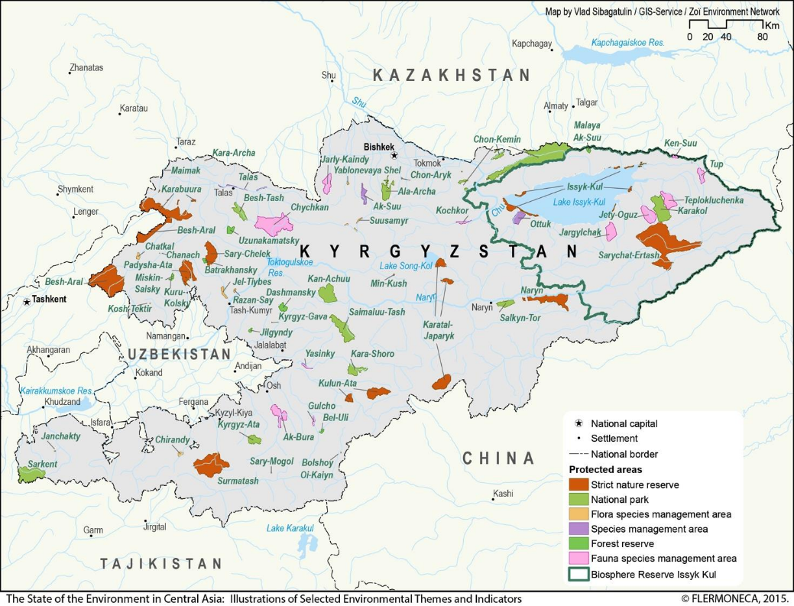
Kygyzstan protected areas
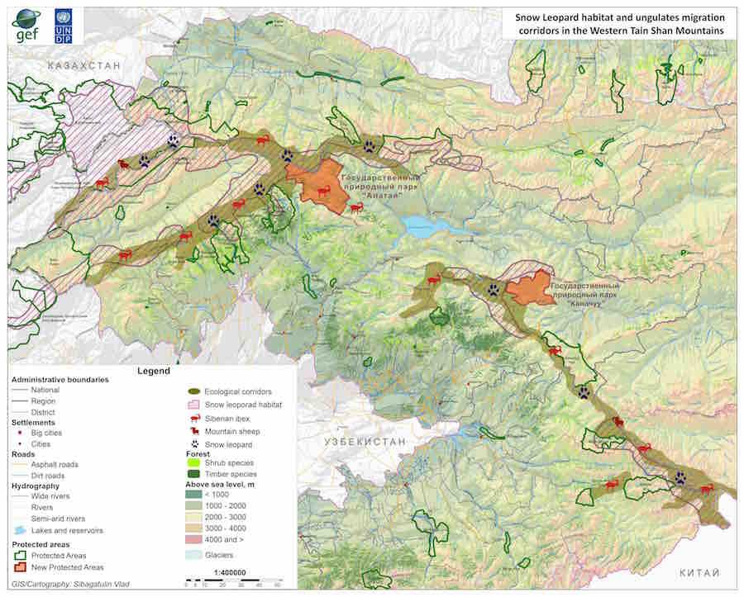
Project wildlife area and corridors

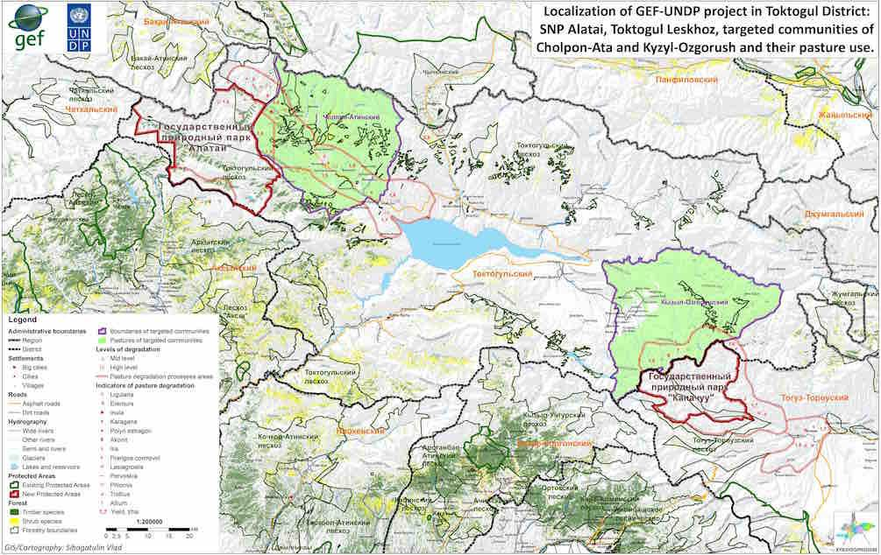
Pasture lands Toktogul District

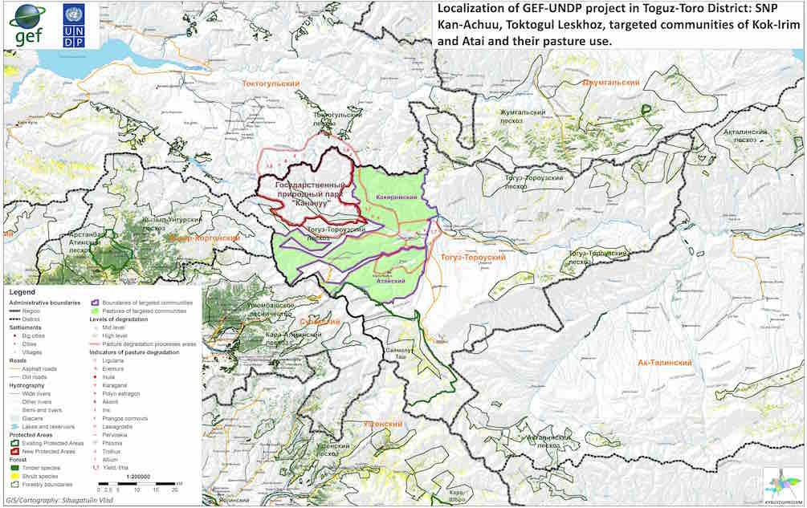
Pasture land Toguz-Toro District

- Photos
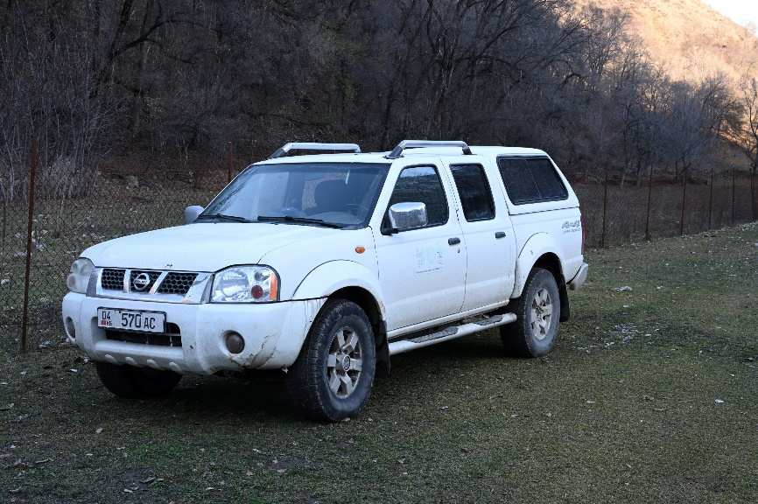
Car operational for Toktogul park's office provided by the project

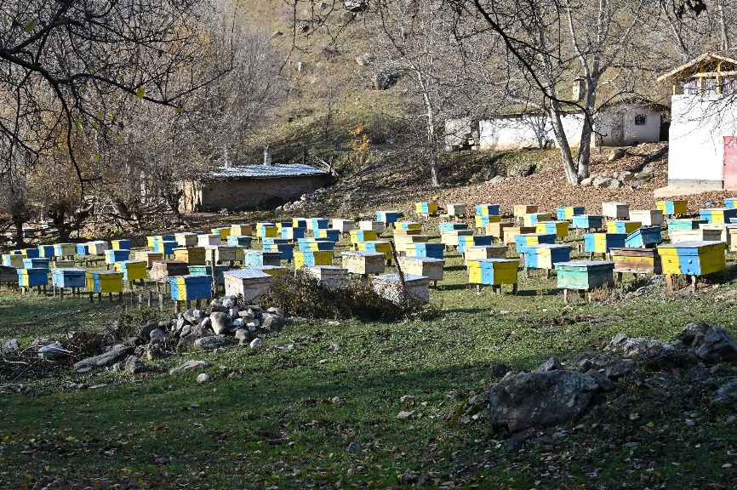
Bee keeping

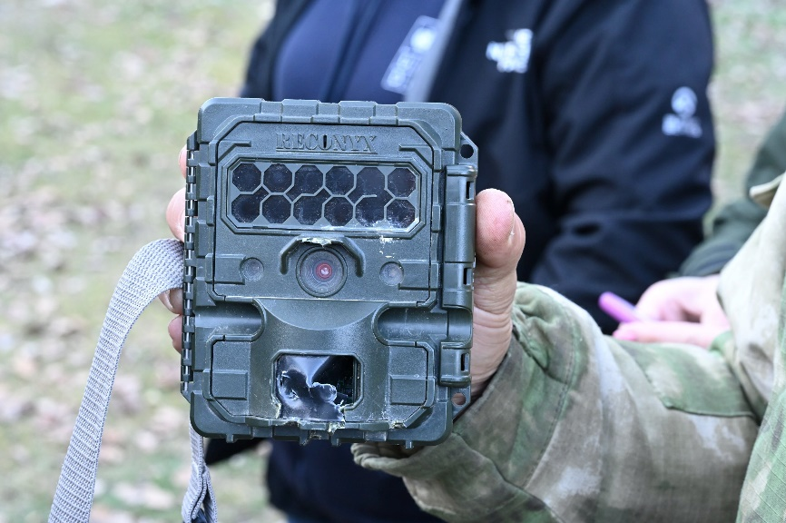
Camera trap slightly damaged by bear
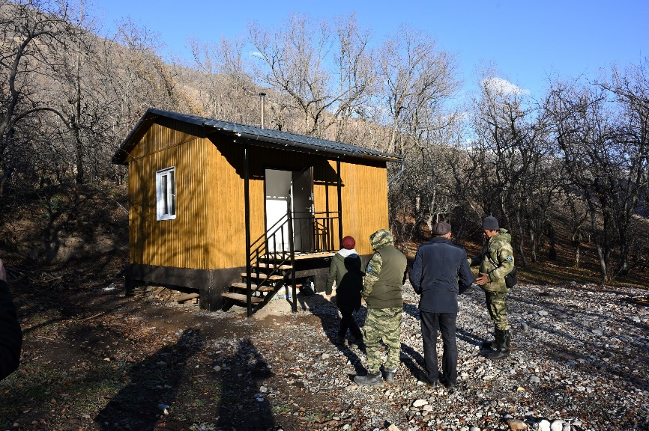
Newly constructed ranger accommodation in Alatai SNP

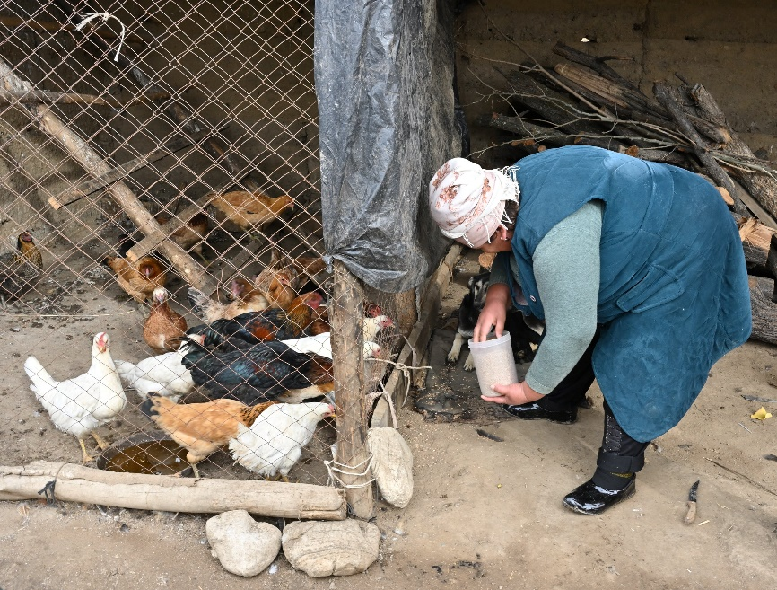
Micro project: chicken farming

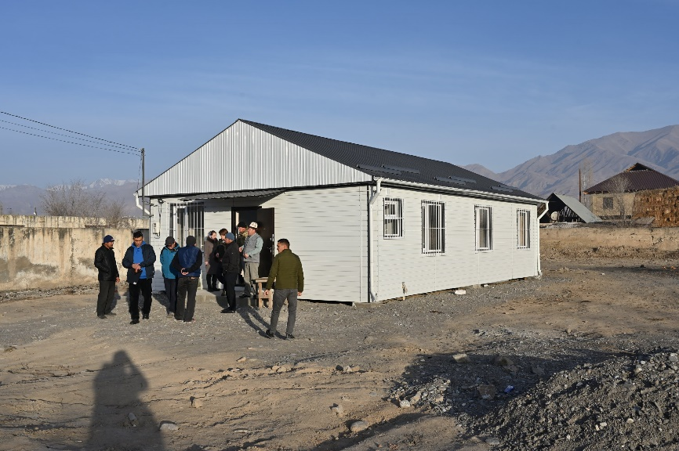
Administrative building in Toguz -Toro District

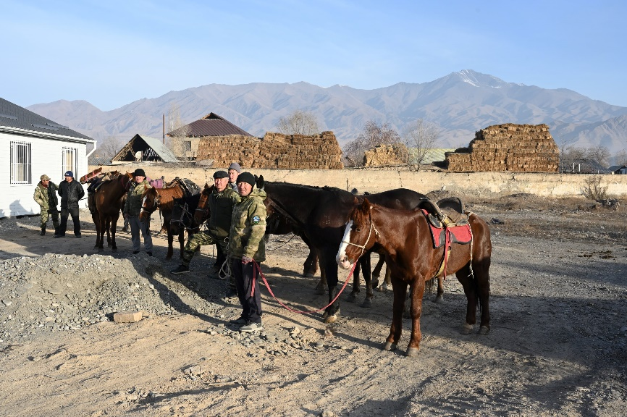
Rangers with horses and equipment provided by project in Toguz-Toro

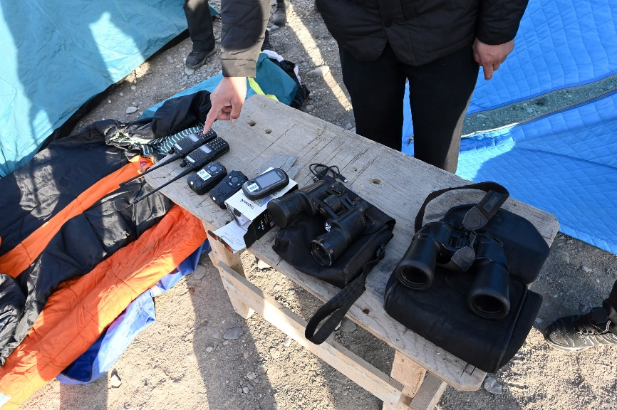
Various equipment for Kan-Achuu SNP, provided by project

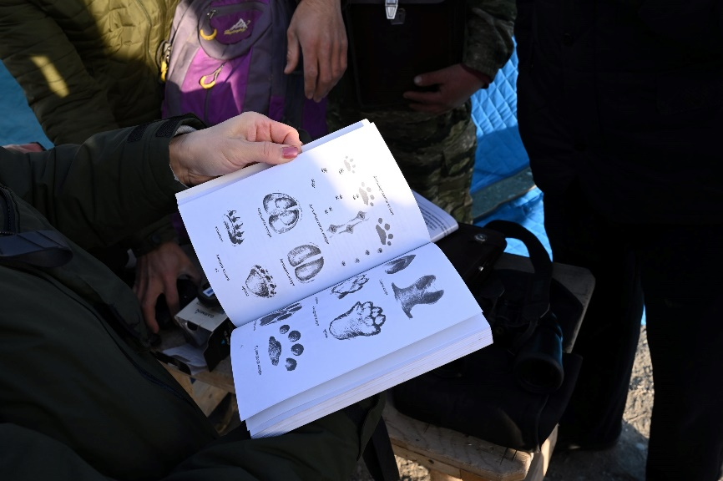
Ranger instruction book provided by project

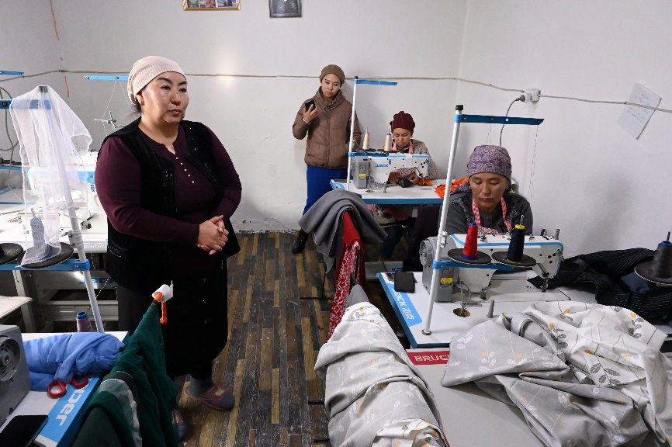
Micro project: sewing workshop

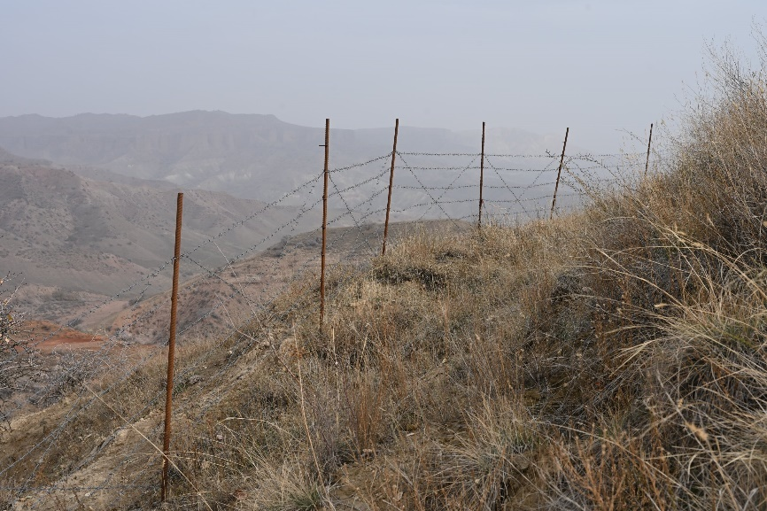
Recovering vegetation in fenced enclosure

- TE Mission itinerary
Time | Name | Position | Entity/Activity | Place
November 8 , 2023 Wednesday
06:15 | Floris Deodatus | International Consultant for the WTS Project Terminal Evaluation | Arrival to Bishkek
15:00 | Gulmira Akhmatova | National Consultant for the WTS Project Terminal Evaluation | Meeting with a National Consultant
16:00-17:00 | Lira Zholdubaeva  Aidai Ashiralieva | Climate Change Programme and Policy Analyst  Programme Associate | Meeting with a Team leader and a Project Associate and a Project Coordinator | Bishkek
17:00-18:00 | Nurgazy Abdrakhmanov |  | Security brief UNDP | Bishkek
November 9, Thursday
9:00-10:00 |  |  |  | Bishkek
10:00-11:00 | Alexandra Solovieva,  Monica Rijal  Aidai Arstanbekova  Lira Zholdubaeva  Aidai Ashiralieva | UNDP SM  UNDP MnE | Meeting with UNDP CO SM | Bishkek
11:30-12:30 | Project team |  | Meeting with Project team | Bishkek
14:00-19:00 |  |  | Travel Bishkek - Toktogul
19:00 |  |  | Dinner with WTS field specialist | Toktogul town
10 November 2023 (Friday)
8:30-9:30 | Stalbek Anarbaev | Director and the park management staff | Visiting the office of the Alatai State Nature Park | Toktogul town
9:40-10:30 | Akylbek Tukebaev OR Kojobergenov Nurbolot | Head (Akim) or his Deputy | Meeting with Akim (Head) District State Administration of Toktogul district | Toktogul town
10:50-12:00 | Kanybek Toktonazarov | Director | Visiting the office of Toktogul leskhoz (forestry) | Toktogul town
12:00-13:00 |  |  | Lunch | Toktogul town
13:00-15:30 |  |  | Drive to SNP Alatai territory
15:30-16:30 |  |  | Visiting the park territory  Meeting with park rangers
16:30-19:00 |  |  | Drive back to Toktogul  Arrival to Toktogul | Toktogul town
11 November 2023 (Saturday)
7:30-8:30 |  |  | Drive to Cholpon-Ata village
8:30-9:30 | Jamankulov Oskon | Head of Cholpon-Ata aiyl aimak | Cholpon-Ata Aiyl aimak | Cholpon-Ata village
 | Kadyrbek uulu Bakbergen | Chairman of Pasture Committee | Cholpon-Ata Aiyl aimak Pasture users union
9:30-10:30 | Jeenbaev Kairat | Local community "Cholpon-Ata-Alatai" | Ecotourism - bird watching | Cholpon-Ata village
10:30-11:00 |  |  | Drive to Aktektir village
11:00-12:00 | Chalov Akmat | The Chairman of the Kelechek -Aktektir Community | project of social support of vulnerable population | Ak-Tektir village
12:00-13:10 | Tabyldy kyzy Guzel | Kyrgyz Jaiyty, Initaitive group Kunduz | a wool processing and clothing workshop to provide employment to women | Ak-Tektir village
13:10-14:00 |  |  | Drive back to Toktogul
15:00-16:00 |  |  | Drive to Uch-Terek village
16:00-17:00 | Cholponkulov Muratbek | Ketmen-Tobo honey beekeepers' social association | Honey products processing workshop | Uch-Terek village
17:00-17:30 |  |  | Drive to -Kyzyl-Ozgorush village
17:30-18:30 | Mamyrkulov Nurlan | Chairman of Kara-Suu public association | Ecotourism Development Project | Kyzyl-Ozgorush village
18:30-19:00 | Toktalieva Gulnara | representative of a local  community Tash Kechtuu | Milk processing project | Tash Kechuu village
19:30-20:00 |  |  | Drive to Meimankana Kok-Bel  Accomodation to Kok-Bel hotel | Kok-Bel
12 November 2023 (Sunday)
8:00-12:30 |  |  | Drive to Aksy district  Lunch on the road (KaraKol town)
12:30-13:30 | Mairambek Osmonov | Deputy director | Rengit forestry of Aksy LH counterpart,  Meeting with Aksy leskhoz team members
13:30-14:30 |  |  | Drive to Akjol forestry
14:30-15:00 | Mairambek Osmonov | Deputy director | Akjol forestry, Aksy leskhoz,  Walnut plantations
15:00-19:00 |  |  | Drive back to Toktogul, arrival to Toktogul
13 November 2023 (Monday)
08:30-10:00 |  | Representative of a Toktogul leskhoz, foresters | Drive to Bordu site, Toktogul leskhoz
10:00-10:30 |  |  | Inspection of walnut plantations in Bordu site to Toktogul leskhoz
10:30-12:00 |  |  | Drive back to Toktogul
13:00-14:30 |  |  | drive to Kairak site, Toktogul leskhoz
14:30-15:30 |  |  | Meeting with leskhoz representatives  Inspection of fruit plantation
15-30 |  |  | Drive to Bishkek
14 November (Tuesday)
09:00-10:00 | Ibraev Emir | Former director Department of Biodiversity Conservation and Protected Areas | MNRETS KR | Bishkek, Chui 160, UN headquarters, 2nd floor, Aquarium meeting room
10:30-11:30 | Chyngyz Kochorov | Head of Secretariat | GSLEP (Global Snow Leopard and Ecosystem Program) under the Ministry of Natural Resources, Environment and Technical Supervision of the Kyrgyz Republic | Bishkek, Erkindik boulevard 2,  Ministry of Natural resources,  Ecology and Technical supervision,  3rd floor, 319 room
14:00-15:00 | Amankulov Mirslav, Talant Tudumatov | Director | Ministry of Natural Resources, Environment and Technical Supervision - Department of Biodiversity Conservation and Specially Protected Areas | Bishkek, Gorkyi str., 142, 4th floor
15:10-16:30 | Musaev Almaz, Bakyt Yrsaliev | Director of Forest service,  Deputy of director of Forest service | Forestry Sevice under the Ministry of Agriculture | Bishkek, Lev Tolstoy str. 3
17-00-18-00 | Azamat Isakov | former coordinator WTS Project |  | Bishkek
18:00-18:30 | Taalaibek Amanov | Former Field specialict | UNPP/GEF project WTS | Bishkek
15 November (Wendsday)
09:00-10:00 | Egemberdiev Abdimalik |  | National Association of Pasture Users  of Kyrgyzstan “Kyrgyz Jaiyty” | Bishkek
10:00-11:00 | Talant - Salamat - Aliya |  | NGO "CAMP Alatoo" | Bishkek
11:30-12:30 | Aitkul Burkhnova |  | Kyrgyzstan Association of Forest and Land Users (KAFLU) | Bishkek
13:30-14:30 | Askar Davletbakov |  | National Academy of Science of KR | Bishkek
15:30-16:30 | Zairbek Kubanychbekov |  | PF Ilbirs | Bishkek
16:30-17:30 | Mr. Zhantaev Kanatbek | former director | Integrated Forest Ecosystem Management Project | Bishkek
 | Venera Surappaeva |  | FAO | Bishkek
16 November (Thursday)
8:00-16:00 |  |  | drive to Kazarman, Toguz-Toro district
17:00-18:00 | Manas Murataliev | Akim (Head) | Meeting with Akim of Toguz-Toro district
17 November (Friday)
9:00-10:00 | Suimon Asylbekov | Director | State Nature Park Kan-Achuu | Kazarman village
10:10-11:10 | Askar Batyrbekov | Director | Toguz-Toro leskhoz | Kazarman village
11:10-11:40 |  |  | Drive to Atai aiyl aimak
11:40-12:30 | Asker Zhanybaev | Head of aiyl aimak | Atai aiyl aimak, visiting a fruit plantation initiative | Atai village
12:30-13:30 | Busurmankulova  Baktygul | Ainuska community leader | Mini-sewing shop | Atai village
13:30-14:00 |  |  | Drive to Kok-Irim aiyl aimak
14:00-15:30 | Turatbaeva Ainagul | Kyrgyz Daamy community  leader | Lunch  Mini-bakery shop | Atai village
15:30-16:30 |  |  | Drive back to Kazarman
16:30-17:30 |  |  | Meeting with SNP Kan-Achuu staff, adminbuilding - optional
18 November (Saturday)
8-00-16:00 |  |  | drive back to Bishkek
 |  |  | Arrival to Bishkek
19 November (Sunday)
 |  |  | Preparation debriefing and report
20 November (Monday)
09:00-10:00 | Koshtub Sharma |  | Snow Leopard Trust | Bishkek
 | Kubanych Zhumabai uulu |  | Snow Leopard Foundation | Bishkek
10:00-11:00 | Miragul, Dinara |  | Biofin | Bishkek
11:00-12:00 | Emil Usupov |  | UNDP, SDG classter | Bishkek
13:30-14:30 | Meeting with team |  | WTS Project, Mirlan, Ulan, Anida, Barchynai, Umut | Bishkek
14:30-15:30 | Lira Zholdubaeva, Aidai Ashyralieva |  | UNDP | Bishkek
15:30:16:30 | Kulipa Akmatova |  | "Rural Development Fund" PF | Bishkek
21 November (Tuesday)
 |  |  | Preparation debriefing and report
22 November 2023 (Wendsday)
 |  |  | Hunting Department
16:00 |  |  | Mission wrap-up meeting & presentation of initial findings
23 November 2023
10:45 | Floris Deodatus |  | Departure from Bishkek

- List of persons interviewed
# | Name | Position | Entity | Place
1 | Ms. Alexandra Solovieva | Country Office Resident Representative | UNDP Kyrgyzstan | Bishkek
2 | Ms. Monica Rijal | Country Office Deputy Resident Representative | UNDP Kyrgyzstan | Bishkek
3 | Ms. Lira Zholdubaeva | Team Leader of Climate Change, Environment and Biodiversity Cluster | UNDP Kyrgyzstan | Bishkek
4 | Ms. Aidai Ashiralieva | Programm Associate, Energy&Environment Programme Oversight&Support Unit | UNDP Kyrgyzstan | Bishkek
5 | Mr. Nurgazy Abdrakhmanov | National Security Officer | UNDP Kyrgyzstan | Bishkek
6 | Ms. Aidai Arstanbekova | Specialist, M&E Unit | UNDP Kyrgyzstan | Bishkek
7 | Ms. Viktoria Petrova | Head of Exploration | UNDP Kyrgyzstan | Bishkek
8 | Ms. Umut Zholdoshova | Project Coordinator | WTS Project | Bishkek
9 | Ms. Anida Shergalieva | National Consultant on Supporting the Low-Value Grants Program implementation | WTS Project | Bishkek
10 | Ms. Barchynai Kydykeeva | National Consultant on Project Implementation Support | WTS Project | Bishkek
11 | Mr. Mirlan Dyikanbaev | National Communications Consultant | WTS Project | Bishkek
12 | Mr. Ulan Amanturov | Civil Engineer | WTS Project | Bishkek
13 | Mr. Stalbek Anarbaev | Director | Alatai State Nature Park | Toktogul town
14 | Mr. Ulan Mambetov | Deputy Director | Alatai State Nature Park | Toktogul town
15 | Mr. Marzakan Omutov | Research Specialist | Alatai State Nature Park | Toktogul town
16 | Mr. Bakytbek Tursunaliev | Ranger | Alatai State Nature Park | Toktogul district
17 | Mr. Kalibek Karagulov | Ranger | Alatai State Nature Park | Toktogul district
18 | Mr. Nurbolot Kojobergenov | First Deputy Head-Akim | State Administration of Toktogul district of Jalal-Abad oblast of Kyrgyz Republic | Toktogul town
19 | Mr. Kanybek Toktonazarov | Director | Toktogul leskhoz (forestry) | Toktogul town
20 | Mr. Mirlan Kichinebatyrov | Forester | Toktogul leskhoz | Toktogul district
21 | Mr. Oskon Jamankulov | Head of Cholpon-Ata aiyl aimak | Cholpon-Ata Aiyl aimak, Toktogul region | Cholpon-Ata village, Toktogul district
22 | Mr. Kadyrbek uulu Bakbergen | Chairman of Pasture Committee | Pasture users union of the Cholpon-Ata Aiyl aimak | Cholpon-Ata village, Toktogul district
23 | Mr. Mairambek Zhumanazarov | Former Chairman of Pasture Committee | Pasture users union of the Cholpon-Ata Aiyl aimak | Cholpon-Ata village, Toktogul district
24 | Mr. Esenkul Nusupov | Chairman | Public Supervisory Board of the Alatai SNP | Cholpon-Ata village, Toktogul district
25 | Mr. Kairat Jeenbaev | Local community "Cholpon-Ata-Alatai" | Micro-project (Ecotourism - bird watching) | Cholpon-Ata village, Toktogul district
26 | Mr. Akmat Chalov | The Chairman of the Kelechek -Aktektir Community | Micro-project (Social support of vulnerable population) | Ak-Tektir village, Toktogul district
27 | Ms. Gulmira Usubalieva | Member of the Kelechek -Aktektir Community | Micro-project (Social support of vulnerable population) | Ak-Tektir village, Toktogul district
28 | Ms. Nurchakan Chalova | Member of the Kelechek -Aktektir Community | Micro-project (Social support of vulnerable population) | Ak-Tektir village, Toktogul district
29 | Ms. Kalbyubyu Chokulova | Member of the Kelechek -Aktektir Community | Micro-project (Social support of vulnerable population) | Ak-Tektir village, Toktogul district
30 | Ms. Gulsara Tabyldy kyzy | Kyrgyz Jaiyty, Initaitive group Kunduz | Micro-project (Wool processing and clothing workshop) | Ak-Tektir village, Toktogul district
31 | Mr. Tabyldy Ismailov | Kyrgyz Jaiyty, Initaitive group Kunduz | Micro-project (Wool processing and clothing workshop) | Ak-Tektir village, Toktogul district
32 | Mr. Muratbek Cholponkulov | Ketmen-Tobo honey beekeepers' social association | Micro-project (Honey products processing workshop) | Uch-Terek village, Toktogul district
33 | Mr. Nurlan Mamyrkulov | Chairman of Kara-Suu public association, volunteer ranger | Micro-project (Ecotourism Development) | Kyzyl-Ozgorysh village, Toktogul district
34 | Mr. Asan uulu Tynybek | Member of the Kara-Suu public association, volunteer ranger | Micro-project (Ecotourism Development) | Kyzyl-Ozgorysh village, Toktogul district
35 | Ms. Gulnara Toktalieva | Representative of a local community Tash-Kechtuu | Micro-project (Milk processing) | Tash Kechtuu village, Toktogul district
36 | Mr. Mairambek Osmonov | Deputy director | Aksy leskhoz | Aksy district
37 | Mr. Djalynbek Suerkulov | Forester | Aksy leskhoz | Aksy district
38 | Mr. Kumarbek Ergeshbaev | Forester | Aksy leskhoz | Aksy district
39 | Mr. Barchynbek Tashmatov | Forester | Aksy leskhoz | Aksy district
40 | Mr. Abdybaly Zhanaliev | Farmer | Aksy leskhoz | Aksy district
41 | Mr. Kylychbek Moldaliev | Forester | Aksy leskhoz | Aksy district
42 | Mr. Batyr Baizhumanov | Director | Сonstruction company “Orion Group International” | Toktogul town
43 | Mr. Chyngyz Kochorov | Head of Secretariat | GSLEP (Global Snow Leopard and Ecosystem Program) | Bishkek
44 | Mr. Mirslav Amankulov | Director | Department of Biodiversity Conservation and Protected Areas, MNRETS | Bishkek
45 | Mr. Talant Tudumatov | Deputy Director | Department of Biodiversity Conservation and Protected Areas, MNRETS | Bishkek
46 | Mr. Azat Osmonov | Specialist | Department of Biodiversity Conservation and Protected Areas, MNRETS | Bishkek
47 | Mr. Kumar Mambetaliev | Head | Department of Bioresources, MNRETS | Bishkek
48 | Mr.Emil Ibraev | Former director | Department of Biodiversity Conservation and Protected Areas, MNRETS | Bishkek
49 | Mr. Azamat Isakov | Former Coordinator WTS Project | WTS Project | Bishkek
50 | Mr. Taalaibek Amanov | Former Field specialict | WTS Project | Bishkek
51 | Mr. Bakyt Yrsaliev | Deputy of director of Forest service | Forestry Service of the Ministry of Agriculture | Bishkek
52 | Mr. Abdimalik Egemberdiev | Director | Association of Pasture Users of Kyrgyzstan “Kyrgyz Jaiyty” | Bishkek
53 | Mr. Talant Toktosunov | Project specialist for pasture and forest management | NGO PF "CAMP Alatoo" | Bishkek
54 | Ms. Salamat Dzhumabaeva | Coordinator for climate change adaptation and biodiversity conservation projects | NGO PF "CAMP Alatoo" | Bishkek
55 | Mr. Aitkul Burkhnov | Director | Kyrgyzstan Association of Forest and Land Users (KAFLU) | Orto-Sai village
56 | Mr. Askar Davletbakov | Head of Department | Institute of Biology, National Academy of Sciences of KR | Bishkek
57 | Mr. Zairbek Kubanychbekov | Director | Public Foundation Ilbirs | Bishkek
58 | Mr. Zhantaev Kanatbek | Former Director | Integrated Forest Ecosystem Management Project (World Bank project) | Bishkek
59 | Ms. Venera Surappaeva | Consultant | FAO | Bishkek
60 | Mr. Manas Murataliev | Head-Akim of the region | State Administration of Toguz-Toro district of Jalal-Abad oblast of Kyrgyz Republic | Kazarman village, Toguz-Toro district, Jalal-Abad oblast
61 | Mr. Tagaibek uulu Damirbek | Deputy Head-akim of the region | State Administration of Toguz-Toro district of Jalal-Abad oblast of Kyrgyz Republic | Kazarman village, Toguz-Toro district, Jalal-Abad oblast
62 | Mr. Sumeikul Asylbekov | Director | State Nature Park Kan-Achuu | Kazarman village, Toguz-Toro district, Jalal-Abad oblast
63 | Mr. Aknazar Tilemambetov | Deputy Director | State Nature Park Kan-Achuu | Kazarman village, Toguz-Toro district, Jalal-Abad oblast
64 | Mr. Batyrbek uulu Askar | Director | Toguz-Toro leskhoz | Kazarman village, Toguz-Toro district, Jalal-Abad oblast
65 | Mr. Askerbek Zhanybaev | Head of aiyl aimak | Atai aiyl aimak, (fruit plantation initiative micro-project) | Atai village, Toguz-Toro district, Jalal-Abad oblast
66 | Mr. Kubanychbek Masyrakunov | Farmer | Atai aiyl aimak, (fruit plantation initiative micro-project) | Atai village, Toguz-Toro district, Jalal-Abad oblast
67 | Ms. Baktygul Busurmankulova | Leader of "Ainuska" community | Mini-sewing shop (micro-project) | Atai village, Toguz-Toro district, Jalal-Abad oblast
68 | Ms. Gulnaz Turdubaeva | Leader of community | Ecotourism micro-project | Kok-Irim AA, Toguz-Toro district, Jalal-Abad oblast
69 | Mr. Koustubh Sharma | Director, Science and Conservation/International Coordinator | Snow Leopard Trust | Bishkek
70 | Mr. Kubanych Zhumabai uulu | Director | Snow Leopard Foundation | Bishkek
71 | Ms. Miragul Kochkorova | Director | Biofin | Bishkek
72 | Ms. Dinara Turdumatova | Consultant | Biofin | Bishkek
73 | Mr. Emil Usupov | Consultant | UNDP, SDG classter | Bishkek
74 | Ms. Kulipa Akmatova | Director | NGO PF "Rural Development Fund" | Bishkek

- List of documents reviewed
- Project Identification Form (PIF)
- UNDP Initiation Plan
- Final UNDP-GEF Project Document with all annexes
- CEO Endorsement Request
- UNDP Social and Environmental Screening Procedure (SESP) and associated management plans (if any)
- Inception Workshop Report
- Mid-Term Review report and management response to MTR recommendations
- All Project Implementation Reports (PIRs)
- Progress reports (quarterly, semi-annual or annual, with associated workplans and financial reports)
- Oversight mission reports
- Minutes of Project Board Meetings and of other meetings (i.e. Project Appraisal Committee meetings)
- GEF Tracking Tools (from CEO Endorsement, midterm and terminal stages)
- GEF/LDCF/SCCF Core Indicators (from PIF, CEO Endorsement, midterm and terminal stages); for GEF-6 and GEF-7 projects only
- Financial data, including actual expenditures by project outcome, including management costs, and including documentation of any significant budget revisions
- Co-financing data with expected and actual contributions broken down by type of co-financing, source, and whether the contribution is considered as investment mobilized or recurring expenditures
- Audit reports
- Electronic copies of project outputs (booklets, manuals, technical reports, articles, etc.)
- Sample of project communications materials
- Summary list of formal meetings, workshops, etc. held, with date, location, topic, and number of participants
- Any relevant socio-economic monitoring data, such as average incomes / employment levels of stakeholders in the target area, change in revenue related to project activities
- List of contracts and procurement items over ~US$5,000 (i.e. organizations or companies contracted for project outputs, etc., except in cases of confidential information)
- List of related projects/initiatives contributing to project objectives approved/started after GEF project approval (i.e. any leveraged or “catalytic” results)
- UNDP Country Programme Document (CPD)
- List/map of project sites, highlighting suggested visits
- List and contact details for project staff, key project stakeholders, including Project Board members, RTA, Project Team members, and other partners to be consulted
- Project deliverables that provide documentary evidence of achievement towards project outcomes

- Evaluation Question Matrix (evaluation criteria with key questions, indicators, sources of data, and methodology)
Reviewed Component | Sub-Question | Indicators | Sources | Data Collection Method
Review criteria: Relevance - How does the project relate to the main objectives of the GEF, UNDP and of Kyrgyzstan to strengthen its capacity to manage land and forest resources, including biodiversity conservation?
Is the Project relevant to the GEF objectives? | - How does the Project support the related strategic priorities of the GEF?  - Were GEF criteria for project identification adequate in view of actual needs? | - Level of coherence between project objectives and those of the GEF | - Project document and project results  - GEF policies and strategies | - Policy coherence analysis  - Interviews with government officials and other partners
Is the Project relevant to UNDP objectives? | - How does the project support the objectives of UNDP in this sector? | - Existence of a clear relationship between project objectives and country programme objectives of UNDP | - Project document and project results  - UNDP strategies and programme | - Policy coherence analysis  - Interviews with UNDP environment section
Is the Project relevant to Kyrgyzstan’s policies on forest conservation and biodiversity conservation? | - Does the project follow the government's policy priorities for forest and biodiversity conservation?  - How does the Project support the management of land and forest resources, including biodiversity conservation in Kyrgyzstan?  - Does the project address the identified problem?  - How country-driven is the Project?  - Does the Project adequately take into account national realities, both in terms of institutional framework and programming, in its design and its implementation?  - To what extent were national partners involved in the design of the Project? | - Degree to which the project supports the management of land and forest resources, including biodiversity conservation in Kyrgyzstan  - Degree of coherence between the project and national priorities, policies and strategies; particularly related to the management of land and forest resources, including biodiversity conservation in Kyrgyzstan  - Appreciation from national stakeholders with respect to adequacy of project design and implementation to national realities and existing capacities?  - Level of involvement of Government officials and other partners into the project design and implementation | - Project document and results  - National policies, strategies and programmes  - Key government officials and other partners | - Policy coherence analysis  - Review of problem analysis  - Interviews with government officials and other partners
Does the Project address the needs of target beneficiaries? | - How does the project support the needs of target beneficiaries?  - Has the implementation of the project been inclusive with regard to relevant Stakeholders?  - Are local beneficiaries and stakeholders adequately involved in project formulation and implementation? | - Appreciation of project results by target beneficiaries  - Degree of involvement and inclusiveness of beneficiaries and stakeholders in project design and implementation | - Beneficiaries and stakeholders  - Needs assessment studies  - Project document and results | - Document analysis  - Interviews with beneficiaries and stakeholders in the field
Is the Project internally coherent in its design? | - Was the project sourced through a consistent problem analysis?  - Is there a direct and strong link between project expected results (Result and Resources Framework, Theory of Change) and the project design (in terms of project components, choice of partners, structure, delivery mechanism, scope, budget, use of resources etc.)?  - Is the length of the project conducive to achieve project outcomes? | - Level of consistency between project expected results and internal project design logic  - Level of consistency between project design and project implementation approach | - PIF, Project Document, MTR report  - Key project stakeholders (Government, RTA, …) | - Document analysis  - Key Interviews
How is the Project relevant in light of other donors? | - How does the project strategies and outcomes match with other donor interventions?  - How does the GEF help to fill gaps (or give additional stimulus) that are crucial but are not covered by other donors? | - Degree to which the project was coherent and complementary to other donor programming in Kyrgyzstan | - Other Donors’ policies and programming documents  - Other Donor representatives  - Project documents | - Documents analyses  - Interviews with other Donors
Directions for future projects | - What lessons have been learnt and how can they be adopted in future projects in order to strengthen the alignment between the project and the partners’ priorities and areas of focus? | - Identified opportunities for follow up | - Conclusions reached under above questions | - Discussions with key stakeholders (Government, donors, beneficiaries)
- Review criteria: Effectiveness – To what extent have the expected outcomes and objectives of the project been achieved?
How is the Project effective in achieving its expected outcomes? | - Has the project achieved its expected outcomes?  - Conservation and sustainable management of Key Biodiversity Areas within landscape  - Ecosystem resilience and habitat connectivity in Western Tian Shan are enhanced by regulating land and forest use in buffer zones and corridors and support to sustainable livelihoods  - Strengthened national capacities for snow leopard conservation, promoting Kyrgyz regional and global cooperation, and setting the scene for up-scaling | - Results framework indicators  - Introduced and adopted methodologies, skills and knowledge  - Improved capacity for managing land and forest resources, including biodiversity conservation in Kyrgyzstan  - Change in capacity for awareness raising  - Stakeholder involvement and government awareness  - Change in local stakeholder behaviour  - Change in capacity in policy making and planning to improve the management of land and forest resources, including biodiversity conservation in Kyrgyzstan:  - Policy reform  - Legislation/regulation change  - Development of national and local strategies and plans  - Improved capacity in implementation and enforcement  - Design and implementation of risk assessments  - Implementation of national and local strategies and action plans through adequate institutional frameworks and their maintenance  - Monitoring, evaluation and promotion of pilots  - Improved capacity in mobilizing resources  - Leverage of resources  - Human resources  - Appropriate practices  - Mobilization of advisory services | - Project progress reports  - Key stakeholders including UNDP, Project Team, Representatives of Gov. and other Partners  - Research findings  - METT | - Documents analysis  - Meetings with main Project Partners  - Interviews with project beneficiaries  - Field visits
How is risk and risk mitigation being managed? | - How well have risks and assumptions been managed?  - What is the quality of risk mitigation strategies developed? | - Completeness of risk identification and assumptions during project planning  - Quality of existing information systems to identify emerging risks and other issues?  - Quality of risk mitigations strategies developed and followed | - Quantum risk log  - Project documents and evaluations  - UNDP, Project Staff and Project Partners | - Document analysis  - Interviews with project and UNDP staff
Directions for future projects | - What lessons have been learnt for the project to achieve its outcomes?  - What changes could have been made (if any) to the formulation of the project in order to improve the achievement of project’s expected results? |  | - Conclusions reached under above questions | - Discussions with key stakeholders (Government, donors, beneficiaries)
- Review criteria: Efficiency – Has the project been implemented efficiently, cost-effectively and in-line with international and national norms and standards?
Is Project support channelled in an efficient way? | - Has adaptive management been used to ensure efficient resource use?  - Have Project Results Framework and work plans and any changes made to them been used as management tools during implementation?  - Are the accounting and financial systems in place adequate for project management and producing accurate and timely financial information?  - How adequate is the M&E framework (indicators & targets)?  - Are progress reports produced accurately, timely and responded to reporting requirements including adaptive management changes?  - Is project implementation as cost effective as originally proposed (planned vs. actual)  - Did leveraging of funds (co-financing) happen as planned?  - Are financial resources utilized efficiently? Could financial resources have been used more efficiently?  - Is the project decision-making effective?  - Does the government provide continuous strategic directions to the project's formulation and implementation?  - Have these directions provided by the government guided the activities and outcomes of the project?  - Does the project mainstream gender considerations into its implementation? | - Availability and quality of financial and progress reports  - Timeliness and adequacy of reporting provided  - Level of discrepancy between planned and utilized financial expenditures  - Planned vs. actual funds leveraged  - Adequacy of project choices in view of existing context, infrastructure and cost  - Quality of RBM reporting (progress reporting, monitoring and evaluation)  - Occurrence of change in project formulation/ implementation approach (i.e. restructuring) when needed to improve project efficiency  - Existence, quality and use of M&E, feedback and dissemination mechanism to share findings, lessons learned and recommendation on effectiveness of project design.  - Cost associated with delivery mechanism and management structure compared to alternatives  - Gender disaggregated data in project documents | - Project documents and evaluations  - UNDP, Representatives of Gov. and Project Staff  - Beneficiaries and Project partners  - Steering committee minutes | - Document analysis  - Key Interviews (project staff, government, steering committee)
How efficient are partnership arrangements for the Project? | - Is the government engaged?  - How does the government demonstrate its ownership of the projects?  - Did the government provide counterparts to the project?  - To what extent are partnerships/linkages between institutions/ organizations encouraged and supported?  - Which partnerships/linkages are facilitated? Which one can be considered sustainable?  - What is the level of efficiency of cooperation and collaboration arrangements? (between local actors, UNDP and relevant government entities) | - Specific activities conducted to support the development of cooperative arrangements between partners  - Examples of supported partnerships  - Evidence that particular partnerships/linkages will be sustained  - Types/quality of partnership cooperation methods utilized | - Project documents and evaluations  - Project Partners  - UNDP, Representatives of Gov. and Project Staff  - Beneficiaries | - Document analysis  - Interviews
Does the Project efficiently utilize local capacity in implementation? | - Was an appropriate balance reached between the utilization of international expertise and local capacity?  - Does the project support mutual benefits through sharing of knowledge and experiences, training, technology transfer among developing countries?  - Did the Project take into account local capacity in formulation and implementation of the project?  - Was there an effective collaboration with scientific institutions with competence in management of land and forest resources, including biodiversity conservation in Kyrgyzstan? | - Proportion of total expertise utilized taken from Kyrgyzstan  - Number/quality of analyses done to assess local capacity potential and absorptive capacity  - Evidence of collaboration in the frame of trans-national World Heritage Site and snow leopard landscape | - Project documents and evaluations  - UNDP, Project Team and Project partners  - Beneficiaries | - Document analysis  - Interviews
Directions for future projects | - What lessons can be learnt from the project on efficiency?  - How could the project have more efficiently addressed its key priorities (in terms of management structures and procedures, partnerships arrangements etc.…)?  - Suggestions for future projects? |  | - Conclusions reached under above questions | - Discussions with key stakeholders (Government, donors, beneficiaries)
- Review criteria: Impacts - Are there indications that the project has contributed to the improvement of the management of land and forest resources, including biodiversity conservation in Kyrgyzstan?
How is the Project effective in achieving its long-term objectives? | - Did the project achieve its objective to promote an integrated landscape approach for the conservation of internationally important biodiversity, and land and forest resources in the Western Tian Shan mountains in Kyrgyzstan? | - Results frame indicators  - Changes in capacity:  - To pool/mobilize resources  - To provide an enabling environment,  - For implementation of related strategies and programmes through adequate institutional frameworks and their maintenance,  - Changes in use and implementation of sustainable alternatives  - Changes to critical threats to biodiversity in Western Tian Sharn:  - Human-Wildlife Conflicts  - Unsustainable Pasture Management  - Overgrazing in Forests  - Unsustainable Use of Forests  - Legal and Illegal Hunting of Ungulates  - Changes to the state of barriers such as:  - Weak management of Key Biodiversity Areas  - Unsustainable management of land and forest in wider landscape  - Low uptake of and capacity to implement international best practices for snow leopard conservation and management of its habitat | - Project documents  - Key Stakeholders  - Research findings  - METT  - Core indicator values | - Documents analysis  - Meetings with UNDP, Project Team and project Partners  - Interviews with project beneficiaries and other stakeholders
How is the Project impacting the local environment? | - What are the impacts or likely impacts of the project on?  - Local environment;  - Poverty; and,  - Other socio-economic issues. | - Results frame indicators  - Provide specific examples of impacts at those three levels, as relevant | - Project documents  - Key Stakeholders  - Research findings  - METT | - Data analysis  - Interviews with key stakeholders
Directions for future projects | - How can future projects build on successes and learn from its weaknesses of this project in order to enhance impact? |  | - Conclusions reached under above questions | - Discussions with key stakeholders (Government, donors, beneficiaries)
- Review criteria: Sustainability - To what extent are there financial, institutional, social-economic, and/or environmental risks to sustaining long-term project results?
Are sustainability issues adequately integrated in Project design? | - Were sustainability issues integrated into the formulation and implementation of the project?  - Does the project employ government implementing and/or monitoring systems?  - Is the government involved in the sustainability strategy for project outcomes? | - Evidence/Quality of sustainability strategy  - Evidence/Quality of steps taken to address sustainability | - Project documents and MTR  - UNDP, project staff and project Partners  - Beneficiaries | - Document analysis  - Interviews
Did the project adequately address financial and economic sustainability issues? | - Did the project adequately address financial and economic sustainability issues?  - Are the recurrent costs (if any) after project completion sustainable? | - Level of recurrent costs after completion of project and funding sources for those recurrent costs  - Level and source of future financial support to be provided to relevant sectors and activities after project end  - Evidence of commitments from Kyrgyz government, international partners, or other stakeholders to financially support relevant sectors of activities after project end | - Project documents and MTR  - Government, UNDP, project staff and project Partners  - Beneficiaries  - BioFin strategy? | - Document analysis  - Interviews
Organizations arrangements and continuation of activities | - Are results of efforts made during the project implementation period well assimilated by organizations and their internal systems and procedures?  - Is there evidence that project partners will continue their activities beyond project support?  - What degree is there of local ownership of initiatives and results?  - Have appropriate ‘champions’ identified and mobilized? | - Degree to which project activities and results have been taken over by Government, local counterparts or institutions/organizations  - Number/quality of champions mobilized | - Project documents and evaluations  - UNDP, project staff and project Partners  - Beneficiaries | - Document analysis  - Interviews
Enabling Environment | - Have policies, laws and other frameworks been addressed through the project, in order to assure sustainability of key initiatives and reforms?  - Have the necessary related capacities for law enforcement been built?  - What is the level of political commitment to build on the results of the project? | - State of enforcement capacity  - Current policy and legislation  - Evidence of commitment by the political class through speeches, enactment of laws and resource allocation to priorities | - Project documents and MTR  - UNDP, project staff and project Partners  - Beneficiaries | - Document analysis  - Interviews
Institutional and individual capacity building | - Is the capacity in place at the national and sub-national levels adequate to ensure sustainability of results achieved to date? | - Elements in place in those different management functions, at appropriate levels (national and sub-national levels) in terms of adequate structures, strategies, systems, assigned tasks, skills, incentives and interrelationships with other key actors | - Project documents and MTR  - UNDP, Project staff and project Partners  - Beneficiaries  - Capacity assessments available, if any  - METT | - Interviews  - Documentation review
Social and political sustainability | - Did the project contribute to key building blocks for social and political sustainability by training and communication activities?  - Did the project contribute to local Stakeholders’ acceptance of the new practices in this regard? | - Example of contributions to sustainable political and social change with regard to improving the management of land and forest resources, including biodiversity conservation in Kyrgyzstan | - Project documents and MTR  - Project communication strategy  - UNDP, project staff and project Partners  - Beneficiaries  - Media | - Interviews  - Documentation review
Replication | - Have successful project results been documented, published and promoted?  - Were project activities and results replicated elsewhere and/or scaled up?  - What was the project contribution to replication or scaling up of innovative practices or mechanisms to improve the management of land and forest resources, including biodiversity conservation in Kyrgyzstan?  - Did the project have a catalytic role? | - Publications  - Number/quality of replicated initiatives  - Number/quality of replicated innovative initiatives  - Volume of additional investment leveraged | - Other donor programming documents  - Beneficiaries  - UNDP, project staff and project Partners  - Media | - Document analysis  - Interviews
Challenges to sustainability of the Project | - What are the main challenges that may hinder sustainability of efforts?  - Have any of these been addressed through the project management?  - What could be the possible measures to further contribute to the sustainability of efforts achieved with the project? | - Challenges in view of building blocks of sustainability as presented above  - Recent context changes which may present new challenges to sustainability of project outcomes | - Project documents and MTR  - Beneficiaries  - UNDP, project staff and project Partners | - Document analysis  - Interviews
Directions for future projects | - Which areas/arrangements under the project show the strongest potential for lasting long-term results?  - What are the key challenges and obstacles to the sustainability of results of project initiatives?  - How can the good practices of this project continue to benefit improved land and forest resources management and biodiversity conservation in Kyrgyzstan?  - How can national decision-makers (Parliament, Government etc.) improve policies and practices to improve land and forest resources management and biodiversity conservation in Kyrgyzstan? |  | - Conclusions reached under above questions | - Discussions with key stakeholders (Government, donors, beneficiaries)

- TE Rating scales
Ratings for Outcomes, Effectiveness, Efficiency, M&E, Implementation/Oversight, Execution, Relevance | Sustainability ratings:
6 = Highly Satisfactory (HS): exceeds expectations and/or no shortcomings  5 = Satisfactory (S): meets expectations and/or no or minor shortcomings  4 = Moderately Satisfactory (MS): more or less meets expectations and/or some shortcomings  3 = Moderately Unsatisfactory (MU): somewhat below expectations and/or significant shortcomings  2 = Unsatisfactory (U): substantially below expectations and/or major shortcomings  1 = Highly Unsatisfactory (HU): severe shortcomings  Unable to Assess (U/A): available information does not allow an assessment | 4 = Likely (L): negligible risks to sustainability  3 = Moderately Likely (ML): moderate risks to sustainability  2 = Moderately Unlikely (MU): significant risks to sustainability  1 = Unlikely (U): severe risks to sustainability  Unable to Assess (U/A): Unable to assess the expected incidence and magnitude of risks to sustainability

- Progress towards results matrix (Achievement of outcomes against End-of-project Targets)
This project will contribute to achieving the following Country Program Outcome as defined in CPAP or CPD: | UNDAF Pillar C, Outcome 2: By end of 2016 sustainable management of energy, environment and natural resources practices operationalized.  UNDAF Pillar C, Outcome 2 Indicators: % of people living in ecosystems resilient to climate change; % increase in agricultural production for markets and households;  Country Program Outcome A.2.9: Environment and climate change integrated into pro poor (socio-economic) development policies and programs
Country Program Outcome Indicators: | % of people who have equitable access to ecosystem services by province; % of water use efficiency for agricultural and energy production; % of population benefiting from non-carbon energy sources
Applicable GEF-6 Biodiversity Strategic Objectives, Programs, Outcomes, Indicators: | BD-1, Program 1, Outcome 1.2, Indicator 1.2  BD-1, Program 2, Outcome 2.2, Indicator 2.2  BD-4, Program 9, Outcome 9.1, Indicator 9.1
Applicable GEF-6 Land Degradation Strategic Objectives, Programs, Outcomes, Indicators: | LD – 3, Program 4, Outcome 3.2, Indicator 3.2
Applicable GEF-6 Sustainable Forest Management Strategic Objectives, Programs, Outcomes, Indicators: | SFM – 1, Program 2, Outcome 1, Indicator 1  SFM – 2, Program 5, Outcome 3, Indicator 3  SFM – 3, Program 7, Outcome 5, Indicator 5
Project Goal: | Improve the status of globally significant biodiversity, and improve the provision of ecosystem services from forest and land resources in Kyrgyzstan’s Western Tian Shan mountains, supporting sustainable livelihoods.

Component | Indicator | Baseline (2016) | End of Project Target | MTR level | TE level | Rating | Justification of rating
Objective: To promote a landscape approach to protection of internationally important biodiversity, and land and forest resources in the Western Tian Shan mountains in Kyrgyzstan | 1. Trend in population levels of globally significant fauna (Red List, ecosystem indicator or keystone species) in Jalal-Abad province:  Snow leopard (Panthera uncia)  Ibex (Capra sibirica)  Golden eagle (Aquila chrysaetos)  Tian Shan white clawed bear (Ursus arctos isabellinus) | Negative trend over the past 25 years of individuals that are present at least sometime during the year in Jalal-Abad province. Number of individuals and annual rate of change:  Snow leopard (Panthera uncia): 49; <0%  Ibex (Capra sibirica): 4116; <3%  Golden eagle (Aquila chrysaetos): 31;<1%  Tian Shan white clawed bear (Ursus arctos isabellinus): 197; <4% | Population trend is at least stable over a rolling five-year period. Number of individuals and annual rate of change:  Snow leopard (Panthera uncia): 49; >0%  Ibex (Capra sibirica): 4839; >3%  Golden eagle (Aquila chrysaetos):40; >1%  Tian Shan white clawed bear (Ursus arctos isabellinus): 256; >5% | - Snow leopard (Panthera uncia): 31;  - Ibex (Capra sibirica): 3050;  - Golden eagle (Aquila chrysaetos): 0;  -Tian Shan white clawed bear (Ursus arctos isabellinus): 234 | - Snow leopard (Panthera uncia): 48 (98% of EoP target);  - Ibex (Capra sibirica): 7580 (157% of EoP target);  - Golden eagle (Aquila chrysaetos): 131 (328% of EoP target);  - Tian Shan white-clawed bear (Ursus arctos isabellinus): 376 (147% of EoP target) | S | SL stable, Ibex increasing, bear increasing, golden eagle fluctuating  SL population still to be determined by camera trapping
 | 2. Status of globally significant flora in Toktogul and Toguz-Toro districts:  Semenov’s fir (Abies Semenovii)  Juniper (Juniperus sp.)  Relict spruce (Picea schrenkiana) | Index of area and forest quality of globally significant flora in Toktogul and Toguz-Toro districts (ha):  Semenov’s fir (Abies Semenovii) – Total = 4,281.8 ha:  Ha - Category 1: 2,025.1 (47%)  Ha – Category 2: 1,728.3 (40%)  Ha – Category 3: 528.4 (12%)  Ha – Category 4: 0 (0%)  Juniper (Juniperus sp.) – Total = 6,847.3 ha:  Ha - Category 1: 694.4 (10%)  Ha – Category 2: 4,254.9 (62%)  Ha – Category 3: 1,898 (28%)  Ha – Category 4: 0 (0%)  Relict spruce (Picea schrenkiana) – Total = 2,125.5 ha:  Ha - Category 1: 850.6 (40%)  Ha – Category 2: 1,048.8 (49%)  Ha – Category 3: 226.1 (11%)  Ha – Category 4: 0 (0%) | Index of area and forest quality of globally significant flora in Toktogul and Toguz-Toro districts:  Semenov’s fir (Abies Semenovii) – Total = 4,281.8 ha:  Ha - Category 1: 2,225.1  Ha – Category 2: 1,956.3  Ha – Category 3: 100.4  Ha – Category 4: 0  Juniper (Juniperus sp.) – Total = 7,171.8 ha:  Ha - Category 1: 1289.1  Ha – Category 2: 4,701.7  Ha – Category 3: 1,181.0  Ha – Category 4: 0  Relict spruce (Picea schrenkiana) – Total = 4,202.6 ha:  Ha - Category 1: 1,745.7  Ha – Category 2: 2,456.9  Ha – Category 3: 0  Ha – Category 4: 0 | - Semenov's fir (Abies semenovii) - 4,930.5 ha (115% of EoP target)  - Juniper (Juniperus sp.) - 9,204.6 ha (128% of EoP target)  - Relict spruce (Picea schrenkiana) - 4,322.2 ha (103% of EoP target) | - Semenov's fir  (Abies semenovii) – 4,493.2 ha (105% of EoP target)  Ha - Category 1: 2,288.9  Ha – Category 2: 2,168.0  Ha – Category 3: 36.3  Ha – Category 4: 0  - Juniper (Juniperus sp.) – 10,243 ha  (143% of EoP target)  Ha - Category 1: 6,658.7  Ha – Category 2: 3,568.2  Ha – Category 3: 16.1  Ha – Category 4: 0  - Relict spruce  (Picea schrenkiana) - 4,830,4 ha (115% of EoP target)  Ha - Category 1: 2,718.5  Ha – Category 2: 2,044.6  Ha – Category 3: 67.3  Ha – Category 4: 0 | HS | Achievements for different species between 105 and 143%
 | 3. Area of degraded pastureland in four target A/As in Toktogul and Toguz-Toro districts  - Cholpon-Ata  - Kyzyl-Ozgorush  - Kok-Irim  - Atai | 65,361 ha (estimated based on relevant available data) | 0 ha (decrease of 65,361 ha) | - Set up four (4) demonstration sites (0.6 ha in total) to conduct monitoring activities of degraded pastures; Joint activities with the Kok- Yrim AA of Toguz-Toro district on restoring degraded pastures (250 ha) and providing sainfoin seeds; | Achieved 75 % of EoP.  Area of degraded pastureland decreased 16 026 ha:  Alatai SNP 1 346 ha  Kan-Achuu SNP 502 ha  Kok-Irim AA 1 668 ha  Atai AA 5 760 ha  Cholpon-Ata AA 1 751 ha  Kyzyl-Ozgorysh AA 4 999 ha | MS | Achievement is only 75%
 | 4. Landscape area under directly improved conservation management | Area of Jalal-Abad province for which improved biodiversity, forest, and land management measures will be directly influenced by project results:  0 ha | Area of Jalal-Abad province for which improved biodiversity, forest, and land management measures will be directly influenced by project results:  472,635 ha (SFM in 34,382 ha of forest (the forested area under management by Toktogul and Toguz-Toro leskhozes), restoration of degraded forest in 4,886 ha, implementation of SLM in 147,268 ha of pasturelands (65,361 ha of which is degraded pasturelands). In addition, 286,099 ha of protected areas, of which 87,322 ha are the two new PAs in the primary target districts.) | Integrated management plan was developed for Toktogul LH (72,324 ha);  Natural regeneration -on 7,200 ha, and new plantings on 250 ha;  • In the territory of the Alatai NP, the disputed areas around the lake Kara-Suu of 1,662.8 ha were transferred to NP (SAEPF order of 01.01.2019 No. 01-9/10) and in collaboration with of the SNP Alatai project, the lake Kara-Suu was excluded from the list of fish hosts of the Ministry of Agriculture;  more effective management and protection - 88,985 ha (including the transferred area of 1,663 ha); | Area of Jalal-Abad province for which improved biodiversity, forest, and land management measures was directly influenced by project results - 615,998.5 ha:  1) SFM-189,787.7 ha:  • Toktogul LH - 72,324 ha  • Toguz-Toro LH -54,874.5 ha  • Aksy LH- 62,589.2 ha  Restoration of degraded forest (4,886 ha)  2) Implementation of SLM- 132,106.4 ha, (including enhancement of degraded pastures of 65,361 ha):  • Cholpon-Ata AA pastures 56,494 ha  • Kok-Irim AA pastures 31,629 ha  • Atai AA pastures 15,741 ha  • Kyzyl-Ozgorysh AA pastures 28,242.4 ha  3) Protected areas in the primary target district including two new SNP - 294,104.4 ha:  - SNP Alatai (new) 56,826.4 ha  - SNP Kan-Achuu (new) 30,496.5 ha  - Dashman SNR 7,958.1 ha  - Besh Aral SNR 112,463.4 ha  - Saimaluu Tash SNP 31,932 ha  - Sary-Chelek SNR 23,868 ha  - Padysh-Ata SNR – 30,560 ha | HS | Achieved 130% of the EoP target.
 | 5. Landscape area under indirectly improved conservation management | Area of Jalal-Abad province for which improved biodiversity, forest, and land management measures will be indirectly influenced by project results:  0 ha | Area of Jalal-Abad province for which improved biodiversity, forest, and land management measures will be indirectly influenced by project results:  944,317 ha (Area of two target districts, less the area of the PAs (87,322 ha), SFM land (34,382 ha), afforested area (4,886 ha), and SLM land (147,268 ha) covered in these districts under direct coverage above.) | Areas of the two pilot SNPs (88,985 ha), SFM land (34,382 ha), afforested area (7,450 ha), and SLM land (147,268 ha) covered in these districts under direct coverage above. | Achieved for 92.3% of EoP or 880577.2 ha.  Area of Jalal-Abad province for which improved biodiversity, forest, and land management measures will be indirectly influenced by project results:  -880577.2 ha (Area of two target districts Toktogul (781,500 ha) and Toguz-Toro (381,600 ha) and ecological corridor Chatkal (64105 ha), less the area of the two SNPs (87322.9 ha), SFM land (127198.5 ha), SlM land (132106.4 ha). | MS | Achieved for 92.3% of EoP
 | 6. Population of Toktogul and Toguz-Toro districts that have derived indirect livelihood benefits from project results (disaggregated by gender) | Toktogul District  0 women  0 men  Toguz-Toro District  0 women  0 men  Baseline: 2015 | Toktogul District communities of Cholpon-Ata and Kyzyl-Ozgorush  8,979 women  9,328 men  Toguz-Toro District communities of Kok-Irim and Atai  2,723 women  2,909 men | Toktogul District communities of Cholpon-Ata and Kyzyl-Ozgorush - 20,166 people:  - 9,879 women  - 10,287 men  Toguz-Toro District communities of Kok-Irim and Atai –  5,836 people:  - 2,864 women  - 2,972 men | Achieved.  Toktogul district communities of Cholpon-Ata and Kyzyl-Ozgorush - 20,118 people:  - 11,159 women  - 8,959 men  Toguz-Toro district communities of Kok-Irim and Atai –  6063 people:  - 2,937 women  - 3,126 men | HS | 110 % achieved
Outcome 1: Conservation and sustainable management of Key Biodiversity Areas within landscape | 7. Management effectiveness of key alpine protected areas in Jalal-Abad province covering 286,099 ha | METT Score:  Alatai SNP (new PA): 17  Kan-Achuu SNP (new PA): 16  Sary-Chelek SBR: 59  Padysh-Ata SNR: 45  Besh Aral SNR: 43  Saimaluu-Tash SNP: 29 | METT Score:  Alatai NP (new PA): >50  Kan-Achuu NP (new PA): >50  Sary-Chelek SNR: >65  Padysh-Ata SNR: >50  Besh Aral SNR: >50  Saimaluu-Tash SNP: >40 | METT Score:  Alatai SNP (new PA): 23  Kan-Achuu SNP (new PA): 21  Sary-Chelek SBR: 59  Padysh-Ata SNR: 46  Dashman SNR: 44  Besh Aral SNR: 47  Saimaluu-Tash SNP: 40 | METT Score:  Alatai SNP (new PA): - 78 (156% of EoP)  Kan-Achuu SNP (new PA): 75 (150% of EoP)  Sary-Chelek SNR: 70 (107% of EoP)  Padysh-Ata SNR: 63 (126% of EoP)  Besh Aral SNR: 79 (158% of EoP)  Saimaluu-Tash SNP: 63 (157.5% of EoP) | HS | 121% achieved
 | 8. Status of HCVF management approach legal and regulatory framework | HCVF management approach not legally recognized, and consequently not regulated | HCVF management approach has legal basis, and relevant regulations are produced, | - Initial review of the legal and regulatory framework, which concluded that the HCVF management approach, is not reflected in existing legal framework.  - Jointly with the UNDP Kazakhstan review and developing a draft concept of HVCF;  - Regional Workshop in Almaty;  - Developed the first draft of the HCVF concept for Kyrgyzstan and the methodology for determining forests of this category. | Achieved.  Forest Code amended to include HCVF as a distinct article.  Proposed law, embedding HCVF, under consideration by the Cabinet of Ministries.  MoA KR approved methodology for HCVF identification (Order No.177, May 22, 2022).  Successful identification and mapping of HCVF in Toktogul and Toguz-Toro leskhozes.  FS under MoA KR issued monitoring instructions for HCVF (Order No. 01/1-8/416, Dec 12, 2022). | HS | These steps demonstrate a comprehensive approach, integrating HCVF into Kyrgyz Republic forestry practices for sustainable management and biodiversity conservation.
 | 9. Existence of HCVF management measures in FMPs and level of implementation in Toktogul and Toguz-Toro districts | HCVF management measures not incorporated in FMPs in Toktogul and Toguz-Toro districts  0/6 on GEF TT scale: No existence or mention of biodiversity (e.g. HCVF) considerations in sector policy | Implementation is initiated (defined as incorporation of HCVF management practices in approved FMPs) in Toktogul and Toguz-Toro districts  4/6 on GEF TT scale: “Step 4: The regulations are under implementation” | Kyrgyzstan suggests merging HCV 1 with HCV 3 and HCV 2 with HCV 4, resulting in four groups:  1) HCV 1 & 3: Biodiversity Concentrations  Endemic and endangered species with global significance.  2) HCV 2 & 4: Large Landscape Ecosystems  Vital ecosystems at global, regional, or national levels.  3) HCV 5: Fundamental for Local Communities  Essential for local communities' basic needs, identified through engagement.  4) HCV 6: Cultural and Historical Significance  Globally or nationally significant cultural, archaeological, or historical sites, identified through engagement.  The final classification for Kyrgyzstan will be decided in 2019. | Achieved.  Advancements in HCVF Identification and Management:  The approved Methodology and step-by-step guidance for HCVF identification.  Progress in the identification and mapping of HCVF within the territory of Toktogul and Toguz-Toro LHs.  Identification Outcomes:  Toktogul LH identified four HCVF categories and HCVF area- 47,951.3 ha, Toguz-Toro LH identified three categories and HCVF area - 11,170.5 ha. Total HCVF area is 59,121.8 ha, exceeding the End of Project target by 148%.  Integration of HCVF management into FMPs of leskhozes.  JFMCs established in both Toguz-Toro and Toktogul LHs.  Trainings on HCVF management and conservation for 120 representatives from Toktogul, Toguz-Toro and other leskhozes in the WTS region. | HS | This progress reflects a robust commitment to surpassing conservation targets and instilling sustainable forestry practices in the WTS region.
 | 10. Average number of hectares covered per week by anti-poaching patrols (PA rangers, forest rangers, and game wardens) in Alatai SNP (56,826 ha) and Kan-Achuu SNP (30,497 ha), Toktogul (104,860 ha) and Toguz-Toro (57,356 ha) leskhoz territories, and Chychkan Zoological (game) reserve (65,551) territories in Toktogul and Toguz-Toro districts, out of the 315,090 ha total SNP, leskhoz, and game reserve) | 250 hectares patrolled per week in 2016 (10 km covered per day by ranger teams (2+ individuals) for each of five management areas for 5 of 7 days) | 1000 hectares patrolled per week in 2021 (baseline * four times the number of anti-poaching ranger team patrols for each location. Assessed as the minimum coverage necessary to ensure effective management, regulatory monitoring, and deterrence of illegal activities) | No data  - Identified and addressed training needs for SAEPF's anti-poaching patrols.  - Collaborated with SAEPF, local NGOs, and the Academy of Science, learning from successful community-based conservation experiences, notably Panthera in Chon Kemin valley.  - Conducted outreach meetings with local communities in collaboration with the Department of Biodiversity Conservation and PAs, focusing on establishing community patrols.  - Established two Freelance Ranger groups in Toktogul and Toguz-Toro districts two of which were women. | Achieved.  4767 ha patrolled per week (477% of EoP).  From 2022 to 2023, anti-poaching and protection patrol operations were carried out by Alatai SNP, Kan-Achuu SNP, Toktogul and Toguz-Toro leskhozes, covering in total 243,110 ha in active collaboration with the Jalal-Abad regional office of the MNRETS KR, as well as district police offices. | S | Achieved, but difficult to verify as no SMART patrolling has been fully implemented yet
Outcome 2: Ecosystem resilience and habitat connectivity in Western Tian Shan are enhanced by regulating land and forest use in buffer zones and corridors and support to sustainable livelihoods | 11. Area of sustainably managed forest in Toktogul and Toguz-Toro districts (broken down by HCVF in PAs, HCVF in leskhoz, and all other forest) | Total 0 ha out of 40,839 ha of HCVF  Toktogul HCVF: 31,045 ha (5,658 ha within Alatai PA, 25,387 ha in leskhoz);  Toguz-Toro HCVF: 9,794 (799 within Kan-Achuu PA, 8,995 ha in leskhoz); | >40,000 ha | 0 ha of HCVF  Actions in this area will follow the adoption of the HVCF concept and methodology (see Targets 8 & 9 above). | 188% of EoP.  The total area of HCVF identified within the targeted leskhozes (59,121.8 ha) and two SNPs (12729 ha) - 75,204.8 ha, surpassing the End of Project (EoP) target by 188%.  Toktogul district HCVF total area – 60,680.3 ha, including:  Alatai SNP: HCVF of 1st category - 12,729 ha.  Toktogul LH: HCVF area – 47,951.3 ha:  - HCVF of the 1st category: 14,634.2 ha  - HCVF of the 4th category: 30,936.2 ha  - HCVF of the 5th category: 141.6 ha  - HCVF of the 6th category: 2,239.3 ha.  Toguz-Toro district HCVF total area – 14,524.5 ha, including:  • Kan-Achuu SNP: HCVF of 1st category - 3,354 ha,  • Toguz-Toro LH HCVF area – 11,170.5 ha:  HCVF of the 1st category: 1,649.3 ha  - HCVF of the 4th category: 8,979.8 ha  - HCVF of the 6th category: 541.4 ha. | HS | 188% achieved
 | 12. Area of forest resources restored in the landscape (broken down by reforested/afforested area, vs. area under natural regeneration support | 0 ha | 4,886 ha (500 ha reforestation/afforestation, 4,500 ha supported for natural regeneration) | 250 ha afforestation and 7,200 ha support for natural regeneration.  4 plots for reforestation have been identified and agreed with the Department of Forest Ecosystem Development.  Spring 2018, planting on 94 ha,  Autumn 2018, preparatory work for planting - 50 ha,  Spring of 2019- 100 ha planted.  200 ha - identified for next year.  The main species planted are: Tien Shan spruce, walnut, almond and pistachio. | Achieved.  A total of 8,923 ha (or 193% of the EoP) are fenced to support natural regeneration and 528 ha reforestation/  afforestation reaching and exceeding the target of 500 ha (105% of EoP). | HS | respectively 193% and 105% achieved
 | 13. Lifetime indirect GHG emissions avoided | 0 tons CO₂ equivalent | 2,979,548 tons CO₂ equivalent | No progress.  Methodology to calculate the emissions and emission reductions is ongoing with the National communication on climate change project team. | 4,905,020 tons CO2 equivalent.  The project is projected to prevent and absorb 4,905,020 tons CO2-equivalent, exceeding the EoP target of 2,979,548 tons CO2 equivalent, and its impact on the carbon balance was assessed in 2023 using the latest EX-ACT tool. | HS | 165 % achieved
 | 14. Implementation of e-Pasture Management System (as an SLM mechanism supporting implementation of the Pastures Law) in Toguz-Toro and Toktogul districts | Pasture Management Committees (PMCs) do not have support mechanisms to implement SLM | e-Pasture Management System implemented by 4 PMCs in Toktogul and Toguz-Toro districts | Revision and improvement of the existing pasture management system is underway as well as on-site training for pilot pasture management committees. | The E-Pasture Management System has been implemented in four pilot aiyl aimaks in Toktogul and Toguz-Toro districts, facilitating database creation, automatic data processing, fair pasture allocation, conflict resolution, and effective public control for local pasture committees, contributing to the development of a localized community-level pasture use plan. | HS | 100 % achieved
 | 15. Hectares of alpine grassland and forest ecosystems under improved conservation management | 0 ha | 186,536 ha - SFM in 34,382 ha of HCVF, restore degraded forest in 4,886 ha, and implement SLM in 147,268 ha of pasturelands | Working groups have been created under district administrations to revise regional development strategies and integrate biodiversity conservation concepts. As a result, biodiversity conservation management has been improving in the area where the project pilots are, including the following areas: two pilot PAs (88,985 ha), SFM (34,382 ha), afforested area (7,450 ha), and SLM (147,268 ha). | Achieved and exceeded (134%)  250655,8 ha -  - SFM has been practicing in 72,727 ha of HCVF areas (SNP Alatai – 12,729.5 ha,  SNP Kan-Achuu – 3354 ha),  Toktogul LH – 47951.3 ha and Toguz-Toro LH - 11,170.5 ha), exceeding the EoP target by 217%.  -9,451 ha of degraded forests have been restored (8,923+528 ha), surpassing the EoP target by 193%. 9,451 hectares of degraded forests have been restored (8,923+528 ha), surpassing the EoP target by 193%.  -sustainable pasture management has been implemented in 166,000 ha, surpassing the EoP target by 113%. | HS | 134% achieved
 | 16. Hectares of pastureland under SLM in Toktogul and Toguz-Toro districts | 0 ha | 147,268 ha | Not achieved.  - 300 ha restored, procurement of seed for degraded pastures;  - New SNPs are closed to grazing, as a result, pastures in SNPs should be restored naturally;  - Developed an integrated management plan with partners in the Toktogul district with the focus on biodiversity conservation. Area adjacent to the SNP Alatai (72,324 ha). | Achieved and exceeded by 113%  166,000 ha of pastureland under SLM including 30,000 ha of pastureland within SNP Alatai and SNP Kan-Achuu. | HS | 113% achieved
 | 17. Number of people whose livelihoods are affected by land degradation in Toktogul and Toguz-Toro districts (with a population number index value fixed set at 100 for 2016 (in case of total population increases or decreases)) | Women: 11,702  Men: 12,237  Total: 23,939  Index = 100%  Toktogul District  Cholpon-Ata Village  3,562 women  3,802 men  Kyzyl-Ozgorush Village  5,417 women  5,526 men  Toguz-Toro District  Kok-Irim Village  1,703 women  1,782 men  Atai Village  1,020 women  1,127 men | Women: <11,702  Men: <12,237  Total: <23,939  Index: <100% of total population  Toktogul District  Cholpon-Ata Village  3,562 women  3,802 men  Kyzyl-Ozgorush Village  5,417 women  5,526 men  Toguz-Toro District  Kok-Irim Village  1,703 women  1,782 men  Atai village  1,020 women  1,127 men | An in-depth assessment of livelihoods affected by land degradation in Toktogul and Toguz-Toro districts is being prepared:  - Toktogul District communities of Cholpon-Ata and Kyzyl-Ozgorush – 20,166 people: 9,879 women and 10,287 men  - Toguz-Toro District communities of Kok-Irim and Atai 5,836 people:2,864 women and 2,972 men. | Index: 3,4% of total population is affected by pasture degradation  Women: 13846, affected 389  Men: 12998, affected 434  Total: 26844, affected 823  Toktogul District  Cholpon-Ata Village:  4160 women (affected 120)  4283 men (affected 154)  Kyzyl-Ozgorush Village:  6754 women (affected 108)  5399 men (affected 113)  Toguz-Toro District  Kok-Irim Village:  1711 women (affected 80)  2053 men (affected 92)  Atai village:  - 1221 women (affected 81)  - 1263 men (affected 75) | S | The achievement seems considerable. However, both baseline and TE level are based on assumptions. The indicator is therefore questionable
 | 18. Herder/farmer income change based on benefits from micro-finance/grant program for individuals participating in the program. | Women: N/A  Men: N/A | Women: 10% increase  Men: 10% increase | No progress  Waiting for the implementation of the micro-grant scheme, which should generate income for local communities including herders and farmers. | -Women: 5.02% increase  - Men: 5.02% increase  Herders/farmers (744 individuals (including 469 women, making up 63% of participants), saw a 5.02% boost in income from 15 Low-Value grant projects (total grants’ sum $199,361). The project calculated the total income from ONLY these LVG activities which reached KGS 2,992,865 ($36,104) during 2022-2023. Compared to the baseline of Djalal-Abad oblast's average annual income of 80,064 KGS in 2021 (stat.org), participants in the LVG program received income 4,023 KGS per person per year in the initial years (2022-2023), showing a 5.02% increase. Considering that LVG grantees only started implementing the project in 2022-2023, this demonstrates an overall significant improvement in the financial well-being of the participants. | MU | - 50% achievement  annual returns on grant is 15%, but sustainability is questionable
Outcome 3: Strengthened national capacities for snow leopard conservation, promoting Kyrgyz regional and global cooperation, and setting the scene for up-scaling | 19. Level of illegal wildlife trade activity, as indicated by number of snow leopard, snow leopard prey, and other illegal wildlife seizures at border crossings and at Manas international airport, as well as number of arrests related to wildlife trafficking | Annual number of seizures:  2015 - On the Tajik-Kyrgyz border - attempted transfer from Tajikistan to Kyrgyzstan of two snow leopard skins and one snow leopard cub  2015 - one snow leopard skin confiscated in Bishkek (from Talas region)  2016 - one snow leopard skin confiscated in Issyk-Kul  Zero seizures assisted by specially trained dogs  4 arrests related to wildlife trafficking  <50% of prosecutions resulting from wildlife trafficking arrests | Annual number of seizures:  Snow leopard: <Baseline (at least one seizure assisted by specially trained dogs)  Snow leopard prey: <Baseline (at least one seizure assisted by specially trained dogs)  Other illegal wildlife: <Baseline (at least one seizure by specially trained dogs)  Number of arrests = >baseline  >50% of arrests result in prosecutions | No progress | Achieved.  -2021 attempt to sell SL skin in Osh;  -2021 wounded SL found in Talas Oblast, 70 pellets extracted from wound  -2022 State Border Service reported intended smuggle to Kazakhstan of SL skin and skull in Chaldybar village of Chui oblast;  -2022 Issyk-Kul Oblast Department of Internal Affairs one SL shot, gun, skull and skin found  -2022 State Customs Service reported no seizures of illegal wildlife products at Manas International Airport | MS | This indicator is not SMART  We can conclude that law enforcement is ongoing, but effectiveness not clear
 | 20. Level of international cooperation and coordination with Kyrgyzstan border countries regarding illegal wildlife trade, biodiversity management in borderland protected areas, and snow leopard monitoring | No formal international agreement between Kyrgyzstan and neighbouring countries related to snow leopard conservation | International agreement between Kyrgyzstan and at least one bordering country under implementation regarding at least one of the below issues:  Cooperation on law enforcement at border points regarding illegal wildlife trade  Illegal hunting by border guards  Data sharing on snow leopard monitoring | Consultation meetings with Central Asian partners, including GSLEP Secretariat.  Coordination meeting in Tashkent (July 2018) on establishing a Memorandum of Cooperation for SL Conservation.  Khujand meeting (April 2019) on regional genetic laboratory and review the Memorandum of Cooperation.  Agreements for joint expeditions and data exchange.  Products developed for the International Snow Leopard and Ecosystem Forum (Bishkek, August 2017). | Achieved -100%  Agreement between Kyrgyzstan, Tajikistan and Uzbekistan signed  Global Snow Leopard and Ecosystem Protection Program (GSLEP) Steering Committee Meeting held in Kyrgyzstan on October 20-21, 2022. Representatives from 12 snow leopard range countries – Afghanistan, Bhutan, India, Kazakhstan, China, Kyrgyzstan, Mongolia, Nepal, Pakistan, Russia, Tajikistan, and Uzbekistan. | HS | Achievement is 100%  The development of international collaboration in conservation in general and SL conservation specifically is instrumental for effective landscape management and the conservation of endangered species
 | 21. Quality and coverage of snow leopard monitoring data in Kyrgyzstan as indicated by estimated accuracy and timeliness of national snow leopard population estimate | Latest population estimate 15 years prior (2001) with a 30% confidence level (lowest possible estimated population / highest possible estimated population, i.e. 150/500 = 30%) | Publishing of annual estimates with a 60% confidence level (the average confidence level among other snow leopard range states in GSLEP population estimate) | Development of a Snow Leopard Monitoring Database with all relevant stakeholders.  Snow Leopard monitoring methodology is being developed jointly with the GSLEP Secretariat.  The project has also begun developing protocols and methodologies for research on the snow leopard in WTS.  Procurement of 50 camera traps for Alatai and Kan-Achuu SNPs to achieve robust population estimates by December 2023. | The analysis indicates an estimated 21 snow leopards (confidence interval: 15-21) in the entire Western Tien Shan region, with varying densities related to rocky terrain levels and protected areas.  For estimating snow leopard population in the Western Tian Shan with a 60% confidence level, camera traps and PASK methodology were used. Despite delays due to climatic anomalies, the data collected and analysed. | MS | This is the first estimate of the SL population using camera trapping PASK. This result cannot be compared with the baseline given and neither with the SL figure of the baseline of Indicator 1.  The methodology is under development  It is satisfactory because it may be the first and best population estimate, but not satisfactory since we can scientifically not determine a trend

- Project contributions to the GEF Biodiversity Results Framework
Objective | Program | Outcome | Indicator | Project contribution to indicator
Biodiversity Focal Area
BD-1 Improve sustainability of protected area systems | 1: Improving Financial Sustainability and Effective Management of the National Ecological Infrastructure | 1.2: Improve management effectiveness of protected areas | 1.2: Protected area management effectiveness score. | METT Score:  Alatai SNP (new PA):from 17 to 78  Kan-Achuu SNP (new PA): from 16 to 75  Sary-Chelek SNR: from 59 to 70  Padysh-Ata SNR: from 45 to 63  Besh Aral SNR: from 43 to 79  Saimaluu-Tash SNP: from 29 to 63
 | 2: Nature’s Last Stand: Expanding the reach of the global protected area estate | 2.1: Increase in area of terrestrial and marine ecosystems of global significance in new protected areas and increase in threatened species of global significance protected in new protected areas. | 2.1: Area of terrestrial and marine ecosystems and number of threatened species. | Two new SNP - 294,104.4 ha:  SNP Alatai (new) 56,826.4 ha  SNP Kan-Achuu (new) 30,496.5 ha  Covering homerange of snow leopard, ibex, Tian Shan clawed bear and golden eagle
 |  | 2.2: Improved management effectiveness of new protected areas | 2.2: Protected area management effectiveness score. | METT Score:  Alatai SNP (new PA):from 17 to 78  Kan-Achuu SNP (new PA): from 16 to 75
BD-4 Mainstream biodiversity conservation and sustainable use into production landscapes and seascapes and production sectors | 9: Managing the Human-Biodiversity Interface | 9.1 Increased area of production landscapes and seascapes that integrate conservation and sustainable use of biodiversity into management. | 9.1: Production landscapes and seascapes that integrate biodiversity conservation and sustainable use into their management. | Patrolled in leskhoz: 155788 ha  SFM in HCVF: 72,727 ha  Restoration of degraded forest: 9,451 ha  Sustainable pasture management: 166,000 ha
Land Degradation Focal Area
LD-3 Integrated Landscapes: Reduce pressures on natural resources from competing land uses in the wider landscape | 4: Scaling-up sustainable land management through the landscape approach | 3.2: Integrated landscape management practices adopted by local communities based on gender sensitive needs | 3.2: Application of integrated natural resource management (INRM) practices in wider landscapes. | Area of Jalal-Abad province for which improved biodiversity, forest, and land management measures was directly influenced by project results: 615,998.5 ha  including: protected areas, ecological corridors, buffer zones, pastures, leskhoz
Sustainable Forest Management Focal Area
SFM-1 Maintained Forest Resources: Reduce the pressures on high conservation value forests by addressing the drivers of deforestation. | 2: Identification and maintenance of high conservation value forests. | 1: Cross-sector policy and planning approaches at appropriate governance scales, avoid loss of high conservation value forests | 1: Area of high conservation value forest identified and maintained. | HCVF identified in leskhozes: 59 121.8 ha  HCVF in two new SNP: 12 729 ha  Total per category:  HCVF of the 1st category: 32 366 ha  HCVF of the 4th category: 39 915 ha  HCVF of the 5th category: 141 ha  HCVF of the 6th category: 2 780 ha
SFM-2: Enhanced Forest Management: Maintain flows of forest ecosystem services and improve resilience to climate change through SFM. | 5: Capacity development for SFM within local communities. | 3: Increased application of good management practices in all forests by relevant government, local community (both women and men) and private sector actors. | 3: Area of sustainably managed forest, stratified by forest management actors. | Total SFM-189,787.7 ha:  Subtotals:  Toktogul LH: 72,324 ha  Toguz-Toro LH: 54,874.5 ha  Aksy LH: 62,589.2 ha (additionally)
SFM-3 Restored Forest Ecosystems: Reverse the loss of ecosystem services within degraded forest landscapes | 7: Building technical and institutional capacities to identify degraded forest landscapes and monitor forest restoration. | 5: Integrated landscape restoration plans to maintain forest ecosystem services are implemented at appropriate scales by government, private sector and local community actors, both women and men. | 5: Area of forest resources restored in the landscape, stratified by forest management actors. | Restoration of degraded forest: 4,886 ha

- Code of conduct and signed Evaluation Consultant Agreement form
Evaluators/Consultants:
1. Must present information that is complete and fair in its assessment of strengths and weaknesses so that decisions or actions taken are well founded.
2. Must disclose the full set of evaluation findings along with information on their limitations and have this accessible to all affected by the evaluation with expressed legal rights to receive results.
3. Should protect the anonymity and confidentiality of individual informants. They should provide maximum notice, minimize demands on time, and respect people’s right not to engage. Evaluators must respect people’s right to provide information in confidence, and must ensure that sensitive information cannot be traced to its source. Evaluators are not expected to evaluate individuals, and must balance an evaluation of management functions with this general principle.
4. Sometimes uncover evidence of wrongdoing while conducting evaluations. Such cases must be reported discreetly to the appropriate investigative body. Evaluators should consult with other relevant oversight entities when there is any doubt about if and how issues should be reported.
5. Should be sensitive to beliefs, manners and customs and act with integrity and honesty in their relations with all stakeholders. In line with the UN Universal Declaration of Human Rights, evaluators must be sensitive to and address issues of discrimination and gender equality. They should avoid offending the dignity and self-respect of those persons with whom they come in contact in the course of the evaluation. Knowing that evaluation might negatively affect the interests of some stakeholders, evaluators should conduct the evaluation and communicate its purpose and results in a way that clearly respects the stakeholders’ dignity and self-worth.
6. Are responsible for their performance and their product(s). They are responsible for the clear, accurate and fair written and/or oral presentation of study imitations, findings and recommendations.
7. Should reflect sound accounting procedures and be prudent in using the resources of the evaluation.
8. Must ensure that independence of judgement is maintained, and that evaluation findings and recommendations are independently presented.
9. Must confirm that they have not been involved in designing, executing or advising on the project being evaluated and did not carry out the project’s Mid-Term Review.

Evaluation Consultant Agreement Form
Agreement to abide by the Code of Conduct for Evaluation in the UN System:
Names of Evaluators: (1) Floris Deodatus_(international consultant); Gulmira Akhmatova (National consultant)

We confirm that we have received and understood and will abide by the United Nations Code of Conduct for Evaluation.
Signed at _Steenwijk, The Netherlands_________ on _8/1/2023_________
Signature: _____________________________________________________________________
Signed at __Bishkek, Kyrgyz Republic___________ (Place) on ______________________ (Date)
Signature: _____________________________________________________________________
- Signed TE Report Clearance form
Terminal Evaluation Report for (Project Title & UNDP PIMS ID) Reviewed and Cleared By: Commissioning Unit (M&E Focal Point)
Name: _____________________________________________

Signature: __________________________________________ Date: _______________________________

Regional Technical Advisor (Nature, Climate and Energy)

Name: _____________________________________________

Signature: __________________________________________ Date: _______________________________

- Management Effectiveness Tracking Tool (METT)

Protected area | Baseline at project start-up 2016 | METT result 2019 | METT result 2021 | METT result 2023 | Target by project completion
Besh-Aral State Nature Reserve | 43 | 47 | 69 | 79 | >50
Sary-Chelek State Biosphere Reserve | 59 | 59 | 60 | 70 | >65
Padysha-Ata State Nature Reserve | 45 | 45 | 55 | 63 | >50
Dashman State Nature Reserve | 40 | 46 |  | 58
Saimaluu-Tash State Nature Park | 29 | 39 | 53 | 63 | >50
Alatai State Nature Park | 17 |  | 69 | 78 | >50
Kan-Achuu State Nature Park | 16 |  | 63 | 75 | >50

- Equipment purchased between 2017 and 2022 (>US$ 1000)
Description | Journal Date | Local Currency | USD Amount | Fiscal Year
cameras | 7-Sep-2017 | 85 400.00 | 1 249.45 | 2017
photocopiers | 29-Sep-2017 | 150 370.00 | 2 200.00 | 2017
comp pm17083 | 11-Oct-2017 | 218 743.20 | 3 198.00 | 2017
lcd projector mobile | 13-Oct-2017 | 88 570.00 | 1 294.88 | 2017
desktop computers | 19-Oct-2017 | 510 948.00 | 7 470.00 | 2017
radio, wireless security co | 28-Sep-2018 | 95 216.80 | 1 372.00 | 2018
optical amplifiers | 28-Sep-2018 | 218 332.40 | 3 146.00 | 2018
gps receivers | 28-Sep-2018 | 301 057.20 | 4 338.00 | 2018
uninterruptible power supply | 30-Oct-2018 | 1 856.00 | 1 856.00 | 2018
cameras | 30-Oct-2018 | 2 680.00 | 2 680.00 | 2018
notebook computers | 30-Oct-2018 | 2 712.00 | 2 712.00 | 2018
desktop computers | 30-Oct-2018 | 5 272.00 | 5 272.00 | 2018
cameras | 30-Oct-2018 | 6 650.00 | 6 650.00 | 2018
equip.for rangers for pas | 5-Dec-2018 | 227 408.40 | 3 258.00 | 2018
notebook computers for pas | 24-Dec-2018 | 91 438.00 | 1 310.00 | 2018
desktop computers for pas | 24-Dec-2018 | 121 452.00 | 1 740.00 | 2018
desktop computers for pas | 24-Dec-2018 | 184 621.00 | 2 645.00 | 2018
low cab forward tractors | 20-Feb-2019 | 3 099 425.00 | 44 500.00 | 2019
it equip for dep of forest | 17-Sep-2019 | 342 825.00 | 4 915.05 | 2019
caravans or camper trailers | 10-Mar-2020 | 133 108.60 | 1 907.00 | 2020
electric motors | 10-Mar-2020 | 459 982.00 | 6 590.00 | 2020
lifeboats or liferafts | 10-Mar-2020 | 462 983.40 | 6 633.00 | 2020
notebooks/folders for proj use | 19-May-2020 | 120 000.00 | 1 503.76 | 2020
optical amplifiers | 9-Jun-2020 | 249 932.80 | 3 328.00 | 2020
notebook computers | 30-Jun-2020 | 129 108.00 | 1 740.00 | 2020
notebook computers | 30-Jun-2020 | 129 108.00 | 1 740.00 | 2020
notebook computers | 30-Jun-2020 | 129 108.00 | 1 740.00 | 2020
computer printers | 30-Jun-2020 | 133 931.00 | 1 805.00 | 2020
computer printers | 30-Jun-2020 | 133 931.00 | 1 805.00 | 2020
computer printers | 30-Jun-2020 | 133 931.00 | 1 805.00 | 2020
desktop computers | 30-Jun-2020 | 386 582.00 | 5 210.00 | 2020
desktop computers | 30-Jun-2020 | 386 582.00 | 5 210.00 | 2020
desktop computers | 30-Jun-2020 | 386 582.00 | 5 210.00 | 2020
cameras | 30-Jun-2020 | 681 156.00 | 9 180.00 | 2020
cameras | 30-Jun-2020 | 681 156.00 | 9 180.00 | 2020
cameras | 30-Jun-2020 | 681 156.00 | 9 180.00 | 2020
notebook computers | 4-Aug-2020 | 115 200.00 | 1 500.00 | 2020
radios | 4-Aug-2020 | 124 416.00 | 1 620.00 | 2020
gps receivers | 4-Aug-2020 | 1 059 840.00 | 13 800.00 | 2020
it equipmnt for padysh-ata | 30-Sep-2020 | 136 000.00 | 1 759.38 | 2020
screens for panel syst pm20088 | 13-Oct-2020 | 91 449.40 | 1 162.00 | 2020
projectors pm20088 | 13-Oct-2020 | 327 785.50 | 4 165.00 | 2020
it supplies | 21-Dec-2020 | 169 912.00 | 2 010.79 | 2020
cookware and kitchen tools | 18-Aug-2021 | 156 325.00 | 1 850.00 | 2021
tables | 18-Aug-2021 | 170 000.00 | 2 011.83 | 2021
cookware and kitchen tools | 18-Aug-2021 | 197 307.50 | 2 335.00 | 2021
cookware and kitchen tools | 18-Aug-2021 | 235 501.50 | 2 787.00 | 2021
sewing equipment | 19-Aug-2021 | 404 494.00 | 4 786.91 | 2021
textile and fabric machiner | 1-Oct-2021 | 87 800.00 | 1 040.28 | 2021
textile and fabric machiner | 1-Oct-2021 | 119 600.00 | 1 417.06 | 2021
textile and fabric machiner | 1-Oct-2021 | 121 500.00 | 1 439.57 | 2021
textile and fabric machiner | 1-Oct-2021 | 125 800.00 | 1 490.52 | 2021
textile and fabric machiner | 1-Oct-2021 | 159 600.00 | 1 891.00 | 2021
textile and fabric machiner | 1-Oct-2021 | 167 900.00 | 1 989.34 | 2021

- Annexed in a separate file: TE Audit Trail

Outcomes, Effectiveness, Efficiency, M&E, I&E Execution, Relevance are rated on a 6-point rating scale: 6 = Highly Satisfactory (HS), 5 = Satisfactory (S), 4 = Moderately Satisfactory (MS), 3 = Moderately Unsatisfactory (MU), 2 = Unsatisfactory (U), 1 = Highly Unsatisfactory (HU). Sustainability is rated on a 4-point scale: 4 = Likely (L), 3 = Moderately Likely (ML), 2 = Moderately Unlikely (MU), 1 = Unlikely (U)
https://www.iucn.org/resources/publication/guidelines-management-planning-protected-areas
UNDP, 2020. Guidance for conducting terminal evaluations of UNDP-supported, GEF-financed projects.
https://www.oecd.org/dac/evaluation/daccriteriaforevaluatingdevelopmentassistance.htm
https://www.unevaluation.org/document/detail/2866
The project was initially attached to the Kyrgyz State Agency for Environment Protection and Forestry (SAEPF), but after institutional reform in 2019 the project was implemented with two governmental partners: (1) the Ministry of Natural Resources, Environment and Technical Supervision responsible for among others Protected Area management, and (2) the Forestry Service under the Ministry of Agriculture responsible for Forest management.
The responsible RTA at RO changed 3 times, and an organisational change at CO the responsible unit due to a merger of two units (Climate Chage, Environment and Disaster Risk Management) in 2022
https://whc.unesco.org/en/list/1490/
The GEF has not articulated a clear theory of change or time frames for the achievement of and reporting on expected environmental results for its GEF-6 focal area programs
https://www.undp.org/nature/our-work-areas/integrated-landscape-management
During the project no accurate registration of surveillance coverage was applied and coverage has been estimated. Currently the surveillance tool "SMART" is being introduced for protected areas, but systematic data over the project's lifetime are not available.
O’Donoghue, Mark & Slough, Brian & Poole, Kim & Boutin, Stan & Hofer, Elizabeth & Mowat, Garth & Murray, Dennis & Krebs, Charles. (2022). Snow track counts for density estimation of mammalian predators in the boreal forest. Wildlife Research. 50. 10.1071/WR21159.
Roe et al., 2015. Are alternative livelihood projects effective at reducing local threats to specified elements of biodiversity and/or improving or maintaining the conservation status of those elements? Environmental Evidence DOI 10.1186/s13750-015-0048-1
https://www.camp.kg/
https://www.undp.org/eurasia/projects/aid-trade-central-asia
as per the Project Document
This role was taken over by the MNRETS after the institutional changes in 2019
The field assistant responsible for component 1 activities left the project in September 2022, but he has not been replaced. From then on, the remaining Field specialist took the responsibilities for both components 1 and 2
Information from UNDP, MNRETS, GIZ and NABU pending
Outcomes, Effectiveness, Efficiency, M&E, I&E Execution, Relevance are rated on a 6-point rating scale: 6 = Highly Satisfactory (HS), 5 = Satisfactory (S), 4 = Moderately Satisfactory (MS), 3 = Moderately Unsatisfactory (MU), 2 = Unsatisfactory (U), 1 = Highly Unsatisfactory (HU). Sustainability is rated on a 4-point scale: 4 = Likely (L), 3 = Moderately Likely (ML), 2 = Moderately Unlikely (MU), 1 = Unlikely (U)
The rating "4" reflect the entire project duration and represent the average (MS) between a negative score for the "U-MU" first 3-4 years of the project and the "S-HS" last 2-3 years of the project
see also: https://www.biofin.org/
with assistance WWF-Kyrgyzstan
https://reliefweb.int/report/kyrgyzstan/know-how-electronic-pasture-management-naryn-oblast
E-pasture systems have been introduced by another UNDP project in 2014-2016, but abandoned by most users due to technical shortcomings. NGO Camp-Alatoo improved the system and assisted pasture committee in learning to use it
https://globalsnowleopard.org/gslep-projects/paws/
https://learn.landcoalition.org/en/good-practices/use-electronic-pasture-committee-epc-information-management-system-kyrgyzstan/
https://www.iucn.org/resources/publication/guidelines-management-planning-protected-areas
Roe et al., 2015. Are alternative livelihood projects effective at reducing local threats to specified elements of biodiversity and/or improving or maintaining the conservation status of those elements? Environmental Evidence DOI 10.1186/s13750-015-0048-1
UNDP 2013. Climate Profile of the Kyrgyz Republic
https://www.fao.org/in-action/epic/ex-act-tool/suite-of-tools/ex-act/en/
grass and herbs cover, particularly with perennial species, is in fact more important for reducing erosion risk than tree cover
https://www.iucn.org/resources/publication/guidelines-management-planning-protected-areas
https://snowleopard.org/learning-how-to-count-cats/
https://learn.landcoalition.org/fr/good-practices/use-electronic-pasture-committee-epc-information-management-system-kyrgyzstan/
https://smartconservationtools.org/en-us/
https://www.iucn.org/our-union/commissions/world-commission-protected-areas
https://covid19.who.int/region/euro/country/kg
Outcomes, Effectiveness, Efficiency, M&E, I&E Execution, Relevance are rated on a 6-point rating scale: 6 = Highly Satisfactory (HS), 5 = Satisfactory (S), 4 = Moderately Satisfactory (MS), 3 = Moderately Unsatisfactory (MU), 2 = Unsatisfactory (U), 1 = Highly Unsatisfactory (HU). Sustainability is rated on a 4-point scale: 4 = Likely (L), 3 = Moderately Likely (ML), 2 = Moderately Unlikely (MU), 1 = Unlikely (U)
Access at: http://web.undp.org/evaluation/guideline/section-6.shtml
Other sources included in footnotes
Use the 6 point Progress Towards Results Rating Scale: HS, S, MS, MU, U, HU
http://www.unevaluation.org/document/detail/100

