





EVALUATION OF THE PRIVATE SECTOR DEVELOPMENT PROJECT (PSDP) AND BUILD FACILITY

Final Evaluation Report for the PSDP and Mid-Term Evaluation of the BUILD Facility in Malawi.
June 2024

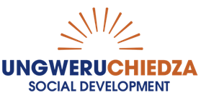

Table of Contents
Acronyms 6
1. Executive Summary 8
2. Introduction 14
2.1 Interpretation of the Terms of Reference 14
2.2 Purpose and Scope of Work 15
2.3 Evaluation Timelines 16
3. Literature Review 17
3.1 Overview 17
3.2 The Private Sector Context in Malawi 17
4. Evaluation Approach and Methodology 20
4.1 Evaluation Criteria 20
4.2 Primary Evaluation Questions 21
4.2.1 Evaluation Questions per Evaluation Criteria 21
4.3 Methodological Approach 21
4.3.1 Overview 21
4.3.2 Evaluation Focus on Programme Outcomes and Outputs 23
4.3.3 Sampling Methodology 26
4.4 Indicators and Data Collection Methods 29
4.5 Limitations of the Methodological Approach 31
4.6 Applying a Rating Scale 31
5. Key Evaluation Findings 32
5.1 Assessment of Malawi’s Policy Environment for Private Sector Development 32
5.2 Comparative Analysis of Development Partner Interventions 35
6. Achieving the PSDP Output One 37
6.1 Malawi Innovation Challenge Fund 39
6.1.1 Project Progress Against Key Evaluation Criteria 41
6.1.2 Case Study of Presscane Mwitha Sugarcane Farm 46
6.1.2 Case Study of Ethanol Company 47
6.2 The BUILD Malawi Fund 51
6.2.1 Purpose of the BUILD Malawi Mid-Term Evaluation 51
6.2.2 Overview: Generic Findings and Thematic Issues 52
6.2.3 Project progress Against Key Evaluation Criteria 56
6.3.5 Equity and Inclusion. 61
6.2.4 Key implementation issues emerging at mid-term. 62
6.2.5 Opportunities and Recommendations 62
6.3 Case Study of Ziweto Enterprises 65
6.4 Green Economic Transition Facility 66
6.4.1 Project Progress Against Key Evaluation Criteria 67
6.4.2 Recommendations 69
7. Achieving the PSDP Output Two 70
7.1 The Growth Accelerator 72
7.1.1 Project Progress Against Key Evaluation Criteria 72
7.1.2 Case Study of Planet Green Africa 76
7.2 Zantchito: Skills for Jobs Programme 79
7.2.1 Overview of Zantchito 79
7.2.2. Purpose of the Zantchito Intervention 79
7.3 Structure and Alignment of Zantchito 80
7.4 Components of Zantchito 80
7.5 Current Progress 82
7.6 Limitations of the Evaluation 84
7.7 Findings and Recommendations 84
8. Achieving the PSDP Output Three 89
8.1 Relevance and Coherence 91
8.2 Implementation and Efficiency 92
8.3 Effectiveness 93
8.4 Sustainability 95
8.5 Key Recommendations 95
9. Conclusions and Recommendations 95
9.1 Overview 95
9.2 Conclusions from Key Evaluation Findings 96
9.2.1 Relevance and Coherence 97
9.2.2 Effectiveness 98
9.2.3 Efficiency 100
9.2.4 Sustainability 103
10. Generic PSDP Recommendations 104
10.1 Macro Level Recommendations 104
10.2 Meso and Micro Level Recommendations 107
References 110
12. Annexes 114
12.1 Evaluation Team Composition 114
12.1.1 Team Expertise 114
12.1.2 Evaluation Team Roles 114
12.2 Evaluation Matrix 117
12.3 Data Collection Instruments 129
12.3.1 Key Informant Instrument (UNDP, Development Partners, Government Ministries and Agencies) 129
12.3.2 Grantees Instrument 133
12.3.3 Instrument for the Build Facility 136
12.3.4 PSDP Participant survey 139
12.3.5 Focus Group Discussion Instrument 143
12.4 List of Evaluation Respondents 145

Figure 1: Programme of work 16
Figure 2: Five stages of small-business growth represented in the PSDP. 20
Figure 3: Application of the OECD DAC criteria to the PSDP and Build Facility evaluations. 21
Figure 4: Data triangulation. 22
Figure 5: PSDP results. 23
Figure 6: PSDP theory of change. 24
Figure 7: BUILD Facility and BUILDER TA results 25
Figure 8: BUILD Fund Theory of Change 26
Figure 9: Sample for field work data collection. 28
Figure 10: Rating scale for PSDP outputs 32
Figure 11: Barriers to making optimal use of PSDP funding. 35
Figure 12: Progress on PSDP Output One 37
Figure 13: Overall MICF portfolio by company size. 39
Figure 14: Original MICF Model 2014-2015 39
Figure 15: Strengthening change and the Ecosystem 2016-2019 40
Figure 16: MICF Rounds 41
Figure 17: Idle irrigation pumps at Nkhotakota (Ethco) and idle roaster at Mzuzu Coffee 43
Figure 18: Female beneficiary representation by MICF project type. 45
Figure 19: Evaluators view the MICF-funded irrigation pumps and engage with small holder sugar cane farmers in Nkhotakota. 49
Figure 20: Integration of the BUILD Fund and the BUILDER TA. 55
Figure 21: The evaluation team visits the Ziweto plant for manufacturing livestock feed. 65
Figure 23: Progress on PSDP Output Two 70
Figure 22: Field Visit to Planet Green Africa in Blantyre. 77
Figure 24: Building blocks of the Zantchito programme. 81
Figure 25: National range of Zantchito 82
Figure 26: Phased process of selecting incubates. 83
Figure 27: Evaluation visit to the Mzuzu eHub 83
Figure 28: Disaggregated data on early Zantchito progress 84
Figure 29: Effectiveness of the Zantchito facility. 86
Figure 30: Progress on PSDP Output Three 90
Figure 31: Engagement between UNDP and the Government of Malawi counterpart ministries 93
Figure 32: Stakeholder groups that responded to the survey. 96
Figure 33: Survey respondents disaggregated by gender and by region. 97
Figure 34: Relevance and coherence of the PSDP in the context of Malawi’s economic growth trajectory. 98
Figure 35: Ratings for addressing equity and development issues through the PSDP. 99
Figure 36: Effectiveness of the PSDP in addressing key economic growth factors. 100
Figure 37: Performance of UNDP in managing the PSDP. 101
Figure 38: Efficiency of UNDP management at the strategic level. 102
Figure 39: Efficiency of UNDP’s oversight of fund managers. 103
Figure 40: PSDP building blocks for business resilience and growth. 104

Table 1: PSDP results and associated indicators. 29
Table 2: BUILD Facility outcomes and associated indicators 31
Table 3: Assessment of components within Malawi’s private sector landscape 32
Table 4: Insights from incubators and incubates. 88

Acronyms
Acronym |  | Full Name
AAAA | - | Addis Ababa Action Agenda
AA-EFFECT | - | Accelerating Alternative Energy and Fuel-Efficient Technologies
AU | - | African Union
BCF | - | Bamboo Capital Finance
BDS | - | Business Development Services
BESTAP | - | Business Environment Strengthening Technical Assistance
BI | - | Business Incubator
BMS | - | Buy Malawi Strategy
CPD | - | Country Programme Document
DAC | - | Development Assistance Committee
DAPP | - | Development Aid People to People
DFI | - | Development Finance Institution
DP | - | Development Partner
DRGR | - | Debt Relief for Green and Inclusive Recovery
ECF | - | Extended Credit Facility
EDGE | - | Enterprises for Development, Growth, and Empowerment
EDI | - | Equity, Diversity and Inclusion
EU | - | European Union
FAO | - | Food and Agriculture Organisation
FDI | - | Foreign Direct Investment
FInES | - | Financial Inclusion for Entrepreneurial Scaling
GA | - | Growth Accelerator
GETF | - | Green Economic Transition Facility
GiZ | - | German Development Cooperation
IDPPS | - | Integrated Development Partnership for Private Sectors
IFAD | - | International Fund for Agricultural Development
IFC | - | International Finance Corporation
IMF | - | International Monetary Fund
KfW | - | German Development Bank
LDC | - | Least Developed Country
LPG | - | Liquified Petroleum Gas
LUANAR | - | Lilongwe University of Agriculture and Natural Resources
MBS | - | Malawi Bureau of Standards
METLS | - | Malawi Electronic Trade Licensing System
MFI | - | Micro Finance Institution
MICF | - | Malawi Innovation Challenge Fund
MITC | - | Malawi Investment and Trade Centre
MOU | - | Memorandum of Understanding
MSE | - | Micro and Small Enterprises
MSME | - | Micro, Small, and Medium Enterprises
MUBAS | - | Malawi University of Business and Applied Sciences
NRB | - | National Registration Bureau
OECD | - | Organisation for Economic Cooperation and Development
PMB | - | Staff-Monitored Program with Executive Board Involvement
Pro-Doc | - | Project Document
PSDP | - | Private Sector Development Programme
PUNO | - | Participating United Nations Organizations
RBM | - | Reserve Bank of Malawi
RC | - | Resident Coordinator
SDG | - | Sustainable Development Goal
SMEDI | - | Small and Medium Enterprises Development Institute
STIEF | - | Social Transformation and Innovation through Entrepreneurship and Access to Finance
TA | - | Technical Assistance
TACB | - | Technical Assistance and Capacity Building
TEVET | - | Technical, Entrepreneurial and Vocational Education and Training
ToR | - | Terms of Reference
UCSD | - | Ungweru Chiedza Social Development
UNCDF | - | United Nations Capital Development Fund
UNDAF | - | United Nations Development Assistance Framework
UNDP | - | United Nations Development Programme
USAID | - | US Agency for International Development
USD | - | United States Dollar
VAC | - | Venture Appraisal Committee
WB | - | World Bank

Executive Summary
The Private Sector Development Programme (PSDP) II 2020-2023 is in the last year of its implementation. Considering this, the United Nations Development Programme (UNDP) Malawi contracted Ungweru Chiedza Social Development (UCSD) to conduct an end of project evaluation of the PSDP II. The evaluation has taken into consideration the implementation challenges, enablers, and successes, and has provided learnings that can be used by UNDP and its partners to enhance future programmatic designs. The evaluation also provides findings and recommendations that can inform the design of a successor private sector development programme (2024-2028). The evaluation also has an accountability purpose in fulfilling donor reporting requirements.
The scope of this evaluation was to assess the performance of the PSDP over the implementation period of 1st January 2020 to 30 June 2023. The evaluation has been structured so that it reviews and assesses all the outputs of the project. This includes an assessment of the instruments that have been used to catalyse private sector growth which include the Malawi Innovation Challenge Fund (MICF), the Growth Accelerator (GA), the Green Economic Transition Facility (GETF), the Build Facility Malawi, and Zantchito: Skills for Jobs Programme. As part of this end-term PDSP evaluation, UCSD leveraged the opportunity to incorporate a mid-term review to provide a more comprehensive analysis of the BUILD Facility and its present status. The main purpose of the mid-term evaluation was to provide an independent assessment of the progress the BUILD Fund has made towards achieving its planned results and to identify lessons to inform future blended finance Fund designs.
The PSDP is implemented through a direct implementation modality with UNDP as the lead implementing agent. There is also a wide spectrum of key stakeholders involved in the design and support of the PSDP. The evaluators therefore used non-probability sampling methodology that included purposive and convenience sampling. We used purposive sampling to identify the key role players in the design, management and implementation of the PSDP. For the field work we used convenience sampling to select respondents for inclusion in the sample because they were the easiest for the evaluators to access based on geographical proximity.
The recommendations from the evaluation have been divided into two sections. Recommendation one to four are strategic macro level recommendations aimed at informing the formulation of the next iteration of the PSDP. Recommendations five to fourteen are meso / micro level recommendations aimed at supporting UNDP to strengthen the current PSDP programme and to look forward to the next phase of the PSDP. The evaluators therefore identified three clusters of project sites in the north, central and southern areas and undertook field visits to collect the necessary data to assess them. To collect additional quantitative and qualitative data the evaluators ran a survey on SurveyMonkey. The survey link was shared with all stakeholders who were listed on the spreadsheets provided to the evaluation team by UNDP.
The evaluation assessed the PSDP facilities against the outputs articulated in the programme Logframe.
PSDP Output One:
In line with the African Union (AU) vision 2063 and the Malawi Growth and Development strategy, Malawi Innovation Challenge Fund (MICF) complements the national development agenda by promoting innovation as drivers of economic development. MICF has been able to champion pro-poor private sector led development and innovation. Implementation of projects such as the Presscane Mwitha Sugarcane Farm model clearly demonstrates the implementation efficiency of the MICF funding. MICF has been able to develop partnerships between large companies and smallholder farmers. As of December 2022, the MICF end of project report indicates 42% of the projects were successfully completed, 30% of the projects were closed due to implementation challenges and 28% were still under implementation. MICF as a program was well designed, with proper risk management approaches. The inclusive business models targeted by MICF have proved to be more sustainable beyond the MICF support. MICF targeted large companies that were already financially stable and more resilient companies. However, most of these companies were yet to test the waters for more innovative and inclusive business models. MICF projects have been characterised by piloting of inclusive business model. Presscane Mwitha Sugarcane Farm demonstrates the efficiency of inclusive business models by integrating smallholder farmers into the sugar cane value chain. Similar patterns have been observed within the coffee value chain with Mzuzu Coffee and others. MICF has reached out to 51% female beneficiaries among its direct project beneficiaries.
This mid-term evaluation of the BUILD Malawi Facility has noted sufficient positive signs to indicate that the UNCDF in its new role as Facility lead, together with UNDP and FAO, can leverage the Facility in areas where tailored debt and equity investments have a strong potential for successful growth:
- The evaluation finds that the reconceptualization of the BUILD Malawi Facility as a provider of impact capital to SMEs is the most strategic option in the current uncertain economic context. If it operates as a Facility anchored to the BRIDGE Facility of the United Nations Capital Development Fund (UNCDF), with FAO providing technical support, it can initially be capitalized with the US$ 6.4 million from the Joint-SDG Fund (JSDGF) and if it is able to secure further philanthropic investment capital it could reach a targeted capitalization of US$ 20 million.
- The capital should, as envisaged, be invested as flexible capital that could potentially leverage up to a target of 50 businesses in Malawi to grow and drive achievement of targeted SDGs.
- Strategically the Facility should continue with a blended set of transactions by co-investing with other financiers to generate leverage.
- In the current economic crisis in Malawi, the BUILD Malawi Facility can offer a small niche portfolio of investments and can generate some track record that can attract new investors as the economic turmoil in Malawi recedes. Such a portfolio might be able to generate some returns, even though capital preservation may be a challenge to achieve in the short term.
- At this stage further modifications to the BUILD Fund may create more delays and further confusion for potential investors and investees. Given the lengthy delays, the Joint SDG Fund would be best placed to agree an extension to the current programme to the end of 2025 in order to ensure the deployment of the remaining resources already invested in the BUILD Fund by the Joint SDG Fund and to ensure that a vehicle able to host commercial return-seeking capital remains in place for the future.
- In the last quarter of 2025 the Joint SDG Fund and its partners (UNCDF, UNDP and FAO) should undertake a rapid assessment of the BUILD Malawi Facility progress and then use the evidence to make a clear decision about the future of the fund beyond that timeframe.
- Given the delays, the facility needs to refresh the current pipeline of potential investees.
- The interest from companies such as Global Seeds does indicate a demand for the facility to address financing gaps within the agricultural sector. The Malawi Market Scoping Report does, however, note the absence of a larger group of middle-sized firms as a result of difficulties in the business environment, which constrains the growth of small firms. This is further exacerbated by the risks that are brought about by persistent instability in the macro-economy and regulatory deficiencies are more navigable by larger firms due to their broad networks and larger financial resources.
- This mid-term evaluation has been constrained by the lack of data on progress made against the indicators set out in the programme logical framework. If investments are made in more companies over the next year, there must be a concerted effort to ensure that quantitative and qualitative data on investees is collected so that future reviews / assessments have concrete evidence to work with.
- The BUILD Malawi Facility will need to revise the targets and indicators in the original BUILD Fund results framework to meet the requirements of the revised programme.
- Despite limited evidence it appears that there is need for the BUILD Facility to develop a more proactive strategy for assessing gender profiles at company management level and along supply chains, and then responding with appropriate gender mainstreaming TA.
- There is scope to establish clearer investment criteria, including financial returns as well as transparent yet rigorous methodologies for collecting data against environmental and gender equality / inclusion metrics and associated SDG targets. Promotion of gender equality and inclusion can be focused on inclusion through supply chain outlets.
- BUILD Malawi partners must ensure that the processes for application eligibility, technical review, criteria for selection, contracting and appointment of service providers is as far as possible fast tracked to avoid lengthy delays and loss of momentum.
- The BUILD Fund partners must continue to closely monitor local policies and strategies to assess whether they are adequately addressing SDG impact and financial risks.
- Promote knowledge sharing and reporting on track record of SDG investments with investees through a BUILD Fund community of practice that can disseminate information and encourage knowledge sharing.
- The BUILD Malawi Facility scope to be narrowed and focusing on one or two instruments, which might have a higher chance of implementation success and are additional in the market.
- This evaluation recommends aligning the TA from FAO with the requirements of the restructured BUILD Facility to ensure that the TA provided meets the needs of the investees.
The Green Economic Transition Facility (GETF) is a support facility partnering with private sector willing to invest in green business solutions. The first window of the facility is the ‘Accelerating alternative Sources of Energy and Fuel-Efficient Solutions (AA-EFFECT)’. This window is supported by the Republic of Ireland and targets companies with an appetite to assist households to transition and adopt alternative energy and fuel-efficient solutions.
At the global level, the Green Economic Transition Facility is aligned to SDG 7: ‘Ensure access to affordable, reliable, sustainable and modern energy for all’. At a national level, the facility is aligned with the national charcoal strategy, the energy policy and the Forest Act. The GETF has not been implemented in isolation, it rides on the successful implementation and experience of the existing UNDP Growth Accelerator Programme, which is an established platform. The GETF thus tries to complement UNDP private sector led instruments by focusing on sustainable and innovative products to penetrate and address the green transition needs in Malawi. The GETF is in its early stages of implementation. The first cohort was contracted in December 2023. There are also limited private sector players involved in the energy sector, with a lot of the applications coming from LPG players. Effective implementation has been limited by foreign exchange challenges with Reserve Bank of Malawi issuing quotas on foreign exchange. The GETF comes with a 35,000 USD technical support to innovative enterprises. This technical support is provided as tailor made support specific for each enterprise rather than a lump sum TA support.
PSDP Output Two:
The results expected from Output 2 focus on the necessary support to youth led MSEs to formulate innovative business ideas that are effective in bringing sustainable solutions to development challenges and that can also create jobs. Key interventions are provided through the primary vehicles of the Growth Accelerator (GA) and Zantchito. Under the current PSDP UNDP has continued to implement the GA through its serial Entrepreneurship Challenges. The GA serves as a business acceleration instrument that provides technical assistance and seed capital to young and ambitious start-up companies that intend to provide sustainable business solutions to development challenges that align economic growth with sustainable development goals. The “Zantchito-Skills for Jobs” Programme, embedded in the 11th European Development Fund (EDF), has been set up to create an ecosystem of job creators through the provision of decent jobs and self-employment opportunities for young TEVET graduates, university graduates, and entrepreneurs, with special attention to women’s needs.
Implementation of the GA facility has been directly aligned to the National development Goals for Malawi, particularly Vision 2063. Following the implementation of the MICF programme by UNDP, an initial needs assessment through stakeholder engagement highlighted the critical barriers to growth for micro, small and medium enterprises (MSMEs) in Malawi. While the MICF focuses on large enterprises with available capital, matching funds of up to 500,000 USD. MSMEs were unable to participate due to limited access to capital. The GA with matching funds of 10,000 USD to 40,000 USD provided an opportunity for MSMEs to access the financing. The GA matching facility is also not 50:50 as it is for MICF, but rather 70% from the GA and 30% from the enterprises.
The implementation of the programme’s delivery mechanism such as training workshops, mentorship sessions and financial grants has been generally positive, with participants reporting enhanced business skills and growth opportunities. The Growth Accelerator has proven to be one of the most effective instruments under the UNDP PSDP. The GA instrument, with its motto of accelerating business seems to be doing just that. Despite the delays in acquiring the financing for procuring equipment, the GA has played a critical acceleration role for all the companies visited. The GA facility is designed to strengthen the institutional capacity of enterprises. Through the facility, enterprises have also benefitted from peer learning and networking among the businesses. The programme has ring-fenced this by providing previous grantees as mentors to the emerging cohorts. Given that the GA facility is designed to target post revenue firms, this stamps the financial viability of the whole programme beyond the grant financing. The model provides a mix of internal financing and development financing for already existing firms. The GA has made efforts to ensure the program is accessible to a diverse range of entrepreneurs, including women and youth. The eligibility criteria include youthful entrepreneurs aged up to a maximum of 45 years old. According to Growth Accelerator Malawi website, 408 jobs have been created, 247 jobs for women and 304 jobs for youth.
The Zantchito: Skills for Jobs Programme is well aligned with the Malawi Government’s strategy for growing and strengthening the private sector. Zantchito is partnering with business incubators in Malawi to build their capacities, grow their business models, and help them to transition to commercially sustainable entities. Through the facility Zantchito is delivering a targeted training programme on entrepreneurship development to BDS providers (both individuals and companies) to improve their capacity to deliver growth-focused services to start-ups and MSEs on a commercially sustainable basis. They are also working with business incubators and BDS providers across to deliver incubation support and bridge access to finance at pre-incubation, incubation, and post-incubation phases.
In the course of 2023, a call for proposals from business incubators was advertised, followed by a shortlisting of Incubators which was completed during the inception period. Submissions were assessed based on five set criteria: incubate selection criteria, services offered, revenue model, impact monitoring and available infrastructure. Following this process six incubators were identified. A profile of the incubators and a justification note was prepared and submitted to UNDP (including preparing a budget for utilisation of US$30,000) following which contracts were signed with the six incubators. As of March 2024, Zantchito was in the early stages of its implementation. Pre-pre-incubation is underway at each of the incubators. As part of the evaluation fieldwork the evaluators were fortunate enough to meet with incubates at three of the business incubators and explore issues of effectiveness and efficiency. A lead BDS provider was assigned to each entrepreneur (under the oversight of the incubator BDO). All necessary training and orientation were completed before the BDOs started to work with the incubates. The first cohort of incubates are currently working with their assigned BDOs to develop basic business plans, business model canvases and the registration of their businesses.
The evaluation team has assessed the early effect of Zantchito within the context of Malawi’s entrepreneurial ecosystem, and the encouraging growth of enterprises at the pre- and post-start-up stage, and the emergence of business incubators and accelerators. Zantchito has strategically leveraged the value add that incubators can offer nascent entrepreneurs, including shared office spaces, business support, mentorship, start-up competitions, networking forums and funding for start-ups. Through its structured and strategic model Zantchito is increasing the complexity of entrepreneurial support. From the evidence available at this early stage of implementation the logical progression of the Zantchito model enables it to select the established business incubators, which in turn have the capacity to work with Zantchito to evaluate the strengths and weaknesses of potential start-ups. This is proving to be key for determining fields which require special assistance from the incubator. The evidence suggests that Zantchito has been strategic in selecting business incubation centres that are geared towards specific vertical markets in locations where agrobusinesses and industrial activity are concentrated.
Zantchito is in the very early stages of implementation, and this evaluation was undertaken at the pre-incubation stage of the first cohort selected via the first funding window. This means that the evaluators have very little data against which to measure effectiveness or impact of the facility. Evaluation survey data found that 79% of respondents see Zantchito as an effective mechanism for delivering support to start-up businesses. 72% of respondents agree that the business incubators have been rigorously selected and that the business incubators are selecting incubates in an effective way (82%). Responses seemed to suggest, however, that the quality of the BDS providers needs to be improved, with 64% feeling that they are effectively supporting incubates while only 53% feel that the incubates are receiving comprehensive start up support.
PSDP Output Three:
The results that were expected from Output 3 have been focused on the engagements that UNDP has been facilitating with the Ministry of Trade and Industry on key components of the business enabling environment. UNDP has aimed to work with the Ministry to promote enablers for private sector growth, including policy and regulatory adaptations that are intended to reduce binding constraints that have been emerging from the implementation of investments under the MICF, the BUILD Malawi Fund and the Growth Accelerator.
Consultations with the Ministry of Industry and Trade indicated that the support provided by UNDP PSDP in supporting the Buy Malawi Strategy (BMS) is a valued and constructive intervention. Through the BMS, the Ministry facilitates the identification of local industries and supports the uptake of local products in the economy, which promotes import substitution. As Malawi is a net importer such initiatives aim to reduce the current negative trade balance. All the activities implemented with support from UNDP were aligned to the BMS.
Through the PSDP UNDP committed to supporting the BMS with strategic interventions designed to promote local companies and streamline the ease of doing business for the companies. These have included the automation of licensing, standards, and more recently payment integration. This approach aims to ensure that all private sector activities and transactions are efficient and compliant. The BMS activities supported by UNDP have also looked at the identification of smuggling and counterfeit products and actions to counteract these illegal activities.
Across the different activities, implementation efficiency has been variable. For instance, the implementation of MBS standards training was conducted and completed as planned. Other initiatives such as automation of licensing documentation have been slow to implement. Implementation efficiency for the UNDP PSDP programme has to some extent been affected by the requirements of UNDP’s procurement system. In the UNDP ecosystem procurements is a thorough and time-consuming process and it takes some time for approvals to be signed off. A measure of progress for this output is the extent to which the partnership between UNDP and the government is sufficiently robust to achieve the anticipated PSDP results. Both UNDP and their respective government counterparts were positive about the progress made, but also highlighted obstacles that have slowed down activities in certain areas. These obstacles include capacity within key counterpart government ministries, bureaucratic delays and intermittent presence of government officials in Steering Committee meetings.
For the Buy Malawi campaign, there are now visible results as local products have started penetrating supermarkets and retail shops. Participation of the Buy Malawi at trade fairs has also provided networks for supermarkets in terms of product sourcing. Apart from the administrative challenges highlighted above, this initiative also faced other challenges. A BMS Secretariat was established to create awareness and mobilize consumers at all levels, including businesses and government institutions, to buy domestic products, thereby injecting money into the Malawian economy instead of giving away the purchasing power to foreign countries. The effectiveness of the Secretariat has been limited by the lack of full-time dedicated staff for the Secretariat to plan and implement activities in a timely manner. There were also no available resources for the executive committee meetings.
The recommendations from the evaluation have been divided into two sections. Recommendation one and two are strategic macro level recommendations aimed at informing the formulation of the next iteration of the PSDP. Recommendations 3 and 4 are meso / micro level recommendations aimed at supporting UNDP to strengthen the current PSDP programme and to look forward to the next phase of the PSDP.
Macro Level Recommendations:
- UNDP Malawi should strengthen its strategic policy level support to the Ministry of Industry and Trade and other associated ministries to address the interconnected SME-growth barriers and support productive capacities of Malawian SMEs.
- UNDP Malawi should undertake deliberate efforts to support SMEs access to export markets.
Meso and Micro level Recommendations:
- UNDP Malawi should develop more flexible tailor-made PSDP monitoring mechanisms for tracking and assessing the use of funds by different businesses at different levels with different needs.
- UNDP Malawi should identify bottlenecks and delays and enhance their internal policy framework, with clear guidance on procedures for private sector engagement to expedite faster turn-around times for contracting and disbursement of funds.

2. Introduction

2.1 Interpretation of the Terms of Reference
The Private Sector Development Programme (PSDP) II 2020-2023 is in the last year of its implementation. Considering this, the United Nations Development Programme (UNDP) Malawi contracted Ungweru Chiedza Social Development (UCSD) to conduct an end of project evaluation of the PSDP II. The evaluation has taken into consideration the implementation challenges, enablers, and successes, and has provided learnings that can be used by UNDP and its partners to enhance future programmatic designs. The evaluation also provides findings and recommendations that can inform the design of a successor private sector development programme (2024-2028). The evaluation also has an accountability purpose in fulfilling donor reporting requirements. The main purpose of the evaluation has been to provide an independent assessment of the progress the PSDP has made in achieving its planned results. The objectives of the evaluation are as follows:

- Assess the extent to which project outcomes and outputs have been achieved.
- Assess and analyse the impact of the project on the livelihoods of beneficiary households and individuals, especially women in project areas.
- Assess the relevance of the project strategies to development needs of the people and global, regional, and national development goals.
- Assess and analyse the effectiveness of the project in achieving the specific expected results and analyse any factors contributing and hindering its progress.
- Assess to what extent was gender equality issues promoted or addressed in project design, implementation, monitoring, and reporting.
- Make recommendations for future programming.
- Document lessons learnt for sharing with other stakeholders and players working towards achieving social impact and inclusive business models through private sector engagement.

The evaluation team was also asked to assess progress made on the implementation of the BUILD Fund. This funding facility is one of the tools in the PSD portfolio of de-risking mechanisms for private sector investment in Malawi. The fund is a joint project between the UNDP, the Food and Agriculture Organization (FAO), and the United Nations Capital Development Fund (UNCDF), with the Joint Sustainable Development Goals (SDG) Fund as the anchor investor and UNDP as the technical lead. The modalities of the BUILD Fund required that a mid-term evaluation was necessary after the mid-point of operations. To fully capitalize on the ongoing evaluation of the PSDP the mid-term evaluation of the BUILD Fund was undertaken concurrently. The objectives of this evaluation were to:
- Assess the extent to which project outcomes and outputs are on track or off track both in terms of its development and financial results.
- Assess the relevance of the project strategies to provide sustainable SDG financing needs in Malawi.
- Assess and analyse the effectiveness of the project in achieving the specific expected results and analyse any factors contributing and hindering its progress.
- Document lessons learnt.
- Recommend potential revisions or actions to enhance the programme effectiveness, efficiency, and sustainability.

2.2 Purpose and Scope of Work
The scope of this evaluation was to assess the performance of the PSDP over the implementation period of 1st January 2020 to 30 June 2023. The evaluation has been structured so that it reviews and assesses all the outputs of the project. This includes an assessment of the instruments that have been used to catalyse private sector growth which include the Malawi Innovation Challenge Fund (MICF), the Growth Accelerator (GA), the Green Economic Transition Facility (GETF), the Build Facility Malawi, and Zantchito.
As required by the evaluation ToR the evaluation has focused on the extent to which the PSDP through its funding modalities has catalysed the growth of Malawian businesses and contributed to the upliftment of poor households that have directly and indirectly benefitted from the programme. To achieve these evaluation objectives UCSD with the support of the UNDP Malawi team has developed a data collection plan together with the data collection instruments that have enabled us to collect and analyse data necessary for assessing the impact of the programme.
In order to fully understand the kind of outcomes and impact that the PSDP has had the evaluators selected a sample of MICF, Growth Accelerator, Zantchito and Build Facility guarantees for detailed review and analysis. This has been complemented by a case study of an identified intervention to demonstrate the ways in which the PSDP has had a measurable impact. The evaluation sampled a geographical spread of interventions through PSDP partners, with a focus on the north (Mzuzu), central (Lilongwe) and South (Blantyre / Zomba).
The BUILD Facility is one of the tools in the PSDP portfolio of de-risking mechanisms for private sector investment in Malawi. The BUILD Malawi Fund (“BUILD Malawi” or “the Fund”) was originally conceived and designed as a blended finance investment fund and was established to be an open-ended permanent capital vehicle. The weak economic environment in Malawi, however, necessitated the restructuring of the Fund into a Facility capable of investing with a higher degree of risk and attracting non-return seeking philanthropic capital/donations for on-lending to prospective client Micro, Small, and Medium Enterprises (MSMEs).
As part of this end-term PDSP evaluation UCSD leveraged the opportunity to incorporate a mid-term review to provide a more comprehensive analysis of the BUILD Facility and its present status. The main purpose of the mid-term evaluation was to provide an independent assessment of the progress the BUILD Fund has made towards achieving its planned results and to identify lessons to inform future blended finance Fund designs. In addition, the evaluation was commissioned to fulfil accountability requirements of UNDP and its donors. This BUILD Facility component of the PSDP Evaluation included an analysis of the two companies – Global Seeds and Ziweto - that the BUILD Facility has thus far engaged with. This includes an analysis of the Technical Assistance (TA) provided to the two companies as well as a case study of Ziweto.

2.3 Evaluation Timelines
The project evaluation was carried out in five (5) phases as represented in the schema below (Fig 1):
Figure 1: Programme of work
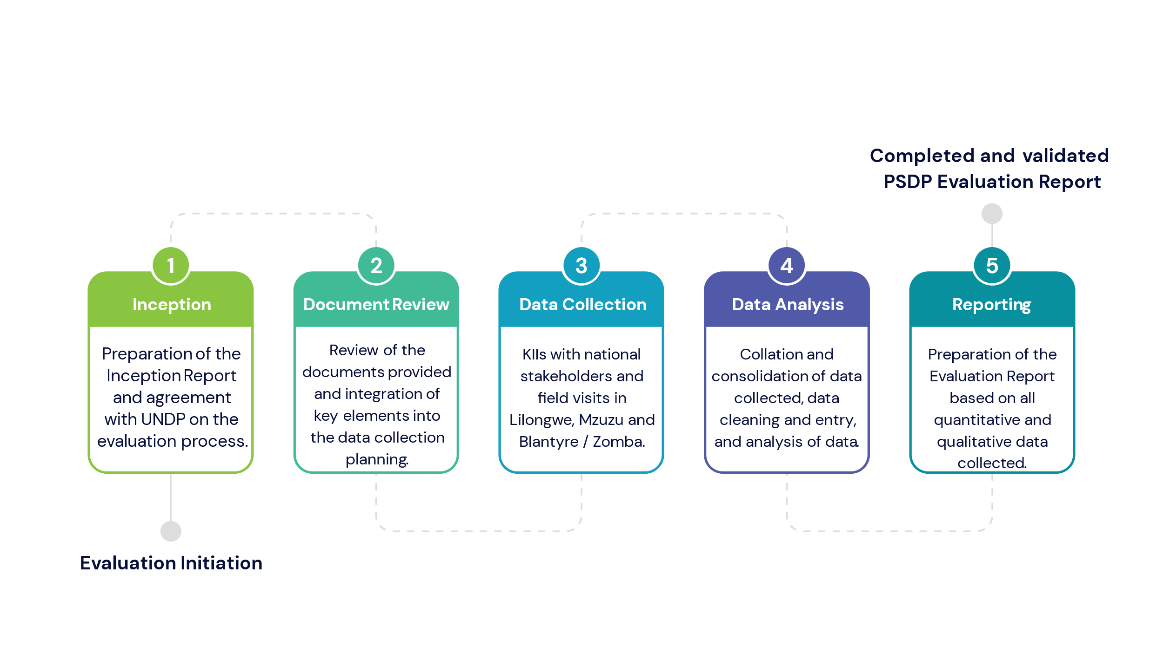

Literature Review

3.1 Overview

3.2 The Private Sector Context in Malawi
In a detailed report in 2021 the International Finance Corporation (IFC) found that Malawi has failed to deliver the inclusive growth necessary to lift more of its people out of poverty and that most remain trapped in subsistence farming. In the post-COVID environment the Malawian economy urgently requires new drivers of growth to jumpstart an economic recovery and help meet the jobs challenge of a rapidly growing, youthful population. The current population of Malawi in 2024 is 21,475,962, a 2.6% increase from 2023, in large part driven by the country's high fertility rate of 3.8 children per woman. The population is growing at roughly 3 percent a year, meaning that the already densely populated country will likely double its citizenry within a generation. In 2023 three-quarters of Malawians were younger than 35, and 42 percent were under the age of 14.
According to the IFC an estimated 400,000 Malawians are entering the job force each year, and the economy is not growing at a pace to provide decent work. In addition to a constrained private sector economic growth and development has been hampered by a challenging macroeconomic environment that has made it difficult for the economy to grow significantly in line with national development plans. Natural disasters and adverse climate hazards in the past decade have included dry spells, seasonal droughts, intense rainfall, riverine floods, and flash floods. These frequent disasters impose on the country large costs for repairs and rebuilding, diverting scarce resources from other development needs. The effects of Tropical Cyclone Idai, in 2019, placed Malawi in the top five countries worldwide most affected by extreme weather events, according to the Global Climate Risk Index. More recently, Tropical Storm Ana and Tropical Cyclone Gombe (2022) and Tropical Cyclone Freddy (2023) caused serious damage and significantly impacted private sector operations, resulting in substantial disruptions to livelihoods and a reduction in overall activity.
The private sector in Malawi has a dualistic structure. The agricultural sector in Malawi, for example, has a distinct dualistic structure characterized by an estate and a smallholder sub-sector. With a few, large and often foreign owned companies engaged in the production of tea, the processing and marketing of tobacco, growing and exporting sugar and producing a limited range of fast-moving consumer goods on one side. Private sector contributions to robust economic growth are partly limited by their access to affordable finance which is structurally prohibitive. In 2020, Malawi scored 61 points (out of 190) in the ease of doing business index with the country offering a quite favourable environment for enterprises. Specifically, the country's attractiveness was high in terms of getting credit, which obtained 90 index points on a scale of zero to 100. UNDP’s Country Programme Document (CPD) for Malawi 2019-2023 noted that lack of access to finance, corruption and unreliable electricity and water supply were key constraints hindering private sector development and investment. According to FinDev the percentage of adults age 15+ in Malawi with an account at a financial institution or through a mobile money provider was 43% as compared to 55% in sub-Saharan Africa and 76% globally . An RBM/UNCDF 2020 survey indicated that 60% of adults lacked access to formal financial services and only 14% of adults actively used formal financial services.

Infrastructure development, the manufacturing base, and adoption of new technology remain far below the sectors’ potential. On the other side, there are many micro and small enterprises including women-owned and youth start-ups that mainly operate in the informal sector. The World Bank notes that three in four enterprises (74%) are micro enterprises, 23% are small enterprises and only 3% are medium enterprises, yet despite potential to contribute more to the economy, the capacity of the MSMEs to expand remains low because they often do not have the same access to knowledge and networks as larger businesses. Their business development and economic contribution is limited by poor technical and entrepreneurial practices, lack of access to credit, licensing issues, quality standards and production certification issues, lack of access to information, networking, mentoring and limited product development and product diversification which results in low value addition and high levels of enterprise mortality. A USAID assessment undertaken in 2016 found that many companies were constrained by the poor and unreliable quality and supply of products needed for their business operations. This inability to secure a stable supply of quality materials both stunts growth and keeps Malawian products out of more lucrative (international) markets.

The Government of Malawi’s Vision 2063 foresees a “vibrant knowledge-based economy with a strong and competitive manufacturing industry that is driven by a productive and commercially vibrant agriculture and mining sector”. The Growth and Development Strategy 2017-2022 committed to accelerating the transition to a productive, competitive, and resilient nation as well as to integrate the Sustainable Development Goals into its development trajectory. The strategy outlined five key priority areas:

- Agriculture, water development and climate change.
- Education and skills development.
- Energy, industry, and tourism development.
- Transport and information and communication technology infrastructure; and
- Health and population.

UNDP’s Private Sector Development (PSD) Programme Document (ProDoc) states that Malawi’s potential to achieve high and sustainable economic growth, as well as creation of more formal jobs is constrained by a weak private sector. In its 2019-2023 CPD for Malawi UNDP aimed to support Government efforts with regards to private sector led growth and focused support on accelerating the growth of start-up companies, crowding in impact investment for sustainable enterprise development, and scaling innovation and productive investments in Malawi’s agriculture, manufacturing, irrigation, and renewable energy sectors. The expected results of the PSDP aligned with national efforts to enable the private sector to enhance innovation, productivity, and entrepreneurship; enable youth-led downstream micro and small enterprises to generate ideas for business start-ups, acceleration, and growth; and address selected business environment constraints for private sector growth. The PSDP was also aligned with SDG 8 (Promote sustained, inclusive, and sustainable economic growth, full and productive employment, and decent work for all) and SDG 9 (Build resilient infrastructure, promote inclusive and sustainable industrialization and foster innovation). The PSDP is also aligned to the UNDP Strategic Plan, which places an emphasis on efforts to “advance poverty reduction in all its forms and dimensions”.

The PSDP has been using a combination of instruments to support the private sector inclusive of Micro, Small and Medium-sized enterprises. These instruments have been designed to support partners to access financial support, technical advisory services, business development services and business incubation services for increased productive capacities, innovation, business growth and acceleration, and job creation. The programme has been working closely with the Ministry of Industry and Trade to address some of the challenges related to the business enabling environment.

The PSDP has deployed specific instruments for private sector de-risking and from early to growth stage enterprises as part of the continuum of the entrepreneurial journey. These include the Malawi Innovation Challenge Fund (MICF), the Growth Accelerator (GA), the Green Economic Transition Facility (GETF), the Build Malawi Facility and Zantchito, Entrepreneurship and Access to Finance. The PSDP has also initiated the Accelerating Alternative Energy and Fuel-Efficient Technologies (AA – EFFECT) under the Green Economic Transition Facility (GETF), which have been aimed at de-risking and accelerating Green Business Growth in Malawi. The facility is a new component of the Private Sector Development Programme (PSDP) that will support the Private Sector to move into commercially sustainable green businesses solutions which is expected to deliver big environmental and social impacts. The PSDP has been conceptualised as a suite of facilities aimed at leveraging business emergence, development, and resilience across the various stages of business growth:

Figure 2: Five stages of small-business growth represented in the PSDP.
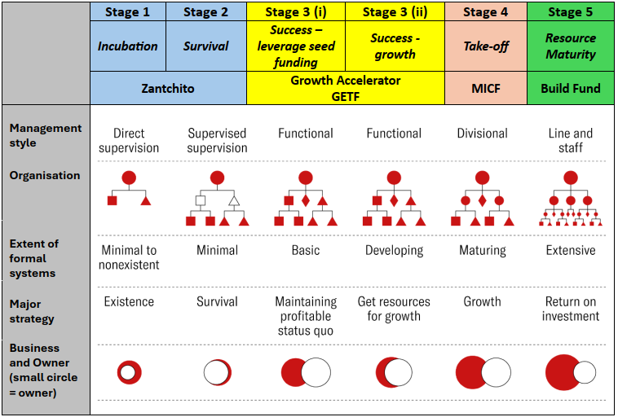
Source 1: Authors adapted from Harvard Business Review
The evaluators have carried out their assessment based on the understanding that the PSDP comprises holistic, strategic and interlinked interventions across the stages of business growth from incubation to maturity.

4. Evaluation Approach and Methodology

4.1 Evaluation Criteria
The most important aspect of using the criteria is relating them to the aim of the evaluation and its context and then building the evaluation criteria and questions around this purpose. In this evaluation the ToR called for the application of all six OECD-DAC evaluation criteria and indicated evaluation questions that aligned with each of these criteria. Our approach was that the criteria were not intended to be applied in a standard, fixed way for every intervention or used in a tick box fashion. We applied the criteria so that they supported interpretation and analysis in relation to the various PSDP interventions. This provided us with the flexibility and ability to adapt the criteria to the context of the PSDP evaluation. The purpose of the evaluation was therefore carefully and clearly defined. Key questions looked at when determining the purpose of the evaluation included:
- What is the demand for an evaluation, who is the target audience and how will they use the findings?
- What is feasible given the characteristics and context of the intervention?
- What degree of certainty is needed when answering the key questions?
- When is the information needed?
- What is already known about the intervention and its results?
- Who has this knowledge and how are they using it?
For UCSD formulating good evaluation questions is a key part of the evaluation process and the use of the six criteria interacts with and supports the process of deciding on evaluation questions.

4.2 Primary Evaluation Questions

4.2.1 Evaluation Questions per Evaluation Criteria
As per the ToR the evaluation applied the OECD-DAC evaluation criteria of relevance, coherence, effectiveness, efficiency, sustainability, and impact (Figure 3). In addition to this – as per the requirements of UNDP – the evaluators applied a gender and inclusion lens to each of the criteria.
Figure 3: Application of the OECD DAC criteria to the PSDP and Build Facility evaluations.
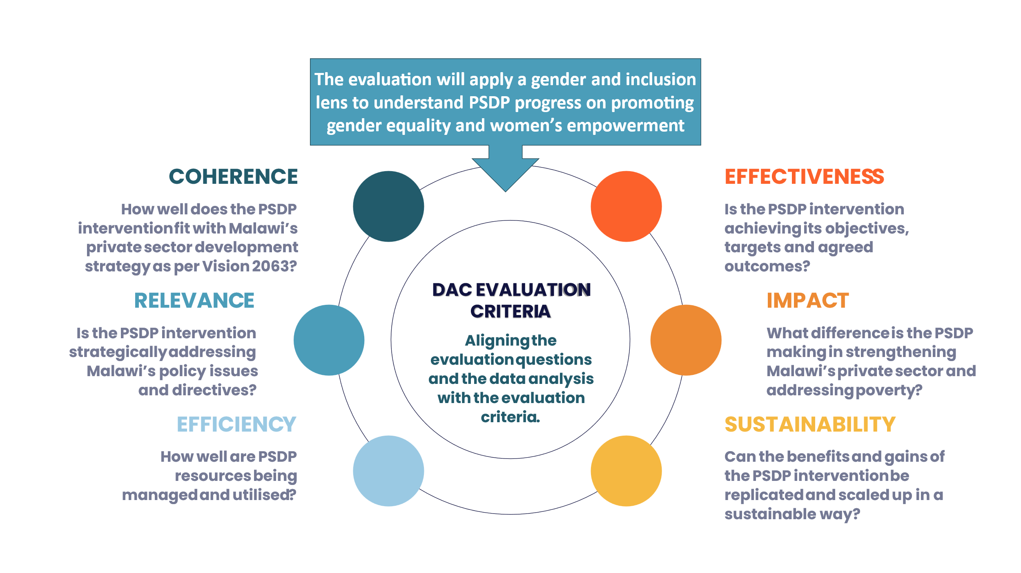

4.3 Methodological Approach
This evaluation is a utilization focused evaluation that provides findings and recommendations generated from the evidence collected with the purpose of enabling UNDP in partnership with the Government of Malawi and other development partners to build on PSDP and BUILD Facility gains and practically address some of the challenges that still exist in subsequent programme cycles.

4.3.1 Overview
This evaluation measured project outputs and outcomes, as well as the emerging impact that the project is having and its sustainable effects on the overarching socio-economic challenges facing Malawi - poverty, unemployment, and inequality. The intention behind conducting this evaluation was to not only gain insights into the immediate outcomes, challenges and successes generated by the PSDP and BUILD Facility but also to identify business models that have the potential for replication and scale up. Ultimately, the findings should serve a pivotal role in steering forthcoming decisions, shaping policies, and charting the future course of action for private sector project funding and implementation in Malawi. The insights gained from this evaluation should not only inform the decision-making process but also support the following actions:
- Contribute to shaping future private sector development strategies in Malawi,
- Support UNDP and its partners to identify best practices in terms of business models led by the private sector and
- Assess instruments that UNDP has developed and deployed that differentiate UNDP from other DPs.
The evaluation of the PSDP and BUILD Facility used a mixed method approach that has utilized primary and secondary data sources to collect quantitative and qualitative data and used continuous data triangulation (Figure 4) to verify data quality:
Figure 4: Data triangulation.
The PSDP is a complex, multi-partner and multi-dimensional intervention. In order to understand and assess the progress made on achieving the results set out in the project Results Framework the evaluators relied on a range of different data sources.
- Quantitative project performance data from reports.
- Qualitative data from key informant interviews with policy makers, development partners, private sector companies, implementers, and end-users.
- Qualitative data from focus group discussions with beneficiaries.
- Quantitative data and qualitative data from a survey conducted across grantees, implementing agents and other project stakeholders.
The mixed-method research approach that we used is in line with the critical realism approach to evaluations / assessments that call for the triangulation of data gathered from multiple research methods. In evaluations critical realism can be used to theorize about social structures, mechanisms, and causes operating in complex systems. Realist evaluation is a theory-driven approach to evaluating programmes and focuses on explaining how, why, for whom, and under what circumstances a programme works effectively. As part of the mixed-method design, both method triangulation and data triangulation have been employed. Method triangulation (using multiple methods of data collection and analysis) included the combination of grounded theory and survey research, which was used specifically to explore certain aspects of the PSDP implementation model, while data triangulation (collecting data from multiple sources) was used to test the causalities.

4.3.2 Evaluation Focus on Programme Outcomes and Outputs
In UCSD’s understanding the overarching PSDP theory of change and the associated results framework had three outputs linked to the overall PSDP outcome. The PSDP outcome is essentially linked to the UNDAF Outcome (By 2023, Malawi has strengthened economic diversification, inclusive business, entrepreneurship, and access to clean energy) and the UNDP Strategic Plan outcome (Advance poverty reduction in all its forms and dimensions).
Figure 5: PSDP results.

In evaluating the PSDP the evaluators used the overarching PSDP Prodoc Results Framework as our core reference point. At the same time, we understood that the PSDP is a project made up of individual funding and support mechanisms, each with its own Results Framework. As we collected data, we therefore cross-referenced the different outputs and outcomes contained in these frameworks to understand how well the constituent parts aligned to create a coherent, holistic and effective project.
Complementing the measurement of performance against the output and outcome indicators, the evaluation team undertook a theory-based approach with the aim of interrogating the assumptions that underpin the PSDP theory of change and the validity of the design thinking and assumptions that informed the identified interventions (activities). This review of the theory of change assumptions enabled the evaluators to better assess the relevance and coherence of PSDP implementation.
Figure 6: PSDP theory of change.
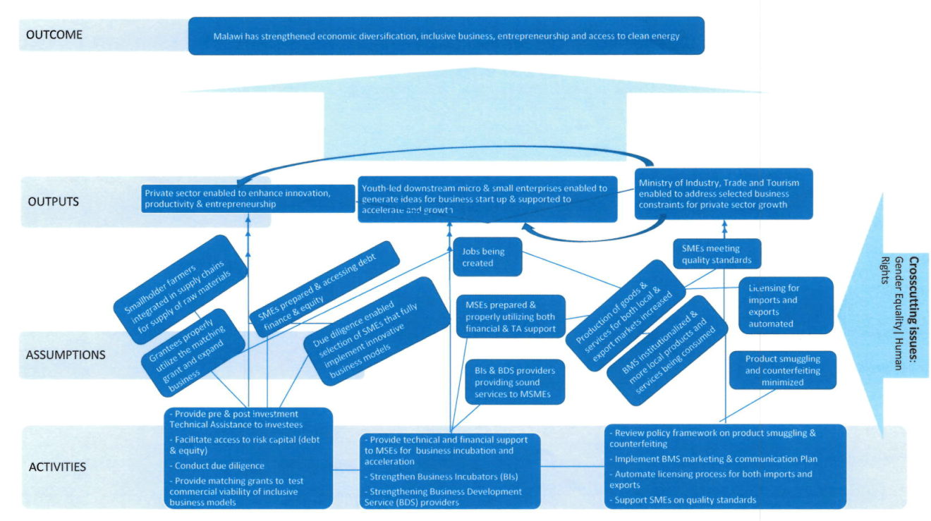
In evaluating the BUILD Facility, the evaluators used the BUILD and BUILDER Results Framework as our reference point. As we collected data, we cross-referenced the different outputs and outcomes contained in this framework to the PSDP Results Framework to understand how well the constituent parts aligned to create a coherent, holistic, and effective project.

Figure 7: BUILD Facility and BUILDER TA results

Complementing the measurement of performance against the output and outcome indicators, the evaluation team will also undertake a theory-based approach with the aim of interrogating the assumptions that underpin the BUILD Fund theory of change and the validity of the design thinking and assumptions that inform the identified interventions (activities). This review of the theory of change assumptions will enable the evaluators to more assess the relevance and coherence of BUILD Facility and BUILDER TA implementation.
Figure 8: BUILD Fund Theory of Change
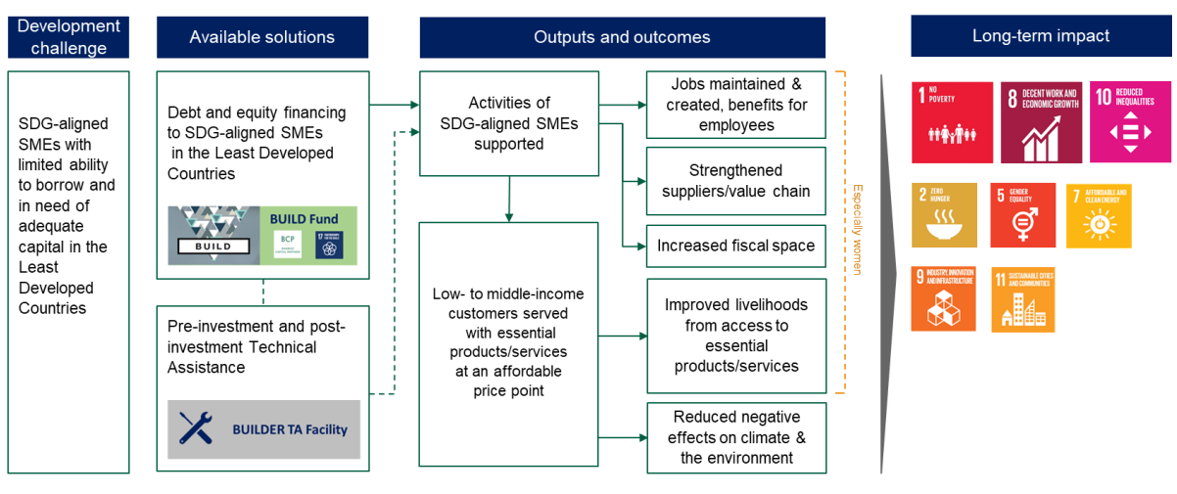

4.3.3 Sampling Methodology
In order to understand and assess the progress made on achieving the objectives set out in the PSDP the evaluators relied on a range of different data sources. A mixed methods approach to the data collection process was employed, using primary and secondary data sources, combining both qualitative and quantitative data elements. To ensure accuracy and reliability, we employed a mix of quantitative and qualitative data collection methods. We used a set of core assessment questions (as per the ToR) to focus and structure the evaluation and to answer the kinds of issues that are of concern to the formulators, implementers, and beneficiaries of the PSDP and the BUILD Facility.
To ensure maximum insights, the evaluation team applied gender equity, gender investment, social inclusion and green transition lenses to the data that was collected. We used an equity lens to consider what aspects of equity the PSDP and the BUILD Facility aimed to address (e.g., redistribution of resources to those with the greatest need, equitable participation in the design, implementation and evaluation processes, extension of access / services or a to a traditionally underrepresented or excluded group, etc.). We then evaluated the relevant processes, activities, outputs, outcomes and impacts of the PSDP and BUILD interventions from a gender and youth perspective and assess to what extent the intervention has resulted in progress (or the lack thereof) towards intended and/or unintended equity results.
The data collection process included three modalities:
- Key informant interviews: these comprised semi-structured one on one interviews with key stakeholders, including government policy makers, development partners, private sector actors in both the formal and informal sectors, and key stakeholders at project site level, including project staff, local government officials, traditional leaders and community members.
- Focus Group Discussions: Semi-structured small group discussions (6 to 12 participants) were organized with beneficiaries of the PSDP and the BUILD Facility.
- Survey: We used standardized data collection from a predefined group of respondents structured to minimize bias.
The data collected has been used to measure specific project indicators, gather financial and economic data, and conduct in-depth interviews to gather qualitative insights into the project's impact on entrepreneurial growth, business development and individual empowerment.

4.3.2.1. Sample Frame for Qualitative Data Collection
UCSD’s understanding is that the PSDP was developed through an exhaustive, structured process of eliciting staged responses from government, the private sector, development partners and civil society, reviewing the inputs, and assessing their implications. The process included participation, input, review, and revision from key stakeholders in industry, government, and organisations with a vested interest in the expansion of private sector activities across the labour market. The complexity of multiple and interlinked sectors along with the PSDP itself meant that the sampling frame of possible respondents was going to be broad. The PSDP is also a living project that has been embedded in an evolving political, economic, and social landscape since 2013. It is also ten years into its iterative lifecycles, which means that many institutions, stakeholder groups and individuals have been involved with the PSDP since its initial planning and inception up to the present moment, and others have already completed their involvement. The evaluation therefore aimed to capture the perspectives of as wide a range of stakeholders as possible, bearing in mind the limited time available for the evaluation.
The ToR indicated that this should be an end of term evaluation, but the evaluators aimed to position the evaluation of the PSDP in a more holistic way. This meant keeping a primary focus on the implementation of the PSDP while at the same time looking back to its original design and formulation, and forwards to the actual and potential outcomes and impact of activities that have been implemented.
The PSDP is implemented through a direct implementation modality with UNDP as the lead implementing agent. There is also a wide spectrum of key stakeholders involved in the design and support of the PSDP. The evaluators therefore used non-probability sampling methodology that included purposive and convenience sampling. We used purposive sampling to identify the key role players in the design, management and implementation of the PSDP. For the field work we used convenience sampling to select respondents for inclusion in the sample because they were the easiest for the evaluators to access based on geographical proximity. In consultation with the UNDP the evaluation team drew on the databases of key stakeholders to segment respondents by sector, interest groups, technical specialist, management as well as direct and indirect beneficiaries, and then worked with UNDP to populate this with names and contact details. The sampling targeted state and non-state actors at national level who held implementation knowledge of the PSDP directly, businesses that have been supported through the various PSDP funding mechanisms, as well as beneficiaries who have benefitted from business growth, including farmers and micro traders who have participated in value chains.
The Terms of Reference (ToR) stated that the project was implemented nationally. The evaluators therefore identified three clusters of project sites in the north, central and southern areas and undertook field visits to collect the necessary data to assess them. At the project sites the evaluators engaged with a sample of key informants, project staff and targeted groups and interviewed them. A 95% confidence level was applied to the sample to ensure that the sample of grantees was an appropriate sample for this evaluation. In other words, the evaluators were 95% certain (confidence level) that the sampled organisations that were engaged with contained the required population parameter of organisations / entities receiving funding from the PSDP through its various funding mechanisms.

Figure 9: Sample for field work data collection.
ENTERPRISE Location  Modern Farming Technologies (MFT) Mzuzu  Mzuzu E-Hub (ZAN) Mzuzu  Ethanol Company (MICF) Mzuzu  Kwithu Kitchen Factory (MICF) Mzuzu  Mzuzu Coffee (MICF) Mzuzu  Planet Green Africa Lilongwe  NxtGen Labs (ZAN) Lilongwe  NASCOMEX / NASFAM Lilongwe  Perisha Agro and Packaging (GA) Lilongwe  Zanchito Lilongwe  Afribam (MICF) Lilongwe  Mundawathu Gardens (GA) Lilongwe  Pyxus Agriculture (MICF) Lilongwe  Synergy Labs (ZAN) Lilongwe  aQysta Irrigation Zomba  Amazing Bakes (GA) Zomba  Zomba Private Ambulances (GA) Zomba  Satemwa Tea and Coffee Estate (MICF) Blantyre  Arkay Plastics (MICF) Blantyre  Press Cane (MICF) Chikwawa  Trend Setters (GA) Blantyre  Imani Investments (GA) Blantyre  Dzuka Africa (ZAN) Blantyre  Malawi University of Business and Applied Sciences (ZAN) Blantyre | 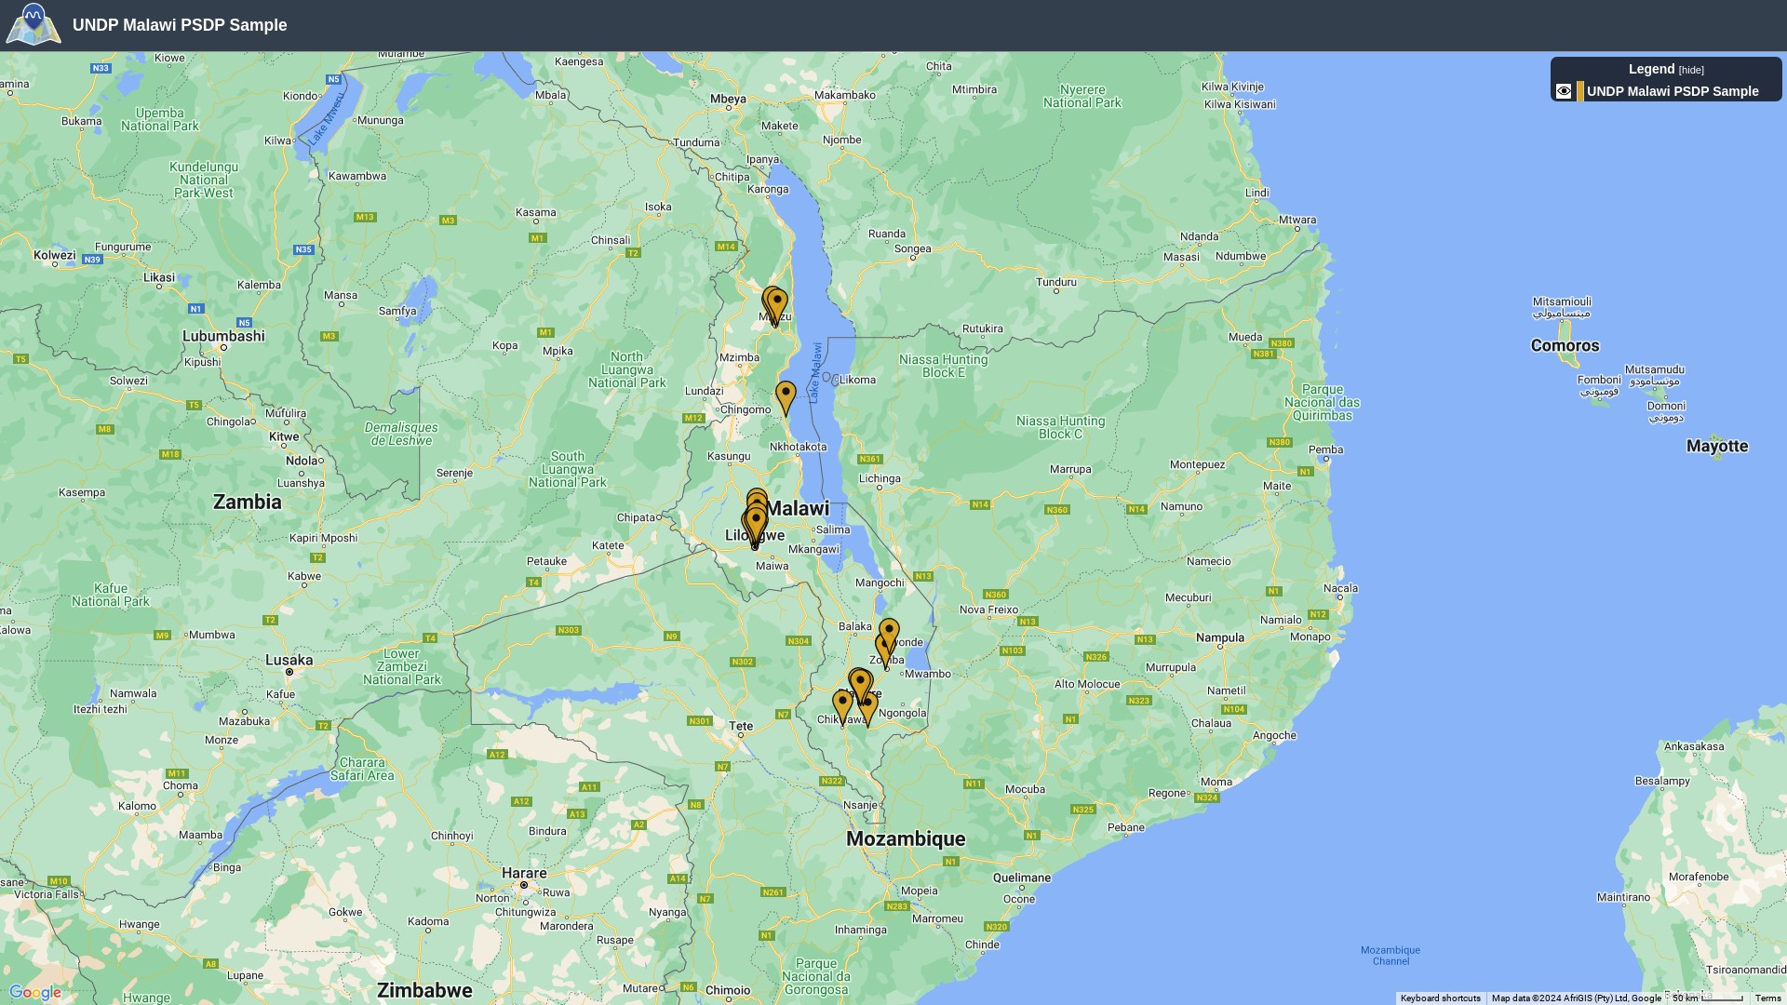

As there are only two companies currently receiving funding and technical assistance through the Build Facility (Ziweto and Global Seeds) we will include both as part of our sample.
The evaluation team met with managers of the MICF, the Growth Accelerator, GETF and Zantchito. They also met with the development partners including UNDP, European Union, IFAD, GIZ and Irish Aid. They also met with officials from the Ministry of Trade and Industry and the Ministry of Finance.

4.3.2.2 Sample Frame for Quantitative Data Collection
To collect additional quantitative and qualitative data the evaluators ran a survey on SurveyMonkey. The survey link was shared with all stakeholders who were listed on the spreadsheets provided to the evaluation team by UNDP. The survey link was shared with stakeholders who included the following:
- Businesses funded through the MICF.
- Businesses funded through the Growth Accelerator.
- Business Incubators funded through Zantchito.
- Businesses funded through the BUILD Malawi.
- Business Development Services providers to Zantchito incubates.
- Government of Malawi officials.
- Development partners.
A total of 211 links were shared, with 19 messages bouncing. A total of 68 responses were received, for a response rate of 35.4%. On the assumption that our population size was 350 with a sample size of 211 and a confidence level of 95% we get a margin of error of 4%. Statistically the acceptable margin of error for a survey is usually between 4% and 8% at the 95% confidence level. For this survey the 4% margin of error indicates how close the results reflect the views of the overall population of respondents involved in the PSDP. The survey questions are attached as Annex 9.3.4.

4.4 Indicators and Data Collection Methods
The PSDP Results Framework includes a set of indicators that have been designed to measure progress on its outcomes and outputs. The evaluation team used available data to assess progress and provide an evidence-informed account of PSDP effectiveness and impact. As far as possible the evaluation team synthesised data from different projects.
Table 1: PSDP results and associated indicators.
Result | Indicators | Source / comments
Outcome  By 2023, Malawi has strengthened economic diversification, inclusive business, entrepreneurship, and access to clean energy | The employment rate by sex, age, mother tongue | National Statistics Office  The evaluators will need to make certain assumptions when attributing programme effect on employment rate.
Output 1  Private sector enabled to enhance innovation, productivity and entrepreneurship | 1.1 Number of private sector entrepreneurs enabled to access regional and international markets, including access to affordable risk capital to de-risk investment for inclusive business growth models. | - The quantitative data for these indicators will be drawn from project reports.  - We note that the Prodoc results framework only speaks to the MICF and the Growth Accelerator, whereas the evaluation will also cover additional mechanisms including the Build Fund, the Green Economic Transition Facility (GETF), Zantchito, and the Accelerating Alternative Energy and Fuel-Efficient Technologies (AA – EFFECT).  - We will therefore look both to disaggregate and synthesize the data from the different funding mechanisms so that we can do a composite as well as a granular analysis.  - We will include indicators from the different funding mechanisms to ensure we fully cover the PSDP initiatives.  - We are making the assumption that as we go through all the project documents, we can integrate output level indicators from the different results framework to create a composite set of indicators.
 | 1.2 Number of new jobs generated by firms participating in the Malawi Innovation Challenge Fund (MICF) disaggregated by gender.
 | 1.3 Aggregate number of poor people experiencing net positive income or livelihood improvement as a result of MICF programmes.
 | 1.4 Increased lending to SMEs as a result of the MICF.
 | 1.5 Number of SMEs on-lent to as a result of the MICF
Output 2  Youth led downstream Micro and Small Enterprises enabled to generate ideas for business start-up; and supported to accelerate and grow. | 2.1 Number of MSEs enabled to access affordable finance, BDS and incubation services for business start-up with support from the STIEF.
 | 2.2 Number of MSEs enabled to access affordable finance and Technical Assistance for business acceleration with support from the Growth Accelerator.
 | 2.3 Number of direct full-time jobs created by supported MSEs.
Output 3  Ministry of Industry, Trade and Tourism enabled to address selected business constraints for private sector growth. | 2.1 Automated licensing system for Exports and Imports in place. | Data will be sourced from the Ministry of Industry, Trade and Tourism around the level of support provided to remove barriers and constraints to business growth and development smoothen key binding business constraints.
 | 2.2 Number of SMEs supported to comply with quality standards under the BMS.
 | 2.3 Number of companies enrolled and financially subscribing to the BMS.

Throughout its portfolio of investments, the BUILD fund committed to collecting and consolidating the short-term outcome metrics included in the following table, where projections until 2024 were specified. We understand that these indicators and targets may have been subsequently revised.
Table 2: BUILD Facility outcomes and associated indicators
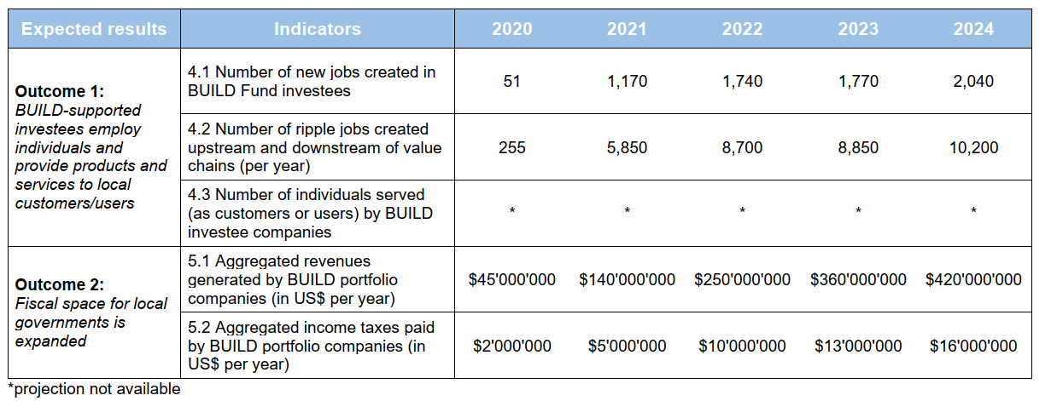

Limitations of the Methodological Approach
From the outset the PSDP as an umbrella programme has a set of complex facilities all at different stages of their implementation cycle in what is clearly a complex institutional and socio-economic context in Malawi. This has made it somewhat challenging to fully understand and analyse outcomes and impact. The evaluation team can report, however, that the evaluation methodology was implemented as planned (as per the Inception Report). The team was able to meet with most of the sampled organisations and where requested these organisations were very helpful in setting up focus group discussions with beneficiaries. The evaluation team was pleased with the response rate to the survey as this provided quantitative data that has been used for the evaluation purposes because of its generalizability, ease of analysis, consistency, and precision. The team collected a large amount of qualitative data which helped to provide an understanding of the PSDP's context, although it was not robust enough to explain complex issues or interactions. Qualitative data was used for this evaluation research, but it needs to be acknowledged that it has its limitations in being subjective, time-consuming, costly, and difficult to analyze and interpret. The evaluation team also experienced a “snowballing effect” where one respondent would refer the team to another respondent not initially on the list of stakeholders. While these added voices added substance and validity to the findings it also delayed completion of the primary data collection process.

4.6 Applying a Rating Scale
In assessing the three programme outputs of the PSDP has applied a rating scale to provide UNDP with a clear assessment of progress made. The rating scale uses a five-point scale on the spectrum from 1 (highly satisfactory) to 5 (difficult to rate). It should be noted that the ratings are indicative as the different funding facilities under the PSDP are not necessarily comparable given their different target sectors and time frames. Figure
Figure 10: Rating scale for PSDP outputs
Overall Rating | Description | Score
Highly satisfactory | The project has been executed exceptionally well, achieving its goals and objectives with a high level of quality and efficiency. All key performance indicators are not only met but often surpassed. | 5
Satisfactory | The project has met the predetermined standards and achieved its goals. While it may not have excelled in every aspect, it has performed adequately and met the requirements set out in the project plan. Overall, the project has been successful. | 4
Partially Satisfactory | The project has achieved some of its goals but falls short in certain areas. While there may be aspects of the project that have been successful, there are notable areas where improvements could be made or objectives that were not fully met. | 3
Unsatisfactory | The project has not met the expected standards or achieved its goals. It signifies a significant underperformance, indicating that the project has not delivered the desired results and may require substantial corrective actions or even termination. | 2
Too early to rate | The project is in the early stages of its implementation and therefore there is insufficient year-on-year data to make an informed judgement. | 1

5. Key Evaluation Findings

5.1 Assessment of Malawi’s Policy Environment for Private Sector Development
Assessing Malawi’s policy environment for private sector development is multidimensional and involves looking at various factors that influence business operations. This includes regulatory frameworks, economic policies, political stability, infrastructure, access to finance, labour market conditions, and the broader macroeconomic environment.
Table 3: Assessment of components within Malawi’s private sector landscape
Regulatory Framework | The Malawi government has been working to improve the business environment to attract more private sector investments. These include efforts to simplify the process of starting a business and obtaining the necessary permits and licenses. These initiatives have been supported by partners such as USAID/Malawi Private Sector Engagement Assessment and UNDP’s Private Sector Development Programme. The Malawi Business Registration Services portal is currently online and fully functional (https://accounts.mbrs.gov.mw/).  The regulatory framework for private sector companies involved in the charcoal industry lamented the unaligned regulatory environment. Legal charcoal is subject to value added tax, which makes the product uncompetitive with the illegal charcoal.  According to the IFC, the regulatory environment and growth of the private sector in Malawi require disentangling political rents and business interests. There is a need to strengthen accountability and transparency in the public procurement process to ensure firms are not dependent on government connections and to support the diversification of resources to more complex and export-oriented sectors rather than rent seeking sectors such as farm inputs and construction.
Economic Policies | In November 2023, the Reserve Bank of Malawi adjusted the exchange rate to 44%, aiming to align with market fundamentals. However, liquidity remains a challenge. This has been detrimental to the economy and the private sector at large, as they must be in line to access foreign exchange. Due to such factors, initiatives such as the Build Facility under UNDCF have proved to be beneficial for private sector companies such as Ziweto, which were unable to access foreign currency to pay for their imported raw material requirements.  Monetary policy in Malawi is quite tight, with the policy rate pegged at 24.00% in February 2024. This has raised the benchmark lending rate to 26%, crowding out private sector companies from assessing commercial bank loans. Malawi being a net importer with limited exports, such tight monetary policies have been criticized for their failure to address cost push inflation, which is as a result of high input costs such as imported inputs, energy, and labour. These policies are rather efficient in addressing demand pull inflation, which occurs due to increased aggregated demand that exceeds aggregate supply.  The country is a highly indebted country, with public debt hovering around 69.1% of the GDP, thus relying on domestic financing and development partners, thus further crowding out the private sector. Fiscal discipline and debt sustainability remain two of the key priorities to resuscitate the economy.
Political Stability | Generally, Malawi experiences stable political environments for the private sector. However, as we approach the election period, next year, political tensions and disputes are likely to disrupt the environment.
Infrastructure | Malawi faces significant infrastructure challenges, especially in electricity, transport, and water supply. Access to electricity is a big challenge. In 2021, only 14.2% of the population had access to electricity. Private sector companies are mostly equipped with power backups using generators, making efforts for renewable energy futile.
Access to Finance | Due to the high interest rates and limited access to finance for the private sector. The government, through a number of initiatives, is trying to bridge this gap. Notable initiatives include the Financial Inclusion and Entrepreneurship Scaling Project, which offers affordable financing to entrepreneurs. The Agricultural Commercialization Project has also provided significant financial support to cooperatives and businesses in the agricultural sector. Despite these efforts, viable companies such as Trend setters are still facing challenges in accessing affordable working capital. Similar challenges are faced by companies such as Global Seeds. There is limited commercial financing that is aligned with the agricultural sector, especially for seasonal enterprises such as the seed business.
Labour Market Conditions | According to Agenda 2063, Malawi’s vision is to become an inclusively wealthy and self-reliant nation. The Malawi Government recognized the role of entrepreneurship in achieving this goal and, as such, its involvement in supporting projects such as Zantchito skills for job projects. Despite these efforts, some labour market conditions still limit job creation, specifically the increase in the minimum wage from 50,000 MWK to 90,000 MWK for urban and rural workers.
Barriers to entrepreneurship for women in Malawi | Women in Malawi face many barriers to entrepreneurship, including cultural, social, and economic factors. Gender-biased cultural beliefs and norms create stereotypes that discourage women from starting businesses. Malawian society continues to have a patriarchal structure, with most women being responsible for unpaid housework and childcare. Women in Malawi tend to have limited access to capital, finance, and business development services. They also face high taxes, intense competition, and gender-based violence.

In the challenging private sector terrain in Malawi the evaluation survey asked respondents what they experienced as the most significant obstacles / barriers to growth during the period under review. The foreign exchange challenge that Malawi has been grappling with over the past few years was cited as the biggest obstacle to growth faced by business (73% of respondents) while the COVID 19 pandemic was cited as another major challenge (38%).
Figure 11: Barriers to making optimal use of PSDP funding.

5.2 Comparative Analysis of Development Partner Interventions
There are several other development partners supporting private sector development in Malawi. Some of these development partners include World Bank, USAID, GIZ, KfW.
The World Bank is implementing several projects in this regard. Some of the key flagship projects include the Agricultural Commercialization (AgCom) project and the Financial Inclusion and Entrepreneurship Scaling (FInES) Project. Unlike the AgCom, UNDP PSDP is not sector specific. AgCom has a focus on the agricultural sector, specifically focused on building productive alliances between producers and off-takers. This approach leaves out other significant sectors such as tourism, logistics and ICT.
On the other hand, the UNDP programme can also learn from implementation aspects of the AgCom programme. For instance, the programme has a component which supports last mile public infrastructure (approximately 18 million USD was allocated). Under this component, enterprises and projects will be supported with access to feeder roads, electricity, water, and other infrastructure. In relation to access to electricity an amount of USD10,000-20,000 has been allocated per project which can be used to finance step-down transformers and low voltage extension lines of about 3 kilometers. Under the UNDP PSDP – in particular the MICF and the GA - there are some projects which have not yet been connected to electricity due to funding challenges. This places quite significant constraints on their business models and profitability.
The FInES project is implemented by the Reserve Bank of Malawi with support from World Bank with a total project cost of USD 86 million. The project supports the following key components: Liquidity enhancement for MSMEs, scaling entrepreneurship and building firm capabilities and enhancing the enabling environment for financial inclusion and growth of entrepreneurs. Unlike the UNDP PSDP, FInES offers concessional loans to MSMEs. The project may appear to be supporting the private sector, but it is potentially crowding out private sector in the long term as core funds of financial institutions are invested in treasury bills. A potential challenge is that once the project is over, these MSMEs do not have the capacity to get core financing from commercial banks. These loans also add to the national debt for Malawi as they need to be repaid at some point. Without proven productivity, such loans are a burden to the economy in the long term.
In December 2023 the World Bank announced that it would provide Malawi with budget support to strengthen the country’s ability to enhance fiscal sustainability and transparency, stimulate private sector-led growth, and increase resilience to shocks. Budget support was agreed based on the assumptions that the Government of Malawi was committed to addressing macroeconomic imbalances, unsustainable debt, and longstanding structural and business environment constraints inhibiting private sector-led growth. The decision was also premised on the government’s efforts to restore macroeconomic stability through addressing long-standing fiscal, monetary and external sector imbalances, as reflected in the new Extended Credit Facility with the International Monetary Fund (IMF). This initiative offers the potential for UNDP to synergize the PSDP with the World Bank’s commitment to mobilizing private finance and investment including in digital and energy sectors.
USAID through the Malawi’s Feed the Future Growth Poles Project is supporting private sector companies in the strategic agrobusiness sector, focusing on macadamia farming. This initiative is sector specific, and it excludes emerging sectors. Through the partnership, the Feed the Future Growth Poles Project is a partnership between USAID, which has invested USD 40 million and the Embassy of Ireland, which has contributed Euro 9 million. The project is providing farmers with macadamia seedlings cultivated specifically for Malawian conditions. The focus on strategic sectors such as macadamia nuts is however quite high risk, as the commodity is susceptible to price volatilities. The UNDP PSDP is broader and spreads the risk and can address challenges across multiple sectors including Macadamia, as seen from projects such as Tropha. The UNDP PSDP also allows for disruptive sectors such as science, technology and innovations.
The Malawi-German cooperation since 2014 through GIZ has been implementing a number of private sector led projects. The projects include the Green Innovation Centers (GIAE) and More Income and Employment in Rural Areas (MIERA) targeting smallholder farmers, MSMEs and lead companies. The GIAE program has been closed as of 2023, while MIERA is still operational. MIERA focuses on the development of new business approaches, agricultural value chains (oil seeds, cassava, rice, macadamia, chili/paprika), particularly the down-stream part of the value chain (processing, aggregation and marketing), the tourism sector, the eco-friendly construction materials industry and improving market infrastructure. Alongside this partners such as GIZ mainly provide technical assistance to MSMEs. GIZ does not provide financial assistance directly but provides financial assistance support through KfW. However, KfW currently implements some of its key private sector development programmes through UNDP. This highlights the suitability of instruments under the UNDP PSDP. There are scenarios where GIZ does provide financial support through matching grants which are called Integrated Development Partnership for Private Sector (IDPPs). These are value chain specific and targeted to GIZ partners or potential partners within value chains of interest.

6. Achieving the PSDP Output One
The core objective of the PSDP has been to contribute to the Government of Malawi’s efforts to transition the country to a productive, competitive and resilient nation in a coherent and policy-aligned manner. To achieve this the PSDP is aligned to SDG 8: “Promote sustained, inclusive and sustainable economic growth, full and productive employment and decent work for all” and SDG 9: “Build resilient infrastructure, promote inclusive and sustainable industrialization and foster innovation. The PSDP is all a component of Outcome 1 of the UNDAF: “By 2023, Malawi has strengthened economic diversification, inclusive business, entrepreneurship, and access to clean energy.” The programme is also aligned to the UNDP Strategic Plan (2018–2021) Outcome 1, which places an emphasis on “advance poverty reduction in all its forms and dimensions.
The results expected from the PSDP Output 1 were expected to achieve diversified and innovative private sector with the ability to generate investment and create jobs. Key interventions for this output have been the following:
- Provision of matching grant finance through the Malawi Innovation Challenge Fund (MICF) to private sector companies operating in Malawi (both domestic and international) and interested in investing in productive capacities in Malawi for export promotion and import substitution, innovating in the way they do business and ensuring that the business models are inclusive of the poor.
- Facilitation of opportunities for private sector companies in Malawi to access other debt finance opportunities, on more affordable commercial terms, such as the “Malawi Window” earmarked under the Build Fund, a permanent blended finance vehicle for LDCs. The expectation was that by 2023 several private sector companies would have been enabled to access risk capital to grow their businesses, access regional and international markets and create jobs.
Figure 12: Progress on PSDP Output One

Overall Rating | Description | Score | Comments
Satisfactory | The project has met the predetermined standards and achieved its goals. While it may not have excelled in every aspect, it has performed adequately and met the requirements set out in the project plan. Overall, the project has been successful. | 4 | The MICF has – in the assessment of the evaluators – been successful interventions in the Malawi private sector. The MICF funding mechanisms has provided significant opportunities to medium and small enterprises to grow their businesses, diversify their products and penetrate new market opportunities. Regular tracking of the enterprises funded under this mechanism will need to be conducted to assess whether they are proving to be resilient within the turbulent Malawian economy.
Too early to rate | The project is in the early stages of its implementation and therefore there is insufficient year-on-year data to make an informed judgement. | 1 | The BUILD Facility has been fundamentally restructured and has yet to initiate new financing opportunities for larger enterprises. The GETF is in the very initial stages of its implementation and there is not yet sufficient data to provide an evidence-based rating.

The following sections assess in detail the progress of the MICF, the BUILD Malawi Fund, and the Green Economic Transition Facility (GETF) in achieving the requirements of the PSDP Output One. The rating provided is generic to the facilities assessed under Output One.

6.1 Malawi Innovation Challenge Fund
The Malawi Innovation Challenge Fund (MICF) was established as a US$ 11 million competitive, transparent mechanism that provides grant finance for innovative projects proposed by the private sector active in Malawi’s agricultural, manufacturing and logistics sectors. Supported by the United Nations Development Programme, UK Aid and KFW, the MICF was designed to be a quick, responsive mechanism that would not be overly bureaucratic and that would understand the needs of the private sector in Malawi. The MICF was first launched in April 2014 to accelerated economic diversification and increase opportunities for the poor through more income and job creation. The MICF was designed to create productive partnerships with private sector, mainly with lead firms and producers, especially smallholder farmers. By the end of the project, MICF had reached out to both large, medium and small enterprises, with large firms accounting for 47% of the portfolio.
Figure 13: Overall MICF portfolio by company size.
The model followed an inclusive business model for integration of smallholders, suppliers and producers into national, regional and global value chains. The initial design of the MICF was premised on the assumption of working with grantee companies to develop partnerships with low-income producers and beneficiaries.
Figure 14: Original MICF Model 2014-2015
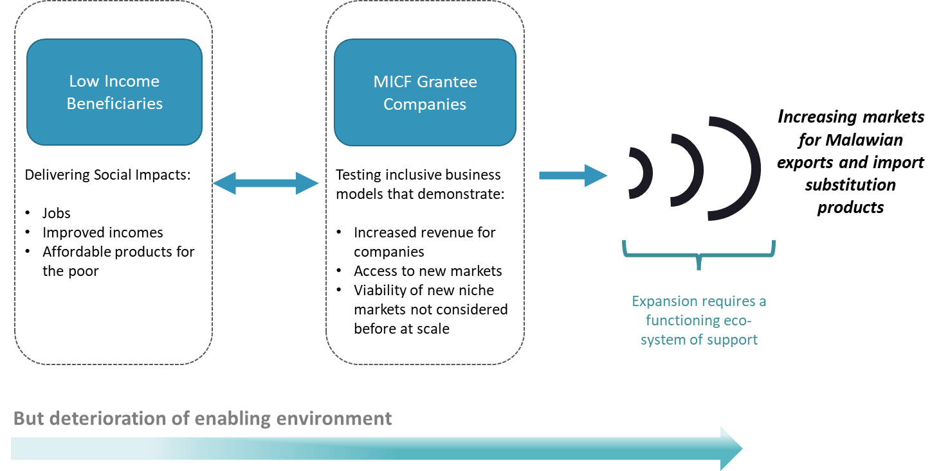
Source: MICF end of contract report
However, the initial implementation of the project warranted the need for reassessment as projects were faced with two sets of challenges: firstly, logistical challenges in input provision, aggregation, warehousing and transportation, and secondly challenges with accessing financing for implementation of MICF projects and financing to grow the enterprises beyond MICF support. As such, the later rounds of the MICF were restructured to also develop the wide eco-system.
Figure 15: Strengthening change and the Ecosystem 2016-2019
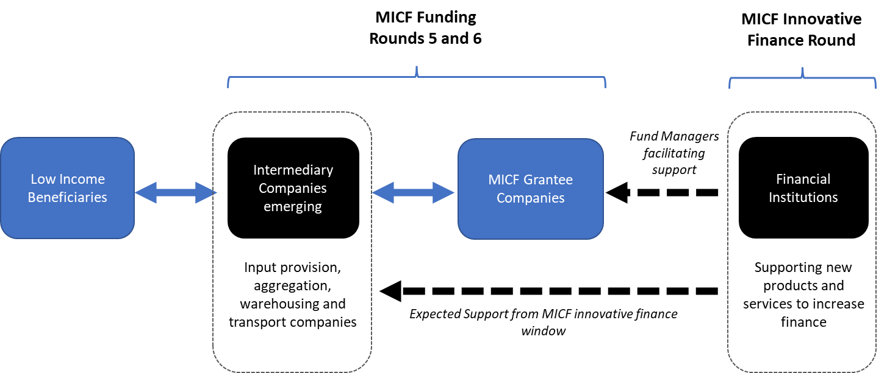
Source: MICF end of contract report
MICF was further iterated due to the occurrence of COVID-19 crisis. Enterprises were faced with cash-flow constraints as both domestic and international demand fell leading to reduced revenues and overall reduction in productivity as workforces were subjected to travel restrictions, and illnesses. The MICF responded by helping key business deliver systematic impact to reduce supply chain downturn and also putting in place windows to support rapid recovery.
The implementation of the fund followed 4 main steps:
- Step 1: Public Announcement of the MICF challenge
  - Marketing of MICF in Malawi as per communications strategy
- Step 2: Project Concept Notes (PCN)
  - Registering the PCN and checking for eligibility
  - PCN screening and grading, by the MICF Fund Managers
  - PCN review and shortlisting by Investment Panel (IP)
- Step 3: Request for Proposal
  - Invitation to submit a full business plan with financial proposal, within seven weeks
  - Proposal preparation and submission
  - Due Diligence and risk assessment
  - Evaluation of proposals by the Investment Panel (IP)
  - Notification to applicants
- Step 4: Pre-Grant negotiation and Grant Agreement
  - Develop the Logic Model and results framework
  - Finalizing of Milestones and Milestone Budget
  - Signing of Summary of Negotiations
  - Submission of documentation to UNDP by Fund Manager
  - Final approval by UNDP and signing of contract between Grantee and UNDP
According to the end of project report, 9 rounds have been implemented by MICF, which are summarized in Figure 15 below.
Figure 16: MICF Rounds
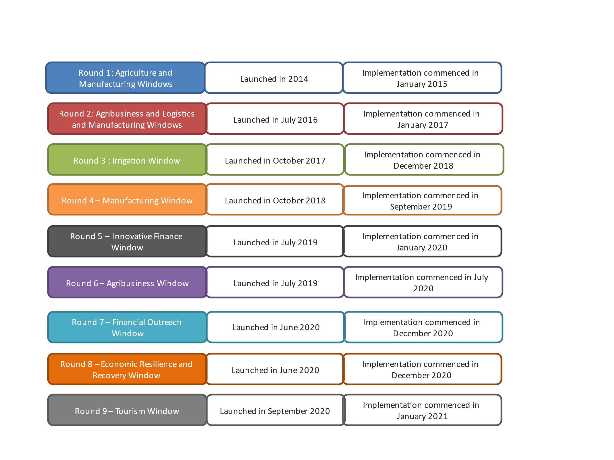
Source: MICF end of project report
The MICF fund was characterised by offering incentives to private sector to pilot new approaches that would not otherwise be commissioned on a purely commercial basis. The fund aimed at unlocking innovative high economic and social impact projects which were not previously explored. Such projects would also unlikely access commercial funding as they would be deemed to be risky. 40% of the innovations under MICF have been in ICT, followed by 27% in processing technologies. The processing technologies were mainly for development of new or upgraded products for both the local and international markets. The processing technologies/equipment were typically manufactured from China, and India, some were fabricated locally. A few utilized European manufacturers. 12% of the innovations were in packaging and 21% were unspecified.

6.1.1 Project Progress Against Key Evaluation Criteria

6.1.1.1 Relevance and Coherence
In line with the vision 2063 and the Malawi Growth and Development strategy, MICF complements the national development agenda by promoting innovation as drivers of economic development. MICF has been able to champion pro-poor privates sector led development and innovation. According to the MICF endline report, MICF fund was designed to address some developmental challenges facing the country. For instance, the poverty rate between 2010 and 2019 has been stable at 50.7% with a high percentage in rural areas at 57% compared to 19% in urban areas as of 2019. Through MICF, 77,651 smallholders have directly been engaged with MICF, 90% have seen a direct income gain due to engagement with the MICF. On average, the MICF end of project reports an overall income increase of 124% from baseline figures.

6.1.1.2 Implementation and Efficiency
Implementation of projects such as the one with Presscane clearly demonstrates the implementation efficiency generated through MICF funding. MICF has been able to develop partnerships between large companies and smallholder farmers. The innovation in these projects is significant. With Presscane not owning land, the MICF funding has been able to facility the company to pilot an out-grower scheme which has now grown from 100 hectares to 1000 hectares. The MICF has been able to implement innovations across different sectors.
As of December 2022, the MICF end of project report indicated that 42% of the projects were successfully completed, 30% of the projects were closed due to implementation challenges and 28% were still under implementation. MICF as a programme was comprehensively designed, with state-of-the-art risk management approaches. This enabled the MICF to negotiate the challenges affecting 30% of financed projects which were at risk. The evaluators noted that many of the risk factors that arose were linked to internal challenges faced by these private sector companies. For example, Mzuzu Coffee was and continues to be a company in financial distress. Financial management challenges meant that the company was unable to absorb the full MICF funding. In the case of a company such as the Ethanol Company (EthCo) there were challenges around organisational and leadership commitment for the proposed stakeholder partnership model with local sugarcane farmers. An additional concern arising from the visit of the evaluators to these two companies is that some of the machinery and equipment purchased with MICF funds have yet to be utilised. It was clear from visits to Mzuzu Coffee and EthCo that idle equipment is not being used, which signifies an opportunity cost in not using the equipment to generate revenue. In some cases, such as implementation of EthCo project, the challenges of an incomplete projects rest with the smallholder farmers in Nkhotakota who have been left holding idle equipment. For a variety of reasons including an incomplete warehouse Mzuzu Coffee sits with an unused and uninstalled coffee roaster, which again signifies lost production.
Despite these challenges the MICF funding to Mzuzu Coffee helped reduce the financial risk faced by the company. This necessitated the signing of an agreement between NBS bank and Mzuzu Coffee where NBS bank paid coffee farmers directly and in good time. This arrangement also helped Mzuzu Coffee to renew the contract with Phoka cooperative which had stopped its supply of coffee to the company due to the financial challenges being faced by Mzuzu Coffee. A worrying implementation challenges is the knock-on effect of financial constraints leading to the inability of companies to install and utilise expensive equipment. It was clear from visits to Mzuzu Coffee and EthCo that idle equipment is not being used for other purposes, so there is a significant opportunity cost to not using the equipment to generate revenue.
Figure 17: Idle irrigation pumps at Nkhotakota (EthCo) and idle roaster at Mzuzu Coffee
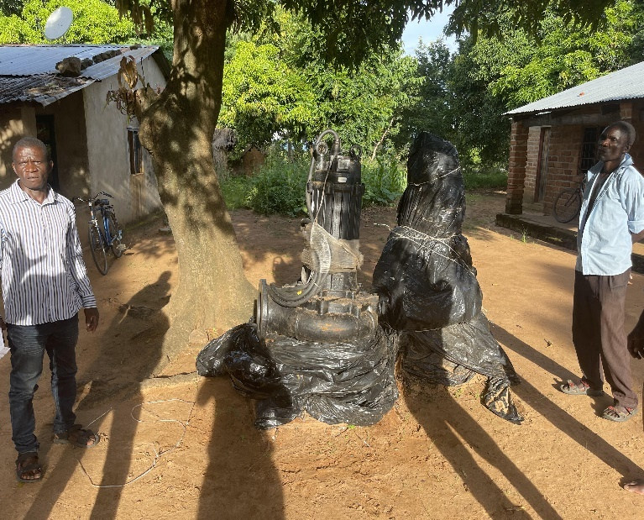 | 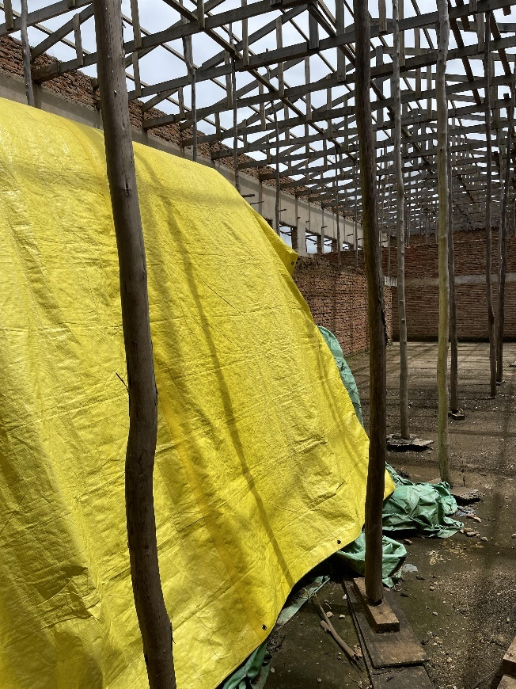

6.1.1.3 Effectiveness
According to the MICF endline report, the following was achieved as of December 2022.
Level | Indicator | Actual (December 2022)
Impact | Aggregate number of poor people experiencing net positive income or livelihood improvement | 693,870
 | Estimated % increase in aggregate income accruing to poor households from new earnings, increased earnings or cost savings, due to MICF projects. | 112%
Outcome | Number of households recording or on-track to achieving additional income as a result of MICF Projects | 56,926
 | Volume of Small and Medium Enterprise loans provided by financial institutions, microfinance and non-bank financial institutions in Malawi | MK7,157 million
 | Number of SMEs borrowing from MICF Grantee Financial Institutions / Non-Bank Financial Institutions | 23,395
 | % of companies that are able to leverage new external finance for their inclusive business project after receiving an MICF grant | 46%
 | Number of MICF projects that are 'on track’ towards achieving scale and / or replication | 61%
Output | Number of low income, unskilled people getting permanent employment as a result of MICF Projects | 2,916 (40% female)
 | Number of smallholder households benefiting from new or enhanced income generating, or livelihood improvement, opportunities as a result of MICF projects. | 78,346 (51% female)
 | Number of low-income direct consumers utilising new or enhanced products/services that impact on their basic human needs as a result of MICF Projects | 57,512
 | Increase in amount of land under irrigation as a result of the implementation of irrigation round projects | 826ha
 | Demonstration Effect: Degree to which innovation is visible (High, Medium, Low categorisation) | High 55%  Medium 18%  Low 27%
 | Commercial Viability Index: % of MICF Projects classified as progressing towards reaching commercial viability | 68%
 | Additional investment directly leveraged from the Private Sector through MICF | US$24.5 million

6.1.1.4 Resilience and Sustainability
The inclusive business models targeted by MICF have proved to be more sustainable beyond the MICF support. MICF targeted large companies that were already financially stable and more resilient. However, most of these companies had not yet test the waters of more innovative and inclusive business models. For instance, Presscane worked with smallholder farmers to develop an out-grower scheme. The project started with 100 hectares, but this is now being developed to cover 1,000 hectares. The MICF funding provided the catalytic investment for the company to make these kinds of innovative decisions. For most of the completed projects reviewed the document and the results indicate that the MICF has provided companies with the additional leverage to grow or expand elements of their business. This suggests that the MICF is having a sustainable impact beyond the project itself, with many companies managing to commercialise their new innovations.

5.3.1.5 Equity and Inclusion
MICF projects have been characterised by the piloting of inclusive business models. Presscane demonstrates the efficiency of inclusive business models by integrating smallholder farmers into the sugar cane value chain. Similar patterns have been observed within the coffee value chain with Mzuzu Coffee and the groundnut value chain at NASFAM. The data shows that the MICF has achieved gender parity in having 51% of its female beneficiaries among direct project beneficiaries.
The MICF appears to have recognised from the outset that while women play an important role across the agricultural sector, a comparison of productivity between male and female farmers shows some divergences. According to the MICF End of Contract report these divergences in productivity for the same crop between male and female farmers can be as high as 28% which is driven by a lack of access to family labour at key times within the agricultural season and access to appropriate agricultural equipment and knowledge. In terms of beneficiaries, all companies funded by the MICF tracked and reported female representation amongst their direct project beneficiaries. At the portfolio level, 51% of beneficiaries were female. This encompassed a total of 39,844 individuals engaged in the MICF supported business models. The proportion of total beneficiaries reached that are female, according to company type, is shown in Figure 17. Projects in the service and mainstream exports businesses recorded the highest proportion of female beneficiaries.

Figure 18: Female beneficiary representation by MICF project type.

The diverse nature of MICF projects means that some projects specifically target women while others have female only supply chains. In the MICF End of Contract report it was found that women benefit equally because the MICF projects work to remove traditional barriers to female productivity and profitability such as access to inputs and markets.

6.1.2 Case Study of Presscane Mwitha Sugarcane Farm
Introduction
PressCane Limited is an ethanol distillery company which is a subsidiary of the conglomerate Press Corporation Limited. The distillery was commissioned in June 2004 and is located in Chikwawa. The company employs 83 staff. The company produces ethanol from sugarcane molasses which is sourced from the Illovo Sugar Factory. The company has a mandate to supply fuel ethanol to oil marketing companies such as Puma Energy Malawi, Petroda and Total Energies for blending purposes in a ratio of 20% fuel ethanol to 80% petrol. Some of the ethanol is sold to beverage companies for production of liquor products. Potable alcohol (food grade) is mainly sold to beverage companies and SMEs for the production of liquor products. The company also exports ethanol products to neighboring countries and beyond in order to generate foreign exchange for Malawi.
Key Initiatives and strategies
Product innovation: Presscane manufactures ethanol from Molasses supplied by Illovo Sugar. However, the company has been looking for feed stalk for the distillery. This is because the shortage of available molasses means that the company is not able to operate at optimal capacity. The company requires 112,000 MT of molasses per year but only gets 60,000 MT from Illovo. In some cases, the company imports molasses to supplement the shortfall. The company has been looking for ways to source additional raw materials locally. The company has identified this project to pilot the production of ethanol using syrup as syrup produces more ethanol than sugarcane molasses.
Food security: The project is not only looking at commercial viability but also aims to ensure food security for smallholder farmers. 10% of the out-grower scheme is allocated to smallholder farmers as land under irrigation for food security.
MICF Support
PressCane applied for the MICF matching grant facility in 2016 and implementation started in 2017 to develop an irrigation scheme in the Mwitha Sugarcane Farm. The project was completed in 2020. The company was awarded about 357,000 USD which was matched by 448,718.82 USD from the company. The funds were mostly used for piloting an irrigation scheme through the Chisanja cooperative. A special purpose vehicle was established between PressCane and the smallholder farmers as a joint venture in which Press offered the capital as well as the managerial expertise. The smallholder farmers largely contributed the land for the project. The project involved about 214 smallholder farmers with each owning sizable amount of land. The land was measured, and certificates were issued to all smallholder farmers.
Impact and Success Stories
- 100 ha of land has been developed through the project. This is now being increased to 1000 hectares.
- The company is now confident that it will be able to install a plant for the production of syrup which will be used in the production of ethanol.
- Indirectly, the project has also contributed to food security as 10% of the irrigation scheme is allocated for food security. With the installation of the plant, the smallholders are now supplying sugar to Illovo which implies more income for the smallholder farmers.
- At endline, the project created 19 permanent jobs, 68 seasonal jobs and 150 part time positions.
- The project showcases the successful integration of smallholder farmers into national value chains using inclusive business models.
Challenges and Future outlook
The success of the project was highly depended on stakeholder engagements with smallholder farmers. Specialized consultants were brought on board to facilitate community engagements. The project is now expanding to 1000 ha and will be investing in a syrup plant. The MICF funded Presscane project achieved all its milestones without experiencing any major hurdles. As noted in previous sections the MICF funded projects with EthCo and Mzuzu ran into various challenges that impacted on implementation and meant that they were unable to complete the agreed project milestones. With the MICF being phased out, some of the projects may need to source additional funding – either from commercial banks or development partners – to ensure that they are able to complete these projects and make productive use of expensive equipment already purchased.

6.1.2 Case Study of Ethanol Company
Introduction
In contract to Presscane, which stands as a successful MICF project in terms of project finalization and achievement of agreed milestones, the Ethanol Company project is a case study for a project which was not as viable as initially intended. The Ethanol Company is a sister company to PressCane, both being subsidiary companies of Press Corporation. The Ethanol Company was commissioned in 1982 to produce and market ethanol in Malawi. The company produces fuel ethanol, industrial ethanol, and ethanol for beverages.
Key Initiatives and strategies
Product innovation: Similar to Presscane, the Ethanol company manufactures ethanol from Molasses supplied by Illovo Sugar in Dwangwa, Nkhotakota. The distillery operates at 50% capacity due to a shortage of raw materials. As a result, the company wanted to explore the potential of increasing capacity by utilizing syrup. The business model identified was to aggregate smallholder farmers under irrigation to produce sugarcane which could be made into syrup as a raw material for the production of ethanol.
MICF Support
To implement the innovation, the Ethanol Company applied for the MICF funding, which was approved at 500,000 USD. However, the project was only able to utilize all 287,000 USD of the funding provided. The funds were intended to be used to develop 70 hectares of land in Nkhotakota for an irrigation scheme in partnership with smallholder farmers. The total project cost was pegged at 1.2 million USD with the company and the smallholder farmers contributing the additional matching funds. The project was designed with a special purpose vehicle between Ethanol Company and the Kakasi farmer’s cooperative. In the initial design the smallholder farmers were supposed to contribute 700,000 USD, but this proved to be an unrealistic amount. The Ethanol Company came in to contribute 281,000 USD and the remainder was to be the contribution from the smallholder farmers. This was the key limiting factor for the project, as a targeted 700,000 USD commercial loan to the smallholder farmers proved to be unattainable. The outcome of these financial shortfalls meant that the irrigation scheme is yet to be completed and the Kakasi farmer’s cooperative is currently sitting with unutilized irrigation pumps purchased with MICF funds.
Impact and Success Stories
- Although the project did not achieve the milestone of setting up an irrigation scheme for the production of sugarcane the scheme itself is currently being utilized for rice production.
- The project served as a learning curve for the company on how to manage collaboration and partnership with smallholder farmers. For the future the company is looking to establishing an anchor farm model to avoid an over reliance on smallholder farmers.
- Through the project the Ethanol Company has achieved an important corporate social responsibility milestone, as the scheme set up with MICF funding and matching contribution is now under the ownership and management of the smallholder farmers.
Challenges and Future outlook
The project faced several challenges during the implementation phase. The most notable challenge was flooding caused by cyclone Freddy. The flooding pushed a lot of water into the sugarcane fields resulting in significant crop losses. Without the floods the farmers would have harvested the sugarcane for at least 5 years without replanting. However, with the floods the crop was lost.
Figure 19: Evaluators view the MICF-funded irrigation pumps and engage with small holder sugar cane farmers in Nkhotakota.
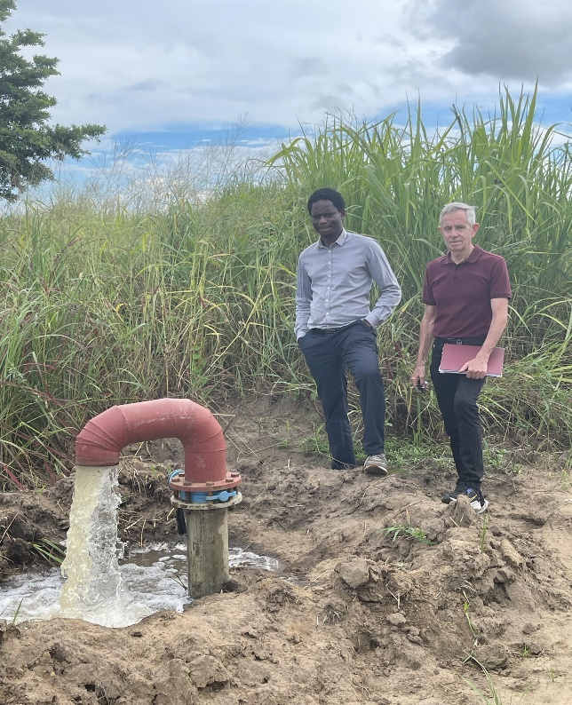 | 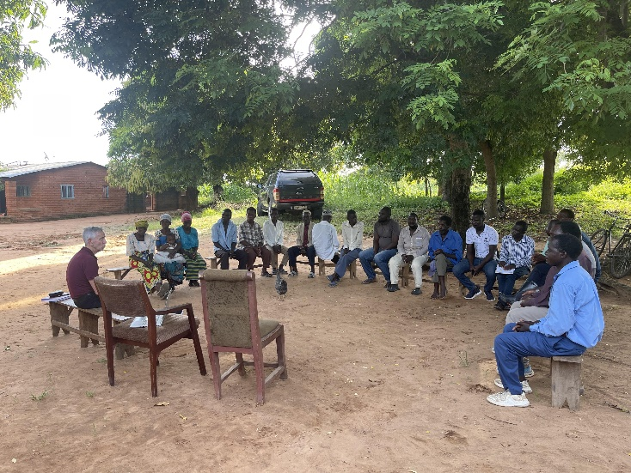

Within the design of the project, it proved difficult for the smallholder farmers to obtain commercial loans as part of their contribution to the project. This is likely the result of local financial institutions not wanting to provide financing to smallholders because they either see farmers as too risky or they do not offer the specialized financial products needed in the sector. This reality has meant that some of the MICF project milestones were not achieved. A critical shortfall was that out of the 70 hectares of land targeted for development, only 30 hectares were developed under irrigation. Unfortunately, this was the section of land which was later flooded. Advanced irrigation channels were developed, but the financing constraints meant that the project was not able to install additional pumps for the scheme. Currently the cooperative is sitting on an idle irrigation pump which is yet to be installed due to lack of finance for installation costs, which includes purchasing of additional solar panels and plumbing accessories.
Recommendations
Project design | Some projects which were supported had viability issues within their design. In particular, the design for Ethanol Company project in partnership with the smallholders’ farmers to develop an out-grower scheme. For the value of the project, it was evident that it was not viable for the smallholder farmers to obtain commercial loans to match their commitments. As such it is recommended for future projects and programmes to assess the commercial viability of projects before financing. A feasibility study at the design stage of the project could provide planners with crucial country contextualized information.  The design of the MICF provides lower risk opportunities for companies to explore innovative projects. For instance, despite the Ethanol Company project not being completed, the project has still managed to create a 30-ha irrigation scheme which is functional and currently supporting rice production.
Organizational development | The contrast between Presscane and Ethanol company clearly shows the need for organizational development support at the design phase of the project. These are two large companies, yet the differences in organizational structure and capacity of the two companies is indicative of how one project was successful while the other faced significant implementation challenges. This evaluation understands that organizational development support was not part of MICF support, however our case studies indicate that future initiatives could also investigate the provision of up-front technical advisory services as is being done through the BUILD Malawi facility. This could potentially increase the likelihood of more successful project outcomes and lower the exposure to risk factors.
Networking and knowledge sharing | It seems that within MICF projects there was limited networking and sharing of experiences among companies. The MICF provided room for peer-to-peer learning, yet it seems that this was a component of the MICF that was optimally exploited. The case in point is Presscane and Ethanol company which were implementing similar project under one umbrella conglomerate, Press Corporation, yet their synergies were not explored. It would have been advantageous to embed peer to peer learning and networking within the overall project design. The evaluators feel that more robust networking and knowledge sharing platforms across all the PSDP facilities would provide greater support to small, medium and larger companies in Malawi.
Contingency support | Despite challenges in finalizing several projects, some of these projects seems to still be viable beyond MICF funding. For instance, the Ethanol Company and Mzuzu Coffee have idle machinery which are yet to be installed. Mzuzu Coffee has partially completed infrastructure which is meant to house the currently unused machinery. These projects would benefit from some kind of contingency support to ensure optimal results. In the case of Ethanol Company, the burden of installing idle equipment has been left to the smallholder farmers, yet it is highly unlikely that they will be able to access financing to install the idle machinery.  Given that these projects failed to absorb the MICF funding, additional MICF funding is thus not warranted. However, beyond the MICF environment these projects would benefit from contingency support to ensure last mile finalization of some activities. These could be in the form a of a small grant from a development partner, a bridging loan or some other financial vehicle providing low interest finance.
Inclusive business models | Despite challenges working with smallholder farmers, the MICF project has managed to champion inclusive business models with sustainable impact among smallholders/beneficiaries. For instance, Presscane now has access to raw materials sourced from smallholder farmers. Before the project, most of the land was idle. This pattern is similar with other projects such as Mzuzu coffee where these projects have integrated smallholders into the national value chains.
Product Diversification | The MICF project with a focus on innovation has been able to pilot and provide product diversification for several private sector players. For instance, for NASFAM the funding has been utilized to produce at least two additional products to supplement those already on the market. The PSDP is thus commended for targeting innovation within the Malawian economy for product diversification.

6.2 The BUILD Malawi Fund

6.2.1 Purpose of the BUILD Malawi Mid-Term Evaluation
The main purpose of the mid-term evaluation is to provide an independent assessment of the progress the BUILD Fund has made towards achieving its planned results and identify lessons to inform future blended finance fund designs. Understanding that this is a mid-term evaluation the evaluators are looking at whether the BUILD Malawi is producing effects as expected and whether there is a necessity of modifying its plans. In addition, the evaluation is being commissioned to fulfill accountability requirements of UNDP as lead participating UN Organization of the Joint Programme to the Joint SDG Fund. This mid-term evaluation aims to analyze the two companies that the BUILD Malawi has engaged with, one with an actual investment in debt and Technical Assistance in post-investment and the other with technical assistance in pre-investment in the framework of the BUILD Malawi. The evaluation also analyzes the approach to Technical Assistance and the additionality to the beneficiary companies. In addition, the evaluation includes a case study that articulates the value, additionality and sustainability of the BUILD facility in a market like Malawi.

6.2.2 Overview: Generic Findings and Thematic Issues

6.2.2.1 Initial Concept
Malawi remains one of the poorest countries in the world despite making significant economic and structural reforms to sustain economic growth. The economy is heavily dependent on agriculture, which employs over 80% of the population, and it is vulnerable to external shocks, particularly climatic shocks. Various difficulties complicate private investment in a Least Developed Country (LDC) such as Malawi, where investors face significant real and perceived risks to doing business, from weak enabling environments to costly and time-consuming pipeline origination and a lack of market data. Malawi records one of the lowest rates of investment in Africa with an average of only 15 percent of GDP invested from 2000 to 2018, compared to 24.5 percent in Tanzania and 34.7 percent in Zambia. Malawi’s domestic MSMEs struggle to grow in part because owners and management often lack awareness of the benefits of financial services, and those that are aware often cannot access finance at reasonable interest rates with sufficiently long tenors. Such an environment obstructs small and medium enterprises' (SMEs) access to finance. This means that many businesses run by women and other vulnerable groups are unable to grow, and Malawi's economy is unable to become inclusive. Malawi’s low rates of impact investing are primarily due to the relative infancy of the market, particularly for non-Development Finance Institution investors, coupled with falling levels of Foreign Direct Investment (FDI).
From the perspective of the Joint SDG Fund a blended finance approach is seen to address the numerous challenges constraining investment in sustainable food systems in developing by de-risking agri-food transactions, both improving project bankability and mobilizing finance to bankable projects. The BUILD Malawi programme was conceptualized as a mechanism that could contribute to ending poverty and hunger by increasing investment in agriculture and other manufacturing and service supply-chains, as well as increasing productivity within these supply-chains through technology and innovation. It was also conceived as a mechanism for achieving gender equality by supporting business where women are significantly represented in boards, management, staff, suppliers, or buyers. The programme initially aimed to create 3,000 jobs (30% minimum for women and youth), integrate 75,000 small-scale producers into investees' supply chains, increase participating small-scale producers’ income by 30%, expand fiscal space with aggregated income taxes of US$ 19.3 million, and strengthen supply chains. The intention was also to capitalize on the UNDP’s substantial portfolio of investee businesses that had previously been funded through the MICF. UNCDF would also bring the technical capacity of its global BUILD Fund and later LDC Investment Platform BRIDGE Facility to issue catalytic loans and guarantees and provide predictable funding to support BUILD Malawi. FAO’s deep technical capability in the agricultural sector was viewed as a mechanism for facilitating the impact of their private sector development strategy.

The BUILD Malawi Fund was originally conceived and designed as a blended finance investment fund and was established to be an open-ended permanent capital vehicle. UNCDF saw the opportunity to leverage its capital mandate to engage the private sector in supporting the goals and targets of the SDGs. UNCDF started deploying its capital mandate by reconstituting its investment mandate to support other UN agencies that were working in financial ecosystems. In 2019 UNDP Malawi approached UNCDF through the SDG Fund. The problem statement was that through the MICF UNDP had achieved some success in growing SMEs but that those companies now faced the challenge of obtaining further investment finance to be able to expand even more. UNCDF saw this as an opportunity to bring into Malawi a blended finance mechanism together with a pipeline of companies potentially eligible for this kind of investment. In support of this initiative the Joint SDG Fund made a commitment of USD 8 million for a 5-year programme in Malawi, which stood as one of the Fund’s largest programmes. At the outset, it intended to attract commercial return-seeking capital, both domestic and international, to invest through an impact fund managed by a third party fund manager (Bamboo Capital) in a pipeline of early-stage Malawian agriculture sector companies – primarily along the agrifood value chain - that were looking for expansion or interested to venture in new business lines, mostly in the so-called “missing middle”, with the goal of generating both commercially viable financial returns and SDG impact.

The vehicle, which was incorporated in October 2021, was intended to be a blended finance approach which would combine official development assistance with other private or public resources, to 'leverage' additional funds from other actors. The expectation was that this blended finance vehicle would offer the possibility to scale up commercial financing for Malawi and channel such financing toward investments with development impact aligned with the SDGs. The use of financial instruments such as debt, equity, or guarantees at concessional terms offers some unique advantages for private sector participation, as it enables donors to de-risk financial structures, provide patient capital, or lengthen maturities of financing. BUILD Malawi was structured with two layers (or “tranches”) of capital, which were to be blended to invest in a portfolio of companies, but with different risk and return features to the ultimate investors, dependent on the tranche they have invested in. These include a first-loss, or catalytic, tranche and a mezzanine tranche. The first-loss layer is the first to bear losses, thereby protecting the mezzanine layer, which is the first to receive financial returns.
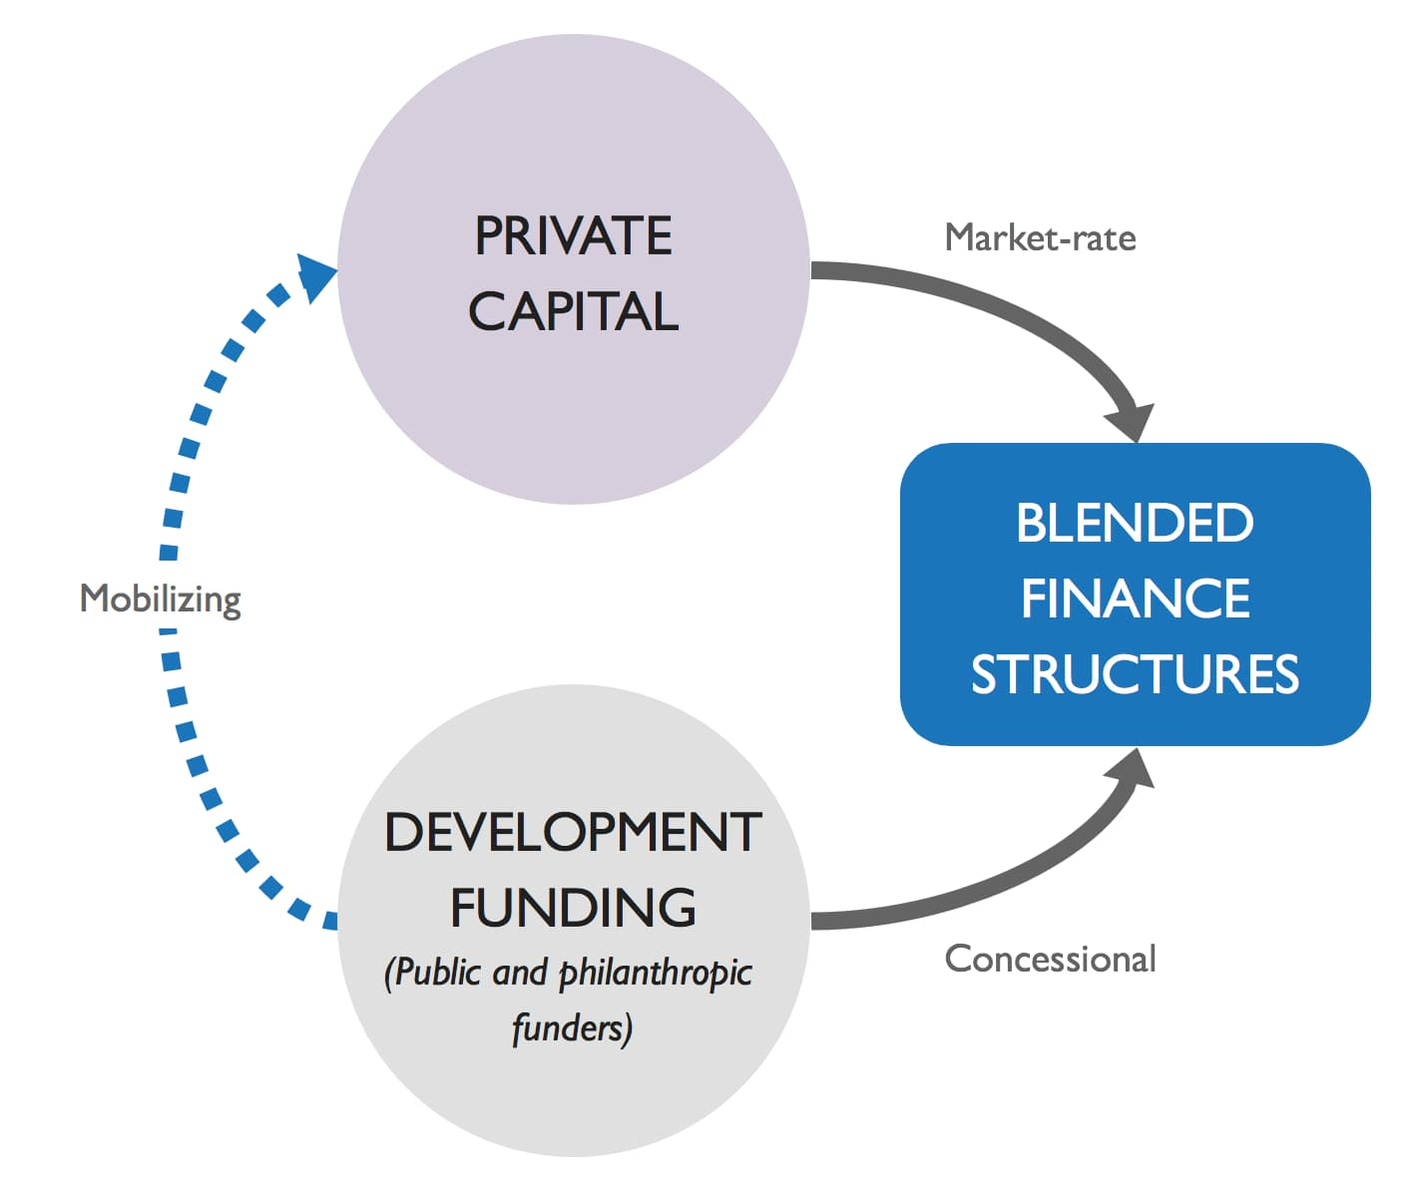
UNDP and UNCDF recognized that financing shortfalls are especially large for small and medium enterprises (SMEs) in Malawi that are seeking relatively small amounts of growth capital. To address the operating challenges of the so-called “Missing Middle” UNCDF designed the BUILD Malawi as a mechanism that would provide both financing and technical assistance in an integrated fashion to support private sector growth opportunities in a constrained market such as Malawi. UNCDF signed a partnership with Bamboo Capital Partners to launch in 2020 the Bamboo-UNCDF Initiative for the Least Developed Fund (the “BUILD Fund” or “BUILD” or “the Fund”), blended finance vehicle to provide finance to SDG oriented businesses in LCDs. Bamboo Capital Partners (BCP) was selected based on its reputation as an award-winning, pioneer impact investing fund manager with expertise that included managing “blended finance impact-first funds” which allows it to invest in early-stage companies and in countries where commercial banks or investment funds are highly risk averse. The Fund was designed primarily to support enterprises carrying high financial risk and high expected social impact, deemed to be below the radar of other impact investment funds, development finance institutions (DFIs), and other more commercially oriented financiers. Individual transaction sizes may be as low as $250,000, aligned with the Fund’s intended “missing middle” focus.
The BUILD Malawi Fund and the accompanying BUILDER Technical Assistance facility were intended to support businesses with a combination of loans, equity, and technical assistance. Taken together the BUILD and BUILDER were constituted as the first investment initiative to integrate the lessons learned from UNCDF’s past experiences to create a new, innovative approach for investments into SMEs in LDCs. The integration of the BUILD Fund and the BUILDER TA facility into UNCDF interventions is illustrated in Figure19 below:
Figure 20: Integration of the BUILD Fund and the BUILDER TA.
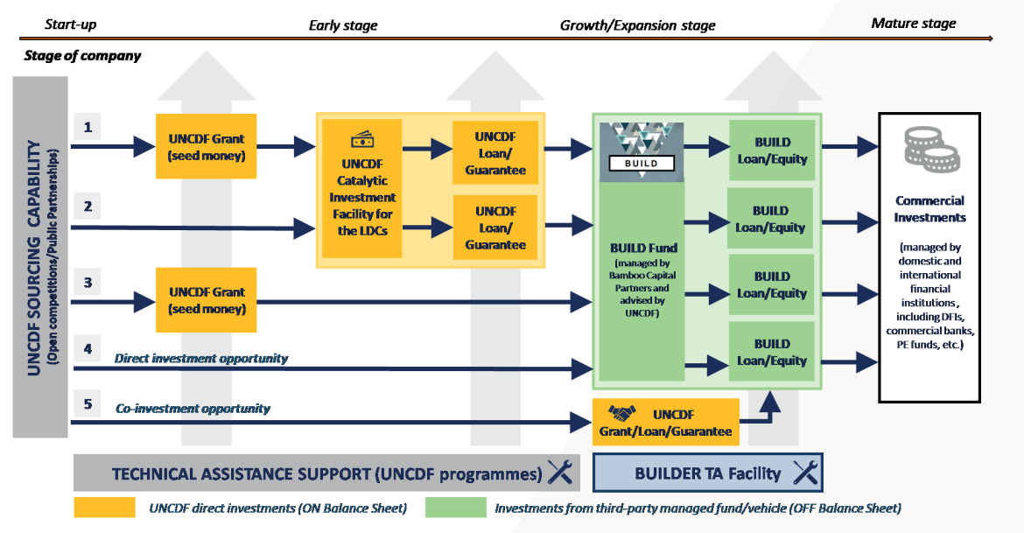
Source: UNCDF
As initially conceptualized BUILD Malawi was a structured blended finance window of the global BUILD fund, managed by BCP, with a target capitalization of US$ 35 million. Through the BUILDER facility, technical assistance would be provided to businesses both before and after investment to improve quality of their growth and SDG impact as well as reduce associated risks and costs. The Fund was designed on the premise that commercial investors would have appetite to invest into a vehicle able to provide between 3-5% net returns per annum de-risked thanks to first-loss catalytic capital and delivered through the deployment of such blended capital into a pipeline of companies, primarily those companies that had previously been supported by grants from UNDP’s MICF.

6.2.2.2 Revision to the Initial BUILD Malawi Concept
The initial conceptualization of the BUILD Malawi ran into a series of challenges that informed key changes to the structure and purpose of the Fund. In essence these challenges constituted a “perfect storm” of circumstances that have had impacts at global and national levels:
- Post-COVID economic recovery challenges.
- Turbulent global political circumstances, including Russia’s invasion of Ukraine and more recently the conflict in Gaza.
- Contractions in the agricultural sector.
- Fuel shortages.
- Unstable availability of power.
- Limited availability of foreign currency and fluctuation in foreign exchange rates.
- Devaluation of Malawi’s currency which directly impacted also the demand from MSMEs for the Build loans.
- Hedging costs for USD-denominated investment funds like Build Malawi have spiked from 9.5% in January 2022 to 19.3% in October 2022
This combination of factors effectively meant that the BUILD Malawi blended finance investment vehicle that was intended to attract commercial return-seeking capital was going to prove unrealistic. The economic situation in Malawi had severely constrained the prospects of the Fund to deliver on its initial financial forecasting. This in turn has reduced investor appetite from considering the BUILD Malawi Fund as an investment vehicle of choice. In May 2023, because of the challenging macro-environment, both globally and in Malawi, the Joint SDG Fund (donor) and the Participating UN Organizations approved the revision of the BUILD Malawi Joint Programme. Such revision implied the restructuring of the BUILD Malawi investment vehicle from a Fund, managed by external Fund Manager BCP, to a Facility, to be deployed by UNCDF as Facility Manager from its own balance sheet. The submission form for programme revision (13 March 2023) noted that in view of the many implementation challenges described above, the BUILD Malawi Fund was no longer workable in its original conceptualization. In the prevailing macro-environment at the time, the previously stated goal of bringing $10-15m of commercial return-seeking private capital into the Fund, including from international sources, was not likely to be achievable at that stage or in the mid-term. Therefore, the UN Country Team in Malawi recommended that the Fund be restructured so that it served as a seamless transition from the BUILD Fund to the BUILD Facility in such a way that it would not create distortions or brand recognition uncertainty in the market.
The restructuring has entailed the liquidation of the existing fully regulated Fund established in Luxembourg and the use of a different vehicle to pursue its goals. The process of unwinding the initial fund with Bamboo Capital entailed a long legal process, but the liquidation of the vehicle has now been approved and the assets of the fund have been returned to UNCDF, who will now manage the funds directly. It is to be noted that the BUILDER TA remains intact as it was originally designed. The BUILDER TA is the Technical Assistance Facility attached to the BUILD and it provides technical advisory support to the selected companies to help improve their pre-investment bankability and preserve their post-investment creditworthiness. Such advisory support is fundamental to de-risk financial transactions, and to maximize the developmental impact of the investment.

6.2.3 Project progress Against Key Evaluation Criteria

6.2.3.1 Relevance and Coherence
The evaluator understand that the lack of progress made with the BUILD Malawi since 2020 lay beyond the control of the UNDP and its partners, including the Resident Coordinator (RC) and other Participating United Nations Organizations (PUNOs). The downturn in Malawi’s macroeconomic situation from 2019 onwards made it more and more challenging for the partners to implement BUILD Malawi in its initial format as a blended finance vehicle. The restructuring of the BUILD Malawi was a pragmatic decision taken by the SDG Joint Programme partners based on prevailing negative economic factors and the paucity of evidence available from programme implementation. This also meant that the initial relationship between outcome, outputs, activities, and inputs as logically articulated in the BUILD Malawi logical framework were no longer adequate to the changed needs of the Joint Programme. It also meant that there was basically no data that could be used to quantify the SMART indicators in the logical framework or disaggregate them by sex, age, and location.
The conceptualization of the BUILD Malawi was clearly intended to take the funding facilities embedded in the PSDP to the next level, based on the challenge of meeting the SDG financing gap by 2030 with limited public resources. BUILD Malawi was of many initiatives globally to strengthen the involvement of the private sector in financing and implementing the SDGs. The 2015 Addis Ababa Action Agenda (AAAA) provided the global framework for financing the 2030 Agenda and encouraged public and private actors to join forces and act together to support the achievement of the SDGs. In conceptualizing the BUILD Malawi, the SDG Joint Programme drew on the AAAA’s call to harness the potential of blended finance instruments for sustainable development with careful consideration to the appropriate structure and use of such instruments. BUILD Malawi is coherent in that aligns with commitment to blended finance as a means towards multiplying the impact of public development finance in Malawi by bringing in the private sector and contributing to bridge the investment gap primarily in the agriculture / agribusiness sector and create self-sustaining market-based solutions for financing sustainable development.
As a blended finance vehicle, the formulation of the BUILD Malawi programme was aimed at synergizing a public sector growth model with the development rationale of the SDGs. The value proposition for the BUILD Malawi was that businesses and investors in Malawi’s agriculture sector could bring innovation and technologies, entrepreneurship, industry expertise, market-based solutions, distribution networks, investment capacity, and managerial and operational expertise, including risk-management. It seemed at the time to represent a promising way of contributing to building Malawi’s economic, social, and environmental resilience. It was also clearly aligned to the Government of Malawi’s economic growth and private sector development agenda as articulated in Malawi Growth and Development Strategy, as well Malawi's investment framework that is primarily governed by the Investment and Export Promotion Act 2012 and facilitated by the Malawi Investment and Trade Centre (MITC). The restructuring of BUILD Malawi into the BUILD Facility, while necessitated by circumstance, retains its coherence and relevance within the overall policy and programmatic efforts of the Government of Malawi to revitalize and grow the private sector. The restructured BUILD Malawi Facility needs to ensure its additionality by avoiding overlaps or duplications with existing instruments currently available. Locally this includes the Malawi Agricultural and Industrial Investment Corporation (MAIIC), which was established in 2018 and operates as a local development finance institution that provides financing solutions to support commercially viable projects in Agriculture, Agro-processing, Manufacturing, Tourism, Energy, Mining, Real Estate, and ICT for development in Malawi. International partner programmes in the sector include the EU’s KULIMA programme which supports extension services through Farmer Field Schools, agricultural research, access to finance through blending with European Investment Bank and value chains, USAID’s Enterprises for Development, Growth, and Empowerment (EDGE) Fund and its loan guarantee portfolio for SMEs in the Agricultural, Tourism and Renewable Energy sectors, and the World Bank’s Business Environment Strengthening Technical Assistance (BESTAP) Project and the Financial Inclusion and Entrepreneurship Scaling Project.
UNCDF wanted to provide an evidence base to inform the reshaping and reactivation of the BUILD Malawi Facility. To achieve this objective UNCDF conducted a market scoping exercise, including both primary and secondary research, to investigate its options relating to how to operate in the Malawi Market. This included operating through financial intermediaries, by potentially deploying a portfolio guarantee structure or other relevant financial instruments. The Scoping Report proposes that the restructured Facility should retain flexibility and deploy several financial instruments, including Portfolio Guarantees, Single Loan Guarantees, Direct Loans and Technical Assistance as the preferred option. The Scoping Report acknowledges that portfolio guarantee structures already exist in the Malawi market and highlights the fact that the BUILD Malawi Facility should therefore focus on providing a few instruments that strategically address gaps in the market. The Scoping Report further notes that the BUILD Malawi Facility would help to address some of the financing challenges faced by MSMEs, and points to a number of options that facilitate greater financial leverage:
- Establish Border Single Loan Guarantee structures that entail the sourcing over a period of several transactions derived from a pipeline generated by UNCDF and UNDP to one or two selected local financial institutions.
- Issuance by UNCDF of direct loans to candidates from the UNCDF/UNDP pipeline, targeting a specific sector and primarily companies that lack the ability to obtain loans due to lack of collateral, or require lending in foreign currency (mostly USD) for their operations.
- A well-designed Portfolio Guarantee targeting Micro-Enterprises and the smallest of the SMEs (the “missing middle”, with specific tranches catering to small holder farmers and women owned micro enterprises, that would be deployed with a Micro Finance Institution (MFI) or a financial institution with similar outreach as guaranteed party.

6.2.3.2 Implementation and Efficiency
The documentation shared with the evaluators and the interviews that were conducted show that a very detailed level of conceptualization and scoping went into the creation of BUILD Malawi. BUILD Malawi was established as a vehicle to facilitate innovative blended finance, built on funding from the Joint SDG Fund, management by BCP and technical support from UNDP, UNCDF and FAO. This partnership was intended to provide access to pipeline, concessional and commercial capital to SDG-positive businesses in last mile settings in Malawi. Although the BUILD Fund was a global LDC-focused initiative, it had the capacity to form dedicated investment “windows” to accommodate investors (at all risk levels) who wanted to focus their support on a specific country. The BUILD Malawi Window, therefore, was bespoke mechanism designed to facilitate investment in multiple sectors (including agriculture, energy, and financial services) and aimed to deploy investments to companies in both US Dollar and the Malawian kwacha. The investment portfolio yield will be priced to consider credit risk and foreign exchange depreciation risk.
By this point UNDP Malawi had been implementing the PSDP for some years and had built up a pipeline of “bankable” SMEs and projects with a social impact in Malawi. To initiate the BUILD Malawi process UNDP requested the UNCDF to conduct a due diligence mission during which fifteen companies were interviewed and assessed. All the companies that were interviewed during this due diligence phase were previous or existing MICF grantees and Growth Accelerator ventures. It was determined that a minimum of twenty-six (26) Malawian companies that have previously been supported with UNDP Malawi can absorb a minimum amount of USD 15 million (as a conservative allocation) to drive financial and developmental objectives. Due to the current foreign currency shortages in the Malawi market, local financial institutions are unable to cater the needs of SMEs (both small and medium scale) in need of foreign currency. This poses a major challenge for these companies to operate their businesses in an efficient and sustainable way. As a possible “efficiency” option UNCDF and UNDP create a vehicle for a UN institution to collaborate with a local legal institution that would then be responsible for obtaining and perfecting collateral and recoveries with the ambition to reduce the credit risk. Given the limited time left for the programme, the resources currently available to BUILD Malawi Facility need to be utilized fairly urgently by UNCDF to serve the financing needs of Malawian MSMEs, including but not limited to companies previously supported by UNDP Malawi. To expedite the utilization of resources the delivery model for the BUILD Facility may need to comprise both single loan and portfolio approaches to guarantee issuance, as well as the possibility of direct lending from UNCDF as was done in the case of Ziweto.
As discussed previously because implementation through this modality became increasingly challenging, it was not possible to implement according to the original design. What was possible, however, was the provision of pre-investment business advisory support through the BUILDER TA Facility to the two companies that were identified through the initial pipeline scoping (Ziweto and Global Seeds), aimed at de-risking financial transactions, and maximizing the positive developmental impact of these investments. From interviews with Ziweto and Global Seeds the business advisory support has been extremely rigorous and time-consuming, and both companies indicated that the process was and continues to be stringent. There was, however, a recognition that this support has been valuable in terms of strengthening the internal business systems and capacities of both companies.
The implementation of the Build Facility has also been faced by internal challenges within UNCDF. Changes in management came with a new paradigm shift. This implied delays in implementation and execution of the facility. At some point the new UNCDF management had reservations about the facility, citing the facility as being risky. This challenge seems to continue as the management has also recently changed and this could potentially mean another paradigm shift of the facility internally. During the implementation, the coordination of the facility with FAO proved to be confusing for some of the beneficiaries. For instance, with Global Seeds the role of FAO was not clear and seemed not to be aligned with the overall company needs. FAO assistance was more aligned with trials while the company had an appetite for field demonstrations.

6.2.3.3 Effectiveness
At the time of this evaluation Ziweto is the only company in Malawi that has received investment support through the first iteration of the BUILD Fund (as managed by Bamboo Capital Partners) via a loan of USD250,000 to manage accumulated debt. With the sudden depreciation of the Malawian Kwacha in mid-2022 the BUILD Malawi team understood that such depreciation would have a severe impact on Ziweto’s business fundamentals, as the business relied on several USD-valued imported goods whose costs were suddenly increased in Kwacha equivalent, substantially changing the economics of the business. Through a review process it was mutually decided that the nutrition business was unlikely to be profitable for the next few years. Based on this reality it was decided that BUILD Malawi would only finance the working capital need of the existing agrovet business. Proceeds were disbursed in USD directly to international suppliers, helping Ziweto overcome the non-availability of USD in the country. However, repayments would be denominated in MWK at 19.5% to prevent Ziweto from taking the forex exposure risk.
Ziweto has been using this Facility for the purposes of payment to their existing suppliers for the purchase of stock. In receiving this loan Ziweto agreed to a Loan Repayment Schedule. The rate of interest on the Loan for each Interest Period is the percentage rate per annum which is the aggregate of nineteen-point five percent (19.5%) per annum net of all local taxes and fees. The loan was secured after a detailed due diligence process which was necessary to ensure that Ziweto had the ability to repay the funds. While Ziweto management did indicate that the process was onerous and time consuming it also acknowledged that it served as a significant learning curve for the business. Both Ziweto and UNCDF have indicated that the company has been diligent in repaying the loan as per the agreed repayment schedule. This indicates enhanced capacity within the company to manage its finances effectively. Through the BUILDER TA business development support will continue to be provided through Ernst and Young, who have been contracted by UNDP Malawi to deliver ongoing operational and financial management support to Ziweto in anticipation of future investment.
The evaluation notes that before launching BUILD Malawi the UNCDF undertook a pilot with Kombeza Foods, a woman-led company that had been funded via the PSDP’s Growth Accelerator. According to UNCDF this pilot was not successful owing to problems associated with the macroeconomic downturn. There were challenges in procuring equipment from India, which were coupled with cyclone Freddy. This in turn led to challenges of loan repayment, which undermines the purpose of the blended finance approach. It will be important going forward that the lessons learned from this pilot are applied to future investments.

6.2.3.4 Sustainability
The conceptualization of the BUILD Malawi Fund was premised on creating an enabling environment for mobilizing additional financial resources for Malawi, helping to reduce poverty and hunger by increasing investments in sustainable agriculture and other manufacturing and supply-chains. The initial BUILD Malawi Fund was seen to have significant impact potential and set targets to support 37,500 households, integrate 75,000 small-scale producers into investee supply chains, increase SME income by 30%, and create 6,000 sustainable jobs, including 3,000 jobs (30% minimum for women and youth).
Given the delays caused by the Fund restructuring process, it is too early to make any definitive assessment about sustainability – either of BUILD Malawi itself or of the longer-term growth of Ziweto as an agribusiness. What the evaluation can point to is the fact that the BUILD Malawi-related processes that Ziweto – and to some extent Global Seeds - have gone through has built the resilience of the two companies and thereby increased the likelihood that they will be able to expand their operations. In the context of the BUILD Malawi leverage is vital for all partners, as scalability will only be reached through a high volume or size of operations and on the degree of standardization of financial structure of the participating companies. The consistent repayment by Ziweto within the current macroeconomic environment is promising for the sustainability of the facility. Thus, the sustainability of the facility is more aligned to the type of deals and enterprises being supported. The initiation pipeline indicated an appetite for USD loans which can be leveraged upon, given that most of the structural challenges have now been resolved and internal challenges continue to be addressed.
Major financial injections into the Malawian economy from the World Bank, the IMF and USAID suggest a serious commitment to strengthening the liquidity environment for private sector growth. For example, the World Bank Board of Executive Directors in December 2023 approved the Malawi First Growth and Resilience Development Policy Operation of $80 million to support core structural reforms in the economy. Further sustainability could be secured with more focus being put on providing pre-investment technical assistance and post-investment business advisory services to strengthen the investment readiness of companies selected from the pipeline. The UN partners in the Fund should continue to promote the vehicle to potential capital providers, with an increased focus on concessional providers interested in supporting SDG impact and Malawi as a country in crisis, but without overselling the prospects of leveraging more commercial capital.

6.3.5 Equity and Inclusion.
There are a limited number of gender and inclusion outcomes in the BUILD Malawi log frame, but no reporting has been made against the indicators. In the context of this evaluation there is insufficient evidence to show that equity and inclusion outcomes are being achieved. The Outcome 2 indicator: Percentage increase in incomes generated to small-scale producers in investee companies’ supply chains may be the only indicator that can in some way be measured, based on Ziweto’s use of Agro-Vet shops across the country that serve as outlets for their products. BUILD Malawi has the potential to support businesses that they fund to promote equity, diversity, and inclusion (EDI) through company policies, practices, and processes and through their downstream supply chains. For example, suppliers can be required to show their efforts in this space to even be considered for selection as an outlet. A diverse and inclusive supply chain should actively promote equal opportunities, fairness, and respect for women in the agrobusiness sector to be involved in the supply chain ecosystem.

6.2.4 Key implementation issues emerging at mid-term.
Having only recently been restructured the BUILD Malawi Facility is currently in the process of stabilizing its approach and scanning the sector for potential investees. Given the very limited progress in disbursing resources from the Fund the evaluators can only point to the following implementation challenges that were noted during their engagement with key respondents:
- The lengthy fund liquidation and restructuring processes have led to uncertainties about future implementation modalities and created a loss of momentum for the BUILD Malawi Facility and its potential beneficiaries.
- Foreign exchange challenges have posed major challenges to the implementation of BUILD Malawi, creating forex losses and higher than foreseen risks to investment.
- Communication about the change in the Fund’s format and focus have not filtered down to the level of potential beneficiaries.
- Lengthy delays in contracting TA service providers have created frustration for the two businesses currently engaged with BUILD Malawi.
- The running costs of the Fund (management fees plus costs of service providers to the Fund) have been outsized compared to the size of the vehicle, but with UNCDF taking over the direct management mandate this concern should be alleviated.
- While recognizing the importance of a comprehensive due diligence process the two companies have found the process to be lengthy, onerous, and time-consuming, and to some an extent an opportunity cost for their businesses.
- The lengthy delays have created a challenge for the Joint SDG Fund as the funding window for BUILD Malawi Facility is supposed to come to an end at the end of 2024, which creates the need for an in-depth discussion about the viability and likely utility of an extension. A serious concern has been the inability of the programme to achieve its expected results against the BUILD Fund Logframe.
- Restructuring of individual programmes within the UN family, including the role of Resident Coordination, may have also contributed to delays.

6.2.5 Opportunities and Recommendations
Malawi finds itself in the midst of a complex web of economic and environmental crises while also facing a debt restructuring process that is insufficient to address the depth of its challenges. To embark on a path to sustainable development and economic recovery, Malawi needs a holistic approach that takes into account all aspects of its economic, social, political and environmental realities – and includes all creditor classes. Supporting Malawi’s path towards sustainable development requires substantial additional external resources. According to the DRGR Project external remains critical for Malawi – as for many other developing countries – and relying on fiscal adjustment would not only be insufficient to boost economic development but could be counterproductive and accentuate inequalities. The country faces the dual challenge of managing its debt, while also needing to invest in private sector growth, including in green technologies and sustainable practices to mitigate the impacts of climate change, to which Malawi is increasingly vulnerable. Despite the challenges of deployment within a deteriorating investment and growth environment, the restructured BUILD Malawi facility retains its relevance as one avenue for supporting investment-ready SMEs to receive debt and equity finance. The BUILD Malawi Facility can capitalize on the UNDP’s substantial portfolio of businesses, UNCDF’s BRIDGE Facility architecture, and FAO’s deep technical capability in the agricultural sector to reach more companies through their private sector development strategy.
This mid-term evaluation of the BUILD Malawi Facility has noted sufficient positive signs to indicate that the UNCDF in its new role as Facility lead, together with UNDP and FAO, can leverage the Facility in areas where tailored debt and equity investments have a strong potential for successful growth:
- The evaluation finds that the reconceptualization of the BUILD Malawi Facility as a provider of impact capital to SMEs is the most strategic option in the current uncertain economic context. If it operates as a Facility anchored to the BRIDGE Facility led by UNCDF and FAO technical support, it can initially be capitalized with US$ 6.4 million from the Joint-SDG Fund (JSDGF) and the facility and if it is able to secure further philanthropic investment capital it could reach a targeted capitalization of US$ 20 million.
- The capital should as envisaged be invested as flexible capital that could potentially leverage up to a target of 50 businesses in Malawi to grow and drive achievement of targeted SDGs.
- Strategically the Facility should continue with a blended set of transactions by co-investing with other financiers to generate leverage.
- In the current economic crisis in Malawi the BUILD Malawi Facility can offer a small niche portfolio of investments might be created and generate some track record that can attract new investors as the economic turmoil in Malawi recedes. Such a portfolio might be able to generate some returns, even though capital preservation may be a challenge to achieve in the short term.
- At this stage further modifications to the BUILD Fund may create more delays and further confusion for potential investees. Given the lengthy delays the Joint SDG Fund would be best placed to agree an extension to the current programme to the end of 2025 in order to ensure the deployment of the remaining resources already invested in the BUILD Fund by the Joint SDG Fund and to ensure that a vehicle able to host commercial return-seeking capital remains in place for the future.
- In the last quarter of 2025 the Joint SDG Fund and its partners (UNCDF, UNDP and FAO) should undertake a rapid assessment of the BUILD Malawi Facility progress and then use the evidence to make a clear decision about the future of the fund beyond that timeframe.
- Given the delays, the facility needs to refresh the current pipeline of potential investees.
- The interest from companies such as Global Seeds does indicate a demand for the facility to address financing gaps within the agricultural sector. The Malawi Market Scoping Report does, however, note the absence of a larger group of middle-sized firms as a result of difficulties in the business environment, which constrains the growth of small firms. This is further exacerbated by the risks that are brought about by persistent instability in the macro-economy and regulatory deficiencies are more navigable by larger firms due to their broad networks and larger financial resources.
- This mid-term evaluation has been constrained by the lack of data on progress made against the indicators set out in the programme logical framework. If investments are made in more companies over the next year, there must be a concerted effort to ensure that quantitative and qualitative data on investees is collected so that future reviews / assessments have concrete evidence to work with.
- The BUILD Malawi Facility will need to revise the targets and indicators in the original BUILD Fund results framework to meet the requirements of the revised programme.
- Despite limited evidence it appears that there is need for the BUILD Facility to develop a more proactive strategy for assessing gender profiles at company management level and along supply chains, and then responding with appropriate gender mainstreaming TA.
- There is scope to establish clearer investment criteria, including financial returns as well as transparent yet rigorous methodologies for collecting data against environmental and gender equality / inclusion metrics and associated SDG targets. Promotion of gender equality and inclusion can be focused on inclusion through supply chain outlets.
- BUILD Malawi partners must ensure that the processes for application eligibility, technical review, criteria for selection, contracting and appointment of service providers is as far as possible fast tracked to avoid lengthy delays and loss of momentum.
- The BUILD Fund partners must continue to closely monitor local policies and strategies to assess whether they are adequately addressing SDG impact and financial risks.
- Promote knowledge sharing and reporting on track record of SDG investments with investees through a BUILD Fund community of practice that can disseminate information and encourage knowledge sharing.
- The BUILD Malawi Facility scope to be narrowed and focusing on one or two instruments, which might have a higher chance of implementation success and are additional in the market.
- This evaluation recommends aligning the TA from FAO with the requirements of the restructured BUILD Facility to ensure that the TA provided meets the needs of the investees.

6.3 Case Study of Ziweto Enterprises
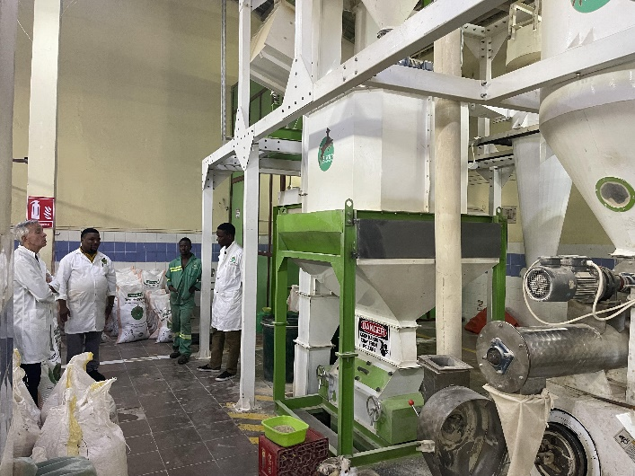
The evaluators of the PSDP visited Ziweto Enterprises Limited on the 26 February 2024. It is the one company that has to date received funding from the BUILD Fund. Ziweto Enterprises Limited is a company based in Lilongwe. In March 2024 Ziweto had been established for eight years and currently employs 43 staff, 25 of whom are women. Ziweto’s business model is to raise the value of livestock by providing access to quality and affordable veterinary and animal nutrition products and livestock production equipment among livestock farmers through its network of 21 “Ziweto Agrovet Shops”. 18 of these outlets are managed by women entrepreneurs. Ziweto partners with leading veterinary products manufacturers to source products that are distributed through its network of veterinary shop outlets branded as “Ziweto Agro-vet Shops.” The company has established a network of 21 Ziweto Agrovet Shops in all regions of Malawi. The company also recruits, trains, and empowers young people to operate micro-franchised outlets, and has to date facilitated the establishment of twelve outlets. Ziweto has recruited, trained, and equipped 5,047 Livestock Lead Farmers, who operate as last mile distributors reaching thousands of smallholder farmers in remote communities across Malawi. 1,985 of these lead farmers are women.
Figure 21: The evaluation team visits the Ziweto plant for manufacturing livestock feed.
Ziweto was one of the agribusiness beneficiaries of UNDP’s MICF programme that received a grant to establish a manufacturing plant. Following this intervention Ziweto applied for and received a loan from the BUILD Malawi for working capital to increase its stock levels. This was agreed in order to facilitate the expansion of Ziweto’s activities to scale up its distribution of veterinary and animal nutrition products, its manufacturing of animal nutrition products and its livestock breeding activities.
Bamboo Capital Partners S.A. authorized a loan to Ziweto in its capacity as Fund Manager of the Fund. Ziweto applied for financing in the form of a loan facility and Bamboo Capital made this facility available under the terms and conditions of the contract signed in January 2023. The total commitment was two hundred and fifty thousand United States Dollars (USD 250,000), equivalent in Malawian Kwacha as of the date of execution of the Agreement. In terms of the contract Ziweto agreed to a loan repayment schedule that would see them repay the loan in its entirety by January 2025.
The original iteration of the BUILD Malawi was premised on a set of outputs and outcomes based on the Joint Framework Results Framework in 2022. By 2023 most of the indicators for Malawi were no longer applicable because the Fund had by then restructured. Indicators such as “number of new jobs created in BUILD Fund investee companies, disaggregated by gender” were not useful in measuring Ziweto’s progress given the loan nature of the investment.
Ziweto has benefited from technical assistance (TA) provided through the BUILD Malawi. The initial phase of this TA was to support the stringent due diligence process required by BUILD Malawi prior to financing. As a beneficiary of the MICF Ziweto had already established a robust infrastructure and efficient business-processes to manage its capital grant. This TA during the MICF grant cycle was viewed as critical to reduce financial and operational risks, and to maximize sustainable development goal (SDG) impacts. Under the current BUILD Malawi loan Ziweto will receive further TA through a Contract for Goods and Services signed between UNDP and Ernst and Young Advisory Services in 2023.

Preparing TA services for Ziweto started in 2022 with a project set up to support them to assess their business needs using a diagnostic tool. The results of the diagnostic assessment were used to develop a proposal for institutional support to Ziweto through a structured TA package funded by UNDP and FAO. This was submitted to the TA steering committee and approved in March 2023. A ToR was developed to procure a business advisory service provider, and this was validated in June 2023. UNDP has been leading this process and in August 2023 the ToR was advertised. An evaluation committee assessed the bidders and validated a contract with Ernst and Young in December 2023. Onboarding with the service provider started in January 2024. Ziweto has agreed to a cost-sharing modality for the TA. Ernst and Young have now submitted an inception report outlining the TA support that they will be providing. Over the course of 2024 Ernst and Young is contracted to provide advisory services, capacity building and TA to Ziweto in the following areas:

- To support business structuring and standardization of key processes and operations.
- To enhance the strategic planning and strategic financial management functions; and
- To implement impact management structure in order to improve its strategic planning, its financial and accounting management, its governance and its impact narrative in a context of business expansion.

6.4 Green Economic Transition Facility
Launched in 2023, the Green Economic Transition Facility (GETF), under the first Window of funding, 'Accelerating Alternative Sources of Energy and Fuel-Efficient Solutions' (AA-EFFECT), aims to support investments in affordable and accessible alternative energy and fuel-efficient business solutions to be adopted and used by households in Malawi. The GETF is a support facility partnering with private sector investors willing to invest in green business solutions. The first window of the facility is the AA-EFFECT which is being supported by the Republic of Ireland and targets companies with an appetite to assist households to transition and adopt alternative energy and fuel-efficient solutions. Other windows for the GETF include:
- Window 2: Accelerating Green Business Solutions. This is being funded by the Government of Germany through the German Development Bank KfW. This window supports private sector led investments which are focussed on accelerating the development of green business to address pressure points in the environment. This window has just been launched in 2023.
- Window 3: Climate Change & Adaptation. This window is yet to be launched and will target accelerating private sector investment in climate change and adaptation.
The GETF has been launched recently and this evaluation will mainly consider progress made under Window 1: Accelerating Alternative Sources of Energy and Fuel-Efficient Solutions.

6.4.1 Project Progress Against Key Evaluation Criteria

6.4.1.1 Relevance and Coherence
- Alignment with National Development Goals
At the global level, the GETF is aligned to SDG 7: ‘Ensure access to affordable, reliable, sustainable and modern energy for all’. At a national level, the facility is aligned with the national charcoal strategy, the energy policy and the Forest Act. The national development agenda aims at diversifying the energy sector through sustainable and innovative products and services to reduce deforestation and the associated impacts on rural livelihoods and the national economy.
- Needs Assessment
Access to reliable, affordable, efficient, and modern energy services in Malawi remains a significant challenge. The country has low national electrification rate estimated at 14.2% as of 2021, the lowest in Southern Africa Development Community (SADC). Rural and urban electrification rates are estimated at 3.9% and 48.7%, respectively. Over 98% of the population still resorts to biomass as the main source of energy for cooking, which has huge adverse impacts on the environment. Hence the need for a facility that embraces a shift towards access to clean and modern energy sources and services.
- Complementarity
The GETF has not been implemented in isolation. It is premised on the successful implementation and experience of the existing UNDP Growth Acceleration Programme, which is an established platform. The GETF thus tries to complement UNDP private sector led instruments by focusing on sustainable and innovative products to penetrated and address the sustainable energy needs of Malawi.

6.4.1.2 Implementation and Efficiency
The GETF is in its early stages of implementation. The first contract for the platform was drawn up in December 2023. There are also limited private sector players involved in the energy sector, with a lot of the applications coming from liquified petroleum gas (LPG) players. The early stage of the facility indicates that the industry was not sufficiently ready for the initiative. There is limited readiness for the business ideas put forward and hence more work is required to make business ideas ready for investment. There is a need for a diversified portfolio with a mix of products from LPG, hydro, biogas, briquettes, sustainable charcoal, e-cooking and others. GETF is now moving into pre-technical assistance support to applicants to improve their business models for them to be ready to access funding.
As much as the GETF has looked at post revenue enterprises, it is imperative to also look at start-ups to ensure development of innovative products in the energy sector at all levels of the economy. The involvement of start-ups would also address the issue of diversifying the portfolio. Under the GETF, startups which demonstrated readiness for investment are under consideration. The facility does not intend to support speculative startups but rather viable startups to avoid increased failure rate.
The concentration of applications in the LPG sector seems counterintuitive, given that LPG is imported, however it does offer an alternative fuel. The GETF must ensure that it avoids exacerbating the foreign exchange problem in the country. There is need for import substitution innovative products, with LPG being considered as a transitional source of fuel. For the other sectors, there is a lot of pre-TA support required to make ideas investment ready. It should be noted that the concentration of LPG is only for window 1, which focuses on alternative sources of energy and fuel-efficient solutions. The other windows will likely bring in other innovations to ensure a diversified portfolio.

6.4.1.3 Effectiveness
Effective implementation has been limited by foreign exchange challenges with the Reserve Bank of Malawi issuing quotas on foreign exchange. To facilitate procurement of equipment, there has been an outcry by enterprises for contracts to be transacted and paid in dollars. There has been assurance from RBM and consensus from UNDP, however, internal regulation within UNDP sometimes limits such disbursement. It is imperative that this is aligned within the programme to fast-track implementation of the programme.

6.4.1.4 Sustainability
- Institutional Capacity
The GETF comes with a 35,000 USD technical support to innovative enterprises. This technical support is provided as tailor made support specific for each enterprise rather than a lump sum TA support. This addresses some of the challenges faced under the Growth Accelerator, where the technical support is offered as a bundle for the grantees. Under the GETF, institutional partners such as Irish Aid are even willing to offer more technical support to the enterprises when required.
- Financial Sustainability
THE GETF facility is offered to post revenue enterprises for acceleration, as such the sustainability of the project is embedded. The private sector-led entities are provided with technical support to ensure that the growth is managed to avoid crippling the businesses.

6.4.1.5 Equity and Inclusion
The facility targets at least 30% women participation. For instance, output 2 focuses on the number of low-income direct consumers to access and utilize new or enhanced products/services. The target is to reach out to 110,000 consumers of which 30% should be female. Similarly, the facility targets at least 30% of the proposals submitted to the Venture Appraisal Committee (VAC) should be from female owned enterprises. However, the early stages of implementation indicate limited participation by women.

6.4.2 Recommendations

Diversification of the portfolio | There is a need to diversify the GETF portfolio, as there is a significant concentration from LPG players. The portfolio should have a mix of players from biogas, solar, briquettes, hydro, e-cooking and others. It seems the market was not investment ready for such a facility. Continued support to startups that demonstrate viability is highly recommended as well. There is need for pre-technical support to address some bottlenecks in the enabling environment.
Policy alignment and enforcement | There is a need for policy alignment, enforcement and awareness raising. For instance, sustainable charcoal is facing competition from illegal charcoal. Charcoal overall is charged VAT. Furthermore, despite several policy documents, enforcement is a challenge.
Addressing Foreign Exchange challenges | The foreign exchange challenge is prominent across all the PSDP facilities, with the exception of the BUILD Facility. Flexibility in disbursing the funds in foreign currency will address several delays which have been observed by all the other facilities.

7. Achieving the PSDP Output Two
The results expected from Output 2 focus on the necessary support to youth led MSEs to formulate innovative business ideas that are effective in bringing sustainable solutions to development challenges and that can also create jobs. Key interventions are provided through the primary vehicles of the Growth Accelerator (GA) and Zantchito. Under the current PSDP UNDP has continued to implement the GA through its serial Entrepreneurship Challenges. The GA has been serving as a business acceleration instrument that provides technical assistance and seed capital to young and ambitious start-up companies that intend to provide sustainable business solutions to development challenges that align economic growth with sustainable development goals. The “Zantchito-Skills for Jobs” Programme, embedded in the 11th European Development Fund (EDF), has been set up to create an ecosystem of job creators through the provision of decent jobs and self-employment opportunities for young TEVET graduates, university graduates, and entrepreneurs, with special attention to women’s needs.
The key requirements under PSDP output two include the following:
- The provision of technical advisory services and financial support to potential entrepreneurs to be incubated (incubatees) along the different stages of incubation (i.e. early business idea stage, incubation stage, post incubation stage).
- The provision of a financing facility through which financial support will be provided by a financial service provider.
- Technical and advisory support to the growth of existing Business Incubators (BIs) and BDS providers that will strength their performance whilst standardizing and boosting service offering to potential and existing MSEs.
- Post-revenue support provided to start-ups to accelerate their businesses through risk capital and technical advisory services.
Figure 23: Progress on PSDP Output Two

The ratings provided for Output Two are different based primarily on the different lifecycle stages of the two facilities. The GA has been supporting small businesses since 2018 and successive funding windows have supported a range of successful companies. The rating for Zantchito should be viewed as preliminary, given that Zantchito is in the early stages of its implementation. The assessment is made primarily on the design of Zantchito and the initiation of its first round of incubation.
Overall Rating | Description | Score | Comments
Satisfactory | The project has met the predetermined standards and achieved its goals. While it may not have excelled in every aspect, it has performed adequately and met the requirements set out in the project plan. Overall, the project has been successful. | 4 | The Growth Accelerator Malawi has demonstrated positive economic outcomes with ventures generally performing well, launching new products onto the market and creating job opportunities that in some cases have surpassed targets. Challenges remain but are being addressed through stakeholder collaboration and targeted interventions to enhance the GA’s effectiveness and contribute to sustainable entrepreneurship and economic growth in Malawi. Regular tracking of the enterprises funded under this mechanism will need to be conducted to assess whether they are proving to be resilient within the turbulent Malawian economy.
Too early to rate | The project is in the early stages of its implementation and therefore there is insufficient year-on-year data to make an informed judgement. | 1 | The evaluators have found that Zantchito is a relevant, well-designed intervention in Malawi’s SME sector. It provides a holistic model for business incubation together with an impressive architecture of technical and advisory services to young incubates. Despite some initial teething issues, the setup of the first round of the programme has been well-managed and achieved its early targets. We feel, however, that it is still too early in Zantchito’s lifecycle to provide a definitive rating/

The following section assesses in detail the progress to date of Zantchito and the Business Incubators that it has selected to facilitate the programme in achieving the requirements of the PSDP Output 2. This assessment of Zantchito is based on data collected from the following sources:
- Documentation provided by UNDP, the EU and Zantchito.
- Meeting with the EU.
- Meeting with Zantchito senior management in Lilongwe.
- Visits to three business incubators in Lilongwe (NextGen Labs), Mzuzu (Mzuzu EHub) and Blantyre (Malawi University of Business Incubation Centre).
- Focus group discussions with incubates at three of the business incubators that were visited.

7.1 The Growth Accelerator
M-Hub - Malawi’s first innovation hub - partnered with Growth-Africa to implement a project that aimed at supporting innovative entrepreneurs with financial and technical assistance in a bid to scale up their ventures. Known as the Growth Accelerator Entrepreneurship Challenge, the project has been supporting innovative and impactful Malawian enterprises as a way to contribute towards SDGs 1, 8 and 9. Under the current PSDP UNDP has continued to implement the Growth Accelerator (GA) through its serial Entrepreneurship Challenges. The Growth Accelerator serves as a business acceleration instrument that provides technical assistance and seed capital to young and ambitious start-up companies that intend to provide sustainable business solutions to development challenges that align economic growth with sustainable development goals and the 2023 African Union Commission’s agenda. The rationale for the funding instrument is that it addresses a gap in the market by playing a catalytic business development role through the provision of technical assistance, grant finance and equity to selected start-up companies.
In July 2023 16 successful early-stage entrepreneurs were officially unveiled under Cohort 6 of the Growth Accelerator Entrepreneurship Challenge. The Growth Accelerator was launched in 2018 in a partnership between the United Nations Development Programme (UNDP) and the Royal Norwegian Embassy. To date the Growth Accelerator has supported 62 business ventures in 5 cohorts. With the 2023 intake the number of businesses supported through the facility has increased to 78. The evaluation team met with a sample of these Growth Accelerator companies to understand how the facility has supported the growth of their businesses.

7.1.1 Project Progress Against Key Evaluation Criteria

7.1.1.1 Relevance and Coherence

- Alignment with National Development Goals
Implementation of the GA facility has been directly aligned to the National development Goals for Malawi, particularly Vision 2063. Enabler 4 under Vision 2063 highlights the need for a vibrant private sector which is currently associated with lack of graduations from small to medium, and large enterprises. The economy is characterized by having a missing middle hence the need to accelerate the growth of micro and small enterprises. According to the Finscope MSME 2019 survey, 74% of MSMEs are micro and 23% are small, while 3% are medium enterprises.
- Needs Assessment
Some of the lessons learnt from implementing MICF is that MSMEs were left out from accessing MICF financing given that the capital requirement was relatively larger. Under MICF, enterprises were required to match funds ranging from 250,000 USD to 500,000 USD. According to the 2019 Finscope Survey, the average turnover for micro, small and medium firms was 5,957 USD, 17,478 USD and 163,770 USD, respectively. With such limited turnover, MSMEs could not access the MICF facility. Furthermore 64% of MSMEs do not borrow financing, 6% use credit from family and friends, 18% use informal credit, 7% use credit from other formal non banked institutions and only 4% use credit from banks. As such the Growth Accelerator directly addressed the needs of MSMEs in Malawi.
Following the implementation of the MICF programme by UNDP, an initial needs assessment through stakeholder engagement highlighted the critical barriers to growth for micro, small and medium enterprises (MSMEs) in Malawi. While the MICF focuses on large enterprises with available capital, matching funds of up to 500,000 USD. MSMEs were unable to participate due to limited access to capital. The GA with matching funds of 10,000 USD to 30,000 USD provided an opportunity for MSMEs to access the financing. The GA matching facility is also not 50:50 as it is for MICF, but rather 70% from the GA and 30% from the enterprises.
- Stakeholder engagement
Addressing the needs of MSMEs through the GA facility was not done in isolation. Consultations with the Ministry of Industry and Trade as well as UNDP and other stakeholders, highlights a strong stakeholder feedback for UNDP or any other development partner to provide financing facility tailored to the MSMEs sector. According to the World Bank enterprise survey, MSMEs consist of more than 80% of the enterprises in Malawi. Implementation of the GA in Malawi which targets MSMEs is thus more aligned to the structure of the economy.

7.1.1.2 Implementation and Efficiency
The implementation of the programme’s delivery mechanism such as training workshops, mentorship sessions and financial grants has been generally positive, with participants reporting enhanced business skills and growth opportunities. The design is that Milestone 1 is an advance from UNDP which is combined with initial capital contribution from the venture and milestone 2 is disbursed after proof that the Milestone 1 advance and venture contribution has been exhausted. Milestone 3 is retained for demonstration of impact. By design the tranches correspond to UNDPs regulations for disbursement, however this also entails an inherent implementation challenge which is a one size fits all, where milestones are in three tranches. In some cases, despite funds being allocated for machinery which can be procured at once, the funds are still received in tranches. This inherent implementation challenge implies inherent delays in implementation of the project. However, this arrangement ensures that the GA facility is not put at risk by frontloading the ventures with UNDP funding.
Some enterprises have been quite unfortunate due to the occurrence of foreign exchange shortages in the country. The funds from the GA facility are disbursed in kwacha, the enterprises then have to request for forex in USD. Given the foreign exchange challenges, it would have been beneficial if some of these funds were disbursed in USD. Due to such delays, some of the enterprises had to request extensions to ensure all the milestones were met.
Training that was conducted in Lilongwe would take 2-3 days, for the companies this met that about a week was lost. These trainings were being conducted every month as such for MSMEs being away from their business for that long had quite an impact on their business. Despite these implementation challenges, the grantees highlighted that the GA experience has grown their companies, and this has made them more resilient. To them the GA has lived up to its goal of accelerating enterprises.

7.1.1.3 Effectiveness
Following the consultation, the Growth Accelerator has proven to be one of the most effective instruments under the UNDP PSDP. The GA instrument, with its motto of accelerating business seems to be doing just that through the promotion of early-stage entrepreneurs. Despite the delays in acquiring the financing for procuring the equipment, the GA has played a critical acceleration role for all the companies visited. Without the financial and technical support provided through the GA most of the enterprises would have remained stagnant. For instance, Zomba Private Ambulance which had remodeled a Nissan Vanette, now has 2 ambulances which were supported under the GA facility. The ambulances can offer basic and advanced life support and are in high demand servicing Zomba, Balaka and Blantyre.
Funding through the GA has clearly enabled small businesses to take a major step forward in terms of production capacity, diversification and reach. Considering the cost of accelerators, the GA accelerator has proven itself to be a cost-effective mechanism for driving funds into promising ventures. The technical assistance and mentorship provided through the GA is greatly valued by the entrepreneurs. The GA funding windows have been strategically selected to meet potential growth areas in the Malawi economy and has had a significant impact on the GA-supported businesses to expand and I some cases subsequently attract additional capital.

7.1.1.4 Resilience and Sustainability
- Institutional Capacity
The GA facility is designed to strengthen the institutional capacity of enterprises. The GA offers a 6-month mentorship which utilizes a network of local and international businesspeople, industry experts and professionals. Technical support in terms of providing a series of audit and analysis workshops is also provided to the enterprises. These workshops cover several issues including:
- Business diagnostics.
- Strategy formulation.
- Business model refinement.
- Product/Service improvements.
- Managing growth.
This has proved to be vital for the businesses, which are mostly MSMEs. Through the facility, enterprises have also benefitted from peer learning and networking among the businesses. The programme has ring-fenced this by providing previous grantees as mentors to the emerging cohorts. During COVID-19 it was not possible to provide in-person technical support to the 2020 cohort beneficiaries given the circumstances. Several entrepreneurs from this cohort have requested that this support should be made available to them to ensure uniformity and sustainability. The current GA covers the cost of travel and accommodation for ventures during the sessions.
- Financial Sustainability
Given that the GA facility is designed to target post revenue firms, this reinforces the financial viability of the whole programme beyond the grant financing. The model provides a blend of internal company financing and development financing for already existing firms. However, the following issues might limit the financial viability of the enterprises, which might affect the whole programme:
- One size fits all approach: Given that funds are released in tranches, those companies that require a significant portion of the funding at the beginning are delayed and forced to wait for the next tranche for them to procure the necessary equipment and start production. This limits the cash flow of certain enterprises and can impact on these enterprises where they may have already started incurring costs such as rentals in the process of expanding their businesses. This may mean that they are not able operate at optimal capacity since some parts of the production line are not available.
- Access to standards: In order to grow some of these enterprises need access to lucrative markets which require adherence to product standards. Delays in getting the standards affects their business models. Delays in access to the whole production line for some enterprises implies delays for the enterprises in accessing MBS standards as there is a need for the whole production line to be set up before MBS officer can conduct an assessment.

7.1.1.5 Equity and Inclusion
The GA has made efforts to ensure the programme is accessible to a diverse range of entrepreneurs, including women and youth. The eligibility criteria include youthful entrepreneurs aged up to a maximum of 45 years old. According to the Growth Accelerator Malawi website, 408 jobs have been created and 247 jobs for women and 304 jobs for youth.

7.1.2 Case Study of Planet Green Africa
Introduction
The evaluation team met with Atupele Kampesi, one of the co-founders of Planet Green Africa in Blantyre. The company was registered in 2019. They manufacture biofuel briquette by recycling agricultural waste to provide low-income households across Malawi access to sustainable, affordable cooking alternative to reduce the dependence on wood fuel for cooking. Bio briquettes, also known as biomass briquettes, are compressed blocks of organic materials such as agricultural waste, forestry residues, or industrial by-products. Planet Green Africa has recognised the gap in the market for briquettes that serve as an eco-friendly alternative to conventional fossil fuels like coal, wood, and charcoal. The briquettes made by Planet Green Africa are made from agricultural waste such as maize foliage and groundnuts shells.
Key Initiatives and strategies
Product innovation: The company focuses on creating charcoal briquettes which have a high burn rate that appeals to Malawi’s cooking and heating needs. The fuel is non-carbonized and smokeless, which provides a healthier alternative for users.
Diversification: Apart from producing briquettes, the company has diversified and now manufactures efficient cookstoves using an innovative technology which uses less fuel.
Figure 22: Field Visit to Planet Green Africa in Blantyre.
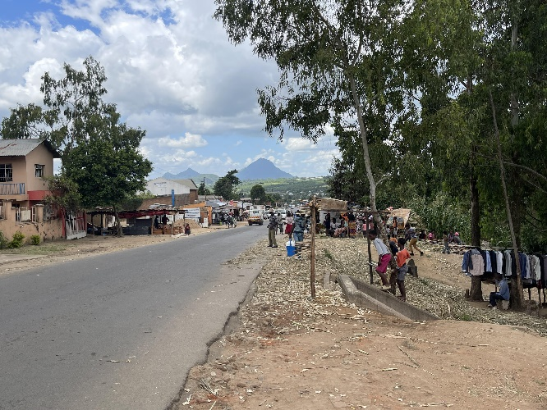 | 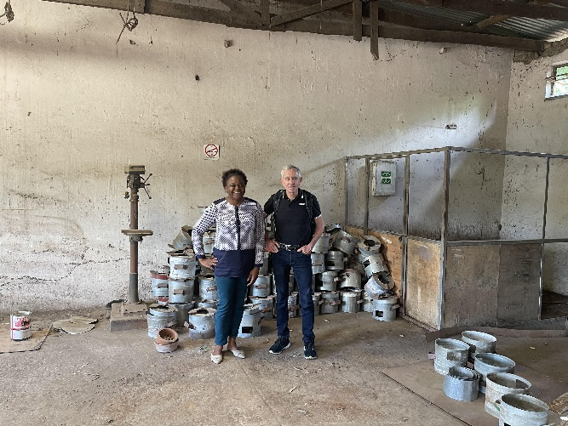

Growth Accelerator’s Support
Through the Grow Accelerator, the company was provided with technical support and resources to accelerate its growth trajectory. Some of the key areas of support include:
- Business development workshops: Planet Green Africa participated in workshops organized by the Growth Accelerator, covering topics such as business strategy, marketing, and financial management. These workshops equipped the company's founders with the essential skills and knowledge to scale their business effectively. For instance, the company diversified into cookstoves following the training.
- Access to funding: Secured investment capital to upgrade its production facilities, expand its product line, and enter new markets. The company has received funding of 38,000 USD through the Growth Accelerator.
- Mentorship and networking: through Growth Accelerator's mentorship programme, Planet Green Africa received guidance from industry experts and entrepreneurs working in the same area. The mentorship sessions helped the company's founders navigate challenges, identify growth opportunities, and refine their business strategies. Additionally, Grow Accelerator's extensive network of partners and stakeholders facilitated valuable networking opportunities, enabling the company to forge strategic partnerships and collaborations. The company has been supported and advised by other Growth Accelerator grantees such as Kombeza Ltd.
Impact and Success Stories
- Previously the company had contracts to supply briquettes to Mary’s Meals. With existing capacity, however, the company was not able to deliver as Mary’s Meals requires these kinds of briquettes in all its school feeding programmes. With the new machinery, the company will be able to meet the increased demand for briquettes.
- Through the project, non-carbonized charcoal production is being promoted as an alternative to wood charcoal.
- The project is indirectly supporting a group of women who are involved in the supply of ceramic cookstove parts. For the cookstoves, the ceramic parts are sourced from a group of women in Blantyre.
Challenges and Future outlook
Once the briquettes are made, they need to be dried. This becomes a challenge during the rainy season as it takes longer for the briquettes to be dried.
The main reason the company applied for funding is for the procurement of the production line, however the funding for the production line is received in tranches yet the machinery could be procured at once. This has caused delays in achieving follow on miles which are dependent on production. MBS certification is also awaiting the full set up of the production line.
Attendance at the business training also brings business to a standstill. There is a lot of time required to attend the trainings and for small scale businesses this implies that the owners are away from their businesses for a while, and this has negative implications on the daily operations of the business.
Recommendations
The role of technical assistance | The role of technical assistance should not be underestimated under the GA. It was recognized that during COVID-19, there was a Covid 19 window which was not able to accommodate technical assistance. Firms which participated under this window have highlighted the need for such technical assistance to ensure their growth is sustainable
Addressing Foreign Exchange challenges | Malawi continues facing foreign exchange challenges. It is therefore recommended that the facility has the flexibility of disbursing the funds in foreign currency, especially USD given that in most case these funds are used for procurement of imported equipment. Disbursement of funds in local currency has resulted in huge project delays.
Tailor made technical support | The GA support seems to be limited by its one-size fits all structure, the nature of funds disbursement and technical support. For some firms, flexibility is required. For instance, in cases where funds are for the procurement of machinery, a special provision can be made so that this could potentially be done all at once instead of in tranches.
Re-design the nature of workshops and trainings | Given that the training courses created opportunity costs for entrepreneurs in terms of being away from their businesses it is imperative to re-design the nature of the training to ensure that they are adaptable to the specific needs of enterprises. UNDP is currently considering moving into regional workshops under the new cohorts to look at cost benefit analysis of moving facilitators to regional workshops and covering the costs of accommodating ventures.

7.2 Zantchito: Skills for Jobs Programme

7.2.1 Overview of Zantchito
Within Malawi’s broader private sector development strategy, the Ministry of Trade and Industry has stressed the importance of the role that SMMEs play an important role in growing the country’s economy and contributing to income, output, and employment. A critical understanding underpinning the Zantchito is that incubators have the ability to provide multifaceted support that facilitates the creation of start-ups and assists them until they have the capacity to survive in a competitive market. In the context of the private sector development arc in Malawi development partners including the European Union, Irish Aid and GIZ have recognised that the role of emerging entrepreneurs and innovators is critical to downstream commercial growth and see the development value of investment at this level. In the conceptualisation of Zantchito there was a recognition that the success of incubators depends on several factors, including the sustainability of public financial flows, the dynamism of the macro-environment and the private sector’s role as a supportive actor in the broader ecosystem. To achieve an optimal scale and impact, business incubation centres need to be made sustainable as institutions – with market-responsive structures and self-led revenue generation capacities. Given that Malawi’s small and micro enterprises tend to be survivalist in nature and most of these businesses fail to grow beyond this level. To address this fundamental challenge the PSDP took the strategic decision to design a facility as a channel through which funding for small business development could be channelled.

7.2.2. Purpose of the Zantchito Intervention
Based on these strategic insights Zantchito was designed as a multi-layered mechanism that would provide comprehensive business incubation support to small and artisanal business development in Malawi. The rationale was that Zantchito would establish dedicated funding windows through which support would be provided via mentoring, training, networking, funding, piloting of innovations and access to markets. A central element of this support would be to stimulate job creation, which could potentially lead to financial growth and create opportunities for more employees, as well as the promotion of young emerging women entrepreneurs. The intention of Zantchito is to ensure that incubators support the initial stages of the innovation life cycle, from pre-seed to scale-up, while at the same time creating a supportive environment for start-up companies, which can increase their chances of success.

7.3 Structure and Alignment of Zantchito
The “Zantchito-Skills for Jobs” Programme is embedded in the 11th European Development Fund (EDF) and is designed as an intervention aimed at addressing the Malawi economy’s need for skilled professionals and providing decent jobs and self-employment opportunities for young Technical, Entrepreneurial and Vocational Education and Training (TEVET) graduates. Zantchito Skills for Jobs represents a six-year intervention as part of the EU apex programme. Zantchito focuses on enhancing pre-incubation, incubation, post-incubation support and Business Development Services (BDS) to TEVET graduates and MSEs.
The objective of Zantchito is to promote entrepreneurial culture, sustainable enterprise creation and decent, formal jobs in Malawi. It aims to support 3,800 entrepreneurs towards increasing their revenue by 80% as well as creating 7,600 permanent jobs and increasing access to external finance. Zantchito’s Entrepreneurship and Access to Finance Entrepreneurship and Access is the business incubation programme that supports idea-stage entrepreneurs in Malawi. It is implemented through five workstreams:
- Strengthening business incubators.
- Strengthening BDS.
- Providing pre-incubation, incubation, post-incubation support to TEVET graduates and MSEs.
- Providing financing facilities to TEVET graduates and MSEs.
- Developing a substantive learning agenda.
Zantchito clearly aligns with the Government of Malawi’s Vision 2063. Under Enabler 4 the government aims to nurture a private sector that can drive economic development and wealth creation through the provision of innovative solutions, creation of jobs and mobilization of domestic revenue. Enabler 5 calls for relevant quality education that incorporates a strong element of academic excellence and technical and vocational skills fit for the labour market, entrepreneurship, and implementation of Vision 2063. Within the framework of the 2063 Agenda, entrepreneurship is recognized as a key enabler to realizing this goals. The Zantchito Skills Programme is therefore well aligned with the Malawi Government’s strategy for growing and strengthening the private sector.

7.4 Components of Zantchito
Zantchito is partnering with business incubators in Malawi to build their capacities, grow their business models, and help them to transition to commercially sustainable entities. Through the facility Zantchito is delivering a targeted training programme on entrepreneurship development to BDS providers (both individuals and companies) to improve their capacity to deliver growth-focused services to start-ups and MSEs on a commercially sustainable basis. They are also working with business incubators and BDS providers across to deliver incubation support and bridge access to finance at pre-incubation, incubation, and post-incubation phases. The building blocks of the Zantchito programme are illustrated in Figure 23 below:
Figure 24: Building blocks of the Zantchito programme.
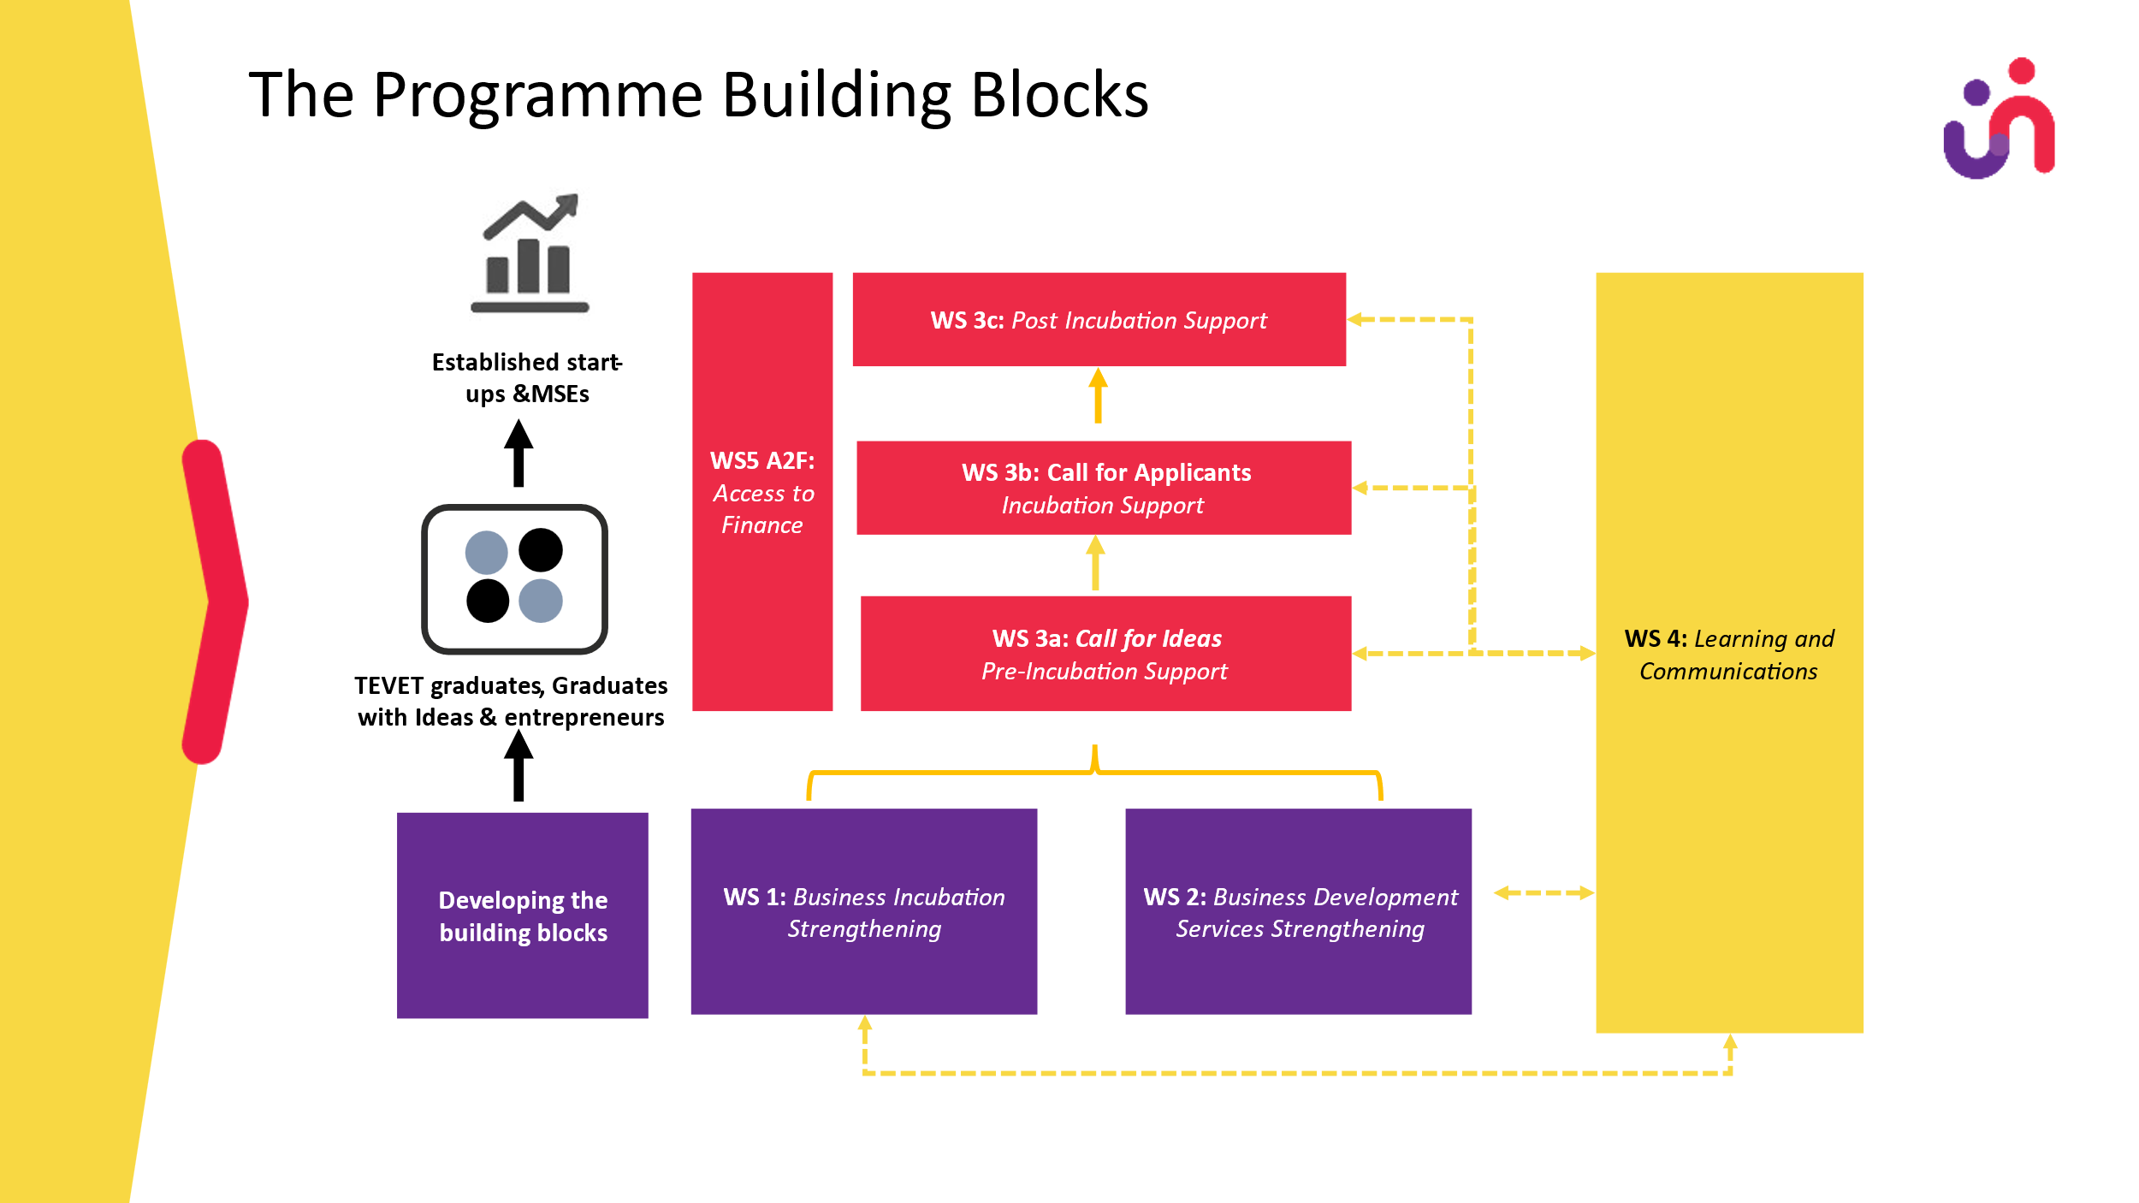
Zantchito is unique in that the support it provides covers all three regions of the country, so that it has a national footprint. This ensures that Zantchito funding can be spread in an equitable manner to emerging entrepreneurs in all parts of the country. 6 incubators have been contracted in the southern, central and northern regions as show in Figure 24.
Figure 25: National range of Zantchito
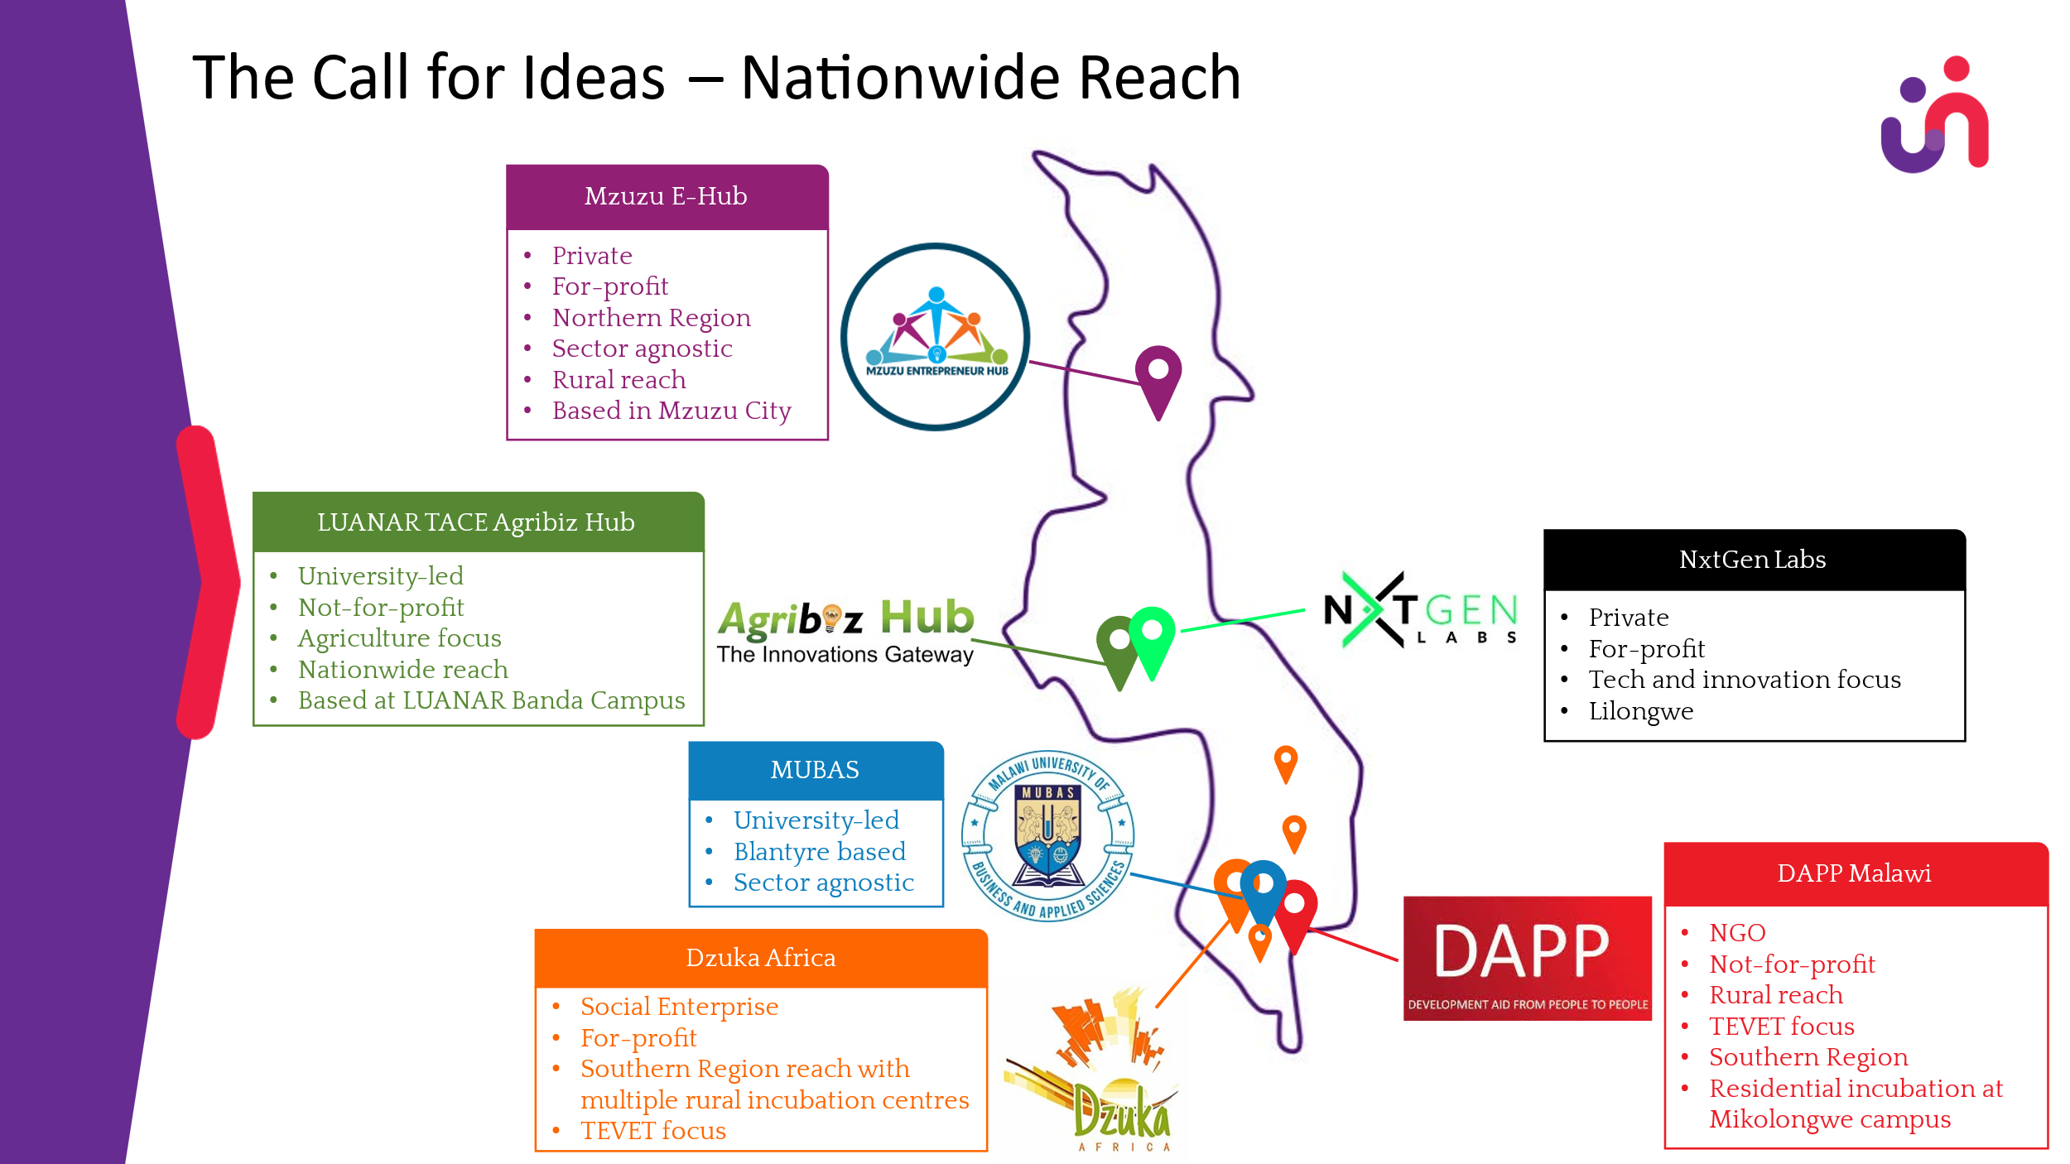

7.5 Current Progress
In the course of 2023, a call for proposals from business incubators was advertised, followed by a shortlisting of Incubators which was completed during the inception period. Submissions were assessed based on five set criteria: incubate selection criteria, services offered, revenue model, impact monitoring and available infrastructure. Following this process six incubators were identified. A profile of the incubators and a justification note was prepared and submitted to UNDP (including preparing a budget for utilisation of US$30,000) following which contracts were signed with the following incubators.
- NxtGen Labs in Lilongwe.
- Lilongwe University of Agriculture and Natural Resources (LUANAR) in Lilongwe.
- Development Aid from People to People (DAPP) in Blantyre
- Malawi University of Business and Applied Science (MUBAS) in Blantyre
- Dzuka Africa in Blantyre
- Mzuzu E-Hub in Mzuzu City
Once the incubators had been appointed a process of recruiting and training a cohort of Business Development Officers (BDOs) was undertaken. Nine ‘lead’ BDS providers were selected for the Trainer of Trainer (ToT) programme and invited for an initial training. A training workshop with 23 consultants representing the nine shortlisted lead providers was conducted on July 18th, 2023. Zantchito was launched at each of the selected incubators in October and December 2023.
Call for Ideas were mainly released in September / October 2023 with the pre-pre-incubation participants selected by the end of November. The selection of participants was a rigorous, phased process:
Figure 26: Phased process of selecting incubates.
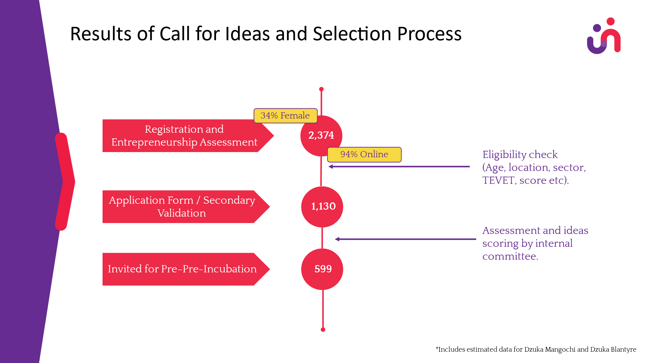
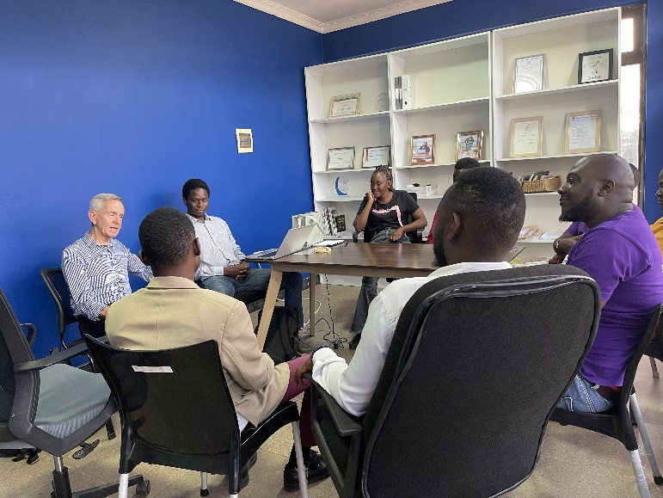
As of March 2024, Zantchito was in the early stages of its implementation. Pre-pre-incubation is underway at each of the incubators. As part of the evaluation fieldwork the evaluators were fortunate enough to meet with incubates at three of the business incubators and explore issues of effectiveness and efficiency. Discussions with incubates centred on the start-up selection process as a critical activity and their perspectives on the process. Evaluating the strengths and weaknesses of potential start-ups is key for determining how efficiently the process has been rolled out and how effective this process has been in generating cohorts of startups that are more likely to succeed. We also explored the quality of assistance and support provided by the incubator.
Figure 27: Evaluation visit to the Mzuzu eHub
A lead BDS provider was assigned to each entrepreneur (under the oversight of the incubator BDO). All necessary training and orientation were completed before the BDOs started to work with the incubates. The first cohort of incubates are currently working with their assigned BDOs to develop basic business plans, business model canvases and the registration of their businesses. Data on the profile of the incubates is shown in Figure 27:
Figure 28: Disaggregated data on early Zantchito progress
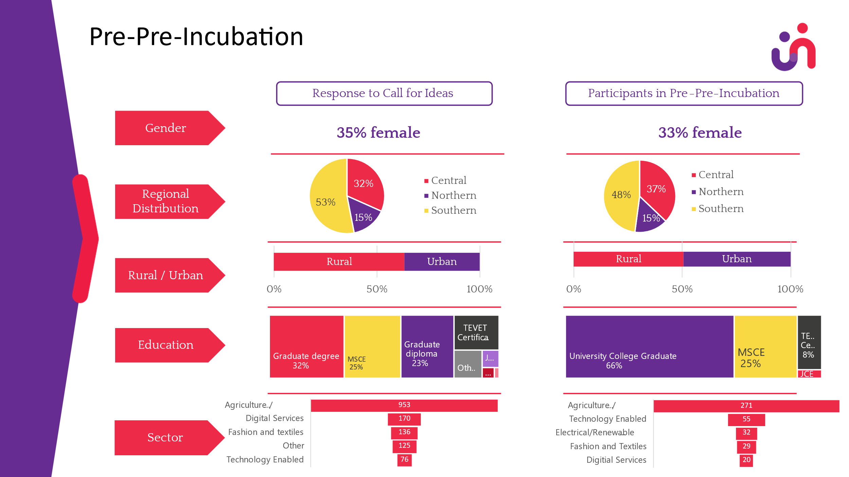

7.6 Limitations of the Evaluation
As a funding facility Zantchito is in an early phase and therefore it is quite difficult to measure success. There is undoubtedly an extensive list of success factors relating to business incubation, including business incubator occupancy rate and/or number of new firms supported, business incubator space, graduate firms, level of funding received from key benefactors, sales growth and employment growth. Whilst certain statistical outputs, such as survival rate of incubates or sales growth can perhaps be more straightforward to measure, there can be additional aspects of effectiveness that are only or, at least, more relevant to specific incubators, incubates and regions. For instance, survival rates as a measure of success may be primarily relevant to those business incubators for which the main goal is to maintain businesses in the region and/or to improve the regional entrepreneurial ecosystem, rather than perhaps others that may focus primarily on the creation and generation of innovation and its spillover effects or may measure success, taking into consideration the amount of funding and/or the amount of time invested in the incubates. Data for these kinds of factors will only really emerge in the post-incubation phase.

7.7 Findings and Recommendations
The evaluation team has assessed the early effect of Zantchito within the context of Malawi’s entrepreneurial ecosystem, and the encouraging growth of enterprises at the pre- and post-start-up stage, and the emergence of business incubators and accelerators. Zantchito has strategically leveraged the value add that incubators can offer nascent entrepreneurs, including shared office spaces, business support, mentorship, start-up competitions, networking forums and funding for start-ups. Through its structured and strategic model Zantchito is increasing the complexity of entrepreneurial support. This increased complexity, along with complexities in the incubation process models, is clearly premised both on experience from other countries. The model being applied in Malawi has been both tailor made for Malawi’s needs while at the same time applying tried and tested strategic goals and mechanisms that enable the business incubation process and tailor it according to the desired objectives of each specific incubation process.
From the evidence available at this early stage of implementation the logical progression of the Zantchito model enables it to select the established business incubators, which in turn have the capacity to work with Zantchito to evaluate the strengths and weaknesses of potential start-ups. This is proving to be key for determining fields which require special assistance from the incubator. The engagement that the evaluators have had with Zantchito and three of the incubators demonstrated the ability of business incubation centres to bridge knowledge gaps, foster innovation, provide much-needed support and link more developed centres with less developed areas by expanding access to new markets and products. The geographical spread of the incubators across the three regions of Malawi is strategically sound in that it is clearly enabling smaller cities such as Mzuzu to tap into Malawi’s human capital at the grassroots level. Already at this early stage of implementation the Zantchito-funded business incubation centres are providing emerging entrepreneurs with business expertise and training on all stages of product development – from an initial concept or idea, through to market release and beyond. Through Zantchito support these incubators are able to work with incubates to cover the complete process of delivering a new product or improving an existing one for customers.
What is evident to the evaluators is that Zantchito remains a donor-driven intervention to grow the private sector at the grass roots. While this represents a critical initiative in efforts to invigorate small business growth and resilience, Malawi can only leverage this dividend if the Government itself invests in creating a ‘formal’ and ‘affordable’ space for urban and rural microenterprises to prosper. Support for micro and small enterprises is most effective where the legal and regulatory environment provides both security and opportunity, while creating an effective balance of incentives and disincentives. Zantchito is a cutting-edge intervention promoting entrepreneurship development as an essential component in improving a weak economy, as well as improving entrepreneurship development. A notable aspect of Zantchito is that while it is working at the micro level with emerging entrepreneurs it is also working at the policy level to support the Government in creating a supportive regulatory environment for MSE.
The evidence suggests that Zantchito has been strategic in selecting business incubation centres that are geared towards specific vertical markets in locations where agrobusinesses and industrial activity are concentrated. This approach is more likely to reduce the gap in supply and demand between start-ups and the industries where they will be absorbed. In locations such as Lilongwe, Blantyre and Mzuzu it should be easier for start-ups to access domain experts, agriculture and industry veterans and other infrastructural support.
Zantchito is in the very early stages of implementation, and this evaluation was undertaken at the pre-incubation stage of the first cohort selected via the first funding window. This means that the evaluators have very little data against which to measure effectiveness or impact of the facility. Nevertheless, initial findings from our engagement with the facility the evaluation can make the following observations:
Evaluation Criteria | Findings
Coherence | The objectives and design of Zantchito respond to the private sector development policies and objectives of the Government of Malawi, the development priorities of key donors, as well as MSE sector role players and beneficiaries. Zantchito also addresses a key component of the PSDP trajectory by targeting support to the micro level.
Relevance | Zantchito is compatible with other MSE interventions in Malawi, sector or institution, demonstrating external coherence with the interventions in the same context, including government and other development partners. Zantchito demonstrates complementarity, harmonization and co-ordination with other stakeholders within the MSE space, and the intervention appears to be adding value while avoiding duplication of effort.
Effectiveness | At this early stage Zantchito is delivering initial results in an economic and timely way. Fund inputs are already resulting in key outputs, including the appointment of incubators and BDS providers, the selection of the first cohort of incubates and the provision of initial training and mentorship support. While there have been concerns from beneficiaries that the process has been very slow, the evaluators recognize that Zantchito takes its responsibility for development partner funds very seriously and is determined to manage the facility in a thorough and accountable way.

Through the survey Zantchito participants were asked to rate the effectiveness of the facility in relation to a set of statements.
Figure 29: Effectiveness of the Zantchito facility.

The survey data suggests that 79% of respondents see Zantchito as an effective mechanism for delivering support to start-up businesses. 72% of respondents agree that the business incubators have been rigorously selected and that the business incubators are selecting incubates in an effective way (82%). Responses seemed to suggest, however, that the quality of the BDS providers needs to be improved, with 64% feeling that they are effectively supporting incubates while only 53% feel that the incubates are receiving comprehensive start up support.
Over and above these findings the discussions that the evaluators have had with the spectrum of Zantchito stakeholders has highlighted a range of relevant issues. The impression that the evaluators gained from their interactions with the incubators and the incubates is that business incubators are undoubtedly creative nodes for entrepreneurship, and we would suggest that Zantchito create a shared space – such as a community of practice – where ideas, experiences and innovations can be shared amongst themselves and with the emerging entrepreneurs. These following may serve as useful reflections for the management of the Zantchito facility going forward:
- Tech-oriented Business incubators such as NextGen Labs support technology-focused and technology-oriented start-ups which are potentially a shorter route to the market. Tech businesses usually do not require a great deal of capital for initial product development and market adaptation. This puts tech start-ups in a strong position. Incubation further facilitates their entry into the market.
- Business incubation centres can provide co-working spaces for freelancers. Since freelancers are already earning, they could be charged on a ‘per seat’ basis. In addition to generating revenue, co-working spaces can have positive impacts that should be explored further.
- At the macro level, start-ups that have benefitted from university-based business incubation centres such as LUANAR or MUBAS may feel the need to be ‘incubated’ again in a more market-oriented incubator outside the university, in order to grow and enter the market.
- When designing training programmes for start-ups, market knowledge and learning are extremely important. Augmenting theoretical content with practical market practices gives aspiring start-ups the first-hand knowledge they require to enter the market successfully.
- Conducting regular industry visits and information sessions on real-life market dynamics could be beneficial for incubates as they assess their potential markets. These sessions could be sourced by the business incubators from experienced market professionals and entrepreneurs.
- Regular industrial and agrobusiness visits for start-ups could be arranged to expose incubates to the reality of doing business in a competitive environment. Visiting relevant businesses can expose start-ups to practical knowledge beyond the environment of an incubation facility.
- Regular investor road shows or ‘demo days’ help to link start-ups with the investor community. These networking events have the potential to enable start-ups to understand the mindset of investors by meeting and engaging with them in person.
- For start-ups working on complex concepts where academic backing and validation plays a pivotal role, strong linkages with academia can help them to acquire knowledge of the domain from experts.
- Partnerships and collaboration with government agencies, other development partners, civil society organisations and businesses are essential for business incubation centres to successfully support incubated start-ups. These partnerships can in various ways support incubators to match start-ups with the right regulatory institutions and other public and private stakeholders, in order to achieve more of an impact.
- Our findings suggest that the government could look at developing a clear and simple strategy for supporting business incubators throughout the country and develop a mechanism for coordinating the activities of all institutions and companies that are in the process of incubating new business.
Table 3 below captures some of the key issues and suggestions that were made during meetings with business incubation managers and with groups of incubates.
Table 4: Insights from incubators and incubates.
Insights from Incubators
- The process of selecting and appointing business development service providers was slow and delayed the incubators in moving ahead with the programme for the incubates.
- There is concern about the length of time that it has taken to appoint financial services providers.
- There is also concern about the length of time it takes for Zantchito funds to be processed and disbursed.
- The only for-profit incubator felt that the disbursement processes are cumbersome and slow, and that they were only able to carry up-front costs because they had reserves.
- Some incubators have experienced challenges around timelines and reporting but feel that this is a learning process and that they will be more efficient the next time around.
- Gender responsive programmes are essential for promoting women’s entrepreneurship and equipping them with the skills and knowledge needed to thrive in the labour market.
- The common challenge that all entrepreneur support organizations face is a lack of innovation, primarily due to Malawi’s limited focus on research and development.
- It is important to link incubates with learning opportunities outside of the incubator, such as Afrihub and other online learning sites.
- Most incubators are seeing their first cohort of incubates as a pilot and a learning process, so would like to see as much support as possible from Zantchito.
Insights from Incubates
- Design thinking and ‘ideation’ workshops can help to streamline thinking and planning processes, encouraging the formation of ideas, reflection and a focus on products and customer needs.
- It would be useful to have an information sharing session before the call for applications – perhaps using webinars – so that people can ask questions and be better informed before applying.
- Establish co-working spaces that can provide business development and support services at a very low cost due to economies of scale.
- Ensure that the training and mentoring addresses the incubates’ lack of awareness of procedures and processes required to establish companies.
- Ensure that there is consistency in the quality of business services that are provided by the BDS providers.
- Incubates feel that they would like to have the scope to change their appointed BDS if they are not happy with the services provided.
- Incubates prefer training and support to be provided in person rather than online as some individuals have network and data challenges.
- Incubates who live some distance from the incubator feel disadvantaged in comparison with their peers who live closer to the incubator as transport costs are a challenge.
- Some incubates feel that they are not fully informed about the programme schedule and feel that they are not fully kept in the loop, for example about when the prototyping process will start or what kinds of support the BDS is supposed to provide.
- Incubates would like Zantchito to establish some kind of certification process for incubates as well as establish some kind of alumni platform.
- Incubates feel that a “one size fits all” type of funding may not meet the needs of specific concepts or prototypes as some will require more funding than others – so they would like to suggest a more flexible, tailored approach.
- Some incubates felt that they weren’t altogether clear on the nature of the funding of the Zantchito – especially where there are specific costs involved that need to be paid up front as seems that it is more slanted to businesses that have products rather than services.

8. Achieving the PSDP Output Three
The results that were expected from Output 3 have been focused on the engagements that UNDP has been facilitating with the Ministry of Trade and Industry on key components of the business enabling environment. UNDP has aimed to work with the Ministry to promote enablers for private sector growth, including policy and regulatory adaptations that are intended to reduce binding constraints that have been emerging from the implementation of investments under the MICF, the BUILD Malawi Fund and the Growth Accelerator. Initiatives through this programme have included the following:
- Supporting the Ministry of Trade and Industry and the Malawi Bureau of Standards (MBS). This initiative supports the Ministry’s capacity to focus on direct support for small- to medium-sized enterprises to access domestic and export markets by improving adherence to quality standards, opening opportunities for employment growth, economic diversification, innovation, higher productivity and competitiveness.
- Addressing business procedure challenges such as bureaucratic processes to obtain business permits and licenses for both exporting and importing for increased efficiency in trade facilitation.
- Combatting counterfeiting and smuggling to promote local industrialization; and
- Institutionalization and mainstreaming of the Buy Malawi Strategy to enhance private sector’s supply chains and overall increased employment opportunities and industrial growth.
Figure 30: Progress on PSDP Output Three

Output Three has focused on policy and technical level support to the Ministry of Industry and Trade and associated agencies linked to its mandate. This support has been provided through very challenging times- including COVID-19, climatic and environmental stressors and economic meltdown – and the assessment should be viewed within this context.
Overall Rating | Description | Score | Comments
Partially Satisfactory | The project has achieved some of its goals but falls short in certain areas. While there may be aspects of the project that have been successful, there are notable areas where improvements could be made or objectives that were not fully met. | 3 | Achievement of Output 3 is partial. The evaluators have noted the many challenges faced by the Government of Malawi over the PSDP life cycle that have impacted on its ability to maximise the support provided by UNDP and other development partners. Moving forward UNDP will need to work closely with the Ministry of Industry and Trade to refine and strengthen technical support mechanisms that will enable the government to fully optimize this critical development support.

8.1 Relevance and Coherence
Consultations with the Ministry of Industry and Trade indicated that the support provided by UNDP PSDP in supporting the Buy Malawi Strategy (BMS) is a valued and constructive intervention. Through the BMS, the Ministry facilitates the identification of local industries and supports the uptake of local products in the economy, which promotes import substitution. As Malawi is a net importer such initiatives aim to reduce the current negative trade balance. All the activities implemented with support from UNDP were aligned to the BMS. The essence of the Buy Malawi Strategy is to encourage consumption of locally produced goods and services through deliberate interventions, and to change the mindset and negative perceptions towards goods produced in Malawi. The Buy Malawi campaign is an attempt to change consumer behaviours through advocacy for locally produced products and promote shifts in buying patterns. To facilitate the BMS the government put in place eight measures aimed at guaranteeing the success of the BMS:
- All public procuring entities are advised to buy at least 60% of their goods and services from Malawi based suppliers of goods and providers of services.
- All civil servants and public servants in all Government Ministries, Departments, Agencies and Parastatals are obliged to wear locally produced clothes every Friday.
- Declaration for the Ministry of Lands, Housing and Urban Development to prioritize allocation of land to local manufacturers or investors seeking to manufacture goods and provide services locally.
- Declaration that 18th March each year be a Malawi Day dedicated to showcase locally produced goods and services.
- Call to all hospitality facilities to set aside at least one day in a week to serve Malawian dishes.
- Call to all Malawians to be patriotic and be the first to patronize local tourism facilities.
- Call to all commercial banks to emphasize on lending money to enterprises that produce goods and provide services locally, rather than only focusing on enterprises that import finished products for resell.
- Setting up a fully-fledged Buy Malawi Strategy Secretariat to mobilize and influence the private and public sectors to increase local production and consumption of goods and services.
Through the PSDP UNDP committed to supporting the BMS with strategic interventions designed to promote local companies and streamline the ease of doing business for the companies. These have included the automation of licensing, standards, and more recently payment integration. This approach aims to ensure that all private sector activities and transactions are efficient and compliant. The BMS activities supported by UNDP have also looked at the identification of smuggling and counterfeit products and actions to counteract these illegal activities. In essence these interventions can be outlined as follows:
- Automation of licensing.
- Standards and accreditation support under Malawi Bureau of Standards (MBS).
- Ministry of Industry and Trade support to facilitate Buy Malawi marketing and promotions. This has also included support to develop a policy framework to minimize product smuggling and counterfeiting.
- Payment Integration.

8.2 Implementation and Efficiency
Across the different activities, implementation efficiency has been variable. For instance, the implementation of MBS standards training was conducted and completed as planned. Other initiatives such as automation of licensing documentation have been slow to implement. The approach to this intervention was that a consultant would be identified to work on the Malawi electronic trade licensing platform. In 2022, the system was developed but the system faced several hardware challenges. The support from UNDP was focused more on software development and the hardware component was the responsibility of the government. This was a key requirement as new systems needed to align with government server parameters. The hardware component was then taken up by the e-government department, mainly server/data centres integration. By December 2023, the data centers were ready, but going live had to wait for security checks as this platform was developed by international contractors from China. This process took several months to complete. Further to that, there are now challenges with meeting the requirements of other databases. This includes integration with databases under the Registrar General and the National Registration Bureau (NRB). This involved the signing of memoranda of understanding (MOUs) between different agencies including the Registrar General, National Registration Bureau and the Ministry of Industry and Trade. The technical discussions with NRB have just been concluded in May 2024.
Implementation efficiency for the UNDP PSDP programme has to some extent been affected by the requirements of UNDP’s procurement system. In the UNDP ecosystem procurements is a thorough and time-consuming process and it takes some time for approvals to be signed off. The Ministry of Industry and Trade indicated that procurement could take more than three weeks to be approved. Stakeholders such as the Ministry would appreciate expedited procurement processes to ensure more efficient and timely delivery. However, it should be acknowledged that proper planning in procurement is very critical as it has been observed that some procurement has tended to be a last-minute activity which is not optimal.
A measure of progress for this output is the extent to which the partnership between UNDP and the government is sufficiently robust to achieve the anticipated PSDP results. Both UNDP and their respective government counterparts were positive about the progress made, but also highlighted obstacles that have slowed down activities in certain areas. These obstacles include capacity within key counterpart government ministries, bureaucratic delays and intermittent presence of government officials in Steering Committee meetings. Respondents to the survey (Figure 30) were generally positive about the quality of UNDP engagement with counterpart ministries, but again the responses suggest that there is space to strengthen this critical strategic engagement:
Figure 31: Engagement between UNDP and the Government of Malawi counterpart ministries

8.3 Effectiveness
At this point in the implementation of the PSDP programme it is not possible to assess the effectiveness of the automation of licensing given that the platform is not yet functional. The system is yet to integrate online payment options. There are ongoing discussions to integrate payments through the DPO group. At this stage, however, their services do not seem to be aligned with government requirements, for instance in the area of reporting standards. DPO Pay holds funds for 24 hours, yet government finds this modality to be too risky to have Government funds held by a private entity. This also entails challenges for the cash flow requirements for the government as all these transactions need to ensure they are deposited into Malawi Government account number one, which is the main central account for government inflows, outflows and balances. The government is exploring options which include the Government Natswitch payment gateway which will be plugged into government systems and reporting. For the short term, it is imperative that government explore private sector players to provide this service. Furthermore, to ensure effectiveness, there is need to also explore hardware support for these services, including infrastructure and specialized technologies for easier implementation.
Under standards and accreditation, there are reports from MBS indicating a 100% growth in number of MSMEs which are now accredited by MBS. This is attributed to UNDP support to MBS through the provision of training as well as other activities in the ecosystem. For instance, the Small and Medium Enterprises Development Institute (SMEDI) has been facilitating MSMEs to access MBS training and certification at 50% discounted fees.
For the Buy Malawi campaign, there are now visible results as local products have started penetrating supermarkets and retail shops. Participation of the Buy Malawi at trade fairs has also provided networks for supermarkets in terms of product sourcing. What is lacking from these international trade fairs is the need to attract international buyers and investors.
To date the following activities and initiatives supported through the PSDP have been rolled out under the Buy Malawi component of the programme:
- Participation at the 2023 Takulandirani Malawi Tourism Expo in Lilongwe and 10 members were supported.
- Participation at the Malawi Tanzania Cross border Trade Summit.
- Participation at the National Agriculture Fair in Blantyre and 14 members were supported with pavilions.
- Participation at the 33rd International Trade fair in Blantyre and 20 members were supported with pavilions.
- Facilitation of B2B and business linkages for members.
- Trained 86 participants comprised for MSMEs and Cooperatives in MBS training for MS19 and MS21 which are critical for market access.
- Conclusion of consultations and validation of the Anti-smuggling Bill, Anti Counterfeit Bill and Illicit Policy.
- Malawi Electronic Trade Licensing System (METLS) deployment on Data Centre.
The following planned activities were not accomplished during this phase.
- Commemoration of the Buy Malawi Day.
- Packaging industries conference.
- Buy Malawi strategy review to incorporate trade in services.
- Payment integration on METLS.
Apart from the administrative challenges highlighted above, this initiative also faced other challenges. A BMS Secretariat was established to create awareness and mobilise consumers at all levels, including businesses and government institutions, to buy domestic products, thereby injecting money into the Malawian economy instead of giving away the purchasing power to foreign countries. The effectiveness of the Secretariat has been limited by the lack of full-time dedicated staff for the Secretariat to plan and implement activities in a timely manner. There were also no available resources for the executive committee meetings. In addition to this, most of the MSMEs remain offline and are not able to utilize emerging technologies such as e-commerce.

8.4 Sustainability
For the Ministry of Industry and Trade, sustainability for most of the activities is embedded. For instance, enactment of the bills will be embedded into relevant institutions for implementation. Linkages between buyers and suppliers will be self-sustaining once business transactions have been established.
Given the need for continuous promotion of local products, however, the future implementation of Buy Malawi strategy will be challenging. Despite the initial concept being to have the Buy Malawi independently funded by government and private sector. Almost all the financial support has been from UNDP with limited financial support from private sector and government. There is a need to develop a sustainable model for implementation of the Buy Malawi strategy. This could include strengthening the capacity of the Secretariat to drive the strategy, including the deployment of additional staff and the commitment of additional resources.
Under automation of business licensing, the idea is to have the consultants still engaged for one year to assess implementation of this mechanism. At this stage, this one year has been exhausted. However, the Ministry of Industry and Trade is keen for the consultant to continue backstopping the implementation for another year. The idea is to ensure that internal system administrators are also adequately trained. At the time of this evaluation the systems administrator training sessions had yet to be conducted. It is recommended that this should be considered in the next programming.

8.5 Key Recommendations
Based on the progress of the BMS and the perspectives of the Ministry of Industry and Trade several key priorities have emerged. These can assist UNDP in focusing its support for the duration of the current PSDP on the following areas:
- As initiatives are supporting private sector development, there is a need to ensure linkages with the market that have potential for measurable value addition.
- MSMEs in Malawi need to gain exposure beyond the local Malawian market by effectively leveraging science, technology and innovation.
- The is a need to support initiatives such as the development of e-commerce platforms to streamline business processes.
- To ensure economies of scale, there is a need to develop key aggregators in specific sectors such as agribusiness and agro-processing, and support logistics and other support services such as regional payments.
- Strengthen the capacity of the Buy Malawi secretariate to drive the strategy through additional staff and resources.

Conclusions and Recommendations

9.1 Overview
The various facilities that have been part of the PSDP architecture have been individually assessed in the previous sections of the report, and recommendations specific to those individual facilities have been made. The conclusions and recommendations in sections 9 and 10 are generic to the entire PSDP as they synthesize issues and concerns that cut across all of the facilities. The data used for this section has been drawn from all of the data collection sources.

9.2 Conclusions from Key Evaluation Findings
The responses to the survey provide a useful set of perspectives on the PSDP and its coherence, relevance, efficiency, effectiveness, and impact on private sector growth in Malawi, and in this section have been combined with findings from reviews of each of the facilities. Survey responses came from a range of different stakeholders as illustrated in Figure 31 below:
Figure 32: Stakeholder groups that responded to the survey.

One of the notable aspects of the fieldwork was that a large percentage of the businesses that were visited are owned and managed by men. This is reflected in the gender disaggregated response rate to the survey, with more than two thirds of respondents being male (Figure 32). Predictably more than half of respondents were from the central region where the capital city is located.
Figure 33: Survey respondents disaggregated by gender and by region.

9.2.1 Relevance and Coherence
There is clear evidence that the objectives and design of the PSDP have responded to beneficiaries and partner/institution needs, policies, and priorities, and that the compatible with other development partner interventions in Malawi. The PSDP in its various formats has been sensitive to Malawi’s economic, environmental, equity, social, political economy, and capacity conditions and aligned with the Government of Malawi’s economic growth strategies and their efforts to grow the economy. In applying the relevance criterion, the evaluators found that the PSDP and BUILD Facility “quality of design” addressed relevant private sector growth priorities and needs. Through interviews and field work we gained an understanding of how effectively stakeholders’ priorities and needs have been articulated in the intervention’s objectives, its underlying theory of change, and its implementation modalities. We applied the relevance criterion to understanding gendered power dynamics and reflected on the SDG commitment to “leave no one behind”. In this regard the evaluation points to the fac that the PSDP has supported women-led business, women start-ups, and women beneficiaries, but there is still much work to be done in levelling the playing field for women who want to succeed in business. The survey results show that 82% of respondents felt that the PSDP is an extremely relevant intervention, and 70% feel that the PSDP is extremely well aligned with government strategies for private sector growth.
Figure 34: Relevance and coherence of the PSDP in the context of Malawi’s economic growth trajectory.

The external coherence of the PSDP lies both in its focus on economic growth and development, but also in terms of addressing other SDGs in the process. This includes complementarity, harmonization, and co-ordination with others pro-poor interventions in Malawi, and the extent to which the PSDP is adding value in a synergistic way. Figure 23 reflects the success that UNDP has had in ensuring that the PSDP does not only stimulate economic growth, but also addresses other equity issues. In interviews with officials from the Ministry of Trade and Industry reinforced the view that the PSDP has been an important component of the government’s economic growth strategy and that UNDP’s inputs into private sector policy formulation has been significant. Officials noted that the PSDP was well-aligned with government efforts reduce regulatory bottlenecks, promote import substitution, and encourage citizens through the “Buy Malawi” initiative to buy locally manufactured products. The PSDP is also viewed as a vehicle that supports the development and growth of the local entrepreneurial sector and improves MSME competitiveness by enhancing the operations of individual MSMEs, assisting priority industries, and improving the MSME operational and regulatory environment.

9.2.2 Effectiveness
A key evaluation question was the extent to which the PSDP interventions have achieved, or are expected to achieve, their objectives, and its results, including any differential results across groups. Outcome and impacts measure the extent to which output results contributed to changes through improvements brought about by the PSDP in areas of human capital development, institutional strengthening, market viability and strengthened supply chains. This takes into account the performance indicators and targets specified in the project results framework. The scope of this evaluation has not allowed for a complete assessment of outcomes as only the MICF has reached completion, while other funding facilities are in their initial phases. The focus, therefore, has been on programme outputs. While insufficient, the information gathered through the document review, key informant interviews, field visit and survey, have been used to assess the contribution of the PSDP to Malawi’s private sector growth strategy and to key SDGs.
Figure 35: Ratings for addressing equity and development issues through the PSDP.

A key evaluation question was the extent to which the PSDP interventions have achieved, or are expected to achieve, their objectives, and results, including any differential results across groups such as women and youth. The analysis of the PSDP’s effectiveness has involved taking account of the relative importance of the objectives or results, including whether private sector funding activities related to the PSDP implementation are contributing to longer-term sustainable change in Malawi in the following areas:
Figure 36: Effectiveness of the PSDP in addressing key economic growth factors.

9.2.3 Efficiency
The evaluation has assessed the efficiency with which UNDP has managed the various PSDP interventions in an economic and timely way and how they have overseen the conversion of inputs (funds, expertise, time, etc.) into outputs and outcomes in the most cost-effective. The evaluation assessed how well programme delivery took place within the intended timeframe set out in the PSDP Prodoc 2020-2023, as well as how efficiently timeframes were adjusted to meet evolving demands, including the significant disruption caused by COVID-19. The evaluation focused on assessing operational efficiency (how well the intervention was managed). In both key informant interviews and through the survey the evaluators asked stakeholders what their experiences were of working in collaboration with UNDP on the conceptualization, management, and implementation of the PSDP. Figure 26 rates UNDP performance against seven metrics. On all the metrics UNDP’s management of the PSDP is rated as either excellent or good.

Figure 37: Performance of UNDP in managing the PSDP.

While the survey suggests that UNDP’s management of the PSDP has been good, there were a number of recurring issues that came up during meetings with fund managers, business incubators and businesses funded through the MICF and the GA:
- The time taken to assess, select and contract grantees takes too long.
- Disbursement of performance-linked funding tranches is slow and puts smaller companies at risk when they do not have adequate reserves.
- Approval of milestones can be slow and cumbersome, which delays disbursements.
- The paperwork required for applications, doing due diligence and reporting is onerous for smaller companies – and a few companies noted that even though they were fully digitized they still had to provide hard copies because of UNDP’s auditing requirements.
At the strategic advocacy, collaboration and policy engagement levels UNDP have played an important role in managing the alignment of the PSDP with the policy frameworks of the government, and the country priorities of development partners. Figure 32 indicates that most stakeholders feel that UNDP has efficiently managed the different facilities and components of the PSDP, as well as the diverse stakeholders that have a stake in its implementation. PSDP partnership outputs have been achieved by building strategic partnerships with other stakeholders and ensuring close collaboration with the government through the Ministry of Trade and Industry and the Ministry of Finance. This collaboration has ensured that UNDP has buy-in and political commitment from government for private sector development in Malawi. One concern that was expressed by several key informants was that UNDP could do more to ensure that key government counterparts are more involved in PSDP planning and governance processes, and that they are encouraged to be more involved in the various facility steering committee meetings. There was a perception that officials responsible for components of the PSDP are not fully invested and demonstrate limited interest in the activities of the PSDP funding facilities.
Figure 38: Efficiency of UNDP management at the strategic level.

UNDP has at various stages in the life cycle of the PSDP devolved day to day management responsibilities for the MICF, GA, GETF and Zantchito to fund managers that have included Landell Mills, Imani Development, Bamboo Capital, and the Cadmus Group. UNDP is responsible for the contracting and oversight of these fund managers. Figure 33 indicates that 80% of respondents felt that UNDP were either extremely efficient or somewhat efficient in their oversight role. In general business respondents interviewed in the field were satisfied with the role of UNDP appointed fund managers.

Figure 39: Efficiency of UNDP’s oversight of fund managers.

9.2.4 Sustainability
The evaluators have attempted to assess whether the benefits of PSDP initiatives are likely to continue after donor funding has been withdrawn. When evaluating the sustainability of PSDP initiatives it was important to assess the extent to which the benefits of a programme will continue and what have been the major factors which have influenced the achievement or non-achievement of sustainability of the programme. There are in-built sustainability elements in the business models of the various facilities, in particular the strengthening of business management capacity and the obligation for companies to provide some form of matching funds as an investment in their own businesses. The evaluators have, however, differentiated our understanding of sustainability:
- Firstly, there is the sustainability of the PSDP as a set of interventions funded by development partners. Sustainability in this context is dependent on the predictability of future donor support. This lies outside of the government’s sphere of influence.
- Secondly, there is the sustainability of the businesses funded through Improved PSDP vis a vis national and international macroeconomic factors that can either facilitate or hinder private sector growth. This is to some extent within the government’s sphere of influence.
- Thirdly, there is sustainability in terms of increased resilience of businesses and their ability to grow and flourish despite adverse economic conditions.
From an evaluation perspective it is difficult to predict how the outcomes of the PSDP will be sustainable. It is possible, however, to point to several inter-locking achievements of the PSDP that have been highlighted by stakeholders that are likely to contribute to greater resilience of businesses in Malawi as shown in Figure 39:
Figure 40: PSDP building blocks for business resilience and growth.
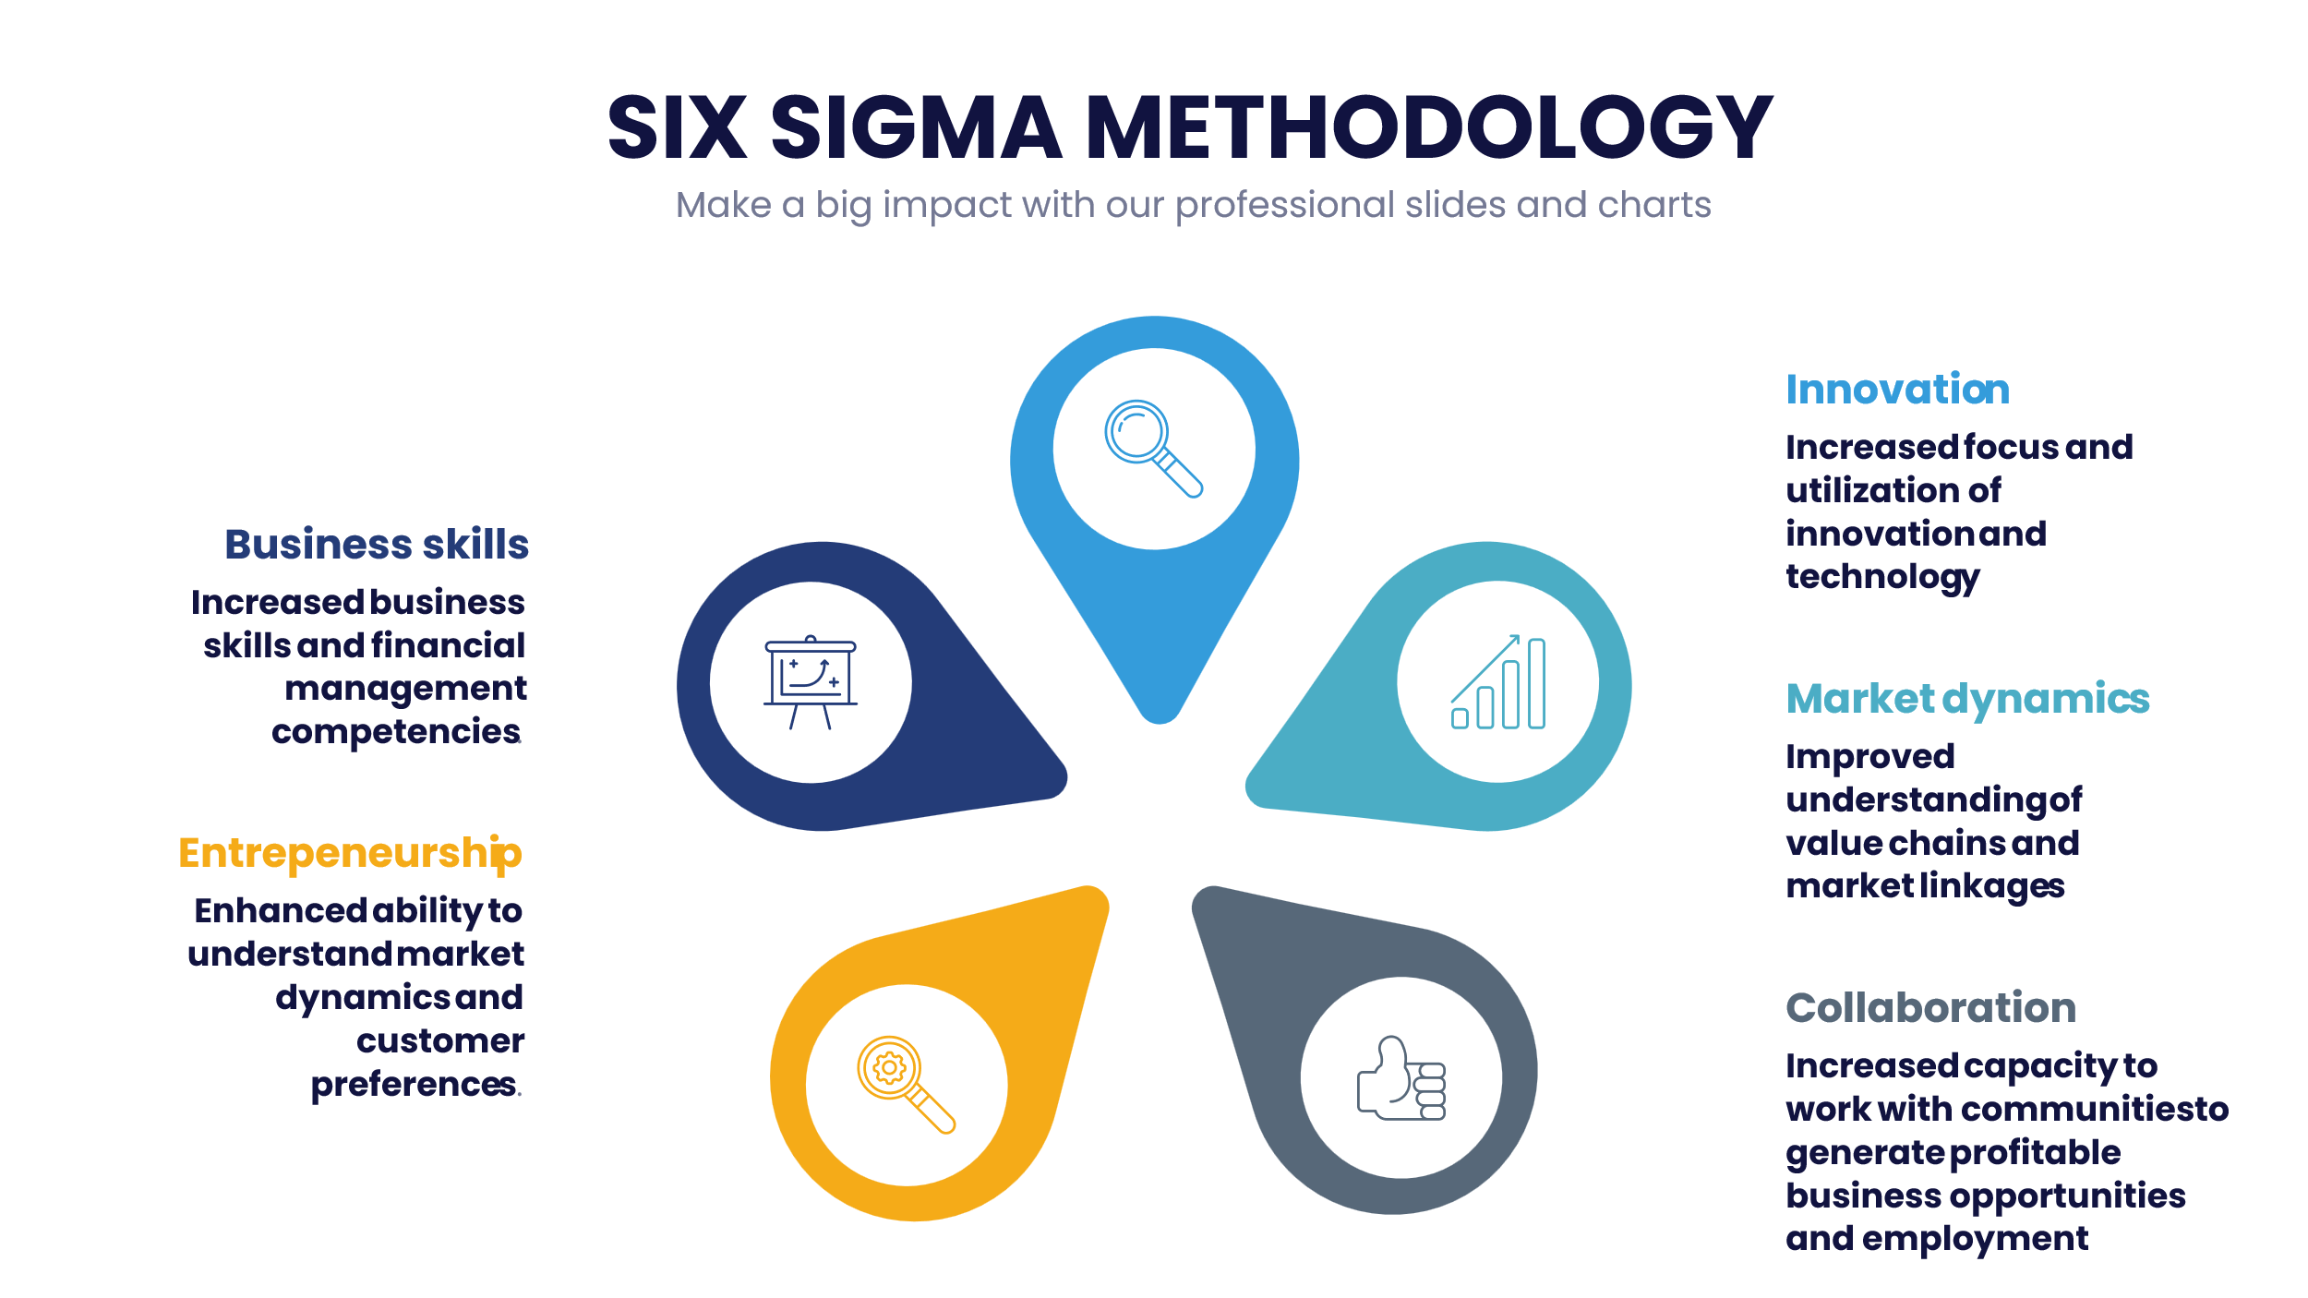

10. Generic PSDP Recommendations
In the assessment of the individual PSDP funding mechanisms in the previous sections, facility-specific recommendations have been proposed. The following recommendations are more generic in nature and apply to all the facilities that have been reviewed.

10.1 Macro Level Recommendations

R1 | UNDP Malawi should strengthen its strategic policy level support to the Ministry of Industry and Trade and other associated ministries to address the interconnected SME-growth barriers and support productive capacities of Malawian SMEs. | Working with its government counterparts UNDP should support an ecosystem approach to SMEs that incentivizes SME-formalization and enables a set of SME-friendly regulations aimed at lighter and easier-to-implement compliance requirements, tax-related obligations and reporting process. This is critical for Malawi given its relatively higher level of fragility. This would also require UNDP to facilitate active engagement and dialogue among the financial industry, national authority, and the SME-sector to better understand the SME-financing gap and introduce well informed, context sensitive reforms that can help create additional financial services or players better equipped to serve the SME-sector and bridge the financing gap.
Implementation time frame |  | Immediate (0-3 months) | Medium-term (3 to 6 months) | Longer-term (6 to 12 months)
 |  | x
R2 | UNDP Malawi should undertake deliberate efforts to support SMEs access to export markets. | There is need for concerted efforts by UNDP and relevant stakeholders to promote export markets for SMEs. This will in future address the challenges faced by SMEs regarding access to foreign exchange. E-commerce platforms and regional payment systems can be leveraged to support SME access to regional markets. Through its technical and investment support UNDP should target efforts to support the creation of platforms and networks that connect local businesses with regional and international markets.
Implementation time frame |  | Immediate (0-3 months) | Medium-term (3 to 6 months) | Longer-term (6 to 12 months)
 |  |  | x

10.2 Meso and Micro Level Recommendations

 |  |  |  | x
R3 | The PSDP should be develop more flexible tailor-made monitoring mechanisms for tracking and assessing the use of funds by different businesses at different levels with different needs. | Utilize a Results-Based Monitoring and Evaluation (RBM&E) approach that analyzes and evaluates programme activities, outputs, and outcomes at the PSDP level to measure and track program performance, but also use a results-based monitoring and evaluation approach to track the progress of individual companies more accurately, allowing facility managers to identify any issues or successes early on in the process.
Implementation time frame |  | Immediate (0-3 months) | Medium-term (3 to 6 months) | Longer-term (6 to 12 months)
 |  |  |  | x
R4 | UNDP Malawi should identify bottlenecks and delays and enhance their internal policy framework, with clear guidance on procedures for private sector engagement to expedite faster turn-around times for contracting and disbursement of funds. | To a larger extent, beneficiaries appreciate the fast turnaround times for disbursement of funding. However, there have been instances where the disbursements have been delayed. One critical example has been under Zantchito, where the delays in having a financial service provider has delayed disbursement of funding and the projects. UNDP has been recommended for providing a makeshift arrangement with the fund managers to at least make some of the early-stage payments while waiting for the financial service provider. UNDP should develop instruments that  facilitate engagement with the private sector as a partner, including jointly designed initiatives.
 |  | x

References
Abraham, F., and Schmukler S.L. (2017). Addressing the SME Finance Problem. World Bank Research and Policy Briefs No 7. Retrieved from https://documents1.worldbank.org/curated/en/809191507620842321/pdf/Addressing-the-SMEfinance-problem.pdf
AFC / UNDP. (2016). Financing the SDGs in the Least Developed Countries: Diversifying the Financing Tool-box and Managing Vulnerability. Retrieved from https://www.un.org/ohrlls/sites/www.un.org.ohrlls/files/financing-the-sdgs-in-the-least-developed-countries-ldcs-_-diversifying-the-financing-tool-box-and-managing-vulnerability-en.pdf
Almeghari, H. and Ojala, J. (2021). Structural barriers to SME-ecosystem development in LDC’s – Regulatory Frameworks, Technical Capacities and Access to Finance. Achieving Sustainable Development in the Least Developed Countries – LDC Future Forum. Retrieved from https://www.un.org/ldc5/sites/www.un.org.ldc5/files/structural_barriers_to_sme-ecosystem_development_in_ldcs_almeghari_ojala.pdf b
Bamboo Capital Partners S.A. (2023). Loan Facility Agreement BUILD II Malawi Sub-Fund S.A. SICAV-RAIF / Ziweto Enterprise Limited. Lilongwe.
Cunningham, J.A., Menter, M. and Wirsching, K. (2019). Entrepreneurial ecosystem governance: a principal investigator-centered governance framework. Small Business Economics Vol. 52, 545–562 Dalberg. (2011). Report on support to SMEs in developing countries through financial intermediaries. Retrieved from https://www.eib.org/attachments/dalberg_sme-briefing-paper.pdf
European Union. 2021. European Union and UNDP Contribution Agreement. FED/2021/423-895.
Government of Malawi. (2017). Malawi Growth and Development Strategy (MGDS) III (2017-2022). Lilongwe: Ministry of Finance, Economic Planning and Development. Retrieved from https://www.undp.org/malawi/publications/malawi-growth-and-development-strategy-iii
Government of Malawi. (2012). Micro, Small and Medium Enterprises (MSME) Policy. Lilongwe: Ministry of Industry and Trade. Retrieved from https://npc.mw/policies/
Government of Malawi. (2021). National Export Strategy II (NES II) (2021-2026). Lilongwe: Ministry of Industry and Trade.
Government of Malawi. (2012). Investment and Export Promotion Act. Lilongwe: Ministry of Industry and Trade.
Government of Malawi. (2011). Public-Private Partnership Act. Lilongwe: Ministry of Finance, Economic Planning and Development.
Government of Malawi. (2016). National Industrial Policy. Lilongwe: Ministry of Industry, Trade and Tourism. Retrieved from https://npc.mw/policies/
Government of Malawi. (2017). Malawi Sustainable Development Goals (SDGs) Implementation Plan (2017-2030). Lilongwe: Ministry of Finance, Economic Planning and Development.
Government of Malawi. (2017). Trade, Industry and Private Sector Development Strategy (2017-2022). Lilongwe: Ministry of Industry, Trade and Tourism.
Government of Malawi. (2016). National Trade Policy. Lilongwe: Ministry of Industry, Trade and Tourism.
Government of Malawi. (1998). Competition and Fair-Trading Act. Lilongwe: Ministry of Justice.
Government of Malawi. (2012). Business Licensing Act. Lilongwe: Ministry of Industry and Trade.
Government of Malawi. (2017). Special Economic Zones Act. Lilongwe: Ministry of Industry, Trade and Tourism.
Government of Malawi. (2016). National Agriculture Policy. Lilongwe: Ministry of Agriculture, Irrigation and Water Development. Retrieved from https://npc.mw/policies/
Government of Malawi. (2018). National Agricultural Investment Plan (NAIP) (2018-2023). Lilongwe: Ministry of Agriculture, Irrigation and Water Development.
Government of Malawi. (2020). Malawi Vision 2063: An Inclusively Wealthy and Self-reliant Nation. Lilongwe: National Planning Commission. Retrieved from https://npc.mw/vision-2063/
Government of Malawi. (2020). Private Sector Engagement Policy. Lilongwe: Ministry of Industry, Trade and Tourism.
Government of Malawi. (2022). National Agricultural Investment Plan 2018-2023. Lilongwe: Ministry of Agriculture, Irrigation, and Water Development.
Government of Malawi. (2020). National Export Strategy II (2021-2026). Lilongwe: Ministry of Trade.
Government of Malawi. (2021). National Industrial Policy. Lilongwe: Ministry of Industry and Trade.
Government of Malawi. (2020). National Trade Policy. Lilongwe: Ministry of Trade.
Government of Malawi. (2020). Micro, Small and Medium Enterprise (MSME) Policy. Lilongwe: Ministry of Industry and Trade.
Government of Malawi. (2021). National Agriculture Investment Plan (NAIP) 2018-2023. Lilongwe: Ministry of Agriculture.
Government of Malawi. (2022). Malawi 2063: Transforming Our Nation. Lilongwe: National Planning Commission.
Government of Malawi. (2021). Private Sector Engagement Policy. Lilongwe: Ministry of Industry and Trade.
Government of Malawi. (2019). National Agriculture Commercialization Policy. Lilongwe: Ministry of Agriculture.
ILO (2019). Small matters: global evidence on the contribution to employment by the self-employed, micro-enterprises and SMEs. Retrieved from https://www.ilo.org/wcmsp5/groups/public/---dgreports/--- dcomm/---publ/documents/publication/wcms_723282.pdf
Joint SDG Fund at https://www.jointsdgfund.org/
Joint SDG Fund. (2022). SDG Financing: Catalytic Investments (C2) – 2022 Annual Progress Report Malawi.
Joint SDG Fund / UNCDF / UNDP / FAO. (2022). Note to File – Status Quo of the Build Malawi Fund and Future Deployment & Capitalization Strategy. Lilongwe 25 November 2022.
Joint SDG Fund. (2023). Submission form for Programme/Budget Revision Documentation of extended duration of JP Document.
MICF. (2014-2020). Portfolio Statistics.
MICF. (2018). Summary of Contract Negotiation Minutes: MICF Round 3 – Irrigation Window. Project No. 03-01-14.
UNCDF. (2018). BUILD Enterprise Resource Technical Assistance Facility. New York. UNCDF.
UNCDF. (2020). BUILD Fund – Impact Framework. UNCDF / Bamboo Capital Partners.
UNCDF. (2020). Assessment Report: Viability of “Malawi Window” the BUILD Fund and BUILDER TA Initiative - An integrated support mechanism for SDG investment in Malawi. New York. UNCDF.
UNCDF. (2023). Provision of Technical Assistance to Global Seeds Limited by United Nations Capital Development Fund via the BUILDER TA Facility. Lilongwe.
UNCDF. (2024). Malawi Market Scoping Report.
UNDP. (2020). Programme Document Malawi: Private Sector Development (PSD).
UNDP. (2022). Accelerating Alternative Energy and Fuel-Efficient Technologies (AA-EFFECT).
UNDP. (2023). Initiation Plan - Accelerating Alternative Energy and Fuel-Efficient Technologies (AA-EFFECT).
UNDP Independent Evaluation Office. (2024). Evaluation of UNDP’s support to Private Sector Development and Structural Transformation (Draft).
UNDP. (2024). Contract for Goods and/or Services Between United Nations Development Programme and Ernst & Young Advisory Services P/L. Number and Date: RFP/MWI/007-2023 2023/08/10.
Zantchito. (2023). Zantchito: Entrepreneurship and Access to Finance – Quarter 3 Report. Nathan – A Cadmus Company.
Zantchito. (2023). Map of BDS Providers with KYC Scorecard. Nathan – A Cadmus Company.
Zantchito. (2023) Agreement between The United Nations Development Programme and Mzuzu Entrepreneurship Hub (Mzuzu E-Hub).
Zantchito. (2023). Competitive Map of Business Incubator. Nathan – A Cadmus Company.
Zantchito. (2024) UNDP PSD II Programme: Annual Review. PowerPoint Presentation. Lilongwe.

12. Annexes

12.1 Evaluation Team Composition

12.1.1 Team Expertise
Our management approach is designed to ensure effective coordination, communication, and execution of the evaluation. Collectively, the team brings with them:
- Specialized knowledge and extensive experience in project evaluation comparable to the demands of this evaluation.
- A deep understanding of the local context, challenges, and nuances, allowing us to offer a service that will be both relevant and effective.
- A commitment to promoting gender diversity and ensuring equitable representation within the evaluation process as well as experience in the area of gender mainstreaming.
- Experience working on diverse projects and initiatives across the region/country and international organisations, affording them a comprehensive grasp of the cultural, economic, and social intricacies unique to each context.
- Strong project management skills to evaluate the project's adherence to timelines, budgetary constraints, and overall efficiency.

12.1.2 Evaluation Team Roles
Lead Evaluator / Philip Browne: Technical lead will provide subject-matter expertise in areas such as private sector development, gender analysis, data collection, and evaluation methodologies. Will guide the evaluation process and ensure alignment with best practices. Will compile and present evaluation findings in a clear, structured manner.
Philip has over twenty-five years of expertise consulting in the development sector, as well as undertaking programme management, evaluations, policy analysis and strategic planning with governments, development agencies and NGOs in South Africa and the East, West and Southern Africa regions. Philip is a gender and social inclusion specialist with extensive experience in gender mainstreaming for policy formulation, programme design and the development of gender responsive M&E systems. Philip has an academic background in education (MPhil) as well as public and international development management (MPDM), and Public Health (MPH), with a focus on social policy and inclusion, human rights-based approaches, social sector research and political economy.
Philip has extensive experience in conducting evaluations and social / health impact assessments, as well undertaking gender, inclusion and vulnerability assessments. Philip has specialised in the application of specific evaluation and assessment tools, including gender analysis, gender lens investing, political economy, and development investment prioritisation / cost-benefit analyses. He has worked extensively in the areas of gender equality/women’s empowerment, public health (in particular HIV and sexual and reproductive health), education, social development, economics and labour markets, and governance. He has experience in policy analysis, and gender responsive results-based planning and management, and the development of theories of change (ToCs). Philip also brings extensive policy, research work and training in the field of development assistance, human rights, gender, and sustainable development. He has strong analytical skills in project formulation and administration, programme implementation and Monitoring & Evaluation, together with the capacity to produce detailed gender responsive evaluations, research, policy and programme documents. Philip is also an experienced trainer and facilitator in the areas of M&E, gender, social inclusion and human rights, and using a human centred design thinking methodology in all capacity development interventions. His clients have included government departments, UN agencies, the Global Fund, the World Bank, academia, international NGOs, global philanthropies, and the private sector.
National Evaluator / Khwima Singini: This team member will conduct data collection, and work with the Lead evaluator to conduct analysis of data, and report writing. Will also work with the Lead evaluator in compiling and presenting evaluation findings in a clear, structured manner. Will also ensure that all project documentation is well-organized and accessible.
Khwima is an accomplished professional with an extensive background in project evaluation,
private sector development, and inclusive business models. With a master’s degree in economics
and a bachelor’s degree in social science (Economics), both with Distinction, Khwima possesses a
strong academic foundation that complements his hands-on expertise.

With 11 years of diverse experience spanning various sectors, Khwima is an exceptional candidate for the role of a project evaluator. The following are some of his project evaluation experiences.
- Lead evaluator for the GIZ More Income and Employment in Rural Areas Project (MIERA), demonstrating his ability to guide and execute evaluations of significant development initiatives.
- Lead evaluator for the Inclusive Business Model component for GIZ MIERA.
- Project Officer for evaluation of the Agri finance Capacity Building tools for MSMEs and smallholder farmers and evaluated the use of digital platforms by MSMEs.

Apart from this, he is also skilled in designing strategic plans. He has developed strategic plans for the Export Development Fund (EDF), the Malawi Agriculture and Industrial Investment Corporation and also developed business plans for over 30 MSMEs. Khwima was also a Technical Assistant to the Ministry of Trade and Industry, focused on the implementation of the Malawi National Export Strategy, he was responsible for conducting evaluations of the NES implementation plan under the Trade and Industry Private Sector Sector Wide Approach (TIPSWAp). As a senior partner for African entrepreneurship, Khwima was responsible for conducting evaluations for partner countries (Zambia and Zimbabwe) under the CultiAf project.
With his proven track record as a lead evaluator, combined with his extensive experience in private sector development and analytical prowess, Khwima Singini is poised to make a significant impact as a project evaluator. His dedication to excellence, depth of knowledge, and ability to lead evaluations of impactful projects make him a standout candidate for this role.
Project Manager / Lusungu Kanchenche: A dedicated project manager will oversee all aspects of the evaluation. This individual will be responsible for overall project coordination, stakeholder engagement, quality assurance, and timely delivery of outputs. Stakeholder Engagement Coordination - Will facilitate effective communication with UNDP, project stakeholders, and local communities, ensuring that their insights and perspectives are integrated into the evaluation. Will be responsible for conducting rigorous quality checks at every stage of the evaluation, ensuring accuracy, coherence, and adherence to evaluation standards.

12.2 Evaluation Matrix

Criteria | Evaluation Questions | Supplementary Considerations | Data Sources | Data collection methods and tools | Data analysis approach
Relevance | - How relevant was the project to the global, regional, and national development goals?  - How relevant was the project to the development needs of the people / beneficiaries, in particular women, youth and vulnerable groups?  - Were the outcome and outputs of the projects stated explicitly and precisely in verifiable terms with SMART indicators disaggregated by sex, age and location?  - To what extent was the relationship between outcome, outputs, activities, and inputs of the projects were logically articulated?  - How well did project intervention and activity design adequately respond to the gender needs and gaps identified through the gender and rights-based approach problem analysis? | In applying the relevance criterion, we will consider PSDP and BUILD Facility “quality of design” to understand how well the intervention was built to address relevant priorities and needs and whether goals have been clearly specified. Through interviews and field work we will gain a better understanding of how effectively stakeholders’ priorities and needs are articulated in the intervention’s objectives, its underlying theory of change, and its implementation modalities. This will enable us to understand gaps in project design that may potentially have undermined the PSDP and the BUILD Facility’s overall relevance. This element for analysis also influences the evaluability of the overall intervention by adding a focus on the intervention’s design quality at the outset. It also provides insight into the intervention’s appropriateness to UNDP and its partners. For example, we will consider the extent to which it has been designed with technical, organizational and financial feasibility in mind. We will also apply the relevance criterion to understanding gendered power dynamics and reflecting on the SDG commitment to “leave no one behind”. For Ungweru Chiedza gendered power dynamics and the marginalization of certain groups – including racial/ethnic groups – are central considerations for understanding relevance within the context of private sector development initiatives. | Analysis of key Malawi policy and strategy documents  PSDP documents and data.  Malawi SDG reporting.  National economic statistics.  Benchmarking review.  Interviews with policy makers, programme managers, and grantees.  Research on private sector development in Malawi.  UNDP and other development partner publications. | Document review  Key informant interviews  Survey | Synthesis and analysis of relevant documentation, possibly with references to other similar country experiences.  Literature sourced during the document review exercise.
Relevance (BUILD Facility) | - How relevant is the BUILD Facility to the global, regional, and national development goals?  - How relevant is the BUILD Facility to the SDG financing needs in Malawi?  - To what extent are the outcome and outputs of the BUILF Facility are stated explicitly and precisely in verifiable terms with SMART indicators disaggregated by sex, age, and location?  - To what extent is the relationship between outcome, outputs, activities, and inputs of the projects logically articulated? |  | Analysis of key Malawi policy and strategy documents  BUILD Facility documents and data.  Interviews with policy makers, programme managers, and  Participating companies.  Research on private sector development in Malawi.  UNDP, UNCDF, FAO and SDG Fund publications. | Document review.  Key informant interviews. | Synthesis and analysis of  Relevant BUILD Facility documentation.  Literature sourced during the document review exercise.
Coherence | - Was the project consistent and complementary with other interventions in the areas private sector development and inclusive business models, women and youth economic empowerment?  - Did the project interventions duplicate existing similar interventions in the targeted areas, and were there any collaborations with similar interventions? | From a policy perspective the evaluation will consider the alignment of the PSDP and the BUILD Facility with national policy commitments by the Government of Malawi together with the SDGs, and how these have been taken into account in the intervention’s design and implementation. In looking at PSDP implementation in specific contexts (geographical location, sector, gender, age) the evaluators will consider coherence with interventions implemented by other actors in the private sector development space. For example, how are services provided by a range of actors – are there overlaps or gaps? Our assessment of coherence will consider how the PSDP has added value in relation to others and how duplication of effort has been avoided. | Analysis of key Malawi policy and strategy documents  PSDP documents and data.  Benchmarking review.  Interviews with policy makers, programme managers, and  implementing partners.  Research on private sector development in Malawi.  UNDP and development partner publications. | Document review  Key informant interviews  Survey | Synthesis and analysis of  Relevant PSDP documentation.  Literature sourced during the document review exercise.  The survey will include Likert-scale questions linked to each of the evaluation criteria and related evaluation questions so that the evaluators can quantify responses to the questions.
Coherence  (BUILD Facility) | - To what extent is the BUILD Facility consistent and complementary with other interventions in the areas private sector development and financial access for the missing middle?  - Do the BUILD Facility interventions duplicate any other existing similar interventions? |  | Analysis of key Malawi policy and strategy documents  BUILD Facility documents and data.  Interviews with policy makers, programme managers, and  Participating companies.  Research on private sector development in Malawi.  UNDP, UNCDF, FAO and SDG Fund publications. | Document review.  Key informant interviews. | Synthesis and analysis of  Relevant BUILD Facility documentation.  Literature sourced during the document review exercise.
Efficiency | - Were the processes of achieving results efficient?  - Do the actual results justify the costs incurred and were the resources effectively utilized?  - What project strategies or factors contributed to project implementation efficiency?  - How did the project financial management processes and procedures affect the performance of the project implementation?  - Were there more efficient ways and means of delivering results? | Efficiency measures the outputs – both qualitative and quantitative -- in relation to the inputs. It is an economic term which signifies that aid uses the least costly resources possible in order to achieve the desired results. To understand this, we will compare alternative approaches to achieving the same outputs, to see whether the most efficient process has been adopted. In evaluating the efficiency of the PSDP and the BUILD Facility, we will consider the following questions:  - Were activities cost-efficient?  - Were objectives achieved on time?  - Were these projects implemented in the most efficient way compared to alternatives? | PSDP documents and implementation data.  Budget and expenditure reports.  Project interim reviews and assessments  Interviews with programme managers, and grantees. | Document review  Key informant interviews  Survey | Synthesis and analysis of relevant implementation documentation reporting against the PSDP results framework.  If sufficient financial data is available, we will do a rapid cost / benefit analysis.
Efficiency (BUILD Facility) | - Are the processes of achieving results efficient?  - Does the actual progress on results justify the costs incurred and are the resources effectively utilized?  - What BUILD Facility strategies or factors are contributing to project implementation efficiency?  - How are the BUILD Facility financial management processes and procedures affecting the performance of the project implementation?  - Are there more efficient ways and means of delivering results? |  | BUILD Facility documents and implementation data.  Budget and expenditure reports.  Interviews with programme managers, and grantees. | Document review  Key informant interviews. | Synthesis and analysis of relevant implementation documentation reporting against the BUILD Facility results framework.  If sufficient financial data is available, we will do a rapid cost / benefit analysis.
Effectiveness | - To what extent were the project outcome and outputs achieved?  - What factors have contributed to achieving or not achieving intended project outputs and outcomes?  - Have there been any positive and negative unplanned effects/results?  - Were the project strategies effective in responding to the needs of the beneficiaries especially the vulnerable population including those with disabilities and albinism, what results are being observed?  - To what extent, gender issues were mainstreamed in the project strategies and implementation? | The evaluation will focus on the effectiveness of the PSDP and the BUILD Facility in providing equitable access to its services, benefits, and opportunities. To do this it will assess the extent to which the results targets, output targets and indicators of the two programmes have been achieved. It considers factors such as geographic accessibility, affordability, and availability of information or support systems to ensure that all individuals have equal opportunities to participate in and benefit from the PSDP facilities and the BUILD Facility. | PSDP reports and implementation data – from PSDP and the funding mechanisms.  Project interim reviews and assessments  Interviews with programme managers, and grantees. | Document review.  Key informant interviews.  Focus group discussions.  Survey. | Synthesis and analysis of relevant PSDP documentation.  Literature sourced during the document review exercise.  Case study.
Effectiveness (BUILD Facility) | - Are the BUILD Facility outcome and outputs on track?  - What factors have contributed to intended outputs and outcomes being on or off track?  - Have there been any positive and negative unplanned effects/results?  - To what extent are gender issues mainstreamed in the project strategies and implementation? |  | BUILD Facility reports and implementation data – from BUILD and the funding mechanisms.  Project interim reviews and assessments  Interviews with programme managers, and grantees. | Document review.  Key informant interviews.  Focus group discussions. | Synthesis and analysis of relevant BUILD Facility documentation.  Literature sourced during the document review exercise.  Case study.
Sustainability | - To what extent are the project positive results likely to be sustained after the completion of the project?  - What strategies did the project have to ensure continuation and sustainability of the project outcomes after completion of the project?  - What are the key factors, if any, that required attention to improve prospects of sustainability of project outcome?  - How were the capacities strengthened at individual and organizational level to ensure sustainability of project results?  - What are recommendations for similar intervention in future to ensure sustainability? | This criterion examines PSDP and BUILD Facility sustainability in promoting long-term equity outcomes through private sector development. It assesses whether PSDP efforts to address socio-economic and equity issues are integrated into its core strategies, policies, and resource allocation, ensuring that equity considerations are sustained beyond the evaluation. Through interviews and focus group discussions participants' voices are heard, valued, and integrated into the evaluation findings and recommendations. When interpreting evaluation findings, we will apply an equity lens to identify and understand gender, disability and ethnic disparities and inequities. The results will be analyzed in the context of social, economic, and historical factors that may contribute to differential outcomes through intersectional analysis. | PSDP reports, other documents and implementation data.  Project interim reviews and assessments  Interviews with programme managers, and grantees.  Any available economic forecasting. | Document review  Key informant interviews  Focus group discussions.  Survey | Synthesis and analysis of relevant PSDP documentation.  Literature sourced during the document review exercise.  Case study.
Sustainability (BUILD Facility) | - To what extent are the positive results of the BUILD Facility likely to be sustained after the completion of the project?  - What strategies does the BUILD Facility have to ensure continuation and sustainability of the project outcomes after completion of the project?  - What are the key factors, if any, that require attention to improve prospects of sustainability of the BUILD Facility outcome?  - How are the capacities strengthened at individual and organizational level to ensure sustainability of BUILD Facility results?  - What are recommendations for similar intervention in future to ensure sustainability? |  | BUILD Facility reports, other documents and implementation data.  Interviews with programme managers, and grantees.  Any available economic forecasting. | Document review.  Key informant interviews.  Focus group discussions. | Synthesis and analysis of relevant BUILD Facility documentation.  Literature sourced during the document review exercise.  Case study.
Impact | - To what extent has the project impacted on the livelihoods of beneficiary households?  - What effects did the project bring to households who were engaged in different values chains?  - What are benefits and risks of the project on people of different socio-economic strata including women and youths?  - What are the unintended positive or negative effects, if any, as the result of the project? | We will use the questions to explore the extent to which the PSDP has empowered both emerging entrepreneurs as well as smallholder farmers that have the potential to be productive, and the extent to which the project has enhanced their capabilities, self-determination, and agency. It assesses whether the PSDP has enabled individuals and communities to have greater control over their lives, resources, and decision-making processes. This criterion examines the impact of the PSDP on reducing social, economic, or environmental disparities among different population groups in Malawi. It considers whether the project has contributed to reducing inequalities and closing the gap between advantaged and disadvantaged groups.  As we are looking at a mid-term evaluation of the BUILD Facility, we will not include the impact criterion. | PSDP reports, other documents and implementation data.  Project interim reviews and assessments  Interviews with programme managers, grantees and beneficiaries. | Document review  Key informant interviews  Focus group discussions.  Survey | Synthesis and analysis of relevant PSDP documentation.  Literature sourced during the document review exercise.  Case study
Implementation | - How did project management arrangements and procedures affect the performance of project implementation?  - What partnerships were built or strengthened to improve performance of project implementation?  - How effective was the delivery of inputs specified in the project documents, including selection of responsible institutions, institutional arrangements, identification of beneficiaries, scheduling of activities and actual implementation.  - How responsive was project management to significant changes in the environment in which the project functions (both facilitating and impeding project implementation)?  - To what extent were lessons learnt from other relevant programmes/projects incorporated into the project?  - Was there a suitable Monitoring and Evaluation Framework? How often was the framework used to monitor progress towards achieving project outcomes and outputs?  - Did monitoring and backstopping of the projects meet the expectations of key partners?  - What was the role of UNDP CO and its impact (positive and negative) on project delivery?  - To what extent were recommendations from the periodic reviews including project steering committee meetings and impact assessments implemented in the project? | In the context of implementation, the evaluators will want to understand a number of issues that may have impacted either positively or negatively on the roll out of the PSDP and the BUILD Facility. Critically we will want to understand the issue of access – how easy was the application and award process and were there any intended / unintended barriers for certain people. We will also want to understand how the post-award process was experienced by grantees in terms of ongoing support and mentoring, training, facilitation of market access and other issues that tend to impact emerging enterprises.  For the BUILD Facility we will examine how the shift from its initial conceptualization to its current format have had any specific implementation issues. | PSDP documents and implementation data.  Budget and expenditure reports.  Project interim reviews and assessments  Interviews with programme managers, and grantees. | Document review.  Key informant interviews.  Survey. | Synthesis and analysis of relevant implementation documentation reporting against the PSDP results framework.  If sufficient financial data is available, we will do a rapid cost / benefit analysis.
Implementation (BUILD Facility) | - How do project management arrangements and procedures affect the performance of BUILD Facility implementation?  - What partnerships have been built or strengthened to improve performance of BUILD Facility implementation?  - How effective is the delivery of inputs specified in the project documents, including selection of responsible institutions, institutional arrangements, identification of beneficiaries, scheduling of activities and actual implementation?  - How responsive has BUILD Facility management been to significant changes in the environment in which the project functions (both facilitating and impeding project implementation)?  - Have lessons learnt from other relevant programmes / projects been incorporated into the project?  - Is there a suitable Monitoring and Evaluation Framework? How often is the framework used to monitor progress towards achieving project outcomes and outputs?  - Have the monitoring and backstopping responsibilities of key partners of the BUILD Facility met expectations thus far?  - How have the roles of UNDP CO, FAO, UNCDF and their respective impacts (positive and negative) expedited / retarded project delivery? |  | BUILD Facility documents and implementation data.  Budget and expenditure reports.  Project interim reviews and assessments  Interviews with programme managers, funders and participating companies. | Document review.  Key informant interviews. | Synthesis and analysis of relevant implementation documentation reporting against the BUILD Facility results framework.

12.3 Data Collection Instruments

12.3.1 Key Informant Instrument (UNDP, Development Partners, Government Ministries and Agencies)

Key Informant Interview Guide
Respondent Name
Gender | Male |  | Female |  | Other
Organisation
Job Designation
Location
Interview Date
Interview Time

UNDP has commissioned Ungweru Chiedza to conduct an evaluation Malawi’s Private Sector Development Project (PSDP). The purpose of the evaluation is to assess the effectiveness and impact of the PSDP and how efficiently it has been implemented since 2020. By conducting this evaluation, UNDP and its partners seek to gain insights into the outcomes and benefits generated by the PSDP, identify areas of success and areas for improvement, and inform future decision-making and policy formulation related to project funding and implementation. As part of evaluating the PSDP, we would like you to share your perspectives on the following evaluation questions.

Please answer the questions as openly and fully as you can. Please note that your participation in this study is voluntary and you are free to withdraw from the interview at any point. Your individual responses will be kept confidential within the evaluation team. We will not show your answers to anyone who is not part of our evaluation team.

Please note that if you are in agreement, we will record the interview to ensure that we capture your responses accurately. The recording will only be used for the purpose of this evaluation and will be permanently deleted as soon as we have transcribed the interview responses.

1: Background and Role
  - Please describe your current role, duties, and responsibilities.

  - Please can you elaborate on the way in which you have been involved with the PSDP?

2. PSDP Conceptualization
  - Please describe your involvement in the conceptualization / formulation of the PSDP 2000-2023.
  - In your view how relevant has the PSDP been in contributing to Malawi’s global, regional, and national development goals?
  - How involved in successor PSDP project – we have discussed Africa continental

  - Would you say that the PSDP has made a significant contribution to the development needs of the people / beneficiaries, in particular women, youth and vulnerable groups? Can you please expand on your answer.
  - To what extent do you feel that the PSDP outputs and outcomes were (as articulated in the ToC and the Results Matrix) the most appropriate in the context of private sector development in Malawi? Probe for thoughts on the logic of the project, its indicators and disaggregation of data.
  - I your view have the PSDP funding mechanisms and interventions adequately responded to the gender needs and gaps identified through the gender and rights-based approach problem analysis? Please expand on your answer.
Involvement of the ministry – is there a blueprint for engagement?
  - Do you feel that the PSDP has been adequately aligned with other interventions in Malawi to boost private sector growth, including government programmes? What is the reason for your answer? Probe around possible duplication of interventions by different entities.

3: PSDP Implementation and Challenges
- How did project management arrangements and procedures affect the performance of project implementation?
- What partnerships were built or strengthened to improve performance of project implementation?
- How effective was the delivery of inputs specified in the project documents, including selection of responsible institutions, institutional arrangements, identification of beneficiaries, scheduling of activities and actual implementation.
- How responsive was project management to significant changes in the environment in which the project functions (both facilitating and impeding project implementation)?
- To what extent were lessons learnt from other relevant programmes/projects incorporated into the project?
- Was there a suitable Monitoring and Evaluation Framework? How often was the framework used to monitor progress towards achieving project outcomes and outputs?
- Did monitoring and backstopping of the projects meet the expectations of key partners?
- What was the role of UNDP CO and its impact (positive and negative) on project delivery?
- To what extent were recommendations from the periodic reviews including project steering committee meetings and impact assessments implemented in the project?
4: Monitoring, Reporting, and Feedback Mechanisms
  - How efficiently has the PSDP progress and performance been monitored and tracked? What evidence can you provide for this?
  - What mechanisms were put in place to gather feedback from stakeholders? How is this feedback utilized?
  - As government / development partners do you feel that you were provided with adequate updates and feedback from project implementation? Please expand on your answer.

5: Resource Management, Fund Allocation and Project Delivery
  - Can you describe how resources (financial, human, technical) are allocated and managed in the PSDP. Probe: Were there any resource gaps or challenges faced during the implementation, and how were they addressed?
  - What other kinds of support were provided to support PSDP implementation during the roll out of the project?
  - Do you feel that the processes that were put in place to achieve PSDP results were efficient? Were there any areas that you think could have been improved upon?
  - In your view have the the results that have been achieved justify the project costs incurred and were the resources effectively utilized?
  - In your experience were there any PSDP strategies or factors that contributed to the efficiency of project implementation? What were these factors?
  - How did the project financial management processes and procedures affect the performance of the project implementation?
  - Looking back, do you think that there were more efficient ways and means of delivering PSDP results? In your view what would these have been?

6: Project Effectiveness
  - To what extent were the project outcome and outputs achieved?
  - What factors have contributed to achieving or not achieving intended project outputs and outcomes?
  - Have there been any positive and negative unplanned effects/results?
  - Were the project strategies effective in responding to the needs of the beneficiaries especially the vulnerable population including those with disabilities and albinism, what results are being observed?
  - To what extent, gender issues were mainstreamed in the project strategies and implementation?

7: Impact
  - In your view has the PSDP had a measurable impact on development and growth of SMEs in Malawi? What is the basis for your answer?
  - In your view has the PSDP had a measurable impact on the livelihoods of beneficiary households? What is the basis for your answer?
  - In your view what benefits has the PSDP brought for households who have been engaged in different values chains? Is there clear evidence for this?
  - Do you think that people of different socio-economic strata including women and youth have experienced different kinds of outcomes from the PSDP? What have these outcomes been? Probe: intended or unintended.

8: Sustainability
  - Do you feel that the positive results / achievements of the PSDP are likely to be sustained after the completion of the project? What reasons can you give for your answer?
  - Do you feel that the PSDP had – from inception – built in sustainability strategies / mechanisms to ensure continuation and sustainability of the project outcomes after completion of the project? Can you expand on your answer.
  - Through the lifecycle of this PSDP did any aspects of the project require adjustment in order to improve the prospects for sustainability of the project outputs and outcome?
  - Do you feel that the enterprises that benefitted from PSDP funding / support were adequately equipped at the individual and organizational level to ensure sustainability of project results?

9. Lessons Learned and Future Recommendations
  - From your perspective, what are the key lessons learned from the implementation of the PSDP?
  - Are there specific areas or components of the PSDP that you believe should be scaled up or prioritized in future initiatives?
  - What recommendations would you suggest for future iterations of the PSDP or for similar programmes?
  - What are recommendations for similar interventions in the future to ensure continuous growth and viability of the private sector in Malawi?

10: Final Thoughts
  - In hindsight, is there anything you would have done differently in the implementation or management of the PSDP?

Thank you for your time and valuable insights.

12.3.2 Grantees Instrument

Key Informant Interview Guide (beneficiary enterprises of PSDP)
Respondent Name
Gender | Male |  | Female |  | Other
Organisation
Job Designation
Location
Interview Date
Interview Time

UNDP has commissioned Ungweru Chiedza to conduct an evaluation Malawi’s Private Sector Development Project (PSDP). The purpose of the evaluation is to assess the effectiveness and impact of the PSDP and how efficiently it has been implemented since 2020. By conducting this evaluation, UNDP and its partners seek to gain insights into the outcomes and benefits generated by the PSDP, identify areas of success and areas for improvement, and inform future decision-making and policy formulation related to project funding and implementation. As part of evaluating the PSDP, we would like you to share your perspectives on the following evaluation questions.

Please answer the questions as openly and fully as you can. Please note that your participation in this study is voluntary and you are free to withdraw from the interview at any point. Your individual responses will be kept confidential within the evaluation team. We will not show your answers to anyone who is not part of our evaluation team.

Please note that if you are in agreement, we will record the interview to ensure that we capture your responses accurately. The recording will only be used for the purpose of this evaluation and will be permanently deleted as soon as we have transcribed the interview responses.

1: Background and Role
  - Please describe the nature of your enterprise / business.
  - Please describe your current role, duties, and responsibilities.
  - Please can you elaborate on the way in which you have benefitted from / supported by the PSDP?

2. PSDP Application and Award
  - Please describe how you applied for support from the PSDP 2000-2023.
  - How easy / difficult was the application process? Please explain your answer. Probe: was the application process user friendly?
  - In your experience was the awarding of funds done in a timely and efficient manner? Please elaborate on your answer.
  - In the process of applying for the grant did you experience any barriers or obstacles? If so, please explain what they were and how they were addressed.
  - Would you say that being awarded funds from the PSDP funding mechanisms has made a significant contribution to the development and growth of your enterprise? Can you please expand on your answer.
3: Implementation Successes and Challenges
  - What would you say have been some of your successes as a beneficiary of the PSDP?
  - What have been some of the challenges that you have experienced since you were provided with PSDP funding? How were you able to deal with these challenges?
  - As a result of PSDP funding have you been able to build or strengthened your enterprise to become competitive and sustainable? Please provide details.
  - How responsive has the PSDP (or funding mechanisms) been in facilitating and supporting the development and growth of your enterprise?
4: Monitoring, Reporting, and Feedback Mechanisms
  - How are you required to report on your progress and performance? How easy / difficult is this reporting process?
  - Do you have adequate systems in place to account for the management of the funds provided to your enterprise? How do you report on this?
  - What mechanisms were put in place to gather feedback from stakeholders? How is this feedback utilized?
  - Do you feel that the PSDP has provided you with adequate updates and feedback about ways in which you have been utilizing the funding? Please expand on your answer.

5: Grant Management
  - Can you describe how resources (financial, human, technical) were allocated to your enterprise? Probe: Have you experienced any resource delays, gaps or challenges during the implementation, and how did you address them?
  - What other kinds of support were provided by the PSDP implementation during the grant process?
  - In your experience were there any factors that contributed to the efficiency of the grant award? What were these factors?
  - Looking back, do you think that there could have been more efficient ways and means of providing the PSDP funding to you? In your view what would these have been?

6: Project Effectiveness
  - To what extent have your growth objectives been achieved as a result of the funding awarded to your enterprise? Please explain.
  - What factors have contributed to your enterprise achieving or not achieving its intended growth targets?
  - Have there been any positive and negative unplanned effects/results of the PSDP grant?
  - To what extent, gender issues were mainstreamed in the project strategies and implementation?

7: Impact
  - From your personal experience is the PSDP having a clear and measurable impact on the development and growth of SMEs in Malawi? What is the basis for your answer?
  - In your view has the funding that you received through the PSDP enabled you to have an impact on the livelihoods of households in your area of operation? What is the basis for your answer?
  - In your view what benefits has the PSDP brought for households who have been engaged in different values chains? Is there clear evidence for this?
  - Has the growth of your enterprise had an impact of the lives of young people, women, people with disabilities? If so, what have these outcomes been? Probe: intended or unintended.

8: Sustainability
  - How do you feel that your enterprise has benefitted from PSDP funding / support? Please provide details.
  - Has the funding mechanism provided your enterprise with any support (business intelligence, mentoring, training etc.) to ensure that your business is sustainable? If so, please provide details. Probe: How effective was this support.
  - Do you feel that the funding that you received through the PSDP has adequately equipped your enterprise at the individual and organizational level to ensure business sustainability? Please explain your answer.

9. Lessons Learned and Future Recommendations
  - From your perspective, what have been some of the key lessons learned from your involvement in the PSDP?
  - As a result of your experience as a grantee are there any specific areas or components of the PSDP that you believe should be improved, scaled up or prioritized in future initiatives?
  - What recommendations would you suggest for future iterations of the PSDP or for similar programmes?
  - What are recommendations for similar interventions in the future to ensure continuous growth and viability of the private sector in Malawi?

10: Final Thoughts
  - In hindsight, is there anything you would have done differently as a grantee of the PSDP?

Thank you for your time and valuable insights.

12.3.3 Instrument for the Build Facility

Key Informant Interview Guide (beneficiary enterprises of the BUILD Facility)
Respondent Name
Gender | Male |  | Female |  | Other
Organisation
Job Designation
Location
Interview Date
Interview Time

UNDP has commissioned Ungweru Chiedza to conduct an evaluation Malawi’s BUILD Facility. The purpose of the evaluation is to assess the effectiveness so far of the BUILD Facility and how efficiently it has been implemented since its inception. By conducting this evaluation, UNDP and its partners seek to gain insights into the outcomes and benefits generated by the BUILD Facility, identify areas of success and areas for improvement, and inform future decision-making and policy formulation related to project funding and implementation. As part of evaluating the BUILD Facility, we would like you to share your perspectives on the following evaluation questions.

Please answer the questions as openly and fully as you can. Please note that your participation in this study is voluntary and you are free to withdraw from the interview at any point. Your individual responses will be kept confidential within the evaluation team. We will not show your answers to anyone who is not part of our evaluation team.

Please note that if you are in agreement, we will record the interview to ensure that we capture your responses accurately. The recording will only be used for the purpose of this evaluation and will be permanently deleted as soon as we have transcribed the interview responses.

1: Background and Role
  - Please describe the nature of your enterprise / business.
  - Please describe your current role, duties, and responsibilities.
  - Please can you elaborate on the way in which you have benefitted from / supported by the BUILD Facility?

2. PSDP Application and Award
  - Please describe how you applied for support from the BUILD Facility.
  - How easy / difficult was the application process? Please explain your answer. Probe: was the application process user friendly?
  - In your experience was the awarding of funds done in a timely and efficient manner? Please elaborate on your answer.
  - In the process of applying for the grant did you experience any barriers or obstacles? If so, please explain what they were and how they were addressed.
  - Would you say that being awarded funds from the BUILD Facility has made a significant contribution to the development and growth of your enterprise? Can you please expand on your answer.
3: Implementation Successes and Challenges
  - What would you say have been some of your successes as a beneficiary of the BUILD Facility?
  - What have been some of the challenges that you have experienced since you were provided with BUILD Facility funding and/or technical assistance? How were you able to deal with these challenges?
  - As a result of BUILD Facility funding have you been able to build or strengthen your enterprise to become competitive and sustainable? Please provide details.
  - How responsive has the BUILD Facility been in facilitating and supporting the development and growth of your enterprise?
4: Monitoring, Reporting, and Feedback Mechanisms
  - How are you required to report on your progress and performance? How easy / difficult is this reporting process?
  - Do you have adequate systems in place to account for the management of the funds provided to your enterprise? How do you report on this?
  - What mechanisms were put in place to gather feedback from stakeholders? How is this feedback utilized?
  - Do you feel that the BUILD Facility has provided you with adequate updates and feedback about ways in which you have been utilizing the funding? Please expand on your answer.

5: Grant Management
  - Can you describe how resources (financial, human, technical) were allocated to your enterprise? Probe: Have you experienced any resource delays, gaps, or challenges during the implementation, and how did you address them?
  - What other kinds of support were provided by the BUILD Facility during the grant process?
  - In your experience were there any factors that contributed to the efficiency of the grant award? What were these factors?
  - Looking back, do you think that there could have been more efficient ways and means of providing the BUILD Facility funding to you? In your view what would these have been?

6: Project Effectiveness
  - To what extent have your growth objectives been achieved as a result of the BUILD Facility funding awarded to your enterprise? Please explain.
  - What factors have contributed to your enterprise achieving or not achieving its intended growth targets?
  - Have there been any positive and negative unplanned effects/results of BUILD Facility funding and/or technical assistance?
  - Can you please tell us about the nature and effectiveness of any TA that you received through the BUILD Facility
  - To what extent have gender issues been mainstreamed in the BUILD Facility project strategies and implementation?

7: Sustainability
  - How do you feel that your enterprise has benefitted from BUILD Facility funding / support? Please provide details.
  - Has the funding mechanism provided your enterprise with any support (business intelligence, mentoring, training etc.) to ensure that your business is sustainable? If so, please provide details. Probe: How effective was this support.
  - Do you feel that the funding that you received through the BUILD Facility has adequately equipped your enterprise at the individual and organizational level to ensure business sustainability? Please explain your answer.

8. Lessons Learned and Future Recommendations
  - From your perspective, what have been some of the key lessons learned from your involvement in the BUILD Facility?
  - As a result of your experience as a grantee are there any specific areas or components of the BUILD Facility that you believe should be improved, scaled up or prioritized in future initiatives?
  - What recommendations would you suggest for future iterations of the BUILD Facility or for similar programmes?
  - What are recommendations for similar interventions in the future to ensure continuous growth and viability of the private sector in Malawi?

9: Final Thoughts
  - In hindsight, is there anything you would have done differently as a grantee of the BUILD Facility?

Thank you for your time and valuable insights.

12.3.4 PSDP Participant survey
This data collection instrument will be sent out as a survey. The questions listed below will be entered into Survey Monkey and the survey link will be sent to all the respondents via email.
Dear Participant,
Thank you for your willingness to take part in the PSDP participant survey. Your input is crucial in helping us assess the effectiveness and impact of the project. Before you proceed with the survey, we want to assure you that your participation is entirely voluntary, and your responses will be treated with the utmost respect for your privacy.
Anonymity and confidentiality are of utmost importance to us. Your individual responses will be kept strictly confidential and will only be used for research and evaluation purposes. Your name and any personal identifiers will not be linked to your survey data or shared with any third parties. The survey data will be stored securely on our servers and accessible only to authorized research personnel.
By continuing with the survey, you are giving your informed consent to participate, acknowledging that you understand the purpose and potential use of the collected data. Your decision to participate or decline will in no way affect your relationship with the PSDP or any associated organizations.
Section 1: Demographic Information
- Gender:
  - Male
  - Female
  - Non-binary/Other
- Age:
  - Under 18
  - 18-25
  - 26-35
  - 36-45
  - 46-55
  - 56 and above
- Employment Status:
  - Employed
  - Unemployed
  - Self-employed
  - Student
  - Retired
  - Other (please specify)
- Location:
  - [Specify region / city / district]
Section 2: Awareness and Knowledge
- Were you aware of the PSDP before participating in this survey?
  - Yes
  - No
  - Unsure
- How did you learn about the PSDP and/or its various funding mechanisms?
  - Word of mouth
  - UNDP website
  - University / research institution website
  - Social media
  - Professional networks
  - Other (please specify)
- Which of the PSDP funding mechanisms have you been most involved with (as implementer or beneficiary)?
  - Malawi Innovation Challenge Fund (MICF)
  - Growth Accelerator (GA)
  - Zantchito
  - Build Malawi
  - Social Transformation and Innovation through Entrepreneurship and Access to Finance (STIEF)
  - Green Economic Transition Facility (GETF)
  - Accelerating Alternative Energy and Fuel-Efficient Technologies (AA-EFFECT)
  - Other

c) Section 3
- How confident are you that the PSDP and its component mechanisms are appropriate for growing the private sector in Malawi?
Very confident | Somewhat confident | Unsure | Not very confident | Not confident at all

- How satisfied are you that the disbursement of PSDP grants has been managed efficiently?
Very satisfied | Somewhat satisfied | Unsure | Not very satisfied | Not satisfied at all

- How satisfied have you been with reporting requirements for the grant funding?
Very satisfied | Somewhat satisfied | Unsure | Not very satisfied | Not satisfied at all

- How effective have the feedback mechanisms between your institution, UNDP and the grant beneficiaries?
Very effective | Somewhat effective | Unsure | Not very effective | Not effective at all

- To what extent would you say that the funding provided through the PSDP is adequate to achieve Malawi’s private sector growth objectives?
More than adequate | To some extent adequate | Unsure | Not really adequate | Not adequate at all

- In your view has the implementation of the PSDP between 2020 and 2023 been a collaborative exercise between the different stakeholders (government, development partners, private sector, communities)?
Very much | To some extent | Unsure | Not much | Not at all

- Would you say that this collaboration has helped to build Malawi’s entrepreneurial capacity / expertise?
Very much so | To some extent | Unsure | Not sufficiently | Not at all

- If it has achieved this objective, can you provide an example of this? (Open ended question)

- Do you believe that the level of collaboration that you have been part of has produced lessons / results that can contribute directly to critical development challenges in Malawi?

Very much so | To some extent | Unsure | Not sufficiently | Not at all

- To what extent would you say that the PSDP has contributed to Malawi’s efforts to meet its commitments to the following development strategies:
 | Very much | To some extent | Not sure | Not much | Not at all
MIP 1 10 Year Implementation Plan
The Sustainable Development Goals (SDGs)
The African Union
Agenda 2063
The SADC’s Regional Indicative Strategic Development Plan (RIDSP)

- To what extent would you say that the outputs of the PSDP have contributed to Malawi’s efforts to address the following equity issues:
 | Very much | To some extent | Not sure | Not much | Not at all
Poverty alleviation
Reducing socio-economic inequalities
Gender equality
Women’s empowerment
Youth empowerment
Inclusion of people with disabilities
Inclusion of ethnic minorities

- Does your institution have the necessary monitoring systems in place to track and assess the longer-term impact of the PSDP?

Very much so | To some extent | Unsure | Not sufficiently | Not at all

- Is the current PSDP funding model sustainable for the implementation of the kinds of private sector growth initiatives that you are involved in or leading?

Very much so | To some extent | Unsure | Not sufficiently | Not at all

- Do you feel the activities related to the PSDP implementation is contributing to long-term sustainable change in Malawi in the following areas?

Issue | Very much so | To some extent | Unsure | Not very much | Not at all
Enhanced human capital development
Enhanced business/entrepreneurship skills
Increased capacity for innovation
Empowerment of young entrepreneurs
Empowerment of women entrepreneurs
Empowerment of persons with disabilities
Economic growth in previously marginalized areas

- What aspects of the PSDP did you find most beneficial? (Open-ended question)
- What recommendations / suggestions could you make for improving the effectiveness and / or efficiency of the PSDP? (Open-ended question)

Note: Thank you for taking time to completing the survey and sharing your valuable insights. Please note that the information will be used to inform the evaluation of the PSDP. The evaluation findings will be communicated and disseminated following completion of the evaluation.

12.3.5 Focus Group Discussion Instrument

Focus Group Discussion Guide for PSDP beneficiaries.

Collect the following information for each FGD participant:
- Name
- Age
- Gender
- Occupation
- Household head [Y or N]
- Disability [Y or N]

Introduction:
- Welcome participants and introduce the facilitators/moderators.
- Explain the purpose of the FGD: to gather diverse perspectives on the PSDP implementation and impact.
- Discuss confidentiality and the ground rules for the discussion.
- Seek consent for recording the session, if applicable.

Warm-Up:
- Request each participant to introduce themselves and share a brief personal experience with the PSDP (specifically the enterprise that they are familiar with).

1. Sector Engagement
  - Which economic sector are you involved in?
  - Are you a worker? Or a household manager? Or both?
  - As a worker what are your main activities?
  - I would like to hear about the challenges you and your community experiences with income generating activities. Could you please explain the biggest challenges you face? (e.g. access to inputs, access to water, extreme weather conditions, pests/disease, illness)
  - Have the challenges changed over time? How have they changed? Can you tell me about anything you or your community has done to address the challenges?

2. Implementation Insights
  - From your perspective, what have been the strengths of your relationship / engagement with [enterprise]? What kind of differences to you personally / to your community has this relationship brought about?
  - Were there any challenges or areas of concern that you observed or experienced during your relationship with [enterprise]?

3. Perceived Impact
- In what ways has the development and growth of this [enterprise] positively affected you, your family, or your community?
- Were there any unintended consequences or outcomes from your engagement with [enterprise]? Were these positive or negative? What were these unintended consequences and why were these either positive or negative?

4. Gender division of labour/Household decision-making (HHDM)
  - In this area / community what are the main tasks that women do and what are the main tasks that men do? How do couples make decisions about who does what task?
  - Can you please tell me about how women/men make decisions with their spouse about income generation (e.g. what to grow, what farming techniques to use, what to sell)? (Probe: Do they have a conversation? How often?
  - Do husbands and wives make decisions on their own?). Has it always been like this, or has it changed? [If yes] When did it change?
  - Has your involvement with [enterprise] brough about any positive or negative changes for you as a man or a woman, as a young person or and older person? Can you please specify what these changes have been.

- Learnings / Sustainability
  - Do you think you have learned anything new after participating in the work of [enterprise]? Please explain.
  - What do you think are the benefits of participating in this kind of enterprise?
  - What do you think the challenges are to participating in this kind of enterprise?
  - What do you think will happen to you and other people in this community if [enterprise] no longer operates here? (Probe: How do you think you or your community will change with time? Will you continue doing this the same way? Why?
  - Do you think that your involvement with [enterprise] has given you new skills / knowledge that you can use in the future? What kind of skills / knowledge?

6. Closing
  - Is there any other feedback, comment, or insight you' would like to share regarding your involvement with [enterprise] that hasn't been covered in our discussion today?

12.4 List of Evaluation Respondents

Name | Organization | Email
Cinzia | UNDP | cinzia.tecce@undp.org
Chionetsero Chingoli | UNDP | chionetsero.chingoli@undp.org
Brown Amos Msiska | UNDP | brown.msiska@undp.org
Tawonga Chunga | UNDP | tawonga.chunda@undp.org
Madalo | UNDP
Peter Kulemeka | UNDP | peter.kulemeka@undp.org
Ezron Chirambo | Ministry of Industry and Trade | ezronn@yahoo.com
Mayeso Msokera | Ministry of Industry and Trade | mayeso.msokera@trade.gov.mw
Edward Joshua | NAO Ministry of Finance | ejoshua@naosupportmw.org
Charles Lumanga | NAO Ministry of Finance | clumanga@naosupportmw.org
Eugene Maseya | NextGen Labs | maseyaeu@gmail.com
Chiku Kilembe | Embassy of Ireland | chikumbutso.kilembe@dfa.ie
Matilda Sibweza Palamuleni | EU | matilda.sibweza-palamuleni@eeas.europa.eu
Munday Makoko | IFAD | tsilizanim@gmail.com
Grant Blumrick | Afribam | grant@afribam.com
Navin Kumar | Zantchito | navin@imanidevelopment.com  Navin.Kumar@cadmusgroup.com
Lilian Mpama | Zantchito
Tambulani Chunga | Landell Mills | nduwa_chunga@landell-mills.com
Ron Ngwira | Pyxus Agriculture | rngwira@pyxus.com
Edwina Hanjahanja | KfW | edwina.hanjahanja@kfw.de
Mackenzie Bright | KfW | Mackenzie.bright@kfw.de
Felix Sichali | NASCOMEX | FSichali@nasfam.org
Aubrey Chinseu | NASCOMEX | achinseu@naccomex.com
Cosmas Kafwafwa | NASCOMEX-Farm Manager | Focus Group Discussant
Charity Matola | NASCOMEX-farmer | Focus Group Discussant
Mr Chisale | NASCOMEX-Chairperson
Berias Unyolo | Mundawathu | mundawathugardens@gmail.com
Fannie Gondwe | Perisha Agro and Packaging | fanniegondwe@gmail.com
Moses Nyirenda | Imani Investments | moses@imani-investments.com
Atusaye Kayuni | Modern Farming Technologies (MFT) | atusaye@malawifruits.org.uk
Wangiwe Kambuzi | Mzuzu E-hub | wangiwe.kambuzi@mzuzuehub.org
Jonathan | Mzuzu E-hub | Focus Group Discussant
Tommer Naki-incubatee | Mzuzu E-hub | Focus Group Discussant
Prince Mussa-Incubatee | Mzuzu E-hub | Focus Group Discussant
Nickson Nkhoma-Incubatee | Mzuzu E-hub | Focus Group Discussant
Lusungu Chirwa-incubatee | Mzuzu E-hub | Focus Group Discussant
Maggie Njera-incubatee | Mzuzu E-hub | Focus Group Discussant
Ian Katanga-Incubatee | Mzuzu E-hub | Focus Group Discussant
Malama Mwenya-Incubatee | Mzuzu E-hub | Focus Group Discussant
Mackson Ngambi | Mzuzu Coffee | mdkngambi@mzuzucoffee.org
Square Nyasulu | Mzuzu Coffee
Packston Munthali | Mzuzu Coffee
Jones Katumba | Mzuzu Coffee | jkatumba@mzuzucoffee.org
Brian Namata | Ethanol Company | bnamata@ethanolmw.com
Lusubilo Chakaniza | Ethanol Company | Lchakaniza@ethanolmw.com
Derek Zamaere | Ethanol Company
Titus Kaliapa | Trend Setters | titus.kaliapa@yahoo.com
Daniel Kukhoma | Trend Setters
Mwayi Kampesi / Atupele Kampesi | Planet Green Africa | mwayik@planetgreenafrica.com
Jan Prene | Arkay Plastics | crk@arkayplastics.com
Bryson Mkhomaanthu | Press Cane | BMkhomaanthu@pressethanolmw.com
Connex Chilangwe | Press Cane | CChilangwe@pressethanolmw.com
Upile Mawenda | Malawi University of Business/science | umawenda@mubas.ac.mw
Charity Kasiya | Malawi University of Business/science | ckasiya@mubas.ac.mw
Chikondi Kandiyelo | Malawi University of Business/science | Focus Group Discussant
Isham Mussa-Incubatee | Malawi University of Business/science | Focus Group Discussant
Samson-Incubatee | Malawi University of Business/science | Focus Group Discussant
John Nembo-Incubatee | Malawi University of Business/science | Focus Group Discussant
Wisdom Kusembere-Incubatee | Malawi University of Business/science | Focus Group Discussant
Precious-Incubatee | Malawi University of Business/science | Focus Group Discussant
Juliet Makondetsa-Incubatee | Malawi University of Business/science | Focus Group Discussant
Loveness Chimombo-Incubatee | Malawi University of Business/science | Focus Group Discussant
Anne Khozomba-Incubatee | Malawi University of Business/science | Focus Group Discussant
Moses Kachezera-Incubatee | Malawi University of Business/science | Focus Group Discussant
Grace Msiska | Amazing Bakes | gracehellenmsiska@gmail.com
Evanson Brake | Amazing Bakes | Focus Group Discussant
Philes Site | Amazing Bakes | Focus Group Discussant
Gloria Alfonso | Amazing Bakes | Focus Group Discussant
Faith Zakalia | Amazing Bakes | Focus Group Discussant
Ms Mercy | Amazing Bakes | Focus Group Discussant
Siyaphera Makunganya | Zomba Private Ambulances | eecmalawi@gmail.com
Tim van der Linden | aQysta Irrigation | tim.van@aqysta.com
Byton Simwela | Ziweto | ziwetomalawi@gmail.com
Mr Paul | Ziweto
Shane Phiri | Global Seeds | shane.phiri@yahoo.com
Fabrizio Commetto | UNCDF | fabrizio.cometto@uncdf.org
Nelly Toute Elimbi | UNCDF | nelly.toute-elimbi@uncdf.org
Heewong Kim | Joint SDG fund | heewoong.kim@un.org
Maria Berenguer | Joint SDG fund | Maria.berenguer@un.org
Jabusile Shumba | UN Resident Coordination Office | Jabusile.shumba@un.org

UNCDF. 2024. Malawi Market Scoping Report.
World Bank Group. 2021. Creating Markets in Malawi - The Road to Recovery: Turning Crisis into Economic Opportunity at https://www.ifc.org/content/dam/ifc/doc/mgrt/cpsd-malawi.pdf
UNFPA. 2023. World Population Dashboard – Malawi at https://www.unfpa.org/data/world-population/MW
Ibid.
Statista. 2023. Ease of doing business in Malawi 2020 at https://www.statista.com/statistics/1243672/ease-of-doing-business-in-malawi-by-topic/#statisticContainer
FinDev Gateway. Financial Inclusion in Malawi at https://www.findevgateway.org/country/financial-inclusion-in-malawi
FinDev Gateway. Financial Inclusion in Malawi at https://www.findevgateway.org/country/financial-inclusion-in-malawi
https://www.undp.org/malawi/news/advancing-financial-inclusion-malawi-through
World Bank Blogs. 2022. Efrem Chilima. Supporting Malawi’s small enterprises to spur economic growth and create more job opportunities at https://blogs.worldbank.org/africacan/supporting-malawis-small-enterprises-spur-economic-growth-and-create-more-job
USAID. 2016. USAID/Malawi Private Sector Engagement Assessment at https://pdf.usaid.gov/pdf_docs/PA00KZTX.pdf
National Planning Commission. Malawi Vision 2063 at https://www.google.com/search?q=malawi+vision+2063+pillars&oq=malawi+Vision+2063&gs_lcrp=EgZjaHJvbWUqBwgCEAAYgAQyBwgAEAAYgAQyBwgBEAAYgAQyBwgCEAAYgAQyBwgDEAAYgAQyBwgEEAAYgAQyBwgFEAAYgAQyCAgGEAAYFhgeMg0IBxAAGIYDGIAEGIoFMg0ICBAAGIYDGIAEGIoFMg0ICRAAGIYDGIAEGIoF0gEKMTE0NzZqMGoxNagCALACAA&sourceid=chrome&ie=UTF-8
The evaluators will not apply the impact criterion to the evaluation of the BUILD Facility as it is a mid-term (process) evaluation.
https://www.ifc.org/content/dam/ifc/doc/mgrt/cpsd-malawi.pdf
https://www.worldbank.org/en/country/malawi/publication/malawi-economic-monitor-turning-the-corner-healthy-watersheds-for-a-strong-economy
Reserve Bank of Malawi
https://wageindicator.org/salary/minimum-wage/malawi
The World Bank. 2023. Malawi: World Bank Approves Budget Support Package to Support Reforms for Growth and Resilience at https://www.worldbank.org/en/news/press-release/2023/12/12/malawi-afe-world-bank-approves-budget-support-package-to-support-reforms-for-growth-and-resilience
MICF End of Contract Report.
The Joint Sustainable Development Goals (SDG) Fund describes itself as an innovative instrument to incentivize the transformative policy shifts and stimulate the strategic investments required to get the world on track to meet the SDGs. The UN Secretary-General sees the Joint SDG Fund as a key part of the reform of the UN’s development work by providing the “muscle” for a new generation of Resident Coordinators (RCs) and UN Country Teams (UNCTs) to really accelerate SDG implementation.
Joint SDG Fund. 2022. Blended Finance for Food Systems at file:///C:/Users/equal/Downloads/DB%20-%20Food%20Systems%20-%20Draft%204_0.pdf
United Nations Joint SDG Fund. Build Malawi Window: A Specialized Structured Blended Finance Vehicle for Agribusiness at https://sdginvest.jointsdgfund.org/proposals/build-malawi-window-specialized-structured-blended-finance-vehicle-agribusiness
International Finance Corporation. 2021. Creating Markets In Malawi - The Road to Recovery: Turning Crisis into Economic Opportunity at https://www.ifc.org/content/dam/ifc/doc/mgrt/cpsd-malawi-es.pdf
Joint SDG Fund / UNCDF / UNDP / FAO. November 2022. Note to File – Status Quo of the BUILD Malawi Fund and Future Deployment and Capitalization Strategy.
UNCDF. 2022. BUILD Enterprise Resource: Technical Assistance Facility.
MAIIC has experience with loan guarantee programmes being a provider of guarantees in the Malawi market themselves with World Bank indirectly as guarantor, and currently has a USD 2 million guarantee facility running to end of 2026.
A key component of the BESTAP is to promote access to finance and productivity enhancement to support the growth and development of micro and small enterprises. The objective of the World Bank Financial Inclusion and Entrepreneurship Scaling Project is to increase access to financial services, promote entrepreneurship and capabilities of Micro, Small and Medium-sized Enterprises (MSMEs) in Malawi and focusing on liquidity enhancement for MSMEs, scaling entrepreneurship and building firm capabilities and enhancing the enabling environment for supporting the financial inclusion and growth of entrepreneurs.
UNCDF. 2020. Assessment Report: Viability of “Malawi Window” the BUILD Fund and BUILDER TA Initiative.
Loan Facility Agreement BUILD II Malawi Sub-Fund S.A. SICAV-RAIF / Ziweto Enterprise Limited, 2023.
UNCDF. 2021. Blended Finance in Action - Road to Doha SDG Finance in LDCs: Focus on Malawi
Debt Relief for Green and Inclusive Recovery (DRGR) Project. December 2023. Locked in Crisis: Why Malawi Can’t Achieve Meaningful Debt Restructuring at https://drgr.org/news/locked-in-crisis-why-malawi-cant-achieve-meaningful-debt-restructuring/
UNCDF. 2024. Malawi Market Scoping Report.
Last-mile delivery is the final phase of the delivery process, where an item is moved from a warehouse shelf to the back of a truck, and then to the customer's doorstep. The consumer may receive SMS updates on the package's location and time of arrival along the way.
Loan Facility Agreement - BUILD II Malawi Sub-Fund S.A. SICAV-RAIF / Ziweto Enterprise Limited signed on the 25 January 2023.
https://data.worldbank.org/indicator/EG.ELC.ACCS.ZS?locations=MW accessed on 03/04/2024
Consultation with Irish Aid.
https://malawi.un.org/sites/default/files/2021-01/MW2063-%20Malawi%20Vision%202063%20Document.pdf
https://finmark.org.za/system/documents/files/000/000/498/original/FinScope_MSME_Survey_Malawi_2019_Report.pdf?1615982038
https://finmark.org.za/system/documents/files/000/000/498/original/FinScope_MSME_Survey_Malawi_2019_Report.pdf?1615982038
https://finmark.org.za/system/documents/files/000/000/498/original/FinScope_MSME_Survey_Malawi_2019_Report.pdf?1615982038
https://www.enterprisesurveys.org/en/data/exploreeconomies/2014/malawi
https://growmalawi.org/ accessed on 22/03/2024
Ministry of Trade and Industry. Overview of the SME sector in Malawi at https://trade.gov.mw/index.php/dept/sme-s-cooperatives/policy-and-planning#:~:text=Small%20and%20medium%2Dsized%20enterprises,to%20income%2C%20output%20and%20employment.
European Development Fund – “Zantchito – Skills for Jobs” Programme – 2021 at https://www.welcomeurope.com/en/the-list-of-our-calls-projects/european-development-fund-zantchito-skills-for-jobs-programme-2021/
UNDP. 2019. Country programme document for Malawi (2019-2023) at https://www.undp.org/sites/g/files/zskgke326/files/migration/mw/fe89a03b48d13da655382851d6083661dd2bae1ecb02174e8fc50081c839257b.pdf
Buy Malawi at https://buymalawi.mw/about-us/what-government-is-doing-to-make-buy-malawi-a-success/
DPO is a payment gateway that offers small and medium-sized businesses, right up to global companies, the solution, the technology, the opportunity, and the support to make and receive online payments wherever and whenever they want.
Interview with officials from the Ministry of Trade and Industry on 05/02/2024.

