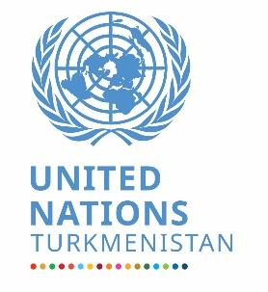

***Final Evaluation of the   
United Nations Sustainable Development Cooperation***  ***Framework (UNSDCF) for Turkmenistan 2021–2025***

**Evaluation report**

**prepared by UNSDCF Final Evaluation Team:**

**Ms. Bahar Agayeva, Evaluation Expert**

**Ms. Elena Kleperson, Evaluation Expert**

**Mr. Tomislav Novovic, Team Leader- Evaluation Expert**

**Ashgabat, September 2024**

**Table of contents**

List of abbreviations 4

Executive summary 6

Introduction 12

1 Background 12

1.1 Country background 12

1.2 UNSDCF for Turkmenistan 2021-2025 14

2 The objective for the final evaluation 16

3 Evaluation Methodology, Criteria and Approach 17

3.1 Outline of the evaluation methodology 17

3.2 Evaluation criteria 18

3.3 Evaluation approach 18

3.3.1 Phase 1. Inception - desk review and document analyses 18

3.3.2 Phase 2. Data collection and analysis 18

3.3.3 Phase 3. Synthesis & reporting 19

3.3.4 Phase 4 Review and validation 19

3.4 Ethical Considerations 20

4 Findings 21

4.1 Relevance and flexibility 21

4.2 Coherence and coordination 26

4.3 Effectiveness 34

4.4 Efficiency 51

4.5 Progress towards impact 58

4.6 Sustainability 59

5 Conclusions and lessons learned 63

5.1 Conclusions about UNSDCF relevance 63

5.2 Conclusions on coherence and coordination 64

5.3 Conclusions about effectiveness 64

5.4 Conclusions on efficiency 64

5.5 Conclusions on progress towards impact 65

5.6 Conclusions on Sustainability 65

6 Lessons learned 65

7 Recommendations 66

**List of graphs and figures**

***Graph 1. Overview of Human Development Index (HDI) for Turkmenistan*** 13

***Graph 2.* *Opinions about the UNSDCF alignment with the national priorities*** 23

***Graph 3.* *Opinions about alignment of the UNSDCF with the needs of citizens (including vulnerable groups)*** 24

***Graph 4. Opinions on UN response to the immediate needs that COVID-19 created*** 26

***Graph 5.* *Opinion of UN Staff on cooperation and communication among UN Agencies*** 27

***Graph 6.* *The RCO’s role in enhanced coherence during the UNSDCF implementation*** 28

***Graph 7.* *UNRC Office contribution to communication with the national partners*** 29

***Graph 8.* *The opinions of UN Agencies in Turkmenistan if they used sufficiently joint programming*** 30

***Graph 9. The UN Staff perception of the JWPs as a tool for cooperation and coordination*** 31

***Graph 10. Opinion of UN Staff on cooperation and communication among UN Agencies*** 31

***Graph 11. Experience of UN programme and operations staff in direct cooperation with other UN Agencies*** 33

***Graph 12. UN Staff perception of effectiveness under UNSDCF outcomes*** 34

***Graph 13. Planned budget under UNSDCF outcomes, % of total*** 51

***Graph 14. Overview of the delivered funds under UNSDCF outcomes, % of total*** 51

***Graph 15. Planned vs delivered funding under the UNSDCF outcomes (million USD)*** 52

***Graph 16. Planned vs delivered resources and funding gaps under the UNSDCF (million USD)*** 52

***Graph 17. Overview of mobilized vs delivered funds, in %*** 52

***Graph 18. Overview of the development partners and their funding for the UNSDCF implementation in 2023 (million USD)*** 53

***Graph 19. UNSDCF financing for the SDGs (million USD)*** 54

***Graph 20. Overview of UN Agencies planned vs delivered funds under the UNSDCF implementation (mil USD)*** 55

***Graph 21. Overview of the financial status of UN Agencies- 2021-2023*** 56

***Graph 22. Perception of Delivering as One by UN Operations Staff*** 57

# List of abbreviations

**BOS** - Business Operations Strategy

**CA** - Contribution Analysis

**CCA** - Common Country Analysis

**COVID-19** - Coronavirus Disease 2019

**CSO** - Civil Society Organization

**DAC** - Development Assistance Committee of the OECD

**DCO** - Development Coordination Office

**DFA** - Development Finance Assessment

**DoA** - Delivering as One

**ECD** - Early Childhood Development

**ECO** - Economic Cooperation Organization

**EE** - Evaluation Experts

**EM** - Evaluation Manager

**EMT** - Evaluation Management Team

**ERG** - Evaluation Reference Group

**ET** - Evaluation Team

**FAO** - Food and Agriculture Organisation

**FMC** - Financial Management Control

**GBV** - Gender-Based Violence

**GDP** - Gross Domestic Product

**GEWE-** Gender Equality and Women Empowerment

**GoT** - Government of Turkmenistan

**HDI** - Human Development Index

**HIV/AIDS** - Human Immunodeficiency Virus/Acquired Immunodeficiency Syndrome

**HRBA –** Human Rights-Based Approach

**ILO** - International Labour Organisation

**INFF** - Integrated National Financing Framework

**IR** - Inception Report

**ITC** - International Trade Centre

**JCSC** - Joint Country Steering Committee

**JEG** - Joint Expert Group

**JP** - Joint Programme

**JWPs** - Joint Work Plans

**LNOB** - Leave No One Behind

**M&E** - Monitoring and Evaluation

**MCH** - Maternal and Child Health

**MoU** - Memorandum of Understanding

**NCDs** - Non-Communicable Diseases

**NPSD** - National Programme for Socio-Economic Development

**OECD** - Organization for Economic Cooperation and Development

**OHCHR** - Office of the High Commissioner for Human Rights

**OMT** - Operations Management Team

**OTS** - Organization of Turkic States

**OVI** - Objectively Verifiable Indicator

**PFM** - Public Financial Management

**R&D** - Research and Development

**RCCT-CA** - Regional Center for Climate Change Technologies in Central Asia

**RCO** - Resident Coordinator’s Office

**RH** - Reproductive Health

**SCO** - Shanghai Cooperation Organization

**SDGs** - Sustainable Development Goals

**SoV** - Sources of Verification

**SOP** - Standard Operating Procedures

**SPECA** - UN Special Program for Economies of Central Asia

**STEM** - Science, Technology, Engineering, and Mathematics

**TB** - Tuberculosis

**TL** - Team Leader

**ToC** - Theory of Change

**ToR** - Terms of Reference

**UN SWAP** - UN System-wide Action Plan on Gender Equality and the Empowerment of Women

**UN-Habitat** - United Nations Human Settlements Programme

**UNCF** - UN Cooperation Frameworks

**UNCT** - United Nations Country Team

**UNDP** - United Nations Development Programme

**UNDRR** - United Nations Office for Disaster Risk Reduction

**UNECE** - United Nations Economic Commission for Europe

**UNEG** - UN Evaluation Group

**UNEP** - United Nations Environment Programme

**UNESCAP** - United Nations Economic and Social Commission for Asia and the Pacific

**UNESCO** - United Nations Educational Scientific and Cultural Organization

**UNFPA** - United Nations Population Fund

**UNHCR** - United Nations High Commissioner for Refugees

**UNICEF** - United Nations Children's Fund

**UNIDO** - United Nations Industrial Development Organization

**UNODC** - United Nations Office on Drugs and Crime

**UNOPS** - United Nations Office for Project Services

**UNSDCF** - United Nations Sustainable Development Cooperation Framework

**UNSDS** - United Nations Sustainable Development System

**VNR** - Voluntary National Report

**VPOA** - Vienna Plan of Action for Landlocked Developing Countries

**WHO** - World Health Organisation

# Executive summary

The United Nations Sustainable Development Cooperation Framework (UNSDCF) 2021-2025 for Turkmenistan was signed in March 2020 between the Government of Turkmenistan and the United Nations. It aligns with Turkmenistan’s national priorities and the Sustainable Development Goals (SDGs). It focuses on three key strategic areas: people-centred governance and rule of law, inclusive and sustainable economic growth, and quality, affordable health, education, and social protection. The UNSDCF is organized around five expected outcomes: public administration, economic diversification, environmental sustainability, health, social protection, and education. The framework promotes the active participation of vulnerable groups, aiming to ensure no one is left behind, in line with the 2030 Agenda.

**Purpose and objectives of the evaluation:** The final evaluation assessed the relevance, effectiveness, coherence, efficiency, and sustainability of the UNSDCF in Turkmenistan. Key objectives were to enhance accountability to stakeholders, foster transparent and participatory dialogue, and provide actionable recommendations for accelerating SDG progress. The evaluation focused on identifying lessons learned and best practices while highlighting areas for improvement. The evaluation was also designed to inform future strategic planning cycles for the UN Country Team (UNCT) by ensuring alignment with the 2030 Agenda and the country’s evolving development priorities.

**Methodology:** The Evaluation Team (ET) followed a ***theory-based approach***, with the Theory of Change (ToC) as the foundational framework. The ToC outlined the causal pathways leading to desired outcomes and provided a structured method to assess the contributions of UNSDCF activities to broader development goals. This approach allowed for flexibility, enabling the ET to identify discrepancies between planned and actual achievements.The ***contribution analysis*** methodology complemented the ToC by examining how the UNSDCF’s initiatives influenced observed outcomes. Gender-responsive and human rights-based approaches were integrated to ensure that vulnerable groups and cross-cutting issues such as gender equality, human rights, and environmental sustainability were addressed.

The evaluation is organised around the following phases:

* Inception Phase: This phase involved a comprehensive desk review and the development of an evaluation matrix, outlining core questions, indicators, and methods for data collection. The Evaluation Team mapped relevant documents, such as national development strategies and UNSDCF reports, and conducted a stakeholder analysis to ensure inclusivity.
* Data Collection and Analysis Phase: This phase involved both qualitative and quantitative data collection. The ET engaged with 138 stakeholders through interviews and focus groups, using a purposive sampling technique to ensure diverse representation. Online surveys were also conducted to enhance triangulation.
* Synthesis and Reporting Phase: The collected data was synthesized into findings, conclusions, and recommendations. The ET applied a cross-validation approach to corroborate data from multiple sources, ensuring the accuracy and reliability of the findings. The final report emphasized the UNSDCF’s successes, challenges, and strategic recommendations for future planning.
* Review and Validation Phase: The draft report was shared with stakeholders for review. A validation workshop was conducted to incorporate feedback, after which the final evaluation report was submitted, integrating all relevant recommendations and corrections.

The evaluation adhered to the OECD DAC and United Nations Ethical Guidelines. All participants gave informed consent, and confidentiality was strictly maintained. The ET ensured impartiality, credibility, and accountability throughout the evaluation process.

**Presentation of findings**

During the evaluation, the following key findings have been generated

***Relevance and flexibility***

The UNSDCF 2021-2025 has been highly relevant to Turkmenistan’s national priorities, responsive to emerging challenges, and strategically flexible in its approach, particularly during the COVID-19 pandemic. The evaluation highlights the need for improved gender-sensitive indicators to support mainstreaming GEWE as guiding principle and continued alignment with the evolving national context, but overall, the framework remains robust in promoting sustainable, inclusive development in Turkmenistan.

The UNSDCF has been well-aligned with Turkmenistan’s national development priorities, covering governance, economic diversification, and social services, and promoting gender equality and human rights. The framework reflected the national strategic documents, including the National Programme for Socio-Economic Development until 2052 and the Presidential Programme for Socio-Economic Development of Turkmenistan (2022-2028), which prioritized economic diversification, social inclusion, and environmental sustainability. Additionally, the framework integrated a human rights-based approach and focused on the inclusion of vulnerable groups such as people experiencing poverty, women, and those living in rural areas. The alignment of the UNSDCF with international human rights treaties reinforced the commitment to leaving no one behind, although the evaluation identified a need for stronger gender-responsive planning and comprehensive gender-sensitive indicators to track progress.

The UNCT demonstrated strategic responsiveness and flexibility, particularly during the COVID-19 pandemic, helping the Government of Turkmenistan develop a Preparedness and Response Plan (PRPT) to manage the outbreak. The UN Country Team supported the procurement of medical supplies, trained health workers, and engaged in risk communication and community outreach.

In addition to the immediate health response, the UNCT developed a National Socio-Economic Response Plan (SERP) to mitigate the long-term socio-economic impacts of the pandemic. The UN Joint Programme, funded by the Joint SDG Fund, was critical in addressing the needs of vulnerable groups, including women and youth. The UNCT also mobilised resources for digital health services, distance education, and women’s entrepreneurship, among other initiatives.

By repurposing approximately USD 23.6 million for COVID-19 recovery efforts, the UNCT showcased its adaptability and maintained the focus on sustainable development. One critical initiative has been a joint UN project, "Prevention of COVID-19 in Turkmenistan" (funded by a World Bank loan). These efforts aligned with strategic goals, including inclusive economic growth, improved social protection and disaster resilience.

***Coherence and coordination***

The FE assessed the coherence and coordination of the UNSDCF 2021-2025 by analyzing the alignment of UN agency programs and work plans with the Cooperation Framework (CF) and the role of the Resident Coordinator Office (RCO) in fostering a more cohesive approach among UN agencies. The evaluation examined how the RCO's redefined responsibilities contributed to joint action and convergence toward UNSDCF outcomes, the functionality of joint coordination structures, and the coherence of UN agencies' support in addressing national development challenges.

**Alignment with the Cooperation Framework**: The UNSDCF enabled greater coherence by aligning UN agencies' initiatives with national development priorities and UNSDCF outcomes. Agencies have synchronized their country plans and work programs, adopting joint programming where possible. Despite this progress, challenges remain in parallel agency-specific work plans that create additional burdens for reporting and monitoring. Differences in measurement indicators across agencies have made data collection and comparability difficult, further complicating the joint implementation of initiatives.

Role of the Resident Coordinator Office (RCO). The RCO has played a pivotal role in enhancing coherence and cooperation among UN agencies. Survey participants and interviewees recognized the RCO for providing strong strategic leadership and facilitating alignment with the government's development agenda. The RCO's involvement has improved collaboration with national partners, notably through initiatives like the Development Partners Coordination Group (DPCG), which fosters joint approaches in priority areas such as gender equality and climate action. However, some stakeholders noted the need for more capacity within smaller UN agencies to engage in these joint efforts fully.

**Strengthening Coherence for National Development**: The evaluation found that the UNCT, under the RCO's leadership, has successfully implemented joint initiatives, including the Human Security Trust Fund and the Joint Programme on Social Protection, which were significant in driving progress. The Joint Work Plans (JWPs) have generally contributed to greater alignment, but inconsistencies in sub-output formulation and financial efficiency limit their full potential as planning and monitoring tools.

**Effectiveness of Coordination Structures**: The Steering Committee, Results Groups, and Thematic Groups have proven effective in supporting the implementation of the UNSDCF. However, the evaluation highlighted the need for these structures to expand their roles to include more open and forward-looking discussions and to improve cross-sectoral synergies. Additionally, stakeholders recommended further integrating national bodies into the joint planning and decision-making processes.

***Effectiveness***

The evaluation team (ET) assessed the UNSDCF’s effectiveness in delivering outputs that contribute to critical outcomes, goals, and targets, considering how well the UNSDCF responded to the needs of vulnerable and marginalised groups.

The UN Agencies in Turkmenistan have effectively supported institutional and policy reforms, particularly in inclusive growth, social inclusion, and environmental governance. Progress has been made across various sectors, with national ownership of SDG implementation being a key success. Initiatives like the launch of the National SDG Database and Trade Information Portal were cited as examples of successful output delivery.

Under Outcome 1, the shift toward digital government systems has begun, with 'one-stop-shop' service centers established, though challenges remain in fully transitioning away from paper-based systems. Strategic planning aligned with the SDGs and civil service reform efforts are ongoing, but uneven participation and implementation gaps persist, especially in rural areas.

For Outcome 2, outputs such as establishing the Single Window System and the Statistical Business Register have improved business processes and trade competitiveness. However, further investment in capacity building is required to ensure these systems are fully operational across all sectors.

Outcome 3 has seen progress in climate resilience and sustainable development, including energy savings and CO2 reduction initiatives. However, monitoring systems and strategic plans must be fully implemented to ensure long-term effects.

Under Outcome 4, health and social protection advancements have been made, particularly in expanding healthcare access and improving health information systems. The response to COVID-19 demonstrated enhanced government capacity, but challenges remain in ensuring these benefits reach all regions uniformly.

Outcome 5 has made progress in education, particularly in integrating life skills into the curriculum, though challenges persist in ensuring these skills are taught uniformly across all regions.

Despite significant achievements, the UNSDCF faces challenges in fully realizing some of its ambitious targets by 2025. While the foundation has been laid for continued progress, financial and institutional support gaps could limit the attainment of several outcomes, particularly those related to gender equality, digital infrastructure, and inclusive education. Survey participants indicated optimism, but noted that challenges such as limited capacity building and motivation of civil servants need to be addressed to ensure sustainable progress.

The UNSDCF has contributed to improving the situation of vulnerable groups, including persons with disabilities, stateless individuals, and marginalized populations. However, gender equality and empowerment of women and girls remain areas where further progress is needed. Additionally, the evaluation found unintended positive results, such as the strengthening of government partnerships and increased trust in UNCT initiatives.

***Efficiency:***

The evaluation of the efficiency of the UNSDCF revealed both successes and areas for improvement in mobilizing and utilizing resources. Over three years, the UN system managed to mobilize $206.4 million, surpassing the initial five-year target of $162.4 million by 27%. This highlights strong resource mobilization, particularly under Outcome 4, focused on health and social protection. However, other outcomes, such as education and economic diversification, received fewer resources than expected, indicating a need for more balanced allocation.

Despite the significant overall funding, the distribution among different outcomes varied widely. Outcome 4 exceeded expectations, but Outcome 5, which focuses on education, reached only 54% of its modest target. Funding gaps for critical outcomes, such as climate resilience under Outcome 3, raise concerns about the ability to sustain progress in less-funded areas.

The Government of Turkmenistan contributed 70.5% of the total funding, reflecting a strong national commitment. However, much of this investment was concentrated on immediate health needs rather than on long-term reforms, leading to imbalances in sectoral progress. This focus on short-term priorities may hinder the broader reform efforts required to sustain development outcomes across all sectors.

Efforts like establishing the Joint Expert Group on SDG Financing and developing the Integrated National Financing Framework (INFF) show potential for enhancing long-term financial sustainability toward achieving the Sustainable Development Goals (SDGs). However, delays in key areas of implementation, such as the Development Finance Assessment, indicate a need for faster progress in aligning financial flows with development priorities. Presenting the findings from the Common Country Analysis, including the estimates for SDG funding needs, including financing gaps for the SDG key transitions, during the 2024 Turkmenistan Investment Forum is a good advocacy effort to support Turkmenistan’s National commitments to SDGs transformation submitted at the 2023 SDG Summit.

The "Delivering as One" (DoA) approach has achieved some operational efficiencies, particularly in procurement and logistics, but feedback suggests there is room for greater integration across UN agencies. The challenges in implementing joint work plans and financial management across different agencies reflect the need for stronger coherence in operational strategies.

The national Pooled Fund approach proposal could help address current funding imbalances and promote stronger partnerships and strategic resource management. This would be especially critical for sustaining progress in social protection and expanding successful models in other sectors. RCO advocated for three years about the need for a Pooled Fund, and in 2024, the UNCT agreed to support it for new projects, opening a new way for UNCT to work with the Government and among themselves.

***Progress towards impact***

The evaluation of the UNSDCF's progress towards impact highlighted both achievements and challenges. The UNCT has significantly advanced Turkmenistan’s progress towards SDG targets, particularly in key areas such as health, social protection, economic growth, and climate action. UN support has been instrumental in developing and implementing crucial national policies and frameworks. These include strengthening the health system to improve resilience under SDG 3, developing a robust social protection framework under SDG 1 and SDG 10, and supporting economic diversification efforts, such as the WTO Accession roadmap under SDG 8.

In environmental sustainability, the UN contributed to creating key national strategies, including those focused on renewable energy and climate action, contributing to SDG 7 and SDG 13. Initiatives like the National Child-Centered Disaster Risk Reduction Strategy reflect the UN’s commitment to building a resilient framework aligned with SDG 11. However, despite these advancements, implementing policies and sector-level impacts remains challenging, often hindered by external factors such as government changes, staff turnover, and limited data availability.

The analysis underscores the need for advocacy among key stakeholders on the importance of advancing on SDGs, including better data collection, monitoring systems, and sustained investment in IT infrastructure to track SDG progress effectively. While UNCT made a concerted effort to improve access to data- with some small successes - more needs to be done. Establishing an SDG database is a promising step but requires further operationalisation to realize its full potential. Challenges in coordination, ownership, and integration of policies—particularly in sensitive areas like human rights, disability, gender and governance—also highlight the need for a more strategic approach. The evaluation stresses the importance of securing financial support, strengthening institutional capacities, and enhancing data collection systems to ensure sustained progress. Continued capacity-building and fostering greater ownership among national stakeholders are key to maintaining momentum and ensuring that progress towards SDG targets is sustainable in the long term.

***Sustainability***

The evaluation of sustainability within the UNSDCF framework focused on the likelihood that national partners and stakeholders would sustain the progress achieved through various initiatives over time. UN Agencies in Turkmenistan have made significant efforts to integrate sustainability considerations into the design and implementation of the UNSDCF. This has involved capacity development, institutional strengthening, policy advocacy, and building multi-stakeholder partnerships. However, the evaluation found that results' sustainability and scalability remain challenging due to limited financial and human resources, frequent changes in government counterparts, and a lack of clear strategies for sustaining outcomes beyond the current UNSDCF period.

Fundamental mechanisms supporting sustainability include tailored capacity development for service delivery in social protection, health, and education. For instance, social workers and government staff were trained to enhance the social care system, and health services for vulnerable groups, such as early identification of developmental delays, were expanded. Institutional capacity-building was also a critical part of the sustainability strategy, with improvements in the social protection and health sectors and governance reforms that enhanced transparency and service delivery.

The UN also played a crucial role in shaping policy reforms that align with SDG targets, such as the National Human Rights Action Plan and the National Strategy on Renewable Energy. However, challenges remain, particularly around weak policy implementation capacities, insufficient data for monitoring progress, and the rapid rollout of new services without adequate workforce capacity.

Partnership building and knowledge management were also integral to sustainability efforts, with the UN focusing on multi-stakeholder engagement and establishing monitoring systems like the SDG database. However, the evaluation highlighted the need for more robust exit strategies, ensuring local capacities are built to maintain and scale successful initiatives beyond the UNSDCF period. Additionally, securing consistent financial support for sustaining achievements, mainly through innovative financing, remains critical.

The evaluation found that progress towards the sustainability of results is more likely in specific thematic areas, such as health, climate change, social services, and inclusive growth, where national institutions have shown more substantial commitment. However, challenges such as changing government priorities and the long-term effects of the COVID-19 pandemic continue to impact the availability of resources and the sustainability of specific initiatives.

The evaluation suggests enhancing monitoring and reporting sustainability indicators, developing more robust exit strategies, and securing diversified funding sources to sustain long-term progress. Integrating cross-cutting issues such as gender equality and disability inclusion into national policies and governance structures will ensure that vulnerable groups continue to benefit from these initiatives. Strengthening partnerships with civil society, academia, local NGOs, and the private sector will also be key to scaling up and sustaining the results achieved under the UNSDCF.

**Conclusions**

**Conclusions on UNSDCF Relevance:** The UNSDCF was well-aligned with Turkmenistan’s national development priorities, including key programs like the National Programme for Socio-Economic Development (NPSD). The framework addressed the needs of vulnerable populations through a human rights-focused strategy. It also demonstrated adaptability, especially during the COVID-19 pandemic, ensuring a rapid response to national needs. However, there were shortcomings, particularly regarding gender and disability inclusion, where the UNSDCF lacked robust indicators to track progress. Future programming should more comprehensively integrate gender equality and disability inclusion throughout the cycle.

**Conclusions on Coherence and Coordination:** The UN Agencies aligned their work plans with the UNSDCF, ensuring a unified approach to national development goals. The post-reform United Nations Resident Coordinator Office (UN-RCO) was critical in enhancing coherence among UN Agencies, facilitating better coordination with the government. However, parallel agency-specific programs sometimes created reporting burdens and inconsistencies. While coordination mechanisms like the Steering Committee and Results Groups promoted collaboration, there is room for improvement in leveraging these platforms for more strategic discussions and cross-sector synergies. The creation of the Strategic Advisory Board in April 2024 reflects well on the strategic collaboration between the Government and the UN, ensuring greater coherence and enhancing visibility.

**Conclusions on Effectiveness:** The UNSDCF contributed to institutional reforms and policy development, especially in social protection, health, and WTO accession support. However, the pace of reform in other critical areas, such as institutional governance and financial tools for green economy growth, lagged behind expectations. External factors such as geopolitical challenges and governance issues further hindered progress. Despite these setbacks, with intensified efforts and improved resource mobilisation, the likelihood of achieving certain outcomes remains high.

**Conclusions on Efficiency:** The UNSDCF Funding Framework successfully mobilised resources, particularly for health and social protection. However, some outcomes, such as disaster risk reduction and climate adaptation, were underfunded. While total funds exceeded the five-year target, gaps remain in economic reform, education, and governance, highlighting the need for a more diversified funding strategy. The "Delivering as One" approach improved operational efficiency in some areas, though challenges like fragmented initiatives and coordination difficulties persisted.

**Conclusions on Progress Towards Impact:** The UNSDCF has laid the groundwork for potential long-term impacts, particularly through policy advocacy and capacity development. However, measuring the UN’s contribution to national outcomes remains challenging, especially in assessing and analysing the long-term effects of UN-supported capacity-building on national stakeholders and institutions. The sustainability of reforms in areas like social protection, disaster risk reduction, and human rights depends on continued government commitment and effective monitoring systems. The UNSDCF's ability to scale these initiatives revolves on the government’s capacity to implement and fund programs over time.

**Conclusions on Sustainability:** Several mechanisms, such as capacity development, institutional strengthening, and policy advocacy, have been established to ensure the sustainability of UNSDCF outcomes. However, challenges like limited financial and human resources and changing government priorities threaten the long-term scalability of results. The evaluation underscores the need to consider sustainability prospects and exit strategies from the design of UNSDCF and its initiatives, as well as stronger local capacities and firm government commitments to sustain progress beyond the UNSDCF period. Strategic partnerships and the development of long-term collaboration are essential to address systemic challenges and ensure sustained results.

**lessons learned**

Key lessons include the importance of adaptive management, particularly during crises like the COVID-19 pandemic, and the value of expertise and system strengthening in supporting national reforms. Coordinated and participatory approaches were essential for ensuring ownership and alignment with national needs. However, balancing responsiveness with long-term strategic focus remains a challenge, as addressing ad-hoc requests can detract from long-term objectives. Innovative engagement and communication tools, combined with strong capacity-building and data-driven decision-making, are critical for sustaining stakeholder involvement and ensuring the scalability of progress.

**Recommendations:**

The ET presents key recommendations to enhance the effectiveness, coherence, coordination and sustainability of the UNSDCF.

Firstly, planning and implementation structures should be strengthened by enhancing coordination between Results Groups and the Steering Committee. This will promote strategic joint planning, reduce duplication, and improve coherence across outcomes. A unified monitoring and evaluation system is needed to streamline data collection and ensure comparability across agencies.

The ET recommends redefining UNSDCF outcomes for the next cycle to reflect the UN’s contribution better and align them with planned activities. Clear targets, robust monitoring, and improved alignment with SDG goals will enhance accountability and track progress.

The UNCT should diversify funding sources by engaging international financial institutions, the private sector, and philanthropic organisations to address funding disparities. Advocating for increased government co-financing and establishing Pooled Funding will provide more sustainable financial support.

The integration of the LNOB, especially disability inclusion, gender equality, gender mainstreaming (GEWE), and the HRBA approach (including child rights mainstreaming), should be strengthened across all UNSDCF outcomes, supported by capacity-building efforts for UN staff.

Further support for institutional reforms is needed, particularly in governance and environmental sustainability. Climate adaptation, disaster risk reduction, and green technologies should be proposed to be incorporated into sectoral reforms.

To ensure inclusivity in UNSDCF initiatives, stakeholder engagement must be expanded to include civil society, the private sector, and marginalised communities and youth.

Finally, the UNCT should develop clear sustainability (“exit”) strategies from the early stages and work with national partners to ensure the sustainability of successful interventions beyond the UNSDCF period.

# Introduction

The United Nations Sustainable Development Cooperation Framework (UNSDCF) is a key instrument for advancing the 2030 Agenda for Sustainable Development, guiding UN Country Teams (UNCTs) in aligning with national development priorities through comprehensive country analysis.

As the UNSDCF implementation in Turkmenistan nears its end, the UNCT initiated an independent final evaluation to assess the UN Development System's collective contributions at the country level. This evaluation serves as the primary accountability mechanism, focusing on strategic issues, outcome-level contributions, and alignment with Sustainable Development Goal (SDG) targets.

The evaluation followed a structured approach outlined in the Terms of Reference, consisting of three phases: Inception/Desk Review, Data Collection, and Synthesis & Reporting. During the Inception phase, the Evaluation Team (ET) conducted a thorough desk review of secondary data—including documents from the Evaluation Manager (EM) and UN agencies, national statistics, and reports from development partners. Initial discussions with the EM and the Evaluation Management Team (EMT) refined the evaluation approach, identified key stakeholders, and reaffirmed objectives.

Throughout the process, the EM and EMT provided crucial data to the ET, which compiled a comprehensive list of stakeholders for interviews and discussions. These included representatives from UN agencies, government ministries, donors, civil society organizations, national human rights institutions, youth groups, development partners, the private sector, and beneficiaries. This engagement ensured the evaluation captured diverse insights from those contributing to and benefiting from UNSDCF outcomes.

The Final Evaluation Report details the methodology used to assess the relevance, coherence, performance, and outcomes of the UNSDCF. It examines the framework's impact on transforming development processes in Turkmenistan and the sustainability of these achievements, focusing on the principle of "leaving no one behind." The report presents findings that form the basis for conclusions and recommendations, providing actionable insights to enhance future UN engagements in Turkmenistan.

# Background

## Country background

In a landmark decision for the country's future trajectory, the President of Turkmenistan sanctioned the National Programme for the Socio-Economic Development of Turkmenistan in 2022-2052. This strategic agenda echoes Turkmenistan's unwavering dedication to attaining the Sustainable Development Goals (SDGs) and delineates national priorities to revamp the country's economic framework. Key priorities include catalysing economic diversification, cultivation of human capital, and comprehensive reforms in public finance and fiscal policies. In addition, the country is working to bolster the vital oil and gas sector, promoting progress in energy efficiency alongside renewable energy endeavours. The Programme further commits to enhancing water utilisation efficiency, pivotal agricultural sector reforms, and the dynamic development of rural areas.

Due to new realities, in 2022, the President of Turkmenistan adopted the Socio-Economic Development Program for 2022-2028. The economy in the country in 2022 and 2023 showcased resilience, with a robust GDP growth rate of 6.2%, signalling a solid economic performance. Despite a pervasive global economic slowdown and inflationary pressures, Turkmenistan's resource-rich economy, fuelled by hydrocarbon exports, continued to stockpile substantial foreign exchange reserves, fostering a reassuring fiscal surplus. The growth trajectories outlined in the Presidential Programme of Socio-Economic Development for 2022-2028 are optimistic, forecasting a 59% increment in natural gas production and 47% rise in the GDP by 2028.

In recent years, this buoyant economic outlook enabled a surplus in the state budget, reinforcing governmental capacities for more significant social investment. Reflective of this, in 2023, over three-quarters of the state budget was strategically allocated to bolster the social sector infrastructure and services. Further testament to the country's developmental achievements is the Human Development Index (HDI) score of 0.744 in 2022, which places Turkmenistan among the high human development category, notably ranked 94th out of 191 countries surveyed globally. In the realm of demographic insights, the Population and Housing Census conducted in December 2022 revealed a balanced population of almost 7.1 million residents.

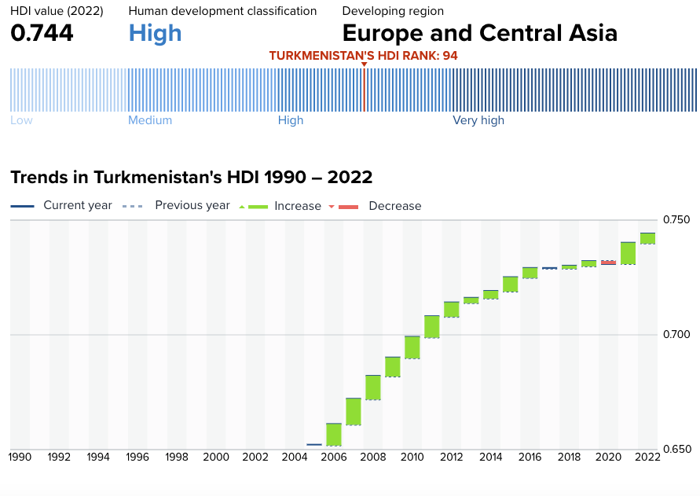***Graph 1 Overview of Human Development Index (HDI) for Turkmenistan***

Source: Human Development Reports- HDI trends <https://hdr.undp.org/data-center/specific-country-data#/countries/TKM>

Climate change and environmental sustainability have climbed to the top of the national and international agenda, mirrored in Turkmenistan's engagement with the United Nations. Contributing to regional environmental governance efforts, Turkmenistan has been instrumental in establishing a Regional Climate Change Technologies Center to serve the expansive Central Asia region. A significant aspect of environmental advocacy has been the country's action on reducing methane emissions—a byproduct of its pivotal hydrocarbon sector, which underpins the national economy with considerable reserves of over 50 trillion cubic meters of natural gas and over 20 billion tons of oil. At the pivotal COP28 climate summit in Dubai in December 2023, Turkmenistan underscored its environmental commitment by joining the Global Methane Pledge, embarking on promises to impose rigorous environmental standards and seeking strengthened ties with global organisations. As part of its environmental stewardship, Turkmenistan aspires to trim its GHG emissions by 20% by the year 2030 from 2010 levels, marking a significant step towards reducing its economy's carbon and greenhouse gas footprint.

Turkmenistan's diplomatic endeavours are deeply interwoven with its commitment to fostering regional stability, the judicious use of shared water resources, the security of energy transit routes, and advancements in transport and digital connective infrastructures. The nation has taken on a proactive role in significant regional platforms such as the UN Special Program for Economies of Central Asia (SPECA), the Vienna Plan of Action for Landlocked Developing Countries (VPOA), the Organization of Turkic States (OTS), and the Economic Cooperation Organization (ECO), reflecting its resolve to engage constructively on multiple fronts of regional cooperation and development.

In keeping with its international commitments, Turkmenistan presented its second Voluntary National Review at the UN High-Level Political Forum on Sustainable Development in July 2023. This insightful report illuminated Turkmenistan's progress in advancing 11 SDGs, underscoring the country's staunch recommitment to existing and emergent priorities and its ambition to sculpt broad-ranging partnerships. The report marked a milestone in the nation's drive for sustainable growth, spotlighting endeavours to integrate cutting-edge green technologies and bolster youth participation in the sustainable development process. With an eye towards the future, Turkmenistan delineated its National Commitments to SDG Transformation at the SDG Summit in September 2023. These pledges span a spectrum of areas, including buttressing an inclusive social protection system, ensuring food and water resource security, achieving universal health coverage through superior healthcare services, persistent investment in significantly reformed education systems, and fostering lifelong learning. Turkmenistan focuses on fostering peace and youth development and enhancing the status of women and girls. It also strived to expedite digital transformation, leverage data for evidence-based policymaking and formulate sound strategic policies. In parallel, efforts are to foster international partnerships and actively engage in mitigation and adaptation initiatives to counter climate change while ensuring a seamless green energy transition.

## UNSDCF for Turkmenistan 2021-2025

The United Nations Sustainable Development Cooperation Framework 2021-2025 (UNSDCF) was signed by the Government of Turkmenistan and the United Nations on 14 March 2020. It is aligned with the national priorities framed by the Sustainable Development Goals (SDGs) and contributes to their implementation. It draws on the full range of expertise and resources of the United Nations Country Team (UNCT), Government, and civil society, and in close coordination with development partners, aims to assist the country in delivering key development results.

UNSDCF envisioned that by 2025 the country, also with UN support, would make progress in achieving its national development goals aligned with the SDGs within the following three strategic priority areas:

1. People-centred governance and rule of law.
2. Inclusive, green, and sustainable economic growth.
3. Quality, inclusive, and affordable health, education, and social protection.

The implementation of the UNSDCF has been coordinated and monitored through joint Work Plans (JWPs) within established joint Results Groups (RGs). Leveraging its comparative advantage - a convenor of dialogues and platforms with the participation of diverse stakeholders, a development policy advisor, a promoter of international best practice and an advocate for leaving no one behind – the UN system addressed the major bottlenecks and risks and partner with the Government of Turkmenistan to accelerate the achievement of the SDGs. Operationally, the UNSDCF organised its initiatives around five expected outcomes***,*** further organised around outputs

|  |  |  |
| --- | --- | --- |
| PEACE | PLANET | PROSPERITY AND PEOPLE |
| OUTCOME 1. People have access to more effective, innovative, and transparent public administration based upon the rule of law, human rights, gender equality, labour rights, and quality data. | **OUTCOME 2** Conditions for sustainable and inclusive economic diversification are strengthened with competitive private and financial sectors, enhanced trade and investment promotion, and the adoption of new and digital technologies. | **OUTCOME 4.** The population of Turkmenistan enjoys higher quality and inclusive health and social protection services. |
| 1.1. State institutions of Turkmenistan introduced systems of digital government, document management, and provision of efficient services for the population using ‘one stop shop’ principles.  1.2. Sectoral ministries and agencies integrated a system of strategic planning, targeted budgeting and financing to achieve the SDGs, considering the interests of children, women, people with disabilities and other vulnerable groups  1.3. Public administration reform introduces a merit and performance-based civil service system, including the pool of highly competent, motivated, impartial civil servants, who develop, plan and implement evidence-based, human centred public policy  1.4. Government, including law enforcement agencies and other state institutions develop, implement programmes and mechanisms in the field of human and labour rights and gender equality on the basis of recommendations from UN treaties and mechanisms and ILO supervisory bodies and feedback from civil society, including workers’ and employers’ organisations and relevant population groups  1.5. Ministries and agencies of Turkmenistan introduced a system for collecting, analysing and using disaggregated data, taking into account the priorities of state policy and the SDGs for the development of people-centered and gender-responsive policies and programmes. | **2.1.** Private sector, particularly SMEs and women entrepreneurs, enjoy simplified procedures of doing business and have expanded access to information, innovative technology and financing.  **2.2.** Public institutions and private sector strengthened human, institutional, and R&D capacity and have sufficient financial resources for effective realization of the comprehensive programmes on diversification and digitalization of all sectors of economy with the focus on vulnerable groups.  **2.3**. Innovative and diversified financial (fiscal, insurance, and investment) and banking instruments are available to support dynamic development of green economy.  **2.4.** Institutional and regulatory systems are improved to foster favorable climate in order to attract private capital and foreign investments and to support trade.  **2.5.** Institutional capacity of public institutions is strengthened in regard to collection, analysis, and availability of disaggregated quality data on economic development, trade, private sector development, and investments. | **4.1.**The legislative, regulatory and financing framework for health and social protection is strengthened.  **4.2.** The system of data collection and analysis for monitoring and making managerial decisions is improved (disaggregated data on gender, age, social vulnerability)  **4.3.** The system and mechanisms are strengthened to increase access to information about a healthy lifestyle, the prevention of morbidity, social protection, with a focus on women, children, adolescents, persons with disabilities, and other vulnerable groups.  **4.4.** Effective and sustainable implementation of the national programmes and strategies for MCH and nutrition, ECD, RH, TB, HIV/AIDS, NCDs and infectious diseases  **4.5.** A system of social protection is introduced to provide quality, inclusive and social services at the community level. |
| **OUTCOME 3.** There is effective design and implementation of disaster risk reduction and climate adaptation and mitigation measures, enabling a more rational use of resources, increased resilience, and a ‘green’ economy transition. | **OUTCOME 5.** The education and skilling system offers all people the skills and knowledge for employment success in a diversifying economy and enhanced social integration and resilience. |
| **3.1** The GoT develops and effectively implements policies and strategies in the field of climate change, with a focus on reduction of CO2 emissions and adaptation  **3.2** National institutions, local communities, including women, children and vulnerable groups, and entrepreneurs/economic sectors are financially stable and technically prepared for disasters and response  **3.3** Government institutions, private sector, and civil society, trade unions and Union of Industrialists and Entrepreneurs, apply innovatio, digital technology and green solutions contributing to efficient use of energy, water, land and other natural resources, renewable energy and development of sustainable cities and green economy with active participation of women, children and vulnerable groups of population  **3.4** The GoT and stakeholders have stronger capacity for climate analysis, assessment, monitoring, and reporting on climate change, environmental protection, disaster risk reduction with focus on women, children and vulnerable groups; | **5.1.** Access to quality pre-school education for all children, including children with disabilities is increased.  **5.2.** Secondary education system is strengthened to ensure the quality of education with focus on life skills (social and emotional skills, creativity, problem solving, life skills) including prof. targeting for all children  **5.3.** The national programme on inclusive education is adopted and effectively implemented.  **5.4.** The system of vocational, primary, secondary, higher and continuous education is strengthened, and considers the needs of the labor market  **5.5.** Employment services system is improved, including strengthened state employment services and expanded opportunities for private recruitment agencies.  **5.6.** Effective labour market regulation system established, including improved labour market analysis and forecasting to formulate efficient active labour market measures for women, youth and vulnerable population |

The UNSDCF affirmed that the 2030 Agenda aimed to leave no one behind, envisioning "a world of universal respect for equality and non-discrimination" both between and within countries, including gender equality. It reiterated the State's responsibilities as the primary duty bearer to "respect, protect, and promote human rights, without distinction of any kind." Sustainable development was to be achieved with the active participation of all people, especially the most vulnerable.

The Cooperation Framework (CF) integrated human rights and the empowerment of all people in Turkmenistan, particularly those identified by the Common Country Analysis (CCA) as being at the highest risk of being left behind. Grounded in theories of human and social capital development, the Theory of Change (ToC) for the CF emphasized that achieving inclusive economic growth and environmental sustainability required the participation of all people in Turkmenistan—women, men, youth, older people, people with disabilities, and other vulnerable groups. This participation was deemed crucial for the economic, political, and social modernization of society. The ToC outlined the pathway to achieving the CF’s outcomes and contributing to the 2030 SDG Agenda**.**

The UNCT shared updates on how the UNSDCF has been progressing through regular reports. They have adopted a practice of updating the Common Country Analysis (CCA) every year. This process helped track how well the SDG-related targets have been met and served as a conversation starter around strategies for speeding up SDG progress.

In 2023, a mid-term review (MTR) of the UNSDCF was conducted[1]. The document assessed the framework's relevance, effectiveness, efficiency, coherence, and sustainability, particularly in relation to its alignment with Turkmenistan's national priorities and the Sustainable Development Goals (SDGs). The review critically examined the progress made across five strategic outcomes: enhancing public administration, fostering sustainable economic diversification, advancing environmental management and climate resilience, ensuring inclusive health and social protection, and promoting quality education and skills development. The MTR identified key achievements and challenges, offering strategic insights for refining the UNSDCF’s focus and implementation strategies during the remaining period and informing the design of future frameworks.

Strategically, the review underscored the necessity for the UNSDCF to adapt to emerging challenges and newly adopted government programs, such as the impact of the global COVID-19 pandemic and long-term national development strategies. It highlighted the importance of integrating these new priorities into the UNSDCF to ensure continued alignment with Turkmenistan’s evolving context. The document also pointed out significant data collection and monitoring gaps, particularly in data disaggregation, crucial for evidence-based policymaking. The recommendations emphasised the need for enhanced coherence and coordination among UN agencies, focusing on joint programming, resource mobilisation, and leveraging the UN’s role in supporting Turkmenistan’s National commitments to SDGs transformation and SDG targets.

# The objective for the final evaluation

The rationale for this UNSDCF evaluation was to assess the extent to which the UNCT in Turkmenistan prioritized support and actively contributed to the country's comprehensive development. As the Terms of Reference emphasized, the goal was to strategically utilize the findings to inform the next UNCT strategic planning cycle, aligning with broader UN system reforms. The insights gained from the evaluation and the recommendations derived from its conclusions were intended to facilitate the alignment of UN interventions by integrating Agenda 2030 and principles of equality and leaving no one behind more substantively. This alignment aimed to forge a robust coalition to assist Turkmenistan in achieving its SDG targets and fulfilling its commitments effectively.

The specific objectives of the UNSDCF evaluation were to:

1. Enhance accountability of UN actions to stakeholders: The evaluation systematically presented evidence of results achieved within the framework of the UNSDCF, objectively assessing the effectiveness of strategies and interventions. This process empowered stakeholders, including national counterparts and donors, to hold the UNCT and other involved parties accountable for fulfilling their roles and commitments.
2. Foster transparent and participatory dialogue: The evaluation established a platform for open discussion and learning with stakeholders, facilitating dialogue on national progress, challenges, and best practices within the system-wide national response context. Offering insights into programming and results at the country level informed planning and decision-making for the upcoming UNSDCF programme cycle and enhanced UN coordination. Valuable lessons and best practices documented during this process benefited Turkmenistan and other countries through sharing with the DCO.
3. Provide actionable recommendations for SDG acceleration: The evaluation delivered clear and actionable recommendations to support the next UNSDCF cycle, accelerating progress towards the SDGs. These recommendations, logically connected to evaluation conclusions and findings, prioritized areas for improvement and incorporation into the new UNSDCF programming cycle. Drawing upon identified lessons learned, these recommendations paved the way for enhanced UNSDCF contribution and effectiveness.

***Thematic Scope:*** The evaluation encompassed all contributions to the UNSDCF 2021-2025 outcomes from national and regional programs, projects, and activities conducted by the UNCT, including various UN agencies such as FAO, ILO, IOM, ITC, OHCHR, UNDP, UNDRR, UNECE, UNEP, UNESCAP, UNESCO, UNFPA, UN-Habitat, UNHCR, UNICEF, UNIDO, UNODC, UNOPS, and WHO. It synthesized and built upon program and project evaluations conducted by individual agencies during the UNSDCF period, fostering coordination to avoid duplication of efforts and promoting efficiencies. The evaluation also assessed UNSDCF cross-cutting priorities and global UN programming principles, such as Leave No One Behind (LNOB), human rights, gender equality, women's empowerment, disability inclusion, youth participation, environmental sustainability, and results-based management. It considered changes in the national context, including the impact of the COVID-19 pandemic, regional political instability and conflicts, demographic trends and migration.

**Geographic Scope:** The evaluation aimed to encompass various regions of Turkmenistan, aligning with the geographic distribution of UN activities. Priority was given to areas with a strong UN presence and significant financial allocations, particularly in regions benefiting from core support- such as social protection and health services. Key locations where these priorities were addressed include Türkmenabat, Mary, Türkmenbaşy, and Daşoguz.

***Time Scope:*** The evaluation covered the implementation period from January 2021 to June 2024.

***Users of Findings:*** The evaluation's primary users included the UNCT, Government and Parliament of Turkmenistan, Office of the Ombudsperson, national research institutions, line ministries participating in UNSDCF Results Groups, and civil society. Additionally, bilateral and multilateral donors and broader development partners were important audiences for the evaluation findings.

# Evaluation Methodology, Criteria and Approach

The final evaluation was based on the United Nations Development Coordination Office/ United Nations Evaluations Group Guidelines for the Evaluation of the UN Sustainable Development Cooperation Frameworks,[2] and adhered to United Nations Evaluation Group (UNEG) Norms and Standards for evaluations and the UNEG Ethical Guidelines (2020) [3].

The final evaluation (FE) has concentrated on the main evaluation criteria – relevance and adaptability, coherence and coordination, efficiency and effectiveness, sustainability and orientation towards impact.

## Outline of the evaluation methodology

The Terms of Reference (ToR) set the framework for this evaluation, which served the Evaluation Team (ET) to develop a tailor-made methodology. The ET employed a ***theory-based evaluation approach using the Theory of Change (ToC), integrating contribution analysis, gender-responsive principles, and a human-rights-based approach***.

The central element of this methodology—***theory-based evaluation***—promoted adaptability and learning, enabling the Evaluation Team (ET) to compare actual achievements with those outlined in the Theory of Change (ToC) and its chain of objectives while identifying discrepancies. It offered a comprehensive and structured framework, using the ToC as a roadmap to outline the intended sequence of events and causal pathways leading to the desired outcomes and the UNSDCF's contribution to broader development effects. The ToC articulated assumptions and risks along with the hierarchy of objectives, allowing the ET to systematically assess whether and how the UNSDCF organized the process to achieve these objectives. This iterative process helped the ET uncover the underlying mechanisms and contextual factors influencing the delivery of outputs and progress towards outcomes.

The ***contribution analysis*** complemented these efforts by disentangling and examining the connections between the UNSDCF's initiatives and observed outcomes. This process enabled the ET to establish a causal chain within the ToC, validating each step and determining whether planned activities led to the desired outputs and whether these outputs contributed to progress towards outcomes and broader development impacts. This method was recommended given the contributions of multiple UN Agencies, national stakeholders, and other interrelated factors.

The evaluation used a ***participatory and consultative approach***, whereby key stakeholders and national partners were engaged, and their views and feedback were collected and used at different stages of the final evaluation (FE). By engaging all key stakeholders from the outset, the ET sought to bolster national ownership and, consequently, promote the adoption of review findings and recommendations to improve the implementation of the current UNSDCF and inform future cycles. The evaluation included both an internal and external participatory process. Specifically, the ET worked closely with the Evaluation Manager/Evaluation Management Team (EM/EMT), UNRCO, UNCT, Result/Thematic Groups, representatives from the government, civil society, private sector, academia, and other development partners, including international partners.

The FE explicitly addressed cross-cutting issues such as gender equality and women’s empowerment (GEWE), human rights-based approach and non-discrimination, LNOB and disability inclusion, and environmental sustainability. It also specifically addressed the programming approaches defined by the UNSDCF, such as cross-sectional cooperation, results orientation, data and statistics, young people’s participation, gender mainstreaming, and innovation and technology, through an adequate review design and relevant questions and methodology to yield key findings, conclusions, and recommendations in these areas.

## Evaluation criteria

The Final Evaluationfollowed the United Nations Development Coordination Office/ United Nations Evaluations Group Guidelines for the Evaluation of the UN Sustainable Development Cooperation Framework.[4] It was structured around six key evaluation criteria – **relevance (including adaptability), coherence (including coordination), efficiency, effectiveness, sustainability and orientation towards impact**.

## Evaluation approach

The ET will follow the four-phase approach:

### Phase 1. Inception - desk review and document analyses

In this phase, the ET mapped, reviewed, and analyzed all relevant documents and background data, focusing on key national development strategies and programs in Turkmenistan. The documents reviewed included the main documents the UNSDCF Turkmenistan 2021-2025, Joint Work Plans, Annual Results Reports, UNINFO data, Steering Committee meeting reports, CF Result Matrix Monitoring documents, Common Country Analysis Documents, Information Management Survey Reports, and Development and Sectoral Strategies of Turkmenistan. Additionally, the ET reviewed evaluation reports from UNCT and other relevant documents. This phase involved the preliminary identification of critical horizontal issues and themes, lessons learned, best practices, and success stories for further investigation, verification, and triangulation. The ET also identified the main interlocutors, partners, and stakeholders for structured interviews and focus group discussions.

The ET prepared the inception report that detailed the evaluation’s methodology, scope, approach, and data collection and analysis strategies. It included a comprehensive stakeholder analysis and an evaluation matrix that outlined selected analysis criteria, core questions, specific questions, and indicators. It involved specifying data collection and analysis tools, key evaluation questions, and methods for addressing these questions.

### Phase 2. Data collection and analysis

The ET proposed a comprehensive approach that integrated both ***summative and formative*** methodologies. The summative component aimed to critically evaluate lessons learned and analyze the realization of visible results at various levels, while the formative component focused on the adaptability of these achievements for future phases and potential CF’s expansions. The ET employed a customized theory-based evaluation and mixed-method approach, combining qualitative and quantitative data collection and interpretative techniques to answer specific evaluation questions.

The Evaluation Team (ET) ensured triple representativeness by adopting a comprehensive approach that incorporated programmatic, geographic, and stakeholder dimensions. For programmatic representativeness, the ET conducted a thorough mapping of all UNSDCF thematic areas, ensuring coverage across all outcomes, and tailored evaluation questions to reflect each priority. Geographic representativeness was achieved by including visits and interviews in various regions outside the capital, enabling insights into urban and rural perspectives. The ET also engaged stakeholders through both in-person and online formats, covering areas with high UN activity and financial allocations (as highlighted in the previous paragraphs). For stakeholder representativeness, the ET employed a purposive sampling method, engaging diverse groups, including national and local government, UN entities, implementing partners, and specific focus on marginalized and vulnerable populations. This comprehensive inclusion ensured that perspectives from various societal segments, including civil society, academia, and the private sector, were represented, thus capturing a full spectrum of views on the UNSDCF’s impact and relevance. This approach ensured a comprehensive perspective on both achievements and obstacles encountered. The ET, in collaboration with the RCO and other UN agencies, identified key interlocutors among the government, civil society, academia, private sector, and vulnerable and marginalized groups, resulting in interviews with 138 stakeholders (70 men and 68 women) with large majority of them participating in the Results Groups[5]. The ET interviewed representatives of all UN Agencies (resident and non-resident) operating in Turkmenistan. Online surveys with the UN agencies programme (41 participant) and operational staff (9 participants) were organised, ensuring additional cross-validation and triangulation.

In addition, the ET organised focus group discussions with beneficiaries, covering a diverse range of participants. For example, four groups with youth with disabilities in Ashgabat, Dashoguz, Turkmenabat, and Mary, with 29 participants (15 men and 14 women), aged 16 to 35, have been organised. Three groups comprised young people receiving social services in Ashgabat, Turkmenabat, and Mary, totaling 24 participants (9 men and 15 women), have been organised addressing issues related to social support for people with disability and older persons. One group was organised with stateless persons in Turkmenbashi and included 8 participants (5 men and 3 women), discussing challenges in accessing legal identity and essential services. Additionally, three groups of young women aged 16 to 46 (25 women), have been organised on reproductive health services in Ashgabat, Turkmenabat, and Mary, focusing on the quality of reproductive health care and related services.

The nominations from UN agencies were validated during a meeting with the Evaluation Advisory Group, including representatives from eight agencies, on 23 May 2024. Given the inclusiveness of the process and the ET’s plans to visit various locations outside Ashgabat, the evaluation met criteria for programmatic, geographic, and stakeholder representativeness (as detailed in the Stakeholders Table in Annex II). Interviews were scheduled with both Ashgabat-based and non-resident agencies, with visits outside the capital and online interviews reaching as many UNSDCF final beneficiaries as possible.

### Phase 3. Synthesis & reporting

This phase was primarily devoted to analysing and synthesising the collected data and preparing the Final Evaluation based on the work completed during the desk and field phases. The ET analyzed the data to facilitate the preparation of the evaluation report, utilising the qualitative data analysis software MAXQDA to manage the uploaded data collection instruments.

The ET prepared codes and classifications based on the evaluation matrix and its elements, including sub-questions, judgement criteria, and indicators. In parallel, the ET added classifications and other attributes to tailor the data analysis to the specific purpose of the evaluation. Responses were grouped according to the evaluation matrix and respondent categories, with interview notes coded against the matrix to ensure direct alignment with the judgement criteria and indicators.

The final Evaluation Report presented findings, conclusions, and recommendations following a logical cause-effect linkage. When formulating and presenting findings and conclusions, the report described the assessed facts, the judgement criteria applied, and how these led to specific findings and conclusions. The ET applied a cross-validation approach**[6]**, ensuring the accuracy of findings by corroborating information from various sources and collection methods. Multiple sources were examined to ensure the internal validity of the findings. This triangulation process confirmed and cross-checked major trends, establishing patterns through the convergence of data from different sources[7]. The report included a consolidated analysis of key results, challenges, and lessons learned from the analytical phase. The qualitative assessment of progress and achievement probability was conducted at both outcome and output levels, accompanied by an assessment of outcome indicators, related risks, and the formulation of lessons learned. Forward-looking recommendations addressed identified gaps and opportunities, proposing concrete, realistic, and operational solutions to provide relevant and feasible input for decision-making and follow-up related to the formulation of the next UNSDCF cycle.

### Phase 4 Review and validation

The Final Evaluation Report was shared with all UNCT members, Evaluation Steering Committee members, and other relevant stakeholders for review and validation of the evaluation outcomes. This phase included the following steps: i) preparation of the first draft of the Evaluation Report according to the proposed structure, ii) review of the draft report by the UNCT, the Government, and other key partners, iii) conducting a validation workshop, iv) incorporation of the received feedback, correction of factual inaccuracies, and professional editing, all leading to v) the submission of the Final UNSDCF Evaluation Report.

## Ethical Considerations

The ET was fully aware of the OECD DAC ethical considerations for development evaluations and the United Nations Ethical Guidelines[8]. The ET adhered to these ethical principles in selecting interviewees, interacting with them, and respecting their personal and institutional rights.

The ET sought informed consent from stakeholders before asking questions related to the UNSDCF and its evaluation. The team briefly explained the reasons for and objectives of the evaluation, as well as the scope of the questions. Stakeholders were informed of their right to refuse participation or withdraw at any time. The ET ensured respondent privacy and confidentiality, recognizing that disclosing confidential information could seriously jeopardize the efficiency and credibility of the evaluation process. As such, the ET exercised discretion in all evaluation matters, refraining from divulging confidential information without proper authorization. The ET respected informants' rights to provide information confidently, ensuring that sensitive data could not be traced back to its source to protect key informants from potential reprisals. Original data, including interview records and notes, were retained in confidential files until the evaluation was completed. The ET maintained full independence and reported no conflicts of interest related to this work. Throughout the evaluation process, the ET adhered to the principles of impartiality, credibility, and accountability.

# Findings

The following paragraphs present the findings organised around the evaluation criteria and corresponding evaluation questions. The ET answered these questions using judgement criteria and evaluation indicators.

## Relevance and flexibility

The ET analysed whether the UNSDCF addressed Turkmenistan's long—and mid-term priorities, including international commitments and the implementation of the principle of leaving no one behind. The ET evaluated whether the UNSDCF responded to the needs of people, especially the most vulnerable. The evaluation further explored the resilience, responsiveness, and strategic approach of the UNSDCF and UN Agencies in addressing emerging and emergency needs, including significant challenges such as the impacts of COVID-19, to determine their effectiveness in adapting to and managing these critical situations.

***1.1. Has the UNSDCF been addressing the country’s long- and mid-term priorities and needs of the people?***

**F1. The external intervention of UNSDCF 2021-2025, under five outcomes, has been and remains within the mandate of UN Agencies, aligned with the national development priorities and the needs of the people in Turkmenistan.**

**The long-lasting presence, mandates, and achieved results of the UN Agencies in Turkmenistan contributed to more substantive insight into the country's development needs and challenges, with particular reference to vulnerable and excluded groups.**

The process of UNSDCF formulation has been comprehensive, reflecting appropriately the priorities and needs of the country and its citizens and identifying adequate developmental responses.

The process of identifying the priorities and the needs of citizens started with consultations with the national stakeholders on critical development challenges and opportunities, garnering inputs and ideas for the UN planning cycle[9]. This initial step continued with the preparation of an analytical and human rights-based Common Country Analysis (CCA)[10]. This document provided an updated assessment of the country’s development landscape, focusing on complex social inclusion trends, political economy and environment, and democratic governance, including human rights and gender equality. The analytical basis included reflection on the UN’s collaboration with the main partners and stakeholders and recommendations from the previous activities and initiatives.

UNCT organized wide-ranging consultations with the main national partners to validate these findings and conclusions, especially focusing on challenges and opportunities[11]. The development priorities, linked with the mandate of UN, have been grouped under the three strategic areas that defined the structure of the UNSDCF. In ***governance and rule of law***, the UN system strived to address financing needs for achieving the SDGs and enhance national statistical capacities. By leveraging CSO outreach, the UN prioritised the need to deliver effective services to vulnerable groups and promote gender equality. The UNCT prioritised a development partners' platform to share expertise on governance reforms, particularly in public administration and financial management. For ***inclusive, green, and sustainable economic growth***, the UNCT highlighted the need to support policy initiatives to improve the business environment and financial sector efficiency and invest in low-emission, climate-resilient growth. UNCT underscored the need to engage with the private sector to introduce innovative digital solutions and green technologies and promote corporate environmental responsibility and women entrepreneurship. With the need to enhance export, trade, transboundary water management, and energy efficiency, the UNCT committed to aligning efforts with various regional initiatives. Partnerships with the Green Climate Fund (GCF), Global Environment Facility (GEF), and Adaptation Fund have been emphasised for implementing adaptation and mitigation measures. In ***quality, inclusive, and affordable services***, the UNCT recognised the need to work with national and international development partners to enhance health and social protection performance and support education reforms that aligned labor market needs with educational outcomes, particularly for young people and vulnerable groups.

**F2. UNSDCF was aligned with the national strategic documents and the country's priorities at the time of its design.**

The primary reference has been the National Programme for Socio-Economic Development, 2011-2030 (NPSD). This strategic document incorporated four guiding principles: high rates of growth, macroeconomic stability, private sector development, and improved living standards and quality of life. It also called for accelerated development through stronger institutions and policies, better synergy between the public sector and private market forces, greater use of modern technology, and deeper integration into the global economy. The UNSDCF has been particularly relevant for aligning with its long-term plans for "a diversified economy, characterised by enhanced human capital, improved market institutions, expanded domestic processing of agricultural and other products, greater use of renewable energy, and modern, evidence-based environmental protection approaches". It also aligned with the efforts for improving living standards through a blend of economic and social policies, focusing on diversification, innovation, infrastructure, expanded private sector jobs, training, and targeted social assistance.

In addition, the UNSDCF supported priorities from the Presidential Programme for Socio-Economic Development of Turkmenistan for 2019-2025 (PPSD). This critical mid-term development document aligned national development priorities with the SDGs and integrated environmental aspects into socio-economic planning. The PPSD maintained the strategic priorities of the NPSD 2030, focusing on market reforms, knowledge and innovation, technology absorption, economic sector diversification, improved living standards, and enhanced intellectual capital. The UNSDCF has been particularly relevant for the PPSD focus on consistent SDG implementation and achieving nationalised SDG targets.

The UNSDCF aligned with another critical strategic document, the Rural Development Programme, which complemented and supported accelerated agricultural reforms and was integrated into the PPSD. The UNCT support has been relevant to its investment component that aimed to upgrade educational, health, and cultural facilities, energy and water supply, and local government infrastructure across the country, prioritising the rural regions.

**F3. The ET finds[12] the current UNSDCF's "real-time relevance" and strong alignment with critical national priorities despite several severe and unexpected developments that occurred during the implementation.**

The first major development was the COVID-19 pandemic, which, as in other countries, significantly affected many areas of society and the economy. The pandemic necessitated a rapid and flexible response, and the UNCT successfully adjusted its modus operandi to respond effectively to these changing circumstances. This adaptability was documented and highlighted as a strength in the UNSDCF implementation.

The country has adopted several key policy documents after the UNSDCF's formulation. For example, the Programme of the President of Turkmenistan for Socio-Economic Development (2022-2028) was approved in July 2022, reinforcing the country's commitment to neutrality and constructive international cooperation. It highlighted the country's macroeconomic and social objectives, emphasising stability, GDP growth, social protection, and improved living standards. The program included detailed activities across economic stability, GDP growth, social protection, special economic zones, online banking, modern technology in construction, industrial updates, agriculture, communication services, high-speed internet access, and urban transportation routes. It also strived to promote educational reforms, STEAM education, vocational school infrastructure, and cultural development. Also, the Program for the Revival of a New Era of a Powerful State: The National Program for the Socio-Economic Development of Turkmenistan 2022-2052[13] (NPSEDT) has been adopted, integrating previous strategic documents and outlining a comprehensive vision for the country's socio-economic development. The NPSEDT covered central aspects of the economy, social well-being, environmental sustainability, governance, international affairs, and research and development. It aimed to ensure economic security, foster innovation and digitalisation, and improve healthcare systems. The Programme also emphasised Turkmenistan's commitment to fulfilling the 17 SDGs by 2030, engaging stakeholders, and securing financing through agreements with international bodies. While the Programme recognises a spectrum of vulnerable groups exposed to a lack of social protection and inclusion, it does not comprehensively address other critical reasons for exclusion, (such as for example, access to justice and rule of law for the poor, geographical remoteness, and the impacts of climate change) or structural challenges they face.

The ET finds that the UNSDCF remains generally aligned with the objectives of these main national programmes, plans and sectoral strategies, providing reassurance about its relevance to the country's priorities and coherence with its development plans. Furthermore, the UNCT responded more directly to these emerging strategic priorities, signing a Memorandum of Understanding on implementing the NPSEDT 2022-2052.

**F4. The rights and needs of people experiencing poverty and people in vulnerable situations have been considered and incorporated during the UNSDCF 2021-2025 design. UNCT in Turkmenistan remained responsive in addressing their needs following the principle "leave no one behind".**

The UNSDCF formulation has been driven by a human rights-based approach, with a clear strategy to reach vulnerable groups and ensure their rights. These efforts have resulted in two strategic priorities that included a human rights focus[14]; that is further operationalized under three outcomes[15]. The ET finds that this approach aligns with Turkmenistan’s[16]legal obligations to implement, uphold and respect the rights reflected in the ratified core UN international human rights treaties and their additional protocols[17]. This focus responded to the country’s renewed commitment to human rights, signalled by its intent to ratify the International Convention on the Protection of the Rights of All Migrant Workers and Their Families and consideration to ratify additional international human rights instruments.

|  |
| --- |
| ***Graph 2* *Opinions about the UNSDCF alignment with the national priorities*** |
| *Source: Results of the online survey- UN Programme and Operations staff* |
| ***Graph 3* *Opinions about alignment of the UNSDCF with the needs of citizens (including vulnerable groups)*** |
|  |
| *Source: Results of the online survey- UN Programme and Operations staff* |

The UNSDCF 2021-2025 design did not initially prioritise a strong gender focus. Still, UNCT in Turkmenistan has made efforts to advance GEWE: through legal reforms, capacity building, and targeted interventions in governance and the rule of law, health, education, and social protection, the UNCT has demonstrated its commitment to ensuring that gender equality is considered cross-cuttingly, also being a pillar of UN's work in Turkmenistan. At the same time, there is a need to strengthen gender-responsive planning and coordination and ensure that critical aspects of the UN's work contribute to the realisation of gender equality and the empowerment of all women and girls in Turkmenistan.

The ET notes that while the UNSDCF 2021-2025 incorporates references to gender equality within its objectives, the integration of gender-sensitive indicators and benchmarks is insufficient. Practically, the ratio of gender-sensitive indicators to the overall indicators remains low, reflecting a missed opportunity to embed gender considerations across all outcomes fully. The ET observed that the targets associated with these indicators often captured only incremental and superficial changes rather than driving transformative shifts in gender relations.

For example, under Outcome 1, the indicators lacked the necessary disaggregation by gender and other intersecting factors, limiting their effectiveness in tracking true progress in gender equality in women's participation in governance-related areas. Similarly, in the area of sustainable economic diversification (Outcome 2), while there were targets related to increasing women's participation in the labor market, the lack of gender-specific indicators undermined efforts to measure and promote substantial economic empowerment for women. Moreover, in the health and social protection sectors (Outcome 4), the ET finds that while some indicators referenced women’s health, such as maternal mortality rates, they did not comprehensively cover the broader gendered health disparities. Indicators related to social protection were similarly limited in their ability to track gender-specific impacts, particularly in rural areas where women are often more vulnerable.

The interviewed representatives of UN Agencies recognized gender as one of the critical considerations during the UNSDCF design and implementation, expressing the opinion for need for more substantive knowledge among the UN staff and activities concerning gender and gender mainstreaming. They recognised that the Resident Coordinator had demonstrated strong leadership in championing gender equality, emphasising "a continued need for collective action among UN agencies to ensure more gender-responsive and gender-transformative results". The efforts to enhance the effectiveness of the Working Group on Gender and Human Rights[18] has been a critical step. Still, they recognised that staff, in general, need to grasp and enforce gender-mainstreaming in their regular planning, programming and implementation of activities.

In addition, the UNSDCF emphasised environmental sustainability as a cornerstone for achieving national development priorities, defining a dedicated outcome (Outcome 3) that recognised the critical link between environmental sustainability and the country's overall development. In this context, the UNSDCF focused on ensuring that Turkmenistan's natural resources are managed sustainably, with particular attention to combating climate change, improving disaster risk reduction, and promoting a green economy. These components are aligned with Turkmenistan's commitments under international environmental agreements, such as the Paris Agreement, by supporting the development and implementation of critical national policies, including the National Climate Change Strategy and the National Action Plan for Adaptation of Health to Climate Change.

***1.2. How resilient, responsive and strategic were the UNSDCF/ UN Agencies in addressing emerging and emergency needs, including those of the most vulnerable?***

**F5. UNSDCF's implementation has been flexible and responsive to the country's emerging priorities and challenges. Particularly responsive (and flexible) UNCT was during the COVID-19 pandemic, helping the Government to develop its immediate and recovery responses with measures to counterbalance the adverse impacts**

The main factor that contributed to UNCT’s flexible and agile response during the implementation of UNSDCF was its active dialogue with the Government of Turkmenistan and its interaction with other stakeholders. Partners also highlighted, in general, efficient decision-making and dynamic communication with the Resident Coordinator and heads of UN agencies in Turkmenistan, praising their proactive role in advocacy and maintaining policy dialogue on core development issues. The knowledgeable and experienced staff of UN agencies and the project teams present at national institutions have helped establish active working ties with these institutions.

There are numerous examples of flexibility and responsiveness during UNSDCF implementation. Still, some of the highlighted examples could be the reaction of the UN Country Team in Turkmenistan over the COVID-19 pandemic, helping the country implement bold measures in the early stages of the outbreak and post-recovery period. The stakeholders highlighted this adaptability and recognised the UN's crucial role in assisting the Government of Turkmenistan in developing and implementing a comprehensive Preparedness and Response Plan of Turkmenistan to Acute Infectious Disease (PRPT)[19]. The UNCT rapidly aligned its efforts with the PRPT, mobilising capacities and resources, and prioritizing assessments of medical and non-medical supplies, equipping quarantine facilities, and raising funds for priority interventions[20]. The ET finds that the CPRP played a coordination and coherence role, allowing other development partners to implement assistance programs in the country. Some of the main deliverables included producing COVID-19 educational materials, risk communication, and community engagement (through various media). Partners trained health workers on preventive measures and PPE use, enhancing community response. They improved surveillance and case management for early COVID-19 identification and isolation and trained health workers on sampling, case definitions, and clinical management. The UNCT also provided guidelines for surveillance and risk communication. In laboratory and diagnostics, the UNCT supplied test systems and PPE, developed a national outbreak response guide, and trained field specialists. They supported logistics and supply management, ensuring the procurement and distribution of essential medical supplies[21].

In addition to its immediate impact, the COVID-19 pandemic profoundly affected Turkmenistan's socioeconomic development, resulting in decreased GDP growth, reduced exports due to falling global energy prices, and increased prices for consumer goods due to supply chain disruptions. Vulnerable groups were additionally exposed to risks, including loss of income, reduced access to essential services, and increased food insecurity[22]. To address these challenges, the UNCT supported the Government in developing a ***National Socio-Economic Response Plan to the pandemic (SERP)[23]***, which constituted an integrated support package of measures to mitigate the pandemic's negative impact on the socio-economic situation in Turkmenistan. Its focus was rightly on the most vulnerable groups, addressing their immediate needs and laying the foundation for long-term sustainable development based on "leaving no one behind" principle. Notably, the UN Joint Programme funded by the Joint SDG Fund was fully oriented towards supporting the most vulnerable groups affected by the pandemic. The UNCT actively engaged in resource mobilization to support the SERP, submitting funding proposals on various topics, including digital health services, distance education, women's entrepreneurship, youth engagement, and support for people with disabilities[24].

The UNCT strategically repurposed approximately USD 23.6 million to bolster Turkmenistan's COVID-19 response, contributing to a total support package exceeding USD 940 million. Key initiatives included maintaining uninterrupted health services, expanding digital and vocational opportunities, and enhancing digital governance and trade systems. These efforts addressed immediate pandemic-related challenges and aligned with long-term goals of fostering a sustainable, inclusive economy and improving health and social protection systems.

In parallel, the UNCT focused on protecting vulnerable populations by strengthening social services, supporting gender-based violence prevention, and promoting sustainable agricultural practices. Public awareness campaigns, including the "Reaffirming our Commitment to Confronting COVID-19" initiative, effectively engaged the broader population. At the same time, targeted interventions addressed the needs of specific groups such as children, people with disabilities, and those in institutional care. These measures were instrumental in advancing disaster risk reduction, climate adaptation, and human rights compliance, ensuring that Turkmenistan’s development trajectory remains resilient and inclusive[25]..

***Graph 4 Opinions on UN response to the immediate needs that COVID-19 created***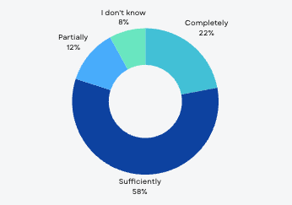

*Source: Results of the online survey- UN Programme and Operations staff*

The representatives of the UN agencies participating in the survey were generally affirmative regarding the alignment of UN activities with the needs and challenges that emerged due to COVID-19's effects. The large majority (80%) expressed a positive opinion, but still, a high percentage did not have enough information about the UN’s activities and support.

## Coherence and coordination

The ET assessed the coherence and coordination of the UNSDCF by examining the alignment of UN agency programs and work plans with the CF, particularly in their design and implementation. The ET also analyzed the effects of the post-reform Resident Coordinator Office (RCO) on enabling coherence, specifically looking at how the redefined roles and responsibilities of the RCO contributed to the UNCT’s ability to act jointly and converge their efforts towards UNSDCF outcomes.

Additionally, the evaluation explored how the UNSDCF enhanced the coherence of UN agencies' support for addressing specific national development challenges, focusing on the methods, partnerships, and modalities instrumental in this process. Finally, the ET reviewed the functionality and effectiveness of the UNSDCF’s joint coordination structures in driving progress towards the SDGs and the overall UNSDCF outcomes.

***2.1. To what extent have UN agency programs and work plans been effectively and meaningfully derived from the CF both in design and implementation?***

**F6. The UNSDCF contributed to greater coherence, enabling the UN agency's initiatives, programs, and work plans to be based on its (UNSDCF) priorities and outcomes.**

The UNSDCF has proven to be a practical framework for UN agencies to prepare their country plans, design and implement initiatives and activities, and work collaboratively. High-level officials have noted that with the UNSDCF, the UNCT operates more cohesively. This coherence is evident in the development and implementation of Joint Programmes. Both the UNCT and the government recognise the importance of these initiatives while expressing a strong commitment to prioritising joint programming[26]. UN Agencies in Turkmenistan have aligned their respective country strategies and program frameworks, including synchronised timeframes with the UNSDCF. These UN Agency plans and strategies elaborate on the UNSDCF areas of intervention and outcomes under which each UN Agency operates. They use appropriate outcome-level indicators from the UNSDCF (to which the respective UN Agency contributes). In addition, these plans provide a detailed account of agency-specific outputs, which are different from those presented in the UNDSCF results matrix.

***Graph 5* *Opinion of UN Staff on cooperation and communication among UN Agencies***

1. 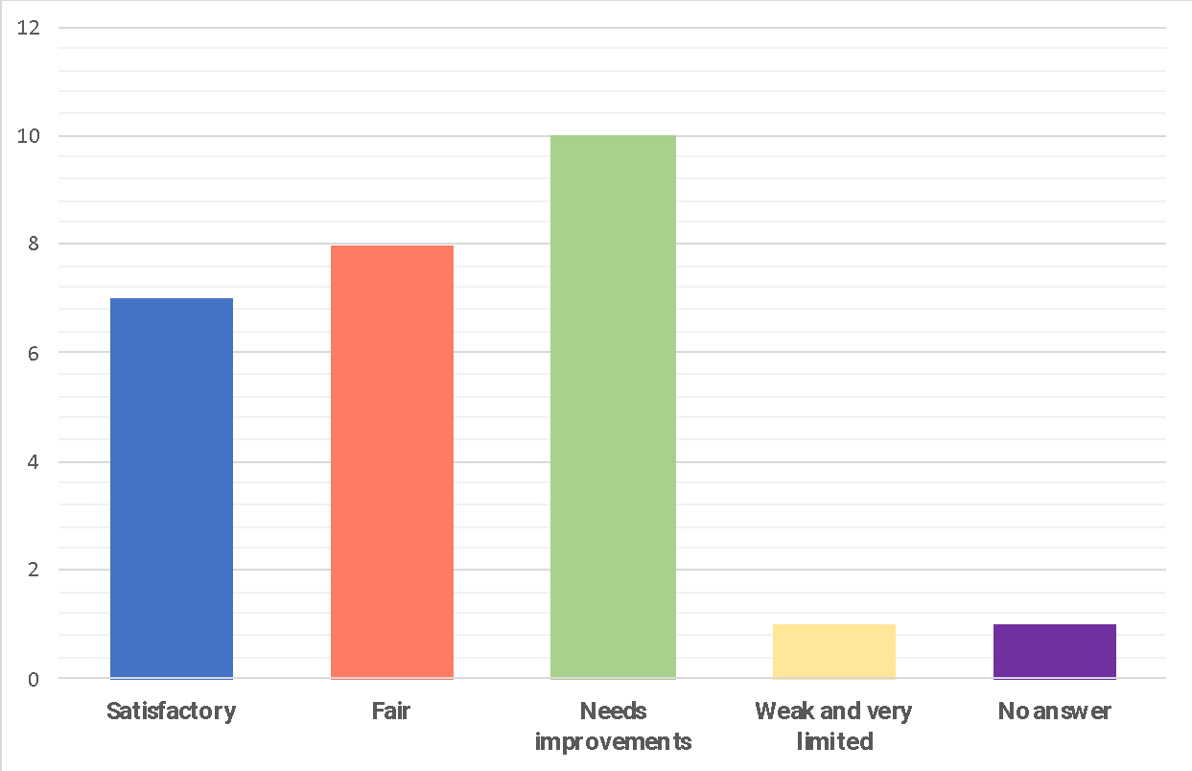

*Source: Results of the online survey- UN Programme and Operations staff*

Despite progress in coherence and expressed commitment to more joint planning and implementation, the existence of parallel agency-specific country programs and work plans alongside the UNSDCF complicates monitoring and reporting. The interviewed representatives of UN Agencies stated that they must report on their strategies and plans using specific outputs, indicators and benchmarks (from these Agency-specific plans). They also report the progress and contribution towards the UNSDCF sub-outputs, outputs and outcomes, which creates an additional burden on their staff.

The representatives of UN Agencies recognised that they maintain a unique M&E system with a set of agency-specific and tailored indicators to the respective outputs. While the indicators at the outcome level have been preserved in these systems, there are differences in measuring outputs and justifying contributions to UNSDCF outcomes. The indicators may have different definitions, data collection methodologies, and collection frequencies across agencies, creating confusion and difficulty in data comparability[27].

**2.2. To what extent did the post-reform Resident Coordinator office’s roles and responsibilities enable UN Agencies to achieve coherence in implementing UNSDCF?**

**F7. The RCO has been pivotal in enhancing the coherence and cooperation among UN agencies in implementing the UNSDCF. The stakeholders recognised the RCO’s critical role in strategic leadership, coordination, and integration of UN Agencies. Additionally, the RCO contributed to partnership building and aligning UNSDCF efforts with national development priorities.**

The UN staff that participated in the survey and interviews (as much as the national stakeholders) recognised UN RCO-RC for providing "strong and strategic leadership", which has been critical in ensuring the alignment of the UN's efforts with the government's development agenda. They stated that the RC's engagement at the highest levels of government has facilitated the integration and alignment of the UN's strategic response with Turkmenistan's priorities. This high-level engagement has also generated positive comments on more coordinated, coherent and joint UN work in Turkmenistan.

The high-level officials and other national stakeholders perceive UN as "a credible and reliable partner", recognizing improvements in joint and consolidated efforts. For example, the partners stated that the RC's direct link to key governmental bodies, such as the Ministry of Finance and Economy and the Ministry of Foreign Affairs, has been based on "mutual trust and respect”- these relationships have ensured that political support for the UNSDCF remained strong at all stages of UNSDCF implementation [28]."

The RCO has fostered inclusive and proactive engagement with UN Agencies with non-resident status. Interviewed representatives of these agencies praised the RCO's flexible approach, which involved them in the UNSDCF planning and implementation processes from the outset. They stated that it allowed them to contribute their expertise and resources effectively and reflect their priorities in the UNSDCF[29].

***Graph 6* *The RCO’s role in enhanced coherence during the UNSDCF implementation***

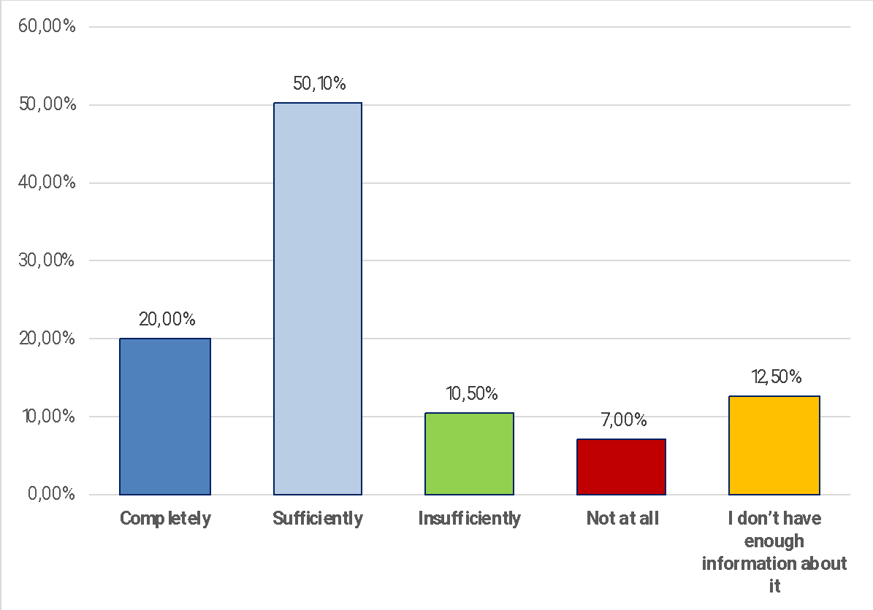

*Source: Source: Results of the online survey- UN Programme and Operations staff*

The online survey results among the UN Programme and Operations staff indicated similar views. The large majority of survey participants (a total of 70.1%positive, while 50.1% stated "sufficiently" and 20% "completely") affirmed the positive role and responsibilities of the post-reform Resident Coordinator office in facilitating UN Agencies' coherence in implementing the UNSDCF. However, 17,5% of respondents expressed different views, commenting that while the UN RCO works to involve smaller UN Agencies in implementation, these agencies often lack the necessary capacities. Some respondents also criticised the RCO as an expensive structure focused solely on coordination without engaging in mobilising resources, programming or implementation. The ET finds that a surprisingly high percentage (12.5%) of participants, all from the UN Programme Staff, marked they did not have an opinion about the UN RCO's role.

The partners highlighted the RCO's role in ensuring accountability and transparency (in implementing the UNSDCF). The RCO has been leading on establishing robust monitoring and reporting systems, ensuring that progress towards development goals is consistently assessed and reported. This process involved regular progress reports, assessments, and stakeholder consultations, all aimed at maintaining accountability. Transparent reporting practices show the UN's contributions to national growth and progress under the SDGs.

The RCO has been instrumental in establishing partnerships and generating support for implementing the UNSDCF in Turkmenistan. One notable initiative has been creating and actively managing the ***Development Partners Coordination Group (DPCG)[30]***. This platform aims to align the activities of development partners with national developmental priorities and needs, fostering joint approaches and synergies in areas such as gender equality and climate action. The RCO's role in the DPCG involves coordinating various development efforts to ensure that partners' initiatives complement each other rather than operate in isolation. This coordination helps to avoid duplication and maximise the impact of development programs. Regular DPCG meetings, co-chaired by the RC or heads of Agencies and their Embassy co-chair, include high-level representatives from the government, UN agencies, and other stakeholders and are instrumental in discussing and aligning key development priorities and strategies.

***Graph 7* *UNRC Office contribution to communication with the national partners***

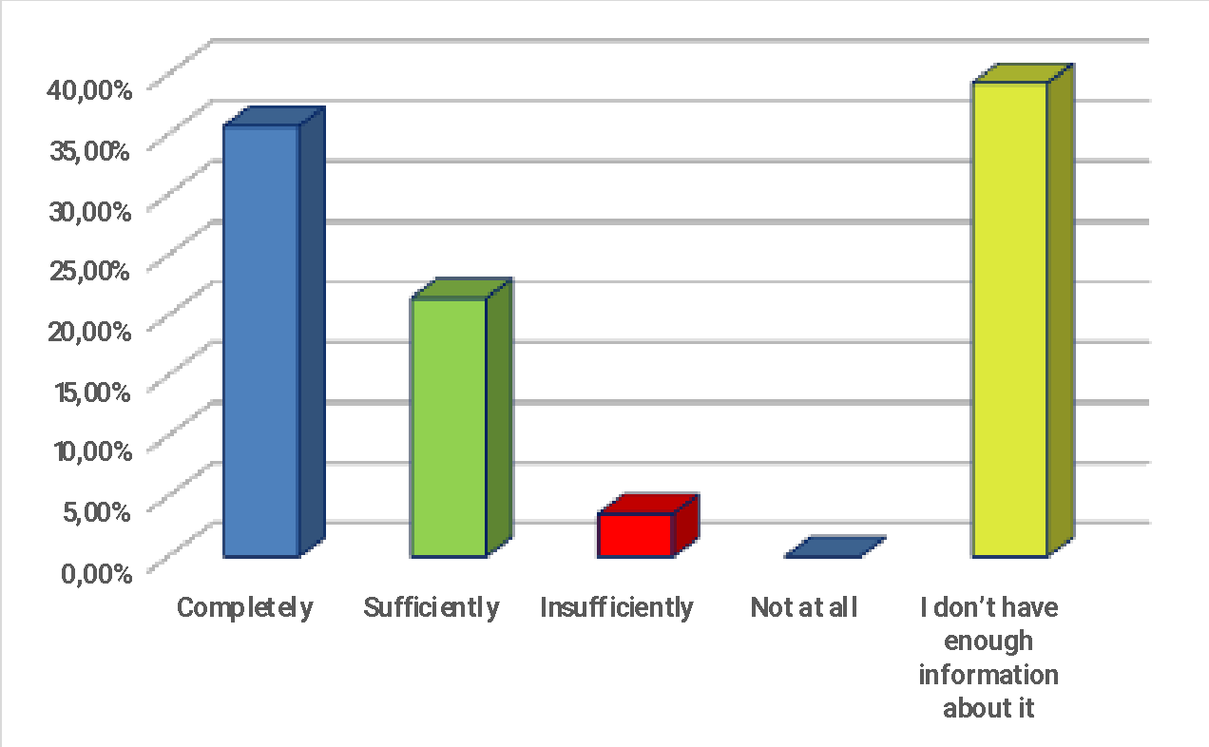

*Source: Results of the online survey- UN Programme staff*

Additionally, the DPCG includes thematic working groups focusing on priority areas- governance, sustainable economy, education and climate action. These groups provide technical coordination and support to priority sectors, contributing to a more integrated approach to development in Turkmenistan. The development partners perceive this RCO's activities as "highly effective" in contributing to the coherence and effectiveness in implementing the UNSDCF.

***2.3. How has the UNSDCF strengthened the coherence of UN Agencies’ support to address specific national development challenges and enhance the achievement of results?***

**F8. The evaluation found that UNCT, with the RCO's leadership, has successfully implemented joint initiatives, setting the framework for more comprehensive joint programming.**

The UNCT had limited but positive experience designing and implementing joint initiatives- it included the Human Security Trust Fund (HSTF) supported "Empowering and Engaging the Youth to Mitigate the Multidimensional Threats of the Health Pandemic[31]" and the "Joint Programme on Improving the System of Social Protection through the Introduction of Inclusive Quality Community-Based Social Services[32]" supported by the Joint SDG Fund. Both, the UN representatives and the national partners acknowledge the significance of these initiatives and have expressed a strong commitment to further expand joint programming and joint initiatives in various sectors.

The stakeholders recognised that the “Joint Programme on Improving the System of Social Protection has been particularly successful and impactful”. Through this initiative, the partners- the Ministry of Labour and Social Protection and UN Agencies[33]- supported transforming the social service delivery system to reach the most deprived and vulnerable populations. In this context, the main results included adopting a new Law on Social Services, developing community-based social services, and piloting new specialised social services. The Government proceeded with the recommendations from this initiative, preparing and adopting a National Social Services Development Plan for 2023-2030.

These joint initiatives have generated some lessons that can inform future efforts. One key lesson is the importance and benefits of well-established coordination to effectively align the diverse expectations of different agencies with national priorities. The ET finds that the JP on social services maintained a generally cohesive implementation approach and coordination that involved the leading UN Agency and the RCO.

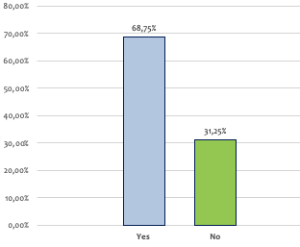***Graph 8* *The opinions of UN Agencies in Turkmenistan if they used sufficiently joint programming***

*Source: Results of the online survey- UN Programme staff*

Another lesson is that this initiative applied standardised M&E practice, confirming it to be critical for accurate and reliable assessment of progress and measuring results. These efforts enabled well-planned technical resources and streamlining management and operational processes (within participating UN Agencies) while ensuring flexible and responsive funding arrangements are crucial for the success of planning and implementation of joint projects.

The benefits of joint planning and programming have been recognised, and the RCO coordinated and led the development of ten new Joint Programmes aligned with national priorities, High-Impact Initiatives, and National SDG Commitments. The UNCT submitted proposals to the government for approval and potential funding and at a later stage this transformed into the UN-Government Strategic Advisory Board (SAB). For example, the partners proposed expanding technology transfer practices by establishing the Regional Center for Climate Change Technologies in Central Asia (RCCT-CA). As part of its analytical function the RCO coordinated and co-organized an innovative policy dialogue “Hard Talk” on methane reduction and green energy transition, leading to actionable recommendations. The SAB endorsed concrete steps towards shutting down the methane “super emitters”, including through the direct USD 10 million co-financing of the prepared Joint Programme. Note the need to achieve concrete results to demonstrate Turkmenistan’s high level of ambition to reduce global warming. Another critical project will support a Just Green Energy Transition in Turkmenistan with the idea to initiate actions with the Joint SDG Fund seed funding for the “Support to Policy Making and Building National Capacity towards Green Energy Transition in Turkmenistan”. Additionally, the UNCT committed to supporting Public Finance Management (PFM) reform in Turkmenistan. In the area of economic development and social system, the UNCT proposed a joint programme aimed at enhancing job creation and integrated quality inclusive social services and the initiative for strengthening health, border, and mobility management at points of entry in Turkmenistan. In the agricultural sector, the UNCT proposed Seeding Digital Agriculture in Turkmenistan. In the governance area, UNCT proposed an initiative on Digital Governance and Population Policies and support to strengthen the capacity of the Ombudsperson’s Office of Turkmenistan to protect human rights in line with the Paris Principles[34].

**F9. UN Joint Work Plans (JWPs) have contributed to "greater cooperation, coherence and alignment of activities among UN agencies, the Government of Turkmenistan, and other stakeholders".**

The survey participants and key informants recognisedthat JWPs generally reflect the logically formulated hierarchy of objectives based on Results-Based Management (RBM) principles- linking outcomes, outputs and sub-outputs. They stated that the JWPs have been generally useful in directing the efforts of UN Agencies and facilitating the integration of various initiatives under the same outcomes.[35]

Still, the ET finds some challenges that hinder the full potential and effectiveness of the JWPs. Essentially, the JWPs are primarily compilations of agency initiatives formulated as sub-outputs, whereby each UN Agency decides how to distribute its projects and components across outcomes and outputs (hence, formulate sub-outputs that are agency-specific) based on its rationale[36]. Still, in some cases, more than one UN Agency is assigned to sub-outputs- it’s a total of 18 sub-outputs- and it is recommended that they be separated. Also, in many cases, sub-output formulation indicates inconsistency, ranging from the activity to higher-level output phrasing- each UN Agency decides how to formulate sub-outputs based on its rationale (and distribute its initiatives across outcomes and outputs). The ET finds the number of sub-outputs (under respective outputs) varied significantly, going from 3 to 21. These issues affect the coherence and clarity of the JWPs.

***Graph 9: The UN Staff perception of the JWPs as a tool for cooperation and coordination***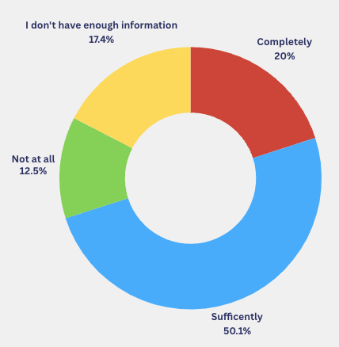

*Source: Results of the online survey- UN Programme and Operations staff*

There are also cases where sub-outputs do not correspond directly to the outputs. In addition, some output indicators do not capture the actual work and delivery. This misalignment further complicates the assessment of effectiveness.

***Graph 10. Opinion of UN Staff on cooperation and communication among UN Agencies***

1. 
2. *Source: Results of the on-line survey- UN Programme and Operations staff*

For example, ***Output 2.1***. Recommendations on regulatory and institutional changes developed to simplify business procedures and expand access to information, innovative technology and financing for private sector, particularly SMEs and women entrepreneurs, included two indicators that measure *the number of women-led businesses with improved performance, increased business transactions, and income generation* and *the number of policies prepared for the benefit of micro, small and medium-sized enterprises (MSMEs)*. These indicators could be (potentially) relevant to measuring the achievement of this output. However, the support under sub-outputs has been focused on the operation and maintenance of the Single Window for Export-Import Transactions system, strengthening the institutional capacity of the Ministry of Trade through digitalization processes, improving statistics of foreign trade in services, enhancing statistical information on the volume of passenger and cargo transportation, developing a financial account to introduce the System of National Accounts 2008 further, and establishing a digital land cadaster in Turkmenistan. The analysis showed that none of these sub-outputs is linked with the output indicators, which limits the functionality of JWPs as continuous planning and monitoring documents for achieving results and fostering synergies.

Another area for consideration is financial efficiency. The JWPs primarily represent compilations of agency initiatives formulated as sub-outcomes and distributed under outputs and outcomes. Still, a single project might have several results that could be achieved in synergy. However, when these projects are dissected into components and distributed across different UNSDCF result areas, it becomes difficult to see the programs and their results relative to the budgets allocated. This dissection distorts the budget-versus-result analysis, making it challenging to evaluate financial efficiency accurately.

***EQ2.4. How functional and effective have the UNSDCF joint coordination structures and national SDG governing bodies been in ensuring progress towards outcomes?***

**F10. With the RCO's leadership, the UNCT established and maintained effective coordination mechanisms that contributed to the enhanced coherence of UN activities. The Steering Committee, Results Groups, and Thematic Groups provided structured frameworks for collaboration and joint planning.**

The ET finds that mechanisms established for the UNSDCF implementation were functional, supporting strategic guidance and positioning, joint planning, programming and advocacy, and setting the basis for coordinating various policy planning and implementation actions.

In this context, the interviewed representatives of UN Agencies and survey participants shared views about “stronger synergies among UN Agencies in responding to national priorities”. For example, at the strategic level, a direct link between the Government Working Group on SDGs, chaired by the Ministry of Finance and Economy and the UNSDCF Steering Committee, chaired by the UN Resident Coordinator and Minister of Foreign Affairs, has been established. This cooperation ensured a high level of political engagement and facilitated links between the national priorities and processes with the UNCT activities under the UNSDCF.

The analysis of meeting minutes showed that the SC members were involved mainly at the formal level, with limited strategic inputs and leadership during UNSDCF implementation. Their role was limited to acknowledging progress and endorsing plans for the next period.

Partners have recognised joint **Results Groups** (JRGs) as a critical mechanism supporting the implementation of the UNSDCF through joint planning, monitoring activities, and progress reporting. The UNCT and UNRCO have emphasised strengthening national participation and ownership in the RGs. Key national institutions, including the State Committee on Statistics, the Ministry of Health and Medical Industry, the Ministry of Labour and Social Protection of the Population, the Ministry of Foreign Affairs, and various UN Agencies, have actively participated in the RGs. The ET finds that all JRGs meet regularly, focusing on JWPs to track and report on progress against planned activities and results, identifying lessons and good practices. However, key informants have highlighted the need to expand the role of JRGs to include space for open and forward-looking discussions. The ET finds the need to engage more stakeholders in the planning and decision-making and involve them in implementation.

The ET has observed that cross-outcome and cross-sector synergies remained limited during the UNSDCF implementation, suggesting improvement in promoting a more unified and strategic approach to planning and implementing development interventions. Still, the recent practice of joint Results Groups' meetings, focused on (joint) planning that UN Agencies recognised, could be useful as part of the support to cross-sectoral cooperation and synergies between outcomes and results groups. The interviewed RG members have been affirmative about these activities, stating that this involvement "fosters a sense of collaboration and shared responsibility for the country's sustainable development[37]". In parallel, they recommended the need for strengthening linkages between JRGs and existing national structures, such as the *Working Group of the Inter-Ministerial Commission on the implementation of Turkmenistan's international obligations in the field of human rights conventions and international humanitarian law[38], the Social Protection Coordination Group[39], and the Working Group on SDG Indicators*. According to survey participants, these joint and coordinated efforts could further enhance the relevance and effectiveness of UNSDCF implementation mechanisms[40].

|  |  |
| --- | --- |
| ***Graph 11 Experience of UN programme and operations staff in direct cooperation with other UN Agencies*** | |
| **Programme Staff** | **Operations Staff** |

1. *Source: Results of the on-line survey- UN Programme and Operations staff*

The partners also highlighted the opportunity for considering improvement in funding arrangements- suggesting “flexible funding mechanisms to support adaptive and responsive joint programming, allowing the UN Agencies to respond more effectively to changing circumstances and emerging needs”. The RCO advocated for a format of pooled funding to include various opportunities- e.g., bilateral co-financing agreements between UN agencies and the Government, global thematic funds, bilateral agreements with donors, and in-kind contributions. The RCO recognised several benefits this mechanism could offer, including more robust planning, support for underfunded priorities, and higher efficiency[41].

The UNCT established Thematic Groups to align with strategic priorities and leverage opportunities for in-depth discussions on synergies, complementation, and joint programming under the UNSDCF. Currently, five UN Thematic Groups on Human Rights, Gender, Youth, Communication, Monitoring, Evaluation, and Learning as well as Health and Social Inclusion[42] are operational. Despite the limited capacities and personnel of the UNCT in Turkmenistan- for example, not all (resident) agencies have personnel with technical capacities in the respective areas, these groups function relatively well. The UN staff highlighted the strengths of these Thematic Groups, especially concerning joint planning, programming and advocacy. They also recognised that the limited capacities and resources within the UNCT mean these groups often struggle to cover their broad mandates and agendas effectively. Another challenge is the wide scope of subjects under the TGs' mandate, calling for prioritisation and focusing on specific priorities. The ET finds the need to invest resources for thematic analysis needed to ensure consistency in data interpretation and analysis. Thus, expanding and refining the thematic focus of these groups, supported by appropriate resources and structures, can expand the UNCT's opportunity to respond to strategic priorities and leverage opportunities for joint programming and synergies under the UNSDCF.

## Effectiveness

The ET assessed the achieved outputs and evaluated whether they contributed to the expected outcomes, goals, and targets outlined in the UNSDCF results matrix. The evaluation included an analysis of the likelihood of continued progress towards these outcomes, considering the degree to which the foundational outputs had set the stage for future success. Moreover, the evaluation explored how well the UNSDCF responded to the needs and priorities of the target population, mainly focusing on vulnerable and marginalised groups. In addition, the ET analysed key factors that affected implementation, producing unintended results and affecting the delivery of results.

***EQ3.1. Have the outputs been achieved, and to what extent they contribute to the UNSDCF Outcomes?***

**F11. UN Agencies in Turkmenistan promoted and provided well-conceptualised support for institutional and policy reforms around sustainable and inclusive growth, social inclusion, and environmental governance, contributing to the enabling environment for improved services and human rights, ensuring that no one is left behind. UN Agencies established a strong presence at national and sub-national levels, responding to national priorities and addressing the needs of people in Turkmenistan.**

Drawing on the desk review and interviews with key informants- primary data collection, the evaluation team found key links between UN Agencies' main outputs and progress towards the outcomes. For example, the survey results indicate that a large majority (75%) of respondents believe that UN agencies have effectively achieved results under the UNSDCF's outcomes.

***Graph 12. UN Staff perception of effectiveness under UNSDCF outcomes***

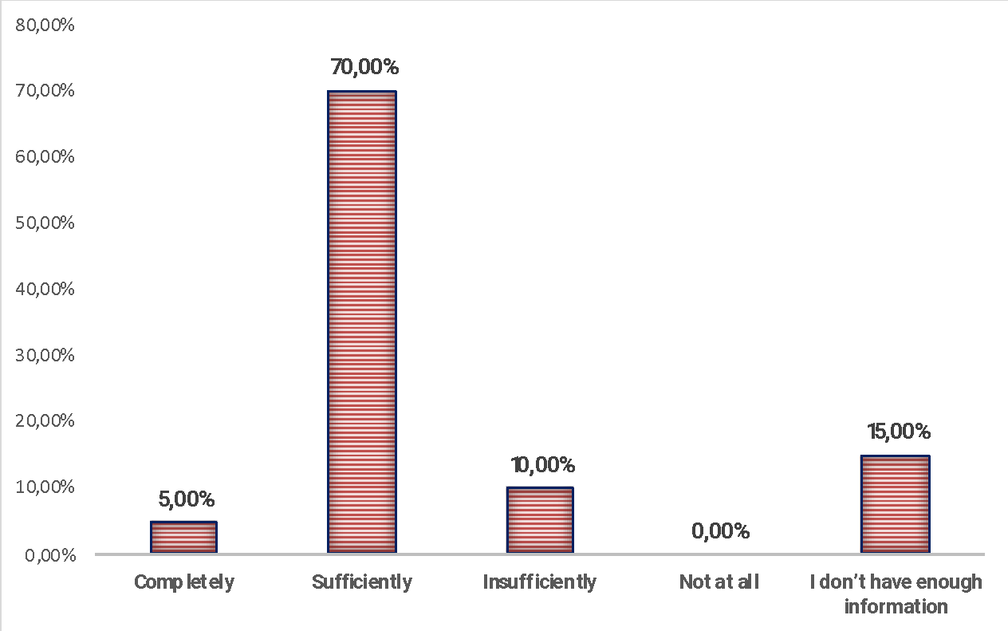

1. *Source: Results of the on-line survey- UN Programme and Operations staff*

A small portion (10%) felt the effectiveness was insufficient, while no respondents deemed the UN Agencies as ineffective[43].

Regarding the most important results achieved during the UNSDCF implementation, the responses highlighted several key areas. They pointed to the launch of the National SDG database, Trade Information Portal, progress in the WTO accession process, and support to SMEs in complying with export management formalities. Adopting and accepting various laws and policies, particularly those resulting from UN strategic initiatives projects, were frequently mentioned. Additionally, the survey participants recognised UNCT's efforts under the UNSDCF to support the implementation of the National State Program of Turkmenistan for their considerable contribution to economic and sustainable development, which benefitted all UN agencies involved. Sustainability and national ownership in implementing the SDGs were emphasised, with consistent reporting on achievements, including the Voluntary National Reviews (VNRs) of 2019 and 2023 and the public opening of the national SDG Database. Respondents also mentioned the expectation for further scaling up in SDG financing. Direct impact on beneficiaries was another area of focus, with contributions seen at both the policy and institutional levels, although some respondents noted that these were only partially achieved[44].

**F12. UN Agencies have been generally effective in implementing activities and delivering outputs[45]**

* **Main results- outputs under Outcome 1**

Under Outputs 1.1. UNSDCF initiated and delivered efforts to introduce digital government systems, which were marked by the development of pilot projects and targeted training for government officials. This progress is evident in urban centres where 'one-stop-shop' service centres have been established to streamline public service delivery. However, expanding these services to more remote areas has been inconsistent, and the transition from paper-based to digital systems still needs to be completed. The need for further investment in digital infrastructure and capacity-building is evident to ensure a comprehensive and nationwide rollout of digital government services. In parallel, there have been positive developments in strategic planning, particularly with sectoral ministries beginning to align their strategies with the SDGs. Efforts to integrate the needs of vulnerable groups, such as women, children, and people with disabilities, into these plans have been commendable. However, incorporating these strategic plans into the ministries' budgeting processes has proven challenging. The program-focused and gender-responsive budgeting is being considered, but its application remains a work in progress, requiring further efforts to institutionalise these practices (Output 1.2).

The civil service reform process has also seen foundational steps taken under Output 1.3, focusing on enhancing the competency of civil servants through training programs in evidence-based policymaking and human-centred administration. Despite these initiatives, participation has been uneven, with urban areas benefiting more than rural regions. The broader adoption of data-driven decision-making across the civil service still needs to be improved, and issues of motivation and career advancement remain pressing challenges that must be addressed to retain competent civil servants. Moreover, the UNCT has supported the government in embarking on developing programs to advance human rights, gender equality, and labour rights, guided by recommendations from UN treaties and supervisory bodies. In this context, the UN prepared and delivered capacity development programs targeting law enforcement and other state institutions, aiming to embed international standards into practice. Nonetheless, the slow pace of progress and the limited engagement of civil society, including workers' and employers' organizations, have hampered the full realisation of these initiatives. Bridging the gap between policy formulation and effective implementation remains a key priority (Output 1.4).

Finally, efforts have been made to enhance the capacity of ministries and agencies to collect and analyse disaggregated data, which is crucial for developing people-centred policies aligned with the SDGs- for example, UN has supported national stakeholders to complete the major data collection initiatives successfully completed or ongoing: national survey on health and status of a woman in the family, Population and Housing Census, Multiple Indicator Cluster Survey (MICS). While new tools and methodologies have been introduced, challenges persist, particularly in ensuring data quality and consistency. Continuous capacity-building initiatives are required to ensure that data is effectively utilised in policy development, ensuring that these policies are genuinely responsive to the diverse needs of the population (Output 1.5).

* **Main results- outputs under Outcome 2**

UN Agencies have been generally effective in delivering a series of strategic outputs under the efforts to improve the economic landscape. Some of the primary references have been to simplify business procedures, expand access to information and technology, and foster a more favourable investment climate. However, challenges remain, particularly in fully embedding these changes across all sectors.

Under Output 2.1., UN Agencies advanced efforts to streamline business operations by developing and implementing the Statistical Business Register. The interviewed partners praised this central database for standardizing and simplifying the registration process for legal entities and individual entrepreneurs, thus reducing bureaucratic hurdles that previously stifled entrepreneurial activities. Complementing this, the establishment of the Single Window System has integrated over 15 state regulatory bodies, allowing businesses to complete export-import operations through a unified platform efficiently. The prevailing positive opinions recognise that "this system has enhanced Turkmenistan's trade competitiveness by reducing both the time and costs associated with customs procedures". Still, they also stated that despite these successes, ongoing training and capacity-building are essential to ensure these systems are fully utilised and embedded across all sectors.

In the realm of capacity development, UN Agencies improved public and private sector competencies. For example, the ET finds that Output 2.2. introduced a trade information portal, which provides detailed information on import-export procedures across 25 product categories; this result has increased transparency and equipped businesses with the critical data needed to expand their trade activities. Developing a digital platform for banking services has also modernised the financial sector by offering mobile and Internet banking services, thus promoting financial inclusion, especially in remote areas. The partners stated that further efforts are required to ensure widespread adoption and practical usage.

UN Agencies supported financial innovation, particularly by adopting Development Finance Assessments, laying the groundwork for the Integrated National Financing Framework (INFF). This framework is designed to align financial resources with Turkmenistan's SDG targets. Although promising, the full implementation of the INFF and the introduction of specific financial instruments, such as green bonds or social impact bonds, are still in the early stages. The ET recognised the need for continued engagement with international financial institutions and the private sector as critical to advancing this agenda. UNCT supported investment promotion efforts in the context of Turkmenistan's progress towards WTO accession. The UN's technical assistance in conducting legislative reviews has been critical in ensuring national policies align with WTO standards, thus creating a more predictable and transparent regulatory environment conducive to foreign investment. Additionally, establishing the Central Asia Gateway, a regional trade portal, has further bolstered Turkmenistan's investment climate by facilitating intra-regional trade and improving access to international markets, which is critical to diversifying the country's export base. Finally, the capacity of public institutions to collect and analyse disaggregated data on economic development, trade, and private sector growth has improved. The UNCT supported the operationalisation of the SDG database within the State Statistics Committee, now providing data on nearly 130 SDG indicators. The partners recognized this result as a critical advancement in monitoring and reporting on progress towards the SDGs. The ongoing development of a detailed Supply and Use Table (SUT) further enhances the country's statistical capabilities, providing essential data for informed decision-making. However, challenges persist in ensuring this data's consistency, reliability, and regular updating, highlighting the need for continued efforts to fully leverage these tools for evidence-based policymaking (Output 2.5).

* **Main results- outputs under Outcome 3**

Outcome 3 reflects results toward climate resilience and sustainable development, with the UNCT playing a critical role in supporting the GoT across several key areas. These efforts have led to delivering results concerning energy savings, CO2 emissions reduction, disaster preparedness, and the adoption of green technologies. Still, this process needs to continue- development of monitoring systems and full implementation of strategic plans are necessary to ensure these initiatives' sustainability and long-term impact.

UN supported Turkmenistan in enhancing its technical capacity to develop and implement climate policies, particularly focused on reducing CO2 emissions and climate adaptation. The cooperation in the Aral Sea basin, facilitated by the UN Aral Sea project, has strengthened joint management efforts, marking an important step toward transboundary water management. Significant energy conservation efforts, particularly through the Sustainable Cities project, led to a cumulative energy savings of 3.2 billion megajoules by 2023, with a target to save an additional 3 billion MJ by 2024. These initiatives also contributed to a reduction of 535,000 tons of CO2 equivalent emissions. Moreover, the establishment of new protected areas, such as Pyatnyak and Zengibaba, and the restoration of degraded forests in reserves like Amudarya and Kaplankyr, highlighted the GoT's commitment to biodiversity and ecosystem preservation, with plans to restore over a thousand hectares of saxaul ecosystems by 2025. In addition, UN Agency under Output 3.2 focused on disaster preparedness and the engagement of vulnerable populations. The UN supported the development of a Child-centered Disaster Risk Reduction Strategy and a Multi-Year Action Plan. These frameworks aim to enhance the resilience of vulnerable groups, particularly women and children, to natural disasters. Additionally, seismic micro-zoning in Ashgabat demonstrated advances in disaster preparedness while implementing "Green Standards" and energy conservation measures contributed to safer urban development. The National Action Plan for Climate Adaptation and Health, supported by the UN, also included crucial WASH improvements in healthcare settings, collectively enhancing disaster response capabilities across the country (Output 3.2).

In ensuring the processes aligned with the Sendai Framework for DRR the Government of Turkmenistan, in cooperation with UN, established an Interagency Working Group for Disaster Risk Reduction functioning as the National Platform for DRR and called to contribute in facilitating the exchange of information, creating synergies between national and international actors in DRR, implementing the State Program for Emergency Preparedness, and rationalizing resources required to mainstream DRR into development policies, planning and programmes. A Joint Action Plan for 2022 on cooperation in coordinating emergency preparedness and response between the Government of Turkmenistan and the United Nations was signed, and the document encompassed three pillars on norms and standards for DRR and resilience, enhancing resilience and risk management, and preparedness and response. However, the work of the National DRR Platform and the implementation of actions within the mentioned pillars still needs significant support.

Efforts to integrate green technologies and promote renewable energy have progressed. The UN was instrumental in developing key strategic documents such as the National Strategy for Renewable Energy and the Waste Management Concept, which serve as blueprints for sustainable practices across various sectors. For example, installing modern transformers in Ashgabat resulted in measurable reductions in CO2 emissions, demonstrating the impact of these renewable energy initiatives. Sustainable urban infrastructure and climate-smart agricultural practices were also promoted, engaging local communities, including women and vulnerable groups, in developing green solutions and contributing to Turkmenistan's broader sustainable development goals. (Output 3.3). In addition, UN agencies emphasised enhancing GoT's capacities in climate analysis, monitoring, and reporting. The development of the National Greenhouse Gas Inventory System, supported by the UN, was a critical step toward establishing a comprehensive Monitoring, Reporting, and Verification (MRV) system. While these systems are still being fully operationalised, they represent significant progress in aligning Turkmenistan's national policies with international climate commitments. Capacity-building workshops and training sessions were also held to enhance the technical skills of government officials and other stakeholders in climate analysis, with the integration of climate change adaptation into the educational curriculum further fostering a culture of sustainability among the population (Output 3.4.).

* **Main results- outputs under Outcome 4**

Outcome 4 represents significant advancements in Turkmenistan's health and social protection infrastructure, supported by the UNCT. These efforts have led to strengthened legislative frameworks, enhanced health information systems, expanded healthcare access, and improved social protection services. However, challenges remain in ensuring these benefits reach all regions uniformly, necessitating ongoing efforts to build local capacities and ensure comprehensive coverage.

UN support included legislative and regulatory framework improvements for health and social protection. The adoption of the National Immunization Strategy and the COVID-19 national response plan exemplifies the country's improved capacity to address public health emergencies with the UN's support. The UN Agencies facilitated the rapid procurement and distribution of COVID-19 vaccines, showcasing the government's enhanced capability in managing health crises. In addition to the COVID-19 response, significant progress has been made in controlling infectious diseases such as tuberculosis (TB), HIV, and viral hepatitis. The UNCT provided critical support for strengthening the national TB program by delivering diagnostic tools, laboratory equipment, and treatment supplies. This has led to better detection and treatment outcomes for TB patients. The establishment of HIV testing and counseling centers, with UN assistance, has contributed to increasing early detection rates and reducing the virus's spread. Similarly, efforts to manage viral hepatitis, especially hepatitis B and C, have been bolstered through strengthened health systems and public awareness campaigns.

Further efforts are required to ensure that policies related to non-communicable diseases (NCDs) and reproductive health are consistently implemented across all regions, particularly in rural areas where access to health services remains limited (Output 4.1). The UN's assistance in developing the Health Information System (HIS) has been a critical achievement. Implemented in several regions, HIS has improved the accuracy and timeliness of health data reporting, allowing for disaggregation by gender, age, and social vulnerability. This capability has enabled more targeted health interventions, such as addressing high maternal mortality rates in specific regions. However, the full integration of HIS across all regions remains incomplete, and further expansion is necessary to maximize its potential in national health planning and decision-making (Output 4.2).

Efforts to increase access to health information and preventive services have been a focal point under Output 4.3. The rollout of mobile health clinics in rural and underserved areas has provided essential healthcare services and education on disease prevention to populations with previously limited access. Public health campaigns, such as the "Healthy Schools" initiative, have also been launched to promote nutrition and physical activity, aiming to reduce the risk of NCDs among children and adolescents. While these initiatives have reached thousands, there is still a need to broaden the scope and intensity of these campaigns, particularly among vulnerable populations. Implementing the Integrated Management of Childhood Illness (IMCI) strategy highlights maternal and child health progress.

UN has been actively involved in strengthening primary health care (PHC) in Turkmenistan by providing comprehensive training to health professionals across various regions in key areas such as prenatal and antenatal care, nutrition, early childhood development, and nurturing care. These efforts aim to enhance the skills and knowledge of PHC workers, enabling them to deliver higher-quality care to mothers and children. A significant focus has been placed on building the capacity of health workers in nutrition counseling, particularly concerning adolescent nutrition, to ensure young people receive the guidance they need for healthy growth and development. Additionally, the establishment of new HIV testing and counseling centers, supported by the UN, has increased early detection rates and contributed to reducing the spread of the virus. Sustaining these efforts will require continuous capacity building and resource allocation, especially in remote and underserved regions with weaker health infrastructure.

UN provided support in conducting Turkmenistan's National Micronutrient Survey among non-pregnant women aged 15-49 years, pregnant women, and children aged 6-59 months, which generated critical evidence on the micronutrient status and nutritional health of these specific sub-groups. The data is vital for identifying at-risk groups, guiding targeted interventions, and monitoring the effectiveness of national strategies to enhance nutrition and health across Turkmenistan.

Finally, under Output 4.5, adopting the new Social Protection Law, developed with UN guidance, set the foundation for more inclusive social services. This law has led to the establishment of community-based social service centers that provide tailored support to vulnerable groups, including older people and people with disabilities. These centers have been particularly crucial during the COVID-19 pandemic, offering home-based care services to ensure that vulnerable individuals receive the necessary support. However, to fully realize the potential of these initiatives, ongoing efforts are needed to train social workers and ensure that these services are accessible across all regions, particularly in remote and marginalized communities.

* **Main outputs under Outcome 5**

The UNCT reported progress under some outputs. For example, progress has been marked by a concerted effort to improve the quality of secondary education, particularly in integrating life skills into the curriculum. Specialised UN agencies have implemented some initiatives to enhance teachers' capacities in delivering education that fosters creativity, critical thinking, and problem-solving among students. However, challenges remain in ensuring that these skills are uniformly taught across all regions, especially in rural areas where resources and training opportunities are less available. Under Output 5.3 UN Agencies invested efforts to strengthen the capacities and mechanisms for implementing inclusive education, with some gradual progress. Establishing Education Data Management Information Systems has been a key achievement, allowing for better tracking and analysis of educational outcomes. Additionally, support for implementing inclusive education policies has been provided, though the reach and effectiveness of these efforts vary across different regions. While some areas have seen considerable improvements, particularly in urban centers, the full integration of inclusive education practices across the country remains a work in progress.

The UN has supported updating curricula to reflect competency-based educational approaches and promoting vocational training programs. Through participation in the TAMUN Model UN conference, the UN trained young people in soft and digital skills, teamwork, and public speaking. Additionally, trainers with disabilities were trained to advocate for disability rights.

***EQ3.2. Is the UNSDCF likely to progress towards attaining the established outcomes, goals, and targets as set in the UNSDCF results matrix?***

**F12. The UNSDCF is progressing in delivering outputs and advancing towards outcomes and established benchmarks. However, this progress is mixed, with some targets proving challenging to achieve, particularly in areas requiring uniform implementation and sustained financial and institutional support.**

|  |  |
| --- | --- |
| ***Outcome 1: By 2025, people have access to more effective, innovative, and transparent public administration based upon the rule of law, human rights, gender equality, labor rights, and quality data.***  While progress has been made under its outputs, some challenges remain in implementation (especially concerning capacity-building) and ensuring the sustainability of these initiatives. For example, the participants in the survey highlighted that there has been some progress in implementing reforms and improving governance systems. Most respondents (57% of which 9% strongly agree and 48 % agree) expressed confidence that the country, with the UN's support, will likely achieve established targets by 2025. The participants highlighted the main achievements included establishing and strengthening digital government systems, enhancing the Ombudsman Office's capacity to address citizen complaints, and advancing legal reforms in line with international human rights standards. Still, a considerable portion stated that Outcome 1 targets are unlikely to be achieved, citing limited capacities and a lack of genuine commitment. The participants recognised that challenges remain, particularly in areas such as ensuring the full achievement of gender equality targets and the progress in implementing labour rights protections.  The ET finds that where activities have been initiated, they are often still in the early stages, requiring continued investment in training, infrastructure, and institutional reforms. | |
| **Indicators, baselines and targets** | **Progress** |
| **Outcome Indicator 1.1:** Extent to which legal frameworks address human and labour rights, including gender equality and non discrimination on the basis of age, sex, disability, ethnicity, religion, political opinion, economic or other status, List, Legal frameworks (SDG 5.1.1)  **Baseline (2020):** Rating of 2 on a 4-point scale/  **Target (2025):** Rating of 4. | **Status – Improving:** Progress has been made in aligning Turkmenistan’s legal frameworks with international human rights standards, supported by the UN. A key achievement is the National Human Rights Action Plan (NHRAP) for 2021-2025, which provides a foundation for ongoing reforms. Another significant development is the drafting of the Law on Prevention and Response to Gender-Based Violence, focusing on comprehensive protection for women and girls.  Turkmenistan’s 2022 reporting on SDG 5.1.1 demonstrates progress across multiple areas. The country scored 70% for overarching legal frameworks and public life, 44.4% for violence against women, 60% for employment and economic benefits, and 81.8% for marriage and family laws. These results reflect ongoing efforts to enhance legal protections, although further work is needed to fully achieve the 2025 target, particularly in areas such as gender-based violence and labor rights. |
| **Outcome Indicator 1.2:** Effective consideration of applications by the Ombudsman Office in accordance with the Paris Principles. (SDG 10.3.1)  **Baseline** (2020): The Office of the Ombudsman of Turkmenistan examines complaints regarding decisions or actions or omissions of public authorities which violate the rights, freedoms or legitimate interests of individuals and investigates them.  **Target** (2025): Improved mechanism for considering appeals in accordance with the Paris Principles*.* | **Status:** **Improving**  Considerable progress has been made with UN support. As reported by the Ombudsman’s Office of Turkmenistan, improvements were achieved in six of the seven sub-targets. By 2021, progress had been made on sub-targets 1, 2, 6, and 7, improving the mechanism for handling complaints. By 2023, further progress was achieved on sub-targets 4 and 5, including the introduction of a system to track appeal outcomes and the collection of disaggregated data.  The Ombudsman’s Office, supported by the UNCT, has implemented new systems for handling both written and oral complaints, leading to an increase in the percentage of complaints addressed. Representatives from the office and interviewed partners have recognized these improvements as critical to enhancing public trust and accountability. |
| **Outcome Indicator 1.3:** % of nationalized SDG Indicators that have disaggregated data (where relevant) available to report, Percent, Total (SDG 17.18.1)  **Baseline (2019):** 50% of nationalised SDG indicators have disaggregated data/  **Target (2025):** 91% (State Statistical Committee). | **Status: Improving (On-track)**  The ability to collect and utilize disaggregated data is essential for monitoring progress toward the SDGs and developing inclusive policies. Turkmenistan has made notable progress in this area by establishing the National SDG Database within the State Statistics Committee, supported by the UN Country Team (UNCT). This has facilitated improved data collection and analysis capabilities. According to recent reports from Turkmenstat, the percentage of nationalized SDG indicators with disaggregated data available has increased to 73.8%. This marks a significant improvement from the 2019 baseline of 50%, indicating strong momentum toward achieving the 2025 target of 91%. Continued efforts to enhance statistical capacity will be key to ensuring comprehensive reporting on SDG progress. (https://sdg.stat.gov.tm/ru/indicator/17-18-1) |
| **Outcome Indicator 1.4:** A population and household census in Turkmenistan is conducted, data is used for development of national socio-economic programmes and strategies, text, Census is conducted (SDG 17.19.2)  **Baseline:** Census conducted in 2012/  **Target:** Census 2022. | **Status:** **Completed**  The successful completion of the 2022 Population and Housing Census, supported by the UN, marked a significant milestone, especially concerning the accuracy and speed of data processing. |
| **Outcome Indicator 1.5:** % of women in managerial positions, Percent, Total (SDG 5.5.2)  **Baseline:** 23.8 (Data from the State Statistical Office)  **Target (2025):** 30% of managerial positions held by women. | **Status:** **Decreasing**  The data shows a downward trend in the percentage of women in managerial positions from 2016 to 2023. In 2016, the percentage stood at 24.1%, which then decreased slightly in subsequent years, dropping to 22.1% in 2019. After a small rebound in 2020 to 23.8%, the percentage again decreased to 22.1% in 2021, followed by a modest rise to 22.4% in both 2022 and 2023. These trends reflect fluctuations in women’s representation in managerial roles, suggesting that despite targeted efforts, more consistent progress is needed to reach the 30% target by 2025. Key initiatives, including leadership development programs for women, advocacy for gender-sensitive policies, and concerted efforts to remove barriers to career advancement, remain crucial to reversing this decline and advancing gender equality in leadership.  The decline from 24.1% in 2016 to 22.4% in 2023 underscores the challenges in sustaining progress, even with interventions in place. This highlights the importance of intensifying efforts to close the gender gap in managerial positions and meet the set target by 2025. |
| **Indicator 1.6:** Proportion of ever-partnered women and girls aged 15 years and older subjected to physical, sexual or psychological violence by a current or former intimate partner in the previous 12 months, by age and place of occurrence, Ratio, Total (SDG 5.2.1.)  **Baseline (2020):** Survey on the status and health of women in families/  **Target (2025):** TBD | **Status: Progressing- On track**  The national survey on the status and health of women in families, supported by the UN, has provided vital data on the prevalence and nature of gender-based violence in Turkmenistan. Following this, the Law on Prevention and Response to Gender-Based Violence is being developed. |

|  |  |
| --- | --- |
| ***Outcome 2: Sustainable Economic Diversification under the United Nations Sustainable Development Cooperation Framework (UNSDCF) for Turkmenistan***  Under Outcome 2, Turkmenistan has made progress in areas such as GDP growth and export expansion. However, challenges remain in fully achieving credit and entrepreneurial targets. While the UNCT has made valuable contributions at the output level, more comprehensive, sustained, and targeted efforts will be needed to meet the 2025 goals. A closer look at **Outcome Indicator 2.2**, which tracks the total amount of credits provided by credit institutions, reveals steady growth from 76,321 million manats in 2018 to 110,250 million manats in 2022. This reflects positive developments in the financial sector, with improved access to credit contributing to economic diversification.  All indicators under this Outcome have clearly defined baselines and targets, as outlined in the signed Cooperation Framework. This clarity allows for a more accurate measurement of progress and ensures that the country is on track to meet its targets. While external factors such as global market trends and domestic policy changes have undoubtedly played a role in driving economic improvements, the UNCT’s efforts have been instrumental in advancing financial and banking tools for green economy growth and in supporting the development of policies to attract private capital and foreign investments. Survey results, interviews, and desk research highlight numerous achievements under Outcome 2, though some outputs, particularly those related to financial and banking tools for green growth, continue to face challenges.  Despite these difficulties, the likelihood of achieving Outcome 2 is relatively high, with 80% of respondents in the final evaluation survey expressing positive views on progress. Continued commitment from both the UNCT and national partners will be essential to sustaining this momentum and overcoming the remaining barriers to full achievement by 2025. | |
| **Indicators, baselines and targets** | **Progress** |
| **Outcome Indicator 2.1.** Annual Growth Rate of Real GDP per Employed Person (SDG 8.2.1)  **Baseline (2020): 4.5%** (in 2019- 3.4%- VNR 2019).  **Target:** Not less than 4% annually by 2025. | **Status**: **Progressing- On track**  The annual growth rate of real GDP per employed person is difficult to ascertain precisely due to the lack of detailed employment data. The overall GDP growth rate in Turkmenistan has been strong, with estimates around 6.3% in 2023 and a projected 6.5% in 2024, driven mainly by energy exports and state-led investments. However, the growth per employed person likely varies significantly across sectors, with certain industries lagging.  The UNCT’s role in supporting economic policies has contributed to this growth, but more granular efforts are needed to ensure that this growth is inclusive and benefits the wider workforce. |
| **Outcome Indicator 2.2:** Total amount of Credits provided by credit institutions, mln TMT and % distribution by enterprises (public, non-public) and population, (SDG 8.10.1, SDG 9.3.2)  **Baseline (2018): 76,321** d.  **Target:** 2% increase annually by 2025. | **Status**: **Stagnating**  Credit growth in Turkmenistan has been moderate, with an increase observed, particularly in the public sector. However, the annual growth rate of credits provided to the private sector remains below the 2% target. Efforts by the UNCT to promote financial inclusion and the development of microfinance have seen some success, particularly in broadening access to credit for SMEs and individuals. However, the overall credit market remains constrained, and further reforms are needed to achieve the desired growth rates and support private sector expansion. |
| **Outcome Indicator 2.3:** Number of entrepreneurs, disaggregated by sex (SDG 5.5.2)  **Baseline (2020):** 81,139(SSC data) .  **Target:** 5% increase annually by 2025. | **Status**: **Completed**  The number of entrepreneurs, including female entrepreneurs, has seen a gradual increase, supported by UNCT initiatives that focus on capacity building, financial access, and mentorship. The recent data indicates a stronger performance in the number of entrepreneurs. The total number of entrepreneurs increased from 81,139 in 2020 to 89,440 in 2021 and further to 96,074 in 2022. These figures represent a growth rate that exceeds the targeted 5% per year, demonstrating that progress has been more robust than initially stated. This improvement can be attributed to various UNCT-supported initiatives focused on capacity building, enhancing financial access, and providing mentorship, particularly for women and youth. Despite this progress, gender disparities in entrepreneurship remain a challenge, requiring continued targeted interventions to ensure that the entrepreneurial environment becomes more inclusive and supportive, particularly for female entrepreneurs. Further efforts should aim to sustain this growth and address existing barriers, particularly around financial access and business development support for women. |
| **Outcome Indicator 2.4:** Turkmenistan exports, mln. USD (SDG 17.11.1)  **Baseline (2018):** USD 11,650 million.  **Target:** Increase exports to USD 13,250 million by 2025. | **Status**: P **Progressing- On track**  Turkmenistan’s exports have shown a strong upward trend, with exports reaching USD 11.4 billion in 2023. The country is on track to meet or even exceed the target of USD 13,250 million by 2025. This growth is largely due to increased energy exports and efforts to diversify trade. The UNCT has played a crucial role in enhancing trade facilitation, supporting export diversification, and improving market access. The continued focus on expanding into new markets and reducing dependency on a few key commodities will be essential to sustaining this progress. |

|  |  |
| --- | --- |
| **Outcome 3: There is effective design and implementation of disaster risk reduction and climate adaptation and mitigation measures, enabling a more rational use of resources, increased resilience, and a ‘green’ economy transition.**  The progress under this outcome was evident in some areas but lagged in others. The UN's contributions were crucial, particularly in capacity building, policy formulation, and supporting the development of national strategies. However, the pace of implementation and the challenges in scaling up successful initiatives indicated that while some progress would be made by 2025, full achievement of the outcome might only be possible with intensified efforts and enhanced resource allocation.  The surveyed and interviewed stakeholders perceived progress toward Outcome 3 as being on track, with the majority of outputs deemed relevant and necessary for achieving the desired results. The capacity-building initiatives related to climate change policy implementation, disaster risk reduction, preparedness, and sustainable innovation were highlighted as critical accomplishments. Staff members expressed confidence that the outcome and its outputs would likely be achieved. However, they noted that efforts related to enhanced disaster risk reduction and preparedness had a slightly lower likelihood of fully realising due to the complexities involved in implementing comprehensive disaster preparedness measures across various sectors. However, challenges were identified - the survey showed the need to improve and enhance coordination among UN agencies and with the Government of Turkmenistan, ensuring that all relevant stakeholders are actively engaged in the implementation process, and maintaining continuous monitoring of progress with the flexibility to adjust strategies and activities as needed. | |
| **Indicators, baselines and targets** | **Progress** |
| **Outcome Indicator 3.1.** Number of gender-sensitive adaptation and mitigation measures implemented and scaled up (SDG 13.2.1; 13.3.2):  **Baseline:** 0 (2020)  **Target:** 3 by 2025 | **Status:** **Stagnating**  The government had initiated a few gender-sensitive adaptation and mitigation measures, mainly focusing on sectors vulnerable to climate change such as agriculture and water management. However, the scaling up of these measures to a national level was slower than expected, primarily due to limited financial resources, institutional capacity, and the complex nature of integrating gender considerations across diverse sectors. The UN supported these initiatives by providing technical assistance, facilitating knowledge exchange, and advocating for gender integration in climate policies. Despite these efforts, the overall progress toward the 2025 target was incremental, and achieving the full target would require significant acceleration in implementation and more robust gender mainstreaming practices. |
| **Outcome Indicator 3.2:** Ratio of land consumption rate to population growth rate (SDG 11.3.1)  **Baseline:** 98,4% (2019)  **Target (2025):** to be determined | **Status:** **Progressing- On track**  While it is true that at the CF signing stage, a clear baseline was not available, Turkmenstat has since provided robust data on the indicator. The reported figures show the following trends: 96.0% in 2018, 98.4% in 2019, 98.8% in 2020, 98.7% in 2021, 99.0% in 2022, and 97.0% in 2023. This demonstrates that reliable data has been gathered and analyzed over time, reflecting a close alignment with a potential target of 100%. The government is making notable progress toward this goal.  Efforts by the UN to build statistical capacities through technical training and advisory services have been instrumental in enabling Turkmenstat to report on this indicator effectively. With these data points now available, it becomes possible to assess the impact of policies aimed at sustainable land use and population growth management more clearly. Although the target remains to be officially determined, the government is nearing what could be seen as an ideal target of 100%, suggesting that current policies are moving in the right direction. Continued efforts to maintain and improve data collection and analysis will ensure that progress is sustained and accurately tracked in the coming years. |
| **Outcome Indicator 3.3:** Extent to which knowledge products for sustainable development (including climate change education) are included in national education curricula, teacher education, and student assessment as well as media and other public information dissemination tools (SDG 12.8.1)  **Baseline:** 2 (2020)  **Target (2025):** 4 | **Status:** **Progressing with challenges**  The integration of sustainable development and climate change education into the national curriculum has shown substantial progress by 2022. Knowledge products related to sustainability have been increasingly incorporated into educational materials, teacher training, and student assessments. According to Turkmenistan’s 2022 reporting to the custodian UN agency for SDG indicators 4.7.1/ 12.8.1/ 13.3.1, the progress includes scores of 0.875 for national education policies, 0.828 for curricula, 0.900 for teacher education, and 1000 for student assessment. These figures highlight advancements, particularly in policy development and teacher education, despite some challenges.  The UN has played a critical role in supporting these efforts, including curriculum development, teacher training workshops, and promoting the inclusion of sustainability topics in national education policies. While these developments are promising, the transition from pilot initiatives to broader implementation remains ongoing. To reach the 2025 target, it will be necessary to deepen efforts, ensure consistency across educational institutions, and address remaining gaps, particularly in teacher preparedness and student engagement with sustainability topics. |
| **Outcome Indicator 3.4.** Number of nationwide sectoral or community-based plans, investments, and/or measures implemented for the sustainable and integrated management of land, water, biological diversity, energy, and other natural resources, taking into account gender aspects (SDG 6.4; 15.1.1; 15.2.1; 15.3.1):  **Baseline:** National Strategy of Climate Change 2020  **Target:** 3 by 2025 | **Status: Progressing with challenges**  Progress under this indicator was mixed, with several community-based plans and investments launched, particularly in managing water resources and renewable energy projects. However, the implementation of these plans on a nationwide scale, encompassing a fully integrated approach across multiple sectors, faced significant hurdles. These challenges included limited financial resources, bureaucratic inefficiencies, and varying levels of commitment among local authorities.  The UN provided support through technical assistance and pilot projects, helping to establish best practices and encouraging local buy-in. However, to achieve the 2025 target, there was a need for more cohesive and coordinated efforts across all levels of government, increased financial investment, and the scaling up of successful pilot initiatives to broader applications. |
| **Outcome Indicator 3.5.** Number of velayats and communities implementing programs to strengthen disaster risk reduction, preparedness, and response to climate-related hazards and natural disasters in line with the Sendai Framework for DRR, which are gender-sensitive and have sex-disaggregated data (SDG 1.5.2; 11.b.2; 13.1.3)  **Baseline:** National plans for the protection of the population, settlements and economic facilities from natural and man-made emergencies are developed taking into account administrative units and types of risks  **Target (2025):** National plans for DRR include sex disaggregation and gender responsiveness. | **Status:** **Progressing with challenges**  Implementation of disaster risk reduction (DRR) programs has begun in several velayats and communities, with some successes in building local capacity and raising awareness about climate-related risks. However, the process of fully aligning these programs with the Sendai Framework and ensuring they were gender-sensitive was still in its early stages. The absence of clearly defined baselines and specific targets made it challenging to measure the full impact of these efforts.  Nonetheless, the UN's support was crucial in promoting the importance of DRR, facilitating capacity-building workshops, and advocating for the inclusion of gender-sensitive approaches in local planning. While these initial steps were promising, achieving the 2025 targets would require more structured monitoring, better-defined objectives, and more robust integration of gender perspectives in all DRR activities |

|  |  |
| --- | --- |
| ***Outcome 4: By 2025, the population of Turkmenistan enjoys higher quality and inclusive health and social protection services.***  The UN staff and stakeholders involved in the evaluation generally acknowledge that significant progress has been made, particularly in areas such as policy development, capacity building, and the implementation of various health and social protection initiatives. For instance, there has been notable progress in improving maternal and child health services, addressing non-communicable diseases, and enhancing the social protection framework. The adoption of new policies and the scaling up of social services are highlighted as key achievements that have laid a solid foundation for future progress. However, there are also concerns about the sustainability of these efforts and the challenges that remain. The perception is that while the trajectory is positive, there are still significant hurdles to overcome, particularly in terms of ensuring the full implementation and effectiveness of the programs and policies that have been introduced. Issues such as the adequacy of funding, the capacity of local institutions to deliver on these initiatives, and the need for continued international support are seen as critical factors that could influence the ultimate success. Overall, the perception is that while Outcome 4 is on track to be achieved by 2025, it will require sustained effort, continued monitoring, and strategic adjustments to ensure that the gains made are not only maintained but also built upon to fully realize the intended outcomes. | |
| **Indicators, baselines and targets** | **Progress** |
| **Indicator 4.1:** Number of people covered by social protection systems (including community-based social services), by sex and type of beneficiaries (SDG 1.3.1).  **Baseline (2018):** The total number of pension beneficiaries 457,392 (167,545 males and 289,947 females- 231,459 in rural areas). Social allowances covered 513,464 people, (51,793 males vs. 461,671 females).  **Target (2025):** Expansion of coverage, with an expected increase in beneficiaries. | **Status:** **Progressing**  Implementing the new Law on Social Services in 2021 marked a significant milestone in expanding social protection coverage. The law aimed to increase inclusivity, particularly for vulnerable groups such as people with disabilities, women, and rural populations. With UN support, mainly through capacity-building initiatives and the training of new social workers, the foundations have been strengthened to broaden the reach of social services. Community-based social services have also been introduced, increasing accessibility for those in remote areas. However, while the expansion is evident, the precise quantification of the increase in coverage remains unclear, with further data collection needed to measure the exact impact. |
| **Indicator 4.2:** Budget spending on education, health, and social protection as a percentage of GDP (SDG 16.6.1).  **Baseline (2018):** Education: 3.8%, Health: 1.6%, Social protection: 3.8%.  **Target (2025):** Increase to 5% of GDP for each category (Education, Health, Social Protection). | **Status:** **Progressing**  Budget allocations have been gradually increasing amid the ongoing economic and social reforms in Turkmenistan. However, the target of 5% for each sector by 2025 remains ambitious, especially considering the economic constraints that the country is facing. The increase in spending has been directed towards improving infrastructure, expanding services, and ensuring a more equitable distribution of resources. Nonetheless, challenges persist in achieving the desired level of investment, particularly in the health sector, where the need for substantial improvements in service delivery and infrastructure remains critical.  Within the UNSDCF framework, UNCT has advocated and provided technical support to increase public spending in these critical areas, enhancing national commitment. The focus has been on scaling up services and improving quality, particularly in the health and social protection sectors. The UN's involvement in drafting policies and budget frameworks has been pivotal in ensuring that the allocations align with international best practices and the population's needs[46]. |
| **Indicator 4.3: Mortality rate attributed to cardiovascular disease, cancer, diabetes, or chronic respiratory disease (SDG 3.4.1).**  **Baseline (2017):** 24.5% likelihood of death attributed to these non-communicable diseases (NCDs), with a higher rate among males (29.9%) compared to females (19.7%).  **Target (2025):** A 1.5% annual reduction in the mortality rate. | **Status:** **Progressing with challenges**  The mortality rate from cardiovascular disease, cancer, diabetes, or chronic respiratory disease has shown notable fluctuations over the years. According to data from the Health Ministry, the total mortality rate was 24.5% in 2017, rising slightly to 24.8% in 2018, and dropping to 23.2% in 2019. However, there was an increase to 24.1% in 2020, followed by a further rise to 27.1% in 2021. In 2022, the rate significantly dropped to 21.9%. Gender disparities are evident across these years, with male mortality consistently higher than female mortality. In 2022, the male mortality rate stood at 26.5%, compared to 17.8% for females.  Despite progress in some areas, such as the decline in mortality rates from 2021 to 2022, the ongoing high rates highlight the persistent burden of non-communicable diseases (NCDs) in Turkmenistan. Public health initiatives, including promoting healthier lifestyles and improving early detection programs, continue to face challenges, particularly due to the high prevalence of risk factors such as smoking, poor diet, and physical inactivity. To further reduce mortality rates, continued support from the UN will be essential, particularly in strengthening national health strategies, building healthcare capacity, and implementing effective public health campaigns.  These figures indicate progress, but the mortality rate remains elevated, highlighting the ongoing burden of NCDs in Turkmenistan. Despite public health initiatives aimed at reducing these rates, such as promoting healthier lifestyles and enhancing early detection programs, the persistent high prevalence of risk factors like smoking, poor diet, and physical inactivity poses significant challenges. Continued UN support, particularly in strengthening national health strategies, building capacity for healthcare providers, and implementing public health campaigns, will be crucial in achieving reductions in the mortality rate |
| **Indicator 4.4:** Percentage of children under five who are stunted by sex (SDG 2.2.1).  **Baseline (2019 MICS):** 7% of children under five were stunted, with slight variations between males (7.4%) and females (6.8%). Regional disparities were also significant, with the highest stunting rates in Mary Velayat (10%) and the lowest in Ashgabat City (3%).  **Target (2025):** Reduce stunting to 5% overall, with further disaggregation by region to be provided later. | **Status:** **Progressing**  The stunting rate among children under five has shown some improvement in urban areas like Ashgabat, where access to better healthcare and nutrition is available. However, stunting remains a significant issue in rural areas, particularly in Mary and Lebap regions. The target of reducing stunting to 5% by 2025 is challenging but achievable if efforts are intensified.  UN's support has been crucial in addressing child malnutrition through various programs aimed at improving maternal and child health. These programs have included nutritional interventions, support for breastfeeding, and efforts to improve food security in vulnerable communities. While progress has been made, particularly in urban areas, continued focus is needed in rural regions to achieve the desired outcomes. |
| **Indicator 4.5:** Integration of the IMNCI approach in primary health care facilities and children's hospitals.  **Baseline:** Policy partially in place, but the other elements of the IMNCI (Integrated Management of Neonatal and Childhood Illness) approach were not yet implemented.  **Target (2025):** Achieve a score of 3, with at least three elements functional in about 15% of PHC (Primary Health Care) facilities and 20% of hospitals. | **Status:** **Progressing**  The integration of the IMNCI (Integrated Management of Neonatal and Childhood Illness) approach in healthcare facilities remains incomplete. While some progress has been made in adopting policies and guidelines, the actual implementation across facilities has been inconsistent.  The UN has supported the Ministry of Health in implementing the IMNCI approach. The UN has provided technical support and resources for training healthcare providers, training of trainers were conducted at the national and regional level and integrating IMNCI guidelines into national health policies. Despite these efforts, the full implementation of all IMNCI elements remains incomplete, with progress varying across regions. The views are that achieving a score of 3 by 2025, with at least three elements fully functional, is within reach if efforts are accelerated and training, resource allocation, and monitoring continue. |
| **Indicator 4.6:** The proportion of women of reproductive age (15-49 years) who have a need for family planning and are satisfied with modern methods.  **Baseline:** 47.1% of women had their family planning needs met with modern methods.  **Target (2025):** Increase to 50%. | **Status**: **Progressing with challenges**  Through partnerships with national and local health authorities, the UN Agencies have been actively involved in expanding access to modern contraceptives and family planning services. These efforts have included awareness campaigns, the distribution of contraceptives, and capacity-building for healthcare providers. While there has been a positive trend in the uptake of modern family planning methods, reaching the 50% target by 2025 will require sustained efforts, particularly in rural areas where access to services remains limited[47]. |
| **Indicator 4.7:** TB case notification rate per 100,000 population (SDG 3.3).  **Baseline (2019):** 32.9% notification rate.  **Target (2025):** Reduce to 29.9%. | **Status**: **Progressing with challenges**  According to the Ministry of Health, the target of reducing the TB case notification rate to 29.9% by 2025 was achieved in 2022. The notification rate steadily declined from 32.9% in 2019 to 29.5% in 2020, 29.3% in 2021, and reached the target of 29.9% in 2022. This progress reflects successful efforts in early detection and treatment adherence, with significant support from the UN, including technical assistance for the national TB program, public health campaigns, and capacity-building for healthcare workers. Continued efforts are needed to sustain these gains and address challenges posed by high-risk populations and drug-resistant strains. |
| **Indicator 4.8: Share of etraps providing early intervention services to children under five.**  **Baseline:** 14% of etraps provided early intervention services.  **Target (2025):** Increase to 40%. | **Status:** **Progressing with challenges**  The expansion of early intervention services has been prioritized, with steady progress made in recent years. According to available data, the share of *etraps* offering early intervention services increased from 12% in 2019 to 30% in 2023, showing marked improvement. The figures for each year are 2019: 12%; 2020: 14%; 2021: 18%; 2022: 18% and 2023: 30%  UN support has played a critical role in this progress, particularly through the development and implementation of programs aimed at addressing developmental delays in young children, especially in remote and underserved areas. Despite these gains, achieving the target of 40% by 2025 remains a significant challenge, requiring continued investment in healthcare provider training and the establishment of additional early intervention centers. |

|  |  |
| --- | --- |
| ***Outcome 5: By 2025, the education and skilling system offers all people the skills and knowledge for employment success in a diversifying economy and enhanced social integration and resilience***  UNCT has achieved some results under Outcome 5- the focus on inclusivity, digitalisation, and capacity building produced limited results, but has created a basis for the continued improvement of Turkmenistan's education system. The challenges remain, particularly in the quality and access to education. The interviewed stakeholders and survey participants shared opinions about the importance of the outcome, at the same time voicing concerns regarding the full achievement of its targets. They recognise that progress towards achieving Outcome 5 has been very limited, with some advances in increased access to preschool education and efforts to improve legislation. However, they emphasised the need for substantial investment in education infrastructure, particularly in rural areas, quality of education and improvement of curricula. | |
| **Indicators, baselines and targets** | **Progress** |
| **Outcome Indicator 5.1:** % of children and young people achieving minimum proficiency in reading and mathematics, by sex (SDG 4.1.1)  **Baseline (2020):** Reading: 82%; Counting: 70%; Stud. grades 2 - 3: Reading - 71%, Counting - 53%  **Target (2025):** Reading: 87%; Counting: 75%; Stud. grades 2 - 3: Reading - 76%, Counting - 58% | **Status: Progressing**  Evidence of UN support, particularly through programs led by specialised UN Agencies, indicates a focus on enhancing educational quality and supporting teacher training. These efforts aim to improve student outcomes in reading and mathematics. However, there is no explicit, verified evidence showing that these targets have been fully met, though ongoing initiatives indicate progress toward these goals. |
| **Outcome Indicator 5.2:** Participation rate in organized learning (one year before the official primary entry age), by sex (SDG 4.2.2)  **Baseline (2020):** Total: 50% (MICS 2019); Akhal velayat: 32%; Dashoguz velayat: 16%  **Target (2025):** Total: 80%; Average by regions: 50% | **Status: Progressing**  Specialised UN Agencies and other partners have contributed to increasing access to early childhood education, particularly in underrepresented regions. Although specific data on the achievement of the 2025 target is not readily available, the UN's role in promoting early childhood education, improving facilities, and training educators suggests positive momentum toward increasing participation rates. |
| **Outcome Indicator 5.3:** Participation rate of youth and adults in formal and non-formal education and training in the previous 12 months, by sex, Velayats (SDG 4.3.1)  **Baseline (2019):** Female: 40.4% (MICS 2019)  **Target (2025):** 5% increase annually | **Status: Stagnating**  UN support, particularly through the Union of Industrialists and Entrepreneurs, has been instrumental in promoting skills development and vocational training. Programs aimed at empowering women and providing non-formal education opportunities have been key areas of focus. However, there is limited concrete evidence available regarding the exact increase in participation rates since the baseline year. |
| **Outcome Indicator 5.4:** % of young people (aged 15-24 years) not in education, employment, or training, by sex (SDG 8.6.1)  **Baseline (2019):** Female: 19.3% (MICS 2019)  **Target (2025):** To be determined | **Status: Progressing**  According to Turkmenstat, the percentage of young people not in education, employment, or training has shown a gradual improvement since 2019.  The rates have declined from 15.1% in 2020 (through 15.8% in 2021 and 15.4% in 2022) to 14.9% in 2023, showing steady progress. However, further analysis is necessary to assess the specific contribution of UN support to this positive trend. |
| **Outcome Indicator 5.5:** Number of ALMPs designed and implemented for targeted non-hydrocarbon sectors, in line with international labor standards and gender equality concerns (SDG 8.b.1)  **Baseline:** 2 Programs on improving the sphere of employment and creation of new jobs in Turkmenistan for 2015-2020 and its Action Plan. Plan of Action to ensure full realization of rights to work and employment by persons with disabilities in Turkmenistan for 2017-2020.  **Target (2025):** 3 programs | **Current Status: Some progress**  UN support has been limited in developing labor market programs, particularly those focused on non-hydrocarbon sectors |
| **Outcome Indicator 5.6:** Extent of alignment of national labor laws, regulations in line with international labor standards (SDG 8.8.2)  **Baseline:** Score: 3 (on a 4-point scale: 4 being fully aligned)  **Target (2025):** Score: 4 | **Status**: **Progressing with challenges**  The alignment of national labor laws with international standards has been an area where UN agencies, particularly the specialised UN Agencies, have provided some support. While improvements have been noted, with efforts to address gaps in labor standards and promote gender equality, comprehensive data on the achievement of the target score of 4 is not available. |

***EQ 3.2. To what extent did the UNSDCF interventions reached the vulnerable groups? Have the UNSDCF results responded to the needs and priorities of the target population?***

**F13. The results achieved under the UNSDCF implementation have contributed to the improved situation of the vulnerable groups**

In the context of supporting vulnerable groups, the UN Human Rights Council adopted the Universal Periodic Review report for Turkmenistan- Fourth Cycle (in June 2024), with recommendations[48]. Notably, Turkmenistan has supported recommendations to strengthen the Office of the Ombudsperson, aiming for full compliance with the Paris Principles, and the office's request for accreditation with the Global Alliance of National Human Rights Institutions (GANHRI) is a positive step in this direction. UNCT played an important role in this process, contributing to the Ombudsperson’s Office’s ability to improve access and respond to the needs of marginalised groups, including persons with disabilities[49]. Additionally, UNCT facilitated the development and implementation of critical national legal frameworks- with the National Human Rights Action Plan (NHRAP) 2021-2025 as a comprehensive blueprint for the government's efforts to align Turkmenistan's legal system with international human rights standards. The UNCT also supported stateless persons, assisting with Turkmenistan's commitment to ending statelessness by establishing a Statelessness Determination Procedure (SDP), ensuring that all individuals have a transparent and fair process for obtaining nationality and safeguarding their human rights.

The country’s cooperation with the UNCT and respective UN Agencies to combat forced labour, particularly through monitoring working conditions during the cotton harvest, is commendable, with further encouragement to align labour practices with international standards[50].

In parallel, the UNCT's work under Outcomes 4 and 5 addressed the needs of the most vulnerable groups by emphasising inclusivity in health, social protection[51], and education as one of the country’s commitments to advancing human rights through enhanced access to essential services. The ET finds various examples in this context. UNCT worked with national institutions to enable vulnerable populations, particularly those in remote and underserved areas, to access quality health services. UNCT's partnership with the government-supported implementation of the National Immune-prophylaxis Program for 2024-2030, expanded vaccination coverage, and prevented any group from being left behind. Further advancing the rights of persons with disabilities, the UNCT supported authorities in developing a roadmap for an inter-sectoral system that provides access to assistive technologies and services. Concurrently, the implementation of the National Strategy "Healthy Mother - Healthy Child - Healthy Future" (2021-2025) was bolstered by the UNCT, ensuring that critical family planning and emergency care services are accessible to all, irrespective of their location or socioeconomic status. UNCT also focused on ensuring that Turkmenistan's education and skilling systems are inclusive and everyone can acquire the skills necessary for employment and social integration. Central to this is the UNCT's support for finalising the National Concept of Inclusive Education for 2023-2028, which guarantees equal access to quality education for children with disabilities and other marginalised groups. The UNCT also facilitated various skills-building initiatives for vulnerable groups, including people with disabilities, unemployed youth, and low-income families, women from Afghan and local communities, ensuring that education and training opportunities are accessible to all. Moreover, the UNCT integrated human rights education into the national curriculum, promoting gender-responsive teaching methods and incorporating climate change adaptation and disaster risk reduction into education.

The ET finds a continued need to strengthen gender-responsive planning and coordination and ensure that critical aspects of the UN's work contribute to the realisation of gender equality and the empowerment of all women and girls in Turkmenistan. In addition to governance, UNCT has progressed in fully integrating gender equality across all outcomes. For example, under Outcome 2, the UNCT has taken steps to address gender issues by promoting the inclusion of women in economic activities and supporting women-led enterprises[52]. Under other UNSDCF outcomes, UN Agencies worked to expand access to reproductive health services, particularly for women in remote areas, also helping authorities integrate gender-responsive teaching methods and incorporate gender equality into curricula, contributing to a more inclusive education system[53]

***EQ 3.3. What are the main factors that contributed to the realization or non-realization of the UNSDCF outputs and outcomes? What unintended results did the UNSDCF implementation produce?***

**F14. The strategic positioning of UNCT as a critical partner of the Government and national partners in responding to development challenges has been a driver of results.**

The authorities and donors see UNCT as a whole and individual UN Agencies as partners of choice in responding to the multitude of needs in the priority sectors. The UN's neutral role and UN' flag', with its ability to tap into its national and international expertise[54] and pool of advisors, technical specialists, and the regional UN network, is valued as a driver of effectiveness by interviewed stakeholders. They also valued UNCT assistance, particularly from the point of ensuring joint response across borders with other countries in Central Asia in the specific areas (e.g., environmental issues and water resources, addressing radicalisation and prevention of radical extremism, for example). This presented a solid political opening for UNCT to maximise its innovation potential and provide more sensitive support to the population in Turkmenistan, especially vulnerable groups

The UNCT's ability to mobilise resources from various global funding sources- such as the Global Fund for Fighting AIDS, Tuberculosis and Malaria (under Outcome 4) and the Global Environment Facility and Global Climate Facility (under Outcome 3) has contributed to its strategic positioning. Additionally, UN agencies have been strong partners during the COVID-19 pandemic and have continued to address gaps in providing primary health care and support (in line with government priorities). Under Outcome 4, UNCT’s capacity for evidence-based planning twinned with flexibility and innovation, enabled the authorities to strengthen a social protection system and introduce community-based services. Additional factors contributing to UN support stability were founded on government counterparts' ownership over results and interventions and national financial contributions[55].

**F15. The ET found various factors that affected implementation and progress under the UNSDCF**

The UNSDCS outcomes and targets are sometimes overambitious, not matching the UN's position in these areas, the scope of initiatives, or the available financial resources of UN Agencies. The ET found certain weaknesses in elaborating and justifying the pathway of change of interventions—especially in some areas where the operational framework was very narrow. For example, Outcome 5, under which UNCT had limited resources and a narrow operational space, confirms this issue. This outcome involved improvements in the education and skilling system to enhance knowledge and skills for employment, also envisaging that beneficiaries could utilise these skills and expertise in a "diversified economy" and contribute to "enhanced social integration and resilience". Similarly, under Outcome 2, the ET finds that the clear framework of how inputs, planned and delivered initiatives, and their results lead to desired change are ambitious, vague and broad. The challenge is that many of the outputs are defined as umbrella results that allow for diverse projects conducted by UN agencies, different beneficiaries, and partners, making it difficult to report on their cumulative contribution to achieving the expected and common results. For example, some of the results such as the Single Window System for Export-Import Operations (that streamlined permitting processes across 13 out of 15 government organisations), the launch of the Statistical Business Registry (for improved data management and business registration processes), the UN-Private Sector Partnerships Platform (for dialogue between the UN, private businesses, Government, and international organisations, promoting the implementation of national development priorities and the SDGs) are significant, but still it's not clear how these results will lead to strengthened sustainable and inclusive economic diversification[56]

The monitoring and indicator framework also has deficiencies, further influencing the measurability of the results. Outcome and output indicators and targets need clarification and remain difficult to verify. There are challenges with multi-year logic and issues with cumulative and net annual targets (which need to be more moderate if established at the annual level). This is accompanied by limitations in data collection and data segregation (especially at the level of vulnerable groups), which affect the level to which indicators could be fully accounted for. The current UNSDCF has shown advancement in terms of ensuring more cross-sector integration and coherence. Still, there have been difficulties in safeguarding and nurturing inter- and intra-sector synergies and ensuring regular cooperation and coordination between the UN Agencies and also with public institutions. The evaluation found that gender mainstreaming and LNOB, including disability inclusion, have been recognised as priorities and mainstreamed across the UNDSDCF. However, implementation of interventions and reporting still happens in silos without much cross-fertilisation and reflection on cumulative results of interventions (with the exception of joint projects, as in the case of social protection).

UN Agencies face funding gaps and limited funding opportunities, which affects planning in the medium to longer term, including funding gaps for scale-up of models and pilots. Limited financial resources and narrow funding opportunities outside of Governmental funding 64 influenced the potential for upscaling or initiating innovative models. Thus, some of the interventions had shorter timeframes and smaller scales (despite certain variations among UN Agencies) that could lead to fragmentation of assistance and a demand-driven output orientation versus a longer-term holistic approach. The analysis showed that these kinds of interventions remained focused on immediate results (as opposed to the notion that real impact can only be achieved via longer-term focus).

Various external factors, including a complex geopolitical landscape, regional security, socioeconomic issues, and governance challenges, have influenced the UNSDCF implementation. These factors have slowed progress under the UNSDCF outcomes, particularly in civil society engagement, human rights advocacy, and governance improvements. The slow pace of reforms and high staff turnover within governmental institutions have further hindered implementation, draining resources and disrupting continuity. Additionally, bureaucratic obstacles have limited private sector growth and development partner engagement, reducing the effectiveness of development initiatives. To overcome these challenges, it is essential to strengthen institutional capacities, secure consistent government support for reforms, and foster a stable economic environment conducive to sustainable development.

## Efficiency

The ET focused on assessing the adequacy and integration of funding mechanisms supporting the UNSDCF, and the UN system's mobilization and utilisation of resources. The ET examined the existence of an integrated funding framework and appropriate funding instruments, assessing if these mechanisms ensured smooth implementation. The ET evaluated the extent to which the UN system mobilised and delivered human, technical, and financial resources compared to what was planned, highlighting instances of successful inter-agency synergies that contributed to achieving the UNSDCF's planned results. Furthermore, the ET assessed the appropriateness of UN Agencies' financial and human resource allocations to achieve results.

***EQ 4.1. How has the UN system mobilized and used its resources (human, technical and financial) and inter-agency synergies to achieve the planned UNSDCF results? EQ 4.2. To what extent are the financial and human resources appropriate to support the implementation of strategies and achieving UNSDCF outcomes?***

**F16. The UNSDCF Funding Framework for Turkmenistan was strategically designed to align planned financial resources with the country's sustainable development priorities and SDGs. The framework addressed financial gaps while improving transparency and developing strategic collaborations.**

The Funding Framework provided a comprehensive view of Turkmenistan's development needs (e.g., health, social protection, economic diversification, climate change) and funding landscape, while ensuring transparency in resource utilisation.

|  |  |
| --- | --- |
| ***Graph 13. Planned budget under UNSDCF outcomes, % of total*** | ***Graph 14. Overview of the delivered funds under UNSDCF outcomes, % of total*** |
| Source: |  |

Its key strategic goal was to increase coherence within the UN system and facilitate coordination among UN Agencies in mobilising resources.

It established a realistic and rational budget structure based on the actual costs of achieving specific outputs within the UNSDCF. This results-based budgeting approach ensured that financial planning was grounded in the realities of the country's development needs.

The total required funding for the UNSDCF 2021-2025 was estimated at $162.3 million, with significant differences in distribution among outcomes- for example, the largest portion of the budget, $96.8 million or 59.6%, was directed towards Outcome 4 (inclusive health and social protection services) while only $2.6 million, or 1.6% was allocated for Outcome 5 (education and skilling for a diversifying economy).It also recognised the limited availability of international public financing due to Turkmenistan's upper-middle-income status, which led to a decline in Official Development Assistance (ODA).

To respond to these challenges and operationalise this funding framework UNCT prepared a sound Resource Mobilization and Partnerships Strategy (RMPS) for Turkmenistan (2021-2025). It emphasised the need to diversify funding sources beyond traditional donors, including leveraging international financial institutions (IFIs), private sector investments, and innovative financial instruments such as SDG and green bonds. Additionally, the RMPS focused on strengthening public-private partnerships (PPPs) and enhancing domestic resource mobilisation by improving tax systems, public financial management, and aligning expenditures with UNSDCF goals.

**F17. Overall, the total funds secured in three years amounted to $206.4 million, surpassing the five-year target of $162.4 million by 27%, indicating a strong performance in resource mobilization.**

Outcome 4 stands out significantly. It exceeded its five-year target of $96.8 million by achieving $172.7 million in just three years, representing 178% of the intended amount.

***Graph 15 Planned vs delivered funding under the UNSDCF outcomes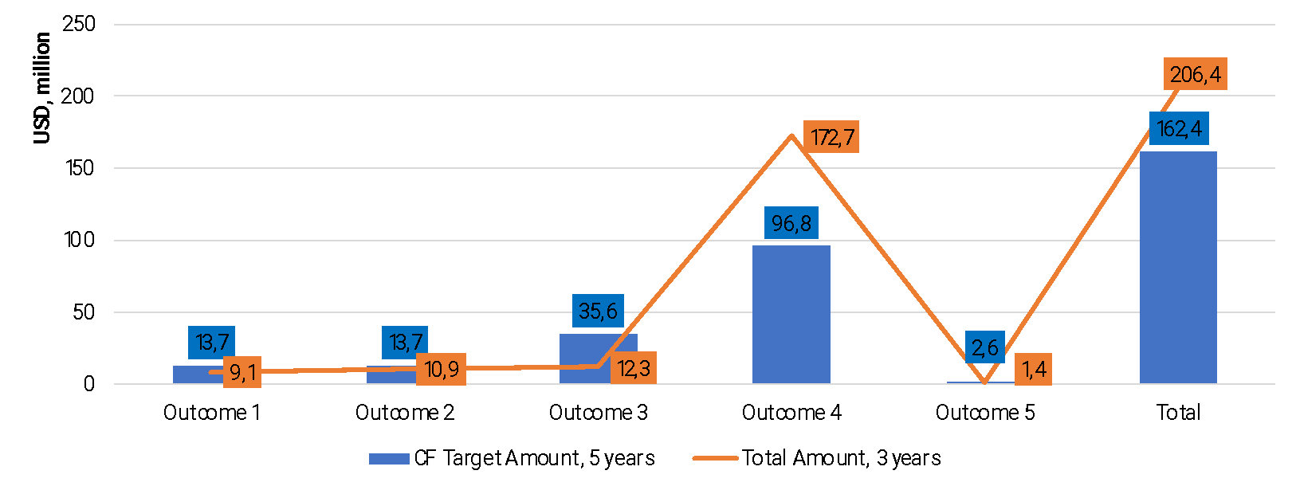 (million USD)***

*Source: UN Turkmenistan dashboard where?*

Other outcomes saw varied levels of progress. For Outcome 1, which aims at effective public administration, $9.1 million was mobilised and delivered out of the $13.7 million target, covering 66% of the goal.

***Graph 16 Planned vs delivered resources and funding gaps under the UNSDCF (million USD)***

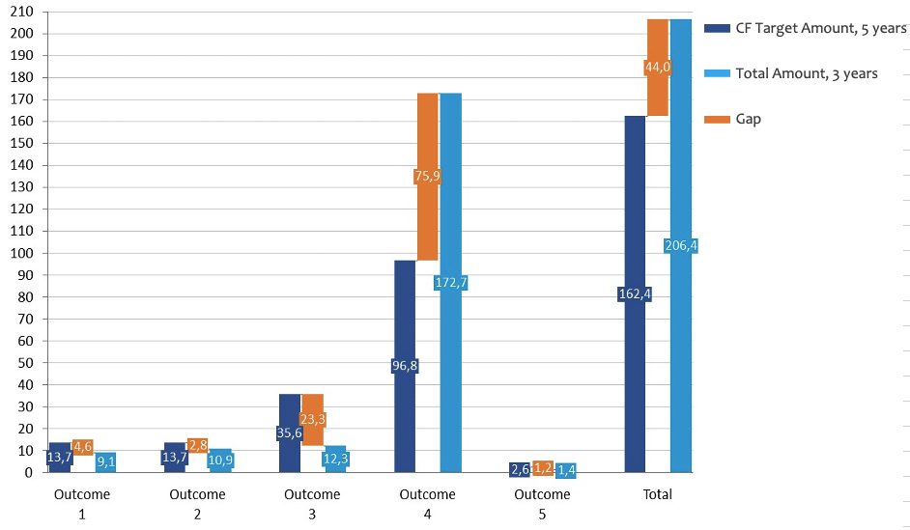

*Source: UN Turkmenistan dashboard ?*

Outcome 2, centred on sustainable economic diversification, reached $10.9 million of its $13.7 million target, achieving 79%.

Outcome 5, which addresses education and skilling, reached 54%; however, in real figures, this area targeted a very modest $2.6 million and delivered $1.4 million.

***Graph 17. Overview of mobilized vs delivered funds, in %***

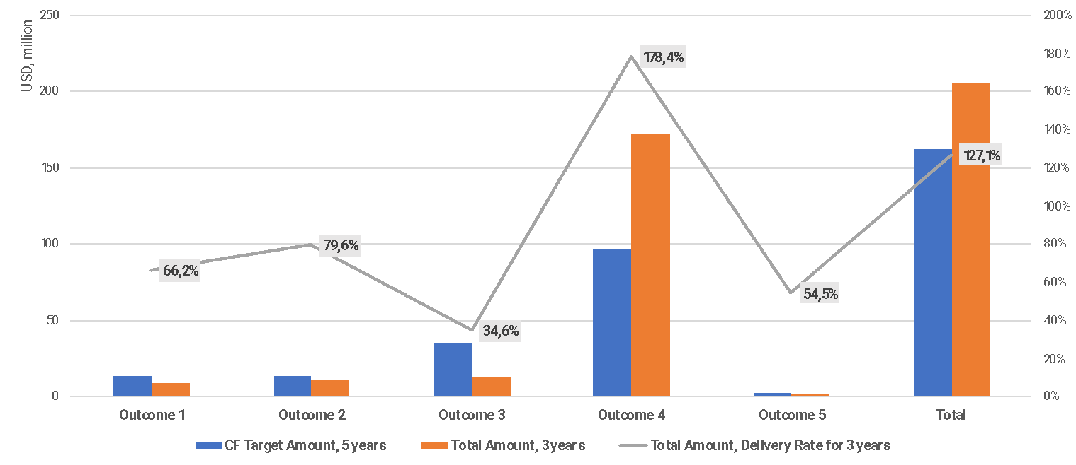

*Source: UN Turkmenistan dashboard ?*

The delivery under Outcome 3 is below expected targets, reaching only 35% ($12.3 versus targeted $35.6 million)

The Government of Turkmenistan’s significant financial contribution, accounting for 70.5% of the total funding, underscores its strong commitment to the nation’s development. However, much of this funding is concentrated on health-related procurement, leaving less government investment available for crucial sectoral reforms. This focus on immediate needs rather than long-term structural changes is further challenged by the limited funding from international donors, who often prioritize specific projects over comprehensive development and reform initiatives.

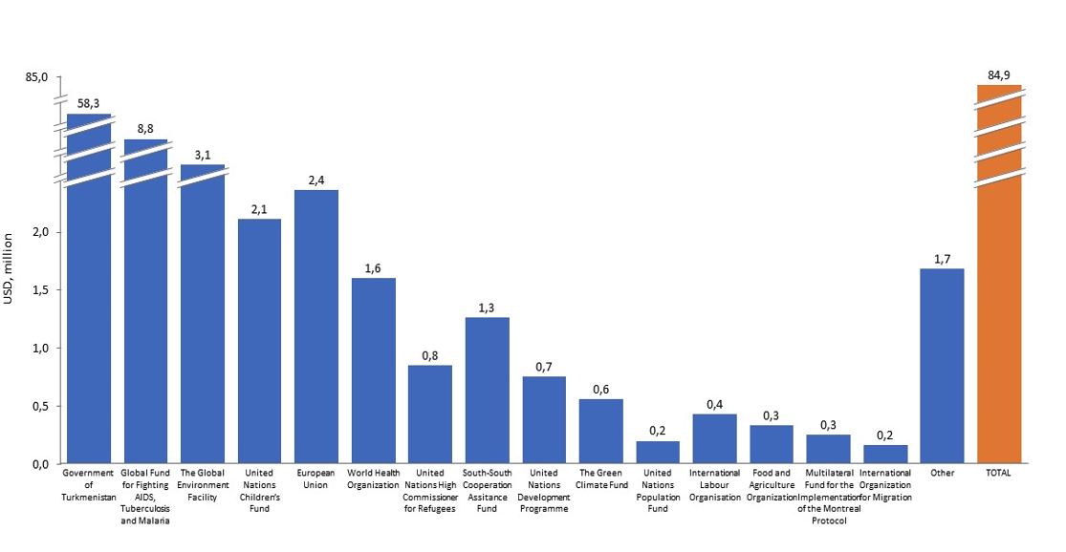***Graph 18. Overview of the development partners and their funding for the UNSDCF implementation in 2023 (million USD)***

*Source: UN Turkmenistan dashboard*

The Global Fund for Fighting AIDS, Tuberculosis, and Malaria emerged in 2023 as the second-largest contributor, providing $8.8 million, or 10.7% . Environmental sustainability also received considerable attention, as evidenced by the $3.1 million contribution from the Global Environment Facility (GEF), which constitutes 3.7% of the total funding, and the Green Climate Fund, which has 0.7% ($555,949 in 2023). Various United Nations agencies used their regular/ core resources to support the implementation of the UNSDCF.

These figures additionally underscored the need for a more balanced and diversified funding strategy.

**F17. In collaboration with the Government of Turkmenistan, UNCT has taken steps to enhance the financing of the SDGs by establishing the Joint Expert Group on SDG Financing (JEG on SDG Financing).**

The JEG on SDG Financing is structured under the National Working Group on SDG Implementation in Turkmenistan, established by a presidential decree in 2017. This expert-level platform has been planned as a critical interface between the UN and the Government, facilitating the development of strategies and proposals to secure financing for the effective implementation of the SDGs. A key focus of the JEG is the development of the Integrated National Financing Framework (INFF) for SDGs, a strategic approach endorsed globally to align financial flows with national development priorities. Additionally, the JEG is responsible for leading the Development Finance Assessment (DFA) exercise, a critical component to guide the subsequent steps in implementing the INFF.

Despite these efforts, the work plan for implementing the INFF in Turkmenistan during 2023 and 2024 reveals a mix of achievements and delays. While governance and coordination have been successfully maintained, including consistent communication within the JEG and preparation of annual reports, the ET observed delays in foundational areas such as the formation and operationalisation of the INFF oversight body. Critical tasks such as mapping existing costs, financing assessments, and conducting risk evaluations have not been implemented as planned, and the development of a detailed roadmap for INFF implementation has also lagged behind schedule. Still, the JEG's work remains critical for ensuring that Turkmenistan can secure the necessary financing to achieve its ambitious SDG targets.

The UNCT's financial commitment towards the SDGs under the UNSDCF is evident and reflects the UN's strategic priorities. The ET found improvements in financial reporting in 2023, which included UNSDCF-related allocation for SDGs. It showed a substantial commitment of resources, with a total of $84.9 million allocated across various SDGs, of which $82.7 million was available for implementation. The distribution of these funds reflects the prioritization of certain SDGs, particularly SDG 3 (Good Health and Well-being), which received the largest share of funding at over $70 million. This focus is indicative of the significant health-related challenges and priorities within Turkmenistan.

***Graph 19. UNSDCF financing for the SDGs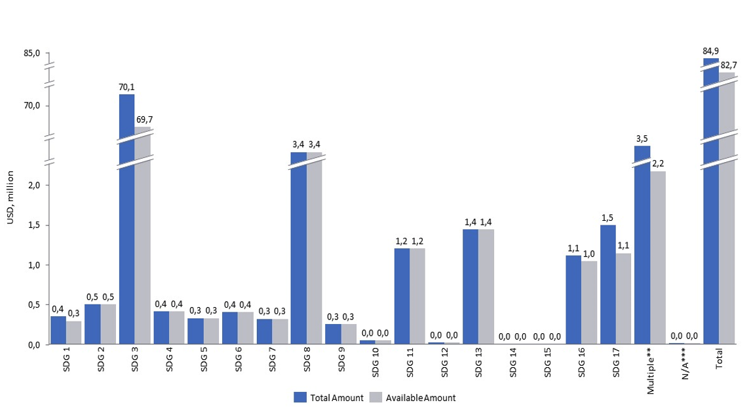 (million USD)***

*Source: UN Turkmenistan dashboard*

Other SDGs, such as SDG 2 (Zero Hunger), SDG 11 (Sustainable Cities and Communities), and SDG 17 (Partnerships for the Goals), also received considerable funding, emphasising the UN's commitment to addressing issues related to food security, urban development, and global partnerships. SDG 13 (Climate Action) and SDG 16 (Peace, Justice, and Strong Institutions) were also prioritised, with over $1 million allocated to each, reflecting the importance of climate resilience and governance in the development agenda.

However, the ET noted a significant challenge in how these funds have been associated with the SDGs, as many activities under UNSDCF contribute to multiple SDGs simultaneously, making it difficult to disaggregate the impact of funding by individual SDGs. The allocation labelled as "Multiple," totalling $3.48 million, further highlights this issue, where funds contribute to more than one SDG. Yet, the precise distribution among the targeted SDGs needs to be clearly defined. This ambiguity makes it challenging to assess the exact impact of the funding on each SDG. It underscores the need for a more refined mechanism to track and report how funds contribute to specific SDG outcomes.

***EQ4.3. Was the UNSDCF supported by an integrated funding framework and adequate funding instruments?***

**F18. The positive total outcome masks significant variations among the agencies. Some agencies showed strong resource mobilisation capabilities; on the other hand, there are UN agencies with fewer resources, and others are just initiating programs in Turkmenistan.**

UNDP stands out as the most significant contributor, mobilising $141.4 million over three years, exceeding its five-year target of $124.6 million by $16.8 million. UNICEF also significantly exceeded its target, mobilising and delivering $38.3 million against a target of $8.4 million, resulting in an excess of $29.9 million. WHO and UNHCR have similarly outperformed their targets. WHO secured $4.2 million against a target of $700,000, exceeding the target by $3.5 million. UNHCR mobilised $1.2 million, surpassing its $100,000 target by $1.1 million. FAO and UNECE also exceeded their respective targets. FAO mobilised $3.2 million against a $2.7 million target, , while UNECE secured $239,000, surpassing its modest target of $200,000.

***Graph 20. Overview of UN Agencies planned vs delivered funds under the UNSDCF implementation (mil USD)***

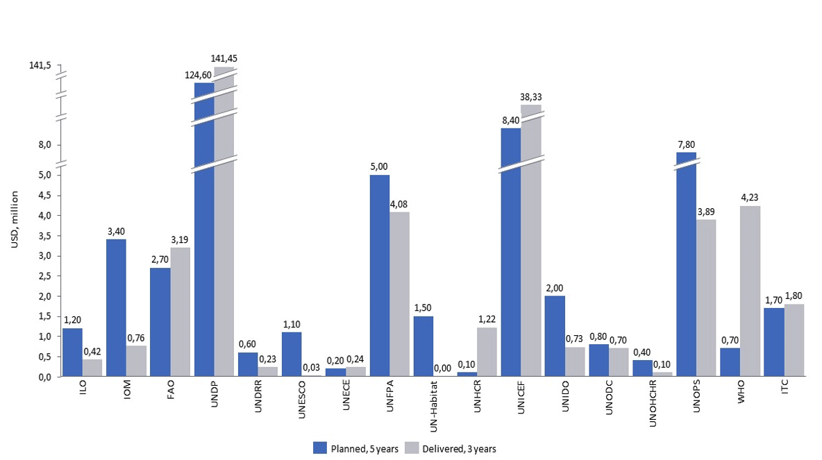

*Source: UN Turkmenistan dashboard*

These disparities among agencies suggest a need (to explore potentials) for recalibrating strategies to ensure that all UNSDCF outcomes are adequately funded and effectively implemented. In this context, the EC finds that RC/ RCO work on advocating for and engaging with the Government to address these issues and promote the diversification of co-financing methods under the UNSDCF.

***Graph 21. Overview of the financial status of UN Agencies- 2021-2023***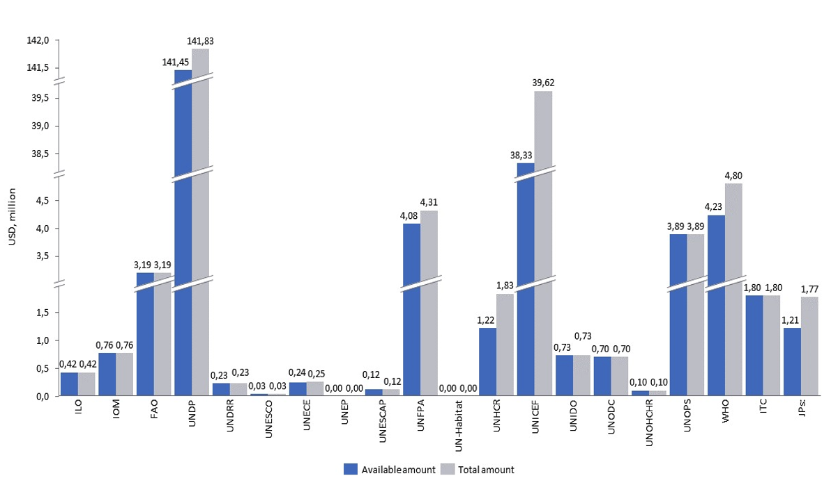

*Source: UN Turkmenistan dashboard*

The proposal for a ***Pooled Fund*** approach has been central to these efforts and the mid-term review report also recognised these forward-looking efforts for supporting progress under SDGs. The interviewed representatives, especially from smaller and non-resident UN Agencies, recognised the positive sides of the Pooled Fund model as a platform for stronger strategic planning and more effective support for underfunded priorities. They expect that this platform could facilitate a clearer delineation of roles with stronger partnerships between UN entities and national ministries, and improved coherence and quality assurance of outcomes. The example of the Joint Programme on Social Services (that the Joint SDG Fund supported) has been emphasised, with systemic improvements (adoption of the Law on Social Services) and strengthened services to reach the most vulnerable populations. To maintain the momentum and fully implement the National Social Services Development Plan through 2030, the Pooled Fund has proposed the continuation of this joint programme in Phase II. Discussions among experts regarding establishing a national Pooled Fund have progressed, developing draft Terms of Reference (ToRs), a Memorandum of Understanding (MoU), and a Standard Administrative Arrangement. Future steps include creating the Fund's Operations Manual and establishing a dedicated Fund Aid Unit within the Government to strengthen resource management capabilities. In addition to three strategic UNSDCF priorities, the Pooled Fund is recommended to incorporate a climate window[57]

**F19. The "Delivering as One" (DoA) approach in Turkmenistan has led to some operational efficiencies, particularly in procurement and logistics. However, feedback from stakeholders indicates mixed perceptions about the actual progress regarding the DoA.**

The UNCT in Turkmenistan is following the "Delivering as One"- with the establishment of the Operations Management Team (OMT) to enhance the cost-efficiency and effectiveness of operations. The OMT's implementation of the UNCT Business Operations Strategy (BOS) led to some achievements, including securing long-term procurement agreements for essential services such as office supplies, travel, and logistics. However, survey feedback indicates divided views concerning progress in the DoA implementation. While 14.29% of respondents felt the approach was implemented completely, and 42.86% believed it was sufficient, an equal proportion of 42.86% indicated that it was insufficient.

The concerns raised by respondents primarily revolve around the fragmentation of projects and the lack of coherent, integrated JWPs. Instead of working towards joint outcomes, many initiatives appeared to be isolated efforts driven by individual agency mandates rather than a unified strategy. Additionally, the divergence in procedures, operations platforms, and the use of different policies and systems by various UN agencies were cited as significant barriers to achieving greater integration and collaboration. Respondents also highlighted the need for more interaction and communication between agencies, emphasising that increased cooperation could lead to a more seamless and effective DoA.

***Graph 22 Perception of Delivering as One by UN Operations Staff***

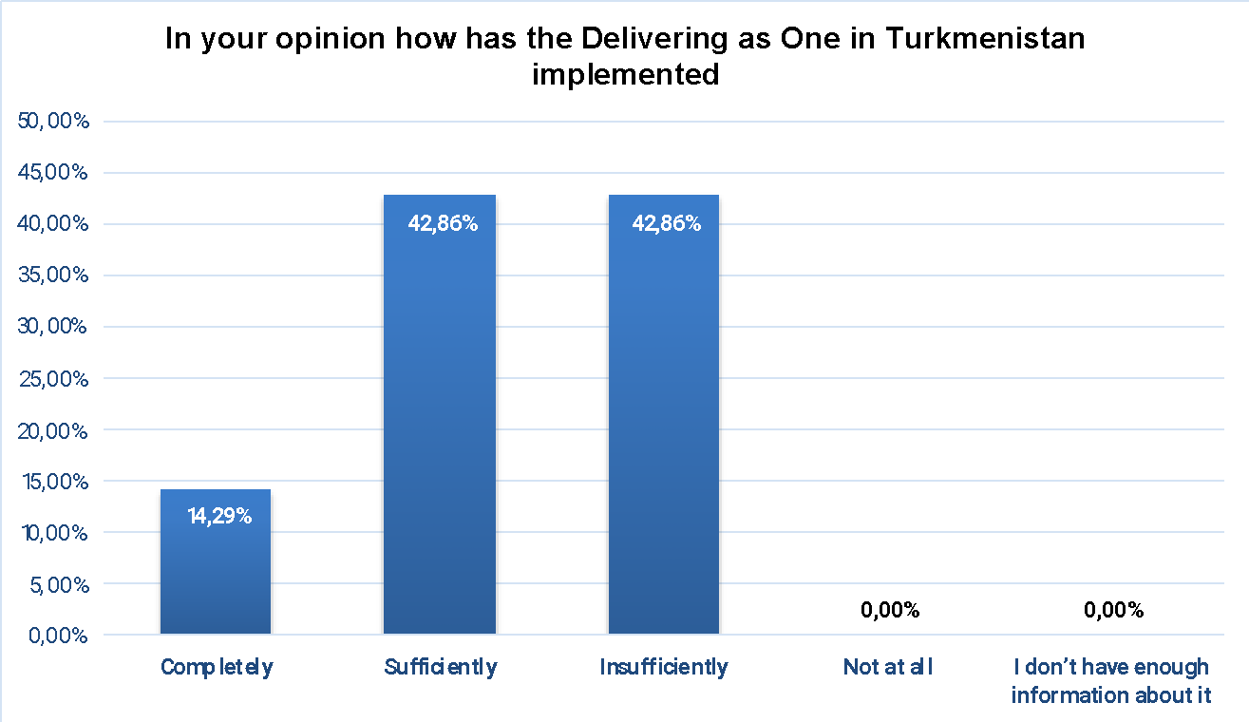

1. *Source: Results of the on-line survey- UN Programme and Operations staff*

The survey further highlighted specific areas where the DoA made noticeable progress. For instance, 50% of respondents who answered positively acknowledged advancements in the joint procurement of goods and services, joint recruitment of experts, and ICT support. These areas of progress reflect a growing willingness among UN agencies to collaborate more closely in certain operational aspects, leading to cost savings and enhanced efficiency. Additionally, 75% of respondents recognised improvements in shared premises and common utilities, which have reduced overhead costs and fostered a more cohesive working environment among the agencies.

Despite these advancements, the approach was seen as underperforming in critical areas such as financial management, establishing a “One UN budget,” and implementing joint communication. The respondents recognised some progress in these areas, expressing concerns about challenges in aligning financial and operational processes across agencies. The feedback underscores the need for a more concerted effort to unify operational practices, improve communication, and ensure that all agencies work towards shared goals.

**Monitoring and evaluation** have been integral to the UNSDCF’s implementation, creating a dedicated UNSDCF M&E Group comprising senior officials and specialists from across the UN agencies. This group was tasked with developing a robust M&E system based on the Results Matrix, including clear indicators, baselines, and targets. However, the mid-term evaluation highlighted some areas for improvement, such as the need for clearer monitoring protocols and better-defined roles. The M&E Plan initially struggled to fully capture the contributions of individual UN agencies toward achieving overall outcomes. Despite these early challenges, the 2023 annual progress report marked significant advancements in reporting, with a sharper focus on outcomes, alignment with the SDGs for Turkmenistan, and enhanced financial and gender-related progress tracking.

**Communication** has also been a critical area, with the "Communicating as One" strategy has been adopted to “ensure coherence and effectiveness”. The UN Joint Communication Team (JCT), comprised of communication experts from various UN agencies, developed a Joint Communication Strategy and Action Plan, with the RCO office coordinating these efforts. This included regular meetings, updates, and coordinated communication efforts for key initiatives. However, challenges remain in securing a consistent budget for these joint communication activities and in fostering greater engagement from UN agency staff. This area is perceived as one that needs improvements.

## Progress towards impact

The evaluation of progress towards impact involved analyzing the tangible changes observed at the national level, particularly in the context of key reform areas linked to the SDGs. The ET identified several instances where the UNCT contributed to these changes, focusing on policy and systemic changes, also reflecting on inherent challenges.

***EQ 5.1. To what extent do the UNSDCF's achieved results demonstrate sound and sustainable progress towards achieving the expected SDG targets and reform priorities?***

**F20. The UNSDCF has contributed to advancing Turkmenistan’s progress toward achieving SDG targets and reform priorities, with UN Agencies playing a critical role in policy development, capacity building, and introducing innovative approaches. However, identifying the UN's contribution to national outcomes is inherently challenging, a topic underscored during UNCT discussions, emphasising the difficulty and importance of accurately measuring the UN's impact on national development.**

UN Agencies have been instrumental in supporting developing and implementing key national policies and frameworks directly aligned with SDG targets. For instance, in the health sector, UN support has been crucial in strengthening the Ministry of Health’s capacity to manage public health issues, procuring essential medicines and vaccines and training healthcare workers. These initiatives have addressed immediate needs and laid the groundwork for a more resilient and sustainable health system that can contribute to the achievement of SDG 3 (Good Health and Well-being).

In the area of social protection, the development of the Law on Social Services represents a significant advancement in Turkmenistan’s social policy framework. This law institutionalizes a range of community-based social services for vulnerable populations, including the elderly, people with disabilities, and economically disadvantaged groups, aligning with the broader objectives of SDG 1 (No Poverty) and SDG 10 (Reduced Inequalities). The UN’s advocacy efforts and technical assistance in this area have been crucial in ensuring that these services are established, funded, and sustained over the long term. In the context of development planning, UN provided technical assistance and worked closely with the Government on the development WTO Accession roadmap, contributing to **SDG 8 (Decent Work and Economic Growth)** and **SDG 17 (Partnerships for the Goals)**. This roadmap includes the Framework Agreement on Facilitation of Cross-Border Paperless Trade, aimed at modernizing and streamlining trade processes to enhance efficiency and compliance with international standards (also facilitating cross-border paperless trade). The UN-Government Joint Expert Group on SDG Financing also worked on public financial management systems and integrated national financing frameworks.

Similarly, in the realm of climate change and environmental sustainability, UN Agencies have supported the development of key strategies, such as the National Strategy on Renewable Energy and the Nationally Determined Contributions (NDCs) under the Paris Agreement. These efforts are central to Turkmenistan’s progress towards SDG 7 (Affordable and Clean Energy) and SDG 13 (Climate Action). Creating a National Child-Centered Disaster Risk Reduction Strategy further underscores the UN’s commitment to building a resilient and inclusive development framework that can withstand future shocks, directly contributing to SDG 11 (Sustainable Cities and Communities).

However, while these policy advancements are significant, the evaluation highlights ongoing challenges in ensuring the effective implementation of these policies and ensuring sectoral-level impact. Capacity development, a core component of UN interventions, remains a complex and long-term process. While UN Agencies have made tangible efforts to build the capacities of national institutions, the full impact of these efforts is often delayed by external factors such as changes in government priorities, staff turnover, and the broader socio-economic environment. These factors can undermine the continuity and effectiveness of capacity-building initiatives, mainly when there is a lack of a comprehensive human resource development strategy or performance-based management systems within public institutions.

**Limited data availability and challenges in monitoring and measuring progress towards impact and achievement of outcome targets (and broader SDG targets) also hamper the sustainability of progress under the UNSDCF.**

The lack of detailed demographic data and the absence of robust monitoring and evaluation systems make it difficult to track progress toward SDG targets and assess the impact of UN interventions. Establishing an SDG database, supported by the UN, is a critical step towards addressing these gaps. This database, coupled with the National Action Plan on SDG indicators, can significantly enhance the State Statistics Committee's (SSC) capacity to collect, analyze, and disseminate data related to SDG progress. However, the operationalization of these systems remains a work in progress, and their effectiveness will depend on sustained investment in IT infrastructure, technical staff capacity, and the development of new statistical methodologies aligned with international standards.

Furthermore, the evaluation identified the need for greater coordination and integration of policy initiatives to ensure that they contribute to sustainable development outcomes. While the UN has supported the development of policies and strategies across various sectors, the institutionalisation and broader application of these models depend heavily on the commitment and ownership of national stakeholders. This is particularly true for initiatives that involve sensitive issues such as human rights, gender equality, and governance reforms, where progress is often difficult to quantify or publicly claim.

The evaluation emphasizes the importance of a strategic and integrated approach to ensure that the results achieved under the UNSDCF lead to sustained progress towards SDG targets. This includes securing consistent financial support, strengthening institutional capacities, and enhancing data collection and monitoring systems. The UNCT must continue to work closely with government partners to secure upfront commitments and mobilize additional resources, including from the private sector, to sustain and scale successful interventions. Additionally, investing in ongoing capacity-building and knowledge-sharing activities will be crucial to fostering a stronger sense of ownership and commitment among national institutions.

## Sustainability

The analysis of sustainability prospects centred on the likelihood that national partners and stakeholders will maintain the progress made towards the UNSDCF outcomes over time. The ET assessed how well the UNSDCF incorporated sustainability considerations into its design and implementation, ensuring the achievements would endure beyond the CF's lifespan.

***6.1. How likely is progress towards the outcomes (and SDGs) to be sustained over time by national partners and stakeholders?***

**F21. UN Agencies in Turkmenistan have established several mechanisms that could support the sustainability of outcomes and progress towards the SDG targets.**

The demand to ensure the sustainability of the achievements under the UNSDCF (hence, maintain the progress under outcomes) has been considered from the design stage[58]. The ET finds that most effective tools have been capacity development and institutional strengthening, policy advocacy and reform, partnership building and multi-stakeholder engagement, and knowledge management and learning. However, sustainability and scalability of results remain critical challenges due to factors such as limited and unpredictable financial and human resources, frequent changes in government counterparts and priorities, including limited institutional capacities and ownership of some of them, and lack of clear strategies for sustaining and scaling up outcomes beyond the UNSDCF period. Long-lasting partnerships between UN Agencies and the national institutions in Turkmenistan (together with the political neutrality and strong country's commitment to international cooperation) have been positive factors that contributed to an increased sense of ownership (as the basis for sustainability).

The ET finds that the UN Agencies in Turkmenistan have established several mechanisms that support the sustainability of outcomes.

* **Capacity development at various levels:** During the implementation of UNSDCF, UN Agencies have been effective in providing tailor-made and, to a large extent, innovative capacity development assistance, investing in the skills, knowledge, and capabilities of individuals, organizations, and systems to create a foundation for continued progress and self-reliance. This balanced approach focused on strategic priorities and demands in line with the mandates of these partner organisations, also considering the needs of end-beneficiaries[59].

The ET finds positive evidence of capacity development for the delivery of services under all outcomes[60]. For example, strengthening capacities within the social protection system and advancing the delivery of community services has been ensured in partnership with the Ministry of Labour and Social Protection (MLSP). It included extensive training programs for social workers and government staff[61] on the basic theory and practice of social care, also addressing strengthening specialised services for vulnerable populations. The UN focused on enhancing the capacity and role of NGOs in delivering some services. This involved identifying government champions who understand the value that NGOs can bring and supporting these champions in raising awareness and building support within the government for NGO-led service provision.

Support to the professionals from the public health system has been provided with a focus on different aspects and services, such as early childhood development and modern practices in research and prevention of non-communicable diseases[62]***.*** Also, important (and largely innovative) capacity development activities addressed health services for vulnerable groups- for example, early identification services for developmental delays and disabilities among young children. The tailor-made capacity development programme targeted primary health care (PHC) professionals, expanding early intervention services to more districts. In addition, a five-year Integrated Management of Childhood Illness (IMCI) was developed and approved. In parallel, UN Agencies enhanced laboratory capacities at primary healthcare facilities, including health houses and polyclinics, contributing to reliable and up-to-date laboratory investigations.

The capacities within the education sector have been addressed to deliver competency-based curricula at primary and secondary levels, focusing on foundational, transferable, and digital skills; also, UN Agencies responded to the needs for enhancing capacities for digital education and e-book development[63].

* **Improving national institutions, addressing their operational efficiency, modernisation, and supporting procedural reforms:** UN implemented organisational development as part of a sustainability strategy to meet organisational strategic objectives and improve service delivery. A strong focus was placed on capacity development, particularly in governance, human rights, gender equality, and the rule of law. For instance, UN Agencies enhanced the capabilities of law enforcement bodies to support child victims and witnesses of crime, and strengthened the Ombudsperson's Office to manage complaints effectively, ensuring accessibility for all, including individuals with disabilities. The UN supported the development of the National Action Plan on SDG Indicators and the establishment of an online SDG database, improving the Government's ability to monitor and report on sustainable development and fostering greater transparency and accountability. The ET already elaborated on examples of strengthening institutions within social protection or health care. In social services, the UN assisted the Ministry of Labour and Social Protection in developing policies to enhance social protection systems. Similarly, the UN worked with the Ministry of Health and Medical Industry to improve healthcare services, coordinating health procurements and offering policy advice, thereby mitigating the impacts of the global cost-of-living crisis and improving health outcomes for the population. In education, the UN developed institutional capacities for inclusive policies, particularly for vulnerable children, helping to make schools more inclusive and child-focused.

Moreover, the UN's efforts to support micro, small, and medium enterprises (MSMEs) by digitalising the economy and improving financial markets have laid the groundwork for their growth.

**Policy Advocacy and Reform as a Sustainability Strategy:** The UNCT has played a pivotal role in shaping sustainable outcomes by driving key policy reforms. Critical achievements include the National Human Rights Action Plan (2021-2025), the National Action Plan on Combating Trafficking in Persons (probably for four years, beginning in 2025), and the Law on Social Services, all of which align with international standards and SDG targets. In addition, the UN facilitated the creation of the National Action Plan on Gender Equality (2023-2028) and the National Action Plan on Child Rights (2023-2028), furthering gender equality and child protection. Environmental sustainability efforts were bolstered through the development of the National Strategy on Renewable Energy and related legal frameworks.

However, the sustainability of these reforms is challenged by weak policy implementation capacities, insufficient data for monitoring, and inadequate coordination among stakeholders. The rapid rollout of new services exposed gaps in workforce capacity, while limited involvement of local authorities in early planning stages hindered effective execution. To ensure these policies lead to lasting impact, there is a critical need to strengthen institutional capacities, improve data availability, and enhance coordination across all levels of governance

* **Partnership Building and Multi-Stakeholder Engagement:** The UNCT has actively pursued partnership building and multi-stakeholder engagement to mobilize resources, expertise, and networks essential for the long-term success of its interventions. This collaborative approach has been crucial in driving sustainable development efforts across various sectors.
* **Knowledge Management and Learning for Sustainability:** The UN has strategically invested in knowledge management and learning to ensure continuous improvement and the sustainability of its initiatives. Key efforts include establishing a National SDG database to enhance the monitoring and evaluation of progress towards SDG targets, and promoting the Education Management Information System (EMIS) for data-driven education management and policymaking. Additionally, the UN has played a pivotal role in building national capacities through targeted training and the development of the Social Work Bachelor program, which includes curriculum development and faculty training based on international best practices. These initiatives are designed to equip social workers with the necessary skills and knowledge to deliver high-quality services. Furthermore, the UN has mainstreamed climate change adaptation and disaster risk reduction into the education system by developing methodological manuals and digital curricula, thereby enhancing the resilience of schoolchildren and local communities.

Despite UNCT's catalytic and convening role in various areas, several interviewees identified sustainability and scalability of results as key challenges of interventions implemented under the UNSDCF. While various initiatives have successfully piloted innovative approaches and delivered positive results, UNCT's limited financial and human resources constrain its ability to sustain and scale these interventions independently.

Evaluation participants identified several sustainability-related priorities that the UNCT could focus on more closely in the future. The following key areas emerged during this evaluation:

* Strengthening the connections between output-level interventions and broader systemic changes is essential. This will ensure that the benefits of UN Agencies' activities are sustained and scaled up beyond individual initiatives.
* Developing sound exit strategies is crucial. This involves building local capacities and advocating for the integration of successful models into national policies and programs. Some evaluation participants suggested that the UNCT should be transparent with government partners about the temporary nature of its support and the need for sustainability plans.
* Enhancing the monitoring, evaluation, and reporting of sustainability indicators and the achievement of outcomes is necessary. This will better demonstrate the long-term effects of the UN's interventions under the UNSDCF and inform future UNSDCF preparation, programming, and decisions on priority initiatives.
* Investing in successful initiatives' financial sustainability is important to ensure their continuity. To mobilize additional resources, innovative financing mechanisms, such as global funds, IFIs, and public-private partnerships, can be explored.
* Promoting the active participation and ownership of beneficiaries and local stakeholders in the design, implementation, and monitoring of UN Agencies' initiatives from the planning and programming stages through implementation has been and remains essential. Although it was done in the previous cycle, there is a need for more open and ctitical interactions

**F22. Many UN's partners have shown ownership and commitment to providing ongoing support for sustaining the results and progress under the UNSDCF outcomes. However, challenges remain in ensuring the long-term sustainability and scalability of certain results, particularly in the context of changing socio-economic priorities, challenges concerning substantive sectoral and governance reform, and the need for more strategic planning and diversified resource mobilization.**

The commitment of national institutions to sustain and scale the outcomes of UNSDCF initiatives varies across thematic areas, reflecting differing levels of financial, aspirational, and human resource support. The evaluation found strong evidence of sustained commitment, particularly in health, climate change, social services, and inclusive growth. For example, the Ministry of Health and Medical Industry has demonstrated a significant commitment to enhancing public health systems, including the procurement of medicines, vaccines, and diagnostic equipment, as well as training healthcare workers—signalling a clear intent to sustain and scale the impact of these initiatives.

Similarly, the State Statistics Committee (SSC) has committed to advancing its data collection, analysis, and dissemination capabilities, supported by national funding. This includes upgrading IT infrastructure, enhancing technical staff capacities, and developing new statistical methodologies aligned with international standards. Key achievements, such as the Statistical Business Register and the SDG database, crucial for informed decision-making and monitoring progress, will be maintained through ongoing national support.

However, challenges remain in securing consistent financial backing for strengthened institutions, particularly at the local level. The sustainability of these initiatives is influenced by changing government priorities, policies, and budgets, particularly during staff turnover and political transitions. Additionally, the lack of a comprehensive human resource development strategy and high turnover in public institutions have hindered the sustainability of developed capacities. The current economic situation and long-term effects of COVID-19 further constrain the availability of resources.

The evaluation underscores the need for a strategic, integrated approach to sustainability that addresses financial, institutional, and policy challenges. Proactive engagement with government partners to secure upfront commitments and mobilize diversified funding sources, including private-sector partnerships, will be critical. Investing in capacity-building through training, technical assistance, and knowledge-sharing is essential to foster a stronger sense of ownership and long-term commitment among national partners.

While recognizing the multitude of partnerships that UN has established to sustain the attained results, several evaluation participants noted that there are opportunities for further strengthening and leveraging these partnerships. The following are the main ideas that emerged during this evaluation.

* Advocating with government partners to strengthen institutional commitments for taking over and scaling up successful initiatives, as the ET found that securing firm financial and operational commitments from government partners to sustain initiatives after UN's exit has been challenging.
* Exploring greater engagement with universities and research institutions, as there is untapped potential for collaboration with academia and the research community.
* Promoting more strategic and long-term partnerships, beyond initiative-based collaborations, to address systemic challenges.
* Strengthening the capacity of partners, particularly local NGOs and private sector actors, to sustain and scale up the results achieved by providing targeted technical assistance, knowledge-sharing, and networking opportunities.
* Exploring the links between digitalisation and development and opportunities to use digitalisation in addressing LNOB-related priorities

***6.2. In which UNSDCF strategic priority areas the progress of vulnerable groups is likely to be sustainable?***

**F23. While UNCT has achieved progress under all SDGs, the sustainability of these results will depend on the national institutional and financial capacities to maintain these achievements. Still, UNCT prioritised reaching and empowering the most vulnerable groups through targeted interventions and integrating gender considerations into all aspects of its programming. There are opportunities to further enhance the sustainability and impact of these cross-cutting efforts by adopting a systematic mainstreaming approach, ensuring gender participation and transformation and further streamlining disability inclusion, strengthening the capacity of UN staff and partners, advocating for the integration of cross-cutting issues into national policies and accountability frameworks, institutionalizing gender and disability inclusion-related mechanisms, and strengthening engagement with advocacy groups.**

UN Agencies in Turkmenistan have prioritised achievement of SDG targets and focused on reaching and empowering the most vulnerable populations, including marginalised women and girls, youth, persons with disabilities, and rural communities. By integrating gender equality and women’s empowerment into all aspects of planning and programming, the UN has laid the groundwork for sustained progress in these areas. This includes developing the National Action Plan on Gender Equality (2023-2028) and the National Report on CEDAW, which, for the first time, includes data on domestic violence. Targeted interventions such as bridging the digital gender divide, fostering economic independence for women, and promoting environmentally sustainable women-led startups are poised to yield long-term benefits. Additionally, systems to respond to gender-based violence (GBV) have been strengthened through multisectoral responses, SOPs, crisis centers, and hotlines, ensuring that these initiatives have a lasting impact.

Efforts to support vulnerable groups extend to expanding employment and vocational education opportunities for youth and persons with disabilities, ensuring their inclusion in the workforce and society. These initiatives, coupled with sustainable agricultural practices, water management, and energy efficiency projects in rural areas, directly involve local communities in planning and execution, enhancing the likelihood of sustainability. Furthermore, rapid assessments during the COVID-19 pandemic highlighted the need for comprehensive health and social protection measures, leading to strengthened healthcare access and inclusive education initiatives that are vital for long-term resilience.

To ensure the sustainability of these achievements, the evaluation participants suggested the following key measures:

* Integrating Leave No One Behind (LNOB) principles, gender equality, and human rights across all initiatives will ensure that project results are sustained and scaled inclusively and equitably.
* Moving beyond participation to achieve real gender transformation requires a structured approach to implementing and evaluating gender-sensitive policies, ensuring that inclusivity efforts lead to meaningful advancements.
* Enhancing the capacity of UN staff and partners to apply LNOB and gender-responsive approaches will be crucial for sustaining development outcomes.
* Advocating for the inclusion of cross-cutting issues like disability inclusion, gender equality, and human rights into national policies and budgets will institutionalise these priorities and ensure the sustainability of results.
* Establishing sustainable LNOB and gender-related mechanisms within community initiatives and governance structures will foster long-term inclusivity and equity.
* Strengthening partnerships with civil society, academia, and advocacy groups will amplify results and ensure that interventions remain responsive to the evolving needs of disadvantaged groups.

These strategies are essential for embedding sustainability into the UNCT's efforts and ensuring the achievement of the SDG targets that are particularly relevant for vulnerable groups

# Conclusions and lessons learned

The ET prepared conclusions based on an in-depth analysis of findings and facts obtained from desk reviews, surveys, interviews, and direct interactions with final beneficiaries through focus groups.

## Conclusions about UNSDCF relevance

The UNSDCF's design and implementation strongly aligned with Turkmenistan's national development priorities and the needs of its population. The CF successfully incorporated key national strategic documents, including the National Programme for Socio-Economic Development (NPSD) and the Presidential Programme for Socio-Economic Development (PPSD), ensuring that the UNSDCF remained relevant to the country's evolving socio-economic context and the revised strategic and policy documents. The UNSDCF also effectively addressed the needs of vulnerable groups by embedding human rights-focused strategies across its outcomes. Through strategic support for national policies and strategies, the UNSDCF prioritised inclusivity and accessibility, ensuring that development benefits reach all segments of society.

The UNSDCF demonstrated flexibility and responsiveness, particularly in its adaptation to emerging challenges during and after the COVID-19 pandemic. The UNCT's ability to rapidly mobilise resources and align its efforts with national response plans exemplified its operational agility. This adaptability was crucial in mitigating the pandemic's impact on the country's socio-economic landscape, particularly for vulnerable populations.

However, there are areas for improvement, particularly in the initial prioritisation of gender considerations within the UNSDCF's design. While efforts were made to integrate gender equality into various outcomes, the framework's gender-sensitive indicators were insufficient, limiting the ability to track substantive progress towards gender equity. This shortfall underscores the need for a more robust approach to gender mainstreaming in future programming. A similar situation is with mainstreaming disability inclusions, which highlights the importance of including LNOB more substantively throughout the programming cycle.

## Conclusions on coherence and coordination

The UN Agencies have aligned their programs and work plans with the UNSDCF, which served as a practical framework that guides the development of country-specific strategies and programs for the UN Agencies, ensuring they are synchronised with the strategic priorities and outcomes defined within the UNSDCF. At the same time, the existence of parallel agency-specific programs alongside the UNSDCF complicates monitoring and reporting, creating additional reporting burdens and possible inconsistencies in data collection and analysis while complicating the assessment of progress towards UNSDCF outcomes.

The post-reform United Nations Resident Coordinator Office (UN-RCO) has played a critical role in enhancing the coherence of UN efforts. The RCO's strategic leadership and high-level engagement with government bodies have been pivotal in aligning UN activities with national development priorities and globally prioritised SDG transitions. This coordination has facilitated a more unified approach among UN agencies, including non-resident agencies, which have been effectively integrated into the planning and implementation processes. However, there are concerns about the RCO's focus on involving agencies with limited implementation capacities in complex initiatives. Also, the challenge remains concerning engagement in resource mobilisation and program implementation. The RCO's driven Pooled Funding opportunity is beneficial in fostering collaboration and cooperation among UN Agencies and national partners. However, establishing and operationalising Pooled Funding would depend on whether all UN agencies recognise and agree with this funding approach.

The established coordination mechanisms, such as the Steering Committee and Results Groups, have generally promoted collaboration and aligned efforts across sectors. These structures have supported joint planning, programming, and monitoring activities, contributing to a more cohesive implementation of the UNSDCF. Nevertheless, there is room for improvement in leveraging these mechanisms for more strategic discussions and cross-sector synergies. The potential for deeper integration and cooperation across different outcomes remains underutilized, suggesting that these groups could be more active in driving strategic alignment and ensuring the coherence of UN interventions.

## Conclusions about effectiveness

The evaluation of the UNSDCF's effectiveness in Turkmenistan reveals mixed results, reflecting both significant achievements and areas of concern. The UNSDCF has been instrumental in promoting institutional reforms, supporting policy development, and responding to the needs of vulnerable populations. Notable progress was observed in areas such as establishing the National SDG Database, the social welfare/ social protection system, including community-based social services, health system improvements, WTO accession support, and launching key economic and social initiatives, including digital governance systems. However, challenges persist in fully realizing the expected outcomes. These include the slow pace of implementation in critical areas such as institutional reform and good governance, financial and banking tools for green economy growth, the development of inclusive education, accessing social services and ensuring sustainable disaster risk reduction measures. The evaluation highlights that while foundational work has been laid in several sectors, the overall pace of reform and adoption of new practices is slower than anticipated, and significant gaps remain in data collection, alignment of output indicators with activities, and the sustainability of interventions.

External factors such as the complex geopolitical environment, security challenges within the region and governance issues within the country have also hindered the effectiveness of the UNSDCF. These challenges have limited the ability to scale successful initiatives. Despite these obstacles, the likelihood of achieving some UNSDCF outcomes remains feasible, contingent upon intensified efforts, better resource mobilization, and enhanced coordination among UN agencies and national partners.

Addressing these gaps, particularly in ensuring national capacities, enhancing government commitment, and fostering cross-sector synergies, is essential moving forward.

## Conclusions on efficiency

The UNSDCF Funding Framework was strategically designed to align financial resources with Turkmenistan's sustainable development priorities and the SDGs, reflecting a comprehensive understanding of the country's development needs. The framework facilitated transparency in resource utilisation and strength in resource mobilisation, particularly in the health and social protection sectors. Particularly successful UNCT has been in mobilising and delivering resources under Outcome 4.

However, resource utilisation efficiency varied across different outcomes. While health-related initiatives saw substantial funding, other areas, such as disaster risk reduction and climate adaptation (Outcome 3), were under-delivering (with 35% of the targeted funds). Similarly, evident discrepancies exist in financial plans and allocations under outcomes. Moreover, while the total funds secured exceeded the five-year target, a significant funding gap remains within the critical areas (such as economic reforms, education and governance) partially created by the reliance on government contributions that were primarily directed towards health-related procurements rather than long-term structural reforms. These disparities underscore the need for a more balanced and diversified funding strategy that addresses immediate social and health needs as stated national priorities but also considers and drives sustainable reforms across various sectors.

The UNCT made efforts to establish strong partnerships and enhance financial management, but some challenges remained in realising the full potential of the "Delivering as One" approach. UN Agencies need to achieve greater operational efficiency by addressing issues such as fragmentation of initiatives, coordination and cooperation challenges, and unified strategies among UN agencies.

## Conclusions on progress towards impact

The UNCT has contributed to achieving (some of) the expected SDG targets and reform priorities, but several challenges hinder fully realising these impacts. The complexity of defining and measuring the UN's contribution to national outcomes is evident, particularly in capacity development, where the relationship between capacity building and performance is difficult to quantify and often takes time to manifest in tangible results. One of the areas in which capacity development support has been invested in enhancing data collection and monitoring capabilities for a meaningful analysis of the achievement of SDG targets; however, this area requires further support and integration with public funds. Moreover, piloting innovative approaches and reform models that have shown promise depends heavily on the government's commitment, which is beyond the UN's direct control. Complementary to this, UN's efforts in policy advocacy and systemic change have yielded critical advancements in areas such as social protection, disaster risk reduction, human rights, and gender equality. However, translating these policies into actionable, well-funded, monitored programs remains a work in progress. Despite these challenges, the UN's role in supporting national planning, policy development, and capacity building has laid the groundwork for potential long-term impacts. Still, its scalability will depend on the government's ability to effectively implement, monitor, and fund these initiatives over time.

## Conclusions on sustainability

The likelihood of sustaining progress towards the UNSDCF outcomes and related SDG targets is mixed, with several key factors influencing the sustainability of the achievements. UN Agencies in Turkmenistan have established mechanisms crucial for these outcomes' long-term success, such as capacity development, institutional strengthening, policy advocacy, and partnership building. These efforts have significantly enhanced national institutions' capabilities, laying a strong foundation for continued progress. However, challenges remain, particularly concerning the sustainability and scalability of results. These challenges include limited and unpredictable financial and human resources, government counterparts' institutions, elaborated priorities changes, and limited institutional capacities. The lack of clear strategies for sustaining and scaling up outcomes beyond the UNSDCF period poses a significant risk to the durability of the progress achieved.

The participatory and consultative process employed during the UNSDCF's formulation and implementation has fostered a strong sense of ownership among national stakeholders. This ownership, coupled with long-lasting partnerships between UN Agencies and national institutions, has been instrumental in linking the UNSDCF achievements with national priorities and ensuring that progress is more likely to be sustained.

Despite these positive aspects, there is a recognised need for more robust contingency planning and strategic approaches to address the sustainability challenges. The evaluation highlighted the need to develop sound exit strategies, build local capacities, and secure firm commitments from government partners to take over and scale up successful initiatives. Additionally, there is a need for more strategic and long-term partnerships that go beyond individual initiatives to address systemic challenges and ensure the long-term sustainability of results.

# Lessons learned

The following lessons have been generated during the UNSDCF implementation:

* **Strategic Focus and Adaptive Management**: The UNSDCF has guided coordinated efforts to support Turkmenistan's national development priorities, directing resources towards commonly agreed outcomes. While focusing on national priorities remains important, the UNCT adaptive approach has also been highly valued. Experience during the COVID-19 pandemic emphasised the importance of adaptive management. The rapid implementation of Turkmenistan's emergency actions and post-emergency socio-economic recovery plan demonstrated the UN's ability to respond effectively to crises. By regularly assessing and adjusting such frameworks, the UN can remain agile, adapting to socio-economic changes and ensuring continued progress towards development goals, even under challenging circumstances.
* **Expertise, Policy Advice, and System Strengthening**: UN agencies ensured added value through their focused expertise and policy advice, particularly in supporting reforms aligned with the National Development Strategy 2022-2052. In this context, system-building initiatives, such as strengthening social protection systems, proved to be highly important. These initiatives, where international expertise is paired with national priorities, ensure that interventions are rooted in proven practices and national commitment, fostering long-term sustainability and progress in specific sectors aligned with the UNSDCF.
* **Coordinated and Participatory Approaches**: The participatory process used in formulating the UNSDCF has been essential for ensuring that interventions are relevant and aligned with the needs of Turkmenistan. The UN's approach to involve a broad range of stakeholders—from government ministries and public institutions to civil society organisations— has fostered a sense of ownership and commitment, which is critical for successful development initiatives. However, further refining the UNSDCF to include more detailed output-level deliverables is required to enhance its effectiveness. This would allow for additional accountability and a more substantial alignment of the collective UNCT actions and outputs with the UNSDCF outcomes.
* **Balancing Responsiveness with Strategic Focus**: The UN's ability to respond quickly to Turkmenistan's evolving needs has been a significant strength. However, this responsiveness must be balanced with a sustained strategic focus. While beneficial in the short term, the risk of diverting resources to address ad-hoc requests from authorities can sometimes detract from achieving long-term goals. Therefore, the JWPs proved to be effective in ensuring focus on strategic objectives.

Still, a critical lesson from implementing the JWPs is a requirement for local ownership and leadership. The UN's role as a facilitator and supporter of national efforts, rather than as a primary implementer, has proven effective in fostering a sense of responsibility among local stakeholders. Encouraging local leadership in the design of initiatives under the UNSDCF outcomes, implementation, and evaluation strengthens the effects of these interventions.

* **Innovative Engagement and Analysis**: Sustaining stakeholder engagement and support is critical for the success of the UNSDCF. Creative communication methods and tools—such as redesigned annual progress reports, CCA evidence dissemination package, innovative policy dialogues (Hard Talk format) and regular online and in-person meetings—have kept stakeholders informed and involved throughout the lifecycle of UN interventions. The UNSDCF implementation showed that leveraging technology to enhance engagement, particularly in a rapidly evolving digital landscape, allows the UN to reach a broader audience and ensure its initiatives are understood, supported, and sustained. Therefore, the success of UN interventions often hinges on the ability of national counterparts to absorb and apply new knowledge and skills- thus, targeted capacity-building efforts remain critical to empower national institutions to sustain and scale the progress made. Another important lesson is the value of building analytical capacities—leveraging data and evidence to inform decision-making. UNCT has supported the development of national data systems and addressed the government's ability to design, monitor, and assess public policies, and this remains a critical lesson for maintaining progress in the priority sectors.

# Recommendations

The ET has prepared the following recommendations for the UNCT, the Government of Turkmenistan and other stakeholders, grounded in the thorough analysis of findings and conclusions:

* **R1. Strengthen planning and implementation structures and mechanisms**

While the existing coordination mechanisms, such as the Steering Committee and Results Groups, have been effective, there is a significant opportunity to leverage these structures for deeper integration and cooperation across outcomes. Strengthening these groups will ensure that joint planning is more strategic and that UN interventions are better aligned and more coherent, reducing duplication and enhancing impact.

The ET recommends that UNCT improve coherence and joint programming by reinforcing the roles of Results Groups and the Steering Committee in driving strategic discussions, joint planning, and cross-sectoral synergies. The ET recommends establishing clear joint planning and programming protocols to involve all resident and non-resident UN agencies. The (joint) RGs should be empowered to lead the development of genuine and well-elaborated joint work plans and joint projects and programs, ensuring alignment with UNSDCF priorities and enhancing the coherence of interventions across different sectors. The JRG should discuss priorities and link interventions with the specific outputs and outcomes within the UNSDCF results matrix.

As a follow-up action, the ET recommends further aligning agency-specific programs with the broader UNSDCF; these actions should be supported by standardised monitoring and evaluation systems that facilitate data comparability and reduce the reporting burden.

The ET recommends that RCO continue to actively facilitate joint planning and programming and coordinate efforts in identifying and mobilising resources (aiming to foster collaboration among UN agencies).

* **R2. Improve results framework, including monitoring, evaluation, and data collection systems**

The ET recommends that UNCT and national partners redefine UNSDCF outcomes (for the next planning cycle) to adequately and appropriately reflect UN contribution, aligning them with the planned activities, sub-outputs and outputs. Additionally, the UNCT should strengthen the alignment between the UNSDCF and the SDGs by ensuring that all UNSDCF outcomes, outputs, and indicators are directly mapped to relevant SDG targets.

In addition, the ET recommends defining outcome indicators that capture UNCT’s contribution and establishing realistic targets (annual targets and for the entire implementation). By redefining outcomes and ensuring clear benchmarks, the UNCT can provide clearer evidence of its impact, enhance accountability, and ensure that the UNSDCF remains focused on areas where the UN has the most significant potential to drive change.

The ET recommends that UNCT overhaul its monitoring, evaluation, and learning (MEL) systems to address data collection gaps and align output indicators more closely with activities. A standardised, unified system for data collection and analysis across all UN agencies is needed to ensure that data is disaggregated by gender, age, and other relevant variables. Additionally, the UNCT should establish a robust mechanism for tracking the long-term impact of interventions, particularly in areas where progress has been slow. This process could be facilitated if the UN MEL Group co-leads NAP on data with the Statistical Office.

* **R3. Explore opportunities to diversify funding, enhance resource mobilization and financial sustainability**

The evaluation revealed disparities in resource mobilisation across different outcomes, with some areas receiving less funds or being significantly underfunded. While understanding that as the upper middle income country, Turkmenistan’s UNCT faces significant difficulties attracting donor funding, the ET neverthless recommends that UNCT consider options to plan and develop a comprehensive resource mobilisation strategy that diversifies funding sources beyond the GoT and traditional donors. This strategy should realistically explore partnerships with international financial institutions, private sector entities, and philanthropic organisations.

Moreover, the ET recommends that UNCT advocate for increased government co-financing for genuine development interventions and sectoral reforms (as indicated under R5). In addition, the the UNRCO and UN Agencies should advance pooled funding, utilizing the format of UN Joint Programmes, with consensus and clear roles of respective UN Agencies, as per the UNSDG Guidance Note on a New Generation of Joint Programmes. Sustainability of CF funding and financing should be at the center of UNCTs resource mobilization efforts.

* **R4. Promote LNOB- gender equality and disability inclusion across all outcomes**

While the UNSDCF has made efforts to integrate LNOB, including gender and disability considerations, these areas require further strengthening. The ET recommends that the UNCT and national partners prioritize LNOB integration, particularly gender equality and disability inclusion, youth and HRBA across all UNSDCF outcomes. To achieve this, LNOB should be embedded from the programming stage by ensuring that problem identification (outcome and lower levels in the hierarchy of objectives--otuputs and initiatives) reflects and considers the voices and needs of marginalised groups. The Theory of Change should explicitly address barriers to inclusion, while activities should be tailored to meet the needs of vulnerable populations. In addition to general indicators, the ET recommends to establish specific LNOB-focused targets and disaggregated indicators.

There is a need to support these efforts through targeted capacity-building initiatives to enhance UN staff understanding and the implementation of gender and disability mainstreaming practices.

* **R5. Strengthen support for institutional development and systemic (governance) reforms**

The ET recommends that the UNCT intensify its support for institutional and systemic reforms, fostering national leadership and commitment. Recognising that such reforms, particularly in areas like climate adaptation and mitigation, require sustained, long-term engagement, it is essential to frame these support measures within the upcoming UNSDCF for 2026–2030. This approach needs to align with realistic timeframes and available resources. The need remains to continue enhancing national capacities to ensure institutional development and priority reforms are systematically planned and implemented. In this context, the ET recommends aligning these efforts with the NPSEDT 2052, particularly the goal of establishing a national analytical think tank to drive informed decision-making and policy development.

The new UNSDCF should include provisions for technical assistance to develop reform frameworks, enhance public financial management systems, and promote transparency through digitalisation. These efforts should be closely coordinated with the government to develop a phased roadmap for sustaining and scaling successful reforms in priority sectors, such as governance, social protection, health, and education.

In addition, the UNCT should emphasize environmental sustainability by supporting the government’s implementation of climate adaptation and mitigation strategies. This could include promoting green technologies, supporting climate-smart agriculture, and integrating environmental education into the national curriculum. Strengthening institutional capacities for effective climate action, including disaster risk reduction, should also be incorporated into the 2026-2030 UNSDCF, ensuring that these essential reforms can be addressed progressively over time while remaining realistic within the available resources and timelines.

* **R6. Increase stakeholder engagement and foster inclusive development**

The ET recommends that UNCT increase its engagement with a broader range of stakeholders, including civil society organizations, the private sector, and marginalised communities, including families of migrants staying behind, ensuring their active participation in the design and implementation of critical initiatives under the UNSDCF. Inclusive consultation processes and regular feedback mechanisms that allow these groups to contribute meaningfully to decision-making are needed. This increased stakeholder engagement would ensure that UNSDCF interventions are more inclusive, responsive to local needs, and ultimately more effective in achieving development outcomes.

* **R7. Improve the focus on impact and long-term sustainability**

The ET recommends that UNCT focus on improving the sustainability of UNSDCF results and concentrates on progress towards impact by developing clear exit strategies for all major interventions (as in the case of the joint initiative on social services), including plans for scaling successful pilots and ensuring that benefits are sustained after the project ends.

The ET recommends working closely with national partners to build local capacities and secure commitments to continue critical initiatives beyond the UNSDCF period.

1. Mid-Term Review of the United Nations Sustainable Development Cooperation Framework (UNSDCF) for Turkmenistan (2021-2025)- Final Version; prepared by: Dr. Rastislav Vrbensky, 2023
2. *http://www.unevaluation.org/document/detail/2972*
3. <http://www.unevaluation.org/document/download/2787>
4. http://www.unevaluation.org/document/detail/2972
5. The in-country mission was organized between 26 June and 06 July 2024. In addition, the ET members organized focus groups before and after these dates, completing the primary data collection by 13 July 2024.
6. Morras-Imas and Rist define triangulation of methods as “Collection of the same information using different methods in order to increase the accuracy of data”, p. 300. Morra **Imas**, L. G., & **Rist**, R. C. (2009). The Road to Results: Designing and Conducting Effective Development Evaluations. Washington, D.C., World Bank.
7. Morras- Imas and Rist, p. 376.
8. United Nations Evaluation Group (UNEG), UNEG Ethical Guidelines for Evaluation- UNEGFN/CoC , 2020. Ref to <http://www.unevaluation.org/document/detail/2866>
9. The identified priorities have been accelerating development through stronger institutions and policies, better synergy between the public sector and private market forces, increased use of modern technology, and deeper global economic integration. The focus has been on high growth rates, macroeconomic stability, private sector development, and improved living standards. Economic policies highlighted the need for diversification, innovation, industrialisation, agricultural development, digital economy growth, and public spending efficiency, aiming for significant capital investments. The social policies prioritised expanding the middle class through new private sector jobs, training, and higher incomes and reducing vulnerability through targeted social assistance and better services. https://turkmenistan.un.org/en/213125-common-country-analysis-2020.pdf
10. The Common Country Assessment for Turkmenistan- adopted in September 2020. There is also a good practice of preparing an annual update of CCA. <https://turkmenistan.un.org/en/213125-common-country-analysis-2022-update> and <https://turkmenistan.un.org/en/259052-common-country-analysis-2023-update>
11. The process involved the GoT, representatives of parliament, the judiciary and independent institutions, UN heads and senior staff
12. Based on the analysis of background documents and discussions with the stakeholders
13. https://turkmenistan.gov.tm/en/post/60824/program-revival-new-era-powerful-state-was-approved-national-program-socio-economic-development-turkmenistan-2022-2052
14. These strategic priorities are: i. People-centred governance and rule of law and iii. Quality, inclusive and affordable health, education, and social protection
15. For example, Outcome 1: People have access to more effective, innovative, and transparent public administration based upon the rule of law, human rights, gender equality, labour rights, and quality data; Outcome 4: The population of Turkmenistan enjoys higher quality and inclusive health and social protection services; or Outcome 5: The education and skilling system offers all people the skills and knowledge for employment success and enhanced social integration and resilience in a diversifying economy.
16. Turkmenistan- status of ratification could be accessed on the web-site (Ausgust 2024): https://tbinternet.ohchr.org/_layouts/15/TreatyBodyExternal/Treaty.aspx?CountryID=180
17. While Turkmenistan has ratified key international human rights treaties such as the Convention on the Rights of Persons with Disabilities (CRPD) and the International Covenant on Economic, Social and Cultural Rights (ICESCR), there is a need to ratify related optional protocols, including the CRPD-OP and CESCR-OP. Additionally, there is a need to ratify other treaties such as the Convention against Torture (CAT), its Optional Protocol (CAT-OP), the International Convention for the Protection of All Persons from Enforced Disappearance (CED), or the International Convention on the Protection of the Rights of All Migrant Workers and Members of Their Families (CMW)- <https://tbinternet.ohchr.org/_layouts/15/TreatyBodyExternal/Treaty.aspx?CountryID=180>
18. This WG has faced challenges such as limited senior staff involvement and insufficient resources for joint programming,
19. The PRPT was designed through a whole-of-government and whole-of-society multisectoral approach, involving relevant ministries and ensuring contributions from non-government actors and the private sector. It defined objectives, policies, actions, and implementing structures to mitigate the adverse effects of the pandemic.
20. UN Agencies led the procurement of laboratory tests, PPE, equipment, and consumables exceeding USD 3 million. For example, the GoT and the UNCT allocated USD 11 million to support the implementation of this plan jointly (this was a 2020 allocation). The ET finds that the CPRP played a coordination and coherence role. For instance, WB allocated a USD 20 million loan for the COVID-19 response through UNDP, UNICEF, and WHO. The Government of Japan provided a grant totaling USD 2.8 million for health system strengthening, realized through UNOPS. The Global Fund allocated USD 3.4 million to support the CPRP and health systems strengthening
21. All these efforts align with Outcome 4: Quality Inclusive Health and Social Protection, aiming to enhance health and social services for Turkmenistan, especially for vulnerable rural populations.
22. The key findings from the socio-economic impact assessment indicated a significant downturn in economic activities, which led to increased unemployment and income loss. This situation exacerbated vulnerabilities, especially among women, children, and persons with disabilities. The health sector faced immense pressure due to the pandemic, revealing gaps in preparedness and response mechanisms. Additionally, the education sector was severely affected, with schools closing and transitioning to remote learning, which was challenging due to limited infrastructure and resources.
23. https://unsdg.un.org/resources/immediate-socio-economic-response-plan-acute-infectious-disease-pandemic-turkmenistan
24. As a result, a joint program proposal on digital health services and telemedicine was included in the COVID-19 Response and Recovery Fund's Catalogue of Solutions, and the UN Human Security Trust Fund (UNHSTF) provided USD 300 thousand in seed funding to implement the joint program "Empowering and Engaging the Youth to Mitigate the Multi-Dimensional Threats of the Health Pandemic."
25. The interviewed partners stated that these comprehensive efforts showcased the UNCT's flexibility and responsiveness in supporting the Government of Turkmenistan by developing and implementing the CPRP and SERP, highlighting significant contributions and collaborative efforts in addressing the pandemic.
26. This collaboration has resulted in ten new Joint Programmes submitted to the Government for approval, aligning with national priorities and SDG commitments.
27. Survey participants recognised alignment with the UNSDCF but also highlighted areas for improvement, particularly concerning the reporting challenges and joint planning and programming.
28. The international development partners recognised the capacity of UN Agencies to deliver and contribute to changes in a complex country context- especially considering the starting positions, including the baselines, in many critical areas.
29. At the same time, the national stakeholders complemented these statements, emphasising the importance of these UN Agencies, their expertise and knowledge inputs (that exceeds their financial aspects and contributions).
30. For example, https://turkmenistan.un.org/en/255973-meeting-development-partners-coordination-group-turkmenistan
31. https://www.un.org/humansecurity/hsprogramme/empowering-and-engaging-the-youth-to-mitigate-the-multi-dimensional-threats-of-the-health-pandemic/
32. https://www.jointsdgfund.org/programme/improving-system-social-protection-through-introduction-inclusive-quality-community-based
33. UNICEF, UNDP, UNFPA, and UNODC
34. During the evaluation the UNCT highlighted two additional joint initiatives on addressing multidimensional threats to human security from climate change and improving health services for women and children through digital solutions.
35. One of the survey participant stated that the JWP structure that links results and resources is favourable for effective resource management and accountability.
36. This approach reflects the guidelines, JWP tips sheet and UN Agency contribution.
37. KII notes
38. For example, <https://www.mfa.gov.tm/en/news/4337> or <https://www.undp.org/turkmenistan/press-releases/undp-and-working-group-interdepartmental-commission-discussed-updates-national-human-rights-action-plan-turkmenistan-2021>
39. Some details are also available <https://jointsdgfund.org/programme/improving-system-social-protection-through-introduction-inclusive-quality-community-based>
40. The ET finds that these comments and suggestions are actually rooted in the RGs' Terms of Reference (ToRs), which are committed to improving internal coordination and ensuring a coherent UN system-wide approach to analysis, planning, implementation, and monitoring strategic priorities and outcomes. The ToRs also define key tasks such as identifying opportunities for joint programs and programming, engaging in joint resource mobilisation from national stakeholders and development partners, and conducting joint advocacy on critical issues to advance the 2030 Agenda and SDGs.
41. They mentioned “a clear division of labor between the UN and ministries, enhanced program coherence, and quality assurance of results in line with the UNSDCF”
42. Health Thematic group and Social Inclusion Thematic groups have been established in 2024.
43. However, 15% of the respondents indicated that they lacked sufficient information to form an opinion on the effectiveness of the UN agencies- the ET finds that this is unexpectedly high, considering that the programme and project staff participated in the survey.
44. Question 10 from the online survey- comments and responses.
45. Analysing the outputs and achievements of their indicators reveals some critical challenges, particularly in aligning these indicators with the activities they are meant to measure. Also, in some cases, it is challenging to establish explicit contribution claims. The appropriateness and lack of clear targets and established baselines further complicate the accurate tracking of progress, which undermines the overall effectiveness of the monitoring and evaluation framework. Despite these obstacles, meaningful strides have been made across various outputs, leading to progress under the UNSDCF strategic areas and broad outcomes.
46. The interviewed representatives of the central institutions expect this commitment to contribute to enhanced services, particularly for marginalised groups, and improve the population's overall well-being.
47. The progress indicates a growing awareness and acceptance of modern family planning methods, but continued support and resources are necessary to ensure that all women can access these services.
48. Turkmenistan accepted a total of 236 recommendations during the UPR process. Additionally, the country partially supported 30 recommendations, indicating a willingness to consider them but with reservations or conditions attached. However, Turkmenistan did not support 50 recommendations, which were noted instead of accepted.Details available in the matrix of recommendations: <https://www.ohchr.org/sites/default/files/documents/hrbodies/upr/sessions/session44/tm/UPR44_Turkmenistan_Thematic_List_of_Recommendations.doc> .
49. The interviewed stakeholders recognised technical assistance for the Office's accreditation with the GANHRI, which ensured its compliance with the Paris Principles.
50. The UPR recommended strengthening the Interdepartmental Commission on Human Rights is recommended to ensure a coordinated approach to reporting and implementing international human rights obligations. The government is also encouraged to consider submitting a voluntary mid-term UPR report by 2026, detailing progress, challenges, and potential needs for technical assistance.
51. The UNCT's efforts in social protection are exemplified by the preparation of the Social Services Development Plan for 2024-2028 and the introduction of new university programs such as "Social Work," which are vital for creating a more inclusive social protection system that effectively serves older people and people with disabilities.
52. The interview participants stated that these were relatively small but important efforts, considering the country context in which women's participation in the formal labour market remains limited with considerable gender pay gaps
53. In education, the UNCT has emphasised the importance of ensuring that girls, especially those with disabilities, have equal access
54. Across the UNDCS pillars, UNCT interventions have reflected a thorough situation review of recommendations and lessons learned and a study of feasible methods tested during previous assistance cycles or through modelling and piloting
55. The interviewed stakeholders stated that "UNCT relationships with the Government (especially at the senior management level) and the partners respect accorded to the UNCT have considerably facilitated progress". They highlighted that the UN Agencies ensured a strong feeling of ownership primarily by involving relevant stakeholders and development partners in all activities.
56. And other results, such as competitive private and financial sectors, enhanced trade and investment promotion, and new technologies
57. For further inspiration and concrete guidance on implementing the Pooled Fund approach, the MTR recommended that Turkmenistan can look to successful examples in the region, as documented in the UN DCO ECA publicationIn this context, UNCT supports establishing a Regional Center for Climate Change Technologies in Central Asia—a center of excellence focused on technology transfer, capacity building, and innovation. Turkmenistan has championed this initiative since 2011, reiterating its commitment at COP27 and the UN General Assembly in 2022, with further endorsement from Central Asian states during a meeting in Beijing in May 2022. The MTR recommended that UNCT in Turkmenistan.
58. This has been a common opinion of the national partners and also the staff from UN Agencies
59. The expectation has been that the end-beneficiaries, especially from the most vulnerable groups, would have better opportunities and increased abilities to actively participate in mainstream society, through access and quality of social services (health, education, and social protection) and social inclusion measures, greater economic and employment opportunities access to justice, participation and influence on different policy and decision-making processes and active participation in development processes.
60. This was documented to some extent in UNSDCF progress reports and with more details in UN Agency progress reports
61. The analysis indicated that over 700 representatives, including 45 specialists in social work, underwent this training, which consisted of both online and full-time sessions conducted by international and national trainers
62. UNICEF annual reports
63. UN Supported preparation of the national concept for inclusive education for 2023-2028, and teachers were trained to integrate climate change adaptation into their teaching.