Nedim Celebic

December, 2024

UNDP in Bosnia and Herzegovina

**Final Project Evaluation**

Project for Improving Performance of Local Services (PIPLS) in Bosnia and Herzegovina

**FINAL EVALUATION REPORT**

|  |  |
| --- | --- |
| Evaluation conducted in the period: | June-October 2024 |
| Inception Report date: | July 25, 2024 |
| Draft Report date: | October 14, 2024 |
| Final Report date: | October 30, 2024 |
| Country of the evaluation intervention: | Bosnia and Herzegovina |

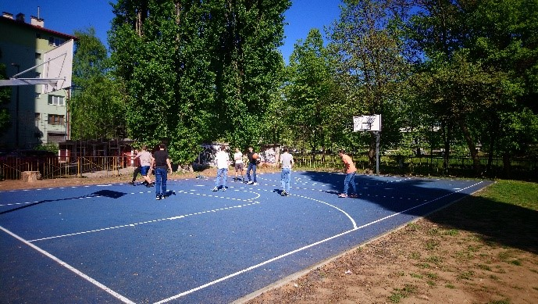

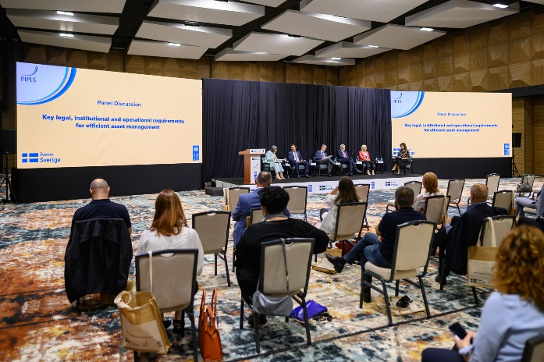

**Project and evaluation information details**

|  |  |  |
| --- | --- | --- |
| **Project Information** | | |
| **Project/outcome title** | Project for Improving Performance of Local Services (PIPLS) in Bosnia and Herzegovina | |
| **Quantum ID** | 00120548 | |
| **Corporate outcome and output** | Outcome 2. By 2025, people contribute to, and benefit from more accountable and transparent governance systems that deliver quality public services and ensure rule of law. | |
| **Country** | Bosnia and Herzegovina | |
| **Region** | - | |
| **Date Project document signed** | 26 November 2020 | |
| **Project dates** | **Start** | **Planned end** |
| 1 January 2021 | 31 December 2024 |
| **Total committed budget** | USD 3,141,224.69 | |
| **Project expenditure at the time of evaluation** | USD 3,058,697.92 | |
| **Funding source** | Government of Sweden, UNDP BiH, and Government of Bosnia and Herzegovina | |
| **Implementing party**[**[1]**](https://euc-word-edit.officeapps.live.com/we/wordeditorframe.aspx?ui=en-US&rs=bs-Latn-BA&wopisrc=https%3A%2F%2Fundp.sharepoint.com%2Fteams%2FBIH%2FKnowledgeHub%2F_vti_bin%2Fwopi.ashx%2Ffiles%2Ff67aa0c4982949f88f7a38d6b81616ae&wdenableroaming=1&mscc=1&hid=C47F22A1-6066-8000-B70E-8801FF7CA3C5.0&uih=sharepointcom&wdlcid=en-US&jsapi=1&jsapiver=v2&corrid=9b5c1223-0e5a-2736-e9f5-1034b1ab3a93&usid=9b5c1223-0e5a-2736-e9f5-1034b1ab3a93&newsession=1&sftc=1&uihit=docaspx&muv=1&cac=1&sams=1&mtf=1&sfp=1&sdp=1&hch=1&hwfh=1&dchat=1&sc=%7B%22pmo%22%3A%22https%3A%2F%2Fundp.sharepoint.com%22%2C%22pmshare%22%3Atrue%7D&ctp=LeastProtected&rct=Normal&wdorigin=ItemsView&wdhostclicktime=1714057866527&instantedit=1&wopicomplete=1&wdredirectionreason=Unified_SingleFlush&_ftn1) | UNDP Bosnia and Herzegovina | |

|  |  |  |
| --- | --- | --- |
| **Evaluation information** | | |
| **Evaluation type (Project/ outcome/thematic/country programme, etc.)** | Project evaluation | |
| **Final/midterm review/ other** | Final | |
| **Period under evaluation** | **Start** | **End** |
| January 1, 2021 | December 31, 2024 |
| **Evaluators** | Nedim Čelebić, PhD | |
| **Evaluator email address** | [nedim.celebic@gmail.com](mailto:nedim.celebic@gmail.com) | |
| **Evaluation dates** | **Start** | **Completion** |
|  | June 26, 2024 | October 30, 2024 |

[[1]](https://euc-word-edit.officeapps.live.com/we/wordeditorframe.aspx?ui=en-US&rs=bs-Latn-BA&wopisrc=https%3A%2F%2Fundp.sharepoint.com%2Fteams%2FBIH%2FKnowledgeHub%2F_vti_bin%2Fwopi.ashx%2Ffiles%2Ff67aa0c4982949f88f7a38d6b81616ae&wdenableroaming=1&mscc=1&hid=C47F22A1-6066-8000-B70E-8801FF7CA3C5.0&uih=sharepointcom&wdlcid=en-US&jsapi=1&jsapiver=v2&corrid=9b5c1223-0e5a-2736-e9f5-1034b1ab3a93&usid=9b5c1223-0e5a-2736-e9f5-1034b1ab3a93&newsession=1&sftc=1&uihit=docaspx&muv=1&cac=1&sams=1&mtf=1&sfp=1&sdp=1&hch=1&hwfh=1&dchat=1&sc=%7B%22pmo%22%3A%22https%3A%2F%2Fundp.sharepoint.com%22%2C%22pmshare%22%3Atrue%7D&ctp=LeastProtected&rct=Normal&wdorigin=ItemsView&wdhostclicktime=1714057866527&instantedit=1&wopicomplete=1&wdredirectionreason=Unified_SingleFlush&_ftnref1) This is the entity that has overall responsibility for implementation of the Project (award), effective use of resources and delivery of outputs in the signed Project document and workplan

# Table of Contents

1. Table of Contents 3

2. List of Acronyms and Abbreviations. 4

3. Executive Summary 5

4. Introduction 11

5. Description of the Intervention 13

6. Evaluation Scope and Objectives 17

7. Evaluation Approach and Methods 18

8. Data Collection and Analysis 23

9. Findings and Conclusions 26

9.1 Relevance 26

9.2 Coherence 29

9.3 Effectiveness 31

9.4 Efficiency 36

9.5 Impact 38

9.6 Sustainability 44

9.7 Gender Equality, Diversity and Inclusion Considerations (Gender+) 46

10 Lessons Learned 47

11 Recommendations 48

12 Report Annexes 50

# List of Acronyms and Abbreviations

AMC Association of Municipalities and Cities

BAM Bosnia and Herzegovina Convertible Mark

BIH Bosnia and Herzegovina

CCI Centres for Civic Initiatives

DIM Direct Implementation Modality

EU European Union

EUR Euro

FBIH Federation of Bosnia and Herzegovina

GDP Gross Domestic Product

IMF International Monetary Fund

IPA Instrument for Pre-Accession Assistance

ILO International Labour Organization

ILDP Integrated Local Development Project

LID Local Integrated Development (Project)

MEG Municipal Environmental Governance (Project)

MTS Municipal Training System

PIPLS Project for Improving Performance of Local Services

RS Republika Srpska

SAA Stabilization and Association Agreement

SAI Supreme Audit Institutions

SDGs Sustainable Development Goals

SEE Southeast Europe

TAF Technical Assistance Facility for Local Governments

UN United Nations

UNDP United Nations Development Programme

USD United States Dollar

WHO World Health Organization

# Executive Summary

**About the Project**

The Project for Improving Performance of Local Services (PIPLS) supports local governments in enhancing transparency and accountability in the management of publicly owned assets. This initiative aims to generate funding for capital investments and improve the delivery of services.

The Project has two outcomes:

* Improve access to critical public services through better governance and greater investment in local infrastructure and;
* Inject speed and purpose to the implementation of the newly elected local government leaders' reform agendas through the provision of expert technical assistance across a number of priority sectors.

Under its first outcome, the Project helps partner local governments establish a system for the strategic management of their public asset portfolios and develop the necessary skills of staff managing the system. Moreover, to make the most of available financial resources, the Project also provides direct and on-site support to local and cantonal governments in practicing smart revenue and expenditure management, consequently contributing to better fund generation for capital investments. Unchecked executive spending is accordingly reduced, and more funds for investment in services are made available by strengthening internal control systems and introducing a new level of scrutiny to the local governments’ financial management practices. Furthermore, the Project also supports efforts to introduce and strengthen structured public procurement practices to ensure public funds are safeguarded. Best performing local governments are rewarded with grant funding for the implementation of priority public service infrastructure projects.

Under its second outcome, the Project worked with newly elected and reform-oriented mayors in pursuing a progressive service-oriented agenda through its Technical Assistance Facility (TAF) component. Newly elected local government leaders are supported in delivering their service priority interventions across four thematic areas: digital governance; service delivery and infrastructure; local economic development; and financial management.

The Project, implemented from January 2021 to December 2024, is financed by Sweden and co-financed and implemented by the United Nations Development Programme in cooperation with 3 cantons and 22 local governments (LGs). In addition to local governments, the Project works with the Public Administration Reform Coordinator’s Office (PARCO), entity Ministries of Finance, and entity Associations of Municipalities and Cities (AMCs). The total Project budget amounts to $ 3,141,224.69.

**Evaluation Purpose, Scope and Objective**

1. **Purpose**

The primary purpose of this evaluation is to provide an unbiased, comprehensive review of the Project for Improving Performance of Local Services (PIPLS) in Bosnia and Herzegovina. This includes examining the Project’s overall performance and results, as well as identifying potential indicators of transformative change resulting from the Project’s activities.

1. **Scope**

The evaluation examines the extent to which the Project’s planned outcomes have been achieved since its inception on January 1, 2021, and assesses the likelihood of achieving the remaining goals by its scheduled end date, December 31, 2024, as outlined in the Project Document and Results Framework.

This evaluation will cover the Project’s entire timeline, focusing on Project processes, strategic partnerships, and the contextual factors that were crucial in generating both expected and unexpected outcomes. It will also investigate the factors that supported or hindered the Project’s ability to achieve its objectives. Furthermore, the evaluation will assess key cross-cutting aspects, including gender equality, disability and human rights, environmental impact, resilience, and innovation within the Project’s results areas.

1. **Objective**

The main objective of this evaluation is to assess the Project’s progress, achievements, challenges, gaps, delays, and any contextual issues or institutional risks. Through a robust data collection approach, the evaluation will aim to provide collective insights and highlight critical lessons learned, including signs of transformative change, any missteps, and key cross-cutting issues, with a focus on inclusivity. The evaluation will analyse the processes of change influenced by the Project, the level of stakeholder buy-in and ownership, and the specific contributions the Project made toward these changes. It will also provide strategic recommendations for the Project’s owners and partners to enhance implementation, particularly as the Project approaches its exit strategy and considers a potential Phase II follow-up.

**Methodology and approach**

The evaluation employed a number of data collection methods to collect and triangulate the Project performance data. A comprehensive survey was conducted to capture perceptions and attitudes from keyProject stakeholders, including the partner local and regional (cantonal) governments, the Project partners represented in the Project steering structures, associated institutions, and final beneficiaries, among others. The survey was shared with some 77 prospective respondents, receiving 33 responses, with respondent structure broadly reflective of the Project partner landscape. The survey assessed Project perceptions across all critical aspects of the evaluation, ranging from suitability of approach to Project team performance, and collected recommendations regarding potential follow-up measures. While two focus groups were originally planned, covering two distinct geographical areas to ensure maximum convenience for prospective local government participants, only one was ultimately organised due to the limited availability of invitees, resulting in low responsiveness. By utilizing diverse data collection methods, potential limitations associated with individual samples were mitigated, allowing for comprehensive evaluation of project results. Nonetheless, the focus group that was held took in eight participants from six local governments of various sizes and levels of development, providing a helpful tool for the validation of data received through the survey. The size and structure of participating local governments is also broadly representative of the overall partner landscape. In addition to the focus group, the evaluator conducted 18 interviews with key interlocutors, including senior municipal leaders, cantonal officials, members of the Project steering structure, as well as institutions that took some part in Project activities. These interviews provided supplementary insights into the relevant programmatic work. All local governments that took part in the Project were able to contribute to the evaluation in one form or another, ensuring that relatively low availability of respondents did not have an adverse impact on the quality of the evaluation process or its outcomes.

The evaluation also took in multiple documents provided by the Project Team. In addition to the Project document and regular reports submitted to the donor, the evaluator reviewed Project deliverables, including policy and institutional frameworks that local and cantonal governments created with support of the Project, knowledge products as well as specific action plans and financial reports adopted by local governments and spotlight notes. In addition, the evaluator was provided with a detailed monitoring and evaluation matrix that was used to store critical performance data across all Project components with means of verification. The matrix was particularly valuable in illustrating the volume of work completed and the sheer number of individuals and institutions involved in the Project implementation.

Finally, the evaluator visited seven Project localities, interviewing beneficiaries and observing changes resulting from the Project in real time. The visits provided the evaluator with an understanding of the context in which the Project was implemented as well as a first-hand account of its impact.

**Principle evaluation findings, conclusions and recommendations**

1. **Relevance**

PIPLS represents a direct programmatic response to support local governments in Bosnia and Herzegovina in leveraging untapped potential development resources needed to deliver their mandates. Public finance management reform remains an issue of concern at all levels of government, and an area of criticism voiced regularly in EU progress reports, a benchmark for the country’s progress along its path to accession. The 2023 edition of the report notes that further significant improvements are needed in public finance management, singling out public procurement and asset management as key levers.[1] The Project addresses enhancing both revenues and expenditures management practices, thus directly contributing to the country’s strategic objectives in the area of public finance management, including the Public Finance Management Strategy, the Public Administration Reform Strategic Framework and the Action Plan, the RS Local Self-Government Development Strategy 2023-2029, with transparency and accountability, efficient use and maintenance of assets, and fair public procurement processes central to all the instruments listed. The latter was welcomed enthusiastically by partner local governments and counterparts at higher levels of government as public procurement remains an implicit barrier to development and effective delivery of local government mandates. Smart and efficient management of public finance is also among the priorities defined in the overarching SDG Framework in BIH.

Importantly, the Project significantly improved public services for over 180,000 people, raising an additional 14 million BAM for capital investments through enhanced financial management. In Bosnia and Herzegovina, where local communities face deteriorating infrastructure, the Project addressed both immediate needs and long-term reforms in local government financial practices. Its strategy, which focused on building municipal staff capacity, creating operational frameworks, and influencing policy, was key to its success. However, the Project did not directly address the needs of marginalized groups, such as women and people with disabilities, though it still positively impacted them through infrastructure support. Additionally, the COVID-19 pandemic and evolving stakeholder demands led to necessary adjustments, ensuring the Project remained relevant and continued to expand its scope with minimal disruption.

1. **Coherence**

The Project achieved a high degree of coordination and complementarity, both within the programmatic landscape of UNDP’s Country Office, as well as the broader operating context.

The Project operated in strong coordination with other UNDP’s interventions at the local level. For example, PIPLS built on the results of the Integrated Local Development Project (ILDP) that supported preparation of local development strategies in a harmonized manner and the Municipal Environmental Governance (MEG) Project that established performance benchmarks in local governments.

The make-up of the Project Steering Board greatly facilitated continuous communication and coordination of effort with relevant domestic authorities considering the two entity Ministries of Finance were represented. This enabled timely information sharing and coordination with ongoing domestically-led efforts, as well as access to information on other emerging donor-funded interventions of interest. In terms of donor coordination, the Project maintained regular contact with relevant interventions and provided inputs in the design of other donor funded interventions with a similar programmatic focus, such as the USAID-funded Local Governance Assistance activity.

While the Project undertook significant effort to ensure complementarity and avoid duplication, there were instances where greater thematic focus by the Project would have benefited the intervention’s overall coherence.

1. **Effectiveness**

The progress towards achieving the Project's overall targets is satisfactory, with all of the indicators defined in the logical framework achieved and, in most instances, exceeded. The Project’s approach, working in parallel to build staff capacity, introduce internal municipal tools, structures and policies, and build an enabling framework at higher levels of government has been recognized by the stakeholder community and praised as especially effective in comparison to many similar interventions that were less holistic in character.

The Project has not only fully achieved the outcome-level targets in terms of better governance (improved revenue and expenditure management, asset management, internal controls and public procurement), service delivery and infrastructure in partner local governments and cantons, but has also created models with strong potential for replication and upscaling.

Looking across partner local governments, the following results require highlighting: i) critical institutional structures have been established and policies adopted to provide the necessary groundwork for effective asset management in 22 local governments, ii) 238 local government employees were trained across 22 events, iii) 14 million BAM was raised through Project-instigated smarter financial management; iv) ten service-oriented infrastructure Projects were implemented, valued at 3.4 million, and benefiting more than 180,000 people; v) an additional 30 Projects across 11 local governments were implemented through the Technical Assistance Facility.

The Project also delivered a number of knowledge and policy products, with most coming about as a result of demand voiced by partner institutions. Toolkits with user-friendly data collection tools were developed, alongside an Asset Management Manual, to enable replication of Project results in non-partner localities. While originally unintended, the Project’s growing relationship with the National Public Procurement Agency resulted in a number of deliverables that have an impact beyond the original Project target group, to include a Public Procurement Manual as well as the development and adoption of the BIH Public Procurement Strategy, that the Project supported in close cooperation with the Delegation of the European Union to BIH. The latter is especially significant considering it represents a requirement for the country’s accession to the EU.

While explicitly absent from Project design, gender equality, diversity and inclusion considerations were taken up in implementation, albeit on an *ad hoc* basis. The Project overwhelmingly delivered its results in an equal and equitable fashion, with a review of verification data indicating broad gender parity, but this was mostly due to the efforts of the Project team but also due to some underlying factors, such as the ratio of men to women working in local administration that significantly tilted towards female staff members.

**d) Efficiency**

There is clear and demonstrable evidence that the Project delivered value for money in terms of the deployment of available resources when set against Project results. Overall, Project activities benefited from greater-than-expected co-financing contributions from local administrations. This demonstrates a meaningful level of engagement by Project partners, a testament to the relevance and effectiveness of the intervention. Furthermore, efficient Project management allowed for an increase in both beneficiaries and results compared to original targets outlined in the logical framework.

Nevertheless, the evaluation has recorded scenarios where PIPLS staff had to manage five or even six parallel workstreams in a single locality, making it very difficult to pull all of those individual strings into one coherent package as well as coordinate all of the activities at ground level. The workload placed on the Project Team was also at times overwhelming, considering available human resources.

**e) Impact**

There is ample verifiable data, generated through the evaluation, to confirm the Project’s substantial impact on target localities and communities. In terms of immediate impact, service delivery infrastructure was improved across 10 partner local communities, with 180,000 direct beneficiaries enjoying improved access to critical local services, ranging from education to public administration and road infrastructure. In addition, activities delivered under the Technical Assistance Facility component of the Project resulted in 30 separate Projects with an expected financing envelope of 150 million BAM, to include schools, recreational facilities, and water supply systems, among others. The number of direct beneficiaries under this component is more difficult to assess due to the long-term nature of many of the individual Projects reviewed.

As noted earlier, shortcomings in Project design were partially addressed through targeting efforts by the Project Team, aimed at improving the quality of life for marginalized groups. Tuzla represents a notable example; as part of the PIPLS-supported infrastructure intervention, the premises of the citizen service centre were refurbished in a way to make the service windows accessible to people in wheelchairs, while two disabled-accessible elevators were installed. A ramp enabling entry to the main building for wheelchair-bound citizens was installed as well, alongside a guidance path for people with visual impairment, making it possible to navigate the service centre with ease.

In terms of transformative, or systemic, change, the Project provides proof of concept that better management of finances directly translates into service gains for citizens. Municipality of Novo Sarajevo, for instance, raised its taxation revenue fivefold, from 1 to 5 million BAM annually, allowing it to invest additional funding into capital Projects. Similar impact was visible in other partner municipalities regardless of their development level. Finally, the enabling framework for asset management created through the Project is both replicable and scalable, creating potential for gains across the entire local governance landscape.

**f) Sustainability**

Project deliverables and results have largely been internalized by partner institutions in the form of new organizational structures, staffing assignments and internal documents. Sustainable staff capacities were built through a series of intensive training events that targeted a significantly higher number of individuals than called for in the Project document (238 versus 100) – this is in large part due to the desire of the Project Team to mitigate the risk of competent staff being reassigned and thus adversely affecting system continuity. Data collection tools and internal regulations were drafted jointly with partners and formally adopted into the local governments’ internal operating frameworks. Importantly, efforts were made to engage higher levels of government into policy-making efforts, thereby safeguarding sustainability but also enabling replication and scaling.

Evaluation confirmed the need for continued engagement by UNDP, or alternative development actors, to prevent backsliding, which was reiterated resolutely by stakeholders at all levels. Specifically, both operational staff and municipal leaders call for the continuation of on-site technical assistance in the implementation of asset registries, critical tools in the management of municipal property. At present, there are no legal mechanisms to safeguard the changes made. With local election coinciding with the end of the Project, there is a need to safeguard the results that have been achieved and exploit openings that have been created that could otherwise be overlooked by incoming mayors and municipal councils/assemblies. Moreover, the stakeholders have emphasized significant room and need for upscaling of practices created under the Project in an additional group of local and cantonal governments, which would be important from the perspective of creation of a critical mass of local governments and cantons.

An important platform that could contribute to sustainability of the result is the community of practitioners established with support of the Project. This platform helped streamline good practices and established regular exchange among professionals in the areas covered under the Project, and asset management in particular.

**Recommendations:**

1. **Sustainability and impact**
   * **Follow-up activities should be launched with a minimum delay** to preclude the loss of momentum or the creation of a vacuum that may occur once the PIPLS support package is withdrawn. While the structures and policies are largely in place, the system needs further technical assistance to keep and build momentum, especially in pursuit of a policy framework.
   * **Continue to nurture a community of practitioners** that can serve as a nucleus for future efforts by stakeholders to increase the number of local governments practicing good asset management through mentorship and peer-to-peer exchanges. This can be pursued effectively through the two Associations of Municipalities and Cities.
2. **Coherence and relevance**

* **The scope of any future intervention should be narrower** to ensure better workload management for partners but also greater focus by the Project team, with asset management foremost. A longer time-frame for Project implementation with longer time periods allotted for the implementation of specific municipal commitments needs to be planned for to avoid fatigue and maximize outcomes.
* Considering the disparities in capacity and size of local administrations in Bosnia and Herzegovina, any future intervention **should employ an asymmetrical approach** that recognizes the specificities of each partner local government, allowing them to progress at a speed and intensity they can effectively manage and translate into development gains.
* Greater focus on gender **equality, diversity and inclusion** in Project design would be welcome, to ensure that marginalized social and economic groups benefit from Project outcomes in an equitable fashion. This may include giving EDI-friendly Projects greater consideration and implementing measures that prioritize EDI assets for assistance through the asset management plans. More meaningful integration of gender would also be welcome.
* With **public procurement** front and centre of most efforts to curb financial mismanagement and improve responsible spending, **follow-up interventions should utilize the openings created by PIPLS to further consolidate gains made**. This could include work on developing new public procurement legislation, as well as support in implementing the newly adopted strategy prepared with support of the Project to ensure its viability.

1. **Effectiveness and efficiency**

* Any future iteration of the PIPLS intervention should do much more to capitalize on its work through **a more strategic approach to communication of activities and results**. Therefore, a comprehensive communications strategy and action plan should be developed and deployed with sufficient focus placed on outreach and Project visibility.

# Introduction

The purpose of the Final Project Evaluation (the Evaluation) is to provide an impartial in-depth review of the “Project for Improving Performance of Local Services (PIPLS) in Bosnia and Herzegovina”, including its overall performance and results, and any indicator of transformative change brought about by the Project.

Using participatory evaluation approaches and methodologies, the evaluation assessed the relevance, coherence, efficiency, effectiveness, sustainability, and potential for the longer-term impact of the Project, making strategic recommendations for future decision-making related to asset management and service delivery by local governments in Bosnia and Herzegovina.[2]

Findings, best practices, and recommendations generated by the Evaluation will help the institutional partners in Bosnia and Herzegovina, the Embassy of Sweden, UNDP, and other relevant stakeholders strengthen the ongoing or future decision-making and work, including for adapting successful programming modalities to suit the changing context in the country. Thus, the Evaluation will be used to promote organizational learning and adaptation both at the strategic and operational levels.

The evaluation exercise and the resulting report are based on the requirements elaborated in the Terms of Reference (Annex 1), with the Inception Report providing further elaboration on the proposed approach and methodology. The evaluation exercise was implemented with the following specific objectives:

* Assess the overall Project progress against its Result Framework, based on data, qualitative information and evidence on results, and identify critical gaps or delays;
* Assess the Project’s context, assumptions and risks;
* Engage all relevant stakeholders (institutions, state, entity and cantonal ministries, local governments, the international community, etc.) in structured conversations or a survey, to enable collective insights and distilling of key lessons learned about change processes influenced by the Project, mistakes, as well as important cross-cutting issues, such as innovation, gender equality and leaving no one behind;
* Provide evidence-based recommendations for future decision-making in the area of asset management, particularly in terms of potential future intentions, strategy of intervention, modalities of implementation, and geographical areas for interventions.

By applying a highly participatory approach, the exercise encouraged open engagement by all relevant stakeholders on the performance and impact of the Project. Honest feedback was solicited on all areas where stakeholders may have felt a change in approach would have yielded better or quicker results, while inputs were also sought on the future expected direction of both the intervention and the broader operating context for local development. The evaluation exercise took in a wide array of interested stakeholders across multiple sectors and levels of government. In addition to primary Project interlocutors, the local governments and cantonal ministries, the evaluation took in views, perceptions and attitudes of institutions at the entity and state levels, end beneficiaries, municipal service users affected by the intervention, and representatives of the principal donor organization, SIDA.

The evaluation used a multiple-level analysis to generate an understanding of change processes influenced by the Project. The process also looked at buy-in and ownership by the stakeholders, and assessed how this change was made, trying to attribute a specific Project contribution to the overall impact. The evaluation formulated strategic recommendationsfor consideration by the Projectowners and its partners, towards a potential continuation of the Project beyond December 2024.

As this is the final Project evaluation, the scope of the exercisewas focused on the extent to which the planned Project outcomes and outputs had been achieved since Project inception until the final quarter of 2024, looking towards the Project’s conclusion on December 31. As noted, the emphasis was on how well the Project had performed against the benchmarks set in the Project Document and the accompanying logical framework.

The evaluation looked into the Project’s processes, strategic partnerships and local ownership, and linkages in the specific country’s context that proved critical in producing the intended outputs.

The process also took in all the factors that facilitated and/or hindered the progress in achieving the outputs, both in terms of the external environment and risks as well as internal – the latter including weaknesses in programme design, management and implementation, and available human and financial resources. The evaluation also looked at the Project’s impact on cross-cutting issues**,** to include gender equality, diversity and inclusion, as well as the Project’s environmental impact.

The general information on the Project and the evaluation process, to include scope, objectives, approach and methodology, make up the initial five chapters. The findings and recommendations of the evaluation are contained in the final three chapters, provided alongside illustrative case studies.

The executive summary captures the main elements of the evaluation report, including evaluation purpose and scope, summary of key evaluation findings and proposed recommendations.

# Description of the Intervention

**Socio-Economic Context at Time of Project Inception**

Bosnia and Herzegovina (BIH) is an upper middle-income country with a 3.5 million population, which is gradually declining and aging. Driven mostly by consumption and public investment, the country’s Gross Domestic Product (GDP) rate per capita has been slightly above USD 7,500 in 2023[3]. With the per capita GDP at some 32% of the European Union (EU) average[4], the pace of BIH’s convergence with the EU remains among the slowest in the region.

The country has a high level of human development[5], but still ranks below average for the Europe and Central Asia region. Gender inequality and poverty remain a concern, particularly in rural areas and among minorities[6]. BIH experiences negative migration trends, with 250,000 people having left BIH since 2013[7]. Since the end of 2017, the country has been also struggling with increased numbers of migrants and asylum seekers. The complexity of the BIH governance structure, inefficiency in government operations, complex coordination and a lack of overarching political consensus undermine public policies and slow down reforms. Although the country has adopted the 2030 Sustainable Development Goals (SDGs) Framework in BIH, the authorities need to invest additional efforts to achieve the SDG targets. Corruption continues to plague the country across all walks of life, with BIH scoring 35 points out of 100 on the 2023 Corruption Perceptions Index[8].

Meanwhile, BIH was granted a candidate status for joining the EU in December 2022, while in March 2023 the European Council approved opening of accession negotiations with BIH. However, as indicated in the Bosnia and Herzegovina 2024 Report issued by the European Commission, since March 2024, the reform dynamic has stalled.

**Sector-Specific Analysis**

Local governments in BIH still struggle to provide inclusive and quality services to citizens and the business sector. This arises from cumbersome and fragmented governance structure in BIH, with lack of clarity in the division of responsibilities among various levels of government. In addition, an insufficient adherence to subsidiarity principle for assigned and transferred competencies to local authorities result in limited fiscal capacity of local governments to generate enough funding for quality services and for local development. Due to weak local economies, local governments have been for years politically driven to be a lucrative employer, which caused that the majority of local administrations are overstaffed and costly, but without sufficient capacities and skills that modern governance requires. As such, local governments are inefficient, which seriously hampers provision of quality service and impedes local economic development.

Local governments’ revenues are largely based on portion of shared indirect taxes, which account for 30% of municipal budgets in the FBIH entity and 50% of municipal budgets in the RS entity[9]. Direct taxes provide about 9% of revenues (on average) in both entities, while the rest of revenues come from locally collected fees and penalties[10]. This means that local governments in BIH receive about 40-60% of their revenues from taxes administered at higher levels, collect between 4-10% from property-transfer taxes and generate the remaining 45-50% from their own efforts and resources (including charges and fees).

The quality of local government fiscal governance and finance management remains low. Over the last 10 years, public finances have benefited from solid revenue growth, but local governments have not made significant structural changes in their budgets. Recurrent expenditures take up almost 50% of local government budget, out of which approximately 35% is allocated for wages, while less than 10% is directed to targeted development activities, including those for enhancing service delivery. This frequently results in delaying much-needed public investment. As such, local government finance management suffers from substantial spending inefficiencies and poor targeting for development priorities, while collection of revenues and fees are a challenge. Although a more balanced revenue sharing between levels of government might be appropriate, there is still an overall need for significant administrative savings and greater efficiency in service delivery.

Despite positive changes in recent years, there are local governments that still perform in a traditional, administration-focused manner, providing essential services but failing to demonstrate sufficient flexibility to find ways to finance development and better manage their assets (e.g. via public-private partnership and inter-municipal cooperation; fees/rent from services and management from local business zone or other public spaces; attracting domestic and foreign direct investments by allocating unused and construction land and by parafiscal reductions; return on direct investments, local property tax, etc.). To utilize opportunities, local governments would need up-to-date property registers and inventories, clear and simplified procedures and modernized asset management skills and equipment. Local grant and subsidy systems that are not performance based, are often subject to political interference and do not provide intended outcomes. Despite existing regulatory framework, local government financial internal controls and audits are ineffective. ”The value for money” approach for efficient and effective public fund spending has not yet been anchored in key policies and practices, fuelling political patronage, corruption and in-transparent local government decision making processes.

Public procurement remains highly vulnerable to undue influences and corruption. Nonetheless, and according to the available data collected by the Public Procurement Agency, no one has ever been prosecuted, or convicted for offenses of corruption relating to public procurement. The economic costs of corruption, including in public procurement, are nearly impossible to calculate but the OECD estimates that corruption inflates the price of public procurement contracts by an average of 20-25% and as high as 50% in some cases. The costs of corruption, however, go beyond financial costs as corrupt procurement practices lead to misallocation of public funding and failure to meet basic service needs.

Meanwhile, critical local government functions remain underfunded in areas such as local road management and maintenance, water supply and wastewater management services, solid waste disposal, primary healthcare, education, culture and sports.

With governments around the country announcing dramatic pandemic-induced cuts to their capital investment plans in this budget year and beyond, it is likely that public service providers will suffer further capacity gaps even as the needs for their services grow. With the emerging national SDG framework placing increased emphasis on local governments in providing better access to clean water and improved waste management services, among others, municipal authorities must do a better job in managing available resources.

With the 2020 local elections ushering in a group of reform-minded mayors, and municipal councils, there was ample opportunity to move forward with a more progressive agenda for local governments in Bosnia and Herzegovina. Previous experiences, however, show that, at least initially, new administrations tend to struggle in coming to grips with the demands of governing. They are frequently overwhelmed by the daily business of troubleshooting, often diverting time, energy and resources away from undertaking needed structural reforms. With the Covid-19 pandemic further complicating the local government landscape, and financing likely to be sparce, the need for new mayors to hit the ground running is even more pressing.

**About Project**

The PIPLS theory of change calls for the establishment of a system for strategic management of public assets, and the development of the necessary staff skills to manage said system, as critical prerequisites for local governments to increase the level of transparency and accountability in managing publicly owned goods, generating additional revenues and improving service delivery.

By engaging with the entity local government associations and decision-makers at higher levels of government, efforts are made to influence the relevant policy framework towards creating a better enabling environment and ensuring the sustainability of results.

Support to local and cantonal governments in practicing smart revenue and expenditure management contributes towards generating funding for capital investments in critical service areas, in line with relevant local development strategy documents. By strengthening internal control systems and introducing a new level of scrutiny to the local governments' financial management practices, unchecked spending is curbed and more funds for investments in services are available, resulting in tangible quality of life improvements.

With its overall objective “to contribute to an improvement in the overall quality of public service infrastructure in BIH”, the Project works across the following two outcomes:

1. Improve access to critical public services through better governance and greater investment in local infrastructure and;
2. Inject speed and purpose to the implementation of the newly elected local government leaders' reform agendas through the provision of expert technical assistance across a number of priority sectors.

The first outcome is pursued through three interlinked and mutually reinforcing results taking place across 15 local and 2 cantonal governments.

**Under Result 1, the Project helps local governments establish a system for strategic management of public assets held by municipal authorities**, to include creating clear lines of responsibility for asset management within each institution; establishing and regularly updating a register of assets with a transparent record of all purchases, sales or disposition of assets; development of asset management plans to help ensure efficiency and effectiveness in asset utilization; building the necessary staff skills to effectively manage the system and its components; and creating the requisite policy framework for effective asset management at local government level.

**Under Result 2, the Project works with partner local authorities to optimize public spending and generate funding for capital investments in critical service areas,** as identified by relevant local development strategy documents. Activities under this result work towards introducing and internalizing a rigorous process of disciplined expenditure management aimed at establishing a conservative level of operational spending. ln addition, the Project will work to strengthen internal control systems to curb unlawful spending and introduce a new level of scrutiny to the local governments' financial management practices. Considering the largely inefficient and ineffective public procurement practices, and their detrimental impact on service delivery, the Project also pursues enhancements in procurement policies and procedures across all partner local governments. As with Result 1, the Project works with willing policy partners at higher levels of government to effect practice-based changes in the regulatory environment.

**Under Result 3, the Project clearly and immediately demonstrates the benefits of improved governance practices and arrangements**, created under Results 1 and 2, to mobilize newly available funding in implementing critical public service priorities. ln practical terms, local governments that have performed the best, or have saved and generated the most money while implementing asset management systems, are rewarded with a "top-up grant" through the Project grant facility thus enabling the implementation of their priority interventions already called for under their local development strategies. Competing local governments are evaluated against targets established based on an in-depth external review of their financial situation at Project inception. In addition, to be eligible, priority infrastructure interventions for best-performing municipalities must be i) linked to their development strategy; ii) co-financed with at least 60% of the total amount by the local authority; and iii) operate on a fully sustainable basis once completed to encourage long-term thinking by local decision-makers. The selection process is guided by SDG financing considerations with funding channelled to meet the implementation of prioritized goals across all partner communities. ln essence, Result 3 represents an incentive for participating local and cantonal governments to maximize their commitment to good governance practices outlined under the first two Project results.

**The second outcome is pursued through specialized technical assistance across three principle thematic areas**: i) **digital governance**; to include improving processes and instruments in the service of better performance and enhanced transparency and accountability; ii) **service delivery and infrastructure**, to include taking critically important infrastructure Projects from concept to maturity, as well as helping set the service delivery agenda for the local community and introducing new service lines; and, finally, **local economic development**; to include developing innovative entrepreneurship, and employment incentive and promotion programmes. The Facility offers targeted technical assistance in keeping with the specific needs of each client local government while considering the overarching intervention logic. Assistance is offered on a first-come, first-served basis, with interested local authorities required to commit to seeing through the necessary activities to achieve the stated objective of the technical assistance, whether that be the adoption of new transparency policy or the implementation of an infrastructure intervention.

Outcome 2’s single resultis defined as follows: **Local government leaders are supported in their efforts to effectively deliver their reform agendas aimed at improving the quality of life in their communities, focusing in particular on the delivery of critical public services**.

Project activities are implemented in three cantons (Posavina, Tuzla and Sarajevo) and 22 selected local governments: Banja Luka, Centar Sarajevo, Goražde, Gradiška, Han Pijesak, Ilidža, Jablanica, Laktaši, Lukavac, Modriča, Mostar, Novi Grad, Novo Sarajevo, Odžak, Orašje, Prijedor, Šamac, Teslić, Tešanj, Tuzla, Trebinje, Živinice.

# Evaluation Scope and Objectives

1. **Purpose**

The primary purpose of this evaluation is to provide an unbiased, comprehensive review of the Project for Improving Performance of Local Services (PIPLS) in Bosnia and Herzegovina. This includes examining the Project’s overall performance and results, as well as identifying potential indicators of transformative change resulting from the Project’s activities.

1. **Scope**

The evaluation examines the extent to which the Project’s planned outcomes have been achieved since its inception on January 1, 2021, and assesses the likelihood of achieving remaining goals by its scheduled end date, December 31, 2024, as outlined in the Project Document and Results Framework.

This evaluation will cover the Project’s entire timeline, focusing on Project processes, strategic partnerships, and the contextual factors that were crucial in generating both expected and unexpected outcomes. It will also investigate the factors that supported or hindered the Project’s ability to achieve its objectives. Furthermore, the evaluation will assess key cross-cutting aspects, including gender equality, disability and human rights, environmental impact, resilience, and innovation within the Project’s results areas.

1. **Objective**

The main objective of this evaluation is to assess the Project’s progress, achievements, challenges, gaps, delays, and any contextual issues or institutional risks. Through a robust data collection approach, the evaluation will aim to provide collective insights and highlight critical lessons learned, including signs of transformative change, any missteps, and key cross-cutting issues, with a focus on inclusivity. The evaluation will analyse the processes of change influenced by the Project, the level of stakeholder buy-in and ownership, and the specific contributions the Project made toward these changes. It will also provide strategic recommendations for the Project’s owners and partners to enhance implementation, particularly as the Project approaches its exit strategy and considers a potential Phase II follow-up.

1. **Evaluation Criteria**

The evaluation will use established international Project evaluation standards, drawing on the OECD DAC Evaluation Quality Standards, including relevance, coherence, effectiveness, efficiency, impact, and sustainability. A detailed evaluation matrix[11] has been developed to outline the specific criteria, evaluation questions, data sources, and tools utilized to assess Project performance in response to the questions identified in the Terms of Reference (ToR).

# Evaluation Approach and Methods

* 1. **Evaluation Approach**

Based on the [UNDP Evaluation Guidelines](http://web.undp.org/evaluation/guideline/covid19.shtml) and in consultations with the Government of Sweden, the Evaluation will be participatory, involving relevant stakeholders.

The evaluation needs to assess the degree to which the Project’s supported or promoted gender equality, a rights-based approach, and human development. In this regard, [United Nations Evaluation Group’s guidance on Integrating Human Rights and Gender Equality in Evaluation should be consulted.](https://www.uneval.org/document/detail/980)

The evaluation approach was characterized by the following elements:

* **Contextual Understanding**: Emphasis was placed on gaining a deep understanding of the socio-economic and political context in which the Project operates, as well as the organizational and institutional context that influences the Project’s current status, leadership, and management. The relatively unique constitutional and political makeup of the country, as well as the overall political environment, were also considered.
* **Participatory Approach**: All relevant Project stakeholders were involved and consulted throughout the evaluation to ensure comprehensive insights, maximizing the evaluation’s impact.
* **Tailored Methodology**: Evaluation products were specifically designed to match the identified knowledge levels and capabilities of targeted groups.
* **Inter- and Intra-Organizational Focus**: Lessons learned from the evaluation were aimed at enhancing development at both individual and network levels by integrating findings into strategies, systems, and procedures.
* **OECD-DAC Evaluation Standards**: The evaluation adhered to internationally recognized practices, with a focus on relevance, coherence, effectiveness, efficiency, impact, and sustainability—ensuring alignment with the Project’s theory of change.
* **Utility Focus**: Efforts were made to ensure stakeholders owned the evaluation process and that the findings were directly beneficial. Communication was clear, concise, and avoided unnecessary technical language.
* **Integrity and Impartiality**: The evaluation followed a transparent methodology with no conflicts of interest, maintaining a high standard of objectivity.
  1. **Evaluation Methodology**

The **evaluation methodology** was based on standard international practices in project evaluation relying on the OECD DAC Evaluation Quality Standards and covering criteria of relevance, coherence, effectiveness, efficiency, impact and sustainability.

**Data Sources**

The sources of information included relevant project documents as well various stakeholders which participated in, or were relevant for, the project implementation. Initial information about the project was gathered through revision of UN Cooperation Framework for Bosnia and Herzegovina 2021-2025, UNDP Country Programme Document for Bosnia and Herzegovina 2021-2025, SDG Framework in Bosnia and Herzegovina 2030, Prodoc and Revised ProDoc and budget addendum as well as series of other project documents and reports listed in **Annex 5**. Additionally, significant data was collected through survey, interviews, field visits and focus groups with wide range of direct beneficiaries (LG and cantonal representatives, users of provided financial aid and grants), management team, partners and other relevant stakeholders presented in **Annex 4**. In order to ensure comprehensive and integrated evaluation results, selected stakeholders involved representatives and key beneficiaries from all project components, project donors and project management team. Information collected from relevant documents and stakeholders provided empirical evidence and insights into all aspects of the project as well as enabled assessment of effectiveness, efficiency and other evaluation criteria. Data collected also revealed the extent to which the Project’s objectives have been met enabling identification of strengths and areas for improvement.

**Sample and Sampling Frame**

Non-random, purposive sampling was used to ensure the relevance of perspectives to the evaluation. Purposive sampling also ensured participation of beneficiaries from all Project components enabling assessment of all Project results and indicators. The sample used in the data collection process included all types of stakeholders, including local partners, the donor, and final beneficiaries. Care was taken to ensure adequate geographical distribution as well as representation of stakeholders across all Project components. In total, some 64 stakeholders were consulted (survey, interviews, focus groups, site visits), although the evaluation initially targeted a higher number of 100 stakeholders. By utilizing diverse data collection methods, potential limitations associated with individual samples were mitigated, allowing for a comprehensive and integrated evaluation of the Project's results. While two focus groups were originally planned, covering two distinct geographical areas to ensure maximum convenience for prospective local government participants, only one was ultimately organised due to low availability of invitees. Given the limited availability of key beneficiaries, 18 interviews were conducted with them to compensate for the cancellation of the second focus group. This approach ensured feedback was gathered from representatives of all target groups. A complete list of interviewed beneficiaries and focus group participants can be found in **Annex 4**.

**Data Collection Procedures and Instruments**

Data collection methods used throughout the evaluation process included:

* + *Desk research*. The purpose of the desk research was to gain an understanding of the socio-economic, political, legal, and environmental context within which the Project was planned and implemented. This research provided detailed insights into the Project's content, processes, and products. **Annex 5** includes the comprehensive list of documents supplied by the Project and outlined by the ToR. This research was instrumental in establishing a robust foundational understanding of the subject and identifying gaps in gender and social inclusion. Both strategic documents and Project-related documents (ProDoc, reports) served as valuable sources of the necessary information.
  + *Survey.* Aimed primarily at final beneficiaries (local governments, cantonal governments) and selected direct beneficiaries to capture their perceptions of the Project’s effectiveness and added value. The survey was anonymous and the sample ensured gender parity. The survey results provided a robust quantitative foundation for understanding beneficiaries' perceptions of the results and the added value of the Project. The survey was sent via UNDP Project contacts, while access to data was only in the hand of the evaluator. **Annex 3** includes the full list of multiple-choice and open-ended questions featured in the survey, facilitating comprehensive feedback from all beneficiaries on various aspects of the Project. Additionally, **Annex 8** contains all graphs with quantitative survey results.
  + *Key Informant Interviews.* Conducted with key stakeholders, including the Project team, partners, and associates, as well as third parties familiar with the Project, to gather comprehensive perspectives. Interviews were conducted in the local language and lasted approximately 60 minutes each. **Annex 3** contains detailed stakeholder interview guides, each offering a unique approach and tailored set of questions. These guides are customized for mayoral interviews, interviews with representatives of the donor organization (SIDA), interviews with representatives of partner institutions on the steering board, and interviews with representatives of relevant international partners active in the field. Additionally, a separate Technical Assistance Facility (TAF) interview guide was developed and utilized during the evaluation process. These interview guides facilitated a comprehensive and tailored assessment of various Project beneficiaries. Full list of interviewed beneficiaries, including more than 50% of women, is provided in **Annex 4**.
  + *Focus Group Discussions.* Because of the summer holiday season, the members of only one of two planned focus groups were available. They included direct beneficiaries, such as representatives of local governments and municipal authorities, to gain insights into perceptions, and opinions, and to verify the data collected through surveys and interviews. The focus group had eight participants (50% women) representing 6 municipalities from both entities. **Annex 4b** includes a comprehensive list of focus group participants from six municipalities: Teslić, Orašje, Lukavac, Tešanj, Tuzla, and Prijedor. The focus group discussion was moderated using the previously developed Focus Group Guide (**Annex 3**). The key topics discussed with the beneficiaries present included the validation of survey results, general impressions about the Project, its implementation, impact and sustainability, and the challenges and lessons learned. While the Focus Group served as a validation tool for the previously collected survey results, other methods, such as interviews, allowed for broader participation from beneficiaries who were unable to attend the Focus Group.
  + *Site Visits and Observations.* Visits to seven Project locations allowed for direct observation of local activities and Project outcomes, providing context and helping to highlight the importance of the Project’s impact in different areas. Sites visited include municipalities of Ilidža, Centar, Novo Sarajevo, Banja Luka, Gradiška, Trebinje and Sarajevo Canton. These visits enabled direct observation of implemented infrastructure projects such as Startup Incubator in Trebinje and Centar or Playground in Novo Sarajevo. Field visits provided contextual data and firsthand insights, making them invaluable for understanding real-world applications and impact of the Project.
  + *Case Studies.* Notable examples of the Project’s impact were documented in three case studies from Odžak, Tuzla and Gradiška, illustrating the Project’s influence on local communities.

**Performance Standards**

Key standards or measures used to evaluate performance relative to the evaluation questions include:

* + *The Logical Framework Matrix* is a tool used to map out the logical relationships between project activities, outputs, and outcomes. It helps in identifying the causal pathways and ensuring that all necessary steps are included to achieve the desired results. All evaluation methods and questions were assessed relative to Logical Framework in order to evaluate progress towards defined results and indicators. Project indicators are specific, measurable elements used to assess the progress and success of a project. They provide quantitative data that can be tracked over time to evaluate whether the Project is meeting its objectives.
  + *Beneficiary satisfaction* measures how well the Project meets the needs and expectations of its stakeholders. It was assessed through surveys, open ended questions, interviews, focus groups and other methods to gauge stakeholder satisfaction.
  + *Quality of Deliverables.* This measure assesses the quality of the Project's outputs and deliverables. It ensures that the Project meets the required standards and specifications.
  + *Team satisfaction* evaluates the morale and engagement of the project team. It was measured through project team interviews and feedback to ensure that the team was motivated and effective.

**Stakeholder Participation**

Evaluation process involved wide range of stakeholders like mayors, civil servants, cantonal assistant ministers, project team, representatives of donor (SIDA), UNDP management, grant support users, etc. Evaluation used participative approach in which all stakeholders were able to provide feedback through different data collection methods such as surveys, interviews, and focus groups. Equal involvement (50% - 50%) of men and women in focus groups as well as interviews significantly contributed to diverse viewpoints and experiences, enriching the evaluation process. Additionally, equal involvement of men and women helped in identifying and addressing gender specific issues, enhancing the overall relevance of the findings, fostering credibility and trust in the evaluation results among all stakeholders, leading to a more accurate and comprehensive assessment, preventing biases, thereby increasing the validity of the results and demonstrating commitment to inclusivity, boosting stakeholder buy-in and support.

**Ethical Considerations**

In order to protect the rights and confidentiality of informants, comprehensive set of measures were taken to address ethical issues during each evaluation phase such as commissioning, planning and design, implementation, including data collection, reporting, dissemination and communication. To protect the rights and confidentiality of informants during evaluations, several measures are recommended by the [UNEG Ethical Guidelines for Evaluators](https://www.unevaluation.org/document/detail/2866):

* + *Informed Consent:* Ensure that all participants are fully informed about the evaluation process and provide their consent to participate.
  + *Confidentiality:* Safeguard the personal information of participants by keeping data secure and only sharing it with authorized personnel.
  + *Anonymity:* Where possible, anonymize data to protect the identity of participants, especially when reporting results.
  + *Non-Retaliation:* Assure participants that their involvement will not lead to any negative consequences or retaliation.
  + *Cultural Sensitivity:* Respect cultural norms and values, ensuring that the evaluation process is appropriate and respectful.
  + *Transparency:* Be clear about the purpose of the evaluation, how the data will be used, and the measures in place to protect participants.

**Background Information on Evaluator**

The evaluator is a senior evaluator with more than 15 years of academic and professional experience in project management, strategy and policy development and project monitoring, learning and evaluation. Beside previously successful evaluation of The Economic Governance for Growth Project implemented by UNDP, the evaluator successfully monitored and evaluated more than 10 Horizon, Erasmus, EU and other projects by serving position of Manager for monitoring, learning and evaluation of projects at University Sarajevo School of Science and Technology. Some of the key technical skills include data analysis, research skills, interviewing techniques, focus group facilitation, project management, problem solving, etc.

**Major Limitations of the Methodology**

While partners have overwhelmingly reacted to the evaluation with interest and enthusiasm, the evaluator encountered issues of availability stemming from the fact that the bulk of the data collection process coincided with the annual summer holiday season. What was encouraging is that a number of respondents participated in the evaluation from their holidays indicating a high degree of commitment and appreciation for the Project. Regardless of sample limitations for survey and focus group, mitigation actions conducted to overcome these issues included organization of 18 interviews with key beneficiaries and 7 site visits, which enabled comprehensive assessment and feedback opportunity for majority of beneficiaries. However, broader timeframe with more working days would be beneficial for relaxing the intensive work of the evaluator and the efforts invested to assess a multi-million and multi-year intervention according to the highest evaluation standard, including combination of methodologies and in-depth reporting.

# Data Collection and Analysis

* 1. **Data Collection**

The evaluation process was divided into three key phases: Inception and Desk Research, Fieldwork, and Synthesis.

**Inception and Desk Research Phase**

The Inception Phase involved confirming the evaluation’s objectives, scope, and outputs with the Project team. The evaluator developed the work plan and agreed upon the schedule with the UNDP team.

Key activities under this phase entailed:

* Initial meetings with the Project Team and UNDP Monitoring and Evaluation Officer.
* Desk research and review of Project documents.
* Sample size definition, design of data collection instruments, and preparation of a key informants list.
* Preparation of an evaluation timeline and report structure.
* Submission of the Inception Report, including receiving feedback from UNDP.

During the inception phase, the evaluator reviewed multiple documents **(Annex 5)** provided by UNDP, including:

* UN Cooperation Framework for Bosnia and Herzegovina 2021-2025
* UNDP Country Programme Document for Bosnia and Herzegovina 2021-2025
* Sustainable Development Goals Framework in Bosnia and Herzegovina (SDG Framework)
* ProDoc and Revised ProDoc and budget addendum
* Annual Project Progress Reports
* PIPLS and TAF Annual Progress Reports and TAF Spotlight Report
* Project Board Meeting Minutes
* Medium-Term and Annual Plans and Annual Reports

In addition, the evaluator was provided with a detailed monitoring and evaluation matrix that was used to store critical performance data across all Project components with means of verification. The matrix in particular was valuable in providing an idea of the volume of work that was performed and the sheer number of individuals and institutions that were involved with the implementation of the Project.

**Fieldwork**

Following desk research, the evaluator developed data collection tools to be used during the Fieldwork Phase. These included:

* Survey Questionnaire: The evaluator designed, developed, and administered a comprehensive survey of perceptions and attitudes. He shared it online (via Google Forms Survey) with critical Project interlocutors, including participating local and regional governments, Project partners represented in the Project steering structures, associated institutions, and final beneficiaries. The survey was shared with some 77 prospective respondents with 33 responses received, broadly reflective of the Project partner landscape. Although only 42% of responses were received, evaluation findings and their credibility were strengthened through additional 18 interviews with key beneficiaries as well as focus group and field visits. The survey assessed perceptions across all critical aspects of the evaluation, ranging from suitability of Project approach, through to Project team performance and suggestions for potential follow-up measures. **Annex 8** provides major findings and analysis of the survey results.
* Focus group: While two focus groups were originally planned, covering two distinct geographical areas to ensure maximum convenience for prospective local government participants, only one was ultimately organised due to low availability of invitees. Nonetheless, the focus group that was held took in eight participants from six local governments of various sizes and levels of development, providing a helpful tool for the validation of data received through the survey. As previously mentioned, in order to mitigate both 42% response rate of survey participants and eight participants of focus group, additional 18 interviews and 7 field visits were conducted to validate and confirm evaluation findings revealed through the survey and focus group. Overall, focus group participants were very forthcoming in sharing their views on the Project. **Annex 4b** provides the list of focus group participants.
* Key informant interviews: In addition to focus groups, the evaluator conducted 18 interviews with key interlocutors, to include senior municipal leaders, cantonal officials, members of the Project steering structures, as well as institutions that took some part in Project activities and can provide supplementary information on relevant Project component. Overall, there was a differing level of awareness of the Project across the pool of interviewees but, encouragingly, the majority of the mayors were well informed and supportive of the Project, indicating a high degree of local ownership. Targeted interview guides with tailored questions were developed for all individual interviewee groups. **Annex 4a** contains full list of organizations and their representatives who participated in interviews.

The evaluator also visited seven localities where the Project was implemented, interviewing beneficiaries and observing changes resulting from the Project in real time. The visits provided the evaluator with an understanding of the context in which the Project was being implemented as well as a first-hand account of its impact.

**Synthesis Phase**

In the Synthesis Phase, data from desk research and fieldwork were analysed and interpreted in relation to the evaluation questions. The findings were categorized and compared to draw conclusions on successful and less successful aspects of the Project. The evaluation included:

* Outcome harvesting and insights into systemic changes, contextual, and institutional factors.
* Lessons learned and recommendations for future similar interventions.
* Data disaggregation by location, age, and gender where applicable.
* Integration of supporting materials (e.g., photos, press clippings) collected during field visits.
* [The Gender Results Effectiveness Scale (GRES)](https://erc.undp.org/pdf/GRES_English.pdf) including gender negative, gender blind, gender targeted, gender responsive, gender transformative
  1. **Data Analysis**

Data were analysed using a combination of quantitative and qualitative methods, supported by several triangulation approaches:

1. *Data cleaning*: All collected quantitative and qualitative data was checked, cleaned or corrected to ensure accuracy and consistency of the data. This method particularly enabled check on accuracy of data for different stakeholder groups like men, women, different social groups etc.
2. *Descriptive Statistics*: Measures like mean and median were used to summarize the data and provide an overview of the key findings. This method was particularly appropriate for analysis of survey questions which revealed majority of quantitative data and numerical feedback from key beneficiaries.
3. *Qualitative Analysis*: Coding and thematic analysis were used to identify patterns and themes from interviews and focus groups. While survey questions primarily resulted in quantitative data, interviews and focus groups revealed qualitative information. Therefore, coding and thematic analysis served as the most relevant methods to address wide range of open-ended evaluation questions in both interview questionnaires and focus groups questionnaires.
4. *Software Analysis and Data Visualization*: Charts, graphs and other visual tools were created to present the data in a clear and understandable manner. Survey data were analysed and visualized using Excel. Similarly to descriptive statistics, this method proved to be relevant for analysis and interpretations of survey questions which revealed majority of quantitative data and findings.
5. *Data Triangulation*: Project and evaluation documents, as well as relevant literature, were cross-referenced. The method combined data from multiple sources and methods to validate findings and ensure a comprehensive understanding of the evaluation questions.
6. *Methodological Triangulation*: Desk research, surveys, FGDs, interviews, and case studies were combined to ensure robust data validation.

Preliminary findings and recommendations were presented to the UNDP team and the donor for feedback, following submission of the Preliminary Findings Report. Feedback from this session is also incorporated into the Draft Evaluation Report.

# Findings and Conclusions

## 9.1 Relevance

**Major Findings and Conclusions**

The Project is evaluated as **highly relevant** as it represents a direct programmatic response to support local governments in Bosnia and Herzegovina in leveraging untapped potential development resources needed to deliver their mandates. Public finance management reform remains an issue of concern at all levels of government, and an area of criticism voiced regularly in EU progress reports, a benchmark for the country’s progress along its path to accession. The 2023 edition of the report notes that further significant improvements are needed in public finance management, singling out public procurement and asset management as key levers. The Project addresses enhancing both revenues and expenditures management practices, thus directly contributing to the country’s strategic objectives in the area of public finance management, including the Public Finance Management Strategy, the Public Administration Reform Strategic Framework and the Action Plan, RS Local Self-Government Development Strategy 2023-2029, with transparency and accountability, efficient use and maintenance of assets, and fair public procurement processes central to all the instruments listed. Smart and efficient management of public finance is also among the priorities defined in the overarching SDG Framework in BIH. In Bosnia and Herzegovina, where local communities face deteriorating infrastructure, the Project addressed both immediate needs and long-term reforms in local government financial practices. Its strategy, which focused on building municipal staff capacity, creating operational frameworks, and influencing policy, was key to its success. However, the Project did not directly address the needs of marginalized groups, such as women and people with disabilities, though it still positively impacted them through infrastructure support. Additionally, the COVID-19 pandemic and evolving stakeholder demands led to necessary adjustments, ensuring the Project remained relevant and continued to expand its scope with minimal disruption.

The introduction of strategic asset management allows for feeding of information into both strategic and financial planning processes, enabling local officials to allocate resources based on accurate data, helping prioritize the deployment of available resources and, ultimately, improving the quality of local community services. Efforts at better financial management, public procurement and internal control are vital in ensuring the proper deployment of available resources to effect positive change in partner communities. At the same time, Project-instigated investment in priority infrastructure, based on the local governments’ performance in improving their financial management, was extremely relevant as it targeted re-channelling of public funds into projects already identified as critical in the local governments’ development strategies.

Public finance management reform remains an issue of concern at all levels of government, and an area of criticism voiced regularly in EU progress reports, a benchmark for the country’s progress along its path to accession. The 2023 edition of the report notes that further significant improvements are needed in public finance management, singling out public procurement and asset management as key levers.[12] The Project addresses enhancing both revenues and expenditures management practices, thus directly contributing to the country’s strategic objectives in the area of public finance management, including the Public Finance Management Strategy, the Public Administration Reform Strategic Framework and the Action Plan, RS Local Self-Government Development Strategy 2023-2029, with transparency and accountability, efficient use and maintenance of assets, and fair public procurement processes central to all the instruments listed.

The Project has also been conducive to the implementation of development pathways defined within the emerging SDG Framework in BIH, placing emphasis on good governance, as well as on the role of local governments in providing better access to public services such as clean water and improved waste management services, local road management and maintenance, primary healthcare, education, culture and sports, among others.

The Project framework is deemed complementary to the implementation of state- and entity- level instruments, to include the Public Administration Reform Strategy and Action Plan, entity public finance management reform strategies and the RS Local Self-Government Development Strategy 2023-2029, with transparency and accountability, efficient use and maintenance of assets, and fair public procurement processes central to all the instruments listed.

The Project’s tripartite approach to the topic of asset management, working to build capacities of staff across the administration, instituting an internal operating framework in the form of tools, manuals and regulations, as well as efforts to create an overarching policy environment conducive to better asset management all proved highly popular with stakeholders at all levels. While the environment for any meaningful change remains unconducive at all levels of government, the fact that the Project was very much a product of local government needs helped negotiate some of the structural challenges that persist. There is ample evidence that the intervention has laid the groundwork for a meaningful upgrading of local service delivery infrastructure. In addition to asset management, the Project’s focus on internal control as well as public procurement and smarter financial management correspond directly to rising community demands for quality services, with local administrations having to deliver more for less with available funds having to go further. How local governments raise and spend their money directly affects their ability to deliver on their role, making the Project’s focus on these thematic areas highly relevant. In addition, the Project’s Technical Assistance Facility component (Outcome 2) allowed eligible local governments to target programmes of specific interest, choosing from one of the broader thematic areas of economic development, digitalization, and service delivery. Overwhelming interest by local partners to take part in the Facility, which required a separate application process, attests to the relevance of this Project component as well.

However, while the Project was overwhelmingly relevant for partner local communities, few provisions were made for the specific needs of groups at risk of marginalization. Project design did not sufficiently consider the needs of women, people with disabilities, or other marginalized groups, although during implementation there were successful attempts to remedy this through introducing gender equality, diversity and inclusion considerations in the selection of priority infrastructure Projects.

COVID-19, as well as shifting but relevant demands by Project stakeholders, required periodic changes to the Project that ensured continued relevance, with partners as well as activities added to the Project portfolio with minimum disruption.

Overall satisfaction of local governments and cantonal beneficiaries with the Project has been assessed as high, over 87% of survey respondents said they were satisfied or very satisfied.

**Figure 1.** Rate of satisfied expectations with the project

The Project maintained good communication with key stakeholders and beneficiaries using different communication channels. More than 96% of respondents described communication and coordination with the Project team as excellent or very good.

**Figure 2.** Coordination and communication with the project team

While respondents were quick to point out the Project’s good performance, both survey respondents and interviewees pointed to the need for immediate continuation of technical assistance as they still do not feel very confident, specifically with regard to asset management processes. More investment is needed to secure a sustainable phase-out.

## 9.2 Coherence

## 

**Major Findings and Conclusions**

The Project achieved a **high degree of coordination and complementarity**, both within the programmatic landscape of UNDP’s Good Governance Sector and its Country Office, as well as the broader operating context. PIPLS built on the results of the Integrated Local Development Project (ILDP) that supported preparation of local development strategies in a harmonized manner and the Municipal Environmental Governance (MEG) Project that established performance benchmarks and water resources management in local governments. In terms of Project design, the Project benefited from being preceded by a cluster of local governance and local development projects that generated a significant body of best practice that was ultimately integrated into the PIPLS intervention, complementing and consolidating results achieved under the auspices of earlier UNDP projects. In terms of donor coordination, the Project maintained regular contact with relevant interventions and provided inputs in the design of other donor funded interventions with a similar programmatic focus, such as the USAID-funded Local Governance Assistance activity and Advancing Public Finance Management in BiH, funded by the Ministry of Finance of the Slovak Republic. In large part due to the composition of its Project Steering Board, the Project was also able to continuously and effectively map complementary interventions to avoid duplication of effort and ensure synergies. In terms of **programmatic coherence** **of intended results within the Project** itself, the intervention at times lacked focus due to the sheer number of thematic areas targeted and activities implemented – this was a clear shortcoming in the Project design.

Advancing Public Finance Management in BiH, funded by Ministry of Finance of the Slovak Republic

To a large extent, the Project benefited from UNDP’s experience and expertise in the areas of local governance and local development, drawing on lessons learned and best practices from decades-long work of the organisation with local and regional authorities.

This helped inform the PIPLS Project design, replicating and consolidating initiatives with proof of concept on the ground and bringing to focus themes where local authorities have struggled for years, such as asset management. In particular, the Project was able to draw on UNDP’s work on local development planning, as well as the initiatives implemented under the auspices of the Local Integrated Development Project and the first phase of the Economic Governance for Growth intervention – this was reflected in PIPLS successes with generating additional municipal revenues and instituting smart spending practices. In addition to building on previous work, the Project successfully pursued complementarities with ongoing interventions, both at the level of UNDP’s Good Governance Sector and the Country Office as a whole. UNDP’s work on Sustainable Development Goals (SDGs) and SDG financing efforts, also supported by SIDA, was enhanced by the PIPLS-instigated efforts to free up additional development funding for critical interventions aimed at meeting national SDG targets. Investments in infrastructure were coordinated with the Country Infrastructure Development Initiative (CIDI), UNDP’s flagship intervention aimed at implementing large-scale service infrastructure upgrades. Evaluation revealed that CIDI engineers were engaged or consulted through all implemented infrastructure projects such as support to preparation of project documentation for sport hall Hrasnica in Municipality of Ilidža.

In addition to complementing the work of other local government interventions, the Project also worked with initiatives from UNDP’s Energy and Environment Sector to ensure coherence of effort in local governments where other UNDP-implemented works were ongoing.

Interviews with stakeholders confirmed robust and continuous support from the Project Board and UNDP management. Project Board members maintained effective communication and coordination with the Project Team and were cooperative, although their mandate and roles at times limited their ability to address political challenges related to Project interventions. UNDP senior managers contributed to cohesive project delivery by ensuring that interventions aligned with the broader UNDP strategy, avoiding overlaps. Thanks to these efforts, the Project achieved satisfactory internal synergy, aligning well with UNDP’s diverse development initiatives.

The make-up and structure of the Project Steering Board significantly facilitated continuous communication and coordination of effort with external partners as well. This is especially pertinent with the two entity Ministries of Finance that were represented in the Steering Board, alongside the Public Administration Reform Coordinator. This enabled timely information sharing and coordination with ongoing domestically-led efforts, as well as access to information on other emerging donor-funded interventions of interest. In terms of donor coordination, the Project maintained regular contact with relevant interventions and provided inputs in the design of other donor funded interventions with similar programmatic focus, such as the USAID-funded Local Governance Assistance activity.

While the Project undertook significant effort to ensure complementarity and avoid duplication, there were instances where greater thematic focus by the Project would have benefited the intervention’s overall coherence.

At the same time, and while local administrations face overstaffing, there remains a shortage of skilled civil servants capable of leading project activities within their governments. Often, a small group of local government staff is assigned to multiple donor projects, regardless of their thematic focus, which can be particularly challenging for areas with significant donor involvement. Although the Project coordinated effectively both within UNDP and with other development actors, a more concentrated thematic focus could have further enhanced the overall coherence of the interventions. It is, however, noteworthy that the activities delivered under the asset management portfolio, designed to be mutually reinforcing, generally managed to achieve the necessary degree of operational coherence to ensure maximum effectiveness.

## 9.3 Effectiveness

**Major Findings and Conclusions**

Progress towards achieving the Project's overall targets is **highly satisfactory**, with all of the indicators defined in the logical framework achieved and, in most instances, exceeded. Critical asset management structures have been established and internal policies adopted, with some 238 staff trained to manage the newly established system. More than 14 million BAM was raised through Project-instigated smarter financial management with ten service-oriented infrastructure Projects implemented, benefiting more than 180,000 people, showing a direct link between better financial management and improved services for the public. As a result, access to critical municipal services, ranging from education and healthcare to emergency services and administration, was greatly enhanced, while innovative tools and instruments for asset management were developed, deployed and tested in a challenging operational setting but with immediate and positive results. Additionally, 30 tailored projects across 11 local governments were implemented through the Technical Assistance Facility, targeting administration headed by newly elected mayors. Failures in Project design, however, have adversely affected the ability of the Project to effectively engage with gender equality, diversity, and inclusion considerations, and gender in particular. Efforts of the Project Team to remedy design flaws have, nonetheless, yielded significant result in select aspects.

The Project was overwhelmingly effective in the delivery of its core mandates. Interviews with key informants, focus groups, and quantitative data collection processes all strongly indicate overwhelming satisfaction with the Project design, implementation and results achieved – 96.9% of all respondents consider it effective or very effective. Objective means of verification in the form of documents[13] generated via the Project and reviewed by the evaluator, as well as site visits, are also broadly supportive of this evaluation finding. The Project’s methodological approach, working in parallel to build capacities of key staff, introduce internal municipal tools, structures, and policies, and develop an enabling framework at higher levels of government has been recognized by the stakeholder community and praised as especially effective. When set against the backdrop of the global pandemic that coincided with the start of implementation, the results of the Project are particularly noteworthy.

**Figure 3.** Project effectiveness in addressing partner needs in local communities

Looking across partner local governments, the following results require highlighting: i) critical structures have been established and policies adopted, to provide the necessary groundwork for effective asset management, ii) 238 local government employees were trained across 22 events, iii) 14 million BAM was raised through Project-instigated smarter financial management; iv) ten service-oriented infrastructure Projects were implemented, valued at 3.4 million, and benefiting more than 180,000 people; v) an additional 30 Projects across 11 local governments were implemented through the Technical Assistance Facility, to include the development of technical documentation for a future school catering to more than 700 children as well as the introduction of e-government and digital processes in a number of partner localities. The scope of projects supported was varied in both thematic sector and scale, illustrating the challenges faced by the project.

**Figure 4.** Overall execution of the PIPLS project

The Project also delivered a number of knowledge and policy products, with most coming about as a result of demand voiced by partner institutions, to include the Federation Association of Municipalities and Cities as well as more advanced local governments such as Gradiška.

Toolkits with user-friendly data collection tools were developed, alongside an Asset Management Manual, to enable replication of Project results in non-partner localities. While originally unintended, the Project’s growing relationship with the National Public Procurement Agency resulted in a number of deliverables that have an impact beyond the original Project target group, to include a Public Procurement Manual as well as the development and adoption of the State Public Procurement Strategy, supported by the Project. The latter is especially significant considering it represents a requirement for the country’s accession to the EU.

While virtually absent from Project design, gender equality, diversity and inclusion considerations were taken up in implementation, albeit on an ad hoc basis. The Project overwhelmingly delivered its results in an equal and equitable fashion, with a review of verification data indicating broad parity between genders, but this was mostly due to the efforts of the Project team but also due to some underlying factors, such as the ratio of men to women working in local administration that significantly tilted towards female staff members.

**Under Outcome 1, the Project worked to improve access to critical public services through better governance and greater investment in local infrastructure**.

Output 1.1 calls for partner local governments to improve service delivery through better management of the municipal asset portfolio. The Project implemented comprehensive asset management assessments across all participating local governments, feeding tailor-made asset management plans, marking a first for Bosnia and Herzegovina. User-friendly data collection tools were developed and deployed, while 18 local governments created asset registries to record and manage asset data. 17 local governments adopted rulebooks on asset management, mandating a strategic approach to the function. All participating local governments adopted action plans for asset management and created the necessary implementing structures. Nine local governments also made organisational and staffing changes to reflect the strategic importance of asset management to their organisations. It is important to note that although 15 local governments were targeted by the intervention, ultimately 18 benefited from a full complement of support significantly increasing development impact.

The Project also produced an Asset Management Manual, a comprehensive step-by-step guide with a supporting toolkit, which was acclaimed by the practitioner community. In terms of added value, the Project generated significant interest from entity and cantonal policymakers in developing an enabling framework in terms of new legislation that would safeguard gains made by the Project.

In total, 238 local government staff were trained in asset management practices across 22 separate training events (88 men and 150 women), ensuring the local governments possess the requisite asset management skills and capacities. In addition, the Project hosted a Forum on Asset Management, bringing together practitioners and policy, in an effort to initiate policy discussion on improvements in the relevant legal framework. Overall, the project significantly improved the overall understanding of the asset management function, and its benefits, especially within the ranks of senior municipal leadership. The evidence delivered through the implementation of these activities proved to be a powerful awareness raising tool.

**Table 1. Overview of results achieved against Log Frame indicators under Output 1.1**

|  |  |  |  |
| --- | --- | --- | --- |
| **Indicator** | **Baseline** | **Target** | **Result** |
| *Number of local governments implementing improved asset management practices* | 0 | 15 | 18 |
| *Number of local government staff members from target local governments with increased capacities* | 0 | 100 | 238 |

Under Result 2, the Project works with **partner local and cantonal governments to help them practice smart revenue and expenditure management, including through enhanced internal control and public procurement capacities.**

More than 14 million BAM was generated in additional revenues through better management of expenditures[14], as attested by financial reports submitted by partner local governments and reviewed in the course of the evaluation. This is a significant increase in the relevant indicator. The performance of local governments was uneven, with some performing better than others, as recognized through the Project’s incentive facility. For instance, the Municipality of Novo Sarajevo alone managed to improve its taxation and revenue collection from 1 million to 5 million BAM in just under two years based on recommendations provided by the Project.

A total of 131 municipal and city officials were trained in public procurement and internal control practices (37 men and 94 women), exceeding the Project target of 100. Internal control systems were put into place in 14 local governments and 2 cantons. In addition, the Project supported the development and roll-out of a public procurement manual, as well as assisting the National Public Procurement Agency in developing an overarching strategy document for the country, covering the period 2024-2028, also leveraging partnership with the Delegation of the European Union to BIH. Responding to demands by stakeholders, the Project also commissioned and implemented an assessment of property taxation legislation in Sarajevo Canton, to be used as a basis for a new set of modern legislation treating this topic.

**Table 2.** **Overview of results achieved against Log Frame indicators under Output 1.2**

|  |  |  |  |
| --- | --- | --- | --- |
| **Indicator** | **Baseline** | **Target** | **Result** |
| *Amount of savings and additional revenues generated through better expenditure management* | 0 | BAM 10 million | BAM 14 million |
| *Number of local government staff who benefit from improved skills and capacities in the areas of expenditure management, internal control and public procurement* | 0 | 100 | 131 |

Under Result 3,**public service infrastructure in partner local communities is upgraded,** andhas the following indicators. Under this result, the Project developed a comprehensive performance evaluation framework to evaluate the progress of local governments towards achieving benchmarks set through the Project, as a means to single out local governments that will be rewarded with grant funding for critical service delivery infrastructure, arising from their respective development strategies. Ultimately, the Project selected 10 local governments for support, with all Projects granted funding completed at the time of evaluation. The Projects implemented are valued at 3.4 million BAM, with local co-financing exceeding 2.5 million BAM.

According to Project monitoring and evaluation data, and supported by a review conducted by the evaluator, some 183,400 residents of partner local governments benefited from Project impact in this regard, compared to the target of 20,000.

**Table 3. Overview of results achieved against Log Frame indicators under Output 1.3**

|  |  |  |  |
| --- | --- | --- | --- |
| **Indicator** | **Baseline** | **Target** | **Result** |
| *Number of infrastructure projects implemented in partnership with selected local governments* | 0 | 9 | 10 |
| *Number of residents who benefit from new/improved local services* | 0 | 20,000 | 183,000 |

Under Outcome 2, **the Project was tasked with injecting speed and purpose to the implementation of the newly elected local government leaders’ reform agenda.**

Under the outcome’s sole output, 2.1, **the Project supports local government leaders in effectively delivering their reform agendas aimed at improving the quality of life in their communities, focusing in particular on the delivery of critical public services.**

Following the election of a new cohort of mayors in 2020, the Project issued a call for expression of interest to all eligible administrations in the country, inviting applications for the provision of technical support across the following four thematic areas: digital governance, service delivery, financial management, and local economic development. The rationale behind the call, and the project component, was to provide newly elected mayors who often had little or no exposure to the work of municipal government, with the immediate tools to formulate and accelerate their policy agendas and to become better acquitted with local reform priorities. After evaluation of received applications, it was noted that the local governments were mostly interested in digital governance, local economic development, and service delivery and infrastructure, while the local government’s disinterest in financial management was evident.  Since financial management was covered through the second component of the PIPLS Project, the Project team received an endorsement from the Project Steering Board to remove expenditure management as a TAF topic and to refocus the remaining resources on the three primary topical areas.

In total, 30 Projects across 11 local governments were implemented through the Technical Assistance Facility – the total financial envelope for Projects supported exceeds 150 million BAM in funding earmarked by partner local governments through financial planning. Eight projects were implemented in the area of digitalization, while 11 each were implemented in the areas of economic development and service delivery.

Digitalization projects supported include digitalization readiness assessments, development of digitization roadmaps, and the establishment of document management systems. All of these interventions have, to varying degrees, improved the local governments’ service delivery capability, bringing services to citizens in a quicker and more efficient manner, while also raising awareness of the benefits of digitalization to both internal and external performance of local administrations. Four local development strategies were developed and supported to adoption, to include the first ever development strategy for the City of Mostar. A public-private partnership feasibility study was also implemented, alongside two incentive schemes for local economic development that are now used as a blueprint for how the two partner administrations disburse their economic development funds.

**Table 4. Overview of results achieved against Log Frame indicators under Output 2.1**

|  |  |  |  |
| --- | --- | --- | --- |
| **Indicator** | **Baseline** | **Target** | **Result** |
| *Number of infrastructure Projects implemented in partnership with selected local governments* | 0 | 5 | 11 |
| *Number of local governments which embarked on digitalization of governance processes and instruments.* | 0 | 5 | 8 |
| *Number of local governments which developed new instruments to support private sector in their local communities* | 0 | 5 | 11 |

## 9.4 Efficiency

**Major Findings and Conclusions**

There is clear and demonstrable evidence that the **Project delivered value for money in terms of the deployment of available resources when set against Project results**. Overall, Project activities benefited from greater-than-expected co-financing contributions from local administrations. This demonstrates a meaningful level of engagement by Project partners, a testament to the relevance and effectiveness of the intervention. Furthermore, efficient Project management allowed for an increase in both beneficiaries and results compared to original targets outlined in the logical framework.

However, a shortage of human resources impacted certain areas, particularly in gender equality, diversity, inclusion, and visibility, which did not fully meet the Project's intended standards.

The Project’s financial management performance was satisfactory with adequate resources allocated and spending found to be largely in concert with planning, except for the disruptions caused by the global pandemic where programmatic delays caused changes in anticipated spending. Overall, the available financial resources were proven sufficient, especially in light of the Project Team’s performance in getting maximum value for money, with savings generated across most Project components. The Project’s efficiency in spending was especially significant considering it recorded significant currency losses to the amount of USD 152,915 but to no adverse effect to the delivery of results.

There are, however, concerns about whether sufficient human resources were allocated for the implementation of the Project considering the sheer size and scope of the intervention. A cursory review of Project activities shows that the intervention consisted of hundreds of activities that placed a significant strain on available human resources, effectively “squeezing out” softer Project activities such as monitoring, evaluation and learning as well as visibility to the detriment of the Project. This was especially evident in the initial stages of the Project when the Technical Assistance Facility was in full swing with 30 parallel interventions taking place under the management of only two staff members who were tasked with other duties as well. The evaluation has recorded scenarios where PIPLS staff had to manage five or even six parallel workstreams in a single locality, making it very difficult to pull all of those individual strings into one coherent package as well as coordinate all of the activities at ground level. The workload placed on the Project Team was also at times overwhelming, considering available human resources.

The Project’s efforts at encouraging and securing proactive engagement by stakeholders were reflected in a significantly greater than expected financial commitment of partners in funding activities, acting as a multiplier for Project effects. Interestingly, both sets of partners struggled somewhat with procurement of goods and services proving problematic in terms of speed and efficiency of processes. UNDP’s introduction of Quantum during the Project implementation period caused some delays and required staff to train on the new system alongside a punishing workload. Nonetheless, the ability of the Project to attract funding should be noted as the TAF component alone, with a relatively modest budget, managed to mobilize significant local funds – one example is the sports hall in the Municipality of Ilidža where the Project supported the development of the technical documentation for a new sports hall with the investment in design unlocking a 4.5 million BAM investment in infrastructure. The new sports hall is expected to be finished in 2025.

Project design and subsequent retooling of its approach failed to substantively address gender equality, diversity and inclusion provisions, although efforts were made by Project staff to introduce EDI-sensitive criteria into selection processes for critical infrastructure Projects, ultimately resulting in better services for a number of marginalized groups in partner localities.

Project visibility seemed to have been another casualty of the Project’s large programmatic footprint that was not supported with an adequate number of staff members. A number of critical Project results that would have resulted in significant positive publicity for the Project, the organisation and the donor were not showcased, resulting in missed opportunities.

Overall, there is clear and demonstrable evidence that the Project delivered value for money in terms of the deployment of available resources when set against Project results, while Project outcomes have been significantly multiplied through generating additional municipal resources to fund Project-related activities but also increase general municipal budgets. Infrastructure Projects were realized with better-than-expected financial participation from partner local administrations – the infrastructure component raised 2.5 million BAM in local funding, co-financing projects at a rate of 75% compared to 60% required in the Project document. Efficiencies in Project management also enabled an increase in Project results compared to the original targets, as specified in the logical framework. Nonetheless, greater investment in human resources would have yielded significantly better results in terms of ensuring gender equality, diversity and inclusion, as well as visibility.

## 9.5 Impact

**Major Findings and Conclusions**

The Project had a **direct and immediate impact in target localities.** There is ample verifiable data, generated through the evaluation, to confirm the Project’s substantial impact on target localities and communities. In terms of immediate impact, service delivery infrastructure was improved across 10 partner local communities, with 180,000 direct beneficiaries enjoying improved access to critical local services, ranging from education to public administration and road infrastructure. In addition, activities delivered under the Technical Assistance Facility component of the Project resulted in 30 separate Projects with an expected financing envelope of 150 million BAM, to include schools, recreational facilities, and water supply systems, among others. The number of direct beneficiaries under this component is more difficult to assess due to the long-term nature of many of the individual Projects reviewed.

Shortcomings in Project design were partially addressed through targeting efforts by the Project Team, aimed at improving the quality of life for marginalized groups. In terms of transformative, or systemic, change, the Project provides proof of concept that better management of finances directly translates into service gains for citizens. Municipality of Novo Sarajevo, for instance, raised its taxation revenue fivefold, from 1 to 5 million BAM annually, allowing it to invest additional funding into capital Projects. Similar impact was visible in other partner municipalities regardless of their development level. Finally, the enabling framework for asset management created through the Project is both replicable and scalable, creating potential for gains across the entire local governance landscape.

Nonetheless, it is noteworthy that the Project’s impact on traditionally marginalized groups, to include women and youth, was underwhelming as few provisions were included in Project design. While efforts by the Project Team ultimately improved PIPLS’ gender equality, diversity and inclusion performance, the overall impact on these groups was considerably lower than was possible.

There is ample verifiable data, generated through the evaluation, to confirm the Project’s substantial impact on target localities and communities. In terms of immediate impact, service delivery infrastructure was improved across 10 partner local communities, with 180,000 direct beneficiaries enjoying improved access to critical local services, ranging from education to public administration and road infrastructure. The process of selecting eligible local governments for project financing was comprehensive and took in a number of objective considerations, with partner authorities having to meet key performance benchmarks in terms of progress achieved and savings generated. Conversations with interviewees note that this approach was very effective in ensuring commitment and ownership over PIPLS activities which then translated into measurable impact in their local communities. Interviews with beneficiaries attest to the necessity of investment in locations visited, with linkages to local development strategies ensuring coherence as well as intended impact.

Furthermore, there is now a clear and replicable model with proof of concept for good asset management by public authorities in Bosnia and Herzegovina, as demonstrated by the performance of local governments that have successfully partnered with the Project. The change in approach to how local governments manage their vital assets is evident and objectively verifiable through the active and positive changes in how municipalities perform this function, as evidenced through field visits and review of documentation provided. PIPLS local governments now have the tools, staff capabilities and organizational structures to significantly enhance asset management operations in a systemic and strategic manner. If these results are sustained, the effects will far exceed that of the infrastructure component, with changes being more transformative and impactful.

In addition, significant funds have been saved as well as generated through the introduction of relatively uncomplicated and replicable financial management measures that yield substantial funding windfalls, especially at a time when inflation is restricting what authorities can do with the budgets at their disposal. A total of 14 million BAM was generated for development investment across the implementation period, with figures for 2024 yet to be added to this number. Municipality of Novo Sarajevo, for instance, raised its taxation revenue fivefold, from 1 to 5 million BAM annually, allowing it to invest additional funding into capital projects.

Against a backdrop of fiscal instability brought on by the pandemic, and the overall environment of political instability at all levels of government in the country, Technical Assistance Facility aimed to inject speed and purpose to the implementation of the newly elected local government leaders’ reform agenda through the provision of expert technical assistance across a number of priority sectors. The demand was simply overwhelming with newly elected leaders desperate for assistance in delivering their programmes in year 1 of their term in office. Working with newly elected mayors and legislatures, the TAF offered specialized expert assistance across principle thematic areas of digital governance, service delivery and infrastructure and local economic development. Activities delivered under the TAF component of the Project, or Outcome 2, resulted in 30 separate projects with an expected financing envelope of 150 million BAM, to include schools, recreational facilities, and water supply systems, among others. The number of direct beneficiaries under this component is more difficult to assess due to the long-term nature of many of the individual Projects reviewed. In addition to supporting the development of project documentation for critical infrastructure interventions helping mobilize funding through bringing projects to maturity, PIPLS supported eight digitalization projects, to include implementing digitalization readiness assessments, development of digitization roadmaps, and the establishment of document management systems. All of these interventions have, to varying degrees, improved the local governments’ service delivery capability, bringing services to citizens in a quicker and more efficient manner. Four local development strategies were developed and supported to adoption, to include the first ever development strategy for the City of Mostar. A public-private partnership feasibility study was also implemented, alongside two incentive schemes for local economic development that are now used as a blueprint for how the two partner administrations disburse their economic development funds.

Shortcomings in Project design with regards to gender equality, diversity and inclusion were partially addressed through targeting efforts by the Project Team, aimed at improving the quality of life for marginalized groups. Tuzla represents a notable example; as part of the PIPLS-supported infrastructure intervention, the premises of the citizen service centre were refurbished in a way to make the service windows accessible to people in wheelchairs, while two disabled-accessible elevators were installed. A ramp enabling entry to the main building for wheelchair-bound citizens was installed as well, alongside a guidance path for people with visual impairment, making it possible to navigate the service centre with ease.

**Figure 5.** Difference made to local community/canton

Three case studies are provided here for illustrative purposes of the type and scope of impact that the Project has delivered in partner local communities. The case studies are selected to demonstrate the impact of multiple PIPLS programmatic components, i) delivering assistance to newly elected mayors, ii) improving public service delivery infrastructure, and iii) introducing a system for strategic asset management. The evaluator selected these local governments as demonstrative of both the challenges faced by the Project as well as the results delivered.

**Case study 1. Technical Assistance Facility**

**Municipality of Odžak**

Odžak is located in northern Bosnia and Herzegovina, in close proximity to the country’s border with Croatia. According to the 2013 census, the population of the municipality is circa 18,000, although the number is likely much smaller – Odžak is one of the communities most adversely affected by outward migration in Bosnia and Herzegovina. While its economy has traditionally been geared towards agriculture, metal processing, electronics and the food industry increasingly make up the bulk of the local economy.

With a new mayor in office, the priorities were to develop a realistic long-term blueprint for development and to exploit the increasingly attractive geographical location of the municipality to draw investment. Accordingly, the Facility was deployed to facilitate and support the inclusive and participatory design of the long-term development strategy for the local community, covering the period 2022-2027. The integrated local development planning methodology deployed was initially a proprietary product of UNDP that has since been mainstreamed across the local government community in the country, with both cantons and entities taking it up as well to help guide long-term development across key sectors. As a result, a draft of Development Strategy of the Municipality of Odžak for the period 2022 - 2027 was prepared and unanimously adopted by the Municipal Council of Odžak Municipality in December 2021. The total estimated value of the Strategy is 40.569.334 BAM out of which 7.696.167 BAM will be secured from the city budget and 32.873.167 BAM from external sources.

In addition to helping the local community formulate its development priorities, the Facility also provided on-site implementation support in the form of expert assistance with the development of annual implementation plans and the establishment of a monitoring framework to track the strategy’s implementation. In addition, municipal staff and senior leaders were provided on-the-job training in both the relevant preparation and implementation protocols. In addition, and based on the specific circumstances of the local community - as well as the vision of its leadership - further assistance was sought in developing Odžak’s business enabling infrastructure. The municipality stands to benefit greatly from its relatively unique geographical location with a nearby railway station (Modriča), river ports (Brčko and Šamac), airports (Tuzla and Osijek), as well as the future Vc corridor connecting the region to the EU and expected to pass less than a mile away from the municipality’s industrial area. Odžak is also relatively close to Sarajevo, Zagreb and Belgrade, as the key regional capitals, while its proximity to the common EU market makes it even more attractive as a potential investment destination for commerce. With existing industrial zone capabilities increasingly filling up, there was a pressing need to create additional business enabling infrastructure in the municipality with the local assembly establishing three new business zones, “Svilaj 1”, “Svilaj 2” and “Svilaj 3”. Industrial zones are resource-intensive to establish and operate, requiring a full complement of infrastructure services as well as connectivity. This makes the process of developing the necessary design and implementation documents both multi-layered and complex. The Facility provided critical technical assistance here, taking the idea of creating two new business zones and translating it into the necessary technical documentation needed to inform and enable the process of creating the requisite physical and other preconditions.

**Picture 1.** Industrial zone in Odžak

In addition to large-scale business infrastructure, the Facility was tasked with developing and implementing a new green market in the urban centre of Odžak with the idea of bringing local agri-food products to the local market in a structured and controlled manner. The market would provide a vibrant place of commerce and would help local farmers offer their produce and products at prices that are acceptable for both sellers and buyers. In turn, the buyers would have easy access to quality farming products with a known place of origin and cultivation practices.

**Picture 2.** Green market in Odžak

The Facility’s role was both to develop the necessary design documents, to include a feasibility study, and to implement the necessary construction works, delivering a turnkey solution for the local community.

**Case study 2 Delivery of service infrastructure improvements**

**City of Tuzla**

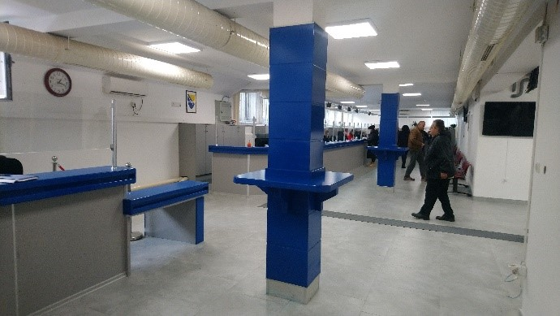As a result of results achieved under the auspices of the Project's asset management and revenue maximization activities, the City of Tuzla was invited to submit an application for the PIPLS grant scheme that rewards best performing local governments. The Project submitted called for enhancing access to, and improving the quality of, services offered through the Citizen Support Centre, the primary hub through which citizens of Tuzla can interact with their local administration. The Project’s focus was primarily on improving access for people with physical disabilities, adapting the current premises in a way that would enable equal and equitable service delivery for all. The Project yielded significant results in dramatically improving both access to and quality of local services. As part of the intervention, the premises of the centre were refurbished in a way to make the service windows accessible to people in wheelchairs, while two disabled-accessible elevators were installed. A ramp enabling entry to the main building for wheelchair-bound citizens was installed as well, alongside a guidance path for people with visual impairment, making it possible to navigate the service centre with ease.

**Picture 3.** Citizen Support Center Tuzla 1 **Picture 4.** Citizen Support Center Tuzla 2

According to estimates of the City of Tuzla, some 1,400 people use the services of the centre daily, out of which 11% have some form of physical disability. The new elevators, in addition to enabling access, are significantly more energy efficient.

**Picture 5.** Citizen Support Center Tuzla 3 **Picture 6.** Citizen Support Center Tuzla 4

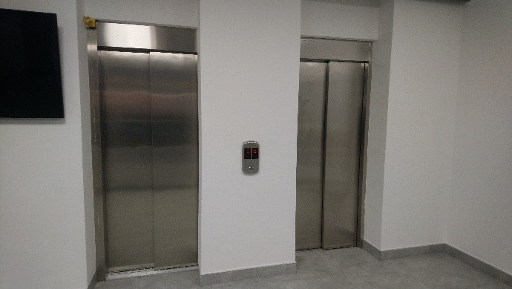

**Case study 3: Asset management**

**City of Gradiška**

The City of Gradiška represents a standalone example of successful Project implementation, driven in concert by two sets of committed stakeholders and supported with the requisite knowledge, skills and tools. Gradiška approached the Project in a systemic and strategic fashion, helping dictate the tempo of Project implementation and helping finetune the methodology to the individual needs of its administration. The city administration successfully implemented the full array of activities brought about by PIPLS, to include implementing an inventory of assets, creating a fully-fledged asset registry, revising and overhauling the organigram and staffing table to reflect asset management as a critical administrative function, and developing the relevant regulatory framework, among others. The overwhelming success of the Project in Gradiška is in large part due to unwavering political commitment as well as operational effectiveness of local counterparts, supported ably by the Project team and its consultants. The mobilizing effect of the Project’s work in Gradiška should be utilized by UNDP going forward to demonstrate what is possible in a local context when there is will. This case study also clearly indicates that the overall Project approach is adequate for the operating environment, attesting to the quality of both Project design and implementation.

## Sustainability

**Major Findings and Conclusions**

Project deliverables and results have largely been **internalized by partner institutions in the form of new organizational structures, staffing assignments and internal documents**. Data collection tools and internal regulations were drafted jointly with partners and formally adopted into the local governments’ internal operating frameworks. Importantly, efforts were made to engage higher levels of government into policy making efforts, thereby safeguarding sustainability but also enabling replication and scaling. Evaluation confirmed the need for continued engagement by UNDP, or alternative development actors, to prevent backsliding was repeated resolutely by stakeholders at all levels.

An important platform that could contribute to sustainability of the result is the community of practitioners established with support of the Project. This platform helped streamline good practices and established regular exchange among professionals in the areas covered under the Project, and asset management in particular.

The Project has instituted safeguards to ensure continuity and rooting of critical processes in the municipalities’ internal regulatory framework. Improvements made by PIPLS have been, by design, systemic and structural, and there is substantive ownership of processes by the stakeholders, as well as recognition of its benefits both by senior leadership and the operational staff tasked with the daily work of managing municipal assets.

Encouragingly, all local governments have created municipal asset management registries and action plans, necessary internal mechanisms to safeguard Project results and ensure continuity. The process that informed the development of said documents was informed by an inclusive exercise of mapping and assessing standing municipal asset management policies, procedures and capacities, ensuring that the local stakeholders were engaged in the Project from the initial stages, recognizing ball of the gaps and deficiencies present within their portfolios before PIPLS.[15]

Job descriptions and staffing tables, as well as organigrams of partner municipalities, were adjusted and adapted to reflect the significance of the new functions taken on by partner administrations.

The asset management manual also provides a standing desk reference for municipal officers tasked with the work of managing the municipal asset portfolio, providing them with a readily available resource that will help take them through practical scenarios encountered in daily work. In addition to asset management, the Project also produced a public procurement reference guide, endorsed by the National Public Procurement Agency, and aimed at providing a greater degree of support to municipal, procurement officers and commissions. It is important to note that the Project, nominally aimed at the local level of government, provided critical support to national public procurement authorities in the development of a national strategy that will directly benefit the speed and efficiency of public procurement processes at the local level.

Measures to maximize revenues, such as improved local taxation, have likewise been enshrined in decisions by municipal assemblies/councils or the executive, as proscribed by the relevant legislation, ensuring that the windfalls generated with Project support will be replicated beyond closure.

There is ample operational capacity within partner local governments to sustain Project-instigated processes.The number of staff members trained in asset management represents a guarantee that prospective reassignments of critical staff, or retirements as well as redundancies, will not unduly disrupt the asset management system as additional staff were trained in each local government as a mitigation measure for that potential risk – the Project ultimately trained more than twice the number of staff members called for in the Project document. In addition to capacity building of staff in the segment of asset management, other Project components also delivered extensive training and on-the-job coaching for municipal and cantonal interlocutors, to include in public procurement. Critical Projects were implemented by joint teams, composed of UNDP technical staff and their municipal counterparts – this was a vital training opportunity for municipal engineers and Project managers who were exposed to more advanced Project management techniques and practices.

The need for continued engagement by UNDP, or alternative development actors, to prevent backsliding has been expressed repeatedly and resolutely by stakeholders at all levels. Specifically, both operational staff and municipal leaders call for continuation of on-site technical assistance in the implementation of asset registries, critical tools in the management of municipal property. The process of instituting a system that will perform without any external action is a long-term one and requires external engagement to ensure focus and continued commitment.

**Figure 6.** Long-term sustainability of project results

At present, there are no overarching legal mechanisms to prevent a reversal. Municipal officers, meanwhile, are more concerned about the provision of technical assistance needed to support implementation of mechanism that are now on the municipal books. With local election coinciding with the end of the Project, there is a need to safeguard the results that have been achieved and exploit openings that have been created in core PIPLS municipalities that may otherwise be overlooked by incoming mayors and municipal councils/assemblies. While the Project did benefit from an exit strategy, the sheer ambition of the Project design and the volume of work that was delivered made consolidation of results more difficult.

## Gender Equality, Diversity and Inclusion Considerations (Gender+)

**Major Findings and Conclusions**

The Project's performance in the field of gender equality, diversity and inclusion leaves much to be desired. Outside of collecting gender disaggregated data, and ensuring equitable participation of men and women in Project activities, there was little that was built into the design of the intervention to benefit women in particular. Overall, **in terms of the Project’s score on the Gender Results Effectiveness Scale, it can be assessed as occupying the middle ground between Gender Blind and Gender Targeted**. Many programming opportunities were missed and insufficient consideration was given to groups such as youth, people with disabilities, members of traditionally disadvantaged minority ethnic groups such as Roma, and the long-term unemployed. While the Project Team addressed some of the design flaws through implementation, this area is one where the Project could have benefited immensely from better planning.

While the Project’s overall programmatic performance can be described as excellent, its track record in ensuring the differential needs of marginalized groups is recognized through intervention design and implementation is poor. Outside of collecting gender disaggregated data, and ensuring equitable participation of men and women in Project activities, there was little that was built into the design of the intervention to benefit women in particular. While there was passing attention given to gender-sensitive budgeting (GSB) in the Project proposal, no substantive measures were foreseen to implement said commitments; GSB represented a natural point of entry for gender considerations considering the Project’s focus on financial management and is therefore a missed opportunity. This is something that needs to be addressed in any future intervention of relevant thematic interest. Structural inequalities at any level can only be meaningfully addressed if there is sufficient consideration of gender in the financial planning and allocation process. There is also concern that the internal UNDP project review process did not identify gaps in this regard or address them prior to final approval.

Overall, **in terms of the Project’s score on the Gender Results Effectiveness Scale, it can be assessed as occupying the middle ground between Gender Blind and Gender Targeted**. This rating is based on an assessment of Project data provided through the monitoring and evaluation matrix that was used to record all Project activities. For the ten infrastructure projects supported by PIPLS through grants, monitoring efforts primarily focused on assessing the number of direct and indirect beneficiaries. Notably, more detailed evidence is available for the project *"Delivery of Service Infrastructure Improvements in Tuzla."* This initiative directly benefited 400 individuals and indirectly impacted 1,000, with an average gender distribution of 45% male and 55% female. Furthermore, approximately 11% of the beneficiaries included individuals with disabilities.

Greater focus on gender **equality, diversity and inclusion** in project design in general would be welcome to ensure that marginalized social and economic groups benefit from project outcomes in an equitable fashion. While EDI-friendly projects were afforded greater consideration when selecting priority infrastructure interventions, this was largely due to the Project Team’s commitment and engagement rather than the intention of the Project document. Youth, people with disabilities, members of traditionally disadvantaged minority ethnic groups, such as Roma and the long-term unemployed, all require special consideration as gender equality is not necessarily equity, having in mind the specific positions occupied by these groups in the social hierarchy of the local government landscape.

Should there be a follow-up intervention along the lines proposed here and flagged by Project stakeholders, there will be a number of opportunities emerging to remedy the Project’s poor performance in this regard through a follow-up activity. Programme budgeting represents a natural point of entry for gender-sensitive considerations to be included, while EDI principles can be integrated into the local government performance evaluation matrix that was used to select best performers in the first phase of the Project. Furthermore, the first phase was also effective in addressing, albeit on an ad-hoc basis, concerns of people with disabilities when it comes to accessing critical public services. This should be formalized and reinforced. Overall, each outcome, output and activity of any future follow-up intervention needs to be carefully examined through the lens of EDI.

# Lessons Learned

Key factors that have been highlighted repeatedly as critical to Project performance and its ultimate success in delivering beyond its mandate include the following.

1. The intervention was very much **demand-driven** as the topics tackled through the Project were repeatedly and vocally raised by local government representatives for many years. Asset management is considered a key function of local government albeit one that has been somewhat neglected by higher levels of government - and the donor community - chiefly due to the subject’s inherent complexity, making quick wins highly unlikely. In addition to asset management, the Project tackled public procurement, a key enabler of municipal development, internal control, and smarter expenditure and revenue management. Importantly, the topics were not viewed in isolation but were rather seen jointly through the prism of enabling local development. Both the donor and the Project team have been contacted repeatedly by non-partner local governments asking for assistance in replicating positive practices in their administrations, once more confirming the topical relevance of the Project.
2. The Project benefitted from **clear and quantifiable objectives** that enabled continuous stocktaking and finetuning of the Project approach and (re)allocation of available resources. It is important to note that the Project also profited from flexibility in approach where the members of the Project board were happy to endorse slight modifications to the Project plan in order to address problems or exploit opportunities, with the latter much more common. Multiple respondents have noted that there has been a clear and concerted effort by the Project team from the outset to ensure that objectives and expectations are understood and accepted by all relevant partners.
3. **Good cooperation** and **continuous communication** between Project team and municipal stakeholders was highlighted as a critical driver for the success of all Project components. Interorganisational Project teams, bringing together municipal staff, Project officers and consultants, were especially effective as they instilled a sense of shared mission and informalized communication. Importantly, municipal respondents without fail noted their trust in their UNDP colleagues – some 97% of all interlocutors that took part in the survey assessed their communication and cooperation with the Project team as either excellent or very good. Ultimately, it was this trust that enabled the Project to largely maintain a reasonable balance between proper planning and flexibility. Regular reviews and check-ins, at the level of each local partner institution, have also been flagged as useful feedback tools that ensured a shared understanding of progress made and issues faced in Project implementation.
4. **Sufficient political commitment** by local leadership was present across most of the partner local governments, reflected in decisive action being taken to formalize Project results in the form of revised organizational and staffing structures. Importantly, most mayors were unreserved in their support of complementary measures taken to ensure efficiency and integrity in public spending through effective public procurement, stronger internal control and better financial management.

# Recommendations

|  |  |  |  |
| --- | --- | --- | --- |
| **Evaluation criteria** | **Finding** | **Recommendation** | **Intended for** |
| **Relevance** | While the evaluation found the overall Project to be highly relevant, as well as effective, in delivering its programmatic mandate, it fell significantly short on meeting organisational gender equality, diversity and inclusion standards, particularly in the Project design phase. | Greater focus on gender equality, diversity and inclusion in Project design is necessary, to ensure that marginalized social and economic groups benefit from Project outcomes in an equitable fashion. This may include giving EDI-friendly Projects greater consideration and implementing measures that prioritize EDI assets (welfare centres, civil society premises, etc.) for assistance through the asset management plans. | UNDP |
| **Relevance** | The Project’s work on public procurement substantially exceeded the original Project remit, with PIPLS recognized as a strategic partner by the State Public Procurement Agency. The development and adoption of the National Public Procurement Strategy has added significant value to the Project and opened new potential avenues of work for a follow-up intervention in what is a critical good governance area. | With public procurement front and center of most efforts to curb financial mismanagement and improve responsible spending, follow-up interventions should utilize the openings created by PIPLS to further consolidate gains made. This could include work on developing new public procurement legislation, as well as support in implementing the newly adopted strategy to ensure its viability. | Sida, UNDP |
| **Coherence** | The evaluation noted issues with programmatic coherence due to too many parallel programmatic lines running simultaneously in partner local governments. Both Project staff and local stakeholders expressed concerns due to overwhelming workloads. | Scope of any future intervention should be narrower to ensure better workload management for partners but also greater focus by the Project Team, with asset management foremost. Longer time frame for Project implementation with longer time periods allotted for implementation of specific municipal commitments needs to be planned for as well in order to avoid fatigue and maximize outcomes. Projects of similar complexity tend to benefit from an inception period to allow for settling in and finetuning. | Sida, UNDP |
| **Effectiveness** | PIPLS has failed to effectively communicate its many significant accomplishments, adversely affecting the Project’s ability to mobilize further interest, ownership and support. | Any future iteration of the PIPLS intervention should do much more to capitalize on its work through a more strategic approach to communication of activities and results. Therefore, a comprehensive communications strategy and action plan should be developed and deployed with sufficient focus placed on outreach and Project visibility. | Sida, UNDP |
| **Impact** | The one-size-fits all approach adversely impacted the Project’s ability to increase impact in a way that would maximize opportunity and minimize risk. The size of workload and Project demands were resulting in diminishing returns in smaller local governments as the staff were overwhelmed. | Having in mind the disparities in capacity and size of local administrations in Bosnia and Herzegovina, any future intervention should employ an asymmetrical approach that recognizes specificities of each partner local government, allowing them to progress at a speed and intensity they can effectively manage and translate into development gains improving Project impact. | Sida, UNDP |
| **Sustainability** | There is ample interest by non-partner local governments to benefit from the Project, as attested through contacts reported to the evaluator with significant scaling and replication potential across both entities. | Continue to nurture a community of practitioners that can serve as a nucleus for future efforts by stakeholders to increase the number of local governments practicing good asset management through mentorship and peer-to-peer exchanges. This can be pursued effectively through the two associations of municipalities and cities. | Sida, UNDP |
| **Sustainability** | The sustainability of the Project remains at risk, even with all the measures that have been foreseen in Project design and consequently in implementation, especially in light of the local elections and the changes in office anticipated. | Follow-up activities should, if at all possible, be launched with minimum delay to preclude loss of momentum or the creation of a vacuum that may occur once the PIPLS support package is withdrawn. While the structures and policies are largely in place, the system needs reinforcement in terms of both technical assistance as well as momentum, both provided by a potential second phase of the Project. | Sida, UNDP |

# Report Annexes

* + - Annex 1 - TOR for the Evaluation
    - Annex 2 – Evaluation Matrix
    - Annex 3 - Data Collection Instruments (Questionnaires)
    - Annex 4 - List of Interviews Conducted
    - Annex 5 - List of Supporting Documents Reviewed
    - Annex 6 – Project Result Framework with Baseline, Planned and Achieved Targets
    - Annex 7 – Code of Conduct Statement
    - Annex 8 - Survey Analysis Graphs

**ANNEX 1 – TOR for the Evaluation**

Individual Contract

**Terms of References**

**Identification of the Position**

|  |  |
| --- | --- |
| Job Title: | National Consultant for Final Project Evaluation |
| Project: | Project for Improving Performance of Local Services (PIPLS) in Bosnia and Herzegovina |
| Supervisor: | Aida Laković Hošo |
| Location: | Bosnia and Herzegovina |
| Travel requirement: | Yes |
| Practice Area: | Governance and Peacebuilding |
| Application deadline: | N/A |
| Type of Contract: | National |
| Duration: | June 2024 - September 2024 (up to 25 expert days) |
| Presence in the UNDP premises | Partial presence |

**Background and context**

**Country context**

Bosnia and Herzegovina (BiH) is an upper middle-income country, with a population of roughly 3.28 million in 2021 and with the status of European Union (EU) candidate. The country has a **complex governance structure** stemming from the Dayton Peace Accords. In addition to the state-level authorities, the country comprises two entities - the Federation of Bosnia and Herzegovina (FBiH) and Republika Srpska (RS), with Brčko District (BD) as autonomous self-government, 10 cantons within the FBiH and 145 local governments.

Despite the positive momentum created in the country by the European Council’s December 2022 decision to grant [**Bosnia and Herzegovina European Union (EU) candidate member status**](https://www.eeas.europa.eu/eeas/eu-candidate-status-bosnia-and-herzegovina-message-people-and-tasking-politicians-0_en), the overall context continues to be marked by political instability, slow pace of structural reforms, slowed-down economic stabilization, deepening poverty and inequalities, divisive political rhetoric and growing outmigration.  The local governance system of BiH still operates under legislative, institutional, and financing frameworks not aligned with the European Charter on Local Self-Governance. Despite such an environment, local authorities across the country continue to do their best to provide vital services to the country’s population and numerous businesses. However, their performance is impeded, local challenges remain largely unaddressed, and development opportunities unexplored, all of which affect the quality of life and weaken the citizens’ trust in the government.

Due to their limited fiscal space, unclarities and inefficiencies in the assignment of functions, and often unfunded mandates, local governments in BiH lack commensurate financial resources. They receive most of their revenues from taxes administered at higher government levels and have limited power to decide on local sources of revenue to strengthen fiscal autonomy. Collection of revenues from municipal assets, local taxes, and fees is a challenge. The existing financial equalization systems do not provide for protecting financially weaker local governments. Moreover, the quality of local governments’ fiscal governance and finance management remains low. On average, recurrent expenditures take up a significant part of local governments' budgets, while less than 10% is directed to development interventions and service delivery improvements. All this significantly undermines the quality of public services and people’s well-being. While a more balanced revenue sharing between levels of government is necessary, experience shows that there is significant space for the maximisation of revenues, administrative savings, and greater efficiency in service delivery. Public procurement is vulnerable to corruption, while capacities remain limited. While there are emerging good practices, management of local government assets is generally ineffective, with outdated or missing property registers and inventories, lack of clear and simplified procedures, and modern asset management capacities. Weak internal audit capacity and internal controls within local administrations, including inadequate oversight by councils, fail to safeguard public interest leading to inefficiency and waste of public resources.

At the same time, improvement of democratic processes and governance performance has been most notable at the local government level. Due to the proximity to the citizens and greater accountability of their directly elected leaderships, local governments have been readily embracing reform-oriented actions and testing new approaches supported by the international community. For instance, local authorities had become frontrunners in introducing integrated and participatory strategic planning.

In terms of the ongoing regulatory reforms that govern the role of local governments in BiH, the Draft Law on Amendments to the Law on Principles of Local Self-Governance in the FBIH has been withdrawn from further procedure, while In Republika Srpska a new Local Self-Government Development Strategy has been adopted. One of the measures outlined in this strategy is aimed at strengthening the public finance management through improving financial planning and management.

**About the Project:**

|  |  |
| --- | --- |
| **Title** | Project for Improving Performance of Local Services (PIPLS) in Bosnia and Herzegovina |
| **Quantum ID** | 00120548 |
| **Corporate outcome and output** | By 2025, people contribute to, and benefit from more accountable and transparent governance systems that deliver quality public services and ensure rule of law. |
| **Country** | Bosnia and Herzegovina |
| **Date Project document signed** | 1 January 2021 |
| **End date** | 31 December 2024 |
| **Budget** | 3,441,675 USD |
| **Funding source** | Government of Sweden, United Nations Development Programme (UNDP) in Bosnia and Herzegovina and Local Governments |
| **Implementing party**[16] | United Nations Development Programme (UNDP) in Bosnia and Herzegovina |

[The Project for Improving Performance of Local Services (hereinafter: PIPLS) in Bosnia and Herzegovina](https://www.undp.org/bosnia-herzegovina/projects/pipls-project) is supporting local governments in Bosnia and Herzegovina to i) increase their level of transparency and accountability in managing publicly owned goods, ii) generate additional revenues, and iii) improve service delivery.

The Project helps partner local governments in establishing a system for the strategic management of their public asset portfolios and develop the necessary skills of staff managing the system. To make the most of available financial resources, the Project also provides direct and on-site support to local and cantonal governments in practicing smart revenue and expenditure management, consequently contributing to better fund generation for capital investments. Through Project engagement with partner governments, unchecked executive spending is reduced, and more funds for investment in services are made available by strengthening internal control systems and introducing a new level of scrutiny to the local government's financial management practices. Furthermore, the Project also takes in efforts to introduce and strengthen structured public procurement practices to ensure public funds are safeguarded. Finally, the Project worked with newly elected and reform-oriented mayors in pursuing a progressive service-oriented agenda through its Technical Assistance Facility (TAF) component. Newly elected local government leaders were supported in delivering their service priority interventions across three key thematic areas: digital governance; service delivery and infrastructure; and local economic development[17].

In improving the overall quality of public service infrastructure in BIH, the Project pursues two Outcomes:

1. Outcome 1. To improve access to critical public services through better governance and greater investment in local infrastructure, and
2. Outcome 2. To inject speed and purpose to the implementation of the newly elected local government leaders’ reform agendas through the provision of expert technical assistance across several priority sectors.

The Project’s Outcome 1 is pursuedthrough three interlinked and mutually reinforcing Results/Outputs, taking place across 18 local and 3 cantonal governments:

* Result/Output 1.1: Partner local governments improve service delivery through better management of the municipal asset portfolio.
* Result/Output 1.2: Partner local and cantonal governments practice smart revenue and expenditure management, including through enhanced internal control and public procurement capacities.
* Result/Output 1.3: Public service infrastructure in partner local communities upgraded.

The Project’s Outcome 2 is pursued through a specialized Technical Assistance Facility and implemented across 11 local governments (out of which seven are part of the Outcome 1 cluster):

* Result/Output 2.1: Local government leaders effectively delivered their reform agendas aimed at improving the quality of life in their communities, focusing on the delivery of critical public services.

*A detailed outline of the Programme Result Framework is available in* ***Annex 1.***

**Partnerships**

The Project is financed by the Government of Sweden and co-financed and implemented by the United Nations Development Programme (UNDP) in cooperation with local governments (LGs).

Key Project partners are the National Public Administration Reform Coordinator’s Office, the Ministry of Finance of the Federation of Bosnia and Herzegovina, the Ministry of Finance of the Republika Srpska; the two associations of municipalities and cities; the Office for Development and European Integration of the Posavina Canton, local governments and cantons.

Project activities are being implemented in three cantons (Posavina, Sarajevo and Tuzla) and 22 selected local governments: Banja Luka, Centar Sarajevo, Goražde, Gradiška, Han Pijesak, Ilidža, Jablanica, Laktaši, Lukavac, Modriča, Mostar, Novi Grad, Novo Sarajevo, Odžak, Orašje, Prijedor, Šamac, Teslić, Tešanj, Tuzla, Trebinje, Živinice.

*Overview of the key Project’s stakeholders and partners is provided in* ***Annex 2.***

**Target groups and beneficiaries**

Through its set of assistance tools, the Project targets the following beneficiaries:

* 15 local governments and 2 cantons where the Project will introduce and institutionalize improved good governance practices, with up to 9 governments out of this group implementing improvements in public service delivery infrastructure.
* Approximately 20,000 citizens (out of which ca 50% are women) in target localities will benefit from improved access to and quality of vital local public services.
* Up to 10 local governments in total with no more than 20 Projects implemented, will be serviced through the Facility.

**Implications of the COVID-19 pandemic**

Due to COVID-19 pandemic outbreak which caused outstanding circumstances, travel bans, and meeting restrictions, the Project was not able to implement the activities in line with the original plan. Consequently, some actions have been significantly delayed. COVID-19 also caused disruption in the operation of the suppliers who had problems with the timely delivery of contracted goods/works which was beyond their control. This, in turn, among some other factors, led to a 12-month no-cost extension of the Project by December 31, 2024.

**Linkage with global and national strategic frameworks**

BiH, along with other countries in the world, is a signatory to various global commitments and negotiations, including the Agenda 2030 and its Sustainable Development Goals (SDG). The Project contributes to the SDG 16 “Peace, Justice and Strong Institutions” as well as to EU accession agenda: Public procurement (Chapter 5), Judiciary and fundamental rights (Chapter 23), Financial control (Chapter 32)

At design, the Project was framed by the United Nations Development Assistance Framework for Bosnia and Herzegovina 2021-2025 and the UNDP Country Programme Document 2021-2025, contributing directly to higher change as defined by the Outcome 4 “By 2025, people contribute to, and benefit from more accountable and transparent governance systems that deliver quality public services and ensure rule of law”.

At present, besides development strategies at the local government level, the Project is highly relevant and contributes to several strategic documents at the higher government level. Concretely, it is in line with the RS Local Self-Government Development Strategy 2017-2021 and 2023-2029 and its goal related to ensuring local government financial stability, which entails, among other, enhanced fiscal accountability and more efficient collection of own revenues[18]. Further, the Project is also compatible with priorities set in the Public Administration Reform (PAR)[19] strategies and action plans, as well as public financial management reform strategies, which relate mainly to the state, entity and BD levels[20], but affects local and cantonal administrations, as well as the broader public sector. The importance of improved public finance management has been highlighted in the Joint Socio-Economic Reforms 2019-2022, as well as in the BIH 2020 Report by the European Commission[21].

**Summary of the Project’s achievements:**

The Project has made significant efforts to enhance asset management practices across partner Local Governments (LGs) in BiH. An exhaustive survey of asset management practices was conducted, providing valuable insights into the regulatory framework and operational capacities within LGs. This survey, the most comprehensive to date in the country, covered crucial aspects such as policy existence, human resource capabilities, and transparency. Subsequently, Asset Management Working Groups were established within 18 LGs, facilitating the adoption of Action Plans and the implementation of comprehensive training programmes. Technical assistance was provided to partner LGs in the implementation of strategic municipal asset management practices, including the development and adoption of General Acts and the establishment of user-friendly Excel-format evidence registries. These efforts culminated in the development of an Asset Management Manual, providing practical guidance for future asset management processes within LGs.

In addition to its work with partner municipalities and cities, the Project has played a pivotal role in fostering dialogue between practitioners and policymakers, aiming to advocate for regulatory improvements in asset management at both entity and local levels. Forums and roundtable discussions were organized, resulting in specific recommendations for regulatory amendments.

Furthermore, revenue and expenditure management capacities were improved across partner LGs through a thorough review process, resulting in substantial savings and additional development funding generation commitments. The Project introduced measures to strengthen internal controls and enhance local public procurement capacities. This involved comprehensive training programmes, the development of reference guides, and the facilitation of mapping complex business processes. The culmination of these efforts was the submission of a detailed report on public procurement practices, coupled with support for the development and adoption of a Public Procurement Strategy for the coming years. The Project recognized and rewarded the best-performing LGs, providing financial support for critical infrastructure interventions. This initiative resulted in the approval of ten interventions aimed at improving communal services, sports facilities, and business infrastructure, further improving the overall quality of public service infrastructure in target localities in BIH.

Finally, the Project worked with newly elected and reform-oriented mayors in pursuing a progressive service-oriented agenda through its Technical Assistance Facility (TAF) component. In total, 30 Projects were supported in 11 LGs. Eight Projects in six LGs contributed to the improvement of service provision through the introduction of new digital tools and/or processes. Under the Infrastructure thematic area, the Project supported the preparation of main designs and feasibility studies for 11 large infrastructure Projects, with a total financial envelope of over 150 million BAM. Moreover, the Project supported the development of 4 integrated local development strategies as well as the development of 3 year and annual work plans for 4 LGs. Furthermore, the Project supported the development of a Public-Private Partnership feasibility study and implementation of economic recovery Projects in 3 LGs within the Economic development thematic area.

**Purpose, objectives, and scope of the evaluation**

**a) Purpose**

The purpose of this Final Project Evaluation (the Evaluation) is to provide an impartial in-depth review of the “Project for Improving Performance of Local Services (PIPLS) in Bosnia and Herzegovina”, including its overall performance and results as well as the potential signals of transformative change induced by the Project.

Using participatory evaluation approaches and methodologies, the Evaluation is expected to assess the relevance, coherence, efficiency, effectiveness, sustainability, and potential for longer-term impact of the Project and make strategic recommendations for future decision-making related to assets management and service delivery by local governments in Bosnia and Herzegovina.

Findings, best practices, and recommendations generated by the Evaluation will help the institutional partners in Bosnia and Herzegovina, the Embassy of Sweden, UNDP, and other relevant stakeholders strengthen the ongoing or future decision-making and work, including for adapting successful programming modalities to suit the changing context in the country. Thus, the Evaluation will be used to promote organizational learning and adaptation both at the strategic and operational levels.

**b) Objective**

The Evaluation will have the following specific objectives:

* Assess the overall Project progress against its Result Framework, based on data, qualitative information and evidence on results, and identify critical gaps or delays;
* Assess the Project’s context, assumptions and risks;
* Engage all relevant stakeholders (institutions, state, entity and cantonal ministries, local governments, the international community, etc.) in structured conversations or through a survey, which will enable collective insights and distilling of key lessons learned about change processes influenced by the Project, mistakes, as well as important cross-cutting issues, such as innovation, gender equality and leaving no one behind;
* Based on the findings, the Evaluation will provide evidence-based recommendations for future decision-making in the area of concern, particularly in terms of potential future intentions, strategy of intervention, modalities of implementation, and geographical areas for interventions. It will consider options for phasing out or follow-up interventions in view of sustainable system transformation.

**c) Scope**

The Evaluation will assess the extent to which the planned Project’s results have been achieved since the beginning of the Project on January 01, 2021, and the likelihood for their achievement by the end of the Project on December 31, 2024 (based on the Project Document and its Results Framework).

The Evaluation will assess the entire Project. It will look into the Project’s processes, strategic partnerships and linkages in the specific country’s context that proved critical in producing the intended or unintended results, the factors that facilitated and/or hindered the Project’s effort to bring about the change related to its objectives.

The Evaluation will also assess the cross-cutting aspects of the Project, such as gender equality, disability and human rights, resilience and innovativeness in result areas.

**Evaluation criteria and key questions[22]**

The Evaluation will address the following questions to determine the Programme’s relevance, coherence, effectiveness, efficiency, impact, and sustainability, including lessons learned and forward-looking recommendations:

**Relevance**

* Are the Project and its components addressing the structural challenges in the local governance sector?
* To what extent has the Project’s work been relevant, having in mind effective national and international policies and strategies, SDGs, the needs of beneficiaries, women, men and vulnerable groups?
* To what extent have the method of delivery, implementation approach and strategy applied by this Project been appropriate to the given development context?
* Have any changes been made to the Project to adjust its implementation strategy to the changing circumstances and needs?
* To what extent were human rights, gender equality and social inclusion mainstreamed within the Project?

**Coherence**

* To what extent has the Project been successful in ensuring complementarity, harmonization and coordination with other relevant interventions of the governments in the country and other donors, avoiding duplication of efforts and adding value?

**Effectiveness**

* Which are the main achievements, blueprints, signature solutions, knowledge products created by the Project work?
* Is the Project meeting its main targets set in the Project Result Framework? Critical gaps, unintended results? Overview of the Project’s progress against the result framework indicators is to be provided in an Annex of the Evaluation Report.
* To what extent and through what mechanisms have the Projects managed to transfer knowhow to local governments?
* Are there unique Project approaches and innovative solutions?
* Is the Project meaningfully focusing on gender equality?  Is the Project truly ensuring no one is left behind?
* Which are intended and unintended partnerships and networks nurtured by the Project?
* What were the main challenges along the way? How were they addressed?
* What worked and what – not, and why?

**Efficiency**

* Have resources (financial, human, technical) been allocated strategically and economically to achieve the Project’s results?  Were the Projects’ activities implemented as scheduled and with the planned financial resources?
* To what extent have the target groups and other stakeholders taken an active role in implementing the Projects? What modes of participation have taken place? How efficient have partner institutions been in supporting the Projects’ implementation?
* Are there any weaknesses in the Projects’ design, management, human resource skills, and resources?
* Were monitoring and quality assurance aspects of the Projects adequately covered?
* To what extent were resources used to address inequalities in general, and gender issues in particular?

**Potential for longer-term impact and transformative change**

* What are signals of transformative change that can be attributed to the Project work?
* Change in quality of life of people in targeted localities, focusing on socially excluded, women, and youth?
* Change in institutional capacities and services, regulatory environment, governments practices and information management systems?
* Are there specific aspects that may be considered to ensure the intervention will contribute to system change?

**Sustainability**

* Are Project processes, achievements and approaches owned by its partners?
* Are there solid pre-conditions to sustain and “root” Project results and capacity after it ends?
* Anticipated risks?
* To what extent did the Project establish mechanisms, procedures and policies to allow primary stakeholders to carry forward the results attained by the Project, including gender equality, empowerment of women, human rights and human development?

**The evaluation shall further assess:**

* To what extent has the Project contributed to the improvement of gender equality and other leave no one behind principles?
* Has the Project been implemented in accordance with a human rights perspective: i.e. Have

target groups been participating in Project planning, implementations and follow up? Has the

Project discriminated against anyone or had any adverse impacts through its implementation? Has the Project been implemented transparently? Are there accountability mechanisms in the Project?

**Future-looking concept and recommendations**

It is critical for the Evaluation to contribute to collective learning, with greater focus on adaptive management and systemic change, accountability over the use of public resources, considering the strategic context and the authorizing environment. With that view, in the forward-looking recommendations, the Evaluation will:

* Capture good practices, success stories, lessons learned, or transferable examples that could suggest adaptation in the future programming and implementation of interventions in the area of concern?
* Identify and refine areas of contestation in the system tackled by the Project and suggest new opportunities to accelerate change and impact? Illustrate how potential future work would contribute to that change?
* Suggest potential future interventions and scope of work which could scale and sustain the Project’s achievements, particularly in the context of Agenda 2030?

The evaluation needs to assess the degree to which the Project’s supported or promoted gender equality, a rights-based approach, and human development. In this regard, [United Nations Evaluation Group’s guidance on Integrating Human Rights and Gender Equality in Evaluation should be consulted.](https://www.uneval.org/document/detail/980)

Methodology

Based on the [UNDP Evaluation Guidelines](http://web.undp.org/evaluation/guideline/covid19.shtml) and in consultations with the Government of Sweden, the Evaluation will be participatory, involving relevant stakeholders.

The Evaluation will be conducted by a National Evaluation Consultant (the Evaluator).

The Evaluator will propose an evaluation methodology and agree on a detailed plan for the assignment as a part of the Evaluation Inception Report[23]. The proposed methodology may employ any relevant and appropriate quantitative, qualitative or combined methods to conduct the Final Project Evaluation, exploring specific gender sensitive data collecting and analytical methods and tools applicable in the concrete case. The Evaluator is expected to creatively combine the standard and innovative evaluation tools and technics to ensure maximum reliability of data and validity of the evaluation findings.

The proposed methodology should employ participatory approaches, relevant quantitative, qualitative or combined methods to conduct the Evaluation, based on diverse ecosystem of evidence, using gender sensitive data collection and analytical methods and tools applicable in the concrete case.

Limitations to the chosen approach/methodology and methods shall be made explicit by the Evaluator and the consequences of these limitations discussed in the proposed methodology.

The Evaluator is expected to carry out the evaluation process with careful consideration of these Terms of References. In cases where sensitive or confidential issues are to be addressed in the evaluation, the Evaluator should ensure an evaluation design that does not put informants and stakeholders at risk during the data collection phase or the dissemination phase.

Standard UNDP evaluation methodology would suggest but not limit the Evaluation to the following data collecting methods:

* Desk review: The Evaluator will review the relevant Project materials, such as the Project Document, the results framework, Quality Assurance reports, monitoring tools, progress reports, annual workplans, Project Board meeting minutes etc. *An extensive list of documents for desk review is provided in Annex 3*
* Qualitative insights will be generated through interactive workshops and conversations with stakeholders, to generate insights, feedback and recommendations around the key questions suggested to drive the Evaluation.  The Evaluator is expected to leverage interactive tools (such as “the most significant change”, visual tools / cards/ creative canvases to capture insights, progress and suggestions, etc.) to unleash creativity and generate valuable insights from partners. *A detailed list of main stakeholders that may be considered for conversations is provided in Annex 2.*
* Survey questionnaire: The Evaluator can also use a simple, gender-sensitive questionnaire/survey to gain feedback and perceptions from all stakeholders and groups who benefit from the Project. The survey will be distributed via digital (SurveyMonkey) tools and if needed – on paper to ensure equal access to all.
* Field visits (minimum 4-5 field visits to be organized) to validate key tangible outputs and interventions.
* [Other methodologies](https://erc.undp.org/methods-center/methods), as appropriate, such as case studies, statistical analysis, social network analysis, etc. can also be used to gather data.
* Data review and analysis of monitoring and other data sources and methods. To ensure maximum validity, reliability of data (quality) and promote use, the evaluation team will ensure triangulation of the diverse data sources.
* Funding analysis and sources of funding data: The Evaluation will gather and analyse data related to financial resources allocated to the Project, to generate understanding on how the funds were utilized, identify trends, assess financial sustainability.
* Gender and human rights lens. All evaluation products need to address gender, disability, and human rights issues.

The expected duration of the assignment is up to 25 expert days in the period June to August 2024, including travel within Bosnia and Herzegovina.

**Evaluation tasks/deliverables**

Following the initial briefing and a detailed desk review, the Evaluator will be responsible for delivering the following products and tasks:

* **Inception Report** (max 10 pages) will be presented before the Evaluation starts, showing how each evaluation question will be answered by proposing methods, sources of data and data collection procedures. The Inception Report should elaborate an **evaluation matrix** (*provided in Annex 4*) for the Project and propose a schedule of tasks, activities and evaluation deliverables. The Evaluation Inception Report should follow the structure proposed in the [UNDP Evaluation Guidelines, p. 27](http://web.undp.org/evaluation/guideline/documents/PDF/UNDP_Evaluation_Guidelines.pdf)
* **Evaluation and data collection:** Upon the approval of the Inception Report and the evaluation work plan by the UNDP and the Embassy of Sweden in Bosnia and Herzegovina, the Evaluator is expected to carry out the Evaluation.
* **Draft Evaluation Report:** Based on the findings generated through desk review and data collection process, the Evaluator will prepare and submit the Draft Evaluation Report to the UNDP and key stakeholders for review. **The Evaluation findings, lessons learned, and forward-looking recommendations will be separately presented in distinct sections of the Evaluation Report**. *The structure of the Report is outlined in Annex 5.*
* **Evaluation review process** (and eventual dispute settlement): Comments, questions, suggestions, and requests for clarification on the evaluation draft will be submitted to the Evaluator and addressed in the agreed timeframe. The Evaluator should reply to the comments through the **evaluation audit trail document**[24]. If there is disagreement in findings, these should be documented through the evaluation audit trail, while effort should be made to come to an agreement.
* **Evaluation debriefing:** will be held with UNDP and the Embassy of Sweden in Bosnia and Herzegovina, institutions’ representatives and other key stakeholders to present main findings and recommendations in an online form (i.e. Skype/Zoom/Microsoft Teams briefing). In addition, short briefings on immediate findings with UNDP senior management and the Government counterparts involved in the Project (Project Board members) will be considered after completion of the initial assessment.
* **Evaluation Report (maximum 40 pages of the main body) should** be logically structured (structure of the Evaluation Report is outlined in Annex 5 of the Terms of Reference), contain data and evidence-based findings, conclusions, lessons learned, and recommendations, and be presented in a way that makes the information accessible and comprehensible.
* Evaluation brief and other knowledge products or participation in knowledge-sharing events, if relevant to maximize use of the Evaluation.
* Based on the evaluation findings and in a distinct report section, the Evaluator will provide forward-looking actionable recommendations to UNDP and the Government counterparts involved in the Project (Project Board members), outlining key strategic priorities to be addressed after completion of the Project in terms of policy dialogue and the work influenced by UNDP, Embassy of Sweden and potential follow-up activities by the governments and public institutions in Bosnia and Herzegovina.
* The Evaluation ends with a Management Response provided by the UNDP and approved by the Embassy of Sweden in Bosnia and Herzegovina. Management Response shall contain a general assessment of the conducted Evaluation and its process, as well as a statement of the UNDP and Embassy’s position regarding the conclusions and recommendations given in the final Evaluation report.

**Evaluation team composition and required competencies**

The evaluation will be conducted by a National Evaluation Consultant who will design and implement the evaluation process in line with these Terms of References.

**a) Competencies**

**a. Corporate Responsibility and Teamwork:**

* Demonstrates commitment to UNDP’s mission, vision and values;
* Displays cultural, gender, religion, race, nationality and age sensitivity and adaptability;
* Plans, prioritizes and delivers tasks on time.
* Strives for and promotes excellence in performance continually;
* Participates effectively in a team-based, information-sharing environment, collaborating and cooperating with others;

**b. People Skills:**

* Recognizes and responds appropriately to the ideas, interests, and concerns of others;
* Ensures others’ understanding of, involvement in, and adaptation to a change process.

**c. Results-Orientation:**

* Plans and procedures quality results to meet established goals.

**d. Communication:**

* Formulates written information clearly and persuasively;
* Shares information openly with co-workers and partners while using discretion to protect confidences;
* Strong communication skills;
* Presents information in a clear and articulate manner.

**e. Job Knowledge and Expertise:**

* Knowledge of economics, poverty, gender inequality and vulnerability
* Strong analytical skills;
* Strong presentation skills;
* Advanced writing skills,
* Strong facilitation and coordination skills;
* Ability to conceptualise, write and present in a clear and concise manner.
* Ability to multitask and work under time pressure.

Initiative and sound judgment.

**b) Required qualifications for the Evaluation Consultant**

Academic Qualifications/Education

* Minimum Master’s degree in economics/business/ public administration or other related disciplines;

Experience

* At least 5 years of extensive Project/programme review and evaluation expertise and experience, with evaluations in the area of good governance and local development;
* Proven knowledge and experience in design and application of qualitative and quantitative data and insights collecting tools attuned to complex changing context and innovative ways of working;
* System thinking capability and strategic advice in a development context;
* Excellent analytical skills and ability to extract strategic findings and patterns in a complex development setting;
* Proven ability to integrate gender, leave no one behind and other cross-cutting aspects in data and insights collecting tools and to reflect those in analysis, conclusions, and recommendations;

Languages Requirements

* Fluency in English language as well as in Bosnian, Serbian, Croatian languages.

Other

* General understanding and knowledge of the political/administrative and development context of Bosnia and Herzegovina.
* Prior work experience with UNDP/UN Agencies.

**Evaluation timelines and deliverables**

|  |  |  |  |
| --- | --- | --- | --- |
| **Deliverable** | **Anticipated timing** | **Number of days** | **Responsible party** |
| Desk Review and Inception Report | 10 July 2024 | 5 | Evaluator |
| Field data collection | 31 July 2024 | 9 | Evaluator |
| Evaluation debriefing/presentation | 2 August 2024 | 1 | Evaluator |
| Draft Evaluation Report | 15 August 2024 | 5 | Evaluator |
| *Review of the Draft Evaluation Report* | *22 August 2024* | 0 | Evaluation reference group |
| Final Report | 16 September 2024 | 5 | Evaluator |

**Evaluation ethics**

This evaluation will be conducted following the principles outlined in the [UNEG ‘Ethical Guidelines for Evaluation’.](http://www.unevaluation.org/document/detail/102) The Evaluator shall safeguard the rights and confidentiality of information providers, interviewees and stakeholders through measures to ensure compliance with legal and other relevant codes governing collection of data and reporting on data. The Evaluator must also ensure security of collected information before and after the evaluation and protocols to ensure anonymity and confidentiality of sources of information where that is expected. The information knowledge and data gathered in the evaluation process must also be solely used for the evaluation and not for other uses with the express authorization of UNDP and partners. The Evaluator must be free from any conflict of interest related to this evaluation.[25]

**Implementation arrangements and reporting relations**

The Evaluator will report to the Evaluation Manager appointed by UNDP, who will oversee and support the overall evaluation process. An evaluation reference group will be formed to provide critical and objective inputs throughout the evaluation process to strengthen the quality of the evaluation. The UNDP Senior Management and Embassy of Sweden will take responsibility for the approval of the evaluation report. UNDP team will support the implementation of meetings, including translation from and to local languages. An updated stakeholder list with contact details (phone and email) will be provided by the Project to the Evaluator.

The Evaluator will bear responsibility for conducting the Evaluation process. This entails designing the evaluation process according to these Terms of Reference; preparing the Evaluation Inception Report; undertaking a rigorous desk review; gathering data from different sources of information; analysing, organizing and triangulating the collected information; responding to comments and factual corrections from stakeholders and incorporating them, as appropriate, in subsequent versions; and making briefs and presentations ensuring the evaluation findings, conclusions and recommendations are communicated in a coherent, clear and understandable manner.

Stakeholders will be engaged in the Evaluation process through participation in the workshops, interviews surveys and other opportunities to provide feedback through questionnaire or interviews, with particular focus on voicing all Project beneficiaries and ensuring gender-sensitive representation of feedback.

**TOR annexes**

*Annex 1. Project Logical Framework and Theory of Change*

*Annex 2. List of the main stakeholders and their roles in evaluation*

*Annex 3. List of documents to be considered for the evaluation desk review*

*Annex 4. Required Evaluation Matrix Template*

*Annex 5. Standard outline for an evaluation report*

*Annex 6. Code of Conduct*

*Annex 7.* [*UNDP Evaluation Guidelines and Evaluation Quality Assessment Process*](https://view.officeapps.live.com/op/view.aspx?src=https%3A%2F%2Ferc.undp.org%2Fdocs%2FSec%25204%2520UNDP%2520evaluation%2520report%2520template%2520and%2520quality%2520standards.docx&wdOrigin=BROWSELINK)

*Annex 8.* [*UNDP Evaluation: complaints and dispute settlement, and reporting wrongdoing process*](https://view.officeapps.live.com/op/view.aspx?src=https%3A%2F%2Ferc.undp.org%2Fdocs%2FSec%25204%2520complaints%2520dispute%2520settlement.docx&wdOrigin=BROWSELINK)

**Procurement Notice**

**Identification of the Position**

|  |  |
| --- | --- |
| Reference: |  |
| TOR Reference: |  |
| Job Title: | National Consultant for Final Project Evaluation |
| Desired Start Date: | 1.7.2024. |

**Sourcing of Candidates:**

|  |  |
| --- | --- |
| Advertisement: | Yes |
| Advertise on: | Newspaper – Avaz  Newspaper – Dnevni List  Newspaper – Dnevne Nezavisne  Newspaper – Oslobodjenje  Website – UNDP Bosnia and Herzegovina – www.ba.undp.org  Website – Global UNDP – www.undp.org  Website – Posao.ba  Click or tap here to enter text. |
| Advertisement Start Date: | 7.5.2024. |
| Advertisement End Date: | 21.5.2024. |
| Sourcing through Registry? |  |

Documents to be Included When Submitting the Proposals

Interested individual consultants must submit the following documents/information to demonstrate their qualification

1. Most recent CV, including reference to similar evaluations conducted by the candidate;

2. Financial proposal (to be submitted separately);

3. Evaluation Methodology Proposal (outlining the specific design and methods for the evaluation):

The Annexes can be found at:



Financial Proposal

☒ Lump sum contracts

The financial proposal shall specify a total lump sum amount in USD, and payment terms around specific and measurable (qualitative and quantitative) deliverables (i.e. whether payments fall in instalments or upon completion of the entire contract). Payments are based upon output, i.e. upon delivery of the services specified in the TOR. In order to assist the requesting unit in the comparison of financial proposals, the financial proposal will include a breakdown of this lump sum amount.

☐ Contracts based on daily fee

The financial proposal will specify the daily fee, travel expenses and per diems quoted in separate line items, and payments are made to the Individual Consultant based on the number of days worked.

Travel

All envisaged travel costs must be included in the financial proposal. This includes all travel to join duty station/repatriation travel.  In general, UNDP does not accept travel costs exceeding those of an economy class ticket. Should the IC wish to travel on a higher class he/she should do so using their own resources.

Evaluation

☒ Best value for Money

When using this weighted scoring method, the award of the contract should be made to the individual consultant whose offer has been evaluated and determined as:

1. responsive/compliant/acceptable, and
2. having received the highest score out of a pre-determined set of weighted technical and financial criteria specific to the solicitation.

|  |  |
| --- | --- |
| Technical evaluation percentage: | 70 |
| Financial evaluation percentage: | 30 |

The financial proposal should account for at least 30% of the total score

☐ Lowest evaluated offer

When using this method, the award of a contract should be made to the individual consultant whose offer has been evaluated and determined as both:

1. responsive/compliant/acceptable, and
2. offering the lowest price/cost

Technical Evaluation Criteria

Evaluation will be conducted through:

|  |  |
| --- | --- |
| Interview: |  |
| Desk Review: |  |

Longlisting/Shortlisting Criteria

Qualifications as stated in the ToR

|  |  |
| --- | --- |
| Criteria: | Points |
| Relevant Education | Max 25 points (20 points for MSc/MA  + up to 5 points for PhD) |
| Relevant professional experience | max 60 points |
| Prior work experience with UNDP/UN Agencies | max 10 points |
| Knowledge of English | max 5 points - will be assessed as: 5 points for fluency and the points decrease as per the level mentioned in the CV: good - 4 points; fair/upper intermediate – 3 points; intermediate - 2 points; beginner - 1 point. |

Technical Evaluation Criteria

|  |  |
| --- | --- |
| Criteria: | Points |
| Criterion A: - Rating based on Qualifications | 20% |
| Criterion B: - At ---least 5 years of extensive research, Project review, evaluation expertise and experience, with evaluations in the area of good governance and local development; - Proven knowledge and experience in design and application of qualitative and quantitative data and insights collecting tools attuned to complex changing context and innovative ways of working; o System thinking capability and strategic advice in development context; o Excellent analytical skills and ability to distil strategic findings and patterns in a complex development setting; o Proven ability to integrate gender, leave no one behind and other cross-cutting aspects in data and insights collecting tools and to reflect those in analysis, conclusions, and recommendations.; -General understanding and knowledge of the political and administrative context in BiH. | 50% |
| Criterion C: Evaluation Methodology Proposal (outlining the specific design and methods for the evaluation): -Explaining why they are the most suitable for the work; Providing a brief methodology on how they will approach and conduct the work; -Presenting the Consultant’s approach, proposed detailed methods and tools, scope and evaluation criteria and questions; The methodology should apply a mixed-method approach collecting both quantitative and qualitative data to validate and triangulate data; The methodology should include the files in evaluation matrix (Annex 4); | 30% |
| Only candidates obtaining a minimum of 70 points would be considered for the Financial Evaluation) Final Evaluation The final evaluation score will be based on Combined Scoring Method where technical evaluation will be weighted a maximum of 70% and combined with the financial offer which will be weighted a maximum of 30%. |  |

Signatures

|  |  |  |
| --- | --- | --- |
| Approved by |  |  |
| Aida Laković – Hošo, Good Governance Sector Leader |  | Date |
| Name and Title | Signature | Date |

**ANNEX 2 – EVALUATION MATRIX**

|  |  |  |  |  |  |  |
| --- | --- | --- | --- | --- | --- | --- |
| **Relevant evaluation criteria** | **Key Questions** | **Specific Sub-Questions** | **Data Sources** | **Data collection Methods / Tools** | **Indicators/ Success Standard** | **Methods for Data Analysis** |
| **Relevance and coherence** | Is the Project relevant? – Has it conformed to the needs and priorities of stakeholders, beneficiaries and policies? | * Are the Project and its components addressing the structural challenges in the local governance sector? * To what extent has the Project’s work been relevant, having in mind effective national and international policies and strategies, SDGs, the needs of beneficiaries, women, men and vulnerable groups? Specifically, how did it contribute to Public Finance Management Strategies in BiH? * Does the Project contribute to findings and needs of stakeholders in LG development strategies? * To what extent have the method of delivery, implementation approach and strategy applied by this Project been appropriate to the given development context? * Have any changes been made to the Project to adjust its implementation strategy to the changing circumstances and needs? * To what extent were human rights, gender equality and social inclusion mainstreamed within the Project? * Were adequate steps taken by the Project to adjust its implementation strategy to the new circumstances and needs imposed by COVID-19 pandemic relevant? * To what extent has the Project been successful in ensuring complementarity, harmonization and coordination with other relevant interventions of the governments in the country and other donors, avoiding duplication of efforts and adding value? | Project management / reports  Relevant Documentation  All stakeholders | Desk/literature review of relevant documents  Interviews/focus groups with key stakeholders (semi-structured)  Survey/Questionnaire | Alignment with country priorities, other relevant strategic frameworks  Evidences that PIPLS recognized and addressed the needs of beneficiaries and target groups  Alignment with gender-sensitive, human rights-based and conflict-sensitive approaches in implementation.  Examples of PIPLS activities to adjust its intervention during the COVID-19 pandemic  Opinions of stakeholders and examples of responsiveness and flexibility of the PIPLS Project during implementation | Triangulate data collected from various sources and means (e.g., cross check interview data with desk review to validate or refute TOC; primary and secondary data sources).  Qualitative content analysis of interviews with the key stakeholders and results of survey |
| **Effectiveness** | Has the PIPLS contributed to improved access to the most important public services through better governance and greater investment in local infrastructure?  Has the PIPLS contributed to LG leaders to effectively deliver their reform agendas aimed at improving the quality of life, and focusing on delivery of critical public services? How? | * What are the major achievements which PIPLS contributed to your LG/canton? * To what extent did your LG/cantonal revenues increase thanks to PIPLS Project? What about savings? * Which public services were improved in LG/canton through PIPLS? * What were the major gaps which you noticed in implementation related to achieving intended results? * Which are the main blueprints, signature solutions, knowledge products created by the Project work? * Is the Project meeting its main targets set in the Project Result Framework? Critical gaps, unintended results? * To what extent and through what mechanisms have the Projects managed to transfer knowhow to local governments? * Are there unique Project approaches and innovative solutions? * Is the Project meaningfully focusing on gender equality?  Is the Project truly ensuring no one is left behind? * Which are intended and unintended partnerships and networks nurtured by the Project? * What were the main challenges along the way? How were they addressed? * What worked and what – not, and why? | Project management / reports  Relevant Documentation  All stakeholders | Project relevant data extraction  Interviews with key stakeholders;  On-line survey  Other as appropriate | Evidences of improved skills of target groups  Evidences about newly established/upgraded public services  Evidences about revenue growth and savings through Project  Opinions of stakeholders regarding their application of acquired skills and knowledge  Evidences of improved public finance management practices of partner governments | Contribution analysis against the outcomes and outcome indicators  Analysis of the PIPLS achievements versus established targets |
| Efficiency | Has the implementation of the PIPLS been efficient concerning adherence to the work plans (timely implementation), flexibility and responsiveness? | * Have resources (financial, human, technical) been allocated strategically and economically to achieve the Project’s results?  Were the Projects’ activities implemented as scheduled and with the planned financial resources? * To what extent have the target groups and other stakeholders taken an active role in implementing the Projects? What modes of participation have taken place? How efficient have partner institutions been in supporting the Projects’ implementation? * Are there any weaknesses in the Projects’ design, management, human resource skills, and resources? * Were monitoring and quality assurance aspects of the Projects adequately covered? * To what extent were resources used to address inequalities in general, and gender issues in particular? | Project management / reports  Relevant Documentation  All stakeholders | Desk review of the PIPLS documents and Project management practices  Interviews with PIPLS Project Team  Interviews/focus groups with key stakeholders | Evidences of timely implementation of activities (without delays) - analysis of planned vs implemented activities including utilization of inputs  Evidences and records on timely implementation or delays and changes in implementation of plans  Evidence that sound management system was in place and facilitated efficient implementation of the PIPLS  Existence of results-oriented and quality monitoring system and reporting systems and examples of monitoring and results reports  Existence of a sound risk management practice and evidence that risks were adequately monitored and mitigated | Analysis of the PIPLS management practices  Desk review of the critical indicators  Triangulation of the collected data |
| Potential for longer-term impact and transformative change | Are there any particular signals and achievements which could be declared as transformative and systematic change that can be attributed to the Project work?  Are there indications on overall effects (impact) of the intervention? | * How did the Project contribute to change in quality of life of people in targeted localities, focusing on socially excluded, women, and youth? * Are there any significant system changes resulting in change in institutional capacities and services, regulatory environment, governments practices and information management systems? * Are there specific aspects that may be considered to ensure the intervention will contribute to system change? | Relevant Documentation  All stakeholders | Desk/literature review of relevant documents  Interviews focus groups with key stakeholders | Evidence (including opinions of stakeholders) that people/organizations  benefited from the PIPLS  Opinions of the stakeholders about the PIPLS implementation | Desk review of the critical indicators  Triangulation of the collected data  Qualitative analysis of interview data |
| Sustainability | Will the benefits produced by the intervention be maintained and continued after the Project? | * Are Project processes, achievements and approaches owned by its partners? Did LG/cantonal government adopt regulations which will ensure institutionalization of Project interventions? * Are there solid pre-conditions to sustain and “root” Project results and capacity after it ends? * Anticipated risks? * To what extent did the Project establish mechanisms, procedures and policies to allow primary stakeholders to carry forward the results attained by the Project, including gender gender equality, empowerment of women, human rights and human development? | Project management / reports  Relevant Documentation  All stakeholders | Desk/literature review of relevant documents  Interviews with key stakeholders/focus groups  Survey/Questionnaire | Opinions of the stakeholders regarding sustainability of the achieved results and progress in the areas of the PIPLS’s intervention  Evidences that the PIPLS and partners have ensured financial and operational sustainability of the achieved results  Stakeholders’ opinions about partnership, actual involvement and ownership of results achieved during implementation of the PIPLS  Opinions of the stakeholders about areas for future considerations and follow-up actions | Desk review of the critical indicators  Triangulation of the collected data  Qualitative analysis of interview data |
| Leave no one behind / Gender | Has the PIPLS Project considered gender mainstreaming and the “no-one is left behind” principle? | * To what extent have the Project outreached marginalized groups (i.e. youth, persons with disabilities, returnees, internally displaced, minorities…)? * Have the Projects been implemented in accordance with a civic and human rights perspective: i.e. Have target groups been participating in planning, implementation and follow up? Has anyone been discriminated by the Projects through the implementation? Have the Projects been implemented in a transparent fashion? Are there accountability mechanisms in the Project? * To what extent is gender equality respected and mainstreamed within the Project? | Project management / reports  Relevant Documentation  All stakeholders | Desk/literature review of relevant documents  Interviews with key stakeholders/focus groups  Survey/Questionnaire | Opinions of the PIPLS Project team and stakeholders about the degree of mainstreaming gender equality and no one left behind principle during the Project preparation and implementation | Triangulation of the collected primary and secondary data |
| **Future-looking concept and recommendations** | What are the major courses of action to exploit positive effects of the Project? | * Capture good practices, success stories, lessons learned, or transferable examples that could suggest adaptation in the future programming and implementation of interventions in the area of concern? * Identify and refine areas of contestation in the system tackled by the Project and suggest new opportunities to accelerate change and impact? Illustrate how potential future work would contribute to that change? * Suggest potential future interventions and scope of work which could scale and sustain the Project’s achievements, particularly in the context of Agenda 2030? | Project management / reports  Relevant Documentation  All stakeholders | Interviews/focus groups with key stakeholders  Survey/Questionnaire | Identified directions to expand positive effects of the Project and possible future interventions | Qualitative analysis of interview data |

**ANNEX 3 – QUESTIONNAIRES AND INTERVIEW GUIDES**

## Stakeholder questionnaire

1. **General information**
   1. **What is your role within the Project:**

* Direct partner (local government/canton)
* Project partner (ministry or other public institution)
* Beneficiary
* Other (please fill in)____________________________________________________

**1.2 How often have you participated in Project activities or events?**

* Throughout
* Occasionally
* Rarely
* Never
  1. **What Project components did you work on? Please mark all that are relevant.**
* Asset management
* Financial management
* Internal control
* Public procurement
* Infrastructure
* Other________________________________________________________________

#### Communication, understanding and engagement

**2.1 How well do you understand the PIPLS Project objectives and activities?**

* + Very well
  + Well
  + Somewhat
  + Slightly
  + Not at all
  1. **How would you assess communication and coordination with the PIPLS Project Team?**
  + Excellent
  + Good
  + Fair
  + Poor
  + Very poor

#### 3. Project planning and implementation

#### **How would you describe the PIPLS Project planning process (in terms of timeliness, resources and expectations)?**

* + Very effective
  + Effective
  + Neutral
  + Ineffective
  + Very ineffective
  + I can’t say.

**3.2 How effective do you find the PIPLS Project approach in addressing the needs of partner local governments/beneficiaries?**

* Very effective
* Effective
* Neutral
* Ineffective
* Very ineffective

**3.3. Which activities are you most satisfied with, and which are you least satisfied with?**

**3.4 How would you rate the overall execution of the PIPLS Project?**

* Excellent
* Good
* Fair
* Poor
* Very poor

#### 4. Impact and sustainability

**4.1 Did the Project meet your expectations?**

* + Fully met
  + Mostly met
  + Partially met
  + Not met

**4.2. How satisfied are you with the implementation of Project activities in your local government/canton?**

* Very satisfied
* Satisfied
* Neutral
* Unsatisfied
* Very unsatisfied

**4.3. How satisfied are you with the results achieved during the Project implementation?**

* Very satisfied
* Satisfied
* Neutral
* Unsatisfied
* Very unsatisfied
  1. **What is the greatest achievement that the PIPLS Project has contributed to in your local government/canton?**

____________________________________________________________________________________________________________________________________________________________________

* 1. **Do you believe the PIPLS Project’s outcomes to be sustainable in the long term?**
  + Strongly agree
  + Agree
  + Neutral
  + Disagree
* Strongly disagree

Please explain why.

______________________________________________________________________________________________________________________________________________________________________________________________________________________________________________________________

**5. Lessons learned (open ended)**

**What recommendations, if any, would you make to the design of future Projects dealing with this subject matter?**

__________________________________________________________________________________________________________________________________________________________________________

**What were the major challenges encountered in implementation?**

__________________________________________________________________________________________________________________________________________________________________________

**What do you think were the main factors that contributed to achieving Project results?**

______________________________________________________________________________________________________________________________________________________________________

**What would you do differently, if anything?**

__________________________________________________________________________________________________________________________________________________________________________

**Has the work of your local government changed since the implementation of the PIPLS Project activities?**

* Yes
* No

**If yes, in what ways?**

______________________________________________________________________________________________________________________________________________________________________

**Have any other activities been undertaken in your local government as a result of the PIPLS Project?**

* Yes
* No

**If yes, in what ways?**

__________________________________________________________________________________________________________________________________________________________________________

## 

## Stakeholder Interview Guides

## Mayoral interviews

1. How long have you been involved with PIPLS?
2. Do you fully appreciate the goals and objectives of the Project?
3. Do you feel the PIPLS Project's approach meets the needs of the local government community?
4. Do you feel well informed about the Project methodology and objectives?
5. Do you find the PIPLS targets to be realistic and achievable?
6. Do you feel the team was effective in delivering the Project?
7. How would you assess your institution’s collaboration and communication with the Project?
8. What Project components did you find particularly effective in achieving Project goals (asset management, internal control, financial management, public procurement)?
9. To what extent were the Project's objectives met?
10. What has been the most significant impact of the Project in your view? Please elaborate why.
11. What were the main challenges faced during the Project, and how were they addressed?
12. What lessons can be learned from this Project?
13. What would be your recommendations in this field going forward?
14. Are there any best practices from this Project that you believe should be scaled up?
15. Do you feel that the Project has met your expectations and those of other stakeholders?
16. Is there anything else you would like to share about your experience with this Project?

## 

## Interview with representative of donor organisation (Sida)

1. How long have you been associated with the Project?
2. What are your thoughts about PIPLS, how important do you think it is for the development of the country?
3. How satisfied are you with the Project results? Did it bring some changes? For whom they are significant?
4. What do you think, how the Project managed it? What factors influenced the Project achievements?
5. How would you assess the performance of the Project team?
6. Did the Project bring about systemic or structural change?
7. What are your thoughts about how best to consolidate Project gains moving forward? Is institutional, financial and political support at place or is something missing?
8. What should be replicated, multiplied or scaled-up? Any best practices to suggest? What would you like to see more in the next phase?

## Interviews with representatives of partner institutions represented in the Steering Board

1. How long have you been associated with the Project?
2. What are your thoughts about PIPLS, how important do you think it is for the development of the country?
3. How satisfied are you with the Project results? Did it bring some changes? For whom they are significant?
4. What do you think, how the Project managed it? What factors influenced the Project achievements?
5. How would you assess the performance of the Project team?
6. Have you received sufficient information, support and/or cooperation from the Project?
7. What was the most challenging aspect of Project implementation, coordination, communication, available time or knowledge?
8. Did the Project bring about systemic or structural change?
9. What are your thoughts about how best to consolidate Project gains moving forward? Is institutional, financial and political support at place or is something missing?
10. What should be replicated, multiplied or scaled-up? Any best practices to suggest? What would you like to see more in the next phase?

## Interviews with representatives of relevant international partners active in the field

1. Are you familiar with the work of the PIPLS Project and how important do you find it for the development of the country?
2. How much do you know about Project results? Have you been able to see any impact of the Project on the ground, especially in terms of systemic or structural change?
3. Do you see any difference between LGs that participated in the Project and others that did not participate? What distinction can be attributed to the Project?
4. Do you think the Project could have a galvanising effect on the remainder of the local government community?
5. How to secure sustainability of such initiatives, what is the reality?

## Technical Assistance Facility Interview Guide

1. What was the level of your involvement with TAF?
2. What are your general views on the effectiveness of the Facility in delivering your mandate?
3. Did the Facility meet your expectations in expedited delivery of municipal priorities?
4. How did you find the communication and collaboration with the UNDP PIPLS team?
5. Do you feel the programmatic focus of the facility allowed the accelerated implementation of your priorities upon coming into office (digital governance, service delivery and local economic development)?
6. What are some additional subject areas that you would like to see highlighted in future interventions in this area?
7. Did you find the model of delivery to be adequate considering your needs?
8. What did you find especially useful? What would you do differently?
9. Has your administration in general benefited from taking part in the facility?
10. Have you been able to translate some of the TAF experiences into your standard municipal practice?
11. How would you assess the sustainability of intervention(s) delivered under the auspices of TAF?
12. Would you like to share some additional observations regarding TAF?

## Focus Group Guide

**General information**

#### Participants: Local government and cantonal employees (direct Project partners) – no fewer than 5 and no more than 12.

#### Venue: To be determined

*Objectives: Validate findings of survey; collect additional qualitative data.*

### Focus group programme and guide

**Welcome and introduction:**

* Present purpose and objectives of focus group, and the overall evaluation process
* Encourage open and honest feedback.
* Introduce rules of discussion.
* Conduct *tour de table* for participants to introduce themselves.

**General impressions:**

* What were your initial expectations of the Project? Which components in particular were you most interested in?
* How did you find the Project methodology in terms of tools employed (ex. the ratio between capacity building and technical assistance)?
* Did you feel PIPLS Project objectives were set up in a realistic and achievable manner?
* Were you clear on your role in the Project?

**Project implementation:**

* **Do you feel the Project was effectively delivered?**
* **Where do you feel the Project was especially effective in delivering? Please single out programmatic component and give examples.**
* **Were there any major issues in implementation, such as availability of resources or time to ensure delivery? Were there difficulties in mobilizing the requisite internal resources needed to ensure implementation?**
* **Did the Project receive senior leadership endorsement and support?**
* **How effective was the cooperation and communication with Project team and consultants brought in to assist? Did you feel sufficiently involved throughout?**

**Project impact and sustainability**

* To what extent were the Project's objectives achieved in your local government or canton? Please be specific and cite relevant case studies/examples.
* Can you reflect on each of the programmatic components, as relevant to your institution?
* Were there any objectives that you feel were missed or underdelivered?
* Can you single out the most significant impact/result of the Project for your local government or canton?

**Challenges and lessons learned**

* What were the biggest obstacles faced during the Project and how did you negotiate them?
* How sustainable are the achieved outcomes beyond the Project?
* Have you institutionalized the Project deliverables to ensure sustainability? Please give examples.
* What are your recommendations for moving forward in the areas of asset management and overall financial management in local and cantonal governments?

**Summary and follow-up**

* Summarize discussion points and key take-aways.
* Provide contact for any follow-up needed.

**ANNEX 4 – LIST OF INDIVIDUALS AND GROUPS INTERVIEWED**

* 1. **INTERVIEWS**

|  |  |  |  |  |
| --- | --- | --- | --- | --- |
| **Date** | **Time** | **Organization/Institution** | **Name and title of representative** | **Status** |
| **25 July 2024** | **11:00 – 12:00** | Orašje Municipality | Mr. Marijan Oršolić, Mayor  Location: Municipality of Orašje | **DONE** |
| **16 August 2024** | **10:00 – 10:30** | Site visit to Ilidža Municipality | Mr. Benjamin Mešak, PIPLS Coordinator  Location: Ilidža Municipality | **DONE** |
| **11:00 – 11:30** | Site visit to Government of the Sarajevo Canton | Ms. Dalila Zečić, Coordinator  Location: Sarajevo Canton, Prime Minister’s Office | **DONE** |
| **12:00 – 12:30** | Site visit to Centar Sarajevo Municipality | Mr. Haris Sijarić, PIPLS coordinator  Location: Centar municipality, room 33 | **DONE** |
| **13:00 – 13:30** | Site visit to the FBiH Association of Municipalities and Cities | Mr. Halko Basarić, Project Board member  Location: The FBiH Association of Municipalities and Cities, Musala 5/1 | **DONE** |
| **21 August 2024** | **11:00 – 12:00** | UNDP BiH  Monitoring and Evaluation Analyst | Ms. Amra Zorlak    Location: UN House, Conference Room 225, 2nd floor | **DONE** |
| **21 August 2024** | **13:00 – 15:00** | UNDP BiH  PIPLS Project Team | Ms. Maja Smrzlić, Ms. Dina Imamović, Mr. Dženan Turalić, Mr. Goran Rokvić, Mr. Haris Šahbaz, Mr. Franc Kljajić  Location: UN House, Conference Room 226, 2nd floor | **DONE** |
| **21 August 2024** | **15:00 – 16:00** | UNDP BiH  GG Sector Leader | Ms. Aida Laković- Hošo    Location: UN House, Conference Room XXX | **DONE** |
| **22 August 2024** | **10:00 – 11:00** | Site visit to Novo Sarajevo Municipality | Mr. Hasan Tanović, Mayor  Location: Novo Sarajevo Municipality, Mayor’s Office, IV floor | **DONE** |
| **23 August 2024** | **10:00 – 10:30** | Ministry of Administration and Local Government of the Republika Srpska | Mr. Đorđe Papak, Assistant Minister  Ms. Miliana Dragojević, Coordinator  Location: Ministry of Administration and Local Government of the Republika Srpska, Trg Republike Srpske 1, Banja Luka | **DONE** |
| **11:00 – 11:30** | Ministry of Finance of the Republika Srpska | Ms. Ivana Grgić, Project Board member  Location: Ministry of Finance of the Republika Srpska, Trg Republike Srpske 1, Banja Luka | **DONE** |
| **12:00 – 12:30** | Site visit to City of Banja Luka | Ms. Milada Šukalo, Adviser to Mayor  Location: City of Banja Luka, Trg srpskih vladara 1, Banja Luka | **DONE** |
| **14:00 – 15:00** | Site visit to City of Gradiška | Mr. Zoran Adžić, Mayor  Location: City of Gradiška, Vidovdanska 1a, Mayors’s Office no. 53 | **DONE** |
| **27 August 2024** | **12:00 – 14:00** | Site visit to City of Trebinje and Innovation Center | Mr. Mirko Ćurić, Mayor  Mr. Dražen Bošković Deputy Mayor  Ms. Nataša Tučić, PIPLS Coordinator  Location: City of Trebinje, Vuka Karadžića 2, Mayor’s Office and  Co-Working Hub, Stepe Stepanovića bb. | **DONE** |
| **03 September 2024** | **10:00 – 10:30** | Ministry of Finance of the Tuzla Canton | Mr. Suad Mustajbašić, Minister  Mr. Anel Selimović, PIPLS Coordinator | **DONE** |
| **03 September 2024** | **13:00 – 13:30** | Ministry of Finance of the Posavina Canton | Mr. Mijo Stanić, Minister  Ms. Blanka Ćošković, PIPLS Coordinator | **DONE** |
| **03 September 2024** | **15:00 – 15:30** | Odžak Municipality | Ms. Nada Ćulap, Mayor | **DONE** |
| **16 September 2024** | **14:00 – 15:00** | Embassy of Sweden in Bosnia and Herzegovina | Mr. Ognjen Grujic, Programme Officer | **DONE** |

* 1. **FOCUS GROUP - DOBOJ**

**ANNEX 5 – LIST OF REVIEWED DOCUMENTS**

* UN Cooperation Framework for Bosnia and Herzegovina 2021-2025
* UNDP Country Programme Document for Bosnia and Herzegovina 2021-2025
* Sustainable Development Goals Framework in Bosnia and Herzegovina (SDG Framework)
* ProDoc and Revised ProDoc and Budget Addendum
* Annual Project Progress Report 2021
* PIPLS AND TAF Annual Progress Report 2022
* PIPLS AND TAF Annual Progress Report 2022
* TAF Spotlight Report
* Project Board Meeting 1 Minutes
* Project Board Meeting 2 Minutes
* Project Board Meeting 3 Minutes
* Project Board Meeting 4 Minutes
* Project Board Meeting 5 Minutes
* Project Board Meeting 6 Minutes
* Medium-Term and Annual Plans and Annual Reports

**ANNEX 6 – PROJECT LOGFRAME**

|  |  |  |  |  |  |  |
| --- | --- | --- | --- | --- | --- | --- |
|  | **Results chain** | **Indicators** | **Baseline (incl. ref. year)** | **Targets** | **Sources and means of verification** | **Assumptions and risks** |
| **Overall objective / Impact:** | **To contribute to an improvement in the overall quality of public service infrastructure in BIH.** | World Bank Quality of Infrastructure Index year-on-year growth acceleration rate. | 6.24 (2019) | 7 (2024) | Global proxy |  |
| **Specific objective/Outcome 1** | **To improve access to critical public services through better governance and greater investment in local infrastructure.** | Number of local and cantonal governments practicing improved revenue and expenditure management, to include asset management internal control and public procurement. | 0 (2019) | 15 local governments  2 cantonal governments (2023) | Project and municipal financial and other reports. |  |
| Number of households in target localities with access to previously unavailable local services. | 0 (2019) | 20,000 (2023) | Project and municipal reports. |
| **Specific objective/ Outcome 2** | **To inject speed and purpose to the implementation of the newly elected local government leaders’ reform agenda.** | Number of local governments improving the quality of life in their communities, focusing on the delivery of critical public services. | 0 (2019) | 10 (2022) | Project and municipal reports. |  |
| **Outputs 1/ Results** | **Result 1: Partner local governments improve service delivery through better management of the municipal asset portfolio.** | Number of local governments implementing improved asset management policies and practices. | 0 (2019) | 15 (2023) | Decisions of Municipal Councils; Inventory exercise reports; Project reports; Municipal reports. | Local development planning in the country is conducted based on the standardized methodology for local development planning, thus eliminating possibilities for overly-high number of local planning documents, which are not aligned with municipal budgets and remain detached from the municipal development management system.  Political climate in BIH is still tense and dominated by nationalistic rhetoric.  Forthcoming Local Elections in 2020 may delay planned local level Project intervention. |
| Number of local government staff members from target local governments with increased professional and technical capacity for asset management. | 0 (2019) | 100 (2023) | Attendance sheets; Project reports; Postings and information in media and newspapers; Photo and video records |
| **Result 2: Partner local and cantonal governments practice smart revenue and expenditure management, including through enhanced internal control and public procurement capacities.** | Amount of savings/additional revenues generated through better expenditure management. | 0 (2019) | BAM 10 million (2023) | Budget reports, budget documents. |
| Number of local government staff members who benefit from improved skills and capacities in the areas of expenditure management, internal control and public procurement. | 0 (2019) | 100 (2023) | Attendance sheets; Project reports; Postings and information in media and newspapers; Photo and video records |
| **Result 3: Public service infrastructure in partner local communities upgraded.** | Number of infrastructure Projects implemented in partnership with selected local governments.  Number of residents who benefit from new/improved local services. | 0 (2019)  0  (2019) | 9 (2023)  20,000  (2023) | Official documentation and reports from target local governments, and rehabilitated public buildings/ infrastructure photos; Postings and information in media and newspapers; Photo and video records; Project reports. |
| **Outputs 2/ Results** | **Result 1: Local government leaders effectively delivered their reform agendas aimed at improving the quality of life in their communities, focusing in particular on the delivery of critical public services.** | Number of infrastructure Projects implemented in partnership with selected local governments. | 0 (2019) | 5 (2022) | Official documentation and reports from target local governments and rehabilitated public buildings/ infrastructure photos; Project reports. |
| Number of local governments which revised their financial planning. | 0 (2019) | 5 (2022) | Budget reports, budget documents; Project reports. |
| Number of local governments which embarked on digitalization of governance processes and instruments. | 0 (2019) | 5 (2022) | Project reports; Postings and information in media and newspapers; Photo and video records. |
| Number of local governments which developed new instruments to support private sector in their local communities. | 0 (2019) | 5 (2022) | Project reports; Postings and information in media and newspapers; Photo and video records. |

**ANNEX 7 – CODE OF CONDUCT**

**United Nations Evaluation Group Code of Conduct for Evaluation in the UN System Evaluation Consultants Agreement**

**Form to be signed by all consultants as individuals (not by or on behalf of a consultancy company) before a contract can be issued.**

Agreement to abide by the Code of Conduct for Evaluation in the UN System Name of Consultant: Nedim Čelebić

I confirm that I have received and understood and will abide by the [United Nations Code of Conduct for Evaluation.](https://www.unevaluation.org/document/detail/100)

“Evaluators should not have worked or contributed to the Project/ programme, outcome or UNDAF/UNSDCF under evaluation at any time in any way”.

Signed at (place) on (date) Signature: July 2024

**ANNEX 8 – SURVEY ANALYSIS GRAPHS**

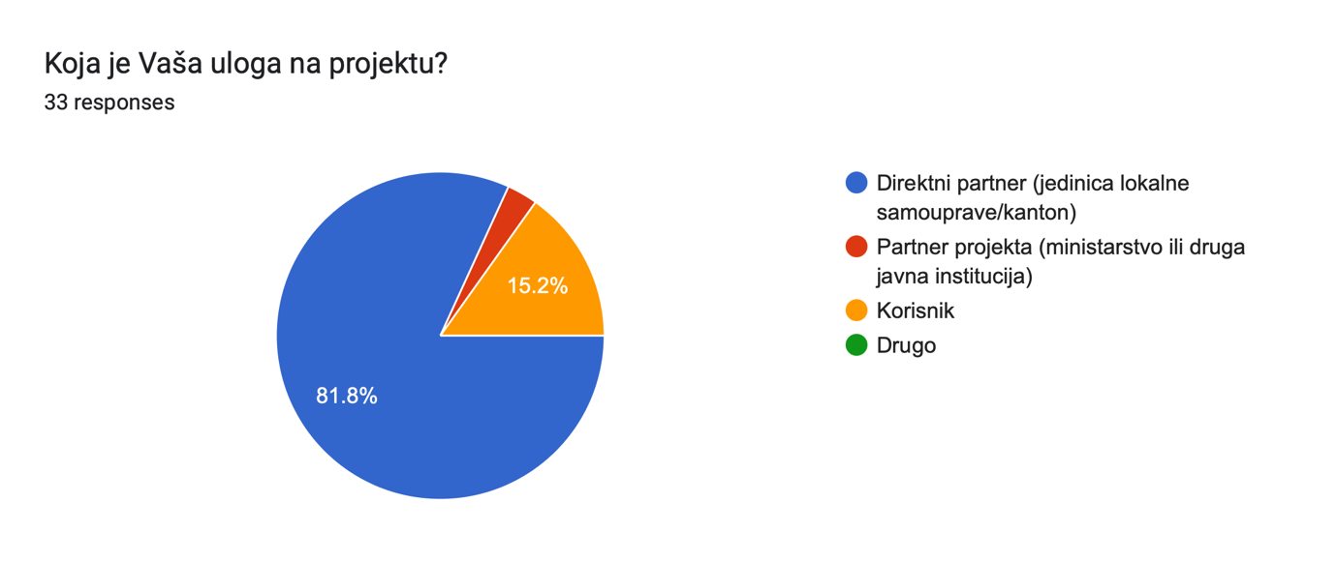

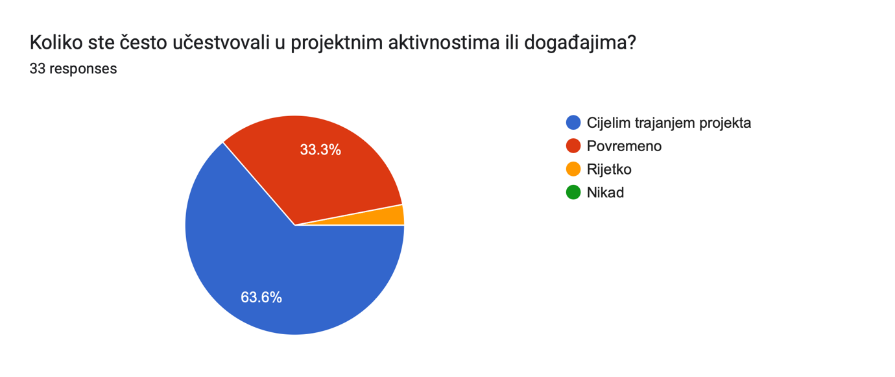

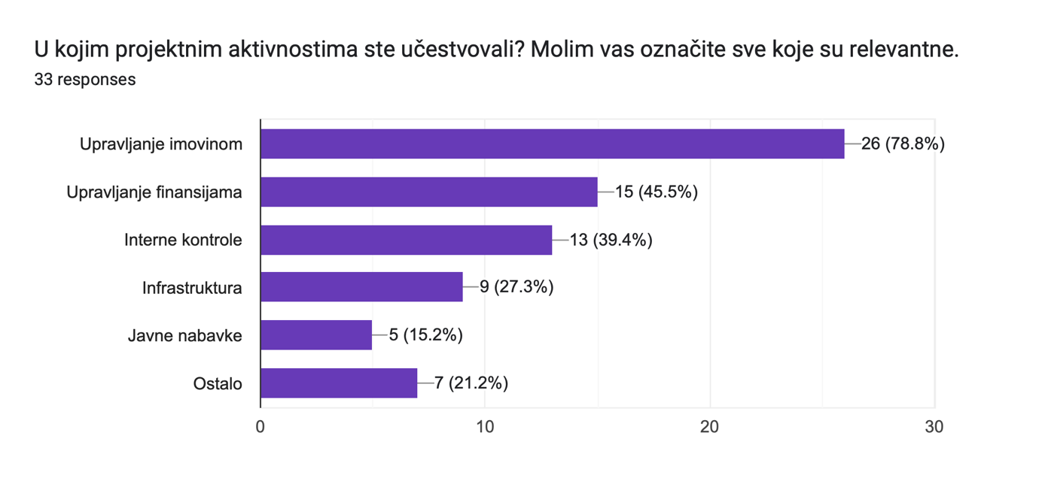

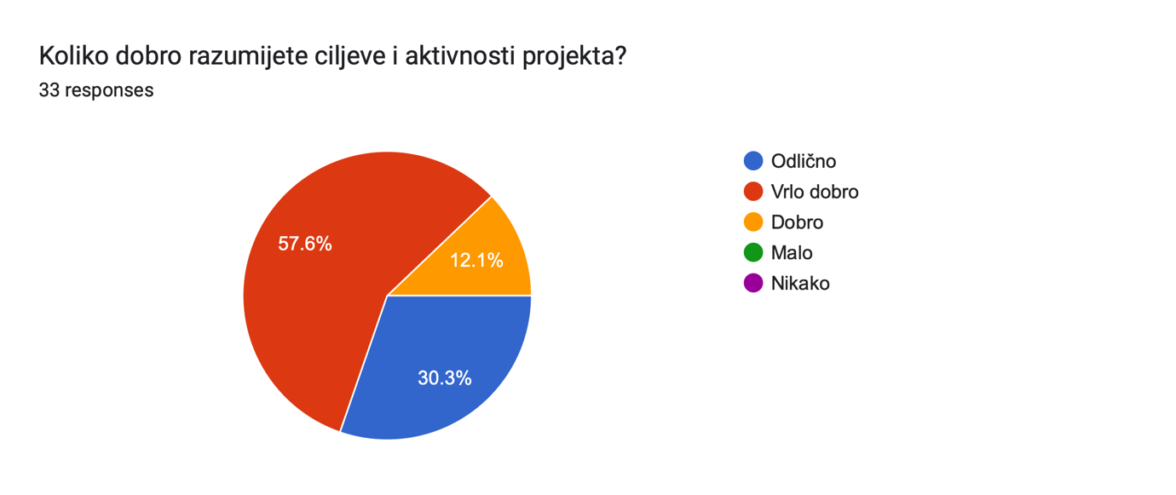

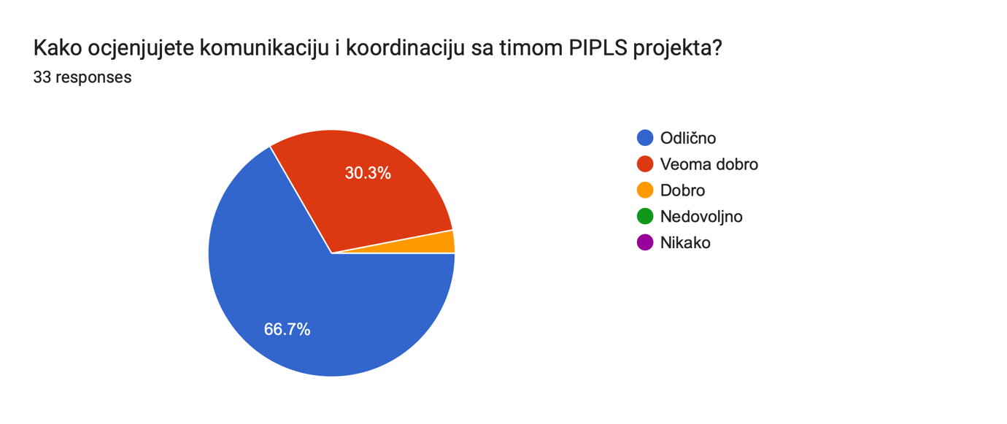

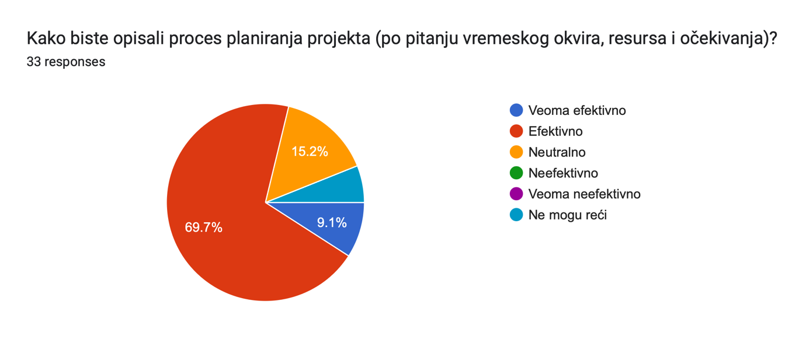

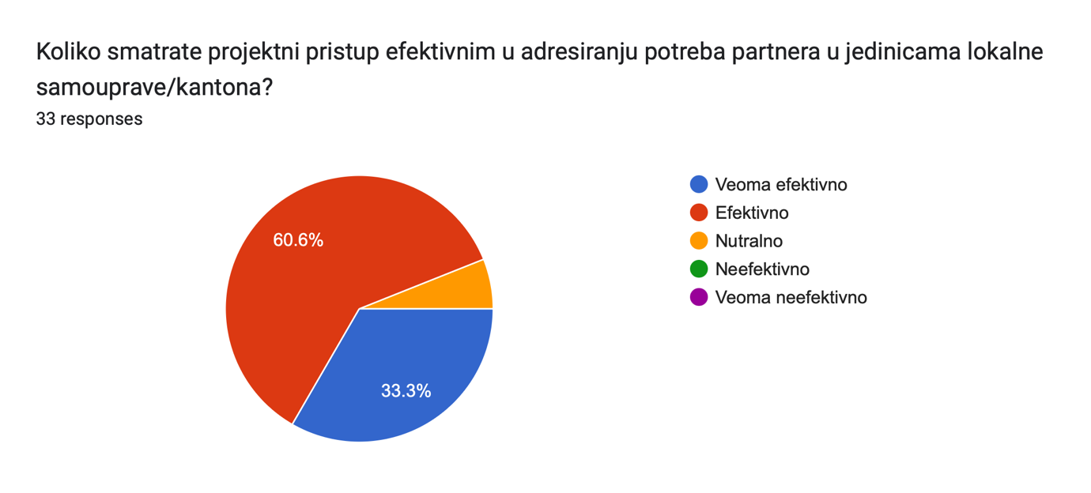

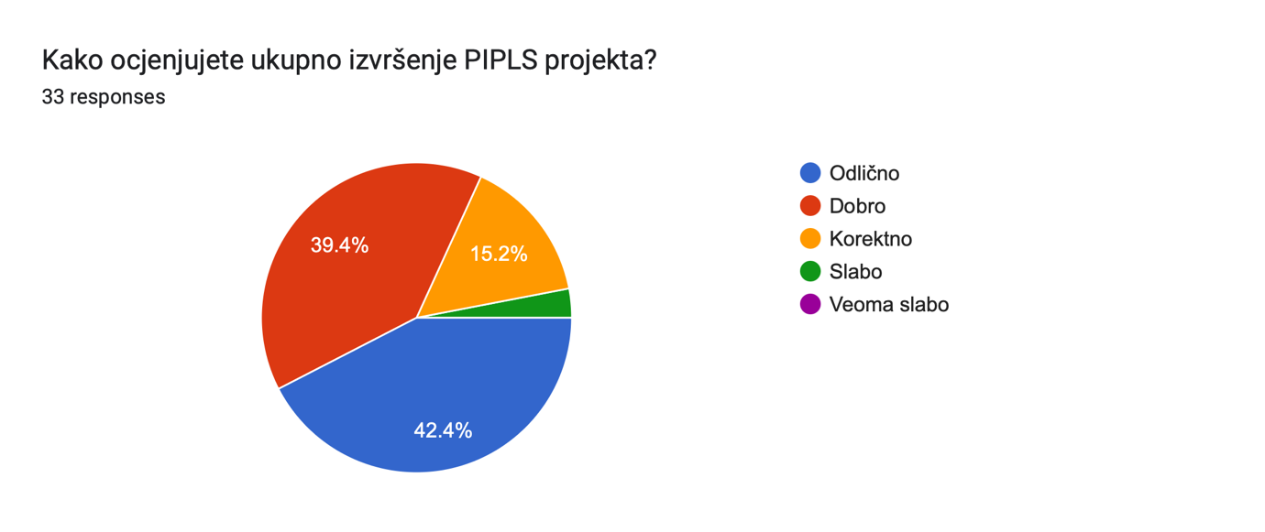

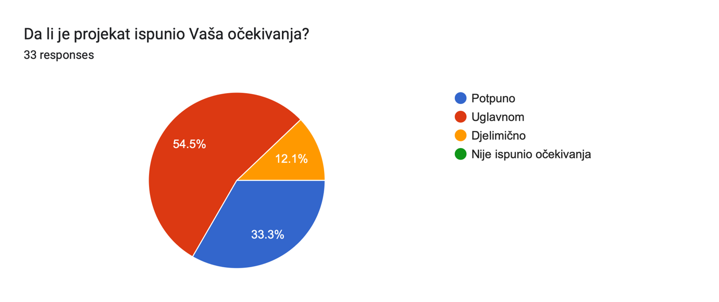

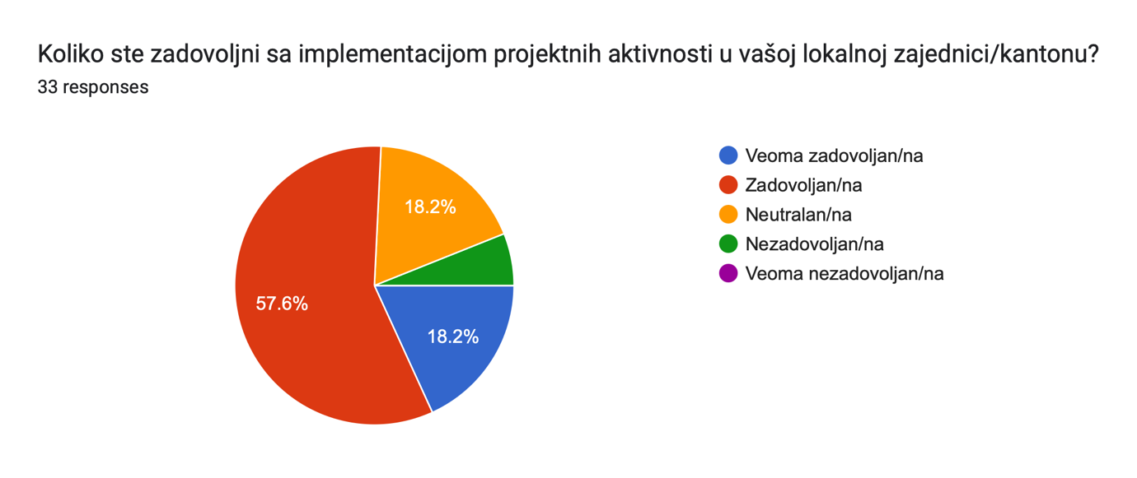

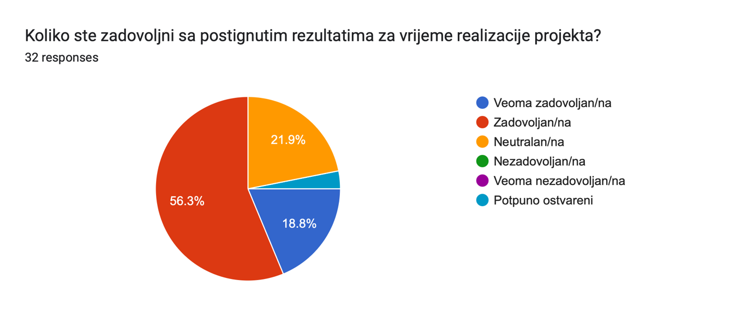

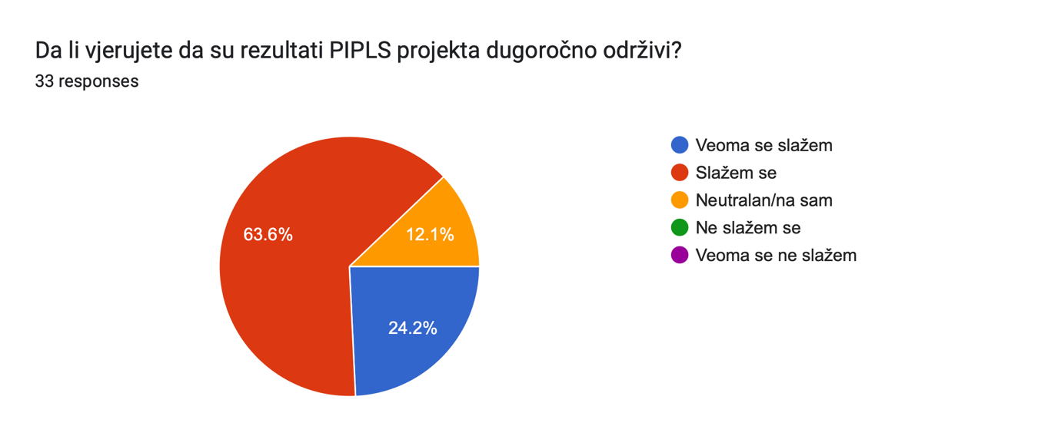

Forms response chart. Question title: Razlikuje li se rad vaše JLS/kantona u odnosu na razdoblje prije implementacije aktivnosti PIPLS projekta? 

. Number of responses: 32 responses.

Forms response chart. Question title: Da li su poduzete druge aktivnosti u vašoj JLS/kantonu koje su nastale kao rezultat PIPLS projekta?

. Number of responses: 32 responses.

1. https://europa.eu/newsroom/ecpc-failover/pdf/qanda-23-5613_en.pdf
2. Annex X provides additional details on the questions the evaluation sought to answer.
3. World Bank, <https://thedocs.worldbank.org/en/doc/d5f32ef28464d01f195827b7e020a3e8-0500022021/related/mpo-bih.pdf> , 2019.
4. [Eurostat](https://ec.europa.eu/eurostat/statistics-explained/index.php/GDP_per_capita,_consumption_per_capita_and_price_level_indices), 2017.
5. <https://data.undp.org/countries-and-territories/BIH#:~:text=Bosnia%20and%20Herzegovina's%20Human%20Development,of%20204%20countries%20and%20territories>, UNDP: Measuring average levels of income, health and education, the Human Development Index of BIH was at 0.78 in 2022, ranking it 79th among the countries with a high level of human development.
6. The poverty headcount ratio showed 17 % of the population living on less than 60 % of median national income, a lower value than in many countries of Central and Eastern Europe. Household Budget Survey, 2015, BIH Agency of Statistics.
7. Migration and Brain Drain, the World Bank Group, 2019.
8. Source: <https://tradingeconomics.com/bosnia-and-herzegovina/corruption-index>
9. [Analytical Report](https://europa.ba/wp-content/uploads/2018/06/Master-LGI-report-04062018-web-eng.pdf), Local Government in Bosnia and Herzegovina: Report on Consultations of a Joint Commission on Local Government, June 2018.
10. Ibid.
11. Please see Annex X for details.
12. https://europa.eu/newsroom/ecpc-failover/pdf/qanda-23-5613_en.pdf
13. The evaluator reviewed samples of adopted municipal policies on asset management, enshrining changes advocated through the Project, changes to organizational charts and staffing tables that reflect a formalized role for asset managers, training attendance sheets, a user-friendly data collection tool for assets, and the manual for asset management, among others.
14. This is the 2023 figure as the financial reports for the final Project year are pending – the figure is likely to be significantly larger on Project closure.
15. The municipal asset management toolkit includes a user-friendly data collection tool that is used to map out all relevant local government assets, the asset management registry that holds all relevant data, action plans to set out necessary measures to be undertaken by local governments, and the Asset Management Manual as a desk reference guide for all practitioners. This set of documents facilitates the transfer of good Project practices to non-partner local governments.
16. This is the entity that has overall responsibility for implementation of the Project (award), effective use of resources and delivery of outputs in the signed Project document and workplan.
17. Although the Technical Assistance Facility originally offered assistance to newly elected mayors in the area of proper financial management as well, due to assistance provided through the PIPLS Project financial management programmatic subcomponent, it was decided to focus assistance across the other three thematic areas.
18. There is no Local Self-Government Development Strategy in the FBIH entity.
19. [http://parco.gov.ba//wp-content/uploads/2014/02/strategy-for-public-administration-reform.pdf](http://parco.gov.ba/wp-content/uploads/2014/02/strategy-for-public-administration-reform.pdf)
20. A country-wide public financial management (PFM) reform strategy has yet to be developed and adopted to ensure a common reform direction. The RS entity continue to lack a PFM strategy, whereas all other levels implement reforms on PFM strategies that come to an end in 2020. In light of the COVID-19 crisis and the need to maintain functioning PFM systems, all levels of government have embarked on a process of developing new PFM strategies until 2025.
21. <https://ec.europa.eu/neighbourhood-enlargement/sites/near/files/bosnia_and_herzegovina_report_2020.pdf>
22. Specific evaluation questions to be defined in the Evaluation Inception Report.
23. [UNDP Evaluation Guidelines, Inception Report Content Outline.](https://view.officeapps.live.com/op/view.aspx?src=https%3A%2F%2Ferc.undp.org%2Fdocs%2FSec%25204%2520Inception%2520Report%2520content.docx&wdOrigin=BROWSELINK)
24. Template available at <http://web.undp.org/evaluation/guideline/documents/PDF/UNDP_Evaluation_Guidelines.pdf>, p. 25.
25. [UNDP Evaluation Guidelines, Box 7. Sources of conflict of interest in evaluation](http://web.undp.org/evaluation/guideline/documents/PDF/UNDP_Evaluation_Guidelines.pdf).