**Strengthening Protected Area Network of Turkey:**

**Catalyzing Sustainability of Marine and Coastal Protected Areas**

***Turkey***

**GEF Agency: United Nations Development Programme**

**EA: Environmental Protection Agency for Special Areas**

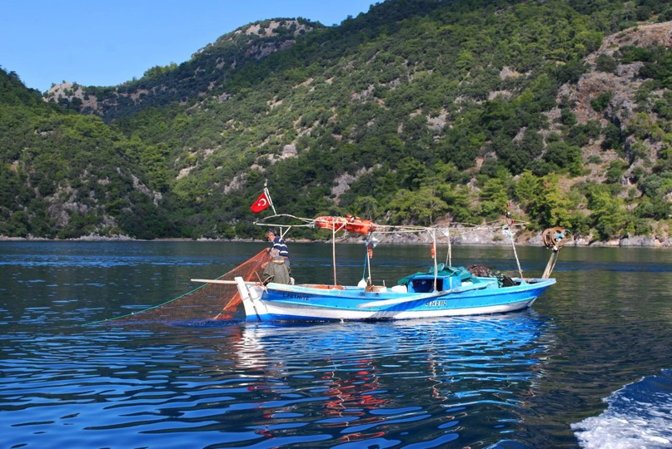

**GEF Biodiversity Focal Area (OP2)**

**GEF Strategic Objective BD-I**

**Full-sized Project**

**GEF ID: #3550**

**UNDP Atlas ID: #00051431 / UNDP PIMS: #3697**

**Mid-term Evaluation**

**December 2, 2011**

**Josh Brann,** *International Consultant,* [*Brann.Evaluation@gmail.com*](mailto:Brann.Evaluation@gmail.com)

**Mesut Y. Kamiloglu,** *National Consultant,* [*mykamiloglu@yahoo.com*](mailto:mykamiloglu@yahoo.com)

Table of Contents

I. Executive Summary IV

II. Introduction: Evaluation Scope and Methodology 1

III. Project Overview and Development Context 2

A. Development Context 2

B. Concept Development and Project Description 2

i. Concept Background 2

ii. Project Description 3

iii. Stakeholder Participation in Development 6

IV. Project Design and Implementation 6

A. Assessment of Project Strategy and Design 6

B. Project Implementation Approach 8

i. Management Arrangements 8

ii. Future Challenges: Turkey’s Institutional Restructuring 9

C. Project Relevance 12

D. Project Management and Cost Effectiveness (Efficiency) 14

E. Financial Planning by Component and Co-financing 14

F. Flexibility and Adaptive Management 15

G. UNDP Project Oversight 16

V. Project Performance and Results (Effectiveness) 19

A. Progress Toward Achievement of Anticipated Outcomes 20

i. Outcome 1: Responsible institutions have the capacities and internal structure needed for prioritizing the establishment of new MCPAs and for more effectively managing existing MCPAs 20

ii. Outcome 2: MCPA financial planning and management systems are facilitating effective business planning, adequate levels of revenue generation and cost-effective management 24

iii. Outcome 3: Inter-agency coordination mechanisms in place to regulate and manage economic activities within multiple use areas of the MCPAs 26

B. Priorities and Risks for the Remainder of Implementation 29

VI. Key GEF Performance Parameters 30

A. Sustainability 30

i. Financial Risks to Sustainability 30

ii. Sociopolitical Risks to Sustainability 31

iii. Institutional Framework and Governance Risks to Sustainability 31

iv. Environmental Risks to Sustainability 33

B. Catalytic Role: Replication and Scaling-up 33

C. Monitoring and Evaluation 34

i. Project Monitoring, Reporting, and Evaluation 34

ii. Environmental Monitoring 35

D. Project Impacts and Global Environmental Benefits 36

E. Stakeholder Participation in Implementation 37

F. Capacity Development 38

VII. Main Lessons Learned and Recommendations 38

A. Lessons from the Experience of the Turkey MCPAs Project 38

B. Recommendations for the Remaining Implementation Period 39

C. Project Mid-term Evaluation Ratings 42

VIII. Annexes 45

**Acronyms**

BDU Business Development Unit (of GDNAP )

CBD Convention on Biological Diversity

CEO Chief Executive Officer

DCAC Dalyan Channels Administrative Commission

EPASA Environmental Protection Agency for Special Areas

FSP Full-sized project

GDNAP General Directorate of Natural Assets Protection (formerly EPASA, and others)

GDNCNP General Directorate for Nature Conservation and National Parks

GEF Global Environment Facility

GIS Geographic Information System

GPS Global Positioning System

Ha Hectares

LMU Local Management Unit

LWG Local Working Group

MARA Ministry of Agriculture and Rural Affairs

MCPA Marine and coastal protected area

METT Management Effectiveness Tracking Tool

MoCT Ministry of Culture and Tourism

MoEF Ministry of Environment and Forestry

MoEU Ministry of Environment and Urbanization (formerly MoPW)

MoFW Ministry of Forests and Water Affairs (formerly MoEF)

MoPW Ministry of Public Works

MOU Memorandum of Understanding

M&E Monitoring and evaluation

NBSAP National Biodiversity Strategy and Action Plan

NESAP National Environmental Strategy and Action Plan

NEX National Execution

NFA No Fishing Area

NGO Non-governmental Organization

PA Protected area

PIR Project Implementation Report

PMU Project Management Unit

PPG Project preparation grant

SEPA Special Environmental Protected Area

SIT National protected site

UNDP United Nations Development Programme

USD United States dollars

WWF World Wildlife Fund

# Executive Summary

1. The Republic of Turkey Marine and Coastal Protected Areas (MCPAs) project is a Global Environment Facility (GEF) Full-sized project (FSP), with GEF support of $2.30 million United States dollars (USD) (including $0.10 million project preparation grant (PPG) funding), not including the GEF Agency fee to UNDP. Originally planned co-financing was for $4.12 million USD (including PPG co-financing of $0.10 million), for a total planned project budget of $6.65 million at CEO Endorsement. The project is executed under UNDP’s National Execution (NEX) modality, and was initially executed by the Environmental Protection Agency for Special Areas (EPASA), which was an institution affiliated with the former Ministry of Environment and Forestry (MoEF). This institutional arrangement has since changed, as discussed further below.
2. According to GEF and UNDP evaluation policies, all GEF-funded FSPs must have an independent mid-term evaluation. This mid-term evaluation considers the actual performance and progress toward results of the project against the planned project activities and outputs, based on the relevant evaluation criteria: relevance, efficiency, effectiveness, results and sustainability. The evaluation methodology was based on a participatory mixed-methods approach, which included three primary elements: a) a desk review of project documentation and other relevant documents; b) interviews with key project participants and stakeholders; and c) field visits to project sites on Turkey’s Aegean and Mediterranean coasts. The evaluation is based on evidence from the start of project implementation (September 2009) to October 2011, and includes an assessment of issues prior to approval, such the project development process, overall design, risk assessment and monitoring and evaluation planning. The desk review was begun in September 2011, and the evaluation mission was carried out from October 17 – October 27, 2011.
3. As stated in the project document, the overall project objective is “*to facilitate expansion of the national system of marine and coastal protected areas and improve its management effectiveness.*” The project objective is to be achieved through the following three outcomes:

**Outcome 1:** **Responsible institutions have the capacities and internal structure needed for prioritizing the establishment of new MCPAs and for more effectively managing existing MCPAs**

**Outcome 2:** **MCPA financial planning and management systems are facilitating effective business planning, adequate levels of revenue generation and cost-effective management**

**Outcome 3:** **Inter-agency coordination mechanisms in place to regulate and manage economic activities within multiple use areas of the MCPAs**

1. Project activities are carried out at both the central level (with respect to institutional capacity development and cross-sectoral coordination), and at the site level (with respect to implementation, local management units, no-fishing areas, and other activities). Site-level activities are focused on six protected areas – five Special Environmental Protected Areas (SEPAs) (for which the former EPASA is the responsible authority), and one nature park (for which the former General Directorate for Nature Conservation and National Parks (GDNCNP) is the responsible authority). The five SEPA sites are Datça-Bozburun, Fethiye-Göcek, Foça, Gökova, and Köycegiz-Dalyan, and the nature park is Ayvalik Islands Nature Park. In addition, the project contributed to the establishment of a sixth SEPA site, Saros Bay.
2. Following Turkey’s elections in June 2011, the government environmental line agencies are undergoing a reorganization that started in August 2011, and the institutional structure of the project’s original government executing partners has been completely changed: The former EPASA (responsible for SEPA sites) has been reformed under the new Ministry of Environment and Urbanization (MoEU) (formerly the Ministry of Public Works (MoPW)) as the General Directorate of Natural Assets Protection (GDNAP) in combination with the branch of the Ministry of Culture and Tourism (MoCT) responsible for protected natural sites (SITs) (which number an estimated 1,265 sites). In addition, the former MoEF has been reformed as the Ministry of Forests and Water Affairs (MoFW), under which is the GDNCNP, which is responsible for national parks and other similar protected areas. In this sense, Turkey now has two bodies under two separate ministries responsible for natural protected areas. The types of protected areas under each are significantly different, as SEPAs, SITs and national parks all have different scope, rationale, and level of protection.
3. The first half of project implementation has been carried out as expected according to the project document and workplans. To date the project has produced significant positive results (as further discussed below), and is well positioned to continuing progressing toward the project objective by project end. However, the institutional restructuring described above has introduced significant risks and unknowns related to the remaining implementation period. The key government partners’ level of collaboration, coordination, and commitment at the provincial and central level to continue supporting the project objective in a results-based manner will likely determine the ultimate success of the project. Many of the recommendations of this evaluation focus on repositioning project implementation in the context of this institutional restructuring to reach the greatest level of achievement possible at project completion. The mid-point ratings for the project are provided below, based on the first half of project implementation.
4. Project **relevance** is considered ***satisfactory***. At the local level the project is supporting the needs and priorities of local stakeholders with respect to the effective management of marine and coastal resources. This includes working with municipalities such as Akyaka in Gökova SEPA, and with fishermen’s cooperatives in multiple sites. The project is relevant at the national level by supporting Turkey’s marine and coastal biodiversity conservation priorities and strategies as outlined in documents such as the Ninth Five-Year Development Plan (2007-2013), the National Agenda 21, the National Biodiversity Strategy and Action Plan (NBSAP), the Sectoral Expertise Reports For Environment, Forestry and Tourism, and the National Environmental Strategy and Action Plan (NESAP). The project is also supporting Turkey’s commitments under multilateral environmental agreements such as the Convention on Biological Diversity (CBD), and the Barcelona Convention. For the GEF, the project is relevant to the GEF’s first biodiversity strategic objective on catalyzing the sustainability of protected area systems.
5. Although the project objective is relevant to the above biodiversity conservation priorities and strategies, the project is ambitious for its size and timeframe. The project strategy of taking a systemic approach to strengthening protected areas was guided by the GEF’s portfolio level strategy, but given the time and resources available, alternative project strategies or designs may have been more appropriate. For example, given the size of the SEPA sites, the project design could have worked to develop a strong approach to effective management at one site, and then followed up with an intensive replication effort to extend the example to the other areas.
6. Considering all aspects of project implementation and financial management, project **efficiency** is rated ***satisfactory***. The project is implemented in a cost-effective manner, with financial management procedures in-line with international norms and standards for development projects. The project management and implementation approach is well structured to produce results at or above the level expected based on the input of resources. This can be partially attributed to the dedication of the many individuals involved, and the strong stakeholder ownership of the project. The government institutional restructuring may have a slight negative influence on overall project efficiency due to the fact that some outputs already produced will need to be revised and some project activities restructured. The project’s financial delivery rate is less than 50% at the mid-point, and activities will have to be executed at a greater rate in the second half of the project.
7. Based on progress toward overall achievement of objective and outcomes, project **effectiveness** is rated ***satisfactory***. The project’s implementation progress is generally on track (or was up to the point of the institutional restructuring) with the activities and outputs carried out effectively contributing to the achievement of project outcomes. Once the institutional framework is resettled there will need to be a reassessment of the project workplan to maintain the current results-focus, while ensuring key activities continue to move ahead such as establishment and operationalization of the Local Management Units (LMU) for each site.
8. While mid-term evaluations are generally not well positioned to provide ratings on sustainability, this evaluation report included a sustainability rating as required. The **sustainability** of project results is rated ***moderately likely***, based on an assessment of the four components of sustainability.
9. Below are the key **recommendations** of this evaluation report. Additional recommendations are included at the end of the report. The target audiences for each recommendation are in brackets.
10. ***Key Recommendation:*** The Project Steering Committee and implementation partners should approve at the next Steering Committee meeting an official project extension to October 2013, to account for the period between approval and actual implementation start so that the project can still have a four-year implementation period. In addition, the Steering Committee should consider a further six-month extension to address delays resulting from the current government institutional restructuring. Thus a total of a one-year extension would be appropriate. *[Project Management Unit (PMU), Project Steering Committee, UNDP]*
11. ***Key Recommendation:*** The project design is ambitious in scope for the amount of resources and planned implementation period. At this stage the project team and partners should revise the project workplan to consolidate some outputs and activities, particularly under Outcome 1, which was adjusted at inception to include ten outputs. Some outputs under multiple outcomes are overlapping and could be consolidated to focus on key results. A workplan revision is also necessary to adaptively manage the government institutional restructuring. *[PMU, Key Partner Institutions, GDNAP, UNDP]*
12. ***Key Recommendation:*** Once the landscape of institutions involved in and responsible for management of SEPA sites is clear, the project team should re-assess the Steering Committee membership, and ensure involvement of all necessary stakeholders, including for example the Gendarmes. Any newly involved stakeholders will need to be fully updated on the project objective and planned activities. The reconstituted Steering Committee can then approve the necessary changes in the project workplan, logframe, budget, etc. for the second-half of implementation. *[PMU, GDNAP, UNDP]*
13. ***Key Recommendation:*** To respond to the institutional restructuring, this evaluation recommends the project take a decentralized implementation approach for the second-half of the project. This would involve broadly increasing the focus on site and provincial level activities, and on strengthening local management. For example, there will be a need to increase involvement of provincial directorates of the General Directorate of Fisheries & Aquaculture, the former GDNCNP, and the private sector (especially the tourism sector). Reflecting this increased decentralized focus, it would be useful to hold site-level meetings with the participation of all stakeholders (including media) to refresh the local awareness about the project, get further local feedback on key issues and suggestions for implementation. *[PMU, GDNAP, UNDP]*
14. ***Key Recommendation:*** The project strategy originally envisioned the establishment of LMUs for each of the sites to facilitate effective management. The project had made progress toward this goal through capacity development activities for EPASA staff recruited for this purpose, but the institutional restructuring occurred before the LMUs were officially established, and made operational. This evaluation recommends that the establishment of site-level LMUs remain a top priority, and that these should be established before the end of the project. Alternative approaches of having management staff based in provincial headquarters would not be nearly as effective for managing marine and coastal resources. *[PMU, GDNAP, MoEU]*
15. ***Key Recommendation:*** After the establishment of the new ministry (the MoEU) and new institutional arrangements at the provincial level, in the view of this evaluation the best way to establish the Local Working Groups (LWGs) would be under the chairmanship of the local governor at each site, with the participation of all related institutions and organizations. This evaluation recommends this issue be given priority in the remaining project period to better implement the project activities in the provincial level and to give more power and authority to the local level establishments for the future of the project. *[PMU, GDNAP, MoEU]*
16. ***Key Recommendation:*** To facilitate a decentralized implementation approach, this evaluation recommends the addition of site-based project officers to catalyze and guide local level activities. One or two project officers may be appropriate, depending on the division of responsibilities. Previous UNDP-GEF project experience has shown that having site-level project staff can be of great benefit in increasing communication with and the involvement of local stakeholders. *[PMU, GDNAP, UNDP]*
17. ***Key Recommendation:*** The project should as soon as possible carry out the public awareness baseline survey of key stakeholder groups originally foreseen; it is critical to have a clear understanding of public awareness related to the project objective of conserving coastal and marine biodiversity in Turkey, and this would allow an assessment of progress in this area at the end of the project. This information would also provide input for further activities to strengthen awareness local stakeholder ownership. Opportunities for future activities include school activities linked with local media, information boards at ports, and an information stand at weekly markets. *[PMU]*
18. ***Key Recommendation:*** Given the project’s anticipated decentralization shift, the project should add on-the-ground site level activities to provide small-scale but direct contributions to the project objective, increase stakeholder awareness and participation, and demonstrate concrete results to local stakeholders. This could be effectively achieved through partnership with local level civil society organizations, and the project could explore potential partnership with the GEF Small Grants Programme, which has already supported some community-level activities in the area. The most relevant activities should be drawn directly from stakeholder input, but opportunities include feasibility studies for local eco-labels (particularly for organic agriculture to reduce nutrient run-off), awareness raising on illegal spear fishing with restaurant commitment and certification, ghost net cleanup, public awareness campaigns by civil society, and additional work on creating opportunities for fishermen to involve tourists in fishing excursions. *[PMU, GDNAP, UNDP, Project Steering Committee]*
19. ***Key Recommendation:*** Increasing individual and institutional capacity for effective management of marine and coastal resources is one of the main outcomes of the project, and a number of activities have already been carried out to support this. Following the government institutional restructuring however, there is an increased need to continue and to strengthen capacity development and training activities, including staff from the GDNAP coming from MoPW that may now be involved in SEPA management. The project should also exploit opportunities for biodiversity mainstreaming within the new MoEU, by seeking synergies for biodiversity considerations in other MoEU work, such as coastal land-use planning. The MCPA Training and Implementation Center should present opportunities to catalyze and scale-up good management practices, and the e-learning platform developed by the project can also contribute. Another capacity development opportunity would be for site-level exchanges within the project sites for the government staff responsible. *[PMU, GDNAP]*

**Turkey MCPAs Project Mid-term Evaluation Rating Summary**

| **Project Component or Objective** | **Rating** |
| --- | --- |
| **Project Formulation** |  |
| **Relevance** | S |
| Conceptualization / design | MU |
| Country-drivenness | S |
| Stakeholder involvement in design | MS |
| **Project Implementation** |  |
| **Implementation Approach (Efficiency)** | S |
| Management implementation | S |
| Use of the logical framework | MS |
| Financial planning and management | S |
| Adaptive management | S |
| Use and establishment of information technologies | S |
| UNDP supervision and support | S |
| Operational relationships between the institutions involved | MS |
| Technical capacities | S |
| **Monitoring and Evaluation** | MS |
| M&E design | MU |
| M&E plan implementation | S |
| M&E budgeting | S |
| **Stakeholder Participation** | MS |
| Production and dissemination of information | MS |
| Local resource users and civil society participation | MS |
| Establishment of partnerships | S |
| Involvement and support of governmental institutions | MS |
| **Project Results** |  |
| **Progress Toward Overall Achievement of Objective and Outcomes (Effectiveness)** | S |
| **Objective**: To facilitate expansion of the national system of marine and coastal protected areas and improve its management effectiveness | S |
| **Outcome 1:** Responsible institutions improved the capacities and internal structure needed for prioritizing the establishment of new MCPAs and for more effectively managing existing MCPAs | S |
| **Outcome 2:** MCPA financial planning and management systems are facilitating effective business planning, adequate levels of revenue generation and cost-effective management | S |
| **Outcome 3:** Inter-agency coordination mechanisms in place to regulate and manage economic activities within multiple use areas of the MCPAs | MS |
| **Sustainability** |  |
| **Overall Sustainability** | ML |
| Financial | L |
| Socio-political | ML |
| Institutional framework and governance | ML |
| Environmental | L |
| **Progress Toward Overall Achievement and Impact** | S |

*Ratings explanation: HS – Highly Satisfactory; S – Satisfactory; MS – Moderately Satisfactory; MU – Moderately Unsatisfactory; U – Unsatisfactory; HU – Highly Unsatisfactory; UA – Unable to Assess; N/A – Not Applicable*

*Sustainability ratings: L – Likely; ML – Moderately Likely; MU – Moderately Unlikely; U - Unlikely*

# Introduction: Evaluation Scope and Methodology

1. According to GEF and UNDP evaluation policies, mid-term evaluations are standard practice for GEF funded projects, and a mid-term evaluation was a planned activity of the monitoring and evaluation plan of the Turkey MCPAs project. The UNDP Turkey Office initiated the mid-term evaluation near the mid-point of the project’s planned four-year implementation period. This evaluation reviews the actual performance and progress toward results of the project against the planned project activities and outputs, based on the standard evaluation criteria: relevance, efficiency, effectiveness, results and sustainability. The evaluation represents an objective independent perspective designed to fulfill both the learning and accountability functions of evaluation. The evaluation assesses project results based on expected outcomes and objectives, as well as unanticipated results. The evaluation identifies relevant lessons for other similar projects in the future in Turkey and elsewhere, and provides recommendations for the remaining implementation period as necessary and appropriate.
2. In addition to assessing the main GEF evaluation criteria, the evaluation provides the required ratings on key elements of project design and implementation. Further, the evaluation will, when possible and relevant, assess the project in the context of the key GEF operational principles such as country-drivenness, and stakeholder ownership, as summarized in Annex 2.
3. The evaluation methodology was based on a participatory mixed-methods approach, which included three primary elements: a) a desk review of project documentation and other relevant documents; b) interviews with key project participants and stakeholders; and c) field visits to relevant project sites on the Aegean coast of Turkey. The evaluation is based on evaluative evidence from the start of project implementation (September 2009) to October 2011, and includes an assessment of issues prior to approval, such the project development process, overall design, risk assessment and monitoring and evaluation planning. The desk review was begun in September 2011, and the evaluation mission was carried out from October 17 – October 27, 2011. The list of stakeholders interviewed is included as Annex 4 to this evaluation report.
4. All evaluations face limitations in terms of the time and resources available to adequately collect and analyze evaluative evidence. With additional time, more stakeholder viewpoints and relevant data could have been gathered for this mid-term evaluation. Also, as is understandable, some documents were available only in Turkish language, although all key documents were available in English. The composition of the evaluation team, with a national consultant, ensured that language was not a critical barrier in collection of the evaluative evidence. Altogether the evaluation challenges were not significant, and the evaluation is believed to represent a fair and accurate assessment of the project.
5. The evaluation was conducted in accordance with UNDP and GEF monitoring and evaluation policies and procedures, and in-line with United Nations Evaluation Group norms (i.e. impartiality, independence, transparency, ethics, etc.) and standards.
6. The intended users of this mid-term evaluation are the project team and UNDP country and regional offices. As relevant, the mid-term evaluation report may be disseminated more widely with additional stakeholders to substantiate adaptive management decisions or share lessons and recommendations.

# Project Overview and Development Context

## Development Context

1. Turkey’s location straddling three biogeographic regions, i.e., the Euro Siberian, Irano-Turanian and Mediterranean, is a key factor underlying its biodiversity importance. Marine biodiversity represents an important, though generally underappreciated, element of Turkey’s biological wealth. The country’s land area consists almost entirely of two peninsulas – the Anatolian Peninsula and the Thrace Peninsula. As such, it has a relatively long coastline (8,549 kilometers, excluding islands) bordering four different seas – the Mediterranean, Aegean, Marmara and Black Seas.
2. Within the marine areas bordering Turkey’s lengthy coastline is found an abundant, highly diverse and globally significant biodiversity endowment. Overall, some 3,000 plant and animal species have been identified in Turkey’s marine waters.
3. The coastal dunes and beaches along Turkey’s Mediterranean seashore include important breeding grounds of two globally endangered marine turtle species: the loggerhead (*Caretta caretta*) and the green (*Chelonia mydas*).
4. While the Mediterranean coast of Turkey has more extensive biological diversity, the Black Sea has historically supported a substantially more productive fishery. The Black Sea has a lower salinity level, and the number of species living in it is only 20% of the number that live in the Mediterranean. Still the Black Sea provides 70% of Turkey’s fish production. The difference in diversity is due partly to the fact that the continental shelf of the Black Sea is very narrow, which limits the abundance and species variability of benthos.The Aegean Sea and its islands contain abundant microhabitats – including those dominated by *Posidonia oceanica* and *Cystoseira* species – which play an important role in the sustainability of the ecosystem.
5. Prior to the institutional restructuring discussed throughout this report, institutional responsibility for the establishment and management of MCPAs was with four agencies: (i) EPASA, (ii) the Fisheries Department, Ministry of Agriculture and Rural Affairs, (iii) the GDNCNP and (iv) the MoCT. EPASA is responsible for managing over 73.5% of total MCPA coverage under the baseline. This includes responsibility for managing nine SEPAs that may be categorized as MCPAs.[1] These nine SEPAs total over four million hectares and represent Turkey’s primary form of MCPA. Decision-making regarding SEPAs involves a number of institutional actors. For example, EPASA’s planning decisions related to SEPA zoning need to be implemented by relevant local government bodies. Similarly, EPASA recommendations concerning pollution control or fisheries regulation must be agreed to and enforced by the relevant bodies, i.e., departments of MoEF and the Ministry of Agriculture and Rural Affairs (MARA).

## Concept Development and Project Description

### Concept Background

1. According to stakeholders involved in the project development phase, the project concept emerged from a mission by the UNDP Regional Technical Advisor to Turkey in late-2005, at the government’s request for UNDP’s assistance in identifying possible follow-up opportunities to the previous World Bank-implemented GEF project “Biodiversity and Natural Resource Management” (GEF ID #458), which was operational from mid-2000 to late 2008 (originally planned closing was the end of 2006). The government (as represented by the GEF Operational Focal Point at the time) was interested in building on the experience of the World Bank project through replication, since continuing the same project was not an option. The protected areas gap analysis in Turkey had identified marine ecosystems and steppe ecosystems as requiring additional coverage, but the government decided to focus on marine ecosystems and suggested EPASA as the project lead agency. EPASA had been working for years on MCPAs and implementation of the Barcelona Convention, and an advisor on MCPA management plans from the former State Planning Organization (now Ministry of Development) suggested they should seek funding under GEF-4 with UNDP. The project concept was accepted by UNDP in December 2005, and from that point on UNDP provided initial co-financing to further develop the concept to what would have been the PDF-B stage. During the first part of 2006 the project concept was developed through stakeholder meetings, and discussions on potential co-financing were held with EPASA; on this timeline the project would have been submitted to the GEF for approval in late 2006 or 2007. However, the changes in the GEF project cycle that occurred during the changeover from GEF-3 to GEF-4 delayed project preparation, and the PPG was only finally approved in late 2007.

### Project Description

1. The project was developed to address the main threats to marine and coastal biodiversity in six protected area sites on the western Aegean coast of Turkey. The key threats include: a.) Degradation of marine habitats and ecosystems, driven primarily by land-based sources related to increased coastal development and agriculture, and diffuse marine sources from a large boat-based tourism industry in the region; b.) Overharvesting of marine resources, especially of fish stocks, along with illegal harvests; the fishing industry also negatively impacts non-commercial threatened species such as sea turtles and monk seals; and c.) Conversion or destruction of coastal habitats, mainly from coastal tourism development. The main barriers identified for addressing these threats were 1.) Limitations in capacity for management of sensitive marine and coastal habitats; 2.) Inadequate long-term sustainable financing to support effective management of marine and coastal protected areas, and 3.) Competing or overlapping government institutional jurisdictions, and inadequate cross-sectoral coordination and bureaucratic conflict resolution.
2. The project is classified as a GEF FSP, since the funding received from the GEF is greater than $1 million USD. Total GEF support is $2.30 million USD (including $0.10 million PPG funding), not including the GEF Agency fee to UNDP. Originally planned co-financing was for $4.12 million USD (including PPG co-financing of $0.10 million), for a total planned project budget of $6.65 million at CEO Endorsement. Table 3 at the end of Section IV outlines the planned project budget breakdown by outcome, and Table 4 shows expected and actual co-financing to date.
3. Following Turkey’s elections in mid-2011, the government line agencies were reorganized, and the institutional structure of the project’s original government partners has been completely changed. This is further discussed in Section IV.B on implementation arrangements. The project is executed under UNDP’s NEX modality, with the former EPASA as the executing partner, which was an affiliated institution with the former MoEF. Other key government institution partners are the former GDNCNP, and the MARA General Directorate of Protection and Control.
4. As stated in the project document, the overall project objective is “*to facilitate expansion of the national system of marine and coastal protected areas and improve its management effectiveness.*” The project document does not specify a long-term project goal. The project objective is stated in a manner to focus on positive change over time, rather than a single specific end goal, although quantitative targets are specified in the objective-level logframe indicators (see further discussion in Section V.A on progress toward outcomes).

**Outcome 1:** **Responsible institutions have the capacities and internal structure needed for prioritizing the establishment of new MCPAs and for more effectively managing existing MCPAs**

**Outcome 2:** **MCPA financial planning and management systems are facilitating effective business planning, adequate levels of revenue generation and cost-effective management**

**Outcome 3:** **Inter-agency coordination mechanisms in place to regulate and manage economic activities within multiple use areas of the MCPAs**

1. The project activities are focused at both the central level (with respect to institutional capacity development and cross-sectoral coordination), and at the site level (with respect to implementation, LMUs, No Fishing Areas (NFAs), and other activities). The site-level project activities are focused on six protected areas (see Figure 1) – five SEPAs, for which EPASA is the responsible authority, and one nature park, for which the GDNCNP is the responsible authority. In addition, the project contributed to the establishment of a sixth SEPA site. Information about the MCPAs specifically covered under the project is shown in Table 1 below. Example images of two of the project sites are shown in Photo 1 and Photo 2.

Table 1 Sites of Project Activities

|  |  |  |
| --- | --- | --- |
| **Name** | **Designation** | **Habitat Type and Area (hectares)** |
| Datça-Bozburun | SEPA | Marine and coastal, halophytic habitats and forests: 144,389 ha, of which 73,663 is marine area |
| Fethiye-Göcek | SEPA | Marine and coastal, and halophytic habitats and forests: 80,537 ha, of which 34,011 is marine area |
| Foça | SEPA | Marine and coastal ecosystems: 7,144 ha, of which 5,178 is marine area |
| Gökova | SEPA (recent expansion) | Marine and coastal, halophytic habitats and forests: Originally 57,690 ha, of which 29,935 is marine area; extended to 109,778 ha of which 82,023 is marine area |
| Köycegiz-Dalyan | SEPA | Marine and coastal and halophytic habitats, coastal sand dunes and inland dunes, freshwater habitats and forests: 46,146 ha, of which 4,084 ha is marine area |
| Ayvalik Islands Nature Park | Nature Park | Marine and coastal, islands with some human settlement: 17,950 ha, of which 14,200 is marine area |
| Saros Bay | SEPA (new) | 73,021 hectares in total of which 53,834 is marine area |

Figure 1 Turkey MCPAs Project Field Sites

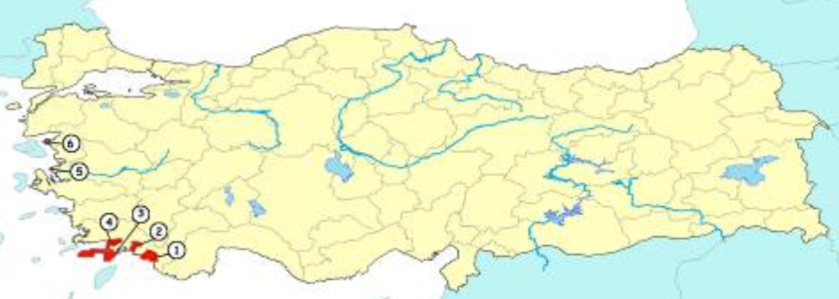

**Key:** 1. Fethiye-Göcek SEPA; 2. Köycegiz-Dalyan SEPA; 3. Datça-Bozburun SEPA; 4. Gökova SEPA; 5. Foça SEPA; 6. Ayvalik Islands Nature Park

|  |  |
| --- | --- |
| Photo 1 Gökova Bay SEPA Site | Photo 2 Ayvalik Islands Nature Park |

1. The project’s key milestone dates are shown in Table 2 below, as per the revised GEF milestones adopted under GEF project cycle revisions for GEF-4. The project development period from PPG approval to implementation start totaled approximately 22 months. This is significantly faster than the average for GEF FSPs during GEF-3, which averaged at least 42 – 49 months from concept to implementation start.[2] According to the inception report, in the period between agency approval and implementation start the project hired staff, designated national experts, established the project office, established the EPASA Business Development Unit (BDU), and organized the Steering Committee. The project implementation start was one month earlier than expected. The inception workshop was held November 11-12, 2009, in Ankara, with 120 participants.

Table 2 Turkey MCPAs Project Key Milestone Dates

|  |  |  |
| --- | --- | --- |
| **Milestone** | **Expected date [a]** | **Actual date**[3] **[b]** |
| 1. PIF Approval | Not Applicable | November 26, 2007 |
| 2. PPG Approval | Not Specified | March 27, 2008 |
| 3. GEF Approval by Council | January 2008 | February 22, 2008 |
| 4. CEO Endorsement | February 2009 | April 17, 2009 |
| 5. Agency Approval | May 2009 | May 29, 2009 |
| 6. Implementation Start (first disbursement) | October 2009 | September 2009 |
| 7. Mid-term Evaluation | November 2011 | October 2011 |
| 8. Project Operational Completion | October 2013 | Not Applicable |
| 9. Terminal Evaluation Completion | 3rd Quarter 2013 | Not Applicable |
| 10. Project Financial Closing | December 31, 2014 | Not Applicable |

### Stakeholder Participation in Development

1. According to data collected for this evaluation, the project development process was generally participatory, including consultations with government stakeholders. Multiple (at least three) large-scale stakeholder consultations were held during the development phase, involving a wide range of stakeholders. Individuals consulted at the local and central levels stated that their input had been collected and incorporated in the project design process.
2. Although multiple steps were taken to incorporate stakeholder feedback to the project design, the process may not have been adequately comprehensive during the design phase. This is indicated by the fact that at the project inception workshop, many additional activities and adjustments to the project design were incorporated based on the workshop discussions (further discussed in Section IV.F on adaptive management). Some modifications and revisions to the project design and workplan are expected at the inception phase, but having significant changes at this stage is not considered good practice.

# Project Design and Implementation

## Assessment of Project Strategy and Design

1. The project document for the Turkey MCPAs project is clear and comprehensive, following a standard UNDP format that ensures the key elements of the project document are included. This standardized approach marks this project as part of the “new generation” of UNDP-GEF projects, in which project documents meet minimum standards, contrasting with the early days of the GEF. For example, the project document includes the key components of stakeholder analysis, risk assessment, threat analysis, sustainability plan, replication approach, monitoring and evaluation plan, and lessons learned from previous GEF experience.
2. The project stakeholder analysis is included as section 1.4 of the project document, and identifies 28 different institutions or stakeholder groups with interests relevant to the project. The stakeholder analysis outlines their roles and responsibilities with respect to project implementation. In section 1.2 the project document provides a narrative analysis of the threats for the targeted region. While this analysis is comprehensive and sound, all GEF projects would benefit from having a threat matrix annex that identifies each threat, and how specific components of the project work to address this threat. Such an analysis helps establish and understanding of a project’s theory of intervention.
3. The project risk assessment is included as Table 8 in section 2.3 of the project document. The risk assessment table identifies six potential risks to the project, provides a risk rating, and a risk mitigation strategy. All risks are rated moderate or low. The risk assessment table is updated in the inception workshop report, in section 1.4.3, as Table 3. One of the previously identified risks is updated, and three new risks are added. Adding multiple new risks to the project risk assessment table at the project inception phase is also frequently seen in UNDP-GEF projects (based on the experience of the evaluator), and is not considered good practice – the addition of many new risks at the inception phase is an indicator that the risk analysis in the project document was not adequate.
4. The first risk identified in the project document risk assessment table is “Institutional / regulatory: Unexpected changes in institutional structure and/or responsibility for specific PAs.” This risk is rated low. This is in fact that current significant risk facing the project, following the institutional restructuring of the government environmental line agencies. Unfortunately the project document did not provide an adequate risk mitigation strategy for this risk, simply explaining in the risk mitigation strategy section of the table that “A potentially significant disruption to project activities based on institutional restructuring therefore now appears unlikely.” In this case, and in many GEF projects, the project document needs to do a better job of providing potential risk mitigating actions that could be taken if the identified risk occurs. It is not enough to simply list the possible risks, but an actual “back-up plan” needs to be proposed as well.
5. As further discussed in Section IV.C below, the project is relevant to Turkey’s biodiversity conservation priorities. However, the project is ambitious for its size and timeframe. The project was planned for only four years, with a budget of $2.2 million USD from the GEF, but is addressing protected areas covering more than 400,000 ha. Further, it is working on three distinct areas of intervention – capacity development, business planning, and institutional coordination – that have complementary but distinct lines of activity. The project strategy is to address the full system of MCPA management for the SEPA sites, as guided by the GEF’s portfolio level strategy, but given the time and resources available, alternative project strategies or designs may have been more appropriate. For example, given the size of the SEPA sites, the project design could have worked to develop a strong approach to effective management at one site, and then followed up with an intensive replication effort to extend the example to the other areas. According to stakeholders involved in the project design, the strategy adopted was driven by the GEF policies at the time.

## Project Implementation Approach

### Management Arrangements

1. As described previously, the project executing agency is the former EPASA, which was affiliated with the former MoEF. The June 2011 elections in Turkey resulted in significant institutional restructuring for the environmental government line agencies, including EPASA. Thus the project institutional management arrangements have been completely changed, as further discussed below. The Figure 2 below provides an organogram of the original project implementation arrangements.

Figure 2 Turkey MCPAs Project Management Organogram

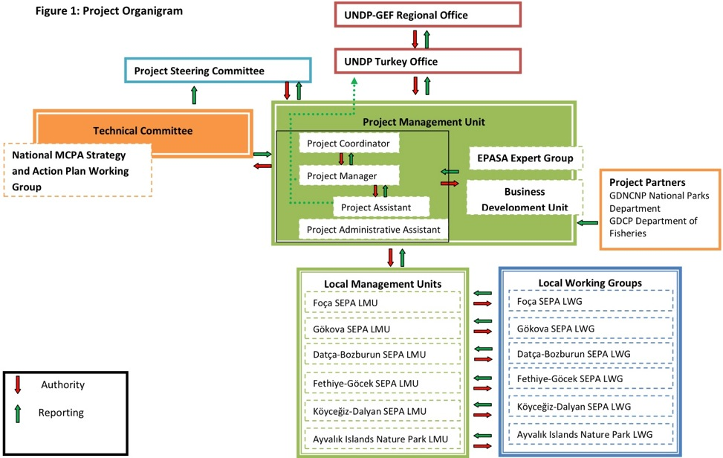

1. The PMU consists of the project manager, project assistant, and project administrative assistant, who are contracted by EPASA (now GDNAP), and who are located in the EPASA offices in Ankara. The project coordinator is a senior EPASA staff member who works closely with the project manager. Members of the expert group are contracted on an individual activity basis to carry out many of the project technical activities. The BDU in EPASA, established at the start of the project, also works on the activities related to Outcome 2 on financial sustainability. The project field sites are located in three provinces on the western coast of Turkey, approximately a one-hour flight from Ankara. Local partners at the field level are supporting the local level project activities, and the project manager travels to the project field sites approximately once per month.
2. A Project Steering Committee provides overall guidance and oversight for the project, as is the common practice for UNDP-GEF projects. According to the project document, the steering committee is responsible for:

(i) Achieving co-ordination among the various government agencies;

(ii) Guiding the program implementation process to ensure alignment with national and local statutory planning processes and sustainable resource use and conservation policies, plans and conservation strategies;

(iii) Ensuring that activities are fully integrated between the other developmental initiatives in the region;

(iv) Overseeing the work being carried out by the implementation units, monitoring progress and approving reports;

(v) Overseeing the financial management and production of financial reports;

(vi) Monitor the effectiveness of project implementation; and

(vii) Preparing regular report-backs for the representing Departments/Institutions.

1. The project inception report states that the steering committee will be made up of 19 members representing key stakeholder organizations. In the first steering committee meeting held after the inception workshop (February 22, 2010) 27 individuals participated, and 26 participated in the second steering committee meeting, held March 28, 2011. The inception workshop report states that project steering committee meetings will be held semi-annually; however, given the need to bring together a large number of high level individuals, so far only annual meetings have been held. This frequency appears to be adequate, and is consistent with standard practice in other UNDP-GEF projects, as long as steering committee members are available on an ad-hoc basis to provide input on major decisions that cannot wait until the formal meeting is held.
2. In addition, as part of its adaptive management approach, at the inception phase it was decided to establish a project partners group to support technical aspects of project implementation. The project team organizes semi-annual “project partners” meetings, the third and fourth of which were held September 14, 2010 and March 16, 2011.

### Future Challenges: Turkey’s Institutional Restructuring

1. Following Turkey’s elections in June 2011, the government environmental line agencies are under an ongoing reorganization begun in August 2011, and the institutional structure of the project’s original government executing partners has been completely changed: The former EPASA (responsible for SEPA sites) has been reformed under the new Ministry of Environment and Urbanization (MoEU) (formerly the Ministry of Public Works (MoPW)) as the General Directorate of Natural Assets Protection (GDNAP) in combination with the branch of the Ministry of Culture and Tourism (MoCT) responsible for protected natural sites (SITs) (which number an estimated 1,273 sites). In addition, the former MoEF has been reformed as the Ministry of Forests and Water Affairs (MoFW), under which is the General Directorate of Nature Protection (GDNP), which is responsible for national parks and other similar protected areas. In this sense, Turkey now has two bodies under two separate ministries responsible for natural protected areas. The types of protected areas under each are significantly different, as SEPAs, SITs and national or nature parks all have different scope, rationale, and level of protection.
2. In this circumstance the project’s implementation approach, and ability to achieve the expected outputs and outcomes has been thrown into question. This institutional restructuring was still underway at the time of the mid-term evaluation, and thus there is still significant uncertainty about how the project can and should proceed. EPASA, the project executing agency, has been effectively dismantled, with staff reassigned to new duties under the new GDNAP. This has a detrimental impact on the project’s work to establish LMUs at each of the field sites. The LMUs were not yet legally operational, though they had started to take shape. EPASA had assigned 17 newly recruited staff to the LMUs, and the staff had received orientation and capacity development training on biodiversity conservation and management of marine and coastal resources. The physical offices for the LMUs were prepared in May 2011 – one month before the election. Following the election, all further activities in establishing the LMUs were put on hold.
3. The GDNAP is re-organized under provincial directorates based in the capital of each province (the relevant provinces being Izmir and Mugla provinces for the SEPA sites in this project). There are conceivable alternatives to establishing the LMUs, such as having site management staff working from the provincial capital. However, given the distances involved, the number of local stakeholders, and the need for daily active management at the sites, the establishment of site-based LMUs would be a highly preferred option. In addition, the project team needs to secure political support to have adequate staff from the GDNAP assigned to managing the SEPA sites. This evaluation recommends that establishment of site-level LMUs remains a top priority, and these should be established before the end of the project.
4. The institutional restructuring requires the project team and stakeholders to now consider the most effective way forward to achieve the greatest possible results by the end of the project. There are a few alternatives; for example:
   1. Wrap up the current activities, complete any additional activities not affected by the restructuring, and wind down the project early, canceling whatever budget isn’t used;
   2. Completely shift the nature of the project activities to focus on new barriers under the new institutional framework; or
   3. Decentralize the project approach to focus on catalyzing effective management from the provincial level, and continue moving forward with the planned outcomes under the new institutional framework.
5. The project objective remains valid, and in fact critical, considering the still present threats to marine and coastal resources in Turkey, including at the project sites. Therefore, this evaluation supports fully continuing the project through adaptive management to focus on the new institutional pressure points to continue working for effective management of the SEPA sites (as in option C above). Implementing a significant lobbying effort is critical, to inform key decision-makers in new positions in the MoEU and GDNAP of the project’s status as an international development project with support from the GEF and UNDP, the project objective and expected outcomes, the project’s activities and achievements to date, and the reasons why it is imperative that the project continue with the full support of the relevant government institutions. The key government partners’ level of collaboration, coordination, and commitment at the provincial and central level to continue supporting the project objective in a results-based manner will likely determine the ultimate success of the project. A majority of the recommendations of this evaluation focus on repositioning project implementation in the context of this institutional restructuring to achieve the greatest possible progress toward the objective at project completion.
6. To facilitate a decentralized implementation approach, this evaluation recommends the addition of site-based project officers to catalyze and guide local level activities. One or two project officers may be appropriate, depending on the division of responsibilities. Previous UNDP-GEF project experience has shown that having site-level project staff can be of great benefit in increasing communication with and the involvement of local stakeholders.
7. The project should as soon as possible carry out the public awareness baseline survey of key stakeholder groups originally foreseen; it is critical to have a clear understanding of public awareness related to the project objective of conserving coastal and marine biodiversity in Turkey, and this would allow an assessment of progress in this area at the end of the project. This information would also provide input for further activities to strengthen awareness local stakeholder ownership. Opportunities for future activities include school activities linked with local media, information boards at ports, and an information stand at weekly markets.
8. Given the project’s anticipated decentralization shift, the project should add on-the-ground site level activities to provide small-scale but direct contributions to the project objective, increase stakeholder awareness and participation, and demonstrate concrete results to local stakeholders. This could be effectively achieved through partnership with local level civil society organizations, and the project could explore potential partnership with the GEF Small Grants Programme, which has already supported some community-level activities in the area. The most relevant activities should be drawn directly from stakeholder input, but opportunities include feasibility studies for local eco-labels (particularly for organic agriculture to reduce nutrient run-off), awareness raising on illegal spear fishing with restaurant commitment and certification, ghost net cleanup, public awareness campaigns by civil society, and additional work on creating opportunities for fishermen to involve tourists in fishing excursions.
9. Increasing individual and institutional capacity for effective management of marine and coastal resources is one of the main outcomes of the project, and a number of activities have already been carried out to support this. Following the government institutional restructuring however, there is an increased need to continue and to strengthen capacity development and training activities, including staff from the GDNAP coming from the former MoPW that may now be involved in SEPA management. The project should also exploit opportunities for biodiversity mainstreaming within the new MoEU. The GDNAP’s new institutional setting (the former EPASA), embedded within a ministry of “civil engineers” working on land-use and infrastructure planning, presents opportunities for synergies in integrating biodiversity considerations in these planning activities in coastal areas. By embracing this new challenge the project could generate additional benefits through increasing awareness and capacity on environmental management of MoEU staff that previously have had little or no exposure to such issues. One capacity development opportunity would be for site-level exchanges within the project sites for the government staff responsible. The MCPA Training and Implementation Center should present opportunities to catalyze and scale-up good management practices, and the e-learning platform developed by the project can also contribute.

## Project Relevance

1. Based on the assessment of project relevance to local and national priorities and policies, priorities related to relevant international conventions, and to the GEF’s strategic priorities and objectives, overall project **relevance** is considered to be ***satisfactory***.
2. Turkey’s national environmental and biodiversity-related priorities are outlined in the documents such as the Ninth Five-Year Development Plan (2007-2013), the National Agenda 21, the NBSAP, the Sectoral Expertise Reports For Environment, Forestry and Tourism, the NESAP.
3. The project is relevant to all these documents. For example, in the Ninth Five-Year Development Plan, para. 459 reflects that Turkey will take necessary steps to speed up biodiversity and genetic resources research, conservation and evaluation studies and to ensure that these will bring further economic support to Turkey. The first of the main principles of the plan is that “conservation of natural and cultural resources and environment should take into consideration of the future generations of the country.”
4. The NBSAP gave importance to marine and coastal biodiversity, and allocated one component to the conservation of it as shown below:

* Component 6.3.6. Marine and Coastal Biodiversity: Under this component there are three targets determined to conserve the marine and coastal biodiversity. In addition, there are strategic actions under each target to reach the targets.
  + Objective 9: to protect the marine and coastal biodiversity, to ensure the sustainability of the ecological functions of the marine and coastal biodiversity, and to develop and implement effective methods for the sustainable use of these ecosystems.
  + Target 9.1. Strengthening the essential administrative, legislative, institutional and technical capacities in order to assess, monitor, protect and for the sustainable use of marine and coastal biodiversity.
  + Target 9.2. Eliminate information deficiencies regarding marine and coastal biodiversity, determination of the endangered areas and species that have importance in terms of biodiversity, register these areas as protection sites, and develop and implement monitoring programs.
  + Target 9.3. To address threats to marine and coastal biodiversity.

1. Therefore, project is relevant to the NBSAP, and supports implementation of the NBSAP.
2. The NESAP proposes preparation and implementation of activities on the “Conservation and Management of the Marine and Coastal Resources and Regulation of the Coastal Areas.” It also stresses the importance of the rehabilitation of the management of the coastal areas. The project strongly supports the NESAP in this regard.
3. The Sectoral Expertise Report for the Environment also reflects the importance of the Integrated Coastal Area Management and Prevention of the Marine Pollution. The project also supports this report. The Sectoral Expertise Report for Tourism gives priority to the conservation of the environment and dictates that all the investments related to the tourism sector will be considered as an approach to protect and develop the natural, historical, social and cultural environment.
4. The GEF is the designated financial mechanism of the CBD, and therefore biodiversity conservation projects funded by the GEF must be relevant to and support the implementation of this convention. Turkey is a party to the CBD, having ratified the convention on February 14, 1997. The Turkey MCPAs project supports multiple aspects of the CBD, including the protected areas program of work, which includes sub-components on addressing protected area threats, governance, participation, protected area capacity needs, sustainable finance needs, and management effectiveness. In addition, the project supports broader aspects of the CBD, such as Article 8. “In-situ Conservation”; Article 10. “Sustainable Use of Components of Biological Diversity”; Article 11. “Incentive Measures”; Article 12. “Research and Training”; Article 13. “Public Education and Awareness”; Article 14. “Impact Assessment and Minimizing Adverse Impacts”; and Article 20. “Financial Resources”.
5. The project also directly supports Turkey’s commitments under the Convention for the Protection of the Mediterranean Sea against Pollution, also known as the “Barcelona Convention.” This convention was signed in 1976 by 21 countries, including Turkey. In 1982, a “Protocol Concerning Mediterranean Specially Protected Areas,” or “SPA Protocol,” was added. A revised “Protocol Concerning Specially Protected Areas and Biological Diversity in the Mediterranean” was adopted in 1995, replacing the 1982 Protocol. The convention has specific articles on pollution from ships (Article 6), pollution from land-based sources (Article 8), and monitoring (Article 10). The 1995 protocol to the convention states, “each party shall take the necessary means to protect, preserve and manage in a sustainable and environmentally sound way areas of particular natural or cultural value, notably by the establishment of specially protected areas.” The project objective directly supports these two conventions, and is relevant to other multilateral environmental agreements such as the Convention on Migratory Species (the “Bonn Convention” of 1979), and the Ramsar Convention (1971).
6. The GEF strategic priorities for each of its thematic focal areas (biodiversity, climate change, etc.) have evolved from one GEF phase to the next, but overall these priorities have remained roughly focused on the same broad areas of intervention. The project was approved under the strategic priorities for GEF-4 (July 2006 – June 2010), [4] but is also being implemented under the strategic priorities for GEF-5 (July 2010 – June 2014).[5] The project is aligned under the GEF-4 first Strategic Objective for the biodiversity focal area: “Catalyzing the Sustainability of Protected Areas”, and under this objective, it is focused on the second Strategic Program: Increasing Representation of Effectively Managed Marine Protected Areas in Protected Area Systems. The indicators for this strategic program include the extent and coverage of PAs, and the level of management effectiveness. This project is supporting and contributing to these indicators for Turkey’s National Protected Area Systems by supporting new PAs and improving the management effectiveness of its MCPA network. The project contributed to the establishment of Saros Bay SEPA, which covers 73,021 ha (53,834 ha of marine area). By focusing on strengthening the conservation of marine biodiversity through Turkey’s MCPA system, the project will contribute to achieving the main indicators of this Strategic Objective.

## Project Management and Cost Effectiveness (Efficiency)

1. Overall, the **efficiency** of the project is rated ***satisfactory***. The project is implemented in a cost-effective manner, with financial management procedures in-line with international norms and standards for development projects. The project management and implementation approach is well-structured to produce results at or above the level expected based on the input of resources. This can be partially attributed to the dedication of the many individuals involved, and the strong stakeholder ownership of the project. The government institutional restructuring may have a slight negative influence on overall project efficiency (in contrast to a potentially larger impact on project effectiveness) due to the fact that some outputs already produced will need to be revised and some project activities restructured.
2. The Project Steering Committee approves the project’s annual workplans and corresponding budget each year. The project budget is managed according to UNDP standards, using the ATLAS system. The project makes an annual budget request based on the activities foreseen for the year, UNDP advances the funds, and the project staff monitors the budget regularly during the year.
3. One project execution tool that supports efficiency is UNDP’s logistics service, which the project uses for organizing meetings, travel, etc. The project team simply draws of a basic outline of requirements for any large meetings requiring organizational support, and the contracted agency makes the necessary reservations and other arrangements. This saves the project team significant time in handling logistical and organizational details, allowing the team to focus on substantive aspects of project implementation.
4. The project M&E plan includes an annual financial audit, but this has not yet been conducted.
5. According to data provided by the project, the project’s financial delivery rate is only 25.8% as of September 30, 2011 (see Table 3 below). This is the percentage of GEF budget spent to date. The project team estimates that based on current commitments under contract, the delivery rate will reach 34% by the end of 2011. At this current level of delivery, project activities will have to be executed at a significantly greater rate in the second half of the project.

## Financial Planning by Component and Co-financing

1. The planned GEF financing for each of the project components is broken down in Table 3 below, and the total planned budget for each component, taking planned co-financing into consideration. The total GEF financing is $2.20 million, with co-financing of $4.00 million. Outcome 1 is the largest of the project components, and is budgeted for 40.5% of the GEF financing, and more than 50% of the total project budget; Outcome 2 is budgeted for 28.7% of GEF resources, and 18.2% of total project budget; Outcome 3 is budgeted for 21.3% of GEF resources, and 20.5% of the total project budget. The M&E budget is discussed further is Section VI.C.i below. The project management budget is planned for 9.5% of GEF resources, and 9.8% of total project budget; both figures are below the GEF stated threshold of 10%.
2. Virtually all planned co-financing is coming from the Government of Turkey, through the EPASA budget – at least this was the planned approach prior to institutional restructuring. Now there is a question about the extent and nature of co-financing that will be ultimately realized, as this depends on the new budgeting approach of the MoEU and GDNAP. The Table 4 below shows the planned and current level of co-financing. It was initially planned that EPASA would contribute $2.00 million in cash co-financing and $2.00 million in in-kind co-financing (for a co-financing ratio of 1:1.8). As EPASA is the executing agency, it was foreseen that EPASA would be able to use its annual budget to directly contribute to implementation of the project. The total figure contributed thus far, according to project sources, is approximately $1.92 million, or 48% of planned co-financing of which $482,268 in kind and $1,437,268 in cash. This figure indicates that co-financing is moving in a positive direction and approximately 50% of the co-financing has been secured at this point. Some additional leveraged financial support has also been secured, included approximately $34,000 from the WWF Mediterranean Program Office in support of some training on communication and stakeholder engagement.

## Flexibility and Adaptive Management

1. The project is being implemented in a flexible manner, with a strong focus on adaptive management and a results-based approach. During and after the inception phase of the project, the below mentioned specific changes have been made in the Outputs and Activities of the project document.

* Output 1.1 from the original project document was designed as six separate outputs to make using the project budget and activity plan easier and more efficient. It was agreed that a training and implementation center would be established in addition to local management units. While updating the risk assessment, activities for the local stakeholders and local people were included in the workplan. These activities will be conducted in conjunction with the local management units to strengthen the local management capacities.
* Five original outputs were defined under Outcome 1. At the inception workshop more outputs were added to Outcome 1, with a total of 10 outputs defined under Outcome 1. 5.
* The ‘’Preparation of Capacity Building Program for the Marine and Coastal Protected Areas Training and Application Center’’ was added as a new activity under the capacity development objective. Cooperation agreements have been planned and signed to run and manage the center, and to prepare the capacity development program.
* A Draft Strategy and Action Plan will be finalized in 2012 in order to facilitate for the 10th National Development Plan in participation with the working group for the National Marine and Coastal Protected Areas Strategy and Action Plan and other institutions and organizations. This change was made under the Capacity Building Objective, under Activity 1.10. Sharing a National Strategy and Action Plan Proposal to take into consideration in the 10th National Development Plan to expand and strengthen the MCPAs System (Integration of the Sustainable Development into Sectoral Policies).
* Business Plans were supposed to be prepared for all the project sites, according to the sustainable finance section of the project document. It was decided to prepare business plans only for Foça and Gökova SEPA sites since their management plans have already been finalized.
* Local Working Groups (LWGs) were supposed to be established in 2010 in the project document. It was decided to establish these LWGs after the establishment of the LMUs since these units will be in charge of carrying out the secretarial works of the LWGs.
* Ayvalik Islands Nature Park, under the management of the former GDNCNP, was added as a sixth site that the project would support to develop a local level management mechanism. The inclusion of this site serves as a mechanism to link, under the project, the two main agencies responsible for MCPA management in Turkey. This supports information sharing and replication within Turkey beyond EPASA and the SEPA sites.

1. At the inception workshop there were also changes made in the logframe, risk assessment, and some other parts of the project document as necessary. In the logframe, some text edits were made, and some baseline data corrected. In the risk assessment, three additional risks were added. All the changes have been approved by the Steering Committee Members during the meetings of the committee.

## UNDP Project Oversight

1. As the GEF Agency responsible for project implementation, UNDP has a general oversight and support role. The project document outlines UNDP’s many roles and responsibilities with respect to the project, including: timely implementation and deliver of project activities and outputs; coordination and supervision of activities; organizational arrangements for all project meetings to be held under the aegis of EPASA; contracting of local and international experts involved in the project activities; management of financial administration; link to other relevant UNDP activities; provide networking support with other stakeholders; support linkages to national policy goals, relevance, effectiveness and impartiality of the decision-making process.
2. UNDP Turkey country office staff carry out ongoing ad-hoc monitoring, and project monitoring missions are also completed by the respective Regional Technical Advisor from the UNDP Bratislava Regional Centre; for example, in July 2011 the UNDP Regional Technical Advisor visited the project field sites to assess progress and provide recommendations on project implementation. As the project office is based in Ankara, it is feasible to have regular personal contact between the project team and UNDP staff as necessary. In addition, the UNDP Deputy Resident Representative has participated in Project Steering Committee meetings.
3. UNDP also plays a role in various M&E activities, and standard UNDP monitoring tools, such as the annual Project Implementation Report (PIR) are requirements for the project. As mentioned in Section IV.D above on financial management, UNDP supports project financial management through the ATLAS system, including procurement and contracting, as well as logistical arrangements for project activities.
4. All data collected during the evaluation mission indicates that UNDP is carrying out its oversight and supervision responsibilities in an effective and efficient manner, with regular communication with the project team, and attention, when necessary to key project issues. In addition, according to project stakeholders, UNDP has been a strong and transparent partner throughout the project concept and development phase.
5. UNDP has been a strong partner for EPASA and the project team to date, but following the government institutional restructuring UNDP’s role as an advocate for the project with key government stakeholders will be even more critical. UNDP staff will need to work closely with the project team and stakeholders to support the project through this reorganization, and to find the best path forward for the project. Once the path forward is clear, it is likely that some administrative arrangements will need to be addressed, and support will be needed to revise and update the project workplan and budget as necessary.

Table 3 Project Planned and Actual Expenditure Through September 30, 2011 *(all amounts in millions USD)*

|  |  |  |  |  |  |  |
| --- | --- | --- | --- | --- | --- | --- |
|  | **GEF Amount Planned** | **% of GEF Amount Planned** | **Total Planned** | **% of Total Planned** | **GEF Amount Actual** | **Actual % of GEF Amount Planned** |
| **Outcome 1: Responsible institutions improved the capacities and internal structure needed for prioritizing the establishment of new MCPAs and for more effectively managing existing MCPAs** | $0.89 | 40.5 | $3.19 | 51.5 | 0.24 | 26.5 |
| **Outcome 2: MCPA financial planning and management systems are facilitating effective business planning, adequate levels of revenue generation and cost-effective management** | $0.63 | 28.7 | $1.13 | 18.2 | 0.11 | 17.6 |
| **Outcome 3: Inter-agency coordination mechanisms in place to regulate and manage economic activities within multiple use areas of the MCPAs** | $0.47 | 21.3 | $1.27 | 20.5 | 0.08 | 18.1 |
| **Monitoring and Evaluation\*** | $0.16 | 7.3 | $0.16 | 2.6 | Not specified |  |
| **Project Management** | $0.21 | 9.5 | $0.610 | 9.8 | 0.13 | 64.0 |
| **Total** | 2.20 | 100.0 | $6.20 | 100.0 | 0.57 | 25.8 |

*Source: “GEF Amount Planned”: Data provided by project; “Total Planned”: Prodoc Section III, Part I “Total Budget and Workplan”; “GEF Amount Actual”: Data provided by project.*

*Monitoring and evaluation financing is given an overall budgeted amount in the M&E plan of the project document, but is not a separate budget line item, thus does not sum with all project components for the total project budget figure.

Table 4 Project Planned and Actual Co-financing Through September 30, 2011 *(all amounts in millions USD)*

|  |  |  |  |  |  |  |  |  |  |  |  |  |  |  |  |  |  |  |  |
| --- | --- | --- | --- | --- | --- | --- | --- | --- | --- | --- | --- | --- | --- | --- | --- | --- | --- | --- | --- |
| Co-financing (Type/Source) | Agency Financing | | Multi-lateral Agencies (Non-GEF) | | Bi-lateral Donors | | National Government | | Local Government | | Private Sector | | NGOs | | Other Sources | | Total Co-financing | | Percent of Expected Co-financing |
| Planned/Actual | P | A | P | A | P | A | P | A | P | A | P | A | P | A | P | A | P | A | Actual share of proposed |
| Grant | 0.02 |  |  |  |  |  | 2.00 | 1.44 |  |  |  |  |  |  |  |  | 2.02 | 1.44 | 72.0% |
| Credits |  |  |  |  |  |  |  |  |  |  |  |  |  |  |  |  |  |  |  |
| Loans |  |  |  |  |  |  |  |  |  |  |  |  |  |  |  |  |  |  |  |
| Equity |  |  |  |  |  |  |  |  |  |  |  |  |  |  |  |  |  |  |  |
| In-kind |  |  |  |  |  |  | 2.00 | 0.48 |  |  |  |  |  |  |  |  | 2.00 | 0.48 | 24.0% |
| Non-grant Instruments |  |  |  |  |  |  |  |  |  |  |  |  |  |  |  |  |  |  |  |
| Other Types |  |  |  |  |  |  |  |  |  |  |  |  |  |  |  |  |  |  |  |
| **TOTAL** | 0.02 |  |  |  |  |  | 4.00 | 1.92 |  |  |  |  |  |  |  |  | 4.02 | 1.92 | 48.0% |

*P=Planned; A=Actual*

*Source: Planned: Prodoc, Section III, Part I. Actual: Provided by project team. Information on the breakdown of actual is not provided by co-financing source, but there is only one significant co-financing party, the national government, through EPASA.*

# Project Performance and Results (Effectiveness)

1. Keeping in mind that this is the mid-term evaluation and the project has at least two more years of implementation, considering the progress thus far toward the achievement of expected outcomes and toward the overall project objective, **effectiveness** is rated *satisfactory*. The mid-term evaluation ratings on effectiveness and all other aspects are based on the evaluative evidence at this point in the project’s implementation, and evaluation ratings at the end of the project should also consider the full range of evaluative evidence available at that point; in other words, the mid-term evaluation ratings should in no way be seen as pre-determinative of the project’s potential final level of achievement.
2. The project has produced a number of key results to date, as further discussed under each of the outcomes below. Highlights include:

* Positive feedback from stakeholders and some good partnerships, such as with Mugla University.
* The project was making good progress toward setting up the LMUs before this activity was delayed by the institutional flux.
* The establishment of the Saros Bay SEPA site and expansion of the Gokova Gulf SEPA site are excellent results.
* The initiation of the training center at Akyaka shows promise for having a long-term catalytic role in the region.
* A range of high quality technical reports on issues such as ecosystem services assessments are an important long-term contribution.
* The implementation and monitoring of NFAs is helping to establish a potential model for Turkey.
* The establishment of some valuable site-level infrastructure to achieve threat reduction: The installation of mooring buoys in Göcek Bay.

1. The project objective has four indicators and associated targets in the project logframe. These are A. The number of hectares of expanded MCPA coverage achieved under the project (target of incremental 100,000), and three impact level indicators related to three globally significant species. The project has exceeded the target for the first indicator by reaching approximately 106,000 of new and expanded MCPA ha through the establishment of the Saros Bay SEPA site and expansion of the Gokova Gulf SEPA site. The impact level indicators should be re-considered to assess their utility as yardsticks for project results, as further discussed in Section VI.C.i and VI.D, and in Annex 3.
2. The project logframe indicators and related targets for each of the project outcomes are assessed in greater detail in Annex 3.

## Progress Toward Achievement of Anticipated Outcomes

### Outcome 1: Responsible institutions have the capacities and internal structure needed for prioritizing the establishment of new MCPAs and for more effectively managing existing MCPAs

1. This outcome is focused on strengthening the MCPA system, and increasing the coverage of marine protected areas. A key activity is the development of a medium term (10 –year) strategy for further MCPA strengthening and expansion. Originally only five outputs were planned for this outcome, but at the inception phase this was expanded to ten outputs, as discussed in Section IV.F on adaptive management.
2. There are three main indicators for this outcome in the project logframe – the percentage of Turkey’s legally protected marine territory, the Management Effectiveness Tracking Tool (METT) and UNDP’s Capacity Assessment scorecard. Under the Capacity Assessment scorecard the project has shown some positive progress, but is less than 50% of the way to the systemic, institutional, and individual capacity target values.
3. Output 1.1. At six project areas: Establishment of local management units as well as training and implementation center. This is among the most critical outputs of the project. The Terms of Reference for the LMUs and associated staff have been developed, and physical offices are present at three of the sites – Ayvalik (where there is a staff office for the nature park), Foça (where the project helped set up an office for the LMU), and Köycegiz (where there is a directorate office for the GDNAP – the former EPASA local office). EPASA recruited 57 new staff to manage all of its SEPA sites, and of these 17 were to staff the LMUs. In early 2011 the project conducted a five day orientation training for all 57 staff, to develop capacity in MCPA management. Relevant local government staff at the project sites were also provided with the same training. However, the LMUs were never legally operationalized, and their future operation is uncertain under the new institutional structure.
4. The other key result under this output is establishment of the MCPAs Training and Implementation Center in Akyaka town (see Photo 3), in partnership with Mugla University. The municipality of Akyaka has granted use of space in one of its buildings, and the university supporting a director of the center – one of the university professors – until the ministry provides additional funding. The long-term vision is for the center to serve as a Mediterranean regional center of excellence related to marine conservation and protected area management. A regular training course curriculum is being developed in partnership with national and international organizations (e.g. the United States National Oceanic Atmospheric Administration, WWF Mediterranean Program Office), and within the next year a course schedule should be implemented. The center will also be used for education and awareness building purposes, and one of the rooms in the center will be turned into an information center for the public and for tourists visiting the region who are interested in biodiversity conservation issues. It is expected that the center will eventually be self-sustaining through training fees for courses given.
5. Output 1.2. At six project areas: conduct information and awareness raising activities for staff of relevant institutions and organizations. Training activities have been carried out, but as outlined in the recommendations of this report, additional work will be needed to focus on the new staff of the GDNAP that are coming from the former MoPW. The project has developed an excellent tool to extend training to a large number of individuals and which takes advantage of the growing potential of information technology: an E-Learning Platform related to marine environmental management. A curriculum for the E-Learning Platform has also been developed for the BDU in (former) EPASA. The E-Learning Platform includes course titles such as “Principles of Environmental Economics,” “Conservation of Biodiversity and Marine Biodiversity,” “Financial Sustainability and Marketing Approach,” and “Resource Management and Resource Inventory.” This is an excellent tool, but now the project must work to ensure its uptake by relevant staff. It is not enough to simply inform people that this tool is available, but it has to be proactively promoted, and specific measures have to be taken to encourage staff to use the tool.

Photo 3 The New MCPAs Training and Implementation Center, Akyaka Town Center

|  |  |
| --- | --- |
|  |  |

1. Output 1.3. At six project areas: Inform and raise awareness of local people and tourists visiting region. 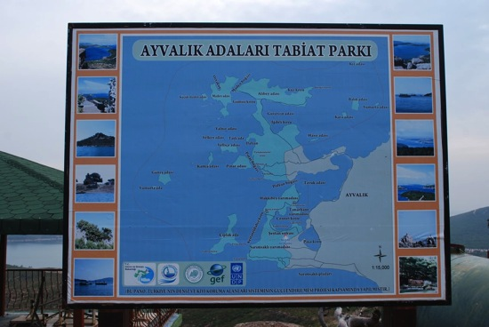The project also has two websites, one in English (<http://www.mpa.gov.tr/>) and one in Turkish (<http://www.dka.gov.tr>) that serve as information dissemination tools at a broad level. The Turkish website averaged approximately 500 visits from 257 visitors per month from December 2010 through July 2011, with approximately 97% of the visitors coming from within Turkey, while visitors from an average of seven other countries visit the site each month. These figures have been relatively consistent over time, with a peak of 733 visits and 421 visitors in March 2011. The English version of the website has had approximately 75 visits per month from an average of 40 visitors, with visitors coming from an average of eight countries other than Turkey. The website domain names have been acquired by EPASA so they can be used and maintained after the project is completed.

Photo 4 Information Board, Ayvalik Islands

1. A range of printed public awareness materials have been produced, but these remain to be fully distributed to have an actual influence. Additional materials are envisioned, such as an informational booklet for each of the sites, and possibly a short documentary for each of the sites. Continuing to build awareness and engagement of stakeholders at the local level should be one of the ongoing priorities for the project. Another opportunity that exists would be to put information boards at each of the ports of the project sites. An information board has been established at a public location for Ayvalik Islands Nature Park (see Photo 4 Information Board, Ayvalik Islands). The information center at the Akyaka training center will also support this output, although it is only at one of the sites.
2. 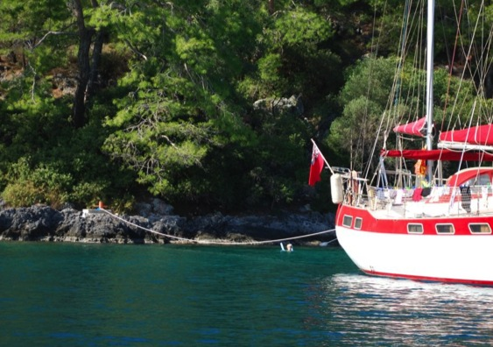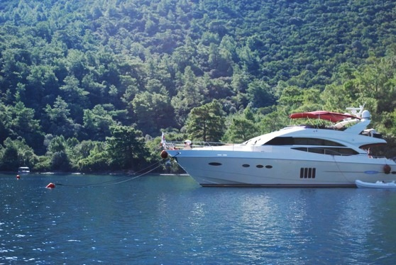Output 1.4. At six project areas: Determination of sensitive areas and usage areas. There is insufficient environmental data available to analyze scientifically the most sensitive zones for each of the project sites, but a workshop was held in May 2010 with scientific experts to identify sensitive zones on the best available information. Under this output mooring buoys have been established in Göcek Bay to relieve anchorage pressure on sensitive benthic environments (see Photo 6 and Photo 5). The mooring buoy installation was primarily supported through EPASA co-financing of the project. This is one of the activities under the project that has had immediate concrete results on the ground, and is contributing at least in a small-scale to impact level results. Göcek is one of if not the main center of yachting in the Turkish Aegean coast; funds are not available to establish mooring buoys in sensitive areas of all project sites. Sensitive zones have been identified for Foça, Göcek, Gökova and Datça, and remains to be completed for Fethiye, and Ayvalik. The project will also establish where the NFA boundaries will be established and demarcated with buoys.

Photo 5 Göcek Bay Onshore Mooring Installation

Photo 6 Boat Moored to Göcek Bay Buoy Installation

Output 1.5. Improving and strengthening of MCPA regulatory system. This output is focused on strengthening the monitoring and enforcement of regulations at SEPA sites. This is being piloted at Foça, where a 10 meter boat has been procured, and EPASA has budgeted for operations and maintenance. Initially the boat was to be used by the municipality for enforcement, but this was not optimal, and once the LMU office was established in Foça, use of the boat for enforcement was transferred to this office. However, EPASA does not have a licensed boat captain available at the site, but the local fishery cooperative has offered to provide the services of its captains, and even share fuel expenses. This is an excellent example of cooperation with local stakeholders.

1. Output 1.6. Determination of potential MCPA on a basis of marine protected area system. This output involved a gap analysis to assess potential areas for new marine protected areas. However, the lack of adequate quality data is hampering this process, and the project team anticipates achieving the output through three to six regional workshops with expert input to assess potential areas for protection in the Mediterranean, Aegean, Marmara, and Black seas.
2. Output 1.7. Expansion of coverage of marine areas within National Protected Areas. This is another of the important results achieved thus far under the project. The Saros Bay SEPA site was established covering 53,834 hectares of marine area, and the Gokova Gulf SEPA site was expanded by 52,088 hectares of marine area, on December 22, 2010 as documented in the official government legislative gazette, number 27793. This activity did not start from zero under the project, but the project team and stakeholders made a significant contribution to bringing this result to fruition.
3. Output 1.8. At six project areas: Carrying out of technical monitoring and evaluation studies. This activity is not yet completed. The plan was to establish a shared monitoring protocol across the sites, but since EPASA is already monitoring a number of parameters, the project anticipates organizing site-specific workshops to raise awareness of the environmental monitoring activities and increase awareness among key stakeholders to support effective information flows for management. Regular water quality monitoring is also ongoing in the five SEPA sites. The monk seal population is monitored in the Foça SEPA, and sea turtle monitoring is carried out by project partners in Fethiye-Göcek and Köyceğiz-Dalyan SEPA sites.
4. Output 1.9. At six project areas: Provision of support for preparatory studies of management plans. EPASA has already prepared draft management plans for Foça and Gökova, and these are awaiting approval and printing. Avyalik Islands Nature Park also has a management plan under the GDNP. The Fethiye-Göcek SEPA site has a management plan for the main yachting use area, but not for the overall site. The project anticipates focusing on further development of management plans for Datça and Köyceğiz.
5. Output 1.10. Sharing of a “national strategy and action plan” suggestions about to be evaluated at 10th National Development Plan for expansion and strengthening MCPA system (Integration of sustainable development into sectoral policies and final report of gap analysis). Experts contracted by the project carried out work on this activity in 2011, but following the institutional restructuring it is likely changes and revisions will have to be made. It is expected that this output will serve as an input to the national government’s overall 10-year development plan, which would be an excellent opportunity for the project to support biodiversity conservation mainstreaming in national policies.

### Outcome 2: MCPA financial planning and management systems are facilitating effective business planning, adequate levels of revenue generation and cost-effective management

1. There are three indicators and associated targets for this outcome in the project logframe. These are values for the financial sustainability scorecard, EPASA’s self-financing capacity, and EPASA’s self-funded revenue. These indicators will likely have to be revised following the institutional restructuring that has eliminated EPASA as an individual institution. According to the mid-term assessment of the financial sustainability scorecard, the value and percentage of the total possible score has decreased relative to the baseline figure. Further analysis would be required to fully understand the dynamics behind this decrease, and to what extent it is representative of the project’s achievements.
2. Output 2.1. Establishment of Business Development Unit. The BDU was formally established within EPASA at the beginning of the project, but has been operational since January 2010. The orientation training of the BDU in sustainable financing for MCPAs was conducted. The BDU is working to increase self-generated revenue from the SEPA sites through various financial mechanisms. For example, the BDU has increased the number of daily use sites (the primary mechanism for revenue generation) and executed lease agreements to generate revenue from these sites. The BDU has also succeeded at increasing revenue from previously established daily use sites. According to the project team, the percentage of self-generated revenue climbed to 16.5% as a share of the total EPASA budget (this is also an indicator in the logframe). However, since EPASA is now integrated into the GDNAP under the MoEU, it does not have a specific budget, and the share of the revenue generated with support of the BDU will decrease as a percentage of the new larger GDNAP budget. Thus the target of 25% will not be reached, and should be revised to an absolute figure.
3. Output 2.2. Development of the BDU personnel capacities on MCPA financial management. The project is working with four national experts to support collaboration and capacity development of the BDU. A curriculum in this area is being developed for the E-Learning platform (discussed under Output 1.2). Once the E-Learning curriculum is finalized, a face-to-face training will be held (with the first training expected in early 2012), the experience of which will be used to revise the E-Learning curriculum. A study tour was also planned for BDU staff to Cinque Terre National Park in Italy, but the management issues at this site precluded the planned study tour. A new activity is planned for a protected area near Trieste, Italy, but is pending official approval, which cannot be granted until the institutional restructuring is complete. It is planned to conduct a total of three exchange visits to support capacity development of the BDU.
4. Output 2.3. Implementation of system financing plan and revised site-level business plans. After the inception workshop it was determined that none of the sites had actual business plans, so this activity was revised to focus on preparing business plans, but this can only be done for sites that already have management plans. The project has started preliminary work on this for Foça and Gokova, with final reports expected in early 2012. This activity can then be replicated in the remaining sites as their management plans are finalized.
5. One of the activities under this output involved the preparation of a system-level financing plan, taking into consideration the site-level business plans. However, this was conceptualized under the initial institutional structure of EPASA, and the relevance of this activity under the new institutional framework will have to be re-assessed.
6. Output 2.4. Identification and implementation of appropriate revenue generating mechanisms. Multiple studies have been prepared under this output to identify and assess the potential of various revenue generating mechanisms, and the relevant legal and legislative arrangements. The regular operations of the BDU are also linked with this output.
7. Output 2.5. Implementation of cost offsetting mechanisms. The project is working to win budget support for SEPA management from other relevant government agencies, asking them to plan allocations in their institutional budgets to support activities under their mandate at the SEPA sites. This is another activity that will be delayed by the government institutional restructuring.
8. Output 2.6. Integration of the economic principles into EPASA implementation plans for cost effective management. A workshop on the Integration of Economic Principles into Planning Process of MCPAs was held March 23, 2011 in Ankara with 76 participants (primarily EPASA staff), and based on this experience the project is preparing guidelines on the integration of environmental economics principles in planning. Economic assessments of ecosystem services have been completed for the two sites with the best data (Foça and Gokova), and will be completed for the other sites in the first half of 2012, but with less detail due to less available data for inputs to the assessment.
9. Output 2.7. Increase public awareness on economic benefits of MCPA. Multiple public awareness activities are planned in the project workplan but not yet undertaken, including the publication of information on the economic value of ecosystem services (related to output 2.4), training activities for resource users (e.g. fishermen and tourism operators), and the promotion of the MCPAs through visual and printed local and international media. This will include information on the contribution of the MCPAs to the local economy. As previously mentioned, public awareness activities are one area this evaluation recommends for increased priority in the remaining implementation period. Under this output the project could also continue its work to facilitate elimination of the regulatory hurdles that preclude fishermen from conducting any tourism related activities on their boats as fishermen. Developing tours with local fishermen would be an excellent way to promote the importance of marine biodiversity with the millions of tourists visiting the area each year, while expanding revenue generation for sustainable livelihoods of resources users.[6] Educating visitors to the region on the importance of sustainable fisheries, through direct interactions and discussions with fishermen, increases awareness of the importance of approaches such as MCPAs in supporting sustainable development.
10. One of the recommendations of this evaluation is for the project to consolidate some planned outputs and activities. If this is undertaken, Output 2.7 could be integrated with Output 1.3.
11. Output 2.8. Integration of MCPA sustainable financing strategies into a national 10-year plan MCPA strategy and action plan. It was originally envisioned that the project could aggregate in a single system the revenue and expenditures for marine protected areas in Turkey, including SEPA sites and other sites under the management of the former GDNCNP. This was not yet completed, and under the new institutional framework this would be extremely difficult as the project would have to work within the context of two ministries, involving both the GDNAP (under the new MoFW) and the GDNAP (under the new MoEU). It is expected that the project may cancel this part of this output, and use the resources to revise completed expert reports based on the new institutional arrangements. The second part of this output, focusing on the MCPA strategy and action plan, is still to be carried out once all relevant expert reports on financial aspects have been completed.

### Outcome 3: Inter-agency coordination mechanisms in place to regulate and manage economic activities within multiple use areas of the MCPAs

1. Under Outcome 3, inter-agency co-ordination should be encouraged at national and site levels. At the national level, inter-agency coordinating efforts focus on co-ordination and harmonization of protected area expansion and management efforts. At local level, co-ordination includes the establishment of site-level LWGs, together with demonstrations of practical methods of inter-agency co-operation. On the marine side, this includes developing inter-agency approaches to regulating fishing, shipping and diving, while on the terrestrial side a planning approach is utilized to help control multiple land-based threats.
2. Under Outcome 3, there are three indicators. 1) Number of NFAs established within SEPAs; 2) Marine fish populations in areas to be declared NFAs; 3) Marine pollution levels in SEPAs. There are five outputs under Outcome 3. Results for each output are given below.
3. Output 3.1. National-level marine protected areas coordination mechanism. Defining gaps, overlapping jurisdictions and responsibilities were carried out by a national expert, but this is a legislative document that may need to be revised following the institutional restructuring.
4. Defining vertical and horizontal integration for the management of protected areas in accordance with agreed principles along with relevant agencies has not yet been done. The first National MCPA Strategy and Action Plan Working Group meeting were held with 23 participants on November 30, 2010. Actually it was planned to have meetings at the provincial and central levels for management of protected areas, but due to the new institutional changes it has not yet been completed. The project plans to organize these meetings next year once the institutional set-up is clear and operational. Forming a national MCPA strategy and action plan working group, organizing meetings regularly with the related organizations, and preparation of the coordination aspect of draft national MCPA strategy and action plan have been carried out and finalized. A final meeting was organized on the coordination of management activities.
5. Preparation of a regulation for coordination was ongoing through the meetings with relevant stakeholder organizations, but after the establishment of the new organizational structure it was stopped. This activity is going to continue once the new institutional structure is set-up and clear.
6. Output 3.2. Local Management Boards established at five SEPAs. As previously discussed in Section IV.B.ii on institutional restructuring, the establishment of LMUs at the site level is a critical activity for the project. Along with the LMUs, the project is working to establish LWGs, or management boards, that would leverage local stakeholder involvement in MCPA management. Under this output the project is working to establish site-level co-ordination structures at four SEPAs and one nature park, while building the capacity of an existing structure at the sixth site. The latter – Köyceğiz-Dalyan – had previously established the Dalyan Channels Administrative Commission (DCAC), enabling consultations among key stakeholders. The experience of the DCAC was examined for its potential usefulness as a model for similar structures at the remaining project sites. Adaptation of the DCAC model and establishment of similarly structured LWGs would then be supported at the four remaining sites. Decentralization of activities is another issue to be taken into consideration for these types of projects, instead of trying to manage the projects from the central level. Therefore establishment of local level working groups is important for project success and ownership.
7. However, up to now, LWGs (and LMUs) have not been established. As previously discussed in Section IV.B.ii, progress was made in this direction in the first half of 2011, but the LMUs did not receive their legal mandates for operation before the June 2011 elections, and resulting institutional restructuring.
8. Progress has been made toward LWGs in some sites, but not in others. Stakeholders at Ayvalık Nature Park indicated that they feel they don’t need this type of body because the most effective communication is through personal contacts with the related government agencies. In fact, it is really crucial to establish LWGs at each project site, as effective management requires the participation and input of local stakeholders, as demonstrated in many biodiversity conservation projects around the world, but also particularly in the previously mentioned World Bank-implemented project (GEF ID #458). After the establishment of the new ministry (the MoEU) and new institutional arrangements at the provincial level, in the view of this evaluation the best way to establish these LWGs would be under the chairmanship of the local governor at each site, with the participation of all related institutions and organizations. This evaluation recommends this issue should be given priority in the remaining project period to better implement the project activities in the provincial level and to give more power and authority to the local level establishments for the future of the project.
9. Output 3.3. No fishing areas established within two SEPAs. The NFAs are being established at Datça-Bozburun and Gökova SEPAs. In the first part of the project the areas for six NFAs were agreed with local stakeholders in Gökova Bay, and the areas, covering 1,914 ha were established. These areas are not yet being effectively enforced, with regular incursions of illegal spearfishing for the highly commercially valuable grouper species.
10. Examining existing fishery and social-economic researches (including micro credits) was conducted based on existing information available. Conducting necessary fishery and social-economic research (taking into account losses and gains of the fisheries) has been achieved and the final report of the studies is expected at the end of November 2011. Research on alternative income sources for the local fisheries while identifying NFAs will also be reported at the end of November 2011. In Datça-Bozburun, informing local people and fishermen about the justifications of the identified NFA is ongoing (see Photo 7) and a final meeting will be organized with the fishermen to select the NFAs for this SEPA.
11. Gathering input from EPASA and fisheries cooperatives in order to revise the circulars of MARA has not been done yet, but meetings with the related bodies on this issue have been planned for early next year. Inclusion of the NFAs into the physical planning by EPASA will be carried out in coming months, and will be approved once all issues have been finalized. Preparing and printing a brochure about NFAs established by EPASA has already been carried out and finalized.
12. Examining existing fish stock research has already been conducted by the EPASA itself. Monitoring and assessing fish stocks annually (both at MCPAs and NFAs) are still going on and these studies will continue this year and coming years. At the end of the project, there will be three years study and results available, so it will be possible to demonstrate the effectiveness of the NFAs at the end of the project.
13. Output 3.4. Demonstrated regulatory and co-ordination mechanisms for controlling ship-based threats to SEPAs. The project legal advisor has already prepared an action plan and legislative issues on this matter. The project now plans to have a final meeting with the participation of all related bodies and organizations to discuss the plan in detail and finalize it. Later the action plan will be published and distributed to all responsible organizations for implementation.
14. Output 3.5. Marine conservation goals fully integrated into terrestrial planning process at Gökova SEPA. Building on a recent baseline study at this site that includes marine biodiversity research and support under the European Union’s SMAP II project, the project is supporting efforts to fully integrate marine biodiversity considerations into terrestrial planning processes. The planners of the GDNAP will carry out this study, since they have the capacity for this. Therefore the project resources planned for this activity can be shifted elsewhere. For Foça, Gökova and Datça, environmental plans need to be prepared for integration with the overall management plans. It would be ideal to shift the budget to prepare management plans for the areas that are lacking, as there is not budget allocated for such a study.

Photo 7 Discussing Datça-Bozburun NFAs with Selimiye Village Fishermen

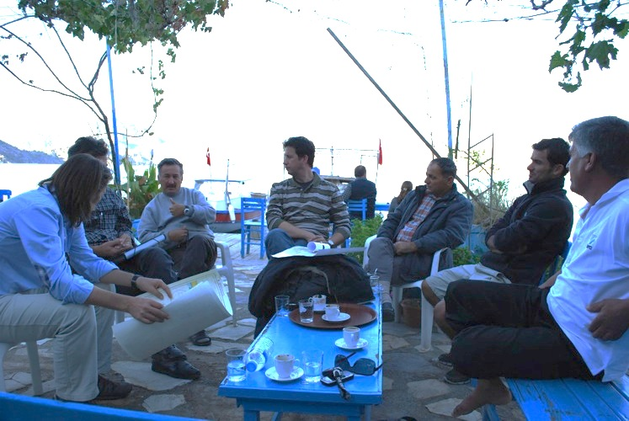

## Priorities and Risks for the Remainder of Implementation

1. One of the important roles of a mid-term evaluation is to identify the priorities and risks for the remaining implementation period, to support the project in moving toward eventual achievement of the outcomes and objectives.
2. Risk: Institutional Framework. As has been referenced throughout this evaluation, the most critical risk for the Turkey MCPAs project at present is the uncertainty surrounding the institutional restructuring of the government, which has the potential to significantly negatively affect project implementation. This issue has been discussed in detail previously in Section IV.B.ii on implementation arrangements, and is further discussed in Section VI.A.iii on institutional risks to sustainability. A negative influence of this development on the project is not a foregone conclusion, but must be managed appropriately. Therefore, one of the immediate priorities for the project team must be to carry out an effective lobbying and information campaign among high-level decision makers in the new institutional structure. This will serve to inform them about the objectives of the project, develop buy-in and ownership within institutions that were not involved in project development and approval, and secure the necessary political support to continue with successful project implementation. This will involve direct informational meetings with the relevant general directors, undersecretaries, and if possible even the ministers of the two new key ministries (MoEU and MoFW).
3. Informing and involving provincial level decision-makers about the project will also be critical, since many aspects of decision-making related to SEPAs and the GDNAP in general will be decentralized to their level. This would involve provincial governors, mayors, and provincial directors of relevant government institutions. An excellent opportunity that should be pursued as soon as possible would be to organize a media event around the official grand opening of the regional training center in Akyaka. Decision-makers would likely be interested in attending this photo opportunity with regional media coverage; regional development agency and EU representatives should also be invited.
4. Risk: Institutional Coordination. There are numerous potential institutional coordination issues under the new institutional arrangements. The project already included institutional coordination as one of its primary components, which was focused on engaging all relevant government institutions in effective management of the SEPA sites. Now the former single MoEF has been split into two ministries – the MoEU (in combination with the former MoPW), and the MoFW. EPASA was formerly affiliated with the MoEF, and has now been shifted under the MoEU. Some management aspects have also been decentralized, authority under the provincial governors. This creates potential issues in multiple ways – for example, management plans for SEPA sites that were prepared under the former MoEF would now have to be approved by the MoEU. In addition, the GEF Operational Focal Point (the chair of the Steering Committee) is now in a separate ministry from the project. Some stakeholders pointed out that there may be some improvements in coordination as well, since the site level land-use planning process will be streamlined in one institution (MoEU), instead of being subjected to decision-making bureaucracy between multiple government institutions.
5. There are multiple priority actions for the project to continue working on coordination issues. First, establishing the LMUs should continue to be a key activity. Priorities here are to clarify the legal authority needed for establishment and operation of these offices. The project should also work to ensure the continued functioning of the LMU office already established at Foça. The most critical activity will be to lobby decision-makers in the GDNAP to secure allocation of staff for SEPA site management through the LMUs. Second, the project should engage with the GDNAP to emphasize individual and institutional capacity development on MCPA management. This was already well-underway with EPASA, and may now need to be “reset” to involve staff from the GDNAP, particularly those coming from the previous MoPW. Third, as previously stated, the project must continue working to strengthen the engagement of provincial and local level government institutions in monitoring and enforcement of MCPA management regulations. The gendarmes (on land) and coast guard (on sea) are the only bodies with the capacity to provide the necessary level of enforcement. The General Directorate of Fisheries & Aquaculture is also responsible for enforcement, and their involvement at the provincial level should be strengthened as well.
6. Other priorities: Other priority activities, previously discussed in this evaluation report, are a focus on public awareness and local stakeholder engagement at the site level.
7. The project should also provide boundary markers for the SEPA sites at key points (it would be too expensive, and unnecessary, to delineate the entire boundary), and should delineate the boundaries of the NFAs. The NFAs have been approved and are operational (based on GPS coordinates agreed by stakeholders), but enforcement could be strengthened with marked boundaries. This is one activity that could help demonstrate some basic concrete results to local resource users to increase ownership and buy-in.

# Key GEF Performance Parameters

## Sustainability

1. While a sustainability rating is provided here as required, sustainability is a temporal and dynamic state that is influenced by a broad range of shifting factors. It should be kept in mind that the important aspect of sustainability of GEF projects is the sustainability of results, not necessarily the sustainability of activities that produced results. In the context of GEF projects there is no clearly defined timeframe for which results should be sustained, although there is the implication that they should be sustained indefinitely. The greater the time horizon, the lower the degree of certainty possible when evaluating sustainability.
2. In addition, by definition, mid-term evaluations are not well-positioned to provide ratings on sustainability considering that many more activities will be undertaken that may positively or negatively affect the likelihood of sustainability. Based on GEF evaluation policies and procedures, the overall rating for sustainability cannot be higher than the lowest rating for any of the individual components. Therefore the overall **sustainability** rating for the Turkey MCPAs project for this mid-term evaluation is *moderately likely*.

### Financial Risks to Sustainability

1. At present the financial sustainability of the project results appears likely, though as with many aspects of the project there is a high level of uncertainty at the moment. The most significant question is what the budget approach of the new MoEU will be with respect to funding management of SEPA sites, since EPASA no longer has its own budget specifically dedicated for this purpose – the SEPA sites are only part of the mandate of the new GDNAP. Until the institutional framework to support marine and coastal biodiversity conservation in the SEPA sites becomes clear, it cannot be known if the government budget support for SEPA sites will be more or less than it was previously.
2. Financial sustainability for other aspects of the project appears positive – for example, with respect to the training center (as highlighted in Section V.A.i on Outcome 1), the project has a strong partner in Mugla University that is committed to seeing the center become self-sustaining. The local authorities will maintain the mooring buoys established in Göcek. Some aspects of the project, such as institutional coordination and management planning, depend less on financial means than on other aspects of sustainability, such as institutional issues.

### Sociopolitical Risks to Sustainability

1. There are some socio-political risks, and sustainability in this regard is considered moderately likely. There are some expectations from local fishermen from the project with respect to the establishment and enforcement of NFAs. If these expectations can’t be met by the project management before the end of the project this may jeopardize the sustainability of some project activities. Their main expectations from the project are to fully operationalize the NFAs to fulfill their role as a mechanism for fish population recruitment; otherwise, income from fisheries in surrounding waters will decrease as illegal fishers overharvest commercially valuable species. Fishermen will not support and feel ownership of the project unless the relevant authorities control the illegal and spear gun fishing, catalyzed by the project management team and partners. Therefore, priority must be given to the control of illegal and spear gun fishing in the region. Once the fishermen observe that there are not any illegal fishing and spear gun fishing, their support, trust and ownership for the project will certainly increase. To control the illegal fishing, the coast guard and gendarmes must take an effective role and they should be supported with personnel, equipment and other necessary facilities. Otherwise, illegal fishing and spear gun fishing will not be able to be controlled by the project and this will negatively affect the sustainability of the project. Fisheries Cooperatives might also be supported by the project to control illegal fishing in collaboration with government authorities.

### Institutional Framework and Governance Risks to Sustainability

1. EPASA was part of the MoEF and was headquartered in the capital, Ankara. It was organized into two “main service units,” as follows:

* Research, Planning, Project and Implementation Department, which was responsible for planning at various scales, monitoring conformity with plans, preparing maps and “implementing infrastructure projects and installations;”
* Environmental Protection, Research and Evaluation Department, which was responsible for: Research and studies on natural resource protection, development and productivity; proposing protection measures related to hunting and fishing; determining pollution standards and reporting on polluting installations; supporting the organization of solid waste collection; following activities within areas “indicated and approved as sensitive zones,” and; monitoring ships and their waste disposal.

1. In addition to its headquarters offices, EPASA was operating six regional directorates, at Mugla, Antalya, Mersin, İzmir, Denizli and Aksaray. Overall, EPASA staff numbered well over 200 and good technical experience, and various environmental management responsibilities.
2. On the other hand, the GDNCNP was responsible for the selection, designation, planning, conservation, and management of national parks, nature parks, natural monuments, and nature reserve areas under the provisions of the National Parks Law No. 2863. The GDNCNP was managing each protected area under the rules of its “long term development plan” (management plan) through a network of Park Directorates. The Directorates were also responsible for the conservation of game and wildlife species within their natural habitats by making necessary decisions on hunting control throughout the country.
3. Formerly EPASA and GDNCNP were working under the responsibility of the same Ministry namely the MoEF. But after the reorganization of the Ministries, a new General Directorate (the GDNAP) was established under the MoEU, which will also be responsible for the management of the SEPAs. There is no EPASA anymore; GDNCNP works under the MoFW.
4. There are six departments under the GDNAP at the central level: Research and Assessment, Protection and Control, Public Improvement Planning, Investment and Projects, Registration and Advertisement and Management Services. There is not any specific department responsible for the SEPAs at the central level of the GDNAP.
5. At the provincial level, there used to be six Regional Directorates under EPASA, but now there will be Division Directorates for SEPAs under the provincial Directorates of the MoEU. Most of the Provincial Directors are coming from the former MoPW, so they are all civil engineers with little training in relevant environmental management issues for marine and coastal conservation.
6. Regional Directorates of former EPASA used to report directly to EPASA and this was very fast and efficient way of reporting. But no w, Division Directors for SEPAs will be reporting to the Provincial Directorates of Environment and Urbanization. Provincial Directorates will be reporting to the Governor Offices, and Governor Offices will be reporting to the General Directorate. This process will slow down the communication and reporting lines and will negatively affect the project activities.
7. Coordination between the GDNAP and GDNCNP might be more difficult than before since they are under the different ministries now.
8. High-level officials of the MoEU are mainly coming from the former MoPW with little understanding of relevant environmental management issues for marine and coastal conservation and project activities. Therefore, high-level official and provincial Directorates must be immediately informed about the project and environmental issues to get their support for the project.
9. There is also a lack of enforcement capacities at the field level under the governance risks since gendarmes are not efficiently enforcing against illegal fishing, and the coast guard has limited capacity and ability to effectively control the illegal fishing in the field.

### Environmental Risks to Sustainability

1. Illegal spear gun fishing in the NFAs in Gökova could be considered a main environmental threat to the sustainability of the project activities in this site. Therefore, maximum efforts should be spent during the project implementation period to organize systemic control of illegal fishing and spear gun fishing in the project sites, and especially in Gökova site.
2. In addition, Göcek and Fethiye sites are under the pollution risk from both marine and terrestrial based pollution. It is crucial to control and minimize land-based activities in coastal areas that threaten marine biodiversity values and to regulate vessel anchorage and to ensure reception of solid and liquid wastes from vessels. Reduced impacts on marine areas from other marine-based and land-based activities might provide an additional support to environmental sustainability.
3. These issues should be given priority and importance during the project implementation to control, mitigate and stop these negative effects. Otherwise, these will be environmental risks to the sustainability of the project activities.

## Catalytic Role: Replication and Scaling-up

1. The catalytic role of the GEF is one of its key operational principles, and should be supported by all GEF-funded projects on the basis that the GEF’s resources are so limited that it must seek to extend its influence beyond the projects it funds. As highlighted in Section III.A on the project’s development context, the Aegean coast and the project sites make up only a small portion of Turkey’s marine and coastal biodiversity resources. There are multiple opportunities to replicate the good practices of the project in Turkey’s other marine and coastal ecosystems, including the Black Sea coast. Replication of the project’s positive examples would greatly benefit other areas of Turkey that are also lacking effective management. The project is producing multiple publications and reports, and success stories and lessons learned from the project should be recorded and disseminated to all related organizations and bodies all around the country.
2. At the mid-point of the project it is early for there to be much progress in replication, but there are some indications that the project can have a catalytic influence. To begin, there are other MCPAs in Turkey that can build on the example of establishing LMUs to support effective management, including the newly established Saros Bay SEPA site. Previous GEF projects in the country have shown that establishment of local management and working groups is very important for the sustainable management of protected areas.
3. The project includes support for MPA expansion, and will produce a 10-year Action Plan for MPA management and expansion. At a smaller scale, the NFAs that the project is supporting are pilot efforts for such fisheries management mechanisms, and according to members of the General Directorate of Fisheries & Aquaculture, once these NFAs have been monitored for three years to assess their effectiveness, they can be replicated in other parts of the country as appropriate.
4. The NFAs – much smaller than the full SEPA sites – are a good starting point for replication, which can be more easily achieved with smaller areas than with areas as large as the SEPA sites. As success builds over time, further scaling-up, and replication to additional areas can be carried out in other similar parts of the country.
5. Other replication opportunities can be explored by bringing members or representatives of relevant organizations, institutions and the public from other similar parts of the country to the project sites to show them the project activities and to give them chance to talk to the people and project staff. The MCPA Training and Implementation Center can have a catalytic influence in this regard, facilitating replication and scaling up of good management practices, and contributing to the establishment of networks among MCPAs.

## Monitoring and Evaluation

### Project Monitoring, Reporting, and Evaluation

1. The project M&E plan is outlined in both the project document (dated April 28, 2009) and the CEO Endorsement Request (dated February 5, 2009), with information on the specific M&E activities, M&E budget, roles and responsibilities, and the timeframe for activities. These are all key elements of a “good practice” M&E plan. In the project document, the M&E plan is described in section IV “Monitoring and Evaluation Plan and Budget” first in narrative form and then summarized in the immediately subsequent table. Overall the M&E plan is based on standard UNDP-GEF project M&E procedures, and conforms to UNDP and GEF standards and norms. The M&E plan includes: inception workshop and report, PIR, quarterly progress reports, ATLAS monitoring logs (issues, risks, lessons), mid-term and final evaluations, a terminal report, lessons learned, an annual audit, and annual monitoring visits by UNDP to the project sites. The M&E plan does not specifically mention Steering Committee meetings, though the Steering Committee is naturally part of the project monitoring framework. The total indicative cost of the M&E activities is $157,000 - approximately 7% of GEF resources and 2.5% of the overall planned budget. There is no indication in the available project documents if the M&E costs will be funded solely through GEF funding, or with a combination of co-financing as well. This projected M&E budget is fully adequate for a project of this size.
2. The project logframe, with associated indicators and targets, is one of the primary tools for assessing project implementation progress and results. The logframe for the Turkey MCPAs project is included with this evaluation report as Annex 3, with an independently assessed level of progress for each indicator. In addition, possible revisions to the logframe are suggested. The logframe relies heavily on various “scorecards” as indicators for project results. The robustness of the capacity assessment scorecard and the financial sustainability scorecard is as yet not fully determined. It is useful to have these scorecards as indicators for this and other UNDP-GEF projects so an increasing body of data on their use can be collected, but they should be supported by non-scorecard indicators for project outcomes as well, to ensure project results are being adequately captured.
3. GEF project indicators are required to meet SMART criteria,[7] and the indicators in the Turkey MCPAs logframe fall short on multiple fronts. For example, the logframe includes an indicator on sea turtle emergence for nesting at Dalyan beach – while sea turtles could be an indicator species for the marine ecosystem as a whole, the project is not carrying out any specific activities related to sea turtles, such as supporting the sea turtle rehabilitation center, or promoting a campaign for boat propeller guards. In addition, *Caretta caretta* takes at least 20 years to reach sexual maturity, so any ecosystem changes benefiting the turtle population would not be documented through a sea turtle emergence indicator. Similar issues could be applied to the other impact level indicators in the project logframe, covering monk seals and sand bar sharks. Some logframe indicators are redundant (e.g. ha of new MCPAs, and percentage increase in protected area coverage), some indicators need to be more specific (e.g. EPASA has tools for sustainable financing options – what kind of tools, and with what level of revenue generation potential?), and others need to be revised (e.g. self-financing revenue as a percentage of total budget – this is dependent on the overall budget size, so may not accurately reflect project achievements, and will need to be revised following institutional restructuring anyway). As the project logframe with SMART indicators is the most critical tool for a results-based project implementation approach, M&E design is considered moderately unsatisfactory.
4. Overall the M&E plan is being implemented as envisioned, other than the fact that a financial audit, which was planned annually, has not yet been conducted. The project quarterly progress reports and PIRs have been comprehensive and timely, and this mid-term evaluation was organized at the foreseen time. Some project monitoring reports are only in Turkish, which limits their utility in evaluations and lessons sharing. UNDP also appropriately supports the M&E activities of the project through regular informal communications for ad-hoc monitoring, and through field missions as necessary. One excellent aspect of M&E plan implementation is the contribution from the GEF Operational Focal Point on the annual PIR, as the involvement of the Focal Point in M&E activities is recommended as per the GEF’s revised M&E policy. M&E implementation is rated satisfactory, and M&E overall is rated moderately satisfactory.

### Environmental Monitoring

1. There are multiple project activities that relate to environmental monitoring, including Output 1.8 (on establishing monitoring protocols for the sites) and Output 1.6 on protected area gap analysis based on available environmental data. In reality, multiple organizations and institutions (e.g. various government departments, universities, NGOs, etc.) are collecting environmental monitoring data, and there is no centralized database or functional data management or sharing system. Each year different universities must bid against each other for permission to conduct research in specific areas, and thus data becomes fractured. In addition, some organizations do not willingly share their research data. Thus it is difficult to access the broad range of environmental monitoring data potentially available to inform management decisions.
2. Under Output 1.6 the original plan was for the project to develop a GIS-based analysis of critical biodiversity areas that are lacking protection, but this is not possible with the data currently available to the project team. The budget available for this activity would not be enough to support a biodiversity survey of the entire Aegean coast.
3. EPASA regularly monitors some environmental parameters – for example water quality (for the past eight years), and some key biodiversity species, such as sea turtles (for 20 years), and monk seals (for 4-5 years). Also, for example, the General Directorate of Fisheries & Aquaculture monitors some fish stocks, and monitoring of the pilot NFAs is underway. According to some stakeholders, a new government initiative is underway to develop a centralized environmental monitoring knowledge base under the auspices of the navy, but this will take at least a few years to become operational if it moves ahead.

## Project Impacts and Global Environmental Benefits

1. For the GEF biodiversity focal area project impacts are defined as documented changes in environmental status of species, ecosystems or genetic biodiversity resources. Global Environmental Benefits in the biodiversity focal area have not been explicitly defined, but are generally considered to involve sustained impact level results of a certain scale or significance. The project document specifically highlights the expected global environmental benefits of this project: “The global biodiversity benefits are associated with a number of tangible changes in the structure and functions of Turkey’s system of marine protected areas. First, management of over 161,000 ha of marine protected areas will be substantially improved as compared with baseline efforts, with greatly increased attention paid to conservation of marine biodiversity within these existing sites. Second, the project will help to bring an estimated 100,000 ha of marine area under protection. As a result of these and related changes, globally threatened species, including monk seals *Monachus monachus*), marine turtles (*Caretta caretta* and *Chelonia mydas*), sandbar shark (*Carcharinus plumbeus*) and sea grass (*Posidonia oceanica*) will benefit from the effective havens represented by these sites through lowered levels of pressure and reduced risk of local extirpation. Critical habitats types such as *Cystoria mediterranea*, *Caulerpa prolifera*, *Pinna nobilis*, *Arbasia lixuria*, *Paracentratus lividus* and *Zostera marina* will likewise benefit. Marine areas are expected to increase their importance as local biodiversity havens for species threatened elsewhere within the Mediterranean, Black and Aegean Seas.”
2. The CEO Endorsement Request further states: “By seeking above all an increase in the sustainability of the MCPA system, the project aims to ensure that its impacts are both significant as well as long term in nature. As such, the expected stream of impacts on marine biodiversity in particular arising from a shift in current trends is expected to continue well beyond project completion.”
3. The project logframe includes a number of impact level indicators. The inclusion of impact indicators is an important and positive element of the project logframe, but the relevance of the indicators selected could be significantly improved, as discussed in Section VI.C.i above. The appropriateness of impact indicators must be well considered because changes in ecosystems and species may require years to be measurable. This issue highlights the importance of long-term environmental monitoring to assess and document changes in biodiversity over time.
4. The indicator species selected as impact indicators are sea turtles, monk seals, and sand bar sharks. Under Outcome 3, the project also includes indicators on water quality and fish weight and length for key species in the NFAs. The project PIR provides baseline data and some initial monitoring data for these indicators (see the project logframe assessed level of achievement in Annex 3), but it would be difficult to say at this stage of implementation that the project has made a significant incremental contribution to any changes from the baseline noted. Some positive changes may have already been underway due to baseline activities carried out by EPASA.
5. To date, the on-the-ground impact level results of the project are relatively small-scale and site-based. The NFAs do appear to have a positive effect for some species, although the most valuable commercial species, grouper, is still being illegally harvested in these areas. The installation of mooring buoys in sensitive sites of Göcek Bay is certainly having a positive influence on the benthic environment in the bay, as fewer boat anchors are damaging key ecosystems. If the expected outcomes are successfully reached, a theory-based assessment implies that the project will make a positive contribution to long-term global environmental benefits, as the management effectiveness for the MCPAs improves over time.

## Stakeholder Participation in Implementation

1. Stakeholder participation at central level is really satisfactory in terms of participation in the Steering Committee Meetings, workshops and other meetings regarding the preparation of the work plan etc. During the negotiations with the stakeholder organizations and institutions in Ankara, it was very clear that all the stakeholders were very happy to be participating in the project activities.
2. Local level participation is less satisfactory compared with the central level participation. This may be due to the lack-as-yet of the local level management units and working groups established at the project sites. Although the central level organizations of the former Ministry of Food Agriculture and Livestock (General Directorate of Fisheries & Aquaculture), GDNCNP and others are participating in all the project activities at central level, their provincial and local level staff and officials are not frequently participating in the project activities at local level.
3. The village of Akyaka is directly involved with the project through various activities, but particularly through the establishment of the training center, which will be located in a building provided by the village. Other municipalities, such as Foça, are aware of and in agreement with the project activities. Yet there are also opportunities for further participation of local communities and civil society, whose involvement is critical for implementing project activities and eventually achieving objectives. Participation of local civil society organizations in the project activities could be greater, with the exception of the local Fisheries Cooperatives. For example, local NGOs should be encouraged to take an active role in implementing project activities including resource protection, alternative income generation (ecotourism, organic agriculture, etc.), awareness raising, etc. The involvement of women, school children and youth should also be emphasized. Such activities must be carried out in a way that provides a direct linkage with the main goal and objective of the project, generating global environmental benefits through conservation of marine and coastal biodiversity.
4. Below are some opportunities to involve local civil society organizations and community groups in project activities and to strengthen local ownership of the SEPA sites:

* The training center could be used to train school children regarding the environmental conservation issues, to have meetings with women and youth groups, etc.
* Income generating activities for local communities should be encouraged, and collaboration with the GEF Small Grants Programme could be explored.
* Local NGOs could be given training courses on project preparation and implementation.
* Contests with songs, painting, poetry, etc. could be organized among the school children and some awards could be given to the winners of the contests by the project.
* Local press and media could be invited to some of the meetings and project activities.
* Provincial and local organizations of the related ministries should be invited to participate in the project meetings and activities.
* Courses on carpet viewing, handicrafts, etc. could be organized especially for women’s groups.

1. Participation of the gendarmes is also not satisfactory or not at the expected level. Their participation and active role especially in controlling illegal fishing and spear gun fishing is really very crucial, and the project must find a way to leverage higher-level political support and community level awareness to catalyze the participation of the gendarmes in fulfilling their monitoring and enforcement duties at ports and fish markets.
2. Addressing gender equality is one of UNDP’s important areas of work, and is often reviewed in project assessments. There are few gender specific issues related to the objective and outcomes of the project, although as previously mentioned, the project could actively engage women’s groups in awareness building and sustainable local development activities related to conservation of marine and coastal resources.
3. Previous GEF programmatic evaluations, such as the Third Overall Performance Study of the GEF and Fourth Overall Performance Study of the GEF, have indicated that among the critical elements to ensure the sustainability of project results is strong stakeholder ownership of the processes and activities supported under the project. Stakeholder ownership of the project objective and results is satisfactory. This was clear from the meetings and discussions with the representatives of the different stakeholders and organizations in Ankara, and the project sites. Individuals participating appreciate being involved, and feel strongly about the importance of conserving marine and coastal biodiversity resources in Turkey. The project will continue to empower stakeholders through capacity development and institutional coordination, and as some key benchmarks are reached (such as establishment of the LMUs) it is anticipated these groups will work to carry the project results forward.

## Capacity Development

1. Capacity development activities are a focus of Outcome 1 of the project, and are discussed further in the previous Section V.A.i on progress under this outcome.

# Main Lessons Learned and Recommendations

## Lessons from the Experience of the Turkey MCPAs Project

1. As unlikely as it may seen at the beginning of a project, government turnover and institutional change, to a large or small degree, can create significant setbacks for environmental conservation projects; strong risk mitigation strategies should be in place from project start. In the case of the Turkey MCPAs project, institutional restructuring as a result of national elections will have a major upheaval, as the executing organization, EPASA, has been completely changed. Such a major change did not seem likely at the beginning of the project two years prior, yet the possibility was identified as a risk in the project document. However there was not a structured risk mitigation strategy to deal with this issue.
2. Having a strong executing partner with a committed staff and budget can generate catalytic returns from GEF investments. The Turkey MCPAs project was the first time EPASA had served as the executing partner for a UNDP-GEF project. The project development process required time for EPASA to understand and accept the working arrangements and co-financing commitments necessary for GEF and UNDP support, but once all agreements were reached and the project was approved, EPASA proved to be a dedicated partner. EPASA’s annual budget for SEPA management was significant (in the tens of millions of USD), and the GEF project was able to leverage a portion of that budget into specific investments for biodiversity conservation, such as the installation of mooring buoys at Fethiye-Göcek. EPASA’s role in the Turkey MCPAs project represents an excellent example of a government partner committed to it’s mandate, but recognizing that it could substantively benefit from international donor support through capacity development and partnership building.
3. Local resource users can be supportive of regulations for conservation and sustainable use of marine biodiversity. Fisheries cooperatives are prepared to accept enforcement of NFAs, but are counting on the project team and other stakeholders to also ensure regulations are abided by all parties. In multiple project sites the local fishery cooperatives are interested in supporting biodiversity conservation, and are willing to make in-kind contributions to assist in management activities. However, if illegal use is not restricted, their support is sure to decline.
4. Effective management, including monitoring and enforcement of regulations, requires active engagement of all relevant stakeholders, at the appropriate levels. In the case of Turkey’s SEPAs, the gendarmes are responsible for enforcing the law in the terrestrial portions of the SEPAs, but they are as yet not adequately engaged at the local level to fully support this process.

## Recommendations for the Remaining Implementation Period

1. ***Key Recommendation:*** The Project Steering Committee and implementation partners should approve at the next Steering Committee meeting an official project extension to October 2013, to account for the period between approval and actual implementation start so that the project can still have a four-year implementation period. In addition, the Steering Committee should consider a further six-month extension to address delays resulting from the current government institutional restructuring. Thus a total of a one-year extension would be appropriate. *[PMU, Project Steering Committee, UNDP]*
2. ***Key Recommendation:*** The project design is ambitious in scope for the amount of resources and planned implementation period. At this stage the project team and partners should revise the project workplan to consolidate some outputs and activities, particularly under Outcome 1, which was adjusted at inception to include ten outputs. Some outputs under multiple outcomes are overlapping and could be consolidated to focus on key results. A workplan revision is also necessary to adaptively manage the government institutional restructuring. *[PMU, Key Partner Institutions, UNDP]*
3. ***Key Recommendation:*** Once the landscape of institutions involved in and responsible for management of SEPA sites is clear, the project team should re-assess the Steering Committee membership, and ensure involvement of all necessary stakeholders, including for example the gendarmes. Any newly involved stakeholders will need to be fully updated on the project objective and planned activities. The reconstituted Steering Committee can then approve the necessary changes in the project workplan, logframe, budget, etc. for the second-half of implementation. *[PMU, UNDP]*
4. ***Key Recommendation:*** To respond to the institutional restructuring, this evaluation recommends the project take a decentralized implementation approach for the second-half of the project. This would involve broadly increasing the focus on site and provincial level activities, and on strengthening local management. For example, there will be a need to increase involvement of provincial directorates of the General Directorate of Fisheries & Aquaculture, the former GDNCNP, and the private sector (especially the tourism sector). Reflecting this increased decentralized focus and with the final goal of establishing the LWGs, it would be useful in the near term to hold site-level meetings with the participation of all stakeholders (including media) to refresh the local awareness about the project, and get further local feedback on key issues and suggestions for implementation. *[PMU, UNDP]*
5. ***Key Recommendation:*** The project strategy originally envisioned the establishment of LMUs for each of the sites to facilitate effective management. The project had made progress toward this goal through capacity development activities for EPASA staff recruited for this purpose, but the institutional restructuring occurred before the LMUs were officially established, and made operational. This evaluation recommends that the establishment of site-level LMUs remain a top priority, and that these should be established before the end of the project. Alternative approaches of having management staff based in provincial headquarters would not be nearly as effective for managing marine and coastal resources. *[PMU, GDNAP, MoEU]*
6. ***Key Recommendation:*** After the establishment of the new ministry (the MoEU) and new institutional arrangements at the provincial level, in the view of this evaluation the best way to establish the LWGs would be under the chairmanship of the local governor at each site, with the participation of all related institutions and organizations. This evaluation recommends this issue be given priority in the remaining project period to better implement the project activities in the provincial level and to give more power and authority to the local level establishments for the future of the project. *[PMU, GDNAP, MoEU]*
7. ***Key Recommendation:*** To facilitate a decentralized implementation approach, this evaluation recommends the addition of site-based project officers to catalyze and guide local level activities. One or two project officers may be appropriate, depending on the division of responsibilities. Previous UNDP-GEF project experience has shown that having site-level project staff can be of great benefit in increasing communication with and the involvement of local stakeholders. *[PMU, UNDP]*
8. ***Key Recommendation:*** The project should as soon as possible carry out the public awareness baseline survey of key stakeholder groups originally foreseen; it is critical to have a clear understanding of public awareness related to the project objective of conserving coastal and marine biodiversity in Turkey, and this would allow an assessment of progress in this area at the end of the project. This information would also provide input for further activities to strengthen awareness local stakeholder ownership. Opportunities for future activities include school activities linked with local media, information boards at ports, and an information stand at weekly markets. *[PMU]*
9. ***Key Recommendation:*** Given the project’s anticipated decentralization shift, the project should add on-the-ground site level activities to provide small-scale but direct contributions to the project objective, increase stakeholder awareness and participation, and demonstrate concrete results to local stakeholders. This could be effectively achieved through partnership with local level civil society organizations, and the project could explore potential partnership with the GEF Small Grants Programme, which has already supported some community-level activities in the area. The most relevant activities should be drawn directly from stakeholder input, but opportunities include feasibility studies for local eco-labels (particularly for organic agriculture to reduce nutrient run-off), awareness raising on illegal spear fishing with restaurant commitment and certification, ghost net cleanup, public awareness campaigns by civil society, and additional work on creating opportunities for fishermen to involve tourists in fishing excursions. *[PMU, UNDP, Project Steering Committee]*
10. ***Key Recommendation:*** Increasing individual and institutional capacity for effective management of marine and coastal resources is one of the main outcomes of the project, and a number of activities have already been carried out to support this. Following the government institutional restructuring however, there is an increased need to continue and to strengthen capacity development and training activities, including staff from the GDNAP coming from MoPW that may now be involved in SEPA management. The project should also exploit opportunities for biodiversity mainstreaming within the new MoEU, by seeking synergies for biodiversity considerations in other MoEU work, such as coastal land-use planning. The MCPA Training and Implementation Center should present opportunities to catalyze and scale-up good management practices, and the e-learning platform developed by the project can also contribute. Another capacity development opportunity would be for site-level exchanges within the project sites for the government staff responsible. *[PMU, GDNAP]*
11. ***Recommendation:*** The project could draw on lessons and experiences from other integrated local sustainable development approaches, such as the EU’s LEADER+ program, and UNESCO’s Man and Biosphere Approach. In addition, lessons from the SEPA approach could be shared at the international level (for example, at the World Parks Congress), since the SEPA approach is a unique model for protected landscapes with integrated sustainable local development. *[PMU, GDNAP , UNDP]*
12. ***Recommendation:*** Following the splitting of the former MoEF, the General Directorate supporting the project (the GDNAP) and the General Directorate responsible for national parks are now in two separate ministries. The project should follow-up with the GDNAP to ensure clear lines of communication with a dedicated contact person in the general directorate on the technical working group who can inform and engage other relevant staff in the GDNAP on project activities as appropriate. *[PMU, GDNAP, Project Partners]*
13. ***Recommendation:*** As the institutional restructuring of environmental line agencies is underway, some opportunities may appear for the project to further its objective in a results-based manner that were not otherwise planned. For example, the project should provide input on the regulations currently being developed for provincial commissions to strengthen opportunities for public participation in the management of protected areas. *[PMU, GDNAP and Project Partners]*
14. ***Recommendation:*** Environmental monitoring data is critical for effective marine and coastal biodiversity management, and for carrying out a number of project activities. Turkey is currently lacking a centralized data sharing mechanism for environmental monitoring data, and this remains one of the barriers to effective management. There are indications that a mechanism may be developed and managed by the Turkish Navy. If this initiative comes to fruition, the project should take this opportunity to support and strengthen the centralized integration of environmental monitoring data in a manner that would benefit the management of the SEPA sites. *[PMU, Project Partners]*
15. ***Recommendation:*** This evaluation recommends the project team increase the comprehensiveness of quarterly progress reporting in English, to facilitate the identification and sharing of lessons and experiences beyond Turkey. This would also support M&E activities such as the planned terminal evaluation. Reporting should not be an overly burdensome activity, but some additional information would be beneficial. *[PMU, UNDP]*

## Project Mid-term Evaluation Ratings

|  |  |  |
| --- | --- | --- |
| **Project Components** | **Rating** | **Qualitative Summary** |
| **Project Formulation** |  |  |
| Relevance | S | Overall relevance is rated satisfactory with respect to local and provincial needs and priorities, and national biodiversity priorities. |
| Conceptualization / design | MU | * The project was too ambitious to focus on six large sites, and a large number of activities and outputs, for the resources and timeframe of the project. Other approaches may have been more relevant given the resources available. * Also, the project design phase could have been more comprehensive, instead of continuing to incorporate additional feedback for increasing activities at the inception stage. * Financial planning and revenue generation component had higher relevance at the time of the project development (i.e. 2006 and preceding years) than it does at present. However under the new institutional arrangements, this aspect may again gain in relevance, as the central government budget allocations for the SEPA sites may be shifted under the new structures. |
| Country-drivenness | S | People feel happy with the project and committed to success |
| Stakeholder involvement in design | MS | There were meetings and consultations, but some additional stakeholders could have been involved evidently, and more work could have been done since they got to the inception phase and then added more activities to the project |
| **Project Implementation** |  |  |
| **Implementation Approach (Efficiency)** | S | Overall project efficiency and cost-effectiveness is good. |
| Management implementation | S | Project management is well implemented. |
| Use of the logical framework | MS | The project logframe indicators and targets need some revision to fully support a results-based implementation approach. |
| Financial planning and management | S | Project financial management is carried out according to UNDP required procedures. |
| Adaptive management | S | A number of positive changes have been made to project implementation plans. Many more may be needed to address the institutional changes now underway. |
| Use and establishment of information technologies | S | They are effectively using the website, and have developed the e-learning approach, which is positive. There could be more work done to support stakeholders in securing GIS-based environmental data for management, but this relates to an overall general problem of environmental data management among many stakeholders. |
| UNDP supervision and support | S | Overall UNDP is providing strong support during the project implementation. There are some aspects of the project design that could have been improved, which is partly UNDP’s responsibility. At the same time UNDP serves the needs and wishes of partner governments, and is bound within the strategies and requirements of the GEF Secretariat. |
| Operational relationships between the institutions involved | MS | Project implementation and coordination at the central level is adequate. At the site level, in the SEPAs, there still needs to be additional work on institutional coordination and stakeholder information sharing. The project is continuing to work on this in establishing the LMUs and local working groups. |
| Technical capacities | S | The project is involving highly technically qualified experts, including university professors and PhD level national experts. |
| **Monitoring and Evaluation** | MS | Overall M&E is considered moderately satisfactory. |
| M&E design | MU | The M&E plan meets GEF and UNDP M&E minimum standards, except in the area of SMART logframe indicators and targets, which is a critical element for a results-based implementation approach. |
| M&E plan implementation | S | The M&E plan is being implemented as envisioned, and Turkey’s GEF OFP has provided input on the annual PIR process. The annual audit has not been carried out, and progress reporting in English could be more comprehensive for better information sharing and identification of lessons. |
| M&E budgeting | S | The allocated budget is adequate for a project of this size. |
| **Stakeholder Participation** | MS | Central level stakeholder participation is good, but there is a need for additional involvement of provincial and local level stakeholders. |
| Production and dissemination of information | MS | Need to make sure all of the local level stakeholders are getting awareness materials produced by project. Project is also continuing to work on this, and MCPA Training and Implementation Center is also expected to play a role. |
| Local resource users and civil society participation | MS | Could involve some additional stakeholders at the site level in project activities; more local civil society engagement, and further awareness activities with community, private sector, and relevant government institutions. |
| Establishment of partnerships | S | Good example with Mugla University and the training center. Could also explore additional opportunities for establishing MOUs and MOAs between relevant stakeholders at the local level. Also, will be strengthened through the establishment of the local working groups. |
| Involvement and support of governmental institutions | MS | Could involve some additional organizations in the steering committee, and also need more involvement of multiple provincial level government institutions, including fisheries department, gendarmes, and GDNP. |
| **Project Results** |  |  |
| **Progress Toward Overall Achievement of Objective and Outcomes (Effectiveness)** | S | See below. |
| **Objective**: To facilitate expansion of the national system of marine and coastal protected areas and improve its management effectiveness | S | Project is generally on track, or was up to the point of the institutional restructuring of the ministries. Now there will need to be a reassessment and additional focus on revising project outputs already produced, and ensuring key activities continue to move ahead such as establishment of the LMUs. |
| **Outcome 1:** Responsible institutions improved the capacities and internal structure needed for prioritizing the establishment of new MCPAs and for more effectively managing existing MCPAs | S | Activities being carried out as planned – undertaking capacity development activities, trainings, etc. Progress on establishment of LMUs, but need continued focus. |
| **Outcome 2:** MCPA financial planning and management systems are facilitating effective business planning, adequate levels of revenue generation and cost-effective management | S | Established BDU, increasing revenues, allocated more daily use areas. Additional working being done by experts that will have positive contribution. Ecosystem services financial assessments completed, though revisions may be required due to institutional restructuring. |
| **Outcome 3:** Inter-agency coordination mechanisms in place to regulate and manage economic activities within multiple use areas of the MCPAs | MS | Things have been carried out according to the work plan but many activities remain. Now they will need more time to deal with the new institutional structure, and reassess the situation. |
| **Sustainability** |  |  |
| **Overall Sustainability** | ML | Based on the components of sustainability rated below. |
| Financial | L | Overall OK. One question is what the budget allocation for management of the SEPA sites will be under the new management structure, now that EPASA is no longer independent and is part of the central budgeting process, and the new GDNAP has an expanded mandate. |
| Socio-political | ML | There is strong support from some stakeholders, but not all relevant stakeholders at the site level are fully engaged, aware, and supportive. |
| Institutional framework and governance | ML | Rating based on the uncertainty of the institutional framework of the current situation, and how the relevant government institutions will work for MCPA management. With the expanded mandate of the new GDNAP to cover all of the natural SIT areas, there is moderate risk. Also, based on the previous experience of GEF projects in Turkey where coordination mechanisms and other innovations were established, these sometimes have lost sustainability after project completion, so there needs to be a focus on ensuring this does not happen. |
| Environmental | L | The environmental risks to the marine environment generally remain but are improving with project and other stakeholders support. There are some issues related to environmental risks to the NFAs, but these do not pose a major overall risk to project results. |
| **Progress Toward Overall Achievement and Impact** | S | Overall the project is on track is well implemented. But there are currently important questions for the best way forward, based on the changes in institutional structures related to environmental management in Turkey. |

# Annexes

Annex 1: Evaluation Terms of Reference

Annex 2: GEF Operational Principles

Annex 3: Outcome Level Logframe

Annex 5: Visibility Sheet

Annex 6: List of Persons Interviewed

Annex 7: Field Visit Schedule

Annex 8: Mid-term Evaluation Inception Report

Annex 9: Documents Reviewed

Annex 10: Mid-term Evaluation Preliminary Findings Presentation

Annex 11: Project Mid-term Scorecards: METT, Capacity, Financial

Annex 12: Evaluation Documentation

Annex 13: Evaluator CVs

Annex 14: Management Response

**Annex 1: Mid-term Evaluation Terms of Reference**

*Note: For space considerations elements of the TORs related to operational aspects of the evaluation, and the annexes of the TORs, have not been included.*

**Terms of Reference**

**for**

**Mid-Term Evaluation of the UNDP/GEF Project: PIMS 3697: Strengthening Protected Area Network of Turkey: Catalyzing Sustainability of Marine and Coastal Protected Areas (MCPA)**

|  |  |
| --- | --- |
| **Project Title:**  **Vacancy Type:**  **Location:**  **Category:**  **Type of contract:**  **Reporting Language:**  **Application Deadline:**  **Starting Date:**  **Expected duration of Assignment:**  **Duration of Contract:**  **Reference Code:** | Strengthening Protected Area Network of Turkey: Catalyzing Sustainability of Marine and Coastal Protected Areas (MCPA)  Two (2) External Vacancies  Turkey (Ankara and visits to Balıkesir, İzmir and Muğla Provinces)  Environment and Sustainable Development (ESD)  IC (Individual Contract)  English  08 June 2011  12 September 2011  30 man/days throughout the contract validity (non-consecutive)  12 September – 25 November 2011   1. Midterm Evaluation International Expert (MARINE MTE_INTERNATONAL) 2. Midterm Evaluation Local Expert(MARINE– MTE_LOCAL) |

**Introduction**

**Standard UNDP/GEF M&E requirements**

This Mid Term Evaluation (MTE) is initiated by the UNDP Turkey as the Implementation Agency for this project and it aims to provide managers (at the Project Implementation Unit, UNDP Turkey Country Office and UNDP-GEF levels) with strategy and policy options for more effectively and efficiently achieving the project’s expected results and for replicating the results. It also provides the basis for learning and accountability for managers and stakeholders.

The Monitoring and Evaluation (M&E) policy at the project level in UNDP/GEF has four objectives:

* to monitor and evaluate results and impacts;
* to provide a basis for decision making on necessary amendments and improvements;
* to promote accountability for resource use; and
* to document, provide feedback on, and disseminate lessons learned.

A mix of tools is used to ensure effective project M&E. These might be applied continuously throughout the lifetime of the project – e.g. periodic monitoring of indicators -, or as specific time-bound exercises such as mid-term reviews, audit reports and independent evaluations.

In accordance with UNDP/GEF M&E policies and procedures, all projects with long implementation periods are strongly encouraged to conduct mid-term evaluations. In addition to providing an independent in-depth review of implementation progress, this type of evaluation is responsive to GEF Council decisions on transparency and better access of information during implementation.

The MTE is intended to identify potential project design problems, assess progress towards the achievement of objective, identify and document lessons learned (including lessons that might improve design and implementation of other UNDP-GEF projects), and to make recommendations regarding specific actions that might be taken to improve the project. It is expected to serve as a tool of validating or filling the gaps in the initial assessment of relevance, effectiveness and efficiency obtained from monitoring. The MTE provides the opportunity to assess early signs of project success or failure and prompt necessary adjustments.

**Project Context**

The United Nations Development Programme (UNDP) Turkey assists the Government of Turkey (GoT) to implement a Global Environment Facility (GEF) – funded Full-Sized Project[8], which aims to facilitate expansion of the national system of marine and coastal protected areas and improve its management effectiveness. The Project officially commenced in May 2009, and will end in October 2013. Total budget of the project is US$ 6,220,000 including US$ 2,000,000 GEF grant, US$ 20,000 UNDP financing and US$ 2,000,000 (in cash) and 2,000,000 (in kind) Government co-financing.

Within the marine areas bordering Turkey’s lengthy coastline is found an abundant, highly diverse and globally significant biodiversity endowment. Overall, some 3,000 plant and animal species have been identified in Turkey’s territorial sea. Among these are about 12 species of marine mammals, including: two endangered species of sea turtle, the loggerhead (Caretta caretta) and the green (Chelonia mydas), and; the Mediterranean monk seal (Monachus monachus), one of Europe’s most endangered species, of which fewer than 100 individuals still survive along Turkish coasts. Some 480 species of marine fish have been identified in Turkish waters, of which 50% are believed to be in danger of local extirpation. Economically important fish species include anchovy, horse mackerel, bonito, sardine, bluefish, mullet and turbot. Avian fauna dependent on Turkey’s marine environment include Audouin’s gull (Larus audouinii), as well as the migratory summer visitor Eleonora’s falcon (Falco eleonorae). The major threats facing Turkey’s marine areas are habitat degradation associated with changes in coastal human populations and distributions and associated sea/coast use pressures. Protected areas have a potentially significant, yet largely unrealized, role to play in eliminating these threats to marine area biodiversity in Turkey. Currently, about 4% of Turkey’s territorial waters is protected. The proposed long-term solution for marine biodiversity conservation in Turkey’s territorial sea is a reconfigured Marine and Coastal Protected Area (MCPA) network designed to protect biodiversity while optimizing its ecological service functions – under effective and sustainable adaptive management.

Working together with its partners, the project will achieve the following three outcomes and make progress towards the long-term solution:

* Outcome 1: Responsible institutions have the capacities and internal structure needed for prioritizing the establishment of new MCPAs and for more effectively managing existing MCPAs
* Outcome 2: MCPA financial planning and management systems are facilitating effective business planning, adequate levels of revenue generation and cost-effective management
* Outcome 3: Inter-agency coordination mechanisms in place to regulate and manage economic activities within multiple use areas of the MCPAs

**Objectives of the Evaluation**

The evaluation is initiated and commissioned jointly by UNDP Turkey Country Office and by the UNDP/GEF regional coordination unit (Bratislava). Mid-term evaluations are intended to identify potential project design problems, assess progress towards the achievement of objectives, identify and document lessons learned (including lessons that might improve design and implementation of other UNDP/GEF projects), and to make recommendations regarding specific actions that might be taken to improve the project. It is expected to serve as a means of validating or filling the gaps in the initial assessment of relevance, effectiveness and efficiency obtained from monitoring. The mid-term evaluation provides the opportunity to assess early signs of project success or failure and prompt necessary adjustments. To this end, the MTE will serve to:

* Strengthen the adaptive management and monitoring functions of the project;
* Enhance the likelihood of achievement of the project and GEF objectives through analyzing project strengths and weaknesses and suggesting measures for improvement;
* Enhance organizational and development learning;
* Enable informed decision-making;
* Create the basis of replication of successful project outcomes achieved so far.

The evaluation will be undertaken by a team comprising an International Consultant (Evaluation Team Leader) and a Local Consultant. The Evaluation Team is expected to work with key project stakeholders, including UNDP Country Office in Turkey, Environmental Protection Agency for Special Areas (EPASA) and its local management units, MoEF General Directorate of Nature Conservation and Nature Parks, Ministry of Agriculture and Rural Affairs, Ayvalık Adaları Nature Park’s Branch Chief, local universities and ENGOs.

Particular emphasis should be put on the current project results and the possibility of achieving all the objectives in the given timeframe, taking into consideration the speed, at which the project is proceeding. More specifically, the evaluation should assess:

Project concept and design

The evaluation team will assess the project concept and design. ET should review the problem addressed by the project and the project strategy, encompassing an assessment of the appropriateness of the objectives, planned outputs, activities and inputs as compared to cost-effective alternatives. The executing modality and managerial arrangements should also be judged. The ET will revise and re-assess the relevance of indicators and targets, review the work plan, planned duration and budget of the project.

Implementation

The MTE will assess the implementation of the project in terms of quality and timeliness of inputs and efficiency and effectiveness of activities carried out. Also, the effectiveness of management as well as the quality and timeliness of monitoring and backstopping by all parties to the project should be evaluated. In particular the MTE is to assess the Project Management Unit’s use of adaptive management in project implementation.

Project outputs, outcomes and impact

The MTE will assess the outputs, outcomes and impact achieved by the project as well as the likely sustainability of project results. MTE should encompass an assessment of the achievement of the immediate objectives and the contribution to attaining the overall objective of the project. The ET should also assess the extent to which the implementation of the project has been inclusive of relevant stakeholders and to which it has been able to create collaboration between different partners. The ET will also examine if the project has had significant unexpected effects, whether of beneficial or detrimental character.

**Detailed Scope of Work**

The MTE expert(s) will look at the following aspects:

**Project Concept**

Project relevance and strategy: The extent to which the project is suited to local and national development priorities and organizational policies, including changes over time as well as the extent the activities contribute towards attainment of global environmental benefits:

1. How and why project outcomes and strategies contribute to the achievement of the expected results.
2. Examine their relevance and whether they provide the most effective way towards results.
3. Do the outcomes developed during the inception phase still represent the best project strategy for achieving the project objectives (in light of updated underlying factors)? Consider alternatives.
4. Were the relevant country representatives, from government and civil society, involved in the project preparation?
5. Does the recipient government maintain its financial commitment to the project?

Preparation and readiness

1. Are the project’s objectives and components clear, practicable and feasible within its timeframe?
2. Were the capacities of executing institution and counterparts properly considered when the project was designed?
3. Were lessons from other relevant projects properly incorporated in the project design?
4. Were the partnership arrangements properly identified and the roles and responsibilities negotiated prior to project approval?
5. Were counterpart resources (funding, staff, and facilities), enabling legislation, and adequate project management arrangements in place at project entry?

Stakeholder participation during project preparation

1. Did the project involve the relevant stakeholders through information-sharing, consultation and by seeking their participation in the project’s design?

Underlying Factors/Assumptions

1. Assess the underlying factors beyond the project’s immediate control that influence outcomes and results. Consider the appropriateness and effectiveness of the project’s management strategies for these factors.
2. Re-test the assumptions made by the project management and identify new assumptions that should be made
3. Assess the effect of any incorrect assumptions made by the project

Project organization/Management arrangements

1. Were the project roles properly assigned during the project design?
2. Are the project roles in line with UNDP and GEF progamme guides?
3. Can the management arrangement model suggested by the project be considered as an optimum model? If no, please come up with suggestions and recommendations

Project budget and duration

1. Assess if the project budget and duration were planned in a cost-effective way?

Design of Project Monitoring and Evaluation system

1. Examine whether or not the project has a sound M&E plan to monitor results and track progress towards achieving project objectives.
2. Examine whether or not the M&E plan includes a baseline (including data, methodology, etc.), SMART indicators and data analysis systems, and evaluation studies at specific times to assess results and adequate funding for M&E activities.
3. Examine whether or not the time frame for various M&E activities and standards for outputs are specified.

Sustainability and replication strategy

1. Assess if project sustainability and replicability strategy was developed during the project design? And assess its relevance

Gender perspective:

1. Extent to which the project accounts for gender differences when developing project interventions.
2. How gender considerations are mainstreamed into project interventions?

**Project Implementation**

Project’s Adaptive Management

1. Monitoring Systems

* Assess the monitoring tools currently being used:
  + Do they provide the necessary information?
  + Do they involve key partners?
  + Are they efficient?
  + Are additional tools required?
* Reconstruct baseline data if necessary[9]. Reconstruction should follow participatory processes and could be achieved in conjunction with a learning exercise
* Ensure the monitoring system, including performance indicators, at least meets GEF minimum requirements[10]. Apply SMART indicators as necessary.
* Apply the GEF Tracking Tool and provide a description of comparison with initial application of the tool.
* Assess whether or not M&E system facilitates timely tracking of progress towards project’s objectives by collecting information on chosen indicators continually; annual project reports are complete, accurate and with well justified ratings; the information provided by the M&E system is used to improve project performance and to adapt to changing needs.

1. Risk Management

* Validate whether the risks identified in the project document and PIRs are the most important and whether the risk ratings applied are appropriate. If not, explain why.
* Describe any additional risks identified and suggest risk ratings and possible risk management strategies to be adopted
* Assess the project’s risk identification and management systems:
  + Is the UNDP-GEF Risk Management System appropriately applied?
  + How can the UNDP-GEF Risk Management System be used to strengthen the project management?

1. Work Planning

* Assess the use of the logical framework as a management tool during implementation and any changes made to it
  + Ensure the logical framework meets UNDP/GEF requirements in terms of format and content
  + What impact did the retro-fitting of impact indicators, if such have on project management
* Assess the use of routinely updated work plans;
* Assess the use of electronic information technologies to support implementation, participation and monitoring, as well as other project activities;
* Are work planning processes result-based[11]? If not, suggest ways to re-orientate work planning;

1. Financial management

* Consider the financial management of the project, with specific reference to the cost-effectiveness of interventions. (Cost-effectiveness: the extent to which results have been delivered with the least costly resources possible. Also called cost-effectiveness or efficacy). Any irregularities must be noted.
* Is there due diligence in the management of funds and financial audits?
* Did promised co-financing materialize? (Please fill the form on co-financing attached table 1).

1. Reporting

* Assess how adaptive management changes have been reported by the project management;
* Assess how lessons derived from the adaptive management process have been documented, shared with key partners and internalized by partners.

1. Delays

* Assess if there were delays in project implementation, then what were the reasons?
* Did the delay affect the achievement of project’s outcomes and/or sustainability, and if it did affect outcomes and sustainability then in what ways and through what causal linkages?

1. Contribution of Implementing and Executing Agencies

* Assess the role of UNDP and EPASA against the requirements set out in the UNDP Handbook on Monitoring and Evaluating for Results. Consider:
  + Field visits
  + Participation in Steering Committees
  + Project reviews, PIR preparation and follow-up
  + GEF guidance
  + Skill mix
  + Operational support
* Consider the new UNDP requirements outlined in the UNDP User Guide[12], especially the Project Assurance role, and ensure they are incorporated into the project’s adaptive management framework
* Assess the contribution to the project from UNDP and EPASA in terms of “soft” assistance (i.e. policy advice & dialogue, advocacy, and coordination) and suggest measures to strengthen UNDP’s and EPASA’s soft assistance to the project management.

1. Stakeholder Participation, Partnership Strategy
   1. Assess whether or not local stakeholders participate in project management and decision-making. Include an analysis of the strengths and weaknesses of the approach adopted by the project and suggestions for improvement if necessary;
   2. Consider the dissemination of project information to partners and stakeholders and if necessary suggest more appropriate mechanisms;
   3. Identify opportunities for stronger partnerships;
2. Implementation of replication approach;
3. Sustainability: extent to which the benefits of the project will continue, within or outside the project scope, after it has come to an end. The evaluators may look at factors such as establishment of sustainable financial mechanisms, mainstreaming project objectives into the broader development policies and sectoral plans and economies or community production;

**Project Results (Outputs, Outcomes and Impact)**

Progress towards achievement of intended outcomes/measurement of change: Progress towards results should be based on a comparison of indicators before and after (so far) the project intervention, e.g. by comparing current conditions for development of Protected Areas management effectiveness, financial sustainability and capacity to the baseline ones;

**Evaluation Methodology**

The project progress and achievements will be tested against following GEF evaluation criteria:

* Relevance – the extent to which the activity is suited to local and national development priorities and organizational policies, including changes over time.
* Effectiveness – the extent to which an objective has been achieved or how likely it is to be achieved.
* Efficiency – the extent to which results have been delivered with the least costly resources possible.
* Results/impacts – the positive and negative, and foreseen and unforeseen, changes to and effects produced by a development intervention. In GEF terms, results include direct project outputs, short-to medium term outcomes, and longer-term impact including global environmental benefits, replication effects and other, local effects.
* Sustainability – the likely ability of an intervention to continue to deliver benefits for an extended period of time after completion. Projects need to be environmentally as well as financially and socially sustainable.

The Project will be rated against individual criterion of ***relevance, effectiveness, efficiency and impact/results based*** on the following scale:

* Highly Satisfactory (HS): The project has no shortcomings in the achievement of its objectives.
* Satisfactory (S): The project has minor shortcomings in the achievement of its objectives.
* Moderately Satisfactory (MS): The project has moderate shortcomings in the achievement of its objectives.
* Moderately Unsatisfactory (MU): The project has significant shortcomings in the achievement of its objectives.
* Unsatisfactory (U) The project has major shortcomings in the achievement of its objectives.
* Highly Unsatisfactory (HU): The project has severe shortcomings in the achievement of its objectives.

As for ***sustainability criteria*** the evaluator should at the minimum evaluate the “likelihood of sustainability of outcomes at project termination, and provide a rating for this.

The following four dimensions or aspects of sustainability should be addressed:

*Financial resources:*

1. Are there any financial risks that may jeopardize sustenance of project outcomes?
2. What is the likelihood of financial and economic resources not being available once the GEF assistance ends (resources can be from multiple sources, such as the public and private sectors, income generating activities, and trends that may indicate that it is likely that in future there will be adequate financial resources for sustaining project’s outcomes)?

*Socio-political:*

1. Are there any social or political risks that may jeopardize sustainability of project outcomes?
2. What is the risk that the level of stakeholder ownership (including ownership by governments and other key stakeholders) will be insufficient to allow for the project outcomes/benefits to be sustained?
3. Do the various key stakeholders see that it is in their interest that the project benefits continue to flow?
4. Is there sufficient public / stakeholder awareness in support of the long term objectives of the project?

*Institutional framework and governance:*

1. Do the legal frameworks, policies and governance structures and processes pose risks that may jeopardize sustenance of project benefits?
2. While assessing this parameter, also consider if the required systems for accountability and transparency, and the required technical know-how are in place.

*Environmental:*

1. Are there any environmental risks that may jeopardize sustenance of project outcomes? The evaluation should assess whether certain activities will pose a threat to the sustainability of the project outcomes. For example, construction of dam in a protected area could inundate a sizable area and thereby neutralizing the biodiversity related gains made by the project.

On each of the dimensions of sustainability of the project outcomes will be rated as follows:

* Likely (L): There are no or negligible risks that affect this dimension of sustainability.
* Moderately Likely (ML): There are moderate risks that affect this dimension of sustainability.
* Moderately Unlikely (MU): There are significant risks that affect this dimension of sustainability
* Unlikely (U): There are severe risks that affect this dimension of sustainability.

All the risk dimensions of sustainability are critical. Therefore, overall rating for sustainability will not be higher than the rating of the dimension with lowest ratings. For example, if a project has an ‘Unlikely’ rating in either of the dimensions then its overall rating cannot be higher than ‘Unlikely’.

The evaluator(s) should develop detailed methodology and work plan for MTE during the preparatory phase of the MTE. The MTE tools and techniques may include, but not limited to:

* Desk review;
* Interviews with Project Management Unit and key stakeholders, including UNDP Country Office in Turkey, Environmental Protection Agency for Special Areas (EPASA) and its local management units, MoEF General Directorate of Nature Conservation and Nature Parks, Ministry of Agriculture and Rural Affairs, Ayvalık Adaları Nature Park’s Branch Chief, local universities and ENGOs any other stakeholders as deemed necessary (Annex 3: Tentative List of Meetings).
* Field visits to the project sites;
* Questionnaires;
* Participatory techniques and other approaches for gathering and analysis of data.

An indicative outline of the Mid-term Evaluation Report is presented below.

**Indicative Outline of the Mid-term Evaluation Report**

The key product expected from this mid-term evaluation is a comprehensive analytical report in English that should, at least, include the following contents:

* Executive summary (1-2 pages)
  + Brief description of the project
  + Context and purpose of the evaluation
  + Main conclusions, recommendations and lessons learned
* Introduction (2-3 pages)
  + Project background
  + Purpose of the evaluation
  + Key issues to be addressed
  + Methodology of the evaluation
  + Structure of the evaluation
* Project and its development context (3-4 pages)
  + Project start and its duration
  + Implementation status
  + Problems that the project seek to address
  + Immediate and development objectives of the project
  + Main stakeholders
  + Results expected
* Key findings (including best practice and lessons learned, assessment of performance) (8-10 pages)
  + Project formulation
    - Project relevance
    - Implementation approach
    - Country ownership/Driveness
    - Stakeholder participation
    - Replication approach
    - Cost-effectiveness
    - Sustainability
    - UNDP comparative advantage
    - Linkages between project and other interventions within the sector
    - Indicators
    - Management arrangements
  + Implementation
    - Financial management
    - Monitoring and evaluation
    - Management by the UNDP country office
    - Coordination and operational issues
    - Identification and management of risks (adaptive management)
  + Results
    - Attainment of objectives
    - Prospects of sustainability
    - Contribution to upgrading skills of the national staff
    - Special emphasis will be given to the economic evaluation of the natural resources/business plan activity of the project
* Conclusions and recommendations (4 – 6 pages)
  + Corrective actions for the design, duration, implementation, monitoring and evaluation of the project
  + Actions to follow up or reinforce initial benefits from the project
  + Proposals for future directions underlining main objectives
  + Suggestions for strengthening ownership, management of potential risks
* Lessons learned (3 – 5 pages)
  + Best and worst practices in addressing issues relating to relevance, performance and success
* Annexes
  + TOR
  + Itinerary
  + List of persons interviewed
  + Summary of field visits
  + List of documents reviewed
  + Questionnaire used and summary of results
  + Co-financing and Leveraged Resources (see Annex 4)
  + METT

The length of the mid-term evaluation report shall not exceed 30 pages in total (not including annexes).

**TIME FRAME OF WORK**

The duration of the assignment will be 60 days upon the signature of the Contract.

The work will be undertaken during a period of 30 man/day throughout the time-frame below;

Contract Start Date: 12 September 2011

Contract Completion Date: 25 November 2011

**DUTIES AND RESPONSIBILITIES OF EVALUATION TEAM**

The mid-term evaluation will be carried out by Mid-term Evaluation Team comprising one international and a national expert. They will receive the support of UNDP Country Office and Project Management Unit, and will be assisted by a translator/interpreter (when needed).

**International Expert**

The international consultant is the team leader and will be responsible to deliver the expected output of the mission with the help of local consultant.

Duties and Responsibilities:

* Desk review of documents, development of draft methodology, detailed work plan and MTE outline ;
* Debriefing with UNDP and EPASA, agreement on the methodology, scope and outline of the MTE report ;
* Interviews with PMU, UNDP Turkey, EPASA and key stakeholders ;
* Field visit to the pilot project site and interviews with local key stakeholders ;
* Debriefing with UNDP and project partners and will provide an *aide memoire*;
* Development and submission of the first MTE report draft . The draft will be shared with the key project stakeholders for review and commenting;
* Finalization and submission of the final MTE report through incorporating suggestions received on the draft report ;
* Supervision of the work of the national expert (during entire evaluation period).

**National Expert**

The local consultant will work under coordination of international consultant (MTE Team Leader). The local consultant will provide input in reviewing all the project-relevant documentation and provide the International Consultant (MTE Team Leader) with a compilation of information prior to the evaluation mission.

Duties and Responsibilities

* Collection of background materials upon request by MTE Team Leader/International Expert;
* Provision of important inputs in developing methodologies, work plans and MTE report outlines;
* Desk review of materials;
* Participation in debriefings with UNDP CO and EPASA representatives;Organize the mission program, arrange and facilitate meetings with key stakeholders;
* Assistance to the MTE Team Leader in conducting interviews with relevant stakeholders;
* Field visit and assistance to the MTE Team Leader in interviewing local stakeholders at project sites;
* Participation in debriefing with UNDP and project partners;
* Assistance to the MTE Team Leader in developing the first draft of the MTE report. The draft will be shared with the key project stakeholders for review and commenting.
* Assistance to the MTE Team Leader in finalization of the Final Mid-term Evaluation report;
* Provide regular translation/interpretation as necessary;

**DELIVERABLES AND REPORTING**

The products expected from the evaluation are as follows:

* Detailed methodology, work plan and outline;
* Mid-term evaluation report with findings;
* Lessons learned and recommendations for improvement, including recommendations for the revision of project strategy, approach, outputs and activities, if necessary;
* Recommendations for a strategy for future replication of the project approach for other types of the biodiversity projects, for other countries in the region;
* Description of best practices, and an “action list” in a certain area of particular importance for the project.

The core product of the Mid-Term Evaluation will be the Mid-Term Evaluation Report given in section 5 supplemented by Co-financing given in Annex 4 and Rate Tables given in Annex 5.

**Annex 2. GEF Operational Principles**

**http://www.gefweb.org/public/opstrat/ch1.htm**

**TEN OPERATIONAL PRINCIPLES FOR DEVELOPMENT**

**AND IMPLEMENTATION OF THE GEF'S WORK PROGRAM**

1. For purposes of the financial mechanisms for the implementation of the Convention on Biological Diversity and the United Nations Framework Convention on Climate Change, the GEF will **function under the guidance of, and be accountable to, the Conference of the Parties** (COPs). For purposes of financing activities in the focal area of ozone layer depletion, GEF operational policies will be consistent with those of the Montreal Protocol on Substances that Deplete the Ozone Layer and its amendments.

2. The GEF will provide new, and additional, grant and concessional funding to meet the agreed **incremental costs** of measures to achieve agreed global environmental benefits.

3. The GEF will ensure the **cost-effectiveness** of its activities to maximize global environmental benefits.

4. The GEF will fund projects that are **country-driven** and based on national priorities designed to support sustainable development, as identified within the context of national programs.

5. The GEF will maintain sufficient **flexibility** to respond to changing circumstances, including evolving guidance of the Conference of the Parties and experience gained from monitoring and evaluation activities.

6. GEF projects will provide for **full disclosure** of all non-confidential information.

7. GEF projects will provide for consultation with, and **participation** as appropriate of, the beneficiaries and affected groups of people.

8. GEF projects will conform to the **eligibility** requirements set forth in paragraph 9 of the GEF Instrument.

9. In seeking to maximize global environmental benefits, the GEF will emphasize its **catalytic role** and leverage additional financing from other sources.

10. The GEF will ensure that its programs and projects are **monitored and evaluated** on a regular basis.

**Annex 3: Turkey MCPAs Logframe Assessment of Progress Toward Objective and Outcomes**

| **Component** | **Indicator** | **Baseline** | **Target** | **June 30, 2010** | **June 30, 2011** | **MTE Assessment** | **Comments and Suggested Revisions** |
| --- | --- | --- | --- | --- | --- | --- | --- |
| Objective: To facilitate expansion of the national system of marine protected areas and improve its management effectiveness | Coverage of marine ecosystems in the National Protected Area System of Turkey | 240.216 ha. | End of project – 340.216 ha. | No change from baseline, though efforts are ongoing; progress expected in late 2010 | Approximately 106,000 ha of marine ecosystems were established as the part of MCPA including Saros Gulf SEPA and Gokova SEPA as of 22 December 2010 (Official Gazette no: 27793). | Concur with PIR data, which indicates a total of 105,922 hectares were added between Saros and Gökova. Target exceeded. | Increasing PA area is generally seen as a positive outcome, but the basis for the target value should be explained. What is the rationale behind a 100,000 ha increase being adequate? Are the new areas covered by PAs of high biodiversity value? An improved indicator could be an assessment of PA coverage of critical biodiversity areas, rather than simply hectares of coverage. It would be possible to create a very large marine PA in Turkey’s territorial waters without this having significant value for biodiversity conservation. On the other hand, it may be possible to cover the most valuable biodiversity areas with protected coverage of much less than 100,000 ha. What are the key types of marine ecosystems on Turkey’s coast, and to what extent do protected areas cover them? According to the project staff, data on Turkey’s coastal and marine ecosystems is currently limited. Project experts are assessing the extent and quality of data available on high biodiversity value marine and coastal ecosystems. Until MCPA coverage of key marine and coastal ecosystems can be assessed, the current indicator functions as a proxy, but without fully meeting SMART criteria. |
| Sea turtle emergences at Fethiye and Dalyan | Average 250 nests annually | Average 300-350 nests annually | Counting process will be completed the end of August 2010.   The nest counts completed in breeding season of 2009 were 90 and 330 for Calis, Yaniklar and Akgol Beaches of the Fethiye SEPA, and Dalyan-Iztuzu Beach of the Koycegiz-Dalyan SEPA respectively. | Counting process will be completed by the end of August 2011.  The nest counts completed in breeding season of 2010 were 95 and 354 for Calis, Yaniklar and Akgol Beaches of the Fethiye SEPA, and Dalyan-Iztuzu Beach of Koycegiz-Dalyan SEPA respectively. | Data not independently confirmed, but data collection methodology appears robust. | Although sea turtles are an important Red List species in Turkey’s coastal ecosystems, sea turtle emergences are not a relevant indicator for this project, and different impact level indicators should be chosen. The project is not working directly on any sea turtle specific conservation measures (although there are some activities that could be undertaken, such as working with tourism and private boat operators to install turtle-safe boat equipment), and the sexual maturity of sea turtles is at least 20 years, which means that any ecosystem wide quality improvements resulting from the project will not be reflected in sea turtle emergences for decades. Because of the challenges of monitoring biodiversity in the marine environment, finding appropriate impact level indicators to assess project results can be difficult. The project could consider using a “threat reduction” approach or find other metrics that better meet SMART criteria. For example, the Threat Reduction Assessment methodology could be applied, or individual metrics could be examined such as the estimated percentage of boat waste collected (for example, based on a baseline of the amount of waste collected at project start relative to the number of boats operating), an elimination of illegal fishing activities, or the number of boats anchoring in sensitive areas without mooring buoys. Since land and water based pollution discharges are a key threat, a range of water quality indicators in different project sites could be useful. One water quality indicator is already included under Outcome 3, but more could be applied. Water quality is also one of the easier environmental indicators to assess. At the same time, any water quality indicators considered would need to be assessed relative to the potential contribution of the project before being applied, but useful approaches may be found through specific locational targeting of water quality assessment. Stock assessments of various fish species in the region could also be useful, but are harder to determine. The project is using fish indicators in relation to the NFAs, but it would be helpful to have much more comprehensive data for the region. Marine bird population trends can also be a useful indicator because they are also easier to monitor, but need to be monitored over a period of years. Finally, since the SEPA sites include land area and their effective management for biodiversity considerations would include appropriate land use decision-making and enforcement, another potentially useful impact indicator could be the level of intactness of coastal habitats and ecosystems, or the rate of loss due to land conversion. |
| Estimated Mediterranean Monk seal (Monachus monachus) populations within pilot and new SEPAs | Average 60 annual sightings in the last three years | Sightings will be increased 10-20% during the project period | The monk seal sightings collection will be finalized by the end of 2010 for the Foça SEPA.   The previous counts were 31 for 2008 and 51 for 2009. | The monk seal sightings will be finalized by the end of 2011 for the Foça SEPA.  The previous count was 118 for 2010. | Data not independently confirmed, but data collection methodology appears robust. | Similar to the above indicator on sea turtle emergences, it is not clear how directly relevant the monk seal population figures are in assessing project results. Monk seal populations could be a good long-term indicator for the quality of the marine environment. The value of this indicator in assessing project results would need to be further justified through logical linkages to project activities. In addition, the rationale for the target value should be made explicit – why is a 10-20% increase an appropriate target? What good does this demonstrate? At what level would the monk seal population become sustainable? Whatever this value is should be the starting point for an indicator target, then the scope of the project in potentially contributing to this goal should be clarified.. |
| Estimated populations of Sandbar sharks (Carcharinus plumbeus) at Gokova SEPA | Average 15 sighting recorded | Average 25 sighting recorded | 42 sandbar shark sightings in 2009  The sand-bar shark count will be re-commenced in 2011 by EPASA. | N.A. The sand-bar shark observations will be finalized by the end of 2011 for the Gökova SEPA. | Data not independently confirmed, but data collection methodology appears robust. | See two previous indicators. The rationale for the target value needs to be made clear. What figure would be “good enough” for the sand bar shark population? Also, the link between sightings recorded and actual population numbers should be made clear in relation to the monitoring methodology. |
| Outcome 1: Responsible institutions have the capacities and internal structure needed for prioritizing the establishment of new MCPAs and for more effectively managing existing MCPAs | Legally established protected areas, as % of area of overall ecological zone | 2.8% (within Turkey’s coastal waters) | 4% (within Turkey’s coastal waters) | No change yet to report; progress expected in late 2010   The positive comments from relevant Ministries were received prior to submission of the establishment offer of the Saroz Gulf as a Special Environmental Protection Area. Moreover, the marine border expansion of the Gökova SEPA was also submitted to the Prime Ministry. Currently, the Turkish Prime Ministry is assessing both offers. If there will be no objection or amendment requests from the members of the Council of Ministers, it is likely that this will be achieved by the end of 2010. | 4% (Within the Turkey's Coastal Waters) | Based on the 105,922 hectares of protected area added in the Saros Bay and Gokova SEPA sites, the percentage of area covered increased to slightly more than 4.0%. | This percentage indicator is just another way of documenting the same result under the objective, with the indicator of an increase of 100,000 hectares of new protected areas. Therefore this indicator should be consolidated either under the objective or under the outcome, to eliminate redundancy. Outcome 1 relates to institutional capacity, and thus if a replacement indicator was to be added for this outcome, it should focus on the outcome level result. Are there other ways of assessing institutional capacity besides the METT and the capacity assessment scorecard? Since the indicator also addresses the institutions’ ability to establish new MCPAs, perhaps an indicator could be the status of new MCPA establishment underway at the end of the project – is the institution responsible for SEPAs taking steps without project support to establish any new MCPAs? Other measures could also be considered. |
| Management Effectiveness of PAs at project sites (METT Scorecard): Datça-Bozburun SEPA Fethiye-Göcek SEPA Foça SEPA Gökova SEPA Köyceğiz-Dalyan SEPA Ayvalık Adaları | Datça-Bozburun SEPA – 58% Fethiye-Göcek SEPA – 51%  Foça SEPA – 52%  Gökova SEPA – 56% Köyceğiz-Dalyan SEPA – 63% Ayvalık Adaları -37% | Datça-Bozburun SEPA – 78% Fethiye-Göcek SEPA – 72%  Foça SEPA – 78%  Gökova SEPA – 78% Köyceğiz-Dalyan SEPA – 82% Ayvalık Adaları -65% | METT scores not measured in this reporting period | N.A.  METT scores not measured in this reporting period. It will be measured prior to MTE conducted between September and November 2011. | According to the mid-term scores provided by the project team, the results are as follows.  Datça-Bozburun SEPA – 63 Fethiye-Göcek SEPA – 67 Foça SEPA – 65 Gökova SEPA – 71 Köyceğiz-Dalyan SEPA – 75 Ayvalık Adaları – 57  These are the raw scores from the METT, and it is not clear if the baseline percentage figures are direct conversions from the raw score or based on another calculation. In the first instance, all scores have improved over the baseline value, and are making progress toward the target value. | To fully capture the positive results of the project, it may be helpful to have an additional indicator or sub-indicator that relates to specific project activities, such as the development and implementation of management plans. This may be covered within the METT score calculation, but could be called out individually as well.  Other indicators of management effectiveness could also be used, such as the number of enforcement patrols conducted, or number of violations prosecuted. |
| Capacity Assessment Scorecard   (a) through (e) below: | (see data below) | (see data below) | Not measured in the reporting period | N.A.  CAS scores not measured in this reporting period. It will be measured prior to MTE conducted between September and November 2011. | Capacity assessment scorecard mid-term results:  Baseline values:  Systemic – 18  Institutional – 26  Individual – 9  Target Values:  Systemic – 28  Institutional –38  Individual – 17  Mid-term Values:  Systemic – 20  Institutional – 32  Individual – 12  All values have increased, but still have more than half of the way to go to the target value. | None. |
| (a) Policy formulation  Systemic  Institutional | Policy Formulation 4/out of 6 2/out of 3 | Policy Formulation 5/out of 6 3/out of 3 | Not measured in the reporting period | N.A. CAS scores not measured in this reporting period. It will be measured prior to MTE conducted between September and November 2011. | See above. | See above. |
| (b) Implementation  Systemic  Institutional   Individual | Implementation 5/out of 9 17/out of 27 6/out of 12 | Implementation 8/out of 9 22/out of 27 9/out of 12 | Not measured in the reporting period | N.A. CAS scores not measured in this reporting period. It will be measured prior to MTE conducted between September and November 2011. | See above. | See above. |
| (c ) Engagement and consensus  Systemic  Institutional   Individual | Eng. and consensus 4/out of 6 3/out of 6 2/out of 3 | Eng. and consensus 6/out of 6 5/out of 6 3/out of 3 | Not measured in the reporting period | N.A. CAS scores not measured in this reporting period. It will be measured prior to MTE conducted between September and November 2011. | See above. | See above. |
| (d) Mobilize info and knowledge  Systemic  Institutional   Individual | Info and knowledge 2/out of 3 2/out of 3 1/out of 3 | Info and knowledge 3/out of 3 3/out of 3 3/out of 3 | Not measured in the reporting period | N.A. CAS scores not measured in this reporting period. It will be measured prior to MTE conducted between September and November 2011. | See above. | See above. |
| (e) Monitoring  Systemic  Institutional   Individual | Monitoring 3/out of 6 2/out of 6 0/out of 3 | Monitoring 6/out of 6 5/out of 6 2/out of 3 | Not measured in the reporting period | N.A. CAS scores not measured in this reporting period. It will be measured prior to MTE conducted between September and November 2011. | See above. | See above. |
| Outcome 2: MCPA financial planning and management systems are facilitating effective business planning, adequate levels of revenue generation and cost-effective management | Improved financial sustainability for SEPAs, as measured by the  Financial Sustainability Scorecard   (a) through (c ) below: | Total 58% - 113 out of 196 | Total 76% - 148 out of 196 | Not measured in the reporting period | FSS scores not measured in this reporting period. It will be measured prior to MTE conducted between September and November 2011. | The mid-term values are below, based on the mid-term scorecard assessment provided by the project team. The absolute score, and the percentage score both declined relative to the baseline figure. In addition, due to a revision of the scorecard for GEF-5, the total possible score increased relative to the baseline value, further exacerbating the percentage decline.  Total Score for PA System: 109  Total Possible Score: 220  Actual score as a percentage of the total possible score: 50% | The project team may wish to explain in the management response the basis for the decline, in the absolute value of the score, and to indicate if this is also due to the scorecard revision. It is understandable that the percentage score would decrease if the total possible score increases due to the revision. |
| (a) Legal and regulatory framework | 44% - 34 out of 78 | 62% - 48 out of 78 | Not measured in the reporting period | FSS scores not measured in this reporting period. It will be measured prior to MTE conducted between September and November 2011. | Target nearly reached. Total possible score increased.  Mid-term score:  61% - 55 out of 90 | None. |
| (b) Business planning | 90% - 55 out of 61 | 93% - 57 out of 61 | Not measured in the reporting period | FSS scores not measured in this reporting period. It will be measured prior to MTE conducted between September and November 2011. | Significant decline relative to baseline. Total possible score decreased.  Mid-term score:  46% - 27 out of 59 | None. |
| (c ) Tools for revenue generation | 42% - 24 out of 57 | 74% - 42 out of 57 | Not measured in the reporting period | FSS scores not measured in this reporting period. It will be measured prior to MTE conducted between September and November 2011. | Slight decline relative to baseline. Total possible score increased.  Mid-term score:  38% - 27 out of 71 | None. |
| EPASA self financing capacity | EPASA lacks tools for developing sustainable finance options | EPASA has tools to identify and implement a range of affordable and sustainable financing options and mechanisms for funding the planning and management of marine protected areas | The Business Development Unit of EPASA has been established in January 2010. As a first step, the public land that are utilized as daily-use/recreational purposes, and hired by the General Directorate of National Real Estate in SEPAs were determined. With the existing regulation income generated from these sites should be transferred to EPASA. Required steps for this have taken by BDU. However, this process takes a long time, and former agency is reluctant to transfer its rights. Moreover, the new public lands were hired for daily use purposes. | The Business Development Unit (BDU) of EPASA continued its operations during this reporting period. As the main activity, the income generated from daily recreational use sites remained to be collected by EPASA. Moreover, BDU made an inventory of the wooden piers constructed formerly at SEPA sites, and these were also commenced to be charged as they were occupying public area. Additionally, a price list was also prepared for the ecosystem services use (i.e. commercial filming at SEPA site is 750 USD/day) for the SEPA sites. The price list application for the users initiated to be tested in 2011. | Concur with PIR self-assessment. | This indicator target should be more specific in terms of the number and type of “tools” expected to be available, and what the financing capacity of these tools is supposed to be in terms of revenue generation or other desired results. At the same time, the purpose of developing financing tools is to ensure consistent and adequate funding for SEPA sites. Therefore, an improved indicator would be something like “EPASA has diversified financial tools to generate at least 90% of the needed funding for SEPA management on an annual basis”(i.e. a 10% financing “gap”). The figure of 90% is only an example, but could be used as an actual target figure of budget availability necessary for meeting minimum management standards for maintaining environmental quality. The actual target would need to be analyzed by SEPA management authorities and project environmental experts. |
| EPASA’s self-funded revenue | 10% of total budgets | 25% of total budgets | 11.5% of total budget  For the first half of 2010, the revenue generated was 4,418,000 TL as of 15 July 2010. | 15,7% of total budget in 2010  The revenue generated was 4,854,047 TL. | Concur with self-reported result. Not possible to independently verify, but no reason to question data presented. | Although EPASA has become part of the GDNAP, which has a mandate beyond just the SEPA sites, the new GDNAP should still be able to track revenues through the Ministry’s revolving fund. However, a percentage-based indicator target may not be the most relevant because the overall budget level can change, affecting the percentage calculation. A revised indicator could be based on the absolute value of self-generated revenue, as is presented in the PIR data. |
| Outcome 3: Inter-agency coordination mechanisms in place to regulate and manage economic activities within multiple use areas of the MCPAs | Number of No Fishing Areas established within SEPAs | “No current ‘No Fishing Areas’ other than the ones out of project sites declared under the regulation of Fishery | Two No Fishing Areas covering approximately 1,000 ha. established within SEPAs | Six No Fishing Areas covering 1,914 ha were established in the Gökova SEPA. | Six No Fishing Areas covering 1,914 ha were established in the Gökova SEPA in previous reporting period. Assesment to establish more NFAs in Datca-Bozburun SEPA has been commenced. | Concur with self-reported PIR results. However, while NFAs have been established, they are not fully enforced. | The indicator and target could be improved through revision to focus on the coverage of the NFAs in terms of the hectares and ecosystems covered. For example, it may be helpful for NFAs to focus on fisheries “refugia” where key nursery areas or other critical habitats are located.  In addition, the indicator would be improved by including enforcement in the definition of “establishment”. Establishing NFAs does not provide benefits if they are not enforced.  Thus a revised indicator could be “NFAs established and enforced covering 1,000 ha of critical fish habitats.” However, it would be helpful to have a clear understanding of why 1,000 ha is the established target value – does this cover all of the critical fisheries habitats? What level of coverage does this represent? |
| Marine fish populations in areas to be declared ‘No Fishing Areas’ | Decreased fish stocks (levels to be assessed once NFA has been determined) | 30% increase in estimated fish stocks within 2 years of declaration of NFA | No change in the reporting period; baseline likely to be determined in late 2010. | The baseline study was carried out in 6 established NFAs in Gökova SEPA. The average values for the baseline indicators (weight and length) was calculated for the economically important species as:  Dentex dentex (n=59): 220.4 gr & 25.5 cm Spaurus aurata (n=19): 440.6 gr & 31.9 cm Pagellus erythrinus (n=19): 142.3 gr & 19.6 cm.   Further study was commenced to monitor the fish stock estimates for 2011 & 2012. | Concur with self-reported result. Not possible to independently verify, but no reason to question data presented. | The indicator and target could be improved by specifying exactly what is being measured when referring to “fish stocks” – the number and size of indicator species in the NFAs. Thus a clarified indicator would read, “30% increase in average size and weight of three economically important species.”  Another consideration would be to move this impact level indicator to the objective level, rather than having it under Outcome 3, which focuses on institutional coordination. An alternative indicator for institutional coordination could be the existence of a functional coordination mechanism, such as a centralized multi-stakeholder integrated coastal area management mechanism that has some decision making power, meets regularly, and includes appropriate representation. |
| Marine pollution levels in SEPAs | Ambient pollutions levels rising in recent years at several sites | 25% reduction in ambient pollution levels associated with ship-based sources in three SEPAs, including yachting center Fethiye-Gocek | The marine pollution levels have been monitored at monthly intervals in SEPAs for 5 years. For the present project, fecal coliform and fecal streptecoc values have been monitored in the Fethiye-Göcek SEPA, Gökova SEPA and Foça SEPA at 17, 11 and 9 marine stations respectively. The mean and SDEV of these measurements for 2009, which can be taken as the baseline values (in CFU/100 ml), are as follows: FECAL COLIFORM (Minimum Threath Value: 200 CFU/ml) Fethiye Göcek SEPA (mean +-SDEV) : 140.7 +- 173.7 Gökova SEPA (mean +-SDEV) : 208.5 +- 199.2 Foça SEPA (mean +-SDEV) : 118.3 +-52.4  FECAL STREPTECOC (Minimum Threath Value: 100 CFU/ml) Fethiye Göcek SEPA (mean +-SDEV) : 97.2 +- 141.6 Gökova SEPA (mean +-SDEV) : 55.0 +- 44.3 Foça SEPA (mean +-SDEV) : 68.4 +-16.0 | Compared to 2009 values, more than 25% reduction in the pollution levels were determined.  The marine pollution levels have been monitored at monthly intervals in SEPAs for 6 years. For the present project, fecal coliform and fecal streptecoc values have been monitored in the Fethiye-Göcek SEPA, Gökova SEPA and Foça SEPA at 17, 11 and 9 marine stations respectively. The mean and SDEV of these measurements (in CFU/100 ml) for 2010 are as follows:  FECAL COLIFORM (Minimum Threath Value: 200 CFU/ml) Fethiye Göcek SEPA (mean +-SDEV) : 8.1 +- 6.6 Gökova SEPA (mean +-SDEV) : 9.2 +- 7.5 Foça SEPA (mean +-SDEV) : 26.7 +-25.0  FECAL STREPTECOC (Minimum Threath Value: 100 CFU/ml) Fethiye Göcek SEPA (mean +-SDEV) : 15.8 +- 10.4 Gökova SEPA (mean +-SDEV) : 9.1 +- 5.9 Foça SEPA (mean +-SDEV) : 12.7 +-7.6 | Concur with self-reported result. Not possible to independently verify, but no reason to question data presented. | See previous indicator comment regarding impact and outcome level indicators relating to Outcome 3, which focuses on institutional coordination.  Water quality is a good environmental indicator because it is easy to measure, and can influence many other aspects of the ecosystem. However, a clear logical link needs to be made between water quality and the project activities to ensure relevance for assessing project results. There are multiple other stakeholders in the region working on wastewater treatment, which may have much more influence than the project on water quality.  Another alternative indicator target under this outcome could be for example the establishment and operation (with sustainability) of the LWGs: “Local working groups established with appropriate representation, meeting regularly as necessary, and providing input to management bodies that is reflected in management decisions.” This is an outcome level indicator that could be used if the impact level indicators are shifted to the objective level. |

**Annex 4: Visibility Sheet**

**PIMS 3697 MTE Main achievements in raising the Project’s visibility**

**Number of meetings / trainings organized**

* 12 Workshops/Symposium, 789 participants
* 9 Trainings, 296 participants
* 6 Local Meetings, 165 participants
* 119 other meetings, 906 participants

Among these 2156 participants, 60% were males and 40% were females.

**Workshop and trainings on**

* MPA Planning and Management,
* MCPA Sensitive Areas,
* MCPA Sustainable Financing,
* Integration of Economic Principles into Planning Process of MCPAs,
* Protected Areas, Biological Diversity and Introduction to MCPAs,
* Ecological Approach in MCPA Management,
* Communication and Stakeholder Engagement,
* MCPA Training and Implementation Centre Capacity Development Programme,
* MCPA Strategy and Action Plan,
* Project Communication Strategy

**Communication and Dissemination Activities**

* **5057 people** reached through meetings organized and participated
* A total of **389 articles/ news** in local, regional and national media
* Various news at websites of UNDP and EPASA and various news portals
* **TV and Radio Programmes**, **TRT, NTV TV ve CNN Türk Live Broadcasts**, TRT and and UNDP Radio
* Documentary Film on Mavi Tutku TRT “**Gökova; Denizlerin En Denizi”**
* Project website is online [**www.dka.gov.tr**](http://www.dka.gov.tr/) **and** [**www.mpa.gov.tr**](http://www.mpa.gov.tr/)
* Brochures, posters, banners, folder and files, bags and notebooks for the meetings
* MCPA Public Awareness and Informative materials including project brochure both in English and Turkish, sticker, poster and brochures about fisheries restricted areas and local working groups for local people in the six project sites.
* 7 Action Plans of UNEP-MAP RAC/SPA,
* Guidelines on “Management” and “Economic” Aspects of MPAs prepared by UNEP-MAP RAC/SPA were published in Turkish in May 2011.
* Denizlerimizin Sakinleri (Residents of Our Seas) Book

**Annex 4. Evaluation Field Visit Schedule List of Persons Interviewed**

|  |  |  |  |
| --- | --- | --- | --- |
| **Day** | **Name& Surname** | **Organization-Position** | **Place** |
| **Day 0:** | Ms. Katalin Zaim  UNDP ESD Program Manager (Through Skype) | |  |
| **Day 1:** | **GDNAP:**  Mr. Osman Iyimaya – General Director of GDNAP  Mr. Güner Ergün – Project Coordinator at GDNAP  Mr. Harun Güçlüsoy – Project Manager | | **Ankara** |
| **MoFWW**  Mr. Salih Ayaz – Division Director  Ms. Rahime Polat – Expert at the Division & Project observor | | **Ankara** |
| **MoFAH-EU& Foreign Affairs Division**  Mr. Turgay Türkyılmaz – Head of Department  Dr. Altuğ Atalay – Head of Department  Cihan Toslak – Expert  Hamdi Arpa – Expert | | **Ankara** |
| **UNDP-CO**  Mr.Ulrika Richardson-Golinski- DRR | | **Ankara** |
| **Day 2:** | **MoFAH-GDNC&NP**  Ms. Rana Altıntaş - Expert  Mr. Hakan Baykal- Expert  Mr. Erdoğan Ertürk - Expert  Mr. Murat Gülbitti - Expert  Ms. Kadriye Mollamehmetoğlu - Expert  Mr. Koray Abacı – UNDP ESD Program Monitoring and Evaluation Expert | | **Ankara** |
| **Day 3:** | **GDNAP-Mugla Division**  Mr. Mesut Avcı - Director  Mr. Bekir Erdogan – Expert  **Mugla University Rectorate**  Prof.Dr Yusuf Ziya Erdil – Deputy Rector  Prof.Dr. Ahmet Balcı – Director of the MCPA Training and Implementation Centre  **MoEF – Mugla Directorate**  Mehmet Şahin - Director  **Akyaka Municipality**  Mr. Ahmet Çalca- Mayor | | **Muğla** |
| **Day 4:** | **Akyaka Fisheries Cooperative**  Mr. Can Görgün – Head of Cooperative  **MCPA Training and Implementation Centre-Akyaka**  Prof.Dr. Ahmet Balcı – Director  **Selimiye Fishermen Community**  Mr.Hürriyet Çetin  Mr. Ramazan Akkaya  Mr. Uğur Çetin | | **Muğla** |
| **Day 5:** | **GDNAP-Mugla Division (Göcek & Dalaman Coves)**  Mr. Bekir Erdoğan  Mr. Lütfi Yıldız Kaptan  **Ölüdeniz Environment Protection and Tourism Society**  Prof Dr. Mansur Harmandar – Muğla Unv. Rector  Mr. Keramettin Yılmaz – Ölüdeniz Municipality – Mayor  Mr. Ümit Ünsal – President of Ölüdeniz Environment Protection and Tourism Society  Mr. Muzaffer Konakçı – Fethiye Tourism & Infrastructure Union (panelist)  Prof Dr. Ahmet Nuri Tarkan (panelist)  Prof Dr. Ahmet Balcı (panelist)  Ms.Sibel Kurtuluş – Ölüdeniz Municipality – Env.Engineer (panelist)  Mr. Şaban Arıkan – Maritime Merchant Organization  Mr. İbrahim Akoğlu – MELSA (Mugla Governorship Daily Use Sites Operations)  **DEMAKER-Dalyan**  Prof.Dr. Yakup Kaska  Ms. Meryem Tekin | | **Muğla** |
| **Day 6** | Travel from Akyaka to Ayvalik | |  |
| **Day 7:** | **MoFAH-GDNC&NP – Ayvalık Nature Park**  Mr. Atasay Tanrısever  **GDNAP-Izmir Division**  Assist. Prof. Y. Emre Dinçaslan  **Municipality of Foça**  Mr. Muzaffer Ağluç – City Planner  **Foça Fishing Cooperative**  Mr. Ceyhan Çetin | | **Ayvalık/Balıkesir**  **Foça/İzmir** |
| **Day 8:** | **MoEU – Izmir Directorate**  Mehmet Gökarslan- Director  Assist. Prof. Y. Emre Dinçaslan  **Institute of Marine Sciences and Technology**  Prof.Dr. Hüseyin Avni Benli | | **İzmir** |
| **Day 9:** | **UNDP-CO**  Ms.Katalin Zaim – ESD Program Manager  Mr. Koray Abacı - UNDP ESD Program Monitoring and Evaluation Expert  Mr. Harun Güçlüsoy – Project Manager  Ms. Gülden Atkın – Project Assistant  Mr. Mustafa Yılmaz – Strengthening of the Forest Protected Areas of Turkey Project Manager | | **Ankara** |
| **Day 10:** | **GDNAP**  Mr. Güner Ergün- Project Coordinator  Ms. Gülhan Badur Özden- Expert  Mr. Harun Güçlüsoy – Project Manager  Ms. Gülden Atkın – Project Assistant  Ms. Ebru Yazıcı – Project Staff | | **Ankara** |

Additional (by phone): Ms. Adriana Dinu, UNDP Biodiversity Chief Technical Advisor, for Regional Technical Advisor

**Annex 8. Mid-term Evaluation Inception Report**

**Mid-term Evaluation**

**Inception Report**

***Strengthening Protected Area Network of Turkey: Catalyzing Sustainability of Marine and Coastal Protected Areas***

**GEF Agency: United Nations Development Programme**

**Executing Agency: General Directorate of Natural Assets Protection (Government of Turkey)**

**GEF Biodiversity Focal Area**

**GEF Strategic Objective BD-1**

**Full-size Project**

**GEF ID: 3550**

**UNDP PIMS: 3697**

**Josh Brann**

**International Consultant**

[**Brann.Evaluation@gmail.com**](mailto:Brann.Evaluation@gmail.com)

**Mesut Yasar Kamiloglu**

**National Consultant**

[**mykamiloglu@yahoo.com**](mailto:mykamiloglu@yahoo.com)

**September 1, 2011**

**Contents**

1. Evaluation Approach, Scope and Methodology
2. Proposed Evaluation Workplan

Appendix 1: Turkey Coastal Protected Areas Draft Evaluation Matrix

Appendix 2: Interview Guide

Appendix 3: GEF Operational Principles

Appendix 4: Expected Ratings Table

Appendix 5: Draft Table of Contents for the Mid-term Evaluation Report

Appendix 6: Midterm Evaluation Field Visit Programme

**I. EVALUATION APPROACH, SCOPE AND METHODOLOGY**

The project “Catalyzing Sustainability of Marine and Coastal Protected Areas” project is an important effort conserving unique marine and coastal biodiversity species and ecosystems through strengthening the management of protected areas and enhancing their sustainability. The project the addresses critical issues of coastal development, land-based pollution, unsustainable use of marine resources, and marine and coastal habitat loss. The project began in mid-2009 (in practice commenced mid September 2009), and has an expected approximately 4-year implementation period, with closing scheduled for October 2013. The project is within the biodiversity focal area of the GEF portfolio, supporting the first strategic priority of the GEF-4 biodiversity strategy. The project has GEF funding of $2.53 million, and co-financing constitutes an additional $4.12 million, for a total project budget of $6.65 million.

The project objective is *“To facilitate expansion of the national system of marine and coastal protected areas and improve its management effectiveness.”* The project has three expected outcomes:

***Outcome 1:*** *Responsible institutions improved the capacities and internal structure needed for prioritizing the establishment of new MCPAs and for more effectively managing existing MCPAs*

***Outcome 2:*** *MCPA financial planning and management systems are facilitating effective business planning, adequate levels of revenue generation and cost-effective management*

***Outcome 3:*** *Inter-agency coordination mechanisms in place to regulate and manage economic activities within multiple use areas of the MCPAs*

The mid-term evaluation is initiated jointly by the UNDP Country Office in Turkey and the UNDP Regional Coordination Unit in Bratislava, in line with UNDP-GEF monitoring and evaluation guidelines, and will be taking place following the first two years of project implementation, as dictated by the project monitoring and evaluation plan. The evaluation will assess progress made thus far toward expected outcomes and objectives, and will assist in ensuring the project is on track to achieve the maximum possible results by the time of project closure. The evaluation will be carried out as a collaborative and participatory exercise, and will draw on lessons and experiences from the GEF portfolio, to provide relevant recommendations for the remaining implementation period.

The mid-term evaluation will involve four primary methodological elements:

1. Desk review of project documentation, and development of the inception report
2. In-country field visit, including visits to project field sites, and qualitative interviews with key stakeholders at the national and local levels, including: UNDP Country Office in Turkey, General Directorate of Natural Assets Protection (formerly Environmental Protection Agency for Special Areas (EPASA)) and its local management units, Ministry of Forest and Water Works (formerly MoEF) General Directorate of Nature Conservation and Nature Parks, Ministry of Food, Agriculture and Husbandary (formerly Ministry of Agriculture and Rural Affairs), Ayvalık Adaları Nature Park’s Branch Chief, local universities and ENGOs any other stakeholders as deemed necessary
3. Drafting of the mid-term evaluation report, and circulation to evaluation participants for additional feedback and input, as appropriate
4. Finalization of the evaluation report and follow-up with the project team and stakeholders

The evaluation team will also discuss with UNDP and the project team the potential usefulness and appropriateness of additional methodological aspects, such as a stakeholder survey or questionnaire.

The evaluation must begin with an assessment of the project design to identify any key design elements that present structural challenges for the achievement of project objectives. The primary focus of the mid-term evaluation will be the degree to which progress has been made toward the achievement of expected project outcomes. The MTE will serve to:

* Strengthen the adaptive management and monitoring functions of the project;
* Enhance the likelihood of achievement of the project and GEF objectives through analyzing project strengths and weaknesses and suggesting measures for improvement;
* Enhance organizational and development learning;
* Enable informed decision-making;
* Create the basis of replication of successful project outcomes achieved so far.

The project will be assessed against the impact and process indicators outlined in the project inception report revised project logframe. An inherent part of the analysis will be a review of the quality and effectiveness of the project M&E plan and framework. Many projects require restructuring of the logical framework at the point of mid-term evaluation due to either unforeseen challenges or original insufficient design. It must be ensured that the project’s monitoring and evaluation framework aligns with project outputs, outcomes and impacts. In particular, the identification of results-based SMART indicators and targets for each project component is critical.

Following the completion of the evaluation, the evaluation report will be shared with project stakeholders for comments and feedback on factual errors or omissions. The follow-up process will be undertaken in collaboration with the project team, and the project team will be expected to provide a preliminary response to each of the mid-term evaluation recommendations.

The evaluation will be conducted in a participatory manner, following UNDP and GEF evaluation principles and guidelines. Furthermore, the evaluation will be conducted in accordance with the norms and standards of the United Nations Evaluation Group.

Evaluative evidence will be assessed against the primary GEF evaluation criteria:

* **Relevance:** Are the project’s outcomes consistent with the focal areas/operational program strategies and country priorities?
* **Effectiveness:** Are the actual project outcomes commensurate with the planned original or modified project objectives?
* **Efficiency:** Is the project cost effective? Was the project the least cost option? Was project implementation delayed, and, if it was, did that affect cost effectiveness?
* **Results:** The positive and negative, and foreseen and unforeseen, changes to and effects produced by a development intervention. In GEF terms, results include direct project outputs, short- to medium-term outcomes, and longer term impact including Global Environmental Benefits, replication effects, and other local effects.
* **Sustainability:** Likelihood of continued benefits after project closure in the short and long-term:
* Financial risks
* Socio-political risks
* Institutional framework and governance risks
* Environmental risks

Appendix 1 to this inception report includes the evaluation matrix based on the above criteria. In addition, Appendix 2 outlines the interview guide that will be used to collect evaluative evidence to respond to the evaluation criteria.

Further, the evaluation will, when possible and relevant, assess the project in the context of the key GEF operational principles such as country-drivenness, and stakeholder ownership, as summarized in Appendix 3.

Ratings will be provided on relevance, effectiveness, efficiency and results, based on the standard UNDP-GEF six-point ratings scale (below). A blank table of expected ratings is included as Annex 4 of this inception report.

* **Highly satisfactory (HS):** The project had no shortcomings in the achievement of its objectives in terms of relevance, effectiveness, or efficiency
* **Satisfactory (S):** The project had minor shortcomings in the achievement of its objectives in terms of relevance, effectiveness, or efficiency
* **Moderately satisfactory (MS):** The project had moderate shortcomings in the achievement of its objectives in terms of relevance, effectiveness, or efficiency
* **Moderately unsatisfactory (MU):** The project had significant shortcomings in the achievement of its objectives in terms of relevance, effectiveness, or efficiency
* **Unsatisfactory (U):** The project had major shortcomings in the achievement of its objectives in terms of relevance, effectiveness, or efficiency
* **Highly unsatisfactory (HU):** The project had severe shortcomings in the achievement of its objectives in terms of relevance, effectiveness, or efficiency

Ratings for sustainability will be based on a four point scale: Unlikely (U), moderately unlikely (MU), moderately likely (ML), and likely (L).

**II. PROPOSED EVALUATION WORKPLAN**

The evaluation will involve four phases, which correspond to the below workplan. The evaluation is expected to take 30 working days spanning approximately eight weeks.

**Draft Mid-term Evaluation Work Plan**

|  |  |  |  |  |
| --- | --- | --- | --- | --- |
|  | October 10 –14 | October 17 - 28 | October 31 – November 14 | November 15 – December 2 |
| I. Document review and mission preparation | 5 days |  |  |  |
| II. Field visits and interviews |  | 13 days |  |  |
| III. Evaluation report drafting and circulation |  |  | 8 days |  |
| IV. Follow-up and finalization of report |  |  |  | 4 days |

A draft Table of Contents for the expected evaluation report is included as Appendix 5 of this inception report.

The draft evaluation mission itinerary is attached as Appendix 6 of this inception report.[13]

**Appendix 1: Turkey Coastal Protected Areas Draft Evaluation Matrix**

| **Evaluation Questions** | **Indicators** | **Sources** | **Data Collection Method** |
| --- | --- | --- | --- |
| ***Evaluation Criteria: Relevance*** | | | |
| * Does the project’s objective fit within the priorities of the local government and local communities? | * Level of coherence between project objective and stated priorities of local stakeholders | * Local government stakeholders * Local community stakeholders * Local private sector stakeholders * Relevant regional and local planning documents | * Local level field visit interviews * Desk review |
| * Does the project’s objective fit within Turkey’s national biodiversity conservation priorities? | * Level of coherence between project objective and national policy priorities and strategies, as stated in official documents | * National policy documents, such as National Biodiversity Strategy and Action Plan, National Capacity Self-Assessment, etc. * National legislation such as National Parks Law, etc. | * Desk review * National level interviews |
| * Did the project concept originate from local or national stakeholders, and/or were relevant stakeholders sufficiently involved in project development? | * Level of involvement of local and national stakeholders in project origination and development as indicated by number of planning meetings held, representation of stakeholders in planning meetings, and level of incorporation of stakeholder feedback in project planning | * Project staff * Local and national stakeholders * Project documents | * Field visit interviews * Desk review |
| * Does the project’s objective fit GEF strategic priorities and operational principles? | * Level of coherence between project objective and GEF strategic priorities * Level of conformity with GEF operational principles | * GEF strategic priority documents for period when project was approved * Current GEF strategic priority documents * GEF operational principles | * Desk review * Field visit interviews |
| * Does the project’s objective support implementation of the Convention on Biological Diversity? Other MEAs? | * Linkages between project objective and elements of the CBD, such as key articles and programs of work | * CBD website * National Biodiversity Strategy and Action Plan | * Desk review |
| ***Evaluation Criteria: Efficiency*** | | | |
| * Is the project cost-effective? | * Quality and comprehensiveness of financial management procedures | * Project documents * Project staff | * Desk review * Interviews with project staff |
| * Are expenditures in line with international standards and norms for development projects? | * Cost of project inputs and outputs relative to norms and standards for donor projects in the country or region | * Project documents (budget files, audit, etc.) * Project staff * National stakeholders | * Desk review * Interviews with project staff |
| * Are management and implementation arrangements efficient in delivering the outputs necessary to achieve outcomes? | * Appropriateness of structure of management arrangements * Extent of necessary partnership arrangements * Level of participation of relevant stakeholders | * Project documents * Project staff * Local, regional and national stakeholders | * Desk review * Interviews with project staff * Field visit interviews |
| * Was the project implementation delayed? If so, did that affect cost-effectiveness? | * Project milestones in time * Required project adaptive management measures related to delays | * Project documents * Project staff | * Desk review * Interviews with project staff |
| * What is the contribution of cash and in-kind co-financing to project implementation? | * Level of cash and in-kind co-financing relative to expected level | * Project documents * Project staff | * Desk review * Interviews with project staff |
| * To what extent is the project leveraging additional resources? | * Amount of resources leveraged relative to project budget | * Project documents * Project staff | * Desk review * Interviews with project staff |
| ***Evaluation Criteria: Effectiveness*** | | | |
| * Is the project objective likely to be met? To what extent and in what timeframe? | * Level of progress toward project indicator targets relative to expected level at current point of implementation | * Project documents * Project staff * Project stakeholders | * Field visit interviews * Desk review |
| * What are the key factors contributing to project success or underachievement? | * Level of documentation of and preparation for project risks, assumptions and impact drivers | * Project documents * Project staff * Project stakeholders | * Field visit interviews * Desk review |
| * What are the key risks and priorities for the remainder of the implementation period? | * Presence, assessment of, and preparation for expected risks, assumptions and impact drivers | * Project documents * Project staff * Project stakeholders | * Field visit interviews * Desk review |
| * Is adaptive management being applied to ensure effectiveness? | * Identified modifications to project plans, as necessary in response to changing assumptions or conditions | * Project documents * Project staff * Project stakeholders | * Field visit interviews * Desk review |
| * Is monitoring and evaluation used to ensure effective decision-making? | * Quality of M&E plan in terms of meeting minimum standards, conforming to best practices, and adequate budgeting * Consistency of implementation of M&E compared to plan, quality of M&E products * Use of M&E products in project management and implementation decision-making | * Project documents * Project staff * Project stakeholders | * Field visit interviews * Desk review |
| ***Evaluation Criteria: Results*** | | | |
| * Are the planned outputs being produced? Are they likely to contribute to the expected project outcomes and objective? | * Level of project implementation progress relative to expected level at current stage of implementation * Existence of logical linkages between project outputs and outcomes/impacts | * Project documents * Project staff * Project stakeholders | * Field visit interviews * Desk review |
| * Are the anticipated outcomes likely to be achieved? Are the outcomes likely to contribute to the achievement of the project objective? | * Existence of logical linkages between project outcomes and impacts | * Project documents * Project staff * Project stakeholders | * Field visit interviews * Desk review |
| * Are the key assumptions and impact drivers relevant to the achievement of Global Environmental Benefits likely to be met? | * Actions undertaken to address key assumptions and target impact drivers | * Project documents * Project staff * Project stakeholders | * Field visit interviews * Desk review |
| * Are impact level results likely to be achieved? Are the likely to be at the scale sufficient to be considered Global Environmental Benefits? | * Environmental indicators | * Project documents * Project staff * Project stakeholders | * Field visit interviews * Desk review |
| ***Evaluation Criteria: Sustainability*** | | | |
| * To what extent are project results likely to be dependent on continued financial support? What is the likelihood that any required financial resources will be available to sustain the project results once the GEF assistance ends? | * Financial requirements for maintenance of project benefits * Level of expected financial resources available to support maintenance of project benefits * Potential for additional financial resources to support maintenance of project benefits | * Project documents * Project staff * Project stakeholders | * Field visit interviews * Desk review |
| * Do relevant stakeholders have or are likely to achieve an adequate level of “ownership” of results, to have the interest in ensuring that project benefits are maintained? | * Level of initiative and engagement of relevant stakeholders in project activities and results | * Project documents * Project staff * Project stakeholders | * Field visit interviews * Desk review |
| * Do relevant stakeholders have the necessary technical capacity to ensure that project benefits are maintained? | * Level of technical capacity of relevant stakeholders relative to level required to sustain project benefits | * Project documents * Project staff * Project stakeholders | * Field visit interviews * Desk review |
| * To what extent are the project results dependent on socio-political factors? | * Existence of socio-political risks to project benefits | * Project documents * Project staff * Project stakeholders | * Field visit interviews * Desk review |
| * To what extent are the project results dependent on issues relating to institutional frameworks and governance? | * Existence of institutional and governance risks to project benefits | * Project documents * Project staff * Project stakeholders | * Field visit interviews * Desk review |
| * Are there any environmental risks that can undermine the future flow of project impacts and Global Environmental Benefits? | * Existence of environmental risks to project benefits | * Project documents * Project staff * Project stakeholders | * Field visit interviews * Desk review |

**Appendix 2: Interview Guide**

*Overview: The questions under each topic area are intended to assist in focusing discussion to ensure consistent topic coverage and to structure data collection, and are not intended as verbatim questions to be posed to interviewees. When using the interview guide, the interviewer should be sure to target questions at a level appropriate to the interviewee. The interview guide is one of multiple tools for gathering evaluative evidence, to complement evidence collected through document reviews and other data collection methods; in other words, the interview guide does not cover all evaluative questions relevant to the evaluation.*

Key

**Bold** = GEF Evaluation Criteria

*Italic* = GEF Operational Principles

1. PLANNING / PRE-IMPLEMENTATION
2. **Relevance**
   1. Did the project’s objectives fit within the priorities of the local government and local communities?
   2. Did the project’s objectives fit within national priorities?
   3. Did the project’s objectives fit GEF strategic priorities?
   4. Did the project’s objectives support implementation of the relevant multi-lateral environmental agreement?
3. *Incremental cost*
4. Did the project create environmental benefits that would not have otherwise taken place?
5. Does the project area represent an example of a globally significant environmental resource?
6. *Country-drivenness / Participation*
7. How did the project concept originate?
8. How did the project stakeholders contribute to the project development?
9. Do local and national government stakeholders support the objectives of the project?
10. Do the local communities support the objectives of the project?
11. Are the project objectives in conflict with any national level policies?
12. Monitoring and Evaluation Plan / Design *(M&E)*
13. Were monitoring and reporting roles clearly defined?
14. Was there either an environmental or socio-economic baseline of data collected before the project began?
15. MANAGEMENT / OVERSIGHT
16. Project management
17. What were the implementation arrangements?
18. Was the management effective?
19. Were workplans prepared as required to achieve the anticipated outputs on the required timeframes?
20. Did the project develop and leverage the necessary and appropriate partnerships with direct and tangential stakeholders?
21. Were there any particular challenges with the management process?
22. If there was a steering or oversight body, did it meet as planned and provide the anticipated input and support to project management?
23. Were risks adequately assessed during implementation?
24. Did assumptions made during project design hold true?
25. Were assessed risks adequately dealt with?
26. Was the level of communication and support from the implementing agency adequate and appropriate?
27. *Flexibility*
28. Did the project have to undertake any adaptive management measures based on feedback received from the M&E process?
29. Were there other ways in which the project demonstrated flexibility?
30. Were there any challenges faced in this area?
31. **Efficiency** *(cost-effectiveness)*
32. Was the project cost-effective?
33. Were expenditures in line with international standards and norms?
34. Was the project implementation delayed?
35. If so, did that affect cost-effectiveness?
36. What was the contribution of cash and in-kind co-financing to project implementation?
37. To what extent did the project leverage additional resources?
38. Financial Management
39. Was the project financing (from the GEF and other partners) at the level foreseen in the project document?
40. Where there any problems with disbursements between implementing and executing agencies?
41. Were financial audits conducted with the regularity and rigor required by the implementing agency?
42. Was financial reporting regularly completed at the required standards and level of detail?
43. Did the project face any particular financial challenges such as unforeseen tax liabilities, management costs, or currency devaluation?
44. Co-financing *(catalytic role)*
45. Was the in-kind co-financing received at the level anticipated in the project document?
46. Was the cash co-financing received at the level anticipated in the project document?
47. Did the project receive any additional unanticipated cash support after approval?
48. Did the project receive any additional unanticipated in-kind support after approval?
49. Monitoring and Evaluation *(M&E)*
50. Project implementation M&E
51. Was the M&E plan adequate and implemented sufficiently to allow the project to recognize and address challenges?
52. Were any unplanned M&E measures undertaken to meet unforeseen shortcomings?
53. Was there a mid-term evaluation?
54. How were project reporting and monitoring tools used to support adaptive management?
55. Environmental and socio-economic monitoring
56. Did the project implement a monitoring system, or leverage a system already in place, for environmental monitoring?
57. What are the environmental or socio-economic monitoring mechanisms?
58. Have any community-based monitoring mechanisms been used?
59. Is there a long-term M&E component to track environmental changes?
60. If so, what provisions have been made to ensure this is carried out?
61. *Full disclosure*
62. Did the project meet this requirement?
63. Did the project face any challenges in this area?
64. ACTIVITIES / IMPLEMENTATION
65. **Effectiveness**
66. How have the stated project objectives been met?
67. To what extent have the project objectives been met?
68. What were the key factors that contributed to project success or underachievement?
69. Can positive key factors be replicated in other situations, and could negative key factors have been anticipated?
70. Stakeholder involvement and public awareness *(participation)*
71. What were the achievements in this area?
72. What were the challenges in this area?
73. How did stakeholder involvement and public awareness contribute to the achievement of project objectives?
74. **RESULTS**
75. Outputs
76. Did the project achieve the planned outputs?
77. Did the outputs contribute to the project outcomes and objectives?
78. Outcomes
79. Were the anticipated outcomes achieved?
80. Were the outcomes relevant to the planned project impacts?
81. Impacts
82. Was there a logical flow of inputs and activities to outputs, from outputs to outcomes, and then to impacts?
83. Did the project achieve its anticipated/planned impacts?
84. Why or why not?
85. If impacts were achieved, were they at a scale sufficient to be considered Global Environmental Benefits?
86. If impacts or Global Environmental Benefits have not yet been achieved, are the conditions (enabling environment) in place so that they are likely to eventually be achieved?
87. Replication strategy, and documented replication or scaling-up *(catalytic role)*
88. Did the project have a replication plan?
89. Was the replication plan “passive” or “active”?
90. Is there evidence that replication or scaling-up occurred within the country?
91. Did replication or scaling-up occur in other countries?
92. LESSONS LEARNED
    1. What were the key lessons learned in each project stage?
    2. In retrospect, would the project participants have done anything differently?
93. **SUSTAINABILITY**
94. Financial
95. To what extent are the project results dependent on continued financial support?
96. What is the likelihood that any required financial resources will be available to sustain the project results once the GEF assistance ends?
97. Was the project successful in identifying and leveraging co-financing?
98. What are the key financial risks to sustainability?
99. Socio-Political
100. To what extent are the project results dependent on socio-political factors?
101. What is the likelihood that the level of stakeholder ownership will allow for the project results to be sustained?
102. Is there sufficient public/stakeholder awareness in support of the long-term objectives of the project?
103. What are the key socio-political risks to sustainability?
104. Institutions and Governance
105. To what extent are the project results dependent on issues relating to institutional frameworks and governance?
106. What is the likelihood that institutional and technical achievements, legal frameworks, policies and governance structures and processes will allow for the project results to be sustained?
107. Are the required systems for accountability and transparency and the required technical know-how in place?
108. What are the key institutional and governance risks to sustainability?
109. Ecological
110. Are there any environmental risks that can undermine the future flow of project impacts and Global Environmental Benefits?

**Annex 9: Documents Reviewed**

Relevant Project Documents

* + - UNDP Prodoc
    - Project GEF CEO Endorsement Request
    - Project Inception Report
    - Project Workplans
    - Steering Committee Meeting Reports
    - Expert Reports: Communication, Finance & Economy, Fisheries Socio-Economy, Legal, Maritime Legal
    - E-Learning Platform Documents
    - Project Workshop and Training Meeting Reports
    - Project Output Materials (brochures, publications, etc.)
    - Project Activity Reports and Presentations
    - Project website analytics reports
    - International Expert Reports: Financial sustainability
    - Annual Project Implementation Report
    - Quarterly progress reports
    - Relevant project scorecards (METT, financial, capacity)

Other Relevant Documents

Barcelona. 1976. Convention for Protection against Pollution in the Mediterranean Sea.

CBD. 1994. Convention on Biological Diversity.

CMS. 1979. Convention on Migratory Species.

European Commission. 2009. “Commission Notice to the Member States of 14 April 2000 laying down guidelines for the Community initiative for rural development (Leader+),” (2000/C139/05), May 18, 2000.

GEF. 2007. GEF/C.31/1, “Focal Area Strategic and Strategic Programming for GEF-4,” July 16, 2007.

GEF. 2010. GEF Council document GEF/R.5/31, “GEF-5 Programming Document,” May 3, 2010.

GEF Evaluation Office. 2007. “Joint Evaluation of the GEF Activity Cycle and Modalities,” May 2007, Washington, D.C.: GEF Evaluation Office. Evaluation Report No. 33.

GEF Evaluation Office. 2009. “Fourth overall performance study of the GEF: progress toward impact”. OPS4.

GEF Evaluation Office. 2010. “Country Portfolio Evaluation: Turkey (1992-2009),” Vol. 1 and Vol. 2.

Ramsar. 1971. Convention on Wetlands of International Importance.

ROT. 2008. “National Biological Diversity Strategy and Action Plan, 2007.” (NBSAP). Ministry of Environment and Forestry, General Directorate of Nature Conservation and National Parks, Department of Nature Conservation, National Focal Point of Convention on Biological Diversity, Ankara, Republic of Turkey.

World Bank. 2009. “Implementation Completion Report: Biodiversity And Natural Resource Management,” Report No. ICR0000789.

**Annex 10: Mid-term Evaluation Preliminary Findings Presentation**

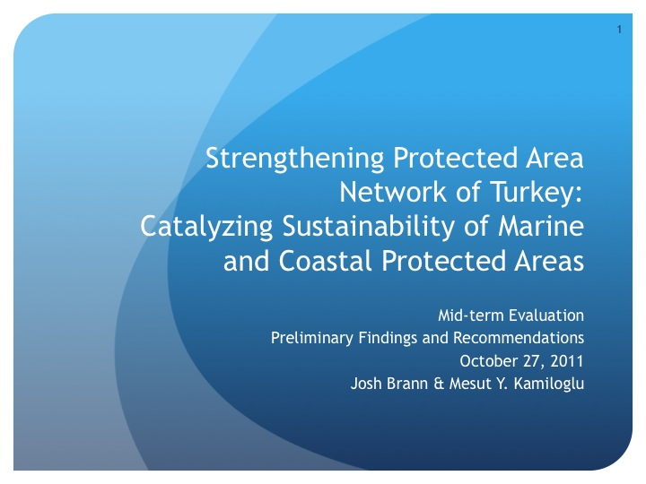

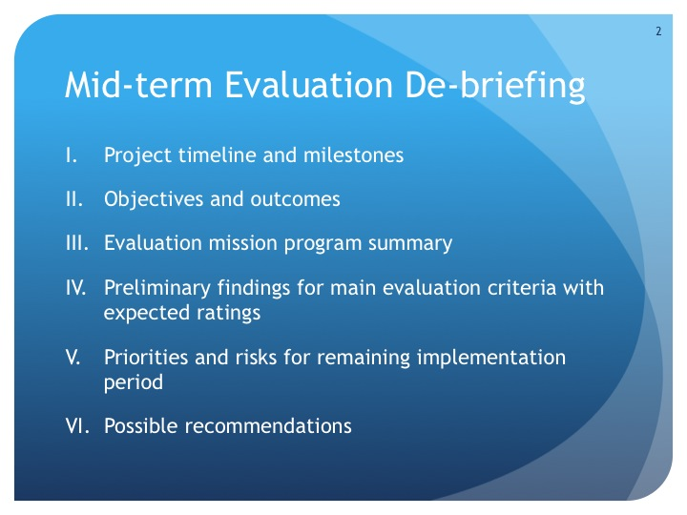

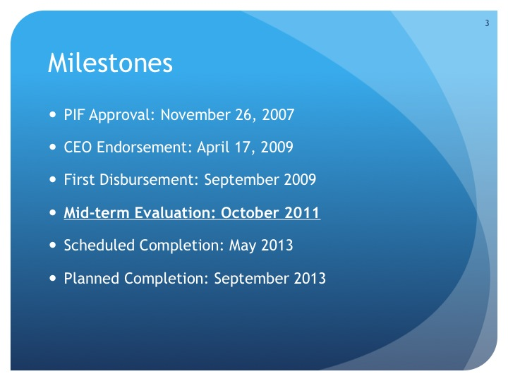

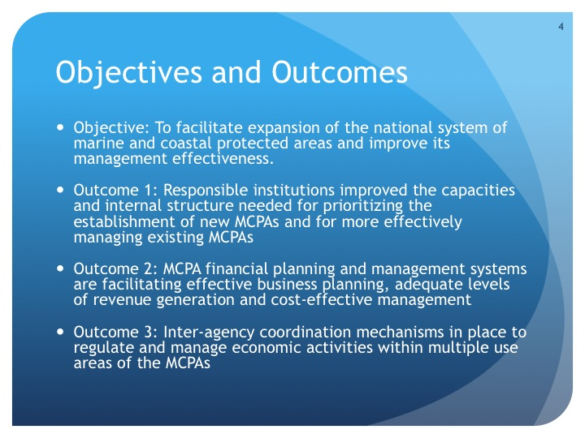

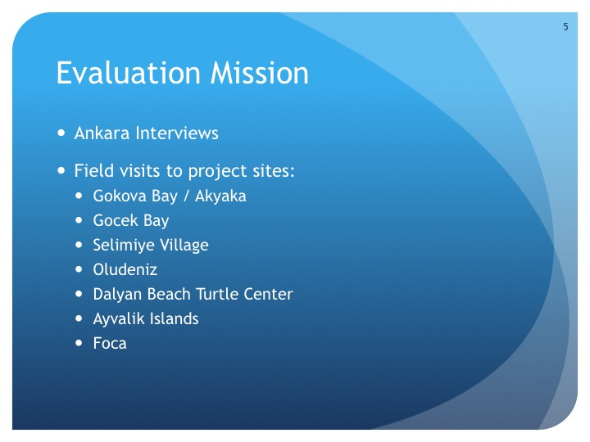

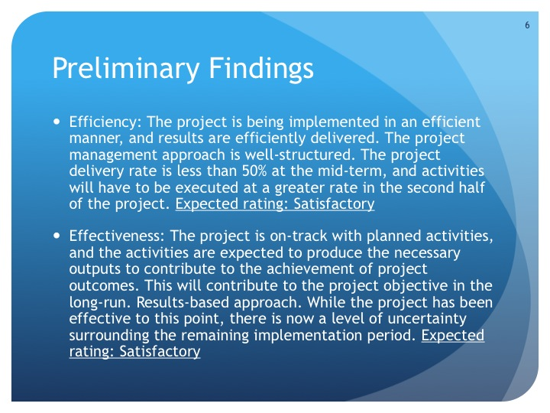

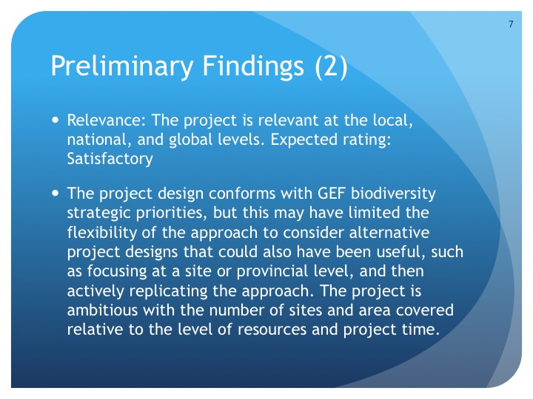

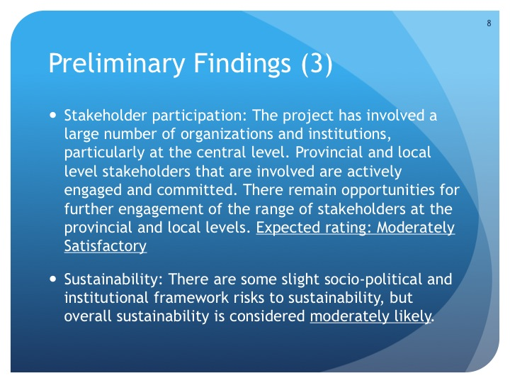

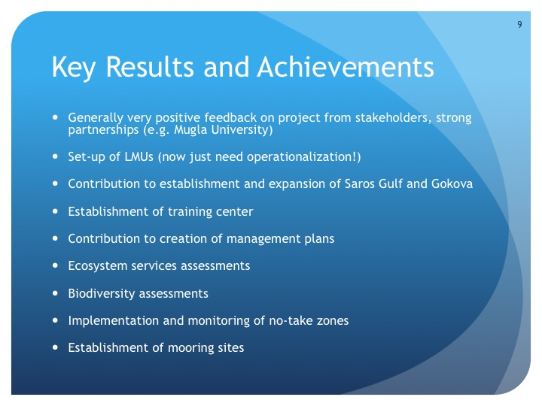

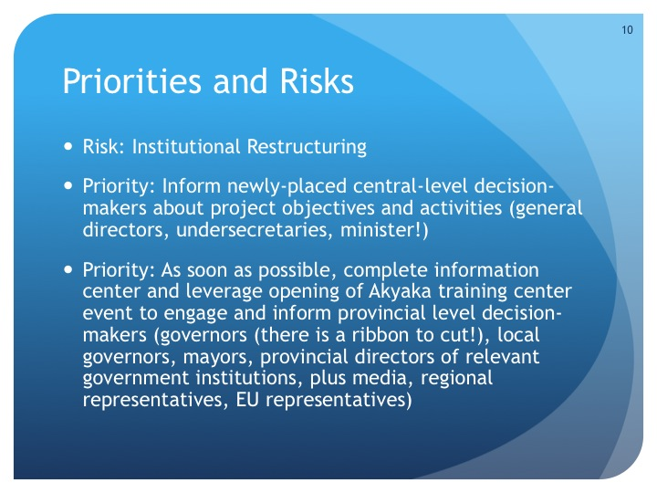

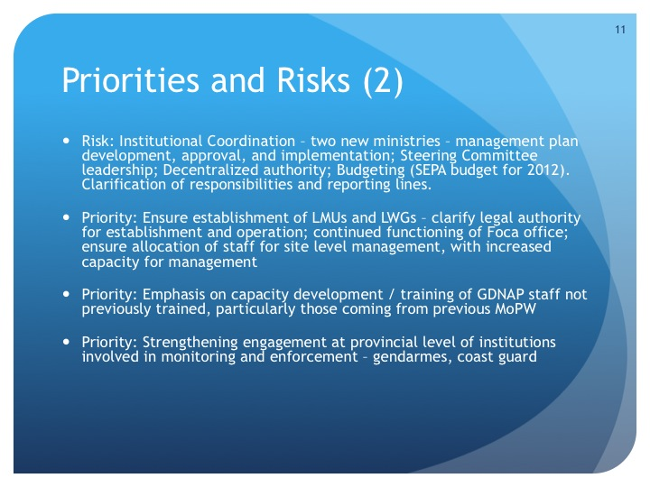

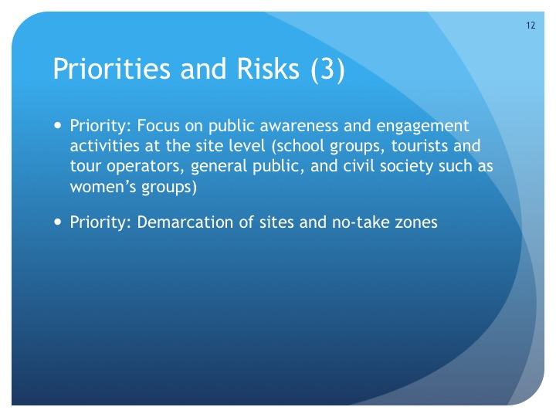

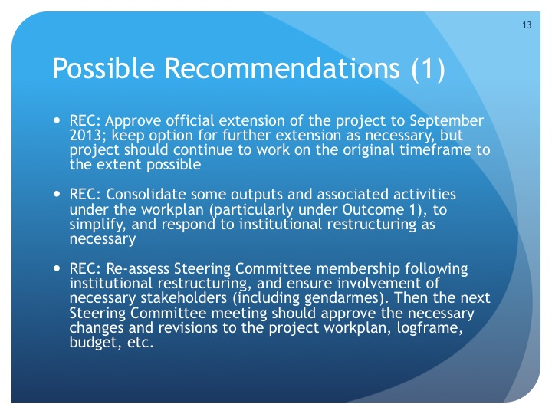

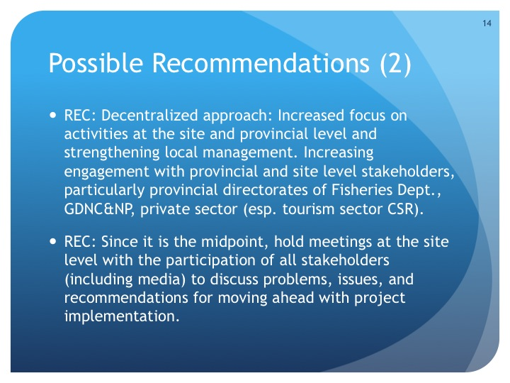

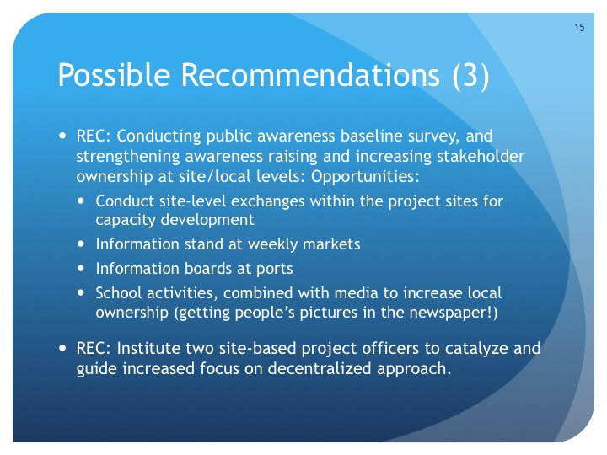

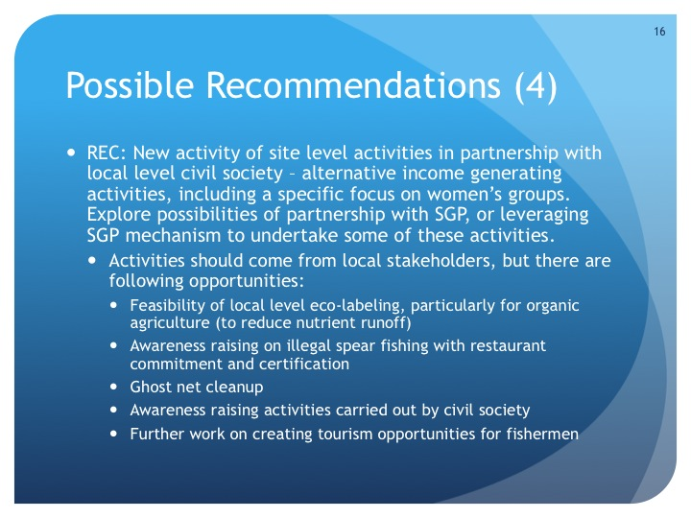

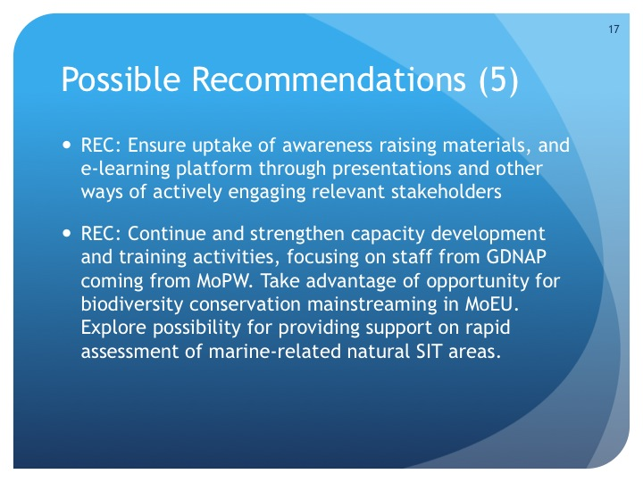

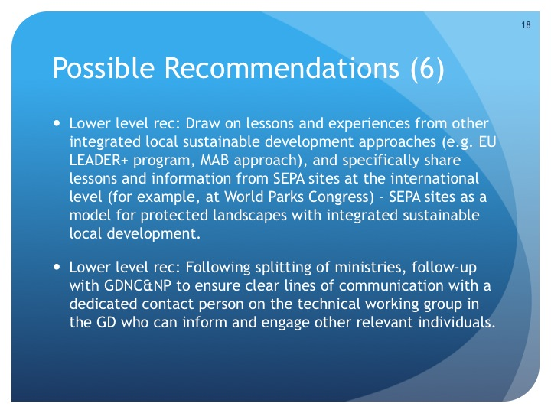

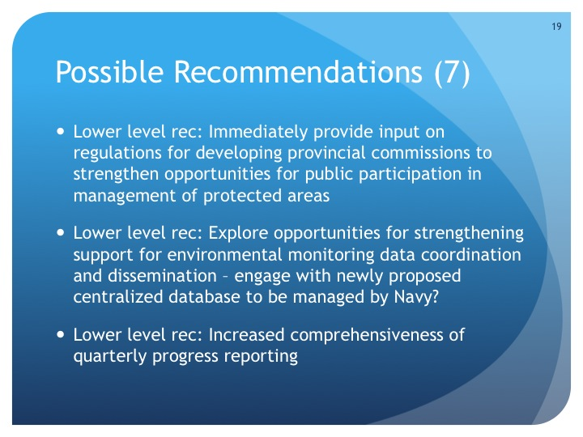

**Annex 11. Project Mid-term Scorecards: METT, Capacity, Financial**

See accompanying files.

**Annex 12. Evaluation Documentation**

Photo 8 Evaluation Team with Project Manager and Partners

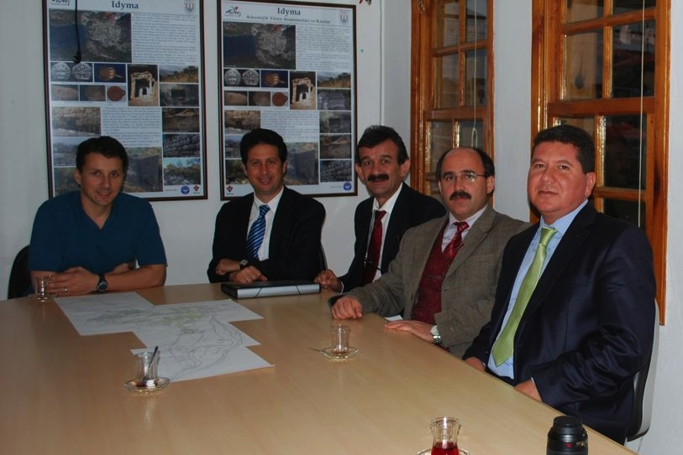

**Annex 13. Evaluator CVs**

Please see PDF version of this report.

**Annex 14. Management Response**

**PIMS 3697: Strengthening Protected Area Network of Turkey: Catalyzing Sustainability of Marine and Coastal Protected Areas**

UNDP Management Response Template

Mid-term Evaluation Date: **February 2012**

|  |  |  |
| --- | --- | --- |
| Prepared by: **[Project Manager or other]** | Position: **Project Task Leader** | Unit/Bureau: **UNDP Turkey** |
| Cleared by: | Position: | Unit/Bureau: |
| Input into and update in ERC: | Position: | Unit/Bureau: |

|  |  |  |  |  |
| --- | --- | --- | --- | --- |
| **Evaluation Recommendation or Issue 1.** | | | | |
| ***Key Recommendation:*** The Project Steering Committee and implementation partners should approve at the next Steering Committee meeting an official project extension to October 2013, to account for the period between approval and actual implementation start so that the project can still have a four-year implementation period. In addition, the Steering Committee should consider a further six-month extension to address delays resulting from the current government institutional restructuring. Thus a total of a one-year extension would be appropriate. *[PMU, Project Steering Committee, UNDP]* | | | | |
| **Management Response:** | | | | |
| **Key Action(s)** | **Time Frame** | **Responsible Unit(s)** | **Tracking\*** | |
| **Comments** | **Status** |
|  |  |  |  |  |
| **Evaluation Recommendation or Issue 2.** | | | | |
| ***Key Recommendation:*** The project design is ambitious in scope for the amount of resources and planned implementation period. At this stage the project team and partners should revise the project workplan to consolidate some outputs and activities, particularly under Outcome 1, which was adjusted at inception to include ten outputs. Some outputs under multiple outcomes are overlapping and could be consolidated to focus on key results. A workplan revision is also necessary to adaptively manage the government institutional restructuring. *[PMU, Key Partner Institutions, UNDP]* | | | | |
| **Management Response:** | | | | |
| **Key Action(s)** | **Time Frame** | **Responsible Unit(s)** | **Tracking\*** | |
| **Comments** | **Status** |
|  |  |  |  |  |
| **Evaluation Recommendation or Issue 3.** | | | | |
| ***Key Recommendation:*** Once the landscape of institutions involved in and responsible for management of SEPA sites is clear, the project team should re-assess the Steering Committee membership, and ensure involvement of all necessary stakeholders, including for example the Jandarmes. Any newly involved stakeholders will need to be fully updated on the project objective and planned activities. The reconstituted Steering Committee can then approve the necessary changes in the project workplan, logframe, budget, etc. for the second-half of implementation. *[PMU, UNDP]* | | | | |
| **Management Response:** | | | | |
| **Key Action(s)** | **Time Frame** | **Responsible Unit(s)** | **Tracking\*** | |
| **Comments** | **Status** |
|  |  |  |  |  |
| **Evaluation Recommendation or Issue 4.** | | | | |
| ***Key Recommendation:*** To respond to the institutional restructuring, this evaluation recommends the project take a decentralized implementation approach for the second-half of the project. This would involve broadly increasing the focus on site and provincial level activities, and on strengthening local management. For example, there will be a need to increase involvement of provincial directorates of the General Directorate of Fisheries & Aquaculture, the former GDNCNP, and the private sector (especially the tourism sector). Reflecting this increased decentralized focus, it would be useful to hold site-level meetings with the participation of all stakeholders (including media) to refresh the local awareness about the project, get further local feedback on key issues and suggestions for implementation. *[PMU, UNDP]* | | | | |
| **Management Response:** | | | | |
| **Key Action(s)** | **Time Frame** | **Responsible Unit(s)** | **Tracking\*** | |
| **Comments** | **Status** |
|  |  |  |  |  |
| **Evaluation Recommendation or Issue 5.** | | | | |
| ***Key Recommendation:*** The project strategy originally envisioned the establishment of Local Management Units (LMUs) for each of the sites to facilitate effective management. The project had made progress toward this goal through capacity development activities for EPASA staff recruited for this purpose, but the institutional restructuring occurred before the LMUs were officially established, and made operational. This evaluation recommends that the establishment of site-level LMUs remain a top priority, and that these should be established before the end of the project. Alternative approaches of having management staff based in provincial headquarters would not be nearly as effective for managing marine and coastal resources. *[PMU, GDNAP, MoEU]* | | | | |
| **Management Response:** | | | | |
| **Key Action(s)** | **Time Frame** | **Responsible Unit(s)** | **Tracking\*** | |
| **Comments** | **Status** |
|  |  |  |  |  |
| **Evaluation Recommendation or Issue 6.** | | | | |
| ***Key Recommendation:*** After the establishment of the new ministry (the MoEU) and new institutional arrangements at the provincial level, in the view of this evaluation the best way to establish the LWGs would be under the chairmanship of the local governor at each site, with the participation of all related institutions and organizations. This evaluation recommends this issue be given priority in the remaining project period to better implement the project activities in the provincial level and to give more power and authority to the local level establishments for the future of the project. *[PMU, GDNAP, MoEU]* | | | | |
| **Management Response:** | | | | |
| **Key Action(s)** | **Time Frame** | **Responsible Unit(s)** | **Tracking\*** | |
| **Comments** | **Status** |
|  |  |  |  |  |
| **Evaluation Recommendation or Issue 7.** | | | | |
| ***Key Recommendation:*** To facilitate a decentralized implementation approach, this evaluation recommends the addition of site-based project officers to catalyze and guide local level activities. One or two project officers may be appropriate, depending on the division of responsibilities. Previous UNDP-GEF project experience has shown that having site-level project staff can be of great benefit in increasing communication with and the involvement of local stakeholders. *[PMU, UNDP]* | | | | |
| **Management Response:** | | | | |
| **Key Action(s)** | **Time Frame** | **Responsible Unit(s)** | **Tracking\*** | |
| **Comments** | **Status** |
|  |  |  |  |  |
| **Evaluation Recommendation or Issue 8.** | | | | |
| ***Key Recommendation:*** The project should as soon as possible carry out the public awareness baseline survey of key stakeholder groups originally foreseen; it is critical to have a clear understanding of public awareness related to the project objective of conserving coastal and marine biodiversity in Turkey, and this would allow an assessment of progress in this area at the end of the project. This information would also provide input for further activities to strengthen awareness local stakeholder ownership. Opportunities for future activities include school activities linked with local media, information boards at ports, and an information stand at weekly markets. *[PMU]* | | | | |
| **Management Response:** | | | | |
| **Key Action(s)** | **Time Frame** | **Responsible Unit(s)** | **Tracking\*** | |
| **Comments** | **Status** |
|  |  |  |  |  |
| **Evaluation Recommendation or Issue 9.** | | | | |
| ***Key Recommendation:*** Given the project’s anticipated decentralization shift, the project should add on-the-ground site level activities to provide small-scale but direct contributions to the project objective, increase stakeholder awareness and participation, and demonstrate concrete results to local stakeholders. This could be effectively achieved through partnership with local level civil society organizations, and the project could explore potential partnership with the GEF Small Grants Programme, which has already supported some community-level activities in the area. The most relevant activities should be drawn directly from stakeholder input, but opportunities include feasibility studies for local eco-labels (particularly for organic agriculture to reduce nutrient run-off), awareness raising on illegal spear fishing with restaurant commitment and certification, ghost net cleanup, public awareness campaigns by civil society, and additional work on creating opportunities for fishermen to involve tourists in fishing excursions. *[PMU, UNDP, Project Steering Committee]* | | | | |
| **Management Response:** | | | | |
| **Key Action(s)** | **Time Frame** | **Responsible Unit(s)** | **Tracking\*** | |
| **Comments** | **Status** |
|  |  |  |  |  |
| **Evaluation Recommendation or Issue 10.** | | | | |
| ***Key Recommendation:*** Increasing individual and institutional capacity for effective management of marine and coastal resources is one of the main outcomes of the project, and a number of activities have already been carried out to support this. Following the government institutional restructuring however, there is an increased need to continue and to strengthen capacity development and training activities, including staff from the GDNAP coming from MoPW that may now be involved in SEPA management. The project should also exploit opportunities for biodiversity mainstreaming within the new MoEU. The MCPA Training and Implementation Center should present opportunities to catalyze and scale-up good management practices, and the e-learning platform developed by the project can also contribute. Another capacity development opportunity would be for site-level exchanges within the project sites for the government staff responsible. *[PMU, GDNAP]* | | | | |
| **Management Response:** | | | | |
| **Key Action(s)** | **Time Frame** | **Responsible Unit(s)** | **Tracking\*** | |
| **Comments** | **Status** |
|  |  |  |  |  |
| **Evaluation Recommendation or Issue 11.** | | | | |
| ***Recommendation:*** The project could draw on lessons and experiences from other integrated local sustainable development approaches, such as the EU’s LEADER+ program, and UNESCO’s Man and Biosphere Approach. In addition, lessons from the SEPA approach could be shared at the international level (for example, at the World Parks Congress), since the SEPA approach is a unique model for protected landscapes with integrated sustainable local development. *[PMU, GDANP, UNDP]* | | | | |
| **Management Response:** | | | | |
| **Key Action(s)** | **Time Frame** | **Responsible Unit(s)** | **Tracking\*** | |
| **Comments** | **Status** |
|  |  |  |  |  |
| **Evaluation Recommendation or Issue 12.** | | | | |
| ***Recommendation:*** Following the splitting of the former Ministry of Environment and Forestry, the General Directorate supporting the project (the GDNAP) and the General Directorate responsible for national parks are in two separate ministries. The project should follow-up with the GDNAP to ensure clear lines of communication with a dedicated contact person in the GD on the technical working group who can inform and engage other relevant staff in the GDNAP on project activities as appropriate. *[PMU, GDNAP, Project Partners]* | | | | |
| **Management Response:** | | | | |
| **Key Action(s)** | **Time Frame** | **Responsible Unit(s)** | **Tracking\*** | |
| **Comments** | **Status** |
|  |  |  |  |  |
| **Evaluation Recommendation or Issue 13.** | | | | |
| ***Recommendation:*** As the institutional restructuring of environmental line agencies is underway, some opportunities may appear for the project to further its objective in a results-based manner that were not otherwise planned. For example, the project should provide input on the regulations currently being developed for provincial commissions to strengthen opportunities for public participation in the management of protected areas. *[PMU, GDNAP and Project Partners]* | | | | |
| **Management Response:** | | | | |
| **Key Action(s)** | **Time Frame** | **Responsible Unit(s)** | **Tracking\*** | |
| **Comments** | **Status** |
|  |  |  |  |  |
| **Evaluation Recommendation or Issue 14.** | | | | |
| ***Recommendation:*** Environmental monitoring data is critical for effective marine and coastal biodiversity management, and for carrying out a number of project activities. Turkey is currently lacking a centralized data sharing mechanism for environmental monitoring data, and this remains one of the barriers to effective management. There are indications that a mechanism may be developed and managed by the Turkish Navy. If this initiative comes to fruition, the project should take this opportunity to support and strengthen the centralized integration of environmental monitoring data in a manner that would benefit the management of the SEPA sites. *[PMU, Project Partners]* | | | | |
| **Management Response:** | | | | |
| **Key Action(s)** | **Time Frame** | **Responsible Unit(s)** | **Tracking\*** | |
| **Comments** | **Status** |
|  |  |  |  |  |
| **Evaluation Recommendation or Issue 15.** | | | | |
| ***Recommendation:*** This evaluation recommends the project team increase the comprehensiveness of quarterly progress reporting in English, to facilitate the identification and sharing of lessons and experiences beyond Turkey. This would also support M&E activities such as the planned terminal evaluation. Reporting should not be an overly burdensome activity, but some additional information would be beneficial. *[PMU, UNDP]* | | | | |
| **Management Response:** | | | | |
| **Key Action(s)** | **Time Frame** | **Responsible Unit(s)** | **Tracking\*** | |
| **Comments** | **Status** |
|  |  |  |  |  |

1. An additional five SEPAs managed by EPASA are located in inland areas of Turkey.
2. GEF Evaluation Office. 2007. “Joint Evaluation of the GEF Activity Cycle and Modalities,” May 2007, Washington, D.C.: GEF Evaluation Office. Evaluation Report No. 33.
3. Sources: 1a: Not applicable; 1b: GEF online database; 2a: Not specified; 2b: GEF online database; 3a: CEO Endorsement Request; 3b: GEF online database; 4a: CEO Endorsement Request; 4b: GEF online database; 5a: CEO Endorsement Request; 5b: Inception Workshop Report; 6a: CEO Endorsement Request; 6b: 2011 PIR; 7a: CEO Endorsement Request; 7b: Field dates of mid-term evaluation mission; 8a: CEO Endorsement Request; 8b: Not Applicable; 9a: According to UNDP-GEF M&E procedures, TEs are normally carried out during the last three months of project operation, or at leastwithin a year of project completion; 9b: Not Applicable; 10a: Based on standard UNDP operational procedures; 10b: Not Applicable.
4. For the focal area strategic approach for GEF-4, see GEF Council document GEF/C.31/1, “Focal Area Strategic and Strategic Programming for GEF-4,” July 16, 2007.
5. For the focal area strategic priorities for GEF-5, see GEF Council document GEF/R.5/31, “GEF-5 Programming Document,” May 3, 2010.
6. One example of this type of tour in a similar context (albeit in Vietnam, on the other side of the world) can be seen at <http://www.hoianecotour.com/Tours.html>.
7. The GEF Evaluation Office defines SMART indicators as being Specific, Measureable, Achievable and Attributable, Relevant and Realistic, Timebound, Timely, Trackable and Targeted. See <http://www.gefcountrysupport.org/report_detail.cfm?projectId=232> for additional information.
8. See Project Document <http://www.undp.org.tr/Gozlem2.aspx?WebSayfaNo=2193>
9. See p.67 of UNDP’s “Handbook on Monitoring and Evaluation for Results”, available at <http://www.undp.org/gef/monitoring/policies.html>
10. See section 3.2 of the GEF’s “Monitoring and Evaluation Policy”, available at

    <http://207.190.239.143/uploadedFiles/Policies_and_Guidelines-me_policy-english(1).pdf>
11. RBM Support documents are available at http://www.undp.org/eo/methodologies.htm
12. The UNDP User Guide is currently only available on UNDP’s intranet. However UNDP can provide the necessary section on roles and responsibility from http://content.undp.org/go/userguide/results/rmoverview/progprojorg/?src=print
13. Note: Appendices 3 to 6 of this inception report have been left out here due to redundancy with other elements of the evaluation report and annexes.